Disclaimer
The information in this publication is, according to the Ministry for the Environment’s best efforts, accurate at the time of publication. The Ministry will make every reasonable effort to keep it current and accurate. However, users of this publication are advised that:
- the information does not alter the laws of New Zealand, other official guidelines, or requirements
- it does not constitute legal advice, and users should take specific advice from qualified professionals before taking any action based on information in this publication
- the Ministry does not accept any responsibility or liability whatsoever whether in contract, tort, equity, or otherwise for any action taken as a result of reading, or reliance placed on this publication because of having read any part, or all, of the information in this publication or for any error, or inadequacy, deficiency, flaw in, or omission from the information in this publication
- all references to websites, organisations or people not within the Ministry are for convenience only and should not be taken as endorsement of those websites or information contained in those websites nor of organisations or people referred to.

Acknowledgements
We gratefully thank Andrew Tait and Raghav Srinivasan (National Institute of Water and Atmospheric Research) for extrapolating climate station data and contributing their expertise in the generation of the growing season maps. We further thank Robert Hathaway and Wallace Farms for allowing access to their properties to test the delineation tools. Special thanks to Wetland Training Institute, United States of America, particularly Charlie Newling and Jim Teaford, for encouragement, support and guidance on applying the US wetland delineation system for New Zealand wetlands.
Report prepared by Suzanne M Lambie, Beverley R Clarkson, Scott Fraser, Robbie Price, Manaaki Whenua – Landcare Research.
This document may be cited as: Ministry for the Environment. 2021. Wetland delineation hydrology tool for Aotearoa New Zealand. Wellington: Ministry for the Environment.

Originally published in July 2021 and Appendix 1 updated in January 2024 by the
Ministry for the Environment
Manatū Mō Te Taiao
PO Box 10362, Wellington 6143, New Zealand
ISBN: 978-1-99-003362-9
Publication number: ME 1575
© Crown copyright New Zealand 2021
This document is available on the Ministry for the Environment website: environment.govt.nz.

Contents
Summary 6
Introduction 7
Background 8
Objectives 9
Wetland hydrology 10
Growing season 11
Wetland hydrology indicators 15
Field identification procedure for wetland delineation 35
Hydrophytic vegetation and hydric soils assessed but inconclusive 35
Field testing 39
Site 1: Reporoa 39
Site 2: Piopio 39
Conclusions 41
Appendix 1: Wetland delineation data form 42
Appendix 2: Distribution of climate stations used to determine the growing season 43
Appendix 3: Deciduous native trees and shrubs 44
Appendix 4: Data sheets from field trials 46
Glossary 58
References 59

Tables
Table 1: Approximate start dates, end dates and duration of the growing season for the main office locations of 14 local authorities across New Zealand 12
Table 2: Wetland hydrology indicators for New Zealand 15
Table 3: Quick reference guide for New Zealand wetland delineation data sheet Error! Bookmark not defined.
Table 4: List of deciduous native trees and shrubs 44

Figures
Figure 1: Four steps for delineating wetlands using the hydrophytic vegetation, hydric soils and wetland hydrology tools 6
Figure 2: Flow diagram for wetland hydrology tool 10
Figure 3: Map of New Zealand indicating the start of the growing season 13
Figure 4: Map of New Zealand indicating the end of the growing season 14
Figure 5: Surface water present 17
Figure 6: High water table in soil pit 18
Figure 7: Water shimmering on soil surface 19
Figure 8: Water mark on a) raupō and b) kahikatea and c) absence of lichen indicated by the arrow 20
Figure 9: Sediment deposits on a) boardwalk supports and b) raupō as indicated by the arrow 21
Figure 10: Debris on a) a fence post and b) deposited on the ground surface 21
Figure 11: Algal mat on soil surface 22
Figure 12: Iron sheen on water surface 22
Figure 13: Surface cracks in soil 23
Figure 14: Google Earth images show inundation at different time steps 24
Figure 15: No vegetation on concave surface 25
Figure 16: Salt crust in central Otago 25
Figure 17: Collection of aquatic snail shells on wetland fringe 26
Figure 18: Water-stained raupō leaves 26
Figure 19: Wetland vegetation bent in the direction of water flow 27
Figure 20: Oxidised rhizospheres around living roots 28
Figure 21: Oxidised soil, where the brown colour represents chemically reduced iron after exposure to air 29
Figure 22: Redox concentrations in recently tilled wetland soil 30
Figure 23: Aerial imagery for a wetland in October 2017 and March 2019 indicating soil saturation 31
Figure 24: Stunted trees due to high water table (affected trees indicated by the yellow circle) 32
Figure 25: Concave area in grazed pasture 33
Figure 26: a) Frost-heave hummocks in Southland and b) at Old Man Range, affected area in b) shown in the yellow circle 34
Figure 27: Four steps for delineating wetlands using the hydrophytic vegetation, hydric soils and wetland hydrology tools 36
Figure 28: Simple key to identifying hydric soil features 37
Figure 29: Simple key to describing wetland hydrology 37
Figure 30: Hydrology tool a) test site at Reporoa, b) hydric and c) non-hydric soil profiles 39
Figure 31: Hydrology tool a) test site at Piopio, b) hydric and c) non-hydric soil profiles 40

Summary
The identification and delineation of ‘natural inland wetlands’ are required under the National Policy Statement for Freshwater Management 2020. Internationally accepted methods of delineating wetlands include identification of hydrophytic vegetation, hydric soils and wetland hydrology. Manaaki Whenua – Landcare Research has developed tools to identify hydrophytic (wetland) vegetation and hydric (poorly drained) soils. This guide presents the wetland hydrology tool, which is the final component for identifying wetlands and delineating their boundaries. All three tools are based on the US wetland delineation system used for regulatory purposes.
The wetland hydrology tool outlines the primary and secondary hydrology indicators and assessment procedure and integrates these within established protocols for identifying hydrophytic vegetation and hydric soils to delineate wetlands.
Wetland hydrology indicators are assigned to four groups: 1) observation of flooding or groundwater; 2) evidence of flooding or ponding; 3) evidence of current or recent soil saturation; and 4) other hydrological evidence from site conditions or data. Group 1 are primary indicators, and groups 2, 3 and 4 are a combination of primary and secondary indicators.
To confirm the presence of wetland hydrology, the following are required:
- one primary indicator, or
- two secondary indicators.
Wetland delineation should be undertaken following the four main steps outlined in figure 1. The hydrology tool provides supporting evidence for the hydrophytic vegetation and hydric soils tools and is particularly valuable where these tools yield uncertain results. Some overlap occurs between the hydric soils and hydrology tools, and we suggest the hydrology tool should be used when the hydric soils tool is used. The New Zealand Wetland Delineation Data Form (appendix 1) can be used to identify hydrophytic vegetation, hydric soils and wetland hydrology.
Figure 1: Four steps for delineating wetlands using the hydrophytic vegetation, hydric soils
and wetland hydrology tools
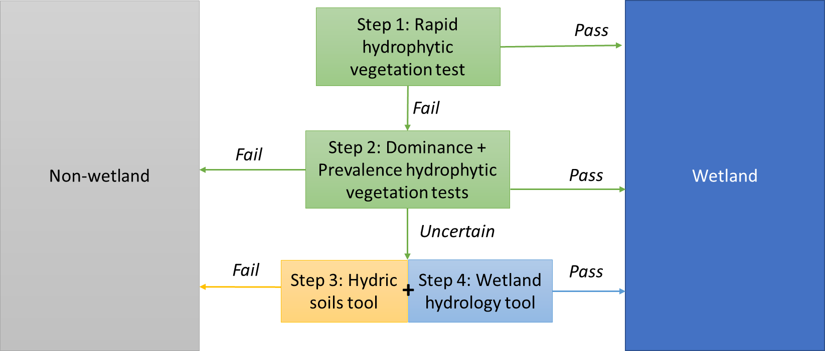

Introduction
The National Policy Statement for Freshwater Management 2020 (Freshwater NPS 2020) allocates responsibility for the protection, identification and encouragement of restoration of natural inland wetlands to local authorities. The New Zealand Resource Management Act 1991 defines wetlands as ‘permanently or intermittently wet areas, shallow water, and land water margins that support a natural ecosystem of plants and animals that are adapted to wet conditions’.
Under the Freshwater NPS 2020, the definition of a natural inland wetland is refined further to mean a wetland not constructed by artificial means (unless it was constructed to offset impacts on, or restore, an existing or former natural wetland). It does not include geothermal wetlands or areas of improved pasture that have more than 50 per cent exotic pasture species and are subject to temporary rain-derived water pooling.
The definition can be difficult to apply consistently in the field, therefore, to fulfil the requirements under the Freshwater NPS 2020, development of a system to delineate wetlands is required to support local authorities and other stakeholders. Further, the Freshwater NPS 2020 requires local authorities to consider wetland delineation protocols when uncertainty or dispute about the existence of a natural inland wetland occurs.

Background
The United States has developed a scientifically robust wetland delineation system for regulatory purposes (Environmental Laboratory, 1987; US Army Corps of Engineers, 2005, 2008, 2010) consisting of assessment of three diagnostic environmental characteristics or criteria: vegetation, soils and hydrology. Under US legislation (section 404, Clean Water Act and regulations), all three criteria are required to classify an area as a wetland.
Vegetation and soil assessments indicate whether an area was a wetland over the medium to long term, while the hydrological indicators confirm that an area remains a wetland. Wetland hydrology indicators provide evidence that hydrophytic vegetation and hydric soils are not relics of a past hydrologic regime.
The Vegetation Tool (Clarkson, 2014) and Hydric Soils Tool (Fraser et al, 2018) have been developed in New Zealand based on the US model. Within this project, we develop the hydrology indicators to contribute the final component to New Zealand’s wetland delineation system.

Objectives
Develop a wetland hydrology tool to support the vegetation and hydric soils tools for New Zealand conditions.

Wetland hydrology
Wetland hydrology can be defined as encompassing all hydrological characteristics of areas that are periodically inundated or have soils saturated to, or near, the surface during a portion of the growing season (based on Environmental Laboratory, 1987).
To meet the standard for wetland hydrology, an area must be:
- inundated for at least seven consecutive days during the growing season in most years (50 per cent probability of recurrence); or
- saturated at or near the surface for at least 14 consecutive days during the growing season in most years (50 per cent probability of recurrence, for example, 5 years in 10). Soils may be considered saturated if the water table is within:
- 15 centimetres of the surface for sands
- 30 centimetres of the surface for all other soils.
The presence of water for long enough during the growing season provides the anaerobic and reducing conditions necessary to develop the hydric soils and hydrophytic vegetation typical of wetlands. Although hydrology is the most important of the three criteria, it can sometimes be the most difficult to determine in the field. This is because water levels can be highly variable during the year, including being extremely low during the dry season or during drier-than-normal years.
Indicators of wetland hydrology can be either direct or indirect. Direct evidence includes actual observation of soil saturation or flooding, long-term water level monitoring data, and detection of flooding through aerial photographs. Indirect evidence includes water marks and silt deposits on trees, silt-stained leaves on the ground surface and flood debris. Indicators are divided into two categories – primary and secondary – based on their estimated reliability in determining whether wetland hydrology is present.
Interpreting hydrological indicators is undertaken during the growing season and includes observation of primary and secondary indicators (figure 2), after assessment with vegetation and hydric soil tools, and confirms the presence or absence of a wetland.
Figure 2: Flow diagram for wetland hydrology tool
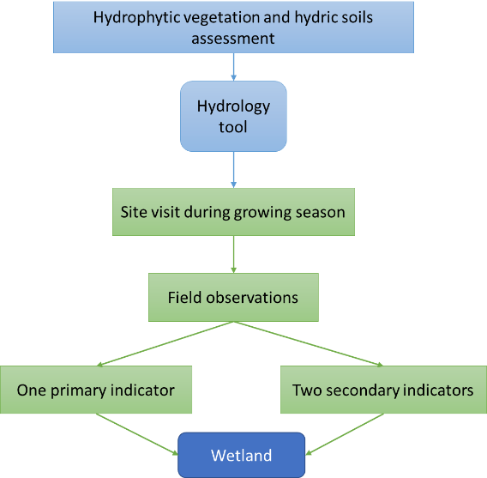

Growing season
The growing season is under way if plants are accumulating biomass or soil temperatures are above the threshold that allows for microbial activity (US Army Corps of Engineers, 2010). The growing season starts when one of these factors begins, and ends when the most persistent factor ceases.

1. Plant growth
Plant growth assessments should be undertaken for non-evergreen vascular species. This may be problematic in New Zealand because most native species are evergreen (appendix 3 contains a list of deciduous native trees and shrubs). However, if two or more exotic deciduous species are nearby these may be used for this index. The growing season has begun if two or more species exhibit one or more of the following:
- emergence of herbaceous plants
- new growth from vegetative crowns (eg, bulbs)
- coleoptile and/or cotyledon emergence
- bud burst on woody plants
- emergence or elongation of leaves of woody plants
- emergence or opening of flowers.
The end of the growing season is indicated by woody deciduous plants entering senescence or herbaceous plants ceasing flowering and their leaves dying. Determining the end of the growing season can be complicated by drought conditions leading to early senescence or potentially a return to growth later in the year. In this case, soil temperature measurements may be easier and more reliable for determining the end of the growing season.

2. Soil temperature
Soil temperature can be used to signal the start and end of the growing season. The growing season begins when minimum soil temperatures are above 5 degrees Celsius in the top 30 centimetres of the soil profile. If the soil temperature is not known and on-site data collection not practical, then the growing season can be approximated as the period when air temperatures are above –2.2 degrees Celsius, based on long-term records. An air temperature of –2.2 degrees Celsius or lower represents a ‘killing’ frost, whereby virtually all vegetation is affected to some degree and is usually measured at a frequency of 5 years in 10 (US Army Corps of Engineers, 2010).
To define a practical solution for determining the growing season, we worked with the National Institute of Water and Atmospheric Research to produce maps of New Zealand showing the first day of the growing season as determined by the day of the last killing frost, and the end of the growing season as determined by the day of the first killing frost. Daily minimum air temperatures were used (measured at 1.2 metres above the ground surface) for each day from all New Zealand climate stations (n=187), with a minimum of six years of data, between 2001 and 2020 (appendix 2). Climate stations established for a longer period were weighted more than climate stations established for a shorter period. Because climate station data are insufficient between 2002 and 2010 in the Northland, Taranaki coast, Gisborne and Manawatu–Wanganui regions (appendix 2), the establishment of the growing season may be best assessed from the nearest meteorological station through the National Climate Database.
For each year, and each climate station, the day of the year with the first and last occurrence of air temperatures lower than –2.2 degrees Celsius was extracted. The median day of the year indicating the first and last killing frost dates was determined and interpolated to 500-metre grids using smoothing spline interpolation with elevation as a covariate (as also undertaken by Wratt et al, 2006) and presented as maps of New Zealand showing the start and end of the growing season (figure 3 and figure 4).
Start and end dates of the growing season for the main office locations for 14 local authorities across New Zealand have been extracted from the map layer to give an indication of the growing season in each region (table 1).
Table 1: Approximate start dates, end dates and duration of the growing season for the main office locations of 14 local authorities across New Zealand
Main office location | Local authority | Council type | Growing season start (date) | Growing season end (date) | Growing season length (days)
Whangarei | Northland | Regional | Continuous | Continuous | Continuous
Auckland | Auckland | Unitary City | 12 July | 23 June | 347
Hamilton | Waikato | Regional | 1 August | 12 June | 316
Whakatane | Bay of Plenty | Regional | 14 July | 4 July | 356
Napier | Hawke’s Bay | Regional | 4 August | 19 June | 319
Palmerston North | Horizons | Regional | 19 July | 23 June | 339
Wellington | Greater Wellington | Regional | 11 August | 13 June | 306
Nelson | Nelson | Unitary city | 25 July | 26 June | 336
Nelson | Tasman | Unitary district | 5 August | 17 July | 316
Blenheim | Marlborough | Unitary district | 4 August | 14 June | 314
Christchurch | Environment Canterbury | Regional | 16 August | 11 June | 299
Greymouth | West Coast | Regional | 24 July | 18 June | 329
Dunedin | Otago | Regional | 14 August | 1 July | 321
Note: Only local authorities with sufficient data have been included.
Figure 3: Map of New Zealand indicating the start of the growing season
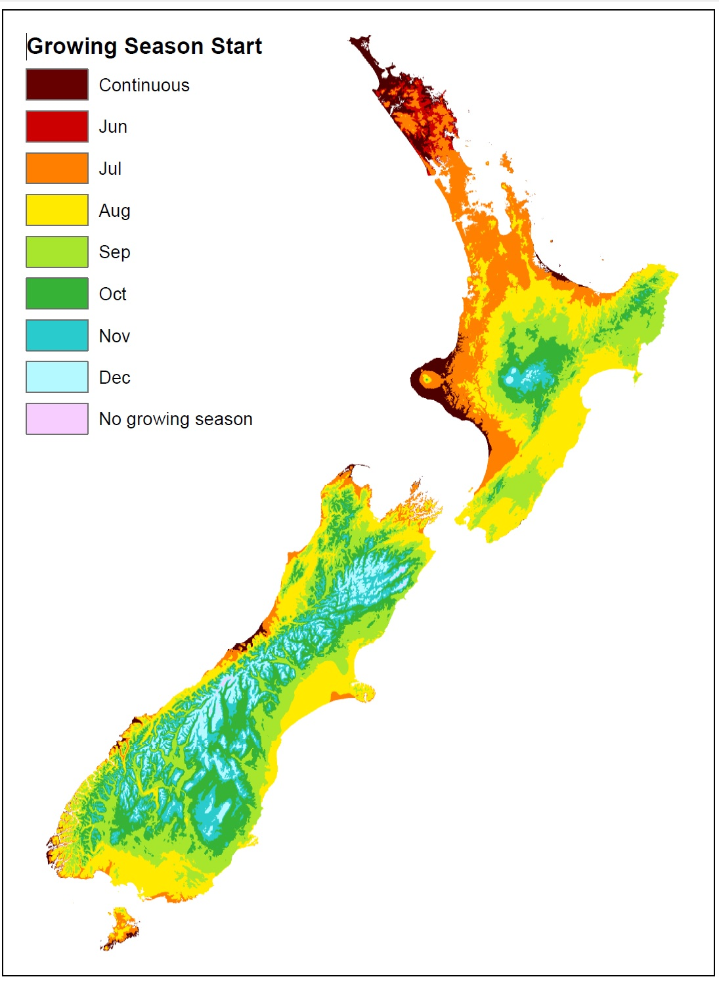
Note: ‘Continuous’ refers to areas where the growing season occurs all year, and ‘no growing season’ refers to areas where no growing season occurs.
Figure 4: Map of New Zealand indicating the end of the growing season
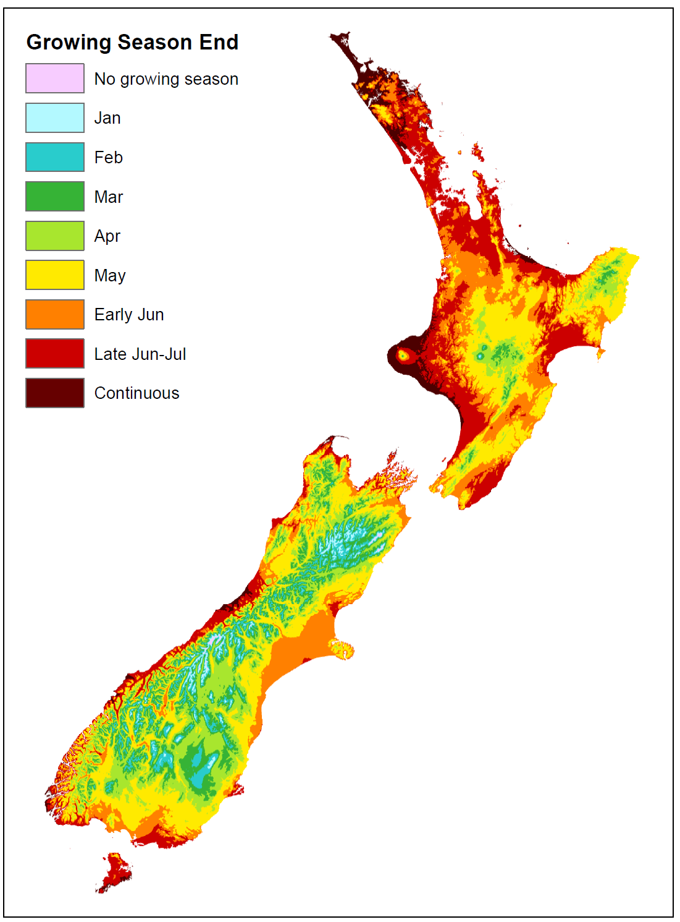
Note: ‘Continuous’ refers to areas where the growing season occurs all year, and ‘no growing season’ refers to areas where no growing season occurs.

Wetland hydrology indicators
Hydrology indicators are one-off observations that identify the presence or absence of a wetland in areas where hydrophytic vegetation and hydric soils are present or uncertain. However, because hydrology indicators can be highly transient, a follow-up visit may be required during the normal, wetter period of the growing season.
Wetland hydrology indicators are assembled into four groups: 1) observation of flooding or groundwater; 2) evidence of flooding or ponding; 3) soil saturation; 4) landscape, vegetation and soil observations (which may overlap with the vegetation and hydric soil tools) (table 2). Group 1 are primary indicators and groups 2 to 4 have a mix of primary and secondary indicators. The presence of one primary indicator, or two secondary indicators, confirms the presence of a wetland.
Table 2: Wetland hydrology indicators for New Zealand
 | Category
Indicator | Primary | Secondary
Group 1: Observation of flooding or groundwater
1A: Surface water | X
1B: Groundwater | X
1C: Soil saturation | X
Group 2: Evidence of flooding or ponding
2A: Water marks | X
2B: Sediment deposits | X
2C: Drift deposits | X
2D: Agal mat or crust | X
2E: Iron deposits | X
2F: Surface soil cracks | X
2G: Inundation visible on aerial imagery | X
2H: Sparsely vegetated concave surface | X
2I: Salt crust | X
2J: Aquatic invertebrates | X
2K: Water-stained leaves | X | X
2L: Drainage patterns |  | X
Group 3: Evidence of current or recent soil saturation
3A: Hydrogen sulphide odour | X
3B: Oxidised rhizospheres along living roots | X
3C: Reduced iron | X
3D: Recent iron reduction in tilled soils | X
3E: Dry-season water table |  | X
3F: Saturation visible on aerial imagery |  | X
Group 4: Evidence from other site conditions or data
4A: Stunted or stressed plants | X
4B: Geomorphic position |  | X
4C: Shallow aquitard |  | X
4D: Facultative-neutral test |  | X
4E: Frost-heave hummocks |  | X

Wetland delineation using the hydrology tool should be undertaken during periods of ‘normal rainfall’. Normal rainfall is monthly rainfall two-to-three months before the field assessment time, which is sufficiently similar to historical monthly rainfall. Monthly climate information for New Zealand can be found at niwa.co.nz/climate/monthly and mean monthly rainfall from 1981 to 2010 can be found at niwa.co.nz/education-and-training/schools/resources/climate/meanrain.

Group 1: Observation of flooding or groundwater

Indicator 1A: Surface water (primary indicator)
Surface water can be observed in the form of either flooding or ponding during the growing season (figure 5).
Figure 5: Surface water present
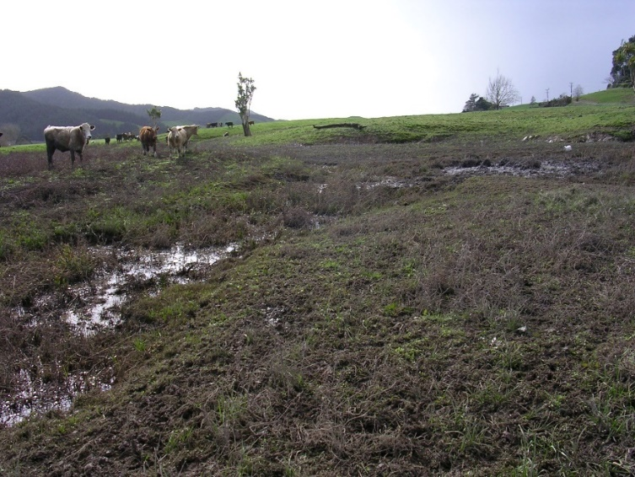

Caveats
- Not all areas with flooding or ponding are wetlands but may have surface water after heavy rainfall events.
- Drought can reduce the prevalence of surface water.
- Not all wetlands have flooding or experience inundation.

Indicator 1B: Groundwater (primary indicator)
The high water table is observed within 30 centimetres of the soil surface during the growing season as determined by soil pit, auger hole or shallow monitoring well (figure. 6). The depth to the water table should be assessed after the water table has reached an equilibrium in the hole. This may take some time, therefore, it is suggested all the holes be dug for all the points across the landscape as per the hydric soils tool at the area of interest, to allow sufficient time for the water table to reach an equilibrium before the depth to the water table is assessed.
Figure 6: High water table in soil pit
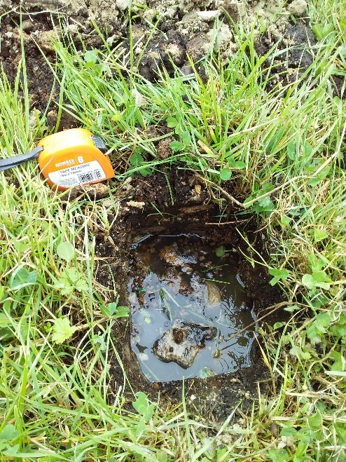

Caveats
- Drought can reduce the water table height and the hydrology tool cannot be interpreted during droughts.
- Not all wetlands have a water table within the top 30 centimetres of the soil profile throughout the growing season.
- Any inspection hole should not penetrate any impeding soil layer that contributes to a perched water table. The hydric soil field guide should be used to determine the presence of and depth to impermeable soil layers.

Indicator 1C: Soil saturation (primary indicator)
Soil saturation is observed in the top 30 centimetres of the soil profile during the growing season. This is indicated by ‘water glistening on the surfaces and broken interior faces of the soil samples removed from a pit or auger hole’ (US Army Corps of Engineers, 2010). The water table must be located immediately under the saturated zone unless there is an impermeable soil layer within the top 30 centimetres of the soil profile (figure 7).
Figure 7: Water shimmering on soil surface
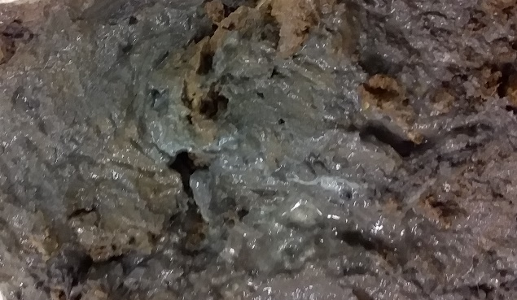

Caveats
- Seeing water only on the faces of peds does not meet this indicator, the interior of the peds must also be saturated.
- Soil should not be shaken or squeezed to force water from the pore spaces.

Group 2: Evidence of flooding or ponding

Indicator 2A: Water marks (primary indicator)
Water marks (discolouration or staining) are seen on trees, rocks or other fixed objects in the area of interest during the growing season (figure 8). Lichen may also be absent below the flooding level (Beckelhimer and Weaks, 1984).
Figure 8: Water mark on a) raupō and b) kahikatea and c) absence of lichen indicated by the arrow
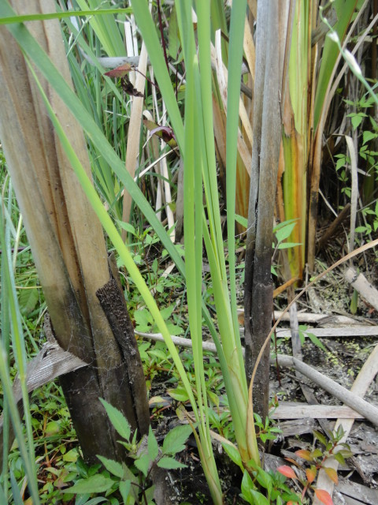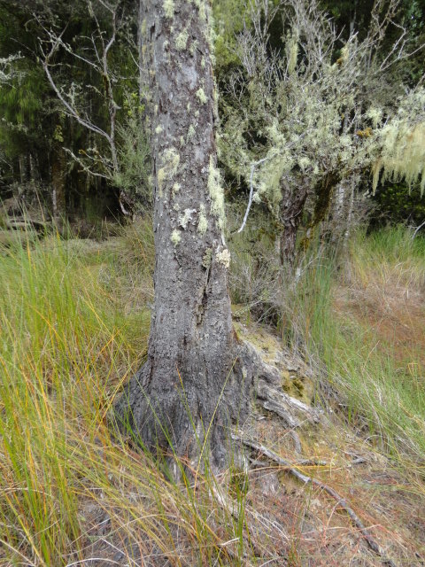
b)
a)
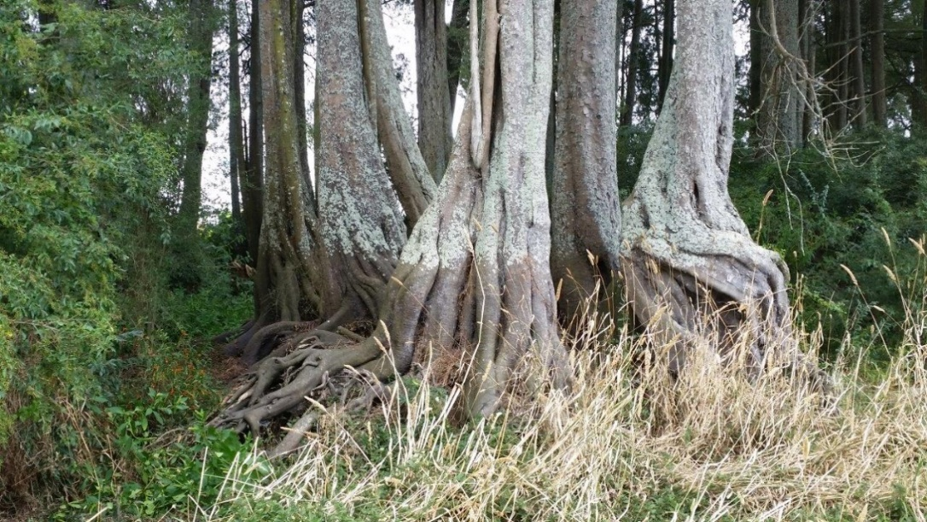
c)
Photo C: Karen Denyer.

Caveat
- Water marks may reflect recent, extreme weather events, and field assessments should not be undertaken within two weeks of an extreme weather event.

Indicator 2B: Sediment deposits (primary indicator)
Thin layers or coatings of fine mineral material (eg, silt or clay) or organic matter (eg, pollen) are seen on trees, rocks or other fixed objects in the area of interest during the growing season (figure 9).
Figure 9: Sediment deposits on a) boardwalk supports and b) raupō as indicated by the arrow
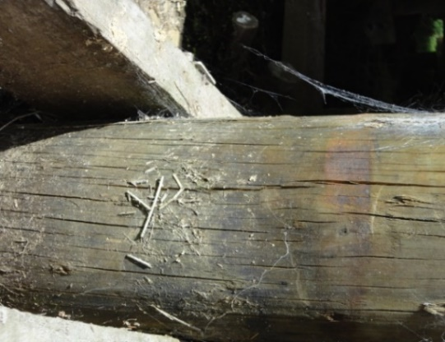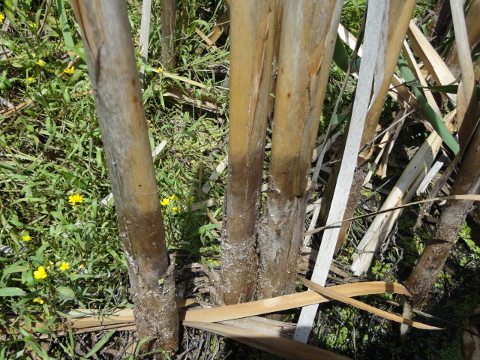
a)
b)

Caveats
- Sediment deposits may reflect recent, extreme weather events, and it is suggested field assessments of hydrology indicators should not be undertaken within two weeks of an extreme weather event.
- Thick accumulations of sand or gravel in fluvial channels are not included in this indicator.

Indicator 2C: Drift deposits (primary indicator)
Debris (eg, branches, leaves, plastic fragments) is seen deposited on the ground surface or entangled in vegetation or other fixed objects in the area of interest during the growing season (figure 10). Deposits can be at the high-water mark in ponded or flooded areas, on the upstream side of trees or other fixed objects or distributed through a deposition zone where the water drains away.
Figure 10: Debris on a) a fence post and b) deposited on the ground surface
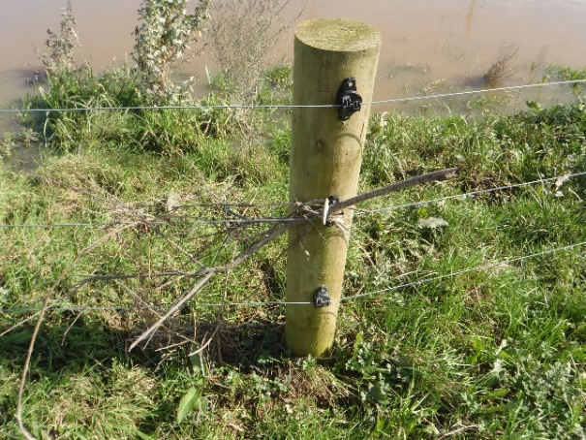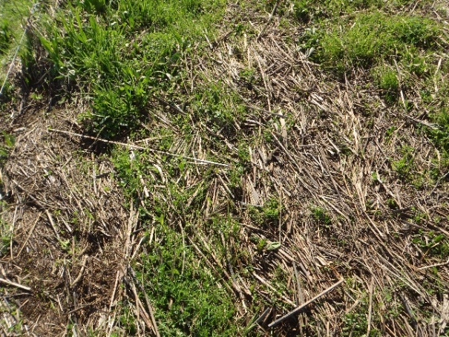
a)
b)

Caveat
- Drift deposits may reflect recent, extreme weather events, and it is suggested field assessments of hydrology indicators should not be undertaken within two weeks of an extreme weather event.

Indicator 2D: Algal mat or crust (primary indicator)
An algal mat or crust is seen on or near the soil surface after the water has drained away during the growing season (figure 11).
Figure 11: Algal mat on soil surface
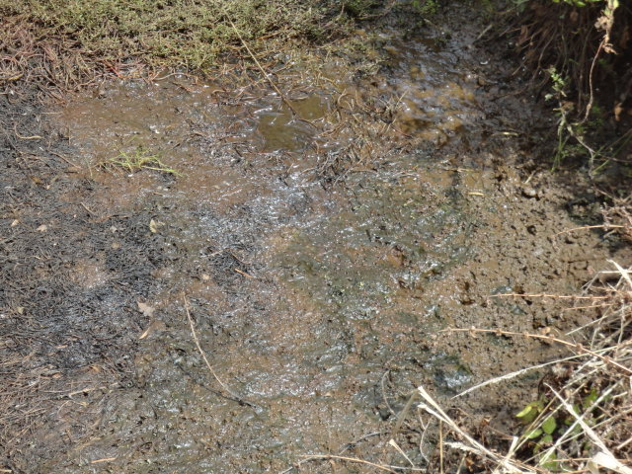

Caveat
- Algal deposits are most likely in seasonally ponded areas, interdunal swales, lake edges, tidal areas and low-gradient stream margins.

Indicator 2E: Iron deposits (primary indicator)
A thin orange or yellow crust or gel or oxidised iron is seen on or near the soil surface or as a sheen on standing water in the growing season (figure 12).
Figure 12: Iron sheen on water surface
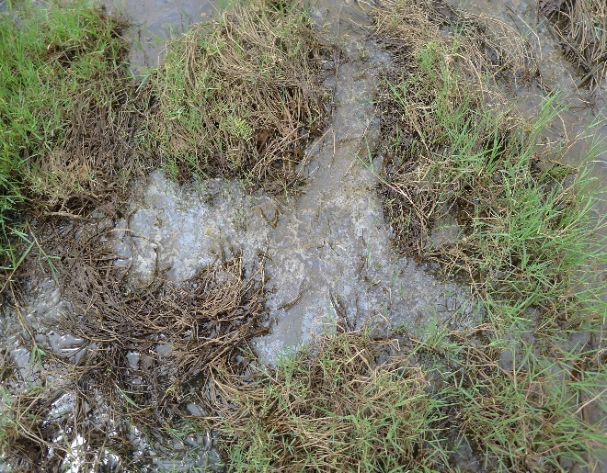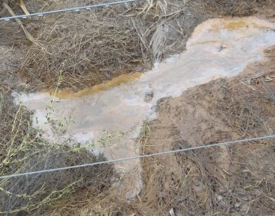

Caveats
- The sheen on standing water is differentiated from an oily film by cracking to angular fragments when touched.
- The orange or yellow deposits may occur in areas where water has drained away.

Indicator 2F: Surface soil cracks (primary indicator)
Surface soil cracks are seen where mineral or organic sediment dry and shrink to form a network of cracks or polygons during the growing season (figure 13).
Figure 13: Surface cracks in soil
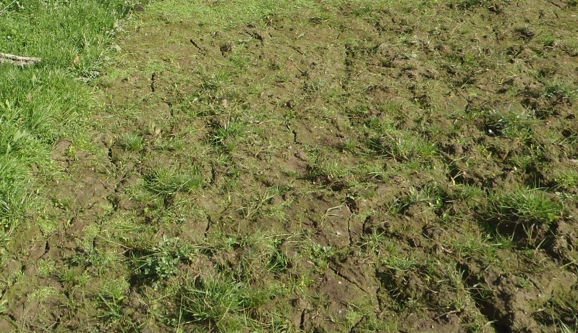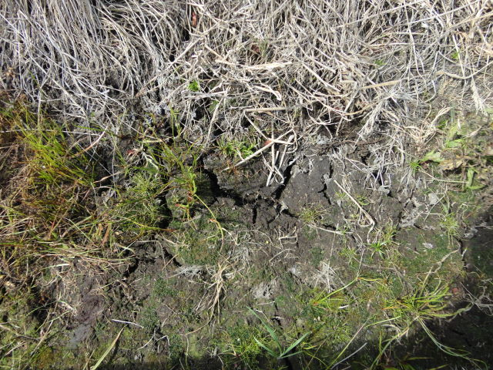

Caveats
- While surface soil cracks usually form in areas where water has ponded long enough to alter soil structure, they can also occur temporarily in non-wetlands but do not occur in conjunction with hydrophytic vegetation and/or hydric soils.
- This indicator does not include deep cracks associated with shrink–swell clays.

Indicator 2G: Inundation visible on aerial imagery (primary indicator)
Inundation is seen on one or more recent aerial or satellite images during the growing season (figure 14).
Figure 14: Google Earth images show inundation at different time steps
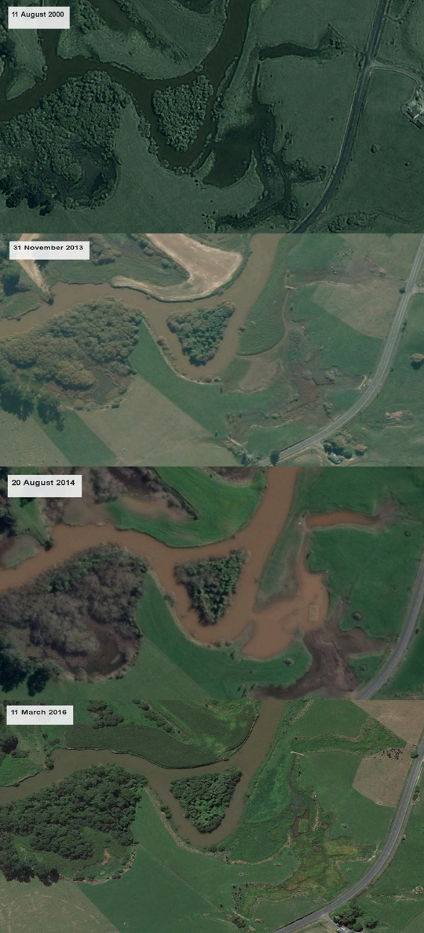
Note: Images indicate the variation in imagery available for the same location over time.

Caveats
- Not all areas with flooding or ponding are wetlands but may have surface water after heavy rainfall events.
- Drought can reduce the prevalence of surface water in areas.
- Not all wetlands have flooding or experience inundation.

Indicator 2H: Sparsely vegetated concave surface (primary indicator)
A lack of vegetation (less than 5 per cent coverage) is seen on concave land surfaces resulting from prolonged ponding during the growing season (figure 15).
Figure 15: No vegetation on concave surface
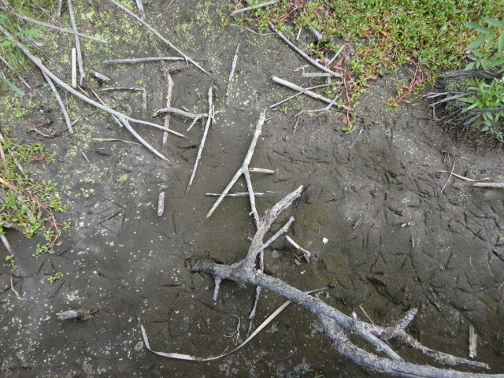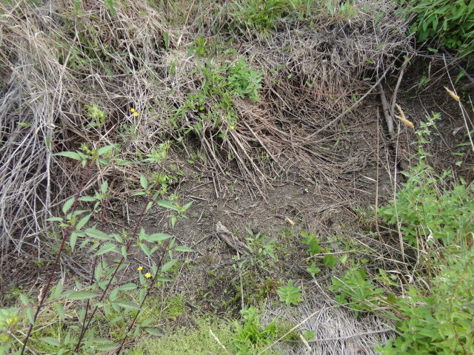

Caveat
- A woody overstory of trees or shrubs may or may not be present.

Indicator 2I: Salt crust (primary indicator)
Hard or brittle deposits of salts are seen on the ground surface, usually in depressions, seeps or lake fringes, after evaporation of saline surface water during the growing season (figure 16).
Figure 16: Salt crust in central Otago
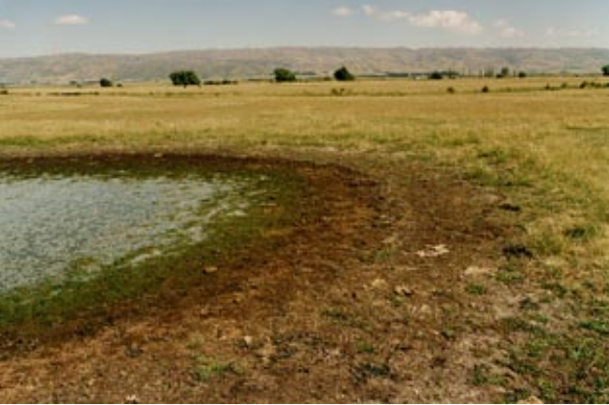
Photo: Peter Johnson.

Caveats
- Salt crusts also occur in geothermal areas.
- Indicator does not include fluffy or powdery salt deposits that result from capillary rise and evaporation of groundwater.

Indicator 2J: Aquatic invertebrates (primary indicator)
Numerous live or dead aquatic invertebrates, including diapausing eggs, remains of aquatic invertebrates, such as aquatic snails or crustaceans, are seen on the soil surface or plants or other emergent objects (figure 17).
Figure 17: Collection of aquatic snail shells on wetland fringe
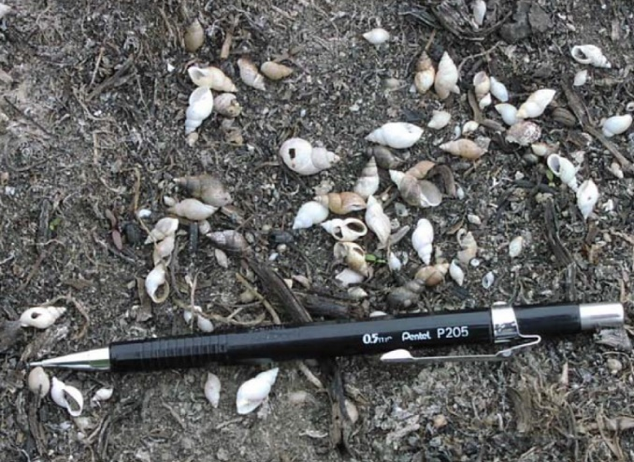
Photo: US Army Corps of Engineers, 2010.

Caveats
- One or two individuals is not significant to meet this indicator.
- Invertebrate remains can be carried to the area of interest by high winds, flooding or other animals.
- Invertebrate remains may be buried by tillage or other land management strategies.

Indicator 2K: Water-stained leaves (primary and/or secondary indicator)
Water-stained grey or black leaves are visible due to long periods of saturation during the growing season (figure 18).
Figure 18: Water-stained raupō leaves
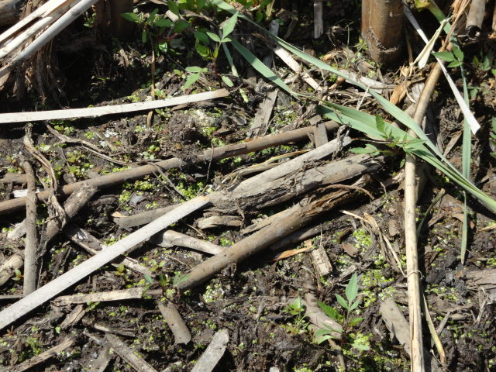

Caveats
- Colour is maintained after leaves dry and is considerably different from leaves in nearby non-wetland areas.
- This indicator is a secondary indicator in areas of very high rainfall, for example, on the West Coast of the South Island.

Indicator 2L: Drainage patterns (secondary indicator)
Areas that have recently experienced overland water flow may show soil erosion, low vegetation bent in the direction of water flow, or absence of leaf litter or small woody debris (figure 19).
Figure 19: Wetland vegetation bent in the direction of water flow
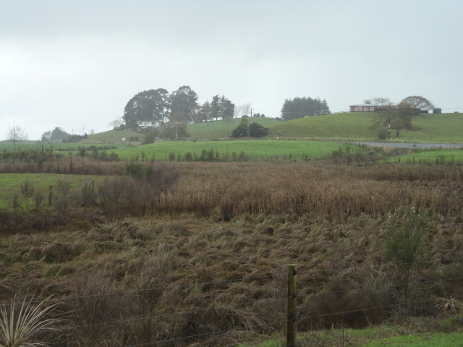

Caveats
- Areas are usually in seeps, vegetated swales, tidal flats and adjacent to stream channels.
- Drainage patterns may reflect recent, extreme weather events (high winds as well as flooding). Field assessments should not be undertaken within two weeks of an extreme weather event.
- Vegetation bent can also be a result of snow melt from adjacent mountains.

Group 3: Evidence of current or recent soil saturation
Many of the indicators in this group overlap with those in the Hydric Soils – Field Identification Guide (Fraser et al, 2018).

Indicator 3A: Hydrogen sulphide odour (primary indicator)
Hydrogen sulphide odour, similar to rotten eggs, is detected from the top 30 centimetres of the soil profile. Hydrogen sulphide is produced in soils only when saturation has been prolonged.

Caveats
- This odour occurs in saturated soils when microorganisms use sulphur as a terminal electron acceptor (Lamers et al, 2013).
- Soil must be saturated at the time tested and have been saturated for long enough to produce reducing conditions.
- To test: dig down 30 centimetres from the soil surface, no deeper, and smell the soil.

Indicator 3B: Oxidised rhizospheres along living roots (primary indicator)
A soil horizon with greater than or equal to 2 per cent iron-oxide (orange coating) can be seen on the surfaces of living roots or soil pores immediately surrounding the roots within the top 30 centimetres of the soil profile during the growing season (figure 20).
Figure 20: Oxidised rhizospheres around living roots
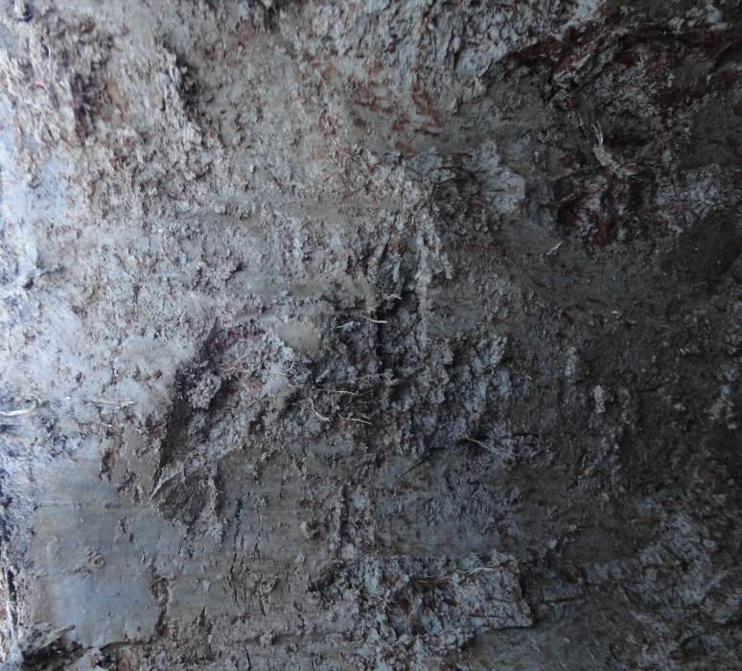

Caveats
- Oxygen leakage from live roots oxidise ferrous iron in soil solution.
- Oxidisation can be confused with organic matter associated with live roots, and a hand lens may be required to distinguish iron-oxides.
- Iron coatings can be concentric when in cross-section and stain the fingers when the roots are rubbed.
- Note the location and abundance of the oxidised rhizospheres in the soil profile or remarks section of the site assessment form.

Indicator 3C: Presence of reduced iron (primary indicator)
A soil layer containing reduced iron in the top 30 centimetres of the soil profile can be seen where the soil changes colour upon air exposure. Iron reduction occurs in soils after prolonged saturation and the soil becomes anaerobic and chemically reduced. Oxygen oxidation begins on exposure (figure 21).
Alpha, alpha-dipyridyl is a commonly used assessment for the presence of reduced iron, resulting in a pink colour where this compound is sprayed on soil. However, alpha, alpha-dipyridyl is highly toxic (ThermoFisher Scientific, 2014) and can require specialised equipment to dissolve the compound in ammonium acetate plus water solution. We suggest test strips may be a safer option (Semi-quantitative test strips QUANTOFIX Total iron 1000, MN | MACHEREY-NAGEL (mn-net.com); but these were not tested for effectiveness in confirming reduced iron during development of the hydrology tool.
Figure 21: Oxidised soil, where the brown colour represents chemically reduced iron after exposure to air
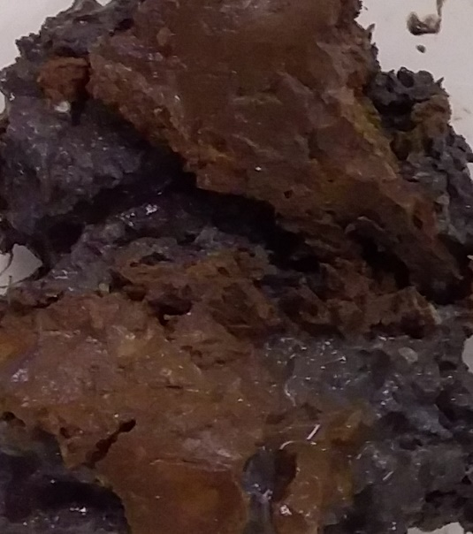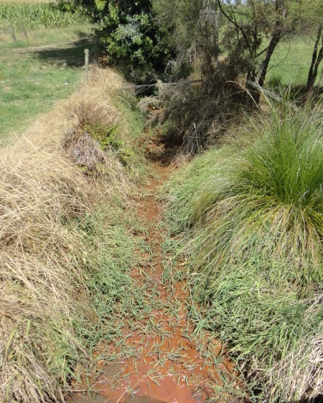

Caveats
- Avoid areas that have been in contact with iron digging tools.
- Soil should be tested for colour change immediately after exposure to the air.
- Use the Munsell colour chart to determine if a colour change has taken place. The soil must be saturated at the time of assessment.
- Soils with negligible amounts of ferrous iron may not exhibit a colour change.

Indicator 3D: Recent iron reduction in tilled soils (primary indicator)
A soil layer containing greater than or equal to 2 per cent redox concentrations is visible in pore linings of masses in a soil that has been tilled less than two years ago within the tillage zone or the top 30 centimetres of the soil profile, whichever one is shallower (figure 22). The prolonged presence of redox features indicates lengthy saturation followed by cultivation, leading to oxidation.
Figure 22: Redox concentrations in recently tilled wetland soil
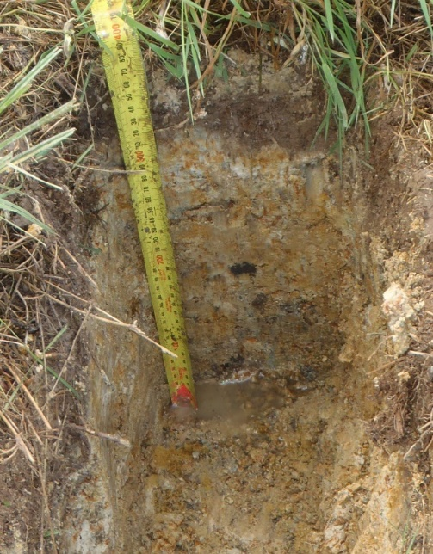

Caveats
- This indicator is most reliable in areas where the soils are tilled regularly, which allows for breaking up of older oxidised aggregate surfaces and replacement by newly oxidised aggregates.
- Obtaining the tillage history of the site of interest will help to interpret this indicator.
- There is no minimum thickness for the soil horizon with redox concentrations.

Indicator 3E: Dry-season water table (secondary indicator)
A water-table depth between 30 centimetres and 60 centimetres of the soil profile can be seen during the normal dry season or a drier-than-normal period of the year.

Caveats
- A test hole may take time to fill with water, depending on the soil’s texture, so the water table may not be immediately obvious.
- The water table could be lower than 60 centimetres in some wetlands.
- Any inspection hole should not penetrate any impeding soil layer that contributes to a perched water table. The hydric soils field guide should be used to determine the presence of and depth to impermeable soil layers.

Indicator 3F: Saturation visible on aerial imagery (secondary indicator)
Visual assessment of one or more aerial or satellite images can identify sites where soil saturation corresponds to depressions, drainage patterns, crop management, field verified hydric soils or other evidence of a seasonally high water table during the growing season (figure 23).
Figure 23: Aerial imagery for a wetland in October 2017 and March 2019 indicating soil saturation
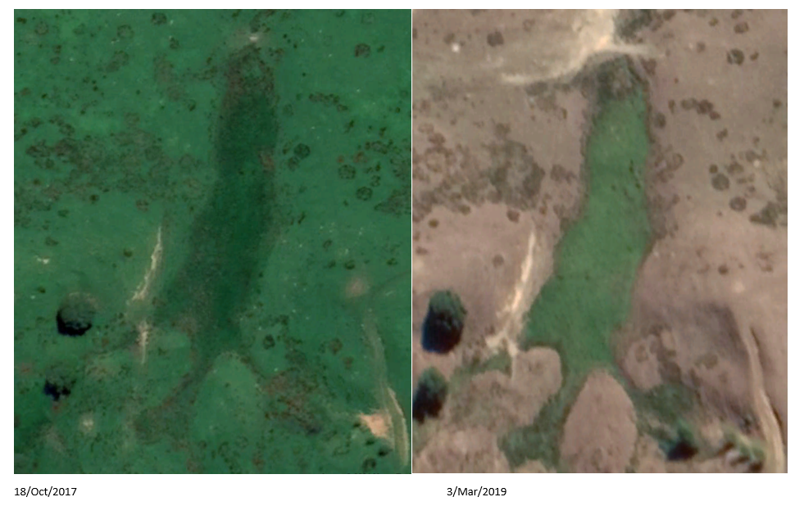

Caveats
- Aerial imagery is useful in areas of interest with sparse plant cover and where the ground surface is visible.
- Aerial imagery may reflect recent, extreme weather events and may require further investigation to determine when the imagery was taken in relation to heavy rainfall events.
- Not all wetlands have consistent saturation regardless of rainfall.
- Use imagery taken at least five different times.

Group 4: Evidence from other site conditions or data

Indicator 4A: High water table stunted or stressed plants (primary indicator)
It can be seen that most plants in cultivated or planted wetland areas are smaller, less vigorous or appear more stressed compared with neighbouring non-wetland areas (figure 24).
Figure 24: Stunted trees due to high water table (affected trees indicated by the yellow circle)
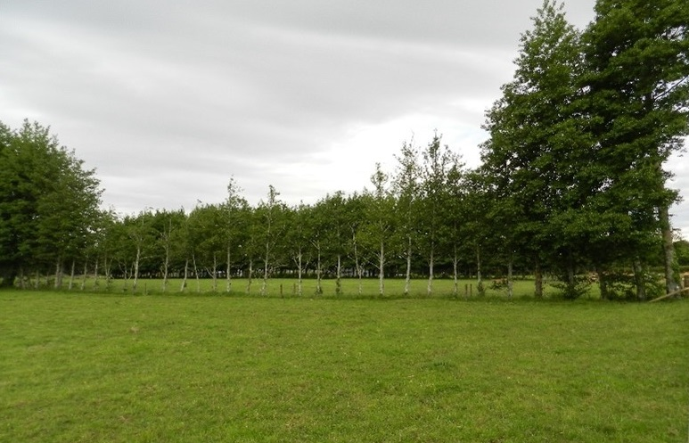

Caveats
- Non-wetland cropping plants, such as ryegrass (Lolium spp.) or oats (Avena spp.) can exhibit stunted growth and yellowing of leaves in wet soils.
- Stunting may also be the result of low soil fertility, herbicide applications, disease and insect damage.

Indicator 4B: Geomorphic position (secondary indicator)
The possible wetland may be seen in a localised depression, swale, drainage system, concave position in a floodplain, at the toe of a slope, on extensive flatland, the low-elevation fringe of a pond or waterbody, or groundwater discharge zone (figure 25). This indicator includes concave positions on rapidly permeable soils (eg, the pumice deposits on the North Island Central Plateau and floodplains on sand and gravel substrate) only when the water table is near the surface.
Figure 25: Concave area in grazed pasture
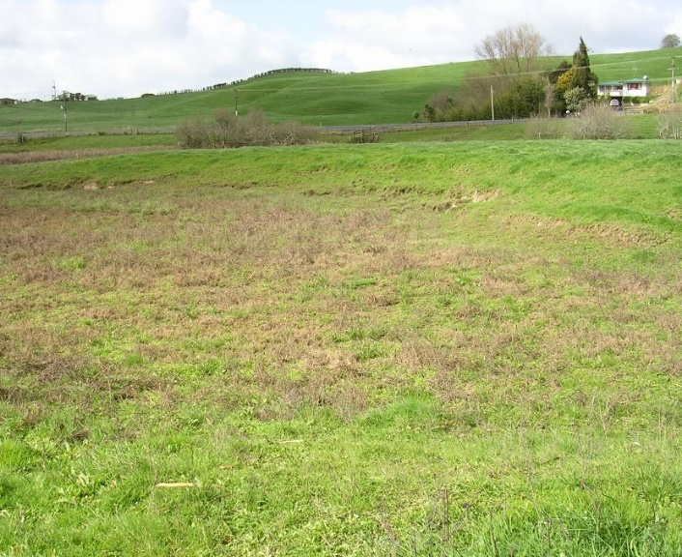

Caveat
- Not all of the landforms noted above exhibit wetland hydrology.

Indicator 4C: Shallow aquitard (secondary indicator)
A semi-permeable–impermeable layer is confirmed within 60 centimetres of the soil surface, which decreases movement of groundwater and causes a perched water table within 30 centimetres of the soil surface during the growing season. This semi-permeable–impermeable layer can be composed of clay or non-porous rock.

Indicator 4D: Facultative-neutral test (secondary indicator)
A further secondary indicator is whether the plant community passes the facultative- (FAC-) neutral test. The FAC-neutral test is undertaken by compiling a list of dominant plant species in the community and removing any species with FAC status. The compilation uses the 50/20 rule as already undertaken in the vegetation tool (Clarkson, 2014). If 50 per cent or more of the remaining species are facultative wetland (FACW) and/or obligate (OBL) wetland plants, then the test is passed. The test can be used in systems where no FAC dominant plants are present and, if OBL and FACW wetland plants are present in equal numbers compared with facultative upland (FACU) and upland (UPL) plants, then the non-dominant plants should also be assessed.
FAC-neutral test: Dominant species (OBL + FACW) > (FACU + UPL).

Indicator 4E: Frost-heave hummocks (secondary indicator)
Frost-heave hummocks are produced as water-logged soils undergo freeze–thaw processes (figure 26).
Figure 26: a) Frost-heave hummocks in Southland and b) at Old Man Range, affected area in b) shown in the yellow circle
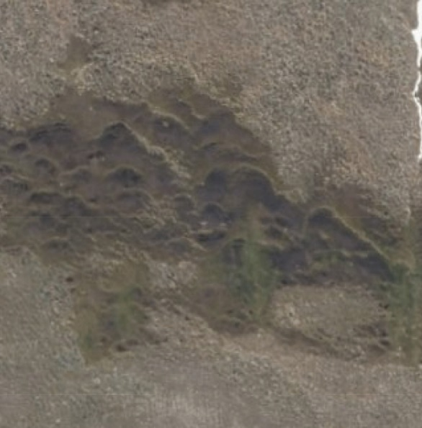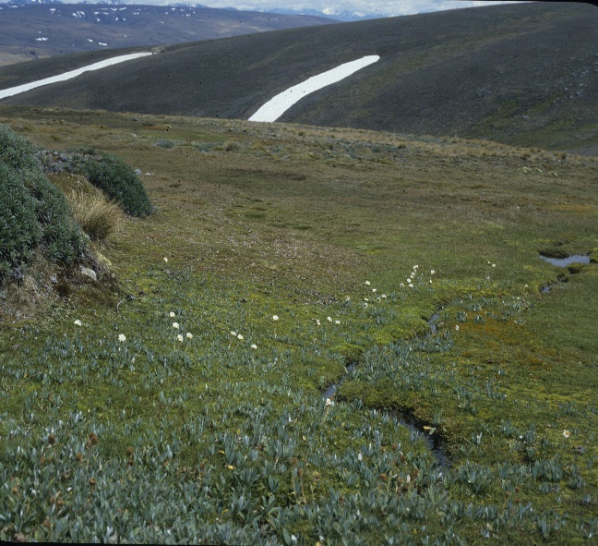
b)
a)
Photo A: LINZ Data Service 2021; photo B: James Barringer.
Caveat
- This indicator does not include hummocky topography produced by shrink–swell clay soils or pugging by livestock.

Field identification procedure for wetland delineation
To outline the practical steps for delineating wetlands using the vegetation, hydric soils and wetland hydrology tools, two scenarios are presented. First, where the vegetation and hydric soils tools have been used but the presence, absence or boundary of the wetland remains unconfirmed. Second, where no wetland delineation has been undertaken and all three tools are assessed across one or more transects at a site of interest.
Wetland delineation should be undertaken when climatic and hydrologic conditions are ‘normal’, that is, when no abnormal conditions are present, such as drought, flood, recent disturbance (eg, landsliding) or where wetlands have been filled, drained or cleared (Clarkson, 2014), and within the growing season.

Hydrophytic vegetation and hydric soils assessed but inconclusive
These sites may include more difficult sites where the vegetation and hydric soils tools have been inconclusive. At sites where vegetation and soils have been assessed, the hydrology tool could be used from either the office or field.

Office approach
The hydric soils tool includes the measurement of the depth to the water table. If the depth to the water table is less than 30 centimetres when the site was previously visited, then the primary indicator 1B (groundwater) is satisfied and the sampling point is confirmed as wetland. Further, the original version of the hydric soils field wetland determination form (Fraser et al, 2018) included a box to be ticked if there was ponding. If this box is ticked the primary indicator 1A (surface water) is satisfied and the sampling point is confirmed as wetland. If these primary indicators were not present in the hydric soils determination, it may be possible to assess the site using the primary indicator 2G (inundation visible on aerial imagery). Google Earth could be used for this purpose and the site could be assessed over several time points to determine if inundation is sufficient to confirm wetland hydrology.

Field approach
If a follow-up field visit to apply the hydrology tool is required, the following steps should be followed.
Equipment: Thermometer, hand lens, spade, soil auger.
Step 1: Identify the growing season for the area of interest.
Step 2: Assess weather conditions. Establish a suitable time to visit the site, within the growing season, during normal weather conditions, that is, not immediately after heavy rainfall or during, or immediately after, drought conditions (minimum of two weeks after extreme weather events).
Step 3: Check the soil temperature at the site and confirm temperature is above 5 degrees Celsius in the top 30 centimetres of profile.
Step 4: Establish transect(s) across landforms as per Clarkson (2014).
Step 5: Identify the presence of hydrology indicators as per section C of the wetland delineation data form (appendix 1). One primary or at least two secondary indicators confirm the presence of wetland hydrology. Assessment of indicator 1B and indicator 3E is to be undertaken after the water table has stabilised in a pit or auguring hole, which could potentially take up to one hour.

New sites
For new sites that have not been assessed for wetland delineation, it is advisable to undertake assessments following the four main steps outlined in figure 27. For many New Zealand wetlands, the rapid hydrophytic vegetation test (see rapid test in Clarkson, 2014) may suffice to confirm the presence, absence and boundary of a wetland. Where the rapid test is inconclusive and/or the boundary requires clarification, further vegetation, hydric soils and wetland hydrology assessments are recommended. Because the hydrology tool is easy, quick and overlaps with the hydric soils tool, this should be undertaken whenever the hydric soils tool is used.
Figure 27: Four steps for delineating wetlands using the hydrophytic vegetation, hydric soils
and wetland hydrology tools
Equipment: 2 metre x 2 metre quadrat or four poles to demarcate plots, 10 metre tape measure, diameter tape, plant indicator status ratings list as per Clarkson (2014 or the latest update), thermometer, hand lens, spade, soil auger, Munsell colour book, New Zealand Soil Description Handbook, laminated copy of the field identification guide sheet as per Fraser et al (2018), copies of the wetland delineation data form and the quick reference guide to the wetland delineation data form (appendix 1).
Step 1: Identify the growing season for the area of interest.
Step 2: Assess weather conditions. Establish a suitable time to visit the site, within the growing season, during normal weather conditions, that is, not immediately after heavy rainfall or during, or immediately after, drought conditions (suggest a minimum of two weeks after extreme weather events).
Step 3: Establish transect(s) across landforms as per Clarkson (2014).
Step 4: Complete assessment for hydrophytic vegetation as per section B of the wetland delineation data form (appendix 1) using established guidelines (Clarkson, 2014).
Step 5: Where the vegetation tool is inconclusive, complete the assessment for hydric soils as per section C of the wetland delineation data form (appendix 1) using established guideline (Fraser et al, 2018) and figure 28.
Figure 28: Simple key to identifying hydric soil features
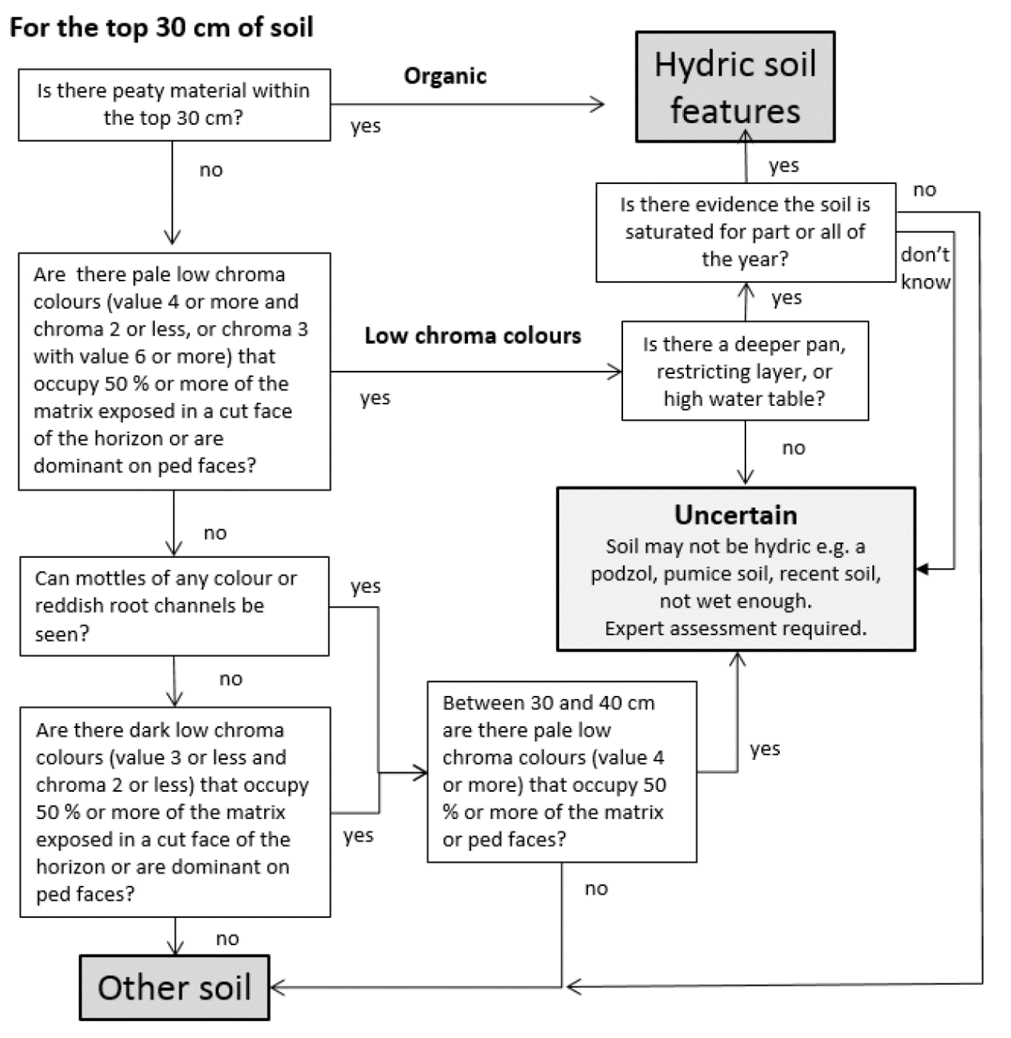
Source: Fraser et al, 2018
Step 6: Complete section C of the wetland delineation data form (appendix 1) and identify the presence or absence of hydrology indicators (figure 29). One primary or at least two secondary indicators confirm the presence of wetland hydrology as per table 2.
Figure 29: Simple key to describing wetland hydrology
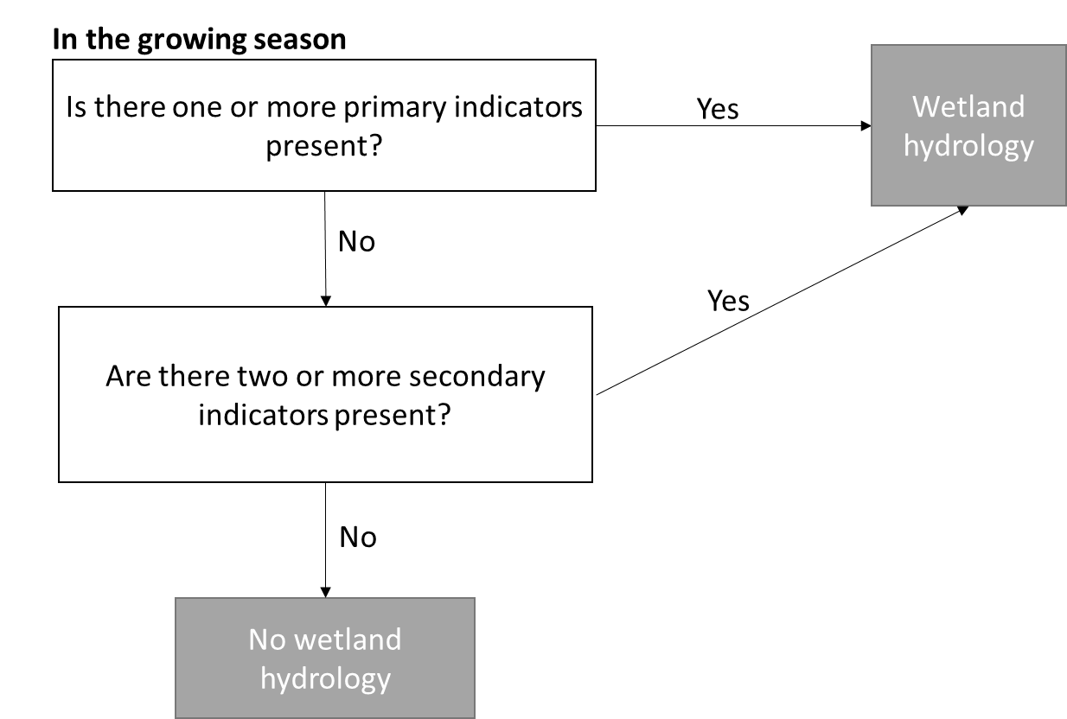
Step 7: More complex landscapes may require more than one transect to be undertaken at a site to confirm either the presence, absence or boundary of a wetland.

Field testing
The hydrology tool was tested at two sites in Waikato, on a pumice soil that can be problematic for the hydric soils tool, and a contrasting clay soil. A dairy farm near Reporoa, where the soil was formed on pumice from the Taupō eruption, was visited on 16 February 2021. A second dairy farm near Piopio, with a complex landscape affected by limestone caverns and numerous seepage zones, was visited on 18 February 2021. The hydrology tool was tested in combination with the vegetation and hydric soils tools, and was selected based on landform, slope, vegetation cover and soil wetness.

Site 1: Reporoa
This site was chosen specifically to test the hydrology tool as support to the hydric soils tool where it is likely to be inconclusive, because the pale colours associated with pumice soils overlap with those that define Gley and, therefore, hydric soils. The area of interest was a slight depression in the landscape under intensive dairy grazing (figure 30a). The vegetation was dominated by willow weed (Persicaria hydropiper) and introduced pasture species. The vegetation tool confirmed the presence of hydrophytic vegetation. The area contained ponded water and light chroma-coloured soils usually associated with Gley hydric soils, but the light colour may also have been due to the pumice parent material. Three sampling points were selected along a putative wet–dry gradient and tested for wetland indicators using the three tools. Sampling points 1 and 2 showed the presence of hydrological indicators, particularly ponding and a high water table, which may have been affected by recent rainfall but did not alter the conclusions of the hydrology tool (figure 30b, c). These two sampling points also satisfied the hydrophytic and hydric soils tests. In contrast, hydrological, hydrophytic vegetation and hydric soil indicators were all absent from sampling point 3. Therefore, the boundary of the wetland was between sampling points 2 and 3 (appendix 4).
Figure 30: Hydrology tool a) test site at Reporoa, b) hydric and c) non-hydric soil profiles
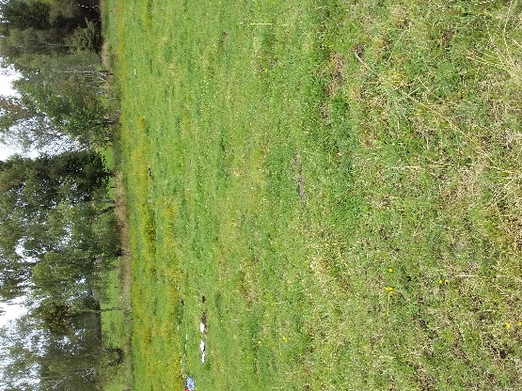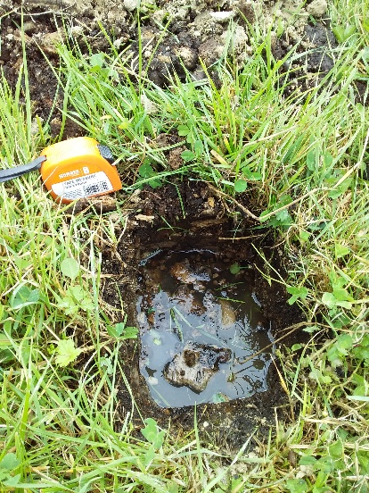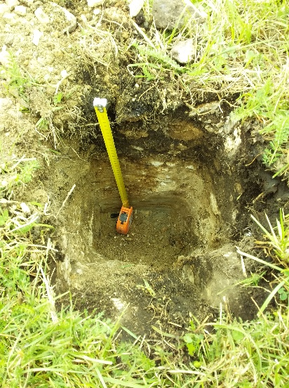
c)
a)
b)

Site 2: Piopio
This site is geologically complex and affected by the presence of limestone-derived caverns and seepage zones. The area of interest contained a small pond and a putative wetland extending into the neighbouring paddock. The site was in a depression at the bottom of a slope and was extensively grazed by cattle and sheep; the pond was not fenced off from animals (figure 31). Sample points 1 and 2 confirmed the presence of wetland hydrology mostly in the form of ponded water and hydrogen sulphate odour. Hydrophytic vegetation and hydric soils were also present. The third point, slightly upslope from sampling points 1 and 2, did not have any hydrological indicators (nor hydrophytic or hydric soil indicators) and the boundary of the wetland was between points 2 and 3 (appendix 4).
Figure 31: Hydrology tool a) test site at Piopio, b) hydric and c) non-hydric soil profiles
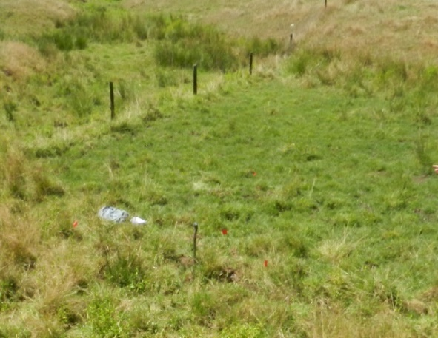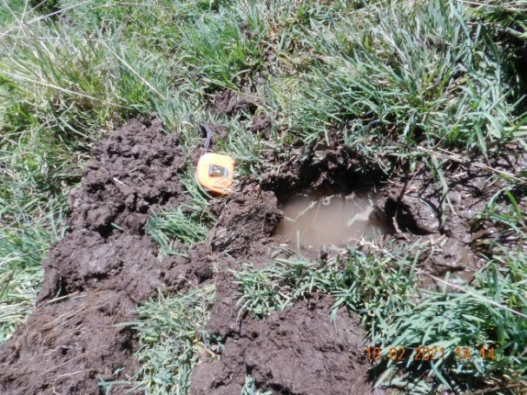
b)
a)
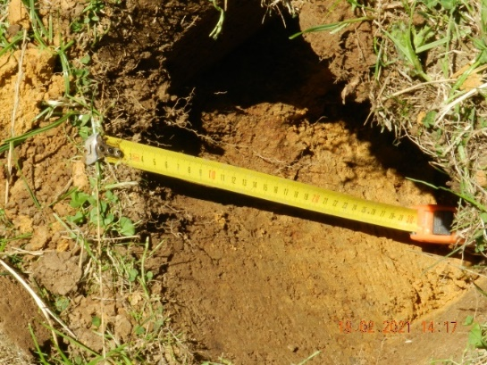
c)

Conclusions
The hydrology tool for wetland delineation presents a simple mechanism to confirm the presence of a wetland in combination with the hydrophytic vegetation and hydric soils tools.
On establishment of the growing season and normal rainfall, the hydrology tool can be used for field identification at sites not previously assessed for wetland delineation and in the field or office for sites previously assessed for hydrophytic vegetation and hydric soils. Use of the wetland delineation data form and the quick reference guide will allow non-experts to identify the location and boundaries of wetlands in New Zealand.

Appendix 1: New Zealand wetland delineation data form
The New Zealand wetland delineation data form and the Quick reference guide for New Zealand wetland delineation data form are available on the Ministry for the Environment website.

Appendix 2: Distribution of climate stations used to determine the growing season
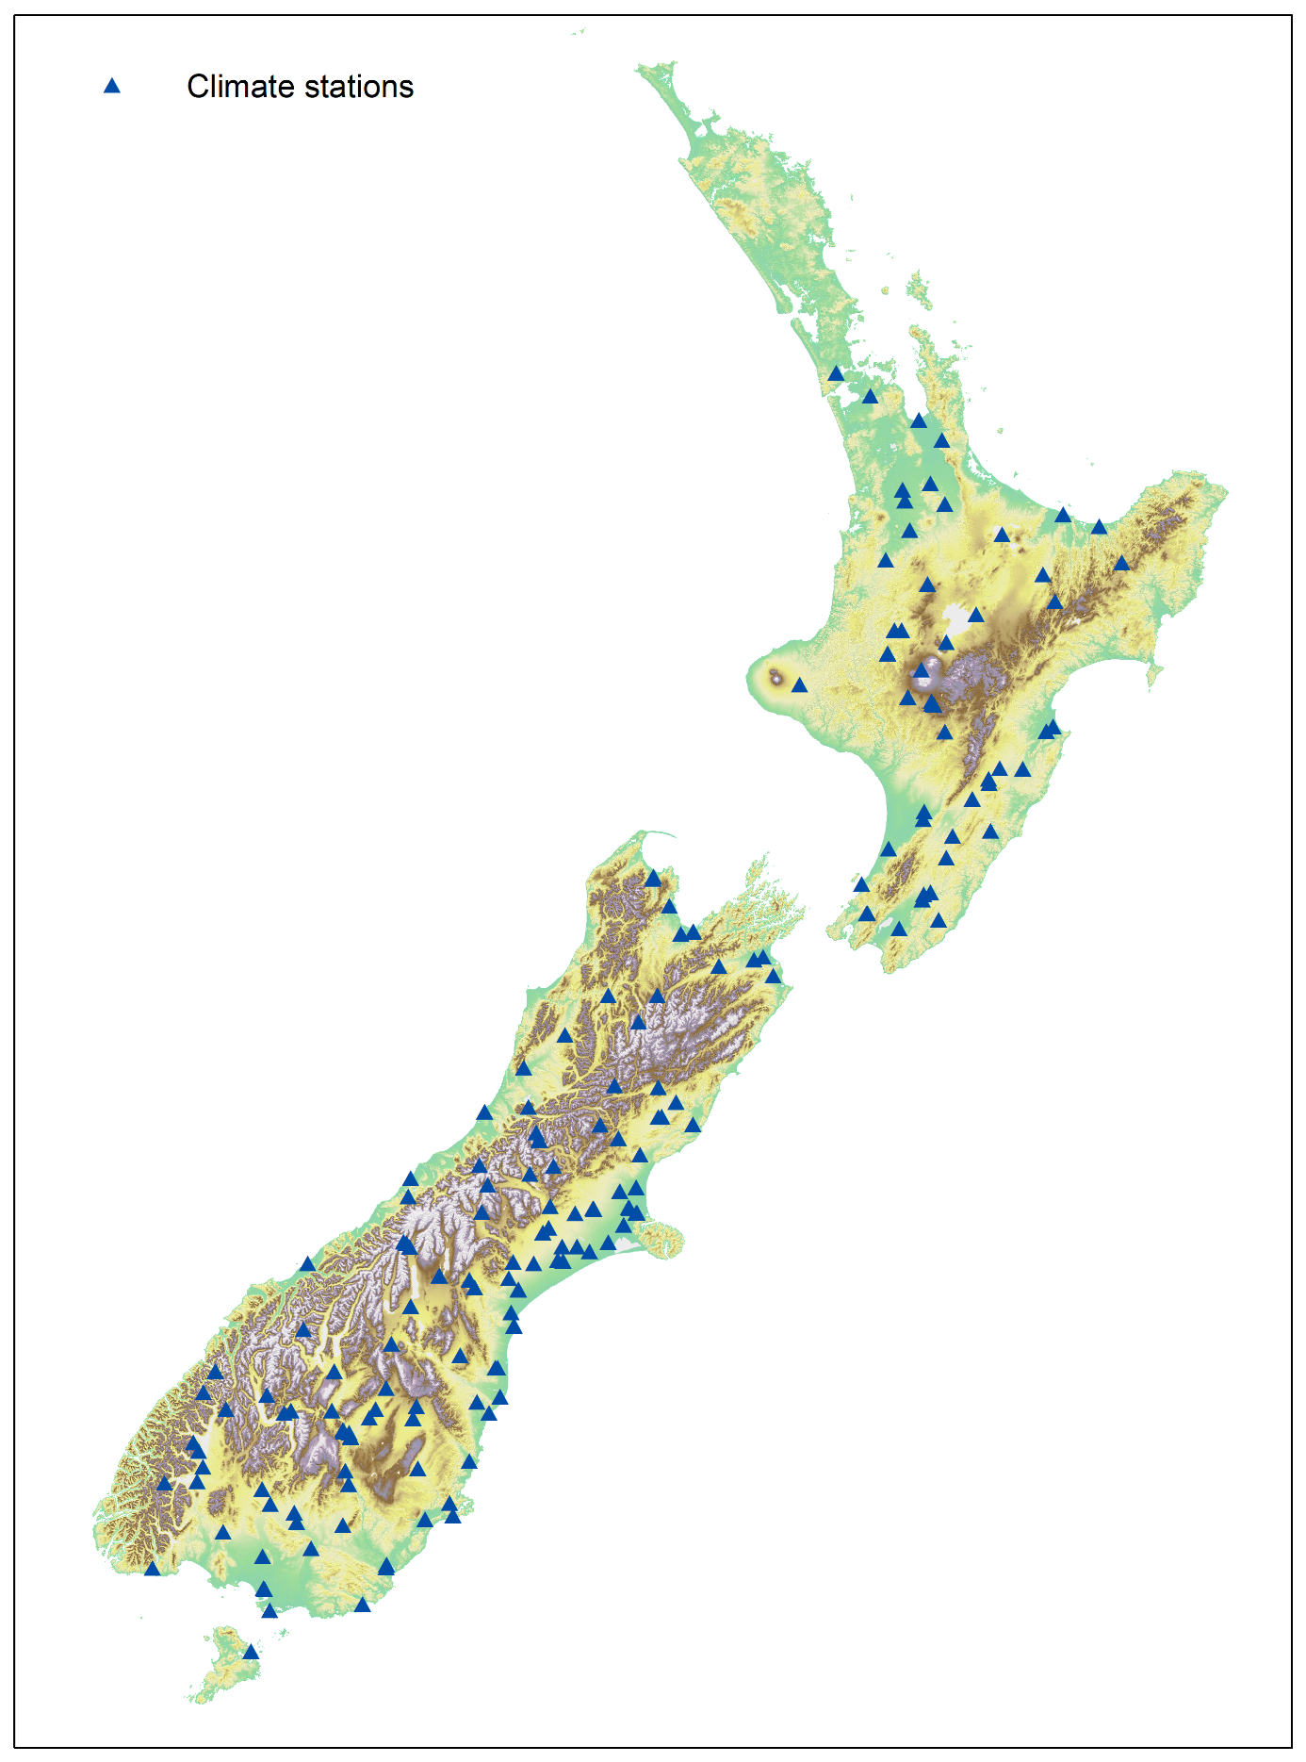

Appendix 3: Deciduous native trees
and shrubs
Approximately 28 species (c 5 per cent) of the New Zealand woody flora have a marked loss of leaves in winter (McGlone et al, 2004). Only 11 species are consistently fully winter deciduous, that is, adults are entirely leafless, or nearly so, towards the end of winter (table 4). In addition, 11 species are semi-deciduous, with leaf loss more pronounced in southern populations or cold sites, and some populations of kōwhai (Sophora) are brevideciduous, meaning they lose their overwintering leaves in spring at the time of flowering and before the new leaves have flushed.
Four tutu (Coriaria) subshrub species are summer green in which the above-ground stem and leaves die back completely in winter. Because these species have woody rootstocks they are here regarded as shrubs.
Table 3: List of deciduous native trees and shrubs
 | Scientific name | Common name
Deciduous
 | Discaria toumatou | Matagouri
 | Fuchsia excorticata | Kōtukutuku, tree fuchsia
 | Hoheria glabrata | Mountain lacebark
 | Hoheria lyallii | Mountain lacebark
 | Muehlenbeckia astonii | Shrubby tororaro, wiggywig, mingimingi
 | Olearia fragrantissima | Fragrant tree daisy
 | Olearia gardneri (Heads, 1998) | Deciduous tree daisy
 | Olearia hectori | Hector’s tree daisy, deciduous tree daisy
 | Olearia odorata | Scented tree daisy
 | Plagianthus divaricatus | Salt marsh ribbonwood, marsh ribbonwood
 | Plagianthus regius subsp. regius | Mānatu, ribbonwood, lowland ribbonwood
Semi-deciduous
 | Aristotelia serrata | Makomako, wineberry
 | Carmichaelia odorata | Scented broom, leafy broom
 | Carmichaelia arborea | South Island broom, tree broom, swamp broom
 | Coprosma virescens
 | Coriaria arborea var. arborea | Tutu, tree tutu
 | Fuchsia perscandens | Fuchsia
 | Fuchsia procumbens | Creeping fuchsia, climbing or trailing fuchsia
 | Muehlenbeckia australis | Pōhuehue, large-leaved muehlenbeckia
 | Muehlenbeckia complexa | Small-leaved pōhuehue, scrub pōhuehue, wire vine
 | Olearia fimbriata
 | Urtica ferox | Ongaonga, tree nettle
Brevideciduous
 | Sophora microphylla | Kōwhai, weeping kōwhai, small-leaved kōwhai
 | Sophora tetraptera | Kōwhai, large-leaved kōwhai
Summer green
 | Coriaria angustissima | Small-leaved tutu
 | Coriaria plumosa | Feathery tutu, mountain tutu, small-leaved tutu
 | Coriaria pottsiana
 | Coriaria sarmentosa | Tutu

Appendix 4: Data sheets from field trials
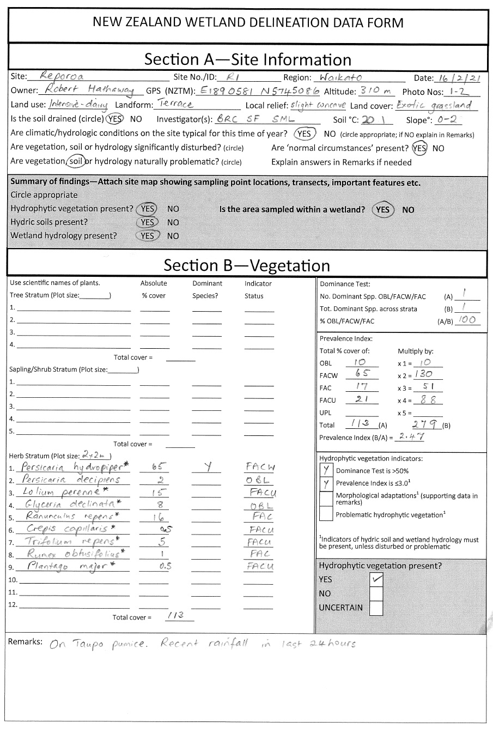

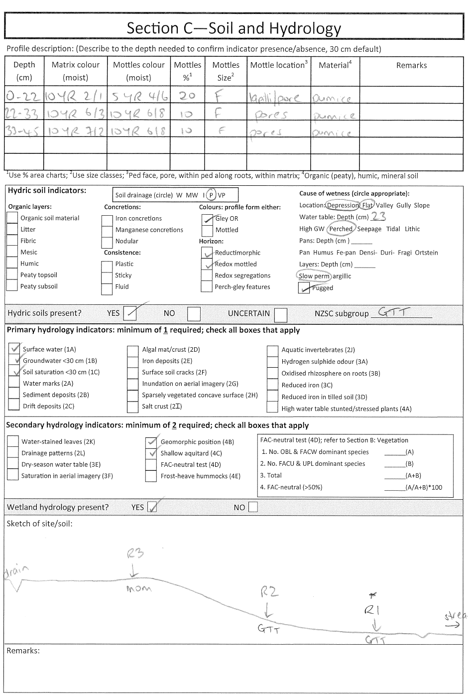
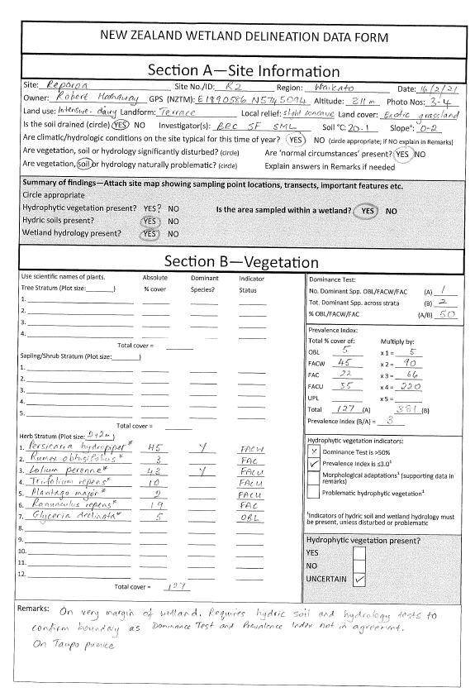
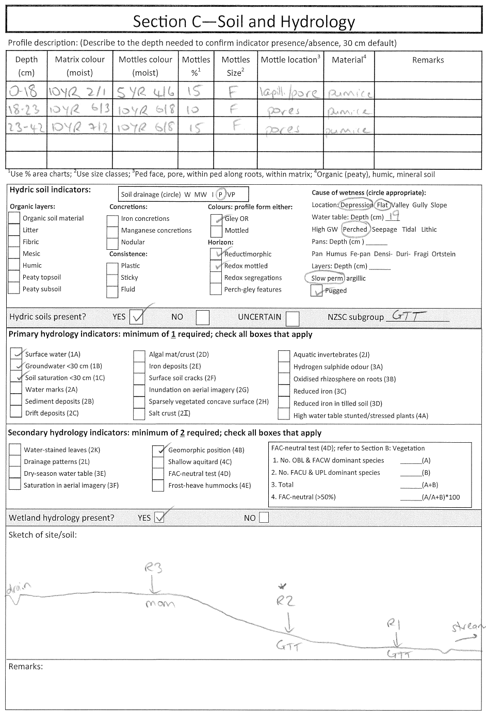
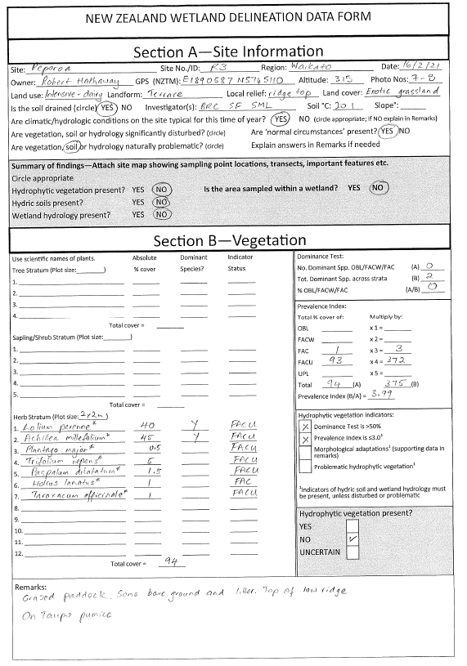
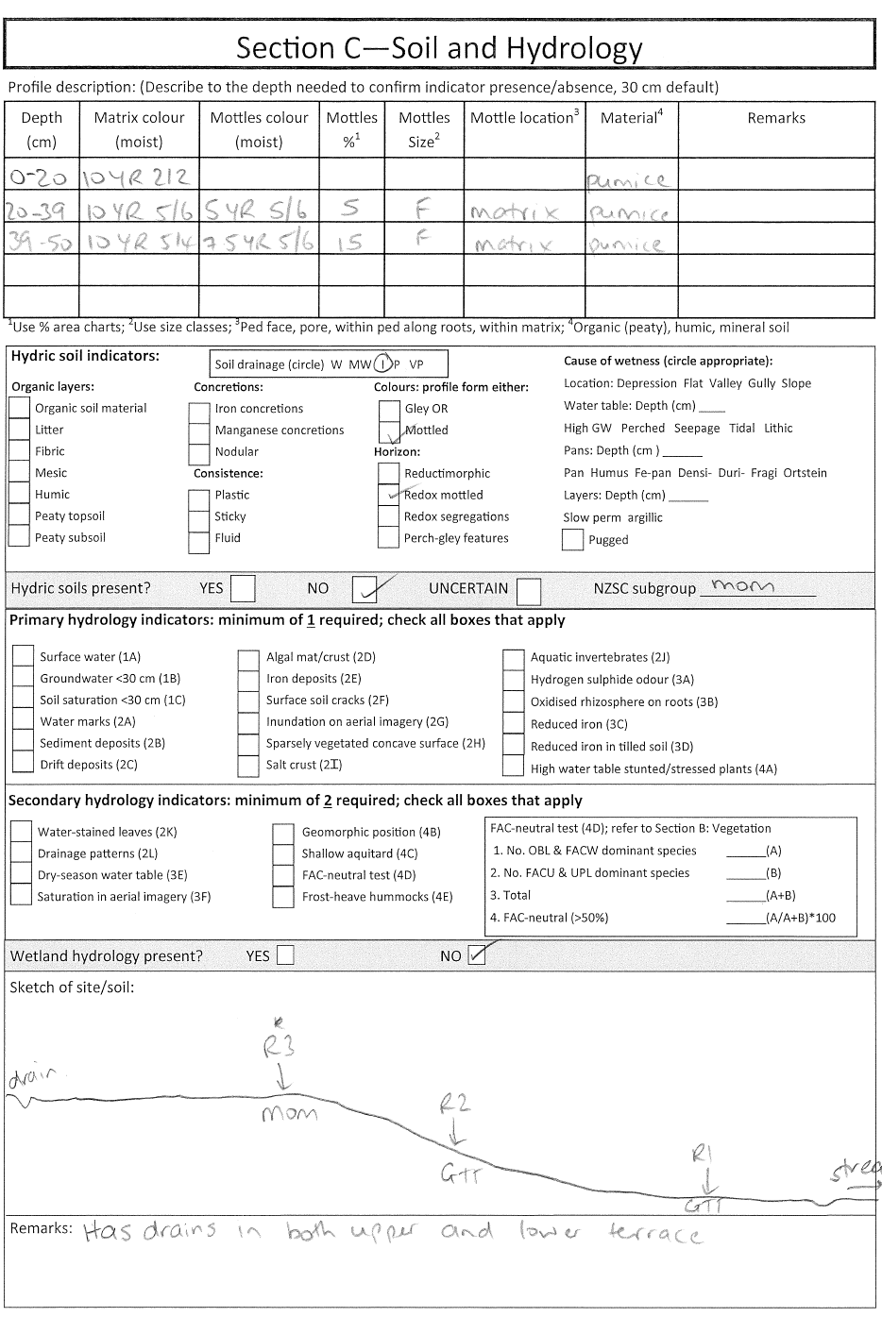
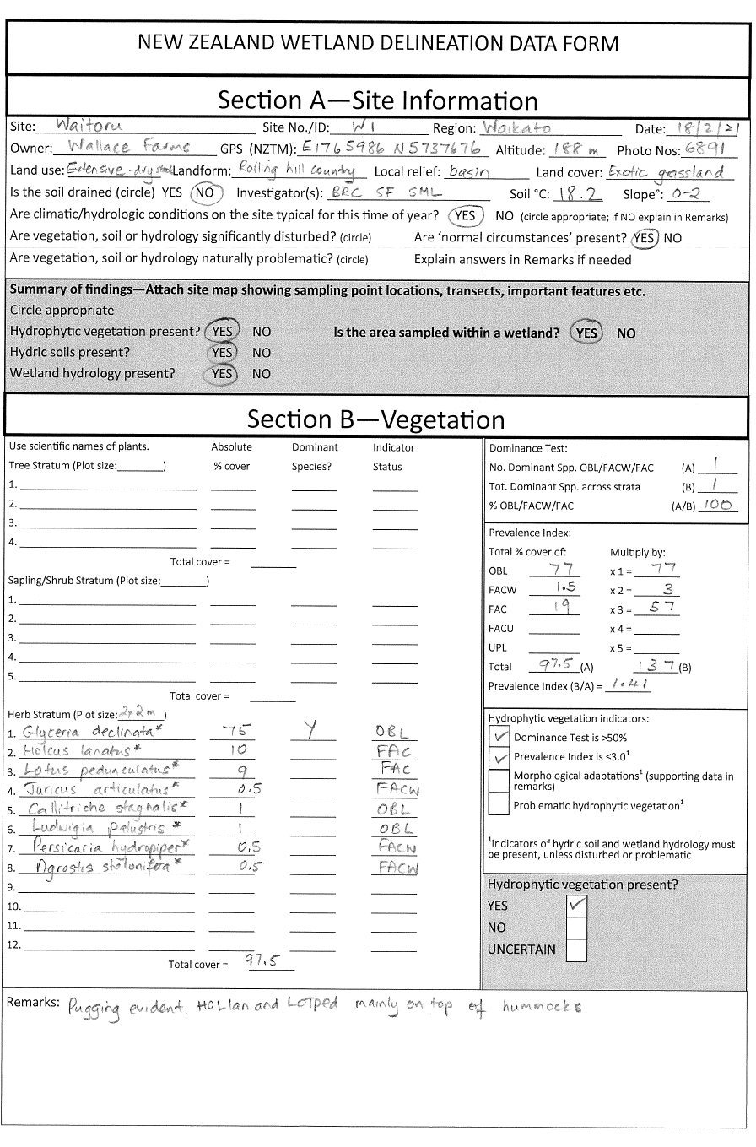
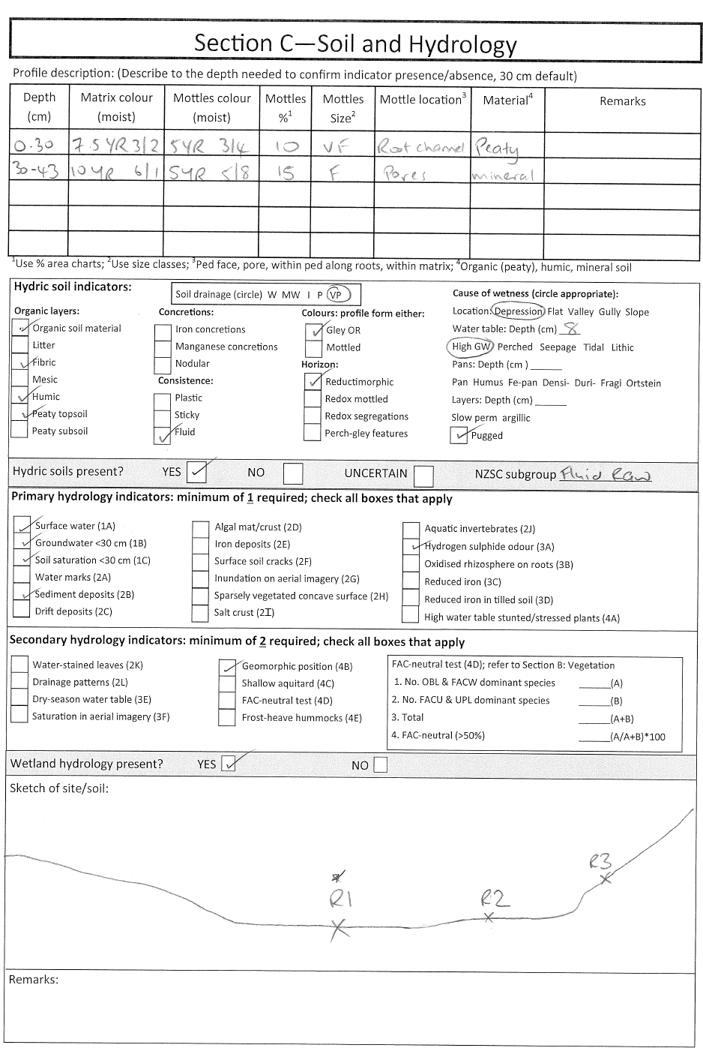
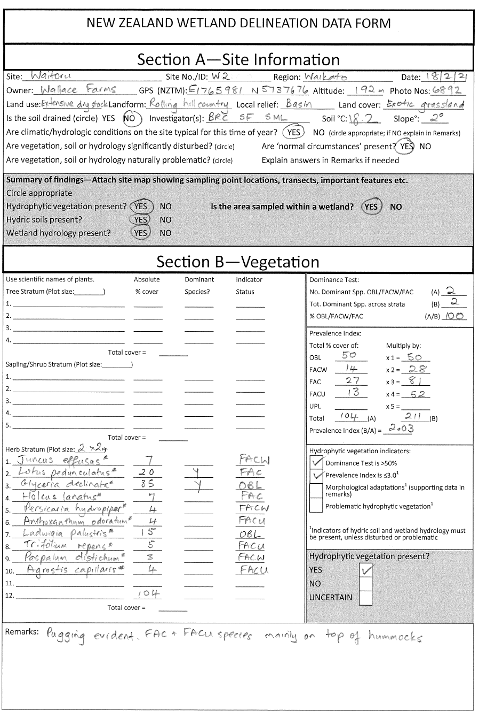
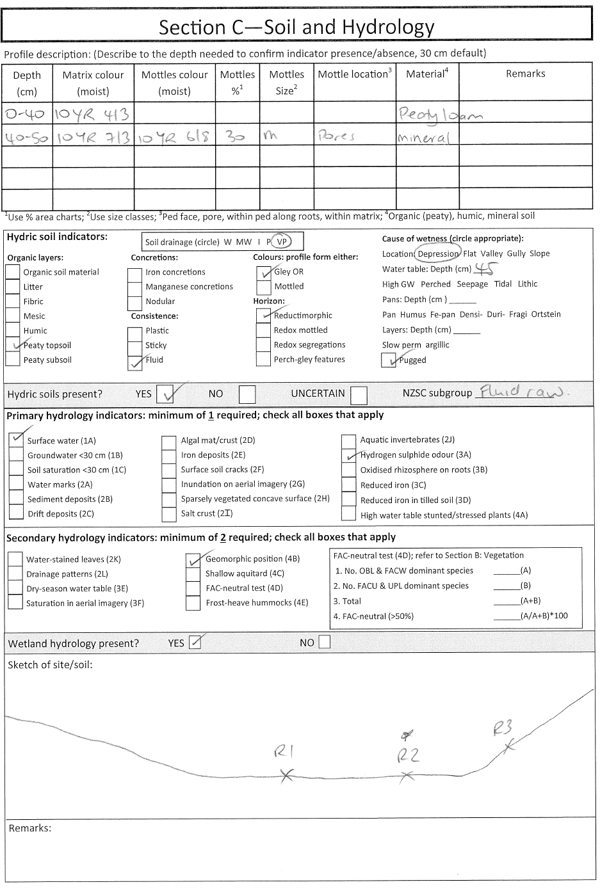
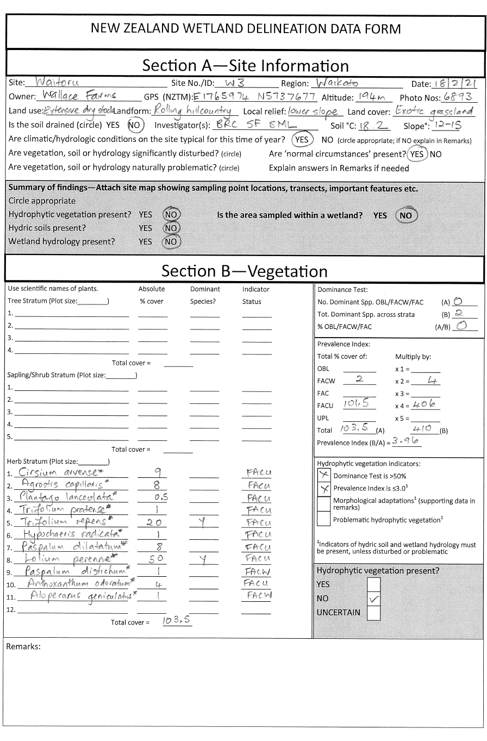
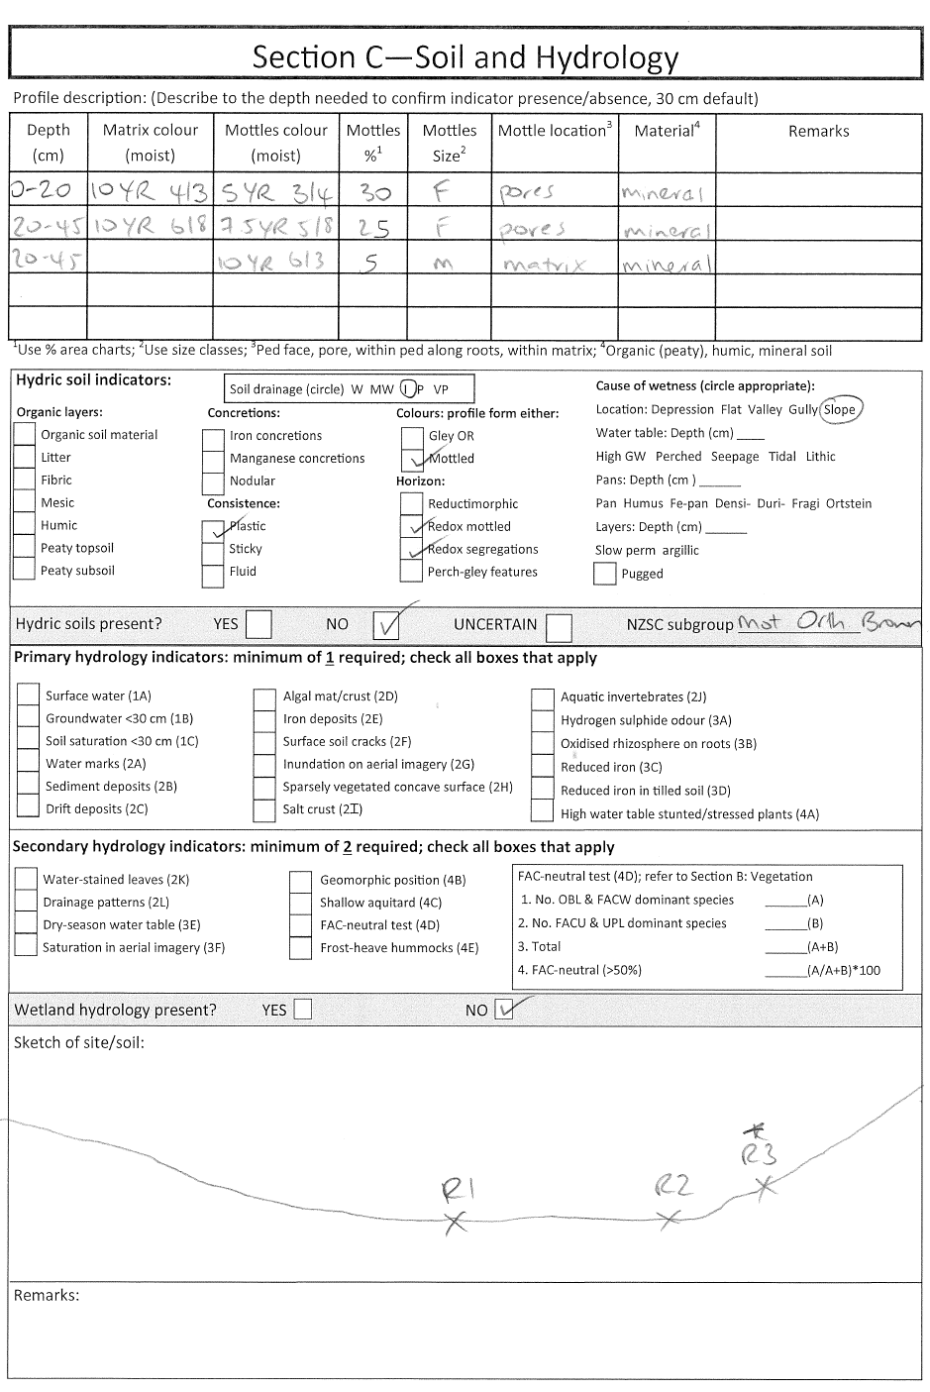

Glossary
Definitions are from the Corps of Engineers Wetlands Delineation Manual (Environmental Laboratory, 1987), unless otherwise indicated.
Aquitard. A layer of soil or rock that retards the downward flow of water and is capable of perching water above it.
Brevideciduous. Brief (one month or less) loss of most leaves from the canopy just before flowering or during flushing of a new cohort of leaves (McGlone et al, 2004).
Deciduous. Marked leaflessness in winter, and more than 90 per cent of leaves lost by beginning of spring flush (McGlone et al, 2004).
Duration (inundation/soil saturation). The length of time during which water stands at or above the soil surface (inundation), or during which the soil is saturated. As used here, duration refers to a period during the growing season.
Growing season. The portion of the year when soil temperatures at 30 centimetres below the soil surface are higher than biologic zero (5 degrees Celsius), approximated as the period between the last frost day and the first frost day.
Hydrophytic vegetation. Plants capable of growing in soils that are often or constantly saturated with water during the growing season.
Hydric soils. Soils that have formed under conditions of saturation, flooding or ponding long enough during the growing season to develop anaerobic (low oxygen) conditions in at least the upper 30 centimetres of the soil.
Inundation. A condition in which water from any source temporarily or permanently covers a land surface.
Saturation. A soil layer is saturated if virtually all pores between soil particles are filled with water. This definition includes part of the capillary fringe above the water table (ie, the tension-saturated zone) in which soil water content is approximately equal to that below the water table (US Army Corps of Engineers, 2010).
Semideciduous. Partial leaflessness in winter, and more than 50 per cent of leaves lost by beginning of spring flush (McGlone et al, 2004).
Summer green. Used in New Zealand to indicate herbs or subshrubs that die down to a root stock or rhizomatous network (McGlone et al, 2004).
Surface water. Water present above the substrate or soil surface.
Water table. This is the upper surface of groundwater or that level below which the soil is saturated with water. It is at least 15 centimetres thick and persists in the soil for more than a few weeks.
Wetland boundary. This is the point on the ground at which a shift from wetlands to non-wetlands or aquatic habitats occurs. These boundaries usually follow contours.

References
Beckelhimer SL, Weaks TE. 1984. The effects of periodic inundation and sedimentation on lichens occurring on Acer saccharinum L. The Bryologist 87(3): 193–196.
Clarkson BR. 2014. A vegetation tool for wetland delineation in New Zealand. Landcare Research Contract Report LC1793. Hamilton, NZ: Manaaki Whenua – Landcare Research.
Clayden B, Hewitt AE. 1994. Horizon notation for New Zealand Soils. Lincoln, NZ: Manaaki Whenua Press.
Environmental Laboratory. 1987. Corps of Engineers Wetlands Delineation Manual. Wetlands Research Program Report Y-87-1. Vicksburg, USA: Environmental Laboratory.
Fraser S, Singleton P, Clarkson B. 2018. Hydric Soils – Field Identification Guide. Landcare Research Contract Report LC3233. Hamilton, NZ: Manaaki Whenua – Landcare Research.
Heads M. 1998. Biodiversity in the New Zealand divaricating tree daisies: Olearia sect. nov. (Compositae). Botanical Journal of the Linnean Society 127: 239–285.
Hewitt AE. 2010. New Zealand Soil Classification. Lincoln, NZ: Manaaki Whenua Press.
Lamers LPM, Govers LL, Janssen ICJM, Geurts JJM, Van der Welle MEW, Van Katwijk MM, Van der Heide T, Roelofs JGM, Smolders AJP. 2013. Sulfide as a soil phytotoxin-a review. Frontiers in Plant Science 4: 268–268.
McGlone MS, Dungan RJ, Hall GMJ, Allen RB. 2004. Winter leaf loss in the New Zealand woody flora. New Zealand Journal of Botany 42: 1–19.
Milne JDG, Clayden B, Singleton PL, Wilson AD. 1995. Soil Description Handbook. Lincoln NZ: Manaaki Whenua Press.
ThermoFisher Scientific. 2014. Safety data sheet for alpha, alpha-dipryidyl. Retrieved from https://www.fishersci.com/store/msds?partNumber=D955&productDescription=A+A+DIPYRIDYL+CRYSTAL+CERT+5G&vendorId=VN00033897&countryCode=US&language=en (4 March 2021).
US Army Corps of Engineers. 2005. Technical standard for water-table monitoring of potential wetland sites. ERDC TN-WRAP-05-02. Vicksburg, USA: US Army Engineer Research and Development Center. Retrieved from https://www.nrcs.usda.gov/Internet/FSE_DOCUMENTS/16/nrcs143_020656.pdf (3 July 2021).
US Army Corps of Engineers. 2008. Regional supplement to the Corps of Engineers wetland delineation manual: Arid West Region (Version 2.0). Wetlands Regulatory Assistance Program Report ERDC/ECL TR-08-28. Vicksburg, USA: US Army Engineer Research and Development Center.
US Army Corps of Engineers. 2010. Regional supplement to the Corps of Engineers wetland delineation manual: Western Mountains, Valleys and Coast Region (Version 2.0). Wetlands Regulatory Assistance Program Report ERDC/EL TR-10-3. Vicksburg, USA: US Army Engineer Research and Development Center.
Wratt DS, Tait A, Griffiths G, Espie P, Jessen M, Keys J, Ladd M, Lew D, Lowther W, Mitchell N, Morton J, Reid J, Reid S, Richardson A, Sansom J, Shankar U. 2006. Climate for crops: Integrating climate data with information about soils and crop requirements to reduce risks in agricultural decision making. Meteorological Applications 13: 305–315.

