

Waste levy and reporting obligations
Information for disposal facility operators new
to the Waste Minimisation Act 2008

About this information sheet
Disposal facility classes 1, 2, 3-4, 5 and industrial monofills have waste levy or reporting obligations under the Waste Minimisation Act 2008 and associated regulations. This information sheet explains your obligations.

Why do I have obligations?
All facility classes 1, 2, 3–4, 5 and industrial monofills have obligations under the Waste Minimisation Act because you:
- are operating a new class 1 or 2 disposal facility (levy liable) and are already required to report monthly on waste tonnages and pay the waste levy, or
- have registered a class 3–4 disposal facility (levy liable) and must now report monthly on waste tonnages from 1 January 2023 and pay the waste levy from 1 July 2023, or
- have registered a class 5 cleanfill facility or industrial monofill facility and must now report quarterly on waste tonnages from 1 January 2023. These class types do not pay the waste levy.

What are my obligations?
Date | Obligation description | Class 1 facilities | Class 2 facilities | Class 3–4 facilities | Class 5 facilities | Industrial monofills
NOW | Must already be reporting on waste tonnages in OWLS | ✓ | ✓ | X | X | X
NOW | Must already be paying invoices for waste levy | ✓ | ✓ | X | X | X
From  1 January 2023 | All facilities must now measure waste and diverted material tonnages | ✓ | ✓ | ✓ | ✓ | ✓
From  1 January 2023 | Measurements of waste and diverted material tonnages must be made using an approved measurement method – a weighbridge, volume conversion, or average tonnage | ✓ | ✓ | ✓ | ✓ | ✓
On or before  20 February 2023  20th of every month thereafter | All levy-liable sites must submit their monthly tonnages through OWLS for the preceding month.  For example, tonnages for January must be submitted by 20 February | ✓ | ✓ | ✓ | X | X
1st quarter return due on or before 20 April 2023  Every quarter thereafter | Non-levied facilities must submit their quarterly tonnages through OWLS for the preceding quarter  For example, tonnages for 1st quarter January-March must be submitted by 20 April | X | X | X | ✓ | ✓
1 July 2023 | All levy liable classes are subject to the waste levy from this date | ✓ | ✓ | ✓ | X | X
5 September 2023 | Levy liable classes will receive their waste levy invoice from OWLS | ✓ | ✓ | ✓ | X | X
On or before  20 October 2023 | All levy-liable classes must pay their invoice and monthly thereafter | ✓ | ✓ | ✓ | X | X

Are facilities checked for compliance?
All disposal facility classes registered with the Ministry are audited to ensure correct calculation of waste tonnages and waste levy owed. Auditors will visit your facility and check that:
- the information you are submitting through OWLS is correct
- if you use a weighbridge, that it is compliant and acceptable for the measurement of waste and diverted material
- you are recording all material entering the site.

How will reporting on waste tonnages affect my accounting practices?
- Auditors must be able to understand how you record your waste tonnages, which are used to calculate the waste levy that you must pay (if applicable to your class type).
- Auditors reconcile your returns against any calculation spreadsheets you may have and link these to each individual transactions at your facility.
- You may be asked to clarify or change your product codes so that the path of your waste and diverted material, both incoming and outgoing, is aligned with your obligations in the Waste Minimisation Act and associated regulations and easy for our auditors to understand and follow.
- Operators of facilities that do not have a weighbridge and have previously estimated waste amounts are required to use an approved volume conversion method in the Waste Minimisation (Calculation and Payment of Waste Disposal Levy) Regulations 2009 or an approved average tonnage system.

What else do disposal facility operators need to know?
Please refer to the Waste disposal levy guide for disposal facilities for more information about your obligations.
What if I don’t comply with my obligations?
If you don’t report on waste tonnages on the set date (late returns cannot be submitted) and have levy payment obligations, we will issue an invoice based on estimate of your waste return. We are not able to alter an estimation even if updated waste tonnage returns are provided after an estimation has occurred.
If you don’t pay the waste levy or comply with levy information reporting requirements:
- interest will be added to your outstanding invoice. This will compound until the invoice is paid
- unpaid levy can be recovered as debt
- you may be prosecuted. Failure to comply with the Regulations is an offence under section 65 of the WMA, which carries a maximum fine of $100,000. Additional penalties for commercial gain can be sought under section 67 of the WMA.
Matters of non-compliance will be referred to our regulatory compliance team for investigation.

Disclaimer
While every effort has been made to ensure the information in this publication is accurate, the Ministry for the Environment does not accept any responsibility or liability for error of fact, omission, interpretation or opinion that may be present, nor for the consequences of any decisions based on this information.
Published in December 2022 by the  Ministry for the Environment – Manatū Mō Te Taiao  Publication number: INFO 1123 | 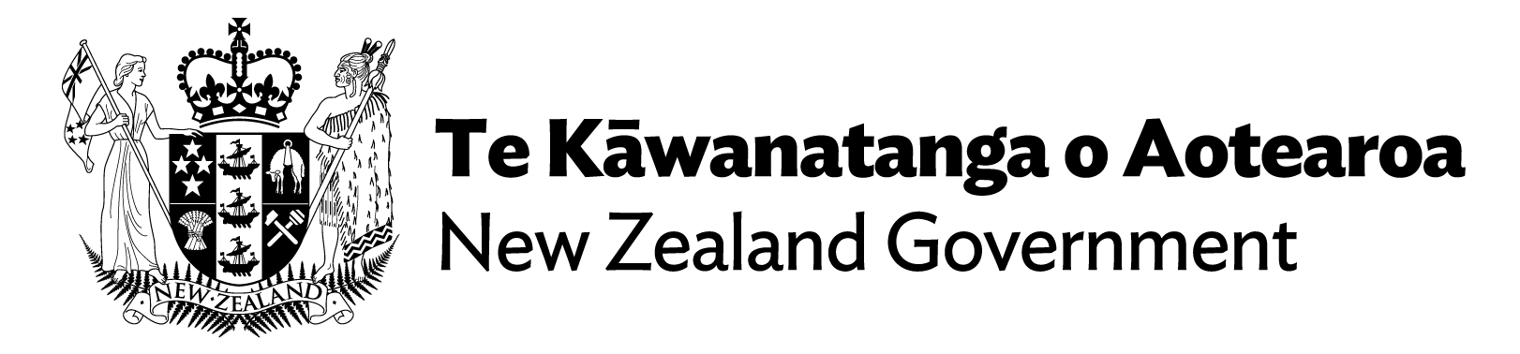

Waste tonnages are submitted through the Ministry’s Online Waste Levy System (OWLS).
You can apply to provide an annual return through OWLS. Applications must be made by 20 July – the start of the financial year. Include details of your expected annual tonnage and how this was calculated. If you have not been approved in advance for annual returns, you must report and pay monthly.
The quarters are January – March; April – June; July – September; and October – December.
Pre-existing class 1 and 2 facilities will already be submitting waste returns and receiving waste levy invoices.
OWLS will issue an invoice 15 days after the waste return has been submitted. For example: A class 3–4 disposal facility operator (DFO) receives waste for the month of July. On or before 20 August the DFO must submit their waste tonnages in OWLS for the month of July. Fifteen days after 20 August OWLS will issue an invoice to the DFO for levy owed for July.

