Using the Fish Passage Assessment Tool to meet the NPS-FM and NES-F
The Ministry for the Environment supports and endorses the use of the
Fish Passage Assessment Tool (FPAT) to help councils with fish passage compliance, monitoring, and enforcement in Aotearoa New Zealand.

Contents
- Who this information is for
- Why fish passage is important
- The Fish Passage Assessment Tool (FPAT)
- Legislation: NPS-FM and NES-F
- Information required to meet the NES-F
- Guidance for using FPAT

Who this information sheet is for
- Regional-council or unitary-authority staff with compliance, monitoring and enforcement responsibilities.
- Asset owners who are fixing existing, or constructing new, in-stream structures.
- Treaty partners, consultants, contractors, community groups, citizen scientists and others who are undertaking surveillance of in-stream structures in local waterways.

Why fish passage is important
An elaborate network of rivers and streams sprawl across Aotearoa New Zealand. These waterways are the veins of Papatūānuku (Earth Mother), and the water that flows within them is her blood, which supports all living things. Healthy and free-flowing water is essential to support the fish species that call these waterways home.
Many of our indigenous species are found only in New Zealand. They are taonga or mahinga kai species (species used for food), so are of significant biodiversity and cultural value. Some of our freshwater fish – such as eels (tuna), whitebait (eg, inanga), and introduced trout and salmon – are also an important part of recreational and commercial fisheries.
However, more than 75 per cent of Aotearoa New Zealand’s freshwater fish are threatened with, or at risk of, extinction. A high proportion of our freshwater fish also undertake migrations within and between both rivers and the sea as part of their natural life cycles. This reminds us of the importance of the interconnectedness of our freshwater ecosystems: ki uta ki tai – from the mountains to the sea.
If fish movement is restricted by in-stream barriers, such as poorly designed and maintained culverts, then the distribution, abundance and existence of our indigenous and sports fish species may be at risk.
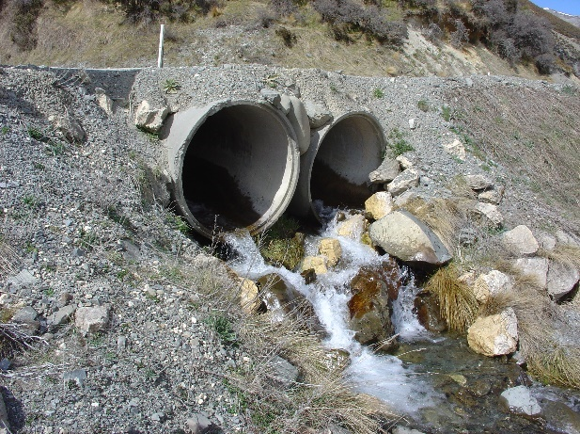
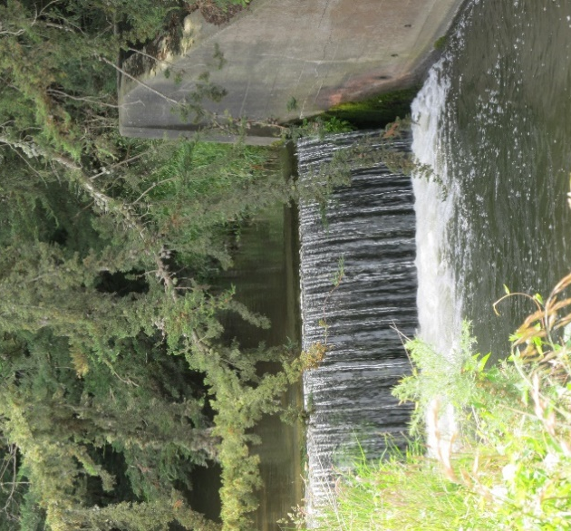
Photo credits: Sjaan Bowie
New Zealand Fish Passage Advisory Group

The Fish Passage Assessment Tool

About the tool
The Fish Passage Assessment Tool (FPAT) is a free, user-friendly, mobile reporting tool included in the NIWA Citizen Science app.
It enables users to capture and meet the information requirements of the National Policy Statement for Freshwater Management 2020 (NPS-FM) and the Resource Management (National Environmental Standards for Freshwater) Regulations 2020 (NES-F).
The FPAT can be used to gather all the information required for existing structures (under the NPS-FM) and is an easy and consistent way to monitor (and maintain) new structures (under the NES-F). For example, under the NES-F, new structures are required to be monitored and maintained over their lifetime, which may include carrying out assessments after a major storm event to ensure fish passage is provided for and/or structures are appropriately maintained.

Why you should use it
The FPAT contributes to an improved understanding of fish passage at a local, catchment, regional and national scale. It also helps to ensure that fish passage data is collected in a consistent way.
The Ministry uses the FPAT information for national environmental reporting.
We also endorse and fund the user support and upgrades of the FPAT.

Where to access it
The FPAT is free to download in the Apple Store and Google Play store.

How to access the data
The FPAT data is held in a national database and can be viewed and downloaded via desktop.
FPAT records can be viewed on the NIWA website.

How we support the tool
The Ministry for the Environment funds, supports and endorses the use of the FPAT, and encourages councils to use the FPAT to meet the requirements of the NPS-FM and NES-F.
The FPAT is maintained and updated on a regular basis, to reflect feedback from users and to ensure the functionality of the app remains practical and effective.

Who uses the tool
While many regional and unitary councils use the FPAT for their reporting requirements, some use alternate systems to collect required information on the design and performance of in-stream structures.

How to use the tool
Detailed, step-by-step instructions on using the FPAT are available in NIWA’s Fish Passage Assessment Protocol mobile application user guide.
The Ministry has created guidance to support the use of the tool:
- Implementation guidance
- Video on the FPAT (YouTube).

Legislation
Regional councils and the Department of Conservation have responsibilities to manage fish passage in our waterways under, respectively, the Resource Management Act 1991 and the Freshwater Fisheries Regulations 1983. In September 2020, the NPS-FM and the NES-F came into force, bringing extra requirements to help protect our precious freshwater habitats and the species within them.
Te Mana o te Wai, a fundamental concept underpinning the NPS-FM, prioritises the need to restore and protect the integrity of water, and the intrinsic values and health of freshwater ecosystems. Te Mana o te Wai recognises that protecting the health of freshwater protects not just the mauri (life force, vital essence) of the water itself, but also the health and wellbeing of the wider environment.

The purpose of the NPS-FM
The NPS-FM establishes the regulatory framework for the long-term management and improvement of freshwater in Aotearoa. Regional councils implement the objectives and policies of the NPS-FM through regional plans, including fish-passage action plans, that seek to improve fish passage in our waterways.
Section 3.26 of the NPS-FM provides the overarching objective relevant to fish passage, requiring that the passage of fish is maintained, or improved, except where it is desirable to prevent the passage of some fish species to protect desired fish species, their life stages or their habitats.

The purpose of the NES-F
The NES-F, Subpart 3 regulates activities that pose a risk to fish passage, by setting requirements for the placement, use, alteration, extension or reconstruction of culverts, weirs, flap gates, dams and fords. This includes the placement, alteration, extension or reconstruction of any of these structures in, on, over or under the bed of any river or connected area in Aotearoa, including temporary structures.
However, the NES-F regulations do not apply to:
- an existing structure, including any later alterations or extensions of that structure, where it was in the river or connected area before 3 September 2020
- a customary weir that is used for the purpose of practising tikanga Māori, including customary fishing practices.
The NES-F requires that specified information on culverts, weirs, flap gates, dams and fords – such as location, dimensions, construction materials and the type of bed substrate under or within the structure – be provided to regional councils.
The NES-F sets design requirements needed for culverts and weirs to meet permitted-activity standards, providing developers and landowners an opportunity to provide good fish passage without the need to apply for a resource consent.
The NES-F also details the monitoring and maintenance requirements for structures with alternative designs that need a resource consent. This monitoring and maintenance will ensure that fish passage is provided for the life of the structure.
Regional councils are responsible for enforcing the NES-F regulations to ensure fish passage is maintained in our waterways.

Permitted activities under the NES-F
The placement, use, alteration, extension or reconstruction of a culvert or weir in, on, over, or under the bed of any river or connected area can be carried out as a permitted activity (without a resource consent) if it complies with the conditions of the NES-F.
Conditions include (but are not limited to):
- The structure must provide for the same passage of fish upstream and downstream as would exist without the structure (regulation 70(2)(a) and regulation 72(2)(a)).
- Culverts must be laid at the same slope as the river or connected area; must be buried at least 25 per cent below the bed of the river; contain natural stream bed substrate through the full length of the culvert; and must be 1.3 times the width of the river or connected area (regulation 70(2)(b) to (g)).
- Weirs must have a fall of height of no more than 0.5 metres; with a slope no steeper than 1:30; and the face of the weir must include roughness elements (eg, mixed-grade rocks) to provide for a variety of flow velocities across the weir (regulation 72(2)(b) to (e)).

Information required to meet the NES-F
To assess risk to fish passage, certain information on the design and performance of all new culverts, weirs, flap gates, dams or fords (or alterations, extensions or reconstructions of existing structures) is required to be collected and provided to the relevant regional council. The following information must be provided within 20 working days after the completion of the activity and as often as required by resource consent conditions:
- the type of structure
- the geographical coordinates of the structure
- the flow of the river or connected area
- whether the water is tidal at the structure’s location
- the width of the river or connected area at the water’s surface
- the width of the bed of the river or connected area
- whether there are improvements to the structure to mitigate any effects the structure may have on the passage of fish
- whether the structure protects particular species, or prevents access by particular species to protect other species
- the likelihood that the structure will impede the passage of fish
- visual evidence (for example, photographs) that shows both ends of the structure, viewed upstream and downstream.
Additional structure-specific information is also required, such as the drop height of a culvert, weir slope or material from which the structure is made.
All this information can be collected using the FPAT.

Guidance for using FPAT
This guidance section has been developed from questions asked by people using FPAT. It is divided into four sections:
- Before you set out
- Filling out the survey
- After you have completed the survey
- FPAT and other reporting

Before you set out
Before you start, read the step-by-step instructions for using the FPAT available in NIWA’s Fish Passage Assessment Protocol mobile application user guide.
Before using the app, familiarise yourself with different types of in-stream barriers.
There are human-made barriers – such as weirs, culverts and dams – but also naturally-formed barriers, such as waterfalls, that may impact fish passage.
More information: Examples of barriers to fish passage are provided in Appendix B of NIWA’s FPAT user guide. Case studies can also be found on Department of Conservation’s fish passage webpage.

Gathering enough data
- Take lots of photos. Some structures are easy to categorise, but if you aren’t sure how to describe the structure, these photos will help with doing this later. It’s also helpful to have photos looking both upstream and downstream for context, as well as the required photos of the structure. It’s best to take the photos when standing in the waterway, if it is safe to do so. Think like a fish.
- Take lots of notes – record your key observations in the comments section of the FPAT. If you see some wildlife, type it in to the notes, for example, “Tuna (eels) were seen upstream of weir”.

Remote locations with no cell-phone reception
- Download and cache the maps before you head out into the field – this is essential if you are heading into a remote area or somewhere without cell-phone reception.

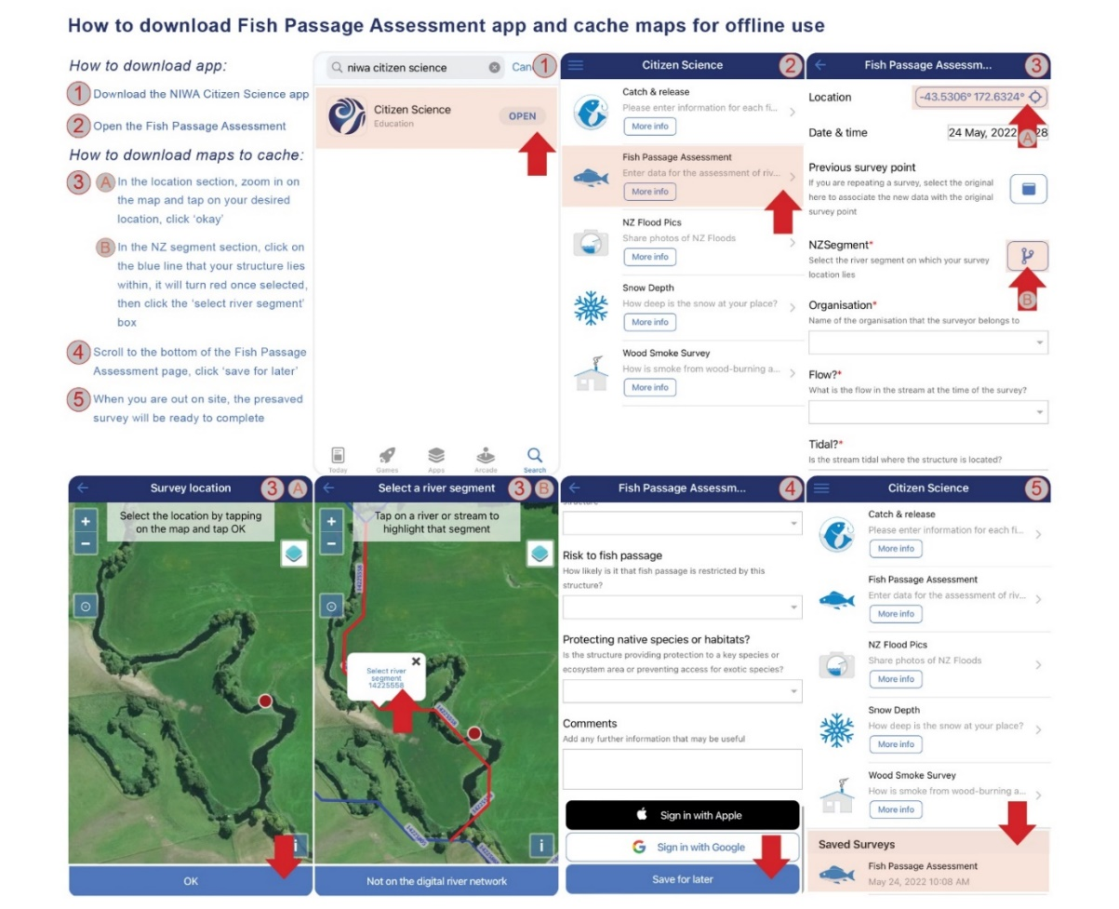
- Alternatively, complete a survey on location and save it for uploading later.
More information: Section 4 of the Fish Passage Assessment For Tool mobile application User Guide - Version 2.0 for step-by-step instructions.

Filling out the survey

Information fields
Many of the information fields collected by the FPAT are intuitive, but there may be some you are unfamiliar with. Some examples are “low-velocity reticulation zones” and “wetted margins”. If a culvert is properly designed and built to meet the NES-F permitted-activity criteria, both low-velocity reticulation zones and wetted margins will be present.
While there are descriptions for each information field in the app, it may be useful to read about these before you go out into the field. NIWA’s FPAT user guide contains clear descriptions of all the information fields and parameters you will need to measure.

Asset ID numbers
If you know the Asset ID number and asset owner of the structure, you can record this. It’s all great information to collect, but you can also leave this field blank if you need to.

Segment numbers
You will need to select the “NZ Segment” for the structure you are surveying. The app contains a segment number for permanent rivers and watercourses, however, if the watercourse you are assessing does not have a segment number, select the nearest connected NZ Segment to the stream you’re surveying.

Your organisation
If you are not affiliated with an organisation, select “other”. Alternatively, you can contact the app designers at NIWA to have the name of your organisation added to the list – you’ll need to do this before you head out.

Measuring water velocity
- Why this is a compulsory field: Including water velocity as a compulsory field was discussed extensively during development of the FPAT and the consensus amongst stakeholders and the fish ecology experts was it is a crucial field for evaluating the risk to fish passage.
- How to measure it: Measure water velocity at the time of the assessment. The timed-float method is one easy way of measuring water velocity. Simply count how many seconds it takes for an object to travel one metre in the stream.
- What tools you will need: Useful tools for measuring velocity are a measuring tape and a small floating object like a tennis ball. If you don’t have a tennis ball, you can even use a leaf. Make sure you carefully place the ball in the river – don’t throw it as this ‘bounce’ affects the velocity measure.
- What to do if it’s too hard to measure: In locations where water velocity is difficult to measure, you may need to get help from trained surveyors who will have an agreed protocol for dealing with these instances. You should identify inaccurate values during surveyor-led quality control before uploading saved data to FPAT.

Identifying structures preventing dispersal of undesirable species
To identify a site that may be preventing the movement of undesirable species, select ‘Yes’ to the survey question “Protecting native species or habitats?”.
More information: See section 3.9 of the Fish Passage Assessment Tool mobile application User Guide - Version 2.0.

Finding a structure’s original assessment
Each structure is assigned a ‘parent ID’ number in FPAT that allows users to find all the assessments for that structure over time. So, if you are updating a structure, you can look up its original assessment.

After completing the survey

Editing your data in FPAT
Any submitted data that has been uploaded to FPAT can only be edited by the NIWA FPAT database administrator. Giving users the ability to directly edit their records would have required developing an entirely new system – one that enabled users to register and log in, and that provided a process for identifying and flagging errors, and an interface for viewing and editing records.
If you have data needing editing or deleting, for example, you recorded a site in error and need to delete it, please contact the app designers at NIWA.
Similarly, contact NIWA if you are having technical difficulty with the app.

Printing and downloading your data
To view and download data you have uploaded to the database, visit the Fish Passage Assessment tool website.
Fish passage risk rankings and prioritisation scores are calculated overnight and will not be available until the day after the records have been submitted using the mobile app. Instructions on how to download this data can be found in section 2.5 of the Fish Passage Assessment Tool mobile application User Guide - Version 2.0.
An API is also available for downloading data. Instructions on how to use the API can be found in section 2.5.3 of the Fish Passage Assessment Tool mobile application User Guide - Version 2.0.

Filtering data to see if remediation has occurred
You can filter data in FPAT either within the tool, after you have downloaded it, or via the API.
The data can be processed further via a secondary tool (such as ArcGIS, R, Python and Excel) to extract individual records (using the FPAT response ID) or to identify records that have fish passage remediation applied including what type of remediation.
Filtering by the parent ID field lets you track changes over time at a site where repeat surveys have been completed.

Quality assurance of your data
The FPAT app has inbuilt controls on the data form that can be entered in each field to reduce errors. There is no formal quality assurance (QA) process built into the data submission process.
We recommend you implement a QA process in your own workflow before submitting your data. For example, you could complete your surveys in the field but save them and check the data back in the office before submitting the surveys to the FPAT database.
Alternatively, you can integrate your QA processes into how you use the data after downloading the data from the FPAT database. For example, you could filter data based on the organisation who collected the data to remove data not collected by your organisation or a preferred supplier. Or you could carry out data quality checks and where you find erroneous data report this to NIWA to be corrected.

FPAT and reporting

Connecting FPAT with your compliance workstreams
The FPAT can be used for existing compliance workflows to implement the fish passage regulations in the NES-F.
This means you can directly connect to the FPAT database using the Application Programming Interface (API) and extract data into your own systems such as internal asset and/or consenting databases. In the same way, you can also develop appropriate QA processes for the data you received from FPAT.
Information on the API can be found in section 2.5 of the Fish Passage Assessment Tool mobile application User Guide - Version 2.0.

FPAT meets all requirements for data reporting under both the NPS-FM and NES-F
Completing the Fish Passage Assessment Tool survey satisfies the requirements to comply with both the NES-F and NPS-FM regulations. You do not need to submit any other data to the Ministry. However, FPAT is not designed as a compliance tool, and it should not be used to determine whether a structure complies with the regulations or a regional rule.
FPAT was designed to provide a nationally consistent method for capturing data about instream structures and objectively assessing the likely risk to fish passage to support environmental reporting. The NES-F and NPS-FM introduced a requirement to collect specific information about all new (NES-F) and existing (NPS-FM) instream structures and the FPAT was updated to reflect this.
For further information on using FPAT to meet reporting requirements under the NPS-FM and NES-F, please refer to the FPAT video.

FPAT and privacy
No private data is made available via the FPAT, only the information on the structure and its location.
There was a consensus among stakeholders and the project steering group that all data captured by FPAT should be made public. This is both to act as an incentive to improve environmental performance and because data transparency is crucial for accurate environmental reporting and effective prioritisation of remediation.
We recommend you take a proactive approach to informing landowners that data about structures in their waterways will be publicly available.

Helpful resources
If you are interested in finding out more about the FPAT, you can access some of the resources below:
- The Ministry for the Environment’s fish passage hub
- The Department of Conservation’s fish passage resources
- The New Zealand Fish Passage Advisory Group FPAT guide
- The Ministry for the Environment’s FPAT video
- The Department of Conservation’s FPAT video
- New Zealand Fish Passage Advisory Group fish passage case studies

Disclaimer
The information in this publication is, according to the Ministry for the Environment’s best efforts, accurate at the time of publication. The Ministry will make every reasonable effort to keep it current and accurate. However, users of this publication are advised that:
- The information does not alter the laws of New Zealand, other official guidelines, or requirements.
- It does not constitute legal advice, and users should take specific advice from qualified professionals before taking any action based on information in this publication.
- The Ministry does not accept any responsibility or liability whatsoever whether in contract, tort, equity, or otherwise for any action taken as a result of reading, or reliance placed on this publication because of having read any part, or all, of the information in this publication or for any error, or inadequacy, deficiency, flaw in, or omission from the information in this publication.
- All references to websites, organisations or people not within the Ministry are for convenience only and should not be taken as endorsement of those websites or information contained in those websites nor of organisations or people referred to.

Published in July 2022; Updated in September 2022
by the Ministry for the Environment – Manatū Mō Te Taiao
Publication number: INFO 1071

