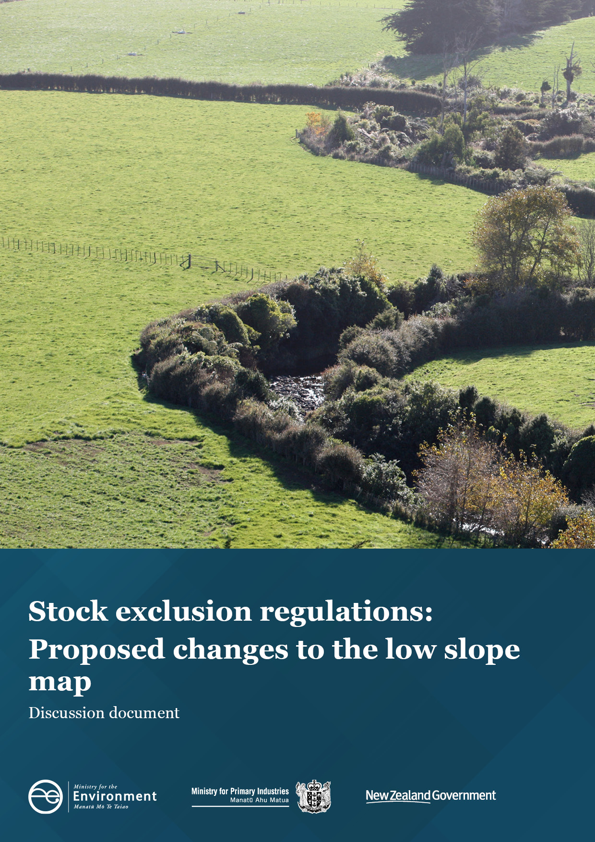
Disclaimer
The information in this publication is, according to the Ministry for the Environment’s best efforts, accurate at the time of publication. The Ministry will make every reasonable effort to keep it current and accurate. However, users of this publication are advised that:
- The information does not alter the laws of New Zealand, other official guidelines, or requirements.
- It does not constitute legal advice, and users should take specific advice from qualified professionals before taking any action based on information in this publication.
- The Ministry does not accept any responsibility or liability whatsoever whether in contract, tort, equity, or otherwise for any action taken as a result of reading, or reliance placed on this publication because of having read any part, or all, of the information in this publication or for any error, or inadequacy, deficiency, flaw in, or omission from the information in this publication.
All references to websites, organisations or people not within the Ministry are for convenience only and should not be taken as endorsement of those websites or information contained in those websites nor of organisations or people referred to.

This document may be cited as: Ministry for the Environment and Ministry for Primary Industries. 2021. Stock exclusion regulations: Proposed changes to the low slope map. Wellington: Ministry for the Environment.

Published in July 2021 by the
Ministry for the Environment
Manatū Mō Te Taiao
PO Box 10362, Wellington 6143, New Zealand
ISBN: 978-1-99-003366-7 (online)
Publication number: ME 1579
© Crown copyright New Zealand 2021
This document is available on the Ministry for the Environment website: environment.govt.nz.

Contents
Message from the Ministers 5
Section 1: What we are consulting on – proposed changes to the low slope map for stock exclusion 6
Context for the proposed changes to the low slope map 7
Section 2: Assessment criteria 8
Section 3: Proposed changes – introduction of a new map 9
We propose a different mapping approach 9
Introducing a more advanced mapping methodology 9
Managing stock exclusion through the proposed map and freshwater farm plans 10
Applying a 500 metre altitude threshold and removing tall tussock and depleted grassland from the map 10
Cumulative impact of the proposed changes to the low slope map 11
Case study of the proposed map in practice 12
Section 4: Initial regulatory impact analysis of the proposed options 15
Option 1: Status quo 15
Option 2: Proposed changes to low slope map (preferred option) 15
Section 5: Options we are not considering 19
Section 6: Estimated costs and benefits for regulated parties 20
Limitations of analysis 20
Section 7: How to have your say 23
Timeframes 23
How to provide feedback 23
More information 23
Publishing and releasing submissions 24
Section 8: Glossary 25
Section 9: Consultation questions 27

Tables
Table 1: Comparative analysis of Option 1 and Option 2 16
Table 2: Estimated costs and benefits to regulated parties 21

Figures
Figure 1: The current map 12
Figure 2: The proposed map 13
Figure 3: Case study in Otago showing preferred option (light green) overlaid on the current map (dark blue) 14

Message from the Ministers
New Zealanders value our freshwater. Our rivers and lakes, and how we care for and use them, are a fundamental part of who we are. We respect the mana of our freshwater – Te Mana o te Wai.
The Government’s Essential Freshwater package aims to improve freshwater quality and ecosystems in both urban and rural areas across Aotearoa New Zealand. Working together we can achieve a big improvement in freshwater quality.
Freshwater farm plans are a further stage of the Essential Freshwater package. But we also want to improve some existing parts of the package. We are consulting now on changes to the low slope map used for stock exclusion regulations, and we will soon ask for your feedback on changes to the intensive winter grazing rules.
Your feedback across these three important areas will help us to design freshwater regulations that are practical and enduring.
The Government is strongly supporting the integration of freshwater regulations into broader farm planning. We have allocated $37 million to roll out integrated farm planning and help farmers and growers access this effective ‘whole of farm’ planning to meet new regulatory and other requirements. Integrated farm plans will go beyond freshwater and include areas such as animal welfare, biosecurity and greenhouse gas reduction.
We know many farmers and growers are already committed to practices to improve water quality and it’s vital they have their say and contribute to this consultation.
The experience of farmers, advisors and regulators who have already developed farm plans will provide useful support for all farmers to develop their own plans.
It is a busy time for the primary production sector, particularly for those recovering from the impacts of drought and flooding. Thank you for your contribution to this freshwater consultation.
Freshwater farm plans will be developed and owned by farmers. We look forward to hearing your thoughts and those of all interested in freshwater and ecosystem health. We expect to share the consultation findings with you by the end of the year.

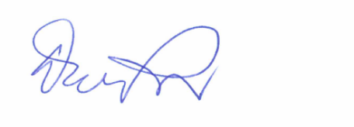
Hon David Parker
Minister for the Environment
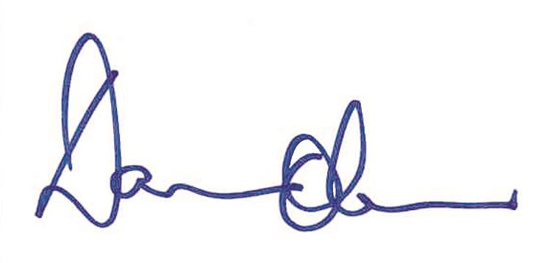
Hon Damien O’Connor
Minister of Agriculture

Section 1: What we are consulting on – proposed changes to the low slope map for stock exclusion
As part of the Resource Management (Stock Exclusion) Regulations 2020, we introduced a map that identifies low slope land across New Zealand. This map designates the requirement to exclude the relevant livestock from wide rivers, lakes, and natural wetlands.
Feedback has shown that the mapping methodology needs to be improved, because the current map includes areas of land that were not intended to be captured by the regulations.
We are asking for your thoughts on proposed changes to the current map. This document presents analysis of the current map, Option 1, and proposed changes to the map, Option 2. It includes questions to fill information gaps and show support for the proposed changes.
You can use the interactive web map (https://environment.govt.nz/what-government-is-doing/areas-of-work/freshwater/e/low-slope-map-for-stock-exclusion/) to see how the current and proposed maps identify low slope land.
We are combining consultation on these changes with consultation on the discussion document Freshwater farm plan regulations (https://environment.govt.nz/publications/freshwater-farm-plan-regulations-discussion-document). The stock exclusion regulations and the freshwater farm plan system are complementary management responses to the issue of stock accessing waterways. The proposed changes to the current map aim to ensure an appropriate balance is reached between the nationwide consistency of requirements in regulations and the on-farm tailored flexibility of freshwater farm plans.
This document asks for feedback on proposed changes to the current map only. We are not seeking feedback on any matters already set out in:
- the Resource Management Act 1991
- the National Policy Statement for Freshwater Management 2020 (NPS-FM)
- the Resource Management (National Environmental Standards for Freshwater) Regulations 2020 (NES-F).

Have your say
We welcome your feedback on all elements of this proposal, at: https://consult.environment.govt.nz. The questions throughout the document are given as a guide only. You do not have to answer them all, and any comments are encouraged.

Context for the proposed changes to the low slope map
Following the introduction of the stock exclusion regulations, stakeholders raised several concerns.
The main concern is that the low slope map (the current map) captures many areas of high slope land – nearly 11.5 per cent of the area captured by the current map is land with a slope greater than 10 degrees. The current map also fails to capture some areas of low slope land.
It should be noted that the current map includes any land currently grazed and any land that could be changed into a pastoral system in future. The map needs to include these areas because it is the land-based trigger for the requirement to exclude beef cattle and deer from access to waterways.
Another concern is that the map captures extensive farming operations in the high country. We have listened to these concerns.
Given that high-slope land and extensive pastoral systems tend to be stocked at lower rates, the marginal environmental benefit of excluding stock from accessing waterways in these areas is lower, for significantly higher costs. It was intended that freshwater farm plans would be used to manage some stock exclusion requirements in these areas. Freshwater farm plans provide for a tailored risk-based approach to reduce the impacts of pastoral activity.
Officials from the Ministry for the Environment and Ministry for Primary Industries worked with key stakeholders (Beef + Lamb New Zealand, Federated Farmers, Deer Industry New Zealand, and regional councils) to investigate the concerns raised about the current map.
Questions – Context for the proposed changes to the low slope map
1. Do you agree with our framing of the issue. If not, why not?
2. What other information should we consider?

Section 2: Assessment criteria
The following criteria were used to evaluate the options in this discussion document.

1. Effective
- avoids, remedies, or mitigates the effects of farming and/or horticultural land use on freshwater
- supports the requirements of the RMA, the Freshwater NES and the Freshwater NPS
- supports regional council requirements and objectives
- supports catchment objectives
- supports enhanced freshwater health, including ecosystem health
- is fair and treats regulated parties equally.

2. Practical
- flexible – takes a risk-based approach and tailors mitigations to the farm scale
- continuously improves to account for innovation and new information
- enabling – engages and empowers famers to achieve freshwater outcomes
- accessible – interacts well with other relevant systems
- trusted by all stakeholders
- achieves maximum benefits with minimum wasted effort or expense
- considers positive and negative impacts on the wellbeing of people (individuals and communities) and freshwater

3. Gives effect to Te Mana o te Wai
- places the wellbeing of the water first, and promotes values-based, holistic management to sustain the wellbeing of the people
- acknowledges mātauranga Māori
- gives practical expression to the principles of Te Mana o te Wai.

4. Takes into account the Treaty of Waitangi (Te Tiriti o Waitangi)
- takes into account the principles of the Treaty of Waitangi (Te Tiriti o Waitangi)
- promotes partnership and protects Māori rights/interests and relationships with their taonga
- acknowledges opportunities that may arise for Māori to exercise rangatiratanga and kaitiakitanga.
Question – Assessment criteria
3. Do our objectives and criteria focus on the right things? If not, what would you change and why?

Section 3: Proposed changes – introduction of a new map

We propose a different mapping approach
We consider that a different mapping approach should be taken to identify where beef cattle and deer will need to be excluded from waterways.
Officials have developed a preferred option to amend the current map. An interactive version on the proposed map is available here: https://environment.govt.nz/what-government-is-doing/areas-of-work/freshwater/e/low-slope-map-for-stock-exclusion/. We consider the preferred option will improve the application of the stock exclusion regulations to farming practices across New Zealand. We propose doing this by:
- using a more advanced mapping methodology called ‘local terrain averaging’ to identify low slope land
- managing the need to exclude stock from waterways in areas with an average slope of between 10 degrees to 5 degrees through freshwater farm plans. This will significantly reduce the likelihood that high slope land is captured by the low slope map. Stock exclusion on this land will be addressed through a risk-impact assessment in a certified freshwater farm plan, with a presumption that stock will need to be excluded from waterways
- applying an altitude threshold of 500 metres above sea level to the proposed map. Any land above this threshold will not be included in the map. Stock exclusion requirements on land above 500 metres in altitude will be addressed through freshwater farm plans
- removing depleted grassland and tall tussock areas from the map. As with the altitude threshold, this will contribute to ensuring that land with a low carrying capacity and that is stocked extensively is managed appropriately through freshwater farm plans.
Taken together, we consider these changes will address concerns with the current map.
This approach was chosen on the basis that stock exclusion requirements for any land not captured by the proposed map will be managed by freshwater farm plans (appropriate stock exclusion requirements would be decided between a farmer and a freshwater farm plan certifier). As with other farm management decisions made through the freshwater farm plan, risks to freshwater would be identified based on the on-farm activity and other factors, such as slope, soil type, and climate; mitigation options are then chosen to minimise that risk.

Introducing a more advanced mapping methodology
The current map involves averaging slope over large areas, which has contributed to concerns.
This is particularly relevant in areas with variable terrain. Due to differences in size and shape between Land Information New Zealand (LINZ) primary parcel blocks (land parcels), adjacent properties that share similar terrain have been captured inconsistently. This has created an issue of fairness between farm properties.
Instead of averaging slope across land parcels, our preference is to use a mapping approach called ‘local terrain averaging’. This method calculates slope across the average slope of an aggregated 4.5 hectare area comprising 15 metre by 15 metre cells. Each 15 metre cell with a local average of 5 degrees or less is selected and the edges of the resulting layer are smoothed to give the map its boundary. This approach more closely resembles the surrounding landscape and will better align with farmers’ intuitive understanding of their own land.
The main reason the local terrain averaging option was not originally used is because the low slope map had to include a land ownership boundary to identify who was responsible for livestock management. Land parcels were the only way to identify who is responsible for excluding livestock from access to waterways, because paddock scale mapping was not considered practicable.
The LINZ primary parcel layer still needs to be laid over top of the proposed map to identify who is responsible for livestock management.

Managing stock exclusion through the proposed map and freshwater farm plans
We propose managing stock exclusion through both the regulations and freshwater farm plans.
A national map provides a consistent nationwide tool for identifying where the greatest risk to freshwater lies in relation to stock intensity. In identifying this risk accurately, mandatory requirements through the regulations should aim to minimise unnecessary or unintended impacts. Regional councils can still be more stringent in their regional planning to address known freshwater quality issues as a result of stock access to waterways.
We therefore propose the new map applies to areas with an average slope up to 5 degrees and areas with an average slope between 5 degrees and 10 degrees are managed through freshwater farm plans.
This allows stock exclusion on land outside the map to be managed through freshwater farm plans. This will significantly reduce the amount of land captured by the proposed map, from around 8.2 million hectares in the current map to 5.2 million hectares in the proposed map.
The proposed map is a more accurate way of identifying low slope land. The current map captures too much high slope land (greater than 10 degrees). The proportion of land with a slope greater than 10 degrees captured in the proposed map is around 0.07 per cent.

Applying a 500 metre altitude threshold and removing tall tussock and depleted grassland from the map
The current map does not include an altitude threshold. This means that it captures some high-country areas of extensive pastoral farming that Cabinet did not intend to be subject to mandatory stock exclusion requirements in regulations. These areas, which are generally stocked at lower rates, are particularly difficult to access. Requiring stock to be excluded from accessing waterways in extensive pastoral farming systems in such areas would impose significantly higher costs relative to the benefits to freshwater ecosystems.
To address this, we propose that land above 500 metres in altitude is not captured by the low slope map and is managed through freshwater farm plans. This will ensure that land management above this altitude threshold takes into account the challenges of excluding stock from waterways in the high country.
We also propose that tall tussock and depleted grassland should be removed from the map. This serves as a proxy for likely stock intensity, because areas with these ground cover categories are unlikely to have high stocking rates.

Cumulative impact of the proposed changes to the low slope map
The proposed changes will more reliably capture land where stock exclusion will effectively reduce the likelihood of contaminants, such as sediment, E.coli, and nitrates, entering surface waterbodies.
Improving the mapping methodology and managing some stock exclusion through freshwater farm plans better reflects Cabinet’s intention for how stock would be managed. When it agreed to consult on stock exclusion regulations in 2019, Cabinet agreed that national regulation would not apply to low intensity high country farming. Cabinet’s intention was to have a balance between the use of regulations and freshwater farm plans.
The proposed map will capture an area of about 5.2 million hectares. The current map captures an area of around 8.2 million hectares. Taken together, the total area of land captured across New Zealand with a slope of over 10 degrees that is captured will decrease from around 11.5 per cent in the current map, to an estimated 0.07 per cent in the proposed map.
Land with an average slope of 5 degrees or less below the 500 metre altitude threshold is captured by the proposed map and will be required to comply with the regulations. Any stock exclusion requirements on land not captured by the proposed map will be managed by freshwater farm plans, which are risk-based and so allow for discretion. See the case studies below of the proposed map applied across New Zealand.
An interactive version of the proposed map is available on the Ministry for the Environment’s website at: https://environment.govt.nz/what-government-is-doing/areas-of-work/freshwater/e/low-slope-map-for-stock-exclusion/.

Case study of the proposed map in practice
Figure 1 and Figure 2 show the current and proposed maps respectively.
Figure 1: The current map
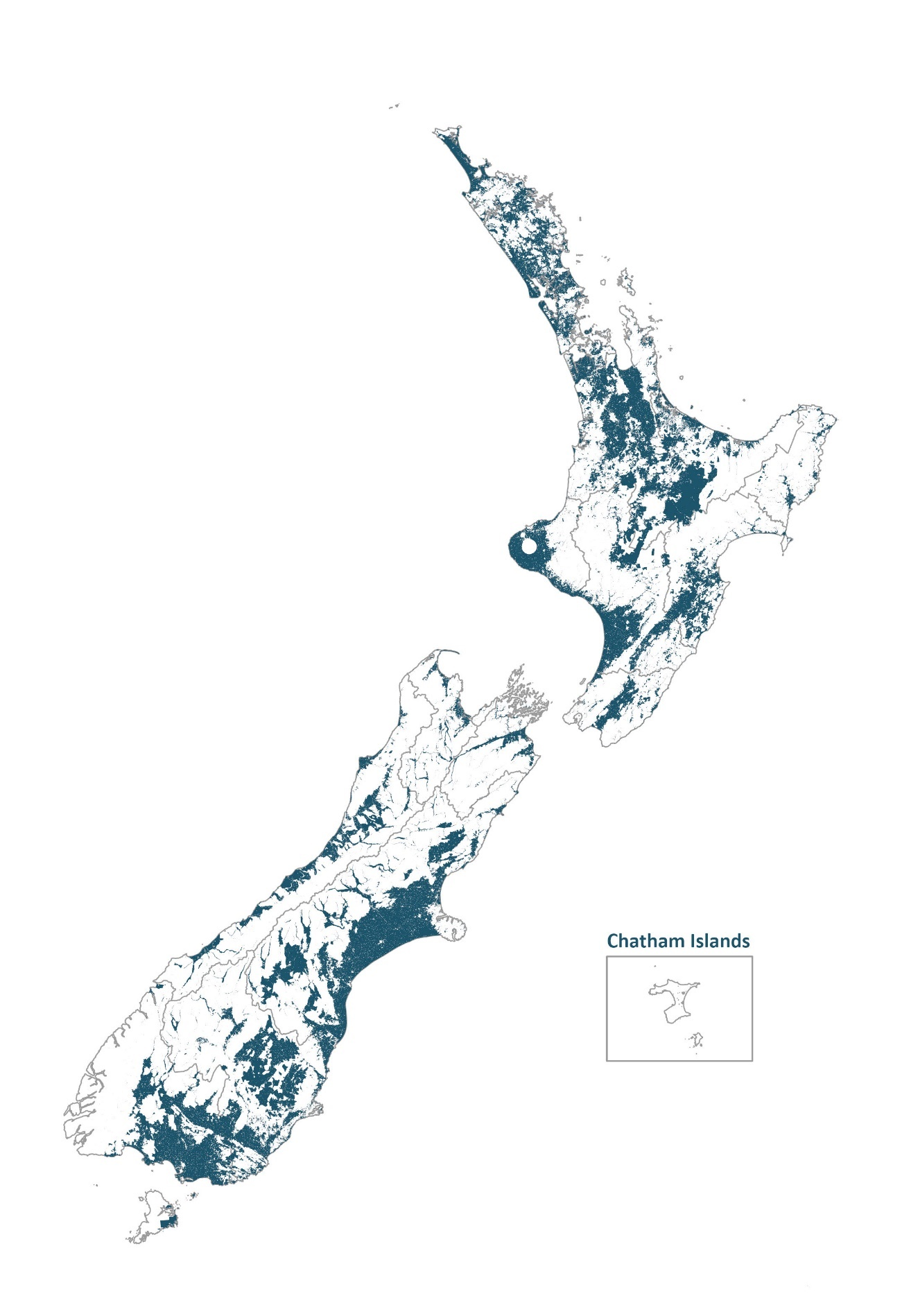
Figure 2: The proposed map
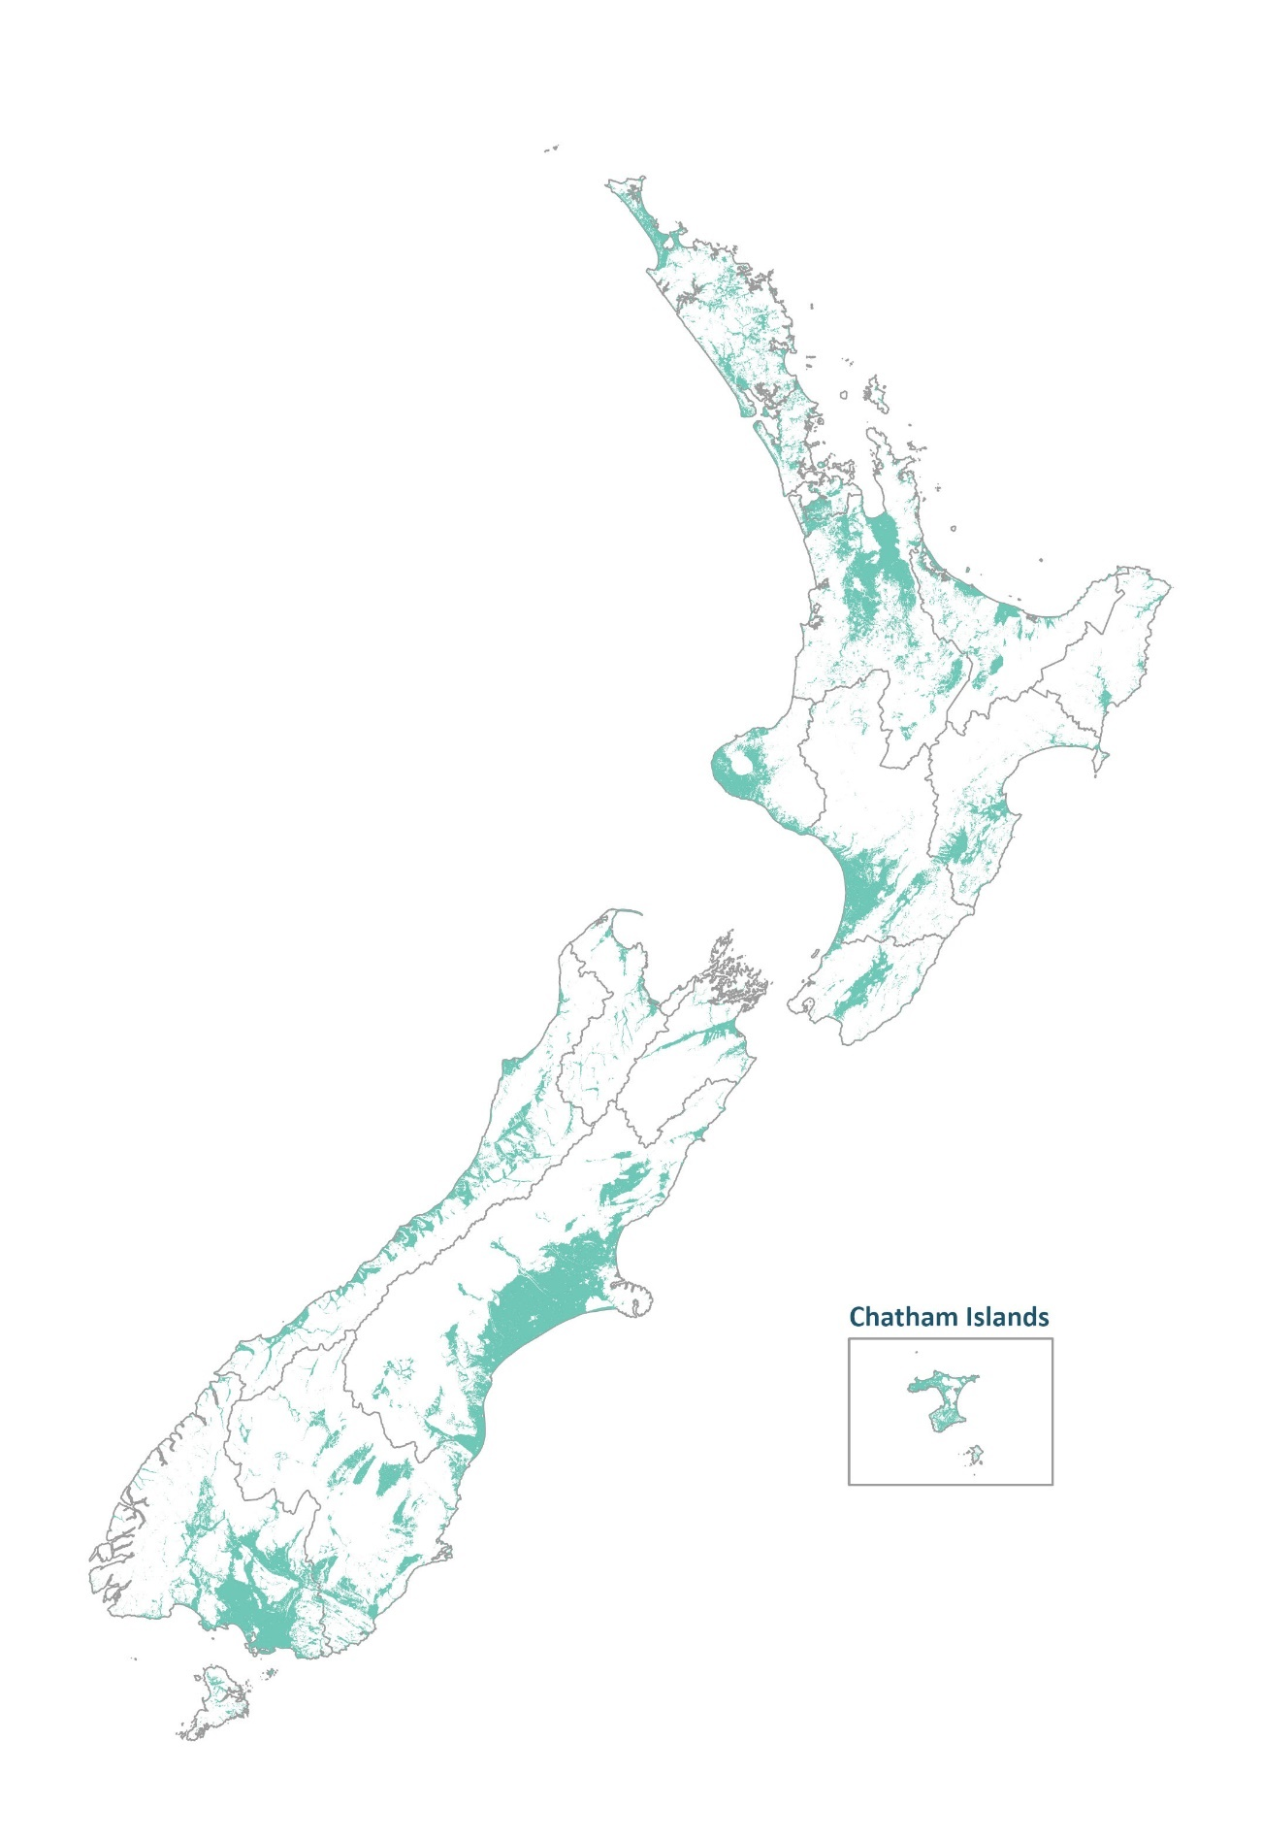

Figure 3 shows an example of how the maps differ in the Ida Valley in central Otago. In this example, the areas in the current map to the bottom of the image (shown in blue) have been removed from the proposed map (green) because they are over 500 metres in altitude. A small area of (transparent green) land is added to the proposed map to the right of the centre if the image. These areas are less than 5 degrees in slope but were not included in the current map because they were part of large land parcels which had average slopes over 10 degrees.
Figure 3: Case study in Otago showing preferred option (light green) overlaid on the current map (dark blue)
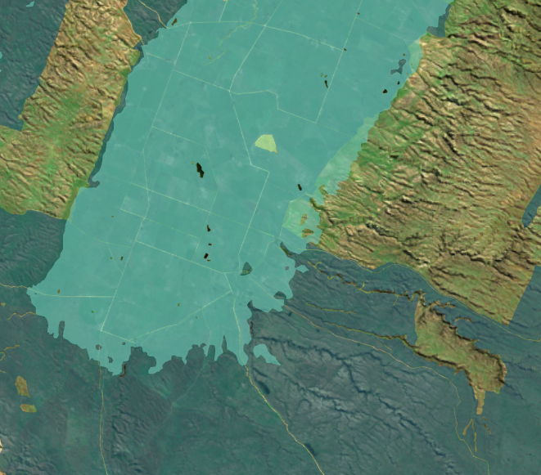

Questions – Proposed changes – introduction of a new map
4. Do you think the changes to the low slope map will more accurately capture low slope land?
5. Do you agree that the 500-metre altitude threshold should be added?
6. Do you agree that the regulations and freshwater farm plans are complementary ways to manage the need to exclude stock from waterways? If not, why not?
7. If you own land captured by the map, does the proposed low slope map layer reflect what you would expect to be captured?

Section 4: Initial regulatory impact analysis of the proposed options
We are proposing two options through this consultation.

Option 1: Status quo
Option 1 proposes retaining the current map in the Resource Management (Stock Exclusion) Regulations 2020 used to identify low slope land.
The map averages slope across a land parcel and applies to areas with an average slope of 10 degrees or less. It is designed to capture currently grazed land, and areas where land use could potentially be changed to grazing.
The map’s objective is to identify where beef cattle and deer must be excluded from waterways from 1 July 2025. Feedback has shown that the map captures areas of steep and high-altitude land, to an extent that is inconsistent with Cabinet’s original intention in agreeing to consult on stock exclusion regulations.

Option 2: Proposed changes to low slope map (preferred option)
Option 2 proposes changing the current map (see section 3).
The objective of the proposed changes is to improve how the current map identifies where beef cattle and deer must be excluded from waterways from 1 July 2025.
The map incorporating the proposed changes is still intended to capture currently grazed land, along with areas where land use could potentially be changed to grazing in the future.
See table 1 for a comparative analysis of Option 1 and Option 2 against the criteria listed in section 2.
Table 1: Comparative analysis of Option 1 and Option 2
 | Option 1: Status quo – the map does not change in the regulation | Option 2: Update map (preferred option)
Effective | 0  The main concern with the current map was that it captures steep land; around 11.5 per cent of the land in the current map is over 10 degrees average slope. Another concern raised is that the current map captures extensive pastoral systems. In both cases the concern is that the (higher) costs associated with stock exclusion do not necessarily justify the benefits in all cases.  The current map also leads to inequities between farmers with similarly-sloped land. This is because land parcels are of variable sizes and shapes, and this is a particular issue in variable terrain. | ++  Option 2 is significantly more effective at achieving the intent of the regulations than Option 1. Around 0.07 per cent of the land identified in the proposed map is over 10 degrees average slope. However, this comparison will be dependent on the effectiveness of freshwater farm plans to reduce on-farm risk.  Option 2 treats regulated parties equally, because local terrain averaging reflects local topography. Land parcels are relevant in terms of establishing who owns the land but are no longer the unit of measurement for average slope.  Option 2 supports regional council objectives and, in conjunction with freshwater farm plans, helps to lessen the effects of farming on freshwater. It thereby supports the requirements of the RMA, the Freshwater NES and the Freshwater NPS, supports catchment objectives, and supports enhanced freshwater health, including ecosystem health.
Practical | 0  The current map is interpretable, but inflexible. It does not fully give effect to Cabinet’s intent that some stock exclusion for extensive pastoral farming in high country areas would be managed through freshwater farm plans rather than regulations.  A risk to the successful implementation of the current stock exclusion regulations is lack of support from some farmers, industry groups and councils that oppose the current map because of its inaccuracies in capturing low slope land.  Regional sector criticism focused on the use of land parcels as the unit of measurement, noting this had effectively separated farmers from their intuitive understanding of the slope of their own land. | +  Option 2 is more practical than Option 1. It is clearer for regulated parties and regulators to understand. Regional sector participants in the development of proposed changes described local terrain averaging as easier to explain to farmers, and simpler to implement and enforce.  Option 2 is more flexible in allowing for a risk-based approach to be taken, and mitigations tailored to the farm scale on land between 5 degrees and 10 degrees slope. This option interacts well with other systems, notably freshwater farm plans.  Option 2 responds to significant concerns expressed by the primary sector, including about negative impacts on the wellbeing of people (individuals and communities) because the regulations captured more land than was the policy intent.
Gives effect to Te Mana o te Wai | +  Contributes to the regulations, which provide a good balance between putting the needs of the water first and considering the needs of people. | +  There is little difference between the ability of Option 1 and 2 to give effect to Te Mana o te Wai.  A management response will still occur where beef and deer are grazed on land with a slope between 10 degrees and 5 degrees. Freshwater farm plans involve considering the whole farm system. Because Option 2 increases the areas in which freshwater farm plans apply, it better targets investment into reducing the effects of farming activities on waterways. This will be the case in areas of land between 5 degrees and 10 degrees slope, and on higher altitudes or poor pastures where the net benefits of (mandatory) stock exclusion are less certain in all cases.  Option 2 provides more discretion for effective livestock exclusion on slopes greater than 5 degrees through freshwater farm plans. This means investment that would have otherwise gone to mandatory stock exclusion might be better directed to other actions on farms that address higher priority issues in that catchment.
Takes into account Treaty of Waitangi (Te Tiriti o Waitangi) | 0  Would not fall disproportionately heavily on Māori landowners. | +  We assume Option 2 will not fall disproportionately-heavily on Māori landowners. The new proposal offers more flexibility for stock exclusion on land between land with slopes between 5 degrees and 10 degrees.  Because the proposed map has not yet been tested with specific Māori landowners, we would like to hear feedback from Māori landowners on this assessment, which is subject to consultation.
 | 1 | 5
Overall assessment | Concerns raised by regional and primary sector stakeholders about the map’s fitness for purpose indicate that it would be challenging to successfully implement the regulations with it.  Due to averaging slope across large areas, the map captures land that was not intended to be captured and fails to capture land that should be captured. | The proposed changes address issues raised about the current map. Option 2 is fit for purpose in that it is a significant improvement on the current map.  It retains the consistency of a mandatory national minimum requirement for stock to be excluded from waterways.  It rectifies the inclusion of steep land.  The extent to which it addresses stock exclusion requirements for extensive pastoral farming in high country is a matter to be tested through consultation.

Questions – Impact analysis of the proposed options
8. Do you agree with our preferred approach? If not, why not?
9. What other information should we consider?
10. What are the likely impacts and cost implications of the preferred approach (Option 2) compared with the status quo (Option 1)?

Section 5: Options we are not considering
We are not recommending any exemptions from the proposed map for stock exclusion regulations.
Section 360 regulations are constrained by law in the level of interpretation they can provide for. The stock exclusion regulations cannot be written to provide regional councils with the ability to exercise discretion over when requirements should and should not be enforced.
The desirability of having discretion was the most frequently mentioned issue during our work with regional and primary sector stakeholders to investigate concerns raised about the current map. Stakeholders suggested that stock exclusion requirements need flexibility, to allow for specific place-based circumstances that may not be accommodated in the national map.
The changes to the map outlined in section 4 (Option 2, the preferred option) are a response to stakeholders’ desire for discretion around stock exclusion requirements. The use of freshwater farm plans to manage stock exclusion in areas above 5 degrees average slope (and also in areas above 500 metres in altitude) will mean discretion is available for stock exclusion through the freshwater farm plan system rather than section 360 regulations. Freshwater farm plans are risk-based, so measures to address stock exclusion will be as appropriate rather than mandatory requirements.
In this way the proposed changes to the map aim to find an appropriate balance between national consistency, through mandatory regulatory requirements, and the discretion to more flexibly determine local on-farm solutions through the freshwater farm plan system.
Questions – Options we are not considering
11. Do you agree our proposed changes to the low slope map address the need for stock exclusion requirements to have some flexibility? If not, why not?

Section 6: Estimated costs and benefits for regulated parties
We consider the benefits to freshwater ecosystems will be enhanced under Option 2 for the benefit of the wider community.
The estimated costs and benefits have been assessed for a range of regulated parties including the following.
Farmers and growers: The costs of complying with the regulations will vary between farmers. These costs are affected by factors such as the length of stream already fenced, the accessibility of the terrain in which their pastoral activity is based, and the type of livestock farmed. The suggested changes presented in Option 2 will significantly reduce the likelihood of the map capturing beef and deer farmers who were not intended to be. This will reduce operational costs, because beef and deer farmers incur the highest costs due to fencing infrastructure.
Regional councils: Regional councils are responsible for enforcing compliance with the regulation and administering any infringement fees. We consider that Option 2 will more clearly define regional council responsibility regarding mandatory stock exclusion. Costs will be associated with administering the freshwater farm plan regime for land not captured by the proposed map. The marginal cost of this, however, will likely be negligible because all commercial farms will be required to have a freshwater farm plan, regardless of the proposals in this document.
Other parties: Members of the wider community may be engaged to provide services through fencing or other stock exclusion services, and administration to support the implementation of stock exclusion methods.

Limitations of analysis
We have limited information on the total area of rivers fenced and the costs associated with excluding stock from accessing waterways. We would like to collect more information on these topics. While it is relatively straightforward to locate lakes and rivers passing through pastoral land in low slope areas, information is incomplete on how many of these (and wetlands) are already fenced and with what setback. This makes it difficult to establish with accuracy the total cost of any proposed regulations. To fill these knowledge gaps, information from the Survey for Rural Decision Makers was used to estimate the stream length already fenced.
Table 2: Estimated costs and benefits to regulated parties
Affected parties | Comment: nature of cost or benefit (e.g., ongoing, one-off), evidence and assumption (e.g., compliance rates), risks | Impact  $m present value where appropriate, for monetised impacts; high, medium, or low for non-monetised impacts
Regulated parties  (farmers and growers) | Costs  The one-off and ongoing maintenance costs for stock exclusion will fall most heavily on farmers with beef cattle because these farms have lower levels of existing stock exclusion, and occupy high slope land in steep terrain that can be difficult to access.  These costs are higher in high-slope land due to accessibility.  Option 2 results in a significant reduction in high slope land captured by the map from up to 11.5 per cent to an estimated 0.07 per cent. This will significantly reduce the costs between the two options.  Benefits  The proposed changes in Option 2 will reduce the amount of land captured by the mandatory regulation and the associated ongoing and one-off costs. | Costs  The monetised costs for Option 1 were estimated at $1.1 billion present value, assuming fences costing $5/m to $20/m (depending on sector) and productivity in setbacks varying by sector. This leads to $773 million in capital costs and $17 million per year in productivity losses (given the land being grazed was reduced due to mandatory setbacks).  Benefits  The estimate above includes beef cattle and deer in high country terrain being included in under the 10-degree slope threshold.  These costs will reduce for Option 2 because of the proposed map changes.  Management of stock exclusion on land outside the map through freshwater farm plans will enable a more targeted risk-based response to the need for stock exclusion.
Regulators  central government | Costs  Central government will continue to conduct general oversight of the effectiveness of regulation as part of ongoing work programmes.  Benefits  Option 2 provides a more comprehensive and clear process to identify and manage stock exclusion on low slope land. | Costs  The costs to central government are considered low for both Option 1 and Option 2.  Benefits  The costs to administer Option 2 are considered low.
Regional councils | Costs  Regional councils will be responsible for the ongoing enforcement of the regulations. Option 2 will result in an increase in stock exclusion management through freshwater farm plans, which will reduce regional council compliance costs. Under Option 2, ‘compliance’ checks may be less frequent because freshwater farm plans include an audit check in the system.  Benefits  Option 2 will provide confidence that stock exclusion via the map and freshwater farm plans is a more accurate and comprehensive way to ensure beef cattle and deer do not access waterways. | Costs  The costs of compliance monitoring and follow-up enforcement action are estimated at $10 million per year.⁷ This figure has been calculated from an estimate of the additional regional council staff required to administer Option 1.  Benefits  The benefits are considered to decrease operational costs because compliance and enforcement will be easier to determine using the proposed map under Option 2 because the new approach will be more accurate.
Other parties  (wider community) | Costs  The primary costs to the wider community in terms of stock exclusion are the ongoing impacts on human health as a result of E.coli entering water where people swim.  Benefits  Option 2 will provide a more comprehensive process to manage livestock to significantly minimise stock access to surface waterways. | Costs  The wider community will not incur any increase in cost due to Option 2.  Benefits  We consider Option 2 will provide the greatest assurance that livestock activity around freshwater ecosystems will be more effectively managed.

Questions – Estimated costs and benefits
12. Do you agree with our estimation of the costs and benefits?
13. What other information should we consider?

Section 7: How to have your say
The Government welcomes your feedback on this discussion document. Section 9 contains a complete list of the questions posed throughout the document. They are a guide only and all comments are welcome. You do not have to answer all the questions.
To ensure your point of view is clearly understood, please explain your rationale and provide supporting evidence where appropriate.

Timeframes
This discussion document was published on 14 July 2021. We are accepting submissions via the online submission tool from 26 July until 12 September 2021.
When the consultation period has ended, we will analyse feedback and provide advice to Ministers on next steps.

How to provide feedback
You can make a submission in two ways:
- via Citizen Space, our consultation hub, available at https://consult.environment.govt.nz/
- write your own submission.
If you want to provide your own written submission you can supply this as an uploaded file in Citizen Space.
We ask please that you don’t email or post submissions because this makes analysis more difficult. However, if you need to please send written submissions to Stock Exclusion Regulations: proposed changes to the low slope map, Ministry for the Environment,
PO Box 10362, Wellington 6143 and include:
- your name or organisation
- your postal address
- your telephone number
- your email address.
If you are emailing your feedback, send it to freshwaterfarmplans@mfe.govt.nz as a:
- PDF, or
- Microsoft Word document (2003 or later version).
Submissions close at 5 pm, 12 September 2021.

More information
Please direct any queries to:
Email: freshwaterfarmplans@mfe.govt.nz
Postal: Stock Exclusion Regulations: proposed changes to the low slope map consultation Ministry for the Environment, PO Box 10362, Wellington 6143

Publishing and releasing submissions
All or part of any written comments (including names of submitters) may be published on the Ministry for the Environment’s website, environment.govt.nz. Unless you clearly specify otherwise in your submission, the Ministry will consider that you have consented to website posting of both your submission and your name.
Contents of submissions may be released to the public under the Official Information Act 1982 following requests to the Ministry for the Environment (including via email). Please advise if you have any objection to the release of any information contained in a submission and, in particular, which part(s) you consider should be withheld, together with the reason(s) for withholding the information. We will take into account all such objections when responding to requests for copies of, and information on, submissions to this document under the Official Information Act.
The Privacy Act 2020 applies certain principles about the collection, use and disclosure of information about individuals by various agencies, including the Ministry for the Environment. It governs access by individuals to information about themselves held by agencies. Any personal information you supply to the Ministry in the course of making a submission will be used by the Ministry only in relation to the matters covered by this document. Please clearly indicate in your submission if you do not wish your name to be included in any summary of submissions that the Ministry may publish.

Section 8: Glossary

Who ‘we’ refers to
‘We’ in this document means the Ministry for the Environment and the Ministry for Primary Industries.
If we mean parliament, Cabinet, the rest of government or the Crown, we will use those words.

How we refer to Māori
How we refer to Māori in this document depends on the context. This is what we mean when we use the following terms:
- Māori a term for all Māori
- iwi tribal groups or bodies.

Land parcel
Refers to primary land parcels as defined by Toitū Te Whenua Land Information New Zealand (LINZ).
In the current map of low slope land, land parcels are the base unit of measurement applied when determining the average slope for a farm. Low slope land is defined as areas with an average slope of 10 degrees or less across the land parcel.
Potential for confusion exists about the relevance of land parcels to the low slope map.
Land parcels will no longer be used as the unit of measurement to determine slope under the proposed changes to the map.
Land parcels will still be relevant to the regulations, for the purposes of confirming land ownership and for the definition of wide river (see below).

National Policy Statement
A National Policy Statement is a statement issued under section 52 of the Resource management Act 1991.

Resource Management (National Environmental Standards for Freshwater) Regulations 2020 (NES-F)
The NES-F are standards that set requirements for carrying out certain activities that pose risks to freshwater and freshwater ecosystems.

Wide river
Means a river (as defined in the Resource Management Act 1991) with a bed that is wider than 1 metre anywhere in a land parcel.
Some confusion has occurred about the definition of wide river, and related concerns have been raised about what it means for stock exclusion requirements.
The definition of wide river only means that a river with a bed that is at any point in a land parcel wider than 1 metre is a wide river.
For the avoidance of doubt, the definition of wide river does not, on its own, trigger a requirement to exclude beef cattle and deer.
The requirement to exclude beef cattle and deer from access to waterways applies only on land that is included in the low slope map: it does not apply to sections of a wide river that are outside the low slope map (ie, the map only requires stock to be excluded from accessing a wide river along the length of that river that is inside the map).
This means that requirements may apply to a river with a bed less than 1 metre wide in the low slope map, if the bed of that river is wider than 1 metre within the land parcel.
This gives effect to the intent of the low slope map, which is to protect waterways that are likely to be under the most pressure from stock.
The intent is also to avoid the opposite problem: capturing waterways that are unlikely to be under high pressure from stock. These could, for example, be areas of a land parcel at altitudes over 500 metres, and/or with depleted grassland or tall tussock land covers.

Others
When we say ‘extensive farming operations’, we mean low intensity high-country farming.
The Land Cover Database is a land cover map which was produced by Manaaki Whenua – Landcare Research, and identifies different land cover classes, such as high and low producing grassland, across New Zealand.
When we say ‘livestock’, we mean dairy, dairy support, pigs, beef cattle, and deer (unless otherwise specified) regulated under the stock exclusion regulations (it does not include feral animals).

Section 9: Consultation questions
Context for the proposed changes to the low slope map
1. Do you agree with our framing of the issue. If not, why not?
2. What other information should we consider?
Assessment criteria
3. Do our objectives and criteria focus on the right things? If not, what would you change and why?
Proposed changes – Introduction of a new map
4. Do you think these changes to the low slope map will more accurately capture low slope land?
5. Do you agree that the 500 metre altitude threshold should be added?
6. Do you agree that the regulations and freshwater farm plans are complementary ways to manage the need to exclude stock from waterways? If not, why not?
7. If you own land captured by the map, does the proposed low slope map layer reflect what you would expect to be captured?
Options analysis
8. Do you agree with our preferred approach? If not, why not?
9. What other information should we consider?
10. What are the likely impacts and cost implications of the preferred approach (Option 2) compared with the status quo (Option 1)?
Options we are not considering
11. Do you agree our proposed changes to the low slope map address the need for stock exclusion requirements to have some flexibility? If not, why not?
Estimated costs and benefits
12. Do you agree with our estimation of the costs and benefits?
13. What other information should we consider?

Low slope land is currently any land parcel with an average slope of 10 degrees or less when measured across the LINZ Primary Parcel Layer.
Beef and deer must be effectively excluded from waterways in the low slope map from 1 July 2025 unless intensively grazing which requires exclusion on any terrain from 1 July 2023. Note that dairy cattle and farmed pigs will be required to be excluded from ‘wide rivers’ no matter the terrain.
Please see section 8: Glossary for definitions of the NPS-FM and NES-F.
High slope land is currently any land parcel with an average slope greater than 10 degrees when measured across the LINZ primary parcel layer.
If beef cattle and deer are intensively grazed, the requirement to exclude them from waterways applies to ‘any terrain’.
Such as sediment loss and elevated E.coli concentrations.
Note that the proposed map includes coverage of the Chatham Islands, which were not included in the current map.
See Regulatory Impact Analysis: Action for healthy waterways, Part II Detailed Analysis.
According to LINZ, a primary parcel is any land parcel that is or is intended to be: • owned by the Crown, with the exception of a movable marginal strip • held in fee simple • Māori freehold land or Māori customary land • part of the common marine and coastal area • the bed of a lake or river • road or railway • vested in a local authority.
It has been claimed that the definition of wide river requires stock to be excluded EITHER from the entire length of every river that at any point is wider than 1 metre, OR from the entire length of every river within a land parcel if the river is at any point in the land parcel wider than 1 metre. Neither of these interpretations are correct.
Unless beef cattle and deer are being intensively grazed.

