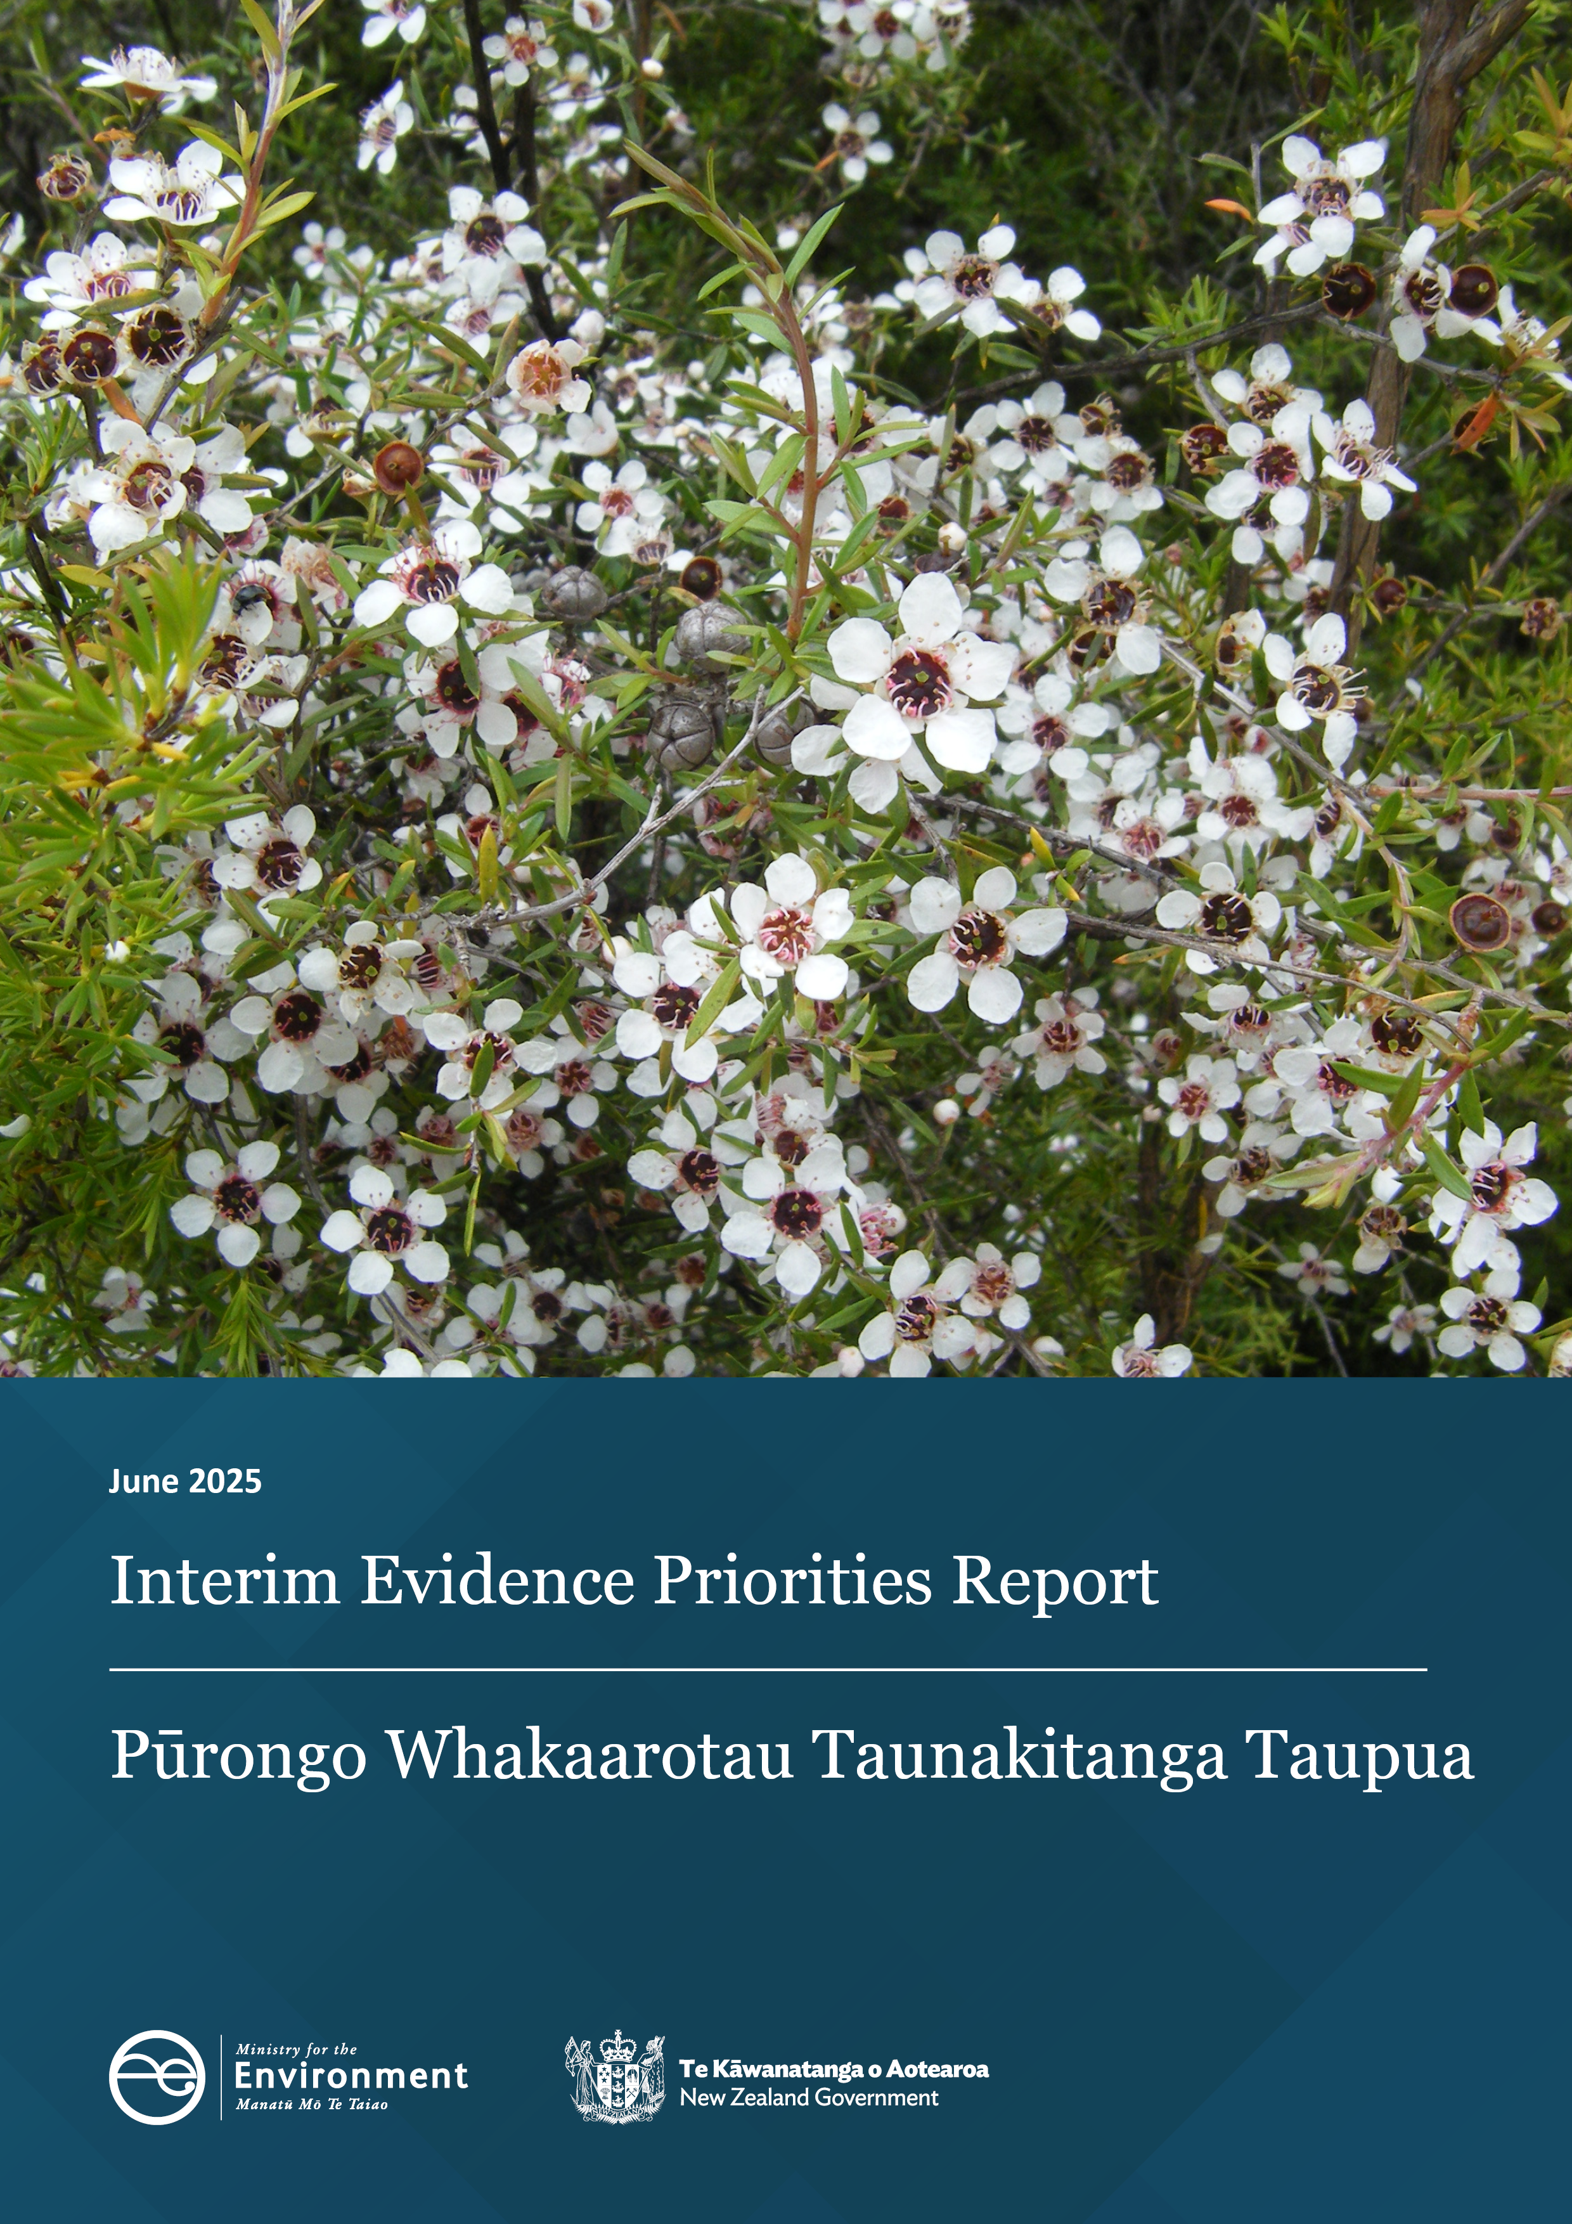

Disclaimer
The information in this publication is, according to the Ministry for the Environment’s best efforts, accurate at the time of publication. The Ministry will make every reasonable effort to keep it current and accurate. However, users of this publication are advised that:
- the information does not alter the laws of New Zealand, other official guidelines, or requirements
- it does not constitute legal advice, and users should take specific advice from qualified professionals before taking any action based on information in this publication
- the Ministry does not accept any responsibility or liability whatsoever whether in contract, tort, equity, or otherwise for any action taken as a result of reading, or reliance placed on this publication because of having read any part, or all, of the information in this publication or for any error, or inadequacy, deficiency, flaw in, or omission from the information in this publication
- all references to websites, organisations or people not within the Ministry are for convenience only and should not be taken as endorsement of those websites or information contained in those websites nor of organisations or people referred to.

This document may be cited as: Ministry for the Environment. 2025. Interim Evidence Priorities Report. Wellington: Ministry for the Environment.

Published in June 2025 by the
Ministry for the Environment
Manatū mō te Taiao
PO Box 10362, Wellington 6143, New Zealand
environment.govt.nz
ISBN: 978-1-991140-90-6
Publication number: ME 1899
© Crown copyright New Zealand 2025

Contents
Message from the Secretary for the Environment 5
Message from the Departmental Chief Science Advisor 6
Introduction 7
Terms used in this report 7
Background 8
How we developed this report 9
Evidence priorities 10
Strategic priority 1: Improve the resource management system to be more efficient and effective 10
Strategic priority 2: Strengthen the resilience of communities, businesses and places to climate change and natural hazards 11
Strategic priority 3: Support the transition to a competitive, low-emission, resource-efficient economy 12
Strategic priority 4: Improve the quality and accessibility of evidence for all decision-makers 12
Strategic priority 5: Ensure our investment, partnerships and relationships enable others to achieve impactful solutions 13
Investment packages 14
Next steps 15

Tables
Table 1: Key terms used in this report 7
Table 2: Evidence priorities under strategic priority 1 10
Table 3: Evidence priorities under strategic priority 2 11
Table 4: Evidence priorities under strategic priority 3 12
Table 5: Evidence priorities under strategic priority 4 13
Table 6: Evidence priorities under strategic priority 5 13
Table 7: Investment packages 15

Message from the
Secretary for the Environment

As Aotearoa New Zealand’s lead advisor on the environment and climate, the Ministry for the Environment deals with some of the biggest challenges facing our country now and in the future.
Whether it’s building resistance to natural hazards, reducing emissions, or developing a new system for planning and resource management, our advice stands or falls on the quality of our science, data and evidence.
We have a statutory obligation to report on some of this evidence, including six-monthly environmental domain reports, the three-yearly ‘Our environment’ report and the yearly Greenhouse Gas Inventory.
But gathering high-quality scientific information is not cheap. While New Zealand is uniquely vulnerable to a changing climate and natural hazards, there is still a lot we don’t understand about both our built and natural environments.
It is critical that our investments into evidence and data are deliberately designed to generate maximum benefit – to inform great policy-making, and better decisions by government, business and communities.
This Interim Evidence Priorities Report– the first for the Ministry – is a practical and significant step towards a more deliberate, accessible and focused approach to investing in the evidence that is critical to our role as lead advisor on the climate and environment.
The Ministry invests a considerable amount into this evidence base, but we also depend on research from New Zealand’s research institutes and information gathered by other central government agencies, local government, the private sector and communities.
We are just one partner in a collaborative effort to create an evidence base that is relevant, accessible, aligned and mutually reinforcing. It’s important that we share with our partners how we are planning to invest through this report.
By focusing on these priorities, we aim to build a resilient and informed evidence base that will support our efforts to enable people and places to thrive, now and in the future.

James Palmer
Secretary for the Environment

Message from the Departmental Chief Science Advisor

Aotearoa New Zealand’s environment and climate is changing. We rely on a healthy environment and a stable climate to support our way of life, but growing pressures mean we must be more deliberate in how we invest in evidence to guide decision-making.
Evidence matters because it provides the foundation for effective action, helping us identify risks, track environmental change and design policies that deliver lasting impact. Strong investment in evidence ensures we can anticipate challenges, measure progress and make informed decisions to shape our future.
As the lead advisor on environmental and climate policy, the Ministry plays a crucial role in ensuring data, science and evidence support robust decisions. This Interim Evidence Priorities Report helps clarify our evidence needs, providing a foundation for collaboration and alignment across the science sector, government agencies and wider stakeholders.
By setting out priority areas, this report enables better coordination, ensuring research investment is focused where it will have the most meaningful impact. Effective investment requires deliberate choices: every research effort must strengthen policy, reporting and environmental stewardship.
By working together and focusing our efforts, we can ensure the right evidence is available when it matters most, supporting informed action and collective impact.
This report is a tool for alignment, clarity and action—ensuring that our investments create the knowledge we need to lead with confidence.
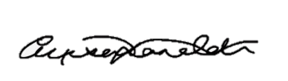
Alison Collins
Departmental Chief Science Advisor

Introduction
As Aotearoa New Zealand’s lead advisor on environment and climate issues, the Ministry for the Environment (the Ministry) relies on robust data, science and evidence to shape policy, assess performance, target investment and underpin our reporting responsibilities. This Interim Evidence Priorities Report ensures we invest in the right areas to strengthen decision-making and long-term impact. This will deliver on our mission:
As Aotearoa New Zealand’s lead advisor on environment and climate, we enable people and places to thrive, now and in the future.
Hei kaitohutohu matua o Aotearoa mō te taiao me te āhuarangi, ka whakaahei mātou i ō tātou iwi me ō tātou wāhi ki te puāwai, ināianei, hei te anamata hoki.
The report communicates our evidence needs and provides opportunities for central and local government, research institutions and industry to collaborate. Being transparent about our priorities allows us to maximise the impact of our investments.
This interim report directs our evidence investment for the financial year 2025/26. A comprehensive, longer-term report will be published in 2026. It sets the foundation for a long-term, strategy-led approach, ensuring sustained focus on high-impact areas.

Terms used in this report
Table 1 provides our definitions of the key terms used throughout this report.
Table 1: Key terms used in this report
Term | Definition
Evidence | Information that supports the development of evidence-informed policy and regulatory decisions and is derived from:  - systematic reviews  - data (including social sciences, economics and mātauranga)  - scientific research findings  - other reliable sources.
Strategic priorities | Five focus areas that drive the Ministry’s work programme, contained in our Strategic Intentions document.
Evidence priorities | Areas in which we need to invest strategically to address enduring and persistent issues or future opportunities.
Investment packages | Collections of projects aimed at answering our persistent and challenging questions.

Background
New Zealand’s environment and climate are changing, creating new challenges for resilience and economic growth. Evidence from Our environment 2025 highlights increasing climate variability, rising sea levels, more frequent extreme weather events, pests and shifting ecosystems—all of which impact the way we manage natural resources. These environmental changes directly affect key economic sectors such as agriculture, tourism and fisheries, which depend on stable climate conditions and healthy ecosystems.
The Ministry plays a critical role in shaping New Zealand’s response through resource management reform, adaptation planning, emissions reduction, investment and environmental reporting. Effective decision-making in these areas relies on robust data, science and evidence to ensure policies are informed, targeted and impactful.
New Zealand’s unique geography and biodiversity make it particularly vulnerable to environmental change, yet gaps in our understanding remain. We need critical evidence to strengthen resource management, assess climate impacts and improve emissions reduction strategies. Greater integration of local and traditional knowledge with modern scientific approaches enhances resilience and sustainability.
To address these challenges, a coordinated approach to evidence investment is essential. Targeting priority areas for data collection, scientific research and technology will improve risk management, strengthen climate adaptation and support sustainable economic development. By clearly communicating evidence needs, the Ministry aims to bring together agencies, researchers and industry to align efforts and build long-term resilience.

How we developed this report
The development of this report was guided by our Strategic Intentions, with the five strategic priorities providing the framework to ensure alignment with organisational goals.
We identified evidence needs through:
- Ministry environmental reporting (including Our environment 2025)
- existing government-wide and Ministry-specific research priority strategies and publications
- horizon scanning to anticipate emerging challenges over the next one to three years
- internal engagement.
Subject matter experts, including the Ministry’s Chief Advisors Network, played a key role in testing these priorities to ensure policy relevance, practical applicability and alignment with long-term environmental objectives.
To refine the evidence priorities, we applied the following criteria:
- urgency
- strategic impact
- enduring value.
The outcome is a strategy-led, future-oriented approach. It ensures investment in evidence is adaptable to changing contexts and priorities, sustainable and enduring – building a cohesive evidence base that remains fit for purpose now and into the future.
By providing clear signals on where our priorities are, we will help direct our own investment portfolio to areas of urgency and provide clarity to others in the system if they want to align funding bids or collaborate on topics of mutual benefit.
The evidence priorities in this report will drive our strategic investment packages. These packages are collections of projects aimed at answering our persistent and challenging questions. They are described in more detail below (see Investment packages).

Evidence priorities
Our evidence priorities are areas where we need to invest strategically to address enduring and persistent evidence issues or future opportunities. They are not all our evidence needs or the limit of what we will invest in each year.
The priorities are intended to be viewed together, and while they are presented under an overarching strategic priority, there are clear links from each evidence priority to strategic priorities other than their primary one.
Some of these evidence priorities will evolve over time. Our knowledge is constantly growing, our horizon shifting, and the evidence needs we see as a priority may expand or contract as work is completed. There will always be room for improvement and refining.

Strategic priority 1: Improve the resource management system to be more efficient and effective
The evidence priorities in table 2 address the questions associated with an efficient and effective resource management system – both through the reform process and ongoing performance. Together they will provide a long-term assessment of:
- what is working well in the system
- what needs improvement
- where there are roadblocks to efficiency
- how we can reduce costs while balancing development with environmental outcomes.
Table 2: Evidence priorities under strategic priority 1
Evidence priority | Description | Impact
Environmental, social and economic evidence showing the outcomes of a new resource management system on our natural and built environments and communities. | We require credible and comprehensive evidence from a diverse range of sources to analyse the outcomes of a more enabling and permissive resource management system. | Our advice, monitoring and reporting will demonstrate the long-term trends of our natural and built environments as part of a simpler, proportionate, consistent and implementable resource management system.
Understanding of interactions between environmental variables and the effectiveness of their management for safeguarding the environment. | We have sufficient evidence to justify the approach, limit setting, and what domains and attributes are selected. | Limits under the new resource management system will be grounded in robust evidence that is proactively identified and sourced to ensure it is timely, substantiated and fit for purpose.
Performance monitoring of the resource management system. | Economic and social data (including user experiences) to assess the performance of the resource management system from a range of inputs. For example, the cost of consenting, barriers to development and overall system performance. | This will enable greater:  - understanding of the costs of the resource management system  - accountability among system actors driven by clear performance metrics and cost analyses  - improved long-term monitoring by proactive data collection.

Strategic priority 2: Strengthen the resilience of communities, businesses and places to climate change and natural hazards
Addressing the impacts of climate change and natural hazards will require robust and credible information about:
- where risks lie
- the likelihood that a significant event occurs
- the potential impact on people and infrastructure.
Decision-makers at all levels of the system need trusted data to make adaptation decisions now and to anticipate what might occur in the future.
Table 3: Evidence priorities under strategic priority 2
Evidence priority | Description | Impact
Natural hazard risk and economic impact to our built environment and communities. | The development of comprehensive natural hazard identification and impact that is accessible, easy to use and regularly updated as new data is available. | This will help public and private sector decision-makers more accurately understand and model risk to take a more full and balanced approach to land-use decisions. It will provide evidence to identify natural hazards across the country, report spatial boundaries and levels of risk in those areas, and provide insights into the economic and social impact of these hazards.
Climate risks are assessed to inform adaptation solutions. | We require further evidence to understand the current climate risk and accurately model our future position. We will invest in priority datasets. | Adaptation needs are identified early, can be effectively implemented, and have significant value and impact. Local decision-makers have the information they need, when they need it. Adaptation solutions are grounded in evidence that considers current needs and future climate risks.

Strategic priority 3: Support the transition to a competitive, low-emission, resource-efficient economy
To undertake a transition to a competitive, low-emission, resource-efficient economy, we need to have a better understanding of where emissions are coming from and how to accurately measure them. We need to plan proactively for new methods to remove and reduce emissions.
This includes investigating areas where we have a lack of data on emissions or waste and ensuring the known sources of emissions are measured to the greatest accuracy possible – including developing new methods to undertake this. We need to find new ways to remove carbon dioxide from the atmosphere. This will give us more, viable options to meet our climate targets and reduce emissions.
Table 4: Evidence priorities under strategic priority 3
Evidence priority | Description | Impact
A holistic view of measuring and understanding how to reduce emissions and contaminants from the waste system. | We need to better understand the types and volume of emissions and contaminants that are being generated from waste – especially in areas we traditionally have little information on. | This will improve our advice and reporting on the waste system by taking a wider system view and investigating areas where little is currently known – resulting in greater precision and consistency of how we measure waste gas emissions and composition and contaminants.
Exploring the next frontier of removals and emissions reduction to improve projections, inventory and emissions reduction policy. | Our carbon reporting relies nearly entirely on planted forestry and the soil carbon inventory. We need to better understand other avenues for carbon sequestration and impacts from changes to land use. | Our evidence base improves:  - our understanding of trends and future emissions profiles  - the range of removal tools available to us  - emissions reduction policy.

Strategic priority 4: Improve the quality and accessibility of evidence for all decision-makers
This is where our internal data, science and evidence investments can have the greatest impact. These priorities address two key areas that are often repeated:
- critical knowledge gaps that cause risk and credibility issues
- accessibility of the data we and others collect.
These evidence priorities apply strongly to the other priorities. We see them as a driving force towards strategic investment in foundational evidence and common datasets and models. They support the evidence needs of Ministry and the public who use the data collected.
Table 5: Evidence priorities under strategic priority 4
Evidence priority | Description | Impact
Ensuring our underpinning climate and environmental evidence base is relevant, credible and legitimate by filling data gaps. | To address our fragmented and reactive evidence base we will invest in baseline data building (eg, land-use information and mapping) and improving reliability and consistency of our data. | We will have a fit-for-purpose evidence base with high-quality and continuously improving evidence that supports decision-makers.
We can collate, analyse and make accessible the data we and others collect on the climate and environment. | We will:  - invest in improving the methods and efficiency of data collection and collation  - minimise errors and risk through standardisation and big data analytics  - ensure that the data we collect is readily accessible to our partners. | The Ministry, local government and the private sector can access high quality, nationally consistent and reliable data in a timely way.

Strategic priority 5: Ensure our investment, partnerships and relationships enable others to achieve impactful solutions
We aim to ensure that the Ministry supports local and community-based evidence building to make high-quality decisions and achieve impactful solutions. This should be done in a meaningful way that respects our partnerships and obligations and develops methods that can clearly show the benefit of local evidence.
We also want to increase our understanding of the economic and social outcomes of investing in the environment – both from a public funding and a private investment perspective. There is an evidence gap of the long-term benefits of environmental investment and how scaling investments can have exponentially greater benefits and returns.
Table 6: Evidence priorities under strategic priority 5
Evidence priority | Description | Impact
Using case studies and pilot studies to understand how local evidence building and community-based approaches that grow and share local knowledge and mātauranga Māori can bolster our national evidence base. | We will invest in evidence that supports local environmental data and evidence activities to build local knowledge, mātauranga Māori and community-based approaches that contribute to a larger national evidence base. | Our evidence base supports and informs locally tailored solutions for communities. Community-based/generated data, knowledge and mātauranga Māori can be shared with the Ministry in a way that is meaningful, designed appropriately and mutually beneficial.
Market and investment analysis to support the public and private sector in scaling investment in adaptation/retreat, biodiversity, emissions reduction, and sustainability. | We can provide credible economic and environmental analysis that will support investment programmes that leverage co-funding opportunities, are scalable and are justified by data that shows positive outcomes. | Our evidence base clearly demonstrates the effectiveness of environmental investment, where this can have the most impact, and analysis of the long-term returns.

Investment packages
Our investment packages are where we plan to strategically invest in the next one to three years. They are the areas where we can forecast the biggest shifts in our evidence base. They procure high-quality and foundational data and insights into the impact of climate change and natural hazards, ensuring that the data we and others collect is readily accessible and usable.
These are not all of our investments, rather they are where we have prioritised our efforts within the limits of constrained budget and capacity.
We are actively directing our investment efforts through strategic priority 4, recognising it as the area with the greatest potential to drive impact across all other strategic priorities through better evidence that is useable and accessible. This focus leverages the Ministry’s position as lead advisor and promotes the importance of standardisation and national consistency in evidence use.
We used the following principles to identify the most suitable investment packages to deliver on the two evidence priorities under strategic priority 4:
- Enduring benefit: Addressing challenging and enduring evidence issues in the Ministry that have rarely been progressed because of this challenge but will have a significant impact if completed.
- Cross-cutting utility: Broad and cross-cutting impact for the Ministry with outcomes that are relevant for multiple work programmes.
- Co-funding opportunities: There are realistic pathways to collaboration and co-funding opportunities from external organisations.
- Diversification of the evidence base: Contributing to a diversified and broader evidence base for the Ministry that includes a variety of evidence such as social sciences, economics and mātauranga Māori.
- Urgency: The evidence need is critical from a risk or credibility perspective, or to advance prioritised Ministerial objectives.
Our investment packages are explained in table 7.

Table 7: Investment packages
Title | Description | Impact
Nationally Consistent Frameworks for Natural Capital Accounting and Limit Setting | A coordinated approach for measuring and valuing natural capital, enabling consistent, multi-agency use. | Frameworks and standardised accessible data enable use of locally and regionally collected data to measure and value New Zealand’s natural capital. For example, standardised regional and national data is essential to infrastructure planning and establishing and tracking progress against limits.
National Land-use Mapping | A comprehensive national-scale land-use information system to support spatial planning at a local and national level. | Resource managers and decision-makers have information on what activities occur where to support development and environmental management decisions. For example, collating land-use data into one information system to identify land tenure, legal constraints and infrastructure assets, and enable cost-savings in data queries and efficient development planning.
Advanced Technology for Natural Hazard Risk Profiles | Emerging technologies such as automated update methods and remote sensing to improve efficiency, accuracy or resolution. | Better risk modelling and accuracy to make informed decisions around natural hazards. Data to provide insights into social and economic impact. For example, investing in flood mapping data and management assets (informed by the Land-use Mapping Investment package) will provide foundational data for the National Adaptation Framework.
Improving Climate Emissions and Natural Hazards Data and Accessibility | Investing in accessible, usable and quality climate and natural hazard data in a single place for all New Zealanders to use. | All New Zealanders have access to data that empowers them to engage meaningfully with us and make better decisions with high-quality data. Better infrastructure and accessibility to data also reduces costs and time for policy analysis.

Next steps
Our Interim Evidence Priorities Report outlines the Ministry’s key evidence needs and how we are planning to progress these through our investment packages. It also provides a platform for discussions across the sector, helping to align priorities and create opportunities for collaboration.
Over the coming months, we will engage further to refine these priorities and explore how they can support long-term investment in science, data and evidence. A more comprehensive report will be released in early 2026, building on this foundation to strengthen alignment and impact.
For any questions or to discuss investment opportunities, please contact us at science.advice@mfe.govt.nz.

