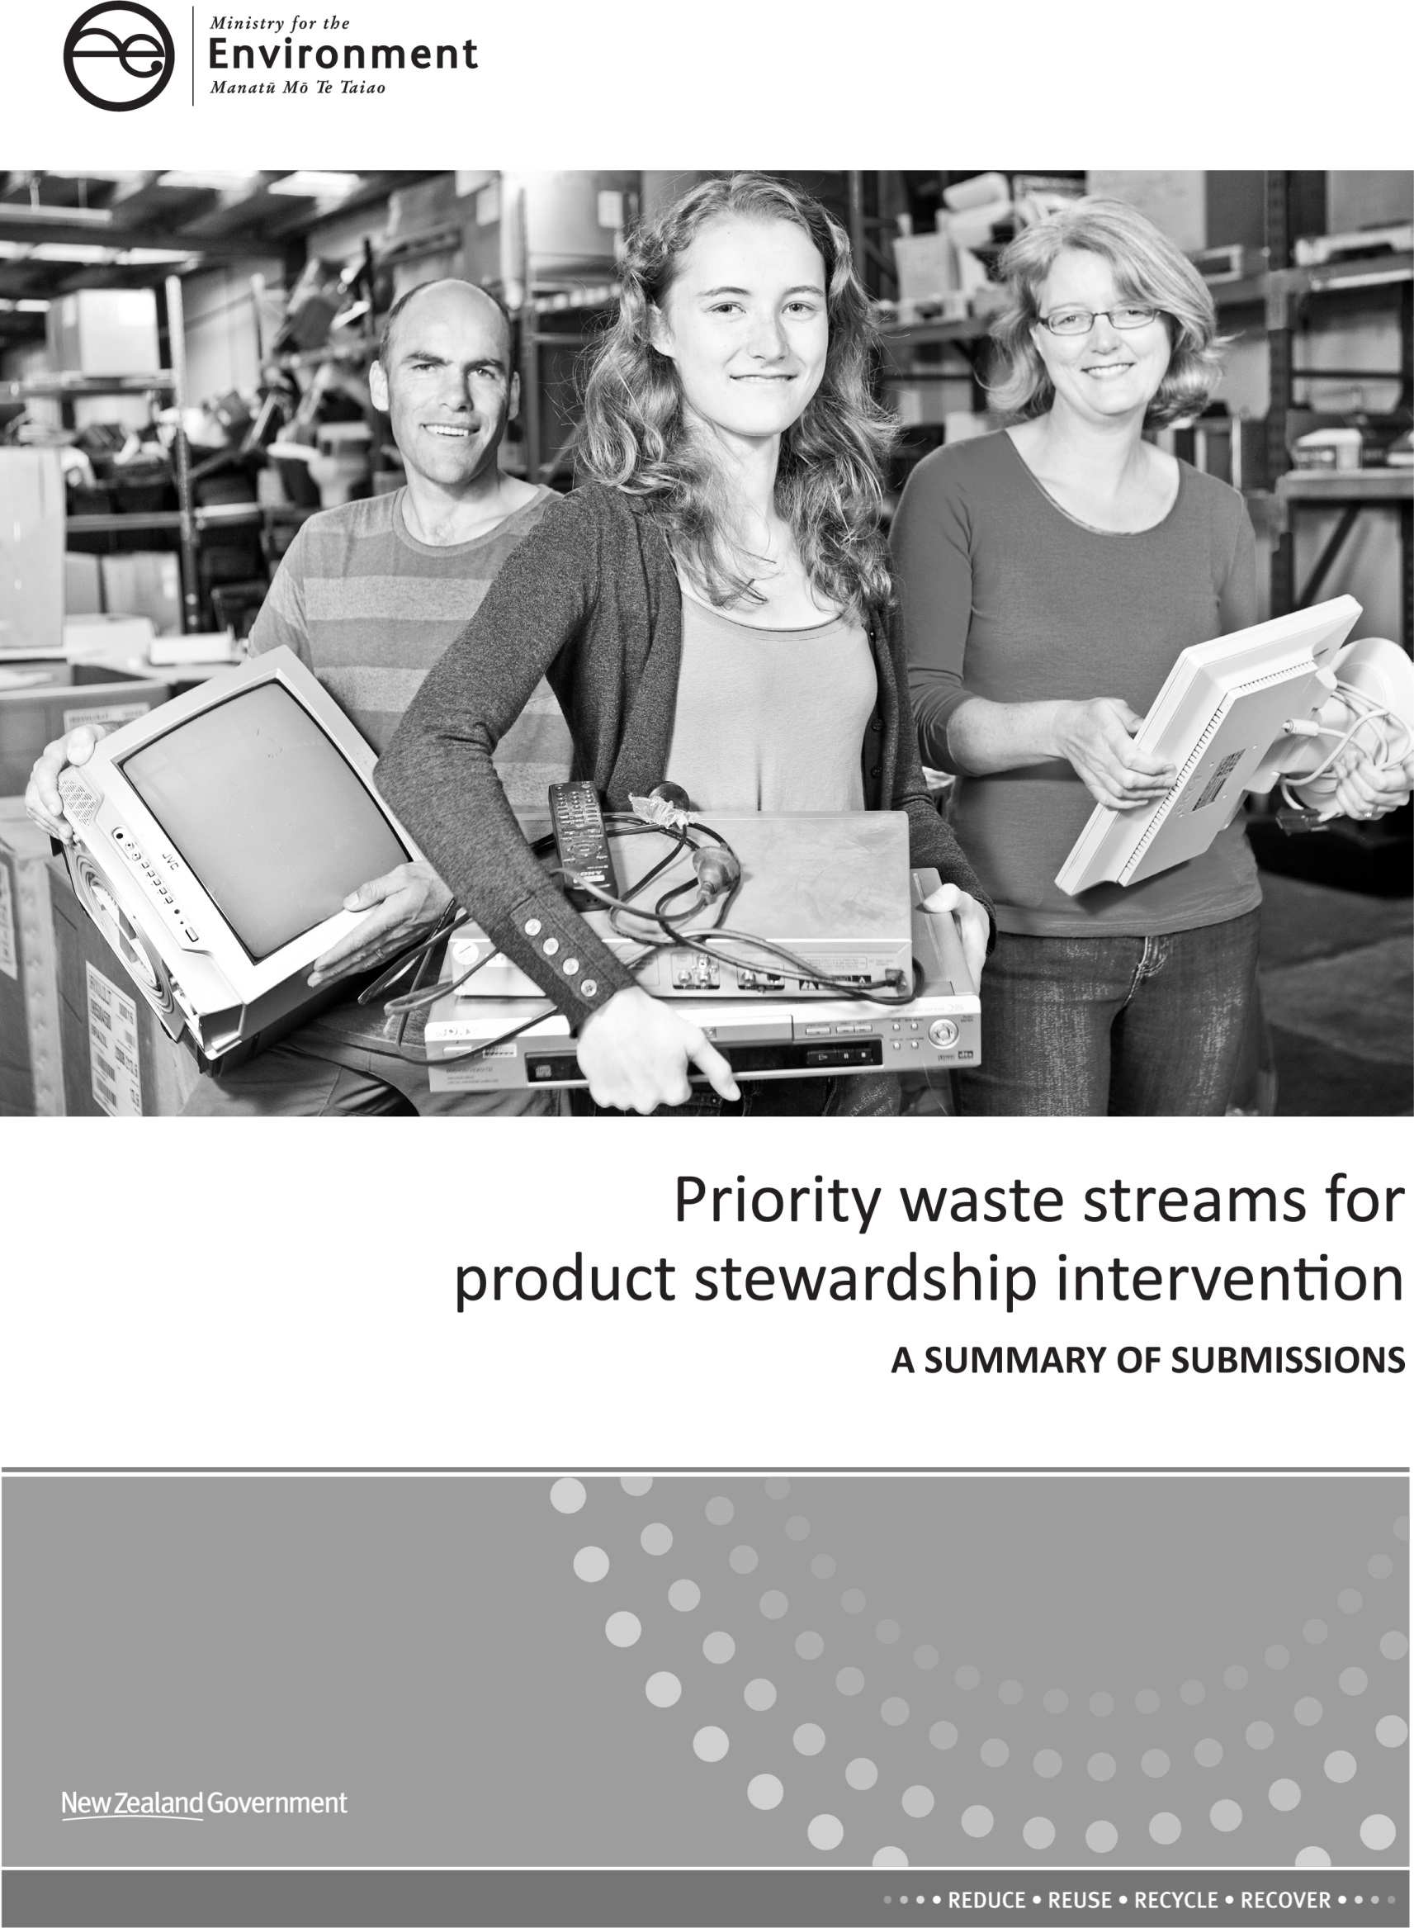

This report may be cited as: Ministry for the Environment. 2015. Priority waste streams for product stewardship intervention: A Summary of Submissions. Wellington: Ministry for the Environment.

Published in April 2015 by the
Ministry for the Environment
Manatū Mō Te Taiao
PO Box 10362, Wellington 6143, New Zealand
ISBN: 978-0-478-41289-5 (print)
978-0-478-41291-8 (electronic)
Publication number: ME 1196
© Crown copyright New Zealand 2015
This document is available on the Ministry for the Environment’s website: www.mfe.govt.nz.

Contents
Executive summary 5
Introduction 6
Objectives of the discussion document 6
Consultation 6
Approach to summary 7
Notes on conventions used in this document 7
Submissions received 8
Number and type of submissions 8
Types of submitters 9
Consultation theme 1: Product stewardship priorities 10
Consultation theme 2: Priority product declaration 28
Electrical and electronic equipment 37
Tyres 41
Agrichemicals and farm plastics 42
Refrigerants and synthetic greenhouse gases 46
Appendix 1: Indicative process – product stewardship decisions 49
Appendix 2: Consultation meetings held 50
Appendix 3: Priority waste streams for product stewardship intervention discussion document OFFLINE SUBMISSION FORM 51
Appendix 4: List of submitters 58

Figures
Figure 1: Breakdown of how the submissions were received 8
Figure 2: Breakdown of submissions received by submitter type 9
Figure 3: Breakdown of submissions by the response to question 1(a) 10
Figure 4: Breakdown of submissions by the response to question 1(b) 15
Figure 5: Breakdown of submissions by the response to question 1(c) – electrical and electronic equipment 20
Figure 6: Breakdown of submissions by the response to question 1(c) – tyres 22
Figure 7: Breakdown of submissions by the response to question 1(c) – agrichemicals and farm plastics 23
Figure 8: Breakdown of submissions by the response to question 1(c) – refrigerants and other synthetic greenhouse gases 24
Figure 9: Breakdown of submissions by the response to question 1(d) 25
Figure 10: Breakdown of submissions by the response to question 2(a) 28
Figure 11: Breakdown of submissions by the response to question 2(b) 31
Figure 12: Breakdown of submissions by the response to question 2(d) – same scope as Australia 37
Figure 13: Breakdown of submissions by the response to question 2(d) – include other electrical and electronic equipment 38
Tables
Table 1: Summary for submitter’s comments on the criteria 12
Table 2: Other product groups suggested by at least three submitters or more 26
Table 3: Other product groups suggested according to submitter type 26
Table 4: Frequency of product group mentioned by submitters 28
Table 5: Costs and benefits identified by submitters that would arise from mandatory product stewardship scheme 34
Table 6: Details of public consultation workshops 50
Table 7: Details of meetings held during consultation period 50

Executive summary
On 21 May 2014, the Government released a discussion document asking whether to intervene to improve the management of four product waste streams: electronic and electrical equipment; tyres; agrichemicals and farm plastics; and refrigerants and other synthetic greenhouse gases.
Feedback was sought on the criteria for selecting priorities; whether the four product waste streams identified were the right waste streams to be the focus of potential government intervention; and whether any of the four products should be declared priority products under the Waste Minimisation Act 2008, requiring a product stewardship scheme to be developed and accredited. This document summarises the feedback received.
The consultation included two themes: product stewardship priorities and priority product declaration. In response to the first theme, the majority of submitters agreed with the criteria for selecting product stewardship priorities. Many responses highlighted the need to weight the criteria, valuing ‘risk of harm’ and ‘resource efficiency’ higher than the other criteria. Many submitters suggested that ‘industry readiness’ isn’t necessary as a criterion.
For all four identified waste streams, a majority of submitters were supportive of these products as being the focus of potential government intervention. Many submitters want regulations to be developed to create a ‘level playing field’ for managing these product waste streams, but want to make sure any mandatory product stewardship schemes are well designed. A number of submitters identified additional priority waste streams; the most frequently mentioned being packaging and/or plastic/plastic bags.
For the second theme about declaring any product groups as a ‘priority product’, the majority of submitters were supportive of priority product declaration, with most submitters wanting it to happen sooner rather than later. Some submitters recommended that the Government consider a broader range of tools than just product stewardship for managing waste streams, and others suggested further research and analysis be undertaken before priority product declaration is made.
All the local government submissions were positive for prompt action on the four proposed – and other – waste streams. From a local government perspective, regulatory intervention from central government could achieve benefits that outweigh the costs.
In general, the industry (waste) submissions were predominantly focused on the particular waste stream that the organisation provides a service for. They were supportive of the four proposed priorities and of government intervention, with the exception of a small number of submitters who disagreed with some of the specific proposals.
The majority of submissions from the community recycling organisations were supportive of the proposals, welcomed the progress being made, and were keen to be involved in further consultation about the specifics of potential regulatory intervention.
Most submissions from industry-specific representative bodies related to those waste streams that most affected their members. For example, The Agrecovery Foundation focused on agricultural chemicals and farm plastics. Although largely supportive of the proposals, many of the industry representative bodies expressed a need for further analysis of costs and benefits and more consultation. A small number of submitters were not supportive of the proposals.
Introduction

Objectives of the discussion document
The Waste Minimisation Act 2008 (WMA) provides tools to minimise waste and its harmful effects and maximise benefits from resource recovery. Since the WMA came into effect, the Government has encouraged voluntary product stewardship efforts as a first priority. However certain waste streams continue to present disposal challenges or market barriers to effective recovery, and Government intervention may be warranted.
The discussion document Priority waste streams for product stewardship intervention sought New Zealanders’ views on whether Government should intervene to improve the management of four product waste streams: electrical and electronic equipment; tyres; agrichemicals and farm plastics; and refrigerants and other synthetic greenhouse gases.
The discussion document asked whether Government had correctly identified the four waste streams as priorities for action, or whether there were other priorities the Government should focus on. This included consulting on whether any of these waste streams should be declared as ‘priority products’ under the WMA and if so, when.
The discussion document was designed to seek feedback and information to inform the selection of waste stream priorities and the possibility of priority product declaration for them. It was not designed to determine the form of any mandated product stewardship scheme.
If the Government decides to proceed with considering regulatory options to manage any waste stream, such as mandatory product stewardship schemes under the WMA, consultation will be undertaken with significantly affected parties and all decisions will be made by the Minister for the Environment and Cabinet. A diagram showing the regulatory process is provided in Appendix 1 and explained in more detail in the discussion document Priority waste streams for product stewardship intervention.

Consultation
Public consultation on the discussion document was held from 21 May 2014 to 2 July 2014. An electronic copy of the document was placed on the Ministry’s website and hard copies were distributed at consultation workshops. In addition, a notice announcing the consultation was placed on the Ministry’s website and approximately 2100 stakeholders were emailed notifying them of the consultation.
From 6 June 2014 to 23 June 2014, the Ministry held seven public meetings plus nine smaller targeted meetings or teleconferences with interested stakeholder groups. The purpose of these meetings was to present the background and context for the discussion document and answer questions about the content of the discussion document or the submission process. (See Appendix 2 for the full list of meetings). This report summarises the 216 written submissions received by the Ministry for the Environment during the consultation period on the priority waste streams for product stewardship intervention.

Approach to summary
All submissions received were assigned a unique identification number and classified according to the type of submitter (for example, individual, local government, industry (waste)). Where a submitter fell into more than one submitter type category, we made a judgement as to what would be considered the main submitter type. Some submissions received were anonymous. These have been recorded as ‘unspecified’ submitter type.
Every effort has been made to ensure the report accurately summarises the overall feedback on the discussion document and the proposals outlined within it. However, we cannot guarantee that all views are reflected in this report.
The submissions received were a mix of online form submissions, offline form submissions (which provided the questions with response options to select from), and separate documents either emailed to waste@mfe.govt.nz or posted to the Ministry. Every submission we received was acknowledged.
Submissions were collated in a central database. In the database, the responses ‘unspecified’ and ‘unsure’ were combined. Our analysis does not differentiate between submitters that selected ‘unsure’ from the options on the submission form and submitters that were not clear in their written submission what their position was to a particular question.

Notes on conventions used in this document
Where numbers and percentages are used when referring to the number of submitters who supported or opposed specific proposals, these are based on the Ministry’s interpretation of the submissions. Protocols were established to ensure as great a degree of consistency in interpretation as possible. Submissions received in the submission form format did not require interpretation. See Appendix 3 for the offline submission form.
Selected quotes from submissions have been included in this document. They have been selected for their value in illustrating issues raised by submitters or because they articulate issues in a way that is difficult to paraphrase without losing the original meaning. Their inclusion in this document does not imply that they have been given more weight over and above submissions that have not been cited specifically.
Where quotes from submissions are used, any unexplained acronyms or minor errors have been amended to allow for improved readability. Every effort has been made to ensure citations of submissions are accurate.
Some submitters raised issues about product stewardship, The Commerce Act, and the management and minimisation of waste that are considered outside the scope of the discussion document. These have not been considered as part of this summary process.
Submissions received

Number and type of submissions
In total 216 submissions were received on the discussion document. Figure 1 provides a breakdown of how the submissions were received. A full list of all submitters is available in Appendix 4.
Figure 1: Breakdown of how the submissions were received
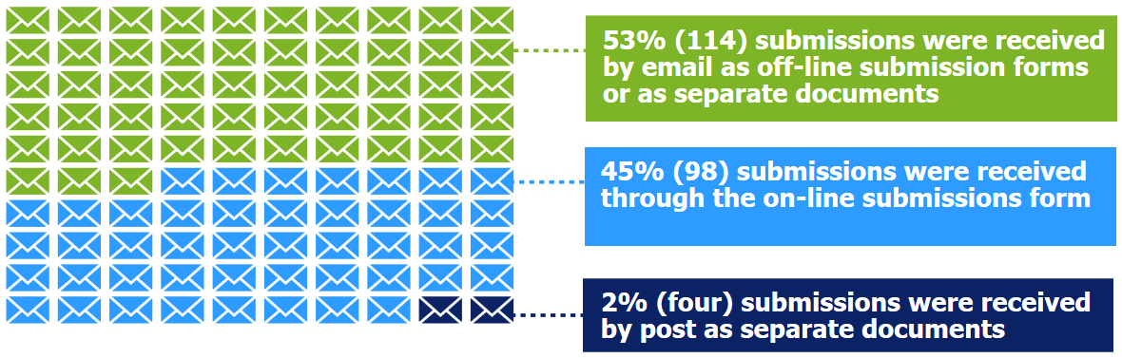
Types of submitters
Figure 2 provides a breakdown of submissions received by submitter type.
Figure 2: Breakdown of submissions received by submitter type
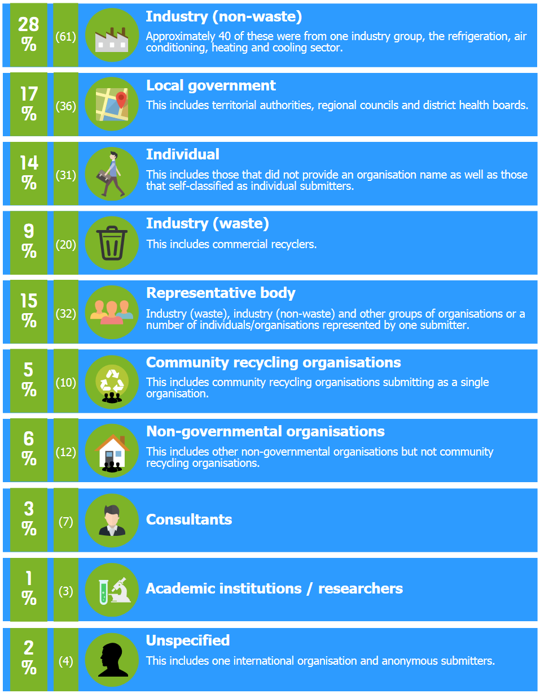
Consultation theme 1: Product stewardship priorities
In the discussion document the following waste stream criteria were proposed for selecting product stewardship priorities:
- risk of harm
- resource efficiency opportunities
- voluntary measures insufficient
- industry readiness
- current producers (not just legacy products).
These criteria were compared against a range of waste streams.
- Do you agree that these waste stream evaluation criteria are suitable to select product stewardship priorities, consistent with Waste Minimisation Act objectives? If not, please suggest alternatives.
Figure 3: Breakdown of submissions by the response to question 1(a)
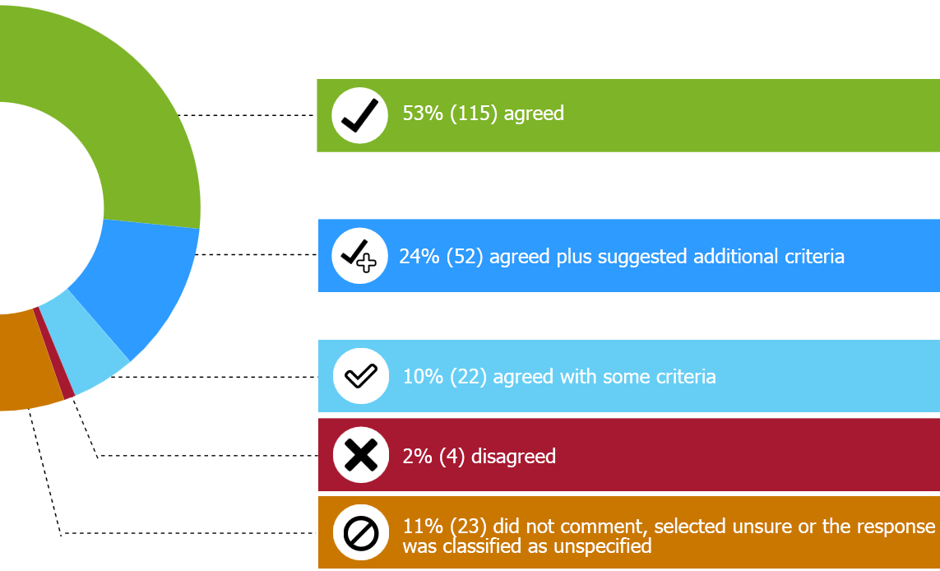
Of those in agreement, 38 per cent (44) were from the industry (non-waste) category followed by 17 per cent (19) for local government and the individual category. For the following categories, 50 per cent or more of the submitters within that group agreed with all of the proposed criteria: individual, industry (non-waste), local government, and unspecified.
The submissions from the refrigerants sector noted that all of the proposed criteria applied effectively to refrigerant and other synthetic greenhouse gases.
The Employers and Manufacturers Association agreed with the criteria but said the criteria would need to be ‘future proofed’ to accommodate new products coming on to the market.
The majority of additional criteria were proposed by submissions from the local government or representative body categories.
Additional or alternative proposed criteria included:
- lifecycle analysis
- manufacturing/design
- consumer readiness
- volume of waste
- public concern/community expectations
- overall scheme cost
- environmental nuisance
- behaviour change and education
- product complexity
- infrastructure capacity
- costs to government/financial impact
- benefits of recovery.
Some submitters proposed an alternative approach of amending the harm and resource efficiency opportunities criteria and combining the following three criteria:
- harm (environmental and human health)
- benefits (resource efficiency, economic and social)
- practicality (voluntary measures ineffective, suitable for product stewardship).
One submitter, Making a Difference for Central Otago, raised the point that poor quality products and built-in obsolescence are huge and unnecessary contributions to our waste streams therefore reliability and durability of a product along with the ability to repair, reuse or recycle it should be considered.
Several submitters, across more than one category type, agreed with the proposed criteria but suggested the criteria are weighted according to importance. Risk of harm and resource efficiency criteria were considered by submitters as being of most importance and therefore should have a higher weighting.
Ten per cent (22) of the submitters agreed with some of the proposed criteria and most of the submitters provided their reasons why. For example, the WasteMINZ Territorial Authority Forum Steering Committee submission agreed with the criteria with the following amendments: industry readiness should be given a lower priority, the risk of harm criterion should be expanded to consider both toxicity and quantity of waste streams and the cost to government (central and local) of waste management, and recycling operations under the status quo should be considered as an additional criterion. The Forum did not agree with the assessment of the packaging product group against the criteria and felt that risk of harm should be amended to “+ - high/probably”.
Of the five criteria proposed, Table 1 provides submitters’ recommended amendments or comments against each one.
Table 1: Summary for submitter’s comments on the criteria
Criterion | Summary of submitters comments on the criteria
Risk of harm | - It is not clear how harm is defined or how relative harm is assessed  - Short-, medium- and long-term impacts should be considered in the assessment  - Should be expanded to include risk of harm to New Zealand/New Zealanders and other countries/people in other countries as our waste is largely exported  - Should be clarified to include harm to the environment and harm to human health  - Good criterion as it links to the clean, green image New Zealand portrays to international markets  - Needs to expand to consider the toxicity of the waste stream and the quantity of the waste stream  - Legacy products should still be considered and assessed  - Clarify whether it is harm just when it becomes waste  - Expand to consider the scale of risk, is it only a few individuals or the entire population and ecosystem  - Must include impact on climate change
Resource efficiency opportunities | - Needs to include materials and energy conservation and contribution to a circular economy  - Not meeting this criterion should not be a reason to not address the harm  - Consider reuse and recycling  - Only subjectively described and in a manner that is difficult to interpret  - Should include reliability and durability of product
Voluntary measures insufficient | - There is not enough public data to determine if the schemes are decreasing the net waste for the targeted waste streams  - Should be that voluntary measures are not able to achieve their full potential without intervention to reduce free-riding
Industry readiness | - This is not a useful criterion/should not be used/needs further consideration/not a useful classification  - Not meeting this criterion should not be a reason for not prioritising government intervention  - Criterion does not reflect that not all industry players are seeking regulatory intervention  - Should be given a much lower priority than the other criteria  - Industry readiness does not necessarily equate to industry willingness, free-riders are not willing or ready. This criterion could also include infrastructure readiness/capacity or industry preparedness  - It could prevent some types of waste ever being selected because producers are not always keen to recycle their waste, will oppose mandatory product stewardship  - The criterion reflects historical investment in bringing parties together and that it will always be a problem for some  - With a reasonable lead-in time industry can be ready
Current producers | - This criterion needs more work. Brands come and go in the market or same brand changes the products it sells  - Need to clarify exactly what it means  - Needs to cover new waste streams that may arise due to technology changes
Particular comments about the criteria that illustrate the general stance of the submitters, particularly for the industry readiness criterion, include:
Beta Antifeeze Ltd
“All [the criteria] are relevant and important and a good base to evaluate. What is of concern is that there appears not to be the level of information known of each area of waste to evaluate the list in the discussion document in a consistent and fair way. There is no way of making a good judgement to prioritise waste as we don’t have all the facts.”
Auckland Council
“Agree that the suggested criteria are suitable to select product stewardship priorities. However, we recommend a weighting or ranking criteria which would provide a more robust assessment of products suitable for regulatory intervention.”
Envision New Zealand
“Suggest that volume is added to the list because a low toxicity product of huge volume results in other harms, such as speeding up the day when new landfills will be required, significant costs on society in terms of disposal costs and loss of valuable landfill space.”
Sarah O’Bryan (Individual who works for Environment Centre Hawke’s Bay)
“I think it is important to clarify that ‘industry’ doesn’t just refer to the producers of the harmful products, but also the end-of-life receivers, dismantlers, recyclers and/or waste disposers. It might be better to sub-categorise ‘industry readiness’ to include producer/distributor recognition of harm and end-of-life systems availability. That way, measurements and decisions can more accurately reflect where the ‘readiness” is coming from.”
Taranaki Regional Council
“Do not think it is necessary to wait for industry readiness before taking action. Government can provide the leadership and impetus as some sector of industry may need this or be waiting for this.”
WasteMINZ Territorial Authority Forum Steering Committee
“Disagree that industry readiness should be given the same priority for assessment in the longer term. There may be extreme cases where the risk or volume associated with a particular product may be sufficiently significant that a product stewardship scheme is needed even where industry is not ready for a scheme.”
Patterson Environmental Ltd
“I do not agree that the criterion industry readiness should be used. This will be taken by some industries as a signal to never be ready….with a reasonable and well communicated lead-in time and given that ample experience exists overseas, industry readiness should not be a criterion.”
Fonterra Co-operative Group Ltd
“Generally agree with the evaluation criteria proposed. However, of all the criteria, Fonterra considers that the best indicators as to whether or not further intervention is required will be: industry readiness to find better solutions; and where voluntary measures have been tried, and with good engagement by willing players, but participation rates and waste minimisation have been low.”
Environment Network Manawatu
“If a legacy product is found where the risk of harm and/or the possibility of recovering resources is sufficiently high, we would submit that it would be worthwhile declaring that product a priority in spite of any implementation challenges.”
WasteManagers
“There are a number of question marks against the criterion of industry readiness. For the following waste streams industry mechanisms exist to improve the management of these waste streams therefore it is not a question of industry readiness rather than industry not being pushed to improve the process lifecycle by implementing effective product stewardship schemes. These include: used motor oil, industrial hazardous waste, treated timber, paint, batteries, mercury lamps and packaging.”
Four submitters indicated that they disagreed with all of the proposed criteria.
Carter Holt Harvey sought clarification of three of the criteria, in particular risk of harm and whether it should assume a legal disposal option as compared to illegal dumping; and whether the resource efficiency category meant supporting new business opportunities is not a justification for product stewardship, and
“‘Industry readiness’ is questionable particularly where the majority of the country’s recovery and recycling has developed without a framework of a product stewardship scheme. The suggestion that significant sectors of industry are seeking greater regulation needs to be explained.”
Fujitsu stated that consideration should be given to the maturity of the recycling infrastructure as it may become cost prohibitive if the recycling infrastructure is immature. Secondly they seek flexibility in the transboundary movement of waste as there may not be the facilities onshore to manage the hazardous waste materials.
Tyreless Corporation agreed with the proposed headings but considered tyres to be the biggest problem that needs fixing and that the processors are ready.
Sustainability Trust stated that the scope of the criteria was too narrow and not enough attention had been given to the benefits from waste minimisation. They also suggested splitting the waste streams into those that product stewardship can be effectively used for and those that are better suited to other intervention tools.
- Do you agree with the assessment of waste streams against these criteria outlined in Appendix 4 of the discussion document? If not, please provide information or propose improvements.
Figure 4: Breakdown of submissions by the response to question 1(b)
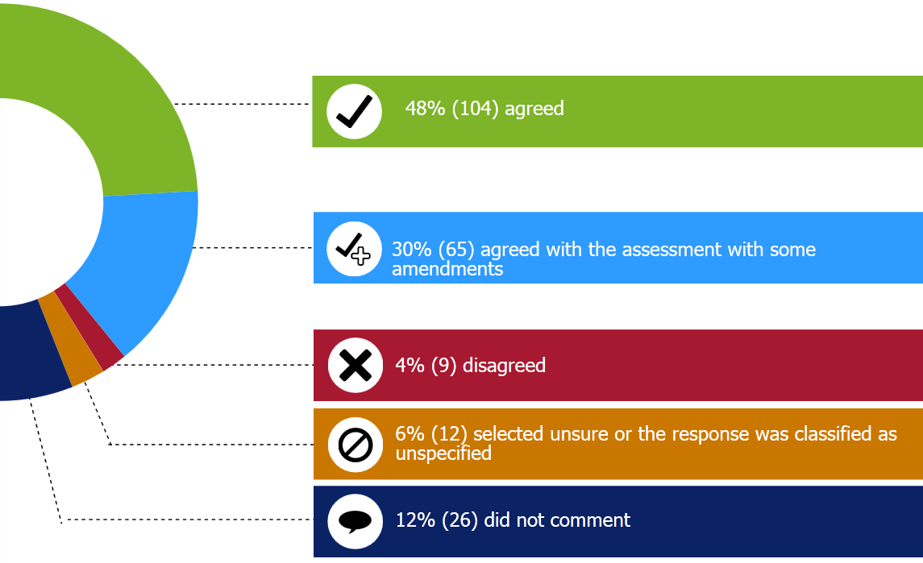
Many of the submitters limited their comments and assessment to the waste stream of most interest to them, that impacts them the most, or that they were most knowledgeable about.

E-waste
Some submitters commented specifically on the assessment of the criteria against the e-waste waste stream. For example, confirming that industry is ready to recycle these products and although there are challenges ahead, the public support is there.
Two submitters, Ecotech Services and eDay NZ Trust said the criterion current products was not correct as it is likely that the complete range of current products making up e-waste can be subjected to product stewardship, so should be given the assessment of ‘very high/definitely’.
The Employers and Manufacturers Association questioned whether the assessments for risk of harm and resource efficiency opportunity may be flawed due to the change in new products entering the market and that while the rating may be true for older products it is not be true for new products. The Consumer Electronics Association New Zealand shared this opinion noting that new technology televisions do not pose a toxicity issue and that the level of recoverable material is less than cathode ray tube televisions. They stated that the level of hazard in televisions is decreasing but the volume increase in other forms of e-waste poses an issue.
The Scrap Metal Recyclers Association New Zealand questioned whether the description for the criterion resource efficiency opportunity was a little high level and that if the Government could help remove obstacles encountered by the sector the voluntary participation would be higher. They also stated that the industry readiness criterion should place a heavy weighting on the state of evolution of solutions and should be assessed in terms of the availability of low complexity practical disposal solutions that are relatively easy to implement, commercial level playing fields, and “citizenship”.
The Warehouse Group disagreed with the assessment of this waste stream for both resource efficiency opportunity and industry readiness. They stated that efficiency opportunities are only available within some e-waste types and there is a considerable amount of industry discussion but this translates to limited industry readiness. The scale of potential impact such as risk of harm should be a consideration in the criteria. They stated that making a waste stream a priority should trigger the building of efficiency and industry readiness.
The Australia Information Industry Association also disagreed with the assessment noting that there is not enough evidence to support the assessment for risk of harm and the assessment is higher than international evidence would support. They want to place greater emphasis on the resource efficiency opportunity criterion.
The Telecommunications Forum New Zealand did not agree with the assessment of the criteria, particularly for mobile phones.
Fisher and Paykel stated
“We would submit that its scope should be restricted to those products where a significant percentage are presently disposed of inappropriately. In New Zealand, because their scrap value is such that they are already recycled, white appliances are not in this category.”

Agrichemicals and containers and other farm plastics
Some submitters commented specifically on the assessments of agrichemicals and farm plastics. The Southern District Health Board pointed out that agrichemicals have the most direct health risks compared to the other proposed priority waste streams. The Agrecovery Foundation and Agcarm Inc said the definition for resource efficiency opportunities for agricultural chemicals was not clear. For this part of the waste stream there would appear to be no resource efficiency. They pointed out that there is some through the sale of plastic from their containers which is made into other products, but the value of the new product is low.
Tredi New Zealand Ltd SA questioned whether industry was ‘definitely’ ready for intervention of agrichemicals. They stated that the agrichemicals industry is not fully supportive of the voluntary Agrecovery scheme and does not appear to have any interest in action to deal with legacy agrichemicals. Tredi stated there was a mixed message in the way the matrix in the discussion document is presented on this issue.
Three submitters thought the assessment of risk of harm for farm plastics needed to be reviewed. For example, 3R Group Limited thought the waste stream categories were too broad and used farm plastics as an example. They stated that the assessment is different when applied to a narrower approach. Environment Canterbury suggested that the risk of harm for other farm plastics is ‘very high/definitely’ due to the majority of it being burned or buried in farm pits in Canterbury, Waikato, and Bay of Plenty regions. Agpac Ltd (Plasback) pointed out that the industry readiness criterion for farm plastics should be rated ‘high/probably’ rather than ‘unknown’.

Tyres
Specific comments on the assessment of the criteria against the tyres waste stream did not add any new information relating to risk of harm than that outlined in the discussion document. A few submitters (five) suggested that the risk of harm rating should be very ‘high/definitely’ not the current rating of ‘high/probably’. One submission on the tyre assessment, Waste Transformation, did not accept that the existing voluntary measures had entirely failed as the success of the collection system was due to enforcement. They also stated:
“In respect of industry readiness we contend that the issue is with disposal, that is what is generating the perceived need to designate tyres as a priority product. Once the disposal issue is under control, the urgency to designate tyres as a priority product will lessen.”
One submitter, Tyreless Corporation, disagreed specifically with the assessment of the criteria for the tyre product group. As per other submissions about tyres, they said that the rating for risk of harm criterion should be higher.

Refrigerants
Many of the industry (non-waste) submitters primarily interested in the refrigerants waste stream demonstrated how the refrigerants waste stream could be assessed against the criteria. This is summarised as follows:
- Risk of harm: refrigerants are flammable, toxic and cause environmental harm.
- Resource efficiency: noted that the waste disposed and containers recycled can be tracked and reported.
- Voluntary measures are insufficient: as the current voluntary product stewardship scheme for refrigerants is not supported by all of industry. It’s time for a level playing field.
- Industry readiness: demonstrated through 1700 people having Approved Filler Certificates and 80 per cent of those have been trained. The existing voluntary scheme, Recovery, has collected and destroyed 280,000 kgs of refrigerant gases.
- Current producers: although ozone depleting refrigerants are being phased out, the current and new refrigerants on the market still have global warming potential and other environmental issues.
Fisher and Paykel questioned whether some types of refrigerants met the current products criterion:
“In the first half part of the 1980s, the ozone-depleting refrigerant FC-12 was replaced by the non-ozone-depleting refrigerant HFC-134a. This has a GWP [global warming potential] of 1300 – rather lower than that of CFC-12 – albeit still high. Since then the global domestic refrigeration industry has been steadily transitioning to the low GWP natural refrigerant HC-600a (isobutane) – with a GWP of just 3. The US EPA [Environmental Protection Agency] has recently ruled that emissions of this do not warrant mandatory recovery. Thus refrigerators containing ODP refrigerants have not been produced for decades and those using high GWP refrigerants are rapidly becoming legacy products.”

Packaging
A number of submitters, particularly from the local government, community recycling organisations, NGO and individual categories, disagreed with the assessment of the packaging waste stream.
These submitters predominantly disagreed with assessment of the risk of harm criterion. Submitters said the assessment should be ‘high/probably’ instead of the current assessment of ‘not applicable’. This is due to the environmental harm caused by the incorrect disposal of packaging waste such as the impact it has on marine wildlife and birds when plastic bags are ingested, and the release of dioxins in to the atmosphere when plastic packaging is burnt. A few submitters provided research reports to support their position from the Royal Society Journal of Biological Sciences and the United Nations Environment Programme. Other submitters pointed out that the assessment of packaging was not aligned to the positon of other countries, referring to the many countries that have banned single use plastic bags. The littering of packaging waste that ends up on beaches and other recreational areas was also mentioned as being a factor that leads to harm from this waste stream. A couple of submitters who commented on the assessment of packaging also referred to the persistence of plastic packaging in the environment and that it is photodegradable and enters the food chain.
Several of the local government submitters mentioned the costs to their sector and the community for managing the packaging waste stream. This was estimated by one submitter – Community Business and Environment Centre – as costing ratepayers tens of millions annually. Other submissions from local government provided estimates of the resourcing required to clean up the litter in local coastal locations, the most prevalent of which were plastic wastes.
It was suggested by Tasman District Council that as the packaging waste stream category is very broad, as are the assessment scores, the packaging waste stream could be categorised by constituent materials (such as glass or plastic), or into use categories (such as food and beverage packaging, and consumer goods packaging).
Some submitters who disagreed with the assessment of packaging mentioned the industry readiness criterion stating that although industry have opposed government intervention for packaging product stewardship, the industry is ready and it’s feasible, and industry readiness should not be a measure of willingness.
The Glass Packaging Forum agreed in principle with the assessment of the waste streams and agreed with the rating for risk of harm. They also noted that the Glass Packaging Forum’s accredited voluntary scheme for glass packaging has successfully delivered on its objectives and targets since accreditation, and their Public Place Recycling Scheme is on track to achieve its year one objectives. They said that the packaging industry can deliver effective and efficient voluntary product stewardship and it is their intention to help introduce voluntary schemes for other packaging materials.

Other
Other waste streams mentioned by submitters where they questioned the assessment were: household organic waste (industry readiness); nappies and sanitary (resource efficiency opportunity); asbestos (handling risk of harm not disposal); construction and demolition waste (contains a range of products); and biosolids.
The Association for Promotion of Electric Vehicles and Auto Stewardship New Zealand raised the issues of automotive batteries, existing and future technologies, and end-of-life vehicles. They noted that anxiety around the end-of-life management of the batteries is a barrier to the uptake of electric vehicles.
Environment Canterbury highlighted that contaminated soils, asbestos and poly chlorinated biphenyls (PCBs) are all significant and challenging waste issues that require better regulatory frameworks but would not easily fit in to a product stewardship model.
Carter Holt Harvey stated that the arguments made in favour of compulsory product stewardship for the four proposed products could usefully be balanced with a discussion on each of the alternative options. They stated that the inference is that some of these products would be disposed of illegally, which is more of a justification for effective enforcement of existing legislation compared to introducing alternative regulation.
- Do you agree that the following four product groups should be a priority for the Government to consider regulatory interventions? Do you think others should be included? Why or why not?
The discussion document provided a table of many waste streams that pose risk of harm and benefits from resource recovery or treatment. The document proposed four product groups which the Government considers, at this time, have the best prospect for improved outcomes through product stewardship interventions.

Electrical and electronic equipment
Figure 5: Breakdown of submissions by the response to question 1(c) – electrical and electronic equipment
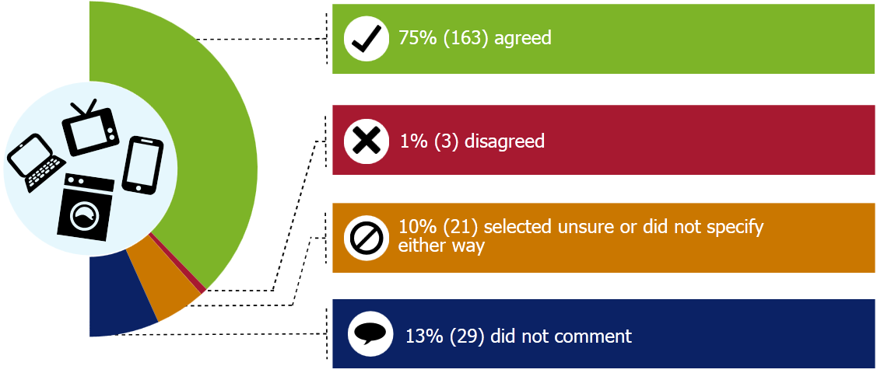
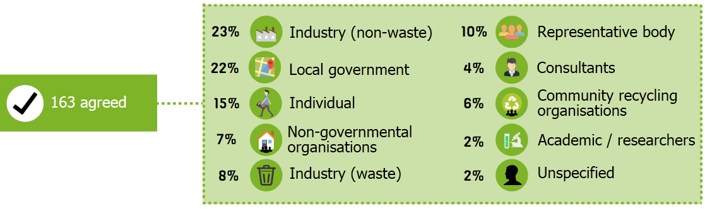
Note: The figures do not all add up to 100 per cent due to rounding of numbers.
Of those submitters that agreed to electrical and electronic equipment being a priority for the Government, responses highlighted concerns relating to harm, loss of resources and this waste stream being a fast growing one. For example, Fulton Hogan stated
“The scope for improved resource efficiency is high for e-waste and given the important/significance of rare earth metals greater efforts must be made to recycle and reuse these.”
Wellington City Council was one of several local government submitters that provided estimates of illegal dumping and/or landfilling of electrical and electronic waste. They estimate that
“Illegal dumping of TV sets and monitors continues at the rate of approximately 15 per week within our city boundaries” and “currently on average four to six televisions, and one to two computer monitors a week are being disposed of at the transfer station by residents who elect to not pay the $25.00 fee for recycling them.”
The Federated Farmers survey of its members showed that there was
“strong support among farmers for the declaration of e-waste as priority products.”
A key representative body, the Australia Information Industry Association, stated
“The AIIA is a supporter of product stewardship to manage e-waste, however, we would like to emphasise the need for any product stewardship scheme to be designed in a way which ensures it is focused on those products which are currently not being managed by other mechanisms and which pose the greatest problems in terms of waste management and environmental impact. Whilst we support the adoption of product stewardship in principle, we would like there to be more analysis of category scope before a decision is made on the e-waste category specifically.”
Three submitters disagreed with the proposal. Two were from the industry (waste) category: An undisclosed submitter (#591964) and the Scrap Metal Recyclers Association New Zealand; and one representative body (the Telecommunications Forum New Zealand) who does not agree with regulatory intervention of electrical and electronic equipment at this stage.
The Scrap Metal Recyclers Association New Zealand stated that they are
“very excited about the opportunity to leverage the potential of the existing metals recovery industry to extend its reach to cope with all electrical and electronic product on a voluntary and self-sustaining basis.”
Tyres
Figure 6: Breakdown of submissions by the response to question 1(c) – tyres

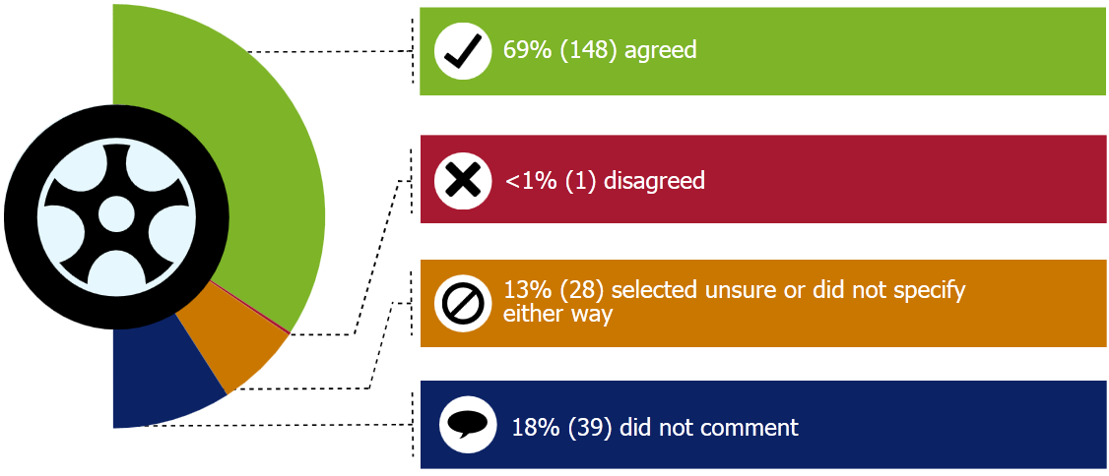
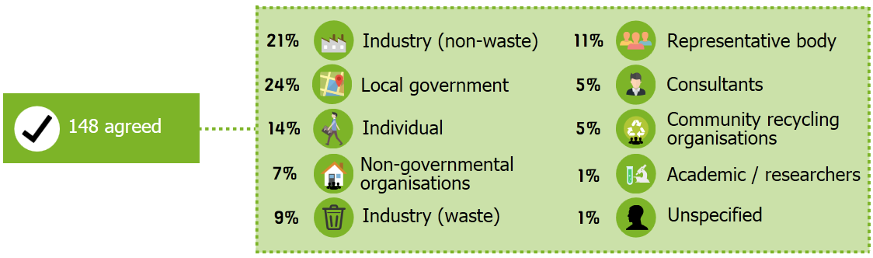
Note: The figures do not all add up to 100% due to rounding of numbers.
One submitter, Tyre Recyclers Association of New Zealand, agreed with the proposal to declare tyres a priority product provided it was not automatically assumed to be supportive of the Tyrewise proposal.
One submitter, Waste Transformation Ltd, disagreed with the proposal, and stated
“We contend that the collections industry is operating reasonably effectively. While the management and regulation of stockpiles may be necessary in the short term to manage risks such as fire and environmental pollution, we believe that emerging technology can deal effectively with stockpiles and lessen the need for designation of tyres as a priority product.”

Agrichemicals and farm plastics
Figure 7: Breakdown of submissions by the response to question 1(c) – agrichemicals and farm plastics
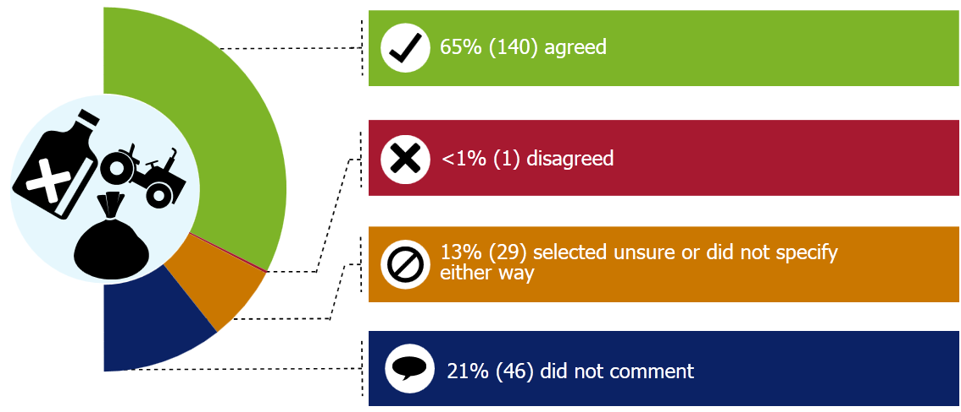
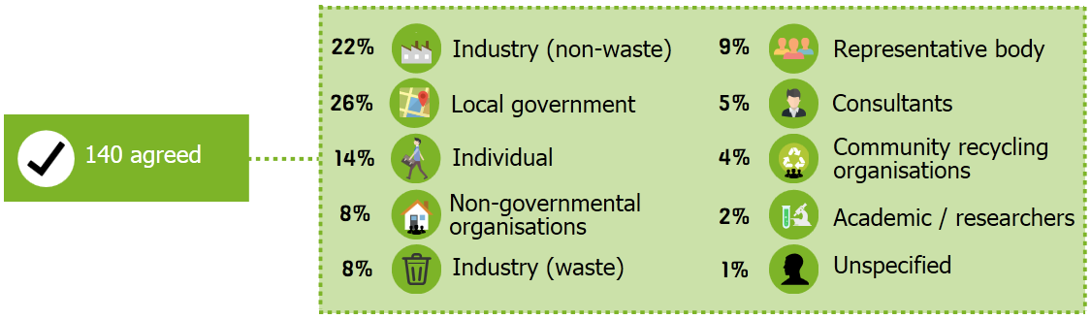
Note: The figures do not all add up to 100% due to rounding of numbers.
Of those that agreed to agrichemicals and farm plastic products being a priority for the Government, many submissions referred to the current practice of burying or burning these waste products on farm. Plasback on behalf of Agpac Ltd stated
“We believe it is right for government to include all farm plastics rather than only chemicals and their containers. This is because a number of recent reports on non-natural agricultural waste has raised awareness of farm waste and highlighted that it is a real and growing problem….Significant quantities of farm waste are still being disposed by either burning or burying on farm.”
An example of a supportive statement from a local government submitter is that from Hawke’s Bay Regional Council who stated
“The Council us supportive of a product stewardship scheme for the collection of unwanted agrichemicals but firmly believes that the scheme must be mandatory and that unwanted chemicals should be given priority product status. The disposal of farm plastics is a major issue in Hawke’s Bay, with the majority either being illegally burned or dumped in farm pits….Due to the geographical isolation of rural properties throughout New Zealand, there will need to be different options available for collection/delivery of farm plastics for disposal.”
Federated Farmers stated
“There is strong support among farmers for declaration.”
The Fertiliser Association did not specify either way as it
“opposes a mandatory product stewardship approach to agrichemicals and farm plastics unless a comprehensive cost-benefit analysis is carried out indicating a clear benefit from the introduction of mandatory controls.”

Refrigerants and other synthetic greenhouse gases
Figure 8: Breakdown of submissions by the response to question 1(c) – refrigerants and other synthetic greenhouse gases
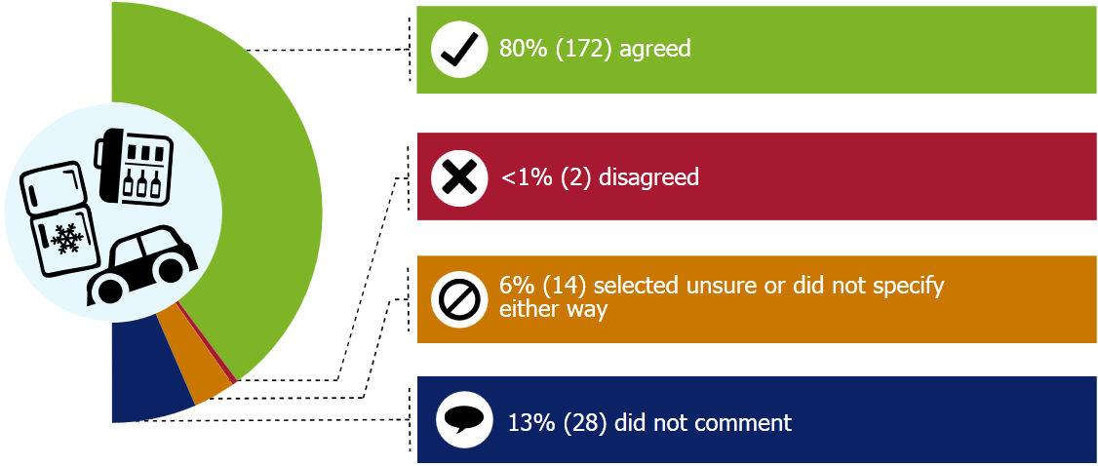
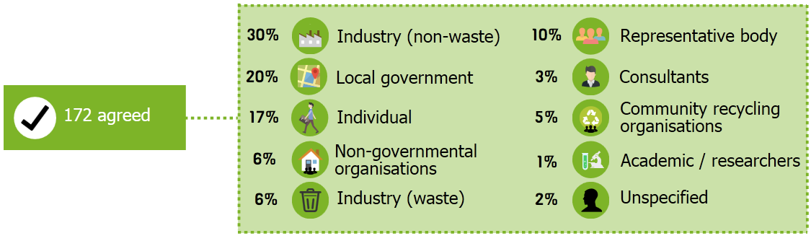
Of those that agreed, submitters highlighted the environmental harm caused by the gases and that the current voluntary scheme is achieving relatively low recovery rates compared to overseas schemes that are mandated.
For example, Dunedin City Council stated
“More needs to be done to engage downstream installers and re-fillers in addition to better enforcement under existing legislation and education. The industry needs the support of a product stewardship scheme to achieve these outcomes….”
And Fulton Hogan stated
“Given the significance of these gases with respect to climate change we agree that this should be included as one of the initial priorities.”
Two submitters disagreed with the proposal. Dua Refrigeration Training stated
“The voluntary scheme is in place and is working satisfactorily. This could be enhanced if the Government were to classify all synthetic greenhouse gases as ecotoxic under the Hazardous Substances and New Organisms Act…Some licensing but not regulations, for the whole industry and support from Government would tidy the problem up.”
CMA Recycling New Zealand Ltd stated that [it is]
“impossible to recycle economically in the volumes available in New Zealand. The infrastructure required to handle and recycle the gasses from refrigerants is very expensive and a massive outlay would be required for small volumes which are also hard to measure.”
- Do you think others should be included? Why or why not?
Figure 9: Breakdown of submissions by the response to question 1(d)

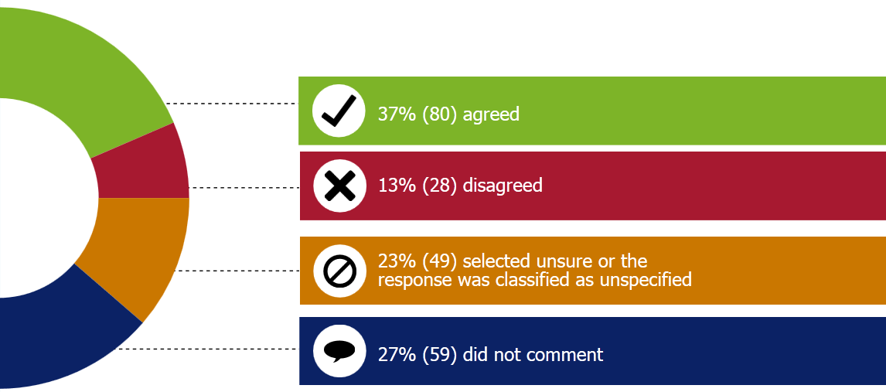

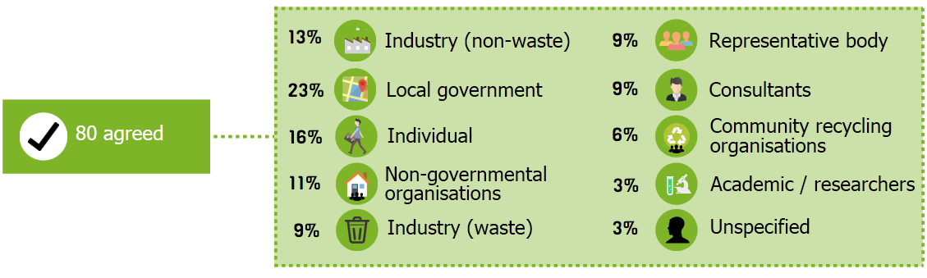
Note: The figures do not all add up to 100% due to rounding of numbers.

Yes – include others
Of the 80 submitters that said ‘yes – include others’, table 2 lists the other product groups that were suggested by at least five submitters or more.
Table 2: Other product groups suggested by at least three submitters or more
Other product group | Number of submitters
Packaging | 36
Batteries | 15
Paint | 15
Treated timber | 10
Plastic or plastic bags | 8
End-of-life vehicles | 7
Oil | 7
Glass | 7
Lamps/mercury-containing lights | 5
Polystyrene | 5
Construction waste | 3

Table 3: Other product groups suggested according to submitter type
Submitter type | Other product groups
Local government | Packaging (plastic bags, glass bottles and beverage containers specifically mentioned), paint, treated timber, waste oil, end-of-life vehicles, batteries, lamps, asbestos and other hazardous wastes.
Industry (non-waste) | Oil based products and used oil, treated timber, packaging (PET bottles, polystyrene, glass packaging, plastic chemical containers specifically mentioned), inorganic chemicals, detergents, paint, asbestos and batteries.
Industry (waste) | Waste oils and other motor industry wastes, treated timber, gypsum and wood waste, particle/ply board, polystyrene, organics, other industrial and primary sector hazardous wastes and batteries.
Community recycling organisations | Packaging plus one submitter specifying glass.
NGOs | Packaging (beverage containers, plastic bags, drink containers, glass bottles specifically mentioned), other single use packaging items, treated timber and batteries.
Individuals | Packaging - (plastic bags/plastics, glass bottles, polystyrene or plastic packaging specifically mentioned), batteries, construction waste, oil, solvents, food waste, nappies, end-of-life vehicles, waste medicines and paint.
Representative bodies | Contaminated soil, used oil, treated timber, paint, batteries, construction and demolition waste, nappies, organic waste, biosolids, lamps, packaging (plastic bags, BPA, styrenes specifically mentioned), asbestos, medical waste, other farm plastics, end-of-life vehicles and other hazardous wastes.
The Sustainability Trust and Nelson Environment Centre stated that all of the waste streams in Appendix 4 of the discussion document were suitable for a product stewardship approach and
“It is a matter of establishing relative priority and then working through the list rather than deciding which waste streams should have schemes and which should not.”
The Engineers for Social Responsibility, the Environment Network Manawatu, and the Community Recycling Network Aotearoa suggested all the other waste streams listed in Appendix 4 of the discussion document should be considered as urgent and are suitable for a product stewardship approach. The Motor Trade Association and the New Zealand Auto Association suggested end-of-life vehicles as an additional product group. Batteries and construction waste were also mentioned by the submitters in this group.

No – do not include others
Of the 28 submitters that said ‘no – do not include others’, the general stance of those that gave a reason for this position was that the four proposed product groups should be tackled first and then expand to other products over time after more discussion with the specific industry.
3R Group Limited stated
“Attempting a mandatory product stewardship is new for us [New Zealand] – with these four products the impact will be felt by every consumer so we must get it right in order to ensure that it gives the biggest bang for the buck for the waste streams which are truly problematic.”
Marlborough Helicopters said start small and expand over time.
Four of the submitters with this position mentioned other product groups that could be included in the future such as batteries, end-of-life vehicles, paint, treated timber, and mercury-containing lamps.
Business New Zealand did not comment on any of the proposed priority waste streams or name any specific product group that should or should not be declared as priority products. Business New Zealand said that the justification for intervention should be based on sound cost benefit analysis and a clearly defined problem, as well as identifying whether the intervention will have any net benefits.
Business New Zealand also noted that its membership has mixed views on the merits or otherwise of mandatory product stewardship. While some members are totally opposed to any form of mandatory product stewardship, others are receptive to at least one or more of the proposed products as being potentially subject to mandatory product stewardship. Therefore, individual members were encouraged to put in submissions.
Carter Holt Harvey thought that alternatives to compulsory product stewardship should be considered and are concerned that the discussion document presumes that effective waste minimisation is dependent on regulation and the direct intervention of government agencies. Carter Holt Harvey pointed out that the discussion document does not acknowledge the results achieved by non-accredited voluntary product stewardship schemes.
Consultation theme 2: Priority product declaration
The discussion document asked for feedback on whether the necessary conditions can be met at this time for the declaration of priority products as proposed, and if not what other considerations are required.

Do you think the Minister should declare any product groups as a priority product under the Waste Minimisation Act? If so, which ones?
Figure 10: Breakdown of submissions by the response to question 2(a)
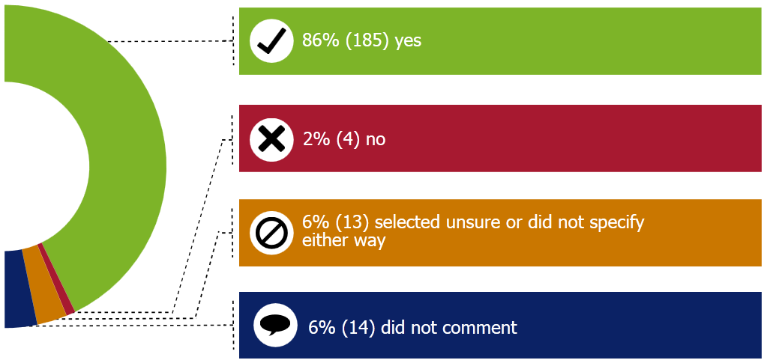
Not all submitters who agreed provided detail on which product groups the Minister should declare as a priority product under the Waste Minimisation Act 2008. Of those submitters that did, the most frequently mentioned are listed in table 4.
Table 4: Frequency of product group mentioned by submitters
Product group | Number of submitters
Refrigerants | 103
Tyres | 87
E-waste | 85
Agricultural chemicals and/or farm plastics | 74
Other products mentioned by submitters in addition to the four proposed product groups were:
Packaging | 19
Batteries | 9
Treated timber | 6
Paint | 5
Plastics | 4
Oils | 3
End-of-life vehicles | 3
Asbestos | 3
Mercury-containing lamps | 2
The following product groups were all mentioned once: industrial hazardous waste, aluminium cans, plastic bags, fossil fuels, contaminated soil, construction and demolition waste, nappies, organics, biosolids, primary sector hazardous wastes, medical wastes, and polychlorinated biphenyls.
Of those submitters that were supportive of the Minister declaring any product groups as priority products feedback included:
Agpac Ltd (Plasback)
“We believe the Minister should give urgent consideration to greater intervention in the agricultural supply chain before making agrichemicals and other farm plastics a priority product. We recommend intervention by the government to tackle the issue of free riders in the agricultural crop packaging market as a means to overcoming the funding shortfall.”
Fonterra Co-operative Group Ltd raised the following point
“For each priority product, Fonterra urges the Government to assess the full range of tools available to it under the WMA before declaring a product as a priority under the WMA. This is especially important given that data is limited and incomplete. There are a number of other statutes which provide for waste management and/or the reduction of harm and/or improved resource use efficiency. Fonterra interacts with all of these on a day-to-day basis. Therefore, Fonterra emphasises the importance of avoiding duplication in regulatory requirements which can lead to unnecessary cost and burden to business.”
Two submitters nominated agricultural chemicals to be priority products, (Tredi New Zealand Ltd SA and Transpacific Technical Services). Both said that legacy agrichemicals should be removed from the product group and declared separately and be subject to mandatory regulation. They stated that all other agrichemicals and farm plastics can be managed by mandatory product stewardship.
One submitter in this category, Beta Antifreeze Ltd, suggested that the waste streams from the motor industry should be tackled under a wider strategy to respond to the whole problem. These would include: batteries, end-of-life vehicles, oil and industrial hazardous waste (glycol).
The Sustainable Business Council supports the declaration of all four proposed product groups except for electrical and electronic equipment, because the Government should re-engage with industry first on the potential scope and appropriate approach before making any such declaration.
The four submitters who thought that the Minister should not declare any product groups as priority products were:
- Atmos Design Ltd
- Genaction
- the Scrap Metal Recyclers Association New Zealand
- the Telecommunications Forum New Zealand.
The last two submitters said ‘no’ in relation to electrical and electronic equipment only.
The Scrap Metal Recyclers Association New Zealand
“does not believe there is a need to declare electrical and electronic goods as a priority waste stream for product stewardship intervention.”
And
“therefore proposes the Ministry adopts a first things first approach to improving waste minimisation outcomes in the electrical and electronic products category. We should defer declaring these electrical and electronic products as a priority waste stream for product stewardship intervention in the meantime, and should first concentrate on measures to assist the profitable disposal of all of the commodities within the stream, within the constraints of accepted environmental and health parameters.”
The other three submitters did not expand on the reasons for their response.
Of those that did not specify either way, Fulton Hogan stated
“Not at this stage – until the current four products are up and running and lessons learnt from this initial process”
and Fujitsu stated
“We support in principle the programme of product stewardship for e-waste, however we feel that more research and analysis is needed to further understand the scope of the scheme and whether New Zealand is geared up to provide the right facilities, policies and processes to effectively manage e-waste on a large scale.”

If you support priority product declaration, what timing do you think is appropriate? Should it be done soon, or wait until all regulatory framework and scheme design options are explored in a future discussion document?
If submitters supported priority product declaration for one or more product groups, the discussion document asked what timing submitters thought was appropriate.
Figure 11: Breakdown of submissions by the response to question 2(b)
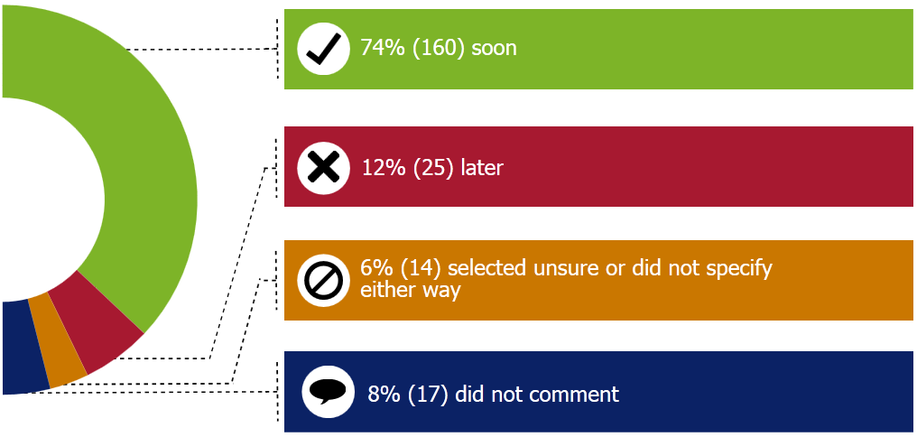

Timing for priority product declaration
Declare soon
Many submitters suggested that declaration could be made soon – all options could then be explored and schemes developed and implemented. A number of submitters noted that there is no timeframe provided in the Waste Minimisation Act 2008 from when a product is declared a priority product to when a scheme needs to be implemented.
Wanaka WasteBusters stated
“Declaring priority product does not need to preclude exploring options, it is up to the Government to set the parameters for the “people and organisations” required to develop schemes.”
Some submitters stated that a declaration of priority product sends a strong signal of the need for timely and effective action.
The NZ Tyre Recyclers and Collectors Association stated
“New Zealand needs some sense of urgency to this problem. A declaration now would give emerging industries some certainty of the timetable and of the market environment in which they will have to operate. While the industrial infrastructure is being prepared, the details of the scheme can be settled.”
Some submitters stated that priority product(s) should be declared as soon as possible to provide clarity to all stakeholders, and allow them to integrate its potential impact into their long-term planning. Submitters noted that a declaration now would give industries (emerging and existing) some certainty of the timetable and/or the future market environment in which they will have to operate.
A large number of local government submitters suggested that the Minister should set a timeframe by which a scheme would need to be up and running, following a declaration of a priority product. These submitters acknowledged that this timing may be different for different waste streams. Eighty-one per cent (29) of local government category of submitters thought the Minister should declare priorities soon.
Sixty-nine per cent (42) of industry (non-waste) submitters thought the Minister should declare priority products soon. The majority of the submissions from the refrigerant sector commented that declaring soon would consolidate existing efforts by their sector.
Sixty per cent (12) of the industry (waste) submitters said the Minister should declare priority products soon with many of the waste tyre submitters commenting on the need for “some sense of urgency for this problem.”
All of the community recycling organisation submitters (10) agreed that the Minister should declare priority products soon. Reasons to support this position include, from the Community Business and Environment Centre and Cleanstream Northland Ltd
“These products have been researched enough and it is time for action and legislation to be enacted. Voluntary programmes do not get the results and industry needs clear direction.”
The Mana Recovery Trust stated
“I feel if we wait for “design option” we will be back to the drawing board in 3 years’ time with no action.”
Eleven of the 12 NGO submitters think it should be done soon. The Ecofriends Group stated
“In an ideal world we would already be taking strong action to correct the mismanagement and legacy issues of the past. It makes no sense to pontificate over every possibility when sensible options can be introduced now to mitigate legacy issues then are refined as new information or technology becomes known.”
The Cromwell and Districts Community Trust stated
“Although we would like the declaration in place in a timely fashion, this should not be without a stringent regulatory framework and scheme design in place to ensure all parties make progress on implementation of robust schemes in the shortest possible timeframe.”
Half (16) of the submitters from the ‘representative body’ category stated the Minister should declare priority products soon. Many of the submitters that thought the declaration should be done soon also commented that more consultation and analysis is required first, including the Employers and Manufacturers Association, Sustainable Business Council, and Federated Farmers.
Ninety-four per cent of the individual submitters thought the Minister should declare the priority products soon.
Comments in relation to this question include
Bernie Gunn
“We simply need to do something so let’s just get on with it.”
Mark Molloy
“At least start the public awareness campaign until regulations can be activated.”
Heather Powell
“We are being left behind in world trends. Our reputation is suffering.”
Ruth McNamara
“The longer you wait the more problems are being created by having to get rid of historic waste. The piles of these will grow bigger the longer it takes to legislate.”
Michael Garbes
“Most emerging industries, such as recycling of tyres and farm waste plastics, need time for implementation and review.”
Other submitters also proposed timeframes for declaration and implementation. For example, EnviroWaste Services Ltd stated they support
“the declaration of these priority products as soon as practically possible with an aim that this is completed within 12 months with an implementation timeframe for regulations etc to be completed of an additional 12 months. This will allow sufficient time for industry to be consulted and meaningful systems and regulations to be developed.”

Wait until all regulatory framework and scheme design options are explored
Some submitters highlighted that even though they thought environmental hazards should be addressed as soon as possible, waiting for a robust framework to be developed is preferential to ensure Government does not spend taxpayer money unnecessarily on a scheme or project that may not be effective or achieve sufficient outcomes. A handful of submitters noted that whilst there may not be any improvement in the short term, in the longer term a well-structured scheme upfront would be more effective.
Federated Farmers stated
‘There is an argument for declaring priority products immediately to give clear signals to the market and bolster the effectiveness of voluntary schemes, by enabling them to become mandatory. However, the risk of mandating a process before it is certain that the outcomes will be successful outweighs the benefits in our view. We consider that declaration of priority products should only follow once further consultation and investigation has determined that practical and cost-effective options for product stewardship exist. However, declaration of a priority product should happen as soon as possible after this point, to avoid unnecessary delays.’
Three local government submitters support the proposal to wait until all options are explored.
Eighteen per cent (11) of the industry (non-waste) submitters said the Minister should wait until all options are explored. Twenty-five per cent (five) of the industry (waste) submitters prefer to wait until all options are explored. Three representative body submitters said that the Minister should wait until all options are explored. One NGO submitter (Enviroed Ltd) thinks the Minister should wait until all options are explored as the aim should not be to delay product declaration but to ensure the regulatory framework and scheme design options chosen will last. Only one individual submitter thought the Minister should wait until all options are explored and one academic submitter (the University of Waikato) supported the proposal to wait until all options are explored.
Specifically with regards to e-waste, some submitters noted that a priority product should not be declared until the E-waste Product Stewardship project, being supported by the Waste Minimisation Fund, has been completed.

Information provided to improve the assessment

Identified costs and benefits for priority product declaration
The discussion document asked submitters to provide information to improve the assessment of waste streams for priority product declaration, such as any costs and benefits that may result from mandatory product stewardship schemes. Eight-five per cent (180) of the submissions received provided information. The costs and benefits identified by submitters have been summarised in table 5 below.
Table 5: Costs and benefits identified by submitters that may arise from mandatory product stewardship schemes
 | Costs | Benefits
Cultural | No cultural costs or benefits specifically identified
Economic | Provision of infrastructure and resources (including staff time and training, variation to existing contracts, logistics and transport, communication to the public, administration)  Any levies imposed associated with packaging changes to incorporate labels and logos  Establishment of collection points, storage, marketing, education, general management  Recycling and/or dismantling costs  Costs shifted to the consumer and/or producer  Compliance and enforcement  Costs to schemes for issues such as leaded glass for which there are not many viable options to recycle globally | Equitable costs and avoidance of ‘free riders’ – even playing field for all  Economies of scale from wide industry involvement  Create employment opportunities  Increased capital (development of reputable local recycling/destruction industries)  Supporting innovation and improved product design  Improved services and nationwide coverage and standardisation of waste management practices  Less taxpayer/ratepayer money being spent on clean-ups – this money will be freed up for other initiatives  Opportunities for improved relationships/ventures between private, public and community sectors  Better financial management and greater transparency of schemes  Long term, cost saving by preventing remediation that might have occurred later  Improved reputation and industry image (eg, public perception, NZ’s 100% pure/clean and green image  Market value of resources
 | Costs | Benefits
Environmental |  | Improved environmental outcomes (eg, decrease in illegal dumping, resource efficiency – increased recovery of resource and effective resource management, less waste to landfill, less leaching of toxic chemicals into the environment)  Reliance on farm dumps removed – options available  Compliance with international obligations such as the Stockholm Convention  Improved tracking of products (eg refrigerants) for disposal and data collection  Nationwide clear consistent messaging on appropriate disposal mechanisms  Visual amenity improved – no stockpiles which would reduce various risks such as fire (tyres)
Social |  | Reduced health and safety risk with associated storage of quantities of hazardous substances  Quality of workmanship  Opportunities for education and behaviour change  Public will be more aware of the environmental issues associated with their end-of-life products  Challenge consumerist and throw-away ideologies  Human health  Provision of jobs to implement and support the schemes
A number of submitters noted that all reasonable costs for a mandatory product stewardship scheme should be covered by the scheme itself. Other submitters stated that ultimately the cost of product stewardship is borne by consumers.
Some submitters noted the cost of implementing a product stewardship scheme would be linked to the design of the scheme. Federated Farmers highlighted that
“Costs for implementing mandatory schemes range from the low hundreds to thousands of dollars, depending on the size of the operation and remoteness of the location.”
Additionally, some submitters provided information on the costs and issues faced under the status quo. This included the costs to participate in current voluntary schemes and recycling initiatives. The majority of the submitters involved in the Refrigerant Recovery Scheme noted that
“The current voluntary levy for refrigerant recovery is $1.50+GST and license training is $0/5 per kilogram of refrigerant sold.”
Tasman District Council stated the
“cost for council in voluntary schemes has typically been in the order of $5,000 and annual costs no more than $6,000 per annum. This equates to approximately $0.12 per person per annum.”
Auckland Council stated that they have
“spent over $500,00 over the past 12 years on agricultural waste disposal form rural properties.”
A handful of local government submitters provided an overview of the costs faced by councils to monitor and clean up illegal dumping incidents. For example, Auckland Council stated
“Illegal dumping costs Auckland Council approximately $535,000 per year, and a prosecution of illegal dumping can require months of staff time.”
The Australian Information Industry Association explained the current costs to members participating in the Australian National Product Stewardship Scheme for Televisions and Computers.
”The current costs to members of the largest scheme are around AUD$1 per kg. Costs to participants early in the scheme were initially higher (around AUD$1.30 per kg). The most expensive element of the scheme is the recycling of leaded glass due to limited solutions internationally. Costs increase where targets are set at levels which are not reasonable given actual rates of waste arising. Scheme costs are also higher where there is unnecessary duplication through multiple co-regulatory arrangements (product stewardship schemes)”.
A number of councils noted that no ‘significant’ costs to their council were foreseen should mandatory product stewardship schemes be required. Many councils noted that there was the potential for some minor costs to be incurred by their council should mandatory schemes be introduced (such as providing infrastructure and storage facilities); however these costs were anticipated to be far outweighed by the benefits.

Defining the scope of declaration of priority products
The scope of any declaration of priority product (or regulations) would need to be defined. The discussion document proposed different scope options for the four proposed product groups.

Electrical and electronic equipment

Should New Zealand start with the same scope as Australia (TVs, computers, and computer peripherals) or include other electronic wastes as well.
Figure 12: Breakdown of submissions by the response to question 2(d) – same scope as Australia
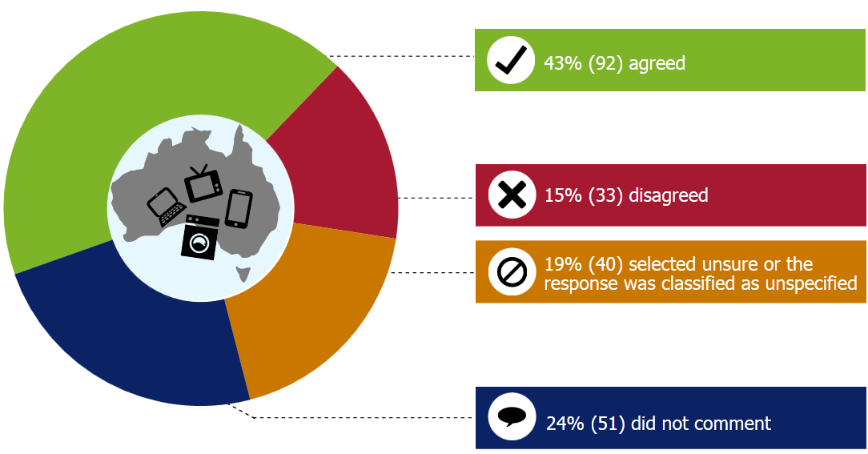
Note: The figures do not all add up to 100% due to rounding of numbers.
Of those who agreed with the proposed scope, several, particularly local government submitters and representative bodies, showed support for New Zealand starting with the same scope as Australia.
Wellington City Council stated
“We agree initially New Zealand should start with the same scope as Australia. Wellington City Council would then support the subsequent inclusion of additional items once the process for the initial items had been implemented.”
Several industry (non-waste) submitters also supported modelling the scope to Australia’s, with Fuji Xerox stating
“Probably. Benchmarking against Australia is a sensible place to start given the similarities in the countries culture and nature. This would be preferable to starting a New Zealand scope from the ground up.”
This viewpoint was shared by other industry (non-waste) submitters such as Fulton Hogan Ltd, Dove Electronics, Daikin NZ, and industry (waste) submitters such as 3R Group Limited, Transpacific Technical Services, and Envirowaste Services Ltd.
Of the submitters that did not agree with framing the scope the same as Australia’s, the largest group of submitters came from the representative body category, with submitters such as the Motor Industry Association of New Zealand, the Sustainable Business Council, Business NZ, and NZ Auto Association disagreeing with following the Australian model.
Industry (non-waste) represented the largest percentage group of submitters that selected the unspecified/unsure position. However, within the unspecified/unsure group, a number of submitters did agree, on some level, with aligning the scope the same as Australia’s. These included the South Waikato Achievement Trust, Wanaka Wastebusters, Eunomia Research and Consulting, Ann Dennison, and Atmos Design Ltd.
The majority (69 per cent) of local government submitters supported the scope for electrical and electronic equipment being the same as the Australia scheme, and nearly half (49 per cent) also thought that other electrical and electronic equipment should be included too.

Or include other electrical and electronic equipment included as well?
Figure 13: Breakdown of submissions by the response to question 2(d) – include other electrical and electronic equipment
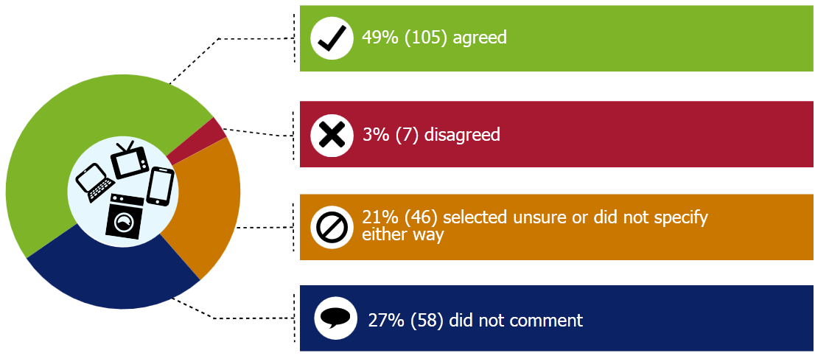
Of those that agreed with including other electrical and electronic equipment, 21 submitters made specific mention of including batteries.
Auckland Council stated
“the scope of an electrical and electronic equipment scheme should include the following product groups as a minimum –
Computers and computer peripherals (all computer-like products which contain similar componentry such as motherboards, power supplies, chipsets, graphics cards etc.)
TVs and Monitors (and all similar screed (sic) devices)
Mobile phones
Household batteries

Research [appended to the submission by Auckland Council] into the appropriate disposal of household batteries and the recent survey of attitudes to end of life options for household batteries indicate a high level of public concern of inappropriate disposal of household batteries.

We therefore strongly suggest that household batteries should be included in any e-waste product stewardship scheme due to the synergies related to disposal technology.”

Taranaki Regional Council
“Would support the scope being broader than the Australian scheme to include, in addition to TVs, computers and computer peripherals, audio-visual equipment like speakers, amplifiers and video players, to reduce confusion in the minds of the general public. These items were often brought to eDays….but could not be accepted….If broadening the scope is likely to delay the timing….then we would support a narrower scope which aligns with Australia.….we would suggest NZ learns as much as possible from international experience…….We can be guided by experts…..both in terms of design of scheme and scope.”
Of those that were unspecified or unsure, Fisher and Paykel stated
“Levying brown goods sold in New Zealand while not capturing those purchased overseas via the internet would be unfair on local retailers.”
And
“Agree with the category of electrical and electronic equipment but it is too broad. One option could be electrical and electronic equipment – brown goods.”
The other electrical and electronic equipment that was suggested by submitters to be included were: all freeview receivers and other television peripherals, mobile phones, audio-visual equipment, transistor radios, cameras, circuit boards of any type, automotive batteries (all types), batteries (excluding alkaline), rechargeable batteries, batteries (type not specified), mercury-containing lamps, whiteware (fridges, washing machines), kitchen and household appliances, and photocopiers.
Some submitters, especially from the individual category, proposed the inclusion of all electrical and electronic equipment in the scope. Reasons provided included that all electrical and electronic equipment cause similar problems in landfill and contain recyclable material; it will reduce consumer confusion; economically more efficient; the standard components are the same; and many can already be easily managed by existing infrastructure.
DHL Supply Chain stated
“New Zealand should adopt a ‘full scope’ model for electrical and electronic equipment which includes all types of electrical and electronic products and makes no distinction between items sold for household or non-household uses.”
Federated Farmers stated
“The scope of materials to be included in any declaration of priority product should be as broad as practical. Other e-waste as well as TVs, computers and peripherals should be included.”
Southern Institute of Technology and Institute for Refrigeration, Heating and Air Conditioning Engineers stated
“Electrical and electronic equipment that contains refrigerants, such as heat pumps, domestic fridges, freezers and car air-conditioning units.”
Some submitters recommended phasing in additional electrical and electronic equipment over time, such as Gisborne District Council, Environmental Education for Resource Sustainability Trust, and Waste Education NZ Ltd.
The Warehouse Group stated
“It is important to be specific about the scope [of] e-waste as it is very broad. Scope should initially be narrow, expanding over time to capture more products. The boundaries of a narrow scope could be understood through using sales data (potentially available from Customs or GFK market information) and assessment of potential impact (potentially available from The Sustainability Consortium).
Robust analysis of e-waste streams is needed to identify those with the greatest potential impact (risk of harm x scale exposed). Adopting another country’s scope would ignore any local specifics. It is important to start with a narrow scope and then expand.
Based on analysis by The Warehouse Group, we believe the following e-waste categories are most important to address initially:
- TVs & Accessories
- Monitors
- Computers & Tablets
- IT Accessories
- Mobile Phones
- Printer consumables.
This is the view of The Warehouse Group and should not preclude further, robust analysis.”
Other submitters stated that more analysis was required before determining the scope of electrical and electronic equipment to be declared.
Australia and NZ Recycling Platform Ltd stated
“Subject to consultation and cost-benefit-analysis, it may be that the geographic/demographics of NZ require a broader scheme or a scheme that operated on synergies between product groups rather than distinct product based programmes.”
Australia Information Industry Association stated
“Analysis of the different categories of e-waste potentially generated in New Zealand should be carried out to help inform the scope.”

Tyres

Should the scope be all pneumatic (air filled) tyres: those for cars; motorcycles; trucks; buses; off-road vehicles; aircraft; and certain solid tyres (forklifts); but not bicycle tyres?
Figure 14: Breakdown of submissions by the response to question 2(d) – all pneumatic tyres
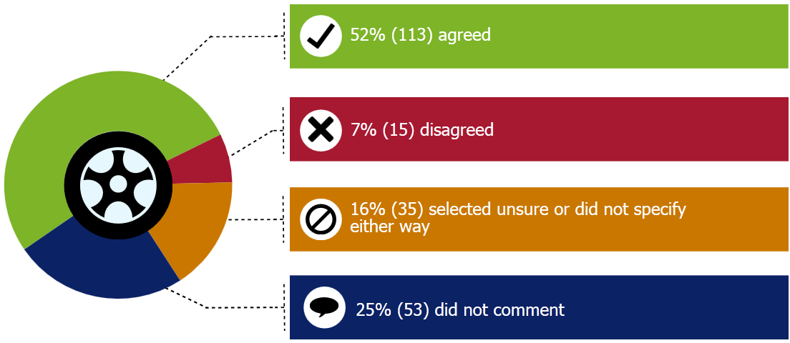
Note: The figures do not all add up to 100% due to rounding of numbers.
Of those that agreed with the proposed scope, several, particularly local government submitters and representative bodies, recommended that bicycle tyres could be included at a later phase or a ‘stage 2’ or suggested that bicycle tyres could be collected voluntarily alongside a mandatory scheme for the other tyre types proposed.
Envirowaste Services were among several submitters who supported the proposed scope and explained that bicycle tyres and solid tyres
“Would likely be regarded as problematic and as a contaminant and therefore should not be included in the first phase of a priority product declaration. These could be included at a later date if regulation was determined necessary and technology permitted it.”
This view was shared with the majority of submitters including:
- Auto Stewardship New Zealand
- the WasteMINZ Territorial Authority Forum Steering Committee
- Southern District Health Board
- Goodyear Dunlop
- Tyres New Zealand Ltd
- the Employers and Manufacturers Association.
The Employers and Manufacturers Association also stated that if the scope is all car tyres then all car tyres must contribute to the recovery scheme, meaning imported new and used cars with tyres must equally contribute to the solution.
Of the submitters that did not agree with the proposed scope, the most frequently suggested other tyre type to include in the scope of a declaration was bicycle tyres. This was particularly prevalent from the individual submitter type, who represented 47 per cent of those that disagreed with the proposed scope. Fulton Hogan could not see any reason not to include bicycle tyres although noted that they will be a small part of the waste stream.
Tauranga City Council stated
“It would be appropriate for bicycle tyres to be included, but subsidised by all other tyres because of the overall environmental and health benefit cycling provides and the fact that cycling is a sustainable transport option.”
Federated Farmers raised the concern that
“Old tyres are an important resource for farmers….It is essential that the traditional reuse of old tyres on farms be protected.”

Agrichemicals and farm plastics

Should the scope be all chemicals which require an Agricultural Chemicals and Veterinary Medicine (ACVM) registration and their plastic containers?
Figure 14: Breakdown of submissions by the response to question 2(d) - agricultural chemicals and veterinary medicine registration and their plastic containers
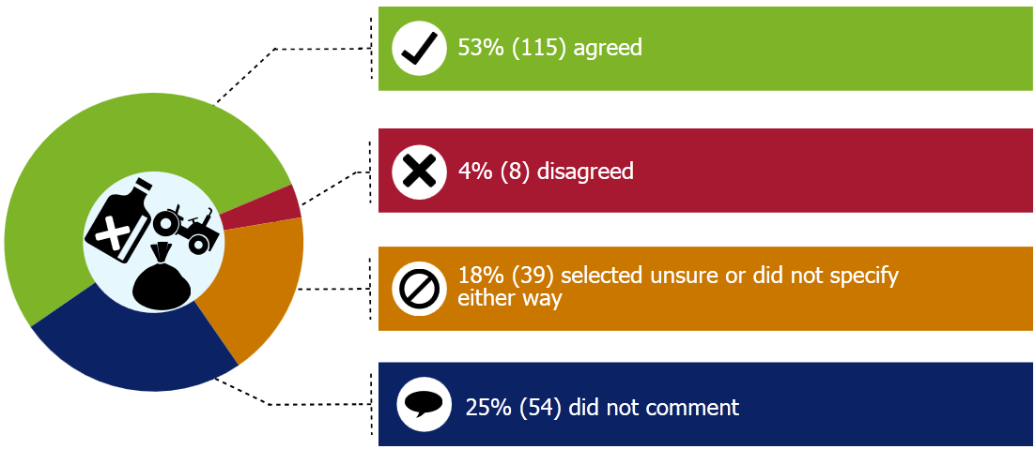
Note: The figures do not all add up to 100% due to rounding of numbers.
Many councils and the WasteMINZ TA Forum Steering Committee noted that the scope should include all chemicals that required agricultural chemicals and veterinary medicines (ACVM) and there containers regardless of their ACVM registration date. Their submissions noted that this would enable all persistent organic pollutants (POPs) and orphaned agrichemicals to be included in the scope of a scheme.
Auckland Council supported the proposed scope and also stated
“Legacy chemicals (such as those no longer registered) must also be catered for in any product stewardship scheme. Currently once a chemical is de-registered it becomes a legacy chemical. This means that the “legacy” group continues to grow and therefore can never be eliminated. We recommend that the group that is considered “legacy” must be a set list of products which are identified as at specified date (such as the start of a scheme). This list should not be added to once it has been defined.
Legacy material which pre-dates the establishment of a product stewardship scheme needs a separate (but possibly linked) disposal and funding mechanism. This should be established at the same time as a product stewardship scheme, but using a different establishment process to ensure that legacy issues do not hold up the development of a current agrichemicals product stewardship scheme”.
Regarding the scope of a scheme for agricultural chemicals and farm plastics, the Employers and Manufacturers Association stated
“The existing voluntary scheme should be the start point for scope of the scheme and where extension is desired by that sector or there is a stated need from the farming sector, then the existing scheme could be extended.”
Envirowaste Services Ltd stated that the scope should include
“all chemicals which require ACVM registration and their containers, whether the containers are triple rinsed or not.”
Four per cent (eight) of all submitters disagreed that the scope of priority product declaration (or regulation) should apply to all chemicals that required agricultural chemicals and veterinary medicines registration and their plastic containers.
One of those that disagreed with this scope, Zoetis NZ Ltd, highlighted that there are additional large volume agricultural chemical products that do not require ACVM registration but should also be included in the scope. Whilst the Agrecovery Foundation and Agcarm Incorporated both noted that the current voluntary Agrecovery product stewardship schemes definition of agrichemicals is
“ACVM and non ACVM registered agrichemicals and animal health products including products such as pesticides, herbicides, insecticides, fungicides, vertebrate poisons, plant growth regulators, worming medicines and fertilisers, foliar sprays, hydroponic products, other medicines and sanitation agents.”
Another submitter who disagreed, Tredi New Zealand Ltd SA, stated that the
“agricultural chemicals that are of most concern are the legacy agrichemicals and the unknowns which so far as we are aware cannot be included on the ACVM register, therefore they would fall through the cracks again.”
Twenty-five per cent (54) of submitters did not respond to this question and 18 per cent (39) either were ‘unsure’ or did not specify whether they agreed or disagreed.
A number of submitters noted that all agrichemical and farm plastic products should be included. Whilst others, such as the Sustainability Trust, specified that fertilisers, all agricultural/horticultural and veterinary medicines and their plastic containers should be included.
With regards to chemicals, NV Interactive New Zealand Limited suggested also including
“urea, phosphorous, pesticides, herbicides, benzines, nitrogen containing compounds, CO2, CH3, Nox and other tracer elements used to monitor attenuation.”
Zoetis NZ Ltd stated that the focus should be on those chemicals
“posing the most harm to the environment via their toxic properties or volume. Ideally a single scheme would incorporate all agricultural-related waste to minimise complexity and reduce cost in terms of resources, managing levy payments etc”.
Southern X Press noted that a more cost effective scheme could be operated by including a wider range of products, specifically all industrial chemical containers.

Should wider farm plastics (such as silage wrap, twine, crop protection netting) be included?
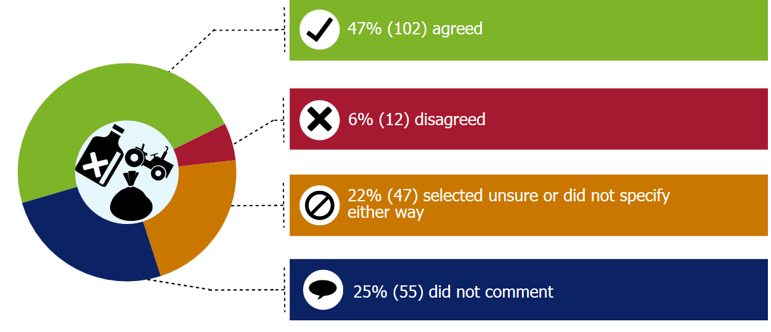
Of the 216 submissions received, 47 per cent (102) agreed that wider farm plastics should be included in the scope of priority product declaration (or regulation).
Of those that provided additional comments to this response, the farm plastics suggested to be included in scope were: silage/bale wrap (12); crop protection netting (12); twine (12); feedbags (six); bulk containers; ground protection; and non-agricultural chemical containers.
The Agrecovery Foundation and Agcarm Incorporated both highlighted that
“farm plastics is a very general term. This needs to be defined. It should definitely include silage wrap. Agrichemicals packaging should be included, not limited to just plastic packaging but all packaging types and within certain volumes for example 500ml up to 200 litres.”
Six per cent (12) of the submissions received disagreed that wider farm plastics should be included in the scope of priority product declaration (or regulation). One submitter, Genaction Ltd, noted that although silage wrap is an issue it is not as important to consider and prioritise as other products. The Tasman District Council, the Southern District Health Board and WasteManagers stated that the scope should be initially limited to ensure the scheme is expedited and that wider farm plastics could be considered in the second stage or as part of a packaging scheme at a later date.
3R Group Limited disagreed that farm plastics should be included in the scope of a priority product declaration or regulation. 3R’s submission noted that they
“strongly believe that the discussion about farm plastics needs to be clearly split between chemically contaminated plastics and other plastics. The risk of harm to the environment and human health created by chemically contaminated plastics is higher than those farm plastics which are contaminated with organic matter such as silage films.”
Twenty-five per cent (55) of submitters did not respond to this question and 22 per cent (47) either were ‘unsure’ or did not specify whether they agreed or disagreed.
Of those that were ‘unsure’, the Employers and Manufacturers Association noted that the scope of the products should be limited initially to those originally identified, to ensure that the solution was ‘logistically workable’ and that infrastructure could be developed. The Fertiliser Association noted that they
“seek clarification of the meaning of ‘other’ farm plastics in this context to avoid a situation where reusable low volume packaging may be inappropriately captures by unnecessary regulation.”
Agpac Ltd (Plasback) noted that they “advocate for agricultural chemicals and farm plastics to be covered by the declaration of priority products if the crop packaging industry does not engage in voluntary measures to contribute to the accredited product stewardship scheme in place”.
Fulton Hogan, the Agrecovery Foundation, and Agcarm Inc expressed preference for used agrichemicals and their containers being the priority to include in the scope of a declaration or priority product (or regulation) at this time. Fulton Hogan also noted that if silage wrap and twine can be incorporated in the scheme then they too should be included.
Environment Canterbury’s submission noted that all farm plastics should be included in scope; however, as there is a lack of industry readiness and willingness for the declaration of other farm plastics they recommend government explores an alternative approach before declaring these as a priority product at this time. They stated that this might be a good time to improve the national regulatory framework around wider farm plastic.
Donaghys Ltd stated that the most important farm plastic products to include, in order or priority based on the relative volumes sold, are silage wrap, silage covers, round bale net, and twine.
Federated Farmers stated
“Wider farm plastics such as silage wrap and crop protection netting should also be able to be recycled by any product stewardship scheme, in addition to a wide range of agrichemicals and their containers. There is a particular concern among farmers over the nuisance caused by poor disposal of silage wrap.”
A number of councils noted that historic/legacy agricultural chemicals need to somehow benefit from this system. Christchurch City Council and Hastings District Council highlighted that a mechanism will be required to allow new waste streams that emerge as the result of new technologies to be included in the future.
Refrigerants and synthetic greenhouse gases

Should the defined product be containers holding the target gases, rather than the gases themselves?
Figure 15: Breakdown of submissions by the response to question 2(d) – containers holding the target gases, rather than the gases themselves
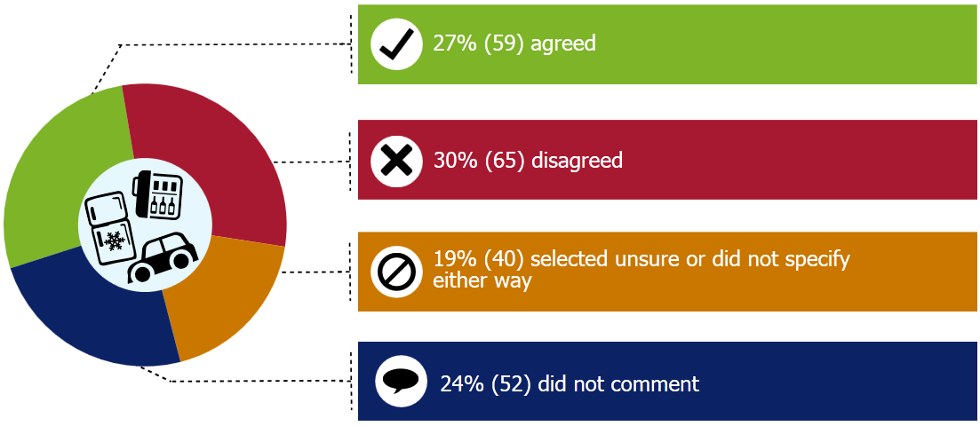
Peter Wise disagreed that the defined product should be the containers holding the gas and stated
“The focus should be on all aspects of refrigerant usage no just the containers. All refrigerants are hazardous and in the wrong hands can cause serious accidents.”
The TA Forum Steering Committee, Sarah O’Bryan, and the Dunedin City Council also disagreed and asserted that the defined product should be all gases included under the Montreal Protocol. The Institution of Professional Engineers New Zealand stated that
“…It will be difficult to name all the containers for the relevant gases. It would be more practical to name the gas and then the onus is on the dismantler or disposer to check if the gas is contained within the container. Products containing these gases can also be refurbished a number of times during the component’s life cycle, for example an air conditioning unit may be re-gassed a number of times before the appliance is obsolete, yet the gas needs to be managed during servicing in the same way as if the appliance had reached end of life”.
WasteManagers disagreed and considered the defined product should be the gases themselves
“Except or unless a scheme variation to consider end of life refrigeration and air conditioning equipment. These gases are sometimes imported in small containers though would more typically be imported in bulk and transferred to and between multiple containers thus the container is not the trackable target hazardous product.”
Wanaka Wastebusters agreed that the defined product should be the containers holding the target gases. They stated
“Separating the gases from the containers or appliances they are contained in seems impractical as a mechanism for securing their recovery.”
The Trust for the Destruction of Synthetic Refrigerants and DHL Supply Chain also agreed. The Trust for the Destruction of Synthetic Refrigerants stated

“Regulations should be based on the gases themselves or on the containers (equipment types) as appropriate from the established procedures for the ETS levies”.

DHL Supply Chain stated

“The scope should be to the products for which the target gases for a working component rather than the gases themselves”.

Do you agree that other synthetic gases which deplete ozone and contribute to climate change should be included?
The second part of the refrigerants scope proposal was whether submitters agreed that other synthetic greenhouse gases which deplete the ozone and contribute to climate change should be included or not. Submitters were asked, in relation to refrigerants and other synthetic greenhouse gases, to specify which gases they thought are the most important to include in the scope of a scheme and why.
Figure 16: Breakdown of submissions by the response to question 2(d) –should other synthetic gases be included
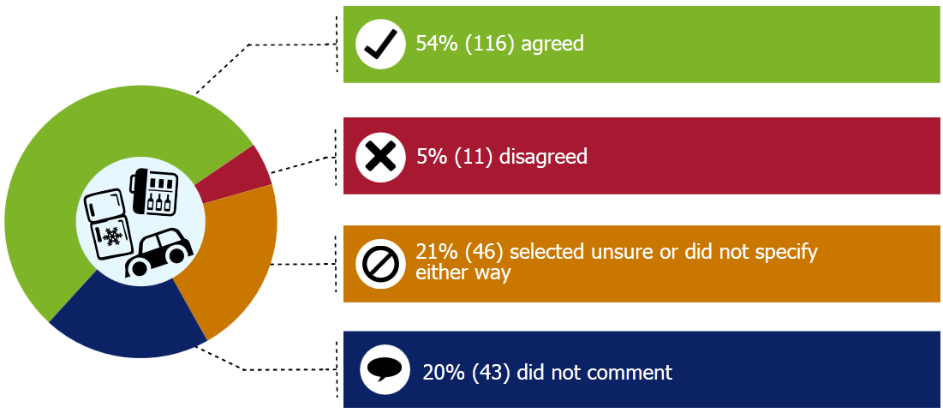
Rex Verity agreed that other synthetic greenhouse gases which deplete the ozone and contribute to climate change should be included stating
“If necessary, redefine ‘synthetic’ gases to include the methane and CO₂ produced by human industrial, transport, commercial, residential and agricultural activities as these are the most important gases to be phased-out.”
A number of those involved in the refrigeration and air conditioning sector disagreed that other synthetic greenhouse gases should be included in the scope. These submitters suggested that widening the scope beyond refrigerants may make implementation more complex and less achievable.
A number of submitters from the refrigeration and air conditioning sector cited this same reason but agreed that other synthetic greenhouse gases should be included in the scope. Similarly, the Employers and Manufacturers Association’s submission stated
“The scope of the products should be limited to those originally identified and within initially tight constraints to ensure a logistically workable and sustainable infrastructure can be implemented.”
Additionally the Southern District Health Board indicated that the scope initially should be limited to ensure the scheme is expedited. They noted that Regulations could then be written so the scope could be widened easily at a later date.
Regarding what products should be covered by the scope, many local government submissions recommended that all gases under the Montreal Protocol should be included in scope. For example, Auckland Council stated
“We support all ozone depleting substances and synthetic greenhouse gases being included for regulatory intervention and priority product status. In addition, we support the proposed change in wording from ‘refrigerants’ to ‘ozone depleting and other synthetic greenhouse gases’ in order to control other harmful substances such as halons, methyl bromide and sulphur hexafluorine (sic)”.
Envirowaste Services, WasteManagers, Fulton Hogan Ltd, and the Regional Waste and Contaminated Land Forum also supported the inclusion of these three gases.
Other gases that submitters suggested for inclusion in scope were: aerosol propellant gases, CFC and similar gases, carbon dioxide, carbon monoxide, nitrous oxide, hydrofluorocarbons, and perfluorocarbons. Additionally a small number of submitters suggested a broader category of gases should be included in the scope. For example:
Ann Dennison stated
“Any synthetic gases which deplete ozone and contribute to climate change should be included in scope.”
Fisher and Paykel stated
“All ozone-depleting gases should be included and all SGGs above a certain global warming potential should be included. However, there needs to be a pragmatic lower limit on quantity not recovered. Normal recovery techniques, for example, will not recover all the refrigerant dissolver in compressor oil.”
And
“A requirement on refrigerant importers and installers without a matching requirement on importers of pre-charged refrigeration equipment (such as dehumidifiers and air-conditioned vehicles) would tend to push manufacturing offshore”.
Dua Refrigeration Training stated
“The EU have a target of banning all refrigerants with a global warming potential great that 150 by a certain date. We should look to do something similar.”
Appendix 1: Indicative process – product stewardship decisions
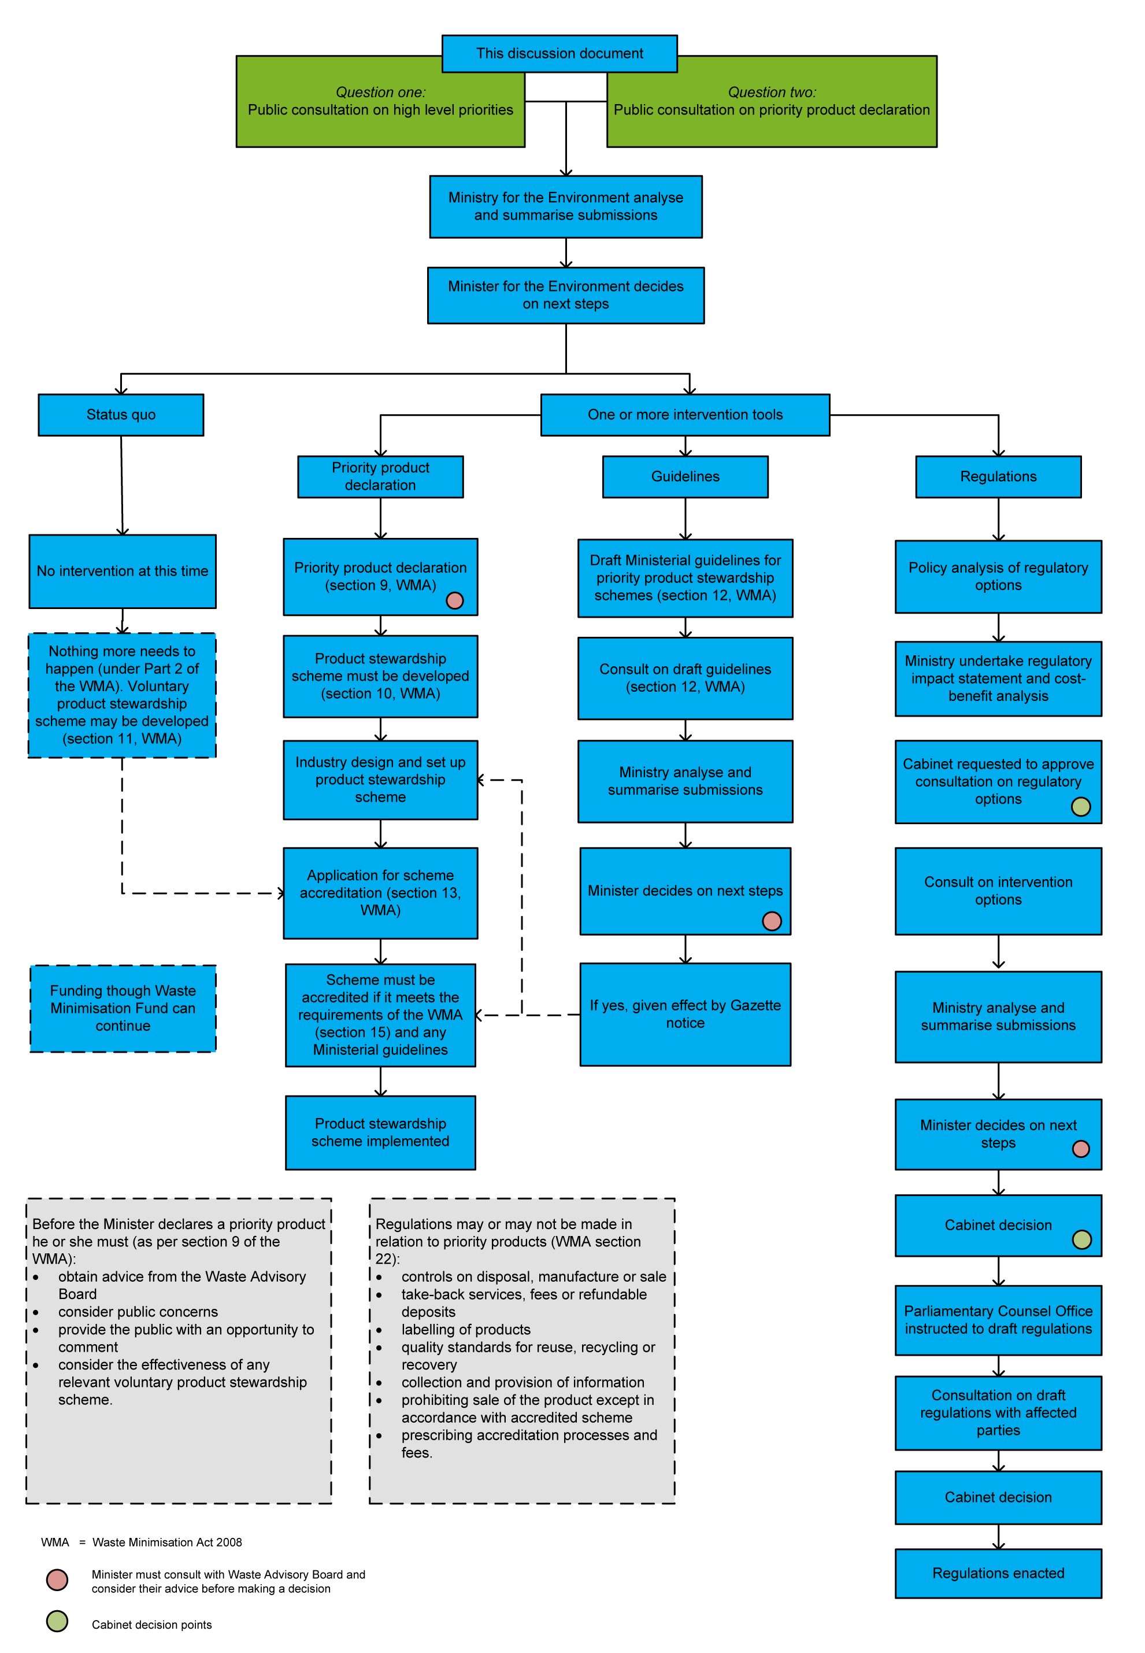

Appendix 2: Consultation meetings held
During the consultation period (21 May 2014 to 2 July 2014) seven public workshops were held around the country. The purpose of these workshops was to provide attendees with a broad overview of what was being sought through the consultation. The workshops also provided attendees with an opportunity to have their questions answered. Workshop details are highlighted below in table 6.
Table 6: Details of public consultation workshops
Workshop location | Date | Approximate number of attendees
Wellington | 6 June 2014 | 16
Christchurch | 9 June 2014 | 17
Auckland | 12 June 2014 | 40
Taupō | 13 June 2014 | 18
Invercargill | 19 June 2014 | 17
Dunedin | 20 June 2014 | 29
Nelson | 23 June 2014 | 13
Total |  | 150
In addition to the public workshops, meetings were also held with industry groups and interested bodies. Further details of these meeting are outlined in table 7 below.
Table 7: Details of meetings held during consultation period
Organisation | Date
Consumer Electronics Association New Zealand | 4 June 2014
New Zealand Telecommunications Forum | 11 June 2014
Sustainable Business Network (Auckland members) | 12 June 2014
Institute of Refrigeration, Heating & Air Conditioning Engineers in New Zealand | 12 June 2014
Scrap Metal Recycling Association of New Zealand | 13 June 2014
Australian Information Industry Association Environment Special Interest Group | 20 June 2014
Community Recycling Network | 20 June 2014
Tasman/Marlborough/Nelson Councils | 23 June 2014
Taranaki Solid Waste Management Committee | 26 June 2014

Appendix 3: Priority waste streams for product stewardship intervention discussion document OFFLINE SUBMISSION FORM

Consultation questions

Consultation theme 1: Product stewardship priorities
1a The following waste stream criteria for selecting product stewardship priorities are being proposed:
- risk of harm
- resource efficiency opportunities
- voluntary measures insufficient
- industry readiness
- current producers (not just legacy products).
Do you agree that these waste stream evaluation criteria are suitable to select product stewardship priorities, consistent with Waste Minimisation Act objectives?
agree with all proposed criteria
agree with all proposed criteria, plus propose extra criteria
agree with some of the proposed criteria
disagree with all the proposed criteria
unsure

Please expand on your response:

1b Do you agree with the assessment of waste streams against these criteria outlined in Appendix 4 of the discussion document?
agree
agree with amendments
disagree
unsure
Please expand on your response:

1c The following four product groups have been identified by the Government as priorities for product stewardship intervention at this time. Do you agree that these four product groups should be a priority for the Government to consider regulatory interventions?

Electrical and electronic equipment
agree
disagree
unsure

Please expand on your response:

Tyres
agree
disagree
unsure

Please expand on your response:

Agrichemicals and farm plastics
agree
disagree
unsure

Please expand on your response:

Refrigerants and other synthetic greenhouse gases
agree
disagree
unsure

Please expand on your response:

Do you think other product groups should be included?
yes, include other products
no, do not include other products
unsure

Please specify which product groups and the reasons why or why not.

1d Do you have or know of any other information that can improve the assessment of priorities in the discussion document?
yes
no
unsure

If yes, please provide the information.

Further comments on the selection of priority waste streams.

Consultation theme 2: Priority product declaration
2a Do you think that the Minister for the Environment should declare any product groups as a priority product under the Waste Minimisation Act?
yes
no
unsure

If so, which ones, and why?

2b If you support priority product declaration, what timing do you think is appropriate? Should it be done soon, or wait until all regulatory framework and scheme design options are explored in a future discussion document?
soon
wait until all regulatory framework and scheme design options are explored
unsure

Please explain your reasons why.

2c Please provide information to improve the assessment of whether to declare priority products if you are able to. For example:
Costs your business, industry or council may face if mandatory product stewardship schemes are required for priority products.

Possible benefits that would arise from product stewardship for priority products.

Any other information.

2d The scope of any declaration of priority product (or regulations) would need to be defined. What products do you think should be covered in scope?

Electrical and electronic equipment:
Should New Zealand start with the same scope as Australia (TVs, computers, and computer peripherals)?
yes
no
unsure

Do you think any other electronic wastes should be included in scope as well?
yes
no
unsure

Please specify which e-waste you think most important to include in scope, and why.

Tyres
Should the scope be all pneumatic (air filled) tyres: those for cars; motorcycles; trucks; buses; off-road vehicles; aircraft; and certain solid tyres (forklifts); but not bicycle tyres?
yes
no
unsure
If you prefer a different scope for tyres, please specify which tyres you think are most important to include in scope, and why.

Agrichemicals and farm plastics
Should the scope be all chemicals which require an Agricultural Chemicals and Veterinary Medicines Act (ACVM) registration and their plastic containers?
yes
no
unsure

Should wider farm plastics (such as silage wrap, twine, crop protection netting) be included in scope?
yes
no
unsure

Please specify which agrichemicals and farm plastics you think most important to include in scope, and why.

Refrigerants and synthetic greenhouse gases
Should the defined product be containers holding the target gases, rather than the gases themselves?
yes
no
unsure
Do you agree that other synthetic gases which deplete ozone and contribute to climate change should be included in scope?
yes
no
unsure

Please specify which gases you think are most important to include in scope, and why.

Further comments
Further comments on declaration of priority products under the Waste Minimisation Act.

Any other comments you wish to make.

Appendix 4: List of submitters
Submission number | Submitter | Submitter type
591366 | 22 Degrees Ltd | Industry (non-waste)
591015 | 3R | Industry (waste)
591290 | Abilities Inc | Community recycling organisation
591212 | Agcarm Inc | Representative body
590845 | Agpac Ltd (Plasback) | Industry (non-waste)
591821 | Airtech Ltd | Industry (non-waste)
581434 | Alistair Campbell | Individual
593388 | Andrew Beattie of Beattie Group | Industry (non-waste)
589985 | AngloGold Ashanti member of IRHACE | Industry (non-waste)
590956 | Ann Dennison | Individual
589405 | Anonymous | Unspecified
593366 | Anonymous | Unspecified
591752 | Anonymous | Unspecified
593765 | Aotea Electric Westland Ltd | Industry (non-waste)
582110 | Aroha Drinks | Industry (non-waste)
591117 | Association for Promotion of Electric Vehicles | Representative body
591364 | Atmos Design Ltd | Industry (non-waste)
591687 | Auckland Council | Local government
591922 | Australia and New Zealand Recycling Platform Ltd | Representative body
592312 | Australia Information Industry Association | Representative body
591203 | Auto Stewardship New Zealand | Representative body
591831 | Barbara Folkard | Individual
593763 | Beattie Air Conditioning Ltd | Industry (non-waste)
589368 | Rodger Wyatt of Beattie Group | Industry (non-waste)
582112 | Bernie Gunn | Individual
592382 | Beta Antifreeze Ltd | Industry (waste)
589966 | Bridgestone NZ Ltd | Industry (non-waste)
591372 | Business NZ | Representative body
590402 | Canterbury District Health Board - Community and Public Health | Local government
591384 | Carter Holt Harvey | Industry (non-waste)
593768 | Celsius Consulting Ltd | Industry (non-waste)
591510 | Central Otago District Council | Local government
587930 | Central Otago Wastebusters | Community recycling organisation
590957 | Central Refrigeration and Air Conditioning Ltd | Industry (non-waste)
591969 | Christchurch City Council | Local government
591964 | Not disclosed | Industry (waste)
592527 | Cleanstream Northland Ltd | Community recycling organisation
588919 | Climate Control | Industry (non-waste)
593762 | Climate Control Companies Association | Representative body
592330 | CMA Recycling New Zealand Ltd | Industry (waste)
592522 | Community Business and Environment Centre | Community recycling organisation
591840 | Community Recycling Network Aotearoa | Representative body
591219 | Consumer Electronic Association NZ | Representative body
588524 | Consumer NZ | Representative body
590227 | Craig McCall of RealCold Pty Ltd | Industry (non-waste)
593848 | Crawford Refrigeration Ltd | Industry (non-waste)
591807 | Cromwell and Districts Community Trust | NGO
591362 | Daikin NZ | Industry (non-waste)
583611 | Dave Puohotana | Individual
588302 | David Lindsay of Eunomia | Consultant
592536 | Davies Heat and Cool | Industry (non-waste)
582111 | Dean Satchell | Individual
590847 | Dennis William Kilpatrick of Beattie Refrigeration & Air Conditioning Service | Individual
589955 | DHL Supply Chain | Industry (non-waste)
592059 | Donaghys Ltd - Crop Packaging Division | Industry (non-waste)
589704 | Dove Electronics Ltd | Industry (non-waste)
593736 | Dua Refrigeration Training | Industry (non-waste)
590399 | Dunedin City Council | Local government
592530 | Ecochill Ltd | Industry (non-waste)
593362 | Ecocool | Industry (non-waste)
592001 | Ecotech Services | Industry (waste)
591468 | eDay NZ Trust | NGO
591224 | Employers and Manufacturers Association | Representative body
584233 | Engineers for Social Responsibility | Representative body
587946 | Enviroed Ltd | NGO
591213 | Envirohub Bay of Plenty | NGO
592318 | Environment Canterbury | Local government
591291 | Environment Network Manawatu | Representative body
589962 | Environment Southland | Local government
591395 | Environmental Education for Resource Sustainability Trust | NGO
592319 | Envirowaste Services Ltd | Industry (waste)
583258 | Envision NZ Ltd | Consultant
591244 | Eunomia Research and Consulting | Consultant
590945 | Fairhall Downs | Industry (non-waste)
587940 | Far North District Council | Local government
591007 | Federated Farmers | Representative body
592531 | Fenn Refrigeration Ltd | Industry (non-waste)
591748 | Fertiliser Association | Representative body
593733 | Fisher and Paykel | Industry (non-waste)
592308 | Fonterra Cooperative Group Ltd | Industry (non-waste)
597414 | Frigie King Ltd | Industry (non-waste)
590948 | Fuji Xerox | Industry (non-waste)
595649 | Fujitsu | Industry (non-waste)
591966 | Fulton Hogan | Industry (non-waste)
591746 | Genaction Ltd | Industry (non-waste)
591796 | Geraldine Tait | Individual
588921 | Gisborne District Council | Local government
590853 | Glass Packaging Forum | Representative body
584239 | Glen Crowther | Individual
591970 | Global Product Stewardship Council | Representative body
590702 | Glynn Cowley | Individual
589712 | Goodyear Dunlop Tyres (NZ) Ltd | Industry (non-waste)
592532 | Gregory Hicks of Beattie Services | Industry (non-waste)
588703 | Halon Recycling Ltd | Industry (waste)
590226 | Hastings District Council | Local government
588917 | Hawke’s Bay Refrigeration | Industry (non-waste)
591694 | Hawke’s Bay Regional Council staff only submission | Local government
588903 | Heat and Cool Airconditioning Ltd | Industry (non-waste)
585580 | Heather Powell | Individual
586319 | Not disclosed | Individual
591689 | Household Battery Workgroup | Representative body
593759 | Institute of Refrigeration Heating & Air Conditioning Engineers | Representative body
592334 | WasteNet Southland for Gore District Council, Invercargill City Council and Southland District Council | Local government
592370 | Iona Jelf | Individual
589718 | IservNZ | Industry (non-waste)
590681 | J & J Laughton Shredding Services Ltd | Industry (waste)
591256 | James Bryant | Individual
591799 | Janet Young of Sustainability Trust | Individual
591751 | JAS-ANZ | Industry (non-waste)
591803 | Kaikoura District Council | Local government
590839 | Keep Waitakere Beautiful Trust | NGO
591287 | Keith Bannister | Individual
591928 | Kilmarnock Enterprises | Community recycling organisation
592393 | Lindsay Dyet of Beattie Airconditioning Service | Industry (non-waste)
591242 | Making a Difference for Central Otago | NGO
586221 | Mana Recovery Trust | Community recycling organisation
592325 | Manawatu District Council | Local government
592399 | Manukau Coolcar Air Conditioning Centre | Industry (non-waste)
591018 | Manurewa Local Body | Local government
591306 | Mark Gilbert | Individual
583615 | Mark Molloy | Individual
593738 | Marlborough District Council | Local government
585376 | Marlborough Helicopters | Industry (non-waste)
590350 | Martella Moffat Refrigeration and Air Conditioning | Industry (non-waste)
590682 | Matthew Hansen | Individual
592737 | McAlpine Hussmann Ltd | Industry (non-waste)
590952 | Michael Garbes | Individual
590946 | Mike Little | Individual
588994 | Milmeq Ltd | Industry (non-waste)
585177 | Motor Industry Association | Representative body
592336 | Motor Trade Association | Representative body
592321 | Napier City Council | Local government
591764 | Nelson Environment Centre | NGO
592734 | Northland Regional Council | Local government
593726 | Not disclosed | Industry (non-waste)
585152 | NV Interactive NZ Ltd | Industry (non-waste)
591692 | NZ Automobile Association | Representative body
590944 | NZ Tyre Recyclers and Collectors Association | Representative body
591753 | Otago Polytechnic | Academic institution / researcher
591967 | Otago Regional Council | Local government
589895 | Owen Douglas | Individual
591761 | Pacific Rubber Recycling Ltd | Industry (waste)
592043 | Packaging Council of NZ Inc | Industry (non-waste)
593730 | Padraic Durham of Milmeq Ltd | Representative body
589363 | Palmerston North City Council | Local government
590973 | Patterson Environmental Ltd | Consultant
592744 | Patton Ltd | Industry (non-waste)
588984 | RefrigeNation | Industry (non-waste)
590675 | Peter Wise | Individual
589408 | Ravindar | Individual
588539 | RealCold Pty Ltd | Industry (non-waste)
591226 | Not disclosed | Industry (waste)
590912 | Refrigerant License Trust Board | Representative body
593363 | Refrigeration Specialities Ltd | Industry (non-waste)
591756 | Regional Waste and Contaminated Land Forum – staff only submission. On behalf of Auckland Council, Bay of Plenty, Canterbury, Greater Wellington, Hawke’s Bay, Taranaki and Waikato Regional Councils | Local government
591216 | Rex Verity | Individual
582113 | Rotorua District Council | Local government
590698 | Ruapehu District Council | Local government
590955 | Rural Contractors Association NZ | Representative body
591368 | Ruth McNamara | Individual
589406 | Sam Tozer | Individual
592378 | Sarah O'Bryan works for Environment Centre Hawkes Bay | Individual
592017 | Scrap Metal Recyclers Association NZ | Representative body
592373 | Selwyn District Council | Local government
587964 | South Waikato Achievement Trust | Community recycling organisation
592375 | Southern District Health Board | Local government
588904 | Southern Institute of Technology and IRHACE member | Academic institution / researcher
591305 | Southern X Press Ltd | Industry (non-waste)
590706 | Southfreeze Refrigeration Ltd | Industry (non-waste)
590311 | Southland Disability Enterprises Ltd | Community recycling organisation
591259 | Sou'West Solutions Ltd | Industry (non-waste)
591828 | Sustainability Trust | NGO
591240 | Not disclosed | Unspecified
590849 | Sustainable Business Council | Representative body
591211 | Sustainable Initiatives Fund Trust | NGO
590316 | Sustainable Whanganui Trust | NGO
587074 | Tania Gaborit of Maketu Ecological Services Ltd | Consultant
591577 | Taranaki Regional Council | Local government
591781 | Tasman District Council staff only submission | Local government
590692 | Taupo District Council | Local government
589993 | Tauranga City Council | Local government
593729 | Telecommunications Forum New Zealand | Representative body
590684 | The Agrecovery Foundation | Representative body
591932 | The EcoFriends Group | NGO
592020 | The Heat Pump People | Industry (non-waste)
592317 | The Institution of Professional Engineers New Zealand | Representative body
589365 | The Warehouse Group | Industry (non-waste)
591804 | Thermal Solutions | Industry (non-waste)
589411 | Thomas | Individual
591959 | Timaru District Council | Local government
589413 | Tom Sullivan-Robertson | Individual
591762 | Transpacific Technical Services | Industry (waste)
590862 | Tredi New Zealand Ltd SA | Industry (waste)
593385 | Trust for the Destruction of Synthetic Refrigerants | Industry (waste)
592397 | Tyre Recyclers Association of NZ | Representative body
591787 | Tyre Removals Auckland | Industry (waste)
593843 | Tyreless Corporation | Industry (waste)
589715 | TyrePlus - Tyre Recycling Waikato | Industry (waste)
590959 | Waihi e-waste and Recycle Centre | Industry (waste)
591758 | Waikato Regional Council | Local government
585027 | Waikato University | Academic institution / researcher
591379 | Waimakariri District Council | Local government
591373 | Waitaki Resource Recovery Trust | Community recycling organisation
591836 | Wanaka Wastebusters | Community recycling organisation
592329 | Wanganui District Council | Local government
591386 | Waste Education NZ Ltd | Consultant
591295 | Waste Transformation Ltd | Industry (waste)
591392 | Waste Watchers Ltd | Consultant
590328 | WasteManagers | Industry (waste)
590110 | WasteMINZ Territorial Authority Steering Committee consisting of Marlborough, Taupo, Gisborne, Hastings, Selwyn and Kapiti Coast District Councils, Invercargill and Dunedin City Councils and Auckland Council | Local government
591750 | Wellington City Council | Local government
592348 | Western Bay of Plenty District Council | Local government
590857 | Xin (Frank) Shi | Individual
590353 | Youling Global Services Ltd | Industry (non-waste)
591298 | Zero Waste NZ Ltd | Industry (waste)
591759 | Zoetis NZ Ltd | Industry (non-waste)

Classification of submitter type
Local government: This category covered territorial authorities and councils plus the Manurewa Local Board and the WasteMINZ Territorial Authority Forum Steering Committee that represents city, district and unitary authorities across New Zealand led by a steering committee made up of nine councils. Thirty-six submissions were classified as local government.
Industry (non-waste): This category included submitters from companies whose primary purpose was not provision of any waste-related service such as Marlborough Helicopters, Real Cold Pty Ltd, DHL Supply Chain, Fulton Hogan Ltd, and Fonterra Co-operative Group Ltd. Sixty-one submissions were classified as industry (non-waste).
Industry (waste): Submitters classified in this category include those whose key purpose is the provision of waste management and minimisation services organisations such as Tyreplus, Tredi New Zealand Ltd, and 3R Group Limited. Twenty submissions were classified as industry (waste).
Community recycling organisations: The community recycling organisations are those that operate as social enterprises or on a not-for-profit basis such as Wanaka Wastebusters, Kilmarnock Enterprises, and the Community Business and Environment Centre. The recycling services are their main purpose. Ten submissions were classified as community recycling organisations.
Non-governmental organisation: Submitters in this category covered organisations that are not part of government nor operate on a for-profit basis such as trusts and voluntary groups. It did not include organisations already captured in the community recycling organisation category. For example, the Sustainable Whanganui Trust and the Keep Waitakere Beautiful Trust. Eleven submissions were classified as being from non-governmental organisations.
Individuals: Submitters in this category included those that provided a name only, classified themselves as an individual or worked for a particular organisation but the submission did not necessarily represent the views of that organisation. Some of the individual submitters were from the refrigerant sector but did not submit on behalf of an organisation. Thirty-one submissions were classified as being from individuals.
Representative body: Submitters in this category covered a broad spectrum of sector groups, waste and non-waste industry plus others involved in product stewardship. This includes recognised industry associations plus other types of interest bodies. For example, the Refrigerant Licence Trust Board, the Employers and Manufacturers Association, Scrap Metal Recyclers Association New Zealand, The Agrecovery Foundation, Consumer New Zealand, and the Household Battery Workgroup. Thirty-two submissions were classified as representative body.
Amongst the other submitter types (14), three were classified as academic bodies / researcher, seven as consultants and four were ‘unspecified’. Unspecified included those that submitted anonymously.

A legacy product is a type of product that is no longer available for sale on the current market.
A circular economy is an alternative to a traditional linear economy (make, use, dispose) in which we keep resources in use for as long as possible, extract the maximum value from them whilst in use, then recover and regenerate products and materials at the end of each service life. (WRAP http://www.wrap.org.uk/content/wrap-and-circular-economy).
‘Brown goods’ is a term given to small household appliances such as toasters, kettles and irons.

