Proposed Amendments to the Environmental Reporting Act 2015
Preliminary Cost Benefit Analysis

November 2021

Document status: | Final | Allen + Clarke has been independently certified as compliant with ISO9001:2015 Quality Management Systems
Version and date: | V4.0; 25/11/2021
Author(s): | Dave Grimmond, Nick Leffler
Filing Location: | \A+C\NZ - Work\MfE\2021 Preliminary CBA of ERA amendments
Peer / technical review: | Nick Leffler
Verification that QA changes made: | Nick Leffler
Proof read: | Venessa Steele
Formatting: | Nick Leffler
Final QA check and approved for release: | Nick Leffler, Senior Consultant

CONTENTS

Executive Summary 1

1. Introduction 7
2. PRoposed Changes to the ERA 7
3. Scope 8
4. Approach and Assumptions 8
4.1. Approach 8
4.2. General Assumptions 8
5. Cost Benefit Analysis 11
5.1. Clarify the purpose of environmental reporting 11
5.2. Mandate a government response to synthesis reports 12
5.3. Add drivers and outlooks to the reporting framework 14
5.4. Adjust roles and responsibilities 17
5.5. Mandate a standing advisory panel 18
5.6. Replace environmental domains with cross-domain themes 20
5.7. Reduce the frequency of synthesis reports to six-yearly 22
5.8. Replace domain reports with one commentary each year 23
5.9. Establish a set of core environmental indicators 25
5.10. Strengthen the mechanisms for collecting data 27
6. Total Cost and resource implications 30

Annex 1 – Summary of Costs and Benefits 32
Annex 2 - References 39

Executive Summary
The Ministry for the Environment (the Ministry) is preparing a consultation document on proposed changes to the Environmental Reporting Act 2015 (ERA), including:
- Clarifying the purpose of environmental reporting
- Mandating a government response to synthesis reports
- Adding drivers and outlooks to the reporting framework
- Adjusting roles and responsibilities
- Mandating a standing advisory panel
- Replacing environmental domains with cross-domain themes
- Reducing the frequency of synthesis reports to six-yearly
- Replacing domain reports with one commentary each year
- Establishing a set of core environmental indicators
- Strengthening the mechanisms for collecting data.
Initial estimates of the costs, benefits, and risks of the proposals have been included in the draft consultation document. Allen + Clarke was engaged by the Ministry to undertake a preliminary Cost Benefit Analysis (CBA) of the proposals to inform updates to the consultation document. The focus of the preliminary CBA is primarily on the costs of implementing the proposals but, where possible, commentary has also been made on the potential benefits and risks. An outlook period of 12 years was chosen to represent two cycles of reporting on the proposed new reporting cycle.
The draft consultation document also outlines the Government’s intention to progress changes to better incorporate te ao Māori and mātauranga Māori in environmental reporting. These changes will be developed with Māori and could result in changes being made to the existing proposed amendments or may also result in additional amendments being developed.
The cost of implementing the 10 proposed amendments is estimated to have an upfront cost of $7.8m and ongoing costs of $16.2m per year. This translates into a present value of $133 million for the 12-year period. Table 1 presents the total FTE and cost estimates by agency.
Table 1: Cost summary of 10 ERA Proposals
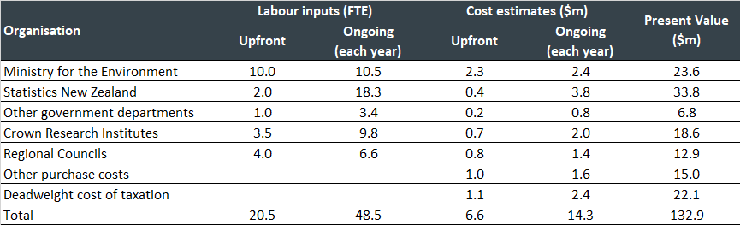
Given the limited information available, Monte Carlo analysis was used to provide a 95% confidence interval of the potential range of costs for each proposal and the combined package of proposals. The Monte Carlo analysis suggests the present value of the costs to range from $111m to $172m. Table 2 presents the present value, expected benefits, and risks for each proposal.
Table 2: Overview of present value of costs, benefits, and risks for the 10 proposed amendments (proposals)
NOTE: Benefits, risks, and mitigations in black text were included in the draft consultation document and are presented for reference. Additional benefits, risks, and mitigations suggested by Allen + Clarke are in blue text.
Proposal | Mean Present Value of Costs  ($m)  (Range of costs) | Benefits | Risks and mitigations
Proposal 1: Clarify the purpose of environmental reporting | $0.0  ($0.0 - $0.0) | - Clarity over ‘who’ the reports are for and ‘why’ the state of the environment should be reported on informs what range, level and quality of information to expect.  - Greater visibility in reporting may also help to prevent duplication in effort of other reports, and greater engagement in the reporting by the public, which will increase the consciousness of the state of the environment with potential ancillary benefits. | - Unnecessary limits on environmental reporting, however, this is unlikely.  - Capture by intermediate targets is always a risk associated with clarification of purpose. To mitigate this, it would be useful to ensure that future evaluations of the performance of the amendments review this aspect.
Proposal 2: Mandate a government response to synthesis reports | $3.6  ($1.6 - $7.1) | - Ensures that the findings from environmental reports are being acknowledged and addressed by the Government. A joint response across multiple Ministers ensures the appropriate ministry with the appropriate area of expertise is addressing environmental issues that cut across several sectors and which require cross-sectoral integrated responses.  - Knowledge that there will be a considered response to the synthesis report will also promote effort and care in the preparation of synthesis reports and ancillary activities.  - The response also provides clarity to the public on what action the Government will take, creating greater accountability for action, and increased focus on resulting environmental improvements. | - A joint response across multiple Ministers may make responding within the timeframes challenging.  - Responses could be subject to political considerations.  - Possibility of a perceived conflict of interest for Ministry staff in preparing the report if the Ministry is also instructed by the Minister for the Environment to be involved in preparing the response.  - These risks are mitigated by the provisions of the Public Service Act 2020.  - Increases the visibility and accountability to the public which will help mitigate the risks. The primary risk relates to the timeliness of the reporting.
Proposal 3: Add drivers and outlooks to the reporting framework | $50.8  ($35.1 - $71.2) | - Including drivers and outlooks will provide a fuller picture of the state of the environment. Drivers provide context of what is causing pressures on the environment and outlooks provide forward-looking information on how the environment may change in the future. These elements will provide high-quality information to underpin decisions for effective policies and interventions.  - Reinforces the value of the reports and therefore also the Government response as mandated by Proposal 2. This in turn increases those benefits. | - Unnecessary limits to environmental reporting by specifying only one framework. If new, more desirable frameworks are developed in the future, we may not be able to incorporate these learnings.  - By nature, future outlooks include an element of uncertainty, reports will need to stipulate where assumptions/predictions have been made.  - Despite the risk of uncertainty inherent in a future outlook, their inclusion provides a better understanding of what may happen without action. Ensuring that the reports and government responses are well communicated to the public helps to mitigate the uncertainty and increases the use of the forecast.
Proposal 4: Adjust roles and responsibilities | $0.0  ($0.0 - $0.0) | - This will provide greater clarity of roles and maintain the independence of reporting as well as greater cost efficiency. It will ensure that each agency has the opportunity to lead on the parts of reporting within its strengths.  - Note that the extent of greater cost efficiency may be minimal unless substantial overlap currently exists. | - There is some concern regarding how the separation of roles will work in practice, i.e., placing too much responsibility on Stats NZ (who may not have the necessary resources to provide what is required which may have flow on effects for aspects of work the Ministry leads).  - Adjusting roles may risk some of the existing procurements and relationships with data providers and the science community.  - Clarity in roles provides for greater certainty and ownership over what resources may be required that can be factored into annual planning. This includes the additional resourcing requirements identified in this preliminary CBA.  - The Ministry and Stats NZ will need to continue to work in partnership and can therefore manage the transition of procurements and relationships, if necessary, through this partnership approach.
Proposal 5: Mandate a standing advisory panel | $3.6  ($2.2 - $5.6) | - Provides independent expert science and data knowledge, as well as different perspectives, skills and experience from a range of disciplines including te ao Māori and mātauranga Māori.  - An expert panel that engages in the reports and the response from the government can help to increase the visibility of environmental reporting, advocating for change, and increasing the accountability for action. | - Risks in protecting the independence of the panel's advice and managing any conflicts of interest. If the panel were to advise on the direction of environmental reporting, there is a risk in relevant areas being missed out or gaps in reporting due to biases or oversight.  - This can be mitigated by the Secretary for the Environment being the ultimate decision-maker and through having clear terms of reference which set out expectations around the role and conduct of members.  - Terms of reference of the panel and its role in relation to the Secretary for the Environment should be drafted with roles clearly defined to further mitigate risk.
Proposal 6: Replace environmental domains with cross-domain themes | $0.5  ($0.2 - $1.1) | - More effective reporting of the complexity and interconnectedness of environmental systems, which will enable holistic integrated responses across multiple environmental domains.  - Acknowledging the interconnectedness of environmental systems may support increased understanding and engagement with the reports and the responses by the public. This should create greater interest in the environment and accountability for action. | - The broad nature of the themes may result in under-reporting of some lesser-known issues that are covered in more depth in the confines of an environmental domain.  - There is also a risk that the themes are not broad enough to cover future issues.  - The overlap and interconnectedness between the themes could make it difficult to determine the scope and boundaries of the individual themes.  - This can be mitigated by having comprehensive synthesis reports and ensuring environmental indicators are published outside of the report production cycle.  - Complexity reduces engagement in the reports by the public. The comprehensive synthesis reports and out of cycle indicators can help to mitigate this if they are accompanied by good communications products.
Proposal 7: Reduce the frequency of synthesis reports to six-yearly | $0.0  ($0.0 - $0.0) | - Provides a more appropriate balance between timeliness of reporting, rates of environmental change and linkages between environmental change with new information.  - Provides time and resources to incorporate mātauranga Māori into reporting, and the time needed to create and collect the data, statistics and knowledge needed.  - Potential benefit of increased engagement by the public in more comprehensive but less frequent reports. | - Visibility of environmental issues may be diminished with reports being published with less frequency.  - This is mitigated by the in-between commentaries and the requirement for core environmental indicators. A longer reporting cycle enables more time and resources to be put into the data and knowledge for the report and to develop innovative and interesting ways to present the report information.  - The second part of the mitigation measure related to “innovative and interesting ways to present the report information” may actually be a benefit. This relates to having more comprehensive data to develop engagement products that could increase public engagement.
Proposal 8: Replace domain reports with one commentary each year | $0.0  ($0.0 - $0.0) | - Has the flexibility to focus on environmentally significant issues in a timely way as identified by the standing advisory panel, including reporting on issues that are important to Māori.  - Having both long-term data and the ability to observe change (progress or decline) over the shorter-term are core parts of effective monitoring.  - As with Proposal 7, there is also a potential benefit of increased engagement by the public in less frequent but more engaging reports. | - There may be several environmentally significant issues that the standing advisory panel wants reported on at the same time. There is a risk of overloading the environmental reporting programme staff who may not have sufficient resources to complete commentaries.  - Having flexibility to report on any theme at any time within the six-year period creates uncertainty for the public as to when the information they need will become available, if at all. This can be partially mitigated through a website notice of which commentaries are currently being prepared.  - We will need to balance the benefits of long-term synthesis reports and short-term commentaries with the compliance costs and the usefulness of particular data points, so the benefits continue to outweigh the costs.  - The mitigation identified in Proposal 5 that the Secretary for the Environment is the ultimate decision maker, will help manage the workload for environmental reporting programme staff.  - There is, however, an associated risk of disengagement of the standing advisory panel if their advice on what to focus reports on is not seen to be sufficiently acted on by the Secretary for the Environment.
Proposal 9: Establish a set of core environmental indicators | $62.4  ($44.1 - $89.4) | - This sets priorities on what should be measured, when, where and by whom.  - It would direct long-term funding for maintenance and updating.  - Publishing data on indicators will ensure up-to-date data are available to the public outside of the report production cycle.  - Provides flexibility in selecting core indicators and there would be less delay in changing regulations than if the indicators were included in the ERA.  - The process of engagement to establish and maintain the core set of indicators can increase the interest and ownership in the indicators by relevant stakeholders ensuring differing views and voices are reflected in the reporting. | - One of the biggest risks will be the implementation of the core indicators. If the set of core indicators does not get updated at environmentally meaningful frequencies because they are not linked to ongoing funding, then their usefulness will be limited.  - There may not be enough data and evidence to create or update indicators on an ongoing basis.  - These risks have ensuing consequences of the relevant stakeholders that have contributed to defining the indicators becoming disengaged from the reporting. This suggests that the stakeholders that have contributed should continue to be engaged.
Proposal 10: Strengthen the mechanisms for collecting data | $18.0  ($12.2 - $25.4) | - Improved data and knowledge collection.  - Other public sector agencies or organisations could be required to give information according to consistent methodologies, frequencies, and monitoring sites, for national reporting through the ERA, and if needed through the Data and Statistics Bill.  - Mechanisms in the ERA and the Data and Statistics Bill would not create duplication but would facilitate and protect the independence of data gathering.  - Improved mechanisms for data collection also support the clarity of roles achieved through Proposal 4 in that the mechanisms can be designed to increase accountability to ensure efficient data collection. | - The data might not yet exist, adding further costs and time to fill gaps in key reporting measures.  - Long-term data and observing change (progress) over the shorter term are core parts of effective monitoring. However, we must balance this with the compliance costs and the usefulness of particular data points.

- Introduction
Under the Environmental Reporting Act 2015 (ERA), the Ministry for the Environment (the Ministry) and Statistics New Zealand (Stats NZ) are required to produce six independent reports on the state of New Zealand’s environment over a period of three years. Based on the experience of completing two three-yearly cycles and the Parliamentary Commissioner for the Environment’s (PCE) review of the effectiveness of the ERA, the Ministry and Stats NZ are proposing changes to the ERA to increase the impact of the environmental reports.
A consultation document on the proposed amendments to the ERA has been prepared that includes initial estimates of the costs, benefits, and risks. To increase the accuracy of the figures included in the consultation document, the Ministry has commissioned Allen + Clarke to undertake a more detailed preliminary Cost Benefit Analysis (CBA).
The purpose of this report is to provide independent advice to agencies on the potential costs and benefits of the proposed amendments to the ERA. The report will inform updates to the consultation document prior to its publication and will be published as a stand-alone document alongside the consultation document. The focus is primarily on estimating the costs, with commentary on the potential benefits and risks provided where this is available.
- PRoposed Changes to the ERA
In 2019, the PCE issued a report on how well New Zealand reports on the state of its environment. Focusing Aotearoa New Zealand’s environmental reporting system critiqued the approach to reporting set up under the ERA and outlined steps to improve the system. The report included, amongst others, specific recommendations on amendments to the ERA to improve its effectiveness.
Based on the experience of the Ministry, Stats NZ, and other contributing agencies the following changes to the ERA are being proposed:
- Clarify the purpose of environmental reporting.
- Mandate a government response to synthesis reports.
- Add drivers and outlooks to the reporting framework.
- Adjust roles and responsibilities.
- Mandate a standing advisory panel.
- Replace environmental domains with cross-domain themes.
- Reduce the frequency of synthesis reports to six-yearly.
- Replace domain reports with one commentary each year.
- Establish a set of core environmental indicators.
- Strengthen the mechanisms for collecting data.
In addition, beyond the proposals above, the consultation document outlines the Government’s intention to progress changes to better incorporate te ao Māori and mātauranga Māori in environmental reporting. These changes will be developed with Māori and could result in changes being made to the existing proposed amendments and may also result in additional amendments being developed.
- Scope
The scope of this preliminary CBA is the 10 proposed amendments included in the consultation document. We acknowledge the parallel work on developing changes to better incorporate te ao Māori and mātauranga Māori in environmental reporting and note that this may result in additional costs and benefits being included within the existing proposed amendments, and where further amendments are developed, they will need to have their own costs and benefits established. These are, however, not included in this preliminary CBA.
- Approach and Assumptions
  - Approach
This is a desk-based preliminary CBA based on available documentation provided by the Ministry and additional documentation and tools available to the project team based on prior experience and knowledge. No engagement with agencies has been included in the preparation of the CBA.
As a preliminary CBA, the focus is primarily on the costs and no effort has been made to ascribe a value to the potential benefits. However, where possible, commentary has been provided on the benefits to inform an approach to a full CBA when final policy proposals are established following the consultation.
Given the limited information available in preparing the CBA, a Monte Carlo analysis has been carried out on the estimated costs to assess the range and probability of potential cost outcomes. A 12-year outlook period has been chosen to calculate the present value of the costs of the proposals. This time period was chosen as it reflects two cycles of reporting on the proposed new frequency of synthesis reports. Following current Treasury guidelines for their CBAx tool, a 5% discount rate is used for calculating present values, but this and other assumptions are relaxed in the Monte Carlo analysis (The Treasury 2021).
  - General Assumptions
Specific assumptions (e.g., number of Full Time Equivalent (FTE) staff) and results are presented by proposal. However, there are a number of general assumptions that apply to all proposals as follows:
- Labour costs
- Deadweight cost of taxation
- Compliance Costs
- Current costs of passing the ERA amendments
- Monte Carlo analysis.
    - Labour costs
The cost of public sector time is benchmarked on a 2015 comprehensive investigation into the cost of policy advice in New Zealand, which has been adjusted for inflation to 2021 prices by subsequent increases in public sector wages (The Treasury. 2015.). The approach is to account for frontline policy or analytical FTE labour inputs but to price these costs accounting for all overhead costs. This will include management overheads and support staff providing ancillary activities such as accounts, IT support and HR. Thus, while staff engaged in the direct activities of interest will earn less than the numbers used in the tables and graphs below, the calculations account for the higher comprehensive cost to society represented by these higher cost figures.
The original Treasury study presented a range of estimates that differed between departments. The Ministry’s results in 2014 were close to the median result. Translated into 2021 prices, this median value is estimated to be $229,400, which is used to value departmental labour costs. The 25-percentile value of $206,500 is used to value Stats NZ, Crown Research Institute (CRI) and regional council labour inputs. This lower value reflects an assumption that non-policy operations are not likely to require the same level of management oversight as departments with a policy focus.
    - Deadweight cost of taxation
The analysis also uses the New Zealand Treasury recommendation that a 20% deadweight cost of tax premium be applied to costs that will require tax funding as an assumption (The Treasury. 2015 (b)). Most of the costs of a project typically arise from the consumption of resources, such as labour, materials etc. But additional costs arise where the funds for the project come from taxation. Taxes encourage people to move away from things that are taxed and toward things that are not taxed or more lightly taxed. Their consumption choices are distorted away from what they would prefer in the absence of taxes. The change in the mix of consumption has an adverse welfare effect which is additional to the loss of welfare resulting directly from the loss of money that is taken away in the form of tax. This welfare loss is referred to as the deadweight cost of taxation (or sometimes as a deadweight loss, or ‘excess burden’).
    - Compliance costs
The cost estimates presented assume that agencies external to central government will be reimbursed on a full cost recovery basis. In some cases, an explicit monetary spend has been assumed, say for contracting expert advice or research. Although these other potential purchase costs have been explicitly accounted for, our estimates make no judgement about budget allocation decisions. The key presumption is that there will be budget that will fund full cost recovery so that the proposals will not impose any further compliance costs on society. This assumption does not imply this will be the ultimate approach and other arrangements may be made that could be considered in a full CBA.
    - Current costs of passing the ERA amendments
A number of activities involved with the ERA proposals are considered to be business as usual for the Ministry and other agencies involved and so are not regarded as imposing explicit additional costs on society. This includes all processes in relation to the design of amendments, consultation processes, and the government costs associated with passing legislation. This means that it is assumed that Proposal 1 (Clarify the purpose of environmental reporting) and Proposal 4 (Adjust roles and responsibilities) will have no additional cost consequences. It also means that no cost estimates have been prepared here in relation to the parallel work proposed for developing changes to better incorporate te ao Māori and mātauranga Māori in environmental reporting. These will have their own costs and benefits independent of those assessed here.
    - Monte Carlo Analysis
Monte Carlo simulation techniques provide a method for investigating the interactions between multiple areas of uncertainty. A Monte Carlo simulation is a computer-based technique that uses statistical sampling and probability distributions to simulate the effects of uncertain variables on model outcomes. It provides a systematic assessment of the combined effects of multiple sources of risk.
The approach adopted here is to simulate 20,000 observations for each varied component assuming random inputs into a Beta distribution. The assumed distribution takes into account prior information about the potential distribution and can also constrain the distribution to avoid impossible outcomes, like negative costs.
The strength of the Monte Carlo simulation is that it allows a wide range of combinations between the different components (for example, one simulation could effectively assume that some costs are low, but others are high). Twenty thousand simulations were found to be sufficient to ensure that results were stable between different samplings.
A key implication of undertaking Monte Carlo analysis is that it allows us to present a graphical (histogram) presentation of the distribution of cost estimates and also to provide 95% confidence intervals for the cost estimates.

- Cost Benefit Analysis
  - Clarify the purpose of environmental reporting

Details of proposed change
Clarify the purpose of the ERA to include the purpose of reporting on the state of the environment and what the reports are supposed to achieve.

Assumptions
Although a key component of the suite of ERA proposals, it is presumed that the activities involved fall within the business-as-usual activities of the Ministry. This means there should be no explicit additional cost implications from this proposal.

Costs
This proposed change has no impact on FTE requirements or costs.
Table 3: Cost summary for Proposal 1, Clarify the purpose of environmental reporting
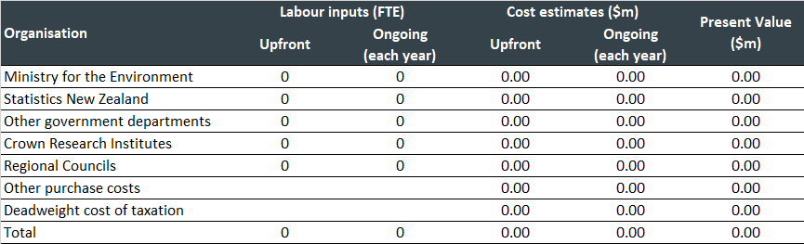

Monte Carlo analysis
No Monte Carlo analysis undertaken for Proposal 1 as there is no associated cost.

Benefits
The initial benefits identified in the consultation documentation are:
- Clarity over ‘who’ the reports are for and ‘why’ the state of the environment should be reported on. It ensures that the public are informed on what range, level and quality of information to expect.
We agree with these benefits and note that greater clarity on roles and responsibilities should aid the efficiency and effectiveness of environmental reporting. Greater visibility in reporting may also help to prevent duplication in effort of other reports and greater engagement in the reporting by the public will increase the consciousness of the state of the environment with potential ancillary benefits.

Risks
The following risk was noted in the consultation document:
- Unnecessary limits on environmental reporting, however, this is unlikely.
Capture by intermediate targets is always a risk associated with clarification of purpose. It suggests that it would be useful to ensure that future evaluations of the performance of the amendments should review this aspect.
  - Mandate a government response to synthesis reports

Details of proposed change
The purpose is to encourage a timely and comprehensive response from the Government to the evidence presented in national synthesis reports.

Assumptions
It is assumed that this proposal will have resource implications every six years in the year following the release of synthesis reports. The Ministry is expected to require one full time equivalent resource to co-ordinate responses from other departments. Our cost estimates assume nine FTE inputs to assess implications and responses to each synthesis report, 0.5 FTE from the Ministry and 8.5 from other departments.

Costs
The cost estimates of Proposal 2 are presented in Table 4. The 10 FTE government labour requirement is estimated to impose a $2.8m cost on one year during the proposed six-year reporting cycle. The present value of two cycles (with costs assumed in year 6 and year 12) is $3.6m.
Table 4: Cost summary for Proposal 2, Mandate a government response to synthesis reports
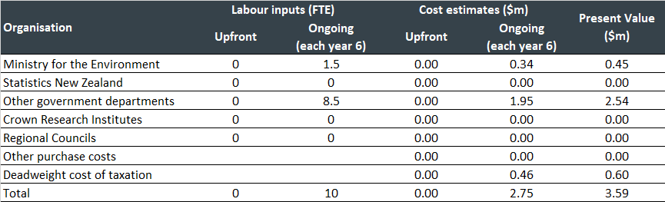

Monte Carlo analysis
In addition to the standard risks around the size of discount rate, deadweight costs of taxation and labour costs, the critical cost estimate risks for Proposal 2 revolve around the actual level of labour input used in responding to the synthesis reports and co-ordinating these responses. Allowing for variations in assumptions as presented in Table 5, implies a 95% confidence interval around the present value of cost estimates for Proposal 2 that range from $1.6m to $7.1m.
Table 5: Distribution assumptions underpinning Monte Carlo analysis of Proposal 2
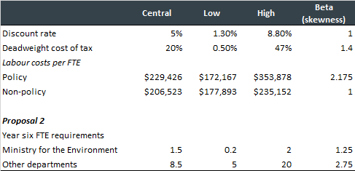
Figure 1: Distribution of cost estimated for Proposal 2
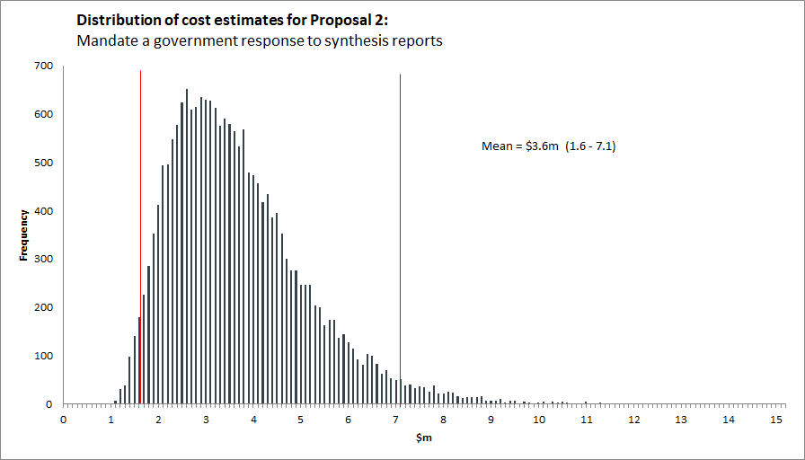

Benefits
The initial benefits identified in the consultation documentation are:
- Ensures that the findings from environmental reports are being acknowledged and addressed by the Government. A joint response across multiple Ministers ensures the appropriate ministry with the appropriate area of expertise is addressing environmental issues that cut across several sectors and which require cross-sectoral integrated responses.
We agree with these benefits and note that this proposal signals the Government’s commitment to environmental reporting. Knowledge that there will be a considered response to the synthesis report will also promote effort and care in the preparation of synthesis reports and ancillary activities. The response also provides clarity to the public on what action the Government will take creating greater accountability for action, and increased focus on resulting environmental improvements.

Risks
The following risks were noted in the consultation document:
- A joint response across multiple Ministers may make responding within the timeframes challenging.
- Responses could be subject to political considerations.
- Possibility of a perceived conflict of interest for Ministry staff in preparing the report if the Ministry is also instructed by the Minister for the Environment to be involved in preparing the response.
- These risks are mitigated by the provisions of the Public Service Act 2020.
In addition to the provisions of the Public Service Act 2020, a formal response increases the visibility and accountability to the public which will help mitigate the risks. The primary risk relates to the timeliness of the reporting.
  - Add drivers and outlooks to the reporting framework

Details of proposed change
Extend the pressure-state-impact framework to include a requirement for information on:
- drivers – factors that cause the pressures on the environment
- outlooks – how the state of the environment may change in the future, and the likely impact of such changes.

Assumptions
It is assumed that the largest resource cost for implementing this proposal will fall on Stats NZ, with an additional 10 FTE required each year. Allowance has also been made for additional expert resources at the Ministry (4 FTE per year). The costing factors in cost reimbursements for CRIs and regional councils, as well as a $1m per year to purchase services from other organisations.

Costs
The cost estimates of Proposal 3 are presented in Table 6. The 17 FTE labour requirement and budget for purchase of services is estimated to impose a $5.5m cost per year with a present value over two cycles of $50.4m.
Table 6: Cost summary for Proposal 3, Add drivers and outlooks to the reporting framework
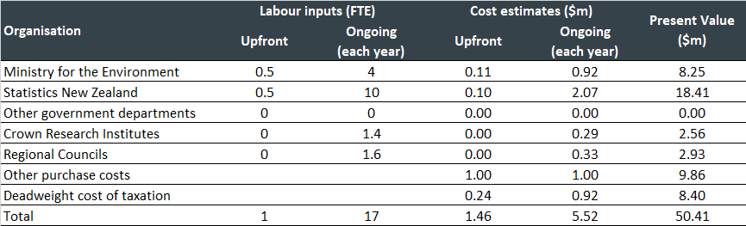

Monte Carlo analysis
In addition to the standard risks around the size of discount rate, deadweight costs of taxation and labour costs, the critical cost estimate risks for Proposal 3 revolve around the actual level of labour input used in the Ministry, Stats NZ, CRIs, and regional councils. In addition, we have allowed for annual purchases averaging $1m per year, which could also be more or less in practice. Allowing for variations in assumptions as presented in Table 7 implies a 95% confidence interval around the present value of cost estimates for Proposal 3 that range from $35.1m to $71.2m.
Table 7: Distribution assumptions underpinning Monte Carlo analysis of Proposal 3
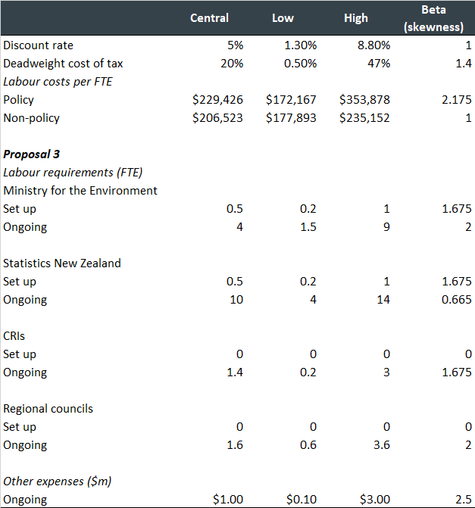
Figure 2: Distribution of cost estimates for Proposal 3
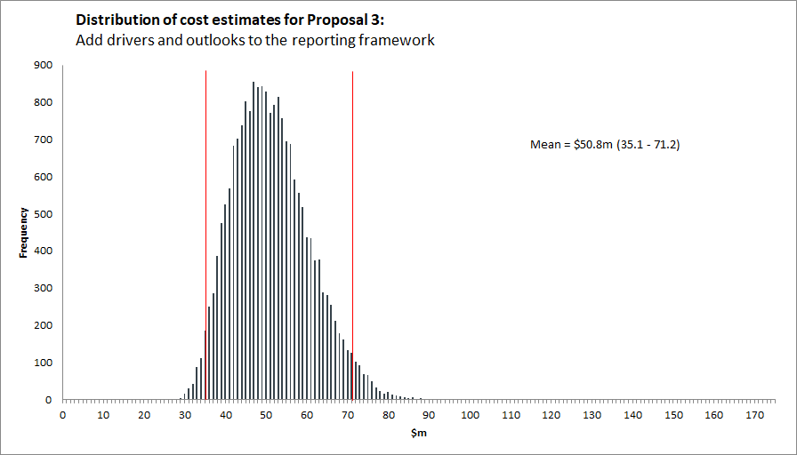

Benefits
The initial benefits identified in the consultation document are:
- Including drivers and outlooks will provide a fuller picture of the state of the environment. Drivers provide context of what is causing pressures on the environment and outlooks provide forward-looking information on how the environment may change in the future. These elements will provide high-quality information to underpin decisions for effective policies and interventions.
We agree with this benefit which reinforces the value of the reports and therefore also the Government response as mandated by Proposal 2. This in turn increases those benefits.

Risks
The following risks were noted in the consultation document:
- Unnecessary limits to environmental reporting by specifying only one framework. If new, more desirable frameworks are developed in the future, we may not be able to incorporate these learnings.
- By nature, future outlooks include an element of uncertainty, reports will need to stipulate where assumptions/predictions have been made.
Despite the risk of uncertainty inherent in a future outlook, their inclusion provides a better understanding of what may happen without action. Ensuring that the reports and government responses are well communicated to the public helps to mitigate the uncertainty and increases the use of the forecast.
  - Adjust roles and responsibilities

Details of proposed change
Adjust the roles and responsibilities for the Secretary for the Environment and the Government Statistician, to reduce overlaps and ensure that each organisation uses their expertise, with:
- the Secretary for the Environment as the steward for New Zealand’s environment
- the Government Statistician as the leader of the official statistics system.

Assumptions
It is assumed that the costs involved in delivering this proposal represent business as usual activities for both agencies and so no additional cost implications are expected.

Costs
This proposed change has no impact on FTE requirements or costs.
Table 8: Cost summary for Proposal 4, Adjust roles and responsibilities
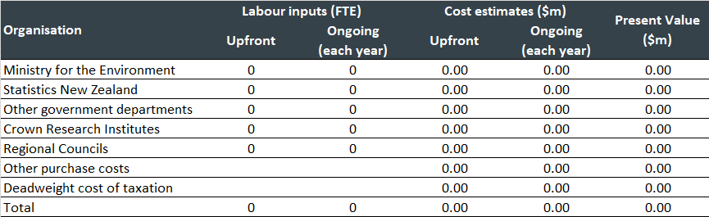

Monte Carlo Analysis
No Monte Carlo analysis undertaken for Proposal 4 as there is no associated cost.

Benefits
The initial benefits identified in the consultation document are:
- This will provide greater clarity of roles and maintain the independence of reporting as well as greater cost efficiency. It will ensure that each agency has the opportunity to lead on the parts of reporting within its strengths.
We agree with these potential benefits but note that the extent of greater cost efficiency may be minimal unless substantial overlap currently exists.
Risks
The following risks were noted by the Ministry:
- There is some concern regarding how the separation of roles will work in practice, i.e., placing too much responsibility on Stats NZ (who may not have the necessary resources to provide what is required which may have flow on effects for aspects of work the Ministry leads).
- Adjusting roles may risk some of the existing procurements and relationships with data providers and the science community.
While the resourcing risk may exist, the additional clarity in roles provides for greater certainty and ownership over what resources may be required that can be factored into annual planning. This includes the additional resourcing requirements identified in this preliminary CBA. Despite the adjustment in roles and responsibilities, the Ministry and Stats NZ will need to continue to work in partnership and can therefore manage the transition of procurements and relationships, if necessary, through this partnership approach.
  - Mandate a standing advisory panel

Details of proposed change
Require the establishment of a standing advisory panel under the ERA.

Costs
The costs associated with formally instituting a standing advisory panel include the Ministry providing secretariat services for the advisory panel and the costs of holding panel meetings. The cost estimates presented are based on secretariat duties requiring one FTE input from the Ministry each year. We have assumed that there will be on average seven panel members who will meet on average six times per year. We also assume that reimbursement costs for panel members will average $1,685 for each member attending a meeting. This amount includes travel, accommodation, and meeting fees according to the Cabinet Fees Framework. An allowance of $1000 per meeting is also allowed for venue hire and catering purposes.
Table 9: Cost summary for Proposal 5, Mandate a standing advisory panel
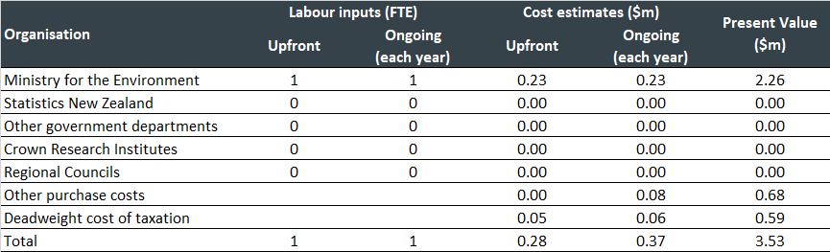

Monte Carlo analysis
In addition to the standard risks around the size of discount rate, deadweight costs of taxation and labour costs, the critical cost estimate risks for Proposal 5 revolve around the actual level of labour input required to provide secretariat services for the panel. Factors to be considered include the size of the panel, the number of times they meet each year, and the costs associated with holding each meeting. Allowing for variations in assumptions as presented in Table 10 implies a 95% confidence interval around the present value of cost estimates for Proposal 5 that ranges from $2.2m to $5.6m.
Table 10: Distribution assumptions underpinning Monte Carlo analysis of Proposal 5
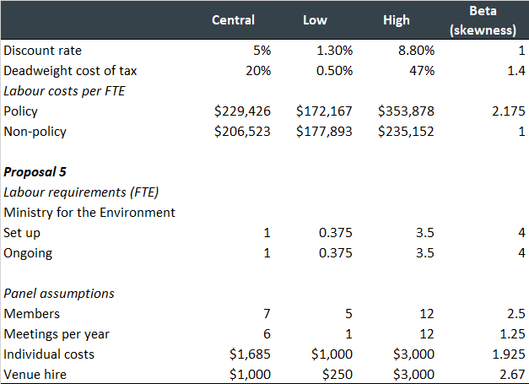
Figure 3: Distribution of cost estimates for Proposal 5
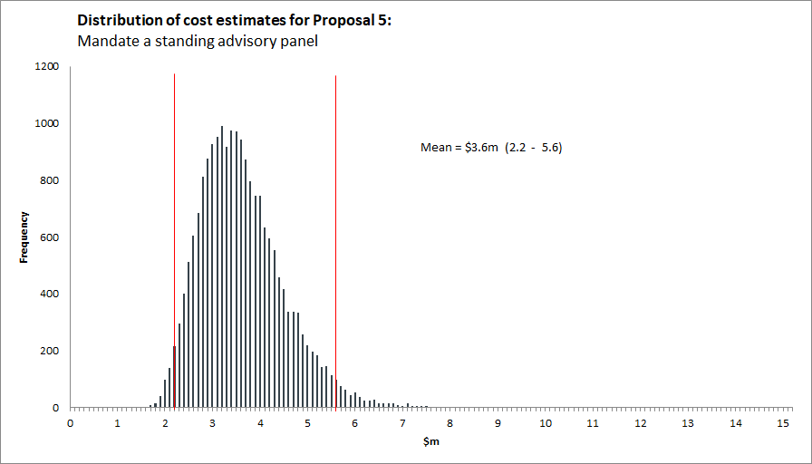

Benefits
The initial benefits identified in the consultation document are:
- Provides independent expert science and data knowledge, as well as different perspectives, skills and experience from a range of disciplines including te ao Māori and mātauranga Māori.
We agree with this benefit and also note that an expert panel that engages in the reports and the response from the Government can help to increase the visibility of environmental reporting, advocating for change, and increasing the accountability for action.

Risks
The following risks were noted in the consultation document:
- Risks in protecting the independence of the panel’s advice and managing any conflicts of interest. If the panel were to advise on the direction of environmental reporting, there is a risk in relevant areas being missed out or gaps in reporting due to biases or oversight.
- This can be mitigated by the Secretary for the Environment being the ultimate decision-maker and through having clear terms of reference which set out expectations around the role and conduct of members.
We acknowledge the risk identified in the consultation document and agree that clarity on expectations on role and conduct of members should be spelled out in terms of reference for members. In addition, terms of reference of the panel and its role in relation to the Secretary for the Environment should be drafted with roles clearly defined to further mitigate risk.
  - Replace environmental domains with cross-domain themes

Details of proposed change
Replace environmental domains with cross-domain themes that form the basis of synthesis reports and in-between commentaries.

Assumptions
It is assumed that there will be upfront design and planning costs associated with a transition from domains to themes, but once embedded there will be no ongoing cost implications from this proposal.

Costs
Upfront input by two FTE will be required to manage the transition to a cross-domain theme focus. This includes 0.5 FTE each from the Ministry and Stats NZ, plus the equivalent of one FTE from other government departments. This will have a resource cost equivalent to $0.5m (see Table 11).
Table 11: Cost summary for Proposal 6, Replace environmental domains with cross-domain themes
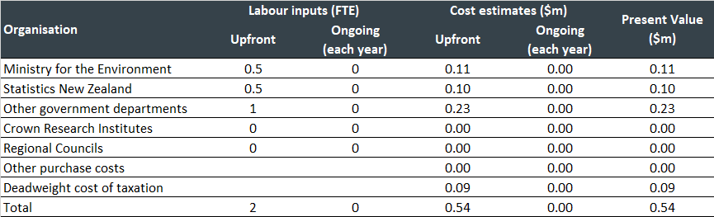

Monte Carlo analysis
In addition to the standard risks around the size of discount rate, deadweight costs of taxation and labour costs, the critical cost estimate risks for Proposal 6 revolve around the actual level of labour input required to manage the proposed transition. Allowing for variations in assumptions as presented in Table 12 implies a 95% confidence interval around the present value of cost estimates for Proposal 6 that range from $0.2m to $1.1m.
Table 12: Distribution assumptions underpinning Monte Carlo analysis of Proposal 6
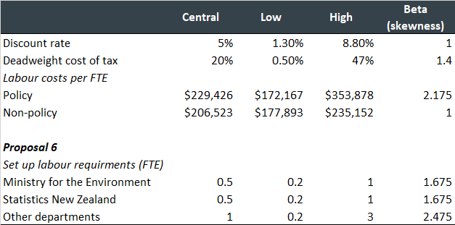
Figure 4: Distribution of cost estimates for Proposal 6
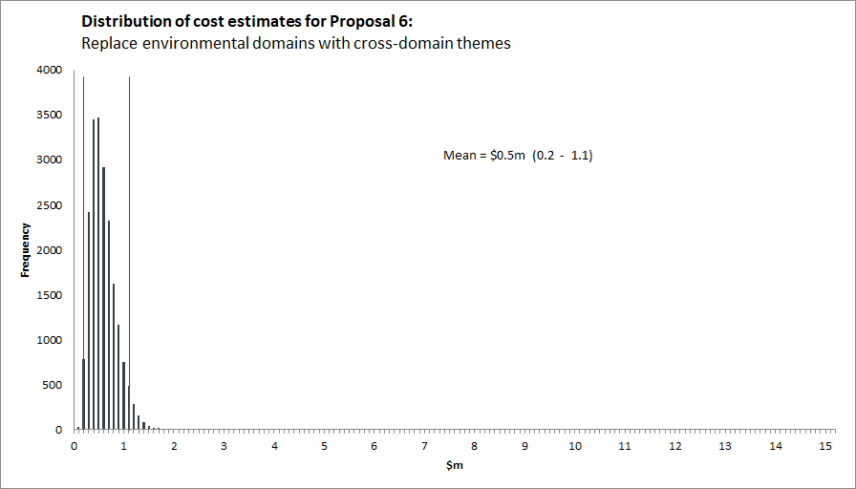

Benefits
The initial benefits identified in the consultation document are:
- More effective reporting of the complexity and interconnectedness of environmental systems, which will enable holistic integrated responses across multiple environmental domains.
In addition to this benefit, it is likely that acknowledging the interconnectedness of environmental systems may support increased understanding and engagement with the reports and the responses by the public. This should create greater interest in the environment and accountability for action.

Risks
The following risks were noted in the consultation document:
- The broad nature of the themes may result in under-reporting of some lesser-known issues that are covered in more depth in the confines of an environmental domain.
- There is also a risk that the themes are not broad enough to cover future issues.
- The overlap and interconnectedness between the themes could make it difficult to determine the scope and boundaries of the individual themes.
- This can be mitigated by having comprehensive synthesis reports and ensuring environmental indicators are published outside of the report production cycle.
We agree with these risks and also note the additional risk that the complexity reduces engagement in the reports by the public. The comprehensive synthesis reports and out of cycle indicators can help to mitigate this if they are accompanied by good communications products.
  - Reduce the frequency of synthesis reports to six-yearly

Details of proposed change
Move from a three-yearly to a six-yearly cycle for synthesis reports.

Assumptions
No cost implications are expected from this proposal, as a reduction in report frequency is not expected to reduce staffing requirements, but instead enable more in-depth analysis underpinning the reports.

Costs
No cost implications expected.
Table 13: Cost summary for Proposal 7, Reduce the frequency of synthesis reports to six-yearly
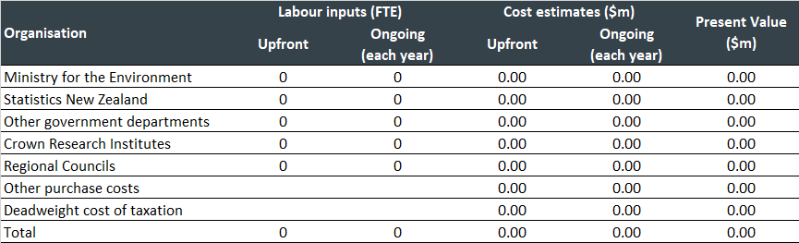

Monte Carlo Analysis
No Monte Carlo analysis undertaken for Proposal 7 as there is no associated cost.

Benefits
The initial benefits identified in the consultation document are:
- Provides a more appropriate balance between timeliness of reporting, rates of environmental change and linkages between environmental change with new information.
- Provides time and resources to incorporate mātauranga Māori into reporting, and the time needed to create and collect the data, statistics and knowledge needed.
In addition to these benefits, with which we agree, there is also a potential benefit of increased engagement by the public in more comprehensive but less frequent reports.

Risks
The following risks were noted in the consultation document:
- Visibility of environmental issues may be diminished with reports being published with less frequency.
- This is mitigated by the in between commentaries and the requirement for core environmental indicators. A longer reporting cycle enables more time and resources to be put into the data and knowledge for the report and to develop innovative and interesting ways to present the report information.
While we acknowledge the risk and mitigation included in the consultation document, we wonder whether the second part of the mitigation measure related to “innovative and interesting ways to present the report information” may actually be a benefit. This relates to having more comprehensive data to develop engagement products that increases engagement by the public.
  - Replace domain reports with one commentary each year

Details of proposed change
Between six-yearly synthesis reports, replace the six-monthly domain reports with one theme-based commentary each calendar year.

Assumptions
As with Proposal 7, the reduction in report frequency is not expected to have resource or cost implications as reductions in report frequency are expected to be offset by improvements in depth of analysis.

Costs
No cost implications.
Table 14: Cost summary for Proposal 8, Replace domain reports with one commentary each year

Monte Carlo analysis
No Monte Carlo analysis undertaken for Proposal 8 as there is no associated cost.

Benefits
The initial benefits identified in the consultation document are:
- Has the flexibility to focus on environmentally significant issues in a timely way as identified by the standing advisory panel, including reporting on issues that are important to Māori.
- Having both long-term data and the ability to observe change (progress or decline) over the shorter-term are core parts of effective monitoring.
As with Proposal 7, there is also a potential benefit of increased engagement by the public in less frequent but more engaging reports.

Risks
The following risks were noted in the consultation document:
- There may be several environmentally significant issues that the standing advisory panel wants reported on at the same time. There is a risk of overloading the environmental reporting programme staff who may not have sufficient resources to complete commentaries.
- Having flexibility to report on any theme at any time within the six-year period creates uncertainty for the public as to when the information they need will become available, if at all. This can be partially mitigated through a website notice of which commentaries are currently being prepared.
- We will need to balance the benefits of long-term synthesis reports and short-term commentaries with the compliance costs and the usefulness of particular data points, so the benefits continue to outweigh the costs.
In relation to the risks identified in the consultation document, we note the mitigation identified in Proposal 5 that the Secretary for the Environment is the ultimate decision maker, which can help manage the workload for environmental reporting programme staff. There is, however, an associated risk with that of disengagement of the standing advisory panel if their advice is not seen to be sufficiently acted on by the Secretary for the Environment.
  - Establish a set of core environmental indicators

Details of proposed change
Define themes for a set of environmental indicators in the regulations and develop those indicators to help achieve the purpose of the ERA.

Assumptions
It is assumed that the Ministry will require a substantial initial upfront investment of resources to help define an appropriate set of environmental indicators and design a programme of work to enhance the set of indicators over time. For this reason, it is assumed that the Ministry will need to maintain activity in this area. Input from Stats NZ and others will be required to help collect data and manage indicator series. Interest has been expressed by other government agencies to be involved with this proposal, so allowance for FTE involvement from other agencies has been included in the cost estimates.

Costs
An upfront input of seven FTE and ongoing annual commitment of five FTE from the Ministry is expected to have a present value of $11.8m. Ongoing inputs of eight FTE from Stats NZ, two FTE from other government agencies, 7.5 from CRIs and four FTE from regional councils, result in a cost estimate with a twelve-year present value of $61.8m (see Table 15).
Table 15: Cost summary for Proposal 9, Establish a set of core environmental indicators
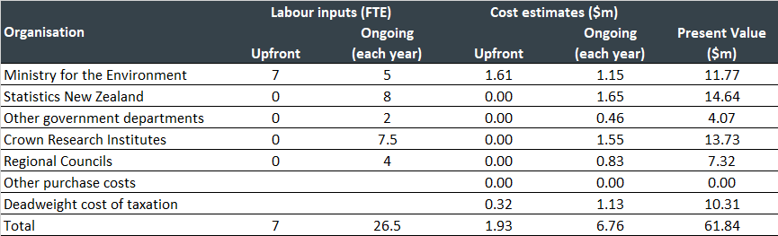

Monte Carlo analysis
In addition to the standard risks around the size of discount rate, deadweight costs of taxation and labour costs, the critical cost estimate risks for Proposal 9 revolve around the actual level of labour input required. Allowing for variations in assumptions as presented in Table 16 implies a 95% confidence interval around the present value of cost estimates for Proposal 9 that range from $44.1m to $89.4m.
Table 16: Distribution assumptions underpinning Monte Carlo analysis of Proposal 9
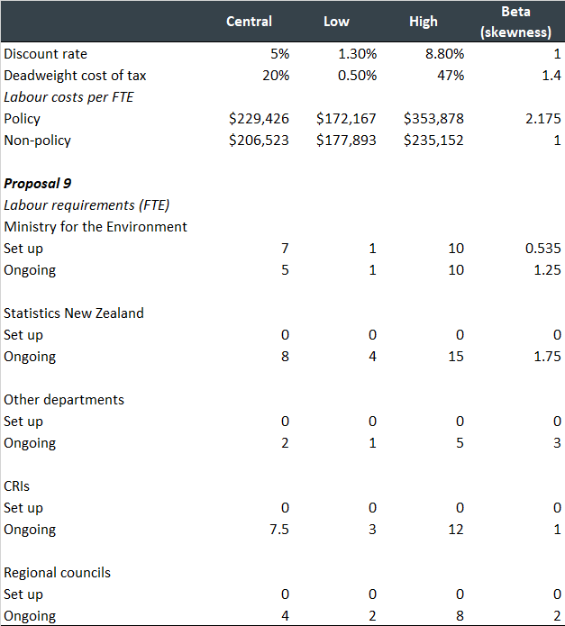
Figure 5: Distribution of cost estimates for Proposal 9
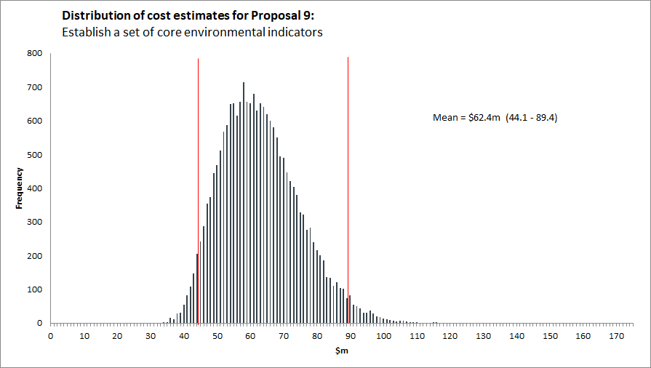

Benefits
The initial benefits identified in the consultation document are:
- This sets priorities on what should be measured, when, where and by whom.
- It would direct long-term funding for maintenance and updating.
- Publishing data on indicators will ensure up-to-date data are available to the public outside of the report production cycle.
- Provides flexibility in selecting core environmental indicators and there would be less delay in changing the themes for these indicators as set in regulations and the indicators themselves than if the indicators were included in the ERA.
In addition to these benefits, the process of engagement to establish and maintain the core set of indicators can increase the interest and ownership in the indicators by relevant stakeholders, ensuring different views and voices are reflected in the reporting.

Risks
The following risks were noted in the consultation document:
- One of the biggest risks will be the implementation of the core indicators. If the set of core indicators does not get updated at environmentally meaningful frequencies because they are not linked to ongoing funding, then their usefulness will be limited.
- There may not be enough data and evidence to create or update indicators on an ongoing basis.
These risks have ensuing consequences of the relevant stakeholders that have contributed to defining the indicators becoming disengaged from the reporting. This suggests that the stakeholders that have contributed should continue to be engaged.
  - Strengthen the mechanisms for collecting data

Details of proposed change
Include new provisions in the ERA to set out powers for acquiring existing data for national environmental reporting.

Assumptions
It is assumed that most of the costs associated with this proposal will be upfront, but that a level of ongoing input will also be required. Our cost estimates factor in a reasonable scale of input from CRIs and regional councils. In addition, an allowance has been made for research and/or equipment for improving data collection mechanisms.

Costs
An upfront input of one FTE for each of the Ministry and Stats NZ will be required to co-ordinate with significant 3.5 FTE input from CRIs and four FTE input from regional councils. This then falls to 25% of the upfront costs on an ongoing annual basis thereafter for each of these agencies, together with an allowance of $500k per year for purchase of services or equipment. The present value of the 12-year cost for strengthening data collection mechanisms is estimated at $13m (see Table 17).
Table 17: Cost summary for Proposal 10, Strengthen the mechanisms for collecting data
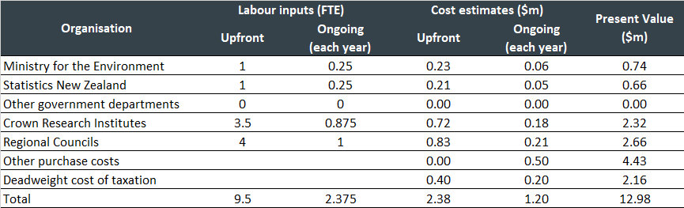

Monte Carlo analysis
In addition to the standard risks around the size of discount rate, deadweight costs of taxation and labour costs, the cost estimate for Proposal 10 will be influenced by assumptions on labour input requirements and on the budget for purchasing improvements. Allowing for variations in assumptions as presented in Table 18 implies a 95% confidence interval around the present value of cost estimates for Proposal 10 that range from $12.3m to $25.5m.
Table 18: Distribution assumptions underpinning Monte Carlo analysis of Proposal 10
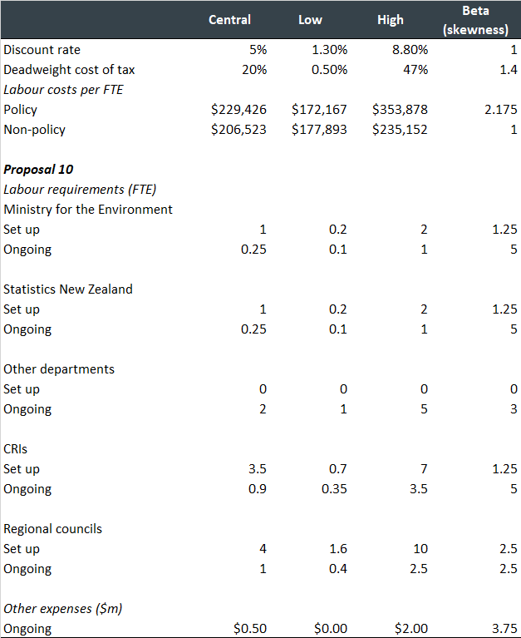
Figure 6: Distribution of cost estimates for Proposal 10
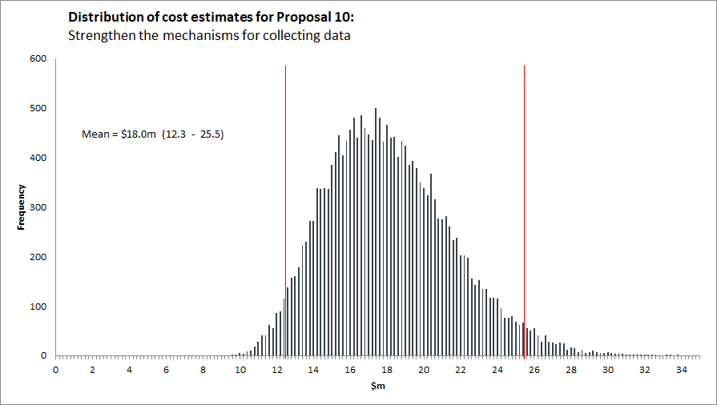

Benefits
The initial benefits identified in the consultation document are:
- Improved data and knowledge collection.
- Other public sector agencies or organisations could be required to give information according to consistent methodologies, frequencies and monitoring sites, for national reporting through the ERA, and if needed through the Data and Statistics Bill.
- Mechanisms in the ERA and the Data and Statistics Bill would not create duplication but would facilitate and protect the independence of data gathering.
Improved mechanisms for data collection also support the clarity of roles achieved through Proposal 4 in that the mechanisms can be designed to increase accountability to ensure efficient data collection.

Risks
The following risks were noted in the consultation document:
- The data might not yet exist, adding further costs and time to fill gaps in key reporting measures.
- Long-term data and observing change (progress) over the shorter term are core parts of effective monitoring. However, we must balance this with the compliance costs and the usefulness of particular data points.
We agree with the risks identified in the consultation document.
- Total Cost and resource implications
The summary of cost estimates from the ten proposals is presented in Table 19. The present value of all the cost estimates is $133m for the 12-year period.
Table 19: Cost summary for 10 ERA proposals
Table 20 and Figure 7 present the results of combining the Monte Carlo analysis for the 10 proposals. The distribution nature of the Monte Carlo approach means that one cannot necessarily replicate the central estimates (the mean value of $139m obtained from the Monte Carlo analysis compares with a baseline estimate of $133m). Of more interest is the distribution of cost estimates, with the analysis suggesting a range from $111m to $172m of the present value of the expected costs.
Table 20: Confidence intervals for ERA proposal cost estimates
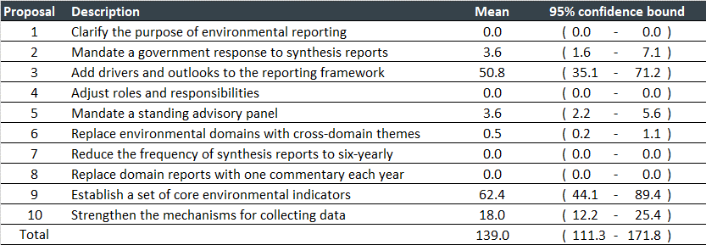
Figure 7: Distribution of cost estimates for all proposals combined
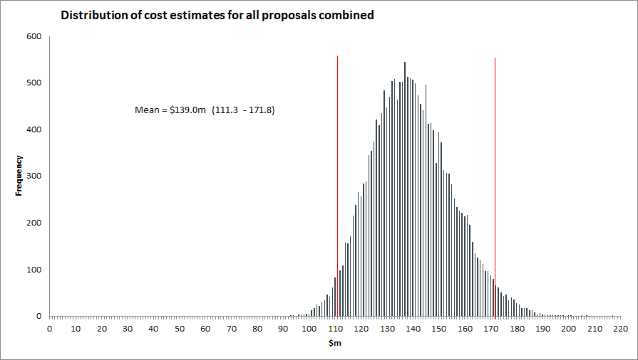
To put these values into context applying the value of ecosystem services derived by de Groot et al. (2012) into current day New Zealand prices, would suggest, for example, that the ecosystem service-based land value for one hectare of inland wetland in New Zealand was worth $941,000 in 2021 (see footnote 5).
Table 21: Estimates of natural environment land values based on ecosystem service estimates
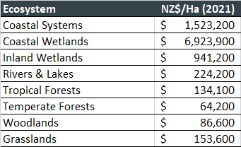
Given that there is an estimated 250,000 hectares of wetlands in New Zealand, but that this represents less than 10% of the wetlands that existed in New Zealand prior to human habitation, it would suggest that there is considerable potential benefit to New Zealand from improved environmental outcomes. From a societal wellbeing perspective, the environmental reporting programme would be cost neutral if it led to, for instance, the protection of the 118 to 182 hectares of wetland that might otherwise be under threat of destruction or alternatively if it promoted the natural reversion of 118 to 182 hectares of land back into wetland.

Annex 1 – Summary of Costs and Benefits
NOTE: Benefits, risks, and mitigations in black text were included in the draft consultation document and are presented for reference. Additional benefits, risks, and mitigations suggested by Allen + Clarke are in blue text.
Proposal | Estimated additional funding (NZ$ m)
Proposal 1: Clarify the purpose of environmental reporting | Ministry for the Environment |  | Stats NZ |  | Other organisations |  | Purchase costs |  | Deadweight Cost of Tax |  | Mean Present Value  (Range)
 | Upfront | Ongoing  (annual) | Upfront | Ongoing  (annual) | Upfront | Ongoing  (annual) | Upfront | Ongoing  (annual) | Upfront | Ongoing  (annual)
 | $0.0 | $0.0 | $0.0 | $0.0 | $0.0 | $0.0 | $0.0 | $0.0 | $0.0 | $0.0 | $0.0  ($0.0 - $0.0)
 | Benefits
- Clarity over ‘who’ the reports are for and ‘why’ the state of the environment should be reported on informs what range, level and quality of information to expect.
- Greater visibility in reporting may also help to prevent duplication in effort of other reports, and greater engagement in the reporting by the public, which will increase the consciousness of the state of the environment with potential ancillary benefits.
 | Risks and mitigations
- Unnecessary limits on environmental reporting, however, this is unlikely.
- Capture by intermediate targets is always a risk associated with clarification of purpose. To mitigate this, it would be useful to ensure that future evaluations of the performance of the amendments review this aspect.
Proposal | Estimated additional funding (NZ$ m)
Proposal 2: Mandate a government response to synthesis reports | Ministry for the Environment |  | Stats NZ |  | Other organisations |  | Purchase costs |  | Deadweight Cost of Tax |  | Mean Present Value  (Range)
 | Upfront | Ongoing  (each year 6) | Upfront | Ongoing  (each year 6) | Upfront | Ongoing  (each year 6) | Upfront | Ongoing  (each year 6) | Upfront | Ongoing  (each year 6)
 | $0.0 | $0.3 | $0.0 | $0.0 | $0.00 | $2.0 | $0.00 | $0.0 | $0.0 | $0.5 | $3.6  ($1.6 - $7.1)
 | Benefits
- Ensures that the findings from environmental reports are being acknowledged and addressed by the Government. A joint response across multiple Ministers ensures the appropriate ministry with the appropriate area of expertise is addressing environmental issues that cut across several sectors and which require cross-sectoral integrated responses.
- Knowledge that there will be a considered response to the synthesis report will also promote effort and care in the preparation of synthesis reports and ancillary activities.
- The response also provides clarity to the public on what action the Government will take creating greater accountability for action, and increased focus on resulting environmental improvements.
 | Risks and mitigations
- A joint response across multiple Ministers may make responding within the timeframes challenging.
- Responses could be subject to political considerations.
- Possibility of a perceived conflict of interest for Ministry staff in preparing the report if the Ministry is also instructed by the Minister for the Environment to be involved in preparing the response.
- These risks are mitigated by the provisions of the Public Service Act 2020.
- Increases the visibility and accountability to the public which will help mitigate the risks. The primary risk relates to the timeliness of the reporting.
Proposal | Estimated additional funding (NZ$ m)
Proposal 3: Add drivers and outlooks to the reporting framework | Ministry for the Environment |  | Stats NZ |  | Other organisations |  | Purchase costs |  | Deadweight Cost of Tax |  | Mean Present Value  (Range)
 | Upfront | Ongoing  (annual) | Upfront | Ongoing  (annual) | Upfront | Ongoing  (annual) | Upfront | Ongoing  (annual) | Upfront | Ongoing  (annual)
 | $0.1 | $0.9 | $0.1 | $2.1 | $0.0 | $0.6 | $1.0 | $1.0 | $0.2 | $0.9 | $50.8  ($35.1 - $71.2)
 | Benefits
- Including drivers and outlooks will provide a fuller picture of the state of the environment. Drivers provide context of what is causing pressures on the environment and outlooks provide forward-looking information on how the environment may change in the future. These elements will provide high-quality information to underpin decisions for effective policies and interventions.
- Reinforces the value of the reports and therefore also the Government response as mandated by Proposal 2. This in turn increases those benefits.
 | Risks and mitigations
- Unnecessary limits to environmental reporting by specifying only one framework. If new, more desirable frameworks are developed in the future, we may not be able to incorporate these learnings.
- By nature, future outlooks include an element of uncertainty, reports will need to stipulate where assumptions/predictions have been made.
- Despite the risk of uncertainty inherent in a future outlook, their inclusion provides a better understanding of what may happen without action. Ensuring that the reports and government responses are well communicated to the public helps to mitigate the uncertainty and increases the use of the forecast.
Proposal | Estimated additional funding (NZ$ m)
Proposal 4: Adjust roles and responsibilities | Ministry for the Environment |  | Stats NZ |  | Other organisations |  | Purchase costs |  | Deadweight Cost of Tax |  | Mean Present Value  (Range)
 | Upfront | Ongoing  (annual) | Upfront | Ongoing  (annual) | Upfront | Ongoing  (annual) | Upfront | Ongoing  (annual) | Upfront | Ongoing  (annual)
 | $0.0 | $0.0 | $0.0 | $0.0 | $0.0 | $0.0 | $0.0 | $0.0 | $0.0 | $0.0 | $0.0  ($0.0 - $0.0)
 | Benefits
- This will provide greater clarity of roles and maintain the independence of reporting as well as greater cost efficiency. It will ensure that each agency has the opportunity to lead on the parts of reporting within its strengths.
- Note that the extent of greater cost efficiency may be minimal unless substantial overlap currently exists.
 | Risks and mitigations
- There is some concern regarding how the separation of roles will work in practice, i.e., placing too much responsibility on Stats NZ (who may not have the necessary resources to provide what is required which may have flow on effects for aspects of work the Ministry leads).
- Adjusting roles may risk some of the existing procurements and relationships with data providers and the science community.
- Clarity in roles provides for greater certainty and ownership over what resources may be required that can be factored into annual planning. This includes the additional resourcing requirements identified in this preliminary CBA.
- The Ministry and Stats NZ will need to continue to work in partnership and can therefore manage the transition of procurements and relationships, if necessary, through this partnership approach.
Proposal | Estimated additional funding (NZ$ m)
Proposal 5: Mandate a standing advisory panel | Ministry for the Environment |  | Stats NZ |  | Other organisations |  | Purchase costs |  | Deadweight Cost of Tax |  | Mean Present Value  (Range)
 | Upfront | Ongoing  (annual) | Upfront | Ongoing  (annual) | Upfront | Ongoing  (annual) | Upfront | Ongoing  (annual) | Upfront | Ongoing  (annual)
 | $0.2 | $0.2 | $0.0 | $0.0 | $0.0 | $0.0 | $0.0 | $0.1 | $0.1 | $0.1 | $3.6  ($2.2 - $5.6)
 | Benefits
- Provides independent expert science and data knowledge, as well as different perspectives, skills and experience from a range of disciplines including te ao Māori and mātauranga Māori.
- An expert panel that engages in the reports and the response from the government can help to increase the visibility of environmental reporting, advocating for change, and increasing the accountability for action.
 | Risks and mitigations
- Risks in protecting the independence of the panel's advice and managing any conflicts of interest. If the panel were to advise on the direction of environmental reporting, there is a risk in relevant areas being missed out or gaps in reporting due to biases or oversight.
- This can be mitigated by the Secretary for the Environment being the ultimate decision-maker and through having clear terms of reference which set out expectations around the role and conduct of members.
- Terms of reference of the panel and its role in relation to the Secretary for the Environment should be drafted with roles clearly defined to further mitigate risk.
Proposal | Estimated additional funding (NZ$ m)
Proposal 6: Replace environmental domains with cross-domain themes | Ministry for the Environment |  | Stats NZ |  | Other organisations |  | Purchase costs |  | Deadweight Cost of Tax |  | Mean Present Value  (Range)
 | Upfront | Ongoing  (annual) | Upfront | Ongoing  (annual) | Upfront | Ongoing  (annual) | Upfront | Ongoing  (annual) | Upfront | Ongoing  (annual)
 | $0.1 | $0.0 | $0.1 | $0.0 | $0.2 | $0.0 | $0.0 | $0.0 | $0.1 | $0.0 | $0.5  ($0.2 - $1.1)
 | Benefits
- More effective reporting of the complexity and interconnectedness of environmental systems, which will enable holistic integrated responses across multiple environmental domains.
- Acknowledging the interconnectedness of environmental systems may support increased understanding and engagement with the reports and the responses by the public. This should create greater interest in the environment and accountability for action.
 | Risks and mitigations
- The broad nature of the themes may result in under-reporting of some lesser-known issues that are covered in more depth in the confines of an environmental domain.
- There is also a risk that the themes are not broad enough to cover future issues.
- The overlap and interconnectedness between the themes could make it difficult to determine the scope and boundaries of the individual themes.
- This can be mitigated by having comprehensive synthesis reports and ensuring environmental indicators are published outside of the report production cycle.
- Complexity reduces engagement in the reports by the public. The comprehensive synthesis reports and out of cycle indicators can help to mitigate this if they are accompanied by good communications products.
Proposal | Estimated additional funding (NZ$ m)
Proposal 7: Reduce the frequency of synthesis reports to six-yearly | Ministry for the Environment |  | Stats NZ |  | Other organisations |  | Purchase costs |  | Deadweight Cost of Tax |  | Mean Present Value  (Range)
 | Upfront | Ongoing  (annual) | Upfront | Ongoing  (annual) | Upfront | Ongoing  (annual) | Upfront | Ongoing  (annual) | Upfront | Ongoing  (annual)
 | $0.0 | $0.0 | $0.0 | $0.0 | $0.0 | $0.0 | $0.0 | $0.0 | $0.0 | $0.0 | $0.0  ($0.0 - $0.0)
 | Benefits
- Provides a more appropriate balance between timeliness of reporting, rates of environmental change and linkages between environmental change with new information.
- Provides time and resources to incorporate mātauranga Māori into reporting, and the time needed to create and collect the data, statistics and knowledge needed.
- Potential benefit of increased engagement by the public in more comprehensive but less frequent reports.
 | Risks and mitigations
- Visibility of environmental issues may be diminished with reports being published with less frequency.
- This is mitigated by the in-between commentaries and the requirement for core environmental indicators. A longer reporting cycle enables more time and resources to be put into the data and knowledge for the report and to develop innovative and interesting ways to present the report information.
- The second part of the mitigation measure related to “innovative and interesting ways to present the report information” may actually be a benefit. This relates to having more comprehensive data to develop engagement products that could increase public engagement.
Proposal | Estimated additional funding (NZ$ m)
Proposal 8: Replace domain reports with one commentary each year | Ministry for the Environment |  | Stats NZ |  | Other organisations |  | Purchase costs |  | Deadweight Cost of Tax |  | Mean Present Value  (Range)
 | Upfront | Ongoing  (annual) | Upfront | Ongoing  (annual) | Upfront | Ongoing  (annual) | Upfront | Ongoing  (annual) | Upfront | Ongoing  (annual)
 | $0.0 | $0.0 | $0.0 | $0.0 | $0.0 | $0.0 | $0.0 | $0.0 | $0.0 | $0.0 | $0.0  ($0.0 - $0.0)
 | Benefits
- Has the flexibility to focus on environmentally significant issues in a timely way as identified by the standing advisory panel, including reporting on issues that are important to Māori.
- Having both long-term data and the ability to observe change (progress or decline) over the shorter-term are core parts of effective monitoring.
- As with Proposal 7, there is also a potential benefit of increased engagement by the public in less frequent but more engaging reports.
 | Risks and mitigations
- There may be several environmentally significant issues that the standing advisory panel wants reported on at the same time. There is a risk of overloading the environmental reporting programme staff who may not have sufficient resources to complete commentaries.
- Having flexibility to report on any theme at any time within the six-year period creates uncertainty for the public as to when the information they need will become available, if at all. This can be partially mitigated through a website notice of which commentaries are currently being prepared.
- We will need to balance the benefits of long-term synthesis reports and short-term commentaries with the compliance costs and the usefulness of particular data points, so the benefits continue to outweigh the costs.
- The mitigation identified in Proposal 5 that the Secretary for the Environment is the ultimate decision maker, will help manage the workload for environmental reporting programme staff.
- There is, however, an associated risk of disengagement of the standing advisory panel if their advice on what to focus reports on is not seen to be sufficiently acted on by the Secretary for the Environment.
Proposal | Estimated additional funding (NZ$ m)
Proposal 9: Establish a set of core environmental indicators | Ministry for the Environment |  | Stats NZ |  | Other organisations |  | Purchase costs |  | Deadweight Cost of Tax |  | Mean Present Value  (Range)
 | Upfront | Ongoing  (annual) | Upfront | Ongoing  (annual) | Upfront | Ongoing  (annual) | Upfront | Ongoing  (annual) | Upfront | Ongoing  (annual)
 | $1.6 | $1.2 | $0.0 | $1.7 | $0.0 | $2.8 | $0.0 | $0.0 | $0.3 | $1.1 | $62.4  ($44.1 - $89.4)
 | Benefits
- This sets priorities on what should be measured, when, where and by whom.
- It would direct long-term funding for maintenance and updating.
- Publishing data on indicators will ensure up-to-date data are available to the public outside of the report production cycle.
- Provides flexibility in selecting core indicators and there would be less delay in changing regulations than if the indicators were included in the ERA.
- The process of engagement to establish and maintain the core set of indicators can increase the interest and ownership in the indicators by relevant stakeholders ensuring differing views and voices are reflected in the reporting.
 | Risks and mitigations
- One of the biggest risks will be the implementation of the core indicators. If the set of core indicators does not get updated at environmentally meaningful frequencies because they are not linked to ongoing funding, then their usefulness will be limited.
- There may not be enough data and evidence to create or update indicators on an ongoing basis.
- These risks have ensuing consequences of the relevant stakeholders that have contributed to defining the indicators becoming disengaged from the reporting. This suggests that the stakeholders that have contributed should continue to be engaged.
Proposal | Estimated additional funding (NZ$ m)
Proposal 10: Strengthen the mechanisms for collecting data | Ministry for the Environment |  | Stats NZ |  | Other organisations |  | Purchase costs |  | Deadweight Cost of Tax |  | Mean Present Value  (Range)
 | Upfront | Ongoing  (annual) | Upfront | Ongoing  (annual) | Upfront | Ongoing  (annual) | Upfront | Ongoing  (annual) | Upfront | Ongoing  (annual)
 | $0.2 | $0.1 | $0.2 | $0.1 | $1.6 | $0.4 | $0.0 | $0.5 | $0.4 | $0.2 | $18.0  ($12.2 - $25.4)
 | Benefits
- Improved data and knowledge collection.
- Other public sector agencies or organisations could be required to give information according to consistent methodologies, frequencies, and monitoring sites, for national reporting through the ERA, and if needed through the Data and Statistics Bill.
- Mechanisms in the ERA and the Data and Statistics Bill would not create duplication but would facilitate and protect the independence of data gathering.
- Improved mechanisms for data collection also support the clarity of roles achieved through Proposal 4 in that the mechanisms can be designed to increase accountability to ensure efficient data collection.
 | Risks and mitigations
- The data might not yet exist, adding further costs and time to fill gaps in key reporting measures.
- Long-term data and observing change (progress) over the shorter term are core parts of effective monitoring. However, we must balance this with the compliance costs and the usefulness of particular data points.
All Proposals | Estimated additional funding (NZ$ m)
Total | Ministry for the Environment |  | Stats NZ |  | Other organisations |  | Purchase costs |  | Deadweight Cost of Tax |  | Mean Present Value  (Range)
 | Upfront | Ongoing  (annual) | Upfront | Ongoing  (annual) | Upfront | Ongoing  (annual) | Upfront | Ongoing  (annual) | Upfront | Ongoing  (annual)
 | $2.3 | $2.4 | $0.4 | $3.8 | $1.8 | $4.2 | $1.0 | $1.6 | $1.1 | $2.4 | $139.0  ($111.3 - $171.8)

Annex 2 - References
Groot, Rudolf de, Luke Brander, Sander van der Ploeg, Robert Costanza, Florence Bernard, Leon Braat, Mike Christie, et al. 2012. ‘Global Estimates of the Value of Ecosystems and Their Services in Monetary Units’. Ecosystem Services 1 (1): 50–61. https://doi.org/10.1016/j.ecoser.2012.07.005.

The Treasury. 2015. ‘Policy Measurement Report 2014/15’. New Zealand Government. https://www.treasury.govt.nz/sites/default/files/2016-09/policy-measurement-report-14-15.pdf.

The Treasury. 2015 (b). ‘Guide to Social Cost Benefit Analysis’. New Zealand Treasury. https://treasury.govt.nz/publications/guide/guide-social-cost-benefit-analysis.

The Treasury. 2021. ‘CBAx Tool User Guidance’. The Treasury. https://www.treasury.govt.nz/publications/guide/cbax-tool-user-guidance.

Note that this is the mean value of the Monte Carlo analysis and does therefore not match the present value calculated in for each proposal.
A Beta distribution was selected as it provides scope to constrain the distribution outcomes within plausible bounds (established by the A and B terms) and to allow skewed distributions (established by the relative size of the α and β terms). In practice each alpha term has been set to 1 and then the beta value adjusted (which sets the distribution skewness) to ensure that the resulting distribution mean matches the values used in the central calculations. The resulting distributions are bounded by plausible constraints but also utilise available information about the likely distribution. For example, if the average price of a milkshake is $10, prices below zero and over $50 may be excluded as impossible or implausible. But as the average price is $10, observations of $8-$12 would be expected to be more likely than observations of $38-$42. So, in this example, A would be set to 0, B to 50, and with α set to 1, a value of 5 would be chosen for β, as this is the value that will generate a sample average of 10. For the Monte Carlo analysis of the cost estimates of the proposed ERA amendments, the following assumptions have been made: - α = 1 - β = adjusted to ensure that the distribution average equals the central estimate - A = lower bound of distribution (if not constrained by a zero lower bound, assumed to be lower than the low sensitivity test value by a proportion that is 25% of the gap between the sensitivity low value and the central estimate) - B = upper bound (typically assumed to be greater than the high sensitivity test value by a proportion that is 25% of the gap between the sensitivity high value and the central estimate).
Given this preliminary CBA covers a 12-year period, though the costs are expected to be incurred in the year following the release of the report, the costs have been included in year 6 and 12 to capture the costs of two cycles of reporting.
While it is likely that premises will be available at the Ministry, including the costs accounts for the opportunity cost of the premises.
Original data from de Groot et al. (2012), translated into 2021 New Zealand values and capitalised into land value equivalents using a 5% discount rate.
See for example https://www.environmentguide.org.nz/issues/biodiversity/new-zealands-biodiversity/wetlands/
Note that this is the mean value of the Monte Carlo analysis and does therefore not match the present value calculated in for each proposal.

