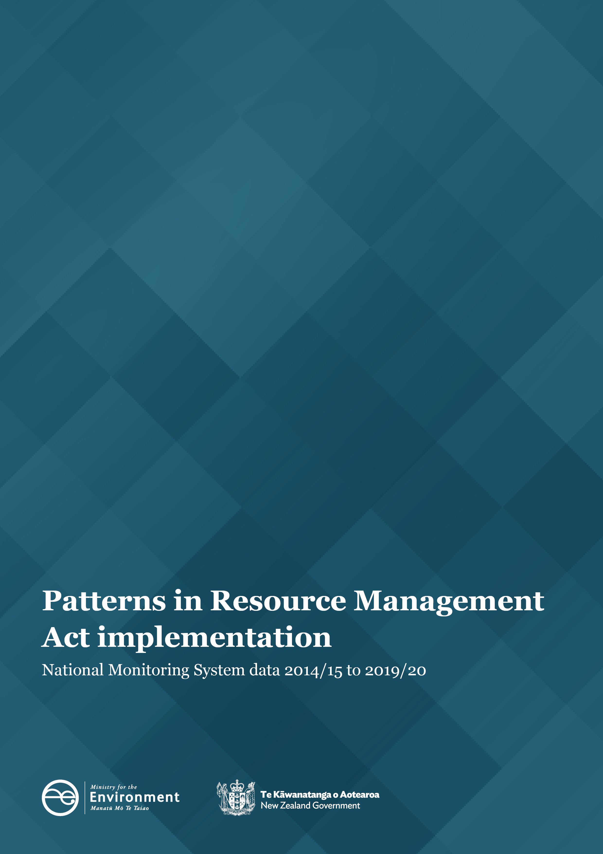

Disclaimer
The information in this publication is, according to the Ministry for the Environment’s best efforts, accurate at the time of publication. However, users of this publication are advised that:
- The information does not alter the laws of New Zealand, other official guidelines, or requirements.
- It does not constitute legal advice, and users should take specific advice from qualified professionals before taking any action based on information in this publication.
- The Ministry does not accept any responsibility or liability whatsoever whether in contract, tort, equity, or otherwise for any action taken as a result of reading, or reliance placed on this publication because of having read any part, or all, of the information in this publication or for any error, or inadequacy, deficiency, flaw in, or omission from the information in this publication.
- All references to websites, organisations or people not within the Ministry are for convenience only and should not be taken as endorsement of those websites or information contained in those websites nor of organisations or people referred to.
Copyright
© Crown copyright New Zealand 2021. Unless otherwise stated, this copyright work is licensed for re-use under a Creative Commons Attribution 4.0 International licence. In essence, you are free to copy, distribute and adapt the work, as long as you attribute the work to the New Zealand Government and abide by the other licence terms. To view a copy of this licence, visit Creative Commons Attribution 4.0 International licence.
If you publish, distribute, or otherwise disseminate this work (or any part of it) to the public without adapting it the following attribution statement should be used: Source: Ministry for the Environment and data providers and licensed by the Ministry for the Environment for re-use under the Creative Commons Attribution 4.0 International licence. If you adapt this work in any way, or include it in a collection and publish, distribute, or otherwise disseminate that adaptation or collection to the public, the following attribution statement should be used: This work uses material sourced from the Ministry for the Environment and data providers, which is licensed by the Ministry for the Environment for re-use under the Creative Commons Attribution 4.0 International licence.
Where practicable, please hyperlink the name of the Ministry for the Environment to the Ministry for the Environment web page that contains, or links to, the source data.

Acknowledgements
We would like to acknowledge the contribution of local authorities to collect and provide the data for the National Monitoring System that informs this report.

This document may be cited as: Ministry for the Environment. 2021. Patterns in Resource Management Act implementation: National Monitoring System data 2014/15 to 2019/20. Wellington: Ministry for the Environment.
Published in September 2021 by the
Ministry for the Environment
Manatū Mō Te Taiao
PO Box 10362, Wellington 6143, New Zealand
ISBN: 978-1-99-003378-0
Publication number: ME 1592
This document is available on the Ministry for the Environment website: environment.govt.nz.

Contents
Key patterns in RMA implementation 5
Patterns in RMA implementation 6
Resource consent data shows different patterns in implementation 6
Councils are generally processing consents within statutory timeframes 8
Percent of consents granted continues to increase 9
A small percent of consents are notified each year 10
Councils are using section 92 or section 37 more often for processing consents 13
Planning processes 16
Most plans are decided within statutory timeframes 16
Iwi and hapū participation within the resource management system 18
Councils are continuing to enable iwi and hapū capacity to participate in planning and consenting 18
Number of iwi management plans (or iwi planning documents) continues to grow 19
Compliance, monitoring and enforcement 20
Number of enforcement actions taken by most councils remains constant 20
Levels of monitoring and enforcement staffing vary year to year 21
References 22

Figures
Figure 1: Number of new resource consents granted by year and type, 2014/15–2019/20 6
Figure 2: Number of new consents granted by area 2019/20 7
Figure 3: Percent of new consents processed within statutory timeframes, 2014/15–2019/20 8
Figure 4: A contrast of the percent of new consents processed within statutory timeframes, 2014/15–2019/20 9
Figure 5: Percent of new resource consents granted, 2014/15–2019/20 9
Figure 6: Percent of types of new resource consents declined or refused by type from local authorities, 2014/15–2019/20 10
Figure 7: Percent of new resource consents that were notified, 2014/15–2019/20 11
Figure 8: Percent of resource consents notified by each council for 2019/20 12
Figure 9: Percent of resource consents that use at least one section 92 or section 37 in their processing, 2014/15–2019/20 13
Figure 10: Median processing time of resource consents (in working days) 14
Figure 11: Median processing time (in working days) of new consents by councils 15
Figure 12: Percent of new plans or plan changes decided within the statutory timeframe, 2014/15–2019/20 16
Figure 13: Median number of years to complete a plan change once notified, 2014/15–2019/20 17
Figure 14: Percent of councils that provided budget to iwi and hapū to participate in either the development of resource management plans or resource consent processing 18
Figure 15: Number of iwi management plans recognised by iwi authorities and lodged each year with councils, 2014/15–2019/20 19
Figure 16: Number of enforcement actions taken by regional territorial and unitary authorities, 2014/15–2019/20 21
Figure 17: Number of council staff (full-time equivalent staff (FTE)) for consenting, monitoring and enforcement, and planning, 2014/15–2019/20 21

Key patterns in RMA implementation
This report is written to inform central and local government of patterns in Resource Management Act 1991 (RMA) implementation. It has been publicly released to make it accessible to the wider resource management community.
The report is organised by topic. Each topic contains several findings that are supported by a figure or table and accompanying text. The report provides an overview and is not intended to be a comprehensive record of patterns in the National Monitoring System (NMS).
Unless otherwise noted, all consenting facts and figures:
- relate to applications for new resource consents only. These comprise of most applications that councils receive
- are grouped under the financial year that the decision to grant or declined the application is made. This excludes applications that are incomplete, withdrawn or returned
The term ‘processed’ refers to consents that are granted or declined.
The RMA is the main legislation guiding the management of New Zealand’s environment. Most of the everyday decision-making under the RMA is undertaken by councils. Each year, the Ministry for the Environment collects information from councils on their implementation of the RMA via the NMS.
This report highlights patterns in the implementation of the RMA by councils over the past six years, as recorded by the NMS. The data collected by the NMS will continue to inform the Ministry’s understanding of how the current resource management system is working and provide information as a new resource management system is developed.
Key patterns in the 2019/20 data are set in the context of periods where councils were operating under COVID-19 alert levels 3 and 4, with consequential impacts on their operations.
Councils have different combinations of responsibilities under the RMA. There are unitary, regional and territorial authorities. In some instances within this report, the data is broken down to reflect the different types of council where differences occur in implementation.
All councils have provided data for all years of the NMS, except Ōtoraohanga District Council in 2018/19 and Chatham Islands Council for 2016/17. Chatham Islands Council also did not provide consenting data for 2019/20.
Key patterns in 2019/20
- The number of resource consents issued by year and type differs across councils.
- Councils are largely processing consents within statutory timeframes.
- The percent of consents granted continues to increase.
- The percent of consents notified has been declining in recent years.
- Councils are using section 92 or section 37 more in processing consents.
- Iwi planning documents continue to be produced and recognised by councils.
- Councils are implementing their compliance, monitoring and enforcement functions.

Patterns in RMA implementation

Resource consent data shows different patterns in implementation
A resource consent is permission from the local council for an activity that might affect the environment and that is not allowed ‘as of right’ in district or regional plans, or national direction instruments under the RMA. Anyone may apply to their local council for resource consents. Depending on the local rules, this might include consent to subdivide their property or take water from a stream.

Number of resource consents by year and type has remained variable
In 2019/20, 34,667 new (section 88) resource consents granted. This was a small decrease from the previous year. The number of consents granted by local authorities has varied since 2014/15 and has decreased each year for the past three years.
A decrease has occurred in coastal, discharge and land use consents over the past three years from 2016/17, while an overall rise has occurred in the number of subdivision consents and water permits over the same period (see figure 1). Land use consents are the most common type of consent granted for all areas.
Figure 1: Number of new resource consents granted by year and type, 2014/15–2019/20
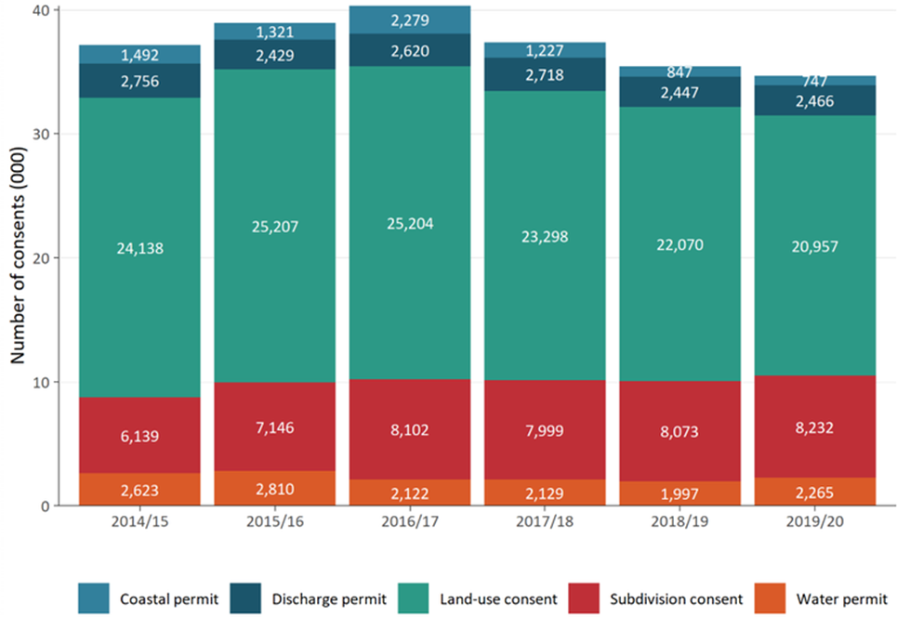

Three councils process more than one-third of all consents
The data return of Auckland Council has a large effect on the dataset as a whole. Since 2014/15 the NMS data has shown that Auckland Council is the largest processor of resource consent applications across councils in New Zealand. In 2019/20, Auckland Council processed 28 percent of new consents in New Zealand followed by Christchurch City Council (6 percent) and Marlborough District Council (5 percent).
Figure 2: Number of new consents granted by area 2019/20
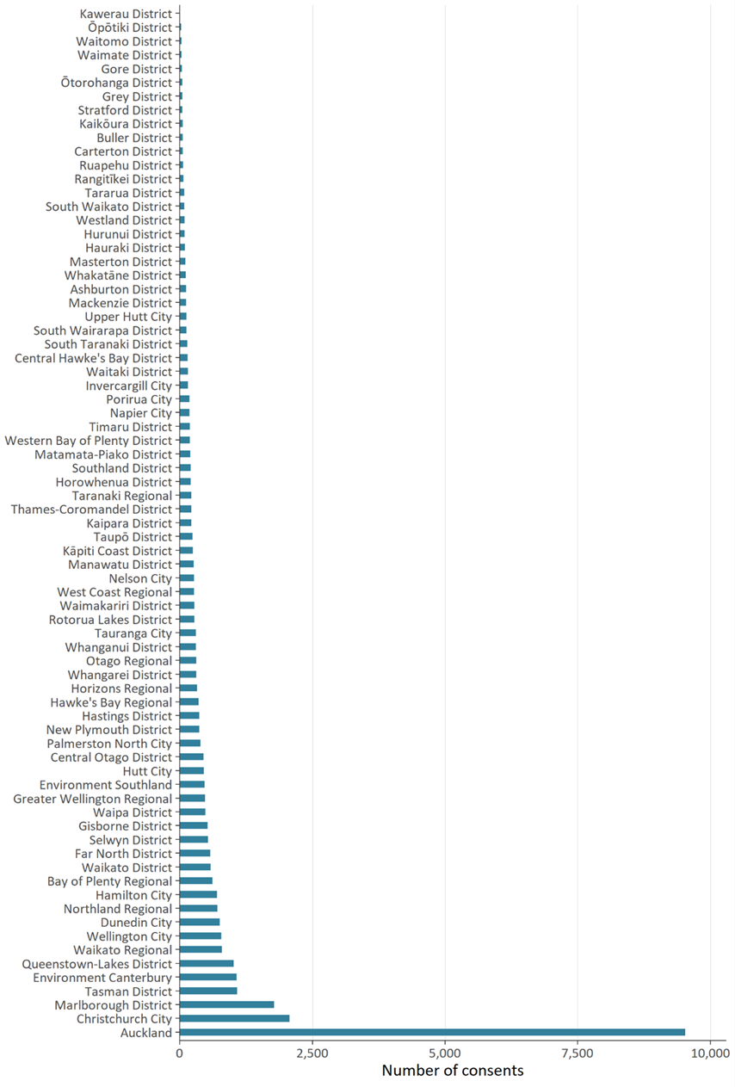
The number of consents processed is likely to be indicative of the different types of development occurring in each area, noting that some activities consented may not start immediately or may lapse if not given effect to.
The size of a council’s area and population, the geography and environmental factors within an individual region or district, can also influence the number, type and complexity of consents applications processed.

Councils are generally processing consents within statutory timeframes
Local authorities have a responsibility under the RMA to process resource consent applications within a set amount of time. In most cases, the statutory time limit under the RMA for a non-notified consent is 20 working days, and 10 days for a fast-track consent. Longer timeframes may be enabled under certain circumstances, such as if the consent application is notified or a hearing is held.
The Resource Management (Discount on Administrative Charges) Regulations were introduced in 2010. They require the discount of administrative charges for processing resource consents where councils do not meet statutory consent processing times, providing a financial disincentive for local authorities to exceed statutory timeframes when processing resource consents.
The timeframe before a decision can be issued for a consent application is variable and is influenced by the nature and complexity of the application, whether it is non-notified, limited notified, or publicly notified and if a hearing is held.
Although most councils process resource consents within statutory time limits, an overall decrease has occurred in the percent of consents processed within statutory timeframes since 2014/15, with some improvement in 2019/20 (see figure 3).
Figure 3: Percent of new consents processed within statutory timeframes, 2014/15–2019/20
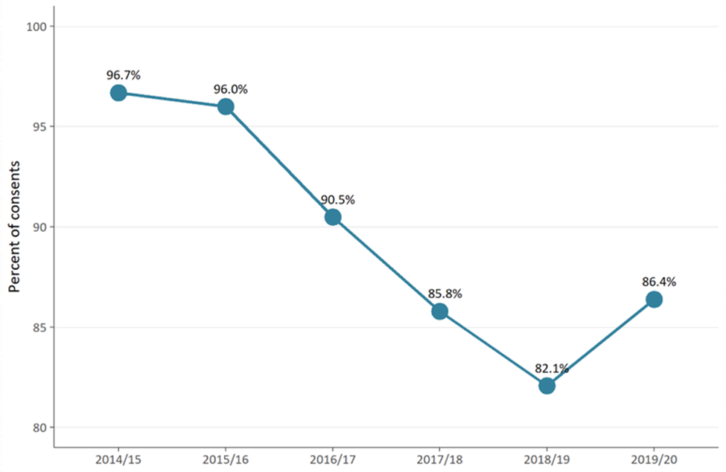
Figure 4 shows that, at a national level (‘all areas’), an approximate 5 percent increase has occurred in the percent of consents processed within statutory timeframes in 2019/20 compared with 2018/19. This was mostly driven by the consents processed by Auckland Council, which shows an increase of 15 percent, while ‘other areas’ remained almost the same as in 2018/19. This shows the effect that Auckland Council data has on national level data within the NMS.
Figure 4: A contrast of the percent of new consents processed within statutory timeframes, 2014/15–2019/20
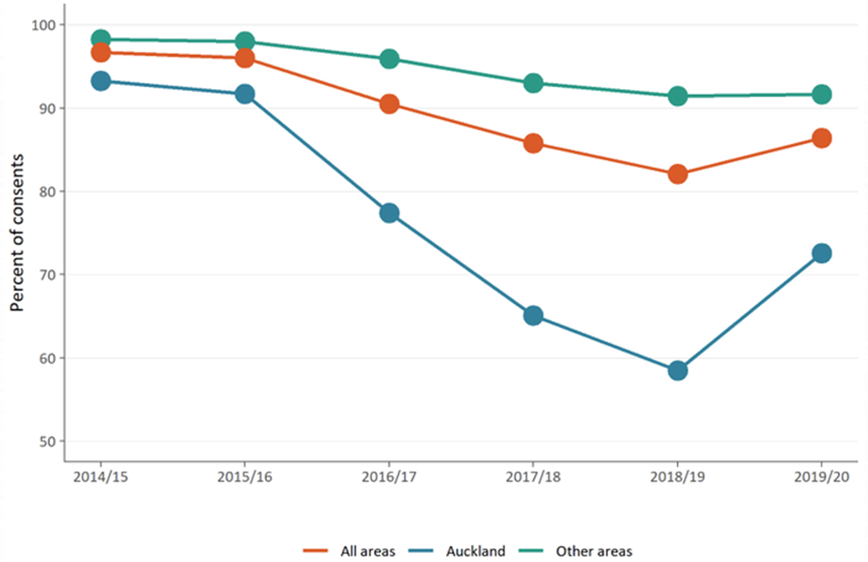

Percent of consents granted continues to increase
Across New Zealand, most resource consent applications are granted. The percent of consents granted by councils is consistently above 99 percent. In 2018/19, only 105 resource consent applications were declined against 35,434 applications approved (see figure 5). For 2019/20, only 59 consent applications were declined, compared with 34,686 applications approved.
On average, over the past five years, this works out to be two-to-three consents declined by councils out of every thousand applications.
Figure 5: Percent of new resource consents granted, 2014/15–2019/20
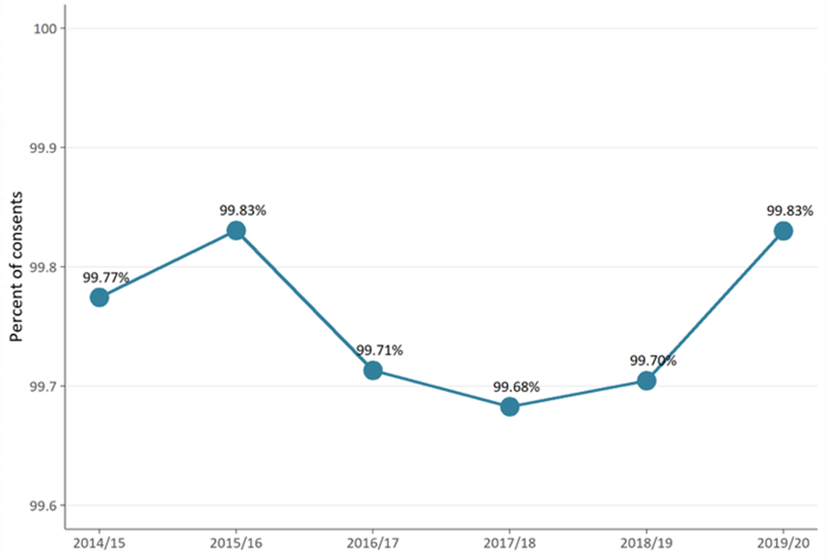
Although the percent of consents approved by local authorities has generally remained stable across years and by type, these figures experience minor fluctuations.
In 2018/19, a sharp rise occurred in the percent of coastal permits declined by local authorities (figure 6). We consider this to be an anomaly related to the limited number of coastal consents processed where a small change in figures results in a large percent of change. The overall percent of consents declined has remained relatively static.
Figure 6: Percent of types of new resource consents declined or refused by type from local authorities, 2014/15–2019/20
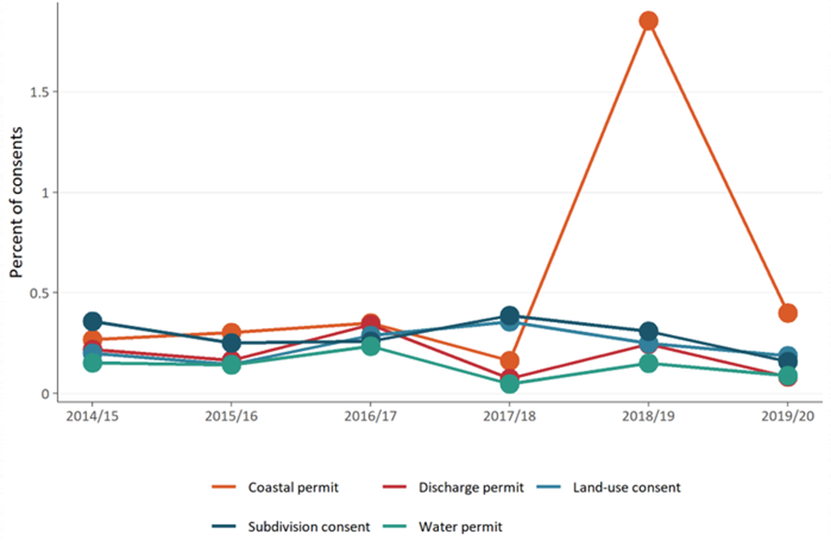

A small percent of consents are notified each year
Resource consents can be limited or fully notified depending on the circumstances such as if the effects of the consent are more than minor, if the activity is not subject to notification preclusions, if affected people have not given their written approval to the application, or the consenting authority considers that special circumstances exist that warrant public notification of the consent. Most resource consent applications are processed on a non-notified basis.
Over the past three years, a downward pattern has occurred in the number of consents councils are publicly notifying, however, the actual change is small and remains within the 3 percent to 4 percent range (figure 7).
Figure 7: Percent of new resource consents that were notified, 2014/15–2019/20
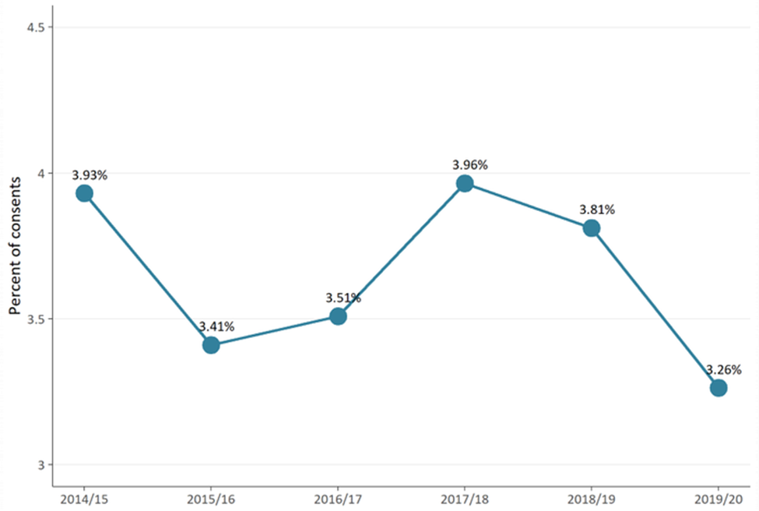
Figure 8 shows that most councils are notifying (or limited notifying) a small percent of their consent applications, although some variation occurs.
Figure 8: Percent of resource consents notified by each council for 2019/20
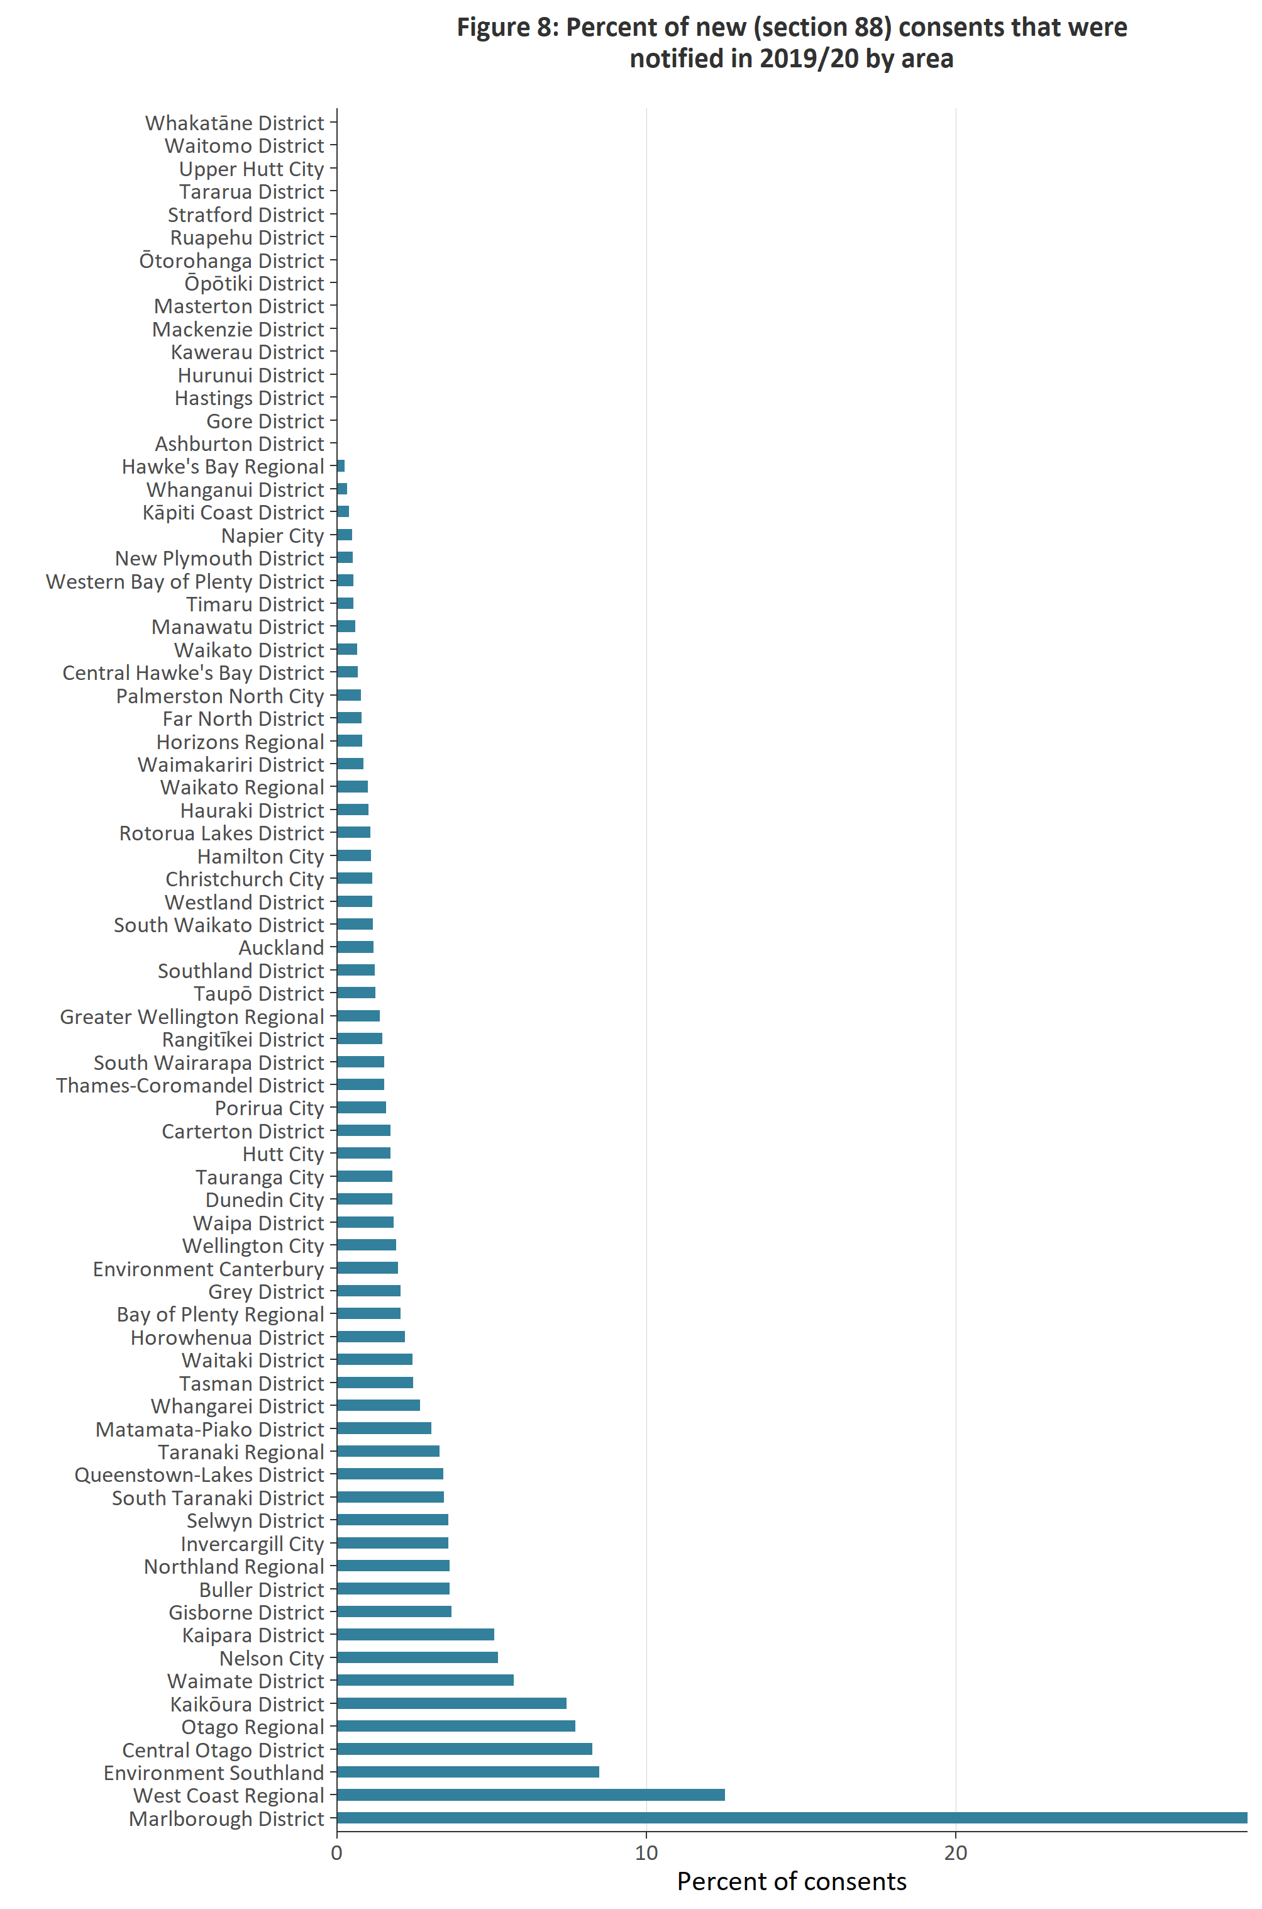

Councils are using section 92 or section 37 more often for processing consents
Section 92 of the RMA allows for a council to request additional information from a resource consent applicant before deciding the application. The ‘processing clock’ is stopped while the applicant provides that information. Generally, additional information is sought by a local authority to better understand the possible adverse effects a proposed consenting activity may have on the environment.
Section 37 allows for a council to extend timeframes (up to double the time) or waive a failure to comply with the statutory timeframes, including those related to the processing of a resource consent.
Figure 9 shows that, in the past five years, councils have been increasing their use of section 92 and section 37 of the RMA.
Figure 9: Percent of resource consents that use at least one section 92 or section 37 in their processing, 2014/15–2019/20
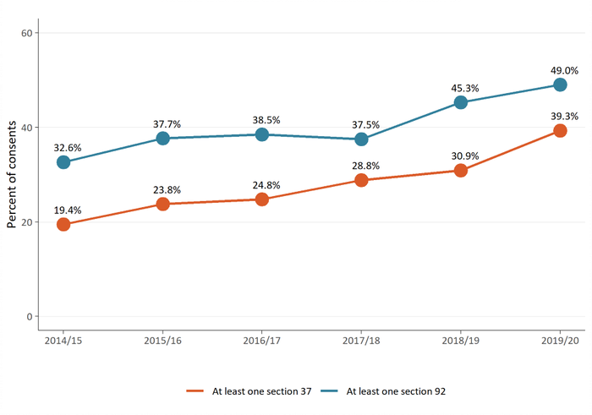
Figure 10 shows that, of all resource consents granted, declined or refused, water permits take the most time for councils to process.
Figure 10: Median processing time of resource consents (in working days)
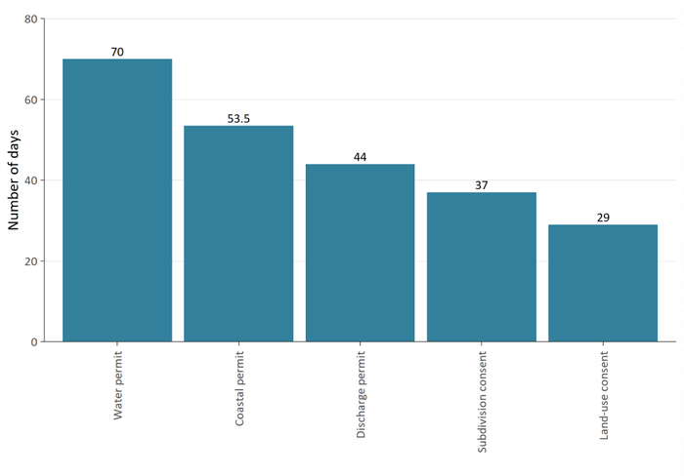
Figure 11 shows that, if the working days where further information is being sought and extended timeframes are included in the calculation, the median timeframe for councils to process a recourse consent is 33 days.
Figure 11: Median processing time (in working days) of new consents by councils
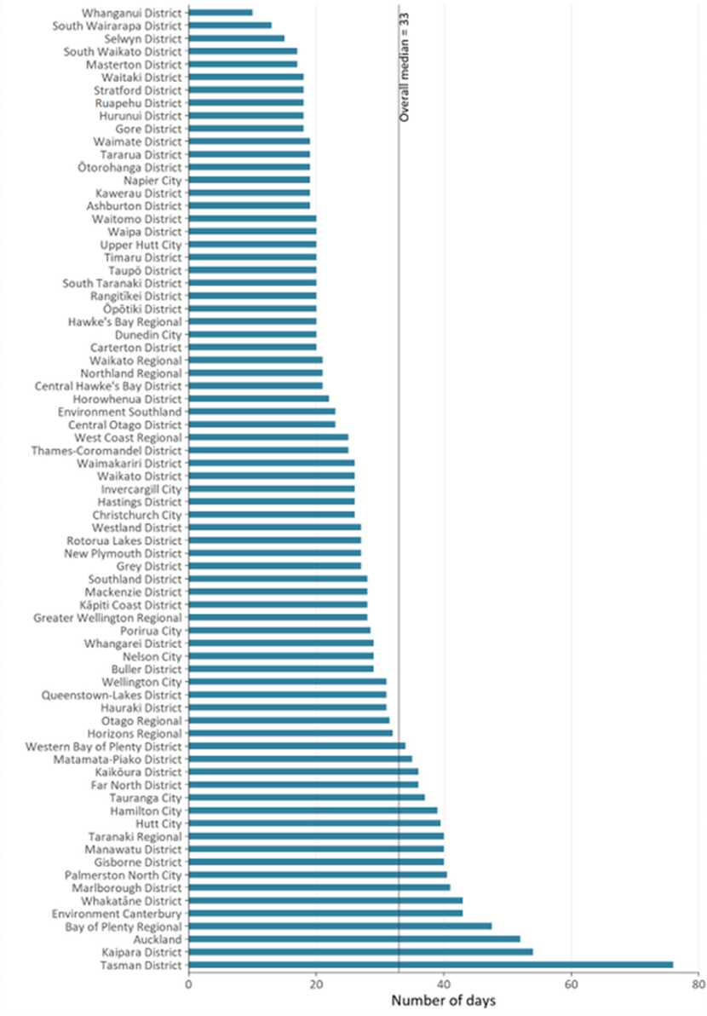

Planning processes
Councils prepare regional and district plans under section 30 and section 31 of the RMA. A regional or district plan will state what activities can be undertaken as of right and what a consent is needed for, depending on where a person lives.
Local authorities must review their plans, or any plan provisions, every 10 years or earlier. Plan changes can be initiated by councils or can be requested by private individuals or entities.
The Resource Legislation Amendment Act 2017 introduced a requirement to seek an extension from the Minister for the Environment if a council wanted to exceed the two-year statutory timeframe for making a decision on a proposed plan from the date of notification (Schedule 1, clause 10A).

Most plans are decided within statutory timeframes
Local authorities generally meet the two-year statutory timeframe for making decisions on their proposed plans or plan changes. Figure 12 highlights that, as of 2014/15, local authorities are issuing decisions on new plans or plan changes within the statutory two-year timeframe from notification (Schedule 1, clause 5).

Figure 12: Percent of new plans or plan changes decided within the statutory timeframe, 2014/15–2019/20
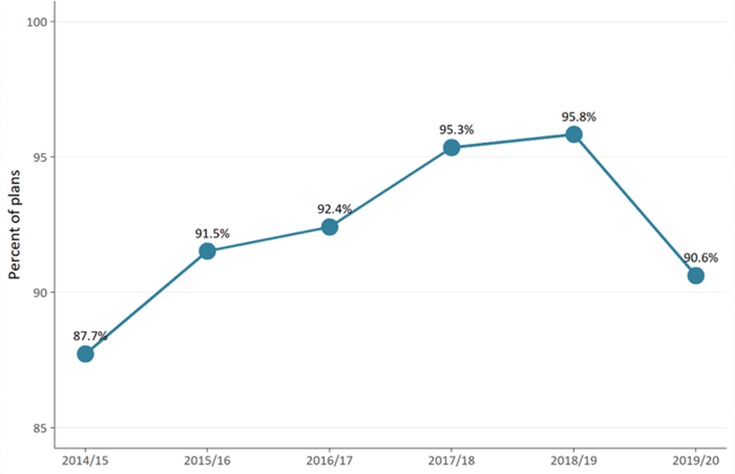
For the most part, it is taking less time to issue a decision on plan changes. In 2019/20, the median time it took councils to complete a plan change is 1.07 years from the date of public notification (figure 13).
It is important to note that, although councils are demonstrating they are able to complete plan changes in just over a year, it generally takes significantly longer for full plan reviews to be decided and made operative.
Figure 13: Median number of years to complete a plan change once notified, 2014/15–2019/20
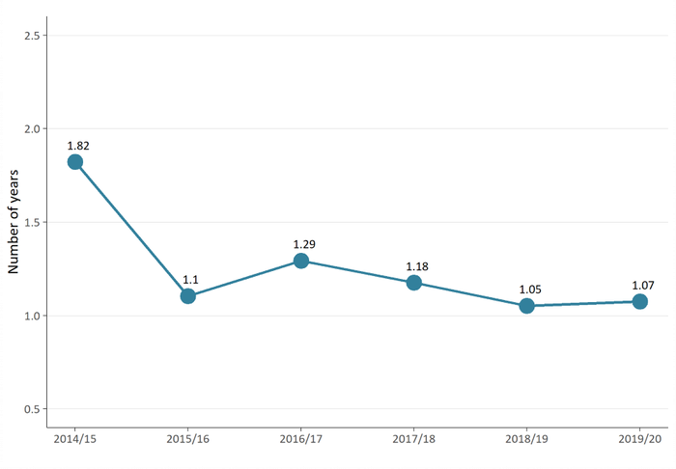

Iwi and hapū participation within the resource management system
Local authorities have processes in place to support tangata whenua participation in resource management.
This support can come in the form of a budgetary commitment from local authorities to support iwi and hapū to participate in both planning and consenting processes. In-kind forms of support may also be available, such as access to databases or memoranda of understanding.
Iwi management plans are developed by iwi and hapū as a way for tangata whenua to express their kaitiakitanga of the natural and physical resources in their takiwā. They are planning documents recognised by an iwi authority and therefore must be taken into account by councils when preparing plans or policy statements.

Councils are continuing to enable iwi and hapū capacity to participate in planning and consenting
As of 2019/20, an increase has occurred in the percent of councils providing budget to support iwi and hapū to participate in the development of plans. However, a reduction has occurred in the percent of councils providing budget to support iwi to participate in resource consenting processes (figure 14).
Figure 14: Percent of councils that provided budget to iwi and hapū to participate in either the development of resource management plans or resource consent processing
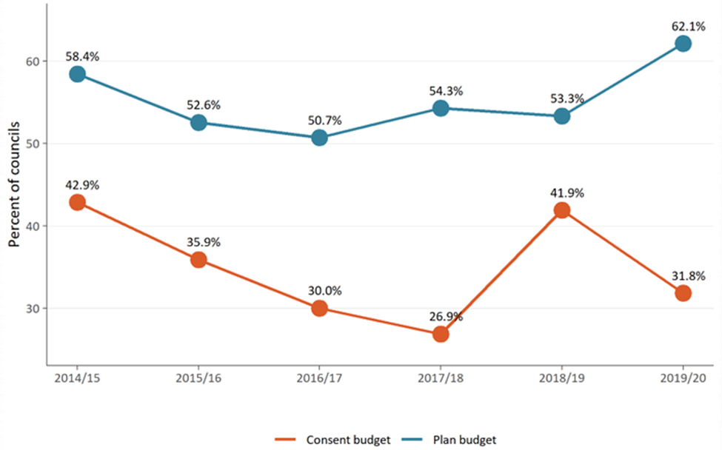
Statutory requirements are in place for councils to consult with tangata whenua through iwi authorities during the development of regional policy statements, regional and district plans and plan changes. A 9 percent rise has occurred since 2018/19 in the number of local authorities that set aside budget for iwi and hapū for the plan making process (figure 14).

Number of iwi management plans
(or iwi planning documents) continues to grow
Iwi management plans enable tangata whenua to express their values relating to specific areas, natural resources or taonga. They are an important and helpful tool for local authorities to understand values and interests for tangata whenua.
Where iwi management plans are recognised, they can also provide guidance for interactions between local authorities and iwi and hapū, as well as direction on decision-making and information requests.
The number of iwi management plans lodged with local authorities has increased from 8 in 2015/16 to 12 in 2019/20 (figure 15). Overall, an increase is occurring in the number of iwi planning documents that councils must take into account when preparing their policy statement and plans. It is important to note that 2014/15 was the first year the NMS data was collected, so the figure of 190 iwi management plans reflects the total number of instances an iwi management plan was lodged at that point.
Figure 15: Number of iwi management plans recognised by iwi authorities and lodged each year with councils, 2014/15–2019/20
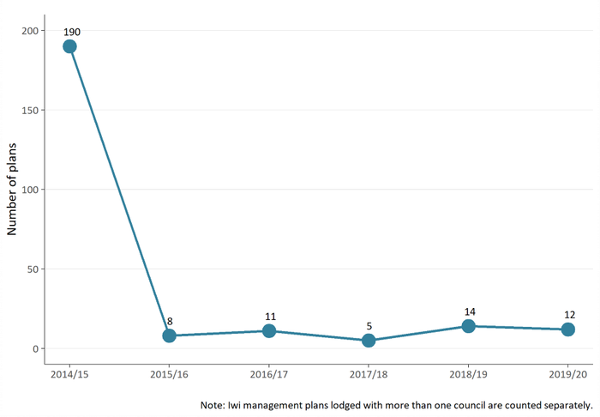

Compliance, monitoring and enforcement
Compliance, monitoring and enforcement (CME) refers to activities undertaken to ensure compliance with the RMA, including rules established under plans, meeting resource consent conditions, regulations and national environmental standards.
Local authority responsibilities include a duty to monitor a range of matters. These include the efficiency and effectiveness of policy statements and plans, the exercise of resource consents (section 35) and requirements to observe and enforce their policy statements, plans and national environmental standards (section 84 and section 44A(8)).
While the RMA does not prescribe specifically how local authorities should undertake their CME functions, CME is an important part of fulfilling their statutory functions to demonstrate that their objectives, policies and methods are meeting the purpose of the RMA. Councils can use different types of enforcement tools under the RMA, from options such as issuing abatement notices or seeking an enforcement order, through to actions such as issuing infringement notices or taking a prosecution.
CME is an important function within the RMA because it ensures resource management plans, consents and people and companies within the area are delivering the environmental outcomes supported by councils under the RMA. However, the amount of active CME work is likely to vary between councils, depending on the number of consents they have and the local environmental context.

Number of enforcement actions taken by most councils remains constant
Since 2016/17, regional and territorial authorities have, overall, been relatively consistent in the number of enforcement actions taken (figure 16). The large spike shown in 2017/18 for unitary authorities reflects Auckland Council increasing the total number of enforcement actions by 165 percent. The number of enforcement actions by unitary, regional and district councils has decreased slightly in 2019/20.
Figure 16: Number of enforcement actions taken by regional territorial and unitary authorities, 2014/15–2019/20
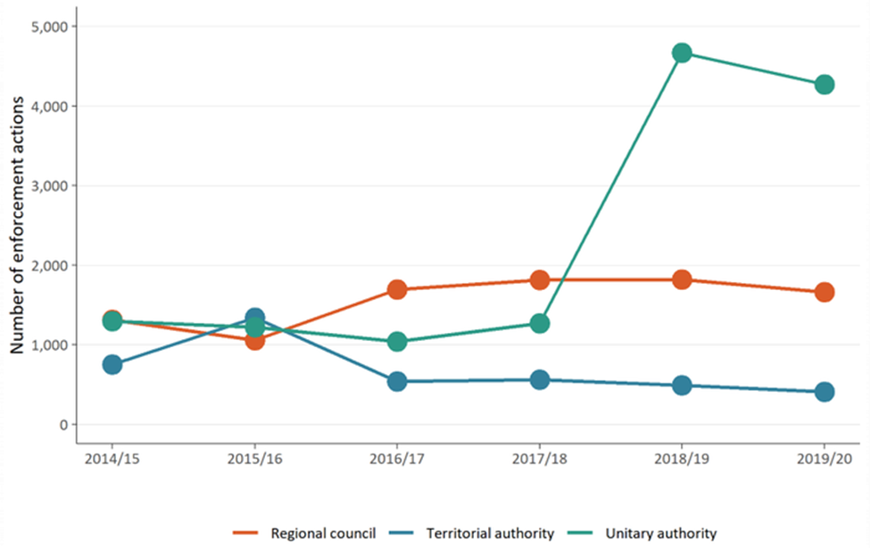

Levels of monitoring and enforcement staffing vary year to year
In 2019/20, the levels of CME full-time equivalent staff remain relatively high, compared with previous years since 2016/17, however, a decline has occurred since 2018/19 (figure 16).
Figure 17: Number of council staff (full-time equivalent staff (FTE)) for consenting, monitoring and enforcement, and planning, 2014/15–2019/20
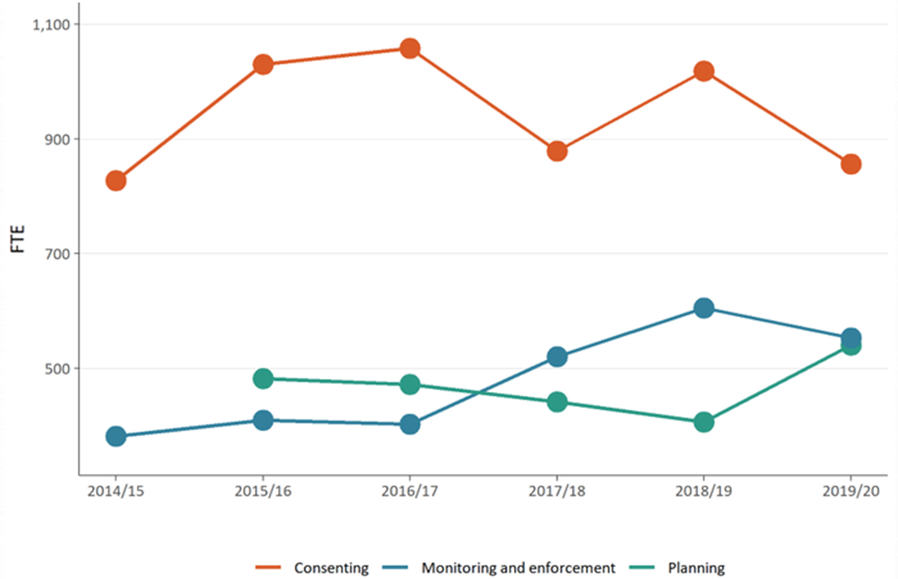

References
Ministry for the Environment. 2007. Environment New Zealand 2007. Wellington: Ministry for the Environment.
Ministry for the Environment. 2020. Trends in Resource Management Act Implementation: National Monitoring System 2014/15 to 2018/19. Wellington: Ministry for the Environment.

See Trends in Resource Management Act implementation: National Monitoring System 2014/15 to 2018/19 report.

