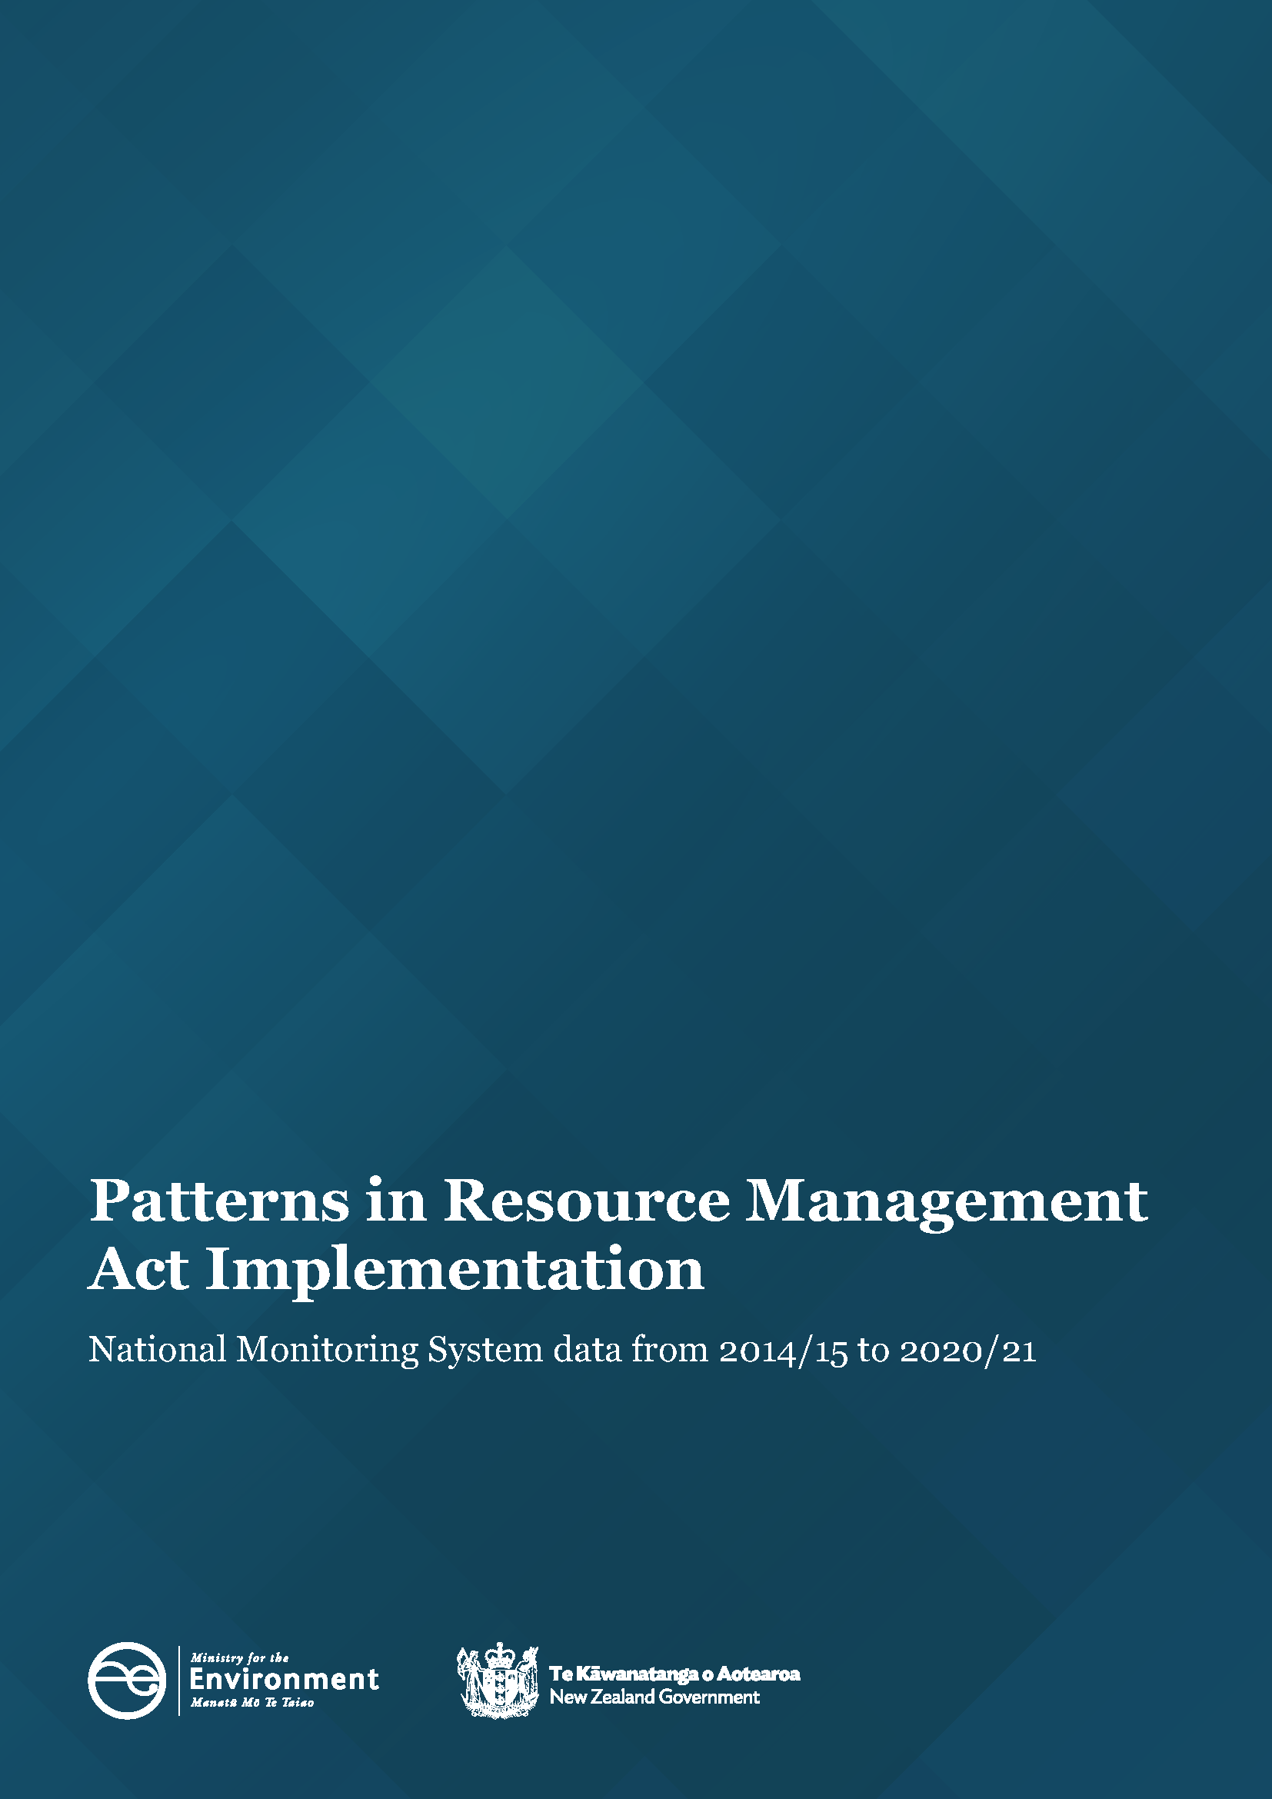
Disclaimer
The information in this publication is, according to the Ministry for the Environment’s best efforts, accurate at the time of publication. However, users of this publication are advised that:
- The information does not alter the laws of New Zealand, other official guidelines, or requirements.
- It does not constitute legal advice, and users should take specific advice from qualified professionals before taking any action based on information in this publication.
- The Ministry does not accept any responsibility or liability whatsoever whether in contract, tort, equity, or otherwise for any action taken as a result of reading, or reliance placed on this publication because of having read any part, or all, of the information in this publication or for any error, or inadequacy, deficiency, flaw in, or omission from the information in this publication.
- All references to websites, organisations or people not within the Ministry are for convenience only and should not be taken as endorsement of those websites or information contained in those websites nor of organisations or people referred to.
Copyright
© Crown copyright New Zealand 2022. Unless otherwise stated, this copyright work is licensed for re-use under a Creative Commons Attribution 4.0 International licence. In essence, you are free to copy, distribute and adapt the work, as long as you attribute the work to the New Zealand Government and abide by the other licence terms. To view a copy of this licence, visit Creative Commons Attribution 4.0 International licence.
If you publish, distribute, or otherwise disseminate this work (or any part of it) to the public without adapting it the following attribution statement should be used: Source: Ministry for the Environment and data providers and licensed by the Ministry for the Environment for re-use under the Creative Commons Attribution 4.0 International licence. If you adapt this work in any way, or include it in a collection and publish, distribute, or otherwise disseminate that adaptation or collection to the public, the following attribution statement should be used: This work uses material sourced from the Ministry for the Environment and data providers, which is licensed by the Ministry for the Environment for re-use under the Creative Commons Attribution 4.0 International licence.
Where practicable, please hyperlink the name of the Ministry for the Environment to the Ministry for the Environment web page that contains, or links to, the source data.

Acknowledgements
We would like to acknowledge the contribution of local authorities who collect and provide the data for the National Monitoring System that informs this report.
This document may be cited as: Ministry for the Environment. 2022. Patterns in Resource Management Act Implementation – National Monitoring System data from 2014/15 to 2020/21. Wellington: Ministry for the Environment.
Published in November 2022 by the
Ministry for the Environment
Manatū Mō Te Taiao
PO Box 10362, Wellington 6143, New Zealand
ISBN: 978-1-99-102570-8 (online)
Publication number: ME 1680
© Crown copyright New Zealand 2022
This document is available on the Ministry for the Environment website: environment.govt.nz
Contents
About this National Monitoring System data report 5
About this National Monitoring System data report 5
Patterns in RMA implementation 6
Resource consent data patterns 6
Combined consents introduced as a new data set 6
Two councils processed most resource consents 7
Most new resource consents were processed within statutory timeframes 9
Councils approved most new resource consent applications 10
There is variation in the types of resource consents being declined 11
Percentage of new resource consents that were notified remained low 12
Councils used section 37 and section 92 on a more regular basis 15
Median processing times of consent types varied from 2014/15 to 2020/21 16
Plan-making processes 18
Councils have completed a higher percentage of plans within two-year statutory timeframes 18
Iwi and hapū participation within the resource management system 19
There was variation in how councils budgeted for iwi and hapū to participate in consenting and plan-making 19
Fewer new iwi management plans or iwi planning documents endorsed 20
Compliance monitoring and enforcement 21

Councils took more enforcement action 22

Councils had a small increase in the levels of monitoring and
enforcement staff 23

Figures
Figure 1: Number of new consents granted by year and type 6
Figure 2: Number of new consents granted by council 8
Figure 3: Percentage of new consents granted or declined that were processed within statutory timeframes 9
Figure 4: Percentage of new consents granted or declined that were processed within statutory timeframes 10
Figure 5: Percentage of new consents that were granted 11
Figure 6: Percentage of new consents that were declined by type 12
Figure 7: Percentage of new resource consent applications that were notified 13
Figure 8: Percentage of new resource consent applications that were notified by council 14
Figure 9: Percentage of new consent applications granted or declined that used at least one section 37 or section 92 15
Figure 10: Median processing time of new consent types in working days by year 16
Figure 11: Median processing time of new consents granted or declined by council 17
Figure 12: Percentage of plans that were decided within the statutory timeframe 18
Figure 13: Median processing time to complete a plan change once notified 20
Figure 14: Percentage of councils that provided budget to iwi/hapū to participate in either the development of resource management plans or processing of resource consents 20
Figure 15: Number of new iwi management plans endorsed by iwi authorities and lodged with councils 21
Figure 16: Number of enforcement actions taken by councils (by council type) 22
Figure 17: Number of full-time equivalent (FTE) council staff for consenting monitoring and enforcement, and planning 23
Figure 18: Total full-time equivalents (FTE) working on resource management at local authorities 23

About this National Monitoring System data report
This report is written to inform central and local government of patterns in Resource Management Act 1991 (RMA) implementation, which reflects the roles councils play in everyday decision-making under the RMA. Every year, the Ministry for the Environment (the Ministry) collects information from councils on their implementation of the RMA and this report has been publicly released to make it accessible to the wider resource management community.
The report highlights patterns in how councils have implemented the RMA over the past seven years, as recorded by the National Monitoring System (NMS). The data collected by the NMS will continue to inform the Ministry’s understanding of how the current resource management system has been working and will provide information as a new resource management system is developed.
Councils include unitary, regional and territorial authorities and these have different combinations of responsibilities under the RMA. In some sections within this report, the data is broken down to reflect the different types of council where differences have occurred in RMA implementation.
Unless otherwise noted, all consenting facts and figures within this report:
- relate to applications for new resource consents in 2020/21 and have been grouped under the financial year in which the decision to grant or decline the application was made
- exclude data from applications that were incomplete, withdrawn or returned
- use the term ‘processed’ to refer to consents that were granted or declined
- use the term ‘planning’ to refer to plan-making.
Key patterns from 2020/21
- Combined land-use and subdivision consents included as a new data point.
- Most councils were processing resource consents within the statutory timeframes, however there was a rise in the use of section 37 to extend statutory timeframes.
- The percentage of consents that were notified decreased to their lowest levels since 2014/15.
- In their plan-making, councils completed a higher percentage of plans within the
two-year statutory timeframes
- There was variation in how councils provided budget support for iwi and hapū to be involved within resource consents processing and plan-making.
- The overall number of full-time equivalent (FTE) council staff working in resource management decreased for a third year in a row.

Patterns in RMA implementation

Resource consent data patterns
Resource consents under the RMA are administered by local councils (ie, district and city councils, regional councils and unitary authorities) for activities that do not meet requirements in district or regional plans. Different types of consents are used for different activities depending on the rules in a district or regional plan.
A resource consent is permission from a local council for an activity that might affect the environment, and that isn’t allowed ‘as of right’ in the district or regional plan. Some types of subdivision activities also require a resource consent. Where discretion by a local council needs to be exercised, the council may place conditions on an application while still allowing it to go ahead.

Combined consents introduced as a new data set
In 2020/21, local councils granted a total of 37,101 consents compared to 34,806 for 2019/20 (see figure 1). A new data set has been included to illustrate combined land-use and subdivision consents for the 2020/21 period. This new datapoint has been added to reflect situations where an application for both consents follows a single application process. Councils told us that 1081 of these combined consents had been granted.
Figure 1: Number of new consents granted by year and type
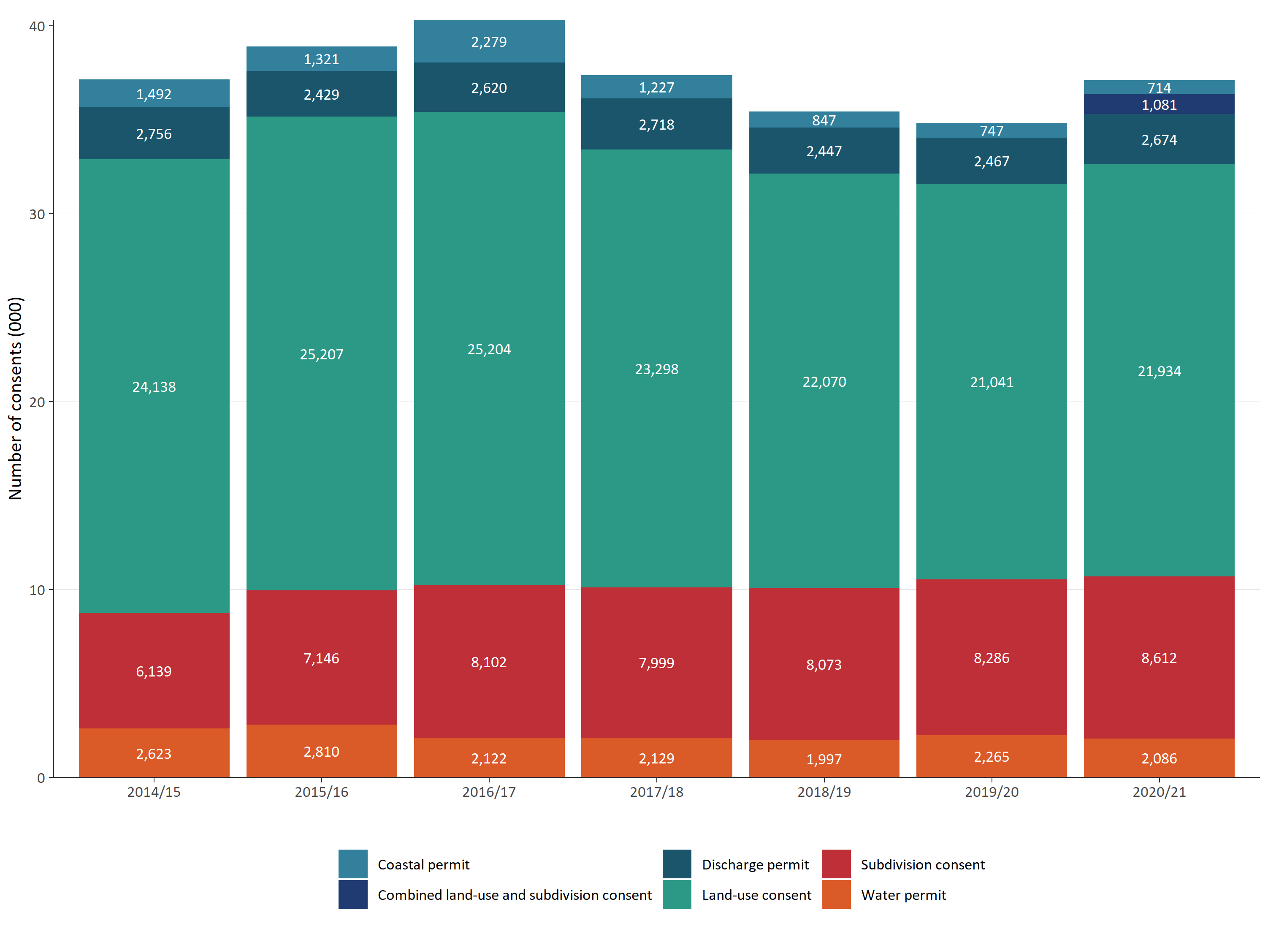

The number of subdivision and land-use consents increased slightly in 2020/21, as did discharge permits. However, there was a slight reduction in the number of coastal and water permits that were issued. Overall, there has been variation in the pattern of resource consents being granted by councils, with land-use consents being the largest category each year.

Two councils processed most resource consents
Auckland Council continued to be the largest processor of resource consents nationwide (see figure 2 overleaf). In 2020/21, it processed over 10,000 consents, compared to processing just under 10,000 consents in the previous year. Due to the high number of consents processed by Auckland Council, patterns in the national data set are influenced by the data return from the region.
Christchurch City Council processed the second largest number of consents in 2019/20 and in 2020/21.
Figure 2: Number of new consents granted by council
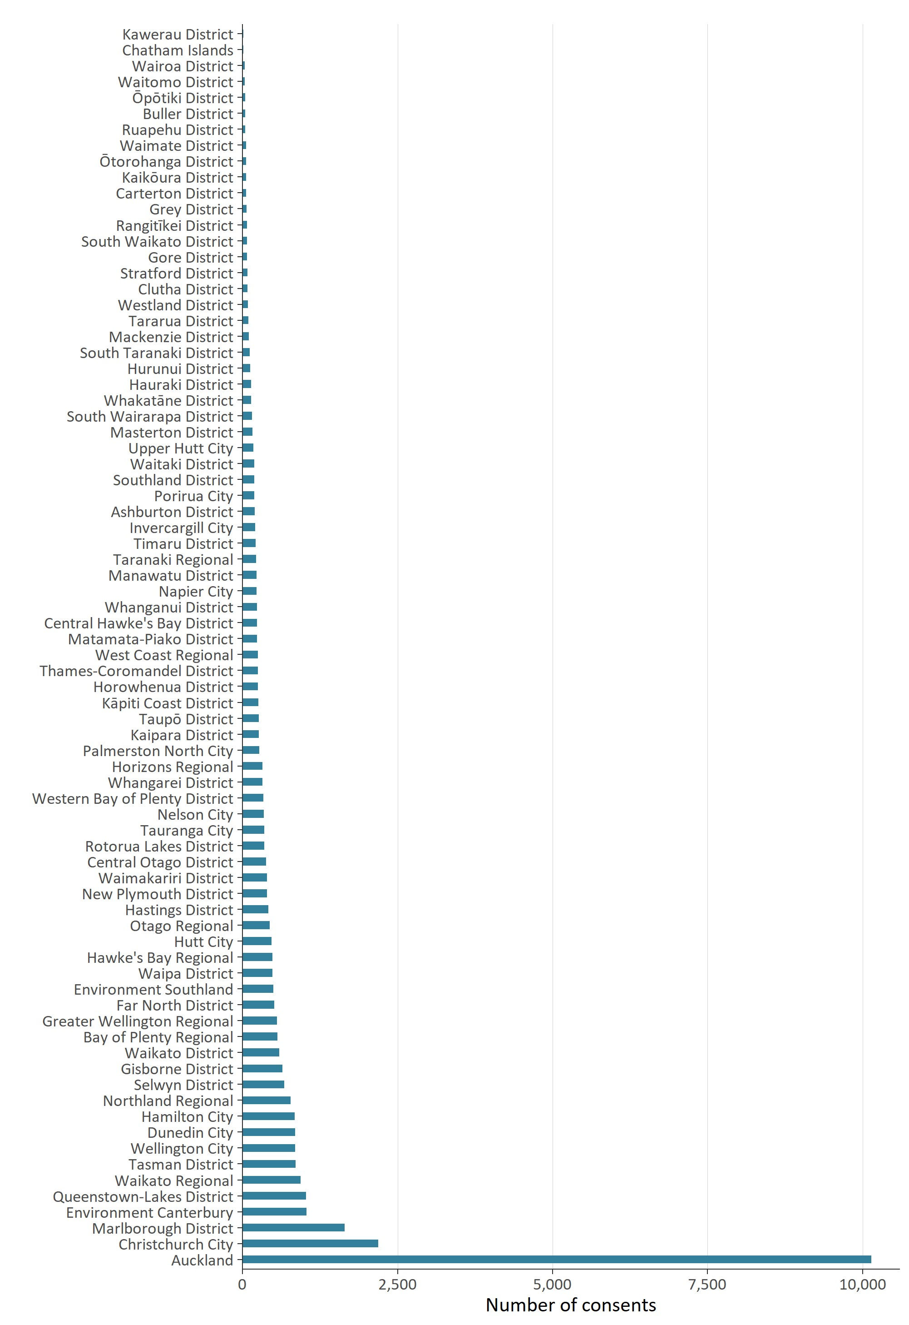
The data provided by councils in relation to the number of combined land-use and subdivision consents that were processed showed that Christchurch City Council had processed the highest number (307), with the second highest (167) number processed by Wellington City Council. While figure 2 shows Auckland Council granted the greatest number of consents it had not categorised any consents as being combined land-use and subdivision consents.
The data from other councils showed a variation with areas such as Whanganui District Council processing 130 consents, while at the other end of the data set, both Rangitikei District Council and Mackenzie District Council each recorded two combined land-use and subdivision consents in 2020/21.

Most new resource consents were processed within statutory timeframes
Councils have a responsibility under the RMA to process resource consent applications within a set amount of time; the statutory time limit for a non-notified consent is 20 working days and 10 working days for a fast-track consent. However, the nature, scale and complexity of environmental effects from an activity can require councils to notify the consent process and this can extend the timeframe in which the council can issue a decision.
When a council cannot meet its statutory requirements for processing a resource consent, and special circumstances do not apply, the council must give the applicant a discount on administrative charges. This requirement, which was introduced under the Resource Management (Discount on Administrative Charges Regulations 2010), provides a financial incentive for all local councils to meet the RMA’s statutory timeframes.
The data provided from councils showed that councils were largely processing new resource consents within the statutory timeframes. Figure 3 shows an improvement occurred during the 2020/21 financial year while remaining below the highest level achieved in 2014/15.
Figure 3: Percentage of new consents granted or declined that were processed within statutory timeframes
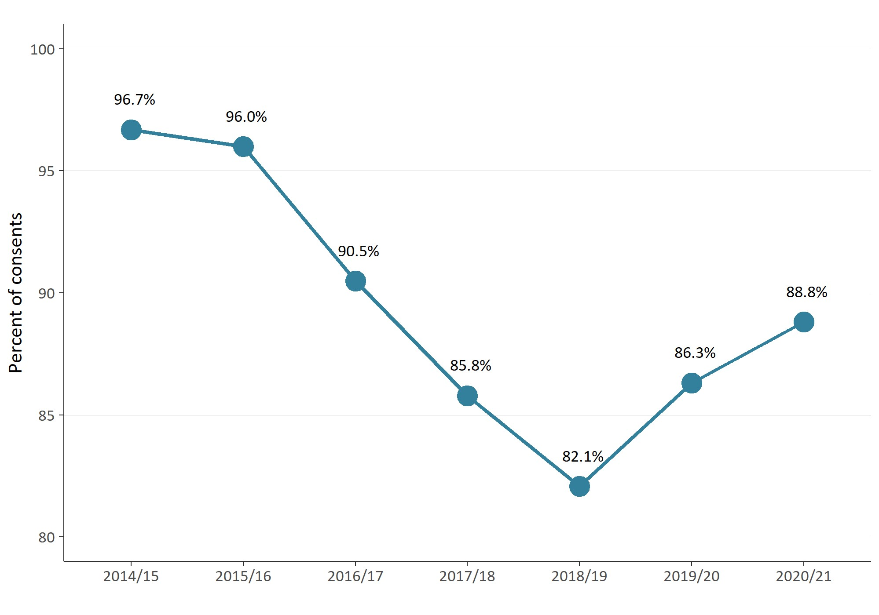
This increase of 2.5 percent shown in figure 3 was mostly driven by the consents processed by Auckland Council while ‘other areas’ showed a modest reduction compared to the 2019/20 results (see figure 4). This demonstrated the effect that Auckland Council’s data had on national-level data within the NMS.
Figure 4: Percentage of new consents granted or declined that were processed within statutory timeframes
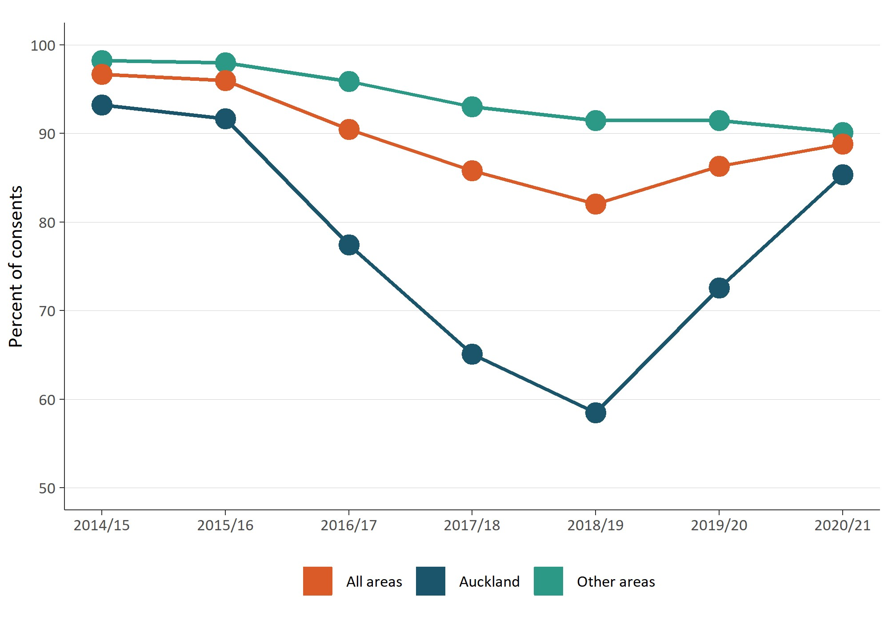

Councils approved most new resource consent applications
The percentage of new consents granted by councils across New Zealand remained consistently high in the 2020/21 period (see figure 5 overleaf). There has been little variability in the approving of new resource consents since 2014/15, with more than 99 percent of all consents being approved each year.
Figure 5: Percentage of new consents that were granted
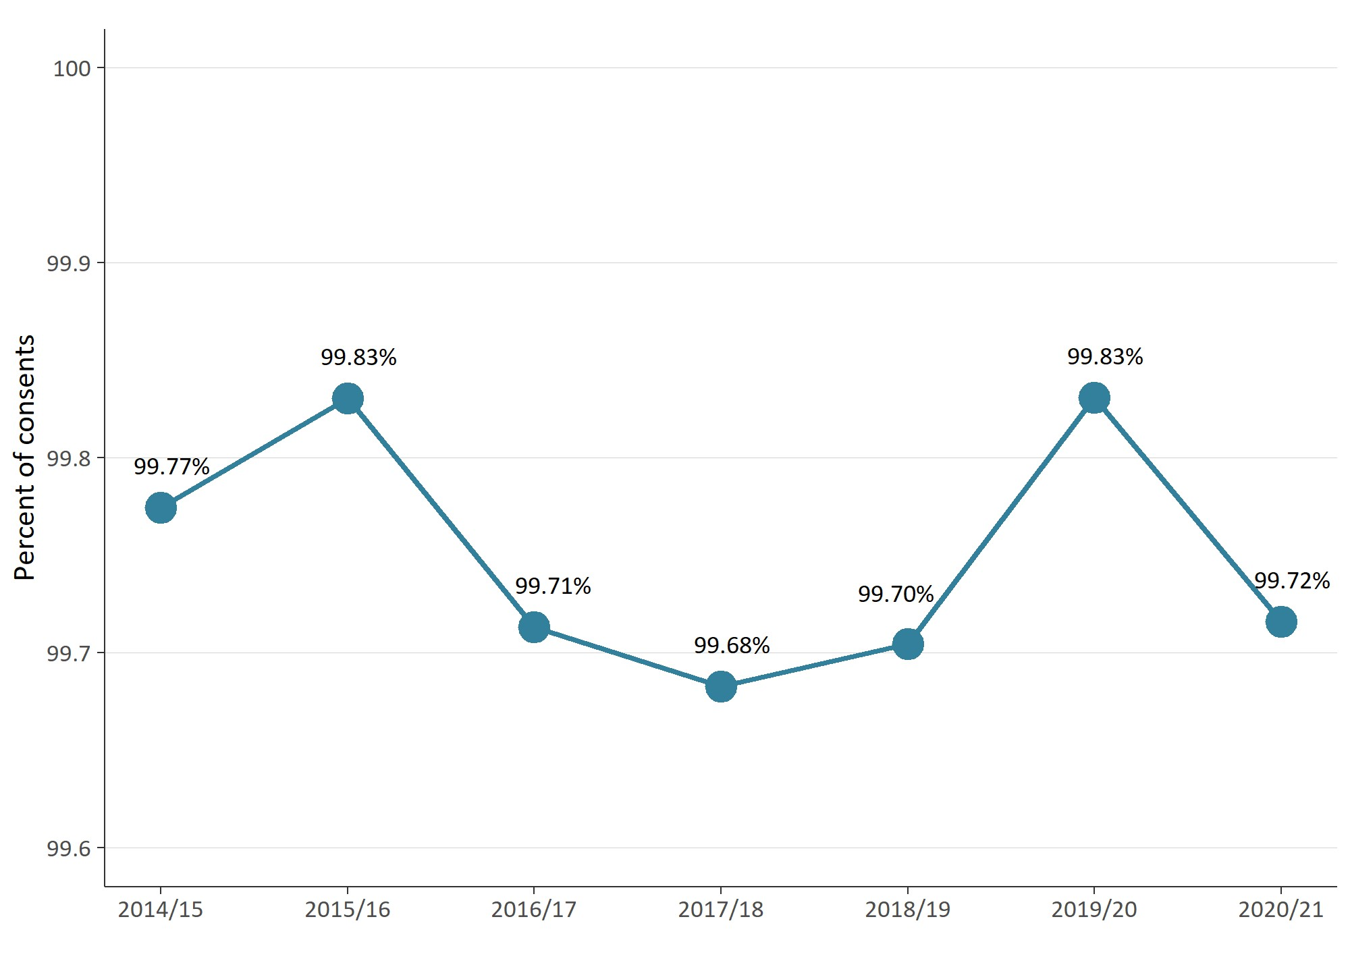

There is variation in the types of resource consents being declined
NMS data since 2014/15 has provided the types of resource consents that have been declined or refused by councils. Overall, the figures have generally remained stable across years and by type, with minor fluctuations as shown in figure 6 (overleaf).

Figure 6: Percentage of new consents that were declined (by type and year)
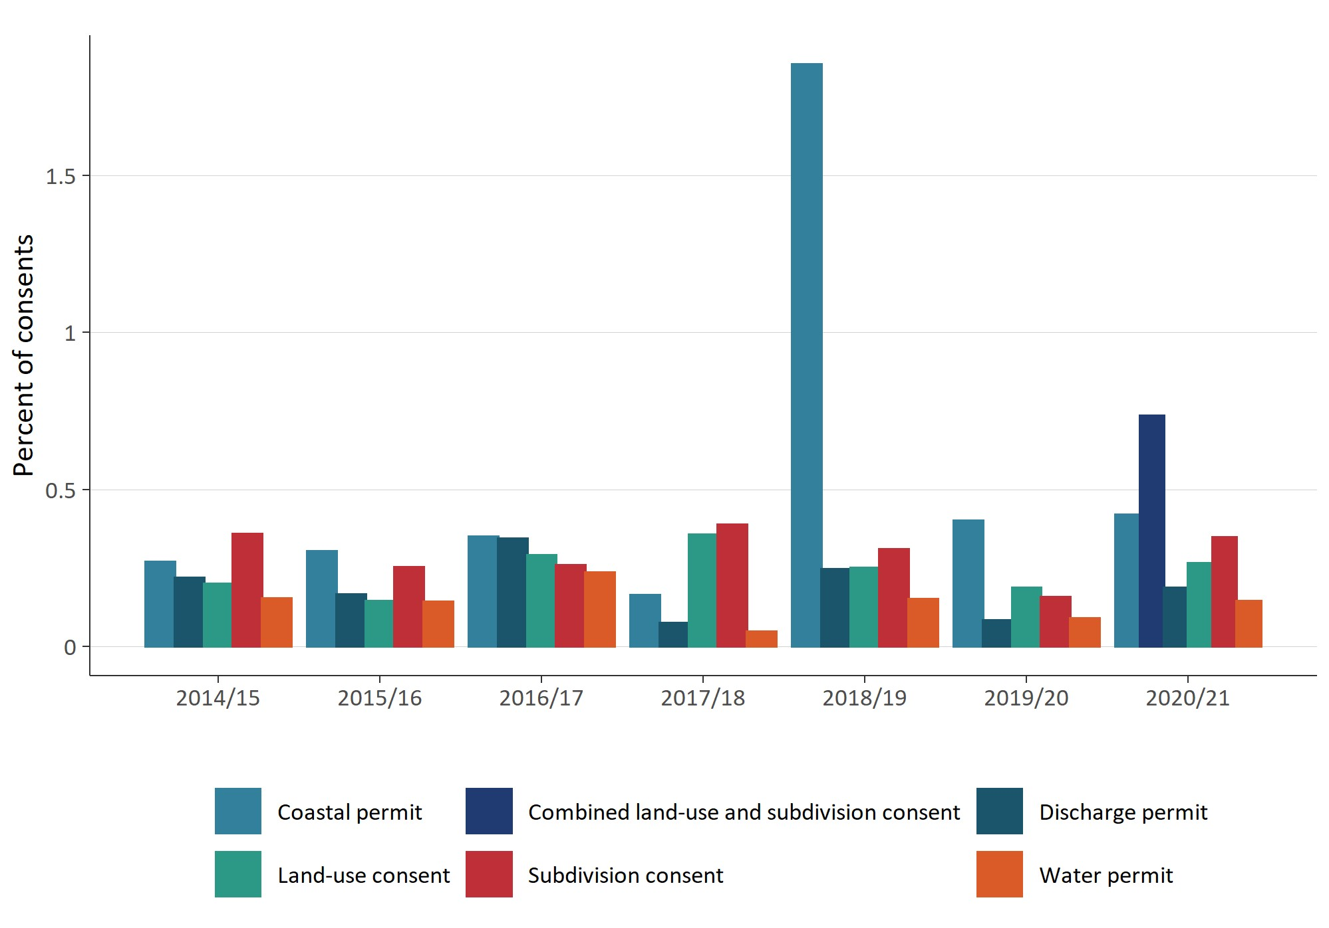

Percentage of new resource consents that were notified remained low
Most resource consent applications are processed on a non-notified basis.
The 2020/21 data set showed the percentage of notified consents to be at its lowest since 2014/15 when the Ministry began collecting NMS data (see figure 7 overleaf). The proportion of notified consents has historically remained low — over any year it has been under 4 percent (of all new resource consent applications).
Figure 7: Percentage of new resource consent applications that were notified
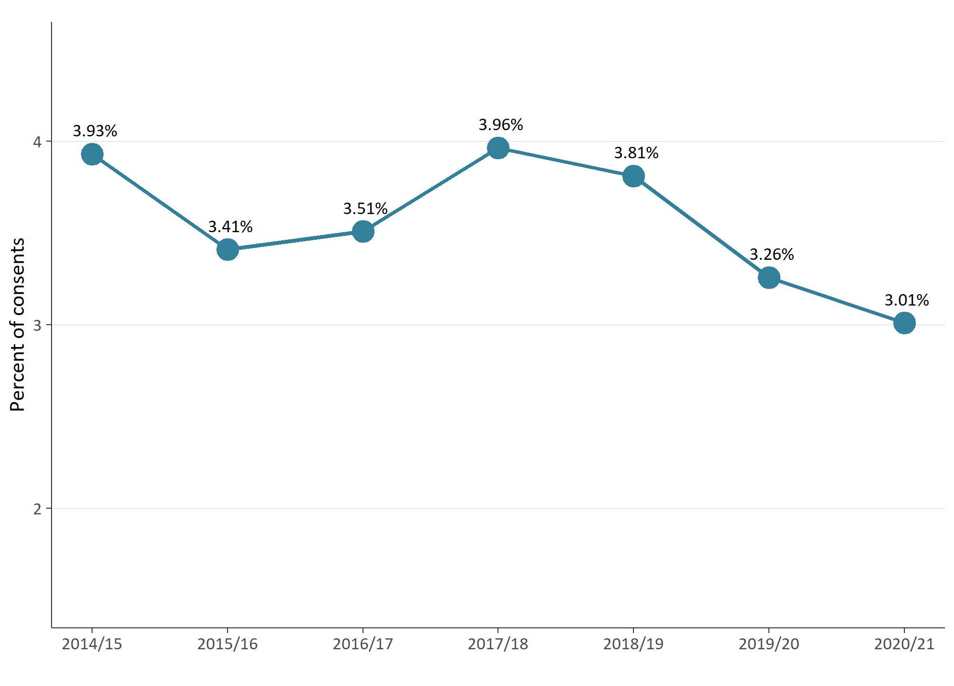
In 2020/21, the national data set showed the largest proportion of notified consents were processed by Marlborough District Council, followed closely by Buller District Council, Otago Regional Council and Northland Regional Council (see figure 8 overleaf).

Figure 8: Percentage of new resource consent applications that were notified by council
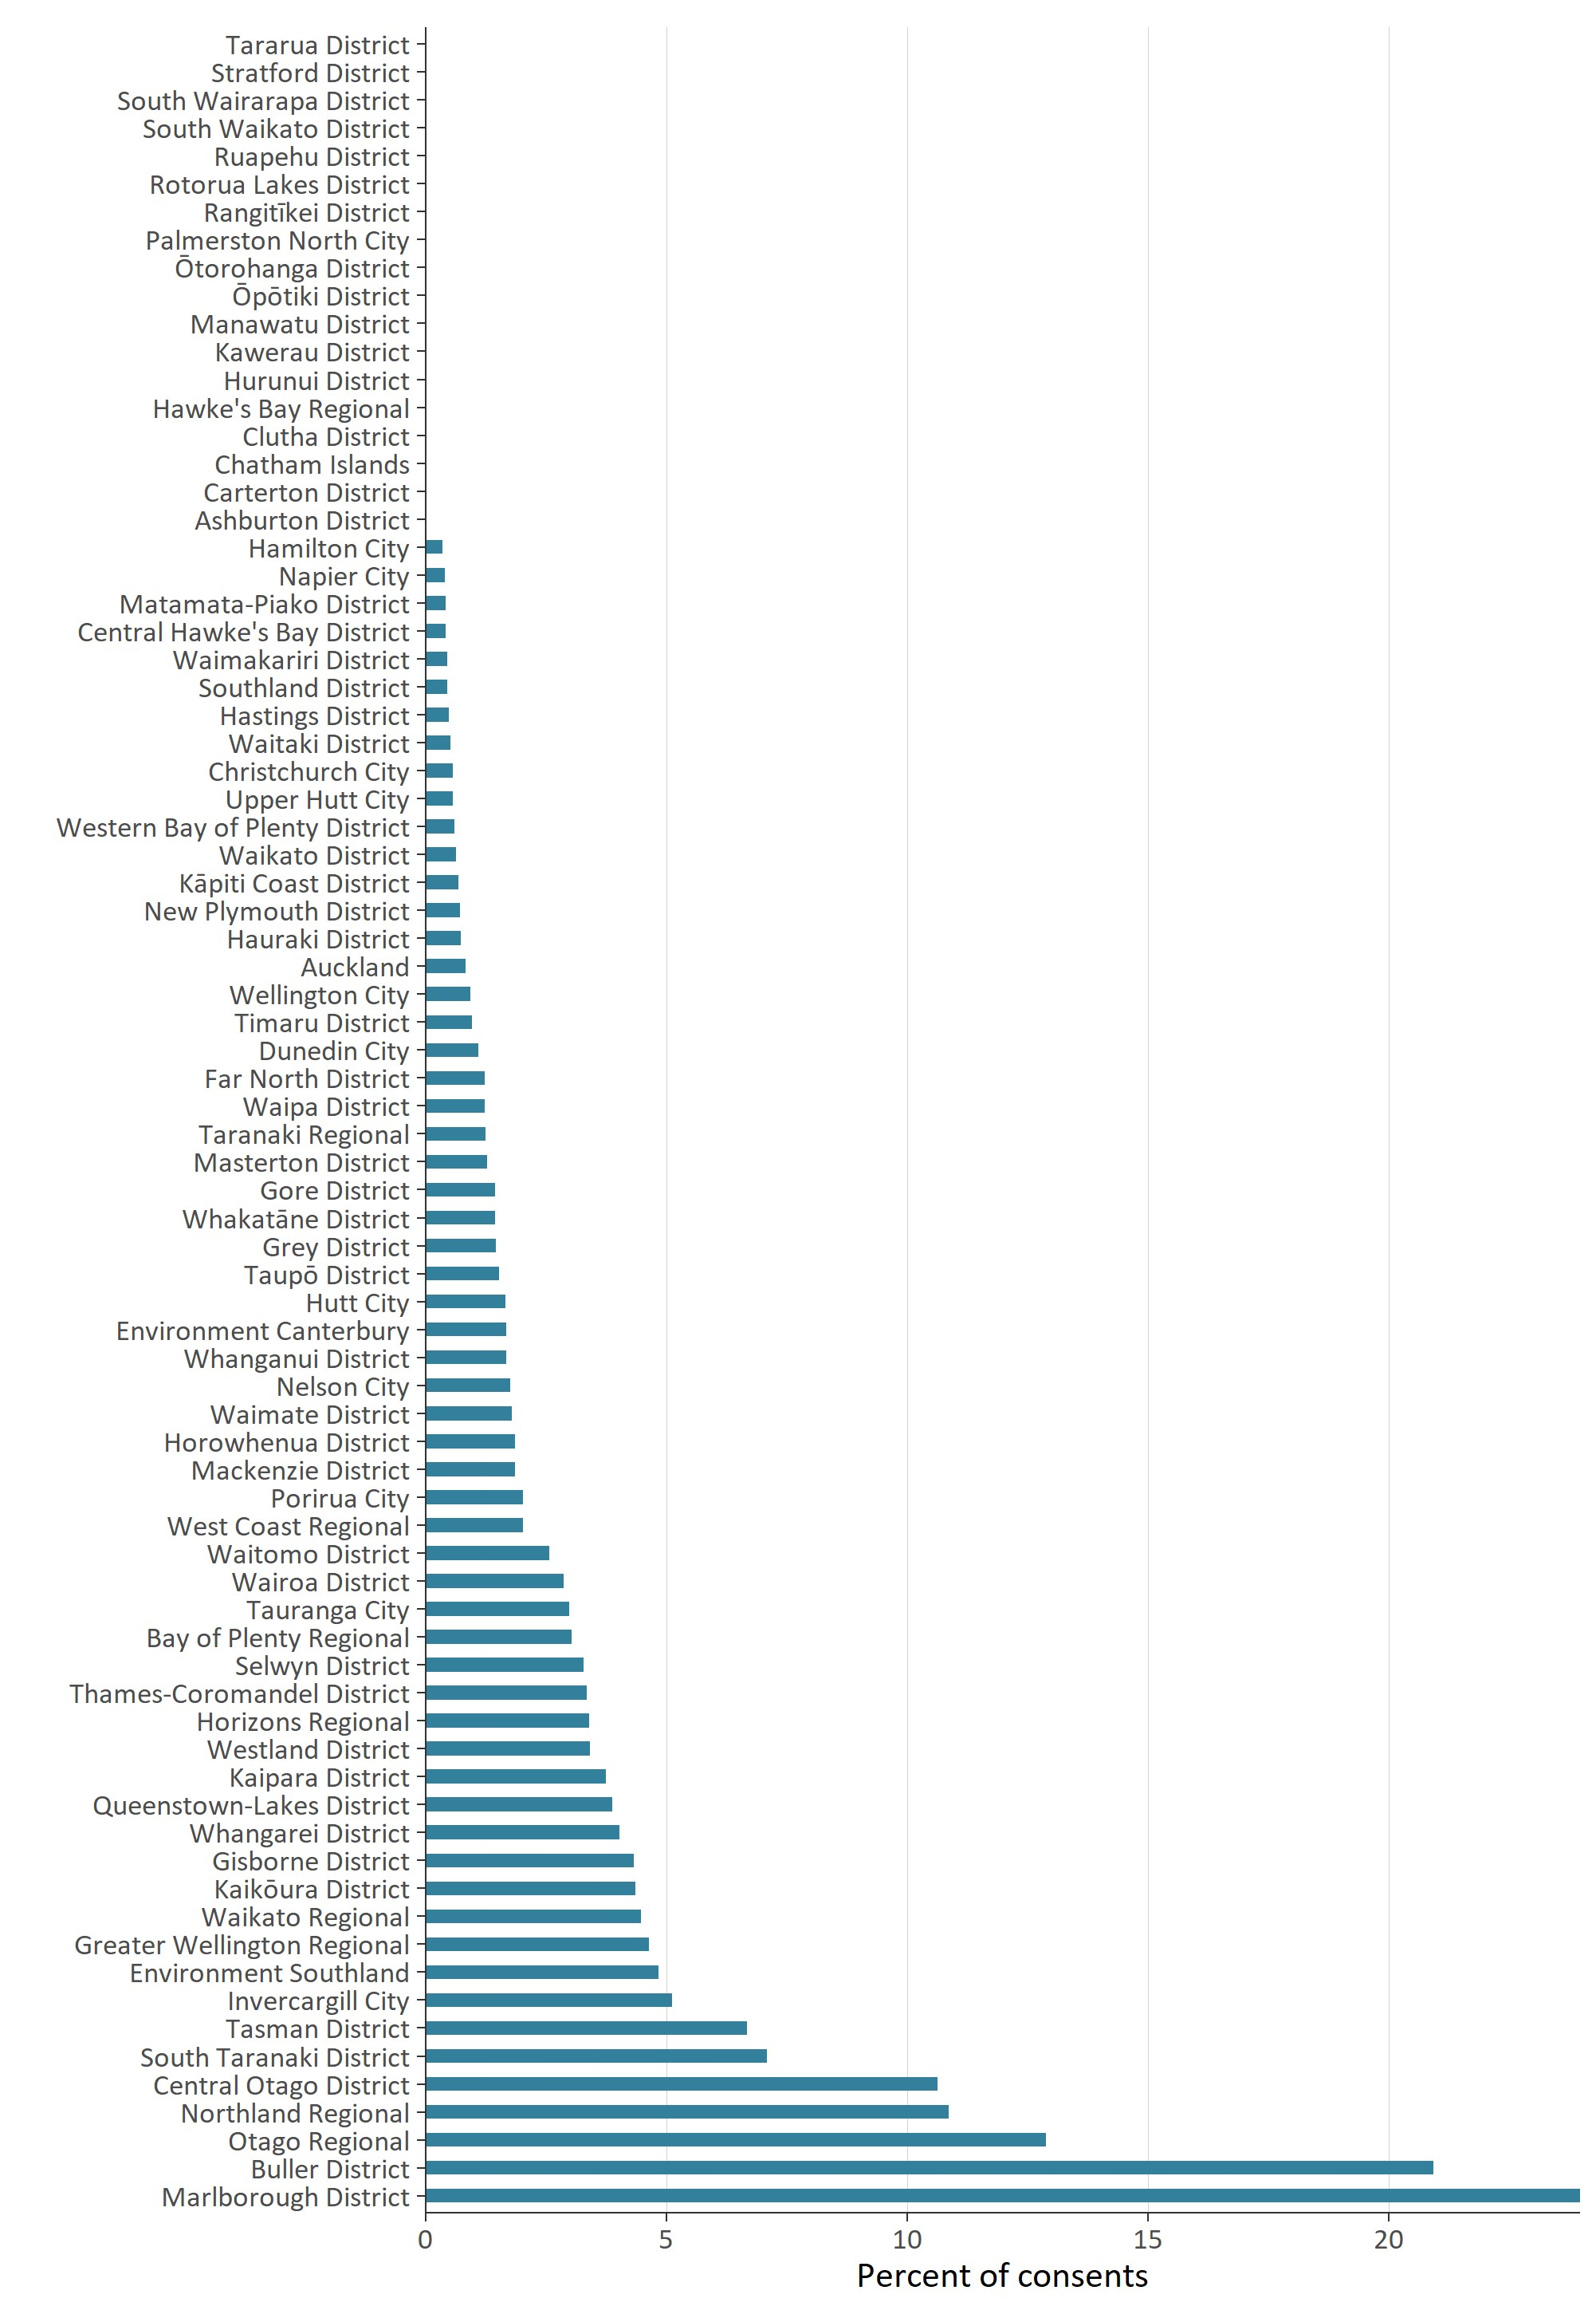

Councils used section 37 and section 92 on a more
regular basis
Section 37 allows a council additional working days provided certain circumstances are met during the processing of a resource consent. Where used, section 37 allows a council to double the statutory timeframes or to waive a failure to comply with the statutory timeframes. In using section 37, a council must take into account the interests of persons who may be directly affected by the waiver, the interests of the community in making a decision on a consent, and a council’s overall duty to avoid unreasonable delay.
Section 92 of the RMA allows a council to ask for more information from a resource consent applicant before making a decision on the application. The processing clock is paused while the applicant responds to the council’s request. Generally, a council seeks additional information to better understand a proposed consenting activity and any environmental effects it may have on the environment. When a council is processing a consent, both sections 37 and 92 can be used one or more times on the same application.
The use of sections 37 and 92 has increased since 2014/15. The increase in 2020/21 was 6 percent for section 37 and 1.5 percent for section 92 as shown in figure 9.
Figure 9: Percentage of new consent applications granted or declined that used at least one section 37 or section 92
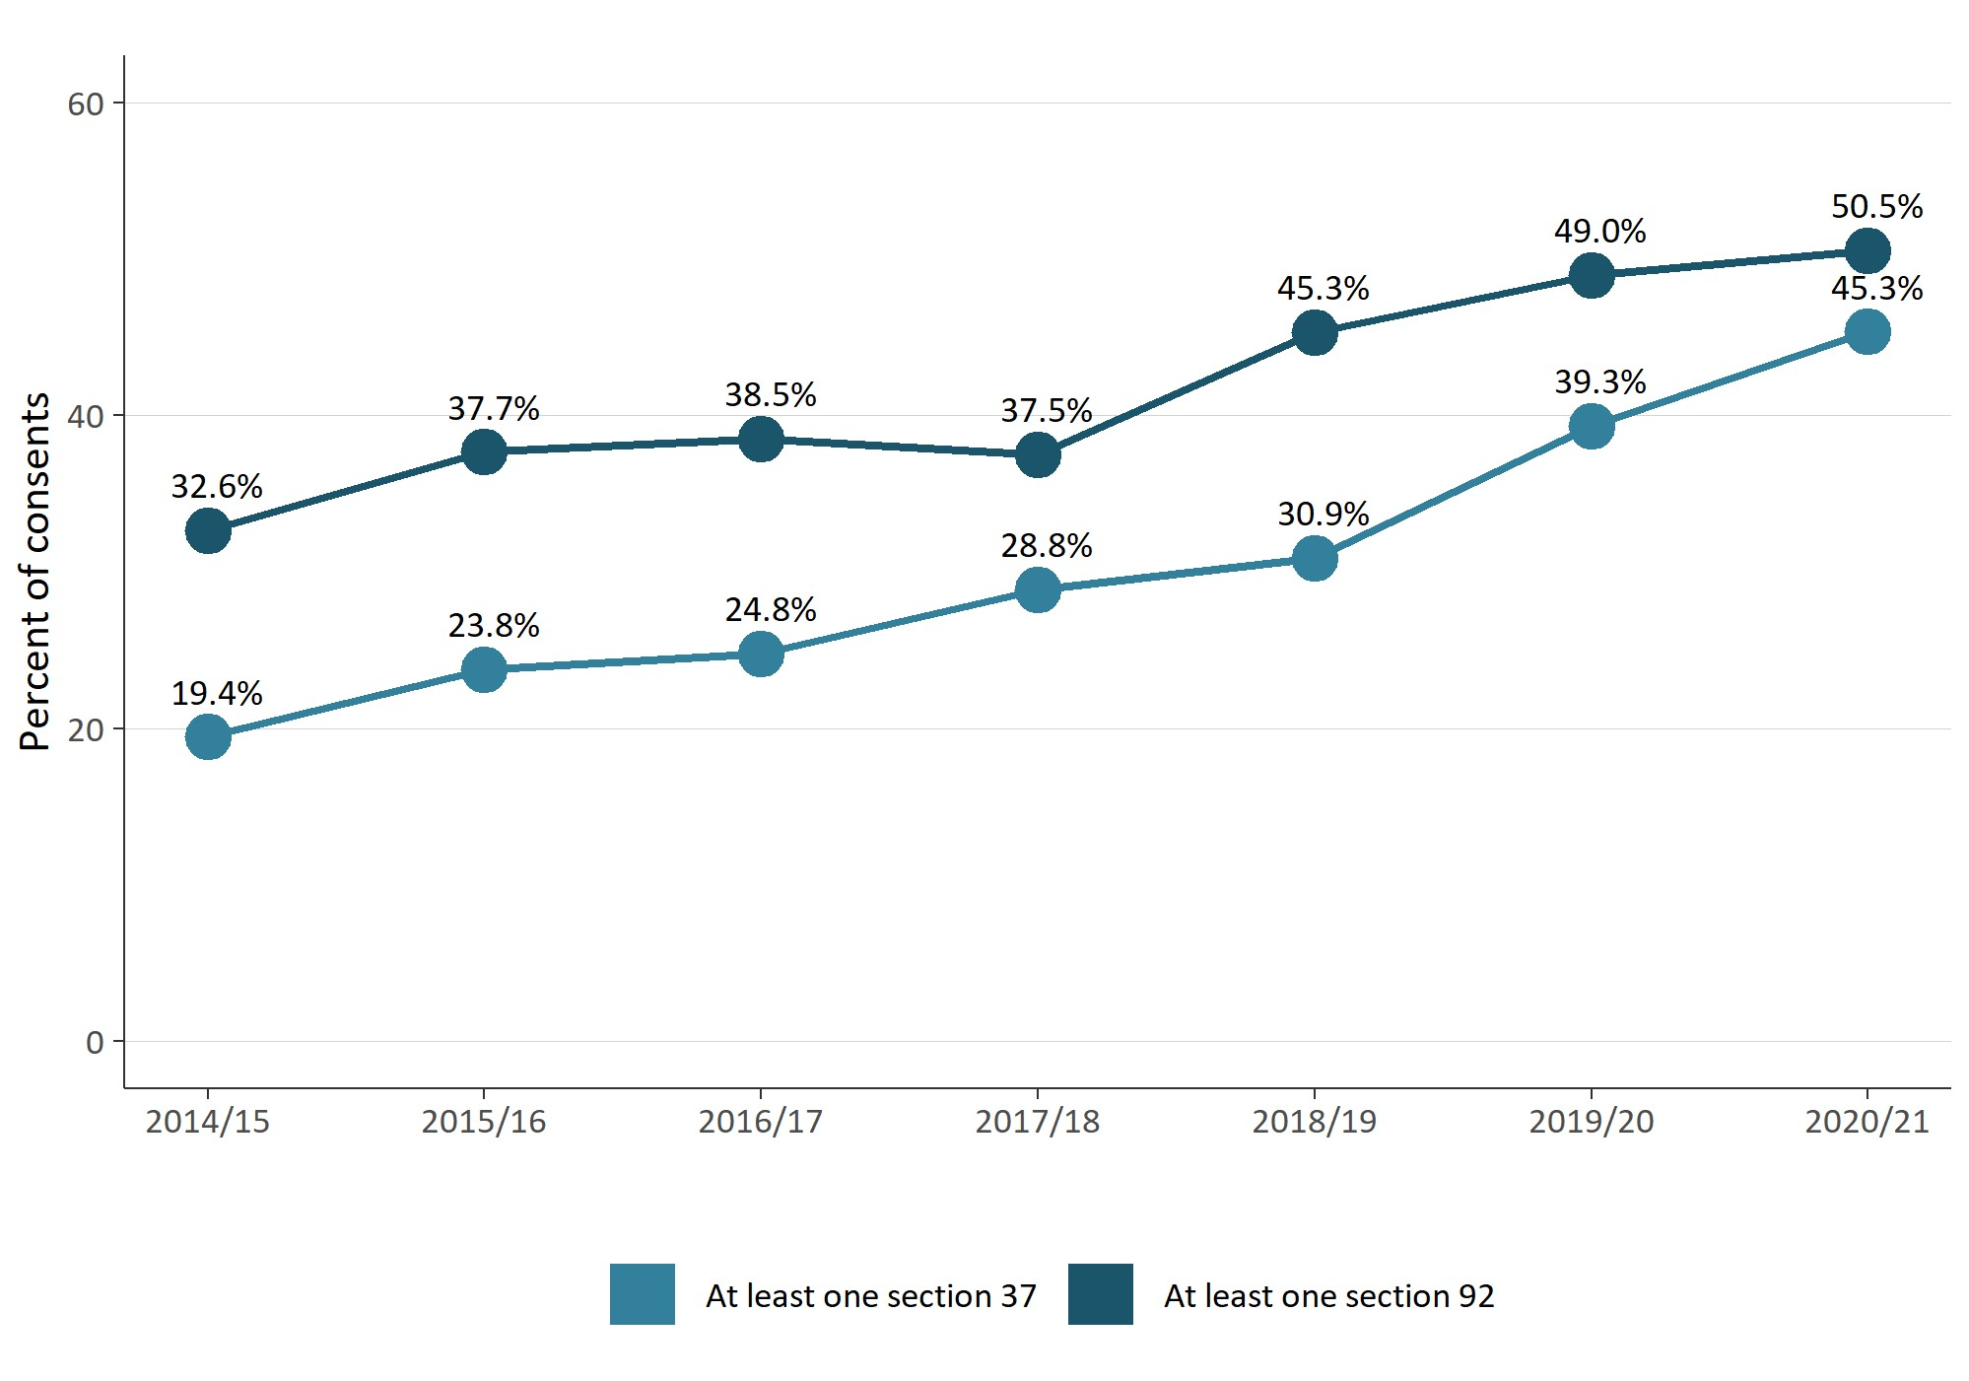

Median processing times of consent types varied from 2014/15 to 2020/21
Figure 10 gives a breakdown of types of resource consent and the median length of time in working days that councils took to process them. This data includes processing to grant or decline a resource consent. Combined land-use and subdivision consents were reported for the first time in 2020/21 and took councils a median of 35 days to process. The time taken to process coastal permits decreased from a median of 54 days in 2019/20 to 42 days in 2020/21.
Figure 10: Median processing time of new consent types (in working days by year)
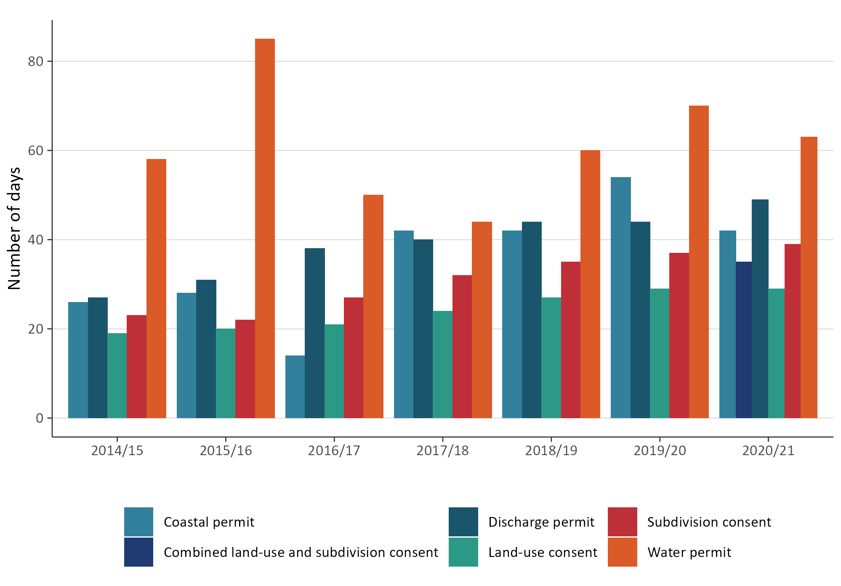
Figure 10 also shows that in comparison to the data from 2019/20, the median processing time remained unchanged for land-use consents, however subdivision consents showed a small increase in the median processing days. Water permits and discharge permits all showed a difference in their median processing days compared to 2019/20. Overall, there is variation between years, with median processing days being higher in 2020/21 than in 2014/15.
Figure 11 (overleaf) shows the median number of processing days for each council. Overall, the median timeframe for councils to process a resource consent was 35 days in 2020/21.
For district and city councils, South Wairarapa District Council recorded the lowest number of median processing days to make a decision on a resource consent and Manawatu District Council recorded the highest median processing days.
For regional councils, Waikato Regional Council recorded the lowest median processing days while Taranaki Regional Council provided the highest number of median processing days.
For unitary councils, both Auckland Council and Tasman District Council recorded a higher number of median processing days while Chatham Islands Council recorded the lowest.
Figure 11: Median processing time of new consents granted or declined by council
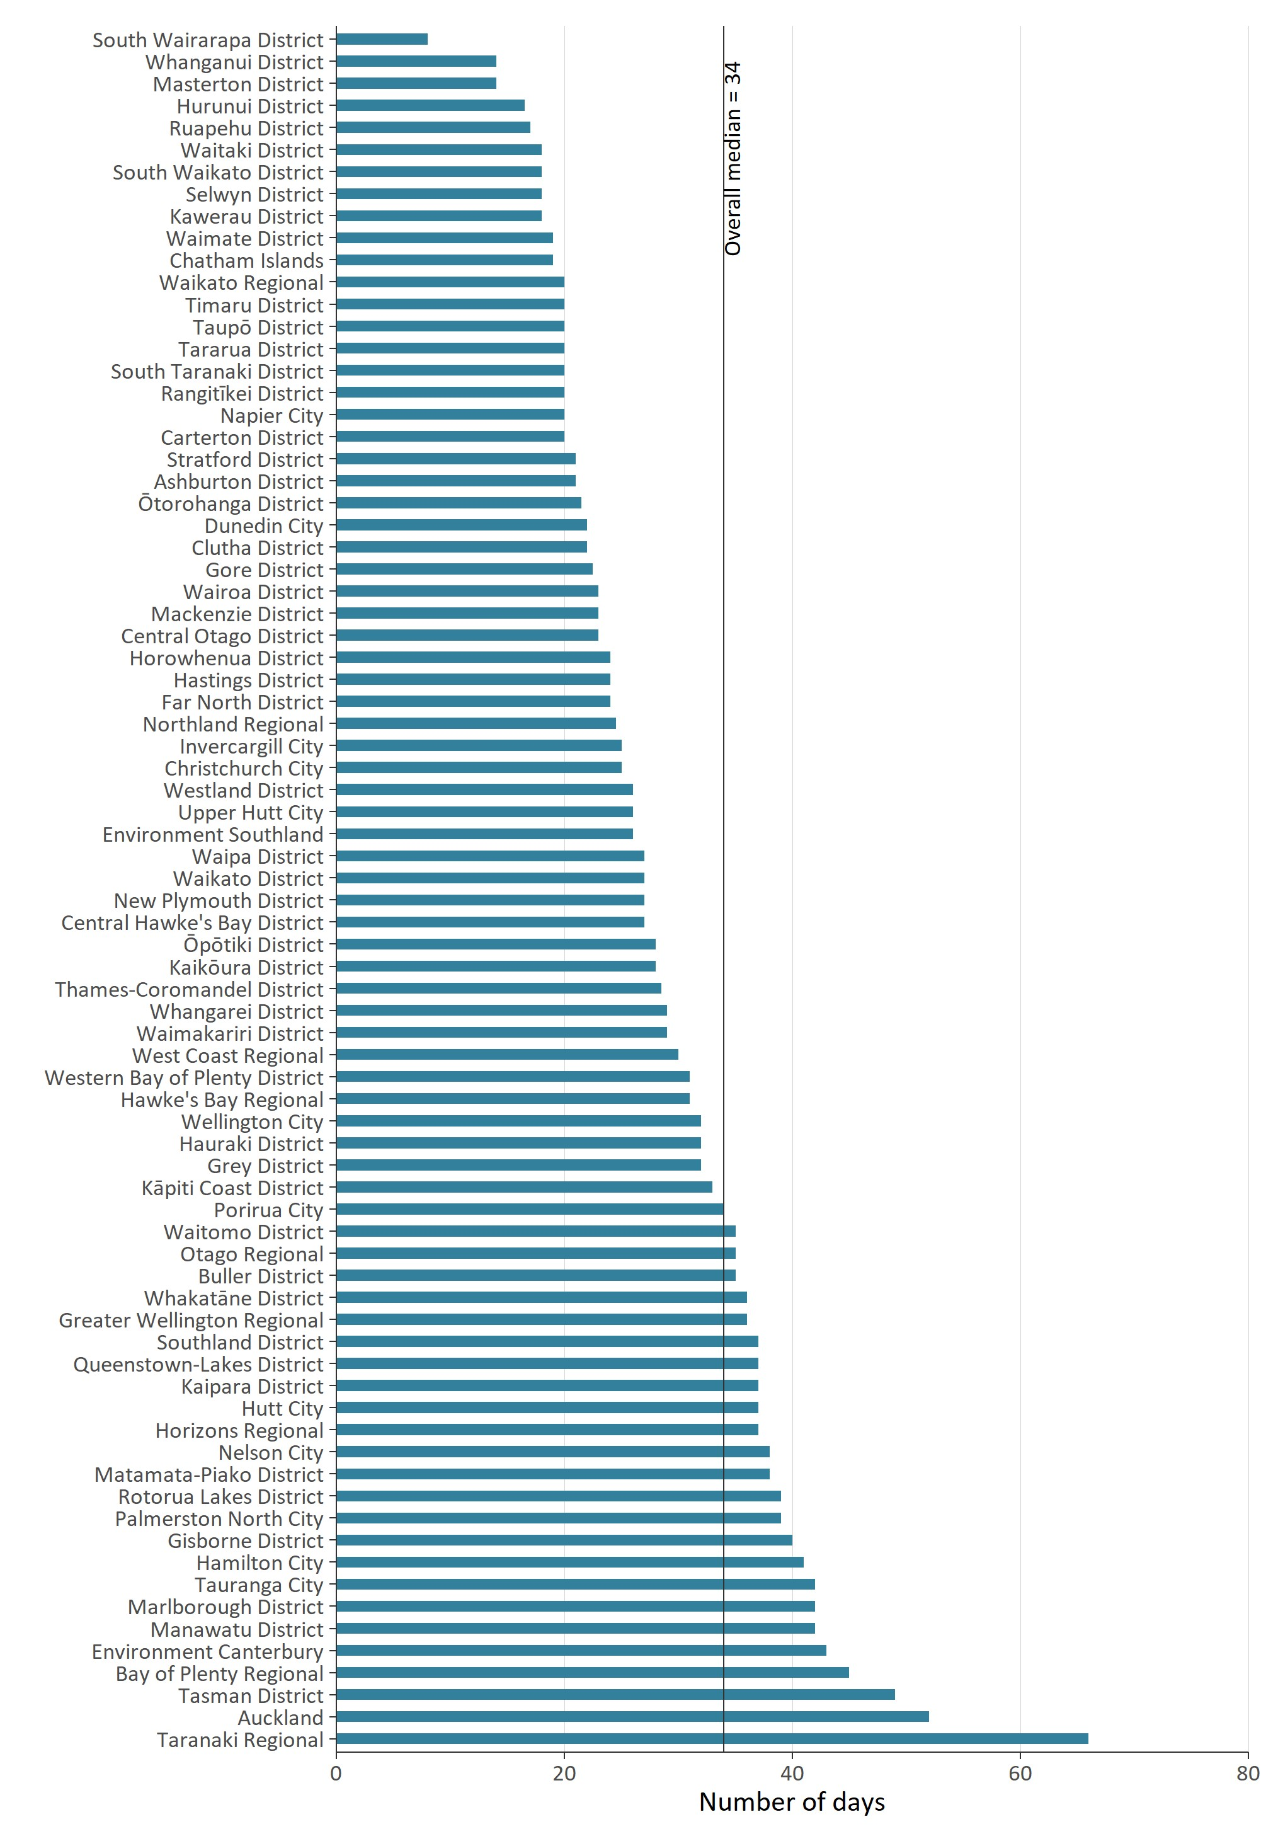

Plan-making processes
Councils prepare regional and district plans under section 30 and section 31 of the RMA.
A regional or district plan will state what activities can be undertaken as of right (‘permitted’) and what a resource consent is needed for.
Councils must review their plans, or any plan provisions, at least every 10 years. Plan changes can be initiated by councils or can be requested by private individuals or entities. These are known as plan-making processes.
The Resource Legislation Amendment Act 2017 introduced a requirement for councils to seek an extension from the Minister for the Environment if they wanted to exceed the two-year statutory timeframe for making a decision on a proposed plan from the date of notification (Schedule 1, clause 10A).

Councils have completed a higher percentage of plans within two-year statutory timeframes
Under Schedule 1 of the RMA, all councils are required to meet the two-year timeframe (from notification) for making decisions on proposed plans or plan changes.
Figure 12 shows that since 2014/15, councils have completed a higher percentage of plan changes within two years of notification. For 2020/21, the data showed a 4.5 percent improvement from the previous year.
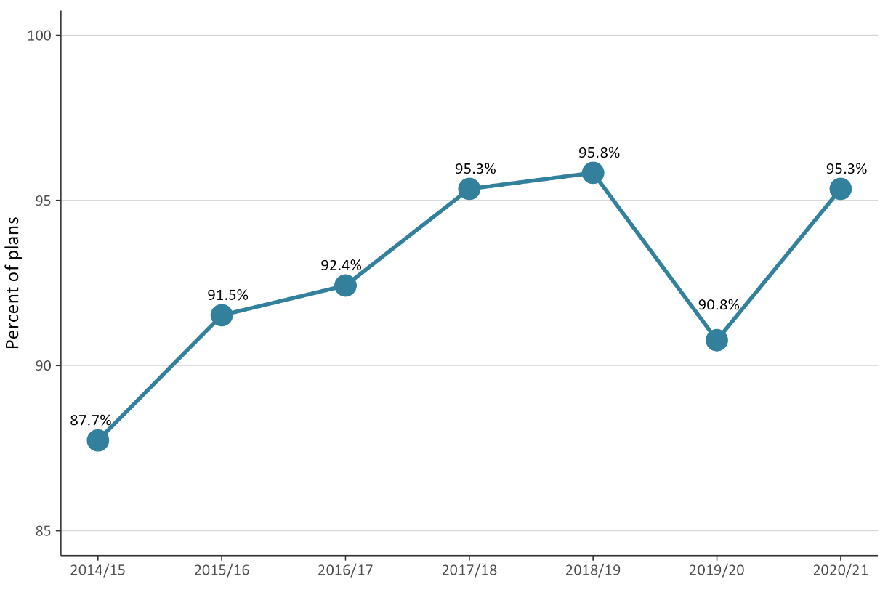
Figure 12: Percentage of plans that were decided within the statutory timeframe

Figure 13 shows that processing time has remained relatively consistent since 2015/16. In 2020/21, the median processing time for completing this task was 1.1 years after notification, which is a minor increase compared to 2019/20 (which was 1.07 years).
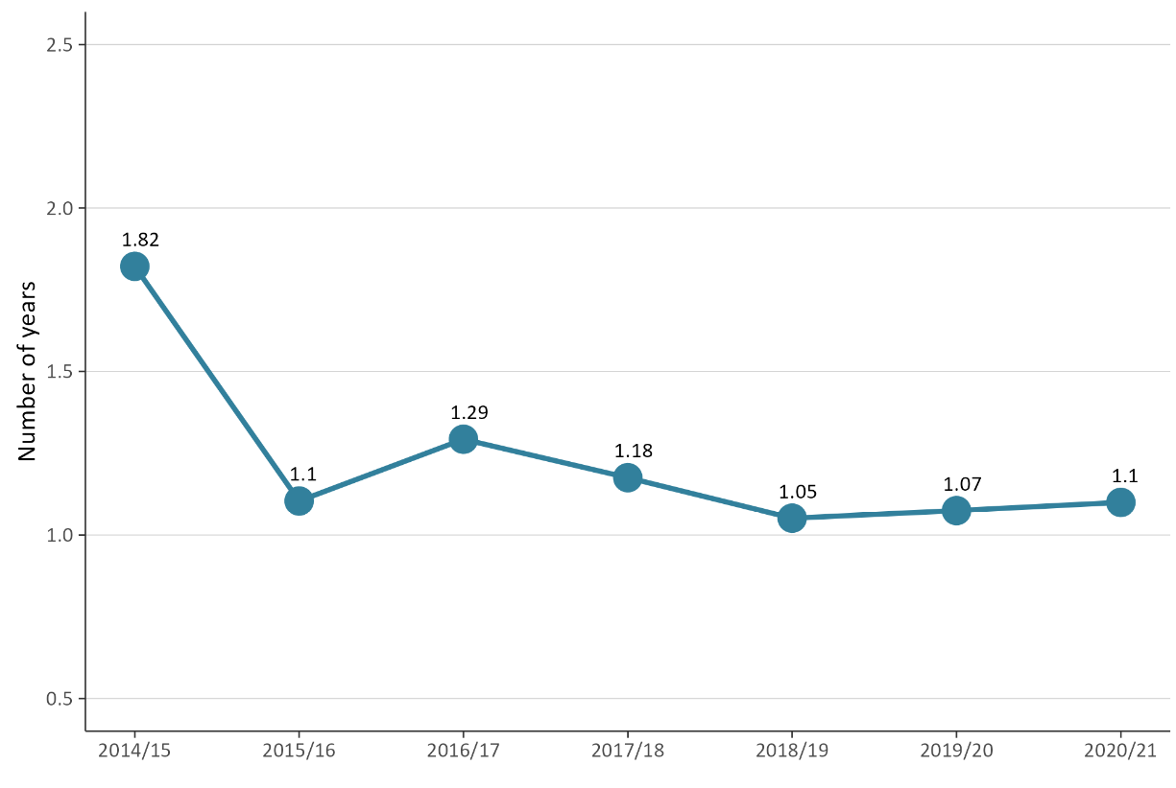
Figure 13: Median processing time to complete a plan change once notified

Iwi and hapū participation within the resource management system
The RMA sets out different ways to enable iwi and hapū participation in resource management processes. Councils also have processes in place to support tangata whenua participation in resource management.
This support can come in the form of a budgetary commitment from councils to support iwi and hapū to participate in both plan-making and consenting processes. In-kind forms of support may also be available, such as access to databases or memoranda of understanding.

There was variation in how councils budgeted for iwi and hapū to participate in consenting and plan-making
Figure 14 (overleaf) shows the percentage of councils providing budget for iwi and hapū for consenting matters slightly increased in 2020/21 compared to the previous year. The percentage of councils providing a budget for iwi and hapū to develop resource management plans has reduced 6 percent from a peak of just over 61 percent in 2019/20.

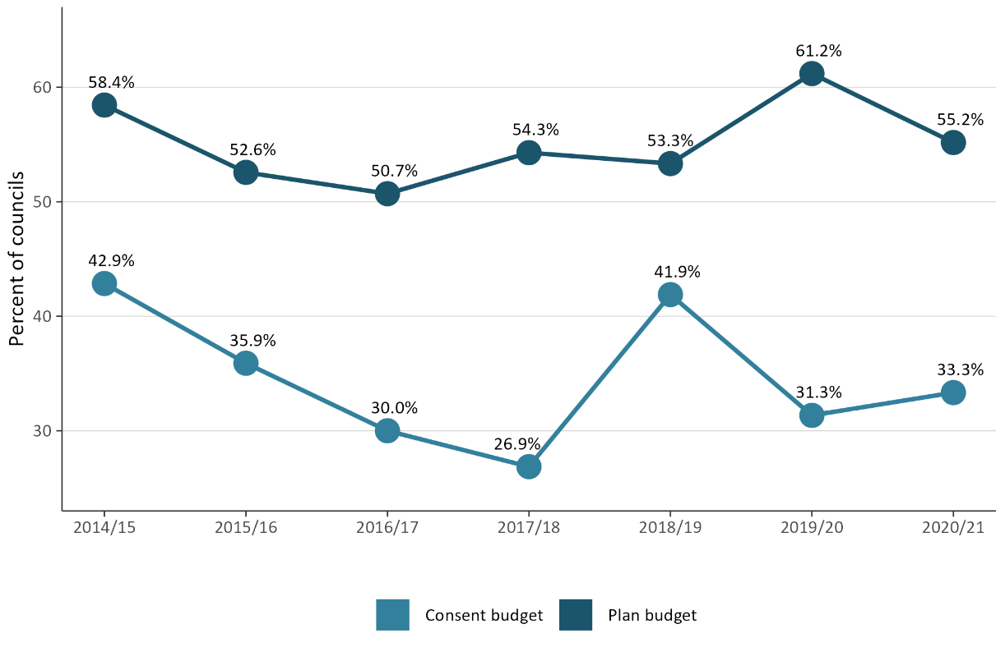
Figure 14: Percentage of councils that provided budget to iwi/hapū to participate in either the development of resource management plans or processing of resource consents

Fewer new iwi management plans or iwi planning documents endorsed
Iwi management plans (IMPs) describe resource management issues of importance to tangata whenua and can also be used to express values relating to specific areas, natural resources or taonga. IMPs can also provide guidance for interactions between councils and iwi/hapū, as well as direction on decision-making and information requests. An IMP can help improve understanding of specific values and interests for tangata whenua.
Figure 15 (overleaf) shows one IMP was lodged with a council in 2020/21, which is lower than what was lodged in previous years.

Figure 15: Number of new iwi management plans endorsed by iwi authorities and lodged
with councils
Note: Iwi management plans lodged with more than one council are counted separately.
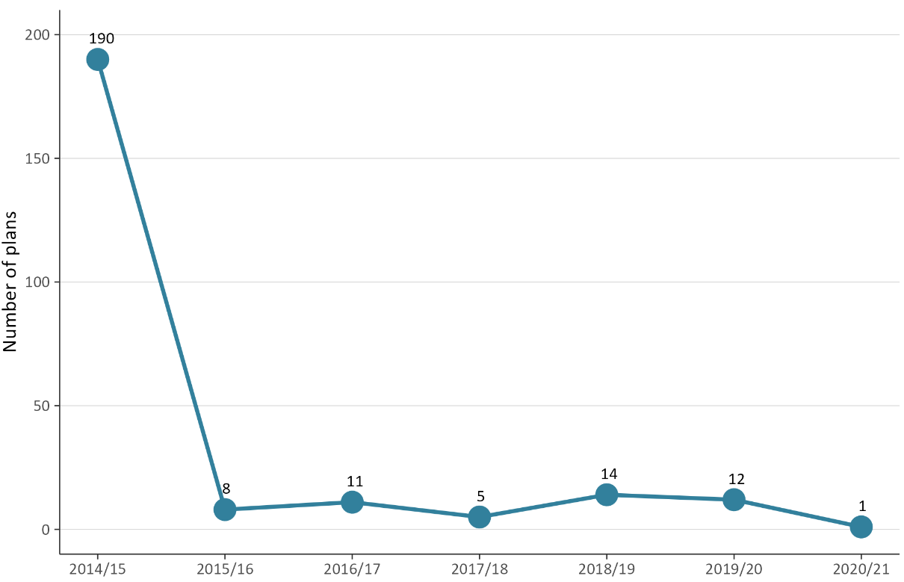

Compliance monitoring and enforcement
Under the RMA councils have a responsibility to monitor a range of matters as part of their compliance monitoring and enforcement (CME) duties. CME functions enable councils to:
- ensure the efficiency, effectiveness and enforcement of policy statements and plans
- monitor and enforce the exercising of resource consents and resource management plans
- ensure people and companies are delivering the environmental outcomes supported by councils.
CME is an important part of fulfilling their statutory functions to demonstrate that their objectives, policies and methods are meeting the purpose of the RMA. The amount of active CME work varies between councils, depending on the number of consents they have and the local environmental context.
Councils can use different types of enforcement tools under the RMA, from issuing abatement notices or seeking an enforcement order, through to issuing an infringement notice or taking a prosecution.

Councils took more enforcement action
For unitary authorities, figure 16 shows an increase in enforcement action being taken in 2020/21 compared to the 2019/20 year. The higher numbers since 2017/18 reflected the increased number of enforcement actions reported by Auckland Council.
Figure 16 also illustrates that since 2016/17, the number of enforcement actions reported by regional councils and territorial authorities (district and city councils) has remained generally consistent, with slight increases in 2020/21 compared to the previous financial year.
Figure 16: Number of enforcement actions taken by councils (by council type)
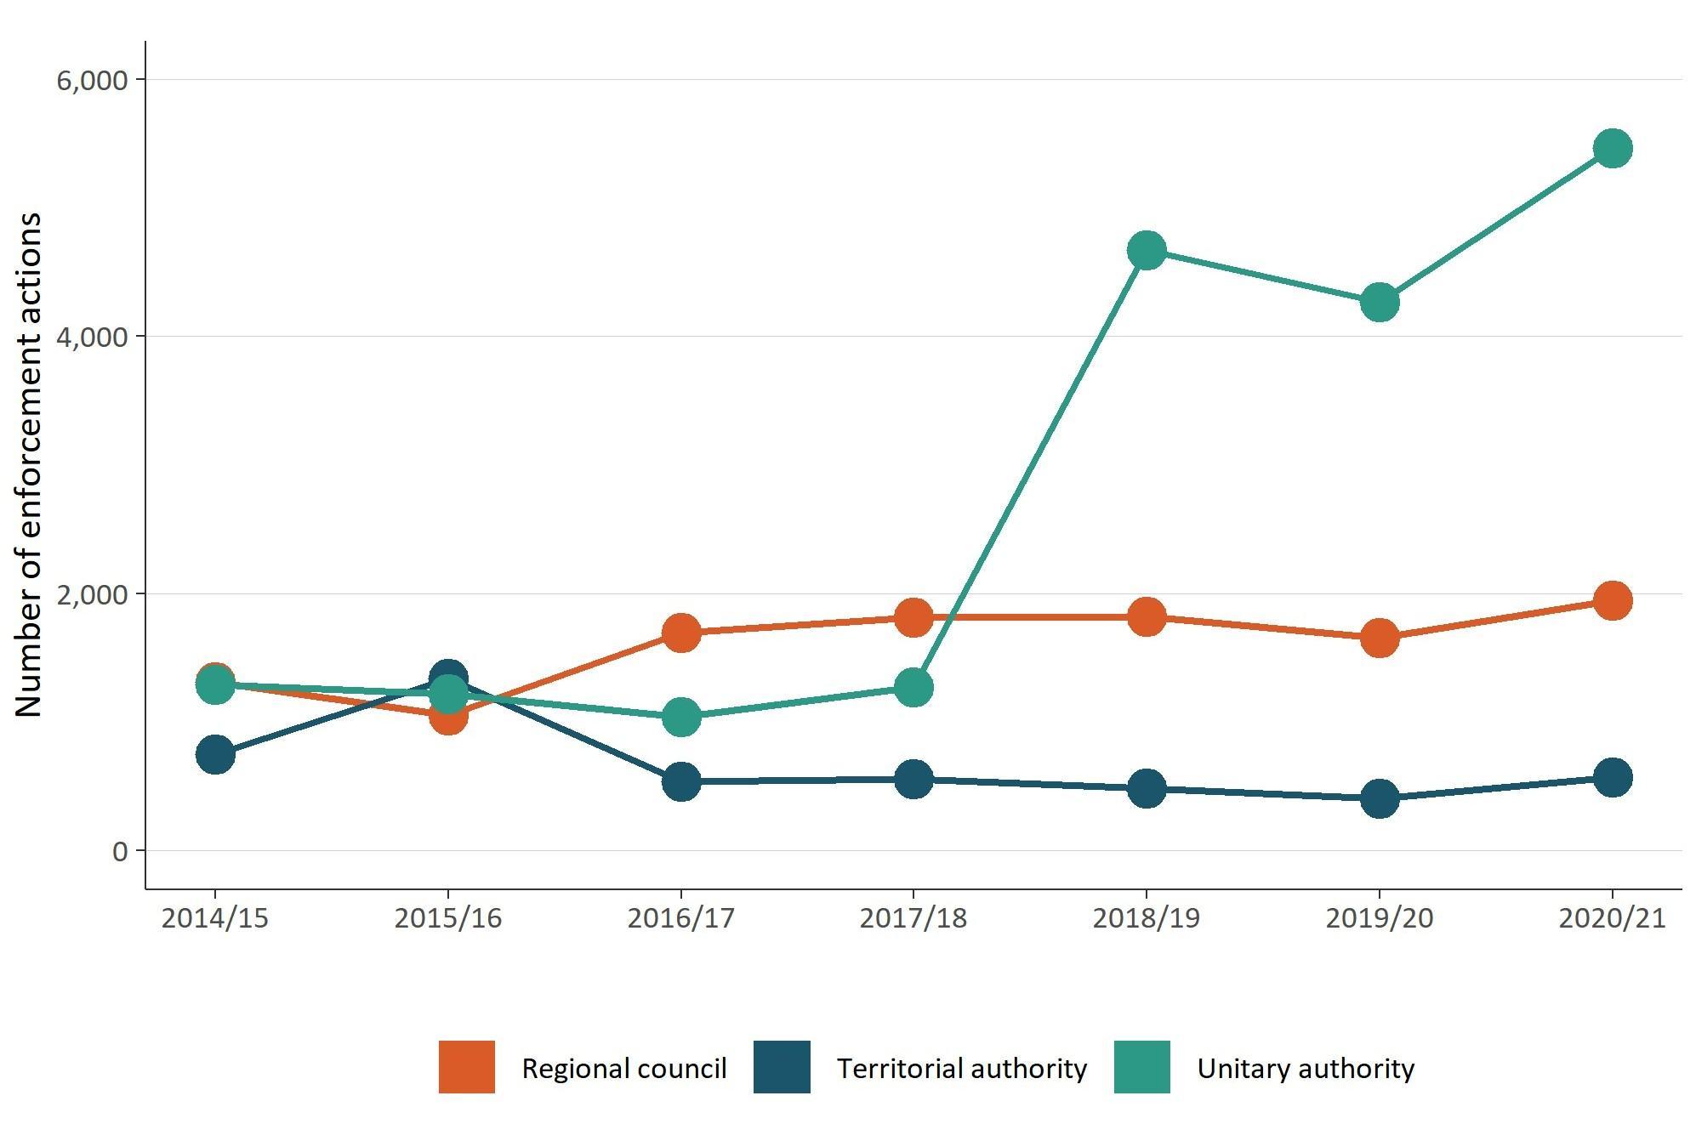

Councils had a small increase in the levels of monitoring and enforcement staff
Full-time Equivalents (FTE) is a measure of the number of employees working in the different areas of consenting monitoring and enforcement and plan-making at councils. Since 2014/15, consenting staff numbers have remained higher than FTE measured in plan-making and CME (see figure 17 overleaf).
While FTE for monitoring and enforcement staff levels was similar in 2020/21 to 2019/20, a small increase occurred in the number of consenting FTE for councils, and a decrease in plan-making FTE.
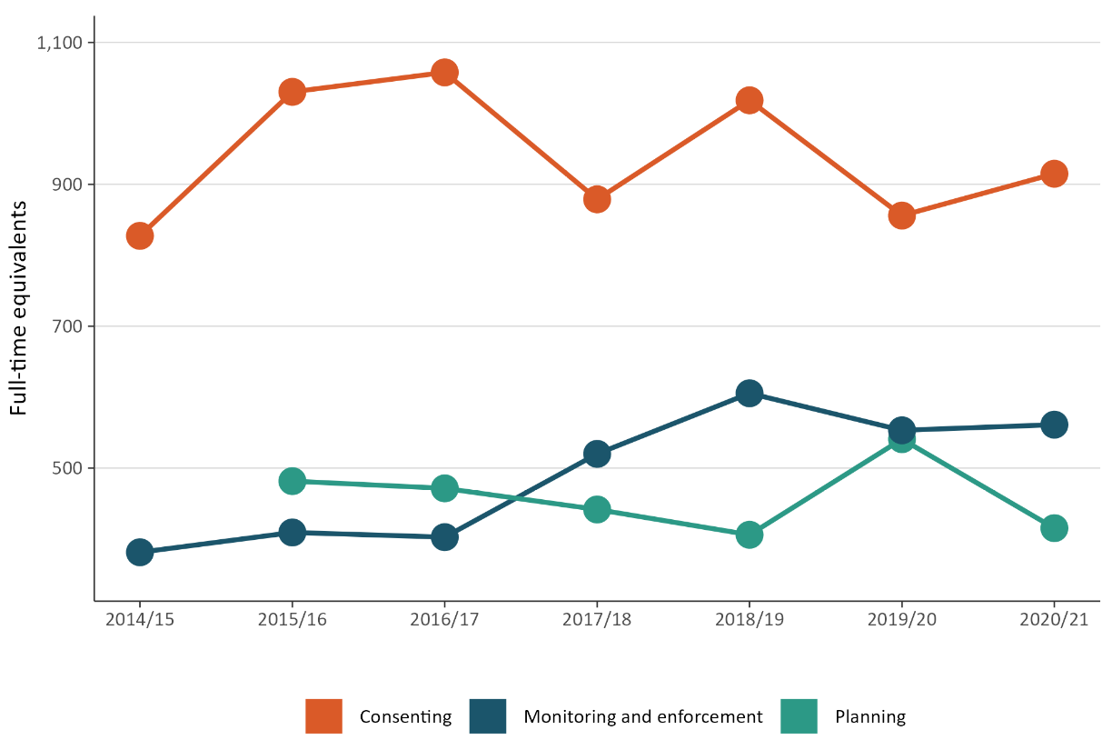
Figure 17: Number of full-time equivalent (FTE) council staff for consenting, monitoring and enforcement, and planning
Figure 18 shows the total number of FTE employed by councils on resource management in 2020/21 was 1891. The data used combined staff numbers for consenting, monitoring and enforcement, and plan-making. There had been a decrease compared to the previous three financial years where overall numbers peaked in 2018/19.
Figure 18: Total full-time equivalents (FTE) working on resource management at councils
Note: FTE data records the number of staff employed and does not include vacancies.
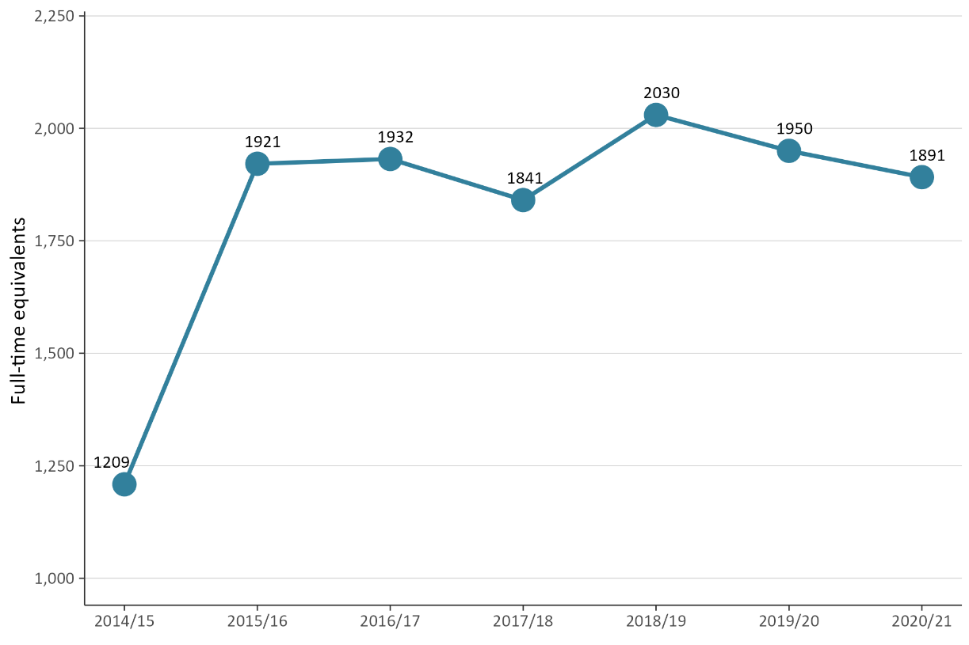

The RMA uses the term ‘local authorities’. In this report we have used ‘councils’ to refer to all local authorities, that is district and city councils, regional councils and unitary authorities.

