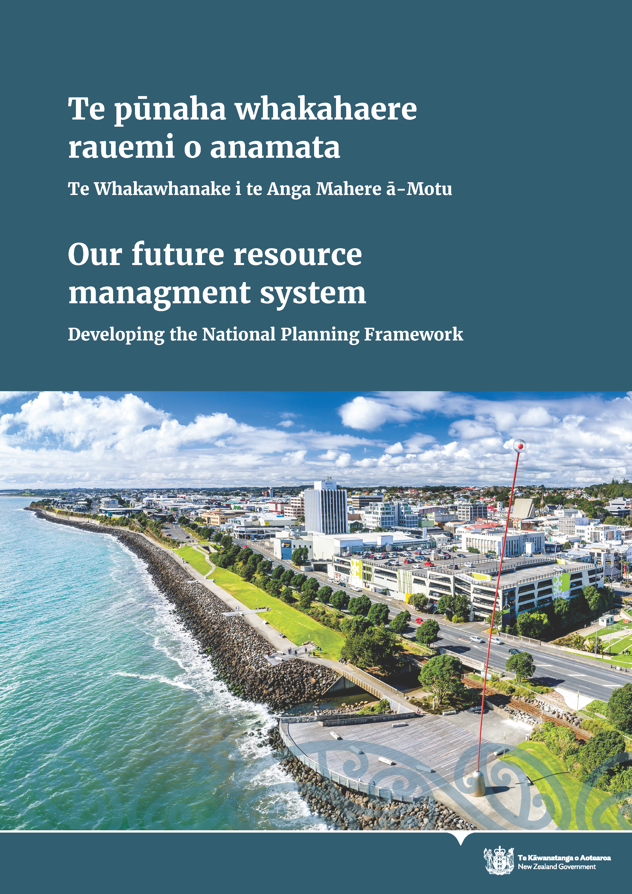

Disclaimer
The information in this publication is, according to the Ministry for the Environment’s best efforts, accurate at the time of publication. The Ministry will make every reasonable effort to keep it current and accurate. However, users of this publication are advised that:
- the information does not alter the laws of New Zealand, other official guidelines, or requirements
- it does not constitute legal advice, and users should take specific advice from qualified professionals before taking any action based on information in this publication
- the Ministry does not accept any responsibility or liability whatsoever whether in contract, tort, equity, or otherwise for any action taken as a result of reading, or reliance placed on this publication because of having read any part, or all, of the information in this publication or for any error, or inadequacy, deficiency, flaw in, or omission from the information in this publication
- all references to websites, organisations, or people not within the Ministry are for convenience only and should not be taken as endorsement of those websites or information contained in those websites nor of organisations or people referred to.
This document may be cited as Our future resource management system: Developing the National Planning Framework. Wellington: Ministry for the Environment.

Published in April 2023 by the
Ministry for the Environment
Manatū Mō Te Taiao
PO Box 10362, Wellington 6143, New Zealand
ISBN: 978-1-991077-47-9
Publication number: ME 1759
© Crown copyright New Zealand 2023
This document is available on the Ministry for the Environment website: environment.govt.nz.

Contents
Foreword 5
Part one: Introduction 8
Developing the National Planning Framework 9
Working with local government on the resource management reforms 10
Part two: Topics for discussion 13
National Planning Framework 14
Regional implementation 39
Appendix 1: Questions for discussion 43
Appendix 2: Glossary of terms 45
Appendix 3: Resource management system reform key documents 46

Tables
Table 1: National Planning Framework overarching layer 20
Table 2: Direction on key considerations for regional planning committees 22
Table 3: General changes suggested to align RMA national direction with the new RM system 24
Table 4: Changes to existing national direction instruments 25
Table 5: NPF direction that supports regional planning committees 27
Table 6: Risk Assessment Framework 28
Table 7: Attributes of mandatory matters for environmental limits 29
Table 8: Framework outcomes and supporting policies for infrastructure 32
Table 9: Framework for outstanding natural features and landscapes 34
Table 10: Framework for cultural heritage 36
Table 11: Direction on urban trees 38
Table 12: Significant Natural Areas Criteria 38

Figures
Figure 1: Key components of the future resource management system 8
Figure 2: RM system transition and implementation timeline 40

Foreword
Tēnā koutou katoa
Our thoughts continue to be with all communities in areas affected by Cyclone Gabrielle and other severe weather events in recent months. We are very aware of the significant recovery work ahead and our focus is on supporting councils and communities with building Aotearoa New Zealand’s resilience to future events.
The Ministry is currently assisting with the broader government response in a number of ways, including options for support in the immediate and longer term to assist the recovery. We also want to signal that we have work underway across our programmes to look at what we can do to support the recovery.
We are planning for the next stages of the resource management system reform, anticipating the Natural and Built Environment Bill and the Spatial Planning Bill to be passed in mid-2023.
Soon after the new legislation comes into force the Government will release a draft National Planning Framework (NPF), which will provide more detailed national direction on how decision-makers in the new resource management system will give effect to the new legislation. The intention is that this comes into effect in early 2025.
The NPF will comprise a single, cohesive and coherent body of national regulation to direct regional planning committees to prepare regional spatial strategies and Natural and Built Environment plans and local authorities to undertake consenting in the new resource management system.
Resource management reforms will play an instrumental role in planning for natural hazards. The NPF will provide national direction on risk reduction and resilience to natural hazards and the effects of climate change. The NPF will guide regions on how to undertake risk assessments, respond to, and prepare for future hazard and climate events, supporting consistency across the country.
The first NPF is intended to provide high-level direction for regional planning committees to support strategic direction and identification of natural hazards at the regional level and consideration of strategic opportunities to improve resilience.
The information in this document will help you prepare for the board of inquiry consultation later this year on the first NPF.

I look forward to working with you on developing the new resource management system.
Ngā mihi nui

Sam Buckle
Deputy Secretary, Waste and Resource Efficiency, Water and Land Use Policy

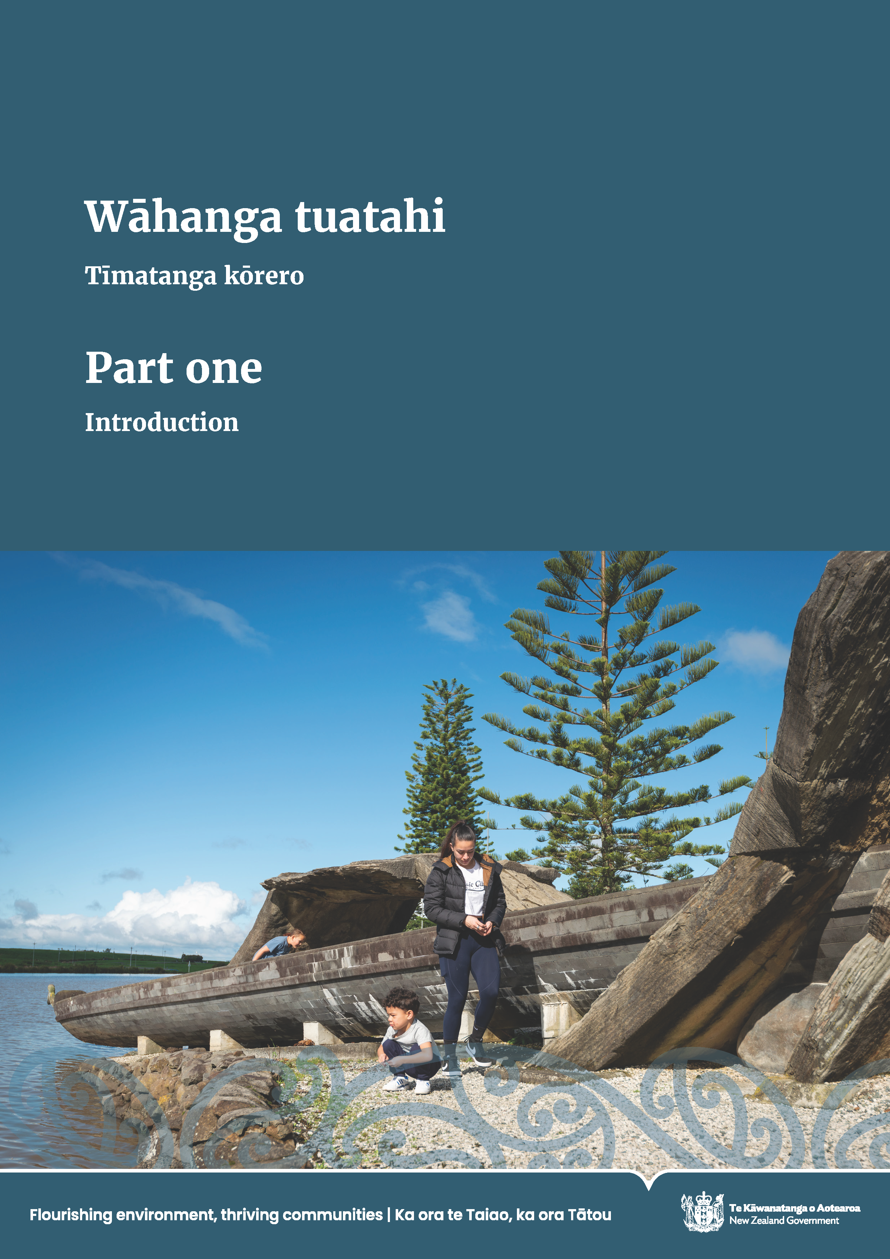

Part one: Introduction
The new resource management system represents a new way of thinking that seeks a shared vision and focuses on a shared aspiration to protect and restore te taiao and improve the wellbeing of people across Aotearoa New Zealand.
Three new pieces of legislation will replace the Resource Management Act 1991 (RMA). They are the:
- Natural and Built Environment Act (NBE Act), the main replacement for the RMA, to protect and restore the environment while better enabling development
- Spatial Planning Act (SPA), which requires the development of regional spatial strategies (RSSs) and implementation plans, to help coordinate and integrate long term-strategic decisions in each region
- Climate Adaptation Act (CAA), to address complex issues associated with managed retreat.
The Natural and Built Environment Bill (NBE Bill) and Spatial Planning Bill (SP Bill) were introduced to Parliament on 22 November 2022. The Environment Committee is currently considering them through the select committee process and we are planning for them to be passed in mid-2023. We will adjust our plans accordingly to reflect the new legislation.
These Bills establish the framework for a new system as outlined in figure 1.
- Key components of the future resource management system
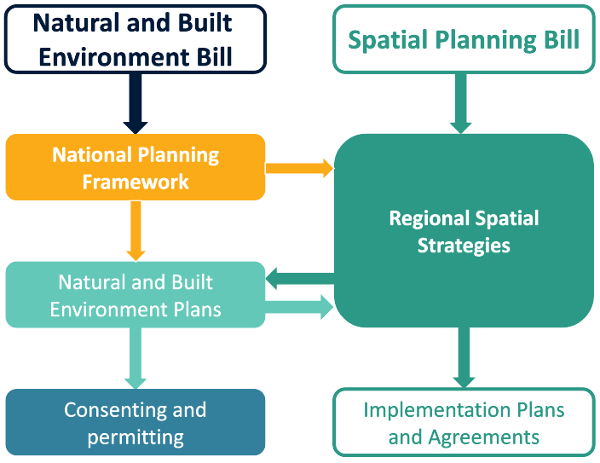
The Climate Adaptation Bill is likely to be introduced to Parliament in 2023 and enacted the following year.

More information on our future resource management system
When the NBE and the SP Bills were introduced into Parliament in November 2022, the Ministry for the Environment (the Ministry) published Our Future Resource Management System: Overview.
This document sets out the key components of the new resource management system as proposed in these Bills. It was designed to provide a high-level overview of the new system to help people as they submitted on the legislation. We haven’t repeated this information in this document. We encourage you to read the other document to better understand the resource management reform context.

Developing the National Planning Framework
In anticipation of the Bills being passed in mid-2023, we are planning the next stages of reform and will adjust our plans to reflect the final legislation. This includes planning for the transition to the new system and developing the National Planning Framework (NPF), as well as information on the regional implementation of the proposed new system.
Part two of this document provides detailed information on these topics, including a series of questions to guide your discussion. We welcome your input into how these proposals should be shaped. In summary:
- The NPF is secondary legislation under the NBE Act and will act as the link between the primary legislation and regional decision making. It consolidates national environment policy statements, planning standards and regulations into one coherent planning framework that directs how regions plan for growth and manages the natural environment and development.
- The NPF will provide central government direction for regional planning and support the development of regional spatial strategies (RSSs) and natural and built environment plans (NBE plans). It will also be required to give effect to the principles of te Tiriti o Waitangi and uphold te Oranga o te Taiao. We are aiming to notify the NPF later in 2023 before it will need to undertake a statutory Board of Inquiry process that will provide further opportunity for input from the community and Treaty partners.
- Environmental limits and targets form part of the NPF – Setting environmental limits and targets to prevent further ecological degradation and improve environmental targets is a key feature of the new resource management system. We also need to ensure that limits and targets reflect mātauranga Māori and te ao Māori perspectives.
- In anticipation of the passing into law of the NBE Bill and SP Bill, we are starting to plan for the regional implementation of the new resource management system. This includes establishing regional planning committees to develop the new RSSs and NBE plans.
Local government will be important delivery partners in the new resource management system. We will outline some initiatives that are designed to support and enable implementation of the new system at a regional level.

Working with local government on the resource management reforms
We appreciate the willingness of local government and sector stakeholders to work with us to help shape the new resource management legislation.
Many of you may have previously attended meetings on the proposed resource management system. We would like to thank local government leaders and planners for the feedback that informed the policy thinking and tested policy options, thus helping shape ministerial decisions, directly leading to the policy decisions that enabled the introduction of the NBE and SP Bills. The input of the Local Government Steering Group has been particularly important as we have worked through policy options, and we are continuing to work with the steering group.
We appreciate your commitment and value the perspectives you provide and look forward to having more opportunities to discuss these proposals with you prior to notifying the NPF.

Bringing us closer together
We recognise the amount of environmental reform underway and are committed to improving how we engage at the local and regional levels. To support this, the Ministry has just established a new regional partnerships team that will change how we engage with local authorities, and with iwi and Māori regionally.
By creating better partnerships, the team will ensure that:
- we listen to you, our policies consider differences between regions, and initiatives are implemented as well as they can be
- we are joined up as a Ministry and you know who you are engaging with, about what and when
- our partners are supported with increased capacity locally.

Our approach includes three key areas of focus:
- creating more effective mechanisms to support pan-iwi national-implementation relationships
- establishing mechanisms to develop stronger, enduring relationships at place
- supporting an uplift in iwi environmental capacity to engage with the Ministry.
This is about having consistent relationships in the regions so we can better understand your aspirations and how we can better work alongside you. The new team will include new kaiwhakatere (regional navigators) enabling us to tailor our engagement to each region’s needs.

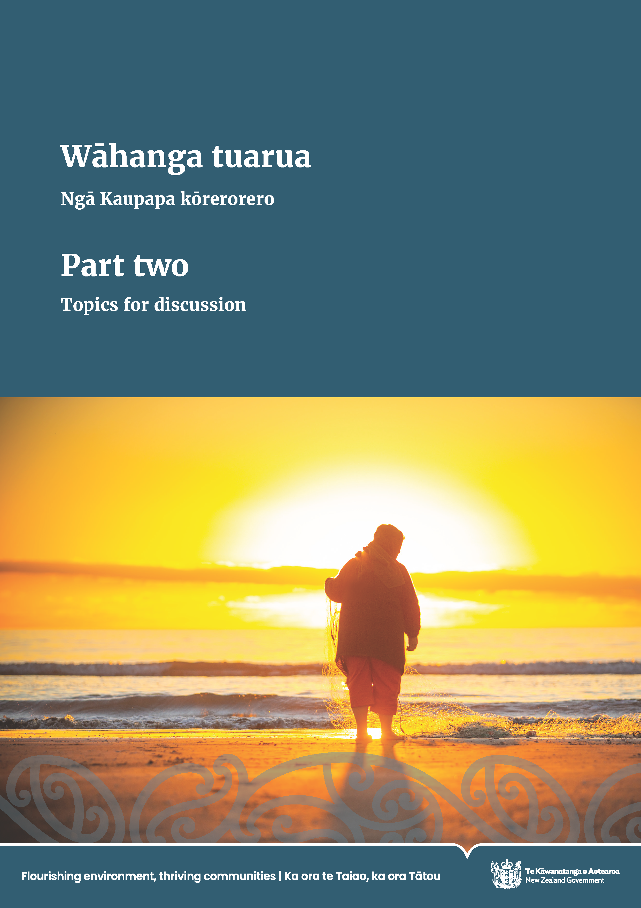

Part two: Topics for discussion
This section covers the following topics:
- National Planning Framework
- NPF overarching layer
- Direction on conflict resolution
- National direction under the RMA (1991)
- Climate change mitigation
- Natural hazards risk management and climate adaptation
- Environmental limits and targets
- Infrastructure
- Outstanding natural features and landscapes
- Cultural heritage
- Urban trees
- Significant biodiversity area criteria
- Regional implementation
- Transition to the new system
- Implementing the new system
- First tranche regions
- A stronger role for iwi/hapū in the new system
At the end of each topic, there are a series of questions to help guide discussion and feedback.

National Planning Framework
A key element of the new system is the National Planning Framework (NPF), which is the new system’s equivalent to ‘national direction’ under the Resource Management Act 1991 (RMA). The NPF will provide direction for regional and local decision making on matters important enough to warrant a nationally coordinated approach.
The NPF will be secondary legislation under the Natural and Built Environment Act (NBE Act) and will act as the link between the primary legislation and regional decision making. The NPF will provide central government direction for regional planning and support the development of regional spatial strategies (RSSs) and natural and built environment plans (NBE plans) described below.
The Natural and Built Environment Bill (NBE Bill) contains requirements that relate to the NPF, including:
- supporting the purpose of the NBE Act to enable the use, development and protection of the environment and recognise and uphold te Oranga o te Taiao (clauses 3 and 33)
- giving effect to the principles of te Tiriti o Waitangi (clause 4)
- providing for a range of natural and built system outcomes (clause 5)
- being made in a way that reflects the decision-making principles (clause 6)
- setting environmental limits and targets (clauses 38 and 49).
Please refer to Part 3 and Schedule 6 of the NBE Bill, which contain most of the provisions about the contents and process for developing the NPF.
We have learnt from the experiences of the current national direction under the RMA that we need to provide a coherent and consistent set of national direction that will provide investment certainty. Currently, under the RMA, national direction is provided across more than 20 different national policy statements, national environmental standards, national planning standards and regulations. These documents and their functions will be consolidated into a single NPF, contributing to a more integrated set of central government direction to inform how we use, protect, and manage our natural and built environments. Existing national direction that is fit for purpose will be rolled over into the NPF.
Bringing all of this national direction together in one place also provides an opportunity for the NPF to have ‘overarching’ or ‘cross-cutting’ direction that will sit across the suite of topic-specific direction.

Why are we developing the National Planning Framework now?
The NBE Bill requires the Minister for the Environment to notify an NPF within six months of the Bill coming into effect. The first NPF is one step in the transition to a new system and will need to be in place in time to inform the development of RSSs by an initial group of regions. Work on the shape of the NPF is underway now to meet this timeframe. We are progressing on the basis of the NBE Bill as it was when it was introduced to Parliament. However, we acknowledge that if the Bill changes, we will have to make sure the NPF is aligned with these changes.
We are seeking your input to inform the development of the first NPF proposals. This document provides a summary of our initial thinking on the scope of the first NPF. Further detail on specific aspects can be provided through this engagement process, if required.
A full public consultation and hearings process run by an independent board of inquiry will follow notification. This will provide further opportunity to have input into the development of the first NPF. The board of inquiry will hear submissions and provide recommendations on the first full NPF proposal. This process will inform final decisions on the first NPF, expected to be made by Cabinet in late 2024.

How will transition to the new system work?
We anticipate that the transition period until NBE plans are operative will be 7 to 10 years. During this time, national direction created under the RMA will remain in force and continue to direct transitional decision making. The NPF will not have legal effect on decisions made under RMA plans and policy statements during this time. The NPF will provide direction for the development of RSSs and NBE plans.
The NPF will be delivered in stages, with the first NPF scheduled for notification in 2023. This will have a tightly defined scope, prioritising direction needed for RSSs. More detailed direction to inform the development of NBE plans will be provided in future amendments to the NPF.
RSSs will be rolled out in tranches and the development of NBE plans would follow in the four years after a region finalises its RSS. The new resource management system would not be fully in effect in a region until the first NBE plan in that region is in effect.
During the transition period:
- the RMA national direction will remain in force, to continue directing transitional decision making
- powers under the RMA to develop and amend RMA national direction will remain in force
- the NPF will not have legal effect on decisions made under RMA plans and policy statements; the NPF will focus on the development of RSSs and NBE plans.
The Ministry for the Environment (the Ministry) is in the early stages of considering the content and timing of future NPF amendments, and these will be subject to further ministerial decisions. The Ministry will publish a roadmap of future NPF amendments, to provide a clear signal as to what is coming next in the NPF. This will include additional detailed direction to inform NBE plans.
We welcome your input on additions to the NPF as even though they may not be ready in time for inclusion in the first NPF, they will be factored into the second.

Regional spatial strategies to be consistent with the National Planning Framework
RSSs are required to be consistent with the NPF, but the NPF will not provide comprehensive requirements for what RSSs must do for all domains. This is because:
- RSSs will not regulate or provide all direction needed for regulation in, NBE plans, as they will not comprehensively cover all land use in a region.
- how directive RSSs will be will vary across issues – they will not have direct regulatory effect
- while an RSS will align with regional boundaries, it is not expected to provide strategic direction for all that region. It only needs to address the places where change is:
- unavoidable and there needs to be coordinated effort to ensure good outcomes
- desirable, to improve outcomes for the community or environment, and multiple parties need to be involved.

Tiriti o Waitangi settlements
The NBE Bill requires that Tiriti settlements must be given the same or equivalent effect as under the RMA (Schedule 2, clause 3). There are over 70 Tiriti settlements, along with the Ngā Rohe Moana o Ngā Hapū o Ngāti Pōrou Act 2019, and Marine and Coastal Area (Takutai Moana) Act 2011 arrangements that interface with the RMA.
Any changes to the planning system, including NPF content, may have implications for Tiriti settlements. We need to ensure these Tiriti settlement agreements are honoured, and their effects are retained in the new system.

First National Planning Framework – suggested approach
The first iteration of the NPF will focus on bringing together existing RMA national direction alongside new direction to fill key gaps in the resource management system. This new direction will primarily be focused on what is needed to inform the development of RSSs.
We are considering whether the first NPF could include the following components:
- integrating the policy intent of all existing RMA national direction into a consistent regulatory framework and updating specific elements in those instruments to reflect key changes to the resource management system in the Bills. This will be the majority of the content of the first NPF.
- an overarching layer that provides direction that applies across the NPF, including on decision making, how to resolve competing outcomes and other conflicts, engagement at the regional and local level, and monitoring the NPF.
- new national direction to provide for system outcomes in the NBE Bill not covered by existing RMA national direction:
- new direction on infrastructure, that will include infrastructure standards
- protection or restoration of outstanding natural features and landscapes
- conservation of cultural heritage
- recognition of, and making provision for, the relationship of iwi and hapū and the exercise of their kawa, tikanga (including kaitiakitanga) and mātauranga in relation to their ancestral lands, water, sites, wāhi tapu, wāhi tūpuna and other taonga
- protection of Takutai Moana protected customary rights and recognition of statutory acknowledgements
- reduction of greenhouse gas emissions and removal of these gases from the atmosphere
- risk reduction and resilience to the effects of natural hazards and climate change.
- requirements and surrounding policy for an initial set of limits and targets. These must be set for six mandatory matters (air, indigenous biodiversity, coastal water, estuaries, fresh water and soil).

Indicative structure of the first National Planning Framework
Chapters | National Planning Framework (NPF) content
Preliminary provisions | - Commencement  - Interpretation, including consolidation of definitions across the NPF
Overarching layer | - Direction on the approach to decision making under Natural and Built Environment Bill (NBE Bill), particularly direction on te Oranga o te Taiao and managing conflicts between outcomes  - Direction on processes for engaging with the community and Māori  - Direction on monitoring the performance of the NPF
Domain chapters | Each domain chapter to contain (if needed):  - outcomes  - policies  - implementing outcomes and policies  - limits and targets  - rules  monitoring requirements.
Freshwater | - National Policy Statement for Freshwater Management (NPS-FM)  - National Environmental Standards for Freshwater (NES-F)  - Stock-exclusion regulations (under Resource Management Act 1991 [RMA], section 360)  - National Environmental Standards for Sources of Human Drinking Water (NES-DW)
Urban development | - National Policy Statement for Urban Development (NPS-UD)  - Resource Management (Enabling Housing Supply and Other Matters) Amendment Act 2021 – includes medium density residential standards
Infrastructure | - New infrastructure direction providing outcomes and RSS direction  - New infrastructure standards  - National Environmental Standards for Telecommunication Facilities (NES-TF)  - National Policy Statement for Electricity Transmission (NPS-ET)  - National Environmental Standards for Electricity Transmission (NES-ET)  - National Policy Statement for Renewable Electricity Generation (NPS-REG)
Coastal and marine | - New Zealand Coastal Policy Statement (NZCPS)  - National Environmental Standards for Marine Aquaculture (NES-MA)  - Marine-pollution regulations (under RMA, section 360)
Biodiversity | - National Policy Statement for Indigenous Biodiversity (NPS-IB)  - Exemption regulations (under RMA, section 360)
Soil | - National Environmental Standards for Assessing and Managing Contaminants in Soil (NES-CS)  - National Environmental Standards for Storing Tyres Outdoors (NES-Tyres)
Air | - National Environmental Standards for Air Quality (NES-AQ) (in part)
Climate change and natural hazards | - Elements of other national direction (eg, NZCPS [policies 24, 25, 26 and 27], NPS-UD [policies 1 and 6], NPS-FM [policy 4], NPS-ET [policy 1], NPS-REG)  - National Policy Statement/National Environmental Standards on industrial-process heat (greenhouse gas emissions)  - Other new climate mitigation and natural hazard direction
Cultural heritage | - Elements of NZCPS (policy 17) and NPS-UD  - New high-level direction on cultural heritage
Outstanding natural features and landscapes | - Elements of NZCPS (Policy 15)  - New high-level direction on outstanding natural features and landscapes
Rural areas and highly productive land | - National Environmental Standards for Plantation Forestry (NES-PF)  - National Policy Statement for Highly Productive Land (NPS-HPL)
Plan processes | - National planning standards  - Updated zone framework and mapping standards  - RSS template

NPF overarching layer
The NPF is intended to be a more integrated and consistent framework than the separate instruments currently prepared under the RMA. There are likely to be topic-specific chapters of the NPF, as shown in the structure in the table above. We think there is value in including a chapter that sits across these topics for broad system direction, to help integrate and provide consistent direction across the NPF. We are calling this the ‘overarching layer.’
We consider the three priority areas for the overarching layer in the first NPF could be:
- further direction on the approach to decision making under the Natural and Built Environment Bill (NBE Bill), particularly, direction on te Oranga o te Taiao and managing conflicts between outcomes.
- processes for engaging with Māori and the community, recognising that specifying a ‘one-size-fits-all’ approach to managing natural resources and working with local communities is likely to be inappropriate
- monitoring the performance of the NPF.

The NBE Bill includes a clause that requires that all persons exercising powers and performing functions and duties under the Bill, if enacted, must give effect to the principles of te Tiriti. This has implications for both the process to develop and the substance of the NPF and regional planning documents (RSSs and NBE plans).
NPF direction to regional planning committees on Māori involvement in plan development is intended to ensure good process is followed by these committees, while still allowing for regional flexibility.
- National Planning Framework overarching layer
Component of overarching layer
Decision making
Applying the purpose and the key Natural and Built Environment Act (NBE Act) provisions to the National Planning Framework (NPF) | Our initial view is that direction is needed to support the intended approach to decision making under the NBE Act (see Part 1 of the Natural and Built Environment Bill [NBE Bill]). This would support the shift to an ‘outcomes-based’ system and help ensure te Oranga o te Taiao is upheld at the regional level. Direction could include the following:  - clear prioritisation of achieving limits and targets as part of regional planning processes  - how to apply an outcomes-based approach to planning, including a focus on achieving benefits for multiple outcomes  - how to manage conflicts between outcomes throughout the system (see further information)  - stating that regional planning committees (RPCs) have an obligation to protect protected customary rights and recognise any relevant statutory acknowledgements, and perhaps require RPC to identify and collate these in their region.
Limits and targets implementation | Requirements for environmental limits and targets will form part of the domain chapters of the NPF and attributes will be listed in a technical appendix (like the approach taken in the National Policy Statement for Freshwater Management). In addition, direction is needed on how to set management units, including integration across the domains for which environmental limits and targets must be set. There may also be other general process direction that applies to setting limits and targets that could sit in the overarching layer.
Cross-cutting concepts | Cross-cutting issues that are addressed in many pieces of national direction should be consolidated in the overarching layer of the NPF, to avoid unnecessary variation and duplication. One example is requirements for ‘integrated management’, which are described differently in different pieces of national direction. Another is the time horizon needed for planning decisions, including the long-term planning needed for climate-related issues (currently only addressed in the New Zealand Coastal Policy Statement, but with wider relevance).
Engagement
Māori involvement | The NBE Bill requires the NPF to provide direction on all ‘system outcomes’. Our initial thinking is that direction on the relationship of iwi and hapū and their taonga (see clause 5(e) of the NBE Bill) is best addressed through procedural direction that ensures Māori values and interests inform decision making at the regional and local levels. It is inappropriate to establish a one-size-fits-all approach to this outcome at the national level, but the NPF should support this outcome to be provided for within each region.  The NBE Bill establishes Māori representation on RPC and includes provision for engagement agreements, Mana Whakahono ā Rohe, joint management agreements, local government Māori participation policies, and a register of Māori groups with relevant interests.  The Spatial Planning Act (SPA) provides for engagement agreements as a mechanism for an RPC and Māori groups with interests in the region to agree how the groups are to participate in preparing a regional spatial strategy.  The NPF can assist in ensuring these provisions work as intended and are implemented efficiently by:  - providing additional process direction for local government and RPC, perhaps to determine which Māori groups they will engage with and how  - specifying a nationally consistent set of matters that must be discussed with Māori  - providing a consistent approach to Māori involvement in plan making across multiple domains in the NPF.
Community engagement in target setting processes | Limits and targets will be set through natural and built environment plans. However, there may be a need for additional process direction for RPCs to set targets for listed attributes based on community aspirations and values.
Monitoring
Monitoring system performance | The NBE Bill requires the NPF to state how its effectiveness and implementation will be monitored (see clause 56(2) of the NBE Bill). The NBE Bill also requires the NPF to require the monitoring and reporting of environmental limits and targets, including enabling aggregation of data at the national level and Māori involvement in monitoring (see clause 53 of the NBE Bill).  The overarching layer could therefore include indicators and a method for monitoring implementation of the NPF, including its contribution to NBE Act outcomes, and the implementation of limits and targets. We will need to consider how this aligns with monitoring and evaluation requirements in existing Resource Management Act 1991 national direction.

Direction on conflict resolution
A key role for the NPF is “helping to resolve conflicts about environmental matters, including conflicts between resource management system outcomes” (clause 33 of the NBE Bill). For example, the need to provide infrastructure may conflict with the need to protect outstanding landscapes. The NPF cannot resolve all conflicts and these need to be managed and considered at all levels of the new system, including in the NPF, RSSs and NBE plans.
In the NPF, we anticipate that there will be content that assists decision makers in addressing conflicts in both the overarching layer and domain-based content. The overarching layer could provide direction on principles or requirements to support good decision making, while content in domain-based chapters will provide direction on specific conflicts. We are still considering several options for this direction. The NBE Bill is still under consideration, and we will need to ensure that any direction in the NPF aligns with the NBE Act.
Table 2 provides an indication of the direction the NPF could provide to regional planning committees requiring a specific set of matters to be considered.
- Direction on key considerations for regional planning committees
Direction on key considerations for regional planning committees
Prioritise measures to achieve environmental limits and targets
Use spatial planning, via regional spatial strategies (RSSs) and zoning/other identification (eg, overlays) in natural and built environment plans (NBE plans), to prioritise different outcomes in different locations, according to their relevance and the extent of their benefits
To the extent practicable, provide direction on how foreseeable conflicts between environmental outcomes within the region are managed in RSSs and NBE plans, rather than leaving decision making to resource consents
To the extent practicable, promote outcomes for the benefit of the natural environment alongside measures that promote development (ie, achieving co-benefits)
Ensure any relevant national interests are considered
Where multiple outcomes have been identified as relevant, seek to achieve these outcomes through one or more of the following:
- managing the adverse environmental effects of activities
- setting requirements for environmental offsetting and redress
- using environmental contributions and other economic instruments
- setting other conditions or requirements that developments must meet
- funding and investing through RSS implementation plans and local government funding processes that recognises co-benefits.
In general, avoid use and development of resources if this will compromise significant natural and cultural values, or create significant risks to life or property, unless a development need is critical for the wellbeing of people and communities and:
- there is a functional or operational need for it to locate there
- an appropriate assessment of alternatives has been completed
- the benefits of development outweigh the costs
- adverse environmental effects have been managed to the extent practicable.

Questions for discussion
- Do you have any feedback on the suggested approach to decision making and conflict resolution?
- Do you have any feedback on the suggested direction on engagement?
- Do you have any feedback on the suggested approach to monitoring?

National direction under the RMA (1991)
Under the Resource Management Act 1991 (RMA), there are several national direction instruments currently in effect. This is substantial direction reflecting many years of policy development under the RMA. The Government is in the process of developing some RMA national direction. All the RMA direction that is in effect in time to be redrafted into the first National Planning Framework (NPF) will be included in the first NPF. This direction will make up most of the content of the first NPF.
The Natural and Built Environment Bill (NBE Bill) requires that the first NPF is prepared on the basis of the national direction set by the RMA. It also requires both Minister for the Environment and the board of inquiry to take into account maintaining consistency with the policy intent of RMA national direction to the extent that it is compatible with the NBE Bill.
The policy intent of RMA national direction will therefore be carried across into the NPF. We will need to make sure it aligns with the new resource management system, but the NBE Bill provides a clear direction to retain the policy intent where possible. This is intended to support a smooth transition, by assuring councils that much of the work they do under the RMA over the coming few years does not go to waste and can be transitioned into the new system.
However, RMA national direction will require some redrafting to ensure it aligns with the new system. Table 3 highlights some of the general ways in which national direction needs to change to align with the new system.
In some cases, such as the National Policy Statement on Freshwater Management, existing national direction includes policy content that has been developed through extensive engagement with partners and stakeholders. This includes the development of the concept of te Mana o te Wai. The intention is to ensure this existing policy is carried over into the new system in a way that is true to its original intent.
- General changes suggested to align RMA national direction with the new RM system
Matter | Comment on approach in the National Planning Framework (NPF)
‘Objectives’ become ‘outcomes’ | ‘Objectives’ in existing national direction will become ‘outcomes,’ and for some existing national direction (eg, national environmental standards) an NPF outcome statement may be included to clarify the general intent of the national direction.
Effects management framework | The effects management framework and general duty in the NBE Bill (avoid, minimise, remedy, offset, provide redress) is different to under the RMA (avoid, remedy mitigate). Each use of ‘avoid, remedy, mitigate’ in existing national direction will need careful consideration to test whether it should be updated to reflect the new effects management framework to ensure the NPF and the NBE Bill are aligned.
Roles and responsibilities | Where national direction assigns a role to a particular party, such as regional councils, these provisions may need to be reconsidered for the new system. It will be appropriate for some functions to remain with regional councils and territorial authorities. These are more likely to be, for example, consenting activities, while others may be appropriate to shift to regional planning committees (RPCs).  Where a matter must be given effect to or considered through the regional spatial strategy (RSS) or Natural and Built Environment Bill (NBE Bill) planning processes, those responsibilities should shift to RPCs.
Give effect to the principles of te Tiriti | The NBE Bill has the legal weight of “give effect to” the principles of te Tiriti o Waitangi, compared to section 8 of the RMA, which requires all persons exercising functions and powers under it to “take into account” the principles of te Tiriti.  Consideration needs to be given to whether any amendments are required through the redrafting process.
Activity statuses in the new consenting regime | There will no longer be ‘restricted discretionary’ or ‘non-complying’ activity statuses in the new system, which are referred to in several national direction instruments. And the definitions of remaining activity statuses have shifted.  Typically, we suggest ‘restricted discretionary’ activities should become controlled activities in the new system. ‘Matters of discretion,’ would become ‘matters of control.’  In general, we suggest non-complying activities should become discretionary activities unless it is an activity that does not meet any of the outcomes (or degrades them) or breaches a limit, in which case it would likely become a prohibited activity.
Resource Management Act 1991 (RMA) planning documents | Where national direction refers to plans or planning requirements (including district plans, regional policy statements and future development strategies) these references will need to be reconsidered for the new system.  These references will be removed, and we suggest that often they should be replaced with reference to RSSs or natural and built environment plans as appropriate.
Table 4 indicates some specific changes that are being considered for national direction instruments. These are the changes we have identified that are necessary to bring the instruments into the new system and are not intended to be large shifts in policy intent.
- Changes to existing national direction instruments
Instrument | Suggested change
New Zealand Coastal Policy Statement (NZCPS) | Ensuring the NZCPS policies on biodiversity, heritage and public access align with the Natural and Built Environment Bill (NBE Bill) requirements for places of national importance, significant biodiversity areas, specified cultural heritage and public access  Aligning Policy 28 monitoring and review requirements with the broader National Planning Framework (NPF) monitoring and review requirements  Restructuring provisions to have clear implementation requirements and clarifying who is responsible for implementing certain provisions.
National Policy Statement for Freshwater Management (NPS-FM) | Incorporating new limits and targets language into the NPF, but retaining general approach as set out in the NPS-FM
National Policy Statement on Urban Development (NPS-UD) | Redrafting future development strategy provisions as direction to regional planning committees (RPCs) for the development of regional spatial strategies (RSSs) in relation to tier 1 and 2 urban environments (rather than being standalone documents)  Redrafting Housing and Business Development Capacity Assessment (HBA) requirements to provide direction to RPCs for RSSs and natural and built environment plans (NBE plans)
Medium density residential standards (MDRS) | Intensification planning instruments and the intensification streamlined planning process have not been transferred to the NBE Bill. Therefore, in the new system, the Minister for the Environment would require the MDRS to apply to a new location through an amendment to the NPF (rather than through the Order-in-Council process).
National Policy Statement for Highly Productive Land | Changes to clarify that the relationship with the NPS-UD is retained – land identified for future urban development (in an RSS), cannot be identified afterwards as highly productive land (HPL)
National Environmental Standard for Air Quality | Existing ambient air quality and consenting provisions will not be carried over into the first NPF, as they are known to be out of date. These will be updated and transferred into the NPF at a later date, in time to inform NBE plans.  Some amendments to the wood burner and mercury amendments will be included (as consulted on in 2020).  New outcome articulating the existing policy intent
Marine pollution regulations | Including an outcome statement to clarify policy intent: broadly, that pollution in the coastal marine area from operational or accidental discharges from ships and offshore installations is avoided or minimised

National planning standards
The national planning standards (planning standards) will be carried over into the new system as appropriate. A new structure will be developed for natural and built environment plan (NBE plan) templates, although the general approach to existing plan templates will remain similar. The zone framework would remain the same, except for some new content on coastal zones. Other parts of the NBE plan standards are likely to remain similar to the status quo.
The key new direction is the RSS template. This will provide a consistent structure to RSSs but allow regional flexibility where appropriate. Any format, accessibility and definitions standards are expected to be similar to those required for RMA plans.
Questions for discussion
- Do you have any feedback on the proposed changes to Resource Management Act 1991 national direction to ensure it is fit for purpose in the new system?
- Do you think any other changes are needed to Resource Management Act 1991 national direction when it is redrafted into the National Planning Framework to ensure it aligns with the Natural and Built Environment Bill? This includes giving effect to the principles of te Tiriti o Waitangi.*
* The Natural and Built Environment Bill requires the first National Planning Framework to be prepared on the basis of Resource Management Act 1991 national direction.

Climate change mitigation
Clauses 5(b)(i) and 5(b)(ii) of the Natural and Built Environment Bill (NBE Bill) include system outcomes for achieving “the reduction of greenhouse gas emissions” and “the removal of greenhouse gases from the atmosphere”. Officials are considering these outcomes jointly under the term ‘climate change mitigation’.
While Resource Management Act 1991 (RMA) national direction is being developed to address a specific aspect of climate change mitigation (industrial process heat), and this will be incorporated into the National Planning Framework (NPF), officials consider that additional content on mitigation as a whole is needed in the first NPF.
This direction would help ensure that regional planning committees approach the overall issue in a consistent way that also looks to improve system performance for other outcomes and assists in managing tensions between climate change reduction and development opportunities.
We consider that the focus for the first NPF should be on setting the foundation at the regional spatial strategy (RSS) level for climate change mitigation in the new system. Over time, the key driver of climate mitigation in the new system will be natural and built environment plans, with strategic support from RSSs. These strategies will provide a blueprint for regions to guide how outcomes such as mitigation will be achieved alongside other strategic priorities for the region.

- NPF direction that supports regional planning committees
What we are trying to achieve | What we are considering
Direction in the first National Planning Framework (NPF) that will support regional planning committees (RPCs) in identifying climate change mitigation opportunities within their region. | Framework outcomes for reducing greenhouse gas emissions.  Direction that encourages RPCs to consider mitigation opportunities alongside other considerations and provides direction on how to do this. This direction would support emissions content already included in existing direction, such as the National Policy Statement for Freshwater Management, the New Zealand Coastal Policy Statement and the National Policy Statement for Urban Development.  Direction on how RPCs should consider existing information (such as regional emissions profiles) when developing RSSs.

Question for discussion
- Do you have any feedback on the suggested climate change mitigation content for the first National Planning Framework?

Natural hazards risk management and climate adaptation
Clause 5(b)(iii) of the Natural and Built Environment Bill (NBE Bill) includes a system outcome for “achieving the reduction of risks arising from, and better resilience of the environment to, natural hazards and the effects of climate change”.
There is increasing urgency to address the effects of natural hazards and the effects of climate change through risk reduction and building resilience. There is limited existing national direction under the Resource Management Act (RMA) aimed at doing so.
Although the RMA does cover natural hazards and (more recently) climate change, it has been insufficient in addressing the risks and providing for adaptation. This is due to the lack of integration across the system, and the absence of strong national direction to provide mandate and guidance for local authorities to implement their statutory mandate. This means that the risk to life, property, the natural environment, and the things we value, is continuing to increase. Climate change is also increasing the frequency and intensity of many of the natural hazards that we experience in Aotearoa.
Direction in the first National Planning Framework (NPF) will ensure a consistent approach to risk reduction and adaptation to natural hazards and the effects of climate change is taken through RSS development. This is intended to lay the foundation for future more detailed direction to be included in the NPF in future to inform NBE plan development.
- Risk Assessment Framework
What we are trying to achieve | What we are considering
Ensuring a consistent approach to risk reduction and adaptation to natural hazards and the effects of climate change and providing confidence in the information used by regions. | Framework outcomes for risk reduction and resilience to natural hazards and the effects of climate change.  Direction that sets a foundation for a future risk assessment framework, focusing on regional spatial strategies (RSS) direction for the first National Planning Framework (NPF). This could include:  - Requiring regional planning committees (RPCs) to identify natural hazards facing their region and consider the risk posed by natural hazards. This recognises that the first regional spatial strategies (RSS) will most likely rely on existing Resource Management Act (RMA) information but could require modelling or identification of specific types of hazards.  - Requiring RPCs to consider what further work is needed to prepare for the preparation of natural and built environment (NBE) plans on reducing risks from natural hazards. This could include:  - determining areas that are at-risk and where further work may be required to determine if development is appropriate  - consider if existing infrastructure is sufficient to manage risks posed by natural hazards, and consider next steps if it isn’t sufficient  - seek information from infrastructure providers on the risks to infrastructure and measures to reduce those risks.  - Direction that encourages RPCs to consider risk reduction opportunities and adaptation approaches alongside other considerations and provide direction on how to do this.  - Enabling existing and innovative risk reduction and adaptation approaches that have multiple benefits like nature-based solutions, identification of areas that act as buffers.

Question for discussion
- Do you have any feedback on the suggested natural hazards content for the first NPF?

Environmental limits and targets in the first NPF
The purpose of setting environmental limits is to protect the ecological integrity of the natural environment from degrading from the state it is when the relevant part of the Natural and Built Environment Bill (NBE Bill) comes into force, and to protect human health (see clause 37 and 40(3) of the NBE Bill). The purpose of setting environmental targets is to help improve the state of the natural and built environment (see clause 47 of the NBE Bill).
The NBE Bill enables environmental limits to be set in the National Planning Framework (NPF), or the NPF may prescribe the process and requirements for limits to be set locally in natural environment plans (NBE plans).
The first NPF will:
- set out measurable biophysical characteristics of the natural environment associated with ecological integrity and human health (attributes) relating to each of the six mandatory matters (air, coastal waters, estuaries, freshwater, indigenous biodiversity and soil) that need to be managed as limits and have associated targets set for
- provide direction on the setting of ‘management units’ within which limits and targets will be managed
- direct the process to set limits in NBE plans and signal how targets are expected to be set (including via engagement)
- outline what form requests for exemptions from limits will take.

Attributes
Limits and associated targets will be based on ‘attributes’. Examples of attributes are the concentration of nitrogen and phosphorus in water. Attributes prescribed in the NPF will be informed by empirical evidence, including scientific knowledge and mātauranga Māori.
The first NPF will bring in existing attributes from the National Policy Statement for Freshwater Management (NPS-FM) and add a small set of new attributes to start to fill key gaps. Existing minimum level targets (‘bottom lines’) will also be carried over from the NPS-FM.
The attributes suggested for the first NPF are set out below. These have been selected on the basis of urgency/importance, suitability and feasibility. These are not the full suite of attributes we expect to have in the NPF over time. Future work will develop further limits and targets ready for implementation through NBE plans. This will be done collaboratively.
- Attributes of mandatory matters for environmental limits
Mandatory matter/domain | Attribute
Air | PM 2.5 (fine particulate matter)
Indigenous biodiversity | Indigenous vegetation cover
Coastal waters | Saltmarsh extent  Seagrass extent  Sediment content and build-up  Nuisance macro-algae  Existing attributes from the National Policy Statement for Freshwater Management
Estuaries
Freshwater
Soil | Erodible soil stabilisation

Management units
Limits and targets will apply within ‘management units’. Management units are geographical areas for which limits and targets will be set and reported on. They will be an important tool in enabling development above limits. Management units must be sufficient to enable the purpose of limits and targets to be met and be determined by reference to scientific knowledge and mātauranga Māori.
The NBE Bill proposes overarching direction for management units. We are considering how much more direction is required in the NPF. A key consideration is whether regional variation could create inconsistencies in applying offsetting requirements, assessing exemptions to limits, and establishing a national picture of the application and implementation of the limits and targets framework.
Some design considerations we would like feedback on are listed below.
Questions for discussion
- What sort of scale would ensure no net loss of ecological integrity and allow development within the management unit?
- How can adding complexity to planning decisions be avoided?
- How can the interconnectedness of all parts of te taiao be provided for?

Exemptions
The NBE Bill allows for exemptions from environmental limits in exceptional circumstances.
Requests for exemptions from limits need to be in a form approved by the Minister for the Environment. We consider that this form should be set out in the NPF, so the exemptions framework is transparent, efficient and clear. This will also help to ensure that requests for an exemption are only submitted where appropriate, and that they include the required information and can be assessed efficiently.

Targets
Targets are intended to reflect a higher level of aspiration than environmental limits. The new system would acknowledge local differences, with communities being able to set targets above a nationally prescribed target to reflect their own aspirations and the things they care about. Communities must also be able to measure progress.
There is an opportunity to provide direction to enable communities to be actively involved. We would like feedback on what this could look like. For example, what level of detail should be provided in the NPF to guide target setting?
Question for discussion
- How can we simplify implementation of management units to meet the purpose of limits and targets and to provide flexibility for appropriate offsetting?

Infrastructure
Clause 5(i) of the Natural and Built Environment Bill (NBE Bill) includes a system outcome for “the ongoing and timely provision of infrastructure services to support the well-being of people and communities”. The NBE Bill also requires the National Planning Framework (NPF) to provide direction on “enabling infrastructure and development corridors” (see clause 58).
While some existing national direction instruments cover specific types of infrastructure (eg, the National Policy Statement for Renewable Electricity Generation, National Environmental Standards for Telecommunication Facilities), there is no existing national direction that covers infrastructure provision generally.
New direction on infrastructure in the first NPF is intended to be a first step towards ensuring that the new resource management system better enables the provision of infrastructure to:
- address the infrastructure deficit
- support future population growth and change
- contribute to reducing climate emissions
- improve natural environmental impacts
- improve efficiency in the speed and cost of infrastructure provision.
In Aotearoa New Zealand, most infrastructure is delivered by a few providers, who operate throughout the country and carry out many common infrastructure activities. Currently, there is little national consistency in how councils manage the effects of infrastructure, except for a limited number of activities referenced by existing national environmental standards. Increased standardisation of common infrastructure activities would have several benefits, including:
- minimising the need to consent and reducing the significant cost of consenting infrastructure projects
- where consenting is required, reducing the number of matters requiring complex bespoke assessment and/or the reliance on external experts to provide it
- reducing litigation risk on the method or approach that should be followed
- providing more certainty that good outcomes for both infrastructure and the environment will be achieved through consistent consent conditions
- speeding up processes.
As shown in table 8, we are considering a package of infrastructure direction in the first NPF to help the resource management system to plan and enable the right infrastructure in the right place at the right time. The package includes:
- framework outcomes and supporting direction on infrastructure provision to direct resource management decision makers, with an initial focus on regional planning committees in developing regional spatial strategies (RSSs)
- policies directing consistent use of a prioritised set of infrastructure standards and rules for an initial shortlist of common infrastructure activities and effects.
- Framework outcomes and supporting policies for infrastructure
What we are trying to achieve | What we are considering
Ensuring that regional planning committees (RPCs) achieve the coordination of planning and funding needed for infrastructure to contribute to multiple outcomes and meet future needs. | Framework outcome on integrating long-term land use and infrastructure planning and funding.  Direction to guide process for engaging with infrastructure providers, infrastructure planning to support national direction on urban development, and the identification of corridors and sites for future infrastructure (required by the Natural and Built Environment Bill).
Ensuring that existing or new infrastructure necessary for human life, and for Aotearoa to function, is provided for. | Framework outcome on providing for ‘lifeline’ infrastructure.  Direction including a clear definition of lifeline infrastructure and direction on how regional spatial strategies (RSSs) should provide for it.  Generally, this direction is intended to simplify the pathway for certain types of infrastructure. If planned for at the regional and strategic level, this may mean there are fewer requirements through the consenting process.
Recognising that infrastructure needs to be developed to support wellbeing and, in many cases (such as wastewater treatment upgrades), to improve te taiao. | Framework outcome on enabling the development of beneficial infrastructure while upholding te Oranga o te Taiao.  Direction that encourages decision makers to look for ‘win-wins’ when considering infrastructure development and helps them navigate potential areas of conflict between outcomes. This could include direction on:  - valuing green infrastructure  - benefits that infrastructure projects may provide  - how RPCs should assess the functional or operational needs for infrastructure to be in particular locations.
Ensuring better use is made of existing infrastructure, to help minimise the need to invest scarce financial and natural resources in new infrastructure. | Framework outcome on enabling optimum use of existing infrastructure.  Direction focused on how existing infrastructure should be treated as things change over time, so that it can provide necessary services while ensuring other outcomes can be achieved.
Supporting the emissions reduction plan and national adaptation plan recommendations for infrastructure. | Framework outcome on enabling infrastructure to support climate change and natural hazards goals.  Direction focused on enabling renewable electricity development and upgrades that reduce emissions from existing infrastructure, as well as adaptation or movement of infrastructure at risk from the changing climate and natural hazards.
Increasing certainty and efficiency for infrastructure projects in the new system | Policies directing consistent use of the following prioritised set of infrastructure standards and rules for common infrastructure activities and effects:  - noise and vibration  - tree works/vegetation management (above ground)  - earthworks – erosion and sediment control, dust, works in waterways  - coastal hazards  - archaeology – unexpected discovery  - outdoor lighting, and lighting for roads and public spaces  - the 2019 draft network utility rules, amended for the new resource management system  - updated National Environmental Standards for Telecommunication Facilities and Electricity Transmission.
Questions for discussion
- Do you have any feedback on the proposed infrastructure direction?
- How can infrastructure be enabled in a way that still allows other outcomes to be achieved?

Outstanding natural features and landscapes
Clause 5(a)(ii) of the Natural and Built Environment Bill (NBE Bill) includes a system outcome for the protection or, if degraded, restoration, of “outstanding natural features and outstanding natural landscapes”.
Existing national direction addresses outstanding natural features and landscapes (ONFLs) only indirectly, to the extent that ONFLs relate to the primary topic of an existing instrument. We consider that additional content is required to ensure that ONFLs are considered as part of the process to develop regional spatial strategies (RSSs).
As shown in table 9, we are considering including framework outcomes and supporting provisions in the first National Planning Framework (NPF), aimed at ensuring (at a level appropriate to RSSs) that:
- ONFLs and their values and characteristics are recognised and described
- the values and characteristics of ONFLs are protected in a way that, as far as possible, also allows other system outcomes to be achieved.
For the first NPF and development of the first RSSs, we are not considering requiring regional planning committees to generate large amounts of new evidence or reassess existing classifications. Instead, a key focus will be enabling committees to make the best use of existing work and evidence, while still allowing the flexibility, should the need arise, to:
- reassess specific existing classifications
- consider candidate sites for new ONFLs in RSSs, where they have not been well identified to date
- identify areas where mapping of ONFLs should be a priority for natural and built environment plans.
In those situations, the first NPF is likely to point committees towards current best practice, with more prescriptive processes and requirements to possibly follow in later versions.
We do consider that a clear understanding and description of what it is that makes a particular feature or landscape ‘outstanding’ is particularly important. Experience under the Resource Management Act 1991 (RMA) has shown that landscape protection is a complex, costly, emotive and litigious issue that often interacts with other outcomes in the NBE Bill. Understanding the special or outstanding values and characteristics of a given feature or landscape will be key to making informed decisions on how best to protect them in a way that also allows for other outcomes to be achieved.
- Framework for outstanding natural features and landscapes
What we are trying to achieve | What we are considering
Ensuring that regional planning committees (RPCs) have a clear understanding of the location and extent of outstanding natural features and landscapes (ONFLs) within a region, and the values and characteristics that make them ‘outstanding’. | A framework outcome for ONFLs to be recognised and described.  Direction to help RPCs approach identifying ONFLs in a consistent way. This could be drawn from, or based on, parts of Policy 15 of the New Zealand Coastal Policy Statement. There are also examples of guidance from relevant sector bodies to draw upon.  Direction to RPCs on how to integrate existing evidence and work on ONFLs into the development of regional spatial strategies.
Ensuring that the aspects that make a feature or landscape ‘outstanding’ are protected, while at the same time ensuring that other system outcomes can also be achieved. | A framework outcome for values and characteristics of ONFLs to be protected.  Direction on how to protect values and characteristics of ONFLs, while also enabling other system outcomes to be achieved. Options include:  - requirements to consider alternatives where strategic development may impact ONFLs  - recognising that functional and operational needs of certain infrastructure may require it to be located within ONFLs  - applying the effects-management framework (where appropriate).

Questions for discussion
- Do you have any feedback on the suggested content on outstanding natural features and landscapes?
- How should regional planning committees take into account outstanding natural features and landscapes already mapped when making decisions on regional spatial strategies?
- How can outstanding natural features and landscapes be protected in a way that also allows for other outcomes to be achieved?

Cultural heritage
Clause 5 (g) of the Natural and Built Environment Bill (NBE Bill) includes a system outcome for “the conservation of cultural heritage”.
Existing national direction addresses cultural heritage only indirectly, to the extent that it relates to the primary topic of an existing instrument. We consider that additional content is required to ensure that cultural heritage is considered as part of the process to develop regional spatial strategies (RSSs).
As shown in table 10, we are considering including framework outcomes and supporting provisions in the first National Planning Framework (NPF), aimed at ensuring (at a level appropriate to RSSs) that:
- cultural-heritage places and their values are identified and documented
- the values of cultural-heritage places are conserved and managed in a way that, as far as possible, also allows other system outcomes to be achieved.
Like for outstanding natural features and landscapes, for the first NPF and development of the first RSSs, officials are not considering requiring regional planning committees (RPCs) to generate large amounts of new evidence or reassess existing cultural-heritage classifications.
Instead, a key focus will be enabling RPCs to make the best use of existing work and evidence, while still allowing the flexibility should the need arise to identify areas where further investigation of potential cultural-heritage values should be a priority for natural and built environment plans. In those situations, the first NPF is likely to guide RPCs, with more prescriptive processes and requirements to follow in future amendments to the NPF.
We consider it important that RPCs have a clear understanding and description of what it is that makes a particular cultural-heritage place worth conserving. Understanding the values and characteristics of a given cultural-heritage place will be key to making informed decisions on how best to conserve them in a way that also allows for other outcomes to be achieved.
- Framework for cultural heritage
What we are trying to achieve | What we are considering
Ensuring that regional planning committees (RPCs) have a clear understanding of cultural-heritage places within a region, and the values that make them worth conserving | Framework outcome for cultural-heritage places to be identified and described.  Supporting direction to help RPCs consider cultural heritage in a consistent way at a scale appropriate for regional spatial strategies (RSSs).  Supporting direction to RPCs on how to integrate existing evidence and work cultural heritage into the development of RSSs.
Ensuring that the values that give meaning value to cultural heritage places are conserved, while at the same time ensuring that other system outcomes can also be achieved. | Framework outcome for cultural-heritage values to be conserved.  Supporting direction on how to conserve values of cultural heritage, while also enabling other system outcomes to be achieved. Options include:  - requirements to consider alternatives, where strategic development may impact cultural heritage  - recognising that functional and operational needs of certain infrastructure may require it to be located within cultural landscapes or other cultural-heritage places  - applying the effects-management framework (where appropriate)  - supporting direction on active use and ongoing management of cultural-heritage places.

Questions for discussion
- How should regional planning committees take into account cultural heritage that is already identified and other places which warrant further investigation when making decisions on regional spatial strategies?
- How can cultural-heritage places best be conserved in a way that also allows for other outcomes to be achieved?

Urban trees
While the Natural and Built Environment Bill (NBE Bill) does not include a requirement for the National Planning Framework (NPF) to address urban trees, the Government has identified direction for urban trees as a priority for inclusion in the first NPF.
Under the Resource Management Act 1991 (RMA), there are several problems with how urban trees are addressed, including:
- scheduling is inefficient and ineffective
- canopy coverage is variable across urban areas. In many areas, the percentage of the canopy coverage from larger trees is reducing.
- intensification leads to increased pressure to remove large trees on private property.
We are considering content in the first NPF, aimed at clarifying the importance of trees in our urban environments and providing guidance to regional planning committees on how to take them into account when preparing the first regional spatial strategies (RSSs). This content is intended to be focused on the strategic direction needed for RSSs, and to lay the foundation for more detailed direction that informs the development of natural and built environment plans, to be provided in subsequent versions of the NPF.
Alongside this, the Government is also actively considering developing RMA national direction on urban trees, to ensure that urban trees are adequately protected during the transition period before the NPF comes into effect.

- Direction on urban trees
What we are trying to achieve | What we are considering
Greater clarity on the importance of trees in urban environments. | Direction which sets out the rationale for trees in our urban spaces, including ensuring equitable access to urban tree-canopy coverage.
Urban tree-canopy coverage is monitored and areas for improvement are identified. | Guidance to regional spatial strategies relating to monitoring data of urban tree-canopy coverage, identifying areas where a coordinated response for urban tree management is required and encouraging urban forest strategies.

Question for discussion
- Do you have any feedback on the suggested urban trees content for the first National Planning Framework?

Significant biodiversity areas criteria
The Natural and Built Environment Bill (NBE Bill) requires natural and built environment plans to identify significant biodiversity areas (SBAs) within their regions. These SBAs are then considered to be ‘places of national importance’, which are covered by NBE Bill provisions that set out how adverse effects on these places are managed.
The NBE Bill requires the criteria for identifying SBAs to be included in the National Planning Framework (NPF). Table 12 sets out the approach to setting SBA criteria that officials are considering.
- Significant Natural Areas Criteria
What we are trying to achieve | What we are considering
The significant biodiversity areas (SBAs) criteria in the National Planning Framework (NPF) should allow regional planning committees (RPCs) to identify SBAs in their natural and built environment plans. The criteria should apply to the terrestrial, marine and freshwater domains. The identified SBAs will then be managed in accordance with other provisions in the Natural and Built Environment Bill and the NPF. | The suggested criteria are largely based on the significant natural areas (SNA) criteria proposed under the proposed National Policy Statement for Indigenous Biodiversity (NPS-IB). The same four categories apply:  - representativeness  - diversity and pattern  - rarity and distinctiveness  - ecological context.  Small changes to the criteria are being considered, to extend their applicability to the freshwater and marine domains (the NPS-IB and its SNA criteria only apply to the terrestrial domain).

Question for discussion
- Do you have any feedback on the suggested significant biodiversity areas criteria for the first National Planning Framework?

Regional implementation
To ensure a successful transition to and implementation of the new system, we need to ensure our partners and stakeholders can transition to and successfully participate in the new system. The new system will require shifts in how we work across local government, hapū/iwi and Māori, central government and stakeholders.

Transition to the new system
Transition to the new system is anticipated to take around 10 years. This timetable was indicated in the Randerson report, and is driven by the need to ensure that the hierarchy of direction and guidance from the National Planning Framework (NPF) to regional spatial strategies (RSSs) and natural and built environment plans (NBE plans) is achieved.
A staged approach is anticipated, whereby some regions will begin the RSS development process, followed by another group of regions. The Natural and Built Environment Bill currently has a final date for RSS notification of seven years after enactment. The NBE plans are required to be developed within four years after notification of the RSSs.
- RM system transition and implementation timeline

Implementing the new system
Ministers agreed funding in Budget 2022 to enable the successful delivery of the resource management system reforms, including funding to support the first group of regions (the “first tranche regions”) to develop RSSs and NBE plans. This Ministry for the Environment (the Ministry) is also exploring ways to manage capacity across the resource management system during the transition.
The Ministry will work alongside this first group of regions, providing guidance, funding and support to enable the establishment of regional planning committees (RPCs) and the development of their strategies and plans in the new system.
Along with local government, the Ministry will work in partnership with iwi, hapū, whānau, Māori interests, post-settlement governance entities to demonstrate how the new system works and is delivered. This will allow us to collectively gather learnings for the regions that follow and consider how best to support and improve implementation over the coming years.

First tranche regions
There is an opportunity for several regions with different characteristics to implement the new system ahead of other regions. RPCs will be established in the “first tranche regions” and will develop the first RSSs and NBE plans with central government support. This will enable local government and iwi/hapū/Māori in these regions to test the new system across a range of resource management issues, providing insights and learnings for regions that follow.
We will work with some regions on a scoping exercise in April to June 2023, to better understand what is required to get work in the new system underway and the support needed from central government. Taking part in the scoping exercise does not commit a region to being in the first implementation tranche. However, agreement with iwi/hapū/Māori is an essential part of progressing the first tranche regions. The next phase after scoping would be formal confirmation of up to three regions as first-tranche regions – possibly by the end of October 2023.

A stronger role for iwi/hapū in the new system
The proposed legislation ensures a stronger role for iwi, hapū, whānau and Māori groups who will be important delivery partners in the new resource management system. This will require shifts in how we work across local government, hapū, iwi and Māori, central government and stakeholders. We need to ensure our partners can transition to, and participate fully in, the new system. We also recognise that there is a lot of environmental reform underway and are trying to improve how we engage at the local and regional levels. To support this, we are employing new kaiwhakatere (regional navigators) to improve connections between the Ministry and our regional partners, focusing on Māori and local government. This is about having relationships in place that will enable a tailored approach to each region’s needs. New skills and knowledge will be needed for people and groups to participate and represent their interests effectively in the new system.
We recognise that iwi, hapū and Māori may face capacity challenges as they take on a stronger role in the new system. The Ministerial Oversight Group for the reforms noted that investment in iwi/Māori capacity was needed to underpin the system, and Ministers agreed funding for this in Budget 2022.
The Ministry has initiated work on potential guidance, training and capacity supports for the new system. This will help local government, iwi, hapū, whānau and Māori interests, and resource management practitioners to build and sustain capacity to transition to and participate in the new system. We will work with these groups to develop this work when the new system begins to roll out. We will build on the experience we have gained from capacity-building for the freshwater reforms.

Question for discussion
Iwi and hapū have a strong role to play in the new resource management system.
- How can we best support your conversations with iwi and hapū in your region about the new resource management system?

Appendix 1: Questions for discussion
- Do you have any feedback on the suggested approach to decision making and conflict resolution?
- Do you have any feedback on the suggested direction on engagement?
- Do you have any feedback on the suggested approach to monitoring?
- Do you have any feedback on the proposed changes to Resource Management Act 1991 national direction to ensure it is fit for purpose in the new system?
- Do you think any other changes are needed to Resource Management Act 1991 national direction when it is redrafted into the National Planning Framework to ensure it aligns with the Natural and Built Environment Bill? This includes giving effect to the principles of te Tiriti o Waitangi.*
- Do you have any feedback on the suggested climate change mitigation content for the first National Planning Framework?
- Do you have any feedback on the suggested natural hazards content for the first NPF?
- What sort of scale would ensure no net loss of ecological integrity and allow development within the management unit?
- How can adding complexity to planning decisions be avoided?
- How can the interconnectedness of all parts of te taiao be provided for?
- How can we simplify implementation of management units to meet the purpose of limits and targets and to provide flexibility for appropriate offsetting?
- Do you have any feedback on the proposed infrastructure direction?
- How can infrastructure be enabled in a way that still allows other outcomes to be achieved?
- Do you have any feedback on the suggested content on outstanding natural features and landscapes?
- How should regional planning committees take into account outstanding natural features and landscapes already mapped when making decisions on regional spatial strategies?
- How can outstanding natural features and landscapes be protected in a way that also allows for other outcomes to be achieved?
- How should regional planning committees take into account cultural heritage that is already identified and other places which warrant further investigation when making decisions on regional spatial strategies?
- How can cultural-heritage places best be conserved in a way that also allows for other outcomes to be achieved?
- Do you have any feedback on the suggested urban trees content for the first National Planning Framework?
- Do you have any feedback on the suggested significant biodiversity areas criteria for the first National Planning Framework?
- How can we best support your conversations with iwi and hapū in your region about the new resource management system?

Appendix 2: Glossary of terms
CAA | Climate Adaptation Act
NBE Act | Natural and Built Environment Act
NBE Bill | Natural and Built Environment Bill
NBE plan | Natural and Built Environment Plan
NPF | National Planning Framework
RMA | Resource Management Act 1991
RPC/RPCs | Regional planning committee / regional planning committees
RSS/RSSs | Regional spatial strategy / regional spatial strategies
SP Bill | Spatial Planning Bill
SPA | Spatial Planning Act
Te Tiriti | Te Tiriti o Waitangi | the Treaty of Waitangi

Appendix 3: Resource management system reform key documents
Environment Committee. 2021. Inquiry on the Natural and Built Environments Bill: Parliamentary Paper.
Ministry for the Environment. 2020. Reforming the resource management system. Cabinet Paper CAB-20-MIN-0522. Wellington: Cabinet Office, Department of the Prime Minister and Cabinet.
Ministry for the Environment. 2021. Departmental Report on the Natural and Built Environments Bill exposure draft.
Ministry for the Environment. 2021. Extracts from Waitangi Tribunal commentary, findings and recommendations on the Resource Management Act 1991.
Ministry for the Environment. 2021. Interim regulatory impact statement: Reforming the resource management system.
Ministry for the Environment. 2021. Natural and Built Environments Bill: Parliamentary paper on the exposure draft.
Ministry for the Environment. 2021. Our future resource management system: Materials for discussion.
Ministry for the Environment. 2022. Our Future Resource System: Overview.
Ministry for the Environment. 2022. Supplementary Analysis Report: The new resource management system.
New Zealand Productivity Commission. 2017. Better urban planning: Final report.
Resource Management Review Panel. 2020. New Directions for Resource Management in New Zealand: Report of the Resource Management Panel Review: Summary and key recommendations.
Severinsen G, Peart R. 2018. Reform of the Resource Management System: The Next Generation Synthesis Report. Prepared for the Environmental Defence Society Incorporated.

Refer to Schedule 6, clause 31(e) of the NBE Bill.
‘Cultural heritage’ is defined in clause 7 of the NBE Bill.
Resource Management Review Panel. 2020. New Directions for Resource Management in New Zealand: Report of the Resource Management Panel Review: Summary and key recommendations.

