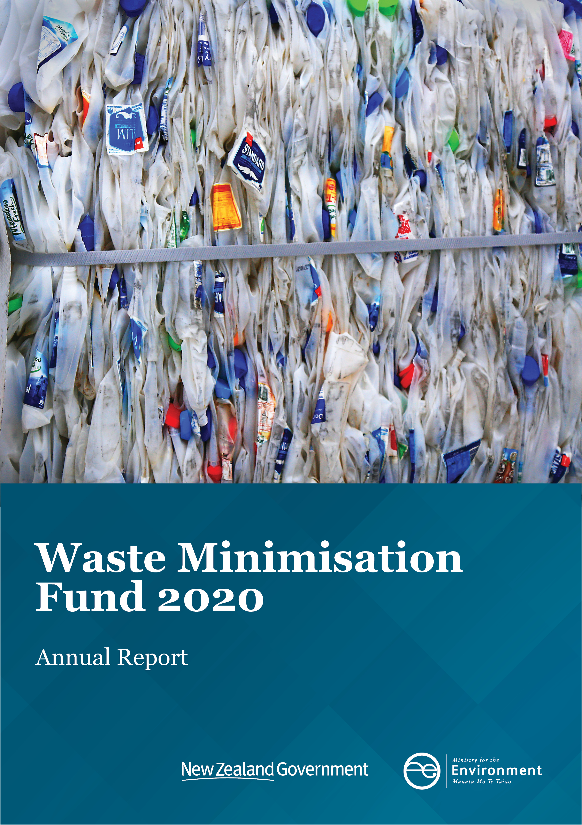

This document may be cited as: Ministry for the Environment. 2021. Waste Minimisation Fund 2020 Annual Report. Wellington: Ministry for the Environment.

Published in June 2021 by the
Ministry for the Environment
Manatū Mō Te Taiao
PO Box 10362, Wellington 6143, New Zealand
ISBN: 978-1-99-003356-8
Publication number: ME 1565
© Crown copyright New Zealand 2021
This document is available on the Ministry for the Environment website: environment.govt.nz.

Contents
WMF 2020 Annual Report 4
Te Pūrongo ā-Tau mō te Pūtea Whakamauru Para 2020 4
Waste Minimisation Fund’s purpose 4
Te pūtake o te Pūtea Whakamauru Para 4
Overview of 2020 5
Tirohanga whānui o te 2020 5
Key initiatives 5
Impact framework 6
A new funds management system (FMS) 6
Strategic engagement 6
Improved Māori participation 6
New funding and support for waste infrastructure investment 7
Strengthening audit and monitoring 7
2020 funding round – the numbers – Huringa pūtea 2020 – ngā rahinga 7
Investment profile by key waste stream – 2019 and 2020 8
Project highlights in 2020 9
Ngā miramira o te kaupapa 2020 9
Para Kore – “Mā Pango, Mā Whero” 9
Palletite: A reusable alternative to pallet wrap 10
Sustainable Business Network: Spreading the word about product stewardship 11
RefillNZ: Reducing Plastic single-use bottles 12
Goodwood 13
A decade of minimising waste He tekau tau o te whakaiti para 14

WMF 2020 Annual Report
This is the Ministry for Environment’s first report for the Waste Minimisation Fund (WMF) – Te Putea Whakamauru Para. It looks back on the fund’s progress during 2020, and reflects on more than a decade of achievement since WMF funded its first project in 2010.

Te Pūrongo ā-Tau mō te Pūtea Whakamauru Para 2020
Koinei te pūrongo tuatahi a te Manatū mō te Taiao mō te Pūtea Whakamauru Para. Ko tāna he tiro whakamuri ki te whakahaerenga o te pūtea i te tau 2020, ka kōrero hoki mō ngā paetaenga i tutuki i te tekau tau mai i tōna kaupapa tuatahi i te 2010.

Waste Minimisation Fund’s purpose
The Waste Minimisation Act 2008 is a key driver of the WMF. Under the Act, the WMF receives a portion of the waste disposal levy.
The WMF provides funding for projects that increase reuse, recovery, recycling, or decrease waste to landfill, one-off use, or litter. The goal is to move away from the linear “take, make, dispose of” approach to a circular one focussing on “make, use, return” principles.

Te pūtake o te Pūtea Whakamauru Para
E urungi ana te Waste Minimisation Act 2008 i te waka o te Pūtea Whakamauru Para. I raro i taua Ture, ka whiwhi te Pūtea Whakamauru Para i tētahi wāhanga o te utu whakawātea para.
Ka tuku pūtea te Pūtea Whakamauru Para ki ngā kaupapa e whakanui ana i te whakamahinga anō, te whakaora, te hangarua, te whakaheke rānei i te para ki ngā ruapara, i ngā hua whakamahinga tōtahi, i te parahanga rānei. Ko te whāinga, kia wehe atu tātou i te ara hātepe ā-rārangi o te ‘kohikohi, hanga, me te porowhiu’ me te aro kē ki tērā e whakamahi ana i ngā mātāpono o te “hanga, whakamahi, me te whakahoki”.

Overview of 2020

Tirohanga whānui o te 2020
The 2020 funding round opened in May 2020 and was broadly influenced by the COVID-19 pandemic. The Strategic Outcomes and Investment Signals were revised to focus on economic recovery in the waste minimisation sector, supporting businesses and organisations with job creation, improved efficiency and/or expansion. Projects and entities that could deliver measurable impact in the short to medium term were also prioritised.
For the first time, an Expression of Interest (EOI) step was introduced to streamline processes and reduce the burden on applicants.
The funding round was heavily over-subscribed, attracting 219 eligible EOI’s requesting a total of $187.8m WMF funding.
After assessment by the independent external panel and the Minister for the Environment,
26 projects were approved for a total of $8.76m in WMF funding. See page 8 for breakdowns of this investment by key waste stream, project type and region. The individual projects will be announced once funding deeds are complete.
The introduction of the EOI step was one of many initiatives taken to improve the fund’s operation and lay the foundations for further evolution.
The scope and nature of the fund are likely to change in line with the increases in the waste levy (from which WMF funding is derived) and the development of a new national waste strategy.

Key initiatives
Independent external evaluation
An independent evaluation of the WMF was undertaken to assess the process, progress and outcomes of the fund. This evaluation was the first such exercise since the fund was established. The work was conducted by the Sapere Research Group, an experienced Government funding programmes evaluator.
Key findings and recommendations of Sapere’s evaluation report included:
- The strategic approach of the WMF should be strengthened by building a common and robust view of national strategic priorities and impact.
- Processes should be further reviewed to make the fund more accessible and better align with Te Ao Māori.
- Engagement with other funds across the Government and within the Ministry for the Environment should be lifted. This would better connect projects and create useful networks at inception.
Sapere’s report provided a useful stocktake of the WMF. It delivered valuable insight into how the WMF can support waste reduction projects and collaborate to achieve better environmental, social and economic outcomes. We agree with the recommendations, and many have already been implemented for the 2021 funding round.

Impact framework
In 2020, we commissioned Ākina Consulting to provide recommendations for structures and measures to maximise our funding programmes’ impact.
Based on that work, an “Impact Framework” is being developed for WMF, setting out the key types of projects that will drive systemic change, together with measurable outcomes for individual projects and the WMF as a whole.
This will help applicants describe their proposals with greater clarity and give WMF improved data on the investment portfolio. The framework will be introduced for the 2021 funding round.

A new funds management system (FMS)
A high priority for the WMF in the last two years has been developing an online funds management system.
The new FMS went live in late 2020 and data migration from legacy systems has begun
– a key milestone for the WMF.
The benefits will be significant, including easier access for applicants, centralised information and more efficient workflow. For the 2021 funding round, applicants will be able to lodge Expressions of Interest and applications through the new portal.

Strategic engagement
Development of an engagement strategy was initiated to enable the WMF to become more directed, accessible, connected, and proactive.
This work was supported by the external evaluation and the work by Ākina Consulting on maximising impact.
This work reached across most aspects of the WMF’s operation and has underpinned key initiatives begun during the year to evolve the fund, such as improved Māori engagement. In a significant step forward for WMF’s engagement strategy, we have also extended our team to include some members based in Auckland.

Improved Māori participation
Participation by Māori-led organisations in the WMF is low. To address this issue, two hui were conducted, one within the Ministry for the Environment, the other with funding programmes across the Government.
The hui considered barriers to Māori effective participation and identified strategies that WMF has taken into its planning. These include ensuring the fund is communicated in a way that aligns with a Te Ao Māori world-view, leveraging relationships with other funding programmes, providing greater support for applicants, simplifying forms, and simplifying co-funding expectations for hapū and other community groups.
The 2021 funding round will include communications targeted to the Māori community to improve awareness and understanding of the WMF and encourage expressions of interest. Assessment of EOI’s will consider the extent to which proposals are Māori-led or have considered opportunities to work with Māori.

New funding and support for waste infrastructure investment
In July 2020, the Government announced an investment of $124m in waste minimisation and resource recovery infrastructure, from the COVID-19 Response and Recovery Fund.
The funding complements the WMF’s waste infrastructure investments and will accelerate progress in filling the major gaps in our waste infrastructure, while phasing in the expanded and increased waste levy.
Initiatives supported by the new funding include plastic recycling and reprocessing plants, fibre optical sorting technology, support for weighbridges for improved waste data collection and improved material and community resource recovery facilities.
A specialist Waste Infrastructure and Investment Team was formed to help implement this initiative. With a dedicated focus on infrastructure and major services projects, the new team will manage the WMF’s infrastructure investments as well as the new initiatives funded by the COVID-19 Response and Recovery Fund.

Strengthening audit and monitoring
To enhance independence and transparency, a pilot programme was developed to separate the relationship management and deed compliance auditing functions of the WMF. This organisational change will be implemented as a pilot programme in 2021 and will be reviewed after 12 months.

2020 funding round – the numbers
Huringa pūtea 2020 – ngā rahinga
2020 Funding round | All active projects* | In contracting*
219 Eligible expressions of interest | 69 Projects | 39 Projects
26 Approved projects | $45.7m WMF funding | $14.9m WMF funding
$8.8m WMF funding | $46.2m Industry funding** | $21.9m Industry funding
*at 31 December 2020
** Industry funding means funding provided by applicants and/or third parties
The 2020 funding round saw a shift in the investment in key waste streams compared to the 2019 round. Construction and Demolition, Organic Waste and E-Waste received significantly greater shares of funding in the 2020 round.

Investment profile by key waste stream – 2019 and 2020
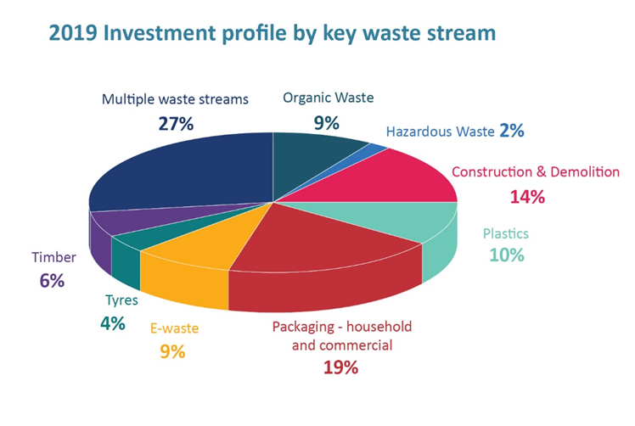
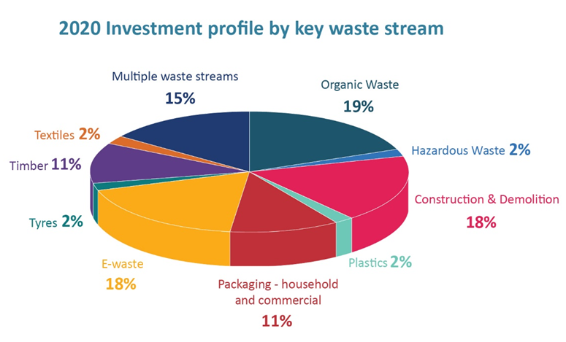
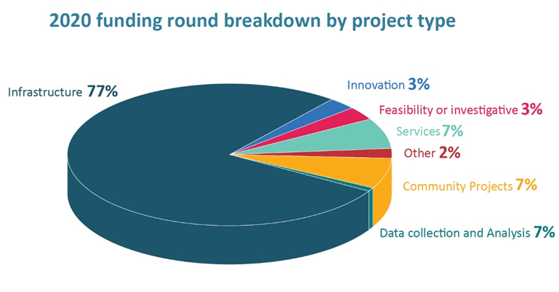

Project highlights in 2020

Ngā miramira o te kaupapa 2020

Para Kore – “Mā Pango, Mā Whero”
2020 saw the completion of another project with Para Kore Marae Ltd’s project to revolutionise how Māori communities manage waste.
Established in 2009, Para Kore educates and advocates from a Māori worldview perspective for a world without waste. Their kaupapa is expressed through an experienced and skilled team who work regionally delivering the Para Kore waste education programme, supporting marae, iwi, kōhanga reo, kura and community organisations to eliminate waste.
The three-year “Mā Pango, Mā Whero” project spanned four regions, which collectively have 136 marae, and was split into four sub-projects named after each region:
- Para Kore ki Te Upoko o te Ika (Wellington)
- Para Kore ki Rotorua
- Para Kore Kahungunu (Hawke’s Bay)
- Para Kore ki Te Tai Rāwhiti (East Coast/Gisborne).
Highlights were:
- Exceeding the total number of marae and community groups signed up to Memorandums of Understanding to further promote and achieve waste minimisation.
- Delivering the Para Kore programme at a total of 20 key Māori kaupapa events over the project’s duration. This included the Waitangi Day event in Porirua, which had over 31,000 attendees.
- Achieving 60.2% (by weight) waste diversion from landfill from signed up marae and community groups in the regions involved - significantly exceeding the original target of 50%.
- Diverting 56.3 tonnes of waste from landfill.
A decade of supporting marae, iwi, kōhanga reo, kura and community organisations to eliminate waste:
Para Kore had humble beginnings with volunteer pilot programmes running in three rural Waikato marae. For more than a decade, the WMF has supported the Para Kore flax-roots kaupapa. Over that time they have chalked up some significant achievements:
- Operates in 541 marae, kohanga reo, kura or other Māori community organisations throughout much of the North Island.
- Has provided education, wānanga and training in waste management to more than 410,000 participants.
- Has been responsible for more than over 535,000kg of waste being diverted from landfill.
- Employs 25, including 17 kaiārahi/regional waste advisors.

Palletite: A reusable alternative to pallet wrap
Since its inception, a key role of the WMF has been to support feasibility studies to investigate new products, services or technologies that can reduce waste. The “PalletiteTM” project is a good example.
A small $20k feasibility grant has resulted in innovatively changing how commercial pallets are wrapped – both in New Zealand and globally.
The new system would do away with single-use plastic wrap, replacing it with reusable, flexible coverings.
Palmerston North Company PalletiteTM successfully got this funding to create a reusable pallet load containment system for logistics, warehouse and supply chain industries.
In addition to this significant environmental benefit, PalletiteTM offers cost and time savings to distributors. Each cover weighs only 2kgs, stores flat and is very simple to apply and remove – trials show operational efficiencies three times greater than standard pallet wrapping.
This could potentially stop 750 tonnes of plastic from going to landfill. |  | 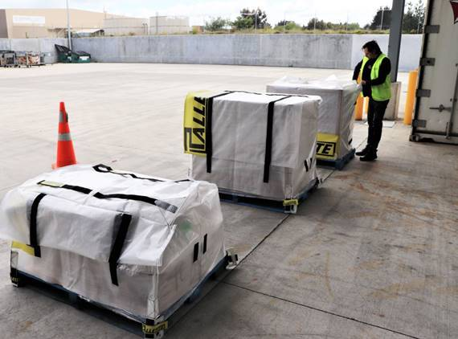

Sustainable Business Network: Spreading the word about product stewardship
The Sustainable Business Network (SBN) reached a major milestone in 2020 with the launch of its communications campaign to promote product stewardship schemes (PSS). With WMF funding of $160,000, the project promotes and facilitates the PSS uptake.
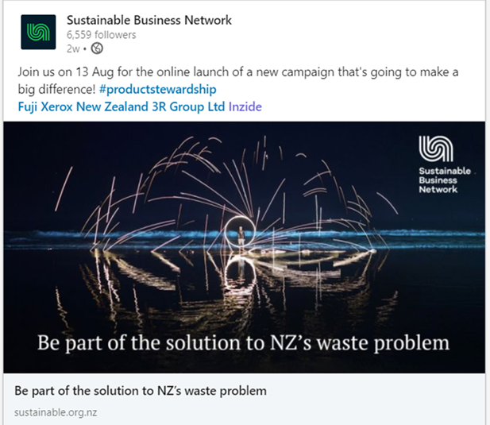
In August 2020, the communications campaign was launched via an online webinar. It consists of a website with resources and a directory of product stewardship schemes (including those accredited by the Ministry for the Environment), video case studies, and
product stewardship resources.
To date, the campaign website has had over 9,000 visitors and profiled 65 product stewardship initiatives.
The network ran 6 workshops across the country (in Auckland, Tauranga, Wellington, Nelson Christchurch and Dunedin) in the first year of their project, 2019. The 135 participants learned about product stewardship schemes, shared tools for creating schemes and workshopped ideas for their own scheme. The project continued to provide support for businesses and launched their media campaign in 2020.
Through the project, SBN has engaged with over 150 businesses. Discussions are active with 20 organisations to support the establishment or augmentation of individual product stewardship initiatives, and a similar number about establishing or joining an existing collective/sector-wide scheme.
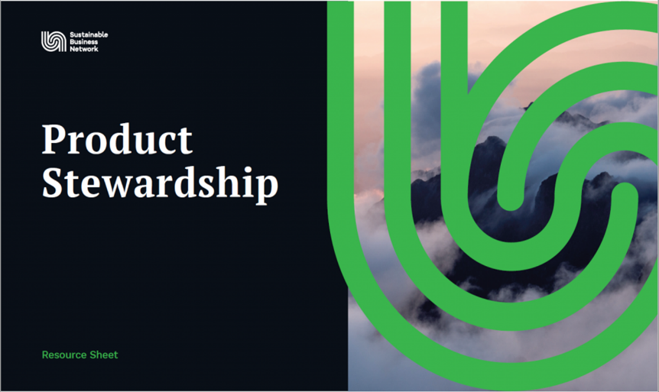
SBN is also connecting with nearly 50 organisations to determine the potential for establishing, augmenting, or joining an existing product stewardship scheme.
All this great mahi puts them well on track to meet targets by the end of the project: 25 businesses actively pursuing joining a new or existing PSS, and increasing awareness of PSS by 25%.

RefillNZ: Reducing Plastic single-use bottles
Wellington-based Fordward Marketing’s project was the first to launch from the 2020 funding round.
WMF’s funding of $150,000 supports the expansion of “RefillNZ”, an award-winning, grass-roots campaign to reduce plastic single-use bottles. The campaign aims to prevent plastic pollution at the source by making it easier to refill reusable water bottles on the go instead of buying water in a single-use plastic bottle.
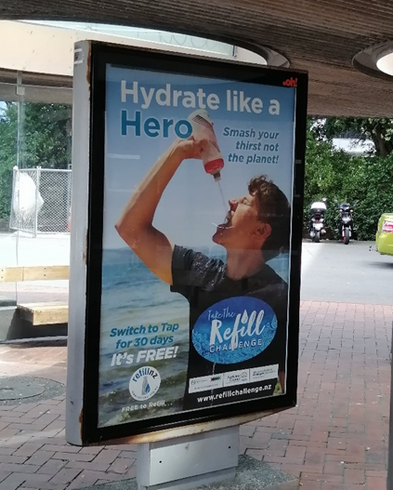
To promote easy and free access to wai for everyone, RefillNZ engages with a wide range of local authorities, tourism businesses, the hospitality sector, central government and community groups such as Para Kore and Wai Auckland.
Through a downloadable iOS app or Refillnz.org.nz website, people can easily find the nearest RefillNZ site and over 1,500 public water fountains in New Zealand.
The project also included a nationwide summer promotional campaign and used bus shelters and billboard advertising to promote positioned wai as the drink of choice.
This one-year project campaign aims to stop almost one tonne of single-use plastic bottles from going to the landfill by encouraging the use of refillable bottles and increasing the number of RefillNZ sites. The project also aims to engage more local councils in this initiative and increase the number of businesses signed up with RefillNZ. The project focusses on using digital platforms to achieve its main goals, so its objective is to see a significant increase in visits to their website and RefillNZ App downloads.
Already, RefillNZ has over 640 hospitality and tourism businesses that have signed up to be RefillNZ sites. They all display the RefillNZ sticker or poster, meaning the public can refill their water bottle for free.

Goodwood
Goodwood is an established recycler of untreated timber collected from businesses (mostly sawmills) in the Bay of Plenty and Waikato regions. They process the untreated timber and wood waste into value-added wood products such as coloured and natural garden mulch, playground surfacing mulch, commercial motorway mulch, and animal bedding for industries such as the Dairy Cow and Goat sectors.
With the purchase of a wheeled loader and excavator, the expansion of Goodwood Ltd’s wood waste collection and manufacturing capacity took a major step forward in 2020.
The loader and excavator are parts of an infrastructure investment, which will also include a tipping truck and 10 containers. The value of that investment is nearly $800,000, of which WMF will contribute up to $660,000. Altogether, the increased capacity is expected to see an additional 4,000 tonnes of wood waste recycled each year. The WMF’s support accelerated the timeframe to achieve this target by 3-5 years.
This project builds on previous WMF funding of $79,035 from the 2016 funding round, for yard equipment (truck, grapple, and containers).
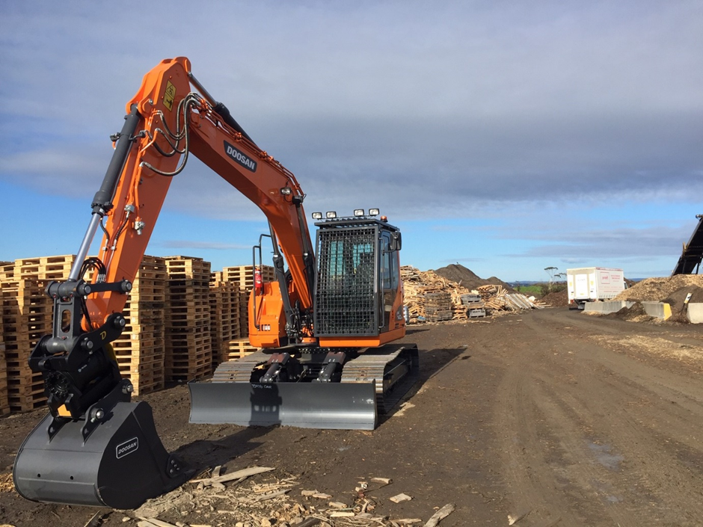 | 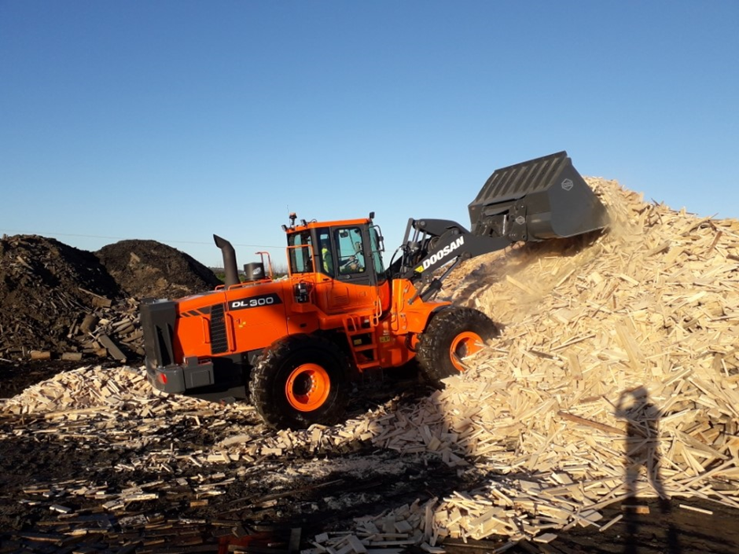

A decade of minimising waste
He tekau tau o te whakaiti para
The WMF has invested over $120m across more than 250 projects since 2010. This investment has helped unlock a similar level of industry co-funding, meaning that approximately $250 million has been invested into initiatives to minimise waste.
WMF’s investment per project ranges from less than $50,000 to over $4m.
