**Disclaimer**

The information in this publication is, according to the Ministry for the Environment’s best efforts, accurate at the time of publication. The Ministry will make every reasonable effort to keep it current and accurate. However, users of this publication are advised that:

* The information does not alter the laws of New Zealand, other official guidelines, or requirements.
* It does not constitute legal advice, and users should take specific advice from qualified professionals before taking any action based on information in this publication.
* The Ministry does not accept any responsibility or liability whatsoever whether in contract, tort, equity, or otherwise for any action taken as a result of reading, or reliance placed on this publication because of having read any part, or all, of the information in this publication or for any error, or inadequacy, deficiency, flaw in, or omission from the information in this publication.
* All references to websites, organisations or people not within the Ministry are for convenience only and should not be taken as endorsement of those websites or information contained in those websites nor of organisations or people referred to.

This document may be cited as: Ministry for the Environment. 2022*. Te pūrongo ā-pau mō te pūtea whakamauru para 2021 | Waste funds annual report 2021*. Wellington: Ministry for the Environment.

Published in August 2022 by the  
Ministry for the Environment   
Manatū Mō Te Taiao  
PO Box 10362, Wellington 6143, New Zealand

ISBN: 978-1-99-102535-7

Publication number: ME 1647

© Crown copyright New Zealand 2022

This document is available on the Ministry for the Environment website: [www.mfe.govt.nz](http://www.mfe.govt.nz).

# Contents

Waste funds family | Te whānau pūtea whakamauru para 7

What our funds do | Te whāinga o ā mātou pūtea 9

Highlights of 2021 | Ngā kōrero me miramira 11

Waste Minimisation Fund | Te Pūtea Whakamauru Para 11

COVID-19 Response and Recovery Fund for Waste and Resource Recovery Initiatives | Te Whakangao Hanganga Para 12

Plastics Innovation Fund, a new approach | Te Tahua Pūtea mō te Kirihou Auaha – he ahunga hou 12

Key initiatives | Ngā kaupapa matua 14

Alignment with other work at the Ministry | Te rere ngātahi me ērā atu mahi a te Manatū 14

Improving Māori participation | Kia kaha ake te whai wāhi mai a ngāi Māori 15

Processes | Ngā tukanga 17

Engagement | Te whiri taura tangata 17

The year in numbers | Ngā raraunga o te tau 18

A busy year in waste investments | He tau toritori mō ngā haumitanga whakahaere para 18

Focus on WMF| Te arotahi ki WMF 18

A healthy appetite | Te kaha hiahia ki te pūtea 19

New projects started | Kua tīmataria ētahi kaupapa hou 21

Over a decade of WMF investment | Ngā haumitanga WMF mō neke atu i te tekau tau 21

# Tables

Table 1: Purposes of waste funds 9

# Figures

Figure 1: Whakataukī 6

Figure 2: Linear and circular economy 10

Figure 3: Waste hierarchy 10

Figure 4: Waste funds 2021 key dates 15

Figure 5: Total number of projects managed during 2021 (WMF and CRRF) 18

Figure 6: Proportion of investments relative to project type 2021 (WMF) 19

Figure 7: Proportion of investments relative to waste stream 2021 (WMF) 19

Figure 8: Total amount of funding requested and approved per year (WMF) 20

Figure 9: New WMF projects started in 2021 21

Figure 10: Proportion of investments relative to project type 2010–21 (WMF) 22

Figure 11: Proportion of investments relative to waste stream 2010–21 (WMF) 22

# 

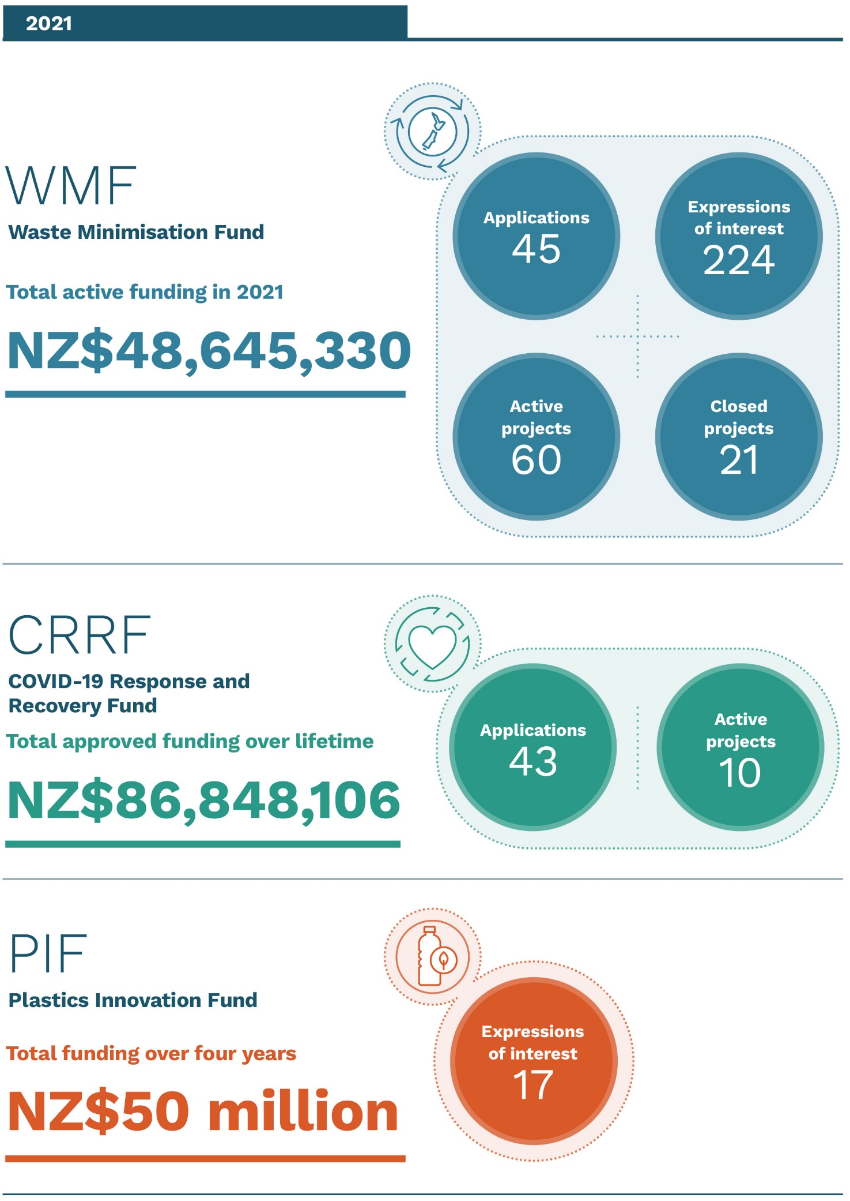

Figure : Whakataukī

|  |  |
| --- | --- |
|  | ⏩ He taura whiri kotahi mai i te kopounga tae noa ki te pūau. ⏪  ⏩ From the source to the mouth of the sea, all things are joined together as one ⏪ |

# 

# Waste funds family | Te whānau pūtea whakamauru para

This is the Ministry for Environment’s (MfE) second annual report for the Waste Minimisation Fund (WMF) – Te Pūtea Whakamauru Para. It looks back on the fund’s progress during 2021 and reflects on two connected MfE waste funds: the COVID-19 Response and Recovery Fund (CRRF) for Waste and Resource Recovery Initiatives, and the Plastics Innovation Fund (PIF). Combined, these three funds aim to accelerate Aotearoa New Zealand’s transition to a carbon‑neutral circular economy.

Koia tēnei ko te pūrongo ā-tau tuarua a Te Manatū mō te Taiao (MfE) mō Te Pūtea Whakamauru Para (WMF). He titiro kōmuri tāna ki ngā kokenga o te pūtea i te 2021, me te huritao ki ētahi atu pūtea whakaiti para e rua a MfE e kōpūtahi ana: te Whakangao Hanganga Para (CRRF) me te Tahua Pūtea mō te Kirihou Auaha (PIF). Ko te whāinga ia, mā te haere pātui o ēnei pūtea e toru ka tere ake te whakawhiti a Aotearoa ki te ōhanga āmiomio tukuwaro-kore.

|  |
| --- |
| CASE STUDY |
| Community Recycling Centre in Onehunga as part of Auckland’s regional Resource Recovery Network  **Auckland Council** was supported with WMF funding to fast-track the establishment of a Community Recycling Centre in Onehunga. This centre will provide waste-recovery services to 70,000 residents in the Maungakiekie-Tāmaki Local Board area, empowering the community to participate in the circular economy.  The centre is the first of a citywide network that will also provide processing capacity for another 300,000 residents through the future Western Springs Recycling Centre.  This project provides a way for businesses and the community to minimise waste by providing access to more resources, such as the upcycling, repair and resale of items that would otherwise go to landfill. The centre will help address Auckland’s growing waste stream resulting from increases in population and construction.  **Post-project outcomes and benefits**   * A full range of resource-recovery services will be provided to central Auckland residents by the end of 2022. * More than 3,000 tonnes of waste will be diverted from landfill annually by 2025. * At least 15 new jobs will be created by 2025.   **Project length:** Three years, completion expected in 2022  **Location:** Auckland – Tāmaki Makaurau  **WMF contribution:**NZ$2,240,000  A photographic of the Community Recycling Centre in Onehunga. |

|  |
| --- |
| **Moving towards a Circular Economy**  ⏩ Maungakiekie-Tāmaki Ward Councillor Josephine Bartley explains the value of the circular economy, saying, “When something breaks in our modern world it is often more expensive to repair than to buy a new one, so usually it goes to the landfill.  **“Community Recycling Centres** are providing a hub for reversing this trend and keeping materials in use for longer instead of landfilling them. The circular economy is a key part of Auckland’s goal of getting to zero waste by 2040. ⏪ |

# What our funds do | Te whāinga o ā mātou pūtea

1. Purposes of waste funds

| Fund | Purpose | Te Whāinga |
| --- | --- | --- |
| Waste Minimisation Fund (WMF)  **Te Pūtea Whakamauru Para** | The WMF receives a portion of the national waste disposal levy, which varies based on actual waste sent to landfill. The WMF supports projects that increase reuse, recovery, and recycling, or decrease waste to landfill, one-off use, or litter. The goal is to move away from the linear ‘take, make, dispose-of’ approach to a circular one focusing on ‘make, use, return’ principles (figure 2), with a preference to move up the waste hierarchy (figure 3). | Ka tukua ki te WMF tētahi wāhanga o te tāke tuku para ā-motu; he moni tēnei ka piki, ka heke i runga anō i te rahi o ngā para e tukuna ana ki ngā ruapara. He tautoko tā te WMF i ngā kaupapa whakapiki i te whakamahi anō, te whakaraara me te hangarua, me ngā kaupapa whakaiti i ngā para e rere ana ki te ruapara, te whakamahinga kotahi noa me te porowhiu rāpihi noa. Ko te whāinga, kia whakarērea atu te ara ahunga tahi o te ‘tango, waihanga, porowhiu’, ka huri ai ki te ara āmiomio me ōna anō mātāpono o te ‘waihanga, whakamahi, whakahoki’ (hoahoa 2), me te piki haere anō i te arawhata whakaiti para (hoahoa 3). |
| COVID-19 Response and Recovery Fund (CRRF) for Waste and Resource Recovery Initiatives  **Te Whakangao Hanganga Para** | The CRRF for Waste and Resource Recovery Initiatives is a one-off package of investments designed to fill major gaps in New Zealand’s recycling and resource recovery network. A total of NZ$86.8 million is being invested in a range of infrastructure projects throughout the country. | Ko te Whakangao Hanganga Para, he whakangaotanga tūtahi hei whakakīkī āputa nui i te whatunga hangarua, whakaaraara rawa. Hui katoa, e NZ$86.8 miriona e kuhuna ana ki ōna anō kaupapa tūāhanga huri noa i te motu. |
| Plastics Innovation Fund (PIF)  **Te Tahua Pūtea mō te Kirihou Auaha** | The PIF supports projects that will minimise plastic waste and its harm on the environment. It seeks to invest NZ$50 million over four years in innovative projects to find ways to use less plastic, introduce circular solutions, reduce imported virgin plastics, and/or improve end-user behaviour. | E tautoko ana te PIF i ngā kaupapa ka whakaiti i ngā para kirihou me ōna pānga kino ki te taiao. Ko te tikanga, i roto i te whā tau, ka kuhuna he NZ$50 miriona ki ngā kaupapa auaha e iti ake ai te whakamahia o te kirihou, e poua ai he rongoā āmiomio, e iti ake ai ngā kirihou urutapu ka tae mai i tāwāhi, e pai ake anō ai hoki ngā whanonga a te hunga ka tae atu he kirihou ki a rātou. |

|  |  |
| --- | --- |
| Figure : Linear and circular economy  An infographic explaining how linear economy works. | An infographic explaining how circular economy works. |
|  |  |

Figure : Waste hierarchy

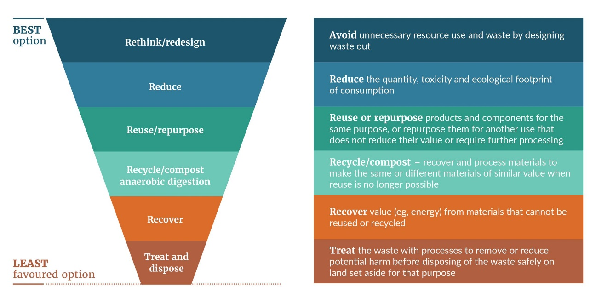

# Highlights of 2021 | Ngā kōrero me miramira

## Waste Minimisation Fund | Te Pūtea Whakamauru Para

The 2021 Waste Minimisation Fund (WMF) round opened in April 2021 with strategic outcomes focused on minimising construction and demolition, and organic waste. These waste streams make up a large proportion of waste sent to landfill in Aotearoa and contribute to greenhouse gas emissions.

There was a healthy appetite for funding with 224 eligible expressions of interest (EOIs) in 2021, requesting a total of NZ$146 million. After assessment by an independent panel, applicants for 45 projects (requesting a total of NZ$22 million) were invited to make a full application. By 31 December 2021, 34 approved projects were in due diligence and are expected to enter into funding agreements in 2022.

The 2021 WMF round had two stages. First, applicants submitted an EOI. Some were then invited to make a full application. Applicants were provided support through videos and one‑on-one meetings to gauge whether their project aligned with the fund’s goals.

|  |
| --- |
| Case study |
| Commercial composting in Kaipara  Seeing a lack of commercial composting facilities in the region, and no provision for the separation of green waste at council landfill sites, Sustainable Kaipara recognised that most commercial green waste from Kaipara’s many hospitality, landscaping, gardening and lawn-mowing businesses was going to landfill.  In response, a hot-compost facility was successfully piloted in the Mangawhai Community Garden. With enthusiastic uptake from the community, the project diverted six tonnes of organic waste from landfill and embedded a reliable system in the region to maintain the operation.  **Sustainable Kaipara** has continued the project by engaging with local council and businesses to carry out a community compost collection service.  **Post-project outcomes and benefits**   * Feasibility study providing recommendations and options for composting in Kaipara * Reducing the amount of green waste, food waste and compostable materials going to landfill * Continuing development of a hot-compost facility * Establishing small-scale composting units around the region, embedding composting as the norm in the community * Starting a community compost collection service in the Kaipara Region   **Project length:**One year, completed in 2021  **Location:** Mangawhai, Northland – Te Tai Tokerau  **WMF contribution:** NZ$46,300 |

## COVID-19 Response and Recovery Fund for Waste and Resource Recovery Initiatives | Te Whakangao Hanganga Para

Initiatives supported by the COVID-19 Response and Recovery Fund (CRRF) include plastics recycling and reprocessing equipment, fibre optical sorting technology, support for weighbridges for improved waste data collection, and improved material and resource recovery facilities.

A specialist Waste Infrastructure and Investment team was formed in 2021 to deliver this package of investments. With a dedicated focus on infrastructure and major services projects, the new team now manages the WMF’s infrastructure investments, along with the CRRF initiatives.

|  |
| --- |
| COVID-19 Response and Recovery Fund Initiatives  Projects being delivered:   * recycling and reprocessing plants for plastics * plastic and fibre optical sorting systems * sorting and baling equipment for agricultural plastics * materials resource recovery facilities for construction and demolition waste * organics collection and processing infrastructure and assets * weighbridges for waste and resource recovery facilities.   Individual projects are in varying stages of design, construction and commissioning. The package of initiatives is expected to be fully delivered by the end of 2024. |

## Plastics Innovation Fund, a new approach | Te Tahua Pūtea mō te Kirihou Auaha – he ahunga hou

The Plastics Innovation Fund (PIF) builds on the lessons learnt in more than 10 years of administering the WMF, with the goal to produce an innovative approach to remove bottlenecks and achieve a more customer-focused programme.

Unlike the WMF, which has historically held a single annual funding round, the PIF applies an ‘open-round’ model. The 2021 open-round model allowed applicants to submit expressions of interest over an eight-month timeframe. Applicants are not rushed when applying, and they work with investment managers to ensure a high-quality submission. Those with good alignment are invited to submit a full application every four to six weeks, ensuring a timely feedback loop for all applicants. The PIF uses an internal review process with input from internal and external subject-matter experts. This reduces risk and increases the likelihood of positive outcomes.

The PIF opened for expressions of interest in November 2021 and on 31 December 2021 had received 17 expressions of interest, requesting more than NZ$56 million in funding. The first PIF funding agreements are expected to be finalised in mid-2022.

|  |
| --- |
| Applicant centric  The 2021 Plastics Innovation Fund model:   * provides applicants with interactive pre-application support, including webinars, videos and one-on-one meetings to discuss potential projects and their alignment to fund criteria * allows applicants to respond to feedback in their final submissions * offers agile decision-making, aligned to clear objectives * provides review, assessment and moderation combined with access to a pool of internal and external subject-matter experts * is an open round * is a contestable and competitive process.   Successful components of this engagement strategy are being considered for other waste funds. |

# Key initiatives | Ngā kaupapa matua

## Alignment with other work at the Ministry | Te rere ngātahi me ērā atu mahi a te Manatū

In addition to establishing and growing the three waste funds during 2021, the Ministry had a busy year progressing policy and regulations regarding waste and emissions. The results of public consultations on the [Waste Strategy, the Waste Minimisation and the Litter Acts](https://environment.govt.nz/publications/taking-responsibility-for-our-waste-consultation-document/) and the [emissions reduction plan](https://environment.govt.nz/publications/aotearoa-new-zealands-first-national-adaptation-plan/) are guiding the future direction of waste funding. A full overview of the Ministry’s related work can be found in the [waste reduction work programme](https://environment.govt.nz/publications/waste-reduction-work-programme/).

Hei āpiti atu ki te whakatū me te whakatupu i ngā pūtea whakaiti para e toru i te 2021, i toritori anō te Manatū ki te kōkiri i ngā kaupapahere me ngā waeture e pā ana ki te para me ngā tukunga kino. Ko ngā kōrero i hua ake i ngā hui tūmatanui ki te whiriwhiri i te [Rautaki Para, te Ture Whakamauru Para, te Ture Porowhiu Rāpihi](https://environment.govt.nz/publications/taking-responsibility-for-our-waste-consultation-document/) me te [Mahere Whakaiti Tukunga Kino](https://environment.govt.nz/publications/aotearoa-new-zealands-first-national-adaptation-plan/) kei te arataki i te ahunga o ngā pūtea whakaiti para ki tua. Arā te roanga atu o ngā kōrero mō ngā mahi katoa a te Manatū e hāngai mai ana, kei te [Hōtaka Kawenga Whakaiti Para](https://environment.govt.nz/publications/waste-reduction-work-programme/).

Figure 4: Waste funds 2021 key dates

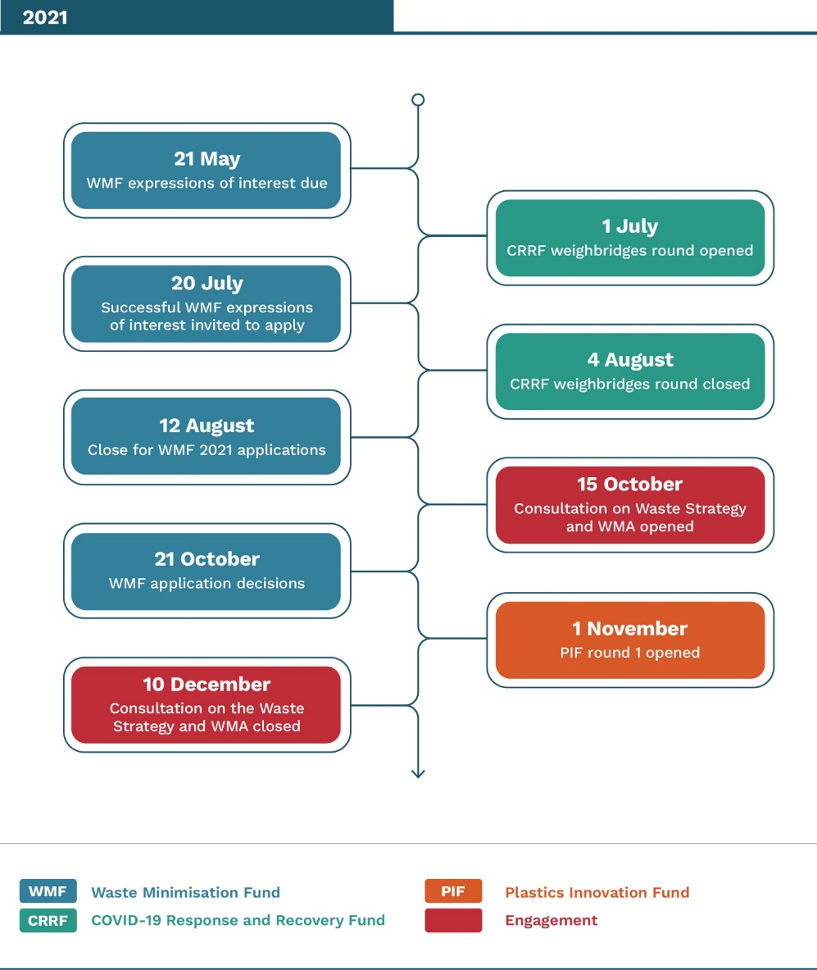

## Improving Māori participation | Kia kaha ake te whai wāhi mai a ngāi Māori

Overall participation of Māori groups and entities across the waste funds remains low, although 2021 saw a slight increase in Māori applicants to the WMF. Work is under way to develop a plan to increase Māori participation and reach across all waste funds (see Engagement | Te whiri taura tangata). In 2021, all WMF applicants were asked to specify benefits for Māori in their projects and about half of the applicants included at least one aspect.

Kei te āhua iti te whai wāhi mai a ngā rōpū me ngā hinonga Māori ki ngā pūtea whakaiti para, engari i te 2021 i paku piki ake te tokomaha o ngā kaitono Māori i te WMF. Taihoa ka whakatakotoria he mahere hei kukume mai i a ngāi Māori ki ngā pūtea whakaiti para katoa (tirohia Te Whiri i te Muka Tangata i raro nei). I te 2021, i tonoa ngā kaitono WMF katoa kia tautuhi i ngā painga ki a ngāi Māori o ā rātou kaupapa. Ko tōna haurua pea i tautuhi mai i tētahi painga, neke atu rānei.

|  |
| --- |
| Case study |
| Para Kore – Te Pae Tata  **Para Kore** began its revolution 14 years ago towards zero-waste marae by 2020. Para Kore launched its first pilot programme in 2009 in three Waikato marae. Through Mātauranga Māori and tikanga Māori, Para Kore educates and advocates for building Māori power through strengthening whakapapa connection to Ranginui (Sky Father) and Papatūānuku (Earth Mother). In practical terms, this is the re-normalisation of zero-waste and closed-loop living practices and philosophies. Today, the kaupapa of Para Kore is active on more than 580 marae, kōhanga reo, kura, wānanga, and community organisations across Aotearoa. It employs 25 people and has diverted more than 500,000 kilograms of waste from landfill.  One of the latest WMF-funded Para Kore projects, Te Pae Tata, worked with marae during 2021 in the Tūwharetoa and Manawatū/Whanganui regions. This project’s outcomes included running Facebook live sessions during lockdown to educate whānau. The project also piloted ikura wānanga (period workshops), which has now been incorporated into the national model and rolled out to the Para Kore community across the motu. Para Kore had tautoko (support) from the tamariki (children) and whānau of Te Kura Kaupapa Māori o Whakarewa to implement waste minimisation systems at events and hui in these regions.  **Post-project outcomes and benefits**   * Overall, 48 marae and organisations established waste minimisation systems and provided education. * A total of 54 wānanga (workshops) were delivered. * Pare Kore systems were implemented at 33 kaupapa Māori events. * Marae in the participating regions are diverting at least 65 per cent of their waste.   **Project length:** Three years, completed in 2021  **Location:** Tūwharetoa, Manawatū/Whanganui  **WMF contribution:**NZ$264,000 |

## Processes | Ngā tukanga

Internal fund structures, processes and operations continued to evolve to become more integrated and customer friendly. An important development was the introduction of an online funds management system across all waste funds. This software is designed to streamline data collection and reporting. It allows applicants to apply through an online portal, and report directly on active projects.

I te whanake tonu ngā anga pūtea, ngā tukanga me ngā whakahaere whakaroto, mei kore e kaha ake te kōtuitui me te arotau ki te kiritaki. Ko tētahi mea nui, ko te pounga o tētahi pūnaha tuihono hei whakataki i ngā tohanga pūtea mō ngā pūtea whakaiti para katoa. Mā tēnei pūmanawa rorohiko ka koutata ake te kohinga raraunga me te taha pūrongo, ā, ka āhei ngā kaitono te tono mā te tāwaha tuihono, me te pūrongo horipū mō ngā kaupapa e kawea ake nei e rātou.

## Engagement | Te whiri taura tangata

The Waste Funds team has been engaging with many stakeholders, including government agencies, to better align with the various policy and waste initiatives. Client-friendly systems and processes are being implemented as the funds restructure to meet the expected growth and strategic alignment with the New Zealand Waste Strategy (expected in the second half of 2022).

Continuous feedback loops with past, current and future applicants contribute to moving to a more applicant-centric and transparent organisation. An Engagement Lead has joined the Waste Funds team to coordinate relevant and consistent engagement and relationship-building.

Kua whiri taura te kāhui Pūtea Whakamauru Para ki ngā tini rōpū whai pānga mai, tae atu ki ngā pūtahi kāwanatanga, kia pai ake ai te rere ngātahi o ngā kaupapahere me ngā kaupapa para. Kei te whakatinanatia ētahi pūnaha, ētahi tukanga e arotau ana ki te kiritaki, hei wāhanga o te whakahounga i te anga pūtea. E pēnei ana kia pai ai te manaaki i te tupu haere o te kaupapa nei, kia rere ngātahi ai hoki ki te Rautaki Para o Aotearoa (ko te tikanga ka puta ā te hauwhā tuatoru o te 2022).

Kua whakaritea he amiotanga e whakahoki kōrero mai ai ngā kaitono o mua, o nāianei, o taihoa ake. Mā konei ka kaha ake te aronui ki ngā kaitono, ka tahi, ka pūataata ake te whakahaere, ka rua. Kua tūhono mai he Kaiārahi Whiri Taura Tangata ki te kāhui pūtea whakaiti para, hei whakahaere, hei whakapūmau i ngā mahi whiri taura.

# The year in numbers | Ngā raraunga o te tau

## A busy year in waste investments | He tau toritori mō ngā haumitanga whakahaere para

The waste funds’ portfolio consisted of 93 projects at the start of 2021. During the year, 62 projects were added through the WMF and CRRF and 29 projects were completed, some of which are featured as case studies in this report. At the end of 2021, the collective waste funds actively managed 126 projects.

Figure 5: Total number of projects managed during 2021 (WMF and CRRF)

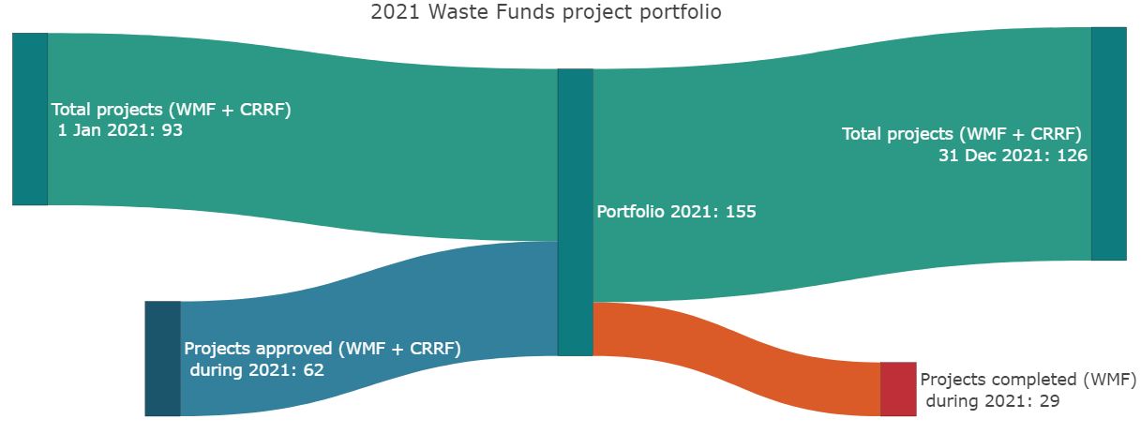

## Focus on WMF| Te arotahi ki WMF

The WMF had approximately NZ$12.5 million to invest in 2021. The WMF invests in a wide variety of projects, from large infrastructure to smaller community projects (figure 6). This suite of investments aims to minimise waste and reduce environmental impacts. Additional benefits include employment and social and cultural impacts. Due to the scale typical of infrastructure projects, these received most of the waste funding during 2021.

The investment priorities for the 2021 round included construction and demolition, and organic waste. This is reflected in the proportion of projects addressing these waste streams funded in 2021 (figure 7).

Figure 6: Proportion of investments relative to project type 2021 (WMF)

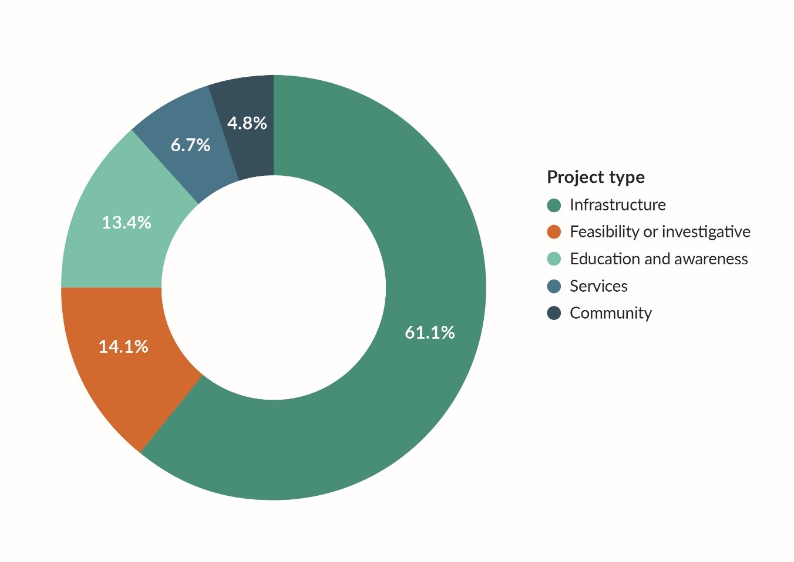

Figure 7: Proportion of investments relative to waste stream 2021 (WMF)

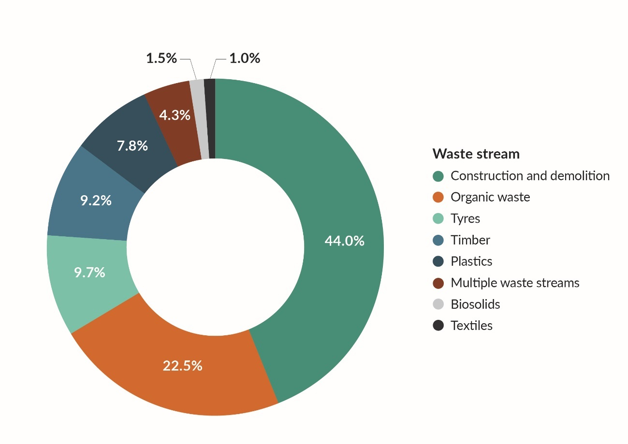

## A healthy appetite | Te kaha hiahia ki te pūtea

As in previous years, the interest from applicants in the 2021 WMF round exceeded available funding. Total funding requests far outnumbered funded projects (figure 8). In addition, the average funding amount requested has steadily grown over the past years. Average funding awarded, however, has remained constant.

Going forward, we are expecting an increase in the amount available for investment, due to the implementation of levy increases for the disposal of waste to landfill.

Figure 8: Total amount of funding requested and approved per year (WMF)

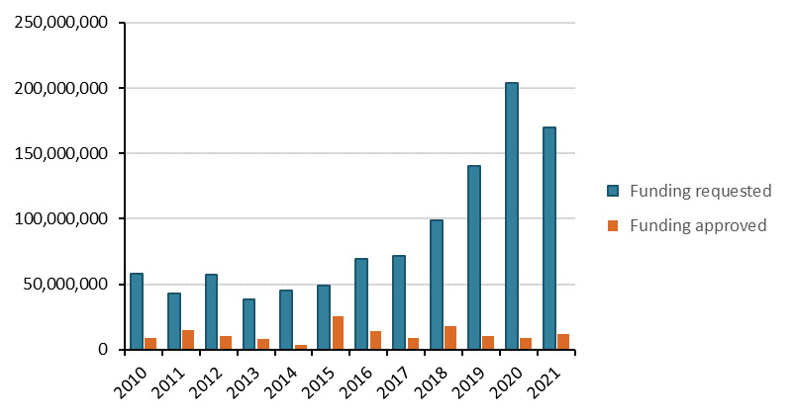

|  |
| --- |
| Case study |
| Composting Hamilton’s food waste  After launching a composting facility at Hampton Downs that receives waste from three councils – Waikato, Bay of Plenty and Auckland – **EnviroWaste** was awarded the Hamilton City contract for kerbside collection.  This service will direct around 5,000 tonnes of food waste a year to the Hampton Downs Organic Compost Facility, along with around 5,000 tonnes of green waste being directed from the Hamilton Organic Recycling Centre.  EnviroWaste used WMF funding to expand its processing capacity to meet increasing demand. It constructed six new composting aeration bunkers, installed one new Gore bunker, purchased a shredder and established a new negatively pressurised compost processing building to increase the facility’s capacity to process organic waste from 4,000 tonnes to 12,000 tonnes a year. This investment produced more than 2,000 tonnes of high-quality compost in 2020 alone.  **Post-project outcomes and benefits**   * Composted 12,000 tonnes of organics a year within 18 months of completing the project * Offset the use of diesel by using renewable energy to operate shredding and screening plants, reducing EnviroWaste’s carbon footprint * Produced the equivalent of at least 1,000 tonnes a year of quality-screened horticultural compost from the six new bays   **Project length:** Three years, completed in 2021  **Location:** Waikato  **WMF contribution:**NZ$1,100,000  A picture containing text, sky, way, road  Description automatically generated |

## New projects started | Kua tīmataria ētahi kaupapa hou

During 2021, 15 funded projects started for a total value of NZ$4,898,548. Figure 9 shows where they are located.

Figure 9: New WMF projects started in 2021

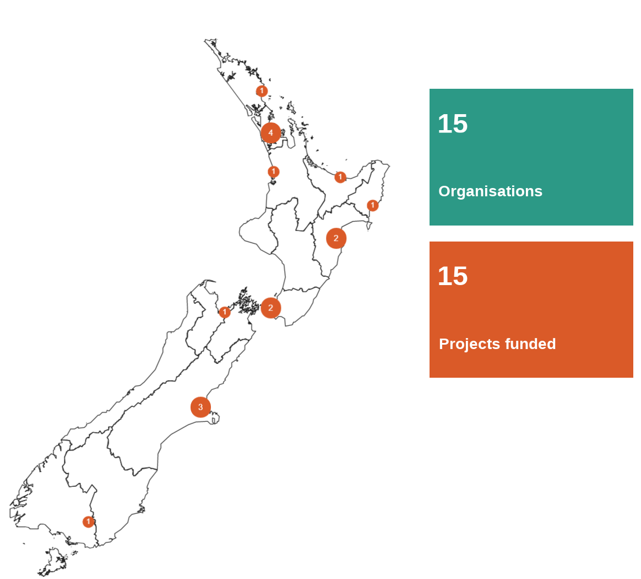

## Over a decade of WMF investment | Ngā haumitanga WMF mō neke atu i te tekau tau

The WMF has invested over NZ$132 million across more than 280 projects since 2010. This investment has helped unlock a similar level of industry co-funding, meaning that approximately NZ$260 million has been invested into initiatives to minimise waste. Investment per project ranged from less than NZ$50,000 to over NZ$4 million.

Over the life of the fund, the distribution per type of project and by waste stream can be found in figures 10 and 11, respectively.

Figure 10: Proportion of investments relative to project type 2010–21 (WMF)

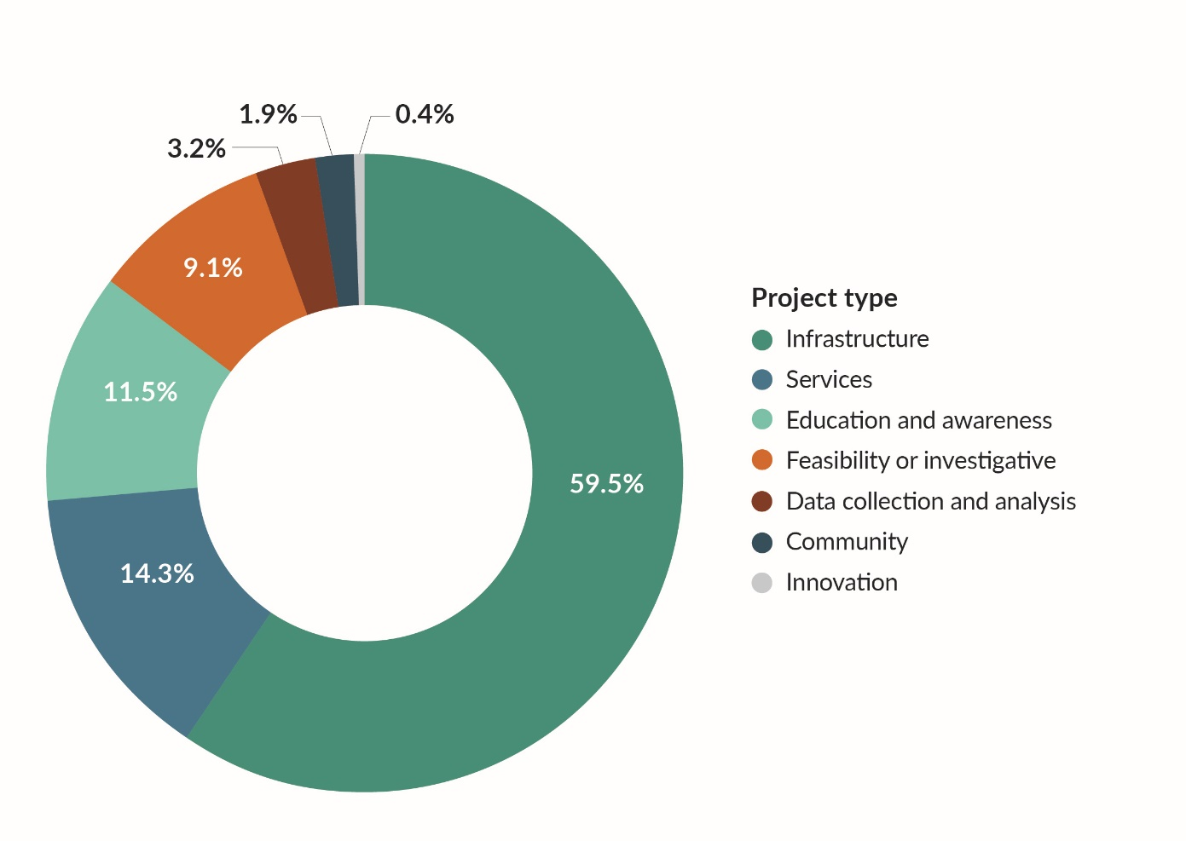

Figure 11: Proportion of investments relative to waste stream 2010–21 (WMF)

