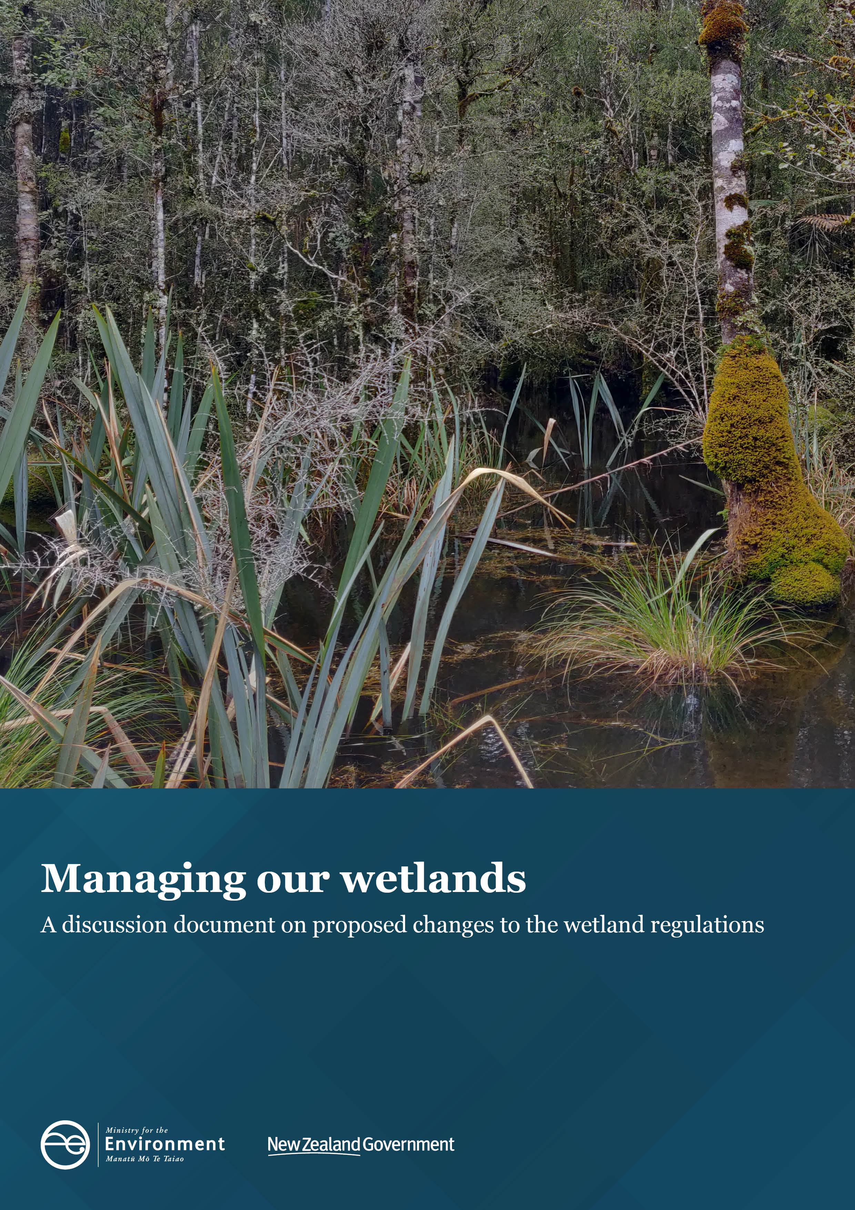

Disclaimer
The information in this publication is, according to the Ministry for the Environment’s best efforts, accurate at the time of publication. The Ministry will make every reasonable effort to keep it current and accurate. However, users of this publication are advised that:
- The information does not alter the laws of New Zealand, other official guidelines, or requirements.
- It does not constitute legal advice, and users should take specific advice from qualified professionals before taking any action based on information in this publication.
- The Ministry does not accept any responsibility or liability whatsoever whether in contract, tort, equity, or otherwise for any action taken as a result of reading, or reliance placed on this publication because of having read any part, or all, of the information in this publication or for any error, or inadequacy, deficiency, flaw in, or omission from the information in this publication.
- All references to websites, organisations or people not within the Ministry are for convenience only and should not be taken as endorsement of those websites or information contained in those websites nor of organisations or people referred to.

This document may be cited as: Ministry for the Environment. 2021. Managing our wetlands: A discussion document on proposed changes to the wetland regulations. Wellington: Ministry for the Environment.

Published in September 2021 by the
Ministry for the Environment
Manatū Mō Te Taiao
PO Box 10362, Wellington 6143, New Zealand
ISBN: 978-1-99-003374-2
Publication number: ME 1588
© Crown copyright New Zealand 2021
This document is available on the Ministry for the Environment website: environment.govt.nz.

Contents
Section 1: Overview of wetland management 4
Purpose of the review 4
Summary of proposals 5
Section 2: Change to the definition of a ‘natural wetland’ 6
Section 3: Better provision for restoration, maintenance and biosecurity activities in ‘natural wetlands’ 8
Section 4: Additional consenting pathways 10
Consenting pathway for quarrying 11
Consenting pathway for landfills, cleanfills and managed fills 12
Consenting pathway for mining (minerals) 13
Consenting pathway for urban development 13
Section 5: Consultation questions 15
Section 6: How to have your say 17
Timeframes 17
How to provide feedback 17
More information 17
Publishing and releasing submissions 18

Section 1: Overview of wetland management
Wetlands are an important part of our landscape. These ecosystems, characterised by permanent or intermittent shallow waters, play a crucial role in maintaining the health of New Zealand’s freshwater. As water moves into a wetland its flow slows, enabling plant surfaces to act as a natural filter. This leads to improved water quality downstream. Wetlands also reduce the impacts of flooding and stabilise shorelines and riverbanks.
Wetlands support a raft of animal and plant life, much of which is native to New Zealand. They have cultural and spiritual significance for tangata whenua as a source of mahinga kai, resources such as raupo, as the home of taniwha, and as part of New Zealand’s network of waterways over which kaitiakitanga is exercised.
New Zealand’s wetlands are at risk. Some 90 per cent of ‘natural wetlands’ have been lost since human settlement began and their degradation and loss is ongoing. There is broad support for the protection of wetlands, both as to their extent and ecological values. The Government is committed to preserving wetlands, and to recognising and actively protecting these culturally significant ecosystems.
Last year, the Government introduced the Essential Freshwater regulatory package. The National Policy Statement for Freshwater Management 2020 (NPS-FM), aims to embed long-term change through regional plans, including policies to restore wetlands. The Resource Management (National Environmental Standards for Freshwater) Regulations 2020 (NES-F), set out the consenting pathways for certain activities in and around wetlands.
The NPS-FM and NES-F are the main sources of national direction and rules about how wetland ecosystems should be managed, and are together referred to as the ‘wetland regulations’ or ‘the regulations’.
A focus of the Essential Freshwater package is the regulatory framework for ‘natural wetlands’, which are those wetlands (excluding constructed wetlands, geothermal wetlands and areas of wetted pasture) that are naturally occurring or have been specially constructed as part of offsetting or to restore a naturally occurring wetland.

Purpose of the review
This discussion document responds to feedback received from various stakeholders and partners on the implementation of the wetland regulations across the country. It sets out proposals for how the definition could be amended to ensure only those areas intended are captured by the regulations and to better provide for restoration, biosecurity and maintenance.
It also proposes that the regulatory framework for ‘natural wetlands’ should be amended to provide a consent pathway for certain activities so that development can occur where necessary, while ensuring no net loss of natural wetland extent or values occurs.
The proposed changes to the NPS-FM and NES-F are consistent with the purpose of the Resource Management Act 1991 (RMA). The proposed changes continue to emphasise the preservation of the character of ‘natural wetlands’ and regulate against inappropriate subdivision, use and development, while providing a consent pathway for appropriate use and development. The obligation to offset any more than minor negative effects is consistent with the RMA’s direction to avoid, remedy or mitigate any adverse effects of activities on the environment.
If amendments are not made, current guidance on implementing the NES-F will remain as the status quo.

Summary of proposals
We are seeking your views on the proposals summarised below.
Change to the definition of a ‘natural wetland’
We propose changing the definition of a ‘natural wetland’ to make it clearer. The Government has received feedback that section (c) of the current definition is being applied inconsistently and is capturing areas that were not intended to be captured.
We are seeking feedback on:
- a proposed revised definition
- whether the change strikes the appropriate balance between wetland protection and land use and development.
Change to better enable ‘natural wetland’ restoration, maintenance and biosecurity work
The Government has received feedback that current regulations are restricting the ability of groups to restore and maintain ‘natural wetlands’ and undertake biosecurity activities. This was not the intention of the regulations.
We are seeking feedback on:
- proposed changes to the regulations that will let groups continue to undertake ‘natural wetland’ restoration and maintenance activities without needing a resource consent
- proposed changes to the regulations that will let biosecurity officers undertake biosecurity activities consistent with a regional or pest management plan.
Proposals for additional consent pathways
The Government has received feedback that there are additional activities that require consenting pathways in the regulations.
We are seeking feedback on proposals to provide discretionary consenting pathways for the following operations:
- quarrying
- landfill, cleanfill and managed fill
- mining (minerals)
- urban development.

Section 2: Change to the definition of a ‘natural wetland’
 The Government has received feedback that the current definition of ‘natural wetland’ in the NPS-FM is problematic to apply and captures some heavily modified, exotic pasture-dominated wet areas.  |  | 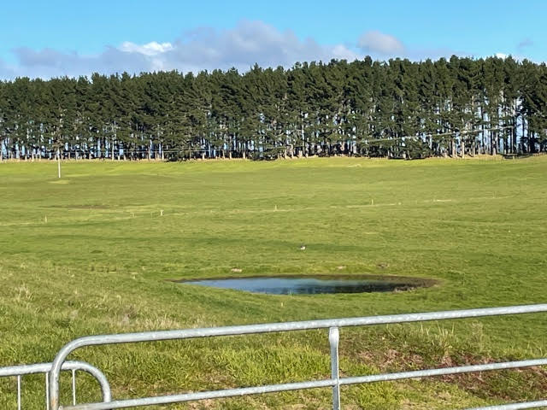
The NPS-FM and NES-F contain regulations that use a definition of a wetland that is a subset of the RMA definition. The wetland regulations are concerned with the protection of ‘natural wetlands’ (defined below).
Some wetlands (eg, ponds and stormwater treatment wetlands) have been constructed for purposes other than conservation. It is unreasonable to make it more difficult for them to be used for their intended purpose, so they are excluded under part (a) of the definition. Areas also exist that may once have been wetlands or streams but are now heavily modified land (eg, pasture that is grazed that gets wet after heavy rainfall). These wetlands are excluded by part (c) of the definition.
The Government has received feedback that the current definition of ‘natural wetland’ in the NPS-FM is problematic to apply and captures some heavily modified, exotic pasture-dominated wetlands even though part (c) of the definition seeks to exclude these areas. This is having unintended consequences, such as restricting changes in land use and development in these areas.
To better achieve the original intent of the regulations the Government is proposing to amend the definition of ‘natural wetland’.
The Nps-fm Currently defines a ‘natural wetland’ as:
... a wetland (as defined in the Act [RMA]) that is not:
- a wetland constructed by artificial means (unless it was constructed to offset impacts on, or restore, an existing or former ‘natural wetland’); or
- a geothermal wetland; or
- any area of improved pasture that, at the commencement date, is dominated by (that is more than 50% of) exotic pasture species and is subject to temporary rain-derived water pooling.
The Government is proposing the following changes to part (c) of this definition:
(c) any area of improved pasture that, at the commencement date, is dominated by (that is more than 50% of) has more than 50 percent ground cover comprising exotic pasture species or exotic species associated with pasture and is subject to temporary rain-derived water pooling.
These changes are proposed because:
- The term ‘improved pasture’ has raised questions from councils around what ‘improved’ is intended to mean. A certain level of intensive farming has been suggested (eg, a nitrogen application rate or certain density of livestock). The intent, however, is just to capture pasture as such.
- Deleting ‘at the commencement date’, removes the need for back-casting by councils in the future (ie, to the status quo as at 3 September 2020, the original NES-F commencement date). Back-casting by an increasing number of years could be contentious, as accurate aerial photos or other data to determine land cover at the required scale may not be available. This would make reliable assessments problematic.
- Removing the word ‘dominated’ recognises that the term is subsequently defined by the ‘50% of’ qualifier and is therefore redundant. Adding the words ‘ground cover’ clarifies and directs how the assessment of species is to be made – as reflected in current Ministry for the Environment (MfE) guidance on this point.
- Including the additional words ‘exotic species associated with pasture’ acknowledges that some exotic species (such as buttercup), while not considered pasture species commonly grow in damp grazed areas. These species need to be factored in so that part (c) fully captures the intended areas.
- The phrase ‘temporary rain derived water pooling’ was included as a placeholder while the hydrology tool for the Wetland delineation protocols was developed (the other tools are soils and vegetation). The protocols set out a methodology to identify wetland extent by examining soil, vegetation and hydrology type. The protocols are incorporated by reference in the NPS-FM. Now that the hydrology tool is in place (from July 2021), the rain derived pooling qualifier is unnecessary.
The revised definition reads:
(c) any area of pasture that has more than 50 percent ground cover comprising exotic pasture species or exotic species associated with pasture.
The revised definition will better acknowledge the original intent that wet pasture areas, even if they were once ‘natural wetlands’, are now highly modified environments and should be able to continue their current use or be able to shift in land use. Under these proposed changes, all other natural wetlands will remain subject to strong regulatory protection.
Definition of ‘natural wetland’
1. Do you agree with the proposed changes to the definition of ‘natural wetland’? Why/why not?
2. Should anything else be included or excluded from the definition of ‘natural wetland’?

Section 3: Better provision for restoration, maintenance and biosecurity activities in ‘natural wetlands’
 the NPS-FM does not currently cover biosecurity work to prevent new pest problems (eg, the eradication of a weed that is not yet widespread) or maintenance of current state.  |  | 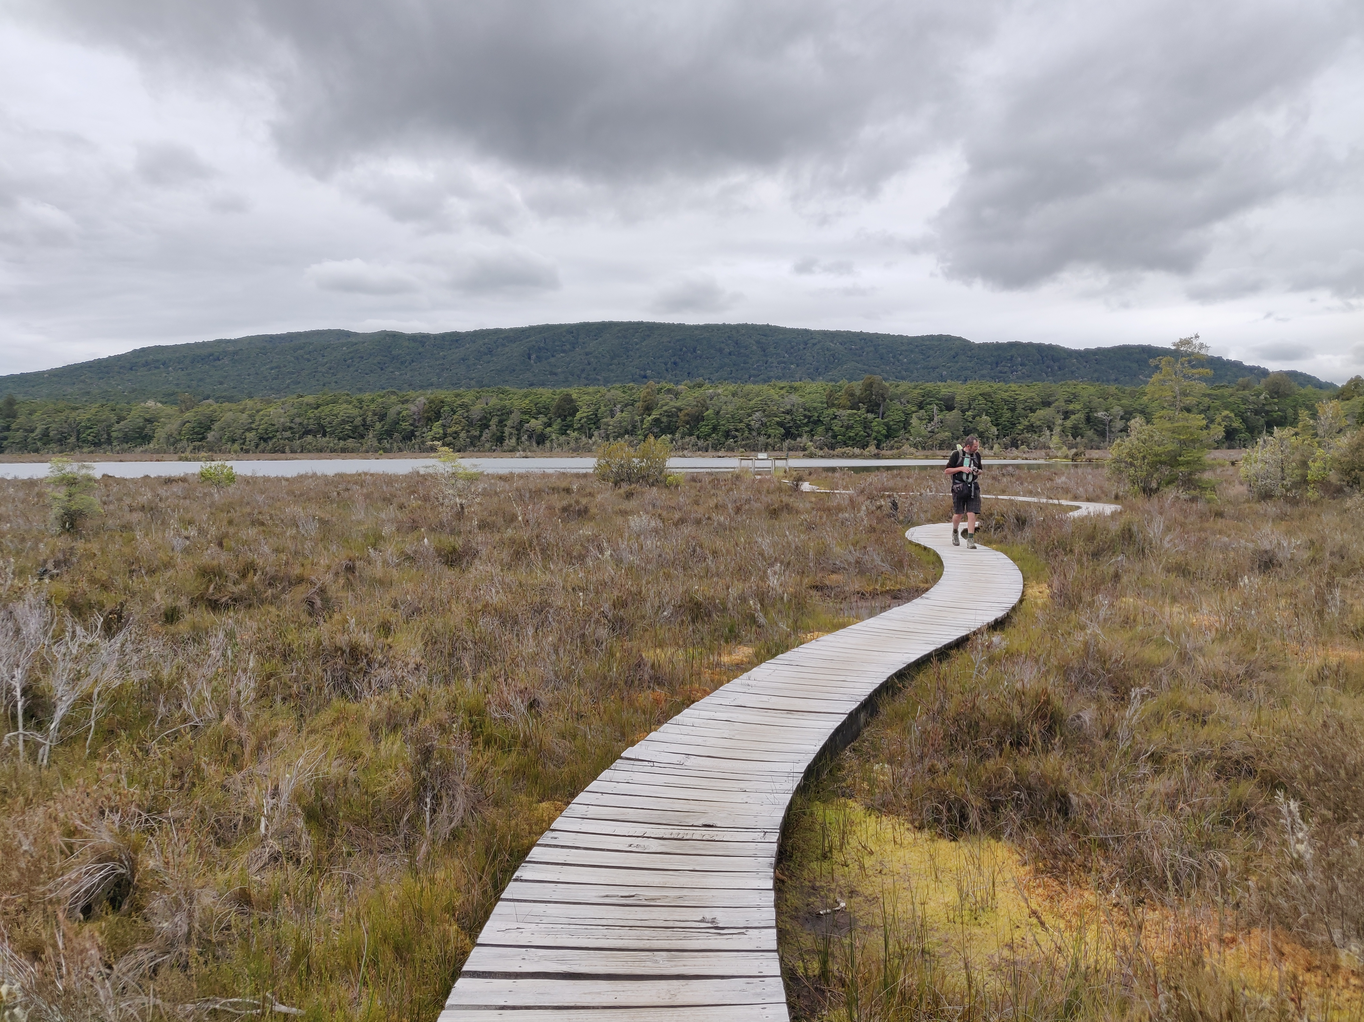
The Government intends to provide for the best possible protection of ‘natural wetlands’ while ensuring that restoration activities and activities that help people understand and enjoy natural wetlands can continue.
The parts of the NES-F that regulate the restoration of natural wetlands recognise that some restoration activities can have short-term negative effects on natural wetlands. For example, weed clearance may result in bare land that then erodes, sending sediment into the water. The NES-F regulates what effects are permissible and which restoration activities require a resource consent. The aim is that any undesired effects are temporary, but the net result of the activities is positive in the longer term.
Restoration work is undertaken by many parties, including landowners or managers, Māori organisations, the Department of Conservation (DOC) and environmental non-governmental organisations. The NES-F provides comprehensive standards for vegetation clearance, earthworks and the taking, use, damming, diversion and discharge of water within and within 10 metres of, a natural wetland for the purposes of restoration.
These standards were put in place to ensure that councils had an overall picture of restoration activities in and around ‘natural wetlands’. They also give councils the ability to restrict or disallow activities that may result in negative overall net effects on ‘natural wetlands’, while allowing compliant activities to continue.
However, the Government has received feedback from councils, DOC and restoration groups that the requirement to notify and/or gain consent from the council to undertake restoration activities is often unduly onerous and has resulted in restoration work not being carried out.
The Government is also aware that the NPS-FM does not currently include maintenance and biosecurity with the definition of restoration, and as such there are no regulatory provisions for maintenance and biosecurity activities in and around ‘natural wetlands’. The NPS-FM says:
restoration, in relation to a natural inland wetland, means active intervention and management, appropriate to the type and location of the wetland, aimed at restoring its ecosystem health, indigenous biodiversity, or hydrological functioning.
As such, the NPS-FM does not currently cover biosecurity work to prevent new pest problems (eg, the eradication of a weed that is not yet widespread) or maintenance of current state.
Further refinements to the provisions are needed so that they achieve the original intent and address biosecurity and maintenance activities. We are therefore seeking feedback on the following proposed changes to the NPS-FM and NES-F to:
- include ‘maintenance’ within the regulations relating to ‘restoration’
- amend the regulations relating to restoration and maintenance activities, so removal of exotic species is permitted, regardless of the size of the area treated, provided the general conditions listed in regulation 55 of the NES-F are met. The intent is to ensure that weed control does not result in effects such as discharge of sediment from extensive newly bare ground, rather than to restrict the size of a weed control programme
- allow activities that are necessary to implement a regional or national pest management plan or are undertaken by a biosecurity agency (which includes DOC, the Ministry for Primary Industries and regional councils) for biosecurity purposes, but with similar restrictions as those that apply to restoration activities, for example regulation 55
- make the restoration and maintenance of a ‘natural wetland’ a permitted activity if it is undertaken in accordance with a council-approved wetland management strategy
- make the use of weed clearance using hand-held tools a permitted activity.
Better provision for restoration, maintenance and biosecurity activities
3. Should maintenance be included in the regulations alongside restoration? Why/why not?
4. Should the regulations relating to restoration and maintenance activities be refined, so any removal of exotic species is permitted, regardless of the size of the area treated, provided the conditions in regulation 55 of the NES-F are met? Why/why not?
5. Should activities be allowed that are necessary to implement regional or pest management plans and those carried out by a biosecurity agency for biosecurity purposes? Why/why not?
6. Should restoration and maintenance of a ‘natural wetland’ be made a permitted activity, if it is undertaken in accordance with a council-approved wetland management strategy? Why/why not?
7. Should weed clearance using hand-held tools be a permitted activity? Why/why not?

Section 4: Additional consenting pathways
 Without a consenting pathway set out in the regulations, activities such as earthworks are unable to be carried out within or near a ‘natural wetland’. |  | 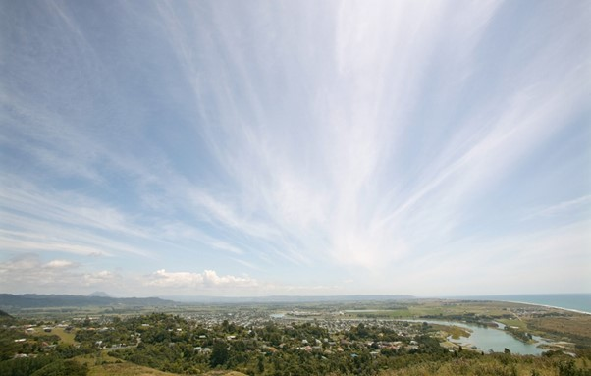
Clause 3.22 of the NPS-FM lists certain activities/groups that are able to seek a consent to carry out things like earthworks within or near a ‘natural wetland’. Without a consenting pathway set out in the regulations, activities such as earthworks are unable to be carried out within or near a natural wetland. An application to carry out earthworks (or water takes or discharges) in a natural wetland cannot be consented because the prohibited activity regulation 53 in the NES-F prevents it.

Five levels of permission are available under the RMA and NES-F:
Permitted activities: resource consents are not required if the activity complies with the conditions set out in the NES-F.
Restricted discretionary activities: resource consents are required and local and/or regional councils may decline or grant the consent depending on their assessment of effects of the proposal on the environment but can only consider the specific matters prescribed in regulations when doing so. If granted, the activity must comply with the conditions set out in the NES-F and any additional conditions imposed by the council relating to the prescribed matters.
Discretionary activities: resource consents are required and local and/or regional councils may decline or grant the consent depending on their assessment of effects of the proposal on the environment. If granted, the activity must comply with the conditions set out in the NES-F and any additional conditions imposed by the council.
Non-complying activities: resource consents are required and local and/or regional councils may decline or grant the consent, with or without conditions, but only if they are satisfied that the effects of the activity on the environment will be minor or that the application is for an activity that will not be contrary to the objectives and policies of the relevant plan or proposed plan.
Prohibited activities: are not eligible for resource consents and local and/or regional councils must not grant a consent.
The NES-F provides a consent application pathway for several activities. These activities are subject to different regulations and conditions, depending on the effects and operational nature of the activity.
The regulations include a ‘gateway test’ for specified infrastructure that councils must use when assessing any consent application. It includes the following requirements:
(a) the activity must be of significant national or regional benefit
(b) there must be a ‘functional need’ for that activity in that location
(c) adverse effects must be managed through the ‘effects management hierarchy’, which requires initial consideration of how to avoid adverse effects where practicable, then how to minimise, remedy, offset, and compensate, in that order.
The Government has recognised that additional activities require consenting pathways due to their national and/or regional significance and/or their occurrence only in particular geographical locations.
We propose that these activities be subject to the same ‘gateway test’ as is already provided for ‘specified infrastructure’ in the NES-F (as set out above). In practice this means that applications for a resource consent must demonstrate to the council how each step of the ‘effects management hierarchy’ (set out in the NPS-FM) will be applied before the consent can be granted.
The effects management Hierarchy requires that:
- Adverse effects are avoided where practicable
- Where adverse effects cannot be avoided, they are minimised where practicable
- Where adverse effects cannot be minimised they are remedied where practicable
- Where more than minor residual adverse effects cannot be avoided, minimised, or remedied, aquatic offsetting is provided where possible
- If aquatic offsetting of more than minor effects is not possible, aquatic compensation is provided
- If aquatic compensation is not appropriate, the activity itself is avoided.

It is the Government’s intention that no net loss of natural wetland extent or values will occur as a result of providing additional consenting pathways.

Consenting pathway for quarrying
The regulations do not provide a consenting pathway for quarrying. Resources from quarries, such as aggregates and gravel, are used in the construction and maintenance of housing, roading and other infrastructure. Due to the nature of the industry, quarries can only occur in areas where the quarried resource is naturally found. From time to time, this may be within, or within 100 metres of, a ‘natural wetland’.
The Government has received feedback that the wetlands regulations are preventing access to resources for the construction of ‘specified infrastructure’ (as defined in the NPS-FM). Because the regulations already provide a consenting pathway for the construction of ‘specified infrastructure’, it makes sense that a consenting pathway also be provided for the resources necessary for the construction and maintenance of that infrastructure.
The Government is therefore proposing that a consenting pathway be provided for the expansion of current quarrying activities, and the development of new quarries. Quarrying would be a discretionary activity within, or within 100 metres of, a ‘natural wetland’. Consents for this type of activity would be determined by the council on a case-by-case basis.
Consenting pathway for quarrying
8. Should a consenting pathway be provided for quarries? Is discretionary the right activity status? Why/why not? (See page 10 for a definition of discretionary activity.)
9. Should resource consents for quarrying be subject to any conditions beyond those set out in the ‘gateway test’? Why/why not?

Consenting pathway for landfills, cleanfills and managed fills
The regulations do not provide a consenting pathway for landfills, cleanfills or managed fills. Feedback from the waste management operators has been that most fill sites in New Zealand are situated within valleys or gullies and are often damp areas of pasture or gully heads. While these operations do not have to be situated where a natural resource occurs, fills are necessary for construction and maintenance of infrastructure and there are substantial cost implications if they are not situated close to development sites. The Government is proposing a consenting pathway for several types of fills.
Types of fill:
Landfills: receive contaminated material and are a necessary part of expanding urban areas.
Cleanfills: receive natural materials, such as clay, gravel, rock and soil, from areas that are not contaminated with chemicals.
Managed fills: are designed for material with low-grade contamination, such as demolition material, received from existing infrastructure.
The proposed consenting pathway would create a new discretionary activity status for the activities and operation of fills within, or within 100 metres of, a ‘natural wetland’. Consents for this type of activity would be determined by councils on a case-by-case basis.
Consenting pathway for landfills, cleanfills and managed fills
10. Should a consenting pathway be created for landfills, cleanfills and managed fills? Is discretionary the right activity status? Why/why not? (See page 10 for a definition of discretionary activity.)
11. Should resource consents for landfills, cleanfills and managed fills be subject to any conditions beyond those set out in the ‘gateway test’? Why/why not?

Consenting pathway for mining (minerals)
The regulations do not provide a consenting pathway for mineral mining activities. In New Zealand such minerals include gold, platinum group metals, nickel, copper and tungsten. Some mined minerals may contribute to clean technologies as part of the transition to a low emissions economy.
Like quarries, mines can only be situated where the resource is located and, on occasion, this may be within, or within 100 metres, of a ‘natural wetland’. The Government is therefore considering whether there should be a consenting pathway for mining to be undertaken as a discretionary activity in such areas.
The Government is also seeking feedback on whether any additional conditions should be placed on resource consent applications for mining, above and beyond those set out in the gateway test (eg, providing a consent pathway only for the mining of minerals that are required for projects of national significance, and are not fossil fuels, or requiring additional conditions around offsetting).
Consenting pathway for mining (minerals)
12. Should a consenting pathway be provided for mineral mining? Is discretionary the right activity status? Why/why not? (See page 10 for a definition of discretionary activity.)
13. Should the regulations specify which minerals are able to be mined subject to a resource consent? Why/why not?
14. Should resource consents for mining be subject to any conditions beyond those set out in the ‘gateway test’? Why/why not?

Consenting pathway for urban development
The regulations provide a consenting pathway for urban development where it is listed in a regional plan under the definition of ‘specified infrastructure’ (see footnote on the previous page for definition). This means urban developers can apply for a consent for activities, such as earthworks and vegetation clearance, in or around a ‘natural wetland’, subject to the offsetting requirements.
There is no consenting pathway for urban development where it is listed in a district plan. As important developments are not always included in a regional plan, it is desirable that the regulations provide a consenting pathway for urban development listed in a district plan.
We propose to use a term from the National Policy Statement for Urban Development 2020 (NPS-UD) to provide a consent pathway in the NES-F for urban development that is ‘plan-enabled’ for housing or for business use. This will ensure there are no delays created by needing a plan change before consent can be sought.
The NPs-ud defines DEVELOPMENT AS ‘plan-enabled’ IF:
- in relation to the short term, it is on land that is zoned for housing or for business use (as applicable) in an operative district plan
- in relation to the medium term, either paragraph (a) applies, or it is on land that is zoned for housing or business use (as applicable) in a proposed district plan
- in relation to the long term, either paragraph (b) applies, or it is on land intensified by the local authority for future urban use or urban intensification in a Future Development Strategy (FDS) or, if the local authority is not required to have an FDS, any other relevant plan or strategy.

By explicitly providing for urban development in the regulations in the NES-F, the Government expects more urban development to be enabled than is currently provided for under the NES-F regulations, while still providing protection to ‘natural wetlands’.
Under the proposed consenting pathway, plan-enabled development within, or within 100 metres of, a ‘natural wetland’ would be a discretionary activity with consent to be determined by councils on a case-by-case basis. The requirement to offset any wetland loss will still apply. However, the Government is aware that this may not always be feasible and/or appropriate for some types of public amenity associated with urban areas (eg, schools and medical centres).
The changes need to strike a balance between the necessity to protect ‘natural wetlands’ but also to provide for housing and urban development where appropriate.
Consenting pathway for plan-enabled development
15. Should a consenting pathway be provided for plan-enabled urban development? Is discretionary the right activity status? Why/why not? (See page 10 for a definition of discretionary activity.)
16. Should resource consents for urban development listed in a district plan be subject to any conditions beyond those set out in the ‘gateway test’? Why/why not?
17. Is the current offsetting requirement appropriate for all types of urban infrastructure, for example, public amenities such as schools and medical centres? Why/why not?

Section 5: Consultation questions
The Government welcomes your feedback. The questions below are a guide only. You do not have to answer all the questions, and all comments are welcome. See section 6 for details of how and when to make a submission.
Definition of ‘natural wetland’
1. Do you agree with the proposed changes to the definition of ‘natural wetland’? Why/why not?
2. Should anything else be included or excluded from the definition of ‘natural wetland’?
Better provision for restoration, maintenance and biosecurity activities
3. Should maintenance be included in the regulations alongside restoration? Why/why not?
4. Should the regulations relating to restoration and maintenance activities be refined, so any removal of exotic species is permitted, regardless of the size of the area treated, provided the conditions in regulation 55 of the NES-F are met? Why/why not?
5. Should activities be allowed that are necessary to implement regional or pest management plans and those carried out by a biosecurity agency for biosecurity purposes? Why/why not?
6. Should restoration and maintenance of a ‘natural wetland’ be made a permitted activity, if it is undertaken in accordance with a council-approved wetland management strategy? Why/why not?
7. Should weed clearance using hand-held tools be a permitted activity? Why/why not?
Consenting pathway for quarrying
8. Should a consenting pathway be provided for quarries? Is discretionary the right activity status? Why/why not? (See page 10 for a definition of discretionary activity.)
9. Should resource consents for quarrying be subject to any conditions beyond those set out in the ‘gateway test’? Why/why not?
Consenting pathway for landfills, cleanfills and managed fills
10. Should a consenting pathway be created for landfills, cleanfills and managed fills? Is discretionary the right activity status? Why/why not? (See page 10 for a definition of discretionary activity.)
11. Should resource consents for landfills, cleanfills and managed fills be subject to any conditions beyond those set out in the ‘gateway test’? Why/why not?
Consenting pathway for mining (minerals)
12. Should a consenting pathway be provided for mineral mining? Is discretionary the right activity status? Why/why not? (See page 10 for a definition of discretionary activity.)
13. Should the regulations specify which minerals are able to be mined subject to a resource consent? Why/why not?
14. Should resource consents for mining be subject to any conditions beyond those set out in the ‘gateway test’? Why/why not?
Consenting pathway for plan-enabled development
15. Should a consenting pathway be provided for plan-enabled urban development? Is discretionary the right activity status? Why/why not? (See page 10 for a definition of discretionary activity.)
16. Should resource consents for urban development listed in a district plan be subject to any conditions beyond those set out in the ‘gateway test’? Why/why not?
17. Is the current offsetting requirement appropriate for all types of urban infrastructure, for example, public amenities such as schools and medical centres? Why/why not?

Section 6: How to have your say
The Government welcomes your feedback on this consultation document. The questions posed throughout this document are summarised in section 5. They are a guide only and all comments are welcome. You do not have to answer all the questions.
To ensure your point of view is clearly understood, you should explain your rationale and provide supporting evidence where appropriate.

Timeframes
This consultation starts on 1 September 2021 and ends on 27 October 2021.
When the consultation period has ended, we will report back to the Minister on submissions received and develop final policy advice that considers these submissions.

How to provide feedback
There are two ways you can make a submission:
- via Citizen Space, our consultation hub, available at https://consult.environment.govt.nz/
- write your own submission.
If you want to provide your own written submission you can provide this as an uploaded file in Citizen Space.
We request that you don’t email or post submissions as this makes analysis more difficult. However, if you need to please send written submissions to: Managing our wetlands, Ministry for the Environment, PO Box 10362, Wellington 6143 and include:
- your name or organisation
- your postal address
- your telephone number
- your email address.
If you are emailing your feedback, send it to WetlandsTeam@mfe.govt.nz as a:
- PDF, or
- Microsoft Word document (2003 or later version).
Submissions close at midnight on 27 October 2021.

More information
Please direct any queries to:
Email: WetlandsTeam@mfe.govt.nz
Postal: Managing our wetlands, Ministry for the Environment, PO Box 10362, Wellington 6143

Publishing and releasing submissions
All or part of any written comments (including names of submitters), may be published on the Ministry for the Environment’s website, environment.govt.nz. Unless you clearly specify otherwise in your submission, the Ministry will consider that you have consented to website posting of both your submission and your name.
Contents of submissions may be released to the public under the Official Information Act 1982 following requests to the Ministry for the Environment (including via email). Please advise if you have any objection to the release of any information contained in a submission and, in particular, which part(s) you consider should be withheld, together with the reason(s) for withholding the information. We will take into account all such objections when responding to requests for copies of, and information on, submissions to this document under the Official Information Act.
The Privacy Act 2020 applies certain principles about the collection, use and disclosure of information about individuals by various agencies, including the Ministry for the Environment. It governs access by individuals to information about themselves held by agencies. Any personal information you supply to the Ministry in the course of making a submission will be used by the Ministry only in relation to the matters covered by this document. Please clearly indicate in your submission if you do not wish your name to be included in any summary of submissions that the Ministry may publish.

See Karen Denyer and Monica Peters, The Root Causes of Wetland Loss in New Zealand: An Analysis of Public Policies and Processes, Wetland Trust, October 2020.
The Wetland delineation protocols, published by MfE in August 2020, are referred to in clauses 3.23 and 1.8 of the NPS-FM. The hydrology tool referred to in the protocols was published by MfE in July 2021, as the Wetland delineation hydrology tool for Aotearoa New Zealand.
Regulation 55 sets out the general conditions that all permitted activities must meet to comply with the regulations, including conditions for prior notice of activity, water quality and movement, earth stability and drainage, vegetation and bird and fish habitats, historic heritage, machinery, vehicles equipment and construction materials.
Under the NPS-FM councils must make, or change, their regional plan(s) to include objectives, policies and methods that promote the restoration of natural inland wetlands within their region.
These activities are wetland restoration, construction of wetland utility structures, maintenance of wetland utility structures, construction of specified infrastructure, maintenance and operation of specified infrastructure, sphagnum moss harvesting, arable and horticultural land use and natural hazard works.
Aquatic offset means a positive and measurable conservation outcome that results from actions intended to compensate for any more than minor negative effects and achieve no net loss of wetland area or ecological value.
Aquatic compensation means a positive conservation outcome intended to compensate for any more than minor negative effects on a wetland, after all other appropriate steps in the ‘effects management hierarchy’ have been applied.
Specified infrastructure refers to infrastructure that delivers a service operated by a lifeline utility (as defined in the Civil Defence Emergency Management Act 2002), regionally significant infrastructure identified as such in a regional policy status or regional plan and any public flood control, flood protection, or drainage works carried out by or on behalf of a local authority, or for the purpose of drainage, by drainage districts under the Land Drainage Act 1908.

