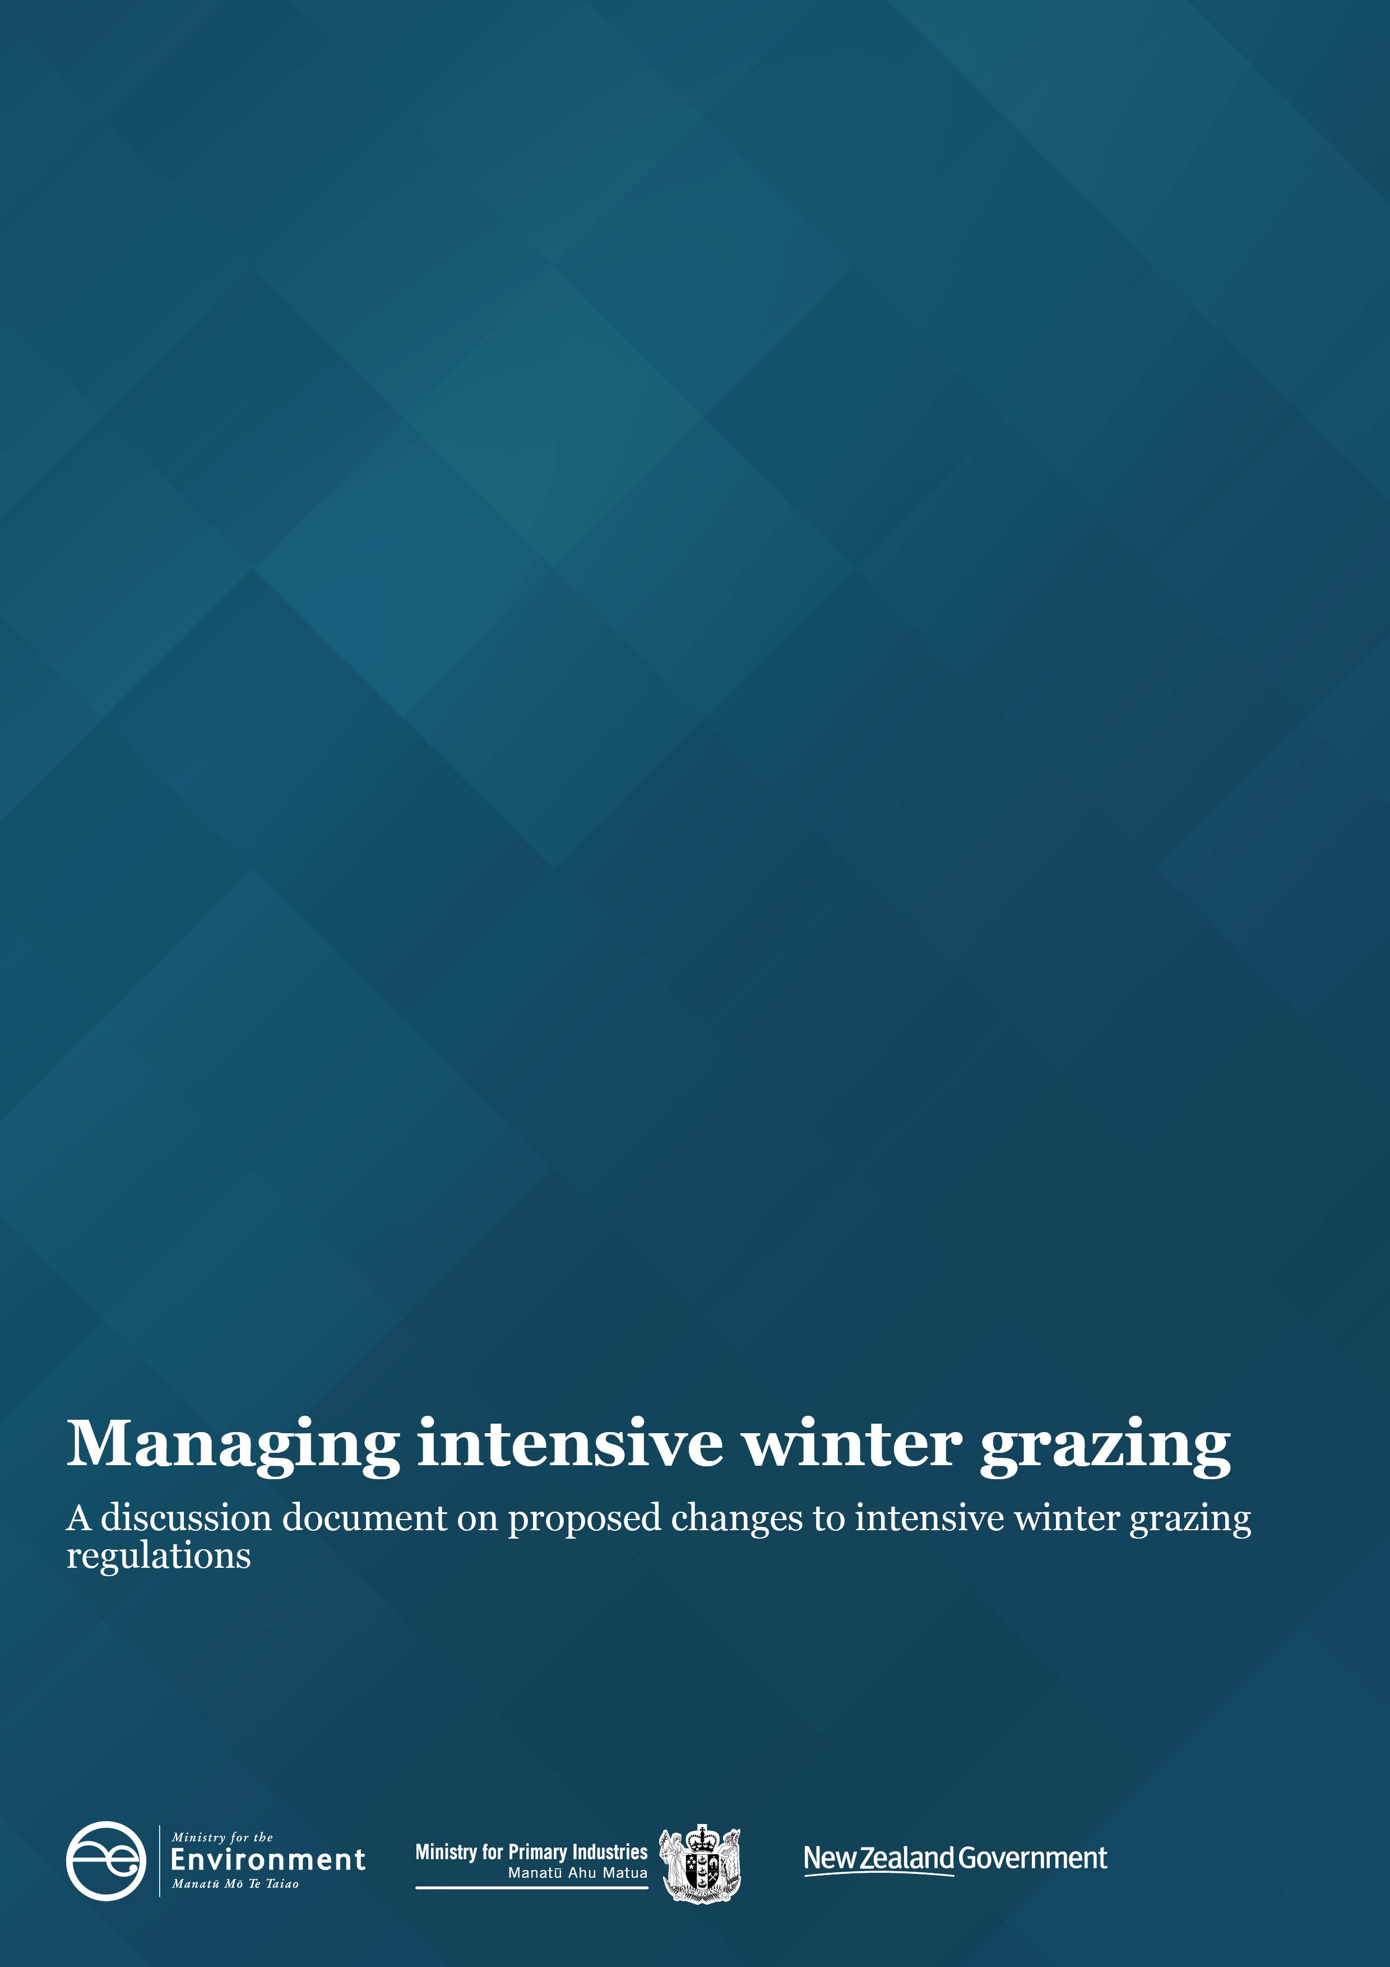

Disclaimer
The information in this publication is, according to the Ministry for the Environment’s best efforts, accurate at the time of publication. The Ministry will make every reasonable effort to keep it current and accurate. However, users of this publication are advised that:
- The information does not alter the laws of New Zealand, other official guidelines, or requirements.
- It does not constitute legal advice, and users should take specific advice from qualified professionals before taking any action based on information in this publication.
- The Ministry does not accept any responsibility or liability whatsoever whether in contract, tort, equity, or otherwise for any action taken as a result of reading, or reliance placed on this publication because of having read any part, or all, of the information in this publication or for any error, or inadequacy, deficiency, flaw in, or omission from the information in this publication.
- All references to websites, organisations or people not within the Ministry are for convenience only and should not be taken as endorsement of those websites or information contained in those websites nor of organisations or people referred to.

This document may be cited as: Ministry for the Environment and Ministry for Primary Industries. 2021. Managing intensive winter grazing: A discussion document on proposed changes to intensive winter grazing regulations. Wellington: Ministry for the Environment.

Published in August 2021 by the
Ministry for the Environment
Manatū Mō Te Taiao
PO Box 10362, Wellington 6143, New Zealand
ISBN: 978-1-99-003372-8
Publication number: ME 1586
© Crown copyright New Zealand 2021
This document is available on the Ministry for the Environment website: environment.govt.nz.

Contents
Section 1: Introduction 4
Have your say 5
Section 2: Why are we proposing changes? 6
Intensive winter grazing practices 6
Introduction and deferral of the intensive winter grazing regulations 6
How the intensive winter grazing regulations work 7
Implementation issues with the intensive winter grazing regulations 8
Section 3: What is being proposed? 11
Amendments to the default conditions 11
What are the main considerations? 12
Implementation timeframes 14
Section 4: How to have your say 15
Timeframes 15
How to provide feedback 15
More information 15
Publishing and releasing information 16
Section 5: Summary of consultation questions 17

Tables
Table 1: Implementation issues with the current default conditions 8
Table 2: Detail of proposed amendments to the default conditions 11

Figures
Figure 1: Sediment loss at a range of slopes (South Canterbury) 13

Section 1: Introduction
The Essential Freshwater reforms introduced the Resource Management (National Environmental Standards for Freshwater) Regulations 2020 (NES-F), which are directed at making early changes to high-risk activities such as intensive winter grazing. The NES-F was made under the Resource Management Act 1991 (RMA).
Since the NES-F was created, the Ministry for the Environment (MfE) and the Ministry for Primary Industries (MPI) have been engaging with external stakeholders to identify issues as they arise and to support stakeholders in the effective implementation of the NES-F.
MfE and MPI have received feedback from various stakeholders that aspects of the intensive winter grazing regulations in the NES-F may require modification to support effective implementation and achieve improved environmental outcomes. The Southland Intensive Winter Grazing NES Advisory Group (SAG) was established to provide recommendations to the Government on addressing implementation issues with the intensive winter grazing regulations. It produced a report in December 2020 identifying practical implementation issues.
As a result of that feedback on the practical challenges associated with meeting and implementing the new requirements, implementation of the intensive winter grazing regulations was deferred for one year (to 1 May 2022). That deferral provides time for further improvement in intensive winter grazing practice, increased monitoring and compliance, and consideration of changes to address the implementation issues.
This discussion document proposes changes to the default conditions aimed at making them more practical to comply with.
This document also includes questions to fill information gaps and test support for the proposed changes. It should be read alongside the Regulatory Impact Statement, which describes the impacts of the proposals in more detail.
The freshwater farm plan regime has also been released for consultation. Your feedback across these related areas will contribute to freshwater regulations that are practical and enduring.
The proposed changes continue to emphasise the protection of freshwater and do not change the intent of the NES-F, which is to ensure intensive winter grazing is conducted in a way that minimises its environmental impact. The requirement that a national environmental standard cannot permit an activity with significant adverse effects is addressed through the changes proposed. We consider that these proposed changes to the NES-F are consistent with the purpose of the Resource Management Act 1991.
This document asks for feedback on proposed changes to the intensive winter grazing regulations only. It does not seek feedback on any other matters within the NES-F, or in:
- the Resource Management Act 1991
- the National Policy Statement for Freshwater Management 2020
- the Resource Management (Stock Exclusion) Regulations 2020 or Resource Management (Measurement and Reporting of Water Takes) Regulations 2010 (which were amended in 2020).

Have your say
We welcome your feedback on the options set out in this document, at: https://consult.environment.govt.nz.
The consultation questions are given as a guide only. You do not have to answer them all, and any comments are encouraged.

Section 2: Why are we proposing changes?

Intensive winter grazing practices
Intensive winter grazing is a farming practice where livestock (cattle, sheep, deer) are confined over winter to outdoor feeding areas planted with annual forage crops (eg, swedes, kale and fodder beet).
Annual forage crops are a part of some pastoral farm production systems. They provide feed when there is no or low pasture growth and contribute to pasture renewal rotations for improved production. However, it is widely acknowledged that, if done poorly or too extensively, intensive winter grazing can have serious negative effects on both animal welfare and the environment, particularly freshwater and estuary health.
Due to the intensive nature of this grazing practice, which strips the protective vegetative cover from the land, it results in the increased discharge of nutrients, sediments and microbial pathogens into surface water and groundwater. In some locations, and with good practice, these impacts can be reduced. Carried out too extensively, on heavy soils and steep slopes with poor practices, more extreme impacts occur.

Introduction and deferral of the intensive winter grazing regulations
The NES-F introduced, among other things, regulations to manage the risk of adverse environmental effects from intensive winter grazing. These regulations were due to come into effect on 1 May 2021. However, following feedback from the primary sector and regional government about the practical challenges associated with implementing the new requirements, the commencement of the intensive winter grazing regulations was temporarily deferred. They are currently due to take effect on 1 May 2022.
Officials from MfE and MPI have been working to support implementation of the regulations, and this deferral has provided time for:
- central government officials to work with regional government and primary sector representatives to develop an intensive winter grazing module. This module was launched publicly in April 2021. It sets out minimum expectations for intensive winter grazing practices and supports farmers to plan and plant annual forage crops according to government expectations. This module was developed with the intention that it would ultimately form part of certified freshwater farm plans, but farmers are already using it and other planning tools.
- the development of proposed regulations for certified freshwater farm plans. Consultation on those proposals runs between 26 July and 12 September 2021
- the Government to assess whether change is required to the permitted activity default conditions within the intensive winter grazing regulations to address the implementation issues identified
- the primary sector to demonstrate real practice change for the 2021 winter grazing season, including for animal welfare, while any changes to the intensive winter grazing regulations are considered
- regional councils to undertake increased monitoring and reporting of intensive winter grazing practices, to ensure measurable improvements are achieved by 1 May 2022. A quarterly report will be delivered from regional councils to show what progress has been made this winter. The first report was sent to Ministers and made publicly available in August 2021.

How the intensive winter grazing regulations work
The intensive winter grazing regulations prevent expansion of intensive winter grazing, while providing three pathways for farmers to undertake the activity.
The expansion restrictions are interim measures (ending 1 January 2025) and require that the area of land used for intensive winter grazing on a farm be no greater than the area used on that farm for intensive winter grazing during the reference period (1 July 2014 to 30 June 2019). Restrictions on expansion continue to apply throughout the deferral to the regulations, and we are not proposing to amend them here.
The three pathways for farmers to undertake intensive winter grazing are:
- Pathway 1: intensive winter grazing activities are permitted if a farmer complies with the default conditions set out in the NES-F
- Pathway 2: intensive winter grazing activities are permitted if a farmer obtains a certified freshwater farm plan (under this pathway, the certified freshwater farm plan must demonstrate that any adverse effects in relation to the intensive winter grazing are no greater than those allowed for by the default conditions)
- Pathway 3: if neither Pathway 1 or Pathway 2 can be met, a farmer needs to obtain a resource consent for intensive winter grazing activities.
National environmental standards cannot permit an activity that has significant adverse effects on the environment. The default conditions that currently form the basis of Pathway 1 and Pathway 2 therefore set out minimum requirements that must be met (or an equivalent management of effects through a certified freshwater farm plan) for the intensive winter grazing practice to be permitted and not have any significant adverse effects on the environment. If those conditions cannot be met, a resource consent can be applied for, under which any adverse effects can be managed in a site-specific manner.

Implementation issues with the intensive winter grazing regulations
Feedback from stakeholder engagement and the SAG report indicates that the intensive winter grazing regulations are not operating as intended, because:
- there are practical implementation issues with the default conditions
- the certified freshwater farm plans pathway (Pathway 2) is not yet available (the freshwater farm plan regime is currently being consulted on and still needs to be finalised before being rolled out).
Because it is difficult to comply with the default conditions in practice, and certified freshwater farm plans are not yet available, the only way to undertake intensive winter grazing when the intensive winter grazing regulations come into effect on 1 May 2022 will be to obtain a resource consent. A larger number of consents may be required as a result, which was not the intention when the intensive winter grazing regulations were being developed.
Table 1 sets out the specific detail of the implementation issues identified with the current default conditions.
Table 1: Implementation issues with the current default conditions
# | Default condition in the current NES-F | Implementation issue
1 | Total area: The area of the farm that is used for intensive winter grazing must be no greater than 50 hectares or 10 per cent of the area of the farm, whichever is greater.  (reg 26(4)(a)) | The Southland Intensive Winter Grazing NES Advisory Group (SAG) raised concerns about the restriction on total area driving the wrong behaviours (eg, encouraging farmers to operate their intensive winter grazing more intensively to stay within the condition, or discouraging farmers from changing to lower yielding or mixed crops that may provide better environmental outcomes).  Officials are not proposing amendments to this default condition. We consider that a control on the extent of intensive winter grazing remains important (in conjunction with the interim restrictions on expansion) if it is being conducted through a permitted activity pathway. It is still possible to apply for a resource consent to expand activities.
2 | Slope threshold: Intensive winter grazing is restricted to paddocks where the mean slope is 10 degrees or less.  (reg 26(4)(b)) | Feedback suggests that measuring the slope as a mean across a paddock is difficult to calculate and could result in grazing of areas at a slope greater than the 10 degrees threshold where it is a small area of the paddock. Instead, the slope could be measured as a maximum slope, which is easier to estimate (eg, using an app or through visual assessments).  The SAG also recommended setting the threshold at 15 degrees.
3 | Pugging: Pugging (5 centimetres-plus) must not cover more than 50 per cent of the paddock and must not be deeper than 20 centimetres at any one point (except near fixed water troughs or entrance gates).  (reg 26(4)(c)) | Feedback received is that:  - this is impractical to implement, monitor and enforce  - little evidence is available of the adverse impacts to freshwater from pugging  - the real concern is soil structure damage, the effects of which can be better managed via other means, such as through critical source area identification  - the condition only provides an exception for fixed water troughs – portable water troughs are considered best practice, and if this pugging condition is retained, portable water troughs should also be included in the exception.
4 | Buffer zone from waterways: Stock must be kept at least 5 metres away from the bed of any river, lake, wetland, or drain.  (reg 26(4)(d)) | The definition of ‘drain’ currently includes sub-surface drains as well as surface drains.  Feedback received is that this is impractical to implement, monitor and enforce, because extensive networks exist of sub-surface drains that have not been mapped or cannot practically be mapped.
5 | Resowing: Land used for intensive winter grazing must be replanted as soon as practicable after livestock have grazed the crop, but no later than 1 October (1 November in Otago and Southland).  (reg 26(4)(e)) | Feedback received is that this is impractical to meet (or to be certain in advance that it will be met) due to unpredictable weather, and farmers still grazing up to 30 September and in some cases into early October. It is not practical to have a nationwide date: for the date to work in all instances, it would have to be overly permissive.  The current regulations may also restrict the ability of farmers to use good management practices, such as companion planting, due to the requirement to replant (a system that uses companion planting does not require replanting because cover is maintained through winter and beyond).
6 | Critical source areas: These areas must be identified and protected (uncultivated and ungrazed).  (No current default condition) | Critical source areas are not currently managed through the intensive winter grazing regulations. The SAG recommended including a new condition requiring the identification and protection of critical source areas, due to the issues with the conditions described above (in particular, with pugging and resowing).  The definition of critical source areas could be based on the definition within:  - the Proposed Southland Water and Land Plan, in line with recommendations from the SAG (but noting the Plan is subject to appeal)  - the proposed certified freshwater farm planning regulations.

Long-term use of certified freshwater farm plans
We recognise that, eventually, all farmers will need a certified (and audited) freshwater farm plan regardless of intensive winter grazing regulations. We consider that freshwater farm plans will ultimately be the best way to manage the activity, and we understand there is widespread agreement within the farming community on this being the most appropriate management tool.
The ability to develop bespoke mitigations through freshwater farm plans will give farmers the ability to manage the effects of intensive winter grazing in other ways, as an alternative to complying with the default conditions.
Longer-term, once certified freshwater farm plans are available and being implemented successfully, we will look at phasing out the permitted activity pathway based on default conditions (Pathway 1) altogether. There would remain a single permitted activity pathway based on certified freshwater farm plans (with no change to the resource consent pathway). However, it is too early to consult on this. The changes proposed in this discussion document are instead focused on addressing implementation issues in the short term before certified freshwater farm plans are available.
Questions: Context for the proposed changes to the intensive winter grazing regulations
- Do you agree with our framing of the issue? If not, why not?
- What other information should we consider?
- Are there any other implementation issues with the current default conditions that have not been discussed above?

Section 3: What is being proposed?

Amendments to the default conditions

Proposed amendments
We propose amending the default conditions so they can be complied with more practically. These amendments are detailed in table 2.
The changes to the default conditions would affect both Pathway 1 and Pathway 2, because Pathway 2 (the freshwater farm plans pathway) relies on the default conditions as a benchmark for assessing outcomes under a freshwater farm plan and therefore whether the intensive winter grazing activity is permitted.
Table 2: Detail of proposed amendments to the default conditions
Detail of proposed amendments to the default conditions
Amend the default conditions to address the practical and weather-dependent issues that make them difficult to comply with at present.
Make the following changes to the default conditions (reg 26(4)).
- Reg 26(4)(a): No change (ie, the limit of area used for intensive winter grazing remains at 50 hectares or 10 per cent of the area of the farm, whichever is greater).
- Reg 26(4)(b): Amend to measure the slope threshold as maximum allowable slope instead of mean slope of a paddock (while keeping the existing threshold of 10 degrees).
- Reg 26(4)(c): Amend so that farmers have to take reasonably practicable steps to manage the effects on freshwater from pugging (in areas that are used for intensive winter grazing). Officials will develop guidance to ensure that farmers and councils have a shared understanding of what reasonable and practicable steps are.
- Reg 26(4)(d): Amend the definition of ‘drains’ to exclude sub-surface drains (as originally intended). Manage sub-surface drains (where known to exist) through critical source areas (see proposed new condition below).
- Reg 26(4)(e): Remove the requirement to resow by 1 October (1 November in Otago and Southland) and, instead, require farmers to resow ‘as soon as practicable’, ie, in order to minimise the amount of time that bare ground is exposed to the weather, and clarify that other methods of establishing ground cover (eg, companion planting) are included. Officials will develop guidance to provide more clarity for farmers and councils as to what steps could demonstrate that farmers were resowing as soon as practicable.
- New condition: Include a new condition requiring that critical source areas must be protected (uncultivated and ungrazed). See the proposed definition of critical source areas in table 1. Officials will develop guidance to ensure that farmers and councils have a shared understanding of how critical source areas will be identified and protected.
Implementation timeframes for these changes are discussed further below under Implementation timeframes.

What are the main considerations?

Making conditions more practical while still managing environmental effects
Under section 43A(3) of the Resource Management Act 1991, national environmental standards cannot permit an activity that has significant adverse effects on the environment.
While the proposed changes to the intensive winter grazing regulations would make the default conditions more practical, we also need to be sure they will not permit adverse effects on the environment.
Feedback received during consultation may identify other changes to the default conditions that may be appropriate to mitigate the risk of adverse effects on the environment.

Slope threshold
There are views that the slope threshold should be higher or lower than the existing 10 degrees; but it is clear that sediment loss increases significantly when intensive winter grazing is undertaken on higher slopes. Modelling used to inform the current regulations shows that an increase in slope from 10 to 15 degrees would double the sediment loss, and an increase to 20 degrees would triple it. Figure 1 illustrates the relationship between sediment loss and slope from a one hectare block of winter crop in South Canterbury.
Figure 1: Sediment loss at a range of slopes (South Canterbury)
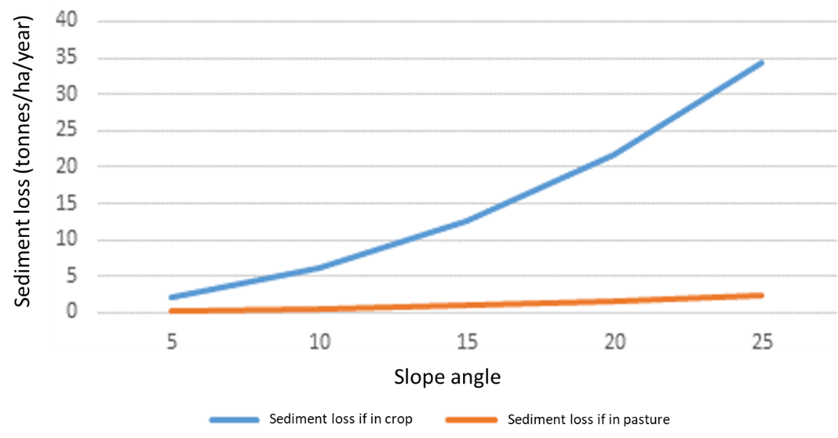
Taking into account both practicality and expected environmental impacts, we think 10 degrees is still appropriate and propose to keep it as a default condition. However, it is easier to measure a maximum slope rather than a mean slope of a paddock, so we propose to move to maximum allowable slope.
Farmers wanting to undertake intensive winter grazing on land above that threshold could still apply for a resource consent or obtain a certified freshwater farm plan provided the effects are no greater than would be allowed under the default conditions. The freshwater farm plan or resource consent would include specific and enforceable controls to mitigate the risks associated with a higher slope.

Understanding consequences
Making default conditions more practical to comply with should result in fewer applications for resource consents; but there could still be applications where farmers are unable to comply with the default conditions but would be able to obtain a certified freshwater farm plan (once available). Some consents that are granted may end up becoming redundant once certified freshwater farm plans are available to manage the adverse effects of intensive winter grazing.
We want to understand the size of this issue, as to how many consent applications may be made both before and after certified freshwater farm plans become available. We would also like to know about any other concerns that might arise.
However, the alternative to intensive winter grazing regulations would be to allow intensive winter grazing without any effective controls being in place (except perhaps some regional controls) until freshwater farm plans become available. This would create a hiatus of uncertain duration.
Questions: Amendments to the default conditions
- Do you think these proposed changes are the right way to manage intensive winter grazing? If not, why not?
- Do you think these proposed changes would improve the workability of the permitted activity standards? If not, why not? (Please be specific about which provisions you are commenting on when you are responding.)
- Do you think these proposed changes would manage adverse environmental effects of intensive winter grazing effectively? If not, why not?

Implementation timeframes

Further deferral to the regulations
We acknowledge that farmers begin making on-farm decisions well in advance of the winter grazing season beginning in May each year. We understand it is important to provide certainty to farmers in advance of the season beginning about what regulations will apply for the season. In this case, the changes proposed in this document to the intensive winter grazing regulations will not have been finalised before those on-farm decisions need to be made for the 2022 winter grazing season.
Therefore, we propose a further deferral to the commencement of the intensive winter grazing regulations for six months (so the regulations would begin on 1 November 2022). That should provide time for farmers to adjust their practices, cultivation and planting choices in preparation for the 2023 winter grazing season.

During the period of deferral
During any period of deferral, MfE and MPI would continue to work with the primary sector to improve winter grazing practices, as described in section 2. Non-regulatory measures, such as the use of the intensive winter grazing module and increased regional council monitoring of activity, could be strengthened to continue to drive improved practice until the regulations come into effect.
Question: Implementation timeframes
- Do you have any comments on implementation timeframes and whether a further deferral would be necessary?

Section 4: How to have your say
The Government welcomes your feedback on this consultation document. The questions posed throughout this document are summarised in section 5. They are a guide only and all comments are welcome. You do not have to answer all the questions.
To ensure your point of view is clearly understood, you should explain your rationale and provide supporting evidence where appropriate.

Timeframes
This consultation starts on 26 August 2021 and ends on 7 October 2021.
When the consultation period has ended, we will analyse feedback and provide advice to Ministers on next steps.

How to provide feedback
There are two ways you can make a submission:
- via Citizen Space, our consultation hub, available at https://consult.environment.govt.nz/
- write your own submission.
If you want to provide your own written submission, you can provide this as an uploaded file in Citizen Space.
We request that you don’t email or post submissions as this makes analysis more difficult. However, if you need to, please send written submissions to Intensive winter grazing, Ministry for the Environment, PO Box 10362, Wellington 6143 and include:
- your name or organisation
- your postal address
- your telephone number
- your email address.
If you are emailing your feedback, send it to IWG@mfe.govt.nz as a:
- PDF, or
- Microsoft Word document (2003 or later version).
Submissions close at 5pm Thursday 7 October 2021.

More information
Please direct any queries to:
Email: IWG@mfe.govt.nz
Postal: Intensive winter grazing, Ministry for the Environment, PO Box 10362, Wellington 6143

Publishing and releasing information
All or part of any written comments (including names of submitters) may be published on the Ministry for the Environment’s website, environment.govt.nz. Unless you clearly specify otherwise in your submission, the Ministry will consider that you have consented to website posting of both your submission and your name.
Contents of submissions may be released to the public under the Official Information Act 1982 following requests to the Ministry for the Environment (including via email). Please advise if you have any objection to the release of any information contained in a submission and, in particular, which part(s) you consider should be withheld, together with the reason(s) for withholding the information. We will take into account all such objections when responding to requests for copies of, and information on, submissions to this document under the Official Information Act.
The Privacy Act 2020 applies certain principles about the collection, use and disclosure of information about individuals by various agencies, including the Ministry for the Environment. It governs access by individuals to information about themselves held by agencies. Any personal information you supply to the Ministry in the course of making a submission will be used by the Ministry only in relation to the matters covered by this document. Please clearly indicate in your submission if you do not wish your name to be included in any summary of submissions that the Ministry may publish.

Section 5: Summary of consultation questions
Context for the proposed changes to the intensive winter grazing regulations
- Do you agree with our framing of the issue? If not, why not?
- What other information should we consider?
- Are there any other implementation issues with the current default conditions that have not been discussed above?
Amendments to the default conditions
- Do you think these proposed changes are the right way to manage intensive winter grazing? If not, why not?
- Do you think these proposed changes would improve the workability of the permitted activity standards? If not, why not? (Please be specific about which provisions you are commenting on when you are responding.)
- Do you think these proposed changes would manage adverse environmental effects of intensive winter grazing effectively? If not, why not?
Implementation timeframes
- Do you have any comments on implementation timeframes and whether a further deferral would be necessary?

The NES-F is available at: www.legislation.govt.nz/regulation/public/2020/0174/latest/LMS364099.html.
The SAG report is available at: www.es.govt.nz/repository/libraries/id:26gi9ayo517q9stt81sd/hierarchy/environment/water/Essential%20Freshwater%20documents/Southland%20NES%20Advisory%20Group%2015-12-2020%20%28Final%29.pdf.
The Regulatory Impact Statement is available at: https://environment.govt.nz/what-government-is-doing/cabinet-papers/regulatory-impact-statement-intensive-winter-grazing/.
Further information about the freshwater farm plan regime and consultation on that is available at: https://environment.govt.nz/publications/freshwater-farm-plan-regulations-discussion-document/.
Further information about this deferral is available at: www.beehive.govt.nz/release/government-welcomes-undertaking-improve-intensive-winter-grazing-practices.
The module and further information about this is available at: www.mpi.govt.nz/agriculture/farm-management-the-environment-and-land-use/protecting-freshwater-health/intensive-winter-grazing-regulations-delayed/.
Further information about the freshwater farm plan regulations and consultation is available at: https://environment.govt.nz/publications/freshwater-farm-plan-regulations-discussion-document/.
This report is available at: https://nzarm.org.nz/key-winter-grazing-information#IWG%20Report%20to%20Minister%20Parker%20-%201%20August%202021.
Measuring the maximum slope could be based on the Proposed Southland Water and Land Plan, which measures slope as the average slope across any 20-metre distance. See Rule 25 in the Proposed Southland Water and Land Plan, available at: www.es.govt.nz/repository/libraries/id:26gi9ayo517q9stt81sd/hierarchy/about-us/plans-and-strategies/regional-plans/proposed-southland-water-and-land-plan/documents/Proposed%20Southland%20Water%20and%20Land%20Plan%20-%20Part%20A%20-%20Decisions%20Version%20%284%20April%202018%29%20PDF.pdf (note this is subject to appeal).
The Proposed Southland Water and Land Plan is available at: www.es.govt.nz/repository/libraries/id:26gi9ayo517q9stt81sd/hierarchy/about-us/plans-and-strategies/regional-plans/proposed-southland-water-and-land-plan/documents/Proposed%20Southland%20Water%20and%20Land%20Plan%20-%20Part%20A%20-%20Decisions%20Version%20%284%20April%202018%29%20PDF.pdf (note this is subject to appeal).
The proposed certified freshwater farm plan regulations are available at: https://environment.govt.nz/publications/freshwater-farm-plan-regulations-discussion-document/.
‘Availability’ could be based on district, regional or nationwide availability.
Refer to table 1 for details of the current default conditions.
Measuring the maximum slope could be based on the Proposed Southland Water and Land Plan, which measures slope as the average slope across any 20-metre distance. See Rule 25 in the Proposed Southland Water and Land Plan, available at: Proposed Southland Water and Land Plan – Part A – Decisions Version (4 April 2018) PDF.pdf (es.govt.nz) (note this is subject to appeal).
The relationship between the amount of sediment lost at specific slopes is dependent on site-specific factors such as soil type, climate and slope length (ie, longer slopes lose proportionately more sediment than short slopes), as well as the slope angle itself. Figure 1 provides an indication of the relationship between slope and sediment, based on those site-specific factors, for a site in South Canterbury and while it has been shown that sediment loss increases with increasing slope, the exact values of Figure 1 cannot be assumed to represent the whole of New Zealand. See the Regulatory Impact Analysis, Action for healthy waterways Part 2: detailed analysis, available at: https://environment.govt.nz/publications/action-for-healthy-waterways-part-2-detailed-analysis/.
In moving to a maximum slope of 10 degrees (rather than a mean), we expect a reduction in steeper land available for intensive winter grazing without a resource consent. Based on land used for winter grazing in 2018, we estimate that about 3,250 ha of that land would not meet the amended default condition of grazing to a maximum slope of 10 degrees. We note this is a small proportion of the total area used for intensive winter grazing nationally. It is estimated that in 2018 approximately 240,000 hectares was used for winter grazing on all slopes across New Zealand (based on brassica crops).

