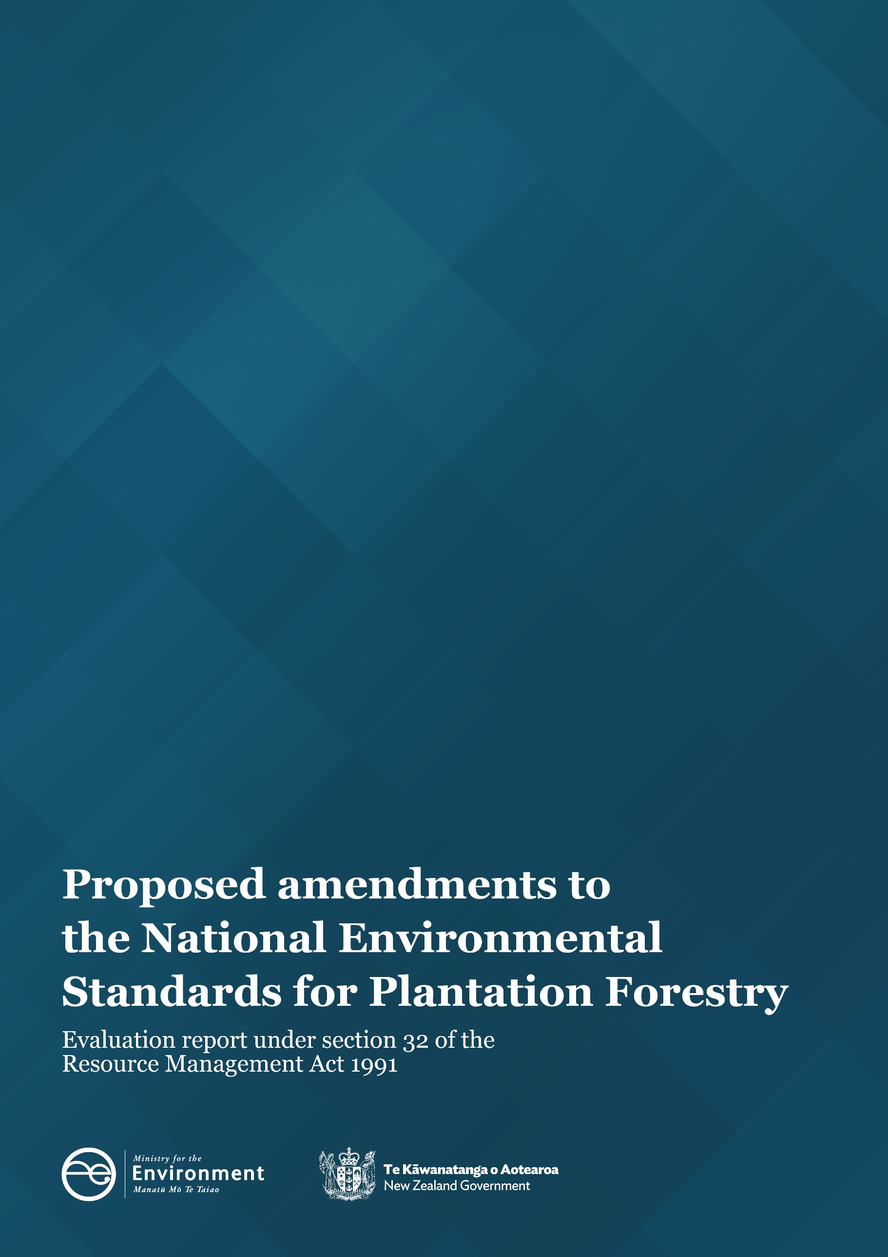

Disclaimer
The information in this publication is, according to the Ministry for the Environment’s best efforts, accurate at the time of publication. The Ministry will make every reasonable effort to keep it current and accurate. However, users of this publication are advised that:
- the information does not alter the laws of New Zealand, other official guidelines, or requirements
- it does not constitute legal advice, and users should take specific advice from qualified professionals before taking any action based on information in this publication
- the Ministry does not accept any responsibility or liability whatsoever whether in contract, tort, equity, or otherwise for any action taken as a result of reading, or reliance placed on this publication because of having read any part, or all, of the information in this publication or for any error, or inadequacy, deficiency, flaw in, or omission from the information in this publication
- all references to websites, organisations or people not within the Ministry are for convenience only and should not be taken as endorsement of those websites or information contained in those websites nor of organisations or people referred to.
This evaluation report has been prepared to evaluate proposed changes to the NES-PF that were identified and consulted on in 2022, prior to Cyclone Gabrielle in February 2023 and the subsequent events and Ministerial Inquiry into Land Use causing woody debris and sediment-related damage in Tairāwhiti and Wairoa (MILU). The MILU report, delivered on 12 May 2023, highlighted the urgent need for action, including to improve the regulatory settings to reduce risk and strengthen resilience.
In response to the MILU the Government has committed a range of measures including a further review of national-level direction and guidance for forestry, including the NES-PF, to consider if new national-level changes are needed. Recommendations from the MILU relevant to the NES-PF will need to be addressed as a separate package of work.
As such, the amendments to the NES-PF that are proposed primarily seek to address the issue of exotic continuous-cover forestry to manage this consistently with plantation forestry nationally, improve environmental outcomes in line with a range of identified improvements to the NES-PF and to enable local control of exotic afforestation.
This document may be cited as: Ministry for the Environment. 2023. Proposed amendments to the National Environmental Standards for Plantation Forestry: Evaluation report under section 32 of the Resource Management Act 1991. Wellington: Ministry for the Environment.
Published in October 2023 by the
Ministry for the Environment
Manatū Mō Te Taiao
PO Box 10362, Wellington 6143, New Zealand
ISBN: 978-1-991077-99-8
Publication number: ME 1810
© Crown copyright New Zealand 2023
This document is available on the Ministry for the Environment website: environment.govt.nz.

Contents
Executive summary 5
Introduction 5
Section 32 evaluations 5
National Environmental Standards for Plantation Forestry 5
What is the problem being addressed? 7
Proposed amendments 7
Evaluation of the proposed amendments 9
Conclusion 11
Introduction 14
Background 14
National Environmental Standards 15
Requirements under Section 32 of the RMA 16
Report structure 16
Part 1 – Overview 18
NES-PF 18
Overview of the amending proposals 19
Section 32 evaluation reports 21
Approach to the section 32 evaluation 23
Part 2 – Context for proposals 26
Current status of exotic forestry 26
Māori interests in forestry 29
The environmental effects of exotic forestry 30
Current regulatory framework 33
NES-PF year one review 37
Problem statement 38
Engagement and consultation feedback 39
Part 3 —Evaluation of the amendments to the NES-PF 42
Scale and significance of the proposal 42
Evaluation of the amended policy objectives of the NES-PF 46
Evaluation of tranche 1 changes – incorporate ECCF into the NES-PF 52
Evaluation of tranche 2 changes – Operational improvements 60
Evaluation of tranche 3 changes – enabling control of afforestation 70
Evaluation of tranche 4: Relationship with other National Direction 78
Conclusion 78
Appendix A – Supporting analysis on forestry land use 81
Appendix B – Cost benefit analysis 100

Tables
Table 1: Positive effects of exotic forestry 30
Table 2: Potential adverse effects of exotic forestry 31
Table 3: Assessment of the scale and significance of the proposed NES-PF amendments 42
Table 4: Criteria to assess the appropriateness of the NES-PF objectives 47
Table 5: Evaluation of proposed NES-PF objectives 48
Table 6: Evaluation of tranche 1 amendments 54
Table 7: Evaluation of tranche 2 amendments 63
Table 8: Evaluation of tranche 3 amendments 72

Executive summary

Introduction
The Minister for the Environment (Minister), in coordination with other Ministers, has undertaken a review of the Resource Management (National Environmental Standard for Plantation Forestry) Regulations 2017 (NES-PF) with the aim of ensuring ‘the right forest is planted in the right place and managed in the right way’. As a result of this review, the Minister is proposing to change the policy objectives of the NES-PF and amend some of its regulations.
The rationale for, and details of, the proposed amendments are outlined in more detail in this evaluation report. In summary, the over-arching aims of the review and proposed amendments to the NES-PF are to:
- expand the types of forests controlled by the NES-PF to include exotic continuous-cover forests (ECCF), to manage their environmental (biophysical) effects on the same basis as plantation forests;
- enable councils to develop local rules and policies to manage the location of ECCF and plantation forests;
- make operational changes to enable foresters and councils to better manage the environmental effects of forestry including slash and wildings.
Exotic continuous-cover forests are defined in the NES-PF amendments. A definition is provided in the report below, however, ECCF are exotic forests that are larger than 1 ha that are deliberately planted for commercial purposes and are either not intended to be harvested and replanted or subject to low intensity harvesting.

Section 32 evaluations
Section 32 of the Resource Management Act 1991 (RMA) outlines the requirements for preparing and publishing evaluation reports. The overarching purpose of section 32 of the RMA is to ensure all statements, standards, regulations, plans or changes are robust, evidence-based and that the proposed objectives and provisions are the most appropriate, efficient and effective means to achieve the purpose of the RMA.
Section 32 outlines a range of requirements, including and assessment of effectiveness and efficiency (incorporating an assessment of costs and benefits). The preparation of this evaluation has been undertaken in accordance with those requirements and best practice as outlined in national guidance documents.

NES-PF
The NES-PF came into force on 1 May 2018. It was developed during a time of net deforestation in Aotearoa New Zealand, prior to the One Billion Trees programme and reforms to the Emissions Trading Scheme. It manages plantation forestry (both exotic and indigenous) over 1 hectare, planted specifically for commercial harvesting purposes. As such, the NES-PF does not apply to other forms of forestry most notably, for the purposes of this evaluation, permanent exotic forests that are grown for carbon sequestration purposes. These may also include transitional forests, which are forests that have been planted and have or will change from an exotic forest to an indigenous forest over time while maintaining a certain level of canopy cover.
The NES-PF includes regulatory controls that are used to manage the effects of plantation forestry on the environment. These controls are nationally consistent rules and conditions (including technical standards, methods and planning requirements). Part 2 of the NES-PF manages effects associated with eight core forestry activities and regulates the following activities.
- Afforestation
- Pruning and thinning to waste
- Earthworks
- River crossings
- Forest quarrying
- Harvesting
- Mechanical land preparation
- Replanting
- Ancillary Activities.
It also includes general provisions that apply to all forestry activities as relevant and a range of administrative matters and specifications.
The NES-PF prevails over district or regional plan rules in relation to plantation forestry, except where the NES-PF specifically allows plan rules to be more stringent (Regulation 6). The NES-PF currently enables more stringent rules to manage plantation forestry within certain unique and sensitive environments, to protect significant natural areas and outstanding natural features and landscapes, and to give effect to other RMA national direction.
A Year One Review of the NES-PF concluded that:
‘Overall, the NES-PF is effective, but some changes could be made to improve environmental outcomes in some areas’
Specific areas highlighted by the review as potential areas of improvement were :
- Wilding Tree Risk Calculator: to adjust some of the settings in the calculator, align how afforestation and replanting are treated, and strengthen the requirements about who is qualified to use it;
- Slash management provisions: to clarify and strengthen the controls and improve management of slash; and
- Biodiversity provisions: to improve clarity and accountability.
Recognition was also given to the need for wider regulatory alignment with relevant national directions, particularly in light of increasing complexity as the number of national directions increase.
In addition to the issues identified above, the Year One Review also identified a range of findings in respect of specific implementation and technical issues.

What is the problem being addressed?
The rate of exotic afforestation in New Zealand has increased, and it is expected to remain high. This has been incentivised by the rising price of New Zealand (carbon) Units and a need to transition to a low-emissions economy.
Changes in land use will impact the versatility of land, for instance, limiting the availability of that land for other uses and potentially impacting (depending on the location, scale and extent of afforestation) existing community and commercial services, including certain agricultural supply chains that support or depend upon current land uses. This change may also result in either increased or new environmental risks (e.g., wilding trees) and/or changes in environmental services like improved biodiversity, water quality and erosion control outcomes.
National direction under the RMA is principally focussed on the management and control of environmental effects associated with plantation forestry. Whilst the RMA enables councils to make their own rules to manage afforestation for forests outside the NES-PF, it is understood that in most cases councils have adopted a permissive approach. Typically, forestry is a permitted activity in rural zones subject to basic controls.
The location and scale of exotic forests have potentially medium and long term cumulative social, cultural, economic and environmental effects. Afforestation in the incorrect place could affect existing economic and community services. For example, large scale afforestation could result in the loss of agricultural or commercial activity that supports supply chains and the community. This could include impacts on meat processing, stock yards, vets, fertiliser sales, and agricultural contractors such as shearers, fencers, and agrichemical spray contractors. Plantation forestry may bring new opportunities, services, and supply chains.
For exotic carbon forests there is potential that these and other issues will need to be managed and controlled. These additional issues could include the locking up of wood fibre resources. As a result agricultural supply changes and services may not be replaced with forest product supply chains and services. However, these forests can provide other environmental services (improved water quality, biodiversity, climate change mitigation by capturing carbon, and reduced erosion/sedimentation outcomes) depending on their management.
In addition, the One Year Review highlighted a number of changes could be made to improve environmental outcomes (as indicated above).

Proposed amendments
Amendments have been proposed to address the issues associated with the increasing demand for ECCF, the cumulative impact of this demand with that of plantation forestry, and a range of operational matters and improvements. These proposed amendments have been presented in four parts or tranches as follows:

Tranche 1: The purpose and scope of the revised NES-PF
This tranche amends the policy objectives of the NES-PF and also includes consequential changes to definitions and regulations necessary to incorporate ECCF into the NES-PF and manage ECCF on broadly similar terms to that of plantation forests in relation to the eight core forestry activities listed above (to the extent that they apply to ECCF).
Other amendments in this sub-part include modification of matters of discretion for afforestation on red zone land (regulation 17(4) and several administrative matters, including expanding the ability for local authorities to charge for the monitoring of a permitted activity to include afforestation).

Tranche 2: Operational improvements
This tranche of amendments primarily responds to matters raised in the Year One Review, and other operational issues, and incorporates changes in relation to the following:
- Wildfire Risk;
- Wilding Tree Risk;
- Slash Management;
- Forest Planning Requirements;
- River Crossings;
- Treaty Settlement Areas;
- Notice periods; and
- Traffic management.

Tranche 3: Controlling the location of exotic forests
This tranche of amendments enables councils to have full control over the location of new plantation forestry and ECCF by expanding the matters that councils may make more stringent or lenient rules for to incorporate all of the matters in or associated with Part 2, sub-part 1 of the NES-PF (afforestation), including, but not limited to:
- rules for plantation and ECCF afforestation generally;
- more stringent (or lenient) permitted activity standards;
- additional (or fewer) matters of discretion if consent is required;
- modifying the activity status of afforestation, or some types of afforestation.

Tranche 4: Relationship with other National Direction
This tranche incorporates some minor amendments to regulations and definitions to be consistent with the National Environmental Standard for Freshwater (NES-F), including for fish passage on river crossing, culvert depths, sediment control measures and machinery use in wetlands.

Evaluation of the proposed amendments

Scale and significance
The scale and significance of the proposals have been assessed, noting that these vary across the proposed amendments and potentially spatially depending on the nature of issues in any particular region or district.
Tranches 1 and 3 were assessed as Moderate although the significance and scale of the Tranche 3 amendments is likely to be Moderate to Low as it is anticipated that only some councils will choose to propose plan changes if the ability to do so is clarified (as they already have the ability to control afforestation in some circumstances). Tranche 2 changes were assessed as Moderate although some amendments to current operational aspects have Low significance but widespread scale as they are minor revisions to ‘business as usual’ while some will have potentially High significance but at a lower scale (in specific circumstances/locations). Tranche 4 amendments were assessed as (very) low and consequently not addressed in the evaluation.

Evaluation of the policy objectives
NES do not contain objectives and policies in the traditional plan sense. In this case the assessment has evaluated the policy objectives, including changes to existing policy objectives of the NES-PF.
It is considered that the proposed policy objectives of the proposal are an appropriate way to achieve the purpose of the RMA in the context of the problems that have been identified in respect of ECCF and the current controls applied to plantation forestry under the NES-PF. The proposed objectives:
- Address a resource management issue –the consistent management of the environmental effects of all exotic forestry and the potentially significant social, economic and cultural effects on local communities of changes in land use due to afforestation.
- Will achieve the purpose and principles of the RMA – enabling people and communities to provide for their social, economic, and cultural wellbeing while avoiding, remedying, or mitigating any adverse effects of activities on the environment in a nationally consistent and effective way.
- Help local authorities to carry out their RMA functions by providing management of all exotic forestry activities in a nationally consistent way.
- Provide clear intent as to what the policy objectives are seeking to achieve to guide appropriate amendments to the NES-PF (evaluated below).
- Are able to be achieved using existing resources, skills and expertise of those responsible for implementing the NES-PF.
- Will not result in unjustifiably high costs being imposed on the public at large, specific areas of interest or discrete parts of the community.
In concluding this, it is acknowledged that the proposals will potentially have greater consequences for Māori that other forestry stakeholders and with wider community, due to their substantial current and potential future interests in forestry – both plantation and ECCF. These consequences have the potential to be both positive and negative.

Evaluation of the proposed amendments to regulations
The proposed amendments have been evaluated in accordance with the requirements of s32, including an assessment of costs and benefits, with quantification of costs where possible. The conclusions of the assessment for the respective tranches are as follows.
Tranche 1
Overall, it is considered that incorporating ECCF into the NES-PF is an efficient and effective method of achieving the policy objectives, and in particular Objective 3, and that the environmental, economic, social and cultural benefits are likely to outweigh the costs. Incorporating ECCF into the NES-PF ensures a consistent national approach to the management of all exotic forestry. Importantly, it does not differentiate between the type of exotic forestry – plantation, transitional or ECCF other forms. Instead, the NES-PF provisions apply as relevant to the type of exotic forestry activity that is occurring at any time and thus provides a ‘level playing field’ across all forms of exotic forestry. As for the current NES-PF, this should result in ‘raising the bar’ in terms of the environmental controls for ECCF at an early stage, with the environmental and community benefits that result.
It is likely that the key costs of the proposal will be borne by the landowners (foresters) and implementors in the short-term and the key benefits fall to local communities and the wider public over the long-term. Importantly, even small improvements in environmental outcomes are potentially significant because they are not limited to the site or the local community, but benefit regions and the country as a whole, with a range of market and non-market social, cultural and economic benefits that then flow on from a better state of the biophysical environment.
Tranche 2
The proposed amendments seek to improve operational practices and associated environmental outcomes, including the key issues of improved wilding and slash management. They are likely to be effective in contributing to maintaining or improving the environmental outcomes associated with plantation forestry and ECCF activities nationally and effectively managing effects in a nationally consistent and effective manner – although it is acknowledged that these amendments alone are unlikely to resolve current issues relating to slash and further changes resulting from the MILU may be required.
It is considered that the proposed amendments are efficient in respect of afforestation notices and wilding management, in that the benefits are likely to outweigh the costs. However, it is acknowledged that there is limited information on the benefits and costs associated with the slash management provisions but on balance the environmental benefits are expected to outweigh the economic costs of this important and topical issue.
Tranche 3
Enabling councils to have more stringent (or lenient) rules than the NES-PF for a broader scope of matters (including clarifying what scope councils already have to apply stringency) to manage the location and scale of exotic afforestation is likely to be effective in meeting the policy objectives, particularly Objective 4. Efficiency gains from the proposed amendments are likely to be minimal, primarily because:
- ECCF is not regulated by the NES-PF, so councils can currently manage its location and scale (should they choose to do so); and
- The location and scale of plantation forestry can be managed at a local level in accordance with the matters in Regulation 6 of the NES-PF and for social, economic and cultural reasons (as these are considered outside of the scope of the current NES-PF).
While the proposal clarifies the ability for councils to control location and scale of exotic afforestation, it is uncertain how effective this will be in meeting the second ‘arm’ of Objective 4 to ‘recognise the national and local benefits of exotic forestry’ in the absence of policy guidance on how the national and local interests should be balanced. It is noted that as an NES, the NES-PF does not include policies to help guide decision making and the policy objectives of the NES-PF direct the preparation of the regulation itself, not subsequent consent processes.
The proposal has the potential to reduce certainty and efficiency in the management of plantation forests as local controls will likely lead to different locational requirements and constraints across councils and hence increased uncertainty and risk (and associated costs) for foresters (in respect of afforestation). However, this is expected to be limited to those districts facing significant pressure from exotic afforestation and there will be the ability to influence those controls though the public plan change process (as a minimum). Any more stringent (or lenient) controls than the NES-PF also need to be justified in the circumstances of each region or district under section 32(4) of the RMA.
Tranche 4
As these are very minor and of very low scale and significance, and align to standards that have already been tested and deemed appropriate in other national direction, they are not reassessed here.

Risks of acting/not acting
The risks of acting (proceeding with the proposed amendments) or not acting (retaining the status quo) was assessed for each significant tranche of proposed amendments as there is uncertainty relating to the provision and their effect. For each tranche it was considered that the risk of not acting was greater than the risk of acting.

Alternative options
Alternative options to achieve the policy objectives have been considered in respect of the key proposed amendments. None of the assessed options are considered to provide a superior approach, although it is acknowledged than some options (for example a standalone NES for ECCF) could achieve similar outcomes.

Conclusion
The Minister for the Environment, in coordination with other Ministers, has undertaken a review of the NES-PF with the aim of ensuring the regulatory settings achieve the aim that ‘the right forest is planted in the right place and managed in the right way’. As a result, the Minister is proposing to change the policy objectives of the NES-PF and amend some of its regulations. The overarching aims of the review and proposed amendments to the NES-PF are to:
- expand the types of forests controlled by the NES-PF to include ECCF, to manage their environmental (biophysical) effects on the same basis as plantation forests;
- enable councils to develop local rules and policies to manage the location of ECCF and plantation forests;
- make operational changes to enable foresters and councils to better manage the environmental effects of forestry including slash and wildings.
This has resulted in proposed amendments that seek to amend provisions in relation to:
- The purpose and scope of the revised NES-PF to incorporate ECCF into the NES-PF (Tranche 1);
- Operational Improvements both BAU and for wilding and slash management (Tranche 2)
- Controlling the location of forests by providing councils with the clear ability to manage afforestation within their districts (Tranche 3)
- Relationship with other National Direction (Tranche 4)
The evaluation undertaken in accordance with section 32 of the RMA concludes that the proposed amendments objectives of the proposal are an appropriate way to achieve the purpose of the RMA in the context of the problems that have been identified in respect of ECCF and the current controls applied to plantation forestry under the NES-PF.
In concluding this, it is acknowledged that the proposals will potentially have greater consequences for Māori that other forestry stakeholders and with wider community, due to their substantial current and potential future interests in forestry – both plantation and ECCF. These consequences have the potential to be both positive and negative.
The evaluation of the proposed amendments to the regulations concludes that the proposed amendments are likely, in general, to be effective and efficient in achieving the policy objectives for the following reasons:
Objective 1 Maintain or improve the environmental outcomes associated with plantation and exotic continuous-cover forestry activities nationally.
Bringing ECCF into the NES-PF, and applying the controls within the NES-PF, is expected to ‘raise the bar’ in respect of the management of adverse effects from ECCF. Additionally, the operational and other amendments to the current NES-PF regulations that are proposed seek to improve environmental outcomes across the board for all types of exotic forestry.
A potential issue for the forestry industry is the economics of slash removal on orange and certain red zone land. It is understood that removal of slash down to a specified size is currently practiced by most forestry companies – although this may be dependent on markets for the material which enables removal costs to be offset. However it is noted that where permitted activity standards in respect of slash removal cannot be met, harvesting becomes a controlled activity (requires a consent that must be granted). This provides for a customised/optimised approach to slash management to be identified and implemented and not that the forest cannot be harvested.
Objective 2 Increase certainty and efficiency in the management of plantation and exotic continuous-cover forestry activities.
Some of the proposed amendments may increase certainty and efficiency. However, clarifying and broadening the ability for councils to adopt more stringent (or lenient) controls on afforestation in their district/region has the potential to bring about variations and inconsistencies from district to district and increased consent requirements, potentially leading to increased uncertainty, risks and costs for foresters – at least until plans are settled. However, it is not known how many councils will choose to exercise this ability and the need for local controls and the nature of these controls will necessarily be justified at a local scale such that this uncertainty cannot be assessed at this time.
Objective 3 Ensure the effects of plantation and exotic continuous-cover forestry activities are effectively managed in a nationally consistent manner.
Bringing ECCF into the NES-PF and the amendments to the operational procedures will assist in achieving effective management in a nationally consistent way – essentially a level playing field aligned to current best practice for all exotic forestry.
Objective 4 Enable local authorities to control the location and scale of plantation and exotic continuous-cover afforestation, while recognising the local and national benefits of exotic commercial forestry.
The proposed amendments clarify the ability for councils to control afforestation and extend the scope of this control. This achieves the first limb of this objective, which is a clear intent of the changes promoted through the proposal. However, it is unclear how the second limb of this objective will be met in the absence of policy direction as to how best to balance the local interest against local and national benefits of exotic commercial forestry.
Overall, it is concluded that the proposed amendments to the regulations are an appropriate method to achieve the policy objectives. In the absence of more detailed assessments on options, costs and benefits, including the likely effectiveness of enhanced controls (for example for slash management), it cannot be concluded that the proposal is the most appropriate method of achieving the objectives.
It is likely that the key costs of the proposals will be borne by the landowners (foresters) and implementors in the short-term and the key benefits fall to local communities and the wider public over the long-term. Councils may also incur costs associated with increased compliance and administration costs (some of which may be recovered) and costs associated with plan changes should they choose to control exotic afforestation. This is likely to stretch existing council expertise and capacity - which were already identified in the One Year Review as a matter of concern.
However, even small improvements in environmental outcomes are potentially significant because they are not limited to the site or the local community, but benefit regions and the country as a whole, with a range of market and non-market social, cultural and economic benefits that then flow on from a better state of the biophysical environment.

Introduction

Background
The Minister for the Environment (Minister), in coordination with other Ministers, has undertaken a review of the Resource Management (National Environmental Standard for Plantation Forestry) Regulations 2017 (NES-PF) with the aim of ensuring ‘the right forest is planted in the right place and managed in the right way’. As a result of this review, the Minister is proposing to change the policy objectives of the NES-PF and amend some of its regulations.
The rationale for, and details of, the proposed amendments are outlined in more detail in this evaluation report. In summary, the over-arching aims of the review and proposed amendments to the NES-PF are to:
- expand the types of forests controlled by the NES-PF to include exotic continuous-cover forests (ECCF), to manage their environmental (biophysical) effects on the same basis as plantation forests;
- enable councils to develop local rules, objectives and policies to manage the location of ECCF and plantation forests;
- make operational changes to enable foresters and councils to better manage the environmental effects of forestry including slash and wildings.
Exotic continuous-cover forests are defined in the NES-PF amendments as:
A forest that is deliberately established for commercial purposes, being—
(a) at least 1 ha of continuous forest cover of exotic forest species that has been planted and—
(i) will not be harvested or replanted; or
(ii) is intended to be low intensity harvested or replanted; and
(b) includes all associated forestry infrastructure; but
(c) does not include—
(i) a shelter belt of forest species, where the tree crown cover has, or is likely to have, an average width of less than 30 m; or
(ii) forest species in urban areas; or
(iii) nurseries and seed orchards; or
(iv) trees grown for fruit or nuts; or
(v) long-term ecological restoration planting of indigenous forest species; or
(vi) willows and poplars space planted for soil conservation purposes
Low intensity harvesting means harvesting where a minimum of 75% canopy cover is maintained at all times for any given hectare of forest land.

Accordingly, the Minister proposes to amend the policy objectives of the NES-PF to be:
Objective 1 Maintain or improve the environmental outcomes associated with plantation and exotic continuous-cover forestry activities nationally.
Objective 2 Increase certainty and efficiency in the management of plantation and exotic continuous-cover forestry activities.
Objective 3 Ensure the effects of plantation and exotic continuous-cover forestry activities are effectively managed in a nationally consistent manner.
Objective 4 Enable local authorities to control the location and scale of plantation and exotic continuous-cover afforestation, while recognising the local and national benefits of exotic commercial forestry.
Objectives 1 and 2 are the original policy objectives of the NES-PF, amended to incorporate ECCF. Objectives 3 and 4 are additional objectives that reflect the intent of the proposed amendments.
This report provides an evaluation of the proposed amendments to the NES-PF in accordance with section 32 of the Resource Management Act 1991 (RMA). It should be read in conjunction with the amended NPS-PF and other reports prepared in accordance with section 46A of the RMA.

National Environmental Standards
National environmental standards (NES) are regulations that apply nationally or within specified parts of New Zealand. They are binding on local authorities and local authorities must observe an NES (section 44A(7)) and enforce that observation to the extent to which their powers enable them to do so (section 44(8)). NES can be established to maintain a healthy environment, protect people and the environment, and to secure a consistent decision-making process nationally. They can address a range of environmental issues and manage the effects of specific activities on people and the environment in a nationally consistent manner.
Under section 43A of the RMA, a NES can prohibit an activity or allow (permit) an activity. Where a NES allows an activity, section 43A(4) states it can:
a) State that a resource consent is not required for that activity; or
b) Do one or both of the following:
i. State an activity is permitted subject to terms and conditions specified in the standards; and/or
ii. Require compliance with the rules in a plan or proposed plan as a term or condition.
Section 44 of the RMA sets out the restrictions on the power of the Minister for the Environment to make (or modify) a NES. Section 44 (1) requires the Minister to:
Before recommending the making of a national environmental standard (including a change to an existing national environmental standard) to the Governor-General, the Minister must—
a) comply with section 46A(3) of the RMA; and
b) prepare an evaluation report for the standard in accordance with section 32; and
c) have particular regard to that report when deciding whether to recommend the making of the standard; and
d) publicly notify the report and recommendation made under section 46A(4)(c) or 51(2), as the case requires

Requirements under section 32 of the RMA
The overarching purpose of section 32 of the RMA is to ensure all statements, standards, regulations, plans or changes are robust, evidence-based and that the proposed objectives and provisions are the most appropriate, efficient and effective means to achieve the purpose of the RMA. Section 5 sets out the purpose of the RMA, to “promote the sustainable management of natural and physical resources”, with sustainable management further defined in section 5(2) as:
“Managing the use, development and protection of natural and physical resources in a way, or at a rate, which enables people and communities to provide for their social, economic, and cultural wellbeing and for their health and safety while–
- Sustaining the potential of natural and physical resources (excluding minerals) to meet the reasonably foreseeable needs of future generations; and
- Safeguarding the life-supporting capacity of air, water, soil and ecosystems; and
- Avoiding, remedying, or mitigating any adverse effects of activities on the environment.”
In achieving this purpose, all those involved in exercising functions and powers under the RMA are required to:
- Recognise and provide for the matters of national importance identified in section 6
- Have particular regard to other matters referred to in section 7
- Take into account the principles of the Treaty of Waitangi referred to in section 8.
The requirements of section 32 are outlined in more detail in Part 1 of this evaluation; however, in broad terms, section 32 requires an evaluation of a proposal (including a proposed national environment standard) to evaluate whether:
- The objectives of the proposal are the most appropriate way to achieve the purpose of the RMA; and
- The provisions of the proposal are the most appropriate to achieve those objectives based on an assessment of efficiency, effectiveness, benefits, costs and the risks of acting or not acting when there is uncertain or insufficient information.

Report structure
This evaluation report is structured in four parts as follows.
Part 1 – Overview to the evaluation
This overview section provides:
- a background to the NES-PF;
- an overview to the proposed amendments;
- an overview of the legislative requirements for section 32 evaluation reports and national direction under the RMA; and
- an outline of the approach adopted to undertake this evaluation of the proposed amendments.
Part 2 – Statutory and policy context
This section provides:
- a context to the proposals and an overview of the resource management issues the changes seek to address including the status and demand for exotic forestry;
- a summary of the current regulatory regime and problems under the status quo.
Part 3 – Evaluation of the proposed changes
This section provides an evaluation of the proposed amendments to the NES-PF and is structured as follows:
- an assessment of the scale and significance of the amending proposals;
- an assessment of the extent to which the amended policy objectives are the most appropriate way to achieve the purpose of the RMA;
- an assessment of whether the proposed amendments to the regulations are the most appropriate way of achieving the amended NES-PF objectives, including an assessment of the efficiency and effectiveness of the regulations in achieving the objectives; and
- an overall conclusion and reasons for deciding on the proposed NES-PF amendments.

Part 1 – Overview

NES-PF
The NES-PF came into force on 1 May 2018. It was developed during a time of net deforestation in Aotearoa New Zealand, prior to the One Billion Trees programme and reforms to the Emissions Trading Scheme. It manages plantation forestry (both exotic and indigenous) over 1 hectare, planted specifically for commercial harvesting purposes, which is defined in NES-PF as:
plantation forest or plantation forestry means a forest deliberately established for commercial purposes, being—
(a) at least 1 ha of continuous forest cover of forest species that has been planted and has or will be harvested or replanted; and
(b) includes all associated forestry infrastructure; but
(c) does not include—
(i) a shelter belt of forest species, where the tree crown cover has, or is likely to have, an average width of less than 30 m; or
(ii) forest species in urban areas; or
(iii) nurseries and seed orchards; or
(iv) trees grown for fruit or nuts; or
(v) long-term ecological restoration planting of forest species; or
(vi) willows and poplars space planted for soil conservation purposes
As such, the NES-PF does not apply to other forms of forestry most notably, for the purposes of this evaluation, permanent exotic forests that are grown for carbon sequestration purposes. These may also include transitional forests, which are forests that have been planted and have or will change from an exotic forest to an indigenous forest over time while maintaining a certain level of canopy cover. These types of forest, and those forests which are subject to low intensity harvesting, are defined as exotic continuous-cover forests and this term (or its acronym ECCF) is used hereafter in this evaluation report.
The NES-PF includes regulatory controls that are used to manage the effects of plantation forestry on the environment. These controls are nationally consistent rules and conditions (including technical standards, methods and planning requirements).
Part 2 of the NES-PF manages effects associated with eight core forestry activities and regulates the following activities.
- Afforestation
- Pruning and thinning to waste
- Earthworks
- River crossings
- Forest quarrying
- Harvesting
- Mechanical land preparation
- Replanting
- Ancillary Activities.
It also includes general provisions that apply to all forestry activities as relevant.
Part 3 of the NES-PF incorporates a range of administrative matters and specifications. This includes permitted activities for which council can charge for monitoring; matters incorporated by reference – which includes important tools that assist in the implementation of the NPS-PF such as the Erosion Susceptibility Classification, Wilding Tree Risk Calculator and flood estimation tools. Schedule 3 details the contents/specifications of required management plans covering: forestry earthworks, harvesting, forestry quarrying and sediment.
The NES-PF prevails over district or regional plan rules in relation to plantation forestry, except where the NES-PF specifically allows plan rules to be more stringent (Regulation 6). The NES-PF currently enables more stringent rules to manage plantation forestry within certain unique and sensitive environments, to protect significant natural areas and outstanding natural features and landscapes, and to give effect to other RMA national direction – being the National Policy Statement for Freshwater Management (NPS-FM) and policies 11, 13, 15 and 22 in the New Zealand Coastal Policy Statement (NZCPS).
Any other forestry activity not covered by the NES-PF is managed by district and regional plans.

Overview of the amending proposals
Consultation on the proposed and indicative amendments to the NES-PF was undertaken in late 2022, primarily based on the ‘Discussion Document’, the Interim Regulatory Impact Statement (Interim RIS) and a series of questions and answers. Consultation was undertaken on the basis of four ‘parts’ in the Discussion Document as follows:
Part A: Incorporating carbon and transitional forestry (referred to as Exotic Permanent (Continuous Cover) Forests) into the NES-PF so that the same provisions apply across all forms of exotic forestry. This part also included consideration of whether management of wind effects should be included in the NES-PF and the use of Forest Management Plans (FMPs).
Part B: Enabling local communities to control exotic afforestation in their communities.
Part C: Improving wildfire risk management.
Part D: A range of provisions associated with the Year One Review of the implementation of the NES-PF, including amendments to the Wilding Calculator and its potential application to replanting.
As a result of that consultation, consideration has been given to the proposed amendments and they have been further refined and progressed under four tranches which are summarised below.
Tranche 1: The purpose and scope of the revised NES-PF
This tranche of changes primarily amends the purpose and scope of the of the NES-PF to the following policy objectives:
- Objective 1 Maintain or improve the environmental outcomes associated with plantation and exotic continuous-cover forestry activities nationally.
- Objective 2 Increase certainty and efficiency in the management of plantation and exotic continuous-cover forestry activities.
- Objective 3 Ensure the effects of plantation and exotic continuous-cover forestry activities are effectively managed in a nationally consistent manner.
- Objective 4 Enable local authorities to control the location and scale of plantation and exotic continuous-cover afforestation, while recognising the local and national benefits of exotic commercial forestry.
This has extended the previous policy objectives of the NES-PF (Objectives 1 and 2) to include ECCF. Objectives 3 and 4 are new objectives.
This tranche of amendments also includes consequential changes to definitions and regulations necessary to incorporate ECCF into the NES-PF and manage ECCF on broadly similar terms to that of plantation forests in relation to the eight core forestry activities listed above (to the extent that they apply to ECCF).
Other amendments in this sub-part include modification of matters of discretion for afforestation on red zone land (regulation 17(4) and several administrative matters, including expanding the ability for local authorities to charge for the monitoring of a permitted activity to include afforestation.
Tranche 2: Operational Improvements
This tranche of amendments in part respond to matters raised in the Year One Review, and in part to other identified matters, and incorporate the following changes:
- Wildfire Risk: modifying current information requirements for an afforestation notice to include a map (in GIS format) of the property boundary and the location of the forest within it, access points and gates; the size and species of the forest; and contact information for the forest owner (and applying these requirements to both plantation and ECCF).
- Wilding Tree Risk: amend the permitted activity notice requirements for wilding tree risk at replanting to require all replanting activities to carry out a wilding tree risk assessment and, where a score is 12 or higher, resource consent is required as a controlled activity (including consequential changes to matters of control).
- Slash Management: amendments to regulation 69 and schedule 3(5) in relation to the management of slash, including the removal of a significant proportion of slash from the cutover in relation to harvesting on orange and red zone land (excluding LUC8e where it involves no more than 2 ha of harvesting in any 3-month period) subject to size and other thresholds.
- Forest Planning Requirements: introduce forest management requirements that apply to both ECCF and plantation forests, incorporating existing management plan requirements to the extent appropriate and requiring a forest management plan in permitted activity rules for afforestation and replanting, earthworks, harvest and forest quarrying.
- River Crossings: amendment of definitions and permitted activity standards (specifically the introduction of permitted activity standards for two new river crossings – double culverts and a removable in-stream structure) and the introduction of the NIWA Regional Flood Estimation Tool (replacing document 3 in Schedule 2).
- Treaty Settlement Areas: amend the regulations to enable Treaty of Waitangi Settlement Areas relating to outstanding waterbodies to be a matter of discretion for resource consent processes, wherever discretion over effects on an outstanding waterbody is already enabled.
- Notice periods: amend the notice periods for earthworks and forestry quarrying in green and yellow zones.
- Traffic management: repeal regulation 57.
Tranche 3: Controlling the location of forests
This tranche of amendments enables councils to have full control over the location of new plantation forestry and ECCF by expanding the matters that councils may make more stringent (or lenient) rules for in, or associated with, Part 2: sub-part 1 of the NES-PF (afforestation), including, but not limited to:
- more stringent rules for plantation and ECCF generally;
- more stringent permitted activity standards;
- additional matters of discretion if consent is required;
- modifying the activity status of afforestation, or some types of afforestation, to be more stringent.
Tranche 4: Alignment of NES-PF with other National Direction
This tranche incorporates some minor amendments to regulations and definitions to be consistent with the National Environmental Standard for Freshwater (NES-F), including for fish passage on river crossing, culvert depths, sediment control measures and machinery use in wetlands.

Section 32 evaluation reports
Section 32(1) of the RMA states that an evaluation must:
- examine the extent to which the objectives of the proposal being evaluated are the most appropriate way to achieve the purpose of this Act; and
- examine whether the provisions in the proposal are the most appropriate way to achieve the objectives by—
  - identifying other reasonably practicable options for achieving the objectives; and
  - assessing the efficiency and effectiveness of the provisions in achieving the objectives; and
  - summarising the reasons for deciding on the provisions; and
- contain a level of detail that corresponds to the scale and significance of the environmental, economic, social, and cultural effects that are anticipated from the implementation of the proposal.
Section 32(2) of the RMA states that the assessment of efficiency and effectiveness in 32(1)(b)(ii) must:
- identify and assess the benefits and costs of the environmental, economic, social, and cultural effects that are anticipated from the implementation of the provisions, including the opportunities for—
  - economic growth that are anticipated to be provided or reduced; and
  - employment that are anticipated to be provided or reduced; and
- if practicable, quantify the benefits and costs referred to in paragraph(a); and
- assess the risk of acting or not acting if there is uncertain or insufficient information about the subject matter of the provisions.
Furthermore, as the proposal seeks to amend the existing NES-PF, section 32(3) of the RMA also applies and requires:
If the proposal (an amending proposal) will amend a standard, statement, national planning standard, regulation, plan, or change that is already proposed or that already exists (an existing proposal), the examination under subsection (1)(b) must relate to—
a) the provisions and objectives of the amending proposal; and
b) the objectives of the existing proposal to the extent that those objectives—
i. are relevant to the objectives of the amending proposal; and
ii. would remain if the amending proposal were to take effect.
As this is an amending proposal, the evaluation below focuses on the changes that are proposed, both on plantation forestry and ECCF and does not reiterate the original section 32 evaluation that was prepared for the NES-PF when it was first gazetted in 2017. However, it does assess the potential implications of the amendments to the NES-PF on plantation forestry activities, where relevant.

Approach to the section 32 evaluation

General approach
This evaluation of the NES-PF is focused on the following components:
An evaluation of the scale and significance of the proposed amendments. Section 32 evaluations are required to contain a level of detail that corresponds to the scale and significance of the effects that are anticipated from the proposal. This evaluation of scale and significance is provided below for the proposed amendments in relation to the different tranches of amendments that are proposed.
An evaluation of the objectives of the amendments to the NES-PF. The first step of the evaluation is to assess whether the policy objectives are the most appropriate way to achieve the purpose of the RMA. This evaluation is provided below against some established criteria to evaluate the appropriateness of objectives under the RMA.
An evaluation of the proposed amendments to the NES-PF in each of the four tranches of the proposal against the policy objectives. This evaluation incorporates assessment of:
- The environments, economic, social and cultural costs and benefits of the provisions to the extent that these can be assessed and quantified where practicable (Appendix B).
- The efficiency of the proposed provisions to achieve the policy objectives.
- The effectiveness of provisions to achieve the policy objectives.
- Risks of acting/not acting where there is uncertain or insufficient information on the provisions.
- An assessment of other reasonably practicable alternatives for achieving the objectives.
- An overall conclusion summarising the key reasons for deciding on the provisions and whether the provisions of the proposal are the most appropriate way to achieve the objectives.
In considering the appropriateness of the provisions in achieving the objectives, consideration has been given to the existing objectives, as amended by the proposals, in accordance with RMA section 32(3).

Approach to assessing efficiency and effectiveness
Section 32(1)(b)(ii) of the RMA requires an assessment of the efficiency and effectiveness of the provisions in achieving the objectives of the proposal. For each tranche of proposed amendments to the NES-PF, the following approach has been adopted.

Efficiency
The assessment of efficiency under section 32 considers whether the provisions will be likely to achieve the objectives at the lowest total cost to all members of society or achieves the highest net benefit to all of society.
Consistent with section 32(2)(a) of the RMA, this assessment of efficiency is focused on the benefits and costs (environmental, economic, social and cultural) anticipated from the implementation of the proposed amendments to the NES-PF.
Section 32(2)(b) of the RMA states that costs and benefits should be quantified where practicable. However due to limitations of available data, the site-specific nature of forestry activities and assumptions necessary to assess changes from the baseline (i.e. benefits and costs without the amendments), it has not been practicable to quantify all benefits and costs in this evaluation. Hence, the majority of benefits and costs have been assessed in a qualitative way and that quantified benefits and costs are limited mainly to transaction costs to foresters and administration costs to local authorities, with some central government implementation costs where provided (see Appendix B: Cost Benefit Analysis (CBA) of the key proposed amendments).

Effectiveness
For the purposes of section 32, ‘effectiveness’ refers to how successful the provisions are likely to be in meeting the desired outcomes as expressed in the policy objectives. The assessment of effectiveness for each part is therefore focused on the extent to which the amended NES-PF provisions will achieve the policy objectives.

Evaluation of reasonably practicable options
Section 32(1)(b)(i) of the RMA requires reasonably practicable options to achieve the objectives to be identified as part of assessing whether the proposed provisions are the most appropriate way to achieve the objectives. ‘Reasonably practicable’ is not defined in the RMA, but can include options that:
- are both regulatory and non-regulatory
- are targeted towards achieving the stated objectives
- are within the Ministry’s resources, duties and powers
- represent a reasonable range of possible alternatives.
Case law has interpreted that the ‘appropriate’ option means a suitable but not necessarily the superior method. This means the most appropriate option does not need to be the optimal or best option, but the section 32 evaluation must demonstrate that it will meet the objectives of the proposal in an efficient and effective way. Case law has also confirmed the requirement to identify reasonably practicable options will always involve at least two options as there is always a choice to be made between doing nothing (status quo) and doing something.
Accordingly, a consideration of potential alternative options to achieve the proposed/revised objectives of the NES-PF has been undertaken. However, it is noted that in some instances the alternative options are largely a binary choice – implement the change or not (i.e. retain the status quo).

Part 2 – Context for proposals

Current status of exotic forestry
Exotic plantation forests were originally established to reduce pressure on Aotearoa New Zealand’s indigenous forest estate, and to meet forecast growth in population and demand for construction materials. The role of forestry in Aotearoa New Zealand and in primary sector production has evolved over time and continues to do so. New Zealand’s competitive advantages in plantation management have grown the exotic forest sector into a significant primary sector export industry, that supports communities across the country, in forest management, processing and exporting.
The plantation forestry and wood processing industry is now the fourth-largest export earner for New Zealand. In 2021, for example, the sector contributed $6.7 billion in export earnings (approximately 1.6% of NZ’s Gross Domestic Product) and employed between 35,000 and 40,000 people in wood production, processing, and wider support industries.
Appendix A provides a high-level analysis of different aspects of the exotic forestry estate – i.e. forestry as a land use (rather than upstream and downstream economic activity). This helps establish a baseline against which anticipated growth in exotic afforestation can be understood and provides context for key aspects of the proposed amendments to the NES-PF. This relates to both the problem statement (discussed further below) and the likely effectiveness and efficiency of the proposed amendments to the NES-PF themselves.
Key findings from the analysis in Appendix A on the current scale, nature and location of exotic forestry are as follows:
- Since the early 2000s, the net stocked area of plantation forests was in decline. Only since around 2019 has positive growth resumed, but the rate of growth has been slow (total growth of 3% between 2018 and 2022).
- The key districts where plantation forestry (net stocked area) growth occurred during 2018 and 2022 were Far North District, Wairoa District, Clutha District, Masterton District, Whakatane District, Kaipara District, Southland District and Carterton District. Combined, these districts accounted for 79% of the growth during that period.
- The annual area of new land planted in exotic plantation forest in 2022 was 45,000 hectares. This is half of the area that was planted in the industry’s peak planting year of 1995, but appears to be on an upward trajectory.
- The increase in the number of approved applications for farm conversions to forestry via the Overseas Investment Office in recent years further confirms a growth trend in forestry at present (although the type of forest and species is unknown). Of note, around 70% of farms purchased are proposed for planting, with 30% potentially retained in current land use which may include more productive farm areas on the property and dwellings.
- Total planted area of plantation forestry is currently (April 2022) estimated at 1.76 million hectares (NEFD 2022), with around 50,200 hectares of additional forestry land awaiting replanting. This gives a total forestry land area of 1.81 million hectares.
- The top five district in terms of net stocked plantation forest area as at 2022 area (in descending order) are Taupo District (10% of the national total), Gisborne District (9%), Whakatane District (6%), Far North District (5%) and Clutha District (5%). These five districts account for 35% of net stocked forestry area in 2022.
- 90% of plantation forestry area is planted in Pinus radiata. Douglas fir is the next most important species at 6% of the total area nationally.
- 71% of plantation forestry is located in the North Island. While Pinus radiata still dominates plantation forestry in the South Island (77% of the South Island plantation forest area), Douglas fir plays a more important role there than it does in the North Island.
- An estimated 58% of the exotic forest estate owned by approximately 27 large forestry companies (each owning greater than 10,000 hectares each. There is, however, a significant number of smaller forest owners that make up the remaining 42% of forestry planted area (NEFD, 2022). This pattern of ownership is based largely on plantation forestry. There is limited data publicly available on the ownership mix and scale of ECCF.
- In 2021, it was estimated that 17% of exotic afforestation was for ECCF (6,900 hectares). In 2022, it was estimated that 17% of exotic afforestation was again for ECCF but the area planted increased to 10,900 hectares. The total area of ECCF is unknown.
- Based on surveyed intentions for 2023, the share of exotic afforestation intended as ECCF was similar (16%), but the total area of intended afforestation had increased strongly indicating 13,900 hectares of new ECCF may be planted. Plantation forestry is still the key market of demand driving afforestation at present.
- The location of ECCF afforestation in recent years has differed from the location of plantation afforestation but is still within areas where plantation forestry exists. Nearly half occurred in the Southern North Island Wood Supply Region (especially the east side of that region) and about a third occurred in the East Coast Wood Supply Region based on 2019/2021 data. Exotic plantation afforestation in those years was relatively more even across Wood Supply Regions.
- If these averages are applied to 2021, the data indicates that around half of exotic afforestation in the East Coast Wood Supply Region that year may have been ECCF, and in the Southern North Island Wood Supply Region, ECCF potentially accounted for around 30% of exotic afforestation. Elsewhere though, ECCF is still only a minor component of the exotic forestry estate (or not present at all). This is consistent with feedback from Environment Southland, where recent growth has all been for future harvest purposes.
- As at 2016/17, 74% of planted forestry was on green or yellow zone land based on the Erosion Susceptibility Classification. 18% was on orange zone land and 7% on red zone land (very high erosion susceptibility). This distribution occurred before the NES-PF came into effect.
- While the NES-PF discourages new plantation afforestation on red zone land, it is expected that it will take many more years to start seeing a material shift in the overall distribution.
- A number of different data sources confirm that exotic forestry is being concentrated on LUC class 6 and 7 land. This trend is expected to continue as there is considerable capacity for additional forestry on the land relative to projected demand (i.e. supply is unlikely to be constrained) and for Pinus radiata at least, planting on more fertile soil can be a disadvantage for plantation forestry. Between 1996 and 2018, surveys of landcover have also shown that forestry area on LUC class 3 and 4 land has decreased slightly (deforestation), with strong growth in forestry landcover occurring on LUC class 6 followed by LUC class 7 land. Care is needed in inferring that this deforestation is freeing up more productive land, as the Afforestation and Deforestation Intentions Survey 2022 identifies that it is mainly driven by demand for infrastructure (including roads and landfills), mining and residential lifestyle. Only some deforestation is providing for dairy or dairy support activities and sheep and beef farming.
- Just over 60% of planted forestry area nationally in 2016/17 was on general owned land. While 9% of New Zealand’s planted forestry area was on Māori Land, this planted forestry accounted for 14% of the total area of Māori Land Court land. About a quarter of planted forestry is on Treaty Settlement land where it makes up just over half of all Settlement Land. Silviculture is a key industry for Māori landowners, as is forestry in general for Māori when upstream and downstream employment is included.
- The nature of Māori land (highly concentrated in LUC 6 and 7 class land and with only a small share in red zone land) provides good opportunities for further exotic forestry growth where this coincides with suitable growing areas and – for plantation forestry – areas where there is infrastructure for harvesting and export/processing. Indicatively, there is estimated to be around 260,000 ha of LUC 6 and 7 Māori owned land currently covered in grassland or woody grassland (and not within red zone land). A substantial portion of this opportunity is within key existing forestry areas.

Future growth in exotic forestry
Key findings from the analysis in Appendix A on the future growth of exotic forestry are as follows:
- Land use is continuously changing, and growth of exotic forestry is one of those changes.
- Exotic afforestation has been identified as having a key role in achieving national climate change and emission reduction goals. The ETS is incentivising both exotic plantation and ECCF afforestation.
- Changing carbon prices, regulatory settings in the ETS, and export prices for farming and plantation forestry all make projecting exotic afforestation challenging.
- Even medium-term afforestation projections can change substantially from one year to the next.
- The latest medium-term projections (to 2030) start from 457,000 hectares for plantation afforestation (2021-2030) and 86,000 hectares for ECCF afforestation.
- Long-term status quo afforestation projections (2021 to 2050) range from 724,000-940,000 hectares for plantation forestry and 197,000-455,000 hectares for ECCF.
- Across plantation and ECCF, projected long-term afforestation could take up 15-22% of remaining grassland that is LUC 6-7, or 32-47% if limited to the districts that account for the majority (72%) of the current exotic forestry estate.
- When considered relative to the total land area nationally, the area potentially taken up by exotic afforestation over the long-term is only a small percentage.
- The location of projected afforestation is also uncertain under the status quo scenario. For the purpose of this section 32 evaluation, it is assumed that future exotic afforestation will continue to be focused on LUC 6 and 7 land and will be spread across a large number of districts, and likely pro-rata current patterns of plantation and ECCF forestry as this largely reflects suitable growing (and other economic) conditions.
- This is the baseline against which the proposed amendments to the NES-PF are assessed.

Māori interests in forestry
Māori interest in forestry is specifically identified and assessed in this evaluation as Māori have significant landholdings, both current and potential future, in the forestry industry and hence any changes to the status quo have the potential to disproportionally affect (negatively and positively) these interests.
Māori currently own NZ$4.3 billion of assets in forestry and in 2018 around 30 per cent of forestry land was estimated to be on whenua Māori, and this is expected to grow to 40% as Te Tiriti – Treaty of Waitangi settlements are completed.
The Treaty of Waitangi Analysis undertaken by the Ministry identified that compared to nationally, a higher proportion of Māori land is suited to exotic carbon forests due to it being on land considered marginal, steep and/or erosion prone. Additionally, whenua Māori has different characteristics to general title land which make it well suited to plantation and exotic carbon forestry - this land tends to be in lower capability land use (LUC) classes compared with general land (65% in LUC 6 and 7, compared with 50% for non-Māori land), and many parcels of this land are small and fragmented. Around 230,000 hectares of Māori land has been identified as well suited to forests – and could qualify for registration in the New Zealand Emissions Trading Scheme (ETS).
Furthermore, much Māori-owned land is landlocked and far from urban centres and while options for this type of land are narrow, much of it may be suitable for forestry. Exotic afforestation can add to Māori-owned plantation forestry and provide economic benefits, including employment in forest management and revenue at harvest. In addition, rising New Zealand unit (NZU) carbon prices can be a significant incentive to established exotic forests, particularly carbon forests.

The environmental effects of exotic forestry
The original section 32 evaluation for the NES-PF identified a range of positive and potentially negative effects of plantation forestry. These are briefly summarised below as these effects are equally relevant to ECCF to the extent that the various forestry sub-activities are undertaken as part of ECCF – together with identification of other positive and negative effects.

Positive effects
Positive environmental effects associated with plantation forestry as identified in the original section 32 evaluation for the NES-PF include:
Table 1: Positive effects of exotic forestry
Activity | Potential Effects
Indigenous vegetation and flora | - Plantation forests can provide a successful habitat for native flora and fauna, including threatened species.  - Research has found that rich native plant species occur under Pinus radiata forests and that indigenous plant diversity increased as the forest aged.  - A number of native bird species actively use the plantation forest estate, as do reptiles and invertebrates.  - In terms of aquatic ecosystems, forests provide more shade and hence cooler water temperatures (relative to pastoral land) that allow invertebrates and native fish to flourish more readily than pasture land.  - Afforestation of pastureland can also lead to aquatic communities and stream conditions more similar to native forest conditions than previously existed1
Water Quality | - The levels of nutrients are usually much higher in waters draining from pastoral land than from catchments with indigenous or exotic forestry  - Conversion of pasture land into pine plantations generally improves stream water quality by reducing contaminant inputs such as sediments, nutrients, pathogens and agrichemicals
Soil erosion / sediment retention | - Sediment generation that reaches streams occurs less from general forestry practices than other productive land uses, especially pasture use.  - The presence of closed canopy forest significantly reduces the degree of erosion (especially landslides) during large storm events.
Ecosystem services | - Ecosystem services provided by plantation forests include provisioning, regulating, cultural and supporting services.  - The services range from those that have market values and can be reflected in Gross Domestic Product (i.e., provisioning services such as wood, fibre, biofuel and carbon sequestration) to less tangible services (e.g., avoided erosion, recreation).
In addition, forestry has the potential to offset emissions, replace high-emissions products with biomaterials and biofuels, climate change mitigation by capturing carbon, reduce erosion and sedimentation outcomes, and contribute to social and cultural wellbeing (notably Māori have significant interests in forests as rangatira, kaitiaki, land and forest owners, workers, and business owners). As outlined earlier in this part of the report, forestry is a major contributor to the national economy, including through employment (both direct and indirect).

Potential adverse effects
Potential adverse effects of plantation forestry activities were identified in the original section 32 for the NES-PF and summarised in Table 2 below.
Table 2: Potential adverse effects of exotic forestry
Activity | Potential Effects
Afforestation | - Landscape and amenity effects, such as shading and modification of outstanding natural landscapes  - Wilding pine spread into vulnerable areas which can have adverse effects on landscapes and the productivity of other land uses  - Adverse effects on indigenous fauna and flora as a result of disturbance of adjacent areas during planting
Pruning and thinning-to-waste | - Discharge of slash into waterbodies with potential to mobilise and cause downstream impacts on aquatic ecosystems and downstream infrastructure
Earthworks | - Sediment discharge to waterways with associated adverse effects on freshwater quality and aquatic ecosystems  - Adverse effects on indigenous fauna and flora as a result of soil disturbance and movement  - Adverse effects on heritage and cultural sites as a result of soil disturbance and movement
River Crossings | - Sediment discharge to waterways with associated adverse effects on freshwater quality and aquatic ecosystems  - Adverse effects on fish passage as a result of poor design or installation of culverts  - Adverse effects on river beds during works or use  - Adverse effects on downstream infrastructure as a result of altered flow paths
Forest quarrying | - Sediment discharge to waterways with associated adverse effects on freshwater quality and aquatic ecosystems  - Adverse effects on indigenous fauna and flora as a result of ground disturbance, movement of machinery  - Effects on landscape and amenity as a result of modification of landforms and noise from heavy machinery
Harvesting | - Sediment discharge to waterways with associated adverse effects on freshwater quality and aquatic ecosystems  - Discharge of slash into waterbodies with potential to mobilise and cause downstream impacts on ecosystems and infrastructure  - Adverse effects on indigenous fauna and flora as a result of disturbance from tree extraction  - Adverse effects on heritage and cultural sites as a result of ground disturbance and tree extraction
Replanting | - Wilding pine spread into vulnerable areas which can have adverse effects on landscapes and the productivity of other land uses  - Adverse effects on indigenous fauna and flora as a result of disturbance of adjacent areas during replanting
Mechanical land preparation | - Sediment discharge to waterways with associated adverse effects on freshwater quality and aquatic ecosystems  - Adverse effects on indigenous fauna and flora as a result of ground disturbance  - Adverse effects on heritage and cultural sites

The regulations in the NES-PF were developed to manage these potential adverse effects in a more effective and nationally consistent manner. The original NES-PF section 32 evaluation concluded that:
The NES-PF provisions will be effective and efficient to maintain or improve the environmental outcomes associated with plantation forestry, while increasing efficiency and certainty in the management of those activities under the RMA.
Accordingly, bringing ECCF into the NES-PF and managing the sub-activities in a similar manner to those for plantation forestry (subject to improvements as detailed below) is expected to result in a similar level of management of environmental effects to maintain or improve environmental outcomes compared to the status quo.
However, since the gazetting and subsequent implementation of the NES-PF concern has been raised around the potential scale of growth in exotic forestry, both plantation and ECCF, in part due to the rise in the NZU carbon prices. This has the potential to bring about large-scale land use change in rural areas, with corresponding potential effects on rural areas, communities and economies.
The range of potential effects are outlined in the consultation Discussion Document. However, in summary, the predicted increase in exotic plantation forest and ECCF of the scale identified in Appendix A and discussed above, has the potential to result in changes in land use patterns, with some areas being planted in exotic forests for the first time. This change in land use may have positive economic benefits for marginal land (and landowners), but also adverse impacts on the environment, and rural communities and economies, including by:
- reducing the versatility of land by incorporating it as permanent forest;
- limiting the use of that land for other uses and reducing (depending on the scale and extent of afforestation); and
- reducing the viability of services and certain agricultural supply chains that support or depend upon these land uses. This could include impacts on meat processing, stock yards, vets, fertiliser sales, and agricultural contractors such as shearers, fencers, and agrichemical spray contractors.
There may also be an either increased or new environmental risks (e.g., wilding trees, wildfire) and/or changes in environmental services such as biodiversity, water quality and erosion control.
At the same time, afforestation can provide a range of positive effects, including those identified above and also providing additional cash-flow options for sheep and beef farms and land that is more isolated or unsuitable for other uses. There is also the potential for forestry to provide biomass to fuel a move to a lower-carbon economy with less reliance in fossil fuels and providing sufficient feedstock to allow local timber processing to establish.

Current regulatory framework

NES-PF
The NES-PF includes regulatory controls that are used to manage the effects of plantation forestry on the environment. The NES-PF regulatory controls are nationally consistent rules and conditions (technical standards, methods, and planning requirements). The policy objectives of the NES-PF are to:
- maintain or improve the environmental outcomes associated with plantation forestry activities; and
- increase the efficiency and certainty of managing plantation forestry activities.
As detailed above, the NES-PF was gazetted in 2017 and came into effect in 2018. The NES-PF was developed during a time of net deforestation in Aotearoa New Zealand, prior to the One Billion Trees programme and reforms to the Emissions Trading Scheme. The NES-PF manages plantation forestry (both exotic and indigenous) over 1 hectare, planted specifically for commercial harvesting purposes and does not regulate forests that are not intended to be harvested for commercial purposes.
Part 2 of the NES-PF manages effects associated with eight core plantation forestry activities, ancillary activities and includes general provisions that apply to all plantation forestry activities where relevant. The NES-PF also sets out what regulations are the functions of regional councils, territorial authorities or both. In summary, the NES-PF regulates the following:
Afforestation: Subpart 1 sets out regulations for afforestation activities, generally permitting afforestation activities where notice is provided, wilding tree risk is low and minimum setbacks can be complied with. Afforestation in more sensitive environments is otherwise managed through the regulations, either as controlled or restricted discretionary activities, or in accordance with the relevant plan or policy statement for afforestation within significant natural areas (SNAs) and outstanding natural features or landscapes (ONFs and ONLs).
Pruning and thinning to waste: Subpart 2 regulates pruning and thinning to waste either as a permitted or controlled activity where the permitted activity regulations cannot be met.
Earthworks: Subpart 3 permits earthworks for territorial authorities and sets a threshold for permitted earthworks subject to location, slope, volume, extent and timing subject to various standards. Any other earthworks are either controlled or a restricted discretionary activity.
River crossings: Subpart 4 permits river crossings and associated infrastructure subject to meeting certain conditions. All other river crossing activities and infrastructure are either controlled, restricted discretionary or discretionary activities.
Forest quarrying: Subpart 5 permits forest quarrying subject to compliance with permitted activity conditions, including erosion and sediment management plans, locations, and operational management. Any forest quarrying activity which does not meet the permitted activity standards is either controlled or a restricted discretionary activity.
Harvesting: Subpart 6 permits harvest activities subject to compliance with the permitted activity conditions, including notice requirements, sediment management, harvest plans in erosion susceptible zones, disturbance controls, and slash and debris management. Any harvest activity which does not meet the permitted activity standards is either controlled or a restricted discretionary activity.
Mechanical land preparation: Subpart 7 generally permits mechanical land preparation in most zones, dependent on slope, subject to the methodology, sediment management and setbacks. Any mechanical land preparation not provided as a permitted activity for is a restricted discretionary activity.
Replanting: Subpart 8 permits replanting subject to setbacks and wilding tree risk and control. Any replanting activity which does not meet the permitted activity standards is either controlled or a restricted discretionary activity.
Ancillary Activities: Subpart 9 regulates several ancillary activities (permitted activities subject to meeting conditions) specifically: slash traps, indigenous and non-indigenous vegetation clearance.
General Provisions: Subpart 10 sets out general provisions that apply to a further range of activities and effects with general conditions relating to discharges, disturbances, and diversions (which includes restrictions on bed disturbance activities during fish spawning times); noise; dust; bird nesting and refuelling fuel that all forestry activities must comply with to be permitted.
Part 3 of the NES-PF incorporates a range of administrative matters and specifications for management plans for certain plantation forestry. This includes permitted activities for which council can charge for monitoring; matters incorporated by reference – which includes important tools that assist in the implementation of the NES-PF such as the Erosion Susceptibility Classification, Wilding Tree Risk Calculator and flood estimation tools.
Schedule 3 details the contents/specifications of required management plans covering: forestry earthworks, harvesting; forestry quarrying and sediment.
The NES-PF generally prevails over rules in district and regional plans. However, pursuant to section 6 of the NES-PF, councils can retain or impose more stringent rules in certain circumstances. These circumstances are limited to when plan rules:
- Give effect to certain national instruments – the National Policy Statement for Freshwater Management 2020 (NPS-FM) and policies 11, 13, 15 and 22 of the New Zealand Coastal Policy Statement 2010 (NZCPS);
- Recognise and provide for certain matters of national importance under:
- section 6(b) of the RMA – the protection of outstanding natural features and landscape (ONFLs)
- section 6(c) – the protection of areas of significant natural areas (i.e. areas of significant indigenous vegetation and significant habitats of indigenous fauna);
- Manage specific unique and sensitive environments (geothermal areas, karst geologies, and areas with separation point granite soils) and certain sources of human drinking water supply.
The ability to be more stringent applies to existing plan rules that relate to these matters and also new rules provided they meet the requirements of section 32(4).
Any other forestry activity not covered by the NES-PF is managed by district and regional plans.

District and regional plans
Prior to the NES-PF, councils managed the environmental effects of plantation forestry activities through regional and district plans. The approach generally varied within regions resulting in differing environmental outcomes dependant on local priorities, resulting in challenges for forestry owners with forests in two or more regions. The variations resulted in increased costs and uncertainty for forest owners as well as inconsistent environmental outcomes and this was a key driver for consistent national direction in the form of the NES-PF.
Regional and district plans still manage certain activities and effects related to plantation forestry that are not regulated under the NES-PF, including (but not limited to) pre-afforestation vegetation clearance, protection of cultural and historic heritage, and certain effects on the transportation network. Additionally, as outlined above, NES-PF enables district and regional plan rules to be more stringent than the NES-PF in certain circumstances – where it is demonstrated to be necessary and appropriate to do so.

Current plan approaches for exotic carbon forestry
To inform this evaluation, and in particular the implications of incorporating ECCF into the NES-PF, a review of eight selected district plans was undertaken to identify whether/how plans currently managed exotic carbon forestry. Plans were selected to provide a national cross-section in districts that were identified as having above average demand for forestry based on rate of growth in forestry land use. That is, the selected plans are more representative of areas that are likely to be a focus of future forestry rather than nationally as a whole based on past growth and development in forestry. Some of these districts also have draft or proposed plans, and these were also assessed.
The conclusion of this review was that for all but one of the plans, exotic carbon afforestation was ‘generally permitted’ in rural areas (and the activity status was unclear in the remaining plan and could have been permitted depending on interpretation). In this case, ‘generally permitted’ means that the activity status of exotic carbon afforestation was permitted (often as a component of rural production or similar) subject to conditions that may include setbacks, locations in respect of sensitive areas, and in some cases the type of tree etc. Where there is an infringement of the standard, resource consent would be required. In this regard, it is anticipated that most plans incorporate controls for setbacks, landscape and other purposes to manage potential adverse effects. It was noted that only two plans (one a proposed plan) had policies relating to managing social /economic wellbeing and effects on rural communities.
A review of draft and proposed plans (where available for the selected councils) indicated that two councils are considering/proposing controlling permanent/carbon forestry more specifically in rural areas through a consenting framework, suggesting a regulatory response was deemed appropriate/necessary to respond to increasing demand for this form of forestry.
In respect of managing the biophysical/environmental effects of exotic carbon forestry, an assessment of regional plan provisions was not undertaken. However, it is anticipated that exotic carbon forestry activities would be regulated to the extent that the sub-activities that are (where necessary) part of exotic carbon forestry (for example activities such as earthworks/road formation, associated sediment discharges and river crossings /culverts) are regulated within the relevant regional plan. That is, the sub-activities would be permitted activities or otherwise require resource consent where permitted activity conditions (for example area/scale thresholds) are not met.
Accordingly, it is concluded that there is currently a relatively permissive regime for exotic carbon afforestation and little specific regulation.

Future demand/response
A workshop was held with representative councils in areas of higher demand for exotic forestry to confirm the findings of the plan review, assessment of growth in forestry/future demand and potential responses to this demand.
In terms of demand, most councils indicated that there was demand for exotic forestry either through existing notices for afforestation (one council was processing 40 to 50 notices per year), enquiries or whole of farm conversions to carbon forestry. This was not unexpected as the selected councils were those in ‘higher potential demand’ areas. There was no consistent pattern in the scale of land use change – ranging from small lots in some cases (for carbon credits) to large scale corporate enterprises.
In terms of future approaches, some councils indicated that they are considering or would consider plan changes to control exotic afforestation – depending on the outcome of the NES-PF review. However, councils (particularly smaller councils) were cognisant of the resources and costs required to investigate the issue and promulgate and support a plan change to control the location of exotic forestry.
A submission on the proposals on behalf of 17 local authorities and Local Government New Zealand also provided a perspective on the potential implications and response to demand for exotic forestry. Indications from that submission include:
- The view that the cumulative impacts of significant land use change to plantation and permanent forestry are generally considered as being negative for most rural communities.
- A more strategic approach to managing growth in forestry was required.
- If a ‘local plan’ option was adopted to manage exotic afforestation (plantation and ECCF), then this would be a ‘high planning priority’ for the submitter councils.

NES-PF year one review
Te Uru R$ā$kau (TUR) and the Ministry for the Environment undertook a targeted ‘Year One’ review of the NES-PF, in accordance with a terms of reference agreed with the relevant Ministers. The review commenced in May 2019 and Ministers were provided with the completed review on 24 July 2020, and it was made public in May 2021.. The Year One Review concluded that:
‘Overall, the NES-PF is effective, but some changes could be made to improve environmental outcomes in some areas’
Specific areas highlighted by the review as potential areas of improvement were:
- Wilding Tree Risk Calculator: to adjust some of the settings in the calculator, align how afforestation and replanting are treated, and strengthen the requirements about who is qualified to use it;
- Slash management provisions: to clarify and strengthen the controls and improve management of slash; and
- Biodiversity provisions: to improve clarity and accountability.
Recognition was also given to the need for wider regulatory alignment with relevant national directions, particularly in light of increasing complexity as the number of national directions increase.
In addition to the issues identified above, the Year One Review identified a range of findings in respect of specific implementation and technical issues. Of relevance to the proposed amendments include:
- Uncertainty in respect of terms used in relation to fords/river crossings;
- Notice periods;
- Extending matters of discretion to include Treaty Settlement Areas; and
- Traffic management/use of public roads.
Also, the Year One Review identified that:
further implementation support for councils and the forestry sector is required to lift performance and compliance’
In particular, the review highlighted that:
- specific guidance and training is needed to improve compliance with wilding conifer controls, slash management, and the use of stringency; and
- better national data on permitted activities, consent applications, and risk-based monitoring. This will allow development and implementation of a nationally consistent compliance, monitoring, and enforcement framework.

Problem statement
In light of the issues discussed above, the Regulatory Impact Statement (RIS) summarises the policy problem that the amendments seek to address.
The Government is seeking to ensure that regulatory settings deliver the right type and scale of forests, in the right place.
The expected increase in exotic plantation and carbon forests (as detailed earlier) will result in changes in land use patterns, with some areas previously used for other purposes being planted in exotic forests for the first time. The effects of these forests will vary according to species of trees, location, size, density, extent, surrounding uses and management models, and function of the forest as well as the profile of the rural community and economies.
This change in land use will impact the versatility of land, for instance, limiting the availability of that land for other uses and potentially impacting (depending on the location, scale and extent of afforestation) existing community and commercial services, including certain agricultural supply chains that support or depend upon current land uses. This change may also result in either increased or new environmental risks in some areas (eg, wilding trees) and/or changes in environmental services like improved biodiversity, water quality and erosion control outcomes.
National direction under the RMA is principally focussed on the management and control of environmental effects associated with plantation forestry. Whilst the RMA enables councils to make their own rules to manage afforestation for forests outside the NES-PF, it is understood that in most cases councils have adopted a permissive approach. Typically, forestry is a permitted activity in rural zones subject to basic controls, for example, on shadowing roads and neighbours.
As more exotic forests are established, the lack of national direction for exotic carbon forests could result in an inconsistency in the rules adopted by each council to manage the effects of these forests. This lack of national direction could also result in different approaches to the management of certain effects of exotic carbon forests even though they may be the same, or similar, to those of exotic plantation forests.
In addition, the current framework is not effective or efficient in managing the environmental effects of forests where the forester’s intention changes from an exotic plantation to a carbon forest after establishment.
The focus of national direction on managing and controlling the environmental effects through technical standards, methods or requirements relating to RMA matters does not support councils to manage the location and scale of exotic forests in their communities.
The location and scale of exotic forests have potentially medium and long term cumulative social, cultural, economic and environmental effects. Afforestation in the incorrect place could affect existing economic and community services. For example, large scale afforestation could result in the loss of agricultural or commercial activity that supports supply chains and the community. This could include impacts on meat processing, stock yards, vets, fertiliser sales, and agricultural contractors such as shearers, fencers, and agrichemical spray contractors. Plantation forestry may bring new opportunities, services, and supply chains.
For exotic carbon forests there is potential that these and other issues will need to be managed and controlled. These additional issues could include the locking up of wood fibre resources. As a result agricultural supply changes and services may not be replaced with forest product supply chains and services. However, these forests can provide other environmental services (improved water quality, biodiversity, climate change mitigation by capturing carbon, and reduced erosion/sedimentation outcomes) depending on their management.
The Year One Review identified possible changes that could be made to improve environmental outcomes (for plantation forests). Further implementation support for councils and the forestry sector is also required to lift performance and compliance. Implementing some of these changes would ensure that the regulatory settings remain effective and efficient (for plantation forestry).

Engagement and consultation feedback

Consultation and engagement
The options and proposals to amend the NPS-PF were presented and summarised in the following documents and released for public feedback in October 2022:
- The National direction for plantation and exotic carbon afforestation discussion document;
- The Interim Regulatory Impact Statement; and
- National direction for plantation and exotic carbon afforestation: questions and answers.
Additional engagement was undertaken with iwi including a Hapori Māori webinar/workshop and iwi-specific hui as outlined in the Treaty of Waitangi Analysis.

Key feedback
Feedback on the proposals to amend the NES-PF is summarised in detail in the Summary of Submissions and the Recommendations Report. As would be expected for an amending proposal of this nature, substantial submissions were received both in support and opposition to the proposals. However, some key themes of relevance to this evaluation include:
- General agreement that there is a lack of national direction to manage the environmental (biophysical) effects of exotic carbon forests and/or transitional forests but some disagreement with the notion that exotic carbon forests and plantation forestry have the same or similar environmental effects.
- The majority of non-forestry submitters agreed that the environmental effects of exotic carbon forestry should be managed by amending the NES-PF, including transitioning from predominantly exotic to predominantly indigenous species; however, there was general concern from the forestry industry that adding exotic carbon forests to the NES-PF would distort the original purpose of the NES-PF and many noted that councils lack resources to monitor and enforce compliance.
- Some submitters saw Forestry Management Plans as a potential regulatory tool to hold owners accountable to meet milestones during the entire life of a forest, including as any permanent exotic forests transition to native forests. However, other submitters did not support this and there were mixed views over how best to implement this option.
- There was general agreement on need to consider environmental, social, cultural, and economic issues when making afforestation decisions, and that they should be managed through the resource management system – but mixed views on whether a local or national approach is more appropriate.
- There was concern around council capacity and capability to effectively control location of plantation and exotic carbon afforestation;
- Local government commonly supported local involvement and control over decision-making but also sought national support to effectively do so. Most local government submitters preferred option was a requirement for consents for afforestation in the NES-PF; and
- The forestry sector was concerned around added costs and complexity with local control and impact of afforestation.
- General support for the proposal to manage wilding risk, but concern from the forestry sector for requiring a new wilding tree risk assessment at replant due to inconsistencies with existing use rights and the risk of liabilities under the NZ ETS.
- Support for many of the operational amendments for slash management, but strong opposition to the proposed amendment adding a management standard for slash on the cutover as a means of preventing slope failure.
- Support for many of the proposed changes to address operational and technical issues – but mixed views on some aspects.

Part 3 —Evaluation of the amendments to the NES-PF

Scale and significance of the proposal

Approach
Section 32(1)(c) of the RMA states that the evaluation must contain a level of detail that corresponds to the scale and significance of the effects and the implementation of the proposal. Scale and significance are therefore key factors influencing the level of detail required for this evaluation.
For the purposes of section 32(1)(c), ‘scale’ essentially refers to geographic area covered by the proposal and the size or magnitude of effects/change anticipated from the proposal and the activities that it relates to. ‘Significance’ refers to the importance or impact of the issue the proposal is intended to respond to, or the significance of the response itself (on the environment, stakeholders including those undertaking the activity and the wider community).

Evaluation
Table 3 below provides an assessment of the scale and significance of the proposal based on several key criteria . It is noted that the amendments proposed in each tranche of changes have been evaluated separately as this affects the level of detail that is provided in both the CBA and section 32 evaluation for some tranches.
Table 3: Assessment of the scale and significance of the proposed NES-PF amendments
Criteria | Assessment | Scale and Significance
Reason for change | The reasons for the proposed changes have been described above. In broad terms, the reasons are threefold:  - There is increasing demand for ECCF, primarily exotic carbon forestry, as a result of the desire to offset emissions and the value of carbon credits. ECCF can give rise to some of the potential adverse effects associated with plantation forestry, but is currently not consistently regulated across New Zealand. In the absence of effective regulation extensive ECCF may give rise to undesirable effects, for example wilding spread, across significant areas of the country. Adopting the same controls for ECCF that apply to plantation forestry will help manage and mitigate adverse effects in a manner consistent to that of plantation forestry.  - Cumulatively the increase in demand for ECCF, together with the existing demand for exotic plantation forestry, has the potential to lead to significant land use change in some areas with potential adverse social, economic and cultural effects on rural communities.  - Forestry ‘best practice’ is not static, but evolves over time in response to new technology and learning through implementation. It is therefore important that the NES-PF requirements also evolve to reflect these changes – and then applied to ECCF. As such, a range of changes, particularly in Tranche 2, are proposed. | Tranche 1:  Moderate  Tranche 2:  Moderate  Tranche 3:  Moderate  Tranche 4:  Low
Degree of shift from status quo | The degree of change from the status quo depends primarily on the nature of the activity – whether the activity is plantation forest or ECCF. For example:  Tranche 1 changes seek to bring ECCF into the NES-PF and be subject to the same management framework as plantation forestry. Currently, ECCF is not specifically regulated under many plans so this represents a moderate change from the status quo. In contrast, incorporating ECCF into the NES-PF has few or no implications for plantation forestry.  Tranche 2 amendments will impact on both plantation forestry and ECCF (where not currently regulated). The majority of the proposed amendments under this trance are minor revisions to current practice (business as usual - BAU)) – although some proposed amendments have more significant implications. These include wilding risk at replanting and the management of slash, which may have implications for existing plantation forestry in some areas (orange and red zones) and wilding management at replanting.  Tranche 3 has potential implications for plantation forestry which, under the proposal, enables afforestation to be regulated under district plans in a more stringent manner than the current NES-PF. This is potentially a significant change for new plantation forests, although it is not known how many councils would proceed with plan changes to introduce more stringent controls on exotic afforestation. This amendment also affects ECCF afforestation, which is not controlled in most plans – again the extent of change depends on future decisions by councils on controlling exotic forestry.  Tranche 4 are minor changes to achieve consistency with other national direction (which has been subject to its own evaluation and justification). | Tranche 1:  Moderate  Tranche 2:  Moderate / potentially high in some locations  Tranche 3:  Unknown / Likely Moderate  Tranche 4:  Low
Who and how many will be affected | All councils will be affected as they will need to observe and enforce compliance with the updated requirements of the NES-PF and it is recognised that most councils have limited staff capacity and expertise However, the councils where plantation forestry currently exists are familiar with the NES-PF and its implementation is within their functions and capabilities – albeit more resource may be required.  All foresters nationwide will be affected by the changes to the NES-PF, although many of these are minor changes to ‘business as usual’ and hence relatively routine. The key implications for foresters relate to those planning new exotic afforestation, management of slash and wilding management and associated uncertainty brought about by potential future plan changes and associated provisions.  Some councils may choose to implement more stringent controls on the scale and location of ECCF and plantation afforestation – although this is unlikely to be a significant number of councils as the afforestation issues are focussed in specific areas as the adoption of controls is not mandatory. The impacts on stakeholders and local communities depends on the extent to which councils propose plan changes to control exotic afforestation, and whether this applies to both plantation forestry and ECCF. Where councils choose to include more stringent plan controls on afforestation, stakeholders and the public have the ability to input into those processes. | Tranche 1:  Moderate  Tranche 2:  Moderate  Tranche 3:  Moderate (unknown)  Tranche 4:  Low
Degree of impact on, or interest from iwi/Māori | Māori have substantial and wide-ranging interests in forests and forestry – more than 30% of New Zealand’s plantation forestry is estimated to be on Māori land. In addition, around 230,000 hectares of Māori land has been identified as well suited to forests – and could qualify for registration in the New Zealand ETS. As such, the proposal will affect Māori and the way in which Māori can utilise their land and Māori have been, and are, interested in the proposal.  Notwithstanding this, the changes proposed in Tranches 1 and 2 are to bring the development and management of ECCF into the NES-PF and to update the NES-PF in accordance with the recent Year One Review of its implementation. These controls are primarily in line with what would normally be expected in the appropriate management of exotic forestry – albeit provided in a nationally consistent framework. This should result in better environmental management and, therefore, potential increase in profits and asset values. However, it will also result in increased compliance costs and regulatory burdens and constrain the flexibility of decision-making for Māori foresters and landowners as forest owners would need to comply with the NES-PF (or other standards).  Possibly the most significant implication for Māori is the potential requirement for new exotic afforestation to obtain consent from local authorities (Tranche 3). However, this is predicated on councils progressing plan changes to manage the scale and location of forestry in their districts and the nature of the controls/restrictions that are applied. It is expected that Māori will be engaged with and able to be involved in those proposals at a local scale – although involvement in statutory processes will increase costs for Māori.  It is also recognised that the proposals clarify that councils are able to control the location of exotic forestry to address potential cultural effects. Should this be undertaken, the result may be a higher level of protection (from afforestation) for cultural areas of significance as well as cultural practices. | Tranche 1:  Moderate  Tranche 2:  Moderate  Tranche 3:  Moderate (unknown)  Tranche 4:  Low
When will the effects occur | There is evidence that the demand for ECCF is increasing and the potential effects of afforestation (and subsequent forestry activities), unless appropriately controlled, may be currently occurring and are likely to increase in the future.  The proposed amendments to NES-PF regulations that manage forestry activities will take immediate effect on gazetting. Potential effects of regulations enabling councils to implement more stringent requirements will be subject to normal plan change processes and could take several years to become operative. | All Tranches: Moderate
Geographic scale of impacts | The geographic spread of the implications of the amendments is wide – essentially wherever exotic afforestation and forestry does or can occur. However, assessment of demand indicates that the potential for forestry growth is more significant in some districts than others and it is anticipated that future growth in forestry will reflect current patterns.  New large-scale afforestation is likely to be concentrated in specific districts such that it is likely that only a proportion of councils will consider it necessary to control the location and scale of afforestation beyond the controls currently provided in the NES-PF.  Smaller ‘farm-lot’ forestry, where farmers are reverting marginally productive land to forestry, is likely to be more extensive nationally and determined by economic (including the NZU carbon price) and other factors. | All Tranches: Moderate
Type of effect | Essentially the proposal seeks to manage two types of effects:  - Environmental effects of ECCF in a consistent framework with that of plantation forestry. These potential adverse effects have been well documented in the original s32 evaluation for the NES-PF and the proposal is to apply the regulations to all types of exotic forestry to manage them in a nationally consistent way consistent. It is expected that the consequence of this will primarily affect ECCF activities, which are currently managed inconsistently nationally. However, some operational improvements/changes are proposed that will also apply to plantation forestry. The intent of operational and similar changes is to improve the management of adverse environmental effects of all exotic forestry activities.  - Social, economic, cultural effects by providing councils with the ability to adopt more stringent or lenient rules to manage the location and scale of exotic afforestation in their districts. As above, this is not a mandatory requirement, it simply provides for councils to control exotic afforestation should the need and circumstances dictate that this is appropriate and necessary. It is likely that the management of these effects will primarily affect plantation forestry afforestation, which is currently subject to a relatively permissive regime for afforestation, although it is noted that councils can already implement more stringent plan rules for afforestation in certain circumstances and to manage adverse effects that are not within the scope of the NES-PF. In addition, councils already have the ability to control the location of ECCF should they choose to. | Tranche 1:  Moderate  Tranche 2:  Moderate to Low  Tranche 3:  Moderate  Tranche 4:  Low
Degree of policy risk or uncertainty | The proposed changes are within the scope and control of local and regional councils. They primarily relate to changes to the existing NES-PF, which is currently being implemented by plantation foresters and councils nationwide and hence within the skills and experience of most key parties.  The One Year Review identified capacity and expertise issues within councils and guidance and training are required to uplift performance. Additional compliance and consenting requirements imposed on councils will likely exacerbate these issues unless otherwise addressed.  Allowing councils to control afforestation in their districts enables councils to propose plan changes and associated controls. These are subject to existing RMA Schedule 1 processes, which councils are well-familiar with. The forestry industry is also familiar with plan and consent processes.  As above, it is not known how many councils will choose to implement plan changes to control afforestation and other matters. Hence there is some uncertainty as to how extensive council management of afforestation (via plan changes) will be. | All Tranches:  Low

Conclusion
Overall, it is assessed that the scale and significance of the proposals are:
Tranches 1 and 3: Moderate although the significance and scale of the Tranche 3 amendments is likely to be Moderate to Low as it is anticipated that only some councils will choose to propose plan changes if given the ability to do so (and already have the ability to control afforestation in some circumstances).
Tranche 2: Moderate although some amendments to current operational aspects have Low significance but widespread scale as they are minor revisions to ‘business as usual’ while some will have potentially High significance but at a lower scale (in specific circumstances/locations).
Tranche 4: Low.
This assessment has been utilised in determining the level of detail provided in the following evaluation, in particular the evaluation of the appropriateness of the provisions in achieving the objectives of the proposal. Some of the operational changes are minor changes to ‘business as usual’ and hence part of a normal evolution of operation requirements. Hence the assessment of the benefits and costs of the operational changes has only addressed those amendments of most potential significance.

Evaluation of the amended policy objectives of the NES-PF

Introduction
Section 32(1)(a) of the RMA requires that the evaluation report examine the extent to which the objectives of the proposal are the most appropriate way to achieve the purpose of the RMA. As previously indicated, NES are regulations that do not include objectives or policies. However, for the purpose of section 32 evaluations the intent of the proposal, as expressed in the policy objectives, is assessed.

Purpose of the RMA
The purpose of the RMA is to promote the sustainable management of natural and physical resources, which means:
“… managing the use, development, and protection of natural and physical resources in a way, or at a rate, which enables people and communities to provide for their social, economic, and cultural wellbeing and for their health and safety while—
  - sustaining the potential of natural and physical resources (excluding minerals) to meet the reasonably foreseeable needs of future generations; and
  - safeguarding the life-supporting capacity of air, water, soil, and ecosystems; and
  - avoiding, remedying, or mitigating any adverse effects of activities on the environment”.
There are of matters of importance in section 6 of the RMA which must be recognised and provided for that are particularly relevant to forestry activities. These include:
- “the preservation of the natural character of the coastal environment (including the coastal marine area), wetlands, and lakes and rivers and their margins, and the protection of them from inappropriate subdivision, use, and development;
- the protection of outstanding natural features and landscapes from inappropriate subdivision, use, and development;
- the protection of areas of significant indigenous vegetation and significant habitats of indigenous fauna;
- the relationship of Māori and their culture and traditions with their ancestral lands, water, sites, waahi tapu, and other taonga:
There are also several relevant ‘other matters’ in section 7 of the RMA to which particular regard must be had to. These include:
b) the efficient use and development of natural and physical resources:
f) maintenance and enhancement of the quality of the environment:

Criteria for assessing the policy objectives
Consistent with evaluations of other recent national directions, this evaluation focuses on four key aspects of appropriateness: relevance, usefulness, reasonableness and achievability as outlined in Table 3. The criteria and assessment matters are based on existing guidance and test different aspects of the appropriateness of the proposed objective to achieve the purpose of the RMA.
Table 4: Criteria to assess the appropriateness of the NES-PF objectives
Criteria | Assessment
Relevance | - Is the objective directed to addressing a resource management issue(s)?  - Will it achieve one or more aspects of the purpose and principles of the Resource Management Act 1991 (RMA)?
Usefulness | - Will it help local authorities to carry out their RMA functions?  - Is the intent of the objective clearly expressed?  - Does it offer sufficient direction to guide decision-making?
Reasonableness | - Will the objective result in unjustifiably high costs being imposed on the public at large, specific areas of interest or discrete parts of the community?  - Is it consistent with identified outcomes sought by iwi and Māori and/or the wider public?
Achievability | - Can the objective be achieved with the tools and resources available, or likely to be available, to those charged with implementing the proposal?

Assessment of amended NES-PF policy objectives
The proposed policy objectives of the amended NES-PF are provided below (underlined is text that has been added to the original NES-PF objectives and struck out is text that has been removed).
O1: Maintain or improve the environmental outcomes associated with plantation and exotic continuous-cover forestry activities nationally.
O2: Increase certainty and the efficiency and certainty in the management of plantation and exotic continuous-cover forestry activities under the RMA
O3: Ensure the effects of plantation and exotic continuous-cover forestry activities are effectively managed in a nationally consistent manner.
O4: Enable local authorities to control the location and scale of plantation and exotic continuous-cover afforestation, while recognising the local and national benefits of exotic commercial forestry.
The primary changes are to broaden the first two (current) NES-PF objectives to incorporate ECCF and the addition of the third and fourth objectives. These objectives seek to achieve effective and nationally consistent management of all forms of exotic forestry, and secondly to enable local authorities to control the location of exotic forestry.
Table 4 provides an assessment of whether the proposed NES-PF objectives are the most appropriate way to achieve the purpose of the RMA against the above criteria. In accordance with section 32(3), this includes an assessment of the existing policy objectives that remain/are amended. The policy objectives of the current NES-PF were examined in the original section32 evaluation and the evaluation below should be read in conjunction with that previous evaluation.
Table 5: Evaluation of proposed NES-PF objectives
Criteria and assessment
Relevance | Are the objectives directed to addressing a resource management issue(s)?  Yes, the proposed objectives address a resource management issue – primarily being the management of the environmental effects of exotic commercial forestry and the potentially significant social, economic and cultural effects on local communities of large-scale changes in land use through future afforestation.  Amendments to the first two objectives bring the management of ECCF into the framework of the NES-PF – essentially seeking to achieve the same biophysical/environmental outcomes as for plantation forestry under the existing NES-PF (including changes/ operational improvements that are also proposed).  The third objective seeks to align the management of ECCF with the regulation applied to plantation forestry. This recognises that several of the forestry activities associated with ECCF are essentially the same as those of plantation forestry and can lead to the same potential adverse environmental effects. Bringing these other exotic forestry activities into the NES-PF provides a nationally consistent regime whereby these effects are managed effectively and consistently across all forms of exotic forestry.  The fourth objective seeks to enable local authorities to manage the location and scale of all exotic afforestation within their districts and regions. This objective has been driven by the cumulative current and likely future demand for exotic forestry – both for plantation forestry and carbon sequestration purposes – and the range of potential effects, including social, economic, cultural and environmental consequences of potentially significant land use change, particularly where forestry in concentrated in some districts and regions. The future demand for exotic afforestation has the potential to exceed that which was the case when the NES-PF was first gazetted, requiring a different approach than that required when the NES-PF was first developed.  Will they achieve one or more aspects of the purpose and principles of the Resource Management Act 1991 (RMA)?  Yes, the amended objectives are specifically aimed at enabling people and communities to provide for their social, economic, and cultural wellbeing while avoiding, remedying, or mitigating adverse effects of activities on the environment in a nationally consistent way in accordance with appropriate forestry practice. The objective to maintain or improve environmental outcomes is also relevant to a number of section 6 and 7 matters, including the protection of significant natural areas and maintaining and enhancing the quality of the environment.
Usefulness | Will they help local authorities to carry out their RMA functions?  Yes, the amended objectives will:  - Contribute to achieving the purpose and principles of the RMA – enabling people and communities to provide for their social, economic, and cultural wellbeing while avoiding, remedying, or mitigating adverse effects of forestry activities on the environment in a nationally consistent and effective way.  - Help local authorities to carry out their RMA functions by providing management of all exotic commercial forestry activities in a consistent way and clarifying their ability to control the scale and location of exotic forestry.  In addition, the objectives provide a regime whereby the environmental effects of ECCF activities are managed consistently with those of plantation forestry, recognising that local authorities where plantation forestry currently occurs are generally familiar with the current NES-PF. This will enable them to manage all types of exotic forestry through rules and conditions they are generally already familiar with. However, it is acknowledged that the NES-PF Year One review found that some councils did not have the capability and capacity to implement the NES-PF and additional support was recommended.  Is the intent of the objectives clearly expressed?  Yes. The amended policy objectives provide a clear direction as to the anticipated outcomes, being:  - Managing ECCF activities in the same manner as equivalent plantation forestry activities to maintain or improve environmental outcomes and achieve national consistency across this type of forestry; and  - Enabling local communities to have the ability to control the location and scale of exotic forestry in their districts and regions, where this is required.  Does it offer sufficient direction to guide decision-making?  As an NES that does not include objectives, the policy objectives are not intended to guide decision making, for example on plan changes or resource consents. Rather, the policy objectives guide the design of the regulations which are then implemented and given effect to by local authorities and decision-makers. As regulations, they provide a framework under which the desired forestry outcomes are able to be achieved.
Reasonableness | Will the objectives result in unjustifiably high costs being imposed on the public at large, specific areas of interest or discrete parts of the community?  The objectives, particularly O4, will result in costs on the public, Māori and stakeholders as a result of their involvement in plan change and resource consent processes to control the location of exotic commercial forestry. However, this is at the discretion of local authorities and is a consequence of, and balanced against, the desire of communities to have a say in the extent and location of exotic commercial forestry in their districts. These plan changes and resource consent costs are therefore only likely to be incurred when the expected social, economic and environment benefits are greater.  The amendments to the first two objectives may increase compliance and management costs for ECCF, where current requirements are less. However, these objectives bring the management of ECCF into line with current practice for plantation forestry and hence any costs are unlikely to be ‘unjustifiably high’.  Objective 3 (new) also has the potential to increase compliance costs for forestry activities, both plantation and ECCF. However, the intent of the objective to ensure effects are ‘effectively managed in a nationally consistent manner’. Hence additional controls and requirements will apply where current controls are ineffective in managing adverse effects and any increase in cost is therefore considered justified. The NES-PF controls for forestry have also been subject to extensive testing and refinement to ensure these maintain and improve environmental outcomes without resulting in unjustified costs on foresters, stakeholders or the wider community.  The proposals are likely to affect Māori disproportionally, due to the significant proportion of New Zealand’s plantation forestry that is estimated to be on Māori land and the likely proportion of Māori land that would be suited to additional exotic commercial forestry (which includes ECCF).  Overall, the amended objectives are aimed at bringing in ECCF into the NES-PF and improving environmental and community outcomes, which is not expected to result in unjustified costs.  Are they consistent with identified outcomes sought by iwi and Māori and/or the wider public?  In part the proposal has resulted from concerns in some communities about the potential rate and scale of exotic afforestation and the effects of this – both biophysical and on social and economic fabric of rural communities. Objective O4 directly responds to these concerns and is therefore consistent with the outcomes sought by those communities.  Māori have substantial and wide-ranging interests in forests and forestry – around 30% of New Zealand’s plantation forestry is estimated to be on Māori land. Compared to nationally, a higher proportion of Māori land is suited to exotic carbon forests due to it being on land considered marginal, steep and/or erosion prone. Around 230,000 hectares of Māori land has been identified as well suited to forests – and could qualify for registration in the New Zealand Emissions Trading Scheme. Accordingly, the proposal may have a disproportional effect on Māori. However, on the basis that the proposed amendments to the policy objectives are aimed at improving environmental outcomes and enabling communities (including Māori) to have input into the location of exotic forestry, these effects are not all necessarily negative.  Based on the submissions provided to the discussion documents, most Māori submitters consider the proposals breach the principles of Te Tiriti o Waitangi/Treaty of Waitangi (Te Tiriti) including the Māori right to exercise tino rangatiratanga on their land. At the same time, half of the Māori submitters supported a national framework for managing ECCF.  However, a key objective is to provide councils the ability to control the location and scale of afforestation. Whether and where this occurs in practice will be required to go through normal statutory processes, including engagement with tangata whenua, other stakeholders and the general public. The objectives also seek to maintain and improve environmental outcomes which is broadly consistent with the identified outcomes sought by iwi/Māori.
Achievability | Can the objectives be achieved with the tools and resources available, or likely to be available, to those charged with implementing the proposal?  In respect of the first three objectives, territorial authorities and regional councils with plantation forestry in their district/region are familiar with implementing the current NES-PF as it applies to plantation forestry. Extending these to ECCF does not require new or additional expertise – although there are likely to be implications for resourcing/expertise in some areas where there is significant growth in exotic forestry or if more stringent management obligations are imposed. As highlighted in the Year One Review, implementation support is required for councils and the forestry industry and need for greater support and resourcing is likely to be exacerbated where requirements are increased.  In respect of the fourth objective, territorial authorities and regional councils are well familiar with preparing and progressing plan changes necessary to control the scale and location of forests should they do so. Again, this is at the direction of each local authority based on the exotic forestry pressures and issues they are facing, and councils will likely only impose greater control where it considered necessary in their district or region. Councils are cognizant of the costs of plan change processes and it is likely that plan changes to control afforestation will only be implemented where there is a need to do so.

Possible alternatives to policy objectives
Two primary alternatives to the proposed amendment to the policy objectives are:
- The status quo;
- Adopt a new NES solely focussed on ECCF.

Status quo
Under this option, ECCF would not be incorporated into the NES-PF. Instead, ECCF would be subject to the controls in district plans – both currently and as a result of future plan changes. This is not considered an appropriate option as it simply perpetuates the issues that the proposed amendments are directed (in part) to address.

Adopt a new NES for ECCF
This option has been promoted in submissions from the forestry sector – either a standalone NES (or a standalone section in the current NES-PF) focussed specifically on ECCF.
This option would have the benefit of allowing more bespoke and customised provisions that are focussed on the specific issues associated with ECCF, as ECCF activities are a subset of those associated with plantation forestry. This may result in a simplified NES for ECCF. However, a key drawback of this option is that ECCF is not always clearly distinct from plantation forestry, particularly forests that are intended to transition to other forms of carbon forest over time (or intended carbon forests that are then harvested) such that transitional forests may be required to be regulated under one NES and then potentially a second. The proposal to incorporate all exotic forestry into the NES-PF provides a more seamless approach to the management of all forms of exotic forestry and applied as relevant to the forestry activity being undertaken and avoids confusion across multiple and over-lapping NES.
From an outcome perspective, provided that whatever form of NES is adopted contains the same provisions for relevant forestry activities, then there is no material difference between this option and the proposal. That is, the same provisions could be duplicated in a standalone document in a way that achieves the same environmental outcomes. However, it is not a superior option and has the potential to create a more complex and unclear regime for exotic forests – particularly those that transition from one form to another over their lifespan. It also risks fragmenting exotic forestry management across two sets of regulations.

Conclusion
It is considered that the proposed objectives of the proposal are an appropriate way to achieve the purpose of the RMA in the context of the problems that have been identified in respect of ECCF and the current controls applied to plantation forestry under the NES-PF. The proposed objectives:
- Address a resource management issue –the consistent management of the environmental effects of all exotic forestry and the potentially significant social, economic and cultural effects on local communities of changes in land use due to afforestation.
- Will achieve the purpose and principles of the RMA – enabling people and communities to provide for their social, economic, and cultural wellbeing while avoiding, remedying, or mitigating any adverse effects of activities on the environment in a nationally consistent and effective way.
- Help local authorities to carry out their RMA functions by providing management of all exotic forestry activities in a nationally consistent way while enabling local control of afforestation.
- Provide clear intent as to what the policy objectives are seeking to achieve to guide appropriate amendments to the NES-PF (evaluated below).
- Are able to be achieved using existing resources, skills and expertise of those responsible for implementing the NES-PF.
- Will not result in unjustifiably high costs being imposed on the public at large, specific areas of interest or discrete parts of the community.
In concluding this, it is acknowledged that the proposals will potentially have greater consequences for Māori that other forestry stakeholders and with wider community, due to their substantial current and potential future interests in forestry – both plantation and ECCF. Those impacts have potential to be both positive and negative as discussed above and detailed further in the evaluation of the proposed amendments to the NES-PF.

Evaluation of tranche 1 changes – incorporate ECCF into the NES-PF

Proposed amendments
The amendments to the NES-PF proposed under Tranche 1 that are evaluated below include changes to definitions and regulations necessary to incorporate ECCF into the NES-PF and to manage ECCF on broadly similar terms to that of plantation forests. In addition, there are changes to the NES-PF regulations relating to harvesting, afforestation and charging for permitted activities to ensure the effects of ECCF and plantation forestry can be effectively managed.
Key changes to the regulations in this tranche include:
- Harvesting of ECCF is subject to the following controls:
- Low intensity harvesting of ECCF will be permitted in all ESC classes if:
- existing regulations 64 to 69 are complied with, and
- any relevant forest planning requirements are complied with (discussed below).
- Low intensity harvesting of ECCF will be a controlled activity in all ESC classes if:
- any of regulations 64 to 69 are not complied with, or
- or the forest planning requirements are not complied with.
- If a controlled activity consent is required for low intensity harvesting due to non-compliance with regulations 64 to 69; matters of control are those in regulation 70(4), and an additional matter enabling consideration of any forest planning requirements.
- Harvesting (other than low intensity harvesting) of ECCF is a discretionary activity on a regional level.
- Modifications of the matters of discretion in regulation 17(4) which applies when afforestation is occurring on red zone land:
- future harvesting and earthworks effects is made a matter of discretion in its own right, rather than only as a subset of erosion.
- planting location and species is also made a matter of discretion in its own right, rather than just as a subset of erosion. Additionally, this is expanded to include discretion over planting density and establishment practice.
- a new matter of discretion is added enabling any residual risk to downstream communities and infrastructure to be assessed.
- a matter of discretion is added giving council the ability to control which forest type – plantation of ECCF forest – to enable the link to be made with the harvesting provisions discussed above.
- a new matter of discretion is added enabling council to prescribe any ongoing management of the forest required to avoid adverse effects on ecosystems, freshwater, coastal water, communities, and infrastructure.
- Expanding the ability for local authorities to charge for the monitoring of a permitted activity to include afforestation.

Evaluation
The following table sets out a high-level assessment of anticipated costs and benefits associated with the proposed amendments to bring ECCF within scope of the NES-PF and the other amendments outlined above. It also provides an overall assessment of the effectiveness and efficiency of these Tranche 1 amendments in achieving the amended policy objectives of the NES-PF. Economic benefits and (environmental, economic and social) costs are drawn from the CBA provided in Appendix B.

Table 6: Evaluation of tranche 1 amendments
Tranche 1: Amend the NES-PF to include ECCF and manage of broadly the same terms as plantation forestry
Benefits | Costs
Environmental  - Natural environmental outcomes are likely to improve through the incorporation of ECCF in the NES-PF. As indicated previously, ECCF is currently subject to a relatively low level of control under most planning regimes and applying the (amended) management regime and requirements of the NES-PF is likely to improve short and long-term environmental outcomes for ECCF. These include better outcomes in respect of erosion, freshwater, indigenous vegetation and fauna, the coastal environment, and wilding conifer spread etc. due to the specific controls in the NES-PF managing these effects.  - The NES-PF reflects industry current industry best practice and the use of standardised techniques nationwide should lead to better environment outcomes that will be achieved sooner compared to the status quo. There is variability in the way that the effects of ECCF are managed across district and regional plans, and some plans do not include rules for all ECCF activities. The benefit of including ECCF in the NES-PF at this relatively early stage of sector development is that a proactive approach can be taken to managing potential adverse effects, rather than a reactive approach once ECCF is more widespread.  - Requiring ECCF afforestation to apply the Wilding Tree Risk Calculator will assist in improving the outcomes associated with wilding conifer spread and management.  - Including ECCF in the NES-PF provides more certainty for this sector which may increase investment and the climate change benefits of this type of forestry.  Economic  - Local authorities, landowners/foresters and stakeholders benefit from avoided or reduced plan change costs to manage the environmental, landscape and amenity effects of ECCF, if they have not already done so, and the need arises in their district/region (or current provisions prove to be ineffective as ECCF afforestation effects increase). While unquantified, this economic benefit is assessed as being moderately significant for local authorities, while minor for landowners/foresters and stakeholders.  - Landowners/foresters benefit from greater consistency/certainty of expectations regarding environmental regulation of ECCF, leading to reduced investment risk and greater efficiency for foresters working across multiple districts.  - Local authorities may benefit from a reduction in consent administration (including processing, decision making, monitoring and enforcement) costs where the NES-PF is more enabling than existing rules for ECCF. They will also benefit from being able to charge for monitoring afforestation that is undertaken as a permitted activity (should they choose to do so). Over time, a nationally consistent set of regulations for ECCF and plantation forestry is expected to assist with efficiently gains in administration for local authorities.  - Landowners adjacent to ECCF benefit from conditions requiring the risk of wilding trees to be considered prior to afforestation – thus reducing potential risks of wilding conifer spread and associated control costs they might otherwise incur.  Social  - The proposed incorporation of ECCF into the NES-PF creates an even playing field in terms of environmental regulation across all forms of exotic forestry. This consistent regulation of both forest types may have wider social benefits.  - The wider public is expected to benefit from improved short-term and long-term environmental outcomes (for erosion, freshwater, indigenous vegetation and fauna, the coastal environment, and wilding conifer spread) within, adjacent to, downstream and downwind of ECCF in those districts/regions where the NES-PF permitted activity conditions are more stringent than existing rules.  Cultural  - Iwi benefit as current and future landowners of ECCF as covered above in terms of economic and social benefits.  - Given the strong environmental focus that tangata whenua have for the land and natural resources in their role as kaitiaki, iwi benefit directly and indirectly from improved environmental outcomes across the country attributable to including ECCF in the NES-PF (and not limited to Māori owned land). | Environmental  - There are few or no adverse environmental ‘costs’ anticipated to arise from managing the effects of forestry activities for ECCF within the NES-PF in accordance with industry best practice. It is anticipated that incorporating the ECCF in the NES-PF will generally ‘raise the bar’ in terms of the management of actual or potential adverse environment outcomes, consistent with an original objectives and intent of the NES-PF.  Economic  - Landowners carrying out forestry activities for ECCF may face a range of increased costs, including:  - increased transactional costs to comply with the relevant NES-PF regulations (including for permitted activities). This includes costs to prepare notices and management plans and application of the Wilding Tree Risk Calculator etc.  - fixed capital and operational costs associated with compliance where the NES-PF dictates a higher standard of practice than landowners would otherwise have implemented under regional and district plan rules.  - net additional transaction costs due to an ability for local authorities to recover costs for monitoring permitted activity conditions including in relation to afforestation.  While these costs have not been quantified, they are assessed as being minor in the CBA (Appendix B).  - Central government faces implementation and administration costs associated with providing any additional guidance. The need to provide additional guidance and training was identified in the Year One review, so any additional cost associated with the proposed amendments over and above the status quo is likely to be minimal and are assessed as negligible in the CBA in Appendix B.  - Local authorities will incur a range of costs associated with processing of notices, consents, undertaking compliance and other matters associated with the administration of ECCF activities. However, given the relatively low proportion of ECCF (as a share of total projected afforestation) and its occurrence across the country, the costs will be distributed across multiple councils and are expected to put only a minor burden on staffing resources relative to the status quo.  Social  - Local communities (via their local authorities) may have reduced autonomy to manage aspects of ECCF where the NES-PF more enabling than status quo provisions. This potential impact has not been quantified, but is expected to be minor. Further, as evaluated below, local authorities have the ability to be more stringent to control ECCF and plantation forestry afforestation and in relation to a number of other matters.  Cultural  - The NES-PF does not provide any exceptions for Māori owned land. Economic and social costs to current and future landowners of ECCF described above apply equally to owners of Māori land (and Treaty Settlement land).  - Some iwi have raised concerns around introducing further constraints to their decision making authority on their land as a result of the proposed amendments to the NES-PF to regulate ECCF.
Risk of acting / not acting
There is some uncertainty and insufficient information associated with the provisions therefore the risks or acting or not acting need to be assessed. While ECCF is only small in scale at present, it is projected to increase at a steady rate and could become more widespread – particularly if the NZU carbon price increases. There is little risk in acting – i.e. incorporating ECCF into the NES-PF on similar terms to exotic plantation forestry as ECCF is currently subject to a low level of control. Incorporating ECCF into the NES-PF, combined with other controls, may increase costs for ECCF. However, this needs to be considered in the context of a level playing field and improved environmental outcomes – although it is acknowledged that the latter will depend on how effectively conditions are monitored and enforced by local authorities, or self-enforced by foresters/landowners. A permissive regime that seeks to generally permit exotic forestry where appropriate to do, albeit one that adopts industry standard techniques, relies on effective implementation and, where necessary, compliance and enforcement. The risk of non-compliance is mitigated by the use of industry best practice, management plan requirements, and a requirement to provide councils with notice at the commencement of several the individual forestry activities. This regime was subject to extensive testing and refinement when the NES-PF was first developed. A largely permitted activity regime for ECCF is also already the status quo for ECCF across many councils, so the associated risk of non-compliance risk in these areas will not necessarily increase.
The risk of not acting is that effective regulation is not present in most districts and future plan changes may not keep pace with the demand for (and effects of) ECCF, given the time delays in completing plan changes. In such situations, there is potential for some adverse environmental effects to start to emerge, which may be difficult for each local authority to prevent or reverse – e.g. once planted, wilding conifer spread may be difficult to control.
There is a risk that some landowners, particularly smaller farm-lot foresters, will not have the capacity or knowledge to comply with some NES-PF conditions relating to forestry activities applicable to their ECCF. However, there is existing guidance developed for the NES-PF and potential for new guidance specifically for ECCF to help mitigate implementation risk more comprehensively than would likely be available under the status quo.
Overall, it is therefore concluded that the risks of acting through the provisions are low and moderately less than the risks of not acting.
Effectiveness  Based on the above examination of indicative costs, benefits and risks it is considered that the proposal will be effective in achieving Objective 3 and to a lesser extent Objectives 1 and 2 as follows:  O1 Maintain or improve the environmental outcomes associated with plantation and exotic continuous-cover forestry activities nationally.  O2 Increase certainty and efficiency in the management of plantation and exotic continuous-cover forestry activities under the RMA.  O3 Ensure the effects of plantation and exotic continuous-cover forestry activities are effectively managed in a nationally consistent manner.  In particular, bringing ECCF into the NES-PF will enable:  - The environmental effects of ECCF to be managed in a nationally consistent and more effective way, in accordance with current industry practice as provided for in the NES-PF (as enhanced by other changes in the proposed amendments).  - Controls on location of ECCF, for example in response to wilding tree risk or very high erosion risk, that are unlikely to be addressed in current plans.  - Greater certainty and clarity of the environmental requirements for ECCF across all districts and regions, and the avoidance of multiple plan changes with associated transaction costs and potentially different and uncertain outcomes to manage potential adverse effects.  - The benefits of moving to consistent industry practice being realised sooner which will result in better environmental outcomes in the short to long term.  - The same provisions are to apply across all types of exotic forestry to the extent relevant for that type of forestry, thus providing a seamless and consistent approach across all types of exotic forestry. |  | Efficiency  The CBA in Appendix B concludes that the benefits of the amendments to the scope of the NES-PF to bring in ECCF, as well as other proposed amendments in Tranche 1 are likely to outweigh the costs over the long-term. The proposed amendments are therefore considered an efficient way to achieve the objectives compared to maintaining the status quo.  This was the conclusion for the application of these same controls and conditions in the NES-PF to plantation forestry in the original section 32 evaluation, and it is logical that a similar net benefit would apply to managing the effects of ECCF given the similarities in the nature of the forestry activities common to both forest types (even if the role, scale and frequency of those activities are relatively less for ECCF).  While the NES-PF is expected to lift forestry practice for ECCF in some districts and for some operators, this is an assumption based on the marginal change from the status quo as it exists today. The ECCF sector is still relatively small, while exotic plantation forestry is a mature and well-resourced/experienced sector which has adopted industry-led environmental codes of practice that broadly align with the NES-PF. At some point in the future when the NES-PF provisions have been applied more widely under the Tranche 1 amendments, it is reasonable to assume that the standards required by the NES-PF will become the ‘norm’ for ECCF too. New landowners contemplating afforestation will, in the future, already anticipate the setbacks and other operational requirements of permitted forestry activities in their decision making/feasibility assessments. At this point, the NES-PF will have ‘done its job’ in ensuring improved environmental outcomes in most cases.  At the same time, under the counterfactual, it is possible that over time the ECCF sector would have established sufficient critical mass, and come under sufficient pressure, that it too established environmental codes of practice and a degree of self-regulation. The implication is that both environmental benefits and economic opportunity costs associated with the Tranche 1 scope amendments are likely to be of a greater magnitude and importance in the short-medium term and diminish over time relative to the counterfactual scenario. In other words, now is the most efficient time to bring ECCF into the NES-PF because the sector is still small and relatively new. The key benefit of the Tranche 1 proposal is that the amendments would lock in best practice much sooner so that in the long-term, environmental outcomes will be higher overall.  As with many other introduced national direction under the RMA, the key costs of the proposal are borne by the landowners (foresters) and implementors in the short-term and the key benefits fall to local communities and the wider public over the long-term. Importantly, even small improvements in environmental outcomes are potentially significant because they are not limited to the site or the local community, but benefit regions and the country as a whole, with a range of market and non-market social, cultural and economic benefits that then flow on from a better state of the biophysical environment (not delved into here). These trade-offs are a key driver of an overall efficient result.
Overall evaluation
Overall, it is considered that incorporating ECCF into the NES-PF is an efficient and effective method of achieving the policy objectives, and in particular Objective 3, and that the environmental, economic, social and cultural benefits are likely to outweigh the costs. Incorporating ECCF into the NES-PF ensures a consistent national approach to the management of all exotic forestry. Importantly, it does not differentiate between the type of exotic forestry – plantation, transitional or ECCF other forms. Instead, the NES-PF provisions apply as relevant to the type of exotic forestry activity that is occurring at any time and thus provides a ‘level playing field’ across all forms of exotic forestry. As for the current NES-PF, this should result in ‘raising the bar’ in terms of the environmental controls for ECCF at an early stage with the environmental and community benefits that result.
It is likely that the key costs of the proposal will be borne by the landowners (foresters) and implementors in the short-term and the key benefits fall to local communities and the wider public over the long-term. Importantly, even small improvements in environmental outcomes are potentially significant because they are not limited to the site or the local community, but benefit regions and the country as a whole, with a range of market and non-market social, cultural and economic benefits that then flow on from a better state of the biophysical environment.

Other reasonably practicable options
Two primary alternatives to the proposal to incorporate ECCF in the NES-PF are:
- The status quo; or
- Adopt a new NES solely focussed on ECCF.
These are assessed as follows.

Status quo
Under this option, ECCF would not be incorporated into the NES-PF. Instead, ECCF would be subject to the controls in district plans (and potentially regional plans) – both as currently occurs and as a result of future plan changes.
Benefits of this option include:
- Councils are familiar with their current provisions;
- It enables councils to impose and customise controls on ECCF to their district or region – rather than a ‘one size fits all’ approach;
- Many plans will already control certain forestry activities (for example earthworks and river crossings) and hence it will avoid differences between how these activities are managed across different land uses;
- Councils can adopt more stringent controls than the NES-PF if considered necessary; and
- It is (initially) a lower cost option.
Drawbacks and costs of this option include:
- Most plans do not currently comprehensively manage ECCF, and there is no consistent approach nationally;
- It does not ensure best forest management practice is adopted in areas that are currently ‘below the bar’;
- Some potential adverse effects, for example wilding management, are unlikely to be addressed in most plans;
- Where plans currently do not effectively manage ECCF, plan changes will be required with associated administration costs for councils, and transaction and participation costs for landowners and the wider community. For forestry operators that operate across districts and regions, transaction costs may be multiplied; and
- Where plan changes are required, the timeframes for undertaking these can be in the order of several years and at considerable costs, delaying the implementation of comprehensive and improved forestry management.
Overall, it is considered that this option is not an efficient or effective method of achieving the policy objective of managing all exotic forestry in a nationally consistent way (Objective 3).

Adopt a new NES for ECCF
This option has been promoted in submissions from the forestry sector – either a standalone NES (or a standalone section in the current NES-PF) focussed specifically on ECCF.
From an efficiency and effectiveness perspective, provided that whatever form of NES is adopted contains the same provisions for relevant forestry activities, then there is no material difference between the options. That is, the costs/benefits and in turn the efficiency and effectiveness is driven by the nature of the provisions and not by whether they are in a standalone NES or part of an existing one (in this case the NES-PF). However, there are some potential benefits and drawbacks/costs of this option as follows:
Benefits
- Having a standalone NES allows more bespoke and customised provisions that are focussed on the specific issues associated with ECCF – should this be desirable.
- ECCF activities are a subset of those associated with plantation forestry, this may result in a simplified NES for ECCF.
Drawbacks/Costs
- The main drawback is that ECCF is not always clearly distinct from plantation forestry, particularly forests that are intended to transition to other forms of carbon forest over time (or intended carbon forests that are then harvested) such that transition forests may be required to be regulated under one NES and then potentially a second. The proposal to incorporate all exotic forestry into the NES-PF provides a more seamless approach to the management of all forms of exotic forestry and applied as relevant to the forestry activity being undertaken.
- This option is likely to be more costly to implement, requiring significantly more drafting, or alternatively is likely to duplicate much of the content of the existing NES-PF.
- Having two NES for different aspect of forestry can be confusing and administratively more difficult to manage, particularly for forests that may transition from one form to another.
- This option will be more difficult to transition to the National Planning Framework in the new resource management system which seeks to integrate (rather than separate out) national direction into a single framework.
Overall, the long-term effectiveness of this option will be similar to that of the proposal, provided that is contains the same or similar provisions for exotic forestry, although it is expected to be less efficient and initial drafting costs would likely be greater. However, it is not a superior option and has the potential to create a more complex and unclear regime for forests that transition from one form to another over their lifespan.

Evaluation of tranche 2 changes – operational improvements

Amendments
The amendments to the NES-PF associated with Tranche 2 changes primarily respond to matters raised in the Year One Review. In summary, Tranche 2 incorporates amendments to the NES-PF that seek to improve management of:
- Wildfire Risk: modifying current information requirements for an afforestation notice to include a map (in GIS format) of the property boundary and the location of the forest within it, access points and gates; the size and species of the forest; and contact information for the forest owner (and applying these requirements to both plantation and ECCF).
- Wilding Tree Risk: minor changes to the permitted activity notice requirements at afforestation; amending the permitted activity notice requirements for wilding tree risk at replanting to require all replanting activities to carry out a wilding tree risk assessment and, where a score is 12 or higher, the default resource consent is a controlled activity (including consequential changes to matters of control).
- Slash Management: amendments to regulation 69 and schedule 3(5) in relation to the management of slash, including its removal from the cutover subject to thresholds as follows:
Slash from harvesting that is sound wood must be removed, unless it is unsafe to do so, from orange zone land and red zone land that is not of Land Use Capability Class 8e, where it involves no more than 2 ha of harvesting in any 3-month period if it has —
(a) a length of over 2 m; and
(b) a large-end diameter of over 10 cm.
A residual volume no greater than 15 m3 of wood per hectare of this size or greater may be left on the cutover.
The cutover includes means the land area that has been harvested and any land between the harvested area and the land that would be covered by water during a 5% AEP event, excluding water bodies or land that would be covered by water during a 5% AEP event.
Sound wood means wood material that can be safely lifted using harvesting equipment and transferred to a landing without degrading or breaking up.
- Forest Planning Requirements: new forest management requirements that apply to both ECCF and plantation forests, incorporating existing management plan requirements to the extent appropriate and requiring a forest management plan in permitted activity rules for afforestation and replanting, earthworks, harvest and forest quarrying.
- River Crossings: amending definitions and inclusion of new permitted activity standards (specifically the introduction of permitted activity standards for two new river crossings – double culverts and a removable in-stream structure) and the introduction of the NIWA Regional Flood Estimation Tool (replacing document 3 in Schedule 2).
- Treaty Settlement Areas: amending the regulations to enable Treaty of Waitangi Settlement Areas relating to outstanding waterbodies to be a matter of discretion for resource consent processes, wherever discretion over effects on an outstanding waterbody is already enabled.
- Notice periods: amending the notice periods for earthworks and forestry quarrying in green and yellow zones to require notice at least 10 and no more than 60 working days before the date on which they are to begin.
- Traffic management: repealing regulation 57.
As noted above, the Tranche 2 amendments are primarily operational improvements have resulted in part from the Year One Review and in part from other concerns. In the main, these operational changes are generally considered to be improvements on BAU in terms of forest practices under the NES-PF and industry best practice rather than a significant change. However, four of the above amendments to the NES-PF are identified as potentially more significant:
- Wildfire management (additional information required in afforestation notices);
- Wilding tree risk;
- Slash management; and
- Forest planning requirements.
Of these four issues, the management of wilding tree risk and slash management are considered to be the most significant and it is therefore these proposed amendments are the primary focus of the assessment in the evaluation below.

Evaluation
The evaluation of the Tranche 2 changes is provided in Table 7. As for the previous evaluation, this has focussed on the costs, benefits and other implications of the key changes highlighted above. It also provides an overall assessment of the effectiveness and efficiency of these amendments in achieving the amended policy objectives of the NES-PF.
As outlined in Appendix B, the assessment of the costs and benefits of slash removal is complex and subject to a wide range of variables. The best current analysis that is available to inform this assessment has been provided by MfE and TUR and this information is utilised and referenced as appropriate.

Table 7: Evaluation of tranche 2 amendments
Tranche 2: Operational Improvements
Benefits | Costs
Environmental  - Wilding risk is assessed in Appendix B, which indicates that the extent of wilding spread is significant, particularly in the South Island. Updating/refining the Wilding Tree Risk Calculator is a BAU improvement and should result in environmental benefits due to better identification of wilding risk and hence control. Additionally, its application to ECCF afforestation will assist in managing risk from this potential source of wilding spread.  - Applying the risk calculator to replanting of the same conifer species previously harvested enables a more detailed assessment of risk and mitigation requirements at this time; again, with the potential for improved environmental outcomes associated with more effective wilding management. Should the assessment trigger a consent, a change to a lower wilding risk species (for example from Douglas fir to Pinus radiata or other as currently appears to be the case) may result – thus potentially reducing wilding risk from existing exotic forests.  - Improved management of slash, including removal of large volumes of slash from the cutover in orange and red zone land has the potential to reduce risks and effects associated with slash in waterways and downstream environments. The extent of this benefit is difficult to quantify for a range of reasons, including:  - It is a permitted activity condition that applies in specific circumstances.  - It allows a certain amount of slash to remain, which may be mobilised in a significant event but also which protects the land and is beneficial as nutrient (when broken down) for a replanted forest.  - Where the condition is not able to be met, a controlled activity consent is required – which must be granted. This enables a considered approach to slash management to be applied to minimise risk, but does not ultimately guarantee how much slash is removed.  - There is uncertainty around what change this requirement will have relative to status quo removal of larger slash, particularly in locations where there is already a commercial market for the material.  - A comprehensive FMP, that incorporates current and additional management plan requirements, is expected to improve forestry planning and management across both ECCF and plantation forestry. However, the extent of this benefit is dependent on the content of the plans and how they are used and applied by foresters (and reviewed and monitored by councils).  - Wildfire risk may be reduced in new forests due to additional requirements for afforestation notices and an improved ability to share digital data. With forestry area projected to increase combined with changes in climate, being better prepared to respond to wildfires is considered to be a moderate-significant indirect benefit of the proposed amendments.  Economic  - Improved management of wilding risk is expected to reduce the spread of wildings (both from new forests and existing forests when replanted) and associated control costs in the long term – including for government agencies and neighbouring landowners. The benefit assessed in Appendix B as being unquantified moderate economic benefit for public agencies and the wider public. The benefit to foresters is assessed as being minor.  - Improved management and removal of slash may result in substantially less slash being mobilised in extreme rain events and hence the potentially significant costs of cleanup and removal from other areas – including private properties, waterways and coastal margins. These costs have not been quantified; however, the following are noted:  - The economic costs of slash mobilisation and discharge to downstream waterways can be significant including where there is a requirement to remove this material and restore/repair damage to land, buildings and infrastructure. The latter in particular (effects on infrastructure such as bridges) has the potential to be significant, although this depends on the extent to which the provisions reduce slash mobilisation and discharge.  - The slash removal requirements are consistent with current forestry practice – where there is a market for this material. That is, in some areas the proposals are consistent with current practice.  - The removal of slash provisions only applies to some orange and red sloped land, and hence do not increase costs for green and yellow zoned land.  - Comprehensive FMPs may improve forest management and assist in aiding and ensuring compliance, with the potential for some (small) benefit.  Social  - There is the potential for significant benefits to local communities associated with improved management of forestry activities – particularly associated with reducing wilding spread risk and improving slash management on orange and red zone land. These issues in particular are of significant concern to the wider community and while the proposals are not intended to fully implement the recommendations of the Ministerial Inquiry into Land Use (MILU), they are likely to contribute to improved social outcomes.  - The wider public and other stakeholders benefit from greater certainty that management of exotic forests has been actively considered and landowners will be more accountable, provided outcomes are enforced. This may lead to improved community and stakeholder perceptions of the forestry sector, improving the industry’s social licence to operate.  Cultural  - Given the strong environmental focus and association that tangata whenua have for the land and natural resources in their role as kaitiaki, iwi may benefit directly and indirectly from improved environmental outcomes associated with the proposed amendments. This includes reducing the risk of land being affected by slash mobilisation and transport downstream affecting freshwater and marine environments and the further spread of wildings. | Environmental  - On the basis that the amendments are improvements to current processes, there should be no, or minimal, negative environmental costs from the Tranche 2 amendments to the NES-PF. It is anticipated that improvements in wilding risk management and the removal of slash will primarily result in positive environmental outcomes.  - There is the potential for perverse outcomes should the removal of slash be uneconomic. For example, slash may be stockpiled and burnt – leading to other environmental effects. However, the potential for this to occur is not able to be assessed.  Economic  - The cost of the proposed amendments in respect of wilding risk management are assessed in Appendix B. This assessment concludes that:  - The economic cost to local authorities that are required to administer the NES-PF, while unable to be quantified, is expected to be minor. While there will be additional administration associated with processing assessments for afforestation and replanting, consenting and compliance costs, these will be spread across multiple councils and is unlikely to be significant. The Year One Review concluded that local councils currently have limited capability and capacity, so any increase has the potential to exacerbate existing resourcing issues.  - Foresters will be subject to additional requirements for risk assessments and the additional cost of these assessment nationally is estimated to be between $1.6m and $2.0m (PV) over the long term. However, when averaged out, this constitutes a small incremental cost and is considered minor.  - The estimated additional cost to foresters for applying the Wilding Tree Risk Calculator at replanting is $45.6m (PV) over the long term. Again, this is a nationwide estimate and is spread across multiple parties. It is assessed as a moderate change in transaction cost.  - The estimated cost to foresters of having to seek consent as a controlled activity for replanting is estimated in Appendix B at $11.6m (PV) over the long term – spread nationwide. This cost is considered a minor increase in transactional costs and is not considered prohibitive to the commercial feasibility of replanting. Compliance costs are also likely to increase, but again these are assessed as being minor.  - The practicality and cost of slash removal has been assessed in reports that have been provided by TUR:  - In respect of current practice, most companies have minimum standards for slash removal on the cutover. Depending on the market for the woody material, these standards may be lesser (eg larger diameter and length) than the proposal for orange and red zone land or in some instances greater (ie smaller length and diameter) when there is a market for ‘bin wood’. Hence, in areas where there are markets the cost may be a marginal one (cost of removal above income for the wood). However, in areas where there is no market for smaller wood, the economics of removing slash from the cutover where there is no potential market is costly and could be prohibitive in some areas (eg Tairāwhiti/East Coast) .  - However, it is noted that the inability to meet permitted activity standards would result in a controlled activity consent being required, which enables a site specific assessment of risks, priority areas and other factors to be considered and an optimised solution being implemented. That is, the slash removal standard is not a ’must meet’. However, there will be a consenting cost for foresters of orange and non-8e red zone land if the standards are not met and local authorities will have an increased burden to administer this increase in consents (and associated compliance monitoring). These consents are net additional to other increases in consent administration attributable the proposed amendments and discussed in Appendix B.  - An initial assessment of the cost of slash removal from orange zone land, undertaken by TUR, indicates that the removal of slash down to 2m in length and a small end diameter of 10cm and residual volume of 15m³/Ha would result in costs of between $175m and $300m per year, which will decline as harvest volumes decrease. This cost will be offset where there are markets for this smaller material; however the TUR analysis assesses income as being minimal - $5 to $7 m per annum. It is also noted that Gilmore (2023) indicated that it is standard industry practice to specify performance requirements for slash removal similar to the ranges specific in the regulation – with ‘many companies extracting on the lower limit’. Hence it is not clear whether the cost assessment relates to the increases associated with the new regulation versus current practice. It may be the case that a large proportion of this cost is already incurred under the status quo regime.  - Landowners of plantation forests and ECCF, and local authorities, would face net additional transaction costs associated with the preparation, review and monitoring (if charged) of FMPs. This may include further costs if FMPs are required to be kept up to date. Costs are anticipated to reduce over time as landowners regularly involved in afforestation get more efficient at producing FMPs. These same efficiency benefits are unlikely to apply to ‘one off’ foresters. Costs may decrease over time for all foresters if industry bodies assist with providing members with templates.  Social  N/A  Cultural  - Iwi/tangata whenua may incur more costs associated with forestry development and harvesting – both ECCF and plantation, on their land in line with the costs highlighted above.
Risk of acting / not acting
There is some uncertainty and insufficient information associated with the provisions therefore the risks or acting or not acting need to be assessed. Some, but not all, of the changes in this have resulted from the Year One review and hence represent incremental change/improvement to the status quo. Some changes are more significant, as indicated above, but are directed at improving the management of a number of negative aspects of forestry such as wilding conifer spread and slash management. The primary risk of acting – ie adopting the proposed amendments – relates to the viability and costs associated with slash removal – particularly in areas that do not have a market for smaller wood material. In this case costs could be significant – and potentially prohibitive (as indicated in the Gilmore report referenced above). However, it is stressed that the provisions relating to slash removal are permitted activity standards for orange and some red zoned land. They do not apply to green and yellow zones and where they cannot be met the default is a controlled activity consent (which must be granted). Accordingly, the standards are not ‘set in stone’, but rather trigger a resource consent where a more specific approach can be adopted in the context of the orange/red zone land that is being harvested. This reduces risk – both to foresters and the environment/wider public by providing closer regulatory oversight to harvesting activities in these higher risk areas – recognising that plantation forest will ultimately be harvested where it has been planted.
In contrast, the risk of not acting on matters such as wilding conifer and slash risks perpetuating the current situation, and potentially exacerbating it (in respect of ECCF afforestation which is currently not subject to the Wilding Tree Risk Calculator under most plans). The management of slash in particular is a highly topical and significant resource management issue in some locations, and it is anticipated that it will be subject to greater scrutiny as the recommendations of the MILU are considered further. A lack of action on matters such as wilding and slash management may further erode the public’s perception of forestry and its effects. Further, the proposed amendments appear to largely reflect (albeit may be slightly more stringent than) current industry standards and practice for slash removal - particularly where there are markets for smaller wood.
The risk of acting/not acting in respect of FMPs is less clear. The requirements for, and role of FMPs, is a negative for some parties. FMPs and their usefulness depend to some extent on the level of regulatory review/oversight. There is a risk that they may become generic ‘template’ documents with limited distinction between sites and, as a result, their usefulness may further diminish. FMPs may also quickly become out of date, particularly around future outcomes if conditions and circumstances changes (including ownership, carbon credit prices, etc).
Effectiveness  Based on the above examination of indicative costs, benefits and risks the proposed changes are likely to be effective in meeting relevant objectives – in particular:  O1 Maintain or improve the environmental outcomes associated with plantation and exotic continuous-cover forestry activities nationally.  O3 Ensure the effects of plantation and exotic continuous-cover forestry activities are effectively managed in a nationally consistent manner.  This is because:  - The changes seek to refine current industry practice, in part based on the findings of the Year One Review and in part to address other know issues, and hence improve the effectiveness of outcomes for both ECCF and plantation forestry. The changes are likely to be most effective for ECCF, in circumstances where the status quo is less stringent and effective in managing environmental effects than current industry practice.  - The update to, and requirement to apply the Wilding Tree Risk Calculator at replanting should result in improved understanding of wilding risk and control/mitigation requirements, and hence improve outcomes in this regard. This potentially includes moving to lower wilding risk species, with the long-term environmental and economic benefits that would result from this.  - The regulations for slash management go some way to providing a framework to better manage slash that results from harvesting on orange and red zone land (other than LUC8e/over 2Ha) – which is an issue of significant prominence and concern across the wider public – in line with current industry best practice.  The effectiveness of FMPs in improving aspects of forestry management is unknown and depends to some extent on how comprehensively they are prepared, implemented and monitored. These plans will incorporate existing management plan requirements (eg earthworks), which will be applied to ECCF and hence should improve outcomes.  However, the requirement for resource consent for replanting, where required due to the wilding calculator score, will likely reduce the effectiveness in meeting the second NES-PF objective to:  O2 Increase certainty and efficiency in the management of plantation and exotic continuous-cover forestry activities under the RMA.  This is because the mitigation requirements, including potentially a change in species, are unknown at the outset and will be established through a consent process. This uncertainty is mitigated by requiring a controlled activity consent (should one be necessary), which must be granted. Therefore the matters at issue are primarily one of how wilding risk is mitigated and not whether forestry can continue to be undertaken and hence uncertainty is primarily related to the nature, extent and cost of any necessary consent conditions/mitigation. However, consent processes can take some time to work through, thus increasing cost and reducing efficiency from a forester’s perspective. | Efficiency  Wilding Risk  If there are known limitations to the current Wilding Tree Risk Calculator and guidance, then it would be inefficient to allow that to continue to be used for the foreseeable future. Best practice constantly evolves, and it is important that assessment of wilding risk is based on the most comprehensive information available given the significant annual costs of wilding conifer control. With afforestation rates projected to grow, including the additional risk of wilding tree spread from ECCF (taller and older trees), the risk of wilding tree spread is potentially going to grow (although noting the Douglas fir planting is declining which is a big contributor in the South Island). It is therefore more important than ever (including more important that when the NES-PF was developed) to ensure that compliance conditions that help avoid, remedy and mitigate wilding tree spread are going to be effective. If providing more detailed information to local authorities helps to achieve this, then this is considered an efficient regulatory outcome.  Most of the costs are marginal changes from the status quo or minor when considering the frequency for foresters and local authorities (including over the course of a year). Foresters bear the majority of the economic costs arising from the amendments around the Wilding Tree Risk Calculator and its application, and cumulatively, the net additional costs to the forestry industry over the long-term are considered to have a moderate impact (i.e., around $63m based on assumptions applied, present value, 5% discount rate), but the potential long-term benefits of reducing or avoiding net additional wilding conifer spread are much greater and benefit the community at large. The amendments help shift more of the potential costs of wilding conifer spread back onto foresters which is appropriate. While not all costs and benefits are quantified, the benefits are considered to outweigh the costs over the long-term and the proposed amendments are therefore more efficient than retaining the status quo.  Slash Management  The efficiency of the provisions in relation to slash management are not able to be assessed as there are significant unknowns. These include the additional costs associated with slash removal in orange and red zones (noting that the national costs that have been assessed do not appear to have a baseline cost associated with the status quo removal currently adopted by industry), the unquantified social and economic cost of the effects of slash mobilisation and transport downstream including the repair of bridges and other infrastructure and the extent to which the proposed amendments will reduce the mobilisation and discharge of slash.  Changes to the FMP requirements and the notification requirements for afforestation in respect of wildfire risk are minimal, although the latter is assessed as resulting in net benefits, particularly when indirect benefits are taken into account.
Overall evaluation
The proposed amendments seek to improve operational practices and associated environmental outcomes, including the key issues of improved wilding and slash management. They are likely to be effective in contributing to maintaining or improving the environmental outcomes associated with plantation forestry and ECCF activities nationally and effectively managing effects in a nationally consistent and effective manner – although it is acknowledged that these amendments alone are unlikely to resolve current issues relating to slash and further changes resulting from the MILU may be required.
It is considered that the proposed amendments are efficient in respect of afforestation notices and wilding management, in that the benefits are likely to outweigh the costs. However, it is acknowledged that there is limited information on the benefits and costs associated with the slash management provisions but on balance the environmental benefits are expected to outweigh the economic costs of this important and topical issue.

Other reasonably practicable options
Tranche 2 involves a number of changes to operational and other activities, in part responding to the Year One Review and in part responding to other issues relating to forestry – most notably wilding and slash management. Many of the other changes are relatively minor and are not assessed further. Hence the focus of the alternative option below relates to the three key changes that have been identified:
- Wilding management;
- Slash management; and
- Forest Management Plans.

Status quo
An alternative to the proposal is the status quo assuming other changes. That is, to bring ECCF into the NES-PF but not proceed with the identified changes in relation to wilding management, slash management and FMPs but rather to apply the current requirements of the NES-PF to ECCF.
The primary result of this would be:
- ECCF being subject to the Wilding Tree Risk Calculator for afforestation (but not replanting) and existing requirements for harvesting (although these are of less relevance to ECCF due to the limited harvesting undertaken) and existing requirements for management plans (earthworks, large quarrying and harvesting) as relevant;
- Plantation forestry not being subject to the Wilding Tree Risk Calculator at the time of replanting when the conifer species is the same as previously harvested – and the consequences of this if adjoining land uses have changed or other factors have increased the risk of the site; and
- Existing and future plantation forests would not be subject to the requirements for slash removal on orange and red zone land – either meeting permitted activity standards or obtaining resource consent as a controlled activity.
Benefits of this option include:
- Councils and foresters are familiar with the current provisions – and they would be broadened to apply to ECCF as relevant to ECCF activities.
- ECCF afforestation would be subject to the Wilding Tree Risk Calculator, with the associated beneficial outcomes of this in terms of wilding management.
- ECCF would be subject to management plan requirements for earthworks (and large quarrying and harvesting if these are undertaken as part of ECCF), which are familiar to foresters and councils.
- This option is likely to result in lower costs (than the proposal) for plantation forestry as it does not require the Wilding Tree Risk Calculator to be applied at replanting, slash removal on orange and red zone land, and the broader requirements for FMPs. The plantation forestry industry would also not need to change current practices.
Drawbacks and costs of this option include:
- The proposals are aimed at improving environmental and community outcomes for both plantation forestry and ECCF. While some benefit will be accrued by bringing ECCF into the NES-PF and being subject to existing controls, no improvements will occur in respect of plantation forestry as the status quo will continue, in particular:
- The application of the Wilding Tree Risk Calculator at replanting provides an opportunity to reduce existing wilding risk from current forestry land.
- The new provisions in relation to removing slash from the cutover for orange and red zone land, or otherwise obtain a controlled activity consent that enables a targeted approach, will reduce the risk of slash mobilisation and associated environmental, economic, social and cultural costs.
Overall, it is considered that this option is not a more efficient or effective method of achieving the policy objectives. In particular, it does not:
- Improve the environmental outcomes associated with plantation forestry activities nationally;
- Ensure the effects of plantation and exotic continuous-cover forestry activities are effectively managed, in the context that improvements are required to reduce potential risks and adverse effects.

Evaluation of tranche 3 changes – enabling control of afforestation

Amendments
This Tranche comprises amendments to the NES-PF to enable councils to have full control over the location of new plantation and ECCF by expanding the matters that councils may make more stringent (or potentially more lenient) for afforestation (subpart 1 of Part 2 of the NES-PF) This may include, but is not limited to:
- additional rules for plantation and ECCF generally;
- more stringent (or lenient) permitted activity standards;
- additional (or fewer) matters of discretion if consent is required;
- modifying the activity status of afforestation, or some types of afforestation.
Given that councils currently have the ability to control afforestation of non-plantation forestry, there are limited implications of this change for ECCF – other than clarification and certainty of the position of the NES-PF on afforestation – which some councils have indicated they are waiting for before deciding how to proceed with a potential plan change to have greater control over this type of forestry.
In respect of plantation forestry, the ability for councils to control afforestation depends on the current NES-PF provisions that allow plan rules to be more stringent under regulation 6 (e.g. afforestation in an outstanding natural features and landscapes, unique and sensitive environments etc) and the extent to which councils can already control plantation afforestation to manage adverse effects (such as social, cultural and economic effects) that are not controlled under the NES-PF. The Discussion Document for the proposals advises that:
Under the RMA, councils are also able to make plan rules to manage effects or activities outside the scope of the NES-PF. This means that:
• For plantation forests, councils can make rules to manage social, cultural and economic effects that are not managed in the NES-PF
This means that councils can already include more specific and stringent rules to control the location of plantation forestry to the extent that these rules are directly managing social, economic and cultural effects not addressed in the NES-PF. As such, the amendment (to allow councils to control the location of afforestation) does not represent a change from the status quo in terms of managing those effects. The primary benefit of the change is to clarify the matters for which more stringent (or lenient) rules can be adopted for exotic afforestation within their jurisdiction and then expanding this to include environmental matters.
As discussed in Part 2 of this evaluation, it is not known how many councils would seek to control plantation or ECCF afforestation over and above the NES-PF. Where local issues are more pronounced, plan changes are already likely to be contemplated, or underway. That cannot be attributed to the proposed amendments, as it is occurring as part of the status quo. Projected growth in afforestation may exacerbate issues in districts where councils are already aware of some adverse effects or give rise to new issues in districts where forestry had not previously been a problem.
Including ECCF in the scope of the NES-PF (as proposed), might address some of the issues currently being experienced, or anticipated in the future – reducing the need for plan changes (or perhaps narrowing the scope of issues that future plan changes might need to address). For districts where forestry is creating adverse effects (local issues), the barriers to developing plan changes that have been experienced to date (for example cost) will not change as a result of the proposed amendments.
The key benefit of the proposed amendments in Tranche 3 is that this will provide clarity that councils can control the location of afforestation – including more stringent (or lenient rules), standards and controls as deemed necessary. Whether more stringent provisions are appropriate and necessary, and the costs and benefits of doing so, will necessarily be considered and assessed at the time of a relevant plan change and be subject to section 32 evaluation requirements.

Evaluation
The following table sets out a high-level assessment of anticipated costs and benefits associated with the Tranche 3 amendments to the NES-PF. It also provides an overall assessment of the effectiveness and efficiency of these Tranche 3 amendments in achieving the amended policy objectives of the NES-PF. Economic benefits and (environmental, economic and social) costs are drawn from the CBA provided in Appendix B.

Table 8: Evaluation of tranche 3 amendments
Tranche 3: Control of afforestation
Benefits | Costs
Environmental  - Local authorities have greater certainty around their ability/option to develop provisions in plans to control the location of exotic afforestation in addition to those matters where plan rules can be more stringent under Regulation 6 of the NES-PF. This enables councils to clearly impose additional controls to manage environmental effects of exotic afforestation when considered necessary and appropriate to do so, particularly where the NES-PF was not being effective in addressing issues specific to that location.  Economic  - Greater clarity is provided that economic considerations and benefits will be able to be taken into account by councils in determining whether to control the location and extent of exotic afforestation in local authority plans. Whether this benefit accrues is dependent on the extent to which councils choose to exercise the ability to control location and the nature of those controls. Any such control will be subject to a specific assessment of the cost and benefits of doing so in accordance with section 32 evaluation requirements.  Social  - Local authorities have greater certainty around their ability/option to develop provisions in plans to manage the social, cultural and economic effects and other matters in relation to exotic afforestation. This is more likely to result in plan changes to respond to these matters in areas where there is concern from local communities about the extent and scale of afforestation. Again, whether this benefit accrues is dependent on the extent to which councils choose to exercise their ability to control location and the nature of those controls, subject to an evaluation of any proposal to do so.  - Local communities have greater certainty around their ability to contribute to the location of new exotic forestry in future plan changes (should they be necessary). Such plan changes may proceed sooner, due to the removal of any uncertainty in relation to the ability to control afforestation.  Cultural  - Iwi/tangata whenua may benefit by having greater certainty around their ability to contribute to the location of exotic forestry in future plan changes (should they be necessary).  - Given the strong environmental focus that tangata whenua have for the land and natural resources in their role as kaitiaki, iwi may benefit directly and indirectly from the ability to input into a more strategic approach to managing exotic afforestation and its environmental effects. | Environmental  - No tangible environmental costs are anticipated from the proposed amendments.  - If a council chose to adopt more lenient provisions for afforestation than otherwise provided for by the NES-PF, then this could reduce environmental and other outcomes below those of the NES-PF. However, we assume that this would only be done in circumstances where an evidence base and rationale for doing so.  Economic  - No tangible economic costs are anticipated to local authorities and participants (including the forestry industry) in respect of plan change processes as the proposal confirms and clarifies the status quo.  - Landowners considering/planning exotic afforestation may face increased uncertainty and perceived greater investment risk as a result of it being clearer that councils can manage the location of exotic afforestation to manage social, cultural and economic effects as well as the ability for rules to be more stringent under Regulation 6. Actual increased investment risk will depend on whether councils choose to regulate the location of exotic afforestation to manage these effects already enabled by existing regulation and the nature of those controls. Plan changes may take many years to be developed. Uncertainty is greatest for the medium and long-term. The CBA provided in Appendix B assessed the economic costs from the Tranche 3 amendments as being minor and not practicable to quantify.  - Landowners, including owners of Māori land, considering/planning exotic afforestation may face increased uncertainty and perceived greater investment risk as a result of councils having scope to manage the location of exotic afforestation for any environmental reason not already addressed in the NES-PF, and to make more stringent rules for forest activities already managed in the NES-PF. Actual increased investment risk will depend on whether councils choose to regulate the location of exotic afforestation to manage environmental effects over and above the controls in the NES-PF and the nature of those controls. Plan changes may take many years to be developed and landowners will have the ability to influence these through the public plan change process (as a minimum). Uncertainty is greatest for the medium and long-term. The CBA provided in Appendix B assessed the economic costs from the Tranche 3 amendments as being uncertain but potentially significant (and not practicable to quantify).  Social  - No material social costs are anticipated from the proposed Tranche 3 amendments beyond what would occur under the status quo.  Cultural  - Iwi/tangata whenua, as forest owners, may incur more costs associated with forestry development – both ECCF and plantation, on their land (as indicated above). Local control may also restrict areas of Māori land for future afforestation (depending on local controls), although we expect that this would be addressed at the plan making stage in the context of a strategic approach to afforestation within a district/region.
Risk of acting / not acting
There is some uncertainty associated with the provisions therefore the risks of acting or not acting needs to be assessed. Not acting (i.e. not implementing the proposed amendments) will continue to result in some degree of uncertainty regarding whether councils can control the location and scale of plantation forestry to manage effects outside the scope of the NES-PF. Not acting also risks costs to communities where exotic plantation afforestation, as currently managed by the NES-PF, leads to adverse local environmental effects at a scale not anticipated when the NES-PF was developed – particularly given the potential cumulative demand for both plantation forestry and ECCF in some districts/regions.
The primary risk and uncertainty associated with acting (implementing the proposed amendments) is that there is limited information on the extent to which councils will seek to implement more stringent or lenient controls on location and scale of exotic afforestation – particularly given the broad, enabling nature of the ability to be more stringent/lenient than the NES-PF– and the speed at which this would occur. Should controls be widespread (i.e., across multiple councils and extensive areas) and restrictive, this may undermine the ‘certainty and efficiency’ component of Objective 2 of the NES-PF. This may also impact on the growth of exotic commercial forestry, with associated economic impacts and opportunity costs. However, the available evidence and feedback to date suggests widespread plan changes with restrictive controls are not likely and these plan changes would be subject to section 32 requirements. We also consider it unlikely that more lenient controls would be adopted by councils, unless there was a strong reason for doing so. As such, the risks of acting are assessed as being less than the risks of not acting.
Effectiveness  The inclusion of a new regulation(s) that clarifies that councils can have more stringent rules to control the location and scale of all exotic afforestation within their district/regions directly gives effect to the first part of Objective 4:  O4 Enable local authorities to control the location and scale of plantation and exotic continuous-cover afforestation, while recognising the local and national benefits of exotic commercial forestry.  By including a new regulation that clarifies where councils can be more stringent than the NES-PF, any doubt that currently exists regarding the ability of councils to control the location/scale of both plantation forestry and ECCF will be removed and councils will be enabled to control the location and scale of exotic forestry with greater confidence and certainty, should they choose to.  This option also enables councils to develop provisions that recognise ‘the local and national benefits of exotic commercial forestry’. However, in the absence of guidance as to the balancing of the national benefits of exotic commercial forestry against local considerations (for example through a tool such as national policy statement), it is unclear how effective the provisions will be in achieving the second arm of this objective. In particular, whether decision-making bodies (for example independent hearing panels acting on behalf of local authorities or the Environment Court) will give an appropriate level of weight to the national rather than local interest, and hence frustrate the ability of communities to have local control.  In respect of the objectives of the current NES-PF, the proposal are unlikely to be effective in achieving Objective 2:  O2 Increase certainty and efficiency in the management of plantation and exotic continuous-cover forestry activities under the RMA  This is because the proposed amendments will allow local authorities to develop more stringent rules for exotic afforestation that are likely to vary from district to district and hence provide uncertainty to the industry as to how exotic afforestation will be managed across regions with associated cost and other implications. | Efficiency  While the NES-PF provisions that manage the environmental effects of forestry activities represent best practice (as understood at the time, or as proposed to be amended following the Year One Review process), it is inevitable that they may not be effective in all locations/situations. The greatest benefit of the ability to give councils control on the location of exotic afforestation is to address situations where the NES-PF is being ineffective or having unintended environmental outcomes.  This benefit is likely to be limited to a relatively small number of land types or locations. The benefits will be felt as marginal changes to environmental outcomes as the plan changes are unlikely to be able influence the adverse environmental effects of existing (established) forests, who will have existing use rights. Further, replanting does not constitute afforestation which may allow adverse effects of those forests to be perpetuated if the amendments allow for control over afforestation only. Other incentives will be needed to address existing/legacy environmental issues.  Councils have already been able to manage the social, cultural and economic effects of exotic afforestation, and this does not change. Clarifying this is useful, but may not be effective in bringing about change over and above the status quo. There are a range of barriers to implementing plan changes to manage these effects of exotic forestry (e.g. resources, capability, cost), and the amendments do not address those.  The costs of the proposed amendments are a potential increase in the complexity of regulation to manage exotic afforestation across the country, although not in the short-term. This may accumulate over the medium and long-term. Complexity and inconsistency raise the costs of doing business, so falls on foresters and landowners, but also communities and NGOs who participate in those processes. The proposed amendments also increase the uncertainty of where exotic afforestation will be enabled in the medium-long term. This creates risks (potentially significant) for foresters that have invested in land for medium and long-term afforestation. While the potential benefits for environmental outcomes are likely to be quite site specific, the uncertainty generated by the proposed amendments may be felt more widely.  The net outcome of direct costs and benefits is uncertain. On balance, the benefits are likely to outweigh the costs on the basis that indirectly being able to improve environmental outcomes through local plan changes where the NES-PF was not sufficiently managing environment effects improves the social, cultural and economic wellbeing of the community as a whole, and potentially beyond the district/region in question. This will need to be assessed and demonstrated though the section 32 evaluation for these local plan changes. The benefits to the many (including future generations) outweighs the costs to the few (being landowners involved in or contemplation afforestation in those districts.
Overall evaluation
Enabling councils to have more stringent rules than the NES-PF for a broader scope of matters (including clarifying what scope councils already have to apply stringency) to manage the location and scale of exotic afforestation is likely to be effective in meeting the policy objectives, particularly Objective 4. Efficiency gains from the proposed amendments are likely to be minimal, primarily because:
- ECCF is not regulated by the NES-PF, so councils can currently manage its location and scale (should they choose to do so); and
- The location and scale of plantation forestry can be managed in accordance with the matters in Regulation 6 of the NES-PF and for social, economic and cultural reasons (as these are considered outside of the scope of the current NES-PF).
While the proposal clarifies the ability for councils to control location and scale of exotic afforestation, it is uncertain how effective this will be in meeting the second ‘arm’ of Objective 4 to ‘recognise the national and local benefits of exotic forestry’ in the absence of policy guidance on how the national and local interests should be balanced. It is noted that as an NES, the NES-PF does not include policies to help guide decision making and the policies objectives of the NES-PF direct the preparation of the regulation itself, not subsequent consent processes.
The proposal has the potential to reduce certainty and efficiency in the management of plantation forests as local controls will likely lead to different location requirements and constraints across councils and hence increase uncertainty and risk for foresters (in respect of afforestation). However, this is expected to be limited to those districts facing significant pressure from exotic afforestation and there will be the ability to influence those controls though the public plan change process (as a minimum). Any more stringent controls than the NES-PF also need to be justified in the circumstances of each region or district under section 32(4) of the RMA.

Other reasonably practicable options
Two alternative options have been considered in respect of enabling council to control the location of exotic forestry through their plans:
- The status quo – assuming that ECCF is brought into the NES-PF pursuant to other proposed amendments; and
- Incorporating the requirement to obtain resource consent for afforestation into the NES-PF as a regulation.
These are assessed below.

Status quo
Under this option, ECCF would be incorporated into the NES-PF but there would be no change to the stringency provisions to enable councils to control the location of exotic afforestation, both plantation and ECCF.
Benefits of this option include:
- It minimises change, recognising that Councils and foresters are familiar with the current provisions, and has a low cost of implementation.
- It is consistent with Objective 2, in that it provides greater certainty and efficiency (than the proposal) to the forestry industry, for foresters looking to establish new forests.
- It is consistent with part of Objective 3 in that it managed exotic afforestation in a consistent way.
- It provides some controls on ECCF afforestation in accordance with the current restrictions on plantation forestry in the NES-PF (eg orange and red zone land in some circumstances).
- Councils will not be required to prepare and progress plan changes, with the associated cost savings.
Drawbacks and costs of this option include:
- It is not consistent with one of government’s stated aims of the proposals, being to enable councils to develop local rules and policies to manage the location of ECCF and plantation forests and Objective 4 of the proposal.
- It will decrease the ability of councils to control the location of ECCF. Currently councils have the ability to control ECCF afforestation (and other sub-activities) as it is not regulated under the NES-PF. Bringing ECCF into the NES-PF without amending the stringency provisions (or similar changes) will reduce the ability of councils to control ECCF afforestation.
- This option decreases the certainty for local communities as to the location and extent of future ECCF, given the largely permissive nature of afforestation rules on most land classes.
Overall, it is considered that while this option achieves some aspects of the objectives – particularly certainty and consistency (for the forestry industry), it will not achieve Objective 4 and further, will reduce the ability for councils to control the location of afforestation (in relation to ECCF).

Including controls (consent requirements) for exotic forestry in NES-PF
Under this option, which was supported in submissions from local councils, amendments would be made to the afforestation provisions (sub-part 1) to include regulations that require resource consent for afforestation. This would then be implemented by local councils.
In accordance with RMA section 43 (4), the consenting framework could apply:
- Generally;
- to any specified district or region of any local authority; or
- to any specified part of New Zealand.
While the benefits of this option are highly dependent on the form it takes, potential benefits are likely to include:
- Giving effect to Objective 4, by providing councils the ability to control the location of afforestation through consents under the NES-PF. Additionally, subject to the nature of the regulations, it allows local communities to be involved in consent processes on afforestation.
- Having a significantly lower implementation cost – requiring amendments to the NES-PF rather than a series of costly local plan changes where the costs fall of councils (and ratepayers), Māori, stakeholders and the forestry industrial.
- Providing consistent regulations for afforestation across both plantation forestry and ECCF.
Drawbacks and costs of this option include:
- It has the potential for a ‘blanket requirement’ for resource consents for all afforestation, including in areas where there are no identified concerns, rather that the proposal which allows councils to proposed plan changes where they are concerned at the extent of afforestation in their districts and regions. This could be mitigated by applying controls in identified priority areas only, or phasing requirements in over time.
- Should a selective district approach be adopted, it reduced the ability for stakeholders and Māori to be involved in processes that determine where consents are required for afforestation.
- While the implementation cost is low, the consenting costs are likely to be significant if consent is required for all afforestation proposals. These costs will fall on foresters (including Māori), stakeholders and private parties.
- This option is likely to reduce certainty to the forestry industry in respect of future afforestation – unless focussed in key areas.
- It is unclear how the second part of Objective 4 (recognising the local and national benefits of exotic commercial forestry) will be taken into account. This is because an NES does not contain policies that help guide decision making on resource consent applications.
Overall, it is considered that while this option achieves a principal aim of the amendments – giving councils the ability to control afforestation in their districts/regions it has the potential to be very inefficient and overly regulatory in areas where afforestation is not considered an issue. This has the potential to increase costs to the forestry industry, including Māori as significant forest owner with large potential landholding for future forestry.
However, it is noted that this option could be made more efficient and effective by targeting controls in known ‘problem areas’ rather than a blanket approach. This approach has the potential to reduce implementation costs significantly and provide greater certainty as to the requirements for afforestation in each district.

Evaluation of tranche 4: Relationship with other National Direction

Amendments
The Tranche incorporates amendments to regulations and definitions to be consistent with the National Environmental Standard for Freshwater, including for fish passage on river crossing, culvert depths, sediment control measures and machinery use in wetlands.
As these are very minor and of low scale and significance, and align to standards that have already been tested and deemed appropriate in other national direction, they are not reassessed here.

Conclusion
The Minister for the Environment, in coordination with other Ministers, has undertaken a review of the NES-PF with the aim of ensuring the regulatory settings achieve the aim that ‘the right forest is planted in the right place and managed in the right way’. As a result, the Minister is proposing to change the policy objectives of the NES-PF and amend some of its regulations. The overarching aims of the review and proposed amendments to the NES-PF are to:
- expand the types of forests controlled by the NES-PF to include ECCF, to manage their environmental (biophysical) effects on the same basis as plantation forests;
- enable councils to develop local rules and policies to manage the location of ECCF and plantation forests;
- make operational changes to enable foresters and councils to better manage the environmental effects of forestry including slash and wildings.
This has resulted in proposed amendments that seek to amend provisions in relation to:
- The purpose and scope of the revised NES-PF to incorporate ECCF into the NES-PF (Tranche 1);
- Operational Improvements both BAU and for wilding and slash management (Tranche 2)
- Controlling the location of forests by providing councils with the clear ability to manage afforestation within their districts (Tranche 3)
- Relationship with other National Direction (Tranche 4)
The evaluation undertaken in accordance with section 32 of the RMA concludes that the proposed amendments objectives of the proposal are an appropriate way to achieve the purpose of the RMA in the context of the problems that have been identified in respect of ECCF and the current controls applied to plantation forestry under the NES-PF.
In concluding this, it is acknowledged that the proposals will potentially have greater consequences for Māori that other forestry stakeholders and with wider community, due to their substantial current and potential future interests in forestry – both plantation and ECCF. These consequences have the potential to be both positive and negative.
The evaluation of the proposed amendments to the regulations concludes that the proposed amendments are likely, in general, to be effective and efficient in achieving the policy objectives for the following reasons:
Objective 1 Maintain or improve the environmental outcomes associated with plantation and exotic continuous-cover forestry activities nationally.
Bringing ECCF into the NES-PF, and applying the controls within the NES-PF, is expected to ‘raise the bar’ in respect of the management of adverse effects from ECCF. Additionally, the operational and other amendments to the current NES-PF regulations that are proposed seek to improve environmental outcomes across the board for all types of exotic forestry.
A potential issue for the forestry industry is the economics of slash removal on orange and certain red zone land. It is understood that removal of slash down to a specified size is currently practiced by most forestry companies – although this may be dependent on markets for the material which enables removal costs to be offset. However it is noted that where permitted activity standards in respect of slash removal cannot be met, harvesting becomes a controlled activity (requires a consent that must be granted). This provides for a customised/optimised approach to slash management to be identified and implemented and not that the forest cannot be harvested.
Objective 2 Increase certainty and efficiency in the management of plantation and exotic continuous-cover forestry activities.
Some of the proposed amendments may increase certainty and efficiency. However, clarifying and broadening the ability for councils to adopt more stringent (or lenient) controls on afforestation in their district/region has the potential to bring about variations and inconsistencies from district to district and increased consent requirements, potentially leading to increased uncertainty, risks and costs for foresters – at least until plans are settled. However, it is not known how many councils will choose to exercise this ability and the need for local controls and the nature of these controls will necessarily be justified at a local scale such that this uncertainty cannot be assessed at this time.
Objective 3 Ensure the effects of plantation and exotic continuous-cover forestry activities are effectively managed in a nationally consistent manner.
Bringing ECCF into the NES-PF and the amendments to the operational procedures will assist in achieving effective management in a nationally consistent way – essentially a level playing field aligned to current best practice for all exotic forestry.
Objective 4 Enable local authorities to control the location and scale of plantation and exotic continuous-cover afforestation, while recognising the local and national benefits of exotic commercial forestry.
The proposed amendments clarify the ability for councils to control afforestation and extend the scope of this control. This achieves the first limb of this objective, which is a clear intent of the changes promoted through the proposal. However, it is unclear how the second limb of this objective will be met in the absence of policy direction as to how best to balance the local interest against local and national benefits of exotic commercial forestry.
Overall, it is concluded that the proposed amendments to the regulations are an appropriate method to achieve the policy objectives. In the absence of more detailed assessments on options, costs and benefits, including the likely effectiveness of enhanced controls (for example for slash management), it cannot be concluded that the proposal is the most appropriate method of achieving the objectives.
It is likely that the key costs of the proposals will be borne by the landowners (foresters) and implementors in the short-term and the key benefits fall to local communities and the wider public over the long-term. Councils may also incur costs associated with increased compliance and administration costs (some of which may be recovered) and costs associated with plan changes should they choose to control exotic afforestation. This is likely to stretch existing council expertise and capacity - which were already identified in the One Year Review as a matter of concern.
However, even small improvements in environmental outcomes are potentially significant because they are not limited to the site or the local community, but benefit regions and the country as a whole, with a range of market and non-market social, cultural and economic benefits that then flow on from a better state of the biophysical environment.

Appendix A – Supporting analysis on forestry land use

Current status of exotic forestry
The following sub-sections provide a high-level analysis of different aspects of the exotic forestry estate – i.e. forestry as a land use (rather than upstream and downstream economic activity). This helps establish a baseline against which anticipated growth in exotic afforestation can be understood and provides context for key aspects of the proposed amendments to the NES-PF (both the problem statement (discussed further below) and the likely effectiveness and efficiency of the proposed amendments themselves).
While there is substantial research on the forestry industry, it is difficult to integrate available datasets to achieve a consolidated and consistent picture. Up to date spatial data on forestry land cover is not readily available meaning that older data from 2016/17 must be relied on. While there is good data collected and reported (in tabular form) on exotic plantation forestry (production forest data from the National Exotic Forestry Description (NEFD)), data on current ECCF is extremely limited. As such, different datasets are used to tell different parts of the story, with some gaps in the evidence base remaining.

Scale of existing exotic forestry
This section provides summary analysis of data available on exotic plantation forestry area - nationally, by district, by year and by species, sourced from the NEFD. The NEFD data comes with a number of caveats and limitations (which are not repeated here). However, a key caveat is that data on production forest area/new planted area excludes harvested areas awaiting restocking. As a consequence, it is not a representation of all land area used for exotic plantation forestry and a cumulative increase in forested area over a given period does not necessarily equate to afforestation area as defined in the NES-PF. This is because some of the increase will be due to the replanting of previously harvested land (i.e. land harvested within the last five years). The NEFD data is however a good indication of the distribution of exotic plantation forestry across New Zealand, how this varies by species and short and long-term trends in exotic plantation forestry. The data does not provide insight on afforestation/planted area of ECCF.
Figure 1 shows the annual estimated new land planted in production (plantation) forests for all exotic species from 1990 to 2022. There was a surge in new land planted in production forests between 1990 and 1999, with 1995 the peak new planting year at 95,000 ha. However, following the peak there was a steady decline such that in 2008 and 2009, new land planted in production forest was only 2,000 ha across the country. An upward trend in new land planted is again noticeable from 2017 onwards. As at 2022, the amount of annual planting (45,000 ha) is still half that of the peak in 1995. Further monitoring of this data will be needed so see if the latest planting growth rates will continue, and whether the level of planting experienced in the mid-90s will be repeated (or even exceeded).
Figure 1: Annual Estimated New Land Planted in plantation forest for all species 1990-2022 (total New Zealand)
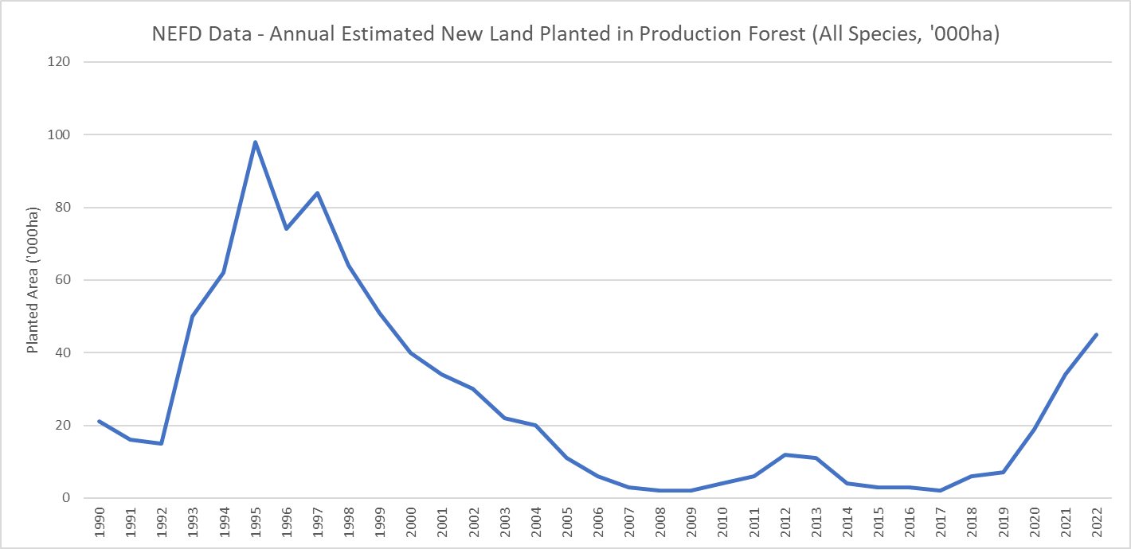
Figure 2 shows the new land planted in production forest (all species) in New Zealand annually over the longer time period of 1921 to 2022. It is shown cumulatively, although care is needed in relying on this as it expected to double count some land planted across harvest cycles. Contrasting this cumulative data is the total planted production forest area (all species) between 1921 to 2022. This is a snap-shot each year and excludes land that is destocked (harvested) at the time and removes land that has been deforested.
For most of the last century, the total planted production forest area is in line with the annual cumulative new land planted in production forest. However, from the early 2000s, the year-on-year change in the planted production forest area gradually declined, and the spread between the cumulative new land planted in the production forest area and the annual planted production forest area widened, suggesting that annual harvested and deforested areas were larger that new planted areas. A key observation from this data is that the total planted area of exotic plantation forest has not substantially changed in the last two decades (and is still below the peak planted area). There are signs of minor net growth in area since 2019, examined further below.
Figure 2: Planted plantation forest area by year compared with cumulative new land planted in plantation forest
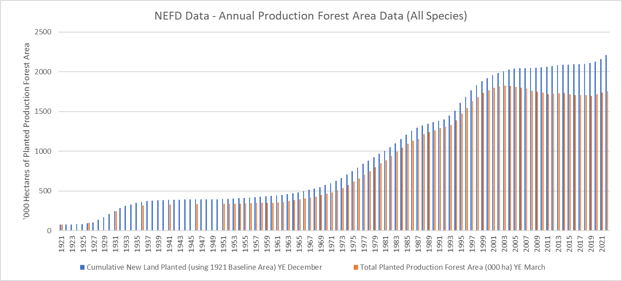
Table 1 focuses on more recent trends in productive forest area in the NEFD data. As at 2022, there was an estimated 1.76 million hectares of plantation forest area. While not shown in the table, the latest NEFD report indicates that there is approximately another 50,000 ha awaiting replanting (so a total area of land used for plantation forestry of 1.81 million ha. The planted area has increased by just 3% since 2019, growth of just under 53,000 ha. By species, the productive plantation forestry is dominated by Pinus Radiata, at 90% of the total. Douglas Fir makes up just 6% and other exotic hardwood and softwood species combined make up 4%. This distribution has been stable in recent years and is unlikely to materially change in future unless there are fundamental shifts in demand for different types of timbre.
Table 1: Annual Estimated planted plantation forest area by all species 2018-2022 (total New Zealand)
The annual Afforestation and Deforestation Intentions Survey (MPI) is one source of data that focusses on afforestation, and provides some insight on the split between plantation and ECCF afforestation. The survey collects data on intended planting, and this can subsequently be compared with actual planting estimates the following year. The total intention for exotic planting in 2021 was 45,200 ha, with actual 2021 afforestation just below that at 41,500 ha. This was split 83% (34,600 ha) plantation and 17% ECCF (6,900 ha).
For 2022, the intended exotic afforestation area was stated as 63,300 ha (indicating 52% growth on the previous years’ planting), but at the time of publishing the report (May 2023), just 47,900 ha had been confirmed (although this is still net growth over 2021 afforestation). If the 2022 intentions are realised in full, the indication was that 84% (53,100 ha) will be for plantation forestry and 16% (10,200 ha) will be ECCF (a 47% increase on the previous year).
While the Intentions Survey data on afforestation of exotic plantation forestry does not directly match the production forest data in the NEFD, the actual plantation afforestation in 2021 indicatively represents a 2% increase in national planation forestry area if added to the 2020 productive forest area, so a slow rate of annual growth. The actual plantation afforestation in 2022 indicatively represents a 3% increase in national plantation forestry area if added to the 2021 productive forest hectares, so a minor increase in the previous years’ rate of growth. Using the intended plantation afforestation for 2023 applied to the 2022 NEFD base, shows a 5% annual growth rate. The growth rate is therefore on the rise, and with 80,860ha of intended plantation afforestation in 2023 according to the latest Intentions Survey, this level of change is getting closer to the 1995 peak of new area planted in production forestry.
Data on the current total area of ECCF is more difficult to confirm (and we have not found a data source for this baseline). As such, we cannot quantify an annual growth rate.

Location of production forestry across Aotearoa
The exotic plantation forestry estate is concentrated in the North Island – making up 71% of total forested area according to the NEFD data. This is the share across all species, but when looking at just Pinus Radiata, the North Island makes up 75% of the national total (96% of exotic plantation area in the North Island is Pinus Radiata, with only 1% Douglas Fir and 3% other exotic species). While the South Island makes up just 29% of exotic plantation forestry area in 2022, it has a different mix of species. Pinus Radiata still dominates with 77%, but Douglas Fir makes up 16% of the South Island total, and other species (including Eucalypt) make up 7% - reflecting the different growing conditions as you move further south.
The North Island has had an above average share of exotic plantation forestry area growth between 2018 and 2022, with 75% of the increase during that period. Within the North Island, this growth is not evenly distributed. Despite having 11% of the total exotic plantation forest area in 2022, the Northland Wood Supply Region accounted for 24% of recent national growth (around 12,500 ha over 5 years focussed in Far North District and Kaipara District). Similarly, the Southern North Island Wood Supply Region accounted for 30% of national growth in plantation forest area 2018-2022 despite having just 10% of the total estate in 2022. Key growth districts in that region were Masterton, Carterton and Horowhenua. The other key growth region was the Otago and Southland Wood Supply Region which accounted for 25% of 2018-2022 growth, despite only having a 13% of total plantation forest area in 2022. This growth was concentrated in Clutha District and Southland District.
Conversely, the Wood Supply Region that plays the most significant role in the plantation forestry estate as at 2022 (Central North Island, with 32% of the productive area) accounted for just 3% of national growth in net stocked area between 2018 and 2022. There may be several reasons for this, including unavailability of suitable land, the age of the trees (i.e. large areas currently destocked), deforestation or forests switching from plantation to ECCF. This has not been examined further.
The 2020 Afforestation and Deforestation Intentions Survey published data on the average share of exotic afforestation by NEFD Wood Supply Region for both plantation and permanent (ECCF) forestry (Figure 3). While the data suggests that there is a lot of variation of these trends year on year, the 2019-2021 data showed quite different spatial patterns between forest type, with the East Coast Wood Supply Region making up 7% of national plantation afforestation in that period, but 31% of ECCF afforestation. Exotic afforestation in the Southern North Island was also heavily weighted towards ECCF in those years. Elsewhere, planation forestry still dominated new exotic forestry land, or it was more evenly split (as in the Central North Island).
Figure 3: Average Share of Exotic Afforestation by Forestry Type 2019-2021
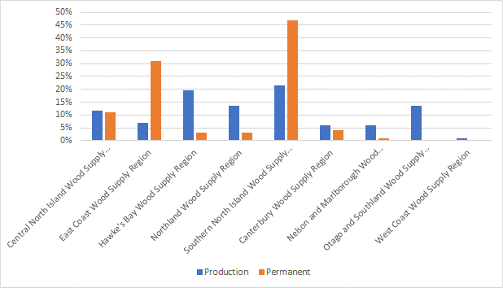
To put those percentage distributions into perspective, we have indicatively applied them to the stated (actual) 2021 afforestation for plantation and permanent forests published in the 2022 Intentions Survey (34,600 and 6,900 ha respectively). While the actual spatial distribution may have been different in 2021, Figure 4 suggests that exotic afforestation in the East Coast Wood Supply Region could have been roughly equal between plantation and ECCF growth that year. In the Southern North Island Region, ECCF afforestation may have been 30% of the total that year. Elsewhere, ECCF afforestation may have made up between 0-16% of the total.
Figure 4: Indicative Exotic Afforestation by Forestry Type 2021 and Wood Supply Region
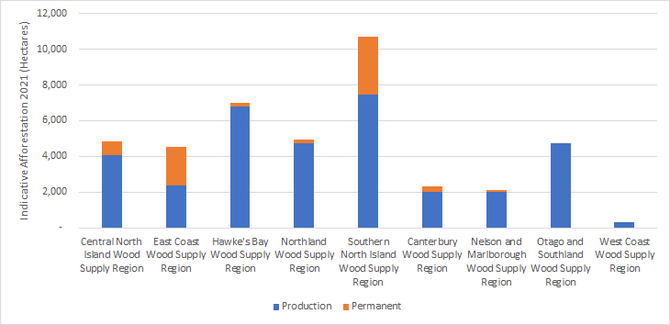

Nature of land planted in exotic forestry
MfE has supplied a spatial (GIS) dataset that intersects the following data:
- 2016/2017 land use from the LUCAS NZ Land Use Map,
- land use capability (LUC) from the NZLRI 2021,
- erosion susceptibility classification (ESC) from the NES-PF, and
- land tenure (an amalgamation of Department of Conservation (DOC) public conservation areas, Crown land, Māori Land Court land, Treaty Settlement land and general land).
The land use data comprises classes that can be summarised according to natural forests, planted forests, grassland with woody biomass, producing grassland (high and low combined), cropland, wetlands, settlement, other, and not classified. Our focus is on the planted forest area and how this intersects with the other spatial layers. We note that the total area of planted forest in the data (measured in the summer of 2016/2017) is 2.15 million ha, so is higher than the net stocked areas at that time according to the NEFD data (which was around 1.71 million ha (excluding harvested area awaiting replanting). The differential cannot be explained by harvested area alone. Accordingly, our focus is on the spatial patterns in the data in 2016/2017, rather than the quantum of land. The data collection method does not distinguish plantation from ECCF – only the appearance of planted exotic forests.
Planted Forestry Land and ESC
Figure 5 shows that 41% of the country is green zone land (low erosion risk), 22% is yellow zone land (moderate erosion risk), 19% is orange zone land (high risk) and 13% is red zone land (very high risk). The distribution of planted forestry land is approximately commensurate with the distribution of green and orange zone land, but has an above average propensity to locate on yellow zone land (37% of forestry land), and a below average propensity to locate on red zone land (7% of forestry cover). Overall, of the land available, planted forestry occupied just 7% of green and orange zone land, 14% of yellow zone land and 4% of available red zone land.
Figure 5: Planted forest land cover (2016/17) across erosion susceptibility class (ESC)
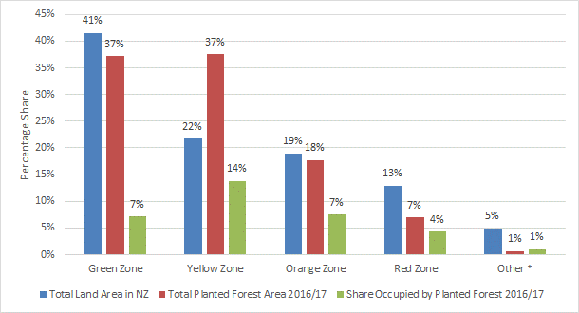
While this seems like only a low share of red zone is being used for planted forestry, it is relevant than 83% of red zone land is DOC land. Just 1.7% of planted forestry area is located on DOC land, so on the assumption that DOC land is generally unavailable for planted exotic forestry, then this leaves just 17% of red zone land theoretically available for exotic forestry land use (and includes 2% in Crown ownership). When considered this way, planted forestry occupied 25% of non-DOC red zone land in 2016/17. Notably, this reflects forestry land use patterns before the NES-PF came into effect, which includes more stringent rules for exotic plantation afforestation on red zone land (and other locations that may include red zone land).
Planted Forestry Land and LUC
The NES-PF does not seek to directly control forestry according to the LUC class, but indirectly does this via the ESC. As slope and soil type are key influences of LUC class, there is a strong and expected correlation between ESC classes and LUC classes. For example, 89% of red zone land falls within LUC 8 (see below for an explanation of LUC classes); 44% of orange zone land falls in LUC 8 and 51% in LUC 7; 60% of yellow zone land falls in LUC 6 and 35% in LUC 7. The distribution of green zones land is however more spread across LUC classes: 34% is within LUC 1-3 (highly productive land), 26% is in LUC 4-5, 33% is in LUC 6 and 7% is in LUC 7-8. This means that the NES-PF’s enabling approach on green zone land, does not effectively direct exotic forestry to particular LUC classes.
Legend – Land Use Capability Classifications
LUC Class 1: Suitable for a wide range of crops (0.7% of NZ land area)
LUC Class 2: Suitable for many crops (4.5% of land area)
LUC Class 3: Restricted range of crops, intensity of cultivation is limited (9.2% of land area)
LUC Class 4: Occasional cropping but reduced range of crops and intensity of cultivation (10.5% of land area)
LUC Class 5: Non-arable, high producing (0.8% of land area)
LUC Class 6: Non-arable, suited to grazing, tree crops, & forestry (28.1% of land area)
LUC Class 7: Non-arable, with soil conservation measures suited to grazing & forestry in some cases (21.4% of land area)
LUC Class 8: Unsuitable for arable, pastoral or commercial forestry use (21.8% of land area)
Figure 6: Exotic forest land cover across Land Use Capability (LUC) classes 2016/17
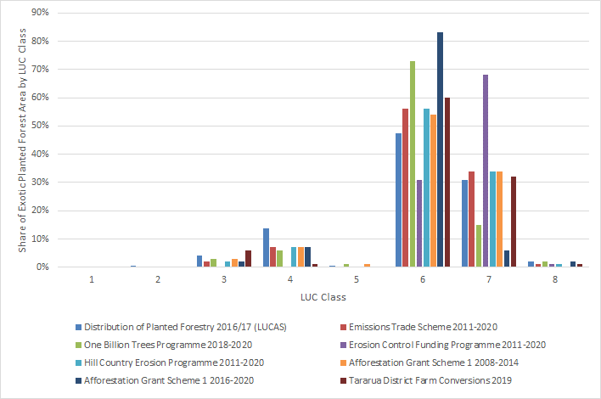
Figure 6 shows the distribution of total 2016/17 planted forestry area by LUC class nationally alongside the distribution of new planted areas of exotic forestry under a number of MPI afforestation programmes that have run for different time periods. Overall, the trends indicate that exotic afforestation has consistently targeted LUC 6 and 7 land, and only a small amount of LUC 4 land, and negligible highly productive land (i.e. LUC 1-3). LUC classes 6 and 7 comprise mainly hill and high country land. Aside for forestry, this land type is widely used for sheep and beef farming (including strong and fine wool), particularly breeding and breeding/finishing farms, and deer. In parts of the country LUC 6 and 7 land is also used for dairying, orcharding and vineyards.
There is little evidence to suggest that concentrating exotic afforestation on LUC 6 and 7 class land will not continue in the future. Based on landcover areas in 2016/17, there was around 6.1 million hectares of LUC 6 and 7 land still in some form of grassland (or grassland with woody biomass). Not all of this land will be suitably located for exotic forestry (with growing conditions critical). Conservatively, the portion that falls within the key plantation forestry areas (i.e. districts that make up 72% of the net stocked plantation forestry area in 2022) equates to 2.9 million hectares of potentially available and suitable LUC 6 and 7 land.
Overall, the quantum of unforested LUC 6 and 7 grassland in proven exotic forestry areas indicates that there are no foreseeable constraints that might start to direct exotic forestry onto more versatile/productive land in the long-term future. Furthermore, according to the NZ Farm Forestry Association, radiata pine is best avoided on high fertility sites because the trees grow too fast, with shallow roots and bigger branches which creates poor form, makes them more subject to breakages and windthrow. These are all relevant deterrents for plantation forestry at least.
It is acknowledged that as the price of carbon units under the Emissions Trading Scheme increases, the economic value of farmland for farming changes, which could potentially see more whole of farm conversions in future, not limited to hill country/high country farms. However, there is insufficient data to predict this with any certainty. To date, forests registered under the ETS have continued to occur on LUC 6 and 7 land (Figure 6).

Tenure of forestry landcover
While the exotic forest estate is characterised by a number of large-scale forests owned by a few big companies, about 30 percent is owned by smaller growers, often as part of a farming operation or as a syndicate. Both corporate and small-scale growers supply domestic processing and export markets. These ownership patterns are largely based off plantation forestry data. The mix of scale and ownership of ECCF is less understood at present.
Based on planted forest area in 2016/17, 61% is located on general owned land (Figure 7). General land makes up around 53% of the country, showing that planted forestry has a greater propensity to occur on general land, although it makes up just 9% of all general land. While DOC land makes up 32% of land area, it makes up just 2% of planted forestry area. Crown land is also a minor share of New Zealand (6%) and 4% of planted forestry is on Crown land (making up just 5% of the total).
Māori are a significant stakeholder in the forestry industry, owning NZ$4.3 billion of assets in forestry and have ownership of around 33% of land under plantation forestry in 2016/17 (split 9% on Māori Land Court land and 24% on Treaty Settlement land). A substantial 14% of Māori Land Court land is used for planted forestry (2016/17) and significant share (54%) of Treaty Settlement land is used for planted forestry.
Figure 7: Exotic forest land cover 2016/17 by tenure of land
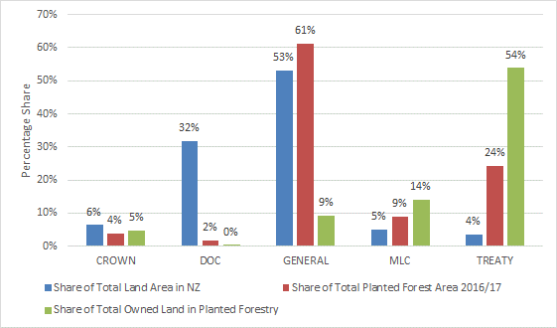
An estimated 9% of Māori Land Court land falls within red zone land, compared to 3% of general owned land, meaning that Māori Land Court land is relatively more disadvantaged by the afforestation rules in the NES-PF for afforestation on red zone land (restricted discretionary when over 2ha/annum), although this disadvantage is only minor given that the significant majority of that land (83%) falls on green, yellow and orange land, where afforestation is more permissive. Further, while Māori owned land makes up only a small share of total land area, nearly 70% of that is LUC 6 and 7, so provides good opportunities for exotic forestry.

Overseas investment in farm conversion to forestry
This analysis examines the immediate previous four years of activity for overseas investment in farm conversions for forestry. This is key to supporting evidence published by some districts on recent and increasing farm losses to forestry.
The assessment draws from data provided by LINZ from the Overseas Investment Office (OIO) relating to farm conversion information throughout the 2019 to 2022 period. It consists of approved consent applications under the Overseas Investment Act for farm purchases seeking conversion to forestry and includes the indicative area that is to be planted on those properties. For clarity, this data does not represent all farm conversions for forestry taking place in New Zealand during that period, as there may be transactions that are wholly carried out by domestic investors/landowners that are not captured.
The data does not show whether the proposed forestry planting is for plantation forestry or ECCF, or what species is being planted. There may also be a delay in when proposed planting occurs, so the data is only an indication of afforestation (that includes overseas ownership). As noted by LINZ, some acquired farmland may have been partly disposed of, with a portion not proposed to be planted on-sold as residential properties or productive farmland (or both). In a few cases, up to half of the total land area acquired under the consents may have been subdivided and sold rather than used for forestry. This data allows analysis at the national level, along with analysis of the key districts that have experienced these applications.
Figure 8 shows a significant increase in the number of farm conversion applications approved by the OIO, particularly from 2020. Since (and including) 2019, a total of 86 such applications have been approved according to the data (this includes 10 applications where the year approved was unknown/unspecified). The North Island had 69 and the South Island had 17 approved applications.
Figure 8: Approved applications for farm conversions to forestry with overseas investors by year
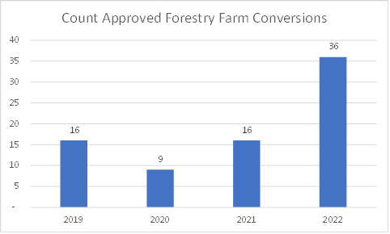
Figure 9 shows trends in terms of the total area of land purchased for forestry conversion in the approved consents. Notably, the year 2022 witnessed a surge in the total area of land purchased for farm conversions to forestry, with over 28,000 ha of total land area for farm conversion being acquired by the overseas owners. This marks a significant increase over the previous two years. Further monitoring of OIO farm conversion applications will confirm if this rate of growth is an outlier, or the beginning of a sustained trend. It is noted that recent changes to the OIO approval process (with applicants now needing to demonstrate a benefit to New Zealand) is expected to make new applications more uncertain, costly and harder to get approved. This may suggest that the recent trend won’t be sustained.
Figure 9: Total area of land purchased for farm conversions to forestry with overseas investors by year
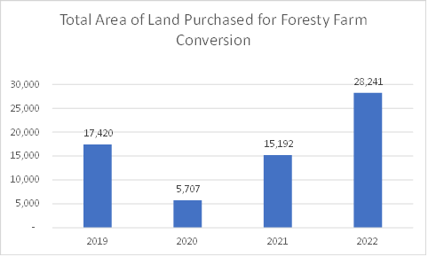
Further analysis of the total approved applications between 2019 and February 2023 (including year unknown records) reveals that the average farm size purchased was 815 ha. The maximum and minimum farm sizes purchased during this period were 2,019 ha and 285 ha.
A district level examination offers a deeper understanding of the key districts that experienced the largest change in recent years. From 2019 to 2022 (including the years unknown records), the Gisborne District had one of the largest increases in activity related to farm conversions to forestry (with overseas owners). In 2019, there were 3 applications for farm conversions with overseas investors approved for a total area of approximately 1,920 ha, while in 2022, 5 applications for farm conversions were approved for a total area of nearly 9,600 ha, representing a 400% increase in farm area purchased through the OIO between 2019 and 2022.
In 2022, Gisborne District accounted for 14% of total approved applications by the OIO in that year. Table 2 shows that the average application farm area in Gisborne was 1,920 ha in 2022. The proposed planting area for the same year reached a total of 6,390 ha. This represents a 67% share (on average) of purchased farmland being proposed for forestry planting – an average share lower than in previous years and suggesting that about a third of the properties may have been retained for farming, residential dwellings or other uses.
Table 2: Recent applications for farm conversions to forestry approved by the OIO in Gisborne District
The national trends for the total area of land proposed to be planted for forestry on purchased farms is set out in Figure 10. As expected, based on the national trends for applications approved and total farm area purchased, there has been a significant increase in total proposed planting area on approved farm conversions in the past three years. In 2022, the total proposed planting area was just under 20,000 ha, spread across a range of districts. This reflects a change of approximately 51% or an increase of just over 9,800 ha compared with the area proposed for planting in 2019 applications. Based on all approved applications between 2019 and February 2023, the average farm area to be planted for forestry was 539 ha/application, with the maximum sized planting area being just over 1,520 ha and the smallest planting area being proposed at around 160 ha.
Figure 10: Total area of land to be planted for forestry on farm conversions with overseas owners
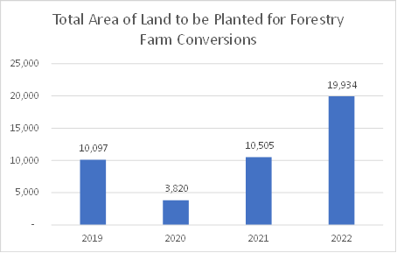
Figure 11 shows that the average share of land used for afforestation on farm conversion properties with overseas investors has ranged from 58% to 72% between 2019 and 2022. While the average share of farms used for afforestation has gradually increased over the last four years, the data suggests it has started to plateau at around 70%. Again, further monitoring of this data will confirm this observation (or not). While the data provides no insight on what the remaining 30% (on average) of purchased farmland is being use for (or retained as), for those stakeholders concerned with loss of rural households or loss of highly productive land as a result of afforestation, it is possible that at least some of this is being retained despite these transactions.
Figure 11: Average share of total land purchased to be planted for forestry on approved farm conversions with overseas owners
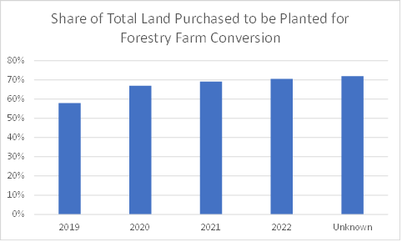
While some districts follow national trends, other districts have had different experiences with respect to applications with overseas investors. It is also important to note that wholly domestic farm conversion to forestry investment may have differing spatial patterns from those analysed where with at least one overseas owner. Figure 12 shows the breakdown of proposed planting area by district and year for applications approved by the OIO. The districts experiencing the greatest investment by overseas interests for farm conversion (by planted area) are Gisborne, Masterton, Wairoa, South Wairarapa, Central Hawke’s Bay and Clutha District. Several other districts have also had applications approved in 2021 or 2022 only, but do not show a consistent trend over the last four years.
Figure12: Total area of land to be planted for forestry on approved farm conversions with overseas owners by district and year
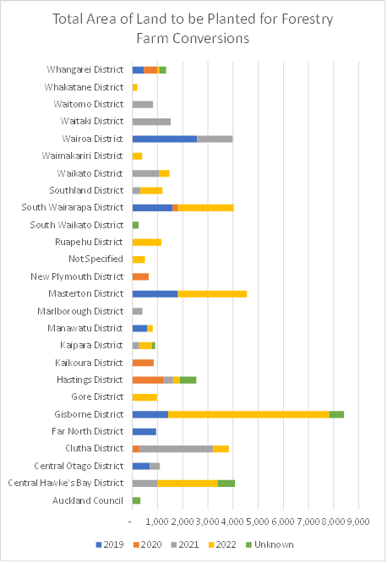
While this data provides some insight on recent and proposed afforestation of farmland where there is an overseas owner (and prior to recent changes in the legislation), it is important to acknowledge that both the number of farms purchased since 2019 and the area proposed to be planted represents just a fraction of farm properties and total land area in each respective district. In Gisborne, where the largest area of forestry planting was approved, the cumulative total from 2019 makes up around 1% of the land area of the district and about 3% of low and high producing grassland area. The precise share of total recent (or planned) afforestation area that these OIO applications make up is uncertain.

Future growth in exotic forestry

Scale of projected exotic afforestation
Patterns of land use continuously change and the area of land in forests is expected to increase in response to climate change and economic incentives. Exotic forests, including plantation and the more recently emerged ECCFs, have a vital role to play as Aotearoa New Zealand transitions to a low-emissions economy. The Government’s first Emissions Reduction Plan establishes the following vision for forestry:
‘By 2050, Aotearoa New Zealand has a sustainable and diverse forest estate that provides a renewable resource to support our transition to a low-emissions economy. Forestry will contribute to global efforts to address climate change and emissions reductions beyond 2050, while building sustainable communities, resilient landscapes, and a legacy for future generations to thrive.’
Elements of this vision include:
- forests continue to play a critical role as carbon sinks, directly offsetting emissions, and as a sustainable source of high-value, low-emissions materials, and bioenergy, which form a key part of our low-emissions economy;
- much of our remote, unproductive and highly erodible land is forested (including with indigenous forests), providing a long-term carbon sink to offset emissions that are hard to reduce and remove;
- forests and forest products support the cultural, environmental and economic aspirations of Māori, hapū and iwi.
Net afforestation is the mechanism used to assist Aotearoa New Zealand to meet national objectives for a low-emissions future. "Future afforestation and deforestation rates are subject to uncertainty in land availability and price, landowner preferences, the impact of carbon price, seedling and labour availability, requirement for Overseas Investment Office approval, government policy, and local council regulation”. As such, projections of exotic afforestation are highly sensitive to the inputs to those models, with many of those inputs, including carbon price and policy settings changing regularly.
Medium-Term Projections
One source of medium-term projections is the Afforestation and Deforestation Intentions Surveys prepared for MPI. These surveys acknowledge that most survey respondents are more comfortable indicating their afforestation intentions just one year ahead. Nonetheless, the reports provide a 10-year projection. In the 2021 Intentions Survey report, the extrapolated low projections for total exotic afforestation between 2021 and 2030 was 351,100ha. However, one year on, and that same projection increases to 542,700ha between 2021 and 2030, as summarised in Figure 13.
Figure 13: Medium-term exotic afforestation projections 2021-2030 – Afforestation and Deforestation Intentions Survey 2021 vs 2022 (low projection)
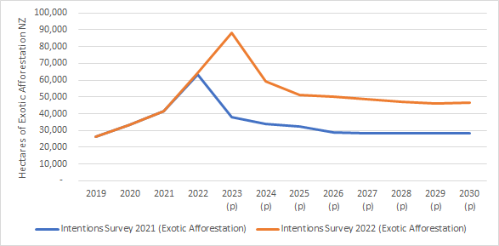
Taking the latest 2022 report projections and applying the actual split of plantation and ECCF afforestation for 2019-2023, and holding the 2023 intended split of forest type constant to 2030, Figure 14 shows the relativities between plantation and ECCF in hectares each year on the left, and the cumulative growth in area (from a 2019 baseline) on the right. Data collected in the Survey indicated that while carbon prices and policy settings are uncertain, the general advice given to prospective investors in afforestation is to “keep their future options open” (page 9) and this means that plantation is still the preferred approach of most. Figure 14 shows that cumulative growth in afforestation for plantation forestry between 2021-2030 is projected at 457,000ha compared to 86,000ha for ECCF in that period.
Figure 14: Medium-term exotic afforestation projections 2019-2030 – Afforestation and Deforestation Intentions Survey 2022 (low projection) - hectares
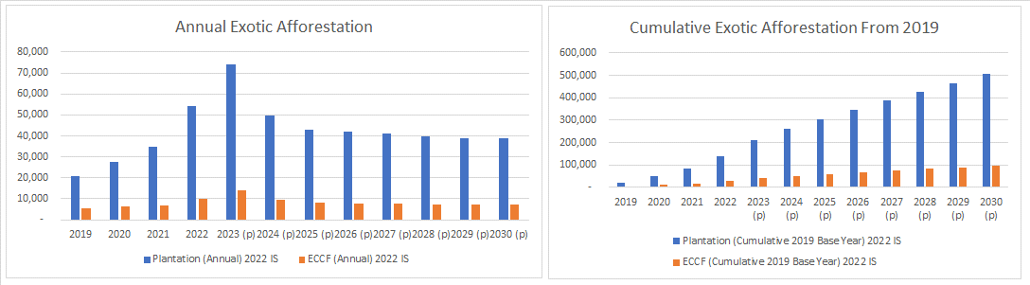
Long-Term Projections
Long-term projections of afforestation are even less reliable than medium-term projections. There are a range of reports and models that have been commissioned for different purposes that project afforestation. For this S32 report and CBA, we have relied on the projections contained in the following report: 2022 LULUCF Accounting Projections, MPI, April 2023. We note that among other things, this report incorporated data from the 2021 Intentions Survey (which as shown above, has now been superseded by higher medium-term projections in the 2022 Survey). However, given the uncertainty and sensitivity across a range of variables, the report is still considered a reasonable basis for understanding the potential order of magnitude of both plantation and ECCF afforestation out to 2050.
Table 3 summarises exotic afforestation according to three scenarios. Total exotic afforestation between 2021-2050 ranges from an estimated 921,000ha to 1.35 million ha, with plantation forestry accounting for between 66% and 82% of the total. This is a long-term average rate of around 25,000-32,000ha per annum for plantation forestry and 7,000-16,000ha per annum for ECCF.
Table 3: Long-term exotic afforestation projections 2021-2050 (total New Zealand)
To put this projected afforestation over the long-term into perspective:
- Applied to the 2020 planted production forest area (NEFD), the projected growth in plantation afforestation (and not accounting for a small amount of projected deforestation) indicates that by 2050, the area of plantation forestry could indicatively be between 2.4 million and 2.6 million hectares (total growth of 44-57%).
- The projected plantation afforestation would indicatively take up between 12-15% of the estimated 6.1 million hectares of remaining LUC 6 and 7 grassland across the country, or 25-33% of the remaining LUC 6 and 7 grassland that falls with the districts that make up 72% of the current exotic forestry estate.
- The projected ECCF afforestation would indicatively take up between 3-7% of the estimated 6.1 million hectares of remaining LUC 6 and 7 grassland across the country, or 7-16% of the remaining LUC 6 and 7 grassland that falls with the districts that make up 72% of the current exotic forestry estate.
- Combined, the projected exotic afforestation would indicatively take up between 15-22% of the estimated 6.1 million hectares of remaining LUC 6 and 7 grassland across the country, or 32-47% of the remaining LUC 6 and 7 grassland that falls with the districts that make up 72% of the current exotic forestry estate.
When considered relative to the total land area nationally, the area potentially taken up by exotic afforestation over the long-term is only a small percentage.
Importantly for this S32 and CBA report, these national growth projections for plantation and ECCF afforestation are part of the status quo future for the exotic forestry sector. The potential effect of the proposed amendments to the NES-PF (individually and in combination) on this status quo future is discussed further in the CBA and the evaluation of proposed provisions.

Location of projected growth in afforestation
MPI has commissioned sophisticated modelling to try and project exotic afforestation by type and the location of that afforestation over the long-term. While the model was able to replicate known recent total afforestation area with sufficient accuracy, and could estimate the economic conditions that would support plantation versus ECCF planting, the model was less accurate at projecting location when compared with recent data.
The location of future afforestation will be driven my multiple factors not limited to:
- Suitable land (although expected to be mainly LUC 6-8 land not in the red zone)
- Land tenure (which affects freehold ownership of forests or leasehold arrangements)
- Location of land, with locations to ports a key factor for plantation forestry, but accessibility of the land a relevant factor for both plantation and ECCF
- Availability of land (i.e. to secure land for sale or lease, landowner intentions)
- Price of land (which influences forestry profitability)
- Forestry infrastructure (including access to labour and other resources)
- Carbon stocks (i.e. the ability of forests in different regions to sequester carbon and revenue from carbon under the ETS – affects profitability)
- The ease of proof of post-1989 land status (to qualify as carbon forestry under the ETS)
- Local authority regulations, including application of greater stringency than applied in the NES-PF.
Given the challenges of putting long-term afforestation projections ‘on the ground’, this S32 and CBA report has chosen not to attempt to develop spatial scenarios of future afforestation for the purpose of understanding the status quo. This would require a level of detail that exceeds the significance of the effects we are trying to understand as a result of the proposed amendments to the NES-PF. That said, the following spatial assumptions have been adopted for the status quo scenario:
        - Afforestation (both plantation and ECCF) will continue to be located on LUC 6 and 7 land for the foreseeable future.
        - Afforestation will be spread across a large number of districts, and likely pro-rata current patterns of plantation and ECCF forestry as this largely reflects suitable growing (and other economic) conditions.
As above, these assumptions about the future spatial distribution of plantation and ECCF afforestation are part of the status quo future for the exotic forestry sector. The potential effect of the proposed amendments to the NES-PF (individually and in combination) on this status quo future is discussed further in the CBA and the evaluation of proposed provisions.

Appendix B – Cost benefit analysis

1 Introduction
This report, prepared by Market Economics (M.E) for the Ministry for the Environment (MfE), provides an indicative cost benefit analysis (CBA) of the proposed amendments to the National Environmental Standards for Plantation Forestry (NES-PF) to determine if they are likely to be an efficient way to achieve the objectives of the NES-PF (which have also been amended and are discussed further in the main body of the S32 report). Efficiency as defined in S32 of the Resource Management Act (RMA) requires that anticipated benefits of introducing new regulation outweigh the anticipated costs (and risks).

1.1 Approach to CBA
The purpose of this CBA is to inform the evaluation of provisions set out (in summary-form) in the main body of the S32 Report. The CBA should be read in conjunction with Appendix A, which provides much of the data, analysis and context upon which costs and benefits have been identified or based.
While a CBA on new or amended national direction would normally be based on the amendments as drafted in the relevant instrument, this is not the case in this instance. M.E has based this CBA on the recommended ‘direction’ of proposed amendments as set out in a draft Recommendations Report (Recs Report), as well as communication that has subsequently refined some of that direction leading up to the actual drafting of changes. Some of that direction on proposed amendments have been informed by public consultation/submissions on the Discussion Document, but not all. Some of the decisions in the Recs Report have been developed from suggestions by selected parties in submissions but not tested through public consultation (this includes charging for compliance monitoring for permitted activity afforestation). Te Uru Rākau (TUR) has sought some further expert evidence to help refine the recommended amendments (this includes assessment on a slash standard for the cutover, as well as two river crossings, and flood flow calculations). While the economic assessment on the slash standard was supplied to M.E, there has been insufficient time for M.E to account for that. Key costs are however reflected in the main body of the S32 Report.
Importantly, the actual drafted amendments (as they will appear in the NES-PF) were not available at the time of drafting. As such, M.E has had to anticipate what some amendments will mean in practice. It is possible that our interpretation of some proposed amendments will differ from those drafted. In light of the timing in which this CBA has been prepared (relative to the timing of drafting), this CBA is considered indicative only.
While care has been taken to try and understand the context within which the proposed amendments will apply in practice (i.e., tangible outcomes), M.E recognises that our knowledge of the forestry sector, and the legal and regulatory framework that influences the forestry sector, is by no means comprehensive. A considerable level of expertise would be needed to understand all costs and benefits and measure those accurately where the amendments are technical in nature. Achieving that level of understanding is not practicable for this report. We also accept that there is a vast amount of research that could be drawn upon to inform this CBA, and we are likely to have only scratched the surface of collating relevant data.
This CBA does not conclude in a national level Benefit Cost Ratio (BCR) as set out in the Treasury guidance to inform Cabinet decision making. This is due to the unique nature of the cost and benefits arising from the proposed amendments to the NES-PF, some of which remain uncertain and/or do not lend themselves to practicable or robust quantification in monetary terms. The costs and benefits of the proposed amendments are expected to vary within, and between, regions and districts. This too makes it challenging to estimate costs and benefits at a national level.
As a result, this report presents a discussion of costs and benefits, some quantified, some monetised and some qualified. This approach is generally consistent with the way in which costs and benefits are assessed in S32 evaluations under the RMA, and the key purpose of this CBA is to inform the S32 Report. Examples are provided where possible to help demonstrate how costs and benefits are likely to apply, and at what general scale and significance. Some further modelling has also been carried out, building on data contained in Appendix A and incorporating some additional data sources. Where time has allowed, M.E has ground truthed some data and assumptions with representatives of the forestry industry. This CBA also draws on information gathered from the workshop with local authorities (July 2023), as well as further information supplied by MfE, MPI and TUR. Ideally, further ground truthing would be sought to confirm the costs and benefits identified. Again, the assessment is not comprehensive, but limited to what could be achieved in the time available.

1.2 Scope of CBA
The main body of the S32 report sets out the proposed direction of amendments in more detail and that is not repeated here. A number of tranches of amendments have been proposed, but this CBA considers amendments in the following 3 tranches only.
- Tranche 1: The purpose and scope of the revised NES-PF
- Tranche 2: Operational Improvements
- Tranche 3: Controlling the location of forests
A number of Tranche 2 Operational Improvements proposed in the amendments that are considered to have minor tangible consequences for forestry practice and regulation/management (and that generally move in the direction of ensuring best practice) are not covered in this CBA. These are listed below and are discussed at a high-level in the main body of the S32 report only:
- River Crossings – minor amendments and replacement flood estimation tool,
- Treaty Settlement Areas – changes to matters of discretion,
- Notice Periods – changes for earthworks in green and yellow ESC zones,
- Traffic Management – repeal regulation 57, and
- Forestry Planning Requirements – incorporates existing Forestry Management Plans, includes management of afforestation and replanting as well as some additional mapping and information requirements provided in sufficient detail to demonstrate compliance with permitted activities.
The Tranche 2 Operational Improvement for slash management includes some minor points of clarification and a proposed amendment as follows:
Slash from harvesting that is sound wood must be removed, unless it is unsafe to do so, from orange zone land and red zone land that is not of Land Use Capability Class 8e, where it involves no more than 2 ha of harvesting in any 3-month period if it has —
(a) a length of over 2 m; and
(b) a large-end diameter of over 10 cm.
A residual volume no greater than 15 m3 of wood per hectare of this size or greater may be left on the cutover.
This is a proposed permitted activity condition, with non-compliance resulting in a controlled activity consent. While this proposed amendment is expected to have tangible consequences for forestry practice and local authority administration of consents, the proposed provision was provided only shortly before this CBA report was due to be finalised. There has been insufficient time to provide a robust assessment of costs and benefits for this CBA. Furthermore, TUR have already commissioned one preliminary expert report on this proposed amendment, which examined potential economic costings of slash removal at different size thresholds. We understand that this costing work was indicative and that more work may be needed to develop a sound understanding of costs relative to status quo practice (including variations across the country). M.E cannot add value to those assessments. We consider that presently central government are best informed (despite information gaps) to understand the potential costs and benefits of the proposed slash amendment at this current point in time. As such, we do not cover it in this report. The proposed amendments for slash management at harvest are discussed at a very high-level within the main body of the S32 report, including their potential costs and benefits. M.E has had input to that high-level evaluation.
Tranche 2 Operational Improvements that are assessed in this CBA are:
- Additional information requirements in afforestation notices, and
- Wilding tree risk management.
Costs and benefits attributable to the proposed amendments to the NES-PF will manifest spatially and temporally, and are borne by a range of stakeholders, often in different ways. The CBA aims to assess costs and benefits at the national level, with consideration given to sub-national distributions where practicable. The CBA assumes 2023 is year 1 of the proposed amendments coming into effect. On the basis that existing long-term projections for the forestry sector (Appendix A) provide an outlook to 2051, this is the long-term horizon within which costs and benefits have been considered (unless otherwise specified). A discount rate of 5% has been used to express monetised costs in 2023-dollar terms. The key stakeholder groups considered in the CBA are:
- Central government (including crown agencies and departments).
- Local authorities – being regional, unitary and territorial authorities,
- Private landowners (or leaseholders) who are carrying out forestry (foresters). This includes exotic plantation forestry and exotic continuous-cover forestry (ECCF).
- Participants in resource management processes (other than local authorities). This group includes members of the public that participate in hearings on plan changes or notified consents, non-government organisations (NGOs) that advocate for industry or other interest groups in plan changes and notified consents (and national regulation), and businesses that provide services to foresters to achieve approvals and compliance.
- The wider public. Includes all landowners and community members, including tangata whenua. Can also include visitors/tourists.
The proposed amendments to the NES-PF can be considered as a ‘bundle’ but equally, some proposed changes could progress to drafting, and some may not. M.E has therefore approached this CBA sequentially, and in the tranche order (and operational improvement order) specified above. That is, the costs and benefits of bringing ECCF into the scope of the NES-PF (and other changes in scope) are assessed first, and then the operational improvements are assessed as if ECCF is already included, so only the net effect of those changes on ECCF are assessed at that point. This approach avoids double counting of cost and benefits but does require that the cumulative costs and benefits of all provisions that do make it to the drafted amendments are taken into account.

1.3 The status quo scenario
As with all CBAs, it is necessary to assess the net effect of proposed changes in policy, funding, or investment. That is, the costs and benefits that would occur over and above what may be expected to occur without any amendments (i.e., the status quo). The status quo scenario is not limited to today, but can be forward looking. This no-amendment future is often referred to as the counterfactual scenario.
It is important to establish what outcomes/future may be expected under the status quo scenario in order to appropriately attribute costs and benefits to the proposed amendments. Central to this CBA is that projected growth in afforestation, harvesting activity and replanting, and the underlying economic incentives of that growth are part of the status quo scenario. As such, this CBA need not consider the merits or otherwise of the settings in the Emissions Trading Scheme, or the Overseas Investment Office, or the costs and benefits of plantation or exotic continuous-cover forestry per se, or its growth. Farm conversions to forestry are implicit in the status quo growth afforestation projections, and with that come a range of potential economic, social and environmental changes. Such outcomes form part of the assessment baseline.
Similarly, some local authorities may have sought to amend their Plans to better manage some of the same effects that the proposed NES-PF amendments seek to manage, even without the proposed amendments. Some of those plan changes are already underway or are in the early planning stages, and the effects (including costs) of those plan changes are not attributable to the amendments. This is not surprising, as those councils are responding to the same issues that MfE have recognised. The main body of the S32 report provides further discussion on the status quo regulatory powers of local authorities with respect to plantation forestry and ECCF. This is directly relevant for assessing the costs and benefits of Tranche 1 and 3 proposed changes.
Overall, this CBA focusses on the tangible shifts in practice that can be expected by giving effect to the proposed amendments. In general, the proposed amendments aim to better manage the effects of forestry growth and forestry activity in the future. For the most part, managing these externality effects is not intended to slow or constrain forestry growth at the aggregate (national) level, although some of the proposed amendments are intended to have a redistribution effect at the local level (in terms of types of forests and activities occurring in certain locations). One of the objectives of this CBA is to identify the potential for unintended consequences of the proposed amendments. That said, an underlying assumption of this CBA is that even with the proposed amendments, total afforestation growth at the national is not likely to be constrained over the long-term. This was discussed further in Appendix A. It is acknowledged, though, that where changes in regulation create uncertainty, this can dampen projected growth rates, especially in the short-term.

2 Amendments to purpose & scope
This section considers the estimated costs and benefits of tangible changes in forestry practice, local authority level regulation and central government level administration anticipated to arise from proposed changes to the purpose and scope of the NES-PF.

2.1 Discussion of proposed amendments
The full suite of changes proposed on the purpose and scope of a revised NES-PF are set out in the draft Recs Report and in the main body of this S32 Report and are not repeated in detail here. The proposed amendments include changes to the objectives of the NES-PF. These are not addressed in this CBA given that the role of the CBA is to assess the efficiency of the provisions that give effect to the objectives. Again, the proposed objectives have been examined elsewhere in the S32 Report.
The tangible changes to the provisions (relating to scope) that are considered in the CBA are summarised as follows, alongside a brief description of the status quo to help highlight the nature of the net change:

 | Status Quo | Proposed Change
1 | Currently, local authorities can manage the effects of ECCF through provisions in their district/regional plans. This can include permitted activity standards and/or a consenting framework that helps manage environmental, as well as social, economic and cultural effects of ECCF afforestation and associated activities. Such provisions may differ from district to district (so are not nationally consistent). | Include ECCF in the NES-PF (alongside plantation forestry) to manage the environmental effects of afforestation, pruning and thinning to waste, earthworks, river crossings, forest quarrying, mechanical land preparation, replanting, ancillary activities, and general provisions in a nationally consistent way. The same consenting requirements (including permitted activity standards) and existing stringency rules that apply to plantation forests will therefore apply to ECCF (with some minor exceptions listed below).
2 |  | Include new harvesting provisions for ECCF where low intensity harvesting will be permitted on all land types if existing regulations 64-69 are met and (new) Forestry Planning Requirements are also complied with, else low intensity harvesting will be a controlled activity requiring consent if one of those two sets of standards is not met. Other harvesting (other than low intensity) of ECCF will be discretionary activity requiring consent.
3 | As above for status quo regulations for ECCF afforestation.  For exotic plantation afforestation:  In Regulation 17(4), discretion over future harvesting and earthworks effects and planting location and species arising from afforestation on red zone land is limited to effects associated with managing erosion and sedimentation effects.  There is no scope to control planting density, establishment method, forestry type (i.e. plantation versus ECCF) or effects on communities and downstream infrastructure associated with exotic plantation afforestation of >2ha/annum on red zone land. | Additional matters of discretion are to be applied for afforestation of 2ha or more in a calendar year (ECCF and plantation forestry) on red zone land as follows to help give councils more control over forestry outcomes and effects on red zone land:  Future harvesting and earthworks effects (a matter of discretion in its own right and not as a subset of erosion);  Effects associated with planting location and species planted (a matter of discretion in its own right and not as a subset of erosion);  Effects associated with planting density and establishment method (new matter of discretion)  Effects associated with forestry type (plantation versus ECCF) (new matter of discretion)  Effects on ecosystems, freshwater, coastal water, communities and infrastructure (new matter of discretion).
4 | Currently, under Part 3 of the regulations, local authorities can only charge to monitor permitted activities associated with earthworks, river crossings, forestry quarrying and harvesting. As such, councils must absorb the cost of monitoring permitted activity conditions of afforestation activity for plantation forests if they choose to carry out any compliance monitoring. | Include an ability for local authorities to charge for monitoring of afforestation where this is a permitted activity.
Bringing ECCF into the scope of the NES-PF
While some existing ECCF forests may be impacted by proposed changes to bring ECCF within the scope of the NES-PF to manage environmental effects, there is insufficient data available to understand how they might be impacted (i.e., transaction and compliance costs). The CBA focusses on new applications for ECCF afforestation (based on projected ECCF afforestation) after the amendments come into effect, and the subsequent activities of those new forests over the long-term.
As discussed in the main body of the S32 report, ECCF is generally a permitted activity in most Plans, with some subject to permitted activity standards such that would apply to plantation forestry. This is not necessarily consistent across the country. Bringing ECCF into the scope of the NES-PF does help achieve national consistency on managing environmental effects, up to the point where further stringency can be applied.
The impact of bringing ECCF into the scope of the NES-PF, to manage its environmental effects broadly in line with plantation forestry, will depend on whether the NES-PF regulations are more stringent that in existing Plans, or more lenient. The situation is the same as when the NES-PF was first proposed for plantation forestry. On the assumption that the current NES-PF regulations reflect best practice for forestry activities, then more stringent regulation (relative to the status quo) should, in theory, improve environmental outcomes (which has flow on benefits for social, cultural and economic outcomes in local communities and for the country overall). However, if the existing regulation of ECCF in Plans is more stringent, and the NES-PF is more enabling of ECCF, then environment outcomes could, in theory, deteriorate, with flow-on costs for social, cultural and economic outcomes in those local authority areas.
Comprehensive data on where each local authority falls on this spectrum has not been collected, but it is considered that while the NES-PF is still permissive for most activities, it is likely to assert more environmental control on ECCF going forward for most local authorities. Requirements like the Wilding Tree Risk (WTR) Assessment, for example, are unlikely to be included in existing Plan regulations for ECCF. Feedback from the forestry sector is that regulating the use of the WTR Calculator has been a positive change for planation forestry and that this should be extended to ECCF afforestation.
While the provisions for plantation forestry activities will apply equally to ECCF if included in scope (with some proposed exceptions), not all activities are common to both or occur at the same scale. Submissions to the Discussion Document indicated that the only similar environmental effects between plantation and ECCF were related to regular access and ongoing maintenance of the forest. MfE’s analysis indicated that pruning and thinning, river crossings and harvest activities are also common to both forest types.
Feedback from the forestry sector was that they anticipated a large share of ECCF afforestation will be permanent forestry occurring on marginal farmland (by farmers). They described a regime that required some tending of trees to maintain the health of the forest (i.e., some pruning and thinning at around year 8-10, mainly to waste), potential to “push in” a pond for fire management, use of existing farm tracks by 4Wd vehicles, with improvements to these only where necessary and management of wilding trees on the forest edge. They indicated that in these situations, ECCF would have low forestry infrastructure requirements relative to plantation forestry. River crossings etc would be no more than required for normal sheep and beef farm access. A lot of the forestry infrastructure typical to plantation forests is required to provide safe access for logging trucks, so this is avoided with permanent forestry. That said, even though the scale of the activities is substantially less, feedback was that the controls in the NES-PF for those activities could still be effective in achieving best practice, particularly when ECCF includes low intensity harvesting.
Afforestation on red zone land
According to land use cover data collected for forestry cover in 2016/2017, just 7% of forestry cover was on red zone Land. This share was established before the NES-PF came into effect, but more recent data on the share of forestry area on red zone land is unknown. It is not expected to have increased over that period, and is likely to have decreased slightly. Assuming (conservatively) that, under the status quo scenario, exotic afforestation over the long-term was distributed across erosion susceptibility zones moderately less than pro-rata the distribution of all forest cover in 2016/17 (i.e., 5% of growth as compared to 7% of growth), then this could indicate that 5% of long-term exotic afforestation could occur on red-zone land. This could equate to 43,000-64,000ha of additional Red Zone exotic forestry cover between 2023 and 2051 according the Low and High long-term afforestation projections (Appendix A). This is a long-term annual average of between 1,500ha and 2,300ha nationally.
That said, the Environmental Monitoring System shows very few consents issued for afforestation activities in the last two years of data (2019-2021), based on M.E assumptions. On average, there have been just 3 restricted discretionary consents per annum, with those not limited to Red Zone planting that exceeded 2ha per annum. This suggests that even if exotic afforestation has continued to occur on Red Zone land since 2016/17, the majority of it has met permitted activity standards (i.e., less than 2ha/annum afforestation rate). We consider that the same is therefore likely in the future.
If the Environmental Monitoring System data, as analysed by M.E, is a reflection of afforestation patterns on red zone land, then while the proposed additional matters of discretion give local authorities more scope to factor in potential long-term risks and effects at the time afforestation, and may be able to influence forest type and management for those particular consent applications (including a requirement for indigenous forestry we assume), in practice, this might apply to a very minor portion of red zone afforestation over the long-term.
Similarly, if the proposed new matters of discretion increase the cost and uncertainty of getting a consent for plantation afforestation on red zone land that is planned for greater than 2ha/year, and this deters applications for that type of forestry, it will either:
- drive more red zone plantation afforestation to smaller, permitted increments (slowing the total growth rate of plantation afforestation on red zone land to a minor degree), or
- it will displace that plantation forestry demand to green, yellow and orange land, and encourage more supply of ECCF (permanent or with low intensity harvesting, or indigenous) afforestation on red zone land.
Again though, these will be marginal changes in forestry patterns/outcomes, limited only to those not willing to adhere to permitted activity conditions. The same applies if the cost and uncertainty of the proposed restricted discretionary consent deters both plantation and ECCF from Red Zone land. This comes with a range of costs and benefits if the consequence is that the land remains unforested, but applies to only a small share of red zone land sought for exotic forestry.
Giving councils greater ability to determine the type of forest that can be planted on red zone land at a rate exceeding 2ha/year could lead to different forestry establishment costs, compliance costs and returns over the long-term depending on what was sought, and what was approved. This could alter investment decisions. Foresters would be expected to rationalise the potential financial implications of adhering to a rate of afforestation greater than 2ha/annum on their red zone land, with the financial certainty of simply meeting the permitted activity standards to ensure they get at least some return on their investment in the land.
Charging for monitoring of afforestation where it is a permitted activity
The NES-PF provisions for afforestation are relatively permissive. On average across the 2019/2020 and 2020/2021 data in the Environmental Monitoring System, there were 9 consents per annum issued for afforestation across the country (based on M.E’s interpretation of the descriptions entered). This is out of an average of 343 notices received per annum for afforestation. Under the assumption that the 9 consented activities also supplied a notice following consent, then this indicates that on average 334 afforestation activities per annum (97%) occurred as a permitted activity.
At the same time, the Environmental Monitoring System data showed, on average over both of those years, just 10 site audits recorded nationwide for afforestation (5 in 2019/2020 and 15 in 2020/21). Most likely, these were in association with the 9 consents that were issued, and not for permitted activities at all. If we assume that all afforestation activities have the same average size (i.e., around 100ha), then 97% of afforestation in 2021, nearly 33,700ha of plantation forestry, was planted with no monitoring by local authorities. Compliance is therefore largely dependent on self-regulation by the industry.
Figure 2.1 shows the level of compliance monitoring (as indicated by site visits) that are achieved when costs can be recovered for Earthworks, Harvesting, River Crossings and Forestry Quarrying. For all four activities, estimated annual consents make up a small share of total annual notices received, confirming that these activities are occurring largely as permitted activities. However, dividing the number of consents for each activity (of any activity status) by the number of site visits shows 4%, 4%, 15% and 6% shares respectively, meaning that the vast majority of site visits are in association with permitted activities. This confirms a willingness/ability of local authorities to monitor permitted activity compliance when costs can be recovered. This is estimated as follows from the Environmental Monitoring System data:
- 53% of permitted earthworks activities had site visits nationally.
- 36% of permitted harvesting activities had site visits nationally.
- 60% of permitted river crossing activity had site visits nationally.
- 24% of permitted forestry quarrying activity had site visits nationally.
- On average, 39% of all permitted activities (where costs can be recovered) had site visits nationally.
Figure 2‑1: Count of Site Visits by Forestry Activity Under the NES-PF – All Councils, Total New Zealand
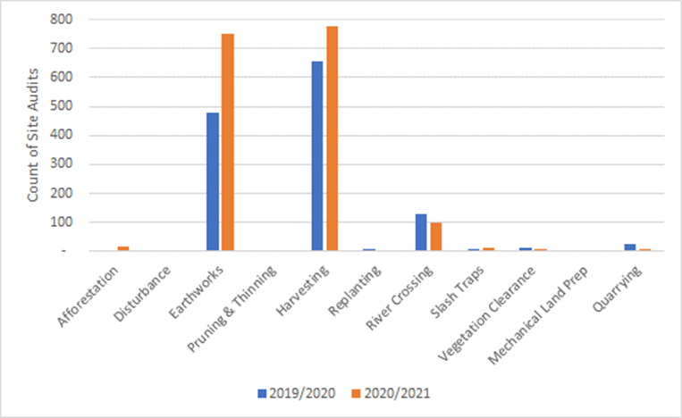
M.E expects that enabling local authorities to charge for monitoring costs for permitted afforestation will be effective in terms of monitoring being carried out by those local authorities. In turn, avoiding, remedying or mitigating adverse environmental effects by applying setbacks and requiring wilding conifer eradication on forestry owned properties, is more likely to be effective when monitored for compliance. As will the avoidance of afforestation in SNAs, ONFLs and Visual Amenity Landscapes by confirming that planting adheres to the areas shown in the Notice and relative to the known boundaries of those landscape areas.
This proposed amendment will however increase compliance costs for foresters. It will increase up-front establishment costs in a sector that does not see a return for decades (ETS revenue may be forthcoming from year 5 – though yearly costs for ETS cost recovery are also going up significantly from now on, so this will be a cumulative impact for landowners). That said, monitoring fees by Councils are fairly priced, and a site visit for a newly planted forest is not expected to result in a significant total cost. Further, both the need for compliance monitoring for afforestation and charging are at the discretion of local authorities and it is likely that not all permitted afforestation activities would result a recovered charge.

2.2 Costs
This section translates the tangible changes of bringing ECCF into the scope of the NES-PF (and other proposed changes that will affect exotic plantation and ECCF afforestation) over and above the status quo into costs borne by different stakeholders, including the nature of the cost.

2.2.1 Costs to local and central government
Implementation costs
- Local authorities may face some net additional implementation costs to bring their plans into alignment with the NES-PF with regards to the proposed changes in scope. This cost is mitigated by the ability to avoid Schedule 1 processes. At the same time, staff in some councils may need to upskill with respect to ECCF, particularly if not yet a feature in their district or region. That said, the forestry activities themselves are the same or similar as for exotic plantation forestry under the current NES-PF, so in districts that have experience with plantation forestry (and the NEFD data on total planted production forest area suggests that every local authority has at least some exotic plantation forestry), any additional upskilling will be negligible. All councils should already be familiar with the scope of the NES-PF. Overall, these administration costs are likely to be minor. Economic cost minor and unquantified.
Administration costs
- Central government is likely to face administration costs associated with amending the objectives and scope of the NES-PF. It may also face costs to provide additional technical advice and guidance – something that some submitters suggested would be needed. M.E understands that workstreams are already underway to increase capacity and capability across the system. The costs associated with those workstreams are part of the status quo (and cannot be counted here) but may be effective in addressing some of the implementation requirements of enacting the proposed amendments without incurring any additional costs. Feedback from MfE is that expenditure on developing a fact sheet on the amendments and potentially running a workshop with local authorities could have a cost circa $10,000 in year 1 of the amendments coming into effect. However, this expense will be met within existing operational budgets under the 2022 Budget (i.e., are not net additional in terms of staff resources). Economic costs negligible.
- Bringing ECCF into the scope of the NES-PF will increase administration time for local authorities (but likely to be mainly Regional and Unitary Councils) to process notices for permitted forestry activities. While notices are required for afforestation, earthworks, harvesting, river crossing and forestry quarrying, there is less certainty around how many ECCF forests created after the NES-PF amendments come into effect will be carrying out earthworks (above the notice threshold), harvesting (i.e., low intensity harvesting), river crossings and forestry quarrying. Given that uncertainty, and the potential for some of those activities to be required more in the long-term (i.e., harvesting (where applicable) and infrastructure required to facilitate that) and potentially beyond our 2051 study period, we have focussed on the net additional administration costs for processing afforestation notices only.
The National Monitoring System recorded 366 plantation afforestation notices across all council types in 2019/2020 and 320 in 2020/2021 – a decrease nationally of 46 notices, despite (minor) growth in plantation afforestation hectares between those years. The average across the last two years has been 343 plantation afforestation notices nationally. The ratio of afforestation notices to afforestation area for plantation forestry has been used as the basis for projecting afforestation notices for ECCF afforestation (and assuming a similar average size profile).
Feedback from one regional council was that currently they spend 15 minutes processing simple (plantation) afforestation notices and about an hour for more complex ones, so even if processing 40 more complex afforestation notices a year, for example, this equates to a week’s work for one FTE in a regional/unitary council.
Based on a series of relatively simple assumptions described in Attachment 1, including long-term projections of ECCF afforestation notices nationally, Table 2-1 quantifies the estimated net additional impact on local authority resources to process future ECCF afforestation notices. A range is provided to cover (indicatively) simple and relatively more complex notices. The three long-term afforestation growth projections discussed in Appendix A for ECCF have been modelled, although the low and central projection does not vary for ECCF over the long-term.
Table 2-1 shows that the net additional weeks of processing time over the 2023-2051 period for all councils combined is between 29-125 weeks, or an annual average increase across all councils of between 1.0-4.3 weeks over the long-term future.
Table 2‑1: Estimated Long-Term National Impact on Afforestation Notice Processing Time Attributable to Bringing ECCF within Scope of the NES-PF (2023-2051)
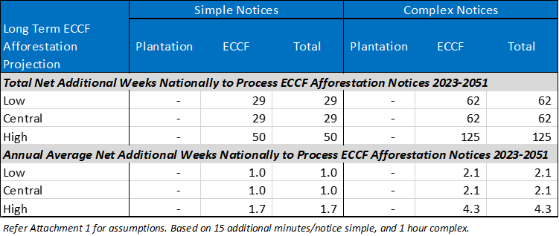
This ‘labour cost’ will be split across councils that process ECCF afforestation notices. Of the regional/unitary council plantation afforestation notices recorded in that data n 2020/2021, 17% were by Hawke’s Bay Regional Council, 16% by Otago Regional Council and 13% each by Environment Canterbury and Horizon’s Regional Council. These four regions account for a combined share of just under 60% of the total plantation afforestation notices recorded in the database by regional/unitary councils in that year. This, alongside the known trends in where exotic forestry has been growing, show that most of the cost of processing ECCF afforestation notices (in terms of an increase in demand of staff time over the course of a year) could be felt by a small number of regional/unitary councils going forward.
Overall, these minor changes attributable to the proposed amendments to require afforestation notices for ECCF afforestation in future are considered unlikely, in and of themselves, to require additional staffing within local authorities, and net additional processing time is anticipated to be absorbed without material disruption and is within existing capabilities. Economic cost minor and unquantified in dollar terms.
- Bringing ECCF into the scope of the NES-PF will increase administration time for local authorities (but likely to be mainly Regional and Unitary Councils) to process WTR Assessments for permitted afforestation of ECCF. We assume for this CBA that it takes councils indicatively 2 hours to process each WTR Assessment under status quo scope requirements. We apply this to the three long-term afforestation growth projections discussed in Appendix A for ECCF, although the low and central projection does not vary for ECCF over the long-term. Further detail on assumptions is set out in Attachment 1.
Table 2‑2: Net Additional Weeks for Local Authorities to Process WTR Assessments for ECCF Permitted Afforestation
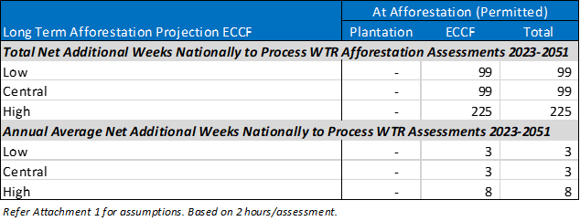
Table 2-2 shows that the net additional weeks of WTR Assessment processing time for ECCF permitted afforestation activity over the 2023-2051 period for all councils combined could be between 99-225 weeks, or an annual average increase of 3-8 weeks over the long-term future. This ‘labour cost’ will be split across councils that process WTR Assessments. Overall, these minor changes attributable to the potential requirement for a WTR Assessment if ECCF is brought within the scope of the NES-PF as proposed are considered likely to, in and of themselves, not to require any additional staffing across local authorities, and is otherwise within existing capabilities. Economic cost minor and unquantified in dollar terms.
- Most local authorities are expected to face net additional administration costs where the NES-PF regulations are less enabling (more stringent) than current provisions that manage ECCF and create more consents that need to be processed than would otherwise have been the case under their status quo regulations. Consents could in theory be required for all forestry activities under the NES-PF for ECCF forestry in the future where they don’t meet permitted activity conditions, but the certainty around the extent to which some activities in ECCF forests will trigger consents is low. Further, analysis of the National Monitoring System data for 2019-2021 showed that on average, 97% of plantation afforestation activities were likely to be carried out as permitted activities. For earthworks and harvesting, the implied share of activities that are permitted is 98%. For river crossings, it is slightly lower at 90% and for forestry quarrying, it is estimated at 99%. This implies that the significant majority of ECCF activities are likely to be carried out as permitted activities, minimising the impact on council consent processing.
Table 2-3 contains data from the National Monitoring System on the cost (to Councils) of consents attributed to the NES-PF. It captures all consents by activity for which a price was provided over the years 2019-2021. They all relate to plantation forestry. While these costs are passed onto foresters (consent applicants) they indicate that on average, consent costs are relatively low. This in turn indicates that the average time burden on staff resources is also relatively low on a per consent basis.
Table 2‑3 – National Consent Cost Data (All Councils and All Activity Statuses) Assigned to the NES-PF 2019-2021 (Plantation Forestry)
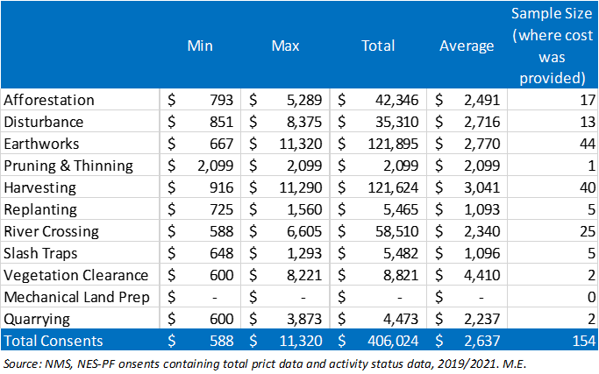
To put this in context. If an estimated 3% of plantation afforestation activities required a consent (on average) between 2019 and 2021, and a similar propensity for consents was assumed for ECCF afforestation, applying the average cost of afforestation consents across all activity statuses of approximately $2,491 to projected ECCF afforestation activities (refer assumptions in Attachment 1), then this would have a long-term total national cost of between $97,000-306,000 between 2023-2051. In present value terms (5%), this equates to a national cost of between $59,000 and $145,000 depending on afforestation projection series. Even when expressed in equivalent FTE time of council resources, this is a minor cost likely to be managed across local authority forestry consent staff given that it equates to an estimated 1-5 additional afforestation consents nationally depending on the year. While potential consents for other ECCF activities over the long-term are additive to this, the generally permissive regime of the NES-PF (which most forestry activities can work within) suggests that bringing ECCF within the scope of the ECCF may have only a minor burden on consent processing time in local authorities. Economic cost minor and partially quantified in dollar terms.
- Local authorities (although mostly regional and unitary councils) will face net additional administration time for the following if ECCF is brought into scope of the NES-PF:
- Costs of compliance monitoring (site audits). Under existing cost recovery provisions, these site visits will be focussed mainly on permitted ECCF activities for earthworks, river crossings, forestry quarrying, and harvesting (refer Table 2-4 for recent site audit activities in relation to plantation forestry). However, site visits for consented ECCF activity will also occur, although noting that consents for plantation forestry activities have in the past been very low in number nationally and the same level of consenting activity is anticipated for ECCF over the long-term. Overall, there were on average 1,503 site visits carried out per annum in recent years, all linked to plantation forestry. The ongoing costs of these are part of the status quo. Estimating the net increase in site audits for ECCF activities (particularly earthworks, harvesting and river crossings which make up the bulk of compliance currently) is challenging. Overall, M.E estimate that site audits for ECCF forestry activities (where costs can currently be recovered) will occur at a fraction of the rate of plantation forestry site audits and will have a minor net additional impact on Council resources when spread over each year. Minor economic cost unquantified.
- Costs for processing forestry management plans (FMPs) requested. Under existing NES-PF provisions, these are required (when requested) for earthworks, harvesting, and quarry erosion and sediment. Refer Table 2-4 for recent FMP activities in relation to plantation forestry. Overall, there were on average 1,435 FMPs requested by councils per annum in recent years. The ongoing costs of these are part of the status quo. Estimating the net increase in FMPs (assuming current NES-PF provisions) for ECCF activities is challenging given that only some ECCF will be involved in low intensity harvesting, and the rest will be permanent forests with no harvesting. Overall, M.E estimate that requests for FMPs for ECCF forestry activities will occur at a fraction of the rate of plantation forestry FMP requests and will have a minor net additional impact on Council resources when spread over each year. Minor economic cost unquantified.
- Costs of enforcement (non-compliance). Table 2-4 shows recent non-compliance enforcement proceedings in relation to plantation forestry. Overall, there were on average 276 enforcement proceedings carried out by councils per annum in recent years. The ongoing costs of these are part of the status quo. Estimating the net increase in non-compliance enforcement for ECCF activities is challenging given that it mainly relates to earthworks and harvesting and only some ECCF will be involved in low intensity harvesting and earthworks of any scale, and the rest will be permanent forests with no harvesting and require little or no earthworks. Overall, M.E estimate that incidence of enforcement proceedings for ECCF forestry activities will occur at a fraction of the rate of plantation forestry enforcement and will have a minor net additional impact on Council resources when spread over each year. Minor economic cost unquantified.
Table 2‑4: National Total Count of NES-PF Related Activities for All Local Authorities (Excluding Consent Processing) – Average for 2019/2020 and 2020/2021
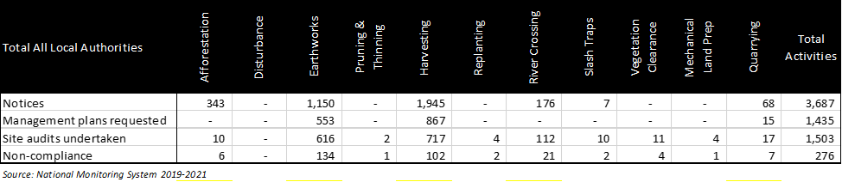
- Local authorities, but mostly Regional and Unitary Councils, will have increased administration costs to monitor compliance for permitted afforestation activities under the proposed amendments for both plantation and ECCF activities. As discussed above, there is a correlation between being able to charge for permitted activity monitoring and the number of site audits that are carried out for forestry activities. On the assumption that 97% of afforestation activities in future will be permitted activities and that councils will take the opportunity to carry out compliance monitoring for 39-60% of those permitted afforestation activities, Table 2-5 shows that the net additional weeks of compliance monitoring time over the 2023-2051 period for all councils combined is between 645-1,492 weeks, or an annual average increase across all councils of between 22-51 weeks over the long-term future. This equates to half of an FTE nationally, or just over 1 FTE nationally.
Table 2‑5: Estimated Long-Term National Impact on Permitted Afforestation Activity Compliance Monitoring Attributable to Enabling Councils to Recover Cots (2023-2051)
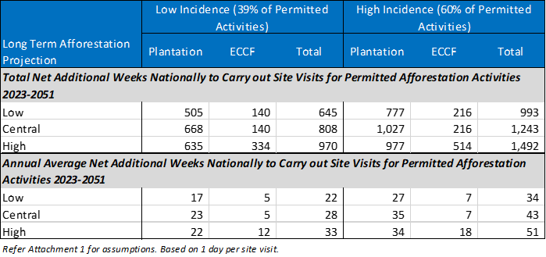
This ‘labour cost’ will be split across councils that process ECCF afforestation notices and are recoverable financially under the proposed amendments. It is included here, despite being passed on to foresters on the basis that the cost will be felt within Council staffing in the first instance. Overall, the net additional compliance monitoring may result in some Regional/Unitary councils requiring an additional staff member, while at other Councils, the additional compliance monitoring may be able to be managed with existing staffing. Economic cost minor and unquantified in dollar terms.

2.2.2 Costs to participants in resource management processes
- Local communities (via their local authorities) have reduced autonomy to manage the environmental, landscape and amenity impacts of ECCF in districts/regions (including incentivising or deterring afforestation locally) where the NES-PF is less or more enabling that status quo provisions in Plans. Consents to manage environmental effects under the NES-PF are non-notified according to the National Monitoring System data. Local authority autonomy is limited to making more stringent rules on specified matters only under the proposed amendments to scope.
Feedback from some local authorities spoken to that were experiencing growth in ECCF was that they were struggling to manage the effects of ECCF under current provisions. On that basis they welcomed some form of national direction. A couple of local authorities were underway with plan changes to manage the effects of ECCF and the proposal to bring ECCF within the scope of the NES-PF may frustrate that process (but may still achieve the same outcome with the stringency provisions). For many Councils that are experiencing little ECCF afforestation, there would be limited change from the status quo. Social and cultural impact minor and unquantified.

2.2.3 Costs to private landowners (foresters)
Transaction costs
- Landowners carrying out forestry activities for ECCF may face increased transaction costs (including for permitted activities) in districts where the NES-PF is less enabling/more stringent (in status and/or conditions). This includes (where applicable) net additional costs to:
- Prepare notices for specified forestry activities. All ECCF foresters would be required to submit notices for permitted afforestation under the proposed amendments. Some ECCF foresters would be required to submit notices for permitted earthworks, harvesting (low intensity), river crossings and forestry quarrying. The incidence of this group of notices though is considered only a fraction of the incidence for plantation forestry activities. Feedback from foresters is than under current notice scope requirements, they take only minutes to prepare. To put this into context, based on projections of ECCF afforestation activity nationally over the long-term, there could be an estimated 1,845-4,400 ECCF afforestation notices prepared between 2023-2051 depending on the long-term afforestation growth scenario. This is a long-term annual average of 64-152 per annum. Economic cost negligible and unquantified in dollar terms.
- Apply the wilding tree risk calculator. All ECCF afforestation activities will need to carry out a WTR Assessment, and this is unlikely to have been required under status quo regulations in most Plans. Based on long-term projections of ECCF afforestation activities, and feedback from forestry consultants that such assessments (under current reporting requirements) will range from $400-1,600 depending on how familiar the assessor is with the site and whether a site visit is required, the present value cost between 2023-2051 is estimated at between $0.4-$3.4 million across the ECCF sector (Table 2-6). Given that unit costs are low, and many forestry companies actually carry out the assessments with in-house expertise for lower costs again, this is minor additional cost. Economic cost minor.
Table 2‑6 – Estimated Net Additional Cost to ECCF Foresters to Carry out WTR Assessments at Afforestation 2023-2051
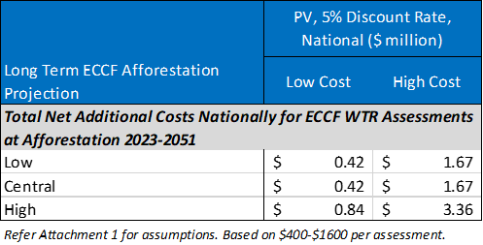
- Prepare management plans for any earthworks, forestry quarrying and harvesting where requested. As discussed above, there is considerable uncertainty around how many ECCF forests will require FMPs over the long-term and it is expected to be only a fraction of number produced by plantation forestry. M.E has not obtained cost estimates from forestry companies to prepare FMPs. ECCF sector-wide, this cost is expected to be minor. Economic cost minor and unquantified.
- Complete flow calculations for river crossing, and report on any slash traps. As above, there is considerable uncertainty around how many ECCF forests will be required to carry out these tasks under the NES-PF over the long-term and it is expected to be only a fraction of number produced by plantation forestry. M.E has not obtained cost estimates from forestry companies to prepare such assessments. ECCF sector-wide, this cost is expected to be minor. Economic cost minor and unquantified.
- Apply for consents where permitted activity conditions cannot be met. As discussed with regards to local authority consent administration costs, there is considerable uncertainty around how many ECCF forests will trigger resource consents over the long-term. It is expected to be only a fraction of the number required by plantation forestry for some activities (such as, but not limited to, harvesting). Generally, though, most ECCF activities are expected to be managed as permitted activities, consistent with plantation forestry. For context, if 3% of ECCF afforestation activities required a consent of some sort, this could equate to an estimated 39-123 consents nationally over the long-term, or on average 1-5 consents for ECCF afforestation per annum over the whole country. M.E has not obtained cost estimates from forestry companies to prepare consents under the NES-PF (over and above council consent fees). ECCF sector-wide, this cost is expected to be minor. Economic cost minor and unquantified in dollar terms.
Compliance costs
- Landowners carrying out ECCF forestry activities may face increased fixed capital and operational costs where the NES-PF conditions dictate a higher standard of practice than landowners would otherwise have been implemented under existing regulations in Plans. This includes prescribed fixtures/materials (such as culverts) that must be used, prescribed methods that must be followed (such as slash management where applicable), and prescribed maintenance expectations and a requirement to eradicate wildings in SNAs and wetlands in accordance with Regulation 11(5). The significance of these net additional compliance costs will vary by property (including the type of ECCF forest (permanent versus low intensity harvesting), the shape and contour of the forestry area, the presence of steams, existing roads/tracks etc. Most costs are expected to be correlated with the scale of the forest area, but some may not, and will impact small forest owners more than large scale forest blocks. Economic costs moderate and unquantified.
- Landowners of ECCF may face net additional compliance costs due to an ability for local authorities to recover costs for monitoring permitted activity conditions in relation to any earthworks, river crossings, forestry quarrying, harvesting and afforestation. The latter introduced as part of the amendments to scope. Estimating the net increase in site audits for ECCF activities (particularly earthworks, harvesting and river crossings which make up the bulk of compliance currently) is challenging. Overall, M.E estimate that site audits for ECCF forestry activities (where costs can currently be recovered) will occur at a fraction of the rate of plantation forestry site audits. For afforestation monitoring charges for ECCF activities, assuming 97% of projected ECCF afforestation activities are permitted activities, and local authorities seek to do site visits on between 39-60% of those, this equates to between 701 and 2,572 site visits that ECCF foresters will have to cover the cost of over the long-term (2023-2051). This is an annual average count of permitted activity afforestation site visits of between 24-89 across the country (Table 2-7). The range reflects the different afforestation projection scenarios for ECCF.
Table 2‑7 – Estimated Net Additional Site Visits for Permitted Afforestation Activities (Costs Charged to Foresters)
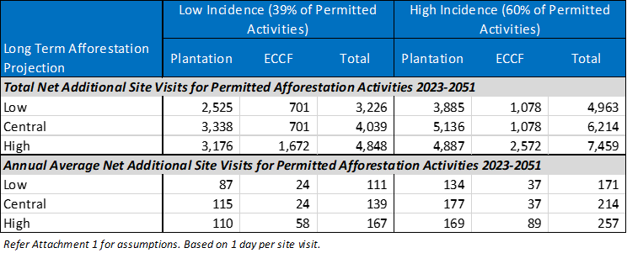
M.E has not sourced costs of site visits from local authorities that are charged to foresters, but overall, the unit cost is anticipated to be relatively minor and unlikely to impact on the feasibility of afforestation. Minor economic cost unquantified in dollar terms.
- Landowners of plantation forestry may face net additional compliance costs due to an ability for local authorities to recover costs for monitoring permitted afforestation activity. The analysis is captured in Table 2-6 above. Based on long-term projections of plantation afforestation activity (refer Attachment 1 for further assumptions), this equates to between 2,525-5,136 site visits that plantation foresters will have to cover the cost of over the long-term (2023-2051). This is an annual average count of permitted activity plantation afforestation site visits of between 87-177 across the country (Table 2-6). While the unit cost is unknown, and despite the larger quantum for plantation foresters, this cost is considered minor over the long-term and unlikely to impact on the feasibility of afforestation. Minor economic cost unquantified in dollar terms.
Opportunity costs
- ECCF forestry landowners may face opportunity costs as a result of ECCF being brought within the scope of the NES-PF as follows:
- afforestation area (return) if setbacks required in Reg 14 are more stringent than applied in district and regional Plans and a restricted discretionary consent cannot be obtained. These opportunity costs are likely to have a greater impact on small forests.
- afforestation area and/or afforestation potential under Reg 12 if their land contained ONFLs and/or SNAs, and ECCF was not otherwise precluded from these areas, and a restricted discretionary consent cannot be obtained. The potential area for permitted ECCF afforestation (while still likely to be focussed on LUC 6 and 7 land) may be reduced nationally, with the potential opportunity cost for ECCF more significant in some districts than others. Depending on the extent of ONFL/SNA on any one property (relative to other unconstrained land), this may adversely affect forestry margins/viability for some landowners.
- afforestation area and/or afforestation potential and/or afforestation species under Reg 11(3) if their land scored 12 or greater on the Wilding Tree Risk Calculator and ECCF was not otherwise precluded from these areas, and a restricted discretionary consent cannot be obtained and a species with a lower spread risk was not feasible. The potential area for permitted ECCF afforestation may be reduced nationally, with the potential opportunity cost for ECCF likely to be more significant in some districts than others.
- the amount (ha), species and type of afforestation that can occur in any one year under Reg 9(2b) if their land is in a red zone and a restricted discretionary consent (as modified by proposed amendments in clause 17(4)) cannot be obtained. No more than 2ha of afforestation in a red zone is permitted per annum for any property. Complying with the permitted activity condition may adversely affect forestry margins/viability and may disproportionately impact owners of Māori land given a greater share of that land being in the red zone. This opportunity cost is however expected to be minor, as the significant majority of plantation afforestation on red zone land is carried out at the permitted rate, and the same would be expected to be feasible for ECCF.
The magnitude of these potential opportunity costs is expected to be minor relative to the status quo. We know, for example, that some existing Plans already prescribe setbacks for ECCF in line with best practice (and the NES-PF). The relative opportunity costs would be no greater than for plantation forestry when the NES-PF was introduced and will impact a smaller sector (with ECCF afforestation projected to account for between 17-34% of total long-term exotic forestry growth to 2051 (Appendix A). Economic opportunity costs minor and unquantified.

2.2.4 Costs to wider public
- There are few or no adverse environmental ‘costs’ anticipated to arise from managing the environmental effects of forestry activities for ECCF within the NES-PF in accordance with industry best practice. It is anticipated that incorporating ECCF in the NES-PF will generally ‘raise the bar’ in terms of management, consistent with an original premise of the NES-PF.

2.3 Benefits
This section translates the tangible changes of bringing ECCF into the scope of the NES-PF (and other proposed changes that will affect exotic plantation and ECCF afforestation) over and above the status quo into benefits borne by different stakeholders, including the nature of the benefits.

2.3.1 Benefits to local and central government
Administration Benefits
- Most local authorities may benefit from avoided or reduced plan change costs to manage the environmental, landscape and amenity effects of ECCF, if not already done so and the need arises in their district/region over the long-term (or current provisions prove to be ineffective as ECCF afforestation effects increase). Some local authorities may not experience much growth in ECCF over the long-term. Southland District Council for example, has seen almost no ECCF afforestation to date (with growth all in plantation forestry). This is not to say that this will always be the case. Other districts have seen a recent surge in ECCF afforestation. There is potential for ECCF afforestation to be widespread across New Zealand, although within suitable growing areas. Any avoided/reduced costs on managing the environmental effects of ECCF will be relatively more significant for districts with a small rating base, but a large area of land suitable for exotic forestry.
Feedback from local authorities indicated that plan changes that would help manage ECCF and provide more stringent control to manage environmental effects of plantation forestry (if considered necessary) and/or better manage the location and scale of plantation forestry (if given scope to do so) would range between $200,000 - $400,000, excluding appeals. While this is the gross cost, we are uncertain of what cost savings would be achieved by bringing ECCF into the NES-PF, with a plan change then managing the residual of local issues. Collectively though, and over the long-term, these cost savings could be moderately significant nationally. Economic benefit moderately significant and unquantified.
- A few local authorities may benefit from a reduction in consent administration (including processing, decision making, monitoring and enforcement) costs if the NES-PF is more enabling than existing rules for ECCF. I.e., they have a net reduction in consent applications. Savings may also arise over time from more standardised consent applications and therefore more efficient processing. Analysis of consent data associated with the NES-PF does show that consent numbers nationally are very small for plantation forestry, and the same can be expected for ECCF under the NES-PF. In the absence of data on existing ECCF related consents across the country, the potential for a reduction over the long-term (where ECCF is projected to grow) is uncertain. Economic benefit minor and unquantified.

2.3.2 Benefits to participants in resource management processes
- Landowners, local communities and NGOs benefit from a reduced need to participate in plan changes to manage the environmental, landscape and amenity effects of ECCF in districts where ECCF was unregulated (or ineffectively regulated) but likely to need a plan change response as afforestation rates increase. Savings in terms of time and expenses associated with participation. Social and economic cost minor and unquantified.
- The wider public, local communities and NGOs benefit from a reduced need to participate in notified resource consent applications to manage the environmental, landscape and amenity effects of ECCF in districts where the NES-PF is more enabling than existing regulations in Plans (and consents under the NES-PF are unnotified). Savings in terms of time and expenses associated with participation. In the absence of data on existing ECCF related consents across the country that are notified, the potential for a reduction over the long-term (where ECCF is projected to grow) is uncertain. Social and economic benefit minor and unquantified.

2.3.3 Benefits to private landowners (foresters)
Transaction Benefits
- Landowners benefit from greater consistency/certainty for ECCF afforestation and how the environmental effects of ECCF activities need to be managed under a single consenting framework, leading to reduced risk in investment and greater efficiency for ECCF foresters working across multiple districts. The uncertainty/inconsistency associated with any more stringent provisions in Plans to manage environmental or other effects of ECCF is unchanged. Changes in certainty are difficult to quantify relative to the status quo. Economic benefit minor and unquantified.
- Landowners may benefit from reduced transaction costs and compliance costs if the NES-PF is more enabling than existing regulations in Plans (i.e., fewer consents required). In the absence of data on existing ECCF related consents across the country that are notified, the potential for a reduction over the long-term (where ECCF is projected to grow) is uncertain. Economic benefit minor and unquantified.
- ECCF foresters may benefit from reduced wilding tree risk control costs over the long-term if the requirement to apply the WTR Calculator at afforestation leads to better investment decisions in afforestation. Regular eradication costs for foresters on their properties is unknown, but potentially last for the life of the forest, which is longer than for plantation forestry. Benefits would be greatest for landowners that would have considered planting Douglas fir although planting of this species has been declining. The benefits of the WTR Calculator on plantation afforestation over the last five years is likely to have spilled over to forestry practice in the ECCF sector. Economic benefit minor and unquantified.
Compliance Benefits
- Landowners may benefit from greater consistency of regulations for managing the environmental effects of ECCF forestry activities over the long-term as the NES-PF is not subject to the same review processes of district and regional plans. This may include consistency during the implementation of Resource Management reforms (if the NES is carried over in the National Planning Framework). It is however acknowledged that an NES can still be reviewed to adapt to changing issues or changes in best practice (as is the case here). Long-term consistency of regulations allows landowners and forestry service providers to operate efficiently and productively as adapting to new regulations takes time and resources. Feedback from some forestry representatives is that FTES are now being dedicated to managing/submitting on regulation and legislation changes aimed at forestry. The benefits of long-term consistency are difficult to quantify. Economic benefit minor and quantified.
- Landowners of plantation forestry benefit from greater equity in the regulation of all exotic forestry – an even playing field. Plantation foresters are not financially disadvantaged for forestry activities that are common to ECCF. Economic benefit minor and unquantified.

2.3.4 Benefits to wider public
- The wider public benefit from improved short-term and long-term environmental outcomes (for erosion, freshwater, indigenous vegetation and fauna, the coastal environment, and wilding conifer spread) within, adjacent to, downstream and downwind of ECCF in those districts/regions where the NES-PF permitted activity conditions are more stringent than existing rules in Plans or improve status quo forestry practice. This is on the basis that the permitted activity conditions in the NES-PF represented industry best practice at the time they were developed, and the use of standardised techniques nationwide will lead to greater (and more rapid) familiarity of those techniques and therefore better outcomes that will be achieved sooner.
- While the adverse environmental effects of ECCF are generally accepted to be less than those of plantation forestry (with many adverse effects linked to clear felling and associated forest infrastructure) this is still likely to be one of the key benefits of including ECCF in the scope of the NES-PF. There is variability in the way that the effects of ECCF are managed across district and regional plans, and many plans do not include rules for all ECCF activities. The benefit of including ECCF in the NES-PF at this early stage of sector development is that a proactive approach can be taken to managing potential adverse environmental effects, rather than a reactive approach following further years of strong sector growth. Economic, social, cultural and environmental benefits moderately significant and unquantified.
- Local communities (and the wider public) may benefit from better outcomes (and reduced risk) achieved by changes to restricted discretionary conditions for ECCF and plantation afforestation on red zone land that occurs at a rate of greater than 2ha/annum. As discussed above though, this will apply to a very small portion of afforestation over the long-term likely to occur on red zone land where the forester is not satisfied with meeting permitted activity afforestation rates. Economic, social, cultural and environmental benefits minor and unquantified.
- The wider public will benefit from ECCF being subject to the WTR Calculator, which will require WTR to be assessed prior to afforestation. This will assist in improving the outcomes associated with wilding conifer spread and management and help avoid exacerbating legacy conifer spread issues on landscape values. Economic, social, cultural and environmental benefits moderate and unquantified.
- Landowners adjacent to ECCF benefit from conditions requiring WTR from ECCF to be considered prior to afforestation. Potential loss of productivity capacity on grazed land is reduced/avoided, and private eradication/control costs are reduced/avoided. This is considered to be a potentially important benefit, particularly if the distribution of EPF afforestation is more dispersed (i.e. a larger number of smaller woodlots for example). This is because trees in ECCF are taller and produce seeds for longer, which increases the duration and distance of potential spread. Economic benefit moderate and unquantified.
- Local authorities, central government and NGOs benefit from conditions requiring WTR from ECCF to be managed. Potentially reduced expenditure/demand for funds to control/eradicate wilding tree species at a landscape scale over the long-term. This is potentially an important benefit of the proposed amendment for the reasons set out above for adjoining landowners. Economic benefit moderate and unquantified.
- The wider public benefits from improved landscape and amenity outcomes over the long-term in those districts where the NES-PF permitted activity conditions (which will avoid ECCF afforestation in ONLFs and visual amenity areas) are more stringent than existing rules in Plans which may have enabled afforestation by ECCF. That is, potential loss of significant landscape and amenity values is reduced where this is restricted more effectively. It is noted that there are potential corresponding economic benefits of maintaining ONLFs/visual amenity landscapes not elaborated on here. It is expected that in districts with widespread ONLFs and/or visual amenity areas that rules that applied to ECCF were already more or equally as stringent than the NES-PF and in which case, the benefit is very minor. This is the case in Queenstown Lakes District for example, where afforestation is a discretionary activity. Economic, social, cultural and environmental benefits moderate and unquantified.
- Given the strong environmental focus that tangata whenua have for the land and natural resources in their role as kaitiaki, iwi benefit directly and indirectly from improved environmental outcomes across the country attributable to including ECCF in the NES-PF (and not limited to Māori owned land). Cultural impact moderate and unquantified.

2.4 Efficiency conclusions
Based on the above indicative examination of costs and benefits it is considered that the benefits of the amendments to the scope of the NES-PF to bring in ECCF, as well as other proposed amendments in Tranche 1 are more likely that not to outweigh the costs over the long-term. The proposed amendments are therefore considered an efficient way to achieve the policy objectives compared to maintaining the status quo.
This was the conclusion for the application of these same controls and conditions in the NES-PF to plantation forestry in the original section 32 evaluation, and it is logical that a similar net benefit would apply to managing the effects of ECCF given the similarities in the nature of the forestry activities common to both forest types (even if the role, scale and frequency of those activities are relatively less for ECCF).
While the NES-PF is expected to lift forestry practice for ECCF in some districts and for some operators, this is an assumption based on the marginal change from the status quo as it exists today. The ECCF sector is still relatively small, while exotic plantation forestry is a mature and well-resourced / experienced sector which has adopted industry-led environmental codes of practice that broadly align with the NES-PF. At some point in the future when the NES-PF provisions have been applied more widely under the Tranche 1 amendments, it is reasonable to assume that the standards required by the NES-PF will become the ‘norm’ for ECCF too. New landowners contemplating afforestation will, in the future, already anticipate the setbacks and other operational requirements of permitted forestry activities in their decision making/feasibility assessments. At this point, the NES-PF will have ‘done its job’ in ensuring improved environmental outcomes in most cases.
At the same time, under the counterfactual, it is possible that over time the ECCF sector would have established sufficient critical mass, and come under sufficient pressure, that it too established environmental codes of practice and a degree of self-regulation. The implication is that both environmental benefits and economic opportunity costs associated with the Tranche 1 scope amendments are likely to be of a greater magnitude and importance in the short-medium term and diminish over time relative to the counterfactual scenario. In other words, now is the most efficient time to bring ECCF into the NES-PF because the sector is still small and relatively new. The key benefit of the Tranche 1 proposal is that the amendments would lock in best practice much sooner so that in the long-term, environmental outcomes will be higher overall.
As with many other introduced national directions under the RMA, the key costs of the proposal are borne by the landowners (foresters) and implementors in the short-term and the key benefits fall to local communities and the wider public over the long-term. Importantly, even small improvements in environmental outcomes are potentially significant because they are not limited to the site or the local community, but benefit regions and the country as a whole, with a range of market and non-market social, cultural and economic benefits that then flow on from a better state of the biophysical environment (not delved into here). These trade-offs are a key driver of an overall efficient result.
There is potential for the economic costs (and opportunity costs) attributable to the Tranche 1 amendments for landowners to disadvantage those planning small scale ECCF afforestation, such as on less productive farmland, more than those planning large scale ECCF afforestation. This is because the feasibility of converting land to ECCF will hinge on and timing and expense of establishment costs and the transaction and compliance costs required by the NES-PF relative to the timing and amount ($) of revenue that can be achieved when registered under the ETS (or gained in the long-term from low intensity harvesting).
Forestry already has a lot of upfront costs, and fixed costs required by the NES-PF will be harder for small foresters to absorb compared with large foresters. For example, afforestation setbacks will account for larger percentage of total land area for small forests than large forests. Similarly, the costs of preparing notices (minimal), management plans (if applicable) and wilding risk calculations (minor) are likely to be much the same irrespective of the size of the forest. As such, it is possible that bringing ECCF into the NES-PF may be slightly less efficient for owners of small permanent afforestation and incentivise (to a small degree) more large-scale land conversions.
Last, opportunities for employment and GDP growth have been considered. No material changes in employment are expected for ECCF landowners (forestry owners and operators), implementors or other stakeholders as a result of the proposed Tranche 1 amendments to scope. While growth in ECCF afforestation (and maintenance of those forests) may increase demand for some services in the forestry sector, that effect is part of the status quo, and therefore not attributable to amendments of the NES-PF. Any increases in demand for goods and services that are attributable to the NES-PF (such as qualified experts to run WTR calculations or council staff to process notices, consents and carry out compliance monitoring for ECCF) are considered to be minor and therefore accommodated primarily through increased productivity rather than necessarily sustaining net additional employment in those businesses/ organisations. A small number of jobs may be sustained across some local authorities as a result of including ECCF into the NES-PF, with the ability to charge for permitted afforestation compliance monitoring and consent processing likely to help offset some of those additional resourcing costs.

3. Operational improvements – additional information requirements for managing wildfire risk
This section considers the estimated costs and benefits to foresters, local authorities and those responsible for responding to wildfire risk (i.e., Fire and Emergency New Zealand (FENZ)) that are anticipated to arise from proposed changes to the information required to be supplied in afforestation notices in the NES-PF.

3.1 Discussion of proposed amendments
The tangible changes to the provisions that are considered in the CBA are summarised as follows, alongside a brief description of the status quo to help highlight the nature of the net change:
 | Status Quo | Proposed Change
1 | Clause 10 of the regulations require that a notice of planned afforestation is provided in writing to the relevant regional and territorial authority as a condition of a permitted afforestation activity that contains:  - The location where the afforestation will occur.  - The proposed setbacks.  - A description of how the setbacks were calculated.  - The dates when afforestation is planned to begin and end.  Species to be planted is an input to the Wilding Tree Risk Calculator (required in conjunction with the afforestation notice), and evidence of species “might be called for by the local council as part of a consent process to confirm the status of a permitted activity”. However, that species information may not be public information. | Notices of afforestation supplied to local authorities as a condition of a permitted activity under clause 10 are also to include:  - A map showing:  - the property boundary;  - the extent and location of the forest within those boundaries; and  - access points and gates.  - The total size of the forest (I.e., in hectares).  - The species of the forest.  - Contact information for the forest owner.
2 | Maps are not specifically required as part of the Clause 10 notice. Councils would need to manually locate the property or land parcel based on forest address details or legal description should they want to include it in their GIS systems. This will only show the boundary of the land where afforestation will occur.  If an image (as opposed to a GIS file) of a site plan for the forest area within that property/parcel was provided with the notice, Councils would need to apply GIS techniques such as georeferencing to then digitise in the approximate afforestation area. This manual process may be a deterrent to many busy GIS departments. | Any maps supplied above must be in GIS format (and not an image file).
All forest types have significant fuel loads and therefore represent a fire risk. Wildfire is a natural hazard which local authorities have functions to manage to minimise the environmental impacts of wildfires. FENZ has no mandate to manage or mitigate environmental effects caused by wildfire, but in terms of them being prepared for wildfires, or in situations where they must respond to wildfires, ready access to information about the site that could be passed on by local authorities (or shared at all times) is expected to be a significant advantage.
Notices of afforestation for permitted afforestation activities are public information and therefore represent the best opportunity for information ‘sharing’ between agencies. It is not explicit in the NES-PF that afforestation that occurs via a controlled or restricted discretionary activity need also supply a notice to local authorities before commencing afforestation, but based on some examples of online notice forms, consent references can be identified for the site, so it seems likely to M.E that all afforestation is picked up by the notice process irrespective of the activity status pathway.
The details currently required in those afforestation notices is limited in scope and may or may not result in local authorities identifying forest areas and related information in their GIS systems. Examples of online notice forms found already include forest/owner contact information and so the proposed amendment to include contact information for the forest owner may not be a change from status quo practice. M.E has only viewed a sample of these forms and has not carried out a comprehensive search. Prescribing that contact information is to be included would, however, ensure that any council not collecting that information as part of the public notice for afforestation does so in the future.
The current requirement to include the date of afforestation (start and finish) is helpful should local authorities be planning site visits to monitor compliance (albeit that for permitted afforestation, Councils are not able to recover the costs of those site visits under current regulations which may be a deterrent for some Councils where resources are already stretched). The date information also has value in monitoring the age of the forest (which is expected to be relevant for managing wildfire risk and preparing for/responding to wildfires). It is not known to what extent local authorities are incorporating forest planting date/current age into their data systems, including making it an attribute in any GIS datasets that may have been established.
Under current clause 10 requirements, location information for the afforestation site is commonly captured as one or more of the following fields: site address, legal description and/or map reference (coordinates). Planting setbacks can be qualified (described) but need not be spatially identified. On some online forms, uploading supporting documentation such as site plans is optional, but those maps are images, and not GIS files. There appears to be little evidence (in the online forms) of detail that should be shown in those site plans, if required or volunteered via those forms.
Spatial information is always more powerful than non-spatial databases, and GIS captures all the data that can be stored in a database as well as the visual data. Supplying information in GIS form (not just of the property where afforestation is planned, but the actual planting extent, visual proof and location of setbacks, accurate calculations of afforestation area by species and location of access ways) would not only make the process of adding afforestation data to Council GIS platforms more efficient (with only limited manipulation required to ensure attribute fields and spatial data is in a consistent format) – saving time and cost – but is also likely to incentivise local authorities to maintain comprehensive forestry data within their GIS platforms. That is, it creates the opportunity to do this, if not done already.
While the driver for the proposed amendments to afforestation notice information requirements is to better manage wildfire risk (for Councils and partners like FENZ), the value of the additional data proposed, and its format in GIS, is far greater for local authorities, and in turn communities and landowners. Being able to combine that data with existing GIS data on zones, designations, roads, SNAs, ONLS, ONFs, waahi tapu, dwelling and other building footprints, network infrastructure including the national grid and gas pipelines, HPL, other natural hazards, waterways, wetlands etc, etc, provides a richer and more integrated data resource for spatial planning, land use monitoring and decision making for land use consents and plan changes.
However, these benefits can only be realised in full if existing forests as well as future afforestation is included and maintained in GIS by local authorities. Any councils starting from scratch with forestry data in GIS following the amendments to clause 10, would be limited to the incremental addition of afforestation areas notified once the amendments came into effect.
Depending on how the final amendments are drafted (and then implemented by local authorities), the GIS maps required to be supplied for afforestation might not show exiting forest area on the same property as the planned afforestation unless this is clearly specified. Providing only maps of the afforestation area would be of lesser value and would potentially mask the wildfire risk for both council and FENZ. This outcome of supplying only partial data on forestry on a property should be avoided if possible.
Feedback from foresters is that afforestation notices required under current regulations are very quick and simple to prepare and submit (with most expected to be online). In terms of needing to supply GIS files as part of the amended notice requirements, this is not expected to add materially add to the time or cost of submitting a notice for most foresters. This is because large scale forestry companies and forest management companies that provide services to smaller forestry owners (whether plantation or ECCF) are all typically using GIS. If they are currently uploading site maps, these are likely to have been images generated from GIS files in any case. Calculating forestry area, or even area by species, is an automated process once forestry areas are captured/plotted spatially in GIS. Locating accessways, if not already in their GIS data layers, is a similarly quick addition. In other words, the proposed amendments are likely to be capturing data that many foresters already have to hand. Uploading the files is quick and easy.
The key cost of shifting to GIS data in afforestation notices is likely to be limited to any small-scale foresters that self-manage rather than use a forestry management service company. This may include farmers who choose to forest less-productive areas of their farms. The implication is that they may face additional costs to have afforestation areas, property boundaries and accessways mapped in GIS by an external service provider. This could be a discrete service offered for a forestry support service company, a farm support service company, a land surveying firm, or it may be a service able to be added by the ‘qualified expert’ completing the Wilding Tree Risk Calculator (on the assumption that such experts may already utilise GIS data to assist with their site evaluations).
Feedback from TUR is that FENZ have already instituted a programme for getting forestry site data from big companies but the intention with the notice provision is to also bring in the smaller forests which FENZ do not have easy access to, and the non-harvest forests, which are less likely to be represented by the forestry industry bodies that already have a formal Charter/relationship with FENZ.

3.2 Costs
Based on the discussion above, this section translates the tangible changes of amending the information requirements for clause 10 afforestation notices over and above the status quo into costs borne by different stakeholders, including the nature of the cost.
3.2.1 Costs to Local and Central Government
Implementation costs
- Local authorities would need to amend afforestation notice templates (which may be online forms) to include additional fields of information and provide the ability to upload GIS files. While clause 10(1) of the regulations requires that written notice is given to the relevant regional council and territorial authority, the National Monitoring System data indicates that afforestation notices are largely received/recorded by regional councils and unitary authorities. For example, in 2020/2021, 295 afforestation notices were recorded by regional/unitary councils and just 25 were recorded by territorial authorities. This suggests that the cost to amend notice templates for afforestation - considered a one-off cost and negligible in terms of resourcing - will be felt largely by regional and unitary councils. Economic cost minor and unquantified.
- Local authorities may need to create new, or adjust existing, protocols for incorporating GIS files supplied with afforestation notices into council systems, and potentially supplying/sharing that GIS data with external agencies such as FENZ. Again, the National Monitoring Data would suggest that this cost will be felt by regional and unitary councils mainly. This is a one-off cost and considered negligible in terms of resourcing. Economic cost minor and unquantified.
Administration costs
- The draft Recs Report indicated potential for central government administration costs to support this amendment. This included providing some support to local authorities to ensure that the receipt of afforestation notices is undertaken in an effective and efficient way. MfE have advised that this would occur in year 1 of the amendments coming into effect. No cost is provided as this is covered by one FTE within Te Uru Rakau already funded operationally in the 2022 Budget. In other words, no net increase in existing staffing resources is required. Economic cost negligible and unquantified.
- The Recs Report also discussed the potential for further guidance to be provided by central government on wildfire risk management (to complement guidance already provided by the NZFOA, and potential development of a template for Wildfire Risk Management Plans (WRMPs). While making WRMPs compulsory was considered, it was not further progressed for the amendments and M.E understands that Te Uru Rakau remain unsure of its regulatory purpose. However, the development of a template is a mechanism that may encourage voluntary development of WRMPs, hence we include this administration cost for central government here, even though there is low certainty of it being pursued. Again however, any such costs are unquantified, managed by one FTE already funded within Te Uru Rakau under the 2022 Budget, and likely to occur in year 1 of the amendments coming into effect. No net increase in staffing resources applies. Economic cost negligible and unquantified.
- Feedback from one regional council was that currently they spend 15 minutes processing simple afforestation notices and about an hour for more complex ones, so even if processing 40 more complex afforestation notices a year, for example, this equates to a week’s work for one FTE in a regional/unitary council. There may be additional time and resources required within local authorities (but expected to be largely within regional/unitary councils) to enter/process the net additional information provided in afforestation notices in Council databases (including GIS layers if used already). Uploading GIS files is likely to shift some/more of this task to GIS staff. The additional burden on staff processing afforestation notices attributable to this proposed amendment is anticipated to be very minor at the individual notice level (and likely well below 15 additional minutes).
It is acknowledged that the effect of projected growth in exotic plantation afforestation (discussed in Appendix A) and the proposed addition of ECCF to the scope of the NES-PF (which while growing at a slower rate, is still projected to increase over time and which will add to the number of notices needing to be processed by local authorities), the cumulative effect of a very minor increase in the processing time per notice as a result of this particular proposed amendment may have a minor cost on council staff resources over the course of the year. Using the example above, approximately 2 weeks of processing time would be required if a council’s afforestation notices doubled from 40 to 80 in a year under current information requirements. The proposed amendments to notice information requirements, may indicatively add 1-2 days a year if processing around 40 notices per annum or 2-3 additional processing days a year if processing around 80 notices per annum if assuming 15 minutes net additional processing time.
Based on a series of relatively simple assumptions described in Attachment 1, including long-term projections of afforestation notices nationally, Table 3-1 quantifies the estimated net additional impact on local authority resources to process the additional notice information proposed. A range is provided to cover (indicatively) a net additional 15 minutes of processing time on both simple and relatively more complex notices. The three long-term afforestation growth projections discussed in Appendix A have been modelled. We include the net (not gross) impact on ECCF afforestation notices on the assumption that ECCF is included in the scope of the NES-PF and is assessed in Section 2.
Table 3-1 shows that the net additional weeks of processing time over the 2023-2051 period for all councils combined is between 47-93 weeks, or an annual average increase of between 1.6-3.2 weeks over the long-term future.
Table 3‑1: Estimated Long-Term National Impact on Afforestation Notice Processing Time Attributable to Proposed Additional Information Requirements (2023-2051)
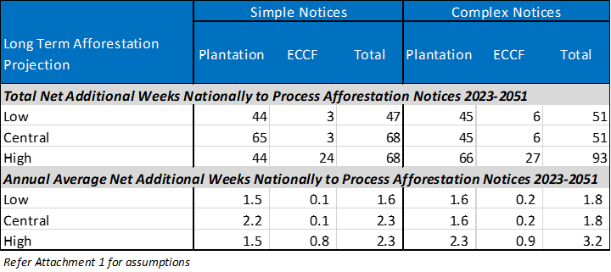
This ‘labour cost’ will be split across councils that process afforestation notices. Of the regional/unitary council afforestation notices recorded in that data n 2020/2021, 17% were by Hawke’s Bay Regional Council, 16% by Otago Regional Council and 13% each by Environment Canterbury and Horizon’s Regional Council. These four regions account for a combined share of just under 60% of the total afforestation notices recorded in the database by regional/unitary councils in that year. This, alongside the known trends in where exotic forestry has been growing, show that most of the cost of processing slightly more information in afforestation notices (in terms of a minor increase in demand of staff time over the course of a year) will be felt by a small number of regional/unitary councils going forward.
Overall, these minor changes attributable to the proposed amendments to afforestation notice information are considered unlikely, in and of themselves, to require additional staffing within local authorities, and net additional processing time is anticipated to be absorbed without material disruption and is within existing capabilities. Economic cost minor and unquantified in dollar terms.

3.2.2 Costs to private landowners (foresters)
Transaction costs
- Some companies/individuals undertaking afforestation may face net additional costs in meeting the needs of the amended afforestation notice. This is limited to preparation of GIS files that show the property boundaries, afforestation extent (by species) and access ways, which may need to be outsourced. Such costs are most likely weighted towards smaller forestry companies and farm foresters rather than large forestry companies who use GIS inhouse.
The additional transaction cost is likely to range from little or no additional charge if the forest owner was already using the services of a forestry management company or land surveying company that uses GIS, through to a small-moderate charge if such a service provider had no prior involvement with the proposed forestry project and was providing the GIS files as an ad-hoc service. Feedback from one regional council spoken to indicates that it is likely to be the former rather that the latter of those two scenarios. That particular regional council currently processes 40-50 NES-PF notices for forestry each year (not limited to afforestation notices) and indicated that the forests relating to the notices ranged from 2.5ha to 150ha (i.e., farm woodlots through to larger forests). However, the notices were being sent to the council from 2-3 main companies who are farm/forestry consultancies working in the region. The experience in this region suggests that the significant majority of proposed afforestation is being managed by an experienced large scale forestry companies or specialist forestry service companies and the requirement for notices to include GIS files is likely to represent a negligible change in practice (and therefore negligible cost passed onto foresters). Economic cost minor and unquantified.

3.3 Benefits
Based on the discussion above, this section translates the tangible changes of amending the information requirements for clause 10 afforestation notices over and above the status quo into benefits borne by different stakeholders, including the nature of the benefit.

3.3.1 Benefits to local and central government
- GIS staff in local authorities (and it seems particularly regional/unitary councils) who may have been entering afforestation property details into their GIS platforms without the aid of GIS files, may have reduced processing time for notices with files arriving already in GIS format. I.e., a saving on time/labour. Economic benefit minor and unquantified.
- A shift to GIS data improves the ability for digital data to be shared/accessed by multiple stakeholders, including FENZ. Economic benefit minor and unquantified.
- Local authorities will have better quality data available on forestry areas at a landscape level. This can support better spatial planning, better planning outcomes and better management and understanding of current and potential future resource management issues, including risk management. Contributes to regulatory efficiency. Economic benefit minor-moderate and unquantified.
- Indirectly, better quality forestry data at a property and landscape level able to be accessed by FENZ, may lead to improved preparedness for wildfire risk, and potentially more efficient responses to wildfires. The key benefit will be giving FENZ access to data on small forestry operations, and ECCF forestry as this is where there is the greatest information gap is currently. Contributes indirectly to organisational efficiency. Data from Scion shows that in 2020/2021 there were 4,586 wildfires in New Zealand (a decrease on the previous year) and 13,348ha burnt (an increase on the previous year and the second worst year on record over the last 36 years). Forestry land accounted for 7% (720ha) of the total burnt area in 2019/2020 and 12% (1,663ha) of the total burnt area in 2020/2021. With afforestation projected to continue at a strong rate over the long-term, plus changing climate conditions, even a small increase in efficiency to respond to wildfires in forestry areas could have moderate-significant benefits for New Zealand over the long-term. Indirect economic benefit moderate-significant but unquantified.

3.3.2 Benefits to participants in resource management processes
- Better quality data available on forestry areas at a landscape level that is more easily accessed/shared in a digital format, may lead to better research on forestry and land use change and improved advocacy outcomes for a range of stakeholders. Economic benefit minor and unquantified.

3.3.3 Benefits to private landowners (Foresters)
- No material direct benefits to foresters are anticipated from the proposed changes in the notice requirements other than indirectly benefiting from improved efficiency and preparedness by FENZ in fighting forestry fires. Economic benefit minor and unquantified.

3.3.4 Benefits to wider public
- Forest consultancy/management service companies may have increased demand for their services/expertise, particularly in GIS roles. Increased productivity and/or a small number of additional jobs potentially sustained nationally attributable to the proposed amendment to clause 10. A minor benefit at a national level. Economic benefit minor and unquantified.

3.4 Efficiency conclusions
Challenges faced in getting up to date and accurate GIS data on exotic forestry areas for this CBA highlights that there is a real gap in forestry data at the national level. The proposed amendments to information requirements in afforestation notices, particularly the requirement to supply that information in GIS format, ensures that there will be better spatial data at the local/regional level in future, which may in turn facilitate better national-level spatial data.
The proposed amendments are consistent with the general trend of greater use of digital data, including the increasing use of, and reliance on spatial data by foresters and local authorities alike. The proposed amendments help ensure that the forestry sector and local authorities are moving with and not behind technology and the information requests are therefore not unreasonable today (and for most, just reflects status quo practice). These benefits of the proposed amendments will increase over time as the GIS data stored by local authorities accumulates.
While there would need to be some immediate adjustments in council systems to implement the changes to the notice requirements, and potentially some increases in notice preparation costs for some foresters (and their agents), as well some increase in notice processing time by local authorities, these are all minor or immaterial costs. Benefits are more difficult to quantify, and mainly flow from councils having better spatial data on forestry that is more accessible within and across organisations. Some of these benefits may be far reaching and certainly not limited to improved wildfire risk management. Most aggregate direct costs and benefits are minor in magnitude but overall, it is considered that there would be net benefits (particularly when indirect benefits are included) and the proposed amendments are therefore more efficient than retaining the status quo.
M.E recommends that to improve the effectiveness of the proposed amendments to clause 10, that MfE also consider that the type of forest (plantation or ECCF) be required as a field of the notice (given that prior to the amendments, only plantation forestry required notices and this will no longer be clear if ECCF is brought within scope). Second, that GIS maps are also required to show the extent, type and species of existing forests on affected land parcels/properties where afforestation is proposed. M.E would also recommend that the requirement for GIS data is considered in other notices required under the NES-PF.

4. Operational improvements – wilding tree risk management
This section considers the estimated costs and benefits to foresters, local authorities and those responsible for controlling wilding conifer spread (including councils, DOC, LINZ and other NGOs with support from private landowners and foresters) that are anticipated to arise from proposed changes to the Wilding Tree Risk (WTR) Calculator and guidance and the rules around WTR in the NES-PF.

4.1 Discussion of proposed amendments
The tangible changes to the provisions that are considered in the CBA are summarised as follows, alongside a brief description of the status quo to help highlight the nature of the net change:
 | Status Quo | Proposed Change
1 | The guidance for the WRT Calculator was published in 2015 by Scion. | Update the WRT Calculator and guidance based on current knowledge and any changes in best practice. Potential changes that may be considered in the update are discussed in the Year One Review (2021).
2 | Clause 11(4) states: The relevant … authority must be given a copy of the WTR Calculator calculation sheet and score at the same time as notice is given under regulation 10 (i.e., Afforestation Notice).  Clause 79(5) states: A copy of the WTR Calculator calculation sheet and score … must be given to the relevant … authority on request. This only applies when the conifer species being planted is different from the one last harvested. | In addition to providing the calculations and the score under Clause 11(4), and Clause 79(5), the following additional information must be included: an assessment of each element of wilding risk for each relevant area of forest which also sets out how the assessments have been made.
3 | Clause 79(1)(a) states: Only when replanting of a conifer species involves a change in the species most recently harvested is the WTR assessment required, and if the score is 12 or more, then replanting becomes a restricted discretionary activity. There are also some exceptions around this.  No WTR assessment is required for replanting a conifer species on land where the same conifer species has been harvested. That activity is a permitted activity so long as all permitted activity conditions are met. | In addition to current provisions, if a conifer species is harvested, the replanting of that land in the same conifer species also requires a WTR assessment, and if the score is 12 or more, then replanting becomes a controlled activity consent.  Control will be limited to:  - The level of WTR;  - The mitigation proposed to restrict wilding conifer spread, including the species to be planted;  - The effects on the values of an SNA or ONFL;  - The information and monitoring requirements; and  - Actual spread of wilding trees and measures to mitigate an actual spread that has occurred.
4 | Clause 79(6) must be met for replanting to be a permitted activity – eradication of wildings in wetlands and SNAs linked to the previous harvest (before replanting occurs) and at least every five years after the replanting when linked to that replanting.  There is no limit on how many properties such eradication may apply to, and it is not limited to land owned by the forester. | Under clause 79(6) – eradication in wetlands and SNAs is limited to the same property as the replanting, or any other adjacent property under the same ownership as the replanting area to satisfy a permitted activity.  There is no requirement to eradicate wildings in SNAs and wetlands on other private properties, even if linked to the forested area.
Update the calculator and guidance
The draft Recs Report says that this update will go ahead so the most up-to-date research and guidance can be applied. This may suggest it is part of the status quo, but M.E is unsure if the current calculator and guidance in Schedule 2 can be replaced at any time or needs to part of an amendment process (i.e., with associated consultation and evaluation). For this CBA, we assume that latter, and that the replacement forms part of the amendments, even though no regulations in Part 2 of the NES-PF need change.
The Year One Review (2021) provides a discussion of some of the changes that an updated WRT Calculator may address, and that discussion is not repeated here. However, based on that discussion, the update may result in a better and more accurate understanding of risk and therefore better environmental and economic outcomes for adjoining landowners and the wider public in terms of landscape effects, and stakeholders involved in wilding tree control.
Such improvements will take many years to become evident and the net changes will be difficult to measure as the effectiveness of forests that were planted and assessed under the current WTR Calculator (and NES-PF provisions) has yet to be revealed/measured. However, anything that avoids exacerbating the current (legacy) wilding conifer spread, which is estimated to have cost Biosecurity New Zealand and DOC “over $40 million in the 2020/21 financial year” for control and eradication on top of costs by regional councils and landowners, is considered a positive effect.
It is possible that any updates may affect how the assessments are performed in future, but new guidance would be provided for practitioners. It is not uncommon for assessment requirements under the RMA to change and for practitioners to have to adjust to those (see for example changes to Housing and Business Capacity Assessments under the NPS-UDC and then NPS-UD). Any changes that may come from the update are not expected to be an issue in term of the capability of suitably qualified experts to apply, but it may initially take longer and therefore cost more to adjust the assessment process (with efficiencies improving over time). These costs may be passed on to foresters.
Additional WTR assessment information
The draft Recs Report states that a greater level of detail showing how the WTR assessment was performed would help councils better understand the assessment process, information used, and the points on the property at which the assessments have been carried out and therefore their understanding of the risk. They pointed out that councils lacked experience in wilding risk assessment and more transparent information (combined with updated guidance) would help build that experience. This is consistent with feedback provided from the forestry sector. If this is the case, then improving the expertise of council staff through the processing of WTR assessments will be a gradual and incremental process, which will occur at a rate commensurate with the number of assessments they receive (with some councils receiving a lot each year, and some very few).
MfE consider that these additional information requirements are not a significant departure from best practice. The draft Recs Report signals potential for a worksheet/template to be developed for the presentation of the more fulsome WTR assessments to council. Templates, as a rule, improve efficiency of completing documentation and help create more standardised costs across companies providing WTR assessment services. Irrespective of whether a template is provided/encouraged, the additional information to be reported to councils may increase the transaction costs for foresters prior to afforestation and replanting. This is not however certain, as it depends on whether the required detail is already being covered by qualified experts, even if it is not currently all supplied to councils. M.E considers that this is likely to be the case, in which case utilising more of that existing assessment in the report that goes to Council is likely to be a minor additional step and one that creates only minor additional work/cost per report.
M.E can see the benefit of councils better understanding risk through more comprehensive documentation if this means that conditions of a controlled or restricted discretionary consent for afforestation or replanting (or a controlled consent for replanting as amended by the proposed provisions – discussed below) will be more effective and efficient in future. However, the recommended amendments give the appearance of applying to WTR assessments that meet permitted activity conditions (i.e., for scores less than 12). As there is no ability for councils to impose further compliance conditions when WTR assessments score are less than 12, there seems no long-term environmental or economic benefit of councils having a more detailed understanding of the assessment process for permitted activities, yet there may be additional transaction costs for foresters for this. Forestry representatives spoken to were not aware of councils challenging or disputing WTR Assessments for permitted activities, due in part to their lack of expertise. They had heard of instances where the qualifications of the assessor were questioned. We comment further on this below in terms of potential effectiveness of this amendment.
Applying the WTR Calculator when replanting the same conifer species
As drafted the draft Recs Report states “Amend the permitted activity notice requirements for wilding tree risk at replanting only to require all replanting activities to carry out a wilding tree risk assessment” (page 33, 3.2c) emphasis added. Recommendation 3.2b also states “The permitted activity notice requirements for wilding tree risk at afforestation and replanting …” (emphasis added). There is no notice requirement for replanting in the current provisions (akin to clause 10 for afforestation), which makes us wonder how councils know that replanting is occurring and therefore permitted activity conditions are being met?
The Bay of Plenty Regional Council’s NES-PF online notice form does provide an opportunity for foresters to alert council of replanting, but practice elsewhere is unknown. Councils may only become aware of replanting if a controlled activity or restricted activity consent was required (which is rare). Until amended provisions are drafted, we interpret the draft Recs Report as suggesting that an actual notice requirement (similar to clause 10) will be added to Sub-Part 8, to provide a mechanism through which WTR Assessments can be submitted (rather than being only on request).
There is a cost associated with carrying out a WTR assessment, estimated at $400-1,600 when not carried out in-house (which is less than the lower range according to feedback from forestry consultants). This cost is already being incurred for plantation afforestation and for replanting of a different conifer species. Feedback from forestry representatives was that the common examples of changing a forest species are to change Pinus contora pine to Pinus radiata or Douglas fir to Pinus radiata or the new Pinus attenuata hybrid (which has a lower wilding spread risk than even Pinus radiata). Margules Groome (2021) also stated that “most or all Douglas Fir areas are re-established to radiata pine after harvest” (page 13). However, exotic plantation foresters are not currently required to re-assess if replanting the same conifer species. Even if the score comes out less than 12, the proposed amendment means that the assessment will be a net additional transaction cost (and potentially a marginally higher transaction cost with the proposed amendment to expand information requirements).
M.E is uncertain whether low intensity harvesting of ECCF forests that is followed by replanting will be captured under Subpart 8 provisions if included in the scope of the NES-PF. For the purposes of this CBA, we have limited costs and benefits associated with WTR at replanting to plantation forestry. Afforestation of ECCF would be captured under WRT provisions if it is a conifer species (addressed in section 2).
The proposed amendment at replanting then generates a range of other net additional costs for plantation foresters and councils if a controlled activity consent is required. These include both transaction and net additional compliance costs for foresters and administration and compliance monitoring costs for councils.
It is understood that use of the WTR Calculator has only been required through regulation since the NES-PF came into effect (and prior to that it was only voluntary). As such, many of the exotic plantation forests being harvested today or in the medium-term future would not have been subject to the WTR assessment (or something similar).
The proposed amendment provides an opportunity to assess the WTR of those sites (and species), in many cases for the first time. Even if retrospectively (at the time of original afforestation), the site would have scored less than 12 under the current WTR Calculator, changes to adjacent land use may now mean that the score is 12 and above. There is a compounding risk that even if the site would have (retrospectively) scored less than 12 and neighbouring land use today is still the same, that the proposed update to the WTR Calculator and guidance may return a result of 12 or more. Both scenarios are however theoretical, as the previous (harvested) forest is unlikely to have ever been assessed for WTR, and so the counterfactual or baseline does not exist. The proposed amendment is intended to focus on managing risk going forward, not retrospectively, and there are now best-practice tools available that can be applied to manage known risks.
Feedback from forestry representatives was that the WTR Calculator and requirement to carry out assessments under the NES-PF has been positive and effective and they support its application. Given the costs potentially involved in eradication, there is a strong incentive not to plant species with a high wilding risk, and this would be likely to continue even if unregulated (i.e., as industry best practice). That said, most of the expenditure on eradication of wildings today is from legacy forests (i.e., Pinus contorta) on land that might have been through several rotations as Pinus radiata since. The contorta seedlings just keep reappearing, especially if eradication practices back when those wildings were establishing weren’t in place – allowing them to mature. Indicatively half of the wilding ‘estate’ is made up of Pinus contorta (and noting that 90% of plantation forests are currently Pinus radiata, so confirms that much of the wilding conifer spread is a legacy issue. Indicatively Pinus radiata accounts for between 5-10% of the wilding estate, with Douglas fir making up around 40%).
Forestry submitters opposed to the requirement to assess WTR at replanting (when the same conifer species is being planted) have raised concerns around existing use rights and risk of liabilities under the ETS if land no longer meets the wilding risk threshold. The Year One Review provides a discussion on existing use rights, and such issues are not discussed further here.
We note that a controlled activity status does ensure that the replanting can occur subject to conditions. The key is then whether compliance costs to manage wilding tree spread of the replanted forest could be such that they threaten the viability of the replanting. Feedback from foresters is that commonly applied conditions of controlled or restricted discretionary activities (with respect to WTR and control), while having a financial cost, have not been a deterrent to exotic afforestation or replanting to date, and so it is considered unlikely that the proposed matters of control would impact the feasibility of replanting under a controlled activity consent, where these costs are assumed to be somewhat higher than the existing costs of eradication/control under permitted replanting (clause 79(6)).
The key issue with wilding tree spread is that those that create the issue (seed origin) are not necessarily the ones that bear the cost of control and management. Wilding tree spread is an externality cost of some (but not all) exotic forestry that is not factored into market transactions. As such, the proposed amendment to require that WTR assessment be carried out at all replanting helps address some of the market failure of existing (albeit harvested) exotic forests via replanting compliance conditions where the risk exceeds acceptable thresholds. This is considered a more economically efficient outcome than the status quo, where replanting may exacerbate the wilding spread caused by the previously harvested forest (although accepting the probability of exacerbating wilding spread through replanting Pinus radiata is relatively low, but not zero).

Figure 4‑1: Wilding Conifers Information System – Current Infestation Area – North Island
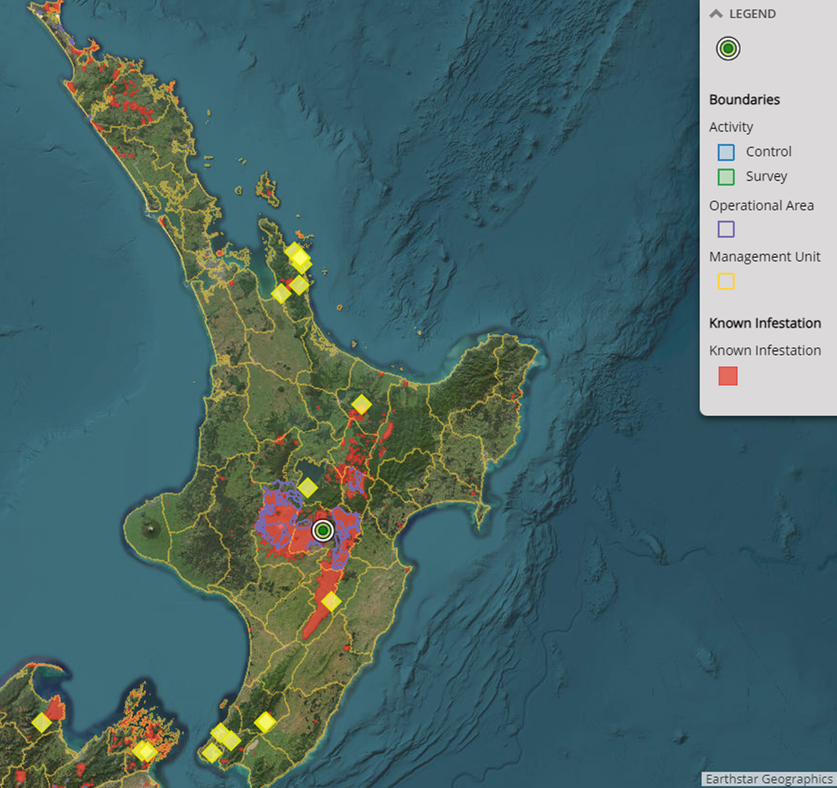
Figures 4-1 and 4-2 show the locations and significant extent of current infestations of wilding conifers in New Zealand. The issue is especially significant in the South Island. There are a range of studies that have been carried out, including CBAs, that quantify the costs to landscape values, tourism, water availability, pastoral land productivity etc. We do not repeat that discussion here.
Figure 4‑2: Wilding Conifers Information System – Current Infestation Area – South Island
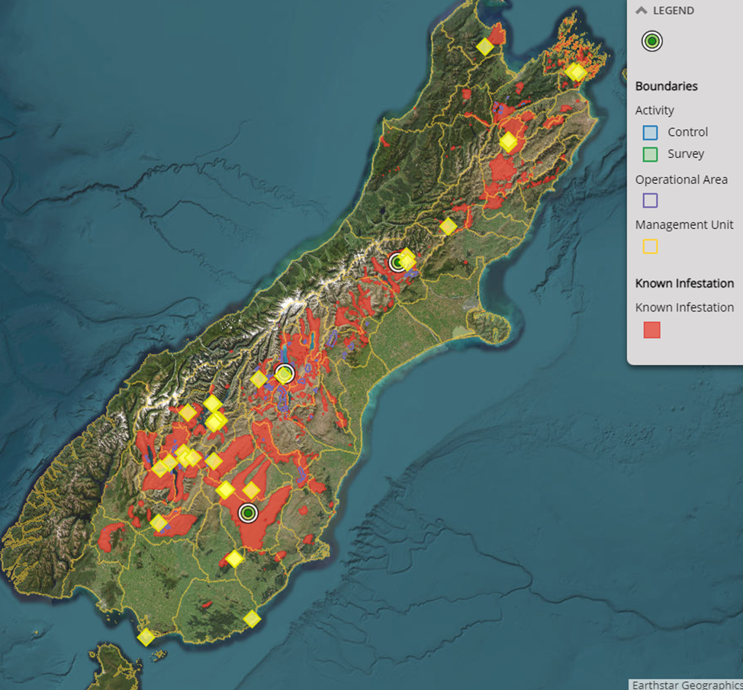
Eradication conditions for permitted replanting
The Year One Review (2021) highlights the inconsistency of the current provisions for eradication of wilding trees at replanting as a permitted activity with those for afforestation, and also the legal anomaly because the NES-PF cannot actually direct foresters to access private property without permission. The proposed amendment corrects this.
Clause 79(6)(b) which required eradication of wilding conifers in SNAs and wetlands (on any property) “at least every 5 years after replanting” is unlikely to have been given effect to in practice given that it would only apply to any permitted activity replanting that occurred since the NES-PF came into effect in May 2018, and those trees would be unlikely to have produced cones/seeds yet. As such, the amendment does not represent a change from the status quo in practice.
However, clause 79(6)(a) which required eradication of wilding conifers in SNAs and wetlands associated with the previous harvested forest (on any property) when carrying out permitted activity replanting, may have been implemented at the time of some replanting that occurred in the past 5 years. The presumption is that if this was carried out by any foresters (and noting that compliance may not have been monitored or enforced), that they sought permission to enter private property and carry out the eradication. Any such actions would be very difficult to verify without a comprehensive survey of every plantation forestry company that carried out permitted replanting in the last 5 years. Nonetheless, such costs (if any) are now sunk costs. Limiting clause 79(6) to the same property as the permitted activity replanting, or the adjoining properties also owned by the forestry company as proposed in the amendments, would theoretically result in a potential saving in eradication costs for foresters for all future replanting relative to the status quo, but one impossible to quantify given the uncertainty of the current baseline.
Given that the current provisions had an unintended outcome (legally), this CBA disregards any benefits of eradication cost savings, or any opportunity costs of more widespread eradication by foresters at the time of replanting for permitted activities. Only the benefit of greater regulatory consistency and certainty is retained but is unquantified.

4.2 Costs
Based on the discussion above, this section translates the tangible changes from the status quo of updating the WTR Calculator and Guidance and amending the provisions in relation to WTR assessment requirements at afforestation and replanting into costs borne by different stakeholders, including the nature of those costs.

4.2.1 Costs to local and central government
Implementation costs
- Minor implementation costs may be expected for most (but not all) local authorities that are required to modify existing methods for receiving notices in order to for replanting notices to be included (if applicable). Further minor implementation costs (including data management protocols) may be needed to receive WTR Assessments for replanting where this is a permitted activity (and on the assumption that this is no longer ‘on request’ or optional. No further implementation costs associated with the requirements for a more fulsome WTR Assessment (or one based on a worksheet/template) are anticipated over and above the minor implementation costs stated above. Economic cost minor and unquantified.
Administration costs
- Central government have advised that Te Uru Rakau will commission the update of the WTR Calculator and associated guidance (if not already). This is expected to occur within year 1 of the NES-PF amendments coming into effect so no discount rates apply (i.e., the 2023/24 financial year for central government). Costs are estimated at $67,000 for the updating, $75,000 for ground truthing the new calculator and a further $53,000 to train councils and foresters in its use. Total year 1 costs of $195,000. MfE has however indicated that these costs are the equivalent cost of existing staff time already covered (operationally) in the 2022 Budget. As such, they are unlikely to impose any net additional resourcing costs on central government than those already anticipated. Economic costs minor.
- While the use of a worksheet/template for the completion of the more comprehensive WTR Assessments is not prescribed in the proposed amendments, MfE has indicated that this may be a cost that is pursed by central government but could be incorporated in the costs stated above. However, additional costs may be needed to develop an ‘electronic worksheet’, but this requirement is currently uncertain. Any costs would be expected to occur in year 1 of the NES-PF amendments coming into effect. Economic cost minor and unquantified.
- All local authorities (although mainly regional and unitary councils) will need to spend time on reviewing any changes in the WTR Calculator and guidance once released. This is a one-off cost for staff regularly working on forestry activities, and is expected to be managed within normal operations, so a negligible cost on resources. Active involvement by central government in council training would be expected to increase the efficiency of the review. Economic cost minor and unquantified.
- When processing WTR Assessments for afforestation and replanting (where the conifer species planted is different from the species last harvested), there will be an increase in the time for local authorities to process each assessment as a result of the additional information provided (this may be partially offset by the requirement to use a standard worksheet/ template).
Based on a series of relatively simple assumptions described in Attachment 1, including long-term projections of afforestation notices and replanting activities nationally, Table 4-1 quantifies the estimated net additional impact on local authority resources to process the additional WTR Assessment information proposed. The three long-term afforestation growth projections discussed in Appendix A have been modelled, although a single replanting activity projection is adopted and assuming that, indicatively for this CBA, that only 5% of replanting activities in any one year relate to replanting of a different conifer species and require a WTR Assessment. We include the net impact (not gross impact) on ECCF afforestation WTR Assessments on the assumption that ECCF is included in the scope of the NES-PF, and is assessed in Section 2. We have assumed that the additional scope of the WRT Assessment adds (indicatively) 30 minutes of additional processing time per assessment.
Table 4‑1: Net Additional Weeks for Local Authorities to Process WTR Assessments under Status Quo Requirements but with Additional Information Required
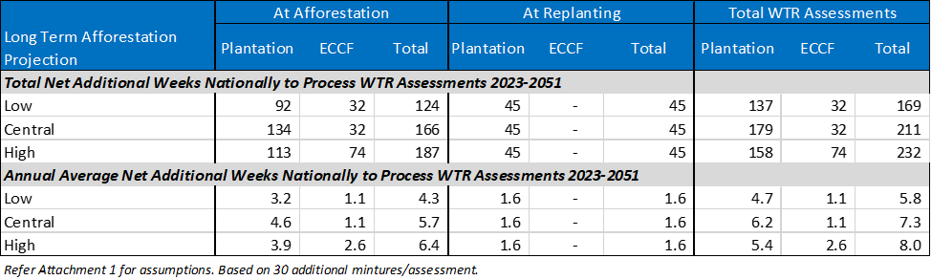
Table 4-1 shows that the net additional weeks of WTR Assessment processing time over the 2023-2051 period for all councils combined is between 169-232 weeks, or an annual average increase of between 5.8-8.0 weeks over the long-term future. This ‘labour cost’ will be split across councils that process WTR Assessments. Overall, these minor changes attributable to the proposed amendments to WTR Assessment information are considered unlikely, in and of themselves, to require additional staffing within local authorities, and net additional processing time is anticipated to be absorbed without material disruption and is within existing capabilities. Economic cost minor and unquantified in dollar terms.
- Local authorities (although mainly regional and unitary councils) will have additional administration costs to process replanting notices (assuming these are introduced akin to clause 10). It is estimated that these notices would be processed relatively quickly, and an assumption of 15 minutes per notice (excluding the processing of the WRT Assessment) has been adopted for this CBA following feedback from one Regional Council on simple afforestation notices. Based on a series of relatively simple assumptions described in Attachment 1, including long-term projections of replanting activities nationally, Table 4-2 quantifies the net additional impact on local authority resources to process notices for 100% of replanting activities in future (if applicable to the NES-PF amendments).
Table 4‑2: Net Additional Weeks for Local Authorities to Process Replanting Notices for All Replanting Activities
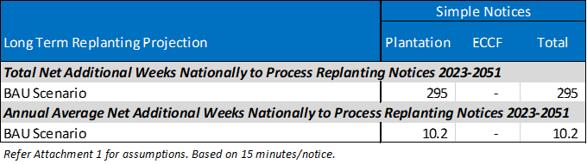
Table 4-2 shows that the net additional weeks of Replanting Notice processing time over the 2023-2051 period for all councils combined could be 295 weeks, or an annual average increase of 10.2 weeks over the long-term future. This ‘labour cost’ will be split across councils that process WTR Assessments. Overall, these minor changes attributable to the potential requirement for a Replanting notice are considered unlikely, in and of themselves, to require additional staffing within local authorities, and net additional processing time is anticipated to be absorbed without material disruption and is within existing capabilities. Economic cost minor and unquantified in dollar terms.
- Local authorities (although mainly regional and unitary councils) will have additional administration costs to process WTR Assessments for replanting where it is for the same conifer species. As above, we assumed for this CBA that only 5% of replanting activities were for a different conifer species. Therefore, the other 95% of replanting activities are assumed to be for the same conifer species and we assume a WTR Assessment would be required whether it is a permitted, controlled or restricted discretionary activity under the amendments. As per section 2, we assume for this CBA that it takes councils indicatively 2 hours to process each WTR Assessment under status quo scope requirements and an additional 30 minutes under the proposed changes in information requirements (discussed above). We therefore apply a gross time of 2.5 hours per WTR Assessment where the conifer species being planted is the same and apply this to 95% of projected long-term replanting activities. Further detail on assumptions is set out in Attachment 1.
Table 4‑3: Net Additional Weeks for Local Authorities to Process WTR Assessments for Replanting Activities That Are For The Same Conifer Species
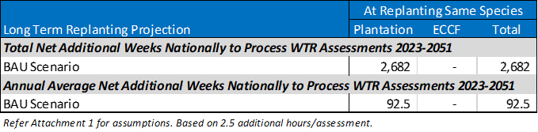

Table 4-3 shows that the net additional weeks of WTR Assessment processing time for same species conifer replanting over the 2023-2051 period for all councils combined could be 2,682 weeks, or an annual average increase of 92.5 weeks over the long-term future. This ‘labour cost’ will be split across councils that process WTR Assessments. Overall, these minor changes attributable to the potential requirement for a WTR Assessment for same species replanting are considered likely, in and of themselves, to require a small amount of additional staffing across local authorities, but is otherwise within existing capabilities. Economic cost minor and unquantified in dollar terms.
- Local authorities will be required to administer and monitor more controlled activity consents where replanting of the same conifer species returns a WTR score of 12 or more. Additional demands on staff resources (time), including for compliance monitoring of those consents. The Environmental Monitoring System is of limited assistance to help estimate how many future WTR Assessments for replanting of the same conifer species would result in a score of 12 or more. On average over the last two years of data in the Environmental Monitoring System, we estimate that only 3 consents/annum nationally have been issued for replanting under current provisions. Those consents have had an average recorded cost (passed on to applicants) of just $1,093, but a minimum cost of just $725, which is assumed to reflect a controlled activity consent. Those costs suggest very little time cost of labour for councils per controlled activity consent, but compliance monitoring (and any enforcement required) would be in addition to that and that aspect would not be recoverable under the NES-PF clause 106.
Indicatively, we assume 10 hours total time to administer the new controlled activity consents at replanting proposed by the amendments. This covers administration time and any compliance monitoring time. Based on other assumptions that 95% of replanting activity is for the same conifer species, and very indicatively, that 10% of those (so 9.5% of total replanting activity) return a WTR Calculator score of 12 or more under the updated calculator, then this could equate to a total number of new controlled activity consents of 4,268 between 2023 and 2051 nationally. In any one year, this could be a minimum of 79 net additional consents (circa the medium term where replanting is estimated to be carried more by large forest owners) and a maximum of 228 net additional consents (circa the short term where replanting is estimated to be carried out more by small scale forest owners).
Table 4‑4: Net Additional Weeks for Local Authorities to Administer and Monitor New Controlled Activity Consents for Replanting the Same Conifer Species (with WTR scores of 12 and above)
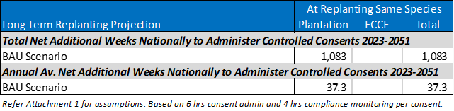
Table 4-4 shows that the net additional weeks of new controlled activity consent administration and compliance monitoring for same species conifer replanting with WTR scores of 12 and over in the 2023-2051 period for all councils combined could be 1,083 weeks, or an annual average increase of 37.3 weeks over the long-term future. That’s one FTE for the whole country. This ‘labour cost’ will be split across councils that process these replanting controlled activity consents. We include this cost here even though a portion is expected to be passed onto the forestry owners but ensure the same ‘council fee’ transaction cost is not included for foresters below to avoid double counting.
Overall, these minor changes attributable to the potential requirement for controlled activity consent for same species replanting are considered likely, in and of themselves, to require a very small amount of additional staffing across local authorities but is otherwise within existing capabilities. Economic cost minor and unquantified in dollar terms.

4.2.2 Costs to private landowners (foresters)
Transaction costs
- Foresters of conifer species may pay more if the update to the WTR Calculator and guidance increases the time and complexity of WTR Assessments for afforestation and when replanting involves a different conifer species, and these costs are passed on by service providers (i.e., qualified experts). These are considered a one-off cost for the life of each forest and are assumed to apply to 100% of afforestation activities between 2023 and 2051 for both plantation and ECCF WTR assessments (under current reporting scope) and 5% of replanting activities for plantation forestry during that time period where WTR assessments are required for a change in conifer species.
The cost, expressed in present value terms (5% discount rate) in Table 4-5 also assumes that these costs are highest (by 20%) in year 1 after the update coming into effect, but dimmish over the medium term (to 2032, as the changes become normal (best) practice and service providers improve efficiencies). Hence, the discounted results by afforestation projection series shows only minimal changes on account that all long-term afforestation projections apply the same medium-term outlook up to 2030 and alternative growth rates apply in 2031 and 2032 under this model (where not net additional costs are assumed to apply after 2032). Further assumptions of the modelling for this cost are set out in Attachment 1. To test the worst outcomes, we have modelled the impact on the upper limit of WTR Assessment costs ($1,600).
Table 4‑5: Indicative Net Additional National Costs to Foresters of WRT Assessments Under Updated Calculator and Guidance ($m, PV, 5% DR)
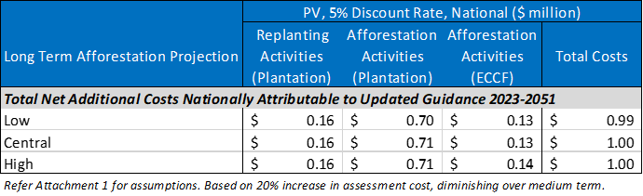
Table 4-5 shows that updates to the WTR Calculator and Guidance may have net additional costs for foresters of around $1.0m (PV). This is the nationwide cost estimate, which will be spread across numerous landowners carrying out WTR assessments at afforestation or different species replanting over the next 10 years and when averaged out, constitutes a small cost increase only. At the industry level, this cost is considered minor. Economic cost minor.
- Foresters of conifer species may pay more for WTR Assessments for afforestation and when replanting involves a different conifer species if additional information requirements are to be provided to local authorities that is not already carried out by service providers (this may be partially offset by the requirement to use a standard worksheet/ template). These are considered a one-off cost for the life of each forest and are assumed to apply to 100% of afforestation activities between 2023 and 2051 for both plantation and ECCF WTR assessments (under current provisions) and 5% of replanting activities for plantation forestry during that time period where WTR assessments are required for a change in conifer species.
The cost, expressed in present value terms (5% discount rate) in Table 4-6 assumes that these costs are maintained over the long-term. Indicatively, and for the purpose of this CBA, it is assumed that the additional reporting scope increases the costs of WTR Assessments for foresters by 15%. This cost is in addition to any costs associated with adjusting to an updated Calculator and Guidance (discussed above). Again, we base the impact on the upper limited of WTR Assessment costs ($1,600). Further assumptions of the modelling for this cost are set out in Attachment 1.

Table 4‑6: Indicative Net Additional National Costs to Foresters of WRT Assessments Under Additional Scope Requirements ($m, PV, 5% DR)
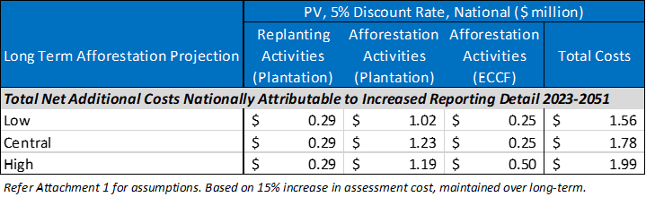
Table 4-6 shows that the proposed requirement for more detailed information provided to councils in WTR Assessments may have net additional costs for foresters of between $1.6m-$2.0m (PV). This is the nationwide cost estimate, which will be spread across numerous landowners carrying out WTR assessments at afforestation or different species replanting over the long-term (to 2051) and when averaged out, constitutes a small cost increase only. At the industry level, this cost is considered minor. Economic cost minor.
- Foresters (namely plantation foresters) replanting the same conifer species will have to pay the cost of a WTR Assessment. These are considered a one-off cost for the life of each forest and are assumed to apply to 95% of replanting activities between 2023 and 2051.
The cost, expressed in present value terms (5% discount rate) in Table 4-7 assumes that these costs apply over the long-term. Indicatively, and for the purpose of this CBA, we have applied the upper range status quo cost of a WTR Assessment for foresters ($1,600), and that this is further increased by the updates to the Calculator and Guidance (by 20%) but diminishing over the medium term (discussed above), and increased (by a further 15% maintained over the long-term) associated with the net additional reporting requirements to local authorities (discussed above).
We therefore apply the gross cost for WTR Assessment for those foresters that would be required to carry out at replanting (same species) only under the proposed amendments. We also assume that the unit cost is required for each replanting activity (tied to a notice of replanting) and is not an assessment that would cover multiple replanting stages that would be notified separately. Further assumptions of the modelling for this cost are set out in Attachment 1.
Table 4‑7: Indicative Net Additional National Costs to Foresters of WRT Assessments Under Combined Proposed Amendments at Replanting (Same Species) ($m, PV, 5% DR)
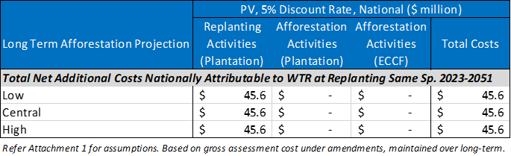

Table 4-7 shows that the proposed requirement to carry out a WTR Assessment at replanting of the same conifer species may have net additional costs for foresters of $45.6m (PV). This is the nationwide cost estimate, which will be spread across numerous landowners carrying out WTR assessments at same species replanting over the long-term (to 2051). The unit cost is not considered prohibitive to the commercial feasibility of replanting (given that foresters changing conifer species or carrying out afforestation already pay similar costs under the status quo), at the industry level, this is moderate change in national transaction costs at replanting over the long-term. Economic cost moderate.
- Foresters (namely plantation foresters) will need to submit a notice of replanting if introduced by the amendments. This would apply to 100% of replanting activity over the long-term. Completion of online notice forms is considered a negligible one-off cost for the life of the forest. Economic cost negligible and unquantified in dollar terms.
- Foresters (namely plantation foresters) replanting the same conifer species where the WTR Score is 12 or more will have to pay for a controlled activity consent. These are considered a one-off cost for the life of each forest and are assumed to apply to 9.5% of replanting activities between 2023 and 2051.
The cost, expressed in present value terms (5% discount rate) in Table 4-8 assumes that these costs apply over the long-term. Indicatively, and for the purpose of this CBA, it is assumed that the average gross cost of a controlled activity consent at same species replanting (associated with a WTR score of 12 or more) for foresters is $5,000. We caution that this has not been ground truthed with forestry representatives. This excludes any council fees passed onto foresters (and captured already above in FTE terms for local authorities).
We also assume that the unit cost is required for each replanting activity (tied to a notice of replanting) and is not a consent that would cover multiple replanting stages that would be notified separately. Further assumptions of the modelling for this cost are set out in Attachment 1.
Table 4‑8: Indicative Net Additional National Costs to Foresters of Controlled Activity Consent Applications at Replanting (Same Species with WTR score of 12 or above) ($m, PV, 5% DR)
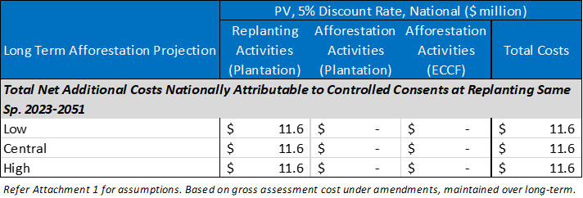
Table 4-8 shows that the proposed requirement to apply for a controlled activity consent at replanting of the same conifer species may indicatively have net additional costs for foresters of $11.6m (PV). This is the long-term nationwide cost estimate, which will be spread across numerous landowners carrying out WTR assessments at same species replanting and scoring 12 or more on the Calculator (to 2051). The unit cost is not considered prohibitive to the commercial feasibility of replanting (given that a number of foresters already pay transaction costs for controlled, restricted discretionary, discretionary or non-complying consents under current regulations). At the industry level, this is considered a minor increase in national transaction costs at replanting over the long-term. Economic cost minor.
Compliance costs
- Foresters (namely plantation foresters) replanting the same conifer species where the WTR Score is 12 or more may have net additional compliance costs associated with a controlled activity consent to mitigate and/or eradicate WTR spread over the life of the forest over and above control costs required for permitted replanting. Control costs are not one-off and are required under a permitted activity to carried out at least every 5 years from replanting (and potentially more frequently under a controlled activity consent). That means that replanting in any year, could be expected to carry out up to 5-6 eradication efforts over the life of the forest if wilding spread was persistent (i.e., assuming an average harvest age for Pinus radiata of around 28 years). For replanting occurring in 2051 (the last year considered within the scope of this CBA), the final eradication of wildings associated with that replanting could occur in 2081 (assuming a 5 yearly frequency).
In the time available, M.E has been unable to confirm a robust average cost range for compliance eradication, assuming this is carried out by a specialist service provider. We provide an indicative scenario for the purpose of this CBA, whereby the assumed average net additional eradication cost per time was $2,500 under permitted activity conditions (noting that eradication is limited to the forest owners’ property, as proposed by the amendments). We then assume, indicatively, that controlled activity consent conditions increase this by 20% in some way. Again, this has not been ground truthed, so should not be relied on. This net increase has been conservatively applied every five years after replanting (for a total of 6 times), for all replanting activity each year requiring a controlled activity consent (assumed at 9.5% of all replanting activity) and projected over the long-term. Further details of assumptions are contained in Attachment 1.
Table 4‑9: Very Indicative Net Additional National Wilding Tree Control Costs to Foresters of Controlled Activity Consents (Same Species Replanting) ($m, PV, 5% DR)
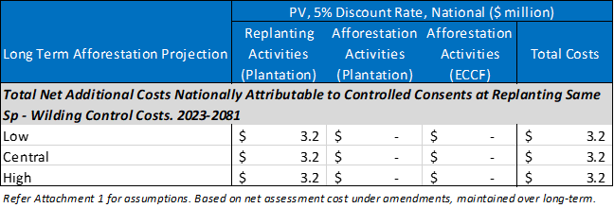
Table 4-9 shows that the potential requirement for net additional wilding tree eradication costs (as a condition of a controlled activity consent at replanting of the same conifer species scoring 12 or more on the WRT Calculator) under M.E’s indicative scenario may have net additional costs for foresters of $3.2m (PV). This is the nationwide cost estimate, which will be spread across numerous landowners potentially requiring controlled activity consents at replanting over the long-term (to 2051). The aggregate cost per replanting activity is not considered prohibitive to the commercial feasibility of replanting (given that it is only expected to be a marginal cost increase over permitted replanting conditions). At the industry level, this is considered a minor increase in national compliance costs at replanting over the long-term. Economic cost minor.
Opportunity costs
- Foresters (namely plantation foresters) replanting the same conifer species where the WTR Score is 12 or more may face opportunity costs (reduced yields/returns) if controlled activity compliance conditions reduce/modify the areas that can be replanted or the species that can be replanted. Based on the approach applied above this could apply to, at most, an estimated 9.5% of replanting activity over the long-term, but is highly uncertain. Economic cost minor and unquantified.
- It is noted that some submitters identified costs (liabilities) associated with meeting ETS requirements if replanted forest outcomes change as a result of the compliance conditions around WTR. Analysis of this potential costs is outside the scope of this CBA, but should not be disregarded if the submission issue is a legitimate one.

4.3 Benefits
Based on the discussion above, this section translates the tangible changes from the status quo of updating the WTR Calculator and Guidance and amending the provisions in relation to WTR assessment requirements at afforestation and replanting into benefits borne by different stakeholders, including the nature of those benefits.

4.3.1 Benefits to local and central government
Administration costs
- Local authorities have a greater understanding of exotic forestry replanting activity occurring as a permitted activity in their district/region as a result of receiving notices of replanting activity (if applicable). Flow-on benefits for land use planning, wilding conifer control management and wildfire risk management. Economic benefit minor and unquantified.
- Local authority capability to understand and assess the risk of wilding conifer tree spread improves through receipt of more detailed information provided and updated guidance – skills development within councils. This benefit is considered minor and will occur incrementally over time, with the rate of upskilling commensurate with the number of WTR assessments processed (with some regional councils receiving more than others). Social and economic benefit minor unquantified.
- Reduced future spread of wilding conifers over the long-term as an indirect result of improved understanding of risk and potentially more effective conditions of consent for afforestation and replanting of conifer species – eradication cost savings over the medium to long-term for DOC, LINZ, central government and local authorities. Helps avoid exacerbating the 2 million hectares of land affected by wildings, which is spreading at a rate of 5% per year. With 96% of forestry area a conifer species and strong growth in exotic forestry area projected over the long-term (Appendix A), and the significant economic, social, cultural and environmental costs of wilding conifer spread that accrue to local authorities and central government, even a marginal improvement in future outcomes is considered to be beneficial. Economic benefit moderate and unquantified.
- Greater regulatory consistency and certainty for local authorities on required eradication of wilding conifers in SNAs and wetlands at the time of, and in relation to replanting. Economic benefit minor and unquantified.

4.3.2 Benefits to private landowners (foresters)
- Reduced future spread of wilding conifers over the long-term as a result of improved understanding of risk and potentially more effective conditions of consent for afforestation and replanting of conifer species – eradication cost savings over the medium to long-term for some forestry owners. Economic benefit minor and unquantified.
- Potential cost savings associated with WTR Assessments arising from industry-wide use of a worksheet or template for assessments (if efficiencies are passed on to foresters by service providers). Economic benefit minor and unquantified.
- Greater regulatory consistency and certainty for foresters on required eradication of wilding conifers in SNAs and wetlands at the time of, and in relation to replanting. Economic benefit minor and unquantified.

4.3.3 Benefits to wider public
- Reduced future spread of wilding conifers over the long-term as an indirect result of improved understanding of risk and potentially more effective conditions of consent for afforestation and replanting of conifer species – eradication cost savings over the medium to long-term for private landowners down-wind of conifer forests and reduced loss of productive capacity. As above, even marginal improvements in practice are beneficial for non-forestry landowners and the wider public. Economic benefit moderate and unquantified.
- Greater regulatory consistency and certainty for NGOs involved in wilding conifer control and landowners on required eradication of wilding conifers in SNAs and wetlands at the time of, and in relation to replanting. Economic benefit minor and unquantified.
- Potential reduced future spread of wilding conifers over the long-term as an indirect result of improved understanding of risk and potentially more effective conditions of consent for afforestation and replanting of conifer species better protects landscape values for the wider public in the medium to long-term. Environmental, Social, Cultural and Economic benefits moderate and unquantified.

4.4 Efficiency conclusions
If there are known limitations to the current WTR Calculator and guidance, then it would be inefficient to allow that to continue to be used for the foreseeable future. Best practice constantly evolves, and it is important that assessment of WTR is based on the most comprehensive information available given the significant annual costs of wilding conifer control. With afforestation rates projected to grow, including the additional risk of wilding tree spread from ECCF (taller and older trees), the risk of wilding tree spread is potentially going to grow (although noting the Douglas fir planting is declining which is a big contributor in the South Island). It is therefore more important than ever (including more important that when the NES-PF was developed) to ensure that compliance conditions that help avoid, remedy and mitigate wilding tree spread are going to be effective. If providing more detailed information to local authorities helps to achieve this, then this is considered an efficient regulatory outcome.
Most of the costs are marginal changes from the status quo or minor when considering the frequency for foresters and local authorities (including over the course of a year). Foresters bear the majority of the economic costs arising from the amendments around WTR, and cumulatively, the net additional costs to the forestry industry over the long-term are considered to have a moderate impact (i.e., around $63m based on assumptions applied, present value, 5% discount rate), but the potential long-term benefits of reducing or avoiding net additional wilding conifer spread are much greater and benefit the community at large. The amendments help shift more of the potential costs of wilding conifer spread back onto foresters which is appropriate in our view. While not all costs and benefits are quantified, the benefits are considered to outweigh the costs over the long-term and the proposed amendments are therefore more efficient than retaining the status quo.

5. Controlling the location of forests
This section considers the costs and benefits of giving councils control over the location of all exotic afforestation through their regional and district plans. It is noted that councils already have the ability to control the location of ECCF within their plans, so this proposed amendment does not change the status quo with respect to ECCF. However, this CBA also considers the proposed amendments in sequence, so at this point, we assume that ECCF is brought within the scope of the NES-PF (discussed in Section 2). This means that the baseline has shifted, and councils will only have the ability to manage the social, cultural and economic effects of ECCF – as they currently do for plantation forestry - and will have the ability to apply more stringent rules for ECCF as set out in clause 6 of the NES-PF – as they currently do for plantation forestry.

5.1 Discussion of proposed amendments
We say “only”, but the existing regulations do give councils a wide scope to manage the effects of forestry, including its location. However, our high-level understanding is that while some councils have taken advantage of clause 6 to provide (or retain) more stringent rules in relation to objectives of the NPS-FM, selected policies of the NZCPS, ONFLs, SNAs, separation point granite soils, geothermal areas, karst geology and drinking water supply sources, relatively few (if any) councils have sought to control the location of plantation forestry (or ECCF) to manage local social, economic or cultural effects. We are aware that there are some district plan reviews underway that may address forestry issues (i.e., Gisborne District Council and Waitaki District Council), and one council recently spoken to (Clutha District) have approved resources to investigate a plan change on forestry (although it is only at the investigative stage). A small number of councils have commissioned assessments on the impact of forestry on rural communities – demonstrating an awareness of adverse effects in some locations.
Potential reasons for this may be:
- uncertainty around the scope of provisions councils can and cannot have in their Plans relative to the NES-PF,
- costs of plan changes (particularly in districts with a small rating base),
- lack of capacity and expertise in councils,
- lack of national guidance on how to balance local issues with national objectives (including how to manage the conflicts with the NPS-HPL which protects the capacity of LUC 1-3 class land for forestry (as a form of primary production)), or
- expectations of a litigious process (added cost and resources).
One Council spoken to felt that forestry was the largest ‘economic’ issue that the council has had to deal with. It is also important to recognise that for other councils, forestry may not have created any significant resource management issues locally, and afforestation may be seen as an opportunity for the district’s community and economic wellbeing.
The proposed amendment would allow councils to control the location of exotic afforestation for any purpose, which we understand to mean that they can create more stringent rules on the management of environmental effects already covered for afforestation, earthworks, harvesting etc in the NES-PF, but also manage a broader range of environmental effects of exotic forestry afforestation (in addition to managing social, cultural and economic effects). This could result in restricting afforestation, or afforestation of a particular type, in certain locations even if the NES-PF enables it.
It is unknown how many councils would seek to control plantation or ECCF afforestation over and above the NES-PF. Where local issues are more pronounced, plan changes are already likely to be contemplated, or underway. That cannot be attributed to the proposed amendments, as it is occurring as part of the status quo. Projected growth in afforestation may exacerbate issues in districts where councils are already aware of some adverse effects or give rise to new issues in districts where forestry had not previously been a problem. Including ECCF in the scope of the NES-PF (as proposed), might address some of the issues currently being experienced, or anticipated in the future – reducing the need for plan changes (or perhaps narrowing the scope of issues that future plan changes might need to address). For districts where forestry is creating adverse effects (local issues), the barriers to developing plan changes that have been experienced to date (and described above) will not change as a result of the proposed amendments.
It is important to understand some of the consequences of the status quo regulation whereby councils can already manage the social, cultural and economic effects of plantation forestry (and ECCF if brought into the scope of the NES-PF) in their district plans, including provide more stringent rules under clause 6, so that the net effect of the proposed amendments can be understood.
- Councils may not sufficiently understand potential social, cultural and economic effects of plantation (and other) forestry. In the absence of national direction or guidance, District Plan provisions may be ineffective or have perverse outcomes including being contrary to national objectives and aspirations for forestry. Other drivers of change in rural communities and economies unrelated to plantation (and other) forestry will continue to have an impact. Plan changes will not necessarily solve all of the issues/problems identified and of concern to local communities and other stakeholders. This risk should be minimised by s32 evaluations and schedule 1 processes that test the efficiency and effectiveness of provisions in relation to the local problem statement. The proposed amendments will not change this outcome.
- Adverse social, cultural and economic effects that are attributable to exotic afforestation will only be managed where and when councils choose to regulate the location of exotic afforestation. The optional nature of plan changes means that outcomes will vary across the country. While the NES-PF provides a consistent and certain baseline for managing the environmental effects of plantation (and ECCF) forestry activities (based on best practice understood at that time), that has always been the limit of the national consistency and certainty. The proposed amendments increase the potential for inconsistency and uncertainty in forestry regulation across the country (above the status quo) by enabling even more locally specific controls. They also potentially erode the level of consistency established by the NES-PF (the baseline) with respect to managing the environmental effects of forestry activities.
- Afforestation trends/regulation (or lack of) in one district may have adverse effects in other districts. This risk is mitigated by the ability of neighbouring districts and stakeholders to participate in the plan change process. The proposed amendments will not change this outcome.
The proposed amendments are likely to increase the clarity of councils’ status quo abilities to control social, cultural and economic effects of forestry and stringency under clause 6, which may see more plan changes instigated (or instigated sooner) where lack of clarity was the barrier.
The proposed amendments may also stimulate more plan changes (than likely under the status quo) by giving councils that ability to manage the location of afforestation for any reason, where a particular local effect/issue was previously outside the scope of clause 6 and could not be achieved by managing social, cultural or economic effects of afforestation.
How many future plan changes this relates to, is highly uncertain. Many council may wish to see what impact bringing ECCF into the scope of the NES-PF has on their district in the first instance (i.e., short-medium term). Importantly, the CBA does not attribute the induced costs or benefits of future plan changes to manage the location of forestry to the proposed amendments to the NES-PF as the amendments are not directive, and only provide the opportunity for councils to develop plan changes. It is however acknowledged that plan changes are costly, particularly when consultation is required, and appeals are lodged. Councils will need to weigh up the cost of pursuing a plan change with the benefits that can be achieved (now and over the long-term).

5.2 Costs
Based on the discussion above, this section translates the tangible changes from the status quo of giving councils full control over the location of exotic afforestation into costs borne by different stakeholders, including the nature of those costs.

5.2.1 Costs to local and central government
- No tangible costs to local authorities attributable to the proposed amendment to provide greater opportunity for local control of exotic afforestation are anticipated. Costs of future plan changes out of scope.

5.2.2 Costs to participants in resource management processes
- No tangible costs to participants in resource management processes anticipated. Costs of participation in future plan changes out of scope.

5.2.3 Costs to private landowners (foresters)
- Landowners considering/planning exotic afforestation may face increased uncertainty and perceived greater investment risk as a result of it being clearer that councils can manage the location of exotic afforestation to manage social, cultural and economic effects as well as more stringent rules under clause 6. Actual increased investment risk will depend on whether councils choose to regulate the location of exotic afforestation to manage these effects already enabled by existing regulation and the nature of those controls. Plan changes may take many years to be developed. Uncertainty greatest for the medium and long-term. Economic cost minor and unquantified.
- Landowners, including owners of Māori land, considering/planning exotic afforestation may face increased uncertainty and perceived greater investment risk as a result of councils having scope to manage the location of exotic afforestation for any environmental reason not already addressed in the NES-PF, and to make more stringent rules for activities already managed in the NES-PF. Actual increased investment risk will depend on whether councils choose to regulate the location of exotic afforestation to manage environmental effects over and above the controls in the NES-PF and the nature of those controls. Plan changes may take many years to be developed. Uncertainty greatest for the medium and long-term. Economic cost uncertain but potentially significant and unquantified.

5.3 Benefits
Based on the discussion above, this section translates the tangible changes from the status quo of giving councils full control over the location of exotic afforestation into benefits borne by different stakeholders, including the nature of those benefits.

5.3.1 Benefits to local and central government
- Local authorities have greater certainty around their ability/option to develop provisions in plans to manage the social, cultural and economic effects and other clause 6 matters of exotic afforestation. Local authorities can be more effective in their role to manage economic, social, cultural and environmental wellbeing. Economic benefit minor and unquantified.
- Local authorities have greater scope to develop provisions in plans to manage the environmental effects of exotic afforestation, particularly where the NES-PF was not being effective in addressing issues specific to that location. Local authorities can be more effective in their role to manage economic, social, cultural and environmental wellbeing. Economic benefit significant in districts experiencing significant adverse environmental effects and minor/negligible in districts experiencing minor/no adverse effects, unquantified.

5.3.2 Benefits to participants in resource management processes
- Local communities and NGOs have greater certainty around their ability to have a say in the location of exotic afforestation (although their ability to actually have a say is dependent on whether their council chooses to develop a plan change). Social benefit minor and unquantified.
- Tangata whenua have greater certainty around their ability to have a say in the location of exotic afforestation (although their ability to actually have a say is dependent on whether their council chooses to develop a plan change). Cultural benefit minor and unquantified.

5.3.3 Benefits to private landowners (foresters)
- No tangible benefits to foresters anticipated.

5.3.4 Benefits to wider public
- Some local communities may potentially benefit if cumulative adverse environmental, social, cultural and economic effects attributable to future exotic afforestation are avoided, remedied or mitigated as a result of councils choosing to introduce a plan change sooner that would otherwise have been the case under the status quo (i.e. timing benefits prompted by the amendment). While some effects of better planning of where afforestation should take place will be felt in the short term, other effects may not be felt until the long term. Plan changes will still take some time (years) to be delivered. Environmental, social, cultural and economic benefits uncertain.
- Some local communities may potentially benefit if cumulative adverse environmental effects (outside the scope of the NES-PF or ineffectively managed by the NES-PF controls) attributable to future exotic afforestation are avoided, remedied or mitigated as a result of councils choosing to introduce plan change provisions that they would not otherwise have had scope to introduce. While some environmental effects of better planning of where afforestation should take place will be felt in the short term, other environmental effects may not be felt until the long term. Plan changes will still take some time (years) to be delivered. Environmental benefits uncertain.

5.4 Efficiency conclusions
While the NES-PF provisions that manage the environmental effects of forestry activities represent best practice (as understood at the time, or as proposed to be amended following the Year One Review process), it is inevitable that they may not be effective in all locations/situations. The greatest benefit of the ability to give councils to control the location of exotic afforestation is to correct for situations where the NES-PF is being ineffective or having unintended environmental outcomes. This is especially important as the majority of forestry activities are able to be carried out currently as permitted activities, with only some activities monitored for compliance.
This benefit is likely to be limited to a relatively small number of land types or locations. The benefits will be felt as marginal changes to environmental outcomes as the plan changes are unlikely to be able influence the adverse environmental effects of existing (established) forests, who will have existing use rights. Further, replanting does not constitute afforestation which may allow adverse effects of those forests to be perpetuated if the amendments allow for control over afforestation only. Other incentives will be needed to address existing/legacy environmental issues.
Councils have already been able to manage the social, cultural and economic effects of exotic afforestation, and this does not change. Clarifying this is useful, but may not be effective in bringing about change over and above the status quo. There are a range of barriers to implementing plan changes to manage these effects of exotic forestry, and the amendments do not address those.
The costs of the proposed amendments are a potential increase in the complexity of regulation to manage exotic afforestation across the country, although not in the short-term. This may accumulate over the medium and long-term. Complexity and inconsistency raises the costs of doing business, so falls on foresters and landowners, but also communities and NGOs who participate in those processes. The proposed amendments also increase the uncertainty of where exotic afforestation will be enabled in the medium-long term. This creates risks (potentially significant) for foresters that have invested in land for medium and long-term afforestation. While the potential benefits for environmental outcomes are likely to be quite site specific, the uncertainty generated by the proposed amendments may be felt more widely.
The net outcome of direct costs and benefits is uncertain. On balance, the benefits are likely to outweigh the costs on the basis that indirectly being able to improve environmental outcomes through local plan changes where the NES-PF was not sufficiently managing environment effects improves the social, cultural and economic wellbeing of the community as a whole, and potentially beyond the district/region in question. The benefits to the many (including future generations) outweighs the costs to the few (being landowners involved in or contemplation afforestation in those districts.

6. Overview and conclusions
This CBA has considered four of the key proposed amendments to the NES-PF. As discussed in section 1, the evaluation of costs and benefits has been based on the general direction of the proposed amendments as set out the draft Recs Report, and not the actual drafted amendments. Care is needed in relying on this evaluation if drafted amendments differ markedly from M.E’s interpretation of how they would appear/apply in the NES-PF. Consideration would need to be given to how any differences in the drafted amendments translate into tangible shifts in practice for foresters, local authorities and other stakeholders relative to M.E’s assumptions.
M.E has carried out some quantification of costs and benefits where practicable. This has necessitated the use of some assumptions applied to, or calibrated with, available data. Some cost and time estimates are based on information gathered from local authorities or forestry representatives, so are ground-truthed but not widely tested. Key assumptions underpinning most calculation can be found in Attachment 1.
A summary of our efficiency conclusions is provided below for each of the four key proposed amendments evaluated:
Proposed Amendment | Efficiency Conclusion
Tranche 1 – including ECCF in the scope of the NES-PF, charging for permitted afforestation compliance monitoring, and changes to matters of discretion for exotic afforestation greater than 2ha/year on red zone land | Based on the examination of costs and benefits it is considered that the benefits of the amendments to the scope of the NES-PF to bring in ECCF, as well as other proposed amendments in Tranche 1 are more likely that not to outweigh the costs over the long-term.  This was the conclusion for the application of these same controls and conditions in the NES-PF to plantation forestry in the original section 32 evaluation, and it is logical that a similar net benefit would apply to managing the effects of ECCF given the similarities in the nature of the forestry activities common to both forest types (even if the role, scale and frequency of those activities are relatively less for ECCF).
Tranche 2 – operational improvement – afforestation notice requirements (to help with wildfire risk management) | Anticipated costs to foresters and local authorities are all minor or immaterial costs. Benefits are more difficult to quantify, and mainly flow from councils having better spatial data on forestry that is more accessible within and across organisations. Some of these benefits may be far reaching and certainly not limited to improved wildfire risk management. Overall, it is considered that there would be net benefits (particularly when indirect benefits are included).
Tranche 2 – operational improvement – Wilding Tree Risk Management | The potential long-term benefits of reducing or avoiding net additional wilding conifer spread are much greater than the costs to foresters and will benefit the community at large. The amendments help shift more of the potential costs of wilding conifer spread back onto foresters which is appropriate. While not all costs and benefits are quantified, the benefits are considered to outweigh the costs over the long-term.
Tranche 3 – giving local authorities control to manage the location of exotic afforestation in district and regional plans | The benefits are likely to outweigh the costs on the basis that indirectly being able to improve environmental outcomes through local plan changes where the NES-PF was not sufficiently managing environment effects improves the social, cultural and economic wellbeing of the community as a whole, and potentially beyond the district/region in question. The benefits to the many (including future generations) outweighs the costs to the few (being landowners involved in or contemplation afforestation in those districts.

Overall, it is considered that all four of these proposed amendments to the NES-PF are more efficient than maintaining the status quo.

Attachment 1 – Further modelling assumptions

Resource Consents Issued Under the NES-PF
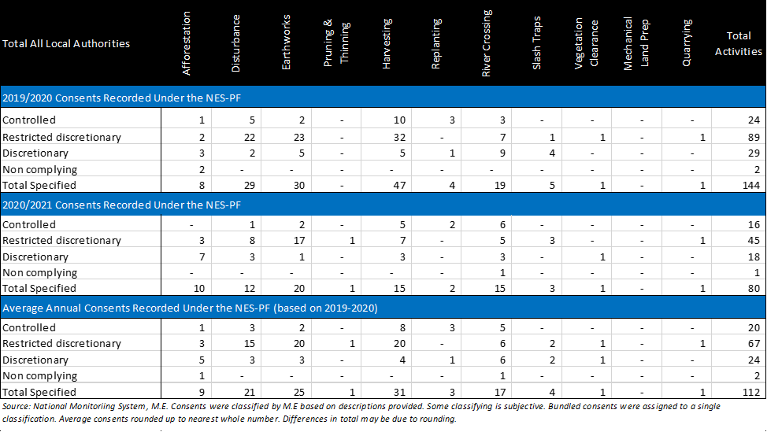
Other Activities Associated with the NES-PF
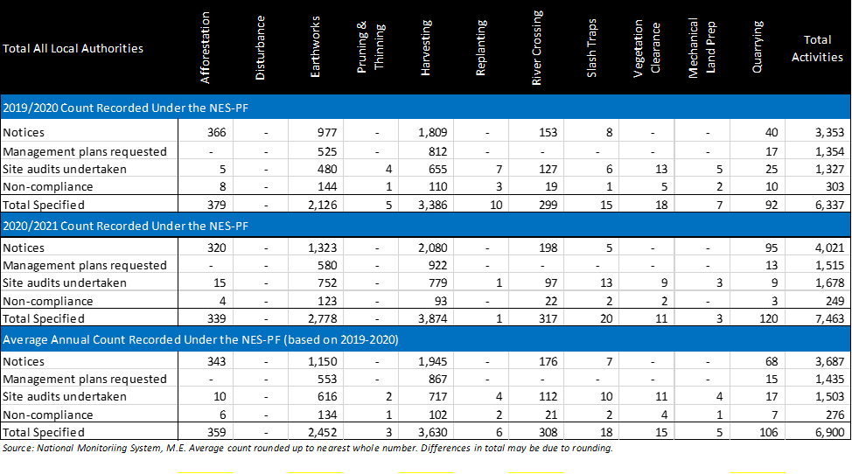

Long-Term Exotic Afforestation Projections (Ha)
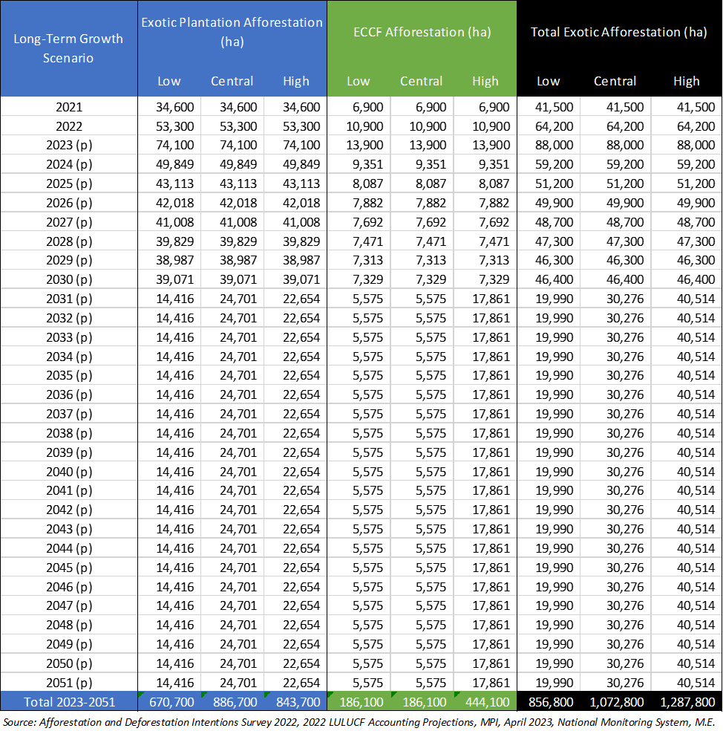
Assumptions:
- Medium-term projections from Intentions Survey applies to all scenarios.
- Long-term (2023-2051) total growth less medium-term projections (2023-2030) is the total afforestation between 2031 and 2051.
- Long-term afforestation 2031-2051, applied evenly per annum.

Long-Term Exotic Afforestation Activities / Notices
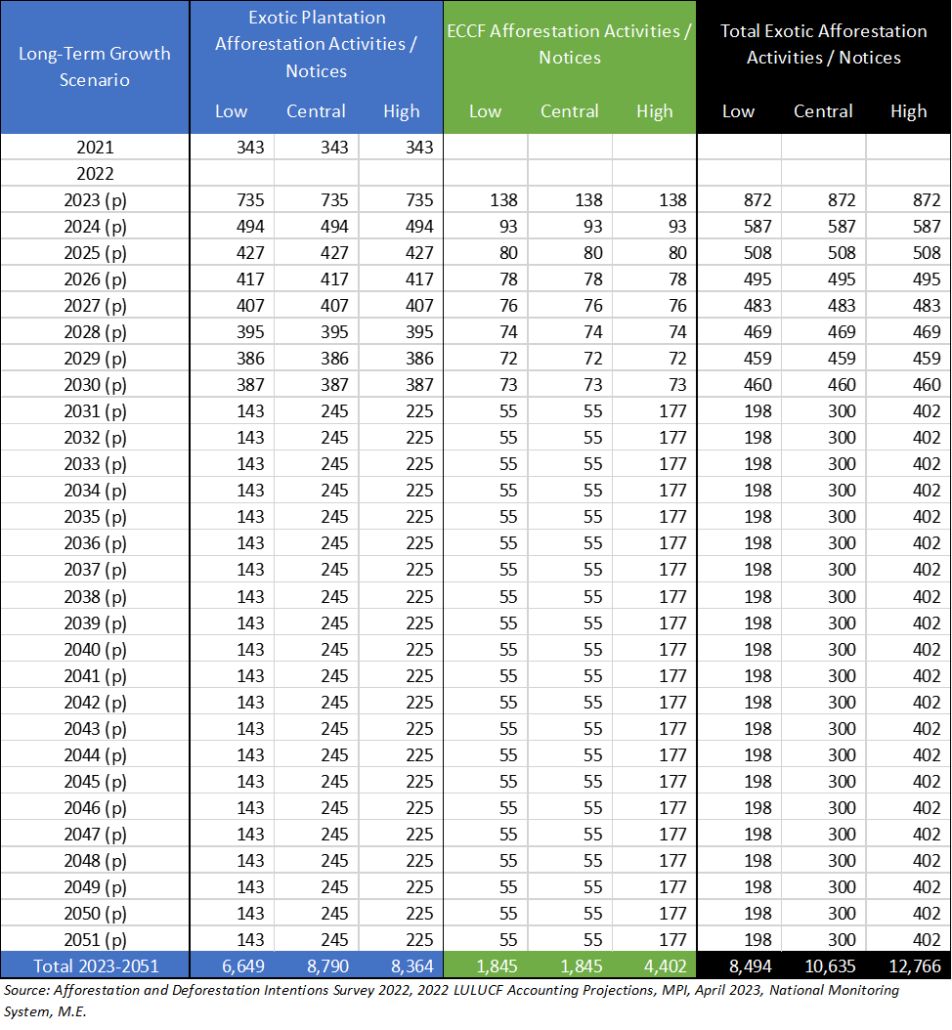
Assumptions:
- Average plantation afforestation area per notice in 2021 was 101ha.
- Assume average area per notice holds constant 2023-2051.
- Assume same average area per notice for ECCF afforestation 2023-2051.
- Notice = activity.
- Local authority processing time per plantation afforestation notice is 15 mins (simple) and 1 hour (complex)
- ECCF afforestation notices take the same time to process as plantation notices.
- 97% of afforestation activities (plantation and ECCF) are permitted activities. 3% require a consent.
- There is one WTR Assessment carried out for each afforestation activity.
- Only 97% of WTR Assessments are processed by local authorities (permitted activities)

Wood Supply Projections (Scenario 3) 2021-2051
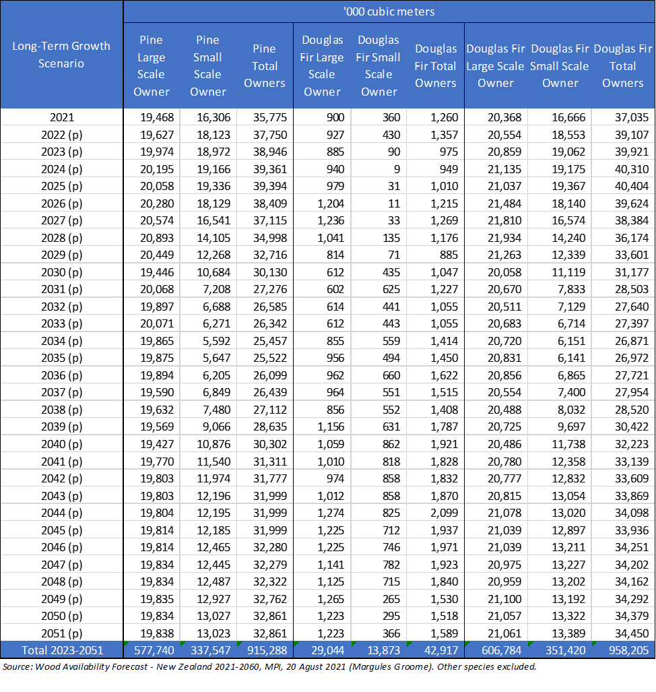

Harvest Area, Indicative Replanting Area & Replanting Activity (Notice) Projections 2021-2051
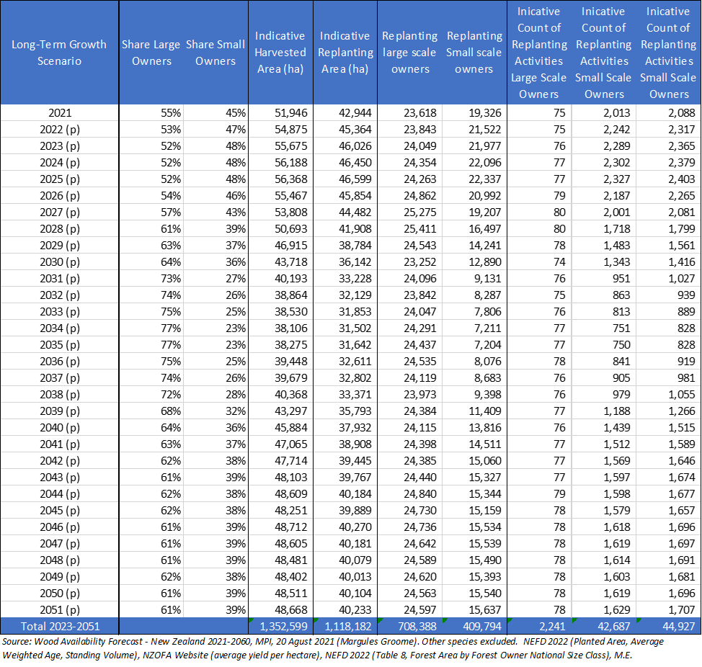
Assumptions:
- Average yield of pine/ha = 728 cubic meters (cross check NZOFA: 650-800 cubic meters).
- Average yield of Douglas fir/ha = 453 cubic meters (averaged across Mackenzie District and Queenstown Lakes District and scaled up 20% to account for an average harvest age of 40.4 years).
- New planting (restocking/replanting) 2021 = 42,907, NEFD 2022.
- Replanting area as share of harvested area awaiting restocking = 90%, NEFD 2022. Held constant to 2051.
- Calculations do not account for lags between harvest area in each year and replanting area – assumed to align (minor limitation).
- Assumes wood supply ratios between large and small forest owners also applies to replanting shares.
- Large scale owners treated as >=1,000ha, small scale owners treated as <1,000ha (NEFD 2022).
- Assume average replanting size for large scale owners is 317ha, held constant to 2051.
- Assumes average replanting size for small scale owners is 10ha.
- Indicative count of replanting activities calibrates to 2021 harvesting notices (2,080).
- Replanting activities = replanting notices.
- Assume 5% of replanting activities is for a different conifer species and 95% is for same conifer species. Held constant over long-term.

Further detail of these activities is provided in Part 2 of this report
Report on the Year One Review of the National Environmental Standards for Plantation Forestry. Prepared for Forestry Ministers By Te Uru Rākau. April 2021
NES are regulations that do not include objectives or policies. However for the purpose of section 32 evaluations the intent of the proposal, as expressed in the policy objectives, is assessed.
See Background section above for the defintion of ECCF
Further detail of these activities in provided in Part 2 of this report
National direction for plantation and exotic carbon afforestation. MPI Discussion Paper No: 2022/10. ISBN No: 978-1-99-105258-2 (online). ISSN No: ISSN 2253-3907 (online). October 2022.
Interim Regulatory Impact Statement: National direction for plantation and exotic carbon afforestation: Resource management proposals. October 2022
National direction for plantation and exotic carbon afforestation: questions and answers
This amendment was not progressed
Report on the Year One Review of the National Environmental Standards for Plantation Forestry. Prepared for Forestry Ministers by Te Uru Rākau. ISBN No: 978-1-99-100372-0 (online). April 2021
The objectives have been numbered for ease of reference in the following assessment.
LUC8e land is excluded as harvesting already requires consent under the NES-PF
Proposed National Environmental Standard for Plantation Forestry: Section 32 Evaluation MPI Technical Paper No: 2017/44. August 2017
Rational Transport Soc Inc v New Zealand Transport Agency HC Wellington CIV-2011-485-2259, 15 December 2011.
As noted in section 3.2 of Ministry for the Environment. 2017. A guide to section 32 of the Resource Management Act: Incorporating changes as a result of the Resource Legislation Amendment Act 2017. Wellington: Ministry for the Environment.
Whakatane District Council v Bay of Plenty Regional Council, CIV-2007-463-000606 (HC), para 40(iii).
Page 12, National Direction for Plantation and Exotic Carbon Afforestation Discussion Paper, October 2022
This additional analysis is intended to complement analysis already provided in the Consultation Document and RIS Report.
Source: NEFD 2022. Tree age and harvest cycles may mean that different districts dominate net growth in the next five years.
As defined by the NEFD. New Plymouth District, Stratford District, South Taranaki District, Wanganui District, Rangitikei District, Manawatu District, Palmerston North City, Hororwhenua District, Kapiti District, Greater Wellington, and on the east: Tararua District, Masterton District, Carterton District and South Wairarapa District.
Comprises just the Gisborne District
Workshop with selected local authorities, 31 July 2023.
As a restricted discretionary activity if greater than 2ha per annum.
Current NES-PF stringency rules (section 6) may also be having an impact on directing exotic plantation afforestation away from red zone land.
Ordinary privately owned freehold land
Land administered under the Te Ture Whenua Māori Act.
Further detail can be found in the Te hau mārohi ki anamata. Towards a productive, sustainable and inclusive economy: Aotearoa New Zealand's first emissions reduction plan, May 2022.
Māori own land in several different ways. In the Treaty of Waitangi analysis, which is summarised here, Whenua Māori is used to refer to land that is owned in different ways by Māori. This includes land owned by Māori collectives as Māori land as defined under Te Ture Whenua Māori Act 1993, land held by Treaty settlement entities, or Iwi, Hapū and Whanau land.
Treaty of Waitangi Analysis and Māori feedback on the proposed national direction for plantation and exotic carbon afforestation. Summary of Māori submissions. MfE 2023.
Aotearoa New Zealand’s First Emissions Reduction Plan, p275
National direction for plantation and exotic carbon afforestation. MPI Discussion Paper No: 2022/10, October 2022
Summarised from: Proposed National Environmental Standard for Plantation Forestry: Section 32 Evaluation MPI Technical Paper No: 2017/44. August 2017. Please see that evaluation report for references and further detail.
Page 12, National Direction for Plantation and Exotic Carbon Afforestation Discussion Paper, October 2022.
National direction for plantation and exotic carbon afforestation. MPI Discussion Paper No: 2022/10. October 2022 (Appendix D, page 86)
Page 15, Interim Regulatory Impact Statement (14 October 2022)
Report on the Year One Review of the National Environmental Standards for Plantation Forestry prepared by Te Uru Rākau, April 2021.
Section 32(4) requires that if a rule imposes a prohibition or greater restriction on an activity to which a national environmental standard applies, the evaluation report must examine whether the prohibition or restriction is justified in the circumstances of each region or district in which the prohibition or restriction would have effect.
https://www.mpi.govt.nz/forestry/national-environmental-standards-plantation-forestry/
31 July 2023, including Gisborne, Southland, Ruapehu, Clutha, Waitaki, Tasman and Tasman Districts and Southland and Canterbury Regional Councils
Yule Alexander Ltd on behalf of 17 Councils and Local Government New Zealand
Report on the Year One Review of the National Environmental Standards for Plantation Forestry. Prepared for Forestry Ministers By Te Uru Rākau. April 2021.
Year One Review report – Executive Summary
Interim Regulatory Impact Statement: National direction for plantation and exotic carbon afforestation: Resource management proposals. October 2022. Paragraphs 49 to 58.
https://environment.govt.nz/news/consultation-open-on-proposals-to-manage-forests-at-a-local-level/
National direction for plantation and exotic carbon afforestation. MPI Discussion Paper No: 2022/10.October 2022
National direction for plantation and exotic carbon afforestation: Resource management proposals, October 2022
https://www.mpi.govt.nz/dmsdocument/53923-National-direction-for-plantation-and-exotic-carbon-afforestation-questions-and-answers
Treaty of Waitangi Analysis and Māori feedback on the proposed national direction for plantation and exotic carbon afforestation.
Draft Summary of submissions - National direction for plantation and exotic carbon afforestation. MPI Draft 11 May 2023
Recommendations and decisions report on amendments to the National Environmental Standards for Plantation Forestry (NES-PF) [11 May 2023]
Eg Yule Alexander Ltd on behalf of 17 Councils and Local Government New Zealand
See Figure 3, Draft Summary of submissions - National direction for plantation and exotic carbon afforestation. MPI Draft 11 May 2023
Adapted from section 4.3, table 3: Ministry for the Environment. 2017. A guide to section 32 of the Resource Management Act: Incorporating changes as a result of the Resource Legislation Amendment Act 2017. Wellington: Ministry for the Environment.
Summary of Treaty of Waitangi Analysis and Māori feedback on the proposed national direction for plantation and exotic carbon afforestation. Prepared by Ministry for the Environment
These criteria are derived from the Ministry for the Environment (2017) ‘A guide to section 32 of the Resource Management Act: Incorporating changes as a result of the Resource Legislation Amendment Act 2017’, Wellington: Ministry for the Environment
Treaty of Waitangi Analysis and Māori feedback on the proposed national direction for plantation and exotic carbon afforestation. Summary of Māori submissions. MfE 2023.
Supplementary Analysis Report (SAR). MfE September 2023.
Removal of slash on the cutover. Report produced for Te Uru Rākau – New Zealand Forest Service. Brett Gilmore Consulting, August 2023.
The economics of slash removal. Initial economic modelling advice from Te Uru Rākau ¬- New Zealand Forest Service, 29 August 2023 (unpublished)
Removal of slash on the cutover. Report produced for Te Uru Rākau – New Zealand Forest Service. Brett Gilmore Consulting, August 2023.
The economics of slash removal. Initial economic modelling advice from Te Uru Rākau ¬- New Zealand Forest Service, 29 August 2023 (unpublished)
National direction for plantation and exotic carbon afforestation. MPI Discussion Paper No: 2022/10, page 30
Short-term afforestation intentions are less likely to be impacted specifically by this proposed amendment given the time that plan change take to be developed and become operative, even if started immediately after the amendments come into effect. We note that there are wider causes of uncertainty in the short-term which are an issue for foresters, but those are outside the scope of effects attributable to the proposed amendments to the NES-PF, but cumulative effects of policy changes on uncertainty should be acknowledged.
GIS data of forestry land registered under the ETS was not able to be shared. Development of new GIS datasets of forestry land use is underway by some research agencies.
Based on our understanding.
(i.e., it is not all discrete land areas that have been planted).
As such it is often described as ‘net stocked area’ of planted exotic production forest.
And the 2023 Intentions Survey indicates that they were (and slightly exceeded with exotic afforestation of 64,200ha, split 83% plantation and 17% ECCF.
Comprises of Auckland, Far North District, Kaipara District and Whangarei District.
New Plymouth, Stratford, South Taranaki, Wanganui, Rangitikei, Manawatu, Horowhenua, Kapiti, Greater Wellington, and on the east: Tararua, Masterton, Carterton and South Wairarapa districts.
Waitaki, Queenstown-Lakes, Central Otago, Dunedin, , Clutha, Gore, Southland and Invercargill.
https://data.mfe.govt.nz/layer/52375-lucas-nz-land-use-map-1990-2008-2012-2016-v011/
https://lris.scinfo.org.nz/layer/48076-nzlri-land-use-capability-2021/
Refer NPS-HPL. LUC 1-3 land makes up 14% of New Zealand’s classified land area.
There is very little LUC 5 land in New Zealand.
Page 11, National Direction for Plantation and Exotic Carbon Afforestation Discussion Paper, October 2022.
M.E calculation limited to LUC 6 and 7, grassland or woody grassland, green, yellow and orange ESC, non-DOC land and local authorities that are not mainly urban. AgFirst (2022) indicates a slightly higher area of 6.62 million hectares of farmed (i.e. pasture) LUC class 5-7 land in New Zealand (page 11).
Te Uru Rākau – New Zealand Forest Service estimates that up to 2.7 million hectares of low-productivity pastoral land may be suitable for new afforestation, of which around 1.5 million hectares could be suitable for production forestry, and 1.2 million hectares is suitable for new permanent forest due to steep and erosion-prone land (Te Uru Rākau – New Zealand Forest Service ‘Private land potential suitable for afforestation’ - r180017). These estimates are based on environmental suitability of land for forestry. They do not consider economic and logistical factors (eg, distance to port, landowner desire to shift land use to forestry).
Taken from website. https://www.nzffa.org.nz/
See for example, https://www.agfirst.co.nz/projects/forestry-on-farms although this research was limited to modelling partial and whole conversions on hill country farms in two regions.
By comparison, 54% of general owned land falls within LUC 6 and 7. While a relatively smaller share, the quantum of land is significant.
The data also includes January & February 2023.
An additional 3 applications were approved in 2023 January and February.
Excludes 'year unknown' applications in the dataset.
ibid.
It is our understanding that the year unknown records were approved in the same period as the other records supplied by LINZ and approved under the same legislation – notably the rules that came into force on 22 October 2018.
Excludes 'year unknown' applications in the dataset.
Based on the LUCAS dataset (2016-2017)
Page 13, National Direction for Plantation and Exotic Carbon Afforestation Discussion Paper, October 2022.
Te hau mārohi ki anamata - Towards a productive, sustainable and inclusive economy. Aotearoa New Zealand’s First Emissions Reduction Plan [p 272]
2022 LULUCF Accounting Projections, MPI, April 2023, paragraph 15.
Not to be confused with the total area of permanent and ECCF forestry area, as the baseline for ECCF is uncertain based on information readily available.
It is understood that the modelling for the report will be updated regularly.
Page 13, National Direction for Plantation and Exotic Carbon Afforestation Discussion Paper, October 2022.
Afforestation Economic Modelling, Manly, B. for MPI, November 2021.
In this CBA, ECCF has the meaning of permanent forestry or forestry where 75% or more of the canopy is maintained at all times (i.e., commercial forestry with low intensify harvesting and replanting).
To be defined as harvesting where a minimum of 75% canopy cover is maintained at all times for any given hectare of forest land (MfE, Recommendation Report).
As defined in the Erosion Susceptibility Classification dataset.
M.E understands that there may be some legal scope issues with this amendment as it was not consulted on. We include in the CBA in case it progresses to drafting.
This includes uncertainty around the total current area of ECCF in New Zealand.
Tranche 3 amendments however give council control on the location of afforestation, and this includes scope to create more stringent rules. This proposed amendment would allow councils to retain their existing rules where they saw net benefits in doing so.
These differences may have arisen from different interpretations of what ECCF covers (i.e., not limited to permanent forestry).
M.E has had to estimate the forestry activity that the consent relates to based on the written description provided. Where the description indicated a bundled consent, M.E estimated the main activity driving the consent (usually this was harvesting).
Derived by dividing the total area of exotic plantation afforestation in 2021 (34,600ha, Intentions Survey 2022) by the average number of afforestation notices issued under the NES-PF between 2019 and 2021 (343).
By contrast, on average afforestation consents account for 90% of afforestation site visits.
At least within 5 years of afforestation.
Afforestation notices accounted for 11% of total NES-PF notices in 2019/2020 and 8% of total notices in 2020/2021.
Afforestation and Deforestation Intentions Survey, MPI.
S32 and CBA workshop with local authorities, 31 July 2023.
Note, this is based on the current form and scope of notices under the NES-PF. Amendments to information requirements are over and above these costs and estimated separately later in the report.
Based on the count of consents as a share of notices for each activity.
Compliance monitoring for permitted afforestation activities under proposed amendments is discussed separately.
Based on the average incidence of permitted activity site visits across all activities with recovered costs (39%) and the highest incidence of permitted activity site visits (river crossings at 60%).
Refer Section 3 for the net additional cost of an increase in the scope of information required.
Refer further assumptions in Attachment 1.
It is our understanding the Central Otago District has some requirements to manage wilding risk in their operative plan.
Refer further assumptions in Attachment 1.
Refer section 4 for assessment of the net additional costs of proposed increased information in assessment reports.
This is assessed separately in Section 5.
Guidelines for the use of the Decision Support System “Calculating Wilding Spread Risk From New Plantings” Scion, 2015, page 10.
For example: https://www.boprc.govt.nz/do-it-online/submit-an-application/submit-a-forestry-notice and https://www.orc.govt.nz/managing-our-environment/land/forestry/national-environmental-standards-for-plantation-forestry-nes-pf/written-notice-plantation-forestry-activities
Addressing this is one of the amendments proposed, refer Section 2 of the CBA.
Showing existing forestry roads would also be beneficial spatial information to provide.
Retrospectively adding in existing forestry areas is likely to be a manual process. This could be improved if councils can go back to forest owners to obtain GIS files they may have inhouse.
That is, afforestation notices should ideally locate (in GIS) the area of existing forest on the property/land parcel in question (if applicable) in addition to the area of afforestation.
New Zealand Forest Owners Association.
S32 and CBA workshop with local authorities, 31 July 2023.
Discussed further in Section 2 of this CBA.
Projected growth in exotic forestry activity, including the proposed amendments to the NES-PF when considered as a bundle, may however sustain some additional council FTEs in key forestry regions/district. The amendments to the notice information requirements, however, would have a negligible cumulative impact on that demand.
This is consistent with the average plantation afforestation hectares per afforestation notice in 2020/2021 derived from the Intentions Survey and the National Monitoring System (i.e., 101ha) – refer Attachment 1.
The indicative cost of 15 minutes of additional processing time is therefore the net additional time, less savings on GIS mapping.
New Zealand Wildfire Summary 2020/21 Wildfire Season Update, Scion.
Appendix A.
If it is feasible that transitional forests will be identified at the point of afforestation, this this would be another option to include.
It is also proposed to extend the maximum time before afforestation that the WTR assessment must be carried out from 6 months to 8 months. This change is considered sufficiently minor in terms of tangible changes in practice and outcomes, and as such is not specifically assessed here. Discussion on the timeframes for WRT assessments is covered in the One Year Review (2021).
Year One Review, 2021, page 7.
M.E assumes this may come in the form of guidance only rather than being prescribed in the provisions and included by reference in Schedule 2.
The Environmental Monitoring Data also shows no notices for replanting in 2019/2020 and 2020/2021.
Currently this only applies to plantation forestry under the NES-PF, but with changes in scope, it would also apply to ECCF.
Wood Availability Forecast – New Zealand 2021 to 2060, Margules Groome for MPI, August 2021.
https://www.nzffa.org.nz/farm-forestry-model/resource-centre/tree-grower-articles/may-2011/what-is-wrong-with-wildings/
https://wildpines.linz.govt.nz/portal/apps/MapSeries/index.html?appid=107dc24b6a784d2a810ee664fa0a3036
For example, https://www.wildingpines.nz/assets/Documents/MPI-Long-Term-Management-Wilding-Conifers-Cost-Benefit-Analysis.pdf and Sandra,. J et al (Scion), Cost benefit analysis of wilding conifer management in New Zealand – Part 1 Important impacts under current management, 2015.
Note, the activity that the consent applied to is not recorded in the data, only that is in relation to the NES-PF. As such, M.E had to infer the main activity from the limited description given. Some descriptions described multiple activities (bundled in one consent) and so M.E may have understated the replanting consents to a minor degree. The data does not show if the consent at replanting was required because of not meeting conditions for setbacks or WTR.
Refer Attachment 1 for modelling assumptions. Replanting is based off harvesting projections over the long term, assuming one follows the other (albeit with a lag period).
We note the proposed amendment would require the assessment to be required within 8 months of the intended replanting (increased from 6 months under the status quo). Unless replanting is carried out more frequently than 8 months, then this supports a 1:1 ratio of WTR assessments per replanting activity (as projected by M.E – refer Attachment 1).
The same table format is maintained for consistency, but the afforestation projections (Low, Central, High) do not apply to the replanting projections, which has a single scenario. Refer Attachment 1.
The same table format is maintained for consistency, but the afforestation projections (Low, Central, High) do not apply to the replanting projections, which has a single scenario. Refer Attachment 1.
Environmental Monitoring System Data shows that on average over the last two year of data, 20 controlled activity consents were approved under all forestry activities, and 112 consents were approved across all forestry activities and all activity statuses.
Launch of the Wilding Conifer Information System | Beehive.govt.nz
Protecting highly valued landscapes generates a range of ecological, social, cultural and economic benefits.
https://www.tararuadc.govt.nz/__data/assets/pdf_file/0022/14980/The-Impacts-of-Afforestation-on-Rural-Communities-in-the-Tararua-District-March-2021.pdf
Southland District Council, July 2023 workshop.
Short-term afforestation intentions are less likely to be impacted specifically by this proposed amendment given the time that plan change take to be developed and become operative, even if started immediately after the amendments come into effect. We note that there are wider causes of uncertainty in the short-term which are an issue for foresters, but those are outside the scope of effects attributable to the proposed amendments to the NES-PF, but cumulative effects of policy changes on uncertainty should be acknowledged.

