Wai Māori Mātuatua

Essential Freshwater
Fish Passage

Fish passage factsheet
Essential Freshwater is part of a new national direction to protect and improve our rivers, streams, lakes and wetlands. The Essential Freshwater package aims to:
- stop further degradation of our freshwater
- start making immediate improvements so water quality improves within five years
- reverse past damage to bring our waterways and ecosystems to a healthy state within a generation.

Who should read this factsheet
This factsheet is part of a series and provides information on the new regulations and policies relating to fish passage and that apply to culverts, dams, weirs, fords and flap gates. It is primarily intended for council staff and land users, but may also be of interest to iwi, the wider agricultural industry, farm advisors and consultants, and anyone else with an interest in freshwater policy.

Culverts | Dams | Weirs | Fords | Flap Gates

Legislative context and requirements
Regional councils and the Department of Conservation (DOC) have specific responsibilities to manage fish passage in Aotearoa New Zealand waterways.
Regional councils have responsibility under the Resource Management Act 1991, the National Policy Statement for Freshwater Management 2020 and the Resource Management (National Environmental Standards for Freshwater) Regulations 2020.
DOC has responsibility under the Freshwater Fisheries Regulations 1983 (see the section Does the instream structure require DOC authorisation? below).

The Resource Management Act 1991
The Resource Management Act 1991 (RMA) is New Zealand’s main piece of legislation that sets out how we should manage our environment. Its purpose is to promote the sustainable management of natural and physical resources. The RMA is supported by a number of instruments which provide national direction for local decision making. Of most relevance to fish passage are:
- National Policy Statement for Freshwater Management (NPS-FM 2020)
- Resource Management Act (National Environmental Standards for Freshwater) Regulations 2020 (NES-F)
Regional councils are responsible for implementing these regulations and policies via regional policy statements, regional plans and deciding resource consent applications. Regional plans set rules governing the use of resources within a region and often contain rules relating to fish passage.
The NPS-FM 2020, NES-F and regional plans have separate purposes and one does not take precedence over another.

National Policy Statement for Freshwater Management 2020
The NPS-FM 2020 came into force on 3 September 2020, replacing older versions of the NPS- FM. The NPS-FM 2020 is a policy document and does not directly contain rules or regulations requiring resource consent, but rather provides councils with updated direction on how they should manage freshwater under the RMA. Central to the NPS-FM 2020 is the fundamental concept of Te Mana o te Wai. The NPS-FM 2020 requires that freshwater is managed in a way that gives effect to Te Mana o te Wai.

Te Mana o te Wai
Te Mana o te Wai is a concept that refers to the fundamental importance of water and recognises that protecting the health of freshwater protects the health and wellbeing of the wider environment. The hierarchy of obligations under Te Mana o te Wai prioritises: first, the health and wellbeing of water first; second, the health needs of people; and third, the ability of people and communities to provide for their social, economic and cultural wellbeing, now and in the future. For New Zealand’s freshwater to be healthy, fish need to be able to move freely between and within freshwater ecosystems.
Figure 1: How regional councils must give effect to Te Mana o te Wai as it relates to fish passage
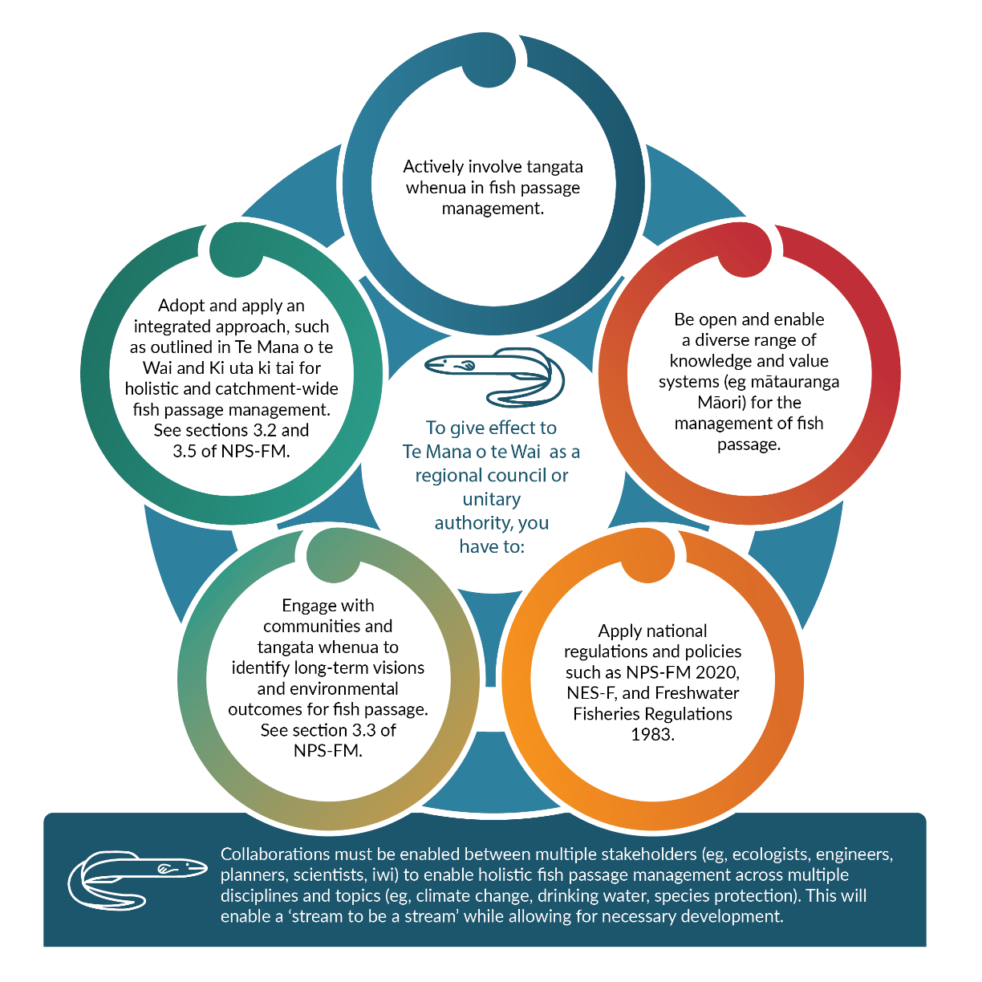
Note: NES-F = National Environmental Standards for Freshwater; NPS-FM = National Policy Statement for Freshwater Management. Source: Fish passage action plan guidance

Fish passage objective
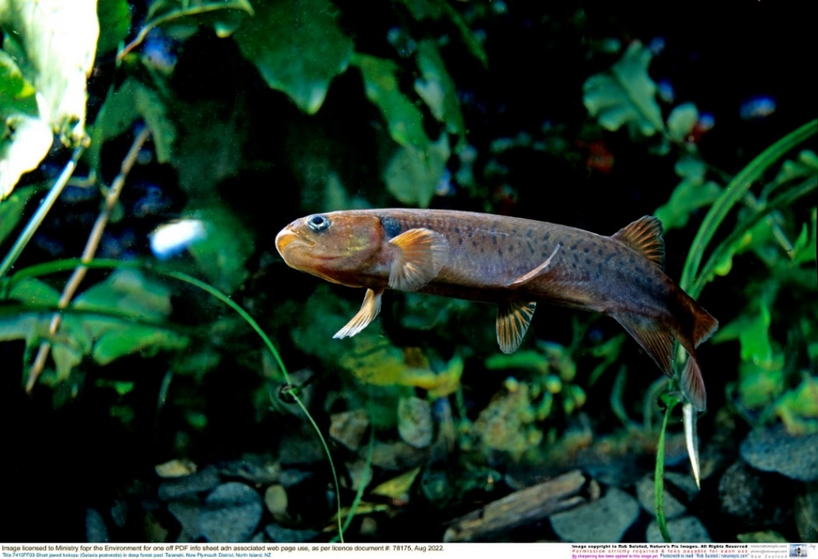
The NPS-FM 2020 (in clause 3.26, below) makes a number of directions to regional councils in relation to fish passage for inclusion in their regional plans. As regional plans are progressively updated to address the requirements under the NPS-FM 2020, the policy position of each regional council will become further supportive of maintaining or improving fish passage.
Short jawed kokopu (Galaxis postvectis) in deep forest pool, Taranaki, Aotearoa New Zealand.
Image: Nature’s Pic Images by Rob Suisted.

National Policy Statement for Freshwater Management 2020
3.26 Fish Passage
(1) Every regional council must include the following fish passage objective (or words to the same effect) in its regional plan(s):
“The passage of fish is maintained, or is improved, by instream structures, except where it is desirable to prevent the passage of some fish species in order to protect desired fish species, their life stages, or their habitats.”
(2) Every regional council must make or change its regional plan(s) to include policies that:
- identify the desired fish species, and their relevant life stages, for which instream structures must provide passage; and
- identify the undesirable fish species whose passage can or should be prevented; and
- identify rivers and receiving environments where desired fish species have been identified; and
- identify rivers and receiving environments where fish passage for undesirable fish species is to be impeded in order to manage their adverse effects on fish populations upstream or downstream of any barrier.

Fish passage action plans
The NPS-FM 2020 directs regional councils to develop an action plan for maintaining or improving fish passage (clause 3.26(6)), to support the fish passage objective.
The Fish passage action plan guidance provides councils with guidance for developing fish passage action plans, while the Fish passage action plan template provides a four-step process for councils to follow to develop effective fish passage action plans.
Figure 2: Four steps towards a fish passage action plan
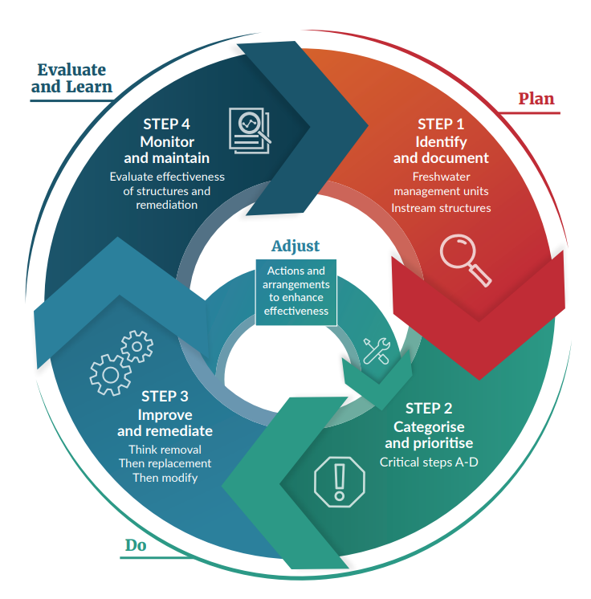
Source: Fish passage action plan template

National Environmental Standards for Freshwater 2020
The Resource Management (National Environmental Standards for Freshwater) Regulations 2020 (NES-F) came into force on 3 September 2020 and sets requirements for carrying out activities that could pose a risk to freshwater and freshwater ecosystems.
Subpart 3 relates to the passage of fish affected by structures, and applies to the placement, use, alteration, extension or reconstruction of any of a culvert, weir, flap gate, dam or ford, in, on, over or under the bed of any river or connected area. The NES-F applies to both temporary and permanent structures.
The NES-F does not apply to structures which existed at the close of 2 September 2020 (including later alterations or extensions of those structures) or customary weirs.

Information requirements under the NES-F
When planning works in relation to culverts, weirs, flap gates, dams or fords built after 2 September 2020, regulations 61 to 68 of the NES-F require that certain information is provided to the regional council on the design and location of structures in relation to the passage of fish, whether the works are permitted or require resource consent under the NES-F or a regional plan. The information must be provided within 20 working days after the activity is finished (ie, the structure is built).
The information required by the NES-F varies depending on the type of structure, but generally includes the following:
- details on the type, size, height, width, shape and ownership of the structure
- the location of the structure
- details of the river, such as width, depth and velocity
- the likelihood that the structure will impede the passage of fish
- information about aprons and ramps.

Fish passage assessment tool

The fish passage assessment tool (FPAT) has been developed to provide an easy-to-use, practical tool for recording instream structures and assessing their likely impact on fish movement and river connectivity. The FPAT includes a free mobile app and its use for providing the required information under regulations 61 to 68 of the NES-F is endorsed by the Ministry for the Environment. Some councils have their own method for collecting the required information, so please check with the relevant regional council.

Monitoring and maintenance requirements under the NES-F
For new instream structures (culverts, weirs, flap gates, dams or fords built from 3 September 2020) allowed by a resource consent (whether under the NES-F or a regional plan), regulation 69 imposes monitoring and maintenance requirements.
The NES-F requires the resource consent to include conditions around monitoring and maintenance, including the following:
- monitoring and maintenance of the structure to ensure that the passage of fish does not reduce over the lifetime of the structure
- preparation of a monitoring and maintenance plan
- updating the information requirements at specified intervals and when a significant natural hazard affects the structure.

Resource consent
Regulations 70 to 74 operate similarly to rules in regional plans and specify the activity status of culverts, weirs and passive flap gates.
Some of these structures will be permitted under the NES-F, provided the structure is able to comply with the relevant conditions, but others will require resource consent. The requirement for resource consent under the NES-F does not negate the need for any potential resource consents under the relevant regional plan. See Regional plan rules section below.

Statutory approvals
Approval from both the relevant regional council and DOC is often required for instream structures in New Zealand’s waterways, including for their installation, use, alteration or removal.
The statutory requirements should be identified and considered early in a process, so any constraints and associated timeframes can be factored into the project.

Does the instream structure require a resource consent from a regional council?
Instream structures often require resource consent from the relevant regional council. There are many variables that will affect whether the activity is permitted (ie, can be undertaken without resource consent) or whether resource consent is required to approve the activity. Therefore, it is important to undertake an assessment of the likely consenting requirements early in the design process. This should consider the regulations under the NES-F and the relevant regional and city/district plan rules.
Regulations 70 to 74 operate similarly to rules in regional plans and specify the activity status of culverts, weirs, and passive flap gates under the NES-F.

NES-F regulations for culverts, weirs and passive flap gates
The NES-F regulations specify the activity status for new culverts, weirs (excluding customary weirs) and passive flap gates that were not in place on 2 September 2020.
The placement, use, alteration, extension or reconstruction of a culvert or a weir in, on, over, or under the bed of any river or connected area is permitted under the NES-F if it complies with the conditions specified under regulation 10(2) for culverts and 72(2) for weirs. If the activity does not meet those conditions, then it will require resource consent as a discretionary activity under the NES-F.
The placement, use, alteration, extension or reconstruction of a passive flap gate in, on, over, or under the bed of any river or connected area requires resource consent as a non-complying activity under the NES-F. Councils can only grant applications for non-complying activities if they are satisfied that the adverse effects are minor or that granting the applications will be consistent with their regional plan’s objectives and policies.

Regional plan rules
In addition to the NES-F regulations around culverts, weirs and passive flap gates, regional plans contain rules regarding instream structures. These rules vary across the country, but generally resource consent may be required for the installation, use, alteration or removal of instream structures, including remediation of existing instream structures, for fish passage. Regional rules can be more stringent than those in the NES-F, or more lenient, if they consider that impeding passage is required to protect certain fish species.

Works in waterways
Often there are other activities associated with the works to the instream structure, such as earthworks or temporary stream diversions, that in some cases may also trigger the requirement for resource consent from the regional council. See the National Works in Waterways Guideline.
National Policy Statement for Freshwater Management 2020
3.26 Fish Passage
[…]
(4) Every regional council must make or change its regional plan(s) to require that regard is had to at least the following when considering an application for a consent relating to an instream structure:
- the extent to which it provides, and will continue to provide for the foreseeable life of the structure, for the fish passage objective in subclause (1)
- the extent to which it does not cause a greater impediment to fish movements than occurs in adjoining river reaches and receiving environments
- the extent to which it provides efficient and safe passage for fish, other than undesirable fish species, at all their life stages
- the extent to which it provides the physical and hydraulic conditions necessary for the passage of fish
- any proposed monitoring and maintenance plan for ensuring that the structure meets the fish passage objective in subclause (1) for fish now and in the future.

Resource consent conditions
Most resource consents are subject to conditions which must be adhered to when carrying out works under the resource consent. Often there will be pre-commencement conditions which must be addressed before construction can commence. Typical pre-commencement conditions include development of an erosion and sediment control plan and monitoring and maintenance plan. Other conditions may apply during construction only or for the lifetime of the consent.

Does the instream structure require DOC authorisation?
Fish passage authorisations are required from DOC for the following activities:
- existing culverts and fords that impede fish passage
- new culverts or fords, that have been constructed to protect vulnerable species or habitat, that will impede fish passage
- proposed damming or diversion of water that may require a fish facility
- structural modification of an existing fish facility that already has approval under the Freshwater Fisheries Regulations 1983.
- See Fish passage authorisations: Apply for permits (doc.govt.nz)

Other statutory requirements
In addition to specific fish passage requirements, it should be noted that there are other statutory requirements that need to be considered in any proposals for development and management of physical structures. These include:
- design integrity for the intended purpose and on-going management of structures and assets (eg, Building Act 2004, Railways Act 2005, RMA, Local Government Act 2002)
- land status (such as landowner approval for any works on their property and on special status areas, eg, Reserves Act 1977)
- protection of species and habitat, for instance section 26ZJ of the Conservation Act 1987, which provides that it is an offence if any works (eg, installing a structure into a waterway) disturb or damage spawning grounds of any freshwater fish
- fish salvage, which can often be required in construction projects within waterways. If, during any fish salvage or translocation, someone wishes to transfer and release fish into any freshwater, they are likely to require approval under section 26ZM of the Conservation Act 1987.
- the requirement for an archaeological authority, under the Heritage New Zealand Pouhere Taonga Act 2014, for modification or destruction of any archaeological site, whether recorded or not.

More about the
Essential Freshwater package
The Essential Freshwater package includes a number of provisions including:
- new National Environmental Standards for Freshwater
- new stock exclusion regulations under section 360 of the RMA
- amendments to the Resource Management (Measurement and Reporting of Water Takes) Regulations 2010
- the National Policy Statement for Freshwater Management 2020, which replaces the NPS-FM 2017
- guidance on the National Objectives Framework of the NPS-FM
- amendments to the RMA to provide for a faster freshwater planning process
- amendments to the RMA to enable mandatory and enforceable freshwater farm plans, and the creation of regulations for reporting nitrogen fertiliser sales.

Factsheets in this series
The full set of Essential Freshwater factsheets are available on our website.

Find out more and give us feedback
Contact us by emailing freshwater@mfe.govt.nz or visit the Essential Freshwater page on our website.

Disclaimer
The information in this publication is, according to the Ministry for the Environment’s best efforts, accurate at the time of publication. The Ministry will make every reasonable effort to keep it current and accurate. However, users of this publication are advised that:
- The information does not alter the laws of New Zealand, other official guidelines, or requirements.
- It does not constitute legal advice, and users should take specific advice from qualified professionals before taking any action based on information in this publication.
- The Ministry does not accept any responsibility or liability whatsoever whether in contract, tort, equity, or otherwise for any action taken as a result of reading, or reliance placed on this publication because of having read any part, or all, of the information in this publication or for any error, or inadequacy, deficiency, flaw in, or omission from the information in this publication.
- All references to websites, organisations or people not within the Ministry are for convenience only and should not be taken as endorsement of those websites or information contained in those websites nor of organisations or people referred to.
Published in September 2022 by the
Ministry for the Environment – Manatū Mō Te Taiao
Publication number: INFO 974

A fish facility is any structure or device, such as a fish pass or fish screen, that is inserted in or by any waterway, to stop, allow or control the passage of fish through, around, or past any instream structure.

