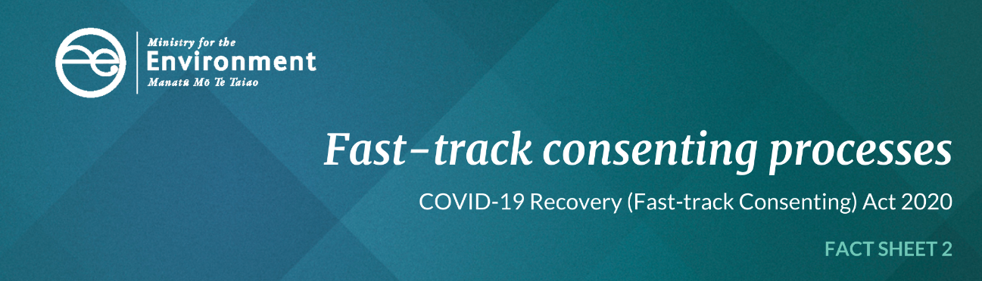

Information for local authorities: Overview of fast-track consenting processes
The COVID-19 pandemic crisis has caused serious economic and social disruption and the consequences will be felt in New Zealand for several years. The consenting and approval processes that are used in normal circumstances do not provide the speed and certainty needed in these times of economic and social crisis.
Therefore, new fast-track processes for resource consents and notices of requirement have been developed to accelerate nationwide infrastructure and development projects and activities that are already planned, to get projects started and people into jobs faster, while still promoting the sustainable management of resources.
The Act COVID-19 Recovery (Fast-track Consenting) Act (the Act) came into effect on 9 July 2020.

Fast-track processes at a glance
The purpose of the Act is to promote economic recovery from COVID-19 by providing certainty for on-going investment in New Zealand, while continuing to promote the sustainable management of natural and physical resources. The Act is a short-term step to stimulate the economy and will self-repeal two years from enactment.
The Act establishes new fast-track resource consenting and notice of requirement processes for eligible infrastructure and development projects. These processes adopt and modify existing Resource Management Act 1991 (RMA) processes and will expedite certain eligible projects, while still applying appropriate environmental safeguards.
View the process diagram for fast-track processes under the COVID-19 Recovery (Fast-track Consenting) Act on our website.
The Act establishes two pathways for a project to access the fast-track consenting and notice of requirement process and come before an expert consenting panel:

Referred projects
Projects that are not listed in the legislation can be confirmed through an Order in Council (‘referred projects’). For these projects an application to become a referred project must be made to the Minister for the Environment. If the Minister accepts the application the project will be confirmed through an Order in Council. If the application relates, at least in part, to the coastal marine area, the decision will be made jointly with the Minister of Conservation.
You can apply online to be referred by the Minister for the Environment to the fast-track consenting process. Guidance about how to apply is available on our website.

Listed projects
Projects that are automatically eligible to use the fast-track process are listed in Schedule 2 of the Act (‘listed projects’). They are referred directly to the expert consenting Ppanels. Read the Act on the New Zealand legislation website.

Application for a Fast-tracked resource consent
Once a project is successfully referred to the fast-track consenting process, either through the Minister for the Environment, or listed in the legislation, the applicants must then lodge an application with the Environmental Protection Authority (EPA) who acts as the secretariat for the expert consenting panels.
The EPA vets the application for completeness before referring the application to an expert consenting panel to consider and determine the application. Expert consenting panels replace the role that local authorities and other first-instance decision-makers have under the RMA.
These panels will be convened by former Chief Environment Court Judge, Judge Laurie Newhook, who has been appointed to be the panel convener. The panels are required to consider and determine the applications. Different timeframes, notification process and appeal rights apply compared to RMA processes. In particular, there is no public notification and no obligation for a hearing. Appeal rights are limited to a point of law appeal to the High Court and a further right of appeal to the Court of Appeal. There is no right of appeal to the Supreme Court.

Applications to the Minister(s) to become a ‘referred project’

Providing written comments
The Act specifies people and organisations that the Minister must or may invite written comments and seek additional information from. The Minister must invite written comments from relevant local authorities. Local authorities have 10 working days to provide comments to Ministry for the Environment, who is supporting this process for the Minister.
The purpose of requesting comments is to help the Minister assess the project against the criteria in Section 18 of the Act and to follow up on any matters raised in, or omitted from the application. Examples of the type of information anticipated from local authorities are:
- comments on the consenting triggers and planning documents identified by the applicant as being relevant to their proposed project
- confirmation of whether a resource consent application or notices of requirement have been sought for the same or similar proposals, and the stage that those applications are at
- information on any RMA enforcement action taken against the applicant
- information on any iwi participation requirements that are relevant to RMA consenting and designation processes (eg, as set out in iwi participation legislation, Mana Whakahono a Rohe, or joint management agreements)
- any infrastructure constraints on local authorities that may arise from the project (such as upgrades to the stormwater network or new servicing infrastructure).
The Minister may request further information from the relevant local authorities at any time before a decision is made on the application.
The Act provides the Minister with the ability to decline an application before requesting written comments. In situations where the Minister’s initial assessment of eligibility clearly indicates that an application will not meet the referral criteria in Section 18 of the Act, the Minister may decide that the application should not be progressed further. This will limit the work required of other Ministers, local authorities, and others to comment on applications when there is an early indication that they are not appropriate for the fast-track process.

Notice of the decision
When the Minister decides on an application for referral, a notice of the decision and reasons must be prepared and provided to the applicant and anyone who was invited to comment on the application (including local authorities as relevant). This notice will also be published on the Ministry for the Environment’s website.

Applications to an expert consenting panel for ‘listed’ and ‘referred’ projects

Appointment to an expert consenting panel
Panel membership includes a Chair who is a current or retired Environment Court Judge, (or other judge or senior lawyer with resource management expertise). Panels will also include a member of (or person nominated by) the relevant local authority/ies, and a representative nominated by the relevant iwi authority/ies.
Panel members will collectively have:
- skill and expertise relating to resource management
- technical expertise in relation to the project or the effects of the project
- expertise in tikanga Māori and mātauranga Māori.

Request for information
Applications to an expert consenting panel are required to be lodged with the EPA and the EPA will undertake a completeness check before referring the application to an expert consenting panel to consider and determine the application.
Under Schedule 6, clause 7 of the Act, at any time before or after the EPA receives an application, the EPA may contact relevant local authorities and request them to provide information that is necessary and relevant to an application.
The local authority must respond by either:
- providing the information within the specified timeframe
- advising that the information will be made available but not within the specified timeframe (and instead providing the information as soon as practicable), or
- advising that the local authority does not hold the information and, if the local authority knows where the information is held, advising the EPA accordingly.
The local authority is able to set, and recover from the EPA, a reasonable charge for the above.

Providing written comments
The Act specifies people and groups that the expert consenting panel must or may invite written comments from. The panel must invite written comments from relevant local authorities.
Written comments from local authorities must be provided no later than 10 working days after the invitation to provide comments is received.

Advice to an expert consenting panel
An expert consenting panel may appoint a special adviser to assist the panel, or appoint a technical adviser to assist the panel. These advisors may be local authority staff. A relevant local authority must also assist a panel by providing advice within the knowledge of the local authority if requested by the panel.
The local authority is able to recover actual and reasonable costs from the EPA for the above.

Attendance at a hearing (if required)
A panel may consider, in its discretion, that it is appropriate to hold a hearing on an application. If so, the panel may hear from relevant local authorities who have provided comments. Further details about hearings are detailed under Schedule 6, clause 21 of the Act.

Comments on draft conditions
Before a panel issues a decision, the panel must provide a copy of its draft conditions to the relevant local authority/ies for written comment if the local authority/ies provided comments on the application when invited by the panel. The panel will set a date by which comments must be provided back to the EPA, and the local authorities will receive copies of all other parties’ comments if they provided comment when first invited by the panel.

Notice of the decision
Notice of the final decision of the panel will be served on the relevant local authorities, and will be published on an internet site maintained by the EPA.

Work on infrastructure
The Act also enables some agencies to undertake specific works on existing infrastructure, such as operation, maintenance, replacement or minor upgrade work, without the need for resource consents, designations or outline plans of work.
This process is currently available to Waka Kotahi New Zealand Transport Agency and KiwiRail provided the activities meet specific requirements in Subpart 2 and Schedule 4 of the Act. Local authorities can recover costs and expenses incurred from their involvement in this process, including fixing charges for monitoring work on infrastructure activities.
Local authorities, Kāinga Ora, and Ministry of Housing and Urban Development can request to be added through Order in Council as an agency that can undertake work on infrastructure.

Role of local authorities in compliance and enforcement
Once a resource consent has been granted, or a designation confirmed or modified, by the panel, the local authority has all the functions, powers and duties as it otherwise would have had if it had granted the resource consent, or dealt with the designation, itself.

Find out more
A series of guidance and factsheets covering the above in more detail are available on these websites: Ministry for the Environment and Environmental Protection Authority.
For more information contact the Ministry for the Environment by emailing: fasttrackconsenting@mfe.govt.nz.
For information on the expert consenting panel process contact the Environment Protection Authority at fasttrack@epa.govt.nz.

Published in July 2020 by the
Ministry for the Environment
Publication number: INFO 949

