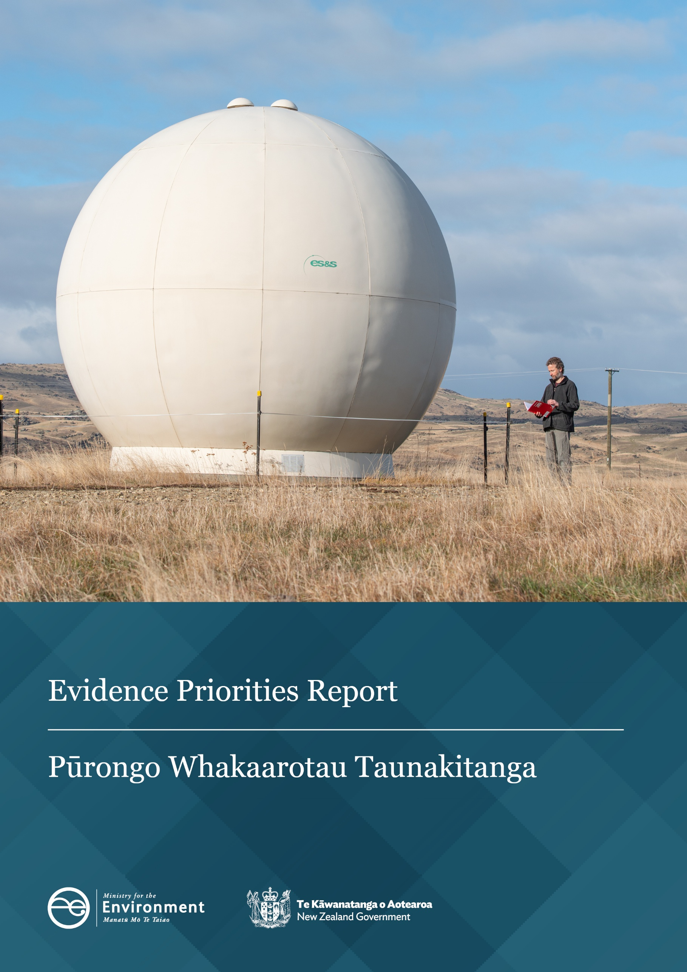

Disclaimer
The information in this publication is, according to the Ministry for the Environment’s best efforts, accurate at the time of publication. The Ministry will make every reasonable effort to keep it current and accurate. However, users of this publication are advised that:
- the information does not alter the laws of New Zealand, other official guidelines, or requirements
- it does not constitute legal advice, and users should take specific advice from qualified professionals before taking any action based on information in this publication
- the Ministry does not accept any responsibility or liability whatsoever whether in contract, tort, equity, or otherwise for any action taken as a result of reading, or reliance placed on this publication because of having read any part, or all, of the information in this publication or for any error, or inadequacy, deficiency, flaw in, or omission from the information in this publication
- all references to websites, organisations or people not within the Ministry are for convenience only and should not be taken as endorsement of those websites or information contained in those websites nor of organisations or people referred to.

This document may be cited as: Ministry for the Environment. 2026. Evidence Priorities Report | Pūrongo Whakaarotau Taunakitanga. Wellington: Ministry for the Environment.

Published in April 2026 by the
Ministry for the Environment
Manatū mō te Taiao
PO Box 10362, Wellington 6143, New Zealand
environment.govt.nz
ISBN: 978-1-991404-36-7
Publication number: ME 1957
© Crown copyright New Zealand 2026
Cover image: Lauder, Central Otago. Credit: Clare Toia-Bailey, Image Central.

Contents
Message from the Departmental Chief Science Advisor 4
Introduction 5
Building on the interim report 6
A cohesive vision for evidence 7
Strategic priority 1: Improve the resource management system to be more efficient and effective 8
Evidence priority 1.1: Credible land-use information for smarter decisions 8
Evidence priority 1.2: Setting limits to protect the environment and human health 10
Evidence priority 1.3: Data and digital foundations 11
Strategic priority 2: Strengthen the resilience of communities, businesses and places to climate change and natural hazards 13
Evidence priority 2.1: Know our hazard risks now and in the future 13
Strategic priority 3: Support the transition to a competitive, low-emission, resource-efficient economy 16
Evidence priority 3.1: Powering up climate data for credible action 17
Evidence priority 3.2: Advancing carbon removal solutions 18
Strategic priority 4: Improve the quality and accessibility of evidence for all decision-makers 20
Strategic priority 5: Ensure our investment, partnerships and relationships enable others to achieve impactful solutions 21
Evidence priority 5.1: Make nature count 21
Working with our partners 23

Message from the Departmental Chief Science Advisor

This Evidence Priorities Report sets out the areas where the Ministry needs to focus its evidence efforts over the next three years. It builds on the Interim Evidence Priorities Report, which provided a broad picture of our evidence landscape. This report turns that broad view into a clear set of priorities that support system reform, statutory responsibilities and better decision‑making.
Evidence is often invisible, but it shapes every part of how decisions are made. Knowing what is most important helps us use our resources well, strengthens planning system reforms underway, and creates opportunities to work more deliberately with others. Good evidence supports consistency, transparency and confidence. Qualities that matter whether you work in policy, planning, science or service delivery.
The priorities in this report reflect the areas where better evidence will make the most difference: credible land‑use information, environmental limits, hazard and climate data, carbon removal evidence, and data that makes nature visible in everyday decisions.
These priorities are not ours alone. A strong evidence system relies on councils, iwi and Māori partners, research organisations, industry and communities. My hope is that this report helps us work together with more clarity, shared purpose, and a stronger understanding of the evidence needed to support Aotearoa New Zealand’s long‑term wellbeing.
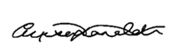
Alison Collins
Departmental Chief Science Advisor

Introduction
In this Evidence Priorities Report (EPR), the Ministry for the Environment (the Ministry) sets out priority evidence needs to support policy, planning and reform implementation. It is a publication that builds on the momentum of the 2025 Interim Evidence Priorities Report (iEPR), and offers a clear, forward-looking overview of the Ministry’s evidence direction.
The EPR is designed to communicate our priorities in a clear and accessible way to central and local government, iwi, research organisations and communities, to support shared understanding, investment and action. This report reflects the Ministry’s purpose, statutory reporting obligations under the Environment Act 1986, and commitment to transparency, collaboration and leadership in environment- and climate-related evidence.
Our purpose
As Aotearoa New Zealand’s lead advisor on environment and climate, we enable people and places to thrive, now and in the future.
Hei kaitohutohu matua o Aotearoa mō te taiao me te āhuarangi, ka whakaahei mātou i ō tātou iwi me ō tātou wāhi ki te puāwai, ināianei, hei te anamata hoki.
This report sits within the Ministry’s wider strategic framework. Our Strategic Intentions and strategic priorities set the direction for the Ministry, and the EPR shows where our evidence efforts need to focus to enable progress for that direction.
The EPR will guide how we invest in evidence over the next three years. It provides a clear view of the priority areas that will shape our annual Evidence Investment Plan and support both immediate policy needs and longer-term system outcomes.
The priorities in this report reflect the Ministry’s role, but they are also an invitation to our partners to work collaboratively to build a trusted, resilient and future-ready evidence base which enables better decision-making for New Zealanders.
Case studies
Case studies throughout this report showcase the types of evidence the Ministry is building and investing in. They illustrate how our evidence priorities connect to the strategic priorities and demonstrate their real‑world impact and the value of investing in the right evidence at the right time.

Building on the interim report
The iEPR was designed as a transition step. Its purpose was to take stock of the Ministry’s full evidence landscape and to identify the broad areas where evidence would be needed in the future. It helped us understand what evidence was needed, identify gaps, and prepare for more detailed prioritisation.
This EPR is the next step in that process. It moves us from a full scan of the evidence landscape to selecting the specific areas where the Ministry needs to invest to deliver its core functions. These include implementing the new planning system, strengthening hazard and climate evidence, meeting statutory reporting requirements, and supporting digital delivery.
The shift from the iEPR to the EPR reflects a move from broad direction-setting to focused delivery.
- The iEPR set out the long-term evidence needs across the whole system and served as a foundation for engagement and horizon scanning.
- The EPR identifies the priority areas that require investment over the next three years to support reform implementation and statutory responsibilities.
The broader needs identified in the iEPR remain important. They continue to guide our longer-term thinking and signal opportunities for research, innovation and collaboration across the system. While not the focus of immediate investment, they will inform future planning cycles and help ensure the wider evidence ecosystem remains visible and connected.

A cohesive vision for evidence
Our evidence priorities are structured around five strategic priorities each aligned with the Ministry’s strategic intentions. These strategic priorities guide investment in evidence that:
- is operationally critical to the performance monitoring and success of the new planning system
- is foundational to environment and climate statutory and reporting obligations
- enables collaboration across central and local government, iwi, research institutions and communities.
Table 1 shows our strategic priorities alongside their most closely related evidence priorities.
Table 1: Our strategic priorities and evidence priorities
Strategic priority | Evidence priorities
Strategic priority 1: Improve the resource management system to be more efficient and effective | 1.1: Credible land-use information for smarter decisions  1.2: Setting limits to protect the environment and human health  1.3: Data and digital foundations
Strategic priority 2: Strengthen the resilience of communities, businesses and places to climate change and natural hazards | 2.1: Know our hazard risks now and in the future
Strategic priority 3: Support the transition to a competitive, low-emission, resource-efficient economy | 3.1: Powering up climate data for credible action  3.2: Advancing carbon removal solutions
Strategic priority 4: Improve the quality and accessibility of evidence for all decision-makers | Drives all evidence priorities by improving the quality and accessibility of evidence across domains, enabling delivery of greater impact under every other strategic priority.
Strategic priority 5: Ensure our investment, partnerships and relationships enable others to achieve impactful solutions | 5.1: Make nature count
Our strategic priorities and our evidence priorities work together. The strategic priorities set the direction for the Ministry, and the evidence priorities identify the evidence that enables progress for that direction. Each evidence priority supports a different part of the policy and planning system, and together they form a coherent set of evidence needs that help the Ministry and its partners make informed, consistent and transparent decisions.
We have taken a balanced portfolio approach in selecting our evidence priorities. They were chosen to meet urgent statutory requirements, enable long-term system transformation, and maintain flexibility for emerging needs. This approach provides continuation of the criteria outlined in the iEPR that prioritised a mix of foundational, enabling and future-focused evidence investments.

Strategic priority 1: Improve the resource management system to be more efficient and effective
The evidence priorities under strategic priority 1 focus on improving our land-use data and building an integrated, transparent and efficient planning system. Investing in credible land-use information, evidence for environmental limit-setting, and digital infrastructure enables smarter, faster and more consistent decision-making for both central and local government.
These evidence priorities support the implementation of planning system transformation by ensuring that planning decisions are grounded in high-quality, nationally consistent data.

Housing development. Credit: Jeff McEwan, Capture Studios.

Evidence priority 1.1: Credible land-use information for smarter decisions

Mission
To create a single, trusted source of land-use information that supports efficient, integrated planning and investment decisions across New Zealand.

Impact
This evidence priority will improve the economic efficiency and effectiveness of spatial planning, reduce duplication of effort, and support better outcomes for people, communities and businesses. It will provide important local context for our economic activities.
The impact will be seen in more coherent land use, better targeted investments, and stronger alignment between environmental, social and economic goals.

Approach
We will improve how land-use information is collected, integrated and applied to support spatial planning and decisions under the new planning system. This work is focused on our understanding of the environment and how we use our land, recognising that other agencies lead on growth projections and infrastructure planning. We aim to invest in evidence that enables high-quality planning decisions and resource use within environmental limits.
To enable this, we will build a future-ready evidence base for land use. This includes connecting datasets across central and local government, iwi and Māori land owners, and community partners, as well as embedding te ao Māori perspectives into land-use classification and mapping. We will explore opportunities to consolidate spatial layers into a federated land-use information system to improve decision-making and transparency. Our land-use information will be structured so it can integrate with spatial planning tools, consenting platforms and performance monitoring.
Case Study: New Zealand Land Use Management classification system
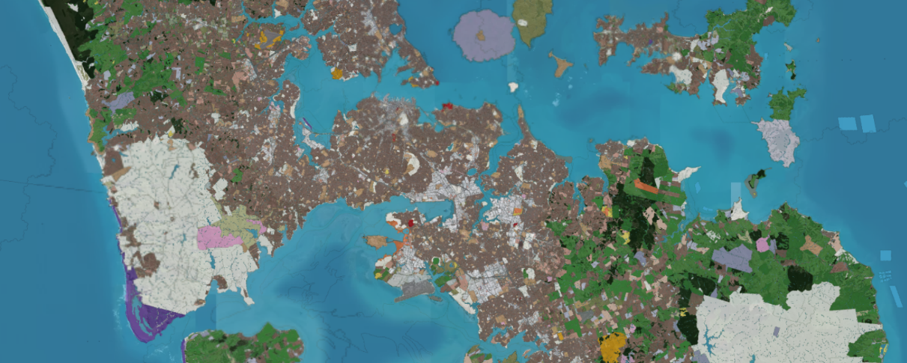
Spatial layer of Auckland from the Land Use Management pilot (v0.3).
As towns and cities expand, the way we build and develop can either degrade or enhance the natural environment and the ecosystems we rely on. To ensure sustainable outcomes, we must better understand how land is used, and we must improve our ability to monitor and manage built and natural environments.
To support smarter, more integrated decision-making, the Ministry is developing a New Zealand Land Use Management (NZLUM) classification system. This initiative aims to provide a consistent, geospatially enabled framework for classifying land use across the country. Currently in pilot phase, the NZLUM platform has already demonstrated its value by supporting regional spatial planning pilots and enabling integration with local datasets.
We will continue to develop the NZLUM, with the goal of a full public release.

Evidence priority 1.2: Setting limits to protect the environment and human health

Mission
To develop an informed, transparent and nationally consistent framework for setting environmental limits that enable resource use and development.

Impact
This evidence priority will ensure the new planning system is underpinned by enforceable, science-based environmental limits. Councils, iwi and communities will have a consistent, evidence-based way to make informed and transparent decisions to enable development while looking after the natural environment and human health.

Approach
We will develop practical methods for setting environmental limits that helps councils, iwi and communities make better decisions about development and protection. This will integrate science and evidence, international best practice, and local knowledge into the development of limits and attributes.
We will develop evidence that defines key concepts such as ‘life-supporting capacity’ and ‘human health’ and clarifies what needs to be managed through limits rather than other tools (such as standards or guidelines). We will build a catalogue of attributes, identify suitable monitoring methods, and provide direction for setting limits and enabling resource use and development within them. Economic evidence, socioeconomic benefits, and future resilience to climate change effects are also key evidence needs.
Case study: Operationalising eDNA technology to monitor more efficiently
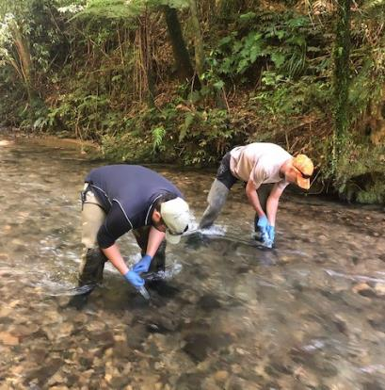
eDNA sampling in the Manganui River by Waikato Regional Council. Credit: Josh Smith.
Collaboration among the Ministry for the Environment, Department of Conservation, regional councils, hapū groups, and Earth Sciences New Zealand has demonstrated that a standardised method for taking eDNA samples from rivers allows the simultaneous assessment of multiple components of river ecosystems from a single sampling effort. The data produced can be used for setting and monitoring river health environmental limits, while also providing information for biodiversity and biosecurity purposes.
The leadership and funding provided by the Ministry has enabled development of a nationally consistent and robust approach. Councils and hapū have played an implementation role, which has ensured practicality and uptake by river managers and other end users.

Evidence priority 1.3: Data and digital foundations

Mission
To deliver the foundational data, analytics and tools needed to support the digital transformation of spatial planning and consenting under the new planning system, while enabling monitoring and evaluation of performance and impact.

Impact
This evidence priority will provide users with the data and digital tools needed to support informed, timely and transparent planning and consenting decisions – and to see what is working and how environmental outcomes are tracking over time.
More and better information will help strengthen assessments and promote consistent decision-making practice. This contributes to a more responsive and accountable system where data can be readily used across planning, assessment and monitoring, and where public engagement is supported by clearer information.

Approach
We will invest in data, digital infrastructure, and analytical tools to provide local government with an easy and efficient planning, consenting and environmental-management experience. This includes expanding long-term data collection, ensuring data can be used in multiple ways and supporting digital platforms that integrate local and national evidence.
Our approach will keep us connected to the wider digitisation of the public sector, ensuring that our digital systems are AI-ready and scalable, and that they support performance monitoring and adaptive decision-making.
Case study: The National Monitoring System
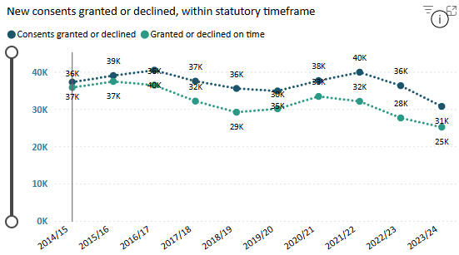
Consent data from the National Monitoring System.
The National Monitoring System has provided annual data on council implementation of the Resource Management Act 1991 (RMA), informing national policy and highlighting best practice. Under the new planning system, it will evolve to track broader performance metrics.

Strategic priority 2: Strengthen the resilience of communities, businesses and places to climate change and natural hazards
Strategic priority 2 is supported by evidence investments that improve the quality, consistency and accessibility of hazard and exposure data. By focusing on national-scale datasets, such as those informing the National Flood Map, the Ministry is providing councils, iwi and communities with clearer information to understand and assess natural hazard risk. This information supports planning and investment decisions that take risk into account and helps strengthen approaches to managing hazards as climate-related pressures increase.
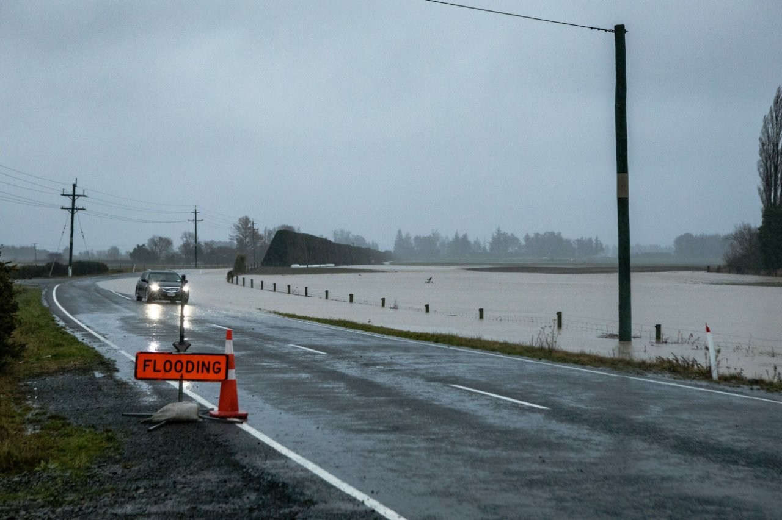
Flooding at Darfield, Canterbury. Credit: Truestock, Kathryn Taylor.

Evidence priority 2.1: Know our hazard risks now and in the future

Mission
To improve the quality and consistency of national natural hazard and exposure data, to support our ability to track exposure and effectiveness of adaptation strategies. This evidence will enable more informed, future-focused decisions that reduce risk and build community resilience.

Impact
This evidence priority will improve critical national hazard datasets – such as data needed to inform the National Flood Map – which will directly support spatial planning and infrastructure design. It will also help with preparation of the National Adaptation Plan.
Councils will be better equipped to identify and manage high-risk areas, improve risk literacy, prioritise infrastructure upgrades, and develop adaptation pathways tailored to local conditions.
Communities and iwi will benefit from clearer hazard information, enabling more proactive climate-resilience planning and engagement, which will reduce impact to the economy.

Approach
We will invest in datasets that contribute to national-scale hazard mapping, with an initial focus on the evidence required to underpin a National Flood Map. This initial focus includes updating key climate-related datasets, freshwater and coastal datasets, topography and landcover datasets, as well as updating flood protection asset data.
Our next phase will focus on natural hazards listed in the National Policy Statement for Natural Hazards and in our 2025 Long-term Insights Briefing. These data investments will underpin council planning, inform housing and infrastructure investment and insurance decisions, and support adaptation pathways for communities and iwi.
To ensure national datasets reflect local reality, we will use innovative technology and methods to improve the accuracy of hazard information. This includes validating national hazard maps with local and regional data. For example, high-resolution Light Detection and Randing (LiDAR) can improve how we model flood risk. We will also address gaps in exposure and vulnerability data, so risk assessments are more consistent and useful for planning.

Case study: LiDAR for natural hazard resilience

Latest phase of Otago LiDAR Mapping. Credit: Otago Regional Council.
The Ministry has supported the acquisition of Light Detection and Ranging (LiDAR) data across New Zealand, to provide government agencies, businesses, and land owners access to high-resolution elevation data to accurately model regional-scale flood risk.
The data support erosion risk management, vegetation and forestry management, environmental monitoring, land-use monitoring and spatial planning, as well as supporting future digital consenting systems.

Strategic priority 3: Support the transition to a competitive, low-emission, resource-efficient economy
The evidence priorities under strategic priority 3 focus on providing the underlying data and science needed for credible, transparent climate projections and scenarios and on supporting carbon removal evidence. Investing in scenario-based modelling and improving our emissions-reporting systems helps decision-makers understand uncertainty and supports New Zealand meet our domestic and international climate obligations.
At the same time, we are supporting innovations in carbon removal by investing in the evidence behind emerging methodologies and encouraging collaboration across the science system and industry. These efforts help build a clearer, more reliable evidence base for carbon removal options and support decisions about future investment, accounting and policy design.
Case study: New Zealand blue carbon dataset
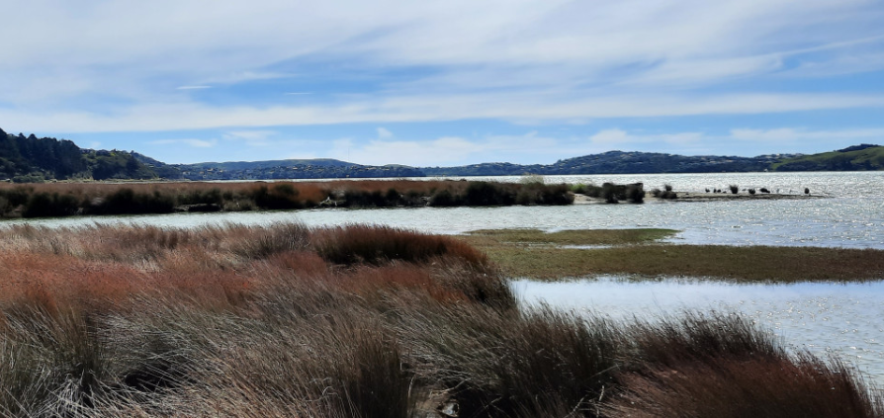
Saltmarshes store carbon and can act as flood protection. Credit: Earth Sciences New Zealand.
The Ministry has collaborated with the Nature Conservancy Aotearoa New Zealand on a project: Developing a national dataset for coastal wetland blue carbon in Aotearoa New Zealand. The aim of the project is to create a foundational dataset of New Zealand’s coastal blue carbon, which will be useful in establishing baseline measurements of carbon sequestration from coastal wetlands.
This work is a first step towards potentially including blue carbon in New Zealand’s Greenhouse Gas Inventory and reducing the cost barrier of voluntary carbon and nature market initiatives.
Overall, this work will support efforts to draw in private financing for coastal wetland restoration initiatives, as well as supporting Ministry objectives for more climate-adaptation and nature-positive action and outcomes.

Evidence priority 3.1: Powering up climate data for credible action

Mission
To deliver credible emissions reporting with near-term projections and long-term scenario modelling that enables decision-making under uncertainty, supports credible climate action, and meets Climate Change Response Act 2002 requirements and international obligations.

Impact
This evidence priority will improve the quality and accessibility of climate data, as well as the clarity of our projections and scenarios. This will help decision-makers understand uncertainty, consider economic risks and opportunities, and meet international reporting obligations.
By providing clearer and more consistent climate information, this evidence priority supports policymakers, businesses and communities to make informed decisions in a context where the future cannot be predicted with certainty.

Approach
Our approach recognises that all projections carry uncertainty, and their value lies in helping people understand that uncertainty when making decisions.
We are investing in modern, scenario-based modelling tools and transparent data systems that make assumptions and levels of uncertainty clear. This allows users to explore plausible futures, understand the basis of different projects, and stress test policy options.
Improving how we communicate confidence levels, strengthening analytical capability, and aligning with digital transformation of the public sector, will provide climate evidence that is credible, accessible and useful for navigating complexity and making informed choices.

Case study: New Zealand’s greenhouse gas emissions projection
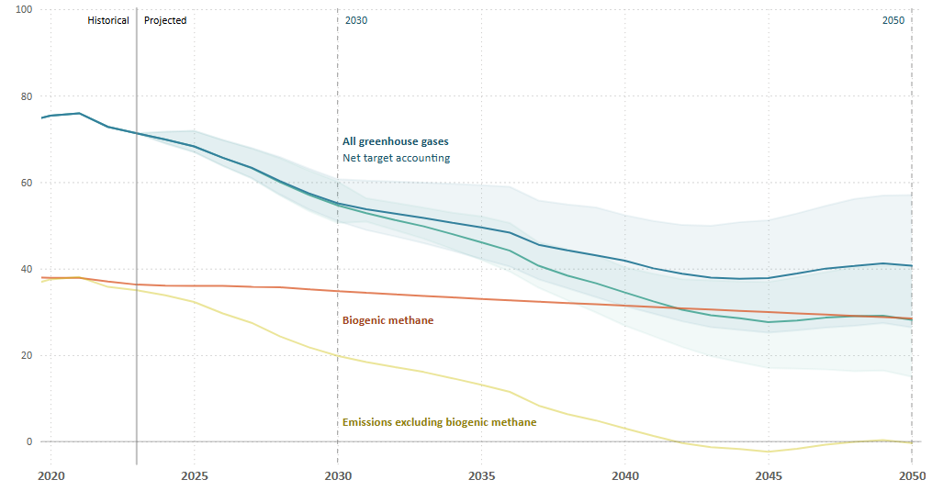 New Zealand's historical and projected greenhouse gas emissions from 2020 to 2050 in Mt CO₂-e.
Emissions projection graphs use 100-year time horizon global warming potentials for non-carbon dioxide gases, based on the values provided in the Intergovernmental Panel on Climate Change's Fifth Assessment Report (AR5).

Evidence priority 3.2: Advancing carbon removal solutions

Mission
To identify, validate and scale innovative carbon removal solutions that contribute to New Zealand’s long-term climate goals. This evidence priority will support the development of engineered and nature-based removal pathways that are resilient to climate change, enabling credible accounting, investment and policy design.

Impact
This evidence priority will position New Zealand to lead in the development and deployment of innovative carbon removal solutions that are resilient to climate change. It will support emissions reduction targets, enable credible accounting, and unlock new opportunities for climate investment and land owner participation.

Approach
Our strategy is to create the conditions for others to invest in and advance carbon removal evidence in New Zealand. We aim to lower barriers to entry and encourage innovation by signalling clear research priorities, endorsing open and credible methodologies, and fostering collaboration across science, industry and international partners. We will focus on transparency, knowledge sharing, and alignment with global standards, to empower researchers, iwi, industry and communities to develop, validate and scale carbon removal solutions that contribute to New Zealand’s climate goals.
Case study: Maximising carbon in mineral soils
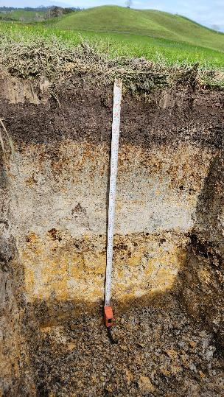
Soils can store large amounts of carbon, which can be enhanced or lost depending on land use and management. A substantial science investment to the Manaaki Whenua Landcare Research group of the Bioeconomy Science Institute has helped to double the amount of high-quality soil information feeding into the soil carbon model that estimates soil carbon stock changes for New Zealand’s Greenhouse Gas Inventory.
This investment advanced our understanding of the land-use changes and management practices that protect or increase soil carbon pools. With this evidence, we can shape policies for carbon removals from the atmosphere, such as on-farm sequestration or peatland rewetting. Carbon-rich soils are an asset for land owners; their increased productivity and resilience helps safeguard our climate change response and adaptation.
A soil profile, sampled for soil carbon stock monitoring.
Credit: Lauren O’Brien, BSI.

Strategic priority 4: Improve the quality and accessibility of evidence for all decision-makers
Among the Ministry’s five strategic priorities, strategic priority 4 is integral and foundational. It is both a standalone priority and a critical enabler of all other strategic priorities. As such, strategic priority 4 is the backbone of the Ministry’s evidence priorities.
Improving the quality and accessibility of evidence addresses two persistent challenges.
- Fragmented and reactive data ecosystems hinder the Ministry’s ability to respond efficiently to emerging and long-term issues strategically and with confidence.
- Limited accessibility and interoperability limit how evidence can be used within the broader public and private sector to make informed decisions.
To overcome these challenges, we are focusing on building an improved evidence base that helps us respond faster, track what is working, and make better decisions. This evidence includes investing in foundational data (eg, land use, climate and environmental indicators), to improve understanding of market and non-market economic values for the environment, and to ensure national consistency through standardisation and digital transformation.
All evidence priorities in this report contribute to strategic priority 4 by improving the quality and accessibility of evidence across domains, enabling delivery of greater impact under every other strategic priority.

Strategic priority 5: Ensure our investment, partnerships and relationships enable others to achieve impactful solutions
The evidence priority ‘make nature count’ directly supports strategic priority 5 by building nationally consistent systems for measuring and valuing nature that others can readily use.
By providing trusted, scalable and locally grounded evidence products, the Ministry enables councils, iwi, communities and businesses to incorporate nature into planning, development, investment and management decisions.
This approach ensures that natural capital and biodiversity data are technically robust and practical to apply, as well as meaningful in social and cultural contexts. It supports decisions that better recognise the role of across New Zealand.
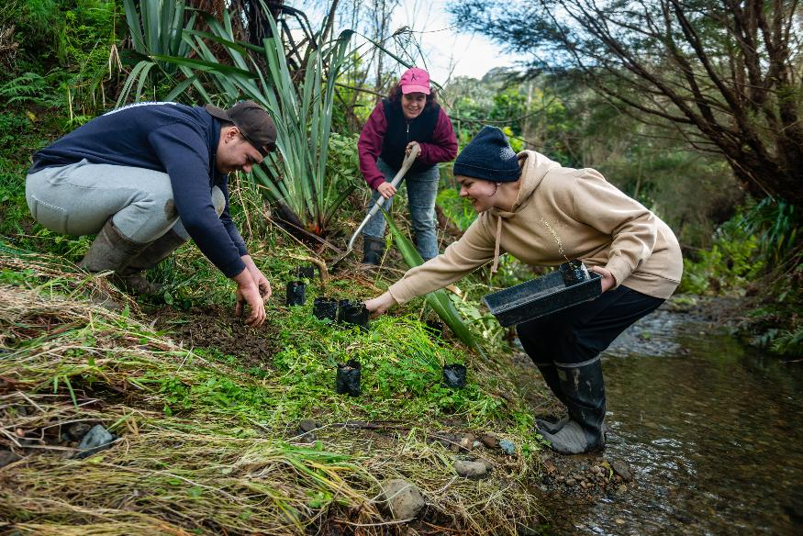
Planting and river care at Hicks Bay, Tairawhiti. Credit: Clare Toia-Bailey, Image Central.

Evidence priority 5.1: Make nature count

Mission
To unlock action and investment by building a verifiable, nationally consistent way to measure and value nature so it is counted and protected in everyday decisions.

Impact
This evidence priority will make nature more visible in decisions that affect land and soil, air, water, biodiversity and climate. By investing in trusted data and tools, we will provide councils, communities and businesses with clearer information to guide restoration, planning and investment, as well as accounting for nature in economic activities. This type of investment means nature gets counted, recognised and cared for in everyday decisions.

Approach
We will invest in foundational data and methods to determine both the economic and social value of nature – ensuring that it is consistently measured and monitored, and that its worth is visible across domains. This includes developing nationally standardised ways to define ecosystems, mobilising data into global biodiversity data platforms (eg, the Global Biodiversity Information Facility), building tools to assess ecosystem services and natural capital, and understanding the long-term costs associated with inaction on environmental issues.
We will design evidence products that enable our partners, ensuring outputs are locally grounded, useable by communities and businesses, and nationally scalable where appropriate. We will also strengthen partnerships with commercial providers, research organisations and other government agencies to expand data coverage and support innovation investment in stacked carbon and voluntary nature markets, and in other areas.
Case study: Terrestrial national ecosystem typology

Being able to consistently measure and map New Zealand’s biodiversity over time is vital for understanding where our efforts to protect and improve natural capital and ecosystem services are paying off. Through the Ministry’s investment and collaboration with the Department of Conservation, regional councils, and researchers from the Bioeconomy Science Institute, the terrestrial national ecosystem typology defines and describes different types of terrestrial and wetland ecosystems.
Having a common language in place ensures consistent, interoperable biodiversity data across regional and national scales, which allows us to measure ecosystem change over time. This supports decisions on where actions should be targeted for biodiversity protection and conservation.
Credit: Raylene Bateman.

Working with our partners
The Ministry’s evidence priorities sit within a wider system of organisations that generate, use and steward environmental and climate evidence. Central and local government, iwi and Māori partners, Crown entities, universities, industry and communities all contribute to this system.
Our aim in setting out these priorities is to signal where the Ministry sees the greatest need for alignment, shared effort and coordinated investment.
Stronger connections between evidence programmes across the system can improve the consistency, accessibility and relevance of national datasets. Areas where collaboration is particularly valuable include improving and standardising land-use information, co-investing in natural hazard and climate datasets, and developing biodiversity and carbon removal evidence that supports nature and climate outcomes.
As part of our ongoing stewardship role, we will continue to make visible where our priorities intersect with the work of others and identify opportunities for shared capability and partnership.
We welcome collaboration and feedback to ensure the environmental and climate evidence base remains coherent, trusted and responsive to New Zealand’s long-term needs. For enquiries or to discuss evidence partnerships, please contact science.advice@mfe.govt.nz.

Our definition of evidence is information that supports the development of evidence-informed policy and regulatory decisions. Such information is derived from systematic reviews, data (including biophysical and social sciences, economics and mātauranga), scientific research findings, and other reliable sources.

