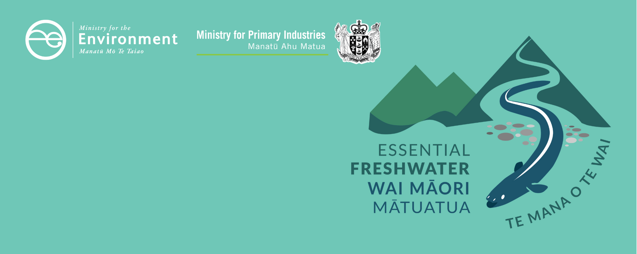

Avoiding loss of rivers factsheet
Essential Freshwater is part of a new national direction to protect and improve our rivers, streams, lakes and wetlands. The Essential Freshwater package aims to:
- stop further degradation of our freshwater
- start making immediate improvements so water quality improves within five years
- reverse past damage to bring our waterways and ecosystems to a healthy state within a generation.
Te Mana o te Wai is fundamental to all freshwater management
Te Mana o te Wai recognises the vital importance of water. It expresses the special connection that New Zealanders have with freshwater. By protecting the health of freshwater we protect the health and well-being of people and our ecosystems. When managing freshwater, Te Mana o te Wai ensures the health and well-being of the water is protected before providing for and human needs or enabling other uses of water. Through discussions with regional councils, tangata whenua and communities people will have a say on how Te Mana o te Wai is applied locally in freshwater management. More information can be found in the Te Mana o te Wai factsheet.

Who should read this factsheet
This factsheet is part of a series and provides information on policies and regulations for rivers. It is primarily intended for council staff and land users, but may also be of interest to iwi, the wider agricultural industry, farm advisors and consultants, and anyone else with an interest in freshwater policy.

New provisions for rivers
The National Policy Statement for Freshwater Management 2020 (NPS-FM 2020) includes a policy to avoid the loss of river extent and values. There is also a new regulation in the National Environmental Standards for Freshwater (NES) to limit the reclamation of river beds. The Resource Management (Stock Exclusion) Regulations 2020 mandate that stock being beef cattle, dairy cattle, dairy support cattle, deer or pigs must be excluded from lakes and rivers over 1 metre wide, with a 3 metre setback and provide conditions for stock crossing lakes
and rivers.

What are the NPS-FM 2020 policies and when do they apply?
From 3 September 2020, regional plans need to be amended to include an overarching policy to avoid the loss of river extent and values, unless there is a functional need1 for the activity in that location and its effects will be managed using the effects management hierarchy.1 A “river” under the NPS-FM 2020 is the same as is defined in the RMA: “a continually or intermittently flowing body of fresh water; and includes a stream and modified watercourse; but does not include any artificial watercourse”.
This amendment must be made as soon as practicable, without the use of the Schedule 1 process in the Resource Management Act 1991 (RMA). Under s104 of the RMA consent authorities need to have regard to a national policy statement. Councils should seek legal advice as to how the NPS-FM 2020 applies to specific applications for resource consent that are being processed at the time of amendment.
Resource consents must be assessed by applying the effects management hierarchy to manage any loss of extent or values (including cumulative effects and loss of potential value) on the river as a result of the proposed activity, particularly in relation to the values of ecosystem health, indigenous biodiversity, hydrological functioning, Māori freshwater values, and amenity.
Councils must impose conditions on resource consents to apply the effects management hierarchy.
Effects management hierarchy
Under the effects management hierarchy, adverse effects on the river extent or values caused by the activity are avoided, minimised, remedied in that order when practicable; then offset, or compensated in that order where possible. If these cannot be achieved, the activity must be avoided and consent declined.
The Ministry is planning to work with partners and stakeholders to develop technical guidance on the effects management hierarchy. In the meantime, aquatic offsetting1 and compensation1 under the effects management hierarchy should be measured and monitored in accordance with the principles that underpin biodiversity offsetting in currently available guidance including those already developed by councils and LGNZ. Note that the NPS-FM 2020 and NES also require consideration of values other than indigenous biodiversity, such as ecosystem health, hydrological functioning, mahinga kai and other Māori freshwater values, and amenity values.
Aquatic offsets should achieve at least no net loss,1 and preferably result in a net gain1 in river extent or values. However, many values (such as biodiversity) cannot be offset or compensated due to irreplaceability or vulnerability, and if they are adversely affected, they will be permanently lost. This means for some projects, offsetting and compensation is not achievable and the activity should be avoided. This will be decided by regional councils.
Regional councils must also develop a plan to monitor the condition of rivers so they can assess whether their plan provisions are successfully ensuring no loss of the extent or values of rivers. If loss of extent or values is detected, councils must have methods in place to be able to respond.
Regional councils must notify plans that give effect to the NPS-FM 2020 by 31 December 2024.

Habitat considerations: the new deposited sediment attribute
To manage deposited fine sediment in rivers, regional councils must investigate whether soft-bottomed1 river sites being monitored are naturally1 hard bottomed.1 This applies to all sites for which a target attribute state for deposited fine sediment applies.
For sites that are determined to be naturally hard-bottomed the council must monitor deposited sediment at the site at least once a year and monitor the freshwater habitat with regard to the current soft-bottomed state of the site. The council should decide whether it is appropriate to return the site to its natural hard-bottomed state, and if so, prepare an action plan to carry this out if needed.

What are the NES regulations and when do they apply?
The NES regulations for river reclamation come into force on 3 September 2020.
The regulations provide that the reclamation of the bed of any river is a discretionary activity and requires a resource consent. More lenient rules in regional plans will be superseded by the NES. A regional rule or resource consent may be more stringent than the regulations. For example, a council can provide that river reclamation is a non-complying or prohibited activity in their plans.
Resource consents for activities which result in the loss of extent or values of a river should only be granted if the exception in the regional plan policy is met. This requires that the regional council is satisfied that there is a functional need for the reclamation in that location, and the effects are managed by applying the effects management hierarchy.
The relationship between these new regulations and existing consents or existing lawful activities is set out in section 43B of the RMA. In general:
- consents granted prior to gazettal of the regulations prevail until reviewed
- consents also prevail if there was a decision made about whether or not to notify the relevant consent application prior to gazettal of the regulations
- activities that require a consent under the regulations may be able continue temporarily under section 20A(2) of the RMA if:
- they were permitted, or allowed without a consent, and lawfully established, prior to the relevant regulations commencing; and
- the effects of the activities are of the same or similar character, scale, and intensity as they were before commencement; and
- the person carrying out the activities applies for consent no later than 6 months after commencement. The activities may continue until the consent application, and any appeals, are finally determined.
- for activities to which section 20A applies, this means that people must apply for their consent no later than 2 March 2021.

What are the stock exclusion regulations and when do they apply?
According to the Resource Management (Stock Exclusion) Regulations 2020, stock (excluding sheep) must be excluded from lakes and wide rivers4 (wider than 1 metre) with a setback of 3 metres or more from the edge of the bed of the lake or the river via fencing or other method such as riparian planting. This is not intended to include ephemeral flows.
The 3-metre setback rule does not apply if stock are crossing the lake or wide river. Most stock must cross a lake or wide river by using a dedicated bridge or culvert, unless they are supervised and actively driven across the lake or wide river; and do not cross the same lake or wide river more than twice in any month. This applies to dairy cattle, dairy support cattle4 and pigs on any terrain, as well as beef cattle4 that are intensively grazing on any terrain, and beef cattle on low slope land.4
However, stock owners do not have to comply with these crossing requirements if it is too difficult to install a culvert or bridge because the river has a highly mobile bed. In this case the owner must ensure that stock are supervised and actively driven across the river.
Deer intensively grazing any terrain, or on low slope land, must be excluded from lakes and wide rivers except when crossing.
These regulations apply from 3 September 2020 for a new pastoral system. For farms that were operating before 3 September 2020, the regulations apply on 1 July 2023 or 1 July 2025, depending on the stock type, and land type.

Why these provisions?
The NES, NPS-FM 2020 and stock exclusion regulations are designed to prevent further loss of river extent and values in New Zealand, preserving freshwater quality and ecosystem health and the benefits that derive from these.
Rivers and streams provide amenity, shared space for recreation and active transport, resilience to natural hazard risk, reduced pressure on storm water infrastructure, improved water quality in downstream receiving environments, benefits for biodiversity and ecosystem health, essential habitat for threatened species, and opportunities for people to be better connected to the natural environment.
Once rivers are lost, the damage is difficult and expensive to reverse. Over time, the cumulative effects of river loss, through activities such as piping streams, reclamation, and permanent diversion, leads to declines in threatened species, ecosystem services and cultural values.

More about the Essential Freshwater package
The package includes a number of new provisions including:
- new National Environmental Standards for Freshwater
- new stock exclusion regulations under section 360 of the RMA
- amendments to the Resource Management (Measurement and Reporting of Water Takes) Regulations 2010
- the National Policy Statement for Freshwater Management 2020 which replaces the NPS-FM 2017
- amendments to the RMA to provide for a faster freshwater planning process.
- amendments to the RMA to enable mandatory and enforceable freshwater farm plans, and the creation of regulations for reporting nitrogen fertiliser sales.

Factsheets in this series
The full set of Essential Freshwater factsheets is available on our website.
Find out more and give us feedback
Contact us by emailing freshwater@mfe.govt.nz, or visit the Essential Freshwater page on our website.

Disclaimer
The information in this publication is, according to the Ministry for the Environment’s best efforts, accurate at the time of publication. The information provided does not alter the laws of New Zealand and other official guidelines or requirements. Users should take specific advice from qualified professional people before undertaking any action as a result of information obtained from this publication.
The Ministry for the Environment does not accept any responsibility or liability whether in contract, tort, equity or otherwise for any action taken as a result of reading, or reliance placed on the Ministry for the Environment because of having read any part, or all, of the information in this publication or for any error, or inadequacy, deficiency, flaw in or omission from the information provided in this publication.
Published in September 2020 by the
Ministry for the Environment and Ministry for Primary Industries
Publication number: INFO 973

See the NPS-FM 2020 text for legal definitions of terms.
https://www.eianz.org/document/item/4447 https://www.doc.govt.nz/Documents/our-work/biodiversity-offsets/the-guidance.pdf https://www.lgnz.co.nz/assets/Uploads/7215efb76d/Biodiversity-offsetting-under-the-resource-management-act-full-document-....pdf Please note that the LGNZ guidance references the hierarchy of obligations in the RMA, and therefore will not be directly applicable to the NPS-FM 2020 as the order and steps of the effects management hierarchy differs.
See the Resource Management (National Environmental Standards for Freshwater) Regulations 2020 for definitions of terms.
5 August 2020
Temporary flows that exist briefly and immediately only after a period of rainfall or snow melt
See the Resource Management (Stock Exclusion) Regulations 2020 for definitions of terms.
Intensively grazing means break feeding, or grazing on annual forage crops, or grazing on pasture that has been irrigated with water in the previous 12 months

