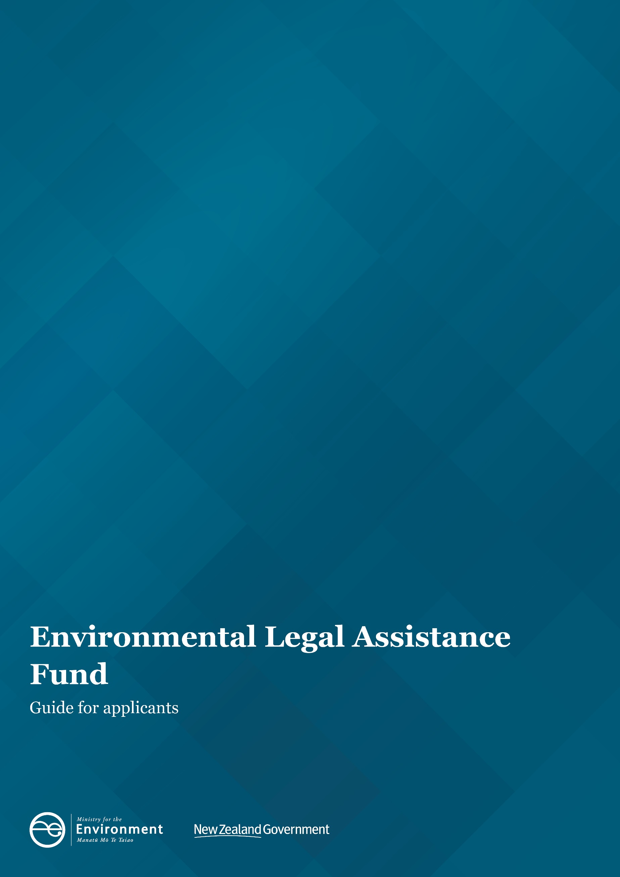

Disclaimer
The information in this publication is, according to the Ministry for the Environment’s best efforts, accurate at the time of publication. The Ministry will make every reasonable effort to keep it current and accurate. However, users of this publication are advised that:
- The information does not alter the laws of New Zealand, other official guidelines, or requirements.
- It does not constitute legal advice, and users should take specific advice from qualified professionals before taking any action based on information in this publication.
- The Ministry does not accept any responsibility or liability whatsoever whether in contract, tort, equity, or otherwise for any action taken as a result of reading, or reliance placed on this publication because of having read any part, or all, of the information in this publication or for any error, or inadequacy, deficiency, flaw in, or omission from the information in this publication.
All references to websites, organisations or people not within the Ministry are for convenience only and should not be taken as endorsement of those websites or information contained in those websites nor of organisations or people referred to.

This document may be cited as: Ministry for the Environment. 2021. Environmental Legal Assistance Fund: guide for applicants. Wellington: Ministry for the Environment.

Updated in July 2021
First published in June 2017 by the
Ministry for the Environment
Manatū Mō Te Taiao
PO Box 10362, Wellington 6143, New Zealand
Publication number: INFO 802
© Crown copyright New Zealand 2021
This document is available on the Ministry for the Environment website: environment.govt.nz.

Contents
About this guide 4
About the fund 4
How much funding is available? 4
What the fund covers 4
What the fund does not cover 5
Eligibility criteria 5
Funding maximum and multiple process applications 6
Timeframes 7
Board of inquiry timeframes 7
Assessment criteria 7
Primary criteria 7
Secondary criteria 8
Other considerations 8
Who makes the decision? 8
Successful applicants 9
Complaints from third parties 9
Completing an application 9
Confidentiality 11
Sending applications and more information 11

About this guide
This guide will help you determine whether your group is eligible for funding from the Environmental Legal Assistance (ELA) Fund and help you answer the questions in the ELA Fund application form.

About the fund
The Environmental Legal Assistance Fund (the fund) is for not-for-profit groups advocating for matters of environmental public interest. Funding enables applicants to participate more effectively and efficiently matters or issues affecting the environment or processes regulating the environment.
An independent advisory panel assesses applications against set criteria and makes recommendations to the Ministry for the Environment.
Successful groups are required to enter into a deed of funding with the Ministry. Please refer to our website to view a copy of a draft deed.
More information about the fund, including an application form, is available on our website.

How much funding is available?
There is no minimum grant and the maximum grant is $50,000 (excluding GST) per group per application for any one case.
The fund has a total annual budget of $600,000 (excluding GST).

What the fund covers
Funding is available to cover the time and expenses of legal representatives and/or expert witnesses used in preparing for, resolving and/or presenting cases before the Environment Court, higher courts, boards of inquiry and for first instance hearings (for example, before decision-making panels) where the right of appeal is likely to be restricted to points of law only. As part of your application you must include a short resume about your legal representatives and expert witnesses which outlines their relevant qualifications and experience, including the experience of your legal counsel in resource management or environmental matters. There is no guarantee any or all requested funding will be awarded. You must be eligible for funding and only reasonable costs will be considered for funding.
If you don’t provide enough information, a request will be made for additional information. Your application will not be assessed until you have provided all the required information.

What the fund does not cover
Funding is not available for:
- assistance at council-level hearings where there is a right of appeal that is not restricted to points of law only
- costs incurred before the funding application being lodged
- costs of members of applicant groups in any event
- sundry costs of non‐incorporated groups
- costs of establishing the group as a legal entity
- ongoing costs of the group, such as capital costs and rent
- costs awarded by the court against a group or individuals of the group
- costs of preparing submissions to the Minister for the Environment for board of inquiry hearings under the call‐in process. This is a prior stage to the board of inquiry hearing.

Eligibility criteria
The fund eligibility criteria must be met before an application for funding is submitted to the Ministry. Only complete and eligible applications will be forwarded to the advisory panel for assessment.
Note: Meeting the eligibility criteria does not guarantee your project will be funded.
- Applicant must be a not-for-profit group.
Eligible groups include:
- iwi and hapū groups
- incorporated societies
- community groups.
It is generally expected that groups are incorporated or a trust. The fund is not available to individuals.
- The group must be party to a proceeding that is eligible for funding
Before applying for funding the group must either:
- already be engaged in the proceedings by being a party to the case, eg, by having lodged a submission with the relevant authority, participated in court proceedings as initiator, respondent or as an interested party; or
- have demonstrated to a court that the group has standing to participate in the proceedings.

- The group’s legal status must be verified by providing the required supporting documentation as requested section 2 of the application form. In general it is expected that groups are incorporated or a trust.
If your group is a legal entity: Many legal bodies are registered with the Ministry of Business, Innovation and Employment as either a trust or an incorporated society and will have an identifying registration number (see www.societies.govt.nz). Please attach a copy of your Certificate of Incorporation and your group’s mandate/rules to your application.
If your group is not a legal entity: You must:
- provide recognition from the Court that your group is a party before the Court in the proceedings
- document the membership of the group and provide proof of the members and history of the group
- have more than one individual who has authority to sign documents on behalf of the group, including the ELA Fund application form
- include a mandate from the group granting those members authority to sign
- provide information that the group has structures in place to act as a group eg, evidence of regular meetings, bank account information.
As a non-incorporated group, you should be aware incorporated groups can be protected from having to personally pay any award of costs against the group.
Iwi/hapū groups and other Māori groups
If you are an iwi, hapū or Māori group and not an incorporated group or a trust, include the same information as required for a group which is not a legal entity.
- The group must submit a complete application and all required supporting documentation as specified in the ELA Fund application form.
Please contact the Ministry by emailing ela.fund@mfe.govt.nz if you have questions about your eligibility to apply to the fund.

Funding maximum and multiple process applications
The Ministry will fund up to a maximum of $50,000 plus GST per group, per application, in respect of any one case. Where the applicant is involved in a number of cases arising out of the same plan process, we will only approve funding after considering all the cases that the applicant is involved in. In this context, the ‘plan process’ means appeals relating to regional policy statements, regional and district plan reviews, plan changes or variations.
Accordingly, applicants for funding involving more than one case arising out of the same plan process must make one application to cover all cases. This application must cover all the issues and cases that are the subject of the plan process involving the applicant. It should detail:
- how and to what extent any of these cases are interrelated
- the plan process the cases relate to
- the counsel to be engaged
- what evidence is proposed, and by whom
- all information relating to any interlocutory proceedings and other procedural matters that may have taken place
- where known, any related parties involved in supporting the issues for which the group seeks funding (eg, the council, other groups) and the issues they are contesting.
You will be expected to prioritise the cases and/or related issues. If funding is made available, it will be fixed in a sum that enables the applicant to participate in those cases with the highest priority. While the funding will not be limited to $50,000 plus GST, the applicant should also not expect to receive the maximum funding of $50,000 plus GST for each issue or case arising out of the same plan process.

Timeframes
Panel meetings are held approximately every six to eight weeks. The close-off date for applications for each panel meeting is approximately five weeks before the meeting. The dates for upcoming panel meetings are available on our website.
As it takes time for applications to be processed, you are advised to apply for funding early, preferably as soon as you have lodged your appeal or otherwise become a party to proceedings. It is important you include all the required information or processing your application will be delayed.
Processing applications normally takes five to seven weeks.

Board of inquiry timeframes
If your group, as a submitter to a board of inquiry, is concerned about timeframes for receiving a decision on funding due to the board of inquiry’s evidence exchange timetable, contact the ELA Fund team to discuss by emailing ela.fund@mfe.govt.nz.

Assessment criteria
The Primary funding criteria recognise whether the application impacts the environment or involves processes regulating the environment that are of consequence to the public generally. The Secondary funding criteria provide other considerations which the Panel may take into account and therefore may also influence the level of funding if any is recommended.

Primary criteria
The panel will consider whether a group’s case is in the environmental public interest, including whether it:
- it relates to or raises nationally or regionally important matters or issues affecting the environment or processes regulating the environment.
- it relates to the relationship of Māori and their culture and traditions with their ancestral lands, water, sites, waahi tapu, and other taonga
- has the potential to create useful case law
- has the potential to improve the administration and efficiency of the relevant resource management Act /environmental legislation.
- involves issues of national or regional importance which will not be addressed in full before the relevant court or a board of inquiry or hearing authority without the expert evidence provided by the group
- whether the group and/or its members has a private interest in the outcome
- there is a degree of collaboration undertaken or proposed to be undertaken by the funding applicant with other parties in the case.

Secondary criteria
The panel may consider:
- when considering the commitment of the group:
  - the funding applicant’s demonstrated ability to manage the case (including any previous experience in legal cases)
  - its history with the issue
  - the time it has invested in the issue or case
  - its financial contribution to the issue or case (having regard to the position of the group and the resources it can offer)
  - its efforts to raise funds and
  - the pro bono contribution from lawyers and/or experts
- whether the case relates to Māori undertaking resource management/environmental duties and functions
- whether the group is open to mediation, and whether mediation is appropriate in the proceedings
- whether there is likely to be an imbalance between the quality of evidence and case management between the parties due to a lack of financial resources
- whether the case is vexatious or frivolous
- whether the case relates to a board of inquiry or a direct referral to the Environment Court or higher courts appeal
- whether the case improves the efficiency and effectiveness of policy and planning instruments
- any other matters arising out of the application.

Other considerations
After consideration of the secondary criteria, the panel may recommend that no funding is awarded.
These criteria are applied to the outcomes the applicant group is seeking to achieve in its case, not to the whole legal proceeding.
Applicant groups that are predominantly made up of people who have a pecuniary interest in the case and would benefit materially from a decision in their favour, will only have funding provided if their case raises matters of high public interest, usually of precedent-setting value.
The fund has limited financial resources and priority will be given to cases of at least regional importance.

Who makes the decision?
Each application is assessed by an independent advisory panel against the fund’s primary and secondary criteria. The panel makes recommendations to the Ministry for the Environment. Our Director Legal and Procurement makes the final decision on whether to fund an application, under delegated authority from our Chief Executive.
The panel will only revisit a matter if exceptional circumstances are established.

Successful applicants
If successful, you will be expected to enter into a deed of funding with the Ministry setting out the terms and conditions of funding. Your group will be required to report back and provide:
- an interim report on the case’s progress by 1 June of each year until a decision on the case is reached
- a final report once a decision is reached. The report will include an update on the outcome of the case, feedback about the value of funding received, a summary of money spent, and a copy of the decision.
We will only pay invoices from the group’s legal representatives and expert witnesses identified in the deed of funding. Invoices must be made out to the Ministry for the Environment.
In general, the deed of funding begins from the date we first received the application. Costs incurred by the group before this date are not eligible for funding.

Complaints from third parties
Where issues merit it, complaints or requests for review of decisions from third parties are submitted to the advisory panel for consideration. As with applications, our Director Legal and Procurement makes the final decision on whether to fund an application, under delegated authority from our Chief Executive.

Completing an application
Applications must be made on the official application form. This is available on our website.
The application form is divided into seven sections. Some sections require text to be provided in the form, while others require supporting information to be attached. When submitting an application, place the application form at the front and attach any supporting information grouped according to the seven sections set out on the following pages.
When filling out the application form, you should pay attention to the fund’s Primary and Secondary criteria.
- Contact details
Provide the contact details of the primary and secondary contacts for the group.
- Group details
- Identify the type of group by ticking the relevant box (eg, iwi/hapū, residents and ratepayers group).
- State when your group began operating.
- Provide the necessary supporting information depending on the legal status of the group section 2 (eg, incorporated society or non-incorporated group).
- State the objectives of the group.
- Note whether the group is part of a larger national body, and if so, what the group’s financial relationship is with the national body.

- Application details
- Briefly outline what your application relates to.
- Indicate the type of case by ticking the relevant box.
- Provide the case name and number.
- Outline the group’s legal argument and the history of its involvement in the case.
- List all the parties involved in the case, and describe any collaboration with other parties with the same interests as your group.
- State whether the group has been involved in mediation for the case.

- ELA Application Details
- State whether any issues been settled by mediation. If so, describe the issues that have been settled.
- Explain how the application meets the primary criteria stated in the question
- How does the case relate to national or regional matters affecting the environment or processes regulating the environment
- Explain how does the case relates to the relationship to Māori, their culture, and traditions with their ancestral lands, water sites, wāhi tapu and other taonga
- Whether the case will create useful case law
- Whether the case could improve the administration or efficiency of relevant environmental law
- Whether the evidence your group is providing in the proceedings will contribute to addressing the national or regional important environment issues in full

- Funding details
- Complete all questions in section 5.
- Complete the table in question 5b to show for each witness and legal counsel:
  - the costs that have been incurred and paid for by your group including costs incurred at council-level proceedings
  - future costs that are to be incurred
  - the value of pro-bono work and discounted rates that has or will be provided. The value of future pro-bono work or discounts should be confirmed in quotes that are provided as part of your application
  - which of the witnesses/legal counsel you are seeking funding for
Please ensure total amounts are provided in the table. The table includes guidance about what information should be included in each column.
- Provide a summary of experience (eg, curriculum vitae) for each person listed in 5b.
- Provide a quote for each individual you are seeking funding for.
- State the costs your group has contributed to the case to date. Note: As requested in section 5, it is helpful to provide an itemised list of costs incurred.
- Provide information on the group’s resources and how it would fund costs that exceed any funding received.
- Provide all of the supporting financial information requested in section 5.

Supporting information
Identify the supporting documents provided with your application by ticking the relevant boxes. In all cases, regardless of the type of case, you must provide a location map.

Group’s declaration
The application form should be signed by the primary and secondary contacts (or duly authorised members) and witnessed by a person authorised to take a statutory declaration, such as a Justice of the Peace.

Confidentiality
Information presented to the Minister for the Environment or the Ministry for the Environment is subject to disclosure under the Official Information Act 1982 (OIA). Therefore information provided in an application may be released upon request. Certain information may be withheld in accordance with the grounds for withholding information under the OIA.
Further information on the OIA is available at www.ombudsman.parliament.nz.

Sending applications and more information

Send applications to:
Environmental Legal Assistance Fund ela.fund@mfe.govt.nz
Note: we no longer accepted printed copies of applications.

For more information please contact the ELA Fund:
Telephone 0800 499 700
Email: ela.fund@mfe.govt.nz
Website: https://environment.govt.nz/what-you-can-do/funding/environmental-legal-assistance-fund/

