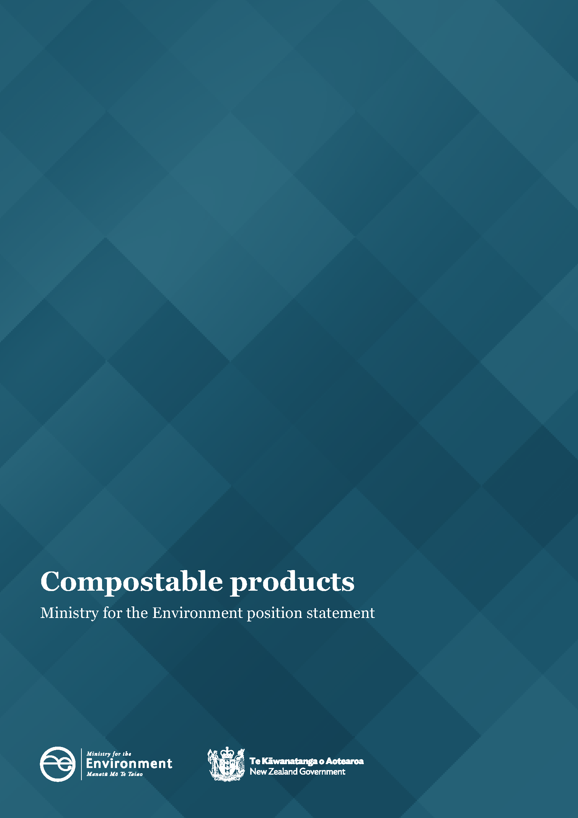

This document may be cited as: Ministry for the Environment. 2022. Compostable products: Ministry for the Environment position statement. Wellington: Ministry for the Environment.

Published in March 2022 by the
Ministry for the Environment
Manatū Mō Te Taiao
PO Box 10362, Wellington 6143, New Zealand
ISBN: 978-1-99-102514-2
Publication number: ME 1627
© Crown copyright New Zealand 2022
This document is available on the Ministry for the Environment website: environment.govt.nz.

Contents
Introduction 4
Purpose 4
Overview of the issues 4
Summary of position 5
Definitions 6
Compostable materials 6
Compostable fibre products 6
Compostable plastic products 6
Standards for industrially and home compostable products 6
New Zealand’s system for compostable products 7
Collection 7
Sorting 7
Processing 8
End markets 8
Can compostable products play a role in a circular economy in Aotearoa New Zealand? 9
Benefits of using compostable products 9
Challenges with compostable products 9
Ministry’s position on the use of compostable products 14
Principles to consider before exploring using compostable products 15
Situations where compostable products might be used in a circular economy in New Zealand 16
Relevant central government policy changes 17
Where to next? 18
What are the different views on compostable products? 19
Appendix 1: Definitions 20
Appendix 2: Overseas positions on compostable products 22
Appendix 3: Examples of innovative circular solutions that do not rely on compostable products 23

Introduction

Purpose
This document describes the Ministry’s position on where compostable products could play a role in a circular economy in Aotearoa New Zealand. It does not provide guidance and should not be interpreted as such. Rather, the position outlined in this document provides information to support Government policy initiatives, including consultation on improving household kerbside recycling collections, the phase-out of single-use and hard-to-recycle plastics, and regulated product stewardship schemes for priority products.
This document covers compostable products, and treats compostable packaging as a subset of compostable products.

Overview of the issues
Global awareness of how plastic impacts the environment has increased in recent years. At the same time, consumers and companies are identifying ways to reduce their environmental impact, including by choosing alternatives to single-use plastic packaging and packaging made from fossil fuels.
In New Zealand, where we have a relatively high per capita use of plastics compared to other OECD countries, manufacturers are exploring alternatives such as biodegradable plastics, degradable plastics, compostable plastics, and biobased plastics. Some of these materials function similarly to conventional plastic; however, these different products have different disposal pathways, which can cause confusion for the public and manufacturers.
Enthusiasm for alternatives to single-use plastic packaging and products may be further accelerated over the next few years by the phase-out of some plastic products in New Zealand and globally. This document focuses on compostable products, which is a subset of biodegradable materials (see Appendix 1 for definitions). Compostable products are designed to break down into water, carbon dioxide, and biomass over a short period of time under specific aerobic conditions.
When considering the role compostable products can play in a circular economy, it is worth noting that compostable products provide no nutrient value to the compost. This means the only potential value of compostable products lies in their ability to help divert food waste from landfill to compost or in removing a potential contaminant in a food waste collection bin. Diverting food waste from landfill is positive because food waste in landfill contributes to New Zealand’s greenhouse gas emissions, and because food waste feeds valuable nutrients into the biological cycle when composted.

Compostable products present challenges.
- Compostable products often end up in landfill due to confusion about how to dispose of them and a lack of collections and processing infrastructure (for example, in the United Kingdom research has found that only 1 in 400 coffee cups actually get composted).
- Consumers often incorrectly believe that compostable products can break down when littered; however, when littered or lost to waterways or the sea, compostable products are contaminants. They are not designed to degrade in these environments.
- Compostable products contaminate recycling bins and our domestic soft plastic collection scheme as they look similar to conventional plastic; however, they are not recyclable.
- We have limited sorting and processing infrastructure in New Zealand to properly manage compostable packaging, in particular for the majority of our compostable products that require the high temperatures of ‘industrial’ composting systems to degrade.

Summary of position
For now, we consider compostable products could have a role in a circular economy in New Zealand:
- in closed-loop settings where they help divert food to compost
- where plastic polymers would usually contaminate the compost or soil (eg, produce labels).
See Ministry’s position on the use of compostable packaging section for more information, including the principles to consider before exploring compostable packaging.
Packaging innovation and improved systems and infrastructure for materials continue to evolve rapidly. We will ensure changes to our position on compostable products are reflected in this document and any future policy documents.

Definitions
The diversity of technical materials classed as biodegradable and their different properties makes it difficult to make general assessments. A summary of relevant definitions is provided in Appendix 1. The key definitions for the purpose of this document are outlined below.

Compostable materials
Compostable packaging is created to be suitable and certified for specific composting environments after use. This means the material biodegrades in specified form in an aerobic composting process through the action of naturally occurring micro-organisms and within a specified timeframe, to a specified level.
Some compostable packaging is derived from biologically derived raw materials like starch, cellulose, soy protein, and lactic acid (eg, polylactic acid (PLA), polyhydroxyalkanoate (PHA), polybutylene succinate (PBS)). These ingredients are modified to create the new product, which does not normally occur in nature. This is often called bio-based compostable packaging. However, not all compostable packaging is bio-based, and not all bio-based packaging is compostable. Some compostable packaging is derived from petroleum.

Compostable fibre products
Compostable fibre products include paper/cardboard, sugarcane/bagasse plates, clamshells, and bamboo cutlery. These types of products break down easily and the fibre adds carbon to compost. Roughly half of the compostable packaging in New Zealand is fibre-based. It is often marketed as being home or commercially compostable.

Compostable plastic products
Compostable plastic can be made from plants or a combination of plants and petroleum. It can look identical to conventional plastics. Usually, this type of material requires industrial composting (not ambient environmental conditions) and therefore will not break down in home compost.

Standards for industrially and home compostable products
Industrially compostable products or packaging have been designed to break down in an industrial composting environment. These facilities operate at much higher temperatures than the average home compost system. There is no current New Zealand certification standard for industrially compostable products. However, some international standards are recognised in New Zealand. As with industrial composting certification there is no New Zealand certification standard for home compostable products. Again, however, there are international standards that are recognised in New Zealand.

New Zealand’s system for compostable products
The collection and sorting of materials will determine the success of a waste management system. Even more important is whether there are end markets or downstream opportunities for the circular use of the resulting material.

Collection
While some products have international certification as home compostable, that does not mean they do compost in the average home composting bin. While something may be able to biodegrade in a laboratory under specific conditions, this does not necessarily translate into composting as post-consumer packaging in a home composting bin.
Additionally, most products are not certified home compostable, and will instead require treatment in industrial facilities with specific conditions that will not be met by even the most efficient home composting system. Therefore, collection points are needed to transport compostable products to appropriate processing facilities.
Collection points for organic waste in public spaces are not well established in New Zealand, with public bins often being for general waste or recycling only. Some local authorities provide kerbside collection of organic material, but do not accept compostable products. Local authorities have unanimously agreed that until the technology improves to enable non-compostable plastics to be easily identified and removed, kerbside food and garden waste collections will not accept compostable packaging.
We are consulting on an approach to improving kerbside recycling by increasing standardisation, which will include some proposals around what could be accepted in food and garden waste bins. Some companies have their own collection schemes for compostable products or are trialing schemes. Some events or venues (eg, Spark Arena) have separation or collection systems in place.
Kerbside collections are part of a wider system, where others can play a role. For example, retailers and third parties can operate collection and return schemes that ensure compostable products are taken to processing facilities. At present, in part due to the confusion around the role of compostable products, there are few collection points operating in New Zealand for consumers to use.

Sorting
For any processing pathway, there is a major challenge in being able to separate compostable plastics and conventional plastics to safely process compostable plastics. Currently, there is no automated process for identifying and separating non-compostable from compostable packaging. Although improved labelling of products could help provide more clarity to consumers if they pay attention to it, the issue of how to quickly identify and separate out non-compostable packaging remains an issue globally.
In many countries, industrially compostable plastics are being sent to waste to energy plants rather than being composted (see New Zealand’s position on waste to energy technology on our website).
Composters are more likely to consider accepting compostable materials if they are supplied as a sorted stream with contamination removed. However, many composters will not accept any compostable materials due to the risks associated with contamination and because it does not add value to the resulting compost so carrying the risk is not worthwhile. This means any role for compostable products in New Zealand at present will depend on whether it can be provided already sorted and decontaminated to a processing facility that will accept it.

Processing
New Zealand has insufficient infrastructure to process compostable materials, particularly if the uptake of compostable products continues to grow. However, some industrial composters accept compostable products (for a list see New Zealand facilities that accept compostable packaging and food serviceware on the WasteMINZ website).
The reasons for not accepting compostable products are generally:
- the risk of contamination from other plastics and the risk of compostable packaging devaluing good quality compost
- that many facilities do not have resource consents needed to accept compostable packaging
- that they sell organically certified compost and are not able to accept compostable packaging.
Even where there may be a role for compostable products in a circular economy in New Zealand, this relies on collection, sorting and processing infrastructure, including a processing facility that accepts the compostable products.
Aside from industrial composting, another processing technology used in some countries to process food waste is anaerobic digestion. It is a biochemical process occurring without the presence of oxygen, converting organic materials to methane and carbon dioxide. In comparison, composting is an oxygen-driven process. Due to the difference in degradation pathways, material suitable for composting may not necessarily degrade under anaerobic conditions in digesters. Some bioplastics can be degraded in digesters, while others cannot. At present, this means anaerobic digestion and compostable products are not compatible in New Zealand.

End markets
Because compostable packaging products that are added to organics processing pose a risk to the quality of the final compost product and the local ecology of an area where that compost is used, there are limited end markets for this type of compost in New Zealand. Therefore, there is currently no market demand driving composters to process compostable products, or to upscale existing infrastructure.

Can compostable products play a role in a circular economy in Aotearoa New Zealand?

Benefits of using compostable products
There are some potential benefits of using compostable products including:
- genuinely and fully compostable products can help divert organic waste from landfill, reducing methane emissions from organics, and delivering food nutrients to compost from the diverted food waste
- some bio-based compostable products (such as PHA) can use organic feedstock for production, helping divert more organic waste from landfill (eg, bagasse, a material used in compostable packaging, is made from sugarcane pulp, a by-product of the sugarcane industry)
- when processed correctly, compostable products can help reduce plastic in landfills, and the associated environmental impacts (this is also true of conventional plastic).

Challenges with compostable products
In many situations, there are challenges with compostable products.
Compostable products do not provide a perfect solution to reducing the amount of plastic ending up in landfills and the environment. Many other countries have recognised these challenges and developed their own positions – see Appendix 2. The main challenges for New Zealand are discussed below.

Compostable products are single-use and not recyclable
Compostable products offer no nutritional or economic value when composted, meaning that even if composted correctly, products are downcycled rather than recycled. The waste hierarchy establishes the order of preference for different waste management options, and due to the challenges with compostable products, they often end up in the ‘dispose’ step of the hierarchy (ie, in landfill or the environment). At best, they fit into the ‘recycle’ step of the hierarchy when composted correctly.
In either scenario, these products are single use, meaning they are used once before being thrown away or composted. Single-use packaging is energy-intensive, contributing to greenhouse gas emissions and resource depletion. To unlock a circular economy, New Zealand needs to focus more on how to reduce and reuse packaging.
The waste hierarchy
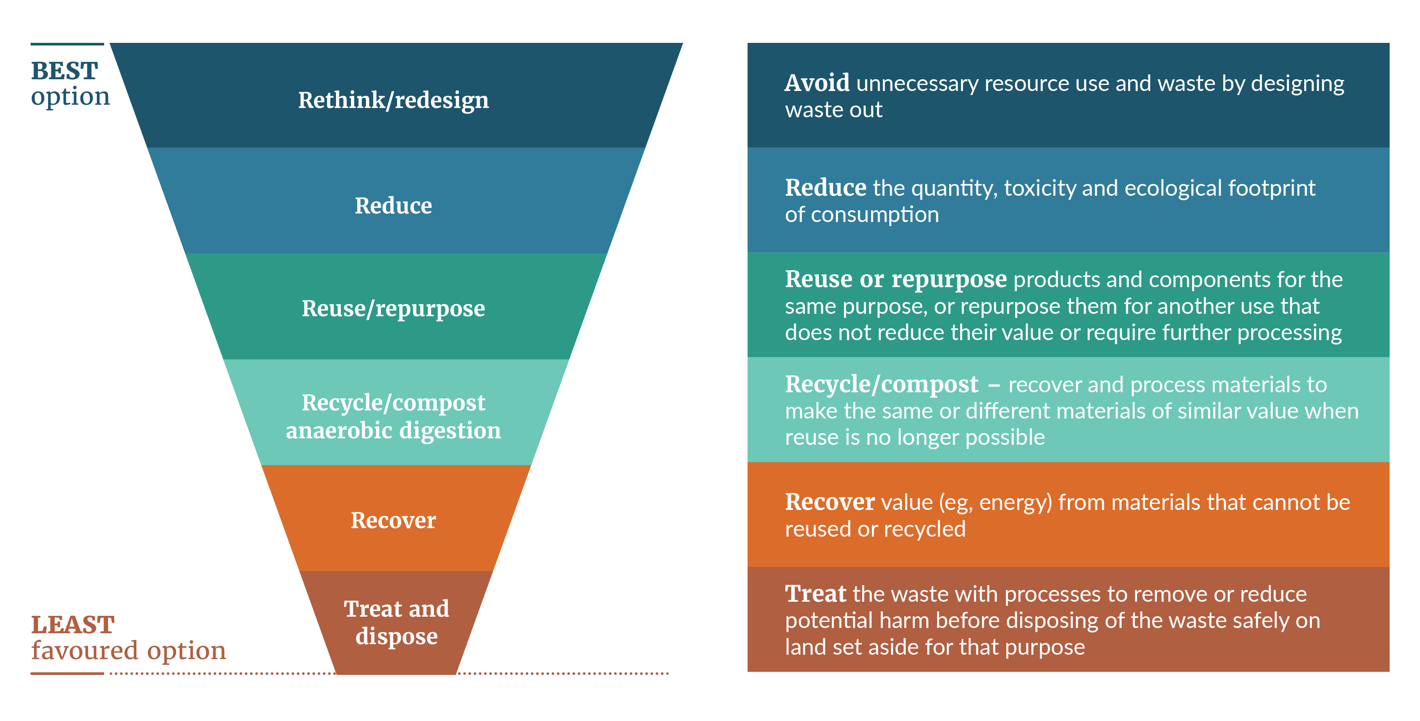

Compostable products often look similar to conventional plastic, leading to confusion
Compostable products can look almost identical to non-compostable packaging. One of the cups below is made from compostable plastic and the other from recyclable plastic, yet they are almost impossible to tell apart. The confusion means that it is difficult for the public to identify compostable products.
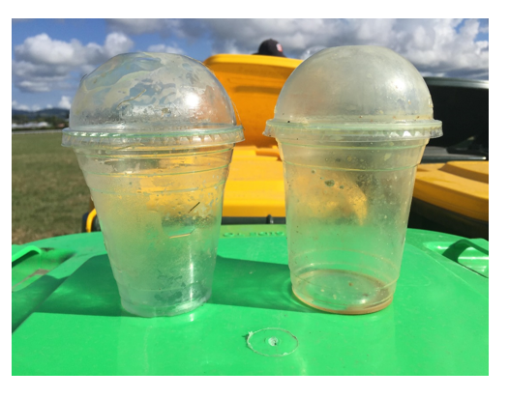
When compostable products are identified, many consumers still do not know how to best dispose of the product. This is particularly problematic when for most compostable products, the appropriate processing pathway is industrial composting, which necessitates collection, sorting, and decontamination before high temperature composting – and this is not widely available in New Zealand.
We recently commissioned a survey on general public attitudes to composting and compostable packaging which highlighted the confusion that consumers often experience. Some common misconceptions were that compostable packaging:
- will compost in landfill or the environment when littered, without negative impacts
- can be recycled.

Confusion leads to compostable products being landfilled or littered
Due to the common misconception that compostable packaging will compost in landfill and will break down quickly if littered, and because of there is a lack of collection and processing infrastructure, compostable products are often disposed of in general waste bins where they end up in landfill.
When littered in the environment, or put into a landfill, compostable products may not break down, as composting is a specific process that will only work in certain conditions. When compostable products are not exposed to the right conditions, they can last a very long time without degrading. They break into microplastics and disperse into the environment or contribute to our greenhouse gas emissions by producing methane if they degrade anaerobically in a landfill.

Confusion about compostable products leads to contamination of recycling streams
Due to the common misconception that compostable products are recyclable, they are often contaminating kerbside recycling bins or entering New Zealand’s soft plastic recycling scheme.
If compostable products enter the recycling stream, the sorting technology does not yet exist to separate them from recyclable plastic, so they contaminate the recycling, lowering its value. If non-compostable plastic packaging accidentally enters the composting stream because it looks similar to compostable packaging, there is a risk of plastic and microplastic contamination in the compost produced, eventually contaminating our soils and food.

New Zealand does not have industrial composting standards, and overseas standards that are used here are not perfect
There is no New Zealand standard for industrial or home composting; however, several international standards (eg, from Europe, USA and Australia) are recognised and frequently used in New Zealand. These standards include tests such as:
- biodegradation tests to make sure the material breaks down by naturally occurring microbes in specific conditions able to be replicated in a laboratory
- ecotoxicity tests on soil
- chemical characterisation to ensure heavy metals and other toxic components are not present.
Broadly, some of the challenges with industrial composting certification are:
- businesses lack clarity and certainty around what the best international certification is for New Zealand
- these official overseas certifications generally allow compostable packaging to contain a small amount (less than 5 per cent) of non-compostable ingredients and the packaging manufacturer does not have to list these ingredients

- because compostable standard certification is very expensive, many companies will use certified compostable films, but the final product will not be certified compostable, resulting in untested additives, inks and dyes ending up in compost. It also means that the final product in a certain form and size may not break down as easily as the individually certified components
- these overseas standards do not test for the presence of all possible additives.
Currently, there are no regulations under the Waste Minimisation Act that require the labelling of ingredients in food packaging. There are provisions under the Act to create labelling requirements on products, but these have not been exercised yet. Whether labelling could be an effective intervention is unclear. Labelling would provide greater clarity for consumers, but some recent research in New Zealand indicates it may not solve problems around confusion and contamination and consumers do not always follow the label.

Compostable products can harm soil, marine environments, and human health
To date, enthusiasm for compostable packaging has focused on the physical breakdown of packaging. A recent study by UMR prepared for the Ministry highlighted that people look to physical breakdown to determine whether compostable products are degrading. Even then, the study showed some common misconceptions: many respondents believed that compostable packaging will ‘break down’ if littered, and that it will compost in landfill with no negative impacts.
Even when compostable products do physically break down, because of cross contamination of waste streams and the challenges with compostable certifications, microplastics and chemicals may remain in the environment following the physical breakdown of materials.
Specifically, fibre-based compostable products can contain additives that enable them to behave more like plastic – in other words, certain additives are used so that the product is more water and grease resistant. Fibre-based compostable products with water and grease resistance often requires the use of per- and polyfluoroalkyl substances (PFAS) or aqueous coatings.
PFAS harm soils:
- they are persistent organic pollutants and bioaccumulate in soils over time. Overseas research has shown PFAS is present at much higher concentrations in composts that accept compostable food packaging than those that do not
- they can dissolve into water, so they can end up in our waterways
- if they enter waterways and our food chain, PFAS have known adverse human health impacts.
Aqueous coatings, also called water-based dispersion coatings, are also problematic. The aqueous solution, while water-based, can include chemical additives including plastic polymers.
Many compostable plastics also contain additives, inks and microplastic residues that may not be tested for or detected in a certification process. Many commercial composters will not accept compostable plastic because it does not break down easily and prevents companies from having certified organic compost. The risk of conventional plastics and microplastics ending up in compost is another source of harm for soil.
As part of the Government’s National Plastics Action Plan, the Government intends to undertake research on the chemical profile of soil that receives ‘compostable’ plastic or treated fibre products. This will help us to build an evidence base for the safety of any present and future uses.

Ministry’s position on the use of compostable products
The Ministry considers that a cautious approach to compostable products is needed. Other jurisdictions are managing the challenges of compostable products, and taking similarly cautious approaches, with some examples described in Appendix 2.
We have a duty of care to our whenua (land) and our soil. We know compostable packaging can contain chemicals, additives, inks, and dyes which may negatively impact our environment once they enter the soil. More research is needed before the use of compostable products could increase. Compostable products are also often not properly processed and end up in our landfills, adding to our greenhouse gas emissions by producing methane. Therefore, we need to be sure that when these products are used, they will be collected, sorted, and processed, and that they will not end up in landfill, littered in the environment, or harming our whenua and soils.
We consider that compostable products could have a role in a circular economy in New Zealand in some situations. This is summarised in the diagram below and then described in more detail in the following section.
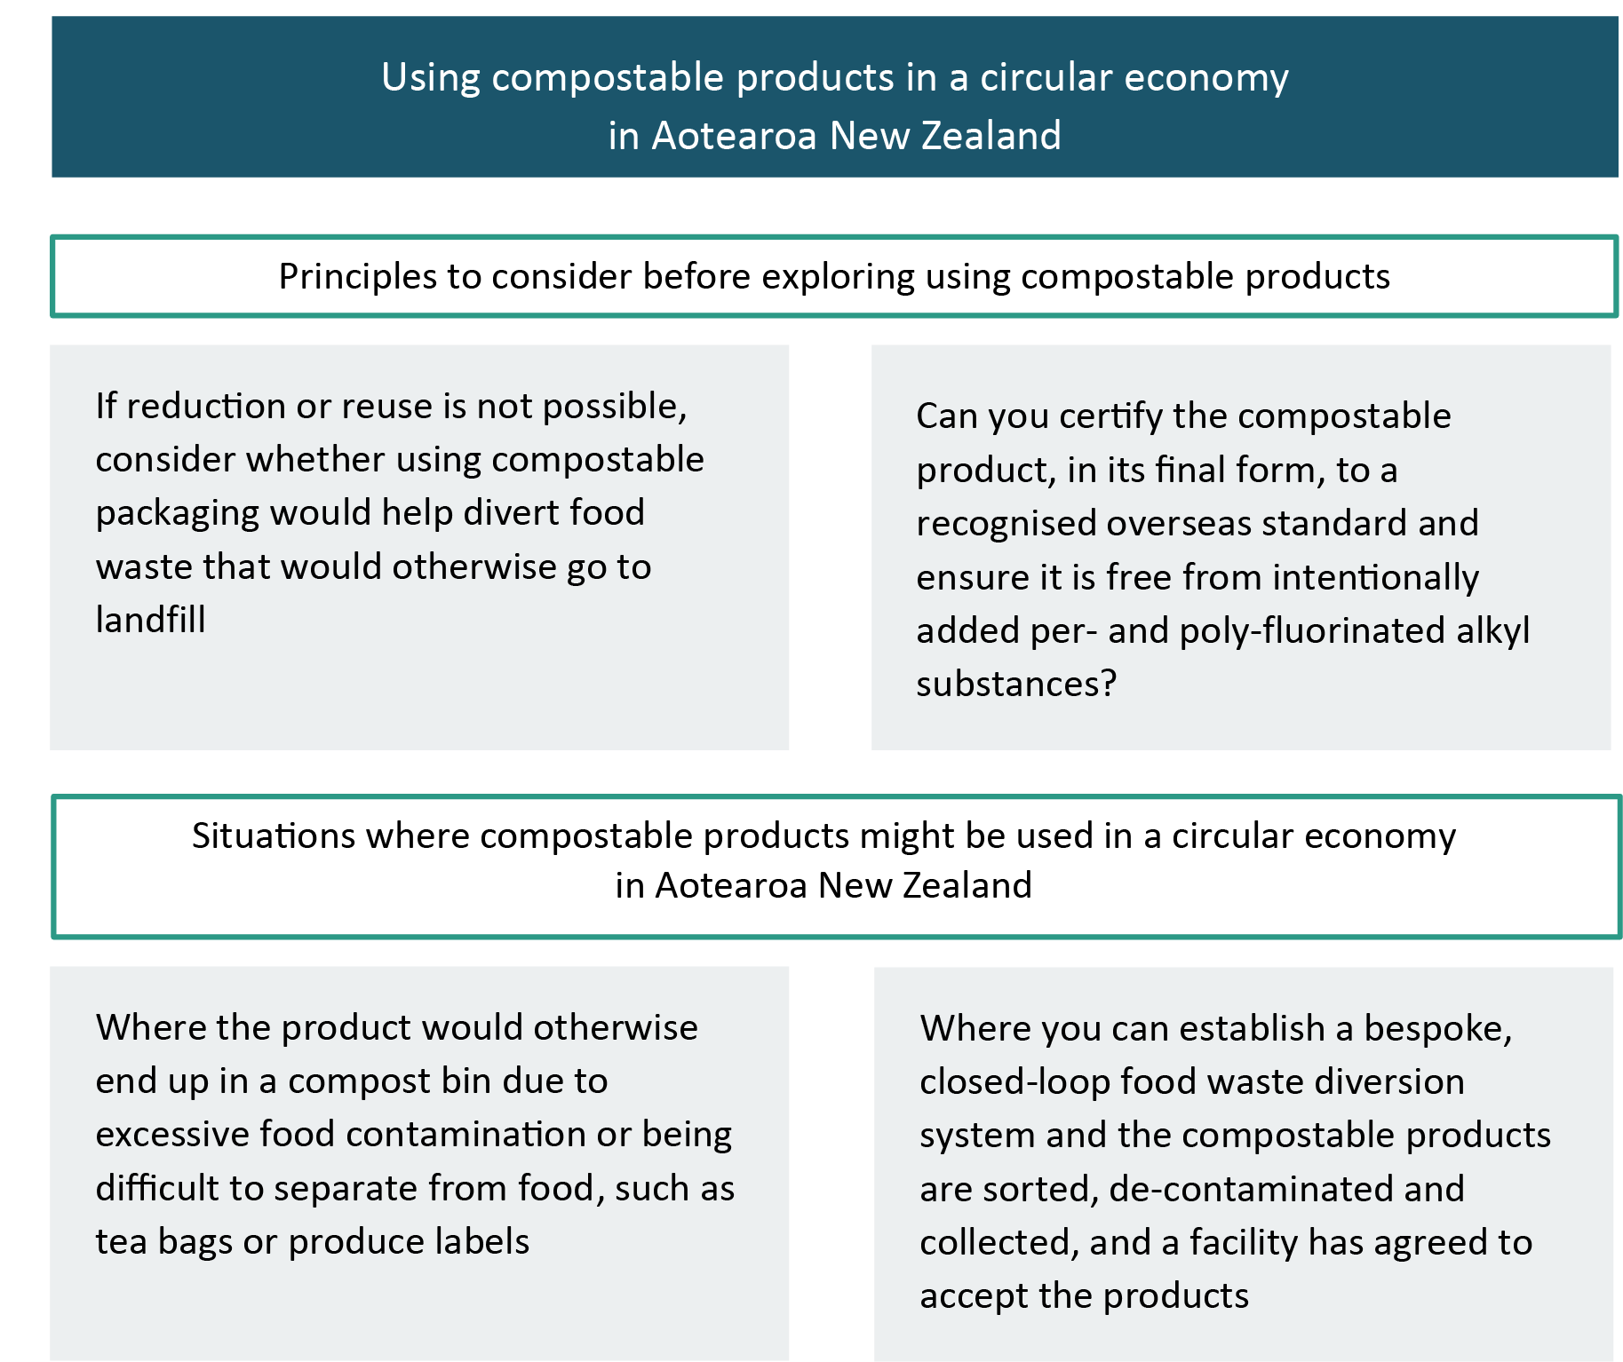

Principles to consider before exploring using compostable products

Elimination, reduction and reuse should be the first choice
As outlined earlier, compostable products are single-use, even when composted properly. This does not support a focus at the top of the waste hierarchy. Therefore, our position is that compostable packaging should be considered only where elimination, reduction and reuse are not suitable alternatives. For example, in situations such as a concert or event, a re-use system may be preferable.

Compostable products should divert food waste away from landfill
The potential value of compostable packaging lies in its ability to support the recovery of food waste. The packaging itself does not contain any nutrients of value to the compost. Therefore, compostable packaging may be useful when the packaging would usually be contaminated with food, and instead of that food contaminating recycling, or ending up in landfill, it can add value to compost (eg, a food bin liner, serving plates at events, tea bags). Examples of where compostable products do not deliver food nutrients to compost include packaging for pantry foods, nappies, sanitary products, cleaner and shampoos.

Use certified overseas standards
Compostable packaging certifications provide assurance that compostable packaging will degrade under certain specified conditions, is not ecotoxic to soils and checks for heavy metals and other toxic components. The main recognised overseas standards used in New Zealand are AS4736, EN13432 and ASTMD6400/6868. WasteMINZ provides further information on these standards (Compostable Packaging | WasteMINZ). Most industrial composting sites in New Zealand will only accept compostable products that meet a certification (if they will accept compostable products at all).

Compostable products should not contain intentionally added PFAS
We are aware that testing for PFAS is complex and imperfect, and that this is an evolving space. However, because of the risks of PFAS described in this document, PFAS should not be intentionally added to compostable products.
Our survey on public attitudes to composting and compostable packaging showed that 74 per cent of people who compost use their compost in their vegetable garden, meaning it is important that compostable packaging fully degrades in that environment and does not contain harmful additives such as PFAS to guard soil and human health.

Situations where compostable products might be used in a circular economy in New Zealand

A closed loop system
Composters are more likely to consider accepting compostable materials if they are supplied as a sorted stream with other contamination removed. Therefore, we have identified that compostable packaging may be suitable in bespoke closed-loop systems, for example events, festivals, and some hospitality settings. In these settings, ideally all service ware used is third-party certified compostable and if not, there are people or processes to remove any contamination before the waste is sent to a composting facility. Compostable products used in this setting would enable any leftover food to be safely diverted from landfill to compost. Such products may include plates, drink vessels, bowls, and cutlery.
In addition, where compostable products are used in closed-loop settings, a facility must be identified that will accept the material for processing. Any criteria laid out by the receiving facility will need to be met. See the WasteMINZ website for a list of facilities that accept compostable products.

Where plastic may typically contaminate compost
Compostable products may be suitable when a traditional polymer is used closely with food (eg, produce labels, tea bags) or to help clean the bin or kitchen caddy (eg, bin liners for organic waste) and thus contaminates the food waste stream for home or commercial composting. For these types of products, a compostable product may be preferable to reduce the risk of plastic and microplastic remaining in compost and soils.

Relevant central government policy changes
There are many ‘moving parts’ affected by central government policy changes, shifting the landscape for a range of materials, including compostable products. These are outlined below.
- Plastic phase-outs: The use of compostable products is likely to increase as manufacturers search for more sustainable alternatives, especially following the Government’s regulated phase out of single-use and hard-to-recycle plastics, including compostable plastics, for example drink stirrers, single-use produce bags, cutlery, plates and bowls, straws and produce labels. This document should provide some useful information to those manufacturers about where compostable products (including non-plastic alternatives) could be a suitable alternative.
- Regulated product stewardship for plastic packaging: The Government has declared six priority products for regulated product stewardship, including farm plastics and plastic packaging. The plastic packaging regime will encompass compostable plastic packaging and laminated packaging including plastics. New regulations could increase incentives for circular resource use of these products, and place responsibility on producers to manage the end of a product’s life.
- Review of the Waste Minimisation Act and Litter Act: We are consulting on a refreshed Waste Strategy, and a review of the Waste Minimisation Act 2008 and the Litter Act 1979. In the review of the legislation, the Government will look at new regulatory powers that are needed, including the ability to set recycled content requirements and a duty of care. These proposals may affect all types of packaging.
- Kerbside standardisation: We are consulting on an approach to improving household kerbside recycling by increasing standardisation, which will include some proposals around what could be accepted in food and garden waste bins and will cover compostable products. It will also include proposals around what could be accepted in recycling bins, which will help provide greater clarity around the materials that will play a role in a circular economy.
- Plastics Innovation Fund: The Government recently announced a $50 million Plastics Innovation Fund to support projects that reimagine how we make, use and dispose of plastics. This document may help guide those investment decisions.
- National Plastics Action Plan: Recently published, this document provides the broad scope of the Government’s actions on plastics and highlights the next steps on our journey. Part of this involves publishing this position statement, committing to scoping research to better understand the impacts of compostable plastics on the soils and food chain, and eventually considering the role of overseas standards in New Zealand.
- New Zealand Plastic Product Declaration: Globally brands, retailers, and packaging companies have committed to using 100 per cent reusable, recyclable or compostable packaging across their global operations by 2025 or earlier. We consider the role of reusable materials and recycling will be more significant than the role of compostable packaging in meeting the 2025 target. Where compostable packaging is used, we would expect the position described in this document to be given consideration.

Where to next?
Future changes in composting packaging, composting infrastructure, packaging design, and labelling, coupled with more research about the chemical profile of the ingredients and additives that may be left behind in soils and the food chain, may overcome some of the challenges described in this document.
The existing landscape and the challenges described inform our current position on compostable packaging. We will ensure any future changes to our position on compostable packaging are reflected in this document or future policy documents.

What are the different views on compostable products?
The composting industry with WasteMINZ issued a position statement in 2019 that includes examples of items that are appropriate to make from compostable materials.
The Packaging Forum recently undertook consultation on a use-case for compostable packaging in New Zealand.
The New Zealand Food and Grocery Council has advised its members to not introduce compostable plastic packaging and products ‘for now’ and have identified some steps that need to be taken before New Zealand can adopt compostable products.
The Australian Packaging Covenant Organisation recently released Considerations for Compostable Plastic Packaging.

Appendix 1: Definitions
Term | Definition
Biodegradable | The meaning of biodegradable is very broad: it means the material is ingested by naturally occurring micro-organisms such as bacteria, yeasts and fungi and produces water, carbon dioxide, biomass containing a range of nutrients, and residual uncomposted materials. The material will degrade via an aerobic or anaerobic process that alters the chemical structure. The timeframe for biodegradation depends on the compounds in the materials, the micro-organisms present, and ambient conditions such as temperature, moisture, and oxygen.
Compostable | Compostable materials  Compostable packaging is created to be suitable and certified for specific composting environments after use. This means the material biodegrades in specified form in an aerobic composting process through the action of naturally occurring micro-organisms and within a specified timeframe, to a specified level.  Some compostable packaging is derived from biologically derived raw materials like starch, cellulose, soy protein, and lactic acid (eg, polylactic acid (PLA), polyhydroxyalkanoate (PHA), polybutylene succinate (PBS)). These ingredients are modified to create the new product, which does not normally occur in nature. This is often called bio-based compostable packaging. However, not all compostable packaging is bio-based, and not all bio-based packaging is compostable. Some compostable packaging is derived from petroleum.  Compostable fibre products  Compostable fibre products include paper/cardboard, sugarcane/bagasse plates, clamshells, and bamboo cutlery. These types of products break down easily and the fibre adds carbon to compost. Roughly half of the compostable packaging in New Zealand is fibre-based. It is often marketed as being home or commercially compostable.  Compostable plastic products  Compostable plastic can be made from plants or a combination of plants and petroleum. It can look identical to conventional plastics. Usually, this type of material requires industrial composting (not ambient environmental conditions) and therefore will not break down in home compost.  Standards for industrially and home compostable products  Industrially compostable products or packaging have been designed to break down in an industrial composting environment. These facilities operate at much higher temperatures than the average home compost system. There is no current New Zealand certification standard for industrially compostable products. However, some international standards are currently recognised in New Zealand. As with industrial composting certification there is currently no New Zealand certification standard for home compostable products. Again, however, there are international standards that are recognised in  New Zealand.
Degradable and oxo-degradable | Degradable means something can break down and includes all types of plastic that can break into little pieces, either over time, with exposure to ultraviolet light from sunlight, by mechanical cutting and shredding, or with the help of additives. Most material will degrade or deteriorate eventually, in the right conditions. However, this can mean hundreds or thousands of years, and can result in microplastics which remain in the food chain and can be harmful to animals and humans.  Oxo-degradable, photo-degradable and landfill degradable products are traditional fossil-fuel based plastics with additives to degrade the product faster than traditional plastic when exposed to light, oxygen or in a landfill.  There are no recognised certification standards for degradable or oxo-degradable products.

Appendix 2: Overseas positions on compostable products
Australia | The Australian Packaging Covenant Organisation’s recent document Considerations for Compostable Plastic Packaging suggests that compostable packaging may be used to facilitate the recovery of food waste or food-contaminated packaging, dependent on infrastructure and the development of government policy. Their document recommends in-vessel composting for processing compostable packaging and suggests the use of compostable packaging for bin liners, produce labels, and in closed-loop food service systems (such as a concert) where all packaging is compostable and suitable collection infrastructure is available.
United Kingdom | The United Kingdom has a position statement on compostable plastic packaging. It recommends six key applications where compostable plastic packaging would be feasible with the current UK infrastructure – these are food caddy liners, produce labels, tea bags, coffee pods, ready meal trays, and closed loop settings. It recommends avoiding compostable plastics where there is potential for them to contaminate conventional plastics recycling and recommends clear labelling for consumers.
Canada | Canada’s policy perspective on compostable plastic packaging varies widely between provinces and territories. Various compostable plastic policies in Canadian provinces include bans on biodegradable and compostable bags as part of a wider plastic bag ban in Newfoundland and Labrador, Nova Scotia, and Prince Edward Island.

Appendix 3: Examples of innovative circular solutions that do not rely on compostable products
- Kiwibank issuing bank cards made with recycled plastic
- Mitre 10 pot recycling
- Ecostore Permanent Bottle Recall
- Again Again
- Innovative timber pack covers could replace single use plastic | Mitre 10™

The essential concept at the heart of the circular economy is to 'ensure we can unmake everything we make'. You can read more about the circular economy on our website.

