This summary provides an overview of key steps and considerations in undertaking a local climate change risk assessment.
Read the full guidance on our website for more detail on each step.

Phase 1: Getting started
Te aromatawai tūraru huringa āhuarangi ā-rohe
Whakarāpopototanga
Local climate change risk assessments
Summary

Step 1A: Establish project team, governance, and communication plan
Outputs: Core project team, governance group, technical reference group
A risk assessment can be done by council staff, iwi/Māori, consultants, and/or in partnership with other councils or agencies. A project team and a technical reference group needs to be formed, along with establishing appropriate oversight and governance.
Reporting oversight and governance group: Makes the ultimate decision on prioritising risks and where to focus adaptation planning and response. Establish the group in partnership with iwi/Māori, councillors, and senior council staff.
Project leadership: Strong project leadership is recommended. Project leadership would include a senior level ‘champion’ and a project manager.
Project team: Involved in activities such as data interpretation, evaluating risks, communication, and stakeholder engagement. Consists of project manager, Treaty partners, hapū or iwi, subject matter experts, and engagement specialists.
Technical reference group: Technical advisors including iwi/Māori representatives, council staff, risk assessment experts, and subject matter experts to advise project team.

Step 1B: Establish the project principles, purpose, and level of the assessment
Who: Core project team, governance group, technical reference group
Outputs: Agreed principles and scope of risk assessment
Principles to guide the assessment should relate to the local context and can be developed in partnership with iwi/Māori.
Clarifying the purpose or why you need a local assessment helps set the objectives and the level of assessment required.
The level of assessment could be high level, detailed, or organisational. To decide on the appropriate level, consider the purpose of the assessment, the quality and amount of data or information available, and the scale and nature of the risk.
It is important to review and update risk assessments as knowledge on climate risk is constantly evolving, and information gaps are frequently being addressed.

Step 1C: Identify stakeholders and plan for iwi/Māori and stakeholder engagement
Who: Core project team, governance group, technical reference group
Outputs: Engagement plan
Local communities can hold practical information about hazards and risks, which can complement technical assessments. Seeking input is an important step during the risk identification and assessment phases.
Stakeholders may include wider community representatives who can inform understanding of the local risks to individuals, iwi/Māori, communities, and sectors. In your planning it will be important to note that iwi/Māori are Treaty partners, not stakeholders.
Engagement is a critical element and should take place at each stage of the assessment. It requires careful planning with specific considerations for iwi/Māori and mātauranga Māori.
Develop your engagement plans in line with good practice principles as set out by the International Association of Public Participation (IAP2).

Engaging with iwi/Māori
It is essential to establish genuine and authentic partnerships. Follow best practice (eg, Office for Māori Crown Relations Guidelines for engagement with Māori). A person with knowledge and experience of Māori engagement principles and tikanga should be on the team.
Early dialogue is important. Contact local iwi/Māori to discuss and agree on the level of participation.
Consider the capability and capacity of those you seek out. They will have varying skills, resources, and knowledge, and competing priorities. Consider equipping iwi/Māori with skills and resources to develop their own frameworks and assessments to inform regional or local assessments.

Phase 2: Setting up the risk assessment

Step 2A: Inputs and scale of assessment
Who: Core project team, governance group, technical reference group
Outputs: List of inputs, scale of assessment, data gaps
All assessments will require regional or local climate projections and other related hazard data. Inputs relating to risk elements are generally sourced from surveys, literature reviews, and engagement. Specific geospatial data will be required if a detailed geospatial assessment is undertaken.
If the assessment is made at a large scale, it may be useful to subdivide the region of assessment so risks that are unique to geographical regions can be grouped and assessed independently. This could be achieved through subdividing by:
- district or community
- type of environment (eg, rural vs urban).
Use judgement to determine the scale and level of detail of an assessment, along with the degree of aggregation of risk information. This will impact cost and resource required.

Step 2B: Climate change scenarios and timeframes
Who: Core project team, technical reference group.
Outputs: Agreed climate change scenarios and timeframes
The recommended climate change scenarios and timeframes are precautionary and align with the National Climate Change Risk Assessment (NCCRA):
- climate change scenarios: RCP 4.5 and RCP 8.5.
- timeframes: present day, 30 years, 2100 and 2150 (optional).
You may decide to consider additional climate change scenarios or timeframes to those recommended in the guidance if appropriate.

Step 2C: Develop and agree organising themes
Who: Core project team, governance group, technical reference group
Outputs: Agree on organising themes
Themes will help to organise your information. They can also help to identify who to involve in surveys and workshops.
You can draw on a range of frameworks, including the NCCRA framework, Treasury’s Living Standards Framework, He Ara Waiora, National Disaster Resilience Strategy, and Te Whare Tapa Whā. You may decide to work with iwi/Māori and stakeholders to develop organising themes that reflect specific needs.
Consider:
- taonga or values relevant to the local assessment, which reflect a range of world views including te ao Māori
- alignment with the NCCRA. For reporting, you may need to map your themes back to the NCCRA ‘value domains’
- linking to potential ownership and responsibility for the identified risks.

Phase 3: Carrying out the risk assessment

Two-step process
Your assessment can follow the two steps set out here:
- Step 3A: Identify hazards; screen elements at risk.
- Step 3B: Qualitative (and in some cases quantitative) detailed assessment (and rating).
If you are short on time and resources, you could just do the risk screening. You could make the detailed assessment later.

Step 3A: Identify hazards; screen elements
at risk
Who: Core project team, technical reference group, subject matter experts, stakeholders, GIS specialists, data analysts
Outputs: Risk screening database
The main steps to identify hazards and screen elements at risk include:
- Identify climate hazards (eg, temperature, flooding) associated with the chosen RCP scenarios and timeframes.
- Identify the elements at-risk (eg, people, assets, values, taonga, species) that could be affected by the above climate hazards.
- Screen the elements at risk, by identifying which climate hazards may impact them.
- Develop a risk statement for each risk. This should generally follow a simple format, eg, “risk to element at risk X due to climate hazard Y” (“risk to transport networks due to coastal inundation”).
- Capture additional context and detail of the risk statement, as well as any known information on spatial distribution or variability of the risk.
- Consider whether a risk is direct (from hazard events) or indirect (from cascading impacts).

Mātauranga Māori and identifying risks to iwi/Māori
Work with local iwi representatives to identify and assess risks. When assessing risks, both physical and spiritual wellbeing are viewed as interconnected and critical. The iwi/Māori protocols associated with the physical and spiritual wellbeing will differ between iwi/hapū groups and will require specific local conversations with the right people.

Step 3B: Detailed physical risk analysis
Who: Core project team, technical reference group, subject matter experts, stakeholders, GIS specialists, data analysts
Outputs: Draft risk-rating workbook
Many climate risks are complex, so a detailed assessment is generally qualitative, drawing on specialist and local knowledge. The project team will need to set up targeted engagement (eg, workshops) with subject matter experts, Treaty partners, and stakeholders.
The recommended method uses a qualitative rating of exposure and vulnerability. The figure on the following page shows the steps for a detailed risk assessment.
Steps of the risk assessment approach
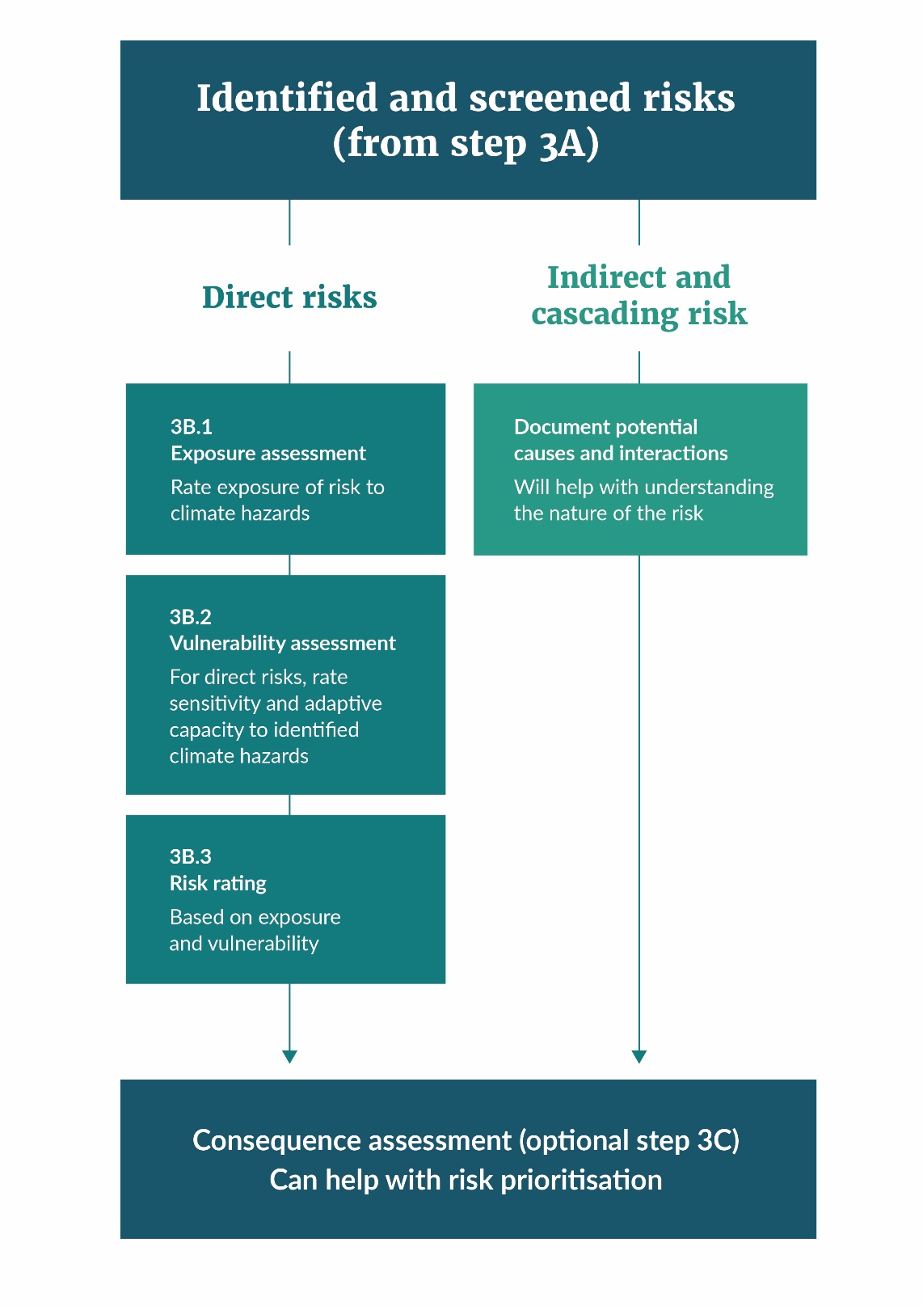
Different levels of inequity (or social vulnerability) will influence the level of risk that communities face. Although imperfect, measures of inequity or social vulnerability can give some insight and help identify where the consequences may be more severe, and where local responses may be necessary.
For each risk, summarise any gaps in the information. This will help reveal any further work needed to improve understanding.

Step 3C: Additional analysis (optional)
Who: Core project team, technical reference group, subject matter experts, iwi/Māori, stakeholders
Outputs: Consequence ratings, opportunities assessment, geospatial analysis
You may choose to do three optional assessments to improve the risk ratings and assist with prioritising risks.
Consequence rating: this relates to a risk’s importance, significance, or value to communities, iwi/Māori, or stakeholders. Often the risks identified through screening are, by virtue of being on the list, more consequential. A comparative assessment of consequence for all risks may be difficult, due to competing value judgements. It may be enough to base the assessment on the exposure and vulnerability rating alone (for direct risks).
Opportunities: collate the credible, positive opportunities for a warmer climate for the relevant theme or sector.
Geospatial analysis: use digital geospatial tools to overlay digital hazard data with data on elements at risk to inform your assessment at a more granular level.

Step 3D: Review of risk-rating workbook
Who: Core project team, technical reference group, subject matter experts
Outputs: Finished risk-rating workbook
All team members should review the draft risk-rating workbook. Different parties can do risk ratings in isolation, so it’s important to review and compare them together as a draft. Review the workbook online, via a workshop, or through conversations with iwi/Māori and stakeholders.
The final workbook should capture and reflect feedback from the review and will inform the risk assessment report.

Step 3E: Risk assessment report
Who: Core project team, technical reference group, governance group
Outputs: Draft and final technical reports, public-facing report
The risk assessment report documents the results of the climate change risk assessment. It will be communicated to a wide audience, including councillors, senior managers, and staff in the organisation, iwi/Māori, partner agencies, local businesses, and the wider community. The report might include technical reports, engagement material, hazard register, spatial maps, or online and print media.

The report should:
- clearly present the risk assessment results and ratings
- document the methods used to identify, analyse, and evaluate these risks
- highlight any limitations and assumptions
- provide evidence to inform an adaptation plan with actions, resources, and timeframes.
A draft report should be prepared for review by the broader project team, technical reference group, and governance group.
The final report should reflect feedback on the draft.
A public-facing report can also be prepared, simplifying, and summarising the information so everyone can easily understand.

Phase 4: Next steps

Step 4A: Risk prioritisation
Who: core project team, technical reference group, governance group
Outputs: Risk prioritisation rating
The risk assessment report presents a set of direct and indirect risks that you have assessed and rated. The next step is to decide which risks to take forward into adaptation planning, and which may need further work. The governance group identifies the priority risks for adaptation planning and response, supported by the project team and technical reference group. There is no specific methodology for prioritisation as different regions and communities have different objectives and context.
Consider:
- primary risk rating (exposure, vulnerability) in relation to timeframe
- consequence of the risk, reflecting local values
- specific location/community inequities or vulnerabilities that may drive a response
- cost of response and funding options
- level of uncertainty remaining, and whether to do more research before agreeing on any action
- whether early action is needed before the risk manifests, to avoid ‘locking in’ a poor outcome.

Step 4B: Adaptation planning
Who: Core project team, technical reference group, governance group
Outputs: Adaptation plan or strategy
The risk assessment provides an evidence base to inform adaptation planning.
An adaptation plan or strategy, with identified actions, resources, and timeframes is a way to respond to the prioritised risks.
The three adaptation steps are:
- Step 3: What can we do about it? ie, identifying and evaluating options.
- Step 4: How can we implement the strategy?
- Step 5: How is it working? ie, monitoring, revisiting risk assessments, regular reviews of adaptation responses, and possible adjustments.
Whatever the approach taken, engagement with stakeholders and iwi/Māori is the key to successful planning and implementation.
Council decisions should reflect the outcomes of the risk assessment. If necessary, the governance group should ensure these outcomes are mainstreamed into adaptation planning.
Disclaimer
The information in this publication is, according to the Ministry for the Environment’s best efforts, accurate at the time of publication. The Ministry will make every reasonable effort to keep it current and accurate. However, we advise users of this publication that:
- the information provided has no official status and so does not alter the laws of New Zealand, other official guidelines or requirements
- it does not constitute legal advice, and users should take specific advice from qualified professionals before taking any action based on information in this publication.
Published in October 2021 by the
Ministry for the Environment – Manatū Mō Te Taiao
Publication number: INFO 1029

