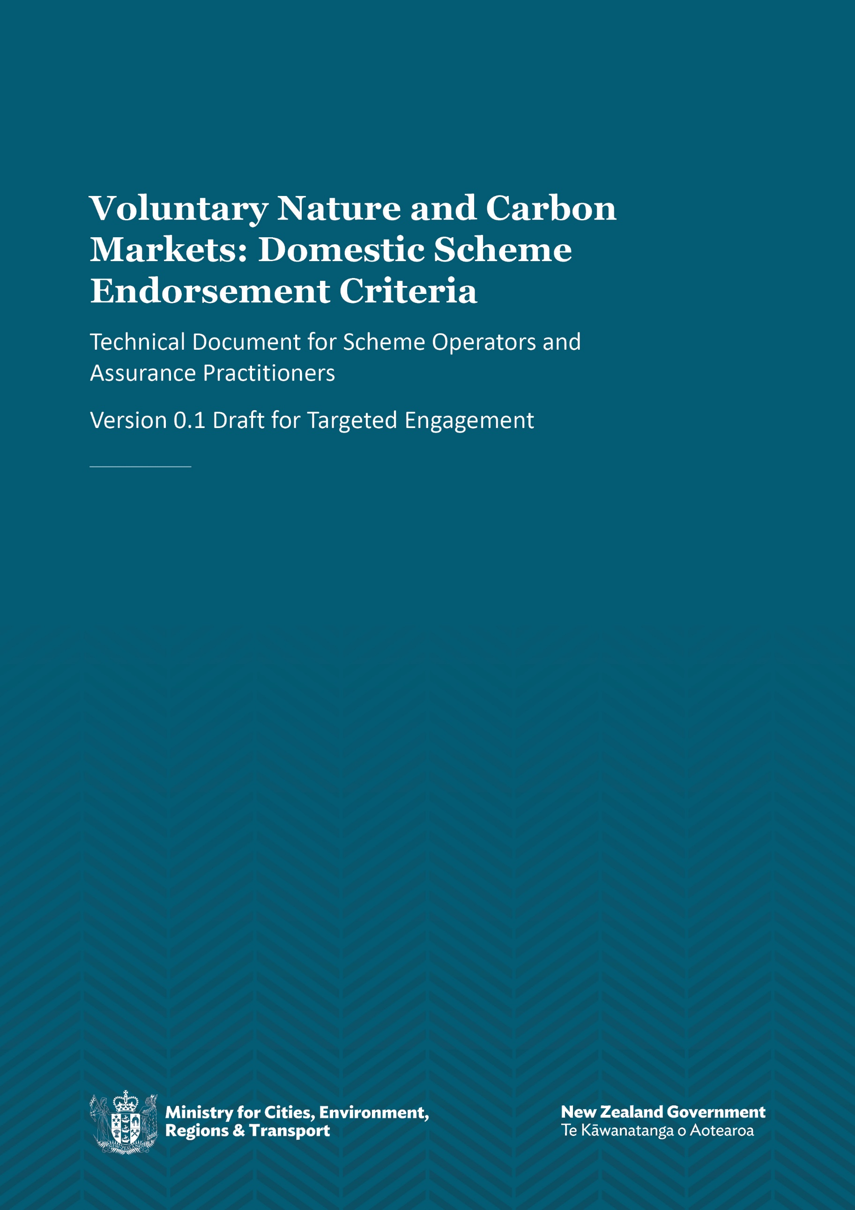

Disclaimer
The information in this publication is, according to the Ministry for Cities, Environment, Regions and Transport’s best efforts, accurate at the time of publication. The Ministry will make every reasonable effort to keep it current and accurate. However, users of this publication are advised that:
- the information does not alter the laws of New Zealand, other official guidelines, or requirements
- it does not constitute legal advice, and users should take specific advice from qualified professionals before taking any action based on information in this publication
- the Ministry does not accept any responsibility or liability whatsoever whether in contract, tort, equity, or otherwise for any action taken as a result of reading, or reliance placed on this publication because of having read any part, or all, of the information in this publication or for any error, or inadequacy, deficiency, flaw in, or omission from the information in this publication
- all references to websites, organisations or people not within the Ministry are for convenience only and should not be taken as endorsement of those websites or information contained in those websites nor of organisations or people referred to.

This document may be cited as: Ministry for Cities, Environment, Regions and Transport. 2026. Voluntary Nature and Carbon Markets: Domestic Scheme Endorsement Criteria – Version 0.1 Draft for Targeted Engagement. Wellington: Ministry for Cities, Environment, Regions and Transport.

Published in July 2026 by the
Ministry for Cities, Environment, Regions and Transport
PO Box 10362, Wellington 6143, New Zealand
mcert.govt.nz
ISBN: 978-1-997358-01-5
Publication number: MCERT 2
© Crown copyright New Zealand 2026

Contents
1. Introduction 5
1.1 Purpose and scope 5
1.2 Context and overview 5
2. Scheme endorsement criteria 8
2.1 Scheme governance 9
2.2 Scheme operations 9
2.3 Project registration 9
2.4 Project development, operation and monitoring 10
2.5 Project outcome assessment 11
2.6 Project data and reporting requirements 11
2.7 Credit issuance 12
2.8 Credit tracking 12
2.9 Transparent public information 13
2.10 Selling credits 13
3. Demonstrating the scheme meets the integrity principles 14
3.1 Additional 14
3.2 Durable and permanent 15
3.3 Real, measurable, and verifiable outcomes and risk mitigation 16
3.4 Transparent 17
3.5 Respectful of rights 18
3.6 Not double-counted and support accurate claims 19
Appendix 1: Scheme endorsement process detail 20
A1.1 Who can seek endorsement? 20
A1.2 Who can provide a scheme assessment for endorsement? 21
A1.3 What is the process for a scheme seeking endorsement? 22
A1.4 What should an assessment report cover? 22
Appendix 2: Project validation and verification providers 24
A2.1 Suitable qualification and experience considerations for validation/verification 25
A2.2 Selection process for validators/verifiers 27
A2.3 Validation/verification report scope 28
A2.4 Prohibited arrangements 28
Glossary 29
References 32

Tables
Table 1: Minimum project data disclosure 17
Table A1.1: The agreement model between MCERT, the assurance practitioner and the scheme 20
Table A1.2: Eligibility criteria for assurance practitioners 21
Table A1.3: Scheme endorsement scoring model 23
Table A2.1: Validation and verification roles 24
Table A2.2: Recognition pathways 25
Table A2.3: Minimum organisation requirements validation/verification 25
Table A2.4: Competence requirements by project type 26
Table A2.5: Recommended standards hierarchy 26
Table A2.6 Lead verifier/lead assurance practitioner requirements 27

Figures
Figure 1: Distinctions and relationships between schemes, methodologies and projects 6
Figure 2: High-level overview of scheme endorsement process 6
Figure 3: How the integrity principles and criteria underpin the scheme endorsement process 7
Figure A1.1: Scheme endorsement process 22

Introduction
Aotearoa New Zealand faces growing pressures from climate change and biodiversity loss. Financing climate change mitigation and nature stewardship is a key challenge. Voluntary nature and carbon markets (voluntary markets) offer a way to channel more private investment into activities that deliver measurable, independently verified environmental benefits.
The Government recently announced its approach to encourage New Zealand’s voluntary markets to grow. The government has a new assurance role to give buyers, landowners and others confidence to invest in voluntary markets by recognising and endorsing high-quality schemes and assessing whether scheme methodologies are scientifically robust.
As a first step, the Government has signalled market integrity by recognising certain international bodies’ accreditation of voluntary schemes and methodologies as a market integrity signal, effective immediately (the international pathway).
As a second step, the Government is developing an endorsement pathway for voluntary schemes developed and operating in New Zealand.

1.1 Purpose and scope
This is a technical document intended for voluntary market participants, particularly voluntary market scheme operators and assurance practitioners.
It sets out the domestic endorsement pathway for voluntary market schemes designed to address New Zealand’s unique environmental challenges and opportunities, to complement the international pathway. We are seeking feedback on:
- scheme endorsement criteria (section 2)
- explanatory material for the integrity principles (section 3)
- suitability of the criteria for assurance practitioners to assess schemes (appendix 1)
- suitability of the criteria for project validation and verification providers (appendix 2)
The Government intends to publish Version 1.0 of this document in 2026 to support the domestic endorsement pathway to go live. This document may be updated from time to time. Any changes will be signalled to the market in advance.

1.2 Context and overview

The government domestic endorsement pathway
The domestic scheme endorsement process is intended to demonstrate which schemes conform to the New Zealand voluntary markets integrity principles (integrity principles). It is separate to the process for assessing the scientific sufficiency of project methodologies (also currently in development), and project validation and verification. Scheme endorsement provides important integrity foundations for each of those processes.
Figure 1 expands on the difference between schemes, methodologies, and projects, illustrating the hierarchy and describing the relationship between them.

Figure 1: Distinctions and relationships between schemes, methodologies and projects
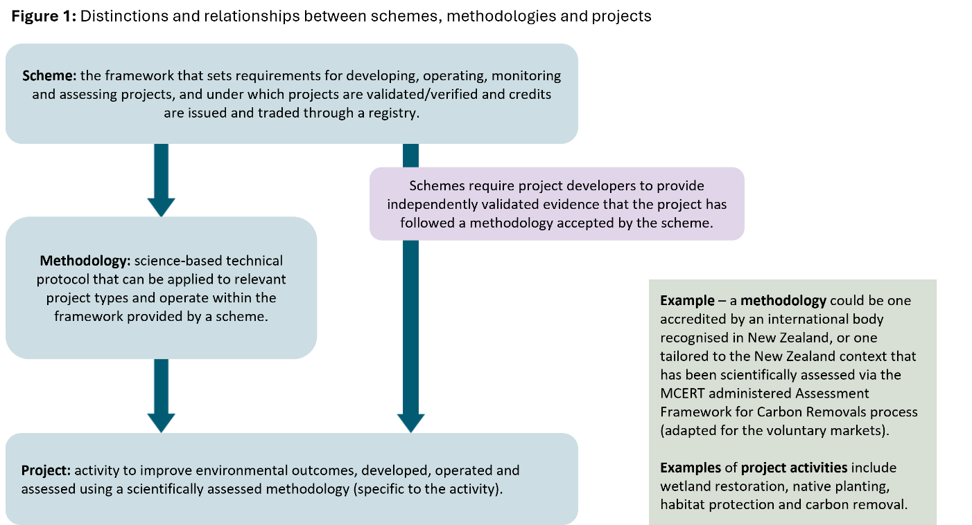
Government endorsement is administered by the Ministry for Cities, Environment, Regions and Transport (MCERT), informed by an assessment undertaken by an MCERT-listed assurance practitioner to demonstrate conformity with the integrity principles and criteria. Key stages in the process are outlined in figure 2.
Figure 2: High-level overview of scheme endorsement process
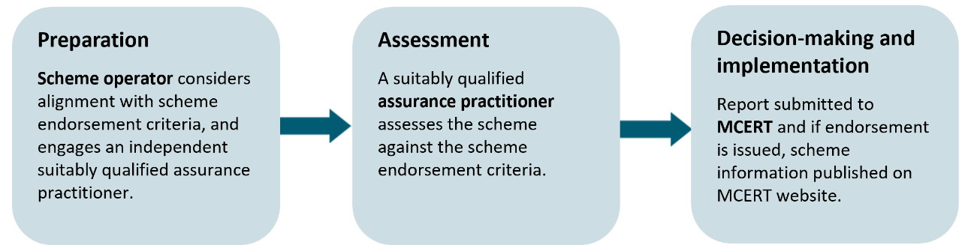
Government endorsement provides an impartial demonstration that a scheme has governance, rules and infrastructure to:
- provide a certification pathway for projects based on scientifically assessed methodologies
- ensure that the creation of nature and/or carbon credits is based on independent verification of project outcomes by a qualified competent body or person
- provide appropriate public information on certified projects and the credits created.
Each of these elements is necessary to create high-integrity nature and/or carbon credits based on positive project outcomes.

New Zealand voluntary markets integrity principles
The integrity principles provide the foundation for government endorsement, ensuring that endorsed projects and the credits issued by them give effect to the principles.
The integrity principles were informed by high-integrity principles developed by international standard-setting, advisory and governance bodies for carbon and biodiversity credit markets and stakeholder engagement. They are outlined in more detail in section 3.
To support market participants to meet the principles and ensure consistent application of the principles, scheme endorsement criteria have been developed to sit underneath and outline in detail what is required to give effect to the integrity principles. The scheme endorsement criteria are outlined in section 2.
Figure 3 illustrates how the integrity principles and scheme endorsement criteria underpin the process for scheme endorsement.
Figure 3: How the integrity principles and criteria underpin the scheme endorsement process
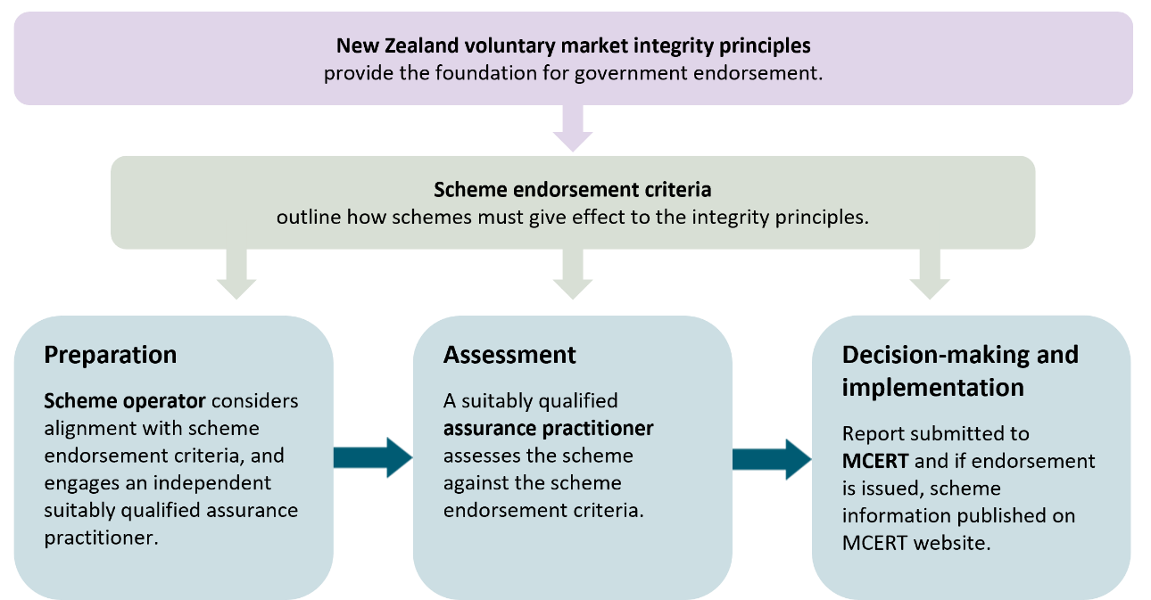

2. Scheme endorsement criteria
This section sets out the criteria used to assess whether a scheme meets the integrity principles.
Questions for feedback:
- Are the criteria sufficiently clear to provide consistent assessments of schemes?
- Do the criteria adequately address risks that could undermine integrity and credibility?
- Do you have any suggestions to improve the criteria?
Disclaimer
Government recognition or endorsement of voluntary market schemes (whether international or operating in New Zealand) is intended solely as a quality signal made at the time of assessment, and does not constitute a Crown guarantee, warranty, or acceptance of responsibility or liability for any aspect of, or participation in a scheme.
Endorsement does not imply that MCERT or the Crown guarantees:
- the performance of a scheme, methodology or project
- that environmental outcomes will be achieved or maintained
- the quality, value or future use of any credit
- financial returns or market performance
- claims made by scheme operators, purchasers of credits or secondary market users of credits.
Assessments undertaken for the purpose of endorsement are conducted by independent assurance practitioners. Endorsement, and any assessment report prepared for endorsement purposes, should not be relied upon as legal, financial, investment or other professional advice.
Market participants remain responsible for undertaking their own due diligence and making their own assessment of quality and credibility. To the extent permitted by law, the Crown accepts no responsibility or liability for any loss, damage or claims arising from reliance on an endorsement, assessment report, or any voluntary market scheme.
The endorsement criteria are the benchmark against which the operations of the scheme are assessed. They give practical effect to the integrity principles and provide a consistent basis for evaluating a scheme.
Conformity with the criteria indicates that a scheme operates with competence, consistency and impartiality, and aligns with international best practice.
Endorsement confirms that a scheme has been assessed as meeting the criteria in this section at the time of assessment.
MCERT may review an endorsement where it becomes aware of information that may affect a scheme’s conformity with the endorsement criteria.
Endorsement may be suspended or withdrawn, subject to appropriate due process, if MCERT determines that a scheme no longer meets the requirement for endorsement, including by operating in a manner that is inconsistent with the integrity principles.

2.1 Scheme governance
Relevant integrity principles: All the integrity principles apply
The organisation operating the scheme must have an effective governance structure (eg, a board, group of people or a person) with overall authority and responsibility for scheme operations that supports overall quality of the credits issued to projects. Requirements for the governance structure include:
- being fully accountable to the shareholders and/or beneficiaries of the organisation operating the scheme
- having appropriate policies and procedures to operate the scheme and manage members’ and/or trustees’ interests
- ensuring implementation of scheme policies and processes
- ensuring impartiality of scheme operations including project assessment
- ensuring adequate resources and competency for project assessment activities
- ensuring that risks to scheme operations are identified and managed
- ensuring transparent decision-making, reporting and dispute-resolution processes
- ensuring that the scheme upholds the integrity principles.

2.2 Scheme operations
Relevant integrity principles: All the integrity principles apply
The scheme must have a suitable management, quality and administrative system with policies, processes and procedures covering:
- financial management to ensure that there are sufficient funds to operate the scheme, including appropriate professional indemnity and public liability insurance
- engagement and contracting with project developers and owners
- development and maintenance of scheme requirements and standards
- recruitment and training of staff to maintain relevant competency
- secure record keeping and information management
- competency requirements and performance monitoring of independent validators and verifiers
- project certification, renewal, suspension and revocation procedures
- handling of complaints and appeals.

2.3 Project registration
Relevant integrity principles: all the integrity principles apply
When registering a project, the scheme must collect information and evidence from the project developer or owner including:
- project name and description
- project location (maps, grid reference, etc.), net area and description
- land ownership and legal rights to carry out project activities
- rights to the anticipated nature and/or carbon outcomes
- project implementation date (when work starts on site) and anticipated end date, if any (eg, 100 years after start date)
- project method or standard to be used for the project and how it has been or will be scientifically assessed
- predicted nature and/or carbon outcomes expected over the project lifetime
- definition of the units that will be used to measure project outcomes
- description of the method that will be used to quantify project outcomes
- expected project validation and verification requirements and standards
- proposed monitoring and reporting requirements for project performance
- how the project methodology is aligned to the integrity principles.

2.4 Project development, operation and monitoring
Relevant integrity principles: additional; durable and permanent; real, measurable, verifiable outcomes and risk mitigation; respectful of rights
The scheme must have strict requirements and rules for the development and operation of projects demonstrated by:
- provision of requirements and procedures for project owners to develop and operate a project
- requiring project development to be based on a project methodology independently assessed as having appropriate scientific rigour
- having requirements in place for developing, approving, reviewing, updating and/or retiring project methodologies
- requiring project design and projected (ex-ante) outcomes to be (independently) validated.
- The nature-based or carbon (ex post) outcomes must be robustly quantified, monitored and reported, demonstrating that the scheme has requirements for project developers to:
- quantify the nature and/or carbon outcomes
- apply appropriate quantification methodologies that are reliable and accurate, based on conservative approaches and sound scientific methods
- define the units for nature and/or carbon outcomes
- monitor and report regularly on project performance and outcomes.

2.5 Project outcome assessment
Relevant integrity principles: all the integrity principles apply
The scheme must have robust requirements (standards) for independent verification of the project outcomes that relate to the project methodology and application of the integrity principles. The scheme must demonstrate:
- project design was based on a scientifically assessed project methodology
- project design and projected outcomes are independently and adequately validated during the ‘Project development, operation and monitoring’ step.
- actual project outcomes have been independently verified by a suitably qualified verification provider
- project design, development and operation of the project and measurement and reporting project outcomes have appropriately applied the integrity principles.
Suitable verification standards include ISO 14064-3, ISAE 3410 and ISAE 5000.
The scheme must as part of its project assessment standard specify the expected qualifications and competency for project validation and verification provision, being either:
- an accredited validation and verification body (VVB) (eg, ISO 14065), or
- an organisation or person that holds appropriate technical qualifications and relevant experience (see appendix 2).

2.6 Project data and reporting requirements
Relevant integrity principles: real, measurable, verifiable outcomes and risk mitigation; transparent; not double-counted and supports accurate claims
The scheme must have effective rules for compiling and reporting project information and project outcomes, demonstrated by:
- publication of project documentation (eg, via a registry) including, as a minimum, project design, details of project location and area (subject to any privacy and data protection restrictions), and progress monitoring reports
- disclosing the boundary for the project activity (physical, administrative, geographic, jurisdictional) and demonstrating that it is conservative and robust, accounting for all significant aspects of the project
- disclosing the methodology used to calculate project outcomes
- assessing all sources of uncertainty in the project outcomes associated with both project baseline and eligible project activities, and identifying the methods used to assess uncertainty (based on reputable peer-reviewed sources or considered to be rigorous by validators and verifiers)
- procedures for determining buffers (based on levels of uncertainty at levels deemed acceptable by validators and verifiers)
- measures, as relevant, to manage leakage including:
- procedures for assessing the likelihood of project activities leading to an increase in emissions elsewhere (leakage) including measures for identifying and mitigating leakage and accounting for any unavoidable leakage
- processes for monitoring and mitigating leakage for the duration of the crediting and permanence periods
- estimation of leakage is robust and conservative, and considers assumptions, models, parameters, data sources and measurement methods

2.7 Credit issuance
Relevant integrity principles: not double counted and supports accurate claims
The scheme must have robust processes for issuing and tracking the credits it issues, demonstrated through:
- credits are issued only after independent validation of projected outcomes (ex-ante credits) or independent verification of ‘actual’ project outcomes (ex-post) and listing the credits on the scheme registry
- specific rules and limitations for the issue and use of ex-ante credits, eg, ‘the use and/or retirement of ex-ante credits is prohibited’
- carbon credits based on quantified and verified carbon removals are equivalent to one metric tonne of carbon dioxide equivalent
- nature credits based on quantified and verified nature outcomes are reported using the units specified by the project methodology
- specification of the crediting period and criteria for renewal of crediting periods including reassessment of baselines and whether eligibility criteria (eg, integrity criteria) for the issuance of carbon credits can still be met
- evidence that the seller of the nature and/or carbon credits has the legal ownership rights to the project outcomes.

2.8 Credit tracking
Relevant integrity principles: transparency, not double counted and supports accurate claims
The scheme must operate a public registry (or provide an equivalent facility) or use a third-party registry to uniquely identify, record and track project activities and credits issued to ensure that credits can be identified securely and unambiguously by requiring:
- project documentation (subject to privacy/data protection restrictions), credits, assignments and retirements to be publicly listed on the (scheme) registry
- identification of the entity on whose behalf the credit was retired
- identification of the purpose of the credit retirement
- procedures to address erroneous issuance of credits including remedial identification of measures and the entities responsible for implementing these
- the length and number of crediting periods to be proportionate to the type of project activity and confidence in measurement technique, reliance on modelled outcomes and risk mitigations such as buffers.

2.9 Transparent public information
Relevant integrity principles: transparent
The scheme must provide comprehensive and transparent publicly available information on all credited project outcomes including:
- project design document
- validation and verification reports
- monitoring reports
- credit-tracking information.

2.10 Selling credits
Relevant integrity principles: transparent, not double counted and supports accurate claims
Sellers must be responsible for the integrity of credits sold and for demonstrating that integrity to buyers. Marketing of credits, including any claims about the origin and quality of the credits, should comply with the Government’s Guidance for Voluntary Climate Change Mitigation.

3. Demonstrating the scheme meets the integrity principles
This section outlines the Government’s agreed integrity principles (refer to the box at the start of each sub-section), with additional explanation of how a scheme can demonstrate conformity with the integrity principles. We are seeking your feedback on the additional explanations.
Questions for feedback:
- Are the additional explanations clear?
- Do you have any suggestions to improve the interpretation and practical application of the integrity principles?
The integrity principles apply to scheme operators and all the scheme activities leading to the creation of nature and/or carbon credits. They enable participants in the voluntary markets to have confidence in the quality and integrity of the projects and project outcomes.
A scheme can achieve government endorsement only if it has clear guidance, tools and procedures to ensure that projects registered under the scheme can provide evidence that they are operating in conformance with the integrity principles.
The integrity principles are outlined below, including examples of how a scheme can demonstrate its application of the principles.

3.1 Additional
Integrity principle: Additional
Credits (including other comparable instruments such as insetting) deliver positive environmental outcomes that are due to a specific activity and would not have occurred in the absence of the credit. For example, the activity is not required by regulation, or other policy measures.
In some circumstances credits could apply to maintenance activity.
Schemes should have procedures in place that demonstrate that the project activity is not an activity required by regulation or an activity that represents business-as-usual management.
For example, in a biodiversity context ‘Additional’ should not be considered as limited to restoring or extending ecosystems, but also the active maintenance, protection and enhancement of existing natural ecosystem conditions (eg, pest control and weed management of an existing ecosystem, where that activity will prevent biodiversity loss).

3.2 Durable and permanent
Integrity principle: Durable and permanent
Activities recognised through credits contribute to long-lasting or permanent outcomes. Voluntary activity demonstrates permanence and states how a project will be managed if, for unforeseen circumstances, the voluntary activity is reversed. This will differ depending on the activity being claimed.
Schemes should have project requirements that demonstrate that credits created by the scheme will represent long-lasting or permanent project outcomes.
The following provisions for managing permanence could be considered:
- what aspects of the project or methodology make permanence more or less likely (ie, whether permanence is technically feasible)
- what legal instruments or other mechanism may be required to maintain the project and ensure durability eg, QEII covenants, Ngā Whenua Rāhui kawenata for Māori land
- what monitoring will be undertaken over time to ensure permanence obligations are met
- what processes are in place to return to compliance where permanence obligations are not met
- what contingencies are in place to rectify project failure or reversal arising from technical issues (ie, well-understood strategies and methods such as buffer credit pools, insurance)
- what management strategies are proposed to address risks that are variable or difficult to predict
- who will incur the liability to rectify the project in the event of failure or reversal (eg, extreme weather events).

3.3 Real, measurable, and verifiable outcomes and risk mitigation
Integrity principle: Real, measurable, and verifiable outcomes and risk mitigation
Credits, and the projects they represent, deliver the tangible outcomes described and have interventions and outcomes that are appropriate for the project area.
Credits are supported by evidence from credible and robust monitoring and reporting, and should be verified by a suitably qualified independent third-party to a reputable and publicly disclosed standard. Requirements for evidential rigour in monitoring, reporting and verification are balanced with considerations of practicality, cost-effectiveness and proportionality.
The risk of any negative impacts, unintended consequences and spillover effects (including leakage) is managed.
The scheme should demonstrate that it requires projects to deliver tangible project outcomes as described in the project methodology and project design, and the outcomes of project interventions are appropriate for the project area.
The scheme should demonstrate that it has appropriate standards in place to provide:
- project monitoring and reporting at appropriate time intervals
- evidence that the project has been assessed as being appropriate for the project area
- evidence that the project design has been validated
- evidence that project outcomes have been verified
- evidence that validation and verification were undertaken by suitably qualified independent parties
- details of the publicly available validation and verification standards used
- explanation of how risk of any negative impacts, unintended consequences and spillover effects (including leakage) are identified and managed.
Leakage
Leakage may arise from:
- activity shifting where project actions in one area cause negative outcomes elsewhere
- market effects arising when changes in supply and demand from a project lead to higher negative outcomes in other regions
- input/output leakage occurring when resource use in a project indirectly causes negative outcomes elsewhere
- investment leakage when capital is diverted from technologies create more positive outcomes
- ecological leakage, unintended environmental consequences, such as spread of pests or increased pressure on neighbouring ecosystems due to conservation work in the project.
Where leakage occurs and cannot be mitigated, it is assessed and compensated eg, through deduction of verified credits already issued.

3.4 Transparent
Integrity principle: Transparent
There is transparency over how all integrity principles are being met.
All stakeholders including credit buyers, project developers, iwi, communities and third-party verifiers can see and understand how credits are created, verified, traded and retired, and what claims are being made.
While meeting this principle, standards will ensure that the public disclosure of information includes safeguards around sensitive information (including, but not limited to, locations of threatened species or culturally sensitive information).
All stakeholders including credit buyers, project developers, relevant Māori groups, communities and third-party verifiers can see and understand how credits are created, verified, traded and retired, and what claims are being made.
While meeting this principle, the scheme requirements will ensure that the public disclosure of information includes safeguards around sensitive information (including, but not limited to, locations of threatened species or culturally sensitive information).
To demonstrate conformity with the principle, the scheme should make the following information about projects and their outcomes publicly available and accessible including:
Table 1: Minimum project data disclosure
Core project-level data category | What is included
Project identification | Project name and project ID.
Project type / activity classification | Project category (eg, nature-based activity, biodiversity, carbon reduction/removal).  Project method and how it was scientifically assessed.  Explanation for any sensitive information that is not publicly reported.
Project crediting and issuance | Information about the credits issued, in relevant units of measurement:  - tonnes of carbon dioxide equivalent  - extent / land area (eg, hectarage).  Additional biodiversity metrics could include condition and contribution to species and ecosystem representation and services.  Issuance:  - date / vintage  - volume.  Operational status – volumes active, retired.  How project outcomes are converted into a quantity of credits.
Project validation and verification, and reporting | Confirmation projects are subject to third-party validation and verification.  Validation and verification identities.  Project monitoring, validation and verification reports.
Project location | Country, sometimes region-level data publicly disclosed.  As a condition of endorsement, GIS-location specific data is required to be provided to government for monitoring (held in confidence).
Risk proxies (where applicable) | Buffer pool contributions, reversals covered/not covered (for some standards).
The scheme should demonstrate that it requires projects to document project outcomes, at appropriate time intervals, using appropriate data protocols.
Data protocols
Schemes encourage projects to use nationally recognised standards for ecosystem classification, extent and condition (eg, National Ecosystem Typology Taskforce for Nature Related Disclosures, and relevant condition indices), and apply authoritative taxonomic references (eg, New Zealand Organisms Register) for species identification.
Schemes encourage projects to publish species occurrence records through recognised biodiversity data platforms, such as the Global Biodiversity Information Facility, for species records where appropriate.

3.5 Respectful of rights
Integrity principle: Respectful of rights
Safeguards are in place to ensure the rights and interests of all people (including Māori and local communities) are respected and upheld, in alignment with recognised international practice
Scheme safeguards should include requirements for projects to demonstrate that:
- appropriate engagement has taken place with relevant Māori groups and local communities, prior to project registration, and engagement will continue throughout the project, commensurate to project implications for rights and interests
- informed consent of relevant Māori groups has been obtained for any aspects of the project which affect those groups’ rights and interests (eg, rights in relation to their whenua, under the Marine and Coastal Area (Takutai Moana) Act 2011, under a Treaty settlement and customary fishing rights), and will be honoured throughout the project
- All reasonable steps have been taken to identify sites of significance to Māori or other cultural heritage sites located within the project site, and the project will ensure that there are no adverse effects on the sites themselves, access to those sites, or cultural activities undertaken at those sites, or those effects will be minimised and addressed
- the project will appropriately treat and recognise third-party intellectual property rights (including the rights of Māori groups to their mātauranga) and ensure that Māori groups have access to any data collected in areas which those groups exercise rights and interests
- they comply with all relevant labour laws
- they have clear and transparent process to address any grievances in relation to the project that Māori groups or local communities raise over the life of the project.

3.6 Not double-counted and support accurate claims
Integrity principle: Not double-counted and support accurate claims
Organisations using credits to make claims should:
a. use accurate wording when stating the environmental outcomes of their credit
b. ensure the positive environmental outcomes represented by a credit are only used once for a claim.
Projects should avoid double issuance and double use of credits and, in cases where multiple credits are generated from the same project, they will have clear demarcation.
Schemes should have measures in place to prevent double claiming, double issuance and/or double use of credits and use accurate wording when stating project environmental outcomes.
Where different credit types or outcomes are generated from the same project, this should be clear, for example:
- separate (eg, carbon and biodiversity) stacked credits should have clear demarcation
- bundled credits, which include specific co-benefits (eg, carbon combined with biodiversity) should convey claims about project outcomes proportionate to evidence.
A scheme that issues ex-ante credits, that are sold ahead of the benefits being materialised, should demonstrate that they have appropriate standards in place to mitigate risk, such as:
- using a conservative method to calculate gains (future likely credits)
- prohibiting retirement of ex-ante credits, until promised gains are realised and verified
- provision for adjustment to match realised outcomes.
Further guidance on disclosure of carbon and nature-related risks and dependencies includes:
- Guidance for Voluntary Climate Change Mitigation
- Taskforce on Nature-related Financial Disclosures and IFRS S1 General Requirements for Disclosure of Sustainability-related Financial Information.

Appendix 1: Scheme endorsement process detail
This section outlines the qualifications and experience that are needed to independently assess a scheme against the integrity principles, which MCERT could rely on to endorse a scheme, along with the assessment and endorsement process.
Questions for feedback:
- Are the eligibility criteria for assurance practitioners and assessment bodies appropriate to provide reliable assessments of schemes?
- Do you have any suggestions to improve the criteria or process?
The scheme endorsement process is designed to ensure that the assessment of a scheme’s conformity with endorsement criteria will deliver a consistent level of scheme quality for projects, project outcomes and credit issuance. The integrity principles apply to schemes and by extension, project outcomes and their representation via scheme credits and claims.
The process involves three key parties, which undertake specific roles in the process, as outlined in the following table.
Table A1.1: The agreement model between MCERT, the assurance practitioner and the scheme
Party | Role | Controls
MCERT | Sets criteria, lists assurance practitioners that can be used, receives assessment report from applicant scheme, makes endorsement decision. | Controls scope, conflict requirements, decision record and publication.
Independent assessment/assurance organisation | Performs conformity assessment of an applicant scheme against the endorsement criteria and prepares report with recommendation. | Must be impartial, competent, evidence-based and free from unmanaged conflicts. Must nominate competent lead individual.
Applicant scheme | Engages assurance practitioner, provides documents as required, responds to information requests from the assessor. | May correct factual errors but cannot control findings, report conclusions or recommendation.

A1.1 Who can seek endorsement?
Operators of schemes that issue nature credits or carbon credits intended for trading on the voluntary markets can apply for MCERT endorsement.
Organisations that develop a specific scheme to implement nature or carbon interventions within its supply chain may seek endorsement to support investment decisions and insetting-related claims. Where credits are created as a result of supply chain interventions or insetting, the scheme must demonstrate that no double counting has taken place.

A1.2 Who can provide a scheme assessment for endorsement?
Assessment is undertaken by an assurance practitioner or other suitably qualified and experienced assessment body listed by MCERT.
Scheme assessors may be ISO conformity-assessment bodies (eg, ISO/IEC 17029 accredited, using ISO 14065) or suitably qualified assurance providers (using ISAE 3000 and ISAE 3410) including companies/audit firms able to undertake sustainability assurance (using ISAE 5000).
All endorsement assessment organisations must demonstrate that they either hold internally, or have arrangements with partner organisations to ensure they have, an appropriate level of understanding of Māori rights and interests.
MCERT may establish a process for identifying and assessing suitably qualified assurance practitioners and assessment bodies for inclusion on the scheme assessor list. This may include periodic calls for applications as well as consideration of applications received outside those periods. Inclusion on the list is at MCERT’s discretion and will be subject to applicants meeting the eligibility requirements for assessors.
Eligibility criteria for scheme assurance practitioners are outlined below.
Table A1.2: Eligibility criteria for assurance practitioners
Criterion | Minimum expectation
Independence and impartiality | Documented conflict of interest policy; no material conflict with likely applicant schemes.
Conformity/assurance capability | Experience in audit, assurance, certification, compliance review, technical due diligence or comparable assessment. ISAE 5000 capability may be accepted where relevant.  Evidence of repeatable assessment method.
Environmental market expertise | Must cover domains relevant to the scheme or show access to experts - carbon markets, nature markets, registries, claims, project methodologies, validation/verification.
Governance and systems assessment | Capability to assess governance, data systems, records, registry controls, credit calculation and complaints processes.
Lead assurance practitioner capability | Named lead individual with assessment/assurance experience and suitable competence for the scheme type.
New Zealand context | Knowledge of New Zealand environmental policy, Māori rights/interests, land systems and voluntary market settings.
Quality management | Document control, reviewer independence, complaints handling, confidential information controls.
Capacity and timeliness | Named team, delivery timetable, escalation process.
Professional risk controls | Appropriate liability arrangements, professional indemnity or equivalent protections.

A1.3 What is the process for a scheme seeking endorsement?
At a basic level, the process is as follows:
- Scheme operators may consider undertaking a readiness self-assessment using information on the MCERT website.
- An applicant scheme may then engage an assurance practitioner from MCERT’s list to undertake an independent conformity assessment against the endorsement criteria.
- The scheme assurance practitioner reports the results of the assessment to the scheme operator.
- The scheme operator decides whether to provide that assessment to MCERT as part of its application for government endorsement.
- MCERT decides whether the scheme meets the scheme endorsement criteria. The scheme application and assessment are kept confidential. Once endorsement has been confirmed, certain scheme information is publicly listed on the MCERT website.
Figure A1.1 illustrates the scheme endorsement process.
Figure A1.1: Scheme endorsement process
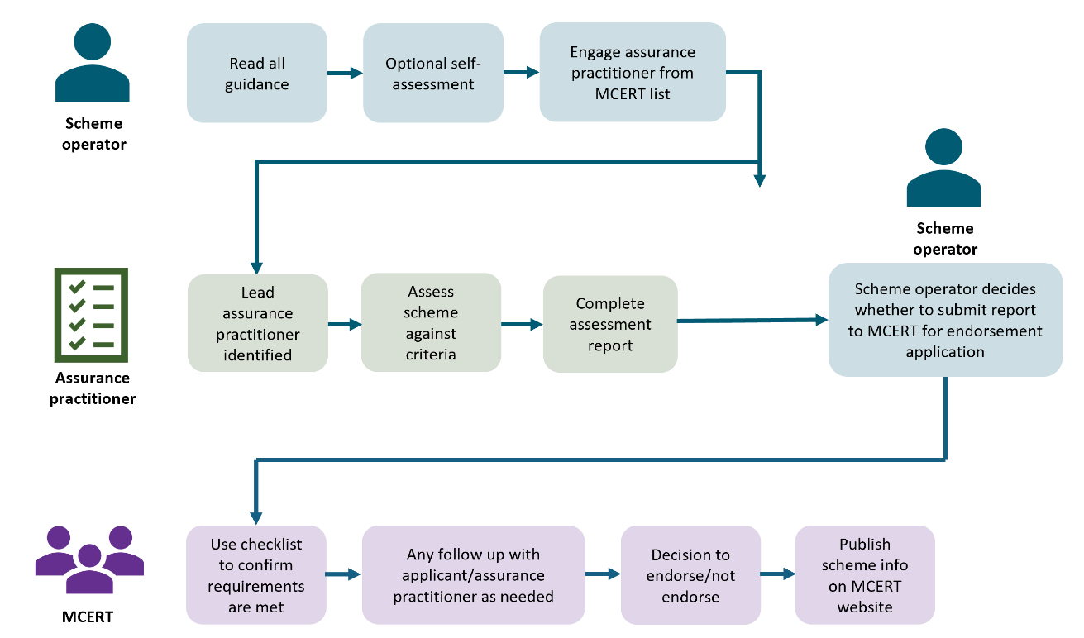

A1.4 What should an assessment report cover?
The assessors report should cover the following:
- recommendation
- scope and limitations of assessment
- standards or frameworks applied, including ISO/IEC 17029, ISAE 5000 or equivalent where relevant
- documents and evidence reviewed
- applicant and scheme overview
- fit and proper person findings
- governance and conflict management
- methodology approval status
- project registration and operating controls
- data, quantification and credit calculation controls
- validation and verification requirements
- registry and credit tracking
- claims and anti-greenwashing controls
- treatment of pending credits, stacking and reversals
- lead assurance practitioner competence and independence statement
- risk assessment and conditions
- scoring table
- assurance practitioner declaration of independence.
Table A1.3: Scheme endorsement scoring model
Gate/criterion | Assessment approach
Mandatory | Pass/conditional pass/fail. Failure should result in rejection or return for revision.
Core quality criteria | 0–5 score: 0 not demonstrated, 3 adequate, 5 leading practice.
Risk classification | Low/medium/high; determines post-endorsement reporting and oversight intensity.
Decision outcomes | Endorse; endorse with conditions; defer; revise and resubmit; not endorse.

Appendix 2: Project validation and verification providers
The intention of this section is to set out how schemes should select organisations or practitioners to validate project design and verify project outcomes.
Questions for feedback:
- Is it appropriate and credible for project validation and verification to be undertaken by either an accredited VVB, or other suitably qualified and experienced assurance practitioners, in the New Zealand context?
- Do you have any suggestions to improve project validation and verification provision?
Schemes should:
- require validation of project design before project activity is credited
- require verification of delivered outcomes before verified credits can be issued or retired
- allow ex-ante credits only if clearly distinguished from verified ex-post credits. Ex-ante credits should not be capable of retirement or final outcome claims before verification
- require every project validation or verification engagement to have a named lead verifier or lead assurance practitioner.
The table below outlines key functional definitions and their timing in a project’s process.
Table A2.1: Validation and verification roles
Function | Purpose | Timing
Validation | Assesses whether project design, baseline, methodology application, monitoring plan and projected outcomes are plausible and conform to the approved method. Under ISAE 5000-style assurance, this may include assurance over assumptions, processes or forward-looking sustainability information where appropriate. | Before project registration or before crediting period commences.
Verification | Assesses whether reported outcomes actually occurred and are truthfully stated, quantified and supported by evidence. | Before issue or conversion of verified credits, and at monitoring intervals.
Assurance/conformity review | Broader confidence process that may apply to scheme systems or project claims but should not be described as a guarantee. ISAE 5000 may be used where sustainability or greenhouse gas information is subject to an assurance engagement. | As specified by scheme, method or MCERT.

A2.1 Suitable qualification and experience considerations for validation/verification
To balance rigour and flexibility, validation and verification may be undertaken by:
- accredited VVB (eg, ISO 14065) or
- organisations and people qualified to use ISAE 5000 as an assurance pathway (eg, auditors and assurance firms, subject to satisfactory technical qualifications and experience).
The table below outlines who can provide validation/verification in particular circumstances.
Table A2.2: Recognition pathways
Pathway | When suitable | Evidence required
Accredited VVB | Carbon/GHG projects where relevant accreditation exists. | Accreditation scope, personnel competence, conflict of interest declaration.
ISAE 5000 assurance provider | Where sustainability, nature or GHG information is subject to assurance by a auditor or assurance practitioner. | Assurance credentials, assurance methodology, ethics/independence systems, technical specialist capability, named lead practitioner.
Accredited assurance body with specialist team | Complex cross-domain projects needing assurance systems plus technical experts. | Accreditation/assurance credentials, technical CVs, method-specific capability.
Qualified specialist organisation | Nature/biodiversity projects where accreditation pathway is immature. | Ecological credentials, verification experience, quality procedures, independent review.
Multidisciplinary consortium | Integrated nature-based carbon projects. | Lead accountable entity, team roles, conflicts, QA process, lead practitioner.
Case-by-case approval | Emerging methods, remote locations, specialist knowledge gaps. | Scheme assessment against minimum competence and independence criteria.
The table below outlines organisational requirements for validation/verification providers.
Table A2.3: Minimum organisation requirements validation/verification
Requirement | Minimum expectation
Legal, accountable entity | Validator/verifier is a legal entity or clearly accountable professional practice.
Impartiality | No unmanaged conflict with scheme, project owner, project developer, credit buyer or methodology proponent.
Competence | Named competent personnel for the project type, method, data and local context.
Lead practitioner | Each engagement has a named lead verifier/lead assurance practitioner responsible for engagement quality, evidence sufficiency and final conclusion.
Quality system | Documented procedures for engagement acceptance, planning, evidence review, sampling, reporting, review and complaints.
Assurance system where applicable | For ISAE 5000 engagements, must demonstrate appropriate assurance methodology, ethics, independence and engagement quality management.
Confidentiality | Systems to protect commercially, culturally and ecologically sensitive data.
Professional risk controls | Professional indemnity or equivalent risk controls appropriate to the assignment.
Record retention | Records retained for the crediting and review period required by the scheme.
Independent review | Internal technical review or engagement quality review before issuing validation, verification or assurance statements.
The following table complements the above requirements, outlining specific expertise required to provide validation and verification for different methodology/project types.
Table A2.4: Competence requirements by project type
Competence area | Nature credits | Nature-based carbon credits | Carbon removal / industrial credits
Method and eligibility | Ecological method and site eligibility | Ecological plus GHG method | GHG/engineering method
Quantification | Biodiversity/ecosystem metrics, sampling, condition scoring | Carbon plus ecological indicators | CO₂e, energy/process data, removals
Baseline/additionality | Ecological counterfactual/common practice | Ecological and GHG baseline | GHG baseline/project scenario
Monitoring design | Sampling, remote sensing, field ecology, data quality | Field ecology plus carbon monitoring | Metering, sampling, modelling, data systems
Leakage/spillover | Ecological displacement and pressure shifting | Ecological and emissions leakage | GHG leakage/activity shifting
Durability/permanence | Management durability, land tenure, threats | Reversal and ecological durability | Reversal risk and operational control
Rights and safeguards | Māori/community/land rights and sensitive ecological data | Same plus carbon attribute rights | Project rights and impacts where relevant
Assurance competence | Assurance over sustainability information where claims or reporting subject to assurance | ISAE 5000 competence plus GHG competence | ISAE 5000 competence plus GHG/engineering competence
The following table outlines specific reference standards for validation and verification for different methodology/project types.
Table A2.5: Recommended standards hierarchy
Use case | Relevant references
GHG project quantification | ISO 14064-2:2019; approved project methodology; programme rules.
GHG validation and verification | ISO 14064-3:2019; ISO 14065:2020; ISO/IEC 17029:2019.
Sustainability assurance including GHG information | ISAE 5000, especially where assurance is provided by company auditors or assurance practitioners over sustainability or GHG information.
Nature/biodiversity validation and verification | MCERT assessed nature credit methodology; ISO 17298:2025 as supporting organisational biodiversity guidance where relevant.
General conformity assessment body competence | ISO/IEC 17029:2019 principles: competence, consistent operation and impartiality.
Assurance engagements | ISAE 5000 should be treated as the current primary sustainability assurance reference, rather than relying on ISAE 3000/ISAE 3410 as standalone references.

A2.2 Selection process for validators/verifiers
Scheme operators should maintain a published procedure for selecting validators/verifiers, which could comprise the following elements:
- Project owner or scheme proposes validator/verifier from a scheme approved list or by case-by-case application.
- Validator/verifier submits competence statement, conflict declaration and proposed validation/verification/assurance plan.
- Validator/verifier organisation nominates a named lead verifier or lead assurance practitioner for the engagement.
- Scheme reviews organisation competence, lead practitioner competence and project-type suitability. Scheme records acceptance decision and conditions.
- Validator/verifier performs engagement in accordance with approved methodology and relevant standards.
- Validation/verification/assurance report and statement are submitted to the scheme.
- Scheme monitors validator/verifier performance and may suspend acceptance for poor performance, conflict breach, or material errors.
Table A2.6 Lead verifier/lead assurance practitioner requirements
Requirement | Minimum expectation
Named individual | A single named individual leads each engagement and is responsible for engagement direction, review and conclusion.
Professional standing | Relevant professional membership, accreditation, assurance role, audit role, technical professional standing or equivalent demonstrated competence.
Assurance/audit competence | Experience in audit, assurance, validation, verification, evidence evaluation, sampling, materiality and reporting.
Technical competence | Competence relevant to the project type, or demonstrable access to and supervision of specialists with relevant competence.
GHG competence where relevant | For carbon or nature-based carbon projects, competence in GHG accounting, baselines, removals, uncertainty and leakage.
Nature competence where relevant | For nature credits, competence in ecology, biodiversity measurement, ecosystem condition, restoration monitoring or equivalent specialist support.
New Zealand context | Understanding of New Zealand land systems, Māori rights and interests, community safeguards and sensitive data obligations, or access to appropriately qualified New Zealand-context expertise.
Independence | No unmanaged conflict with project owner, scheme operator, developer, buyer or methodology proponent.
Accountability | Lead individual signs, approves or is identified in the final report and may be subject to MCERT review.

A2.3 Validation/verification report scope
A validation/verification should outline the following:
- engagement scope and criteria
- project description and method used
- independence and competence declaration
- lead verifier / lead assurance practitioner identity, role and competence statement
- validation/verification/assurance plan
- evidence reviewed, including site visits, remote assessment performed, data and sampling
- baseline and additionality assessment
- quantification and uncertainty assessment
- leakage and reversal risk assessment
- safeguards and rights checks
- findings and non-conformities
- corrections and residual limitations
- validation, verification or assurance conclusion, including credit issuance recommendation
- restriction on use of the statement.

A2.4 Prohibited arrangements
The following practices would not be considered appropriate as constituting independent and transparent processes:
- scheme operator verifying their own project outcomes
- project developer validating their own project design
- credit buyer controlling the verifier’s conclusion
- validator/verifier providing material design advice and then verifying the same design without safeguards
- use of pending credits as verified credits before outcomes are delivered and verified.

Glossary
Term | Definition
Assurance | The confidence that MCERT and voluntary market participants may derive from a competent, independent and evidence-based conformity assessment or assurance engagement. Should not be used to imply that MCERT or the assurance practitioner guarantees credits, projects, claims or voluntary market outcomes.
Biodiversity credit | See Nature credit.
Buffer | In carbon and biodiversity markets, a buffer is a mandatory insurance pool of unsold credits set aside by a registry to cover unforeseen losses in a project's environmental benefits. These pooled credits act as a shared safety net, ensuring that if a project suffers a reversal – such as trees burning down in a wildfire or a restored habitat degrading.
Carbon credit | A verified and tradeable unit representing one tonne of carbon dioxide equivalent reduced or removed from the atmosphere, issued under a recognised carbon standard or registry (source: MfE, 2026).
Carbon removal | Also known as ‘emissions removal’ – the process of removing CO₂ from the atmosphere and locking it away for decades, centuries or millennia (source: MfE, Assessment Framework for Carbon Removals, 2025).
Conformity assessment | An independent assessment of whether a scheme’s governance, operating rules, project controls, registry arrangements, validation and verification requirements, and claims controls conform to MCERT scheme endorsement criteria. It does not imply a legal guarantee.
Credit bundling | Refers to when more than one ecosystem service produced on a piece of land is sold as a single credit to a single buyer. A bundle may represent multiple overlapping co-benefits within a supply area, and the level of quantification of each discrete function/service can vary (source: IEMA, 2023).
Crediting period | The period in which verified GHG emission reductions or removals attributable to a mitigation activity can result in the issuance of carbon credits (source: ICVCM, 2024).
Credit stacking | Refers to when different benefits on a piece of land are sold as separate credits. Each credit type is independent from the other credit types and separate payments can be received for each. An example would be a carbon credit and a water credit sold separately from the same piece of land (source: IEMA, 2023).
Credit tracking | Credit tracking in carbon and biodiversity markets is the formal, digitised process of monitoring the entire lifecycle of an environmental unit – from its initial issuance to its final retirement – using a central electronic registry. This administrative process relies on assigning a unique serial number to every single credit. This permanent tracking ensures transparency, verifies ownership, and structurally prevents the identical environmental benefit from being sold or claimed more than once (source: Conservation International, no date).
Endorsement | A decision by MCERT that a scheme meets the scheme endorsement criteria, subject to stated scope, conditions and ongoing monitoring. A quality signal, not a Crown guarantee.
Ex-ante | In carbon and biodiversity markets, ex ante (a Latin term meaning ‘before the event’) refers to environmental units that are estimated, issued, or traded before the actual carbon removal or ecological restoration has physically taken place (source: adapted from ICVCM, 2024).
Ex-post | In carbon and biodiversity markets, ex post (a Latin term meaning ‘after the event’) refers to environmental units that are issued, traded, or retired only after the carbon removal or ecological restoration has physically occurred and been independently verified (source: adapted from ICVCM, 2024).
Insetting | Climate change mitigation activities undertaken within your own supply chain (ie, across your operations, suppliers, sourcing regions or downstream activities) to reduce greenhouse gas emissions or enhance removals. Unlike offsetting, which typically involves purchasing credits from projects outside your supply chain, insetting focuses on directly addressing emissions where they arise, particularly scope 3 emissions (source: MfE, 2026).
Integrity principles | Core criteria used by governments and international governance bodies to evaluate and endorse environmental credit schemes; these principles serve as the minimum standard required to prevent greenwashing and protect buyers from purchasing low-quality credits.
Lead assurance practitioner | The named individual responsible for leading the scheme assessment engagement and signing or approving the assessment report within the assessment organisation. The lead individual must be competent, independent and acceptable under MCERT requirements.
Leakage | An increase in greenhouse gas emissions outside the boundary of an activity that occurs as a result of that activity, reducing or negating its climate benefit (source: MfE, 2026).
Nature-based carbon credit | A tradeable certificate representing the reduction or removal of one metric tonne of carbon dioxide equivalent from the atmosphere through the preservation, restoration, or sustainable management of natural ecosystems.
Nature credit | Nature credits are units that represent measurable, verifiable improvements in biodiversity or ecosystem health. They aim to reward ‘nature-positive’ actions through efforts that go beyond legal obligations to enhance biodiversity, restore ecosystems, or strengthen natural water cycles (source: EU Biodiversity Strategy for 2030, 2026).
Permanence period | The timeframe during which a carbon or biodiversity project must securely maintain its environmental benefits to prevent them from being reversed. It serves as a commitment timeframe, ensuring that sequestered carbon remains out of the atmosphere, or that a restored ecosystem thrives, long after the financial credits have been issued and sold (source: adapted from Australian Government Clean Energy Regulator, no date).
Project | A commercially structured, geographically defined environmental initiative designed to combat climate change, restore ecosystems, or protect biodiversity. These projects use natural processes – such as tree growth, wetland restoration, or sustainable farming – to either capture greenhouse gases from the atmosphere or prevent habitat loss. In return for these proven environmental outcomes, the project is issued tradable financial instruments (carbon credits or biodiversity units) that can be sold to investors or corporate buyers (source: adapted from Climate Impact Partners, no date).
Project outcomes | Measurable, long-term environmental changes that occur as a direct result of a carbon or biodiversity project; the outcomes represent the actual success of the project over time, such as the verified volume of carbon dioxide permanently sequestered or the verified improvement or increase in an ecosystem of local species population.
Project owner | A project owner (also referred to as a project developer, proponent, or sponsor) is the legal entity or individual that holds ultimate accountability for designing, financing, implementing and managing a carbon or biodiversity project.
Registry | A registry in carbon and biodiversity markets is an official, centralised electronic database that issues, tracks, holds and retires credits. It may be operated by a government agency, an independent international standard-setting body or a scheme. The registry records and tracks the legal ownership of every serialised unit to ensure transparency and prevent double counting.
Retirement | The act of redeeming the emission benefit certified by the carbon credit, usually by informing the voluntary carbon market (VCM) registry that you wish to retire the credit, rendering it no longer available for further trades. The record of its retirement will then be kept on the VCM registry, and some crediting programmes/registries would also provide some certification of the retirement of the credit. Retirement applies to voluntary carbon credits and is distinct from the cancellation of NZUs under the NZ ETS (source: MfE, 2026).
Reversal | A reversal occurs when stored carbon escapes and is released back into the atmosphere, reducing or nullifying the climate benefit that was delivered by the initial instance of removal.
Safeguards | Adherence to social safeguards to ensure respect for Indigenous rights and the participation of local stakeholders, as well as environmental safeguards to mitigate the risk of ecosystem damage or biodiversity loss (source: Conservation International, no date).
Scheme | A scheme is a formal regulatory, statutory or voluntary market framework that establishes the rules, compliance baselines, and accounting methodologies used to recognise environmental improvements with tradable financial instruments (such as carbon credits or biodiversity units) that can be priced, traded and retired on the market.
Scheme assurance practitioner | A scheme assurance practitioner is an accredited technical expert or qualified organisation responsible for assessing a scheme’s policies, and processes for certifying projects and issuing credits
Scheme operator | A scheme operator is the organisation responsible for the management, governance, legal enforcement, and operational execution of an environmental scheme ensuring that all registered projects adhere strictly to the rules and issued credits are structurally sound.
Validation | The process of independent, third-party evaluation of a mitigation activity requesting registration under a carbon-crediting programme by an accredited validation and verification body (VVB) against the program provisions of the applicable carbon-crediting program (source: ICVCM, 2024).
Validation and verification body (VVB) | An independent third-party entity that is accredited for performing validation and verification audits. Verification and validation bodies are often also referred to as auditors (source: ICVCM, 2024).
Verification | The process of periodic independent, third-party ex-post evaluation by a VVB of requests by a registered mitigation activity to issue carbon credits against the programme provisions of the applicable carbon-crediting program (source: ICVCM, 2024).
Vintage | The calendar year in which the emission reduction or removal associated with a carbon credit took place. Because the verification process is conducted after the emission reductions or removals have occurred, carbon-crediting programmes may issue carbon credits after the vintage year (source: ICVCM, 2024).

References
Australian Government Clean Energy Regulator. Undated. Permanence obligations.
Climate Impact Partners. Undated. Nature-based solutions.
Coalition to Grow Carbon Markets. 2025. Shared Principles for Growing High-Integrity Use of Carbon Credits by Companies and Other Buyers.
Commission to the European Parliament, the Council, the European Economic and Social Committee and the Committee of the Regions. 2026. EU Biodiversity Strategy for 2030 - Bringing nature back into our lives. (Document code: COM/2020/380 final)
Global Biodiversity Information Facility (GBIF)
International Advisory Panel on Biodiversity Credits. 2024. Framework for high integrity biodiversity credit markets.
Institute of Environmental Management and Assessment (IEMA). 2023. Stacking and bundling in the finance of nature markets.
Integrity Council for the Voluntary Carbon Market (ICVCM). 2024. Core Carbon Principles, Assessment Framework and Assessment Procedure. Version 1.1.
International Civil Aviation Organisation (ICAO). 2026. CORSIA Eligible Emissions Units.
IFRS Fondation. (2026). IFRS S1 General Requirements for Disclosure of Sustainability-related Financial Information.
ISAE 3000. 2013. International Standard on Assurance Engagements ISAE 3000. Revised – Assurance Engagements Other Than Audits or Reviews of Historical Financial Information. International Auditing and Assurance Standards Board.
ISAE 3410. 2022. International Standard on Assurance Engagements (ISAE) 3410. Assurance engagements on greenhouse gas statements. International Auditing and Assurance Standards Board.
ISAE 5000. 2026. International Standard on Sustainability Assurance 5000, General Requirements for Sustainability Assurance Engagements. International Auditing and Assurance Standards Board.
ISO 14064-2:2019. Greenhouse gases – Part 2: Specification with guidance at the project level for quantification, monitoring and reporting of greenhouse gas emissions reductions or removal enhancements.
ISO 14064-3:2019. Greenhouse gases – Part 3 Specification with guidance for the verification and validation of greenhouse gas statements.
ISO 14065: 2020. General principles and requirements for bodies performing validation and verification of environmental information statements.
ISO 17298:2025. Biodiversity – Considering biodiversity in the strategy and operations of organizations – Requirements and guidelines.
ISO/IEC 17029: 2019. Conformity assessment — General principles and requirements for validation and verification bodies.
Manaaki Whenua Landcare Research. 2024. National Ecosystem Typology. Prepared for the Ministry for the Environment. Wellington: Ministry for the Environment
Ministry for the Environment. 2026. Application form: Science assessment of a carbon removal activity. Accessed 15 Jul 2026.
Ministry for the Environment. 2026. Guidance for Voluntary Climate Change Mitigation. Wellington: Ministry for the Environment.
New Zealand Organisms Register
QEII National Trust. 2025. Enduring gains: key insights into meeting permanence and durability principles in voluntary nature credit markets in Aotearoa. A report prepared by Mātaki Environmental for the QEII National Trust.
Taskforce on Nature-related Financial Disclosures (TNFD). 2023. Recommendations of the Taskforce on Nature-related Financial Disclosures.
United Nations Framework Convention on Climate Change (UNFCCC). Undated (live), Paris Agreement Crediting Mechanism (PACM) methodologies.
United Nations Framework Convention on Climate Change (UNFCCC). 2011. The Cancun Safeguards set out in paragraph 71 of the decision 1/CP.16. The Cancun Agreements: Outcome of the work of the Ad Hoc Working Group on Long-term Cooperative Action under the Convention.
World Economic Forum, Biodiversity Credit Alliance, International Advisory Panel on Biodiversity Credits (2025). High-Level Principles to Guide the Biodiversity Credit Market. WHITE PAPER JULY 2025.

Coalition to Grow Carbon Markets. 2025. Shared Principles for Growing High-Integrity Use of Carbon Credits by Companies and Other Buyers United Nations Framework Convention on Climate Change (UNFCCC). Undated (live), Paris Agreement Crediting Mechanism (PACM) methodologies Integrity Council for the Voluntary Carbon Market (ICVCM). 2024. Core Carbon Principles, Assessment Framework and Assessment Procedure, v1.1 International Advisory Panel on Biodiversity Credits. 2024. Framework for high integrity biodiversity credit markets.
A ‘conservative approach’ protects against quantification of project outcomes being overstated.
ISO 14064-3:2019. Greenhouse gases – Part 3 Specification with guidance for the verification and validation of greenhouse gas statements.
ISAE 3410:2022. International Standard on Assurance Engagements (ISAE) 3410. Assurance engagements on greenhouse gas statements. Note that ISAE 3410 is being withdrawn from December 2026 and is replaced by ISAE 5000.
ISAE 5000:2026. International Standard on Sustainability Assurance (ISSA) 5000, General Requirements for Sustainability Assurance Engagements.
ISO 14065: 2020. General principles and requirements for bodies performing validation and verification of environmental information statements.
Integrity Council for the Voluntary Carbon Market (ICVCM). 2024. Core Carbon Principles, Assessment Framework and Assessment Procedure. Version 1.1.
Ministry for the Environment. 2026. Guidance for Voluntary Climate Change Mitigation. Wellington: Ministry for the Environment.
QEII National Trust. 2025. Enduring gains: key insights into meeting the permanence principle in voluntary biodiversity markets.
Manaaki Whenua Landcare Research. 2024. National Ecosystem Typology. Prepared for the Ministry for the Environment. Wellington: Ministry for the Environment.
Taskforce on Nature-related Financial Disclosures (2026). Guidance on the identification and assessment of nature-related issues: the LEAP approach. London UK: Taskforce on Nature-related Financial Disclosures.
New Zealand Organisms Register. Retrieved 15 July 2026.
Global Biodiversity Information Facility. Retrieved 15 July 2026.
United Nations Framework Convention on Climate Change (UNFCCC). 2011. The Cancun Safeguards set out in paragraph 71 of the decision 1/CP.16. The Cancun Agreements: Outcome of the work of the Ad Hoc Working Group on Long-term Cooperative Action under the Convention. International Civil Aviation Organisation (ICAO). 2026. CORSIA eligible emissions units. Retrieved 15 July 2026. United Nations Framework Convention on Climate Change (UNFCCC). Undated (live). Paris Agreement Crediting Mechanism (PACM) methodologies.
World Economic Forum. 2025. High-Level Principles to Guide the Biodiversity Credit Market. Geneva, Switzerland: World Economic Forum.
Ministry for the Environment. 2026. Guidance for Voluntary Climate Change Mitigation. Wellington: Ministry for the Environment.
Taskforce on Nature-related Financial Disclosures. 2023. Recommendations of the Taskforce on Nature-related Financial Disclosures. London UK: Taskforce on Nature-related Financial Disclosures.
IFRS - IFRS S1 General Requirements for Disclosure of Sustainability-related Financial Information.
ISAE 3000. 2013. International Standard on Assurance Engagements ISAE 3000. Revised – Assurance Engagements Other Than Audits or Reviews of Historical Financial Information. International Auditing and Assurance Standards Board.
ISO/IEC 17029: 2019. Conformity assessment – General principles and requirements for validation and verification bodies.
ISO 14064-2:2019. Greenhouse gases – Part 2: Specification with guidance at the project level for quantification, monitoring and reporting of greenhouse gas emissions reductions or removal enhancements.
ISO 17298:2025. Biodiversity – Considering biodiversity in the strategy and operations of organizations – Requirements and guidelines.

