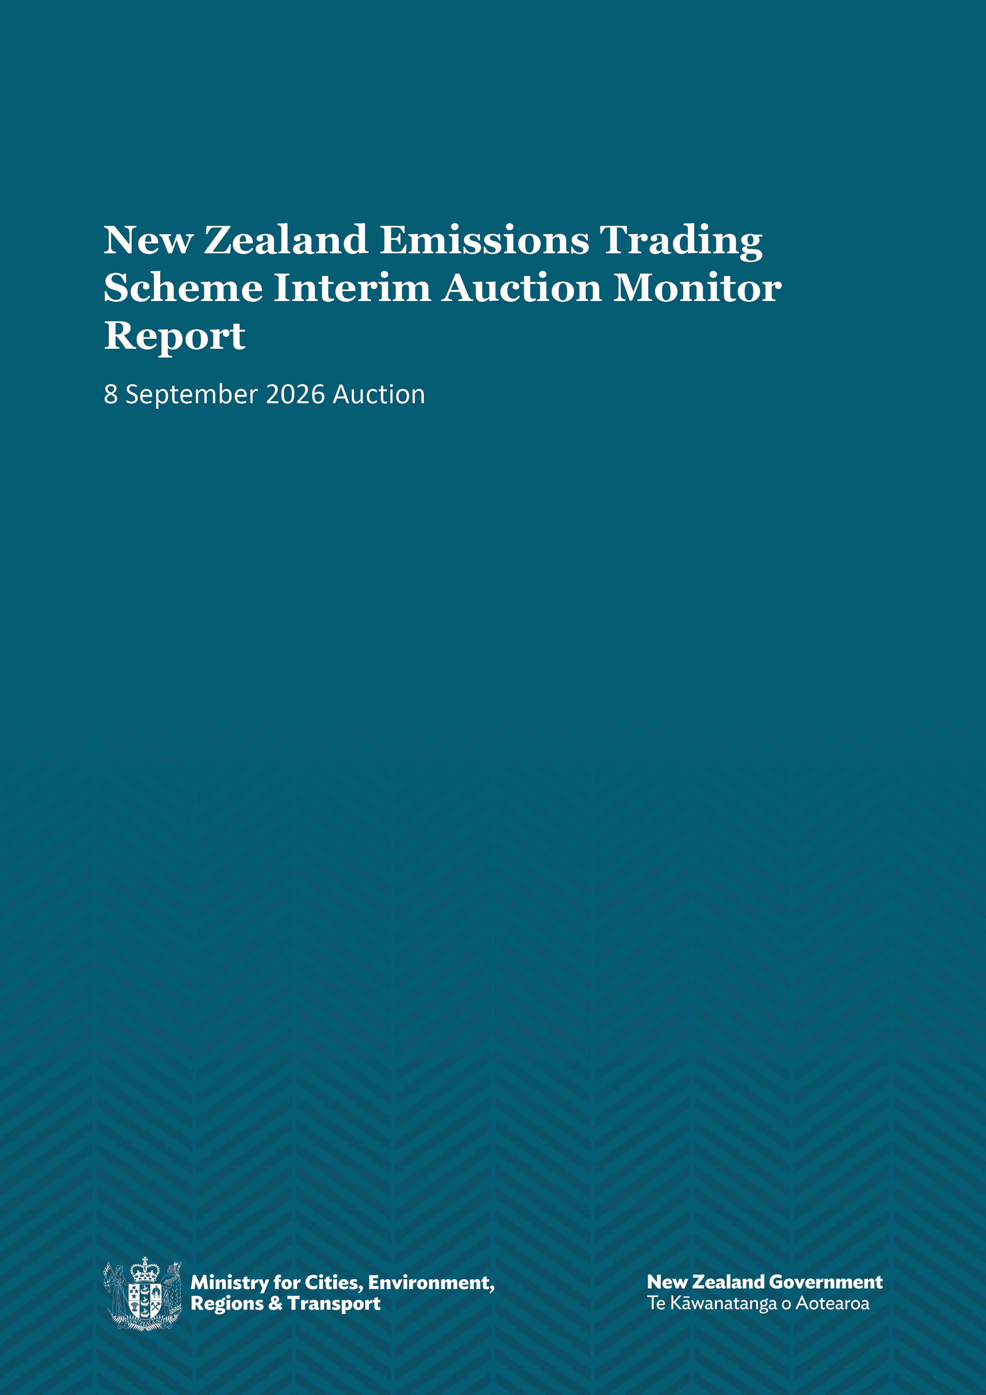

Disclaimer
The information in this publication is, according to the Ministry for Cities, Environment, Regions and Transport’s best efforts, accurate at the time of publication. The Ministry will make every reasonable effort to keep it current and accurate. However, users of this publication are advised that:
- the information does not alter the laws of New Zealand, other official guidelines, or requirements
- it does not constitute legal advice, and users should take specific advice from qualified professionals before taking any action based on information in this publication
- the Ministry does not accept any responsibility or liability whatsoever whether in contract, tort, equity, or otherwise for any action taken as a result of reading, or reliance placed on this publication because of having read any part, or all, of the information in this publication or for any error, or inadequacy, deficiency, flaw in, or omission from the information in this publication
- all references to websites, organisations or people not within the Ministry are for convenience only and should not be taken as endorsement of those websites or information contained in those websites nor of organisations or people referred to.

This document may be cited as: Ministry for Cities, Environment, Regions and Transport. 2026. New Zealand Emissions Trading Scheme Interim Auction Monitor Report: 8 September 2026 Auction. Wellington: Ministry for Cities, Environment, Regions and Transport.

Published in September 2026 by the
Ministry for Cities, Environment, Regions and Transport
PO Box 10362, Wellington 6143, New Zealand
environment.govt.nz
ISBN: 978-1-997358-13-8
Publication number: MCERT 15
© Crown copyright New Zealand 2026

Contents
Introduction and purpose of this report 4
Change of auction operator 4
Auction information 5
Auction results 5
Commentary on the auction results 7
Price 7
Units sold and cover ratio 8
Bidder behaviour 8
Participants 9
Commentary on the auction operation 12
Collateral and settlement 12
Ministry for Cities, Environment, Regions and Transport 12
The auction clearing price 13
The confidential reserve price 13
Resolved tied bids 13
Cost containment reserve 13

Introduction and purpose of this report
This report is produced by the Ministry for Cities, Environment, Regions and Transport (the Ministry) acting in the role of the interim auction monitor for the 23rd New Zealand Emissions Trading Scheme (NZ ETS) auction and the third auction of 2026, held on 8 September 2026.
The NZ ETS auctions of New Zealand Units (NZUs or ‘units’) are held at quarterly intervals each year in accordance with the Climate Change Response Act 2002 and the Climate Change (Auctions, Limits, and Price Controls for Units) Regulations 2020. Specific regulations for the auction monitor function have not been passed, so the Ministry is operating as the auction monitor in the meantime. We call this the ‘interim auction monitor’.
The functions of an auction monitor include but are not limited to:
- monitoring the conduct of agents and auction participants
- the publication of an auction report as soon as is practicable following an auction
- calculating specified metrics about the auction process and auction results
- providing a periodic assessment of the auction system and making recommendations for improvement.
This auction monitor report provides the results of the latest auction. It also presents a comparison with previous auctions and provides assurance that the auction was conducted properly and in accordance with the applicable rules and laws. The next auction, the fourth auction of 2026, is scheduled for 1 December 2026.
We welcome feedback on this report; please send it to etsfeedback@mcert.govt.nz.

Change of auction operator
The Ministry has contracted a new supplier, CBL Markets (Australia) Pty (trading as Xpansiv), to operate NZ ETS auctions following an open procurement process. The September 2026 auction was the first auction delivered by Xpansiv.
The Ministry, acting in the role of the interim auction monitor, has verified that Xpansiv completed all auction operations for the 8 September 2026 auction in accordance with the Climate Change Response Act 2002 and the Climate Change (Auctions, Limits, and Price Controls for Units) Regulations 2020. All operational processes were executed as expected and there were no issues with the 8 September auction.

Auction information
Table 1 provides the price settings and units available for the 8 September 2026 auction.
Table 1: Unit and price information the NZ ETS auction held on 8 September 2026
Units available |  |  |  |  | Prices
September auction | Unsold from previous auctions | Total auction volume  (excl CCR) | Tier 1 CCR | Tier 2 CCR | Price floor | Tier 1 CCR trigger price | Tier 2 CCR trigger price
1,300,000 | 2,600,000 | 3,900,000 | 2,300,000 | 4,200,000 | NZ$71.00 | NZ$203.00 | NZ$254.00
Note: CCR = cost containment reserve.

Auction results
- The third auction of 2026, held on Tuesday 8 September 2026, did not clear.
- No bids were received during the auction bidding window.
- No NZUs were required to be transferred as a result of the auction.
- The unsold units will carry over, and a total of 5,200,000 NZUs (excluding cost containment reserve (CCR)) will be available at the next auction on Tuesday, 1 December 2026.
- The secondary market closing price the day before the auction (7 September 2026) was NZ$49.00 (composite price, multiple inputs).
- The secondary market closing price the day of the auction (8 September 2026) was NZ$46.00 (composite price, multiple inputs).
Table 2 provides the key metrics of the auction. Figures 1 to 9 throughout this report present a comparison of the auction with previous auctions.

Table 2: Metrics for NZ ETS auction held on 8 September 2026
Metrics for NZ ETS auction | Response
Clearing price | None
Maximum bid price | 0
Minimum bid price | 0
Average bid price | 0
Number of participants | 0
Number of successful participants | 0
Volume available at auction (including 6,500,000 CCR units) | 3,900,000 (10,400,000 including CCR)
Volume of NZUs sold | 0
Volume of NZUs bid for | 0
Average bid size | 0
Average volume bid per participant | 0
Average volume won per successful participant | 0
Average number of bids per participant | 0
Total number of bids submitted (not including withdrawn bids) | 0
Number of bids withdrawn | 0
Number of successful bids | 0
Cover ratio (excluding 6,500,000 CCR units) | 0
Aggregated ‘top 5’ participants volume (aggregated bids) as a percentage of total units bid for | 0
Estimated percentage of bidders with compliance obligations | 0

Commentary on the auction results
The 8 September 2026 auction was the third auction of 2026 and received no bids and did not clear. The last auction to sell units was December 2024, which partially cleared at the 2024 auction floor price of $64.00.

Price
No clearing price was established as no bids were registered for the 8 September 2026 auction.
Figure 1: Auction clearing prices (relative to price floor and CCR prices)
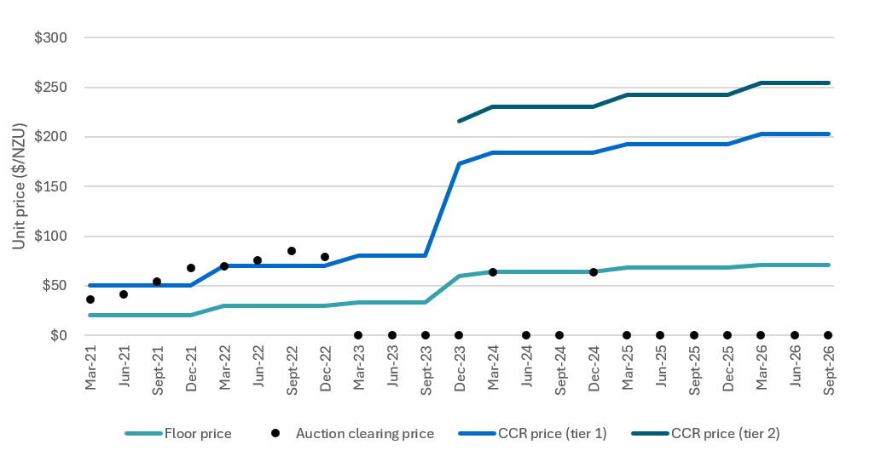
Figure 2: Range of minimum and maximum bid price observed at auctions

Units sold and cover ratio
2,600,000 units were carried over from the previous auction. A total of 3,900,000 units (excluding CCR) were available at the 8 September 2026 auction. No units were sold; therefore, an additional 3,900,000 units will be available at the 1 December 2026 auction. These will only be made available if the December auction’s initial volume is sold.
The cover ratio shows the level of demand compared to the number of units available at auctions. It has been on a downward trend over time.
Figure 3: Bid volume versus total volume sold over time

Figure 4: Trend of cover ratio over time (volume bid/volume sold)

Bidder behaviour
There were no bids submitted during the 8 September 2026 auction.
Figure 5: Total number of successful and unsuccessful bids

Figure 6: Range of maximum and minimum volume of units won per participant

Participants
No auction participants took part in the 8 September 2026 auction.
Note: A participant with compliance obligations is a party who is directly registered in the NZ ETS with obligations under Schedule 3 or Schedule 4 of the Climate Change Response Act. However, there may be participants in an auction who do not have compliance obligations and could be purchasing units on behalf of another party that does have compliance obligations.
Figure 7: Participant numbers per auction

Figure 8: Number of compliance versus non-compliance participants

Figure 9: Percentage of units sold to compliance participants versus non-compliance participants

Commentary on the auction operation
The auction operator has confirmed that the auction mechanism, systems and processes functioned as expected, with no issues or delays observed.
The Ministry is satisfied that the auction was conducted properly and ran in accordance with the applicable regulation and policy.

Collateral and settlement
In past auctions, participants have made use of both cash and non-cash collateral instruments. However, in the 8 September 2026 auction only non-cash collateral instruments were used. There was therefore no requirement to return unused cash collateral immediately following the auction.
No settlement process was undertaken as the auction did not clear.

Ministry for Cities, Environment, Regions and Transport
This is the first time that the interim auction monitor function was performed by the Ministry for Cities, Environment, Regions and Transport.
The Ministry for Cities, Environment, Regions and Transport was formed on 1 July 2026 and it has brought together the Ministry for the Environment, Ministry of Housing and Urban Development, Ministry of Transport, and the local government functions of the Department of Internal Affairs.
The Ministry has applied the process and internal controls for monitoring auctions developed by the Ministry for the Environment without change. These include protecting commercially sensitive information and maintaining segregation between the auction monitor and policy and other functions.
The Ministry will continue to perform the interim auction monitor function and publish the interim auction monitor report.

Appendix 1: Auction mechanics

The auction clearing price
No bids were received, meaning there was no clearing price.

The confidential reserve price
The confidential reserve price (CRP) was not used in the auction.
The Climate Change (Auctions, Limits, and Price Controls for Units) Regulations 2020 require the Minister of Climate Change to set a methodology for calculating a CRP for NZ ETS auctions. The purpose of the CRP is to prevent NZUs from being sold at auction at a price significantly below the secondary market price. If the auction clearing price is less than the CRP, the auction will not sell any NZUs. Unsold NZUs are rolled forward to be sold at the next auction in the same calendar year.
The mechanism for calculating the CRP was last revised ahead of the June 2024 auction to ensure that the mechanism remains confidential.

Resolved tied bids
There were no tied bids in the 8 September 2026 auction. If more than one bid sets the clearing price, those bids are referred to as tied bids. If all tied bids, together, bid for more units than are left, each tied bid is allocated a proportional share of the remaining units, subject to rounding rules.
Bids are only accepted in multiples of 100 units from 500 units (the lot size and minimum bid respectively). Units are allocated to bids in multiples of lot size. Therefore, when tied bids occur and the operator calculates proportional shares, they apply the following rounding rules:
- the number of units allocated to a tied bid, if not a multiple of the lot size, is rounded down to the nearest 100 units (this may include being rounded down to zero)
- if unallocated units remain after tied bids are awarded their proportional share (rounded to the nearest 100 units), any remaining lots are randomly allocated to the tied bids, but only up to their original bid amount.

Cost containment reserve
The CCR trigger prices were not breached in the 8 September 2026 auction. No CCR volume units were sold.
The CCR mechanism provides for additional volume of NZUs to be added to the auction volume if the auction clearing price is equal to, or exceeds, the CCR trigger price or prices. In 2026, there are two distinct CCR tiers and two associated trigger prices.
Both the auction volumes and the CCR trigger price(s) are set by regulation. These details and the dates for future auctions are published on the Ministry for the Environment website which is still operating until the MCERT website is updated. Participants are urged to monitor the Ministry website to keep up to date with these details.

