Forest Reference Level for pre-1990 planted forests under the Paris Agreement

S. J. Wakelin

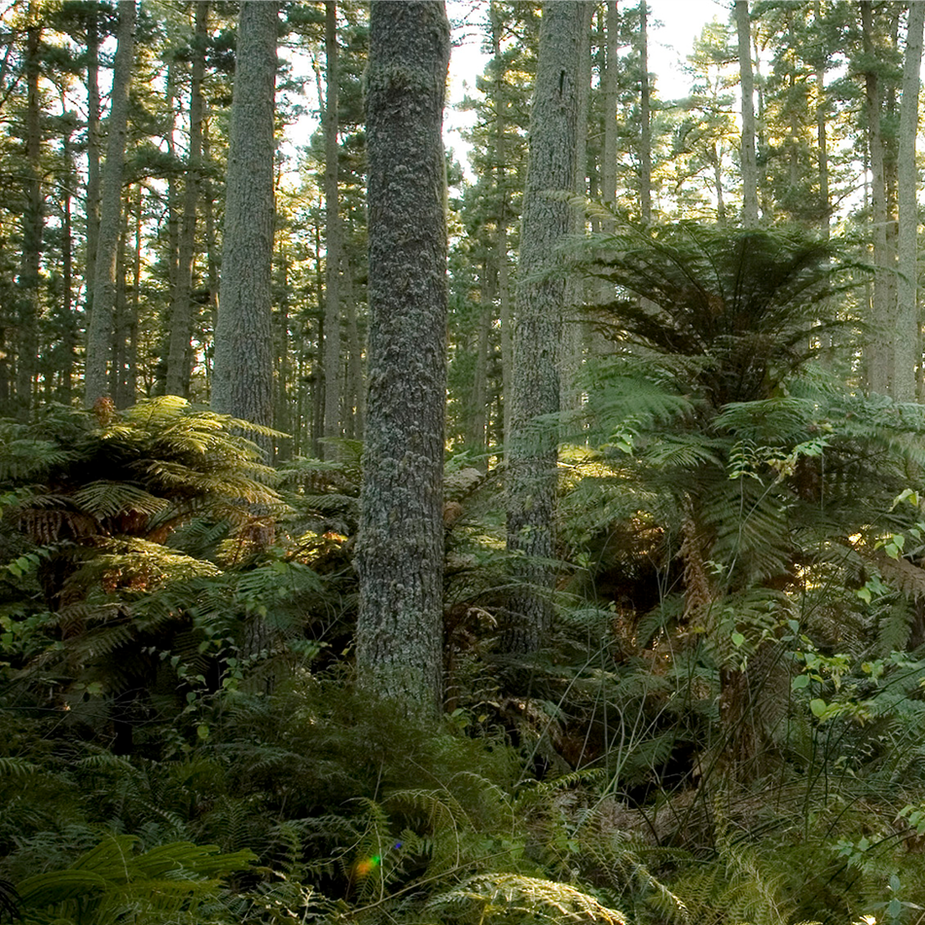

Report information sheet

|  |  |
| --- | --- |
| Report title | Forest Reference Level for pre-1990 planted forests under the Paris Agreement |
| Authors | S.J. Wakelin  Scion |
| Client | MfE |
| Client contract number | 26198 |
| MBIE contract number |  |
| PAD output number | 86695629 |
| Signed off by | Thomas Paul |
| Date | September 2024 |
| Confidentiality requirement | Confidential (for client use only) |
| Intellectual property | © New Zealand Forest Research Institute Limited. All rights reserved. Unless permitted by contract or law, no part of this work may be reproduced, stored or copied in any form or by any means without the express permission of the New Zealand Forest Research Institute Limited (trading as Scion). |
|  |  |
|  |  |
|  |  |
| **Disclaimer** | The information and opinions provided in the Report have been prepared for the Client and its specified purposes. Accordingly, any person other than the Client uses the information and opinions in this report entirely at its own risk. The Report has been provided in good faith and on the basis that reasonable endeavours have been made to be accurate and not misleading and to exercise reasonable care, skill and judgment in providing such information and opinions.  Neither Scion, nor any of its employees, officers, contractors, agents or other persons acting on its behalf or under its control accepts any responsibility or liability in respect of any information or opinions provided in this Report. |

Published by: Scion, Private Bag 3020, Rotorua 3046, New Zealand. www.scionresearch.com

# Executive summary

The problem

New Zealand has indicated that it will account for pre-1990 planted forests in the Paris Agreement compliance period (2021-2030) following the activity-based accounting approach used under the Kyoto Protocol. This means that accounting will be against a Forest Reference Level (FRL) of expected net emissions assuming the continuation of the business-as-usual management practices applied during the 2000-2009 reference period.

This project

This report describes the data and approach used to establish the Reference Level of expected net emissions from New Zealand’s planted forests during the Paris Agreement compliance period from 2021-2030.

Key results

Harvesting activity is the key driver for net emissions from pre-1990 planted forests and the overall FRL value. This report provides the projections of area harvested by age class, required for modelling the FRL in the LUCAS Calculations and Reporting Application, and describes the underlying methodology, assumptions and issues.

The pre-1990 planted forest FRL value of -18,735 kt CO2-e year-1 reported here represents the average annual net emission from these forests from 2021 to 2030. Carbon uptake in pre-1990 planted forests is initially high during the compliance period as harvesting is concentrated in post-1989 forests, but then declines and the forest itself becomes a net source. However, this is balanced by gains in the pool of harvested wood products. Other emissions from soil carbon loss (due to land use change) and wildfires are relatively small. When combined with projected net emissions in pre-1990 natural forests, the FRL value is -20,135 kt CO2-e year-1.

Implications of results for the client

Defining business-as-usual management for production planted forests, based on the data available, is not straight-forward. The logic of expecting a constant fraction of each age class (or of the mature volume available) to be harvested each year is questionable, unless the forest is in a steady-state with an even spread of age classes and management prescribed by legislation. Net emissions can vary significantly from year to year, so when using five-year budget periods small changes to data and assumptions can lead to large differences in the FRL or accounting quantity, depending on whether major changes occur within or outside the compliance period.

Further work

Ongoing work is required to improve estimates of total net stocked planted forest area and its allocation to age classes. Further reconciliation is required to understand the differences between projected and actual emissions as reported in the greenhouse gas inventory for 2010 to 2020. For example, this could be due to a departure from the business-as-usual harvest practice that had been implemented during the 2000 to 2009 reference period, such as a greater proportion of stands being left unharvested.

.

Forest Reference Level for pre-1990 forests under the Paris Agreement

Table of contents

Executive summary 3

Abbreviations 6

Introduction 7

Materials and methods 7

Scope 7

European Union approach to developing the Paris Agreement RFL 8

Developing a Forest Reference Level for New Zealand’s pre-1990 planted forests 9

Summary of FRL development approach 19

Natural disturbance accounting provision 20

Comparison with reported net emissions 20

Results 21

Pre-1990 Planted Forest Reference Level 21

Comparison with reported net emissions 24

Discussion 25

Conclusions 26

References 28

Appendix 1. Land use change into pre-1990 planted forest (MfE 2024) 30

Appendix 2. Exploratory modelling 32

Defining BAU harvesting during the reference period 32

Data and exploratory modelling 34

Appendix 3. Harvest Fraction and other assumptions in the FRL model 39

FOLPI-XL Modelling Approach and scenario outputs 46

Outputs from FOLPI-XL modelling to 2030 48

Appendix 4. Destocking profile, pre-1990 planted forests 52

Appendix 5. HWP calculations 55

# Abbreviations

**BAU** **Business-as-usual**. In the context of this report, refers to the typical forest management practices applied during the 2000-2009 reference period.

**CRA** **Calculation and Reporting Application**. Software within LUCAS (Land Use and Carbon Accounting System) used by the Ministry for the Environment to simulate land use change and forest activity and estimate greenhouse gas emissions and removals.

**FMRL** **Forest Management Reference Level**. Expected net emissions set under the Kyoto Protocol for Forest Management (i.e. pre-1990 forests) in the 2013-2020 commitment period. See FRL.

**FRL** **Forest Reference Level**. Expected net emissions in pre-1990 forests based on projections that assume that business-as-usual management practices undertaken in the 2000-2009 reference period will continue. Used to establish a baseline against which *additionality* can be assessed - for pre-1990 forests and their products, only deviations from the FRL are subject to accounting credits or debits. This is the Paris Agreement equivalent of the Kyoto Protocol FMRL. It can be applied to either activity-based accounting (i.e. “Forest Management”) or land-based accounting (i.e. “Land converted to Forest Land” and “Forest Land remaining Forest Land”).

**HWP** **Harvested Wood Products**. Wood-based materials harvested from forests, which are used for products such as furniture, plywood, and paper and paper-like products, or for energy. In the context of accounting under the Kyoto Protocol and Paris Agreement, the HWP pool includes only the semi-finished wood product categories sawn timber, wood-based panels, and paper and paperboard. Other wood products such as wood pellets are assumed to be instantaneously emitted at the time of harvest.

**IPCC** **Intergovernmental Panel on Climate Change**. The United Nations body for assessing the science related to climate change and providing guidelines for greenhouse gas inventory reporting and accounting.

**LUCAS** **Land Use and Carbon Analysis System**. Programme administered by the Ministry for the Environment to collect, analyse and report on information relating to greenhouse gas emissions and removals associated with land use.

**NDC** **Nationally Determined Contribution**. The contribution New Zealand has committed to make towards climate change mitigation under the Paris Agreement.

**NEFD** **National Exotic Forest Description**. Production plantation forest statistics compiled by the Ministry for Primary Industries from an annual survey of forest owners.

**NIR** **National Inventory Report**. The greenhouse gas inventory report submitted annually under the United Nations Framework Convention in Climate Change.

**UNFCCC** **United Nations Framework Convention on Climate Change**. The United Nations process for negotiating international agreements to mitigate climate change.

# Introduction

New Zealand has indicated that it will account for pre-1990 planted forests in the Paris Agreement compliance period (2021-2030) following the activity-based accounting approach used under the Kyoto Protocol.[1] This means that accounting will be against a Forest Reference Level of expected net emissions, assuming the continuation of the business-as-usual management (BAU) practices applied during the 2000-2009 reference period.

A forest reference level (FRL) is required to account for the contribution of pre-1990 forests to New Zealand’s Nationally Determined Contribution (NDC) under the Paris Agreement and for domestic budgets for the 2050 net zero target.

The Forest Management Reference Level (FMRL) used for the second Kyoto Protocol accounting period (2013-2020), was criticised for having a lack of transparency in how business-as-usual activity was estimated. The initial Kyoto Protocol FMRL was created using different modelling software, input data and assumptions than that used to account for Forest Management in the National greenhouse gas Inventory Report (NIR). This created a discrepancy between these approaches, which was then required to be addressed through technical corrections to the FMRL.

To ensure consistency between the FRL and the NIR, the intention is to model the FRL in the Ministry for the Environment’s (MfE’s) LUCAS Calculations and Reporting (CRA) module, based on BAU activity data developed externally.

This project provides the activity data (principally projections of area harvested by age class) required for modelling the FRL in the CRA, and describes the underlying methodology, assumptions and issues. It also provides estimates of the Forest Reference Level calculated from the data and assumptions described.

# Materials and methods

## Scope

There are no mandatory guidelines for the preparation of a Forest Reference Level. There is an expectation that the approach will be consistent with IPCC guidance on greenhouse gas inventory reporting (IPCC, 2006; IPCC, 2014; IPCC, 2019). Under the “activity-based” Kyoto Protocol accounting rules adopted by New Zealand, all managed forests first established before 1 January 1990 should be accounted for against the FRL. Planted and natural forests established onto land that was not forest land as at 31 December 1989 (i.e. post-1989 forests) are accounted for separately.

The FRL applies to both pre-1990 planted forests and pre-1990 natural forests as defined in New Zealand’s greenhouse gas inventory. New Zealand considers all of its planted and natural forests to be managed (MfE, 2024). Wakelin and Paul (2024) describe the data and assumptions used for calculating the pre-1990 Natural Forest Reference Level for New Zealand. The key input is the estimate of carbon uptake by pre-1990 natural forests which is estimated directly from analysis of LUCAS plots in pre-1990 natural forests. This is the approach used for greenhouse gas inventory reporting. In contrast, reporting of net stock changes in pre-1990 planted forests is based on estimates derived from simulation of harvesting, replanting and deforestation in the LUCAS CRA module.

## European Union approach to developing the Paris Agreement RFL

The key methodological steps described in the European Union (EU) approach to FRL development (Forsell et al.,2018) are based on earlier work by Grassi and Pilli (2017):

1. Stratify the area of *Forest remaining Forest[2]* based on national circumstances. Strata should be characterised by specific management objectives and practices.
2. Identify and stratify the forest management practices for each stratum during the reference period. These should be quantifiable criteria, e.g. the age, diameter or volume at which thinning or harvesting occurs, and monitored over time to document changes.
3. Project the evolution of *Forest remaining Forest* [for this report, pre-1990 planted forest] area. Here it would be assumed that the deforestation rate over the reference period continues.
4. Project the future carbon gains and losses in each pool and stratum.

4.1. Forest increment is calculated by the continuation of the management practices described in step 2.

4.2 Estimation of carbon losses due to harvesting requires:

a) Calculation of the *biomass available for wood supply* during the reference period (BAWSRP). In the EU example, if Norway spruce is typically harvested between 80-140 years of age, the BAWS is the biomass available in this age range.

b) Documentation of the harvest volumes during the reference period (HRP).

c) Calculation of the average harvest fraction over the reference period as HFRP = mean HRP / mean BAWSRP. This is calculated for each stratum.

The HFRP is a proxy that captures the impact of all constraints (markets, policies, owners’ behaviours, accessibility etc) on wood volumes during the reference period.

d) Calculation of the expected evolution of the biomass available for wood supply in the compliance period, based on the age class distribution and growth rates.

e) Calculation of the future harvest during the compliance period by multiplying the mean harvest fraction over the reference period by the expected biomass available.

1. Estimate projected HWP pool stock changes by applying the same HWP category proportions as during the reference period.

The steps above were broadly followed as described in the following section to derive a FRL for pre-1990 planted forests in New Zealand. In essence the FRL is based on:

* areas of pre-1990 planted forests by strata and age.
* estimates of the expected average net stock change per hectare by strata and age, assuming that the management applied in the reference period continues. This is expressed as a carbon yield table.
* Simulation of the impact of harvesting, replanting and deforestation on pre-1990 planted forest carbon stocks, including delayed emissions from the harvested wood products (HWP) pool. Simulation of activity in pre-1990 forest was undertaken using the FOLPI-XL[3] forest estate modelling software to produce annual harvesting and deforestation areas by stratum and age, which were then applied in the LUCAS CRA simulation to derive the associated carbon stock changes through time. Modelling of the HWP pool was carried out in a separate spreadsheet.

## Developing a Forest Reference Level for New Zealand’s pre-1990 planted forests

### Stratify the area of Pre-1990 Planted Forest based on national circumstances

New Zealand’s greenhouse gas inventory reporting of carbon stock changes in planted forests is based on simulations, run in the LUCAS CRA application (MfE 2023). This defines an initial forest state in terms of the profile of areas by age and a yield table that defines carbon stocks by pool at each current and future age. The CRA simulates the development of the forest and carbon stocks over time through annual activity data describing afforestation from a range of pre-forest land uses, destocking by age, and subsequent replanting or conversion to a non-forest land use.

The LUCAS CRA models pre-1990 planted forests in two cohorts – those planted before 1990 and those planted from 1990 onward. This stratification is assumed to pick up major differences in planted forest management and productivity, so the cohorts are represented by two separate yield tables derived from plot data measured in the pre-1990 planted forest inventory (Paul et al. 2024). Stands planted from 1990 onward reach a carbon stock by age 28 that is about 22% higher than stocks achieved by the older cohort at the same age.

Ninety-six percent of pre-1990 planted forest plot area measured across the full 2018-2022 inventory are radiata pine (Paul et al. 2024). Because there are few plots in each of the other species, it is difficult to develop robust yield tables for each species, so all species are combined in each of the tables for the two pre-1990 cohorts for greenhouse gas inventory reporting. A lack of sufficient plots also limits the ability to create yield tables that cover shorter planting year cohorts.

MfE provided the pre-1990 and post-1989 forest age profiles and total forest area as of 2009, based on data used for the 2023 NIR submission. This area was then allocated to three species groups based on the National Exotic Forest Description (NEFD) proportions in April 2010:

* Radiata pine
* Douglas fir and other softwoods
* All hardwoods.

Differentiation by species was made to allow some differentiation of target rotation age by species in the FOLPI-XL model, which prevents situations where the model elects to harvest unreasonably high proportions of non-radiata pine species in a single year. Species-specific yield tables were used for each species group in post-1989 and pre-1990 planted forests (Paul et al., 2024). However, combined “all species” harvest and deforestation age profiles were obtained from the model results for use as inputs to the LUCAS CRA simulation, which does not model species groups separately and instead applies “combined species” yield tables..

### Identify and stratify the forest management practices for each stratum during the reference period.

The intention in this step is to identify quantifiable criteria such as the age, diameter or volume at which thinning or harvesting occurred during the reference period, which can then be monitored over time to document changes. The NEFD provides some information on the extent to which pruning and production thinning is intended to be applied by species (MPI 2023) but without detail of age, diameter, volume or stocking. However, it can be assumed that the yield tables derived from LUCAS plot data reflect the range of silvicultural practices present in pre-1990 planted forests established during the reference period.

Further analysis of the plot data could provide information on the wide range of silvicultural treatments applied during the reference period, which vary between forest owners. However, clearfelling is the dominant management system across all species, and rotation age is the most important management driver for net emissions (see (4) below).

The strata defined for the pre-1990 planted forest FRL are:

* Pre-1990 planted forest, planted before 1990.
* Pre-1990 planted forest, planted after 1990.

The same business-as-usual harvesting that applied over the reference period is assumed to apply in each case, but a different yield table is used.

Two strata of natural forests are also used in the full pre-1990 forest FRL:

* Pre-1990 Tall natural forest
* Pre-1990 Regenerating natural forest.

Harvesting is not anticipated in either case, so these strata are differentiated by the mean sequestration rate derived from LUCAS plots (Wakelin & Paul, 2024).

### Project the evolution of Pre-1990 Planted Forest area.

Two options are provided by Forsell et al. (2018) for projecting the evolution of forest area:

1. Assume constant area of managed land, or
2. Account for projected gains and losses of forest area.

In both cases technical corrections to the FRL (IPCC, 2014) are required to ensure the FRL area appropriately matches the actual areas reported, so the final accounting quantity will be the same. The advantage in projecting area changes is that future technical corrections due to area adjustments should be smaller.

Future mapping improvements that change the area of pre-1990 forests would apply to the whole time series for both greenhouse gas inventory reporting and the FRL, requiring a technical correction to the FRL (IPCC, 2014). These adjustments will ensure the area used in the FRL is consistent with the area used in reporting. Other gains and losses of area do not necessarily imply that a technical correction is needed.

*Gains of pre-1990 Planted forest area*

Pre-1990 planted forest can increase in area after 1990 from two sources:

1. Conversion of non-forest land to pre-1990 planted forest

2. Conversion of pre-1990 natural forest to pre-1990 planted forest.

Gain in pre-1990 planted forest since 1990 are shown in the land use change matrix in Appendix 1. Normally afforestation of non-forest land after 1990 would be accounted for as post-1989 forest land, and therefore not included within the FRL. This means that case (1) above is only possible if pre-1990 forest land has been converted to non-forest land after 1989, and then converted to planted forest. Land deforested since 1 January 1990 is always accounted for as Deforestation land even if subsequently afforested, so should be excluded from the FRL. In the period before 2010 this occurred only in 2008 and 2009 (Table 1) so these areas are part of pre-1990 planted forest for greenhouse gas inventory reporting but accounted for as Deforestation land so excluded from the FRL. Projections after 2009 are not required for the FRL.

With case (2) above, land converted from pre-1990 natural forest to pre-1990 planted forest before 2010 should be included in the pre-1990 planted forest FRL but any subsequent conversion is considered a change to business-as-usual management. This means that these areas are included in the pre-1990 natural forest FRL as if they had remained as natural forests. Soil carbon change would be compared against a baseline of no soil carbon change (i.e. land area is assumed to stay as natural forest instead), so are accounted for in full. Biomass stock change (based on the new area of planted forest) would be compared against stock changes in the natural forest FRL. The FRL stock changes are based on the assumption that the converted area remains as natural forest instead.

Only the area of pre-1990 natural forest converted to pre-1990 planted forest after 2001 would still be undergoing soil carbon stock changes during the compliance period, due to the 20-year transition. These areas are given in Table 4.

**Table 1. Non-forest land converted to pre-1990 planted forest 1990-2009 (accounted for as Deforestation land).**

|  |  |  |
| --- | --- | --- |
| **Previous Land use** | **Area planted into pre-1990 planted forest (ha)** | |
|  | **2008** | **2009** |
| High producing grassland | 17 | 17 |
| Low-producing grassland | 28 | 28 |
| Grassland with woody biomass | 70 | 70 |
| Wetlands - vegetated | 1 | 1 |
| Other land | 1 | 1 |
| **Total** | **117** | **117** |

No projected gains in pre-1990 planted forest land area are included within the FRL.

*Losses of pre-1990 Planted forest area*

Area can be lost from pre-1990 Planted Forest in two ways:

1. Deforestation (conversion to a non-forest land use)

2. Conversion to pre-1990 natural forest.

Deforestation emissions do not form part of the FRL under activity-based accounting: any deforestation that occurs during the compliance period will be accounted for in full and require a technical correction to the FRL to ensure that pre-1990 planted forest area is consistent between reporting and the FRL.

The Deforestation areas assumed in the FRL model are given in Table 2. Deforestation through the compliance period was based on earlier projections provided by the Ministry for Primary Industries (MPI) (Wakelin et al., 2021).

Area converted to pre-1990 natural forest before 2010 is included as pre-1990 natural forest in the FRL. Area converted from 2010 onward remains as pre-1990 planted forest in the FRL. No projections are made within the FRL of further conversions to natural forest.

**Table 2. Pre-1990 planted forest deforestation areas**

|  |  |  |  |  |
| --- | --- | --- | --- | --- |
| **Year** | **Actual Deforestation**  **(ha)** |  |  | **Projected Deforestation (ha)** |
| 2010 | 5454 |  | 2022 | 167 |
| 2011 | 4529 |  | 2023 | 167 |
| 2012 | 6440 |  | 2024 | 167 |
| 2013 | 8243 |  | 2025 | 167 |
| 2014 | 5986 |  | 2026 | 167 |
| 2015 | 4396 |  | 2027 | 167 |
| 2016 | 4432 |  | 2028 | 167 |
| 2017 | 2976 |  | 2029 | 167 |
| 2018 | 1628 |  | 2030 | 167 |
| 2019 | 1114 |  |  |  |
| 2020 | 843 |  |  |  |
| 2021 | 440 |  |  |  |

### Project the future carbon gains and losses in each pool and stratum.

There are two parts to this step in the EU approach:  
1. Determining forest carbon increment.

2. Estimating forest carbon losses due to the continuation of harvest practices.

**Net Stock Changes in Pre-1990 Planted Forest strata**

*Biomass*

Forest biomass carbon increment is captured via carbon yield tables derived from LUCAS plots (Paul et al., 2024). These define the carbon stock change in above-ground biomass, below-ground biomass, dead wood and litter from one age class to the next. Soil organic carbon is not included in the yield tables, so changes in soil carbon due to land use change are modelled separately.

The FRL requires the continuation of management practices applied in the 2000-2009 period, which is not necessarily reflected by stands established after that time. In the FOLPI-XL model, radiata pine forest areas planted before 1990 used a yield table derived from plots planted before 1990, while areas planted from 1990 onward used a yield table derived from plots established from 1990-2009. The yield tables for the other two species groups covered all planting years, as there are insufficient plots available to develop robust yield tables at a lower level of aggregation.

By combining the yield tables with the age profile of pre-1990 forests as of 2009, it is possible to simulate the development of forest carbon stocks over time using the FOLPI-XL modelling tool. FOLPI-XL is a simplified version of the FOLPI forest estate optimisation software tool widely used in New Zealand and Australia since the 1980s for strategic and tactical forest planning (García, 1984; Manley et al., 1989). It uses linear programming to find a solution to an optimisation problem, maximising the model objective while meeting user-defined and internal material balance constraints. The forest can be represented in the same way as in the CRA simulation, using the same age class and yield table data. The optimisation produces a destocking schedule as an output (i.e. annual harvest and deforestation areas by age). This can then be used as an input to the LUCAS CRA, allowing simulation of forest development over time and calculation of the resulting emissions and removals.

More detail is provided in Appendices 2 and 3, including a description of exploratory models that built on previous work to identify issues and help determine a suitable approach to develop a destocking profile (i.e. areas of harvesting and deforestation by age).

The final FRL model developed in FOLPI-XL applied a destocking probability approach based on the destocking profile by age class that applied in 2007-2009. This profile was determined from analysis of successive annual NEFD age class distributions, which cover all planted forests (e.g. MPI 2023). This is described in more detail in the *Harvesting carbon losses* section below. It was assumed that pre-1990 and post-1989 planted forests are managed as a combined resource with no difference in rotation length. The post-1989 planted forest areas as of 2009 were included in the FOLPI-XL model, with actual and projected afforestation to 2030. Further details are provided in Appendix 3.

The output from the FOLPI-XL model was an annual time series of harvesting and deforestation area by age from both pre-1990 and post-1989 planted forests, from 2010 to 2080. The annual deforestation and harvest areas by age for pre-1990 planted forests up to 2030 were used as input to a LUCAS CRA simulation run which produced the corresponding forest carbon stock changes. The deforestation and harvest age profile is given in Appendix 4, while the annual net emission projections are provided in Table 6(a).

When the harvest schedule is simulated in the CRA, combined species yield tables are applied, recognising the “before 1990” and “after 1990” separation.

*Soil organic carbon stocks*

Soil carbon is not included as one of the carbon pools in the yield table, as the soil carbon stock level is a function of previous land use history. New Zealand’s greenhouse gas inventory reporting assumes that there is a steady-state soil carbon stock under a constant land use, and that following land use change the stock changes to a new steady-state level over a linear 20-year transition period (MfE, 2023). Steady-state stock soil carbon values and changes following conversion to pre-1990 planted forests are given in Table 3.

**Table 3. Steady state mineral soil organic carbon stocks and stock change following conversion to pre-1990 planted forest. Negative change = carbon gain (MfE, 2024).**

|  |  |  |  |
| --- | --- | --- | --- |
| **Land use** | **Steady state soil organic carbon stock** | **Total soil stock change to pre-1990 planted forest** | **Annual stock change to pre-1990 planted forest (over 20 years)** |
|  | (t C ha-1) | (t C ha-1) | (t C ha-1 year-1) |
| Pre-1990 natural forest | 92.25 | -0.19 | -0.0095 |
| Pre-1990 planted forest | 92.44 |  |  |
| Post-1989 planted forest | 91.92 | -0.52 | -0.0260 |
| Post-1989 natural forest | 91.92 | -0.52 | -0.0260 |
| Grassland with woody biomass (GWB) | 98.23 | 5.79 | 0.2895 |
| High producing grassland | 105.34 | 12.90 | 0.6450 |
| Low producing grassland | 105.98 | 13.54 | 0.6770 |
| Perennial cropland | 88.44 | -4.00 | -0.2000 |
| Annual cropland | 89.77 | -2.67 | -0.1335 |
| Wetlands – open water | 105.98 | 13.54 | 0.6770 |
| Wetlands – vegetated | 136.06 | 43.62 | 2.1810 |
| Settlements | 105.98 | 13.54 | 0.6770 |
| Other land | 58.37 | -34.07 | -1.7035 |

The soil carbon stock in pre-1990 planted forests is not derived from a combination of the yield table and age class distribution each year, and not modelled in FOLPI-XL. Instead, soil carbon is modelled separately through the difference between steady-state carbon in prior land uses compared with pre-1990 planted forest, and the historic land use changes into pre-1990 planted forest. Land use changes into pre-1990 planted forests are given in Appendix 1.

Because of the steady-state assumption for soil stocks within a land use, there are no BAU practices within the reference period that need to be projected forward to calculate BAU soil carbon stock changes during the compliance period. However, the area of pre-1990 planted forest at the end of the reference period includes areas converted from other land uses, where the conversion involves a transition to a new soil carbon stock level and (if there is a loss of soil carbon) emissions of nitrous oxide. Whether these net emissions from the soil are included in the FRL depends on two factors:

1. Whether the 20-year transition has been completed before 2021.
2. Whether the land is classified as “Forest Management” under activity-based accounting.

The earliest year in which a land use change can occur that will still contribute to soil carbon stock changes in the compliance period is 2002, because of the 20-year transition period. Area gains in 2000 and 2001 will have already reached steady-state soil carbon stocks by 2021. Gains in area between 2002 and 2009 will still be affecting soil carbon stocks (and potentially associated nitrous oxide emissions) between 2021 and 2028 due to the 20-year transition period. Net emissions resulting from gains in area after 2009 are not included within the FRL, as this represents a change to BAU management.

Pre-1990 natural forest that is converted to pre-1990 planted forest before 2010 is still classed as “Forest Management” for activity-based accounting, and is accounted for against the FRL. Projections of ongoing soil carbon stock change during the compliance period on this land should be part of the FRL. Conversions from non-forest land uses into planted forest after 1989 would normally be classed as “Afforestation/Reforestation” land (i.e. post-1989 planted forests). A conversion into pre-1990 planted forest is only possible if the land was already forest as at 1 January 1990, but has since been converted to a non-forest land use. For accounting purposes, this land is classified and accounted for as Deforestation land, so projected emissions are not included in the FRL.

Table 4 shows the areas that were converted into pre-1990 planted forests during the reference period but had not reached a steady-state soil carbon stock by 2021. The weighted annual soil carbon stock changes based on the previous land use mix in each year is given in Appendix 1. Note that some land use changes (from pre-1990 natural forests and from the “Other land” category) result in soil carbon gains, while the rest result in a loss or do not occur. The land use change matrix is also used to calculate nitrous oxide losses associated with soil disturbance resulting from land use change – see *Other emissions* below.

The land converted from pre-1990 natural forest in Table 4 was considered planted forest in 2009 and accounted for under “Forest Management”, so the ongoing soil CO2 changes during the compliance period (a gain in this case) are included in the FRL. There are no soil N2O emissions on this land, as these are only associated with a loss of soil carbon. However, the land converted from the non-forest categories must have undergone deforestation previously (or it would be classed as post-1989 planted forest), so the associated emissions of CO2 and N2O would still be reported under Deforestation land, and therefore excluded from the FRL.

**Table 4. Area gain potentially contributing to soil CO2 and N2O emissions during 2021-2030**

|  |  |  |  |  |  |  |  |  |  |
| --- | --- | --- | --- | --- | --- | --- | --- | --- | --- |
| **Source land use** | **Soil Change  (t C ha-1 year-1) \*** | **Annual gain in area (ha)** | | | | | | | |
| **2002** | **2003** | **2004** | **2005** | **2006** | **2007** | **2008** | **2009** |
| Pre-1990 natural forest | -0.0095 | 1401 | 1408 | 1401 | 1401 | 1401 | 1401 | 147 | 147 |
| High producing  grassland | 0.645 | 0 | 0 | 0 | 0 | 0 | 0 | 17 | 17 |
| Low-producing grassland | 0.677 | 0 | 0 | 0 | 0 | 0 | 0 | 28 | 28 |
| Grassland with woody biomass | 0.2895 | 0 | 0 | 0 | 0 | 0 | 0 | 70 | 70 |
| Wetlands - vegetated | 2.181 | 0 | 0 | 0 | 0 | 0 | 0 | 1 | 1 |
| Other land | -1.7035 | 0 | 0 | 0 | 0 | 0 | 0 | 1 | 1 |

* annual change in soil carbon over 20 years due to land use change

Soil carbon net emissions in the FRL over the 2021-2030 compliance period are only required for the conversions from pre-1990 natural forest to pre-1990 planted forest shown in Table 4, and are given in Table 6(a).

*Harvesting carbon losses*

The most important component of a FRL for production forests is the projected level of harvesting, which has a major influence on net emissions. This is reflected in the EU approach outlined above, which pays particular attention to defining business-as-usual harvesting practices during the 2000-2009 reference period and using this as the basis for projecting harvesting during the compliance period, as captured in the FRL. The harvest profile by age and year is a key input to the LUCAS CRA simulation.

Trials of previous modelling approaches are described in Appendix 2. Results were in agreement with Vauhkonen et al. (2021), who showed that when modelling a single species under clearfell management, the suggested harvest fraction approach was unable to produce projections that were consistent with continuation of BAU forest management if the initial age class distribution was uneven.

The approach adopted for developing the FRL presented in this report involved:

1. Estimating the average proportion of age classes from age 15 to 45 years that was harvested or deforested each year during the reference period, based on annual age class area data for the total planted forest resource provided by annual NEFD reports (e.g. MPI, 2023).
2. Applying the above proportions to the total area available in each age class from 15 to 45 years using the FOLPI-XL modelling system, to create a harvesting and deforestation profiles of areas by age from 2010 to 2030.
3. Simulating the above destocking schedule in the LUCAS CRA to generate emissions and removals from pre-1990 forests over the compliance period.

Details of this process are provided in Appendix 3.

The harvest schedule (areas by age class by year) derived from FOLPI-XL modelling are given in Appendix 4. The LUCAS CRA module calculates removals of CO2 based on the forest area and carbon yield table. Harvest emissions are estimated by assuming that 70% of above-ground biomass is extracted from the forest as logs in the year of harvest, while the other 30% decays in the forest, along with the below-ground biomass and any other carbon (Wakelin & Garrett, 2010; MfE, 2024). Net emissions in the forest as calculated in the LUCAS CRA are given in Table 6(a).

The 70% of AGB removed from the forest includes material that is wasted during processing as well as carbon converted to HWPs (sawn wood, wood-based panels and paper and paperboard). Accounting for HWPs is described in step (5) below.

*Other emissions*

In addition to the carbon stock gains and losses in the forest there are other sources of emissions in pre-1990 forests. Nitrous oxide emissions that result from nitrogen mineralisation and immobilisation associated with soil carbon loss following land conversion are reported in the greenhouse gas inventory. The land use change matrix used to calculate soil carbon stock changes is used to determine N2O emissions due to soil disturbance (Appendix 1). N2O emissions are calculated based on the amount of soil carbon lost, so land use changes resulting in a gain of carbon can be ignored. The table in Appendix 1 includes both the annual soil carbon net *change* over 20 years from each years’ land use change into pre-1990 planted forests (from all land uses) and the annual soil carbon *loss* over 20 years, calculated for just those land uses where a loss occurs.

However, in New Zealand’s case there are no N2O emissions from nitrogen mineralisation and immobilisation to include within the pre-1990 planted forest FRL because:

* Land converted into pre-1990 planted forests from non-forest land uses is accounted for as Deforestation land, and is therefore outside the FRL.
* Land converted into pre-1990 planted forests from pre-1990 natural forest gains soil carbon, and therefore there are no associated N2O emissions.

Wildfire emissions are also a minor component of net emissions in pre-1990 planted forests, and CO2 emissions from wildfires are implicitly captured in the stock change data (see *Natural Disturbance Background Level* below). Wildfire area data does not distinguish between planted forest sub-categories or provide age class information. Non-CO2 wildfire emissions (CH4 and N2O) expressed in carbon dioxide equivalents were obtained for 1990 to 2009 from CRA outputs for Planted Forest Wildfire (Table 5). Total emissions were divided by forest area each year to express emissions on a per hectare basis, with the average over the 1990-2009 period (0.0070 t CO2-e ha-1) used for projections. The longer period was used to better capture the expected rate as wildfire time series emissions are dominated by a few very large events.

Wildfire emissions included in the FRL will need to be adjusted through a technical correction to the FRL to ensure that the correct area is used for the 2021-2030 period. Note that the average emission rate per hectare calculated from the data in Table 5 does not take into account changes in the distribution of age classes (which have different carbon stocks and may have different risk profiles). This is unlikely to have a significant impact in pre-1990 planted forests as wildfires are not a major emission source and the age class distribution is relatively even.

**Table 5. Wildfire emissions in pre-1990 planted forests**

|  |  |  |  |  |  |
| --- | --- | --- | --- | --- | --- |
| Year | Pre-1990 planted forest area (kha) | CH4 emissions  (kt CH4) | N2O emissions   (kt N2O) | Total non-CO2 emissions (kt CO2-e) | Per ha emissions   (kt CO2-e ha-1) |
| 1990 | 1545 | 0.386802 | 0.02084 | 16.353056 | 0.0105845 |
| 1991 | 1546 | 0.197978 | 0.0106666 | 8.370033 | 0.0054129 |
| 1992 | 1548 | 0.101828 | 0.0054863 | 4.3050403 | 0.0027817 |
| 1993 | 1549 | 0.109586 | 0.0059042 | 4.633021 | 0.0029911 |
| 1994 | 1550 | 0.228494 | 0.0123107 | 9.6601675 | 0.0062312 |
| 1995 | 1552 | 0.230771 | 0.0124334 | 9.756439 | 0.006288 |
| 1996 | 1553 | 0.350867 | 0.0189039 | 14.83381 | 0.0095522 |
| 1997 | 1554 | 0.618098 | 0.0333016 | 26.131668 | 0.0168131 |
| 1998 | 1556 | 0.310368 | 0.0167219 | 13.121608 | 0.0084353 |
| 1999 | 1557 | 0.0875639 | 0.0047177 | 3.7019877 | 0.0023778 |
| 2000 | 1556 | 0.177814 | 0.0095802 | 7.5175424 | 0.0048308 |
| 2001 | 1556 | 0.116651 | 0.0062849 | 4.9317159 | 0.0031704 |
| 2002 | 1556 | 0.170866 | 0.0092058 | 7.223793 | 0.0046439 |
| 2003 | 1554 | 0.123151 | 0.0066351 | 5.2065242 | 0.0033504 |
| 2004 | 1549 | 0.165964 | 0.0089417 | 7.0165531 | 0.0045308 |
| 2005 | 1536 | 0.188578 | 0.0101601 | 7.9726105 | 0.0051895 |
| 2006 | 1520 | 0.238695 | 0.0128603 | 10.09144 | 0.0066372 |
| 2007 | 1499 | 0.530805 | 0.0285985 | 22.441143 | 0.0149714 |
| 2008 | 1495 | 0.283113 | 0.0152534 | 11.969315 | 0.0080061 |
| 2009 | 1489 | 0.489905 | 0.0263949 | 20.711989 | 0.0139069 |

New Zealand’s activity data on nitrogen fertilisation are not currently disaggregated by land use, so all emissions from this source are reported in the Agriculture sector of the greenhouse gas inventory.

### Estimate the HWP pool by applying the same HWP category proportions as during the reference period.

New Zealand follows IPCC guidance for greenhouse gas inventory reporting, in which there are no direct links between the forest model and the HWP model (IPCC, 2006; IPCC, 2019). The IPCC approach to HWP reporting uses annual forest products production and trade data to define the inputs to the HWP pool. Losses from the pool are estimated by using a first order decay function to represent the rate of discards from the pool.

Changes in the stock of harvested wood products (HWPs) arising from harvesting in pre-1990 forests form part of the reference level and estimating these is the fifth and final step in the EU FRL approach (Forsell et al., 2018).

HWP stocks are not estimated within the LUCAS CRA application as part of the planted forest simulation. Instead, the CRA forest simulation captures roundwood removed at harvest as an instantaneous emission at the time of harvest, while the LUCAS HWP Carbon accounting model (Wakelin et al., 2020) is used to estimate gains and losses in the HWP pool over time. Gains are based on MPI production and trade data and assumptions made about the conversion of export logs overseas, while losses are based on the application of first order decay functions to represent discards of products with different in-service half-lives (MfE, 2023).

The LUCAS HWP Carbon accounting model requires inputs of production and exports at a product level. The FRL would assume that the same mix of products are produced during the compliance period as were produced during the reference period. This would require extensive modification to the HWP model to replace post-2009 production data and projections to 2030 at the individual product level.

A simpler approach was taken which instead used the HWP Carbon accounting model to create national aggregate discard tables for (a) combined products from logs processed in New Zealand, and (b) combined products from export logs. These are then combined into a single weighted national discard table that can be applied to roundwood removals, rather than to HWP production. More detail is provided in Appendix 5.

A spreadsheet was developed that combines the harvest by age and year profile from Appendix 4 with the pre-1990 planted forest yield tables used in the LUCAS CRA to create the final FRL, to determine the initial quantity of roundwood generated each year from harvesting at each age. Roundwood removed at harvest was assumed to be 70% of the above-ground biomass present at the time and age of harvesting, following the assumption made in the LUCAS CRA application. Alternatively, the HWP spreadsheet can use outputs from the FRL simulation run made in the LUCAS CRA directly – that is, carbon in roundwood removals from harvesting as calculated in the CRA can be used as input.

The national weighted discard table was applied to the total roundwood removed each year summed across all ages. The tables reflect both initial processing losses (i.e. wood not incorporated into one of the three IPCC HWP categories of sawn timber, wood-based panels and paper and paperboard) and discards from the pool of products in service. Landfilled products are excluded from accounting (IPCC, 2014).

Figure 1 shows the discard rates used. Export market share was reasonably stable through the first half of the reference period, but the Chinese log market then expanded rapidly at the expense of the Japanese and South Korean log markets. Similarly, the ratio between the domestic log market and export log market was over 2:1 in 2000 and remained high until a rapid decline at the end of the reference period, reaching parity in 2012 and almost a complete reversal by 2020. Because of this strong trend over the last part of the reference period, basing the weighted discard table on the average share over the whole reference period was not appropriate. Instead, the discard table was derived using only the market share data for the year 2009.

In the data used for greenhouse gas inventory reporting, half-lives differ between end uses and sometimes for the same end use in different markets, but these end uses and half-lives are assumed to apply across the whole time series. No differentiation by species or age of harvest is made in the data. The same assumptions underlie the discard table used for calculating the HWP contribution to the FRL. This means it is assumed that the end use proportions and half-lives reported by Manley and Evison (2017) and Wekesa et al., (2022) also applied in 2009.

The weighted national discard table for all logs was applied to production from harvesting in pre-1990 forests from 2013 onward, with logs from deforestation activity excluded, in accordance with guidance for reporting under the Kyoto Protocol (IPCC, 2014). The 2013 start date is based on the start date for mandatory accounting for HWPs under the Kyoto Protocol, and means that the legacy emissions from historic harvesting that are reported in the greenhouse gas inventory (i.e. delayed emissions from harvesting that took place in 1900-2012) are excluded. This makes the HWP pool a strong sink through the compliance period, as additions to the HWP pool from harvesting are greater than discards from the pool.

A more detailed description of the spreadsheet used to estimate the contribution from HWPs is given in Appendix 5, including sources for the required data inputs. Estimates of the stock changes in the HWP pool are given in Table 6(a).

**Figure 1. Discard curves for domestic and export roundwood and the market-weighted national average.**

## Summary of FRL development approach

The steps above allow estimation of emissions and removals from pre-1990 planted forests under BAU management during the compliance period, forming the FRL for pre-1990 planted forests:

* Two strata of pre-1990 planted forests are recognised in the final simulation made in the CRA, based on age class cohorts (planted before 1990, and planted from 1990 onward). LUCAS plot data defined the average carbon uptake rate for each cohort, reflected in a separate “combined species” yield table for each age class cohort. Three separate species groups were modelled in FOLPI-XL to ensure minor species did not dominate the simulated harvest in any one year. Radiata pine was modelled with separate yield tables for areas planted before 1990 and from 1990 onward, while the other two species groups used yield tables that applied to all planting years.
* Pre-1990 planted forest area was assumed to change over time due to actual and projected deforestation. No gains in area were assumed after 2009.
* Net emissions from the forest are calculated from a simulation of pre-1990 planted forest area by age class over time, undertaken in the LUCAS CRA. This includes harvest emissions based on projections of BAU harvesting after 2009. This harvest schedule was derived in FOLPI-XL by applying the average proportion of age classes harvested each year based on data from 2007-2009. The output was entered into the LUCAS CRA as a schedule of harvest areas by age. Net emissions in the soil carbon pool from land use change were calculated separately, as were non-CO2 emissions from soil carbon disturbance and wildfires where relevant.
* Net emissions from the HWP pool were also modelled separately, based on the area by age harvested, the AGB quantity present at each age in the carbon yield table, an assumption that 70% of AGB would be extracted from the forest as harvested logs, and the application of a national discard curve derived from the HWP carbon accounting model (Wakelin, 2023).

The FRL for pre-1990 forests also includes a contribution from pre-1990 natural forests, calculated separately (Wakelin & Paul, 2024). These estimates are also included in the results presented here (Table 7).

## Natural disturbance accounting provision

All pre-1990 forests are subject to natural disturbances including extreme weather events, wildfires, pests and diseases and geological disturbances. The Kyoto Protocol introduced a natural disturbance accounting provision which allows emissions from disturbances that fall well outside historic levels to be excluded from accounting (IPCC, 2014). New Zealand has declared a background level of zero between 1990 and 2009 for Kyoto Protocol accounting for disturbances other than fire. It was assumed that a low level of disturbance is captured implicitly in LUCAS forest inventory (MfE, 2023), and therefore in the yield tables used in the simulation.

For wildfires, a background level for pre-1990 forests was calculated as 9.34 kt CO2-e for the purposes of Kyoto Protocol accounting (MfE, 2023). This covers direct oxidation of biomass in wildfires in both pre-1990 planted and natural forests. This is included implicitly within the FRL if it is assumed that remeasurement of a representative sample of plots captures biomass losses due to fires. The previously calculated background level will be retained for the initial Paris Agreement FRL, pending further research to update this estimate.

## Comparison with reported net emissions

A preliminary comparison was made between the FRL projections of planted forest net emissions between 2010 and 2020 and the emissions reported in annual greenhouse gas inventory for that period. If there has been a continuation of the management practices applied in the reference period, the projections should be similar to reported net emissions.

# Results

## Pre-1990 Planted Forest Reference Level

The Forest Reference Level is expressed as the average annual net emission in tonnes CO2-equivalent over the 2021-2030 period; in this case -20.135 Mt CO2 year-1 (Table 8), a net carbon sink.

Emission estimates for the pre-1990 Forest Reference Level for planted forests are presented in Tables 6(a) and 6(b) and combined in Table 6(c). Values for the pre-1990 natural forest FRL are given in Table 7 (from Wakelin & Paul, 2024) and a combined pre-1990 forests FRL is provided in Table 8.

In all cases annual values are given for 2021-2030, with annual averages for the two domestic budget periods (2021-2025 and 2026-2030) as well as over the full compliance period also given.

The net emissions from the above-ground biomass, below-ground biomass, dead wood and litter pools reported here were calculated in the LUCAS CRA. Additional calculations were made for soil carbon changes, wildfire emissions and net emissions from the harvested wood products pool. Projected net emissions for the compliance period from pre-1990 natural forests were estimated in a separate report (Wakelin & Paul, 2024) and are also included here as they are a component of the overall pre-1990 FRL.

The FRL presented here is subject to technical corrections throughout the compliance period. Changes in pre-1990 forest area as a result of deforestation would require a technical correction, as would improvements to the yield tables, harvested wood product discard rates, and steady-state soil carbon stocks applying before 2010.

**Table 6. Pre-1990 planted forest emissions for the Forest Reference Level (positive value = emission)**

1. Forest, soil and HWP carbon stock change (t CO2)

|  |  |  |  |  |  |  |  |  |  |  |  |  |  |
| --- | --- | --- | --- | --- | --- | --- | --- | --- | --- | --- | --- | --- | --- |
|  | **2021** | **2022** | **2023** | **2024** | **2025** | **2026** | **2027** | **2028** | **2029** | **2030** | **2021-25** | **2026-30** | **2021-30** |
| Forest C change* | -20800249 | -21790908 | -22862370 | -24412706 | -22441253 | -12960951 | -7431449 | 3544239 | 5688975 | 5979371 | -22461497 | -1035963 | -11748730 |
| Soil C change** | -303 | -254 | -205 | -157 | -108 | -59 | -10 | -5 | 0 | 0 | -206 | -15 | -110 |
| HWPs | -1190500 | -1732203 | -1870008 | -1537574 | -3204008 | -9017043 | -10929543 | -15593174 | -13739449 | -11152458 | -1906859 | -12086333 | -6996596 |
| Total | -21991052 | -23523365 | -24732584 | -25950437 | -25645369 | -21978053 | -18361002 | -12048939 | -8050473 | -5173087 | -24368561 | -13122311 | -18745436 |

* Output from LUCAS CRA run, applying Scion model annual destocking age profile

** Gain in soil carbon results from conversion of natural forest to planted forest (therefore no N2O emissions below, as they only result from a loss of soil carbon).

|  |  |  |  |  |  |  |  |  |  |  |  |  |  |
| --- | --- | --- | --- | --- | --- | --- | --- | --- | --- | --- | --- | --- | --- |
| (b) Non-CO2 emission (t CO2-e) | | |  |  |  |  |  |  |  |  | **Annual average** | | |
|  | **2021** | **2022** | **2023** | **2024** | **2025** | **2026** | **2027** | **2028** | **2029** | **2030** | **2021-25** | **2026-30** | **2021-30** |
| Wildfire*** | 10080 | 10077 | 10076 | 10075 | 10074 | 10072 | 10071 | 10070 | 10069 | 10068 | 10076 | 10070 | 10073 |
| N2O soil | 0 | 0 | 0 | 0 | 0 | 0 | 0 | 0 | 0 | 0 | 0 | 0 | 0 |
| Total | 10080 | 10077 | 10076 | 10075 | 10074 | 10072 | 10071 | 10070 | 10069 | 10068 | 10076 | 10070 | 10073 |

*** Wildfire emissions not adjusted for changes in age distribution

(c) Combined pre-1990 planted forest emissions (kt CO2-e)

|  |  |  |  |  |  |  |  |  |  |  |  |  |  |
| --- | --- | --- | --- | --- | --- | --- | --- | --- | --- | --- | --- | --- | --- |
| ktCO2 | **2021** | **2022** | **2023** | **2024** | **2025** | **2026** | **2027** | **2028** | **2029** | **2030** | **2021-25** | **2026-30** | **2021-30** |
| Biomass | -20800.25 | -21790.91 | -22862.37 | -24412.71 | -22441.25 | -12960.95 | -7431.45 | 3544.24 | 5688.98 | 5979.37 | -22461.50 | -1035.96 | -11748.73 |
| Soil carbon | -0.30 | -0.25 | -0.21 | -0.16 | -0.11 | -0.06 | -0.01 | -0.01 | 0.00 | 0.00 | -0.21 | -0.01 | -0.11 |
| HWPs | -1190.50 | -1732.20 | -1870.01 | -1537.57 | -3204.01 | -9017.04 | -10929.54 | -15593.17 | -13739.45 | -11152.46 | -1906.86 | -12086.33 | -6996.60 |
| Non-CO2 | 10.08 | 10.08 | 10.08 | 10.07 | 10.07 | 10.07 | 10.07 | 10.07 | 10.07 | 10.07 | 10.08 | 10.07 | 10.07 |
| Total | -21980.97 | -23513.29 | -24722.51 | -25940.36 | -25635.30 | -21967.98 | -18350.93 | -12038.87 | -8040.40 | -5163.02 | -24358.49 | -13112.24 | -18735.36 |

**Table 7. Pre-1990 natural forest net emissions, kt CO2-e (Wakelin and Paul 2024)**

|  |  |  |  |  |  |  |  |  |  |  |  |  |  |
| --- | --- | --- | --- | --- | --- | --- | --- | --- | --- | --- | --- | --- | --- |
| kt CO2-e |  |  |  |  |  |  |  |  |  |  | **Annual average** | | |
|  | **2021** | **2022** | **2023** | **2024** | **2025** | **2026** | **2027** | **2028** | **2029** | **2030** | **2021-25** | **2026-30** | **2021-30** |
| Biomass | -1404.092 | -1403.345 | -1402.598 | -1401.850 | -1401.103 | -1400.355 | -1399.608 | -1398.860 | -1398.113 | -1397.366 | -1402.598 | -1398.860 | -1400.729 |
| Soil carbon | 0.042 | 0.040 | 0.037 | 0.034 | 0.031 | 0.028 | 0.025 | 0.013 | 0.000 | 0.000 | 0.037 | 0.013 | 0.025 |
| Non-CO2 | 1.171 | 1.171 | 1.171 | 1.170 | 1.170 | 1.170 | 1.169 | 1.168 | 1.167 | 1.167 | 1.171 | 1.168 | 1.170 |
| Total | -1402.879 | -1402.134 | -1401.390 | -1400.646 | -1399.902 | -1399.157 | -1398.413 | -1397.679 | -1396.946 | -1396.198 | -1401.390 | -1397.679 | -1399.534 |

**Table 8. Combined pre-1990 planted and natural forest net emissions, kt CO2-e**

|  |  |  |  |  |  |  |  |  |  |  |  |  |  |
| --- | --- | --- | --- | --- | --- | --- | --- | --- | --- | --- | --- | --- | --- |
| kt CO2-e |  |  |  |  |  |  |  |  |  |  | **Annual average** | | |
|  | **2021** | **2022** | **2023** | **2024** | **2025** | **2026** | **2027** | **2028** | **2029** | **2030** | **2021-25** | **2026-30** | **2021-30** |
| Biomass | -22204.3 | -23194.3 | -24265.0 | -25814.6 | -23842.4 | -14361.3 | -8831.1 | 2145.4 | 4290.9 | 4582.0 | -23864.1 | -2434.8 | -13149.5 |
| Soil carbon | -0.3 | -0.2 | -0.2 | -0.1 | -0.1 | 0.0 | 0.0 | 0.0 | 0.0 | 0.0 | -0.2 | 0.0 | -0.1 |
| HWP | -1190.5 | -1732.2 | -1870.0 | -1537.6 | -3204.0 | -9017.0 | -10929.5 | -15593.2 | -13739.4 | -11152.5 | -1906.9 | -12086.3 | -6996.6 |
| Non-CO2 | 11.3 | 11.2 | 11.2 | 11.2 | 11.2 | 11.2 | 11.2 | 11.2 | 11.2 | 11.2 | 11.2 | 11.2 | 11.2 |
| Total | -23383.9 | -24915.4 | -26123.9 | -27341.0 | -27035.2 | -23367.1 | -19749.3 | -13436.5 | -9437.4 | -6559.2 | -25759.9 | -14509.9 | -20134.9 |

## Comparison with reported net emissions

Figure 2 compares the BAU FRL projections of planted forest net emissions made in the CRA with the net emissions from planted forests that would be included under Forest Management in the 2009-2022 period, based on the greenhouse gas inventory submitted in 2024 (MfE calculations).

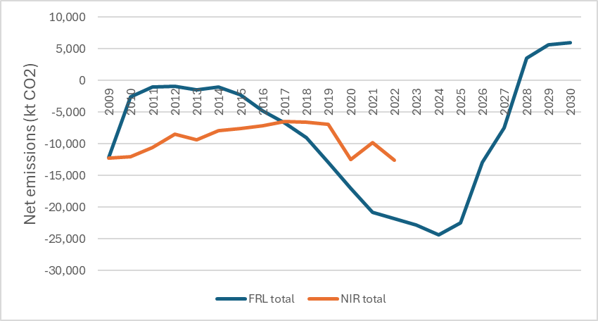

**Figure 2. Comparison of FRL projections for planted forests with estimates of net emissions under Forest Management for 2010-2022, derived from greenhouse gas inventory reporting**

From 2010-2016 net emissions are higher in the FRL projections (i.e. removals are lower), which is consistent with the higher level of harvesting that resulted from applying the harvest fraction approach (see Figure A3-13). In the second half of the compliance period (2026-2030), projected net emissions are lower than what has been reported to date, which is also consistent with the trend in harvest levels shown in Figure A3-13. On average, FRL net emissions are 13% higher annually since 2009 than would be calculated for planted forests under Forest Management accounting based on the 2024 greenhouse gas inventory submission (MfE, 2024a).

Net emissions projected from 2009 onward for the FRL should generally coincide with the reported Forest Management net emissions for the same period if there are no differences in the data and methodology and no significant changes in management.

There are some indications that management has continued to evolve, for example with lower proportions harvested from stands aged below 34 and higher proportions of age class area harvested over that age, as shown in the “post-2009” harvest fraction by age profile in Figure A3-9. The differences shown in Figure 2 could reflect a change in management that is self-correcting over time – i.e. a period of lower-than-expected harvesting leading to lower net emissions than in the FRL, followed by a period of higher net emissions as the mature wood that has accumulated is progressively harvested. The comparison suggests there is no consistent bias.

A further reconciliation could be made by re-running the FRL simulation but with a harvest fraction based on the post-2009 period,

# Discussion

The FRL provided in this report is an important component of accounting for the contribution of forests to New Zealand’s Nationally Determined Contribution under the Paris Agreement, because it defines the business-as-usual level of emissions against which the additionality of actual reported net emissions will be assessed.

The approach taken to develop the FRL follows guidance provided for European Union member states. New Zealand intends to account for forests using the activities introduced for the Kyoto Protocol accounting, rather than the land categories used for greenhouse gas inventory reporting. This means that the FRL applies to “Forest Management”, so care must be taken to exclude any area that would be accounted for as “Afforestation/Reforestation” lands (i.e. forests first established after 31 December 1989) or “Deforestation” land (i.e. any forest land that had been converted to a non-forest land use after 31 December 1989, even where it is later re-established as forest).

The FRL covers both pre-1990 planted and pre-1990 natural forests. It is intended to reflect expected net emissions from these forests over the 2021 to 2030 compliance period, assuming a projection of the business-as-usual management that was applied in the reference period from 2000-2009.

Defining business-as-usual management for production planted forests based on the data available is not straight-forward. In New Zealand, planted forests are generally planted as an investment, with clearfelling scheduled to achieve individual owners’ objectives. The logic of expecting a constant fraction of each age class area (or of the mature standing volume) to be harvested each year is questionable unless the forest is in a steady-state with an even spread of age classes. Even then, rotation age is not prescribed by legislation and forest owners may increase or reduce their harvest in response to their own needs. However, the approach to developing the FRL applied here applies a fixed historic harvest fraction to avoid the need to apply arbitrary yield regulation constraints. These have been used in the past to set pragmatic limits on annual changes in harvest levels, but it is difficult to define an objective rule set to use to create these constraints. In practice, harvesting is likely to continue to fluctuate in response to market conditions and the uneven age class distribution of planted forests in New Zealand.

Difficulty remains in reconciling modelled harvest volumes, areas and ages with production statistics, for several reasons:

* According to the area data based on the LUCAS Land Use Map and NEFD age class distribution, a large area was already available to harvest in 2010, and according to the yield table (pre-1990 forest yield table for the cohort planted before 1990), carbon stocks per hectare were high. Both the areas and per hectare yields are higher than those used in MPI’s Wood Availability Forecasts.
* Estimates of average radiata pine harvest age from annual NEFD reports (e.g. MPI 2023) are slightly lower than modelled harvest ages for both the 2000-09 period and 2010-2021.

If the areas used to model net emissions for the FRL are accurate, it suggests that BAU management in the 2000-2009 reference period resulted in large areas of mature forest being left unharvested, and this continued during the period from 2010 as actual harvesting was low compared with the mature volume available. The harvest fraction-based scenario presented here does accumulate about 64,000 ha of ‘permanent’ forest by 2030 (approximately 4% of the total area), but it also harvests more volume in the 2010 to 2020 period than was reported in MPI production statistics.

The FRL model developed for pre-1990 planted forests for this report produced a destocking schedule (annual harvest and deforestation areas by age) that was then used as input to the LUCAS CRA software to calculate net emissions. This ensures consistency between data and methods used for development of the FRL and greenhouse gas inventory reporting. The net emissions from the above-ground biomass, below-ground biomass, dead wood and litter pools reported here were calculated in the LUCAS CRA. Additional calculations were made for soil carbon changes, wildfire emissions and net emissions from the harvested wood products pool. Projected net emissions from pre-1990 natural forests for the compliance period were estimated in a separate report and are also included here as they are a component of the overall pre-1990 FRL.

The FRL presented here is subject to technical corrections throughout the compliance period. Losses of pre-1990 forest area as a result of deforestation would require a technical correction, to reflect the smaller area of pre-1990 forests. The deforestation emissions would be accounted in full. However, losses of pre-1990 planted forest area to pre-1990 natural forests (and vice versa) are regarded as a change in forest management that should generate credits or liabilities against the FRL, so no technical correction to the FRL is made. Gains in area would only generate a technical correction if they are due to mapping corrections, as gains from non-forest land uses should be accounted for as Deforestation land, and gains from natural forest are a change in forest management.

Wildfire emissions in the FRL are calculated based on a rate per hectare, so would require a technical correction as the area changes. Further technical correction may be required to ensure that reported wildfire emissions and the emissions within the FRL are truly comparable.

Technical corrections would also be required if improvements are made to underlying data and assumptions used in both the FRL and greenhouse gas inventory reporting. This includes the yield tables, harvested wood product discard rates, and steady-state soil carbon stocks applying before 2010.

# Conclusions

The Forest Reference Level (FRL) provided in this report is a single value representing the average net emissions from pre-1990 planted and natural forests expected over the 2021-2030 Paris Agreement compliance period, assuming the continuation of management applied in the 2000-2009 reference period. If actual reported net emissions from pre-1990 forests are higher, an accounting liability ensues.

The FRL value of -20.1 Mt CO2-e is a net removal of CO2 from the atmosphere, with total emissions being only 0.06% of total gross removals. Planted forest wildfire emissions of CH4 and N2O make up 90% of this low level of gross emissions. In the first half of the compliance period, removals are dominated by CO2 uptake in planted forests (87%), followed by increases in the planted forest HWP pool (7%) and CO2 uptake in natural forests (5%). However, the balance changes for the second half of the period as harvesting becomes concentrated in pre-1990 planted forests rather than post-1989 planted forests, and from 2028 onward the pre-1990 planted forests are a net carbon source. As a result, the contribution to gross removals from net CO2 uptake in pre-1990 planted forests falls to 7% for 2026-2030, while increases in the HWP pool carbon stock provide 83%. Removals by pre-1990 natural forests are relatively constant throughout the compliance period, but their contribution doubles to 10% in the second half as removals from pre-1990 planted forests decline.

These results highlight the rapid changes that can occur in planted forests and the difficulties that arise when setting budgets over five-year time periods. A strong trend is evident over the compliance period, driven by the presence of post-1989 planted forests in a relatively narrow band of age classes. This means that net removals from pre-1990 planted forests can fluctuate depending on whether or not post-1989 forests are making a significant contribution to the year’s harvest. The FRL assumes that the business-as-usual harvest fraction is applied to overall planted forests. Delays of only a few years in the timing of increases or decreases in the total level of harvest can also have a major impact on setting the FRL and accounting against it.

The FRL relies on accurate representation of the age class distribution, the yield tables and the assumptions that determine the level of harvest. Discard rates for HWPs are also an important factor. Relatively small changes in the assumptions can have a significant impact on the FRL value by affecting whether emissions or removals take place within or outside the compliance period.

It will therefore be necessary to continue to improve the data used to create the FRL and to report against it, including:

* Total net stocked area in pre-1990 and post-1989 planted forests over time.
* Allocation of net stocked area to age classes (2000-2009) and 2010 to 2030.
* Annual afforestation, deforestation and harvesting areas by age class.
* Yield tables for pre-1990 planted forest cohorts, as relevant plot remeasurement data become available.
* HWP end uses and lifespans in different markets.

There is a need to reconcile the emission and removal estimates for the 2010 to 2020 period resulting from the implementation of the historic harvest fraction with reporting in the greenhouse gas inventory for that period. If there has been no obvious change in management over that period but large differences exist between projected and actual net emissions, the implication is that the harvest fraction is not suitable for defining and projecting business-as-usual management. Net emissions reported in national inventory reports were lower than FRL net emissions from 2010-17 but higher from 2018-2022, suggesting that credits and debits accrued from reference level accounting may balance out in the longer term.

The reconciliation procedure outlined by Forsell et al. (2018) would require new projections to be made based on harvest fractions derived for the post-2009 period. Verification would ideally be undertaken separately for gains and losses, and for each carbon pool.

A better understanding of differences in management between pre-1990 and post-1989 planted forests would be useful to test the assumption that these two forest classes are best modelled as a single resource.

# References

Dovey, S.B., & Wakelin, S.J. (2024). Long-Term Average Carbon Stock Estimation Model. Unpublished contract report prepared for the Ministry for the Environment. Scion, Rotorua

Forsell, N., Korosuo, A., Federici, S., Gusti, M., Rincón-Cristóbal, J-J., Rüter, S., Sánchez-Jiménez, B., Dore, C., Brajterman, O., & Gardiner, J. (2018). Guidance on developing and reporting Forest Reference Levels in accordance with Regulation (EU) 2018/841. [https://op.europa.eu/en/publication-detail/-/publication/5ef89b70-8fba-11e8-8bc1-01aa75ed71a1/language-en. Accessed 18 May 2020](https://op.europa.eu/en/publication-detail/-/publication/5ef89b70-8fba-11e8-8bc1-01aa75ed71a1/language-en.%20Accessed%2018%20May%202020).

García, O. (1984). FOLPI, a forestry-oriented linear programming interpreter. Pp. 293-305 in Nagumo et al (Ed.) Proceedings of IUFRO Symposium on Forest Management Planning and Managerial Economics. University of Tokyo.

Grassi, G., & Pilli, T. (2017). Projecting forest GHG emissions and removals based on the “continuation of current forest management”: the JRC method. EUR 28623 EN. Luxembourg (Luxembourg): Publication Office of the European Union; 2017. doi:10.2760/844243.

Intergovernmental Panel on Climate Change (IPCC). (2006). 2006 IPCC Guidelines for National Greenhouse Gas Inventories. Prepared by the National Greenhouse Gas Inventories Programme, Eggleston H.S., Buendia I., Miwa K., Ngara T. and Tanabe K. (eds). Published: IGES, Japan.

Intergovernmental Panel on Climate Change (IPCC). (2014). 2013 Revised Supplementary Methods and Good Practice Guidance Arising from the Kyoto Protocol, Hiraishi, T., Krug, T., Tanabe, K., Srivastava, N., Baasansuren, J., Fukuda, M. and Troxler, T.G. (eds). Published: IPCC, Switzerland.

Intergovernmental Panel on Climate Change (IPCC). (2019). 2019 Refinement to the 2006 IPCC Guidelines for National Greenhouse Gas Inventories, Calvo Buendia, E., Tanabe, K., Kranjc, A., Baasansuren, J., Fukuda, M., Ngarize, S., Osako, A., Pyrozhenko, Y., Shermanau, P. and Federici, S. (eds). Published: IPCC, Switzerland.

Manley, B.R., & Evison, D. (2017). Quantifying the carbon in harvested wood products from logs exported from New Zealand. *NZ Journal of Forestry*, 62(3).

Manley, B. R., Papps, S. R., Threadgill, J. A., & Wakelin, S. J. (1989). Application of FOLPI - a linear programming estate modelling system for forest management planning. FRI Bulletin No. 164, 14p.

Margules Groome (2021). Wood Availability Forecast – New Zealand 2021 to 2060. ISBN: 978-1-99-101914-1 (online). <https://www.mpi.govt.nz/dmsdocument/47671-Wood-Availability-Forecast-New-Zealand-2021-to-2060>

MFE (2020). New Zealand’s Greenhouse Gas Inventory 1990-2018. Ministry for the Environment, Wellington.

MFE (2023). New Zealand’s Greenhouse Gas Inventory 1990-2021. Ministry for the Environment, Wellington.

MFE (2024). New Zealand’s Greenhouse Gas Inventory 1990-2022. Ministry for the Environment, Wellington.

MPI (2023). National Exotic Forest Description as at 1 April 2022. Edition 39. Ministry for Primary Industries. ISSN:1170-5191.

Palmer, H. (2018). Assessing the feasibility of a continuous cover forestry system for radiata pine in small-scale forests. Farm Forestry New Zealand. <https://www.nzffa.org.nz/article-archive/assessing-the-feasibility-of-a-continuous-cover-forestry-system/>

Paul, T. S. H., Wakelin, S. J., & Dodunski, C. (2024). The National Forest Inventory 2018-2022 analysis: Yield tables and carbon stocks in planted forests in New Zealand based on a five-year inventory cycle. Unpublished contract report prepared for the Ministry for the Environment. Scion, Rotorua.

Vauhkonen, J., Mutanen, A., Packalen, T., & Asikainen, A. (2021). Initial forest age distribution may generate computational sinks or sources of carbon: A generic approach to test assumptions underlying the EU LULUCF forest reference levels. Carbon Balance Manage 16, 13.. <https://doi.org/10.1186/s13021-021-00177-4>

Wakelin, S.J. (2023). Annual updating of the Harvested Wood Products carbon accounting model. Unpublished contract report for the Ministry for the Environment. Scion. 31pp.

Wakelin, S. J., & Garrett, L. G. (2010). Biomass carbon loss from forest harvesting. Unpublished. Report for the Ministry for the Environment, Scion.

Wakelin, S.J., Klinger, S., & Paul, T.S.H. (2021). Forest Reference Level Modelling for the Paris Agreement. Report 2: FRL Model (MPI Contract 406118). Contract report for Ministry for Primary Industries. Scion.

Wakelin, S.J. & Paul, T.S.H. (2012). Towards Species-Specific Simulation in the LUCAS Calculation and Reporting Application. Contract report prepared for the Ministry for the Environment.

Wakelin SJ, Paul TSH (2020). Including Forest Management in New Zealand’s 2030 Paris Agreement Target. Report 1 – Context. Contract report for Ministry for Primary Industries. Scion.

Wakelin SJ, Paul TSH (2024). Forest Reference Level for Pre-1990 Natural Forests under the Paris Agreement. Contract report prepared for the Ministry for the Environment. Scion.

Wakelin, S.J., Searles, N., Lawrence, D., Paul TSH (2020). Estimating New Zealand’s harvested wood products carbon stocks and stock changes. Carbon Balance and Management 15, 10

Wekesa, A., Manley, B., & Evison, D. (2022). Improved data on harvested wood products. MPI Technical Paper No. 2023/02. Ministry for Primary Industries.

# Appendix 1. Land use change into pre-1990 planted forest (MfE 2024)

|  |  |  |  |  |  |  |  |  |  |  |  |  |  |  |  |  |
| --- | --- | --- | --- | --- | --- | --- | --- | --- | --- | --- | --- | --- | --- | --- | --- | --- |
| Year | **Pre-1990 natural forest** | **Pre-1990 planted forest** | **Post-1989 planted forest** | **Post-1989 natural forest** | **Annual cropland** | **Perennial cropland** | **High producing Grassland** | **Low producing Grassland** | **Grassland With woody biomass** | **Wetland - Open water** | **Wetland - Vegetated** | **Settlements** | **Other Land** | **TOTAL** | **Annual soil C change** | **Annual soil C LOSS** |
|  | Hectares per year | | | | | | | | | | | | | | t C ha-1 yr-1 | |
| 1990 | 1401 |  |  |  |  |  |  |  |  |  |  |  |  | 1401 | -0.0095 | 0 |
| 1991 | 1401 |  |  |  |  |  |  |  |  |  |  |  |  | 1401 | -0.0095 | 0 |
| 1992 | 1401 |  |  |  |  |  |  |  |  |  |  |  |  | 1401 | -0.0095 | 0 |
| 1993 | 1401 |  |  |  |  |  |  |  |  |  |  |  |  | 1401 | -0.0095 | 0 |
| 1994 | 1401 |  |  |  |  |  |  |  |  |  |  |  |  | 1401 | -0.0095 | 0 |
| 1995 | 1401 |  |  |  |  |  |  |  |  |  |  |  |  | 1401 | -0.0095 | 0 |
| 1996 | 1401 |  |  |  |  |  |  |  |  |  |  |  |  | 1401 | -0.0095 | 0 |
| 1997 | 1401 |  |  |  |  |  |  |  |  |  |  |  |  | 1401 | -0.0095 | 0 |
| 1998 | 1401 |  |  |  |  |  |  |  |  |  |  |  |  | 1401 | -0.0095 | 0 |
| 1999 | 1401 |  |  |  |  |  |  |  |  |  |  |  |  | 1401 | -0.0095 | 0 |
| 2000 | 1401 |  |  |  |  |  |  |  |  |  |  |  |  | 1401 | -0.0095 | 0 |
| 2001 | 1401 |  |  |  |  |  |  |  |  |  |  |  |  | 1401 | -0.0095 | 0 |
| 2002 | 1401 |  |  |  |  |  |  |  |  |  |  |  |  | 1401 | -0.0095 | 0 |
| 2003 | 1408 |  |  |  |  |  |  |  |  |  |  |  |  | 1408 | -0.0095 | 0 |
| 2004 | 1401 |  |  |  |  |  |  |  |  |  |  |  |  | 1401 | -0.0095 | 0 |
| 2005 | 1401 |  |  |  |  |  |  |  |  |  |  |  |  | 1401 | -0.0095 | 0 |
| 2006 | 1401 |  |  |  |  |  |  |  |  |  |  |  |  | 1401 | -0.0095 | 0 |
| 2007 | 1401 |  |  |  |  |  |  |  |  |  |  |  |  | 1401 | -0.0095 | 0 |
| 2008 | 147 |  |  |  |  |  | 17 | 28 | 70 |  | 1 |  | 1 | 264 | 0.18662 | 0.4514 |
| 2009 | 147 |  |  |  |  |  | 17 | 28 | 70 |  | 1 |  | 1 | 264 | 0.18662 | 0.4514 |
| 2010 | 147 |  |  |  |  |  | 17 | 28 | 70 |  | 1 |  | 1 | 264 | 0.18662 | 0.4514 |
| 2011 | 147 |  |  |  |  |  | 21 | 28 | 70 |  | 1 |  | 1 | 268 | 0.19346 | 0.4579 |
| 2012 | 147 |  |  |  |  |  | 17 | 28 | 70 |  | 1 |  | 1 | 264 | 0.18662 | 0.4514 |
| 2013 | 5 |  |  |  |  |  | 33 | 86 | 139 |  |  |  |  | 263 | 0.45513 | 0.4641 |
| 2014 | 5 |  |  |  |  |  | 29 | 93 | 92 |  |  |  |  | 219 | 0.4943 | 0.5061 |
| 2015 | 5 |  |  |  |  |  | 29 | 95 | 88 |  |  |  |  | 217 | 0.49976 | 0.5118 |
| 2016 | 5 |  |  |  |  |  | 29 | 94 | 92 |  |  |  |  | 220 | 0.49513 | 0.5069 |
| 2017 | 64 |  |  |  |  |  | 18 | 57 | 49 |  |  |  |  | 188 | 0.33924 | 0.5192 |
| 2018 | 64 |  |  |  |  |  | 56 | 82 | 159 |  |  |  | 0 | 361 | 0.37966 | 0.4635 |
| 2019 | 64 |  |  |  |  |  | 129 | 133 | 54 |  |  |  |  | 380 | 0.49545 | 0.5977 |
| 2020 | 64 |  |  |  |  |  | 48 | 168 | 44 |  |  |  |  | 324 | 0.48403 | 0.6055 |
| 2021 | 64 |  |  |  |  |  | 62.75 | 110 | 76.5 |  | 0 |  | 0 | 313.25 | 0.4357 | 0.5500 |
| 2022 | 64 |  |  |  |  |  | 62.75 | 110 | 76.5 |  | 0 |  | 0 | 313.25 | 0.4357 | 0.5500 |
| 2023 | **64** |  |  |  |  |  | 62.75 | 110 | 76.5 |  | 0 |  | 0 | 313.25 | 0.4357 | 0.5500 |
| 2024 | 64 |  |  |  |  |  | 62.75 | 110 | 76.5 |  | 0 |  | 0 | 313.25 | 0.4357 | 0.5500 |
| 2025 | 64 |  |  |  |  |  | 62.75 | 110 | 76.5 |  | 0 |  | 0 | 313.25 | 0.4357 | 0.5500 |
| 2026 | 64 |  |  |  |  |  | 62.75 | 110 | 76.5 |  | 0 |  | 0 | 313.25 | 0.4357 | 0.5500 |
| 2027 | 64 |  |  |  |  |  | 62.75 | 110 | 76.5 |  | 0 |  | 0 | 313.25 | 0.4357 | 0.55 |
| 2028 | 64 |  |  |  |  |  | 62.75 | 110 | 76.5 |  | 0 |  | 0 | 313.25 | 0.4357 | 0.55 |
| 2029 | 64 |  |  |  |  |  | 62.75 | 110 | 76.5 |  | 0 |  | 0 | 313.25 | 0.4357 | 0.55 |
| 2030 | 64 |  |  |  |  |  | 62.75 | 110 | 76.5 |  | 0 |  | 0 | 313.25 | 0.4357 | 0.55 |

Notes:

* Previous Land Use column heading shading:  
  - red = no conversion to pre-1990 planted forest  
  - blue = conversion with loss of soil carbon  
  - brown = conversion with gain of soil carbon
* Annual soil carbon change per hectare per year is the area-weighted average difference in steady-state soil carbon stock values between the previous land use and pre-1990 planted forests, divided by the 20-year transition period.
* Annual soil C loss is the soil carbon change as above but excluding land use change where a gain in soil carbon results. This is potentially used in the calculation of N2O emissions due to soil disturbance, but only in cases where land use changes result in a net loss of soil carbon. However, for pre-1990 planted forests that are accounted for as Forest Management lands within the FRL, there are no land use changes that result in a loss in soil carbon. Land use changes from non-forest land uses into pre-1990 planted do lose soil carbon but this land would be accounted for as Deforestation land and therefore not included in the FRL.
* Areas from 2021 onward (red text on blue cell shading) are projections based on the average from 2017-2020, but are not used in the FRL, because any gains from non-forest land would be accounted for as Deforestation land and gains from pre-1990 natural forest represent a change in management.

# Appendix 2. Exploratory modelling

## Defining BAU harvesting during the reference period

Options for developing a Forest Reference Level, including applying the proposed European Union approach outlined by Forsell et al., (2018), have been previously investigated (Wakelin & Paul, 2020; Wakelin et al., 2021).

Wakelin et al. (2021) describe a trial application of the EU FRL approach to New Zealand data.

The central concept of the EU approach is the use of “harvest fraction” to characterise BAU harvest intensity. This is a useful concept for forests under continuous cover management, where harvest interventions can be more or less frequent and remove more or less volume each time. It has less apparent applicability to forests that have been planted with the intention of future clearfell harvesting in response to market conditions.

Three options were described for projecting the BAU level of harvest by Forsell et al., (2018):

1. Determining biomass harvested as a fraction of biomass available for harvest and apply this fraction by age class to estimates of future harvestable biomass availability.
2. Determining biomass harvested as a fraction of total biomass and apply this fraction to estimates of future total biomass.
3. As a last resort, assuming that the harvest level during the reference period applies during the compliance period (i.e. any increase in harvest due to the forest maturing is treated as a liability against the FRL).

Harvest fraction (harvest volume as a proportion of mature volume available to harvest) would normally be calculated from reported statistics of standing volumes and harvest volumes by age. In Figure A2-1 (from Wakelin et al., 2021) it is instead estimated from a simulation of model outputs that based the allowable level of harvesting on one of MPI’s Wood Availability Forecast scenarios (Margules Groome, 2021).

In this case the Harvest Fractions are derived from the model outputs, rather than being used to determine the future level of harvest by age. Future harvesting rates were determined by setting target rotation ages and limiting the rate of inter-annual increases and decreases in the harvest level. For this scenario, the total harvest fraction falls from over 30% to just over 10% during the 2000-09 reference period. Similar fluctuations were expected in future due to the uneven age class distribution. Setting the required Harvest Fraction to the average value over 2000-09 or the 2009 value and applying this as a constraint to set the allowable harvest level would unduly constrain future harvesting without being consistent with BAU management. It would generate credits or liabilities based on annual harvest areas, volumes and ages that are not consistent with historic practice. It would also not replicate reporting for the 2010-2021 period in the NIR.

**Figure A2-1. Harvest fraction – volume harvested as a proportion of (a) total volume (blue), and (b) total mature volume (red). (The different symbols just distinguish between different time periods, including the reference period (2000-2009, coloured dots) and the compliance period (2021-2030, grey dots)**

In practice, if there is very little mature forest available to be harvested in a year, a higher proportion of it may be harvested, while the opposite is true when the volume of standing mature wood in a harvestable age class is large.

Vauhkonen et al. (2021) showed that the initial age class distribution has a large bearing on the applicability of the harvest fraction approach. Their simulations closely matched the New Zealand situation, with a single-species under clearfell management. Only under an initially uniform age class distribution was the harvest fraction approach able to characterise management in the reference period in a way that allowed projections to be consistent with continuation of BAU forest management.

The authors stated that (emphasis added in bold):

*“…future forest resources and the degree of them that [are] available for different uses such as wood production or carbon sequestration evolve according to both the markets and climate.  In turn, both affect future management regimes and even ownership structure determining the development of forest resources via complex interactions. Therefore,* ***excessive emphases on accurate reproduction of past management practices*** *(hereafter, referred to as the backward-looking nature of the current FRLs) can be in contrast to implementing sustainable forest management or enhancing future carbon stocks.* ***This aspect becomes problematic also if******an ability to correctly produce the historical development of the forest resources (in the Reference Period or before the Compliance Period) becomes a key success criterion*** *for the FRL proposals.*” (Vauhkonen et al., 2021).

While Vauhkonen et al. (2021) regard the forced reproduction of historic development of the resource as undesirable, they do not provide a clear alternative, other than transparent modelling with an open-source application that simulates management based on transition probabilities, constrained to meet requirements under one of three production scenarios. An approach using transition probabilities was ultimately applied for New Zealand’s pre-1990 planted forest FRL, as described in Appendix 3.

## Data and exploratory modelling

Models need to be based on accurate data if model projections are to be consistent with reported statistics. Issues with data quality and completeness were previously identified in Wakelin et al 2021:

1. NEFD area accuracy – particularly small-grower area that is not collected in annual surveys but has been imputed from nursery sales, and whether over-mature areas are still intended to be harvested.
2. Age class distribution by species group as of 2009.
3. Time series for afforestation, deforestation and harvesting by age class and species groups.
4. Reconciling the yield table for 2000-09 and the resulting simulated harvest volumes with MPI harvest statistics.
5. Reconciling plot-based and simulation-based carbon stocks for pre-1990 planted forest.
6. Obtain country-specific end use and half-life estimates for HWPs produced in New Zealand.

The last of these points has been addressed through the survey described in Wekesa et al. (2022). However, there are still issues with the accuracy of net stocked area (in total, by species group and by age), and a lack of harvesting and deforestation data by species and age.

Reconciliation of model outputs with production statistics is limited by the small number of yield tables used (three in the LUCAS CRA simulation). Matching all three components - average harvest age, harvest volume and harvest area – on an annual basis is difficult because the relationship between these variables is set by the yield table.

***Area data***

Pre-1990 and post-1989 planted forest areas by age class as of 2009 were provided by MfE based on the data for the 2023 NIR submission. Allocation to species was made based on 2009 data provided by MPI. The age profile as of 2009 is given for radiata pine and other species in Figure A2-2 and Figure A2-3 respectively (note the difference in scale). The total net stocked area is 1,769,257 ha.

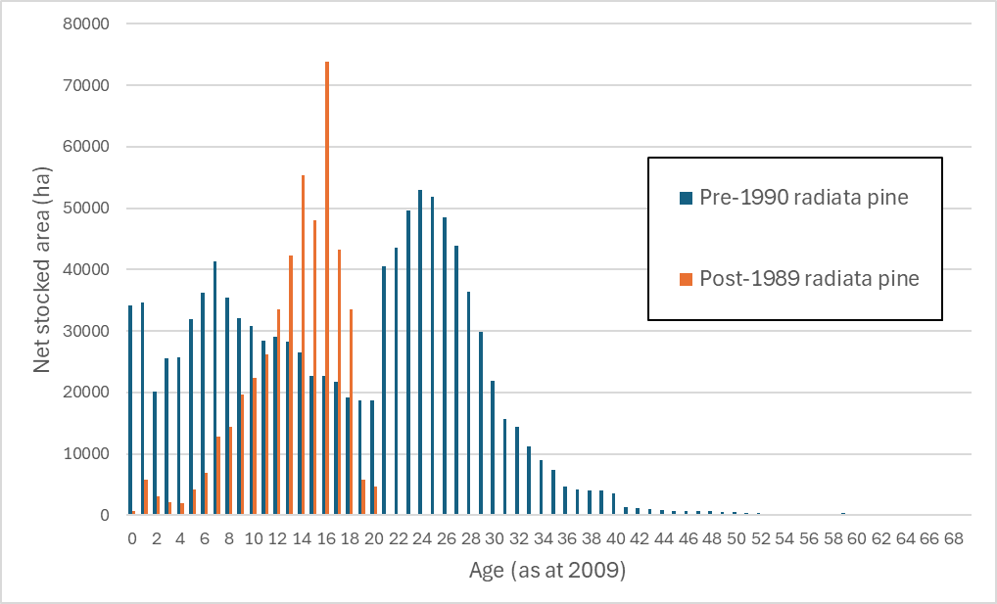

**Figure A2-2. Age profile of radiata pine in pre-1990 and post-1989 planted forest as at 2009.**

For all species groups, the post-1989 distribution of area is narrow, as a result of the short period of high afforestation that took place in the mid-1990s. Also of note is the ‘tail” of pre-1990 forest area that is past the typical rotation ages of 27-29 for radiata pine, 30-45 for other softwoods and 20-30 for hardwoods.

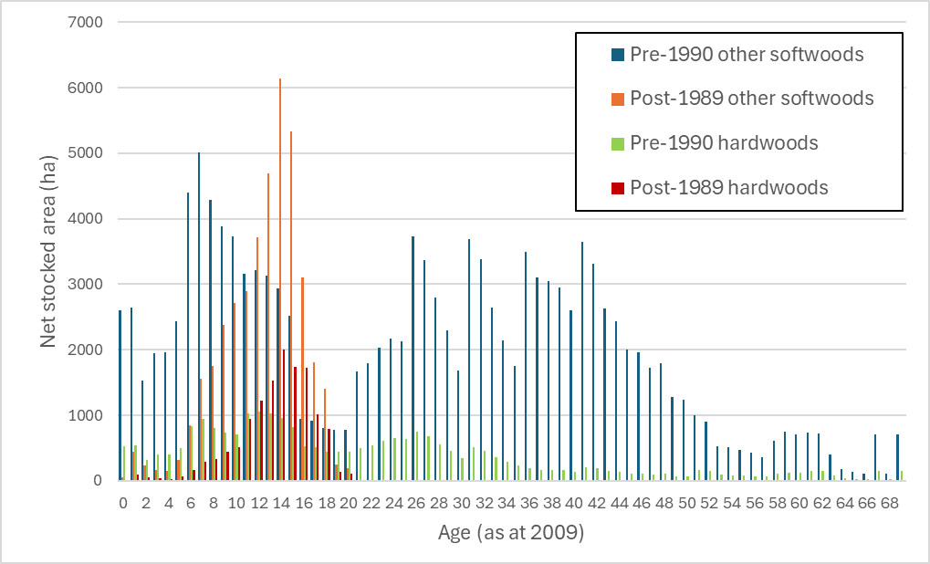

**Figure A2-3. Age profile of Douglas fir and other softwoods and all hardwoods in pre-1990 and post-1989 planted forests as at 2009.**

***Area adjustments***

Two initial models were run in FOLPI-XL using the area data above and yield tables prepared in Paul et al., 2024. The purpose was to explore the availability of harvestable biomass (and therefore potential annual harvesting rates) through simulation over the period from 2010 to 2090. Both models included annual afforestation and deforestation areas from 2010 to 2022 as reported in the greenhouse gas inventory (MfE, 2024). The first had no constraints on total destocking volume or area, while the second was constrained to match MPI roundwood production statistics[4] from 2010 to 2022, and also included deforestation area projections to 2030 used in previous modelling (Wakelin et al., 2021).

The minimum allowable clearfell age for radiata pine was set to 19 years from 2010 to 2015 to ensure enough area was available to meet the post-1989 planted forest deforestation area targets, but the model was otherwise limited to destocking radiata from age 25, other softwoods from age 40 years and hardwoods from age 25 years.

Results suggest that in 2010 there were almost 350 million m3 of mature wood available for immediate harvest (Figure A2-4). When constrained to instead meet actual roundwood removal statistics from 2010 until 2022, another 100 million m3 of additional mature wood built up so that over 450 million m3 was available to be felled in 2023 (Figure A2-5).

**Figure A2-4. Harvest volume (m3) assuming no harvest volume constraints**

**Figure A2-5. Harvest volume (m3) assuming 2010-2022 harvest volume is set based on MPI data**

MPI’s latest wood availability forecasts faced a similar issue, and one approach made after consultation with local forest industry experts was to remove over-mature areas (as of 2019) from the database (Margules Groome, 2021). The decision was made to remove from MPI’s wood availability forest models:

* Radiata pine (large owners) area aged > 35 years
* Radiata pine (small owners) area aged > 40 years
* Douglas fir area aged > 60 years
* Other species area aged > 60 years

In addition:

* Areas imputed or from the 2004 Small Forest Owner Survey that were older than 24 years were removed.
* Area of stands aged 1-4 years were reduced by 5% (to better represent net stocked area)
* A restocking adjustment of 4% was made in East Coast and Canterbury

For the FRL developed in this report, it was decided to follow the lead provided by MPI’s wood availability forecasts and remove some of the mature area, since it can skew estimates of harvest age and/or volume and emissions upward if retained.

For preparation of the FRL presented in this report, the following areas were removed:

* Radiata pine aged > 42 years (8,860 ha)
* Other softwoods aged > 60 years (3,835 ha)
* Hardwoods aged > 60 years (801 ha)

The total area removed is 13,496 ha or 0.8% of the total area. However, removing these areas had minimal impact on the build-up of mature wood in the forest, with almost 400 million m3 still available to be harvested in 2023.

A shift to spatial age class mapping of planted forest area for the NEFD may help to better define planted forest areas by age for use in greenhouse gas inventory reporting and accounting. If over-mature areas are no longer considered to be production forests, the existing yield table may not accurately reflect their ongoing productivity, leading to higher modelled removals than being achieved. More work is needed to define the areas of permanent planted forest and their productivity.

***Simple yield regulation model***

After adjusting the area data as described above, a revised FOLPI-XL model was developed that added a simple constraint to ensure that the annual volume harvested did not decline before 2026. From this point onward, the harvest was allowed to fall and rise by within 20% of the previous year’s harvest. Harvest volumes were well above the roundwood removals reported in MPI statistics, though not as extreme as in the models illustrated in Figures A2-4 and A2-5 where volume increases were not constrained.

**Figure A2-6. Roundwood removals (m3) from MPI statistics (“MPI”) compared with a scenario with harvest volumes based on yield regulation constraints.**

Yield regulation constraints are commonly used in forest modelling to reflect logistical constraints (such as the availability of logging equipment, trucks, export ships and mill capacity), the need for continuity of labour and the need to meet supply contracts. They prevent infeasibly large variation between production from year to year. They are an alternative to setting the level of harvest based on historic factors.

In this case the constraint allows a steady level of production while there is mature wood available to harvest, but after the peak in the age class distribution has passed, the harvest is allowed to decline. This decline is due to the uneven age class distribution and is reflected in some of MPI’s wood availability forecasts. By allowing the harvest to rise and fall with the age class distribution, the harvest age (and age-related characteristics of the logs produced) can be maintained at a reasonably constant level. The alternative is to keep the harvest level constant by varying the harvest age. For example, for the model illustrated in Figure A2-6, it would be possible to reduce the modelled harvest to a level that could be sustained right through to 2040. This would bring the initial modelled harvest volume level down closer to MPI’s production statistics, but would result in much higher average harvest ages than reported by MPI.

Harvesting constraints in the above models did not distinguish between pre-1990 and post-1989 planted forests. Despite differences in ownership, it is reasonable to treat the resource as a single entity. Species groups were also combined, leading to large fluctuations in the proportions harvested by species each year. The FRL model developed after the initial modelling described here took into account these findings by:

* Removing some mature area.
* Modelling species groups separately, to spread the non-radiata pine harvest more evenly across years.
* Applying a simpler Harvest Fraction based on proportions of available age class areas harvested each year, rather than based on available biomass.

This is described in Appendix 3.

# Appendix 3. Harvest Fraction and other assumptions in the FRL model

**Harvest fraction approach**

The FRL model is required to estimate forest carbon losses due to the continuation of business-as-usual (BAU) harvest practices. The approach used to define BAU harvest practices was to determine a harvest fraction by age class over the reference period, corresponding to the proportion of age class area harvested (i.e. the probability of harvest by age, as used by Vauhkonen et al., 2021).

The source data used was the annual single-year age class distribution for planted forests published annually in the National Exotic Forest Description (NEFD) (e.g. MPI, 2023). By comparing successive age class distributions for the 1995 to 2022 period it is possible to see where area has been lost from an age class between successive years (Figure A3-1).

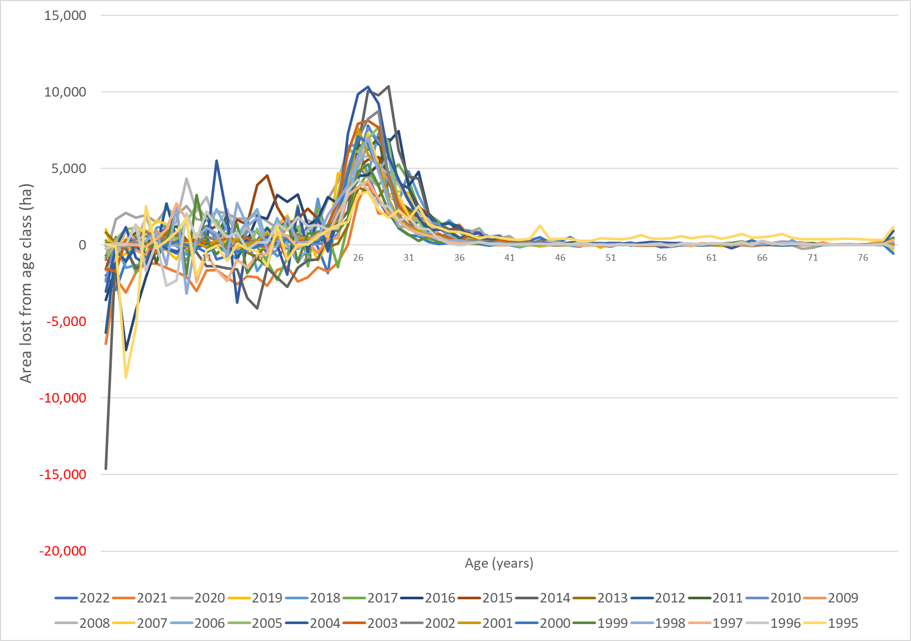

**Figure A3-1. Annual Area lost by age class (negative value indicates a gain of area)**

It is apparent that large areas are lost each year from age classes centred on the average radiata rotation age of 28, while for the older age classes (which hold relatively little area) changes are minor. In the younger age classes there are both gains and losses in area.

Area data is based on survey returns from the larger forest growers providing net stocked area of production planted forest. Area may be lost due to harvesting or deforestation activity, but reductions in reported area could also be due to routine remapping, changes in mapping standards, forest ownership changes, revised estimates following natural disturbances, changes in management intentions (e.g. no longer considering an area to be part of the production forest estate), or errors in reporting or NEFD data management. The gains in area shown in Figure A3-1 are most likely to be due to remapping or errors (or correction of previous errors). Accurate remapping of net stocked area is commonly undertaken after silvicultural interventions are complete and canopy closure is achieved, sometimes in conjunction with mid-rotation field inventory to improve accuracy of harvest forecasts.

Figure A3-2 shows the annual age class share of the total area lost each year at ages 15-45 over the reference period 2000-2009. As expected, typical rotation ages for radiata pine (25-30 years) dominate the area loss, although on average no single age class contributes more than about 16% towards the total area loss. The 15 year minimum matches the lowest age at which harvesting is simulated in the LUCAS CRA, and reflects the greater uncertainty in attributing area changes at younger ages to management interventions.

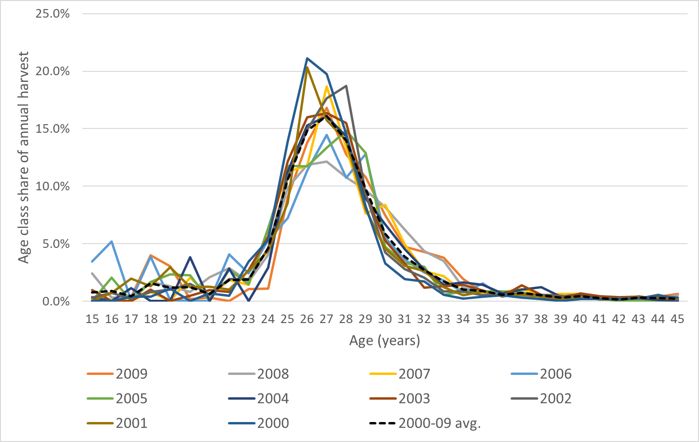

**Figure A3-2. Age class share of the annual harvest, from 2000 to 2009.**

The approach to developing a Harvest Fraction to define harvesting practice during the reference period assumes that the loss of area between ages 15 and 45 equates to a destocking event, which could be either harvesting or deforestation, depending on whether destocking is followed by forest re-establishment or land use change. For the purposes of the FRL, deforestation is assumed to take place at the same range of ages and in the same proportions as harvesting. In this report, “Harvest Fraction” applies to both harvesting and deforestation, i.e. it is a “Destocking Fraction”.

Figure A3-3 shows the cumulative area loss by age for each year in the reference period, showing a similar pattern with low apparent destocking from ages 15 to 24, and little occurring after about age 33. The year 2006 stands out as a comparative anomaly, with apparently greater levels of destocking occurring at younger ages.

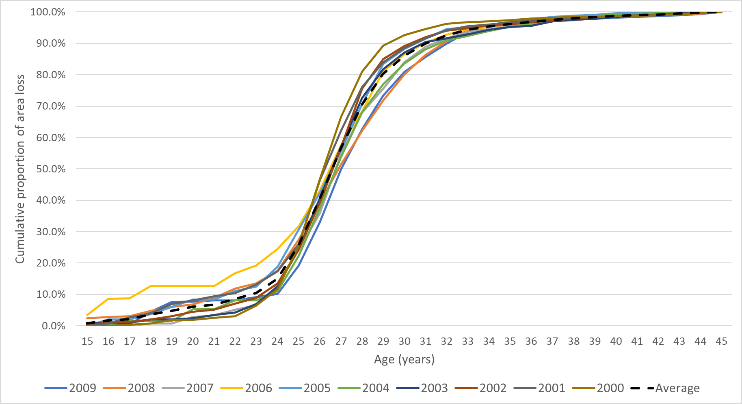

**Figure A3-3. Cumulative loss of area by age class for each year in the reference period.**

Figure A3-2 shows the contribution of each age class to total assumed destocking in each year, but the “Harvest Fraction” instead shows how much of the area available in an age class is destocked each year. This is shown in Figure A3-4 for each year in the reference period, together with the average over the period.

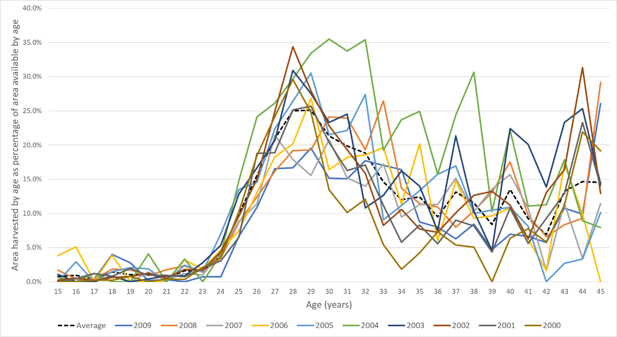

**Figure A3-4. “Harvest Fraction”, or** **area destocked by age as a proportion of available area in an age class, annually over the 2000 to 2009** **reference period**

The area available is defined by the area standing at the end of the previous year in the NEFD age class distribution, while the area destocked is the difference between that area and the area left standing at the end of the destocking year.

.

The age classes with the highest proportion of area felled were the typical rotation age range for radiata pine: 27-29 years. Even at these ages, only about 25% on average of the available area was harvested each year.

There is a large amount of variability in the harvest fraction at ages over 26, both between ages for a given year and between years (Figure A3-4). The average proportion harvested for each age class across 2002-2009 was also calculated (Figure A3-4 and Figure A3-5) and then smoothed using a three-year rolling average. For example, the fractions harvested at ages 14, 15 and 16 were averaged and applied to age 15, while age 16 used the fractions at ages 15, 16, and 17. The smoothed three-year rolling harvest fractions were used for modelling the BAU harvest schedule (Figure A3-5).

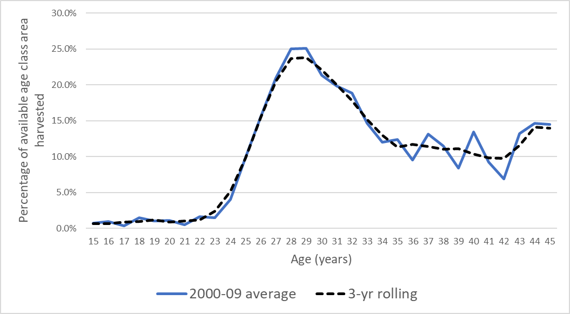

**Figure A3-5. Average harvest fraction (2000-2009) and three-year rolling average**

The sum of proportions from age 15 to age 45 in the three-year rolling average is about 97%, so of the total area entering the age 15 years class, 3% will still be unharvested 26 years later, and this will remain as ‘permanent forest (Figure A3-6).

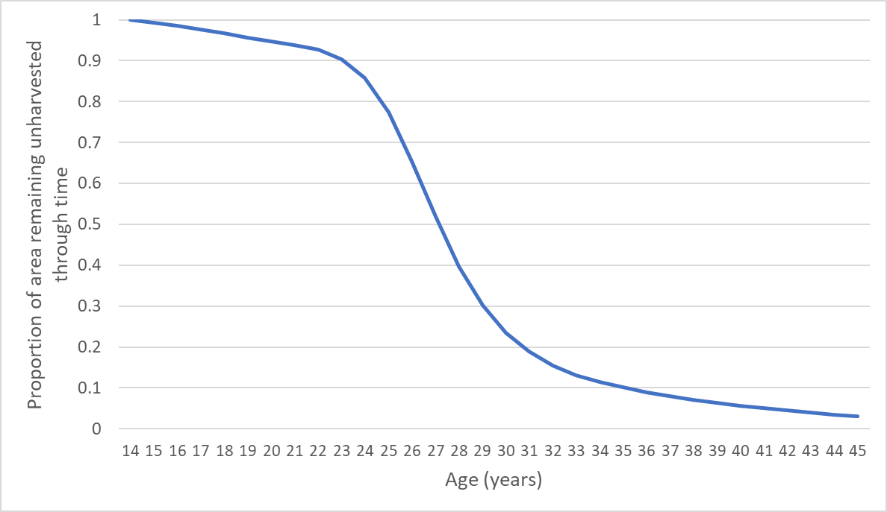

**Figure A3-6. Proportion of an initial area aged 14 that remains unharvested over time, according to the three-year rolling average curve in Figure A3-5.**

*Trends in Harvest Fraction over time*

There was some evidence that harvest fraction may have peaked in the middle of the 2000-2009 period, around 2004 (Figure A3-7) and that it has declined slightly for typical rotation ages of 26-30 during the reference period (Figure A3-8).

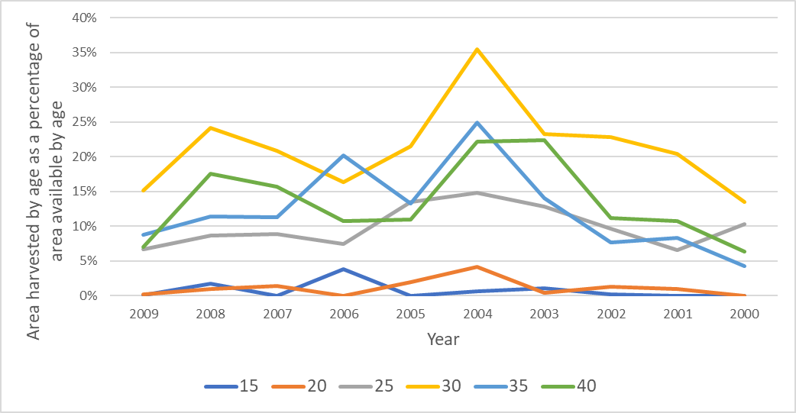

**Figure A3-7. Trend in harvest fraction over time for six ages (15 to 40)**

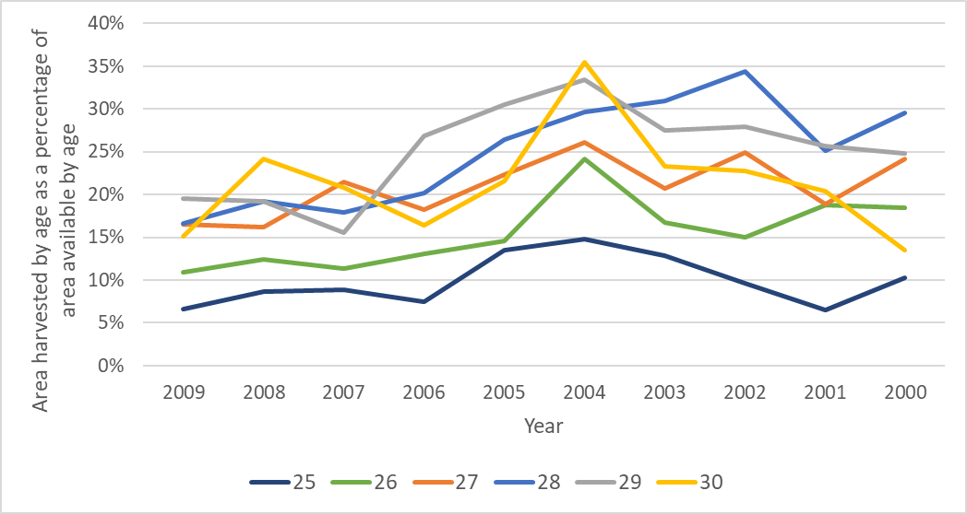

**Figure A3-8. Trend in harvest fraction by age over time for six typical rotation ages (25-30)**

A trend through the reference period should not be extrapolated, but a value at the end of the period can be used if this is more representative than an average (Forsell et al., 2018). Figure A3-9 compares the smoothed three-year rolling average harvest fraction for the 2000-2009 period with early- (2000-02), mid- (2003-06) and late-period (2007-09) averages. Harvest fractions in the early and mid-period peak at a narrow range of ages (27-30) and stay relatively high in the middle of the period. In contrast, at the end of the reference period the peak is lower and broader, and this pattern is also followed in the post-2009 period.

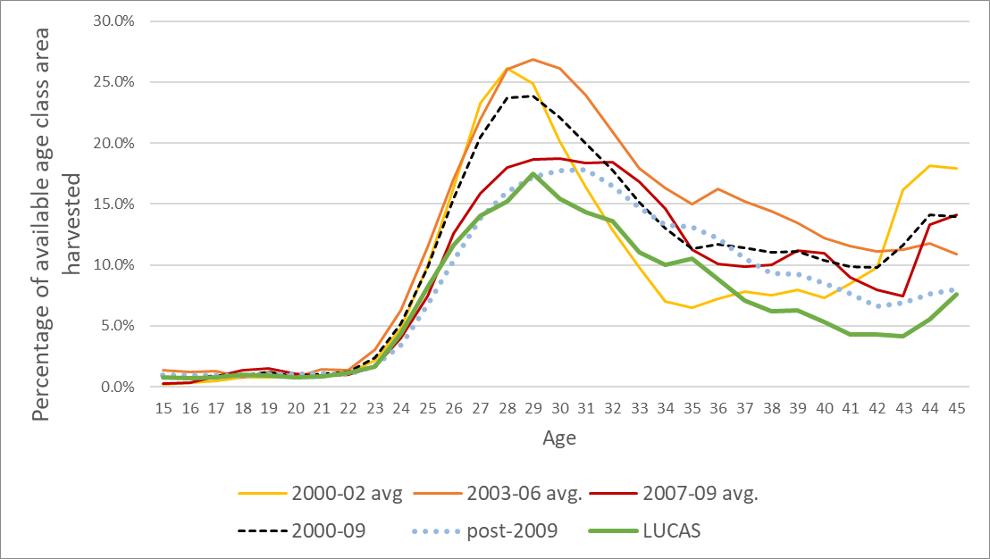

**Figure A3-9. Average harvest fraction by age, derived from NEFD data for different time periods (all 3-year rolling averages), and also harvest fraction derived from a LUCAS CRA simulation run.**

Figure A3-9 also includes the Harvest Fraction derived from a LUCAS CRA simulation run, which is also derived from annual NEFD age class area data, but is influenced by the post-2009 period because of steps taken to balance age class areas through the time series to the latest greenhouse gas inventory reporting year. Values are provided in Table A3-1.

**Table A3-1 Average harvest fraction by age, derived from NEFD data for different time periods (all 3-year rolling averages), and also harvest fraction derived from a LUCAS CRA simulation run.**

|  |  |  |  |  |  |  |
| --- | --- | --- | --- | --- | --- | --- |
|  | **Average harvest fraction by age for different periods** | | | | | |
| **Age** | **2000-02 avg.** | **2003-06 avg.** | **2007-09 avg.** | **2000-09** | **Post-2009** | **LUCAS** |
| 15 | 0.2% | 1.4% | 0.3% | 0.7% | 0.9% | 0.8% |
| 16 | 0.3% | 1.2% | 0.3% | 0.7% | 1.0% | 0.7% |
| 17 | 0.5% | 1.3% | 0.9% | 0.9% | 1.0% | 0.8% |
| 18 | 0.8% | 0.8% | 1.3% | 0.9% | 0.9% | 1.0% |
| 19 | 0.8% | 1.2% | 1.5% | 1.2% | 1.0% | 0.9% |
| 20 | 0.8% | 0.8% | 1.0% | 0.9% | 1.0% | 0.8% |
| 21 | 0.8% | 1.4% | 0.9% | 1.1% | 1.1% | 0.8% |
| 22 | 1.2% | 1.4% | 1.0% | 1.2% | 1.0% | 1.1% |
| 23 | 2.2% | 3.1% | 1.7% | 2.4% | 1.7% | 1.6% |
| 24 | 4.8% | 6.3% | 4.0% | 5.1% | 3.4% | 4.3% |
| 25 | 10.0% | 11.5% | 7.5% | 9.8% | 6.7% | 8.2% |
| 26 | 16.3% | 17.0% | 12.5% | 15.5% | 10.4% | 11.6% |
| 27 | 23.3% | 21.9% | 15.8% | 20.5% | 13.9% | 14.0% |
| 28 | 26.2% | 26.1% | 18.0% | 23.7% | 16.0% | 15.2% |
| 29 | 24.9% | 26.8% | 18.7% | 23.8% | 17.2% | 17.5% |
| 30 | 20.1% | 26.1% | 18.7% | 22.1% | 17.7% | 15.4% |
| 31 | 16.4% | 24.0% | 18.4% | 20.0% | 17.8% | 14.4% |
| 32 | 12.8% | 20.9% | 18.4% | 17.8% | 16.5% | 13.6% |
| 33 | 9.8% | 17.9% | 16.8% | 15.1% | 14.7% | 11.0% |
| 34 | 7.0% | 16.3% | 14.6% | 13.0% | 13.3% | 10.0% |
| 35 | 6.5% | 15.0% | 11.2% | 11.3% | 13.1% | 10.5% |
| 36 | 7.2% | 16.2% | 10.1% | 11.7% | 12.2% | 8.9% |
| 37 | 7.8% | 15.2% | 9.9% | 11.4% | 10.6% | 7.0% |
| 38 | 7.5% | 14.4% | 10.0% | 11.0% | 9.3% | 6.2% |
| 39 | 8.0% | 13.5% | 11.2% | 11.1% | 9.2% | 6.3% |
| 40 | 7.3% | 12.2% | 10.9% | 10.4% | 8.5% | 5.3% |
| 41 | 8.5% | 11.5% | 9.0% | 9.9% | 7.6% | 4.3% |
| 42 | 9.8% | 11.1% | 7.9% | 9.8% | 6.6% | 4.3% |
| 43 | 16.1% | 11.3% | 7.5% | 11.6% | 6.9% | 4.1% |
| 44 | 18.1% | 11.7% | 13.3% | 14.1% | 7.6% | 5.6% |
| 45 | 17.9% | 10.9% | 14.1% | 14.0% | 8.0% | 7.6% |

Three harvest fraction options were modelled in FOLPI-XL to derive a destocking schedule[5]:

* Scion 2000-09 (3-year rolling average from NEFD data for the reference period)
* Scion 2007-09 (3-year rolling average from NEFD data for the last three years of the reference period)
* LUCAS average harvest fraction, derived from a LUCAS CRA NIR simulation.

In each case, the annual harvest from 2010-2030 was set to a specific area from each age from 15 to 45 years. These areas were calculated by applying the proportions shown in Figure A3-9 to the annual area by age class, calculated from the initial area after adjusting for subsequent afforestation, harvesting/replanting and deforestation.

The model included both pre-1990 planted forest and post-1989 planted forest areas, and the harvest fractions were applied to the combined age class area. The final FRL presented here is based on the 2007-2009 average harvest fraction. This option defines harvest practice based only on data from the reference period, but restricts this to the latter part of the period because of the trend towards harvesting lower proportions across a wider range of ages.

It should be recognised that the proportion of an age class harvested in any year would only be expected to remain constant if the age class distribution is even, the mix of species and forest productivity is similar over time and demand is constant. With an uneven age class distribution, we would expect that in years in which age classes 27-29 years hold a large amount of area, the proportion harvested may be low. Similarly, in years in which there is less area in these age classes, the proportion harvested may be greater and younger age classes would be more heavily targeted for harvesting than usual.

## FOLPI-XL Modelling Approach and scenario outputs

The FRL is a projection over the period 2021-2030 of BAU forest management as it was applied during the 2000-2009 reference period. The approach taken here was to simulate forestry activity (afforestation, harvesting, replanting and deforestation) from 2010 onward within the Microsoft Excel-based forest estate optimisation software FOLPI-XL (<https://integral.co.nz/>), which is based on an earlier version developed at Scion (Garcia, 1981; Manley & Threadgill, 1990).

The model defines the initial state of planted forests in terms of areas by age classes, separated into three species groups within the post-1989 and pre-1990 planted forest categories. Yield tables describe the carbon stocks (and volume) in each current age class and for all possible future ages, including after replanting.

As described in Appendix 2, a relatively small amount of over-mature area was removed from the model in accordance with advice provided by forest industry representatives as part of a previous wood availability forecasting exercise.

Because of the differences in rotation length, the species groups were treated separately when projecting BAU management and used species-specific yield tables. Although these species are ultimately combined for greenhouse gas reporting and share the same yield table, this approach ensures that the destocking profile by age does not include years where production is dominated by minor species. Pre-1990 and Post-1989 forests were not constrained separately as they are unlikely to be managed independently in practice. However, they were separately identified in the area data so that different yield tables could be applied and destocking schedules reported separately.

The following yield tables were used (from Paul et al., 2024):

* 2a-4 - Post-1989 radiata pine
* 2a-5 - Post-1989 other softwoods
* 2a-6 - Post-1989 hardwoods
* 2b-5 – Pre-1990 radiata pine planted before 1990
* 2b-7 – Pre-1990 radiata pine planted 1990-2009
* 2a-2 – Pre-1990 other softwoods
* 2a-3 – Pre-1990 hardwoods

Optimisation in FOLPI-XL models uses linear programming to produce a schedule of future harvest activity that maximises the value of an *objective function* while meeting constraints. In the context of commercial forest management, the objective function is normally an equation calculating the net present value of the forest modelled, equal to the sum of discounted future net revenues. Discounting cashflows recognises that one dollar received today is worth more than one dollar received in 50 years’ time. Essentially the modelling exercise seeks a schedule of management activity that will maximise the value of the forest. The FRL model does not include financial information, so the objective function is instead to maximise the sum of discounted future harvest volumes. Discounting is still used to drive harvesting towards economically optimal harvest ages, as otherwise the best solution would be to only harvest stands once they have reached the maximum yield table value.

In practice, constraints included in the FRL model largely determine the harvest schedule. In particular, the use of the “Harvest Fraction” to define the continuation of business-as-usual management means that harvest by age class from 2010 to 2030 was largely an input to the model rather than an output.

The FRL model was further constrained as follows:

* The minimum clearfell age allowed through to the end of the compliance period was 15 for radiata pine, 35 for other softwoods and 20 for hardwoods. These limits were increased to ages closer to the target rotation age for each species group in the longer term (i.e. beyond the compliance period, when harvest fraction constraints were no longer applied and the model would otherwise chose to harvest as early as possible).
* No harvesting of stands older than 45 was permitted.
* The annual harvest from species other than radiata pine was constrained to create a relatively even level that would not dominate in any individual year. Other softwoods production was constrained to be within the range 0.5 – 2.5 million m3, while hardwood production was constrained to be within 0.3 – 0.8 million m3.
* The total harvest in the long term (after the compliance period) was required to be within the range 33.0 – 50.0 million m3. These limits were set based on the outputs from unconstrained runs, to smooth out production levels. A ± 25% limit was also placed on the rate of change in harvest volume from one year to the next.

The evolution of pre-1990 planted forest area over time was simulated with annual deforestation from pre-1990 planted forest and post-1989 planted forest separately to 2030. Annual afforestation into each species (post-1989 forest land) was also included to 2020. Simulations ran until 2090.

**LUCAS CRA Simulation**

The FRL should be produced using the same data and models used for greenhouse gas inventory reporting, to remove other possible sources of differences when comparing FRL net emissions with reported actual emissions. The aim of the modelling in FOLPI-XL was to produce a BAU harvesting schedule (areas harvested by age) from 2010 to 2030 that could be replicated within the LUCAS Calculation and Reporting Application (CRA) software used for greenhouse gas inventory reporting. The LUCAS CRA simulates activity including land use change, harvesting and replanting and the resulting stocks and stock changes in the IPCC carbon pools.

In practice, the FOLPI-XL model used to develop a harvest profile through time is unable to replicate the full complexity of the pathways within the CRA, including historic and future land use changes and their impacts on carbon stocks, and the “carbon equivalent forests” accounting provision. The following section describes the detailed FOLPI-XL model outputs. Final estimates of harvest area by age for each year, in pre-1990 and post-1990 forest separately, and for all species combined, are given in Appendix 4. The net emissions resulting from replicating this harvest schedule in the LUCAS CRA are given in Table 6(a) in the results section of this report.

Note that other components of the FRL given in the results tables presented in this report require information that was not included in the FOLPI-XL model and were calculated externally. This includes:

1. Soil carbon stock changes associated with land use change.
2. Non-CO2 emissions from wildfires.
3. Stock changes in the harvested wood products pool resulting from harvest of pre-1990 forests (see Appendix 5).
4. Contributions to the pre-1990 forest FRL from pre-1990 natural forests, as described in Wakelin and Paul (2024).

## Outputs from FOLPI-XL modelling to 2030

***Harvest profile***

The primary objective of modelling undertaken in FOLPI-XL was to derive a harvest profile of annual harvest areas by age. Harvest and deforestation areas by age are given in Appendix 4, and were subsequently used as inputs to the LUCAS CRA. These harvest areas are based on a scenario labelled “*H1HF*”, which used the average harvest fractions over the 2007-2009 period, as illustrated in Figure A3-9.

Figures A3-10 to A3-13 provide an overview of outputs from this *H1HF* FOLPI-XL scenario. Total destocking initially declines slightly until 2016, then rises and falls again by 2030. The average annual clearfell age is under 30 but initially slightly higher than the average for radiata pine only of 27-29, as reported in the NEFD.

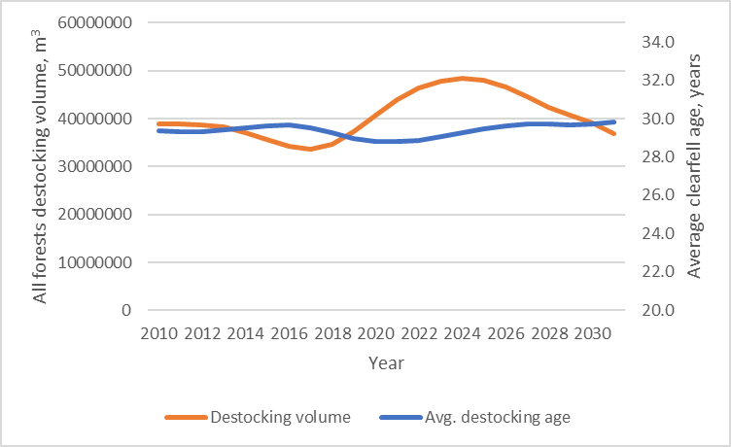

**Figure A3-10. Annual destocking (combined harvesting and deforestation) from pre-1990 and post-1989 planted forests combined, and average age at destocking.**

Destocking volume is dominated by radiata pine (Figure A3-11), with the volume from other softwoods increasing in the second half of the compliance period but still comparatively low. Destocking of minor species was constrained within the limits set out in the previous section to ensure they did not dominate the harvest in individual years.

During the first half of the compliance period destocking volume is mainly from post-1989 planted forests, but this reverses over the second half (Figure A3-12).This is related to their respective age class distributions and in particular the maturing of the large area of post-1989 planted forest planted over a relatively short period in the mid-1990s.

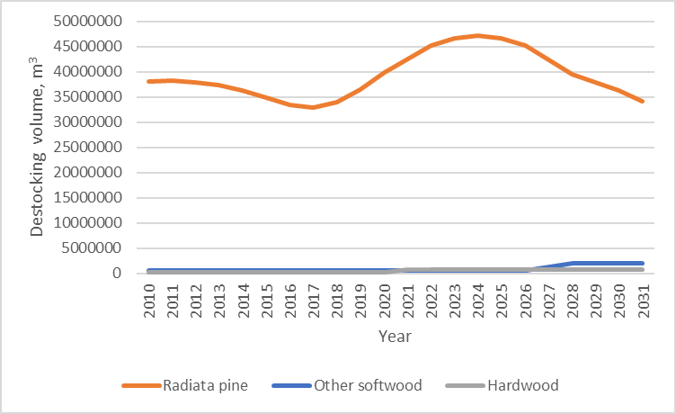

**Figure A3-11. Annual destocking volume by species group**

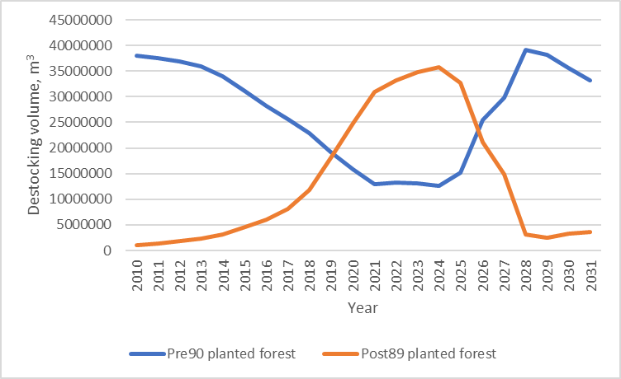

**Figure A3-12. Annual destocking volume by planted forest sub-category (pre-1990 planted forest and post-1989 planted forest).**

Figure A3-13 compares the annual destocking volume results for three FOLPI-XL model scenarios that apply three of the harvest fraction options shown in Figure A3-9:

* Harvest fraction derived from the NEFD area analysis for 2007-2009 only (i.e. the *H1HF* scenario reported in Charts A3-9 to A3-12 above)
* Harvest fraction derived from the NEFD area analysis for 2000-2009
* Harvest fraction estimates from a LUCAS CRA run.

All three options produce a higher level of production than estimated by MPI from 2010-2015 and after 2019.[6]

The harvest fraction for 2007-09 (“Scion 2007-09”) was used in the final FOLPI-XL model to derive the harvest and deforestation schedule presented in Appendix 4 and used as the basis for calculating net emissions for the FRL. This uses only the apparent destocking proportions from late in the reference period, so unlike the “2000-09” option it takes into account the trend towards lower proportions being harvested across a wider range of ages. It is not influenced by harvesting practices after the reference period, so is preferred over the option derived from the LUCAS CRA simulation outputs. In terms of the comparison with reported actual roundwood removals, the “2000-09” option shows a greater discrepancy than the other two, with all three options producing higher volumes for 2010-2015 and from 2019 to 2022 (Figure A3-13).

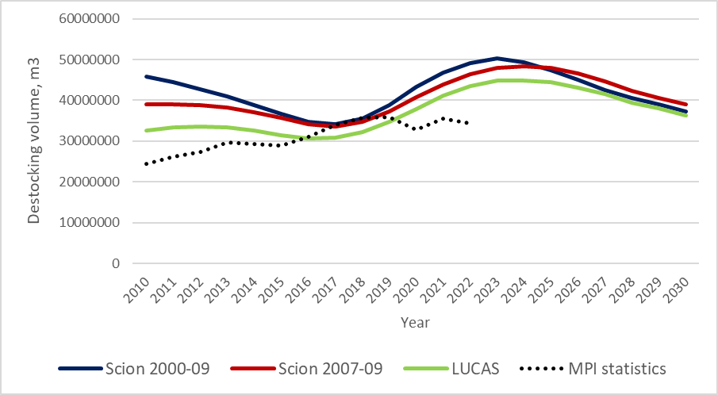

**Figure A3-13. Annual destocking volume based on three alternative harvest fractions.**

# Appendix 4. Destocking profile, pre-1990 planted forests

|  |  |  |  |  |  |  |  |  |  |  |  |  |  |
| --- | --- | --- | --- | --- | --- | --- | --- | --- | --- | --- | --- | --- | --- |
|  |  |  | **Pre-1990 planted forest activity (deforestation or harvesting area) by year and age, 2010-2020 (ha)** | | | | | | | | | | |
| **SubCat** | **Activity** | **Age** | **2010** | **2011** | **2012** | **2013** | **2014** | **2015** | **2016** | **2017** | **2018** | **2019** | **2020** |
| Pre90 | Deforest | 15 | 0.0 | 0.0 | 0.0 | 0.0 | 0.0 | 0.0 | 0.0 | 0.0 | 0.0 | 0.0 | 0.0 |
| Pre90 | Deforest | 16 | 0.0 | 0.0 | 0.0 | 0.0 | 0.0 | 0.0 | 0.0 | 0.0 | 0.0 | 0.0 | 0.0 |
| Pre90 | Deforest | 17 | 0.0 | 0.0 | 0.0 | 0.0 | 0.0 | 0.0 | 0.0 | 0.0 | 0.0 | 0.0 | 0.0 |
| Pre90 | Deforest | 18 | 0.0 | 0.0 | 0.0 | 0.0 | 0.0 | 0.0 | 0.0 | 0.0 | 0.0 | 0.0 | 0.0 |
| Pre90 | Deforest | 19 | 0.0 | 0.0 | 0.0 | 0.0 | 0.0 | 0.0 | 0.0 | 0.0 | 0.0 | 0.0 | 0.0 |
| Pre90 | Deforest | 20 | 0.0 | 0.0 | 0.0 | 0.0 | 0.0 | 0.0 | 0.0 | 0.0 | 0.0 | 0.0 | 0.0 |
| Pre90 | Deforest | 21 | 37.5 | 0.0 | 0.0 | 0.0 | 0.0 | 0.0 | 0.0 | 0.0 | 0.0 | 0.0 | 0.0 |
| Pre90 | Deforest | 22 | 43.3 | 33.7 | 0.0 | 0.0 | 0.0 | 0.0 | 0.0 | 0.0 | 0.0 | 0.0 | 0.0 |
| Pre90 | Deforest | 23 | 83.3 | 61.4 | 82.4 | 0.0 | 0.0 | 0.0 | 0.0 | 0.0 | 0.0 | 0.0 | 0.0 |
| Pre90 | Deforest | 24 | 209.6 | 162.9 | 206.9 | 253.8 | 0.0 | 0.0 | 0.0 | 0.0 | 0.0 | 0.0 | 0.0 |
| Pre90 | Deforest | 25 | 386.4 | 319.9 | 429.1 | 497.9 | 357.1 | 0.0 | 0.0 | 0.0 | 0.0 | 0.0 | 0.0 |
| Pre90 | Deforest | 26 | 629.7 | 506.1 | 723.2 | 885.9 | 601.1 | 452.3 | 180.3 | 91.9 | 0.0 | 0.0 | 0.0 |
| Pre90 | Deforest | 27 | 718.3 | 587.1 | 814.3 | 1062.7 | 761.2 | 541.9 | 566.4 | 246.5 | 159.1 | 0.0 | 0.0 |
| Pre90 | Deforest | 28 | 677.3 | 580.8 | 819.2 | 1037.8 | 791.9 | 595.2 | 588.6 | 409.7 | 147.7 | 128.1 | 0.0 |
| Pre90 | Deforest | 29 | 577.9 | 486.1 | 719.2 | 926.6 | 686.4 | 549.5 | 573.7 | 377.9 | 217.9 | 105.6 | 103.1 |
| Pre90 | Deforest | 30 | 425.0 | 397.8 | 577.5 | 780.4 | 587.9 | 456.9 | 508.2 | 353.4 | 192.8 | 149.4 | 81.5 |
| Pre90 | Deforest | 31 | 344.6 | 285.8 | 461.8 | 612.3 | 483.8 | 382.4 | 412.9 | 305.8 | 176.2 | 129.2 | 112.7 |
| Pre90 | Deforest | 32 | 316.8 | 238.4 | 341.3 | 503.6 | 390.4 | 323.7 | 355.4 | 255.6 | 156.8 | 121.4 | 100.2 |
| Pre90 | Deforest | 33 | 226.1 | 198.9 | 258.3 | 337.7 | 291.4 | 237.0 | 273.0 | 199.6 | 118.9 | 98.1 | 85.5 |
| Pre90 | Deforest | 34 | 159.0 | 138.4 | 210.0 | 249.1 | 190.5 | 172.4 | 194.8 | 149.4 | 90.5 | 72.5 | 67.3 |
| Pre90 | Deforest | 35 | 99.9 | 88.1 | 132.3 | 183.4 | 127.2 | 102.0 | 128.3 | 96.6 | 61.4 | 50.0 | 45.0 |
| Pre90 | Deforest | 36 | 80.5 | 67.4 | 102.5 | 140.6 | 114.0 | 83.0 | 92.4 | 77.4 | 48.3 | 41.2 | 37.8 |
| Pre90 | Deforest | 37 | 69.6 | 59.5 | 86.0 | 119.4 | 95.8 | 81.5 | 82.4 | 61.1 | 42.4 | 35.5 | 34.2 |
| Pre90 | Deforest | 38 | 69.1 | 53.7 | 79.2 | 104.5 | 84.9 | 71.4 | 84.4 | 56.8 | 34.9 | 32.6 | 30.7 |
| Pre90 | Deforest | 39 | 75.1 | 58.8 | 78.9 | 106.2 | 82.0 | 69.9 | 81.7 | 64.3 | 35.9 | 29.6 | 31.1 |
| Pre90 | Deforest | 40 | 64.8 | 55.2 | 74.5 | 91.3 | 71.9 | 58.2 | 69.0 | 53.7 | 35.0 | 26.2 | 24.4 |
| Pre90 | Deforest | 41 | 44.5 | 40.1 | 59.0 | 72.8 | 52.1 | 43.1 | 48.5 | 38.2 | 24.6 | 21.6 | 18.2 |
| Pre90 | Deforest | 42 | 35.6 | 30.1 | 46.9 | 62.9 | 45.4 | 34.1 | 39.2 | 29.4 | 19.2 | 16.6 | 16.4 |
| Pre90 | Deforest | 43 | 19.6 | 26.0 | 37.9 | 54.0 | 42.3 | 32.0 | 33.5 | 25.6 | 15.9 | 13.9 | 13.6 |
| Pre90 | Deforest | 44 | 32.5 | 27.4 | 62.6 | 83.3 | 69.4 | 57.1 | 60.0 | 41.8 | 26.4 | 22.0 | 21.8 |
| Pre90 | Deforest | 45 | 28.3 | 25.2 | 36.7 | 76.6 | 59.6 | 52.1 | 59.6 | 41.7 | 24.0 | 20.5 | 19.2 |
| Pre90 | Harvest | 15 | 0.0 | 0.0 | 0.0 | 0.0 | 0.0 | 0.0 | 0.0 | 0.0 | 0.0 | 0.0 | 0.0 |
| Pre90 | Harvest | 16 | 0.0 | 0.0 | 0.0 | 0.0 | 0.0 | 0.0 | 0.0 | 0.0 | 0.0 | 0.0 | 0.0 |
| Pre90 | Harvest | 17 | 0.0 | 0.0 | 0.0 | 0.0 | 0.0 | 0.0 | 0.0 | 0.0 | 0.0 | 0.0 | 0.0 |
| Pre90 | Harvest | 18 | 0.0 | 0.0 | 0.0 | 0.0 | 0.0 | 0.0 | 0.0 | 0.0 | 0.0 | 0.0 | 0.0 |
| Pre90 | Harvest | 19 | 0.0 | 0.0 | 0.0 | 0.0 | 0.0 | 0.0 | 0.0 | 0.0 | 0.0 | 0.0 | 0.0 |
| Pre90 | Harvest | 20 | 0.0 | 0.0 | 0.0 | 0.0 | 0.0 | 0.0 | 0.0 | 0.0 | 0.0 | 0.0 | 0.0 |
| Pre90 | Harvest | 21 | 358.5 | 0.0 | 0.0 | 0.0 | 0.0 | 0.0 | 0.0 | 0.0 | 0.0 | 0.0 | 0.0 |
| Pre90 | Harvest | 22 | 414.0 | 387.7 | 0.0 | 0.0 | 0.0 | 0.0 | 0.0 | 0.0 | 0.0 | 0.0 | 0.0 |
| Pre90 | Harvest | 23 | 797.3 | 706.4 | 625.1 | 0.0 | 0.0 | 0.0 | 0.0 | 0.0 | 0.0 | 0.0 | 0.0 |
| Continued/ | | **Pre-1990 planted forest activity (deforestation or harvesting area) by year and age, 2010-2020 (ha)** | | | | | | | | | | | |
| **SubCat** | **Activity** | **Age** | **2010** | **2011** | **2012** | **2013** | **2014** | **2015** | **2016** | **2017** | **2018** | **2019** | **2020** |
| Pre90 | Harvest | 24 | 2004.8 | 1875.3 | 1570.2 | 1383.7 | 0.0 | 0.0 | 0.0 | 0.0 | 0.0 | 0.0 | 0.0 |
| Pre90 | Harvest | 25 | 3696.3 | 3683.3 | 3255.5 | 2714.7 | 2603.2 | 0.0 | 0.0 | 0.0 | 0.0 | 0.0 | 0.0 |
| Pre90 | Harvest | 26 | 6024.1 | 5827.2 | 5486.9 | 4830.0 | 4382.5 | 4139.9 | 1433.5 | 997.5 | 0.0 | 0.0 | 0.0 |
| Pre90 | Harvest | 27 | 6870.9 | 6759.1 | 6178.2 | 5793.7 | 5549.5 | 4960.3 | 4503.7 | 2674.3 | 2853.0 | 0.0 | 0.0 |
| Pre90 | Harvest | 28 | 6479.5 | 6686.5 | 6215.5 | 5658.1 | 5773.7 | 5447.8 | 4680.2 | 4445.4 | 2649.2 | 2756.3 | 0.0 |
| Pre90 | Harvest | 29 | 5527.9 | 5596.0 | 5456.8 | 5051.7 | 5004.0 | 5030.2 | 4561.9 | 4099.7 | 3908.1 | 2271.3 | 2348.1 |
| Pre90 | Harvest | 30 | 4065.0 | 4580.4 | 4381.5 | 4255.1 | 4286.4 | 4182.7 | 4041.1 | 3833.8 | 3457.9 | 3214.7 | 1856.5 |
| Pre90 | Harvest | 31 | 3296.5 | 3291.0 | 3503.9 | 3338.1 | 3527.6 | 3500.5 | 3283.1 | 3318.2 | 3159.4 | 2779.1 | 2567.2 |
| Pre90 | Harvest | 32 | 3030.6 | 2745.1 | 2589.5 | 2745.9 | 2846.5 | 2963.2 | 2826.3 | 2772.8 | 2812.7 | 2611.8 | 2282.8 |
| Pre90 | Harvest | 33 | 2163.0 | 2289.9 | 1959.9 | 1841.4 | 2124.6 | 2169.6 | 2170.8 | 2166.0 | 2132.7 | 2109.7 | 1946.6 |
| Pre90 | Harvest | 34 | 1520.7 | 1592.8 | 1593.4 | 1358.3 | 1388.5 | 1578.3 | 1549.1 | 1621.4 | 1623.6 | 1559.1 | 1532.5 |
| Pre90 | Harvest | 35 | 955.8 | 1013.9 | 1003.5 | 999.8 | 927.4 | 933.9 | 1020.3 | 1047.5 | 1100.4 | 1074.6 | 1025.5 |
| Pre90 | Harvest | 36 | 769.9 | 775.9 | 777.8 | 766.7 | 831.1 | 759.4 | 735.1 | 840.1 | 865.6 | 886.8 | 860.5 |
| Pre90 | Harvest | 37 | 666.2 | 684.9 | 652.2 | 651.2 | 698.4 | 745.8 | 655.0 | 663.3 | 760.7 | 764.5 | 778.2 |
| Pre90 | Harvest | 38 | 660.6 | 618.3 | 600.6 | 569.7 | 618.8 | 653.9 | 671.2 | 616.7 | 626.6 | 700.9 | 699.9 |
| Pre90 | Harvest | 39 | 718.6 | 676.9 | 598.6 | 579.2 | 597.7 | 639.6 | 649.6 | 697.5 | 643.1 | 637.4 | 708.4 |
| Pre90 | Harvest | 40 | 620.3 | 635.3 | 565.6 | 498.1 | 524.4 | 533.2 | 548.3 | 582.5 | 627.8 | 564.5 | 555.9 |
| Pre90 | Harvest | 41 | 425.2 | 462.3 | 447.4 | 396.6 | 380.2 | 394.2 | 385.2 | 414.5 | 442.0 | 464.4 | 415.0 |
| Pre90 | Harvest | 42 | 340.7 | 346.5 | 356.0 | 343.2 | 331.0 | 312.5 | 311.5 | 318.4 | 343.8 | 357.5 | 373.4 |
| Pre90 | Harvest | 43 | 187.6 | 299.1 | 287.5 | 294.1 | 308.5 | 293.2 | 266.0 | 277.4 | 284.6 | 299.7 | 309.6 |
| Pre90 | Harvest | 44 | 310.5 | 314.9 | 474.6 | 454.3 | 505.7 | 522.5 | 477.3 | 453.0 | 474.2 | 474.4 | 496.4 |
| Pre90 | Harvest | 45 | 270.5 | 290.3 | 278.2 | 417.6 | 434.9 | 476.9 | 473.6 | 452.5 | 431.1 | 439.9 | 437.4 |

|  |  |  |  |  |  |  |  |  |  |  |  |  |
| --- | --- | --- | --- | --- | --- | --- | --- | --- | --- | --- | --- | --- |
|  |  |  | **Pre-1990 planted forest activity (deforestation or harvesting area) by year and age, 2021-2030 (ha)** | | | | | | | | | |
| **SubCat** | **Activity** | **Age** | **2021** | **2022** | **2023** | **2024** | **2025** | **2026** | **2027** | **2028** | **2029** | **2030** |
| Pre90 | Deforest | 15 | 0.0 | 0.0 | 0.0 | 0.0 | 1.0 | 0.0 | 0.0 | 0.0 | 0.0 | 0.0 |
| Pre90 | Deforest | 16 | 0.0 | 0.0 | 0.0 | 0.0 | 0.0 | 0.0 | 0.0 | 0.0 | 0.0 | 0.0 |
| Pre90 | Deforest | 17 | 0.0 | 0.0 | 0.0 | 0.0 | 0.0 | 0.0 | 0.0 | 0.0 | 0.0 | 0.0 |
| Pre90 | Deforest | 18 | 0.0 | 0.0 | 0.0 | 0.0 | 0.0 | 0.0 | 0.0 | 0.9 | 0.0 | 0.0 |
| Pre90 | Deforest | 19 | 0.0 | 0.0 | 0.0 | 0.0 | 0.0 | 0.0 | 0.0 | 0.0 | 1.8 | 0.0 |
| Pre90 | Deforest | 20 | 0.0 | 0.0 | 0.0 | 0.0 | 0.0 | 0.0 | 0.0 | 0.0 | 0.0 | 1.3 |
| Pre90 | Deforest | 21 | 0.0 | 0.0 | 0.0 | 0.0 | 0.0 | 0.0 | 0.0 | 0.0 | 0.0 | 0.0 |
| Pre90 | Deforest | 22 | 0.0 | 0.0 | 0.0 | 0.0 | 0.0 | 0.0 | 0.0 | 0.4 | 0.9 | 0.0 |
| Pre90 | Deforest | 23 | 0.0 | 0.0 | 0.0 | 0.0 | 0.0 | 0.0 | 0.0 | 0.0 | 1.5 | 1.6 |
| Pre90 | Deforest | 24 | 0.0 | 0.0 | 0.0 | 0.0 | 0.0 | 0.0 | 0.0 | 5.5 | 4.5 | 3.7 |
| Pre90 | Deforest | 25 | 0.0 | 0.0 | 0.0 | 0.0 | 0.0 | 0.0 | 0.0 | 12.5 | 10.2 | 8.8 |
| Pre90 | Deforest | 26 | 0.0 | 0.0 | 0.0 | 0.0 | 0.0 | 0.0 | 0.0 | 16.5 | 19.8 | 17.1 |
| Pre90 | Deforest | 27 | 0.0 | 0.0 | 0.0 | 0.0 | 0.0 | 0.0 | 6.9 | 20.4 | 20.1 | 23.7 |
| Pre90 | Deforest | 28 | 0.0 | 0.0 | 0.0 | 0.0 | 0.0 | 9.7 | 21.1 | 20.1 | 20.0 | 20.9 |
| Pre90 | Deforest | 29 | 0.0 | 0.0 | 0.0 | 0.0 | 1.6 | 25.2 | 28.3 | 17.6 | 17.5 | 18.4 |
| Pre90 | Deforest | 30 | 55.3 | 37.2 | 28.5 | 3.0 | 53.8 | 32.9 | 26.0 | 16.4 | 14.7 | 15.4 |
| Pre90 | Deforest | 31 | 42.7 | 16.4 | 35.1 | 45.8 | 5.2 | 25.0 | 24.0 | 14.8 | 13.4 | 12.7 |
| Pre90 | Deforest | 32 | 60.8 | 13.0 | 13.5 | 30.7 | 30.1 | 26.0 | 17.0 | 14.0 | 12.4 | 11.9 |
| Continued/ | |  | **Pre-1990 planted forest activity (deforestation or harvesting area) by year and age, 2021-2030 (ha)** | | | | | | | | | |
| **SubCat** | **Activity** | **Age** | **2021** | **2022** | **2023** | **2024** | **2025** | **2026** | **2027** | **2028** | **2029** | **2030** |
| Pre90 | Deforest | 33 | 49.0 | 16.8 | 9.7 | 10.7 | 18.3 | 13.1 | 16.1 | 9.0 | 10.7 | 10.0 |
| Pre90 | Deforest | 34 | 40.7 | 13.2 | 12.3 | 7.5 | 6.2 | 7.7 | 7.9 | 8.3 | 6.7 | 8.4 |
| Pre90 | Deforest | 35 | 29.0 | 10.0 | 8.7 | 8.6 | 4.0 | 2.4 | 1.5 | 0.0 | 0.3 | 0.0 |
| Pre90 | Deforest | 36 | 23.7 | 8.6 | 8.0 | 7.5 | 5.5 | 1.9 | 1.6 | 0.0 | 1.1 | 0.0 |
| Pre90 | Deforest | 37 | 21.8 | 7.7 | 7.6 | 7.5 | 5.2 | 2.8 | 0.5 | 0.2 | 2.2 | 2.9 |
| Pre90 | Deforest | 38 | 20.5 | 7.4 | 7.1 | 7.4 | 5.5 | 2.8 | 2.1 | 0.9 | 0.9 | 2.1 |
| Pre90 | Deforest | 39 | 20.4 | 7.7 | 7.5 | 7.6 | 6.0 | 3.2 | 2.3 | 1.5 | 0.9 | 1.0 |
| Pre90 | Deforest | 40 | 17.8 | 6.6 | 6.7 | 7.0 | 5.3 | 3.0 | 2.3 | 1.5 | 1.4 | 0.9 |
| Pre90 | Deforest | 41 | 11.8 | 4.9 | 4.9 | 5.3 | 4.1 | 2.3 | 1.9 | 1.2 | 1.1 | 1.1 |
| Pre90 | Deforest | 42 | 9.6 | 3.5 | 3.9 | 4.2 | 3.4 | 1.9 | 1.5 | 1.1 | 1.0 | 0.9 |
| Pre90 | Deforest | 43 | 9.3 | 3.1 | 3.1 | 3.6 | 2.9 | 1.7 | 1.4 | 0.9 | 0.9 | 0.9 |
| Pre90 | Deforest | 44 | 14.8 | 5.7 | 5.1 | 5.4 | 4.8 | 2.8 | 2.4 | 1.6 | 1.6 | 1.7 |
| Pre90 | Deforest | 45 | 13.2 | 5.1 | 5.3 | 5.1 | 4.0 | 2.6 | 2.1 | 1.5 | 1.5 | 1.6 |
| Pre90 | Harvest | 15 | 0.0 | 0.0 | 0.0 | 0.0 | 111.8 | 0.0 | 0.0 | 0.0 | 0.0 | 0.0 |
| Pre90 | Harvest | 16 | 0.0 | 0.0 | 0.0 | 0.0 | 0.0 | 0.0 | 0.0 | 0.0 | 0.0 | 0.0 |
| Pre90 | Harvest | 17 | 0.0 | 0.0 | 0.0 | 0.0 | 0.0 | 0.0 | 0.0 | 0.0 | 0.0 | 0.0 |
| Pre90 | Harvest | 18 | 0.0 | 0.0 | 0.0 | 0.0 | 0.0 | 0.0 | 0.0 | 289.0 | 0.0 | 0.0 |
| Pre90 | Harvest | 19 | 0.0 | 0.0 | 0.0 | 0.0 | 0.0 | 0.0 | 0.0 | 0.0 | 562.1 | 0.0 |
| Pre90 | Harvest | 20 | 0.0 | 0.0 | 0.0 | 0.0 | 0.0 | 0.0 | 0.0 | 0.0 | 0.0 | 366.1 |
| Pre90 | Harvest | 21 | 0.0 | 0.0 | 0.0 | 0.0 | 0.0 | 0.0 | 0.0 | 0.0 | 0.0 | 0.0 |
| Pre90 | Harvest | 22 | 0.0 | 0.0 | 0.0 | 0.0 | 0.0 | 0.0 | 0.0 | 144.3 | 281.0 | 0.0 |
| Pre90 | Harvest | 23 | 0.0 | 0.0 | 0.0 | 0.0 | 0.0 | 0.0 | 0.0 | 0.0 | 473.0 | 471.7 |
| Pre90 | Harvest | 24 | 0.0 | 0.0 | 0.0 | 0.0 | 0.0 | 0.0 | 0.0 | 1788.1 | 1424.8 | 1094.6 |
| Pre90 | Harvest | 25 | 0.0 | 0.0 | 0.0 | 0.0 | 0.0 | 0.0 | 0.0 | 4051.4 | 3232.3 | 2575.1 |
| Pre90 | Harvest | 26 | 0.0 | 0.0 | 0.0 | 0.0 | 0.0 | 0.0 | 0.0 | 5346.0 | 6284.4 | 5012.8 |
| Pre90 | Harvest | 27 | 0.0 | 0.0 | 0.0 | 0.0 | 0.0 | 0.0 | 1603.6 | 6617.8 | 6375.5 | 6936.6 |
| Pre90 | Harvest | 28 | 0.0 | 0.0 | 0.0 | 0.0 | 0.0 | 1859.5 | 4869.5 | 6516.2 | 6336.7 | 6103.5 |
| Pre90 | Harvest | 29 | 0.0 | 0.0 | 0.0 | 0.0 | 184.0 | 4841.3 | 6533.0 | 5714.1 | 5537.3 | 5383.8 |
| Pre90 | Harvest | 30 | 1943.3 | 3570.8 | 2717.8 | 270.8 | 5999.9 | 6318.2 | 5998.4 | 5333.2 | 4658.5 | 4513.6 |
| Pre90 | Harvest | 31 | 1501.1 | 1575.6 | 3351.6 | 4091.2 | 583.9 | 4797.4 | 5549.0 | 4784.3 | 4248.1 | 3710.1 |
| Pre90 | Harvest | 32 | 2135.1 | 1252.0 | 1291.0 | 2744.3 | 3359.7 | 4989.6 | 3934.4 | 4552.4 | 3919.9 | 3480.0 |
| Pre90 | Harvest | 33 | 1722.8 | 1615.8 | 930.8 | 959.2 | 2044.9 | 2507.3 | 3713.0 | 2928.9 | 3384.4 | 2913.7 |
| Pre90 | Harvest | 34 | 1431.8 | 1270.6 | 1170.7 | 674.0 | 696.6 | 1487.3 | 1818.4 | 2693.9 | 2122.1 | 2451.8 |
| Pre90 | Harvest | 35 | 1020.6 | 956.1 | 833.6 | 767.6 | 443.1 | 458.7 | 355.6 | 0.0 | 92.2 | 0.0 |
| Pre90 | Harvest | 36 | 831.4 | 829.8 | 763.7 | 665.3 | 614.5 | 355.3 | 366.7 | 0.0 | 339.9 | 0.0 |
| Pre90 | Harvest | 37 | 764.5 | 740.8 | 726.3 | 668.0 | 583.8 | 539.9 | 114.6 | 78.6 | 683.7 | 834.9 |
| Pre90 | Harvest | 38 | 721.4 | 710.7 | 676.5 | 662.9 | 611.4 | 535.1 | 493.5 | 284.6 | 293.6 | 624.3 |
| Pre90 | Harvest | 39 | 716.2 | 740.3 | 716.6 | 681.6 | 669.8 | 618.8 | 540.0 | 498.3 | 287.0 | 295.9 |
| Pre90 | Harvest | 40 | 625.6 | 634.3 | 644.1 | 622.9 | 594.3 | 584.9 | 538.8 | 470.3 | 433.4 | 249.6 |
| Pre90 | Harvest | 41 | 413.7 | 466.9 | 465.1 | 471.9 | 457.9 | 437.4 | 429.3 | 395.6 | 344.9 | 317.7 |
| Pre90 | Harvest | 42 | 337.8 | 337.8 | 374.5 | 372.7 | 379.3 | 368.6 | 351.1 | 344.7 | 317.2 | 276.6 |
| Pre90 | Harvest | 43 | 327.4 | 297.0 | 291.7 | 323.3 | 322.7 | 328.9 | 318.7 | 303.7 | 297.8 | 274.0 |
| Pre90 | Harvest | 44 | 519.3 | 550.6 | 490.8 | 481.7 | 535.3 | 535.2 | 543.9 | 527.2 | 501.7 | 491.8 |
| Pre90 | Harvest | 45 | 463.5 | 486.2 | 506.5 | 451.0 | 444.1 | 494.2 | 492.8 | 501.0 | 484.9 | 461.4 |

# Appendix 5. HWP calculations

**Overview - HWP contribution to the FRL**

The FRL requires projections of carbon stock changes in the HWP pool derived from pre-1990 planted forest harvesting that occur during the 2021-2030 compliance period. Calculations are made in a sheet added to the Excel workbook containing the harvest and deforestation areas by age and year for the FRL scenario modelled in FOLPI-XL.

Gains in the HWP pool are estimated from above-ground biomass at harvest ages, after allowing for harvest residues left on site and waste generated during wood processing. Above-ground biomass at harvest ages is obtained from the appropriate pre-1990 planted forest yield tables, depending on when the harvested stand was planted. Combined species pre-1990 yield tables were used (Table A5-1).

Deforestation was modelled with the same age profile as harvesting, but HWPs from deforestation are assumed to be instantly emitted (IPCC, 2014) so are not included within the FRL.

Losses from the HWP pool are calculated based on a discard table derived from the end use lifespans and first order decay functions used in New Zealand’s greenhouse gas inventory reporting. This information is also available in the Long-term Average (LTA) Model used to calculate the long-term average carbon stock for post-1989 forests (Dovey & Wakelin, 2024).

Table A5.1 lists the information required for the pre-1990 planted forest HWP calculations[7], their source and where the data can be found in the HWP calculation spreadsheet.

**Table A5.1 Information requirements and sources for HWP calculations**

|  |  |  |
| --- | --- | --- |
| **Information required** | **Source** | **Location in HWP calculation spreadsheet** (H1HF_HWP_2July2024.xlsx) |
| Harvest areas by age and year (consistent with Appendix 4) | FOLPI-XL (or potentially CRA simulation output) | Sheet: *Pre90 HWP* (taken from *H1HF* sheet). |
| Above-ground biomass present at each harvest age. | Pre-1990 planted forest yield tables (Paul et al. 2024): 2b-1 – planted before 1990 2b-2 – planted after 1990 | Sheet: *Yield Tables* |
| National discard table, based on weighting average of export and domestic discard tables | HWP carbon accounting model (Wakelin 2023), as compiled in the LTA Model (Dovey & Wakelin, 2024) | Sheet: *HWP discard* (Either paste national discard table over Column AC or input the data used to calculate it). |

**Calculation steps:**

*Prepare data and set assumptions:*

1. Either:  
   a) Obtain harvest and deforestation areas by age for 2010 to 2030, separately for pre-1990 planted forest and post-1989 planted forest. This information is in summary form in Appendix 4 of this report, and on the *Data* sheet of the Excel workbook used to calculate the HWP contribution to the pre-1990 planted forest FRL (*H1HF_HWP 30July2024.xlsx*). The raw data on the *H1HF* sheet was copied to the *Pre90 HWP* calculation sheet to allow reformatting via pivot tables, including separation of pre-1990 planted forest planting year cohorts. This process is not automatic, but potentially offers an alternative for sensitivity analysis without needing to re-run the CRA; or  
     
   b) Obtain CRA simulation estimates of annual harvest roundwood removals, and paste these into the *Pre90 HWP* sheet (DA2:DV2 for Pre-1990 forest roundwood removals).
2. [Option 1a only]. Update the pre-1990 planted forest yield tables from Paul et al. (2024) as required to be consistent with the FRL simulation. These are pasted into the *Yield Tables* sheet of the HWP FRL Excel workbook.
3. Obtain the national discard table for all logs, or update the information required to calculate this on the *HWP discard* sheet of the Excel workbook. This information is updated annually in the HWP carbon accounting model used for greenhouse gas inventory reporting, and can also be found copied into the LTA Calculator on the HWP sheet.  
     
   Sources for the market share and market discard tables within the HWP carbon model are given on the *HWP discard* sheet:  
   - Total and export log production: from sheets *Input – MPI production* and *Input – RW export* respectively.  
   - Export log market share: from sheet *Input – RW export*.  
   - Export log market discard tables: from sheet *Exp halflive Export, A67:IT72.*- Domestic log market discard tables: from sheet *Exp halflive Dom, E182:IU182.*Note that the discard tables are applied to roundwood, so as calculated they take into account processing waste in the first year. Other assumptions should be consistent with greenhouse gas inventory reporting (e.g. use of weighted half-lives or aggregate tables, both of which are available in the HWP carbon model).  
     
   Changes to assumptions used in the greenhouse gas inventory that affect the discard rate calculations before 2010 should be updated in the HWP FRL spreadsheet for use in calculating the HWP contribution to the FRL. However, the FRL should reflect business-as-usual in the reference period, so changes after 2009 should not trigger a technical correction, unless it is considered that the later data provides a better reflection of the situation during the reference period.
4. Enter the two user-defined assumptions on the *Pre90 HWP* sheet:  
   a) Cell F1: Start year for pre-1990 planted forest HWP pool calculations – select **2013** for consistency with the Kyoto Protocol reporting guidance (IPCC 2014). The only alternative is to assume a 2010 start year (the earliest possible, since the FOLPI-XL model starts in 2010).  
     
   b) [Option 1a only]. Cell G36: Roundwood removed at harvest as a proportion of AGB at harvest year – enter **0.7** (the default used in the CRA for greenhouse gas inventory reporting).

*Calculations (on sheet Pre90 HWP):*

1. [Option 1a only]. Column N: Based on Year and harvest age, pre-1990 harvesting is assigned to one of three cohorts, potentially associated with a different yield table:  
     
   a) B490 = planted before 1990, so is assigned a yield table derived for stands planted before 1990 (2b-1 from Paul et al. 2024). Harvest areas: Q113:AN144.  
     
   b) 90-99 = planted from 1990 to 1999. Currently assigned a yield table for stands planted after 1990 (2b-2 from Paul et al. 2024). Harvest areas: Q149:AN180.  
     
   c) 00-09 = planted from 2000 onward, and currently assigned the same yield table derived for stands planted after 1990 as above (2b-2 from Paul et al. 2024). Harvest areas: Q185:AN216.

Harvesting is derived from total destocking area (step 1 above) less deforestation area. Deforestation areas are not otherwise used.

1. [Option 1a only]. Annual roundwood (t C) extracted at harvest at each age for the three pre-1990 planted forest cohorts in (5) above is calculated in cells AV111:BR216 by multiplying the area harvested at each age and year by the user-defined proportion of AGB at the same age in the appropriate yield table. The default proportion is 0.7.   
     
   Results are summed for each year and cohort in cells AV1:BR11. These values can be replaced with direct inputs of roundwood from the CRA FRL simulation run, pasted into BX2:CS2 and DA2:DV2.

1. The HWP pool resulting from harvest of pre-1990 planted forests is modelled in cells CY4:DV258.  
     
   Inputs to the HWP pool are the summarised annual roundwood production (t C) described in step (6) above.  
     
   Outputs from the HWP pool are estimated by applying the discard table in step (3) to each year’s production, and summing across production years.  
     
   Column CZ tracks the HWP pool carbon stock from 2010 or 2013 (depending on start date selected) to the year 2260.

1. HWP pool carbon stocks are summarised and converted from t C to t CO2 in cells B2:F25.  
     
   HWP pool carbon stock changes are calculated in cells B42:F63.
2. Pre-1990 planted forest HWP pool stock changes from step (8) above are reformatted for the report tables in the *Report table* sheet.

1. <https://unfccc.int/sites/default/files/NDC/2022-06/New%20Zealand%20NDC%20November%202021.pdf>
2. Note that the EU proposed to use a “land-based” rather than “activity-based” approach in line with greenhouse gas inventory reporting, so the pre-1990 (Forest Management) and post-1989 (Afforestation/Reforestation) distinction made under the Kyoto Protocol is not used. In New Zealand’s case, it would be Forest Management area (i.e. pre-1990 Forest area) rather than *Forest remaining Forest* area.
3. https://integral.co.nz/folpi-xl/
4. <https://www.mpi.govt.nz/forestry/forest-industry-and-workforce/forestry-wood-processing-data/wood-processing-data/>
5. These were initially implemented as proportional constraints in the model, i.e. the target harvest area for each age in each year was set to be a fixed proportion of the area available at that age, according to the values shown in Figure A3-9. Issues with the way this capability is implemented in FOLPI_XL meant that these had to be converted to constraints based on a harvest area, rather than proportion.
6. <https://www.mpi.govt.nz/forestry/forest-industry-and-workforce/forestry-wood-processing-data/wood-processing-data/>
7. Calculations for the HWP pool arising from post-1989 forests are also included in the spreadsheet, but are not relevant to the FRL.