Accounting for Post-1989 Forests under the Paris Agreement: Long-Term Average Carbon Stock and Reference Level

S.J. Wakelin and T.S.H. Paul

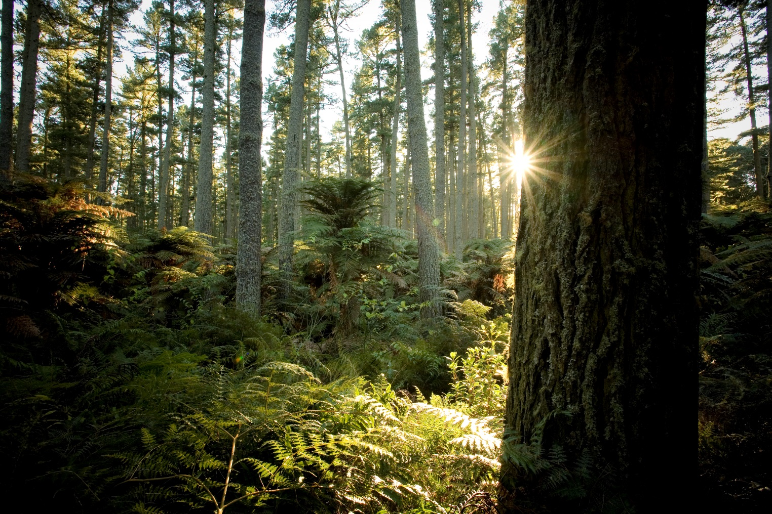

Report information sheet

|  |  |
| --- | --- |
| Report title | Accounting for Post-1989 Forests under the Paris Agreement: Long-Term Average Carbon Stock and Reference Level |
| Authors | S.J. Wakelin, T.S.H. Paul Scion |
| Client | MfE |
| Client contract number | 26198 |
| MBIE contract number |  |
| PAD output number | 89329720 |
| Signed off by | Yvette Dickinson |
| Date | October 2024 |
| Confidentiality requirement | Confidential (for client use only) |
| Intellectual property | © New Zealand Forest Research Institute Limited. All rights reserved. Unless permitted by contract or law, no part of this work may be reproduced, stored or copied in any form or by any means without the express permission of the New Zealand Forest Research Institute Limited (trading as Scion). |
|  |  |
|  |  |
|  |  |
| **Disclaimer** | The information and opinions provided in the Report have been prepared for the Client and its specified purposes. Accordingly, any person other than the Client uses the information and opinions in this report entirely at its own risk. The Report has been provided in good faith and on the basis that reasonable endeavours have been made to be accurate and not misleading and to exercise reasonable care, skill and judgment in providing such information and opinions.  Neither Scion, nor any of its employees, officers, contractors, agents or other persons acting on its behalf or under its control accepts any responsibility or liability in respect of any information or opinions provided in this Report. |

Published by: Scion, Private Bag 3020, Rotorua 3046, New Zealand. www.scionresearch.com

# Executive summary

Under the Paris Agreement, New Zealand has committed in our Nationally Determined Contribution to reduce greenhouse gas emissions to 50 percent below gross emission levels in 2005 by 2030. New Zealand has indicated that it will apply activity-based accounting similar to the requirement under the Kyoto Protocol, with the exception that forests established since 31 December 1989 (post-1989 forests) will be accounted for under stock changing accounting until their long-term average carbon stock (LTA stock) is reached, and then transfer to accounting against a business-as-usual Forest Reference Level (FRL), as for pre-1990 forests.

The purpose of the pre-1990 FRL is to establish ‘additionality’, so that parties only account for net emission changes that result from changes to the business-as-usual management practices carried out during the historic reference period. The purpose of the post-1989 FRL is to provide assurance that changes in management that would affect the calculated LTA stock are reflected in the accounting quantity. This can also be achieved by recalculating the LTA stock, as it is not tied to a historic time period.

Post-1989 forests include natural forests, permanent planted forests (managed without clearfelling) and rotational planted forests (managed with clearfelling and replanting). The long-term average stock for rotational planted forests is determined largely by the average productivity and rotation length, and the rate of loss from the post-harvest residue and harvested wood products pools. A model was previously developed to allow the long-term average stock (LTA stock) and the age at which it occurs (LTA age) to be calculated for rotational planted forests.

LTA stocks for post-1989 natural forests and permanent planted forests are not easily determined as the development of carbon stocks over time is uncertain. These forests would remain under stock change accounting during the 2021-2030 Paris Agreement compliance period if the LTA age is assumed to be over 40. Rotational planted forests that have already passed the LTA age by 2021 could also remain under stock change accounting, or immediately transfer to accounting against a reference level.

There are alternative options for the treatment of the various carbon pools within each component of post-1989 forests. Options should be assessed against:

* Their ability to fairly and simply represent actual long-term net emissions, and to meet Intergovernmental Panel on Climate Change principles of transparency, accuracy, completeness, comparability and consistency.
* Their ability to achieve the objectives of averaging accounting.
* The availability of appropriate and comparable data for both calculation of the LTA and FRL and reporting against it.
* The ability of the LUCAS Calculation and Reporting Application (CRA) to make a like-for-like comparison between the FRL and actual net emissions.

A business-as-usual Reference Level can be developed for rotational planted forests based on a CRA simulation that simulates carbon uptake past the LTA age and then harvests each stand, either at the species-weighted average clearfell age or based on the current destocking age profile. Net emissions after the LTA age is reached (including emissions from harvesting and removals following replanting) form the Reference Level.

Reporting against this FRL will also be based on a CRA simulation, using comparable data sources. The difference between actual and FRL net emissions after the LTA age is added to the net emissions up to the LTA age to form the accounting quantity.

In practice the LTA age can be recalculated to capture changes in wood product markets and lifespans, average clearfell ages, sequestration rates and other factors, potentially re-setting the FRL. Other factors such as soil carbon stock changes could be left out of the LTA and accounted for under stock change accounting only.

This report suggests some alternative options for defining the FRL, makes recommendations on which should be implemented where possible, and outlines the steps required to produce the FRL using the CRA application. A simplified demonstration of averaging accounting is also presented, to highlight the impact on the accounting quantity of compliance and budget periods that are short relative to the rotation length.

Accounting for Post-1989 Forests under the Paris Agreement: Long-Term Average Carbon Stock and Reference Level

Table of contents

Executive summary 3

Abbreviations 6

Introduction 7

New Zealand’s Nationally Determined Contribution under the Paris Agreement 7

Accounting framework for Paris Agreement accounting 8

Assessing options for treatment of pools and forest types within pre-1989 forests 10

Purpose of this report 15

Methods 16

Long-term Average Biomass Stock and Age Estimates 16

LTA Stock and Age calculation 27

Calculating the Post-1989 Forest Reference Level 27

Simplified demonstration of averaging accounting 28

Results and discussion 30

Long-term Average Carbon Stock and Age Estimates 30

Demonstration of averaging accounting 30

Steps to create the post-1989 FRL using the LUCAS CRA 34

Conclusions 35

Acknowledgements 36

References 36

# Abbreviations

**AGB Above-ground biomass** (including stems, branches, foliage, seeds, cones, bark etc). One of the mandatory IPCC forest carbon pools for reporting and accounting.

**BGB Below-ground biomass** (fine and coarse roots). One of the mandatory IPCC forest carbon pools for reporting and accounting.

**CRA** **Calculation and Reporting Application**. Software within LUCAS (Land Use and Carbon Accounting System) used by the Ministry for the Environment to simulate land use change and forest activity and estimate greenhouse gas emissions and removals.

**ETS Emissions Trading Scheme**. The New Zealand ETS, a market-based policy instrument designed to reduce net emissions.

**FRL** **Forest Reference Level**. The level of expected future net emissions, usually expressed as an average annual quantity over a compliance period. This is used in reference level accounting for pre-1990 forests to establish *additionality* – the FRL for pre-1990 forests is based on projections that assume that business-as-usual management practices undertaken in the 2000-2009 reference period will continue. For pre-1990 forests and their products, only deviations from the FRL are subject to accounting credits or debits.  
  
In post-1989 forests, all uptake of carbon is additional. The FRL represents the net emissions expected after the long term average (LTA) age is reached, which serves as a baseline against which over- or under-achievement of the LTA stock can be corrected.

**HWP** **Harvested Wood Products**. Wood-based materials harvested from forests, which are used for products such as furniture, plywood, and paper and paper-like products, or for energy. In the context of accounting under the Kyoto Protocol and Paris Agreement, the HWP pool includes only the semi-finished wood product categories sawn timber, wood-based panels, and paper and paperboard. Other wood products such as wood pellets are assumed to be instantaneously emitted at the time of harvest.

**IPCC** **Intergovernmental Panel on Climate Change**. The United Nations body for assessing the science related to climate change and providing guidelines for greenhouse gas inventory reporting and accounting.

**LUCAS** **Land Use and Carbon Analysis System**. Programme administered by the Ministry for the Environment to collect, analyse and report on information relating to greenhouse gas emissions and removals associated with land use.

**LTA Long Term Average**. Under averaging accounting, stock change accounting for post-1989 forest is used up to the point that the Long Term Average Age is reached. After this point, any further accounting is against a reference level. The LTA age is the age at which the LTA stock is reached in during the first rotation, and the LTA stock is the average stock of carbon in above and below-ground biomass, dead wood, litter and optionally soil organic carbon and HWPs in the long-term.

**NDC** **Nationally Determined Contribution**. The contribution New Zealand has committed to make towards climate change mitigation under the Paris Agreement.

**NIR** **National Inventory Report**. The greenhouse gas inventory report submitted annually under the United Nations Framework Convention in Climate Change.

**NZU New Zealand Unit**. The carbon trading unit used in the NZ ETS, equal to 1 t CO2e.

**UNFCCC** **United Nations Framework Convention on Climate Change**. The United Nations process for negotiating international agreements to mitigate climate change.

# Introduction

## New Zealand’s Nationally Determined Contribution under the Paris Agreement

The Paris Agreement is the global agreement on climate change adopted by Parties under the United Nations Framework Convention on Climate Change (UNFCCC) on 12 December 2015. The Paris agreement follows on from the earlier Kyoto Protocol, which covered two commitment periods: 2008-2012, and 2013-2020. Under the Paris Agreement New Zealand’s Nationally Determined Contribution (NDC) is to reduce net greenhouse gas emissions to 50 percent below 2005 levels.

New Zealand’s NDC, updated in November 2021, is published in the UNFCCC NDC registry (<https://unfccc.int/NDCREG>) and states:

*New Zealand’s assumed accounting for the forestry and other land use sector will be based on a combination of the 2006 IPCC Guidance and the 2013 IPCC Kyoto Protocol Supplement, providing for Kyoto Protocol accounting approaches to be applied to the greenhouse gas inventory land-based categories. New Zealand looks forward to considering methodologies introduced by the 2013 IPCC Wetlands Supplement and the 2019 Refinement to the 2006 IPCC Guidelines in the future. New Zealand’s existing activity start year of 1990 will continue to apply, ensuring continuity of action with previous commitments.*

*New Zealand’s forestry and other land use approach assumes accounting will be either land or activity based, and will apply existing IPCC methodologies to distinguish areas subject to direct human-induced change from those under pre-existing management, as follows:   
  
a. Forests established from the activity start year will continue to be accounted for as they would under the Kyoto Protocol, but once they attain their long-term average carbon stock, taking into account all carbon pools and activities, the forest will transfer to the Forest management/Forest remaining forest category, where it will be accounted for under a business-as-usual reference level. New Zealand will continue to account for all deforestation emissions.   
  
b. Forests established before the activity start year will continue to be accounted for under a business-as-usual reference level, as per the Kyoto Protocol, to address the dynamic effects of age structure resulting from activities and practices before the reference year, and the ongoing cycles of forest harvest and regrowth that occur as part of normal, sustainable forest management in production forests.  
  
c. Accounting provisions to address natural disturbances on managed lands, non-anthropogenic effects and additionality since the activity start year will also continue to apply, building on existing guidance. Accounting for harvested wood products will be based on the production approach.*

New Zealand has also reserved the right to adjust the methodologies used, without reducing ambition.

## Accounting framework for Paris Agreement accounting

### Activity-based accounting

Kyoto Protocol accounting was activity-based, with accounting for afforestation, reforestation and deforestation activities from 1 January 1990 being mandatory in both commitment periods, and accounting for “Forest Management” being mandatory in the second.

In the context of Kyoto Protocol accounting, accounting for “Forest Management” refers to accounting for net emissions from forests first established before the 1990 base year against a business-as-usual reference level, with only the *additional* net emissions forming part of the accounting quantity. A continuation of this approach means that accounting for pre-1990 forests will be against a Forest Reference Level (FRL), which defines expected net emissions during the 2021-2030 compliance period based on the assumption of a continuation of business-as-usual management practiced during the 2000-2009 reference period. It also means harvested wood products (HWPs) will be accounted for based on the Production Approach (IPCC 2006) applied to HWPs produced from 2013 onward. Further detail on New Zealand’s accounting for pre-1990 forests can be found in Wakelin and Paul (2024a) and Wakelin and Paul (2024b).

Post-1989 forests are created through afforestation/reforestation activity since 31 December 1989. Under a continuation of Kyoto Protocol accounting, these will be accounted for as they would under the Kyoto Protocol, except that once they reach their long-term average stock (LTA stock), or the nominal age at which this stock is assumed to be reached (LTA age), the area will then be accounted for against a business-as-usual reference level.

Deforestation of all forests will continue to be accounted for in full.

### Land-based accounting

New Zealand has indicated in its NDC submission that it may apply these accounting principles to the land-based categories used for greenhouse gas inventory reporting, rather than to Kyoto Protocol activities. Land categories would include:

* *Land converted to Forest Land* (land that has been converted to forest land and is still in a transition period (currently assumed to be 20 years), and
* *Forest land remaining Forest land (*land that has remained as forest land for longer than the assumed transition period).

This would mean:

1. Post-1989 forests (Afforestation/reforestation) – these would be *Land converted to Forest Land* for the first 20 years of the first rotation and would then switch to *Forest Land remaining Forest Land*.
2. Pre-1990 forests (Forest Management) – if established by the end of 2001 these would be *Forest Land remaining Forest Land* throughout the 2021-2030 compliance period, but if established after 2001 they would initially be *Land converted to forest land* during the compliance period before transitioning. This would only be possible in situations with multiple changes of land use on land that was originally pre-1990 forest, as otherwise forests planted after 2001 would be post-1989 forests. Under activity-based accounting, pre-1990 forests that are converted to a non-forest land use after 1989 and the reforested is accounted for as Deforestation land.

For this report, activity-based accounting has been assumed.

### Relation to accounting under the New Zealand Emissions Trading Scheme (NZ ETS)

Carbon accounting using the concept of a long-term average carbon stock is now mandatory in the New Zealand Emissions Trading System for post-1989 forests registered as ‘Standard Forests’ (i.e. non ‘Permanent Forests’) after 2022. Carbon units are earned in accordance with the carbon sequestration rate up until the nominal long-term average (LTA) stock for each species group is achieved. After this time, no further units are earned and there are no unit surrender obligations, as long as the land remains as forest land. Full ‘stock change’ accounting is still used for previously registered forests (unless an application to transfer them to averaging accounting has been successful) and also for the new “Permanent forest” category.

However, carbon stock changes estimated for the purposes of awarding New Zealand Units (NZUs) under the NZ ETS are not used for reporting or accounting under the Kyoto Protocol or Paris Agreement. While New Zealand has indicated that it also intends to apply the long-term average accounting concept to post-1989 forests under the Paris Agreement, the implementation will not necessarily be exactly the same.

### Post-1989 forest components and the long-term average stock

As defined in the greenhouse gas inventory (e.g. MFE 2024a), post-1989 forests include:

* Natural forests, e.g. naturally regenerating indigenous forests that will never be harvested. Natural forests also include naturally regenerating forests of exotic species that are managed as forests, e.g. wilding conifers and willow.
* Rotational planted forests, e.g. plantation forests of radiata pine managed with clearfelling followed by replanting on a rotation of 25-30 years.
* Permanent planted forests managed without clearfelling, e,g. planted forests of exotic species that are intended to transition into indigenous forest over time, or that will be managed under a form of Continuous Cover Forestry (CCF).

The LTA stock is defined as “*The long-term average carbon stock per hectare that would be maintained (on average) across all biomass carbon pools under current management conditions*”.

This is affected by factors such as forest type, species, silviculture (including the timing and intensity of thinning), harvesting, the fate of carbon in harvest residues and wood products. An Excel-based model (LTA Calculator) was developed for calculating the LTA stock resulting from afforestation (Dovey & Wakelin, 2024). The underlying principle of the long-term average is that although the carbon stock of a forest and its associated products may vary over time with harvesting and replanting, a long-term average carbon stock can be calculated, and from this an accounting quantity can be derived that represents a net change in stock compared to the pre-existing carbon levels prior to afforestation (Wakelin, et al., 2017).

### The Post-1989 Forest Reference Level

New Zealand’s NDC proposed that once post-1989 forests had reached their LTA stock, the forests would transfer to the Forest Management category (or to the *Forest remaining Forest* category in the case of land-based accounting), where they would be accounted for under a business-as-usual reference level.

Accounting for pre-1990 forests (“Forest Management”) against a Forest Management Reference Level was mandatory under the second commitment period of the Kyoto Protocol. The purpose of the pre-1990 FRL is to establish ‘additionality’, so that parties only account for the difference between the net emissions that occur during the compliance period and those expected following continuation of the business-as-usual management practices carried out during a historic reference period. In contrast, the purpose of the post-1989 FRL is to provide assurance that changes in management that would affect the calculated LTA stock are reflected in the accounting quantity. This can also be achieved by recalculating the LTA stock, as this is not tied to a historic time period.

For this report, the post-1989 FRL is treated separately from the pre-1990 FRL. Conceptually, it represents the 2021-2030 average annual net emissions that are expected under business-as-usual management from post-1989 forests after they have grown past their LTA age. The average annual difference between this FRL and actual reported net emissions past the LTA age are added to the average annual net emissions up to the LTA age to calculate the accounting quantity for post-1989 forests.

In practice, implementation of the post-1989 FRL requires a number of issues to be resolved and alternative approaches are possible. These options are discussed in the following section.

## Assessing options for treatment of pools and forest types within pre-1989 forests

**Averaging accounting, in which net emissions are accounted for only until the LTA stock is reached, is said to offer several benefits:**

* **Minimisation of fluctuations in forest sinks and reversals between sink and source, by only accounting for sinks up to the LTA age, with no harvest liability. This allows easier communication to politicians, the public and the international community of progress towards targets.**
* **Mitigation of criticism of the lack of permanence of positive stock changes in forests that count towards targets, because only sinks that will be maintained on average in perpetuity are included in accounting.**
* **Ensuring ongoing environmental integrity through the use of a reference level, allowing the accounting quantity to be adjusted if the actual LTA stock differs from the LTA stock initially assumed.**

There are alternative accounting options that could be applied to the forest types and pools within post-1989 forests. Selection of options should consider:

* Their ability to represent actual long-term net emissions fairly and simply, and meet IPCC principles of transparency, accuracy, completeness, comparability, and consistency.
* Their ability to achieve the objectives of averaging accounting, as listed above.
* The availability of appropriate and comparable data for both calculation of the LTA and FRL and reporting against it.
* The ability of the LUCAS Calculation and Reporting Application (CRA) to make a like-for-like comparison between the FRL and actual net emissions.

**A number of post-1989 forest components and pools contribute to the accounting value and options for their treatment can differ in terms of the impact they have under stock change and averaging accounting. There are alternative accounting options for the treatment of:**

* **Stock changes related to carbon in the biomass and soil in the pre-afforestation land use.**
* **Different forest types, such as post-1989 natural forests, post-1989 rotational planted forests and post-1989 permanent planted forests.**
* **Rotational forests of different ages relative to the LTA age, including forests harvested before the LTA age and forests already older than the LTA age at the start of the compliance period.**
* **Harvested wood products from harvesting activity in post-1989 forests.**

**These options are described below.**

### **Pre-afforestation biomass loss and soil carbon change options**

**Options:**

1. **Leave both pre-afforestation biomass and soil carbon out of LTA calculation. Account for biomass and soil carbon emissions due to land use change as they occur following afforestation (i.e. steady-state stock to steady-state stock, during the first rotation only if rotations are longer than 20 years). The FRL would not include net emissions from this source; or**
2. **Include average biomass and/or soil carbon change in the LTA calculation, based on typical mix of pre-afforestation land uses. Account for biomass or soil carbon loss emissions as they occur following afforestation as above only if not included within the LTA. Changes in steady-state soil carbon values would be captured in a recalculation of the LTA rather than through the FRL.**

**Pre-existing biomass is lost in the year of afforestation and soil carbon change is reported as an annual rate for 20 years following land use change. These two components are always a net emission**[1]**, are relatively small, and do not repeat with harvest cycles, so would not cause issues if stock change accounting is applied. Therefore, either of the options described above is acceptable.**

**The second option (b) is convenient for projections, in that it does not require projections of conversions from multiple land uses with unique soil carbon changes over time, since an average land use mix is assumed. The current LTA Calculator developed by Dovey** and Wakelin (2024) **allows the pre-afforestation land use mix to be determined by averaging over a historic, user-defined time period. This can then be applied to calculate the average soil carbon change. The first option is the default within the LTA Calculator. This ensures that no credits or liabilities arise simply due to differences in the assumed and actual pre-afforestation land use mix. Treatment of pre-afforestation biomass and soil carbon is then consistent - both must be accounted for under stock change accounting as an emission of biomass in the year of conversion.**

### **Post-1989 natural forest - biomass (AGB, BGB, Dead wood and Litter pools)**

**Options:**

1. **Stock change accounting in perpetuity;**
2. **Calculate a national LTA stock and LTA age based on areas expected to be converted to post-1989 natural forest, the likely succession processes and their success in over-coming barriers, the frequency and intensity of natural disturbance, and the consequent development of carbon stocks over the long term; or**
3. **Assume an interim LTA age > 40, allowing stock change accounting throughout the compliance period.**

**Management of most naturally regenerating indigenous forest would not be expected to involve clearfell harvesting, so the benefits of averaging accounting in terms of reducing fluctuations due to harvest cycles are reduced. Fluctuations in stocks would still occur naturally, though this is difficult to model so assessing the LTA stock and age is not straightforward. All three options are likely to be equivalent at least until the end of the 2021-2030 compliance period, given the low sequestration rate reflected in the current post-1989 natural forest carbon yield table. This is described further in the Methods section.**

### **Post-1989 rotational forest below the LTA in 2021 - biomass (AGB, BGB, Dead wood and Litter pools)**

**In rotational forests these pools fluctuate with the harvest cycle and are the main cause of the issues that averaging accounting seeks to overcome. Applying averaging accounting to rotational forests below the LTA age in 2021 would eliminate these cycles. Two cases for forest below the LTA in 2021 can occur:**

1. **Forests below the LTA in 2021 and harvested after the LTA age**

**This is the usual case expected under averaging accounting. These forests are accounted for under stock change accounting up to the LTA age. Business-as-usual net emissions beyond the LTA age are then included in a post-1989 forest FRL.   
Options for this are:**

1. **Model post-LTA stock changes to a single weighted average clearfell age (currently calculated in the LTA Calculator (Dovey & Wakelin, 2024) as a species-weighted average of 29 years); or**
2. **Model post-LTA stock change to a projected range of rotation ages based on the destocking age profile used in the 2020 inventory year.**

**However, it is not clear that either would correctly balance accounting at any arbitrary future point, such as the end of the compliance period. The second option would require the CRA to continue to apply the harvest profile past 2020, so harvest areas would need to be calculated incrementally by applying the age class percentages (“harvest fraction”) to areas left standing each year in each age class. However, spreading harvest age has the effect of reducing the year-to-year fluctuations in net emissions that can result when accounting for rotational forests. Analysis described in the Methods and Results sections explores the ability of reference level accounting to achieve the objective of smoothing out fluctuations in net emissions.**

**The FRL approach assumes that the harvest profile applied in inventory reporting during the compliance period represents actual harvest ages (and therefore, potential changes compared with the FRL), rather than assumptions made to facilitate the simulation process. If there is no evidence that rotation ages have changed, it may be better to correct the FRL to remove harvest age as a source of differences.**

1. **Forests below the LTA age in 2021 but harvested before the LTA age**

**Under the LTA approach it is recognised that some stands will be harvested at a rotation age that is younger or older than the average assumed within the LTA calculation, but as long as all stands are credited to the LTA age, the correct accounting quantity should result. However, stands harvested during the compliance period at ages younger that the LTA age will only have been credited up to the harvest age. For example, stands harvested at age 15 will only receive about 60% of the credit they would have received if harvested after the LTA age. This creates an accounting imbalance, as stands harvested well beyond the average harvest age will not be rewarded for their greater long term average stock.**

**This situation arises because the CRA simulation applies a harvest age profile to ensure that area is harvested at a range of ages centred on the average harvest age. If all stands were instead assumed to be harvested at the average age, area would accumulate in older age classes and in some years there may be insufficient area to match the known level of harvest. Instead, the CRA process attempts to balance areas by age class over time. Stands felled and replanted before the LTA age during the compliance period cannot be credited up to the LTA age because they never reach it.   
  
Options to address this are:**

1. **Stock change accounting only to the harvest age. Projected net emissions beyond harvest (after replanting) would be part of the FRL and actual net emissions would be accounted against this, but if harvesting were to continue at the same young age there would never be an adjustment under reference level accounting, so stands harvested under the LTA age would never receive full accounting to the (national) LTA age.**
2. **Stock change accounting up to harvest age, but an annual adjustment made after that, up to the LTA age. Projected post-harvest net emissions would still form part of the FRL for comparing actual post-harvest net emissions with. If future rotations are longer than the LTA an accounting adjustment would be calculated against the FRL, at least in theory. In practice a recalculation of the LTA is more likely.**

**The first option (a) is conservative, as it would under-report the accounting quantity based on the national LTA stock and age. This may be offset by under-estimation elsewhere. For example, the HWP contribution to the LTA stock is currently based on a national average applied to all forests. Very early harvests may produce little or no long-lived products, which would result in a lower LTA stock and age than has been considered in the LTA calculation.**

**Option (b) would require an accounting adjustment to be made, taking into the account the difference between the carbon stock at the harvest age and the carbon stock at the LTA age. Calculations would require the sum of areas harvested in the CRA simulation in each age class for each year between 2021-2030, and the post-1989 planted forest carbon yield table.**

**In the longer term, it may be preferable to identify short rotation forests as a separate stratum, particularly if there is an increase in this type of management.**

### **Post-1989 rotational forest already above the LTA in 2021 - biomass (AGB, BGB, Dead wood and Litter pools)**

**First rotation stands planted from 1990 to 1998 could already be past the LTA age by 2021. However, because no credit was given under the Kyoto Protocol for growth before 2008, none of these stands would have been credited with more than the stock at the LTA age (stands planted from 1999-2007 will also not receive full crediting up to the LTA age, assuming the current LTA age estimate of 23 years).**

**If there is no intention for New Zealand to ‘reclaim’ credit not awarded under the Kyoto Protocol, the options for forests that are already over the LTA age in 2021 are:**

**Options:**

1. **Exclude from further stock change accounting i.e. assume full credit has been given under Kyoto Protocol accounting and there is no need to balance under-allocation beyond the LTA, or to track future deviation (unless deforestation occurs).**
2. **As above, but add net emissions past the current age to the FRL.**
3. **Continue to apply stock change accounting up to and beyond harvest/replanting until the LTA age is reached in the next rotation. Then account against the reference level.**

**The first option (a) is simple, and treats the Paris Agreement compliance period as a new starting point for accounting. There would be no fluctuations in net emissions but it would not account for management changes on this land that would change the LTA age as this land would not be included in the FRL. The potential for future accounting gains would be lost (unless the LTA age is recalculated to a value older than the current age in 2021). To retain this potential, stock changes past the current age could be added to the Post-1989 FRL (option b). The investigation of post-1989 FRL accounting described in the Methods and Results sections is relevant to this option.**

**The third option (c) would lead to fluctuations in net emissions, although the scale of this will be less than if applied to all rotational forests. However, since unharvested stands from the peak period of afforestation in the 1990’s are now potentially past the LTA age, the impact could still be significant. It would require a separate pathway through the CRA for these areas. This introduces complexity and inconsistency with the NDC statement.**

### **Post-1989 permanent planted forest - biomass (AGB, BGB, Dead wood and Litter pools)**

**Options:**

1. **Stock change accounting in perpetuity; or**
2. **Assume interim LTA age > 40, allowing stock change accounting throughout the compliance period.**
3. **Assign the rotational planted forest LTA age in the interim and treat as for rotational forests. Adjust LTA as these forests are better characterised and modelled.**

**As with permanent natural forests, management of these forests is assumed to exclude clearfelling, so averaging accounting is not required to avoid the cycles in net emissions that would otherwise result. There could still be periods when these forests are net carbon sources. These forests are not well described and management is unclear. They are more challenging than post-1989 natural forests for two reasons. Firstly, a higher proportion are likely to receive active management that has an impact on carbon stocks. Secondly, the post-1989 planted forest carbon yield table has a much higher sequestration rate than the post-1989 natural forest yield table and will reach a high level of carbon stocks within the compliance period. Because of this, it is less clear that the LTA age will be over 40 years. For example, a forest meeting the “permanent forest” definition in the ETS could be heavily thinned and then clearfelled after 50 years. This would result in a LTA age less than 30 years.**

**The national pre-1990 planted forest yield tables may not be appropriate for forests at much older ages than the plots used to derive them and may not be equally representative of both permanent and rotational components. Natural disturbance as well as thinning may reduce future stocks.**

**If it is assumed that the LTA age is over 40, then it must also be assumed that these forests will not be clearfelled. Further work is required to better define carbon uptake over the longer term for these forests.**

### **Harvested wood products (HWPs)**

HWP Options:

1. Include HWPs in the LTA calculation and FRL. Future changes in factors that affect the HWP pool (e.g. conversion to a higher proportion of longer-lived products) are accounted for against the reference level.
2. Include in the LTA but not in the FRL. Recalculation of the LTA is required if there are changes in HWP factors affecting net emissions from the pool.
3. Exclude from both the LTA and the FRL. HWPs are accounted for in full under stock change accounting, based on the production and trade data inputs to the HWP model. Projections over the compliance period would need to be made using the HWP Model.

In New Zealand’s greenhouse gas inventory reporting, HWPs are assumed to be produced from planted forests – the contribution from natural forests is currently negligible. The contribution from permanent forests (e.g. forests managed under continuous cover forestry systems) is likely to be even lower, so it can be assumed that HWPs are produced by rotational forests – whether above or below the LTA age in 2021.

The HWP pool accounting quantity can fluctuate from sink to source in line with high and low periods of post-1989 planted forest harvesting. Inclusion within the LTA is therefore desirable, as stock change accounting may lead to the issues that averaging accounting is designed to prevent. This is a disadvantage of the third option (c).

The LTA Calculator allows users to choose whether to include HWPs in the calculation of the LTA stock. When included, they add about six years to the LTA age, extending the period over which stock change accounting applies. If factors such as log market mix, end uses within log markets and lifespans for end uses change in future, the calculated LTA age would no longer be correct, so either recalculation of the LTA or accounting against a reference level is required. Recalculating the LTA based on revised LTA assumptions that better reflect the expected LTA stock (second option, b) would be simple, but recalculations may lead to a loss of confidence in progress towards international and domestic emission reduction targets.

For reference level accounting as in option (a) to successfully capture changes in actual HWP pool stocks compared with what was assumed when calculating the LTA, the actual HWP pool changes need to be tracked and compared on a like-for-like basis with the FRL. The difficulty here is that the HWP Carbon Accounting Model for reporting is based on roundwood removal and HWP production and trade data that does not distinguish between the source, whether pre-1990 forest, post-1989 rotational forest (above or below the LTA) or permanent forest. This is modelled at the level of “HWP category end uses within markets” (e.g. “*sawn timber used for concrete formwork and produced from export logs sent to China*”). There is no direct link to the harvested area reported or the assumed biomass removed as roundwood.

The LTA Calculator estimates the HWP pool stocks by applying a weighted national HWP discard table to the roundwood assumed to be produced at the assumed rotation age. This discard table is derived from separate tables for export log markets and the domestic market. This same table is used to produce HWP estimates for the pre-1990 FRL and would be used for the post-1989 FRL, by applying it to the projected harvest beyond the LTA assumed in the FRL. It would be difficult to generate the HWP pool contribution to the FRL directly from the HWP Model – this would require:

* CRA simulation of harvesting beyond the LTA age (and potentially beyond current age for areas already past the LTA age), and estimation of the annual quantity of roundwood removed.
* Allocation of the annual roundwood removed to log markets (domestic and export) and further allocation to HWP products and end uses, after allowing for waste, export pulp and wood chips, and posts and poles.
* Calculation of HWP pool changes with the HWP Model.

Differences between the FRL calculated in this way and the HWP pool changes ultimately reported may still arise even in the absence of fundamental changes in end uses and lifespans, as reporting is based on independent production and trade estimates.

## ****Purpose of this report****

This report describes the options selected for the treatment of the pools within components of the post-1989 forest for accounting under the Paris Agreement.

It describes:

* the accounting approach adopted for different post-1989 forest types.
* the input settings used in the LTA Calculator (Dovey & Wakelin, 2024) to calculate the LTA stock and age, where appropriate.
* the calculated LTA stock and age.
* the assumptions made when deriving the post-1989 Forest Reference Level (FRL) reflecting business as usual net emissions from post-1989 forests above the LTA age during the Paris Agreement compliance period of 2021-2030, and the approach to calculating this using the LUCAS CRA.
* a simplified demonstration implementation of averaging accounting.

The annual and cumulative net emissions over the compliance period will be estimated using the LUCAS CRA.

# Methods

## Long-term Average Biomass Stock and Age Estimates

Approaches used for calculating the LTA stock and LTA age are different for different types of post-1989 forest. The intended management of any given post-1989 forest is usually unknown and can change over time, affecting the LTA stock ultimately achieved. The approach taken here is to assume typical management within three broad forest types:

* Natural forests (estimated to be 12%[2] of post-1989 forests)
* Rotational planted forests (82.7% of post-1989 forests)
* Permanent planted forests (5.3% of post-1989 forests)

The following sections describe the characteristics of these forest types and the likely development of forest carbon stocks over time. The contribution of carbon stocks in wood products and post-harvest residues is covered separately, as is the stock in post-harvest residues. The current level of harvest from natural forests and permanent planted forests managed under continuous cover is insignificant, and there is insufficient information to quantify the contribution of HWPs to long term average stocks in these forest types.

The implication of afforestation on soil carbon stocks is also discussed in a separate section.

### Natural Forests

Post-1989 natural forest consists of:

* forests arising from natural regeneration of indigenous tree species as a result of management change after 31 December 1989
* self-sown exotic trees, such as wilding conifers or grey willows, established after 31 December 1989 (where managed as forest) (MFE 2024a).

**Post-1989 indigenous natural forests are highly variable and succession is difficult to model with any certainty (Wyse et al., 2018). Management of these forests may include active interventions such as control of weeds and browsing pests and supplementary planting, or forest development may be left entirely to natural processes. Forests are also subject to a range of disturbances that affect carbon stocks.**

**Post-1989 self-sown exotic forests may be harvested and/or converted to other land uses such as grassland, planted forest land or indigenous forest.**

**Currently post-1989 forests are mapped as one category and sampled through the LUCAS post-1989 forest inventory. A combined indigenous and self-sown exotic post-1989 natural forest yield table is prepared from plots in post-1989 natural forest. Separation into self-sown exotic and indigenous post-1989 forest is not currently possible due to the small number of plots available. Carbon stocks in this yield table are dominated by exotic species, and there are plans to increase sampling intensity to allow separate yield tables to be prepared in future (MFE 2024a).**

**At a national level, post-1989 Natural Forest will ultimately attain a mean stock equal to the current weighted average stock in pre-1990 natural forests of 812.5 t CO2 ha-1.**[3] **Tall natural forest carbon stocks are estimated to be in a steady-state overall of 898.7 t CO2 ha-1 (MFE 2024b), but natural disturbances can result in tall forest being converted into the regenerating natural forest class, which have lower average stocks (278.7 t CO2 ha-1) though higher sequestration rates (MFE 2024b). However, the long-term outcome for post-1989 natural forests is highly uncertain due to the highly modified characteristics of ex-agricultural soils, isolation from native tree species seed sources, and climate change. More detailed analysis of factors influencing carbon stock development (e.g. forest type, environmental variables, factors inhibiting forest succession, disturbance regimes etc) in the post-1989 forest is required.**

**The mean pre-1990 natural forest carbon stock is shown in Figure 1 with two post-1989 natural forest carbon yield tables – one starting from bare land and the other assuming conversion from transitional Grassland with Woody biomass, GWB (MFE 2024b). These tables end at age 32, so the ETS indigenous forest lookup table is also shown to give an indication of the possible trajectory to age 50. Based on this information, the mean pre-1990 natural forest stock would take well over 50 years (and perhaps centuries) to achieve on average. This means that all post-1989 natural forests would remain under stock change accounting throughout the Paris Agreement compliance period.**

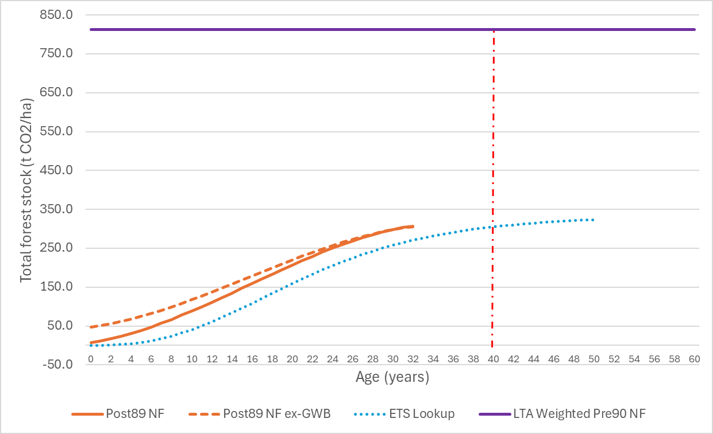

**Figure 1. Post-1989 natural forest carbon yield tables, with (*Post89 NF ex-GWB*) and without (*Post89 NF*) initial biomass in grassland with woody biomass, with ETS indigenous forest default table (*ETS Lookup*) for comparison. Also shown: Pre-1990 natural forest weighted mean current stock (*LTA weighted Pre90 NF*, 812.5 t CO2/ha), and maximum possible age during Paris Agreement compliance period (age 40).**

***Accounting treatment summary***

**Given the uncertainty around the development of carbon stocks in post-1989 natural forests in the future and the very long timeframes involved, these forests would ideally be treated under stock change accounting indefinitely. This is consistent with New Zealand’s intention to use “…***a combination of the 2006 IPCC Guidance and the 2013 IPCC Kyoto Protocol Supplement, providing for Kyoto Protocol accounting approaches to be applied to the greenhouse gas inventory land-based categories”.* However, it would not be consistent with the stated intention to transfer post-1989 forests from stock change accounting to accounting against a reference level after they attain their “long-term average stock”.

**For post-1989 natural forests, the use of an interim long-term average carbon stock based on the average in pre-1990 natural forests is unlikely to result in this LTA stock being exceeded during the Paris Agreement reference period, so forests will remain under stock change accounting to at least 2030.**

### Rotational Planted Forests

The LTA stocks and ages for planted forests managed under a clearfell regime are estimated using the LTA Calculator described in detail by Dovey and Wakelin (2024). **LTA stocks and ages are calculated for three species groups (radiata pine, Douglas-fir and other softwood and hardwoods) and then combined into area-weighted national averages for post-1989 rotational planted forests. Variables that affect this calculation (e.g. rotation length, yield table, harvest residue decay rates and HWP discard rates) are able to be selected and revised by the user.**

**Under Kyoto Protocol accounting for post-1989 forests, all stock changes were treated as additional and therefore accounted for in full. In contrast, for pre-1990 forests only the difference between the actual reported net emissions and the net emissions assumed in the business-as-usual Forest Reference Level were considered part of the accounting quantity. This means that the LTA stock and post-1989 reference level do not need to be limited by historic management practices in a past reference period.**

The intention is for the LTA to reflect both past and expected future forest management based on current best information. Some variables affecting future carbon stocks are determined for each rotation at or relatively soon after planting (e.g. species and stocking) while there is a lag for determining others (e.g. harvest age and wood product markets). Species mix and product markets have changed since 1990 so there is scope to restrict the inclusion of data to time periods that better represent what is expected.

Ultimately the choice of species and management for multiple successive future rotations cannot be predicted with certainty. The effect of differences in future management compared with the assumptions used in estimating the LTA age can be addressed through a post-1989 Forest Reference Level (see below).

**The assumptions made in the LTA Calculator for calculating the LTA stock and age for post-1989 rotational planted forests are listed in Table 1. Assumptions related to carbon stocks in harvested wood products, post-harvest residues and soil are discussed separately in a later section.**

*Yield tables*

Yield tables for three species groups (radiata pine, Douglas fir and other softwoods, and hardwoods) are presented in Paul, et al. (2024); tables 2a-4, 2a-5 and 2a-6 for post-1989 planted forests. The relatively small area of species other than radiata pine and Douglas fir means that there are few plots available from which robust carbon yield tables could be developed for individual minor species.

The approach taken was to calculate the LTA stock and age separately for these three species groups within the LTA **Calculator** (Dovey & Wakelin, 2024) and then weight the results by the area proportions. MFE’s Calculation and Reporting Application (CRA) currently uses a single national combined species yield table for post-1989 planted forests, so a single national LTA stock and age is required.

Carbon yield tables include the above-ground live biomass, below-ground live biomass, dead wood and litter pools, including carbon associated with the understorey (non-crop) component of the stand.

**Table 1. Elements contributing to the LTA stock and their selection period for inclusion in calculations for rotational post-1989 planted forests**

|  |  |  |  |
| --- | --- | --- | --- |
| **Element** | **Selection basis** | **Years to include** | **Source** |
| Yield tables | All post-1989 plots based on latest measurement | Planted 1990 onward | Paul et al. (2024) |
| Silviculture | (as reflected in the yield tables above, based on the representative sample of plots) | |  |
| Rotation age | Current best estimate – based largely on pre-1990 forest harvesting. | For radiata pine - 1995-2022 (data range available in NEFD reports) | Annual NEFD reports e.g. MPI (2022) |
| Species area weighting | Based on net stocked area from the LUCAS plot data used for yield tables | LUCAS plot areas for stands planted from 1990 onward | Paul et al. (2024) |
| HWP market share | Current best estimate, taking into account strong trends since 1990 but smoothing one-off events e.g. Covid. | 2018-2022 (last five years) | Derived in HWP Carbon accounting model (Wakelin (2023). |
| Soil Carbon | Stock change excluded from LTA calculation.  [Option is to include the difference in steady-state soil carbon stocks based on recent pre-afforestation land uses.] | n.a.  [2018-2022 (last five years)] | n.a.  [Land Use Change matrix, MFE (2024b)] |

*Rotation age*

Average clearfell age for radiata pine has been reported by MPI based on a survey of forest owners as part of the National Exotic Forest Description (e.g. MPI 2023). Figure 2 shows that the area-weighted clearfell age has been generally in the range 27-29. A rotation age of 28 is appropriate for use in the LTA **Calculator**.

**Figure 2. Mean clearfell age for *Pinus radiata* as reported in annual NEFD reports (e.g. MPI 2023)**

For Douglas fir and other exotic softwoods, there is no national clearfell age data published in the NEFD. Apart from Douglas fir and to a lesser extent *Cupressus macrocarpa,* *Cupressus lusitanica* and redwood (*Sequoia sempervirens*), planted areas are very small and management regimes vary.

Scion’s Douglas fir manual (Maclaren, 2009) assumed a “base case” rotation for Douglas fir of 45 years. In more recent wood availability forecasts carried out for MPI, the target rotation age for Douglas fir was 35 in Nelson, 38 years in the Central North Island and 43 years in Otago, Southland and Canterbury (Margules Groome, 2021).

Suggested rotation ages for other species from a recent guidebook on alternatives to radiata pine are given in Table 2 (Anon., 2023). Dozens of other softwood and hardwood species have been planted in small areas, generally with higher expected rotation ages than for radiata pine.

**Table 2. Suggested rotations for non-radiata pine species**

|  |  |  |  |
| --- | --- | --- | --- |
| **Species** | **Purpose** | **Rotation** | **LTA Model** |
| **Softwoods** | | | 40 |
| Cypresses | Sawn timber | 35-45 |  |
| Redwood | Sawn timber | 35-45 |  |
| Japanese cedar | Sawn timber | 40-50 |  |
|  |  |  |  |
| **Hardwoods** | | | 30 |
| Eucalyptus spp | Paper, biomaterials | 12-15 |  |
| “ | Posts/poles, engineered wood products | 15-20 |  |
| “ | Sawn timber | 25-40 |  |
| Poplars | Sawn timber | 25-35 |  |

Based on this information, a default rotation age of 40 for Douglas-fir and other softwoods has been implemented in the LTA **Calculator**.

The hardwood resource is dominated by Eucalyptus and related species. In the past there have been attempts to manage eucalypts and acacia on short rotations for paper production, but productivity was lower (and rotations longer) than anticipated. Sawlogs require longer rotations (Table 2). Hardwoods make up a very small proportion of the total resource so the rotation age assumed has little influence on the national weighted mean. A default rotation age of 30 for hardwoods has been implemented in the LTA **Calculator**.

*Species weighting*

A single national LTA stock and LTA age are created by weighting the three species groups (radiata pine, Douglas fir and other softwoods, and hardwoods). The default option within the LTA **Calculator** uses LUCAS post-1989 plot area by species group for the weighting (Table 3). Harvested and unvisited plots were excluded.

**Table 3. LUCAS post-1989 planted forest plot area by species (Data from 2018-2022 measurement cycle, Paul et al. 2024)**

|  |  |  |
| --- | --- | --- |
|  | **Post89 Total plot area (ha)** | |
|  | **Including harvested** | **Excl. harvested and unvisited** |
| **Radiata pine** | **15.37 (84.5%)** | **12.73 (82.4%)** |
|  |  |  |
| **Softwoods** | **1.89 (10.3%)** | **1.83 (11.6%)** |
| Douglas fir | 1.65 (9%) | 1.65 (10.6%) |
| Cypresses | 0.24 (1.3%) | 0.18 (1%) |
|  |  |  |
| **Hardwoods** | **0.97 (5.2%)** | **0.89 (5.8%)** |
| Eucalyptus species | 0.79 (4.3%) | 0.71 (4.6%) |
| Blackwood | 0.06 (0.3%) | 0.06 (0.4%) |
| Oak species | 0.06 (0.3%) | 0.06 (0.4%) |
| Poplar species | 0.06 (0.3%) | 0.06 (0.4%) |

***Accounting treatment summary***

**Productivity and silviculture for rotational post-1989 planted forests are defined by yield tables derived from the post-1989 planted forest inventory plots. Rotation age by species group was also required to calculate the LTA stock, and while information on average rotation length is scarce for minor species, the impact of this assumption on the overall result is limited by the dominance of radiata pine. The impact of the harvested wood products carbon pool on long term stocks is also significant and is discussed in a later section.**

**Accounting for post-1989 rotational planted forests will be under stock change accounting according to the carbon values by age in the combined species post-1989 planted forest carbon yield table until the species-weighted LTA age is reached.**

**Forests harvested in the compliance period before the LTA age is reached should still receive full credit to the LTA age, since the LTA age takes into account both longer and shorter rotations. The additional accounting quantity will have to be calculated externally to the CRA.**

**Forests already beyond the LTA age in 2021 would receive not further credits.**

### Permanent Planted Forests

**While most post-1989 planted forests are established with the intention of eventual clearfell harvesting, management can change due to changes in circumstances or owner objectives. Examples of post-1989 planted forests that may not be clearfelled include:**

* **Forests established with the intention of management under a continuous cover forestry model, including those initially registered within the Permanent Forest Sinks Initiative (PFSI).**
* **Forests registered within the NZ ETS under stock change accounting, which allows an income to be earned from carbon.**
* **Forests established for non-timber values, such as a multiple-species arboretum.**
* **Exotic forests established as a nurse crop for native forest restoration.**
* **Planted forests that are not considered economic to harvest, because of the low potential revenue (e.g. stands with poor stocking, malformed trees, or unmarketable species) or high cost of extraction (e.g. steep and/or remote sites, or forests on fragile soils where the risks of environmental damage are too high).**

**Collectively these may be referred to as *permanent forests*, and calculation of their LTA stock requires a different approach. “Permanent Forest” is not a standard forestry term and is not used by the IPCC – their methodologies recognise that forests cannot be guaranteed to be permanent. It came into use in New Zealand forestry through the Permanent Forest Sink Initiative (PSFI), through which grants were available to establish new forests with covenants placed on the land that restrict (but do not forbid) harvesting.**

***ETS Permanent Forests***

**From 1 January 2023 a new “Permanent Forest” category was created in the ETS. Forests in this category earn New Zealand Units (NZUs) under stock change accounting and must not be clearfelled for 50 years. Limited harvesting within that period is still allowed, as long as at least 30% canopy cover remains in each hectare of forest.**

**After 50 years there are three options:**

1. **Remain under the Permanent Forest category for another 25 years, then choose between the three options again.**
2. **Move the forest to the “Standard Forest” category, under averaging accounting. This would likely mean repaying NZUs previously earned above the long-term average stock under stock change accounting.**
3. **Remove the land from the ETS, repaying the net balance of NZUs earned.**

**Land established earlier under the PFSI can be:**

1. **Moved into the ETS Permanent Forest category.**
2. **Moved into the ETS Standard Forest category**
3. **Withdrawn from the PFSI, surrendering NZUs earned.**

**Land originally registered as standard forest in the ETS can later be transferred to Permanent forest. However, forests registered in the ETS before 2023 can remain as standard forests under stock change accounting.**

The current area in the ETS Permanent forest category has not yet been published. Forests registered as ETS Permanent Forests can be assumed to be managed on at least a fifty-year rotation, but forests outside this ETS class could also be managed with clearfelling and similarly long rotations or under various types of continuous cover forestry, including a managed transition to native forest. The timing and intensity of thinning operations will affect the long-term average carbon stock, but the impact on carbon stocks is not well understood in New Zealand for these new types of management.

***Exotic forest to native forest transitions***

**Some exotic forests have been planted to act as the nurse crop that allows the gradual establishment of a natural indigenous forest. This makes use of the cheaper and easier establishment of the nurse crop, faster sequestration rates allowing more revenue from carbon, and potentially ongoing sequestration revenue from the replacement indigenous forest. One carbon forestry company has established over 60,000 ha with a stated intention of actively managing the transition to indigenous forest.**

**The impact on carbon stocks of this type of management is still uncertain. Creation of canopy gaps for native tree ingrowth, availability of seed source and control of browsing pests will be required.**

***Continuous cover forestry***

**There is very limited experience with management of planted forests under continuous cover forestry silviculture, and therefore little understanding of potential carbon stock development in the longer term.**

***Rotational planted forests that are uneconomic to harvest*.**

**Some forests that were planted with the intention of a later harvest have been left unharvested, either because the returns from harvesting are too low, the ongoing carbon revenues are more attractive or the environmental risks are too high. This changes with changes in extraction costs, timber prices and carbon price, as well as changes in the regulatory environment.**

**Where harvest returns are marginal, the return from replanting may be such that deforestation is likely to occur after harvesting, unless natural regeneration into native forest takes place. A survey of forest owners found that about 6.1 % of post-1989 planted forest was unlikely to be harvested (Manley, 2018).**

**In summary, it is unclear how “Permanent forests” will be managed and how the carbon stock will respond, as illustrated for some examples in Table 4.**

**Table 4: Examples of “Permanent forest” management regimes and likely carbon stock response**

|  |  |  |
| --- | --- | --- |
|  | **Management** | **Likely LTA stock level** |
| **1** | **Production thin twice to 30% canopy cover each time, clearfell at age 50 years** | **Lower**  **↓**  **Higher** |
| **2** | **Pre-commercial thinning only, with clearfell at age 50 years.** |
| **3** | **Limited selection harvest indefinitely, targeting ~30-year-old trees** |
| **4** | **Limited selection harvest indefinitely, targeting ~60-year-old trees** |
| **5** | **Transition to native forest (e.g. with gap creation, natural regeneration, supplementary planting)** |

**For an “ETS Permanent forest” that is managed at the bare minimum 30% canopy cover for 50 years and then converted to repeated rotations of 15 years, both the actual carbon stock at any point in time and the long-term average stock would be relatively low. In contrast, stands of species such as kauri or redwood that receive only limited thinning and are never clearfelled could maintain a very high average stock in the long term (over 100 years).**

**Currently the ETS Standard Carbon tables that must be applied by ETS-registered owners with less than 100 ha do not continue past age 50, so there is no carbon revenue incentive to extend rotations further but still an incentive to avoid the harvest liability. Owners with more than 100 ha are rewarded with NZUs based on plot data using the ETS Field Measurement Approach, which means that the carbon income stream can continue. This ability to earn income from selling NZUs affects harvest decisions, as does the potential economic return from harvesting.**

***Permanent planted forest yield tables and long-term average stocks***

**The yield tables and rotation ages assumed for permanent forests need to reflect the forest area assigned to the permanent class. However, these forests are not clearly identifiable and vary greatly in terms of the impact of management on carbon stocks.** The influence of natural disturbance in these forests on their long-term stocks is also uncertain but likely to be much greater on average than for rotational forests on relatively short rotations.

**The post-1989 planted forest combined species yield table is appropriate to use for the early growth of permanent forest in the absence of a separate assessment of these forests. However, it** has been projected well beyond the maximum age of the measured plots, and includes only the competition-induced mortality and minor attritional damage captured in the growth model applied. It is not yet clear whether it is representative of the species, sites, or management applied to permanent forests.

**Given that the oldest permanent post-1989 stands will be 40 years old in 2030, they will remain under stock change accounting during the Paris Agreement compliance period as long as the LTA age for permanent forests is over 40 years. If the LTA was under 33 there may already be permanent post-1989 forest past their LTA. This could apply to pine stands intended to transition to native forest. If these stands were assigned a long-term average stock equivalent to the mean stock in pre-1990 natural forests (812.5 t CO2 ha-1), this would be achieved by post-1989 planted forests after only 24 years (Figure 3).**[4] **However, in practice the transition is likely to result in a long period in which the stock falls below this LTA, which may not be reached for centuries. Repeated 50-year rotations would also result in a LTA age well below 40 years.**

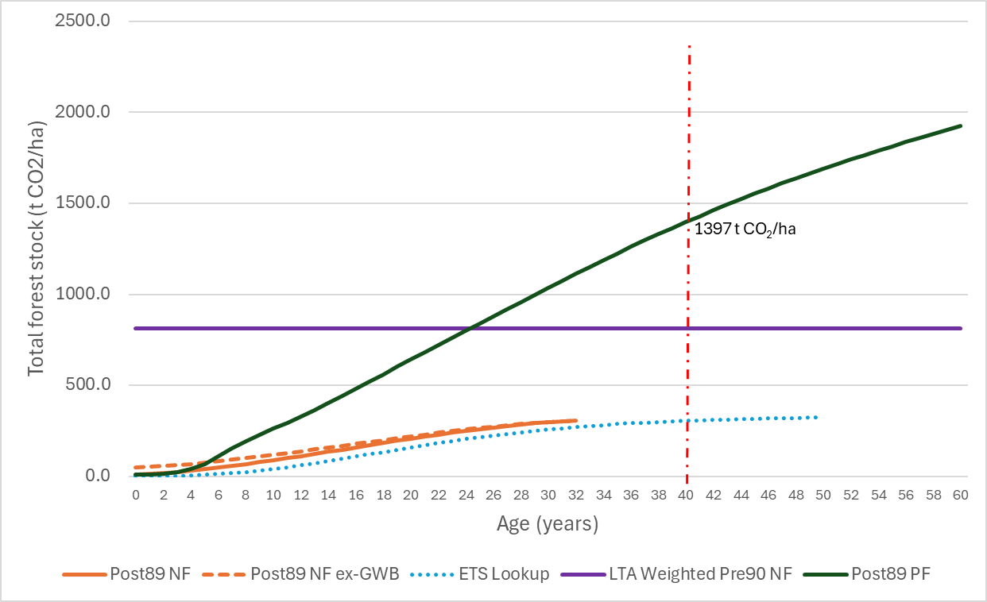

**Figure 3. Post-1989 combined species planted forest carbon yield table (*Post89 PF*), shown with post-1989 natural forest carbon yield tables and LTA stock from Figure 1. Also shown: maximum possible age during Paris Agreement compliance period (age 40) and corresponding carbon stock, and achievement by planted forests of the pre-1990 average natural forest stock of 812.5 t CO2/ha (*LTA weighted Pre90 NF)* by age 24.**

***Accounting treatment summary***

**Similar uncertainty surrounds future carbon stocks for post-1989 permanent planted forests as for post-1989 natural forests, particularly as the intention for some of these planted forests is a transition to indigenous forest. The carbon sequestration rate for planted forest is much higher than for natural forests, so it is more likely that a LTA stock will be exceeded during the compliance period.**

**It would be preferable for these forests to remain under stock change accounting indefinitely, or at least until they can be categorised and modelled. If “averaging accounting” is to be applied, the LTA stock would need to be at least 1397 t CO2 ha-1 if all area is to remain under stock change accounting during the 2021-2030 compliance period. Whether this is appropriate for the average permanent forest will depend on how these forests are identified and managed, and the yield table is likely to need to be revised as more information becomes available.**

A more conservative approach would be to apply the rotational forest LTA, which should allow adjustments to be made via reference level accounting and/or calculation of the LTA.

### Harvested wood products for post-1989 forest types

**HWPs consist of above-ground biomass that is harvested, converted into one of the three semi-finished wood product categories recognised by the IPCC** (sawn wood, wood-based panels and paper and paperboard)**, and enters the domestic and export wood product markets.**

**The LTA Calculator for rotational planted forests includes the HWP pool when calculating the LTA stock. In accordance with the accounting approach used in the Kyoto Protocol (IPCC 2014), HWPs are included only while they are in-service – any long-term or indefinite storage in landfills is ignored. This means that all HWPs produced will have a finite lifespan, and under a constant production rate the HWP pool would reach a maximum stable level.** Modelling across multiple rotations is required to determine the balance between new additions of wood products to the HWP pool with each harvest and the on-going annual discard of existing products.

**The HWP inputs to the LTA Calculator include:**

* **the recoverable above-ground biomass proportion removed during harvest,**
* **the proportion of domestically processed and exported roundwood,**
* **the allocation of exported roundwood to different export markets,**
* **specific discard tables for domestically processed logs and for individual export markets,**
* **period range to create an average table, and**
* **discard table length (truncation).**

***Biomass removed at harvest***

**Initialising the stock of HWP derived from harvesting is based on the assumption that the quantity of stem carbon removed at harvest represents about 70% of above-ground biomass (Wakelin & Garrett, 2010). This assumption is also used in the LUCAS CRA.**

***Proportional share of domestic processing and log exports and proportional share of each export log market***

**These proportions vary over time and were derived from data in the HWP Model used for greenhouse gas inventory reporting (MFE 2024a). These data are sourced annually from FAOStat and MPI.**

***Discard tables for each log market***

**Discard tables for each log market including the domestic market are calculated in the HWP Model based on first order decay, with half-lives assumed for combinations of market, HWP and end use (Wakelin, 2023). The tables used were calculated based on weighted half lives, rather than by summing the individual end use discard tables. These tables take into account carbon in processing residues that are not incorporated into HWPs such as paper or panels, which are instead assumed to be instantly emitted. Domestic log discards also take into account the loss at the time of harvest of carbon in products that are not included in New Zealand’s greenhouse gas inventory reporting: export pulp, export chips and posts and poles.**

**Aggregate discard rates for export logs are based on data provided by Manley and Evison (2017). Equivalent tables for HWPs produced in New Zealand (for domestic use and exports) were produced by Scion (Wakelin, 2023) based on end use mix and lifespan information provided by Wekesa et al. (2022).**

***Period range***

**Individual product lifespans are based on limited information collected at a point in time, so do not vary through time and have been applied to all species and rotation lengths. However, the aggregate discard rate is weighted by the mix of export to domestic logs and export market share, which has changed over time. Aggregate discard tables are therefore provided in the LTA Calculator by year, and it is possible to select a time period over which to create an average discard table. The period 2018-2022 was selected for calculating the LTA. Because of the difficulty in comparing HWP pool reporting (from the HWP Model) with the HWP contribution to the FRL, any changes in end uses and lifespans may require recalculation of the LTA. Stock change accounting to the LTA would then capture the contribution of the HWP pool in full, with no need for changes to be tracked against the reference level.**

***Discard table length (truncation)***

**The LTA Calculator considers eight rotations and by default truncates the average discard table at 150 years, at which time the remaining 0.8% of HWP carbon is emitted. If the discard table was allowed to run out further, a stable LTA stock may not be reached within the eight rotations modelled in the LTA Calculator.**

### Post-harvest residues

Post-harvest residues are derived from the total carbon stock in the forest at the time of harvest minus the carbon in the roundwood assumed to be removed. Residues left on site at after harvest and therefore subject to decay include:

* Dead wood and litter generated throughout the rotation that has not completely decayed yet
* AGB from the trees harvested that has not been removed as logs
* All remaining BGB.

Within the LTA **Calculator**, the decay of biomass is captured in a decay table, using the same decay function used in the CRA (Paul & Wakelin, 2011). The LTA stock calculated therefore includes the pool of post-harvest residues.

By default, the decay of residues in the LTA **Calculator** is truncated to zero at 100 years, by which time only 0.0001% of the initial residues remain. This allows LTA stock to reach an asymptote within the eight rotations modelled.

### Soil carbon adjustments for post-1989 forest types

The LTA **Calculator** allows two approaches for dealing with the soil carbon stock.

1. The LTA **Calculator** can estimate the *change* in soil carbon resulting from land use change to post-1989 forests, then net this off the long-term average that excludes the soil carbon pool. The change in soil carbon depends on pre-afforestation land use mix, which varies over time, so a five-year average for 2018-2022 is used by default and this period can be adjusted.
2. The soil carbon change following afforestation can be excluded from the LTA calculation. Instead, the loss of soil carbon from the pre-afforestation land use as a result of land use change should be captured directly in the accounting quantity through stock change accounting.

LTA calculations made to support projections have previously taken the first approach, accounting for the one-off change in soil carbon average stock due to afforestation. This uses estimates of steady-state soil organic carbon stocks derived for all land uses and the land use change matrix to post-1989 planted forests (MFE 2024b). The assumption made is that the difference between the long-term soil carbon stock under pre-afforestation land uses and the long-term soil carbon stock under post-1989 planted forest represents a change in the long-term average stock. An average pre-afforestation land use mix is assumed, avoiding the need to explicitly project afforestation on each land use.

The option taken was to instead exclude the soil carbon stock change (along with the loss of pre-afforestation biomass) from the LTA calculation. For accounting, the CRA will capture actual soil carbon changes through the Land Use Change matrix modelled in the CRA. Because this is a one-off change that occurs in the first rotation only, there is no cyclical recurrence and therefore no disadvantage in excluding soil carbon from the LTA calculation.

## LTA Stock and Age calculation

The LTA **Calculator** (Dovey & Wakelin, 2024) calculates both the LTA carbon stock for rotational forests and the LTA age to one decimal point.

The LUCAS CRA module will capture carbon stock changes in post-1989 forests up to the national LTA age based on stock change accounting. There are three options for dealing with an LTA age that lies between whole number ages:

1. Include the partial increment under stock change accounting in the CRA calculations.
2. Round the LTA age down – e.g. 22.9 and 23.1 become 22 and 23.
3. Round the LTA age up and down as appropriate – e.g. 22.4 becomes 22; 22.6 becomes 23.

One issue is that relatively small differences in the LTA stock and LTA age can have large impacts given large national areas, stocks per hectare and carbon prices. Rounding can exacerbate this. For example, changes in data or assumptions that result in relatively small LTA age changes as in the examples above can have a large impact whether rounding down (option 2) or up and down (option 3). In both cases a difference in LTA age of 0.2 years can become a difference of 1 year after rounding.

The reverse is also true – that is, if there is a relatively large difference in calculated LTA age, either approach could minimise the impact of this. If rounding up and down, LTA ages of 23.6 and 24.4 both become 24.[5] If rounding down only, 23.1 and 23.9 both become 23.

These small differences in calculated LTA age are not likely to be ‘real’ given the uncertainty around the data and assumptions, and there is an opportunity to adjust the accounting quantity via post-1989 Reference Level accounting. A conservative approach of always rounding down could be justified on this basis, and this is what has been implemented. This avoids the need to make changes to the CRA module, which expects a whole number age as input.

## Calculating the Post-1989 Forest Reference Level

The reference level for post-1989 forest accounting should be generated using the same data used in the LUCAS CRA module for reporting. This requires:

1. Annual post-1989 afforestation and deforestation area from 1990, as used for greenhouse gas inventory reporting. Projected deforestation and afforestation through the compliance period 2021-2030 are optional, as the areas can be corrected when available in the same way that technical corrections are made to the pre-1990 planted forest FRL.  
     
   Afforestation and deforestation needs to distinguish between post-1989 natural forest, post-1989 rotational planted forest and post-1989 permanent planted forest.
2. Annual harvesting and restocking of rotational post-1989 planted forest from 1990 onward, including projections to 2030 based on the weighted rotation age calculated in the LTA **Calculator**, or the destocking age profile used in the latest CRA simulation. This should provide the FRL schedule of annual net emissions that is consistent with the LTA age.
3. Modelled forest biomass carbon stock changes associated with afforestation, harvesting and replanting of post-1989 forests as above. These are calculated from the areas and the post-1989 planted forest and natural forest yield tables. Calculations can be made within the LUCAS CRA.

Soil carbon stock changes can be excluded from the reference level, and instead accounted for under stock change accounting. Changes in the HWP pool could be treated in the same way, or included in the LTA calculation and reference level, with the impact of any future changes in HWP assumptions captured by recalculating the LTA age and correcting the FRL (if necessary).

The above information is required for the five components of post-1989 forests:

1. Post-1989 natural forest **below** the LTA age as of 1 January 2021. Note that:  
   - it is assumed that no post-1989 natural forest area will be above the LTA age until after 2030.  
   - carbon stock changes are based on the LUCAS post-1989 natural forest yield table  
   - HWPs are not produced from these forests until after 2030 (if at all).
2. Post-1989 rotational planted forests **below** the LTA age for rotational planted forest as of 1 January 2021. Note that:  
   - this will include areas that were harvested and replanted between 1990 and 2020.  
   - 93.9% of total annual afforestation into post-1989 planted forest should be assigned to rotational forest, with adjustments to match area by age requirements for harvesting and deforestation during the time series. The remainder is permanent forest.
3. Post-1989 rotational planted forests **above** the LTA age as of 1 January 2021. Note that:  
   - this could include areas that were harvested and replanted between 1990 and 2020.  
   - split area between rotational and permanent planted forest as above.
4. Post-1989 permanent planted forests **below** the LTA age as of 1 January 2021. Note that:  
   - split area between rotational and permanent planted forest as above.  
   - until more information on the expected management of permanent forests is available, all permanent post-1989 planted forest can be assumed to be under the LTA age during 2021-2030.
5. Post-1989 permanent planted forests **over** the LTA age as of 1 January 2021. Note that:  
   - if it can be assumed that the LTA age is over 40, this component is not required in the 2021-2030 compliance period.

**The reference level for post-1989 forest accounting should be generated within the LUCAS CRA module, which provides the ability to model instances of multiple land use changes occurring since 1990 and special cases such as Carbon Equivalent Forests.**

## Simplified demonstration of averaging accounting

**A simplified demonstration of averaging accounting was developed to examine how the application of reference level accounting beyond the LTA age is able to adjust the accounting quantity as forest management deviates from the management assumed when calculating the LTA stock and age. This demonstration does not use data from the LUCAS plot network or GHG inventory reporting.**

**The base case assumed linear carbon uptake of 5 t C ha-1 yr-1, a rotation of 30 years and a one-year delay between harvesting and replanting. This resulted in a LTA stock of 81.1 t C ha-1 and LTA age of 16 years (rounded down to the nearest year). The stock at the LTA age is 80 t C ha-1.**

**The two alternative scenarios assumed the same carbon sequestration rate, but with:**

* Longer rotation (35 years): LTA stock = 93.6 **t C ha-1**, LTA age = 18 years, stock at LTA age = 90 **t C ha-1**.
* Shorter rotation (20 years): LTA stock = 56.0 **t C ha-1, LTA age = 11, stock at LTA age = 55 t C ha-1.**

**The accounting quantity was calculated in two parts:**

1. **Stock change up to the LTA age (16 years) – 80 t C ha-1.**
2. **Reference level accounting beyond the LTA age, with the FRL taken as the annual net stock changes expected from age 16 onward for multiple 30-year rotations. ‘Actual’ net stock changes were calculated after age 16 for the longer and shorter rotation scenarios.  
     
   The difference between the FRL and actual net emissions was calculated over two time periods:   
   (i) 310 years (i.e. ten full rotations with harvesting at age 30 years, ~8.5 rotations for the age 35 rotation scenario and ~14.5 rotations for the short rotation scenario), or  
   (ii) over a variable time period equating to ten full rotations for each scenario.**

**Cumulative progress against the FRL was tracked annually by comparing the cumulative difference between the scenario net emissions beyond the LTA and the FRL emissions. This was done for two cases:**

1. **a single planting year age class cohort, and**
2. **assuming an even age class distribution across the rotations.**

# Results and discussion

## Long-term Average Carbon Stock and Age Estimates

**The LTA stock and LTA age calculated in the LTA Calculator (Dovey & Wakelin, 2024) for rotational forests is given in Table 5.**

**Table 5**: Long-term average (LTA) carbon stock and LTA age using default LTA Calculator options.

|  |  |  |  |
| --- | --- | --- | --- |
| **Forest Type** | **Rotation age** | **LTA**  **(tCO2 ha-1)** | **LTA age (years)** |
| 82.4% Radiata Pine | 28 | 817 | 23.2 |
| 11.8% Douglas-fir, other softwoods | 40 | 781 | 29.0 |
| 5.8% Hardwoods | 30 | 585 | 24.0 |
| Area-weighted clearfell forest |  | 799 | 23.9 |

**When rounded down, the LTA age is 23 years. The unrounded value of 23.9 years suggests that changes in assumptions that increase the LTA stock could quickly see the LTA age tip over to 24 years. Conversely, the LTA age would be relatively robust to changes that result in lower average stocks**

**Testing confirmed that the combined species LTA age would increase to 24 years with separate increases in assumed rotation length of 1 year for radiata pine, 2 years for other softwoods, or 3 years for hardwoods. It would only reduce to 22 years with a decrease in assumed rotation length of 3 years for radiata pine, or 16 years for other softwoods. A decrease of about 16 years would also be required for hardwoods, but this could not be tested because with such a young rotation age the LTA stock cannot be reached within the first rotation and will not stabilise within eight rotations. This means that the LTA calculator cannot calculate the LTA age.**

## Demonstration of averaging accounting

**Figure 4 shows total carbon stocks in the three simplified example scenarios (rotation ages 30 (Base), 35 and 20) modelled over 310 years and the LTA stock for each. Note that this demonstration is not based on data used for greenhouse gas inventory reporting and accounting. In this simple example there is no accumulation of HWPs and harvest residues beyond the immediate next rotation, hence the average stock over the second rotation is the same as the average over all subsequent rotations.**

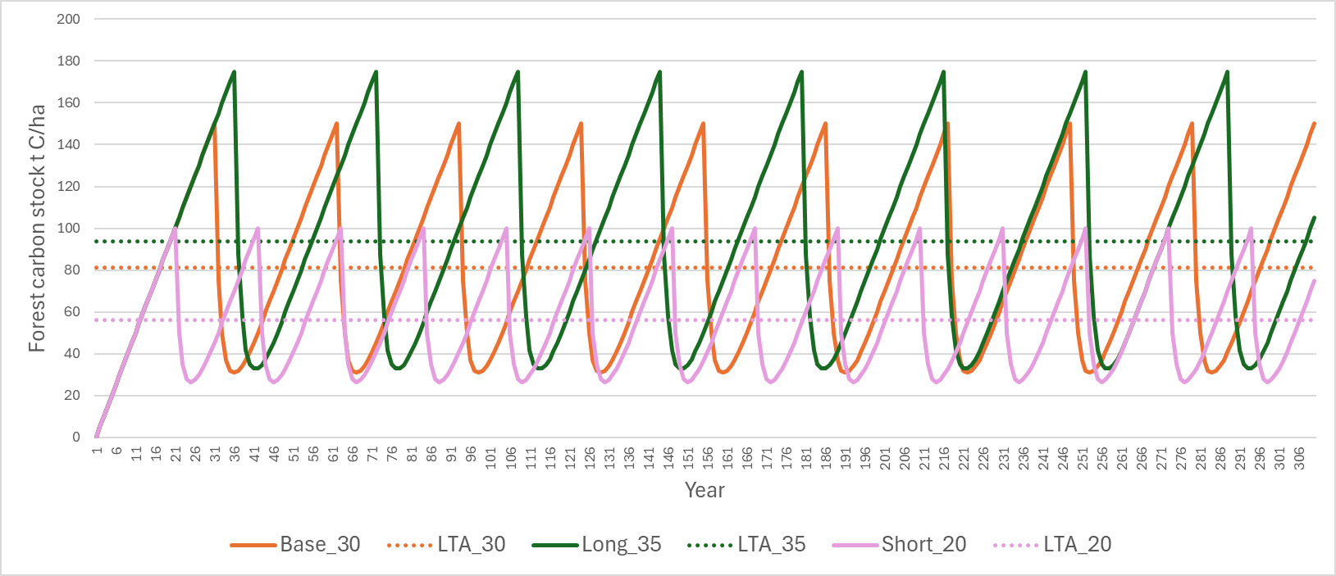

**Figure 4. Total carbon stocks and LTA stock for multiple rotations of three scenarios, varying by rotation age (Base 30 years, Long 35 years and Short 25 years).**

**In all scenarios, there would be credit up to the Base LTA age that assumes a 30-year rotation, indicated by the dotted line in Figure 4 at 80 t C ha-1. This represents an over-allocation if the actual rotation age turns out to be 20 years, and an under-allocation if the actual rotation age turns out to be 35 years, indicated by the other dotted lines in Figure 4 representing the true long term average stock under those rotation age assumptions. The purpose of the post-1989 FRL is to correct this over- and under-allocation.**

**The FRL is calculated from the annual net stock changes that occur after the LTA age is passed, represented by annual changes in the Base_30 “sawtooth” in Figure 4. Accounting against the FRL requires the actual net stock changes past the LTA age to be compared with the FRL. The cumulative difference over the accounting period is added to the reward up to the Base LTA to give the total accounting quantity.**

**Table 6 presents the accounting quantity for each scenario, summed over either 310 years (equal to ten cycles of the 30-year rotation including a one-year replanting lags), or over ten full rotations for each scenario. The total accounting quantity is equal to the stock change component up to the assumed LTA age** in each case **(80** t C ha-1) *plus* the difference between the FRL and actual net emissions beyond that point, summed for the two alternative time periods. The FRL is based on expected net emissions beyond the LTA age for the 30-year rotation. This means that for the base scenario, the difference between the FRL and actual net emissions is zero by definition for both time period scenarios.

For the two alternative rotation age scenarios, the total accounting quantity differs depending on the time period summed across, and in both cases the result differs from the true LTA stock that would result from recalculation of the LTA for the respective rotation ages.

**Table 6.** **Accounting quantities for three scenarios varying in rotation age.**

|  |  |  |  |
| --- | --- | --- | --- |
| **Accounting component** | **Base 30 years**  t C ha-1 | **Long 35 years** t C ha-1 | **Short 25 years** t C ha-1 |
| [i] Stock change to LTA age = 16 years (expected rotation 30 years) | 80 | 80 | 80 |
|  |  |  |  |
| True stock at scenario LTA age (if LTA was recalculated) | 80 | 90 | 55 |
| Stock change after LTA age: |  |  |  |
| 1. Actual net emissions (sum to 310 years) | 70 (FRL) | 25 | -5 |
| [A] Actual net emissions minus FRL | - | -45 | -75 |
| **Total accounting quantity** [i + A] | **80** | **35** | **5** |
| or |  |  |  |
| 1. Actual net emissions (sum to 10 full rotations) | 70 | 95 | 20 |
| [B] Actual net emissions minus FRL | - | 25 | -50 |
| **Total accounting quantity** [i + B] | **80** | **105** | **30** |
|  |  |  |  |

**When actual rotations are different from the assumption made in the LTA age calculation, the cumulative FRL accounting quantity at a given point in time will depend on how far a stand is through its current rotation.**

**This is illustrated for the Long and Short rotation scenarios in Figures 5 and 6. For the long rotation scenario, if an accounting quantity of 10 t C ha-1 is obtained against the FRL, this would deliver the ‘true’ LTA stock for repeated 35 year rotations when added to the stock change accounting value up to the LTA age for repeated 30 year (Base) rotations. This cumulative sum is achieved at various future points (i.e. whenever the solid line crosses the dotted line in Figure 5), but often the total accounting quantity will be much higher or much lower (Figure 5).**

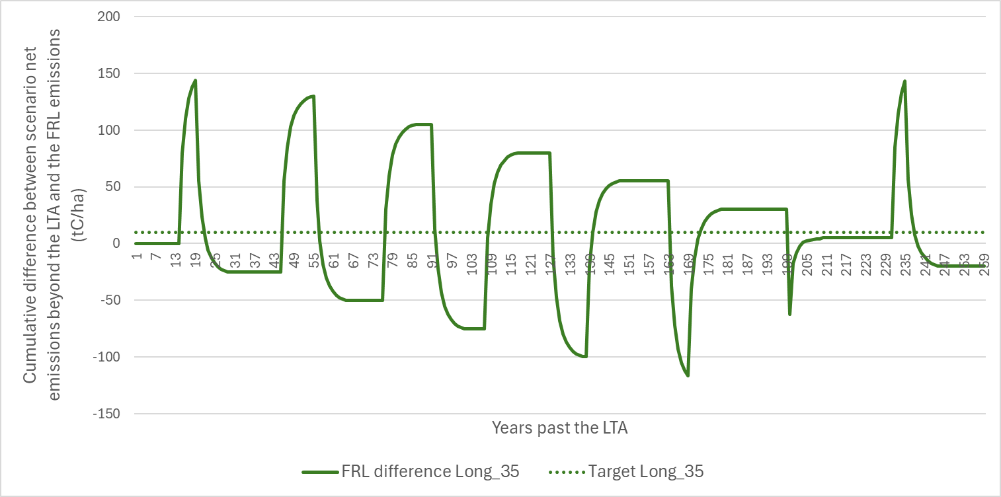

**Figure 5 Accounting quantity calculated against the FRL beyond the LTA age for the Long rotation scenario, and the “target” accounting quantity required that when added to the stock change quantity up to the LTA age would give the actual LTA stock under long (35 year) rotations.**

**For the short rotation scenario, accounting for stock changes up to an LTA age of 16 (LTA stock 80) would overstate the actual LTA stock achieved by 25 t C ha-1 (Table 6), so a target accounting quantity against the FRL of -25 t C ha-1 is required. Again, this is achieved in some future years, but more often the total accounting quantity will be very different (Figure 6).**

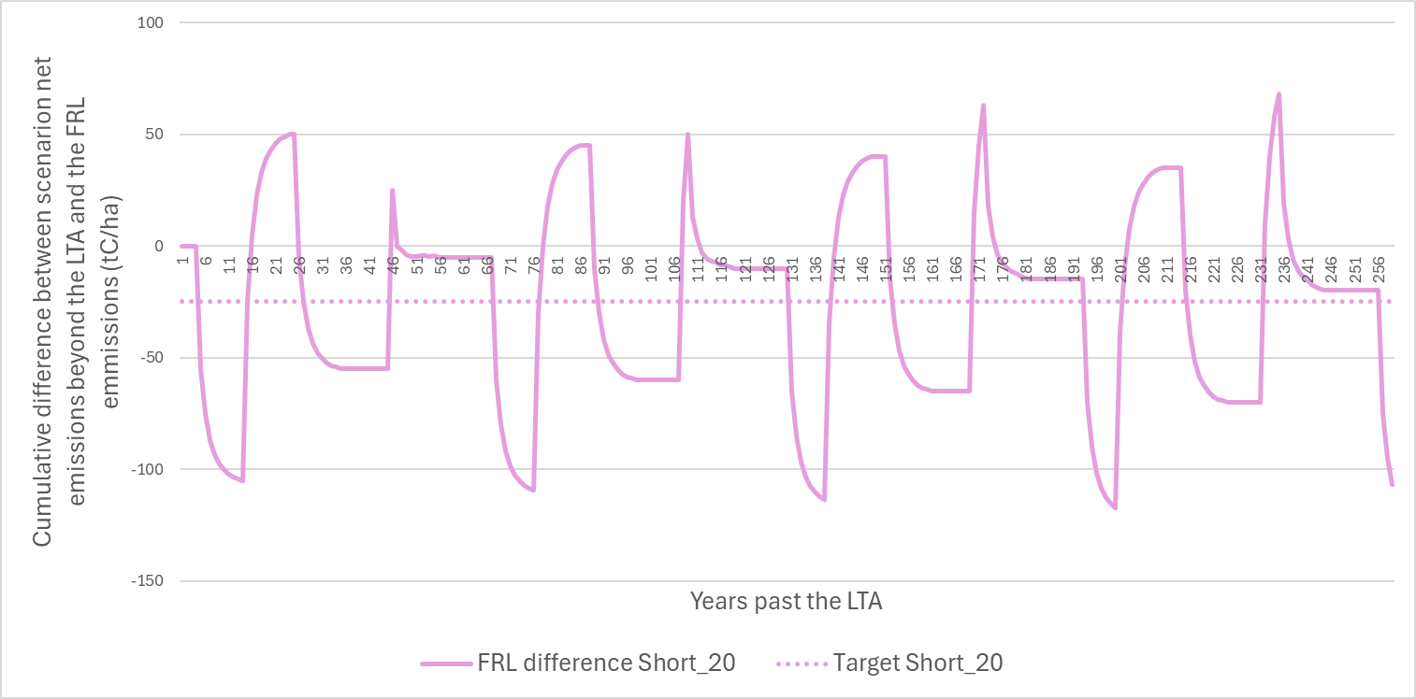

**Figure 6 Accounting quantity calculated against the FRL beyond the LTA age for the Short rotation scenario, and the “target” accounting quantity required that when added to the stock change quantity up to the LTA age would give the actual LTA stock under short (20 year) rotations.**

**It is apparent from Figures 5 and 6 that the timing of the start and end of a budget period or compliance period could have a major impact on the accounting quantity, as could relatively small variations in the timing of actual harvesting. The impact of this would be mitigated by the spread of age classes in the forest, in contrast with the single age class modelled in Figures 5 and 6.**

**To demonstrate the impact of spreading area across multiple age classes, the accounting quantity was accumulated for the long and short rotation scenarios under the assumption of an even spread of age classes across the rotation. This means that in years in which harvesting occurs, there are other forest areas still growing to compensate for the net emission. In these examples it is assumed that there are 1/20th of a hectare in each age class for the short rotation and 1/35th of a hectare in each age class for the long rotation. Each age class is at a different point in accumulating net emission differences against the FRL over time, with some generating credits while others generate liabilities, as shown in Figures 5 and 6.**

**The net results are shown in Figures 7 and 8 for the long and short rotations, respectively. Every time the solid lines intersect with the dashed lines, it means that the total accounting quantity calculated at that point based on averaging accounting (i.e. stock change accounting to the base LTA age then reference level accounting beyond that) is equal to the result that would have been obtained by recalculating the LTA age based on the revised actual rotation lengths. This is the “**true stock at scenario LTA age” given in Table 6.

**There is still variation around the target accounting quantity, although it is less extreme. In practice, differences in the national average rotation age between the FRL assumption and what eventuates are likely to be smaller, which would reduce the fluctuations. On the other hand, the actual age class distribution is less regular, which increases the likelihood of a large year to year variation coinciding with the end of a budget or compliance period.**

**Overall the demonstration suggests that the use of reference level accounting with post-1989 rotational forests is unlikely to result in a correct accounting quantity within a ten year compliance period, in situations where there has been an over- or under-allocation up to the assumed LTA stock.**

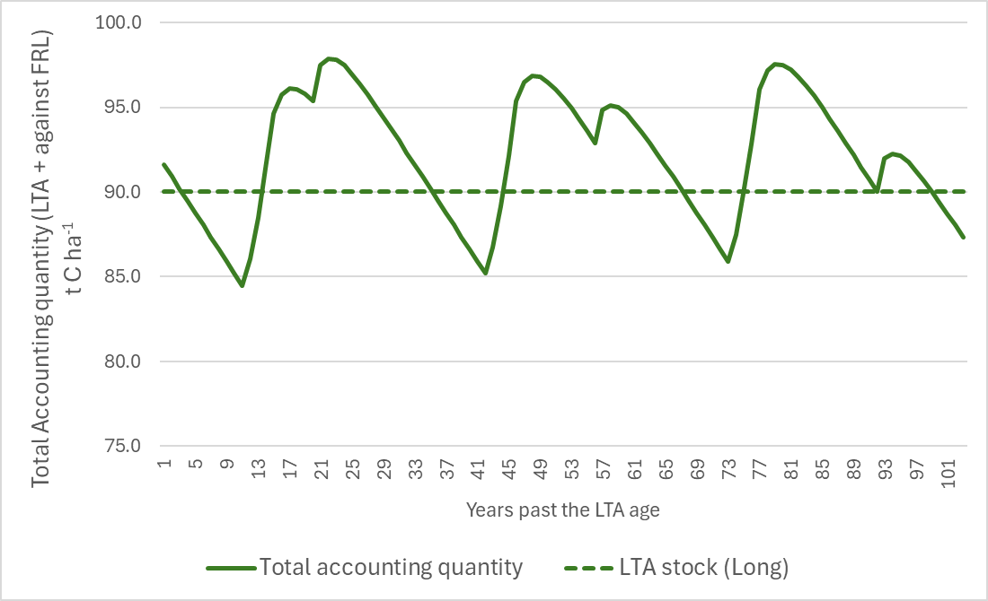

**Figure 7. Total accounting quantity (expressed per hectare) for the Long rotation scenario, assuming equal area in each age class. Target is the true LTA stock for repeated long rotations, 90 t C ha-1.**

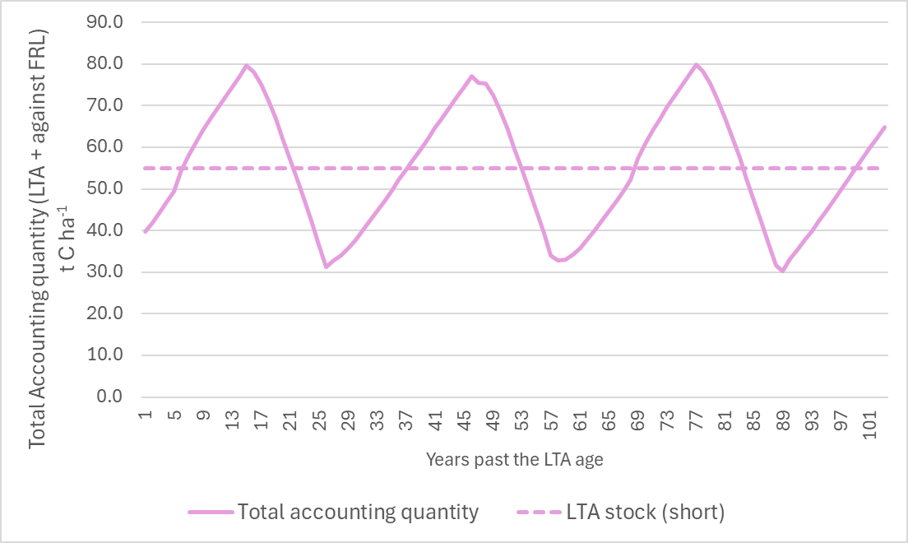

**Figure 8. Total accounting quantity (expressed per hectare) for the Short rotation scenario, assuming equal area in each age class. Target is the true LTA stock for repeated long rotations, 55 t C ha-1.**

## Steps to create the post-1989 FRL using the LUCAS CRA

**The following steps are required to calculate the post-1989 FRL using the LUCAS CRA, if it is determined that reference level modelling is required.**

1. **Model post-1990 forests in the CRA capturing afforestation, deforestation and harvesting from 1990-2020, including special cases (for example, multiple land-use changes and carbon equivalent forests). Allocate planted forest to permanent and rotational categories according to information from the latest harvest intention survey.  
   Note that this is simply the latest NIR run for greenhouse gas inventory reporting.**
2. **The starting point for the FRL simulation is the age profile of post-1989 natural, permanent planted and rotational planted forests as of 31 December 2020.  
     
   Simulate afforestation, deforestation, harvesting and replanting from 2021 to 2030.  
     
   - For permanent natural and planted forests, grow on to 2030 without harvesting.  
     
   - For rotational planted forest destocking age, apply the harvest profile used in the latest NIR run for 2020. (If input is required as harvest area by age per year, then the simulation will need to be advanced one year at a time so that unharvested area by age can be calculated each year, to which the harvest profile proportion can be applied).  
     
   If the harvest age profile approach is not possible, harvest at the species-weighted rotation age of 29 (Dovey & Wakelin, 2024).**
3. **Calculate annual net emissions from 2021 to 2031 in two ways:  
   (i) using the full yield table.   
   (ii) using a yield table that ends at the LTA age.   
     
   Exclude deforestation emissions and the loss of pre-afforestation biomass and the change in soil carbon stocks due to afforestation from the FRL. These will be accounted for in full rather than against the reference level.**
4. **Calculate the difference between (i) and (ii) in (3) above. This gives the annual net emissions above the LTA.  
     
   The sum of these net emissions from 2021-2030 represents the contribution to the FRL from the four pools: AGB, BGB, dead wood and litter.**
5. **To include HWPs in the FRL:  
   - From the simulation output from (3i) above, obtain total annual roundwood removals (70% of total annual above-ground biomass in the areas harvested).  
     
   - In the HWP FRL spreadsheet used for pre-1990 forest FRL, apply the national weighted discard table to each year’s total roundwood removals. This input bypasses the need to calculate inputs to the HWP pool based on the areas harvested and the yield tables.  
     
   - Sum annual stock changes in the HWP pool and add to the net emissions from (5) above.**

# Conclusions

The application of averaging accounting to post-1989 forests requires assumptions to be made about the expected long term productivity and management of these forests. If these assumptions are incorrect and there is documented evidence to demonstrate this, accounting can theoretically be re-balanced by either recalculating the LTA stock and age based on the latest information, or by applying reference level accounting to net stock changes beyond the LTA age.

The demonstration example presented here suggests that reference level accounting is unlikely to balance accounting at any given arbitrary year, such as the end point of a compliance period. This could result in the kind of fluctuations in the accounting quantity that averaging accounting is intended to avoid. This could be further tested, for example via a retrospective assessment of actual net emissions reported in the greenhouse gas inventory compared with a post-1989 LTA age and FRL calculated as at an historic past date. Recalculating the LTA stock and age through the compliance period may be a simpler approach.

Recommendations are to:

* Exclude the loss of pre-afforestation biomass and soil stock change due to afforestation from the calculation of the LTA stock and age. These can be accounted for using stock change accounting.
* Further investigate the characteristics of post-1989 non-rotational forests (both natural and planted) and their likely carbon stock development. These forests need to be characterised in terms of factors such as site quality, environment, forest type, likely succession, management and impacts of climate change, to enable modelling of carbon stocks. This is also required for domestic policy development (such as the development for suitable standard carbon tables for use in the NZ ETS), so some work is already underway. An interim assumption can be made that the LTA age will not be reached for these forests before the end of 2021-2030 compliance period.
* Credit forests that are harvested before the LTA age is reached up to the LTA age in full. This is because the LTA age is based on an average rotation length and implicitly assumes that the impact of stands harvested at an earlier age will be balanced by stands harvested later. The shortfall in crediting of forests harvested before the LTA age is reached can be addressed as a calculation outside the CRA, since the harvest year, harvest age and potential carbon stock increment from harvest age to LTA age are all known.
* Further investigate the ability of the reference level accounting approach to avoid fluctuations in accounting quantity estimates made at the end of five-year periods, if possible using retrospective analysis based on greenhouse gas inventory data.
* Confirm that recalculation of the LTA age during the compliance period is a viable fall-back alternative to reference level accounting.
* If reference level accounting is to be used, determine whether changes in the assumptions underlying HWP calculations should be taken into account through recalculation of the LTA age or through reference level accounting. Projections for the FRL are made by applying a discard table to projections of harvested biomass, whereas reporting of actual HWP pool stock changes is based on production and trade data, with end use half-lives applied. This situation also applies to the pre-1990 FRL, and the different approaches mean that there could be differences between the FRL and actual net emissions from the HWP pool that are the result of methodology rather than real changes in end uses, lifespans or markets. Retrospective investigation of the extent of these differences would be helpful.
* If the proportion of species of other than radiata pine in post-1989 rotational forests continues to increase, investigate the end uses of HWPs produced from logs of different species. As the harvest of other species increases, projections that do not take species differences into account may diverge from reporting based on actual HWP production.

# Acknowledgements

We thank Ministry for the Environment staff for contributions to workshops and helpful discussions.

# References

Anon. 2023. A New Zealand Guide to Growing Alternative Exotic Forest Species. Ministry for Primary Industries, Welllington. ISBN 978-1-991080-00-4. [MPI Specialty Species Booklet Online July23 (canopy.govt.nz)](https://www.canopy.govt.nz/assets/content-blocks/downloads/New-Zealand-guide-to-growing-alternative-exotic-forest-species.pdf)

Dovey S.B., & Wakelin S.J. (2024) Long-Term Average Carbon Stock Estimation Model. Unpublished contract report for the Ministry for the Environment, Scion, Rotorua.

Intergovernmental Panel on Climate Change (IPCC). (2006). 2006 IPCC Guidelines for National Greenhouse Gas Inventories. Prepared by the National Greenhouse Gas Inventories Programme, Eggleston H.S., Buendia I., Miwa K., Ngara T. and Tanabe K. (eds). Published: IGES, Japan.

Intergovernmental Panel on Climate Change (IPCC). (2014), 2013 Revised Supplementary Methods and Good Practice Guidance Arising from the Kyoto Protocol, Hiraishi, T., Krug, T., Tanabe, K., Srivastava, N., Baasansuren, J., Fukuda, M. and Troxler, T.G. (eds). Published: IPCC, Switzerland.

Intergovernmental Panel on Climate Change (IPCC). (2019), 2019 Refinement to the 2006 IPCC Guidelines for National Greenhouse Gas Inventories, Calvo Buendia, E., Tanabe, K., Kranjc, A., Baasansuren, J., Fukuda, M., Ngarize, S., Osako, A., Pyrozhenko, Y., Shermanau, P. and Federici, S. (eds). Published: IPCC, Switzerland.

Maclaren, J.P. (2009). Douglas fir manual. Forest Research Institute Bulletin 237. New Zealand Forest Research Institute.

Manley, B.R., & Evison, D. (2017). Quantifying the carbon in harvested wood products from logs exported from New Zealand. *NZ Journal of Forestry*, 62(3).

Manley, B. 2018. Intentions of forest owners following harvest of post-1989 forests. MPI Technical Paper No. 2018/55. Prepared for Ministry for Primary Industries.

Margules Groome (2021). Wood Availability Forecast – New Zealand 2021 to 2060. ISBN: 978-1-99-101914-1 (online). <https://www.mpi.govt.nz/dmsdocument/47671-Wood-Availability-Forecast-New-Zealand-2021-to-2060>

Ministry for the Environment. (2024a). New Zealand’s Greenhouse Gas Inventory 1990–2022 Volume 1. Ministry for the Environment.

Ministry for the Environment. (2024b). New Zealand’s Greenhouse Gas Inventory 1990–2022 Volume 2 annexes. Ministry for the Environment.

Ministry for Primary Industries (2023). National exotic forest description as at 1 April 2022. Edition 39. Ministry for Primary Industries, Wellington.

Paul, T., & Wakelin, S. J. (2011). Decay curve for planted forest harvest residues in LUCAS. Unpublished contract report for the Ministry for the Environment, Scion, Rotorua.

Paul, T. S. H., Wakelin, S. J., & Dodunski, C. (2024). The National Forest Inventory 2018-2022 analysis: Yield tables and carbon stocks in planted forests in New Zealand based on a five- year inventory cycle. Rotorua.

Wakelin, S.J. (2023). Annual updating of the Harvested Wood Products carbon accounting model. Unpublished contract report for the Ministry for the Environment. Scion. 31pp.

Wakelin, S. J., & Garrett, L. G. (2010). Biomass carbon loss from forest harvesting. Unpublished. Report for the Ministry for the Environment, Scion.

Wakelin, S. J., Manley, B. R., & Dowling, L. J. (2017). Options for calculating the long-term average carbon stock in post-1989 forests. Unpublished. Ministry for Primary Industries (MPI), Internal Contract Report: Output 58646. Scion.

Wakelin, S.J., Paul, T.S.H. (2024a). Forest Reference Level for pre-1990 planted forests under the Paris Agreement. Unpublished contract report for the Ministry for the Environment. Scion. 55pp.

Wakelin SJ, Paul TSH (2024b). Forest Reference Level for Pre-1990 Natural Forests under the Paris Agreement. Contract report prepared for the Ministry for the Environment. Scion.

Wekesa, A., Manley, B., & Evison, D. (2022). Improved data on harvested wood products. MPI Technical Paper No. 2023/02. Ministry for Primary Industries.

Wyse, S. V., Wilmshurst, J. M., Burns, B. R., & Perry, G. L. W. (2018). New Zealand forest dynamics: a review of past and present vegetation responses to disturbance, and development of conceptual forest models. New Zealand Journal of Ecology, 42(2), 87–106. https://www.jstor.org/stable/26538101

1. Unless conversions from “Other land” dominate, which is unlikely.
2. Percentages based on forest area in 2022 (MFE 2024a) and assuming that 6.1% of post-1989 planted forest is permanent forest (Manley, 2018), equivalent to 5.3% of all post-1989 forest.
3. Stocks for tall and regenerating forest in 2022 from MFE (2024b), weighted by areas from MFE (2024a)
4. Assuming the combined species post-1989 planted forest yield table (Paul et al 2024).
5. Note also that MS Excel always rounds 0.5 up for display purposes, and the Excel ROUND function by default will always round 0.5 and higher up, potentially leading to bias (as ideally 50% of the time 0.5 should be rounded down). However, it is unlikely that an LTA age would be calculated with a decimal place of exactly 0.5.