

Disclaimer
The information in this publication is, according to the Ministry for the Environment’s best efforts, accurate at the time of publication. The Ministry will make every reasonable effort to keep it current and accurate. However, users of this publication are advised that:
- the information does not alter the laws of New Zealand, other official guidelines, or requirements
- it does not constitute legal advice, and users should take specific advice from qualified professionals before taking any action based on information in this publication
- the Ministry does not accept any responsibility or liability whatsoever whether in contract, tort, equity, or otherwise for any action taken as a result of reading, or reliance placed on this publication because of having read any part, or all, of the information in this publication or for any error, or inadequacy, deficiency, flaw in, or omission from the information in this publication
- all references to websites, organisations or people not within the Ministry are for convenience only and should not be taken as endorsement of those websites or information contained in those websites nor of organisations or people referred to.

This document may be cited as: Ministry for the Environment, Ministry for Primary Industries and Ministry of Business, Innovation & Employment. 2023. Review of the New Zealand Emissions Trading Scheme: Discussion document. Wellington: Ministry for the Environment.

Published in June 2023 by the Ministry for the Environment,
Ministry for Primary Industries and
Ministry of Business, Innovation & Employment.
ISBN: 978-1-991077-43-1 (digital)
978-1-991077-58-5 (print)
Publication number: ME 1755
© Crown copyright New Zealand 2023
This document is available on the Ministry for the Environment
website: environment.govt.nz.
Cover: Lake Rotorua
Photo: Rod Hill, truestock

Contents
Message from the Minister of Climate Change 6
Message from the Minister of Forestry 8
Executive summary 10
Chapter 1: Introduction and context 13
Aotearoa New Zealand’s climate change response 14
Why the Government is reviewing the NZ ETS 19
This discussion document builds on previous engagement and consultations 22
Chapter 2: Expected impact of current NZ ETS 24
What are the likely emissions reductions and removal outcomes of the NZ ETS? 24
Expected market dynamics 26
Impacts of exotic afforestation 29
Consultation questions 30
Chapter 3: Driving gross emissions reductions through the NZ ETS 31
Cutting our gross emissions now will… 31
A strong and stable NZ ETS price signal should encourage low-emissions choices 33
What is a strong and stable NZ ETS price signal for gross reductions? 33
Increasing the NZ ETS price to drive greater gross reductions could… 38
Removals will play an important role in meeting our climate change goals 41
Conclusion 43
Consultation questions 43
Chapter 4: Changes to the NZ ETS would be significant for Māori 44
Chapter 5: Objectives and assessment criteria 48
Primary assessment criteria 48
Key considerations 48
Consultation questions 50
Chapter 6: Options identification and analysis 51
The NZ ETS review has identified four high-level options 51
Option 1: Use existing NZ ETS levers to strengthen incentives for net emissions reductions 55
Option 2: Create increased demand for removal activities to increase net emissions reductions 58
Option 3: Strengthen incentives for gross emissions reductions by changing the incentives for removals 62
Option 4: Create separate incentives for gross emissions reductions and emissions removals 65
Comparison of options in achieving the objectives 68
One option is not being progressed 69
Consultation questions 69
Chapter 7: Broader environmental outcomes and removal activities 70
Changes to the NZ ETS could encourage more removal activities 70
Work is also underway on complementary measures that support a wider range of removal activities 74
Conclusion 76
Chapter 8: Process and next steps 77
How to make a submission 77
Publishing, releasing and analysing submissions 77
Next steps 78
Where to find further information 78
Glossary 79

Tables
Table 1: Aotearoa New Zealand’s first three emissions budgets (Mt CO₂e) 16
Table 2: Key challenges of exotic afforestation 29
Table 3: Role of removals in Aotearoa New Zealand’s climate change goals 41
Table 4: Primary assessment criteria 48
Table 5: Key considerations for assessing the consultation proposals 49
Table 6: High-level summary on how the options reduce gross emissions reductions and maintain support for removals 68
Table 7: Opportunities to incentivise removals under different options 71

Figures
Figure 1: The Climate Change Response Act 2002 sets out tools for the transition 15
Figure 2: Projected net emissions and target pathways to 2050 17
Figure 3: Projected forestry allocations and surrenders to the New Zealand Emissions Trading Scheme 25
Figure 4: Forecast New Zealand Unit supply and demand in the New Zealand Emissions Trading Scheme 26
Figure 5: Total supply and demand with falling price 27
Figure 6: Modelled New Zealand Emissions Trading Scheme price path 28
Figure 7: Marginal abatement cost curves 34
Figure 8: New Zealand Emissions Trading Scheme price corridor in Climate Change Commission demonstration pathway 35
Figure 9: Estimated household expenditure on emissions prices (at New Zealand Unit price of $75 per tonne carbon dioxide equivalent) 40
Figure 10: Proposed options to strengthen the incentives for gross emissions reductions in the New Zealand Emissions Trading Scheme 52

Message from the
Minister of Climate Change

We’re reviewing the New Zealand Emissions Trading Scheme to make sure it’s fit for the job ahead – cutting carbon pollution.
Over the past 14 years, the NZ ETS has been Aotearoa New Zealand’s main tool for reducing greenhouse gas emissions. However, an emissions trading system should not be a static institution. It must have the ability to evolve in response to changes like the latest science, international policy, and what’s happening at home.
Storing carbon in forests is important, but we’ve got to make sure we are also reducing the amount of pollution we produce in the first place. Aotearoa is still one of the highest-emitting nations in the world per capita, and the climate crisis is now impacting us directly. We must play our part.
Currently, it’s cheaper for most companies to pay for their emissions, rather than invest in new technologies to reduce them. The availability of cheaper carbon removals from trees has dulled the incentive for widespread transformation.
We need the NZ ETS to incentivise both emissions reductions and carbon removals from forestry.
We have also seen the unintended consequences of exotic forestry, including from slash. We are working now on rules and guidance to ensure trees are planted in the right place, for the right purpose, and managed well.

The future we can create for Aotearoa
During consultation on proposals for the emissions reduction plan in 2021, we heard loud and clear that New Zealanders don’t want to miss out on the many benefits of transitioning to a low-carbon economy.
The NZ ETS is a powerful tool for positive change and for ensuring that those responsible for environmental damage pay to cover the costs. It can help us transition to clean energy that powers electrified trains and cars. It can incentivise native and exotic forests, sequestering carbon. This review also suggests that it could, in the future, reward biodiversity and wetland restoration, among other benefits.
The NZ ETS can help us achieve all these goals by putting a price on climate pollution. It raises the cost of doing business with carbon-intensive materials, or systems. As polluting becomes more and more expensive, low-carbon alternatives become more financially viable.
We can all make different choices to tackle the climate crisis. Save energy, buy less, take public transport, or switch to an EV. The Government also recognises that sometimes it is difficult to choose alternatives, or impossible – especially for people on low incomes. In reviewing the NZ ETS, we must be aware of these impacts and the wider implications for our society. It is also why the Government has identified the need for a strategy to ensure a just and equitable transition; this will require other policies, regulations and funding initiatives outside the NZ ETS, which are not covered in this review.
We also recognise that for Māori, the NZ ETS has significant implications. Feedback has shown a diverse range of views. Many Māori have voiced that more ambitious action on climate change is needed. We’ve also heard that for some Māori land owners, having exotic forestry in the NZ ETS is important. The Government is committed to engaging with Māori for this review.
Our task with this review is to determine whether to change the NZ ETS to drive and maintain the price of carbon that is needed to reduce emissions, and if so how, while acknowledging that forests remain an important part of the overall picture.
Thank you for being part of this important discussion.

Hon James Shaw
Minister of Climate Change

Message from the
Minister of Forestry


Forests play a vital role in our climate change response
We need to act now to tackle climate change – and we need to use every tool available. Forests store carbon, helping to address climate change by reducing Aotearoa New Zealand’s net greenhouse gas emissions.
The New Zealand Emissions Trading Scheme (NZ ETS) encourages people to plant forests (called afforestation) by rewarding foresters for the carbon stored in registered forests. Registered forests earn New Zealand Units (NZUs) which can be sold to emitters.
Forestry, and the NZ ETS, are helping us to meet our key international and domestic emissions reduction targets. Aotearoa New Zealand has committed internationally to contributing to global efforts to limit the temperature increase rise to 1.5 degrees Celsius above pre industrial levels. The Government has set domestic targets and emissions budgets to ensure we are on track to reduce our domestic targets. Aotearoa needs significant afforestation to meet these emissions reduction goals.
Forests are also hugely significant to our economy, rural communities, and to Māori both culturally and economically. Māori own significant forestry assets, and many Māori are employed in the forestry workforce. A substantial proportion of Māori land is suitable for forests, but marginal for other uses. We have heard in past consultations that economic returns from forestry in the NZ ETS provide a unique opportunity for Māori land owners and communities. We have also heard we need better support for indigenous afforestation and regeneration, including through the NZ ETS.

But encouraging afforestation should not replace or delay gross emissions reductions
The NZ ETS, in its current form, may not be leading to the best outcomes for all New Zealanders. The NZ ETS is likely to continue to encourage high levels of exotic forest to be planted, but might not encourage gross emissions reductions or indigenous afforestation.
Current NZ ETS carbon prices are too low to encourage emitters in the energy, transport, industrial processes, and waste sectors to reduce their emissions. And failing to drive gross emissions reductions in these sectors risks delaying meaningful decarbonisation across Aotearoa.
While the NZ ETS will continue to support removals through forests, this should not replace or delay emissions reductions. We need to consider how the NZ ETS can provide the necessary price for both reductions and removals.
We are seeking your feedback on two key issues: whether we should change the NZ ETS to provide more robust support for gross emissions reductions; and how we could change the NZ ETS to achieve this. We have identified four high-level options to increase the incentives for gross emissions reductions while retaining or increasing support for removals.
In addition, we are also interested in your views on whether the NZ ETS should be changed to create larger incentives for removal activities which provide greater additional environmental outcomes, like indigenous forests.
We are also aware of the risks associated with incentivising high levels of exotic afforestation in the NZ ETS. If left unchecked and without management oversight, large-scale land-use changes to permanent exotic carbon forests may have unintended impacts on the environment and rural economies. This is why we are also currently consulting on the redesign of the NZ ETS permanent forest category, alongside this consultation on the NZ ETS review.

You will have more opportunities to provide feedback on the NZ ETS review in the future
We encourage you to have your say. You will have more opportunities in the future to engage on the detailed design of any proposals – but decisions we make now at this early stage of the NZ ETS review will be crucial in informing the future direction of this work.

Hon Peeni Henare
Minister of Forestry

Executive summary

Aotearoa New Zealand is committed to playing its part in the global climate response
Through the Paris Agreement, Aotearoa New Zealand is committed to contributing to global efforts to limit the temperature increase rise to 1.5 degrees Celsius above pre-industrial levels.
As part of this commitment, Aotearoa has set a nationally determined contribution (or NDC) under the Paris Agreement. The Government has also introduced a legislative framework for reducing our domestic emissions. This includes a 2050 target, as well as a system of emissions budgets that step progressively towards the 2050 target.

Achieving our climate change goals requires us to take urgent action at home
In meeting Aotearoa New Zealand’s climate change goals, both domestic and international, the Government has agreed that Aotearoa New Zealand’s priority will be:
- focusing on domestic climate action, rather than purchasing offshore mitigation
- reducing gross emissions
- continuing to support removals to contribute to net emissions targets. This acknowledges that forestry remains one of the most effective tools for removing carbon dioxide from the atmosphere and has a range of co-benefits.

We are reviewing the NZ ETS to ensure it is fit for purpose
As part of its advice for the first emissions reduction plan, He Pou a Rangi | Climate Change Commission (the Commission) recommended that the Government amend the New Zealand Emissions Trading Scheme (NZ ETS) to:
- strengthen the incentives for gross emissions reductions
- manage the amount of exotic forest planting the scheme will drive.
The Government is responding by reviewing the NZ ETS. The review aims to clarify the impact that the NZ ETS will have under its current settings and identify the changes that may be needed.
In April 2023, the Commission released its draft advice on the second emissions reduction plan for public consultation. This advice includes a proposed recommendation that the NZ ETS separate the incentives for gross emissions reductions from those applying to forestry.

Current NZ ETS design is not expected to drive material cuts in our gross emissions or significant indigenous afforestation
Currently, the NZ ETS does not distinguish between emissions reductions and removals. As a result, it is likely the NZ ETS will continue to drive considerable carbon removals from exotic forests. However, it is not expected to:
- drive material gross emissions reductions
- lead to significant indigenous afforestation
- promote other nature-based solutions that can remove carbon from the atmosphere.
Our analysis suggests that the current design of the NZ ETS does not align with the Government’s decision to prioritise emissions reductions in Aotearoa New Zealand’s climate response.
As part of this consultation, we want to test whether the NZ ETS should prioritise gross emissions reductions, while maintaining support for removals as the preferred approach to Aotearoa New Zealand’s transition to a low-emissions, climate-resilient future. Chapter 3 sets out this case in more detail.

Māori have a strong interest in the NZ ETS review
Māori have significant interests in the NZ ETS review. The operation of the NZ ETS affects Māori as forest owners, rangatira, kaitiaki, mana whenua, workers and business owners, communities, citizens, taxpayers, and everyday consumers who buy products that have the cost of carbon built into the price.
The Government has also heard from Māori that more urgent climate action is required, with Māori communities disproportionately vulnerable and already facing the impacts of climate change.
The Government is committed to embedding the Treaty of Waitangi | te Tiriti o Waitangi (te Tiriti) in the Crown’s climate response. It is critical to consider Māori aspirations for kaitiakitanga and rangatiratanga of whenua and taonga in the NZ ETS review. Chapter 4 provides more detail on the impacts and opportunities for whānau, hapū, iwi and Māori.

We have identified several options to encourage greater gross emissions reductions, while continuing to support removals
This discussion document proposes new objectives for the NZ ETS, as well as criteria that the Government must consider when making policy decisions. These criteria include the extent to which the NZ ETS incentivises additional gross emissions reductions and emissions removals. Chapter 5 outlines these objectives, criteria and considerations in more detail.
The Government has identified four high-level policy options that could be adopted if the decision is made to use the ETS to prioritise gross emissions reductions while maintaining support for removals. These range from using existing levers within the NZ ETS (such as auction volumes) differently, to incentivising removals through an entirely different system from the current NZ ETS. Chapter 6 provides more detail on these options, as well as an initial assessment against the criteria outlined in chapter 5.
In addition to examining the balance of gross reductions and removals driven by the NZ ETS, this review also considers:
- opportunities to recognise additional types of carbon removals (eg, from wetlands) or technologies (eg, direct air-carbon capture)
- the potential for the NZ ETS to recognise co-benefits alongside carbon removals.
Chapter 7 examines the advantages and disadvantages of recognising additional types of removal activities in the NZ ETS and explores alternative mechanisms.

Your feedback will help shape the next stage of the review
Chapter 8 outlines how you can get involved in this consultation and the next steps for the NZ ETS review. This consultation is the first step for the review. Following consultation, the Government will carefully consider feedback provided through submissions. Further steps will be progressed following this year’s election. Any changes to the NZ ETS consulted on here will be subject to further public consultation on the detailed design of proposals.

Chapter 1: Introduction and context
Each year, we are seeing more and more extreme weather events like Cyclone Gabrielle. Seas are rising. Our regions, businesses and communities are facing costly damage and disruption.
The science tells us that limiting global warming to 1.5 degrees Celsius above pre-industrial levels gives us the best chance of avoiding the worst effects. Because temperatures have already risen more than 1 degree Celsius, we must make urgent cuts to our greenhouse gas emissions to avoid further warming, and we must take active steps to increase our resilience to the impacts that are already locked in.
Making these cuts requires a comprehensive and well-balanced mix of emissions pricing, targeted regulation, tailored sectoral policies, direct investment, and innovation.
The New Zealand Emissions Trading Scheme (NZ ETS) is the government’s main emissions-pricing tool and needs to play a critical role within this mix. It is already expected to contribute to Aotearoa New Zealand’s climate change goals, both domestic and international, and we have an opportunity to strengthen this contribution.
The Government has agreed to prioritise gross emissions reductions in the emissions reduction plan, alongside maintaining support for removals. This decision was informed by 2021 advice on emissions budgets from He Pou a Rangi | Climate Change Commission (the Commission).
The Commission recommended that the NZ ETS be amended to strengthen the incentives for gross emissions reductions and manage the amount of exotic forest planting driven by the scheme. The Commission’s recent draft advice on the second emissions reduction plan reinforces the importance of gross reductions. In May 2022, the Government agreed to review the NZ ETS to assess the desired role of emissions pricing in driving gross reductions, while maintaining support for removals.
What are gross emissions, removals, net emissions, and abatement?
Gross emissions mean the total emissions Aotearoa releases from sectors such as agriculture, transport, energy, industry, land use and waste.
Removals are the result of activities that take carbon from the atmosphere and store it, such as forestry.
Net emissions mean the total of gross emissions, minus any removals.
Abatement means the emissions reductions and removals we achieve within Aotearoa (our net emissions reductions).
The NZ ETS was designed to provide flexibility for businesses to find the lowest-cost emissions reduction options. The design of the NZ ETS supports investment first in the lowest-cost sources for net emissions reductions.
A strong and stable emissions price signal should encourage greater climate action across the economy, including in households, businesses, and the private and public sectors.
The NZ ETS is currently neutral about where net emissions reductions come from in the economy. This is reflected in there being one New Zealand Unit (NZU) price that applies to gross emissions and emissions removals equally.
Current emissions prices in the NZ ETS, and the relative costs of reductions and removals, are predominantly driving exotic forest planting rather than gross emissions reduction investments. This is because it is often cheaper to remove 1 tonne of carbon through forestry than it is to avoid emitting 1 tonne of carbon through innovations and investments in low-emissions production and technologies in the energy, transport and industry sectors. This is discussed further in chapter 2.
Forestry is an important means of removing carbon dioxide from the atmosphere, but it can also achieve other strategic objectives. These include providing long-term carbon sinks (including those that enhance indigenous biodiversity); improving freshwater outcomes; building resilience to the impacts of climate change; and providing economic opportunities for land owners, including tangata whenua.
Environmental, social and economic impacts are also associated with forestry. Existing workstreams will assess how the NZ ETS and wider regulatory framework achieve the right type and scale of forests, in the right place. These include:
- work underway to redesign the NZ ETS permanent forestry category (proposals are currently out for public consultation)
- workstreams relating to the National Environmental Standards for Plantation Forestry
- the Ministerial Inquiry into Land Use in Tairāwhiti and Wairoa (the Inquiry). The Government is currently considering its response to the Inquiry’s recommendations.

Aotearoa New Zealand’s climate change response

Our domestic transition to a low-emissions, climate resilient future
Aotearoa is committed to achieving a low-emissions, climate-resilient future and contributing to global efforts to limit average temperature rise to 1.5 degrees Celsius above pre-industrial levels. To help achieve these goals, the Government amended the Climate Change Response Act 2002 to include the zero carbon framework in 2019 (figure 1).
Figure 1: The Climate Change Response Act 2002 sets out tools for the transition
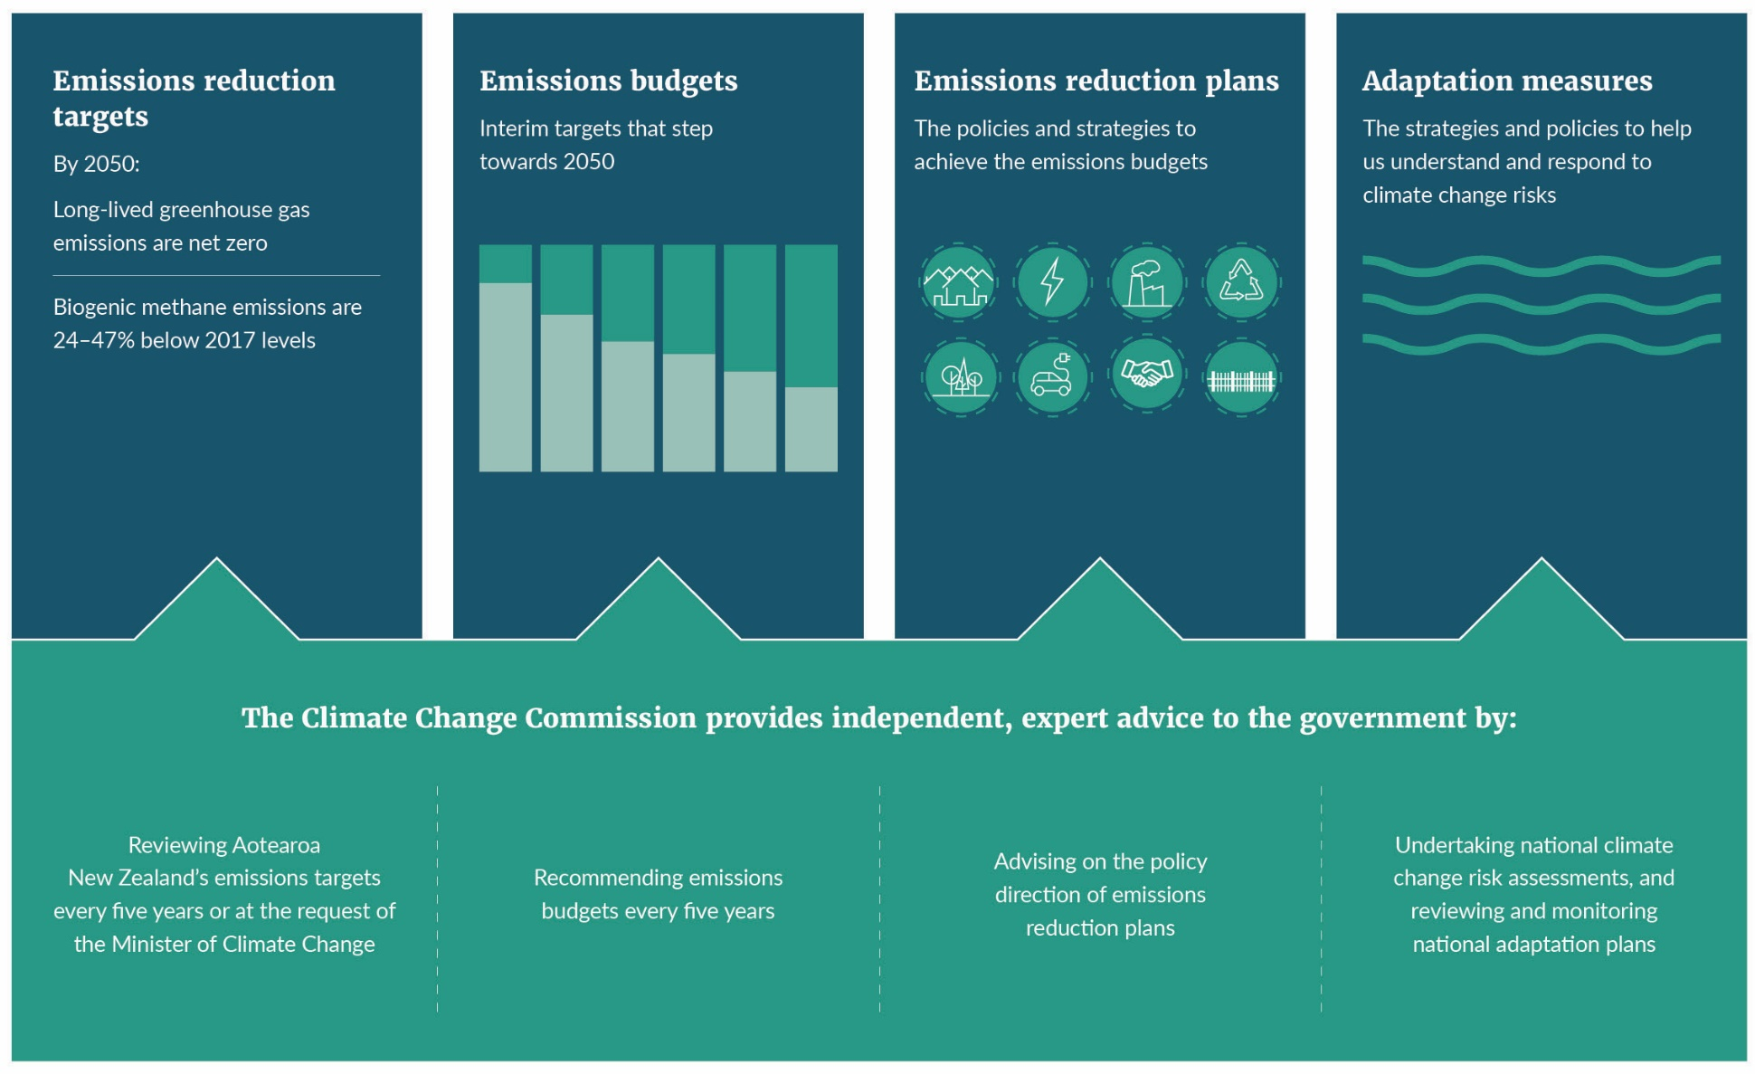
Several elements of this framework are directly relevant to the NZ ETS.
- He Pou a Rangi – Climate Change Commission: The Commission is tasked with providing independent expert advice on climate change matters (including emissions budgets, emissions reduction plans and NZ ETS settings) and monitoring progress towards the government’s mitigation and adaptation goals.
- The 2050 target: This domestic target requires gross emissions of biogenic methane to reduce to 24 per cent to 47 per cent below 2017 levels and all other greenhouse gas emissions to reach net zero by 2050.
- Emissions budgets: These specify the net amount of greenhouse gas emissions permitted over a five-year period (or four years, in the case of the first emissions budget). Emissions budgets will get smaller over time, helping Aotearoa step towards the 2050 target. NZ ETS settings can help reduce emissions to meet these emissions budgets.
- Emissions reduction plans: Plans that set out policies and strategies to meet the emissions budgets. A new plan must be published before the beginning of each emissions budget. The first plan includes several actions related to strengthening incentives in the NZ ETS to reduce emissions.

The NZ ETS needs to play a critical role in meeting Aotearoa New Zealand’s emissions budgets
In May 2022, the Government published the first three emissions budgets (table 1) and the first emissions reduction plan for Aotearoa.
Table 1: Aotearoa New Zealand’s first three emissions budgets (Mt CO₂e)
 | First emissions budget (2022–25) | Second emissions budget (2026–30) | Third emissions budget (2031–35)
All gases, net (AR5) | 290 | 305 | 240
Annual average | 72.5 | 61.0 | 48.0
Note: AR5 = Fifth Assessment Report of the United Nations Intergovernmental Panel on Climate Change.
The emissions reduction plan represents a coherent, strategic package of over 300 actions to meet our first emissions budget and set Aotearoa on a path to meeting the 2050 target.
The actions in the plan reflect the Government’s decisions to:
- prioritise gross emissions reductions
- continue to support removals
- achieve a careful and well-managed transition that is fair, equitable and inclusive, and that supports the wellbeing of New Zealanders.
The emissions reduction plan recognises the value of different tools (pricing, regulation and investment) as we build the foundations for meaningful change and as emphasis shifts over time. The NZ ETS is one of these tools and will play a critical role across multiple emissions budget periods.

The NZ ETS also supports achieving international commitments
Under the Paris Agreement, Aotearoa has set a nationally determined contribution (NDC) of reducing net emissions by 50 per cent below gross 2005 levels for the period 2021–30. This represents our highest possible ambition for contributing to the global effort and will be met through a combination of domestic abatement and offshore mitigation.
The NZ ETS is expected to make a significant domestic contribution to meeting our NDC mostly through its impacts on forestry removals. See chapter 3 for more information about the ongoing role the NZ ETS should play in supporting our NDCs and possible design changes.

Meeting our domestic and international climate change goals will require significantly more abatement
While its net emissions are projected to decrease over time, Aotearoa needs greater emissions reductions and removals to meet its domestic emissions budgets and 2050 target, as well as successive NDCs (figure 2).
The gap between Aotearoa New Zealand’s projected net emissions and the 2030 NDC is estimated to be about 99 Mt CO₂e. This gap could be closed through either greater domestic action or by buying emissions reductions and removals that have occurred in other countries (offshore mitigation).
The more we can reduce emissions or increase removals at home, the less offshore mitigation will be needed to meet the 2030 NDC and future NDCs. The government is currently expected to require between $3.3 billion and $23.7 billion in additional offshore mitigation to meet the 2030 NDC.
Figure 2: Projected net emissions and target pathways to 2050
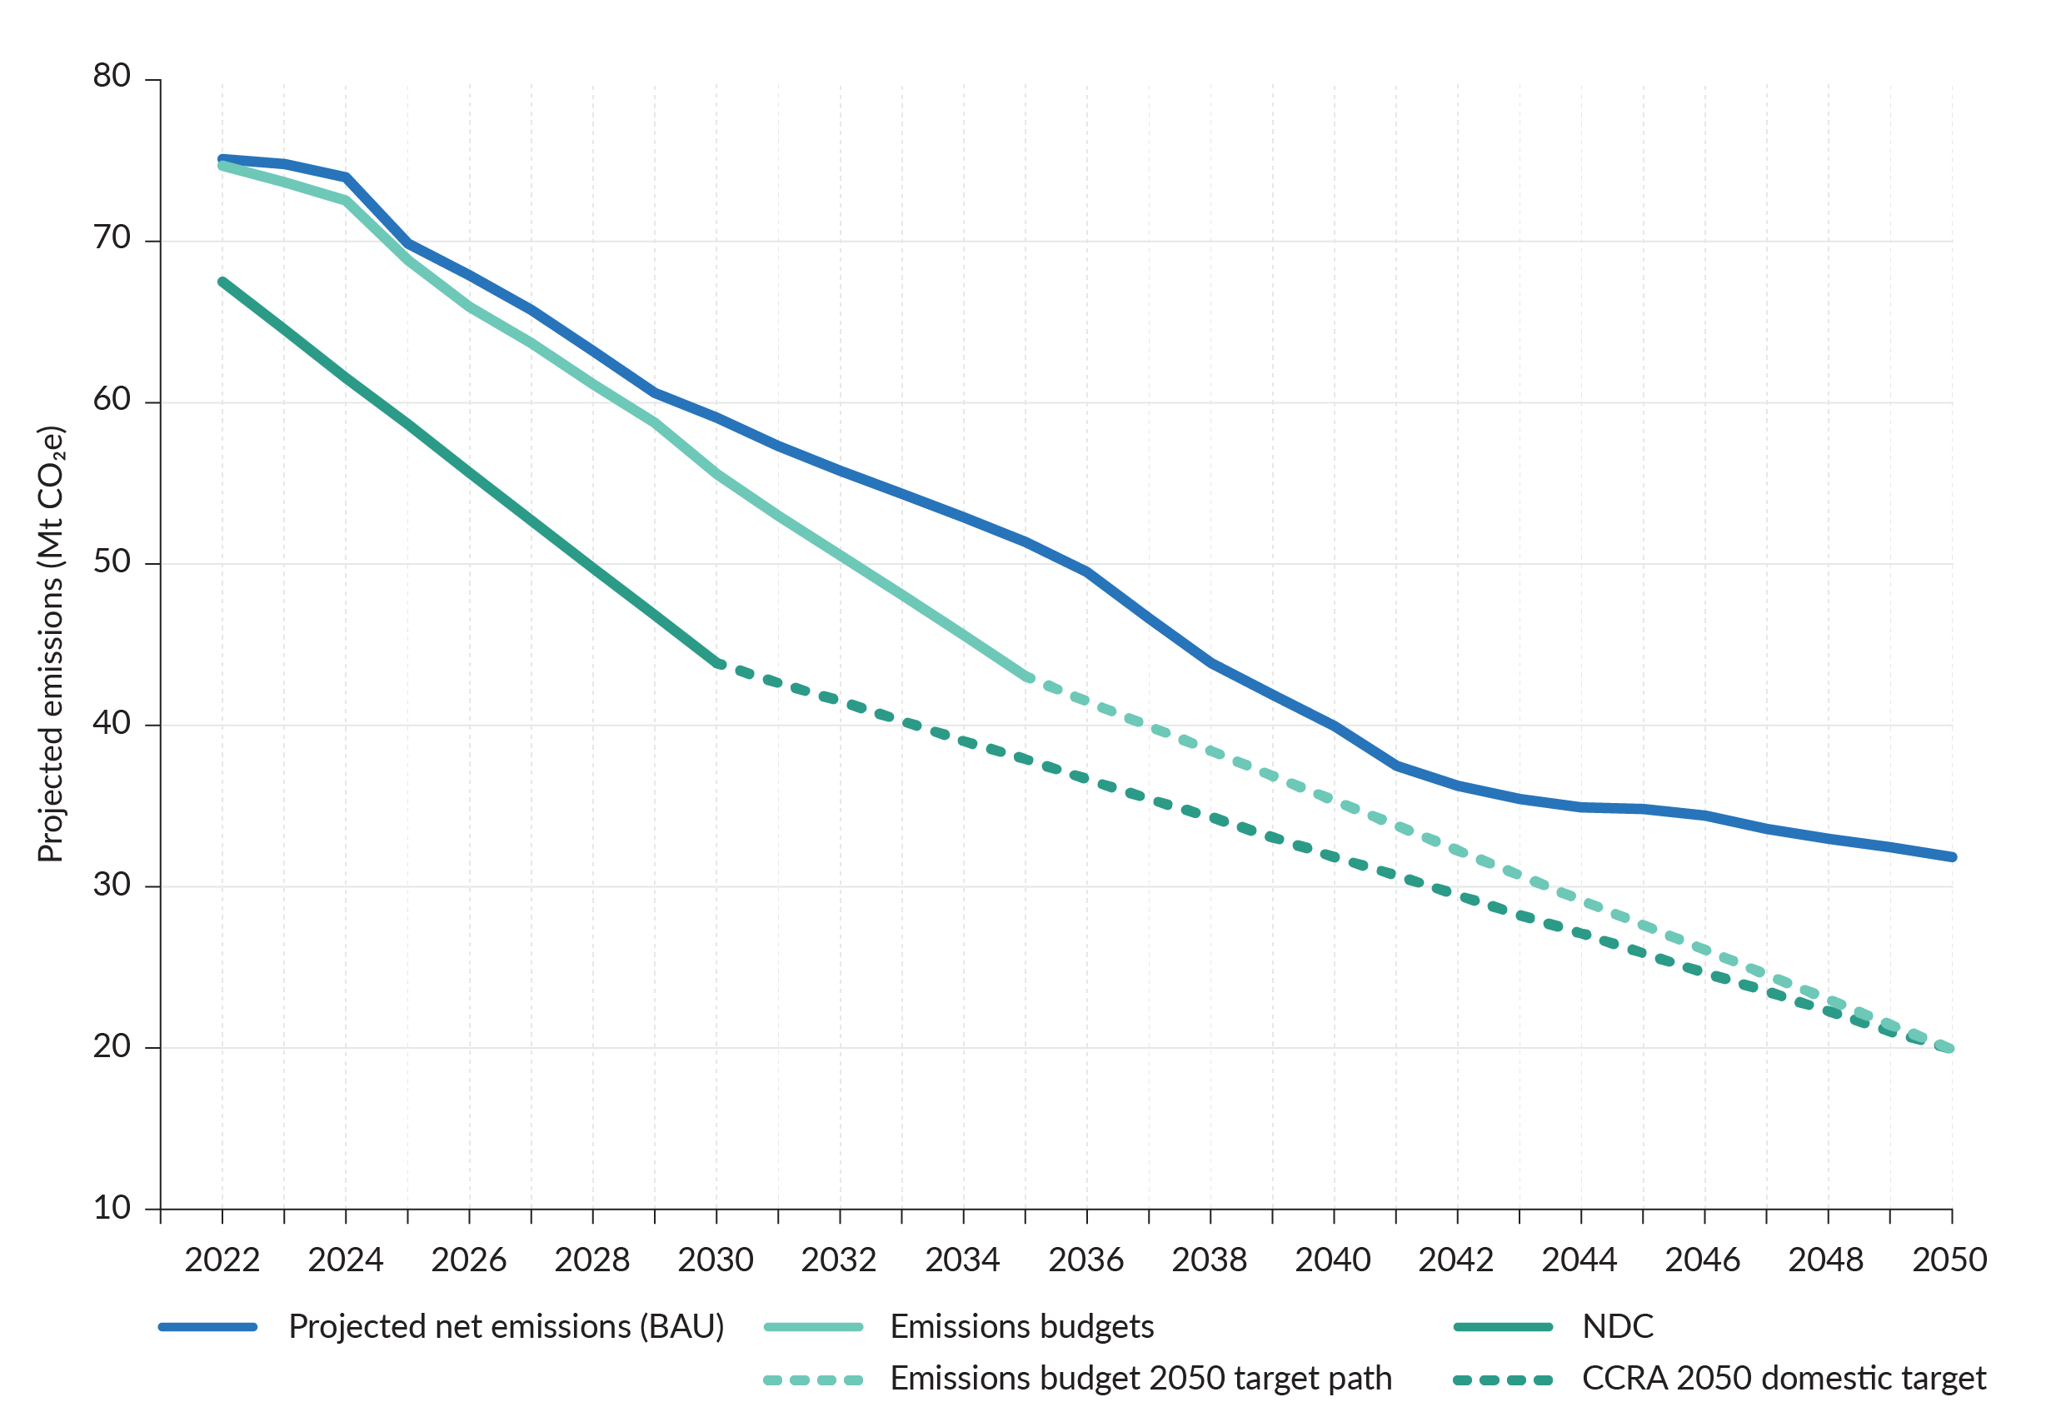
Note: BAU = business as usual; CCRA = Climate Change Response Act 2002.
New Zealand Emissions Trading Scheme
Established in 2008, the New Zealand Emissions Trading Scheme (NZ ETS) aims to help Aotearoa to meet its emissions budgets, domestic 2050 target and international climate change obligations by pricing greenhouse gas emissions.
Emissions pricing is a tool that ensures businesses, households and the public sector incorporate the costs of emitting or the benefits of reducing or removing emissions into day-to-day decisions. Through a price signal, emissions pricing provides a clear, consistent signal of the cost of emissions or the relative benefit of lower-emissions choices or investing in removals, such as forestry.
How the NZ ETS works
NZ ETS participants who carry out certain prescribed activities that emit greenhouse gases must surrender one emissions unit (New Zealand Unit or NZU) for every tonne of greenhouse gas emissions (CO₂e) they produce. Some NZUs are allocated to participants (eg, industrial allocation) and others are available to purchase from the Crown at auctions, which are held four times a year (the primary market), or from other participants in the secondary market. If participants reduce the amount of emissions that result from their activities, they reduce the cost of their surrender obligation. For more information on how the NZ ETS works, see About the New Zealand Emissions Trading Scheme.
Forestry NZ ETS participants can earn NZUs based on the amount of carbon absorbed by the forest. Forests can be both a carbon sink (while growing) or a source of emissions (eg, from harvesting or deforestation), so some forestry participants have surrender obligations, depending on when their forest was planted and the accounting methodology they use. For more information on forestry in the NZ ETS, see How the ETS applies to forestry.
Most trading happens in the secondary market (between participants), not with the Crown at auctions. Auctions have price controls to act as safety valves on the NZU price. The price controls affect the number of units auctioned and auction prices but do not prevent secondary market prices from going above or below these prices. If a trigger price is reached in auction bidding, a reserve amount of units is released (also known as the cost containment reserve). The lower price control is called the auction reserve price. These upper and lower price controls create a price corridor. For more information about price controls, see The role of price controls in the NZ ETS.
The NZ ETS stockpile
The NZ ETS currently has a large supply of NZUs available in the secondary market, known as the ‘stockpile’. This stockpile refers to NZUs that are retained for future use or investment purposes. It includes:
- units held to meet future surrender obligations (eg, by foresters who plan to harvest their trees, as well as other units held against contracts for future supplies)
- units available to the market.
Stockpile units are potentially available as additional supply to the market. In mid-2022, He Pou a Rangi – Climate Change Commission (the Commission) noted that the number of NZUs in the stockpile was around four times the number surrendered in 2021. However, the Commission also analysed the proportion of units that is likely to be ‘surplus’ (that is, the units that are available to the market versus those held against future liabilities). The analysis suggested that about one-third of the stockpile is ‘surplus’. This still represents a risk to achieving emissions budgets.
The government manages this stockpile by reducing the number of new units supplied into the scheme via auction. This aims to ensure a portion of demand is met with NZUs from the stockpile, thus reducing it over time. However, the success of this approach also depends on the supplies of removal units to the market, which may enable the stockpile to grow if participants think the value of NZUs will increase in the future.
The current and potential future size of the stockpile may limit the effectiveness of some of the options in driving gross emissions reductions. The significant number of units currently in the stockpile could also cause a time lag before options start to affect the amount of gross emissions reductions.

Why the Government is reviewing the NZ ETS

The Government has prioritised gross emissions reductions in the first emissions reduction plan
In the first emissions reduction plan, the Government committed to meeting Aotearoa New Zealand’s domestic emission budgets by:
- reducing gross emissions in the transport, energy and industry, building construction, agriculture, waste, and fluorinated gases sectors as a matter of priority
- supporting additional afforestation towards net emissions reductions, in particular to offset hard-to-abate sectors and enhance Aotearoa New Zealand’s high-wage, low-emissions bioeconomy.
Prioritising gross emissions reductions means taking active steps to adopt available low-emissions technology, encourage further innovation, invest in low-emissions infrastructure and encourage low-emissions behaviour.
Taking these steps now is important, because delays could increase the overall cost and pace of Aotearoa New Zealand’s transition to a low-emissions, climate-resilient future, as well as impacting its ability to sustain net zero beyond 2050. Cutting our gross emissions will also help to achieve a range of co-benefits, including for the health and wellbeing of New Zealanders. For more information, see chapter 3.

The NZ ETS is currently expected to deliver significant exotic afforestation and limited gross emissions reductions
Under current settings, the NZ ETS is expected to drive considerable removals, mainly through carbon sequestration from exotic forestry. However, it is currently expected to play a limited role in driving gross emissions reductions or encouraging indigenous forestry.
There are recognised challenges associated with exotic forestry, including the social and environmental impacts of land-use change from other productive land use to unmanaged permanent forests, the loss of land-use flexibility required if emissions removals are to be maintained, and the risks to the permanence of the carbon storage, for example, from fire or pests. This is why the Government has a ‘right tree, right place, right purpose’ strategy for forestry. The types of forestry, their location and management are being considered in other workstreams. This consultation will consider the scale of forestry removals driven by the NZ ETS.
Current market prices are not sufficient to drive material emissions reductions in the energy, transport, industrial processes, and waste sectors. Failing to achieve significant gross reductions in these sectors risks delaying meaningful decarbonisation in Aotearoa. Decarbonising our energy system will require higher prices in the NZ ETS over time, alongside complementary policies to address existing barriers to low-emissions choices.
In addition, the current NZ ETS settings will not drive the level of indigenous forest restoration recommended by the Commission to create a long-term carbon sink for hard-to-abate emissions from 2025. Nor can the current NZ ETS help us achieve net negative emissions in the second half of this century, as is expected of developed countries party to the Paris Agreement. This is discussed further in chapters 2 and 3.
The current settings of the NZ ETS are also limited in the removal activities they incentivise. No incentives are currently in place for activities, aside from forestry, that remove carbon from the atmosphere, such as wetland restoration, which has both carbon and biodiversity benefits.

Aotearoa needs significant afforestation to meet its emissions reduction goals
Given the current relative costs of gross emissions reductions and removals, it is expected the NZ ETS will incentivise significant removals through exotic afforestation. This is discussed further in chapter 2.
Exotic forestry is currently one of the lowest-cost and scalable sources of removals in Aotearoa. Forests are needed to achieve our short-term emissions budgets and contribute to our 2030 NDC, as well as future NDCs, which are expected to be even more ambitious. Forestry will also support Aotearoa New Zealand’s long-term transition by providing a carbon sink for hard-to-abate gross emissions beyond 2050.
Forestry is also important for non-climate reasons. In 2022, the forestry and wood-processing sector contributed $6.5 billion in export earnings and employed around 40,000 people in wood production, processing and wider support industries. It provides high economic returns for land that may otherwise be hard to make a living from, and it provides erosion control. Indigenous forests also provide indigenous biodiversity.
The Government is acting to expand Aotearoa New Zealand’s production and carbon sink forestry estate based on a ‘right tree, right place, right purpose’ strategy. These actions are progressing alongside the NZ ETS review and include:
- redesigning the permanent forest category in the NZ ETS
- developing a carbon removals strategy
- new and enhanced NZ ETS carbon look-up tables
- developing a voluntary carbon market
- exploring a role for biodiversity credits.

The Government has agreed to assess whether changes are needed to the NZ ETS
In its report Ināia tonu nei: a low emissions future for Aotearoa, the Commission recommended that the Government consider how the NZ ETS may be amended to provide more robust support for gross emissions reductions. In doing so, the Commission highlighted the risk that the NZ ETS would drive relatively low-cost net emissions reductions through exotic forests, rather than the gross emissions reductions needed to reach net zero by 2050.
The Commission also recommended that the Government amend the NZ ETS to manage the amount of exotic forest planting driven by the scheme. The Commission reiterated this in its 2023 draft advice, which included a recommendation that the NZ ETS be amended to separate the incentives for gross emissions reductions from those applying for forestry, and that the Government develop integrated objectives for the role of forests with respect to emissions mitigation and adaptation.
The Government has accepted the Commission’s recommendation that Aotearoa New Zealand’s climate response should prioritise gross emissions reductions while maintaining support for removals. This review of the NZ ETS will assess what role emissions pricing should play in supporting this objective. If the Government decided the NZ ETS should prioritise gross emissions reductions while maintaining support for removals, this could mean, for example, that the NZ ETS should:
- incentivise the uptake of low-emissions technology, energy efficiency measures, and other abatement opportunities as quickly as real-world supply constraints allow to reduce gross emissions
- incentivise emissions removals to help meet Aotearoa New Zealand’s climate change goals, including providing a sink for hard-to-abate emissions in the longer term.
While the NZ ETS would continue to drive emissions removals through forestry, this should not displace nor significantly delay gross emissions reductions. This would mean considering how the design and settings of the NZ ETS could provide the necessary price signal for both emissions reductions and removals.

This discussion document builds on previous engagement and consultations
Over the past two years, multiple public consultations have been undertaken relating to the NZ ETS.
Strong and consistent feedback has been received from Māori that more ambitious action on climate change is needed, both for people and the environment. Further feedback has been that exotic forestry in the NZ ETS is important as a financially viable land-use option for Māori land owners and rural communities (as well contributing to our climate goals).
Other feedback relevant to this consultation includes:
- support for incentives for indigenous afforestation and protection of the remaining ngāhere and wetlands
- natural regeneration of indigenous trees needs to be encouraged and rewarded: indigenous regeneration is itself ‘the right tree in the right place’.
Submitters often commented on whether the NZ ETS should have a greater focus on gross emissions reductions or removals.
- During consultation on proposals for the emissions reduction plan in 2021, the most common theme was the need to reduce gross emissions. Many submitters considered that continuing to include forestry in the NZ ETS would encourage increased forestry (especially exotic forestry), rather than gross emissions reductions. These submitters supported proposals to constrain forestry in the NZ ETS. Other submitters supported the continued use of offsets to buy time before low-emissions technologies become readily available and economical.
- During consultation on NZ ETS limits and price control settings in 2022, submitters were divided over where the focus should lie. Just over half supported NZ ETS price controls having a focus on gross emissions reductions, and the remaining submitters supported a focus on net emissions reductions.
- Those who favoured a focus on gross emissions reductions highlighted that this would better align with the emissions budgets and NDC, with some noting that relying on emissions removals from forestry is not an effective long-term strategy.
- Those who supported a focus on net emissions reductions argued that a focus on gross emissions reductions ignores the fact that some emissions are hard to abate. Such a focus also downplays the time and resource constraints associated with investments in emissions reduction technologies.
- As part of the consultation on managing exotic afforestation incentives in the NZ ETS in 2022, submitters were asked whether they agreed that widespread permanent exotic afforestation may make it harder to achieve Aotearoa New Zealand’s long-term climate targets. Views were mixed on this issue.
- Many agreed that the NZ ETS is unsuitable for meeting Aotearoa New Zealand’s climate targets, and a focus is needed on gross emissions reduction rather than removals. They agreed that there is a risk of NZU supply issues in the NZ ETS – resulting from high levels of permanent afforestation – and that large-scale permanent exotic afforestation might affect the carbon price. Many said that indigenous forests are a more sustainable option for permanent carbon sinks than exotic forests.
- Most of those who disagreed stated that permanent exotic afforestation is needed to meet Aotearoa New Zealand’s climate change targets until sufficient technology is in place to enable and drive a net-zero-emissions economy and/or because indigenous forests are expensive to establish and maintain and are slow growing. They also considered that encouraging domestic afforestation is preferable to sourcing carbon credits from overseas, and that government could manage supply issues in other ways (eg, by auctioning fewer NZUs). Māori land owners strongly advocated for this position.
- A 2022 consultation canvassed views on a range of options and system elements for pricing agricultural emissions (as developed by He Waka Eke Noa – see Pricing agricultural emissions), with a summary to be released shortly. A major theme was the trade-off between emissions reductions and the economic impact of these reductions on emitters and communities.

Chapter 2: Expected impact of current NZ ETS
The NZ ETS currently treats emissions reductions and removals the same: 1 tonne of emissions reductions is equivalent to 1 tonne of emissions removals.
Because reductions and removals have the same incentives, the NZ ETS drives investment in the lowest-cost source of abatement first. More costly abatement is incentivised over time as the NZU price increases.
The NZ ETS cannot influence specific volumes or forms of emissions reductions and removals because it does not have levers to drive different types of abatement. This means the government cannot drive faster and greater gross emissions reductions through the NZ ETS.

What are the likely emissions reductions and removal outcomes of the NZ ETS?

The NZ ETS is expected to drive large-scale exotic afforestation to reduce net emissions
Participants in the NZ ETS will choose the cheaper of reducing their emissions or buying NZUs. It is expected that the extent of emissions reductions will be shaped by the expected short- and long-term costs of purchasing NZUs.
Forestry (particularly exotic forestry) is currently one of the lowest-cost and scalable sources of abatement. High current and expected NZU prices are resulting in significant exotic afforestation; a trend that is forecast to continue in the medium term. However, the NZ ETS will likely drive far lower levels of indigenous afforestation over the same period. This is because indigenous forests earn NZUs more slowly than some exotic forests (because most indigenous species tend to grow more slowly than exotic species) and have higher establishment costs.
The Ministry for Primary Industries (MPI) has developed projections of future forestry allocations and surrenders of NZUs from a survey of afforestation and deforestation intentions (figure 3). These projections reflect the price expectations of respondents at the time of the survey (November–December 2021, with some follow up in early 2022). MPI has also used statistical analysis of actual planting rates in response to NZU, land and commodity prices.
Figure 3: Projected forestry allocations and surrenders to the New Zealand Emissions Trading Scheme
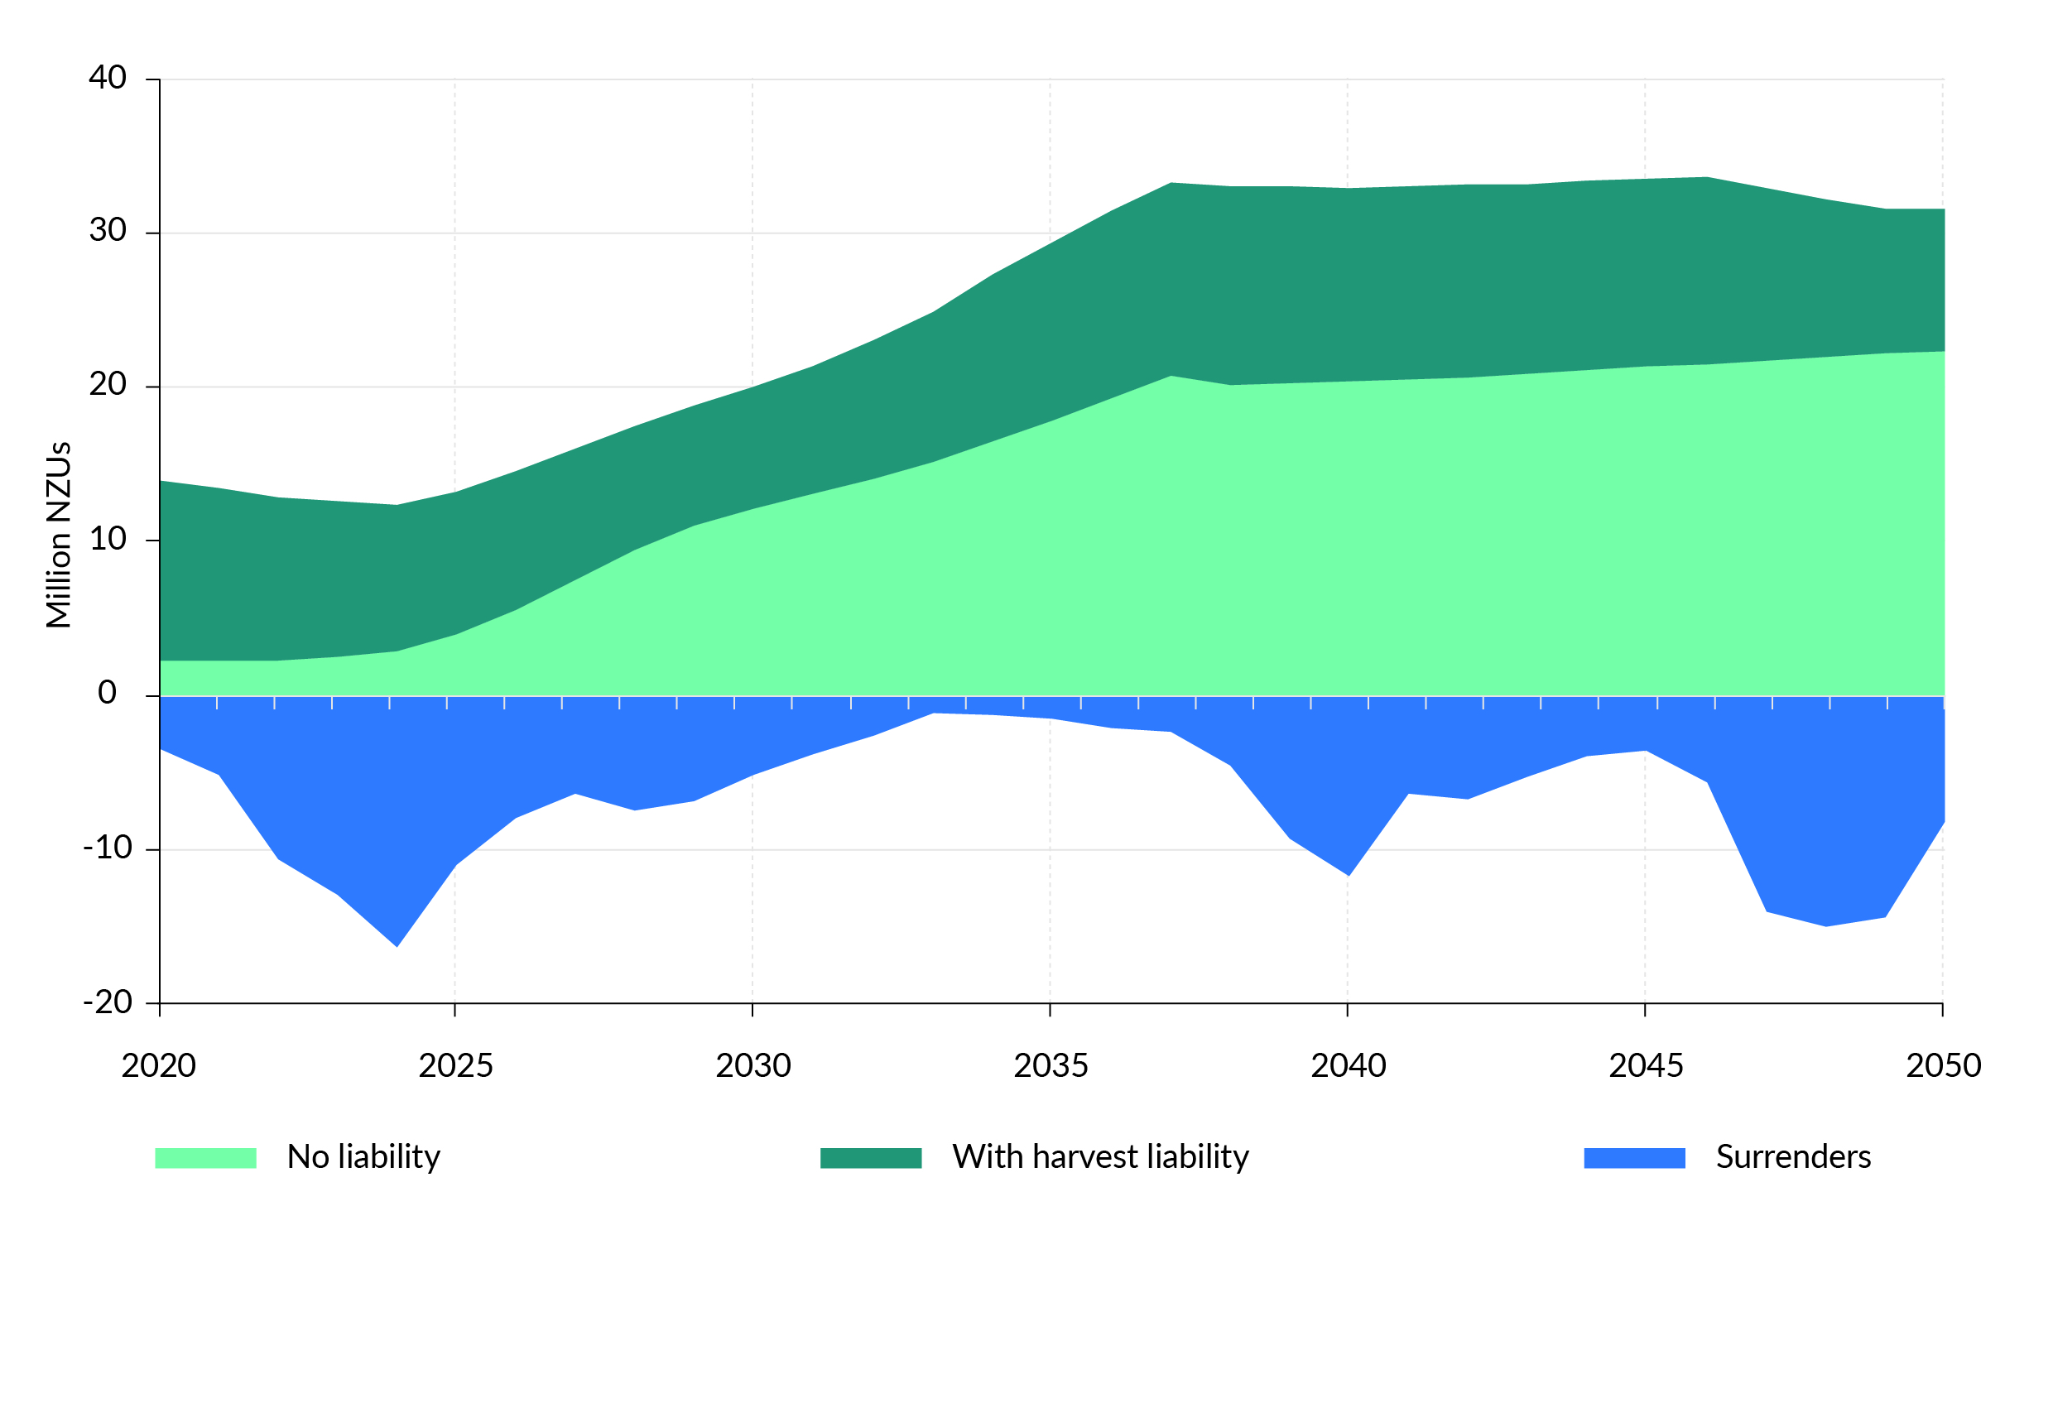
Note: This figure shows the central MPI projection, which estimates an additional 38,000 hectares of new afforestation on average over the long run. The light green area is the estimated number of NZUs from forestry to be potentially available to the market that can be traded. These are largely from new forests either on averaging accounting or in the permanent forests category. The dark green area represents NZUs held by existing forestry participants to meet future harvest obligations. It is generally not expected these NZUs would be supplied to the market. The blue area shows the forecast volume of NZUs forestry participants will be required to surrender for future harvests.
At present, NZUs credited to forests are a small proportion of the overall supply of units available to the NZ ETS market. However, this proportion is expected to increase over time (as shown in figure 3) due to new forest registrations in the NZ ETS.

The NZ ETS may play a limited role in reducing gross emissions and decarbonising the economy
Opportunities to reduce gross emissions tend to have higher costs than emissions removals from exotic forestry. Gross emissions reductions can also be capital intensive, require specialised investments, and be less responsive to carbon pricing. This suggests that, to drive gross emissions reductions, we need higher NZU prices, as well as policies that address market barriers and failures.
At current NZU prices, it is likely that the NZ ETS is incentivising some gross reductions. For example, there is evidence that Aotearoa New Zealand’s carbon price is playing an important role in encouraging the development of renewable electricity generation. In recent NZ ETS consultations, some participants have told us that higher prices over the past few years are influencing investment decisions but barriers exist that make it harder to reduce emissions.
In Ināia tonu nei, the Commission identified the risk of exotic forestry in the NZ ETS displacing and delaying gross emissions reductions in the future. The predicted high supply of forestry removals could allow emitters to meet all or most of their NZ ETS obligations at relatively low cost, avoiding more expensive emissions reductions. The large projected supply of low-cost forestry removal units, as described in figure 3, could dampen NZU prices, over the medium to long term, to levels below prices needed to drive significant gross emissions reductions.
Both gross reductions and removals are required to support our transition to a low-emissions economy. Chapter 3 considers the implications of delaying decarbonisation in Aotearoa and describes the case to prioritise gross reductions in the NZ ETS.

Expected market dynamics
The government’s modelling suggests that, under current NZ ETS settings, the total supply of NZUs could exceed the demand for units from participants with surrender obligations in the NZ ETS (figure 4) from the early 2030s.
Figure 4: Forecast New Zealand Unit supply and demand in the New Zealand Emissions Trading Scheme
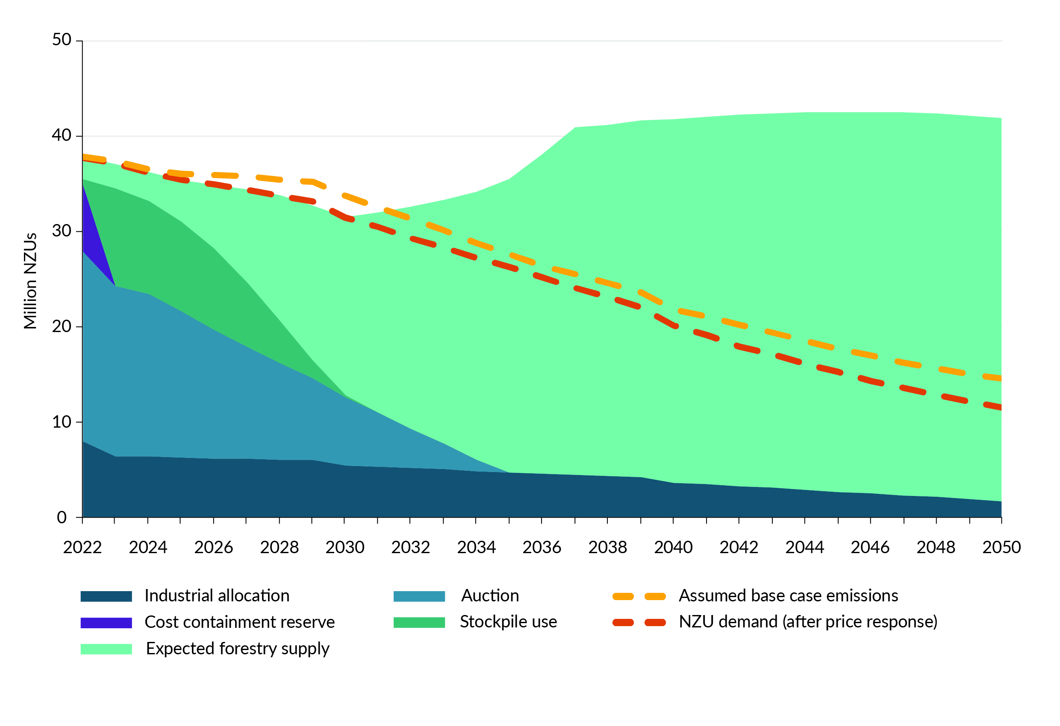
Note: This figure includes the total supply of NZUs from different sources, including forestry, government auctions, industrial allocation, and the stockpile. The assumed base case emissions indicate the forecast demand for NZUs from emitters in the NZ ETS required to meet future surrender obligations.

Regardless of NZ ETS settings, demand for NZUs is forecast to gradually fall over time, largely due to the shift to electric vehicles, which will reduce transport emissions. These projected business as usual reductions are far smaller than those proposed in the emissions reduction plan for the transport, energy and industry, and waste sector sub-targets. The Government intends to reduce the supply of NZUs from auctioning and industrial allocation over time, to help achieve increasingly ambitious emissions budgets in the future.
The total supply of NZUs from removals, however, is forecast to increase over the same period. If NZU prices remain at current levels, the resulting exotic afforestation would result in the supply of NZUs from forests exceeding NZU demand. When this occurs, prices are likely to fall.
For prices to be maintained, NZUs from forests would need to be added to the existing stockpile, which would need to continue to grow and reach enormous levels for these prices to be maintained.
This supply–demand dynamic is highly unlikely to be sustainable. It is far more likely the market price of NZUs will settle at a lower level, at which total supply would be sufficient to just meet demand over the long run (figure 5). The government’s modelling therefore suggests NZU prices would fall, as shown in figure 6.
Figure 5: Total supply and demand with falling price
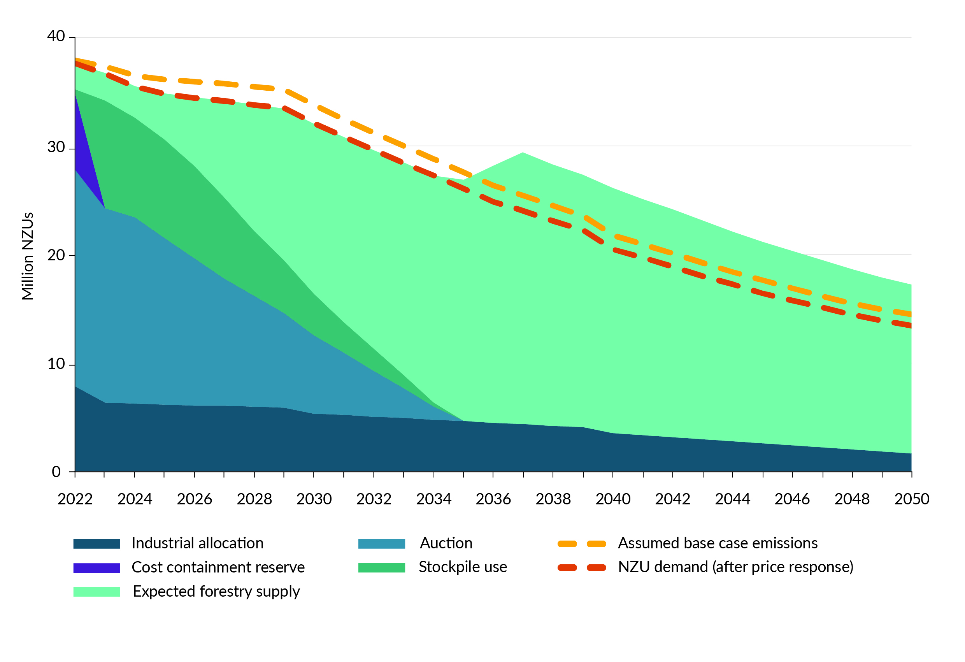
Figure 6: Modelled New Zealand Emissions Trading Scheme price path
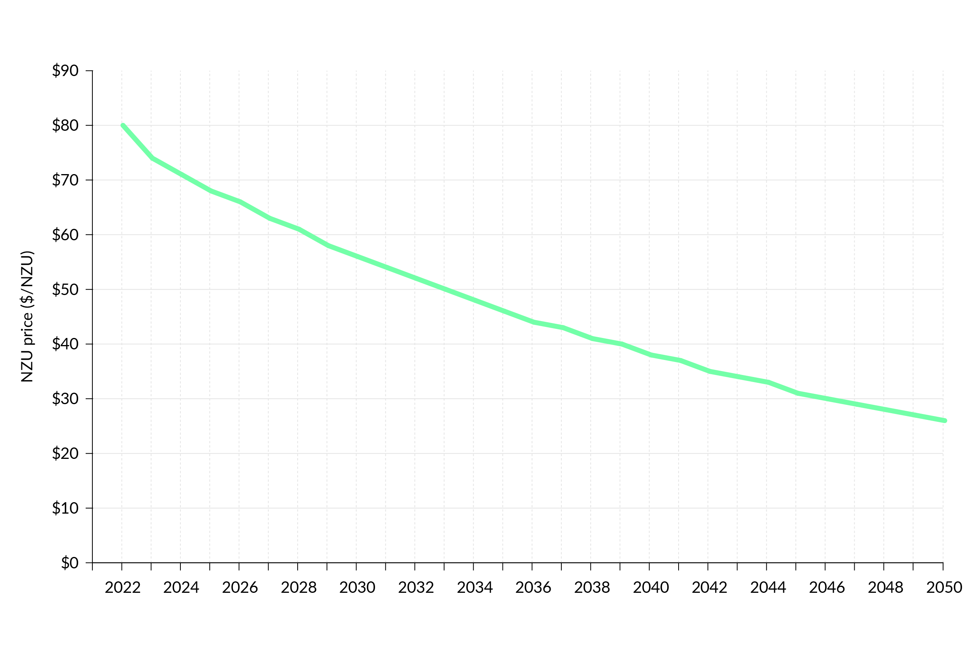
The modelled price pathway indicates how the NZ ETS market could respond to forecast unit supply and demand dynamics. We note that current NZU market prices are lower than presented in figure 6 and expect this response would be quite different if the proposals set out in this discussion document were implemented. The response would also be different if other changes are made to the NZ ETS through parallel government work programmes, such as the redesign of the permanent forestry category.
This modelled price path is not a prediction of future NZU prices. All modelling is inherently uncertain and depends on a range of assumptions, particularly on the expected response to prices by emissions sources and removals. The modelling uses projections of future NZU supply and demand, which are themselves uncertain. Some stakeholders have suggested that NZU pricing and afforestation trends will not play out like this. Reasons cited include that land-use change is affected by other regulatory and societal changes, and consumer demand may lead to markets pricing in carbon and driving reductions.
However, even when different assumptions are used, the analysis suggests that current market settings are likely to lead to NZU supply exceeding demand from emitters, leading to falling NZU prices. This conclusion is supported by other recent government analysis, providing reasonable confidence that the current NZ ETS design will lead to falling prices.

The NZ ETS will not be able to maintain a strong and stable emissions price
If the modelled supply and demand dynamics become a reality, this will have a significant impact on the NZ ETS. In particular, these dynamics would undermine the ability of the NZ ETS to maintain a strong and stable emissions price that drives gross emissions reductions and incentivises removals.
More specifically, falling or uncertain prices could:
- increase uncertainty over the effects of price controls: the NZ ETS price floor and ceiling operate through the NZ ETS auctioning system. Increased uncertainty will occur over whether the price floor or the confidential reserve price will be reached. This could result in future auctions not clearing, which would have implications for the supply of NZUs in the market
- reduce auction revenue: falling prices would also affect government revenue from NZU auctioning, which is currently used to fund other climate policies through the Climate Emergency Respond Fund. However, this would not limit the government from using other funding mechanisms to support climate action.

Impacts of exotic afforestation
Because it grows and absorbs carbon quickly, exotic forestry is an important part of our climate response, as well as a source of income and employment in our communities. Aotearoa will not be able to achieve either its NDCs or domestic emissions targets without some additional exotic afforestation. Well-managed exotic forestry can also support other environmental outcomes, such as stabilising erosion-prone land.
However, the Government recognises that challenges are associated with exotic afforestation, which will need to be carefully managed in the future. Key challenges are set out in table 2.
Table 2: Key challenges of exotic afforestation
Land-use change | Converting land to forestry could have a range of impacts, particularly where converted from other productive uses (such as beef and sheep farming).  Widespread land-use change could have impacts on:  - employment: while not always the case, unmanaged permanent forestry can involve fewer jobs and has flow-on effects for rural communities  - exports: unmanaged permanent forestry generates fewer exports than other land uses  - the environment: unmanaged forests, particularly permanent exotic forests, may also have environmental issues associated with them  (eg, fire, disease, wilding pines), which must be balanced against the environmental benefits forestry can provide (eg, erosion reduction, improving soil conservation, flood regulation, and water quality).  - economic use of land: the ability to generate returns for land that may otherwise be unproductive (eg, through earning NZUs).
Land-use flexibility | Relying on forestry to achieve our climate change goals (including our emissions budgets and domestic 2050 target, as well as our NDCs) means that, once land is forested, it needs to remain forested. Converting land to permanent forestry therefore reduces the flexibility of land uses.
Permanence | The permanence of carbon stored in forests is a further challenge. Forests are vulnerable to fire, strong winds, storms, droughts, and pests and pathogens, and these risks are being exacerbated by climate change. If destroyed, the carbon the forest has stored will be returned to the atmosphere.  Ensuring that removals are permanent requires ongoing management, monitoring and enforcement to make sure trees lost to adverse events are replanted.
The Government has a ‘right tree, right place, right purpose’ strategy for forestry that is designed to address these challenges.
The types of forestry, their location and management are also being considered in other workstreams. For example:
- changes to the National Environmental Standards for Plantation Forestry
- proposed changes to the permanent forest category in the NZ ETS, which is currently out for consultation.
This review will consider the scale of forestry removals driven by the NZ ETS.

Consultation questions
Chapter 2 Consultation questions
2.1 | Do you agree with the assessment of reductions and removals that the NZ ETS is expected to drive in the short, medium and long term?
2.2 | Do you have any evidence you can share about gross emitter behaviour (sector specific, if possible) in response to NZU prices?
2.3 | Do you have any evidence you can share about land owner and forest investment behaviour in response to NZU prices?
2.4 | Do you agree with the summary of the impacts of exotic afforestation? Why/why not?

Chapter 3: Driving gross emissions reductions through the NZ ETS
Chapter 2 showed that the current design of the NZ ETS is unlikely to drive material gross emissions reductions. Instead, Aotearoa will rely on removals (particularly from exotic forestry) to meet its domestic and international climate change goals.
This chapter considers the reasons for prioritising gross emissions reductions in the NZ ETS, while maintaining incentives for the removals. These reasons are informed by the Commission’s modelling and analysis. However, much of the empirical evidence showing the costs and benefits to reduce gross emissions in Aotearoa is still being developed. More evidence will emerge over time, as the NZ ETS and other climate policies have an effect.

Cutting our gross emissions now will…

…decrease cumulative emissions
Because it takes time for low carbon technologies to replace high emissions technologies and low carbon infrastructure to be built, gross emissions reductions are expected to accumulate gradually. The Commission found that even short delays in acting to reduce gross emissions could result in increasing larger shortfalls in future emissions budgets, because the impacts of the delay accumulate. Prioritising actions that reduce gross emissions would result in greater levels of reductions occurring within future emissions budgets, putting Aotearoa on a safer path to meet future climate targets.

…save costs in the longer term
Increasing the speed at which we decarbonise is likely to save costs in the long run. For example, the Commission has found that significant savings could come from fuel switching in:
- transport: the costs of new electrical vehicles, investment in electricity supply and distribution, and charging infrastructure could be more than offset by savings in petrol and diesel use, along with lower maintenance costs
- space and water heating: savings could also be achieved by replacing fossil fuelled space- and water-heating systems with electricity. The high one-off costs of switching will eventually be offset by savings from running the cheaper electric heating system.
- process heat: savings could be made in electrifying process heat, although it may take longer to realise than space and water heating.
For businesses, households and individuals, fuel switching is likely to result in lower transport costs and heating bills. Industries that currently rely on fossil fuels are also likely to save costs by electrifying process heat.
Several barriers prevent these changes happening now. These barriers, which include uncertainty over future emissions prices and the way that price will change with infrastructure investments, can make it harder for individuals and businesses to identify the best choice in terms of medium- and long-term costs.
Delaying some investments that reduce gross emissions could result in greater economic costs in the future. Some costs may just be pushed out into the future. For example, the costs of replacing fossil fuel boilers with either electric or biomass boilers are unlikely to significantly decrease, given they are based on existing technology that is unlikely to come down in cost.
The Commission’s analysis only assessed savings from fuel switching. It did not consider the possible savings from energy-efficiency improvements, mode shifts (such as greater use of forms of transport other than cars), and reduced travel demand, all of which could increase cost savings if they are decarbonised now.

...help to sustain net zero beyond 2050
In its demonstration pathway, the Commission assumed around 0.6 million hectares of new exotic afforestation between 2022 and 2050. The latest projected rates of afforestation suggest that, if sustained, this level would be reached in the 2030s.
High levels of forestry removals could allow Aotearoa to meet the 2050 target with minimal gross reductions. However, after 2050, there will still be significant residual emissions, and additional reductions and removals will be needed to maintain net zero. The Commission’s modelling found that net emissions would increase from 2065 if high rates of afforestation were not sustained, and the amount of carbon stored in forests reaches its long-term maximum.
If our transition locks in a requirement for a high rate of exotic afforestation on an ongoing basis, more land will need to be converted. Although land is plentiful at a national level, this scale of land-use change may risk the social licence of the forestry sector. It would also reduce land-use flexibility for future generations, because already forested land will need to be kept in forest to maintain net zero.

…keep Aotearoa in step with other countries
Other jurisdictions are focusing on reducing gross emissions. Without similar domestic reductions, Aotearoa risks being seen as out of step. This could affect:
- Aotearoa New Zealand’s reputation
- access to markets and capital if overseas consumers and financial institutions increasingly demand specific climate standards for Aotearoa New Zealand’s products and services.

…and result in multiple co-benefits
Reducing gross emissions could provide wider benefits, including to health, broader wellbeing, and the environment. For example, encouraging lower emissions transport can provide environmental benefits (reducing air and noise pollution, and congestion) and health benefits (due to active transport modes). Actions to improve insulation and heating efficiency in homes and buildings can similarly lead to better health and wellbeing.

A strong and stable NZ ETS price signal should encourage low-emissions choices
A strong and stable NZ ETS price signal can help stimulate investment in research and development, which reduces the cost of low-emissions technology. Price stability is important to provide businesses and individuals with the certainty they need to make investments that reduce emissions. However, under current NZ ETS settings, significant falls in NZU prices might occur, discouraging businesses to make low-emissions choices.
Continued investments that are emissions intensive could risk locking in emissions many years into the future. They could also limit Aotearoa New Zealand’s ability to respond to changing circumstances.

What is a strong and stable NZ ETS price signal for gross reductions?

Our understanding of the prices needed to reduce gross emissions will improve over time
We expect a strong and stable NZ ETS price signal to incentivise more gross emissions reductions than the NZ ETS price currently does.
Currently, prices in the NZ ETS reflect the expected supply and demand for units in the market, which are driven by the costs of reduction and removals. This means the government does not set the price emitters face in the NZ ETS, nor the value of NZUs foresters receive for removals, although it can influence through its control of the auction market. To create a strong and stable price signal, changes in the NZ ETS price would be needed to reflect the higher costs of reductions to provide an effective incentive to reduce gross emissions.
To estimate the kind of price pathway needed to drive material gross emissions reductions, we need to be able to assess the costs of reducing gross emissions in different sectors. We want the price that emitters face to be high enough that the decision to switch to low-emissions technology is the most cost-effective decision. The Government’s intention is to give businesses time, opportunity and the incentive to change the way they operate.
Marginal abatement cost curves (MACCs) are an important tool for estimating the costs of reducing emissions. MACCs are models that show the abatement potential of greenhouse gas mitigation measures, and the relative costs associated with each of these measures. For example, replacing a coal boiler with an electric boiler may cost $50 per tonne of emissions that is reduced.
Figure 7 shows simplified and stylised MACCs estimated from different sources. These MACCs are derived from the Commission’s Emissions in New Zealand (ENZ) model and work carried out by the Ministry for the Environment in 2018. They reflect the best knowledge we have to date and will improve over time.
Figure 7: Marginal abatement cost curves
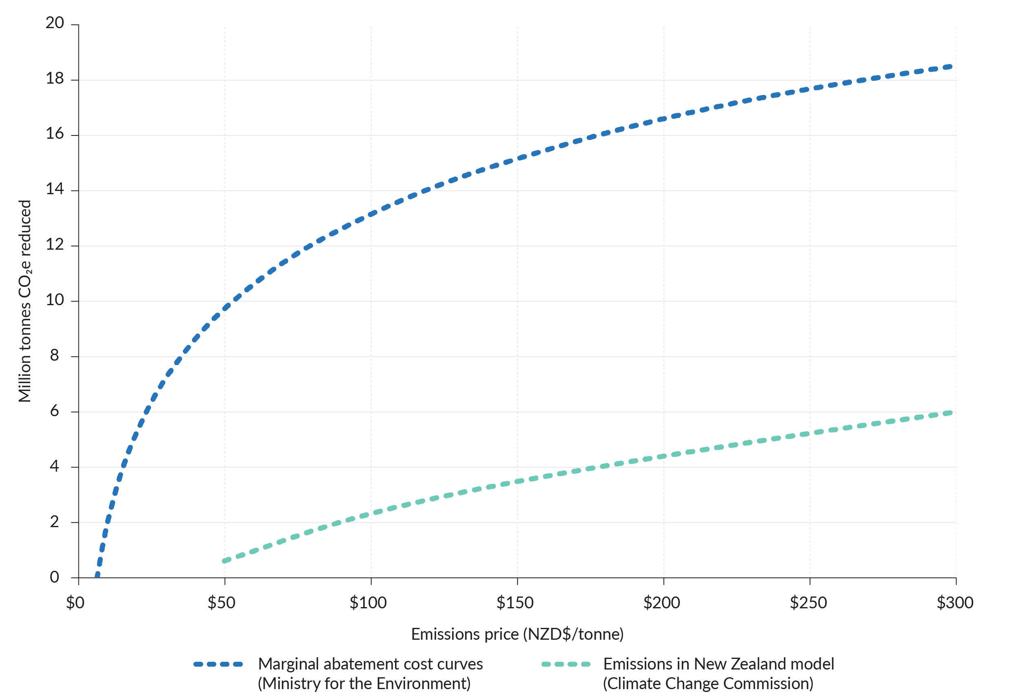
Marginal abatement costs give an indication of the NZ ETS price where abatement options become cost effective and are more likely to be adopted.
However, it is important to understand the limitations of using MACCs. While they can be useful tools to help inform policy development, some uncertainty exists regarding the estimated abatement costs, particularly as we look further into the future.
Some variation exists between the MACCs presented here. This is because they are based on different methods, assumptions and data, and were developed at different times. For example, the Ministry for the Environment’s older MACC includes cost estimates for a wide range of actions to reduce emissions, whereas the Commission’s ENZ model assumes the price response is limited to fuel switching.
With these limitations in mind, the current MACCs suggest NZU prices will need to increase over time to drive increased gross emissions reductions compared with the status quo.
The government is looking to develop more accurate assessments of the costs of emissions reductions in different sectors. This will include improving the MACCs the government uses for climate mitigation policy. Information provided through this consultation will help us gain a better sense of the carbon costs needed to prioritise gross emissions reductions in the NZ ETS. As better information becomes available, our estimation of the optimal price pathway for driving gross emissions reductions will change.

The current price corridor at auction
We have not identified the exact NZU prices required to drive gross emissions reductions. However, the existing price corridor within the NZ ETS auction market indicates the price range that would support the reductions in line with our emissions budgets and the 2050 target.
As discussed in chapter 1, price controls set lower and upper bounds for NZUs bought at auction. When triggered, price controls can indirectly affect the market price for NZUs, helping to prevent prices that are unacceptably high or low. The current price control settings are wide enough to allow price discovery by the market.
The current price corridor was recommended by the Commission in Ināia tonu nei. It based this corridor on the prices needed to drive the reductions in their ‘demonstration pathway’. The demonstration pathway modelled a feasible path to achieve the 2050 net zero target and the emissions budgets for the intervening years (figure 8). The Commission recommended higher price control settings in its advice for NZ ETS units limits and price control settings for 2023–27 and 2024–28.
If NZU prices stay within this range, NZ ETS incentives should reflect the costs to reduce emissions in emitting sectors. It would also ensure prices are broadly stable and predictable, allowing participants to form expectations of future NZ ETS costs and have confidence to make low-emissions investments.
Figure 8: New Zealand Emissions Trading Scheme price corridor in Climate Change Commission demonstration pathway
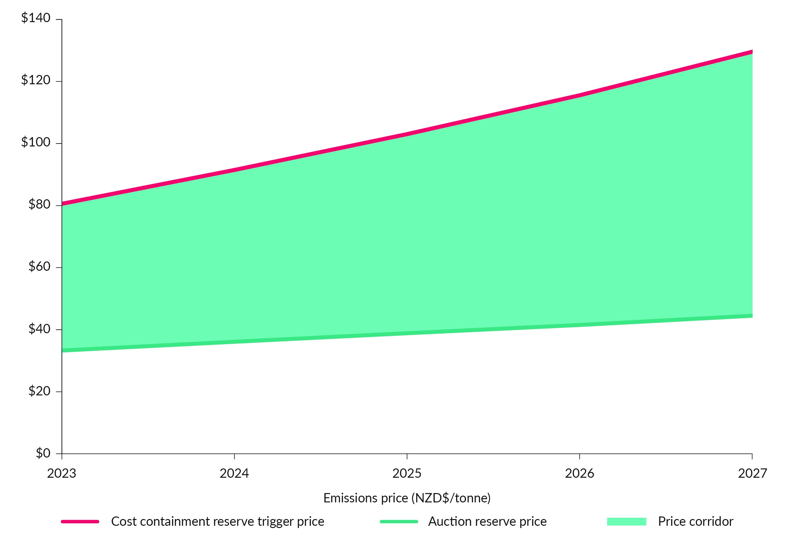
While we are not consulting on the price corridor for the NZ ETS (because this was the subject of a separate consultation and ongoing regulatory process), we are interested in understanding what prices should look like, over time, to prioritise gross emissions reductions. Any information you have on the costs of emissions reductions could help to identify and determine an optimum, future price pathway for the NZ ETS.

A comprehensive package of measures is needed
Emissions pricing is not the only way to drive emissions reductions and removals in Aotearoa. The emissions reduction plan explains the Government’s decision to use a portfolio approach, that is, a mutually supportive and balanced mix of emissions pricing, well-targeted regulation, tailored sectoral policies, direct investment (public and private), innovation and mechanisms that help nature thrive.
The portfolio approach reflects the fact that no one policy instrument, including emissions pricing, can achieve the necessary emissions reductions and removals that are needed to achieve our climate change goals. For example, some sectors (such as transport) do not always respond to price and other measures are more effective in driving the abatement required.
Impact of emissions pricing on transport emissions
The emissions associated with private transport are unresponsive to carbon pricing alone. We estimate that relying on the NZ ETS to increase the uptake of electrical vehicles without any other measures could require a carbon price of $575 per tonne.
Emissions are paid for by the upstream suppliers of fuel, which is reflected in the price paid for fuel at the pump. Higher carbon prices alone are ineffective at reducing these emissions, because NZ ETS costs are a relatively small component of petrol prices and there are barriers that limit people’s ability to switch to less emissions-intensive or alternative forms of transport.
The government has begun to address this through measures such as:
- fuel economy labelling
- the clean car discount and clean car standard, which change the relative prices of vehicles according to their emissions intensity.
These measures target vehicle purchasers who do not or cannot consider the lifetime benefits of low fuel and emissions intensity. In these sectors, the NZ ETS acts more like a revenue-raising tax, pricing the emissions produced but having only a small impact on the level of emissions at current NZU prices.
However, some examples of inelasticity may be short to medium term. If businesses and households expect higher carbon prices to be sustained, they are more likely to make choices that reduce their emissions. For example, households are unlikely or unable to dramatically change their driving habits in the short term in the face of higher fuel prices. However, they are more likely to invest in lower-emissions vehicles when purchasing their next vehicle.
Relying solely on complementary policies to drive gross emissions reductions would be inefficient. The broad, cross-sector coverage of the NZ ETS enables it to affect a wider range of decisions than would be possible with more targeted emissions reduction policies. Regulation and investment can help address some of the major structural, political and behavioural barriers to specific emissions reductions. However, they do not provide the same broad incentives as the NZ ETS for businesses and households to make lower emissions choices.
A price mechanism enables private actors to bring their personal knowledge of the costs and benefits of different transition options over time. An approach that focuses solely on complementary policies could see Aotearoa miss out on low-cost emissions reductions in the near term that are sensitive to price.
The Commission also listed in its 2023 draft advice challenges with an approach that relies on solely complementary policies, including the risk of shifting from a ‘polluter pays’ approach to taxpayers bearing most of the cost burden of gross emissions reductions.

What does this mean for the NZ ETS?
Our current evidence suggests that prices will need to rise to drive material gross emissions reductions, alongside complementary policies, to drive reductions in areas that are not responsive to price.
This implies that the design of the NZ ETS needs to give us the levers to create a particular price pathway for emitters. As discussed in chapter 2, the NZ ETS design currently does not do this. By creating these levers, we will be able to adjust NZ ETS settings to deliver a preferred price pathway as our knowledge improves and we have more up-to-date information on the prices required.
A preferred pathway is one that drives the uptake of low-emissions technology and practices as quickly as real-world constraints allow. Real-world constraints reflect the limits of how quickly supply chains can deliver new equipment, or the speed with which people can learn how to use such equipment. Both the low-emissions technology and real-world constraints are expected to change over time.
We are seeking your feedback on whether this should be the preferred pathway for incentivising gross emissions reductions through our proposed primary assessment criteria (see chapter 6).
The aim of this review is not to determine the exact policy settings for the NZ ETS. Instead, the review explores whether we want to use the NZ ETS to create a preferred price pathway for emitters. If the answer is ‘yes’, the review seeks to identify what this preferred pathway is and how to adjust or redesign the NZ ETS design so it can deliver this price pathway.

Increasing the NZ ETS price to drive greater gross reductions could…

…increase the risk of emissions leakage
Increased NZ ETS costs for emissions-intensive and trade-exposed activities could cause some production to move offshore to countries without similar emissions-pricing policies. If these countries do not have a cap on emissions, there is the risk of increased global emissions. This is referred to as ‘emissions leakage’. Similarly, new forests that displace current farms may result in some leakage of agricultural production.
Pushing reductions faster could result in a loss offshore of businesses that may have been able to adjust to a slower transition. No benefit would be gained for the climate if carbon pricing causes businesses to move their operations to countries that do not have a cap on emissions.
The NZ ETS currently provides free NZUs to at-risk industries (industrial allocation), to manage the risk of emissions leakage. Industrial allocation is slowly being phased out, and high prices, particularly in the near term, could increase the risk of some activities becoming uncompetitive and moving overseas. Recent government analysis suggests some industrial activities could wind down or stop by 2030 in response to higher carbon prices.
If high emitting businesses are closed, the effects would be felt unevenly across Aotearoa. Many high emitters are located in the regions and play an important part of the local economy. Closures would also mean affected regions experience greater economic and employment impacts.
The emissions reduction plan outlines the government’s action to investigate long-term options to address emissions leakage beyond industrial allocation (one alternative is a carbon border adjustment measure). More information on the outcomes of this investigation will be announced in the future.

…affect the cost of energy
If changes to the NZ ETS to prioritise gross emissions reductions result in higher emissions prices, a range of impacts in the energy and industrial sectors are expected.
- Wholesale electricity: Higher emissions prices would lead to higher wholesale electricity prices in the short term. This is because we still require some fossil-fuelled electricity generation that incurs NZ ETS costs, particularly at times of high electricity demand or when Aotearoa experiences a dry year. These generation sources can set the price of wholesale electricity at these times. However, this impact should reduce as the proportion of renewable generation in the electricity system increases.
- Residential and commercial electricity: Higher wholesale electricity prices from rising emissions prices would affect residential and commercial consumers’ electricity prices. How electricity bills could change is uncertain.
- Fossil gas: Higher emissions prices will increase prices paid for fossil gas by consumers and increase the cost of gas production. Higher carbon prices will influence the pace of transition away from fossil gas, particularly for those consumers where other technologies (such as electricity) are readily available. It also creates investment risks for gas supply, particularly for fields with high fugitive emissions. This could lead to a further tightening in gas supply, but the exact impacts are still difficult to quantify.
- Diesel, petrol and coal prices: Higher emissions prices would increase prices for fossil gas, diesel, petrol, and coal for residential, commercial and industrial uses.

…affect household costs
Aotearoa households are exposed to the NZ ETS, largely through emissions price impacts on fuel and energy costs. The impact of emissions prices on other goods and services is usually more indirect, often reflecting fuel and energy as an input into production of that good or service, or as part of freight costs.
Although absolute expenditure on emissions prices tends to rise with income, lower income households tend to spend a greater share of their income on products and services that are affected by emissions prices (figure 9). That is, an emissions price can have a regressive impact on households. The Ministry for the Environment estimates that, at an emissions price of $75 per tonne of CO₂e, expenditure on emissions makes up on average about 0.5 per cent of household gross income (just under $500 per year per household).
However, there could also be cost savings for households from shifting to a low-emissions economy. For example, greater investments in renewable energy, which would reduce the proportion of electricity derived from fossil fuels, would be expected to lower electricity prices in the long run. Also, higher petrol prices would be moderated over time by fuel switching and transport mode shifts driven by stronger NZ ETS incentives. These changes would help lower the costs of goods and services that currently include a substantial carbon component.
Figure 9: Estimated household expenditure on emissions prices (at New Zealand Unit price of $75 per tonne carbon dioxide equivalent)
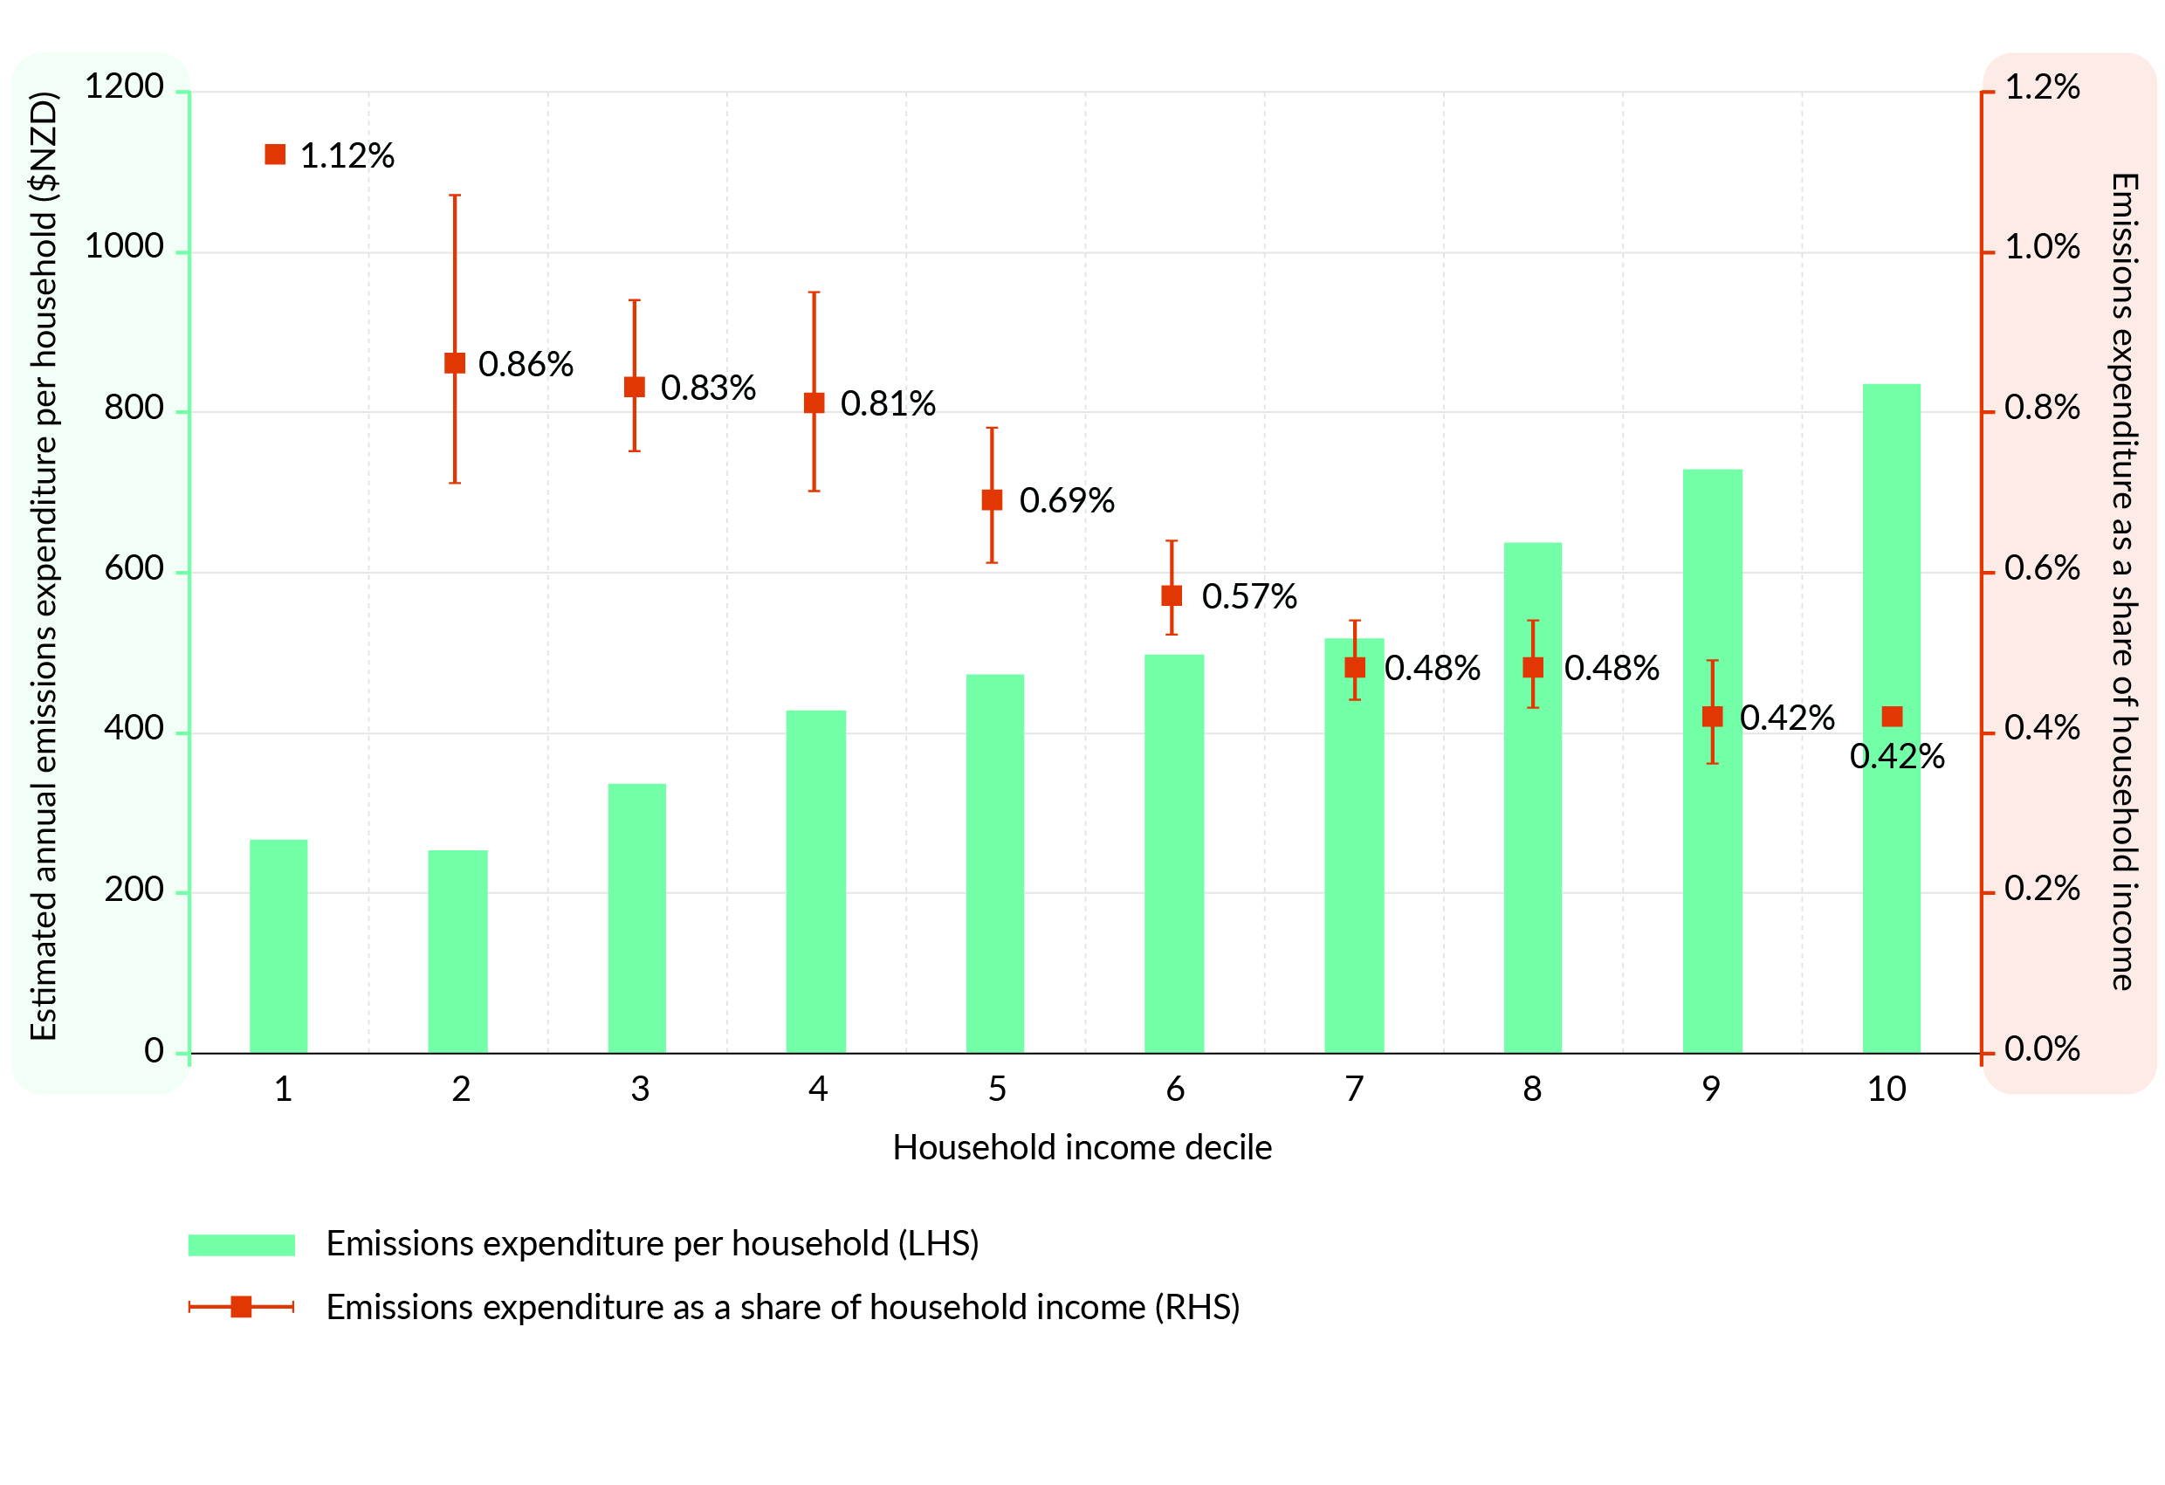
Source: Stats NZ, Ministry for the Environment, Ministry for the Environment calculations
Note: Vertical bars on the chart denote the change in expenditure as a percentage of the lower and upper brackets of each income decile, and the square denotes the change as a percentage of the mid-point of each income decile. The analysis assumes no behavioural changes from households in response to higher carbon prices that would reduce household costs.

Mitigating impacts on households
Instead of reducing the effectiveness of environmental policy, separate measures that target household income may be the best way to address regressive effects of emissions pricing.
In the context of the NZ ETS review, this would entail a design that drives the emissions reductions and removals that are needed, alongside complementary policies to address the impacts on households. Possible approaches include:
- carbon dividend: this is typically a payment linked to the level of the emissions price and paid to all individuals or households. Austria, Switzerland and several provinces and territories of Canada currently operate a form of carbon dividend
- targeted support: another approach is to target support more closely at the households most exposed to the regressive impacts of emissions prices.
It is intended that Aotearoa New Zealand’s equitable transition strategy will include initiatives to help reduce some of the costs imposed on households and communities by the NZ ETS. Targeted measures could help ensure that businesses and households with historically less access to low-emissions alternatives can shift their behaviour as emissions prices rise. The strategy will also identify actions to support households and communities to benefit from the transition and seize opportunities to address existing inequity.

Removals will play an important role in meeting our climate change goals
As discussed in chapter 2, forestry is currently a low-cost form of abatement. As a result, it is likely there will be a strong afforestation response if forestry participants receive the same higher price needed to drive reductions.
This response is likely to take the form of exotic afforestation, because this results in higher returns than indigenous afforestation. Increased afforestation will produce more NZUs to reflect the removals generated. If emitters are able to purchase these units to meet their surrender obligations, they will not be incentivised to reduce their emissions.
Table 3 sets out the role that removals are expected to play in meeting Aotearoa New Zealand’s domestic and international climate change goals.
Table 3: Role of removals in Aotearoa New Zealand’s climate change goals
Domestic climate change goals
Emissions budget 1 (2022–25)  - Limits net emissions to 290 Mt CO₂e  Emissions budget 2 (2026–30)  - Limits net emissions to 305 Mt CO₂e.  Emissions budget 3 (2031–35)  - Limits net emissions to 240 Mt CO₂e | Aotearoa New Zealand’s first emissions reduction plan was published in May 2022 and includes the actions necessary to meet the first emissions budget and put Aotearoa on track to meeting the 2050 target. The second emissions reduction plan must be published in late 2024.  Removals from existing forests are the cheapest way to meet our short-term emissions budgets.
Future emissions budgets (2035–40, 2041–45, 2046–50)  - A new emissions budget will be set every five years from 2025  2050 target  - All greenhouse gas emissions (except biogenic methane) must reach net zero by 2050  - Biogenic methane emissions must reduce to 24–47% below 2017 levels (including a 10% reduction by 2030). | New forests can contribute removals to our future emissions budgets and the 2050 target over the medium and long term. This is especially true for multi-age, biodiverse forests which are also likely to be more adaptive to the impacts of a changing climate.
International climate change goals
Current NDC (2021–30)  Commits Aotearoa to reducing net emissions to 50% below 2005 levels by 2030. This means that Aotearoa can produce net emissions of no more than 598 Mt CO₂e over the period 2021–30.  There is a gap of about 190 Mt CO₂e between our current NDC and our gross emissions (based on the Climate Change Commission’s demonstration pathway). | Net emissions reductions to meet this NDC will come from:  - additional action within Aotearoa (building on the actions in the first emissions reduction plan)  - purchasing offshore mitigation to fill the gap.  Options for additional domestic action include reducing gross emissions more quickly and increasing our removals. This Government has committed to prioritising domestic action as much as possible to achieve our 2021–30 NDC and climate change targets.  Removals from forestry, which contribute to our 2021–30 NDC, cannot be materially increased.
Future NDCs (from 2031)  Aotearoa is due to communicate its next NDC (2031–35) by 2025 | Removals, including from forestry, will be critical for meeting future NDCs, which are expected to be progressively more ambitious.  Because a significant lag time exists in forestry between planting and realising significant carbon removals, decisions made now will have consequences for the role of forestry in meeting future NDCs. New forests established in the 2020s could provide a substantial portion of the net emissions reductions required to meet future NDCs.  If prioritising gross reductions in the NZ ETS results in limiting forestry removals, this could have significant long-term impacts on the costs of meeting future NDCs.

What does this mean for the NZ ETS?
To ensure the NZ ETS can support both emissions reductions and removals, the balance of incentives within the scheme needs to be carefully considered. Changes to the NZ ETS are likely to be needed to create the necessary price pathways for both reductions and removals.

Conclusion
Our current evidence only suggests the range of prices needed to drive emissions reductions. This evidence will improve over time. As our understanding of the necessary price develops, we need to be able to adjust NZ ETS settings to support higher NZU prices. At the same time, we need to consider how this price will affect removals, as well as the incentive for emitters to reduce their gross emissions, given their access to NZUs from removals. Continuing to incentivise removals remains critical, given their importance to meeting our domestic and international targets.
The task is therefore to determine whether and how to change the NZ ETS so settings can be adjusted to drive and maintain the NZU prices needed to reduce emissions, while still maintaining strong incentives for removals that are needed to meet our climate targets.

Consultation questions
Chapter 3 Consultation questions
3.1 | Do you agree with the case for driving gross emissions reductions through the NZ ETS? Why/why not? In your answer, please provide information on the costs of emissions reductions.
3.2 | Do you agree with our assessment of the cost impacts of a higher emissions price? Why/why not?
3.3 | How important do you think it is that we maintain incentives for removals? Why?

Chapter 4: Changes to the NZ ETS would be significant for Māori
The proposals in the NZ ETS review would have a variety of impacts and opportunities for whānau, hapū, iwi and Māori.
This chapter provides an overview of areas that have been identified by our previous analysis and engagement with Māori. It concludes by seeking your feedback on:
- whether Māori rights and interests have been described correctly
- anything we may have missed
- the impacts you consider the most important.
Chapter 6 asks for feedback on how specific options for change will affect the Māori rights and interests described here.

The NZ ETS review is significant across a range of Māori communities and their interests
Māori have made clear that they have a profound interest in Aotearoa New Zealand’s climate response.
Climate change, and the actions we take to mitigate it, have a significant impact on the relationship of Māori to whenua, ngāhere, moana and physical taonga.
As rangatira, kaitiaki, land and forest owners, rural communities, workers, business owners and whānau who are subject to rising costs of living, Māori have a specific interest in changes to the design and operation of the NZ ETS. Previous consultations have reiterated that, to achieve an equitable transition for Māori, the Government needs to:
- consider Māori interests
- reduce existing barriers for Māori participation
- avoid creating new inequities in its climate response.
The impact of the NZ ETS review on forestry opportunities will be particularly relevant to Māori. Around 30 per cent of Aotearoa New Zealand’s 1.7 million hectares of plantation forestry is estimated to be on Māori land. This is expected to grow to 40 per cent as Tiriti settlements are completed.
Forestry provides economic and employment opportunities, as described in chapter 1. In 2018, Māori were estimated to own $4.3 billion of forestry assets and some 2,200 Māori were employed in the sector (40 per cent of the forestry workforce – nearly three times more than their representation in general employment).
Various other government work programmes sit alongside the NZ ETS that will need to be considered collectively to support the role of mana whenua as kaitiaki and rangatira for their communities. These programmes include the current consultation on options to redesign the permanent forest category, as well as the development of both a domestic voluntary carbon market and biodiversity credit system.
This chapter, and the analysis of options in chapter 6, considers Māori interests in the NZ ETS review because of the potential impact of the NZ ETS on:
- the nature and ambition of Aotearoa New Zealand’s climate response
- the feasibility of different land-use options for whenua Māori
- costs of living for whānau and businesses.
The Crown’s obligations to consider these rights and interests stem from te Tiriti and its principles, the Climate Change Response Act 2002 provisions and commitments made in Tiriti settlements.

Māori have expressed a strong interest in the nature and ambition of Aotearoa New Zealand’s climate response
Climate change is already visible in the Aotearoa landscape. Māori wellbeing in both rural and urban areas is being affected, as is Māori exercise of rangatiratanga and kaitiakitanga over their whenua, ngāhere and moana.
The negative impacts of climate change have led to calls from some Māori for greater ambition in Aotearoa New Zealand’s climate response. A claim to the Waitangi Tribunal, for example, states that “[t]he New Zealand Government’s response to the threat of global climate change represents a breach of the Crown’s Treaty of Waitangi obligations towards Māori and Māori have and will continue to suffer prejudice as a result”.
The options considered in chapter 6 vary with respect to the nature and ambition of Aotearoa New Zealand’s climate response. They range from prioritisation of gross reductions while maintaining support for removals, to allowing for an increase in both reductions and removals.

Proposals would affect the viability of different land-use options by changing the incentives for exotic forests, indigenous forests and pastoral farming
The NZ ETS reward for removals is having a significant impact on the relative attractiveness of different land-use options. Activities that remove large volumes of carbon fast and at low cost (such as pine forestry) are more attractive as carbon prices rise, as set out in chapter 2.
Māori have expressed differing views on the increase in returns to exotic forestry. During consultation on the permanent forest category of the NZ ETS in 2022, most Māori forester submitters said that NZ ETS returns for forestry provide a unique opportunity for Māori land owners and communities. They noted the substantial proportion of Māori land that is suitable for afforestation but marginal for other uses, due to it being remote and less versatile. Many argued that pine forests provided a financially viable pathway to permanent indigenous forests, and that long-lived exotics or continuous canopy productions were important permanent forestry options. Māori submitters also pointed out that, in addition to the financial returns, forestry was an important employer of Māori in rural and regional communities.
Some Māori land owners, however, were concerned about the high incentives for pine forestry and wanted greater direct support for indigenous afforestation and regeneration, including from the NZ ETS. This has been a consistent theme of the government’s engagement with Māori. Incentives for more indigenous forests and other nature-based solutions could provide opportunity for Māori to exercise kaitiakitanga and support restoration and protection of not just ngāhere but the cultural practices and mātauranga they support. The broader outcomes the NZ ETS, and other complementary policies, could support are discussed further in chapter 7.
Finally, some Māori have joined other pastoral farmers in expressing concern about the increased incentive to afforest land that is currently being used for sheep and beef farming.
The options considered in chapter 6 vary in their impact on the price that forestry removals would see from the NZ ETS. They also vary in their ability to provide a differential reward from different types of forests (eg, to increase the incentive for biodiverse, indigenous afforestation).

Increasing the cost of emissions is likely to affect the cost of living, including for whānau Māori
Increasing the cost of emissions will have implications across the economy, with flow-on effects for households and communities. Whānau Māori are disproportionately represented in lower income groups with the most limited ability to absorb cost increases.
The options considered in chapter 6 vary in the degree to which they would raise the NZ ETS price for carbon emissions, with flow-through into costs across the economy.

The NZ ETS review will also impact on the rights and interests of future generations
Around half the Māori population is under 25 years old. The effect of this review on future generations, which is complex and nuanced, is therefore of immense importance to Māori.
Chapter 3 set out the case for prioritising gross emissions reductions, while maintaining support for removals. One of the rationales for driving gross emissions now is to reduce the burden of reducing gross emissions on future generations. Enabling the application of mātauranga Māori and nature-based solutions, which extend beyond forestry, is a significant part of Aotearoa New Zealand’s climate change response.
However, the Government also recognises that the NZ ETS review could disadvantage future generations, particularly through options that may limit forestry opportunities. As well as being essential to our climate response, forestry is an important source of income and livelihood for Māori. Limiting economic opportunities in the short term may leave future generations less able to respond to climate change and to realise wider social, economic and cultural aspirations.
The government is keen to hear views and evidence on the impact of this review on the rights and interests of future generations.

The government will support Māori kaitiakitanga and rangatiratanga
The government is committed to embedding te Tiriti in the Crown’s climate response. The NZ ETS review is one of several mechanisms to enable Māori aspirations for kaitiakitanga and rangatiratanga of whenua and taonga.
Although this consultation is largely focused on the NZ ETS review, we welcome broader feedback from Tiriti partners on how to approach an equitable transition for Māori to a low-emissions, more sustainable and resilient Aotearoa in the face of climate change.

Consultation questions
Chapter 4 Consultation questions
4.1 | Do you agree with the description of the different interests Māori have in the NZ ETS review?  Why/why not?
4.2 | What other interests do you think are important? What has been missed?
4.3 | How should these interests be balanced against one another or prioritised, or both?
4.4 | What opportunities for Māori do you see in the NZ ETS review? If any, how could these be realised?

Chapter 5: Objectives and assessment criteria
The Commission has recommended that the Government consider how the NZ ETS may be amended to:
- provide more robust support for gross emissions reductions
- manage the amount of exotic forest planting it drives.
The Government has accepted these recommendations, subject to this review of the NZ ETS. The primary objective of the review is to consider whether the NZ ETS should prioritise gross emissions reductions, while maintaining support for removals. This could mean ensuring the NZ ETS provides a strong and stable price signal of the cost of emissions to the economy. This could help drive more gross emissions reductions in the energy, transport, industrial processes, and waste sectors than the status quo, while also encouraging removal activities across the economy.

Primary assessment criteria
The proposals in this consultation have been assessed against the primary objective for the NZ ETS review using the primary criteria outlined in table table 4.
Table 4: Primary assessment criteria
Primary criteria | Description
Incentivises additional gross emissions reductions | The NZ ETS supports more gross emissions reductions than the status quo by incentivising the uptake of low-emissions technology, energy efficiency measures, and other abatement opportunities as quickly as real-world supply constraints allow. It does this by providing a strong and stable price signal to incentivise gross emissions reductions.
Incentivises emissions removals | The NZ ETS drives levels of removals sufficient to help meet our climate change goals in the short to medium term and to provide a sink for hard-to-abate emissions in the longer term. It does this by providing a strong and stable price signal that rewards removal activities.

Key considerations
Alongside the primary criteria, several key considerations are used to assess the consultation proposals (table 5). These considerations can help us draw out and evaluate many of the important economic, distributional and Tiriti impacts from changes to the NZ ETS to prioritise gross reductions while maintaining support for removals.
Table 5: Key considerations for assessing the consultation proposals
Consideration | Description
Supports meeting NDC | The NZ ETS helps Aotearoa achieve the 2030 NDC and future NDCs, as much as possible, through domestic actions. This includes providing emissions removals that can offset emissions that are outside the NZ ETS.
Affects the functionality of the NZ ETS market | Impacts on the functionality of the NZ ETS market are assessed along three dimensions:  - degree of change – the extent the design of the NZ ETS market changes and the ease of implementing such changes  - complexity of the market – the extent changes to the NZ ETS increase the complexity of the market and impose new costs for participants and the government  - degree of government intervention and/or control – the extent to which the government influences and/or determines NZ ETS outcomes and the degree to which private players do this in the market.
Manages overall costs to the economy and households | The costs imposed by the NZ ETS on the economy, households, different sectors, regions and the government are broadly acceptable.  Additional costs imposed by the NZ ETS on vulnerable groups and communities are mitigated as much as possible through NZ ETS settings and companion policies.  Changes to revenue earned by the government from NZ ETS auctions enable continued support for these companion policies.
Mitigates distributional impacts | The distributional impacts imposed by the NZ ETS across regions, sectors, communities and generations are acceptable.
Gives effect to te Tiriti o Waitangi | Changes to the NZ ETS give effect to the principles of te Tiriti o Waitangi.
Supports co-benefits | The NZ ETS supports other climate and environmental government objectives, alongside incentivising emissions reductions and removals.

Trade-offs will be likely between options when assessed using different criteria and considerations
When assessing the proposals included in this consultation, trade-offs will be necessary between some criteria and considerations.
For some options, the main trade-off will be between the primary assessment criteria, namely:
- prioritising gross emissions reductions
- driving emissions removals.
This trade-off results from the fact that, in some options, prioritising gross reductions in the NZ ETS limits the access of emitters to removals and will likely reduce the incentive for these removals (if no additional actions are taken).
Any options that reduce removals will affect Aotearoa New Zealand’s ability to meet NDCs through domestic actions. Other options enable support for both reductions and removals in a way that is consistent with the Government’s objectives for Aotearoa New Zealand’s climate transition. All the options will impose economic and household costs. However, some variation is likely in the extent of these costs and how they are distributed across Aotearoa and among different groups.

Consultation questions
Chapter 5 Consultation questions
5.1 | Do you agree with the Government’s primary objective for the NZ ETS review to consider whether to prioritise gross emissions reductions in the NZ ETS, while maintaining support for removals? Why/why not?
5.2 | Do you agree that the NZ ETS should support more gross emissions reductions by incentivising the uptake of low-emissions technology, energy efficiency measures, and other abatement opportunities as quickly as real-world supply constraints allow? Why/why not?
5.3 | Do you agree that the NZ ETS should drive levels of emissions removals that are sufficient to help meet Aotearoa New Zealand’s climate change goals in the short to medium term and provide a sink for hard-to-abate emissions in the longer term? Why/why not?
5.4 | Do you agree with the primary assessment criteria and key considerations used to assess options in this consultation? Are there any you consider more important and why? Please provide any evidence you have.
5.5 | Are there any additional criteria or considerations that should be taken into account?

Chapter 6: Options identification and analysis
This review has identified a range of high-level options that would strengthen the incentives for gross emissions reductions in the NZ ETS.
These options primarily focus on curbing our gross emissions reductions. However, they also consider the important role of removal activities.
Options vary in their impact on removals, and these trade-offs will need to be worked through. This focus on removals reflects the Government’s broader commitment to nature-based solutions that remove carbon, increase resilience, and promote greater biodiversity.
Your feedback on these options will lead to a better understanding of the options’ strengths and weaknesses, which will also help in refining the options.

The NZ ETS review has identified four high-level options
This discussion document outlines four high-level options for increasing the incentives for gross emissions reductions in the NZ ETS, while retaining or increasing the support for removal activities. These options also support the key considerations used to assess the consultation proposals.
These options indicate the different changes the government could make and the possible impacts and trade-offs these options involve. Because these options could be applied in different ways, we have provided examples under each. These examples are not intended to be a definitive list. Other options and examples may be identified through this consultation process. These options are briefly summarised in figure 10, with more detail included below.
We are currently consulting on proposals to update the permanent forestry category. The government decisions that are taken following that consultation will form part of the package of incentives for removals and will be considered alongside this review.
Figure 10: Proposed options to strengthen the incentives for gross emissions reductions
in the New Zealand Emissions Trading Scheme
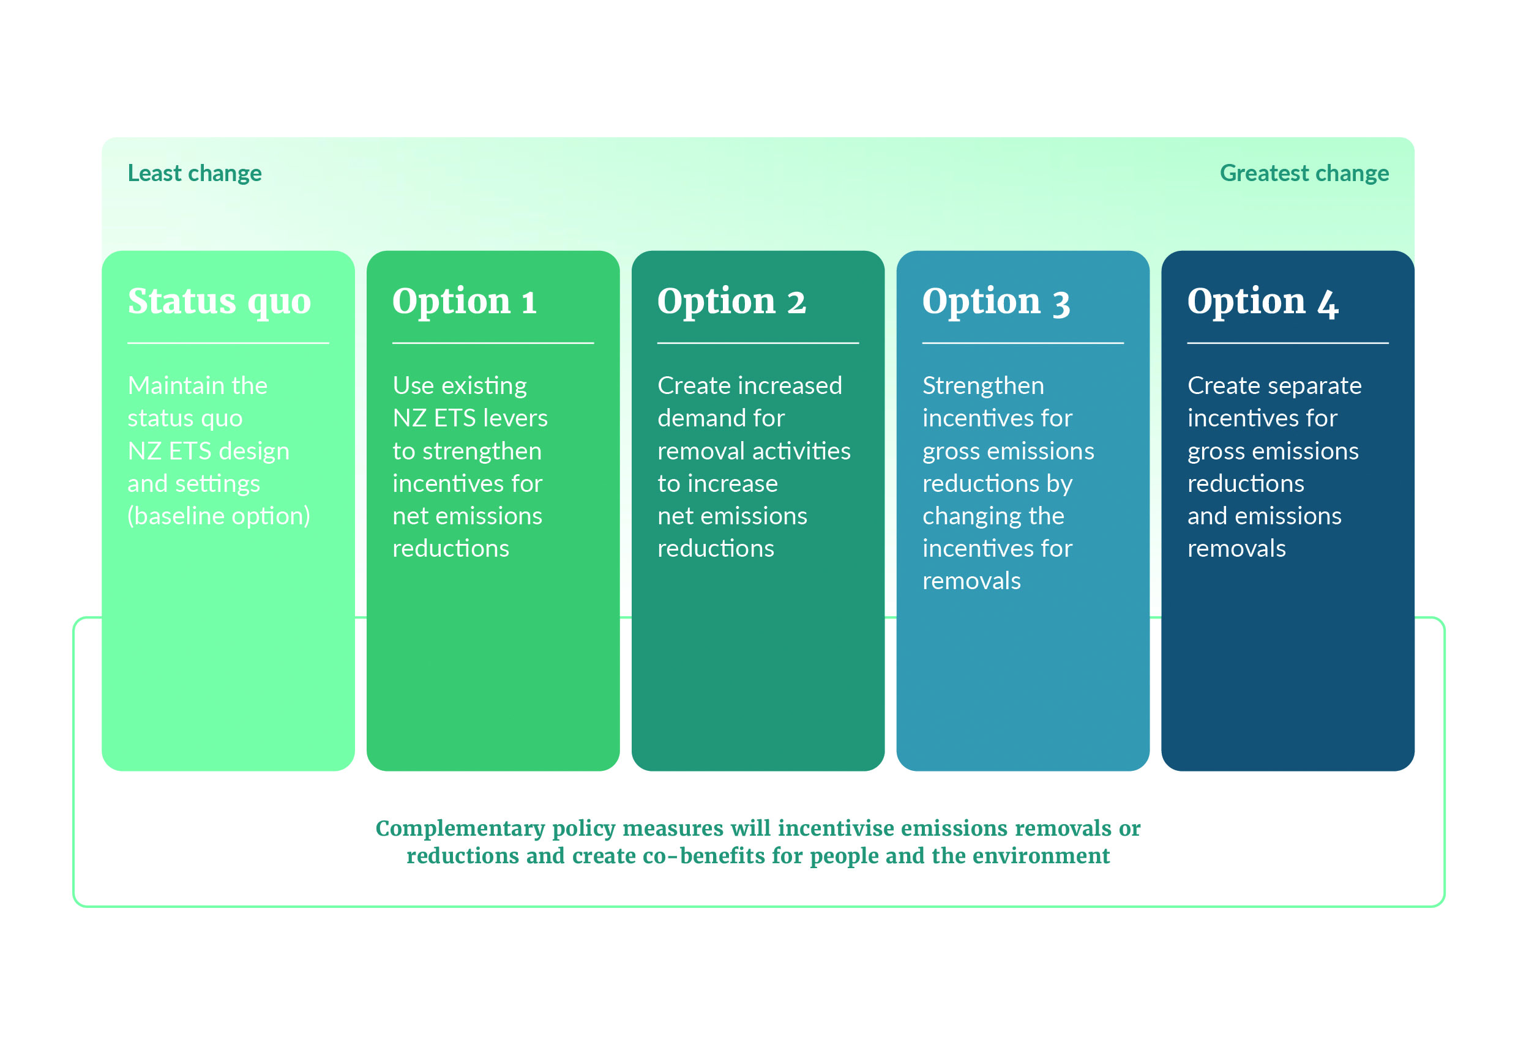

Complementary policy measures could…
…support wider environmental benefits
The Government is exploring the role that a biodiversity credit system could play in supporting biodiversity, complementing carbon markets, and encouraging nature-based responses that build resilience. Such a system could recognise biodiversity protection efforts or outcomes and attract philanthropic, corporate and community investment to directly reward actions that protect, expand or enhance indigenous diversity. This could help to:
- support the objectives of the Aotearoa New Zealand Biodiversity Strategy | Te mana o te Taiao
- complement regulatory protection of biodiversity through national direction and resource management reform
- incentivise specific removal activities with co-benefits (such as indigenous afforestation)
- align with the incentives for indigenous afforestation in the proposed redesigned permanent forest category (currently out for consultation).
…incentivise additional removal activities that support wider environmental benefits
The Government is currently developing a policy framework for a domestic voluntary carbon market (VCM), in which businesses and organisations can purchase credits to offset hard-to-abate emissions targets and meet their climate targets. The VCM can mobilise private investment to support reductions and removals in addition to those driven by the NZ ETS.
Additionally, the Carbon Neutral Government Programme requires government agencies to reduce their emissions and offset those that they cannot reduce by 2025. This will create demand for carbon credits and could increase demand certainty for VCM project developers, as well as supporting further emissions reductions and removals.
…help businesses to transition to low-emissions technologies
Businesses can face large upfront costs when upgrading their infrastructure or equipment to low-emissions alternatives. This financial barrier can delay an organisation’s ability to reduce their gross emissions. The Government has established the Government Investment in Decarbonising Industry Fund to support valuable decarbonisation projects. The programme will see around $650 million of capital grants co-investment made available to support valuable decarbonisation projects and achieve a just transition.
As outlined in figure 10, the degree to which the government intervenes in or redesigns the market varies from option to option. Each high-level option could be implemented in several different ways.
For example, under option 2, NZUs could be purchased by the government or sold to international carbon markets. The impacts of how the options are applied may vary, but they aim to achieve the objectives of incentivising additional gross emissions reductions and emissions removals in a similar way.
Although they are presented as discrete options, components within each option could be combined into a package following consultation. For example, option 3 (which could restrict the use of units allocated for removal activities from surrender obligations) could be combined with option 2 (where the government becomes an additional buyer of these units).
These options and an initial assessment of their expected impacts are detailed below.

Giving effect to te Tiriti o Waitangi and recognising Māori interests
The options set out above will affect different Māori interests in a variety of ways. Chapter 4 explored the importance of the NZ ETS review for Māori due its potential impact on:
- the nature and ambition of Aotearoa New Zealand’s climate response
- the feasibility of different land-use options for whenua Māori
- costs of living for whānau and businesses.
This chapter contains an initial assessment of the options on these broad categories of Māori interests (described in more detail in chapter 4). It seeks feedback from Māori on whether the impacts identified are correct and which impacts are the most important. It also seeks feedback on preferred options.

Limitations of the options analysis
It is not possible to predict with certainty how private actors will respond to policy changes. This review presents a qualitative assessment of how the market is expected to respond to the options. However, the assessment of whether the proposals will meet the Government’s objectives includes assumptions about:
- the actions that actors take to reduce their emissions in response to price, especially because some non-price measures (such as regulation or direct investment or both) may reduce barriers and increase the price response
- changes to removal activities (noting that these have been made independently of projections of wider developments in land prices, which may affect the economics of competing land-use activities)
- future rates of afforestation, based on historical responses to price changes.
Predicting the cost that each option will pose for the government is difficult, because it will depend on the level of abatement that the NZ ETS contributes towards Aotearoa New Zealand’s NDC. The level of this contribution will influence how many offshore units are needed to meet the NDC, the price of which is uncertain.
We have assessed the potential costs to the government on the assumption that the cost of incentivising additional domestic abatement will be cheaper than purchasing units offshore. The government is expected to need to purchase between $3.3 billion and $23.7 billion in additional offshore mitigation to meet the 2021–30 NDC.
These assumptions do not remove the underlying uncertainty within the analysis, and our analysis to date has been limited to the high-level options. Before the government makes its final decisions on the NZ ETS review, detailed modelling and analysis will be undertaken. This analysis will examine how proposals will be applied to existing NZUs or registered forests and will be informed by evidence gathered through this consultation.
Where relevant, we have described the specific caveats that apply to individual options.

The stockpile creates some uncertainty
The ability for NZ ETS participants to hold or ‘bank’ NZUs has led to considerably more units being held in private accounts than is needed to meet surrender obligations (referred to as the ‘stockpile’ and described in chapter 1).
The stockpile of units provides essential liquidity in the NZ ETS secondary market, so buyers can find NZUs to purchase, and sellers can easily find participants to sell to. This also limits the risk of a small number of large participants wielding undue influence in the market. However, the significant number of NZUs in the stockpile could also dampen the NZU price, if they were sold en masse, and lead to challenges in meeting emissions budgets.
However, the large volume of units currently in the stockpile may limit the effectiveness of many of the proposed options or cause a time lag before they start to take effect. This is because participants may use NZUs from the stockpile before changing their behaviour to reduce their emissions. In analysing the options, we have made the following assumptions about stockpile behaviour.
- We assume that participants will not sell stockpiled units into the market if they expect the NZU price to rise and they consider they may make a profit by selling in the future.
- We assume that participants will sell available units from the stockpile into the market if those holding NZUs do not expect the price to rise and result in a future profit.

Option 1: Use existing NZ ETS levers to strengthen incentives for net emissions reductions
Summary
The government could reduce the supply of NZUs, and therefore reduce net emissions, through existing levers such as auction volumes, price controls or industrial allocation.
Reducing the supply of NZUs available to the market is likely to increase the carbon price in the short term. This will create a greater incentive for emitters to reduce their gross emissions and for others to increase their removal activities if they think this price will be sustained (eg, by investing in forestry). This effect is likely to be short-lived because the supply of removals would still be expected to rise in the medium term and is projected to be greater than the demand needed from emitters, even if auction volumes were zero (see chapter 3).
Reducing the volume of NZUs released by the government, which sets the overall NZ ETS cap, would effectively mean reducing our net emissions faster than required by our emissions budgets. Further net emissions reductions, especially in the short term, are likely to be considerably more costly to the economy.
How well will this option incentivise gross reductions and support additional removals?
Short-term increases to price will likely strengthen the incentives for net emissions reductions. However, the increased incentive for removal activities will likely dampen the price in the medium to long term, reducing the incentive for gross emissions reductions.
The government could use existing levers to reduce net emissions faster than required by our emissions budgets. A process is in place for regulating the supply settings in the NZ ETS (other than forestry) and updating them annually. Regulations specify:
- the number of units for release at auction
- the number of units for release if the cost containment reserve is triggered
- the level of the cost containment reserve trigger price
- the auction reserve price.
The Minister, with advice from the Commission, can also recommend making regulations to change the current phase-out rates for freely allocated units to emissions-intensive and trade-exposed (EITE) activities.
Currently, the statutory process for regulating the NZ ETS supply settings does not require consideration of gross emissions reductions or the supply of forestry units.
Option 1 would therefore involve amending the Climate Change Response Act 2002 to require the government (and, where appropriate, the Commission) to also consider the incentive for gross emissions reductions, or the supply of forestry units, before changing these regulations. This may result in reducing the number of units available at auction, increasing the levels at which price control mechanisms are triggered, and reducing the number of units freely allocated to some industrial firms.
Because a wide range of criteria need to be considered in exercising these functions, there is no guarantee that the outcomes would differ from the status quo. The government could still consider multiple criteria and decide to keep unit supply consistent with emissions budgets. This would be in line with the status quo.
If the government did decide to reduce the NZ ETS cap faster than the emissions budgets require, these changes could alter the NZ ETS price corridor (described in chapter 3) and drive up NZU prices, at least in the short term. Increases in price are also likely to drive further afforestation.
Several Māori and other stakeholders have proposed this option during previous government consultations. However, it does not address concerns that the supply of forestry units under the status quo is projected to (more than) fully meet emitter demand for units. Without addressing this issue, the ability of this option to successfully deliver rising prices and gross emissions reductions beyond the short-term is likely to be limited. The limitations of this option were also raised by the Commission in its recently published draft advice on the policy direction of the second emissions reduction plan.
Currently, the number of units released to the market through auction and industrial allocation is designed to align with our emissions budgets. These budgets step towards the 2050 target in a way that is both ambitious and achievable, balancing the need for firms to transition to low-emissions practices with a need to keep overall costs to the economy manageable.
There is a risk that reducing unit supply beyond the levels required by the emissions budgets could lead to firms facing rapidly increased costs without providing enough time for them to transition to low-emissions production. This is a particular risk in the short term and could lead to costs being passed on to the consumer or firms being forced to close.
By contrast, when forestry units from current afforestation become available in the 2030s, they are projected to be sufficient to meet all surrender obligations. Even reducing auction supply to zero is not projected to raise prices to the level needed to incentivise the switch to low-emissions production.
Expected impacts
Incentives for emissions reductions and removals
Option 1 is likely to increase prices in the short term – both at auction and on the secondary market – and incentivise participants to reduce gross emissions. It is unclear how participants who hold stockpiled units would behave under this scenario in the short term, despite the anticipated initial increase in prices. This is because the Commission’s draft advice, as well as this document, outlines that this option would be ineffective in the medium to long term. The immediate increase in removal investments, in addition to the current supply of units projected to be delivered by forestry, is likely to dampen price increases in the long term, which may lead to stockpiled units being sold. This will lower the incentive to reduce gross emissions and make additional removal investments.
Contribution to Aotearoa New Zealand’s nationally determined contribution
Under this option, the NZ ETS contribution to Aotearoa New Zealand’s NDC is likely to reflect the same underlying trends expected for the incentives for emissions reductions and removals under the status quo.
If auction or industrial allocation volumes decrease, prices in the short term will be higher than they are under existing settings. This will result in more emissions reductions and will, in turn, increase the contribution that the NZ ETS can make towards Aotearoa New Zealand’s current NDC.
However, as the higher price will also incentivise more removal activities in the short term, the price is likely to dampen over time. This will also lessen the incentive to reduce gross emissions in the medium and long term. This emissions price forecast could even undermine immediate interest in investing to reduce gross emissions. This means that, although this option could increase the contribution of the NZ ETS to future NDCs more than the status quo, the increase is not expected to be significant.
Functionality of the NZ ETS market
Under this option, the functionality of the NZ ETS does not change relative to the status quo. It does not add any complexity to the system, and the level of government control in the market remains the same.
Costs to economy and households
This option increases NZU prices in the short term and therefore the cost of emissions. These increased costs are likely to be passed on to consumers, especially in the transport and energy sectors. This is likely to disproportionally affect lower income households. Additionally, the lower NZU price, or reduced auction supply, will mean the government receives less revenue from NZ ETS auctions. This could limit the government’s ability to use revenue from the auctions to mitigate the increased costs of the NZ ETS that are passed on to households or reduce the opportunities to fund other policies that reduce gross emissions.
If costs for surrender obligation become too high, some businesses may be forced to close or transition. This may have little impact at a national scale, but it could significantly affect local economies and employment. However, industrial allocation and any other measures introduced in the future to address emissions leakage would be expected to mitigate these impacts.
Sectors involved in removal activities (such as forestry), that have available units to sell, will initially benefit from the higher emissions price. However, this may have flow-on effects, such as encouraging land-use conversion from pasture to forestry, and may affect some rural communities. Over time, as emissions unit prices decrease, current and new removal investments may have lower economic returns.
Te Tiriti and Māori interests
Increases in NZU price will initially benefit Māori owners of existing forest in the NZ ETS, due to the increases in returns from carbon. This will provide particular benefit to those entered in the post-1989 permanent forest category, as well as to participants who have already afforested and registered under averaging accounting (because they no longer face surrender obligations when they harvest). Newly afforested areas may not see a great financial return due to the expectation that price will dampen in the medium to long term when the forest becomes established.
However, the increased NZU price and consequent increase in household costs are likely to impact on Māori households, which are disproportionately represented in lower income groups.
Co-benefits
No scope exists within this option to incentivise activities that have additional co-benefits. Such activities would require complementary policies, such as changes to the NZ ETS permanent forest category or development of a biodiversity credit system, to provide such an incentive.

Option 2: Create increased demand for removal activities to increase net emissions reductions
Summary
Under option 2, additional entities will be able to purchase NZUs outside the NZ ETS (eg, the government or offshore buyers). The government could purchase NZUs to support achievement of the NDC, and offshore buyers might purchase them to meet voluntary emissions targets or support voluntary market claims.
There is currently no evidence of significant demand from offshore buyers because the removals they would be purchasing would still count towards Aotearoa New Zealand’s NDC.
This option would also give the government flexibility to reduce the availability of removal units to emitters. However, the government would still compete with other market participants and would be subject to the market price. This means the government would need to consider the price it pays to support purchasing removals or whether it is better invested in complementary policies to reduce emissions.
How well will this option incentivise gross reductions and support additional removals?
Any increase in demand will likely increase NZU prices, creating a greater incentive for emitters to reduce their gross emissions and increase their removal activities (eg, by investing in forestry). However, the increase in demand may be limited in practice (as purchase is unlikely to be attractive.) This option is only expected to be marginally more effective than the status quo.
Option 2 involves legislative or policy changes to increase the opportunities to sell NZUs allocated from removal activities. This option has been proposed by several stakeholders during previous consultations and engagements. In theory, this option will reduce the number of NZUs that emitters can access in the secondary market. These changes will incentivise gross emissions reductions, because increased demand in the secondary market will likely increase the NZU price. The increase in price is also likely to incentivise increased removal activities.
This option could be achieved in several ways, including by:
- enabling the Crown to be able to purchase NZUs on the secondary market
- enabling NZUs allocated to removal activities to be sold to international carbon markets.
However, the effectiveness of this option will likely be limited. This is due to:
- the fact that the NZUs for purchase may not meet international standards (eg, providing assurance that the units purchased represent new and additional actions that result in permanent reductions or removals)
- countries wanting to use purchased units towards their NDCs, requiring units to be adjusted to ensure the same removals are not counted twice
- the uncertainty of demand for unadjusted units in voluntary carbon markets (VCMs).
In its draft advice on the second emissions reduction plan, the Commission raised similar concerns about this option. The Commission does not consider this option a viable way to encourage further gross emissions reductions or support a sustainable rate of afforestation.
This consultation assumes that the Government will not wish to units offshore if that means they cannot be used to meet Aotearoa New Zealand’s NDCs because of its commitment to meet NDCs through domestic action as far as possible.
Selling units that cannot then be used towards Aotearoa New Zealand’s NDCs would add further challenges to the ambitious targets that already exist. Based on current trends and policies, Aotearoa is likely to need to acquire a substantial net volume of offshore credits to meet the first NDC. Future commitments are also likely to be challenging. Selling units offshore would be costly if the price at which removal units were sold were to be less than the cost of offshore units.

Expected impacts
Incentives for emissions reductions and removals
This option is likely to incentivise marginally greater gross and net emissions reductions, compared with the status quo.
NZU prices and the demand for units are both expected to increase if the government or offshore buyers, or both, can purchase units. The expectation of an increasing NZU price is also likely to discourage participants from selling stockpiled units into the market. As the NZU price increases, more significant gross emissions reductions are likely, as is increased investment in removal activities. However, the effectiveness of this option will be determined by the number of NZUs the government or international buyers are willing to purchase and at what price. Demand for these NZUs is not expected to be high.
Contribution to Aotearoa New Zealand’s nationally determined contribution
This option could incentivise additional emissions reductions and increase the contribution of the NZ ETS to achieving Aotearoa New Zealand’s first nationally determined contribution. It could also incentivise additional afforestation, but these would contribute to subsequent NDCs.
This analysis assumes that any NZUs sold offshore are still counted towards Aotearoa New Zealand’s NDCs and do not include a corresponding adjustment to the NDC. However, demand for units that cannot be counted towards a country’s NDC is not anticipated to be high, which would limit the effectiveness of this option.
Additionally, the government purchasing NZUs may be costly and inefficient. This option works by increasing demand for NZUs, on the assumption that this will lead to higher prices both at auction and on the secondary market, and therefore a greater incentive for gross emissions reductions. The government would simultaneously be competing with emitters to purchase NZUs at this higher price on the secondary market; this is likely to be costly for the taxpayer.
Given the lag between trees being planted and starting to remove carbon from the atmosphere, this purchase of NZUs allocated for removal activities would not incentivise any additional removals in the short term. It therefore functions as a wealth transfer from the public to foresters, with no public benefit.
Overall, this option is expected to marginally benefit Aotearoa over the status quo, provided domestic abatement is more cost effective than purchasing units offshore.
Functionality of the NZ ETS market
Under this option, only be minor changes would be made to the functionality of the NZ ETS. No change would be made to the operation and complexity of the market for participants. However, this option creates more complexity for the government if it purchases units, and an even greater level of complexity if units are sold to offshore buyers. Opening the market to international buyers will require the government to establish a process for implementing international sales, as well as managing the entities or countries that would be eligible to purchase these units.
If the government was to purchase units on the secondary market, it would have more influence in the market than it currently does. The government could influence the price in the market through the volumes of units it is willing to purchase, and through the price paid for these units.
Costs to economy and households
This option increases NZU prices and therefore the cost of emissions. These increased costs are likely to be passed on to consumers, especially in the transport and energy sectors. This is likely to disproportionally affect lower income households. While the government will likely earn more revenue from the sale of NZUs at auction, this additional revenue may need to be used to purchase removal units on the secondary market.
If costs for surrender obligation become too high, some businesses may be forced to close or transition. Although this may have little impact at a national scale, it could significantly affect local economies and employment. Industrial allocation provides a lever for the government to manage the impacts on emissions-intensive and trade-exposed firms.
Sectors involved in removal activities (such as forestry) will benefit from the higher emissions price. However, this may have flow-on effects, such as encouraging land-use conversion from pasture to forestry and may impact on some rural communities.
Te Tiriti and Māori interests
Increases in NZU price (if sustained) will likely benefit Māori forest owners and the owners of land that is suitable for afforestation, due to the increases in returns from carbon. Opening the removals market to a wider range of buyers is also likely to provide more investment certainty within the sector.
However, the increased NZU price and consequent increase in household costs are likely to impact on Māori households, which are disproportionately represented in lower income groups.
Co-benefits
This option could incentivise removals, which provide additional biodiversity, environmental, social or cultural co-benefits. The government could offer a higher purchase price for units that are allocated for removal activities and that have multiple co-benefits (eg, units generated from permanent indigenous forests). Likewise, international buyers who are purchasing units for the purpose of making corporate claims are more likely to buy units that have multiple co-benefits.

Option 3: Strengthen incentives for gross emissions reductions by changing the incentives for removals
Summary
Option 3 will create two prices: one for emissions reduction activities and another for removal activities. A lower price will apply to removal activities, making them less financially attractive. The prices for reductions and removals would still be linked, because an increase to the price for units sold at auction will likely increase the price paid for removal activities.
This option could also allow the government to tailor the support it provides for specific removals activities (eg, enabling it to incentivise indigenous or permanent forestry over exotic forestry).
How well will this option incentivise gross reductions and support additional removals?
The degree to which this option drives gross reductions will depend on the restrictions imposed (eg, on the proportion of units allocated from removal activities that can be used for surrender obligations) and the impact these restrictions have on the price of NZUs. The restrictions imposed by this option could change with time, to ensure it is still effective in delivering the desired balance of gross and net emissions reductions as Aotearoa New Zealand moves towards the 2050 net-zero target.
Without additional measures to encourage more removals, this option is likely to result in less removal activity.
Option 3 will create different prices for units sold at auction and those allocated from removal activities.
This option either increases the relative price for units sold at auction by decreasing the demand for removal activities or decreases the price for units allocated from certain removal activities. Three examples of how this could be achieved are outlined below. The examples are not intended as an exhaustive list and this option could be implemented in many ways.
- Impose restrictions or conditions on the units that NZ ETS participants can surrender as part of the surrender obligations generated through removal activities. This could involve a limit on the proportion of units allocated from removal activities that can be used for surrender obligations. This is the model used in the Californian ETS, where emitters are only permitted to use offsets to meet a portion (currently 4 per cent, increasing to 6 per cent from 2026) of their obligation.
- Restrict the number of units that can be allocated from removal activities. This could involve certain removal activities (eg, sequestration from exotic pine forests) being allocated a reduced number of units relative to the actual amount of CO₂ they have sequestered (eg, 1 NZU for 2 tonnes of CO₂).
- Restrict the time removal units can be held to be used as part of an emitter’s surrender obligation. This option is also known as vintaging.
Vintaging New Zealand Units allocated for emissions removals
Vintaging would put on expiry date on units being held by participants in the NZ ETS stockpile.
For example, a time limit of 10 years could be placed on NZUs allocated from removal activities. After this time, they would not be able to be used to meet surrender obligations.
Vintaging removal units would likely reduce their value in the secondary market and place more demand for units sold at auction.
A time limit could also be applied to units sold at auction, received for industrial allocation, or that are already in the stockpile (including those sourced internationally). However, the expected effects of a time limit being applied to all NZUs are not described in this chapter.
Vintaging could be used either as a stand-alone option or alongside the other options described in this chapter.

Expected impacts
Incentives for emissions reductions and removals
Reducing the supply of units available for surrender obligations is expected to incentivise greater gross emissions reductions. This reduced supply will likely increase the NZU price faced by emitters.
The success of this option will depend on the restrictions the government imposes and whether they are sufficient to drive gross emissions reductions. For example, the impacts of allowing a participant to limit removal units to 50 per cent of their surrender obligations will have a different impact if the restriction of removal units was 90 per cent. However, the range of outcomes from different restrictions has not yet been assessed. Subject to feedback on this consultation, further work will be undertaken to provide detailed analysis of how the options could be implemented and the impacts their implementation may have.
The stockpile behaviour will also be dependent on the restrictions imposed. For example, if restrictions are only imposed on newly allocated forestry units, then participants are likely to hold their stockpiled units because their value is expected to increase over time. If restrictions are applied to all units, then it is anticipated that stockpiled units will be sold into the market and likely to delay the effectiveness of this option.
In the absence of additional policy interventions, this option is likely to decrease demand for units allocated for removal activities and therefore reduce the incentive to invest in additional removal activities.
Contribution to Aotearoa New Zealand’s nationally determined contribution
This option is not expected to increase the NZ ETS contribution to Aotearoa New Zealand’s NDC. Although this option is likely to increase the proportion of gross reductions, these gains will be counterbalanced by the reduced incentives for removal activities.
This risk could be mitigated by introducing additional policy interventions to encourage removal activities (eg, if the government also purchased NZUs from removal activities). In this event, the NZ ETS is likely to make a greater contribution to the NDCs.
Functionality of the NZ ETS market
Although the legislative or structural change to the NZ ETS required for this option will be relatively low, this option imposes a large degree of change to the current operation of the NZ ETS. Those participants with surrender obligations are unlikely to face increased complexity, other than an increase in price. However, those participants undertaking removal activities would be affected, depending on how the option is implemented.
Changing the number of units allocated for forestry activities to differ from the amount of carbon dioxide (CO₂) being removed (eg, 1 NZU for 2 tonnes of CO₂) represents a fundamental shift in the integrity of forestry units. This may have implications for future opportunities to link the NZ ETS with offshore markets. It also raises issues of equity and fairness if a forester faces surrender obligations for harvest or deforestation.
This option introduces considerably more government control into the market. The government will be able to adjust the value of removal activities relative to reduction activities by changing the restrictions imposed on removal activities. This will create volatility in the market for participants who are conducting removal activities.
Costs to economy and households
This option increases NZU prices and therefore the cost of emissions. These increased costs are likely to be passed on to consumers, especially in the transport and energy sectors. This is likely to disproportionally affect lower income households. However, this assumes there is no change in behaviour from households in response higher carbon prices, which would reduce household costs.
If costs for surrender obligations become too high, some businesses may be forced to close or transition. Although this may have little impact at a national scale, it could significantly affect local economies and employment. However, the increased NZU price would likely result in the government earning more revenue from NZ ETS auctions. This increased revenue could be used to mitigate the increased costs likely to face households or to support high emitting industries to transition to low-emissions technologies.
Sectors involved in removal activities, such as forestry, will also be disadvantaged by this option unless complementary measures for removals are introduced. This option would result in two effective prices for units, because those bought at auction will be more valuable and in higher demand than those allocated for removal activities.
Te Tiriti and Māori interests
This option will adversely affect Māori forest owners or those who own land that is suitable for afforestation.
Without complementary policy interventions, this option does not incentivise greater climate ambition relative to the status quo.
The increased NZU price and consequent increase in household costs are likely to impact on Māori households, who are disproportionately represented in lower income groups.
Co-benefits
This option would allow the government to tailor its support for specific removal activities differently. For example, restrictions may not apply to removal units allocated for indigenous forestry, permanent forestry, or the export or destruction of synthetic greenhouse gases.

Option 4: Create separate incentives for gross emissions reductions and emissions removals
Summary
Option 4 would create two markets with two separate prices: one for gross emissions reduction activities and another for removal activities.
Emitters would only be permitted to use units sold at auction or allocated for emissions-intensive and trade-exposed activities to meet their surrender obligations, while removal activities would be incentivised through a separate market. An important design choice for this market would be who purchases these removals: the government or emitters (or both).
The price paid by for removal activities, and the price paid for units at auction or on the secondary market, would not be linked.
How well will this option incentivise gross reductions and support additional removals?
Because emitters could not use removals to meet their mandatory surrender obligations, the government would be able to control the incentive to reduce gross emissions through unit supply settings. As a result, the government could encourage emitters to reduce their gross emissions more than the status quo.
A separate market would incentivise removal activities. The extent removals are incentivised would depend on the design of this new mechanism and the price assigned to and paid for removals. The degree of investment certainty for removal activities would depend on the design of and confidence in this new market.
Under option 4, emitters would no longer be able to use units allocated for removal activities (‘removal units’) to meet their surrender obligation for their gross emissions. Only units sold at auction or allocated for EITE activities (‘gross units’) could be used to meet surrender obligations.
The government would use NZ ETS unit supply settings to reduce the supply of gross units to the market over time. This would incentivise a desired level of gross emissions reductions from emitters. To provide clarity for market participants, the government would need to set out its desired balance of gross reductions and removals towards achievement of emissions budgets and use this to guide supply settings decisions. This aligns with the Commission’s draft advice for the second emissions reduction plan.
To provide an ongoing incentive for removal activities, a separate removals market would be established in which removal units could be bought and sold. This market could use the same infrastructure (such as category definitions, liabilities and accounting approaches) that underpins NZ ETS forestry today.
This is similar to how the European Union ETS and United Kingdom ETS operate: emitters cannot access removals to offset their emissions, and removals are incentivised through complementary policy interventions.
An important design question for the removals market is who would purchase removals units. This would involve one or a combination of the following.
- The government could directly purchase removals: this would contribute to achievement of emissions budgets and the NDC. This could be delivered through:
- a reverse auction (the government purchases a predetermined volume of removals at the cheapest price available from the market)
- a fixed price option (the government buys as many removals as the market is able to provide at a fixed price per tonne of carbon dioxide removed)
- another design.
- Private entities on a mandatory basis: the government could create a new obligation on emitters to purchase removals to contribute to achievement of emissions budgets and the NDC. For example, the government could require emitters to surrender a number of removals in addition to gross units covering their gross emissions.
- Private entities on a voluntary basis: the government could allow voluntary participation in this new market, for example, by companies seeking to buy removals, to support a contribution claim towards Aotearoa New Zealand’s NDC.
By purchasing removals, the government could complement other work programmes. For example, government agencies could purchase removal units to meet their obligations under the Carbon Neutral Government Programme (CNGP). Alternatively, the Crown could choose to incentivise removal activities that have additional co-benefits by offering a different price for different activities.
Like other options, another important design decision relates to whether a new restriction on use of removal units applies to units currently held in the stockpile and, if so, whether and how units in the stockpile could be categorised as a gross unit versus a removal unit.
This option would involve separate incentives for gross emissions reductions and removals. Removals could not be used for surrender obligations for gross emissions, and gross units could not be traded on the removals market.
Expected impacts
Incentives for emissions reductions and removals
Option 4 gives the government control over the reductions incentive facing emitters because participants can only use units sold at auction or received through industrial allocation to meet their surrender obligations. The government can use this control to provide a stronger incentive for gross emissions reductions than the status quo.
The incentive for removals will depend on:
- the price that is paid for units allocated from removal activities
- the number of units the government chooses to release back into the market as part of the auction volumes, if it were to purchase units allocated for removal activities.
As in option 3, the behaviour of participants who have stockpiled units will likely depend on whether the changes apply only to newly allocated units from removal activities or also to those allocated prior to this option coming into effect. The government would need to assess whether and how units in the stockpile could be classified as gross units or removals units.
If restrictions on the use of removals apply only to newly allocated units, participants who hold stockpiled units will be more likely to hold onto them because the price of the units is expected to increase with time. If restrictions are applied to all units, regardless of allocation date, participants who hold units allocated from removal activities would be more likely to sell them into the market, leading to a further dampening of the price expected for units allocated for removal activities.
This option is expected to take the longest to design and implement, given the scale of change to the design of the NZ ETS. This may limit its effectiveness in the short term. However, clearly communicating how we would transition to this option could create a market signal that drives some behaviour change before it is fully implemented.
Contribution to Aotearoa New Zealand’s nationally determined contribution
This option incentivises emissions reductions and removal activities independently and can therefore increase the NZ ETS contribution to our current and future nationally determined contributions.
Functionality of the NZ ETS market
This option involves the most comprehensive changes to the NZ ETS, because it creates two separate markets. Compared with the status quo, this option gives the government much greater control of the price faced both by emitters and those undertaking removal activities. Structurally, this would likely require big changes to the implementation of the NZ ETS. These could be costly and take several years to implement.
Costs to economy and households
This option would be used by government to increase NZU prices and therefore the cost of emissions. These increased costs are likely to be passed on to consumers, especially in the transport and energy sectors. This is likely to disproportionally affect lower income households. Like option 3, the increased NZU price and increased auction volumes would likely result in the government earning more revenue from NZ ETS auctions. While some of this revenue may be needed to support removal activities, the government will have an opportunity to earn further revenue if any of these purchased removal units are released as part of auction volumes. This, however, assumes that the price paid for NZUs at auction will be higher than the price the government purchases removal units for.
Te Tiriti and Māori interests
Although it is unclear how investors in removal activities (such as forestry) will initially respond to this change, in the long term, it could provide more investment certainty for foresters than the status quo (depending on the design and purchase behaviour). This would likely benefit Māori forest owners or the owners of land suitable for afforestation.
However, the increased NZU price and consequent increase in household costs are likely to impact on Māori households, which are disproportionately represented in lower income groups.
Co-benefits
Removal units that provide additional biodiversity, environmental, social or cultural co--benefits could be incentivised under this option. For example, if the government were to purchase units allocated from removal activities, the government could offer a higher purchase price for units that have multiple co-benefits (eg, units generated from permanent indigenous forests or forests grown on Māori land).

Comparison of options in achieving the objectives
Table 6 provides a high-level summary of how effectively options 1 to 4 will achieve the objectives outlined in chapter 5, compared with the status quo.
For simplicity, table 6 does not include the considerations in chapter 5, including the time needed for implementation, the complexity of the required change(s) and the costs to the economy and households. Detailed analysis of the key considerations will be undertaken as part of the next stage of the review.
Table 6: High-level summary on how the options reduce gross emissions reductions and maintain support for removals
 | Options | Prioritises gross emissions reductions | Maintains support for removals
Degree of change required to the New Zealand Emissions Trading Scheme | Option 1: Use existing NZ ETS levers to strengthen incentives for net emissions reductions | Low  Anticipate a short-term reduction in gross emissions due to price increases. However, the increased incentive for forestry removals will likely dampen the price in the medium to long term and reduce the incentive for gross emissions reductions. | Low–Medium  Short term price increases are expected to drive additional afforestation. This will increase unit supply in the medium to long term, which will likely dampen the unit price and reduce this increase in incentive.
 | Option 2: Create increased demand for removal activities to increase net emissions reductions | Low–Medium  Increased demand may increase New Zealand Unit (NZU) prices, creating a greater incentive for emitters to reduce their gross emissions. | Low–Medium  Increased NZU prices will likely increase the incentive for additional removal activities.
 | Option 3: Strengthen incentives for gross emissions reductions by changing the incentives for removals | Medium–High  The changed incentives for removal activities are expected to increase the incentive for gross emissions reductions. | Low  Without additional measures to encourage more removals, this option is likely to result in less removal activity.
 | Option 4: Create separate incentives for gross emissions reductions and emissions removals | High  Limiting the number of units participants can use for their surrender obligations will likely increase the NZU price as a result and encourage emitters to reduce their gross emissions. | Medium–High  Additional removal activities are expected to be incentivised. How far removals are incentivised would depend on the price assigned to and paid for units allocated from removal activities.
Key: Low, Medium and High are qualitative assessments on how each option will achieve the objective relative to the status quo; Low = small improvement (only marginally better than the status quo); Medium = provides a level of improvement likely to have a quantifiable impact; High = significant improvement (and most likely to achieve the objective).

One option is not being progressed
This review has identified several options to prioritise gross emissions reductions in the NZ ETS, while continuing to support removal activities.
The four options outlined above meet either some or all the Government’s policy objectives.
One other option was also identified, but it was not progressed because it would not meet the desired policy objectives outlined in chapter 5. This option is briefly described below.

Removal activities are removed from the NZ ETS, and no alternative mechanism to incentivise removal activities is provided
The option of excluding removal activities from the NZ ETS, without an alternative incentive mechanism, was considered and dismissed. This is because removal activities are critical to meeting Aotearoa New Zealand’s emissions reduction targets and will continue to play an important role in future targets.
The social and environmental effects of land-use conversion to permanent exotic forests are not being considered as part of the NZ ETS review. However, the types of forestry, their location and management are being considered under proposed changes to the National Environmental Standards for Plantation Forestry and the current consultation on proposals for redesigning the permanent forest category in the NZ ETS.

Consultation questions
Chapter 6 Consultation questions
6.1 | Which option do you believe aligns the best with the primary objectives to prioritise gross emissions reductions while maintaining support for removals outlined in chapter 5?
6.2 | Do you agree with how the options have been assessed with respect to the key considerations outlined in chapter 5? Why/why not? Please provide any evidence you have.
6.3 | Of the four options proposed, which one do you prefer? Why?
6.4 | Are there any additional options that you believe the review should consider? Why?
6.5 | Based on your preferred option(s), what other policies do you believe are required to manage any impacts of the proposal?
6.6 | Do you agree with the assessment of how the different options might impact Māori? Have any impacts have been missed, and which are most important?

Chapter 7: Broader environmental outcomes and removal activities
Chapter 6 outlines and assesses four options for driving greater gross emissions reductions through the NZ ETS, while maintaining support for removals.
This chapter looks at incentivising removals more broadly and considers whether the NZ ETS should be used to:
- strengthen incentives for removal activities that have broader environmental outcomes or co-benefits beyond sequestration (eg, indigenous afforestation can enhance indigenous biodiversity)
- include additional removal activities in the NZ ETS, such as blue carbon and the restoration of wetlands.
These issues are considered together because they are related. Some removal activities that have co-benefits can already be entered into the NZ ETS, but the incentives available are not enough to make them widely attractive. In other cases, activities are not included in the NZ ETS and – even if they were – the relative incentives might not be enough.
This chapter also summarises other work programmes that are underway to encourage a broader range of removal activities and realise the associated co-benefits.
Removals activities have a range of benefits beyond removing carbon from the atmosphere
- Indigenous afforestation, which can help to improve indigenous biodiversity.
- Restoring coastal wetland ecosystems would sequester carbon while increasing biodiversity. Restored coastal wetlands could also play an important role in improving resilience to adverse weather events, by absorbing flood waters and reducing heat stress

Changes to the NZ ETS could encourage more removal activities

Work is underway to increase indigenous forestry and improve our understanding of carbon storage
The current reward structure of the NZ ETS provides a greater incentive for removals from fast-growing exotic species, such as pine, rather than slower growing indigenous species. However, the Government has indicated support for indigenous forestry and has several work programmes underway to incentivise indigenous afforestation. Workstreams that would increase the incentive within the NZ ETS include work to redesign the NZ ETS permanent forest category. The Maximising Forest Carbon Programme will undertake research into how carbon storage can be better measured.
Redesign of the New Zealand Emissions Trading Scheme Permanent Forestry Category
In 2022, the Government consulted on proposals to restrict exotic forest species in the permanent forest category of the NZ ETS. Following feedback from stakeholders and Māori, Ministers agreed to redesign the category to target their preferred outcomes, including:
- better addressing the long-term environmental impacts of poorly or unmanaged permanent forests
- managing the impacts on rural communities
- increasing the incentive for indigenous forests.
The Government is currently consulting on the detail of these changes with the intent that a redesigned category will come into effect from 2025.

Maximising Forest Carbon Programme
The Maximising Forest Carbon Programme will run from 2022 to 2026. It will undertake extensive research into carbon storage in different forest types and how carbon storage can be better measured, including the use of remote sensing technology. The Programme will:
- improve the way we measure forest carbon in the NZ ETS, including:
- an updated suite of the default carbon tables used by smaller NZ ETS participants to calculate their carbon storage and unit entitlements, including additional tables for indigenous species to more accurately recognise carbon storage in these forests
- updated methodologies to determine participant-specific yield tables used by larger NZ ETS participants
- consider how good forest management practices resulting in additional carbon storage can be measured, recognised and incentivised, particularly in pre-1990 forests
- consider how climate change will impact on carbon storage in our forests in the future and what interventions may be needed in the short term to mitigate or manage these impacts.

Options identified through the NZ ETS review could further incentivise removal activities with co-benefits
Chapter 6 outlined four options to amend the NZ ETS and assessed their ability to improve the incentive for removals with co-benefits. Table 7 summarises these design opportunities.
Table 7: Opportunities to incentivise removals under different options
Option |  | Opportunities to incentivise removals with co-benefits
1 | Use existing NZ ETS levers to strengthen incentives for net emissions reductions | No opportunities are available under option 1.
2 | Create increased demand for removal activities to increase net emissions reductions | Under option 2, the Government could offer a higher price for removal activities that provide co-benefits, such as biodiverse, indigenous forests. There is also likely to be greater demand in overseas carbon markets for NZUs from removal activities that provide multiple benefits.
3 | Strengthen incentives for gross emissions reductions by changing the incentives for removals | In option 3, the government could look to strengthen the incentives for specific removal activities that offer co--benefits, by allowing emitters to meet their NZ ETS obligations with units from these activities.
4 | Create separate incentives for gross emissions reductions and emissions removals | In option 4, the government could buy removals from indigenous forests at a premium price, or there could be a requirement for emitters to purchase and surrender units from indigenous forests.
The extent to which options 2, 3 and 4 can incentivise indigenous afforestation will largely depend on the price incentive that is offered.
Indigenous afforestation is unlikely to be profitable at a $70 carbon price. Under some scenarios, even an NZU price of greater than $100 does not result in a profit for indigenous forests in the NZ ETS. Enabling investment in indigenous forests to be profitable as well as comparable in profitability to exotic forests will likely require further supporting policy beyond the NZ ETS.
Further work will be undertaken to refine and analyse these options, in light of the feedback we receive during this consultation. This phase of work is also likely to examine the incentives for different forest types in more detail, including those that apply to indigenous afforestation.

Changes to the NZ ETS could help to achieve a specific balance of exotic and indigenous afforestation
The Commission’s advice on the first emissions reduction plan included a recommended level of indigenous and exotic afforestation. While the Government has strongly indicated its support for increasing the levels of indigenous afforestation, it has not decided on a preferred proportion of indigenous and exotic afforestation. As a result, the options outlined above do not indicate the type of forest, or removal activity, that should be prioritised.
As the NZ ETS review and the other work programmes progress, the government will better understand the benefits and costs of incentivising indigenous forests and other removals. It will then be able to assess and determine whether a specific target for indigenous afforestation will best serve to meet our emissions budgets and NDCs.

The NZ ETS could also be expanded to include a wider range of removals
Expanding the range of permissible removal actions within the NZ ETS may help drive more of these activities and disincentivise potential land uses that result in emissions from these sources.
Forestry is the only source of biological removals currently recognised in the NZ ETS (both exotic and indigenous). However, other nature-based solutions and technological forms of removals exist that are not recognised. Examples include:
- the restoration of wetlands
- additional removals in pre-1990 forests resulting from good management practices
- increases in the storage of carbon in our soils due to changes in land-use management.
The NZ ETS also currently rewards some industrial activities that remove emissions, including embedding carbon in products and exporting or destroying synthetic greenhouse gases. However, emerging technologies, such as direct air capture, may also play an important role in the future.
Some additional sources of removals are associated with co-benefits. For example, restoring coastal wetland ecosystems would sequester carbon while increasing biodiversity. Restored coastal wetlands could also play an important role in improving resilience to adverse weather events, by absorbing flood waters and reducing heat stress.

Adding removal activities may have implications for our NDC and incentives to reduce gross emissions
Changes to the type of removals that are included in the NZ ETS may have implications for Aotearoa New Zealand’s current and future NDCs.
Currently, our preferred approach for accounting emissions and removals from land use towards our NDC only includes forestry. If removal activities are brought into the NZ ETS that are not covered by our NDC accounting, it could make it more difficult to meet our NDC.
The main problem relates to the allocation of removals for removal activities. If the removals do not count towards our NDC, but emitters can use them as part of their surrender obligations, Aotearoa would effectively be paying for removals that do not help us meet our NDC. This is a significant obstacle to expanding the scope of the NZ ETS to recognise a broader range of removal activities.
To be considered as a credible source of removals and therefore included in the NZ ETS, it is also important that a new removal activity meets the following criteria.
- Additionality. The removal rewarded must be human induced.
- Permanence. The removal should be enduring, and any subsequent carbon emissions (such as from vegetation being cut down) must be penalised on the same basis as carbon removals are rewarded.
- Scientific validity. Methods used to determine the amount of carbon removed must be unbiased and have a reasonable level of precision.
Including additional categories into the NZ ETS would provide a greater source of NZU supply for emitters. Expanding the NZ ETS therefore involves a trade-off, because increasing the supply of NZUs could undermine the incentive to reduce gross emissions. The balance between incentivising additional forms of removal activities in the NZ ETS with the proposals to reduce gross emissions will be considered further when more detailed modelling and analysis is carried out in the next stages of the review.

Would recognising additional removals with co-benefits in the NZ ETS make them widely attractive?
The costs associated with some additional removal activities and implementation challenges are also barriers to including them in the NZ ETS. Some removals, such as planting of riparian margins and restoring tussock grasslands, do not remove large quantities of carbon. While these activities could deliver wider environmental benefits, the costs associated with NZ ETS registration, monitoring and verification may be greater than the financial returns a participant would receive for the NZUs that would be earned.
If the scope of the NZ ETS is extended to other forms of removals, the reward provided would be limited to the value of the carbon sequestered. The NZ ETS could be leveraged to incentivise activities that generate environmental benefits beyond carbon sequestration. However, prioritising removals with co-benefits may not be the most cost-effective way to reduce net emissions. For example, the most appropriate species of tree for controlling erosion may be less efficient at sequestering carbon than others.
Given the critical role the NZ ETS needs to play in our climate response, this would be a significant drawback. If the scheme is reformed to recognise co-benefits, we are interested in your feedback on the extent to which these co-benefits should be prioritised over emissions reductions. The Commission raised similar concerns in its recent draft advice to the Government and suggested a more holistic approach may be more suitable for other emissions removal activities.

Work is also underway on complementary measures that support a wider range of removal activities

Carbon removals strategy
Multiple work programmes are in place across government that relate to carbon removal efforts. These programmes have different objectives and timeframes but have important interdependencies.
The Government is developing a carbon removals strategy to coordinate and prioritise effort and investment across government, the private sector, and communities.
The strategy will address questions such as how many removals we need to complement ambitious gross emissions reductions, what types of removals are prioritised, and how new removal activities can be recognised and rewarded over time. It will also consider how biodiversity, climate resilience and broader co-benefits could be realised.
Development of the strategy will take into account the feedback received as part of this NZ ETS review consultation. Programmes with close links to the strategy are outlined in further detail below.

Recognising removals as part of the agricultural emissions pricing system
In the section 215 report on agricultural emissions pricing, the Government proposed reforming the NZ ETS to encourage interested parties to invest in science and research, to include further land-use categories in the NZ ETS. Interested parties would be incentivised to invest in research and development early, to increase the likelihood of including additional categories in the NZ ETS as soon as possible after the new system goes live in 2025.
The carbon removals strategy will need to ensure consistency exists in how new on-farm sequestration activities and broader removal activities are measured and considered. On-farm activities will need to be counted consistently across different schemes.

A voluntary carbon market framework
The Government is progressing the development of a VCM framework to support more private–public collaboration, scale up climate activity in Aotearoa, and provide greater assurance of integrity and certainty amid significant changes in global VCMs.
Developing a VCM framework was an important action identified in the emissions reduction plan. Opportunities exist to drive climate mitigation actions outside the NZ ETS, which can be leveraged through VCMs.
Sustainability certifying organisations support the efforts of Aotearoa New Zealand’s businesses to measure their baseline emissions, invest in climate mitigation projects, certify their voluntary emissions reduction and removals, and facilitate purchase of carbon credits through international carbon markets.
However, voluntary climate mitigation in Aotearoa is still underdeveloped to meet increasing demand and largely unregulated, lacking the level of clarity and consistency necessary to stimulate greater domestic project development and high-integrity credit generation.
The development of this market could be implemented alongside the options proposed in chapter 6. For example, option 3 would likely result in a reduced incentive for removal activities. An alternative market for removal activities through the VCM could help to maintain or further incentivise these activities, without impacting on the effectiveness of the option of reducing gross emissions.
The opportunity exists for the VCM to support a more ambitious and optimised carbon removal system for Aotearoa through the trade of removal-based carbon credits.

Carbon Neutral Government Programme
The emissions reduction plan also set out that, by 2025, emissions that cannot be reduced under the CNGP must be offset. This programme could therefore play an important role as a driver of demand in a VCM or suitable alternative mechanism.
The carbon removals strategy will consider where this investment could be best directed. For example, CNGP could prioritise support for development of new and emerging removal activities, or focus on activities that also support biodiversity co-benefits, or focus on meeting our international targets. These decisions will depend on the relative priorities of the strategy.

Biodiversity credit system
The Government is also exploring other policy measures to enhance biodiversity and support wider environmental benefits. For example, work is currently underway to understand the potential role that a biodiversity credit system might play in supporting the protection of biodiversity. This could complement the NZ ETS and, like the VCM described above, be implemented alongside the options proposed in chapter 6. Such a system would seek to drive private investment to directly reward actions that will protect, expand and enhance indigenous diversity.

Conclusion
Options are available within the NZ ETS Review, and in other active work streams, to recognise and incentivise a wider range of removal activities with environmental co-benefits.
The Government is interested in your feedback on whether it should recognise a wider range of removals and increase the incentive for removals with co-benefits, and whether the NZ ETS, or other mechanisms are the best way of doing this.
Chapter 7 Consultation questions
7.1 | Should the incentives in the NZ ETS be changed to prioritise removals with environmental co-benefits such as indigenous afforestation? Why/Why not?
7.2 | If the NZ ETS is used to support wider co-benefits, which of the options outlined in chapter 6 do you think would provide the greatest opportunity to achieve this?
7.3 | Should a wider range of removals be included in the NZ ETS? Why/Why not?
7.4 | What other mechanisms do you consider could be effective in rewarding co-benefits or recognising other sources of removals? Why?

Chapter 8: Process and next steps

How to make a submission
The Government welcomes your feedback on this discussion document. The questions posed throughout this document are summarised below. They are a guide only and all comments are welcome. You do not have to answer all of the questions.
To ensure your point of view is clearly understood, you should explain your rationale and provide supporting evidence, where appropriate.
You can make a submission in two ways:
- via Citizen Space, our consultation hub: https://consult.environment.govt.nz/climate/nzets-review
- write your own submission.
You can upload written submissions via Citizen Space.
We prefer that you don’t email or post submissions because this makes analysis more difficult.
However, if you are posting your submission, send it to NZS review, Ministry for the Environment, PO Box 10362, Wellington 6143. Please include in your submission:
- your name or name of the organisation you represent
- postal address
- telephone number
- email address.
If you are emailing your submission, send it to etsconsultation@mfe.govt.nz as a:
- PDF
- Microsoft Word document (2003 or later version).
Submissions close at 11.59pm on 11 August 2023.
We encourage submissions to be completed and submitted by this date. While late submissions may be still accepted, they may not be considered in time to inform next steps for the NZ ETS review.

Publishing, releasing and analysing submissions
All or part of any written submission (including names of submitters), may be published on the Ministry for the Environment’s website, environment.govt.nz. Unless you clearly specify otherwise in your submission, the Ministry will consider that you have consented to website posting of both your submission and your name.
Contents of submissions may be released to the public under the Official Information Act 1982 following requests to the Ministry for the Environment (including via email). Please advise if you have any objection to the release of any information, including commercially sensitive information, contained in a submission and, in particular, which part(s) you consider should be withheld, together with the reason(s) for withholding the information.
We will take into account all such objections when responding to requests for copies of, and information on, submissions to this document under the Official Information Act.
The Privacy Act 1993 applies certain principles about the collection, use and disclosure of information about individuals by various agencies, including the Ministry for the Environment. It governs access by individuals to information about themselves held by agencies. Any personal information you supply to the Ministry in the course of making a submission will be used by the Ministry only in relation to the matters covered by this document. Please clearly indicate in your submission if you do not wish your name to be included in any summary of submissions that the Ministry may publish.
After receiving submissions, the Ministry will evaluate them and may, where necessary, seek further comments. Your submission will contribute to advice to Ministers. The Government welcomes your feedback.

Next steps
Following consultation, the Government will carefully consider feedback provided through submissions.
Decisions following this consultation will be a matter for the next government. Feedback from submissions will put officials in a good position to advise the incoming government on next steps for the review of the NZ ETS.
Any changes to the NZ ETS consulted on in this document would be subject to further public consultation on the detailed design of proposals.

Where to find further information
Please go to our consultation hub, Citizen Space, to find further information on the NZ ETS Review, ask any questions, register for information sessions, and make a submission.

Glossary
Term | Description
2050 targets | Aotearoa New Zealand’s domestic emissions reduction targets, prescribed in section 5Q of the Climate Change Response Act 2002. It requires net zero greenhouse gas emissions (except biogenic methane) and a 24–47% reduction in biogenic methane by 2050.
Abatement | The emissions reductions and removals we achieve within Aotearoa (our net emissions reductions).
Accounting | In the NZ ETS this refers to the methodology for quantifying the changes in the carbon stored in registered forests from tree growth, and the amount emitted upon events such as harvesting and deforestation.
Afforestation | Establishment (whether by planting or natural regeneration) of forest on land that did not previously have tree cover.
Auctioning | The selling of NZUs by the government to the market through an auctioning system within the NZ ETS. Auctions are held quarterly and open to account holders in the NZ ETS Register.
Auction reserve price | A price control in the NZ ETS. The auction reserve price is the minimum price the government can sell NZUs through auctioning.
Averaging accounting | A method to account for carbon storage in forests intended to be harvested that are also registered in the NZ ETS. Forests will earn NZUs up until the age the forest is expected to reach its long-term average carbon stock over multiple rotations of replanting and harvesting.
Biodiversity | The variability among living organisms from all sources, including land, marine and freshwater ecosystems and the ecological complexes of which they are a part. This includes diversity within species (including genetic diversity) between species and of ecosystems.
Biodiversity credit | An economic instrument that recognises in a consistent way either projects and/or activities that provide positive outcomes for biodiversity, against which ‘nature positive’ claims can be made.
Carbon dioxide equivalent (CO₂-e) | A unit of measurement used to compare greenhouse gases on the basis of their global-warming impact, by converting amounts of other gases to the equivalent amount of carbon dioxide with the same global warming potential.
Carbon Neutral Government Programme (CNGP) | An ongoing government work programme to accelerate the reduction of emissions within the public sector.
Carbon sequestration | The uptake and long-term storage of carbon dioxide from the atmosphere (eg, in vegetation).
Carbon sink | Natural and artificial processes which take carbon dioxide from the atmosphere and store it are known as ‘carbon sinks’. Forests are a good example of a carbon sink, as they take in and store carbon dioxide through the process of photosynthesis.
Climate Change Commission | An independent Crown entity that advises the government on climate change policy within the framework of the Climate Change Response Act 2002.
Climate Change Response Act 2002 (CCRA) | This Act puts in place a legal framework for Aotearoa to meet its international obligations under the UN Framework Convention on Climate Change, the Kyoto Protocol, and the Paris Agreement, including the implementation, operation, and administration of the NZ ETS.
Complementary policy | Government policies that support and reinforce the effects of emissions pricing instruments (such as the NZ ETS) by addressing market barriers and failures.
Cost containment reserve (CCR) | A price control in the NZ ETS. The cost containment reserve is a reserve of NZUs which are available for sale only if a trigger price is reached in the auction.
Demand | The demand for NZUs within the NZ ETS market. This includes the demand for NZUs by emitters to meet NZ ETS surrender obligations and the demand for NZUs for investment purposes.
Deforestation | The conversion of forest land to other land use.
Demonstration pathway | A set of measures and actions proposed by the Climate Change Commission for New Zealand to reduce emissions and achieve the 2050 targets.
Emissions | Greenhouse gases released into the atmosphere from human activity.
Emissions budgets | A total quantity of emissions that is allowed to be released in Aotearoa during an emissions budget period. Each emissions budget covers a period of five years (except the first emissions budget which covers the period 2022–2025).
Emissions leakage | The risk of climate policies – in particular emissions pricing measures – reducing emissions in one location but causing emissions to increase elsewhere so that global emissions overall do not reduce. Emissions leakage is created by the uneven implementation of climate policies in different countries.
Emissions intensive and trade exposed (EITE) | Industrial activities carried out in Aotearoa where the output of the activity 1) creates high levels of emissions per unit of product and 2) is traded overseas.
Emissions reduction plan | The emissions reduction plan sets out how New Zealand will meet its first emissions budget (2022–2025) and sets the path towards meeting our long-term climate targets.
Emissions removals | Also known as ‘carbon removals’ and ‘offsetting’, the removal and permanent storage of emissions through various activities.
Exotic forest | A forest in which the main species does not occur naturally in Aotearoa.
Forest | Forest land in the CCRA means an area of land of at least one hectare that has, or is likely to have, tree crown cover from forest species of more than 30% in each hectare.
Gross emissions | The total greenhouse gas emissions from agriculture, energy, industrial processes and product use, and waste.
Industrial allocation | The free allocation of NZUs to firms carrying out emissions intensive and trade-exposed activities for the purposes of mitigating the risk of emissions leakage.
Indigenous forest | A forest species that occurs naturally in Aotearoa or has arrived in Aotearoa without human assistance.
International climate change goals | New Zealand is committed to international climate change targets as a part to the United Nations Framework Convention on Climate Change and the Kyoto Protocol.
Marginal abatement cost curve (MACC) | Models showing the abatement potential of greenhouse gas mitigation measures, and the relative costs associated with each of these measures.
Nationally Determined Contribution (NDC) | NDCs represent efforts by each country to reduce national emissions and adapt to the impacts of climate change, as part of their obligations under the Paris Agreement. Aotearoa has adopted an NDC for the period 2021–2030 that requires a 50% reduction of net emissions below our gross 2005 level by 2030.
National Environmental Standards for Plantation Forestry (NES-PF) | Regulations made under the Resource Management Act to manage the environmental effects of plantation forestry, including those from planting, forest management, and harvesting.
Net emissions | Net emissions are gross emissions and the emissions and removals from land use, land-use change, and forestry.
New Zealand Emissions Trading Scheme (NZ ETS) | A market-based policy to reduce emissions of greenhouse gases. The NZ ETS puts a price on emissions, charging certain sectors of the economy for the greenhouse gases they emit, and rewarding activities that remove emissions from the atmosphere.
New Zealand Unit (NZU) | One ‘emissions unit’ is equal to one tonne of carbon dioxide equivalent. NZUs can be traded among people and businesses participating in the NZ ETS.
Offshore mitigation | Also known as ‘international units’ and ‘overseas credits’. Offshore mitigation refers to emissions reductions or removals that occur outside Aotearoa.
Participant | In the NZ ETS, a participant is a person or entity that is registered and participates in a forestry activity or carries out an activity covered by the NZ ETS.
Permanent forest | Permanent forests are those not intended to be clear fell-harvested but may be subject to select or small coupe harvesting.
Permanent post-1989 forest category | A new category (activity) in the CCRA which was available from 1 January 2023. Participants who opt to enter the permanent forest category will remain in the NZ ETS for 50 years. Forest land registered in the permanent forest category will earn on the stock change approach, and participants will be unable to clear-fell their forests for 50 years.
Removals | The result of activities that take carbon from the atmosphere and store it, such as forestry.
Secondary market | The market in which previously issued NZUs are traded.
Stockpile | The volume of NZUs being held in the NZ ETS Register by account holders.
Supply | The supply of NZUs within the NZ ETS from different sources, including forestry, auctioning, and industrial allocation.
Surrender | The transfer of one or more units to the Crown surrender account in the NZ ETS Register to meet an emissions obligation in the NZ ETS.
Vintaging | The application of expiration dates for emissions units. NZUs are currently not vintaged.
Voluntary carbon market (VCM) | A market for the voluntary buying and selling of carbon credits that represent the reduction or removal of emissions achieved through mitigation actions, such as afforestation or avoided deforestation. This is distinct from compliance markets, such as the NZ ETS, where entities have obligations to participate and surrender emissions units.

These co-benefits include providing employment in rural communities; providing economic returns for land that may otherwise be unproductive; providing erosion control; enhancing indigenous biodiversity; and providing economic opportunities for land owners, including tangata whenua.
Aotearoa has a domestic 2050 target that requires all greenhouse gas emissions (except biogenic methane) to reach net zero by 2050, and biogenic methane emissions to reduce to 24 per cent to 47 per cent below 2017 levels by 2050 (including a 10 per cent reduction by 2030). A system of emissions budgets (discussed later) will step progressively towards the target.
The Inquiry was announced on 23 February 2023 and sponsored by the Environment and Forestry Ministers. The purpose of the Inquiry was to describe the history of land uses associated with the mobilisation of woody debris (including forestry slash) and sediment in the Tairāwhiti and Wairoa districts, and to make recommendations about the further work needed to address impacts of land use and storms. The Inquiry’s findings and recommendations were released on 12 May 2023 (see Ministerial Inquiry into Land Use, for more information).
Including a 10 per cent reduction by 2030.
An equitable transition strategy is currently being developed by the Ministry of Business, Innovation and Employment. This is intended to include tangible initiatives to address challenges and leverage opportunities that are targeted towards those groups most in need of support (see Ministry for the Environment. 2022. Te hau mārohi ki anamata | Towards a productive, sustainable and inclusive economy: Aotearoa New Zealand’s first emissions reduction plan. Wellington: Ministry for the Environment. Action 3.2.1).
Ministry for the Environment. 2022. Te hau mārohi ki anamata | Towards a productive, sustainable and inclusive economy: Aotearoa New Zealand’s first emissions reduction plan. Wellington: Ministry for the Environment. Action 5.2.4.
The Treasury and Ministry for the Environment. 2023. Ngā Kōrero Āhuarangi Me Te Ōhanga: Climate Economic and Fiscal Assessment. Wellington: The Treasury and Ministry for the Environment.
In 2022, the Commission estimated the surplus component of the stockpile to be between 33 million to 66 million NZUs. The number of surplus units began increasing in 2012. This growth was attributed to the arbitrage of Kyoto Protocol units for NZUs (which has been prohibited in the NZ ETS since 2015), some banking of Kyoto Protocol units (which were cancelled in 2019), the one-off allocation of NZUs to pre-1990 forest owners, the use of the fixed price option by NZ ETS participants in 2019 and 2020, and the sale of NZUs from the cost containment reserve in 2022.
For example, if required innovation fails to occur and high-emissions economic activities are locked in.
The removals referenced here are from sequestration and not from other types of removals recognised in the NZ ETS (eg, the export or destruction of synthetic greenhouse gases).
At the start of 2023, the NZU price was about $75 per unit. Prices have since decreased, with NZUs sitting at about $55 per unit in early May 2023. Chapter 3 provides further discussion of NZU prices.
This is because indigenous forests earn units more slowly than some exotic forests (because most indigenous species tend to grow more slowly than exotic species) and have higher establishment costs.
Climate Change Commission. 2021. Ināia tonu nei: a low emissions future for Aotearoa. Wellington: He Pou a Rangi | Climate Change Commission. Recommendation 11.1.
This component of the 2050 target applies to all greenhouse gas emissions, except biogenic methane.
Climate Change Commission. 2021. Ināia tonu nei: a low emissions future for Aotearoa. Wellington: He Pou a Rangi | Climate Change Commission. Recommendation 25.2a.
Climate Change Commission. 2023. 2023 Draft advice to inform the strategic direction of the Government‘s second emissions reduction plan. Wellington: He Pou a Rangi | Climate Change Commission. Proposed Recommendations 3 and 15.
For example, if it costs $150 per tonne of emissions for an industrial manufacturer to apply a new low-carbon technology, but the expected long-term cost of NZUs is $100, the manufacturer would be expected to purchase NZUs, rather than reducing their gross emissions.
Manley B. 2022. Afforestation and Deforestation Intentions Survey 2021: Final Report. MPI Technical Paper No: 2022/19. Prepared for the Ministry for Primary Industries by the University of Canterbury.
Respondents comprised: (1) large-scale forest owners – generally owners with more than 10,000 hectares of forest, (2) forestry consultants and managers, and (3) other individuals or organisations identified as undertaking afforestation.
Concept Consulting. 2022. Which way is forward? Analysis of key choices for New Zealand’s energy sector. Wellington: Concept Consulting.
Ministry for the Environment. 2022. Proposed changes to New Zealand Emissions Trading Scheme limits and price control settings for units 2022: Summary of submissions. Wellington: Ministry for the Environment.
Ministry for Primary Industries. 2022. Managing Permanent Exotic Afforestation Incentives Regulatory Impact Statement. Wellington: Ministry for Primary Industries.
The March 2023 NZ ETS auction was declined and no NZUs were sold. Some market commentators have suggested uncertainty regarding future NZU market prices may have contributed to this result.
Ministry for Primary Industries. 2022. Afforestation and Deforestation Intentions Survey 2021: Final Report. MPI Technical Paper No: 2022/19. Wellington: Ministry for Primary Industries.
Current examples include the commitment by Tesco supermarkets (the largest buyer of Aotearoa products in Britain) that all its products have net zero emissions across their supply chain by 2050. Nestlé has made a similar commitment and is currently working with Fonterra to develop a net zero dairy farm in Taranaki.
Last year, the Government updated the NZ ETS price settings to adjust for inflation. As a result, the current lower and upper bounds of the NZ ETS price corridor are slightly higher than what the Commission recommended in Ināia tonu nei.
Climate Change Commission. 2022. NZ ETS unit limits and price control settings for 2023-2027. Wellington: He Pou a Rangi | Climate Change Commission.
Climate Change Commission. 2023. Advice on NZ ETS unit limits and price control settings for 2024-2028. Wellington: He Pou a Rangi | Climate Change Commission.
Concept Consulting. 2021. Shifting gear: How New Zealand can accelerate the uptake of low emission vehicles – Report 1: Policies to incentivise EV uptake. Wellington: Concept Consulting.
Climate Change Commission. 2023. 2023 Draft advice to inform the strategic direction of the Government’s second emissions reduction plan. Wellington: He Pou a Rangi | Climate Change Commission. p 62.
For more information, see Environmental Protection Authority. Eligibility. Retrieved 2 June 2023.
Ministry for the Environment. 2022. Regulatory Impact Statement: Updates to NZ ETS unit limit and price control settings regulations. Wellington: Ministry for the Environment.
While we will likely need offshore mitigation to support meeting our NDCs, we do not currently know how expensive offshore mitigation will be, and uncertainty on price will remain high. The government is expected to need to purchase between $3.3 billion and $23.7 billion in additional offshore mitigation to meet the 2021–30 NDC. See The Treasury and Ministry for the Environment. 2023. Ngā Kōrero Āhuarangi Me Te Ōhanga: Climate Economic and Fiscal Assessment. Wellington: The Treasury and Ministry for the Environment.
This is due to the time it takes for the forest to remove carbon after it has been planted.
Reserve Bank of New Zealand. 2018. Te Ohanga Māori – The Māori Economy 2018. Wellington: Reserve Bank of New Zealand.
This quote is from paragraph 3 of the statement of claim to Wai 2607, dated 30 May 2016.
Ministry for Primary Industries. 2022. Managing exotic afforestation incentives: A discussion document on proposals to change forestry settings in the New Zealand Emissions Trading Scheme. Wellington: Ministry for Primary Industries.
For example, the fuel supplier sector may pass costs onto their consumers, which could increase the cost of transporting goods, in turn increasing food prices and the cost of other household items.
This analysis has not yet considered the differences between how removal activities already registered in the NZ ETS and the registration of new removal activities in the future will be impacted. This difference could be a consideration in the design and application of an option, and your views are welcome. It also has not considered how the options will impact on forestry activities that have surrender obligations. This would be worked through in subsequent analysis.
The Treasury and Ministry for the Environment. 2023. Ngā Kōrero Āhuarangi Me Te Ōhanga, the Climate Economic and Fiscal Assessment. Wellington: The Treasury and Ministry for the Environment.
Volumes and price control settings are given in regulations for five years ahead. There are restrictions on changes that can be made in each annual update. Regulations to accelerate phase-out of industrial allocations can only be made after detailed consideration by the Commission.
Such as the consultation in 2022 on Managing exotic afforestation incentives by changing the forestry settings in the NZ Emissions Trading Scheme. Retrieved 2 June 2023.
Climate Change Commission. 2023. 2023 Draft advice to inform the strategic direction of the Government‘s second emissions reduction plan. Wellington: He Pou a Rangi | Climate Change Commission.
To avoid two countries counting the same emissions removals or reductions, sale of international units will require the selling nation to make a corresponding adjustment to its NDC accounting. This would mean the quantity of adjusted removals equivalent to the number sold internationally would not be able to be counted towards meeting NDCs. In effect, this would mean Aotearoa would need to achieve additional gross emissions reductions or removals to compensate.
The Treasury and Ministry for the Environment. 2023. Ngā Kōrero Āhuarangi me te Ōhanga: Climate Economic and Fiscal Assessment. Wellington: The Treasury and Ministry for the Environment.
The Treasury and Ministry for the Environment. 2023. Ngā Kōrero Āhuarangi me te Ōhanga: Climate Economic and Fiscal Assessment. Wellington: The Treasury and Ministry for the Environment.
Industrial allocation provides a lever for the government to manage the impacts on emissions-intensive and trade-exposed firms.
For example, NZ ETS participants might be required to surrender removals equal to 10 per cent of their total gross emissions liability. In this scenario, a participant with a gross emissions liability of 1,000 units would have to surrender 1,000 gross units, as well as 100 removals units. In this model, the government would need to consider the overall cost impact on emitters from the two obligations.
The government could, for example, offer to pay a higher price for removals from indigenous forests than exotic forests, to promote biodiversity outcomes.
Based on modelling undertaken by the Climate Change Commission (Climate Change Commission. 2021. Ināia tonu nei: a low emissions future for Aotearoa. Wellington: He Pou a Rangi | Climate Change Commission) and the Aotearoa Circle (Aotearoa Circle. 2020. Native Forests: Resetting the balance. Aotearoa Circle).
Climate Change Commission. 2021. Ināia tonu nei: a low emissions future for Aotearoa. Wellington: He Pou a Rangi | Climate Change Commission.
Climate Change Commission. 2023. 2023 Draft advice to inform the strategic direction of the Government‘s second emissions reduction plan. Wellington: He Pou a Rangi | Climate Change Commission.
Ministry for the Environment. 2022. Pricing agricultural emissions: Report under section 215 of the Climate Change Response Act 2002. Wellington: Ministry for the Environment.

