**Disclaimer**

The information in this publication is, according to the Ministry for the Environment’s best efforts, accurate at the time of publication. The Ministry will make every reasonable effort to keep it current and accurate. However, users of this publication are advised that:

* the information does not alter the laws of New Zealand, other official guidelines, or requirements
* it does not constitute legal advice, and users should take specific advice from qualified professionals before taking any action based on information in this publication
* the Ministry does not accept any responsibility or liability whatsoever whether in contract, tort, equity, or otherwise for any action taken as a result of reading, or reliance placed on this publication because of having read any part, or all, of the information in this publication or for any error, or inadequacy, deficiency, flaw in, or omission from the information in this publication
* all references to websites, organisations or people not within the Ministry are for convenience only and should not be taken as endorsement of those websites or information contained in those websites nor of organisations or people referred to.

This document may be cited as: Ministry for the Environment. 2024. *New Zealand’s second emissions reduction plan (2026–30): Technical annex to the discussion document*. Wellington: Ministry for the Environment.

Published in July 2024 by the  
Ministry for the Environment   
Manatū mō te Taiao  
PO Box 10362, Wellington 6143, New Zealand  
[environment.govt.nz](https://environment.govt.nz/)

ISBN: 978-1-991140-28-9

Publication number: ME 1837

© Crown copyright New Zealand 2024

# Contents

Introduction 6

Baseline for consultation 7

The Emissions in New Zealand model 10

Computable general equilibrium modelling 12

CGE modelling for ERP2 consultation 12

ENZ model results 13

Previously assumed baseline – the 2023 official greenhouse gas emissions projections 13

ERP2 consultation (interim) baseline 13

Progress relative to targets 18

Emission trends and sectoral results 21

Proposed new policies 32

Policy options 32

Intervention rationale 33

Estimates of effects on net emissions 33

Macro-economic and distributional impacts 36

Macro-economic impacts 36

Impacts on households 37

Sectoral impacts 38

Regional impacts 39

Appendix 1: Baseline assumptions 41

Appendix 2: Intervention logic mapping 49

Appendix 3: Assumptions used in policy modelling 63

# Tables

Table 1: Interim consultation baseline, excluding new policies, compared with 2023 projections per budget period (Mt CO2-e) 14

Table 2: Sources of differences between the 2023 emissions projections and the ERP2 interim baseline (Mt CO2-e) 16

Table 3: Assumptions varied in sensitivity analysis 17

Table 4: Interim consultation baseline compared with 2023 projections per budget period (long‑lived gases) 19

Table 5: Interim consultation baseline compared with 2023 projections per budget period (biogenic methane) (Mt CO2-e) 20

Table 6: Changes in emissions from 2018–22 average to 2030, 2035 and 2050 by sector (Mt CO2-e and percentage change) 23

Table 7: Changes in energy emissions from 2018–22 average to 2030, 2035 and 2050 by subsector (Mt CO2-e and percentage change) 25

Table 8: Potential new policies for inclusion in ERP2 32

Table 9: Additional potential abatement options 33

Table 10: Provisional estimated emissions reduction impacts of new policies in ERP2 on emissions budgets (Mt CO2-e) 33

Table 11: Provisional estimated emissions increase impact of new policies in ERP2 on emissions budgets (Mt CO2-e) 34

Table 12: Projected effects of additional potential abatement options on the second and third emissions budgets 35

Table 13: Interim projections of emissions and removals including effects of proposed new measures (Mt CO2-e), by budget period 35

Table A1.1: List of assumptions for 2023 official projections (with existing measures, WEM), interim ERP2 baseline, low and high scenarios 41

Table A2.1: Logic maps explaining links between selected policies and emissions impacts 49

Table A3.1: Assumptions used for modelling proposed ERP2 policies 63

# Figures

Figure 1: Models used for official projections 7

Figure 2: High-level illustration of Emissions in New Zealand modelling approach 10

Figure 3: Projections range from sensitivity analysis compared with a range based on historical deviation, 2022–50 18

Figure 4: Long-lived gas net emissions in interim ERP2 baseline for consultation, 2023–50 19

Figure 5: Biogenic methane emissions in interim ERP2 baseline for consultation, 2023–50 20

Figure 6: Interim baseline projections – gross and net emissions (using target accounting), 1990–2050 21

Figure 7: Interim baseline emissions by sector, 1990–2050 22

Figure 8: Historical and projected transport emissions by subsector, 1990–2050 23

Figure 9: Travel distance by vehicle type – all road vehicles, 2020–50 24

Figure 10: Historical and projected energy emissions by subsector, 1990–2050 25

Figure 11: Historical and projected manufacturing and construction emissions, 1990–2050 26

Figure 12: Historical and ENZ interim projected agriculture emissions by gas, 1990–2050 27

Figure 13: Historical and ENZ interim projected agriculture emissions by source, 1990–2050 27

Figure 14: Historical and ENZ interim projected stock numbers by stock type, 1990–2050 28

Figure 15: Historical and ENZ interim projected waste emissions, 1990–2050 29

Figure 16: Historical and ENZ interim projected waste tonnages by destination of waste, 1990–2050 29

Figure 17: Historical and projected forestry removals, 1990–2050 30

Figure 18: Historical and projected land area in forestry and sheep and beef farms, 1990–2050 30

Figure 19: Historical and projected afforestation rates for exotic (high, medium, low) and native forests, 1990–2050 31

Figure 20: Expected impact of ERP2 aligned pathway on household consumption, by household income and ethnicity, 2050 37

Figure 21: Expected impact of mitigation policies on output, by sector, 2050 38

Figure 22: Expected impact of mitigation policies on GDP, by region, 2050 39

# Introduction

This technical annex describes the modelling used to provide emissions projections for the second emissions reduction plan (ERP2) consultation. The focus is on providing an interim emissions baseline that represents expected emissions in the absence of any new policies. In addition, some provisional estimates have been made of the expected effects of proposed new policies.

The interim emissions baseline uses data and assumptions that have been updated since the official emissions projections were released in late 2023. It is also based on a different model from the model(s) used for the 2023 projections.

Alongside the emissions projection modelling, some provisional analysis examined the potential wider economic impacts of different policy and other scenarios, including impacts on gross domestic product (GDP) and on different household types. This analysis was undertaken before many of the data and assumptions were updated, such that the current results are provided more as an indicator of the expected analysis to be provided for the final ERP2 documents.

The assessment of the effects of new policies is provisional and is based on our understanding of how these policies might be implemented before regulations are finalised. The assessment is limited in some cases because of a lack of empirical data to inform the expected response to policy and in other cases because policy is in the early stages of development.

In this annex, we set out:

* the background to the setting of an interim baseline for ERP2
* a description of the modelling, including that used for the baseline projections and for the economic impacts
* the description and provisional analysis of proposed new policies
* distributional and wider economic analysis of scenarios broadly corresponding to ERP2
* appendices that include the assumptions used in analysis.

The historical and projection data are presented in this annex in carbon dioxide equivalents (CO2-e) using 100-year global warming potentials (GWPs) from the Intergovernmental Panel on Climate Change (IPCC) Fifth Assessment Report (AR5).[1]

# Baseline for consultation

The interim baseline illustrates the expected future emissions in the absence of additional policies and measures. It provides an understanding of the extent of the current challenge to meet emissions budgets and provides the counterfactual against which the expected effects of new policies can be evaluated.

The Ministry for the Environment published the most recent official greenhouse gas emissions projections in late 2023.[2] This followed the requirements for international reporting that define the assumptions to use for a ‘with existing measures’ (WEM) projection. This includes assuming the effects of only those policies or measures that have been fully implemented. This is the same as the requirement for the ERP2 consultation baseline.

The 2023 WEM projection was produced from an aggregation of projections of sectoral emissions and removals. This used the outputs from several individual models or calculations, curated by different government agencies, as figure 1 summarises. The process of generating projections includes agreeing on a consistent set of input assumptions and then running individual models, some of which depend on inputs from other models. For example, the Ministry of Business, Innovation and Employment (MBIE) has a Supply and Demand Energy Model (SADEM) that uses outputs from:

* the Electricity Authority’s Generation Expansion Model (GEM), which is used to project future electricity generation build in response to demand projections
* the Ministry of Transport’s Vehicle Fleet Emissions model and other transport models.

This process of generating projections takes considerable time.

Figure 1: Models used for official projections

**MBIE**

**MfE**

**MoT**

**MPI**

Electricity Authority Generation Expansion Model (GEM)

Uptake of mitigation technologies (ADOPT model)

**Afforestation & deforestation intentions survey**

**Forestry projections**

Waste, F-gas & Tokelau emission projections

Agriculture inventory model

Vehicle Fleet Emissions Model + other transport demand models

Supply and Demand Energy Model (SADEM)

**Adding-up**

Note: ADOPT model = Adoption and Diffusion Outcome Prediction Tool model; F-gas = fluorinated gas; MBIE = Ministry of Business, Innovation and Employment; MoT = Ministry of Transport; MfE = Ministry for the Environment; MPI = Ministry for Primary Industries.

The 2023 WEM projection adopted assumptions as of mid-2023. Several factors have changed since then, which means our current understanding of the expected future levels of emissions and removals is sufficiently different to warrant an updated baseline to support consultation. Factors that have changed include the following.

* Assumptions around New Zealand Emissions Trading Scheme (NZ ETS) prices have changed from the 2023 projections, which used a New Zealand Unit (NZU) price path that rose to $230 per tonne in 2050 (in 2023 dollar values). More recent assessments – in addition to those released as part of the public consultation on the discontinued NZ ETS review[3] – suggest that without substantial changes to the scheme, NZU prices might fall towards the long-run supply costs of NZUs from forestry, which may be no more than $50 per tonne.[4] Observed NZU prices have also been lower.
* Some climate policies have been discontinued, including the clean car discount (CCD) and future applications under the Government Investment in Decarbonising Industry (GIDI) fund.
* Agriculture pricing has been delayed from 2025. Although the Government has committed to pricing agriculture emissions by 2030, there are no concrete policy decisions to date.
* The Tiwai Point aluminium smelter was previously assumed to close at the end of 2024 (when its previous power supply agreement ends), but the smelter extended its supply agreement in May 2024 and is now modelled as staying open.
* The 2024 New Zealand Greenhouse Gas Inventory (the inventory), published in April 2024,[5] contains:
* methodological improvements that have resulted in higher than previously reported historical agriculture emissions
* updated activity and emissions data, including for land use, land-use change and forestry (LULUCF), with revised time series and new estimated actuals for 2021 and 2022 on levels of deforestation and afforestation.[6]
* More recently (and since the publication of the 2024 inventory):
* new reported animal numbers (which fell significantly in 2022) have revised agriculture emissions down again
* the results of the latest afforestation and deforestation intentions survey,[7] combined with new estimates of land expected to be made available for forestry, have resulted in lower expected future afforestation levels.

The Government has made proposals for new policies, including the roll-out of 10,000 electric vehicle (EV) chargers, reductions in barriers to consenting renewable electricity generation (as part of the Electrify NZ strategy), limits on land-use change to forestry from more productive land-use classes and the introduction of agriculture emissions pricing by 2030. However, these proposed policies have not been fully designed or implemented as at the date of the development of the interim emissions baseline (and therefore, in accordance with the definition of the baseline, are not included). The impacts are still to be fully estimated but some initial estimates of the effects of these policies are included in this annex.

Due to logistical constraints associated with re-running the cross-government projection models as shown in figure 1, an alternative modelling solution has been used to develop an interim baseline to support ERP2 consultation. This solution is the Emissions in New Zealand (ENZ) model. The ENZ model was also used for the Boston Consulting Group’s *The Future is Electric* report[8] and by the Climate Change Commission| He Pou a Rangi for its demonstration and other pathways and advice.[9] The Ministry for the Environment will publish official projections based on agency models later this year, which will provide an updated baseline projection for ERP2. This is expected to produce different results from those using the ENZ model.

# The Emissions in New Zealand model

The ENZ model has been developed by Concept Consulting, building on the work undertaken to develop marginal abatement cost curves for the Ministry for the Environment.[10] ENZ is a bottom-up model as it includes data to represent individual industries and technologies, for example, efficiencies and numbers of industrial boilers, and numbers of EVs and internal combustion engine (ICE) vehicles. For agriculture, the model includes stock numbers for sheep, cattle and deer. This level of detail enables the model to estimate the impacts of policies or of technology trends, such as uptake rates for EVs.

The ENZ model:

* projects the economic and emissions outcomes of the various sectors in New Zealand that produce greenhouse gas emissions
* provides insights into how such outcomes may vary given variations in future ‘state-of-the-world’ drivers (eg, future technology or commodity prices), or policy settings (eg, agriculture emissions pricing, or whether or how passenger vehicle sales should be subjected to a Clean Car Standard).

Figure 2 illustrates the key features of the ENZ model.

Figure 2: High-level illustration of Emissions in New Zealand modelling approach

A diagram explaining the inputs and outputs of the ENZ model. Inputs include:
• State of the world parameters, e.g. commodity prices, population growth, technology costs and effectiveness
• Policy settings
• Carbon prices
• Decisions by producers and households , e.g. technology uptake, fuel switching, and land-use change
Outputs of the model include emissions and economic information. 


Note: CH4 = methane; NZ ETS = New Zealand Emissions Trading Scheme.

Source: Concept Consulting. 2023. *Initial results from running ENZ in policy-evaluation mode*. Presentation to government agencies, November.

The ENZ model projects the future economic and emissions outcomes of decisions that range from whether households buy an EV or ICE vehicle to whether land owners switch from sheep and beef farming to forestry. In many cases, these decisions can be endogenous (ie, defined by activity within the model), where decision-makers are assumed to choose the least-cost option driven by relative prices (eg, EV vs ICE vehicle purchase prices). In other cases, the decisions are exogenously specified (ie, defined as an external assumption that is an input to the model) given current lack of information on key drivers (eg, the costs of zero-emissions aircraft). Areas that allow for endogenous decisions can also be exogenously specified.

The **outputs** from the model include emissions, capital and operating costs, consumer prices and various other key metrics such as electricity demand, number of road vehicles, tonnes of waste going to landfill, and milk production. Calculating outputs takes account of the significant feedback loops that can occur throughout the economy. For example, fuel switching from fossil to electric options (eg, EVs, industrial electro-boilers, home heat pumps) will increase electricity demand, which will drive the need for generation and network investment, which will increase electricity prices, which will affect the rate of fuel switching from fossil to electric. Similarly, the extent of conversion from pastoral farming to forestry will determine the demand for food-processing energy plus the potential availability of biomass for industrial boiler heat decarbonisation. ENZ is a ‘dynamic recursive’ model. This means it solves for these circularities in one year, and the results are used as starting parameters for the next year.

**Carbon prices** are a key feature of the model. These can be exogenously specified or can be endogenously determined by solving for a carbon price trajectory that will achieve a specified emissions objective (eg, net zero long-lived gases by 2050 plus a targeted reduction in biogenic methane by 2050).

**Scenario** functionality allows users to test how outcomes may vary for different external state‑of-the-world or policy settings.

State-of-the-world inputs to the ENZ model include the following variables:

* macro-indicators, such as GDP and population
* commodity prices, such as for gas, coal, oil, milk and timber
* costs of both renewable and fossil technologies, such as power generation, industrial boilers, space heating, cars and batteries.

Given inherent uncertainty over most of the above state-of-the-world parameters, scenario functionality allows for these inputs to be varied to explore the sensitivity of outcomes to such factors.

**Policy settings** can be ‘turned on’ or ‘turned off’ on a scenario basis to explore the potential effect of different policies on emissions and economic outcomes. Examples include limits on specific technologies, the Clean Car Standard, limitations on new forestry planting entering the NZ ETS by land-use class, agricultural pricing, prohibitions on certain technologies or fuels, and subsidies for fuel switching for different types of consumer situations.

Given the many different individual state-of-the-world and policy scenarios, a scenario management module allows for the use of ‘composite scenarios’ to consider different combinations of individual scenarios.

# Computable general equilibrium modelling

Computable general equilibrium (CGE) models use economic data and relationships founded in micro-economic theory to estimate how an economy might react to changes in policy instruments (eg, emissions prices) or technology (eg, EV uptake). A key advantage of CGE models is that they consider the flow-on effects of changes in one part of the economy to changes in other parts of the economy. However, CGE models are quite aggregated and lack the granularity of policy impacts that can be modelled in sector-specific models. They are therefore a useful complementary tool to ENZ and sector-specific models.

One notable limitation of the CGE modelling is that it neither accounts for the impacts of climate change itself on society and the economy, nor for the benefits of mitigating climate change impacts. The economic impacts of climate mitigation actions, which are mostly negative when compared with a counterfactual without mitigation actions, need to be considered in that context.

## CGE modelling for ERP2 consultation

The Ministry for the Environment contracted a consortium of experienced CGE modellers (Principal Economics, Infometrics, and the Centre of Policy Studies, Victoria University of Melbourne) to undertake initial CGE modelling of ERP2 policy options being considered. In addition to the usual estimates of macro-economic impacts, the consortium has a sophisticated framework and evidence base for assessing distributional impacts.

The initial phase of modelling took place before the 2024 inventory was published and other changes to input assumptions were identified. The consortium’s modelling therefore has relied on the 2023 projections to inform its analysis. The modelling has assessed the impacts of high‑level and policy-agnostic scenarios in addition to a limited number of more specific policy proposals, as well as undertaking a range of sensitivity analyses. Because the modelling took place early in the development of ERP2, it helped inform early policy development but is less up to date than the analysis undertaken using the ENZ model.

Wherever practical, the CGE modelling uses assumptions that are the same as or similar to the ENZ modelling assumptions. The different nature of the two models means that different inputs are sometimes needed to represent a given policy intervention. In other cases, the timing of modelling means that CGE assumptions need to be agreed earlier than ENZ modelling, because the latter can more readily incorporate recent information. For the avoidance of doubt, where there are differences in policy impacts, the ENZ results should be considered the more definitive (within the realms of uncertainty inherent in any modelling exercise).

The full modelling results together with detailed information on the CGE framework and methodology are available in the accompanying report from Principal Economics in collaboration with the Centre of Policy Studies (Victoria University of Melbourne) and Infometrics.[11] The CGE modelling will be updated for the final ERP2 package, including by incorporating any relevant feedback from consultation.

# ENZ model results

## Previously assumed baseline – the 2023 official greenhouse gas emissions projections

### Assumptions

The 2023 WEM projections were produced by agencies using the models as shown in figure 1. The set of assumptions (see appendix 1 for detail) include:

* policy settings as at mid-2023, including the CCD, the continued roll-out of the GIDI fund and agriculture pricing from 2025
* an assumed NZU price path increasing to $230 (in 2023 dollar values) by 2050 for projecting energy emissions[12]
* closure of the Tiwai Point aluminium smelter at the end of 2024
* the 2023 Greenhouse Gas Inventory data.

### Official projections

The 2023 official projections were published by the Ministry for the Environment in late 2023.[13] The central projection suggested that net emissions were expected to land within the first, second and third emissions budgets. Updated official projections will be published later in 2024 using the same general approach and models as in 2023, but with updated data and assumptions.

## ERP2 consultation (interim) baseline

### Assumptions

As noted above, the ERP2 interim baseline projections have used the ENZ model rather than agency models. Assumptions and inputs include:

* the 2024 Greenhouse Gas Inventory data, incorporating methodology updates[14] in addition to updated activity data and revised forestry expectations
* an updated assumption that the aluminium smelter continues to operate
* the removal of policies including GIDI fund, the CCD and agriculture emissions pricing from 2025
* a revised emissions price path in which NZU prices continue to rise to $75 in 2028 but then fall to a long-run price of $50 (in 2023 dollar values) from 2035, due to the role forestry is expected to play in the NZ ETS over the medium to long term.[15]

The emissions price path is an assumption based on NZ ETS design and settings as at June 2024, which does not take into account the potential impact of either this year’s NZ ETS settings decisions or proposed policies such as restricting whole-farm conversions to forestry registering in the NZ ETS. These changes may have a material impact on future NZ ETS prices. The full set of assumptions is included in appendix 1.

The resulting emissions projection using the ENZ model and the revised set of assumptions is summarised for each budget period in table 1; more detailed results by sector are discussed further below. The summary suggests net emissions are expected to be:

* below budget for the first emissions budget, even at the high end of the uncertainty range
* above budget for the second emissions budget, although achieving the budget is within the wide range of uncertainty
* above budget for the third emissions budget, although achieving the budget remains (just) within the range of uncertainty.

Table 1: Interim consultation baseline, excluding new policies, compared with 2023 projections per budget period (Mt CO2-e)

| Budget period | Category | Budget | 2023 WEM projections | ERP2 interim baseline |
| --- | --- | --- | --- | --- |
| **First** | **Net emissions** | **290** | **277** | **284.0 ± 4** |
| Gross emissions |  | 301 | 307 |
| Removals |  | –24 | –23 |
| **Second** | **Net emissions** | **305** | **281** | **307.1 ± 18** |
| Gross emissions |  | 342 | 368 |
| Removals |  | –61 | –61 |
| **Third** | **Net emissions** | **240** | **233** | **270.1 ± 29** |
| Gross emissions |  | 326 | 352 |
| Removals |  | –92 | –82 |

Note: WEM = with existing measures.

### Differences between official and interim projections

The interim projections have a central estimate of 307 million tonnes (Mt) CO2-e for the second emissions budget (2026–30). This is higher than was estimated in the 2023 projections (281 Mt CO2-e). The main sources of the differences are outlined below.

* **Policy treatment.** Updates have been made to estimates of policy effects on emissions, policy interplay and the overlap with the NZ ETS. Note that these differences are separate to actual changes in policy that have been enacted since the 2023 policy settings of mid‑2023.
* **Model differences.** The ENZ model uses different input assumptions and methods from those used by agencies. For example, MBIE runs a more detailed optimisation model to simulate electricity generation under different hydrological profiles. In contrast, the ENZ model is simpler, using average inputs. It predicts lower requirements for coal- and gas‑fired generation, but higher natural gas demand for process heat.
* **Inventory changes.** The 2024 Greenhouse Gas Inventory included changes to emission calculation methodologies and assumptions, in addition to recent changes to activity data (industrial production and animal numbers).
* **Changes to input assumptions**. Among the assumptions that changed were that the Tiwai Point aluminium smelter will continue to operate, agriculture emissions pricing will be delayed, and the CCD and GIDI fund expansion have been removed.
* **Emissions price path.** In a revised emissions price path, NZU prices will rise to $75 in 2028 and fall to a long-run price of $50 per tonne by 2035 (all in 2023 dollar values).

The contributions of the different factors to the differences in emissions projections for the second emissions budget are shown in table 2.

The major differences in emissions projections arise from more sophisticated modelling of the interaction between policies, changes to policies and policy settings, and continuation of the Tiwai Point smelter. Recent changes to the inventory methodology resulted in significant increases in reported agriculture emissions but these are largely offset by recent reductions in animal numbers.

Table 2: Sources of differences between the 2023 emissions projections and the ERP2 interim baseline (Mt CO2-e)

|  |  |  |  |  |  |  |  |  |  |
| --- | --- | --- | --- | --- | --- | --- | --- | --- | --- |
| **Source of difference** | **Sector (Mt CO2-e)** | | | | | | |  | |
| Energy | Transport | IPPU | Agriculture | Waste | Forestry | Gross | | Net |
| (1) 2023 WEM | 51.1 | 69.3 | 17.6 | 188.1 | 16.1 | –60.9 | 342.2 | | 281.3 |
| (2) 2023 ENZ WEM – model effect and policy treatment | 13.7 | –0.9 | –2.9 | –0.6 | 0.6 | –0.5 | 10.0 | | 9.5 |
| Energy changes  (2a) Separating NZ ETS and policy impact*  (2b) Updated modelling platform**  Energy total | 9.1  4.6  13.7 |  |  |  |  |  |  | |  |
| (3) Inventory/methodology changes | 1.2 | –1.0 | 0.2 | 2.7 | –0.1 | 0.2 | 3.0 | | 3.2 |
| (4) Tiwai Point continuing | 1.8 | 0 | 3.1 | 0 | 0 | 0 | 4.8 | | 4.8 |
| (5) Agriculture pricing delay | 0 | 0 | 0 | 1.9 | 0 | 0 | 1.9 | | 1.9 |
| (6) Updated price path | 0.7 | 0 | 0 | 0 | 0 | 0 | 0.7 | | 0.7 |
| (7) Removal of CCD and GIDI fund*** | 4.3 | 1.4 | 0 | 0 | 0 | 0 | 5.7 | | 5.7 |
| (8) Total change | 21.7 | –0.5 | 0.4 | 4.0 | 0.5 | –0.3 | 26.1 | | 25.8 |
| **(9) Interim ERP2 baseline** | 72.8 | 68.8 | 18.0 | 192.1 | 16.6 | –61.2 | 368.3 | | 307.1 |

Note: CCD = clean car discount; GIDI = Government Investment in Decarbonising Industry; IPPU = industrial processes and product use; NZ ETS = New Zealand Emissions Trading Scheme; WEM = with existing measures.

* This is an estimate of the difference in modelled energy emissions resulting from changes in the modelling of the interaction between policies and the NZ ETS. The 2023 emissions projections calculated energy emissions and then subtracted the additional effects of some GIDI projects. In the updated projections, the effects of the GIDI fund are limited to those included in the model (including the assumption of an electric arc furnace at NZ Steel and a shift away from coal use for industrial heat, consistent with the requirements of the *National Policy Statement for Greenhouse Gas Emissions from Industrial Process Heat*.[16]

** This is an estimate of the difference in modelled energy emissions due to the use of a different modelling platform (ENZ). For example, MBIE’s projections are based on a more detailed optimisation model to simulate electricity generation under different hydrological profiles. In contrast, the ENZ model uses average inputs. It predicts lower requirements for coal- and gas-fired generation, but higher natural gas demand for process heat.

*** This is based on an updated estimate of emissions abatement from GIDI projects, considering updated information on project timelines for the delivery of funded GIDI projects, updated NZ ETS price path assumptions, and the policy to discontinue further GIDI funding.

### Uncertainty

The results include a central projection and an uncertainty range around this. The range is based on a comparison of the difference between emissions projections previously estimated and the outturn emissions when measured for the updated inventory. Historical deviations were calculated as the absolute percentage difference between actual emissions inventory and historical projections by sector, defining this as the absolute deviation factor (ADF).

We then fitted a regression model to the ADF, considering how far in advance each projection was published. This relationship was applied to the new interim projections: the high estimate was the central projection plus the fitted ADF, and the low estimate was the central projection minus the fitted ADF. The advantage of this approach is that uncertainty estimates are informed by past deviations. However, it is limited by the availability of historical data (projections began in 2015) and it does not necessarily account for all possible sources of deviation.

### Sensitivity analysis

We also performed a sensitivity analysis of the interim ERP2 baseline by varying key assumptions likely to be influenced by external factors rather than direct policy interventions. These parameters include population growth, GDP and prices, which are drivers of long-run emissions trends. A brief description of the differences is provided in table 3; see appendix 1 for the full list of assumptions.

Table 3: Assumptions varied in sensitivity analysis

| Factor | Low | High |
| --- | --- | --- |
| NZU price | Rise to $70 and stay at that level | Fall to $35 and stay at that level |
| Tiwai Point (as proxy for large industry exit) | Exit from 2025 | No exit |
| Oil, coal and gas prices | High | Low |
| Methanol production | Earlier closure of trains | No closures, reopen closed trains |
| Population and GDP growth | Low | High |
| Battery prices | Larger cost reductions | Smaller cost reductions |
| International EV prices | Lower | Higher |
| Vehicle kilometres travelled | No increase | Increase |
| Afforestation/deforestation levels | Higher/lower | Lower/higher |
| Waste | Lower tonnage and more diversion | Higher tonnage and less diversion |

Note: EV = electric vehicle; GDP = gross domestic product; NZU = New Zealand Unit.

The results of this sensitivity analysis provide a range that, up until approximately 2035, is very similar to that estimated using historical deviations of inventory and projections (the ADF approach described above). However, the difference widens in the longer run, particularly towards higher emissions, reflecting higher energy emissions in particular (figure 3).

Figure 3: Projections range from sensitivity analysis compared with a range based on historical deviation, 2022–50

A bar and line graph showing: 
• the annual emissions budget for each of the three budget periods
• A line for the central estimate of interim projected emissions
• A high and low line for alternative high and low scenarios
• An uncertainty range around the central projection, based on historical deviations.  

## Progress relative to targets

In addition to measuring progress relative to emission budgets, the analysis has been used to compare projections with longer-term emissions targets. This includes the 2050 net zero target for long-lived gases and the current 2030 and 2050 targets for biogenic methane.

### Long-lived gases

Figure 4 shows the central interim projection of net emissions of long-lived gases, the range of outcomes using the ADF approach described above and the low and high estimates using the assumptions from the sensitivity analysis above. The two approaches produce similar ranges of possible outcomes through to 2040 but the range based on sensitivity analysis diverges towards higher emissions in the longer run. The projections suggest that net zero could be achieved before 2050, although the central interim projection is above the target level at close to 5 Mt CO2-e but within a very wide range.

Figure 4: Long-lived gas net emissions in interim ERP2 baseline for consultation, 2023–50

A line graph showing long-lived gas emissions with:
• A line for the central estimate of interim projected emissions
• A high and low line for alternative high and low scenarios
• An uncertainty range around the central projection, based on historical deviations.  

Note: LLG = long-lived gas.

Table 4 summarises the results for individual emissions budgets and the 2050 net zero target.

Table 4: Interim consultation baseline compared with 2023 projections per budget period (long‑lived gases)

| Budget period | Category | 2023 projections | ERP2 interim baseline (central) | ERP2 interim baseline (low) | ERP2 interim baseline (high) |
| --- | --- | --- | --- | --- | --- |
| First | Net emissions | 137.2 | 140.0 | 134.7 | 142.8 |
|  | Gross emissions | 161.0 | 163.3 | 159.7 | 164.2 |
|  | Removals | –23.8 | –23.3 | –25.1 | –21.4 |
| Second | Net emissions | 114.2 | 134.2 | 118.8 | 148.0 |
|  | Gross emissions | 175.1 | 195.5 | 182.6 | 206.5 |
|  | Removals | –60.9 | –61.3 | -63.8 | –58.5 |
| Third | Net emissions | 71.0 | 100.2 | 79.0 | 126.0 |
|  | Gross emissions | 163.3 | 182.6 | 166.8 | 202.6 |
|  | Removals | –92.3 | –82.3 | –87.8 | –76.6 |
| 2050 | Net emissions | –3.9 | 4.6 | –3.5 | 21.0 |
|  | Gross emissions | 24.1 | 26.0 | 23.8 | 36.4 |
|  | Removals | –28.0 | –21.4 | –27.4 | –15.3 |

### Biogenic methane

Figure 5 shows the projected emissions of biogenic methane, the 2030 and 2050 biogenic methane targets, and the range of projected emissions using only the ADF approach described above. The ADF approach is used in the absence of sufficient identified parameters for sensitivity analysis.

Table 5 summarises the results for individual emissions budgets and for the 2030 and 2050 targets. The central projection suggests emissions will just meet the 2030 target of 34.3 Mt CO2-e but exceeding the target is within the uncertainty range. The top of the 2050 target range is also within the projection range, although the central projection places emissions close to 3 Mt CO2-e above the top of the target range.

Figure 5: Biogenic methane emissions in interim ERP2 baseline for consultation, 2023–50

A line graph showing biogenic methane emissions with:
• a line for the central estimate of interim projected emissions
• an uncertainty range around the central projection, based on historical deviations
• the methane targets 

Table 5: Interim consultation baseline compared with 2023 projections per budget period (biogenic methane) (Mt CO2-e)

| Budget period | Targets | 2023 projections | ERP2 interim baseline (central) | ERP2 interim baseline (low) | ERP2 interim baseline (high) |
| --- | --- | --- | --- | --- | --- |
| **First** |  | 140.2 | 144.0 | 142.6 | 145.5 |
| **Second** |  | 167.1 | 172.9 | 165.7 | 180.1 |
| **Third** |  | 162.3 | 169.9 | 156.9 | 182.9 |
| **2030** | 34.3 | 33.0 | 34.3 | 32.4 | 36.2 |
| **2050** | 20.2–29.0 | 31.9 | 33.1 | 26.6 | 39.5 |

### Nationally Determined Contribution

The projections have been used to estimate the gap relative to New Zealand’s first Nationally Determined Contribution (NDC1) for the period 2021–30. NDC1 is to reduce net emissions to 50 per cent below the gross 2005 level by 2030.

NDC1 is a point-year target that is managed by a multi-year emissions budget for the period 2021–30. The provisional budget for NDC1 is 571 Mt CO2-e.[17]

The baseline projections total 668 Mt CO2-e from 2021–30 (before taking account of the impact of any additional policies being proposed in the ERP2 discussion document), leaving a gap of 97 Mt CO2-e in a range from 76 to 119 Mt CO2-e. Assuming we just meet the first and second emissions budgets, the gap would be 101 Mt CO2-e.

## Emission trends and sectoral results

### Total

Emissions in gross and net terms are shown in figure 6. Emissions rose until approximately 2005 and have been relatively static since then. Gross emissions are projected to fall in the future; figure 7 shows the contributions each sector makes to these reductions. Net emissions are shown using target accounting; they are projected to fall further because of the forecast removals from forestry.

Figure 6: Interim baseline projections – gross and net emissions (using target accounting),  
1990–2050

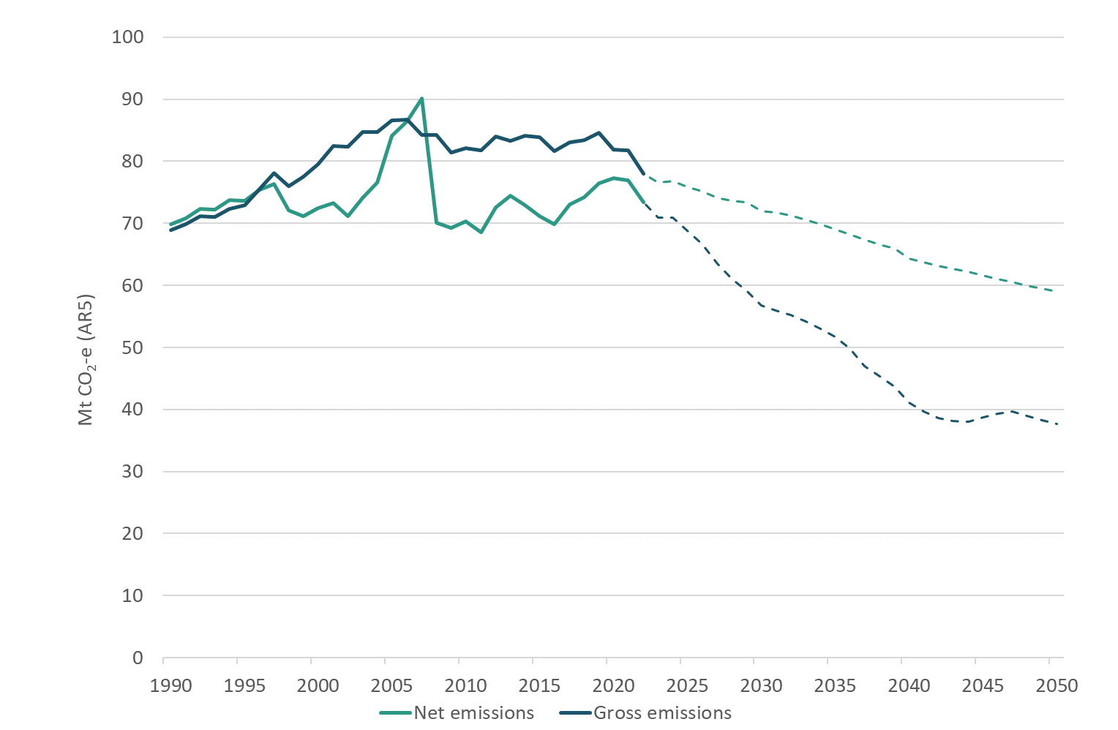

Note: Solid lines = historical data; dashed lines = projections.

Figure 7 shows the historical changes to gross emissions by sector and projections to 2050. Agriculture emissions quantities are shown along the right-hand axis, whereas the quantities of emissions for all other sectors are shown on the left-hand axis.

Figure 7: Interim baseline emissions by sector, 1990–2050

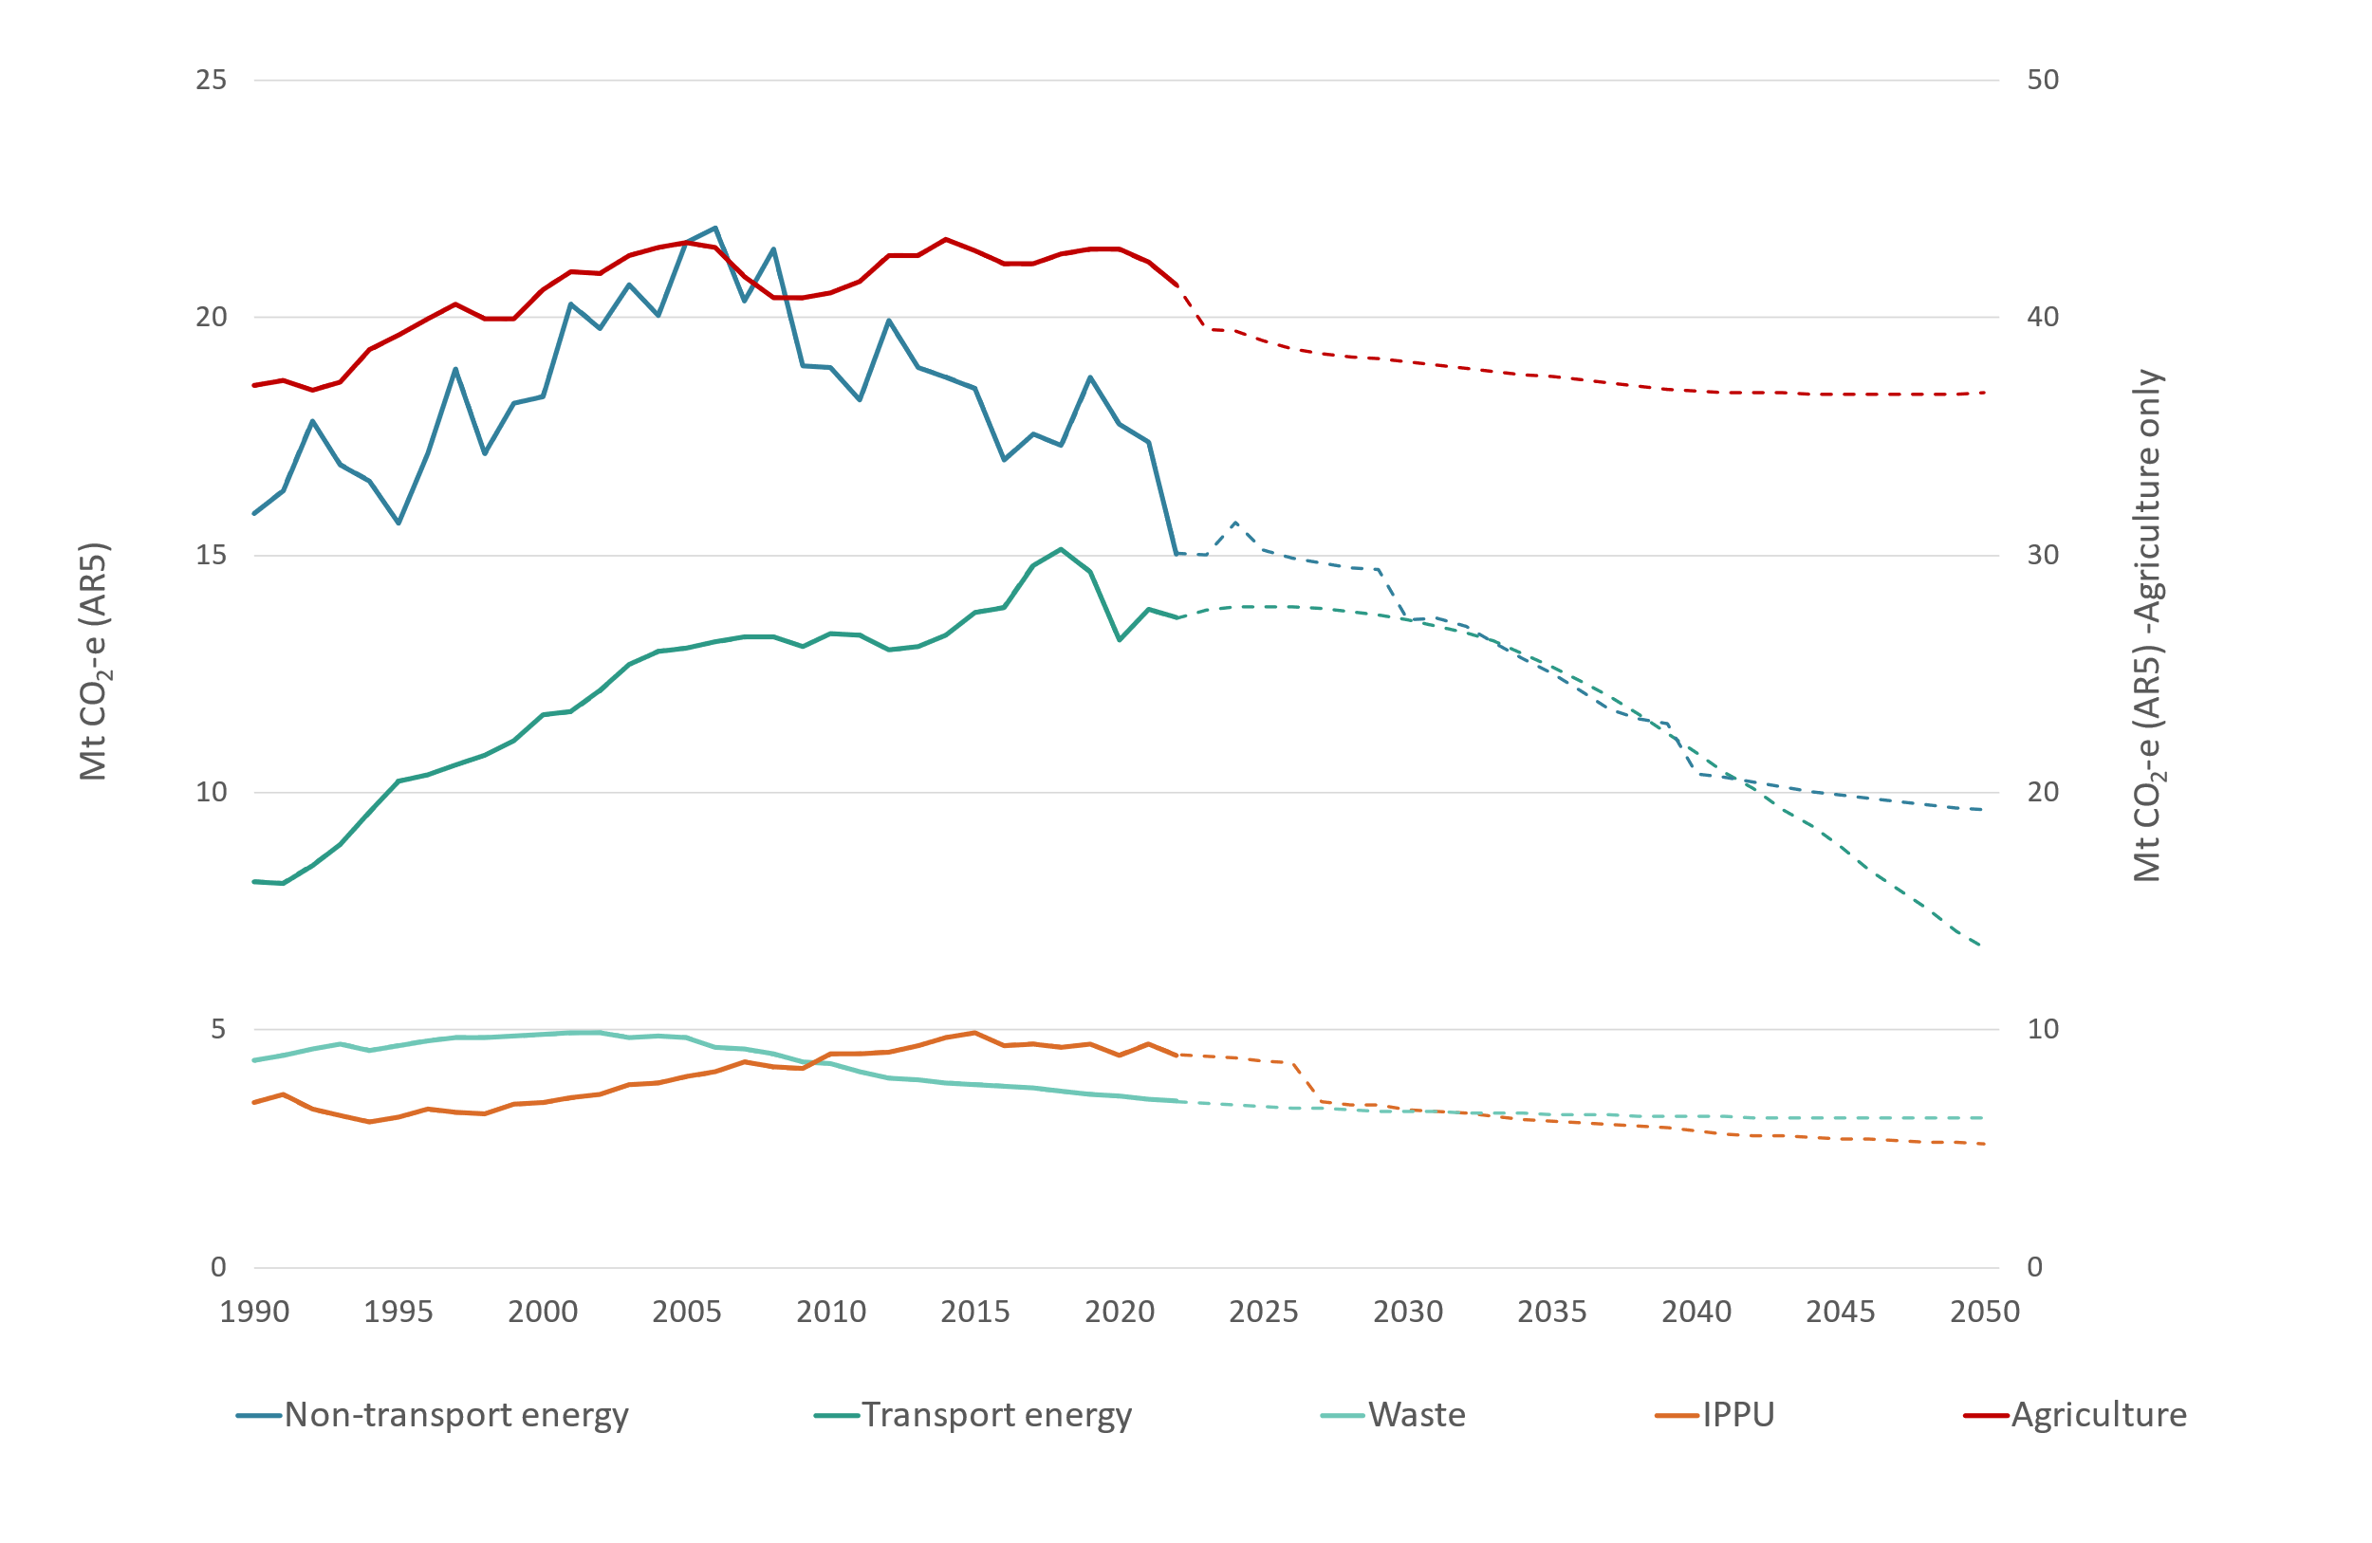

Note: Solid lines = historical data; dashed lines = projections. IPPU = industrial processes and product use.

The largest rises in emissions to 2005 were for transport energy (61 per cent) and non-transport energy (36 per cent), with smaller rises in agriculture (16 per cent), industrial processes and product use (IPPU) (15 per cent) and waste (11 per cent). Since 2005, emissions have fallen for non-transport energy and waste, have risen for transport energy and have been reasonably steady for agriculture. Both transport and agriculture emissions are expected to fall in the future. IPPU emissions peaked in approximately 2015 and have slowly fallen since then.

Table 6 shows the changes in emissions relative to average emissions in the five-year period to 2022 (for which we have actual emissions data);[18] a five-year period is used for the baseline to even out weather impacts on electricity generation emissions, while the projections reflect average conditions. The projections show emissions falling for all sectors. The largest contributions to the 12 per cent projected fall in emissions to 2030 come from agriculture (43 per cent) and non-transport energy (37 per cent). In contrast, transport is a significant source of emissions reductions to 2050 because of the greater penetration of EVs.

Table 6: Changes in emissions from 2018–22 average to 2030, 2035 and 2050 by sector  
(Mt CO2-e and percentage change)

|  |  |  |  |  |  |  |  |  |  |
| --- | --- | --- | --- | --- | --- | --- | --- | --- | --- |
| **Sector** | **Change to 2030** | **% change** | **% of total** | **Change to 2035** | **% change** | **% of total** | **Change to 2050** | **% change** | **% of total** |
| Transport energy | –469 | –3% | 5% | –1,437 | –10% | 11% | –7,367 | –52% | 32% |
| Non-transport energy | –3,617 | –21% | 37% | –4,744 | –28% | 37% | –7,614 | –44% | 33% |
| IPPU | –1,272 | –28% | 13% | –1,528 | –33% | 12% | –1,993 | –43% | 9% |
| Agriculture | –4,237 | –10% | 43% | –4,796 | –11% | 37% | –5,445 | –13% | 24% |
| Waste | –310 | –9% | 3% | –375 | –10% | 3% | –465 | –13% | 2% |
| **Total** | –9,906 | –12% | 100% | –12,880 | –16% | 100% | –22,884 | –28% | 100% |

Note: IPPU = industrial processes and product use.

### Transport energy

Transport emissions peaked in 2018 at 15 Mt CO2-e but fell to 13.1 Mt CO2-e in 2020 during the COVID-19 pandemic, which saw a drop in total vehicle travel. Emissions are projected to stay relatively constant over the next 10 years or so (eg, reaching 12.9 CO2-e Mt in 2034) before falling to just under 7 Mt CO2-e by 2050.

The reductions in emissions are dominated by the change in light passenger vehicle emissions (figure 8). In contrast, domestic air emissions are projected to rise, while commercial emissions and truck and bus emissions are projected to reduce later and more modestly. Despite increases in total vehicle travel, the transport emissions reductions reflect the projected shift to EVs (figure 9). This shift is greater and faster for light passenger vehicles than for other vehicle types. Some of this emissions reduction occurs through a sectoral shift as there will be reduced vehicle emissions and an associated increase in emissions from electricity generation (see below).

Figure 8: Historical and projected transport emissions by subsector, 1990–2050

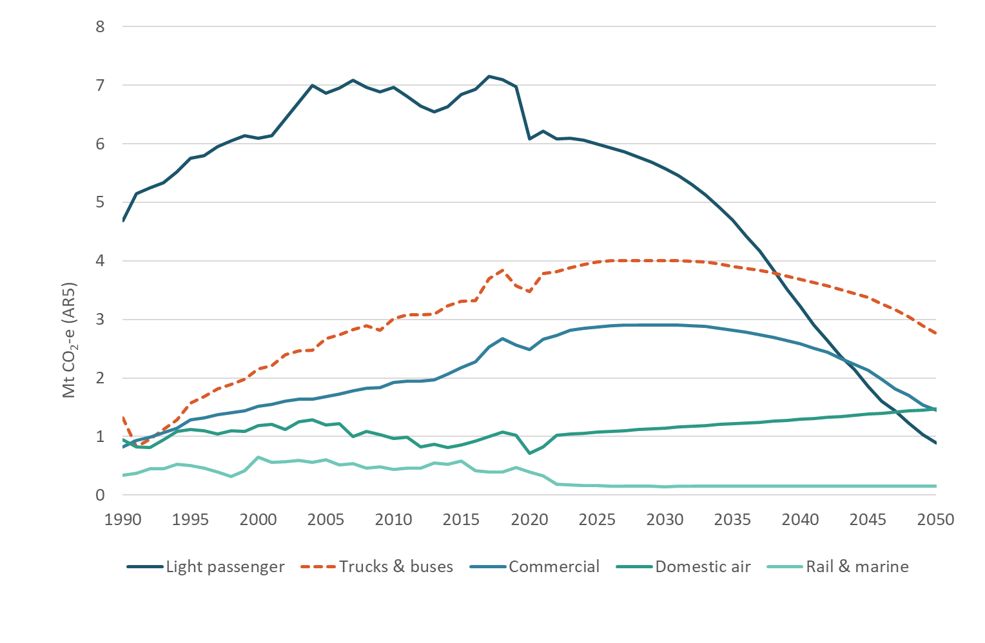

Figure 9: Travel distance by vehicle type – all road vehicles, 2020–50

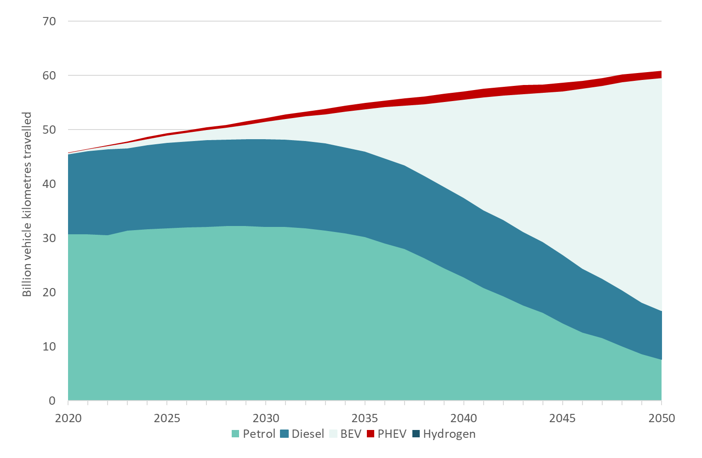

Note: BEV = battery electric vehicle; PHEV = plug-in hybrid electric vehicle.

### Non-transport energy

Historical and ENZ interim projected energy emissions by subsector are shown in figure 10. Historically, manufacturing and electricity generation have been the largest emission sources, followed by ‘residential, commercial and agriculture’. Other energy industries include petrochemicals, such as oil refining that finished in 2022 with the closure of the Marsden Point refinery. Fugitive emissions arise from sources including the production, transmission and storage of fuels, such as gas leaks, and carbon dioxide venting at gas treatment plants and from geothermal fields.

Figure 10: Historical and projected energy emissions by subsector, 1990–2050

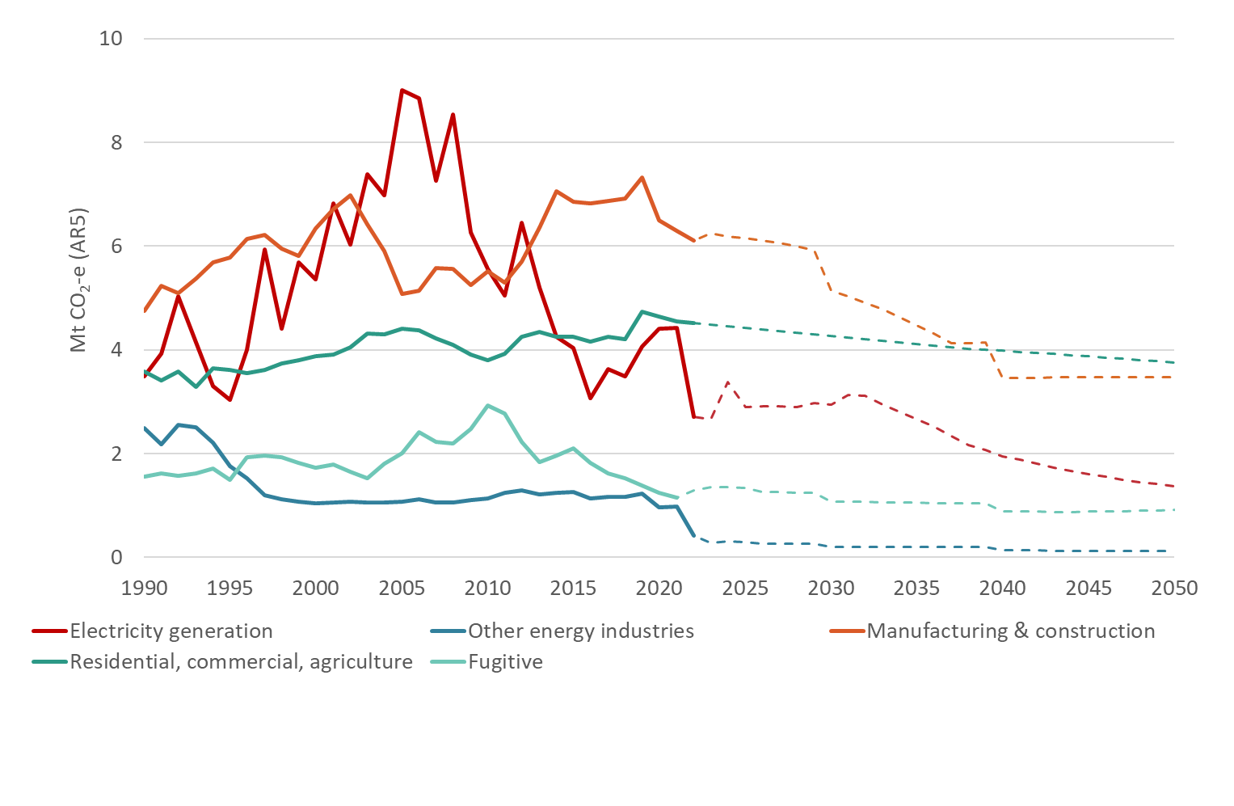

Note: Solid lines = historical data; dashed lines = projections.

The largest projected contribution to total reductions is from manufacturing and construction sectors (table 7), reflecting the shift away from fossil fuels to electricity for industrial heat, particularly in food processing (including the response to the *National Policy Statement for Greenhous Gas Emissions from Industrial Process Heat*)[19] and the reductions in output from petrochemical production with projected closures of methanol trains (see figure 11). Electricity generation emissions are forecast to fall significantly also as fossil fuel generation is replaced by renewables but with total generation increasing to meet higher electricity demand.

The energy emissions estimates have not been updated to take account of known factors changing since 2022, such as levels of production/output from major industries and the quantity of fossil fuels used in electricity generation. Rather, the approach is to use historical data up to the end of calendar year 2022 and modelled projections from that date.

Table 7: Changes in energy emissions from 2018–22 average to 2030, 2035 and 2050 by subsector (Mt CO2-e and percentage change)

|  |  |  |  |  |  |  |  |  |  |
| --- | --- | --- | --- | --- | --- | --- | --- | --- | --- |
| **Sector** | **Change to 2030** | **% change** | **% of total** | **Change to 2035** | **% change** | **% of total** | **Change to 2050** | **% change** | **% of total** |
| Electricity generation | –878 | –23% | 24% | –1,147 | –30% | 24% | –2,451 | –64% | 32% |
| Other energy industries | –752 | –79% | 21% | –757 | –79% | 16% | –840 | –88% | 11% |
| Manufacturing and construction | –1,488 | –22% | 41% | –2,150 | –32% | 45% | –3,148 | –48% | 41% |
| Residential, commercial, agriculture | –262 | –6% | 7% | –423 | –9% | 9% | –771 | –17% | 10% |
| Fugitive | –237 | –18% | 7% | –265 | –20% | 6% | –403 | –31% | 5% |
| **Total** | –3,617 | –21% | 100% | –4,743 | –28% | 100% | –7,613 | –44% | 100% |

Figure 11: Historical and projected manufacturing and construction emissions, 1990–2050

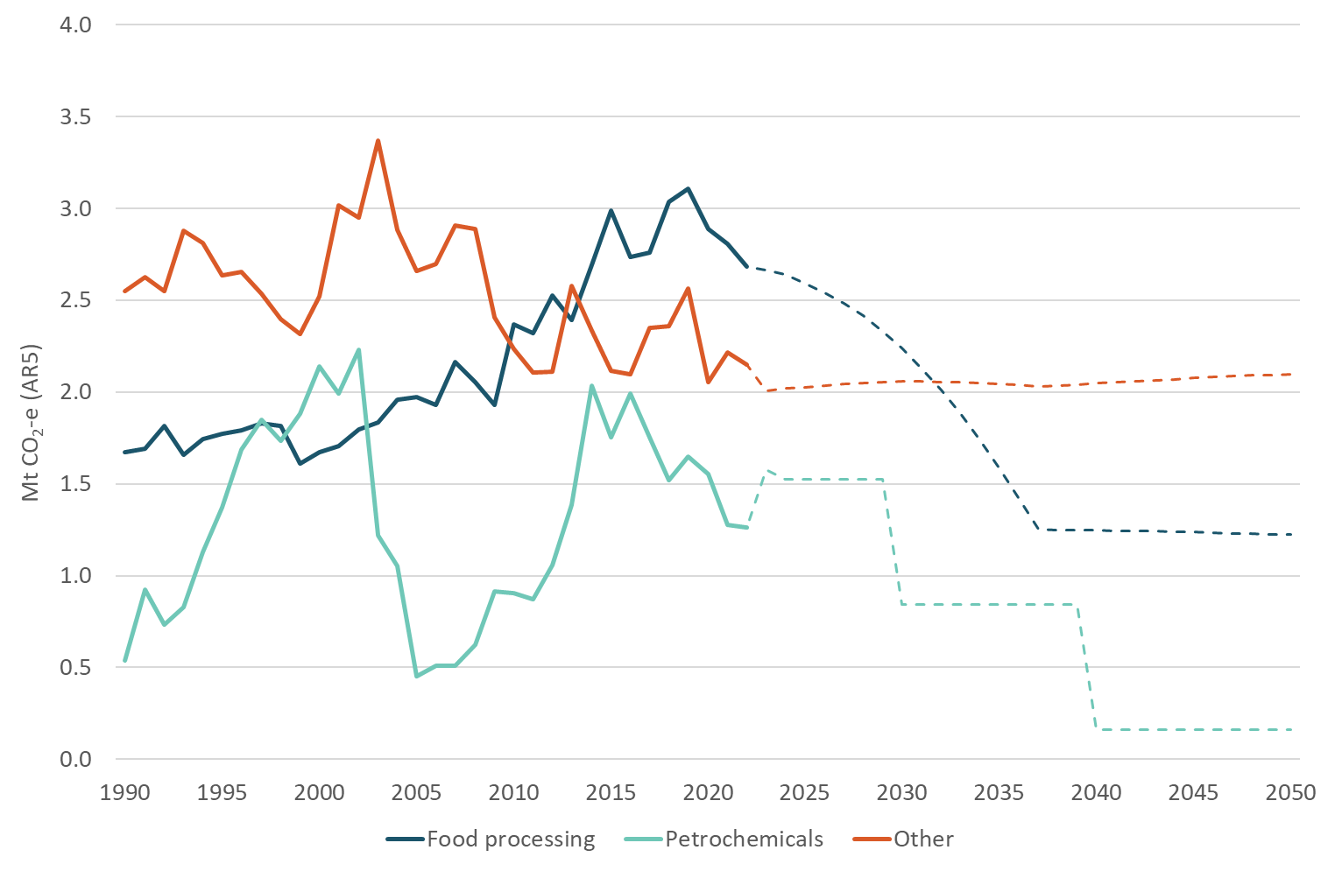

Note: Solid lines = historical data; dashed lines = projections.

### Agriculture

Overall trends in agriculture emissions are shown in figure 12. The major change in the projections is from the reduction in modelled methane emissions. The major contribution to the overall downward projection comes from the ongoing fall in enteric fermentation emissions from sheep and beef accompanied by a flattening out in dairy enteric emissions (figure 13). These trends are associated with projected downward trends in animal numbers (figure 14).

Figure 12: Historical and ENZ interim projected agriculture emissions by gas, 1990–2050

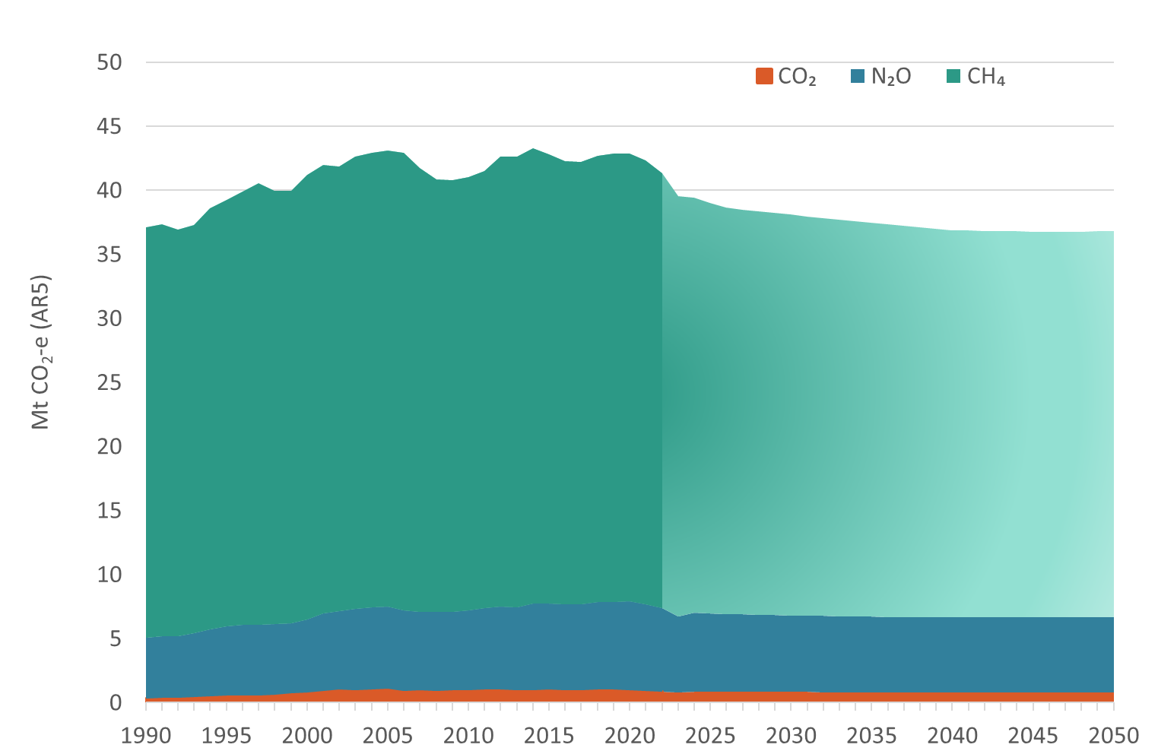

Note: Darker shade = historical data; lighter shade = projections.

Figure 13: Historical and ENZ interim projected agriculture emissions by source, 1990–2050

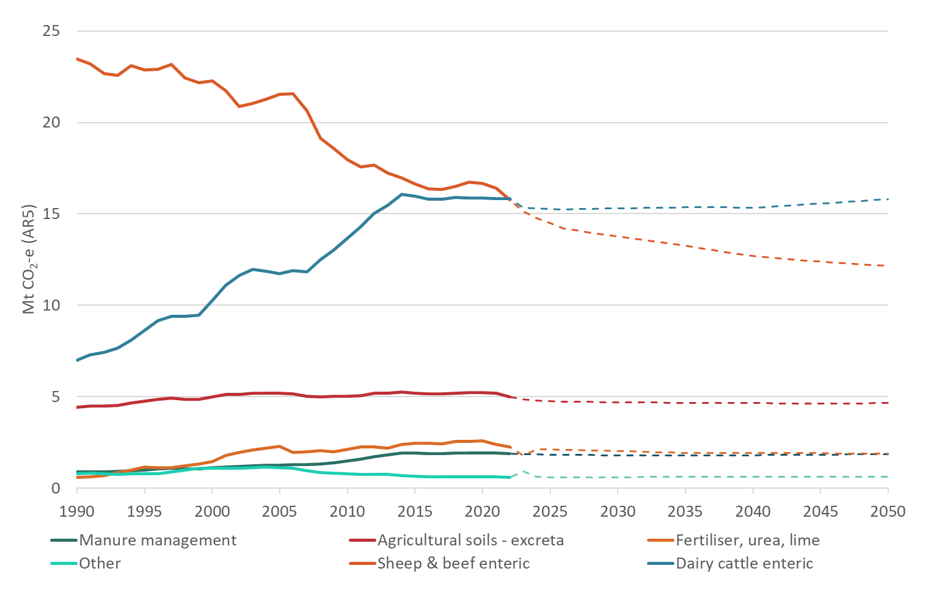

Note: Solid lines = historical data; dashed lines = projections.

Figure 14: Historical and ENZ interim projected stock numbers by stock type, 1990–2050

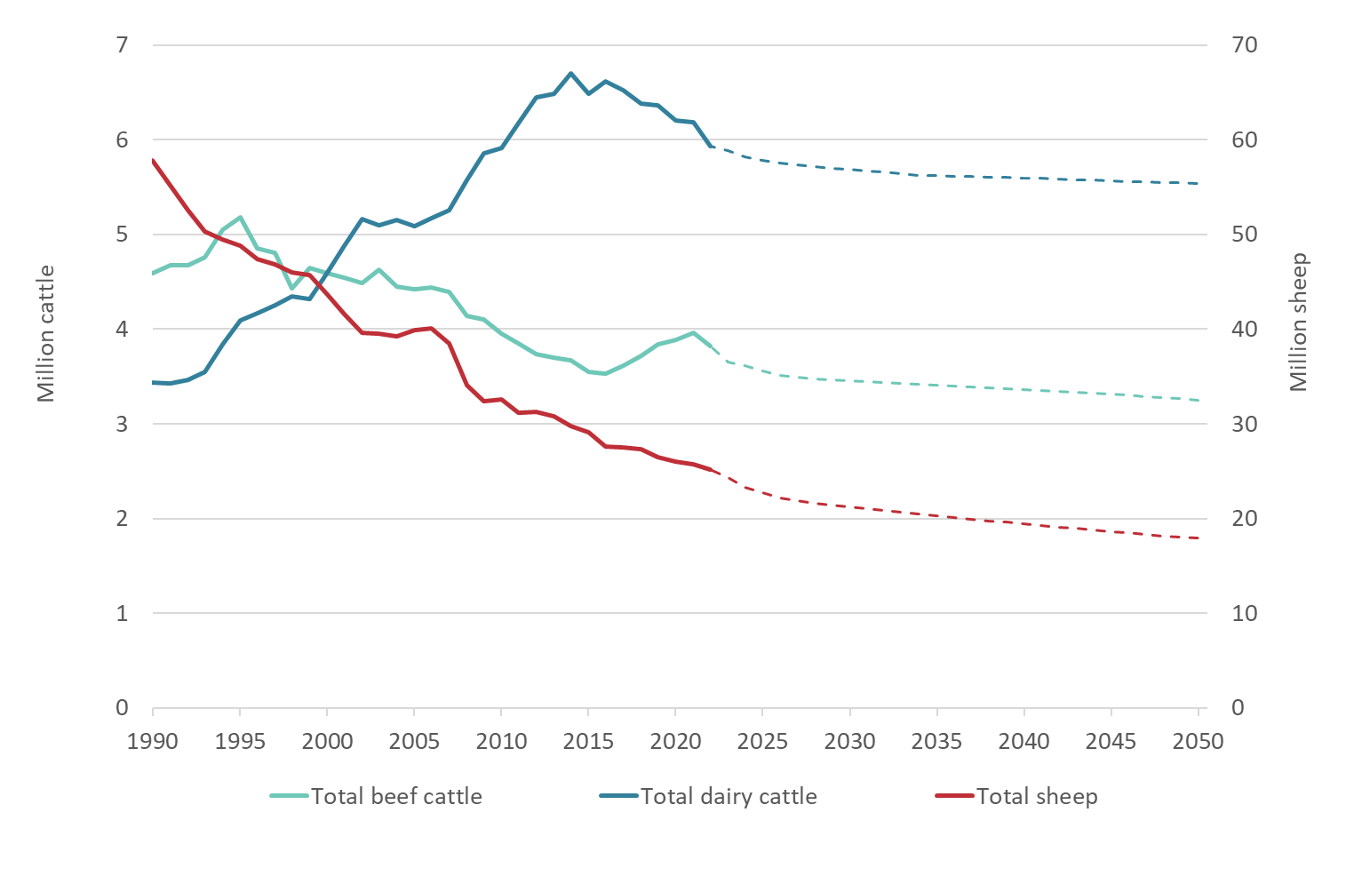

Note: Solid lines = historical data; dashed lines = projections.

Dairy emissions stabilise, despite the falling animal numbers, because of the projected increase in dry matter consumption and milk solids production per head.

### Waste

Historical and ENZ interim projections of waste emissions are shown in figure 15. Emissions peaked around 2002 but have been falling since then and are expected to continue to do so at a reduced rate.

Figure 15: Historical and ENZ interim projected waste emissions, 1990–2050

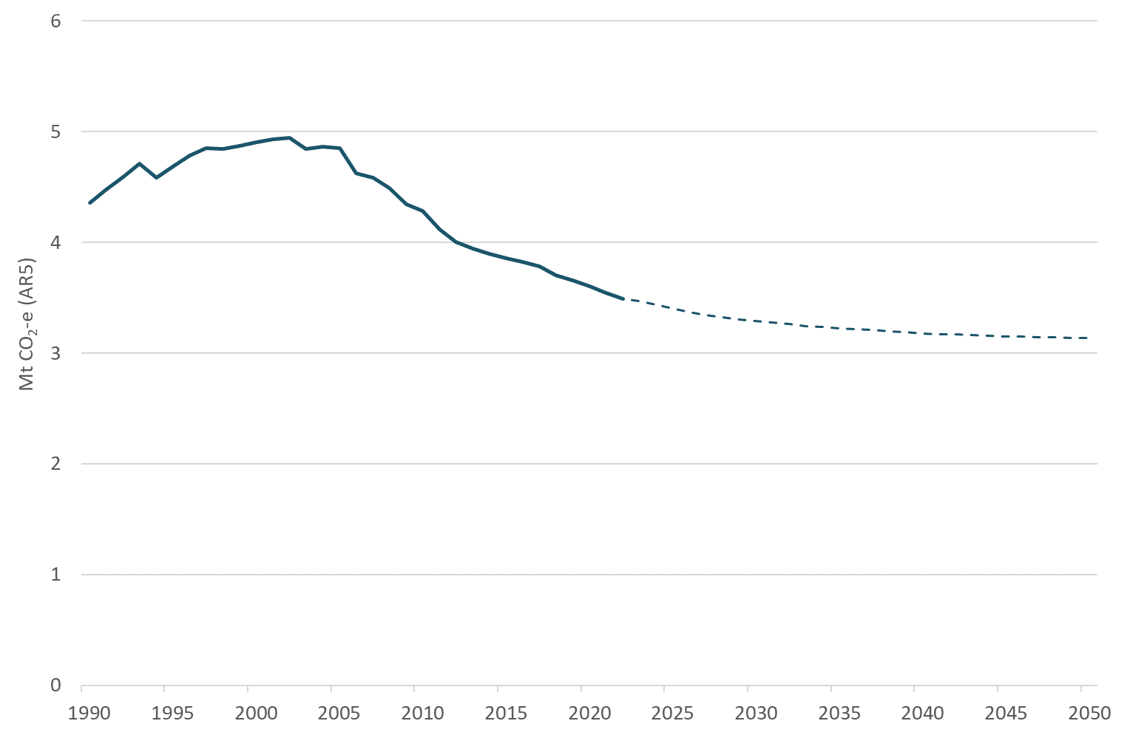

Note: Solid lines = historical data; dashed lines = projections.

There are some small projected reductions in waste tonnages going to landfill (figure 16), with some volumes going to compost or anaerobic digestion. However, the more significant changes are occurring from anticipated improvements to and greater use of landfill gas capture.

Figure 16: Historical and ENZ interim projected waste tonnages by destination of waste, 1990–2050

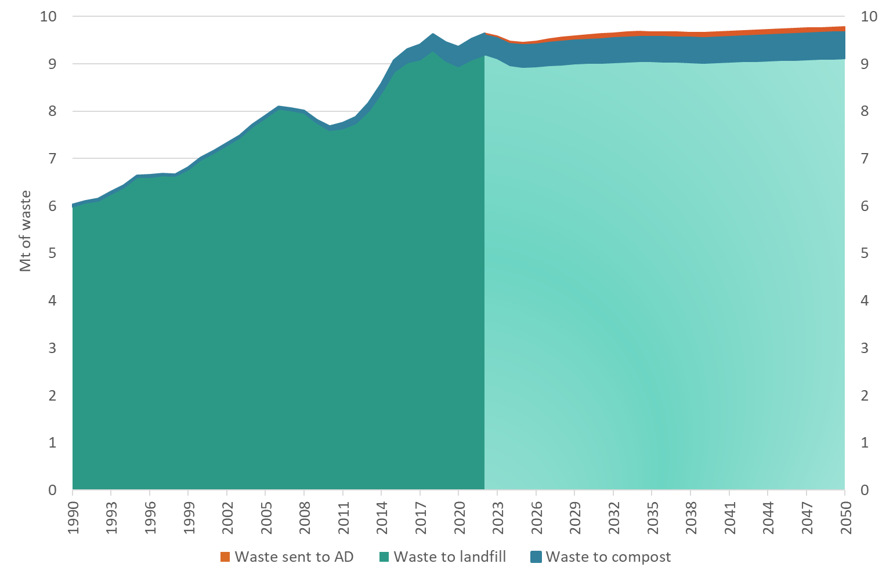

Note: Darker shade = historical data; lighter shade = projections. AD = anaerobic digestion.

### Forestry removals

Figure 17 shows the historical and projected forestry removals, including under central, low and high scenarios for the future. The data are based on 2024 afforestation and deforestation projections. The increasing contribution of removals reflects the ongoing extent of land-use change, chiefly to exotic forestry at the expense of sheep and beef farming (figure 18).

Figure 17: Historical and projected forestry removals, 1990–2050

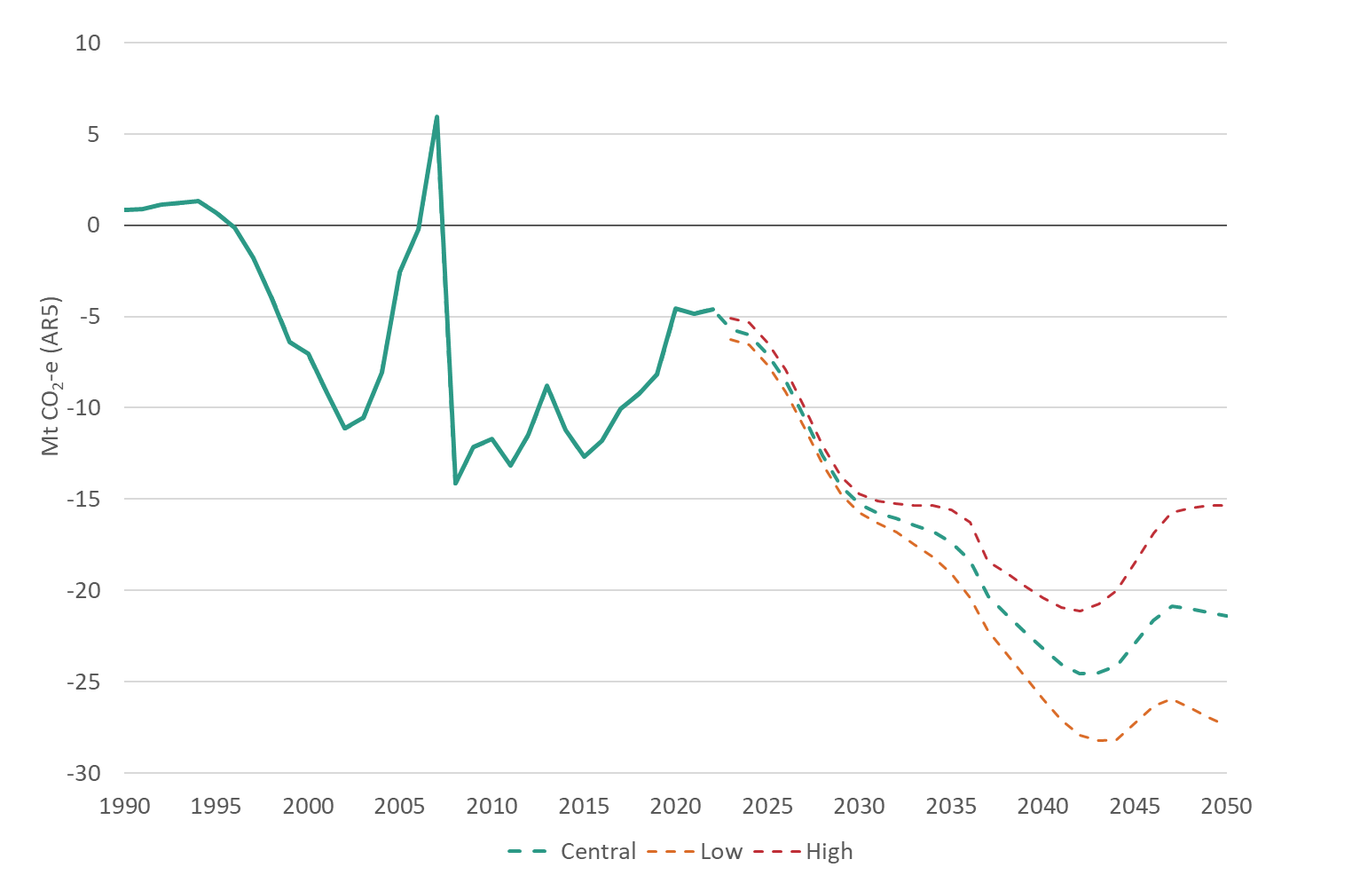

Note: Solid lines = historical data; dashed lines = projections.

Figure 18: Historical and projected land area in forestry and sheep and beef farms, 1990–2050

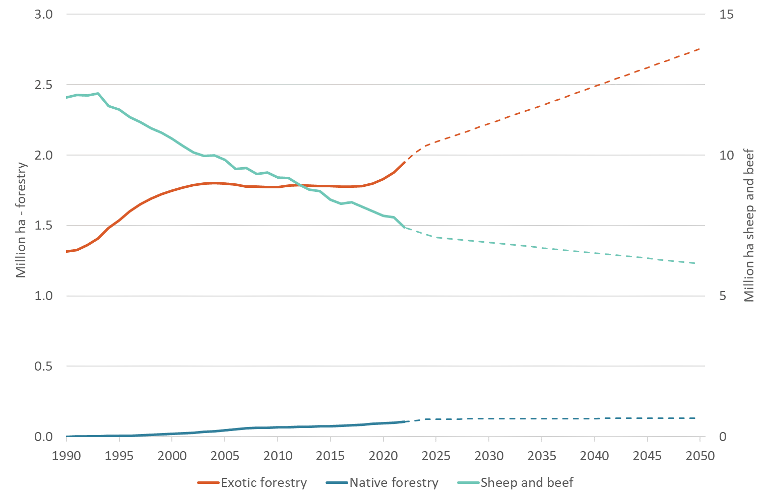

Note: 1. Area in forestry is net forest area, ie, only the area forested and excluding land taken up by roads, gullies and streams within the forest estate. 2. Solid lines = historical data; dashed lines = projections.

Figure 19: Historical and projected afforestation rates for exotic (high, medium, low)  
and native forests, 1990–2050

A line graph showing historical and projected afforestation rates for exotic (high, medium, low)
and native forests from 1990 to 2050.


Note: Solid lines = historical data; dashed lines = projections.

Source: Ministry for Primary Industries. 2024. *2023 LULUCF Accounting Projections*. MPI Technical Background Paper no: 2024/13.

# Proposed new policies

## Policy options

Although ENZ interim projections suggest emissions are close to being on track to meet the requirements of the second emissions budget, the projections have significant uncertainty bands. This means that the introduction of policies to reduce emissions further can increase confidence that New Zealand will meet the budget. In addition, the interim projections suggest that, despite emissions tracking downwards, additional measures are likely to be required to meet the third emissions budget and to put us on track for net zero in 2050. Several policies have been proposed as potential additions to those currently in place. Table 8 sets out some of those potential new policies.

Table 8: Potential new policies for inclusion in ERP2

| Sector | Policy | Explanation |
| --- | --- | --- |
| Energy | Electrify NZ | Create a more enabling consenting environment for renewable energy projects |
|  | Incentivise carbon capture, utilisation and storage (CCUS) | Allow CCUS in NZ ETS, plus create a regulatory regime for permitting, consenting and monitoring individual projects |
| Transport | 10,000 public EV chargers | Enable a network of 10,000 EV charge points by 2030 |
|  | Clean Car Standard | Revise the standard |
|  | Better public transport | Make new investments in major public transport projects in Auckland and the lower North Island to be completed over the next decade |
| Agriculture | Agricultural emissions pricing and mitigation technologies | Introduce emissions pricing from 2030 |
| Forestry | Limits to land-use change to forestry on high-value land uses | Place a three-year moratorium on whole-farm conversions to exotic forestry registering for the NZ ETS from land-use classes (LUC) 1–5; a 15,000 ha per year limit for LUC 6; no limit on LUC 7 |
| Waste | Waste Minimisation Fund | Invest a portion of the forecast levy revenue (through to 2030) into resource recovery systems and infrastructure that processes organic waste |
|  | Organic waste and landfill gas capture | Extend landfill gas capture systems to all class 1 (municipal waste) facilities. Regulatory changes resulting in up to a 7% increase in landfill gas recovery rates |

There is the potential for abatement from additional measures that have not had the same level of analysis as the potential policies noted in table 8. Some of those additional measures are listed in table 9.

Table 9: Additional potential abatement options

| Sector | Abatement option |
| --- | --- |
| Agriculture | Support uptake of EcoPond™ effluent treatment system for dairy farms. Assuming availability from 2025 |
|  | Low-methane rams spread low-methane genetics through flocks. The impact of low-methane genetics is permanent and cumulative, with a flock becoming more methane efficient each year. Assuming availability from 2025 |
|  | Support development and uptake of methane inhibitors. Assuming a 60% effective methane inhibitor was available for dairy in 2027, and sheep and beef in 2030 |
| Forestry | The Government is further exploring the potential to support afforestation on Crown land |

## Intervention rationale

The following discussion quantifies key ERP2 policies where possible. Appendix 2 explains how some individual policies are expected to function to reduce emissions for the second emissions budget and/or for future emissions budgets.

## Estimates of effects on net emissions

Using assumptions noted in appendix 3, tables 10 and 11 summarise the estimated effects of proposed new policies in the first, second and third emissions budgets. The emissions reduction estimates are subject to a high level of uncertainty because the details or settings of the initiatives have not been fully specified to date and there remain other limitations in our understanding of their potential impacts on emissions (eg, the paucity of relevant empirical data). These interim estimates are expected to change, potentially significantly, as policies are developed, and the projections and policy impacts modelling is refined. This includes, in particular, how carbon capture, utilisation and storage (CCUS) will be enabled and what the prices and/or incentive rates for agriculture emissions pricing will be.

Table 10: Provisional estimated emissions reduction impacts of new policies in ERP2 on emissions budgets (Mt CO2-e)

| **Sector** | **Policy** | **First emissions budget** | **Second emissions budget** | **Third emissions budget** |
| --- | --- | --- | --- | --- |
| Energy | Electrify NZ | 0.0 | –0.1 | -1.6 |
|  | Enable carbon capture, utilisation and storage | 0.0 | –1.4 | –3.2 |
| Transport | 10,000 public EV chargers | 0.0 | –0.01 | –0.2 |
|  | Better public transport | 0.0 | –0.1 | –0.3 |
| Agriculture | Agricultural emissions pricing and mitigation technologies | 0.0 | –0.1 | –5.5 |
| Forestry | Limits to land-use change to forestry on high-value land uses | 0.0 | 0.0 | 0.0 |
| Waste | Waste Minimisation Fund | 0.0 | Up to –1.3 | Up to –1.3 |
|  | Organic waste and landfill gas capture | 0.0 | Up to –1.1 | Up to –1.4 |
| Total |  | 0.0 | –4.1 | –13.5 |

Table 11 shows the impacts of proposed changes to the Clean Car Standard that are expected to increase emissions in the second and third emissions budgets. Other recent changes are included in the baseline emission estimates.

Table 11: Provisional estimated emissions increase impact of new policies in ERP2 on emissions budgets (Mt CO2-e)

| **Sector** | **Policy** | **First emissions budget** | **Second emissions budget** | **Third emissions budget** |
| --- | --- | --- | --- | --- |
| Transport | Revisions to Clean Car Standard | 0.0 | +0.2 | +0.8 |

The analysis included the following assumptions.

* Policy to achieve Electrify NZ in the nearer term focuses on requirements for consenting. In modelling this policy, there is a baseline assumption that new generation and transmission will be built to meet demand. Lower consenting costs are expected to flow through to lower wholesale prices and to affect electricity demand relative to other energy sources.
* Enabling CCUS would require its inclusion in the NZ ETS as a source of removals. Further analysis is required on the impact of CCUS on the long-term operation of the NZ ETS. More detailed analysis will be undertaken if the proposal to reward CCUS in the NZ ETS is progressed.
* The effects of 10,000 public EV chargers are based on conservative assumptions in the absence of suitable empirical evidence to base any assessment on.
* Proposed changes to the Clean Car Standard will reduce its stringency. This has been modelled as a reduction in the rate at which the passenger emissions standard reduces over time and a reduction in both the starting standard and rate reduction for commercial vehicles.
* Better public transport reflects the effects of increased investment in public transport, focused on Auckland and Wellington. These effects may be offset or outweighed by the impacts of new investment in road infrastructure that will affect the overall levels of private vehicle travel.
* Agriculture emissions pricing, alongside measures to encourage the development of new technologies, is expected to have relatively significant impacts after 2030 when technologies become more widely available. Prior to specific policy decisions, the assumption is that the pricing system is accompanied by incentive payments for the uptake of these technologies.
* Forestry measures include those that will limit land conversion to forestry. Recent projections of future afforestation suggest these limits may not be binding (the limits are greater than projected afforestation on these land types) and thus not have any impact on net emissions.
* The waste policies are based on effective use of revenue raised by the Waste Minimisation Fund for investment in resource recovery systems.
* Landfill gas (LFG) capture rates are projected to increase in response to regulatory requirements for: (a) all municipal (Class 1) landfills to have LFG capture systems and (b) for average efficiency increases of up to 7% across all landfills with existing gas capture systems in place.

Additional policy measures (see table 9) might be used to achieve further reductions in the second and third emissions budgets. Table 12 sets out the projected effects of those measures on the second emissions budget.

Table 12: Projected effects of additional potential abatement options on the second and third emissions budgets

| Sector | Policy | Second emissions budget period | Third emissions budget period |
| --- | --- | --- | --- |
| Agriculture | Supporting uptake of EcoPond™ | Potential for up to 0.4 Mt CO2-e (at 10% uptake) to 2 Mt CO2-e (at 50%) | Potential for a reduction of up to 1.0 Mt (at 10% uptake by 2030 rising to 20% by 2035) or 3.1 Mt (at 50% by 2030) CO2-e |
|  | Low-methane genetics | Potential for up to 0.1 Mt CO2-e (at 10% uptake) to 0.3 Mt CO2-e (at 50%) | Potential for a reduction of up to 0.2 Mt (at 10% uptake by 2030 rising to 20% by 2035) or 0.5 Mt (at 50% by 2030) CO2-e |
|  | Methane inhibitors | Potential for up to 3.0 Mt CO2-e (at 10% uptake) to 15 Mt CO2-e (at 50%) | Potential for a reduction of up to 13.8 Mt (at 10% uptake by 2030 rising to 20% by 2035) or 43.1 Mt (at 50% by 2030) CO2-e |
| Forestry | Crown land afforestation | Potential for up to 0.1 Mt CO2-e of additional emissions (this is due to carbon losses following afforestation) | Potential for abatement of up to 5 Mt CO2-e |

Including the estimates quantified in table 10 and Table 11 changes the estimated totals for emissions budgets and NDC1.

Table 13 shows the new estimated emissions and removals that take into account the proposed new measures. Under the central projection, net emissions are on track to achieve the second emissions budget but there remains a significant uncertainty margin.

The updated gap to bridge to meet NDC1 is reduced to a central projection of 93 Mt CO2-e.

Table 13: Interim projections of emissions and removals including effects of proposed new measures (Mt CO2-e), by budget period

| Budget period | Category | Budget | 2023 WEM projections | ERP2 interim baseline | With new measures |
| --- | --- | --- | --- | --- | --- |
| First | Net emissions | 290 | 277 | 284.0 ±4 | 284.0 ±4 |
|  | Gross emissions |  | 301 | 307.4 | 307.3 |
|  | Removals |  | –24 | –23.3 | –23.3 |
| Second | Net emissions | 305 | 281 | 307.1 ±18 | 303.3 ±18 |
|  | Gross emissions |  | 342 | 368.4 | 364.5 |
|  | Removals |  | –61 | –61.3 | –61.3 |
| Third | Net emissions | 240 | 233 | 270.1 ±29 | 257.4 ±29 |
|  | Gross emissions |  | 326 | 352.5 | 339.7 |
|  | Removals |  | –92 | –82.3 | –82.3 |

# Macro-economic and distributional impacts

We will update our understanding of the expected quantitative and qualitative impacts of individual policies and the combined impacts of all ERP2 policies, including from the NZ ETS, as part of the process of finalising and publishing ERP2 in December 2024. At present, our understanding is limited to consideration of illustrative pathways to 2050. This section presents the preliminary macro-economic and distributional impact analysis of these illustrative pathways.[20]

This modelling includes three scenarios.

* **Without measures pathway.** In this hypothetical counterfactual scenario, we have no climate mitigation policy.[21] This scenario was chosen to more clearly illustrate the impacts of the considered pathways as a whole across the time period under consideration.
* **Current pathway.** Under this scenario, we continue with our existing climate policies (excluding proposed ERP2 policies). Torshizian et al refer to this as the “WEM pathway”.[22]
* **ERP2 pathway.** Under this scenario, we follow the proposed ERP2 approach. Torshizian et al refer to this as the “Fourth Pathway”.[23]

The modelling shows the possible difference in outcomes in 2050 across households, sectors and regions compared with the counterfactual scenario.

As with all modelling, especially on a three-decade horizon, the CGE results are highly uncertain and should be considered in that context. The modelling can provide insights into where impacts are likely to occur and in what direction, but the magnitude of the impacts is highly uncertain.

## Macro-economic impacts

The CGE modelling suggests that existing climate mitigation actions will lead to real GDP that is about 0.4 per cent lower in 2030 than it would be in a hypothetical ‘without measures’ scenario.[24] The impact on GDP is expected to remain at similar levels through to 2050. Preliminary estimates of the effects of proposed ERP2 policies indicate a slightly smaller impact on the economy than current policy settings, largely due to the assumed impacts of Electrify NZ. However, similar to the ENZ central projections, the CGE modelling suggests that emissions will not fall to the levels set in the 2050 targets; the increased effort to meet the 2050 targets would lead to GDP around 0.7% lower by 2050.

Employment is projected to be about 0.1% lower in 2030 than under the ‘without measures’ counterfactual. Over the long term, however, employment is assumed to return to its long-run trend levels, reflecting an expectation that over the medium to long term, employment will shift from contracting to expanding sectors of the economy. The bulk of the adjustment in the labour market is expected to occur via real wages, which are about 1.7 per cent lower than the ‘without measures’ counterfactual in 2030, and about 1.5 per cent lower over the long term.

## Impacts on households

Overall, ERP2 policies are expected to result in household consumption decreasing 0.39 per cent compared with 0.4 per cent under current policies.

Figure 20 shows that under the ERP2 pathway, all households in New Zealand are expected to have lower consumption in 2050 than they would have without efforts to reduce emissions (the counterfactual). This is because added costs from changing to low-emissions production or from the NZ ETS raise the price of goods and services, so that people cannot purchase as much as they would have otherwise. However, the difference in consumption between the scenarios is fairly small, only between 0.2 per cent and 0.6 per cent by 2050, depending on the type of household. As with all the CGE results, this does not reflect the benefits to households of reducing emissions.

Figure 20: Expected impact of ERP2 aligned pathway on household consumption, by household income and ethnicity, 2050

A horizontal bar graph showing the expected impact of ERP2 policies on household consumption in 2050 compared to if no mitigation efforts were pursued. It presents data for three groups: 65 and older without dependents, 15-64 without dependents, and 15-64 with dependents. Each group is further split into five income brackets ranging from less than $35,600 to $148,000 and over. Data is presented for Māori and non-Māori households.  

Note: Deviation in real consumption in 2050 under the ERP2 pathway from real consumption in 2050 under the counterfactual ‘without measures’ pathway (where we make no efforts to reduce emissions).

Source: Torshizian et al. 2024. *Economic Impact of New Zealand’s Second Emissions Reduction Plan.* Report to Ministry for the Environment by Principal Economics Limited in collaboration with the Centre for Policy Studies and Infometrics Limited.

Lower-income households are expected to be the most affected, particularly those earning between $35,600 and $61,099.

Māori households are expected to be more affected than non-Māori households, but the difference is very small. On average, across all households, Māori are expected to experience a decrease in consumption of 0.4 per cent compared with 0.37 per cent for non-Māori households.

## Sectoral impacts

ERP2 policies are not expected to have significant impacts on sectoral output compared with our existing policies (figure 21). Under the ERP2 pathway, we expect a slight increase in relative output for the electricity generation sector (output 1.1 per cent higher under ERP2 policies and 0.5 per cent higher under current policies, compared with no mitigation policy pathway) and the utilities sector (output 0.2 per cent higher under ERP2 policies and 0.1 per cent lower under current policies, compared with no mitigation policy pathway). In contrast, a slight decrease occurs for the mining sector (output 0.8 per cent lower under ERP2 policies and 0.4 per cent lower under current policies, compared with no mitigation policy pathway).

Figure 21: Expected impact of mitigation policies on output, by sector, 2050

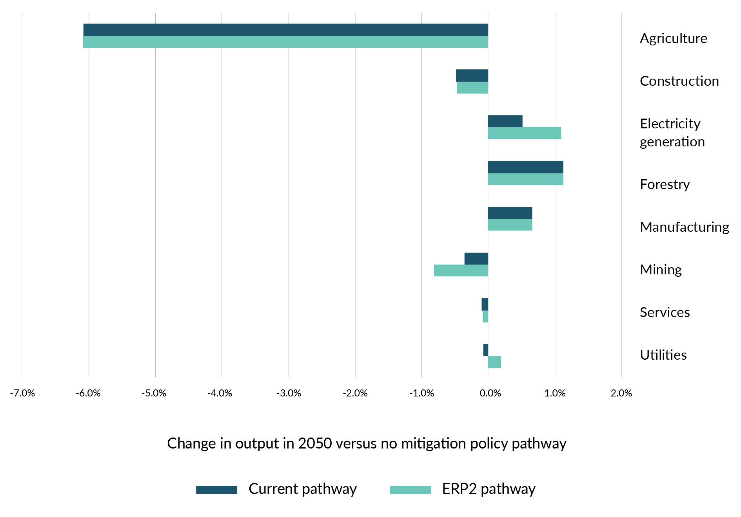

Note: Deviation in sectoral output in 2050 under the ERP2 pathway and ‘current’ pathway (where we continue with existing climate policies) from sectoral output in 2050 under the counterfactual ‘without measures’ pathway (where we make no efforts to reduce emissions).

Source: Torshizian et al (2024), with sectoral aggregation by Ministry for the Environment

Agriculture is expected to be the most affected sector under both pathways. Regardless, agricultural output (in GDP terms) is expected to be higher in 2050 than output today due to efficiencies, productivity improvements and technology uptake. Changes to emissions pricing may make forestry more financially viable and continue to shift the balance of land use from agriculture to forestry. This effect is mitigated somewhat by the Government’s policies which will limit conversions of high-quality agricultural land to forestry. The assessment of the impact to the agriculture sector from pathways does not consider the effect of climate change itself on land use, nor does it account for the market opportunities that may emerge for New Zealand as an exporter of relatively low-emissions dairy and meat products. Under ERP2 policies, minor negative impacts are expected across construction and mining sectors (output 0.5 and 0.8 per cent lower respectively under ERP2 compared with no mitigation policy pathway). Minor positive impacts are expected across manufacturing and electricity generation sectors (output 0.7 and 1.1 per cent higher respectively under ERP2 compared with no mitigation policy pathway).

## Regional impacts

Regional impacts in the model are mainly driven by regional industry mixes and how they are affected by the changes in land use. The Government’s ERP2 policies are expected to slightly improve the overall impacts on regions, compared with the current set of policies.

The most affected regions are those with heavier reliance on dairy and on sheep and beef farming. For example, under ERP2 policies **compared with no mitigation actions**, GDP was 2.2 per cent lower for Southland, 1.6 per cent lower for the West Coast and 1.5 per cent lower for Manawatū–Whanganui (figure 22). However, these regions are expected to be slightly better off under the Government’s ERP2 policies **compared with current policies**. For example, compared with the no mitigation policy pathway, Southland’s GDP is expected to be 2.2 per cent lower under ERP2 policies and 2.4 per cent lower under current policies.

Figure 22: Expected impact of mitigation policies on GDP, by region, 2050

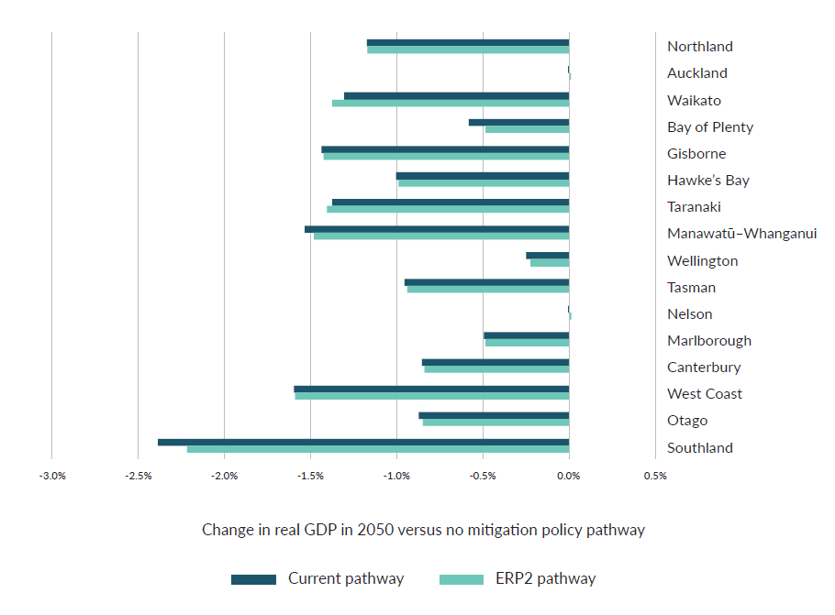

Note: Deviation in real gross domestic product in 2050 under the ERP2 pathway and ‘current’ pathway (where we continue with existing climate policies) from real GDP in 2050 under the counterfactual ‘without measures’ pathway (where we have no efforts to reduce emissions).

Source: Torshizian et al (2024)

The least affected regions are urban areas with more service industries such as Auckland (GDP unchanged under ERP2 policies compared with no mitigation actions) and Wellington (GDP 0.2 per cent lower under ERP2 policies compared with no mitigation actions). There are also minimal effects for regions with a different primary sector mix such as Nelson (GDP unchanged under ERP2 policies compared with no mitigation actions), and Bay of Plenty and Marlborough (for both regions, GDP 0.5 per cent lower under ERP2 policies compared with no mitigation actions).

# Appendix 1: Baseline assumptions

Table A1.1: List of assumptions for 2023 official projections (with existing measures, WEM), interim ERP2 baseline, low and high scenarios

|  |  | **2023 official projections (WEM)** | **Interim ERP2 baseline** | **Interim ERP2 baseline – low** | **Interim ERP2 baseline – high** |
| --- | --- | --- | --- | --- | --- |
| **GENERAL** | |  |  |  |  |
| **General** | Population | Increases from 5.13 million in 2022 to 5.82 million in 2040 and 6.13 million in 2050 | 0.7% population average growth rate 2022–40 | 0.3% population average growth rate 2022–40 | 1.1% population average growth rate 2022–40 |
| Gross domestic product  (real 2009/10 NZ$, production measure) | Increases from NZ$276 billion in 2022 to NZ$385 billion in 2040 and NZ$431 billion in 2050 | 1.9% average real growth rate 2022–40 | 1.4% average real growth rate 2022–40 | 2.4% average real growth rate 2022–40 |
| Oil price  (real 2023 US$ per barrel (bbl)) | Falls from US$84 per bbl in 2023 to US$65 per bbl in 2030, then remains constant | Falls from US$84 per bbl in 2023 to US$65 per bbl in 2030 then remains constant | US$100 per bbl from 2025 onwards | US$40 per bbl from 2030 onwards |
| Exchange rate  (US$/NZ$) | Constant at 0.65 | Constant at 0.65 | Same as baseline | Same as baseline |
| Greenhouse Gas Inventory | 2023 | 2024 | Same as baseline | Same as baseline |
| Public discount rate | Not applicable (NA) | 5% | Same as baseline | Same as baseline |
| **CARBON PRICING** | |  |  |  |  |
| **Prices** | NZU price (real 2023 NZ$) | Increases from NZ$47 in 2022 to NZ$171 in 2040 and NZ$230 in 2050 | Increases to NZ$75 in 2028, then falls to NZ$50 by 2035 | Rises to NZ$70 in 2028 and remains there | Falls to NZ$35 by 2025 |
| Biogenic methane price | Agriculture pricing scheme starting in 2025: 5 cents per kg methane  NZ$5 per t CO2-e long-lived gas price increasing by $0.50/t per year  $100 per t CO2-e reduced incentive payment | None | None | None |
| **TRANSPORT** | |  |  |  |  |
| **Transport** | **Total vehicle kilometres travelled (VKT)** | As modelled by Ministry of Transport (MoT) | –0.1% to 0.5% change in annual VKT per vehicle | No change in annual VKT per vehicle | 0.15% to 0.65% increase in annual VKT per vehicle |
| Domestic air passenger-kilometres | As modelled by MoT | From 7.4 billion in 2019 to 10.4 billion in 2035 and 13.4 billion in 2050 | Same as baseline | Same as baseline |
| International aviation demand (annual growth) | As modelled by MoT | 3.2% in 2025 2.9% from 2031 to 2050 | Same as baseline | Same as baseline |
| Public transport mode share by distance (% of household travel) | As modelled by MoT | From 3.5% in 2019 to:  5.3% in 2035  6.3% in 2050 | Same as baseline | Same as baseline |
| Walking mode share by distance (% of household travel) | As modelled by MoT | From 1.6% in 2019 to:  1.5% in 2035  1.4% in 2050 | Same as baseline | Same as baseline |
| Cycling mode share by distance (% of household travel) | As modelled by MoT | Roughly constant at 0.6% from 2019 | Same as baseline | Same as baseline |
| Rail / coastal shipping freight mode share (% of tonne-kilometres) | As modelled by MoT | From 13.7% / 12.4% in 2019 to 12.8% / 11.6% in 2035  12.8% / 11.7% in 2050 | Same as baseline | Same as baseline |
| Cost of electric vehicle (EV) batteries (real 2023 US$ per kWh) | As modelled by MoT | 152 in 2023 52 in 2035 37 in 2050 | Accelerated battery cost reductions | Same as baseline |
| Capital cost penalties on light passenger EVs | As modelled by MoT | 20% ending 2035 | Same as baseline | Same as baseline |
| EV uptake | As modelled by MoT | Based on total cost of ownership with medium price sensitivity | Based on total cost of ownership with low price sensitivity | Based on total cost of ownership with high price sensitivity |
| EV uptake sensitivity to charger density | Not used | Charger density that will result in virtually no constraints on EV uptake | Same as baseline | Same as baseline |
| Road user charges exemption ends | Current EV road user charges exemption for light and heavy vehicles | Light: 2024  Heavy: 2028 | Same as baseline | Same as baseline |
| Effects of clean car discount | Clean vehicle package | Discontinued 2024 | Same as baseline | Same as baseline |
| Effects of Clean Car Standard | As modelled by MoT | Published target and fees till 2027. Assumed to continue after 2027, following trend of published target | Same as baseline | Same as baseline |
| Emissions intensity of internal combustion engine vehicles entering the fleet | As modelled by MoT | Moderate downwards trend | Same as baseline | Same as baseline |
| Hydrogen shares of zero-emissions heavy vehicles | None | None | Same as baseline | Same as baseline |
| Rail efficiency improvements | As modelled by MoT | 0.25% per year | Same as baseline | Same as baseline |
| Road low-carbon liquid fuels blending (%) | None | None | Same as baseline | Same as baseline |
| Rail electrification  (share of tonne-km) | As modelled by MoT | No further electrification | Same as baseline | Same as baseline |
| Additional electrification of coastal shipping (share of tonne-km) | As modelled by MoT | Increases to 9% in 2026, 3% electrification by 2050 | Same as baseline | Same as baseline |
| Coastal and international shipping efficiency improvements | As modelled by MoT | 1% per year | Same as baseline | Same as baseline |
| Electrification of air travel (share of passenger-km) | None | None | Same as baseline | Same as baseline |
| Domestic aviation low-carbon liquid fuels | NA | NA | Same as baseline | Same as baseline |
| International aviation low-carbon liquid fuels | NA | NA | Same as baseline | Same as baseline |
| International shipping low-carbon liquid fuels | NA | NA | Same as baseline | Same as baseline |
| Low-carbon liquid fuel demand | None | None | Same as baseline | Same as baseline |
| **ENERGY, INDUSTRY AND BUILDINGS** | |  |  |  |  |
| **Industry and energy** | Gas and LPG demand | As modelled by MBIE | Responds to energy and New Zealand Emissions Trading Scheme prices | Same as baseline | Same as baseline |
| Household heating demand reduction relative to 2023 | As modelled by MBIE | 2.8% in 2030 | Same as baseline | Same as baseline |
| Commercial and public building heating demand reduction relative to 2023 | As modelled by MBIE | 9.1% in 2030 | Same as baseline | Same as baseline |
| Phase-out date for fossil gas heating in commercial buildings | NA | None | Same as baseline | Same as baseline |
| Phase-out date for fossil gas heating in residential buildings | NA | None | Same as baseline | Same as baseline |
| Methanol production | Methanex closes Motunui trains end of 2029 and 2039. Other chemical production is constant.  3.7% reduction in emissions for methanol from 2024 onwards | Same as 2023 projections | Methanex closes Motunui trains end of 2024 and 2037. Other chemical production is constant.  3.7% reduction in emissions for methanol from 2024 onwards | Waitara Valley trains reopen from 2026; all trains continue at full output |
| Ammonia-urea production | Production continues at current levels | Production continues at current levels | Same as baseline | Same as baseline |
| Aluminium production | Production ceases at end of 2024 | Production continues at current levels | Production ceases 2025 | Production continues at current levels |
| Steel production | As modelled by Ministry of Business, Innovation and Employment (MBIE) | Electric arc furnace at 50% from 2027 | Same as baseline | Same as baseline |
| Food processing fuel switching | As modelled by MBIE | Coal phased out by 2037, fossil gas use continues | Same as baseline | Same as baseline |
| Food processing energy efficiency improvement | As modelled by MBIE | Dairy: 0.7 % per year Meat: 0.6 % per year Other food: 0.8% per year | Same as baseline | Same as baseline |
| Kinleith pulp mill conversion date to high-efficiency recovery boiler | None | None | Same as baseline | Same as baseline |
| Low-carbon liquid fuel utilisation | Follows road transport assumptions | Follows road transport assumptions | Same as baseline | Same as baseline |
| Cement production – displacement of coal | As modelled by MBIE | Production continues at current levels with no further displacement of coal | Same as baseline | Same as baseline |
| Committed renewable electricity generation build | As modelled by MBIE | 3.7 TWh by 2035 | Same as baseline | Same as baseline |
| Renewable electricity generation capital cost reductions | As modelled by MBIE | Onshore wind: 0.3% per year, offshore wind: 1.1%, utility solar: 1% per year, geothermal: 0.07% per year | Same as baseline | Same as baseline |
| Electricity system demand-side response | As modelled by MBIE | Very low level | Same as baseline | Same as baseline |
| Grid-scale batteries (cost decline from NZ$1,077 per kWh in 2022) | As modelled by MBIE | 2.5% per year cost decline | 4% per year cost decline | 1.5% per year cost decline |
| Residential rooftop solar | As modelled by MBIE | 0.3% annual increase in proportion of total installation control points (ICPs) with rooftop solar Average capacity of new installations 7 kW | Same as baseline | Same as baseline |
| Geothermal carbon capture and storage | As modelled by MBIE | Ngāwhā: 100% capture rate applied in 2024 | Same as baseline | Same as baseline |
| Electrification rate of recreational marine | As modelled by MBIE | No further electrification | Same as baseline | Same as baseline |
| Off-road motive power | As modelled by MBIE | Electrification follows that for heavy trucks with a 10-year lag | Same as baseline | Same as baseline |
| New industrial electricity load – data centres | As modelled by MBIE | 62 MW demand phased in from 2023 to 2025 | Same as baseline | Same as baseline |
| **LAND (AGRICULTURE AND FORESTRY)** | |  |  |  |  |
| **Land-use change** | Afforestation 2022–50 (million hectares) | 1.1 Mha exotic afforestation  0.08 Mha native afforestation  1.2 Mha total afforestation | 0.9 Mha exotic afforestation  0.03 Mha native afforestation  0.93 Mha total afforestation | 1.1 Mha exotic afforestation  0.03 Mha native afforestation  1.14 Mha total afforestation | 0.7 Mha exotic afforestation  0.03 Mha native afforestation  0.72 Mha total afforestation |
| Exotic deforestation | Post-1989 (P89): 1,010 ha per year, zero from 2037 Pre-1990 (P90): 118 ha per year | Same as 2023 projections | P89: 500 ha per year, zero from 2037 P90: 42 ha per year | P89: 1,530ha per year, zero from 2037 P90: 118 ha per year |
| Horticulture | Roughly constant at 0.6% from 2019 | Same as 2023 projections | Same as baseline | Same as baseline |
| **Agriculture** | Livestock  (change from 2022 to 2030) | Dairy cattle decrease from 6.1 million to 5.7 million  Beef cattle decrease from 3.9 million to 3.5 million  Sheep decrease from 25.8 million to 21.4 million | Dairy cattle decrease from 5.9 million to 5.7 million  Beef cattle decrease from 3.8 million to 3.5 million  Sheep decrease from 25.1 million to 21.2 million | Dairy cattle same as baseline  Beef cattle decrease from 3.8 million to 3.4 million  Sheep decrease from 25.1 million to 21.1 million | Dairy cattle same as baseline  Beef cattle decrease from 3.8 million to 3.5 million  Sheep decrease from 25.1 million to 21.3 million |
| Average animal productivity (change between 2022 and 2050) | 1% increase per year  Milk production per cow: 0.66% average increase per year between 2022 and 2050  Adult sheep carcass weights 0.13% average increase per year  Beef cattle carcass weights 0.12% to 0.16% average increase per year between 2022 and 2050 | 1% increase per year | Same as baseline | Same as baseline |
| Agricultural pricing | From 2025 | None | Same as baseline | Same as baseline |
| Share of urea fertiliser coated with urease inhibitor | 49% in 2023, rising to 80% by 2030 and staying constant to 2050 | Same as 2023 projections | Same as baseline | Same as baseline |
| Low-methane breeding | Beef: Efficacy 1.6%. Cost $160 per t CO2-e. Adoption year 2030  Dairy: Efficacy 1.6%. Cost $160 per t CO2-e. Adoption year 2028  Sheep: Efficacy 0.5% to 4.4%. Cost $20 per t CO2-e. Adoption year 2025 | Dairy: Efficacy up to 13% by 2050. Cost $25 per t CO2-e. Peak adoption 4%. Available year 2029. Peak adoption year 2042.  Sheep: Efficacy up to 17% by 2050. Cost $2 per t CO2-e. Peak adoption 4%. Available year 2026. Peak adoption year 2041  Beef: Efficacy up to 8% by 2050. Cost $6 per t CO2-e. Peak adoption 1%. Available year 2035. Peak adoption year 2052 | Same as baseline | Same as baseline |
| Methane inhibitors (Bolus) | None | Dairy and beef efficacy 45% reduction in ruminant methane.  Cost $65 per t CO2-e dairy, $77 beef.  Peak adoption 3% dairy, 2% beef. Available year 2028. Peak adoption year 2042 dairy, 2047 beef. | Same as baseline | Same as baseline |
| EcoPond™ | Efficacy: 90% methane from dairy effluent ponds. Cost: $143 per t CO2-e | Efficacy: 92% methane from dairy effluent ponds. Peak adoption 2%. Available year 2025. Peak adoption year: 2037. Cost: $35 per t CO2-e | Same as baseline | Same as baseline |
| **WASTE AND F-GASES** | |  |  |  |  |
| **Waste** | Optimal landfill gas (LFG) capture systems | Minimum LFG capture rates: Municipal open landfills have 68% in 2022, increasing to 69% in 2030  Municipal closed landfills have a constant efficiency of 52%  Municipal facilities with no LFG are assumed to have a 20% efficiency starting 2027, 39% in 2028 and 59% constant until 2050 | Municipal open landfills have a constant LFG efficiency of 68%  Municipal closed landfills have a constant LFG efficiency of 52%  Municipal facilities with no LFG maintain no LFG until 2050 | Waste tonnage 1% lower by 2030 | Waste tonnage 2% higher by 2030. Municipal open landfills have a constant LFG efficiency of 20%  Municipal closed landfills have a constant LFG efficiency of 20%  Municipal facilities with no LFG maintain no LFG until 2050 |
| Anaerobic digestion (AD) | Diversion to AD begins in 2023 at 7.5 kt per year, and increases to 23.2 kt per year in 2025, 78 kt per year (1% of municipal waste) in 2035 and 80 kt per year (2%) in 2050 | Diversion to AD in 2023 is 60 kt per year, and increases to 100 kt per year in 2025, 140 kt per year (4% of municipal waste) in 2035, and 200 kt per year (6%) in 2050. Volumes based on total available capacity projections | Same as baseline | Same as baseline |
| Composting | Diversion to composting increases from 2009 at 39 kt per year (1%) to 487 kt per year in 2025, 635 kt per year in 2035 and 678 kt per year (20%) in 2050 | Diversion to composting increases from 2009 at 39 kt per year (1%) to 495 kt per year in 2025, 553 kt per year in 2035 and 595 kt per year (17%) in 2050 | Diversion to composting increases from 2009 at 39 kt per year (1%) to 506 kt per year in 2025, 564 kt per year in 2035 and 605 kt per year (18%) in 2050 | Diversion to composting increases from 2009 at 39 kt per year (1%) to 489 kt per year in 2025, 546 kt per year in 2035 and 588 kt per year (16%) in 2050 |
| Recycling | Not explicitly modelled but captured in overall waste placement | Same as 2023 projections | Same as baseline | Same as baseline |
| Waste placement | Municipal landfills: 3,380 kt in 2020, 3,316 kt in 2030, 3,381 kt in 2040 and 2,245 kt in 2050  Non-municipal landfills: 5,090 kt in 2020 and constant until 2050 | Municipal landfills: 3,380 kt in 2020, 3,414 kt in 2030, 3,448 kt in 2040 and 3,545 kt in 2050  Non-municipal landfills: 5,090 kt in 2020 and constant until 2050 | Municipal landfills: 3,380 kt in 2020, 3,378 kt in 2030, 3,381 kt in 2040 and 3,422 kt in 2050  Non-municipal landfills: 5,090 kt in 2020 and constant until 2050 | Municipal landfills: 3,380 kt in 2020, 3,489 kt in 2030, 3,604 kt in 2040 and 3,739 kt in 2050  Non-municipal landfills: 5,090 kt in 2020 and constant until 2050 |
| F-gases | Hydrofluorocarbons (HFCs)  (reduction relative to 2022) | 49% emissions reduction by 2040, 65% by 2050 | Same as 2023 projections | Same as baseline | Same as baseline |

# Appendix 2: Intervention logic mapping

Table A2.1: Logic maps explaining links between selected policies and emissions impacts

| Sector and ERP2 proposed policy | If we do the following now | | | Then by 2030 (end of the second emissions budget) and by 2050, we can expect these changes to occur | Which will lead to the following impacts on emissions in the second emissions budget and future budgets |
| --- | --- | --- | --- | --- | --- |
| New Zealand Emissions Trading Scheme (NZ ETS)  Supporting NZ ETS credibility and confidence  NZ ETS unit supply and price control settings (NZ ETS settings)  Manage NZ ETS impacts | *If we do the following now:*   * commit to no vintaging of (putting expiry dates on) New Zealand Units (NZUs) and no differential treatment of NZUs from forestry * work to strengthen NZ ETS market governance * provide NZ ETS settings annually for the next five years, ie, how many NZUs will made available at auction and under which range of price controls * manage the impacts of the NZ ETS, ie, risks associated with high rates of land-use change, by limiting NZ ETS registrations for whole-farm conversions to new exotic forestry on productive agricultural land | | | *… by 2030 we can expect:*   * improved transparency of market information, so market participants have a greater understanding of how the market works * predictability for future NZ ETS auction settings * increased confidence in the NZ ETS market, which increases participation and improves incentives to reduce emissions and increase removals * continued NZ ETS incentives for lowest-cost abatement, eg, exotic afforestation * reduced whole-farm conversions to exotic forestry, protecting productive farmland   *… and by 2050 we can expect:*   * to continue to incentivise increased emissions reductions at their source from businesses and households | *… and then in the second emissions budget, this will lead to:*   * net emissions reductions made up of a mix of removals from forestry and emissions reductions at their source from businesses and households   (Note: The ability to bank NZUs does create some uncertainty about the timing of emissions and emissions reductions.)  *… and then in future emissions budgets, this will lead to:*   * additional removals from forestry and emissions reductions at their source from businesses and households * removals from forestry playing an increasingly important role in reducing net emissions to achieve net zero. |
| Assumptions and dependencies | | * Broader conditions beyond the NZ ETS are highly relevant for investments in forestry removals and emissions reductions at their source. For example, wood prices also factor into decisions on afforestation and harvest times; and for emitters, the price of emissions reduction technology and the age of an investment or infrastructure will factor into decisions about when to invest in or replace technology. * The change we can expect by 2030 resulting from NZ ETS settings will depend on decisions made about those settings later this year. | | |
| Other benefits | | * Limiting NZ ETS incentives for whole-farm conversions to forestry is intended to manage the impact of NZ ETS incentives and balance productive land uses between forestry and agriculture. | | |
| Why this is complementary to the NZ ETS | | * This policy mix is intended to support the function and role of the NZ ETS by providing the regulatory predictability and confidence in the NZ ETS needed and desired to support investment in net emissions reductions (in removals or reductions at their source). | | |
| Energy  Electrify NZ | *If we do the following now:*   * Create a more enabling consenting environment for renewable energy projects | | | *… by 2030 we can expect:*   * reduced time and cost and increased likelihood of consents and reconsents being granted for renewable electricity generation and transmission projects, and increased revenue available to support additional transmission and local lines * these changes could support more renewables projects to become viable faster, and more existing renewables assets to stay in service for longer,[25] which may accelerate displacement of coal- and gas-fired generation, particularly for baseload and intermediate generation[26] * the changes may make more renewable electricity available to support electrification of transport and process heat compared with the counterfactual, helping to mitigate price spikes or security disruptions that could affect the pace of electrification   *… and by 2050 we can expect:*   * the same as above | *… and then in the second emissions budget, this will lead to:*   * an expected reduction in energy emissions due to accelerated renewables development.[27] We anticipate reconsenting decisions could have immediate emissions impacts in the second emissions budget by reducing risk of further reliance on thermal generation to replace any decommissioned assets, while faster and/or additional consented projects could have emissions impacts later in the second emissions budget period or beyond following construction and commissioning * if additional geothermal is consented, the possibility that any emissions reduced from displacing fossil fuels may be partly offset by geothermal production emissions if they are not captured and stored.   *… and then in future emissions budgets, this will lead to:*   * the same as above. |
| Assumptions and dependencies | * Emissions impacts depend materially on private investment decisions. * Private investment decisions in turn depend on the extent to which wider market settings and commercial conditions are sufficient to drive renewables investment and incentivise fuel switching (eg, NZ ETS settings, wider market failures, demand for renewables, access to firming, cost of capital). We are consulting on whether further measures are needed. | | | |
| Other benefits | * Lower consent costs and greater renewable electricity supply can help to manage electricity prices and security of supply risks compared with the counterfactual. | | | |
| Why this is complementary to the NZ ETS | * The NZ ETS is the main tool the Government will use to drive emissions reductions in the energy sector. * The purpose of Electrify NZ is to complement the NZ ETS. * Lowering consenting costs will lower total project costs and encourage faster deployment of renewables in response to NZ ETS price signals. | | | |
| Energy  Consult on options to reduce barriers to deploying carbon capture, utilisation and storage (CCUS) | *If we do the following now:*   * recognise and reward CCUS emissions reductions * create a CCUS monitoring regime * create a long-term liability regime for carbon dioxide (CO2) storage sites | | | *… by 2030 we can expect:*   * uptake of CCUS by emissions-intensive businesses (eg, natural gas and methanol production) due to greater economic incentives to use CCUS. This is because: * emissions reductions through CCUS would be recognised and rewarded, creating a level playing field for CCUS compared with other emissions reduction options like forestry removals – this would support businesses to choose the most cost-effective way to reduce emissions * businesses could be rewarded for capturing CO2 for third parties * the monitoring regime to provide consumers, businesses and international trading partners with confidence in the integrity of the emissions reductions from CCUS * CCUS to be recognised as an effective option for reducing emissions, supporting its uptake * CCUS operators to surrender emissions units or to otherwise account for carbon leaks (depending on the design of the CCUS regime) * the long-term liability regime to: * provide assurance that CO2 storage sites will be closed properly, which will reduce the risk of CO2 leaks and help make sure the CO2 stays in the ground * provide certainty about who bears the long-term liability for CO2 storage sites, which will support uptake of CCUS * make CCUS operators liable for costs associated with site remediation if there is a carbon leak   *… and by 2050 we can expect:*   * the same as above, with potentially greater uptake across more industries, depending on the cost of CCUS relative to carbon prices | *… and then in the second emissions budget, this will lead to:*   * reduced emissions in some emissions-intensive industries (eg, natural gas and methanol production) through: * uptake of CCUS * assurance that CCUS is implemented in a way that provides genuine emissions reductions, with the risk of CO2 leakage managed * potentially increased emissions from the combustion of additional gas supply made viable from use of CCUS in gas production. However, a lot of this additional gas is expected to be used as feedstock in exported methanol instead of being combusted in New Zealand. This will reduce the impact of this additional gas on New Zealand’s emissions   *… and then in future emissions budgets, this will lead to:*   * the same as above, with the potential for emissions reductions from harder to abate uses, if there is greater uptake across more industries. |
| Assumptions and dependencies | | | * Emissions impacts depend on private investment decisions to deploy CCUS and to continue operating emissions-intensive industries in New Zealand. * Private investment decisions depend on market settings and commercial conditions, including: * carbon prices * the cost of CCUS across different industries * the cost of alternatives to lower emissions (eg, making methanol from renewable resources) * commercial opportunities for businesses to shift emissions-intensive industries outside New Zealand. * The timing of CCUS deployment in relation to the second emissions budget is uncertain. We have estimated the amount of CO2 that could be stored out to 2035 based on a series of assumptions about uptake of CCUS across different industries. * We have assumed that CCUS is commercially and technically viable from 2027 for gas production and from 2030 for the petrochemical industry and some industries like cement and steel production if a suitable regulatory regime is put in place. The commercial viability will be driven by the cost of CCUS compared with NZ ETS carbon prices. * These assumptions will be tested during consultation and will be revised as needed in advance of Government decisions on the CCUS regime later this year. | |
| Other benefits | | | * CCUS could support energy security by reducing the emissions intensity of natural gas production, which would make gas production more viable. This could in turn support the security of electricity supply because of the role gas plays in peaking generation. * CCUS could support economic development by enabling businesses to choose the most cost-effective way to reduce emissions. | |
| Why this is complementary to the NZ ETS | | | * The NZ ETS is the main tool the Government will use to drive emissions reductions in the energy sector. * Enabling CCUS to compete on a level playing field with other emissions reduction technologies would allow more efficient responses to NZ ETS price signals. * If the NZ ETS recognises and rewards CCUS emissions reductions (dependent on final Government decisions), then this may result in the creation of new emissions units or decreased demand for existing emissions units. | |
| Transport  10,000 public EV charge points and the retention and review of the Clean Car Standard | *If we do the following now:*   * facilitate private investment in EV charging infrastructure * review the Government co-investment approach to ensure it is fit for purpose and targeted * ensure the Clean Car Standard is effective and targets are achievable | | | *… by 2030 we can expect:*   * industry to have led the development of a network of 10,000 public EV charge points, which will reduce the impact that range anxiety can have on suppressing uptake of light EVs * the Clean Car Standard will be continuing to progressively improve the emissions efficiency of light vehicles imported into New Zealand   *… and by 2050 we can expect:*   * a comprehensive nationwide network of EV charging infrastructure that enables New Zealanders to charge their vehicles easily across the country * higher uptake of light EV and lower-emitting internal combustion engine (ICE) vehicles * fewer higher-emitting ICE vehicles remaining in use | *… and then in the second emissions budget, this will lead to:*   * reduced transport emissions from the light-vehicle fleet as the Clean Car Standard takes effect   (Note: Some quantification of this impact may be possible once the new targets are set.)  *… and then in future emissions budgets, this will lead to:*   * greater reductions in the above, as the targets for the Clean Car Standard become tighter. |
| Assumptions and dependencies | * The main current barrier to light EV uptake is the high upfront cost. Assumptions include that, as technology improves, the cost disparity to light ICE vehicles will decline and therefore this barrier also declines. * A secondary barrier to light EV uptake, which directly influences consumers, is ‘range anxiety’ (fear of not being able to charge a vehicle while travelling longer distances). It is assumed that a denser network of public EV charging points reduces range anxiety. * There will be enough EVs available for import. * This policy area is also dependent on work being undertaken in the energy sector, particularly regulatory measures relating to the costs and processes to connect to electricity networks (currently a barrier to investment in EV charging infrastructure). | | | |
| Other benefits | * EVs can provide energy cost savings. As a result, consumers save money on energy costs, and the EV uptake results in a net reduction in costs for society. * Light ICE vehicles are a contributor to air and noise pollution and associated impacts on health. Transitioning from diesel (and to a lesser degree, petrol) vehicles to light EVs will lessen this negative health impact. | | | |
| Why this is complementary to the NZ ETS | * The EV charge points policy is aimed at addressing the non-price barrier of range anxiety to the uptake of EVs. Retention of the Clean Car Standard motivates vehicle suppliers towards lower CO2 vehicles, increasing the number of models available in New Zealand. However, as transport is covered by the NZ ETS, the waterbed effect may apply, resulting in no impact on net emissions.[28] | | | |
| Transport  Heavy vehicles (freight and related sectors) | *If we do the following now:*   * review vehicle dimension and mass rules to identify and remove unnecessary barriers to uptake of zero-emissions heavy vehicles (ZEHVs) – both battery electric and hydrogen fuel cell electric vehicles * consider the public charging needs for heavy vehicles alongside the light-vehicle charging work programme | | | *… by 2030 we can expect:*   * industry to have a better understanding of how use of ZEHVs will impact its payload capacity * industry to be able to purchase a wider range of ZEHVs than currently meet New Zealand regulations. This could avoid costs of manufacturers’ modifications to vehicles to meet New Zealand standards * the above two outcomes should combine to have industry operating more ZEHVs in New Zealand * heavy EV charging to be better understood, including the role of public charging vs private charging vs other energy provision methods (eg, battery swapping) and the circumstances in which heavy EV charging is needed * some Electrify NZ proposals (related to electricity transmission and local lines) may also enable industry to invest in heavy vehicle charging   *… and by 2050 we can expect:*   * industry to have purchased more ZEHVs and a heavy vehicle charging network to have been established, where it makes economic sense | *… and then in the second emissions budget, this will lead to:*   * some reduced transport emissions from heavy vehicles   *… and then in future emissions budgets, this will lead to:*   * greater reductions in the above. |
| Assumptions and dependencies | | * Currently, the main barrier to ZEHV uptake is the high upfront cost of these vehicles. Assumptions include that, as technology improves and global production increases in the longer term, the cost disparity of ICE vehicles and the payload disadvantage will decline. * This policy area is dependent on work being undertaken in the energy sector, particularly to establish regulatory measures relating to the costs and processes to connect to electricity networks (currently a barrier to investment in EV charging infrastructure). | | |
| Other benefits | | * Diesel heavy vehicles are the primary contributor to air pollution and associated impacts on health in the transport sector. Transitioning from ICE heavy vehicles to ZEHVs will lessen this negative health impact. * ZEHVs can provide energy cost savings. This could result in lower energy costs for businesses, although this will depend on how payloads compare with ICE heavy vehicles. | | |
| Why this is complementary to the NZ ETS | | * These options are aimed at addressing regulatory barriers that may limit the availability of ZEHVs in New Zealand or may increase the cost compared with other jurisdictions. However, as transport is covered by the NZ ETS, the waterbed effect may apply, resulting in no impact on net emissions. | | |
| Transport  Sustainable aviation fuels (SAF) and sustainable shipping fuels | *If we do the following now:*   * work with like-minded countries, such as Singapore and Australia, to support the supply and uptake of SAF * continue working with like-minded countries to put in place the conditions to allow low- or zero-carbon shipping on key trade routes by 2035 | | | *… by 2030 we can expect:*   * the New Zealand Government to be aware of international developments related to SAF and sustainable shipping fuels * sector decarbonisation to be limited as decarbonisation technologies and fuels are not yet widely available at commercially meaningful scales and/or economically competitive prices   *… and by 2050 we can expect:*   * global production of SAF and sustainable shipping fuels to have scaled up and New Zealand industry to have begun adopting these fuels | *… and then in the second emissions budget, this will lead to:*   * a limited impact on emissions   *… and then in future emissions budgets, this will lead to:*   * some reduction in emissions for aviation and shipping to the extent that industry begins to adopt these fuels. |
| Assumptions and dependencies | | * This approach is based on the assumption that industry will take the lead to decarbonise these sectors. It also recognises that for industry to take the lead, global production of SAF and sustainable shipping fuels needs to scale significantly, and New Zealand companies need to be able to access supply of such fuels. There is a high degree of uncertainty for this assumption. * Under an NZ ETS-first approach to reduce emissions, it is assumed that hard-to-abate sectors like aviation and shipping will decarbonise later than other sectors where decarbonisation technologies are more mature. | | |
| Other benefits | | Not applicable | | |
| Why this is complementary to the NZ ETS | | * These options are aimed at international cooperation for hard-to-abate sectors to provide supply of alternative low-emissions fuel sources. However, as transport is covered by the NZ ETS, the waterbed effect may apply, resulting in no impact on net emissions. | | |
| Transport  Public transport | *If we do the following now:*   * progress the following major public transport projects: * Auckland City Rail Link * Eastern Busway * Northwest Rapid Transit * Airport to Botany busway * rail upgrades in the lower North Island * explore options for public transport fleets (buses, trains, ferries) to run on renewable electricity or hydrogen, particularly as these technologies become more available * make better use of existing public transport infrastructure * introduce new technologies to optimise public transport networks * ensure transport investment is integrated with housing and land-use planning | | | *… by 2030 we can expect:*   * completion of some of these public transport projects and substantial progress on planning and delivering the remainder of them * corresponding increases in public transport patronage * more efficient use of existing transport infrastructure in Auckland and Wellington * existing public transport in major centres to be more optimised and more likely to run on lower- or zero-emissions fuels   *… and by 2050 we can expect:*   * completion of remaining major public transport projects listed and improved optimisation of public transport services * more zero-emissions public transport | *… and then in the second emissions budget, this will lead to:*   * reductions in transport emissions to the extent that zero-emissions public transport displaces private transport   *… and then in future emissions budgets, this will lead to:*   * uncertain impact – once public transport services reach capacity, there is a limit to their capacity to displace private transport. |
| Assumptions and dependencies | | * Delivery of these projects is dependent on funding, availability of a qualified workforce and infrastructure maintenance. | | |
| Other benefits | | * Public transport improves access to social and economic opportunities for households. Depending on the quality and cost of public transport, services may reduce transport disadvantage (eg, for those who cannot drive). * Public transport can have co-benefits in reducing air pollution and road congestion on the transport network, which has a corresponding economic benefit related to health and productivity. Where more people use public transport, greater optimisation and efficiency gains can be generated from past investments. * The decarbonisation of the public transport fleet will support greater operational efficiency of the public transport fleet and could enhance national energy resilience to rising oil prices. | | |
| Why this is complementary to the NZ ETS | | * These options are aimed at addressing non-price barriers to responding to NZ ETS price signals. However, as transport is covered by the NZ ETS, the waterbed effect may apply, resulting in no impact on net emissions. | | |
| **Agriculture**  Effective regulations for approving agricultural mitigation tools | *If we do the following now:*   * develop an action plan to ensure new technologies for reducing on-farm emissions are safely and efficiently processed through New Zealand’s inhibitor regulatory systems * assist technology groups to understand New Zealand’s regulatory requirements in order for the technology to be used in New Zealand farms and counted towards our targets * ensure that technology companies understand what is required to be incorporated into the Greenhouse Gas Inventory and that processes are set up to support this | | | *… by 2030 we can expect:*   * there is a streamlined process for mitigation tools to be approved for use in New Zealand * new technologies can efficiently enter New Zealand’s Greenhouse Gas Inventory, meaning the emissions reduction benefit of the technologies can be counted towards climate targets. This will support international reporting on targets and market claims about low-emissions or emissions-efficient food and fibre products * additional technologies may start to be used in New Zealand   *… and by 2050 we can expect:*   * a range of safe and trusted technologies to be implemented and used in New Zealand to achieve a low-emissions agriculture sector | *… and then in the second emissions budget, this will lead to:*   * availability of some mitigation technologies in New Zealand that will reduce on-farm greenhouse gas emissions in the second emissions budget. Most activity in the second emissions budget is spent improving availability of mitigation tools with emissions reductions ramping up in future emissions budgets   *… and then in future emissions budgets, this will lead to:*   * many safe, adoptable on-farm emissions mitigation technologies being available to farmers, with increased biological emissions reductions compared with the second emissions budget. |
| Assumptions and dependencies | | * Regulations must use thorough checks and balances to ensure new technologies are safe for farmers and consumers. * Technology is available and companies are seeking to be entered into the New Zealand market. * International frameworks for calculating the impact of technologies are developed and agreed upon. | | |
| Other benefits | | * Technologies may have co-benefits such as good freshwater outcomes. * Ensuring companies understand how to navigate regulatory processes will enable companies to invest in New Zealand’s market, and will encourage investment in research, development and innovation of new tools and technology in New Zealand. | | |
| Why this is complementary to the NZ ETS | | * Agricultural emissions are outside of the NZ ETS. This policy will help provide farmers with more tools to reduce their on-farm emissions. | | |
| Waste  Organic waste and landfill gas (LFG) capture investigation | *If we do the following now:*   * investigate best-practice LFG capture and determine appropriate regulatory pathways for better managing both LFG capture and the disposal of organic materials | | | *… by 2030 we can expect:*   * an improved regulatory framework for the management and reporting of LFG capture * more efficient best practice in LFG capture to be more widely used across the industry * options to be identified and implemented for management of organic waste, which includes considering which landfill types accept which types of organic waste with the aim of ensuring that the most efficient landfill options receive these materials. Infrastructure starts to be developed and built * LFG capture to improve and expand overall   *… and by 2050 we can expect:*   * ongoing consistent reporting due to improvements to the reporting framework that make requirements clear and aligned with best practice * LFG capture to continue to improve and expand * organic waste management options to be implemented and infrastructure that diverts and recovers organic materials to be in place * residual waste to be managed by the most appropriate landfill types for efficient emissions reduction | *… and then in the second emissions budget, this will lead to:*   * a reduction in biogenic methane emissions from the waste sector   *… and then in future emissions budgets, this will lead to:*   * potential energy recovery opportunities that may displace the need for non-renewable energy in specific applications (eg, with appropriate feedstocks), reducing emissions in other sectors * additional reduced biogenic methane emissions in the waste sector. |
| Assumptions and dependencies | | | * The expected impact is based on the assumption that the efficiency of LFG capture will increase, in part achieved through regulatory changes such as lowering the current landfill size thresholds where LFG capture systems must be installed. * Any additional benefits from possible opportunities for emissions reduction through other landfill disposal activities (ie, class 2 construction and demolition disposal sites) have not been modelled for this scenario. | |
| Other benefits | | | * Improved effectiveness and efficiency of LFG capture systems would expand opportunities for energy recovery from landfill disposal, as well as bringing a range of other benefits such as improving odour and vector control, and reducing health and environmental risks. Potential policy options designed alongside industry may ‘level the playing field’ for landfill operators by recognising their differing abilities to efficiently manage organic materials. * We will improve our understanding of the overall impacts and volume of emissions produced by landfilling in New Zealand, delivering on recommendations by United Nations Framework Convention on Climate Change expert reviewers to justify our current LFG capture recovery rates (as reported in the Greenhouse Gas Inventory). | |
| Why this is complementary to the NZ ETS | | | * Improvements to the regulatory framework for landfills and LFG capture systems would help to appropriately recognise operators’ efforts to reduce emissions through the NZ ETS framework and to ensure that the disposal sector is operating within a well-balanced regulatory system for landfill emissions. | |
| **Forestry and wood processing**  Boosting wood processing | *If we do the following now:*   * streamline the consenting framework for wood-processing facilities to provide the market with the certainty it needs to expand production of harvested wood products (HWPs) * ensure the Wood Processing Growth Fund continues to support commercial investment in expanded domestic wood processing * get the building and construction regulatory system settings right to support building with wood | | | *… by 2030 we can expect:*   * reduction in the cost and time taken to get consented for building or upgrading wood-processing facilities * higher commercial investment in expanded domestic wood processing * increased domestic production of long-lived HWPs such as structural timber and engineered wood products * the above trends to increase the availability and affordability of HWP products, particularly for use as low-emissions building materials * greater uptake of HWPs in building and construction, moving away from more emissions-intensive construction materials   *… and by 2050 we can expect:*   * further expanded domestic wood processing and an increase in long-lived HWPs * significantly greater uptake of engineered wood products and mass timber buildings in construction | *… and then in the second emissions budget, this will lead to:*   * stronger support for increased production and therefore greater availability of long-lived HWPs * greater uptake of lower-emissions building materials in construction * a potential increase in carbon storage in long-lived HWPs[29]   *… and then in future emissions budgets, this will lead to:*   * increased production and therefore greater availability of long-lived HWPs * further transition toward low-emissions building materials in construction * increased carbon storage in long-lived HWPs. |
| Assumptions and dependencies | | * Production of long-lived HWPs as low-emissions building materials can displace existing emissions-intensive building materials. | | |
| Other benefits | | * By supporting increased processing capacity, the growth in domestic demand and production supports the Government’s goal to double the value of exports. | | |
| Why this is complementary to the NZ ETS | | * These are enabling policies that address both known barriers to increasing production (cost of investment in processing, access to capital) and known regulatory and standards barriers to greater uptake of low-emissions wood products in building and construction. On balance, these policies should further reduce the total system costs of building with wood and particularly with innovative products like engineered timber, which will progress key system transition effects such as learning-by-doing and increase acceptance of and familiarity with these low-emissions products across building design, construction and consenting. * Removing barriers and improving structural conditions will allow mass timber to compete with existing emissions-intensive building materials at the margin. | | |
| **Non-forestry removals**  Recognise non-forest carbon removals | *If we do the following now:*   * expand target accounting in the Nationally Determined Contribution (NDC) to include non-forest land uses * develop methodologies to measure and report non-forestry removal activities * identify and develop appropriate mechanisms to recognise non-forest sequestration activities | | | *… by 2030 we can expect:*   * increased interest from land owners and businesses to invest in non-forest removal activities * this increased interest could lead to increased investment in these types of removal activities * incentives to protect existing removal land categories   *… and by 2050 we can expect:*   * all land-use categories to be measured, accounted for and incentivised through suitable, high-integrity mechanisms * restoration of degraded land categories such as wetlands and peatlands | *… and then in the second emissions budget, this will lead to:*   * the beginnings of an increase in actual removal of emissions through non-forest activities * a potential increase in reported net emissions compared with the base year as recent increases in net emissions of non-forest land uses are accounted for, dependent on what choices the Government makes. This can be mitigated by adopting a phased approach that first recognises activities that do not result in a net increase for this period and then expands the activities recognised over time   *… and then in future emissions budgets, this will lead to:*   * increased removal of emissions through non-forestry activities reported in the Greenhouse Gas Inventory and in New Zealand’s NDCs * reduced reported net emissions from land-use removal categories such as wetlands and peatlands * an overall decrease in net emissions compared with the base year as a result of the above changes. |
| Assumptions and dependencies | | * Methodologies appropriate for New Zealand, and internationally aligned, can be developed and tested to begin measuring and reporting prior to 2030. * Incentives and rewards are established for land owners. * Net emissions have increased overall across non-forest land uses since the base year. | | |
| Other benefits | | * Improved ecosystem services deliver biodiversity and resilience outcomes through restoration and development of land categories such as mangroves. | | |
| Why this is complementary to the NZ ETS | | * The NZ ETS is one potential mechanism to recognise non-forest carbon removals. Over time, additional removals will be developed that could contribute to New Zealand’s NDC. | | |

# Appendix 3: Assumptions used in policy modelling

Table A3.1: Assumptions used for modelling proposed ERP2 policies

| **Sector** | **Policy** | **Assumptions** |
| --- | --- | --- |
| Energy | Electrify NZ | Assume a halving in consenting costs (about 2% to 5% of capital costs) for renewables generation but no change to completion time of new build.  Base consenting cost assumptions ($ per kW): hydro $116; geothermal $98; onshore wind $116; offshore wind $139; solar $69. |
|  | Enable carbon capture, utilisation and storage (CCUS) | * CCUS is used to capture an additional 20% of geothermal generation emissions from 2027 (compared with counterfactual). This is because having certainty for the future monitoring and liability regime will incentivise investment in this technology for geothermal electricity generation. * CCUS is commercially and technically viable from 2027 for gas production and from 2030 for the petrochemical industry if a suitable regulatory regime is put in place. The commercial viability will be driven by the cost of CCUS compared with NZ ETS carbon prices. * CCUS will be used to capture 100% of emissions from gas production from the high carbon dioxide (CO2) Kapuni and Maui East fields based on the figures in the *Review of CCS/CCUS Potential in New Zealand* report from Wood Beca.[30] This means that the emissions associated with the production of the gas at Maui East will be fully captured, leading to a net zero emissions profile for Maui East production. The additional emissions from the combustion of the gas from Maui East are captured in the additional gas availability line. * CCUS will result in additional emissions from additional gas supply being unlocked. It is assumed that: * Maui East, which started production at the end of 2023, will produce gas that it is only possible to produce with CCUS * for Maui East production, we have used a proxy estimate of nearly 85 petajoules (PJ) available (based on existing 2C volumes for Maui), with 70% produced and more than half of that production consumed by 2035 (based on overall 2C production estimates from the EY supply and demand study)[31] * this additional production would have the Maui emission factor of 52,840 tonnes per PJ * emissions would reduce by 20% from this additional gas because Methanex would consume a significant portion of it through using it in methanol feedstock for export. This is a conservative estimate because Methanex stated in 2023 that it uses two-thirds of the gas it consumes in feedstock. * CCUS will be used to capture 35% of emissions from the petrochemical industry (from the ‘industry plus electricity focus’ gas emissions modelling done by EY in early 2024). * CCUS will be used to capture 5% of emissions for other industries (eg, cement and steel). These industries use less gas than petrochemical industries and would have higher costs for CCUS due to lower economies of scale. The emissions figures for other industries are based on the figures in the ‘industry plus electricity focus’ scenario in the gas emissions modelling done by EY in early 2024. * CCUS is not likely to be used by 2035 for gas-powered electricity generation, which would involve significant capital investment to meet very high CO2 production rates when the stations are operating. CCUS infrastructure would be used infrequently because gas-fired power generation would only operate when needed. Carbon captured via CCUS will have a very low risk of leaking over the assessed time period (in line with the International Energy Agency view) and given there will be a regulatory regime in place. |
| Transport | 10,000 public electrical vehicle chargers | Assume lack of chargers causes the proportion of battery electric vehicles among new light vehicles to be 10% lower than if there is no constraint. |
|  | Clean Car Standard | Clean Car Standard reduces at a slower rate. By 2027 the standard for passenger vehicles is 103 g CO2/km rather than 63 g CO2/km. For commercial vehicles, the initial 2025 standard is 222 g/km rather than 155 g/km and by 2027 the standard is 175 g/km rather than 87.2 g/km. |
|  | Better public transport | Assume investment in public transport decreases light vehicle mode share 0.7% by 2028. |
| Agriculture | Agricultural emissions pricing and mitigation technologies | Modelled via the effect rather than assuming specific prices or incentive payment amounts.  Note: The form of the agricultural pricing mechanism has not been decided currently.  Production is assumed not to be affected by agricultural emissions pricing.  Methane inhibitors: 45% efficacy, available 2028 with peak adoption for dairy 69% by 2041 and for beef 15% by 2047.  Low-emissions feeds for dairy cattle: 8% efficacy, available from 2024 with peak adoption 6% by 2035.  EcoPond™ for dairy: 92% efficacy, available from 2025 with peak adoption 3% by 2037.  Nitrification inhibitors for dairy: 17% efficacy, available from 2030 with peak adoption 1% by 2045.  Low-methane genetics for sheep, beef and dairy cattle based on the time series provided by the Ministry for Primary Industries. |
| Forestry | Limits to land-use change to forestry on high-value land uses | Conversion limits have no effect with current forestry projections. |
|  | Afforestation of Crown land | The Government is further exploring the potential to support afforestation on Crown land. Assuming planting as follows:[32]   * Indigenous planting of 5,000 ha in 2027 and 7,500 ha from 2028. * Exotic planting of 10,000 ha per annum from 2027. |
| Waste | Waste Minimisation Fund | Investing $30 million of the forecast levy revenue (through to 2030) into resource recovery systems and infrastructure that process organic waste has potential to support an ongoing abatement of up to 250 kt CO2-e per year. |
| Waste | Organic waste and landfill gas (LFG) capture | Average LFG capture increases from 68% to 73% for class 1 (municipal) landfills following requirement for all to have LFG capture. |

1. See box 3.2, table 1 in: IPCC. 2014.[*Climate Change 2014: Synthesis Report. Contribution of Working Groups I, II and III to the Fifth Assessment Report of the Intergovernmental Panel on Climate Change*](https://www.ipcc.ch/site/assets/uploads/2018/05/SYR_AR5_FINAL_full_wcover.pdf) [Core Writing Team, RK Pachauri and LA Meyer (eds)]. Geneva: IPCC.
2. Ministry for the Environment. 2023. [New Zealand’s projected greenhouse gas emissions to 2050](https://environment.govt.nz/facts-and-science/climate-change/new-zealands-projected-greenhouse-gas-emissions-to-2050/). Retrieved 2 July 2024.
3. Ministry for the Environment. 2023. [*Review of the New Zealand Emissions Trading Scheme: Summary of modelling*](https://environment.govt.nz/publications/review-of-the-new-zealand-emissions-trading-scheme-summary-of-modelling/). Wellington: Ministry for the Environment.
4. This is the NZU price at which land owners are assumed to be willing to change from sheep and beef farming to forestry.
5. Ministry for the Environment. 2024. [*New Zealand’s Greenhouse Gas Inventory 1990–2022*](https://environment.govt.nz/facts-and-science/climate-change/new-zealands-greenhouse-gas-inventory/). Wellington: Ministry for the Environment.
6. See changes in chapter 10 of Ministry for the Environment (2024), above note 5.
7. Manley B. 2024. *Afforestation and Deforestation Intentions Survey 2023 Final Report*. MPI Technical Paper No: 2024/14.
8. Boston Consulting Group. 2022. [*The Future is Electric. A decarbonisation roadmap for New Zealand’s electricity sector*.](https://web-assets.bcg.com/b3/79/19665b7f40c8ba52d5b372cf7e6c/the-future-is-electric-full-report-october-2022.pdf) Auckland: Boston Consulting Group.
9. Climate Change Commission. 2021. [*Emissions in New Zealand (ENZ) Model Technical Manual*](https://www.climatecommission.govt.nz/public/Inaia-tonu-nei-a-low-emissions-future-for-Aotearoa/Modelling-files/ENZ-manual-aug-21.pdf)*.* Climate Change Commission. 2024.[*Technical Annex. Modelling and analysis to support the draft advice on Aotearoa New Zealand’s fourth emissions budget*](https://www.climatecommission.govt.nz/public/Uploads/EB4/supporting-docs/Technical-Annex-Modelling-and-analysis-9-4.pdf).
10. Ministry for the Environment. 2020. [*Marginal abatement cost curves analysis for New Zealand: Potential greenhouse gas mitigation options and their costs*](https://environment.govt.nz/publications/marginal-abatement-cost-curves-analysis-for-new-zealand-potential-greenhouse-gas-mitigation-options-and-their-costs/). Wellington: Ministry for the Environment.
11. Torshizian E, Adams P, Stroombergen A. 2024. *Economic Impact of New Zealand’s Second Emissions Reduction Plan.* Report to Ministry for the Environment by Principal Economics Limited in collaboration with the Centre for Policy Studies and Infometrics Limited.
12. Transport projections used a slightly higher price path, consistent with the Commission’s demonstration path, rose to $250 in 2050. Forestry projections are based on the afforestation and deforestation intentions survey, rather than a price-responsive model.
13. Ministry for the Environment. [New Zealand’s projected greenhouse gas emissions to 2050](https://environment.govt.nz/facts-and-science/climate-change/new-zealands-projected-greenhouse-gas-emissions-to-2050/). Retrieved 3 July 2024.
14. Ministry for the Environment. 2024. [*Planned methodological improvements for New Zealand’s Greenhouse Gas Inventory 1990–2022*](https://environment.govt.nz/publications/planned-methodological-improvements-for-new-zealands-greenhouse-gas-inventory-19902022/). Wellington: Ministry for the Environment.
15. Officials need to make assumptions on the forward pathway of NZ ETS prices to inform modelling. The emissions price assumptions are not a prediction or forecast of future NZ ETS prices. They should be considered in the context for which they are intended to be used, namely in providing a consistent input into government climate policy modelling.

    The rising then falling price assumption reflects one view of the broad market dynamics expected under the current NZ ETS framework. Over the period of the first and second emissions budgets, emissions prices are expected to rise modestly, reflecting how the NZ ETS cap is steadily tightening and relatively few forestry units are available to the market, with the consequent need to draw down the stockpile of NZUs to meet demand for NZUs. Over the medium to long term, forestry units are expected to become the dominant source of NZUs in the NZ ETS and therefore the marginal cost of exotic afforestation is expected to anchor the NZ ETS price. The peak in 2028 was calibrated based on NZ ETS forward prices as of February 2024 (acknowledging that trading volumes are low on the secondary market forwards). The long-run price of $50 is based on Ministry for Primary Industries analysis of what NZ ETS price is needed to provide a reasonable return on investment for exotic afforestation. This is the central estimate within a range of $25–$75 per tonne.
16. Ministry for the Environment. 2023. [*National Policy Statement for Greenhouse Gas Emissions from Industrial Process Heat 2023*](https://environment.govt.nz/publications/national-policy-statement-for-greenhouse-gas-emissions-from-industrial-process-heat-2023/)*.* Wellington: Ministry for the Environment.
17. Ministry for the Environment. [Nationally Determined Contribution](https://environment.govt.nz/what-government-is-doing/areas-of-work/climate-change/nationally-determined-contribution/). Retrieved 3 July 2024.
18. These include data in the 2024 Greenhouse Gas Inventory, modified with recent updates to animal numbers and forestry expectations.
19. Ministry for the Environment. 2023. [*National Policy Statement for Greenhouse Gas Emissions from Industrial Process Heat 2023*](https://environment.govt.nz/publications/national-policy-statement-for-greenhouse-gas-emissions-from-industrial-process-heat-2023/)*.* Wellington: Ministry for the Environment.
20. These insights are based on preliminary Computable General Equilibrium (CGE) modelling commissioned by MfE. The CGE modelling estimates the aggregate impacts of ERP2 on the economy and then breaks these down into insights on distributional impacts.
21. For the full set of assumptions used to create the counterfactual scenario, see chapter 2 of Torshizian E, Adams P, Stroombergen A. 2024. *Economic Impact of New Zealand’s Second Emissions Reduction Plan.* Report to Ministry for the Environment by Principal Economics Limited in collaboration with the Centre for Policy Studies and Infometrics Limited.
22. Torshizian et al (2024), above note 21.
23. Torshizian et al (2024), above note 21.
24. Torshizian et al (2024), above note 21.
25. For example, Waitaki and Manapouri dams would need reconsenting during the second emissions budget period.
26. Thermal generation accounted for 2.5 Mt CO2 in the year to December 2023. Some firming/peaking generation could be displaced if renewables are able to free up flexible baseload hydroelectricity capacity. Emissions information from quarterly electricity and liquid fuel emissions data tables: Ministry of Business, Innovation and Employment. [New Zealand energy sector greenhouse gas emissions](https://www.mbie.govt.nz/building-and-energy/energy-and-natural-resources/energy-statistics-and-modelling/energy-statistics/new-zealand-energy-sector-greenhouse-gas-emissions). Retrieved 5 July 2024.
27. The Infrastructure Commission estimated that New Zealand is on track to miss between 11 per cent and 15 per cent of the emissions reductions required from the energy and transport sectors by 2050 due to consenting delays, and a 50 per cent reduction in projected consent processing times is required from 2028 to meet New Zealand’s net zero targets by 2050. New Zealand Infrastructure Commission Te Waihanga. [Infrastructure consenting for climate targets](https://tewaihanga.govt.nz/our-work/research-insights/infrastructure-consenting-for-climate-targets). Retrieved 5 July 2024.
28. If you jump on a waterbed, it sinks in one place and rises in another, but the amount of water in the bed remains the same. The waterbed effect applies the same concept to emissions in an ETS. If emissions are reduced by one participant, this frees up allowances for another participant to increase their emissions, such that total net emissions remain the same.
29. Longer-lived HWPs such as structural timber or engineered wood products delay release of carbon capture by trees by many decades. At the end of a product’s life, stored carbon is released back into the atmosphere. An overall move towards more use of long-lived wood products is recorded as higher emissions removals in New Zealand’s international carbon accounting.
30. Wood Beca. 2023. [*Review of CCS/CCUS Potential in New Zealand: Written in support of the Gas Transition Plan*](https://www.gasindustry.co.nz/assets/CoverDocument/Review-of-CCUS-CCS-Potential-in-New-Zealand-March-2023.pdf)*.* Prepared for Gas Industry Company.
31. Ernst & Young. 2023[. *Gas industry company: Gas supply and demand study*](https://www.gasindustry.co.nz/assets/CoverDocument/Gas-Supply-and-Demand-Study-December-2023.pdf). Auckland, New Zealand: Ernst & Young.
32. These have been provided as illustrative examples of what could be expected under a certain scenario. Afforestation area is based on preliminary estimates of Crown land suitable for planting. Further analysis will be required to confirm land suitability. Afforestation rates would be highly sensitive to policy design. For this scenario, native afforestation is based on similar rates achieved during previous government afforestation programmes, and exotic rates are based on the estimated available area spread across the period.