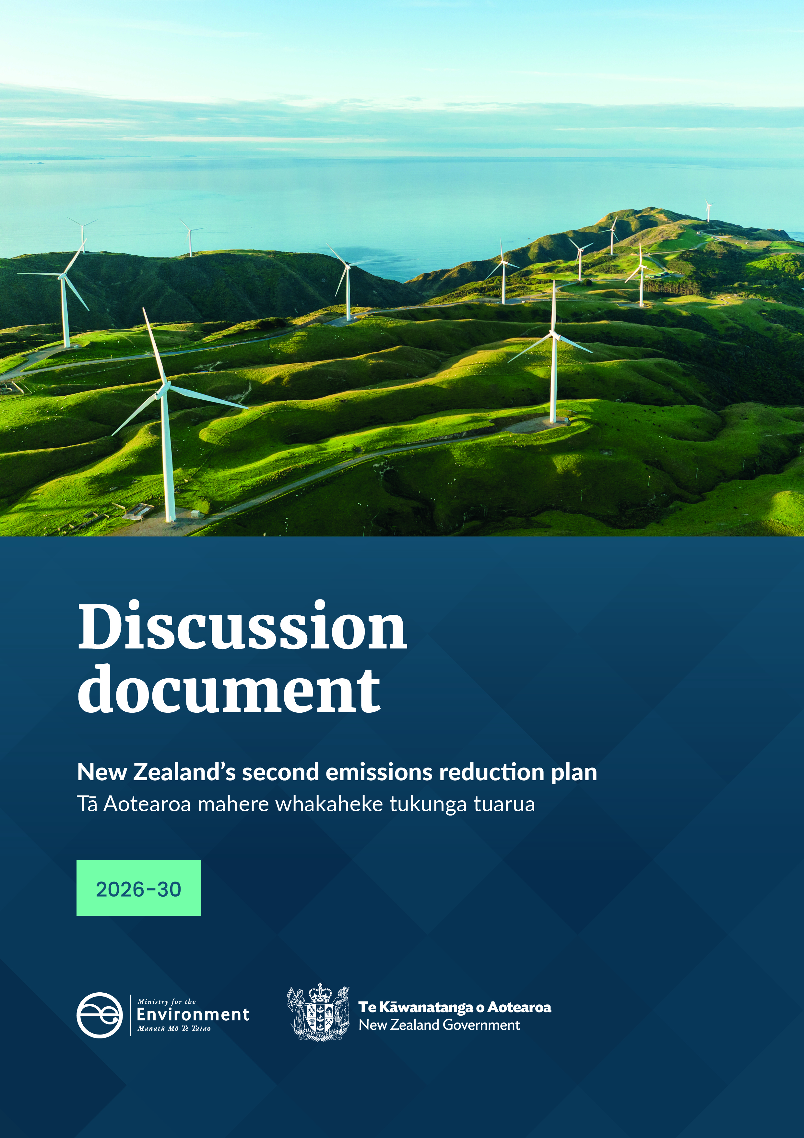
a
get

Disclaimer
The information in this publication is, according to the Ministry for the Environment’s best efforts, accurate at the time of publication. The Ministry will make every reasonable effort to keep it current and accurate. However, users of this publication are advised that:
- the information does not alter the laws of New Zealand, other official guidelines, or requirements
- it does not constitute legal advice, and users should take specific advice from qualified professionals before taking any action based on information in this publication
- the Ministry does not accept any responsibility or liability whatsoever whether in contract, tort, equity, or otherwise for any action taken as a result of reading, or reliance placed on this publication because of having read any part, or all, of the information in this publication or for any error, or inadequacy, deficiency, flaw in, or omission from the information in this publication
- all references to websites, organisations or people not within the Ministry are for convenience only and should not be taken as endorsement of those websites or information contained in those websites nor of organisations or people referred to.

This document may be cited as: Ministry for the Environment. 2024. New Zealand’s second emissions reduction plan (2026–30): Discussion document. Wellington: Ministry for the Environment.

Published in July 2024 by the
Ministry for the Environment
Manatū mō te Taiao
PO Box 10362, Wellington 6143, New Zealand
environment.govt.nz
ISBN: 978-1-991140-27-2
Publication number: ME 1836
© Crown copyright New Zealand 2024

Contents
Message from the Minister of Climate Change 8
New Zealand’s second emissions reduction plan 10
Share your views 11
We want your input as the Government develops New Zealand’s second emissions reduction plan 11
General consultation questions 19
1. Our approach to New Zealand’s climate change response 20
Effective climate action requires both adaptation and mitigation 20
Our strategy sets the direction for our climate change response 22
Leveraging our competitive and natural advantages 22
New Zealand has a unique emissions profile 22
Delivering an efficient and cost-effective transition to net zero emissions 23
Complementary policies have an important role alongside the NZ ETS 25
Pillars of the Government’s climate change strategy 26
Reaching net zero requires collective action 28
Chapter 1 consultation questions 28
2. Tracking our progress towards meeting emissions budgets 29
Interim emissions projections 30
How we are meeting the first emissions budget – amending the first emissions reduction plan 31
Chapter 2 consultation questions 32
How we can meet the second emissions budget 32
How we are tracking towards New Zealand’s Nationally Determined Contribution 34
We will proactively monitor and adapt our approach to meet emissions budgets 34
SYSTEM PLANS 35
3. Strengthening the New Zealand Emissions Trading Scheme 36
Introduction 36
A credible NZ ETS is crucial 37
Aligning the NZ ETS with the second emissions budget 39
Work is progressing on industrial allocation 40
Managing impacts of the NZ ETS 40
Removals, the NZ ETS and meeting our long-term targets 41
The NZ ETS and the cost of living 42
Chapter 3 consultation questions 43
4. How we fund and finance climate mitigation 44
Introduction 44
Work is underway to unlock private investment 44
Chapter 4 consultation questions 46
SECTOR PLANS 47
5. Energy 48
Energy sector at a glance 48
Introduction 49
Emissions profile 49
Proposed approach to reducing energy emissions 51
Electrify NZ is a pillar of the second emissions reduction plan 52
Other policies for meeting the second emissions budget 55
Enabling future emissions budgets 56
Impact on emissions 57
Impacts on iwi and Māori 58
Chapter 5 consultation questions 58
6. Transport 59
Transport sector at a glance 59
Introduction 60
Emissions profile 60
Proposed approach to reducing transport emissions 61
Pillar of transport decarbonisation: EV charging infrastructure 61
Supporting actions 63
Chapter 6 consultation questions 67
7. Agriculture 68
Agriculture sector at a glance 68
Introduction 69
Emissions profile 70
Implementing a fair and sustainable pricing system for on-farm emissions by 2030 74
Impacts on iwi and Māori 74
Chapter 7 consultation questions 74
8. Forestry and wood processing 75
Forestry and wood-processing sector at a glance 75
Introduction 76
Emissions profile 77
Proposed approach to enabling removals and reductions 78
Policies and initiatives 79
Boosting wood processing 80
Impacts on iwi and Māori 82
Other issues 82
Chapter 8 consultation questions 83
9. Non-forestry removals 84
Proposed approach to enabling non-forestry removals 84
What non-forestry removal activities are 84
Why it helps to recognise non-forestry removals 85
How non-forestry removals could be recognised 85
Exploring whether non-forestry removals can contribute to our domestic and international targets 86
Chapter 9 consultation questions 86
10. Waste 87
Waste sector at a glance 87
Introduction 88
Emissions profile 88
Proposed approach for reducing emissions from waste 89
Investment in resource recovery infrastructure and systems 89
Investigating improvements to organic waste disposal and landfill gas capture 91
Impacts on iwi and Māori 92
Chapter 10 consultation questions 92
ADAPTATION AND MANAGING DISTRIBUTIONAL IMPACTS 93
11. Helping sectors adapt to climate change impacts 94
Understanding climate risks will help sectors adapt 94
Addressing climate risks and integrating adaptation in sector policies 95
Chapter 11 consultation questions 97
12. Addressing distributional impacts of climate mitigation policy 98
The Government will support New Zealanders through the transition to a low-emissions economy 98
We can analyse distributional impacts across our economy and society 99
Effects of emissions pricing 103
Sector-specific policies 104
Mitigation strategy 105
Te Tiriti o Waitangi commitments 106
Chapter 12 consultation questions 107
Appendix 1: Consultation questions 108
Appendix 2: Proposals for the second emissions reduction plan 115
Appendix 3: Discontinued policies from ERP1 118
Appendix 4: Glossary 120

Tables
Table 0.1: Key policies proposed for ERP2 and interim projected abatement for the second and third emissions budgets, 15
Table 0.2: Opportunities for potential abatement to explore before publishing ERP2 16
Table 2.1: Emissions budgets, 2022–25, 2026–30 and 2031–35 29
Table 2.2: Interim ERP2 net emissions projections for first to third emissions budgets 31
Table 8.1: 2024 projections of forestry’s contribution to emissions targets (Mt CO₂) 77
Table 11.1: Existing initiatives to support sectors to understand and manage climate risks 95
Table 11.2: Key climate impacts and proposed adaptation considerations for ERP2 sector policies 96

Figures
Figure 0.1: New Zealand’s climate change targets and scale of required emissions reductions (2021–30) 13
Figure 0.2: Projected reductions in sector emissions for the second emissions budget 14
Figure 1.1: New Zealand’s Zero Carbon Framework 21
Figure 1.2: Percentage of gross greenhouse gas emissions by sector, category and gas type, 2022 23
Figure 1.3: A net-based approach to achieving lower overall emissions 24
Figure 1.4: The five pillars of the Government’s climate change strategy 26
Figure 2.1: Interim emissions projections and uncertainty range using target accounting, 2022–50 30
Figure 2.2: Projected sector emissions reductions for the second emissions budget, including new measures 32
Figure 3.1: How the NZ ETS market works 37
Figure 3.2: The risk that the NZ ETS alone does not encourage enough removals to achieve net zero by 2050 42
Figure 5.1: New Zealand’s emissions from the energy sector and industrial processes and product use sector, 2022 50
Figure 5.2: Electricity generation sources, 2022 50
Figure 5.3: Historical and forecast electricity demand, 2000–50 53
Figure 6.1: Transport emissions by transport type, as at December 2022 60
Figure 7.1: Changes in emissions intensity of meat and dairy products, 1990–2022 70
Figure 7.2: Agriculture emissions by activity, as at December 2022 71
Figure 8.1: Actual and projected afforestation rates assumed in the 2024 projections (hectares), 1990–2050 78
Figure 10.1: Waste emissions by activity, as at December 2022 88
Figure 11.1: Effects of climate change on our environment 96
Figure 12.1: Expected impact of ERP2 policies on household consumption, by household income and ethnicity, 2050 100
Figure 12.2: Expected impact of mitigation policies on output by sector, 2050 101
Figure 12.3: Expected impact of mitigation policies on real GDP by region, 2050 102
Figure 12.4: Relative impact of emissions price increases on households by household disposable income 103

Message from the
Minister of Climate Change

He karere mai i te Minita Take Panoni Āhuarangi
We are in a critical decade for climate action, and we need a plan so our communities and economy can continue to thrive as we transition to a low-emissions, high-value future.
The Government is committed to successfully delivering our climate change targets.
In April 2024, the Government announced meeting our targets to reduce New Zealand’s net greenhouse gas emissions as one of nine Government targets to achieve better results for public services and priorities that matter to New Zealanders. This underscores the crucial importance of having a strategy and emissions reduction plan that takes advantage of the abundance of opportunities New Zealand has.
This Government is committed to a least-cost, net-based approach, which will maximise the emissions reduction value of every dollar we spend. It also acknowledges the role that offsets like forestry and other carbon removals play in bringing us closer to our emissions reduction targets. We will not accept shutting down productive sectors of the economy to meet emissions targets. Instead, we will use a technology-led approach to allow production to increase as our emissions come down.
We have a strategy for New Zealand to meet its targets to reduce the impacts of climate change and prepare for its future effects. This will be delivered through five priority pillars, which will inform our second emissions reduction plan and guide our pathway to net zero.
- Infrastructure is resilient and communities are well prepared.
- Credible markets support the climate transition.
- Clean energy is abundant and affordable.
- World-leading climate innovation boosts the economy.
- Nature-based solutions address climate change.
We’re already implementing these pillars: unlocking investment in renewable energy and supporting climate innovation. We also need the right cross-sector package of enabling policies to grow sustainable investments across the economy and remove barriers to emissions reductions.
Climate change is an economic issue, and the future success of our country will rely on our ability to sustainably transition to a low-emissions economy. That's why we want to take advantage of our opportunities in New Zealand, like our abundance of natural resources and capacity for renewable energy, to ensure we minimise costs.
The proposed plan in this discussion document shows us as on track to meet the second emissions budget. Still, delivery will be critical, and we want to hear from you about what more can be done to ensure we meet our target and set New Zealand on the path to deliver net zero by 2050.

Hon Simon Watts
Minister of Climate Change

New Zealand’s second emissions reduction plan

Tā Aotearoa mahere whakaheke tukunga tuarua
Ch. 1 Our approach to New Zealand’s  climate change response | Ch. 2 Tracking our progress towards  meeting emissions budgets
SYSTEM PLANS
Ch. 3 Strengthening the New Zealand Emissions Trading Scheme | Ch. 4 How we fund and finance climate mitigation
SECTOR PLANS
Ch 5. Energy | Ch 6. Transport
Ch 7. Agriculture | Ch 8. Forestry and wood processing
Ch 9. Non-forestry removals | Ch 10. Waste
ADAPTATION AND MANAGING DISTRIBUTIONAL IMPACTS
Ch. 11 Helping sectors adapt to climate change impacts | Ch. 12 Addressing distributional impacts of climate mitigation policy
APPENDIX
Consultation questions and how to  have your say | All ERP2  proposals
Discontinued ERP1 policies | Glossary

Chapter contains consultation questions.

Share your views

Tiria mai ō whakaaro

We want your input as the Government develops New Zealand’s second emissions reduction plan

Background

The Zero Carbon Framework
The Climate Change Response Act 2002 (CCRA) provides the legislative framework to reduce greenhouse gas emissions that cause climate change. Our Zero Carbon Framework supports the development and implementation of climate change policies. These policies contribute to the global effort under the Paris Agreement to limit the global average temperature increase to 1.5°C above pre-industrial levels. They also allow us to prepare for, and adapt to, the effects of climate change.
The framework includes a domestic target to:
- reduce net emissions of all greenhouse gases (except biogenic methane) to zero by 2050
- reduce emissions of biogenic methane to 24–47 per cent below 2017 levels by 2050, including to 10 per cent below 2017 levels by 2030.
The Government is required to sustain net zero emissions from 2050 onwards. A series of emissions budgets place limits on the emissions in each budget period and serve as stepping stones towards our 2050 target. You can read more about the Zero Carbon Framework in chapter 1.
The Government’s targets for the public sector also reflect the budgets and targets for emissions.
Government Target 9 – Reduced net greenhouse gas emissions
In April, the Government announced nine targets to focus the public sector on improving results in health, education, law and order, work, housing and the environment.
Government Target 9 focuses on reducing net greenhouse gas emissions:
On track to meet New Zealand’s 2050 net zero climate change targets with total net emissions of no more than 290 Mt CO₂-e from 2022 to 2025 and 305 Mt CO₂-e from 2026 to 2030.
This aligns with the first and second emissions budgets, and the 2050 net zero target in New Zealand’s Zero Carbon Framework. By meeting our short-term emissions budgets and those set in the future, we can reach and sustain net zero emissions by 2050.

Emissions reduction plans
Under the Zero Carbon Framework, the Government is also required to prepare and publish emissions reduction plans (ERPs) for each emissions budget. By the end of 2024, the Government must publish the second emissions reduction plan (ERP2). The plan must outline the strategy and actions we will take across all sectors of our economy to meet emissions budgets, among other things.

Nationally Determined Contributions
Alongside our domestic targets, New Zealand has an international target under the Paris Agreement, New Zealand’s first Nationally Determined Contribution (NDC). The NDC covers the period 2021–30 and is a target to reduce net emissions 50 per cent below the gross 2005 level by 2030.
ERP2 will set out the Government’s current plans for the domestic contribution to the NDC. The NDC requires New Zealand to find a larger amount of abatement than the first two emissions budgets are set to deliver.
The timing of our climate change targets and the scale of reductions needed out to 2030 are shown in figure 0.1.
Figure 0.1: New Zealand’s climate change targets and scale of required emissions reductions
(2021–30)
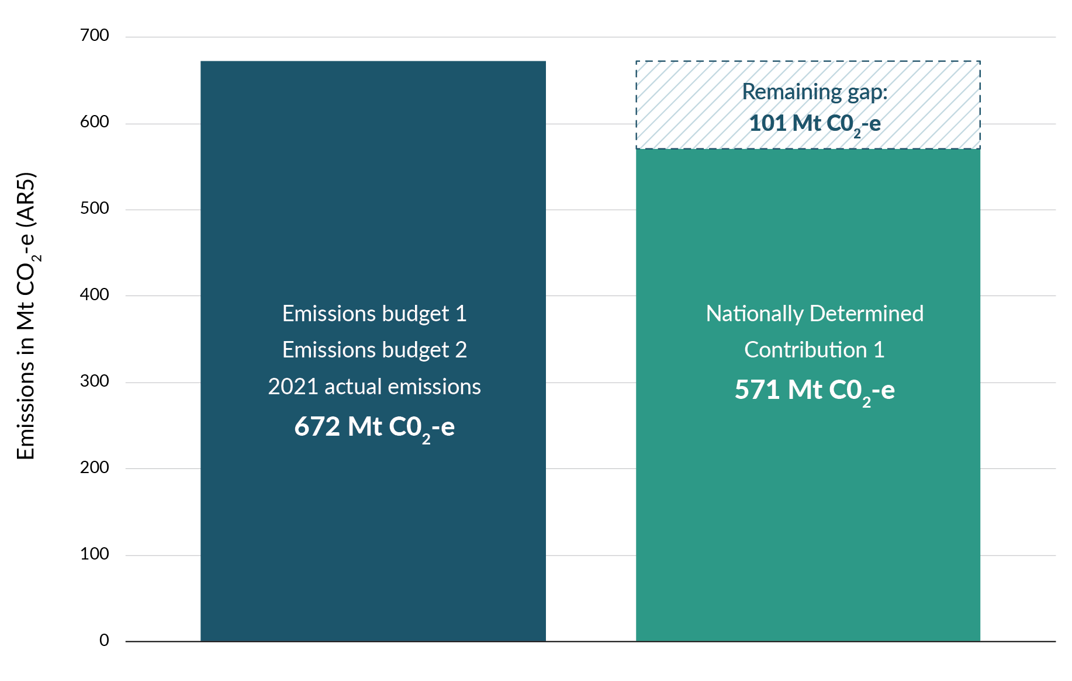
For more information on how New Zealand is tracking towards the NDC, see chapter 2 and the technical annex.
The Government has provisions available in the CCRA to ‘bank’ any emissions reductions that are achieved beyond what is needed for an emissions budget period. Banked emissions reductions can be used to help meet a subsequent emissions budget. For example, if the first emissions budget were overachieved, some of its emissions reductions could be banked for the second emissions budget. Banking can only occur at the completion of an emissions budget, and the Government will consider whether to use these provisions at the appropriate time.

ERP2: Our proposal at a glance
We are proposing that ERP2 outlines actions to reduce net greenhouse gas emissions at least cost to New Zealanders, while adapting to a changing climate.
Over the next five years, New Zealand’s net emissions are expected to reduce across the economy (figure 0.2). This includes changes resulting from new policies and those that would happen anyway. This puts us in a strong position to meet the second emissions budget and Government Target 9. Through ERP2, the Government will implement a clear strategy to make these reductions and remain on track for net zero emissions by 2050.
Chapter 2 has more information on how we are tracking towards the emissions budgets.
Figure 0.2: Projected reductions in sector emissions for the second emissions budget
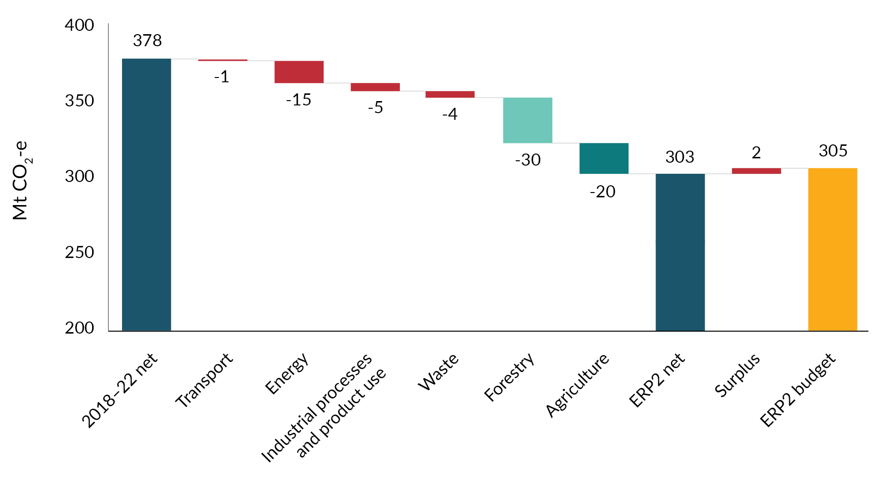
The Government proposes taking a net-based approach to reduce emissions at least cost to New Zealanders. This strategy is based on five pillars.
- Infrastructure is resilient and communities are well prepared.
- Credible markets support the climate transition.
- Clean energy is abundant and affordable.
- World-leading climate innovation is boosting the economy.
- Nature-based solutions address climate change.
Chapter 1 has more information on the proposed strategy to reduce net emissions.

Key policy proposals in this discussion document
Strengthening the New Zealand Emissions Trading Scheme (NZ ETS) by restoring market confidence is critical to ERP2. A credible NZ ETS with a cap that progressively tightens over time will help drive investment across the economy in emissions reductions and carbon removals at least cost to households and businesses.
Alongside the NZ ETS, ERP2 will set out the key actions the Government will take over the next five years (table 0.1), and opportunities for potential abatement (table 0.2), to:
- meet the second emissions budget (2026–30)
- put us on a pathway to reach net zero emissions by 2050 at least cost.
The NZ ETS and key policies are aligned with and will deliver on the Government’s climate strategy and five pillars as outlined above.
Table 0.1: Key policies proposed for ERP2 and interim projected abatement for the second and third emissions budgets,
Sector and key proposed policy | How will this policy help meet the second emissions budget? | Interim projected policy impact for second emissions budget (2026–30) | Interim projected policy impact for third emissions budget (2031–35)
Electrify NZ – reduce consenting burden | Faster and cheaper consents for renewable electricity generation will support greater investment in renewable electricity capacity and grid infrastructure. | Reduces emissions by 0.1 Mt CO₂-e | Reduces emissions by 1.6 Mt CO₂-e
Investigate carbon capture and storage (CCUS) | Reduce barriers to carbon capture, utilisation and storage (CCUS), including by establishing a monitoring and liability regime and exploring NZ ETS treatment of CCUS. | Reduces emissions by 1.4 Mt CO₂-e | Reduces emissions by 3.2 Mt CO₂-e
Target 10,000 electric vehicle (EV) chargers by 2030 | Facilitate private investment in EV charging infrastructure, and review Government co-investment approach to ensure it is fit for purpose and targeted to the area where market barriers exist. | Reduces emissions by 0.01 Mt CO₂-e | Reduces emissions by 0.2 Mt CO₂-e
Better public transport | A rapid transit network for Auckland, with public transport corridors in the north-west, Airport to Botany, and completion of the Eastern Busway.  Improvements to increase capacity and reliability on lower North Island train services for passengers and freight. | Reduces emissions by 0.1 Mt CO₂-e | Reduces emissions by 0.3 Mt CO₂-e
Agricultural mitigation technologies and emissions pricing | Create and enable an environment where farmers and growers have the right tools and technologies to cost-effectively reduce their emissions without having to reduce production.  Price emissions in the agriculture sector from 2030. | Reduces emissions by 0.1 Mt CO₂-e | Reduces emissions by 5.5 Mt CO₂-e
Waste Minimisation Fund | The Government has committed to investing a portion of the forecast waste levy revenue (through to 2030) into resource recovery systems and infrastructure that processes organic waste. | Reduces emissions by up to 1.3 Mt CO₂-e | Reduces emissions by up to 1.3 Mt CO₂-e
Organic waste and landfill gas capture | Work with industry to investigate opportunities to improve organic waste disposal and landfill gas capture. | Reduces emissions by up to 1.1 Mt CO₂-e | Reduces emissions by up to 1.4 Mt CO₂-e
Total |  | Reduces emissions by 4.1 Mt CO₂-e | Reduces emissions by 13.5 Mt CO₂-e
Table 0.2: Opportunities for potential abatement to explore before publishing ERP2
Potential opportunities for future abatement |  | Potential policy impact for the second emissions budget (2026–30) | Potential policy impact for the third emissions budget (2031–35)
Potential for further agriculture emissions reductions | Supporting uptake of EcoPondTM for dairy farms. Assuming availability from 2025. | Potential for a reduction of up to 0.4 Mt (at 10% uptake by 2030) or 2 Mt (at 50% by 2030) CO₂-e in the second emissions budget period. | Potential for a reduction of up to 1.0 Mt (at 10% uptake by 2030 rising to 20% by 2035) or 3.1 Mt (at 50% by 2030) CO₂-e in the third emissions budget period.
 | Low-methane genetics are spread through a flock by low-methane rams. The impact of low-methane genetics is permanent and cumulative, with a flock becoming more methane efficient each year. Assuming availability from 2025. | Potential for a reduction of up to 0.1 Mt (at 10% uptake by 2030) or 0.4 Mt (at 50% by 2030) CO₂-e in the second emissions budget period. | Potential for a reduction of up to 0.2 Mt (at 10% uptake by 2030 rising to 20% by 2035) or 0.5 Mt (at 50% by 2030) CO₂-e in the third emissions budget period.
 | Supporting development and uptake of methane inhibitors. Assuming a 60% effective methane inhibitor is available for dairy in 2027, and sheep and beef in 2030. | Potential for a reduction of up to 3.1 Mt (at 10% uptake by 2030) or 15.3 Mt (at 50% by 2030) CO₂-e in the second emissions budget period. | Potential for a reduction of up to 13.8 Mt (at 10% uptake by 2030 rising to 20% by 2035) or 43.1 Mt (at 50% by 2030) CO₂-e in the third emissions budget period.
Potential for further afforestation abatement, | The Government is further exploring the potential to support afforestation on Crown land. Assuming planting from 2027 as follows:  - Indigenous planting of 5,000 ha in 2027 and 7,500 ha from 2028.  - Exotic planting of 10,000 ha from 2027. | Potential for up to 0.1 Mt CO₂-e of additional emissions in the second emissions budget period (this is due to carbon losses following afforestation). | Potential for abatement of up to 5 Mt CO₂-e in the third emissions budget period.
It is also important to note that many technologies are not yet commercially available. We need data that measures their effectiveness before we can count these technologies in New Zealand’s Greenhouse Gas Inventory. This data will need to be collected over time, meaning some delay in our ability to account for these technologies in the Greenhouse Gas Inventory.
Find more about these proposals and opportunities in chapters 3–10.

Technical annex
The Government has released a technical annex of the modelling used throughout the document. The annex includes:
- a description of the Emissions in New Zealand model (used to provide an interim projection for consultation) and computable general equilibrium model (used to estimate provisional economic effects)
- the approach to estimating emissions as a baseline for ERP2
- modelling results and an assessment of the current challenge for meeting emissions budgets
- qualitative assessments or ‘logic mapping’ for ERP2 policies
- provisional quantitative estimates of the effects of potential new policies.
Read the technical annex on the Ministry for the Environment’s website.

Considering the advice of the Climate Change Commission | He Pou a Rangi
Under the CCRA, when preparing an ERP, the Minister of Climate Change is required to consider advice from the independent Climate Change Commission on the policy direction for ERP2. The Government will continue to do so as it prepares ERP2. ERP2 will be the Government’s response to the Commission’s advice. This means it may contain additional detail and discussion related to that advice beyond what this discussion document presents.

Giving effect to the principles of te Tiriti o Waitangi in an ERP
To recognise and respond to the Crown’s responsibility to give effect to te Tiriti o Waitangi (the Treaty of Waitangi), the CCRA has specific requirements for the development of ERPs. The Minister of Climate Change must include a strategy to recognise and mitigate the impacts of reducing emissions and increasing removals on iwi and Māori. The Minister must also ensure that iwi and Māori are adequately consulted as the plan is developed.
To support consultation, the Government is preparing for a series of regional hui, both online and in-person, targeted to interested iwi and Māori during the public consultation period. This was in response to the level of interest the Government received through early engagement with iwi and Māori for ERP2 consultation.
Further engagement opportunities for iwi and Māori during public consultation will be available through several sector workshops that will focus on policies for specific sectors.
Māori are key partners in our collective effort to reduce emissions and they play major roles in key sectors that will lead New Zealand on the path to achieving net zero. Working with Māori will enhance our climate response, while ensuring solutions are right for communities.
Māori are at risk of being disproportionately affected in the transition to a low-emissions future. Māori start from a position of greater socio-economic disadvantage per capita, and have significant connections to high-emissions industries, particularly agriculture. Historical disruptions to Māori land ownership and assets have significantly impacted their ability to participate in emissions reduction efforts. Recognising these challenges is essential for ensuring that our mitigation plans promote intergenerational equity and respect te ao Māori principles. We will refine our approach to managing the impacts of the transition and supporting people through it, after consultation with stakeholders, including Māori.
We continue to actively engage with iwi and Māori on ERP2, so that we consider their rights and interests and can develop solutions in partnership.
Chapters 1 and 5–12 have more about how ERP2 could affect Māori.

ERPs have statutory requirements – including for public consultation when preparing or amending plans
The CCRA prescribes the statutory requirements of ERPs. The Government will ensure that ERP2 meets all these requirements – that it can deliver enough net reductions to meet the second emissions budget.
The CCRA provides for emissions reduction plans and supporting policies and strategies to be reviewed and amended during their lifetime as the context changes. Through this document we are also consulting on a formal amendment to the first emissions reduction plan (ERP1) to reflect the Government’s new approach to meeting emissions budgets. This is discussed in chapter 2.
Requirements of ERPs
- An ERP must set out the policies and strategies for meeting the relevant emissions budget. It may also include policies and strategies for meeting any emissions budgets that have been notified.
- A new plan must be published at least a year before the budget period starts.
- It must include sector-specific policies and actions to reduce emissions and increase removals during the budget period. For more detail, see chapters 5–10.
- It can include policies or actions for other emissions budgets that have been set.
- It must include a multi-sector strategy to meet the budgets and improve the sectors’ ability to adapt to climate change. See chapter 1 (Our approach to New Zealand’s climate change response), chapter 3 (Strengthening the New Zealand Emissions Trading Scheme), chapter 4 (How we fund and finance climate mitigation) and chapter 11 (Helping sectors adapt to climate change impacts).
- It must include a strategy to mitigate the impacts of reducing emissions and increasing removals on employees and employers, regions, iwi and Māori, and wider communities, and the funding for any mitigation. Chapter 12 has more information.

General consultation questions
The following consultation questions relate to the Government’s general approach to emissions reductions. Some information is provided along with these questions to support you to answer them without extensive reading of the discussion document.
0.1 | What do you think is working well in New Zealand to reduce our emissions and achieve the 2050 net zero target?
0.2 | The Government is taking a ‘net-based approach’ that uses both emissions reductions and removals to reduce overall emissions in the atmosphere (rather than an approach that focuses only on reducing emissions at the source). A net-based approach is helpful for managing emissions in a cost-effective way that helps grow the economy and increase productivity in New Zealand.  a. What do you see as the key advantages of taking a net-based approach?  b. What do you see as the key challenges to taking a net-based approach?
0.3 | The current proposed policies in the ERP2 discussion document cover the following sectors and areas:  - strengthening the New Zealand Emissions Trading Scheme  - private investment in climate change  - energy sector  - transport sector  - agriculture sector  - forestry and wood-processing sector  - non-forestry removals  - waste sector.  What, if any, other sectors or areas do you think have significant opportunities for cost-effective emissions reduction?
0.4 | What Māori- and iwi-led action to reduce emissions could benefit from government support?  There are additional questions about Māori- and iwi-led action to reduce emissions and impacts of proposed ERP2 policies on Māori and iwi in chapters 1 and 12.

1. Our approach to New Zealand’s climate change response

Tā mātou e whai nei e pā ana ki tā Aotearoa urupare ki te panoni āhuarangi
Summary
This chapter outlines the Government’s long-term approach to deliver and sustain net zero emissions by 2050 at least cost. We will implement it over time, through successive emissions reduction plans. Key actions taken over the next five years through the second emissions reduction plan (ERP2) will set in motion a least-cost, low-emissions transition.
The Government proposes taking a strong, net-based approach to reduce emissions at least cost. This strategy is based on five pillars.
- Infrastructure is resilient and communities are well prepared.
- Credible markets support the climate transition.
- Clean energy is abundant and affordable.
- World-leading climate innovation is boosting the economy.
- Nature-based solutions address climate change.

Effective climate action requires both adaptation and mitigation
Our response to climate change must:
- address the impacts that New Zealanders are already experiencing or are likely to experience (through adaptation)
- reduce domestic greenhouse gas emissions that contribute to climate change (through mitigation).
The Government understands the importance of making sure that adaptation and mitigation are focuses for climate policy.
Work is well underway to develop a fair and enduring adaptation framework for New Zealand. Parliament’s Finance and Expenditure Committee is conducting an inquiry to recommend objectives and principles for the design of that framework. Aotearoa New Zealand’s first national adaptation plan was also published in 2022.
Although this consultation focuses mainly on mitigation efforts, ERP2 must also include a multi-sector strategy for supporting sectors to adapt to the effects of climate change (see chapter 11).
New Zealand’s Zero Carbon Framework is a statutory framework within the Climate Change Response Act 2002. It sets the context for the Government’s long-term climate change strategy. Both the framework and the strategy (figure 1.1) connect adaptation and mitigation efforts.
Figure 1.1: New Zealand’s Zero Carbon Framework
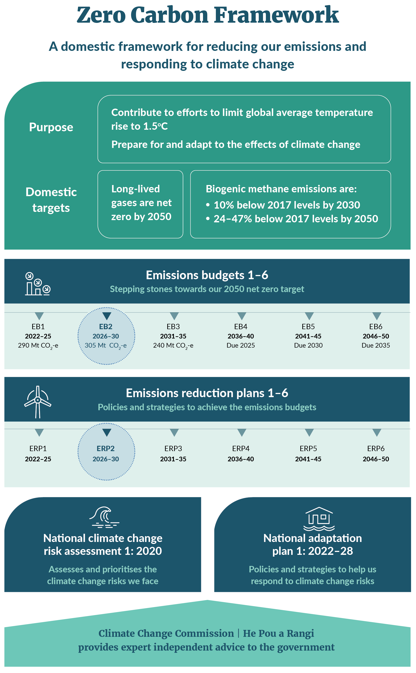

Our strategy sets the direction for our climate change response
Our climate strategy is about New Zealand reaching its economic, social and environmental potential by:
- taking proactive steps to reduce net greenhouse gas emissions at least cost
- adapting to the effects of a changing climate.
We must reduce domestic net emissions to play our part in preventing additional global warming. New Zealand can maximise the opportunities that come from the transition to a net zero economy.
However, having a broad strategy and a vision is not enough. We need a comprehensive plan to prioritise key actions that deliver for New Zealanders. This document outlines our proposals for the strategy in more detail and the plan.
Read more about the Government’s climate strategy.

Leveraging our competitive and natural advantages
At the core of our strategy is the idea that New Zealand’s climate change response should reflect our national context by using our competitive and natural advantages.
We are in a strong position to remove emissions from the atmosphere through forestry and other ways in the long run. However, we must also protect high-quality rural land from excessive afforestation (planting trees). New Zealand has abundant rural land with low productivity that is highly suited to forestry. In future, we may have other viable options for removing emissions, such as restoring wetlands, and capturing and storing carbon.
Decarbonising sectors such as the industrial processes and product use and transport sectors is also vital. As a country, we already have high levels of renewable energy from dams and geothermal fields, and we have abundant potential for wind and solar energy. This makes electrification through affordable clean energy an opportunity to reduce net emissions.
Technology will sit at the heart of our transition, particularly for agriculture. We have one of the most emissions-efficient agricultural sectors in the world because of efficiency gains driven by farmer-led improvements in productivity over time (see chapter 7).

New Zealand has a unique emissions profile
Figure 1.2 shows New Zealand’s emissions from each sector in 2022. The two sectors contributing the most emissions in 2022 were agriculture (53 per cent) and energy (37 per cent). The land use, land-use change and forestry sector offset 25 per cent of gross emissions in 2022.
Together, methane (49 per cent) and nitrous oxide (9 per cent) made up over half of New Zealand’s gross emissions, largely coming from agricultural sources. It is important to recognise that the impact of biogenic methane is different from other greenhouse gases. This is why New Zealand sets different reduction goals for methane and other greenhouse gases. Most of the remaining emissions consisted of carbon dioxide (40 per cent), largely coming from the energy sector and the industrial processes and product use sector.
Figure 1.2: Percentage of gross greenhouse gas emissions by sector, category and gas type, 2022
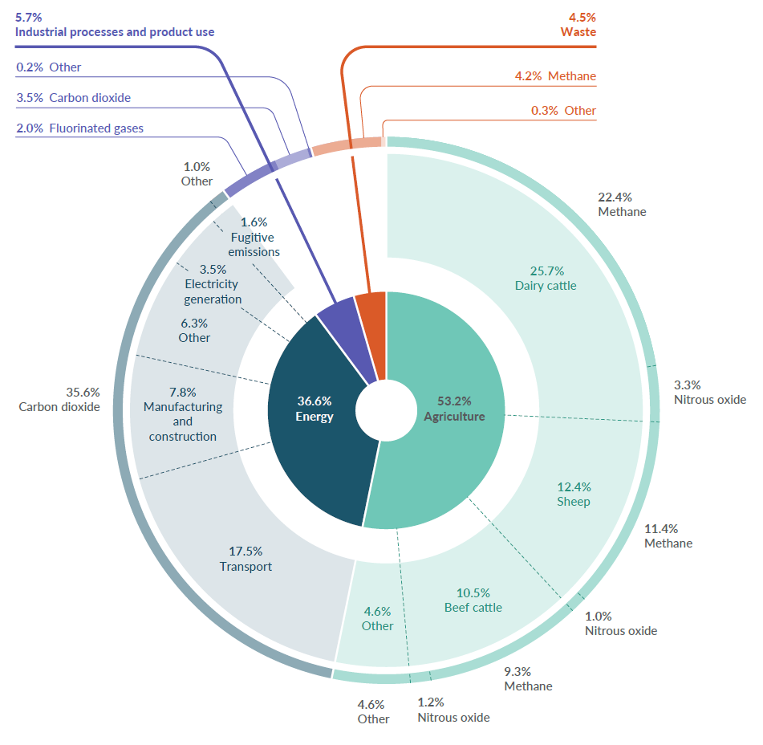

Delivering an efficient and cost-effective transition to net zero emissions
While using our natural advantages, our approach is to ensure the right incentives are in place across the economy to reduce net emissions where it is most cost-effective.

The net-based approach
To increase productivity, we must follow the most efficient, flexible and cost-effective pathway to a net zero 2050. This means taking a net-based approach. That is, we need to balance emissions reductions and removals to achieve lower overall emissions (figure 1.3).
Under our climate change targets, removing one tonne of carbon dioxide through forestry, for example, is recognised as equivalent to preventing the emission of one tonne of carbon dioxide in the first place. Given the opportunities for forestry in New Zealand, afforestation has a critical role in driving down net emissions.
An alternative method is to focus on reducing gross emissions (the amount of emissions initially released into the atmosphere before removals). We consider that a net-based approach provides greater flexibility, which can help keep costs down.
The net-based approach helps us meet the second emissions budget at least cost. It gives us options for both reducing and removing emissions. Emissions budgets and the 2050 net zero target are net targets.
Figure 1.3: A net-based approach to achieving lower overall emissions
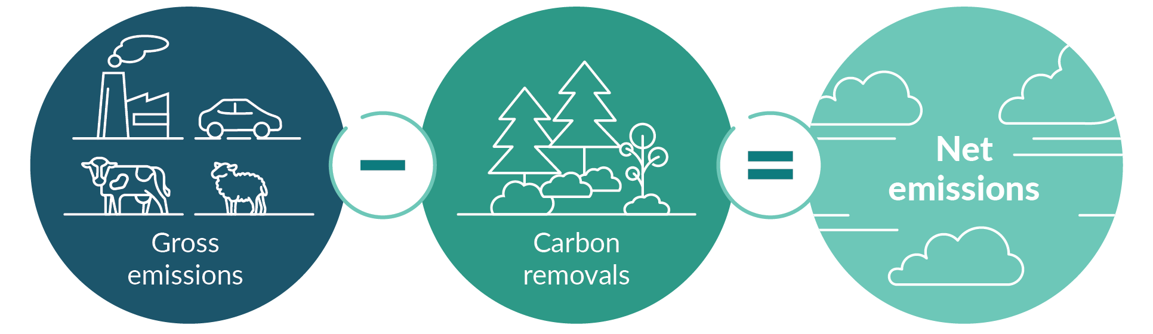
Reducing emissions at least cost
Here, ‘least cost’ refers to minimising the overall cost to the nation, by 2050, of reducing emissions and shifting to a net zero 2050. The costs are costs to businesses and households investing in gross emissions reduction, fiscal costs to the Government, and the wider costs or benefits from changes to the things people value, such as clean air.
We can reduce emissions in New Zealand in a range of different ways. For example, we can plant trees to remove carbon from the atmosphere, replace coal boilers with electric ones and encourage more people to install solar panels. A least-cost approach is economically efficient because it relies on markets, which leads to innovation and investment, rather than involving the Government in directing where and how to make reductions. It gives more flexibility and more options. It also focuses on net emissions, recognising the relatively low-cost abatement opportunity offered by forestry.
Determining the least-cost approach requires taking account of the risks and co-benefits of different pathways, which could influence total economic costs in the long term. Some factors are uncertain and extend far into the future. For example, reducing gross emissions could offer broader savings from co-benefits (eg, reducing transport emissions could yield savings from lower air pollution and congestion, which in turn improves health outcomes).
While a forestry-led response could be least cost in the short term and provide some co-benefits (such as erosion control), it also risks losing stored carbon in the trees through wildfire, pests or weather events. The Government has had to judge the likelihood and scale of these benefits and risks in forming its least-cost strategy.

A market-led approach uses our natural and competitive advantages
Emissions pricing through the New Zealand Emissions Trading Scheme (NZ ETS) will continue to be the main tool to determine where and how to reduce net emissions. The NZ ETS supports a cost-effective approach to reaching our targets. It allows participants to discover where they can reduce net emissions at the least cost across the sectors in the scheme.
We are committed to a split-gas approach to achieving climate change targets. To meet statutory emissions budgets and targets, it will be important to reduce biogenic methane and nitrous oxide from livestock and fertiliser, which are not covered by the NZ ETS. The Government has committed to establishing fair and sustainable pricing of on-farm emissions no later than 2030. This will give farmers the long-term price signal they need to support investment in lowering emissions, without sending agricultural production overseas. This initiative will be preceded by the introduction of farm-level emissions estimation.

Complementary policies have an important role alongside the NZ ETS
We know the NZ ETS alone is not enough to reach our net zero emissions target, and that New Zealand is a technology taker. Many new emissions mitigation technologies will be developed overseas. Together with emissions pricing, there is a clear role for policies that allow the NZ ETS to work better and support the early adoption of emerging technologies.
We need the right interventions to support a least-cost approach. This requires correctly understanding the relationship between complementary policies and the NZ ETS. Complementary policies should not simply buy emissions out of the system at high cost and in the short term, allowing those emissions to rise elsewhere under the NZ ETS cap.
When net emissions are capped (as in the NZ ETS), reducing the cap over time requires emitters to respond by finding and investing in the least-cost options to reduce emissions. Other policies that reduce emissions in sectors covered by the NZ ETS free up emissions units (New Zealand Units or NZUs) for other emitters, enabling them to emit more than they would have otherwise. Emitters will vary in their decisions as to how many of these NZUs they will use and how quickly they will use them. In the long run, this creates a risk that policies to reduce emissions that are additional to the NZ ETS (in sectors covered by the NZ ETS) have limited impact on long-run net emissions.
This is why the Government is prioritising policies that make it cheaper or easier for businesses and households to reduce net emissions – for example, through research and development, removing regulatory barriers or addressing market failures such as lack of information. These policies allow targets and budgets to be achieved at least cost. The Government may consider other complementary policies for select reasons, such as making sure that an activity occurs within the right timeframe. There is also an important role for policies to reduce agricultural emissions, which are outside the NZ ETS cap.
We will carefully consider any new proposals to reduce emissions or increase removals, in terms of how they interact with the NZ ETS. Not doing so may risk developing policies that work at cross-purposes with the NZ ETS and potentially increase the cost of achieving climate targets.

Pillars of the Government’s climate change strategy
In ERP2, we intend to deliver climate action based on five pillars across several sectors (figure 1.4). These reflect the priority areas for the Government’s climate change strategy.
Figure 1.4: The five pillars of the Government’s climate change strategy
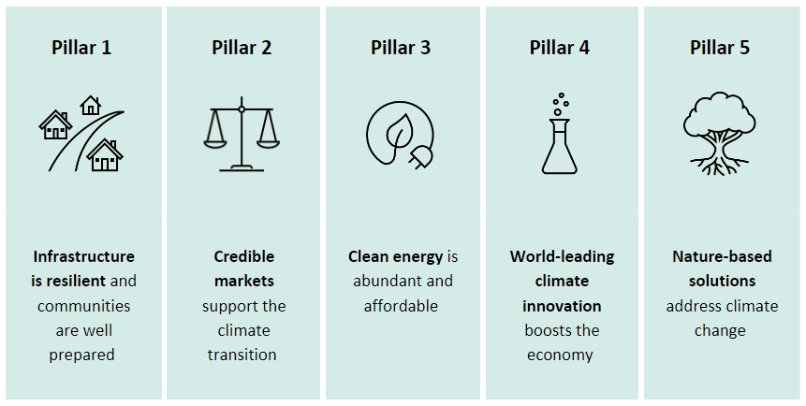

Pillar 1: Infrastructure is resilient and communities are well prepared
Climate change can increase risk across a range of different sectors. For example, extreme weather events and sea-level rise can impact the resilience of our national electricity grid, key transport routes, health infrastructure and services, households and community facilities. To build resilience, we must invest in our infrastructure and built environment.
Our focus is on providing more certainty by:
- improving the quality of and access to climate information, tools and guidance on future risks
- setting a legislative framework that enables decision-making to reduce climate risk.
Chapter 11 has more information on the effects of climate change and how the Government plans to address them.

Pillar 2: Credible markets support the climate transition
Credible domestic carbon markets that price emissions underpin our least-cost, net-based strategy.
The NZ ETS is our main tool to price emissions, and supporting its credibility is a priority for the Government. To support least-cost reductions, the NZ ETS needs to provide stability and certainty, so that market participants face the right incentives to reduce their emissions. Among other things, NZ ETS unit supply settings need to accord with the emissions budgets. Chapter 3 outlines how we plan to support a credible NZ ETS.
Pricing agricultural emissions will also encourage the sector to take up mitigation technologies that reduce on-farm emissions. The Government has committed to getting agriculture out of the NZ ETS and introducing fair and sustainable pricing of on-farm emissions no later than 2030. This approach reduces emissions without causing emissions leakage by sending production overseas.

Pillar 3: Clean energy is abundant and affordable
As a country, we already have high levels of clean, renewable energy, putting us in an excellent position to go further in electrifying industry and transport. In turn, this brings opportunities in other sectors, such as agriculture. To support electrification and other low-emissions fuels, we must have sufficient, reliable and affordable renewable energy.
In support of our goal to double renewable energy, Chapter 5 outlines how we plan to drive investment in renewable electricity generation by using the NZ ETS and cutting red tape to increase investment.

Pillar 4: World-leading climate innovation boosts the economy
Innovation and technology will sit at the centre of our transition. A technology-led approach will reduce net emissions at least cost, while still increasing production.
Economic opportunities will arise as the world shifts toward net zero. Expectations, regulations and standards are rapidly changing. Companies that can pivot through innovation and better practice have opportunities to access markets and meet increasing demand for low-emissions products. Investing in our response now can bring jobs, economic growth and a higher standard of living for all New Zealanders.
Our agricultural expertise positions us to be a global leader in technology that reduces agricultural emissions, while boosting growth and productivity. We can support this innovation by ensuring the right conditions are in place and removing barriers to their eventual use. Our abundant renewable energy potential makes us an attractive proposition for private international investment in low-emissions fuels and carbon-capture technologies.
This Government will apply rigorous standards to government expenditure to ensure climate policies deliver emissions reductions and value for money.
Chapter 7 outlines how we plan to streamline the approval process for emerging tools to reduce agricultural emissions, and to reform the regulations for genetic technologies.

Pillar 5: Nature-based solutions address climate change
We are in a strong position to continue removing emissions from the atmosphere through forestry. Although there are further opportunities in this area, we must also protect high-quality productive rural land from excessive afforestation.
Removing emissions through non-forest measures, such as wetland restoration, on-farm vegetation, coastal vegetation management and Predator Free 2050, may become viable ways to help meet future emissions budgets. They could also offer more options for landowners and businesses, create incentives to change land use or management to reduce net emissions, and bring other co-benefits, such as better water quality, biodiversity and climate resilience.
Chapter 9 outlines how we plan to encourage non-forestry approaches to removing emissions.

Reaching net zero requires collective action
The Government has an important role in reducing net emissions, but it cannot do it alone. Transitioning to net zero by 2050 is a significant challenge. It requires collective action from households, businesses, iwi and hapū, communities, non-government organisations, local government and other organisations. This consultation and the development of ERP2 are critical steps towards working with New Zealanders to reduce emissions.
The Government’s core role is getting the policy and regulatory settings right to reach net zero. Its role is not to direct where emissions reductions occur in the economy. This would be inconsistent with a net-based, least-cost response. We intend to take a market-led approach, using sector policies that support reductions where it is most cost-effective and efficient to do so.

Working with Māori
Māori are essential partners in our collective effort, playing a major role in key sectors that will lead the way. Working with Māori to address emission drivers will enhance our response, producing solutions that are right for communities. To do this, we need to work with and hear from Māori. We have started this process. Māori rights, voices and perspectives are integral to the ERP2. They will ensure that:
- we realise the opportunities for Māori-led reductions
- climate solutions recognise Māori rights and interests.

International cooperation on reducing emissions
Emissions budgets must be met, as far as possible, through reducing and removing domestic emissions. Offshore mitigation can only be used if there has been a significant change in circumstances. That said, collective action can include international cooperation. The Paris Agreement provides for countries to work together to reduce emissions in ways that benefit everyone. For example, New Zealand can work with partners in the Asia–Pacific region. Projects focused on areas such as renewable energy development, waste management or agriculture could use New Zealand knowledge and expertise to help a partner country to transition to a low-carbon economy. New Zealand could secure a share of the reductions towards our international targets and build business opportunities.

Chapter 1 consultation questions
1.1 | What opportunities do the proposed initiatives and policies across the sectors offer for Māori- and iwi-led action to reduce emissions?
1.2 | What additional opportunities do you think the Government should consider?

2. Tracking our progress towards meeting emissions budgets

Te aroturuki i tō tātou koke i te ara whakatutuki i ngā tahua tukunga
Summary
The Government is committed to meeting our climate targets. Our strategy outlines how we will approach the challenges and opportunities in meeting them.
We are building off the momentum that our first emissions budget started. For example, higher rates of forestry have occurred in the last few years, positioning New Zealand well for the future as those trees grow.
Reflecting the Government’s change in approach, we have stopped work on some actions that were included in the first emissions reduction plan (ERP1). This is not expected to materially affect our ability to meet the first emissions budget: our current assessment is that ERP1 remains sufficient to meet it.
To maintain an up-to-date ERP1 and reflect decisions that have already been taken, we are now consulting on formally amending ERP1 using the statutory process set out in section 5ZI(3) of the Climate Change Response Act 2022 (CCRA).
The second emissions reduction plan (ERP2) lays the way for us to achieve future budgets, particularly the second emissions budget. The information we have today suggests that ERP2 can be sufficient to achieve the second emissions budget.
The Government will proactively respond to challenges and opportunities to stay within the budgets. We will continue to rely on the most up-to-date modelling as we finalise ERP2, which will allow us to ensure the sufficiency of the final plan.
Our latest information suggests we expect to stay within the limits of the first two emissions budgets.
New Zealand has a system of emissions budgets to meet the 2050 net zero target. The first three emissions budgets were published in May 2022 (table 2.1). We will need to limit net emissions to the levels set in these budgets.
Table 2.1: Emissions budgets, 2022–25, 2026–30 and 2031–35
 | First emissions budget  2022–25 | Second emissions budget  2026–30 | Third emissions budget  2031–35
All gases, net (AR5)* | 290 Mt CO₂-e | 305 Mt CO₂-e | 240 Mt CO₂-e
Annual average | 72.5 Mt CO₂-e | 61 Mt CO₂-e | 48 Mt CO₂-e
Note: * Global warming potential values adapted from the IPCC Fifth Assessment Report (AR5).
What is a tonne of emissions?
One tonne of carbon dioxide equivalent (CO₂-e) is 1,000 kilograms of emissions. One megatonne (Mt) is 1 million tonnes of emissions. To give a sense of the scale: one tonne of emissions is roughly equivalent to nine trips from Auckland to Wellington in the average car (a total of 5,847 kilometres). One megatonne would be the total length of these trips multiplied by one million.

Interim emissions projections
Figure 2.1 and table 2.2 show that with the key policies outlined in this discussion document, we are on track to achieve the first and second emissions budgets, with greater uncertainty about meeting the third budget.
Longer-term projections are highly uncertain and are contingent on many factors, including assumptions about the rate of technological development, macro-economic and demographic conditions, consumer behaviour as well as government policy choices. Despite this, based on current assumptions, the interim projections show that both the ‘net zero’ target for long-lived gases and the 2050 methane target fall within the range of uncertainty. However, our central estimate falls 3 Mt CO₂-e short of our 2050 long-lived gas target. It is important to note that the yet-to-be-set future emissions budgets will drive policies to ensure long-term targets are met.
We expect ERP2 to set the foundations for meeting future budgets by improving the management of these risks, and we will be proactive and innovative to respond to challenges and opportunities that lie ahead. Emissions budgets are our primary tools for doing so: they will act as ‘stepping stones’ as we move towards meeting each target.
Figure 2.1: Interim emissions projections and uncertainty range using target accounting, 2022–50
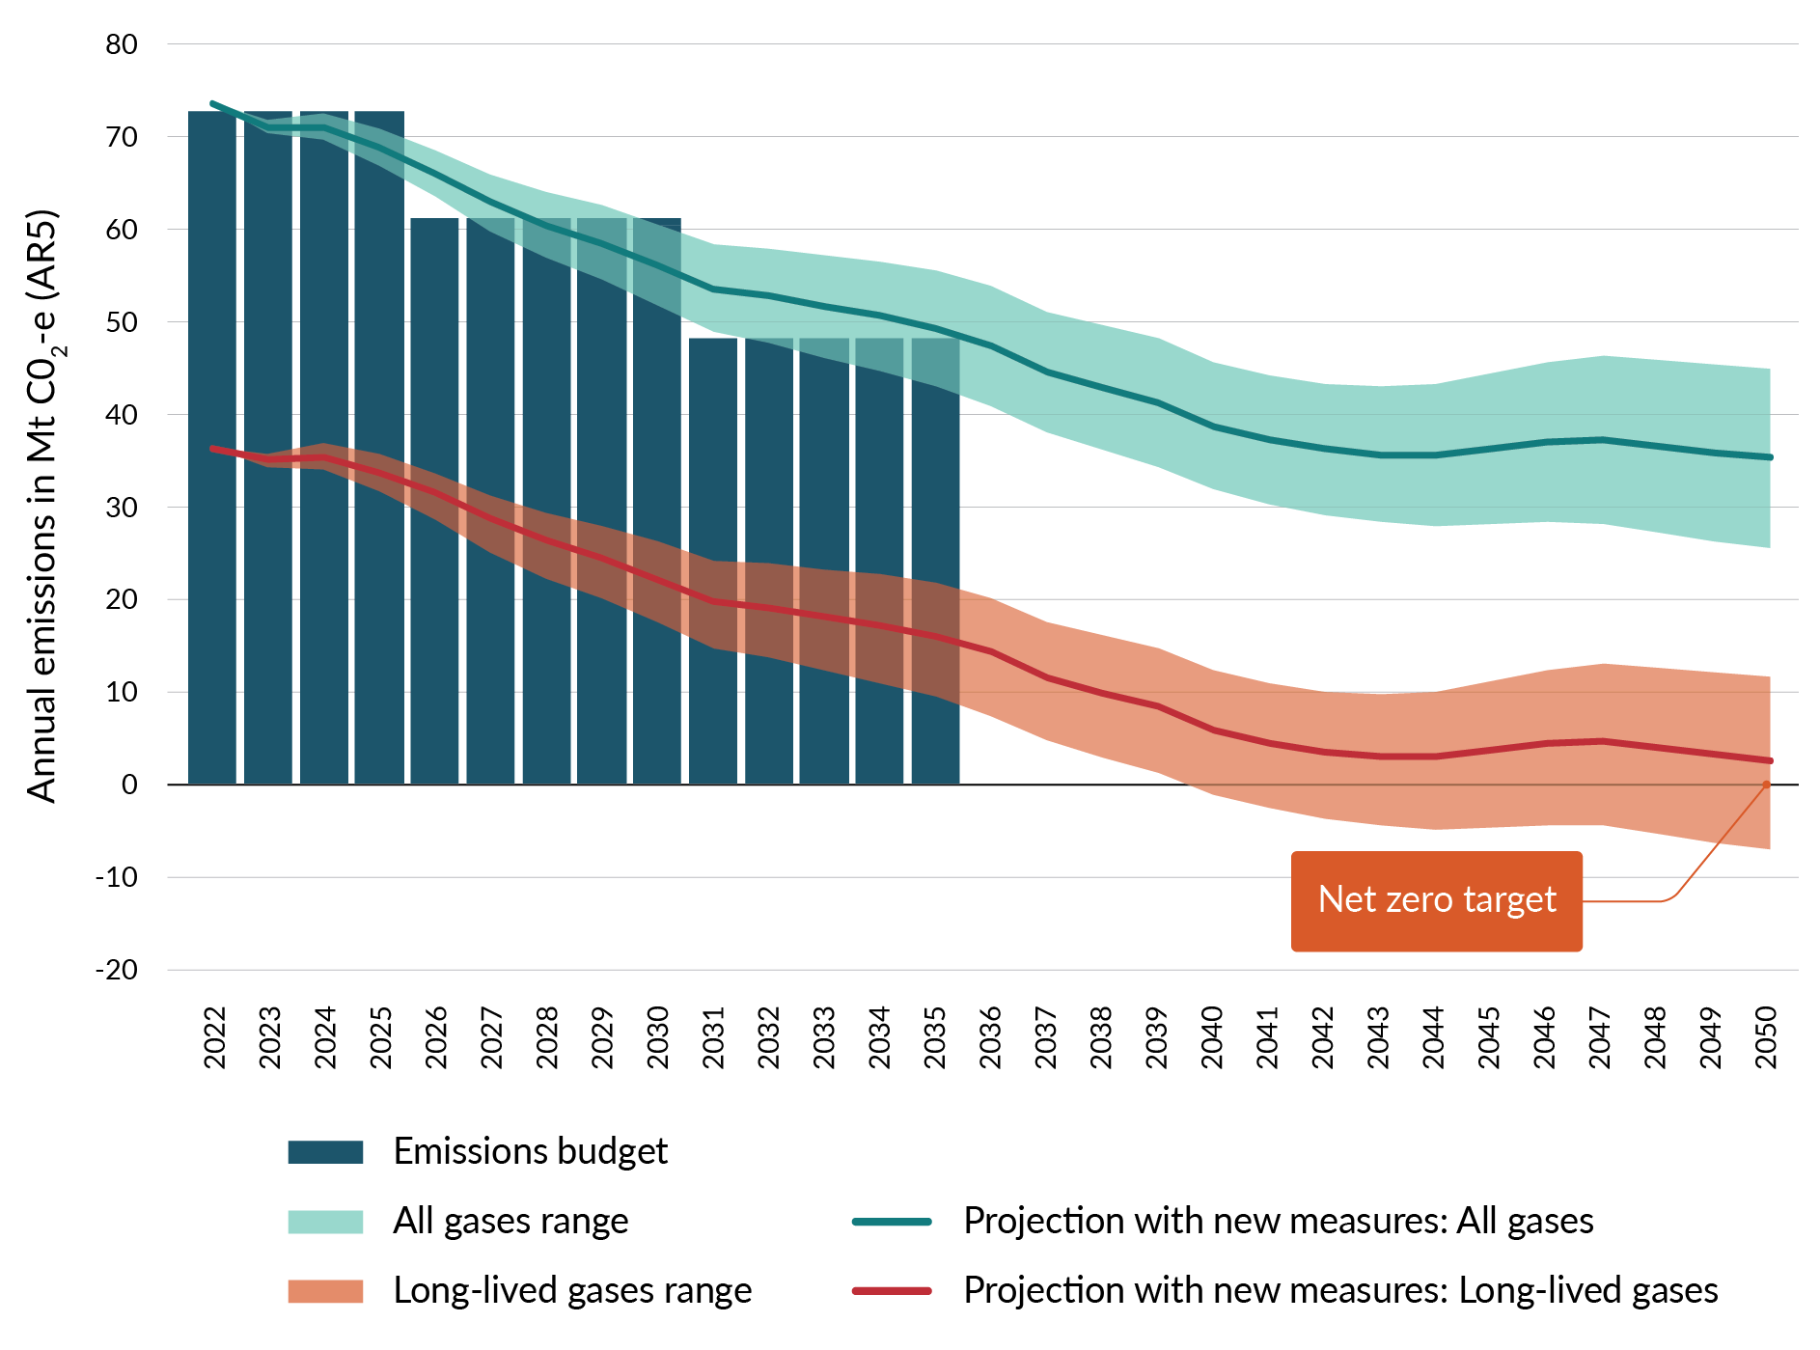
Note: AR5 = Global warming potential values adapted from the IPCC Fifth Assessment Report.
Table 2.2: Interim ERP2 net emissions projections for first to third emissions budgets
Emissions budget | Interim projections  (central estimate*) | Uncertainty for interim projections (central estimate)
First emissions budget  290 Mt CO₂-e | 284.0 Mt CO₂-e | ±4 Mt CO₂-e
Second emissions budget  305 Mt CO₂-e | 303.3 Mt CO₂-e | ±18 Mt CO₂-e
Third emissions budget  240 Mt CO₂-e | 257.4 Mt CO₂-e | ±29 Mt CO₂-e
Note: * ‘Central estimate’ refers to the value believed to be most likely based on current understanding of relevant assumptions including new ERP2 measures.

How we are meeting the first emissions budget – amending the first emissions reduction plan
Share your views
We are seeking feedback on:
- the impact of the proposed change in approach to meeting the first emissions budget using an amended ERP1, in light of the revised strategy for meeting climate targets as laid out in chapter 1.
ERP1 was published in May 2022 and covers the first emissions budget period (2022–25). In reflecting the Government’s change in approach, we have stopped work on some actions that were included in ERP1. The previous Government also stopped work on several ERP1 actions. The current Government’s revised approach to reducing emissions has resulted in the introduction of new policies, as outlined in this discussion document.
The CCRA provides for plans to be reviewed and amended during their lifetime. In order to maintain an up-to-date ERP1 and reflect decisions that have already been taken, we are now consulting on formally amending ERP1 using the statutory process set out in section 5ZI(3) of the CCRA. Appendix 3 includes actions that have been stopped throughout the life of ERP1 to date. These are presented together, to provide a complete and transparent picture of how ERP1 has changed.
Our most recent projections indicate that New Zealand remains on track to achieve the first emissions budget (see interim projections outlined in table 2.2). The interim projections reflect the impact of ERP1 policy changes that can be modelled. They show that these changes are not expected to materially impact our ability to meet the first emissions budget. Progress to date to reduce emissions and the remaining ERP1 actions are sufficient for New Zealand to stay on track.
ERP2 will build on the reductions made through implementation of ERP1. In some cases, the stopped actions in ERP1 were complementary policies intended to support the achievement of future emissions budgets. ERP2 is the vehicle for meeting the second emissions budget, and the development of this plan will consider any impact that removing these policies from ERP1 will have on the ability to meet the second emissions budget.
The Government will continue to monitor the implementation of ERP1 and progress against the first budget, with regular reporting to the Climate Priorities Ministerial Group. As we implement our strategy, there could be further adjustments made to ERP1 actions.

Chapter 2 consultation questions
Current modelling suggests that with a changed approach, the first emissions reduction plan is still sufficient to meet the first emissions budget.
2.1 | What, if any, other impacts or consequences of the Government’s approach to meeting the first emissions budget should the Government be aware of?
2.2 | What, if any, are the long-term impacts from the changes to the first emissions reduction plan on meeting future emissions budgets that should be considered through the development of the second emissions reduction plan?

How we can meet the second emissions budget
Interim projections show that our proposed approach to New Zealand’s climate change response, and new policies introduced through ERP2, are expected to deliver enough net reductions to meet the second budget (figure 2.2).
We expect measures proposed for ERP2 to reduce net emissions over the second budget period. Modelling of key ERP2 complementary policies, such as Electrify NZ, enabling a network of 10,000 electric vehicle (EV) charge points and introducing agricultural pricing, suggests they could provide reductions of about 4.11 Mt CO₂-e during the second budget period and about 13.5 Mt CO₂-e during the third budget.
Figure 2.2: Projected sector emissions reductions for the second emissions budget, including new measures
The technical annex has more detail on how we have modelled key ERP2 proposals. These projections reflect our best current understanding, which we expect will improve this year.
To supplement quantitative modelling, we have provided assessments of the key sector policies and described how they can reduce emissions over the next five years (see logic mapping in the technical annex).
We've been improving the methods of estimating impacts
Projections are usually updated annually. However, for this consultation the Government has developed interim projections using the economy-wide Emissions in New Zealand model.
Using the Emissions in New Zealand model, we updated a set of projections for this consultation that reflect significant economic and policy changes since we released the last projections in December 2023. These changes include the following.
- Assumed New Zealand Emissions Trading Scheme (NZ ETS ) prices have changed to reflect changed assumptions about market supply of forestry units. The modelling assumes a price path in which prices continue to rise to $75 per tonne in 2028 but then fall to a long-run price of $50 per tonne (in 2023 dollar values) from 2035. This reflects one view of the broad market dynamics expected in the NZ ETS as the steady tightening of the NZ ETS cap leads to modest price increases in the near term, while over the medium to long term the marginal cost of exotic afforestation is expected to anchor the NZ ETS price. This assumption does not necessarily reflect the Government’s preferred price pathway for the NZ ETS. The Government will be making decisions on NZ ETS unit and price control settings later in the year. These settings will be incorporated into the finalised ERP2 projections.
- Some climate policies from the previous Government have been removed, including the clean car discount and Government Investment in Decarbonising Industry (GIDI) fund.
- Agriculture pricing is no longer starting in 2025.
- Livestock numbers dropped in 2022, reducing projected agricultural emissions.
- New data from the 2023 Afforestation and Deforestation Intentions Survey and updated forest land availability estimates have resulted in lower afforestation projections and lower carbon removals.
- The Tiwai Point aluminium smelter was previously assumed to close at the end of 2024. A new supply agreement will now see the smelter continue to operate through to 2044.
- The 2024 Greenhouse Gas Inventory, published in April this year, has methodological improvements that have resulted in higher estimates of historical agricultural emissions.
We have also modelled the impact of key policies proposed by Ministers for ERP2, to understand how much they can increase confidence in meeting the second emissions budget. The estimates should be considered preliminary and are likely to change as our modelling improves.
The Government’s emissions projections are ‘snapshots in time’ of how close we think we are likely to get towards meeting an emissions budget. These emissions are not certain, because, for example, prices constantly change, technology continues to develop and shifts in the economy occur.
Given the limitations, projections should be used with some caution. Still, understanding expected trends can give us a sense of what may be needed in ERP2. We think in terms of a range of emissions around the target amount when we are making projections, given how much things may change between now and the end of the budget period.

How we are tracking towards New Zealand’s Nationally Determined Contribution
While our interim projections show we can meet the first and second emissions budgets, additional net emissions reductions will be required to meet New Zealand’s Nationally Determined Contribution (NDC).
The NDC covers the period 2021–30 and requires New Zealand to produce emissions of no more than 571 Mt CO₂-e (provisional). The NDC can be achieved through a mix of domestic and international emissions reductions. This is different from the first and second emissions budgets, which cover the period 2022–30 and must be met as far as possible through domestic abatement.
The policies outlined in this document will contribute to meeting this challenge, but we know that more is needed. Interim projections indicate that approximately 93 Mt CO₂-e of additional abatement, on top of currently proposed policies, will be required to meet the NDC. The gap between the first and second emissions budgets and the NDC is 101 Mt CO₂-e. The Government is considering how to address this challenge and will make further announcements in due course.

We will proactively monitor and adapt our approach to meet emissions budgets
The economy will change between now and 2030, and new technologies will emerge. The Government needs to be responsive and innovative. We intend to take an adaptive management approach to respond to developments and seize new opportunities as required.
Taking this approach involves the following actions.
- Closely monitor the delivery and performance of emissions reduction policies. This includes responding to the assessment of the Climate Change Commission | He Pou a Rangi of our progress against the 2050 target, emissions budgets and emissions reduction plans. This also includes monitoring the performance of policies and actions aimed at meeting New Zealand’s NDC.
- Periodically update modelling and analysis, with a focus on monitoring the early indicators of whether the NZ ETS is delivering as expected (ie, by monitoring the NZ ETS price path and observed rates of afforestation and deforestation).
- Actively develop options for addressing any significant shortfall against the budgets and use these where necessary. This includes a focus on ensuring that annual NZ ETS settings accord with emissions budgets and with additional policies in sectors not covered by the NZ ETS.
- Maintain active ministerial and senior official institutions and processes to ensure all of the above actions happen.
To support this approach, we have established a Climate Priorities Ministerial Group of key Ministers to oversee the cross-government climate change work programme. The group is supported by the Climate Change Chief Executives Board, which provides quarterly progress reports on the Government’s climate priorities.

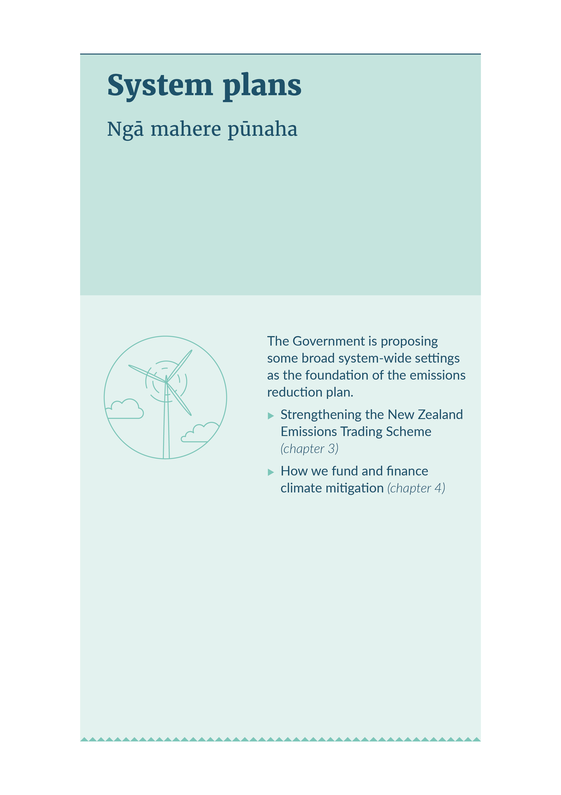
SYSTEM PLANS

3. Strengthening the New Zealand Emissions Trading Scheme

Te whakakaha i te Kaupapa Hokohoko Tukunga o Aotearoa
Summary
This chapter explains how the Government will support the New Zealand Emissions Trading Scheme (NZ ETS) to help meet the second emissions budget and net zero target. A key focus is the credibility of the NZ ETS and aligning it with the second emissions budget.

Share your views
We are seeking feedback on:
- the Government’s proposed actions to strengthen the NZ ETS
- using the NZ ETS as the primary mode for meeting the second emissions budget.

Introduction
The NZ ETS covers emissions from the following sectors, which together are responsible for about half of our emissions:
- energy
- industry
- transport
- waste
- forestry.
The NZ ETS is the best tool the Government has to reduce net emissions at least cost. The Government intends to take a market-led approach, using the NZ ETS to take an efficient, flexible and cost-effective path to net emissions reductions.
The effectiveness of the NZ ETS depends on the credibility of its market. When working properly, it will encourage greater investment to reduce emissions. Increasing investment requires investors to believe the current and future governments will remain committed to targets, maintain NZ ETS settings that are consistent with targets and reward those investments.
New Zealand will meet its second emissions budget through a mix of lower gross emissions from businesses and households (reductions) and carbon capture and storage by forestry (removals).
Figure 3.1: How the NZ ETS market works
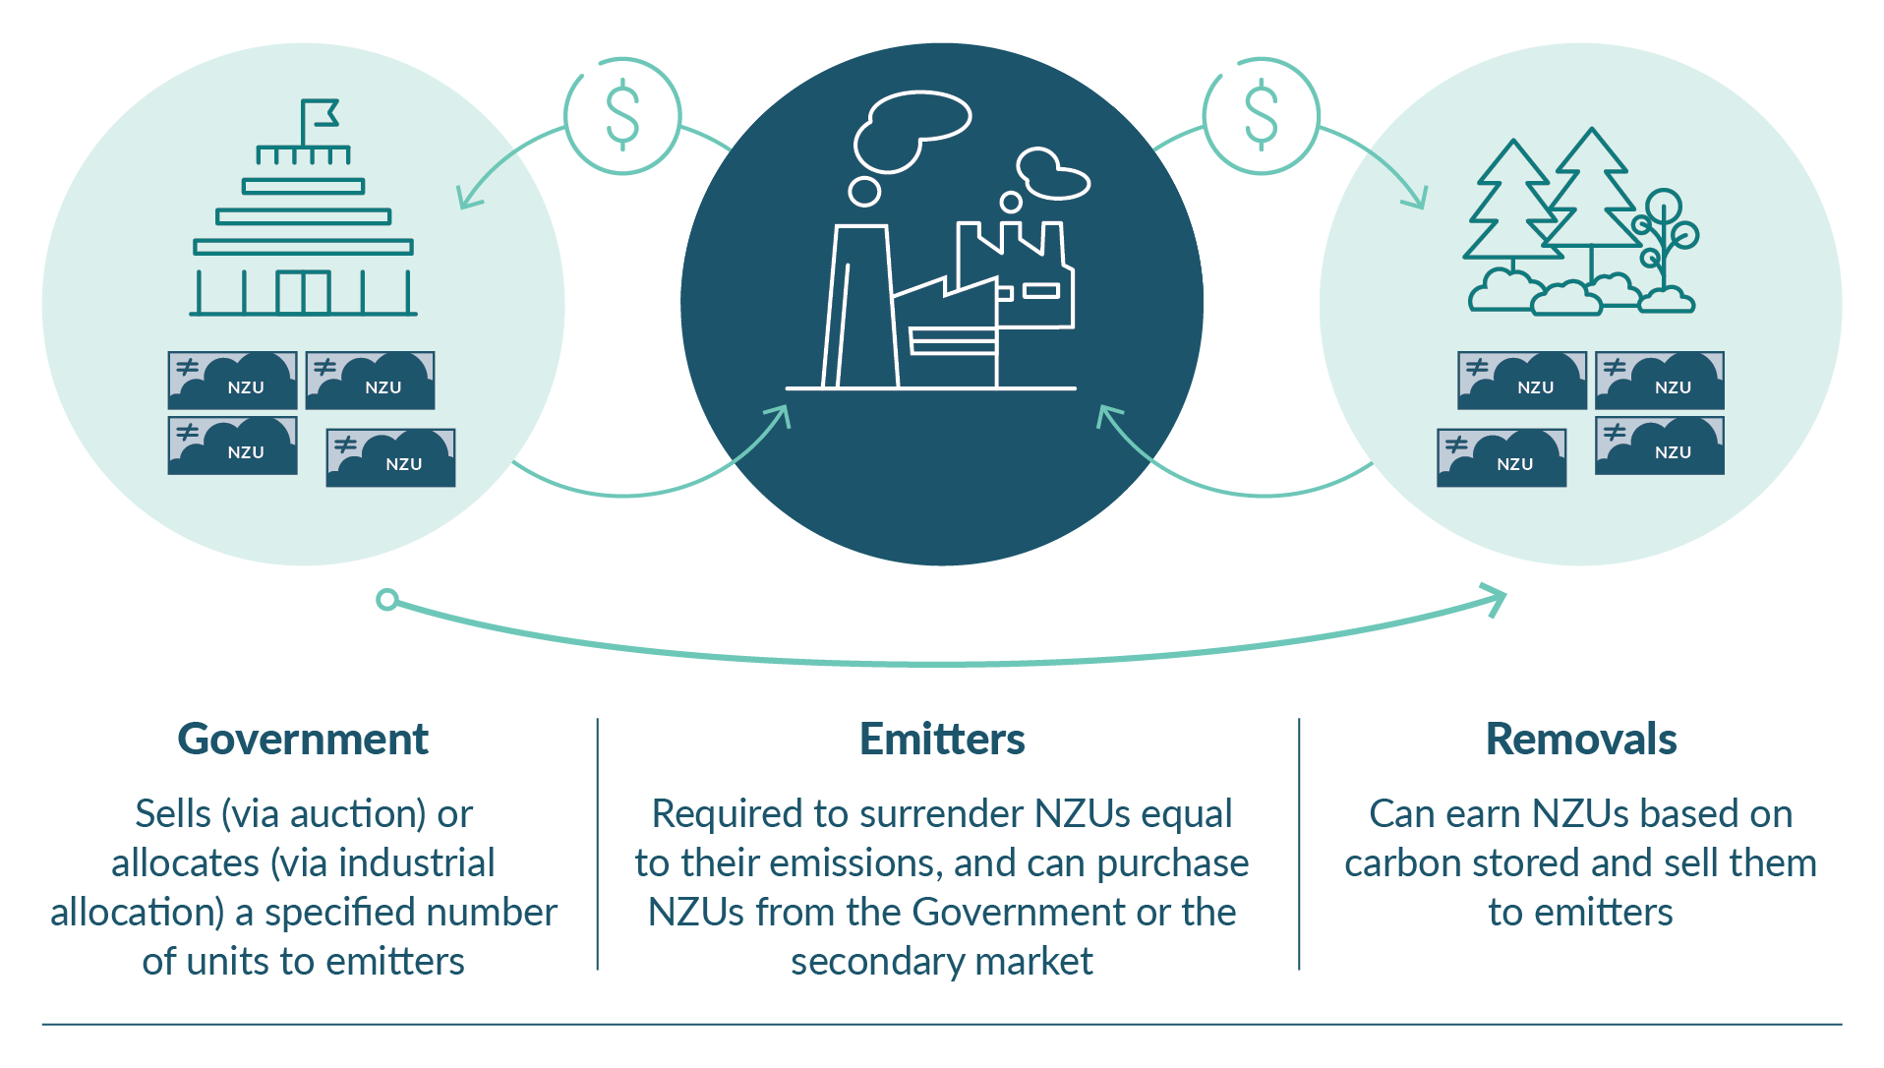
The purpose of the NZ ETS
The legislated purposes of the NZ ETS include assisting New Zealand to meet the 2050 target, its international obligations, and domestic emissions budgets.
The NZ ETS is a cap-and-trade system based on government-issued New Zealand emissions units (NZUs). Emitters must obtain and surrender NZUs to the Government at a rate of one NZU per tonne of carbon dioxide or equivalent (see figure 3.1 for an overview). There are penalties for non-compliance. The requirement to surrender units provides a cap on net emissions according to the number of NZUs the Government issues.
Emitters trade NZUs to obtain the units they need for surrender. Trade solves the problem of where to reduce emissions to bring total emissions within the cap. Emitters treat the market price of NZUs (ie, the NZ ETS price) as a cost that they add to their products. This raises the relative price of high-emissions products across the economy. Emissions fall as households and businesses switch to low-emissions alternatives. The NZ ETS also encourages investment in removals by forestry. A single carbon price supports reductions and removals at least cost.
The Government issues NZUs via auctions, industrial allocations for trade-exposed businesses, and for forestry removals. Auction and industrial allocation volumes are set to fall in line with emissions budgets.

A credible NZ ETS is crucial
The effectiveness of the NZ ETS depends on its credibility. Investors must believe governments will remain committed to targets and choose NZ ETS and other policy settings accordingly. Credibility can be measured by expectations about the current and future value of NZUs.
Actions that lower the expected future value of NZUs have a direct impact on prices in the short term. For example, proposals for vintaging (or putting an expiry date on) NZUs or removal of forestry from the NZ ETS in the (discontinued) NZ ETS review led to a significant price drop.
Credibility drives investment because returns on long-term investment in reductions and removals substantially depend on expectations about the long-term value of NZUs. For example, investment in long-term forestry substantially depends not only on the expected NZU price in the future, but also on whether the treatment of forestry removals in the NZ ETS will change.
For long-lived assets, even low-probability events can have a major impact on investment decisions. If market information suggests that a current or future government might take an action that would reduce the future value of NZUs, this could substantially dampen investment today.
Expectations about potential government actions can affect the credibility of the NZ ETS if improperly managed. These impacts need to be carefully considered as part of any future government decisions on the NZ ETS (and, where appropriate, with due consideration to grandparenting). Such decisions could include those relating to:
- continued alignment with climate change targets
- the introduction of special treatment for certain technologies within the NZ ETS
- NZ ETS price and quantity (or unit limit) settings
- the potential of other removals technologies to enter the NZ ETS
- the potential to link the NZ ETS with other countries.
Other events such as innovations in reductions or removals technologies, and the economic cycle also affect expectations. However, although these events may reduce the expected future value of NZUs, this does not affect NZ ETS credibility. Instead, price changes due to external events are updated assessments of demand for NZUs based on fundamentals.

How the Government will support a credible NZ ETS and broader market confidence
Providing regulatory predictability is a core priority for this Government. That is why one of the Government’s first actions was to end the review of the NZ ETS and why it is committed to:
- no vintaging of NZUs
- no differential treatment of forestry NZUs in the NZ ETS – one tonne of carbon dioxide equivalent (CO₂-e) emissions reduction will continue to be treated as equivalent to one tonne of carbon dioxide removed from the atmosphere.
The Government also has an important role in sending clear signals on climate and NZ ETS policy, including:
- committing to, and aligning with, climate targets and emissions budgets
- committing to the NZ ETS as the main tool and to a coherent role for complementary policies
- communicating that the Government understands why credibility is important and that protecting credibility is a priority
- communicating a credible risk management strategy, so the market understands how the Government intends to respond to demand and supply shocks
- taking consistent and coherent positions on forestry, agriculture, other removals technologies besides forestry, and the NZU stockpile
- expressly ruling out policies that threaten NZ ETS credibility.
The Government is also working to strengthen market governance. We are exploring ways to improve the transparency of market information and the integrity of the market, and to enhance participants’ understanding of how the market works. The aim is to give confidence in the market to those who are trading NZUs, and to provide good market information to support decisions on how best to reduce net emissions. Policy work is underway to inform Cabinet decisions on next steps. The Government expects to release more details on this work later in 2024.

Aligning the NZ ETS with the second emissions budget
Every year, as required by the Climate Change Response Act 2022, the Government sets the NZ ETS unit supply and price control settings (NZ ETS settings) for the next five years. This helps to give the market medium-term regulatory predictability and requires that NZ ETS settings accord with emissions budgets. This is a critical component of the Government’s plan to achieve the second emissions budget, given the central role of the NZ ETS in the mitigation strategy.
Consultation on options for the NZ ETS settings for 2025–29 took place from 15 May to 14 June 2024. Later this year, the Government will make decisions about these settings, in accordance with the budgets and targets.

The stockpile
NZUs do not expire and can be banked indefinitely before they are surrendered. The stockpile comprises NZUs issued in the past but not yet surrendered.
Banking is a valuable feature of cap-and-trade systems. It supports risk management (eg, hedging, forward contracts) and market liquidity. Over the long term, banked units should not affect the incentive to reduce emissions. A company that has a large number of banked NZUs will reduce emissions if that is less costly than surrendering more valuable NZUs, even if the company purchased the units years ago at a low price.
However, in addition to these benefits, banking carries risks. First, the ability to bank units means that control over the timing of NZU surrenders – and therefore of emissions – sits with NZU holders, not the Government. Without control of surrender timing, the Government cannot be certain of achieving time-sensitive targets, including budgets. The Government has only indirect influence over surrender timing.
The second potential risk with banking is that the existing stockpile may exceed the total emissions from sectors covered by the NZ ETS that is consistent with net zero emissions by 2050. However, a significant but uncertain number of the NZUs in the stockpile will never enter the NZ ETS market for purchase and surrender by industrial emitters. Instead, these units are held by owners of production forests registered under stock change accounting and will be surrendered back to the Government when forests are harvested to settle an emissions liability.
The Government is committed to meeting New Zealand’s emissions budgets. Upcoming decisions on NZ ETS settings are a key vehicle for the Government to manage potential risks and deliver budgets and targets in a way that protects the credibility of the NZ ETS.

Work is progressing on industrial allocation
Industrial allocation is the free allocation of NZUs to emissions-intensive and trade-exposed firms. The purpose of industrial allocations is to avoid emissions leakage by helping eligible firms meet some of their emissions costs.
The Government is updating industrial allocation settings last set in 2010. This work began in 2020 and will ensure that free allocations more accurately reflect emissions by firms receiving allocations. Allocations are designed to preserve incentives to reduce emissions, while avoiding emissions leakage. We will publish updated regulations later in 2024.

Managing impacts of the NZ ETS
The Government seeks to reduce net emissions at least cost. To manage unintended consequences that could arise from this approach, the Government intends to constrain the use of certain reductions or removals, while maintaining a least-cost strategy.
Specifically, exotic forestry is an affordable and scalable way to lower net emissions, and an essential part of reaching New Zealand’s climate targets. However, forestry competes with agriculture for land. The NZ ETS creates powerful incentives that could result in large-scale afforestation on productive farmland and whole-farm conversions. To manage this risk, the Government intends to introduce limits on the entry of new forests into the NZ ETS on productive farmland. Existing forests already in the NZ ETS will not be affected.
The NZ ETS will continue to optimise for least-cost reductions and removals, subject to the constraint on exotic forests planted on productive farmland entering the NZ ETS.
The Government also acknowledges that significant exotic afforestation can present other environmental risks that need to be managed. We can use forests to strengthen landscapes to adapt to climate change but, if managed the wrong way, they can also pose a risk to communities, biodiversity and infrastructure through severe weather impacts.

Complementary policies
Although the NZ ETS is the Government’s main tool for reducing emissions, there is a place for complementary policies. These play the largest part in sectors not covered by the NZ ETS, but also can be used in sectors within the NZ ETS.
Substitution policies can drive emissions reductions that displace more cost-effective reductions that would have otherwise occurred due to the NZ ETS. This would not meaningfully lower emissions over the long term, and simply buy emissions out of the system. Without lowering the NZ ETS cap, this would allow emissions to increase in other areas.
Alongside the NZ ETS, complementary policies can contribute to a least-cost approach. Such interventions are cost-efficient when they reduce the overall costs of emissions reduction by unlocking low-cost abatement in areas where the NZ ETS impact is limited. Chapters 5–10 outline these policies.

Removals, the NZ ETS and meeting our long-term targets
There is a risk that from the mid-2030s onwards, the NZ ETS may not encourage enough reductions or removals to achieve and sustain net zero for subsequent years (figure 3.2). This risk arises because:
- a significant amount (about 7.5 Mt CO2-e per year or 20 per cent) of long-lived emissions (eg, agricultural nitrous oxide) will remain outside the NZ ETS
- under current settings, some industrial allocation recipients will continue receiving some NZUs for free beyond 2050.
This issue would not affect the second emissions budget, but it is important for future budgets and the net zero target. Work to reduce agricultural emissions may need to be geared to addressing the risk to our net zero target. Chapter 7 has more information on the work to reduce agricultural emissions. The Government will also investigate options to create durable incentives for forestry removals outside the NZ ETS, in addition to existing NZ ETS incentives.
The Government is also considering ways to encourage other forms of removal, for example wetland restoration and coastal vegetation management (see chapter 9).
Figure 3.2: The risk that the NZ ETS alone does not encourage enough removals to achieve net zero by 2050
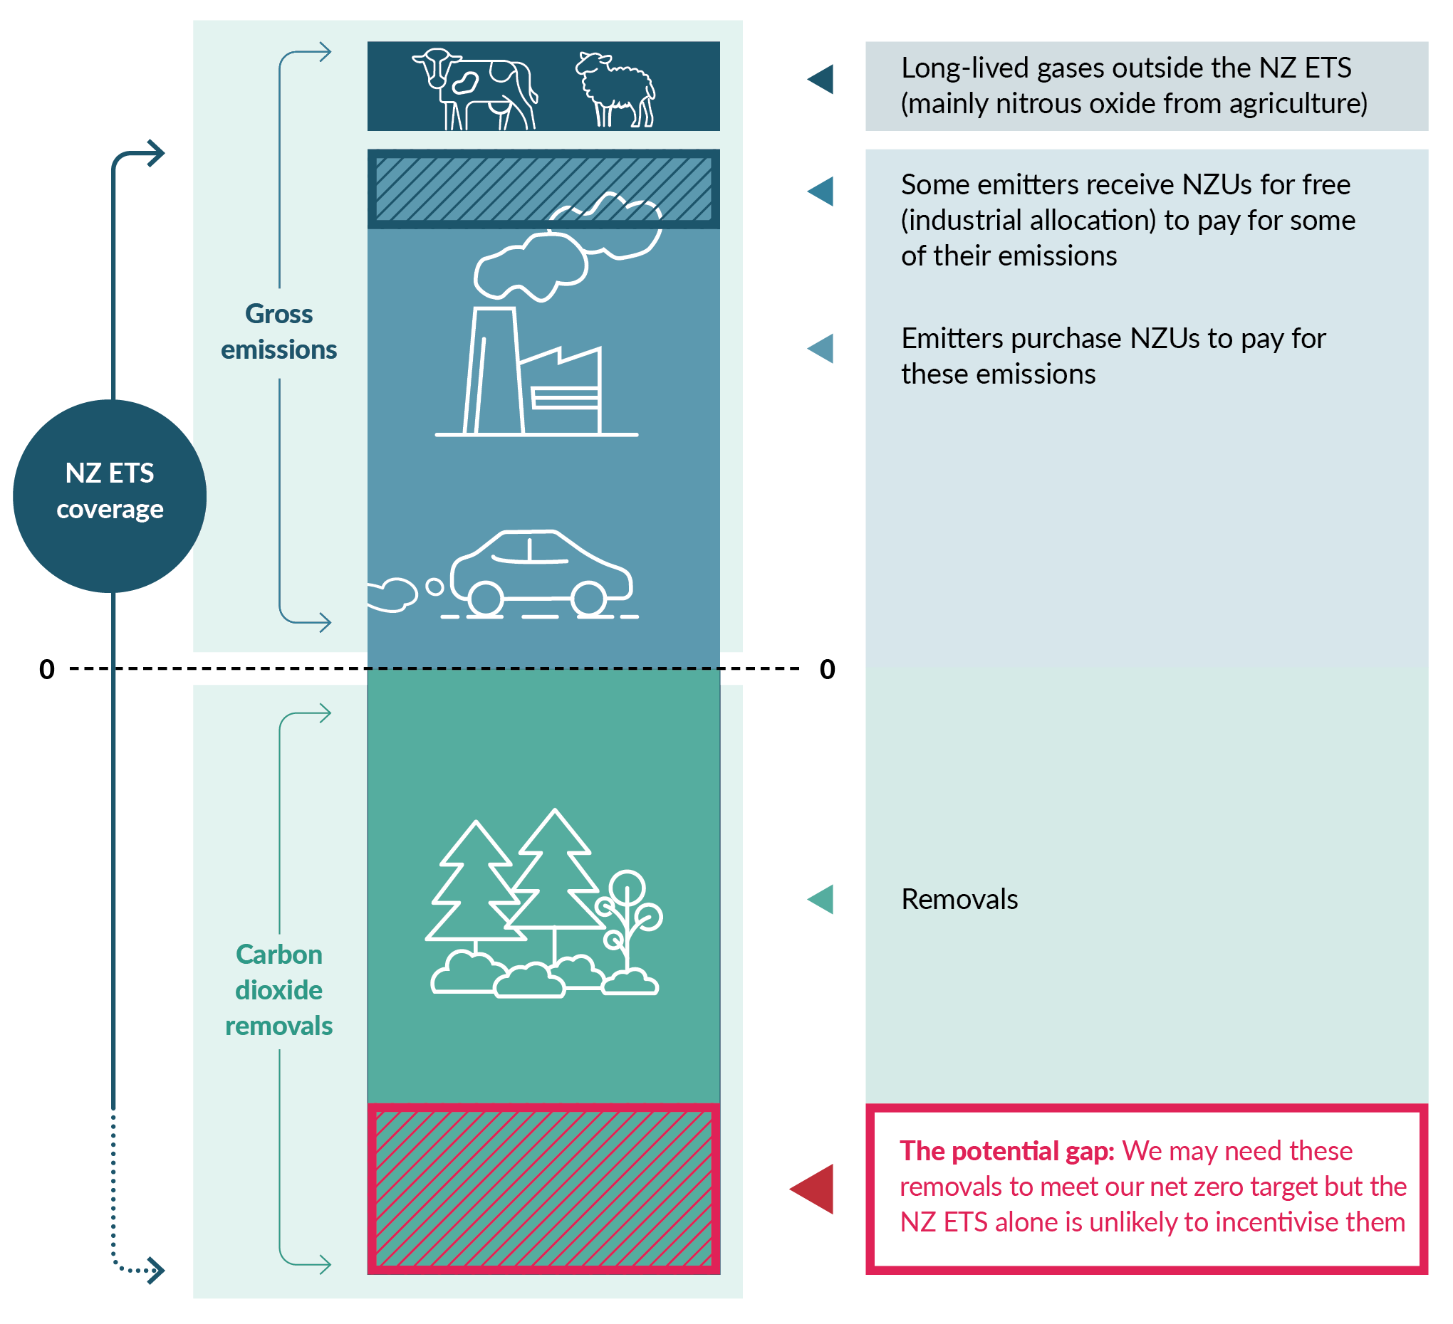

The NZ ETS and the cost of living
Delivering commitments on climate change targets has costs. The Government’s approach and priority is to make the transition and meet our targets in the most cost-effective and least-cost way: by placing the NZ ETS at the centre and enabling the market to pursue a least-cost pathway.
However, the Government acknowledges that the NZ ETS affects the cost of living and of doing business. Emissions pricing disproportionately affects lower socio-economic groups.
Chapter 12 includes more information on how the Government plans to manage the impacts of emissions pricing and other climate change policies.

Chapter 3 consultation questions
3.1 | What else can the Government do to support NZ ETS market credibility and ensure the NZ ETS continues to help us to meet our targets and stay within budgets?
3.2 | What are the potential risks of using the NZ ETS as a key tool to reduce emissions?
3.3 | How can the Government manage these risks of using the NZ ETS as the key lever to reduce emissions?
3.4 | Do you support or not support the Government’s approach of looking at other ways to create incentives for carbon dioxide removals from forestry, in addition to using the NZ ETS?
3.5 | Apart from the NZ ETS, what three other main incentives could the Government use to encourage removals through forestry?
3.6 | Please provide any additional feedback on the Government’s thinking about how to use the NZ ETS to reduce emissions.

4. How we fund and finance climate mitigation

Te pēhea tā mātou tuku me te whakapau pūtea ki te whakamauru panoni āhuarangi
Summary
This chapter outlines how the Government proposes to better support private investment in reducing emissions. Work is underway across government to understand the barriers to green investment in New Zealand, and to identify options to address them. Through the second emissions reduction plan (ERP2), we will signal our approach to scaling private investment.

Introduction
Significant domestic investment in low-emissions services and technologies will be needed to achieve our climate goals. Adapting to the impacts of climate change will also require investment, such as in our infrastructure and built environment and in New Zealand’s unique natural environment.
While we expect this investment to come primarily from the private sector, the Government has a role in addressing barriers to such investment and ensuring the settings are right to enable it. Enabling greater private investment in low-emissions activities, along with its associated expertise, efficiencies and innovation, is critical to reach New Zealand’s targets, including our second emissions budget.
There is growing global demand for ‘green’ investment (see box), and new opportunities are emerging. For example, major banks are now offering a range of new sustainable lending products. However, there are opportunities to scale up green investment further.
What is green investment?
‘Green investment’ refers to financial activities that aim to generate a positive environmental impact alongside financial returns. This typically involves directing capital towards projects, companies or initiatives focused on activities such as renewable energy or resource efficiency.
Examples of green investment products include New Zealand’s Sovereign Green Bond Programme and ‘green business’ loans offered by banks.

Work is underway to unlock private investment
Addressing investment barriers is a priority for the Government, and we are working to enable greater private investment in climate mitigation.
The New Zealand Emissions Trading Scheme (NZ ETS) is our main tool for pricing and reducing net emissions. It aims to incentivise private investment in reducing emissions and removing carbon. Current and expected future NZ ETS prices help inform today’s investment decisions; these will be key to reaching our targets.
However, to invest confidently, market participants need not only clear and robust incentives, but also good information and a strong understanding of opportunities and risks.
To support confident investment, we are:
- working in partnership with the finance sector and industry to develop a sustainable finance taxonomy (a ‘rulebook’ for defining what is green)
- bringing in the mandatory climate-related disclosures regime
- exploring collaboration with the Australian Government on coherent and aligned regulatory frameworks for sustainable finance.

Scaling green investment
Climate change is a key driver of losses in nature and biodiversity. These natural assets and services play a vital role in mitigation and adaptation.
Green investment is beginning to pivot from a sole focus on mitigation to broader environmental activities and outcomes (eg, indigenous biodiversity). Voluntary carbon and biodiversity credits markets are emerging to meet this demand. However, we have heard that market participants, including investors and landowners, need greater certainty and confidence to boost participation and scale up investment.
New Zealand needs the right settings to unlock private investment in carbon and biodiversity markets. The settings include consistent rules aligned with best international practice, and markets that are accessible to landowners. These measures can help New Zealand domestic-focused and export businesses maintain access to high-value export markets. They can also increase climate awareness and scrutiny among New Zealand consumers.
Work underway, such as on the sustainable finance taxonomy, can unlock more investment and confidence in voluntary carbon and biodiversity credits markets. However, we intend to work further with the private sector to find other ways to unlock investment potential in these markets. This may include considering the accessibility and governance of the markets to ensure they are operating cost-effectively and with integrity.

We want to better understand the barriers to investment …
The market for green and transitional (ie, moving towards green) investment in New Zealand is in its early stages. This can mean higher perceived risk, less evidence of profitability and a smaller pool of investors. There are also signs that investable New Zealand green projects are in short supply.
The nature of this market may lead to a mismatch between climate investment opportunities at the right size, in the right timeframe and with the right risk profile for many investors, resulting in businesses investing in offshore green projects. However, we are seeking evidence to better understand whether this remains the case in New Zealand.
We understand the barriers may include:
- a lack of data and evidence about climate risks and opportunities
- high upfront costs and mismatched time horizons for many reduction technologies, infrastructure and nature-positive projects
- policy uncertainty and regulatory barriers.

… and what we can do to remove them
We would like to test which barriers are a priority to address through ERP2 and implement in the next 18 months, for optimal impact on the flow of private investment.
The Government is already addressing barriers to climate-aligned investment. However, there may be opportunities to scale up our efforts further. We would like to understand the additional actions we could take now as part of ERP2.
The following are some ways of doing this that we have identified.
- Improve investor confidence in green investments through measures to reduce real or perceived risks, such as supporting improved data and evidence, further transparency, market integrity via guidance and monitoring, and capability building and technical assistance.
- Work with the private sector to identify barriers and develop solutions to increase the ease of investing in green activities.
- Support the private sector to better integrate climate factors into financial decision-making. This will help ensure that material climate risks and opportunities are being considered routinely and strategically to guide business and investment decisions.
- Reduce investment friction and support access to a wider pool of finance. This includes harmonising standards with other countries (eg, cooperation with Australia) to remove barriers to finance flowing across borders.
- Identify and develop sector-based transition pathways. This includes identifying where specific barriers are required for a sector that can be addressed.
- Improve options for and increase uptake of infrastructure financing tools. Many of these tools could play a role in driving down emissions and strengthening resilience (eg, by attracting private investment in electric vehicle charging infrastructure).
The Government plans to work with the private sector to identify priority actions that will make a meaningful difference in releasing private investment and the supply of investable projects.
Share your views
We are seeking your feedback on which actions should be a priority and why. Insights from this consultation will inform the shape and nature of future work to release investment in mitigation and adaptation.

Chapter 4 consultation questions
4.1 | Do current measures work well to unlock private investment in climate mitigation?
4.2 | What are the three main barriers to enabling more private investment in climate mitigation?
4.3 | What are the three main actions the Government can do to enable more private investment in climate mitigation for the next 18 months?
4.4 | What are the three main things the Government can do to enable more private investment in climate mitigation in the longer term (beyond the next 18 months)?
4.5 | Please provide any additional feedback on the Government’s thinking about how to enable more private investment in climate mitigation for the next 18 months.

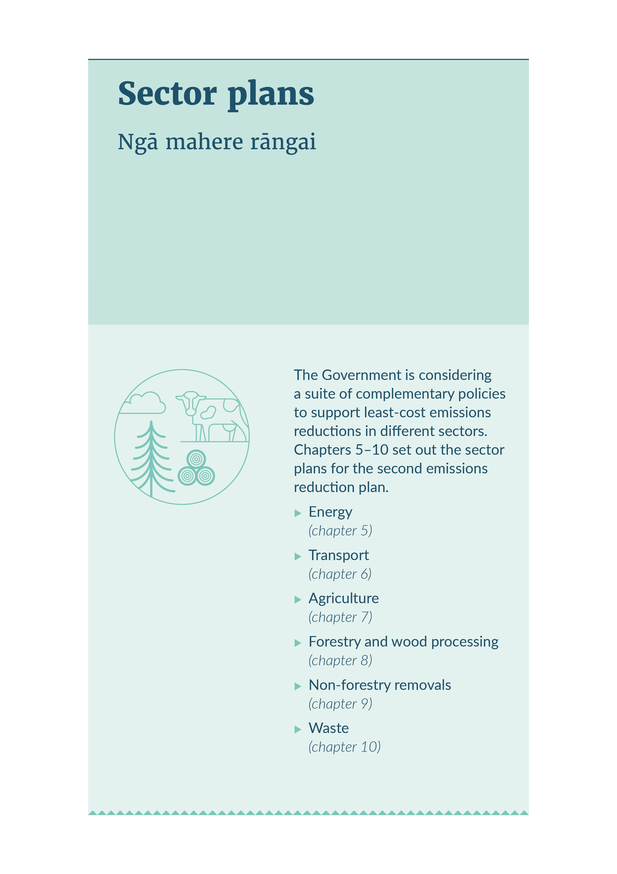
SECTOR PLANS

5. Energy

Te pūngao

Energy sector at a glance

 | Annual emissions | - 2022: 15 Mt CO₂-e  - 2030 (projected): 12–15 Mt CO₂-e  - 2050 (projected): 6–13 Mt CO₂-e
 | Pillars of the strategy | - Clean energy is abundant and affordable.  - Credible markets support the climate transition.
 | Why this sector is important | - New Zealand has abundant renewable energy potential. Harnessing this will help meet our emissions budgets, reduce our dependency on imported fuels and support the reliability and affordability of the energy system.
 | What we’re doing now | - Enabling an acceleration in renewable generation and electricity networks by removing red tape.
 | What’s coming | - Renewable energy will double by 2050.  - A smarter electricity system which gives consumers the ability to change how and when they use power.
 | What this means for New Zealanders | - Over the longer-term households heat their homes more affordably, with renewable energy.  - People charge their electric vehicles easily across the country.  - Renewable energy providers have confidence to invest, enabling them to grow their operations and meet increasing demand.  - Businesses have opportunities to choose cost-effective, low-emissions technologies.

Introduction
Affordable, secure energy is a crucial part of the Government’s plans to reduce emissions. Compared with many other countries, New Zealand’s energy supply is reliable, affordable and highly renewable.
Our electricity system is world-class. Electricity is expected to become even more renewable over the coming decade, with renewable sources making up most of the investment pipeline. New Zealand’s clean, green electricity means electrification is a major pathway for lower emissions across the economy. Electrification depends on affordable and secure electricity. Natural gas will continue to play a role in keeping electricity affordable and secure, leading to lower emissions and a productive, growing economy.
Share your views
We are seeking your feedback on:
- the impacts of the proposed actions
- any other barriers to private investment in decarbonising energy use.

Emissions profile
Emissions from energy use make up 37 per cent of New Zealand’s gross emissions. This includes 17.5 per cent from energy used for transport. Figure 5.1 shows the makeup of emissions from the energy sector and the industrial processes and product use sector. Within these sectors, the sources making the largest individual contributions are vehicles and energy use in buildings. In the second emissions budget period, we expect reductions in energy emissions to come mainly from increased electrification and from energy efficiency in light transport and process heat.
Figure 5.1: New Zealand’s emissions from the energy sector and industrial processes and product use sector, 2022
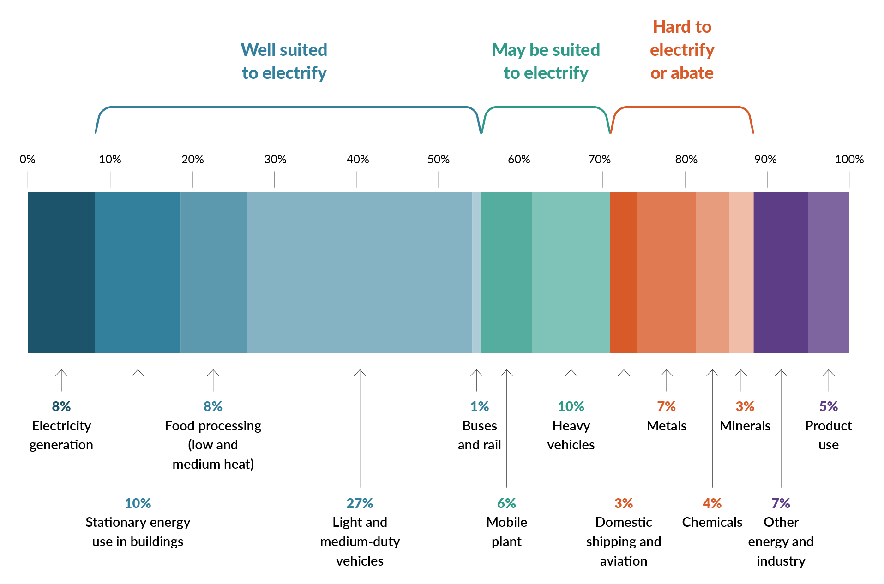
In 2022, electricity generation accounted for about 10 per cent of New Zealand’s total greenhouse gas emissions and 8 per cent of energy emissions. Figure 5.2 shows that the electricity system has a high share of renewable generation (hydroelectric, geothermal and wind), with only 15.5 per cent coming from non-renewable sources (natural gas, coal and other) in 2022.
Figure 5.2: Electricity generation sources, 2022
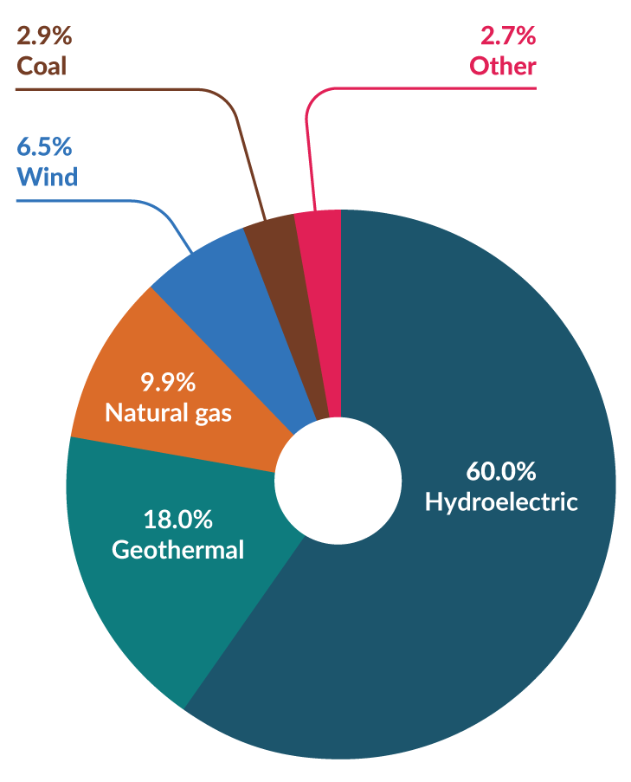
See the Ministry of Business, Innovation and Employment (MBIE) website for more information about energy sector governance and how our electricity system works.

Proposed approach to reducing energy emissions

Role of government
The Government is committed to providing the regulatory certainty and a credible, level playing field to enable private investment in energy. It will take significant investment to meet expected demand for energy and achieve our goals. New Zealand needs investment in generation, transmission and local lines. Advancing technologies will bring new ways for energy users to save money and reduce emissions.
Globally, New Zealand is unusual in not subsidising renewables. Renewable energy competes with fossil fuels, in part due to its abundance and because emissions pricing improves its competitiveness. Most of the known investment pipeline is green (largely solar and onshore wind, with some geothermal).

New Zealand Emissions Trading Scheme
Emissions from our energy system are covered by the New Zealand Emissions Trading Scheme (NZ ETS). The scheme encourages net emissions reductions in the energy sector. The emissions price flows through into the price of energy sources that create emissions when they are produced or used, such as electricity, gas, diesel, petrol and coal.
Energy emissions are in the NZ ETS cap, which limits the degree to which enabling energy policies directly reduce the quantity of net emissions beyond the short run. For example, subsidising a low-emissions technology would displace more cost-effective reductions that would have otherwise occurred due to the NZ ETS. Instead, we are focused on complementary policies that support a least-cost approach by expanding the opportunities to reduce emissions in an affordable way. For example, reducing the time and cost of consents for wind farms is intended to increase the competitiveness of wind generation and to encourage investment.
The role of complementary policies under an emissions cap is to unlock low-cost abatement in areas where the NZ ETS has limited impact by:
- removing unnecessary barriers to investment in low-emissions technologies
- resolving market failures, for example by investing in innovation and research and development (R&D), while providing regulatory certainty for private investment.
Chapter 3 outlines the role of the NZ ETS in incentivising net reductions.

Maintaining a secure, affordable supply
Energy security and affordability are under pressure. Our gas reserves are declining, which has contributed to tight conditions in the electricity market. Insecure or expensive energy will increase living costs for New Zealanders and harm our productivity. It will also undermine our progress towards our targets – end users will not have the confidence to switch to electric technologies without reliable, affordable electricity.
Energy security depends on attracting investment in all forms of energy. To enable investment, we need stable and credible system-wide settings. The Government’s role is to provide certainty for the private investment that maintains a secure supply of energy.

Reconciling investment in gas with lower emissions
We expect that as consumers switch to renewable energy, the demand for gas will reduce over time. Nonetheless, gas will be needed through the transition. The electricity system currently relies on gas and a limited amount of coal to meet peak demand in winter and to cover dry years. Gas and coal are substitutes, particularly for electricity generation. Insufficient gas supply could result in New Zealand burning more coal to keep the lights on, with greater emissions from electricity generation.

Electrify NZ is a pillar of the second emissions reduction plan

Investment in electricity generation and infrastructure
New Zealand’s high share of renewables means that electricity is a low-emissions alternative to fossil fuels. Demand for electricity is expected to rise significantly by 2050 as electric technologies become more widely adopted (figure 5.3). This increase in demand will significantly outpace the demand growth seen in previous decades. Renewable generation capacity must be ready to meet this demand.
Figure 5.3: Historical and forecast electricity demand, 2000–50
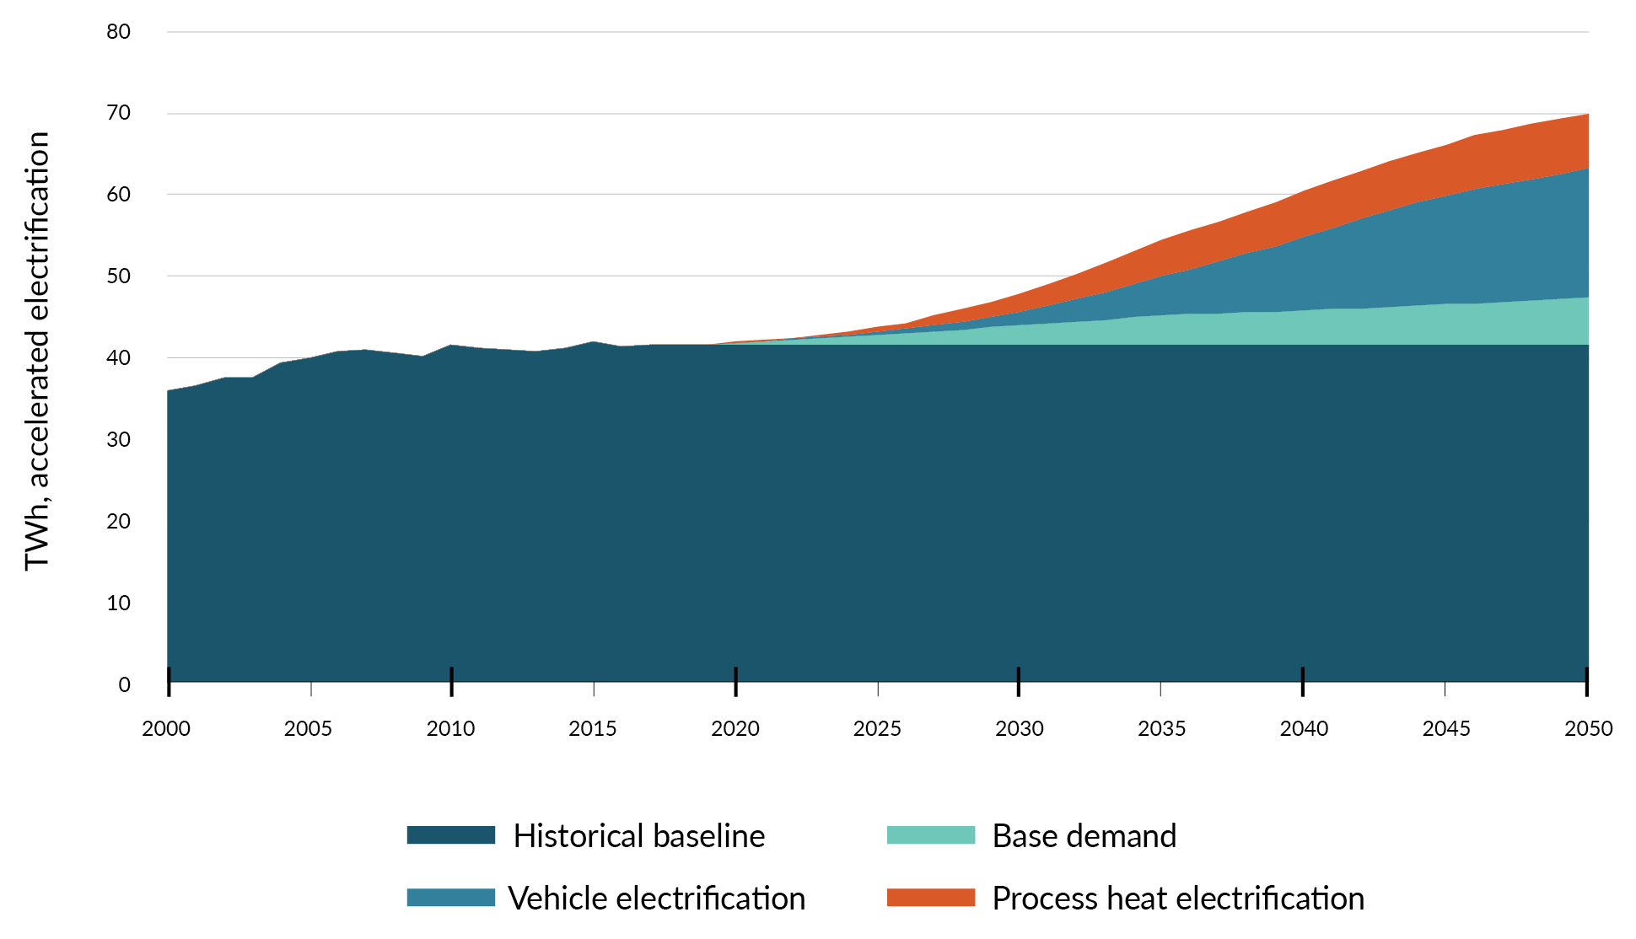
Note: TWh = terawatt hours
Source: Adapted from Transpower. Whakamama i te Mauri Hiko: Empowering our energy future. Retrieved 29 June 2024.
Using currently untapped renewable energy sources, such as offshore wind, could be necessary to increase generation capacity. However, this will depend on overall demand and availability of onshore resources. New Zealand has world-leading offshore wind generation potential; taking advantage of this could contribute to reaching our emissions targets. However, the timeframe required for offshore wind to become economic in New Zealand is currently uncertain. The Government expects offshore renewable energy projects to compete on the same commercial basis as other forms of electricity generation.
We also need to enable significant and timely new investments in electricity transmission and distribution infrastructure. This will be critical for the reliability of our grid, particularly in a changing climate. An estimated $100 billion of investment is needed by 2050 just to build and maintain electricity transmission and distribution infrastructure.

Electrify NZ
The Government has committed to doubling renewable energy by 2050 and can enable investment by removing barriers and resolving market failures that prevent or slow investment in infrastructure needed for electrification. Electrify NZ’s focus on removing red tape will support private investment to enable the generation and networks required to achieve this. Details on the Electrify NZ work programme are expected to be announced soon.

Enabling end-users to electrify
If consumers are to electrify and reduce emissions, we must significantly increase the supply of renewable electricity. For instance, new renewable generation and transmission will support the electrification of transport, including through the Government’s work on supercharging EV infrastructure (see also chapter 6).
Industry, businesses and households need a secure and affordable electricity supply to choose to switch to electric technologies, including electric boilers, vehicles and heat pumps. At the same time, more efficient use of electricity and greater deployment of smart devices over time will maximise existing renewable generation and reduce the need for future upgrades of electricity generation and networks. This can help reduce the need for coal and gas to meet peak demand.
The Government has work underway in the following areas.
- Ensure security of New Zealand’s electricity supply.
- Develop an enabling environment for investment in gas production, including through enabling carbon capture, utilisation and storage to improve the investment climate for gas supply while lowering emissions.
- Mitigate the impact of severe weather on energy infrastructure, including through amended rules about how close trees can grow to power lines.
- Enable the development of new fuels and technologies, including through work to improve market access for grid-scale batteries and demand-response.
- Promote the affordability of New Zealand’s electricity supply.
- The Electricity Authority will lead work to ensure electricity markets are as efficient as possible, to get the best price for consumers.
- Develop an enabling environment for innovation to create a least-cost transition and give consumers new ways to save.
- Minimise the impacts on those least able to pay, including through continued support for the successful Warmer Kiwi Homes programme.
- Enable energy efficiency and a smarter electricity system.
- Explore ways to strengthen New Zealand’s energy efficiency and demand flexibility regulatory regime. This could enhance the effectiveness in how New Zealand regulates energy using products, services and systems, including EV chargers. It could also enable the private sector to seek efficiencies in their energy use.
- Progress amendments to the Energy Efficiency and Conservation Act 2000 to enable standards to be set for devices with capability for demand flexibility, including EV smart chargers. This will support the uptake of EV smart charging in New Zealand and improve consumers’ capability to shift demand for home EV charging away from network peaks.
- Explore further innovation in tariff design (such as feed-in-tariffs for rooftop solar and battery systems) and wider tariff innovations that could enhance uptake of household battery systems and encourage businesses and households to change how and when they use electricity. This will include work led by the Electricity Authority.
Share your views
We are seeking your views on how these actions will support users to switch the way they use energy. This will help us understand the likely impact of the actions on reducing emissions.

Other policies for meeting the second emissions budget

Natural gas
Gas contributes around 9 per cent of New Zealand’s electricity generation and 17 per cent of our total energy supply. It provides energy for industry, commerce and public use, and is also a raw material in the production of methanol and urea. Gas-fired generation keeps electricity affordable and secure, which in turn supports electrification. Gas can also reduce our reliance on coal, which has twice the emissions impact of gas.
The Government has work underway to improve the security of supply for gas and to enable opportunities to reduce emissions from producing and using gas.
- Enable carbon capture, utilisation and storage (CCUS). The Government is consulting on options to remove barriers to employing CCUS. The consultation will focus on reducing regulatory barriers and managing risks for long-term storage. CCUS has the potential to reduce emissions from gas production as well as offer carbon sequestration opportunities for other high carbon dioxide emitters. CCUS is already being used in the geothermal industry. An enabling regulatory regime will provide other hard-to-abate sectors with an opportunity to reduce their emissions.
- Enable renewable gases. Enabling the use of biomethane and hydrogen to replace natural gas provides an opportunity to improve the security of our energy supply through diversifying fuels. Using lower emissions alternatives will also reduce emissions. The Government is exploring what measures are needed to increase the uptake of renewable gases.

Geothermal energy
The Government sees geothermal energy playing an important role in the decarbonisation of New Zealand’s energy system and in process heat. Opportunities to enable greater investment in geothermal could be explored as part of the second emissions reduction plan.

Bioenergy
Bioenergy can reduce emissions in process heat, power generation, and producing chemicals and fuels like sustainable aviation fuels (SAF; see more below). Supply of bioenergy is a key constraint, and in some regions could be outstripped by demand in the future.
The Government is supporting markets by providing information. The Energy Efficiency and Conservation Authority (EECA) is publishing insights to support collaboration between demand-side and supply-side stakeholders. Through the Regional Energy Transition Accelerator programme, this work will inform private sector fuel-switching investments in the regions.

Enabling future emissions budgets
For some sectors and activities, electrification is not currently possible or practical, or is very expensive to implement. Hard-to-abate activities account for 17 per cent of energy and industry emissions, or 7 per cent of total gross emissions. Activities where other low-emissions fuels or carbon capture technologies are currently better suited than electrification are concentrated in heavy transport and industry, as well as ‘firming’ electricity generation that can be dispatched when the wind is not blowing and the sun is not shining.
The Government is enabling private investment in low-emissions fuels and the additional electricity we will need to produce them. It is also supporting R&D that can bring down the cost of future abatement.

Hydrogen
Hydrogen is being trialled and demonstrated as a low-emissions alternative in heavy industry, heavy and specialty transport, production of green fuels (see below) and power generation. It is not expected to play a significant role in meeting the second emissions budget, but near-term action in this area could help to reduce emissions in later budgets.
The Government aims to support private investment in hydrogen. Since the first emissions reduction plan, MBIE has published and consulted on an Interim Hydrogen Roadmap and plans to release an update by the end of 2024. MBIE has also progressed work to understand regulatory barriers to the uptake of hydrogen. The Government is exploring the potential for collaboration with the private sector through an industry-led leadership group to support development of the hydrogen sector. It will use its country-to-country relationships to signal that New Zealand is open for hydrogen investment and export.
The Government is also creating a more enabling consenting pathway for hydrogen products. Hydrogen projects will benefit from Electrify NZ’s work to remove barriers that prevent or slow investment in infrastructure needed for electrification.

Sustainable aviation
Sustainable fuels are needed to decarbonise the planes that carry passengers and goods to, from and around New Zealand.
The Government has funded feasibility studies with the private sector to explore domestic supply chains of alternative jet fuel options. Air New Zealand and MBIE are funding two studies investigating the feasibility of establishing SAF plants domestically, using woody biomass (forestry slash) and municipal solid waste. EECA has also contributed funding for a feasibility study in producing SAF from green hydrogen at Marsden Point, undertaken by Fortescue Future Industries and Channel Infrastructure.
The Government is also considering other ways hydrogen could help decarbonise heavy transport and aviation.

Offshore wind
New Zealand has world-class potential for offshore renewable energy. This source of energy could play a role in meeting future energy demand beyond 2030, particularly if New Zealand produces substantial amounts of hydrogen or electro-synthetic fuels (e-fuels). The Government is supporting private investment in offshore renewable energy by establishing a regulatory framework. The legislation is due to be introduced to Parliament by the end of 2024.

Research and development
New Zealand will need new technologies and processes such as smart meters, fuel cells and new processes to develop industrial goods. A range of government science and innovation programmes supports lowering emissions, including MBIE’s science funds (Endeavour and Catalyst), EECA’s Low Emissions Transport Fund and Callaghan Innovation funding.

Building and construction
The Government intends to support green building practices in New Zealand, and work to establish a clearer picture of this is underway. We’re interested in exploring this topic further as part of ERP2.

Impact on emissions
Actions to enable electrification are the main way the Government proposes to support the NZ ETS to incentivise emissions reductions from energy use in the second emissions budget.
Through this consultation, we are seeking information to better understand and model the emissions impact of policies outlined in Electrify NZ.
Share your views
We are particularly keen to hear from electricity generators on how Electrify NZ:
- could affect the build of projects already in the pipeline
- could lead to additional projects, not currently in the pipeline, being investigated
- see the technical annex for more information on the intervention logic and preliminary emissions reduction estimates for Electrify NZ.
Actions to enable uptake of low-emissions fuels and carbon-capture technology could reduce emissions in the second emissions budget and will reduce the long-term cost of addressing hard-to-abate emissions by enabling markets to choose from a wider range of technologies.
Some emissions impact is possible over the next five years depending on private investment decisions. However, we expect greater impact over the long run as supply chains develop for these technologies and fuels.
Share your views
We are seeking information to better understand the impact of policies to enable the uptake of low-emissions fuels and carbon-capture technology outlined in this chapter. More information on the intervention logic and draft emissions reduction estimates for policies to enable CCUS is provided in the technical annex.

Impacts on iwi and Māori
Iwi and hapū have rights and interests in their rohe (region, district) and in marine areas that could be affected by renewable generation developments – both onshore and offshore. Policies must be designed to:
- understand and respond to the circumstances of Māori
- continue to enable Māori to participate in, and benefit from, the opportunities that electricity and other low-emissions fuels bring.

Chapter 5 consultation questions
5.1 | What three main barriers/challenges that are not addressed in this chapter do businesses face related to investing in renewable electricity supply (generation and network infrastructure)?
5.2 | How much will the Government’s approach to driving investment in renewable energy support businesses to switch their energy use during 2026–30 (the second emissions budget period)?
5.3 | What three main barriers/challenges do businesses and households face related to electrifying or improving energy efficiency, in addition to those already covered in the discussion document?
5.4 | How much will existing policies support private investment in low-emissions fuels and carbon-capture technologies?
5.5 | What three main additional actions could the Government do to enable businesses to take up low-emissions fuels and carbon-capture technology?
5.6 | If you are an electricity generator, please explain and/or provide evidence of how Electrify NZ could affect projects already planned or underway.
5.7 | If you are an electricity generator, please explain and/or provide evidence of how Electrify NZ could increase the likelihood that new projects will be investigated.
5.8 | Please provide any additional feedback on the Government’s proposals to reduce emissions in the energy sector and the industrial processes and product use sector.

6. Transport

Te tūnuku

Transport sector at a glance

 | Annual emissions | - 2022: 13.6 Mt CO₂-e  - 2030 (projected): 11–16 Mt CO₂-e  - 2050 (projected): 3–11 Mt CO₂-e
 | Pillars of the strategy | - Clean energy is abundant and affordable.  - Credible markets support the climate transition.
 | Why this sector is important | - The transport system is critical to economic growth and productivity. New Zealand is in a strong position to decarbonise transport through electrification.  - Making clean energy accessible and enabling electric vehicle (EV) uptake via improved charging infrastructure will remove some non-market barriers to uptake.
 | What we’re doing now | - We are reviewing the Clean Car Importer Standard to ensure it is effective and achievable.  - We are working with businesses through Sustainable Aviation Aotearoa to understand the barriers to decarbonising aviation.
 | What’s coming | - We will enable a network of 10,000 public EV charging points by 2030 and facilitate private investment in EV charging infrastructure.  - We will review regulatory barriers to decarbonising heavy vehicles.  - We will work with other countries on sustainable aviation fuels and low- and zero-carbon shipping on key trade routes by 2035.  - We will support public transport in our main cities.
 | What this means for New Zealanders | - People can charge their EVs easily across the county.

Introduction
Electrifying the light and heavy vehicle fleets can contribute to reducing transport emissions and help us reach and sustain net zero emissions in the context of a market-led approach under the New Zealand Emissions Trading Scheme (NZ ETS).
Given New Zealand’s already high levels of renewable energy, we are in an excellent position to electrify many sources of transport emissions. By accelerating the rollout of EV chargers, we can address a key barrier to electrifying the vehicle fleet.
To enable the use of low-emissions fuel sources in the aviation and maritime sectors, we will need to work with other countries and industry to consider regulatory barriers and ensure New Zealand’s interests are represented appropriately on the international stage.

Emissions profile
Transport is responsible for 17.5 per cent of New Zealand’s gross greenhouse gas emissions. Road transport, in particular, is responsible for 15.9 per cent of national emissions. Among industrially developed countries, New Zealand has the fifth-highest per-capita transport emissions. The sector’s emissions increased by 68 per cent from 1990 to 2022. This was largely driven by the growth in our population and economic activity.
The light vehicle fleet – typically cars and other vehicles for personal use – is responsible for 63 per cent of transport emissions. The heavy vehicle fleet – typically medium and heavy trucks – is responsible for 28 per cent.
The remaining 9 per cent comes from domestic aviation (7.5 per cent), rail (0.9 per cent) and domestic shipping and pipeline (0.7 per cent) (figure 6.1).
Figure 6.1: Transport emissions by transport type, as at December 2022
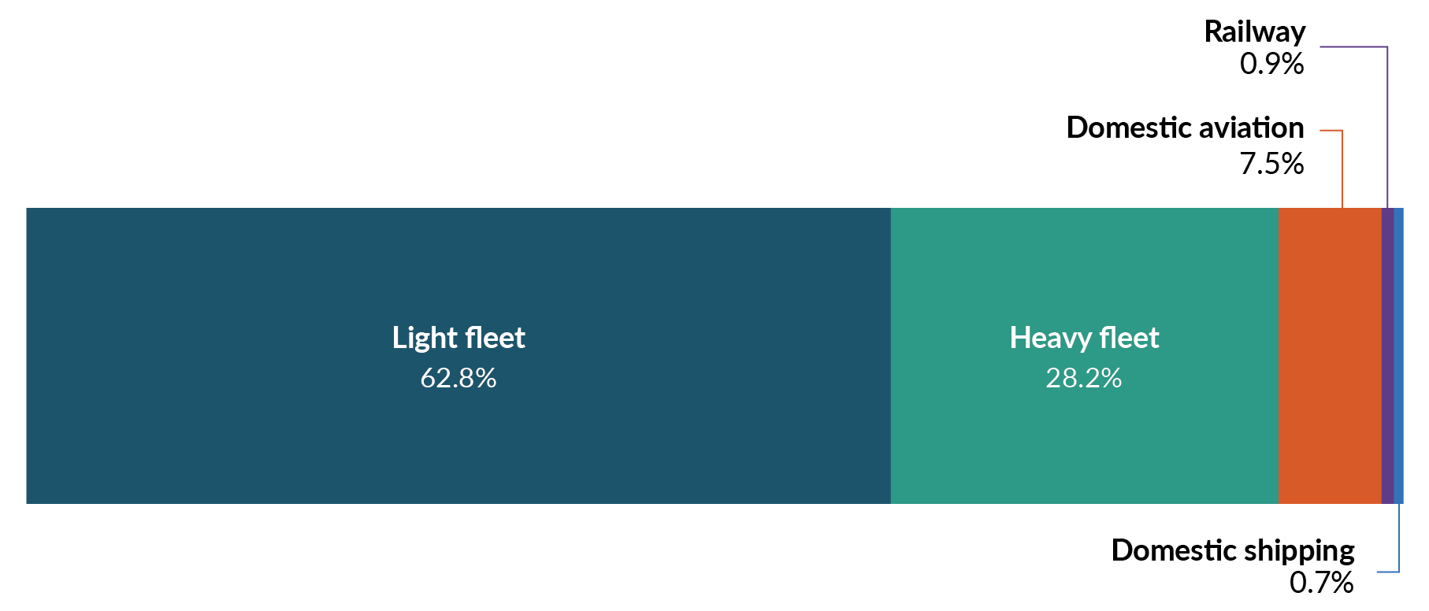
Note: AR5 = Global warming potential values adapted from the IPCC Fifth Assessment Report.

Proposed approach to reducing transport emissions
A credible carbon market is essential to abate emissions at least cost to New Zealand. Emissions from the transport system are covered by the NZ ETS, which limits the degree to which enabling transport policies directly reduce net emissions in the long run. Stable incentives and clear price signals through the scheme are important to encourage private investment in the uptake of cleaner vehicles and fuels.
The Government also has a role to remove regulatory barriers that may inhibit investment in decarbonising the transport sector. Beyond the NZ ETS, the main area of government action is to enable a network of 10,000 public EV charge points by 2030. The Government is also considering how to support other parts of the transport sector to decarbonise by removing regulatory barriers and enabling private investment.
These policies and initiatives will have a lesser and secondary impact on emissions than the NZ ETS in the second emissions budget but will contribute to reaching our targets in an economically efficient way.
Share your views
We are seeking your feedback on:
- the impacts of the proposed initiatives
- other regulatory barriers to decarbonising transport
- any other opportunities that can be realised.

Pillar of transport decarbonisation: EV charging infrastructure
To give New Zealanders the confidence to move to EVs, the Government is planning to have a network of 10,000 public charge points by 2030.
Rapidly converting as much of the light vehicle fleet as possible to low- or zero-emissions vehicles will help us reach the net zero target by 2050.
‘Range anxiety’ and concerns about the availability of publicly accessible charge points continue to hamper EV uptake. Accelerating the rollout of public EV charging infrastructure can address these concerns and enable uptake.
New Zealand’s public charging network currently consists of about 1,000 charging , which can charge 1,200–1,300 vehicles simultaneously. About 250 additional charging stations, capable of charging about 450 EVs simultaneously, are currently in development. This creates a good base network of EV charging infrastructure across the country, including fast chargers every 75 kilometres along most of the state highway network.
The future rollout of public charging infrastructure must occur at a much higher rate. At the end of 2023, New Zealand had one public EV charge point for every 88 EVs in the fleet. Most comparable countries have ratios of one charge point to fewer than 40 EVs. If the rollout lags EV uptake, this may hold back the electrification of the vehicle fleet.
The Government has targeted a network of 10,000 public EV charge points by 2030. Policy interventions and investment decisions to deliver these will undergo robust cost–benefit analyses to ensure maximum value from Government investment.
The 10,000 charge point network is expected to cover the full range of public charging needs. Some possibilities include providing:
- ultra-rapid charging on the highway network
- fast charging at key destinations such as shopping malls, gyms and marae
- slower AC (alternating current) charging where an EV will be parked for longer, such as at workplaces, hotels, motels and holiday parks.
Establishing this pillar includes overcoming existing market barriers – for example, areas with high demand but low capacity such as Lewis Pass; areas with very high seasonal demand such as Kaiteriteri; and areas with low demand and low capacity. We propose to also consider the public charging needs of heavy vehicles, to complement charging at private depots.
Installing chargers at the pace required will depend on the attractiveness for private investment and practical considerations, such as whether charging providers can connect promptly to the electricity network.
We expect that the focus on scaling up charging infrastructure through to 2030 will support reductions in the second emissions budget, by giving New Zealanders the confidence to shift to EVs in the short term.
Getting the regulatory settings right now will also support emissions reductions to meet the third emissions budget and beyond. The rollout of the charging network can then keep pace with long-term EV uptake.
There are two programmes proposed to enable EV charging infrastructure.

Facilitating private investment
For private companies and investors, the business case for public EV charging facilities remains challenging while there are limited numbers of EVs on the road. This is compounded by other challenges such as high network connection costs; different processes for connecting to electricity networks or resource consenting across the country; and long lead-in times for new connections to the electricity network.
The supercharging EV infrastructure work programme includes:
- reducing red tape and regulation relating to public EV chargers
- enabling standards to help consumers shift home EV charging demand away from network ‘peaks’
- working with the Electricity Authority on addressing barriers such as connection costs and ensuring consistent approaches to EV charging connections across all 29 electricity distributors.
The Government has set up a cross-agency taskforce to coordinate work on EV charging infrastructure and to engage with industry.
Chapter 5 has more information on issues relating to electricity network infrastructure and supply.

Reviewing Government co-investment so it is fit for purpose and targeted
Most EV chargers on the public network have been set up with Government co-funding through the Energy Efficiency and Conservation Authority’s (EECA’s) contestable funding rounds. As the network is scaled up and regulatory barriers are addressed, the private sector will likely be able to invest in charging infrastructure with more confidence.
There will probably be an ongoing role for some Government co-investment to target projects that face significant barriers to private investment yet are needed for an effective, nationwide network.
It is timely to review the Government’s co-investment approach so that it can reach its national network goal and provide maximum value from its investment. The review will consider the scale of Government co-investment, how it is prioritised across charger types and locations, the processes to apply for and receive co-investment, and how it could change over time as the market develops. Cost–benefit analysis will inform the design of an updated co-investment model. Decisions on the revised approach are expected before the end of 2024.

Supporting actions
The Government is considering additional actions to support decarbonisation, including actions to address the light vehicle importer standard; regulatory barriers and incentives to heavy vehicle decarbonisation; aviation and maritime decarbonisation; and planned public transport projects.

Ensuring the Clean Car Importer Standard is effective
The light vehicle fleet produces most of New Zealand’s transport emissions. These vehicles stay in our fleet until they are about 20 years old. Reducing the emissions of imported vehicles is important for meeting our emissions budgets.
New Zealand introduced the Clean Car Importer Standard on 1 January 2023. This progressively reduces the average carbon dioxide emissions of light vehicles entering the fleet. It does this through setting annual carbon dioxide targets, which vehicle suppliers must meet on average across the vehicles they import.
The Government has committed to retaining the Clean Car Importer Standard. During 2024, we reviewed the standard to ensure it is operating effectively and the targets are achievable. Signalling targets well in advance can help importers comply and minimise supply and price impacts for consumers. It can also send clear signals to importers about their product mix. New Zealand will set a standard that is achievable and, for consumers, supports vehicle availability, affordability and choice.

Heavy vehicle decarbonisation
Our freight is mainly carried on road by heavy trucks, and heavy vehicles play a key role in other sectors such as waste removal and construction. Decarbonisation of heavy vehicles is at an earlier stage than light vehicles both globally and in New Zealand. Zero-emissions heavy vehicle (ZEHV) make up less than 0.13 per cent of the national heavy truck fleet. Heavy vehicle emissions are currently about a quarter of our transport emissions and continue to grow.
The freight sector and other users of heavy vehicles are market-led and highly competitive. They are best placed to lead the decarbonisation of these vehicles. There are actions the Government can take to remove barriers, enable the sector to reduce its emissions and ensure New Zealand does not face undue barriers to trade. Showing that New Zealand is playing its part in the decarbonisation of freight helps us access markets that are setting more stringent expectations about the emissions associated with their supply chains.
Some companies are exploring the merits of ZEHVs and of different technologies, including electrification and alternative fuels such as hydrogen. A key role for the Government is to remove the barriers so they can adopt these options.
Over the second emissions budget period, we expect significant improvements in the global market to fuel efficiency in internal combustion engine (ICE) trucks as well as to supply more makes and models of ZEHVs. The capital cost difference between ZEHVs and ICE trucks is also expected to keep reducing, and the range of ZEHVs to keep increasing as technology improves.
As well as setting clear expectations for efficient and productive transport outcomes for road and rail, there are some regulatory barriers that could be addressed to enable the sector to decarbonise.

Providing grants to support organisations to purchase zero-emissions heavy vehicles or to convert heavy vehicles to hybrid or zero-emissions technology
As part of Budget 2024 announcements, the Government confirmed a $30 million grant scheme for hybrid or zero-emissions heavy vehicles will proceed. This is intended to support early adopters to overcome upfront cost barriers and accelerate the uptake of these vehicles in New Zealand – whether they are battery electric, hydrogen fuel cell or hybrid heavy vehicles. The programme, which the EECA will administer, is intended to be launched in 2024 and will run to mid-2028.

Reviewing vehicle dimension and mass rules
The current vehicle dimension and mass rules tend to favour trucks that are relatively heavy (for greater efficiency) but with relatively low axle weights (to reduce damage to roads and highways) compared with other markets. These rules affect a range of heavy vehicles, including some ZEHVs. For example, some battery electric trucks sacrifice payload for battery weight to meet the current rules, making them less competitive than ICE trucks, while hydrogen tanks on heavy vehicles can cause them to exceed volume constraints.
The Government could review the regulatory system for barriers to uptake of ZEHVs. Any change to the system would need to be balanced against the increased wear and tear on roads and bridges associated with heavier vehicles, as well as their higher maintenance costs.

Public charging for heavy vehicles
For the short term, we expect electric charging of heavy vehicles to occur mainly at private depots. Some of the barriers to heavy vehicle charging will be addressed by actions on electricity network infrastructure and supply (see chapter 5).
However, there may be opportunities for efficiency in the placement of heavy charging, such as shared charging hubs and refuelling facilities at ports or inland freight hubs where shipping, road and rail networks meet.

Aviation and shipping decarbonisation
Domestic aviation and coastal shipping emissions make up a small portion of emissions from the transport sector (about 8 per cent collectively). Sea freight and supply chains are key drivers of New Zealand’s economy. Showing that we are playing our part in decarbonisation helps us maintain access to international markets and meet international customers’ increasingly stringent expectations about the emissions associated with their supply chains.
We have committed to supporting the phase-down of fossil fuels by enabling the development of sustainable aviation and marine biofuels. These will be important for reducing emissions from the aviation and maritime sectors. Electrification and green hydrogen also have a strong role to play; this includes, for example, the electric ferries already in use in Auckland and Wellington. For more information on fuel policies, see chapter 5.
The Government sees its main role for these sectors as facilitating industry discussions through existing forums, considering regulatory barriers and ensuring New Zealand’s interests are represented appropriately on the international stage. International cooperation on decarbonising aviation and maritime will also help prepare us to take advantage of new technologies as they are released.

Supporting the supply and uptake of sustainable aviation fuels
The Government has established Sustainable Aviation Aotearoa, a group of private sector and government agencies supporting the decarbonisation of the aviation sector. Sustainable Aviation Aotearoa is exploring ways to work with counterparts in other countries, such as Australia and Singapore, particularly on settings that would support sustainable aviation fuel supply and uptake.

Allowing low- or zero-carbon shipping on trade routes by 2035
Bringing together a wide range of industry stakeholders, a pre-feasibility study was completed in 2023 for a potential Australia–New Zealand green shipping corridor, where commercially operating ships would use alternative fuels. Low- or zero-carbon shipping corridors like this could allow New Zealand to:
- maintain the marketing advantage of low/zero carbon credentials, avoiding additional costs of landing product in market, such as carbon tariffs on ships or goods based on voyage emissions
- support an equitable transition by enabling low/zero-carbon Pacific supply chains
- maintain common regulations with regional partners, ensuring that operators can easily move the same craft around all ports in the region.

Reviewing domestic application of international carbon intensity requirements
New Zealand’s domestic coastal shipping sector is exposed to NZ ETS pricing through the fuel it purchases. This differs from international shipping (including international carriers who carry domestic cargo incidental to the carrying of international cargo) as the NZ ETS excludes emissions from fuel used for international marine transport.
Annex VI of the International Convention for the Prevention of Pollution from Ships requires member countries to adopt measures to ensure that domestic voyaging ships operate consistently with the international requirements, to the extent that is reasonable and practicable. New Zealand chose to apply the Annex VI international ship carbon intensity requirements to coastal shipping; however, other countries, such as Australia, use alternative measures to meet this requirement.
While the NZ ETS and the carbon intensity requirements do not directly duplicate each other, subjecting domestic coastal shipping to both regimes could disadvantage them compared with international operators that move freight around New Zealand and are not subject to the NZ ETS. It is unclear whether engaging with the Annex VI carbon intensity requirements will help domestic coastal ships to lower their emissions, beyond the incentives created under the NZ ETS. For the second emissions reduction plan, the Government could review whether the application of the Annex VI carbon intensity requirements to domestic coastal shipping is effective and should continue.
Why aren’t international aviation and shipping emissions included in the second emissions budget
Emissions from international aviation and maritime emissions currently sit outside New Zealand’s commitments under the Paris Agreement. They are not included in our domestic emissions reduction targets and budgets. The Climate Change Commission | He Pou a Rangi is due to report at the end of 2024 on whether to include these emissions in the net zero 2050 target.

Public transport in our main cities
Having reliable and accessible public transport enables more efficient use of New Zealand’s existing transport infrastructure, especially in the largest urban centres, and supports our emissions goals. Public transport can contribute in these ways by:
- reducing congestion and travel time, particularly if coupled with dedicated lanes or routes, and demand management tools and pricing mechanisms
- improving the efficiency and lifespan of existing infrastructure, which reduces the need for new infrastructure investment
- shifting demand from more emissions-intensive transport modes to cleaner energy sources, such as electric trains, buses and ferries
- providing accessible and affordable travel alternatives.
The Government has proposed investments in several major public transport projects in Auckland and the lower North Island, to be completed over the next decade. These projects include:
- Auckland City Rail Link
- Eastern Busway
- Northwest Rapid Transit
- Airport to Botany busway
- rail upgrades in the lower North Island.
Realising the benefits of reliable and accessible public transport will require continued planning, delivery and maintenance to support growing populations and meet demand in our largest cities. Public transport will need to be delivered progressively through investment and improvements to infrastructure and services. This work includes:
- exploring options for public transport fleets to run on renewable electricity or hydrogen, particularly as these energy sources become more widely available
- making better use of existing public transport infrastructure
- introducing new technologies to optimise public transport networks and services
- integrating transport investment with housing and land-use planning.

Supporting public transport authorities to invest in bus decarbonisation initiatives
Through Budget 2024, the Government has reconfirmed $44.721 million over four years to help decarbonise the public transport bus fleet. The funding will be available to public transport authorities to help them meet the costs of initiatives to accelerate the decarbonisation of the public transport bus fleet, such as the costs of zero-emissions buses, and charging and depot infrastructure.

Chapter 6 consultation questions
6.1 | Do you support the proposed actions to enable EV charging infrastructure?
6.2 | What are the three main actions the Government can do to reduce barriers to and enable the development of a more extensive public EV charging infrastructure in New Zealand (without adding too much cost for households and businesses)?
6.3 | Do you support the Government’s proposals to reduce emissions from heavy vehicles?
6.4 | What are the three main actions the Government can do to make it easier to switch to low- and zero-emissions heavy vehicles (without adding too much cost for households and businesses)?
6.5 | Do you support the Government proposals to reduce emissions from aviation and shipping?
6.6 | What opportunities might there be from rolling out new technologies to reduce emissions from aviation and shipping?
6.7 | What are the three main actions the Government can do to make it easier to reduce emissions from aviation and maritime fuels (without adding too much cost for households and businesses)?
6.8 | Please provide any additional feedback on the Government’s thinking about how to reduce emissions in the transport sector.

7. Agriculture

Te ahuwhenua

Agriculture sector at a glance

 | Annual emissions | - 2022: 41.3 Mt CO₂-e  - 2030 (projected): 36–40 Mt CO₂-e  - 2050 (projected): 30–44 Mt CO₂-e
 | Pillar of the strategy | - World-leading climate innovation is boosting the economy.
 | Why this sector is important | - Agriculture makes up about half of New Zealand’s total emissions. It is essential that domestic efforts to reduce emissions support our farmers to produce emissions-efficient products and do not cause production to shift to other parts of the world where it is more emissions intensive.
 | What we’re doing now | - We are reviewing methane science and targets.  - We are accelerating the development of mitigation tools and technologies to reduce on-farm emissions.  - We are developing measurement of on-farm emissions for use by 2025.
 | What’s coming | - We will implement a fair and sustainable pricing system for on-farm emissions by 2030.
 | What this means for New Zealanders | - The agriculture sector maintains production of low-emissions goods to access high-value markets.  - The sector uses technologies to lower emissions while lifting productivity and the value of exports.

Introduction
New Zealand meat and dairy producers have steadily improved the emissions intensity of their goods (the amount of greenhouse gases generated for every unit of meat or milk produced on-farm) by about 1 per cent on average each year between 1990 and 2022 (figure 7.1). This makes New Zealand “among the most efficient producers in the world in terms of emissions intensity”. Efficiency gains have been driven by farmer-led improvements in productivity over time, and now in response to demand from international customers and consumers.
The international community expects New Zealand to make a fair contribution to reducing emissions, and the agriculture sector has a part to play. Across the world, farmers are facing pressure to provide food while reducing their impact on the global climate and local environment.
New Zealand is contributing through international collaboration on the tools and technologies farmers need for this transition, such as through the Global Research Alliance on Agricultural Greenhouse Gases. We are committed to supporting our agriculture sector to remain world leaders.
Increasingly, companies selling and consuming New Zealand’s food exports are focused on counting and reducing emissions in their supply chains to respond to consumer and regulatory demands. This includes setting emissions targets and reporting on their direct, indirect and downstream emissions (scope 1, 2 and 3 emissions), which often capture emissions produced on-farm.
We need to ensure that New Zealand’s pastoral farmers remain competitive in markets demanding sustainably produced food. This may present new challenges. Some promising mitigation technologies in the pipeline are currently more appropriate for more intensive farming, rather than New Zealand’s extensive grazing.
At the same time, domestic efforts to reduce emissions must not simply lower output and result in production shifting to other parts of the world where it may be more emissions intensive.
Figure 7.1: Changes in emissions intensity of meat and dairy products, 1990–2022
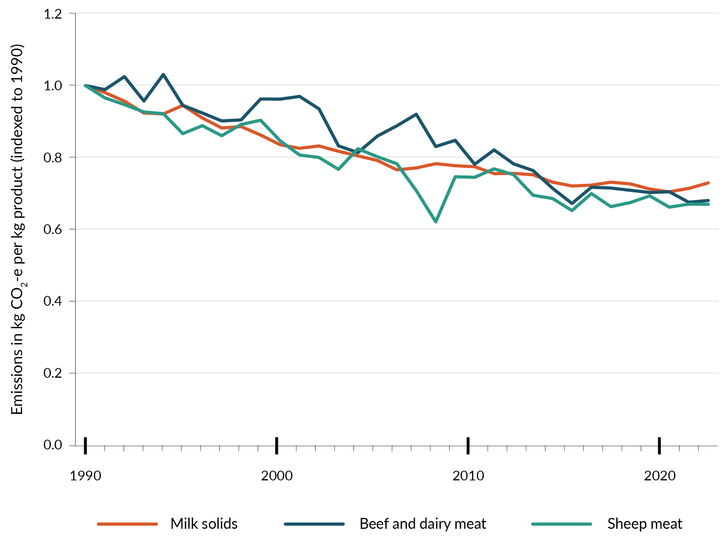

Emissions profile
In 2022, New Zealand’s agriculture sector emitted 37.8 Mt CO₂-e, consisting of:
- 0.9 Mt CO₂-e of carbon dioxide
- 34.4 Mt CO₂-e of methane
- 6.4 Mt CO₂-e of nitrous oxide.
Agriculture contributes a relatively high proportion of emissions because the sector makes up a significant share of our gross domestic product compared with other developed countries, and because New Zealand has already decarbonised significant parts of its economy (eg, in its electricity generation).
Agricultural emissions broken down by activity are shown in figure 7.2. They include:
- 78.2 per cent from methane emissions produced by enteric fermentation – that is, the digestive process of ruminant animals such as cattle, sheep and goats creating methane emissions
- 15.2 per cent from agricultural soils – mostly nitrous oxide generated by micro-organisms acting on nitrogen introduced to the soil via livestock urine, dung or synthetic fertilisers
- 4.6 per cent from manure management systems
- 2.2 per cent as carbon dioxide from other sources (including 2.1 per cent from urea application and liming, and 0.1 per cent from field burning of agricultural residues).
Figure 7.2: Agriculture emissions by activity, as at December 2022
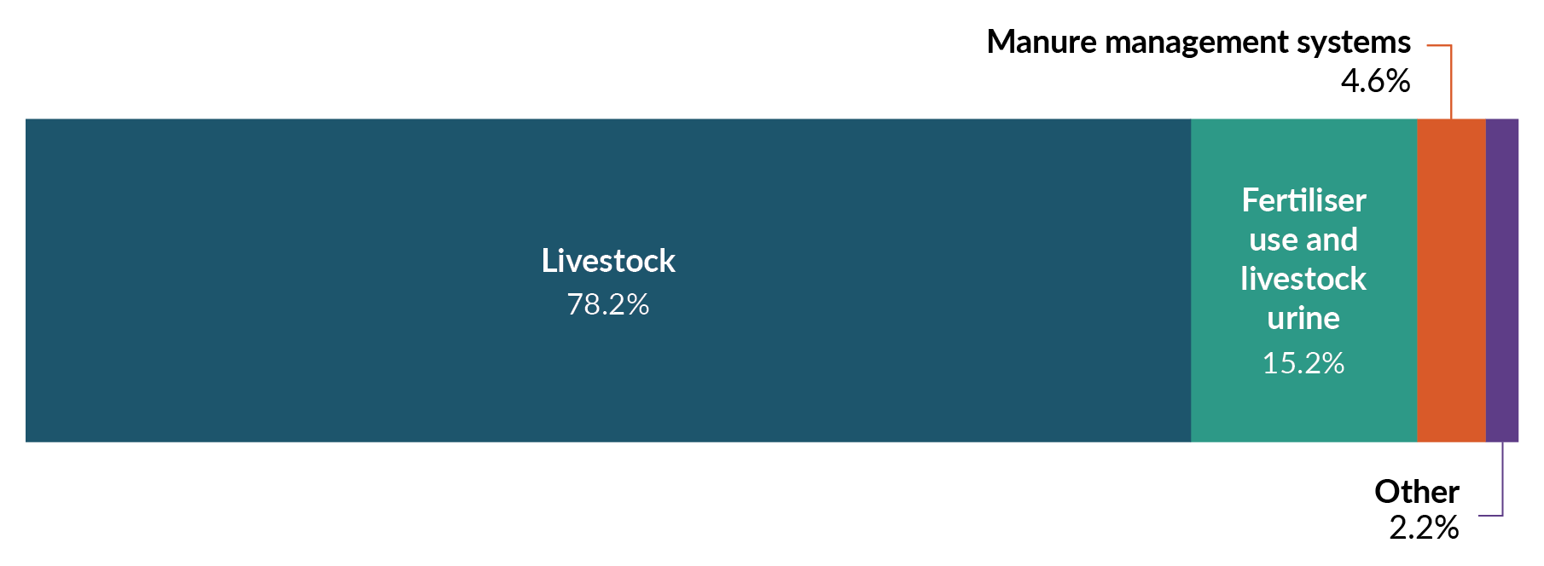
Note: AR5 = Global warming potential values adapted from the IPCC Fifth Assessment Report.
Of the 2022 agriculture emissions, the most significant come from dairy cattle (48.3 per cent), sheep (23.3 per cent) and beef cattle (19.8 per cent).
Most emissions from agriculture are methane. Methane is a short-lived gas compared with other greenhouse gases but has a much greater warming effect.

Proposed approach to reducing agriculture emissions
World-leading innovation is a priority in the Government’s vision for mitigating climate change. We are committed to ensuring producers have the tools and technologies to reduce emissions while maintaining productivity and profitability. This technology-led approach is critical to supporting fair and sustainable pricing of agricultural emissions no later than 2030.

Getting the tools to food and fibre producers
Investment in tools and technologies to reduce emissions has accelerated. Some are available now, but not at commercial scale, including low-methane sheep genetics and EcoPondTM, which is a treatment to significantly reduce methane emissions from dairy effluent ponds.
We expect these new tools will be commercially available to New Zealand’s pasture-based farmers from 2027/28. Tools for reducing nitrous oxide emissions are already in use: 60 per cent of urea fertiliser sold in 2023 was coated with a urease inhibitor, which reduces nitrogen loss. Officials expect that this will increase to 80 per cent in 2030, assuming voluntary uptake.
The most impactful solutions, such as methane inhibitors and vaccines, are several years away from use or are still at an early stage of research. Methane inhibitors are chemical compounds that disrupt the micro-organisms that generate methane during digestion. They can be delivered in a variety of ways, including as feed additives or through slow-release capsules that sit in the animal’s gut. The goal of methane vaccines is to stimulate an immune response in animals to produce antibodies that kill or inhibit methane-producing micro-organisms.
Outlined further below are initiatives and proposed policies to support the development of, and access to, tools and technologies.
The role of the government is to enable food and fibre producers to have the tools they need to stay viable and productive, while reducing emissions. Fulfilling this role includes:
- accelerating the development and commercialisation of emissions-reduction tools and technologies
- supporting clear and effective regulatory pathways for these tools
- standardising the estimation of farm-level emissions
- recognising on-farm carbon sequestration
- providing extension to support producers to make changes.
Assuming mitigations (including a methane inhibitor) are adopted in the emissions budget periods, we can expect reduced emissions of between 0.1 Mt CO₂-e in the second emissions budget and 5.5 Mt CO₂-e in the third emissions budget. This document (table 0.2) also provides illustrative examples of what could be expected under different availability and uptake scenarios for mitigation tools for agriculture.

Accelerating development and commercialisation
A structured research and development (R&D) programme is driving the development and commercialisation of tools to reduce emissions on-farm. It has three main components.
- The Global Research Alliance on Agricultural Greenhouse Gases partners with other countries in conducting research on New Zealand’s interests (eg, the Ireland–New Zealand Joint Research Call and the Global Methane Pledge). It enhances New Zealand’s domestic research capacity and connects with key partners. It also supports developing countries to build capability to reduce global agricultural emissions and promotes global understanding of the challenges of addressing greenhouse gases while maintaining and increasing food production.
- The New Zealand Agricultural Greenhouse Gas Research Centre (NZAGRC), established in 2009, funds pre-commercialisation research into ruminant methane, nitrous oxide and farm systems to reduce greenhouse gas emissions. The NZAGRC has a broad research funding portfolio. It includes co-investment with industry to determine indicators for breeding low-methane sheep and cattle, identifying novel methane and nitrous oxide inhibitors, looking at the viability of vaccines, early life interventions for long-term methane reduction, and low-emissions feeds.
- AgriZero^{NZ}, established in February 2023, is a public–private joint venture to drive product development and commercialisation of emissions-reduction tools and technologies for a range of New Zealand farm systems. It is a novel approach to take R&D to market by investing in the commercialisation of promising opportunities and ventures. Industry and government have so far committed $191 million to this venture over four years. AgriZero^{NZ} is aiming to have at least two new mitigation tools available to New Zealand farmers and growers by 2028, and to enable development and adoption of solutions to drive towards near-zero methane and nitrous oxide by 2040. Since its stand-up in February 2023, AgriZero^{NZ} has spent $29 million across 10 investments. Investments to date include a slow-release biodegradable methane-inhibiting bolus, probiotics and natural enzymes, a methane vaccine and methane inhibitors.

Supporting effective regulatory pathways
To ensure tools and technologies are available, and to remove barriers to their use, the Government has been working to streamline the process for regulatory approval of emerging tools. This includes working with other countries to support recognition of new tools through Codex. The Government is also working to develop methodologies for recognising the use of emissions-reduction tools in New Zealand’s Greenhouse Gas Inventory, so that efforts on-farm contribute towards our targets.
Processes for approving new mitigation tools will be streamlined in New Zealand. New technologies will be able to meet the requirements of the legislation that approves the use of new technology on animals (the Agricultural Compounds and Veterinary Medicines Act 1997 and Hazardous Substances and New Organisms Act 1996); and efficiently enter New Zealand’s Greenhouse Gas Inventory to support international reporting on targets and market claims. In the second emissions budget. These streamlined processes will support the availability of mitigation technologies to reduce on-farm greenhouse gas emissions. In future budgets, they will support the availability of many safe, adoptable on-farm technologies to farmers.
The Government has also committed to reforming the regulations for genetic technologies. Food and fibre producers will be able to adopt technologies that reduce emissions, adapt to climate change and continue to enhance value. This reform is a key opportunity to support the development and commercialisation of tools such as methane vaccines and genetically modified or edited feeds.

Standardising the estimation of on-farm emissions
Key enablers of the Government’s vision to address climate change are enhanced data and evidence.
Currently, farmers have a range of tools to estimate emissions on-farm. There is some inconsistency between these tools, and they often give different results. Standardising estimation is a key step towards pricing emissions in the future. We are developing a standardised calculation methodology for greater consistency, and to support on-farm emissions measurement by 2025. Standardised methods are not expected to lead to direct reductions in the second and third emissions budgets but could be important in scope 3 reporting to our key markets and customers.

Providing extension to support producers to make changes
Part of giving food and fibre producers the information, tools and technologies they need to reduce emissions is helping them make changes that best fit their farming system.
Producers access information about new tools and practices and support their use through a number of channels. These channels include industry levy bodies, the processors they supply, field days and workshops, interaction with neighbours and other farmers, websites and farm advisers. Industry levy bodies and processors are an important form of support, providing information and promoting tools as they become ready for uptake.
We expect extension services to support other policies across the second and third emissions budgets. The effect on emissions is included in the reductions projected for emissions pricing and uptake of technology.

Implementing a fair and sustainable pricing system for on-farm emissions by 2030
A pricing system for agricultural emissions will incentivise the reduction of on-farm emissions
The Government has committed to keeping agriculture out of the New Zealand Emissions Trading Scheme (NZ ETS) and introducing fair and sustainable pricing of on-farm emissions no later than 2030. This reduces emissions without causing emissions leakage by sending production overseas. The Government has also committed to recognising on-farm carbon sequestration (see chapter 9). To get the desired impact, tools to reduce emissions must come ahead of pricing – and our producers must be able to adopt these while remaining profitable. It is also important to continue developing standardised measuring and monitoring of on-farm reductions.
We assume farmers adopt mitigation technologies in response to a financial incentive. The form of the agricultural pricing mechanism could vary significantly from this and is dependent on government decisions.
Primary legislation must be passed before 1 January 2025 to avoid activating NZ ETS surrender obligations for agriculture.

Impacts on iwi and Māori
The agriculture sector plays a significant role in the Māori economy through collectively owned land assets, iwi authorities, individual Māori-owned agribusinesses, and the level of Māori employment in the sector. Policies must be designed to understand and respond to the circumstances of Māori and continue to enable Māori landowners to develop unused or under-used land.

Chapter 7 consultation questions
7.1 | What are the three main barriers or challenges to farmer uptake of emissions-reduction technology?
7.2 | How can the Government better support farm- and/or industry-led action to reduce emissions?
7.3 | How should Government prioritise support for the development of different mitigation tools and technologies across different parts of the agriculture sector?
7.4 | What are three possible ways of encouraging farmer uptake of emissions-reduction tools?
7.5 | What are the key factors to consider when developing a fair and equitable pricing system?
7.6 | Please provide any additional feedback on the Government’s thinking about how to reduce emissions in the agriculture sector.

8. Forestry and wood processing

Te ahumahi ngāherehere me te tukatuka rākau

Forestry and wood-processing sector at a glance

 | Annual removals | - 2022: –4.6 Mt CO₂-e  - 2030 (projected): –15 to –16 Mt CO₂-e  - 2050 (projected): –15 to –27 Mt CO₂-e
 | Pillars of the strategy | - Credible markets support the climate transition.  - Nature-based solutions address climate change.
 | Why this sector is important | - Forestry and wood processing remove carbon from the atmosphere to reduce our net emissions and produce high-value products that can replace emissions-intensive ones.
 | What we’re doing now | - We are restoring confidence in the NZ ETS to give certainty to the forestry and wood-processing sector.
 | What’s coming | - We propose to limit whole-farm conversions to forestry on high-quality land to protect highly productive farmland.  - We will boost wood processing by improving the consenting framework, supporting commercial investments and getting the system settings right to be building with wood.
 | What this means for New Zealanders | - We reduce net emissions, while protecting our most valuable and productive farmland.

Introduction
We recommend reading this chapter together with chapter 7 on agriculture.
The forestry and wood-processing sector has great potential to support the Government’s objectives to grow the economy and exports, add value and lift productivity. Our forests are highly productive, create significant export earnings and produce the raw materials our wood processors use to make high-value products.
Forestry and wood processing also have a vital role in meeting New Zealand’s climate change targets. They remove carbon from the atmosphere to reduce our net emissions and produce high-value products in place of more traditional emissions-intensive products.
Exotic forestry is an affordable and scalable way to capture and store carbon dioxide. The New Zealand Emissions Trading Scheme (NZ ETS) awards New Zealand Units (NZUs) for carbon dioxide sequestered by forests that are registered in the scheme. NZUs awarded to forests can be purchased by emitters to meet surrender obligations. The combination of affordability and scalability makes exotic forestry the main moderator of the NZ ETS price. The long-run price of the NZ ETS, and therefore the balance of contributions to emissions targets from gross reductions and removals, is expected to eventually be determined by the availability of NZUs from exotic forestry. If afforestation is left unconstrained, the NZ ETS price may settle at the cost per tonne of sequestration by exotic forests.
The Government’s approach is to restore confidence and certainty in forestry and wood processing. This will unlock the sector’s full potential to help rebuild the economy, expand exports and meet our climate goals, while balancing productive land uses between forestry and agriculture.
To help achieve this, we have already stopped work on the NZ ETS review, which was driving significant uncertainty in the sector. We have also launched an independent review of the NZ ETS operational costs to ensure the forestry component is cost-effective and efficient.
In addition, in line with the Government’s focus on removing unnecessary regulatory burden, the Government has repealed the mandatory registration system for log traders and forestry advisors that adds compliance costs and no meaningful improvement in outcomes for the sector.
The second emissions reduction plan (ERP2) policies proposed here are intended to further build confidence and certainty in forestry and wood processing by getting the incentives right for forestry and improving the investment environment for high-value wood processing. They are part of the wider government programme for this sector, around four roles:
- contributing to economic growth, jobs and export revenue
- delivering cost-effective, high-value, low-emissions products and solutions to shift away from emissions-intensive building materials and energy
- supporting land-use resilience and adaptation in a changing climate to ensure forestry remains productive nationally and regionally, while delivering recreational, amenity and biodiversity benefits
- removing carbon to support New Zealand’s climate goals.
There are interactions between forestry and agriculture that are part of the same land-use system. The Government will carefully consider how it incentivises a balance of land uses to achieve the best outcomes for forestry, agriculture and the climate.

Emissions profile
Forestry is the only form of carbon removal currently recognised as contributing to New Zealand’s domestic and international climate change targets. Forests can be either a carbon sink (while growing, and in long-lived wood products such as building materials) or a source of emissions (eg, through deforestation).
To estimate carbon removals from forestry, we need to understand the current level of forestry and future planting intentions.
The 2023 Afforestation and Deforestation Intentions Survey (ADIS) reported about 68,500 hectares of exotic afforestation occurred in 2023 and about 51,800 hectares were intended for afforestation for 2024. The 2023 ADIS also reported that about 7,800 hectares of indigenous forest were planted in 2023, while intentions were to plant about 9,000 hectares in 2024. Based on current trends, projected increases in indigenous afforestation from now will make only a minor contribution to New Zealand’s climate commitments.
Based on the Ministry for Primary Industries’ June 2024 projections, the land use, land-use change and forestry (LULUCF) sector is projected to remove between 54.3 and 63.0 Mt CO₂ from the atmosphere in the second emissions budget (table 8.1).
Table 8.1: 2024 projections of forestry’s contribution to emissions targets (Mt CO₂)
Scenario | First emissions budget 2022–25 | Second emissions budget 2026–30 | Third emissions budget 2031–35 | 2050
Lower | –19.0 | –54.3 | –72.3 | –15.2
Central | –23.5 | –61.4 | –82.3 | –21.3
Upper | –24.7 | –63.0 | –86.8 | –27.2
Note 1: A negative number represents a removal of carbon dioxide from the atmosphere.
Note 2: The lower and upper scenarios reflect varying levels of afforestation and deforestation as included in the 2023 projections.
Note 3: Emissions budgets are stepping stones towards our net zero 2050 target. The 2050 figures show the estimated removals from forestry during 2050.
Note 4: The table shows only net emissions and removals from afforestation/reforestation and deforestation.
Note 5: New Zealand’s first Nationally Determined Contribution covers 2021–30 and includes net emissions from forestry. We project a lower scenario of –82.4, a central scenario of –91.7 and an upper scenario of –100.5 Mt CO₂.
Projected afforestation from 2025 will not materially impact net emissions in the second emissions budget. This is because low carbon removals from initial planting (increasing over time) are offset by the emissions from soil and the removal of previous vegetation. Carbon sequestration is therefore low for the first four to five years of exotic forest planting. However, afforestation will be an important contributor to future budgets.
Extensive exotic production forests were planted in the 1990s and have contributed significantly to carbon removals over the past decade. Many of these production forests have now reached maturity and harvest, so removals from older production forests are slowing throughout the 2020s. Existing forests will still contribute more to the first and second emissions budgets than any new planting that occurs (or has already occurred) in these periods.
Figure 8.1: Actual and projected afforestation rates assumed in the 2024 projections (hectares), 1990–2050
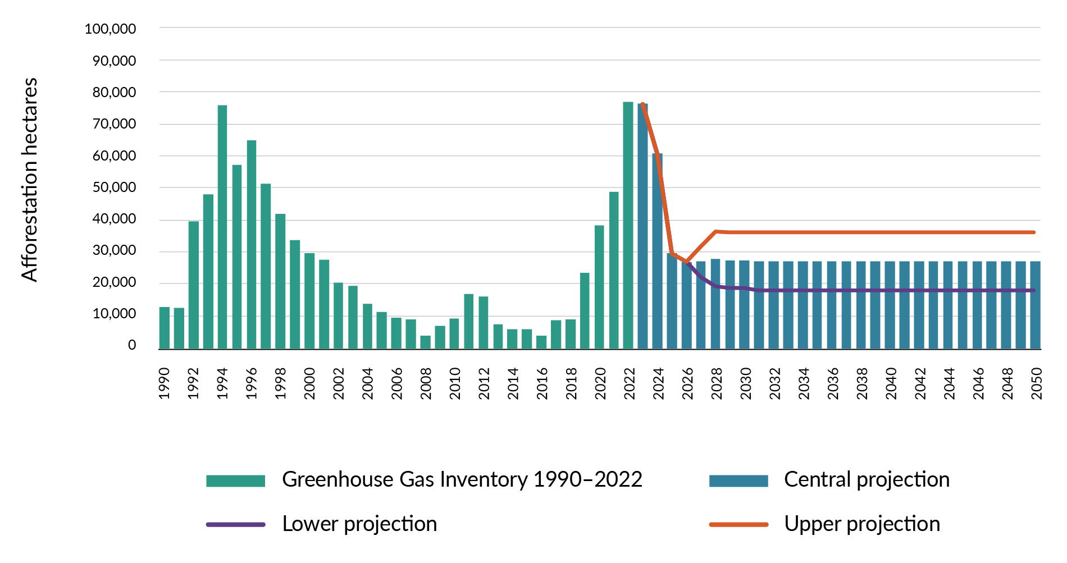
Source: Afforestation projections from 2023–26 and the lower afforestation projection are primarily based on the 2023 ADIS, while the upper projection is primarily based on the 2021 ADIS. To access the ADIS reports, go to Agricultural Greenhouse Gas Inventory reports.
Levels and locations of afforestation will also have an influence on emissions from agriculture. Increased afforestation on land used for agriculture would reduce agricultural emissions, while less afforestation would have the opposite effect.
Officials estimate that restoring price stability and confidence in the NZ ETS, and giving certainty to forestry, will have minimal impact on forestry removals for the first and second emissions budgets. This is because the removals will largely come from existing forests. It takes time for newly planted forests to contribute significantly to removals. Actions are estimated to have a small impact on forestry removals for the third emissions budget but are still likely to achieve the forestry sub-sector target published in the first emissions reduction plan. Officials are working to better understand the proposal’s impact on emissions budgets and targets.
Forestry and wood processing policies that support the displacement of emissions from other sectors (eg, wood products replacing higher-emissions products) contribute to reducing emissions. However, these impacts can be hard to model because of differences in underlying assumptions, high uncertainty and the potential for double counting.

Proposed approach to enabling removals and reductions
Forestry and wood processing play a key role in meeting New Zealand’s climate change targets. They remove carbon from the atmosphere, reducing net emissions and producing high-value products to replace emissions-intensive ones. By encouraging afforestation through appropriate incentives and boosting wood processing, the Government will restore confidence in forestry and wood processing. This will unlock the full potential of the sector, boost the economy, increase exports and meet our climate goals.

Policies and initiatives
Supporting the credibility of the NZ ETS is a priority for the Government. A credible NZ ETS is critical for getting the incentives right for forestry. Other policies to improve incentives for forestry are outlined below, including policies to balance productive land use between forestry and agriculture (see chapter 3).
Our other focus is to improve the investment environment for wood processing. This will give the sector the confidence to pursue emerging ways of processing more domestically grown logs onshore. The result will be high-value products that reduce our emissions.
Below are the Government’s proposed policies for forestry and wood processing. We expect to consult in detail on the impacts and benefits of each policy as it is developed.

Encouraging afforestation through appropriate incentives
Over the last few years, we have seen greater investment in forestry, particularly exotic forestry, due to the significant increase in the NZ ETS carbon price. The increased planting will help us meet emissions budgets at least cost, through the carbon stored as the forests grow. It supports other forestry objectives, for example sustainable land management and increased fibre supply.
Although the NZ ETS is an important tool for incentivising afforestation that supports our climate change goals at least cost, it is important to balance productive land use between forestry and agriculture. Increases in farm conversions to forestry on high-quality land can impact on local communities and food production if left unchecked. The Government proposes the following three policies to encourage afforestation for increased carbon sequestration, in balance with other land uses.

Restoring price stability and confidence in the NZ ETS to give certainty to forestry
Having credible domestic carbon markets that price emissions underpins our least-cost, net-based strategy. A key objective for ERP2 is to restore market confidence in the NZ ETS. This will give certainty to forestry, support continued investment in afforestation, and help meet New Zealand’s emissions budgets and targets at least cost (for more on this policy, see chapter 3).

Managing whole-farm conversions to forestry on high-quality land to protect highly productive farmland
To fully realise the wider economic and climate benefits of forestry, the Government is seeking to carefully balance the trade-offs between forestry, agriculture and climate. Action is needed because at current (and higher) NZ ETS prices, exotic forests are cost-competitive with pastoral land uses, driving whole farm-to-forest conversions. Certainly these exotic forests provide abatement towards our climate change targets. However, they can have wider undesirable impacts on rural communities and economies, affect our longer-term climate approach and reduce land-use flexibility.
Action is required to manage these impacts and to support the Government’s least-cost mitigation strategy. This is why the Government is proposing to limit the number of NZ ETS registrations for whole-farm conversions to exotic forestry on high-quality productive land. This policy aims to balance productive land uses to ensure the best use of land for New Zealand in the long term. The Government expects to release more details on this work later in 2024.

Partnering with the private sector to plant trees
The Government is proposing to explore opportunities to partner with the private sector to plant trees. This includes native afforestation on Crown land (other than national parks) that is unsuitable for farming and has low conservation value. Estimates of the area of Crown land that is suitable for planting are preliminary and conservative. Further analysis will be required to confirm land suitability; however, it is likely that more land is available, and the potential abatement is greater than currently projected.
Planting offers potential for economic return and for greater carbon sequestration to meet New Zealand’s emissions budgets and targets.
Native forests can provide a long-term carbon sink and co-benefits, including biodiversity and adaptation value. Established native forests are likely to be better suited to steep and erosion-prone land as they are more able to withstand extreme weather. The current costs of native afforestation make it uneconomic compared with exotic planting, so the Government is interested in exploring partnerships to improve the incentives for native planting.
Both native and exotic trees can help New Zealand adapt to climate change and provide greater resilience to severe weather, fire and biosecurity incursions. Diversity in exotic forestry can also create opportunities to manufacture new, high-value products.
Decisions on which species will be planted, and where, will be based on the suitability of the land and the opportunities for planting partnerships. The Ministry for Primary Industries, Land Information New Zealand and the Department of Conservation are assessing the amount of land likely to be available for planting. Next steps will be determined after this assessment.

Boosting wood processing
Boosting wood processing will result in more long-lived wood products that can store carbon during their lifetime. This will also expand the economy and provide regional jobs and export potential by generating more high-value products. There are significant opportunities for growth in products such as modern engineered timber in construction, which could replace emissions-intensive materials such as steel and concrete, while also storing carbon.
Woody biomass comprises any woody material left in the forest after harvesting (ie, forestry slash), residues from wood processing (ie, sawdust, woodchips) and logs from plantings of fast-growing trees (ie, pulp forest or biomass crops). Woody biomass can be used as a feedstock to produce low-emissions fuel substitutes such as wood pellets; these produce high-temperature heat for industry and sustainable aviation fuel. Chapter 5 has more information on bioenergy and sustainable aviation and shipping fuels.
Other government actions outside the forestry portfolio will also boost wood processing. These actions include increasing domestic demand for wood products, liberalising the rules holding back the building and construction sector, and expanding the access of wood products from New Zealand to overseas markets.
Long-lived wood products can displace emissions-intensive incumbent materials and store carbon during their service life.
By 2030 we can expect:
- higher levels of carbon stored within harvested wood products
- higher levels of displaced emissions from other sectors.
By 2050 we can expect to transition away from using emissions-intensive products.

Improving the consenting framework for wood processing
The Government is committed to improving the resource consenting framework for wood processing to make it easier to establish new facilities and to re-consent existing ones. This will give wood processors longer-term market certainty to invest in production and innovation.
One set of barriers in the consenting framework involves the time and cost of getting resource consents for wood processing. The Government has already taken steps to improve the consenting environment for infrastructure and other activity that will support forestry and other primary production. Improving the consenting framework could streamline consenting for new wood-processing facilities that meet national or regional significance criteria.
We have also sought advice on mandating a maximum consent processing time of one year to establish new wood-processing facilities, along with advice on streamlining re-consenting of existing facilities.

Ensuring the Wood Processing Growth Fund continues to support commercial investment
The Wood Processing Growth Fund (WPGF) helps wood processors increase New Zealand's onshore capacity. By expanding domestic wood processing, the WPGF will store more carbon within long-lived wood products. Alongside supporting New Zealand’s response to climate change, it aims to increase exports, as well as to create further value and increase the use of wood as an option in the domestic economy.
The WPGF seeks to unlock private capital through investment support, overcoming the barriers faced by the industry. In the first year of operation, the WPGF is:
- supporting a shift to higher-value wood manufacturing, enabling the manufacture of high-value products (eg, engineered timber) from the industrial-grade logs that are currently exported unprocessed
- supporting new manufacturing developments for Radiata pine clearwood, creating appearance timbers that compete with hardwoods in premium export markets
- demonstrating that there is unmet demand for alternative species timbers that command premium prices and that small-scale assistance is effective for them to scale up significantly.

Addressing the settings to support building with wood
More long-lived wood products such as engineered construction lumber, plywoods and panels can store carbon, offsetting our gross emissions. The Government is committed to addressing any regulatory barriers to enable building with wood. This policy is strongly linked to how the Government is considering the building and construction sector. It is also closely linked to the domestic wood-processing policies outlined above. We are currently receiving advice on what actions we could take.

Impacts on iwi and Māori
Māori interests in forestry are extremely wide-ranging. In 2018, Māori were estimated to own $4.3 billion of forestry assets. An estimated 30 per cent of New Zealand’s 1.7 million hectares of plantation forestry is on Māori land, and this is expected to grow to 40 per cent as Treaty settlements are completed. A significant proportion of New Zealand’s privately owned indigenous forest is on Māori-owned land.
Māori freehold land and land returned in Treaty settlements include sizeable areas of existing forest. About 71,000 hectares of Māori freehold land comprise remote and less versatile land, making it well suited to carbon forestry or long-rotation plantation forestry. These two factors, together with the limited range of alternative future land-use options available to Māori, mean Māori landowners may be disproportionately affected by changes to forestry policy.
Share your views
We will consider input from Māori on the first emissions reduction plan, recent climate change consultations, and this consultation as the work progresses.

Other issues

Key climate risks
Increased temperatures and shifts in seasonality and rainfall patterns will drive changes in tree growth and forest maturation, as well as increase risks from pests and disease, wildfires and severe weather.

How forestry policies address adaptation
Addressing adaptation includes:
- considering where forests are planted
- considering opportunities to adapt and diversify the way we practise forestry, which includes diversifying tree species, management practices, products and markets that can strengthen the resilience of landscape and supply
- designing forests to mitigate the increased risk of wildfires and reduce their impact
- considering the erosion control benefits from forests (eg, roots anchor erosion-prone soils; the forest canopy intercepts rain, reducing run-off and sedimentation; and forests moderate fluctuating temperatures and slow river flood flows)
- controlling the spread of wilding conifers.
With increasing storms and the need to maintain social licence, adapting to climate risks will become increasingly important.

Chapter 8 consultation questions
8.1 | How could partnerships be structured between the Government and the private sector to plant trees on Crown land (land owned and managed by the Government)?
8.2 | What are the three main actions the Government could do to streamline consents for wood processing?
8.3 | How large should the role of wood in the built environment play in New Zealand’s climate response?
8.4 | What other opportunities are there to reduce net emissions from the forestry and wood-processing sector?
8.5 | Please provide any additional feedback on the Government’s thinking about how to reduce emissions in the forestry and wood-processing sector.

9. Non-forestry removals

Ngā tangohanga ngāherehere-kore

Proposed approach to enabling
non-forestry removals
The Government recognises carbon sequestration can occur through biological, geological, oceanic, chemical and technological processes. Alongside forestry, the Government sees other forms of removing emissions, such as wetland restoration, on-farm vegetation, coastal vegetation management, marine ecosystems, carbon mineralisation, carbon capture, utilisation and storage, ocean fertilisation, direct air capture and bioenergy with carbon capture and storage as opportunities to reduce net emissions that may become viable in the future.
The Government aims to reduce net greenhouse gas at least cost to meet our climate change targets. Consistent with this approach, the Government will consider all forms of non-forestry removals because of their scientifically verified sequestration. In practice, the Government will prioritise the most promising non-forestry removals technologies, based on affordability, scalability, scientific validation and overseas acceptance. The Government aims to include non-forestry removals in the New Zealand Emissions Trading Scheme (NZ ETS).
Criteria for recognising non-forestry removals technologies include:
- robust scientific validation of sequestration at a standard that is consistent with the Greenhouse Gas Inventory
- additionality
- recognition (or ability to achieve recognition) under New Zealand’s international agreements.

What non-forestry removal activities are
Emissions removals are human-induced activities that draw carbon dioxide from the air or ocean and store it in rocks, on land, in ocean reservoirs or in products such as construction materials. Non-forestry removals include well-known practices such as rewetting drained wetlands, as well as developing technologies such as direct air carbon capture and storage. They vary in their potential scale, costs, co-benefits and risks. Many activities act as both a sink and a source of emissions – for example, a carbon sink can become a source of emissions if vegetation is removed or if ecosystems are disturbed or degraded.
Other activities, such as enhanced rock weathering and carbon capture and storage (CCS), can remove atmospheric carbon and store it on a permanent basis.
The following are examples of non-forestry removal activities.
- On-farm vegetation. Some on-farm vegetation, such as riparian plantings and shelterbelts, sequesters carbon and improves water quality and biodiversity. Currently, the scientific data on how much carbon these types of vegetation can remove are uncertain. Improving the science specific to New Zealand will require further investigation.
- Wetlands and peatlands. Managing and restoring wetlands and peatlands can protect existing carbon stores, enhance carbon uptake, increase biodiversity, improve water quality and protect against flooding and drought. Estimates show a significant potential for reducing emissions if drained peatlands are rewet.
- Coastal vegetation management (blue carbon). Improved management of coastal land types such as wetlands, mangroves and sea grasses can protect existing carbon sinks and establish new ones. Restoration can also bring benefits to coastal and marine ecosystems and social outcomes.
- Other categories. Some other categories include management of forests planted before 1990 to store additional carbon, including pest control; CCS technologies; enhanced rock weathering; and biochar.

Why it helps to recognise non-forestry removals
There is a lot of interest in recognising and rewarding non-forestry removals. Interested groups include people restoring local habitats, farmers improving the sustainability of their land and groups restoring the bush. We are considering a range of ways to encourage non-forestry removals.
Recognising non-forestry removals could provide some form of incentive that rewards businesses or landowners for their efforts. To ensure any scheme remains balanced, the incentive may also need to be paid back if the removals are later lost (eg, when vegetation is cleared). This is the approach that the NZ ETS takes to forestry.
Recognising non-forestry removals could offer more options for landowners and businesses, create incentives to shift land use or management that reduces net emissions, and offer other co-benefits, such as better water quality, biodiversity and climate resilience from wetlands. Non-forestry removals can also ensure New Zealand is not solely reliant on forestry offsets.

How non-forestry removals could be recognised
Different removal activities are at different stages of scientific readiness for recognition in New Zealand. Some, such as coastal vegetation management, require further international and New Zealand-specific data and evidence before they are ready for recognition. However, activities such as peatland restoration are viable now and we can work towards recognising these through policies.
There is a range of mechanisms that could recognise non-forest carbon removal activities. To help the Government decide whether these are ready to be recognised, a decision-making framework could be developed to assess their suitability for recognition in the NZ ETS or through alternative mechanisms. This will ensure the recognition comes through an appropriate mechanism. Key elements of a framework would include the ability to validate removals in a robust and certifiable way that can count towards our international targets.

Exploring whether non-forestry removals can contribute to our domestic and international targets
More work is needed to understand the role that non-forestry removals could play in reaching New Zealand’s domestic and international targets. Compared with forestry, the potential carbon sequestration from these categories is likely to be small in the short to medium term. Changes to our national accounting would also be needed so that New Zealand could count any non-forestry removals towards our domestic and international targets. This would also mean that the loss of those removals would count against our targets, potentially making these targets harder to meet.
Share your views
We are seeking feedback on how non-forestry removals could help New Zealand reach net zero emissions.

Chapter 9 consultation questions
9.1 | What are the three main opportunities for non-forestry removals to support emissions reduction?
9.2 | What are three main barriers to developing more non-forestry removals?
9.3 | It is important to balance landowners ability to use their land flexibly with the recognition of the role of non-forestry removals. How can this balance be achieved?
9.4 | What three main benefits beyond emissions reductions could be created by developing more non-forestry removals?
9.5 | What risks and trade-offs from incentivising land-use and management change to reduce net emissions need to be considered?
9.6 | Please provide any additional feedback on the Government’s thinking about how to reduce emissions through non-forestry removals.

10. Waste

Te para

Waste sector at a glance

 | Annual emissions | - 2022: 3.5 Mt CO₂-e  - 2030 (projected): 3.3 Mt CO₂-e  - 2050 (projected): 3.0 Mt CO₂-e
 | Pillars of the strategy | - Infrastructure is resilient and communities are well prepared.  - Credible markets support the climate transition.
 | Why this sector is important | - Waste is an important issue to New Zealanders. Enabling better waste diversion will help households and businesses to reduce their waste and the associated emissions. Local and central government and the waste management, resource recovery and recycling sector all have key roles in this system.
 | What we’re doing now | - The New Zealand Emissions Trading Scheme (NZ ETS) incentivises efficient landfill gas capture.  - A portion of the waste disposal levy is invested in New Zealand’s waste infrastructure.
 | What’s coming | - We will have further targeted investment in New Zealand’s resource recovery infrastructure and systems (including for construction and demolition waste).  - We will investigate improving organic waste disposal and landfill gas capture.
 | What this means for New Zealanders | - Waste-related biogenic methane emissions are further reduced.  - More reusable and recyclable resources are available for use in the New Zealand economy.

Introduction
Waste is an important issue to New Zealanders. By taking action to reduce waste, we can also reduce the emissions from waste – both direct emissions from landfills and associated emissions from the wider waste sector.
The focus of emissions reduction for the waste sector is biogenic methane, the main greenhouse gas that waste produces. New Zealand has introduced some readily available and widely used technologies that help reduce waste emissions. One example is landfill gas (LFG) capture, where there is potential for further improvements, including within the second emissions budget period.
Share your views
We are seeking feedback on:
- whether our proposal focuses on the correct area
- other priority actions you think the Government should be taking to reduce emissions.

Emissions profile
In 2022 the waste sector produced 3.5 Mt CO₂-e (about 4.5 per cent) of New Zealand’s gross greenhouse gas emissions. Waste emissions were comprised of methane (93.3 per cent), nitrous oxide (4.3 per cent) and carbon dioxide (2.4 per cent). Figure 10.1 presents the proportion of waste emissions by activity.
Figure 10.1: Waste emissions by activity, as at December 2022
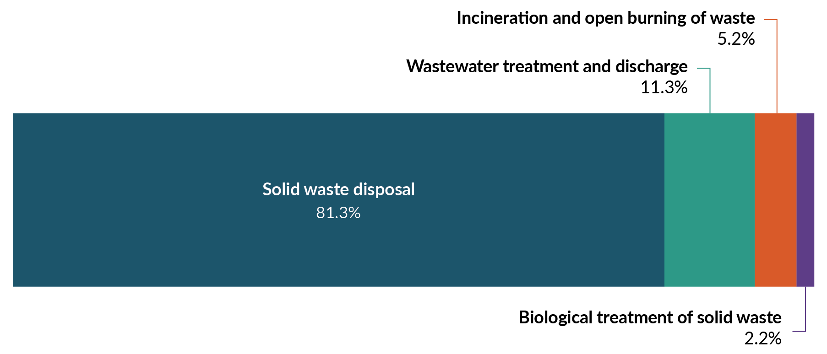
Note: AR5 = Global warming potential values adapted from the IPCC Fifth Assessment Report.

Proposed approach for reducing emissions from waste
A credible market for emissions pricing can support long-term reductions in emissions from unavoidable waste in landfills, at least cost.
Emissions from waste disposal in New Zealand are partially covered by the NZ ETS. For larger landfills that receive higher proportions of organic waste, the NZ ETS cost is (to some extent) reflected in the price customers pay for disposal. Landfill operators are incentivised to reduce emissions by improving the efficiency of LFG capture to minimise costs under the NZ ETS. Businesses and households may also seek alternative options to avoid NZ ETS and other disposal-to-landfill costs, where these options exist.
Actions to enable the NZ ETS to play its role most effectively and to mobilise private capital are to:
- make a Government commitment to invest in New Zealand’s resource recovery infrastructure and systems (using the Waste Minimisation Fund), stimulating private investment in affordable alternatives to landfill disposal for businesses and households
- present a proposal to investigate improvements to organic waste disposal and LFG capture, with the aim of ensuring that emissions reductions from unavoidable waste are recognised fairly and incentivised and that there is a level playing field for disposal operators.

Investment in resource recovery infrastructure and systems
New Zealand has a waste disposal levy that is paid on each tonne of waste sent to most landfills in the country. The levy revenue is reinvested through the Waste Minimisation Fund (WMF) and through an allocation to territorial authorities (councils) to invest in local and regional waste minimisation solutions. Since 2022, the WMF has supported infrastructure projects that divert organic materials from landfill, process organic waste or otherwise improve resource recovery, particularly for organics.
New Zealand’s domestic resource recovery systems are improving – in terms of infrastructure for our cities, districts and regions – from what has been a low base relative to comparable countries like Australia. However, households and businesses still face challenges in recycling unwanted resources that will also help them to reduce waste-related emissions.
The Government has committed to waste minimisation investment priorities (for the WMF) that will also support the reduction of emissions, including during the second emissions budget period. A proportion of the WMF will target infrastructure projects and systems that reduce organic waste and emissions (and other waste streams) within New Zealand, including those that:
- divert organic waste, including from construction and demolition, and process it
- develop and implement schemes for businesses, manufacturers and consumers to take responsibility for the products they produce and buy (product stewardship schemes)
- expand and upgrade resource recovery facilities (including transfer stations)
- investigate and, where appropriate, develop infrastructure for renewable energy recovery of hard-to-recycle materials (eg, wood waste).
These investments will enhance our domestic capability and capacity to reduce waste emissions, recover resources and use recycled materials (eg, in construction and manufacturing). They will also make it easier for businesses and consumers to reduce their waste.

Understanding the impacts of investment
Modelling suggests that investing a portion of the forecast waste levy revenue (through to 2030) via the WMF will support emissions reductions. Directing funding from the WMF to resource recovery systems and infrastructure targeting organic waste has the potential to support emissions reductions of up to 250 kt CO₂-e per year. This is based on the estimated cumulative emissions abatement annually and across multiple projects.
Co-benefits may include:
- encouraging co-investment from the private sector (commercial projects can contest for WMF funding to cover up to 50 per cent of the total project costs)
- reducing pressure and cost on local government to develop infrastructure, alongside industry and community partners, to meet business and consumer expectations for accessible and affordable alternatives to landfill
- supporting a strategic approach to developing infrastructure across the nation.
Longer term, policies and investments that support an efficient and effective resource recovery system to capture and process organic waste could have significant co-benefits for other sectors from the same infrastructure. This may further reduce the future costs of diverting organic material, as well as associated emissions abatement for those sectors. This could benefit sectors and industries that:
- produce waste that could be diverted into recycling systems (reducing waste emissions)
- use recycled resources to deliver production and services (helping to reduce production emissions); for example, in business and industries across the economy and in key sectors such as manufacturing, farming, forestry, construction and transport.
Investment in infrastructure now will also support future options for diverting organic material, which will reduce emissions into the third emissions budget at lower relative cost.
The WMF investment signals can be adjusted to meet New Zealand’s changing context and needs. Between now and 2030, additional waste investment priorities will be considered and, where appropriate, advanced.

Investigating improvements to organic waste disposal and landfill gas capture
In 2004, regulations were introduced requiring landfills that accept municipal waste with a capacity of over 1 million tonnes of waste to capture their greenhouse gas emissions (see box). Large municipal landfills that meet this size threshold have LFG capture systems installed. The waste sector has successfully reduced its emissions, despite New Zealand generating more waste.
Landfill gas capture
LFG capture is a technological solution that captures the biogenic methane emissions from organic waste in landfills. A network of gas wells and/or pipes is installed into waste within a landfill. This captures a portion of the gas that the waste produces as the biodegradable materials within it break down. Methane and other gases are captured and then flared (ie, converted to carbon dioxide, which has less potent warming effects) and sometimes used to generate energy.
There may be opportunities to further leverage the abatement potential of LFG capture. This includes investigating which landfills receive which types of organic materials; efficient and effective settings for any diversion of organic waste from landfills; and the requirements for LFG capture and reporting.
There is room to improve the data and reporting of LFG capture. The 2022 United Nations Framework Convention on Climate Change (UNFCCC) recommended that New Zealand improve the data and reporting of LFG capture, to improve the reliability of our reported efficiency. It is also important that improvements are accurately assessed and accounted for (as far as is practical) within the NZ ETS, so that the scheme works as intended.

Proposal
The Government proposes engaging with industry on how we dispose of and manage organic waste streams in landfills. Further analysis and research would be needed to determine which policy and/or regulation changes would be most effective and efficient to reduce our landfill waste emissions. Accordingly, this proposal involves further investigation and engagement with industry on possible changes (as appropriate) to:
- incentivise or encourage diversion of organic materials from landfill
- determine which landfill types accept which types of organic waste
- review the scope of landfills that require LFG capture systems (including smaller facilities)
- improve settings to raise the average LFG capture efficiency
- improve data and evidence to support LFG capture efficiency calculations and reporting, and to support accurate NZ ETS accounting.
The Government would need to consider the abatement potential and costs of any regulatory changes, as part of the investigation.
For example, initial modelling suggests that a scenario of a 7 per cent increase in LFG capture efficiency across New Zealand’s disposal facilities with LFG capture systems in place, combined with LFG capture expansion to all class 1 facilities, may have an abatement potential of up to 309 kt CO₂-e per year up to the end of the second emissions budget period (2030) and further abatement during subsequent periods. A robust evidence base showing emissions reduction potential is currently being developed to understand the most equitable way to progress any changes. This includes consideration of emissions reductions and the role of NZ ETS. The same scenario would also deliver 1.1 Mt CO₂-e towards the Nationally Determined Contribution (NDC).

Impacts on iwi and Māori
‘Waste’ materials or products are not traditionally a concept in te ao Māori (the Māori world). At a high level, waste minimisation and shifting away from a linear economy that disposes of waste to land, towards pare kore (zero waste) as seen in nature’s cycles, are in line with concepts of kaitiakitanga (guardianship or stewardship) of the land. We are seeking feedback from iwi and Māori as part of this consultation process as we develop waste policies for the second emissions reduction plan.

Chapter 10 consultation questions
10.1 | Do you agree or disagree that the Government should further investigate improvements to organic waste disposal and landfill gas capture?
10.2 | What is the main barrier to reducing emissions from waste (in households and businesses or across the waste sector)?
10.3 | What is the main action the Government could take to support emissions reductions from waste (in households and businesses or across the waste sector)?
10.4 | Please provide any additional feedback on the Government’s thinking about how to reduce emissions in the waste sector.

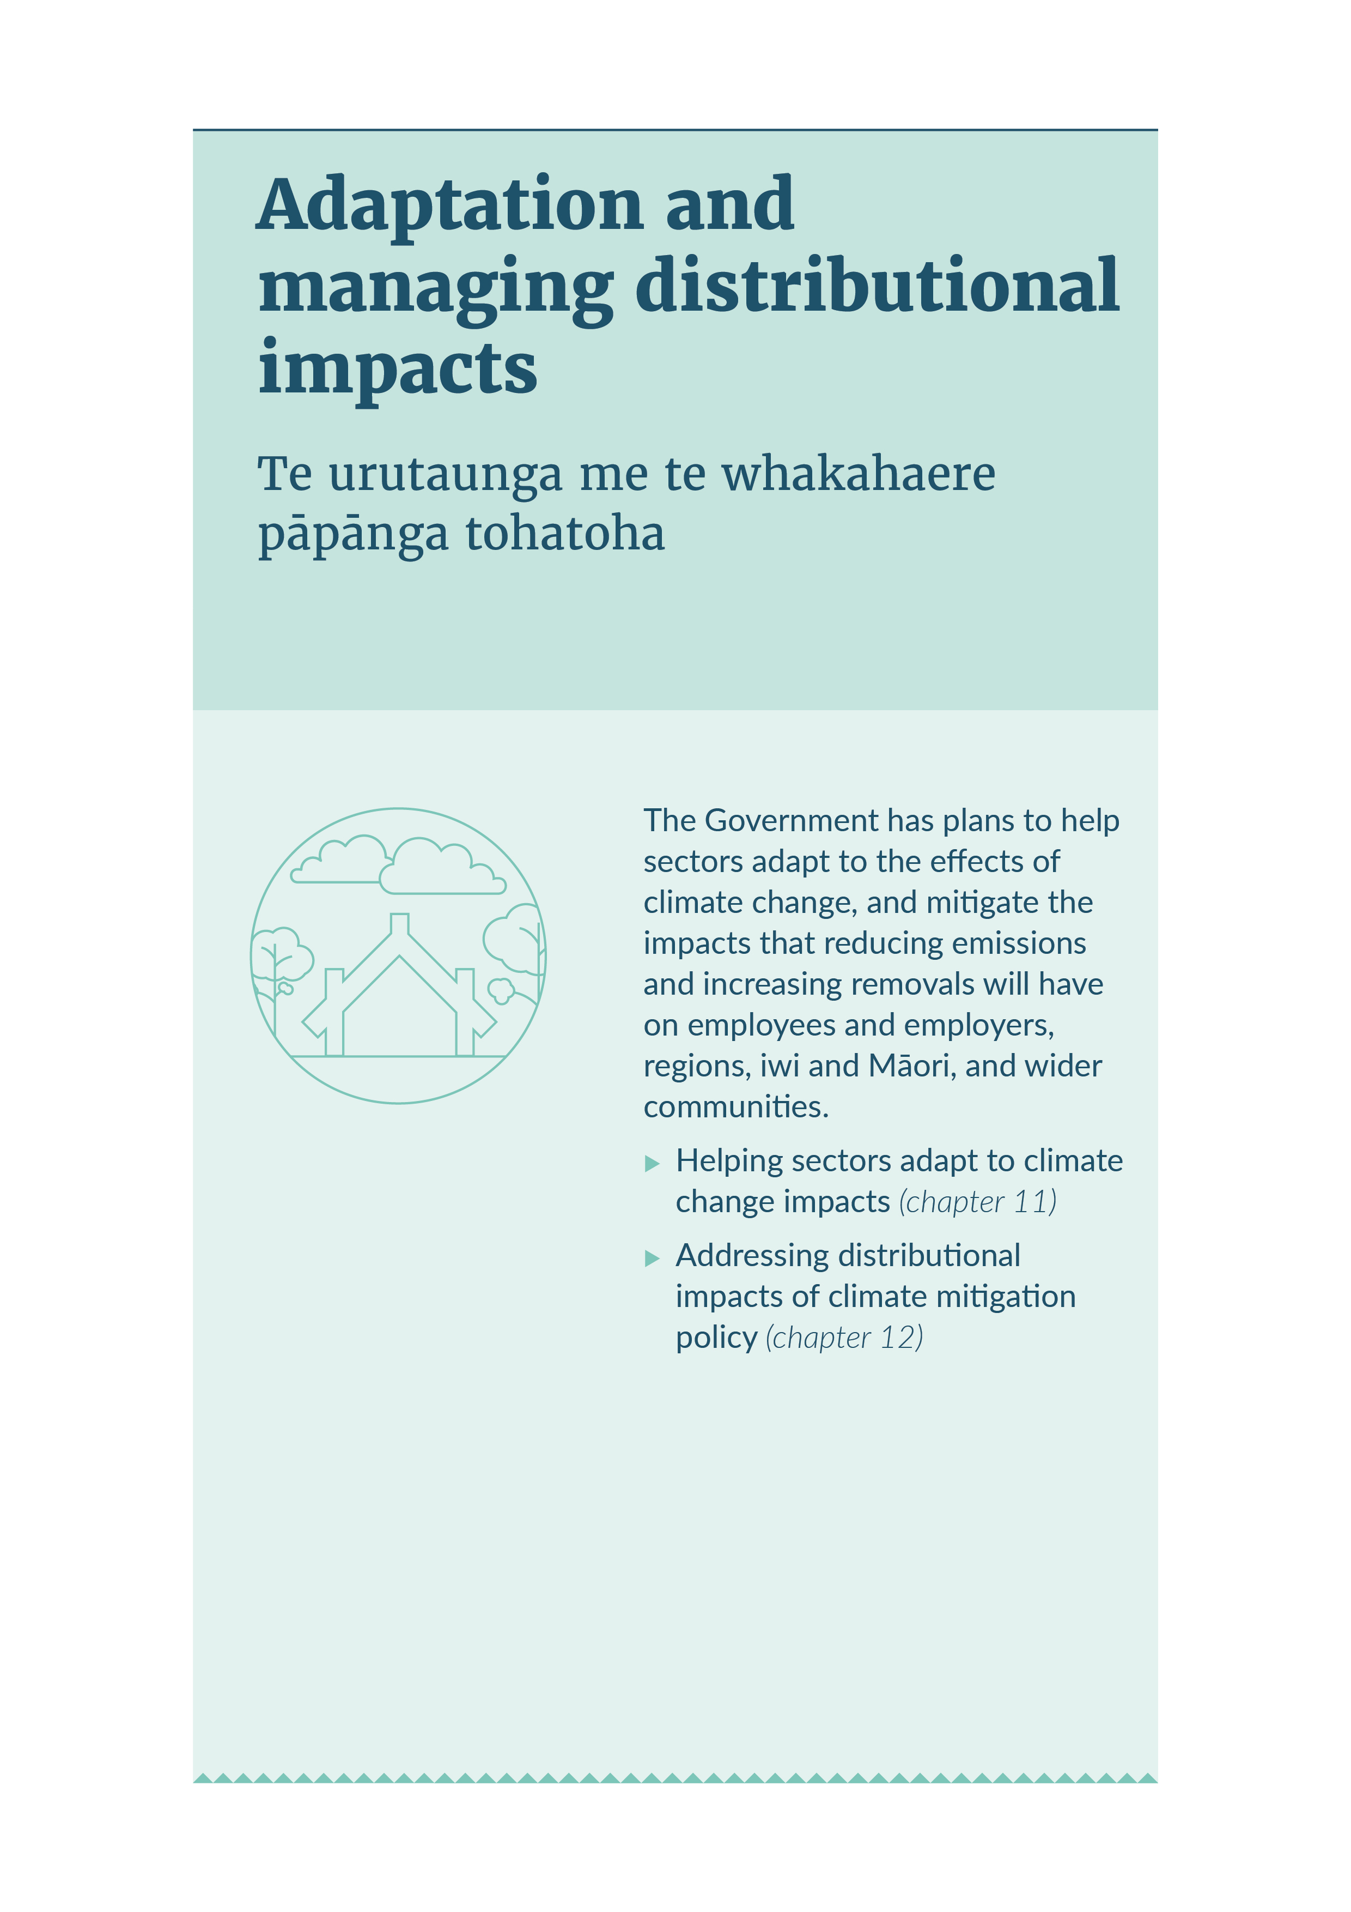
ADAPTATION AND MANAGING DISTRIBUTIONAL IMPACTS

11. Helping sectors adapt to climate change impacts

Te āwhina i ngā rāngai ki te urutau ki ngā pāpānga o te panoni āhuarangi
Summary
The Climate Change Response Act 2022 (CCRA) requires emissions reduction plans to include a multi-sector strategy to meet emissions budgets and improve the ability of those sectors to adapt to the effects of climate change. This chapter outlines how we propose to adapt to the effects of climate change through the second emissions reduction plan (ERP2).
As we work to reduce emissions, we also need to manage climate change impacts. How we approach this could affect the ability of sectors to adapt either positively (ie, adaptation co-benefits) or negatively (ie, maladaptation).

Understanding climate risks will help sectors adapt
Knowing what climate risks need to be managed, now and in the future, is critical to driving resilient infrastructure, and ensuring households, communities and businesses are well prepared for climate change.
The first National Climate Change Risk Assessment, published in August 2020, helps us understand the main climate risks facing New Zealand. These risks show that climate impacts are uneven across different sectors, so different approaches are needed to manage impacts.
The first national adaptation plan, published in August 2022, outlines the Government’s strategy for adapting to climate change. It sets out the actions to address the climate risks. These actions support the long-term adaptation goals to:
- reduce vulnerability to climate impacts
- enhance adaptive capacity and consider climate change in decisions at all levels
- strengthen resilience to climate change.
The Government is developing an adaptation framework to strengthen how New Zealand prepares for and adapts to climate change, in a way that minimises long-term costs while addressing wellbeing, fairness, transition and specific Māori interests. A cross-party inquiry will recommend objectives and principles for the design of the adaptation framework.
Initiatives are underway across government and by sectors to support the understanding and management of climate risks (table 11.1). However, sectors will also need to consider how their own emissions reduction policies can also reduce these climate risks, now and in the future.
Table 11.1: Existing initiatives to support sectors to understand and manage climate risks
Initiative | Examples | Expected outcomes
Climate information, tools and guidance for sectors | - Access to latest climate projections data means all New Zealanders will have the most up-to-date regional and local climate projections  - Scenario analysis or sector-led climate change scenarios and adaptation roadmaps have been produced for the agriculture, energy and transport sectors | - Increase use of climate change risk assessments and future climate scenarios  - Improve transparency and management of climate risks within sectors  - Encourage better risk-informed decisions that manage risks and increase resilience  - Encourage investment in resilient projects and programmes  - Minimise duplication of adaptation measures  - Minimise long-term costs of adaptation
Climate-related reporting within sectors | - Monitor progress of adaptation preparedness from selected organisations with essential policy and service delivery functions under the CCRA.  - The External Reporting Board has produced guidance and support for sector-level climate scenario analysis
Alignment with natural hazards, recovery and resilience work within sectors | - New national direction for natural hazards under the current Resource Management Act 1991 can support long-term resilience. This is in development through phase 2 of the resource management reforms.  - The adaptation framework will clarify the roles and responsibilities of sectors involved after a natural event

Addressing climate risks and integrating adaptation in sector policies
Climate risks facing the sectors include extreme weather, sea-level rise, longer-term trends in weather patterns, flooding, erosion, landslides, wildfire, drought, pests and disease (figure 11.1). To help sectors adapt to the impacts of climate change, we propose that sector policies for ERP2 consider:
- addressing climate risks during planning and policy development, to understand potential impacts
- integrating adaptation to avoid maladaptation or to deliver adaptation co-benefits
- supporting resilience initiatives at the sector level that flow down to businesses, communities and households.
Figure 11.1: Effects of climate change on our environment
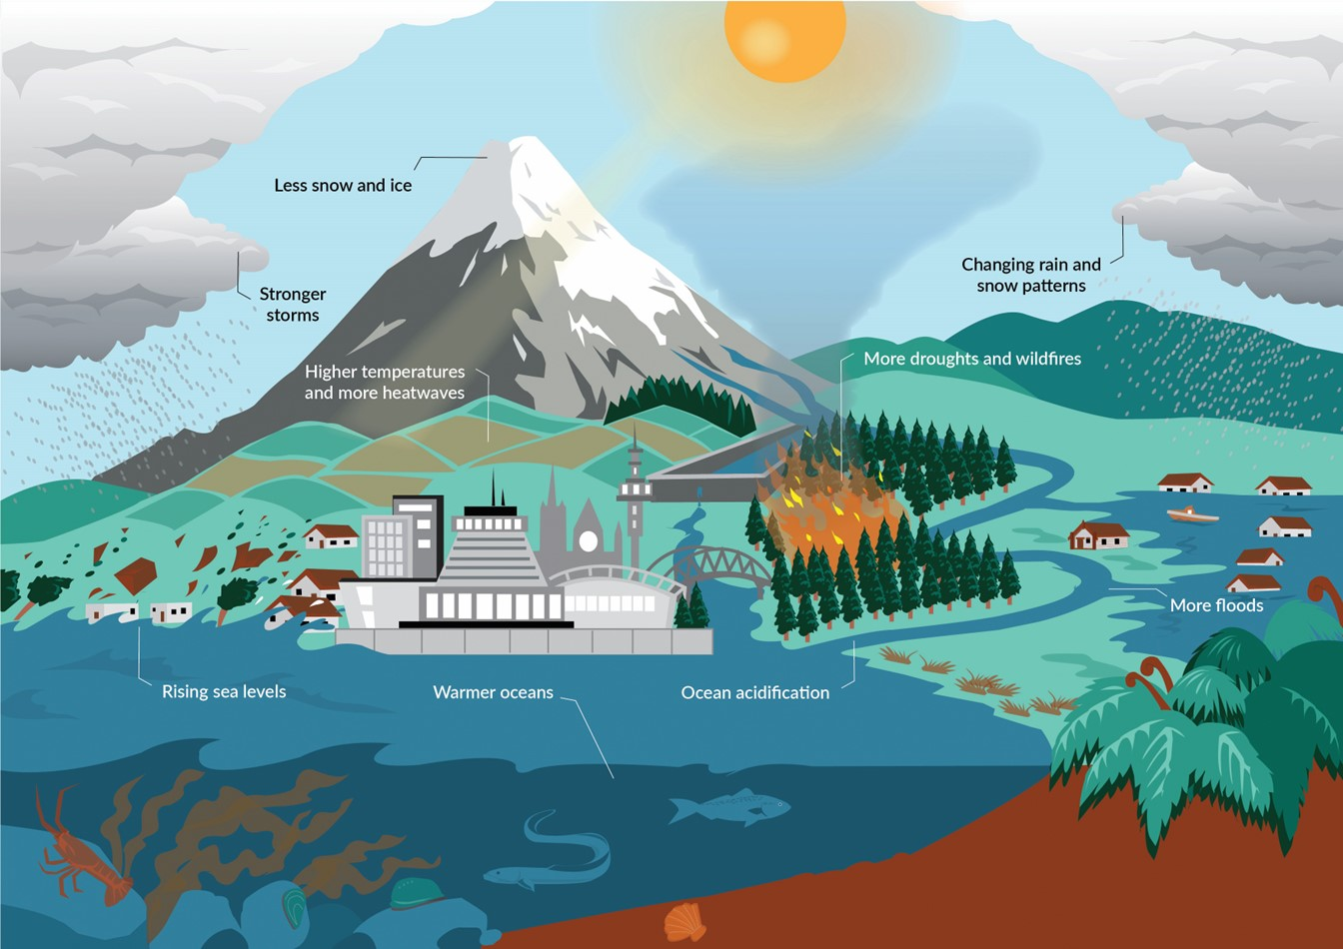
Table 11.2 sets out the sector-specific approaches.
Table 11.2: Key climate impacts and proposed adaptation considerations for ERP2 sector policies
Sector | Climate impacts | Adaptation considerations for policies
Energy | Disrupt and damage energy infrastructure, including electricity generation and network infrastructure | - Energy system resilience to climate impacts  - Resilience of critical infrastructure  - Enabling distributed energy
Transport | Disrupt and damage transport networks and infrastructure, including supply chains | - Location of planned infrastructure  - Upgrades, repair, maintenance or relocation of existing infrastructure  - Maintained connectivity for people and freight due to disruptions
Agriculture | Impact on productivity and the availability of suitable land for agriculture | - Adaptation and biodiversity benefits from agricultural activities and operations  - Investment in resilience to maintain production and supply chains
Forestry | Impact on tree growth and forest maturation | - Forest management and land-use practices  - Diversifying tree species  - Erosion control benefits from forest
Waste | Impact on landfills, contaminated sites, waste and recycling systems and infrastructure | - Appropriate development locations and surrounding land use  - Evaluation of landfills and contaminated sites  - Funding for investigation and remediation of landfills and contaminated sites

Share your views
The final ERP2 will contain a multi-sector strategy to improve the ability of sectors to adapt. We are seeking your feedback now to help us develop this strategy.

Chapter 11 consultation questions
11.1 | What are the three main barriers to managing climate risks through emissions reduction policies in this discussion document?
11.2 | What are the three main benefits of managing climate risks that can come from the emissions reductions policies in this discussion document?
11.3 | What are some examples of how businesses and industries are already managing climate risks?
11.4 | How can these kinds of activities be further supported?
11.5 | Please provide any additional feedback on the pathway the Government has set out for managing climate risks from emissions reduction activities.

12. Addressing distributional impacts of climate mitigation policy

Te whakatutuki i ngā pāpānga tohatoha o te kaupapahere whakamauru panoni āhuarangi
Summary
Alongside our efforts to reduce emissions, we need to address the distributional impacts from climate mitigation policy in the second emissions reduction plan (ERP2). Reducing emissions and increasing removals can be disruptive and impose costs on different groups of New Zealanders.
Each emissions reduction plan is required, under the Climate Change Response Act 2022 (CCRA), to include a strategy to mitigate the impacts of reducing emissions and increasing removals on employees and employers, regions, iwi and Māori, and wider communities, including the funding for any mitigation action.
This chapter sets out an initial analysis of the distributional impacts of some policies in this discussion document. It also outlines how we will more thoroughly assess and address those impacts in the published ERP2.

The Government will support New Zealanders through the transition to a low-emissions economy
Meeting New Zealand’s emissions reduction targets will involve businesses, communities and households making different choices about how they trade, work and live. These choices bring benefits and opportunities for New Zealanders, including new, low-emissions jobs and business opportunities.
But some changes will be challenging. For example, some people may transition to jobs in different industries or change how they use energy in their homes. These challenges will affect different groups in society in different ways.
The Government is approaching climate change in a way that will meet our climate targets while minimising the costs to New Zealanders. It is also committed to strengthening the economy, boosting productivity and easing the cost-of-living crisis for New Zealanders. All these efforts put the economy and New Zealanders in a much better position to adapt to a lower-emissions way of life and to manage any costs and challenges that this shift brings.
In addition to getting the settings right, the Government will support households, businesses, workers and communities with the tools to manage these challenges and seize low-emissions opportunities. This means understanding how policies that reduce emissions and increase removals will affect different groups and exploring options to best support affected people.

We can analyse distributional impacts across our economy and society
When ERP2 is published in December 2024, we will have a better understanding of the expected quantitative and qualitative distributional impacts of ERP2 policies, including from the New Zealand Emissions Trading Scheme (NZ ETS). In the interim, we can use preliminary 2050 pathway modelling.
This modelling compares two possible approaches against a hypothetical counterfactual scenario. It shows the possible difference in outcomes in 2050 across households, sectors and regions. The counterfactual is where we have no climate mitigation policy. The two approaches compared are:
- continuing with our existing climate policies (excluding proposed ERP2 policies)
- following the proposed ERP2 approach.
This modelling provides initial analysis but has limitations. It does not imagine what our future economy is like, with new goods, services and exports. Instead, it models the current economy and helps us to understand where to look for risks. It also only analyses the impacts from our efforts to reduce emissions, not the impacts of climate change. Further details on this modelling can be found in the technical annex.
At an economy-wide level, the modelling suggests that existing climate mitigation actions will lead to real gross domestic product (GDP) that is about 0.4 per cent lower in 2030 than it would be in a hypothetical ‘without measures’ scenario. The impact on GDP is expected to remain at similar levels through to 2050. Preliminary estimates of the effects of proposed ERP2 policies indicate they would have slightly smaller impacts on the economy than the current policy settings have.

Impacts of ERP2 policies

Impacts on households
Figure 12.1: Expected impact of ERP2 policies on household consumption, by household income and ethnicity, 2050
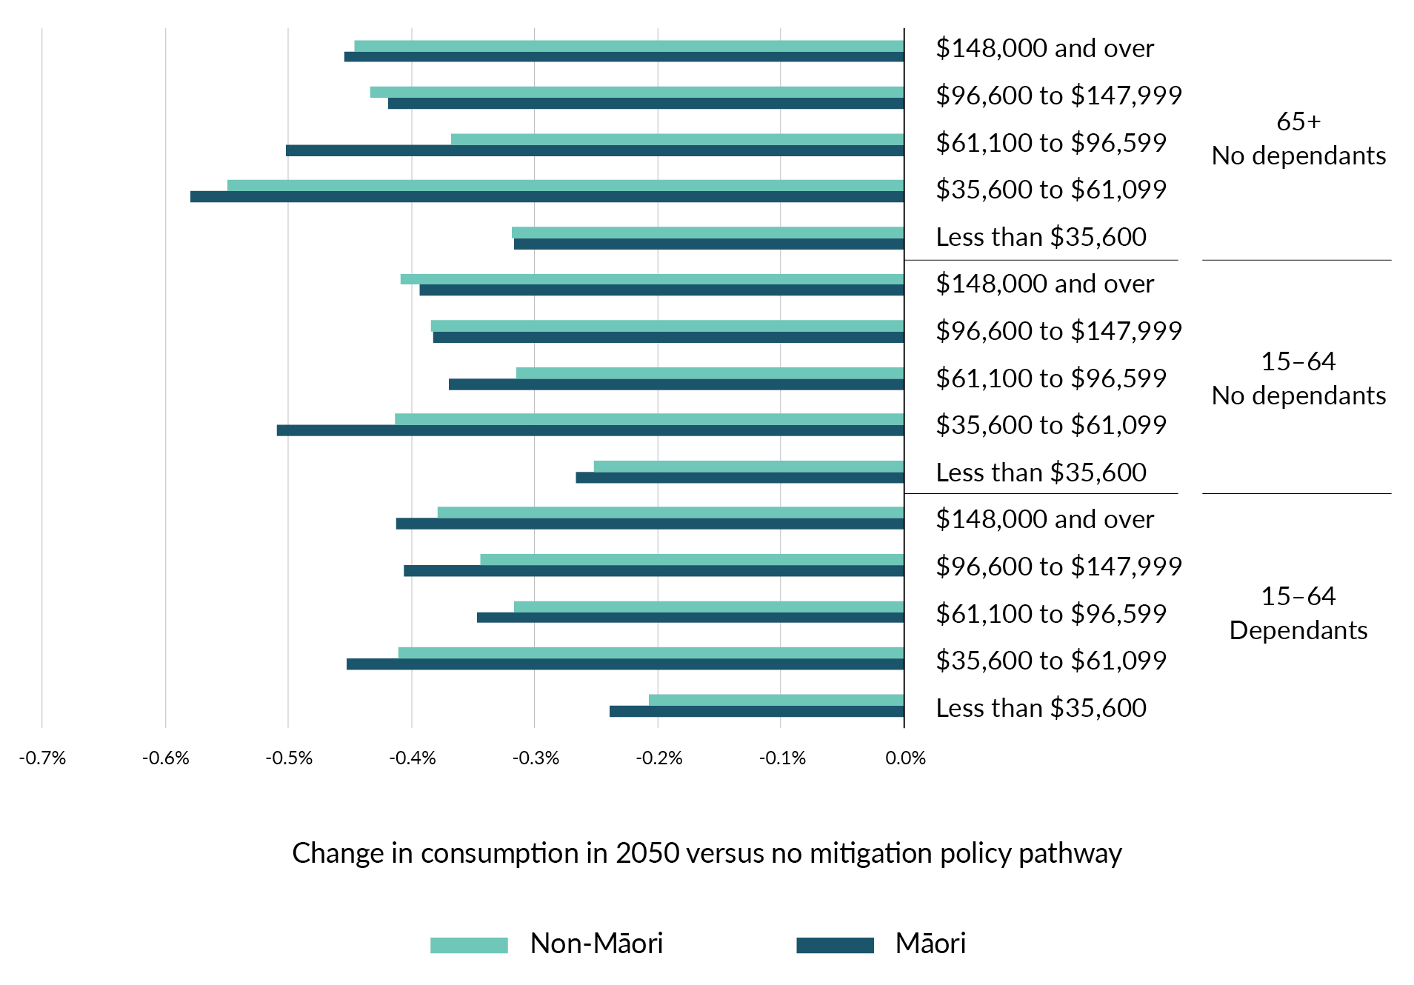
Note: Deviation in real consumption in 2050 under the ERP2 pathway from real consumption in 2050 under the counterfactual ‘without measures’ pathway (where we have no efforts to reduce emissions).
Source: Torshizian, E, Adams P and Stroombergen A (2024) Economic impact of New Zealand’s Second Emissions Reduction Plan. Report to Ministry for the Environment by Principal Economics Limited in collaboration with The Centre for Policy Studies and Infometrics Limited.
Overall ERP2 policies are expected to slightly improve outcomes for households: household consumption decreases by 0.39 per cent compared with 0.4 per cent under current policies.
Figure 12.1 shows that under the ERP2 pathway, all households in New Zealand are expected to have lower consumption in 2050 than they would have without efforts to reduce emissions (the counterfactual). This is because added costs from changing to low-emissions production or from the NZ ETS raise the price of goods and services, so that people cannot purchase as much as they would have otherwise. However, the difference in consumption between the scenarios is fairly small, only between 0.2 per cent and 0.6 per cent by 2050, depending on the type of household.
Lower-income households are expected to be the most affected, particularly those earning between $35,600 and $61,099. This is partially explained in the deeper dive into the effects of emissions pricing below.
Māori households are expected to be more affected than non-Māori households, but the difference is very small. On average, across all households, Māori are expected to experience a decrease in consumption of 0.4 per cent compared with 0.37 per cent for non-Māori households.

Impacts on sectors
Figure 12.2: Expected impact of mitigation policies on output by sector, 2050
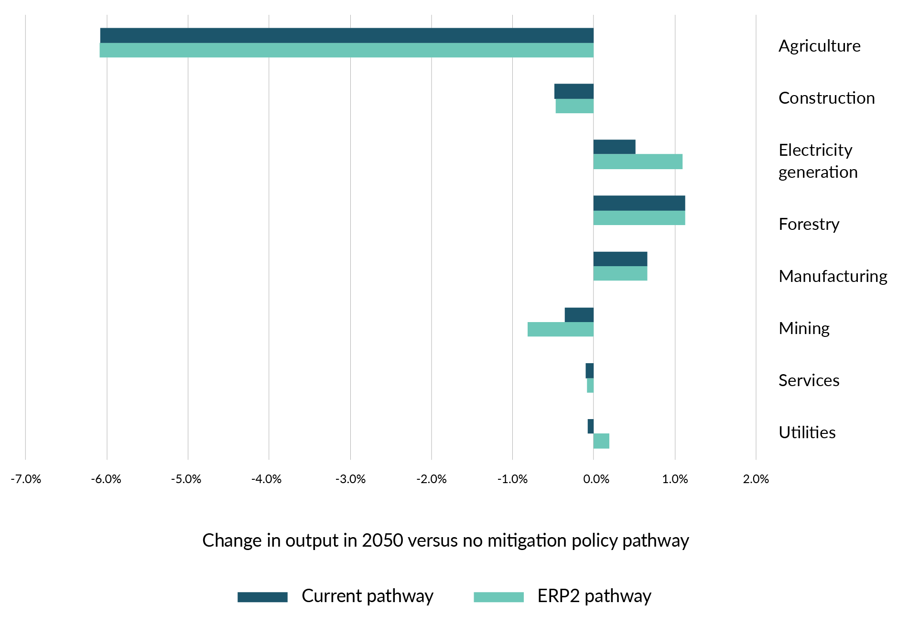
Note: Deviation in sectoral output in 2050 under the ERP2 pathway and ‘current’ pathway (where we continue with existing climate policies) from sectoral output in 2050 under the counterfactual ‘without measures’ pathway (where we have no efforts to reduce emissions).
Source: Torshizian, E, Adams P and Stroombergen A (2024) Economic impact of New Zealand’s Second Emissions Reduction Plan. Report to Ministry for the Environment by Principal Economics Limited in collaboration with The Centre for Policy Studies and Infometrics Limited.
ERP2 policies are not expected to have significant impacts on sectoral output compared with our existing policies. Under the ERP2 pathway, we expect a slight increase in relative output for the electricity generation and utilities sectors, and a slight decrease for the mining sector but the difference between the two scenarios is minor (figure 12.2).
Agriculture is expected to be the most affected sector under both pathways. Regardless, agricultural output (in GDP terms) is expected to be higher in 2050 than output today due to efficiencies, productivity improvements and technology uptake. Changes to emissions pricing may make forestry more financially viable and continue to shift the balance of land use from agriculture to forestry. This effect is mitigated somewhat by the Government’s policies which will limit conversions of high-quality agricultural land to forestry. The assessment of the impact to the agriculture sector from pathways does not consider the effect of climate change itself on land use, nor does it account for the market opportunities that may emerge for New Zealand as an exporter of relatively low-emissions dairy and meat products. Under ERP2 policies, minor negative impacts are expected across construction and mining sectors. Minor positive impacts are expected across manufacturing and electricity generation sectors.

Impacts on regions
Figure 12.3: Expected impact of mitigation policies on real GDP by region, 2050
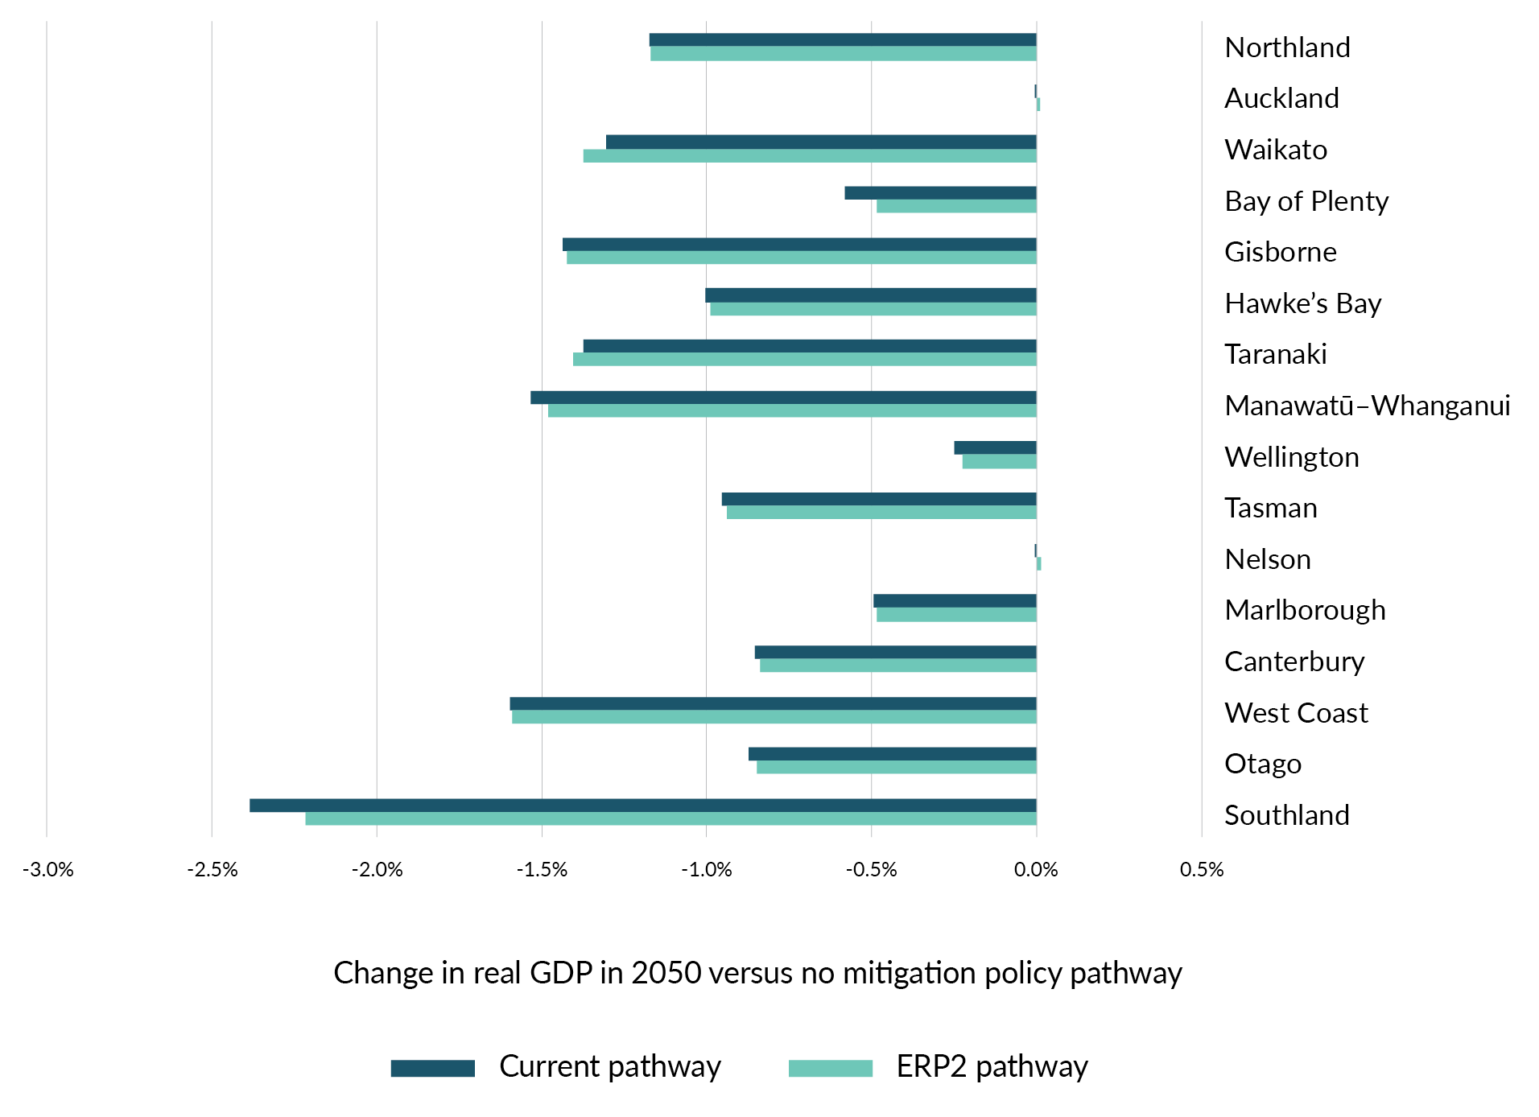
Note: Deviation in real GDP in 2050 under the ERP2 pathway and ‘current’ pathway (where we continue with existing climate policies) from real GDP in 2050 under the counterfactual ‘without measures’ pathway (where we have no efforts to reduce emissions).
Source: Torshizian, E, Adams P and Stroombergen A (2024) Economic impact of New Zealand’s Second Emissions Reduction Plan. Report to Ministry for the Environment by Principal Economics Limited in collaboration with The Centre for Policy Studies and Infometrics Limited.
Regional impacts are mainly driven by regional industry mixes and how they are affected by the changes in land use explained above. The Government’s ERP2 policies are expected to slightly improve the overall impacts on regions, compared with the current set of policies.
As figure 12.3 shows, the most affected regions are those with heavier reliance on dairy, sheep and beef farming such as Southland, the West Coast and Manawatū–Whanganui. However, these regions are expected to be slightly better off because of the Government’s ERP2 policies compared with current policies.
The least affected regions are urban areas with more service industries such as Auckland or Wellington. There are also minimal effects for regions with a different primary sector mix such as Nelson, Bay of Plenty and Marlborough.

Effects of emissions pricing
The Government is proposing that the NZ ETS will be the main tool for reducing emissions across New Zealand. We know that emissions pricing disproportionately affects lower socio-economic groups,, which contain a disproportionate number of people from Māori and Pasifika communities. The costs of emissions pricing will be felt by all New Zealanders, but especially by lower-income households.
This is because lower-income households spend a relatively greater portion of their income on emissions-intensive items and have less capacity to substitute those items for low-emissions options, particularly in the short term. Lower-income households also have less disposable income compared with higher-income households, so feel the additional costs from emissions pricing more keenly.
The Treasury’s analysis highlights the impact on lower-income households. It models how a hypothetical increase in emissions pricing would impact different households by increasing the costs of household essentials such as fuel, electricity and food.
Figure 12.4 presents a simplified version of the Treasury’s analysis. It shows that lower-income households would spend a higher percentage of their disposable income on emissions pricing costs compared with higher-income households.
Figure 12.4: Relative impact of emissions price increases on households by household disposable income
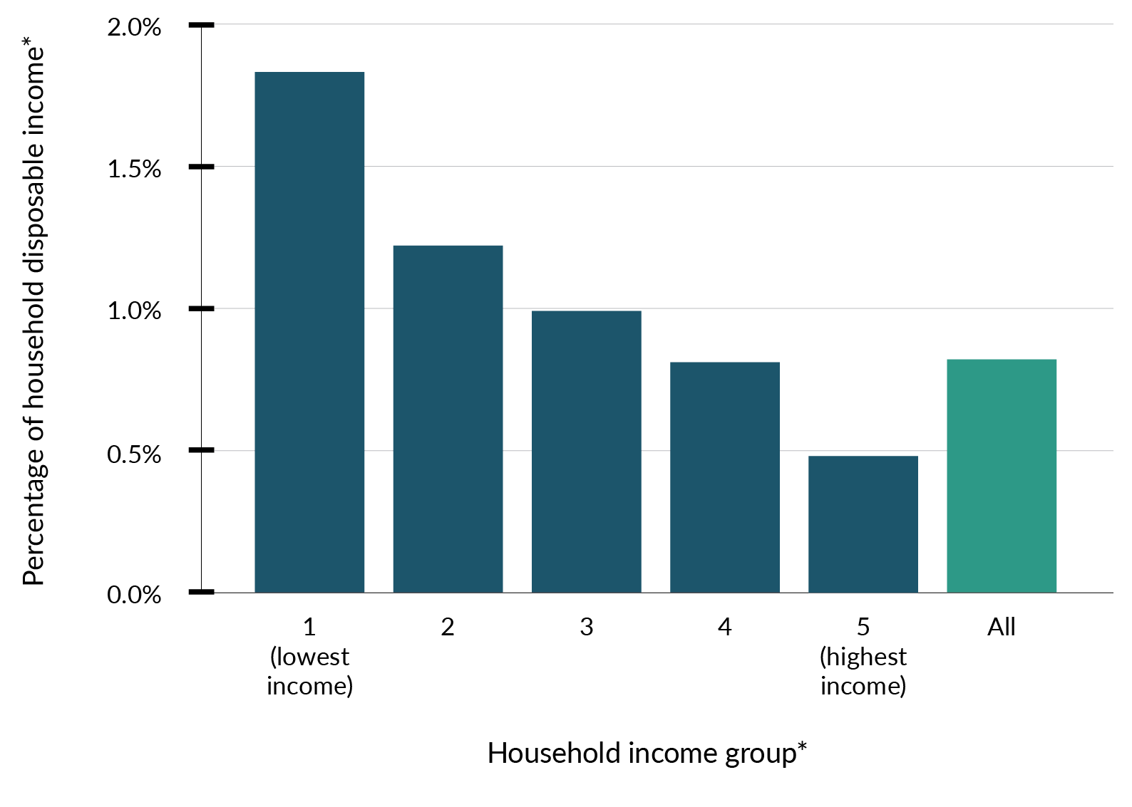
Note: * Mean increased spending on petrol, diesel, gas, electricity, domestic airfares and food due to a carbon price increase from $24.73 to $134.90 per metric tonne CO₂-e, as a percentage of mean household disposable income. Households are divided based on their household equivalised disposable income, with 1 indicating mean household earning in the bottom 20 per cent, and 5 indicating those earning in the top 20 per cent.
To illustrate how the impact can differ for households based on their income, in December 2023 the NZ ETS unit price contributed about 16 cents per litre to petrol prices at the pump. Petrol price is the primary way that households are exposed to an emissions price. Fuel costs represent a higher share of income for lower-income households than for higher-income households. Lower-income households that require a private vehicle will also be relatively less able to pay the upfront costs of switching to an electric vehicle or more fuel-efficient vehicle, such as a hybrid, than higher-income households. The average household currently spends about 0.27 per cent of annual gross income on NZ ETS costs embedded in private transport. This percentage will generally be higher for lower-income households.
Similarly, higher electricity prices expected over the next decade will affect lower- and higher-income households in different ways. While electrification will generally lower overall household energy bills, people on lower incomes will be least able to afford the technological innovations and household upgrades (eg, electric vehicles and home solar generation) that could help offset rising costs.
The impacts are not only economic. For example, people who cannot afford to heat their homes are likely to have poorer health outcomes. This has flow-on effects such as reduced economic and educational opportunities, and increased pressure on the health system.
The impacts on lower-income households are partly offset by the indexing of some existing income support payments to the consumers price index. This means that as the cost of goods and services increases because of efforts to reduce emissions, some benefits will increase as well. Recent Treasury analysis found that 72–84 per cent of low-income households receive some form of indexed payment, which compensates for 40–80 per cent of increasing costs from emissions pricing. The distinct impact of non-NZ ETS policies can also be significant.

Sector-specific policies
We do not yet have detailed analysis of the expected distributional impacts of many of the sector-specific policies set out here, as the policies are still in development and key policy decisions have yet to be made. We will look to include as much information as possible in the final ERP2, due for publication by 31 December 2024, but recognise that this will need to be an ongoing programme of work. As part of the consultation, we seek your feedback to better understand the impacts of the proposed policies. We will consider your feedback and any additional detail as we determine how best to respond to the distributional impacts of ERP2.
Below is some of the high-level analysis available at this stage.
- Electricity and fuel prices are expected to rise over the second emissions budget period. Energy costs are a major input cost for businesses and have a significant impact on New Zealanders’ cost of living. The policies proposed for ERP2 may help to reduce pressure on the cost of energy by reducing the cost to consent electricity infrastructure projects. Reducing energy emissions provides an opportunity to meet trading partners’ growing expectations that goods are produced and transported with renewable energy, maintaining and growing international markets and creating skilled jobs.
- ERP2 policies that support food and fibre producers to reduce emissions without reducing production will support their viability, which in turn will support the local communities, owners and businesses that rely on them. It also helps them to remain internationally competitive, as overseas buyers are increasingly focused on reducing emissions throughout their supply chains.
- The agriculture sector plays a significant role in the Māori economy through collectively owned land assets, iwi authorities, individual Māori-owned agribusinesses, and the level of Māori employment in the sector. Policies that continue to enable Māori landowners to develop unused or underutilised lands will reduce the potential impact on Māori.
- Māori interests in forestry are extremely wide-ranging. In 2018, Māori owned an estimated $4.3 billion of forestry assets. Around 71,000 hectares of Māori freehold land comprise remote and less versatile land, making it well suited to carbon or long-rotation plantation forestry. This means Māori landowners will be disproportionately affected by climate change policies that impact the forestry sector.
- Reducing transport emissions by supporting more electric vehicles can have many benefits, such as reducing air and noise pollution, improving physical health and mental wellbeing, and making our towns and cities more liveable.
- We do not expect any mitigation will be necessary to respond to the potential impacts of the emissions reduction policy presented here for the waste sector. We expect economic impacts from waste policies to be manageable in the longer term. Though waste disposal costs may increase, the volume of disposed waste should decline as alternative systems for resource recovery and recycling grow.

Mitigation strategy
One of New Zealand’s strengths is our effective support systems that can temporarily assist individuals and families through times of uncertainty or when they need help to adapt. These systems are flexibly designed to play a strong role in supporting those individuals disrupted by economic and social transitions, including climate change.
An existing and planned range of support measures will be part of any response to the impacts of climate change, including:
- the Government’s ‘climate dividend’ tax relief – continuing to return money from NZ ETS revenue to the hands of New Zealanders to meet additional costs related to climate change mitigation
- existing government financial assistance and the income support system (including the Winter Energy Payment)
- Apprenticeship Boost scheme – a payment to help employers take on and retain apprentices
- government employment services – including transition advice in cases of involuntary job loss
- providing clear information on possible impacts, to enable people to prepare and respond.
Beyond these measures, the Government will determine whether more support is required once final decisions are made on the content of ERP2, and the impacts become clearer through additional modelling and analysis.
In addition to support measures, a key part of the Government’s strategy has been to meet our climate targets while minimising the costs to and impacts on New Zealanders. This includes the focus on supporting food and fibre producers to reduce emissions without reducing production, and minimising the impact on the agriculture sector and regional economies, as well as on Māori, who have a particularly strong connection to the agriculture sector.
Share your views
We are seeking feedback on:
- how well the above support measures can address the potential impacts from ERP2 policies
- other support you see as key to assisting groups to manage distributional impacts.

Te Tiriti o Waitangi commitments
In mitigating distributional impacts, the Government has a particular obligation under section 3A of the CCRA to recognise and mitigate the impacts on iwi and Māori. Our approach to distributional impacts is guided by Tiriti principles.
Māori are at risk of being disproportionately impacted in the transition to a low-emissions future, because:
- history shows that Māori are more likely to be affected by economic transitions, as they are starting from a position of greater socio-economic disadvantage
- there are many Māori small and medium enterprises in transport, construction and manufacturing
- a significant proportion of Māori work in high-emissions industries.
The transition also offers opportunities for Māori. Iwi and hapū generally take a holistic approach to outcomes, and so are well positioned to make the most of their whenua (land). They may do so through increasing afforestation, based on their confidence in NZ ETS settings, or levering world-leading emissions efficiency for international trade.
Share your views
As part of the consultation, we are:
- continuing to engage with Māori to identify opportunities and barriers for them in the evolving landscape of the low-emissions transition
- continuing to test our understanding of the distributional impacts of policies, and what the Government and Māori need to monitor over time
- exploring how New Zealand can have the right data as a foundation to enable many stakeholders, including Māori, to determine the emissions reduction approach that works best for them.

Chapter 12 consultation questions
12.1 | What are the main impacts of reducing emissions on employees, employers, regions, iwi and Māori, and/or wider communities that you believe should be addressed through Government support?
12.2 | The Government can use a lot of existing tools to support people affected by reducing emissions (welfare and income support systems, employment and training services).  Do you think additional climate-specific services, supports or programmes should be considered by the Government over the coming years?  Please describe what additional climate-specific services, supports or programmes could be useful.

Appendix 1: Consultation questions

Āpitihanga 1: Ngā pātai whakawhitiwhiti whakaaro

Full list of consultation questions
These questions appear throughout the consultation document.
Share your views
0.1 | What do you think is working well in New Zealand to reduce our emissions and achieve the 2050 net zero target?
0.2 | The Government is taking a ‘net-based approach’ that uses both emissions reductions and removals to reduce overall emissions in the atmosphere (rather than an approach that focuses only on reducing emissions at the source). A net-based approach is helpful for managing emissions in a cost-effective way that helps grow the economy and increase productivity in New Zealand.  a. What do you see as the key advantages of taking a net-based approach?  b. What do you see as the key challenges to taking a net-based approach?
0.3 | The current proposed policies in the ERP2 discussion document cover the following sectors and areas:  - strengthening the New Zealand Emissions Trading Scheme  - private investment in climate change  - energy sector  - transport sector  - agriculture sector  - forestry and wood-processing sector  - non-forestry removals  - waste sector.  What, if any, other sectors or areas do you think have significant opportunities for cost-effective emissions reduction?
0.4 | What Māori- and iwi-led action to reduce emissions could benefit from government support?  There are additional questions about Māori- and iwi-led action to reduce emissions and impacts of proposed ERP2 policies on Māori and iwi in chapters 1 and 12.
Chapter 1
1.1 | What opportunities do the proposed initiatives and policies across the sectors offer for Māori- and iwi-led action to reduce emissions?
1.2 | What additional opportunities do you think the Government should consider?
Chapter 2
 | Current modelling suggests that with a changed approach, the first emissions reduction plan is still sufficient to meet the first emissions budget.
2.1 | What, if any, other impacts or consequences of the Government’s approach to meeting the first emissions budget should the Government be aware of?
2.2 | What, if any, are the long-term impacts from the changes to the first emissions reduction plan on meeting future emissions budgets that should be considered through the development of the second emissions reduction plan?
Chapter 3
3.1 | What else can the Government do to support NZ ETS market credibility and ensure the NZ ETS continues to help us to meet our targets and stay within budgets?
3.2 | What are the potential risks of using the NZ ETS as a key tool to reduce emissions?
3.3 | How can the Government manage these risks of using the NZ ETS as the key lever to reduce emissions?
3.4 | Do you support or not support the Government’s approach of looking at other ways to create incentives for carbon dioxide removals from forestry, in addition to using the NZ ETS?
3.5 | Apart from the NZ ETS, what three other main incentives could the Government use to encourage removals through forestry?
3.6 | Please provide any additional feedback on the Government’s thinking about how to use the NZ ETS to reduce emissions.
Chapter 4
4.1 | Do current measures work well to unlock private investment in climate mitigation?
4.2 | What are the three main barriers to enabling more private investment in climate mitigation?
4.3 | What are the three main actions the Government can do to enable more private investment in climate mitigation for the next 18 months?
4.4 | What are the three main things the Government can do to enable more private investment in climate mitigation in the longer term (beyond the next 18 months)?
4.5 | Please provide any additional feedback on the Government’s thinking about how to enable more private investment in climate mitigation for the next 18 months.
Chapter 5
5.1 | What three main barriers/challenges that are not addressed in this chapter do businesses face related to investing in renewable electricity supply (generation and network infrastructure)?
5.2 | How much will the Government’s approach to driving investment in renewable energy support businesses to switch their energy use during 2026–30 (the second emissions budget period)?
5.3 | What three main barriers/challenges do businesses and households face related to electrifying or improving energy efficiency, in addition to those already covered in the discussion document?
5.4 | How much will existing policies support private investment in low-emissions fuels and carbon-capture technologies?
5.5 | What three main additional actions could the Government do to enable businesses to take up low-emissions fuels and carbon-capture technology?
5.6 | If you are an electricity generator, please explain and/or provide evidence of how Electrify NZ could affect projects already planned or underway.
5.7 | If you are an electricity generator, please explain and/or provide evidence of how Electrify NZ could increase the likelihood that new projects will be investigated.
5.8 | Please provide any additional feedback on the Government’s proposals to reduce emissions in the energy sector and the industrial processes and product use sector.
Chapter 6
6.1 | Do you support the proposed actions to enable EV charging infrastructure?
6.2 | What are the three main actions the Government can do to reduce barriers to and enable the development of a more extensive public EV charging infrastructure in New Zealand (without adding too much cost for households and businesses)?
6.3 | Do you support the Government’s proposals to reduce emissions from heavy vehicles?
6.4 | What are the three main actions the Government can do to make it easier to switch to low- and zero-emissions heavy vehicles (without adding too much cost for households and businesses)?
6.5 | Do you support the Government proposals to reduce emissions from aviation and shipping?
6.6 | What opportunities might there be from rolling out new technologies to reduce emissions from aviation and shipping?
6.7 | What are the three main actions the Government can do to make it easier to reduce emissions from aviation and maritime fuels (without adding too much cost for households and businesses)?
6.8 | Please provide any additional feedback on the Government’s thinking about how to reduce emissions in the transport sector.
Chapter 7
7.1 | What are the three main barriers or challenges to farmer uptake of emissions-reduction technology?
7.2 | How can the Government better support farm- and/or industry-led action to reduce emissions?
7.3 | How should Government prioritise support for the development of different mitigation tools and technologies across different parts of the agriculture sector?
7.4 | What are three possible ways of encouraging farmer uptake of emissions-reduction tools?
7.5 | What are the key factors to consider when developing a fair and equitable pricing system?
7.6 | Please provide any additional feedback on the Government’s thinking about how to reduce emissions in the agriculture sector.
Chapter 8
8.1 | How could partnerships be structured between the Government and the private sector to plant trees on Crown land (land owned and managed by the Government)?
8.2 | What are the three main actions the Government could do to streamline consents for wood processing?
8.3 | How large should the role of wood in the built environment play in New Zealand’s climate response?
8.4 | What other opportunities are there to reduce net emissions from the forestry and wood-processing sector?
8.5 | Please provide any additional feedback on the Government’s thinking about how to reduce emissions in the forestry and wood-processing sector.
Chapter 9
9.1 | What are the three main opportunities for non-forestry removals to support emissions reduction?
9.2 | What are three main barriers to developing more non-forestry removals?
9.3 | It is important to balance landowners ability to use their land flexibly with the recognition of the role of non-forestry removals. How can this balance be achieved?
9.4 | What three main benefits beyond emissions reductions could be created by developing more non-forestry removals?
9.5 | What risks and trade-offs from incentivising land-use and management change to reduce net emissions need to be considered?
9.6 | Please provide any additional feedback on the Government’s thinking about how to reduce emissions through non-forestry removals.
Chapter 10
10.1 | Do you agree or disagree that the Government should further investigate improvements to organic waste disposal and landfill gas capture?
10.2 | What is the main barrier to reducing emissions from waste (in households and businesses or across the waste sector)?
10.3 | What is the main action the Government could take to support emissions reductions from waste (in households and businesses or across the waste sector)?
10.4 | Please provide any additional feedback on the Government’s thinking about how to reduce emissions in the waste sector.
Chapter 11
11.1 | What are the three main barriers to managing climate risks through emissions reduction policies in this discussion document?
11.2 | What are the three main benefits of managing climate risks that can come from the emissions reductions policies in this discussion document?
11.3 | What are some examples of how businesses and industries are already managing climate risks?
11.4 | How can these kinds of activities be further supported?
11.5 | Please provide any additional feedback on the pathway the Government has set out for managing climate risks from emissions reduction activities.
Chapter 12
12.1 | What are the main impacts of reducing emissions on employees, employers, regions, iwi and Māori, and/or wider communities that you believe should be addressed through Government support?
12.2 | The Government can use a lot of existing tools to support people affected by reducing emissions (welfare and income support systems, employment and training services).  Do you think additional climate-specific services, supports or programmes should be considered by the Government over the coming years?  Please describe what additional climate-specific services, supports or programmes could be useful.

How to make a submission
Consultation opens on Wednesday 17 July 2024 and closes at 11.59pm on Wednesday 21 August 2024.
The Government welcomes your comments on this discussion document.
Online submissions
The quickest way to make a submission is via the online form. You do not have to answer all the questions. There is space to upload or add links to any evidence you would like to share with your answers.
Emailed submissions
You can also email submissions to ERPconsultation@mfe.govt.nz. If you email feedback, you can send it as a:
- PDF
- Microsoft Word document (2003 or later version).
Contact us for more information
If you have questions or want more information about the policy proposals or the submission process, you can:
- email the Ministry for the Environment at ERPconsultation@mfe.govt.nz
- post to ERP2 Consultation, Ministry for the Environment, PO Box 10362, Wellington 6143.
For more details on how to make your submission, visit https://consult.environment.govt.nz/climate/second-emissions-reduction-plan.

Who will see your submission?
The Privacy Act 2020 applies certain principles about the collection, use and disclosure of information about individuals by various agencies, including the Ministry for the Environment. It governs access by individuals to information about themselves held by agencies. Any personal information you provide as part of a submission will be managed in accordance with the Privacy Act.
All submissions will be accessible to government agencies and Crown entities responsible for developing or implementing parts of the second emissions reduction plan (ERP2). These include, but are not limited to, the following:
- Land Information New Zealand
- Ministry of Transport
- Ministry for Primary Industries
- Ministry of Business, Innovation and Employment
- Ministry for the Environment
- Waka Kotahi | New Zealand Transport Agency
- Energy Efficiency and Conservation Authority
- Civil Aviation Authority
- Maritime New Zealand
- KiwiRail
- The Treasury.
The Ministry for the Environment may publish on its website the content of submissions (including names of submitters) as they are often of high interest to the public; or it may share them in response to an Official Information Request (under the Official Information Act 1982).
The Ministry will also retain your/your organisation’s name and email address as part of a stakeholder list for future communication about ERP2 or related climate issues.
The Ministry for the Environment will consider that, by making a submission, you consent to the release and retention of your details.
If you do not wish us to release or retain your personal details, please state this:
- on the online form
- as part of your emailed submission.
If you think any part of your submissions should be withheld for publication or release under the Official Information Act, please state:
- what and why on the online form
- what and why as part of your emailed submission.
We will consider your preference when responding to any requests for information.

How submissions will be used
The Ministry for the Environment will publish a summary of submissions that will not identify any individual submitters.
After receiving submissions, we will analyse them to help inform final decisions on the plan.

When ERP2 will be published
The Minister of Climate Change will publish the final ERP2 by the end of 2024.

Appendix 2: Proposals for the second emissions reduction plan

Āpitihanga 2: Ngā marohi mō te mahere whakaheke tukunga tuarua
Section | Proposal |  | Description
New Zealand Emissions Trading Scheme (NZ ETS) | Restore confidence in the NZ ETS | Develop predictable regulations to:  - stop the NZ ETS review  - commit to no vintaging of New Zealand Units (NZUs)  - commit to no differential treatment of forestry NZUs  - strengthen market governance and clarify market information
 | Align the NZ ETS with the second emissions budget | Align NZU supply and the NZ ETS cap with the second emissions budget through annual updates of NZ ETS settings
 | Continue reforms of industrial allocation in the NZ ETS | Update industrial allocation regulatory settings to address over-allocation
 | Manage the impacts of the NZ ETS | Manage the risks from high rates of land-use change, by proposing to limit NZ ETS registrations for whole-farm conversions to new exotic forestry on productive agricultural land
Scaling up private investment in climate change mitigation | Identify the barriers to climate investment, to enable greater private investment | Seek evidence through the following:  - data and evidence about climate risks and opportunities  - high upfront costs and mismatched time horizons for many reduction technologies and infrastructure projects  - policy uncertainty  - regulatory barriers
 | Improve investor confidence | Develop predictable regulations
 | Enable electrification | Create a more enabling consenting environment for renewable energy projects
 | Enable low-emissions fuels, including carbon-capture technology | Consult separately on options to remove barriers to using CCUS
Transport | Build a network of 10,000 public electric vehicle (EV) charge points by 2030 | - Facilitate private investment in EV charging infrastructure  - Review Government co-investment to ensure it is fit for purpose and targeted
 | Review the Clean Car Importer Standard | Ensure the standard is working effectively and the targets are achievable
 | Review vehicle dimension and mass rules | Support the uptake of zero-emissions heavy vehicles by reviewing the rules
 | Support aviation and maritime decarbonisation | Support the phase-down of fossil fuels by enabling the development of sustainable aviation and marine biofuels:  - facilitating industry discussions  - working with other countries on sustainable aviation fuels
 | Improve public transport | - Invest in new major public transport projects  - Improve existing infrastructure and services
Agriculture | Technologies to mitigate agricultural emissions | Support the development of, and access to, tools and technology to reduce emissions by food and fibre producers
 | Regulations for agricultural mitigation tools | Enable clear and effective regulatory pathways for agricultural mitigation tools, including:  - working with other countries to streamline the process for regulatory approval for emerging tools and technologies  - developing methodologies to recognise the use of emissions reduction tools in New Zealand’s Greenhouse Gas Inventory  - improving the regulatory environment for genetic technologies
 | Implement pricing for on-farm agricultural emissions by 2030 | - Introduce fair and sustainable pricing of on-farm emissions no later than 2030  - Keep agricultural emissions out of the NZ ETS
Forestry and wood processing | Manage whole-farm conversions to exotic forestry through the NZ ETS | Limits on NZ ETS registrations on newly planted exotic forests on productive land
 | New afforestation on Crown land | Explore opportunities to partner with the private sector to plant trees, including native afforestation on Crown land (excluding national parks) that is unsuitable for farming and has low conservation value
 | Improve the consenting framework for wood processing | Improve consenting for infrastructure and other activity that will support forestry and other primary production
 | Ensure the Wood Processing Growth Fund supports investment in domestic wood processing | Ensure the fund helps to increase wood processing capacity
 | Getting the system settings right to support building with wood. | Addressing regulatory barriers to enable building with wood.
Non-forestry removals | Support non-forestry removals | Recognise removals from activities other than forestry and investigate options to reward non-forestry removals
Waste | Investigate improvements to organic waste disposal and landfill gas (LFG) capture | Engage with industry and investigate opportunities to improve the abatement potential of organic waste disposal and LFG, including:  - encouraging diversion of organic materials from landfill  - determining which landfill types accept which types of organic waste  - reviewing the scope of landfills that require LFG systems  - improving settings to increase the average LFG efficiency  - improving data and evidence to support LFG efficiency calculations and reporting; and NZ ETS accounting  Through the Waste Minimisation Fund, the Government has also committed to investment in resource recovery infrastructure and systems within New Zealand that reduce or recycle organic wastes and have associated emissions reductions

Appendix 3: Discontinued policies from ERP1

Āpitihanga 3: Ngā kaupapahere kua whakamutua nō te mahere whakaheke tukunga tuatahi

ERP1 actions discontinued by this Government
ERP1 action number | Discontinued action
3.2.1 | Develop an equitable transition strategy.
3.2.2b | Support regions and industries to manage the transition.
3.2.3 | Implement the Just Transition Partnership Programme.
3.3.1 | Develop an income insurance scheme.
5.2.1 | Adjust the New Zealand Emissions Trading Scheme (NZ ETS) to drive a balance of gross and net emissions reductions.
5.2.3 | Assess how the NZ ETS can support indigenous biodiversity.
6.10 | Establish the Climate Emergency Response Fund (CERF) to ensure the climate is prioritised in the Budget process.
8.1.1 | Establish a portfolio of Climate Innovation Platforms to support and coordinate strategic, effective and innovative initiatives.
8.2 | Te Ara Paerangi – Future Pathways science-system reform programme.
9.4 | Support businesses moving to circular economy models.
9.10 | Commence a Circular Economy and Bioeconomy Strategy.
10.1.1.6 | Require new investments for transport projects to demonstrate how they will contribute to emissions-reduction objectives and set a high threshold for approving new investments for any transport projects if they are inconsistent with emissions-reduction objectives.
10.1.2 | Revise Waka Kotahi’s national mode shift plan (keeping cities moving) to ensure nationally led activities align with the pace and scale of vehicle kilometres travelled (VKT) reduction and mode-shift required in urban areas.
10.1.2 | Set sub-national VKT reduction targets for New Zealand’s major urban areas (Tiers 1 and 2).
10.1.2 | Develop VKT reduction programmes for New Zealand’s major urban areas (Tiers 1 and 2) in partnership with local government, Māori and community representatives.
10.1.4 | Establish a high threshold for new investments to expand roads, including new highway projects, if the expansion is inconsistent with emissions-related objectives.
10.2.1 | Continue to incentivise the uptake of low- and zero-emissions vehicles through the Clean Vehicle Discount scheme and consider the future of the Road User Charge exemption for light vehicles beyond 2024.
10.2.1 | Establish whether the Clean Vehicle Discount can be extended to other vehicle classes.
10.4.1 | Ensure the next Government Policy Statement on Land Transport (GPS-LT) guides investment consistent with the emissions reduction plan.
11.1.1 | Provide rebates for energy-efficient equipment.
11.2.2 | Ban new fossil-fuel baseload generation.
11.2.2 | Investigate options for dry-year electricity storage through the New Zealand Battery Project.
11.3.1 | Manage the phase-out of fossil gas. Develop a gas transition plan.
11.4.1.a | Develop a mandatory energy and emissions reporting scheme.
11.4.1 | Set an action plan for decarbonising the industrial sector.
11.4.1 | Continue the rollout of the Government Investment in Decarbonising Industry (GIDI) fund.
11.4.1 | Fund further decarbonisation of industry and heat through expansion of the GIDI fund.
11.4.1 | Provide grant funding for commercial space and water heating and high-efficiency electrical equipment.
11.4.1 | Finalise and implement the Advanced Manufacturing Industry Transformation Plan.
11.5.1 | Monitor progress towards the aspirational renewable electricity target.
13.1.1 | An emissions pricing mechanism is developed, and agricultural emissions are priced by 1 January 2025.
13.1.2 | All producers will have emissions reports by the end of 2022 and a farm plan in place by 2025.
13.3.1 | Develop further climate-focused extension and advisory services.
14.1.1a | Ensure regulatory settings deliver the right type and scale of forests, in the right place.
14.4.1 | Develop forestry and wood-processing industry transformation plan.

ERP1 actions discontinued by the previous Government
ERP1 action number | Discontinued action
7.5 | Promote innovation in low-emissions, liveable neighbourhoods, through Crown-led urban regeneration projects.
10.1.2 | Support initiatives to increase the uptake of e-bikes.
10.2.2 | Support social leasing schemes to make access to cleaner vehicles affordable for low-income households.
10.2.2 | Implement an equity-oriented vehicle scrap-and-replace scheme to make cleaner vehicles and low-emissions alternatives affordable for low-income households.
10.2.2 | Investigate whether further targeted support is required to make low-emissions vehicles more accessible and affordable for other disadvantaged groups and communities.
10.3.5 | Implement the Sustainable Biofuels Obligation.

Appendix 4: Glossary

Āpitihanga 4: Kuputaka
Term | Meaning
2050 target (also ‘net zero’) | Set by the Climate Change Response Act 2002, this target requires:  - emissions of all greenhouse gases (except biogenic methane) to be net zero by 2050  - emissions of biogenic methane emissions to be 24–47 per cent below 2017 levels by 2050 (and 10 per cent by 2030).  A target of ‘net zero’ is a target that completely negates the greenhouse gas emissions produced by human activity. This can be done by balancing emissions and removals or by eliminating the production of emissions in the first place.
abatement | The reduction or removal of greenhouse gas emissions.
adaptation | In human systems, the process of adjusting to actual or expected climate and its effects, to moderate harm or take advantage of beneficial opportunities. In natural systems, the process of adjusting to actual climate and its effects. Human intervention may help these systems to adjust to expected climate and its effects.
AR5 | Global warming potential values adapted from the IPCC Fifth Assessment Report and used to calculate the warming impact of different greenhouse gases.
baseline projections | Compiled annual estimates of emissions that represent the expected level of emissions in New Zealand between now and 2050. Baseline emissions are calculated on the basis of existing policies. For more information, see the technical annex.
bioenergy | Energy produced by living organisms.
biofuel | Fuel produced from organic material – often plants or animal waste.
biogenic methane | All methane emissions produced from the agriculture and waste sectors (as reported in the New Zealand Greenhouse Gas Inventory).
carbon capture and storage (CCS) | The process of capturing and storing carbon dioxide to prevent it from entering the atmosphere.
carbon capture, utilisation and storage (CCUS) | The extraction and capture of carbon dioxide from industrial activity or directly from the air. If captured carbon dioxide is not used (eg, as a chemical feedstock or purified and sold for uses such as dry ice manufacture), it is injected into deep geological formations (including depleted oil and gas reservoirs) for permanent storage.
carbon dioxide (CO₂) | A long-lived greenhouse gas, produced by burning fossil fuels, that stays in the atmosphere for hundreds to thousands of years.
carbon sequestration, carbon sink | Any reservoir that absorbs more carbon than it releases, thereby lowering the overall concentration of carbon dioxide in the atmosphere. Examples include forests, vegetation, peatland and the ocean.
Climate Change Commission | He Pou a Rangi | A Crown entity that gives independent, expert advice to the Government on climate change matters, and monitors progress towards the Government’s mitigation and adaptation goals.
climate change | A change in the state of the climate that can be identified (eg, by using statistical tests) by changes or trends in the mean and/or the variability of its properties, and that persists for an extended period, typically decades to centuries. Includes natural internal climate processes and external climate forcings such as variations in solar cycles, volcanic eruptions and persistent anthropogenic changes in the composition of the atmosphere or in land use. The United Nations Framework Convention on Climate Change (UNFCCC) definition of climate change specifically links it to direct or indirect human causes, as: “a change of climate which is attributed directly or indirectly to human activity that alters the composition of the global atmosphere and which is in addition to natural climate variability observed over comparable time periods”. The UNFCCC thus makes a distinction between climate change attributable to human activities altering the atmospheric composition, and climate variability attributable to natural causes.
Climate Change Response Act 2002 | An Act that creates a legal framework to enable New Zealand to meet its international obligations under the United Nations Framework Convention on Climate Change, the Kyoto Protocol and the Paris Agreement.
Climate Priorities Ministerial Group | The Climate Priorities Ministerial Group is a cross-ministerial governance group for climate change. Its purpose is to drive delivery and results across the Government’s climate change work programme, to ensure New Zealand’s international and domestic mitigation commitments and adaptation goals are met.
climate resilience | The ability to anticipate, prepare for and respond to the impacts of a changing climate, including the impacts that we can anticipate and the impacts of extreme events. It involves planning now for sea-level rise and more frequent flooding. It is also about being ready to respond to extreme events such as forest fires or extreme floods, and to trends in precipitation and temperature that emerge over time, such as droughts.
co-benefit | A positive effect that a policy or measure aimed at one objective has on another objective, thereby increasing the total benefit to society or the environment.
complementary policies | Policies that support and strengthen core policies such as emissions pricing.
decarbonise | Reduce greenhouse gas emissions, for example, through low-emissions power sources and electrification.
emissions | Greenhouse gases released into the atmosphere, where they trap heat or radiation.
emissions budget | The cumulative amount of greenhouse gases that can be emitted in New Zealand over five-year periods prescribed in the Climate Change Response Act 2002. Three successive emissions budgets must be in place at any given time.
emissions leakage | Where measures to reduce emissions in one country lead to production, and associated emissions, increasing (eg, because of a business relocating) in another country without an emissions cap. This may result in no global emissions reduction or even increase global emissions. Also known as carbon leakage.
emissions reduction plan (ERP) | A plan that sets out the policies and strategies to meet emissions budgets by reducing emissions and increasing removals. A new plan must be in place before the beginning of each emissions budget period.
fossil fuels | Natural fuels formed in the geological past from the remains of living organisms, for example, coal and natural gas. When used as fuel, these emit greenhouse gases.
greenhouse gases | Atmospheric gases that trap or absorb heat and contribute to climate change. The gases covered by the Climate Change Response Act 2002 are carbon dioxide (CO₂), methane (CH₄), nitrous oxide (N₂O), hydrofluorocarbons (HFCs), perfluorocarbons (PFCs) and sulphur hexafluoride (SF₆).
gross emissions | Total greenhouse gas emissions from human activity. (eg, emissions released from burning coal or other fossil fuels).
hapū | Kinship group, clan, subtribe.
impact | The consequences of realised risks on natural and human systems, where risks result from the interactions of climate-related hazards (including extreme weather events), exposure and vulnerability. They are generally effects on human lives, livelihoods, health and wellbeing; ecosystems and species; economic, social and cultural assets; services (including ecosystem services); and infrastructure. They can be harmful or beneficial. Also known as consequences or outcomes.
Industrial processes and product use (IPPU) | A sector that covers the emissions from industrial activities which are not directly the result of energy consumed during the process. This includes emissions from industrial processes that physically or chemically transform materials (eg, emissions associated with concrete production) and the use of man-made greenhouse gases in products – namely refrigerants.
iwi | Tribe, large group descended from a common ancestor.
land use | The arrangements, activities and inputs that people undertake in a certain type of land cover (eg, forest land, cropland, grassland, wetland and settlements).  Alternatively, the social and economic purposes for which land is managed (eg, grazing, timber extraction, conservation and city dwelling).
land use, land-use change and forestry (LULUCF) sector | A sector that covers emissions and removals of greenhouse gases resulting from direct human-induced land use, land-use change and forestry activities. Associated activities can affect the global carbon cycle by adding greenhouse gases to and or removing them from the atmosphere.
least cost | The overall lowest cost to the nation, by 2050, of reducing emissions and shifting to a net zero 2050. The costs are to businesses investing in gross emissions reduction (many of which are passed on to households as consumers), fiscal costs to the Government, and the wider costs or benefits from changes to the things people value, such as clean air.
maladaptation | Actions that may increase the risk of adverse climate-related outcomes, including increased greenhouse gas emissions, increased vulnerability to climate change and reduced welfare, now or in the future. It is usually an unintended consequence.
methane | A short-lived, but potent, greenhouse gas. It degrades in the atmosphere over decades, but has a warming effect 28 times greater than carbon dioxide. Once in equilibrium, it can continue to be emitted at a stable rate without increasing its concentration in the atmosphere.
mitigation | Human actions to reduce emissions by sources or enhance removals by sinks of greenhouse gases. Examples of reducing emissions by sources include walking instead of driving, or replacing a coal boiler with a renewable electric-powered one. Examples of enhancing removals by sinks include growing new trees to absorb carbon, or industrial carbon capture and storage.
Nationally Determined Contribution (NDC) | The contribution that each Party to the Paris Agreement must define as its contribution to the long-term temperature goals set out in the agreement, in the form of an NDC.
nature-based solutions | Solutions that are inspired and supported by nature and are cost-effective, and at the same time bring environmental, social and economic benefits and help build resilience. Such solutions bring more, and more diverse, nature and natural features (eg, vegetation and water features) and processes into cities, landscapes and seascapes, through locally adapted, resource-efficient and systemic interventions. For example, using vegetation (eg, street trees or green roofs) or water elements (eg, rivers or water-treatment facilities) can help reduce heat in urban areas or support stormwater and flood management.
net-based approach | An approach to reducing emissions where both emissions reductions and removals are used to achieve ‘net’ emissions reductions. In simple terms, ‘net emissions’ equals gross emissions (ie, actual emissions released from a human activity) minus emissions removed (eg, by trees).
New Zealand Emissions Trading Scheme (NZ ETS) | A cap-and-trade system based on government-issued New Zealand Units (NZUs). Emitters must obtain and surrender NZUs to the Government at a rate of one NZU per tonne of carbon dioxide or equivalent. The legislated purposes of the NZ ETS include assisting New Zealand to meet the 2050 target, its international obligations, and domestic emissions budgets.
New Zealand Unit (NZU) | A government-issued New Zealand emissions unit representing the right to emit one metric tonne of carbon dioxide equivalent (CO₂-e).
organic waste | Waste containing carbon compounds that can be readily biologically degraded (including by natural processes), such as paper, food residuals, wood wastes, garden and plant wastes, but not inorganic materials such as metals and glass or plastic. Organic waste can be decomposed by micro-organisms into methane, carbon dioxide, nitrous oxide and simple organic molecules. (Plastic contains carbon compounds and is theoretically organic, but generally is not readily biodegradable)
Paris Agreement | A legally binding international treaty on climate change. It includes provisions on mitigation, adaptation and climate finance. It was adopted by 196 Parties in Paris in 2015 and entered into force in 2016. One goal is “holding the increase in global average temperature to 2°C above pre-industrial levels and pursuing efforts to limit the temperature increase to 1.5°C above pre-industrial levels”.
removal | Removal of carbon dioxide from the atmosphere – see carbon sequestration.
resilience/resilient | The capacity of interconnected social, economic and ecological systems to cope with a hazardous event, trend or disturbance by responding or reorganising in ways that maintain their essential function, identity and structure. Resilience is a positive attribute when it allows systems to maintain their capacity to adapt, learn or transform.
risk | The potential for adverse consequences for human or ecological systems, recognising the diversity of values and objectives associated with such systems. In the context of climate change, risks can arise from potential impacts of climate change as well as human responses to climate change. Adverse consequences may affect human lives, livelihoods, health and wellbeing; economic, social and cultural assets and investments; infrastructure; services (including ecosystem services); and ecosystems and species.
risk assessment | The scientific estimation of risks, which may be either quantitative or qualitative.
risk management | Making plans, actions, strategies or policies to reduce the likelihood and/or scale of potential adverse consequences, based on assessed or perceived risks.
te ao Māori | The Māori world.
te Tiriti o Waitangi or te Tiriti | The Treaty of Waitangi. Note: While these terms are used interchangeably, we acknowledge that the English version and te reo Māori translation are separate documents and differ in a number of respects.
transition | The shift to a low-emissions, sustainable economy and way of life.
Treaty settlements | Legal agreements between the Crown and iwi or hapū to settle historical grievances under te Tiriti o Waitangi.
vintaging | The application of expiration dates for emissions units. NZUs are currently not vintaged.
vulnerability/vulnerable | Being predisposed or more likely to be adversely affected. Elements that contribute to this concept include sensitivity or susceptibility to harm, and lack of capacity to cope and adapt.

Net emissions are the overall balance of emissions and carbon removals. Carbon removal or sequestration is the process of removing carbon dioxide from the atmosphere and locking it away. Planting forests is one method of removal – carbon dioxide is absorbed during photosynthesis and stored as carbon in biomass (trunks, branches, foliage and roots).
Biogenic methane targets are currently subject to an independent review commissioned by the Government.
In this discussion document, the term ‘net zero emissions’ refers to long-lived greenhouse gases and excludes biogenic methane.
The NDC is a point-year target that is managed by a multi-year emissions budget for the period 2021–30. The provisional budget for the NDC is for emissions of no more than 571 Mt CO₂-e.
Figure 0.1 shows the cumulative volumes of the first and second emissions budgets (290 and 305 Mt CO₂-e) and the actual net emissions for 2021 (77 Mt CO₂-e). This covers the same period as the NDC (2021–30).
Estimates of the projected abatement of key ERP2 policies are preliminary and subject to modelling uncertainty. This modelling will be refined and improved for the ERP2 published at the end of year
Further detail, including the assumptions for this modelling, can be found in the technical annex.
CCUS estimates were modelled separately from other key ERP2 policies, which used the Emissions in New Zealand model.
These examples have been provided to illustrate what could be expected under different availability and uptake scenarios for mitigation tools for agriculture. While there is an inherently high level of uncertainty in predicting the uptake and efficacy of emerging technologies (both under existing and proposed measures), there is also a high level of uncertainty in our baseline projections of agricultural emissions, including assumed increases in per head productivity. The 10 per cent (rising to 20 per cent) and 50 per cent uptake rates were chosen to illustrate the potential impact of different scenarios. The emissions reduction estimates include the total impact of these technologies under the given scenarios and so are not additional to reductions that are modelled to occur under the baseline or proposed ERP2 policies.
These examples illustrate what could be expected under a certain scenario. Estimates of the area of Crown land that is suitable for planting are preliminary and conservative. Further analysis will be required to confirm land suitability; however, it is likely that more land is available, and the potential abatement is greater than currently projected.
Afforestation is assumed to take place at rates as shown in table 0.2 from 2027 to 2035 (the end of the third emissions budget) above; actual rates would be highly sensitive to policy design. For this scenario, native afforestation is based on similar rates achieved during previous government afforestation programmes, and exotic rates are based on the estimated available area spread across the period.
See figure 1.3 for details of the net-based approach.
Ministry for the Environment. 2022. Te hau mārohi ki anamata | Towards a productive, sustainable and inclusive economy: Aotearoa New Zealand’s first emissions reduction plan. Wellington: Ministry for the Environment.
Net emissions are gross emissions combined with the emissions and removals from the land use, land-use change and forestry (LULUCF) sector. However, measuring progress towards budgets and targets involves a slightly different approach – ‘target accounting’. This method includes all our gross emissions, but only a subset of emissions and removals from the LULUCF sector.
Carbon removal or sequestration is the process of removing carbon dioxide from the atmosphere and locking it away. Planting forests is one method of removal – carbon dioxide is absorbed during photosynthesis, and stored as carbon in biomass (trunks, branches, foliage and roots).
‘Emissions leakage’ occurs when manufacturing is relocated to other countries that have less stringent climate change policies, leading to an increase in global emissions.
An NZU represents one metric tonne of carbon dioxide equivalent (CO₂-e).
The first two years of settings can only be changed in specific circumstances.
Anyone can hold and trade NZUs, not just emitters with NZ ETS obligations.
This figure is based on a 10-year annual average of historical emissions from 2012 to 2021.
The Treasury. 2024. Household cost-of-living impacts from the Emissions Trading Scheme and using transfers to mitigate regressive outcomes. Retrieved 28 June 2024.
See MBIE. 2023. Energy in New Zealand 2023. Wellington: Ministry of Business, Innovation and Employment.
For more on energy sector governance, see MBIE. 2023. Briefing for the incoming Minister for Energy. Retrieved 29 June 2024. For more on how the electricity system works, see MBIE. Electricity industry. Retrieved 29 June 2024.
Concept Consulting. 2023. Generation Investment Survey: 2023 update. Prepared for the Electricity Authority.
Boston Consulting Group. 2022. The Future is Electric. Auckland: Boston Consulting Group.
CCUS involves the extraction and capture of carbon dioxide from industrial activity or directly from the air. If captured carbon dioxide is not used (eg, as a chemical feedstock or purified and sold for uses such as dry ice manufacture), it is injected into deep geological formations (including depleted oil and gas reservoirs) for permanent storage.
Subject to a cost–benefit analysis.
Dalziel P, Saunders C, Saunders J. 2018. The New Zealand Food and Fibre Sector: A situational analysis. Client report prepared for the Primary Sector Council. Lincoln University: Agribusiness and Economics Research Unit.
Scope 1 emissions are direct greenhouse gas emissions for sources owned or controlled by an organisation. Scope 2 are indirect emissions from the generation of purchased energy that the organisation uses. Scope 3 are an organisation’s indirect emissions resulting from its activities, but generated from sources that it does not own or control.
New Zealand food and fibre producers face a range of initiatives, including: - Fonterra’s scope 3 targets, which target a 30 per cent intensity reduction in land-based emissions by 2030 (from a 2018 baseline) - Synlait’s targets of a 30 per cent reduction in on-farm emissions per kilogram of milk solids and a 45 per cent reduction in absolute scope 1 and 2 emissions by 2028 (from a 2020 base year) - Nestle’s reporting across scope 1, 2 and 3 emissions, and its target of a 50 per cent reduction of its annual net emissions by 2030 compared with its 2018 baseline - Countdown’s aim to reduce scope 3 emissions by 19 per cent by 2030 compared with a 2015 baseline.
Climate & Clean Air Coalition. Global Methane Pledge. Retrieved 30 June 2024.
International food safety standards are coordinated through the Codex Alimentarius Commission, in which New Zealand is an active participant.
The results from the ADIS give reliable estimates of national and regional afforestation and deforestation in subsequent years, which helps to make projections of carbon removal.
Manley B. 2024. Afforestation and Deforestation Intentions Survey 2023: Final report. Prepared for the Ministry for Primary Industries.
Waste-related issues have continuously featured in the top 10 concerns of New Zealanders in the Colmar Brunton/Kantar better futures survey, including the 2023 survey.
As at April 2024, 30 New Zealand landfills are registered NZ ETS participants (all are class 1 facilities). There are currently 330 open disposal facilities across classes 1–5. Class 2 is for construction and demolition waste (eg, excludes household food waste) and classes 3–5 receive lesser organic waste.
Excluding class 5 landfills, industrial monofills and farm fills.
In 2020, New Zealand had a waste management infrastructure deficit of an estimated $2.1–$2.6 billion, while additional, enabling service funding needs amounted to about $0.9 billion.
Waste-related emissions more broadly include both disposal emissions (biogenic methane from biodegradable wastes) and the embodied emissions in wasted products and resources across the economy, which may be relatively inert in a disposal facility (eg, metals, concrete and plastics have relatively high embodied emissions, but are relatively inert when disposed in landfills).
Over a six-year period, 2024–30.
Resource Management (National Environmental Standards for Air Quality) Regulations 2004. See Ministry for the Environment. National environmental standards for air quality. Retrieved 1 July 2024.
UNFCCC. 2023. Report on the individual review of the annual submission of New Zealand submitted in 2022. United Nations Framework Convention on Climate Change.
Provisional modelling estimates that in the remaining NDC period (2024–30) this could achieve up to 1.1 Mt CO₂-e and from 2024–50 up to 6.1 Mt CO₂-e per year.
Ministry for the Environment. 2020. National Climate Change Risk Assessment for Aotearoa New Zealand: Main report – Arotakenga Tūraru mō te Huringa Āhuarangi o Aotearoa: Pūrongo whakatōpū. Wellington: Ministry for the Environment.
Ministry for the Environment. 2022. Aotearoa New Zealand’s first national adaptation plan. Wellington: Ministry for the Environment.
Many of the organisations that are subject to these reporting requirements are within or sit across sectors covered by emissions reduction policies.
These insights are based on preliminary computable general equilibrium modelling commissioned by the Ministry for the Environment. The modelling estimates the aggregate impacts of ERP2 on the economy and then breaks these down into insights on distributional impacts. Results show the expected difference in output or consumption in 2050 between the proposed ERP2 pathway (includes impacts of expected ERP2 measures), our existing climate mitigation policies and a hypothetical counterfactual with no climate mitigation policy (a ‘without measures’ pathway).
Davis C, Hart B, Stubbing B. 2024. Analytical note: Household cost-of-living impacts from the Emissions Trading Scheme and using transfers to mitigate regressive outcomes (24/02)Analytical note: Household cost-of-living impacts from the Emissions Trading Scheme and using transfers to mitigate regressive outcomes (24/02). Wellington: Treasury.
Ministry for the Environment. 2023. Te Arotake Mahere Hokohoko Tukunga | Review of the New Zealand Emissions Trading Scheme: Summary of modelling. See the ‘New Zealand Emissions Trading Scheme household impacts model’ section.
Adapted and simplified from Davis C, Hart B, Stubbing B. 2024. Analytical note: Household cost-of-living impacts from the Emissions Trading Scheme and using transfers to mitigate regressive outcomes (24/02). Wellington: Treasury.
MBIE. Energy prices. Retrieved 1 July 2024.
The Treasury. Household cost-of-living impacts from the Emissions Trading Scheme and using transfers to mitigate regressive outcomes (AN 24/02). Retrieved 1 July 2024.
Transitions Strategy Team, Economic Strategy Branch. 2021. The Emissions Exposure of Workers, Firms and Regions. Occasional Paper 21/01. Wellington: Ministry of Business, Innovation and Employment.
Transitions Strategy Team, Economic Strategy Branch. 2021. The Emissions Exposure of Workers, Firms and Regions. Occasional Paper 21/01. Wellington: Ministry of Business, Innovation and Employment.

