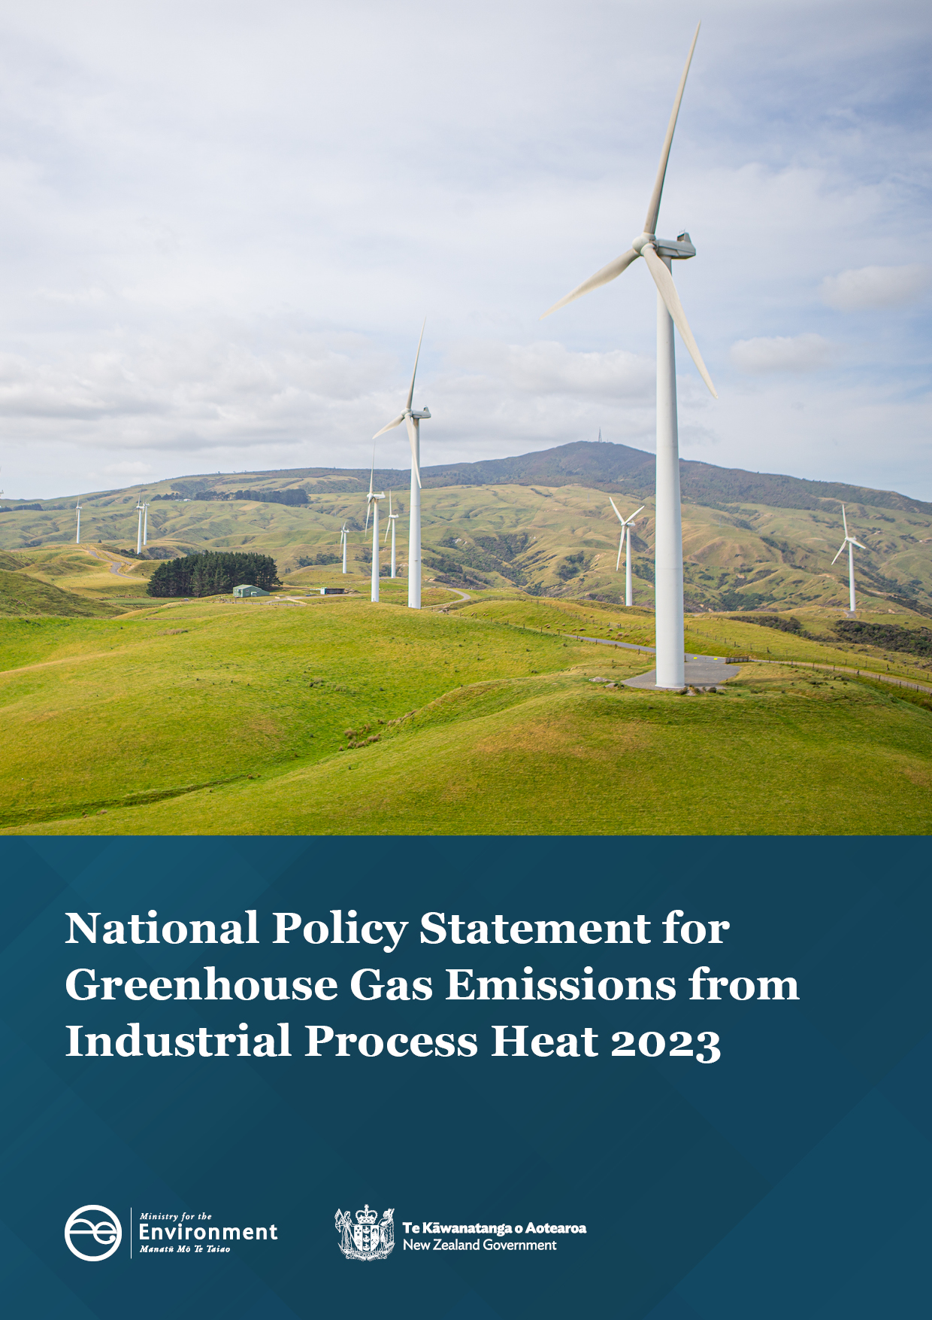
Authority
This National Policy Statement is issued by the Minister for the Environment under section 54 of the Resource Management Act 1991.

Contents
Part 1: Preliminary provisions 4
1.1 Title 4
1.2 Commencement 4
1.3 Application 4
1.4 Interpretation 4
1.5 Application of section 55(2A) of Act 4
Part 2: Objective and policies 5
2.1 Objective 5
2.2 Policies 5
Part 3: Implementing objective and policies 6
3.1 Outline of Part 6
3.2 Cumulative effects 6
3.3 Updating emissions plans 6
3.4 Progress towards achieving national goals 7
Part 4: Timing 8
4.1 Timing 8

- Preliminary provisions
  - Title
- This is the National Policy Statement for Greenhouse Gas Emissions from Industrial Process Heat 2023.
  - Commencement
- This National Policy Statement comes into force on 27 July 2023.
  - Application
- This National Policy Statement applies to emissions of greenhouse gases from fossil fuel-fired heat devices.
- Nothing in this National Policy Statement applies to heat devices that are:
        - back-up heat devices; or
        - heat devices on low-emissions sites.
  - Interpretation
- Terms defined in the Resource Management (National Environmental Standards for Greenhouse Gas Emissions from Industrial Process Heat) Regulations 2023 and used in this National Policy Statement (including the term technically feasible and financially viable lower-emissions alternative) have the meanings in those regulations, unless otherwise specified.
- Terms defined in the Resource Management Act 1991 and National Planning Standards used in this National Policy Statement have the meanings in the Act and Standards, unless otherwise specified.
  - Application of section 55(2A) of Act
- The changes to regional plans required by the following provisions of this National Policy Statement are amendments referred to in section 55(2) of the Act (which, because of section 55(2A) of the Act, means that the changes must be made without using a process in Schedule 1 of the Act):
        - clause 3.2;
        - clause 3.3.

- Objective and policies
  - Objective
- The objective of this National Policy Statement is to reduce emissions of greenhouse gases by managing the discharges to air of greenhouse gases from the production of industrial process heat, in order to mitigate climate change and its current and future adverse effects on the environment and the wellbeing of people and communities.
  - Policies
Policy 1: Discharges to air of greenhouse gases from heat devices are reduced or eliminated by:
        - avoiding discharges from new heat devices that burn coal and deliver heat at or above 300 °C, unless there is no technically feasible and financially viable lower emissions alternative;
        - avoiding discharges from new heat devices that burn coal and deliver heat below 300 °C;
        - restricting discharges from existing heat devices that burn coal and deliver heat at or above 300 °C;
        - restricting and phasing out discharges from existing heat devices that burn coal and deliver heat below 300 °C;
        - avoiding discharges from new heat devices that burn any fossil fuel other than coal, unless there is no technically feasible and financially viable lower emissions alternative;
        - restricting discharges from existing heat devices that burn any fossil fuel other than coal.
Policy 2: Regional councils consider the cumulative effects of discharges of greenhouse gases when considering resource consent applications for discharges from heat devices.
Policy 3: Holders of resource consents for discharges to air of greenhouse gases from heat devices update relevant emissions plans to reflect technological developments and best practice.

- Implementing objective and policies
  - Outline of Part
- This Part sets out what regional councils must do, in addition to meeting the requirements of the Resource Management (National Environmental Standards for Greenhouse Gas Emissions from Industrial Process Heat) Regulations 2023, to implement or give effect to the objective and policies of this National Policy Statement.
  - Cumulative effects
- Every regional council must include the following policy (or words to the same effect) in its regional plan:
“Before granting a resource consent for the discharge of greenhouse gases to air from heat devices on a site, the regional council must:
        - consider the total discharges of greenhouse gases from all heat devices on the site that the application relates to; and
        - recognise that, cumulatively, all discharges of greenhouse gases resulting from the production of industrial process heat, regardless of volume, contribute to climate change, and any reduction in greenhouse gas emissions contributes to mitigating climate change.”
- Terms used in the policy in subclause (1) and defined in the Resource Management (National Environmental Standards for Greenhouse Gas Emissions from Industrial Process Heat) Regulations 2023 have the meaning in those regulations.
  - Updating emissions plans
- Every regional council must include the following policy (or words to the same effect) in its regional plan:
“When considering an emissions plan as part of an application for a resource consent for a restricted discretionary activity relating to discharges to air of greenhouse gases from heat devices, the consent authority must consider:
        - the timing and content of updates of the emissions plan to be made by the holder of the consent; and
        - how those updates will reflect changes in technology and best practices.”
- Terms used in the policy in subclause (1) and defined in the Resource Management (National Environmental Standards for Greenhouse Gas Emissions from Industrial Process Heat) Regulations 2023 have the meaning in those regulations.
  - Progress towards achieving national goals
- Every regional council must, on request by the Minister for the Environment, provide a report to the Minister on:
        - the number of resource consents granted for, and the consented volume of greenhouse gas emissions from, the production of industrial process heat in the region; and
        - the extent to which the discharge of greenhouse gases from the production of industrial process heat has been reduced through emissions plans and other conditions of consents; and
        - the extent to which emissions plans have been implemented; and
        - compliance with any other conditions of consents for the discharge of greenhouse gases into air.
- If the Minister specifies the form of, and timeframe for, reports required by subclause (1), regional councils must, to the extent practicable, provide the reports in the specified form and within the specified timeframe.
- Timing
  - Timing
- This National Policy Statement applies from the date on which it comes into force (see clause 1.2).

