National Direction for Greenhouse Gas Emissions from Industrial Process Heat

Industry factsheet

Introduction
This factsheet has been published to inform industry operators of the national direction for Greenhouse Gas Emissions from Industrial Process Heat:
- National Policy Statement for Greenhouse Gas Emissions from Industrial Process Heat (NPS)
- National Environmental Standards for Greenhouse Gas Emissions from Industrial Process Heat (NES)
It provides a summary of the requirements the NPS and NES introduce for reducing greenhouse gas emissions from industrial process heat. Refer to the NPS and NES for the specific wording of the policy and regulations. This factsheet contains non-statutory guidance and the NES and NPS are the legal documents that must be complied with in decision-making.
This national direction is aimed at helping Aotearoa New Zealand achieve net-zero carbon emissions by 2050. It is part of our national response to mitigate climate change and its adverse effects on the environment and the wellbeing of people and communities.
Who should read this factsheet?
This factsheet is for industries that use fossil fuels in heat devices such as boilers, furnaces, engines, or other combustion devices to generate industrial process heat, that produce greenhouse gas emissions.
Operators will need to consider the heat devices and sites that will require resource consent under the NPS and NES, and the resource consent requirements that will apply to existing air discharge permits once these expire.

Why is this national direction needed?
The NPS and NES support an amendment made to the Resource Management Act 1991 (RMA) that came into effect on 30 November 2022. This amendment to section 104 of the RMA requires regional councils to consider the effects of greenhouse gas emissions when assessing resource consent applications for discharges to air. Industries using process heat must now also consider the greenhouse gas emissions from their operations when applying for a discharge to air consent.
The NPS and NES provide a nationally consistent approach to reducing greenhouse gas emissions from industrial heat processes. This direction will provide greater certainty to industry on:
- prohibited activities
- when resource consent for an activity is required
- the information to be submitted with a resource consent
- the rules and policies a resource consent application must meet to gain consent
- what decision-makers will consider when assessing resource consent applications
- the consent conditions that will need to be met, and what monitoring and reporting will be needed.

Purpose of the national direction
The purpose of the NPS and NES is to reduce greenhouse gas emissions from industries using devices to generate process heat by:
- prohibiting discharges of greenhouse gases from new industrial heat devices that burn coal in low-to-medium temperature processes (below 300 degrees Celsius) and phasing out existing heat devices that burn coal by 2037
- setting national policies and regulations to enable consistent assessment of resource consent applications for discharges from industrial process heat activities
- requiring greenhouse gas emissions to be reduced over time from heat devices through a resource consent process, and by developing and implementing emissions plans
- requiring consent holders to adopt the best practicable option to reduce greenhouse gas emissions
- ensuring decision-makers recognise and consider the cumulative effects of industrial greenhouse gas emissions when assessing resource consent applications
- providing nationally consistent resource consent conditions, including monitoring and reporting requirements.

When does the national direction have legal effect?
Regional councils will be required to give effect to the NPS objective and policies and observe the NES regulations from 27 July 2023.

Defining industrial process heat
In this national direction, industrial process heat is defined as thermal energy used in industrial processes, including in the manufacturing of products and the processing of raw materials, and in horticulture when industrial heat is used to grow plants or other photosynthesising organisms indoors. Examples of process heat use include converting milk into powder and wood pulp into paper, and producing metals and chemicals (eg, methanol). These processes frequently involve burning fossil fuels, which produce greenhouse gas emissions.
Heat devices that burn fossil fuels to heat space and water in commercial buildings are not within scope of the NPS and NES.

What do the National Policy Statement and National Environmental Standards change?
How NPS and NES affect discharges to air of greenhouse gases from industrial process heat activities is described in the following sections.

Prohibited activities
The NES prohibits the discharge of all greenhouse gases from the following heat devices that burn coal:
- new heat devices used in low-to-medium temperature process heat (operating at below 300 degrees Celsius) used as either a primary or back up device
- existing heat devices used in low-to-medium temperature process heat used as either a primary or back up device after 1 January 2037, unless operating under an existing consent granted prior to the commencement date of the NPS and NES with an expiry date later than 1 January 2037.

Consented activities
The NES requires industries and operators to apply for resource consent for the discharge of greenhouse gases from the following fossil fuel-fired heat devices if they emit 500 tonnes or more of carbon dioxide equivalent (CO₂-e) per site per year:
- new heat devices used in low-to-medium temperature process heat (excluding coal as all discharges of greenhouse gases from new coal devices used in low-to-medium temperature processes are prohibited under NES Regulation 7)
- new and existing heat devices used in high temperature process heat (operating at or above 300 °C)
- existing heat devices used in low-to-medium temperature process heat (all discharges of greenhouse gases from existing coal devices used in low-to-medium temperature processes are prohibited from 1 January 2037 under NES regulation 9, unless operating under an existing consent granted before 27 July 2023).
New and existing heat devices used for back-up purposes during maintenance or unexpected events and activities discharging less than 500 tonnes or more of CO₂-e per site per year, will not require resource consent (note: all discharges of greenhouse gases from all industrial heat devices that burn coal used for primary and back-up purposes in low-to-medium temperature processes will be prohibited from 1 January 2037 under NES regulations 7 and 9)
Resource consent can be granted for a maximum of 20 years for new heat devices and 10 years for existing heat devices.
The NES defines ‘existing heat devices’ as devices that were installed and operational before 27 July 2023 (and may have been upgraded and improved). The definition does not apply to devices that replace existing units on, or after, 27 July 2023.
When do the regulations apply to heat devices operating under resource consents?
Industries with existing heat devices that burn fossil fuels, currently operating under an existing discharge to air resource consent that was granted before the NES was enacted, will not have to re-apply for consent until their existing discharge-to-air consent expires.
The NES and NPS requirements only apply once existing consents have expired. No further consents can be granted for existing coal devices used to generate low-to-medium temperature heat after 2037 (the phase out date for coal).
Table 1: Summary of consent requirements for different heat devices
Existing coal devices below 300°C | New coal devices below 300 °C
- Restricted discretionary activity until 1 January 2037, then become prohibited. Any consent renewal must not last past this date  - Must apply the best practicable option.  - Must prepare an emissions plan as part of a consent application  - Consent term must be 10 years or less | - Prohibited
Existing coal devices at or above 300 °C | New coal devices at or above 300 °C
- Restricted discretionary activity  - Must apply the best practicable option  - Must prepare an emissions plan as part of a consent application  - Consent term must be 10 years or less | - Restricted discretionary activity  - Must demonstrate consideration of technically feasible and financially viable lower-emissions alternatives  - Must apply the best practicable option  - Must prepare an emissions plan as part of a consent application  - Consent term must be 20 years or less
Existing non-coal fossil fuel devices | New non-coal fossil fuel devices
- Restricted discretionary activity  - Must apply the best practicable option  - Must prepare an emissions plan as part of a consent application  - Consent duration must be 10 years or less | - Restricted discretionary activity  - Must demonstrate consideration of technically feasible and financially viable lower-emission alternatives  - Must apply the best practicable option  - Must prepare an emissions plan as part of a consent application  - Consent duration must be 20 years or less

Requirements for resource consent applications
Emissions of 500 tonnes or more of CO₂-e per year per site will require resource consent. The following information will be required in consent applications:

Emission plans
Resource consent applications must include an emissions plan setting out actions and methods to reduce greenhouse gas emissions from the proposed activity. This is to encourage best practice in energy efficiency and to reduce greenhouse gas emissions over time. Regulation 15 in the NES requires that an emissions plan for a heat device must include:
- the proposed activity and number of heat devices, and the thermal energy that is produced for an existing heat device or is to be produced for a new heat device, their age, and fuel source
- a transition pathway that sets actions and methods to reduce greenhouse gas emissions from the activity and meet any specified emission reduction targets, including any timeframes set to achieve this
- an assessment of any energy efficiency improvements that are available for the activity, and how improvements could be made
- if a new heat device is proposed, an assessment of any technically feasible and financially viable lower-emissions alternatives
- an assessment of the best practicable option to prevent or minimise any actual or likely adverse effect on climate change.
Emission plans for heat devices on high-emission sites (that burn fossil fuels emitting more than 2,000 tonnes of CO₂-e each year) must be reviewed by a suitably qualified person who is approved by the regional council. This is a practitioner who is qualified to provide an independent review and recommendation to the regional council when they consider the resource consent. The regional council will determine if the practitioner is suitably qualified, and if they accept the recommendation proposed when considering a resource consent application.

The best practicable option
Resource consent applications and emissions plans must include an assessment of the best practicable option to prevent or minimise any adverse effects on climate change from the activity, and other relevant discharges of greenhouse gases from other heat devices (excluding back-up devices) on the same site.
Applicants should consider the best available technologies when assessing the best practicable option. Information on the best available technologies is being prepared for councils and industry by the Energy Efficiency and Conservation Authority (EECA), this will be published on their website later in 2023.

The RMA defines the best practicable option as the method that best prevents or limits adverse effects on the environment from contaminant discharge or noise emissions by considering the:
- the nature of the discharge or emission and the sensitivity of the receiving environment to adverse effects; and
(b) the financial implications, and the effects on the environment, of that option when compared with other options; and
(c) the current state of technical knowledge and the likelihood that the option can be successfully applied.

Assessment of lower emissions alternatives for new heat devices
Emissions plans submitted with a resource consent application for a new fossil fuel-fired heat device must include an assessment of any technically feasible and financially viable lower-emissions alternatives that were considered.
Technically feasible alternatives need to provide an equivalent service while discharging lower or zero greenhouse gas emissions. The alternatives assessment must consider current technical knowledge and advice on how likely alternatives can be successfully applied to undertake the proposed activity. These alternatives are set out in the applicant’s emissions plan, as part of the consent application.
The assessment of ‘financially viable alternative’ must consider operational and capital costs to the applicant's business over a 20-year period and any financial benefits of the lower-emissions alternative.

Resource consent conditions
If a resource consent is granted under the NES, regional councils are required to include conditions requiring the consent holder to:
- adopt the best practicable option as assessed by the regional council.
- comply with the approved emissions plan for the site.
- monitor compliance with the approved emissions plan for the site, including any emissions reduction targets set in the emissions plan, and report to the consent authority on their monitoring.
- update the emissions plan to reflect technological developments and best practice within a timeframe specified in the plan and on the resource consent.
Figure 1: Consent pathway
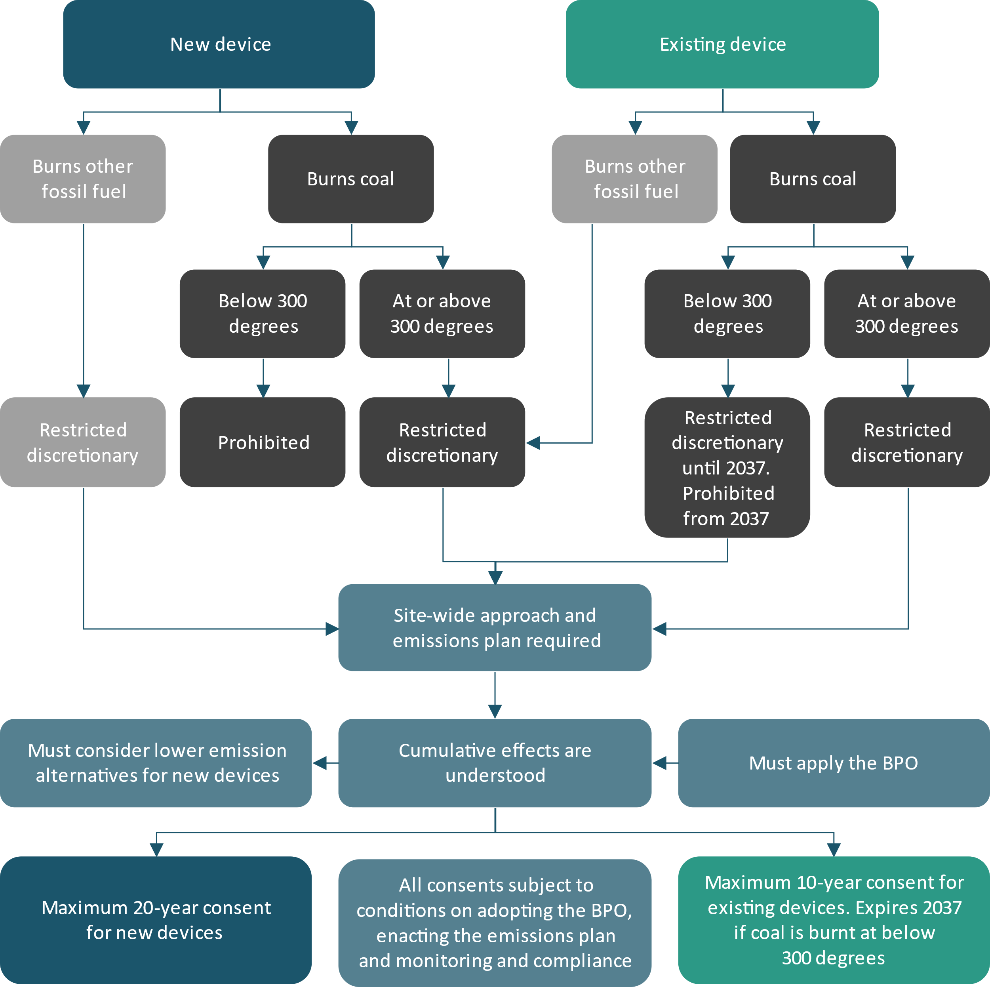
BPO = Best practicable option.

Timing of implementation
Table 1: Timing of implementation
Milestone | Timeframe
Commencement of NPS and NES | 27 July 2023
Prohibited activity regulation for new coal devices used in low to medium temperature processes | Immediate effect
Restricted discretionary activity regulations for new fossil fuel devices (other than coal) in all temperature processes | Immediate effect
Restricted discretionary activity for existing fossil fuel devices operating under permitted activity rules in regional plans, including coal and other fossil fuels in all temperature processes | From 26 January 2025
Restricted discretionary activity for fossil fuel devices (coal and other fossil fuels) that are operating under existing consents | Regulations will apply when existing consents expire
Release of non-statutory guidance | Continuing throughout implementation process

Further guidance to support industry
- Greenhouse gas emissions plan guidance (to be released by EECA)
- Best available technology guidance (to be released by EECA)
- Attributes of a suitably qualified person (published by the Ministry for the Environment)
- Guidance on measuring industrial emissions and emissions factors for organisations
Where to find more information on the NPS and NES
To find information on the process for preparing the NPS and NES, and to read the NPS and NES follow the below links:
- Discussion document
- Summary of submissions and recommendations
- Section 32 report
- Regulatory impact statement
- 2021 Cabinet paper
- National Environmental Standards for Greenhouse Gas Emissions from Industrial Process Heat
- National Policy Statement for Greenhouse Gas Emissions from Industrial Process Heat 2023

Published in June 2023 by the
Ministry for the Environment – Manatū mō te Taiao
Publication number: INFO 1153

