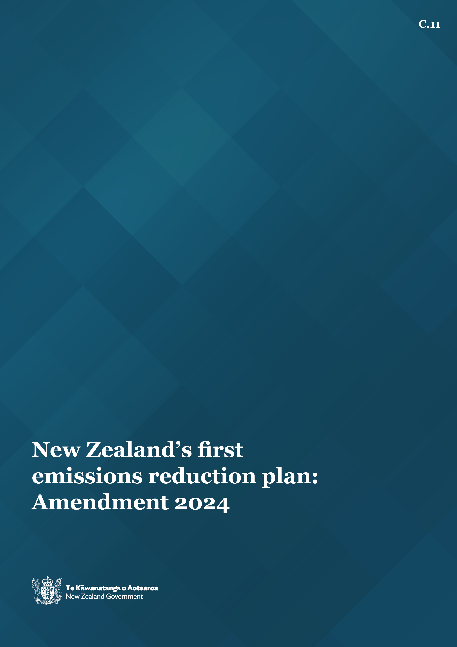

**Disclaimer**

The information in this publication is, according to the Ministry for the Environment’s best efforts, accurate at the time of publication. The Ministry will make every reasonable effort to keep it current and accurate. However, users of this publication are advised that:

* the information does not alter the laws of New Zealand, other official guidelines, or requirements
* it does not constitute legal advice, and users should take specific advice from qualified professionals before taking any action based on information in this publication
* the Ministry does not accept any responsibility or liability whatsoever whether in contract, tort, equity, or otherwise for any action taken as a result of reading, or reliance placed on this publication because of having read any part, or all, of the information in this publication or for any error, or inadequacy, deficiency, flaw in, or omission from the information in this publication
* all references to websites, organisations or people not within the Ministry are for convenience only and should not be taken as endorsement of those websites or information contained in those websites nor of organisations or people referred to.

This document may be cited as: Ministry for the Environment. 2024. *New Zealand’s first emissions reduction plan: Amendment 2024*. Wellington: Ministry for the Environment.

**This emissions reduction plan amendment is published by the Minister of Climate Change under section 5ZI of the Climate Change Response Act 2002.**

Published in December 2024 by the  
Ministry for the Environment on behalf of the Climate Change Chief Executives Board   
Manatū mō te Taiao  
PO Box 10362, Wellington 6143, New Zealand  
environment.govt.nz

ISBN: 978-1-991140-43-2 (online)

Publication number: 1858

© Crown copyright New Zealand 2024

# Contents

Introduction 4

We are on track to meet our first two emissions budgets 5

Our approach is delivering results 6

Getting started with the second emissions reduction plan 7

How to read the amended plan 9

Appendix 1: Table of discontinued actions 10

Appendix 2: New Zealand’s domestic climate change framework 13

# Tables

Table 1: Projections with new measures (net emissions in Mt CO2-e) ) 6

Table 2: New Zealand’s first three emissions budgets (Mt CO2-e) 13

# Figures

Figure 1: The five pillars of New Zealand’s Climate Strategy 5

Figure 2: Emissions projections with new measures and sensitivity range using target accounting 8

# **Introduction**

The Government is committed to meeting New Zealand’s climate change targets to reduce the impacts of climate change and prepare for its future impacts.

This year we launched a new climate change strategy, which, to achieve New Zealand’s emissions reduction goals, takes a cost-effective,[1] net-based approach that uses effective and efficient policies.

We have prioritised climate change within the nine government targets that have been set for the public sector to achieve.

We have changed the settings of the New Zealand Emissions Trading Scheme (NZ ETS) that will ensure New Zealand has a more credible market. The Government has committed to aligning the NZ ETS with New Zealand’s climate targets and giving participants confidence their investments to reduce emissions will be rewarded.

In embedding this Government’s approach, we have taken decisions to discontinue some programmes and start others to ensure our effort is focused on delivering our climate strategy, including the actions and policies that will deliver cost-effective emissions reductions for New Zealand. The previous government also discontinued a number of policies in 2023 as part of its focus to ‘get back to basics’.

This approach will deliver results for New Zealand. Based on the central estimate (the most likely outcome based on our current understanding), current net emissions projections indicate we are on track to meet the first emissions budget.

Published in May 2022, New Zealand’s first emissions reduction plan sets out the policies and actions to meet the first emissions budget for the period 2022–25. We have updated this plan to ensure it reflects this Government’s approach to meeting the first emissions budget in the most cost-effective way. This approach will be further embedded through the implementation of the second emissions reduction plan – our plan to meet the second emissions budget for the period 2026–30.

This document is the 2024 amendment to [New Zealand’s first emissions reduction plan](https://environment.govt.nz/assets/publications/Aotearoa-New-Zealands-first-emissions-reduction-plan.pdf). It is designed to be read in conjunction with the original plan, the associated [table of actions](https://environment.govt.nz/publications/emissions-reduction-plan-table-of-actions/) and the [Government’s climate strategy](https://environment.govt.nz/what-government-is-doing/areas-of-work/climate-change/about-new-zealands-climate-change-programme/governments-climate-strategy/).

# We are on track to meet our first two emissions budgets

The Government is committed to meeting our domestic climate change targets and emissions budgets, outlined in appendix 2. In April 2024, the Government reinforced its commitment in one of the Prime Minister’s nine public service targets.

*Target 9: On track to meet New Zealand’s 2050 net zero climate change targets with total net emissions of no more than 290 megatonnes from 2022 to 2025 and 305 megatonnes from 2026 to 2030.*

In July 2024, the Government launched its climate strategy,[2] an ambitious plan aimed at reducing the impacts of climate change and preparing for its future effects. The strategy has five pillars, which represent our goals for reducing emissions and managing the impacts of climate change (figure 1).

Figure 1: The five pillars of New Zealand’s Climate Strategy

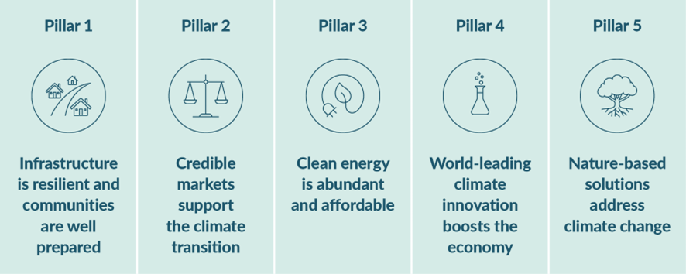

The Government wants to achieve cost-effective emissions reductions. This means incentivising Government, businesses and households to take actions that have the greatest impact on net emissions for a given investment in reductions or removals. This is being achieved by using effective and efficient policies that do not negatively impact on the productivity of New Zealand’s key industries.

This approach is technology-led. It relies on a credible emissions trading scheme, complemented by policies that reduce barriers to investment in emissions reductions and removals.

We are nearly three years into delivering New Zealand’s first emissions reduction plan. New Zealand has faced challenges that have informed how we will continue to deliver the plan going forward. In the early stages, supply chain constraints driven by COVID-19 and later, Cyclone Gabrielle and the Auckland flooding, caused delivery delays across several sectors. Worsening inflation and the cost-of-living crisis have meant some actions have been paused or discontinued to ease cost pressure on households (eg, the previous government cancelling the sustainable biofuels obligation in February 2023).

These challenges have reinforced the need to prioritise actions that deliver cost-effective emissions reductions in line with our approach. This amendment updates the first emissions reduction plan to ensure we are focused on the actions that will minimise the cost-of-living impacts of climate change policies and increase the likelihood of successful delivery of targets and budgets.

We have chosen not to directly intervene or subsidise interventions the market can provide. This has seen this Government stop a number of existing programmes, while some actions were stopped by the previous administration (35 and 6 actions, respectively). The list of discontinued actions can be found in appendix 1.

We have also started work on new actions as outlined in this Government’s coalition agreements. These and additional new actions, are included in the [second emissions reduction plan](https://environment.govt.nz/publications/second-emissions-reduction-plan). Implementing the new approach for the final year of the first emissions budget period will see:

* a renewed emphasis on action to enable renewable energy investment and development
* universal support mechanisms to mitigate the impact of the transition on individuals and households
* work to recognise more sources of removals for the second emissions budget and future budgets.

## Our approach is delivering results

This Government’s approach to reducing net emissions will keep the country on track to meet the first emissions budget. Based on the central estimate,[3] current emissions’ projections indicate we are projected to meet the first emissions budget (see table 1).

These projections account for the impact, where quantifiable, of discontinuing actions in the first emissions reduction plan, expressed in megatonnes of carbon dioxide equivalent (Mt CO2-e).[4]

Table 1: Net emissions projections with new measures (net emissions in Mt CO2-e)

| Emissions budgets limits | Projections including ERP2 policies (central estimate) | Uncertainty for projections  (central estimate) |
| --- | --- | --- |
| First emissions budget 290 Mt CO2-e | 284.1 | ±7 |
| Second emissions budget 305 Mt CO2-e | 303.1 | ±17 |
| Third emissions budget 240 Mt CO2-e | 249.2 | ±33 |

Uncertainty ranges are used to represent a range of possible futures and provide government with an assessment of confidence about our progress.[5]

We will continue to take an agile approach to delivering the first emissions reduction plan and, where needed, make changes to ensure the plan’s ongoing alignment with the Government’s climate strategy as well as its ability to meet the first emissions budget. We will know whether we have managed to stay within the first emissions budget in 2027, when official data for the period becomes available.

## Getting started with the second emissions reduction plan

The Government is also focused on ensuring New Zealand is well positioned to meet future emissions budgets. Its revised approach will also be implemented through the second emissions reduction plan, developed to achieve the second emissions budget (2026–2030).

As the [second emissions reduction plan](https://environment.govt.nz/publications/second-emissions-reduction-plan) contains initiatives from the Government’s manifesto commitments and coalition agreements, work is beginning on some of these in 2024 and 2025 – before the second emissions budget period formally begins on 1 January 2026.

These initiatives include restoring confidence in the NZ ETS and enabling:

* electrification through *Electrify NZ* commitments to support private investment in electricity generation and networks
* carbon capture utilisation and storage
* a network of 10,000 public EV charging points
* technology research and development to reduce agricultural emissions.

The emissions projections (table 1 and figure 2) account for the policies and actions included in the second emissions reduction plan. Any longer-term abatement impact from the stopped actions has been considered in developing that plan.

Modelling shows New Zealand is projected to meet the first and second emissions budget based on central estimates. The modelling shows New Zealand is above the limit for the third emissions budget, however, the amount above the limit has reduced significantly since the July 2024 interim emissions projections (now projected to be 9.2 Mt over budget, compared to 17 Mt over in July).[6] The modeling also shows New Zealand is on track to reach net zero emissions by 2050.

Figure 2 shows our progress towards the first three emissions budgets and net zero by 2050 based on current modelling.

Figure 2: Emissions projections with new measures and sensitivity range (Mt CO2-e), 2022-2050

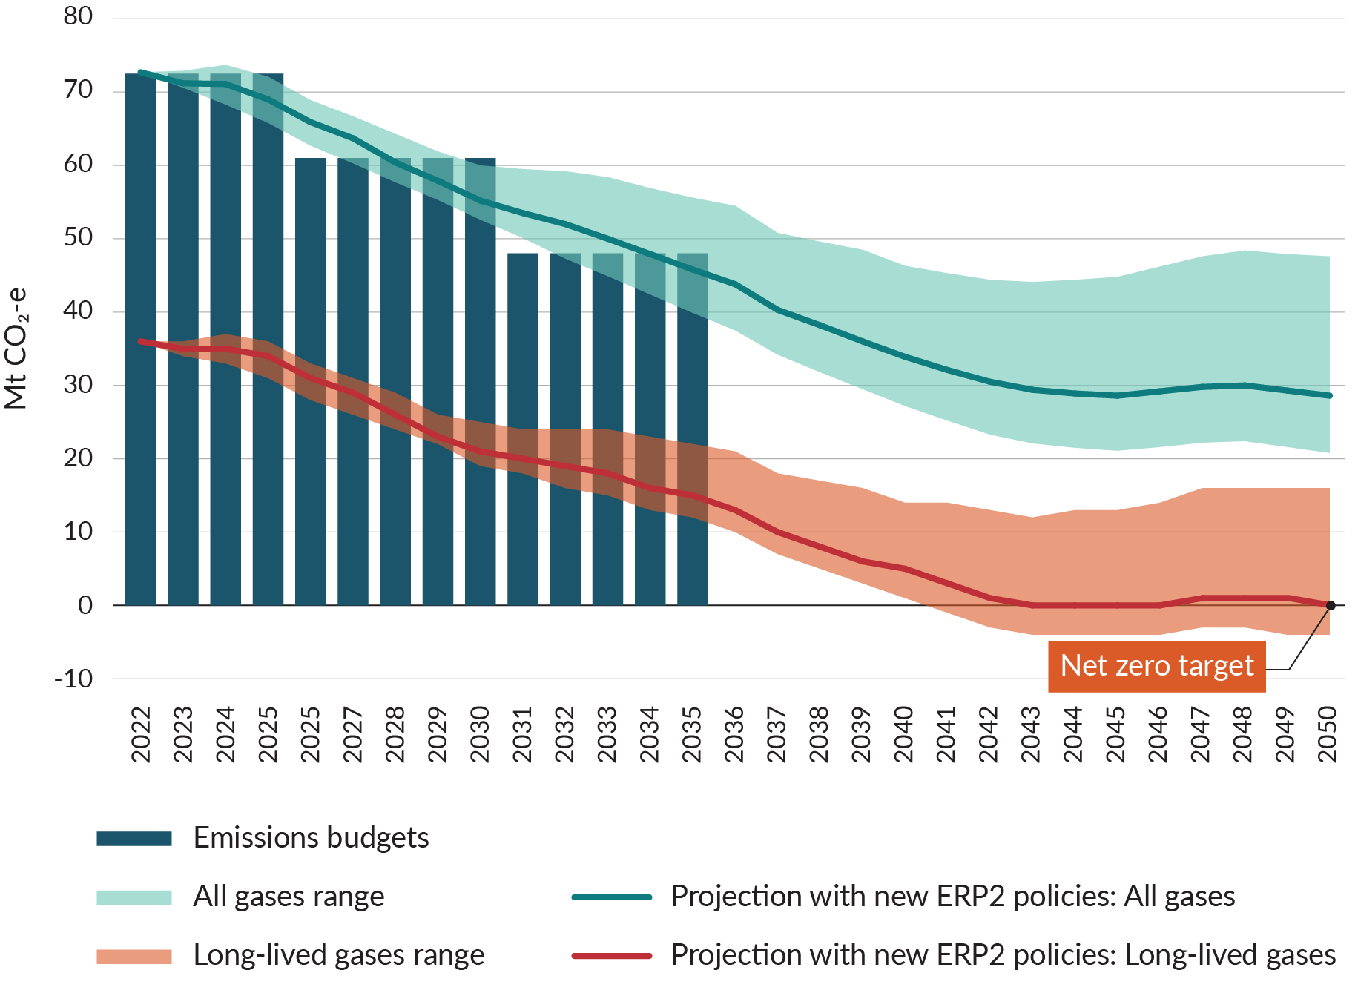

Because projections are based on assumptions made about the future, they become less accurate the further out they go. Much can change between now and 2050. The Government is committed to meeting New Zealand’s long-term targets. This will be done through a series of emissions budgets and future emissions reduction plans.

# How to read the amended plan

This document is designed to be read alongside the original first emissions reduction plan, the associated table of actions, and the Government’s climate strategy. These can be found on the Ministry for the Environment website.[7]

In amending the plan, we have considered the Climate Change Commission’s advice for meeting the relevant emissions budget (*Ināia tonu nei: a low emissions future for Aotearoa* (2021)) as well as its recent report *Monitoring report: Emissions reduction* (2024). The public were consulted on the impacts of the new approach and the amended plan for meeting that emissions budget.[8]

We are continuing to deliver the amended first emissions reduction plan through a set of   
cross-cutting and sector-specific work programmes. The areas with the greatest shift in approach are equitable transition (chapter 3), emissions pricing (chapter 5), transport (chapter 10) and energy (chapter 11).

Appendix 1 provides details on the actions that have been discontinued from the first emissions reduction plan.

# Appendix 1: Table of discontinued actions

Below are the discontinued actions being removed from the first emissions reduction plan, organised by chapter.

### Equitable transition (Chapter 3)

| Actions for delivery | Lead |
| --- | --- |
| 3.2.1 Develop an equitable transition strategy. | MBIE/MSD |
| 3.2.2b Support regions and industries to manage the transition. | MBIE/MSD |
| 3.2.3 Implement the Just Transition Partnerships Programme. | MBIE |
| 3.3.1 Develop an income insurance scheme. | Government, BusinessNZ, New Zealand Council of Trade Unions |

### Emissions pricing (Chapter 5)

| **Actions for delivery** | **Lead** |
| --- | --- |
| 5.2.1 Adjust the NZ ETS to drive a balance of gross and net emissions reductions. | MfE |
| 5.2.3 Assess how the NZ ETS can support indigenous biodiversity. | MfE |

### Funding and finance (Chapter 6)

| **Actions for delivery** | **Lead** |
| --- | --- |
| 6.1 Establish the Climate Emergency Response Fund (CERF) to ensure the climate is prioritised in the Budget process. | TSY |

### Planning and infrastructure (Chapter 7)

| **Actions for delivery** | **Lead (support)** |
| --- | --- |
| 7.5 Promote innovation in low-emissions, liveable neighbourhoods, through Crown-led urban regeneration projects. | Kāinga Ora (HUD, Waka Kotahi, MOT, MfE, Te Waihanga) |

### Research, science, innovation and technology (Chapter 8)

| **Actions for delivery** | **Lead** |
| --- | --- |
| 8.1.1 Establish a portfolio of Climate Innovation Platforms to support and coordinate strategic, effective and innovative initiatives. | Cross government |
| 8.2 Te Ara Paerangi Future Pathways science-system reform programme. | MBIE |

### Circular economy and bioeconomy (Chapter 9)

| Actions for delivery | Lead (support) |
| --- | --- |
| 9.1 Commence a Circular Economy and Bioeconomy Strategy. | MBIE |
| 9.4 Support businesses moving to circular economy models. | MBIE |

### Transport (Chapter 10)

| Actions for delivery | Lead |
| --- | --- |
| 10.1.1.6 Require new investments for transport projects to demonstrate how they will contribute to emissions-reduction objectives and set a high threshold for approving new investments for any transport projects if they are inconsistent with  emissions-reduction objectives. | MOT |
| 10.1.2 Set sub-national vehicle kilometres travelled, or VKT, reduction targets for Aotearoa New Zealand’s major urban areas (Tiers 1 and 2) by the end of 2022. | MOT |
| 10.1.2 Revise Waka Kotahi’s national mode shift plan (Keeping Cities Moving) to ensure nationally led activities align with the pace and scale of VKT reduction and mode shift required in urban areas. | Waka Kotahi |
| 10.1.2 Develop VKT reduction programmes for Aotearoa New Zealand’s major urban areas (Tiers 1 and 2) in partnership with local government, Māori and community representatives. | Waka Kotahi/local government |
| 10.1.2 Support initiatives to increase the uptake of e-bikes. | MOT |
| 10.1.4 Establish a high threshold for new investments to expand roads, including new highway projects, if the expansion is inconsistent with emissions-related objectives. | MOT |
| 10.2.1 Continue to incentivise the uptake of low- and zero-emissions vehicles through the Clean Vehicle Discount scheme and consider the future of the Road User Charge exemption for light vehicles beyond 2024. | MOT/Waka Kotahi |
| 10.2.1 Establish whether the Clean Vehicle Discount can be extended to other vehicle classes. | MOT |
| 10.2.2 Support social leasing schemes to make access to cleaner vehicles affordable for  low-income households. | MOT |
| 10.2.2 Implement an equity-oriented vehicle scrap-and-replace scheme to make cleaner vehicles and low-emissions alternatives affordable for low-income households. | MOT |
| 10.2.2 Investigate whether further targeted support is required to make low-emissions vehicles more accessible and affordable for other disadvantaged groups and communities. | MOT |
| 10.3.5 Implement the Sustainable Biofuels Obligation, which requires liable fuel suppliers to reduce the total emissions of the fuels they supply by a set percentage each year through the deployment of biofuels (in blended or neat form). | MOT/MBIE |
| 10.4.1 Ensure the next Government Policy Statement on Land Transport (GPS-LT) guides investment consistent with the emissions reduction plan. | MOT |

### Energy and industry (Chapter 11)

| **Actions for delivery** | **Lead** |
| --- | --- |
| 11.1.1 Provide rebates for energy efficient equipment. | MBIE/EECA |
| 11.2.2 Investigate options for dry-year electricity storage through the New Zealand Battery Project. | MBIE |
| 11.2.2 Ban new fossil-fuel baseload generation. | MBIE |
| 11.3.1 Develop a gas transition plan. | MBIE |
| 11.4.1 Set an action plan for decarbonising the industrial sector. | MBIE |
| 11.4.1 Continue the roll out of the Government Investment in Decarbonising  Industry (GIDI) fund. | MBIE/EECA |
| 11.4.1 Fund further decarbonisation of industry and heat through expansion of the GIDI. | MBIE/EECA |
| 11.4.1 Provide grant funding for commercial space and water heating and high efficiency electrical equipment. | MBIE/EECA |
| 11.4.1 Finalise and implement the Advanced Manufacturing Industry Transformation Plan. | MBIE |
| 11.4.1 Develop a mandatory energy and emissions reporting scheme. | MBIE |
| 11.5.1 Monitor progress towards the aspirational renewable electricity target. | MBIE |

### Agriculture (Chapter 13)

| **Actions for delivery** | **Lead** |
| --- | --- |
| 13.1.1 An emissions pricing mechanism is developed, and agricultural emissions are priced by 1 January 2025. | MPI |
| 13.1.2 All producers will have emissions reports by the end of 2022 and a farm plan in place  by 2025. | MPI |
| 13.3.1 Develop further climate-focused extension and advisory services. | MPI |

### Forestry (Chapter 14)

| **Actions for delivery** | **Lead (support)** |
| --- | --- |
| 14.1.1a Ensure regulatory settings deliver the right type and scale of forests, in the right place. | MPI (MfE) |
| 14.4.1 Develop forestry and wood processing industry transformation plan (ITP). | MPI |

# Appendix 2: New Zealand’s domestic climate change framework

The Climate Change Response Act 2002 (the Act) provides the framework by which  
New Zealand develops and implements clear and stable policies that contribute to global efforts to limit the increase in global average temperatures. The framework also provides for how New Zealand can prepare for, and adapt to, the effects of climate change.

The Act sets New Zealand’s domestic long-term emissions reductions targets to 2050:

* reduce net emissions of all greenhouse gases (except biogenic methane) to zero  
  by 2050
* reduce emissions of biogenic methane to 24–47 per cent below 2017 levels by 2050, including to 10 per cent below 2017 levels by 2030.

The framework then provides for a series of interim targets, or five-year emissions budgets, to be set as ‘stepping stones’ towards the 2050 target. Table 2 sets out New Zealand’s first three emissions budgets, as stepping stones towards the 2050 target (expressed in megatonnes of carbon dioxide equivalent (Mt CO2-e).

Table 2: New Zealand’s first three emissions budgets (Mt CO2-e)

| Budget period | 2022–25 | 2026–30 | 2031–35 |
| --- | --- | --- | --- |
| All gases, net (AR5) | 290 | 305 | 240 |
| Annual average | 72.5 | 61 | 48 |

For each emissions budget period, the Act requires an emissions reduction plan to be in place setting out the policies and strategies to meet the emissions budget. The Act provides for those plans to be amended during the emissions budget period to maintain their currency.

The first emissions reduction plan was published in May 2022. It focuses on meeting the first emissions budget that limits net emissions to 290 Mt CO2-e for the period 2022 to 2025.

1. ‘Cost-effective’ refers to minimising the overall cost to the nation of reducing emissions and shifting to net zero by 2050. The costs considered include those associated with businesses and households investing in gross emissions reduction, fiscal costs to the Government, and the wider costs or benefits from changes to the things people value, such as clean air.
2. [The Government’s climate strategy | Ministry for the Environment](https://environment.govt.nz/what-government-is-doing/areas-of-work/climate-change/about-new-zealands-climate-change-programme/governments-climate-strategy/)
3. ‘Central estimate’ refers to the value believed to be most likely, based on a spectrum of emissions scenarios.
4. One tonne of carbon dioxide equivalent is 1,000 kg of emissions. One megatonne is 1 million tonnes of emissions. For scale: one tonne of emissions is roughly equal to nine trips from Auckland to Wellington in the average car (total of 5,847 km). One megatonne is this multiplied by one million.
5. Our projections are impacted by three key factors: changes to underlying and/or external factors such as population growth and GDP, and rainfall levels; methodological improvements such as the science and how emissions are measured; and policy design and implementation. External factors and methodological changes can drive substantive shifts in how we are tracking towards emissions budgets.
6. Ministry for the Environment. 2025. [*New Zealand’s second emissions plan*: *2026–30*](https://environment.govt.nz/publications/second-emissions-reduction-plan). Wellington: Ministry for the Environment.
7. [Aotearoa New Zealand's first emissions reduction plan (environment.govt.nz)](https://environment.govt.nz/assets/publications/Aotearoa-New-Zealands-first-emissions-reduction-plan.pdf)

   [Aotearoa New Zealand's first emissions reduction plan: Table of actions (environment.govt.nz)](https://environment.govt.nz/assets/publications/Files/Aotearoa-New-Zealands-first-emissions-reduction-plan-Table-of-actions.pdf)

   [The Government’s climate strategy | Ministry for the Environment](https://environment.govt.nz/what-government-is-doing/areas-of-work/climate-change/about-new-zealands-climate-change-programme/governments-climate-strategy/)
8. Climate Change Response Act 2002 section 5ZI(3)(a) provides that, when an amendment is undertaken, and that amendment is more than minor or technical, the same process as that of preparing an emissions reduction plan is followed.