

**Disclaimer**

The information in this publication is, according to the Ministry for the Environment’s best efforts, accurate at the time of publication. The Ministry will make every reasonable effort to keep it current and accurate. However, users of this publication are advised that:

* The information does not alter the laws of New Zealand, other official guidelines, or requirements.
* It does not constitute legal advice, and users should take specific advice from qualified professionals before taking any action based on information in this publication.
* The Ministry does not accept any responsibility or liability whatsoever whether in contract, tort, equity, or otherwise for any action taken as a result of reading, or reliance placed on this publication because of having read any part, or all, of the information in this publication or for any error, or inadequacy, deficiency, flaw in, or omission from the information in this publication.
* All references to websites, organisations or people not within the Ministry are for convenience only and should not be taken as endorsement of those websites or information contained in those websites nor of organisations or people referred to.

This document may be cited as: Ministry for the Environment. 2024. *New Zealand Emissions Trading Scheme interim auction monitor report: 20 March 2024 auction*. Wellington: Ministry for the Environment.

Published in April 2024 by the  
Ministry for the Environment   
Manatū mō te Taiao  
PO Box 10362, Wellington 6143, New Zealand  
[environment.govt.nz](http://www.environment.govt.nz)

ISBN: 978-1-991140-11-1  
Publication number: ME 1823

© Crown copyright New Zealand 2024

# Contents

Introduction and purpose of this report 5

Background 5

Auction monitor to provide information on auctions 5

(Interim) auction monitor’s functions 6

Auction information: 20 March 2024 7

Auction result 7

Auction metrics 7

Commentary on the results of the auction 8

The auction clearing price 8

The confidential reserve price 8

Resolved tied bids 9

Cost containment reserve 9

Commentary on the auction operation 10

General 10

Collateral and settlement 10

Feedback on the auction monitoring report 11

Appendix: Graphical presentation of historical auction metrics 12

References 16

# Table

Table 1: Metrics for NZ ETS auction held on 20 March 2024 7

# Figures

Figure A.1: Volume of NZUs bid for and cover ratio per auction 12

Figure A.2: Total number of bids per auction 13

Figure A.3: Participant numbers per auction 13

Figure A.4: Bid volume (of thousands of NZUs) per participant 14

Figure A.5: Proportion of bids (by volume) by participant, March 2024 14

Figure A.6: Proportion of successful bids (by volume) by participant over the previous five auctions 15

Figure A.7: Proportion of participants with compliance obligations under the NZ ETS 15

# **Introduction and purpose of this report**

This report is produced by the Ministry for the Environment (the Ministry) acting in the role of the interim auction monitor, for the 13th scheduled New Zealand Emissions Trading Scheme (NZ ETS) auction, first auction of the year, held on 20 March 2024.

Auctioning of New Zealand Units (NZUs or ‘units’) is currently scheduled at quarterly intervals throughout the year as prescribed by the Climate Change Response (Emissions Trading Reform) Amendment Act 2020 and the Climate Change (Auctions, Limits, and Price Controls for Units) Regulations 2020.

The purpose of this report is to record and provide details on the results of the most recent auction, to present a comparison with previous auctions, and to provide an assurance that the auction was conducted properly and in accordance with the applicable rules and laws.

The next and second auction of 2024 is scheduled to be held on 19 June 2024[1].

# Background

Following the 2015/16 review of the NZ ETS, the Government agreed to introduce auctioning of NZUs to align the supply of units in the Emissions Trading Scheme with New Zealand’s climate change targets.[2] Further public consultation on auctioning regulations took place between November and December 2019.[3]

Following extensive regulatory and legislative development and an open market procurement process, an auction operator was appointed to run regular scheduled auctions through the NZX Managed Auction Service.

The first auction occurred on 17 March 2021.

This report concerns the 13th scheduled auction which occurred on 20 March 2024.

## Auction monitor to provide information on auctions

The appointment of an auction monitor requires regulations to be made prescribing the appointment process and the functions of the auction monitor.

Until the required consultations and regulation development have been concluded to appoint an auction monitor, the Minister of Climate Change has agreed that the Ministry for the Environment will perform the function of the auction monitor, referred to in this document as interim auction monitor.

The interim auction monitor function is performed independently of the auction operator and of the Ministry for the Environment policy team responsible for developing the regulations for the auction monitor and auctioning.

## (Interim) auction monitor’s functions

Based on feedback from the 2019 consultation, the Government agreed that the auction monitor should:

* publish certain information about each auction as soon as is practical following the auction
* publish a report on the outcome of each auction before the next auction occurs
* review the auctioning system after the first year and every subsequent two years.

Cabinet has agreed that the auction monitor must publish a report containing prescribed information from each auction and on the outcome of each auction before the subsequent auction occurring [DEV-20-MIN-0047].[4] The auction operator publishes information about each auction shortly following the close of the auction, which can be read in conjunction with this report.

# Auction information: 20 March 2024

## Auction result

The March 2024 auction resulted in the first partial clearance with 84 per cent of the available auction volume sold (excluding cost containment reserve (CCR) volumes).

All participants received their full requested bid volume and the auction cleared at the auction floor price (NZ$64.00).

Revised auction parameters and volumes were applied to the auction as prescribed by regulation.

The two-tier cost containment reserve mechanism was not triggered.

NZUs that were not sold in the auction will be ‘carried over’ into the next scheduled auction.

## Auction metrics

Table 1 provides salient metrics of the auction. Additional details are presented graphically in the appendix.

Table 1: Metrics for NZ ETS auction held on 20 March 2024

|  |  |
| --- | --- |
| Number of participants | 16 |
| Number of successful participants | 16 |
| Volume available at auction (Including 7,700,000 CCR units) | 11,225,000 |
| Volume of NZUs sold | 2,974,300 |
| Volume of NZUs bid for | 2,974,300 |
| Average bid size | 33,798 |
| Average volume bid per participant | 185,894 |
| Average volume won per successful participant | 185,894 |
| Average number of bids per participant | 5.5 |
| Total number of bids submitted (not including withdrawn bids) | 88 |
| Number of bids withdrawn | 1 |
| Number of successful bids | 88 |
| Cover Ratio (excluding 7,700,000 CCR units) | 0.84 |
| Aggregated ‘top 5’ participants volume (aggregated bids) as a percentage of total units bid for | 77.3 |
| Herfindahl–Hirschman Index (measure of market concentration by volume bid for ‘top 10’) | 0.16 |
| Estimated percentage of bidders with compliance obligations | 50 |

## Commentary on the results of the auction

The first auction of 2024 resulted in a partially cleared auction in which all of the submitted bids were successful. Eight-four per cent of the of 3.525 million NZUs available auction volume, excluding the 7.7 million NZUs held in the two-tier CCR mechanism, were sold.

The auctioning mechanism, systems and processes functioned as designed and in accordance with regulation and policy.

The cost containment reserve mechanism trigger prices and tiering structure were altered for the December 2023 and for subsequent auctions in line with the updated NZ ETS auction settings changes. Neither of the two new CCR tiers were breached in the March auction, therefore no CCR volume was required to be released. Consistent with the lower demand, the highest bid received in the auction was *well* below the tier one tigger price of NZ$184.00.

That the market concentration index fell to 0.16 and continues to indicate that although the larger players continue to dominate demand (the top 10 participants submitting 98 per cent of the bids), allocations are being relatively evenly distributed amongst them. There is some variation across auctions in the positions of the major bidders relative to one another. Though this measure is somewhat moot in the instance of a partial clearance where all participants were successful.

Eight of the 16 participants are estimated to have compliance obligations under the NZ ETS. Participants directly registered in the NZ ETS submitted bids for 25 per cent of the total bid volume in this auction.

Some of the auction participants without obligations are likely to have bid on behalf of clients with NZ ETS obligations.

The appendix to this document provide summary auction data.

## The auction clearing price

The auction operator is required to publish the clearing price following the auction.

***The auction cleared at the floor price of*** ***NZ$64.00. As not all of the available units were sold, the auction is considered to have ‘partially cleared’ and all bids were successful.***

## The confidential reserve price

The Climate Change Response Act enables the Minister of Climate Change to set a methodology for calculating a confidential reserve price for NZ ETS auctions. The confidential reserve price has the purpose of preventing NZUs from being sold at auction at a price significantly below the secondary market price. If the auction clearing price is less than the confidential reserve price, the auction will not sell any NZUs. Unsold NZUs will be rolled forward to be sold at the next auction in the **same** calendar year.

The mechanism for calculating the CRP was modified for the March 2024 and subsequent auctions to ensure that the mechanism remains confidential. The effect of the modifications do not manifestly alter the outcome of the auctions in comparison to previous auctions.

The changes to the CRP methodology did not alter the presence or absence of the CRP at the March auction.

## Resolved tied bids

If more than one bid sets the clearing price, those bids are referred to as tied bids. If all tied bids together bid for more units than are left, each tied bid is allocated a proportional share of the remaining units, subject to rounding rules.

Bids are only accepted in multiples of 100 units from 500 units (the lot size and minimum bid respectively). Units are allocated to bids in multiples of lot size. Therefore, when tied bids occur and the operator calculates proportional shares, they apply the following rounding rules:

* the number of units allocated to a tied bid, if not a multiple of the lot size, is rounded down to the nearest 100 units (this may include being rounded down to zero)
* if unallocated units remain after tied bids are awarded their proportional share (rounded to the nearest 100 units), any remaining lots are randomly allocated to the tied bids, but only up to their original bid amount.

***There were no tied bids in the 20 March 2024 auction.***

## Cost containment reserve

The cost containment reserve (CCR) mechanism provides for additional volume of NZUs to be added to the auction volume if the auction clearing price is equal to or exceeds the CCR trigger prices. As of the December 2023 auction, two distinct CCR tiers and associated trigger prices were set.

Both the CCR trigger price and available volumes are set by regulation, though both may be reviewed and are subject to change. The available annual auction volumes and auction dates are published in October of the preceding year by the Ministry for the Environment and were updated in November 2023.

***Note that the NZ ETS auction settings have been amended including the available volumes, CCR trigger levels and tier structures and other auction parameters. Participants are urged to review the updated settings.***

***The CCR trigger prices were not breached in the March 2024 auction. No units of CCR reserve volume were made available for sale.***

# Commentary on the auction operation

## General

The auction operator has confirmed that the auction process ran smoothly with no outages or delays. The Ministry for the Environment and the Environmental Protection Authority have similarly confirmed that the auction ran smoothly.

***The interim auction monitor has no reason to believe that the auction rules were not followed.***

## Collateral and settlement

Unused collateral was returned to the participants on the day of the auction for domestic participants and on the following day for offshore depositors.

The majority of participants continue to prefer cash to other instruments when providing collateral though four non-cash instruments were utilised.

Invoicing and the transfer of NZUs into successful participants’ NZ ETS Register accounts occurred within the required timeframes and was concluded on Tuesday 26 March 2024.

# Feedback on the auction monitoring report

Please send any feedback on this report to the interim auction monitor at [etsconsultation@mfe.govt.nz](mailto:etsconsultation@mfe.govt.nz) for consideration in future reports.

# Appendix: Graphical presentation of historical auction metrics

|  |
| --- |
| Legend for graphs in this report  March 23* Auction 9, held on 15 March 2023  June 22* Auction 10, held on 14 June 2023  September 23* Auction 11, held on 6 September 2023  December 23* Auction 12, held on 6 December 2023  March 24 Auction 13, held on 20 March 2024 (this auction)  Data from the most recent auction and four trailing auctions are presented in this appendix.  *Auction dates noted with an asterisk were declared ‘declined’ by the auction operator.  No NZUs were sold at these auctions. |

Figure A.1: Volume of NZUs bid for and cover ratio per auction

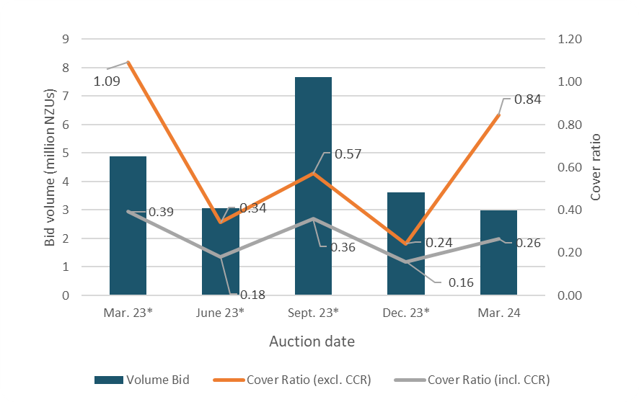

* Declined auction

Figure A.2: Total number of bids per auction

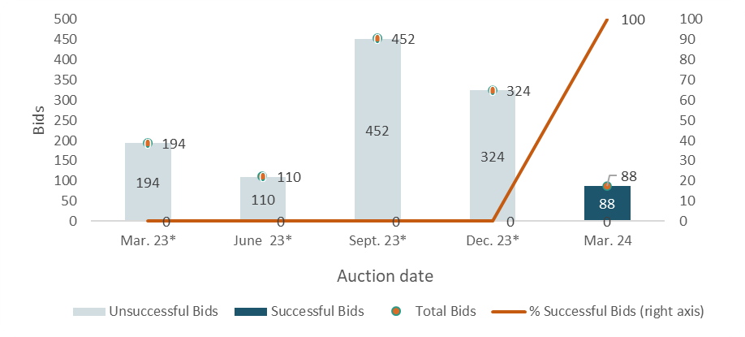

* Declined auction

Figure A.3: Participant numbers per auction

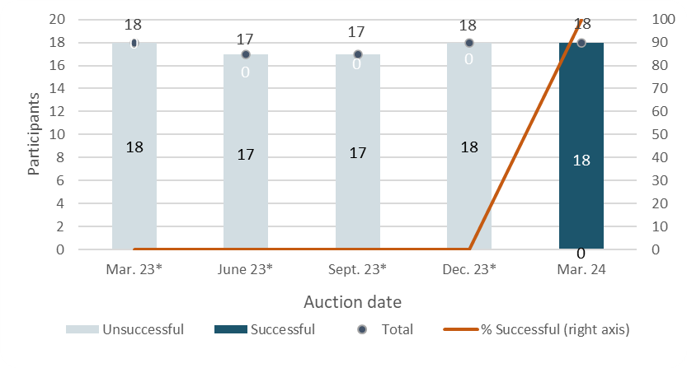

* Declined auction

Figure A.4: Bid volume (of thousands of NZUs) per participant

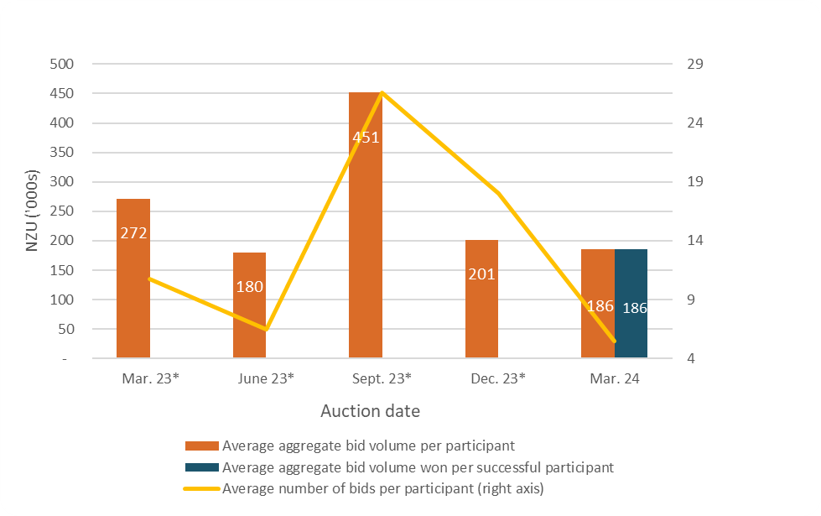

* Declined auction

Note that many participants submitted multiple bids and there may be multiple bidders representing a single participant.

Figure A.5: Proportion of bids (by volume) by participant, March 2024

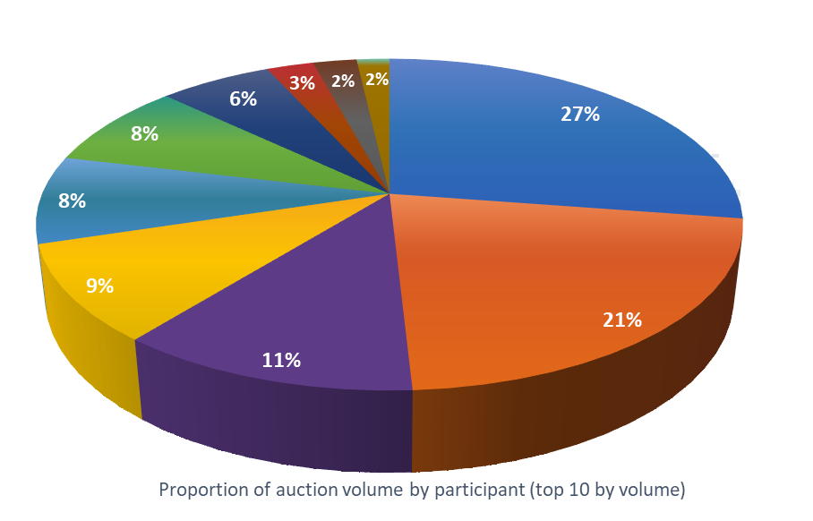

Figure A.6: Proportion of successful bids (by volume) by participant over the previous five auctions

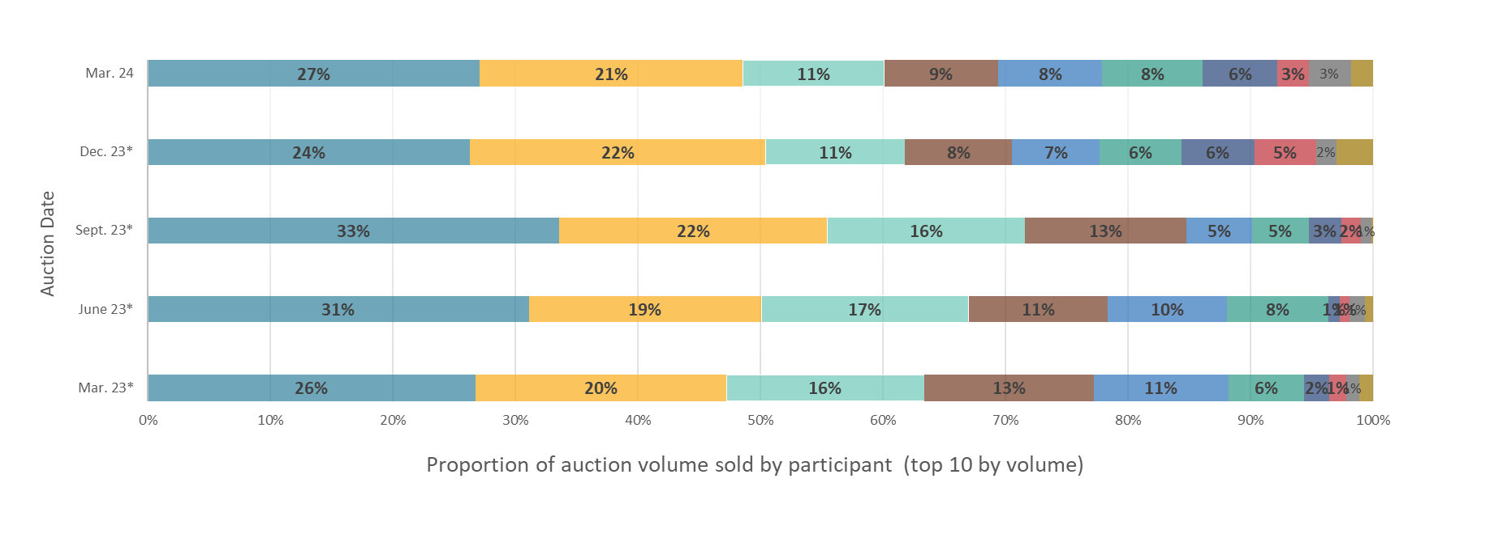

Note: Auctions held on the dates marked with an asterisk were declined. The percentages presented are of bid volumes presented as a facsimile of ‘sold auction volume’.

Figure A.7: Proportion of participants with compliance obligations under the NZ ETS

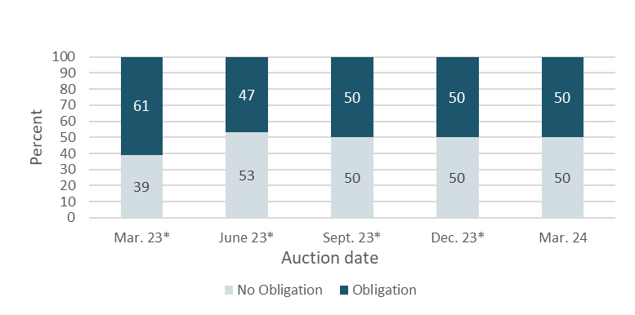

* Declined auction

Figure A.7 represents the estimated percentage of participants that are registered as having compliance obligations on the NZ ETS Register. Larger volume participants, not necessarily registered as having compliance obligations, may be purchasing NZUs on behalf of smaller third parties that do have compliance obligations.

# **References**

New Zealand Cabinet. 2018. *Amendments to the Climate Change Response Act 2002: Tranche One*. Cabinet Committee Minute of Decision CAB-18-MIN-0606.01. Wellington: Cabinet Office, Department of the Prime Minister and Cabinet.

Ministry for the Environment. 2019. *Reforming the New Zealand Emissions Trading Scheme: Rules for auctioning: Technical consultation document*. Wellington: Ministry for the Environment.

New Zealand Cabinet. 2020. *New Zealand Emissions Trading Scheme: Regulatory Decisions on the Rules for Auctioning*. Cabinet Economic Development Committee Minute of Decision DEV-20-MIN-0047. Wellington: Cabinet Office, Department of the Prime Minister and Cabinet.

1. <https://environment.govt.nz/assets/publications/nz-ets-auction-dates-and-volumes.pdf>.
2. <https://environment.govt.nz/assets/Publications/amendments-to-ccra-tranche-1-cab-18-min-0606.01.pdf>.
3. <https://environment.govt.nz/publications/reforming-the-new-zealand-emissions-trading-scheme-rules-for-auctioning-summary-of-submissions/>.
4. <https://environment.govt.nz/assets/Publications/DEV-20-MIN-0047-Minute.pdf>.