

Disclaimer
The information in this publication is, according to the Ministry for the Environment’s best efforts, accurate at the time of publication. The Ministry will make every reasonable effort to keep it current and accurate. However, users of this publication are advised that:
- the information does not alter the laws of New Zealand, other official guidelines, or requirements
- it does not constitute legal advice, and users should take specific advice from qualified professionals before taking any action based on information in this publication
- the Ministry does not accept any responsibility or liability whatsoever whether in contract, tort, equity, or otherwise for any action taken as a result of reading, or reliance placed on this publication because of having read any part, or all, of the information in this publication or for any error, or inadequacy, deficiency, flaw in, or omission from the information in this publication
- all references to websites, organisations or people not within the Ministry are for convenience only and should not be taken as endorsement of those websites or information contained in those websites nor of organisations or people referred to.

This document may be cited as: Ministry for the Environment. 2024. New Zealand Emissions Trading Scheme interim auction monitor report: 19 June 2024 auction. Wellington: Ministry for the Environment.

Published in July 2024 by the
Ministry for the Environment
Manatū mō te Taiao
PO Box 10362, Wellington 6143, New Zealand
environment.govt.nz
ISBN: 978-1-991140-25-8
Publication number: ME 1834
© Crown copyright New Zealand 2024

Contents
Introduction and purpose of this report 6
Background 6
Auction monitor to provide information on auctions 6
(Interim) auction monitor’s functions 7
Auction information: 19 June 2024 8
Auction result 8
Auction metrics 8
Commentary on the results of the auction 8
The auction clearing price 9
The confidential reserve price 9
Resolved tied bids 9
Cost containment reserve 10
Commentary on the auction operation 11
General 11
Collateral and settlement 11
Feedback on the auction monitoring report 12
Appendix: Graphical presentation of historical auction metrics 13
References 17

Table
Table 1: Metrics for NZ ETS auction held on 19 June 2024 8

Figures
Figure A.1: Volume of NZUs bid for and cover ratio per auction 13
Figure A.2: Total number of bids per auction 14
Figure A.3: Participant numbers per auction 14
Figure A.4: Bid volume (of thousands of NZUs) per participant 15
Figure A.5: Proportion of bids (by volume) by participant, March 2024 15
Figure A.6: Proportion of successful bids (by volume) by participant over the previous five auctions 16
Figure A.7: Proportion of participants with compliance obligations under the NZ ETS 16

Introduction and purpose of this report
This report is for the 14th scheduled New Zealand Emissions Trading Scheme (NZ ETS) auction, the second auction of the year, held on 19 June 2024. It is produced by the Ministry for the Environment (the Ministry) acting in the role of the interim auction monitor.
Auctioning of New Zealand Units (NZUs or ‘units’) is currently scheduled at quarterly intervals throughout the year as prescribed by the Climate Change Response (Emissions Trading Reform) Amendment Act 2020 and the Climate Change (Auctions, Limits, and Price Controls for Units) Regulations 2020.
The purpose of this report is to record and provide details on the results of the most recent auction, to present a comparison with previous auctions, and to provide an assurance that the auction was conducted properly and in accordance with the applicable rules and laws.
The next and third auction of 2024 is scheduled to be held on 4 September 2024.

Background
Following the 2015/16 review of the NZ ETS, the Government agreed to introduce auctioning of NZUs to align the supply of units in the Emissions Trading Scheme with Aotearoa New Zealand’s climate change targets. Further public consultation on auctioning regulations took place between November and December 2019. Consultation and feedback on limits and price settings and other auction parameters are undertaken periodically.
Following extensive regulatory and legislative development and an open market procurement process, an auction operator was appointed to run regular scheduled auctions through the NZX Managed Auction Service.
The first auction occurred on 17 March 2021.
This report concerns the 14th scheduled auction which occurred on 19 June 2024.

Auction monitor to provide information on auctions
The appointment of an auction monitor requires regulations to be made prescribing the appointment process and the functions of the auction monitor.
Until the required consultations and regulation development have been concluded to appoint an auction monitor, the Minister of Climate Change has agreed that the Ministry for the Environment will perform the function of the auction monitor, referred to in this document as interim auction monitor.
The interim auction monitor function is performed independently of the auction operator and of the Ministry for the Environment policy team responsible for developing the regulations for the auction monitor and auctioning.

(Interim) auction monitor’s functions
Based on feedback from the 2019 consultation, the Government agreed that the auction monitor should:
- publish certain information about each auction as soon as is practical following the auction
- publish a report on the outcome of each auction before the next auction occurs
- review the auctioning system after the first year and every subsequent two years.
Cabinet has agreed that the auction monitor must publish a report containing prescribed information from each auction and on the outcome of each auction before the subsequent auction occurring [DEV-20-MIN-0047]. The auction operator publishes information about each auction shortly following the close of the auction, which can be read in conjunction with this report.

Auction information: 19 June 2024

Auction result
The June 2024 auction resulted in no NZUs being sold.
No bids were received during the auction bidding window.
No NZUs were required to be transferred as a result of the auction.
All of the NZUs that were available in the June auction will be carried over into the next scheduled auction.

Auction metrics
Table 1 provides salient metrics of the auction. Additional details are presented graphically in the appendix.
Table 1: Metrics for NZ ETS auction held on 19 June 2024
Number of participants | 0
Number of successful participants | 0
Volume available at auction (including 7,700,000 cost containment reserve units) | 11,775,700
Volume of NZUs sold | 0
Volume of NZUs bid for | 0
Average bid size | 0
Average volume bid per participant | 0
Average volume won per successful participant | 0
Average number of bids per participant | 0
Total number of bids submitted (not including withdrawn bids) | 0
Number of bids withdrawn | 0
Number of successful bids | 0
Cover ratio (excluding 7,700,000 cost containment reserve units) | 0
Aggregated ‘top 5’ participants volume (aggregated bids) as a percentage of total units bid for | 0
Herfindahl–Hirschman Index (measure of market concentration by volume bid for ‘top 10’) | 0
Estimated percentage of bidders with compliance obligations | 0

Commentary on the results of the auction
No bids were received during the auction bidding window for the second auction of 2024.
4,075,700 NZUs (excluding the cost containment reserve (CCR) volume) were available for sale. This includes 550,700 units not sold during the March auction and carried over to the June auction.
The auctioning mechanism, systems and processes functioned as designed and in accordance with regulation and policy.
The auction floor (the minimum value at which bids would be accepted at this auction) was NZ$64.00.
The secondary market price on the day before the auction was approximately NZ$49.00.
The appendices to this to this document provide summary auction data on previous auctions.

The auction clearing price
The auction operator is required to publish the clearing price following the auction.
No clearing price was established. No bids were registered for the June auction.

The confidential reserve price
The Climate Change Response Act enables the Minister of Climate Change to set a methodology for calculating a confidential reserve price for NZ ETS auctions. The confidential reserve price has the purpose of preventing NZUs from being sold at auction at a price significantly below the secondary market price. If the auction clearing price is less than the confidential reserve price, the auction will not sell any NZUs. Unsold NZUs will be rolled forward to be sold at the next auction in the same calendar year.
The mechanism for calculating the confidential reserve price was modified for the March 2024 and subsequent auctions to ensure that the mechanism remains confidential. The effect of the modifications will not manifestly alter the outcome of the auctions in comparison to previous auctions.
The Interim Auction Monitor confirms that the confidential reserve price was correctly calculated for the June auction.

Resolved tied bids
If more than one bid sets the clearing price, those bids are referred to as tied bids. If all tied bids together bid for more units than are left, each tied bid is allocated a proportional share of the remaining units, subject to rounding rules.
Bids are only accepted in multiples of 100 units from 500 units (the lot size and minimum bid respectively). Units are allocated to bids in multiples of lot size. Therefore, when tied bids occur and the operator calculates proportional shares, they apply the following rounding rules:
- the number of units allocated to a tied bid, if not a multiple of the lot size, is rounded down to the nearest 100 units (this may include being rounded down to zero)
- if unallocated units remain after tied bids are awarded their proportional share (rounded to the nearest 100 units), any remaining lots are randomly allocated to the tied bids, but only up to their original bid amount.
There were no tied bids in the 19 June 2024 auction.

Cost containment reserve
The cost containment reserve (CCR) mechanism provides for additional volume of NZUs to be added to the auction volume if the auction clearing price is equal to or exceeds the CCR trigger prices. As of the December 2023 auction, two distinct CCR tiers and associated trigger prices were set.
Both the CCR trigger price and available volumes are set by regulation, though both may be reviewed and are subject to change. The available annual auction volumes and auction dates are published in October of the preceding year by the Ministry for the Environment and were updated in November 2023.
As no bids were received, the CCR trigger prices were not breached in the June 2024 auction. No units of CCR reserve volume were made available for sale.

Commentary on the auction operation

General
The auction operator has confirmed that the auction process ran smoothly with no outages or delays (or bids). The Ministry for the Environment has also confirmed that the auction ran smoothly.
The Interim Auction Monitor has no reason to believe that the auction rules were not followed.

Collateral and settlement
All deposited collateral was returned to participants on the day following the auction.
No invoicing, nor transfer of NZUs within the NZ ETS Register, was required.

Feedback on the auction monitoring report
Please send any feedback on this report to the Interim Auction Monitor at etsconsultation@mfe.govt.nz for consideration in future reports.

Appendix: Graphical presentation of historical auction metrics
Legend for graphs in this report
March 23* Auction 9, held on 15 March 2023
June 22* Auction 10, held on 14 June 2023
September 23* Auction 11, held on 6 September 2023
December 23* Auction 12, held on 6 December 2023
March 24 Auction 13, held on 20 March 2024
No data is presented for auction 14, the 19 June 2024 auction, as no bids were received.
Data from the five previous auctions is presented in this appendix.
*Auction dates noted with an asterisk were declared ‘declined’ by the auction operator.
No NZUs were sold at these auctions.
Figure A.1: Volume of NZUs bid for and cover ratio per auction
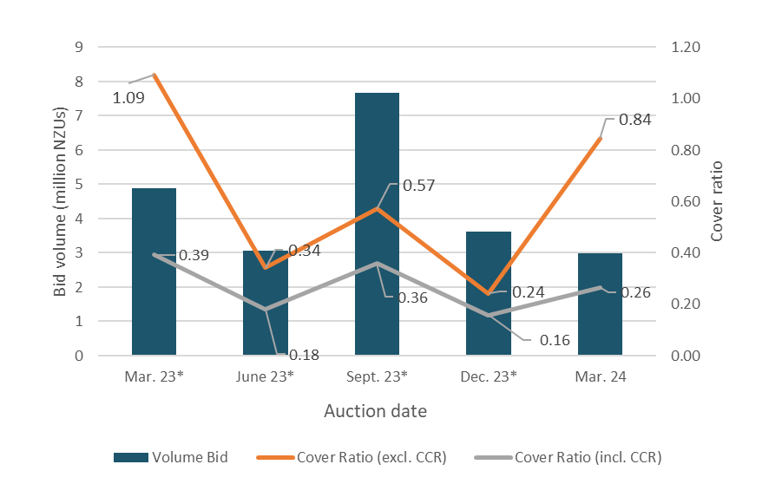
* Declined auction
Figure A.2: Total number of bids per auction
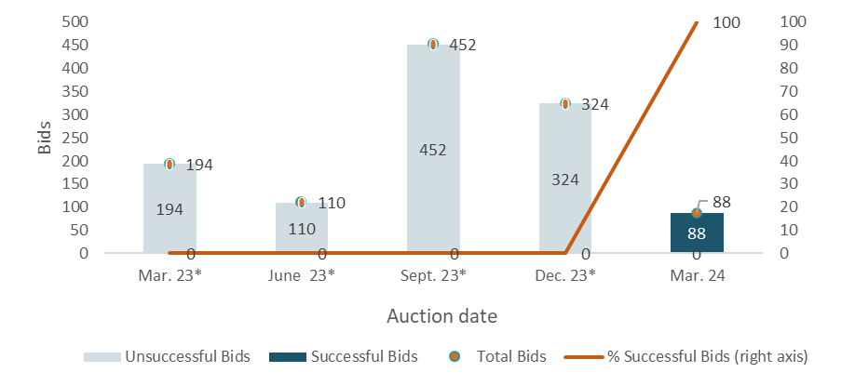
* Declined auction
Figure A.3: Participant numbers per auction
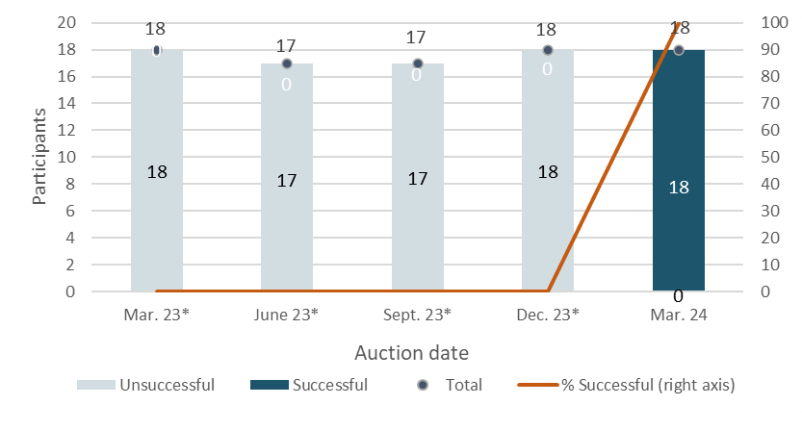
* Declined auction
Figure A.4: Bid volume (of thousands of NZUs) per participant
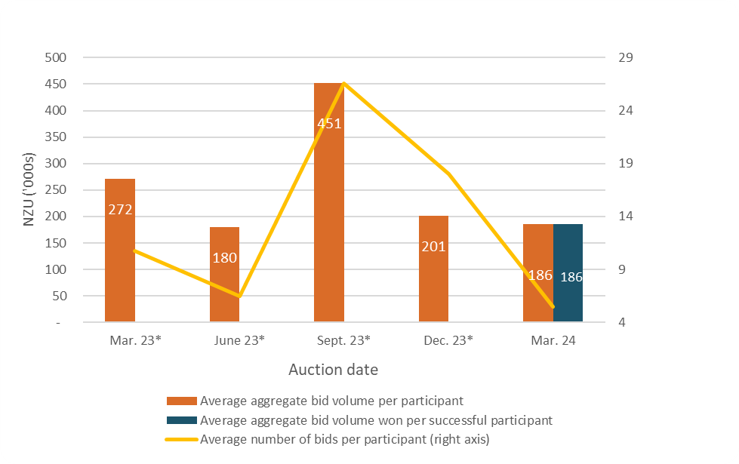
* Declined auction
Note that many participants submitted multiple bids and there may be multiple bidders representing a single participant.
Figure A.5: Proportion of bids (by volume) by participant, March 2024
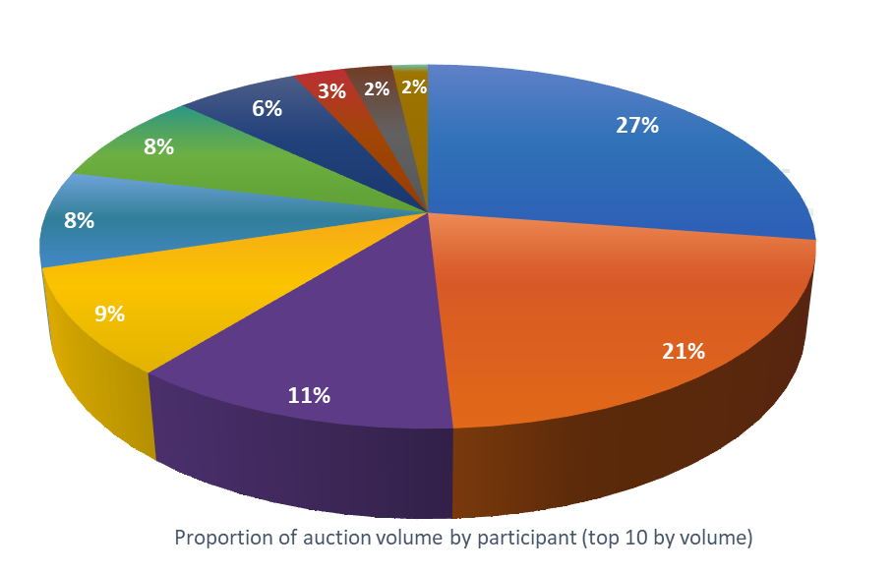
Figure A.6: Proportion of successful bids (by volume) by participant over the previous five auctions
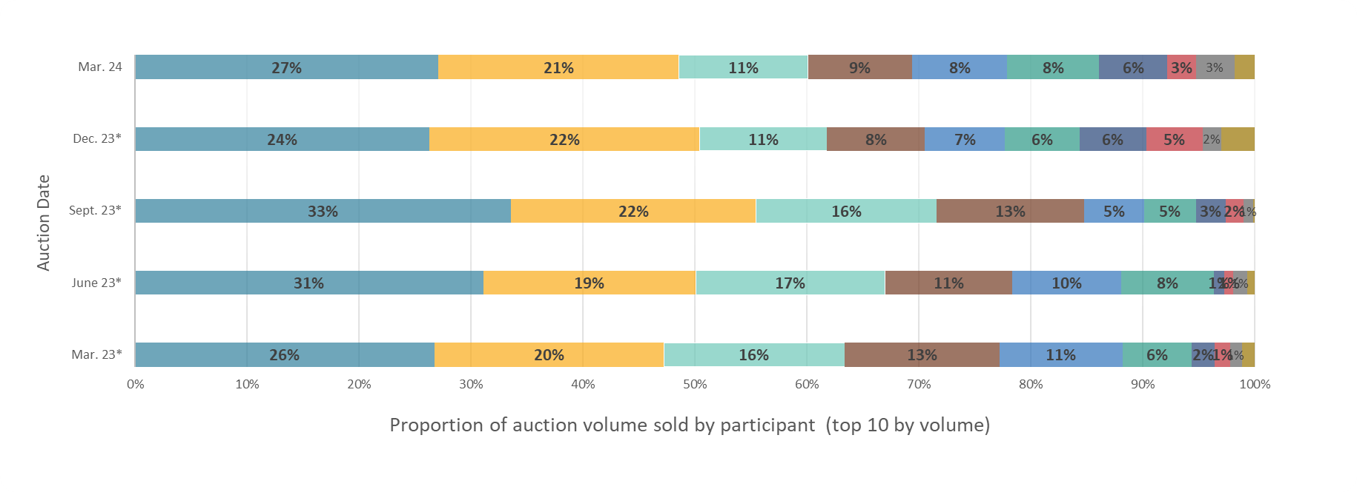
Note: Auctions held on the dates marked with an asterisk were declined. The percentages presented are of bid volumes presented as a facsimile of ‘sold auction volume’.
Figure A.7: Proportion of participants with compliance obligations under the NZ ETS
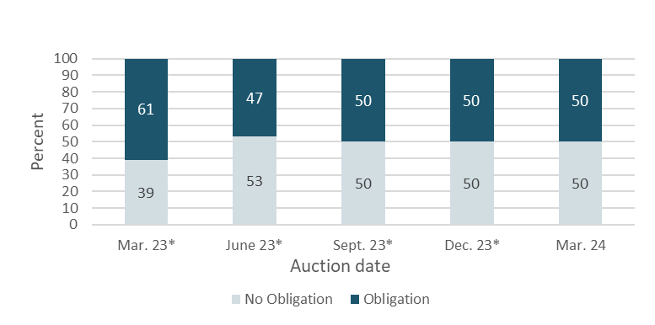
* Declined auction
Figure A.7 represents the estimated percentage of participants that are registered as having compliance obligations on the NZ ETS Register. Larger volume participants, not necessarily registered as having compliance obligations, may be purchasing NZUs on behalf of smaller third parties that do have compliance obligations.

References
New Zealand Cabinet. 2018. Amendments to the Climate Change Response Act 2002: Tranche One. Cabinet Committee Minute of Decision CAB-18-MIN-0606.01. Wellington: Cabinet Office, Department of the Prime Minister and Cabinet.
Ministry for the Environment. 2019. Reforming the New Zealand Emissions Trading Scheme: Rules for auctioning: Technical consultation document. Wellington: Ministry for the Environment.
New Zealand Cabinet. 2020. New Zealand Emissions Trading Scheme: Regulatory Decisions on the Rules for Auctioning. Cabinet Economic Development Committee Minute of Decision DEV-20-MIN-0047. Wellington: Cabinet Office, Department of the Prime Minister and Cabinet.

https://environment.govt.nz/assets/publications/nz-ets-auction-dates-and-volumes.pdf.
https://environment.govt.nz/assets/Publications/amendments-to-ccra-tranche-1-cab-18-min-0606.01.pdf.
https://environment.govt.nz/publications/reforming-the-new-zealand-emissions-trading-scheme-rules-for-auctioning-summary-of-submissions/.
https://environment.govt.nz/assets/Publications/DEV-20-MIN-0047-Minute.pdf.

