

**Disclaimer**

The information in this publication is, according to the Ministry for the Environment’s best efforts, accurate at the time of publication. The Ministry will make every reasonable effort to keep it current and accurate. However, users of this publication are advised that:

* The information does not alter the laws of New Zealand, other official guidelines, or requirements.
* It does not constitute legal advice, and users should take specific advice from qualified professionals before taking any action based on information in this publication.
* The Ministry does not accept any responsibility or liability whatsoever whether in contract, tort, equity, or otherwise for any action taken as a result of reading, or reliance placed on this publication because of having read any part, or all, of the information in this publication or for any error, or inadequacy, deficiency, flaw in, or omission from the information in this publication.
* All references to websites, organisations or people not within the Ministry are for convenience only and should not be taken as endorsement of those websites or information contained in those websites nor of organisations or people referred to.

This document may be cited as: Ministry for the Environment. 2023. *New Zealand Emissions Trading Scheme interim auction monitor report: 15 March 2023 auction*. Wellington: Ministry for the Environment.

Published in April 2023 by the  
Ministry for the Environment   
Manatū Mō Te Taiao  
PO Box 10362, Wellington 6143, New Zealand  
[environment.govt.nz](http://www.environment.govt.nz)

ISBN: 978-1-991077-45-5

Publication number: ME 1757

© Crown copyright New Zealand 2023

# Contents

Introduction and purpose of this report 5

Background 5

Auction monitor to provide information on auctions 5

(Interim) auction monitor’s functions 6

Auction information: 15 March 2023 6

Auction result 6

Auction metrics 7

Commentary on the results of the auction 7

The auction clearing price 8

The confidential reserve price 8

Resolved tied bids 9

Cost containment reserve 9

Commentary on the auction operation 10

General 10

Collateral and settlement 10

Feedback on the auction monitoring report 11

Appendix 12

Graphical presentation of historical auction metrics 12

References 17

# Tables

Table 1 Metrics for NZ ETS auction held on 15 March 2023 3

# Figures

Figure A.1 Volume of NZUs bid for and cover ratio per auction 9

Figure A.2 Total number of bids per auction 9

Figure A.3 Participant numbers per auction 10

Figure A.4 Bid volume (of thousands of NZUs) per participant 10

Figure A.5 Proportion of successful* bids (by volume) by participant, March 2023 11

Figure A.6 Proportion of successful* bids (by volume) by participant over the last five auctions 11

Figure A.7 Proportion of participants with mandatory compliance obligations under the NZ ETS 12

# **Introduction and purpose of this report**

This report is produced by the Ministry for the Environment (the Ministry) acting in the role of the interim auction monitor, for the ninth scheduled New Zealand Emissions Trading Scheme (NZ ETS) auction, the first auction for the year, held on 15 March 2023.

Auctioning of New Zealand Units (NZUs or ‘units’) is currently scheduled at quarterly intervals throughout the year as prescribed by the Climate Change Response (Emissions Trading Reform) Amendment Act 2020 and the Climate Change (Auctions, Limits, and Price Controls for Units) Regulations 2020.

The purpose of this report is to record and provide details on the results of the auction, to present a comparison with previous auctions, and to provide an assurance that the auction was conducted properly and in accordance with the applicable rules and laws.

The next auction, the second of 2023, is scheduled to be held on 14 June 2023.

# Background

Following the 2015/16 review of the NZ ETS, the Government agreed to introduce auctioning of NZUs to align the supply of units in the Emissions Trading Scheme with New Zealand’s climate change targets.[1] Further public consultation on auctioning regulations took place between November and December 2019.[2]

Following extensive regulatory and legislative development and an open market procurement process, an auction operator was appointed to run regular scheduled auctions through the NZX Managed Auction Service.

The first auction occurred on 17 March 2021.

This report concerns the ninth scheduled auction which occurred on 15 March 2023.

## Auction monitor to provide information on auctions

The appointment of an auction monitor requires regulations to be made prescribing the appointment process and the functions of the auction monitor.

Until the required consultations and regulation development have been concluded to appoint an auction monitor, the Minister of Climate Change has agreed that the Ministry for the Environment will perform the function of the auction monitor, referred to in this document as interim auction monitor (IAM).

The IAM function is performed independently of the auction operator and of the Ministry for the Environment policy team responsible for developing the regulations for the auction monitor and auctioning.

## (Interim) auction monitor’s functions

Based on feedback from the 2019 consultation, the Government agreed that the auction monitor should:

* publish certain information about each auction as soon as is practical following the auction
* publish a report on the outcome of each auction before the next auction occurs
* review the auctioning system after the first year and every subsequent two years.

Cabinet has agreed that the auction monitor must publish a report containing prescribed information from each auction and on the outcome of each auction prior to the subsequent auction occurring [DEV-20-MIN-0047].[3]

The auction operator publishes information about each auction shortly following the close of the auction, which can be read in conjunction with this report.

# Auction information: 15 March 2023

## Auction result

Following the completion of the 15 March 2023 auction window the auction operator declared that there were no successful live bids in the auction.

Under the Climate Change (Auctions, Limits, and Price Controls for Units) Regulations 2020 section 33(a)(b), no bids are deemed to be successful and no units may be sold to bidders, if—

1. there is a confidential reserve price at the auction; and
2. the final clearing price is less than the confidential reserve price.

Both of these conditions were met in the Mach auction and no NZUs were sold. Consequently, all of the units that were available for auction will be made available in the next auction which is scheduled to be held on 14 June 2023. As the Cost Containment Reserve (CCR) mechanism was not triggered, the full allocation of CCR units will be available in the next auction.

## Auction metrics

Table 1 provides salient metrics of the auction. Additional details are presented graphically in the appendix.

Table 1 Metrics for NZ ETS auction held on 15 March 2023

|  |  |
| --- | --- |
| Number of participants | 18 |
| Number of successful participants | 0 |
| Volume available at auction (Including 8,000,000 million CCR units) | 12,475,000 |
| Volume of NZU sold | 0 |
| Volume of NZU bid for | 4,887,800 |
| Average bid size | 25,195 |
| Average volume bid per participant | 271,544 |
| Average volume won per successful participant | 0 |
| Average number of bids per participant | 11 |
| Total number of bids submitted (not including withdrawn bids) | 194 |
| Number of bids withdrawn | 54 |
| Number of successful bids | 0 |
| Aggregated ‘top 5’ participants volume (aggregated successful bids) as a percentage of total units sold | 0 |
| Herfindahl–Hirschman Index (measure of market concentration by volume purchased ‘top 10’) | 0.17 |
| Percentage of bidders with mandatory compliance obligations | 61 |

## Commentary on the results of the auction

The ninth NZ ETS auction and the first for 2023 was conducted on 15 March 2023. No units were sold as a result of the auction and consequently the auction operator declared the status of the auction to be ‘declined’.

No bids were considered to be successful as the clearing price did not exceed the confidential reserve price (CRP).

This is the first auction in which the CRP has prevented the sale of any units. The auctioning mechanism, systems and processes functioned exactly as designed and in accordance with regulation and policy.

The cost containment reserve mechanism was not triggered, therefore no CCR volume was required to be released.

With 18 participants and 194 bids submitted, participation in the auction was slightly less than in the three previous auctions.

Auction ‘bid volume’ (the total number of NZUs bid for) was significantly down from the average volume which is reflected in a cover ratio of effectively unity (1.01 excluding the CCR volume).

The market concentration index of 0.17 is at the lower end of the historical range, though it is not inconsistent with decreased demand and indicates in this context that the larger players’ share of the auction is being relatively evenly distributed. However, the top five participants continue to dominate the market with 86 per cent of bids.

Sixty-one per cent of the participants registered as having compliance obligations under the NZ ETS would have been successful in securing most, if not all of their bid volumes had the auction not been declined. Participants registered in the NZ ETS would have acquired 24 per cent of the available auction volume.

As usual, it is highly likely that several of the larger players in the auction represented multiple third parties.

As this is the first auction in which the clearing price did not exceed the CRP reserve, it is unsurprising that there is a significant difference between the secondary market prices at the time of the auction and the clearing price.

The appendix to this document provides auction data that is presented *as though* a clearing price of $43.00, the bid at which the cumulative volume as defined in the regulations, was achieved and that the auction proceeded as though no CRP was applied. The rationale for this is to present a context for the auction result in terms of the metrics and data that have been supplied across the previous auctions and to affect a consistency in information presentation. The presented data is therefore a hypothetical representation of the results of *this* auction.

## The auction clearing price

The auction operator is required to publish the clearing price following the auction.

***The auction clearing price was below the confidential reserve price therefore no bids were considered successful***.

## The confidential reserve price

The Climate Change Response Act enables the Minister of Climate Change to set a methodology for calculating a confidential reserve price for NZ ETS auctions. The confidential reserve price has the purpose of preventing NZUs from being sold at auction at a price significantly below the secondary market price. If the auction clearing price is less than the confidential reserve price, the auction will not sell any NZUs. Unsold NZUs will be rolled forward to be sold at the next auction in the same calendar year.

The legislation requires that the confidential reserve price cannot exceed the trigger price(s) for the cost containment reserve.

***The IAM independently confirms that the confidential reserve price was correctly calculated and applied to the bid data which resulted in no bids being considered successful.***

## Resolved tied bids

If more than one bid sets the clearing price, those bids are referred to as tied bids. If all tied bids together bid for more units than are left, each tied bid is allocated a proportional share of the remaining units, subject to rounding rules. Bids are only accepted in multiples of 100 units from 500 units (the lot size and minimum bid respectively). Units are allocated to bids in multiples of lot size. Therefore, when tied bids occur and the operator calculates proportional shares, they apply the following rounding rules:

* the number of units allocated to a tied bid, if not a multiple of the lot size, is rounded down to the nearest 100 units (this may include being rounded down to zero)
* if unallocated units remain after tied bids are awarded their proportional share (rounded to the nearest 100 units), any remaining lots are randomly allocated to the tied bids, but only up to their original bid amount.

***There were no tied bids in the 15 March 2023 auction.***

## Cost containment reserve

The cost containment reserve (CCR) mechanism provides for an additional volume of NZUs to be added to the auction volume if the auction clearing price is equal to or exceeds the CCR trigger price. Currently, there is only one trigger price level in an NZ ETS auction. The cost containment reserve trigger price for all four 2023 auctions was set according to regulation at NZD80.64 (increased from NZD70.00 per NZU applied in 2022) and as previously published.

The available CCR volume to be shared across all four auctions in 2023 is 8.0 million NZUs.

Both the CCR trigger price and available volumes are set by regulation, though both may be reviewed and are subject to change. The available annual auction volumes and auction dates are published in October of the preceding year by the Ministry for the Environment.

***The CCR trigger price was not breached in the March 2023 auction. No units of CCR reserve volume were made available for sale. The full CCR volume remains available across the remainder of the year’s auctions.***

# Commentary on the auction operation

## General

No NZUs were sold as a result of this auction. The auction operator has confirmed that the auction process ran smoothly with no outages or delays. The Ministry for the Environment has similarly confirmed that the auction ran smoothly.

***The IAM has no reason to believe that the auction rules were not followed.***

## Collateral and settlement

Collateral deposits were significantly less than usual and in keeping with the overall lower demand and price expectations.

With no NZUs being transferred as a result of the auction, collateral was returned to the participants on the day of the auction, with one exception delayed as a result of technical issues. All offshore deposits were returned on the day.

There were no significant issues noted with the receipt of collateral. The majority of participants preferring cash to other instruments when providing collateral, most depositing the cash within the final 48 hours of the ‘collateral window’.

A number of the smaller participants or would-be participants are discovering that the rules and deadlines that apply to the auction and to collateral timings in particular, are generally not negotiable and that it is not best practice to delay financial transfers to the last minute.

The auction operator is to be commended for the encouragement and assistance provided to a number of potential participants.

No invoices were required to be issued.

# Feedback on the auction monitoring report

Please send any information about the NZ ETS auctions to the interim auction monitor at [etsconsultation@mfe.govt.nz](mailto:etsconsultation@mfe.govt.nz) for consideration in future reports.

# Appendix

## Graphical presentation of historical auction metrics

|  |
| --- |
| Legend for graphs in this report  Mar. 22 Auction 5, held on 16 March 2022  June 22 Auction 6, held on 15 June 2022  Sept. 22 Auction 7, held on 7 September 2022  Dec. 22 Auction 8, held on 7 December 2022  Mar. 23* Auction 9, held on 15 March 2023 (this auction)  The most recent auction and four trailing auctions will be presented in this appendix.  * March 2023 auction status was declared ‘declined’ by the auction operator. No NZUs were sold at the auction. |

Note:

The appendix to this document provides auction data that is presented *as though* a clearing price of $43.00 (the bid at which the cumulative volume as defined in the regulations) was achieved and that the auction proceeded as though no CRP was applied. The rationale for this is to present a context for the auction result in terms of the metrics and data that have been supplied across the previous auctions and to affect a consistency in information presentation.

**The presented data is therefore a hypothetical representation of the results of the March 2023 auction.**

Figure A.1 Volume of NZUs bid for and cover ratio per auction

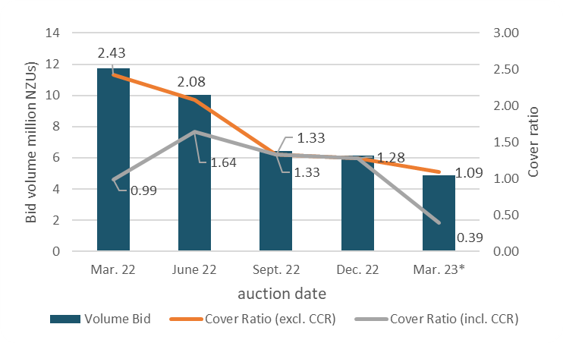

* Declined auction

Figure A.2 Total number of bids per auction

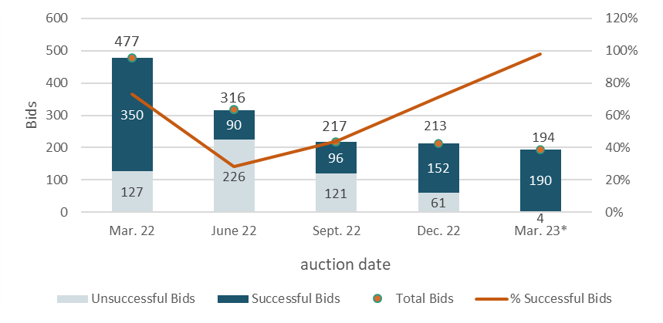

* Declined auction

Figure A.3 Participant numbers per auction

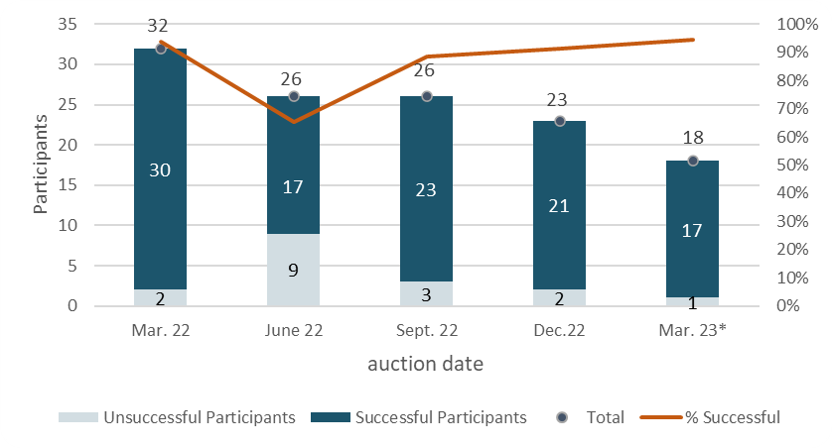

* Declined auction

Figure A.4 Bid volume (of thousands of NZUs) per participant

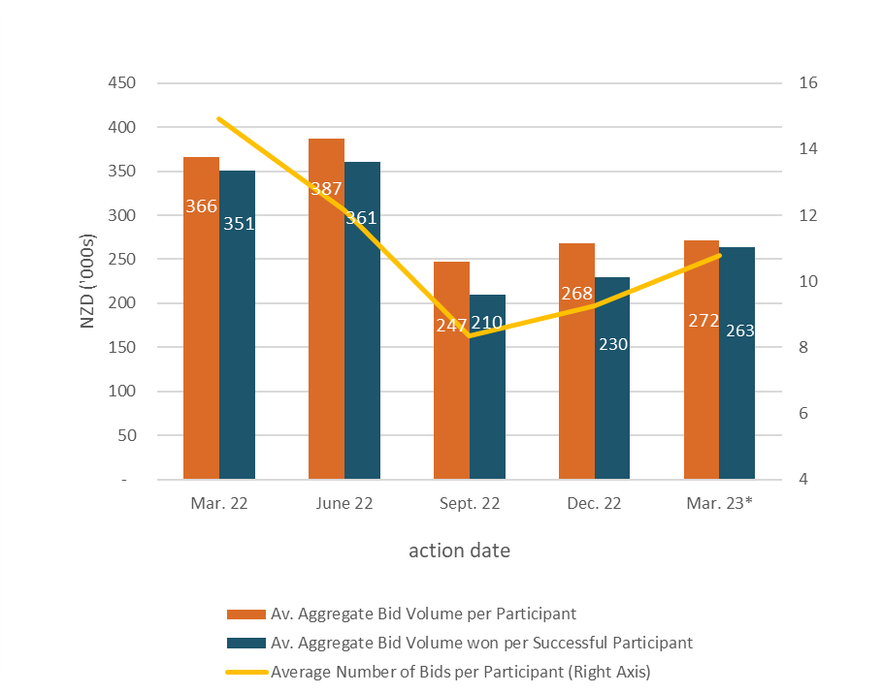

* Declined auction

Note that many participants submitted multiple bids and there may be multiple bidders representing a single participant.

Figure A.5 Proportion of successful* bids (by volume) by participant, March 2023

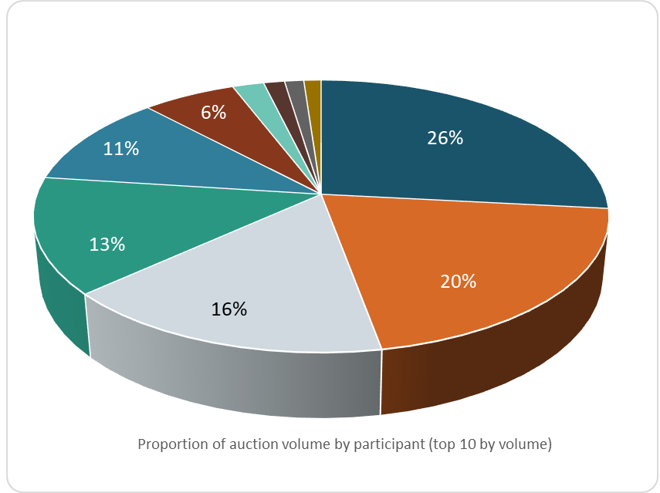

* Declined auction

Figure A.6 Proportion of successful* bids (by volume) by participant over the last five auctions

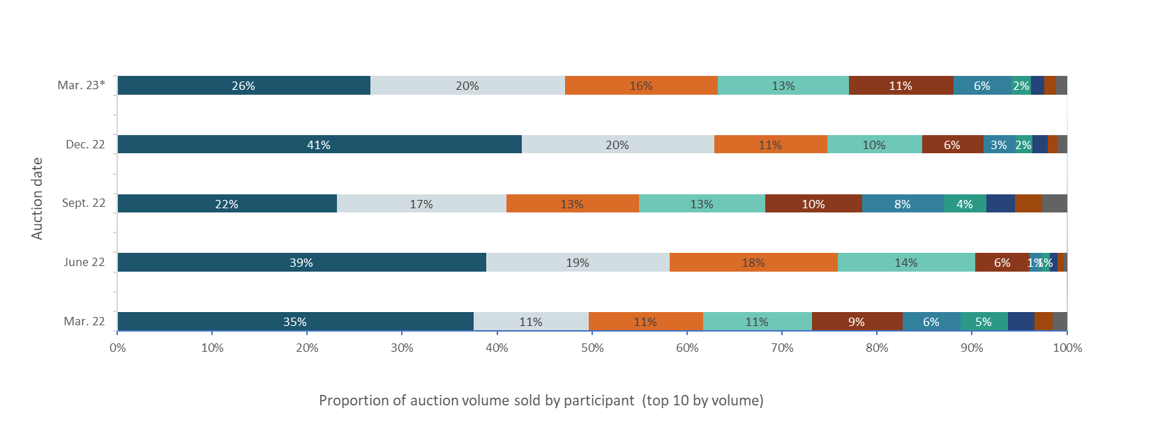

* Declined auction

Figure A.7 Proportion of participants with mandatory compliance obligations under the NZ ETS

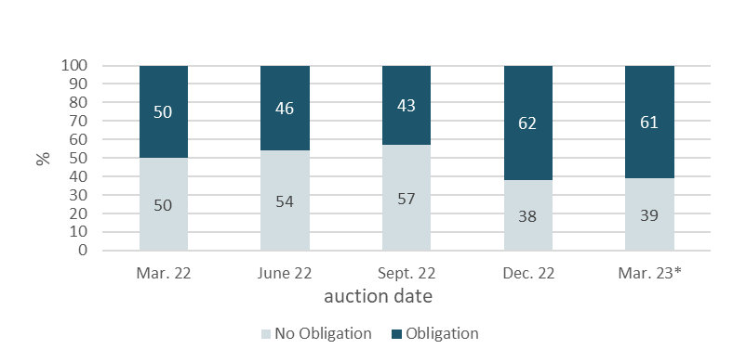

* Declined auction

Figure A.7 represents the percentage of participants that are registered as having mandatory compliance obligations on the NZ ETS Register. Larger volume participants, not necessarily registered as having compliance obligations, may be purchasing NZUs on behalf of smaller third parties that do have compliance obligations.

# **References**

New Zealand Cabinet. 2018. *Amendments to the Climate Change Response Act 2002: Tranche One*. Cabinet Committee Minute of Decision CAB-18-MIN-0606.01. Wellington: Cabinet Office, Department of the Prime Minister and Cabinet.

Ministry for the Environment. 2019. *Reforming the New Zealand Emissions Trading Scheme: Rules for auctioning: Technical consultation document*. Wellington: Ministry for the Environment.

New Zealand Cabinet. 2020. *New Zealand Emissions Trading Scheme: Regulatory Decisions on the Rules for Auctioning*. Cabinet Economic Development Committee Minute of Decision DEV-20-MIN-0047. Wellington: Cabinet Office, Department of the Prime Minister and Cabinet.

1. <https://environment.govt.nz/assets/Publications/amendments-to-ccra-tranche-1-cab-18-min-0606.01.pdf>
2. <https://environment.govt.nz/publications/reforming-the-new-zealand-emissions-trading-scheme-rules-for-auctioning-summary-of-submissions/>
3. <https://environment.govt.nz/assets/Publications/DEV-20-MIN-0047-Minute.pdf>