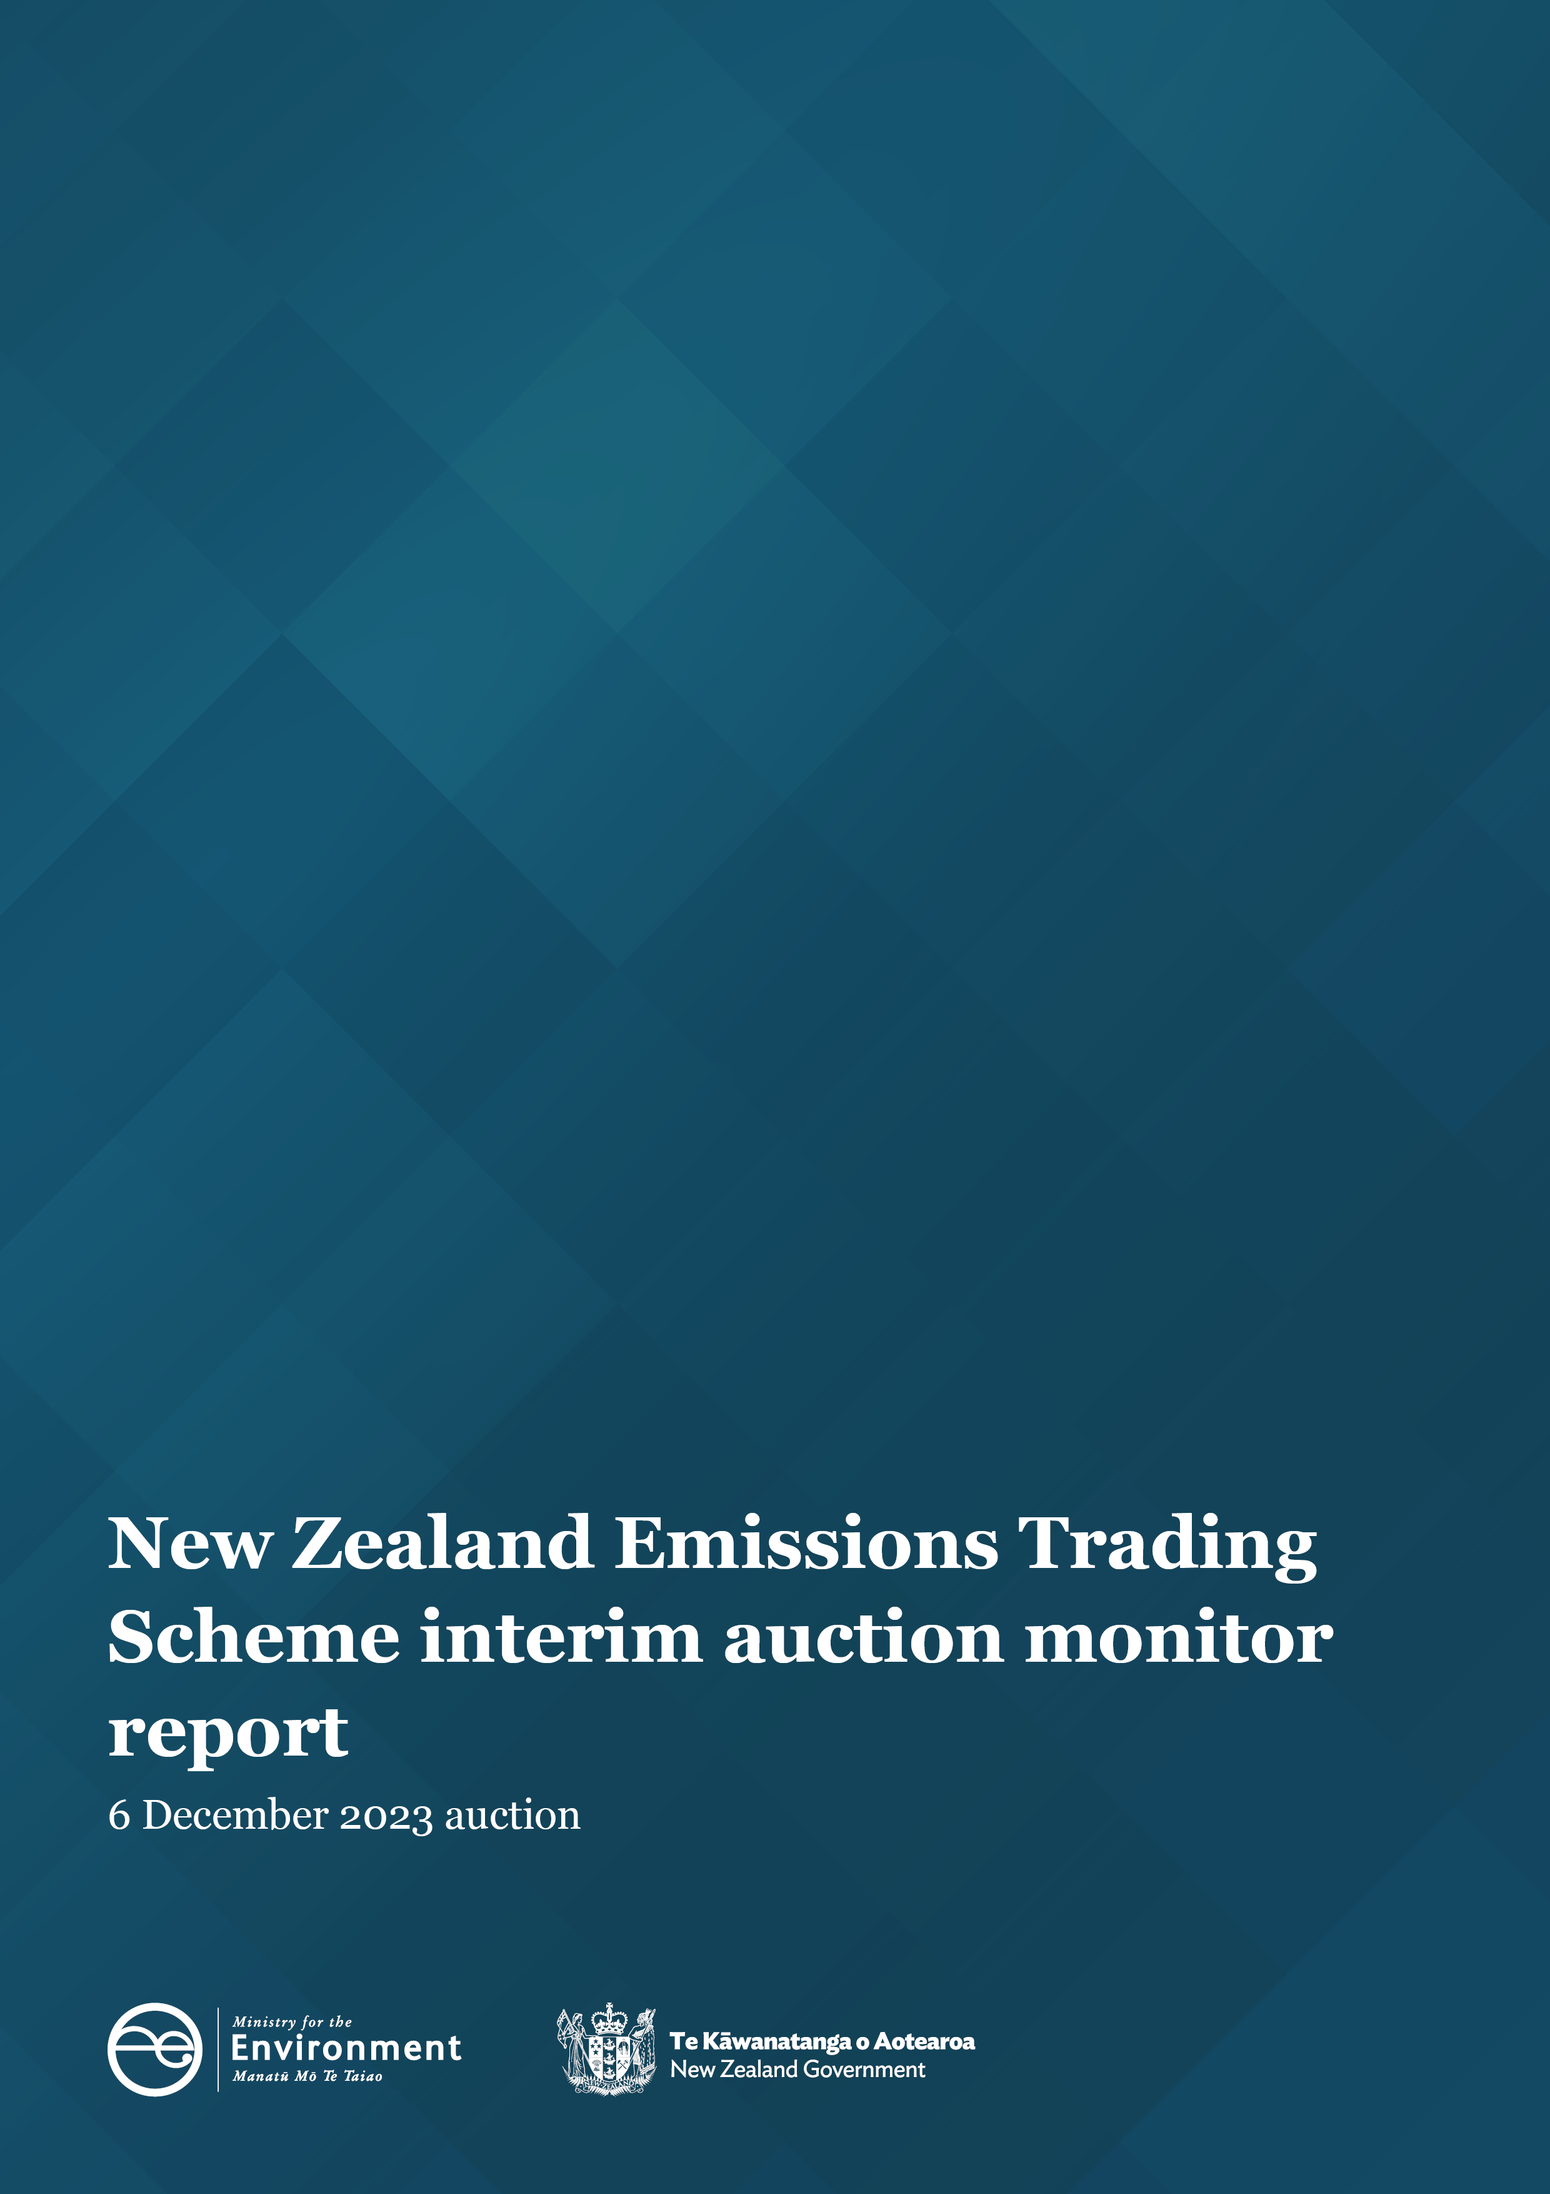

Disclaimer
The information in this publication is, according to the Ministry for the Environment’s best efforts, accurate at the time of publication. The Ministry will make every reasonable effort to keep it current and accurate. However, users of this publication are advised that:
- The information does not alter the laws of New Zealand, other official guidelines, or requirements.
- It does not constitute legal advice, and users should take specific advice from qualified professionals before taking any action based on information in this publication.
- The Ministry does not accept any responsibility or liability whatsoever whether in contract, tort, equity, or otherwise for any action taken as a result of reading, or reliance placed on this publication because of having read any part, or all, of the information in this publication or for any error, or inadequacy, deficiency, flaw in, or omission from the information in this publication.
- All references to websites, organisations or people not within the Ministry are for convenience only and should not be taken as endorsement of those websites or information contained in those websites nor of organisations or people referred to.

This document may be cited as: Ministry for the Environment. 2023. New Zealand Emissions Trading Scheme interim auction monitor report: 6 December 2023 auction. Wellington: Ministry for the Environment.

Published in December 2023 by the
Ministry for the Environment
Manatū mō te Taiao
PO Box 10362, Wellington 6143, New Zealand
environment.govt.nz
ISBN: 978-1-991140-02-9
Publication number: ME 1814
© Crown copyright New Zealand 2023

Contents
Introduction and purpose of this report 5
Background 5
Auction monitor to provide information on auctions 5
(Interim) auction monitor’s functions 6
Auction information: 6 December 2023 7
Auction result 7
Changes to the NZ ETS auction settings 7
Auction metrics 8
Commentary on the results of the auction 8
The auction clearing price 10
The confidential reserve price 10
Resolved tied bids 10
Cost containment reserve 11
Commentary on the auction operation 12
General 12
Collateral and settlement 12
Feedback on the auction monitoring report 13
Appendix 14
Graphical presentation of historical auction metrics 14
References 19

Table
Table 1 Metrics for NZ ETS auction held on 6 December 2023 8

Figures
Figure A.1 Volume of NZUs bid for and cover ratio per auction 15
Figure A.2 Total number of bids per auction 15
Figure A.3 Participant numbers per auction 16
Figure A.4 Bid volume (of thousands of NZUs) per participant 16
Figure A.5 Proportion of bids (by volume) by participant, December 2023 17
Figure A.6 Proportion of successful bids (by volume) by participant over the previous five auctions 17
Figure A.7 Proportion of participants with compliance obligations under the NZ ETS 18

Introduction and purpose of this report
This report is produced by the Ministry for the Environment (the Ministry) acting in the role of the interim auction monitor, for the twelfth scheduled New Zealand Emissions Trading Scheme (NZ ETS) auction, the fourth and final auction for the year, held on 6 December 2023.
Auctioning of New Zealand Units (NZUs or ‘units’) is currently scheduled at quarterly intervals throughout the year as prescribed by the Climate Change Response (Emissions Trading Reform) Amendment Act 2020 and the Climate Change (Auctions, Limits, and Price Controls for Units) Regulations 2020.
The purpose of this report is to record and provide details on the results of the most recent auction, to present a comparison with previous auctions, and to provide an assurance that the auction was conducted properly and in accordance with the applicable rules and laws.
The next and first auction of next year is scheduled to be held on 20 March 2024.

Background
Following the 2015/16 review of the NZ ETS, the Government agreed to introduce auctioning of NZUs to align the supply of units in the Emissions Trading Scheme with New Zealand’s climate change targets. Further public consultation on auctioning regulations took place between November and December 2019.
Following extensive regulatory and legislative development and an open market procurement process, an auction operator was appointed to run regular scheduled auctions through the NZX Managed Auction Service.
The first auction occurred on 17 March 2021.
This report concerns the 12th scheduled auction which occurred on 6 December 2023.

Auction monitor to provide information on auctions
The appointment of an auction monitor requires regulations to be made prescribing the appointment process and the functions of the auction monitor.
Until the required consultations and regulation development have been concluded to appoint an auction monitor, the Minister of Climate Change has agreed that the Ministry for the Environment will perform the function of the auction monitor, referred to in this document as interim auction monitor (IAM).
The IAM function is performed independently of the auction operator and of the Ministry for the Environment policy team responsible for developing the regulations for the auction monitor and auctioning.

(Interim) auction monitor’s functions
Based on feedback from the 2019 consultation, the Government agreed that the auction monitor should:
- publish certain information about each auction as soon as is practical following the auction
- publish a report on the outcome of each auction before the next auction occurs
- review the auctioning system after the first year and every subsequent two years.
Cabinet has agreed that the auction monitor must publish a report containing prescribed information from each auction and on the outcome of each auction prior to the subsequent auction occurring [DEV-20-MIN-0047]. The auction operator publishes information about each auction shortly following the close of the auction, which can be read in conjunction with this report.

Auction information: 6 December 2023

Auction result
Following the completion of the 6 December 2023 auction window the auction operator declared that there were no successful bids in the auction.
Under the Climate Change (Auctions, Limits, and Price Controls for Units) Regulations 2020 section 33(a)(b), no bids are deemed to be successful, and no units may be sold to bidders, if—
- there is a confidential reserve price at the auction; and
- the final clearing price is less than the confidential reserve price.
As has been the case in all previous auctions of 2023, both of these conditions were met in the December auction and no NZUs were sold.
The Cost Containment Reserve (CCR) mechanism was not triggered.
No unsold NZUs from the 2023 auctions will be ‘carried over’ into 2024.

Changes to the NZ ETS auction settings
The Government has consulted on proposals to update New Zealand Emissions Trading Scheme (NZ ETS) unit settings for the period 2024 to 2028. This includes changes to the available volumes and trigger prices.
Changes to the regulations have been enacted and apply to the subject of this report, the auction held on 6 December 2023, and subsequent auctions.
A summary of the changes may be viewed on the Ministry for the Environment’s website: Government announces updated NZ ETS auction settings | Ministry for the Environment.
Participants are strongly encouraged to review the published changes to the regulations and settings before engaging in the auction process.

Auction metrics
Table 1 provides salient metrics of the auction. Additional details are presented graphically in the appendix.
Table 1 Metrics for NZ ETS auction held on 6 December 2023
Number of participants | 18
Number of successful participants | 0
Volume available at auction (Including 8,000,000 million CCR units) | 23,000,000
Volume of NZU sold | 0
Volume of NZU bid for | 3,622,000
Average bid size | 11,179
Average volume bid per participant | 201,222
Average volume won per successful participant | 0
Average number of bids per participant | 18
Total number of bids submitted (not including withdrawn bids) | 324
Number of bids withdrawn | 5
Number of successful bids | 0
Cover Ratio (Excluding 8,000,000 million CCR units) | 0.24
Aggregated ‘top 5’ participants volume (aggregated bids) as a percentage of total units bid for | 72.5
Herfindahl–Hirschman Index (measure of market concentration by volume bid for ‘top 10’) | 0.14
Estimated percentage of bidders with compliance obligations | 50

Commentary on the results of the auction
The 12th NZ ETS auction and the fourth of the year was conducted on 6 December 2023.
As a consequence of the earlier ‘declined’ auctions of 2023, the available cumulative NZU volume was more than three times that of first scheduled auction of the year. The now familiar aggregating impact on trigger volumes virtually ensured that demand would not exceed the trigger volume for the auction, based on historical bid volume.
No units were sold as a result of the auction and consequently the auction operator declared the status of the auction to be ‘declined’.
No bids were considered to be successful as there were less bids received than the available cumulative volume and the lowest bid received did not exceed the confidential reserve price (CRP), negating the option of a ‘partial clearance’.
All four auctions of 2023 have been declined as a result of the CRP mechanism combining with relatively low demand (particularly in relation to the aggregated cumulative volumes) preventing the sale of any units. The auctioning mechanism, systems and processes functioned as designed and in accordance with regulation and policy.
The cost containment reserve mechanism trigger prices and tiering structure were altered for the December and future auctions in line with the recently updated NZ ETS auction settings changes. In the December auction neither of the two new CCR tiers were breached, therefore no CCR volume was required to be released. The highest bid received in the auction was well below the tier one tigger price of NZD173.00.
Auction bid volume (the total number of NZUs bid for) totalled almost 3.62 million; less than half that of the previous auction demand. Cover ratios (the ratio of demand to available volume) remain low due, in the main, to the high cumulative volumes.
Consistent with 2023 auctions, there were 18 active participants in the auction. A total of 324 bids were submitted though again over 70 percent of the bids were submitted from a single participant. This figure does not necessarily equate to the volume of NZUs bid for by the participant.
Again, participants are urged to carefully consider the potential consequences of their approach to participation in the auction process and to be mindful of their obligations under the Auction Participant Terms and Conditions.
The market concentration index fell by approximately 30 percent from the September auction to 0.14 indicating that although the larger players continue to dominate demand (the top 10 participants submitting 95 percent of the bids), allocations are being relatively evenly distributed amongst them. There is some variation across auctions in the positions of the major bidders relative to one another.
Nine of the 18 participants are estimated to have compliance obligations under the NZ ETS. Participants directly registered in the NZ ETS submitted bids for 56 percent of the total bid volume in this auction.
As usual, it is highly likely that several of the larger players in the auction (not registered as having compliance obligations) represented multiple third parties, some of which may have compliance obligations.
Approximately 25 percent of the bid volume exceeded the CRP.
It is difficult to form much in the way of a conclusion as to demand and market behaviour as a result of this auction. The reduction in the available volume to 1.575 million NZUs was swamped by the available cumulative volume aggregated over the year. Demand was exceptionally low (only the June auction of this year elicited less demand). A raised auction floor (NZD60.00) which effectively ‘squeezed’ the bidding range and the prognosticated proximity of the CRP may have combined to reduce demand for this last auction of the year. Bidders instead perhaps preferring to wait for a clean slate next March.
The appendices to this document provide summary auction data. Note that the summary data relating to participant averages should be considered in the light of the extraordinarily high number of bids submitted by a single participant.

The auction clearing price
The auction operator is required to publish the clearing price following the auction.
The received bid volume did not exceed the available cumulative volume nor were the conditions for a partially complete auction met, as the lowest bid was below the confidential reserve price, therefore no bids were considered successful.

The confidential reserve price
The Climate Change Response Act enables the Minister of Climate Change to set a methodology for calculating a confidential reserve price for NZ ETS auctions. The confidential reserve price has the purpose of preventing NZUs from being sold at auction at a price significantly below the secondary market price. If the auction clearing price is less than the confidential reserve price, the auction will not sell any NZUs. Unsold NZUs will be rolled forward to be sold at the next auction in the same calendar year.
No NZUs will be rolled forward to the 2024 auction year.
Note that the NZ ETS auction settings have been amended including the available volumes, CCR trigger levels and tier structures and other auction parameters. Participants are urged to review the updated settings.
The IAM independently confirms that the confidential reserve price was correctly calculated and applied to the bid data which resulted in no bids being considered successful.

Resolved tied bids
If more than one bid sets the clearing price, those bids are referred to as tied bids. If all tied bids together bid for more units than are left, each tied bid is allocated a proportional share of the remaining units, subject to rounding rules. Bids are only accepted in multiples of 100 units from 500 units (the lot size and minimum bid respectively). Units are allocated to bids in multiples of lot size. Therefore, when tied bids occur and the operator calculates proportional shares, they apply the following rounding rules:
- the number of units allocated to a tied bid, if not a multiple of the lot size, is rounded down to the nearest 100 units (this may include being rounded down to zero)
- if unallocated units remain after tied bids are awarded their proportional share (rounded to the nearest 100 units), any remaining lots are randomly allocated to the tied bids, but only up to their original bid amount.
There were no tied bids in the 6 December 2023 auction.

Cost containment reserve
The cost containment reserve (CCR) mechanism provides for additional volume of NZUs to be added to the auction volume if the auction clearing price is equal to or exceeds the CCR trigger prices. As of the December 2023 auction, two distinct CCR tiers and associated trigger prices have been set.
Both the CCR trigger price and available volumes are set by regulation, though both may be reviewed and are subject to change. The available annual auction volumes and auction dates are published in October of the preceding year by the Ministry for the Environment and were updated in November 2023.
Note that the NZ ETS auction settings have been amended including the available volumes, CCR trigger levels and tier structures and other auction parameters. Participants are urged to review the updated settings.
The CCR trigger prices were not breached in the December 2023 auction. No units of CCR reserve volume were made available for sale.

Commentary on the auction operation

General
No NZUs were sold as a result of this auction. The auction operator has confirmed that the auction process ran smoothly with no outages or delays. The Ministry for the Environment has similarly confirmed that the auction ran smoothly.
The IAM has no reason to believe that the auction rules were not followed.

Collateral and settlement
Collateral deposits were less than usual and in keeping with the overall demand and price expectations.
With no NZUs being transferred as a result of the auction, collateral was returned to the participants on the day of the auction for domestic participants and on the following day for offshore depositors.
The majority of participants continue to prefer cash to other instruments when providing collateral though four non-cash instruments were utilised.
No invoices were required to be issued.

Feedback on the auction monitoring report
Please send any feedback on this report to the interim auction monitor at etsconsultation@mfe.govt.nz for consideration in future reports.

Appendix

Graphical presentation of historical auction metrics
Legend for graphs in this report
December 22 Auction 8, held on 7 December 2022
March 23* Auction 9, held on 15 March 2023
June 22* Auction 10, held on 14 June 2023
September 23* Auction 11, held on 6 September 2023
December 23* Auction 12, held on 6 December 2023 (this auction)
Data from the most recent auction and four trailing auctions are presented in this appendix.
*Auction dates noted with an asterisk were declared ‘declined’ by the auction operator.
No NZUs were sold at these auctions.

Figure A.1 Volume of NZUs bid for and cover ratio per auction
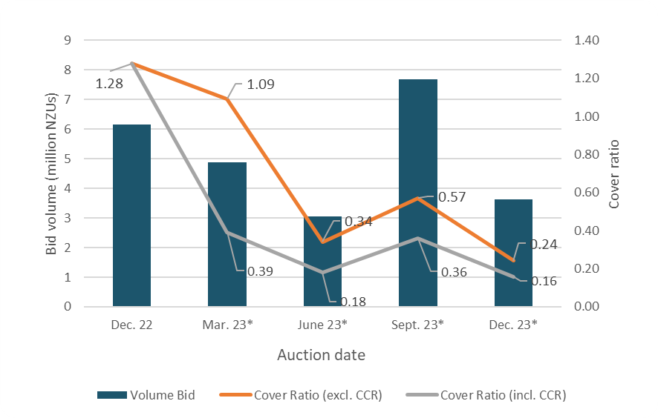
* Declined auction

Figure A.2 Total number of bids per auction
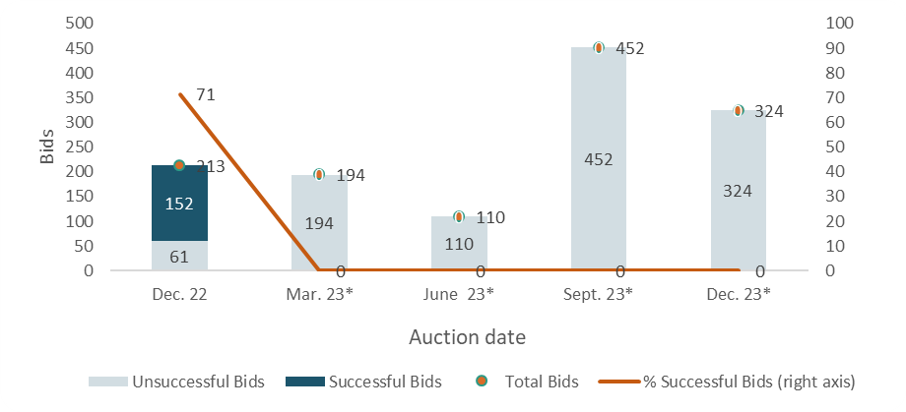
* Declined auction

Figure A.3 Participant numbers per auction
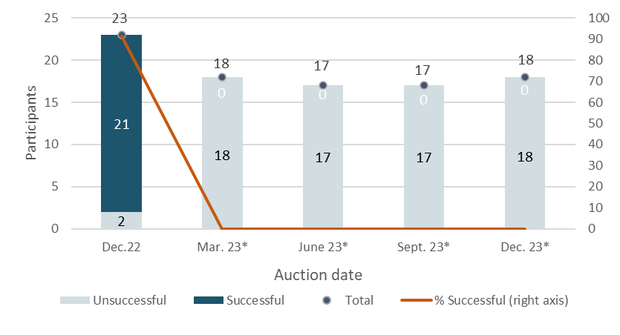
* Declined auction

Figure A.4 Bid volume (of thousands of NZUs) per participant
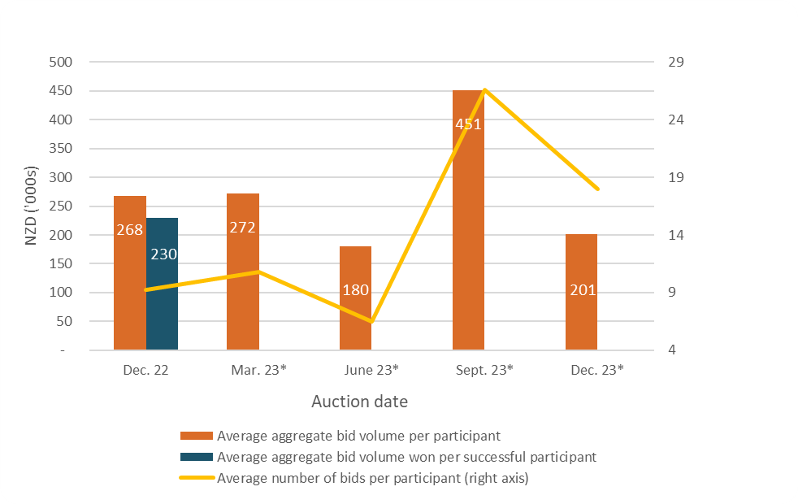
* Declined auction
Note that many participants submitted multiple bids and there may be multiple bidders representing a single participant.
Figure A.5 Proportion of bids (by volume) by participant, December 2023
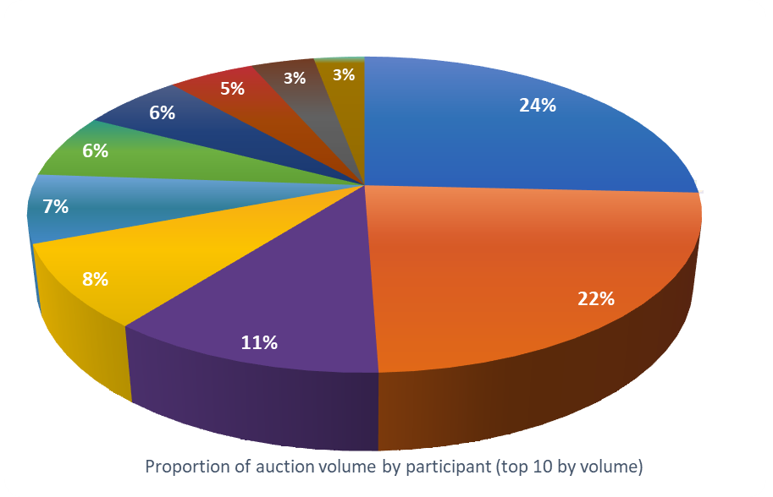

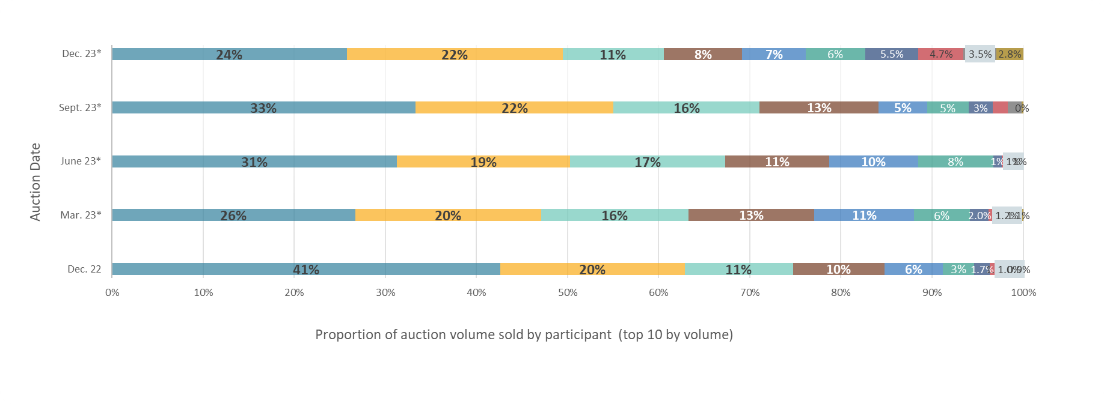
Figure A.6 Proportion of successful bids (by volume) by participant over the previous five
Note: Auctions held on the dates marked with an asterisk were declined. The percentages presented are of bid volumes presented as a facsimile of ‘sold auction volume’.
Figure A.7 Proportion of participants with compliance obligations under the NZ ETS
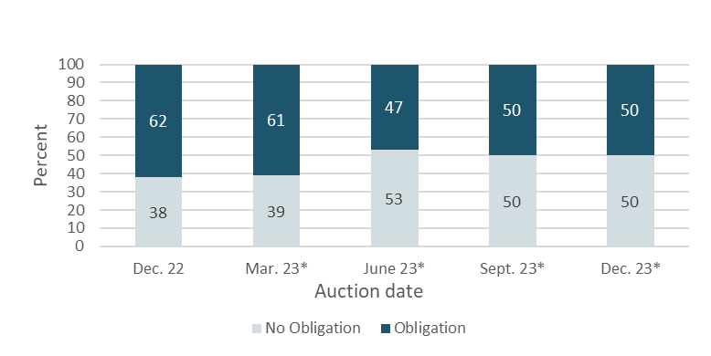
* Declined auction
Figure A.7 represents the estimated percentage of participants that are registered as having compliance obligations on the NZ ETS Register. Larger volume participants, not necessarily registered as having compliance obligations, may be purchasing NZUs on behalf of smaller third parties that do have compliance obligations.

References
New Zealand Cabinet. 2018. Amendments to the Climate Change Response Act 2002: Tranche One. Cabinet Committee Minute of Decision CAB-18-MIN-0606.01. Wellington: Cabinet Office, Department of the Prime Minister and Cabinet.
Ministry for the Environment. 2019. Reforming the New Zealand Emissions Trading Scheme: Rules for auctioning: Technical consultation document. Wellington: Ministry for the Environment.
New Zealand Cabinet. 2020. New Zealand Emissions Trading Scheme: Regulatory Decisions on the Rules for Auctioning. Cabinet Economic Development Committee Minute of Decision DEV-20-MIN-0047. Wellington: Cabinet Office, Department of the Prime Minister and Cabinet.

https://environment.govt.nz/assets/Publications/amendments-to-ccra-tranche-1-cab-18-min-0606.01.pdf.
https://environment.govt.nz/publications/reforming-the-new-zealand-emissions-trading-scheme-rules-for-auctioning-summary-of-submissions/.
https://environment.govt.nz/assets/Publications/DEV-20-MIN-0047-Minute.pdf.

