Interim guidance on the use of new sea-level rise projections
Quick reference guide

Updated Coastal hazards and climate change guidance was published in early 2024 and is available on the Ministry’s website.
Parts of the 2017 Coastal hazards and climate change guidance (2017 guidance) have been updated to reflect the latest sea-level rise scenarios from the Intergovernmental Panel on Climate Change (IPCC) and NZSeaRise. This fact sheet summarises these updates. For more detailed information, see the full interim guidance on the use of new sea-level rise projections.

Why have we released interim guidance?
New information is available on the rate and extent of sea-level rise, and how changes in land levels impact sea-level rise. The effects of climate change, including sea-level rise, are already being felt across New Zealand. Essential planning work by councils needs to continue to manage these increasing risks. It is essential the decisions made are based on the latest science.

What’s changed?
Updated sea-level rise scenarios have been developed for New Zealand as part of the NZSeaRise: Te Tai Pari O Aoteoroa programme. They are based on the latest climate scenarios from the 2021 IPCC Sixth Assessment Report (AR6) and new localised information on changes in land levels around the coast, known as vertical land movement (VLM).
The interim guidance now uses shared socio-economic pathways (SSPs) introduced by the IPCC AR6 report. These span a wide range of plausible societal and climatic futures and replace the previous representative concentration pathways (RCPs) used in the 2017 guidance.
Five “medium confidence” scenarios are now recommended for use in New Zealand. These are SSP1-2.6 M (sustainability), SSP2-4.5 M (middle of the road), SSP3-7.0 M (regional rivalry), SSP5-8.5 M (fossil fuel intensive development) and SSP5-8.5 H+ (upper likely range). These broadly align with the previous four RCP projections used in the guidance although are slightly higher later in the century and beyond (figure 1). SSP3-7.0 M (regional rivalry) is a new scenario which fills the considerable gap between RCP4.5 and RCP8.5.
Figure 1 Comparison of the new nationally averaged NZSeaRise projections (excluding VLM which is shown in figure 2 below) with the matching equivalent suite of four sea-level rise projections in the 2017 MfE coastal guidance
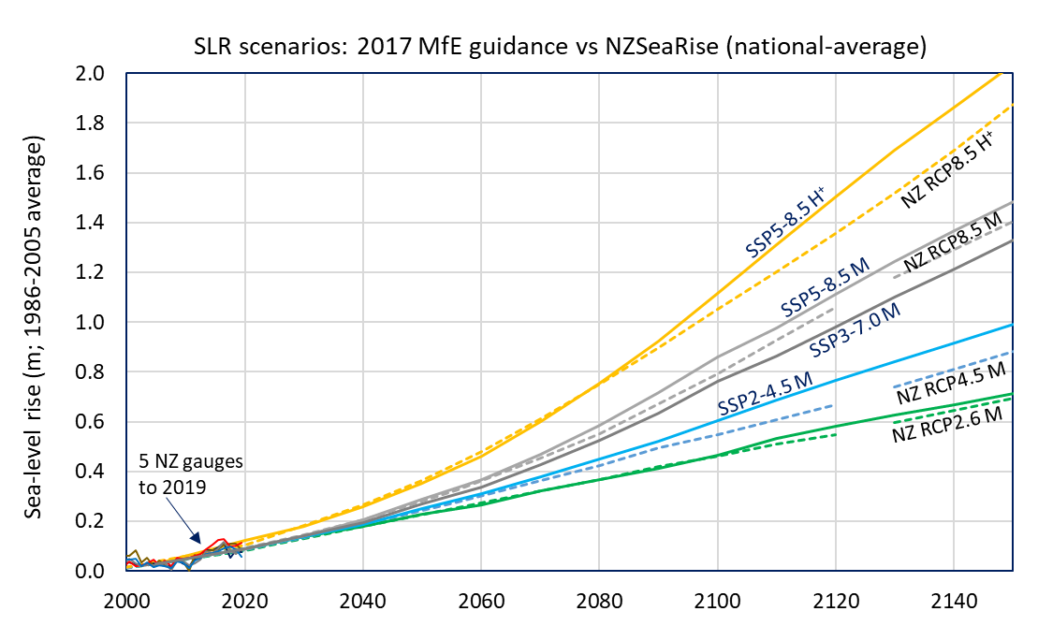
It is recommended councils use additional “low confidence” scenarios to further stress test long-lived or high-risk infrastructure, subdivision or managed retreat. These model some of the more uncertain contributors of sea-level rise, such as instabilities of polar ice cliffs next to the sea, and help convey that sea-level rise will be ongoing for centuries.
VLM rates are now available for every 2 kilometres around the coast. There are some uncertainties, but those rates will likely continue at a similar pace to current estimates. However, this provides a better understanding of local sea-level rise relative to land, as areas are rising or sinking at very different rates around the country. In areas that are subsiding, impacts of sea-level rise will arrive sooner (figure 2).
Figure 2 The impact of rising sea level combined with land subsidence on the mean sea level (MSL) shoreline
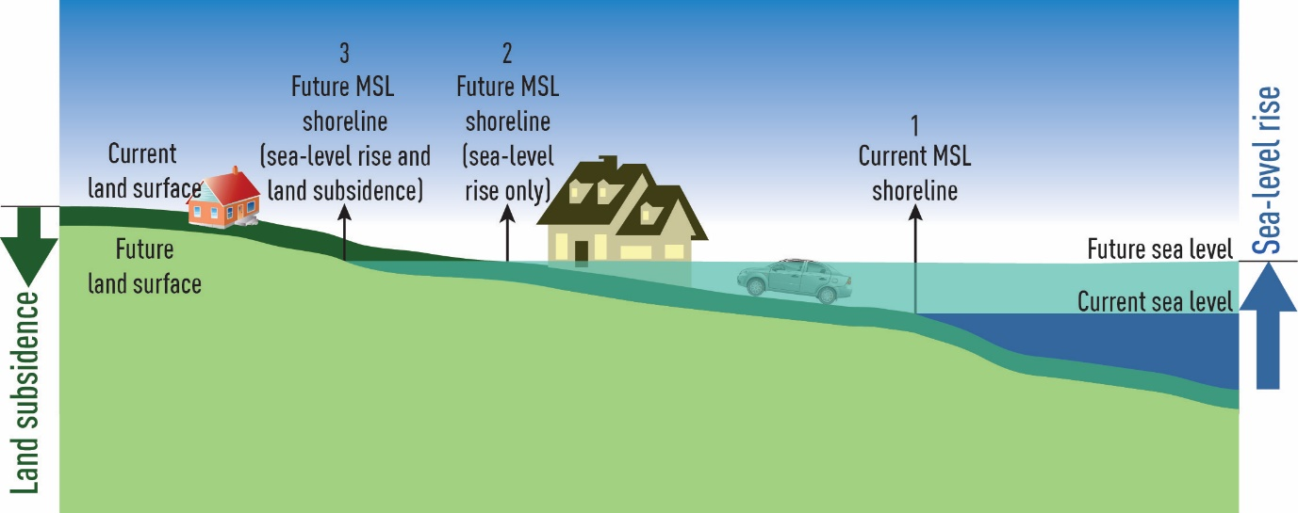
Source for figure 2: A Wadhwa, NIWA and figure 16, The Ministry for the Environment, 2017.
For instance, at the upper end, in southern Wairarapa the land is subsiding at around a rate of 8 millimetres per year. Including VLM effectively doubles the amount of sea level that needs to be planned for by 2100. VLM rates are yet another aspect of uncertainty in how quickly sea level will rise, which further reinforces the benefit of using a dynamic adaptive pathways planning (DAPP) approach, where ongoing changes can be factored in along the way.
Longer timeframes are now recommended for planning. Reliable projections are now available out to 2150 which allows councils to clearly meet the New Zealand Coastal Policy Statement (NZCPS) direction to plan for “at least 100 years”.
Minimum transitional sea-level rise allowances have been updated to reflect the new sea-level rise scenarios and longer timeframes recommended for planning. These broadly align with the previous approach to the transitional period until DAPP strategies are developed, but the longer timeframes and inclusion of VLM mean that the recommended allowances will be higher than recommended in the 2017 guidance. Clearer guidance has also been added for intensification activities to support the identification of qualifying matters for the National Policy Statement on Urban Development (NPS-UD).

How should the guidance be used?
The interim guidance supports councils to understand how to apply the latest sea-level rise scenarios developed by NZSeaRise from their work and that of IPCC.
This update only affects material that was tied to specific sea-level rise scenarios or allowances in land-use planning decisions. This includes relevant sections of chapter 5 (sections 5.3 to 5.7) of the 2017 guidance. All other parts of the 2017 guidance should continue to be used in the meantime until a full refresh of the guidance is completed.
Recommended scenarios
When exercising their functions under the Resource Management Act 1991 (RMA), and giving effect to the provisions of the NZCPS, councils should use the climate change scenarios recommended in this interim guidance as follows.
- Use the five updated “medium confidence” scenarios out to 2150 to undertake risk and vulnerability assessments and stress-test proposals, strategies, project designs, policies, rules, statutory coastal hazard overlays, and emerging spatial plans.
- Include VLM rates to calculate relative sea-level rise (RSLR) locally (noting the caveats and uncertainties outlined), or if rates are low, average them regionally. Where local VLM rates are specifically monitored and more granular, these should be used instead.
- Further stress test risk-sensitive or long-lived projects such as new subdivisions, long-lived infrastructure, or vulnerable cultural sites with “low confidence” SSP scenarios.
The extent to which councils can utilise these scenarios will depend on the stage of the project.
Project stage | Action
New projects, or those at an early stage | Use updated NZSeaRise scenarios recommended in this interim guidance.
Projects at a later stage | Continue to use scenarios recommended in the 2017 guidance, but stress test with VLM to understand how this impacts adaptation thresholds and timing.
Ongoing DAPP projects | Use updated NZSeaRise scenarios recommended in this interim guidance from now and use all five “medium confidence” scenarios for adaptive pathways.
Where DAPP strategies aren’t yet available, councils should use the minimum transitional sea-level rise allowances recommended in the interim guidance which include:
- Category A: Coastal subdivision, greenfield developments and major new infrastructure – using SSP5-8.5 H+ (upper likely range), including VLM out to 2130. This is typically 1.7 metres of rise before including VLM.
- Category B: Changes in land use and redevelopment (intensification) – using all five updated “medium confidence” scenarios (including VLM) out to 2130, or if a more immediate decision is needed, using SSP5-8.5 H+ (upper likely range), including VLM out to 2130. This is typically 1.7 metres of rise before including VLM.
- Category C: Land-use planning controls for existing coastal development and assets planning – using SSP5-8.5 M (fossil fuel intensive development), including VLM out to 2130. This is typically 1.2 metres of rise before including VLM.
- Category D: Non-habitable short-lived assets with a functional need to be at the coast – using the SSP5–8.5 M (fossil fuel intensive development), including VLM out to 2090. This is typically 0.7 metres of rise before including VLM.

Next steps
Disclaimer  The information in this publication is, according to the Ministry for the Environment’s best efforts, accurate at the time of publication. The information provided does not alter the laws of New Zealand and other official guidelines or requirements. Users should take specific advice from qualified professional people before undertaking any action as a result of information obtained from this publication. The Ministry for the Environment does not accept any responsibility or liability whether in contract, tort, equity or otherwise for any action taken as a result of reading, or reliance placed on the Ministry for the Environment because of having read any part, or all, of the information in this publication or for any error, or inadequacy, deficiency, flaw in or omission from the information provided in this publication.  Published in July 2022 by the  Ministry for the Environment – Manatū Mō Te Taiao  Publication number: INFO 1074 | 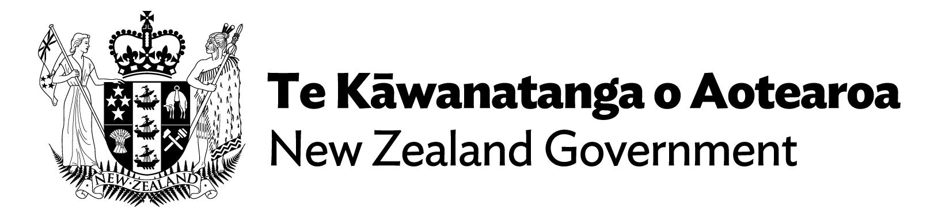

A full refresh of the 2017 guidance will be provided in early 2023 by the Ministry for the Environment. This will include updates to risk and vulnerability material to reflect latest international and national direction on risk assessment, more information on using adaptation planning with the existing statutory framework, case studies, and updates to mean sea-level elevations.
For more information and to access the interim guidance, please visit our website and refer to the NZSeaRise material (including supporting journal papers) on the Takiwā platform.

Ministry for the Environment. 2017. Coastal hazards and climate change: Guidance for local government. Prepared for the Ministry for the Environment by Bell RG, Lawrence J, Allan S, Blackett P, Stephens SA (eds). Wellington: Ministry for the Environment. https://environment.govt.nz/publications/coastal-hazards-and-climate-change-guidance-for-local-government/
The NZSeaRise programme released location-specific sea-level rise projections out to the year 2300 for every 2 kilometres of the coast of Aotearoa New Zealand. These projections can be accessed through a new online tool developed by Takiwā, a data management and analytics platform.
For more information on VLM, see Vertical land movement – NZSeaRise Programme.

