A picture of a neighbourhood street containing homes, pedestrians, and a bicycle.



**Disclaimer**

The information in this publication is, according to the Ministry for the Environment’s best efforts, accurate at the time of publication. The Ministry will make every reasonable effort to keep it current and accurate. However, users of this publication are advised that:

* The information does not alter the laws of Aotearoa New Zealand, other official guidelines, or requirements.
* It does not constitute legal advice, and users should take specific advice from qualified professionals before taking any action based on information in this publication.
* The Ministry does not accept any responsibility or liability whatsoever whether in contract, tort, equity, or otherwise for any action taken as a result of reading, or reliance placed on this publication because of having read any part, or all, of the information in this publication or for any error, or inadequacy, deficiency, flaw in, or omission from the information in this publication.
* All references to websites, organisations or people not within the Ministry are for convenience only and should not be taken as endorsement of those websites or information contained in those websites nor of organisations or people referred to.

This document may be cited as: Ministry for the Environment. 2023. *Implementing* *Aotearoa New Zealand’s first emissions reduction and national adaptation plans*. Wellington: Ministry for the Environment.

Published in April 2023 by the  
Ministry for the Environment   
Manatū Mō Te Taiao  
PO Box 10362, Wellington 6143, New Zealand

ISBN: 978-1-99-102592-0 (online)

Publication number: ME 1701

© Crown copyright New Zealand 2023

This document is available on the Ministry for the Environment website: [environment.govt.nz](http://www.environment.govt.nz).

# Contents

Section 1: Introduction 6

Purpose and scope of plan 7

Section 2: Roles, responsibilities and accountabilities 8

Ministerial roles and responsibilities 8

Agency roles and responsibilities 8

Independent monitoring and advice 10

Section 3: Implementation, monitoring and reporting 14

Implementation, monitoring and reporting by agencies 19

Monitoring and reporting by the Board 20

Section 4: Adaptive management 29

Adaptive management to reduce emissions 29

Adaptive management for national adaptation 30

Appendices 32

# Tables

Table 1: Implementation timeline 5

Table 2: Roles and responsibilities for implementing the emissions reduction plan and national adaptation plan 12

Table 3: Roles and responsibilities for implementing, monitoring and reporting on the emissions reduction plan and national adaptation plan 15

Table 4: Climate Change Chief Executives Board approach to reporting on the emissions reduction plan and national adaptation plan 22

Table 5: Ministers and chief executives who are accountable for chapters in the emissions reduction plan 34

Table 6: Responsibility for emissions budget sector sub-targets (in Mt CO2-e) 36

Table 7: Emissions reduction plan chapter targets, milestones and progress 37

# Figures

Figure 1: Indicative timeline of reports by the Climate Change Chief Executives Board 23

Figure 2: Indicative timeline of reports to the public 24

Figure 3: Aotearoa New Zealand’s adaptation process 31

Figure 4: Emissions reduction plan strategy map 32

Figure 5: National adaptation plan strategy map 33

# 

Table 1: Implementation timeline

| Date | Action |
| --- | --- |
| First half of 2022 | First emissions reduction plan released  Emissions budgets 1, 2 and 3 set  Climate Change Chief Executives Board (Board) established as an interdepartmental executive board |
| Second half of 2022 | First national adaptation plan released  Board‘s first quarterly report on priority areas  Implementation plan in place for the first emissions reduction plan and first national adaptation plan  Ministry of Transport chapter implementation plan in place  Policy decisions made on climate innovation platforms  Policy decisions made on household kerbside-organic-waste collections and business food-waste separation |
| First half of 2023 | Board’s first six-monthly report on implementing the emissions reduction plan  Draft equitable transition strategy released  Climate Change Commission (Commission) releases draft advice on second emissions reduction plan for consultation |
| Second half of 2023 | Board’s six-monthly report on implementing the emissions reduction plan and national adaptation plan  Board’s annual public report on emissions reduction plan released  Commission releases advice on second emissions reduction plan  Gas transition plan published |
| 2024 | Board’s six-monthly monitoring and reporting cycles continue  Commission provides advice on emissions budget 4  Commission’s first report on the emissions reduction plan  Commission’s first report on implementing the national adaptation plan and its effectiveness  Second emissions reduction plan published  Energy strategy published  New regulatory requirements for building operational efficiency and embodied carbon introduced |

# **Section 1: Introduction**

The Government published Aotearoa New Zealand’s [first emissions reduction plan](https://environment.govt.nz/assets/publications/Aotearoa-New-Zealands-first-emissions-reduction-plan.pdf)[1] in May 2022 and the [first national adaptation plan](https://environment.govt.nz/assets/publications/climate-change/MFE-AoG-20664-GF-National-Adaptation-Plan-2022-WEB.pdf)[2] in August 2022. Together, these plans contain strategies, policies and actions for:

* building a high-wage, low-emissions economy that gives economic security in good and bad times
* building a climate-resilient Aotearoa.

The emissions reduction plan sets out how we will meet the first emissions budget[3] and the 2050 target. The actions in the plan are based on five principles:[4]

* **Playing our part** – contributing to the global effort to limit warming to 1.5°C, by setting long-term emissions reduction targets and meeting them through a series of emissions budgets and emissions reduction plans.
* **Empowering Māori** – building Crown–Māori relationships, and the capability to work together as equal partners in our climate response.
* **Equitable transition** – making sure our transition is just and fair and includes all New Zealanders.
* **Working with nature** – designing our climate response in a way that, where possible, protects, enhances and restores nature, including using nature-based solutions to tackle the climate emergency.
* **A productive, sustainable and inclusive economy** – seizing opportunities to invest in higher-paying jobs and more productive businesses, while reducing emissions.

The national adaptation plan sets out our long-term adaptation goals, which are to:

* reduce vulnerability to the impacts of climate change
* enhance adaptive capacity and consider climate change in decisions at all levels
* strengthen resilience.

It also sets out several objectives for addressing the priority climate risks over the next six years.[5] Actions to achieve these objectives are focused around four key priority areas:[6]

* enabling better risk-informed decisions
* ensuring our planning and infrastructure investment decisions drive climate-resilient development in the right locations
* adaptation options, including managed retreat
* embedding climate resilience in all government strategies and policies.

## Purpose and scope of plan

Central government agencies are responsible for planning and implementing actions that they are accountable for. Agencies may prepare their own implementation or delivery plans that set out how specific initiatives will be delivered.

The purpose of this plan is to describe the governance, monitoring and reporting framework that has been established to support the whole emissions reduction plan and national adaptation plan to be effectively implemented, and ensure that we are on track to meet our mitigation and adaptation goals.

This plan sets out:

* who is responsible and accountable for implementing the plans (section 2)
* what processes we will use to monitor and report on implementing the plans (section 3)
* how we will adapt how we implement the plans, to ensure we meet our goals and targets (section 4).

Implementing the emissions reduction plan and national adaptation plan will continue to provide opportunities to learn how we can improve the processes set out in this plan.

This plan describes the governance, monitoring and reporting framework that supports effective implementation of the emissions reduction and national adaptation plans.

# Section 2: Roles, responsibilities and accountabilities

Roles and responsibilities to support government agencies to implement the emissions reduction plan and national adaptation plan are summarised in table 2 and the rest of this section.

While it implements the emissions reduction plan and the national adaptation plan, the Crown has an overarching responsibility to give effect to the principles of Te Tiriti o Waitangi.

## Ministerial roles and responsibilities

The **Climate Response Ministerial Group** (CRMG), chaired by the Prime Minister,governs implementation at the ministerial level.

The **Minister of Climate Change**, who is also deputy chair of the CRMG, is responsible under the [Climate Change Response Act 2002](https://www.legislation.govt.nz/act/public/2002/0040/latest/DLM158584.html) for:

* ensuring that the emissions budgets and long-term 2050 targets are met
* responding to He Pou a Rangi | Climate Change Commission (the Commission)’s monitoring reports.

**Individual ministers** are responsible for implementing policies in their portfolios and overseeing progress towards sub-sector targets and long-term adaptation goals.[7]

## Agency roles and responsibilities

The **Climate Change Chief Executives Board** (the Board)[8] is an interdepartmental executive board that coordinates efforts to deliver climate-change initiatives. It reports to the Prime Minister.[9] The Board’s implementation responsibilities include:

* coordinating how agencies implement their actions and strategies in the emissions reduction plan
* monitoring and reporting on overall progress towards the emissions budgets and sector sub-targets
* monitoring the emissions reduction plan baselines and progress towards specific implementation milestones, to inform six-monthly, annual and biennial reporting cycles
* giving advice on adjusting policy settings to manage emerging risks to achieving sector sub-targets – or varying performance within and between sectors – to ensure emissions budgets are met (this is known as adaptive management)
* reporting annually on the implementation of national adaptation plan actions, and biennially on the sufficiency of national adaptation plan actions.

In undertaking its responsibilities, the Board will partner with Māori on their priority climate-change issues.

The **Ministry for the Environment** (the Ministry) is responsible for:

* leading on climate policy
* annually preparing and publishing the New Zealand Greenhouse Gas Inventory and compiling emissions projections for Aotearoa
* coordinating the cross-agency emissions data and modelling system and related issues.

**Treasury**, alongside agencies that have received funding from the Climate Emergency Response Fund (CERF), is responsible for monitoring and reporting on the CERF. This work includes:

* receiving agencies’ quarterly financial information on forecast and actual expenditure and variances related to CERF-funded initiatives
* receiving agencies’ annual performance monitoring information for CERF-funded initiatives.[10]

The **Department of the Prime Minister and Cabinet Policy Advisory Group** (DPMC PAG) advises the Prime Minister on policy and process. The DPMC PAG has identified emissions reduction as a government priority and is supporting the significant agenda required to meet our emissions-reduction targets. The DPMC PAG will oversee progress on the emissions reduction plan and national adaptation plan and provide up-to-date advice to the Prime Minister, as necessary.

**Other central government agencies**, including the Ministry, are responsible for:

* preparing plans to implement the emissions reduction plan and national adaptation plan and implementing their own actions
* overseeing their progress towards sector sub-targets
* monitoring and reporting on implementation of actions
* monitoring and reporting on emissions reductions achieved in a sector, or through a policy or policy package
* working with other agencies on advice to the Board, when required.

Each chapter of the emissions reduction plan identifies the ministers and chief executives who are accountable for that chapter (they are known as the chapter leads or lead agencies), and the supporting agencies (see table 5). For some chapters, especially cross-cutting chapters, other agencies may also be involved in implementing actions. Responsibilities for each action in the emissions reduction plan are outlined in a [table of actions](https://environment.govt.nz/assets/publications/Files/Aotearoa-New-Zealands-first-emissions-reduction-plan-Table-of-actions.pdf).[11] The national adaptation plan does not assign responsibility to ministers and chief executives on a chapter basis, but responsibilities for its actions are outlined in a [table of actions](https://environment.govt.nz/assets/publications/climate-change/MFE-AoG-20664-GF-National-Adaptation-Plan-Table-of-Actions-WEB.pdf).[12]

The ministers and agencies responsible for overseeing progress against sector sub-targets are set out in table 6.

Deputy chief executives, directors and officials have set up an interagency working group and procedures for sharing information and working together on implementing the emissions reduction plan and national adaptation plan.

## Independent monitoring and advice

The Commission has an important role in monitoring and reviewing Aotearoa New Zealand’s progress towards its emissions-reduction goals and implementing the national adaptation plan. It will:

* prepare an annual progress report on the:
* measured emissions and removals for the year
* latest projections of current and future emissions and removals
* adequacy of the emissions reduction plan and its implementation, and any new opportunities to reduce emissions
* prepare a progress report at the end of each emissions budget period on:[13]
* how well the emissions reduction plan has contributed to progress
* what banking and borrowing across emissions reductions could be appropriate
* how much offshore mitigation may be needed to meet the emission budget for that period
* prepare a biennial progress report on:
* progress towards implementing the national adaptation plan
* effectiveness of the national adaptation plan in achieving its objectives and responding to risks
* barriers to effectively implementing the national adaptation plan and how they can be managed
* other relevant matters.

The **Māori Climate Platform Interim Ministerial Advisory Committee** (the Interim Committee)[14]will provide independent advice and proposals to the Minister of Climate Change and CRMG, to inform their priorities and approach to ensure the transition is equitable for Māori. This may include:

* establishing mechanisms to embed Te Tiriti o Waitangi into climate policy and allocate funding to local projects that support Māori communities
* guiding the implementation of its recommended mechanisms
* guiding the priorities and approach for an equitable transition for Māori.

The Interim Committee may also work with the Board to reflect collective views on the implementation of the emissions reduction plan and national adaptation plan, and develop future plans. This could include giving advice on how to apply indigenous worldviews. Once the Interim Committee has been established, its work will be established in a workplan agreed by the minister of climate change.

Table 2: Roles and responsibilities for implementing the emissions reduction plan and national adaptation plan

| Minister/organisation | Role | Responsibility |
| --- | --- | --- |
| **Ministerial roles and responsibilities** | | |
| Prime Minister | Chair – CRMG  Appropriate Minister – the Board | Lead governance and management of Aotearoa New Zealand’s climate-change programme |
| Minister of Climate Change | Deputy chair – CRMG  Responsible Minister/appropriation Minister – the Board | Set emissions budgets and fulfil statutory duty of ensuring emissions budgets are met  Prepare and publish emissions reduction plans and national adaptation plans |
| Individual ministers | Oversee progress towards sub-sector targets and long-term adaptation goals | Develop and implement climate policies in their portfolios |
| Climate Response Ministerial Group (CRMG) | Prime Minister (chair), Minister of Climate Change (deputy chair) and other Ministers are members | Direct Aotearoa New Zealand’s climate-change programme |
| **Agency roles and responsibilities** | | |
| Climate Change Chief Executives Board (the Board) | Responsible to the Prime Minister | Monitor and report on progress towards the emissions budgets  Monitor and report on implementation of the emissions reduction plan and national adaptation plan  Advise the Prime Minister and CRMG on adaptive management, and on strategic direction of the second emissions reduction plan |
| Ministry for the Environment (the Ministry) | Lead agency for climate change | Lead across the environmental system  Coordinate, develop and publish the emissions reduction plan, national adaptation plan and implementation plan  Lead implementation of actions relating to the Environment and Climate Change portfolios  With Treasury, produce a joint report on the economic and fiscal impacts of climate change, including potential fiscal costs of any projected shortfall against Aotearoa New Zealand’s Nationally Determined Contribution |
| Individual agencies | Develop and implement climate policy for their portfolio | Engage with iwi, local government and stakeholders  Monitor and report on the implementation and progress of emissions reduction plan and national adaptation plan actions they are responsible for  Contribute to cross-agency advice to the Board |
| **Independent advice and monitoring** | | |
| He Pou a Rangi | Climate Change Commission (the Commission) | Provide independent review and advice to government | Advise Minister of Climate Change on 2050 target revisions, emissions budgets, emissions reduction plans, national adaptation plans and other matters as requested  Prepare national climate-change-risk assessments  Monitor and report on progress towards the Government’s mitigation and adaptation goals, including its emissions reduction plans and national adaptation plans |
| Māori Climate Platform Interim Ministerial Advisory Committee | Provide independent advice and proposals to Ministers | Advise minister of climate change and CRMG on how to embed Te Tiriti o Waitangi into the climate response, fund Māori climate action, and support an equitable transition for Māori  May work with the Board to advise on implement the emissions reduction plan and national adaptation plan |
| **Other monitoring and reporting** | | |
| Treasury | Ensure internal controls operate effectively among all government reporting entities | Publish quarterly financial audits and annual performance audits  With the Ministry, produce a joint report on the economic and fiscal impacts of climate change, including potential fiscal costs of any projected shortfall against Aotearoa New Zealand’s Nationally Determined Contribution  Monitor initiatives funded by the Climate Emergency Response Fund |
| Department of Prime Minister and Cabinet – Policy Advisory Group | Support the agenda needed to meet emissions-reduction goals | Advise the Prime Minister on policy and process to support emissions reductions |

# Section 3: Implementation, monitoring and reporting

The agencies accountable for actions in the [emissions reduction plan](https://environment.govt.nz/assets/publications/Files/Aotearoa-New-Zealands-first-emissions-reduction-plan-Table-of-actions.pdf) [table of actions](https://environment.govt.nz/assets/publications/Files/Aotearoa-New-Zealands-first-emissions-reduction-plan-Table-of-actions.pdf)[15] and the [national adaptation plan](https://environment.govt.nz/assets/publications/climate-change/MFE-AoG-20664-GF-National-Adaptation-Plan-Table-of-Actions-WEB.pdf) [table of actions](https://environment.govt.nz/assets/publications/climate-change/MFE-AoG-20664-GF-National-Adaptation-Plan-Table-of-Actions-WEB.pdf)[16] have the primary responsibility to implement and monitor those actions.

Agencies will provide the Board with information it needs to:

* oversee implementation and progress
* understand critical actions and the key policy decisions needed
* identify clear pathways for agencies to collaborate
* make adaptive-management decisions.

The Board secretariat will compile key information into reports for the prime minister, the CRMG and the public.

The Minister of Climate Change is accountable for the emissions budgets.

The Ministry and the Board secretariat will work together to minimise any duplicate monitoring and reporting, to enable the Minister of Climate Change to discharge their statutory duties and the Board to fulfil its functions.

The Commission, Treasury and the DPMC PAG also have monitoring and reporting functions.

These various roles and responsibilities are illustrated in table 3.

Table 3: Roles and responsibilities for implementing, monitoring and reporting on the emissions reduction plan and national adaptation plan

| **Individual or** **organisation** | **Role and responsibilities** | | **Monitoring function** | | **Reporting function** | |
| --- | --- | --- | --- | --- | --- | --- |
|  | **Emissions reduction plan** | **National adaptation plan** | **Emissions reduction plan** | **National adaptation plan** | **Emissions reduction plan** | **National adaptation plan** |
| Prime Minister | Chair – CRMG  Appropriate minister – the Board | | Receive reports and advice from the Board | | None | |
| Climate Response Ministerial Group (CRMG) | Governance at the ministerial level and oversight of the progress of the emissions reduction plan and national adaptation plan | | Receive reports and advice from the Board | | None | |
| Minister of Climate Change | Deputy chair – CRMG  Responsible minister/appropriation minister – the Board  Set emissions budgets and responsible for meeting them  Develop and publish emissions reduction plans and national adaptation plans | | Receive reports from He Pou a Rangi | Climate Change Commission (the Commission) | | Present the Commission’s monitoring reports to Parliament  Respond to the Commission’s monitoring reports | |
| Climate Change Chief Executives Board (the Board) – internal | Oversee the Government’s response to climate change  Coordinate implementation of cross-agency actions and strategies in the emissions reduction plan and national adaptation plan | | Monitor implementation of actions (based on data from individual agencies)  Monitor effectiveness, impact and sufficiency of actions (based on data from individual agencies) | | Report to the Prime Minister and CRMG on:   * stipulated priority focus areas (six-monthly) * progress with implementing actions (six-monthly)   Publish annual reports on progress towards implementing the emissions reduction plan, and meeting sector sub-targets and emissions budget | Report to the Prime Minister on:   * overall implementation of the national adaptation plan (proposed six-monthly reports from mid-2023) * sufficiency of actions to address risks in the [National Climate Change Risk Assessment for New Zealand](https://environment.govt.nz/assets/Publications/Files/national-climate-change-risk-assessment-main-report.pdf)[17] (biennial reports) |
| Advise the Government on policy responses to manage emerging risks and variances, including shortfalls or overshoots of sector sub-targets (adaptive management)  Provide strategic direction for subsequent emissions reduction plans |  | Monitor progress towards sub-sector targets and emissions budgets (based on data from individual agencies) |  |  |  |
| Ministry for the Environment (the Ministry) – internal | Lead on climate policy  Host the Board secretariat  Support the minister of climate change to execute functions under the [Climate Change Response Act 2002](https://www.legislation.govt.nz/act/public/2002/0040/latest/DLM158584.html)  Implement the Ministry’s own actions | | Self-monitor implementation of actions and emissions reductions | | Report to the Board on emissions reductions and the Ministry’s own actions  Report to Treasury on expenditure and performance of CERF-funded initiatives | |
| Monitor emissions reductions across the economy |  | Prepare and publish the New Zealand Greenhouse Gas Inventory (annually)  Compile Aotearoa New Zealand’s emissions projections (annually) |  |
| Central government agencies – internal | Prepare plans to implement their own actions  Oversee progress towards relevant sector sub-targets | | Self-monitor implementation of actions and emissions reductions | | Report to the Board on progress towards implementing their own actions, chapter summaries, priority focus areas and emissions reductions  Report to Treasury on expenditure and performance of their own CERF-funded initiatives | |
| Treasury – internal | Monitor CERF-funded initiatives to enhance the transparency of the impact of the CERF (the CERF covers only a few initiatives in the emissions reduction plan) | | Receive quarterly financial information on spending forecasts, actual expenditure and variances from agencies that receive CERF funding  Receive annual monitoring information on the performance of CERF initiatives from agencies that receive CERF funding | | Publish to the Treasury website:   * quarterly financial audits of CERF-funded initiatives * annual performance audits of CERF-funded initiatives | |
| Department of Prime Minister and Cabinet Policy Advisory Group (DPMC PAG) – internal | Advise the Prime Minister on policy and process to support emissions reductions, which is an identified government priority | | Monitor progress to advise the Prime Minister as necessary | | None | |
| He Pou a Rangi | Climate Change Commission (the Commission) – external | Provide independent advice to the Government on mitigation and adaptation  Monitor and review the Government’s progress towards its emissions-reduction and adaptation goals | | Monitor the Government’s progress towards meeting its emissions budgets, emissions reduction plans and the 2050 target | Monitor implementation progress and effectiveness of the national adaptation plan | Produce annual reports on:   * measured emissions and removal * projected current and future removals * adequacy of the emissions reduction plan * progress with implementing the emissions reduction plan * new opportunities to reduce emissions   Produce an evaluation report at the end of each emissions budget period | Produce biennial reports on:   * progress with implementing the national adaptation plan * effectiveness of the national adaptation plan * recommended ways to address any barriers to success |
| Māori Climate Platform Interim Ministerial Advisory Committee (the Interim Committee) | Provide independent advice to ministers and the Board on implementing the emissions reduction plan and national adaptation plan | | To be determined | | To be determined | |

## Implementation, monitoring and reporting by agencies

Central government agencies are at different stages of the process to develop implementation-plans, and are approaching monitoring and implementation in different ways. To effectively implement the emissions reduction plan and national adaptation plan, agencies are required to:

* establish appropriate governance structures
* work with Māori to develop and implement actions, and fulfil the Crown’s Te Tiriti o Waitangi obligations
* engage with stakeholders (such as Pasifika and rural communities, and local government) to develop and implement actions
* plan their implementation, including setting clear goals, targets and deliverables, and assessing risks (this includes maintaining a risk register to enable the Board to assess risk and prioritise actions across agencies)
* resource and fund the work
* monitor and report to the Board on the implementation and effectiveness of actions, progress towards sub-sector targets and the impact on biodiversity)
* use consistent or comparable methodologies for tracking performance, where possible
* take adaptive-management actions to ensure they are meeting emissions-reduction sub-sector targets and adaptation goals
* work together to ensure:
* actions included in the emissions reduction plan and national adaptation plan are aligned (this includes mapping dependencies in actions to inform work priorities)
* implementation of actions avoids maladaptation
* approaches towards engaging with partners and stakeholders are aligned, to minimise engagement fatigue
* establish processes to partner and collaborate with action or chapter co-leads and supporting agencies, where relevant.

Deputy chief executives, directors and interagency working groups are mechanisms for agencies to:

* share information about their implementation practices
* work together on cross-cutting matters, such as implementing actions that are included in the emissions reduction plan and national adaptation plan (this includes mapping interdependencies)
* avoid maladaptation
* align their approaches to implementing actions with partners and stakeholders.

If agencies are concerned about engagement fatigue or community disengagement, they should raise these concerns with the Board as part of their reporting on policy issues and barriers to success.

Agencies are responsible for reporting their implementation tracking and monitoring to the Board. They will also have monitoring and reporting obligations to other parties, which may include their internal executive leadership, board and minister; the Treasury and select committees; and external stakeholders, including the public.

To assess progress towards implementing actions, agencies must first set milestones to benchmark their progress against. The [national adaptation plan](https://environment.govt.nz/assets/publications/climate-change/MFE-AoG-20664-GF-National-Adaptation-Plan-Table-of-Actions-WEB.pdf) [table of actions](https://environment.govt.nz/assets/publications/climate-change/MFE-AoG-20664-GF-National-Adaptation-Plan-Table-of-Actions-WEB.pdf)[18] includes implementation measures, which are akin to milestones. This work is underway for the emissions reduction plan.

Emissions-reduction targets and milestones for key actions in the emissions reduction plan are set out in table 7. [19] Agencies have provided the Board with initial milestones for all actions (and targets, where appropriate)[20] and will report against these.

## Monitoring and reporting by the Board

The Board and agencies have developed a monitoring and reporting framework to enable the Board to fulfil its functions. This framework initially focuses on requirements to monitor and report on the emissions reduction plan. Similar requirements will apply to the national adaptation plan; however, they may vary, given the different approaches of the two plans. The Board will advise agencies of their specific requirements to report on the national adaptation plan, once they are more fully developed but before the second six-monthly report is due in mid-2023.

The Board’s monitoring and reporting framework acknowledges:

* the need to avoid duplication with existing reporting processes, where possible
* the need to flexibly adapt to the wide variety of action types and delivery approaches
* the need to build a strong and effective monitoring and reporting system using an iterative process, as agencies and the Board evolve their approach to implementing the plans and their reporting becomes more robust.

The Board is required to report:

* six-monthly on overall progress on the emissions reduction plan (Prime Minister and CRMG)
* annually on implementation of the emissions reduction plan (the public)
* annually on overall progress on the national adaptation plan (Prime Minister)
* biennially on the sufficiency of national adaptation plan actions to address risks identified by the [National Climate Change Risk Assessment for New Zealand](https://environment.govt.nz/assets/Publications/Files/national-climate-change-risk-assessment-main-report.pdf)[21] (the public).

Given the volume and complexity of reporting requirements, the Board proposes to adopt a modular reporting format (see table 4). This will reduce the number of reports required, which will avoid unnecessary duplication of work while maintaining effective monitoring.

Figure 1 sets out a timeline of Board reports, and figure 2 sets out the timing of public reports (including reports to Treasury and the Commission).

The following sections provide an overview of the Board’s reports. They explain what may change over time to improve the reporting content and processes. For example, the Board’s monitoring and reporting framework may be amended to reflect the outcomes of the Board’s Partnering with Māori workstream.

The Board’s monitoring and reporting framework will also need to be updated to include reporting on biodiversity outcomes (Action 4.3 of the emissions reduction plan). The Department of Conservation will guide agencies on monitoring the impact on biodiversity. It will also support the Board to include biodiversity outcomes in the monitoring and reporting framework. We anticipate that reporting on biodiversity outcomes will start to become available in the second six-monthly report. Like monitoring emissions reductions, monitoring the impact on biodiversity will develop and improve over time.

Table 4: Climate Change Chief Executives Board approach to reporting on the emissions reduction plan and national adaptation plan

|  |  |  |  |
| --- | --- | --- | --- |
| Report | Target audience | Purpose | Content |
| Six-monthly report on progress of the emissions reduction plan and national adaptation plan | Prime Minister  CRMG  Climate Change Chief Executives Board (Board) | Inform adaptive-management decisions  Give an overview of progress towards the whole emissions reduction plan and national adaptation plan, and sub-sector targets  Be a point of accountability for agencies  Show models of the impact on emissions  Inform decisions on future focus areas or Board agenda items  Fulfil the Board’s requirement to report annually to the Prime Minister on implementation of the national adaptation plan | Nine priority focus areas  Implementation monitoring  Leading indicators  Details of critical actions |
| Annual report on the implementation of the emissions reduction plan | Public | Fulfil a requirement in the emissions reduction plan  Give the public assurance on the progress being made to implement the emissions reduction plan | Nine priority focus areas  Implementation monitoring  Leading indicators  Details of critical actions  Emissions modelling |
| Biennial report on sufficiency of the national adaptation plan | Prime Minister  CRMG | Fulfil a requirement in the national adaptation plan  Report to the Prime Minister on the progress of the national adaptation plan | Implementation monitoring  Assessment of impact and sufficiency of national adaptation plan actions (based on the Commission’s biennial national adaptation plan report) |

Figure 1: Indicative timeline of reports by the Climate Change Chief Executives Board

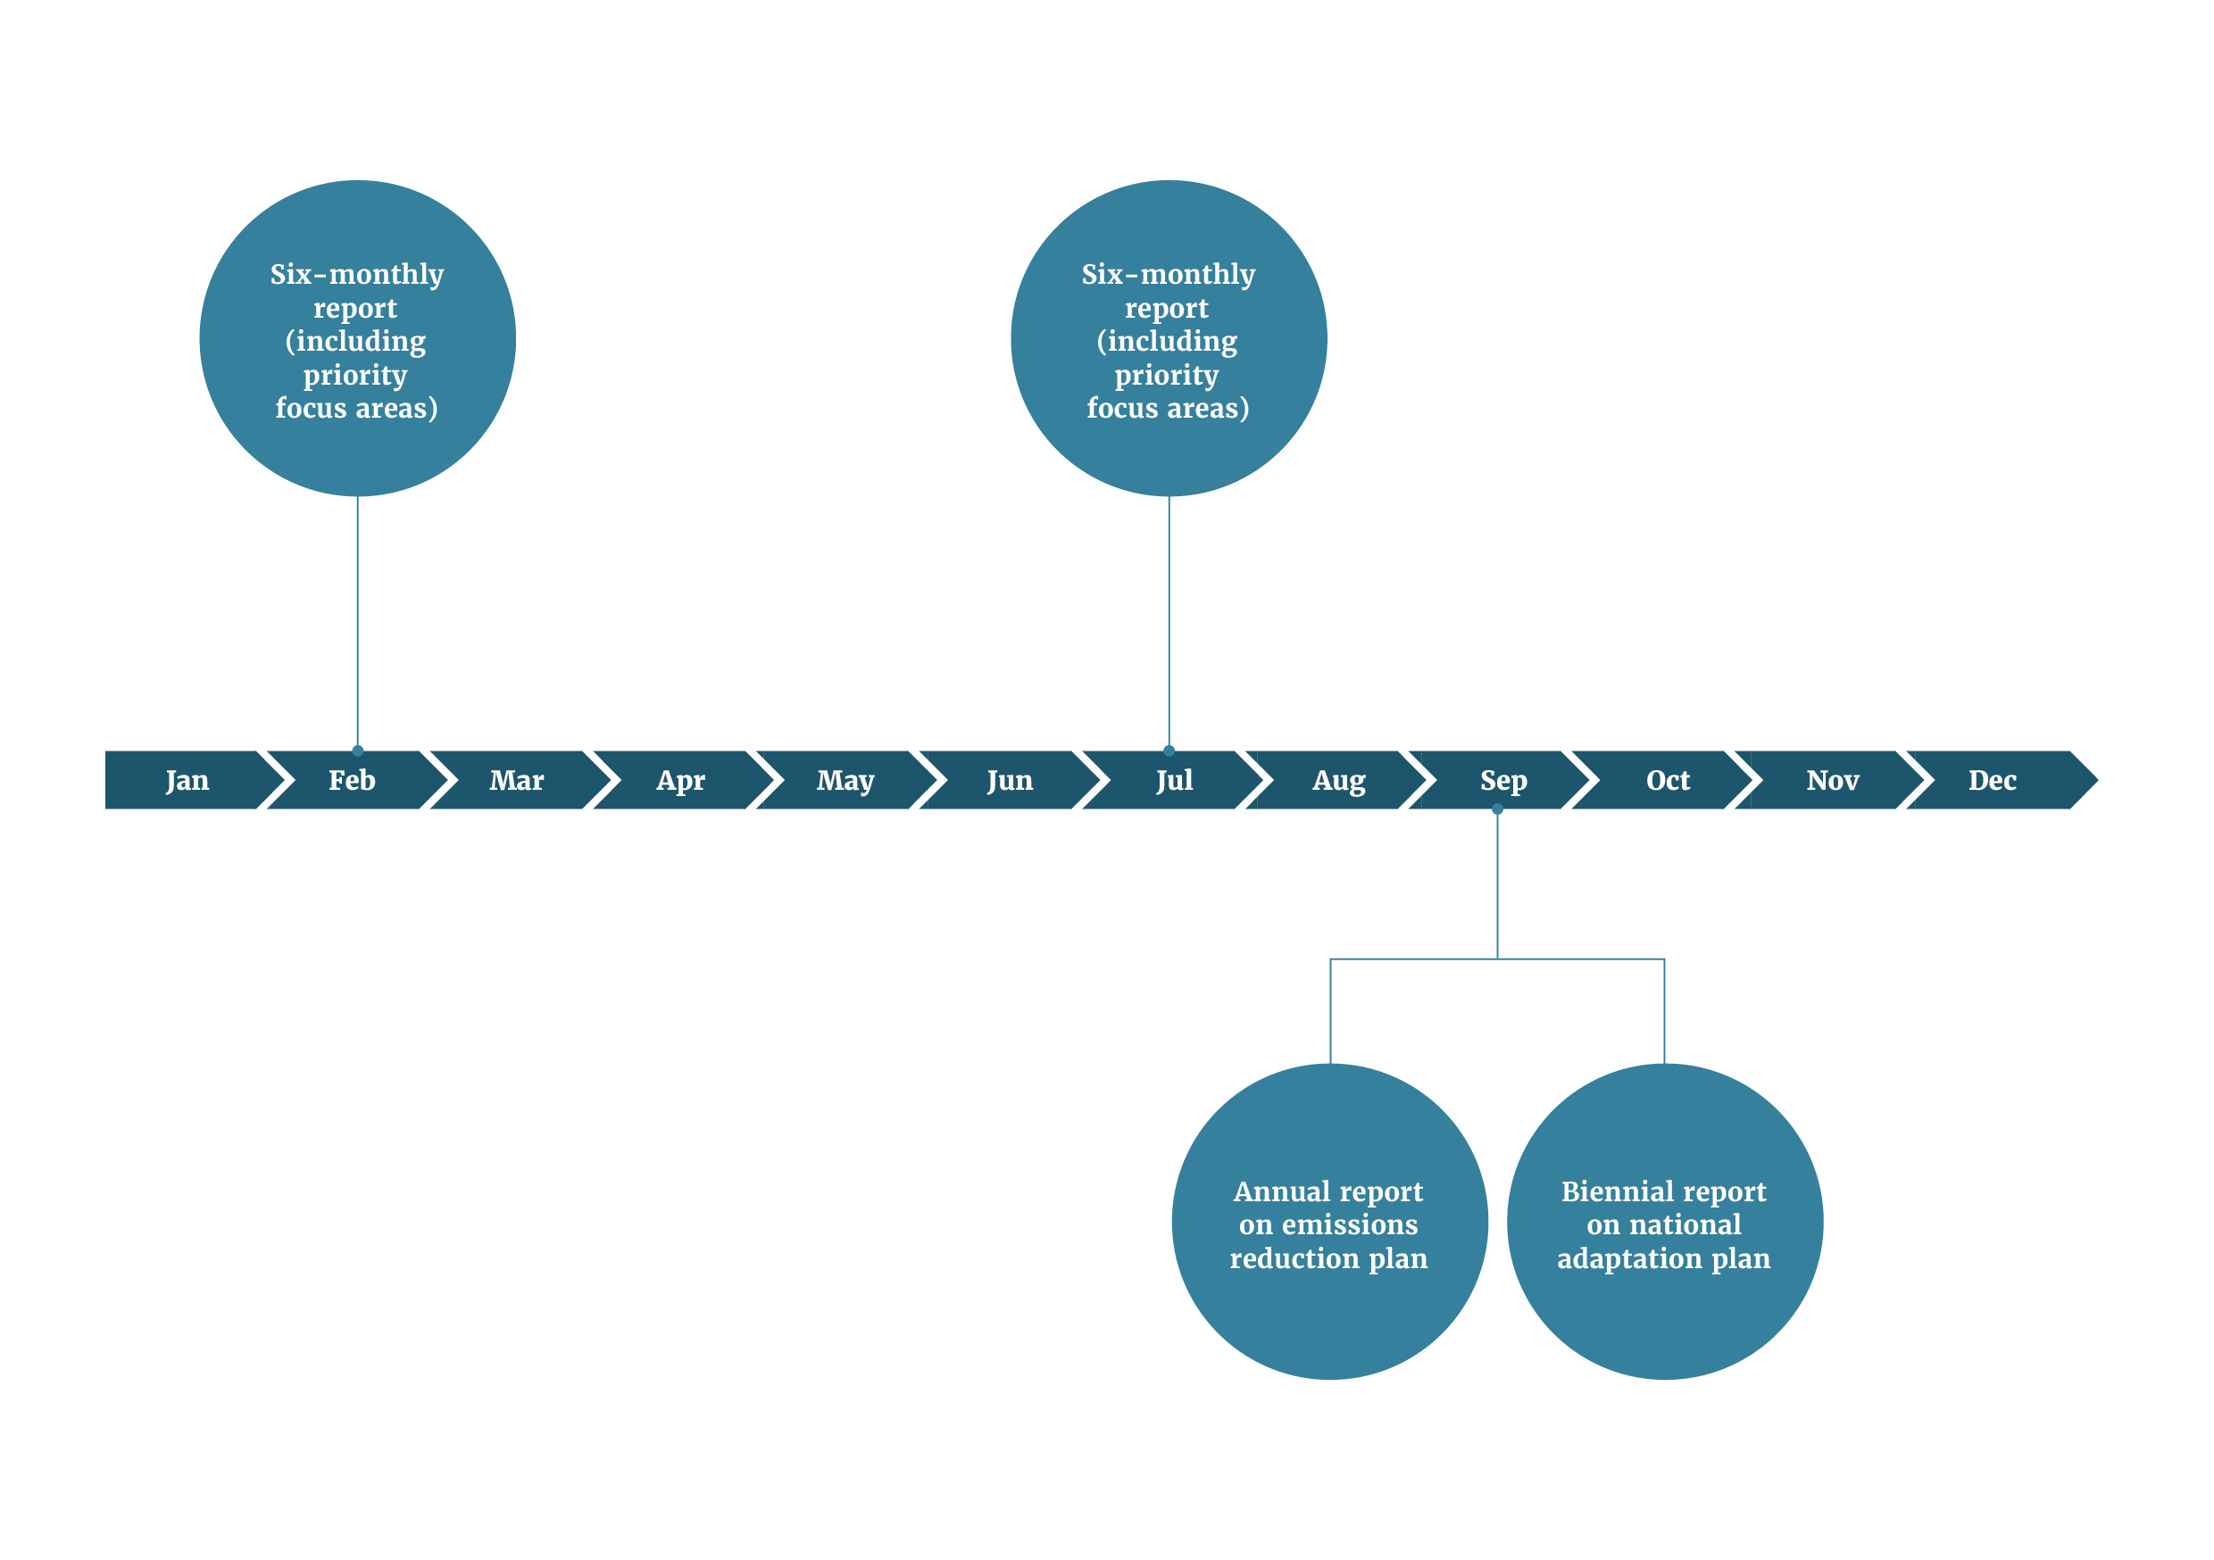

Figure 2: Indicative timeline of reports to the public

The Climate Change Chief Executives Board reports on the emissions reduction plan in 2023, 2024, and 2025.
The Climate Change Commission reports on national adaptation plan progress in 2024, and emissions reduction plan progress in 2024 and 2025.
Treasury reports on Climate Emergency Response Fund performance in 2023, 2024 and 2025.
The Minister of Climate Change responds to the climate change commission’s national adaptation report in 2024, and to the emissions reduction reports in 2024 and 2025.

### Six-monthly reports on the emissions reduction plan and national adaptation plan

The six-monthly reports will cover overall progress of the emissions reduction plan and the national adaptation plan.[22] These reports will provide:

* a summary of progress for each chapter
* detailed reporting on critical actions, including assessments of their impact on emissions.

The six-monthly reports will report against each chapter in the emissions reduction plan’s strategy map.

There are currently five stipulated priority focus areas in the emissions reduction plan:

1. The New Zealand Emissions Trading Scheme (NZ ETS), which includes emissions leakage and forestry incentives
2. He Waka Eke Noa | Primary Sector Climate Action Partnership
3. The Energy Strategy, and the transition to a highly renewable electricity system
4. Transport mode-shift
5. Overarching areas of focus for the 2024 emissions reduction plan

Each quarter, the Board secretariat will prepare a pack for the CRMG that gives a snapshot of each priority focus area. The snapshot will highlight key decisions for the next six months; and priority policy and cross-cutting issues, opportunities and threats. This information is intended to facilitate discussion on:

* critical decisions before ministers, which may affect implementation of the plans or emissions targets
* policy issues to explore in depth at future CRMG or Board meetings
* adaptive-management opportunities and actions
* recommendations and advice provided by the Board.

Further work is required to develop an appropriate reporting structure for the national adaptation plan. This will take place before the first six-monthly report on the national adaptation plan is due. The following sections set out the approach to six-monthly reporting.

#### Summaries of progress for each chapter

Agencies will give the Board the following baseline monitoring information for all their actions in the emissions reduction plan and national adaptation plan:

* Milestones specific to the quarter
* Red, amber, green (RAG) status for each action, which reflects progress towards milestones
* Active status for each action (active, inactive or complete)
* Funding status for each action (fully funded, partially funded or unfunded)
* Any major changes to action scope, process, accountability and timeline

Agencies are responsible for assessing the RAG status of their own actions, based on the Board’s guidance and definitions.

Agencies will also provide the Board with a chapter summary that includes:

* the number of active actions in the chapter
* the number of active actions that have red, amber and green status
* an assessment for each chapter on its impact on emissions
* and update on progress towards sub-sector targets
* a qualitative summary of:
* progress and key successes
* policy issues or barriers to success
* notable adaptive-management decisions, and their impact on sub-sector targets or interdependencies with other chapters or agencies
* new opportunities.

Lead agencies are responsible for providing chapter summaries for the emissions reduction plan. Lead agencies responsible for providing similar information for the national adaptation plan will be identified once a reporting structure is finalised.

#### Detailed reporting on critical actions

The national adaptation plan’s critical actions are identified in the plan itself. The emissions reduction plan’s critical actions will be identified by the Board and agencies, using criteria defined by the Board. The criteria may include the action’s contribution towards sub-sector emissions targets, or how crucial it is to building a low-emissions and climate-resilient system. Critical actions may change over time, as the landscape in Aotearoa changes and the Board refocuses on other emerging critical areas.

The Board will need additional information on critical actions, so it can monitor these actions more closely. This information may include:

* total funding for the action and expenditure to date
* a qualitative assessment that covers:
* a description of progress
* barriers to progress
* new opportunities
* adaptive-management decisions made by agencies
* dependencies with other actions and sectors
* an assessment of the impact the action has on the five principles in the emissions reduction plan’s strategy map[23]
* impact of the action on emissions (emissions reduction plan only), where possible and updated emissions indicators.

#### Monitoring and reporting on the impact of actions on emissions

For critical actions or packages, the Board will ask agencies to monitor and report on the impact of critical actions on emissions at three levels:

* Economy
* Sector
* Policy and policy packages.

##### Economy

The Board secretariat will work with the Ministry to monitor economy-level emissions for the Board. [New Zealand’s Greenhouse Gas Inventory](https://environment.govt.nz/facts-and-science/climate-change/measuring-greenhouse-gas-emissions/about-new-zealands-greenhouse-gas-inventory/)[24] currently measures annual greenhouse gas emissions, with an approximate 15-month delay. The [Climate Change Response Act 2002](https://www.legislation.govt.nz/act/public/2002/0040/latest/DLM158584.html) states that this greenhouse gas inventory is the official metric to use for meeting emissions budgets. However, it will not publish emissions for 2022 until early 2024. The [Stats NZ greenhouse emissions series](https://www.stats.govt.nz/indicators/new-zealands-greenhouse-gas-emissions)[25] uses an alternative statistical method with a shorter lag of around seven months. It produces annual statistics and quarterly updates. Although the statistical methods differ, the Stats NZ greenhouse emissions series could be used to monitor economy-wide progress.

##### Sector

The Board needs a view of how things are tracking, to proactively manage potential risks to achieving the emissions budget or sector sub-targets. Key agencies involved in the emissions reduction plan should develop, and start monitoring, outcome indicators that are directly related to future emissions (for example, trends in the uptake of electric vehicles, the proportion of vehicle kilometres travelled by light vehicles that are low/zero emissions).

To do this, agencies will need to evaluate the quantity, timing and underlying economics of decisions – about investments, operations and land use – that have emissions implications (such as replacing coal boilers, buying electric vehicles, and increasing horticulture or forest planting).

##### Policy and policy packages

Agencies should start regularly reviewing the impact estimates that were originally used for modelling actions. They should update these estimates when they receive new information about the effectiveness of implementing the actions and whether they are having the expected impacts. It will also be important that agencies continue to review and test the validity of critical underlying assumptions. These updated models, combined with leading indicators, will give the Board important information for its six-monthly and annual reports on the efficacy of the emissions reduction plan.

There will be limitations to monitoring and reporting on the impact of actions on emissions, due to data limitations and the early stage of some initiatives. Over time, data will need to improve to enable agencies to update models with the latest data and ensure that they can provide valid, robust and reliable estimates of the impact of actions on emissions.

The six-monthly reports will need to transparently acknowledge these limitations and how they affect the completeness and consistency of the reports. The Board secretariat will work with agencies to include emissions-impact reporting in the six-monthly reports, to give the Board the best possible picture of the impact the actions are having on emissions at the time.

### Annual public report on the emissions reduction plan

Each year, the Board will publish a report on progress with implementing the emissions reduction plan, achieving sector and sub-sector targets, and meeting the emissions budgets. This report is intended to assure the public about progress to implement the emissions reduction plan.

### Biennial report on sufficiency of the national adaptation plan

Every two years, the Board will report to the prime minister and CRMG on the sufficiency of the actions in the national adaptation plan to address the risks in the plan’s scope.

The Commission is also required to report to the minister of climate change on progress with implementing the national adaptation plan, and its effectiveness. We anticipate that the Board will take the Commission’s findings and recommendations into account in its biennial reports to the prime minister.

The minister of climate change is required to respond to the Commission’s report within six months. The Board’s reports may help the minister and the Ministry to prepare those responses.

The Board will give agencies more guidance on the information it needs for this report.

# Section 4: Adaptive management

Implementing the emissions reduction plan and national adaptation plan requires a dynamic system that allows agencies and the Board to adjust and take corrective action, as circumstances change and new information becomes available. Agencies and the Board will adopt an adaptive-management approach to ensure they meet the emissions budgets and address climate-change risks.

Monitoring and reporting – by agencies, the Commission and the Board – will assist adaptive management. They will provide opportunities to adjust the emissions reduction plan and the national adaptation plan to ensure they achieve the intended outcomes.

## Adaptive management to reduce emissions

The Board has a specific responsibility to give advice on adjusting policy settings to manage emerging risks to achieving sector sub-targets and meeting emissions budges. It will also monitor variances within and between sectors.

The Board is currently developing its adaptive-management workstream. This may include:

* developing an adaptive-management plan
* undertaking regular global scans of emerging risks and opportunities
* managing significant system-wide risks.

The Board’s adaptive-management approach will incorporate four advice streams: addressing variances, removing barriers, seizing opportunities and looking ahead.

### Addressing variances

This stream will identify any significant variances from the progress we expect to make on implementing actions in the emissions reduction plan, reducing emissions, achieving leading indicators and meeting the emissions budget. The Board will advise on how to manage these variances.

### Removing barriers

This stream will identify sector-specific and cross-sector risks and barriers, to enable the Government and its stakeholders, to keep actions and pathways in the emissions reduction plan on track. Lead agencies will be responsible for advising ministers on necessary actions to address sector-specific barriers (for example, amending regulations or seeking additional funding).

### Seizing opportunities

This stream will ensure Aotearoa has sufficient flexibility to achieve emissions budgets and adopt emerging mitigation technologies and solutions. This includes piloting new solutions that can be scaled up when they are found to be effective. For example, climate innovation platforms will enable the investigation and demonstration the efficacy of high-risk, high-impact options. Evidence will be used to accelerate and scale up. Having an adaptive portfolio of options will ensure Aotearoa can harness the options that will most successfully support our transformation to a low-emissions, high-wage economy.

### Looking ahead and managing risks and opportunities

Through this stream, the Board will advise the Prime Minister and CRMG on what cross-cutting risks and opportunities are emerging, and what actions we can take to proactively mitigate the risks and seize the opportunities. We will need to use future-insights techniques, global scanning and risk mitigation; engage frequently with stakeholders; and take proactive action based on early insights.

## Adaptive management for national adaptation

Adaptive management is central to the long-term adaptation strategy (see figure 3). It is also embedded in the planning process established by the [Climate Change Response Act 2002](https://www.legislation.govt.nz/act/public/2002/0040/latest/DLM158584.html), which involves continually:

* assessing risk – via the [National Climate Change Risk Assessment for New Zealand](https://environment.govt.nz/assets/Publications/Files/national-climate-change-risk-assessment-main-report.pdf)[26]
* planning – via national adaptation plans
* implementing – via agencies implementing actions in the national adaptation plan
* evaluating – via agencies’ internal processes and reports by the Commission and Board
* adjusting – via amending actions in the national adaptation plan.

The minister of climate change or the Commission will regularly assess the preparedness of organisations, including policy developers and service providers. The [Adaptation Preparedness: 2020/2021 Baseline Survey](https://environment.govt.nz/assets/publications/FINAL-PDF-Adaptation-Preparedness-2020-21-Baseline-report.pdf)[27] set baselines we can use to assess the effectiveness of actions in the national adaptation plan. This will assist the Commission to assess the plan’s effectiveness at reducing risk.

Monitoring the progress of actions in the national adaptation plan, and reporting on the plan’s effectiveness will enable:

* agencies to identify, and advise ministers about, barriers to effectiveness and new opportunities
* the Government to identify whether it is appropriate to adjust the actions in the national adaptation plan.

The Board’s six-monthly reports to the Prime Minister on the national adaptation plan will identify:

* any new actions to be included in the national adaptation plan
* any proposed actions that have received a mandate and can be re-categorised as current critical or supporting actions.

The Commission’s biennial reports on the national adaptation plan will:

* assess progress towards implementing the actions in the national adaptation plan
* assess the extent to which the objectives in the national adaptation plan have been achieved
* assess how well the national adaptation plan responds to the [National Climate Change Risk Assessment](https://environment.govt.nz/what-government-is-doing/areas-of-work/climate-change/adapting-to-climate-change/first-national-climate-change-risk-assessment-for-new-zealand/)
* identify known barriers to effectively implementing the actions in the national adaptation plan, and recommendations on ways to overcome these barriers.

The minister of climate change must respond to the Commission’s report within six months. The Commission’s reports may lead to changes to the national adaptation plan, or implementation of its actions.

Figure 3: Aotearoa New Zealand’s adaptation process

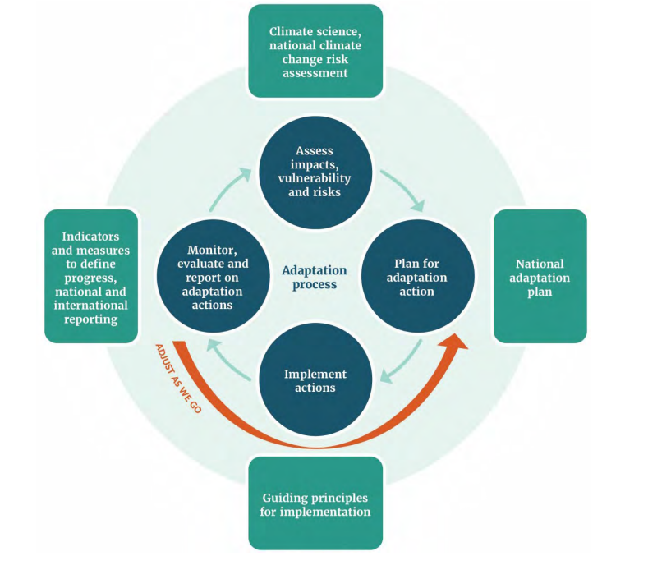

# Appendices

Figure 4: Emissions reduction plan strategy map

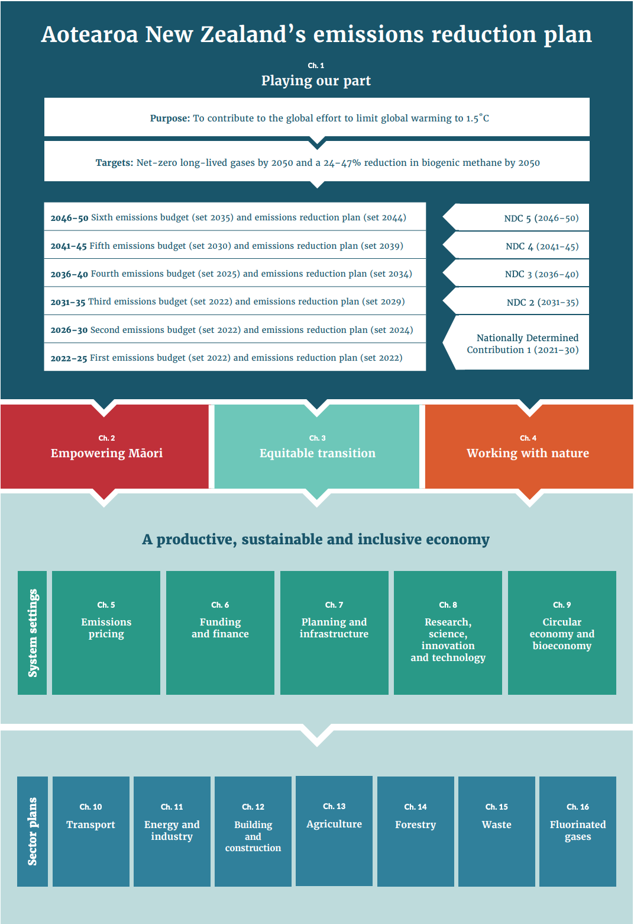

Figure 5: National adaptation plan strategy map

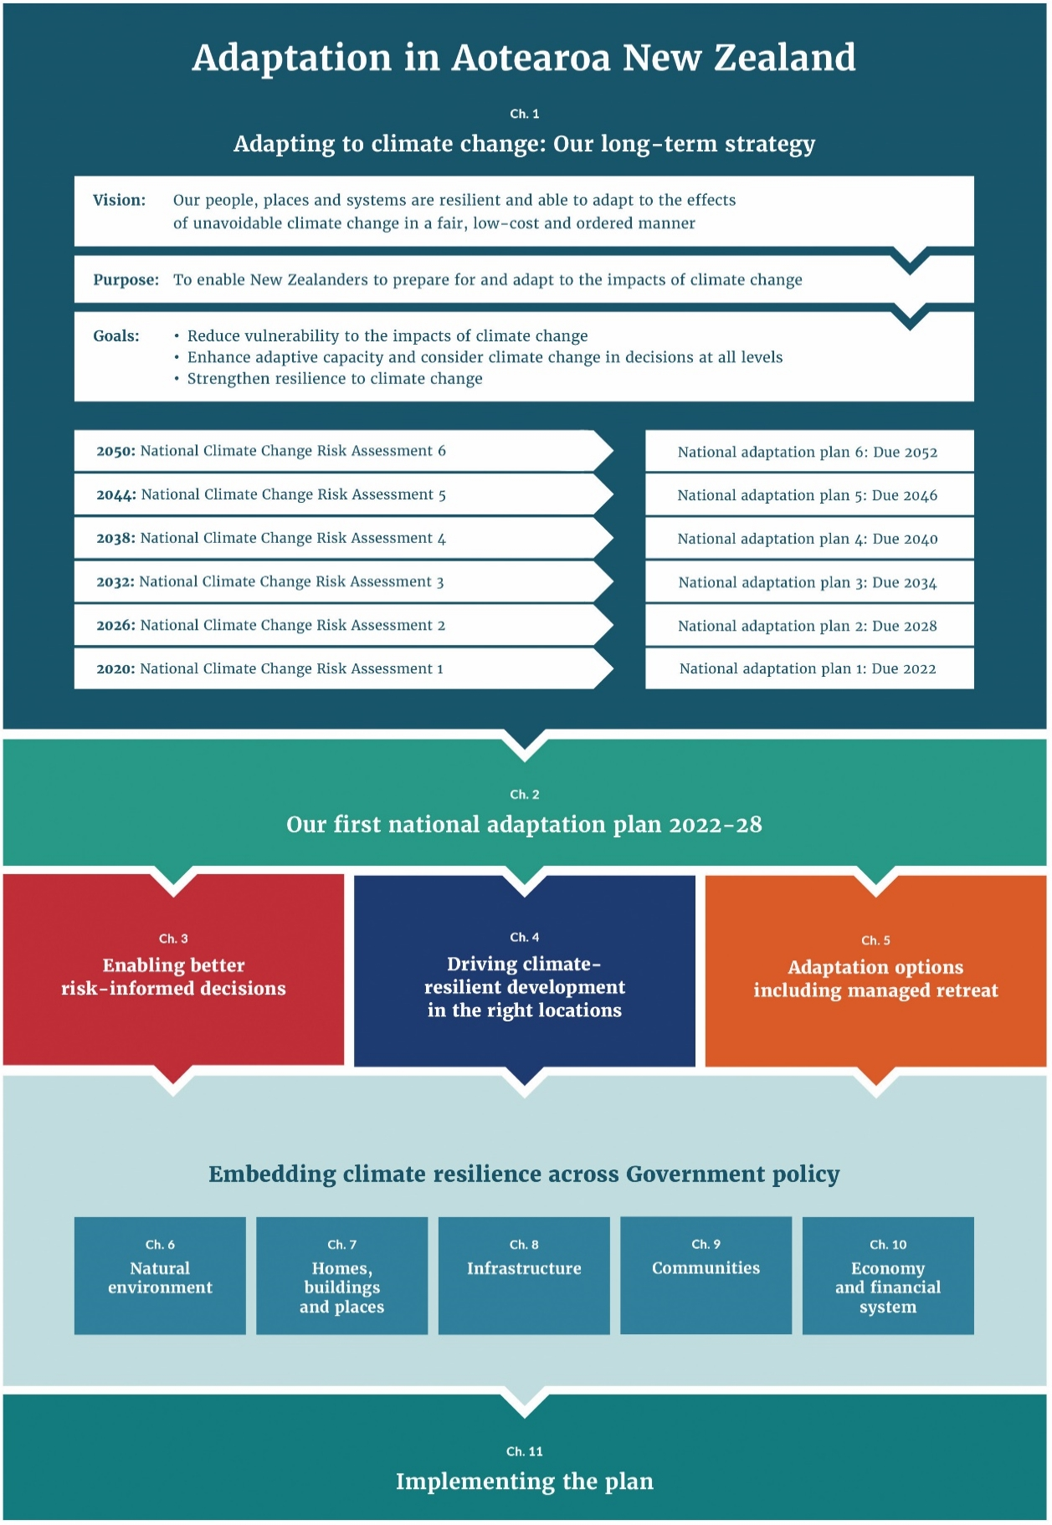

Table 5: Ministers and chief executives who are accountable for chapters in the emissions reduction plan

| **Chapter** | **Responsible minister(s)** | **Responsible chief executive(s)** |
| --- | --- | --- |
| Empowering Māori | Minister of Climate Change  Supported by:  Minister for Māori Crown Relations|Te Arawhiti  Minister for Māori Development | Secretary for the Environment  Supported by:  Te Tumu Whakarae mō Te Puni Kōkiri  Chief Executive of the Ministry of Business, Innovation and Employment  Chief Executive of the Ministry for Māori Crown Relations | Te Arawhiti |
| Equitable transition | Minister for Social Development and Employment  Minister for Economic and Regional Development  Supported by:  Minister of Education  Minister of Climate Change | Chief Executive of the Ministry of Business, Innovation and Employment  Chief Executive of the Ministry of Social Development  Supported by:  Secretary for the Environment  Secretary to the Treasury  Secretary for Education |
| Working with nature | Minister of Conservation  Supported by:  Minister of Climate Change | Director-General of the Department of Conservation  Supported by:  Secretary for the Environment |
| Emissions pricing | Minister of Climate Change  Supported by:  Minister of Energy and Resources  Minister for the Environment  Minister of Agriculture  Minister of Forestry  Minister of Transport | Secretary for the Environment  Supported by:  Director-General of the Ministry for Primary Industries  Chief Executive of the Ministry of Business, Innovation and Employment  Secretary for Transport  Secretary to the Treasury |
| Funding and finance | Minister of Finance  Minister of Climate Change | Secretary to the Treasury  Secretary for the Environment  Supported by:  Chief Executive of the Ministry of Business, Innovation and Employment  Secretary for Internal Affairs and Local Government |
| Planning and infrastructure | Minister for the Environment  Supported by:  Minister for Infrastructure  Minister of Housing  Minister of Climate Change | Secretary for the Environment  Supported by:  Chief Executive of the Ministry of Housing and Urban Development  Secretary for Transport  Chief Executive of Te Waihanga|New Zealand Infrastructure Commission  Secretary to the Treasury |
| Research, science, innovation and technology | Minister of Research, Science and Innovation | Chief Executive of the Ministry of Business, Innovation and Employment  Supported by:  Chief Executive of the Energy Efficiency and Conservation Authority  Director-General of the Ministry for Primary Industries  Secretary for the Environment |
| Circular economy and bioeconomy | Minister of Energy and Resources  Minister for Economic and Regional Development  Minister of Forestry | Chief Executive of the Ministry of Business, Innovation and Employment  Supported by:  Director-General of the Ministry for Primary Industries  Secretary for the Environment |
| Transport | Minister of Transport | Secretary for Transport  Supported by:  Chief Executive of Waka Kotahi | New Zealand Transport Agency  Chief Executive of Civil Aviation Authority  Chief Executive of Maritime New Zealand |
| Energy and industry | Minister of Energy and Resources | Chief Executive of the Ministry of Business, Innovation and Employment  Supported by:  Chief Executive of the Energy Efficiency and Conservation Authority |
| Building and construction | Minister for Building and Construction | Chief Executive of the Ministry of Business, Innovation and Employment  Supported by:  Chief Executive of the Ministry of Housing and Urban Development  Chief Executive of Kāinga Ora | Homes and Communities  Chief Executive of the Energy Efficiency and Conservation Authority |
| Agriculture | Minister of Agriculture | Director-General of the Ministry for Primary Industries |
| Forestry | Minister of Forestry | Director-General of the Ministry for Primary Industries |
| Waste | Minister for the Environment | Secretary for the Environment |
| Fluorinated gases | Minister for the Environment | Secretary for the Environment |

**Note**In some cases, other ministers and agencies not listed here will also be involved in implementing the emissions reduction plan, particularly when the chapters concern cross-cutting actions or policies.

Table 6: Responsibility for emissions budget sector sub-targets (in Mt CO2-e)#

| **Sector** | **First  emissions budget (2022–25)** | **Second emissions budget (2026–30)** | **Third  emissions budget (2031–35)** | **Relevant agency or agencies** | **Responsible minister** |
| --- | --- | --- | --- | --- | --- |
| Transport | 65.9 | 76.0 | 56.8 | Ministry of Transport | Minister of Transport |
| Energy and industry | 70.1 | 72.8 | 63.3 | Ministry of Business, Innovation and Employment | Minister of Energy and Resources |
| Agriculture | 159.4 | 191.0 | 183.0 | Ministry for Primary Industries | Minister of Energy and Resources |
| Waste | 13.7 | 14.9 | 12.7 | Ministry for the Environment | Minister for the Environment |
| Fluorinated gases | 6.8 | 7.5 | 5.9 | Ministry for the Environment | Minister for the Environment |
| Forestry | -26.4 | -57.2 | -81.6 | Ministry for Primary Industries | Minister for Forestry |
| **Total\*** | **290.0** | **305.0** | **240.0** | **The Board** | **Prime Minister^** |

**Notes**

# Sector sub-targets include all greenhouse gases, reflect net (AR5), and are expressed in metric tons of carbon dioxide equivalent (Mt CO2-e). AR5 is the [Fifth Assessment Report of the United Nations Intergovernmental Panel on Climate Change](https://www.ipcc.ch/assessment-report/ar5/), completed in 2014.

* The sum of values for sector sub-targets differs from the total emissions budget, due to rounding.

^ The Prime Minister will oversee ministerial progress against the sector sub-targets. However, the Minister of Climate Change is responsible for meeting the emissions budgets under the Climate Change Response Act 2002.

Table 7: Emissions reduction plan chapter targets, milestones and progress

| Chapter | Targets/milestones (calendar year) |
| --- | --- |
| 1. Empowering Māori | November 2022: Māori Climate Platform Interim Ministerial Advisory Committee appointed  January 2023: Work plan delivered by the Interim Ministerial Advisory Committee |
| 1. Equitable transition | Q4 2022: Public launch of Equitable Transition Strategy engagement process  Q2 2023: Release draft Strategy in June 2023  Q2 2024: Publish final Strategy by June 2024 |
| 1. Working with nature | **Integrated Work Programme (IWP) to deliver climate, biodiversity and wider environmental outcomes**  Early 2024: First annual review of the Biodiversity Incentives three pilot programmes is undertaken. Biodiversity Incentives pilot programmes are expanded or redirected based on the year one review.  DOC’s Native Carbon Storage Programme – milestones under development.  See milestones and progress in the Forestry section on:   * ETS yield tables for indigenous species * maintaining and increasing carbon stocks in pre-1990 forests (joint work programme) * encouraging greater levels of native afforestation in the longer term * reducing the cost of native afforestation   Note that agencies are also working to identify biodiversity outcome milestones for each of the IWP workstreams. These will be used to assess workstream contributions to the IWP outcomes. |
|  | **Report on biodiversity as part of emissions reduction plan reporting**  By early 2024, a biodiversity monitoring and reporting system will be developed to assess how our climate response is protecting, enhancing, and restoring nature. |
| 1. Emissions pricing | **Align NZ ETS settings with emissions budgets**  *Unit supply price control settings*  November 2022: Policy decisions on updates to NZ ETS limits and price control settings for units made by Cabinet  December 2022: Drafting instructions to PCO to enable amendment regulations to be approved by Cabinet decisions  January 2023: Amendment regulations published in the *NZ Gazette*, with updated NZ ETS unit settings taking effect from 1 January 2023 |
|  | **Adjust the NZ ETS to drive a balance of gross and net emissions reductions**  **Assess the role of the NZ ETS in supporting the Nationally Determined Contribution**  Agencies are progressing these actions. MFE has announced the Government is reviewing the NZ ETS to assess if changes are needed to provide a stronger incentive for emissions reductions, while also supporting emissions removals.  Ministers will provide further information on the scope, key milestones, and time frames for the review in due course. |
|  | **Investigate new sources of emissions removals**  **Assess how the NZ ETS can support indigenous biodiversity**  MFE commissioned work on how to scale investment in nature-based solutions via environmental markets such as voluntary carbon markets and biodiversity credit markets. This would aim to direct private and philanthropic capital into nature-based solutions. |
|  | **Market governance framework**  Cabinet has noted that a comprehensive market governance package for the ETS is intended to be in progress this term  Mid-November 2022/February 2023: consulting (targeted engagement) on proposals for this framework  July 2023: Final policy decisions are expected to be proposed to Cabinet  Once approved by Cabinet, MfE intends to provide the Parliamentary Counsel Office with drafting instructions |
|  | **Industrial Allocation Review**  The Climate Change Response (Late Payment Penalties and Industrial Allocation) Amendment Bill has been introduced to the House and had the first reading. The Bill has been referred to Select Committee with the report-back date 20 July 2023.  Mid-2023: Enactment of the Bill is intended for mid-2023. Subject to enactment, data collection, analysis and regulation, changes will be required to implement the reform from 2024. |
|  | **Alternative ways to mitigate the risk of emissions leakage**  End of 2022: reported to the Minister of Revenue and Minister of Finance on the risk of emissions leakage from the cement sector in Aotearoa.  Q2 2023: IRD and Treasury officials report back to the Minister of Finance and Minister of Revenue |
|  | **Voluntary carbon markets**  Officials are progressing analysis to support this action, including:Q3 2023: Lodge Cabinet paper seeking decisions on the objectives for a voluntary carbon market framework. |
| 1. Funding and finance | Budget 2022: Climate Emergency Response Fund (CERF) established  November 2022: Sovereign Green Bonds issued  November 2022 – February 2023: Public consultation on assurance over climate-related disclosures: occupational regulation and expanding the scope of assurance  December 2022: First Aotearoa New Zealand Climate Standards published  Early 2023: Build on the success of New Zealand Green Investment Finance through completion of NZGIF’s first regular Cabinet mandated review |
| 1. Planning and infrastructure | Q4 2022: Natural and Built Environment Act (NBA) and Spatial Planning Act (SPA) Bills introduced to Parliament (emissions reduction plan action 7.1)  Q4 2023: National Planning Framework (NPF) notified (emissions reduction plan action 7.2)  Q3 2023: Urban design guidance to support low-emission housing initiatives (emissions reduction plan action 7.2)  Q1 2023: Process for developing emissions toolkit and policy evaluation tool to enable quantification of emissions impact of development and infrastructure decisions commenced (Emissions reduction plan action 7.4) |
| 1. Research, science, innovation and technology | Q4 2022: Expansion of innovation grants and incentives  Q4 2022: Te Ara Paerangi | Future Pathways Programme publishes white paper |
| 1. Circular economy and bioeconomy | Q4 2022: First tranche of research to establish the evidence base to commence the Circular Economy and Bioeconomy Strategy is underway  Q2 2023: First tranche of research to establish the evidence base to commence the Circular Economy and Bioeconomy Strategy is completed |
| 1. Transport | **EV Charging Infrastructure**  Q1 2023: EV Charging Strategy published for public consultation |
|  | **Freight Decarbonisation Work Programme**  Q3 2023: The EV-charging infrastructure strategy will consider infrastructure needs for charging heavy vehicles |
|  | **Public transport improvement initiatives**  Q1 2023: Bill to incorporate the Sustainable Public Transport Framework into the [Land Transport Management Act 2003](https://www.legislation.govt.nz/act/public/2003/0118/latest/DLM226230.html) introduced  Q1 2023: Community Connect launched nationwide |
|  | **Reflecting emissions reduction plan commitments in Government Policy Statement (GPS) 2024**  Q2 2023: Undertake public engagement on the draft GPS 2024  Q3 2023: Publish final GPS 2024 |
|  | **Transport Choices package**  Q4 2022: Advice to joint Ministers on initial investment package  2022–2024: Implementation of Transport Choices package |
|  | **VKT reduction plan and programmes**  *National targets*  Q2 2023: Sub-national VKT targets finalised following further targeted consultation  *National VKT Plan for Tier 1 and 2 cities*  Q1 2023: Engagement with councils, iwi/Māori and other partners on the national plan  Q2 2023: National plan published  Q4 2023 Finalise Tier 1 Urban VKT reduction programmes |
|  | **Clean Car Standard**  Q1 2023: Implementation of the legislated targets  Q4 2024: Complete legislated review of the targets |
| 1. Energy and industry | Q4 2022: Terms of Reference for the Energy strategy published  Q1 2023:Cabinet decisions on next steps for the NZ Battery Project, looking at options for dry-year electricity security  Q4 2022: Contestable Government Investment in Decarbonising Industry (GIDI) funding rounds, funded through Budget 2022, continue  Q2 2023: Interim Hydrogen Roadmap published  Q1/Q2 2024: Electricity Market Measures discussion document published  Q4 2023: Gas Transition Plan published  Q2 2024: Regulatory settings in place to enable investment in offshore renewable energy  Q4 2024: Hydrogen Roadmap finalised and integrated with Energy Strategy  Q4 2024: Energy Strategy published |
| 1. Building and construction | Q3 2022: Cabinet policy decisions to amend [Building Act 2004](https://www.legislation.govt.nz/act/public/2004/0072/latest/DLM306036.html) to address climate change, and introduce requirements for waste minimisation plans and energy performance ratings  Q4 2022: Implement amendments to Building Code Clause H1 (energy efficiency) compliance pathways  Q4 2022: Additional policy decisions for Building Act Amendment  Q2 2024: Public consultation on introducing emissions-reduction requirements completed  Q2 2025: Regulations introducing emissions-reduction requirements for building operational efficiency and embodied carbon in new buildings Q2 2026:Technical infrastructure (eg, tools, data and reporting) to support emissions reduction for new buildings established |
| 1. Agriculture | **Agriculture emissions pricing (He Waka Eke Noa)**  Q4 2022: Public consultation complete  Q2 2023: Scheme settings agreed by Cabinet.  Q2 2023: Business case submitted  **The Centre for Climate Action on Agricultural Emissions**  Q4 2022: Launch of the Centre (including new Joint Venture) at Fieldays 2022  Q4 2022: Appointment of Joint Venture Chair and directors  Q2 2023: Joint Venture fully operational  Q2 2023: New Zealand Agricultural Greenhouse Gas Research Centre (NZAGRC) enhancements in place |
| 1. Forestry | **Support right mix, level and location of afforestation**  *Regulatory settings*  2022/23: Consultation on how forests are managed through the National Environmental Standards for Plantation Forestry (NES-PF)  2022/23: Redesign the settings of the ETS permanent forestry category to better support long-term indigenous carbon sinks  2024/25: Redesigned ETS permanent forestry category is intended to come into effect from 1 January 2025  *Forestry planning and advisory services*  1 July 2022: Core services start up  October 2022: Extension services roll-out begins  By end of Q2 2023: Core services fully operational  By end of Q2 2025: Extension services fully operational |
|  | **Encourage native forests as long-term carbon sinks**  *NZ ETS yield tables for indigenous species*  February 2023: Science plan finalised and research programme initiated  2023–2024: Peak research and development phase  1 October 2025: Initial regulatory package to be in place  *Reduce the cost of native afforestation*  Q4 2022: Engagement with commercial native tree nursery sector underway. The programme is widening its engagement to other native stakeholders.  Q1 2023: Research programme underway  Q2 2023: Decision on detailed proposals, including improving seedling collection and applying technology to native tree propagation  *Encourage greater levels of native afforestation in longer term*  Q4 2023: Targeted engagement on proposals to encourage greater levels of native afforestation  Q1 2024: Public consultation on proposals to encourage greater levels of native afforestation  2024: Final proposals released |
|  | **Grow the forestry and wood-processing industry to deliver more value from low-carbon products**  *Develop forestry and wood-processing industry transformation plan (ITP)*  December 2022: Finalise ITP  January 2023 onwards: Begin ITP implementation  *Invest in expanding supply of woody biomass*  July 2022: Engagement with landowners begins  Q1 2023: Research programmes underway on optimal species and silviculture, and cost-effective harvest residue recovery  2024–2026: Planting of woody biomass forests |
|  | **Improve fire-management planning**  *Increase awareness of forest fire risk and improve planning for fire management*  Q4 2022: Consulted on options to require fire-management plans for all exotic forests over one hectare |
| 1. Waste | Q4 2022: Contestable waste minimisation fund (emissions reduction plan resource recovery infrastructure) opened  Q2 2023: Policy decisions on household kerbside organic waste collections and business food waste separation  Q2 2023: Policy decisions on new waste strategy and legislation  Q2 2023: Year one research projects to improve waste data delivered  Q3 2023: Delivery partnerships established for organic waste reduction programmes to commence |
| 1. Fluorinated gases | Q4 2022: Consultation on policy proposals for improved management of fluorinated gases – including a regulated product stewardship scheme for refrigerants  Q2 2023: Policy decisions on improved management of fluorinated gases |

1. Ministry for the Environment. 2022. Te hau mārohi ki anamata, Towards a productive, sustainable and inclusive economy: Aotearoa New Zealand’s first emissions reduction plan. Wellington: Ministry for the Environment.
2. Ministry for the Environment. 2022. Aotearoa New Zealand’s first national adaptation plan. Wellington. Ministry for the Environment.
3. In May 2022, the Government gazetted the first three emissions budgets: 2022–2025, 2026–2030 and 2031–2035. These are the first of six interim targets that progress towards our 2050 target under the [Climate Change Response Act 2002](https://www.legislation.govt.nz/act/public/2002/0040/latest/DLM158584.html). Sub-targets have been set for these sectors: transport, energy and industry; building and construction; agriculture; forestry; waste; and fluorinated gases. The sub-targets are designed to help us stay on track to meet our emissions budgets. They are not intended to lock us into a particular path, but are a useful tool for tracking our progress.
4. These principles are reflected in emissions reduction plan’s strategy map (see figure 4).
5. These objectives are set out in the [First National Climate Change Risk Assessment for New Zealand](https://environment.govt.nz/what-government-is-doing/areas-of-work/climate-change/adapting-to-climate-change/first-national-climate-change-risk-assessment-for-new-zealand/).
6. These priority focus areas are reflected in national adaptation plan’s strategy map (see figure 5).
7. The emissions reduction plan and national adaptation plan identify ministerial and chief executive/agency accountability for each chapter (emissions reduction plan) or action (national adaptation plan).
8. The Board currently comprises the key chief executives responsible for delivering actions in the emissions reduction plan. Cabinet has agreed to expand the Board’s functions to include adaptation, and expand its remit (membership) to include the chief executive of the National Emergency Management Agency and Department of Internal Affairs. These decisions will be formalised by an Order in Council under the [Public Service Act 2020](https://www.legislation.govt.nz/act/public/2020/0040/latest/LMS106159.html).
9. The Prime Minister is the appropriate Minister for the Board. The Board therefore reports directly to the Prime Minister. The Minister of Climate Change is the appropriation Minister and responsible Minister for the Board. They are accountable for what is achieved with the appropriation and for the Board’s financial performance.
10. In Budget 2023, the CERF criteria will be extended to cover adaptation and the CERF will be able to support national adaptation plan initiatives.
11. Ministry for the Environment. 2022. Aotearoa New Zealand's first emissions reduction plan: Table of actions. Wellington: Ministry for the Environment.
12. Ministry for the Environment. 2022. Aotearoa New Zealand's first national adaptation plan: Table of actions. Wellington: Ministry for the Environment.
13. Reports will be release approximately every five years, and within two years of the end of the emissions budget period.
14. Establishing the Māori Climate Platform (the Platform) is an action in the emissions reduction plan and national adaptation plan. The Platform is a key vehicle to accelerate climate action for Māori and embed Māori into the climate response over the longer term. The minister of climate change and the Ministry are responsible for the Platform. They are supported by the minister for Māori Crown relations | te arawhiti and minister for Māori development, and their agencies. The Platform is being developed with Māori. The Interim Committee is guiding the Platform’s design. The Platform will be in place from November 2022 to February 2024.
15. Ministry for the Environment. 2022. Aotearoa New Zealand's first emissions reduction plan: Table of actions. Wellington: Ministry for the Environment.
16. Ministry for the Environment. 2022. Aotearoa New Zealand's first national adaptation plan: Table of actions. Wellington: Ministry for the Environment.
17. Ministry for the Environment. 2020. National Climate Change Risk Assessment for Aotearoa New Zealand: Main Report – Arotakenga Tūraru mō te Huringa Āhuarangi o Āotearoa: Pūrongo whakatōpū. Wellington: Ministry for the Environment.
18. Ministry for the Environment. 2022. Aotearoa New Zealand's first national adaptation plan: Table of actions. Wellington: Ministry for the Environment.
19. Note: Agencies and the Board will take an adaptive management approach to emissions reduction and responding to climate risk. This may mean that actions are adjusted or re-prioritised if circumstances change. This may result in changes to emissions reduction plan milestones and national adaptation plan implementation measures.
20. Targets will not be appropriate in all circumstances. They will likely be useful where estimates of emissions reductions have been used to calculate Aotearoa New Zealand’s ability to meet emissions budgets. Tracking against milestones will be more useful when the contribution of an action cannot be practically measured.
21. Ministry for the Environment. 2020. National Climate Change Risk Assessment for Aotearoa New Zealand: Main Report – Arotakenga Tūraru mō te Huringa Āhuarangi o Āotearoa: Pūrongo whakatōpū. Wellington: Ministry for the Environment.
22. The first six-monthly report in February 2023 covered only the emissions reduction plan. Subsequent reports will also cover the national adaptation plan. The second six-monthly report produced each year will satisfy the Board’s requirement to report annually to the Prime Minister on overall progress of the national adaptation plan.
23. Critical actions in the national adaptation plan may also need a qualitative impact assessment. The Board will advise agencies which information they need for the first six-monthly report that includes the national adaptation plan.
24. Ministry for the Environment. 2021. About New Zealand’s Greenhouse Gas Inventory. Retrieved from <https://environment.govt.nz/facts-and-science/climate-change/measuring-greenhouse-gas-emissions/about-new-zealands-greenhouse-gas-inventory/> (14 November 2022).
25. Stats NZ. 2022. New Zealand’s Greenhouse Gas Emissions. Retrieved from <https://www.stats.govt.nz/indicators/new-zealands-greenhouse-gas-emissions> (14 November 2022).
26. Ministry for the Environment. 2020. *National Climate Change Risk Assessment for Aotearoa New Zealand: Main report – Arotakenga Tūraru mō te Huringa Āhuarangi o Āotearoa*: *Pūrongo whakatōpū*. Wellington: Ministry for the Environment.
27. Ministry for the Environment. 2021. Adaptation Preparedness: 2020/21 Baseline – A Summary of Reporting Organisation Responses from the First Information Request Under the Climate Change Response Act 2002. Wellington: Ministry for the Environment.