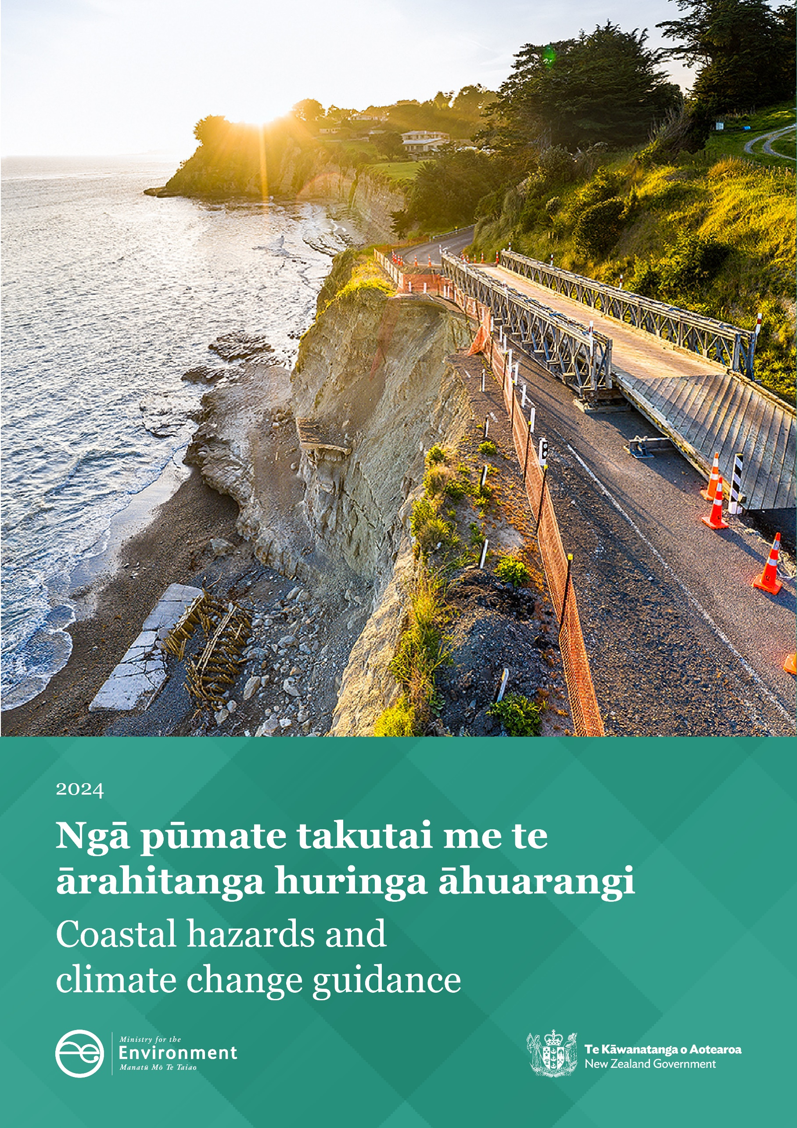
Coastal hazards and climate change guidance

Disclaimer
The information in this publication is, according to the Ministry for the Environment’s best efforts, accurate at the time of publication. The Ministry will make every reasonable effort to keep it current and accurate. However, users of this publication are advised that:
- the information does not alter the laws of New Zealand, other official guidelines, or requirements
- it does not constitute legal advice, and users should take specific advice from qualified professionals before taking any action based on information in this publication
- the Ministry does not accept any responsibility or liability whatsoever whether in contract, tort, equity, or otherwise for any action taken as a result of reading, or reliance placed on this publication because of having read any part, or all, of the information in this publication or for any error, or inadequacy, deficiency, flaw in, or omission from the information in this publication
- all references to websites, organisations or people not within the Ministry are for convenience only and should not be taken as endorsement of those websites or information contained in those websites nor of organisations or people referred to.

This document may be cited as: Ministry for the Environment. 2024. Coastal hazards and climate change guidance. Wellington: Ministry for the Environment.
This publication was updated in October 2026 to remove section 2.1.3 and related content.
Published in February 2024 by the
Ministry for the Environment
Manatū Mō Te Taiao
PO Box 10362, Wellington 6143, New Zealand
environment.govt.nz
ISBN: 978-1-991140-05-0
Publication number: ME 1805
© Crown copyright New Zealand 2024
Acknowledgements
Lead authors on the publication, Coastal hazards and climate change guidance
J Lawrence (PS Consulting Ltd)
R Bell (Bell Adapt Ltd)
Contributing advisors on the publication, Coastal hazards and climate change guidance
A Martin (Thames-Coromandel District Council), N Carpenter (Auckland Council), J Payan (Otago Regional Council), T FitzGerald (Northland Regional Council), S Bendall (Traverse Ltd), H Smith (Massey University), M de Boer (Northland Regional Council), R Levy (GNS Science), T Naish (Victoria University of Wellington), S John (Royal HaskoningDHV), A Sharma (Auckland Transport), Policy and Regulatory Services and Biodiversity Heritage and Visitors (Department of Conservation), Building System Performance (Ministry of Business, Innovation and Employment), Climate Impacts, Climate RM Policy, Resource Management Systems, Adaptation Policy, Nga Parirau, Māori Climate Action and Legal (Ministry for the Environment)
Peer reviewers on the publication, Coastal hazards and climate change guidance
M Dickson, M Ford and M Tuck (University of Auckland)
Contributing authors and advisors on the 2017 publication, Coastal hazards and climate change: Guidance for local government
Authors: R Bell (NIWA), J Lawrence (PS Consulting Ltd), S Allan (Allan Planning and Research Ltd), P Blackett (NIWA) and S Stephens (NIWA)
Advisors: J Hannah (Vision New Zealand Ltd), T Shand (Tonkin+Taylor), P Thomson (Statistics Research Associates Ltd), B Glavovic (Massey University), R Britton (Planning Consultant, Focus Management Group), M Dickson (University of Auckland), P Quilter (Tonkin+Taylor), N Hudson and K Davies (NIWA)

Contents
About this guidance 9
Why is this guidance required? 9
How do I use this guidance? 11
Part A: What is happening? 13
Step 1: Set the context and prepare 13
1.1 Roles and responsibilities 13
1.2 Set the context and prepare 21
Step 2: Assess sea-level rise and coastal hazards 35
2.1 Assessing sea-level rise 36
2.2 Coastal hazard assessment 54
Part B: What matters most? 72
Step 3: Establish values and objectives 72
3.1 Mana whenua and community values and objectives 72
3.2 Local government objectives 76
Step 4: Assess vulnerability and risk 78
4.1 Undertake a coastal climate risk assessment 79
4.2 Assess social, cultural and environmental vulnerability 96
Part C: What can we do about it? 101
Step 5: Identify options and pathways 101
5.1 Identify adaptation options and pathways 101
5.2 Develop dynamic adaptive pathways planning approach 106
Step 6: Evaluate options and pathways 108
6.1 Choose evaluation tools 108
6.2 Evaluate options and pathways 111
Part D: How can we implement the strategy? 113
Step 7: Develop the adaptive planning strategy 113
7.1 Identify signals 114
7.2 Design and set triggers 115
Step 8: Implement the adaptive planning strategy 117
8.1 Measures and processes for implementing the adaptive planning strategy 118
8.2 Funding the implementation of an adaptive planning strategy 124
8.3 Insurance 125
Part E: How is it working? 126
Step 9: Monitor the adaptive planning strategy 126
9.1 Set up the monitoring framework 126
9.2 Involve communities in monitoring 132
Step 10: Review and adjust the adaptive planning strategy 133
10.1 Review the dynamic adaptive pathways planning objectives and actions 133
10.2 Adjust the dynamic adaptive pathways planning objectives and actions 134
Glossary of abbreviations and terms 135
Appendix A: Coastal hazard management case studies 145
Appendix B: Relevant court cases 162
Appendix C: Dynamic adaptive pathways planning approach and addressing barriers to uptake 165
Appendix D: Baseline mean sea level for locations around Aotearoa New Zealand 171
References 174

Tables
Table 1: Overview of legislation and policy instruments for managing coastal hazards and the effects of climate change 15
Table 2: Principles for managing coastal hazards under a changing climate 18
Table 3: Preparatory tasks for developing a dynamic adaptive pathways planning (DAPP) strategy 33
Table 4: Skills, disciplines and knowledge sets to consider in an adaptation team 34
Table 5: Main elements of the two relative sea-level rise approaches for assessing hazards and risk and input to informing a dynamic adaptive pathways planning (DAPP) approach 46
Table 6: Summary of approximate year when absolute sea-level rise (SLR) heights could be reached using the recommended projections for a central location in Aotearoa New Zealand 49
Table 7: Example: Approximate year when relative sea-level rise (RSLR) increments could be reached using recommended projections for the Nelson urban area (compared with table 6 where vertical land movement is not included) 49
Table 8: Interim precautionary relative sea-level rise allowances recommended to use for coastal planning and policy before undertaking a dynamic adaptive pathways planning approach for a precinct, district or region 52
Table 9: Recommended minimum shared socio-economic pathway scenarios for relative sea-level rise projections to use for screening and detailed phases of hazard and risk assessments 54
Table 10: Example of four methods that can be used in combination to understand mana whenua and community values 75
Table 11: Two examples of translating values into objectives 76
Table 12: Questions to generate local government objectives 77
Table 13: Process for assessing climate risks in coastal areas 87
Table 14: Advantages and disadvantages of methods for measuring social vulnerability 97
Table 15: Applicability of different decision support tools 109
Table 16: Examples of indicators for different types of signals and triggers for coastal hazards and climate change 116
Table 17: Effective monitoring implementation 128
Table A.1: Climate change scenarios used to investigate potential peak flood water levels in the valley and around Tangoio Marae 159
Table B.1: Summary of relevant court cases in relation to coastal hazards, application of New Zealand Coastal Policy Statement 2010, and climate change effects 162
Table C.1: Strategies for addressing barriers to dynamic adaptive pathways planning (DAPP) uptake and implementation of the DAPP plan 169
Table D.1: Mean sea level (MSL) at Aotearoa New Zealand locations averaged over the approximate 1995–2014 baseline (used by IPCC) for adding on -sea-level rise projections 172

Figures
Figure 1: Ten-step decision cycle 12
Figure 2: Relationship between key instruments for managing natural hazards in the Aotearoa New Zealand coastal environment 15
Figure 3: Climate change driven hazards that generate coastal impacts 23
Figure 4: Regional coastal flood risk exposure for a 1 per cent annual exceedance probability event locally on top of a 1 metre sea-level rise 25
Figure 5: Types of adaptation options and actions 28
Figure 6: Evolving and shrinking solution space to address sea-level rise 31
Figure 7: Generic adaptation pathways for coastal cities and settlements to sea-level rise 32
Figure 8: Change in annual mean sea level for the four main ports and Moturiki between 1900 and 2020, spliced with a range of New Zealand averaged sea-level rise projections based on shared socio-economic pathway scenarios to 2050 36
Figure 9: Averaged coastal vertical land movement around Aotearoa New Zealand 44
Figure 10: Recommended sea-level rise (SLR) projections (excluding vertical land movement) based on shared socio-economic pathways scenarios (SSP) (from a central location, broadly representative of SLR across Aotearoa New Zealand) 47
Figure 11: Example of an uncertainty framework for coastal hazard assessments to support the dynamic adaptive pathways planning approach 63
Figure 12: Areas flooded from 0.1 metre sea-level rise increments on extreme coastal storm inundation exposure at Mission Bay, Auckland 69
Figure 13: Depth of inundation at Mission Bay, Auckland, for a 1 per cent annual exceedance probability storm tide covering present-day mean sea level and two relative sea-level rise height increments 70
Figure 14: Frequency of inundation (exceedances per year) at Mission Bay, Auckland, for a 1 per cent annual exceedance probability storm tide, covering present-day mean sea level and two relative sea-level rise height increments 70
Figure 15: Three intersecting components of risk, all increasing over time 80
Figure 16: Generic example of an impact or cascades chain that can be created through participatory workshops and hui, underpinned by relevant hazard and risk exposure mapping 82
Figure 17: Effect on level of risk over time for incremental or a precautionary approach to adaptation relative to a local adaptation threshold (or risk tolerance threshold) 84
Figure 18: Suggested workflow for a first pass coastal risk-screening assessment 92
Figure 19: Suggested workflow for a detailed coastal risk assessment 95
Figure 20: Typical lifetimes of different options for avoiding lock-in 105
Figure 21: A dynamic adaptive pathways planning map 107
Figure 22: Signals and triggers linked to the adaptation threshold 114
Figure 23: Coastal hazard management under Resource Management Act 1991 policy and plans 119
Figure 24: Broad New Zealand Coastal Policy Statement 2010 decision context for coastal areas exposed to coastal hazards and climate change 122
Figure A.1: Current mean high water spring tide and a future upper-range coastal storm inundation for a 0.5 metre sea-level rise at Thames using the coastal inundation tool 146
Figure A.2: Combined (joint probability) storm tide and wave setup and runup elevations 147
Figure A.3.1: Relationships among study requirement, type of uncertainty, scenarios and modelling complexity, arising from developing the Auckland coastal inundation layers 147
Figure A.3.2: Coastal storm inundation mapping and planning overlay at Mission Bay, Auckland 149
Figure A.4: Comparison of static (left) and dynamic (right) maps of 1 per cent annual exceedance probability (AEP) coastal storm inundation at present-day mean sea level, Parakai, West Auckland 151
Figure A.5: Example of shoreline-change components as histograms (left), used to develop the width of a coastal erosion hazard zone (CEHZ) based on P_{66%} and P_{5%} lines overlaid on an aerial image (right) 153
Figure A.6: Photographs at the Mapua foreshore (left) and Ruby Bay rock revetment after a wave overtopping event 154
Figure A.8.1: Definition sketch for open coast coastal erosion hazard setback 157
Figure A.8.2: Definition sketch for cliff coastal erosion hazard setback 158
Figure C.1: Example of a pathways map 167
Figure D.1: Schematic of ‘present’ mean sea level and relationship to various vertical datums and additional sea-level rise 171

About this guidance

Why is this guidance required?
Since 2001, the Ministry for the Environment has provided guidance to local government on adapting to coastal hazards and the risks presented from climate change, particularly sea-level rise (SLR). Hazards associated within a complex and dynamic coastal zone, have been an historic and are an ongoing occurrence for the coastal communities of Aotearoa New Zealand. Hence, the need to plan for coastal hazards that exist irrespective of climate change and SLR (ie, cliff collapse, coastal erosion due to changes in sediment supply due to land-use changes, tectonic activity and so on). There is also a need to plan for the way that coastal hazards that will be modified and, in most cases, amplified by SLR.
This guidance incorporates the NZ SeaRise research programme’s updated Aotearoa sea-level rise projections that were released on 2 May 2022. These projections combine the 2021 Intergovernmental Panel on Climate Change (IPCC) Sixth Assessment Report (AR6) sea-level data (downscaled to Aotearoa), with localised rates of vertical land movement (VLM) around the coast (Fox-Kemper et al, 2021; Kopp et al, 2023; Naish et al, in review). The result is estimates of relative sea-level rise (RSLR), or sea-level rise relative to the local landmass. This information is critical for planning and implementing hazard and risk assessments, as well as adaptation approaches locally in our complex and dynamic coastal environments.
The NZ SeaRise method represents an emerging scientific approach. While the SLR projections are based on the same framework used by the IPCC, the satellite-derived estimates of VLM are new science and cover a relatively short time period (8 years). At the time of publication of this guidance, the NZ SeaRise method was still under peer review by an international scientific journal and had not yet been accepted for publication (Naish et al, in review). Further improvements to the NZ SeaRise projections with new and longer measures of satellite-derived VLM and other data are already signalled (Levy et al, 2023). Land Information New Zealand is also set to establish a further six global navigation satellite system stations, which will result in improved measures of sea level.
The NZ SeaRise method is the only currently available approach for estimating RSLR around the entire Aotearoa coast under a range of plausible future climate change scenarios. Using environmental models or approaches like NZ SeaRise, which are emerging science or contain uncertainties, is deemed appropriate for providing insight into complex systems when they represent the only available information (MfE, 2023b). ). However, because of the uncertainty associated with these types of models, it is recommended that they are used alongside multiple sources of information (MfE, 2023b). Due to the uncertainty associated with the NZ SeaRise method, particularly with the satellite-derived VLM rates, this guidance recommends a multi-evidence approach for assessing RSLR. This guidance recommends using these as part of a precautionary approach alongside a dynamic adaptive pathways planning (DAPP) approach, which allows for adjusting pathways as new information emerges.

An overview of changes since the previous update
The 2017 Coastal hazards and climate change: Guidance for local government (MfE, 2017) introduced advances in assessing hazard, risk and vulnerability; making decisions under uncertain and changing conditions; using collaborative community engagement; and updated changes to statutory frameworks. This 2024 guidance revises the 2017 publication with the following updates:
- advances in SLR science and global projections from the IPCC AR6 (IPCC, 2021, 2022)
downscaling new global projections to Aotearoa by the NZ SeaRise project plus the inclusion of VLM to produce localised relative SLR (RSLR) projections
advances in knowledge relating to the types of coastal hazards and how they cascade and compound the effects on the coast
- improved guidance on vulnerability and risk assessment methodology and monitoring adaptive pathways for adaptation plans
- the national adaptation plan (NAP) directions on which climate scenarios to use for hazard and risk assessment within the resource management system.
The new assessments of the physical science – and of the projected and observed impacts, adaptation and vulnerability – show that hazards and their risks are compounding near coasts, estuaries and harbours throughout Aotearoa with impacts cascading more widely. In addition to the environmental risks, a wide range of social, cultural and economic values are at stake.
The climate and sea level are changing, and the pace is accelerating due to greenhouse gas emissions warming the atmosphere and melting of the ice sheets and glaciers. There is growing understanding of the scale and pace of change from ongoing and accelerating SLR and increased frequency of damaging weather events affecting coastal areas. The National Climate Change Risk Assessment (MfE, 2020a) identifies coastal hazards – such as coastal flooding and erosion or landslides, and progressive and ongoing changes (particularly SLR, associated groundwater rise and in combination with extreme rainfall events) – as some of the most significant risks for Aotearoa. Risks to coastal ecosystems, low-lying coastal communities and infrastructure are outlined as three of the top ten most significant risks across multiple domains, including the natural and built environments, humans and the economy. Additionally, in its 2050 challenge paper, Local Government New Zealand (LGNZ) highlighted SLR as one of the main factors that will greatly affect coastal communities (LGNZ, 2016b). The New Zealand Coastal Policy Statement 2010 (NZCPS 2010, DOC, 2010) provides a directive to avoid increasing the risk and to plan for at least 100-years in the coastal area. The NZCPS also includes policies for assessing a range of options for reducing coastal hazard risk to protect significant existing development (Policy 27, DOC, 2010). Climate change and increasing SLR will increase the challenges of long-term sustainable management of the Aotearoa coastal area.

Coastal hazards therefore require specific guidance and consideration. This is especially because SLR will continue for at least several centuries under all climate scenarios, even if greenhouse gas emissions are curbed and the rate of rise and the overall amount of SLR is slowed. There is an ongoing challenge to manage the transition to more resilient coastal communities through adaptive planning.

How do I use this guidance?
This guidance follows a 10-step decision cycle (figure 1). The steps allow for both short- and long-term planning, adaptive pathways and decision-making for coastal areas that are, or will be, affected by coastal hazards and climate change. Adaptation is an iterative process. Iterations within the process can be driven by experience of hazard events and observations of progressive changes, new climate information and projections; reappraising early signals (warnings) and triggers (decision points); and social, cultural and economic change. The steps can be worked through either sequentially or in the order that makes best sense for your specific problem and process, allowing you to loop back to earlier steps if readjustments are needed. The guidance is intended to help only, and local authorities must use the most appropriate processes and methods for their region or district.
Broader guidance on the practical steps to take as part of the adaptation process is expected to be published later in 2024. When this adaptation planning guidance is released, a condensed technical version of the Coastal Hazards and Climate Change Guidance will sit alongside it as a companion document.

Guidance abbreviations and terminology
This guidance uses many terms in a defined way that is specific to this subject matter (examples include ‘adaptation’, ‘dynamic adaptive pathways planning’, ‘projection’, ‘scenario’, ‘uncertainty’, ‘vulnerability’). Please refer to the Glossary of abbreviations and terms for explanations of our use of such terms in this guidance.

Guidance structure
This publication, Coastal hazards and climate change guidance, is an overview of the 10-step decision cycle and includes the following appendices:
A: Coastal hazard management case studies
B: Relevant court cases
C: Dynamic adaptive pathways planning approach and addressing barriers to uptake
D: Baseline mean sea level for locations around Aotearoa New Zealand.

The guidance is structured around five main questions in the 10-step decision cycle.
What is happening?
What matters most?
What can we do about it?
How can we implement the strategy?
How is it working?
Figure 1: Ten-step decision cycle
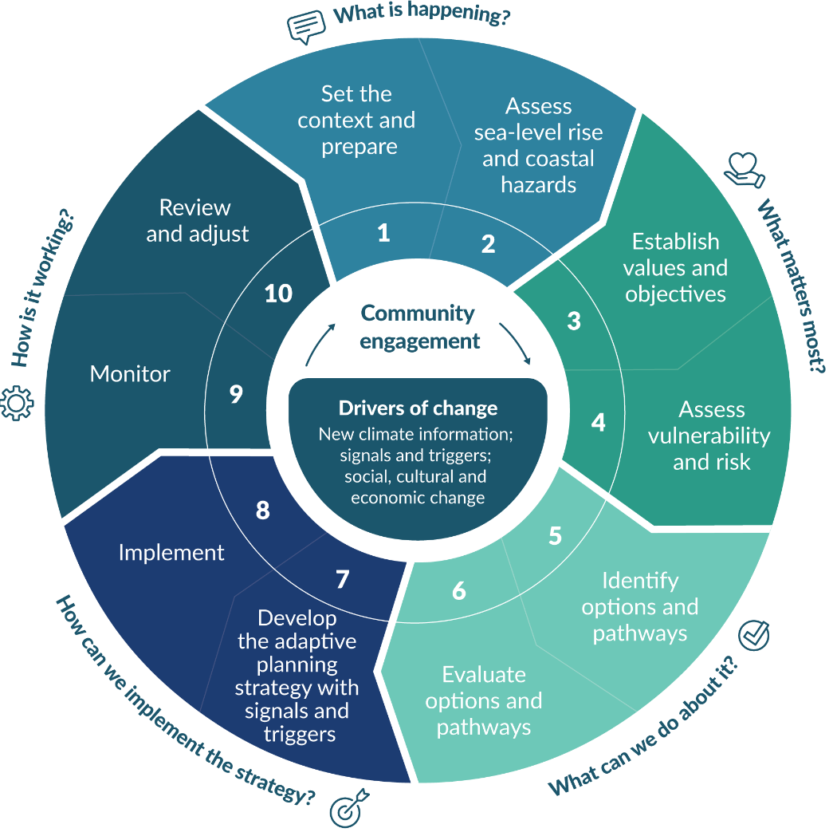
Source: Adapted from Max Oulton (University of Waikato) and UN-Habitat (2014)

Supplements
Two supplements will be published in mid-2024. These are:
Climate change, sea-level rise and coastal hazards science: Coastal hazards and climate change guidance – Supplement A
Community engagement principles and approaches, and practice methods: Coastal hazards and climate change guidance – Supplement B.

Part A: What is happening?

Step 1: Set the context and prepare
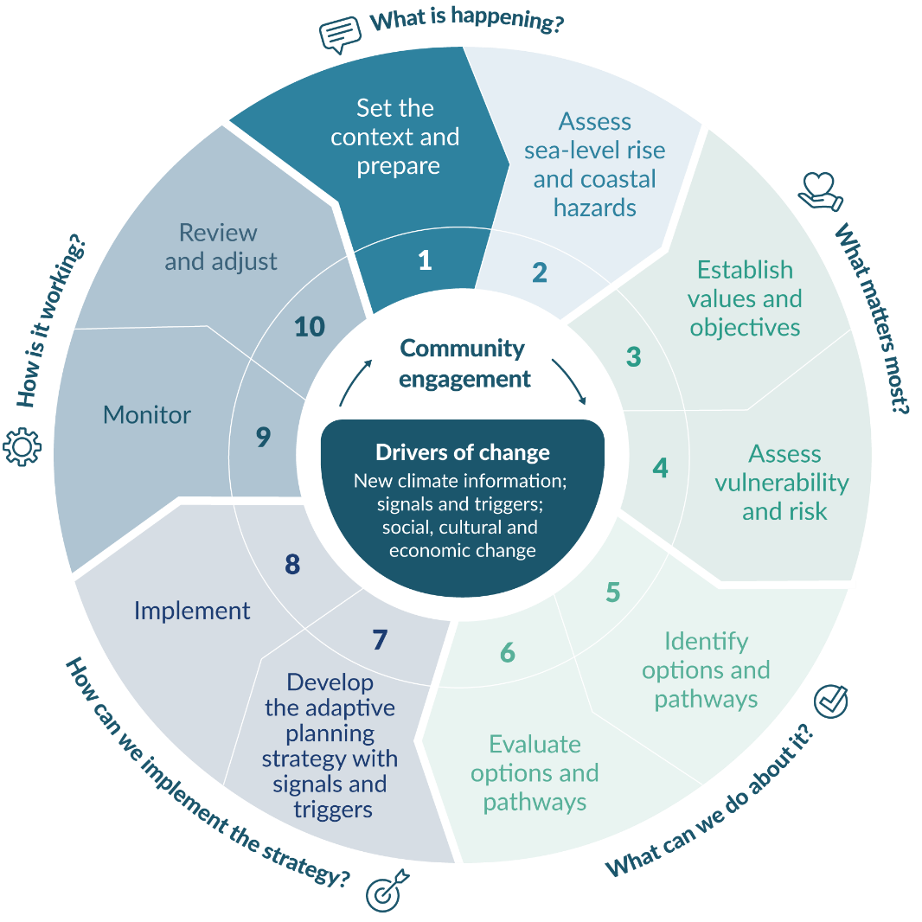

Roles and responsibilities

Users of this guidance
This is a technical document providing national guidance to local and central government, but also other users outside government. It helps local government to plan for and support coastal communities – and council assets and services – to manage and adapt to the increasing coastal hazards and risks from climate change. It sets out recommended best practice for infrastructure and new development in coastal areas. National agencies that operate locally, can also use this guidance where their investment, assets and services are in areas subject to coastal hazards.
One of the enduring questions local government faces is how to continue to achieve the aspirations and values of communities and iwi/hapū, while managing risk and adapting to the impacts of a changing climate and rising sea level.
This guidance aims to strengthen the integration of coastal hazards and climate change considerations into land-use planning, resource management, subdivision and building consenting, asset and flood risk management, infrastructure planning. The guidance can be used by those who deal with these processes from outside local government: planners, engineers, lawyers, community engagement facilitators, policy analysts, scientists, insurers, lenders, and others in the finance sector.
The guidance provides recommended tools to help councils, consultancies and central government agencies work with affected communities, iwi/hapū and stakeholders during preparation of vulnerability and risk assessments, adaptive planning and implementation processes. It sets out principles and approaches for this engagement for and working together throughout the decision-making process. It is complemented by guidance on the New Zealand Coastal Policy Statement (NZCPS) 2010 on coastal hazards (DOC, 2017).
Appendix A provides case studies of coastal hazards management as examples of this guidance in practice.

Legislative responsibilities
Coastal adaptation initiatives will invariably cross territorial boundaries, especially for long, contiguous coastlines, and cross over the landward boundary of the coastal marine area (CMA). The Resource Management Act 1991 (RMA) (section 30 and section 31) states that both regional councils and territorial authorities have functions related to the control of the use of land to avoid or mitigate natural hazards.
Given these split responsibilities, the statutory context and cross-boundary nature of the issues, local government is required to take an integrated approach to long-term development and adaptation in hazard-prone coastal areas and is encouraged to have proactive discussions about partnering in adaptation responses (see DOC (2017) for further guidance). The risk assessment processes and outcomes covered in this guidance will be useful for informing decisions in statutory planning processes regarding significant risk from natural hazards (identified as a matter of national importance in section 6 of the RMA).
The information, methodologies and approaches in this guidance represent good adaptive practice. This guidance will remain relevant, regardless of the legislative framework that it operates within.
Figure 2 shows the main legislation, plans, national policy statements and strategies for managing natural hazards and climate change impacts in Aotearoa New Zealand. These instruments stipulate various responsibilities for national, regional, city and district agencies.
Figure 2: Relationship between key instruments for managing natural hazards in the Aotearoa New Zealand coastal environment
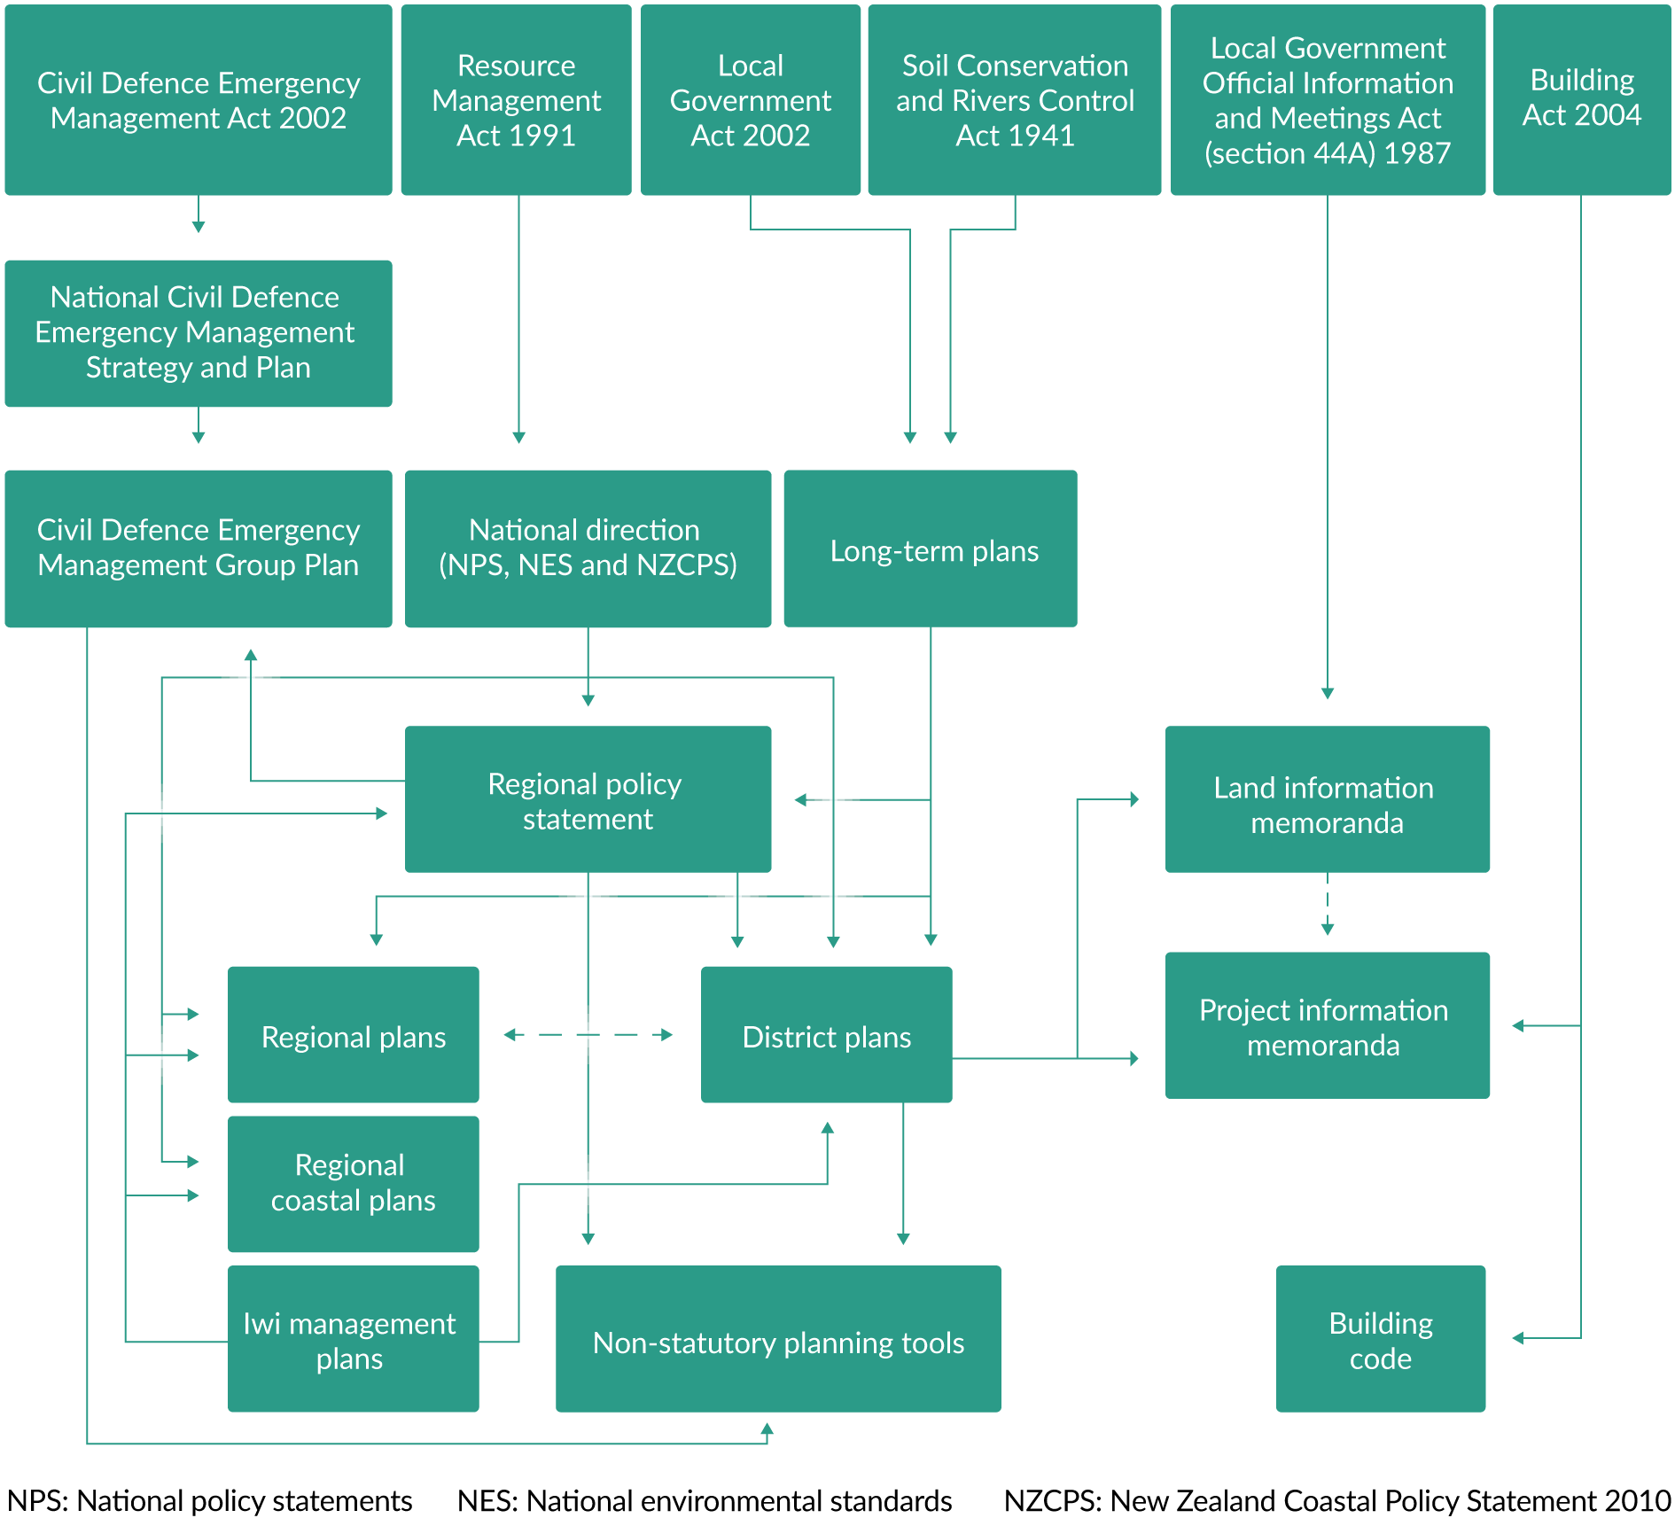
Table 1 outlines the legislation and main policy instruments used for managing coastal hazards and the effects of climate change and SLR.

- Overview of legislation and policy instruments for managing coastal hazards and the effects of climate change
Policy instrument | Effects on coastal hazard management
Resource Management Act 1991 (RMA) | The RMA identifies the preservation of the natural character of the coastal environment and the management of significant risks from natural hazards as s6 matters of national importance. Section 7(i) states that particular regard must be given to the effects of climate change.  The functions stipulated for regional and district councils require avoidance or mitigation of natural hazards, including coastal hazards. The RMA does not specify how to manage the risks from coastal hazards, other than through sustainable management (s5 and s106).  Section 106 of the RMA gives district councils the ability to refuse subdivision consent or apply special conditions where land is subject to significant risk from natural hazards regardless of a district plan’s subdivision provisions. Section 35(5)(j) of the RMA outlines the duty of local councils to keep records of natural hazards.
New Zealand Coastal Policy Statement 2010 (NZCPS) | The purpose of the NZCPS is to state objectives and policies in order to achieve the purpose of the RMA in relation to the coastal environment of Aotearoa New Zealand. The NZCPS is the only compulsory national policy statement under the RMA and there must be one at all times (s57 of the RMA).  Councils are required to give effect to the NZCPS in their policy statements (s62(3)), regional plans (s67(3)(b)) and district plans (s75(3)(b)). They must also have regard to the NZCPS in resource consenting (s104(1)(b)(iv)) and particular regard to it in respect of designations (s168A(3)(a)(ii) and s171(1)(a(ii)).  One of the goals is to manage coastal hazards and climate change risks to avoid increasing the risk of adverse effects. The risk from coastal hazards over at least 100 years must be identified.  The NZCPS does not specify which climate change scenario or SLR projections to use, or the thresholds for applying different planning responses. However, it does require identification of areas “potentially affected”, “taking into account national guidance and the best available information on the likely effects of climate change on the region or district” (Policy 24, DOC, 2010).  The NZCPS includes strong policy direction that requires the avoidance of certain adverse effects in the coastal environment, for example, as may occur through works proposed to mitigate coastal hazard risk.  The NZCPS also includes strategies for assessing a range of options for reducing coastal hazard risk to protect significant existing development (Policy 27, DOC, 2010).
Climate Change Response Act 2002 (CCRA) | The National Climate Change Risk Assessment (NCCRA), developed under s5ZP of the CCRA, sets out how coastal areas will be affected differentially across Aotearoa New Zealand in the Method Report and the Technical Report (MfE, 2020b, 2020c).  The national adaptation plan (NAP) (MfE, 2022a), as part of responding to the risks identified in the NCCRA developed under s5ZP of the CCRA, gives more specific detail regarding management of coastal hazards than provided in the RMA and NZCPS. To identify and assess risk from coastal hazards and the effects of climate change, the NAP stipulates local government should screen for hazards and risks in coastal areas using SSP5-8.5, and use at least two IPCC climate change scenarios (SSP2-4.5 and SSP5-8.5) for detailed hazard and risk assessments, adding the relevant rate of vertical land movement locally. (In addition, the NAP recommends councils should stress-test plans, policies and strategies using a range of scenarios as relevant to the circumstances.)  Under the RMA, local government must have regard to the NAP and the Emissions Reduction Plan (MfE, 2022b) when preparing or changing regional policy statements (s61(2)(e)), regional plans (s66(2)(g)) and district plans (s74(2)(e))
National Planning Standards | To achieve greater consistency in format and design of policy statements and plans, a set of national standards has been promulgated and timeframes set for the update of all plans. The standards stipulate hazard and risk chapters in regional policy statements, regional plans and district plans. They also contain definitions relevant to natural hazards management (such as ground level and ground water).
Local Government Act 2002 (LGA) | Since the amendment to the Act in 2014, councils are required to prepare and adopt an infrastructure strategy as part of a long-term plan for a period of at least 30 years (s101B). Climate change effects in coastal areas could be taken into account in this infrastructure strategy, although potentially limited to significant hazards.
National Policy Statement on Urban Development 2020 (NPS-UD) | The NPS-UD requires councils to give effect to the objectives and policies of the NPS-UD. Objective 8 seeks that urban environments are resilient to the current and future effects of climate change and Policy 1 identifies that such resilience is a component of well-functioning urban environments.  Tier 1 and Tier 2 councils are required to prepare and adopt a FDS every 6 years and in time to inform the next long-term plan. FDS’s form the basis for integrated, strategic and long-term planning. An FDS helps local authorities set the high-level vision for accommodating urban growth over the long term and identifies strategic priorities to inform other development-related decisions. A FDS must be informed by every other national policy statement under the RMA, including the NZCPS (section 3.14(1)(f)).  Urban density requirements in Policy 3 for the largest urban centres (Tier 1) can only be modified to the extent necessary to accommodate a Qualifying Matter (QM) (Policy 4 and section 3.32). One such QM is a matter required in order to give effect to any other NPS, including the NZCPS. However, a site-specific analysis is required to demonstrate where intensification needs to be compatible with the specific matter, and an evaluation report is required to justify why increased development is inappropriate (section 3.33).  Other QMs are matters of national importance under s6 of the RMA, including the management of significant risks from natural hazards, and the preservation of the natural character of the coastal environment, and its protection from inappropriate subdivision, use and development.
Building Act 2004 | The Building Act requires consideration of the effect of the building work on a natural hazard, and consideration of how to protect the land, building and other property when undertaking building work on land subject to a natural hazard. In some cases, building work can still take place but there may a requirement for a notice to be placed on the record of title for the property so future owners are aware the land is subject to a natural hazard. When building on land that might be subject to a natural hazard, you may need to consider both the requirements of the resource management system and the Building Act.  The Natural Hazard Provisions guidance (MBIE, 2023), which relates to sections in the Building Act, includes information on accounting for the impacts of climate change such as sea-level rise.
Building Code | The Building Code sets clear standards that buildings must meet. When considering coastal hazards management, the main Building Code clauses that relate to water ingress will be particularly relevant, these are E1 Surface water, E2 External moisture, E3 Internal moisture, B1 Structure and B2 Durability.
New Zealand Standard for Land Development and Subdivision Infrastructure (NZS 4404:2010) | The NZS 4404:2010 defines freeboard as “…a provision for flood level design estimate imprecision, construction tolerances, and natural phenomena (such as waves, debris, aggradations, channel transition, and bend effects) not explicitly included in the calculations” (p 25).
New Zealand Infrastructure Commission/Te Waihanga Act 2019 | This Act establishes a new Crown entity, the New Zealand Infrastructure Commission, to coordinate and develop infrastructure that improves the wellbeing of New Zealanders. The Commission must provide strategy reports to the responsible Minister that identify how existing infrastructure can meet community expectations and priorities for infrastructure on a 30-year basis (s13). The Commission must consider long-term trends, including the mitigation of, and adapting to, the effects of climate change (s11(b)(iii)).
Marine and Coastal Area (Takutai Moana) Act 2011  and  Ngā Rohe Moana o Ngā Hapū o Ngāti Porou Act 2019 | The Takutai Moana Act supports the recognition of customary interests in the common marine and coastal areas. There may be implications for parties proposing works that have the potential to impact on customary marine title holders or claimants.  The Ngā Rohe Moana o Ngā Hapū o Ngāti Porou Act gives effect to the deed of agreement between ngā hapū o Ngāti Porou and the Crown. The Act also contributes to the legal expression, protection and recognition of the continued exercise of mana by ngā hapū o Ngāti Porou in relation to their ngā rohe moana (s3), which are areas identified in Schedule 2 and include coastal marine areas.
Iwi Management Plans (IMPs) | IMPs are prepared and approved by iwi, iwi authority, rūnanga or hapū for resource management matters, including natural hazards. IMPs identify the issues of importance to iwi or hapū regarding the use of natural resources within their rohe and are underpinned by mātauranga Māori. These documents provide a valuable strategic tool for natural hazard management (Saunders, 2017).  IMPs must be taken into account when preparing or changing regional policy statements (RMA (s61(2A)(a)) and regional (s66(2A)(a)) and district plans (s74(2A)).
See appendix B for relevant court cases.

Principles for managing coastal hazards under a changing climate
Consider the principles that are set out in law, or that have evolved through good practice and case law (see table B.1 in appendix B), when commencing an adaptation planning process. A good adaptation planning process will reflect or account for these main principles (table 2).
- Principles for managing coastal hazards under a changing climate
Principle | Description
Sustainability and resilience | The Resource Management Act 1991 (RMA) concept of sustainable management and the Local Government Act 2002 (LGA) principle of sustainable development support the ability of communities to respond and adapt in a way that avoids or limits harm. Resilience is closely related to sustainability and is increasingly being enshrined in Aotearoa New Zealand legislation.
Meet the reasonably foreseeable needs of future generations | This RMA phrase requires consideration of the interests of future communities, and the direct and indirect impacts they may experience from decisions made today. This principle applies even where the need for a response to climate change has not yet been identified.
Avoid, remedy or mitigate adverse effects | Policy 25 of the New Zealand Coastal Policy Statement 2010 (NZCPS) refers to the risk of “social, environmental and economic harm” from coastal hazards and seeks to reduce, or at least avoid increasing, risks of harm and adverse effects.
Precautionary principle | This principle is applied at the planning response stage (steps 6 to 8 of the decision cycle). It requires precaution for decisions where full information on effects is not available, particularly when effects are potentially significant or decisions are effectively irreversible.  A precautionary approach is also included as Policy 3 of the NZCPS.
Stewardship/kaitiakitanga | This is reflected in both the LGA and RMA, stewardship, or kaitiakitanga, forms the basis of sound planning decisions in the interests of the community, to avoid or minimise loss of environmental values or quality over time. Hapū/iwi assert their right to own, control and manage their ancestral lands and territories, waters and other resources.
Community engagement | Engagement with communities, iwi and affected people is at the heart of local government decision-making. For this to be effective, communities must have enough information to understand the range of scenarios and the increasing risks posed by climate change over time.
Proportionality | Decisions affecting small areas and few people and requiring little sunk investment may reasonably consider climate change effects over a shorter timeframe. Decisions that result in large scale and/or permanent change, that affect important places of value and require considerable sunk investment must consider long-term impacts.
Financial responsibility and disclosure | Local government is expected to act within normal codes of financial responsibility on behalf of the community. Local authorities are required to disclose hazard information on Land Information Memoranda (except where it is apparent from a district plan). Local government must also provide information on governance in relation to the risks and processes, metrics and targets used to assess and manage the risk, if requested by the Climate Change Commission or the Minister of Climate Change under s5ZW of Climate Change Response Act 2002.

Applying a te ao Māori lens
Applying a te ao Māori lens and implementing Māori values are essential to managing and adapting to the impacts of climate change for Aotearoa. Upholding the principles of te Tiriti o Waitangi is a central aspect of the long-term adaptation strategy, as outlined in the national adaptation plan (MfE, 2022a). Applying a te ao Māori lens means developing adaptation responses in partnership with Māori, elevating te ao Māori and mātauranga Māori in the adaptation process and empowering Māori in adaptation planning for Māori by Māori.
Mātauranga Māori represents a valuable record of the environment that is unique to Aotearoa and is integral to the collective responsibility to ensure a flourishing environment for all citizens. The equitable use of both knowledge systems in Aotearoa is an important aspect to building resilience, environmental solutions and empowering Māori, for example, through weaving te ao Māori perspectives and mātauranga with Western science in a community- and marae-based environment and partnering in co-designed projects.
Applying a te ao Māori lens in the response to climate change can yield innovative solutions to complex problems. Empowering Māori so they can carry out their role as kaitiaki (guardians) gives them autonomy over the management of natural resources. Being able to exercise kaitiakitanga is both an expression and affirmation of rangatiratanga (chieftainship) (Jackson et al, 2017). Without rangatiratanga and the ability to lead on environmental matters at place through te ao Māori values, concepts and practices, it would be difficult, if not impossible, to practise kaitiakitanga (Blair, 2002 as cited in McAllister et al, 2023; Selby et al, 2010). As land managers, owners, guardians and governors of significant natural resources, Māori can contribute invaluable knowledge, skills and experience to environmental decision-making (Harmsworth and Awatere, 2013). Some practices, such as mahinga kai, and connections to taonga species are related to geographical locations such as the coast. Mātauranga Māori, at a hapū and iwi level, will be critical to informing local and central government climate adaptation responses (MfE, 2022a).
Māori as tangata whenua (people of the land) and kaitiaki of their ancestral and cultural landscapes are disproportionally affected by climate change impacts on the natural environment for social, economic, cultural and spiritual reasons. Certain whānau, hapū and iwi will be disproportionately affected, as will Māori interests, values, practices and wellbeing. The Ihirangi report (Ihirangi, 2021) Insight to the rauora indigenous worldview framework for the national climate change adaptation plan, outlines that, while variations exist between affected communities, nationally, this effect is disproportionate because many Māori populations:
have strong connections to the whenua in terms of sustenance, relationship and identity
live close to the coast, or in isolated, often impoverished communities
have less access to data and information about climate change
have poor existing physical infrastructure (roading, water, sewerage) within their territories
are heavily invested in primary industries that will be highly affected by climate disruption or mitigation measures
already have a high volume of inadequate housing
are already experiencing environmental stress, water source pollution, degradation, overallocation or diversion of water
experience engagement challenges from large pockets of socially and culturally disconnected tribal citizens, as urbanisation disperses the iwi/hapū population.
Sea-level rise presents a significant concern for hapori Māori (Māori communities), particularly those residing in coastal areas. Approximately 14 per cent of Māori households are in areas highly susceptible to coastal inundation due to projected sea-level rise (Te Puni Kōkiri, 2023). These findings bring attention to the significance of acknowledging and effectively addressing the vulnerabilities and risks experienced by Māori households residing in coastal areas. In particular, it highlights that the challenges are more pronounced for older Māori households, necessitating greater adaptability measures. It underscores the need for targeted strategies, well-planned interventions, and continuous assessments to safeguard the resilience and wellbeing of this group (Te Puni Kōkiri, 2023).
Indigenous communities are often challenged with histories that complicate their climate change adaptation planning with authorities, such as land alienation and access to land and resources. These vulnerabilities are affecting Māori who now live in or near vulnerable locations, such as at the coast and adjacent low-lying land (MfE and Stats NZ, 2023).
Despite being disproportionately affected, many Māori communities are already planning, implementing and leading climate initiatives at place. Māori communities led efforts for recovery responses in severe weather events in 2023 and are often seen as leaders for adaptation and recovery work at place. Examples of Māori-led climate action initiatives are outlined in the Ministry’s Community-led retreat and adaptation funding: Issues and options (MfE, 2023a).
Rauora Framework
The Rauora Framework aims to promote transformative strategies by providing mātauranga-centric guidance to both Māori communities and national climate change responses (Areta, 2023; Tapsell, 2022). It is an ambitious framework that advocates innovative climate approaches through an Indigenous lens (Ihirangi, 2021). The framework offers a comprehensive perspective on climate change from a Māori standpoint, guiding Māori in tackling climate challenges and contributing to the existing literature on Māori perspectives of climate change (Areta, 2023).

Set the context and prepare

Coastal hazards and climate change
Coastal hazards have had both an historic and ongoing impact across coastal Aotearoa irrespective of climate change and SLR. However, climate change will generate increasing risk across coastal Aotearoa, which will be ongoing for centuries due to SLR and other climate change effects (see Climate change, sea-level rise and coastal hazards science: Coastal hazards and climate change guidance – Supplement A).
The term ‘hazard’ is used in this guidance to describe one of the components that drives the accelerating risks arising from climate change along with the exposure and vulnerability of people, their assets and things they value. The ‘hazard’ component of risk in a changing climate for coastal areas can be related to either:
a worsening of hazard events (magnitude, increasing frequency, persistent and compound or multiple contributors) that are conventionally seen as a hazard (eg, more frequent coastal flooding or erosion), or
a progressive change to the coastal environment, caused by climate change (eg, a rise in sea level, rise in estuary and/or harbour temperatures and increased rainfall intensity) and related impacts from groundwater rise and increasing salinity of lowland freshwater systems, which will likely be irreversible for the foreseeable future.
This guidance focuses on three types of coastal hazards that are exacerbated by climate change:
coastal erosion and coastal instability caused by coastal processes, storms, SLR and changes in long-term sediment processes.
coastal flooding caused by storms and changed climatic conditions, or progressive inundation from high tides, all exacerbated by ongoing SLR.
rising groundwater (including compound flood hazards) and progressive salinisation in coastal areas and inland low-lying coastal plains.
These hazards will generate cascading direct and indirect impacts on coastal systems and human wellbeing. However, unpacking how climate change will affect these hazards is complex because current coastal erosion patterns may be more dominant or obscure the impact of SLR for many decades to come (Dickson and Thompson, 2020).
Figure 3 summarises how climate change driven hazards (SLR and changes in storms, precipitation and surface temperatures) exacerbate extreme events and lead to progressive and permanent impacts on the coastal environment.
Figure 3: Climate change driven hazards that generate coastal impacts
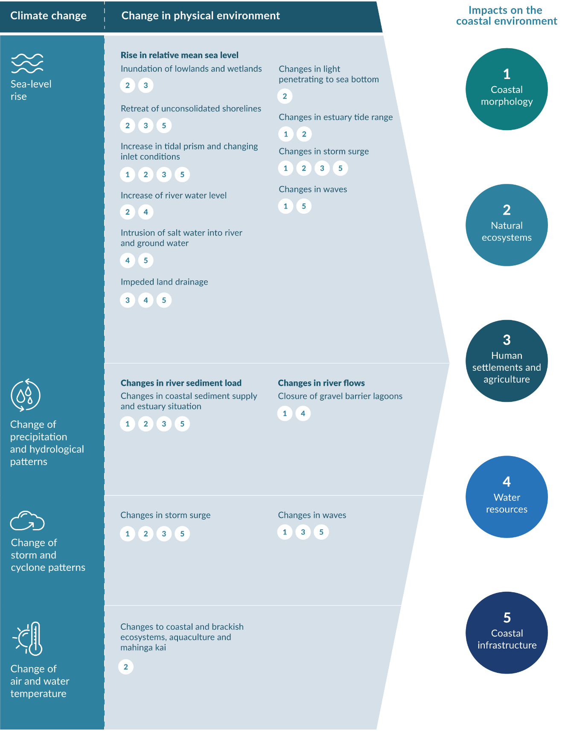
Note: Tide range may change in estuaries, harbours and lowland tidal rivers if sedimentation is not able to keep up with RSLR.
Source: Adapted from figure 13 of Bell et al (2001)
Climate change and SLR will not introduce any new types of coastal hazards, but they are changing the nature, magnitude, frequency and extent of the impacts. Furthermore, SLR and more frequent extreme events will cause compounding consequences that occur simultaneously more often and across several locations with cascading impacts. Additionally, in relation to coastal erosion and groundwater rise, SLR effects may continue to be masked for some time by other historical and future changes in sediment and watershed runoff from both anthropogenic interventions (eg, land-use change, catchment hardening, coastal protection structures, dredging, pumping) and compound effects of climate change on rainfall, waves and sediment runoff.
The NCCRA (MfE, 2020a) recognises the significance of possible cascading impacts (see figure 15 in step 4), for example, the risk of coastal erosion will affect multiple domains, including the natural and built environments, humans and the economy. Therefore, these hazards will increase the risks to coastal development and create risks not yet experienced in certain locations (eg, inland flooding). Coastal environments often experience hazards in other forms, particularly river flooding, which is compounded by tidal influence and SLR. Local government needs to consider multi-hazard assessments in these situations. Identifying cascading impacts can result in a more holistic understanding of the consequences of climate risk and will result in the design of adaptation responses that are flexible yet robust under different future conditions (MfE, 2020a).
Figure 4 shows the levels of coastal flood exposure in different regions of Aotearoa. The highest building exposure is in Canterbury, Hawke’s Bay and Bay of Plenty. Waikato and Canterbury have the longest road network exposed.
Figure 4: Regional coastal flood risk exposure for a 1 per cent annual exceedance probability event locally on top of a 1 metre sea-level rise
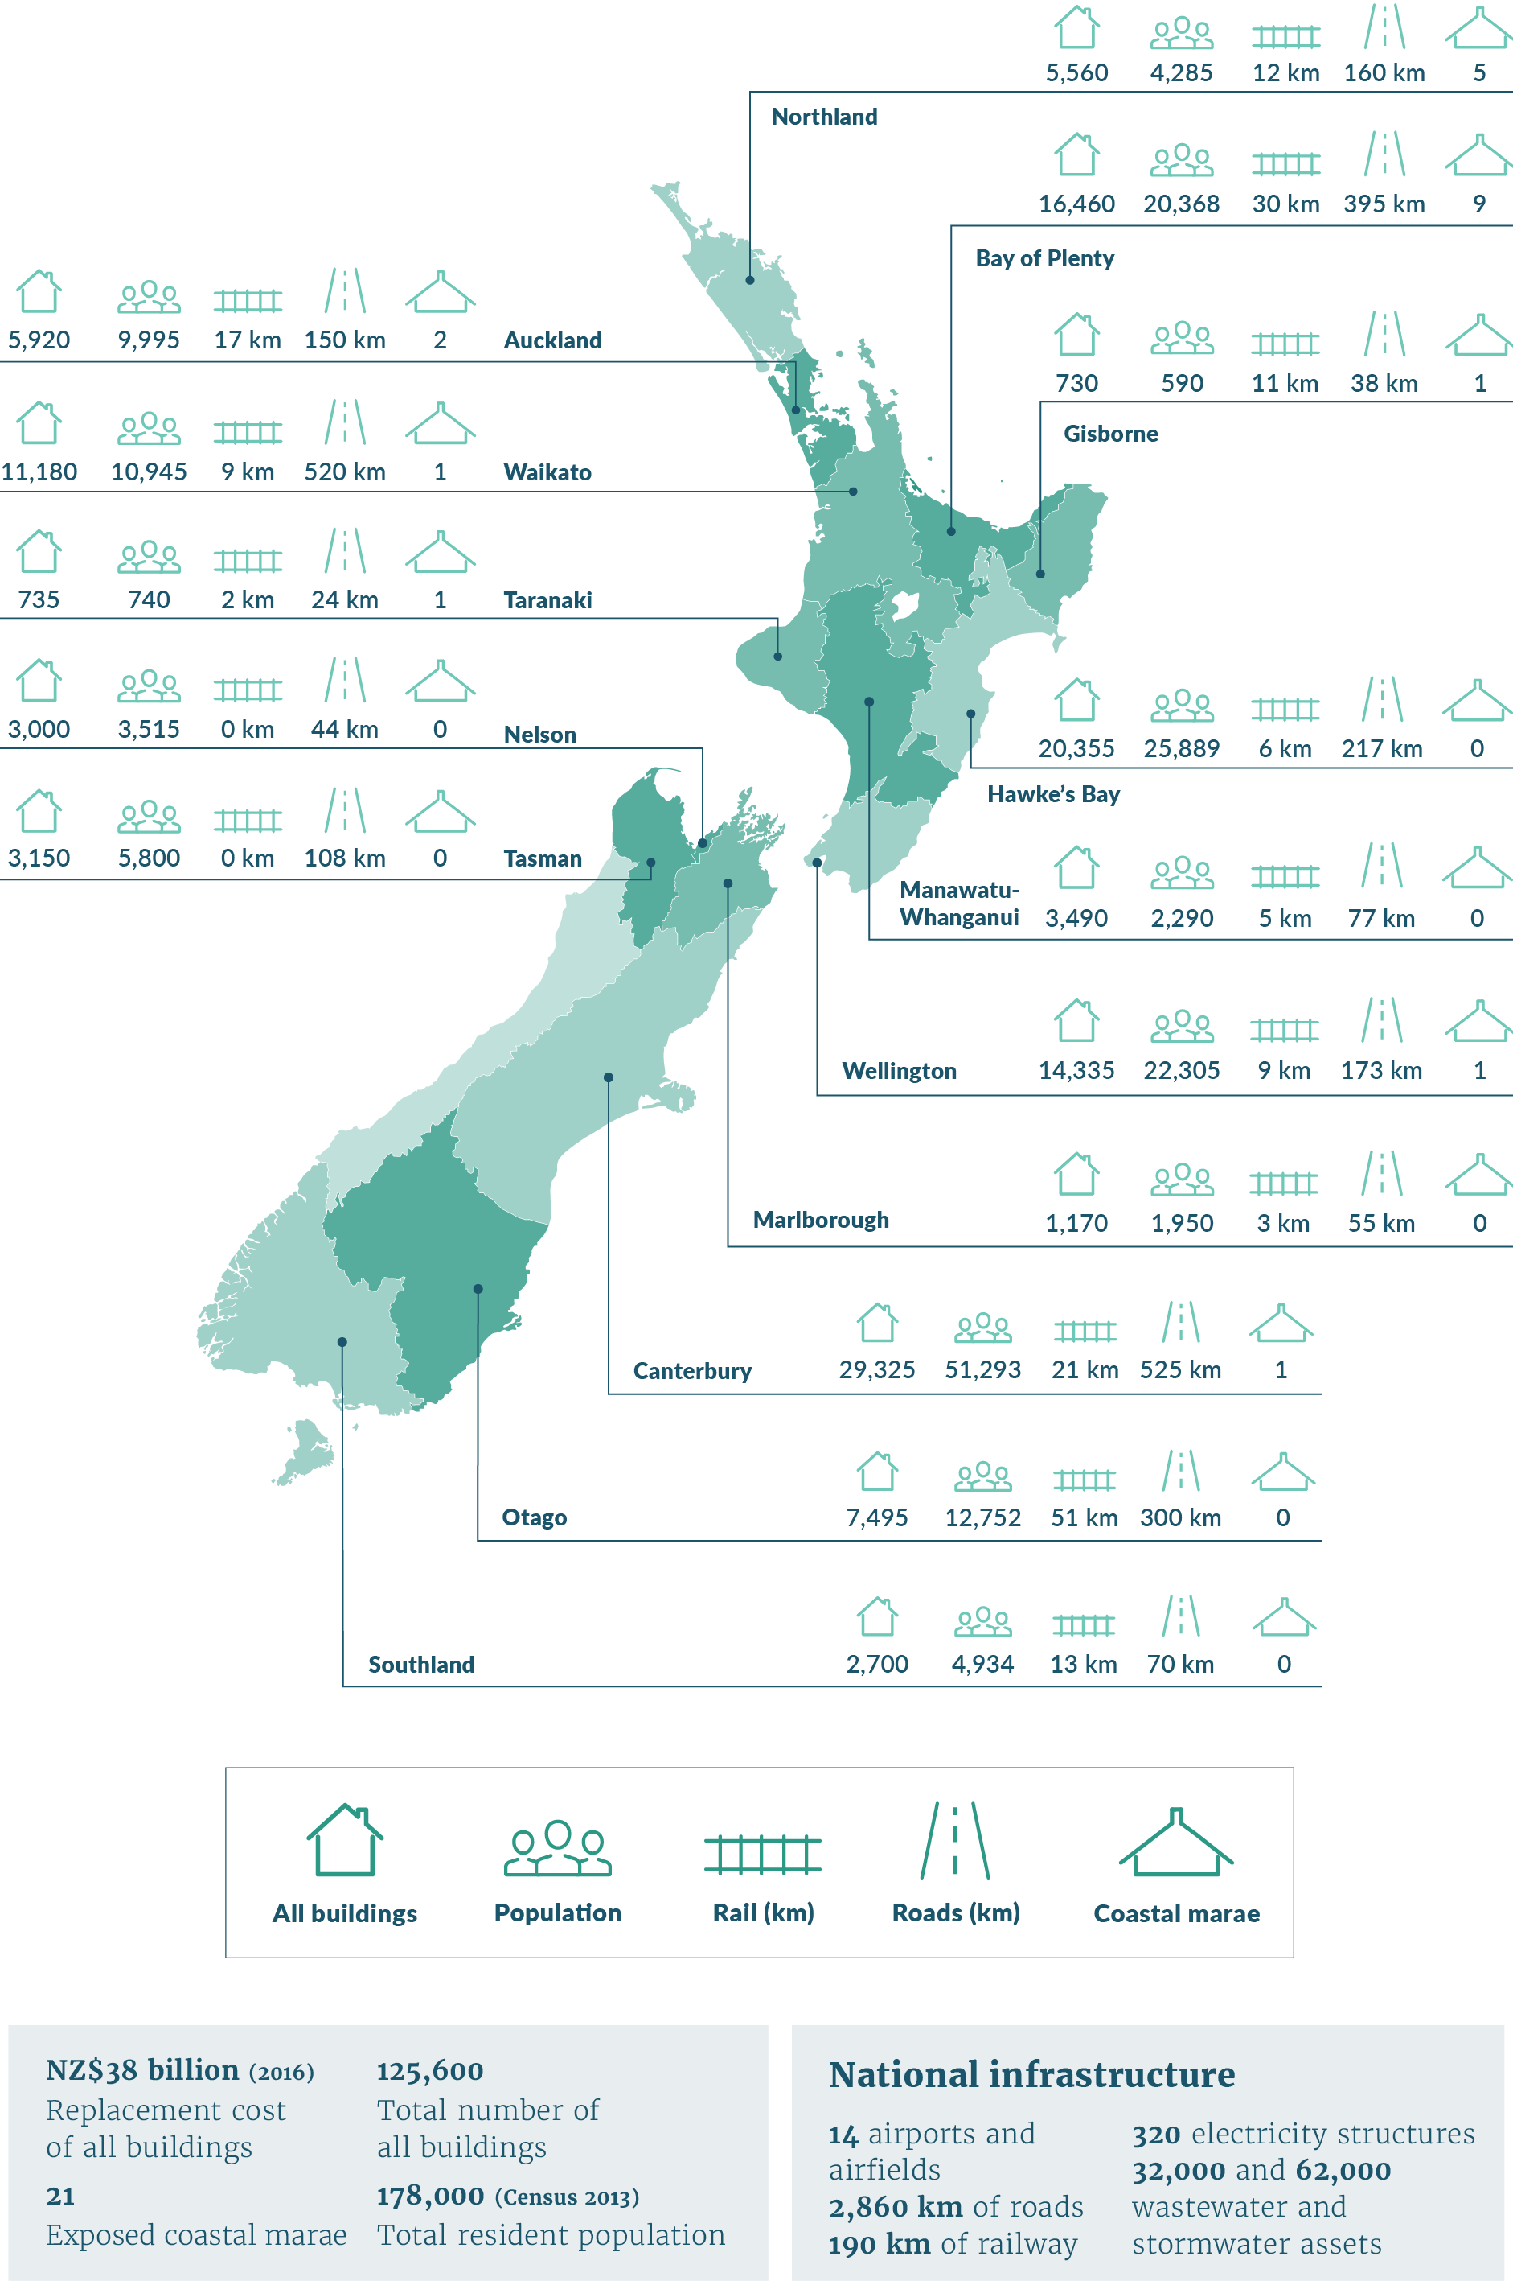
Note: A 1 per cent annual exceedance probability event has a 1 in 100 chance of occurring in any one year.
Source: Bailey-Winiata (2021), Paulik et al (2020, 2023)

Coastal adaptation and managing uncertainty
Despite our increasing understanding of Earth systems, the future remains inherently hard to predict, especially because there is socio-political uncertainty about the rate of global emissions reduction. The responses of ocean and ice environments to climate change have long lag times, their effect is progressive and ongoing but they are accelerating, and surprises cannot be ruled out. Some of these changes are already being observed. Dealing with this uncertainty is central to this guidance.
Regardless of emissions reductions, ongoing SLR is certain and projections are a way to understand how different emissions scenarios may impact in future. Out to 2050 there is a comparatively narrow range of SLR of 0.2 metres to 0.3 metres, but this range increases when we look out to the end of the century to 0.4 metres to 1.2 metres and beyond, with deep uncertainty on the rate, timing and magnitude of SLR. Deep uncertainties also exist about the pace of changes to bio-physical systems (eg, impacts of ocean heating and polar ice-sheet instabilities), as well as future socio-economic change and its effect on mitigating global emissions.
Making decisions under uncertain conditions will always involve judgements based on the available knowledge and appraisal of a range of projections. Not acting in the face of deepening uncertainty also involves considerable risk. Instead, uncertainty needs to be accounted for by considering a wide range of plausible future conditions in developing an adaptive planning strategy.
Compounding and cascading coastal hazards introduce increased risks to coastal locations. Assessments and mapping of coastal hazards can inform communities and iwi/hapū partners of the extent of those impacts and what values would be affected. Following the initial steps in the 10-step decision cycle, a risk assessment should be carried out and an associated adaptive planning strategy developed and implemented. This may go beyond standalone climate change risk assessments that are being developed by councils, with this guidance providing best practice for coastal hazard assessments and engagement with communities, iwi/hapū partners and stakeholders. This assessment should take community and iwi/hapū values into consideration, and then integrate vulnerability assessments with the risk assessments into the adaptive planning strategy.

Risk-based approach
The ISO international adaptation standards (ISO, 2019, 2020, 2021) set out a consistent, globally accepted framework for climate-related risk assessments and managing identified risks. The focus is on time-varying consequences (exposure and vulnerability), depending on assessment of the climate-driven hazards.
In practice, the focus should be on:
‘testing’ adaptation responses to climate change against plausible future shared socio-economic pathway (SSP) scenarios and RSLR projections, and the resulting coastal hazards and risks and progressive changes, and then
evaluating and making decisions on pathways to reduce or avoid risk
‘stress-testing’ to anticipate the potential impact of surprises and unknowns, especially elements of place-based risks with high uncertainty from compound hazards and cascading impacts (Logan et al, 2023).
Understanding changing risk over time (see figure 7) is central to adapting to climate change related coastal hazards. Existing risks will continue to rise, and new compounding and cascading risks will emerge over a wider area.
Improving the capacity to adapt will require a shift from a reactive to an anticipatory regime. The aftermath of natural hazard events can be an opportunity for adaptation. However, this means the community will experience considerable damage first. This could make it challenging to make adaptation decisions with long-term planning horizons that can anticipate consequences of extremes and progressive impacts. Building adaptive capacity should enable our communities to avoid or become more resilient to coastal risks.

Adaptation for coastal hazards
In human systems, adaptation is the process of adjusting to the actual or expected climate and its effects, to moderate harm or exploit beneficial opportunities. It addresses a changing state in the climate and its impacts that manifest in uncertain and dynamic ways and cannot be predicted over the long term.
Some types of change can be adapted to by making incremental adjustments to the way the coastal environment is managed. Other types of change may require completely new ways of doing things, including transformational social and physical adjustments that change the fundamental attributes of natural and human systems (IPCC, 2014a).
In this context, it is important to consider the potential for maladaptation. These are actions that may unintentionally lead to an increased risk of adverse climate-related outcomes through greater exposure when adaptation actions fail. An increase in residual risk may also be created by shifting risk to others in space and time, increasing greenhouse gas emissions, increasing vulnerability to climate change and reduced wellbeing, now or in the future (MfE, 2020a).
Although the appropriate location, form and design of new development in the right places can contribute to future-proofing our communities, many are already under threat from natural hazard events and coastal flooding from ongoing SLR, which will increase over time. Successful adaptation to the impacts of natural hazards and climate change will be vital to the future health and wellbeing of our communities.
In our existing places, people and councils can work together to avoid and reduce risk through a range of adaptation measures to help better prepare for extreme, ongoing and progressive climate change impacts. It is worth noting that adaptation in coastal situations differs from adaptive management, a mechanism sometimes included in resource consent conditions, where decisions can become locked in until they fail. Adaptive management is typically applied to ecosystems, water allocation and water quality, and can have the potential to create avoidable outcomes without considering the dynamic and worsening outcomes from climate change.
Under the conditions of a changing climate, protect and accommodate adaptation measures are increasingly becoming transitory because of physical, economic, social and cultural limits. This means councils and communities should not rule out the full range of adaptation options for areas under threat in recognition that the different options have limits to their effectiveness over time (MfE, 2022a).
Several different types of adaptation options are available (see figure 5).
Avoid: Stops people and assets being put in high-risk locations. This primarily uses land-use planning measures, spatial planning and adaptive management of assets and services.
Accommodate: Stay in place and make changes to buildings and infrastructure to improve resilience and work around the increasing risk. For example, raising floor levels or roads, building relocatable houses, setting minimum build levels, and providing alternative inundation flow paths. Provide room for beach or shoreline change processes and ponding of intertidal areas further inland.
Protect: Stay in place and manage the hazard by defending the shoreline. For example, maintaining or enhancing natural buffers (dunes, estuaries – see box 12), hard structures (seawalls, rock revetments), soft engineering (renourishment, geotextile, sand tubes), tidal gates, pumps, and planting vegetation to support land accretion.
Retreat: Permanent removal or relocation of existing habitation (people and buildings), assets and services from the coast in a planned, staged and managed approach over time. Also applies to ‘managed realignment’ by deliberate breaching or removal of causeways or flood banks to allow wetlands and marshes to migrate further inland (Allan et al, 2023).
Each type of adaptation option has different lifetimes and will have different performance limits. In general, avoidance strategies should be considered first in coastal settings, to ensure that protect and accommodate options do not become the default approach without consideration of the known ongoing and progressive risk from SLR and storm surge.
In practice, a variety of options should be considered, and the option chosen depending on the local circumstances, for example, in areas of significant existing development. Only avoidance and retreat strategies provide permanent reduction of risk.
Figure 5: Types of adaptation options and actions
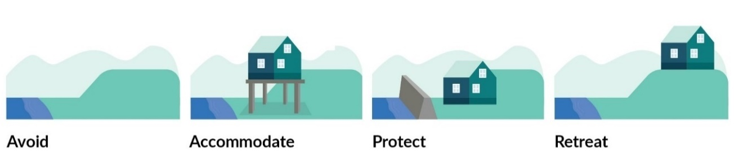
A suite of different options and actions are often necessary depending on the location and type of coastal geomorphology, and the combination of adaptation options used will change over time. The most appropriate adaptation options will be different for every community or project. A place-based and risk-based approach should help to meet the specific needs and circumstances of the community and the council to ensure robust outcomes are well supported and understood by the community.
Adaptation is now an integral part of climate change policy worldwide. The level of adaptation needed will be largely defined by the future development of the world’s economy, energy use, global land-use patterns, population growth and the resolve to swiftly reduce greenhouse gas emissions. This is because these dictate the amount of additional warming we will experience, as well as the rate of mass loss of the Antarctic ice sheet, the supporting sea ice, warming of the oceans and incidence of extreme weather events. Furthermore, ‘deep’ uncertainty exists through the lack of scientific understanding of the processes that determine the rate of ice-sheet loss. The biggest uncertainties in SLR projections relate to:
the emissions pathway that eventuates
polar ice-sheet dynamics and instabilities
relative SLR vertical land movements (including earthquakes).
Regardless of what we do now, however, SLR will continue for at least several centuries (Fox-Kemper et al, 2021). While reducing emissions will slow down the rate and limit the amount of SLR, this will occur over long timeframes. The scale, extent and impact of the increasing coastal risk will be unprecedented across Aotearoa (see box 1). Figure 6 also shows an example of adaptation options in an evolving and shrinking adaptation space and demonstrates why we need to adapt.
- : COASTS POSE A SPECIAL CASE FOR ADAPTATION
Coastal hazards pose a distinctive and severe adaptation challenge for decision-making because they deal with both progressive and ongoing sea-level rise (SLR), as well as increased frequency and magnitude of extreme events (IPCC, 2022). Coastal hazards are also exacerbated by other historical and future changes in sediment and watershed runoff from both anthropogenic interventions (eg, land-use change, protection measures, dredging) and increasingly, the compound effects of climate change on non-SLR processes (eg, rainfall, waves and sediment runoff). These hazards will occur earlier where rates of relative SLR are locally higher (land subsidence), and will reach higher levels if low likelihood, high-impact outcomes associated with collapsing ice sheets occur.
Making decisions about responses to progressive climate change impacts differs from decisions made regarding many other issues. These differences relate primarily to the irreversibility of SLR and the rate, magnitude and scope of ongoing impacts. These differences will also vary regionally and locally in Aotearoa New Zealand, creating unequal impacts on communities (LGNZ, 2016b). If the risk is underestimated, the consequences will be severe with lasting social, cultural and economic effects. If the risk is overestimated for a specific timeframe, using relative sea-level rise projections based on higher emission scenarios, this will be temporary (decade to multi-decadal timescales). This is because sea level will continue to rise, even as emissions are reduced, and it is only a matter of time before the adaptation threshold is reached for those exposed to the risk. While overestimation places costs today, the observed and increasing climate change impacts mean both current and future generations are, and will be, paying the costs. It is also important to consider how the costs and risks experienced by future generations may be affected by decisions taken today.
Decisions that avoid or reduce exposure to future risks can minimise intergenerational risk transfers (which may manifest in the form of increased local authority rates, higher premiums or withdrawal of insurance). Ignoring these considerations is likely to create new or intensify existing inequalities and shift the burden to the welfare state and taxpayers (Handmer, 2008).
There is already committed SLR, due to heat stored in the oceans and future ice sheet response to historic greenhouse gas emissions. Impacts are being observed now from past emissions, and near-term risks are projected to emerge well before 2050 (Levy et al, 2023; Stephens et al, 2018). The ability to adapt to current coastal impacts, to cope with ongoing and increasing coastal risks, and to curtail acceleration of SLR beyond 2050 depends on near-term and ongoing mitigation and adaptation actions. But there are limits to adaptation in the face of progressive SLR, which, over time, will be existential for many ecosystems and human systems.
Limits to adaptation
As protection becomes unaffordable and the limits to accommodation become obvious, planned relocation and retreat may become the only way to address the impacts of inevitable flooding in low-lying coastal areas. This makes SLR a particular challenge for adaptation. Figure 6 demonstrates this as an evolving and shrinking adaptation space as the sea rises. The risks associated with maladaptation should also be considered.
Adaptation options that have a limited life can potentially lead to lock-in of people and their communities and ‘permanent’ buildings and infrastructure, making it harder to change policy and measures as the sea advances. Temporary adaptation options like seawalls, filling land or raising buildings above flood levels may buy time if they can be implemented quickly, but they can entrench development and limit access to communities, making it harder to transition to options like managed retreat, while also increasing ongoing adjustment costs. Planning methods to mitigate the risk of lock-in and limited life to adaptation measures should be developed and implemented as part of an adaptive planning strategy. Responses are more effective if combined and/or sequenced, planned well ahead, aligned with sociocultural values and development priorities, and underpinned by inclusive community engagement processes (IPCC, 2022).
Considering both short- and long-term adaptation needs, including beyond 2100, can reduce adverse consequences and inequitable losses and damages to vulnerable people and communities.
Figure 6: Evolving and shrinking solution space to address sea-level rise
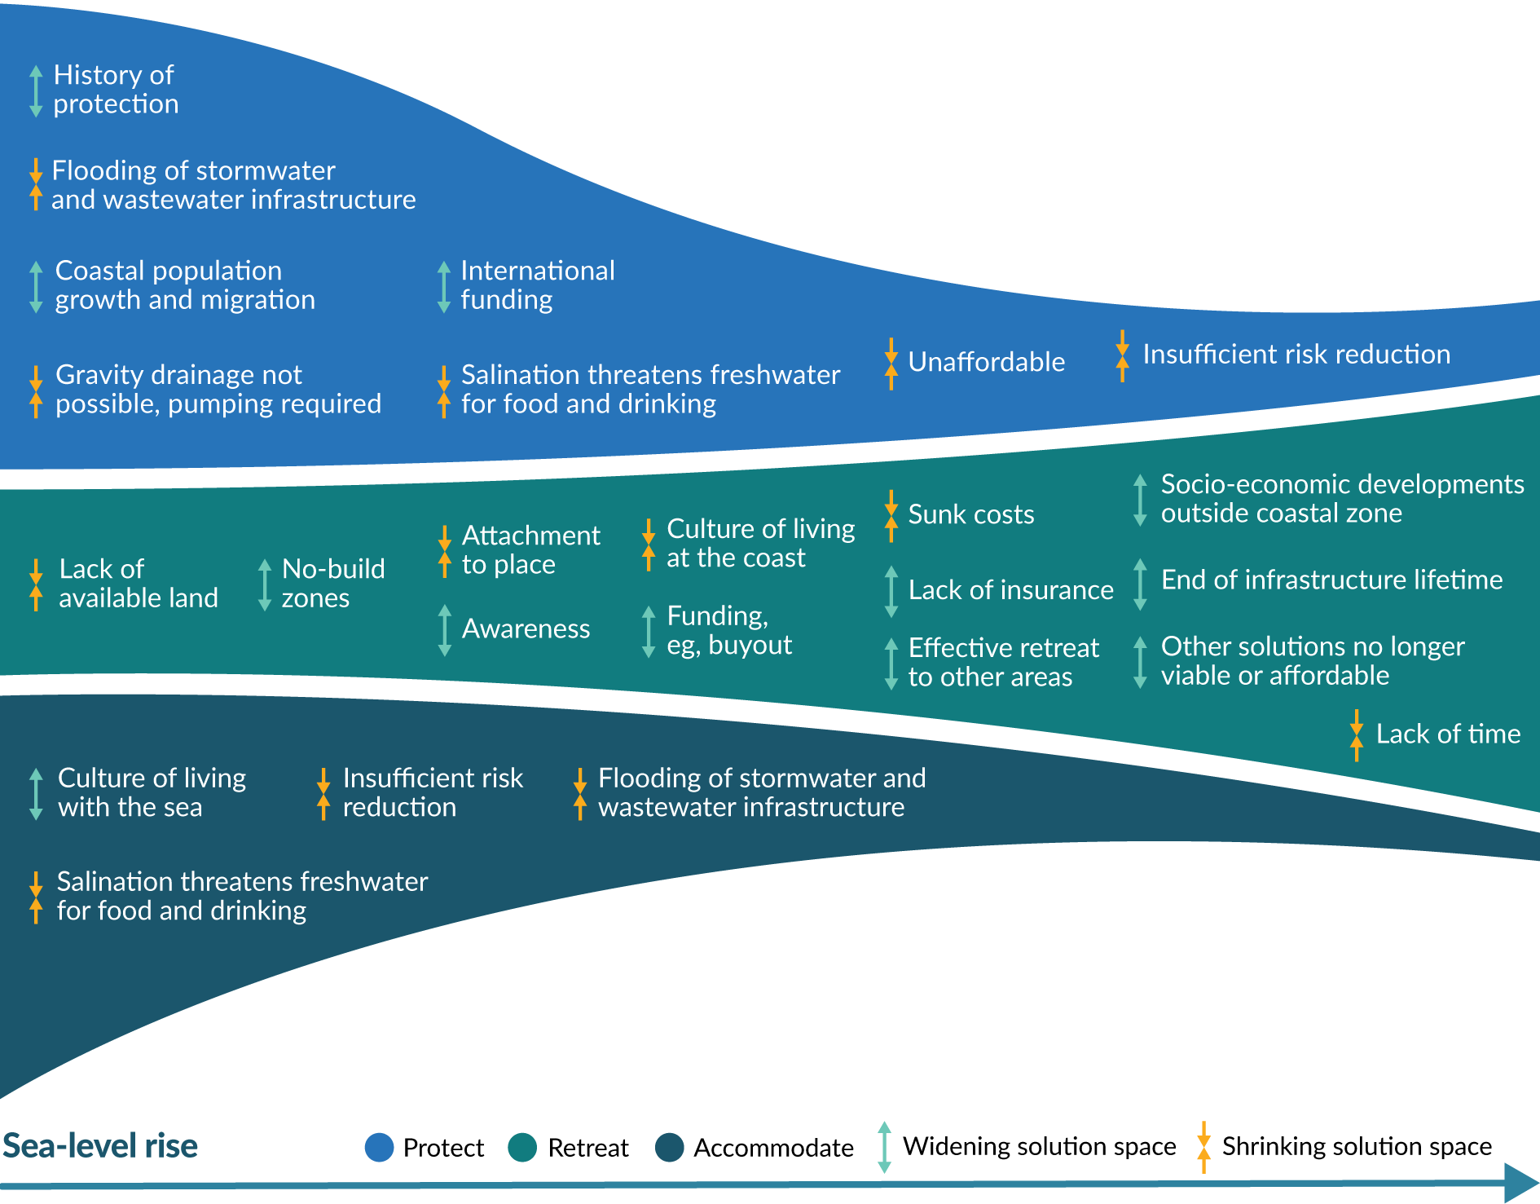
An illustrative example of adaptation options in an evolving and shrinking adaptation space. Different drivers and hard and soft limits shape this space. The figure highlights: 1) a narrowing of the adaptation space as a whole and, 2) a change in the ratio between the three adaptation strategies, with retreat becoming dominant. This will apply differently for different coastal types due to local contexts.
Source: Adapted from Haasnoot et al (2021)

Dynamic adaptive pathways planning
To help local government and communities make decisions when the magnitude and rate of SLR is uncertain, we recommend using the ‘dynamic adaptive pathways planning’ (DAPP) approach for developing adaptive planning strategies. This approach is anticipatory rather than reactive, and it can help avoid decisions that are inflexible and costly to change. Further information on DAPP, and how to do this, can be found in step 5, box 11, appendix A.9 and appendix C. Monitoring the performance of the adaptation actions and options as sea levels continue to rise enables the implementation of different combinations of actions and pathways as needed by the community, councils and infrastructure providers, and, therefore, should start as soon as possible.
Such planning can take the form of a series of interlinked potential pathways to meet community and council objectives (figure 7). The plan is monitored for signals that warn a change is occurring. A predetermined trigger then indicates that the objectives may soon fail to be met and need to be re-evaluated. A decision then needs to be made about whether a change in course is needed to continue to achieve the objectives and avoid reaching an adaptation threshold. The predetermined trigger needs to be designed with sufficient time before the adaptation threshold for new adaptation measures is implemented. Note that while figure 7 includes ‘advance’ as an adaptation option this is drawn from an international example. Advance should be rarely considered an adaptation option in the Aotearoa context (reserved for infrastructure and ports) because reclamation is a discouraged activity under Policy 10 of the NZCPS (DOC, 2010).
Figure 7: Generic adaptation pathways for coastal cities and settlements to sea-level rise
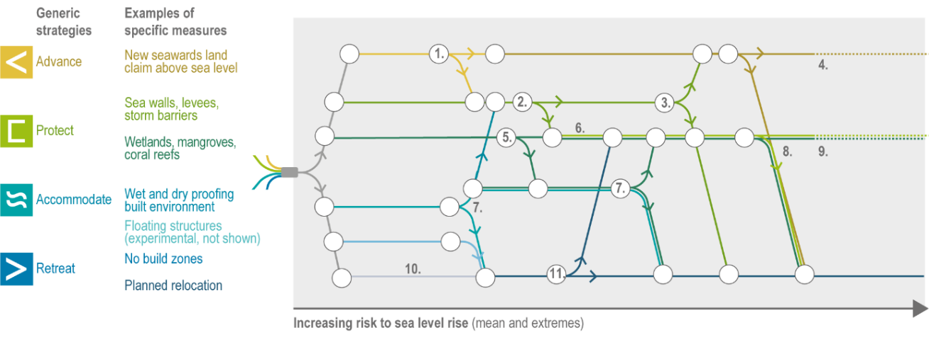
1. Successful pilot, lack of development space triggers advance, or protect due to lack of support, time or finance.
2. Preference for nature-based solutions.
3. Unaffordable, salinisation, pumping limit, lack of support.
4. Unaffordable, pumping limit, lack of time, support, knowledge, material.
5. Warming, limited space, human pressures, frequent flooding require additional measures.
6. Hybrid strategy.
7. Frequent flooding, flooding creates access problems.
8. Warming, limited space, human pressures, frequent flooding.
9. Unaffordable, salinisation, pumping limit, lack of support.
10. Long lead time to align with social goals and ensure just outcomes.
11. Lack of acceptance and equity triggers shift.
Source: IPCC AR6 WGII Cross-Chapter Paper 2: Cities and Settlements by the Sea (Glavovic et al, 2022, figure CCP2.4a)

Preparatory tasks for developing a coastal adaptive planning strategy
Table 3 summarises the main preparatory tasks for developing an adaptive planning strategy for coastal hazards and the effects of climate change.
- Preparatory tasks for developing a dynamic adaptive pathways planning (DAPP) strategy
Tasks | Description
Establish a multi-disciplinary team and agree on the best way to work together. | Establish an early and preliminary mandate for the adaptive planning strategy.  Decide on project management, preliminary resourcing and governance arrangements in the preparation stage, before you begin DAPP.
Establish the scope, context and objectives. | Identify the scope of relevant coastal hazards that will be included in the adaptive planning strategy and objectives for the project (eg, all coastal hazards, or only some, for all or some of the areas at risk, scale, extent). The scope may be informed by the extent of low-lying coastal areas, areas of potential groundwater rise and drainage effects, previous hazard events and reports, and multiple hazards.  Collect available, relevant information (eg, hazard data, demographics, social and environmental processes, monitoring data, relevant plans and policies, iwi management plans, topographic data and aerial imagery).
Agree how your team will engage with iwi/hapū. | Partner with mana whenua early to weave in te ao Māori perspectives. Engage from the beginning with mana whenua and other communities for transparency and to build trust.
Agree how your team will engage with the community and stakeholders. | Decide who you will engage with and how you will engage with them. Engage early with the wider community for best results. This may inform the scope and objectives of the project.  Provide a space for open and confidential deliberation to understand the practical issues of creating resilience.  Seek out local knowledge, experiences and observed changes, mātauranga Māori, and what people value about the area.
Agree on the approach and mobilise resources. | From the contextual information, decide on the overall approach for the DAPP; hazard, risk and vulnerability assessments; and the adaptive framework.  Develop a case for the project within and among council partners, confirm mandate and secure funding.  Develop a work programme.
Source: Adapted from Glavovic (2021)

Building a team
A multi-disciplinary team will be necessary to implement the 10-step decision cycle. A wide set of expertise, skills, knowledge and information will be required due to the pervasive nature of the impacts and implications within the community and across many local government functions and different sectors (eg, utilities, infrastructure, insurance, banking and so on, table 4).
Important considerations include:
the sort of leadership, integration and relationship management and engagement (enabling) skills required
necessary core knowledge (eg, technical expertise, planning and policy, infrastructure, iwi/hapū knowledge, social science techniques, engagement and possibly independent facilitation skills)
the networks and linkages that can be drawn on or established to access skills and knowledge the team requires but does not possess (eg, coastal biodiversity expertise or coastal sedimentation or erosion expertise).
- Skills, disciplines and knowledge sets to consider in an adaptation team
Considerations | Description
Enabling skills | Leadership, integration across portfolios, engaging with the public, strong iwi/hapū relationships and links.
Knowledge sets | Coastal management, coastal hazards, planning and policy, civil defence and emergency management, legal, economics, community engagement, facilitation, iwi/hapū engagement protocols and/or representatives, Indigenous knowledge like mātauranga Māori, biodiversity, roads and transport, asset management, reserves and parks, hydrology (includes groundwater), engineers, surveyors, adaptation specialists, science communicators, emergency response organisations, cross-organisational governance and monitoring expertise.
Access to networks and links | Historical information, institutional knowledge.  Access to networks and liaison with important businesses, industries, utility and infrastructure providers, other local authorities, iwi/hapū groups, local community representatives, Insurance Council of New Zealand, Crown research institutes (eg, GNS Science, National Institute of Water and Atmospheric Research, Manaaki Whenua – Landcare Research) and private and public property owners.  Important individuals and groups who are strongly networked with the core team.
Te Tiriti o Waitangi and te ao Māori | Working in partnership with and resourcing Māori, elevating te ao Māori and mātauranga Māori, and planning for Māori, by Māori is central to the country’s response to climate change (Community-led retreat and adaptation funding: Issues and options (MfE, 2023a)).
Source: Modified from the Irish Local Authority Adaptation Strategy Development Guideline (Gray, 2016), the Ministry for the Environment’s first national adaptation plan (MfE, 2022a) and the Rauora Framework (Ihirangi, 2021)

Step 2: Assess sea-level rise and coastal hazards
This entire section has been substantially revised, compared with the 2017 guidance, to incorporate the updated Intergovernmental Panel on Climate Change (IPCC) 2021 sea-level rise (SLR) projections as set out in the Interim guidance on the use of new sea-level rise projections (MfE, 2022). This 2024 guidance is largely consistent with the interim guidance, and, regardless, it is critical local authorities follow the national adaptation plan (MfE, 2022a) with regard to these issues.
This section recommends new relative sea-level rise (RSLR) projections out to 2150, which are available from the NZ SeaRise platform with and without vertical land movement (VLM) rates. The projections cover a range of plausible future trajectories of the rise of mean sea level (MSL) for Aotearoa New Zealand. These RSLR projections or increments of RSLR heights (eg, 0.1 metre or 0.2 metres) are used as input into hazard and risk assessments (step 2 and step 4) and inform the development of dynamic adaptive pathways (step 5 and step 6) that enable timely adaptation to the range of plausible futures.
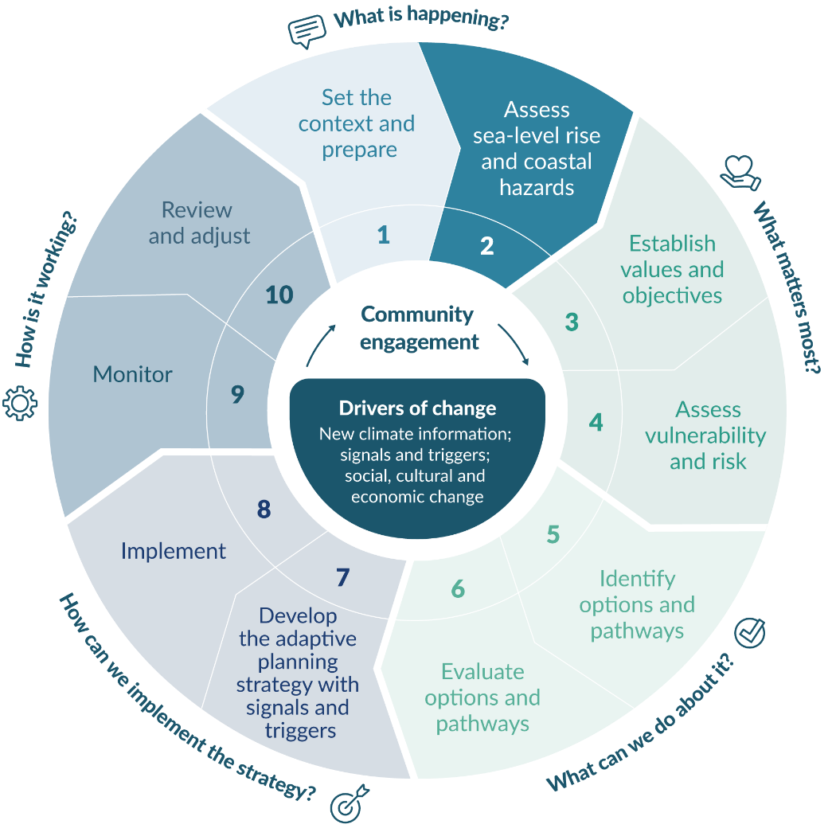
Until an adaptive planning strategy is developed for a location or region, interim precautionary RSLR allowances are provided for different categories of land-use activities for use in plan updates.

Assessing sea-level rise

Current and projected sea-level rise

Measured sea-level rise
After centuries of relative stability, SLR in Aotearoa started around 1900 (Clement et al, 2016; Gehrels et al, 2008; Gehrels and Woodworth, 2013). Figure 8 shows the changes in annual local MSL at the country’s four main ports. The underlying rise in past and future sea level is masked by climate and ocean variability on yearly and decadal timescales. Long records of MSL are necessary to assess SLR and its acceleration, which exist for our four main ports and Moturiki. Splitting the record into approximately two equal periods of 60 years shows a doubling in the rate of SLR around the Aotearoa coastline since 1960.
Figure 8: Change in annual mean sea level for the four main ports and Moturiki between 1900 and 2020, spliced with a range of New Zealand averaged sea-level rise projections based on shared socio-economic pathway scenarios to 2050

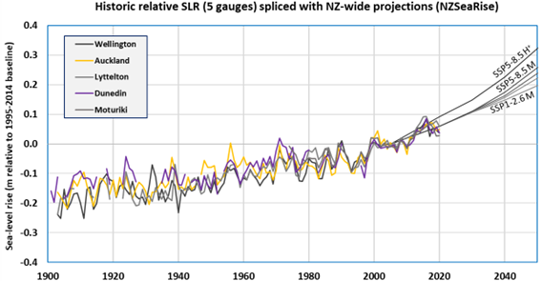
Note: Annual sea level for each gauge site is relative to the mean sea level to a local land datum, averaged from 1995 to 2014 (period used for the Intergovernmental Panel on Climate Change Sixth Assessment Report (IPCC, 2021) and NZ SeaRise projections, with mid-point at 2005). Accurate sea-level measurements are only possible a few kilometres offshore (which excludes near-shore effects on coastal sea level) due to the land-shadow effect on the altimeter signal. See section A.3.3 of Climate change, sea-level rise and coastal hazards science: Coastal hazards and climate change guidance – Supplement A for more commentary.
Source data: Stats NZ coastal sea-level rise marine indicator series (http://www.stats.govt.nz/indicators/coastal-sea-level-rise) combined with sea-level rise projections from a central location (± 0.025 metres by 2130 across New Zealand) from the NZ SeaRise platform without including vertical land movement (NULLhttp://www.searise.nz/maps-2).
Sea level rose 0.21 metres on average across Aotearoa between 1901 and 2020, which explains why low-lying areas are already experiencing an increased incidence of coastal flooding (see box 2). Ongoing SLR will cause more frequent flooding before mid-century, with very high confidence (Lawrence et al, 2022). As sea level continues to rise, so does the scale and frequency of adaptation interventions.
- : Role of sea-level rise in INCREASING coastal flood events in Auckland and HAURAKI
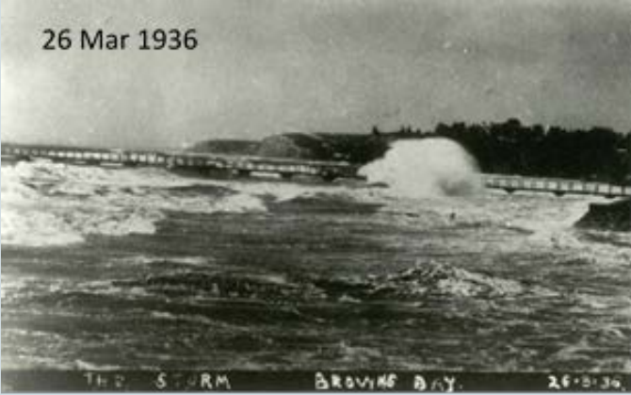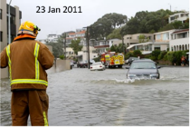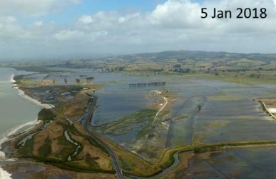
Photos (from left to right): Browns Bay Wharf, Auckland. Kohimarama (Mission Bay), Auckland. Firth of Thames, Hauraki Plains.
In Auckland, the highest storm-tide level on record for the 20th century occurred on 26 March 1936. A cyclonic low-pressure storm generated a storm surge, coinciding with a perigean spring or ‘king’ tide. Some coastal flooding occurred, and waves severely damaged the Browns Bay Wharf. History repeated on 23 January 2011 (photo at left) when ex-tropical cyclone Wilma arrived after a perigean spring tide, leading to damaging coastal inundation of low-lying areas of Auckland.
Both storms were ‘1 in 100-year’ events (1 per cent annual exceedance probability), but the 2011 event was 0.13 metres higher than in 1936, causing deeper coastal flooding. Most of the difference in peak water level between these similar storms is attributable to the 0.12 metre rise in mean sea level over the intervening 75-year period.
A similar situation occurred in the southern Firth of Thames. On 4 May 1938, coastal flooding of the Hauraki Plains caused extensive damage. Subsequently, the coastal stopbank was raised. Eighty years later, on 5 January 2018, the storm tide and wave setup came close to overtopping the stopbank system along the southern Firth coastline but did result in extensive flooding in the Kaiaua/Wharekawa and Te Puru areas (photo at right). The intervening rise in mean sea level since 1938 was a contributing factor.
As mean sea level continues to rise, coastal flooding will become much more frequent and episodically deeper for low-lying coastal areas.
Sources: Tide gauge data (Ports of Auckland Ltd, Auckland Council); Barnett (1938); Marsh et al (2020); Climate change, sea-level rise and coastal hazards science: Coastal hazards and climate change guidance – Supplement A.
Photos: (left) B Eitelberg; (right) Farmers Weekly (http://www.farmersweekly.co.nz/news/sea-threat-arrives)

Updated climate scenarios
The cornerstone of this guidance is the use of SLR projections derived for climate change scenarios in hazard and risk assessments, district and regional plans and adaptation planning. Scenarios are not ‘predictions’ but rather a description (narrative) of how different futures might unfold, and they can be used to stress-test adaptation options, dynamic adaptive pathways, plans or strategies. They can help inform the development of objectives and policies and inform the effectiveness (or otherwise) of risk management strategies, including any lock-in dependencies relying on a single type of option.
Scenarios allow communities, iwi/hapū and stakeholders to explore questions like “What can happen?”, “When might an adaptation threshold be reached?” and then “What can we do about it?” that help illustrate impacts and options under a variety of climate-related outcomes.
For SLR, using projections across a range of scenarios with a dynamic adaptive pathways planning (DAPP) approach avoids a pre-selected estimate of sea-level change (and associated impacts) being invalidated. This is due to updated sea-level projections becoming available or conditions changing (eg, changes in VLM rates or polar ice-sheet responses). It is not possible to assign likelihoods (probabilities) of occurrence to any climate scenario, because these are narratives describing broad socio-economic trends (Horton et al, 2018, van de Wal et al, 2022). Therefore, SLR projections across a range of scenarios should be used.
The goal of working with climate change scenarios is not to predict or forecast the future. It is to better understand what might unfold under a consistent set of assumptions and associated uncertainties. This informs robust decisions for a wide range of plausible futures (Moss et al, 2010).
In 2021, the IPCC issued an updated set of global SLR projections (Fox-Kemper et al, 2021), based on new scenarios called shared socio-economic pathways (SSPs), which include socio-economic assumptions and changes that influence future emissions trajectories (see Climate change, sea-level rise and coastal hazards science: Coastal hazards and climate change guidance – Supplement A). The scenarios span a wide range of plausible societal and climatic futures, from a 1.5 degrees Celsius ‘best-case’ low-emissions scenario (SSP1-2.6) to over 4 degrees Celsius warming scenario (SSP5-8.5) by 2100 (Chen et al, 2021). Even for the low-emissions scenario (SSP1-2.6), average SLR around Aotearoa could exceed 1 metre soon after 2200 (table 6).
The IPCC Sixth Assessment Report (AR6) SLR projections include two sets labelled medium confidence (out to 2150) and low confidence (out to 2300) (Fox-Kemper et al, 2021; Kopp et al, 2023; Slangen et al, 2022). The medium confidence projections across four SSP scenarios form the basis of the SLR projections used in this guidance.
A more limited set of low confidence projections by IPCC, uses a probabilistic ensemble that also includes two land-ice contributions from the Antarctic ice sheet and a structured expert judgement process. Low confidence projections represent the upper range of plausibility, but “cannot be ruled out” (IPCC, 2021, p 317). They can be used to further stress-test new, long-lived development along the coast and provide assurance that managed retreat options involving moving to other coastal areas will not be compromised in the long term by ongoing SLR. They also convey the message that SLR will continue for centuries (beyond 2300) at a rate depending on how quickly and by how much global emissions can be reduced, and how quickly the Antarctic ice sheet loses mass (Turner et al, 2023).
General confidence in SLR projections has grown since the previous 2013–2014 IPCC Fifth Assessment Report projections (Fox-Kemper et al, 2021; Oppenheimer et al, 2019; Slangen et al, 2023) because of:
better understanding of the contributors to sea-level change
longer datasets and improved coverage of the oceans and ice environments
better agreement between the improved models and observations to date
further understanding of ice-sheet dynamics and their uncertainties (eg, Edwards et al, 2021; van de Wal et al, 2022).
It is important for councils and other users of this guidance to understand the methods for deriving future SLR projections, so they have assurance in their application here in Aotearoa.
Climate change, sea-level rise and coastal hazards science: Coastal hazards and climate change guidance – Supplement A has more in-depth information on the science behind the SSP scenarios and SLR projections. We encourage practitioners to read this supplement for more assurance in their assessments and to help address questions during community engagement.

Climate scenario-based sea-level rise projections
It is recommended to use the updated medium confidence scenarios and their associated SLR and RSLR projections out to 2150 to cover the range of plausible coastal futures (see list below). They are derived from the same modular-based framework used for IPCC AR6 projections (Kopp et al, 2023; Naish et al, in review; Slangen et al, 2022), but include climate-ocean responses, earth crustal and gravitational changes and VLM rates around Aotearoa (Levy et al, 2023; Naish et al, in review).
Five representative SLR projections, derived from four SSP scenarios and their associated local RSLR projections (by adding VLM), are recommended for use in this guidance. These five projections cover a range of combinations of processes (Kopp et al, 2023) that contribute to SLR (eg, glaciers, ocean heating, land water storage changes, ice sheets) across four plausible climate and socio-economic futures (represented by SSP scenarios). From the ensemble of thousands of simulations of different combinations of processes that contribute to SLR (and locally RSLR) within the Framework for Assessing Changes to Sea-level (FACTS framework) (Kopp et al, 2023), each SSP scenario is represented by various percentiles of simulated SLR projection time series that make up the full ensemble of possible combinations.
This guidance recommends using four estimates based on the median value (M), which represents the 50th percentile (p50 in the NZ SeaRise platform), and the middle of the likely range, for each RSLR projection. An additional estimate based on the upper-bound of the likely range, the 83rd percentile (p83 in the NZ SeaRise platform) from the high-end emissions scenario SSP5-8.5 to represent H+ is also recommended. While the SSP5-8.5 H+ does not include the low confidence polar ice-sheet contributions, it represents a plausible upper range for RSLR to reflect the deep uncertainties associated with changes to future sea level.,
The SSP scenarios and associated projections (in bold) align with the 2017 guidance (in italics) as follows:
SSP1-2.6 M ⇔ NZ RCP2.6 M
SSP2-4.5 M ⇔ NZ RCP4.5 M
SSP3-7.0 M ⇔ n/a
SSP5-8.5 M ⇔ NZ RCP8.5 M
SSP5-8.5 H+ ⇔ NZ RCP8.5 H+.
A very low-end emissions SSP1-1.9 scenario included in the suite of IPCC AR6 projections (tied to achieving a global temperature at or below 1.5 degrees Celsius) is not used in this guidance but is available from the NZ SeaRise platform. While it provides an aspirational scenario for global greenhouse gas mitigation contributions, likely ongoing future SLR makes it less useful for planning coastal adaptation.
Box 3 outlines reasons for using the SSP5-8.5 scenario and associated SLR projections for coastal areas.
- : Should the high-end SSP5-8.5 scenario be used in coastal planning?
It is recommended to use the high-end emissions scenario SSP5-8.5, on which the median (M) and H+ (83rd percentile) sea-level rise (SLR) projections are based, in coastal planning to identify coastal areas potentially affected and allow high-end stress testing of adaptation options and pathways (step 6). This is to reflect that the world has been on a high emissions trajectory in the past few decades. This is also combined with the very long timeframes (multi-decadal to centuries) for SLR to respond to released emissions and the deep uncertainty about future emissions and tipping points. The SLR projections based on SSP5-8.5 represent a plausible upper range of these uncertainties, while not including the low confidence uncertainties associated with polar ice-sheet instabilities.
The long lag in response of SLR means impacts from the yet-to-be realised commitments to SLR from recent and ongoing emissions will be distinctly different compared with other climate impacts. This is because other climate impacts (eg, heatwaves, precipitation, wind and so on) are more directly tied to global heating and the associated shared socio-economic pathway scenarios. These latter climate impacts will be more responsive to reductions in global emissions within relatively short response times (decades), unlike sea level that will keep rising at a rate depending on the recent past, present and future emissions. Turner et al (2023) suggest that, out to 2500, ongoing SLR is now an irreversible process, unlike surface temperature that will reach equilibrium some decades after emissions peak.
The Intergovernmental Panel on Climate Change Sixth Assessment Report from Working Group III (Riahi et al, 2022, p 386) describes how reaching emissions levels as high as the SSP5-8.5 scenario has become less likely, but “high emissions cannot be ruled out for many reasons, including political factors” and “higher than anticipated population and economic growth”. Climate projections of SSP5-8.5 can also result from strong feedback from climate change, which means high-end projected climate impacts might also materialise while following a lower emission path (Riahi et al, 2022). For SLR, there is deep uncertainty on how these climate feedbacks will affect polar ice sheets once a tipping point is reached (ICCI, 2023). Overall, Riahi et al (2022, p 386), conclude that the high-end scenarios “can be very useful to explore high-end risks of climate change”. Ongoing SLR poses such risks for coastal areas.
It is important for decision-makers to understand and plan for the full range of possibilities Aotearoa New Zealand may face, especially in coastal environments (box 1). Using SSP5-8.5 (M and H+) for coastal hazard and risk assessment screening (step 2 and step 4) is consistent with council planning decisions needing to: i) implement other Resource Management Act 1991 requirements and policies, such as the precautionary approach (Policy 3, New Zealand Coastal Policy Statement, DOC, 2010); ii) identify areas ‘potentially affected’ by coastal hazards and climate change (Policy 24, New Zealand Coastal Policy Statement, DOC, 2010) and iii) have regard to the national adaptation plan (which also directs consideration of the same scenarios) (MfE, 2022a).
Even if the timing of a specific SLR height (up to at least 1.5 metres) for a SSP5-8.5 scenario is not realised, it will be reached decades or even centuries later for lower-emissions trajectories (see table 5) and should be planned for as a plausible eventuality. Dealing with this uncertainty using a dynamic adaptive pathways planning approach, means if higher than expected SLR eventuates, then the next option in the adaptation pathway can be implemented earlier than initially anticipated (or later if future emissions reductions are sufficient to slow the acceleration of SLR).

Using the recommended sea-level rise projections
It is best practice to use SLR projections for these main purposes:
as the primary input to hazard and risk assessments, along with projections for other climate drivers relevant to coastal areas (eg, rainfall intensity, surface and water temperature, changes in storminess)
for developing, evaluating and stress-testing district or regional plans and policies
for informing and evaluating the viability, effectiveness and lock-in potential of adaptation options and pathways using the DAPP approach (step 5 and step 6).
Guidance is provided in section 2.1.3 on recommended SLR allowances to use in the interim for decision-making, to be used prior to the development of an adaptive planning strategy. This is to be used until a clearer understanding of the risks, adaptation thresholds, timeframes and an agreed adaptive planning strategy emerges.
Two types of SLR are used for projections:
absolute (or eustatic) SLR, measured relative to the centre of the Earth, and related to the rise in ocean level
relative (or local) SLR (RSLR), which is the net rise in MSL from both: i) the absolute rise in height of sea level; and ii) local VLM. It is therefore the net rise in sea level relative to the local land surface or sea-bed elevation on which assets and people are placed.
The SLR projections in IPCC AR6 and in the NZ SeaRise platform have a new reference (zero) baseline (Fox-Kemper et al, 2021; Slangen et al, 2023). Projections are now referenced to the MSL from 1995–2014 (mid-point 2005). Appendix D has updated MSLs, averaged across this new reference period at several locations around Aotearoa. The relevant local or regional RSLR projections are then added to the relevant reference MSL, to calculate the range of future plausible MSL and coastal flood levels to the national New Zealand vertical datum (NZVD-2016).

Adjusting sea-level rise for vertical land movement
RSLR directly tracks the net SLR of the adjacent ocean, relative to any change in land elevation, and its effect on coastal hazards that should be adapted to locally or regionally. Subsidence of landmass is occurring in parts of Aotearoa (figure 9), which means including projections of RSLR is important for planning.
Sections of Aotearoa New Zealand’s coastal land that continue to subside will exacerbate the height and rate of SLR relative to the sinking land, even though the rise in absolute sea level is no different at the local level. Ongoing land subsidence (eg, the south of the North Island, see King et al, 2024) will bring forward the timing of when a specific sea-level threshold is reached locally, compared with stable or uplifting areas. Land that is uplifting locally or regionally (eg, parts of the Bay of Plenty) will experience a slower rise in the height of sea level relative to the rising land.
Box 4 describes the approach NZ SeaRise used to derive RSLR projections at 2 kilometre intervals around the coast of Aotearoa using satellite-derived VLM rates (figure 9).
- : NZ SeaRise Relative Sea-Level RISE projections
The NZ SeaRise research programme updated Aotearoa New Zealand sea-level rise (SLR) projections in May 2022 (Naish et al, in review). The NZ SeaRise method is based on the same ‘Framework for Assessing Changes to Sea-level’ (FACTS) framework that was used to generate the 2021 Intergovernmental Panel on Climate Change (IPCC) Sixth Assessment Report (AR6) global and regional SLR projections (Fox-Kemper et al, 2021; Kopp et al, 2023; Naish et al, in review). The NZ SeaRise projections combine the output from the probabilistic sea-level projection methodology used for the AR6 SLR projections for the seas around Aotearoa with vertical land movement (VLM) rates gridded from high-resolution interferometric synthetic aperture radar (InSAR) satellite measurements (figure 9). The result is projections at a 2 kilometre spacing across a range of plausible climate scenarios are now available for SLR and relative sea-level rise (RSLR) around the Aotearoa coast.
The VLM estimates are based on the analysis of historical InSAR observations collected by the European Space Agency’s Envisat satellite between 2003 and 2011 (Hamling et al, 2022). This period was used to reduce the temporal influences of recent major earthquakes on long-term rates, because it preceded most of the moment magnitude (Mw) >6 events that struck Aotearoa since late 2009. This inter-seismic rate (with an uncertainty band) was considered appropriate for the extrapolation of satellite-derived VLM used in the RSLR projections, because over the next 100 years the probability of a high-magnitude earthquake at any location with large local vertical land displacement is low due to the historic length of the earthquake cycle (Beavan and Litchfield, 2012).
However, the satellite-derived VLM estimates may not reflect the actual or ongoing rates for areas that have experienced post-seismic event deformation or for localised areas with high spatial and/or temporal variability. Large post-seismic deformation may follow a major event, temporarily amplifying the local VLM before returning to inter-seismic rates in as little as 10 years (Hamling et al, 2017; Hussain et al, 2018). Seismic hazard risk (Stirling et al, 2012) and the potential for rapid subsidence and/or uplift, while difficult to forecast, are always a possibility. Also, VLM in some locations can be highly variable within a 2 kilometre radius, if there is local subsidence due to compaction of reclaimed land or groundwater extraction, or the region sits across a tectonic boundary (eg, Thames township’s reclaimed coastal margin). In these cases, the spatial averaged 2 kilometre RSLR projections may not reflect localised VLM rates in coastal margins.
The NZ SeaRise method is the only approach currently available for estimating RSLR around the entire Aotearoa coast under a range of plausible future climate change scenarios (Naish et al, in review). Over time, new information comprising updated monitoring of mean sea level and VLM, the next tranche of climate scenarios and associated SLR projections or VLM changes, or if a major earthquake occurs, will become available. Improvements to the NZ SeaRise projections with new VLM and other data are already signalled, and, as projections evolve, the NZ SeaRise platform will be updated (Levy et al, 2023). Further, Land Information New Zealand is set to establish another six global navigation satellite system stations co-located through Action 3.23 of the national adaptation plan (MfE, 2022a), which will result in improved measures of sea level.
Using environmental models, or approaches like NZ SeaRise, which are emerging science or contain uncertainties is appropriate for providing insight into complex systems when they represent the only available information (MfE, 2023b). However, because of the uncertainty associated with them, it is recommended that they are used alongside multiple sources of information (MfE, 2023b). Therefore, because of the uncertainty associated with satellite derived VLM rates from the NZ SeaRise method, a multi-evidence approach is recommended for assessing RSLR. These should be used alongside a DAPP approach, which allows for adjusting pathways as new information emerges.
Figure 9: Averaged coastal vertical land movement around Aotearoa New Zealand
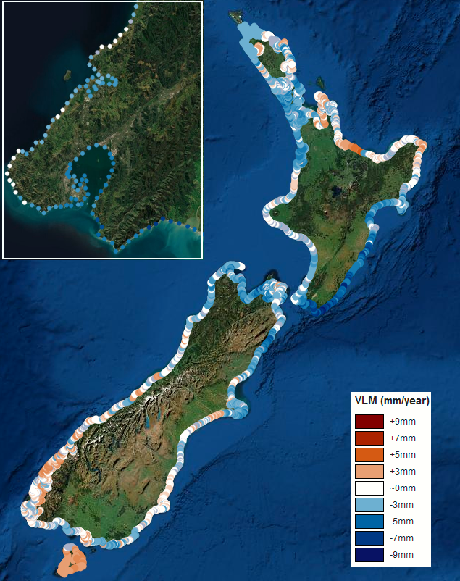
Note: The sites are at 2 kilometre spacing. Vertical land movement (VLM) rates are based on the analysis covering the period 2003–11 by Naish et al (in review). Blue areas = subsidence. White areas are neutral. Red/orange areas = uplift. The inset shows the spacing and spatial variability for the greater Wellington region, which is mostly subsiding (excluding major earthquake ruptures).
Source: NZ SeaRise platform (www.searise.nz/maps-2)

Multi-evidence approach for assessing relative sea-level rise
Aotearoa is a tectonically active country straddling the boundaries between the Pacific and Australian plates. Parts of the country are uplifting while others are subsiding. Changing patterns of uplift and subsidence can bring forward or push back timing of when projections of SLR could occur. Therefore, this guidance recommends using RSLR to account for VLM to improve local estimates of when climate change induced coastal inundation might occur.
The NZ SeaRise method is the only approach currently available for estimating RSLR around the entire Aotearoa coast under a range of plausible future climate change scenarios (Naish et al, in review). Therefore, it represents the best available science for estimating RSLR nationally, although alternative locally monitored estimates of VLM may be available for some locations. However, while the projections are based on the same framework used by the IPCC, the satellite-derived estimates of VLM are emerging science and cover a relatively short time period (8 years). Over time, new information will become available and improvements to methods for estimating RSLR projections will occur, and some of these have already been signalled (Levy et al, 2023) (see box 4).
For complex systems such as these, and where the science is still evolving a multi-evidence approach is recommended (MfE, 2023b). Assessment of RSLR should draw on multiple lines of evidence including(but not limited to):
RSLR with satellite-derived VLM rates
RSLR with locally monitored VLM rates (if available)
SLR projections or increments without VLM
local information and expert judgement
experience and judgements of mana whenua and others with local knowledge.
A monitoring and evaluation system within a DAPP approach (step 9 and step 10) should explicitly include updates on any changes in VLM over time and the adaptive planning strategy adjusted accordingly. This is because incorporating VLM, by using RSLR for areas that are subsiding, means planning for earlier timing of sea-level thresholds being reached. For areas currently uplifting at more than 0.5 millimetres per year, applying a precautionary approach is recommended, where SLR, without accounting for VLM, is considered and compared with RSLR that includes the uplift or subsidence. This approach is akin to coastal erosion hazard assessments for currently accreting coasts, where future accretion is often discounted and set to zero. More detail about how to use the SLR and RSLR projections and associated VLM is contained in the following sections.

Recommended approaches for relative sea-level rise
The two approaches for assessing coastal hazards and risk from the recommended RSLR projections and informing a DAPP approach are:
i) increments: regular increments of RSLR height (eg, at 0.1 metre or 0.2 metre) with associated bracketed time windows when each height is reached, to cover the full range of the recommended projections out to 2150, or
ii) projections: the recommended RSLR projections (or a subset covering the range) for the planning timeframes outlined in section 2.1.2 from the NZ SeaRise platform that either:
- incorporate the satellite-derived VLM rate, or
- add a locally monitored VLM rate (if available) to the non-VLM projections.
Each of these approaches has advantages and disadvantages, depending on the purpose for which they are being used. Increments and projections can also be used in combination in some situations.
Table 5 summarises the main elements, advantages and differences between the two approaches.
- Main elements of the two relative sea-level rise approaches for assessing hazards and risk and input to informing a dynamic adaptive pathways planning (DAPP) approach
Approach | Main elements | Advantages and disadvantages
Increments | Not tied to shared socio-economic pathway (SSP) scenarios (ie, scenario neutral)  Uses NZ SeaRise platform to determine bracketed time frames for each increment across the range of recommended SSP scenarios to at least 2150.  Can be used at national, regional or local spatial scales.  Implicitly includes vertical land movement (VLM) when related to bracketed timeframes for relative sea-level rise (RSLR) projections. | Easy to visualise via hazard maps and communicate where and at what increment adaptation thresholds emerge (eg, figure 12).  Good for both hazard and quantitative risk assessments.  Hazard and risk modelling may not require updating if projections or VLM change, only the time brackets (for when the increments are exceeded).  Useful for stress-testing the lifetime of options and pathways, where an adaptation threshold in terms of an RSLR increment has been pre-agreed.  Not suited for use with other climate hazards or drivers (eg, rainfall) in climate risk assessments, where only projections based on SSP scenarios may be available.
Projections | Tied to SSP scenarios (and nominated timeframes).  Uses NZ SeaRise platform for time series of specific RSLR projections to 2150.  Can be used at regional and local spatial scales.  Can incorporate satellite-derived VLM (using NZ SeaRise platform) or locally monitored VLM rate. | Provides a range of RSLR across SSP scenarios for various specific timeframes (eg, 2050, 2130).  More suited for stress-testing options and adaptation pathways for a specific planning horizon.  Suits detailed hazard assessments, where other hazards or climate drivers are only available as SSP scenario-based projections.  Hazard and risk assessments need updating when SSP scenarios or VLM rate changes.  If a time series of locally monitored VLM rates is available, can add to NZ SeaRise SLR projections (without satellite-derived VLM included).
Figure 10 shows the recommended SLR projections from a central location broadly representative of SLR across Aotearoa for the medium confidence projections out to 2150 (excluding VLM). These projections are spliced with six tide-gauge records for annual MSL over the past two decades, all relative to the new MSL baseline (1995–2014). When these projections are translated to RSLR locally (by including VLM), they can then be used to determine the range of rise in MSL that could occur over different timeframes (eg, 2050, 2130). The other way of using SLR (and RSLR) projections is to determine the time bracket over which a specific SLR (or RSLR) height would be reached (figure 10). This is useful for appraising adaptation or risk thresholds and physical limits for adaptation options (step 5).
Figure 10: Recommended sea-level rise (SLR) projections (excluding vertical land movement) based on shared socio-economic pathways scenarios (SSP) (from a central location, broadly representative of SLR across Aotearoa New Zealand)
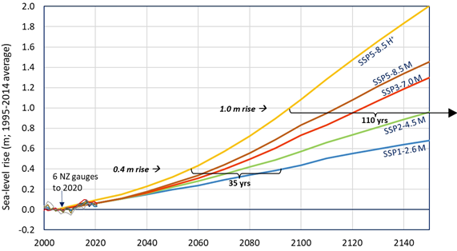
Notes: The figure shows two examples of expected time brackets when a 0.4 metre and 1.0 metre sea-level rise (SLR) height would be reached. Locally, incorporating vertical land movement from NZ SeaRise, a similar graphic can be generated for specific relative sea-level rise heights, or refer to figure 14 in Climate change, sea-level rise and coastal hazards science: Coastal hazards and climate change guidance – Supplement A.
The absolute SLR from south to north across Aotearoa New Zealand varies ± 0.025 metres by 2150, relative to the central location.
Shared socio-economic pathway (SSP) is used by the Intergovernmental Panel on Climate Change for climate scenarios, with the latter number (2.6, 8.5 and so on) related to the previously used representative concentration pathway. M = the median (50th percentile) projection for that SSP. H+ is the top of the likely range for the SSP5-8.5 scenario (83rd percentile), representing widening future deep uncertainties associated with SLR. Annual sea level from the six tide-gauge records is sourced from Stats NZ (http://www.stats.govt.nz/indicators/coastal-sea-level-rise).

Increments for relative sea-level rise
RSLR increments is a useful approach for hazard and risk assessment that informs decisions on adaptation thresholds for local planning purposes. Use of the increments approach for RSLR hazard and risk mapping is particularly informative for engaging with communities and infrastructure providers to explore at what height of RSLR, and where, coastal hazards (like flooding and erosion) become disruptive or intolerable (see figure 11).
This approach involves using a series of regular RSLR heights at either 0.1 metre or 0.2 metre increments. These increments can then be retrospectively applied across the range of recommended SSP scenarios to estimate the time bracket (out to 2150) when any specific RSLR height could be reached. Increments of RSLR are not associated with a particular planning horizon, which may be required for statutory purposes (eg, 30-year infrastructure strategy or assessment of coastal hazards over 100 years). When updates to the SSP scenarios satellite-derived VLM rate occur only the bracketed timeframes associated with the attainment of each of these increments need to change (see figure 10, table 6 and table 7). Changes to the bracketed time windows directly inform whether adaptive planning should be brought forward (allowing for sufficient lead time) or slowed if the timing of each RSLR increment may occur later.
Timeframes can be estimated with or without VLM, providing RSLR or SLR increments respectively. It is worth noting the RSLR projections in the NZ SeaRise platform that exclude VLM (figure 10, table 6) do already include the wider national effects of glacio-isostatic adjustment as well as regional variations in gravitational, rotational and deformational changes of the land across Aotearoa. There are some situations and locations where it might be appropriate to only estimate SLR increments, for example, if the satellite-derived VLM rate has a poor quality factor (ie, 4–5), recent seismic uplift or subsidence has occurred, or locally measured VLM has shown that the satellite-derived VLM rate is inaccurate. Excluding VLM, however, means the timeframes associated with SLR increments are implicitly more uncertain, and this uncertainty will need to be incorporated into hazard and risk assessments, as well as any adaptive planning strategy.
Excluding VLM when uplift or subsidence rates are above 0.5 millimetres per year leads to more uncertainty about timeframes and associated risks, particularly the timing of when different levels of RSLR will occur. This is especially critical for areas with ongoing subsidence. For example, for Petone (median VLM rate of –2.86 millimetres per year), a 0.4 metre SLR threshold would be reached two decades earlier for a SSP2-4.5 M scenario compared with not including VLM. Therefore, RSLR is the recommended increment approach (over SLR increments) because it includes rates of VLM that provide more accurate time brackets for hazard and risk assessments, as well as any adaptive planning strategy.
A monitoring and evaluation system within a DAPP approach (step 9 and step 10) should explicitly include updates on any changes in VLM rates over time (including new coastal global navigation satellite system (GNSS) stations) for both subsiding and uplifting coasts, and the adaptive planning strategy adjusted accordingly. An adjunct to ongoing monitoring and evaluation is to also use RSLR height increments (0.1 metres or 0.2 metres) for hazard and risk assessments and to determine adaptation thresholds. Table 5 outlines the advantage of this approach, where the incremental changes in RSLR heights (and the assessments) still apply if VLM changes – only the bracketed time period for reaching that increment changes.
Table 6 shows the indicative timeframes (to the nearest five years) for reaching various absolute SLR heights, for a central location in Aotearoa, excluding VLM. The left-hand column lists the earliest year when that SLR height could be reached (based on the SSP5-8.5 H+ projection) through to the latest year it could be exceeded (using a SSP1-2.6 M projection) at the right.
Example to generate time brackets for relative sea-level rise increments at regional or local scales
To generate time brackets covering local or regional relative sea-level rise (RSLR) projections for your location, use the NZ SeaRise graphs and downloadable tables from the platform to create a similar table (to table 6) with vertical land movement (VLM) included (especially if the VLM rate is above 0.5 millimetres per year).
Table 7 shows an example for Nelson using the recommended RSLR projections from the NZ SeaRise platform. The average VLM rate is approximately 2.0 millimetres per year subsidence near the urban area of Nelson.
- Summary of approximate year when absolute sea-level rise (SLR) heights could be reached using the recommended projections for a central location in Aotearoa New Zealand
SLR (metres) | Year achieved for SSP5-8.5 H+ (83rd percentile) | Year achieved for SSP5-8.5 (median) | Year achieved for SSP3-7.0 (median) | Year achieved for SSP2-4.5 (median) | Year achieved for SSP1-2.6 (median)
0.2 | 2035 | 2040 | 2045 | 2045 | 2050
0.3 | 2050 | 2055 | 2060 | 2060 | 2070
0.4 | 2055 | 2065 | 2070 | 2080 | 2090
0.5 | 2065 | 2075 | 2080 | 2090 | 2110
0.6 | 2070 | 2080 | 2090 | 2100 | 2130
0.7 | 2080 | 2090 | 2100 | 2115 | 2150
0.8 | 2085 | 2100 | 2110 | 2130 | 2180
0.9 | 2090 | 2105 | 2115 | 2140 | 2200
1.0 | 2095 | 2115 | 2125 | 2155 | >2200
1.2 | 2105 | 2130 | 2140 | 2185 | >2200
1.4 | 2115 | 2145 | 2160 | >2200 | >2200
1.6 | 2130 | 2160 | 2175 | >2200 | >2200
1.8 | 2140 | 2180 | 2200 | >2200 | >2200
2.0 | 2150 | 2195 | >2200 | >2200 | >2200
Notes: Approximate year (to the nearest five-year value) when each absolute sea-level rise (SLR) height could be reached from a central location from the NZ SeaRise platform, under the medium confidence SLR projections, relative to the 1995–2014 baseline (mid-point 2005). Excludes vertical land movement and the low confidence SLR projections. The table uses 0.1 metre SLR height increments up to 1 metre, thereafter 0.2 metre height increments.
Can be considered broadly representative across Aotearoa New Zealand, because the absolute SLR from north to south only varies by ± 0.025 metres by 2150 (relative to the central location).
- Example: Approximate year when relative sea-level rise (RSLR) increments could be reached using recommended projections for the Nelson urban area (compared with table 6 where vertical land movement is not included)
RSLR (metres) | Year achieved for SSP5-8.5 H+ (83rd percentile) | Year achieved for SSP5-8.5 (median) | Year achieved for SSP3-7.0 (median) | Year achieved for SSP2-4.5 (median) | Year achieved for SSP1-2.6 (median)
0.2 | 2030 | 2035 | 2035 | 2035 | 2035
0.3 | 2040 | 2045 | 2045 | 2050 | 2050
0.4 | 2045 | 2055 | 2055 | 2060 | 2065
0.5 | 2055 | 2065 | 2065 | 2070 | 2080
0.6 | 2060 | 2070 | 2075 | 2080 | 2095
0.7 | 2070 | 2080 | 2085 | 2090 | 2105
0.8 | 2075 | 2085 | 2090 | 2100 | 2120
0.9 | 2080 | 2090 | 2100 | 2110 | 2135
1.0 | 2085 | 2100 | 2105 | 2120 | 2150
1.2 | 2095 | 2110 | 2120 | 2145 | 2180
1.4 | 2105 | 2125 | 2135 | 2165 | >2200
1.6 | 2115 | 2140 | 2150 | 2185 | >2200
1.8 | 2125 | 2150 | 2165 | >2200 | >2200
2.0 | 2130 | 2170 | 2180 | >2200 | >2200
Note: Approximate year (to the nearest five-year value) when the relative sea-level rise (RSLR) increment could be reached. The average mean sea level (MSL) for Port Nelson over the baseline period 1995–2014 is 2.335 metres above Chart Datum. In terms of survey levels, New Zealand Vertical Datum-2016 is 2.578 metres above Chart Datum. This means the 1995–2014 MSL is –0.243 metres (appendix D), to which the RSLR increments can be added to translate to MSL in New Zealand Vertical Datum-2016 levels into the future for each time bracket.
Sourced from the NZ SeaRise platform that includes VLM for an average subsidence rate of 2 millimetres per year. Increments are relative to the Port Nelson average MSL over a 1995–2014 baseline.

Projections of relative sea-level rise
At the local and regional scale, it is recommended to use the five RSLR projections (or at least the range) for planning, especially where subsidence or uplift is more than 0.5 millimetres per year. Below this rate, RSLR projections can still be used, but the difference between including or excluding VLM is less sensitive to when an SLR threshold is reached.

Satellite-derived vertical land movement
To incorporate satellite-derived VLM, select the nearest node on the NZ SeaRise platform (figure 9) for RSLR, which will plot as a heavy line for the median projection (compared with the dashed line for the absolute SLR). A VLM error estimate and a quality factor (1 = good, 5 = poor) is generated for each location on the NZ SeaRise platform (see box 3). To check the quality factor and averaging distance for VLM rates, download a .csv attribute file(s) under the Download button for the relevant site(s) by ring-fencing them with a mouse-driven polygon. If the quality factor value is at the poor end of the scale (4-5), or the error estimate is high, then a sensitivity test may be required until a data update with more accuracy becomes available. Use different RSLR projections covering the shaded likely range (not just the median) to test the adaptation option, along with locally monitored VLM rates (if available) and checking neighbouring nodes with higher quality factors.
Where the VLM rates are broadly similar (eg, less than ±0.5 millimetres per year difference from a spatial average), RSLR projections could be averaged across a region, checking and noting what the variation means in terms of the bracketed time windows or RSLR in a planning time horizon. As an example, the subsidence rate around the coastal margin of the Nelson urban area is relatively consistent, in a range –1.67 millimetres to
–2.79 millimetres per year. Therefore, the RSLR projections from site #6488 (Neale Park – SH6), which has a VLM rate at the spatially averaged Nelson urban rate of –2.1 millimetres per year, would suffice for the entire urban area and is used to generate table 7.
Across some regions, districts or cities, VLM can vary markedly over relatively short distances. In that case, care is needed if using RSLR projections with an average VLM rate across a region or district for resource management plans, or council building or engineering standards. In this situation, councils could use different VLM rates for sub-regions or precincts for setting minimum floor and ground levels. For example, as set in council inundation practice notes (eg, in district plans, engineering standards or land-use plans) where the planning rules for managing significant risk may differ spatially by using an overlay showing different colours for varying rules for subdivision, relocation or earthworks by location.
Sampling and averaging the VLM rates on a 2 kilometre grid (figure 9) mean spatial variability is captured within the uncertainties of each of the VLM estimates in RSLR projections. An error and a quality factor (1 = good, 5 = poor) are generated for each location that consider the number of satellite observations available for each coastal location, the radial distance used to bin (sample) the observations and the distance to the nearest GNSS station. If a quality factor is poor, and/or a locally monitored VLM rate is available and is considerably different from the satellite-derived VLM rate, then the latter can be used instead. If the quality factor value is at the poor end of the scale, or the error estimate is high, then a sensitivity test with different VLM rates to test the DAPP options and pathways, coupled with local knowledge of VLM, may be required until a data update with more accuracy becomes available. More information on the quality factor and range of VLM variability for each site is available in Naish et al (in review) and on the NZ SeaRise website.

Locally monitored vertical land movement
In areas where the localised subsidence (negative VLM rate) or uplift (positive VLM rate) is being monitored over time and is considerably different from the NZ SeaRise satellite-derived VLM rate, use the SSP scenario-based SLR projections in the NZ SeaRise platform without VLM (median line is dashed). Then add on the contribution (in metres) from the monitored VLM rate (mm per year) using this formula to the non-VLM SLR projections from the platform (also in metres):
–1.0 × VLM rate [mm/yr] × (Future Year – 2005)/1000 [metres]
An example is the historically reclaimed coastal margin along the Thames (Coromandel) foreshore, which is subsiding at rates known from a local monitoring programme whereas the main landward part of Thames is uplifting.
Independently determining locally measured VLM rates may also be relevant for Christchurch, North Canterbury and Kaikōura, once monitoring establishes a consistent post-earthquake trend in VLM.
Some caution is still needed to appraise how widely the monitored VLM at a site is representative of the movement of the surrounding area.

Interim allowances for relative sea-level rise
Interim RSLR allowances are provided as guidance for plan making and land-use decisions (eg, intensification, change in land use) for coastal areas. They form a precautionary initial planning and design response, before undertaking a detailed risk assessment (step 4), followed by the development of an adaptive planning strategy based on the DAPP approach (step 6 and step 7). The DAPP approach takes a system view to evaluating cascading impacts. This approach is consistent with council planning decisions that implement other Resource Management Act 1991 requirements and policies, such as the precautionary approach (Policy 3, NZCPS, DOC, 2010).
For making interim decisions on new coastal development or infrastructure and changes in land use, such as intensification and upzoning, the precautionary interim allowance recommended (before an adaptive planning strategy is developed) is to use the SSP5-8.5 H+ based RSLR projection to identify areas ‘potentially affected’ by coastal hazards and climate change. Timeframes are also informed by the risk of being affected by coastal hazards, with greater or longer term investments, such as infrastructure or new suburbs, needing assessment over at least a 100-year period out to 2130.
Developing an adaptive planning strategy (based on the DAPP approach) is strongly encouraged to move past the need for precautionary interim allowances. This is so that communities, iwi/hapū and other stakeholders can move to more sustainable options that have been stress-tested and evaluated across a range of RSLR projections. In general, planning to transition to more sustainable adaptation options over time is consistent with policies managing coastal hazard and risk in the NZCPS (Policy 27, DOC, 2010).
Policy 27(1)(e) of the 2010 New Zealand Coastal Policy Statement, which should be followed in coastal areas, states (DOC, 2010, p 24):
[27](1) In areas of significant existing development likely to be affected by coastal hazards, the range of options for reducing coastal hazard risk that should be assessed includes:
…
(e) identifying and planning for transition mechanisms and timeframes for moving to more sustainable approaches.
Table 8 shows the recommended precautionary RSLR projections to use as interim allowances for plan revisions and land-use decisions for coastal areas prior to the development of an adaptive planning strategy based on the DAPP approach. Determination of which planning category a specific application falls within should also include consideration of the implications for an activity, for example, the effect on increasing overland flow paths and flows to stormwater networks, residual risk (from protection works), intended usage of ground floors (non-habitable), accessibility from more frequent road outages, long-term viability of maintaining utility services, and availability of alternative locations. The NZCPS provides policies on where to avoid, encourage, discourage or consider the effects of coastal hazards on subdivision, use and development over at least the next 100 years (Policy 25, NZCPS, DOC, 2010).
- Interim precautionary relative sea-level rise allowances recommended to use for coastal planning and policy before undertaking a dynamic adaptive pathways planning approach for a precinct, district or region
Planning category | Recommended interim precautionary RSLR allowances
A. Coastal subdivision, greenfield developments and major new infrastructure | Using a timeframe out to 2130 (≥100 years), apply the medium confidence SSP5-8.5 H+ based RSLR projection* that includes the relevant VLM rate for the local and/or regional area.  (Note: approximately 1.6 metre rise in MSL, before including VLM.)
B. Changes in land use and redevelopment (intensification and upzoning) | Using a timeframe out to 2130 (≥100 years), apply the medium confidence SSP5-8.5 H+ based RSLR projection* that includes the relevant VLM rate for the local and/or regional area.  (Note: approximately 1.6 metre rise in MSL, before including VLM.)
C. Land-use planning controls for existing coastal uses and assets (building additions) | Using a timeframe out to 2130 (≥100 years), apply the medium confidence SSP5-8.5 M based RSLR projection that includes the relevant VLM rate for the local and/or regional area.  (Note: approximately 1.2 metre rise in MSL, before including VLM.)
D. Non-habitable, short-lived assets with a functional need to be at the coast, which are either low consequences or readily adaptable (including services) | Using a timeframe out to 2075 (≥50 years), apply the medium confidence SSP5-8.5 M based RSLR projection that includes the relevant VLM rate for the local and/or regional area.  (Note: approximately 0.5 metre rise in MSL, before including VLM.)
Notes:
* H+ is the 83rd percentile (or p83 at the top of the likely range on graphs in the NZ SeaRise platform).
i) Relative sea-level rise (SLR) projections that include satellite-derived vertical land movement (VLM) are available from the NZ SeaRise platform. Alternatively, locally monitored VLM can be applied to the SLR projections.
ii) M = median or p50 (50th percentile); MSL = mean sea level; RSLR = relative sea-level rise; SSP = shared socio-economic pathway used by the Intergovernmental Panel on Climate Change; VLM = vertical land movement.
The approximate rise in MSL can be considered broadly representative across Aotearoa New Zealand, because the absolute SLR from north to south only varies by ± 0.025 metres by 2150 (relative to the central location).

Scenarios and relative sea-level rise projections for hazard and risk assessments
Hazard and risk assessments and mapping (step 2 and step 4) will need to draw from the RSLR projections (section 2.1.2), or preferably increments of RSLR heights (eg, 0.1 metre or 0.2 metre intervals for the first 1 metre at least) that cover the range of projections over the planning horizon of at least 100 years.
Outputs from these assessments, especially maps of coastal hazards and risk under different RSLR, will inform decisions on adaptation thresholds and triggers (decision points) for options and pathways in a DAPP approach. They also create an understanding of the sensitivity of impacts to a range of sea-level futures at a locality or district or regional scales.
This guidance takes a risk-based approach to the use of projections and/or increments of RSLR. In this respect, the upper-range SSP5-8.5 H+ should continue to be used in screening and detailed hazard and risk assessments to identify coastal areas potentially affected (Policy 24, NZCPS, DOC, 2010) and high-end stress testing of adaptation options and pathways (step 6). Furthermore, using the RSLR projection based on SSP5-8.5 M allows RSLR to be linked to the other climate drivers (eg, rainfall) if a multi-hazard and risk assessment is being done.
The recommended minimum SSP scenarios and RSLR projections for assessments in table 9 generally align with the national adaptation plan and Ministry for the Environment guidance on local climate risk assessment (MfE, 2021, 2022a).
- Recommended minimum shared socio-economic pathway scenarios for relative sea-level rise projections to use for screening and detailed phases of hazard and risk assessments
Assessment phase | Recommended minimum SSP scenarios to use
Initial screening for coastal hazard or risk assessments | For a timeframe out to 2130 (≥100 years), at a minimum:  For RSLR: use either the medium confidence SSP5-8.5 M or SSP5-8.5 H+ projections* that include the relevant VLM rate or preferably increments of RSLR heights, which would be needed later in detailed assessments (eg, 0.1 metre or 0.2 metre covering the full range of RSLR up to SSP5-8.5 H+).
Detailed coastal hazard or risk assessments | For a timeframe out to 2130 (≥100 years), at a minimum:  For RSLR: use both the medium confidence SSP2-4.5 M and SSP5-8.5 M RSLR projections that include the relevant VLM rate or preferably increments of RSLR heights (eg, 0.1 metre or 0.2 metre covering the full range of RSLR up to SSP5-8.5 H+).
Notes:
* H+ is the 83rd percentile (or p83 at the top of the shaded likely range in NZ SeaRise graphs).
i) Relative sea-level rise projections are available from the NZ SeaRise platform.
ii) M = median or 50th percentile (or p50 at the middle of the shaded likely range in NZ SeaRise Platform graphs); RSLR = relative sea-level rise; SSP = shared socio-economic pathway; VLM = vertical land movement.

Coastal hazard assessment

Types of coastal hazards
Natural hazards in a changing climate for coastal areas can be related to either:
a worsening of the impacts from coastal hazard events (magnitude, changing frequency, persistence and compound or multiple contributors), or
a progressive change or trend (eg, high-tide flooding extending intertidal areas, groundwater rise, salinisation of land and freshwater) from the ongoing rise in MSL and other climate drivers (figure 3).
Both need to be considered in coastal hazard assessments, rather than the conventional focus on coastal hazard events.

Coastal inundation

Changes in storm surge, storm intensity and ocean drivers
Trends and projections of future changes in associated coastal and ocean drivers (wind, waves, storm surges and changes to tide range in estuaries and inlets) are not as clear and consistent as the more dominant rise in MSL (on which coastal hazard events are exacerbated). Projected changes to the contributing processes that combine to generate hazard events (besides RSLR) are likely to vary by region, as storm tracks, winds and weather systems respond to climate change. The projected changes across Aotearoa in wave heights and storm surge with climate change are likely to be relatively modest or inconclusive, however, changes to storm intensity and particularly the frequency of the most extreme events, are more uncertain (see Climate change, sea-level rise and coastal hazards science: Coastal hazards and climate change guidance – Supplement A for more details). To cover some of these uncertainties, section 2.2.2 provides guidance on sensitivity testing of these contributors to coastal hazard events.
Increases in tide range (and high tide level) in estuaries and lowland rivers (from a higher mean sea level) may be more impactful for shallow waterbodies that currently dampen (reduce) the tidal range inland from the inlet or where stopbanks or causeways impede elevated high tides from spreading out over the low-lying margins (Hague et al, 2023). The future rate of sedimentation in these waterbodies, and whether it keeps pace with RSLR, is a critical factor influencing tidal characteristics. Sedimentation processes, including catchment runoff, are themselves also influenced by climate change.
Compared with the present situation – where waves and storm tides are the main drivers of flooding in coastal areas – later this century and beyond RSLR will increasingly become the dominant contributor by elevating coastal hazard events, generating more frequent flooding and associated impacts on existing development (Le Cozannet et al, 2015). Besides extreme events, future climate-influenced changes to waves, winds, tide range and sequencing and frequency of storms will also lead to progressive ongoing changes to geomorphology, shoreline position, groundwater levels and salinisation. These should also be part of a coastal hazard assessment (Policy 24, NZCPS, DOC, 2010). Uncertainties remain, however, particularly about the increased frequency of more intense ex-tropical cyclones and other mid-latitude storms. These should be considered and evaluated as part of applying a precautionary approach to hazard and risk assessments (Policy 3, NZCPS, DOC, 2010).

Coastal flooding
Coastal flooding of the margins of beaches and estuary lowlands (from storm surges, wave processes and king tides) will become a more dominant coastal hazard compared with localised coastal erosion. RSLR will greatly increase the frequency, depth and inland extent of coastal flooding, with previously rare extreme events changing to occur annually (on average) with only modest 0.3 metre to 0.45 metre increases in RSLR, depending on the location’s tide range and storm-surge distribution across different annual exceedance probabilities.
Coastal flooding in various combinations with higher groundwater levels, rainfall runoff and increases in high tide in estuaries, inlets and lowland rivers will lead to more frequent compound flooding impacts on urban settings and coastal lowlands. It will also increase challenges in managing stormwater networks and drainage schemes.
Flooding will be both episodic (ranging from extremes events to nuisance flooding from minor storms elevated by ongoing RSLR) and progressive through the gradual high-tide inundation of low-lying coastal land. Over time, as moderate, nuisance and king-tide flood events become common place, this will lead to a greater cumulative risk to the built environment than infrequent extreme events (Paulik et al, 2021).

Groundwater rise
Groundwater rise is the upward movement of the water table due to short- or long-term fluctuations in rainfall recharge and/or river, ocean or tidal levels (Bosserelle et al, 2022). Low -lying coastal areas may be vulnerable to groundwater rise from RSLR and other climate -driven hydrological processes, including increased rainfall intensities.
The effect of RSLR on groundwater will depend on complex interactions among hydrogeological processes, the sub-surface environment, type of aquifer (confined or unconfined), modification of the natural environment (urbanisation), and connection to the sea (Bosserelle et al, 2022). Locations where water levels in unconfined shallow aquifers already have tidal fluctuations are vulnerable to ongoing RSLR, because they have a direct or indirect hydraulic connection with the ocean.
Groundwater flooding may occur infrequently during extreme events (eg, high tide coinciding with heavy rainfall), when surface and marine compound flooding also occur. Therefore, multi or compound hazard and risk assessments are needed (Bosserelle et al, 2022). For example, a rise in the groundwater level impedes drainage of rainwater during storms and can contribute to and exacerbate surface coastal or pluvial flooding.
While not directly considered by this guidance, the progressive salinisation of groundwater sources used for irrigation, stock water and potable water should be considered as part of longer term considerations for service provision when developing an adaptive planning strategy.

Coastal erosion (beaches and cliffs)
The frequency and magnitude of coastal erosion will also increase to affect most coastlines. Unlike coastal flooding, future coastal erosion rates will be a function of both RSLR and other climate change effects (eg, changes in rainfall intensity, catchment runoff, waves, storm sequencing and sediment supply) and will affect changes in sediment patterns and rates of sediment transport (Bryan and Coco, 2020; Cazenave and Le Cozannet, 2014; Coco et al, 2020; Dickson and Thompson, 2020; Masselink et al, 2020). In turn, these changes will affect the shape and orientation of beaches and shoreline positions, which may influence rates of coastal erosion.
Special features, such as sand spits, tidal entrances, narrow barrier islands and pocket beaches, are particularly vulnerable, being sensitive to changes in sediment movement from subtle changes in wave climate and sediment supply from the catchment via rivers and streams, as well as RSLR (Bryan and Coco, 2020; MfE, 2008). Consequently, future shoreline changes of these features will exhibit considerable uncertainty and variability.
Assessing the hazard from coastal erosion is not as advanced as for coastal flooding, especially with respect to how RSLR interacts with other coastal and hydrological sediment processes and the contextual geomorphology (eg, sandy or gravel beaches and sedimentary cliffs). However, progress is being made (Bryan and Coco, 2020; Coco et al, 2020; Dickson and Thompson, 2020), and the Resilience Science Challenge is conducting national mapping of coastal erosion (Dickson et al, 2022).
Cliff coastlines, while generally less sensitive to RSLR than low-elevation sandy or gravel coastlines, are still at risk from coastal erosion (Dickson and Thompson, 2020), but there is likely to be considerable spatial variability in future erosion rates under RSLR (Dickson et al, 2023). Some cliff sites will be at risk from increased coastal erosion depending on the underlying geomorphology and exposure to ocean currents and storms. This could have a potentially big impact for some cliff-top sites, which could be incorrectly viewed as safe from the effects of sea-level rise. Cliff erosion may also be exacerbated by other climate change effects, such as heavy rainfall and prolonged droughts.
The response of sediment budgets and coastal geomorphology to climatic effects is uncertain, arising from increasing uncertainty in several of the contributing processes that shape shoreline response. Climate change, sea-level rise and coastal hazards science: Coastal hazards and climate change guidance – Supplement A describes in more detail how climate change may alter rates of coastal erosion or accretion.

Compounding hazards
Coastal flooding and erosion, higher groundwater levels, high lowland-river flows and intense rainfall impacts will occur individually in hazard-prone coastal areas. Coastal lowlands and urban settings are increasingly likely, however, to experience a combination of these hazards at a similar time, particularly as the sea level rises and impinges on lowland freshwater systems and from coincident higher rainfall intensities (Moftakhari et al, 2017; Stephens and Wu, 2022). A risk-based approach to managing coastal hazards requires determining or estimating the combined probabilities of different magnitude events and their consequences. This is complex for compound hazards, especially if climate change multiplies the effect differently on each of the contributing processes.
Many of Aotearoa New Zealand’s towns and cities developed around river mouths or estuaries and are vulnerable to river, surface and groundwater flooding, exacerbated by high storm tides. The increasing frequency of compound effects may prove problematic in these places (including for drainage and stormwater management), exacerbating the impact of a type of hazard, such as flooding.
A few Aotearoa studies have accounted for multiple hazards or their joint probability. Datasets on joint coincidence of storm tides and waves are available in some regions (eg, Allis et al, 2015; Stephens et al, 2013, 2015a). Joint probability analyses of storm tides and river flows were undertaken as part of flood modelling for the Buller River and Westport (Pearson, 2004; Wild et al, 2004). Nationally, Stephens and Wu (2022) have mapped the joint dependence of coastal storm surges, rainfall and river flow occurring together and related these compound flooding events to types of weather systems, some of which are more conducive to a higher dependence between the contributing hazards (eg, blocking high pressure systems to the east of Aotearoa).

Tsunami inundation
Tsunami hazards are not addressed in any detail in this guidance but should be considered for completeness in a first pass coastal hazard screening (Policy 24, NZCPS, DOC, 2010). RSLR will somewhat increase tsunami inundation, potentially elevating tsunami wave heights and causing them to affect a wider area and further inland. Margins of estuaries and harbours may also become more vulnerable to tsunami if entrance channels deepen in response to greater tidal flows at a higher sea level. While the most important determinant of a tsunami’s impact will remain its height and wave period when it arrives at the coast, RSLR will further exacerbate the inland reach and overland inundation depths of a tsunami.
The extent of the present-day orange tsunami evacuation zones provides a broad understanding, prior to coastal flood hazard screening, of the landward extent of low-lying coastal land and potential future coastal flooding areas. Climate change, sea-level rise and coastal hazards science: Coastal hazards and climate change guidance – Supplement A describes how climate change may alter tsunami coastal hazards.

Relative sea-level rise and coastal hazard assessments
Policy 24 of the NZCPS requires identification of areas that are “potentially affected by coastal hazards” and assessment of the risks over “at least 100 years” (DOC, 2010, p 23; DOC, 2017). The NZCPS takes a risk-based approach to managing coastal hazards. It is recommended that this includes determining contemporary probabilities of different types of hazards, before including climate change and SLR effects and their consequences.
The purpose of a coastal hazard assessment is to identify the spatial extent (eg, mapping) and magnitude of present and future hazard events, as well as progressive ongoing change, including the effects of climate change, as listed in Policy 24(1) (DOC, 2010). Taking an adaptive risk-based approach means including a range of future RSLR projections (or increments of RSLR; see table 7) in the coastal hazard assessment, along with other climate-related drivers (eg, changes in rainfall, storms, winds, waves, groundwater), to inform which areas are potentially affected and when.
First pass regional scale hazard screening can be done to bring attention to impacts that span multiple territorial authority jurisdictions. It can be used to assess and inform current and future development regional strategies and to coordinate adaptation planning. This screening can also be used to leverage joint funding for research, investigations and engagement for a detailed assessment. Hazard screening enables a focus on those areas where risk from coastal hazards (primarily flooding and erosion) is likely to be immediate (now or next few decades) or high in the long term (at least 100 years). This is to inform interim planning decisions to avoid or reduce (where appropriate) increasing the risk for coastal margins (eg, table 6), prior to detailed hazard and risk assessments and the development of an adaptive planning strategy (based on the DAPP approach) (step 6 and step 7).
Detailed place-based hazard assessments and associated mapping can then be developed. These are useful for community engagement, including ascertaining values and objectives (step 3), which are used as input into vulnerability and risk assessments (step 4). Detailed assessments also inform the development of an adaptive planning strategy based on the DAPP approach (step 6, step 7 and step 8).
The next two sub-sections outline the level and extent of a first-pass screening, followed by a detailed hazard assessment, with RSLR projections or increments to use summarised in table 7. A screening assessment for coastal hazards (eg, flood, erosion) should include representations for one or two annual exceedance probability (AEP) magnitudes or levels. A detailed hazard assessment may include more representations to cover a range of AEPs (extreme, moderate and nuisance events), as well as testing the hazard sensitivity to statistical uncertainty of the computed estimate for an extreme AEP (eg, 95 per cent confidence level).
Incorporating Indigenous worldviews
This guidance recommends that coastal hazard assessments are informed by mātauranga Māori and an Indigenous worldview, including local and technical knowledge and experiences.
A holistic view acknowledges the intrinsic connection between the atmosphere, climate and wider environmental system. It recognises the interdependencies and inter-relatedness of things, including between people and their environment.
The holistic and reciprocal connection between Māori and the natural world is formed through shared whakapapa (genealogy). The creation and ongoing balance of the natural world is interconnected through this web of kinship, and responsibility to care is reflected in pūrākau (stories) where these relationships shape connection to the environment (Harmsworth and Awatere, 2013).
Te ao Māori sees stress on any composite part of the system as creating its own measurable impact on other parts of the whole. It then looks at the quality and state of wellbeing, and assesses that against a measure of abundance, vibrancy, regeneration and health. This has complementary value to assessments but starts from abundance or rauora.
For further reading on this, refer to Hikuroa (2020), Jones et al (2023), Bailey-Winiata (2021), and Wilkinson et al (2020).

First pass hazard screening
This initial stage is a hazard exposure screening exercise, using one or two RSLR projections (or at a minimum consider using SSP5-8.5 H+) to determine the area potentially affected over at least 100 years (see table 7). These first pass screening hazard assessments are generally undertaken by the regional council or unitary authority. The purpose of a region-wide hazard exposure screening exercise, usually with one upper-range climate scenario and associated RSLR projection (table 7), is to broadly identify areas “that are potentially affected” by coastal hazards and climate change (Policy 24, NZCPS, DOC, 2010, p 24). The outputs of a screening assessment should then guide identification of “areas at high risk of being affected” and inform subsequent detailed hazard (and risk) assessments for coastal compartments or localities to focus on, considering areas at high risk of both imminent and long-term risk (see table 6).
First pass hazard screening can be done in several ways (using various types and sources of existing data and information). Box 5 describes main tasks in sequential order for a regional or district-wide hazard screening.

- : MAIN tasks for regional OR DISTRICT hazard screening process
1 Initial questions to guide hazard screening:
- What are the hazard sources?
- What will be affected by the hazard and compounding hazards? Where are the vulnerable areas, and where should we focus our effort?
- What type of hazard assessment should we do? You can use various combinations of data analysis, modelling and mapping techniques. The approach depends on factors such as the locality, data availability, cost and assets at risk.
- What scale of assessment is required? First pass hazard assessments can be done first followed by more detailed assessments in areas affected.
- What climate change scenarios should we use? To account for deepening uncertainty over time, consider one or two hazard magnitudes (using contemporary annual exceedance probabilities), upper-range relative sea-level rise (RSLR) projections or increments from table 7.
- What tools and models should we use and what are the data requirements? Document and make transparent the uncertainties and assumptions underpinning the methodology.
2 Sources of data and information – these could include the following:
- Assess existing or emerging problems: Council staff and Civil Defence Emergency Management groups may be aware of past events and existing or emerging problems in particular areas that are obvious priorities for more detailed hazard assessment.
- Conversations with coastal communities: These should cover local knowledge of events or observed gradual changes (including photographs and media articles).
- Hui with iwi/hapū: Shared information and observations on marae, taonga, areas of customary rights and other cultural sites where changes are occurring in the context of mātauranga Māori.
- Expert workshop: Vulnerable areas can be identified by experienced staff, stakeholders, consultants and iwi/hapū with knowledge and experience of the coastal areas of the region or district, such as knowledge of land elevation, monitoring data trends, floodways, geomorphological change over time, hazard sources, demographics and familiarity with existing building, asset and cultural sites’ databases.
- Literature surveys of existing information: Reports, papers and existing natural hazards portals hosted by councils (eg, Otago Regional Council) and Toka Tū Ake EQC.
- National Coastal Change Database: Historic erosion data are being compiled by the University of Auckland through the Resilience National Science Challenge and will be released on the following website by June 2024 (https://data.coastalchange.nz/).
- Broad scale hazard assessments: Using analytic or probabilistic techniques and available data including any contemporary annual exceedance probability or erosion cut-back probabilities, usually for coastal erosion or coastal flood assessments (eg, Paulik et al, 2023, for coastal flooding). The National Institute of Water and Atmospheric Research national coastal flood mapping work, which links in with the NZ SeaRise Project and some council coastal flood maps, can be accessed online.
- Geographic information system or GeoMaps analysis: Overlays of topographic (eg, LiDAR) and hazard layers and zones to explore the exposure to various receptors, through spatial databases on demographics, buildings, roads, cultural sites and the natural environment (eg, esplanades, reserves, wetlands, marshes, dune systems). Examples are a coastal inundation and sea-level rise slider or erosion zone interactive maps. These are also a good communication tool for partners and communities on what the council aims to do and why.
- Evaluation of hazard exposure using a risk analysis platform, such as RiskScape, to initially evaluate broad-scale hazard layers (from models or polygons) to overlay on datasets of receptors (buildings, roads, reserves, critical facilities and so on). Such hazard exposure assessments and associated maps (eg, figure 12) are then already set up and available to subsequently undertake the detailed hazard assessment and, later in step 4, the risk assessment.
3 Hazard screening outputs – these should include the following:
- Identify localities at high risk of being affected over the next 100 years (Policy 24, New Zealand Coastal Policy Statement, DOC, 2010), considering both long-term and more imminent areas at high risk.
- Determine what coastal compartments and their inland extent (ie, spatial scale) should be assessed for detailed coastal hazard, and eventually risk assessments, to inform interim planning decisions to avoid increasing the risk, before undertaking a dynamic adaptive pathways planning approach and developing an adaptive planning strategy.
- Preliminary mapping of hazards (eg, coastal flooding at RSLR increments, figure 12), including determining the best way to visualise the screening results and communicate the findings.
- Identify data and information gaps that may require additional observations or further modelling or analysis for the detailed coastal hazard assessment.

Detailed coastal hazard assessment
Once first pass hazard screening has been completed, detailed assessments can analyse and map specific hazards or compound hazards and the effects of a range of RSLR projections (or increments) and other climate change drivers on them (figure 3). Detailed coastal hazard assessments should clearly show the location and/or area, and nature of uncertainty in the calculation of the hazard magnitude (ie, confidence interval or variance) for different annual exceedance probabilities of the hazard (see Paulik et al, 2023, for coastal flooding). RSLR projections out to at least 100 years (ie, 2130) or RSLR increments to cover the full range of projections can then be added.

Dealing with uncertainty over time
The type of uncertainty of hazards and climate projections at different planning horizons and the type of planning situation being addressed are important considerations for determining the hazard analysis, simulations and projections for the detailed assessment phase. First pass hazard screening can also indicate the type of situation and level of uncertainty to address, which will guide the scenario choices and required modelling complexity for the detailed hazard assessment.
Different levels of uncertainty lead to different types of hazard assessment in relation to the planning situation and require different types of information. For example, for low-risk short-life non-habitable assets, the hazards, near-term projections and associated uncertainties are largely knowable or known (little uncertainty – level 1, figure 11). In this situation, decisions can be made using a reasonable ‘best estimate’ of hazard probability (based on the current 1 per cent or 2 per cent AEP and sensitivity testing, see below), before adding the narrower range of RSLR for the relevant planning horizon (or in the interim, use guidance for category D in table 8).
Alternatively, for planning (eg, intensification, new development) over the required long-term horizon (at least 100 years), RSLR projections (including extrapolated VLM rates) are associated with deep uncertainty (level 3 and 4, figure 11). The long-term horizon is unknown or disagreed upon by experts or stakeholders, with limited consensus of what the future might bring (Lempert et al, 2003). The rate of change of hazards (including storm intensities) is also uncertain (scenario uncertainty – level 3) and the statistical uncertainty (level 2) may require sensitivity testing using a 95th per cent confidence magnitude or level AEP representation (figure 11). In the case of assessments of future coastal erosion, uncertainties relating to factors such as sediment supply are likely to be at least as significant as uncertainties relating to RSLR. Variability in sediment supply may obscure SLR for many decades to come (Ford and Dickson, 2018).
Detailed hazard assessments should therefore be tailored to both the type(s) of uncertainty and the planning situation being addressed. To cover deep uncertainty, the hazard assessment should be based on a range of RSLR projections (or preferably increments), or at a minimum the recommended projections (see table 7). This is rather than selecting a best (or most likely) estimate or a worst-case scenario.
Different uncertainty levels may apply to different components of a hazard assessment and depend on the situation (ie, type of planning decision) (figure 11). For example, an assessment of future coastal flooding may contain statistical uncertainty based on present-day estimates of climate variability and its effect on waves and storm surge, plus scenario uncertainty for future storm surge (due to unclear change in storm intensity), and both scenario uncertainty and deep uncertainty for ongoing RSLR (both SLR and VLM rates).
Figure 11 sets out an example of an uncertainty framework that can be used to support decision-making under uncertainty when using a DAPP approach. The framework shows a logic flow from the situation to the related level of uncertainty, the SSP scenarios to model, the likely hazard modelling complexity, and the possible decision type.
Figure 11: Example of an uncertainty framework for coastal hazard assessments to support the dynamic adaptive pathways planning approach
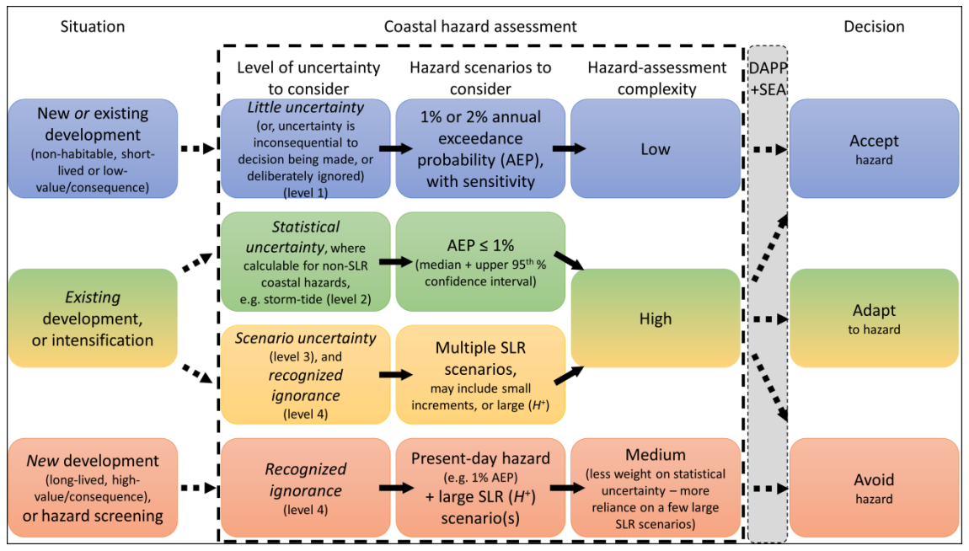
Note: AEP = annual exceedance probability; SLR = sea-level rise. A distinction is drawn (represented by the dashed arrows and dashed box) between the situation, the coastal hazard assessment process, the dynamic adaptive pathways planning (DAPP) process and socio-economic assessment (SEA), and the decision type.
Source: MfE, 2017, as adapted from Stephens et al (2017)

Assess coastal flooding
Magnitudes for a specific AEP are the best descriptors of the likelihood and size of current coastal hazard occurrences (rather than a return period). This is because AEPs allow for change through time by adding RSLR and any climate-influenced changes in climate and ocean drivers onto the currently used level. However, AEPs should be tied to a timeframe or a specific RSLR, because the frequency of flood events will change substantially over time. For a Nelson example, a particular assessment and associated map may be expressed as ‘a current 1 per cent AEP flood combined with an SLR of 0.5 metres that can be expected between 2055 and 2080’ (using table 7 for Nelson with VLM included).
For detailed hazard assessments, it is recommended to use at least two current AEP coastal flood levels, before adding sensitivity factors (see below) and RSLR, such as the 1 per cent AEP flood (used in the screening stage) and a more frequent flood level (eg, 5 per cent or 10 per cent AEP), extracted from the current hazard dataset (see example in figure 12). The higher AEPs represent more frequent events, which could cause more frequent road closures and isolation of communities (Logan et al, 2023; Logan and Reilly, 2023) that may become intolerable at flood levels below a rarer 1 per cent AEP event (Climate change, sea-level rise and coastal hazards science: Coastal hazards and climate change guidance – Supplement A). For building consents, 2 per cent and 1 per cent AEP flood levels are used for minimum floor levels and assessing flooding hazards of the property, respectively, as outlined in the Ministry of Business, Innovation and Employment’s building performance Natural Hazard Provisions guidance (MBIE, 2023).
Coastal hazard experts can usually calculate with reasonable accuracy (with a 95 per cent confidence interval) the probability and magnitude of various AEP coastal flood levels (Climate change, sea-level rise and coastal hazards science: Coastal hazards and climate change guidance – Supplement A), although, for rarer events (low AEP), the length of the historical record influences the width of the uncertainty band (eg, 95 per cent confidence interval) (see Stephens et al, 2020). Although, it should be noted that this type of approach is increasingly difficult because the historical baseline moves with climate change.

Statistical uncertainty
Where the statistical uncertainty of the 1 per cent AEP hazard magnitude is large, using only the ‘best estimate’ or median of the calculated 1 per cent AEP magnitude could over- or under-estimate the hazard. Therefore, detailed coastal hazard assessments should use both the median estimate of the 1 per cent AEP (or other AEPs) and the upper limit of its 95 per cent confidence interval, before adding RSLR, and a sensitivity factor for future changes in waves, storm surge and rainfall intensity (see below).
This sensitivity approach, considering the statistical uncertainty, enables the contrast of the best median estimate with a conservative upper-range value for coastal flood levels, which will help highlight areas that potentially may be affected by current coastal hazards, before adding RSLR.
If it is not possible to accurately calculate statistical uncertainty (because of insufficient or short datasets, or an unquantifiable physical process), then use the best estimate of a 1 per cent AEP or other AEP events. This could be supported with alternative scenarios to establish the sensitivity of the current hazard to the decision required, provided the assumptions and sources of uncertainty in those scenarios are made clear.
Because there is also uncertainty about the future occurrence of high-intensity storms (1 per cent to 2 per cent AEP or less) and their effects on storm surge and waves, which contribute to both coastal flooding and erosion, it is recommended to assess coastal hazard AEP levels with an additional sensitivity factor as a precautionary approach to cover this climate change uncertainty.
Undertake sensitivity testing of coastal flood and erosion hazards using:
a range of plausible increases of 0 per cent to 10 per cent for storm surge to 2100 (use 10 per cent for the western and southern South Island)
a range of plausible increases of 0 per cent to 10 per cent for extreme waves and swell to 2100 (use 10 per cent for the western and southern South Island).
Box 6 describes how to assess overland flooding freeboard in coastal areas and, secondly, how to incorporate RSLR and climate change into assessing coastal flooding of buildings under the Building Code.

- : INCORPORATING CLIMATE CHANGE INTO Freeboard FOR OVERLAND FLOODING GENERALLY and FOR ASSESSING BUILDING FLOOR LEVELS UNDER the Building Code
Two further aspects for assessing coastal flood hazards are addressed here. The first is the role and assessment of freeboard for overland flooding, and the second is on incorporating RSLR and climate change into assessing building flood levels under the Building Code.
Assessing freeboard allowance for coastal flooding hazards
Freeboards are applied to account for additional factors that may not be captured in a hazard scenario. The New Zealand Standard for Land Development and Subdivision Infrastructure (NZS 4044:2010) defines a freeboard as a provision for flood level design estimate imprecision, construction tolerances, and natural phenomena (such as waves, debris, aggradations, channel transition and bend effects) not explicitly included in the calculations (p 25). Similarly, in the building performance Natural Hazard Provisions guidance (MBIE, 2023), freeboard is added to account for any uncertainties associated with historical hazard data and hydraulic assessments, and other environmental factors, such as the effect of wave action generated by vehicles in flooded streets. Note: freeboard should not be used to cover for uncertainty in relative sea-level rise (RSLR) and climate change effects, rather use the recommended RSLR projections or increments of RSLR (table 6 and table 7) and apply separately to the flood hazard levels before applying the freeboard.
Freeboard allowances for ‘habitable’ dwellings currently range from 0.3 metres to 0.5 metres. The freeboard to be applied relates to the level of confidence in the coastal flood level estimates, as well as other matters described in NZS 4044:2010.
Section 4.3.5.1 of the standard recommends that the secondary stormwater system flood level is based on a 1 per cent annual exceedance probability (AEP) storm and is similarly noted in the Ministry of Business, Innovation and Employment (MBIE) (2023) guidance. The focus is on flooding from the upstream catchment, rather than from the sea. However, flooding from coastal storm inundation is different from catchment flooding. To account for this, an additional allowance for RSLR is required on top of the current 1 per cent AEP probability. While NZS 4040:2010 does not specify what sea-level rise or RSLR projection or timeframe to use, for consistency in application to coastal areas, the recommended range of RSLR projections in this guidance over at least 100 years should be assessed for land development projects.
For coastal storm flooding assessments, the ‘top water level’ should include storm tide plus the wave setup (in estuaries or open coasts exposed to waves). Wave runup, which is more intermittent, should not be included in the calculation of the peak coastal flood level, but an additional wave runup allowance should be considered separately in exposed areas to ascertain its dynamic effects, as described in Climate change, sea-level rise and coastal hazards science: Coastal hazards and climate change guidance – Supplement A.
Incorporating climate change within the Building Code
The Building Act 2004 requires the effect of the building work on a natural hazard to be considered and how to protect the land, building and other property when undertaking building work on land subject to a natural hazard. In some cases, building work can still take place but there may a requirement for a notice to be placed on the record of title for the property so future owners are aware that the land is subject to a natural hazard. When building on land that might be subject to a natural hazard, both the requirements of the resource management system and the Building Act 2004 may need to be considered.
The Building Code sets clear requirements that buildings must comply with. When considering coastal hazards management, the main Building Code clauses that relate to water ingress will be particularly relevant. These clauses are: E1 Surface water, E2 External moisture, E3 Internal moisture, B1 Structure and B2 Durability.
Clause E1 of the Building Code includes mandatory provisions for all new building work to manage surface water, where, for a 2 per cent AEP flood, it shall not enter a building. If there is no requirement under district and regional plans for resource consents in relation to surface water inundation of properties and buildings in coastal areas, the following generic guidance is aligned with the MBIE guidance on Natural Hazard Provisions (MBIE, 2023).
What constitutes a flood with a 2 per cent AEP may change over time because of climate change. A flood that has a 2 per cent AEP today will be a different size flood than would have had a 2 per cent chance of happening 50 years ago or in 50 years’ time (MBIE, 2023). Consequently, include an allowance for rising coastal and compound flood hazards and the effects from climate change (eg, storm surge, waves, rainfall intensity) to check such surface waters do not enter the building over its lifetime. Use the 2 per cent AEP flood levels expected at the end of the building life (not the current hazard exposure). The minimum life is 50 years, however, the economic life of a building is generally considered to be between 75 years to 80 years (MBIE, 2023).
The flood hazard assessment should use RSLR applicable at the end of the lifetime, which includes vertical land movement, because it directly affects future coastal flood levels at a locality or on a property. By 2075 (for a minimum 50-year life), a sea-level rise allowance of at least 0.5 metres by 2075 (before including vertical land movement) for a SSP5-8.5 M projection could be used, the same as the interim RSLR allowance for category D in table 8.

Assess coastal erosion
Projections of future shoreline changes for cliffs, inlets and beaches are challenging, often requiring locally specific modelling (Cooper et al, 2020). Assessment methodologies continue to evolve from simple empirical shoreline equilibrium profile change models (eg, Bruun Rule, [Bruun, 1962]) to more complex probabilistic, ensemble or neural network simulations. These all require different levels and types of local data to ground-truth and tune the models to local conditions and shoreline change in the recent past (Cooper et al, 2020; Montaño et al, 2020; Splinter and Coco, 2021). Depending on the type of shoreline change model or approach used, either RSLR increments or specific RSLR scenario projections maybe more useful. For example, when employing a probabilistic erosion hazard approach, often simulations are undertaken for a specific RSLR scenario projection. See case study A.5 (appendix A), which assesses coastal erosion hazard zones for Northland. In this example, the probability distribution of the landward extent of an erosion zone was derived for an upper-range SLR projection (RCP8.5), using the confidence bounds of the projections to define the distribution of the effects of SLR on erosion, alongside the other factors (eg, storm cut-back, ongoing long-term trends, stability slope of dunes).
As described earlier, multiple processes contribute to the coastal geomorphic response to climate change, besides the underlying RSLR. Coastal erosion can be affected by subtle changes in wave and wind climate and progressive changes in catchment sediment runoff, as well as increases in extreme events. In undertaking coastal beach and cliff erosion assessments using simulations, where possible, build in sensitivity testing for both progressive changes in time (eg, wave direction and height, sediment runoff) and extreme storm cut-back events and their sequencing. As discussed above (see ‘Statistical uncertainty’), uncertainty exists about the future occurrence of high-intensity storms and their effects on storm surge and waves that contribute to coastal erosion, so use the recommended additional sensitivity factors as a precautionary approach.

Assess compound flood hazards
A risk-based approach to managing coastal hazards requires determination of the probabilities of different hazards and “taking into account potential sources” of coastal flooding (Policy 24, NZCPS, DOC, 2010, p 23), which is more complex for compound hazards. Quantifying and assessing compound flood hazards is challenging but necessary with the increasing frequency of contributing sources combining from climate change and RSLR. Consider compound flooding sources, such as the coincidence or close succession of coastal flooding, rainfall and stormwater runoff and stream flooding (Stephens and Wu, 2022), as well as estimating a realistic combination of these inundation sources coinciding, rather than just considering and mapping these flood sources separately.
Groundwater is often not addressed in coastal hazard assessments and reporting, due to lack of data and uncertainty on future effects from both rainfall and RSLR. Ongoing improvements in integrated surface hydrology, sub-surface groundwater modelling approaches and national water models can help when addressing compound flooding hazards (Bosserelle et al, 2022).
While further research and data are needed on quantifying compound hazards in the coastal environs from climate change, before more specific assessment guidance can be provided, these Aotearoa examples may be pertinent.
Joint probability analyses have been conducted for coastal hazard sources from storm tides and waves (eg, Allis et al, 2015; Stephens et al, 2013, 2015a).
Compound storm tide and river flow were used to assess Westport flooding (Pearson, 2004; Wild et al, 2004). Note: worst case or 1 per cent AEP combinations of storm-tide and river floods would have an exceptionally low joint probability of occurrence, so usually 1 per cent AEP river floods are more realistically combined with scenarios of a spring tide and a modest storm-tide level.
Nationally, Stephens and Wu (2022) have mapped the joint dependence of contributors to compound flood hazards in coastal lowlands (comprising coastal storm surges, rainfall and river flow) and matched these compound events to types of weather systems. Mostly, the joint occurrence between these contributors was signiﬁcant but only weakly correlated. However, some weather systems are more conducive to a higher dependence between these contributing hazards, such as a blocking high pressure system to the east of the country.
In the interim, a conservative but reasonable allowance should be made for realistic combinations of flooding hazards that are likely to coincide with straddling a high-tide period, based on local and regional observations and past monitoring of compound flood events, and, where relevant, referring to the above references.
Recommended datasets and projections
To assess compound flood hazards in the low-lying margins of estuaries, harbours and wetlands, use extreme rainfall projections from the High Intensity Rainfall Design System (HIRDS v4) for input to compound flooding from streams and pluvial (stormwater) runoff to combine with groundwater rise, relative sea-level rise and coastal storm hazards. Sub 1-hour rainfall intensity changes may be pertinent for developed areas or roads close to the shoreline, when considering compound flood hazards during storm-tide and wave overtopping events, which straddle the spring high-tide period.
To assess progressive long-term changes in estuaries and wetlands from river flows and sediment runoff, use seasonal average rainfall projections (MfE, 2018) to combine with ongoing changes in relative sea-level rise and associated changes in tidal range and landward salinity extent.
Compound hazard assessment criteria
The hazard assessment should address the following questions (adapted from California Coastal Commission, 2018).
- What is the potential exposure from upper-range relative sea-level rise (RSLR) projections plus elevated water levels from maximum storm tide or extreme coastal erosion?
- What is the minimum amount of RSLR that causes concern about flooding, erosion, groundwater rise, compound flooding or saltwater intrusion (eg, from mapping such as figure 12, figure 13 and figure 14)?
- How do flooding, erosion, groundwater rise or saltwater intrusion concerns and extents change with different RSLR increments or a range of projections?
- Are any adaptation thresholds emerging, where RSLR exposure becomes more noticeable or levels of service (such as road access) significantly decline?
However, deep uncertainty remains on how combinations of inundation sources will increasingly combine to worsen flooding in low-lying coastal areas, for both urban and rural settings, and how it will vary between locations. In this situation, using a DAPP approach would be helpful. This helps by further monitoring of areas where compound flood hazards are emerging and incorporating an indicator of multiple flood hazards into the design of signals and triggers (step 7).
Box 7 gives a practical example of hazard mapping using SLR and RSLR increments.
- : Practical example of hazard mapping using Sea-level rise and relative sea-level rise increments
Figure 12 shows an example of a mapped output from a 1 per cent annual exceedance probability (AEP) coastal storm inundation hazard assessment for Mission Bay, Auckland, incorporating sea-level rise (SLR) at 0.1 metre increments up to 1.5 metres SLR (which intrinsically also covers increments of relative sea-level rise that include vertical land movement).
This coastal inundation mapping uses a static topographic flood technique to add SLR increments directly on top of the current median 1 per cent AEP storm-tide elevation, overlaid on the Light Detection and Ranging (LiDAR) digital elevation model. The map clearly shows how extreme coastal flood exposure might change incrementally with SLR across the suburb. Properties on low-elevation land close to the sea will face episodic inundation at low SLR, so will be affected sooner. Properties located further inland at a higher elevation are less exposed to storm-tide flooding (yellow–red colours) and will have longer to adapt.
Figure 12: Areas flooded from 0.1 metre sea-level rise increments on extreme coastal storm inundation exposure at Mission Bay, Auckland
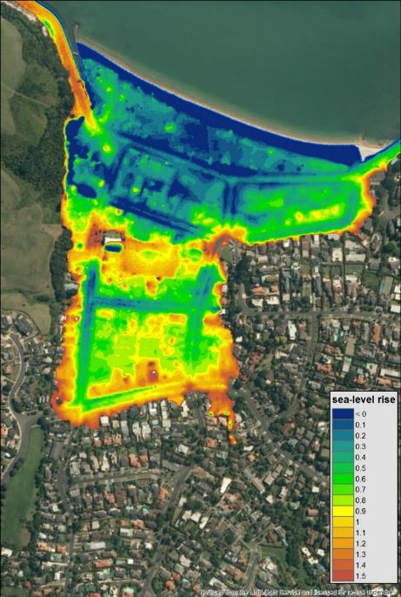
Note: SLR increments have been added onto the 1 per cent AEP storm tide elevation, which was calculated for the current mean sea level. Graphics: Sanjay Wadhwa, NIWA; based on Auckland Council LiDAR data.
Source: Stephens et al (2017)
Figure 13 and figure 14 show how more detailed hazard mapping at Mission Bay has been used to model the depth and frequency (respectively) for a 1 per cent AEP storm tide at present mean sea level and two relative sea-level rise (RSLR) projections. The two types of maps show the potential effects of two RSLR increments on coastal storm inundation, and, together, they provide information that is more useful for decision-making than any one map of flooding extent in isolation. For areas like Mission Bay, which are susceptible to coastal storm inundation, modelling of small increments of SLR and statistical uncertainties can later be used in risk and vulnerability assessments and to support decisions on adaptation thresholds, and when they might occur, as part of the dynamic adaptive pathways planning approach in step 6 (eg, similar to table 7).
We recommend assessing the impacts of 0.1 metre to 0.2 metre SLR or RSLR increments for such locations, in addition to the median and upper 95 per cent of the 1 per cent AEP hazard. This will help identify areas potentially at risk and at what SLR increments.
Figure 13: Depth of inundation at Mission Bay, Auckland, for a 1 per cent annual exceedance probability storm tide covering present-day mean sea level and two relative sea-level rise height increments
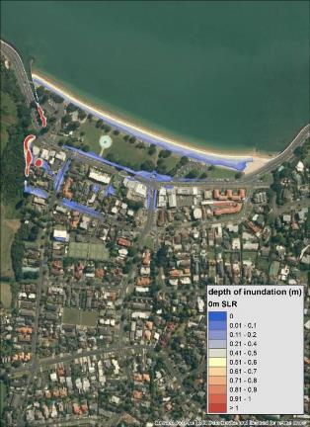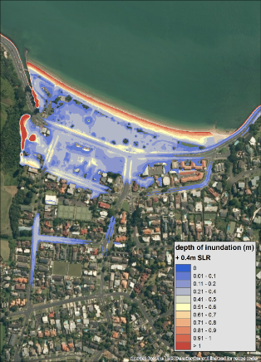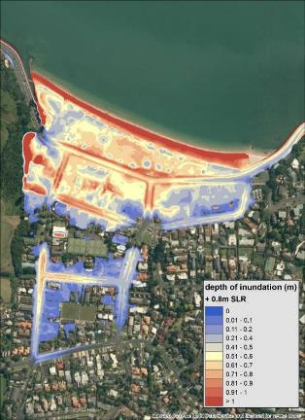
Left: 1 per cent AEP storm tide at present-day MSL. Middle: 0.4 metres RSLR. Right: 0.8 metres RSLR.
Figure 14: Frequency of inundation (exceedances per year) at Mission Bay, Auckland, for a 1 per cent annual exceedance probability storm tide, covering present-day mean sea level and two relative sea-level rise height increments
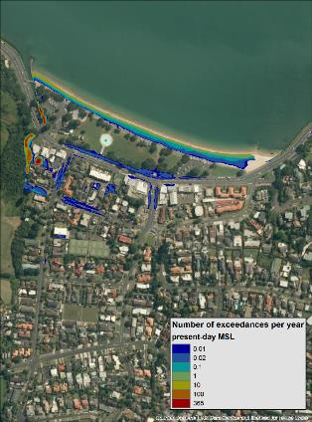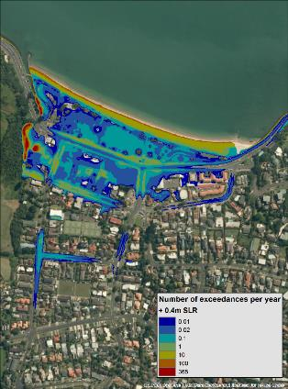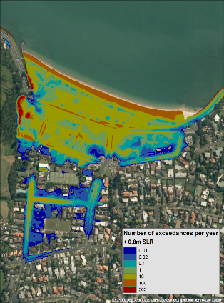
Left: 1 per cent AEP storm tide at present-day MSL. Middle: 0.4 metres RSLR. Right: 0.8 metres RSLR.
Inundation was modelled using a static geographic information system technique. All areas below the modelled sea level are shown as inundated, regardless of connection to the sea; some inland areas may not become inundated as shown. Note the infrequent exposure to coastal storm inundation at present will increase with increased RSLR.
Graphics: Sanjay Wadhwa, NIWA; base maps developed from Auckland Council LiDAR data.

Part B: What matters most?

Step 3: Establish values and objectives
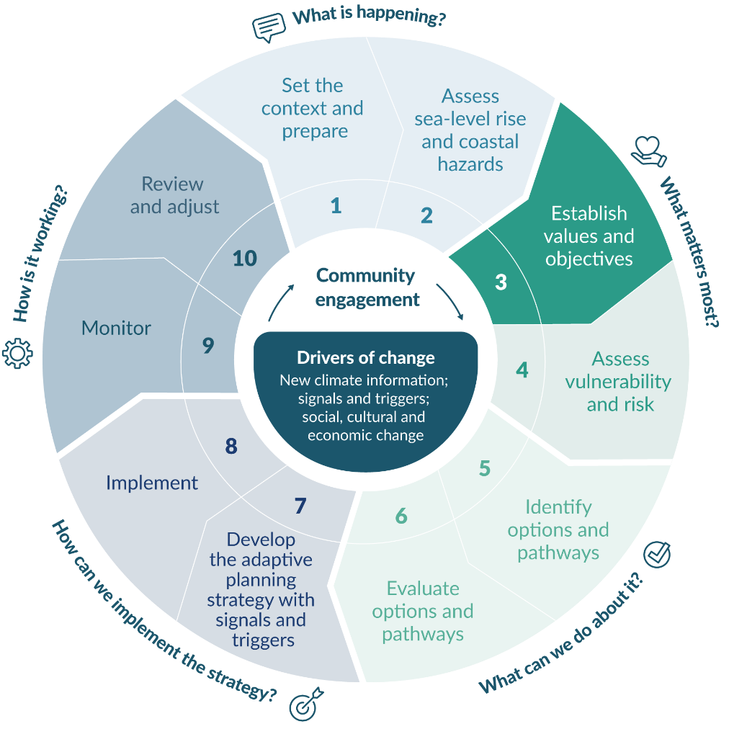

Mana whenua and community values and objectives

What are community values?
Councils should engage with the wider community to understand what ‘things or objects’ of value could be affected by increasing coastal hazards and rising sea levels. This engagement should be done after the coastal hazards and SLR assessments are complete. These values may include:
physical items like homes and property, marae and urupā, public land and buildings, roads, services and utilities, parks and reserves, retail and commercial centres, recreational services, community assets, as well as cultural and historical sites
natural values, like coastal wetlands and estuaries, shorebirds, native fish and lizards, as well as mahinga kai practices
intangible values like the ability to practise tikanga, community cohesion and spirit, wellbeing and occupational identities (Barnett et al, 2016).
A comprehensive understanding of what is important, and who it is important to, will underpin decisions about the value of what is at risk and inform adaptation options and their implementation, evaluation and the monitoring of adaptive planning strategies.
Without this knowledge, community values are unlikely to be fully considered in consent, policy and adaptation decisions. Therefore, there is a risk that community acceptance of decisions will be affected, which can result in opposition to the adaptation plan. Investing time and effort at this step of the decision cycle is more likely to result in successful outcomes later.
Understanding and capturing values and forming objectives can range from scoping studies to more detailed investigations, depending on the scale and detail of the hazard and sea-level rise (SLR) assessments and the nature of the decision. Three stages are involved.
- Explore and capture community, iwi/hapū and stakeholder values in a way that clearly expresses:
- what of value is potentially affected by coastal hazards and SLR
- who values it
- where is it located geographically.
This includes considering the needs of at least two future generations and how decisions today could affect communities in the future. Carefully consider who should participate, how they will participate, and the tools and techniques that will be used to uncover community values (see Community engagement principles and approaches, and practice methods: Coastal hazards and climate change guidance – Supplement B).
- Reframe the agreed community values into objectives for public and private stakeholders to ensure inclusion in the vulnerability assessment and future adaptation decisions.
- Clarify and agree on local government jurisdictions, functions and statutory outcomes or limits. Agreement will require multi-party, multi-function discussion.
These three stages will help councils gauge the feasibility and effectiveness of adaptation plans at the implementation stage.
Box 8 lists potential effects on coastal communities, which can be used in values identification.
- : potential effects of COASTAL HAZARDS on Coastal community values
Private property and businesses
- Flooding of homes and businesses
- Damage or destruction of beachfront property from erosion or inundation
- Property loss, compensation and insurance claims leading to financial instability
- Devaluation of land due to erosion or inundation
- Loss of productive land due to saltwater intrusion
- Loss of land, farm stock and related economic opportunities
Local infrastructure
- Damage to lifeline infrastructure, community facilities, stormwater, wastewater and water supply systems
- Compromising of road access and safety along the foreshore
- Flooding and sedimentation of land and buildings leading to loss of access to services and emergency assistance
- Loss of cultural assets (eg, marae, urupā and kura kaupapa)
Community lifeways and recreation
- Loss of community events
- Limiting beach access for recreation and public use
- Loss of sandy beaches due to erosion or coastal protection works
- Loss of esplanade reserves for recreational use
- Destruction of wild foods (eg, shellfish) used recreationally and as food resources
- Damage to safety and usability of public coastal reserves and estuaries
- Degradation of sacred places and sites resulting in loss of identity, whakapapa and wellbeing
- Displacement of people and loss of social cohesion
Ecology and biodiversity
- Potential to lose species or biodiversity in coastal habitats
- Potential extinction of rare species (eg, New Zealand dotterel)
- Degradation of ecology leading to loss of traditional knowledge
- Loss of or damage to coastal wetlands, marshes and intertidal areas
- Adverse impacts on mahinga kai and whānau health from loss of habitat and dysfunction of sewerage and stormwater networks and septic tanks
- Damage to human–environment relationships and wellbeing
- Saltwater intrusion (salinisation) of freshwater resources
Aesthetics
- Damage to the natural appearance of coastal environments, especially if hard engineering solutions are enacted
- Damage to the appeal of the area as a nice place to live.
Source: Rouse et al (2016)

Methods for understanding mana whenua and community values
Mana whenua and community values are wide ranging, and not all values are easy to draw out or describe. Two things to remember when collecting data on values are:
people undervalue infrastructure until its performance is imperilled; assumptions should be made and factored into the objectives
it is important to focus on the functional aspects of the things the community values, in addition to the current locations of things. For example, people may value specific green spaces or community facilities, but those functions might be able to be provided elsewhere away from coastal hazards.
Many tools can be used to engage and gather information on values, including online resources. Table 10 shows four methods that can be used to understand mana whenua and community values. They can be used in combination, depending on the scale of the process planned.
- Example of four methods that can be used in combination to understand mana whenua and community values
Method | Advantages | Disadvantages | Examples
Review existing documents (eg, iwi/hapū management and natural resource management plans, community outcome documentation, surveys, reports) | May uncover existing community objectives, avoids repeating questions and provides context for future engagement. | Information may be outdated and will need to be verified through subsequent methods. | Supplement B
Postal, internet-based or telephone surveys | Can obtain responses from many people across the region.  Raises awareness of the issues.  Potentially low cost.  Identifies issues that are critical at a regional scale. | Can produce superficial data.  Response rates can be low and represent only certain demographics.  Little opportunity for learning, discussion or interactions.  Risks missing important information. | Supplement B
Important informant interviews | Opportunity to gather detailed information on topics of interest.  Obtains views of those who are not comfortable contributing in other ways. | May miss sections of the community.  No opportunity for participants to listen to, or learn from, others. | Blackett et al, 2010a; King et al, 2011, 2012, 2013; Schneider, 2014
Public meetings, hui or other events (eg, open days, field days) | Can apply several participatory data collection methods in this setting.  Suited to the local scale.  Listening and learning can be built in. | May miss sections of the community who cannot attend.  Careful organisation will be required to ensure balanced dialogue. | Blackett et al, 2010b; John and Martin, 2022; King et al, 2011, 2012, 2013; Rouse and Blackett, 2011; Rouse et al, 2011, 2013
The outcome of this engagement should be a summary of community values, including:
what values are likely to be affected by coastal hazards and SLR
where the values are and who finds them valuable
the diversity and degree of agreement in values and norms
the extent to which different groups in the community will be affected.
Highlight and consider the values of all social groups when assessing risk, identifying and evaluating options and pathways and when implementing and monitoring at steps 4 to 10 of the decision cycle.

Reframe values as objectives
Once the community values have been articulated, aggregate the data into themes, where possible, and appropriate (Flick, 2009; Kitchin and Tate, 2000). The original list of values should be kept, with their underlying richness and detail, for reflection throughout the engagement process.
A usable objective is:
relevant to the community and mana whenua (eg, a safe place to live, with access to amenities, expression of Māori values)
measurable (eg, climate disruption minimised, using the metric of frequency of storms damage avoided)
linked to the decision triggers and adaptation thresholds (eg, disruption to mobility, community tolerance levels or council requirements)
able to be embedded in the monitoring system for the adaptive planning strategy (see step 9).
Table 11 gives two examples of how values can be translated into objectives. The translated objectives can help provide guidance on adaptation options.
- Two examples of translating values into objectives
Theme: public access to greenspace
What is valued by the community | Translated objective
Public recreational space for picnics and family activities | Maintain safe, aesthetically pleasing public greenspaces (including picnic and playground facilities) along or near the foreshore and distributed throughout the community.
Safe playgrounds for children to play
Aesthetics
Greenspaces along the foreshore
Proximity and easy access to parks and reserves
Theme: biodiversity and ecology
What is valued by the community | Translated objective
Native coastal species | Ensure a functioning coastal ecosystem that supports rare and mahinga kai species.
Rare species (eg, New Zealand dotterel)
Functional viable coastal ecosystems
Mahinga kai species present and safe to harvest
Source: Rouse et al (2011, 2016)

Local government objectives
Local authorities should work together to identify and consolidate objectives for the region or district. This can begin prior to, and happen alongside, community objectives being articulated, but should include consideration of the community objectives. Integrating council and community objectives through engagement can address conflict between community aspirations and councils’ statutory requirements which must be met. It is therefore important to be clear in communications and engagement material that setting community objectives is only one part of the process and must be considered in the context of complying with the requirements of the Resource Management Act 1991 and New Zealand Coastal Policy Statement 2010 (NZCPS) (DOC, 2010). These requirements may be formalised in statutory planning documents, long-term plans and 30-year infrastructure strategies, and will have already been through statutory consultation processes. Table 12 lists questions that could guide the generation of local government objectives.
- Questions to generate local government objectives
Question | Supporting questions
Who needs to be part of the conversation? | Who has jurisdiction in this area?  Which functions need to be represented?  Who can represent the main groups?  What and who is missing?  Should other council-controlled organisations and non-council organisations be part of this discussion?
What are the different objectives across the local government functions? | What plans and policies exist?  What are the standards and expectations of levels of service for utilities and infrastructure?  What goals and objectives exist and why? Are they aligned?  How might community objectives fit with requirements under the New Zealand Coastal Policy Statement 2010, Resource Management Act 1991 and any other legislative requirements?
What are the agreed objectives? | How can we identify the most important objectives?  How can we address any misalignment?  What are the implications and consequences of the agreed objectives for local government and external organisations?
Clear statements of community objectives, alongside local government objectives, are an opportunity to look for joint benefits and to manage expectations. For example, areas where development should be avoided may be able to be used as public space, if the public can be protected from future hazard events there.

Step 4: Assess vulnerability and risk
Climate risk assessments (step 4) build on the coastal hazard assessments completed in step 2 (covering the range of the recommended relative sea-level rise (RSLR) projections and/or increments of RSLR heights) and identifying community, stakeholder and council values and objectives in step 3. Outputs from the risk assessments (eg, geo-spatial platforms, maps, reports) are used in the following step 5 to inform communities, iwi/hapū and decision-makers on identifying options and pathways to pre-emptively address the rising climate-related risks.
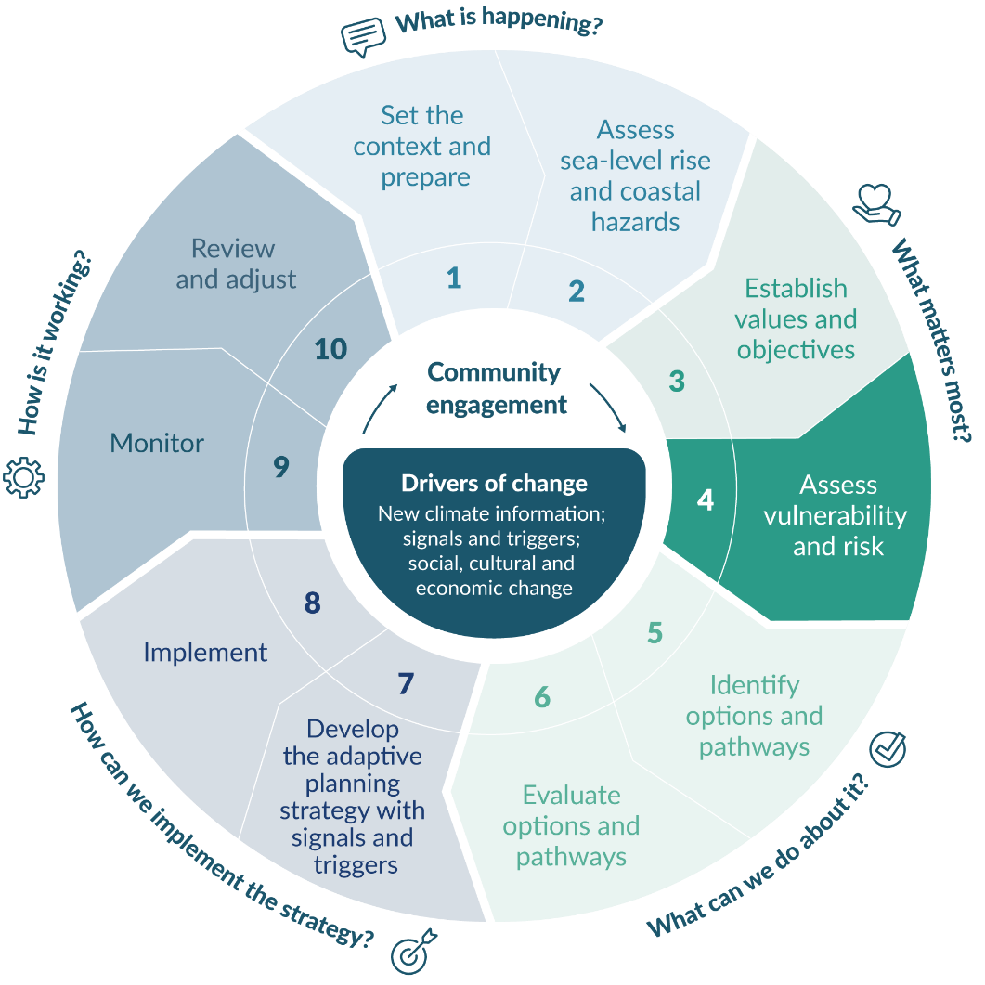

Undertake a coastal climate risk assessment

Climate risk and its components
The core definition of risk in relation to climate change (Reisinger et al, 2020) is the potential for adverse consequences for human and ecological systems, recognising the diversity of values and objectives associated with such systems (determined in step 3 of the decision cycle).

Components of risk
Risk arises from the overlap of three components that increase over time as climate changes and sea level rises (figure 15 and ISO 14091:2021):
the hazard, either singly or as a multi-hazard (eg, flooding and erosion), or compound hazard events and progressive and rising changes that for the coast will be irreversible. See section 2.2 for hazard assessments that provide the temporal and spatial changes in climate hazards for the risk assessment
the exposure, the presence of the things or networks we value (eg, people, whenua, taonga, environments, primary production, buildings, utilities, supply chains) in settings that could be adversely affected by hazards
the vulnerability of the exposed things, environments or networks we value or rely on. Vulnerability is the underlying predisposition of a community, region or system (eg, ecosystem or infrastructure network), including governance and financial systems, to be adversely affected as climate-related risks continue to rise.
Vulnerability combines both sensitivity (sometimes called fragility) and adaptive capacity to cope and adapt to the ongoing changing risks over time.
Sensitivity is the degree to which a system, infrastructure network, community or ecosystem is affected, either adversely or beneficially, by climate hazards, variability or a progressive change. A range of social factors may predispose some communities or individuals to harm from climate-influenced risks, such as age, mobility, ethnicity, socio-economic inequities, or pre-existing health conditions (sections 3.2.3 and 3.2.5 of MfE, 2021).
Adaptive capacity is the ability of systems, financial and governance institutions, humans and ecosystems to adjust to the potential damage and progressive changes, to take advantage of opportunities, or to adapt to consequences (ISO 14091:2021).
Figure 15 shows three intersecting components that contribute to risk, with actions to reduce each risk component, which will all continue rising over time.
Figure 15: Three intersecting components of risk, all increasing over time
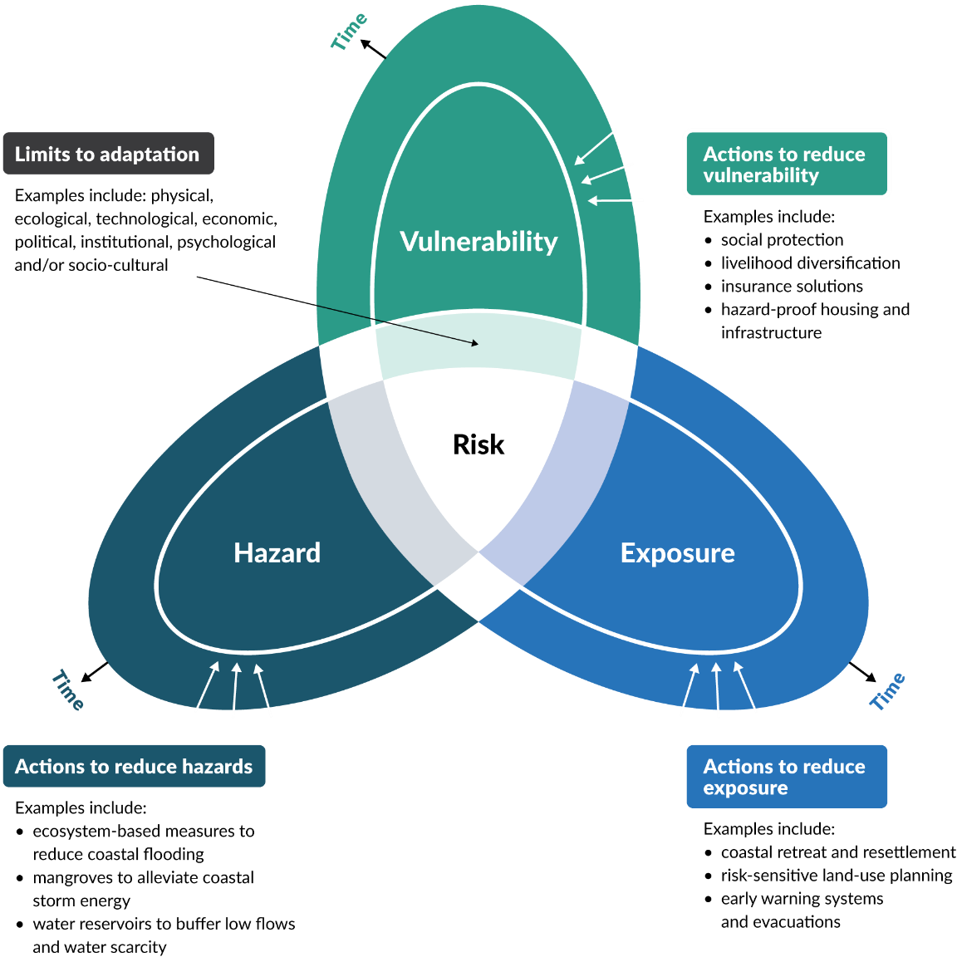
Outwards pointing arrows indicate risk rising over time. The inward pointing arrows indicate examples of actions and options to reduce each rising risk component through adaptation (but with limits) for coastal areas.
Source: Adapted from Garschagen et al (2019)
Due to the complexities of overlapping or competing values and objectives, climate risk assessment and management are not just technical exercises. The evaluation and review phase of risk assessments involve value judgements and precaution, particularly if there is limited quantitative information (eg, on cascading or indirect impacts or compound hazards) and/or contestation of priorities (regional versus local impacts or funding) to address the rising coastal risks.

Coastal climate risk assessment process
Climate risk assessments differ from conventional risk assessments, because they require consideration of extra complexity and uncertainty.

Climate risk considers both events and progressive changes
For coastal areas, ongoing RSLR is one of the primary climate-related hazards that is fundamentally changing risk profiles. The cumulative risk from more frequent small to medium flooding due to a higher mean sea level will eventually outstrip the risk from extreme events during this century (Paulik et al, 2021), even though extreme events will also intensify. Risk assessments should therefore include both progressive changes (eg, permanent high-tide inundation, increased erosion trends, salinisation, groundwater rise, shrinking wetlands and marshes) and more frequent small to medium disruptive events, in addition to the focus on episodic extreme events.

Assessment of climate risks is inherently complex and uncertain
Assessment of climate-related risks needs to embrace the uncertainty in all three components contributing to risk (figure 15), noting the generic definition of risk is the effect of uncertainty in relation to objectives (ISO 14091:2021). It needs to appraise short- and long-term consequences, feedbacks, cascading impact chains, non-linear behaviour and the potential for surprises (Ara Begum et al, 2022), against the backdrop of deepening uncertainty over time of climate change and sea-level rise (SLR).
Local governments need to cope with rising risks that cascade and compound at distance from the hazard drivers (see figure 16) and those emerging in many different coastal areas simultaneously. The use of RSLR projections or increments of RSLR to address the deepening uncertainties of rising coastal hazards (step 2), needs to be carried through to assessing risk, especially detailed assessments, rather than just selecting a best-estimate (most likely) or worst-case projection.
Risk conventionally expressed in terms of likelihood is not helpful when it is significantly changing over time, and as past low-probability extremes become more frequent and therefore more certain. Further, an SLR of at least 0.5 metres is virtually certain by 2100 (table 6).
Figure 16: Generic example of an impact or cascades chain that can be created through participatory workshops and hui, underpinned by relevant hazard and risk exposure mapping
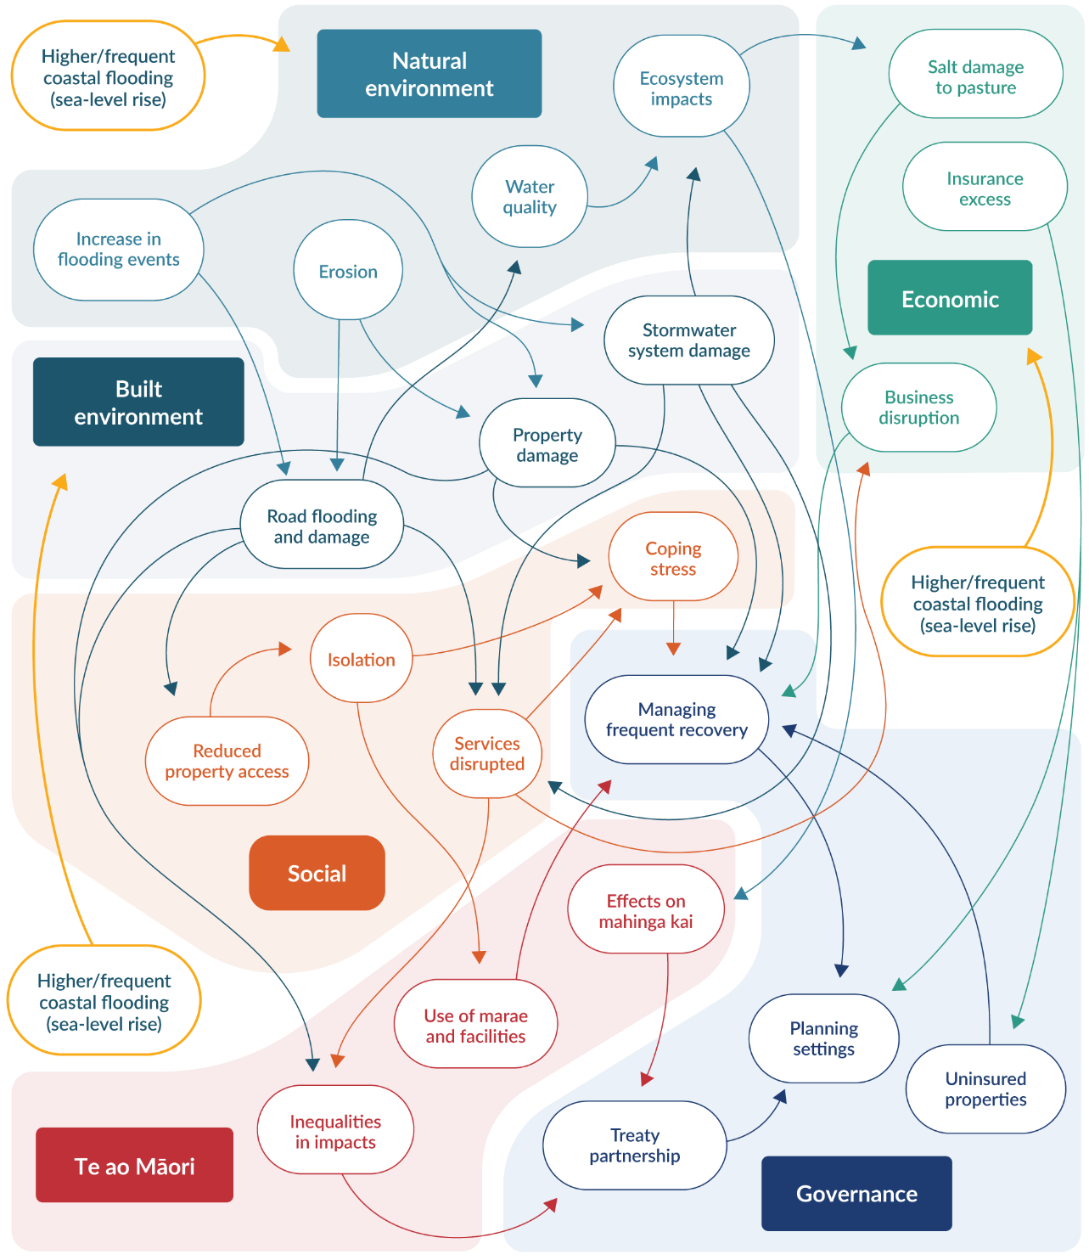
Note: This example explores how cascading impacts to each value domain arise from higher and/or frequent coastal flooding arising from a higher relative sea-level rise. Diagram is for illustrative purposes and needs more local and regional specificity added for local application.

Adaptive capacity is an essential element of climate risk assessments
Adaptive capacity is an integral component of climate risk assessments, exacerbating or reducing vulnerability. This includes the adaptive or coping capacity of the community, of supporting services and infrastructure (including availability and agility of funding and other institutional and governance mechanisms) and of the natural environment.
When making adaptation decisions, the interactions and dependencies among these adaptive capacities need to be considered. Do they enhance or hinder adaptation, and how might they change over time (eg, capacity for more frequent emergency responses to coastal flooding or agile funding mechanisms such as for pre-emptive or reactive managed retreat)?
Environmental or cultural adaptive capacities may be threatened by our adaptive response to protect the built environment. For example, building up a road causeway that has been exposed to increasing floods is likely to constrain the adaptive capacity of an adjacent estuary inlet or wetland.

Climate adaptation is not just a local issue
Climate risks vary at a fine scale across communities and societies (Ara Begum et al, 2022). This could include pockets or precincts within suburbs or within low-lying or cliff-edge coastal margins. Adaptation is often viewed as a ‘local’ issue where the ongoing impact lies, but cascading and compounding impacts (figure 16) also occur across the wider community and nationally.
Climate adaptation (and therefore risk assessment) should consider the interconnections and dependencies between the local, regional and national scales. An example is consideration of local isolation due to storm or flood events causing outages of a vulnerable section of the main coastal road elsewhere, illustrating the need for wider-scale assessment of the risks affecting a specific locality (Logan et al, 2023; Logan and Reilly, 2023). Annex A of ISO 14090:2019 provides guidance on using systems thinking to consider these wider interconnections across different value domains.

Climate risks vary over time
Time is a fundamental consideration in any risk assessment of coastal hazards and climate change impacts. All three components of risk will increase with time (figure 16). Examples of how risk exposure increases over time include: i) the changing land use (eg, intensification, up-zoning, subdivisions or redevelopment); ii) increasing capital value of assets or upgrades to infrastructure that increase the consequences. Increases in vulnerability can occur as assets age or are compromised by progressive changes, for example, groundwater rise affecting foundations or the institutional ability to cope and adapt diminishes.
Adaptation interventions (accommodate, protect), which can reduce risk to varying degrees, also have time limitations because the risk will continue rising (figure 17), including the residual risk (eg, breaching or outflanking of a seawall or more frequent road impassability issues, even though buildings have been raised as an accommodation type option).
Climate risk assessments should be explicit about how time is addressed (Logan et al, 2021), focusing on both immediate specific impacts (including cascading or flow-on risks) and addressing long-term changes and implications through dynamic adaptive pathways planning (DAPP).
Figure 17: Effect on level of risk over time for incremental or a precautionary approach to adaptation relative to a local adaptation threshold (or risk tolerance threshold)
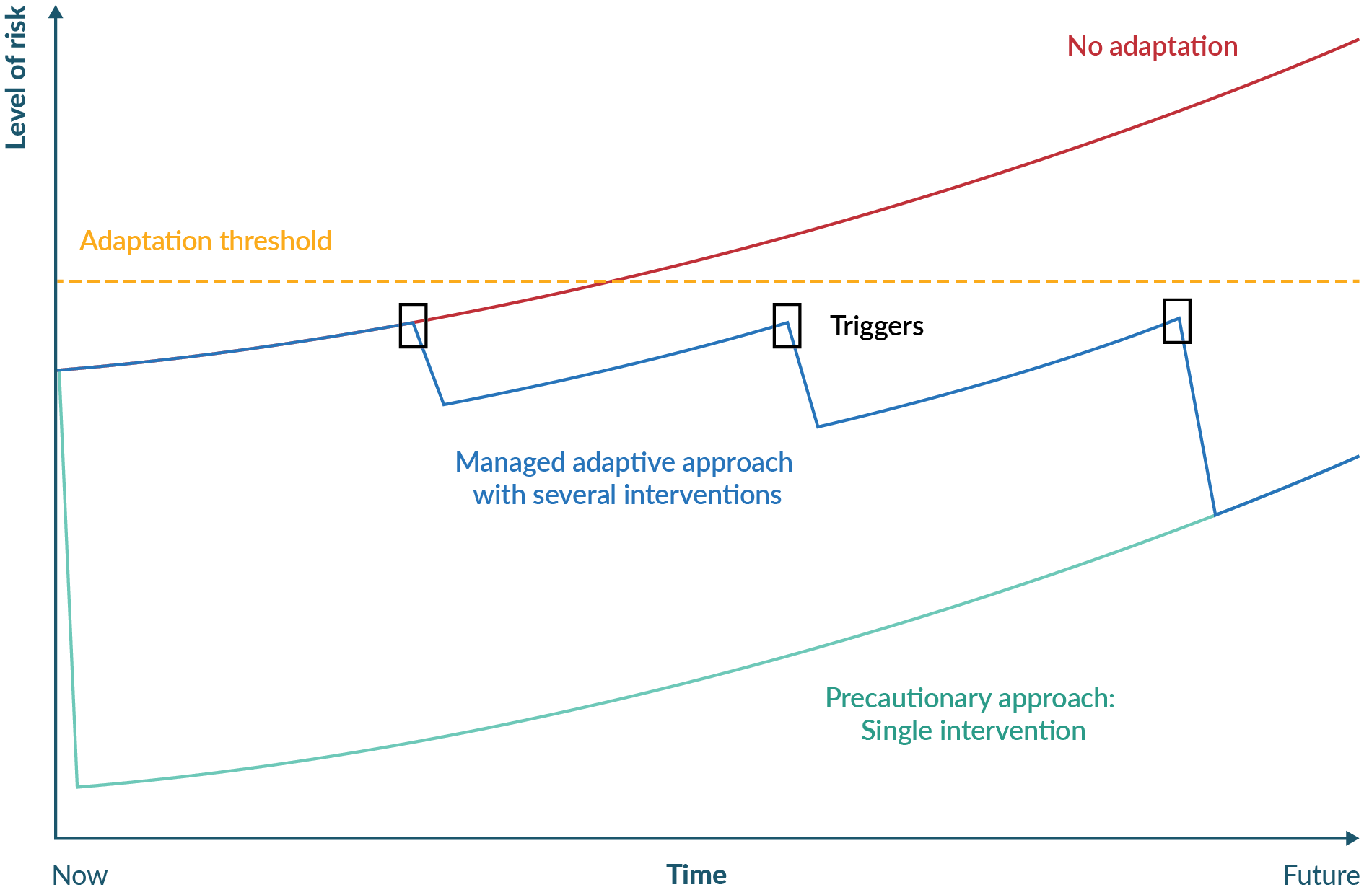
Source: Adapted from MfE, 2008a

Risk assessment methods and process
The main purpose of vulnerability and risk assessments for this guidance is to inform DAPP strategies that are pre-emptive and cover the future extent of the coastal environment at local to regional scales. These assessments provide evidence for the range of time-varying risks, covering the increasing uncertainties, for steps 5 to 8 of the decision process.
Section 5ZW of the Climate Change Response Act 2002 requires reporting organisations (including local authorities) to provide to the Minister of Climate Change or the Climate Change Commission on request, information on risks and processes used to identify, assess and manage the risks. Local and/or regional climate risk assessments could be the basis of such information.
Increasingly, coastal risk assessments are being undertaken within general climate risk assessments across value domains for a region, district or city (MfE, 2021). This has the advantage of addressing climate risks more holistically across different hazards and their compounding and cascading impacts (eg, Greater Wellington (2022–24), Bay of Plenty (2022–23) and Nelson–Tasman (2023)).
Purposes of a coastal climate risk assessment
The purposes of a coastal climate risk assessment are to identify areas that will potentially be affected (prioritising areas that are at high risk of being affected) by coastal hazards and climate change over at least 100 years (Policy 24, New Zealand Coastal Policy Statement, DOC, 2010).
Identify where climate change effects may:
- restrict public access to the coastal environment
- affect the integrity, form, functioning and resilience of the coastal environment
- affect characteristics that have special value to tangata whenua
- inform coastal adaptive planning strategies for new and existing coastal development
- inform councils’ long-term, spatial and land-use planning
- provide a robust evidence base for climate risk disclosures.
When conducting a coastal climate risk assessment, some risk components (figure 16) can be quantified, such as replacement costs, repair costs, number of residents exposed to hazards, hazard magnitudes, SLR projections, building footprints, and transport isolation (Logan et al, 2023; Logan and Reilly, 2023). Primarily, however, risk assessments should appraise qualitative information such as value judgements, cascading impact chains (eg, figure 16), mātauranga Māori, present inequities that affect adaptive capacity, and stakeholder and community description of risk tolerability and initial adaptation thresholds.
Because climate risks affect some groups more than others, the assessment of vulnerability will need to consider and map economic, social, cultural and environmental consequences for a range of future scenarios and RSLR projections (see section 4.2).
Transparency should be integral to risk assessment (section 5.8 of ISO 14091:2021; Thekdi and Aven, 2023). Ensure the methodology used is known and understood by all parties and documented adequately to understand the steps and decisions taken. Explain the strengths and weaknesses of the selected methodology, including assumptions and data sources, to ensure credibility.
There is no single best methodology or tool for a climate risk assessment that covers the time-varying, direct and indirect cascading impacts of climate change.
Box 9 lists some of the available tools for climate risk assessment, which can be used either separately or in combinations of approaches, to ensure a range of quantitative and qualitative information and mātauranga Māori can be integrated.
- : climate risk assessment tools
Quantitative methodologies
RiskScape: This open-source spatial data processing application is used for multi-hazard and risk analysis. It is customisable, based on core modules (eg, hazard model input, asset attributes, vulnerability or fragility functions, and adaptation options). Modellers can tailor the analysis and outputs, input their own hazard model and assets data, or use on-board databases (eg, building footprints) and model simulations. It can be used at a range of spatial scales and resolutions. See examples at national scales (Paulik et al, 2021; Simonson and Hall, 2019), down to the local scale assessments (eg, indirect impacts on infrastructure for South Dunedin, Lan et al (2023), and evaluation of the reduction in risk from adaptation options such as Westport flood protection).
Geographic information system (GIS) or spatial mapping application that overlays hazard × asset (exposure) × vulnerability. An example is the regional coastal risk screening for southern Hawke’s Bay coastal units undertaken by Tonkin+Taylor (2016b), which included elements at risk across four value domains from coastal flooding, erosion and tsunami inundation.
Hybrid methodologies (qualitative/quantitative)
Resilience/risk explorer platform: Risk-informed decision-making platforms that can handle a mix of data and community-sourced information that inform asset management and land-use planning, and risk communication for stakeholder, iwi/hapū and community engagement. An example is the Resilience Explorer dashboard. It can be used for core spatial information on infrastructure impacts (consistent with RiskScape), including the analysis of indirect impacts such as isolation and infrastructure service loss.
Qualitative methodologies
Risk matrices or risk charts can be used to assess and evaluate direct element-by-element risks (MfE, 2019, 2021). However, be cautious when summarising risk assessments via risk matrices (eg, a vulnerability–exposure matrix of coloured cells for risk for a given hazard and planning horizon). They have a propensity to assign qualitatively higher ratings to quantitatively smaller risks, and they have poor resolution when only a few combinations (cells) are considered (Cox, 2008). They also do not easily capture the time-varying increase in risk. Interactive risk charts in the form of scatter plots (rather than matrix cells) are more flexible when working with groups, by encircling uncertainty bounds around risk combinations or highlighting where there is disagreement and/or uncertainty of a risk ranking or threshold that therefore needs further investigation.
MfE (2021) templates can be used for both high-level risk screening and detailed risk assessments. While it is stated as optional, it is recommended to also map impact chains or systems to uncover place-based risks (eg, figure 16).
Constructing impact chains or systems maps can show cascading impacts within and among value domains (eg, figure 16) for indirect and place-based risk assessments (eg, Lawrence et al, 2018, 2020a; annex C of ISO 14091:2021).
CIrcle tool can be used for interactive systems mapping to explore connectivity among drivers of risk, especially for infrastructure and utility services (Hounjet et al, 2016; Lawrence et al, 2020a). This feeds into a place-based risk assessment via collaborative workshops.
Combined mapping and GIS approaches
Combined approaches use GIS or other mapping platforms to integrate quantitative and qualitative findings, including narratives, observations and mātauranga Māori. Compiling such information helps evaluate and prioritise local and wider-scale risks and hotspots.

Engagement
Risk assessment is more than a technocratic process. It needs a specific plan on the roles and expectations and level of engagement with different parties and partners at the start of the assessment, during and at the end of the process (to communicate the findings). This may be a slightly different engagement process than that used for the DAPP approach and developing an adaptive planning strategy, particularly if the risk assessment is part of a general climate risk assessment at a regional or district scale. More details on engagement are set out in Community engagement principles and approaches, and practice methods: Coastal hazards and climate change guidance – Supplement B.
Table 13 outlines a process for setting up and undertaking each task in a coastal climate risk assessment, with stated alignment to policies in the New Zealand Coastal Policy Statement (NZCPS) (DOC, 2010) and relevant risk guidance (eg, MfE, 2021) and ISO standards (ISO 14092:2020 and ISO 14091:2021). Each phase is described in more detail below.
- Process for assessing climate risks in coastal areas
Task | New Zealand Coastal Policy Statement policies, standards and guidance | Description
Task 1: Getting started (pre-planning) | Policies 2 and 4, ISO 14091:2021, MfE (2021) | Buy-in: objectives, purposes, governance and integration, multiple uses, resourcing capability to implement the risk assessment, level of engagement, use of mātauranga Māori and local knowledge.
Task 2: Context and set up | Policies 1 and 24; ISO 14091:2021; MfE (2021); ISO 14090:2019 | Determine scope, system boundaries, organising value domains, scenarios (climate, socio-economic), which qualitative/quantitative methods, outputs and expected outcomes, budget.
Task 3.1: Identify and prepare data and information | Policy 24; ISO 14091:2021; MfE (2021) | Involves identifying types and range of hazards (including compounding) and system elements potentially at risk, data availability and conceptual cascades or impact chains, data inventory.
Task 3.2: High-level risk screening | Policy 24; ISO 14091:2021; MfE (2021) | Involves assessing hazards, elements and places potentially at risk presently and for an upper-range sea-level rise scenario to at least 2130. Rate evidence base and screen for priority, important and unclear hazards and places and networks for next task.
Task 3.3: Detailed risk assessment | Policies 24, 25 and 27; ISO 14091:2021; MfE (2021) | Involves a more detailed assessment of risks from task 3.2. Uses a range of relative sea-level rise increments (or projections) plus other climate and socio-economic scenarios. Use quantitative data where available for both exposure and vulnerability. Develop impact chains, geo-spatial analysis (eg, isolation and utility outages), risks to people, taonga, environment and elements.
Task 3.4: Review and communicate risk | Policies 2 and 4; ISO 14091:2021; MfE (2021) | Review risk and consequence ratings for consistency and confidence. Compare coastal areas. Under what conditions does an upward inflexion in risk occur? Thresholds? Opportunities? Produce outputs: maps, impact chains, risk charts, workbooks, online risk explorer, report.

Coastal climate risk assessment in practice
To support different objectives (including informing subsequent steps in this guidance), defining the spatial extent of the risk assessment and data and resources available to local authorities, two levels of risk assessment with increasing depth and resource requirement are recommended (MfE, 2019, 2021; NCCARF, 2016). This is aligned with the coastal hazard and risk policies of the NZCPS (DOC, 2010) (see also DOC, 2017 guidance).

Set up and scope of risk assessment
Box 10 summarises the key tasks for setting up and scoping the risk assessment process. This is similar to the key tasks for adaptation planning but is located here as a separate, more focused process on what the assessment covers. This is because while a risk assessment is a part of a DAPP approach for coastal areas, it is often undertaken separately as a broader regional or local climate risk assessment (MfE, 2021), of which a coastal risk assessment is a subset.

- : Key tasks FOR THE risk assessment process
- Getting started (pre-planning)
- Decide on:
- the objectives and purposes of the coastal climate risk assessment (and whether it is part of a general climate risk assessment)
- how the risk assessment will support an adaptation planning pathways approach.
- Obtain buy-in to:
- an integrated approach across relevant councils, iwi/hapū and stakeholders, or a
- multi-user collaborative approach.
- Then set up the governance oversight for the risk assessment to achieve the selected approach. Establish the governance group and technical reference group responsibilities, resourcing and capacity to implement the risk assessment.
- Decide on the starting point and how detailed the assessment should be (depending on available data, tools and resources for addressing information gaps).
- Identify stakeholders and plan for engagement and collaboration and develop a communication plan.
- Develop guiding principles (ngā mātāpono) related to the local context and developed in partnership with iwi and hapū.
- Context and set up
Determine the scope, scale of assessment and system boundaries:
- Decide on the range of coastal hazards to assess, which seal-level rise (SLR) increment or relative sea-level rise (RSLR) approach, and planning time horizon.
- Agree on value domains, such as Treasury’s wellbeing domains (MfE, 2021). Address them individually and their interdependencies (figure 16). Cascading risks should focus on vulnerability (sensitivity and adaptive capacity), to address the significant and priority place-based risks.
- Establish the methodology (or mix of methods) for the assessments, depending on availability of quantitative and qualitative data and how mātauranga Māori will be incorporated (see box 4).
- Decide how to gather and store the data and results, and how to make it accessible to stakeholders (see box 4).
- Establish the project team, budget, implementation plan and outputs, usually done through a request for proposals and tendering process.
- Identify and prepare data, information and projections
Compile data and information currently available, including:
- national or regional climate change and RSLR projections, and any downscaled local effects
- mana whenua mātauranga, pūrākau (stories) of the land
- the range of hazards that fit the decided objective and purpose (drawing information and hazard magnitudes from the hazards assessments – see step 2)
- system elements (across the value domains) at risk from exposure from the impacts of climate change
- the attributes and features of assets, land, cultural sites and people who are sensitive to coastal hazards and climate change (inputs to vulnerability). These can include fragility functions that relate the per cent damage or impact of assets to the magnitude of hazard exposure, for example, flood depth above a floor level (included in RiskScape)
- barriers and enablers across the value domains, particularly governance, social and cultural, that could affect adaptive capacity (inputs to vulnerability)
- some scenarios or narratives of future policy, economic and social settings, demographic trends and effects on exposure and vulnerability (annex B of ISO 14091:2021, and Allison et al, 2023). Otherwise, future climate change and RSLR projections are only being assessed for risk on the current situation and policy and economic settings
- essential gaps, and how this information can be gathered.
- Consequence analysis
What elements are at risk and the consequences should they be affected. Things to consider include:
- type of land use or infrastructure
- the expected lifetime of the asset
- whether the development already exists or is yet to be built.
The degree of risk and consequences can then be used to set triggers and adaptation thresholds for the dynamic adaptive pathways planning approach.
- Review and communicate risk
Implications of the risk assessment findings and ratings to make sure:
- there is consistency (across domains, places, elements, intra-regional connectivity)
- a range of future changes have been adequately considered
- adaptation (risk) thresholds that have emerged from the risk assessment have been validated and carried through to step 5 of the decision cycle (to identify and evaluate pathway options)
- the methodology is fit for purpose
- engagement has been adequate and lessons learned have been documented
- the guiding principles (ngā mātāpono) and community, council and iwi/hapū values from step 3 were successfully woven into the assessment
- there is a comfortable level of assurance in the findings and priorities (including from a peer review or challenge process)
- any significant gaps in data, risk metrics, assessment limitations or engagement have been identified
- any opportunities to reduce risk that arose during the assessment have been included, for example, alternative transport routes, repurposing land use, changes in primary production, horticulture, paludiculture, enhancing coastal wetlands and marshes (Allan et al, 2023)
- the objectives and purposes of the assessment have been achieved
- people know how to use the findings to inform subsequent steps in the decision cycle.
Communicate the findings through a variety of channels, such as maps, a geo-spatial risk portal, system maps (cascade chains, eg, figure 16), workbooks, infographics (posters), a summary report, slide pack (for decision-makers) and a technical report.

First pass risk screening
First pass (high-level) climate risk screening (at a regional, city or district scale) can be conducted as a desk-top study or one-day risk workshop or hui to screen the main climate change related risks for coastal areas “potentially affected” by coastal hazards (usually focused on flooding and erosion) and the effects of climate change (Policy 24, NZCPS, DOC, 2010, p 24).
Identify risk hotspots, key interactions or interdependencies, risks that are unclear or lack data, and timeframes (or increments of RSLR) for risks emerging.
Focus on building a shared qualitative understanding of the more significant risks that could compromise community and cultural values, public safety and disruption, and council objectives and levels of service.
The outputs from this screening identify the priority risks to assess in more detail in risk assessment. Be cautious when deciding on priority risks. The most noticeable risks may seem to be a priority, but there may be other ‘hidden’ risks that could be more important or need to be addressed with a long lead time. For example, groundwater is often overlooked but will have significant effects for many coastal areas, even if an ‘accommodate’ option is implemented.
Address any gaps in crucial information, uncertainty bounds or disagreements on risk rankings before the next phase. These discussions may form a basis for early input into land-use planning and building consent that could constrain any further increase in risk from redevelopment or change in land use.
Figure 18 shows a general workflow that could be followed for a first pass coastal risk screening.
Figure 18: Suggested workflow for a first pass coastal risk-screening assessment
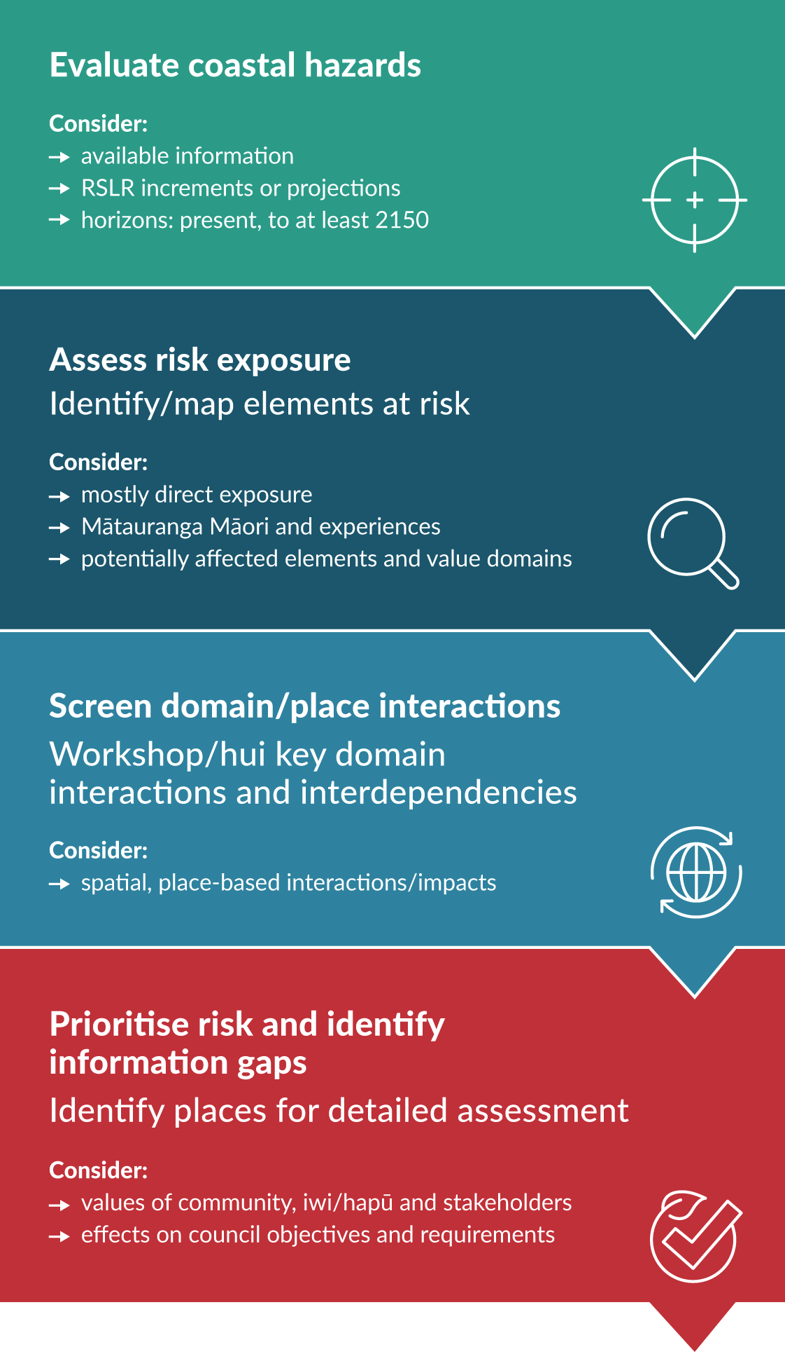
Source: Adapted from the guidance for local climate risk assessments (MfE, 2021) and the recent emphasis on systems mapping of cascades or impact chains to weave in a place-based component (eg, Lawrence et al, 2020a; annex C of ISO 14091:2021). RSLR = relative sea-level rise.
Examples of different types of risk screening, which have mainly focused on risk identification and exposure, are:
- the risk exposure of Auckland shoreline assets and reserves to SLR (Boyle et al, 2019);
- the national coastal risk exposure assessment by Local Government New Zealand of council assets, facilities and reserves (Simonson and Hall, 2019)
- Tasman District coastal risk exposure and posters for four domains and/or themes (Tasman District Council, 2020)
- a risk identification exercise (surveys and in-person or online hui and workshops for the 2022–23 Bay of Plenty climate risk assessment.

Detailed risk assessment
A detailed climate risk assessment takes the higher-ranked, significant short- and long-term and unclear climate risks from the risk-screening phase and undertakes a detailed analysis combining all three elements of risk in figure 15. It determines how climate change may exacerbate existing coastal risks or the emergence of new significant compound hazards (eg, flooding and erosion combinations, liquefaction) and cascading impact chains (figure 16). Elements to include in a detailed risk assessment are as follows.
Focus on vulnerability and the places, systems and networks identified in the regional and/or district screening as at greatest risk across the planning horizon. The assessments should encompass both the elements at risk and the extent of cascading impacts on the locality arising both locally and from across the wider area and/or region.
Use RSLR increments to cover the range of projections out to 2130 or, as a minimum, the RSLR projections recommended by table 6.
Attempt to superimpose future climate projections on a few future socio-economic scenarios or narratives (UNDRR, 2022). Examples are population trends, modal shifts in transport, changes in land-use and growth strategies. Use national, regional and local data, including input from hazard assessments for various RSLR increments or RSLR projections, demographics, and geo-spatial databases of assets and their attributes (eg, Land Information New Zealand and national building footprint).
To assess exposure, identify how and where people, elements and their interconnections and interdependencies are exposed, at different RSLR increments or projections (see Dunedin South and Tauranga examples, Lan et al, 2023; Stephens et al, 2021, or transport isolation of a locality, Logan et al, 2023; Logan and Reilly, 2023).
Assess the value (in monetary terms or intrinsic value) of the assets, taonga, environments, people and utility and infrastructure services exposed to events and progressive change of the identified coastal climate hazards. Express the degree of exposure in both absolute numbers, densities or proportions (eg, of people, buildings, assets, wetlands and the economy) and cascading impacts.
Measure the extent of exposure and present it spatially (eg, a map scaled to the degree to which elements and networks are exposed to the hazard) and temporally to determine the changing exposure over time, to inform where and when risk thresholds arise.
Detailed risk assessments should focus mainly on assessing vulnerability, comprising sensitivity or fragility to climate hazard exposure, social vulnerability (see section 4.2) and adaptive capacity across the value domains. Further guidance on assessing vulnerability is provided in MfE (2019, pp 64–66 and 2021, pp 43–45). Methodologies beyond matrices or risk charts used in these guides are still evolving but should involve the integration of local knowledge and experiences, mātauranga Māori, and deliberations of workshop and hui and combining quantitative and qualitative place-based vulnerabilities on a risk explorer platform (see box 4).
Sensitivity: assess the sensitivity of the built environment and cultural sites by considering the type, physical features (eg, floor or road levels), fragility to disruption or damage and state of maintenance of a building or element of infrastructure to the same hazard exposure. In other value domains, such as the natural environment, sensitivity to direct and indirect cascading effects should be explored for a full range of climate-related coastal hazards including progressive changes (figure 3).
Adaptive capacity: assessing this component of vulnerability is mostly qualitative in nature and forward-looking, involving value judgements, te ao Māori perspectives, expert and stakeholder views and how planning, policy and governance settings enable or hinder adaptation to avoid increasing the risk in coastal areas. Examples include assessing: a) access to and adaptiveness of funding systems; b) risk tolerance of a community; c) capacity to respond to more frequent events and coping ability if communities are isolated more frequently; and d) ecosystem capacity to adapt (up to a tipping point, if relevant).
The findings of when different risk thresholds emerge across the value domains were identified in step 4. This will inform step 5 in identifying limits of the current situation and the types of adaptation options that may be required.
Figure 19 shows an example of a general workflow for a detailed risk assessment. The workflow can also be iterative, particularly if new or improved information is acquired during the process or there is uncertainty or lower confidence in the last risk prioritisation phase.
Figure 19: Suggested workflow for a detailed coastal risk assessment
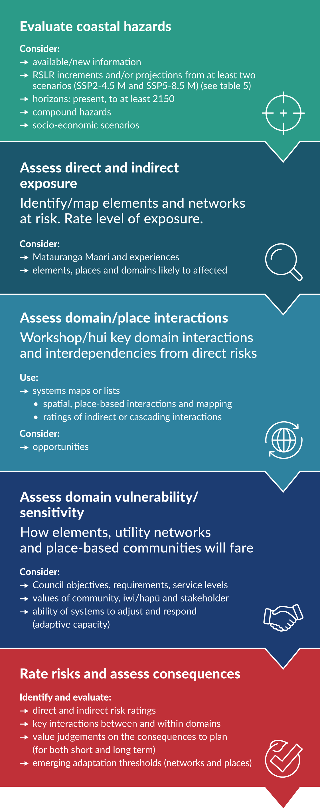
Source: Adapted from the guidance for local climate risk assessments (MfE, 2021), the ISO 14091:2021 climate risk standard and the recent emphasis on systems mapping of cascades or impact chains to weave in a place-based component to the assessment (eg, Lawrence et al, 2020a; annex C of ISO 14091:2021). RSLR = relative sea-level rise; SSP = shared socio-economic pathway.
Examples of a detailed coastal risk assessment are: a) coastal erosion and flooding risk assessment for Tauranga City using the RiskScape multi-hazard framework (Stephens et al, 2021); and b) exposure and vulnerability assessment for the Thames Coromandel Shoreline Management Pathways project (John and Martin, 2022).

Assess social, cultural and environmental vulnerability
The vulnerability component of a risk assessment needs to be broader, encompassing social, cultural and environmental and ecosystem vulnerability over time, which have not often been adequately appraised in conventional risk assessments.

4.2.1 Assess social vulnerability

Identify vulnerable communities
It is good practice to include social and cultural vulnerability assessments when assessing risk. Assessment of climate change impacts and vulnerability is referred to in section 5ZQ of the Climate Change Response Act 2002, and vulnerability is built into the Intergovernmental Panel on Climate Change framing of risk (IPCC, 2022, p 5).
Māori as tangata whenua and kaitiaki of their ancestral and cultural landscape will face disproportionate impacts from climate change and coastal risks in particular (see section 1.1.3; Ihirangi, 2021; MfE, 2022a). In general, it is highly likely that Māori living in locations vulnerable to coastal hazards may be displaced as a result of climate-related impacts. This could disrupt the transmission of location-specific mātauranga Māori and tikanga practices (MfE and Stats NZ, 2023).

Methods for assessing social vulnerability
Conventionally in risk assessments, vulnerability supports adaptation based on technological or engineering interventions (such as protection (eg, seawalls) or accommodation (eg, raising buildings or filling land)). Although these adaptations may reduce the severity of impacts associated with hazards for a time, they often fail to target the social, political and economic drivers of social vulnerability amongst those most at risk (Johnson et al, 2023; Nightingale et al, 2020).
Present, emerging and future impacts of coastal hazards and SLR will exhibit complex cascading impact chains directly or indirectly into the social and cultural domains (Lawrence et al, 2020a; MfE, 2020a).
The social and cultural dimension of vulnerability focuses on the propensity of a group or individual to experience impacts because of a changing climate due to their situation (Adger, 2006). It includes health and safety, mental wellbeing, damage to taonga or cultural sites, grief over repeated loss, business disruption, and capacity to cope and adapt.
It is essential to understand who is vulnerable, to what, and why for delivering equitable adaptation outcomes.
Researchers and practitioners have applied quantitative indicator-based or bottom-up qualitative approaches to understand vulnerability (table 14). A combined, iterative approach that works across spatial scales can maximise the advantages of both types of approaches. An example is using a quantitative indicator approach at the regional or district scale to identify hotspots, then more detailed community or iwi/hapū engagement to better understand local social vulnerability. An alternative is to develop more nuanced indicators through use of serious games with communities and decision-makers (Johnson et al, 2023).
- Advantages and disadvantages of methods for measuring social vulnerability
Method | Examples | Advantages | Disadvantages
Quantitative indicator-based approaches | Social Vulnerability Index (Cutter et al, 2003) considers vulnerability as a product of exposure to a hazard and social and cultural characteristics (eg, education, income, occupation, age, race and gender) | A large pool of existing indicators.  Information available from census data or other assessable data sets.  Useful for high-level comparisons between different populations.  Geographic ‘hot spots’ can be quickly identified, where hazards affect a potentially vulnerable population. | High level, generalised static portrayals about vulnerability (Johnson et al, 2023). Assumes all people and groups with certain characteristics are vulnerable (excludes diversity within groupings).  Limited connection with adaptive capacities.  Biased toward indicators that can be measured rather than what is important to measure and assess.  Less useful at a local scale because the quality or resolution of the data is low or aggregated.  Communities may not like external agencies telling them they are vulnerable.
Bottom-up qualitative approaches | Explore local social vulnerability with potentially affected parties, through collaborative development of indicators, or collecting qualitative data through meetings and interviews | Addresses adaptive capacity, giving a clear picture of actual vulnerability.  Information will be more detailed and related to specific places, hazards and intra-regional connectivity.  Provides a good starting position for considering local adaptation options. | Requires hui and interviews, so takes longer to collate the information. Requires careful attention to who takes part, for a representative view.  Difficult at larger geographical scales.  May be affected by experiences with past hazard events.  Requires more complex analysis.
Combined approaches | Nuanced specific indicators (Johnson et al, 2023) that engage more deeply with the interlinked socio-economic, cultural, political and economic speciﬁcities of place, for example, use of personas through serious games combined with agent-based modelling using climate hazards and relative sea-level rise projections (Johnson et al, 2023; Lawrence et al, 2021c) | Greater engagement with social context of specific place or locality.  Attempts to capture the dynamics (over time) in vulnerability.  Accounts for adaptive capacities and strengths.  Balances detail of grounded, place-specific accounts of vulnerability with high-level vulnerability indices. | Requires expert analyses of the decisions and reasons of all individual players in a serious game from a community.  Skill needed to translate player’s responses into behaviours in an agent-based model.

4.2.2 Assess environmental vulnerability
Environmental vulnerability in coastal settings will be determined by the natural systems exposure to the climate stressors, how sensitive they are to the climate stressors, and whether they can adapt to the type and rate of coastal hazards, and particularly to SLR (MfE, 2020a). Like human systems, the environment has thresholds that, if reached, will affect the ability to adapt. In turn, this depends on the rate of change at the coast and whether the species or system can move or continue to function. It is also dependent on how humans manage and affect the natural systems through their activities.
In the absence of human-induced pressures, many coastal ecosystems and species would be able to adapt in some way. However, most are exposed to the effects of habitat loss, introduced species, nutrient and sediment inputs from land-use practices, and direct disturbances from activities such as roading, subdivision, building construction and marine structures. The coastal environment already contains many threatened and rare ecosystems and species.
Climate risks will affect coastal ecosystems, including intertidal zones, estuaries, dunes, coastal lakes and wetlands, due to both ongoing SLR and extreme weather events. Hazards compound at the coast with interacting and cascading consequences beyond the coastal environment.
When assessing the vulnerability of the coastal environment, at whatever scale, follow the same or similar processes as for social and cultural vulnerability assessments, that is, consider exposure, sensitivity and adaptive capacity in the context of the particular hazards at the location of interest and use the questions in section 4.2.3 as a guide. The vulnerability assessment will feed into the risk assessment of the coastal environment more generally and should include the geomorphic type of coast, the particular species and ecosystem processes, as well as the human effects on the environment at the area or locality.

4.2.3 Questions to guide assessing vulnerability
The vulnerability component of a detailed risk assessment includes an assessment combining sensitivity and adaptive capacity. The following questions can help guide how to determine how vulnerable communities and environments in coastal areas are to the more frequent or progressive impacts of climate change.
Focus the analysis of sensitivity on the following questions
- Are there groups or individuals more predisposed to climate impacts (eg, those with pre-existing stress due to economic conditions, uninsured, renters, certain ethnicities or ages, mobility impaired, lower socio-economic groups, or those with health conditions)?
- Is the system already stressed, starting to stretch coping capacity or risk tolerance (eg, regular overtopping of a seawall, nuisance coastal and/or stormwater flooding, increasing shoreline erosion, or insurance retreat)?
- Is the system, environment or network limited or inflexible in the face of coastal climate change?
- For tourism and recreational activities, how sensitive are public coastal spaces (reserves, esplanades and beaches) to coastal hazards and relative sea-level rise (RSLR)?
- Are some productive land uses more sensitive than others?
- Is the natural ecosystem exposed to ongoing RSLR (eg, nesting birds on beaches, Ramsar sites, wetlands or marshes, or decreasing intertidal flats)?
- What is the system’s impact threshold?
- How do environmental sensitivities vary across the region?
Focus the analysis of adaptive capacity on the following questions
- Are the systems and people able to accommodate the changes in climate impacts? For example:
- are there institutional and governance structures in place to adapt
- does the area have high numbers of elderly and very young people
- are there tapu or other cultural sites
- is there a lack of critical facilities
- are there people located where they cannot physically move from the risk?
- Are there barriers to a system’s ability to accommodate climate impacts? For example, are planning rules based on historic climate conditions or are the rules likely to create other limitations on changing or repurposing land use? (White et al, 2023)
- When does the rate of change exceed the ability of the systems, organisations and people affected to respond?
- Are efforts already under way to address climate impacts (eg, preparedness, criteria for monitoring the effectiveness of current planning, and early signals for a change of course)?

Part C: What can we do about it?

Step 5: Identify options and pathways
A range of options and pathways are developed at this step to reflect the dynamic and changing risk that is driven by climate change, in particular relative sea-level rise (RSLR). At the coast, there are known and unknown impacts of climate change as the risks rise, and there are uncertainties in the future that cannot be predicted. This means that ways of identifying the options and pathways should be appropriate for the dynamic coastal context.
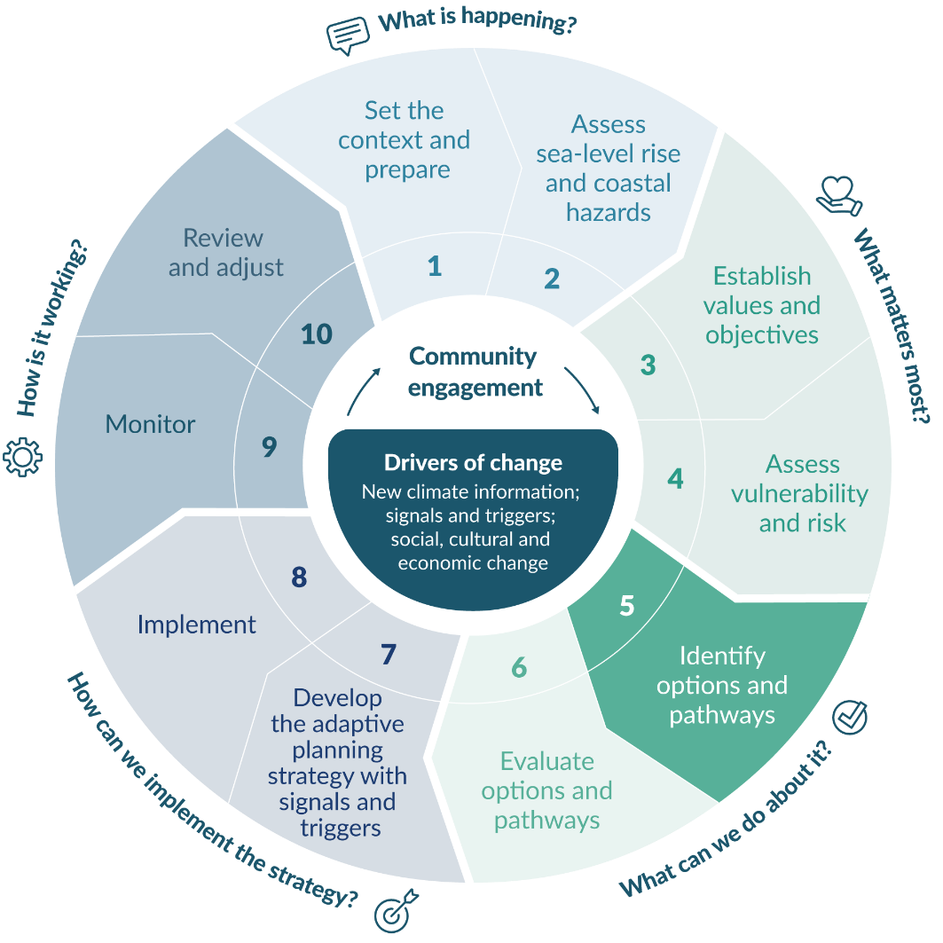

Identify adaptation options and pathways

Consider options and pathways

Adaptation pathways planning
This step outlines how to identify adaptation options and develop dynamic adaptive pathways planning (DAPP) (see box 11). It should be read together with policies 24 to 27 of the New Zealand Coastal Policy Statement 2010 (NZCPS, DOC, 2010) and its associated guidance (DOC, 2017). The outcome will involve several alternative pathways to achieve the agreed objectives.
- : DYNAMIC ADAPTIVE PATHWAYS PLANNING APPROACH
The dynamic adaptive pathways planning (DAPP) approach is a decision making under deep uncertainty (DMDU) approach suitable for use in coastal settings where the rate and magnitude of changing risks are uncertain.
DAPP enables the user to develop short-term actions and long-term options. These are depicted visually as a series of alternative pathways that meet the user’s objectives, for example, to reduce risks from the changing climate and ongoing sea-level rise (SLR). It does this through a step-wise process that:
- identifies objectives and thresholds to be avoided
- identifies possible adaptation options and interlinked pathways
- evaluates the options and pathways by ‘stress-testing’ them for their sensitivity to different future climate change conditions, using a range of future scenarios of relative sea-level rise (RSLR) increments (step 6) and other uncertainty assessment tools (step 7)
- develops an adaptive strategy with signals and triggers that can be monitored for change, and measures for implementing it
- develops a monitoring strategy with indicators to track that give lead time to review changes in impacts and objectives, and to change options or pathways with lead time before the threshold is reached (step 9).
DAPP prevents having to preselect upfront a specific climate change scenario or RSLR projection, compared with a conventional ‘predict-then-act’ single investment approach. DAPP is an approach that enables decisions to be made without delaying decisions until uncertainties are reduced (if they can be). DAPP also enables better informed decisions in crisis situations that can otherwise result in maladaptive outcomes that increase exposure or vulnerability. DAPP is typically used alongside other DMDU evaluation tools (step 6) and can be used at any scale.

Options to consider
Several types of adaptation options are available for adapting to coastal hazards and climate change (figure 5). These adaptation options include the following.
Avoid: Stop people and assets being put in high-risk locations. It primarily uses land-use planning measures, spatial planning and adaptive management of assets and services.
Accommodate: Stay in place and make changes to buildings and infrastructure to improve resilience and work around the increasing risk. For example, raising floor levels or roads, building relocatable houses, setting minimum build levels, and providing alternative inundation flow paths. Provide room for beach or shoreline change processes and ponding of intertidal areas further inland.
Protect: Stay in place and manage the hazard by defending the shoreline. For example, maintaining or enhancing natural buffers (dunes, estuaries; see box 12), hard structures (seawalls, rock revetments), soft engineering (renourishment, geotextile sand tubes), tidal gates, pumps, planting vegetation to support land accretion.
Retreat: Permanent removal or relocation of existing habitation (people and buildings), assets and services from the coast in a planned, staged and managed approach over time. Also applies to ‘managed realignment’ by deliberate breaching or removal of causeways or flood banks to allow wetlands and marshes to migrate further inland (Allan et al, 2023).
Each type of adaptation option has different lifetimes and will have different performance limits. In general, avoidance strategies should be considered first in coastal settings, to ensure that protect and accommodate options do not become the default approach without consideration of the known ongoing and progressive risk from SLR and storm surge. Only avoidance and retreat strategies provide permanent reduction of risk.
In practice, a suite of options should be considered and the option chosen should depend on the local circumstances. For example, in areas of significant existing development a range of options to reduce risk should be assessed. Considering which types of options to use will depend on whether an existing development or a new development is being considered. For example:
maintaining the current level of development (ie, no further development or intensification)
preparing for retreat
protecting the area for longer (assuming the protection is already in place and that retreat or alternative protection are options at some point in the future)
or combinations and intermediate options within this range across the different types.
Consider the adequacy of infrastructure as conditions change over its lifetime, for example, water, wastewater and stormwater services, above-ground utilities and national and local roads. These will require separate evaluation. Urban systems cannot function without supporting infrastructure, and delaying replacement decisions, or putting infrastructure in exposed locations with increasing risk places a large adjustment burden on future generations.
Other criteria will be driven by compliance with relevant statutes (eg, the Resource Management Act 1991, Building Act 2004 and Local Government Act 2002), the values and objectives of the community and councils, and may include coastal amenity, ease of implementation, and any multiple benefits and co-benefits. For areas that have significant development that are likely to be affected by coastal hazards, Policy 27 of the NZCPS (DOC, 2010) sets out requirements for options and strategies for reducing coastal hazard risk .
In practice, a combination of near-term actions and long-term options, which may be staged over time, depending on the exposure of the locality will be needed. The DAPP approach can be used to identify the options, evaluate them, and develop an adaptation strategy and implementation plan (steps 7 to 10). This enables management of the changes in SLR and associated impacts over the lifetime of the option and minimises or avoids lock-in of services that reduces the ability to adapt over time.
- : NATURE-BASED SOLUTIONS
Nature-based solutions (NbS) are accommodation types of adaptation options. At the coast, they can provide a temporary buffer at the same time as providing co-benefits for people and nature.
NbS support biodiversity and wider environmental outcomes. They are well aligned with the 2010 New Zealand Coastal Policy Statement direction to “provide where appropriate for the protection, restoration or enhancement of natural defences …” (Policy 26, DOC, 2010, p 24).
Te Mana o te Taiao – Aotearoa New Zealand Biodiversity Strategy 2020 defines NbS as “solutions that are inspired and supported by nature, cost-effective, and simultaneously provide environmental, social and economic benefits and help build resilience” (DOC, 2020, p 62). When well-designed and implemented, NbS can contribute a range of benefits, including improved biodiversity outcomes, enhanced community wellbeing and climate change mitigation. For example, the restoration and preservation of mangroves, salt marshes and seagrass meadows can also remove carbon (Cooley et al, 2022).

Community engagement
Identifying options and actions for addressing hazard exposure and vulnerability will require contributions from all stakeholders, including the affected community, iwi/hapū, council staff, technical experts, the wider community, government agencies with interests in the area, and potential funding agencies.
It is essential to include the community in identifying options and pathways, particularly for those currently, or soon to be, exposed to coastal climate change effects, because this engagement will:
provide deeper understanding about what options and pathways meet their objectives
highlight what can be practically implemented and how these options might be funded
maintain transparency about the process and understanding of why certain options are included (or not).
Community engagement will bring new ideas. Brainstorming a range of options will avoid narrowing them down too early and increase the flexibility for considering the impact of the rising risk over the lifetime of the options. A combination of complementary options may be most effective. These can be presented as alternative pathways with actions in the near term and options for the long-term. Community engagement principles and approaches, and practice methods: Coastal hazards and climate change guidance – Supplement B describes methods for community engagement on options and pathways.

Identify adaptation thresholds
An adaptation threshold is ‘what people do not want to happen’ (an unacceptable condition). Define these thresholds with communities, iwi/hapū and other stakeholders to reflect their physical, social, cultural or economic perspectives. Councils and infrastructure operators will also have to meet thresholds in the agreed levels of service and in statutory objectives.
The values defined in step 3 and translated into objectives will inform the adaptation thresholds.
Useful thresholds reflect what matters most. These could include:
health and safety indicators, such as number of casualties, water quality, or safe vehicle or cycling limits
frequency or severity of damaging or disruptive events
withdrawal of maintenance, decline in levels of service and utilities and increasing cost of repairs
unaffordable or high-excess insurance premiums or withdrawal of insurance and bank finance
loss of amenity and cultural values
lengthy displacement of people following extreme events.
Useful thresholds will need to be relevant and easily measured by those monitoring them. See step 9 regarding indicators and underlying data needs for monitoring.
With community input, identify the adaptation thresholds for the coastal area of concern.
A template for workshops to develop thresholds, triggers and signals is in Community engagement principles and approaches, and practice methods: Coastal hazards and climate change guidance – Supplement B.

Consider option lifetime
Assessing the lifetime of options is critical, because it informs the trigger points that determine whether a shift in pathways is needed. Lifetime is an important factor in the choice of early actions, along with whether the options lock-in further development and thus increase risk over time. Figure 20 shows typical lifetimes for different adaptation options and how the available options diminish over time. This will depend on the different coastal types (see step 2).
Figure 20: Typical lifetimes of different options for avoiding lock-in
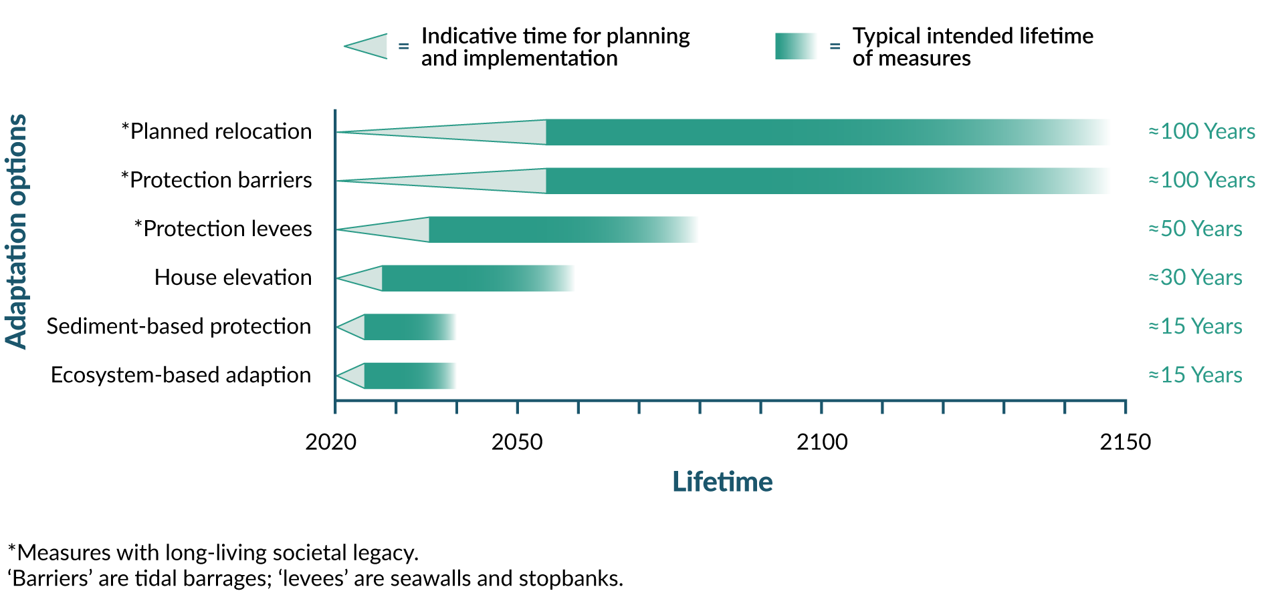
Source: Panel a) Cross-chapter box, Sea-level Rise, Le Cozannet et al (2022), in Cooley et al (2022)

5.2 Develop dynamic adaptive pathways planning approach
Approaches like DAPP do not prescribe a single solution that is embedded at the start. Future options are left for future decisions, provided they continue to help achieve the stated or revised objectives reviewed at decision trigger points. This gives the community guidance about what the future pathways may entail. Transparent trade-offs can be made where there are competing options and different values. Informed debate on the options can then take place, with an awareness of how they might affect future decisions (Kwakkel et al, 2016).
Using DAPP is particularly useful for making decisions in the coastal context, where dynamic characteristics lead to ever-changing risk profiles, and where the rates and magnitude of changes are uncertain, especially over the long term. Such adaptation planning focuses on making the dependencies among adaptation actions transparent and showing whether options will result in lock-in of existing risk or create future exposure to risk. This helps reduce the risk of irreversible decisions and consequence costs and disruption (Kwakkel et al, 2016).
This approach enables decisions to be taken in stages over time to:
set objectives
decide adaptation thresholds based on predetermined conditions that are acceptable or tolerable to those affected by coastal hazards
identify triggers (step 7), based on signals, which allow enough time to implement the response options before the adaptation threshold is reached.
By exploring different pathways using RSLR increments and range of projections to stress-test them, a DAPP can be designed that includes a mix of short-term actions and long-term options. Criteria for the options should include:
flexibility (adjustable or transferable to another option with minimum cost)
lifetime of the option
avoidance of lock-in and path dependency
meeting stated objectives over at least 100 years
performance of the options and pathways to meet the objectives.
Develop the pathways from the present and out into the future using a pathways map (figure 21), which can be visualised as a metro map showing alternative routes for getting to the same objective. All routes meet a specified minimum performance level, to a trigger point for decisions that are implemented before the threshold is reached, giving time for the particular action or option to be decided, to be put in place, or in statutory plans.
The DAPP map shows:
adaptation actions or options
adaptation thresholds (similar to terminal stations on the metro map)
the available actions after a trigger point and ahead of the threshold being reached (via transfer to other stations in another pathway)
signals that a decision point is approaching
the trigger points where a decision is required to review performance, objectives and whether a change of pathway is required (Haasnoot et al, 2013).
Figure 21: A dynamic adaptive pathways planning map
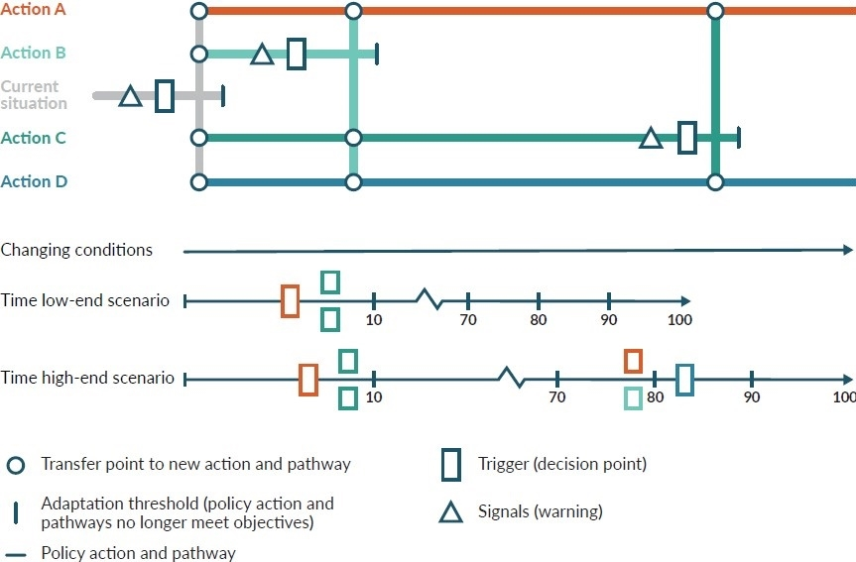
Source: Adapted from Haasnoot et al (2013); Hermans et al (2017)

Step 6: Evaluate options and pathways
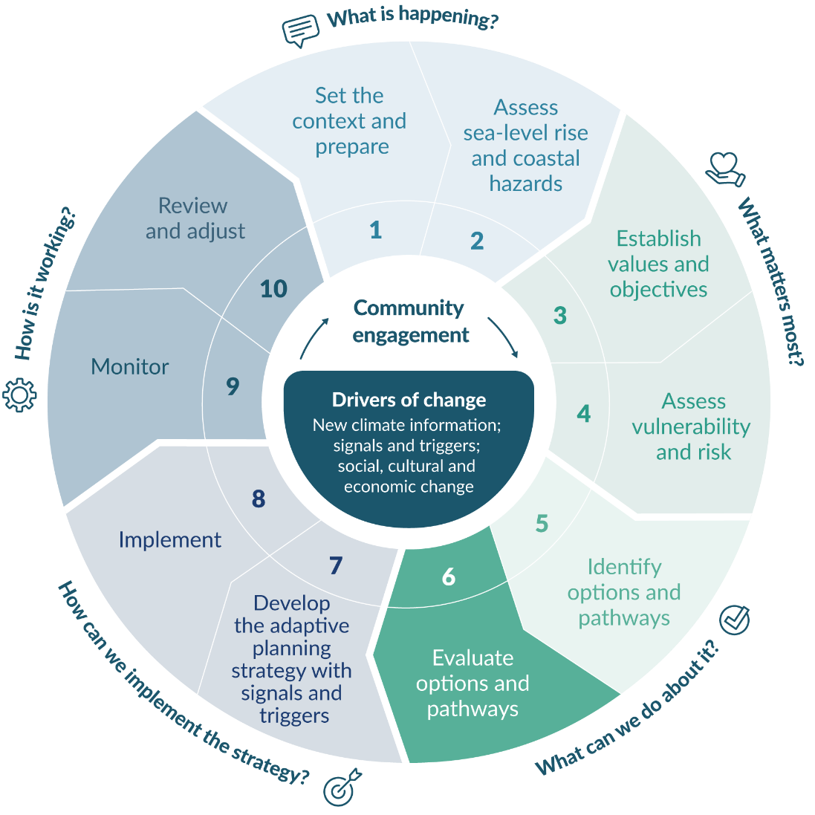

Choose evaluation tools
It is important to evaluate what is a good adaptation option or pathway. This can be used to improve or build an adaptation plan that can be adjusted in the future without creating path dependency and lock-in of land uses in areas exposed to coastal hazards and risks.
Several tools can be used to evaluate the options and pathways, depending on the objectives, and the level of evaluation effort. The evaluation tools can also be used in combination with each other. This evaluation can be done qualitatively or quantitatively and with different levels of effort, depending on the task and resources available. It can be as simple as considering criteria at an adaptation workshop or using a more complex analysis approach.
Criteria to assess in an evaluation include:
ability to meet objectives
flexibility to change in the future
path dependency to avoid lock-in
feasibility of implementation
ability to meet community values and provide co-benefits
sensitivity to compounding and cascading impacts
sensitivity to discount rate
sensitivity to review date
costs and losses, to assess value for money
timing of options
environmental effects.
Many different decision support tools are available, but not all are useful for addressing deep uncertainty and progressive ongoing and increasing risk. The choice of evaluation tools also should reflect the stage in the decision process, the nature and scale of the issue, the objectives and the options. Ensure the tools can perform over a range of plausible climate futures and can readily assimilate either increments of relative sea-level rise (RSLR) (and associated time brackets, see table 6) or the range of recommended RSLR projections out to at least 2130. To do this, apply the tools to a range of sea-level rise (SLR) heights (at constant increments) or scenarios and projected changes in storms, waves and storm surge and groundwater rise.
Table 15 describes the applicability, usefulness and limitations of different decision support tools and approaches and in what circumstances they should be used.
- Applicability of different decision support tools
Tool | Applicability | Usefulness and limitations | Potential uses
Cost-benefit analysis (CBA) | Short-term assessment, particularly for market sectors. | Most useful when climate risk probabilities are known. Climate sensitivity small compared with total costs and benefits. Good data is needed for major cost-benefit components. | Low- and no-regret option appraisal (short term). Use in iterative risk management for relative costs and benefits among options.
Cost-effectiveness analysis | Short-term assessment for market and government sectors. Particularly relevant where there are clear environmental headline indicators and known dominant impacts. Less applicable for cross-sector and complex risks. | Most useful for same situations as for CBA, but for non-monetary metrics (eg, ecosystems, health). Agreement on sectoral social objective (eg, acceptable risks of flooding). | Low- and no-regret option appraisal (short term). Use in iterative risk management.
Multi-criteria analysis | Integrates quantitative and qualitative information (intangibles) when comparing options. | Highly adaptable but requires careful use and documentation. Needs to be tailored to circumstances but can build in considerations, such as ability to adapt, interdependencies, future-proofing and cost. | Simple and effective general process for comparing options in the short, medium and long term, and can contribute to policy development. Relies on informed judgement. Identifies fatal flaws and degrees of difficulty.
Iterative | For assessment of quantitative change in risk or hazard for a preferred adaptation option to compare with the existing situation. Informs viability and lifetime of option and explores residual risk. Applicable at project and strategy level (eg, Beya and Asmat, 2021). | Useful for evaluating effectiveness of options to reduce risk (or increase residual risk) and over what lifetime. Also to assess unintended consequences or side effects in wider area (eg, estuary seawall could increase future flooding upstream). | Can be used with quantitative risk platforms (eg, RiskScape) or hazard modelling comparing risk or hazard performance before and after option is in place.
Agent-based modelling | For integrating climate-related physical hazard drivers and socio-economic drivers under dynamic conditions to evaluate effectiveness and viability of options or actions (Allison et al, 2023). | Most useful for exploring how adaptive actions might be sequentially triggered, in response to various climate change and socio-economic scenarios. Spatially explicit and temporally dynamic. Inputs can be quantitative and qualitative. | Can be used as a tool in combination with robust decision making (RDM) and systems mapping in a dynamic adaptive pathways planning (DAPP) approach.
Real options analysis | Project-based analysis. Large irreversible capital investment, particularly where there is an existing adaptation deficit. Comparing flexible versus non-flexible options. | Most useful for: large irreversible capital decisions; climate risk probabilities known or good information. Good quality data exists for major cost-benefit components. | Economic analysis of major investment decisions, notably major flood defences, water storage. Potential for justifying flexibility within major projects.
Robust decision making (MORDM) | Project and strategy analysis. Conditions of high uncertainty. Near-term investment with long lifetimes (eg, infrastructure).  MORDM for designing adaptive plans | Most useful for high uncertainty in rate and magnitude of climate change signal. Mix of quantitative and qualitative information. Non-monetary areas (eg, ecosystems, health). For exploring the policy design space. | Identifying low- and no-regret options. Testing near-term options or strategies across number of futures or projections (robustness). Comparing technical and non-technical options. Can be used with DAPP.
Exploratory modelling | Computational scenario modelling to explore the characteristics of complex systems. | Uses simple models of complex systems where there are irreducible uncertainties. Requires moderation by experts. | For fast computation to understand the impacts of uncertain futures. Can be applied to a specific infrastructure level or for a larger system.
Portfolio analysis | Analysing combinations of options, including potential for project and strategy formulation. | Most useful for several adaptation actions likely to be complementary in reducing climate risks. Climate risk possibilities known or good information. | Project-based analysis for combinations for future scenarios. Designing portfolio mixes as part of iterative pathways.
Source: Adapted from Watkiss et al (2015); Kwakkel and Haasnoot (2019)
For valuing options, multi-criteria analysis (MCA) is commonly used in Aotearoa New Zealand. It is more subjective than other tools and requires clear criteria and systematic application to reduce bias. It is powerful as a tool to use collaboratively with communities and stakeholders because it is transparent, understandable, and allows community-specific values and interests to directly inform decision outcomes integrated with council statutory objectives. Using MCA with other approaches, such as real options analysis, can help validate results (Lawrence et al, 2019; Stroombergen and Lawrence, 2022). For example, real options analysis can be used to check the robustness of MCA results and to compare the incremental investment cost differences between the various flexible pathways. This enables meaningful comparisons of value for money to be made. Using robust decision making and agent-based modelling with the DAPP approach (Allison et al, 2023) enables exploration of how adaptive actions might be sequentially triggered, in response to various climate change and socio-economic scenarios.

Evaluate options and pathways
Assess and evaluate the effectiveness of the agreed options and actions. This addresses any side effects and shortfalls that thwart the outcomes, and it tests for their effectiveness in reducing risk, under what conditions, and their viability (lifetime). Use the most appropriate evaluation tools (section 6.1).

Effect of the adaptation response
An adaptation response cannot mitigate all hazards or risk in place or over time. Human responses to climate change affect exposure and vulnerability which varies and changes over time. Depending on the local conditions, such as compounding and cascading effects, a greater or lesser residual risk will remain. In addition, an option applied in one location can cause side effects elsewhere and these can have a lasting effect on coastal shorelines and communities. Such effects need to be considered when evaluating the options and pathways.
The following questions can be used when evaluating the effect of changing coastal risk on the options and pathways identified in step 5.
What are the first impacts in coastal areas because of climate change and RSLR and how do the risks evolve over time?
Under what conditions will current strategies become ineffective in meeting objectives?
When will alternative strategies be needed given that implementation has a lead time?
What alternative decision pathways can be taken to achieve the same objectives?
How robust are the options over a range of climate futures?
Can options and pathways be changed with minimum disruption and cost?
Do the options and pathways have side effects beyond the area of concern?

Stress-testing options and pathways
Stress-testing is used to anticipate the potential impact of surprises and unknowns, especially elements of place-based risks with high uncertainty from compound and cascading impacts (Logan et al, 2023). By increasingly stressing a system (option or pathway), it is possible to determine its breaking point and better understand how and why the system or design may fail (Lempert, 2019).
Previously in step 2 and step 4, it was recommended a range of RSLR increments and climate scenarios in hazard and risk assessments and mapping were worked with to cover the range of conditions for identifying and developing options and pathways. Now, preferred actions and options under that range of conditions will be stress-tested, and their effectiveness and viability will be determined. For example, in a Tauranga pilot study, Allison et al (2023), the timing of actions within each pathway was found to be dictated mainly by the rate of RSLR and the timing and severity of storm and flood events.
Stress-testing should use a variety of scenarios, including those with significant cascading impacts. An example is more frequent coastal flooding causing local damage, which may also affect road access by regularly isolating an otherwise unaffected community elsewhere (Logan et al, 2023). The complexity of the system interactions and cascading impacts (eg, figure 16) will affect how the testing is done.
Examples, where stress-testing, as described above, has been used in Aotearoa include the following.
Allison et al (2023) piloted an agent-based modelling approach in Tauranga. The limits for soft and hard protection were around 0.3 metre RSLR, infrastructure upgrades and policy mechanisms performed between 0.40 metre and 0.75 metre RSLR, after which active retreat was the only viable adaptation pathway.
Beya and Asmat (2021) developed detailed hazard models to design, cost and evaluate coastal adaptation options to meet risk thresholds within the DAPP strategies for each coastal cell in the Hawke’s Bay Tangoio to Clifton Coastal Hazards Strategy 2120.
Kool (2020) used stress-testing for comparing different spatial pathways for stormwater and wastewater in the coastal zone of Petone, Wellington.
Bell et al (2022) and Allis and Bell (2019) used both H+ and SLR increments when considering compound stream and coastal flood levels for a causeway on Auckland’s north-western motorway, and for the Petone to Ngauranga cycleway and resilience project in Wellington, respectively.

Part D: How can we implement the strategy?

Step 7: Develop the adaptive planning strategy
The adaptive planning strategy (step 7) for the coastal area of concern comprises the initial actions and alternative pathways that have been developed in step 6. It also includes the underlying supporting actions necessary for implementing the preferred adaptive actions and pathways (eg, Implementing the plan – step 8, and setting up the monitoring regime within councils – step 9). Setting up signals and triggers is a critical step in implementing the strategy, because an essential element of the dynamic adaptive pathways planning (DAPP) approach is monitoring progress to the next switch in the pathway or other option.
This section outlines how to design effective coastal signals (warnings) and triggers (decision points) for the adaptive planning strategy (see figure 22) that can be implemented and monitored for review of signals and triggers for changing course before objectives fail to be met (threshold). At this step, engage with the relevant communities in developing meaningful signals and triggers that can be implemented and that align with community and council objectives identified at step 3.
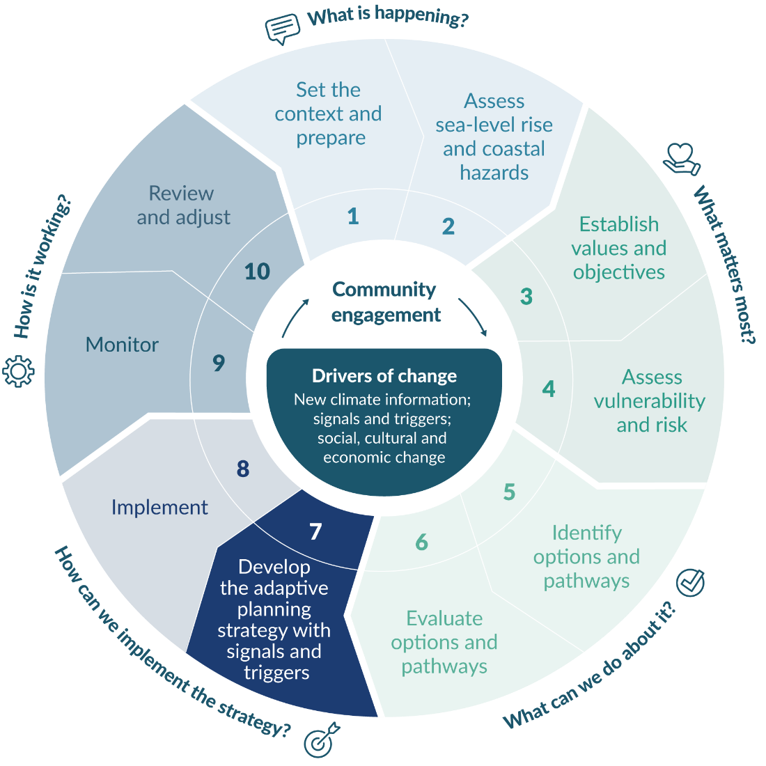

Identify signals
Implementation of the adaptive planning strategy requires signals and triggers for monitoring its effectiveness in reaching objectives. To monitor the plan as conditions change over time, a method is needed to measure when an option or pathway cannot meet its objectives and should be adjusted. This method should ensure sufficient warning of change to enable actions to be taken. This requires an advanced signal or warning to avoid an adaptation threshold being reached and being unprepared, and decisions being made that are maladaptive without recourse to an adaptive planning strategy to guide decision-making. However, unexpected or surprise situations can occur, so it is worth noting that setting a signal is not a guarantee that an adaptation threshold will be avoided.
Figure 22 shows how the performance of adaptation actions decreases over time as conditions change and how signals and triggers are located with sufficient lead time for implementation before the adaptation threshold is reached. Signals and triggers thus help decision-making about whether and when to change pathways.
Examples in the coastal context could be indicators of increasing coastal hazard and sea-level rise impacts on a drainage or stormwater system or an existing seawall; frequency of coastal flooding or erosion; or social or cultural indicators of value to communities; or combinations that provide more robust validation of the change being signalled.
Figure 22: Signals and triggers linked to the adaptation threshold
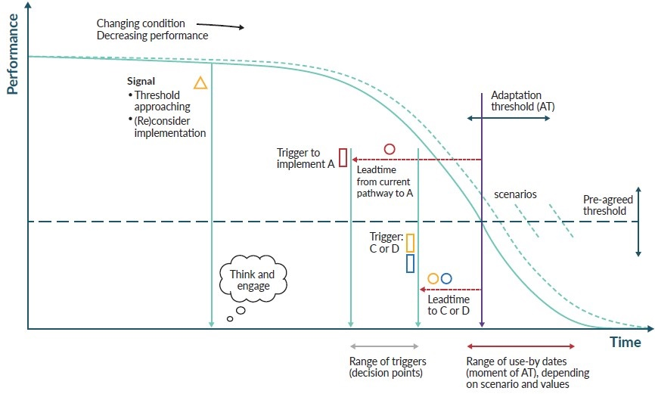
Note: Reduction of service level over time, illustrating an adaptation threshold, signals and triggers. Concept of using monitored indicators, set up as defensible signals (triangle) and triggers (square) to awaken and prompt implementation of the next pathway option or action. In this example, option A requires a longer lead time than options C and D to implement. Only two future pathways are shown here for clarity, focusing the graphic on the bold blue line as an example. A, C and D refer to generic pathways, with different lead times, from figure 21.
Source: MfE (2017) as adapted from graphic by Marjolijn Haasnoot, Deltares and the University of Utrecht, the Netherlands.
Signals will form part of the monitoring system to warn of impending change that may be heading to a trigger or decision point on whether the objectives are still being met. Signals that appear early in the ‘impacts chain’ are preferable because they give more time to prepare for decisions to be made at the trigger point. However, they may be less visible, and information can be less ‘convincing’ for decision-makers (Kwakkel et al, 2016), unless there are several different signals to validate their significance.
Warnings traditionally operate close to an imminent threat, for example, a heavy rainfall or coastal storm alert. Such warnings are problematic for climate effects because they do not give the lead time needed for considered analysis of the change. They also depend on extreme events, which obscure the change, and the signal can be missed because of natural variability. Useful signals are those that are visible above the ‘noise’, can be tracked easily, are relevant to the hazard and local coastal conditions, and are transparent.

Design and set triggers

Designing effective triggers
Triggers denote decision points ahead of an adaptation threshold when a review and decisions are made as to whether to change options or pathways. Triggers should be designed to be:
relevant – they signify changes in coastal risk and are meaningful to councils and communities
measurable – they can be measured or described, recognised and monitored
timely – they can be applied with enough lead time for adaptation
reliable – they can be replicated
convincing – they enable decision-makers to agree on adaptation actions (Kavale, 2022)
pragmatic – data is available or can be readily collected and analysed in an affordable and repeatable manner.
Triggers need to be designed with enough lead time to define the conditions under which the current option or pathway will no longer meet the DAPP objectives at the adaptation threshold. This will enable the adaptive planning strategy to operate over long timeframes and to address uncertainty about the future, making it a dynamic approach.
Triggers need to be cognisant of the next likely action in the pathway, because different actions require different lead times. The commencement of a beach nourishment programme, for example, will have a much shorter lead time to initiate than a managed retreat response or a significant physical structure.
It is more robust to have several types of triggers, because they can validate the change that is occurring. Table 16 describes a range of signals and triggers that could be used, based on coastal flooding and groundwater ponding.
- Examples of indicators for different types of signals and triggers for coastal hazards and climate change
Type of signal or trigger | Description
Coastal flooding | Relative sea-level rise height threshold reached  Frequency or number of coastal flooding events reaching nuisance levels
Coastal erosion | Coastal erosion causing the dune-line to reach a certain distance from a house
Groundwater rise | Salinisation of coastal ground water  Increase in time of standing water in low-lying coastal areas
Social-psychological | Measure of concern, anxiety, tolerance (eg, increased communications with the council about concerns, people start moving out of a community, increased demand for protection)
Financial and economic | Maintenance costs exceed an amount per year  Insurance premium excesses increase, or insurance retreat for a community  Higher cost of maintaining groundwater or stormwater pumping systems
Cultural | Inundation begins or occurs regularly around taonga or culturally significant sites (eg, urupā)
Environmental | Percentage loss of wetlands or bird numbers  Rising salinity in groundwater systems
Governance and institutional | Lower level of service (eg, flood control, wastewater, water supply)  More frequent clearance of stormwater drains due to relative sea-level rise  Managed retreat strategy begins to be developed  Central government roading support withdrawn
Source: Adapted from Lawrence et al (2020b)

Setting triggers before the threshold is reached
The examples of triggers in table 16 all imply that a level of damage or declining level of service will have occurred before adaptation starts. This reflects current experience of climate-driven impact. However, the severity of the impacts at the coast are progressive, ongoing, and RSLR will become the dominant impact as time advances. This means the triggers in table 16 will have a lifetime for their relevance and will need to be reviewed and redesigned before thresholds are reached.
Triggers should be designed to include a buffer that gives lead time to change the option or pathway before the threshold is reached. For infrastructure projects (eg, stormwater, water supply, sewage, re-routing roads and electrical utilities) that have long implementation lead times, thresholds should be anticipated by using earlier triggers, to make sure the community, local authorities and government have time to adjust in the least disruptive manner possible.

Step 8: Implement the adaptive planning strategy
This section outlines how to implement the adaptive planning strategy, including the supporting actions necessary to implement the preferred adaptive actions and pathways. This involves using Resource Management Act 1991 (RMA) planning measures (to avoid or reduce (where appropriate) exposure to coastal hazards and risk), items for integration into the Long-Term Plan for scheduling and funding purposes and how adaptation will be funded.
At this step, engage with the relevant agencies and communities, and address potential new areas of development through RMA planning and non-statutory measures, to avoid or reduce any new exposure to coastal hazard and risk.
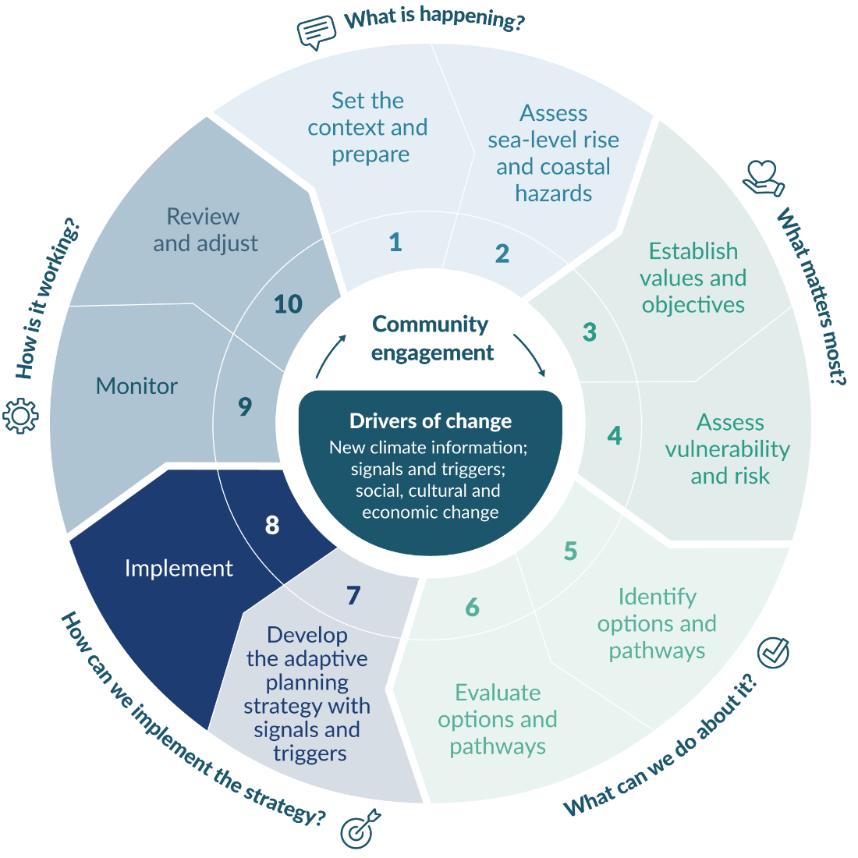

Measures and processes for implementing the adaptive planning strategy
Managing ongoing change and uncertainty in different decision-making contexts requires both statutory and non-statutory measures and processes. These are needed across several areas of council operations, such as asset management, RMA policy or consents, building consents, and at different governance levels. Although, communities and property owners value certainty they also expect the hazards and risks to be managed through council planning.
Current planning relies on static representations of the future in space and time (eg, the use of one scenario, a hazard zone or a line on a map, or a fixed seawall). These static representations can be difficult to adjust readily to the progressive and ongoing coastal hazards. This can result in lock-in of development and maladaptation. Such static measures may instil a false sense of security, where, once protected, a community will expect that protection will continue to be provided as the coastal hazards worsen and the relative sea-level rise (RSLR) advances. This will require increasing and ongoing investment as exposure to risk increases over time. This raises issues around the type of adaptation options being implemented (figure 5) and who pays for them. Councils and communities alike need to understand these limitations of static measures when implementing coastal adaptation actions in the dynamic coastal environment.
Coastal adaptation actions may need to be prioritised in some locations over others, especially where resources are constrained. When doing so, the principles underlying dynamic adaptive pathways planning (step 5 and box 11) should be applied to avoid lock-in of investments and to guide decisions that lead to both short- and long-term benefits. Otherwise, the damage costs of the ongoing and rising risk at the coast are likely to increase and may be transferred to future generations and those least able to pay or afford insurance. The approach to prioritisation of adaptation actions will need to be developed and applied in a fair way across responsibilities (eg, local government services).

Planning framework
Figure 23 shows the planning framework that enables hazard and risk reduction.
Figure 23: Coastal hazard management under Resource Management Act 1991 policy and plans
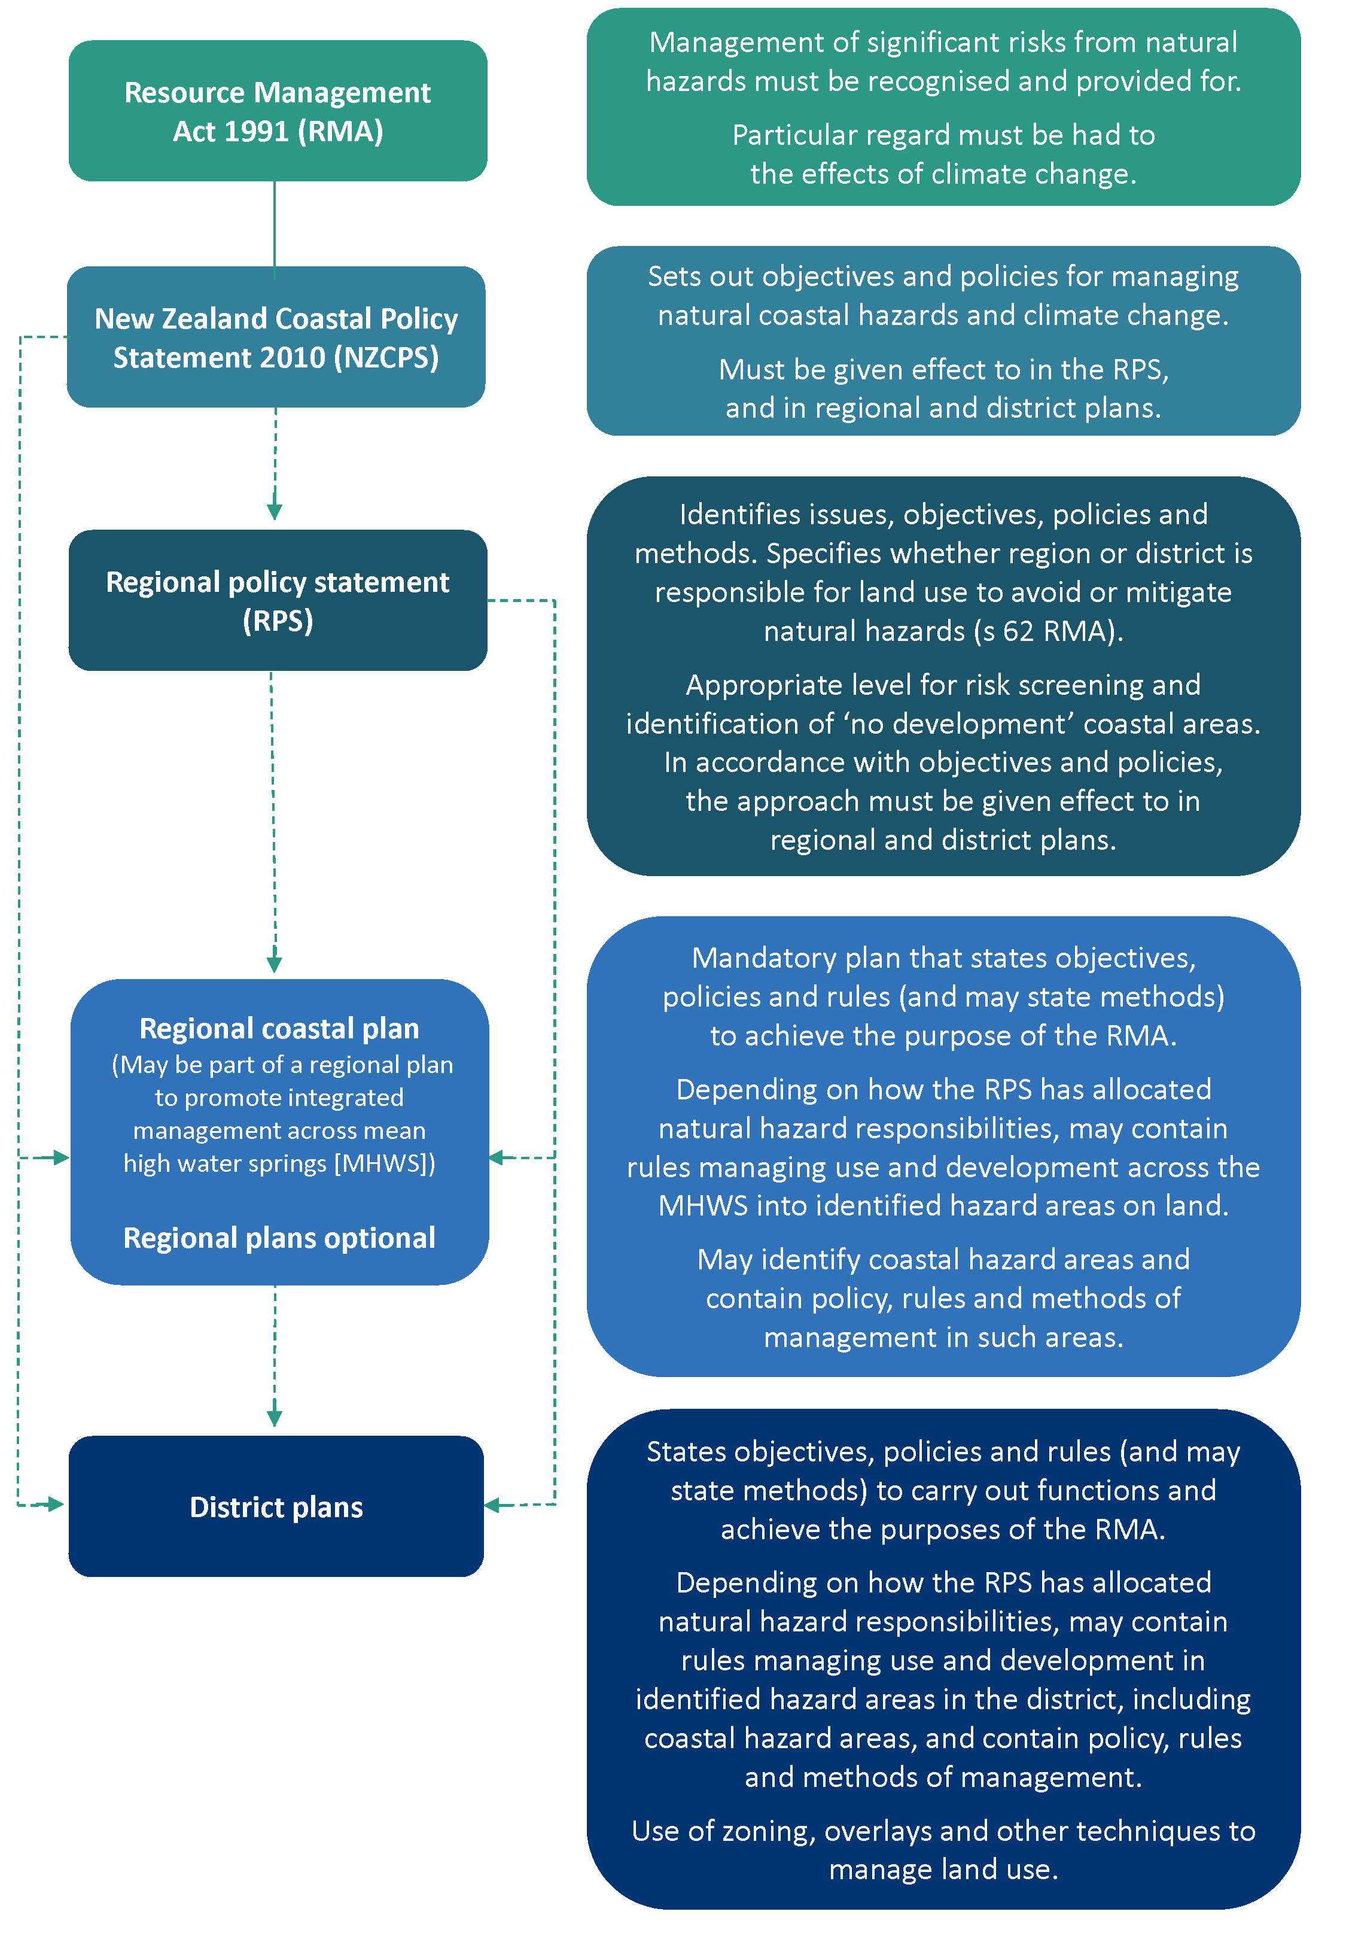
To help local government agencies carry out their statutory functions, and to involve the community in informal ways, local government now undertakes planning outside the RMA framework. Some are statutory requirements, such as Long-Term Plans under s93 of the Local Government Act 2002, while others are less formal and contribute to statutory plans and integrated management of natural and physical resources (eg, coastal hazard plans). Non-statutory plans are usually where community aspirations are best identified and developed. Any elements of the non-statutory plans, however, will need to be carried through into a statutory framework to be effective or enforceable.
The wider community’s objectives for hazard and risk management will be set at a regional level. The regional policy statement will likely include the regional representation of the response to national level policy and the allocation of hazard management responsibilities between the regional and district councils (s62 of the RMA). The regional policy statement may identify exclusion areas for new urban development and areas unsuitable for growth and intensification. The identification of these areas may occur through growth planning exercises at a district and regional level, such as those presently required for larger urban councils to provide ‘sufficient development capacity’ for housing and business land through a Future Development Strategy under the National Policy Statement on Urban Development 2020 – subject to qualifying matters.
Given that a coastal hazards management policy in a regional plan must give effect to the New Zealand Coastal Policy Statement 2010 (NZCPS, DOC, 2010) over a timeframe of at least 100 years, the adaptive pathways process will need to be embedded in the statutory planning framework in a way that provides sufficient certainty over that time horizon. A statutory plan under the RMA therefore needs to contain sufficient information about the adaptation planning strategy, including a description of the issue, an outline of the process and engagement that led to the specific provisions, and the policy provisions that underpin the approach taken. Foreshadowing a potential future shift to an alternative DAPP pathway could also be included, which is consistent with the NZCPS precautionary approach.
Examples of regional plans that embed an adaptation pathways process.
1) The Proposed Marlborough Environment Plan. See case study A.7 in appendix A of this guidance.
2) Whakatane District Council has a Coastal Hazard Erosion Policy Area (CHEPA) in its plan based on the 2100 assessed erosion area (plus a buffer) comprising three zones: the Current Erosion Risk Zone (CERZ), the 2060 Erosion Risk Zone (2060 ERZ) and the 2100 Erosion Risk Zone (2100 ERZ). There is targeted policy and increased limitations on use and development across the three zones. For example, within the CHEPA, existing buildings can be maintained but new buildings and other structures face increasing consent difficulty, depending on the zone. Easier consenting paths are provided for new dwellings if an alternative building site for future relocation is provided. Such sites must be held available (within the same legal ownership title) for eventual building relocation. Relocation is triggered when the line of mean high water springs is at 20 metres from the closest point of the building.
Given the 10-year plan review requirement for district plans, regional plans and regional policy statements, it is likely that, if a transition to a new pathway involves policy adjustment, plan changes, or new rules, it would be subject to formal evaluation through the normal RMA plan review process or a plan change. However, if triggers are reached earlier, the adaptive planning strategy could indicate that possibility and recommend how the shift to another option or pathway may occur (eg, by a plan change, activity land-use classes, or limited consents). In cases where the signal, trigger and threshold are surpassed, having an adaptive planning strategy makes it easier to evaluate the objectives and move to the next pathway. Where an adaptive planning strategy has not been prepared, taking a long-term view of responses will be essential to avoid maladaptive actions, including intensification in coastal areas.
Details of the adaptive planning strategy may be incorporated in a district or regional plan through an appendix or schedule. It can provide context and guidance for planners and decision-makers and be reviewed during normal plan reviews or when the triggers are reached.
The types of planning that can be used to manage coastal hazards and risk include:
spatial planning and growth planning
regional strategies (eg, natural hazard strategies, regional policy statements, coastal or natural hazard policies)
regional plans (regional coastal environmental plan or the coastal or natural hazards section of a regional plan)
district plans
precinct, area or structure plans
special purpose area plans
future development strategy (National Policy Statement on Urban Development)
asset management planning
‘community futures’ or ‘community vision’ planning
collaborative planning
reserves management planning.
Guiding practice: A regional approach to dynamic adaptive pathways planning for coastal hazards
The regional strategic approach to coastal hazards and risk management is to reduce risk by protecting inappropriate development (DOC, 2010, 2017). This includes a structured approach that avoids increasing the risk of social, environmental and economic harm over at least the next 100 years.
The regional policy statement (RPS) is the appropriate level to set out the objectives, policies and methods to apply at the regional level, identify areas where new greenfield urban development should not be allowed and implement policy to prevent development in such areas.
A combined strategic approach among territorial authorities may be needed to achieve RPS objectives.
Unless the RPS specifies otherwise, the default provision for control of the use of land to avoid or mitigate natural hazards lies with regional councils under the Resource Management Act 1991, section 62(2).

Choosing planning methods and techniques
Community engagement principles and approaches, and practice methods: Coastal hazards and climate change guidance – Supplement B (also see table 25 and table 26 of the 2017 Coastal hazards and climate change: Guidance for local government, MfE, 2017) sets out the planning methods and techniques that can be used in the lead up to and in statutory planning. These methods are all directed at managing development through enforceable processes or through education, monitoring and active management of coastal risk. Both appendix A case studies and appendix B case law provide further examples on how different planning methods and techniques can be used. These will depend on the situation, the scale of the area and its current development, the objectives and policies, and the community’s input.
The NZCPS states objectives and policies to achieve the purpose of the RMA in relation to New Zealand’s coastal environment (s56 of the RMA). A purpose of the RMA is to promote sustainable management by avoiding, remedying or mitigating adverse effects of activities on the environment (s5(2)(c)). Figure 24 shows how the NZCPS provides the decision context for coastal areas exposed to coastal hazards and climate change in relation to the type of development being considered under the RMA.
Figure 24: Broad New Zealand Coastal Policy Statement 2010 decision context for coastal areas exposed to coastal hazards and climate change
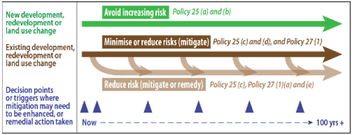
Note: The terminology refers to section 5(2)(c) of the Resource Management Act 1991 to promote sustainable management by, among other things, avoiding, remedying or mitigating adverse effects of activities on the environment.
Source: MfE, 2017
Councils will need to make decisions about the effectiveness and long-term future of existing hard protection structures and similar engineering interventions, which are generally discouraged (Policy 25 and Policy 27 of the NZCPS, DOC, 2010). If appropriate, councils will also have to decide at what stage these structures will need further investment or abandonment (consistent with Policy 25 and Policy 27 of the NZCPS, DOC, 2010). If they are abandoned or removed, planning for a new, restored and more dynamic coastal margin should be foreshadowed and enabled. Box 13 provides guidance on planning approaches to avoid or, where appropriate, reduce greater exposure to coastal hazards and risk.
- : PLANNING APPROACHES TO AVOID (or reduce where appropriATe) GREATER EXPOSURE TO COASTAL HAZARDS AND RISK
1. Down-zoning can prevent intensification or exclude areas from further development or redevelopment (Policy 25, NZCPS, DOC, 2010).
2. Create rules to discourage or limit specified activities in identified hazard areas, using the full range of Resource Management Act 1991 activity classifications, including prohibited activities. When used in association with hazard lines, zoning or overlays, this can ensure that development occurs only in accordance with a consenting process and subject to conditions, or it may prohibit further development entirely. For example, ‘restricted’ or ‘full discretionary’ activity status is an opportunity for a consent authority to set controls through conditions on building location or design in specified zones or certain sites, or to decline consent. ‘Prohibited’ activity status means that no consent can be sought for specified activities in the identified locations. The district plan must specify the discretions and prohibitions.
3. Land filling and raising floor levels at the coast are temporary adaptation measures and can be prohibited in specified locations to avoid further development that will create legacy effects as the sea level rises.
4. Other methods and techniques that can be used in statutory planning to manage coastal hazards and risk include:
- designation of coastal protection or buffer areas, which may be used to provide for infrastructure
- no subdivision areas
- temporary development or land-use consents
- covenants, easements and consent notices
- specifying types of construction and building design and use (eg, relocatable buildings)
- land information memoranda (LIM) or project information memoranda (PIM)
- bonds
- land purchase
- special rating areas for funding capital and maintenance of coastal protection, applied under the Local Government Act 2002, could be used to fund capital or maintenance of coastal protection. The areas to which a special rate is applied, and the rate itself, need to be justified on the basis of benefit obtained from the council activity
- grants and information support.
Source: Adapted from Lawrence et al (2021b).

Funding the implementation of an adaptive planning strategy
The adjustments required to adapt to climate change are unprecedented and ongoing. They will have significant implications for who pays, what is funded, and the funding methods used. The scope and scale of activities that require funding for addressing coastal hazards and climate change will continue to increase. These include the planning, design and implementation and maintenance of adaptation actions, complementary land-use planning, relocation and clean-up activities, setting up a monitoring system, monitoring the effectiveness of the adaptation actions, and all associated council and agency administration.
Current funding instruments are variable and constrained in what they cover. They include reactive funding, such as the Disaster Fund administered by EQC (or Toka Tū Ake – Natural Hazards Commission from July 2024), and proactive funding, such as through council Long-Term Plans, general and targeted rates and levies, 30-year infrastructure strategies, and asset plans. Currently, reactive damage costs and the costs of proactive adaptive planning, and its implementation, lie across national agencies, local government, infrastructure and utilities agencies, individuals, the private sector, iwi/hapū Māori and communities, and are determined on the basis of statutory mandates, need and benefit.
Costs for councils include:
adaptation planning and engagement
implementing coastal adaptation measures
monitoring adaptive plans, signals and triggers
clean-up costs of council assets after extreme events
potential retreat of council assets from affected land
delivery of council services.
Costs for communities include:
immediate damage and adjustment
ongoing health and wellbeing impacts
retreat in some locations
loss of place and culture
increased property rates to fund adaptation measures.
In coastal areas, as ongoing RSLR progresses, funding is also needed to cover climate change impacts (MfE, 2022a). When planning under uncertain and increasing risk conditions at the coast, consider the transfer of residual risk, legal liabilities and the funding consequences of decisions.

Insurance
The Natural Hazards Insurance Act 2023 (replaces the Earthquake Commission Act 1993 and comes into effect 1 July 2024) aims to reduce the impact of natural hazards on people, property and the community. Residential land is insured by EQC (or Toka Tū Ake – Natural Hazards Commission from July 2024). However, this does not cover incremental loss, such as that created by RSLR or king-tide flooding or related ground water rise, but only damage from the direct result of a natural hazard, for example, a storm or coastal flood event.
For councils, insurance instruments are available that can cover their own liability and business interruption, public assets, utilities and infrastructure.
Several types of risk funding are available to councils, such as council collectives (eg, Local Authority Protection Programme Disaster Fund and RiskPool), captives (insurance company owned by the insured), catastrophe bonds, risk swaps, contingent capital, contingent risk and finite risk (Hall, 2022; LGNZ, 2016a). Although some are only triggered after damage occurs and will not motivate risk avoidance and reduction through adaptation.

Part E: How is it working?

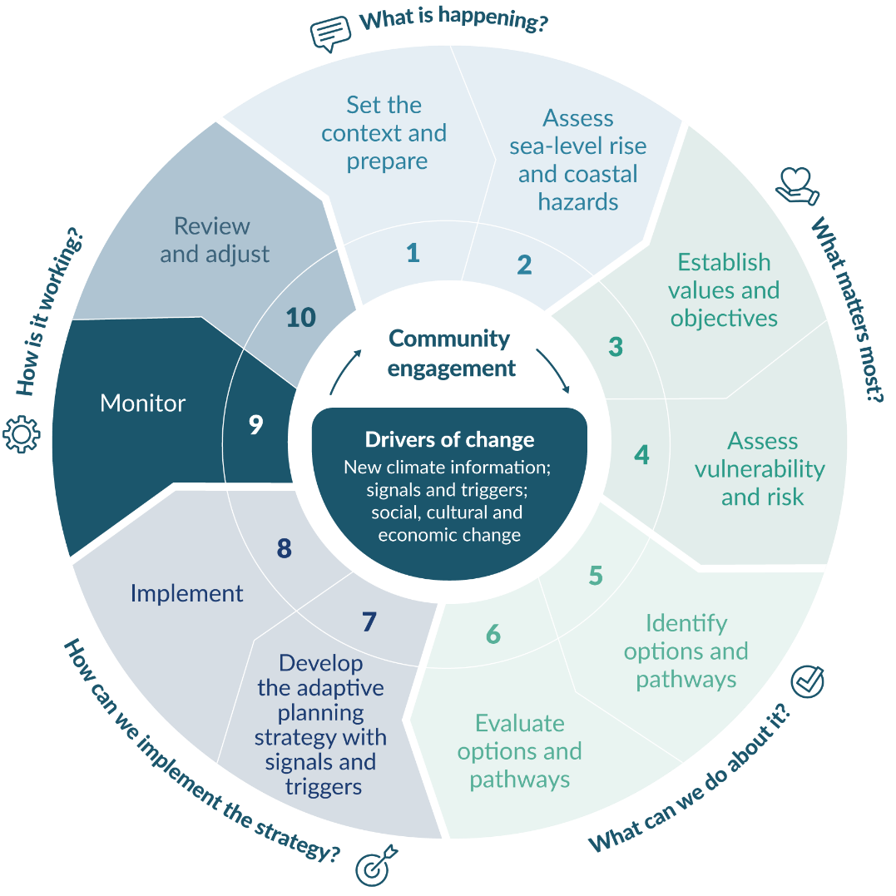
Step 9: Monitor the adaptive planning strategy

Set up the monitoring framework

Rationale for the monitoring framework

Context
As the pace and scale of climate-driven changes at the coast increase, monitoring rates of change above natural variability at a regional or local level will not clearly show the long-term trends, nor changes in the frequency and intensity of extreme events. This is why proxies for change like climate or relative sea-level rise (RSLR) projections or increments are used to stress-test the actions and future options and pathways. This means robust decisions at coastal locations can be made within the decision timeframes of the Resource Management Act 1991 and Local Government Act 2002.
By developing a monitoring framework that is linked to the signals and triggers developed in step 7 and implemented through the channels set out in various statutory and non-statutory plans and measures (step 8 and appendix A), an adaptive planning strategy can be dynamic, flexible, well embedded into ongoing community engagement, and regularly reviewed and updated as climate-related conditions change.
The dynamic adaptive pathways planning (DAPP) approach inherently plans for the future in a changing world, which will have identified conditions where the responses no longer meet the objectives of the adaptive planning strategy (adaptation threshold). Before this point, at a predefined trigger (see examples of indicators in table 16), reassessment of the responses will be necessary to identify whether other actions or transfer to other pathways are required (figure 21).
A monitoring framework is, therefore, essential for implementing the adaptive planning strategy (step 7 and step 8) and linked to each coastal hazard related plan at the local level. A sound information base, including monitoring information, is a fundamental requirement to capture the pace of change (relative to an adaptation threshold) for ongoing planning for adaptation to climate change. Monitoring of the adaptive planning strategy, and review of new information on climate, sea-level rise, vertical land movement and global emissions, and social, cultural and economic changes, will inform the adjustments to be made to decisions or objectives. Regular monitoring contributes to an understanding of changing risks over time, and it enables timely responses to anticipated levels of risk.
Councils are already engaged in monitoring activities:
physical changes (eg, beach profiles and shoreline change, LiDAR surveys, sea and river levels, rainfall and estuarine biodiversity)
the effectiveness of policies, plans and non-statutory strategies.
The United Nations Environment Programme guidance on advancing effectiveness of climate adaptation states that (UNEP, 2023, p 3):
Adaptation interventions need to be assessed for their potential effectiveness (ex-ante) and measure actual effectiveness (ex-post) using a set of metrics identified based on specific criteria. Monitoring and evaluation during implementation helps to ensure climate risk reduction. [Emphasis added.]

Effective monitoring
Integrating existing monitoring systems with monitoring of adaptive planning strategies can leverage synergies and increase the efficiencies among activities, better preparing councils and agencies for the climate-driven changes. There may also be synergies between regional and district council’s coastal management that are interdependent. It may be more efficient for joint decision-making to take place.
The effectiveness of a monitoring system depends on three critical criteria: an organisation’s ability to implement, sustainability and accountability (Kavale, 2022). Table 17 describes how councils can meet these criteria.
- Effective monitoring implementation
Effectiveness criteria | Barriers | How to address the barriers
Ability to implement  The ability of councils to integrate formalised monitoring | - Resource pressures  - Uncertainty about how to integrate with existing monitoring  - No clear monitoring function | - Risk and audit committees  - Citizen science groups augment council monitoring  - Alignment with planning timeframes, Long-Term Plans and activities
Sustainability  Monitoring continuously over the long term | - Staff turnover  - Lack of long-term commitment  - Competing activities and funding priorities | - Formalise in council processes  - Embed responsibilities into planning methods  - Formalise in a council role, not a person
Accountability  Those responsible for acting on signals and triggers are accountable | - Different governance levels creating complexity  - Ambiguous responsibilities  - Inadequate compliance systems | - Delineate a primary authority for monitoring  - Create legal consequences  - Create clear authority for signal and trigger review and action in a publicly visible way  - Socialise monitoring with local communities
Source: Adapted from Kavale (2022)

Constraints affecting monitoring regimes
Several constraints affect the ability to implement a monitoring regime. The prevailing political settings, governance arrangements, statutory frameworks, economic conditions and the availability of resources can all constrain or enable effective monitoring of change. For example, a 10-year funding focus with three yearly Long-Term Plan reviews promotes a short-term focus that can result in shifts in priorities that compete with the ongoing monitoring regime. The 30-year local government infrastructure strategies take a longer view on funding services, which may provide opportunities to fund monitoring of changes in service levels and trends in maintenance and recovery costs. There is also a risk of bias towards short-term monitoring investments for ‘protecting’ communities from coastal hazards and sea-level rise, as opposed to reducing future risk. Building on existing monitoring systems is one way of gaining efficiencies.
Monitoring systems that can be maintained over time within local contexts are fundamental for coastal situations where sea level will continue rising for centuries. This makes long-term tracking and assessment of changes in conditions essential to inform and review the ongoing implementation of the adaptive planning strategy. Well-designed statutory frameworks and consistent decision practices will facilitate ongoing monitoring and pathway choices contingent on signals and triggers.

Establish the monitoring regime

Define the purpose of the monitoring regime
Start by clarifying the purpose of the monitoring regime. This determines the most appropriate elements to use (Bell et al, 2002), such as the types of indicators that can be used to detect change.
Designing the regime to monitor signals and triggers is an iterative process, informed by council engagement with the community, iwi/hapū and other stakeholders.
Clearly define the roles of those taking part in decisions or review at the trigger point. This promotes transparency and equity among stakeholders. Engagement on signals and triggers will have identified who holds data and resources that will be helpful in monitoring. This could include indicators monitored by local citizens, such as king-tide photos, CoastSnap or iwi/hapū observations within their rohe (a tribal district).

Define the monitoring responsibilities
To enable sustainable, long-term and continuous monitoring, decide which agency or individual in the organisation monitors the signals and triggers, how the organisation activates the next steps, and who or what part of the organisation is accountable, for example, a senior manager and risk committee, so decisions can be made with enough lead time before a threshold is reached.
Guiding questions
- What new or revised statutory processes and council priorities are needed for monitoring indicators and for setting and documenting signals and triggers?
- Will the processes, monitoring and review require training or increased awareness at various levels of decision-making?
- Have we assigned responsibilities for monitoring, so the indicators can be activated in a timely manner?
- Which agency or group in council should carry out monitoring, record the results and analyse the data?
- Has a formal ‘institutional memory’ been set up so responsibility can be passed on as personnel change over time?
- Who or what partnership commits funding to the monitoring?

Establish the governance, management and reporting
Decide the governance arrangements for receiving the reporting for action. The composition of the governing body should represent the functional interests for coastal hazards and climate change and include mana whenua.
Decide who will manage, analyse, aggregate or synthesise the results of the monitoring of the indicators. Also decide who will provide regular reporting with information and interpretation to decision-makers, the community and other stakeholders. Comprehensive oversight of the indicators at different scales can support the adaptive planning strategy at a range of locations and situations including across regional and district jurisdictions where coastal hazards have flow-on effects wider than one district.
Guiding questions
- Who reviews the reporting on how the monitored indicators are tracking against the signals and triggers?
- Who audits the reporting when signals and triggers are reached?
- What resources are available to monitor indicators (including any longitudinal surveys)?
- How will the ongoing monitoring outcomes be communicated to the communities?

Formalise the monitoring regime

Embed the monitoring regime responsibilities, review and decision-making processes into the organisation systems and processes
Formally embed the identified signals and triggers in the organisation’s monitoring system so it embodies review, reporting, audits and decision-making. This will enable decision-makers to remain informed of changes over time and to act in a transparent and timely way. This will give long-term consistency to the monitoring of the signals and triggers and enable their effectiveness and relevancy over time as they are adjusted to the changing climate-driven impacts at the coast.
Set up any necessary formal partnership agreements with central government agencies, regional councils and territorial local government when the monitoring regime is shared. Do this to establish clear lines of accountability and who makes the final decision to shift to the next option in the chosen adaptation pathway.
Formalised monitoring systems and processes will also be beneficial for accessible reporting to communities, for example, via websites, to raise understanding of changes over time and how they are being addressed. A good example of this approach is the Land, Air, Water Aotearoa website for freshwater data (www.lawa.org.nz).
Guiding questions
- To what extent should we formalise the monitoring of signals and triggers?
- How can the monitoring system be formalised to ensure the monitoring regime is sustained?
- Can dynamic adaptive pathways planning help us identify enablers and entry points for a robust and flexible implementation pathway?
- How can the planning approach, and the decisions, persist?
- How can the monitoring regime be integrated into existing council practice? Are these processes complementary, enduring and well supported?
- Can we use or extend any current indicators or monitoring regimes?
- Is there other guidance for implementing the adaptive planning strategy?
Box 14 explains how monitoring can be integrated into existing council practice. The use of existing processes will create consistency and give decision-makers assurance in the robustness of their decisions. Processes should be developed rigorously, considering alternatives, based on sound information and community participation.
- : INTEGRATING THE MONITORING SYSTEM INTO COUNCIL PROCESSES AND SYSTEMS
Monitoring can be integrated into existing council practice through the following:
- non-statutory plans, such as spatial and strategic planning and growth strategies, natural hazard management strategies, and community-based planning (community vision statements and plans, collaborative planning and iwi management plans)
- Local Government Act 2002 statutory requirements, such as the Long-Term Plan and annual plans (which can contain budgets for the implementation of monitoring), infrastructure strategies and asset management plans (roads, parks and reserves, stopbanks and other assets)
- statutory Resource Management Act 1991 policies and plans, including:
- regional policy statements, regional coastal plans, and regional and district plans, which could include adaptive pathways with signals and triggers in objectives, policies, rules and methods
- defined activity status (including prohibited) with signals, triggers and thresholds, and special measures, such as scheduled areas and retreat lines
- deferred zoning and closed residential zoning attached to a trigger (eg, no increase in floor site coverage and only minor alterations and non-inhabited buildings)
- consent conditions that enable specific evaluation and targeted outcomes (eg, ‘trigger’ conditions to require an adaptive response when a predetermined set of circumstances is reached)
- other legislative responsibilities that provide opportunities to embed signals and triggers, such as civil defence and emergency management group plans, reserves management plans, and various provisions of the Local Government (Rating) Act 2002 (targeted rates tied to funding impact), Soil Conservation and Rivers Control Act 1941, Public Works Act 1981, Local Government Official Information and Meetings Act 1987 (land information memoranda) and the Building Act 2004, which includes the Building Code application (project information memoranda)
- other relevant council processes including:
- cross-council partnership processes
- Te Tiriti o Waitangi, which gives government a responsibility to provide opportunities for participation by Māori in decision-making and to facilitate participation by Māori
- leadership, education, information and communication with the public and stakeholders
- covenants and easements on consent notices on titles
- bonds
- the purchase of council land for buffers, refuges and open-space areas as part of a signal and trigger system
- building on existing monitoring programmes
- council staff key performance indicators (eg, for chief executive officers and chief financial officers)
- council risk framework (eg, signals and triggers formalised with the Liability and Risk Audit Committee)
- citizen science to monitor some signals and triggers, for example, CoastSnap, King Tide initiatives
- longitudinal community surveys to monitor values, risk perceptions and sensitivity to signals and triggers.
Source: Lawrence et al (2020b)

Involve communities in monitoring
Communities, iwi/hapū and other stakeholders, such as schools and businesses, can contribute to monitoring (see Community engagement principles and approaches, and practice methods: Coastal hazards and climate change guidance – Supplement B). The main benefit is a shared understanding of rates of change, progress towards signal and trigger points, and changes in trigger points. For example, a community may have decided in 2016 that coastal flooding of a main road more than twice a year was a trigger point. The reality and cumulative disruption of regular flooding, however, may shift this perspective so a different trigger point is needed.
Ideally, citizen monitoring is set up in collaboration with local government monitoring, and information is shared and widely communicated. Establishing the monitoring regime may benefit from expert input into its design and analysis of the monitoring outputs.
Planning along dynamic adaptive pathways should also provide for emerging research and findings, new tools for managing hazards and risks, and community engagement at key decision points.

Step 10: Review and adjust the adaptive planning strategy
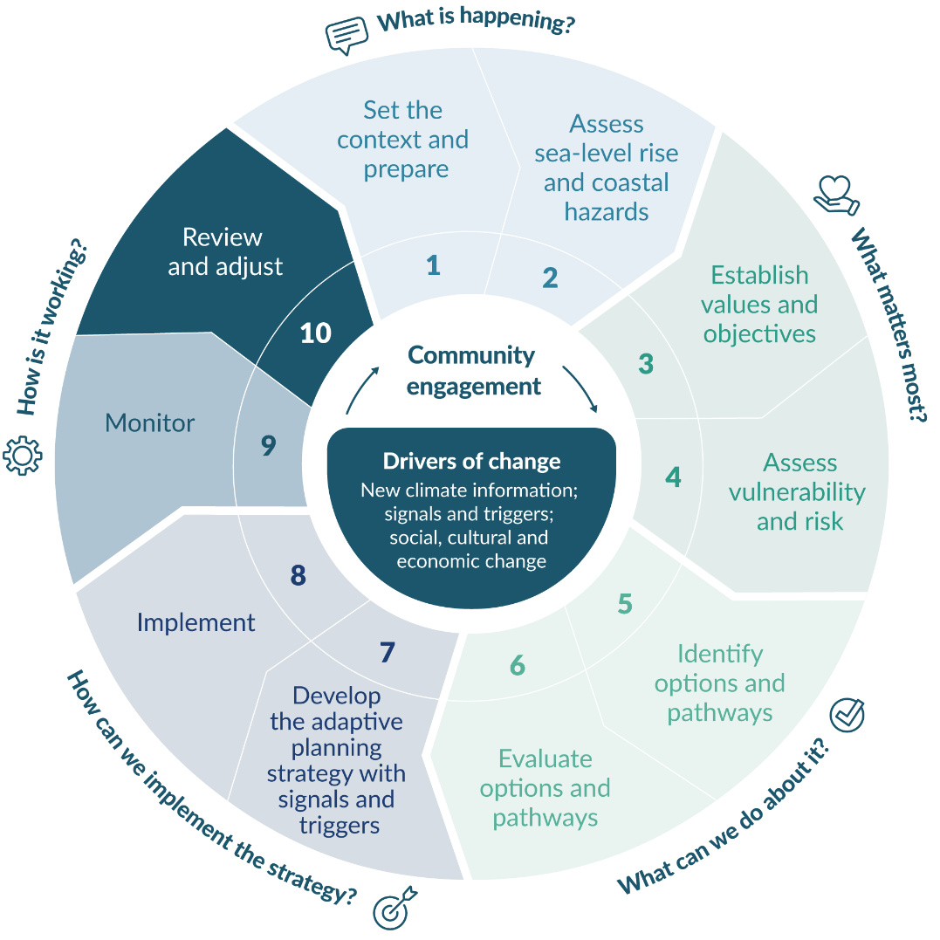

Review the dynamic adaptive pathways planning objectives and actions
Councils should set up a process to activate a review when either a) a trigger or b) a time period, such as 10 years, is reached. To assist monitoring and analysis, keep good documentation of the processes used to derive pathways, triggers, and thresholds.
The review should examine the dynamic adaptive pathways planning (DAPP) objectives, to determine whether they are still relevant, whether the pathway will still meet the objectives, or whether a change in option or pathway is required. The purpose of the review is to determine:
the robustness of the signal and trigger activations
the effectiveness of the existing action.
The review should be informed by the ability of the options to continue to meet the objectives. It will be influenced by the prevailing political settings, governance arrangements, statutory frameworks and practices, societal and cultural perceptions, and economic and funding conditions.
If the review shows that existing actions are not meeting the objectives, decide on an alternative option or pathway.
The outcome of the review should be audited and reported to council, then to the community and relevant stakeholders, before the decision is made to act.
Guiding questions
- Is a multi-disciplinary team with all the right expertise available to undertake the review and redesign signals, triggers, and thresholds?
- How can we revisit the plan objectives when the operating conditions and enablers (statutes or guidance) change?
- How can the dynamic adaptive pathways planning approach be adjusted when surprises or disasters happen?
- What are the risks (including residual risks) if the signals and triggers fail to anticipate the impending adaptation threshold soon enough?
- How do the combined changes in climate and non-climate indicators influence the achievement of objectives going forward?
- What are the cumulative demands of adaptation implementation across the region? Have funding sources and affordability changed?
- Do we need to reprioritise actions due to diminishing physical resources?
- Have either adaptive capacity or risk perceptions changed?

Adjust the dynamic adaptive pathways planning objectives and actions
Once a trigger has been reached, a review has been conducted and a decision to change has been made, assess whether other options or pathways in the plan could meet the objectives and, if so, adjust the plan by changing to the new actions and redesigning the signals and triggers.
These changes will alter, cease or expand the existing actions or services in response to monitoring. They will also necessitate changes to the implementation plan and its funding, which could extend over several years, and reappraisal of the lead time for implementation. Consider the flow-on effects of actions for statutory plans, council budgets, cross-council integration and other actions.
Once the changes are activated, revert either to step 3 (refine the adaptation plan objectives) or step 5 (identify options and pathways) of the decision cycle.

Glossary of abbreviations and terms
Adaptation | A response strategy to anticipate and cope with impacts that cannot be (or are not) avoided under different scenarios of climate change (Denton et al, 2014).  The process of adjustment to actual or expected climate and its effects. In human systems, adaptation seeks to moderate or avoid harm or exploit beneficial opportunities. In some natural systems, human intervention may facilitate adjustment to expected climate and its effects (IPCC, 2014b, annex II).  Adaptation can be categorised as either:  incremental – actions where the central aim is to maintain the essence and integrity of a system or process at a given scale, or  transformational – actions that changes the fundamental attributes of a system in response to climate and its effects.
Adaptation threshold | The threshold (derived value or performance measure) when agreed objectives, community values, risk exposure, or levels of service are no longer being met or start to fail, requiring an alternative adaptation action or pathway to be in place before this occurs. The threshold is not tied to a particular time, rather to a condition –it will be a bracketed time window derived from the scenarios used in the dynamic adaptive pathways planning approach.
Adaptive capacity | The ability of systems, institutions, humans and ecosystems to adjust to potential damage, take advantage of opportunities, or respond to consequences (ISO 14091:2021). See also IPCC 2022 Glossary.
Adaptive planning strategy | For the purposes of this guidance, an adaptive planning strategy encompasses the hazard assessments, the values and objectives and the vulnerability and risk assessments that feed into the dynamic adaptive pathways planning approach, and the measures to implement them through the Resource Management Act 1991, Long-Term Plans, asset plans and other council plans, along with the monitoring framework for review and adjustment.
Annual exceedance probability (AEP) | The chance that an event would reach or exceed a given magnitude in any year, expressed as a percentage or decimal (see Climate change, sea-level rise and coastal hazards science: Coastal hazards and climate change guidance – Supplement A).
AR5 | IPCC Fifth Assessment Report – covering three working group reports and a synthesis report (the previous assessment report in 2007 was the AR4).
AR6 | IPCC Sixth Assessment Report.
CCRA | Climate Change Response Act 2002.
Climate | In a narrow sense, the average weather. More rigorously, the statistical description in terms of the mean and variability of relevant quantities over a period of time, ranging from months to thousands of years. The normal period for averaging climate variables is 30 years (World Meteorological Organization, 2007).
Climate change | A change in the state of the climate that can be identified (eg, through statistical tests) by changes or trends in the mean and/or the variability of its properties, and that persists for an extended period, typically decades to centuries. Includes natural internal climate processes or external climate forcings such as variations in solar cycles, volcanic eruptions, and persistent anthropogenic changes in the composition of the atmosphere or in land use (adapted from IPCC 2013, annex III).
Climate hazards | Climate hazards propagate as climate-driven events or progressive and ongoing trends that cause damage and loss to human and natural systems.
Climate projection | The simulated response of the climate system to a scenario of future emission or concentration of greenhouse gases and aerosols, generally derived from climate models distinguished from climate predictions by their dependence on the emission–concentration–radiative–forcing scenario used, which is in turn based on narrative with assumptions, for example, future socio-economic, technological developments or land-use change that may or may not be realised (adapted from IPCC, 2013, annex III).
Climate risk | Refer to ‘risk’.
Coastal environment | See Policy 1 of the New Zealand Coastal Policy Statement 2010 (DOC, 2010) as to what the coastal environment includes. Includes not only the coastal marine area but also terrestrial environments where they are inter-related with the coastal marine system, and areas at risk from coastal hazards (including climate change).
Coastal hazard | Subset of natural hazards and include tidal or coastal storm inundation, rising sea level, tsunami or meteorological tsunami inundation, coastal erosion (shorelines or cliffs), rise in groundwater levels from storm tides and sea-level rise (plus associated liquefaction), and salinisation of surface fresh waters and groundwater aquifers.
Coastal marine area (CMA) | The foreshore, sea bed and coastal water, and the air space above the water. Seaward boundary is the outer limits of the territorial sea. Landward boundary is the line of mean high water springs or some distance up tidal rivers. Full definition in Resource Management Act 1991, section 2.
Committed SLR | Ongoing ocean heat uptake and the slow adjustment of the ice sheets that will continue over the centuries and millennia following cessation of emissions.
Community | People who live in, or are connected with, a particular location.
Consequences | The outcome of an event that may result from a hazard. May be expressed quantitatively (eg, monetary value, disruption period, environmental effect), by category (eg, high, medium, low) or descriptively (National Emergency Management Agency, pers. comm.).
Deep uncertainty | Uncertainty where what is known is only that we do not know or cannot agree upon amongst experts or is contested by stakeholders with no consensus on what the future might bring. Requires robust decision-making methods and tools to support decisions and policy analysis (Walker et al, 2013).
District plan | Plan that must be prepared by a city or district council to help them carry out their functions under the Resource Management Act 1991. All persons and bodies have to adhere to the plan.
DOC | Department of Conservation.
Dynamic adaptive pathways planning (DAPP) | A decision-making approach to analyse the flexibility of options and pathways under conditions of deep uncertainty using scenarios for stress testing options and monitoring of signals and triggers for anticipatory planning. The same as dynamic adaptive policy pathways adopted by Haasnoot et al 2013.
ENSO | El Niño–Southern Oscillation climate mode that occurs over a two- to five-year cycle, mainly in the Pacific and has an influence on mean sea level at interannual timescales.
Event | Occurrence or change of a particular set of circumstances. Can be one or more occurrences and can have several causes (AS/NZS ISO 31000:2009 Risk management standard).
Exceedance | Extreme hazard event that exceeds a specified extreme level or magnitude in a given planning timeframe.
Exposure | Being present in a place or setting that could be adversely affected. Those that could be harmed in that environment include people; livelihoods; species or ecosystems; environmental functions, services and resources; infrastructure; buildings and economic, social or cultural assets.
FDS | Future Development Strategy.
Foreshore | Any land covered and uncovered by the flow and ebb of the tide at mean spring tides and, in relation to any such land that forms part of the bed of a river, does not include any area that is not part of the coastal marine area.
Freeboard | The NZS 4404:2010 defines freeboard as “…a provision for flood level design estimate imprecision, construction tolerances, and natural phenomena (such as waves, debris, aggradations, channel transition, and bend effects) not explicitly included in the calculations” (p 25).
Frequency | The number or rate of occurrences of hazard events, usually for a given time period (National Emergency Management Agency, pers. comm.).
Groundwater rise | The movement upward of the water table due to short or long-term fluctuations in rainfall recharge and/or river, ocean or tidal levels.
IPCC | Intergovernmental Panel on Climate Change, a scientific and intergovernmental body under the auspices of the United Nations.
IPO | Inter-decadal Pacific Oscillation. A longer term ENSO-like mode that occurs over a 20- to 30-year cycle, mainly in the Pacific. The IPO switched to the negative phase around 1999.
Iwi and hapū | Tribe, large group descended from a common ancestor. Kinship group, clan, subtribe.
Land | Includes land covered by water and the air space above land.
Land information memorandum (LIM) | Information about a land parcel under the Local Government Official Information and Meetings Act 1987 and available on request from territorial local authorities.
LGA | Local Government Act 2002 (and amendments).
LGNZ | Local Government New Zealand (www.lgnz.co.nz).
Light Detection and Ranging (LiDAR) | A laser scanning system usually mounted on an aircraft to measure surface elevations with height accuracies down to 0.1 metres.
Likelihood | The probability or chance of a hazard or event occurring. Usually described quantitatively as a ratio (eg, 1 in 10), percentage (eg, 10 per cent) or value between 0 and 1 (eg, 0.1), or qualitatively using defined and agreed terms, such as unlikely, virtually certain, about as likely as not.
Maladaptive actions (Maladaptation) | Actions that may lead to increased risk of adverse climate-related outcomes, including via increased GHG emissions, increased vulnerability to climate change, or diminished welfare, now or in the future. It is usually an unintended consequence.
MCA | Multi-criteria analysis. Analysis technique for evaluating criteria that are qualitative and quantitative, reflecting the social, cultural, economic and environmental characteristics of the project outcomes or response options (adapted from New Zealand Asset Management Support – www.nams.org.nz).
Mean sea level (MSL) | Average (mean) level of the sea relative to a vertical datum over a defined epoch, usually of several years to decades. Baseline MSL for IPCC and NZ SeaRise sea-level rise projections is the average sea level over the period 1995–2014.
Mean sea-level anomaly | Variation of the non-tidal sea level above or below the longer term MSL on time scales ranging from a month to years due to climate variability. This includes the influence of ENSO and IPO patterns on sea level, winds and sea temperatures, and seasonal effects.
MHWS | Mean high water spring tide. Applies to a high-tide water level during spring or perigean spring tides as well as the line that marks the landward boundary of the CMA.
Mitigation (of climate change) | A human intervention to reduce the sources or enhance the sinks of greenhouse gases (IPCC, 2014b, annex II).
Mitigation (of natural hazards and risks) – or risk reduction | The lessening of the potential adverse impacts of physical hazards (including those that are human induced) through actions that reduce hazard, exposure and vulnerability (IPCC, 2014b, annex II).
National adaptation plan (NAP) | The National adaptation plan (MfE, 2022a) prepared under the Climate Change Response Act 2002 sets out what we need to do to adapt, live and thrive in a different and changing climate.
Natural hazard | Any atmospheric, earth or water-related occurrence (including earthquake, tsunami, erosion, volcanic and geothermal activity, landslip, subsidence, sedimentation, wind, drought, fire or flooding), the action of which adversely affects or may adversely affect human life, property or other aspects of the environment (Resource Management Act 1991, section 2 (adapted)). Hazards can be single, sequential or combined in their origin and effects. Each is characterised by its timing, location and scale, intensity and probability.
NCCRA | National Climate Change Risk Assessment.
NIWA | National Institute of Water and Atmospheric Research.
NPS | National policy statement (see Resource Management Act 1991, sections 45–55).
NZCPS | New Zealand Coastal Policy Statement 2010 (DOC, 2010). A mandatory national policy statement under the Resource Management Act 1991. Administered by the Department of Conservation.
Path dependency | Situation where decisions, events or outcomes at one point in time constrain adaptation, mitigation or other actions or options at a later point in time (IPCC, 2014b, annex II).
Parliamentary Commissioner for the Environment | An independent advisor to the Government on environmental issues. The Commissioner investigates emerging environmental issues and concerns from the public.
Percentile | A measure used in statistics indicating the value below which a given percentage of occurrences in a group of observations or projections fall. The 50th percentile is the median. Used to measure the spread of numerous sea-level rise projection simulations from various models and inputs for a particular combined Shared Socio-economic and Representative Concentration Pathway. Graphs and datasets of IPCC and NZ SeaRise projections typically show the median or p50 (line) and a shaded likely range, which covers the spread of projections between the 17th percentile (p17) and the 83rd percentile (p83). 33 per cent of projections are outside the likely range.
Perigean spring tide | A tide that peaks in clusters about every seven months when the moon’s perigee (its closest point to Earth during its 28-day elliptical orbit) coincides with a spring tide (when the Earth, sun and moon are nearly aligned every two weeks).
Probability | Chance or likelihood that an event will happen, or hazard magnitude be exceeded.
Project information memorandum (PIM) | A report issued by a council on request under section 31 of the Building Act 2004 in relation to a building project.
Projection | Used in two senses in the climate change literature. In general usage, it is any description of the future and the pathway leading to it (ie, not a ‘prediction’). The IPCC has attached a more specific interpretation to the term ‘climate projection’ or ‘sea-level rise projection’ when referring to model-derived estimates of future climate.
Real options analysis | Allows economic analysis of future option value and economic benefit of deferring investment.
Regional council | Councils that primarily manage resources like the air, water, soils and the coastal marine area, along with natural hazards, civil defence, regional land transport and harbour navigation and safety. Aotearoa New Zealand has 11 regional councils. Refer to section 30 of the RMA.
Regional plan | A plan that can be prepared by regional councils to help manage the resources they are responsible for. All persons and bodies have to adhere to the plan.
Regional policy statement (RPS) | Must be prepared by all regional councils and help set the direction for the coordinated management of all resources across the region.
Relative sea-level rise (RSLR) | Sea-level rise experienced locally relative to the land mass. RSLR includes the rate of vertical land movement (VLM) for either subsidence or uplift.
Representative concentration pathway (RCP) | Scenario of future radiative forcings from greenhouse gases.
Residual risk | The risk remaining after adaptation and risk reduction efforts (Oppenheimer et al, 2019).
Risk | Effect of uncertainty on objectives (AS/NZS ISO 31000:2009, Risk management standard and ISO 14091:2021, Adaptation to Climate Change: Guidelines on risk assessment).  Climate risk is the potential for adverse consequences for human and ecological systems, recognising the diversity of values and objectives associated with such systems (Reisinger et al, 2020). ‘System’ is a set of inter-related or interacting elements (ISO 14091; 2021). Through a te ao Māori lens, it is the implicit connectedness between te taiao (environment) and tangata (people) and related mātāpono or guiding principles.
Risk assessment | Qualitative and/or quantitative process of risk identification, risk analysis and risk evaluation (AS/NZS ISO 31000:2009, Risk management standard).
Risk management | Plans, actions or policies to reduce the likelihood and/or consequences of risks or to respond to consequences (ISO 31000:2009, Risk management standard).
RMA | The Resource Management Act 1991 and subsequent amendments. Aotearoa New Zealand’s main piece of environmental legislation providing the framework for managing the effects of activities on the environment.
Scenario | Plausible description of how the future might unfold in terms of interacting factors, including human behaviour, policy choices, land-use change, global population trends, economic conditions, technological advances, international competition and cooperation (Moss et al, 2010).
Sensitivity | The degree to which a system is affected adversely or beneficially by climate-related drivers. The alternative term fragility is often used in the engineering and/or lifelines sector and tools like RiskScape.
Sensitivity testing | Considers the effect of a range of present and future uncertainties that may increase a particular hazard or other component of risk (exposure, vulnerability). Generally applied to assessing a single (or compound) hazard over a single time period or scenario, particularly if the climate change effects on the hazard are uncertain (eg, future storm intensity or changes in storm surge) or a relatively short monitoring record generates wider 95 percent confidence intervals (eg, 1 per cent AEP storm tide). Could also apply to risk assessments to cover uncertainties, such as the vulnerability of some types of assets (eg, groundwater rise impacts on roads and buildings or confidence in existing data on floor levels of buildings for flooding).
Shared socio-economic pathway (SSP) | Scenarios developed to complement the RCPs with varying socio-economic challenges to adaptation and mitigation.
Signal | Derived indicator value, monitoring changes in physical, social, cultural, economic, and risk attributes, which provide early warning to signal that a trigger (decision point) is approaching in the near to medium term. It should prompt thinking and initial engagement processes on the next steps or any changes to the trigger.
Significant wave height | A measure of the highest one-third (33 per cent) of waves over a measurement or modelled period – relates to the height of waves that an observer may estimate.
SLR | Sea-level rise.
SLR increments | Series of projected SLR or RSLR heights at constant intervals (eg, 0.1 metre or 0.2 metre increments) which are scenario neutral, and which can be used in hazard and risk assessments and dynamic adaptive pathways planning to ascertain adaptation thresholds and bracketed timings of local RSLR.
Spatial planning | Planning to influence the future spatial distribution of land-use activities within a defined area.
Stakeholder | Entity with an interest in a geographic area or issue, for example, an asset, utility or a value that is at stake.
Static or ‘bathtub’ inundation model | Hydrodynamic modelling of coastal inundation that does not include the dynamic or transient effects of waves or storm tide flooding of land. Essentially transfers the coastal water level inland until that land elevation is reached.
Storm surge | Temporary increase in sea level induced by winds and barometric pressure associated with weather systems.
Storm tide | Combination of MSL, high tide, storm surge and MSL anomaly (monthly to seasonal variation in MSL), normally includes wave setup, but excludes wave runup.
Stress-testing | Analysis approach used to anticipate the potential impact of surprises and unknowns, especially elements or place-based risks with high uncertainty from cascading impacts (Logan et al, 2023). It is a method to increasingly stress a system and determine its breaking point. This improves understanding of how and why a system or design may fail (Lempert, 2019).
System | A set of inter-related or interacting elements (ISO 14091:2021, Adaptation to Climate Change: Guidelines on risk assessment).
Territorial authority | A city or district council primarily responsible for managing the effects of activities on land. Refer to section 31 of the RMA.
Trigger (decision point) | A derived indicator value, which when reached, provides sufficient lead time to cover community engagement, consenting, design and construction and funding arrangements, to ensure a new adaptation action or pathway can be implemented before the adaptation threshold is reached (see figure 22). The trigger is not tied to a particular time but to a condition – it will be a bracketed time window derived using a SLR increment, or scenarios in the dynamic adaptive pathways planning approach.
Uncertainty | A state of incomplete knowledge that can result from a lack of information or from disagreement about what is known or even knowable. It may have many sources, from imprecision in the data to ambiguously defined concepts or terminology, or uncertain projections of human behaviour (IPCC, 2014b, annex II).
Uncertainty (risk) | The state, even partial, of deficiency of information related to, understanding or knowledge of an event, its consequences or likelihood (AS/NZS ISO 31000:2009, Risk management standard and ISO 14091:2021, Adaptation to Climate Change: Guidelines on risk assessment).
UNFCCC | United Nations Framework Convention on Climate Change. Came into existence in March 1994 following the Rio Earth Summit in 1992. To date, 197 countries have ratified the Convention and are called Parties to the Convention. Preventing ‘dangerous’ human interference with the climate system is the ultimate aim of the UNFCCC.
Unitary authority | An entity that carries out the roles of both regional and district councils. There are currently six, for example, Auckland Council, Tasman District Council.
Upzoning | Changing the zoning in land-use plans to increase the development capacity allowed in the future, eg, for higher-value (eg, from pastoral to residential) or intensification of uses.
VLM | Vertical land movement, which contributes to the relative sea-level rise experienced locally.
Vulnerability | The predisposition to be adversely affected. Encompasses a variety of concepts and elements, including exposure, sensitivity or susceptibility to harm or damage, and lack of capacity to cope and adapt (adaptive capacity) (adapted from IPCC, 2014b, annex II).
Vulnerability assessment | As part of a climate risk assessment (step 4), the process of identifying, quantifying and prioritising (or ranking) the vulnerabilities in a system, environment or community. Conducted across the political, social, economic and environmental fields, as well as those highlighted by hazard threats to community and private assets. Includes the sensitivity of people, land and assets exposed, together with adaptive capacity.
Water table | The ‘surface’ of the sub-surface sediments that are saturated with groundwater in a given vicinity. Typically measured as the elevation that water rises to in a well screened in shallow groundwater.
Wave overtopping | Occurs when the wave runup exceeds the crest elevation of the beach and flows over the top (‘overtops’) of the dune or seawall.
Wave runup | The maximum vertical extent of sporadic wave ‘up rush’ or flowing water (‘green water’) on a beach or structure above the still water or storm tide level. Constitutes only a short-term upper-bound fluctuation in water level compared with wave setup.
Wave setup | The increase in mean still water sea level at the coast resulting from the release of wave energy in the surf zone as waves break.

Appendix A: Coastal hazard management case studies

Coastal inundation tool
(Waikato Regional Council)
Waikato Regional Council has developed a tool to show the susceptibility of coastal areas to inundation from tides, storms and projected relative sea-level rise (RSLR) at a regional scale. It is not designed to define actual coastal inundation hazards or minimum floor levels for specific properties. It is used for screening to identify areas where more detailed assessment might be required, and for raising public awareness.
The tool uses static geographic information system (GIS) mapping to show potential coastal storm inundation, given user-selected sea-level scenarios. It includes guidance on a set of plausible sea levels, based on detailed analyses of sea-level records and a tidal model. Extreme sea levels (not including sea-level rise (SLR)) are included in the tool, calculated using a ‘building block’ extreme sea-level method, for a lower and upper estimate of storm-tide. They have an unknown likelihood of occurrence. The tool does not associate probabilities of occurrence to extreme sea levels but provides a plausible range of extreme sea levels, based on present-day conditions.
The tool allows for testing RSLR projections or a range of increments relative to current mean sea level, by adding an SLR increment to the present-day extreme sea level (figure A.1). It is well suited for large-scale, long-term, scenario-based planning where consequences are being assessed. It could be used, for example, in pre-planning discussions and community engagement.
User feedback shows how the tool has raised public awareness of coastal inundation in the Waikato region. The level of community feedback was improved by an extensive communications effort, especially by the regional and local councils, before the tool was launched.
Figure A.1: Current mean high water spring tide and a future upper-range coastal storm inundation for a 0.5 metre sea-level rise at Thames using the coastal inundation tool
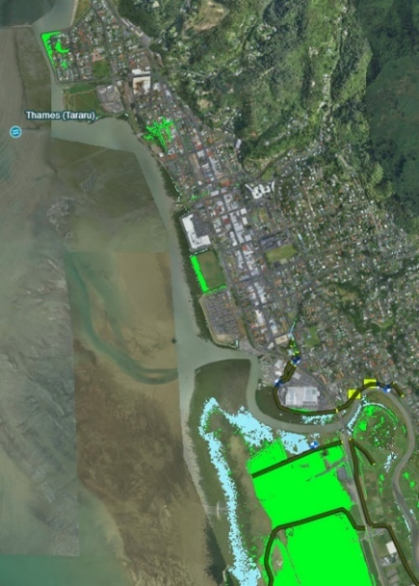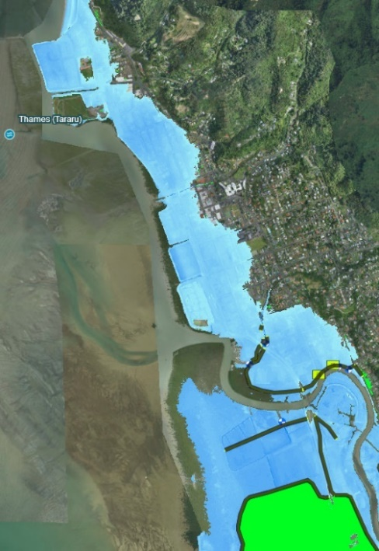
Left: mean high water spring tide elevation at present-day mean sea level (1.8 metre MVD-53). Right: upper storm tide elevation plus 0.5 metre sea-level rise (3.6 metre MVD-53). Blue shading = areas of direct inundation; green shading = areas lower than the relevant sea level but not directly connected to the sea. Dark brown lines = stop banks.
Source: Waikato Regional Council: https://coastalinundation.waikatoregion.govt.nz/

Coastal calculator (NIWA)
The National Institute of Water and Atmospheric Research’s (NIWA’s) coastal calculator was developed to provide coastal hazard source elevations, along with their likelihood of occurrence, for coastal hazard and risk assessments (Allis et al, 2015). The information is suitable for either storm inundation or erosion assessments.
The calculator is a user-friendly way to present complex information, and it can serve as a database, a computer and an interactive presentation tool. Rather than presenting hazard information in written form, it allows the user to explore the sensitivity of hazards to location, SLR and beach state (figure A.2).
The calculator includes extreme sea level and wave analyses from monitoring data; storm tide and wave hindcast models verified against data; joint probability analyses of storm tides and waves; analysis of beach profiles; empirical wave setup; and runup models verified against historical observations. It provides coastal hazard information in a way that meets the recommended requirements for risk-based coastal adaptation:
output clearly related to local vertical datum
high level of modelling detail in a probabilistic framework, including multi-year wave and storm tide hindcasts, statistically robust extreme value modelling and joint probability modelling of both storm tides and waves
models are underpinned by monitoring data
clear presentation of the expected frequency and magnitude of hazard sources, and of the statistical uncertainties of the frequency and magnitude
reporting in several likelihood terms: annual exceedance probability (AEP), average recurrence interval and expected number of exceedances
likelihood clearly related to (user-selected) planning timeframe
flexible treatment of SLR, which can include a range of scenarios or increments of SLR.
A coastal calculator has been built for the Bay of Plenty, Gisborne, Nelson, Tasman and Canterbury regions to provide information for coastal hazard assessment (Goodhue et al, 2015; Robinson et al, 2014; Robinson and Stephens, 2015; Stephens, 2015; Stephens et al, 2014).
Figure A.2: Combined (joint probability) storm tide and wave setup and runup elevations
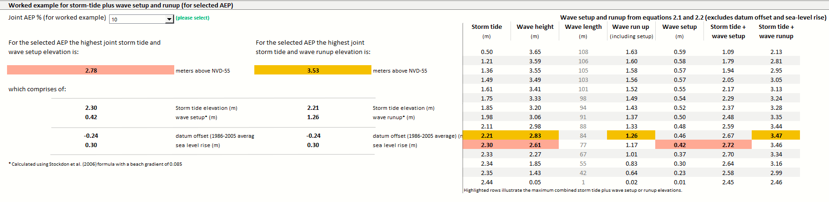
A worked example for a single user-specified annual exceedance probability (AEP) (10 per cent AEP in this case), and maximum combined storm tide plus wave setup elevation (red shading) and wave runup (orange shading) for a range of AEPs.

Coastal inundation by storm tides and waves (Auckland Council)
Auckland Council commissioned mapping of coastal storm inundation areas and depths for the entire Auckland region, to inform emergency management and natural hazard planning in the Auckland Unitary Plan (Carpenter et al, 2021; Stephens et al, 2016).
Figure A.3.1 shows the relationships between the study requirements, types of uncertainty, scenarios and modelling complexity. The mapping was not commissioned to explicitly consider all scenarios recommended in this guidance. The study, however, included and clearly differentiated statistical and scenario uncertainty, plus an allowance for the deep uncertainty surrounding SLR. It therefore had the ingredients needed for decision-making.
Figure A.3.1: Relationships among study requirement, type of uncertainty, scenarios and modelling complexity, arising from developing the Auckland coastal inundation layers
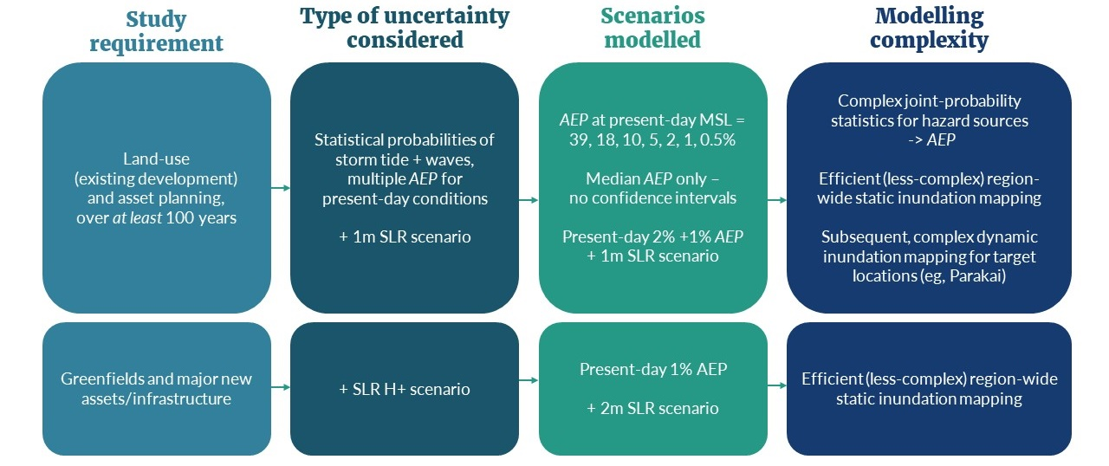
AEP = annual exceedance probability; MSL = mean sea level; SLR = sea-level rise.
The study used median AEP values to model the statistical probabilities of coastal storm inundation. The confidence intervals were not presented because the study considered relatively long timeframes (at least 100 years) with high (plus 1, plus 2 metre) SLR projections. Over this timeframe, the shared socio-economic pathway scenario uncertainty of the SLR projections would dominate the statistical (AEP) uncertainty, meaning that the extra effort of mapping confidence intervals would provide limited additional benefit for decision-making.
The supporting maps are a useful tool for the council to understand and communicate the potential hazard from coastal storm inundation and SLR through their online geographic information system viewer. As a planning tool, the 1 per cent AEP plus 1 metre SLR for coastal storm inundation was selected as a management control overlay, with activities and works subject to policies and rules in chapter E36 (Natural hazards and flooding) of the Auckland Unitary Plan.
Figure A.3.2 shows an example of the coastal storm inundation mapping at Mission Bay. Coastal storm inundation elevations from storm tides and waves were calculated using a probabilistic framework (at present-day mean sea level (MSL)). SLR increments of plus 1 metre and plus 2 metres were added to the 1 per cent AEP elevations at present-day MSL, and inundation was mapped.
This example shows that developed, low-lying areas like Mission Bay are likely to reach decision points before an SLR of 1 metre is reached (the modelled scenario). In this way, the mapping has also acted as a hazard screening tool. For areas susceptible to present-day coastal storm inundation like Mission Bay, further modelling of other SLR increments (small increments) and statistical uncertainties could be used to further determine vulnerability and risk and to support planning strategies and future adaptation decisions.
The maps from this study efficiently defined coastal storm inundation areas at a regional scale, as required for regional policy development. They also identified areas where further work could improve the hazard assessment, such as more detailed assessment of the extreme sea levels or consideration of overland flow paths. Parakai in West Auckland was identified as one such area. The coastal storm inundation maps were revised using local water-level measurements and a dynamic inundation model (Carpenter et al, 2021; Stephens et al, 2016), which is also discussed in the next case study.
Figure A.3.2: Coastal storm inundation mapping and planning overlay at Mission Bay, Auckland
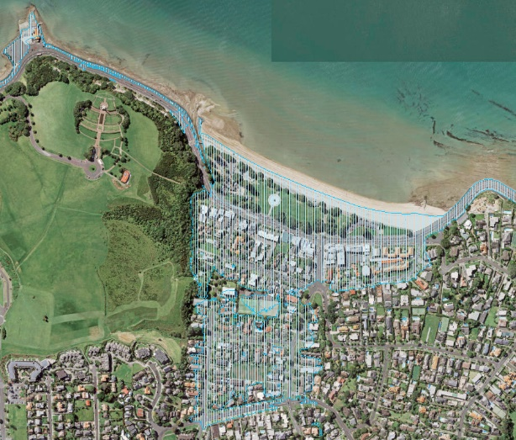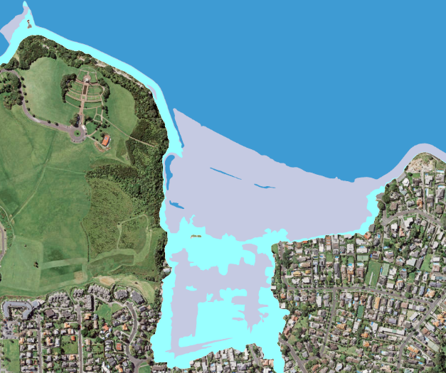
Left: aerial photograph of Mission Bay with the coastal storm inundation management control layer (vertical hatching) from the Auckland Unitary Plan. Right: with present-day 1 per cent annual exceedance probability storm tide, plus wave setup elevation (purple shading), plus 1 metre SLR (light-blue shading) and 2 metre SLR (white shading).
Source: Auckland Council GeoMaps viewer

Static versus dynamic coastal inundation mapping (Parakai, West Auckland; Tauranga City; South Wellington Coast)
Static ‘bathtub’ coastal inundation overlays (often done as a GIS analysis) are usually sufficient to provide a reliable overview of the extent of coastal flooding for various SLR increments or scenarios. The static approach assumes the extreme storm sea level, including wave setup (eg, 1 per cent AEP water level at the shoreline), floods all the land with an elevation at or below that level, over the one to two hours straddling high tide when the event occurs.
However, for situations with a large flat coastal plain extending well inland, the static approach tends to overestimate flooding. In areas exposed to high wave runup and wave surging, the static approach tends to under-estimate flooding. In these situations, therefore, it is prudent to also run a hydrodynamic model with wave runup to check the veracity of the static inundation overlays. Tauranga City and the south coast of Wellington are two examples of places where a dynamic approach has been used.

Parakai, West Auckland
This case study compares static and dynamic inundation mapping results over a wide floodplain at Parakai, West Auckland (Stephens et al, 2016).
Coastal storm inundation areas in the Auckland region were mapped in 2013 (Stephens et al, 2013) using a static level or ‘bathtub’ inundation-mapping technique. In this method, all land lying below the coastal storm inundation elevation is assumed to be flooded in its entirety if there is a direct flow path to the sea or harbour waters. The static inundation maps are created in a GIS and do not fully capture the dynamic and time-variant processes that occur during a coastal storm hazard event (eg, through tidal fluctuations and flow paths).
The static method is efficient, which makes it useful for region-wide application (as per the 2013 Auckland study scope), and for risk screening, such as applied in Waikato Regional Council’s coastal inundation tool (Waikato Regional Council, n.d). The static method is conservative because it tends to over predict rather than under predict inundation by the high-water period of storm tides that may last for one to three hours. The over prediction applies more for wider coastal plains, whereas, for narrower coastal margins, the mapped inundation level will be much closer to the expected inundation extent.
Dynamic inundation modelling uses detailed numerical hydrodynamic models to simulate the incursion of the sea over the land surface. This is detailed, data-intensive, time-consuming and relatively costly work, which is easier to apply over small areas, where more certainty is required.
Parakai has a wide, low-lying coastal plain that is intersected by the Kaipara River above its confluence with the Kaipara Harbour. This was an area identified from the 2013 study where further sea-level data and dynamic inundation modelling could improve Auckland Council’s understanding of coastal storm inundation.
Figure A.4 shows the difference in the 1 per cent annual exceedance probability coastal storm inundation elevations mapped using the static and dynamic (Stephens et al, 2013, 2016) methods. Both methods gave similar elevations at the confluence of the Kaipara River and Kaipara Harbour. The calibrated hydrodynamic model predicted considerable frictional attenuation, however, causing the storm tide elevation to drop inland, while no attenuation is modelled using the static GIS-mapping technique. As a result, the difference in predicted inundation elevation between the two methods increases inland. The dynamic model predicted water levels that were up to 0.5 metres lower than the static method over most of the seaward flood plain, and up to about 2 metres lower further inland. The total area of coastal storm inundation was predicted to be 60 per cent less using the dynamic modelling.
The original static inundation model of the area assumed local stopbanks that were identifiable in the topographic data were fixed structures. In the refined dynamic inundation model, the coastal inundation areas were considered independent of the presence of these structures, given their dynamic nature and potential to change over time. This maintains a degree of conservatism in line with the precautionary principles adopted by the Auckland Unitary Plan.
The difference between the static and dynamic methods was much less for the SLR: for the plus 1 metre SLR increment, the total area of coastal storm inundation was predicted to be just 9 per cent less using the dynamic modelling, and both methods gave approximately the same results for the plus 2 metre SLR increment. Large SLR will inundate the floodplain and fill the basin in which the Parakai–Helensville region is located. Dynamic frictional effects that hold back the flood wave at present-day MSL (when the water is shallow) will be reduced after significant SLR (when the water is deep, assuming no change in the floodplain topography).
These results suggest the static mapping method is likely to be adequate for risk-screening exercises or coastal hazard assessments using high SLR increments (associated with longer planning timeframes). The dynamic mapping method is best used for site-specific hazard assessments where high accuracy is required at the property scale and where smaller SLR increments are being modelled.
Figure A.4: Comparison of static (left) and dynamic (right) maps of 1 per cent annual exceedance probability (AEP) coastal storm inundation at present-day mean sea level, Parakai, West Auckland
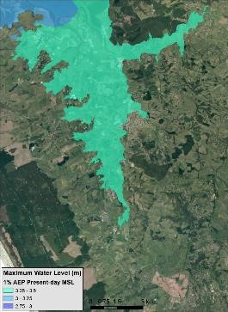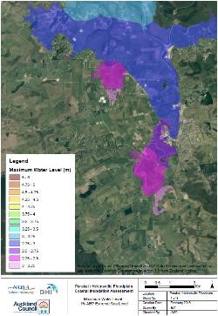
Source: Stephens et al (2016)

Tauranga City
To inform adaptation planning in Tauranga City, the effects of incremental RSLR were quantified on exposed land area and on the number and replacement value of buildings within Tauranga Harbour (as a combined hazard and risk assessment) (Stephens et al, 2021). The assessment compared three coastal hazards: ﬂooding, progressive permanent inundation (high tide) and coastal erosion. Increasingly frequent coastal ﬂooding will be the dominant trigger for adaptation in Tauranga.
The hazard assessment in Tauranga compared the performance of simple static-planar versus complex dynamic models for assessing coastal ﬂooding exposure. Differences between the dynamic and static models were largest below 0.8-metre RSLR. The static approach generally underpredicted the ﬂooding risk exposure relative to the dynamic model. Relevant to setting an adaptation threshold, the static-planar model estimated that 0.2 metres more RSLR would be required to reach 1,500 buildings impacted by 1 per cent AEP storm tides, compared with the dynamic model. This is compelling evidence to use dynamic models to support adaptation planning in Tauranga.

Wellington South Coast
To support the review and update of the District Plan for Wellington City, NIWA assessed the coastal erosion and inundation hazards for three climate scenarios and SLR projections from the 2017 guidance (MfE, 2017) (present day, RCP 8.5 (median) and RCP 8.5 H+), including the effect of subsidence on RSLR in the two future scenarios (Allis et al, 2021).
For inner harbour shorelines, the static approach was used. The secondary effects of climate change were accounted for by increasing the storm surge elevation, wind speeds and offshore waves according to the 2017 guidance (MfE, 2017). These were included as a single ‘storm’ scenario (derived from multi-variate modelling). This included storm-tide + wave-setup elevations (1 per cent AEP only) at about 25 output points around Wellington Harbour, added to the RSLR projections.
On the Wellington South Coast and Mākara Beach, wave runup and setup were modelled using a ‘dynamic’ model, XBeach GPU. This model quantifies the complex interactions of waves, currents and water levels with the intricate bathymetric and topographic features in the surf zone (eg, rocky reefs). The output is a time history of MSL (averaged over multiple wave periods), which is increased by wave setup and ‘surf beat’ in addition to extreme storm tides. The model was validated against inundation from recent storms.
The benefit of using this dynamic approach is the ability to then combine the maximum inland reach of the runup for individual storms into an inundation envelope across all storms. This represents the maximum extent of inundation across all modelled scenarios at the 1 per cent AEP level. It provides a more realistic inland extent of wave surging than from a static approach.

Probabilistic coastal erosion hazard assessment (Northland)
This project assessed and mapped coastal erosion hazards in detail for selected high-priority sites in Northland. The methodology (Shand et al, 2014) combined standard and well-tested approaches for defining coastal erosion hazard zones. It added component parameters, with new techniques for defining and combining parameter ranges, to allow for natural variation and uncertainty in individual parameters (Cowell et al, 2006).
The resulting distribution provided a probabilistic forecast of potential hazard zone width for differing likelihoods, in accordance with Policy 24 of the New Zealand Coastal Policy Statement 2010 (NZCPS) (DOC, 2010) and supported by best practice guidelines (eg, Ramsay et al, 2012).
Models were derived for different coastal types, including unconsolidated beaches, hard and soft cliffs, and estuarine shorelines, with component values determined using statistical, empirical and numerical methods. Component ranges tended to be narrower where processes were better understood or natural variation was small (eg, storm cut). The ranges were wider where processes were less understood (eg, coastal response to SLR) or natural variation was high (eg, long-term fluctuations around river mouths).
Multiple planning timeframes were applied to provide information on current hazards at timescales for planning and accommodating future development. The potential hazard zone was defined based on the probabilistic forecast (figure A.5), with coastal erosion hazard zone (CEHZ) values. A 66 per cent probability of being exceeded (P_{66%}) and a 5 per cent probability of being exceeded (P_{5%}) were adopted as prudent likely and potential CEHZ values, respectively, and mapped from the current shoreline (figure A.5; Shand et al, 2014).
Due to the uncertainly of some components (eg, beach response to SLR), the output is a quasi-quantitative exceedance probability. Still, it provides valuable insight into the range and likelihood of potential hazard extent, which improves our understanding of hazard and risk. While certain likelihoods (P_{66%} and P_{5%}) were selected for mapping, the method allows any other hazard likelihood to be defined and mapped.
This assessment provided the CEHZ likelihood for a particular future climate scenario (RCP8.5), using the scenario confidence bounds to define the SLR parameter range, rather than assessing the CEHZ for a range of potential scenarios as advocated in the Interim guidance on the use of new sea-level rise projections (MfE, 2022).
The updated guidance here suggests modifying the method in future to more clearly separate the statistical and climate scenario uncertainty. The robust statistical framework would still apply for all components other than SLR, and the modelling would use several distinct climate scenarios and SLR projections. Alternatively, the present method could reasonably be applied for relatively short planning timeframes, where there is reasonable agreement between the SLR trajectories for the various concentration pathways.
Figure A.5: Example of shoreline-change components as histograms (left), used to develop the width of a coastal erosion hazard zone (CEHZ) based on P_{66%} and P_{5%} lines overlaid on an aerial image (right)
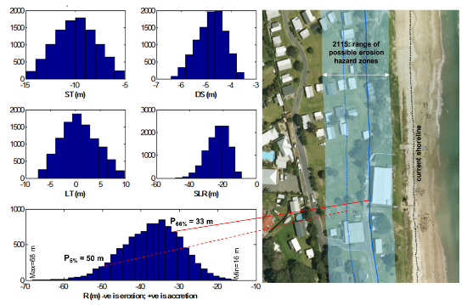
CEHZ components (m): ST = short-term and LT = long-term shoreline change; DS = dune-stability factor;
SLR = sea-level rise contribution to shoreline change; R = combined shoreline change used to set a CEHZ.
Source: Shand et al (2014)

Current good practice: Mapua and Ruby Bay (Plan Change 22, Tasman District Council)
Detailed planning for the small coastal communities of Mapua and Ruby Bay began in the late 1990s. It was undertaken in an environment of considerable pressure for coastal development across the whole of the Tasman coastal area, from Richmond to Motueka, including in the settlements themselves. The approach to plan preparation was an integrated one, identifying and addressing the multiple challenges faced by the two communities, which ranged from natural hazards issues to management of a major contaminated site, and appropriate provision for residential and business land and associated servicing.
The plan evolved over more than a decade, involving an initial stage of information collection and analysis and a structure planning process. Important elements were the intention to provide for future expansion “away from low-lying land and the inundation and erosion-prone coastline between Mapua and Ruby Bay”. It involved revising the pre-existing coastal hazard area to take into account coastal erosion, coastal and freshwater inundation, climate change and sea-level rise, and activities that could increase risk. Further subdivision on the coastal plain and sand spit areas was to be prevented, and erection of new buildings in identified hazard areas was also to be avoided. This is to avoid the long-term adverse effects of coastal erosion and inundation.
With a clearly expressed policy framework, elements of the plan included the identification of a Residential Closed Zone (further subdivision prohibited, no land filling, no new habitable buildings and no extension or replacement of existing habitable buildings closer to the shore) based on the then-current national guidance for sea-level rise and climate change effects. Coastal protection structures became restricted discretionary activities, with effects on the natural environment, adjoining properties and coastal processes being considered.
The plan went through several stages of engagement and a draft statutory plan process, allowing for detailed comments on policy and regulatory components. The formal processes of Plan Change 22 proceeded with wide public interest and debate, submissions, and a council hearing and decisions. The council had successfully sought a declaration from the Environment Court that the subdivision rules should have immediate effect, which the court granted on the basis of the circumstances (see appendix B). Part of the area was subject to appeal to the Environment Court in 2014, which was dismissed in favour of Tasman District Council. At the time of the hearing, it was uncertain whether the major rock revetment at Ruby Bay (figure A.6, photo right panel) would be retained in the long term.
This is an example of planning that is current good practice for coastal hazards and that has retained options for future decision-making. In the meantime, the robustness of the provisions has been subject to testing through the Environment Court. The council is monitoring the wider plan as well as the continuing coastal processes.
Figure A.6: Photographs at the Mapua foreshore (left) and Ruby Bay rock revetment after a wave overtopping event
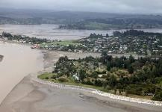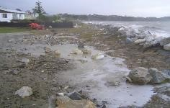
Source: E Verstappen, Tasman District Council

Proposed Marlborough Environment plan
Compiled according to the Proposed Marlborough Environmental Plan, Volume 1, Appeal version, Policy – Chapter 19 – Climate Change and Lawrence et al (2021a).
Marlborough District Council has reviewed the Marlborough Regional Policy Statement, the Marlborough Sounds Resource Management Plan and the Wairau/Awatere Resource Management Plan to create a single resource management document for the district. The Proposed Marlborough Environment Plan includes the regional policy statement, as well as regional and district plan provisions and has a prominent chapter on climate change: ‘Climate change could affect natural hazards and create a coastal inundation hazard associated with sea-level rise’. Note that all of V1, Chapter 19 (Climate Change); V1, most of Chapter 13 (Use of the Coastal Environment); and all of V2, Chapter 16 Coastal Marine Zone rules are treated as operative in accordance with S86F of the RMA.
The plan contains the following.
Issue statement – this acknowledges the range of sea-level rises within the 2017 guidance (MfE, 2017) and localised influences on sea-level rise, including natural coastal protection and land subsidence. It notes the potential for increased frequency of extreme weather events and the effects of this on settlements and regionally important infrastructure.
Objective – the single objective is: Avoid and mitigate the adverse effects of natural hazards influenced by climate change. It is a regional policy statement, regional, coastal and district objective.
Policies – two policies (regional, coastal and district) are in place relating to coastal inundation. Policy 19.2.2 sets out interim SLR allowances to be used (until the second policy has been applied in any area) for different planning situations, as follows:
a) Coastal subdivision, greenfield developments, and major new infrastructure – use a minimum 1.52 m sea-level rise: and
b) Changes in land use and redevelopment (involving intensification or use of land beyond the existing footprint of built development or structures) – use a minimum 1.52 m sea-level rise; and
c) Existing coastal development and assets within their existing footprint – use a minimum 1.0 m sea-level rise; and
d) Non-habitable short-lived assets with a functional need to be at the coast, and which either have low consequences or are readily adaptable (including services) - use a minimum 0.65m sea-level rise.
A single figure is used to give certainty for resource users, rather than the range recommended in the 2017 guidance (MfE, 2017). They are, however, based on a precautionary approach out to ‘at least 100-years’ that accounts for the ongoing progressive SLR changes, thus giving effect to the NZCPS. In particular, the explanation notes that the plan has a life of only 10 years but subdivisions and new property titles that may be approved within the plan’s lifetime have an indefinite life, and buildings and infrastructure have a minimum design life of 50 years. The policy is to be applied to resource consent applications, plan changes and designations. No specific rules are associated with this policy. However, the plan has a setback rule, and applications within this setback area will trigger this policy.
Policy 19.2.3 adopts a process for future more detailed planning in specific circumstances, which is fully aligned with the 2017 guidance, as follows:
Using a collaborative community engagement model, identify and prioritise areas, assets, and infrastructure (e.g. roads) where the coastal environment is under threat of inundation from rising sea levels and associated storm surges. Using that process develop an implementation plan to avoid or mitigate the adverse effects of such outcomes on the community.
The council will undertake a dynamic adaptive pathways planning process with the communities potentially affected by SLR, in accordance with the 2017 guidance (MfE, 2017).
Methods – the methods involve council-led research, and planning processes include an action plan to be developed with affected communities using the 10-step decision cycle to determine long-term strategic plans and decision-making for coastal areas. District rules that apply a horizontal setback are to be used to reduce the potential for structures and infrastructure to be inundated until research and community engagement is completed. It is anticipated these steps may prompt the need for additional rules for ensuring the objective and first policy continue to be met.

Anticipated environmental result
Buildings and infrastructure established after the notification of the Proposed Marlborough Environment Plan are not inundated by the sea.
Monitoring of effectiveness is based on reports of inundation and/or damage to buildings and infrastructure.
The main settlement areas are within the coastal settlement zone, and here buildings are not permitted within 28 metres of the mean high water spring tide. In the other zones, limited opportunity is available for subdivision and new development, but a coastal setback of only 8 metres is typically required. Filling of land is not permitted within 20 metres of the coast in any of the zones, ensuring new buildings closer to the coast can accommodate the ongoing progressive SLR, for example, built on piles or poles or potentially relocatable.
All land-use rules are district rules, whereas rules on filling are district and regional (the regional rules mean any consent granted has a limited life, with a maximum of 35 years). The default status for all activities that do not meet permitted standards is discretionary, enabling relevant policy considerations to be brought into play.
While these provisions do not take into account topographic variability, or exposure of parts of the coast to adverse sea conditions, the regional policy statement provisions set in place an undertaking to progress the detailed DAPP planning needed to adequately address risk.

Assess areas potentially affected by coastal erosion (Gisborne District)
The Gisborne District coastline extends from Takararoa in the south to Omaruparoa in the north. It comprises 138 kilometres of sandy and gravel beaches and 202 kilometres of cliffed coastline. This study first used region-wide screening to identify parts of the coast that could potentially be affected by coastal erosion hazards and to show these on maps at a broad scale. This information can now be used by the council to identify areas along the coast where natural, built and/or cultural features exist that are of value and at high risk of being adversely affected by coastal erosion. Those areas of high risk can be prioritised for more detailed assessment of the effects that could occur.
The assessment addressed the matters identified in Policy 24 of the NZCPS for assessing hazard risk (DOC, 2010). The geomorphological character of the coastline was assessed using an aerial survey by fixed wing aircraft, and the coastline was categorised into unconsolidated beach and cliff coastal types, with conceptual models developed for each to describe the erosion processes. An area susceptible to, or potentially affected by, coastal erosion was assessed using similar methods to Gibb (1998) and Reinen-Hamill et al (2006). For unconsolidated beaches (figure A.8.1), this included terms for:
short-term changes in horizontal shoreline position related to storm erosion due to a singular storm event or cluster of storm events
a dune stability allowance to allow for the collapse of over-steepened dune scarp following erosion
a long-term rate of horizontal coastline movement
horizontal coastline retreat due to the effects of increased mean sea level.
For consolidated cliffs (figure A.8.2), this included terms for the characteristic stable angle of repose, the historic long-term rate of cliff toe retreat and potential increase in future long-term retreat due to SLR effects. Component values were derived from existing and new data, and hazards assessed over a 100-year timeframe. Offsets from a current shoreline were mapped continually around the coastline.
The building block approach of combining components typically produces a maximum hazard extent. This was considered suitable for identifying areas potentially affected by coastal hazard on a regional scale. The study used the continuing high emissions SLR scenario (RCP8.5 median) allowing for local tectonic movements. This was considered appropriate for defining the potential areas affected by erosion hazard based on available national guidance (MfE, 2008) but did not assess hazard for multiple scenarios or an upper-bound scenario as proposed in this guidance update.
Figure A.8.1: Definition sketch for open coast coastal erosion hazard setback
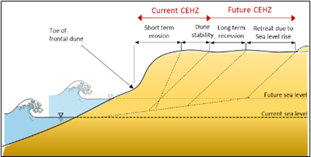
Note: CEHZ = coastal erosion hazard zone.
Source: Shand et al (2014)
Figure A.8.2: Definition sketch for cliff coastal erosion hazard setback
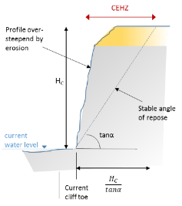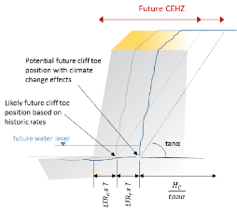
Note: CEHZ = coastal erosion hazard zone.
Source: Shand et al (2014)

Applying the dynamic adaptive pathways planning approach to Tangoio Marae
Compiled by Paula Blackett, National Institute of Water and Atmospheric Research, and Tania Hopmans and Kelly May, Maungaharuru-Tangitu Trust
As a direct result of disputed purchases and raupatu, the hapū of Tangoio Marae (Marangatūhetaua/Ngati Tū, Ngāti Whakaari, Ngāi Tauira, Ngāti Kurumōkihi, Ngāi Te Ruruku, and Ngāi Tahu (the Hapū) were reduced to 1.6 hectare of whenua, adjacent to Te Ngarue Stream, to use for the benefit of the hapū and situate the marae.
Maungaharuru-Tangitū Trust (MTT) is a Treaty of Waitangi Post Settlement Governance Entity and its objectives include being the voice and representative body for the hapū. Their Treaty settlement has expanded their land ownership, however, none of the land was suitable for a marae, so the marae remains on a flood plain. Importantly, Te Ngarue Stream has a history of flood events that could potentially be exacerbated by a changing climate. As a result, the hapū face difficult adaptation choices regarding the future of their marae.
One of the early stages in the decision-making process (see Te Huringa ki Te Rangi – He Rautaki Tāwariwari) was to articulate a shared vison for the future and to understand the diversity of aspirations and outcomes desired by the hapū. This was done by reviewing existing documentation and strategic plans to confirm their continued relevance; interactive group discussions (hui) at the marae; and two online surveys.
This provided information and knowledge on three key subject areas:
aspirations – dreams or hopes for the marae
activities – behaviours and things the people wanted to do at the marae to achieve their aspirations
the types of built-form – spaces, structures, physical things and design features that support activities and aspirations.
A hui with whānau was organised and hosted by MTT and for those unable to attend in person, a follow-up online survey was constructed and made available, which contained questions to enable participation. All of the information gathered through hui and online survey was combined to establish the top priorities and aspirations for the Tangoio Marae community (see Blackett et al, 2022).

Thread 1 – Understanding the past
A detailed understanding of the physical extent of historical flooding and the experiences of hapū and local residents were collected via interviews and surveys collated into a timeline and short video. Council documents and local media reports provided the basis of the timeline, while interviews with kaumātua and others with a long history of association with the valley provided knowledge (mātauranga ā-Hapū), stories and experience of historical events. The interviews delved into what floods the interviewees had experienced, what happened, what it was like to be in a flood, how it affected them and their surroundings, what the damage was and how the clean-up proceeded. In addition, physical information on water depth (eg, relative to door frames) and the extent and duration of flood waters was obtained to help calibrate the hydrological-hydrodynamic models. All this information created a picture of what flooding was like for those who had never experienced one to enable the potential impacts and implications to be visualised.

Thread 2 – Modelling the past and the present
The present hazard and risk were constructed through hydrological-hydrodynamic modelling of Cyclone Bola in 1988, a well-remembered, historical, extreme weather event. The peak water depths were calibrated using photographs in the Tangoio Valley during and after Cyclone Bola and compared with oral observations collected during a hikoi (walk) with whānau present at the marae either during Cyclone Bola or soon after the flood waters receded.

Thread 3 – Modelling possible futures
The calibrated model developed in thread 2 was used to produce a range of possible futures from which to start a conversation around the potential impacts of climate change on Tangoio Marae and surrounding areas (see table A.1). Not all possible future projections were explored, the purpose was to provide a variety of alternatives.
Table A.1: Climate change scenarios used to investigate potential peak flood water levels in the valley and around Tangoio Marae
Scenario | Year | Climate change scenario | Assumed sea-level rise (metres) | Peak discharge (at marae) (cubic metre per second) | Elevation model | Assumptions
Bola | Present | None | None | 146 | No stopbankª | Bridge blocked^{b}
Bola + Climate Change Scenario 1 | 2040 | RCP 6.0 | 0.2 | 154 | With existing stopbank | Bridge blocked
Bola + Climate Change Scenario 2 | 2090 | RCP 6.0 | 0.5 | 164 | With existing stopbank | Bridge blocked
Bola + Climate Change Scenario 3 | 2120 | RCP 8.5 | 1.36 | 160 | With existing stopbank | Bridge blocked
ª The Bola modelling simulation assumed that the existing stopbank constructed around the marae site was not in place. Future modelling scenarios retain the existing stopbank around the marae site.
^{b} The modelling assumes the main Te Ngarue Stream channel is blocked at the Tangoio Settlement Road bridge crossing. Stream channel blockage was observed at the crossing during the Cyclone Bola event and following smaller flood events as a result of forestry slash, logs and debris conveyed by runoff, erosion and flood waters from the catchment.
Source: Blackett et al (2022)

Thread 4 – Communicating with whānau
A hui was organised by MTT to present the timeline, short video and model information back to the hapū. Participants were asked for their thoughts and concerns for the future. Importantly, this hui was finished with a brainstorming session on possible adaptation options and future aspirations for the marae so as not to leave participants with feelings of helplessness.
The adaptation discussion for the hapū of Tangoio Marae had two parts, first exploring the full range of adaptation options and understanding the limits of each option and, second, creating dynamic adaptative pathways plan (DAPP).
Adaptation options and aspirations (eg, new kitchen or building upgrades) for Tangoio Marae were generated by the hapū during a short hikoi (walk) around the marae complex with kaumātua and the hui described in step 4 (assessing vulnerability and risk). The original hapū list was extended by expert opinion, and no options were removed so that participants could recognise their contribution. Further, other factors of relevance to the decision-making process were explored with members of MTT, for example, access to financial resources, costs of insurance, returns on other investment options, land cost and building costs. Each option and aspiration were costed approximately, and the point at which options would fail to protect against flood events was estimated.

Creating a DAPP
The information collected throughout the project was used to design a serious game (Marae-opoly) that mimicked the adaptation challenge in order to provide an experience of flood adaptation decision-making for the marae over a 100-year timeframe. For more detail on the game, see Blackett et al (2022). The facilitated game was played in a hui with six self-selected groups each making different choices on the preferred adaptation strategy. An amalgamation of the different group strategies provided the foundations for a DAPP to be developed. The pathway identified the preferred options within the constraints faced by the hapū. More detailed investigations of the preferred options – improved stopbanks and moving the marae – were then explored.
MTT was responsible for the detailed exploration of pathways and implementation of the DAPP. The ‘Marae Options Committee’ comprised 16 hapū members representing kaumātua, Tangoio Marae trustees, Maungaharuru-Tangitū trustees, kōhanga reo and representatives of the whānau and rangatahi. The Committee explored two options: relocate Tangoio Marae or protect and develop at the current location. When considering offsite options, the Committee evaluated sites that were:
within 40 minutes’ drive from Napier (and within the hapū Takiwā)
at least 0.8 hectares of land
not exposed to risks of flooding, coastal inundation and liquefaction (unless the liquefaction risk could be mitigated) and did not have more than a low risk of tsunami.
An initial 74 properties that were identified as possibilities were narrowed down to just three (for various reasons including access and high level of earthworks). However, the owners of these three properties, which were deemed suitable, were approached but not interested in selling. Various onsite options were also explored and, in December 2018, the Committee reported to the hapū that there was only one feasible option: to rebuild the existing, western stopbank.
A new ‘Marae Development Committee’ was established in 2019 to implement the development of the marae and undertake detailed stopbank design and flood modelling. While modelling was under way (this identified floodwaters from three sources: Te Ngarue Stream, runoff from the hills and overland from the upper valley), MTT learnt of the upcoming sale of the farm neighbouring the marae, and one of the purchased blocks was a metre higher than the existing marae. The modelling showed that, if a platform was raised on the block, it could provide adequate protection for marae development with minimal impacts on neighbours. Overall, it had more advantages than the stopbank options.
In 2021, the Marae Development Committee recommended the block ‘raised platform’ option to the hapū and after two hui ā-Hapū, the hapū decided to relocate the marae 300 metres from the current site. A development plan had been agreed by the hapū, and resource consent applications lodged with the appropriate councils in the months just prior to Cyclone Gabrielle. In mid-February 2023, Cyclone Gabrielle struck at a scale well in excess of Cyclone Bola causing significant damage, disruption and grief to the hapū. Floodwater, silt and forestry debris caused considerable damage leaving 0.5 metres of silt through the whare tīpuna, Punanga Te Wao and significant damage to all of the other buildings.
After the cyclone, questions have been asked regarding the wisdom of redeveloping the marae at the new site that, though elevated, remains on a flood plain. At the time this document was finalised, the investigations were under way.
As of December 2023, the Tangoio floodplain has been categorised as Category 3, being land where “future severe weather event risk cannot be sufficiently mitigated … [and] there is the intolerable risk of injury or death”. Voluntary buy-out of properties in Category 3 areas is being offered, and discussions are underway regarding future use of the Tangoio Marae. In addition, the hapū have created a twelve-month recovery plan to lay the foundation for a strong recovery, including identifying alternative, safe, resilient land as an option for the marae and a papakāinga (village) for the hapū (Maungaharuru-Tangitū Trust’s Locality Plan, 2023).

Reference documents
Maungaharuru-Tangitū Trust’s Locality Plan, 2023: https://tangoio.maori.nz/wp-content/uploads/2023/05/MTT_Locality_Plan_version-1.2_compressed.pdf
Public Notice: Invitation to whenua Māori landowners and Trustees in Tangoio and surrounding areas: https://tangoio.maori.nz/recovery/
Land Categorisation Hawke’s Bay: https://www.hastingsdc.govt.nz/land-categorisation-hb/#initiallandcategorisations
Kia Tipu te Mauri Ora video: https://www.youtube.com/watch?v=rlIOSOuIdMo

Appendix B: Relevant court cases
Table B.1 summarises some relevant court cases relating to coastal hazards, application of the New Zealand Coastal Policy Statement 2010 (DOC, 2010) and the effects of climate change on coastal hazards. The summary has been updated from cases covered in an earlier version of the coastal guidance (MfE, 2008, appendix 2).
More detailed summaries of the main decisions and outcomes from these cases are at: https://niwa.co.nz/natural-hazards/hazards/planning-for-coastal-adaptation.
Table B.1: Summary of relevant court cases in relation to coastal hazards, application of New Zealand Coastal Policy Statement 2010, and climate change effects
Case name | Citation | Year | Court | Key words | Issues under consideration
Judges Bay Residents Association v Auckland Regional Council and Auckland City Council | ENC Auckland A072/98, 24 June 1998 | 1998 | Environment Court | Resource consent, natural hazards, sea-level rise | Hazard protection measures and port development
Auckland City Council & Tranz Rail Ltd v Auckland Regional Council | ENC Auckland A028/99, 15 March 1999 | 1999 | Environment Court | Resource consent, groundwater, earthworks | Relevance of effects on the environment for seeking resource consents for excavation earthworks
Kotuku Parks Ltd v Kāpiti Coast District Council | ENC Auckland A73/2000, 13 June 2000 | 2000 | Environment Court | Subdivision, earthworks | Resource Management Act 1991 (RMA) section 106 (restriction on subdivision consents) and cumulative effects of damage to indigenous fauna
Lowry Bay Residents Association v Hutt City Council | ENC Wellington W45/2001, 31 May 2001 | 2001 | Environment Court | Resource consent, land use consent, natural hazards | Adverse cumulative effects (including natural hazards) on grant of land use consent and coastal discharge permits
Save the Bay v Canterbury Regional Council | ENC Christchurch C6/2001, 19 January 2001 | 2001 | Environment Court | Regional plan, coastal plan, coastal hazards, natural hazards | Hazard zone provisions within regional coastal environmental plan
McKinlay v Timaru District Council | ENC Christchurch C24/2001, 28 February 2001 | 2001 | Environment Court | Natural hazards, existing use rights | Existing use rights regarding reconstruction of a building destroyed by a natural hazard and the role of rules in regional and district plans
Bay of Plenty Regional Council v Western Bay of Plenty District Council | Interim decision ENC Auckland A27/02, 8 February 2002; Final decision ENC Auckland A141/2002, 5 July 2002 | 2002 | Environment Court | Coastal protection area, sustainable management | Variation to proposed district plan concerning natural hazards
Skinner v Tauranga District Council | Interim decision ENC Auckland A163/2002, 19 August 2002; Final decision ENC Auckland A138/2004, 8 November 2004 | 2002 | Environment Court | District plan, coastal hazards policy, hazard risk zones | Amendments to coastal hazards provisions of proposed district plan
Fore World Developments Ltd v Napier City Council | ENC Wellington W29/06, 13 April 2006 | 2006 | Environment Court | Subdivision, coastal erosion | Climate change information on coastal erosion and use of the precautionary approach to account for uncertainties
Re Tasman District Council | [2011] NZEnvC 47 | 2011 | Environment Court | Plan change, coastal erosion, coastal inundation, subdivision | Immediate legal effect of rule in hazard areas
Weir v Kāpiti Coast District Council | Interim decision [2013] NZHC 3522; Final decision [2015] NZHC 43 | 2013 | High Court | Natural hazards, coastal hazards, land information memorandum (LIM) | Inclusion of information on potential erosion of land in LIMs
Carter Holt Harvey HBU Ltd v Tasman District Council | [2013] NZEnvC 25 | 2013 | Environment Court | Resource consent, subdivision, coastal erosion, inundation | RMA section 106 and Policy 24 of New Zealand Coastal Policy Statement (NZCPS), hazard risk to buildings and access from coastal erosion and inundation, meaning of ‘avoidance’ of risk in relation to new development
Mahanga E Tu Inc v Hawkes Bay Regional Council | Environment Court decision [2014] NZEnvC 83; Decision on conditions [2014] NZEnvC 248 | 2014 | Environment Court | Subdivision, land use consent, coastal hazard zones | Conditions for land use and subdivision consents and discharge permits, accepting risk of natural hazards
Gallagher v Tasman District Council | [2014] NZEnvC 245 | 2014 | Environment Court | Subdivision, resource consent, coastal erosion, inundation, district plan | Amendments to district plan to manage hazard risk, coastal hazard identification and management, present and future risk exposure, and application of NZCPS policies
Environmental Defence Society Inc v The New Zealand King Salmon Company Ltd | Supreme Court decision [2014] NZSC 38; High Court decision [2013] NZHC 1992 | 2014 | Supreme Court | Plan change, resource consent, outstanding coastal landscape, natural character areas | Interpretation of NZCPS policies, and importance of strategic planning in giving effect to NZCPS
Coastal Ratepayers United Inc v Kāpiti Coast District Council | High Court decision [2017] NZHC 2933; Environment Court decision [2017] NZEnvC 100 | 2017 | High Court | District plan, coastal hazards, declaration, council procedures | Provisions in proposed district plan relating to coastal hazard management
Man O’War Farm Ltd v Auckland Council | [2017] NZHC 1349 | 2017 | High Court | District plan, coastal hazards, erosion, definition | Legality of definition of land that may be subject to coastal hazards in district plan; amendments to district plan to rectify uncertain definition
Auckland Council v Auckland Council | [2020] NZEnvC 70 | 2020 | Environment Court | Resource consent, coastal marine area, NZCPS | Application of section 104 of the RMA and NZCPS, consent for works on part of an esplanade reserve affected by erosion
Smith v Christchurch City Council | [2022] NZEnvC 86 | 2022 | Environment Court | District plan, resource consent, flood, natural hazards, consent order | Risk of natural hazards (flooding) to people and property
Federated Farmers of New Zealand v Waikato District Council | [2023] NZEnvC 220 | 2023 | Environment Court | Consent order, district plan, natural hazards | Natural hazards and climate change provisions in proposed district plan
Young v Attorney-General | Supreme Court decision [2023] NZSC 142; Court of Appeal decision [2022] NZCA 391; High Court decision [2021] NZHC 463 | 2023 | Supreme Court | Natural hazards, earthquake, subdivision, district plan, remediation, Crown duty to remediate, nuisance | Effect of natural hazards on property and change in district plan, whether the Crown had a duty to remediate these effects

Appendix C: Dynamic adaptive pathways planning approach and addressing barriers to uptake

Developing an adaptive planning strategy
The dynamic adaptive pathways planning (DAPP) approach (Haasnoot et al, 2013) is an exploratory model-based planning tool that helps design strategies that are adaptive and robust over different scenarios of the future. It has been developed as an analytical and assessment approach for making decisions under conditions of uncertainty. Effective decisions must be made under conditions of unavoidable uncertainty (Dessai et al, 2009).
In the context of rising sea levels, where conflicting values prevail for coastal areas, the consequences of decisions can be profound and may be impossible to reverse. This will result in activities that are locked into the place and space, thereby reducing the ability of decision-makers to adapt to future conditions. Costly adjustments that have distributional consequences on different groups within society may result. Such outcomes are maladaptive.
Maladaptation is defined as actions intended to reduce the impacts of climate change but that create more risks and vulnerability. This can include increasing greenhouse gas emissions, disproportionately burdening the most vulnerable, creating high opportunity costs, reducing incentives to adapt, and creating path dependency and lock-in of current development patterns.
The DAPP approach therefore focuses on keeping multiple pathways open into the future, which helps alleviate irreversible decisions and reduces the risk of being wrong when making decisions in the present for long-lived assets and settlements that will be affected by climate change impacts over their lifetime. It does this by making transparent future actions and pathways that can be taken, should actions today prove insufficient to meet objectives. It does this by stress-testing different options and pathways using scenarios based on different emissions and societal conditions (see step 2 and step 6, and Climate change, sea-level rise and coastal hazards science: Coastal hazards and climate change guidance – Supplement A).
The DAPP approach can also be used to facilitate iterative participatory decision-making involving both decision-makers, iwi/Māori, communities and different stakeholders to identify the things they value and thus contribute to effective decision-making. The approach is being used by many councils, water agencies, for national park management decisions in the transport sector and for infrastructure planning (see also Community engagement principles and approaches, and practice methods: Coastal hazards and climate change guidance – Supplement B). Their utility for implementing climate-resilient pathways for water management in situations of uncertainty and for addressing compounding and cascading coastal hazards and risks resulting from ongoing SLR, is particularly helpful for decision-makers.
Within the DAPP approach, an adaptive planning strategy is conceptualised as short-term actions and longer term options in a number of pathways, by using scenarios to stress-test them against different conditions that could evolve over ‘at least 100 years’ (DOC, 2010). The essence of the approach is to anticipate risk proactively by planning for ongoing adaptation over time, in response to how the future actually unfolds. The DAPP approach starts from the premise that policies and decisions have a design life and will fail as the operating conditions change (Kwadijk et al, 2010).
Questions used in the dynamic adaptive pathways planning approach
The set of questions below is used to prompt consideration of the ongoing changing risk and different strategies that would meet short-term and long-term adaptation objectives under different climate change scenarios and their risk profiles.
- What are the first coastal impacts we will face as a result of climate change?
- Under what conditions will current strategies become ineffective in meeting objectives?
- When will alternative strategies be needed given that implementation has a lead time?
- What alternative options and decision pathways can be taken to achieve the same objectives?
- How robust are the options over a range of future climate scenarios?
- Are we able to change path easily and with minimum disruption?
- What are the transfer costs, including for vulnerable groups?
The short-term actions and long-term options, alternative pathways, early signals (warning) and triggers (decision points) before thresholds are met can be drawn using participatory processes with technical advisors, decision-makers, iwi/Māori and communities in the adaptation decision-making process. An example is shown in figure C.1. For details on the application of the approach, see step 6 and the case studies in appendix A, and Community engagement principles and approaches, and practice methods: Coastal hazards and climate change guidance – Supplement B.
Once actions fail, additional or other actions are needed to achieve objectives, and a series of pathways emerges. At predetermined trigger points, decisions are made as to the efficacy of the actions and whether other options or pathways would still enable the objectives to be achieved. Exploring different pathways and considering whether different options will lock in exposure to hazards or create new risks, enables adjustments to be made thereby reducing path dependency. An adaptive planning strategy can be designed that includes both short-term actions and long-term options, creating flexible pathways into the future.
The DAPP approach is monitored for signals that give warnings and triggers that indicate when the next step of a pathway should be implemented or whether reassessment of the adaptive planning strategy is needed. The signals and triggers can be physical processes, economic, social or culturally defined indicators that reflect the tolerability of the adverse consequences by the community affected by the sea-level rise or coastal hazard.
Figure C.1: Example of a pathways map
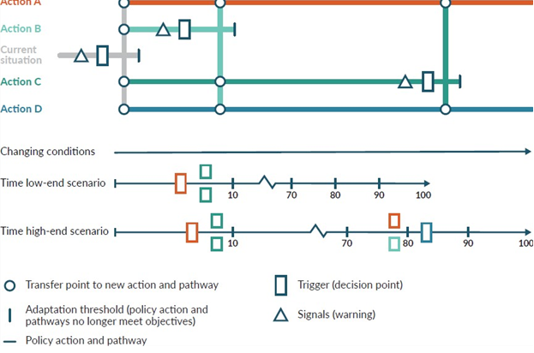
Source: Adapted from Haasnoot et al (2013); Hermans et al (2017)
The resulting pathways can be tested for robustness with respect to a number of assumptions and parameters, for example: different climate change scenarios (using sea-level rise projections or hazard assessments set out in step 2); the sensitivity to discount rate; earlier or later decision review dates, and variations in the costs of the adaptation options and in expected losses. The more scenarios across a range of future conditions and indicators of sensitivity tested, the more robust the decisions will be. Robustness here means objectives can be reached under a range of different futures. Robustness tests can be done on a number of complementary options; for example, structural options may become unaffordable and may need to be supported by planning and regulatory options, targeted rates and insurance to reach desired objectives.
When applied to flood adaptation planning in the Hutt River catchment (see Community engagement principles and approaches, and practice methods: Coastal hazards and climate change guidance – Supplement B), it was noted that the annual exceedance probabilities (AEPs) and related river flows were based on Poisson distributions, which assume a known mean and variance, even though the historic record is too short to establish these reliably. A form of conjugate or extreme value distribution may better reflect the uncertainty around the mean and variance. This is one reason why, for SLR assessments as set out in this guidance, it is important to test for robustness and earlier onset using the upper-end SSP5-8.5 H+ SLR projection (step 2) as well as testing different SLR increments for the sensitivity of actions and options, thereby better reflecting the upper-end uncertainty.

Strategies for addressing barriers to dynamic adaptive pathways planning uptake
Since 2013, uptake of DAPP in Aotearoa New Zealand has gone through several stages and is now being used in a diversity of settings, with a few applications now reaching implementation (Lawrence, 2023). The uptake of DAPP went through three stages: creating interest, increasing awareness with serious games and experimenting in real-life settings (Lawrence and Haasnoot, 2017). Learning over this time has indicated that institutional and technical barriers can impede uptake. Many can be avoided through careful preparation and maintaining flexibility throughout the process by asking the questions listed in the above section.
Avoid rushing the process. Follow a timeframe that ensures stakeholders can engage in the process and understand dynamic adaptive concepts.
Serious games can give stakeholders and decision-makers experience in making a plan over 100 years in a safe environment, where they receive feedback on their decision choices and learn about the consequences of those decisions. Background about and different types of serious games is set out in Community engagement principles and approaches, and practice methods: Coastal hazards and climate change guidance – Supplement B. This will help reduce some of the observed institutional barriers.
Tailor the process to the available information and expertise. Bear in mind that DAPP is primarily an approach for developing adaptive pathways and can be conducted at any level of detail. It is not a prescriptive method.
Use DAPP-lite to scope priorities, information and engagement gaps for more detailed assessment.
Complex model-based DAPP analyses are only one end of the spectrum.
Thoroughly investigate all approaches and explore possibilities to link disparate datasets, risk assessments and cascade mapping. This can result in meaningful insights for informing adaptive decision-making.
Table C.1 outlines strategies for addressing institutional and technical barriers to the uptake of DAPP.

Table C.1: Strategies for addressing barriers to dynamic adaptive pathways planning (DAPP) uptake and implementation of the DAPP plan
Stage of DAPP implementation |  | Institutional barriers |  | Technical barriers | Strategies to overcome barriers
Overcoming initial inertia to the uptake of DAPP in an uncertain context | Short project timeframes can make it difficult for stakeholders to invest in the DAPP process and its outcomes.  Entrenched views can exist within institutions on how coastal flood management should be approached.  Short-term council functions prioritise short- over long-term strategic thinking.  Difficult to get mutual commitment from stakeholders.  Assumption that local government action on climate change will reduce central government assistance with adaptation. |  | Lack of knowledge about DAPP and its application as an analytical approach that can encompass engagement processes.  Lack of capability to adopt new tools. |  | Preparation – understand the differences between commonly used static hazard risk management practices under changing climate that require use of the DAPP approach.  Preparation – mandate long-term strategy champions within organisations.  Preparation – establish clear governance strategies at the beginning of the DAPP process.  Preparation – create space for clear ownership of the DAPP process to develop amongst stakeholders and managers.  Preparation – ensure roles and responsibilities are shared equitably among all stakeholders to facilitate long-term buy-in.  Preparation – appoint ‘knowledge brokers’ to facilitate a common understanding of process and its components.  Preparation – develop partnerships with iwi/hapū.
Using models to investigate the effectiveness of adaptation options to form the basis for developing adaptation plans | Lack of investment in locally relevant models.  Poor understanding of available data due to isolated knowledge within institutions.  Mistrust of the ability of ‘simple’ models and workshop processes to provide useful information. |  | Limited or inaccurate data on physical characteristics of coastal hazard and extreme events, assets at risk, and impact of options.  Unsure how to blend qualitative information and workshop deliberations with quantitative data (eg, RiskScape).  Unclear how available data can address deep uncertainty problems (eg, monitoring plans, triggers and scenarios). |  | Preparation – develop a detailed overview of available models, data and how these might be used before starting this stage of DAPP development, including in developing options for Māori whenua and facilities, cultural sites and for implementation to acknowledge te Tiriti o Waitangi obligations, governance.  Flexibility – tailor the type of DAPP process with the amount and quality of data available (eg, basic scorecard when there is limited information available versus complex model-informed decision pathways).  Flexibility – pool resources across organisations to maximise useful data and possible modelling options.  Serious games – a useful way to communicate model processes, demonstrate the long-term effects of decisions, and build model and team trust.  Flexibility – use a range of metrics (economic, social, cultural and environmental) to show the efficacy of adaptation plans.  Preparation and flexibility – develop monitoring plans and triggers, using several scenarios to test them, use several different indicators to cover local (eg, Mean Annual Flood, Expected Annual Damage), national (eg, sea level and extreme event trends) and global (eg, atmospheric circulation patterns) scales.
Incorporating adaptation plans within policy frameworks and measures | Ability of individuals or communities to block implementation.  Ongoing monitoring costs. |  | Lack of long-term strategic policy at local government level. |  | Preparation – early collaboration to build buy-in with all relevant stakeholders and communities will minimise the likelihood of push-back at the implementation stage.  Preparation – monitoring frameworks are a necessary investment so that adaptation plans can be adjusted before highly damaging events occur.  Preparation – new local-level policy that focuses on proactive management will enable adaptation plans to become embedded.
Source: Adapted from Lawrence et al, 2020b

Appendix D: Baseline mean sea level for locations around Aotearoa New Zealand
Sea-level rise projections in this guidance and the NZ SeaRise platform, in line with global projections in the Intergovernmental Panel on Climate Change Sixth Assessment Report (Fox-Kemper et al, 2021), are relative to a zero baseline of the 20-year period 1995–2014, with a mid-point of 2005. Therefore, the local relative sea-level rise projections should be added to the local or regional mean sea level (MSL), which has been averaged, where possible, over the same baseline period (1995–2014). This ‘grounds’ the future sea level projections to a local vertical datum of the region or preferably the national New Zealand Vertical Datum 2016 (NZVD-2016) (figure D.1).
Figure D.1: Schematic of ‘present’ mean sea level and relationship to various vertical datums and additional sea-level rise
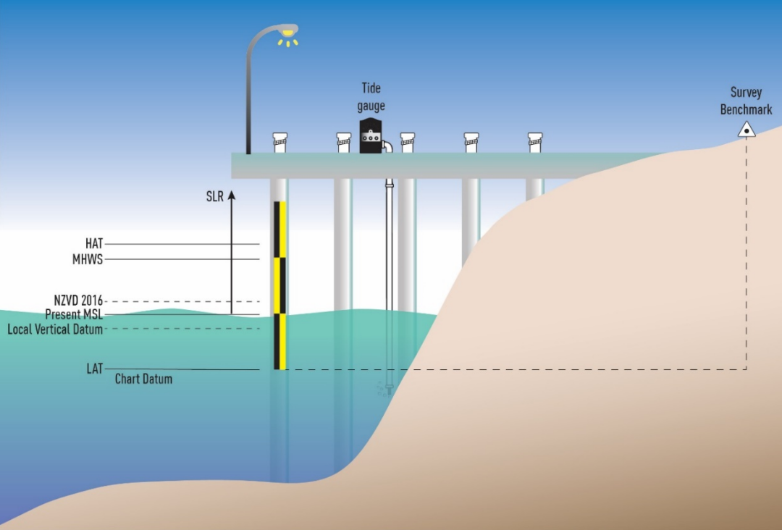
Note: Local Vertical Datum is specific to each region(s) and is superseded by a national New Zealand Vertical Datum (NZVD-2016). HAT = highest astronomical tide; LAT = lowest astronomical tide; MHWS = mean high water spring tide.
Table D.1 lists the average MSL over the 20-year baseline period 1995–2014 (or the nearest available record over several years) for sites around Aotearoa New Zealand, relative to the national NZVD-2016.
For example, at Gisborne, using table D.1, a 1 metre sea-level rise projection would raise the MSL to an elevation of 1 + (–0.14) metres = 0.86 metres relative to NZVD-2016. Storm tide water levels would then be added to these future MSL elevations in the relevant datum.
Table D.1: Mean sea level (MSL) at Aotearoa New Zealand locations averaged over the approximate 1995–2014 baseline (used by IPCC) for adding on -sea-level rise projections
Gauge site | Averaging period (available data) | MSL (m; NZ Vertical Datum 2016)
Auckland (Waitemata) | 1996–2014 | –0.20
Wellington | 1996–2014 | –0.15
Lyttelton (post-quake) | 1996–2014 | –0.25
Dunedin | 1996–2014 | –0.26
Marsden Point | 1996–2014 | –0.16
Onehunga | 2001–2014 | –0.06
Tararu (Thames) | 2001–2014 | –0.18
Moturiki Island | 1996–2014 | –0.10
Tauranga | 1996–2014 | –0.08
Gisborne | 2004–2014 | –0.14
Napier | 1999–2014 | –0.16
Port Taranaki | 1996–2014 | –0.14
Nelson | 1996–2014 | –0.24
Picton | 2005–2008 | –0.12
Westport | 1999–2012 | –0.080
Timaru | 2002–2014 | –0.13
Port Chalmers | 2000–2014 | –0.31
Bluff | 1998–2014 | –0.19
Note: Mean sea level is only provided in terms of the NZVD-2016 national datum and is mostly available for a 19-year nodal tidal period from 1996–2014 from Land Information New Zealand. See below for resources to convert to a historic local vertical datum. The baseline period varies somewhat due to availability of data.
Sources: G Rowe, Land Information New Zealand, pers. comm. and R Bell.
As sea level rises, the updated average MSL can be tracked relative to the baseline MSL in table D.1. This can be done by analysing recent annual MSL from the nearest gauge data or from the Land Information New Zealand (LINZ) website, which is updated annually (usually for a 19 year averaging period). These updated MSL values for standard ports are listed in the LINZ Nautical Almanac or provided at www.linz.govt.nz/sea/tides/tide-predictions/standard-port-tidal-levels. The periods of observation for MSL are at www.linz.govt.nz/sea/tides/tide-predictions/standard-port-periods-observation.
These published MSL values by LINZ are relative to the port chart datum (which is around the lowest low tide) or otherwise the gauge zero datum. In this case, an offset needs to be subtracted from the measured MSL for the various gauges (at chart datum or tide gauge datum) to convert these MSL values into a level relative to NZVD-2016. Offsets to apply can be determined using the NZVD-2016 elevations of the survey benchmark used to define a regional chart datum. Benchmark levels over time are available from the LINZ Geodetic Database (www.geodesy.linz.govt.nz/gdb/?mode=gmap), which needs to be pieced together with the height of the benchmark above chart datum (www.linz.govt.nz/guidance/marine-information/tide-prediction-guidance/standard-port-datum-descriptions).

Resources
Instructions for converting between vertical datums (LINZ): www.linz.govt.nz/data/geodetic-services/coordinate-conversion/online-conversions/instructions-for-carrying-out-online-height-conversions
Online vertical height conversions: https://www.geodesy.linz.govt.nz/concord/index.cgi?Advanced=2

References
This list outlines the references cited in the following documents: Coastal hazards and climate change guidance, Climate change, sea-level rise and coastal hazards science: Coastal hazards and climate change guidance – Supplement A and Community engagement principles and approaches, and practice methods: Coastal hazards and climate change guidance – Supplement B.

Ackerley, D., Bell, R., G., Mullan, A., B., McMillan, H. (2013). Estimation of regional departures from global-average sea-level rise around New Zealand from AOGCM simulations. Weather & Climate 33: 2–22. https://doi.org/10.2307/26169734
Adger, W.N. (2006). Vulnerability. Global Environmental Change 16(3): 268–281. https://doi.org/10.1016/j.gloenvcha.2006.02.006.
Albrecht, F., Pizarro, O., Montecinos, A., Zhang, X. (2019). Understanding sea level change in the South Paciﬁc during the late 20th century and early 21st century. Journal of Geophysical Research: Oceans, 124: 3849– 3858. https://doi.org/10.1029/2018JC014828
Allan, S., Bell, R.G., Forkink, A. (2023). Coastal realignment: Another coastal challenge. Policy Quarterly 19(1): 50–57. https://doi.org/10.26686/pq.v19i1.8105.
Allis, M.J., Bell, R.G. (2019). Retreat is not an option: managing effects of sea-level rise on a critical infrastructure corridor in Wellington, New Zealand. Proceedings of Australasian Coasts & Ports Conference 2019: 10–13 September 2019, Hobart, Australia. Barton (AU): Engineers Australia. pp. 27–33.
Allis, M., J., Bell, R., G., Dawe, I., Stephens, S., A. (2022). Determining an objective coastal land-sea boundary zone for jurisdictional clarity. Retrieved from https://www.coastsandports.org/papers/2021/094_allis_finalpaper.pdf
Allis, M., Rautenbach, C., Gorman, R., Wadhwa, S. (2021). Coastal hazards and sea-level rise in Wellington City: Supporting the 2020–2021 District Plan process. NIWA Report 2021250HN prepared for Wellington City Council. Retrieved from https://wellington.govt.nz/-/media/your-council/plans-policies-and-bylaws/plans-and-policies/a-to-z/spatial-plan/coastal-hazards-report---august-2021.pdf?la=en&hash=E70B002B5D515679482B867E649FD90D3D74FB5C.
Allis, M.J., Stephens, S., Ramsay, D., Gorman, R., Bell, R. (2015). The Coastal Calculator: A user-friendly tool for estimating coastal storm-driven water-levels. Proceedings of Australasian Coasts & Ports Conference 2015: 7. 15–18 September 2015, Auckland, New Zealand.
Allison, A., Stephens, S., Blackett, P., Lawrence, J., Dickson, M.E., Matthews, Y. (2023). Simulating the impacts of an Applied Dynamic Adaptive Pathways Plan using an Agent-Based Model: A Tauranga City, New Zealand, Case Study. Journal of Marine Science and Engineering 11: 343. https://doi.org/10.3390/jmse11020343.
Ara Begum, R., Lempert, R., Ali, E., Benjaminsen, T.A., Bernauer, T., Cramer, W., Cui, X., Mach, K., Nagy, G., Stenseth, N.C., Sukumar, R., Wester, P. (2022). Point of departure and key concepts. In: Climate Change 2022: Impacts, Adaptation and Vulnerability. Contribution of Working Group II to the Sixth Assessment Report of the Intergovernmental Panel on Climate Change [H.-O. Pörtner, D.C. Roberts, M. Tignor, E.S. Poloczanska, K. Mintenbeck, A. Alegría, M. Craig, S. Langsdorf, S. Löschke, V. Möller, A. Okem, B. Rama (eds.)]. Cambridge University Press, Cambridge, UK and New York, NY, USA,
pp. 121–196. Retrieved from www.ipcc.ch/report/ar6/wg2/downloads/report/IPCC_AR6_ WGII_Chapter01.pdf.
Areta, R.C. (2023). Ka hao te rangatahi: Rangatahi Māori experiences of climate change. Master’s Thesis. University of Waikato. https://hdl.handle.net/10289/15744.
Arias, P.A., N. Bellouin, E. Coppola, R.G. Jones, G. Krinner, J. Marotzke, V. Naik, M.D. Palmer, G.-K. Plattner, J. Rogelj, M. Rojas, J. Sillmann, T. Storelvmo, P.W. Thorne, B. Trewin, K. … K. Zickfeld, (2021). Technical Summary. In Climate Change 2021: The Physical Science Basis. Contribution of Working Group I to the Sixth Assessment Report of the Intergovernmental Panel on Climate Change [Masson-Delmotte, V., P. Zhai, A. Pirani, S.L. Connors, C. Péan, S. Berger, N. Caud, Y. Chen, L. Goldfarb, M.I. Gomis, M. Huang, K. Leitzell, E. Lonnoy, J.B.R. Matthews, T.K. Maycock, T. Waterfield, O. Yelekçi, R. Yu, and B. Zhou (eds.)]. Cambridge University Press, Cambridge, United Kingdom and New York, NY, USA, pp. 33−144. https://doi.org/10.1017/9781009157896.002.
Atlas Communications & Media Ltd. (2011). Project Twin Streams case study: Largescale property purchase without recourse to compulsory purchase. Prepared for the Ministry for the Environment on behalf of Waitakere City Council, Ministry for the Environment, Publication No. CR 108. Retrieved from https://environment.govt.nz/publications/project-twin-streams-case-study-large-scale-property-purchase-without-recourse-to-compulsory-purchase/.
Bailey-Winiata, A.P.S. (2021). Understanding the potential exposure of coastal marae and urupā in Aotearoa New Zealand to sea level rise. Masters Thesis. University of Waikato. https://researchcommons.waikato.ac.nz/handle/10289/14567.
Baker, R., F., Watkins, M. (1991). Guidance notes for the determination of mean high water mark for land title surveys. Wellington: Professional Development Committee of the New Zealand Institute of Surveyors. Retrieved from http://docs.niwa.co.nz/library/public/Baker1991.pdf (February 2024).
Bamber, J., L., Oppenheimer, M., Kopp, R., E., Aspinall, W., P., Cooke, R., M. (2019). Ice sheet contributions to future sea-level rise from structured expert judgement. Environmental Sciences 116(23). https://doi.org/10.1073/pnas.1817205116.
Bamber, J., L., Oppenheimer, R., E., Kopp, R., E., Aspinall, W., P., Cooke, R., M. (2022). Ice Sheet and Climate Processes Driving the Uncertainty in Projections of Future Sea Level Rise: Findings from a Structured Expert Judgement Approach. Earth’s Future 10(10). https://doi.org/10.1029/2022EF002772.
Bamber, J.L., Westaway, R.M., Marzeion, B., Wouters, B. (2018). The land ice contribution to sea level during the satellite era. Environmental Research Letters 13(6), 063008. https://doi.org/10.1088/1748-9326/aac2f0.
Barisky, T. (2015). A public engagement toolkit for sea level rise. Prepared for the Sustainability Group, City of Vancouver. Vancouver: City of Vancouver. Retrieved from https://sustain.ubc.ca/sites/sustain.ubc.ca/files/GCS/2015%20Project%20Reports/A%20Public%20Engagement%20Toolkit%20for%20Sea%20Level%20Rise%20-%20GC%20Scholars%202015.pdf.
Barlow, P., M. (2003). Ground water in freshwater-saltwater environments of the Atlantic Coast. US Geological Survey Circular 1262: 113.
Barnett, J., Graham, S., Mortreux, C., Fincher, R., Waters, E., Hurlimann, A. (2014). A local coastal adaptation pathway. Nature Climate Change 4(12): 1103–1108. Retrieved from https://www.researchgate.net/publication/266741093_A_local_coastal_adaptation_pathway.
Barnett, J., Tschakert, P., Head, L., Adger, W.N. (2016). A science of loss. Nature Climate Change 6:
976–978. https://doi.org/10.1038/nclimate3140
Barnett, M.A.F. (1938). The cyclonic storms in Northern New Zealand. Meteorological Office Note 22. Wellington: Meteorological Office.
Beavan RJ, Litchfield NJ. (2012). Vertical land movement around the New Zealand coastline: Implications for sea-level rise. Lower Hutt: GNS Science. Retrieved from www.gns.cri.nz/assets/News-files/N-files/SR-2012-029.pdf.
Becker, J., Patel, P., Ryan, E., Blackett, P., Schneider, P., Robichaux, L. (2018). Understanding community perspectives on coastal issues: Hawke’s Bay Coastal Survey 2017. GNS Science Miscellaneous Series 113, November 2018. Prepared for the Resilience to Nature National Science Challenge.
Bell, R., G. (2010). Tidal exceedances, storm tides and the effect of sea-level rise. In: Proceedings of the 17th Congress of the Asia and Pacific division of the IAHR. Auckland: 10.
Bell, R.G. (2021). How will our coasts and estuaries change with sea-level rise? Implications for communities and infrastructure. Part I, In: Hon. Helen Clark (ed.), Climate Aotearoa: What’s happening & what we can do about it. pp. 61–92. ISBN 978 1 98854 763 3. Allen and Unwin Publishers, Australia. Retrieved from www.allenandunwin.co.nz/browse/book/Edited-by-Helen-Clark-Climate-Aotearoa-9781988547633.
Bell, R., Hannah, J., & Andrews, C. (2022). Update to 2020 of the annual mean sea level series and trends around New Zealand. Prepared for Ministry for the Environment August 2022 (NIWA Client Report No: 2021236HN). NIWA. Retrieved from https://environment.govt.nz/publications/update-to-2020-of-the-annual-mean-sea-level-series-and-trends-around-new-zealand/.
Bell, R.G., Hume, T.M., Hicks, D.M. (2001). Planning for climate change effects on coastal margins. Ministry for the Environment Publication ME 410. P 73. Retrieved from https://environment.govt.nz/publications/planning-for-climate-change-effects-on-coastal-margins/.
Bell, R., G., Paulik, R., Wadhwa, S. (2015). National and regional risk exposure in low-lying coastal areas: areal extent, population, buildings and infrastructure. Report prepared for the Parliamentary Commissioner for the Environment by NIWA. Wellington: Parliamentary Commissioner for the Environment. Retrieved from www.pce.parliament.nz/media/1384/national-and-regional-risk-exposure-in-low-lying-coastal-areas-niwa-2015.pdf.
Bell, R.G., Ray, D., Hickey, C., McBride, G. (2002). Conceptual design of the monitoring programme. In: Ray, D. (Ed.) New Zealand Municipal Wastewater Monitoring Guidelines (pp. 85–91). Wellington: NZ Water Environment Research Foundation. Retrieved from www.waternz.org.nz/Article?Action=View&Article_id=33.
Berkes, F., Folke, C., Colding, J. (1998). Ecological practices and social mechanisms. In: F Berkes, C Folke, J Colding (eds) Linking Social and Ecological Systems: Management practices and social mechanisms for building resilience. Cambridge: Cambridge University Press.
Beya, J., Asmat, C. (2021). Short-term concept design and costing – Clifton to Tangoio 2120 Coastal hazards strategy – Stage 4 – Design workstream: Wave, shoreline evolution and gravel barrier response modelling – Groynes design and cost estimates. Hawke’s Bay Regional Council Report 5537. Retrieved from www.hbcoast.co.nz/assets/Uploads/Design-report-full-final-bookmarked-reduce-size.pdf.
Blackett, P., Davies, K., Davies, B., Holland, P., and Cradock-Henry, N. (2019). Adaptive Futures: An Interactive Serious Game for Decision-Making and Coastal Hazards. Prepared for Natural Hazards Research Platform. NIWA Client Report No. 2019328HN. New Zealand: NIWA
Blackett, P., FitzHerbert, S., Luttrell, J., Hopmans, T., Lawrence, H., Colliar, J. (2022). Marae-opoly: Supporting localised Māori climate adaptation decisions with serious games in Aotearoa New Zealand. Sustainability Science 17: 415–431. doi.org/10.1007/s11625-021-00998-9.
Blackett, P., Hume, T., Dahm, J. (2010a). Exploring the social context of coastal erosion management in New Zealand: What factors drive environmental outcome. The Australasian Journal of Disaster and Trauma Studies 2010-1: 10.
Blackett, P., Smith, E., Rouse, H., Hume, T., Rickard, D., Hume, A., Bell, R., Ramsey, D., Dahm, J., Wishart, P., Singleton, P., Pickett, V. (2010b). How can we engage with coastal communities over adaptation to climate change? A case study in Whitianga on the Coromandel Peninsula. Presentation to New Zealand Planning Institute Conference: Planning Pathways to the Future, Christchurch Convention Centre
20–23 April 2010.
Blair N. (2002). Tamaki Kaitiakitanga in the concrete jungle. In M Kawharu (Ed), Whenua: Managing Our Resources (pp 62–74). Auckland: Reed Books.
Bodeker, G., Cullen, N., Katurji, M., McDonald, A., Morgenstern, O., Noone, D., Renwick, J., Revell, L., Tait, A. (2022). Aotearoa New Zealand climate change projections guidance: Interpreting the latest IPCC WG1 report findings. Prepared for the Ministry for the Environment, Report number CR 501, 51 p. Retrieved from https://ir.canterbury.ac.nz/server/api/core/bitstreams/294aea35-9bc1-4a4f-ba4a-2667e31ef3dc/content.
Bond, S., & Barth, J. (2020). Care-full and just: Making a difference through climate change adaptation. Cities 102, 102734. https://doi.org/10.1016/j.cities.2020.102734
Bosserelle, A.L., Morgan, L.K., Hughes, M.W. (2022). Groundwater rise and associated flooding in coastal settlements due to sea-level rise: A review of processes and methods. Earth’s Future 10: e2021EF002580. doi.org/10.1029/2021EF002580.
Boyle, J., Golubiewski, N., Balderston, K., Hu, C. (2019). Auckland’s exposure to sea level rise: Part 2 – Local inventory. Auckland Council Internal Report 2019/006. Retrieved from www.google.com/url?sa=t&rct=j&q=&esrc=s&source=web&cd=&cad=rja&uact=8&ved=2ahUKEwiWyaHPnuv7AhVhSWwGHdMVDAAQFnoECDAQAQ&url=https%3A%2F%2Fwww.researchgate.net%2Fpublication%2F337670247_Auckland%2527s_Exposure_to_Sea_Level_Rise_Part_2_-Local_Inventory&usg=AOvVaw2Bkl_TG_1rcRDeS6aLVctO.
Brenstrum, E. (1998). The New Zealand Weather Book. Nelson: Craig Potton Publishing: Nelson.
Bruun, P. (1962). Sea-level rise as a cause of shore erosion. Journal Waterways and Harbors Division, ASCE, 88: 117–130. https://doi.org/10.1061/JWHEAU.0000252
Brown Gaddis, E., J., Harp Falk, H., Ginger, C., Voinov, A. (2010). Effectiveness of a participatory modeling effort to identify and advance community water resource goals in St. Albans, Vermont. Environmental Modelling & Software 25(11): 1428–1438. Retrieved from http://dx.doi.org/10.1016/j.envsoft.2009.06.004.
Bryan, K., Coco, G. (2020). Response of sandy coastal systems to changes associated with sea level changes. p. 25-29. In: C., Hendtlass, S., Morgan, D., Neale (eds) Coastal systems and sea level rise: What to look for in future. Special Publication 4, NZ Coastal Society, Dec 2020. Retrieved from https://resiliencechallenge.nz/outputs/the-response-of-sandy-coastal-systems-to-changes-associated-with-sea-level-rise/.
Bryan, K., R., Foster, R., MacDonald, I. (2013). Beach rotation at two adjacent headland-enclosed beaches. Journal of Coastal Research, Special Issue 65: 2095–2100. https://doi.org/10.2112/SI65-354.1
Bryson, J., M., Quick, K., S., Slotterback, C., S., Crosby, B., C. (2013). Designing public participation processes. Public Administration Review 73(1): 23–34. https://www.jstor.org/stable/23355431
Burkett, V., R., Suarez, A., G., Bindi, M., Conde, C., Mukerji, R., Prather, M., J., Clair, A., L., S., Yohe, G., W. (2014). Point of departure. In: CB Field, VR Barros, DJ Dokken et al (eds) Climate Change 2014: Impacts, Adaptation, and Vulnerability. Part A: Global and Sectoral Aspects. Contribution of Working Group II to the Fifth Assessment Report of the Intergovernmental Panel on Climate Change. Cambridge: Cambridge University Press. Retrreived from https://www.ipcc.ch/site/assets/uploads/2018/02/WGIIAR5-Chap1_FINAL.pdf.
Cagigal, L., Rueda, A., Castanedo, S., Cid, A., Perez, J., Stephens, S.A., Coco, G. and Méndez, F.J. (2019). Historical and future storm surge around New Zealand: from the 19th century to the end of the 21st century. International Journal of Climatology, 40(3), 1512–1525. https://doi.org/10.1002/joc.6283.
California Coastal Commission. (2018). Sea level rise policy guidance: Interpretative guidelines for addressing sea level rise in local coastal programs and coastal development permits. Retrieved from www.coastal.ca.gov/climate/slrguidance.html.
Carpenter, N., Roberts, R., Klinac, P. (2021). Auckland’s exposure to coastal inundation by storm-tides and waves. Auckland Council technical report, TR2020/024. Retrieved from https://knowledgeauckland.org.nz/publications/auckland-s-exposure-to-coastal-inundation-by-storm-tides-and-waves/.
Carpenter, N., Sinclair, S., Klinac, P., Walker, J. (2017). Coastal Management Framework for the Auckland Region. Retrieved from www.aucklandcouncil.govt.nz/plans-projects-policies-reports-bylaws/our-plans-strategies/topic-based-plans-strategies/environmental-plans-strategies/Documents/coastal-management-framework-2017.pdf.
Carpenter, N., Vernall, S., Klinac, P. (2022). Shoreline Adaptation Plans for Tāmaki Makaurau: making space for coastal change. pp. 87–92. In: Coastal Adaptation: Adapting to coastal change and hazard risk in Aotearoa New Zealand. Special Publication No. 5, NZ Coastal Society. Retrieved from www.coastalsociety.org.nz/media/view/publications/special-publication-5-coastal-adaptation/.
Carrick, J., Fitzsimmons, C., & Gray, T. (2022). Using Bayesian Belief Networks and participatory action research to improve stakeholder engagement. In: Gómez, S., and Köpsel, V. (eds) Transdisciplinary Marine Research: Bridging Science and Society. London: Routledge.
Cash, D. W., Clark, W. C., Alcock, F., Dickson, N. M., Eckley, N., Guston, D. H., ... & Mitchell, R. B. (2003). Knowledge systems for sustainable development. Proceedings of the National Academy of Sciences, 100(14), 8086-8091. https://doi.org/10.1073/pnas.1231332100
Cazenave, A., Le Cozannet, G. (2014). Sea level rise and its coastal impacts. Earth’s Future 2: 15–34. doi.org/10.1002/2013EF000188.
Chen, D., Rojas, M., Samset, B.H., Cobb, K., Diongue Niang, A., Edwards, P., Emori, S., Faria, S.H., Hawkins, E., Hope, P., Huybrechts, P., Meinshausen, M., Mustafa, S.K., Plattner, G.K., Tréguier, A.M. (2021). Framing, Context, and Methods. In: Masson-Delmotte V., Zhai P., Pirani A., Connors S.L., Péan C., Berger S., Caud N., Chen Y., Goldfarb L., Gomis M.I., Huang M., Leitzell K., Lonnoy E., Matthews J.B.R., Maycock T.K., Waterfield T., Yelekçi O., Yu R., Zhou B. (eds). Climate Change 2021: The Physical Science Basis. Contribution of Working Group I to the Sixth Assessment Report of the Intergovernmental Panel on Climate Change. IPCC AR6, WGI, Chapter 1. Cambridge University Press. Retrieved from www.ipcc.ch/report/ar6/wg1/downloads/report/IPCC_AR6_WGI_Chapter_01.pdf.
Church, J.A., White, N.J. (2011). Sea-Level Rise from the Late 19th to the Early 21st Century. Surveys in Geophysics 32(4): 585–602. Retrieved from http://dx.doi.org/10.1007/s10712-011-9119-1.
Clark, P., U., Shakun, J., D., Marcott, S., A., Mix, A., C., Eby, M., Kulp, S., Levermann, A., Milne, G., A., Pfister, P., L., Santer, B., D., Schrag, D., P., Solomon, S., Stocker, T., F., Strauss, B., H., Weaver, A., J., Winkelmann, R., Archer, D., Bard, E., Goldner, A., Lambeck, K., Pierrehumbert, R., T., Plattner, G-K. (2016). Consequences of twenty-first-century policy for multi-millennial climate and sea-level change. Nature Climate Change 6(4): 360–369. doi.org/10.1038/nclimate2923.
Clement, A.J.H., Whitehouse., P.L., Sloss., C.R. (2016). An examination of spatial variability in the timing and magnitude of Holocene relative sea-level changes in the New Zealand archipelago. Quaternary Science Reviews 131, Part A. 73–101. doi.org/10.1016/j.quascirev.2015.09.025.
Coco, G., Bryan, K., Nontano, J., Cagigal, L. (2020). Modelling coastal evolution for rising sea levels.
pp. 21–24. In: C., Hendtlass, S., Morgan, D., Neale (eds) Coastal systems and sea level rise: What to look for in future. Special Publication 4, NZ Coastal Society, Dec 2020. Retrieved from www.coastalsociety.org.nz/media/view/publications/sea-level-rise/.
Colliar J, Blackett P (2018) Tangoio Climate Change Adaptation
Decision Model: A process for exploring adaptation pathways
for Tangoio Marae Prepared for Maungaharuru--Tangitū Trust and
Deep South National Science Challenge. NIWA Client Report
2018242HN
Colliar J, Blackett P (2018) Tangoio Climate Change Adaptation
Decision Model: A process for exploring adaptation pathways
for Tangoio Marae Prepared for Maungaharuru--Tangitū Trust and
Deep South National Science Challenge. NIWA Client Report
2018242HN
Colliar, J., Blackett, P. (2018). Tangoio Climate Change Adaptation Decision Model: A process for exploring adaptation pathways for Tangoio Marae prepared for Maungaharuru-Tangitū Trust and Deep South National Science Challenge. NIWA Client Report 2018242HN.
Collins, M., Knutti, R., Arblaster, J., Dufresne, J-L., Fichefet, T., Friedlingstein, P., Gao, X., Gutowski, W., J., Johns, T., Krinner, G., Shongwe, M., Tebaldi, C., Weaver, A., J., Wehner, M. (2013). Long-term climate change: projections, commitments and irreversibility. In: TF Stocker, D Qin, G-K Plattner et al (eds) Climate change 2013: The physical science basis. Cambridge: Cambridge University Press.
Colombano, D., D., Litvin, S., Y., Ziegler, S., L., Alford, S., B., Baker, R., Barbeau, M., A., Cebrián, J., Connolly, R., M. et al (2021). Climate change implications for tidal marshes and food web linkages to estuarine and coastal nekton. Estuaries and Coasts 44: 1637–1648. https://doi.org/10.1007/s12237-020-00891-1
Cooley, S., D. Schoeman, L. Bopp, P. Boyd, S. Donner, D.Y. Ghebrehiwet, S.-I. Ito, W. Kiessling, P. Martinetto, E. Ojea, M.-F. Racault, B. Rost, and M. Skern-Mauritzen. (2022). Oceans and Coastal Ecosystems and Their Services. In: Climate Change 2022: Impacts, Adaptation and Vulnerability. Contribution of Working Group II to the Sixth Assessment Report of the Intergovernmental Panel on Climate Change. H.-O., Pörtner, D.C., Roberts, M., Tignor, E.S., Poloczanska, K., Mintenbeck, A., Alegría, M., Craig, S., Langsdorf, S., Löschke, V., Möller, A., Okem, B., Rama (eds). Cambridge University Press, Cambridge, UK and New York, NY, USA, pp. 379–550. https://doi.org/10.1017/9781009325844.005.
Cooper, J.A.G., Masselink, G., Coco, G., Short, A.D., Castelle, B., Rogers, K., Anthony, E., Green, A.N., Kelley, J.T., Pilkey, O.H., Jackson, D.W.T. (2020). Sandy beaches can survive sea-level rise. Nature Climate Change 10: 993–995. doi.org/10.1038/s41558-020-00934-2.
Costa, Y., Martins, I., Correia de Carvalho, G., Barros, F. (2023). Trends of sea-level rise effects on estuaries and estimates of future saline intrusion. Ocean and Coastal Management 236: 106490. https://doi.org/10.1016/j.ocecoaman.2023.106490
Cote, M., & Nightingale, A., J. (2012). Resilience thinking meets social theory: Situating social change in socio-ecological systems (SES) research. Progress in Human Geography 36(4): 475–489. Retrieved from http://dx.doi.org/10.1177/0309132511425708.
Cowell, P.J., Thom, B.G., Jones, R.A., Everts, C.H., Simanovic, D. (2006). Management of uncertainty in predicting climate-change impacts on beaches. Journal of Coastal Research 22(1): 232–245. https://www.jstor.org/stable/4300279
Cox, L.A. (2008). What’s wrong with risk matrices? Risk Analysis 28(2): 497–512. doi.org/10.1111/j.1539-6924.2008.01030.x.
Cox, J., C., Machemehl, J. (1986). Overload bore propagation due to an overtopping wave. Journal of Waterway Port Coastal and Ocean Engineering-ASCE 112(1): 161–163. https://doi.org/10.1061/(ASCE)0733-950X(1986)112:1(161)
Cradock-Henry, N. A., Frame, B., Preston, B. L., Reisinger, A., & Rothman, D. S. (2018). Dynamic adaptive pathways in downscaled climate change scenarios. Climatic change, 150(3-4), 333-341. https://doi.org/10.1007/s10584-018-2270-7
Cutter, S.L., Boruff, B.J., Shirley, W.L. (2003). Social vulnerability to environmental hazards. Social Science Quarterly 84(2): 242–261. doi.org/10.1111/1540-6237.8402002.
Dangendorf, S., Hay, C., Calafat, F., M., Marcos, M., Piecuch, C., G., Berk, K., Jensen, J. (2019). Persistent acceleration in global sea-level rise since the 1960s. Nature Climate Change 9. 705-710. doi.org/10.1038/s41558-019-0531-8.
Davies, K., Fisher, K., Dickson, M., Thrush, S., LeHeron, R. (2015). Improving ecosystem service frameworks to address wicked problems. Ecology and Society 20(2): 37. http://dx.doi.org/10.5751/ES-07581-200237.
DeConto, R., M., & Pollard, D. (2016). Contribution of Antarctica to past and future sea-level rise. Nature 531(7596): 591–597. https://doi.org/10.1038/nature17145.
DeConto, R.M., Pollard, D., Alley, R.B., Velicogna, I., Gasson, E., Gomez, N., Sadai, S., Condron, A., Gilford, D.M., Ashe, E.L., Kopp, R.E., Li, D., Sutton, A. (2021). The Paris climate agreement and future sea-level rise from Antarctica. Nature 593. https://www.nature.com/articles/s41586-021-03427-0.
Denton, F., Wilbanks, T.J., Abeysinghe, A.C., Burton, I., Gao, Q., Lemos, M.C., Masui, T., O’Brien, K.L., Warner, K. (2014). Climate-resilient pathways: Adaptation, mitigation, and sustainable development. In: C.B., Field, V.R., Barros, D.J., Dokken et al (eds) Climate Change 2014: Impacts, Adaptation, and Vulnerability.
Denys, P., H., Beavan, R., J., Hannah, J., Pearson, C., F., Palmer, N., Denham, M., Hreinsdottir, S. (2020). Sea level rise in New Zealand: The effect of vertical land motion on century-long tide gauge records in a tectonically active region. Journal of Geophysical Research: Solid Earth 125: e2019JB018055. https://doi.org/10.1029/2019JB018055
Department of Conservation. (2010). New Zealand Coastal Policy Statement 2010. Wellington: Department of Conservation. Retrieved from www.doc.govt.nz/about-us/science-publications/conservation-publications/marine-and-coastal/new-zealand-coastal-policy-statement/new-zealand-coastal-policy-statement-2010/.
Department of Conservation. (2017). NZCPS 2010 guidance note: Coastal hazards, Objective 5 and Policies 24, 25, 26 & 27. Report prepared by the Department of Conservation. Retrieved from www.doc.govt.nz/globalassets/documents/conservation/marine-and-coastal/coastal-management/guidance/policy-24-to-27.pdf.
Department of Conservation. (2020). Te Mana o te Taiao – Aotearoa New Zealand Biodiversity Strategy 2020. Wellington: Department of Conservation. Retrieved from www.doc.govt.nz/globalassets/documents/conservation/biodiversity/anzbs-2020.pdf.
Dessai, S., Hulme, M., Lempert, R., Pielke, R. (2009). Climate prediction: A limit to adaptation? In: W.N. Adger, I. Lorenzoni, K.L. O’Brien (eds) Adapting to Climate Change. Cambridge: Cambridge University Press, Cambridge. Part A: Global and Sectoral Aspects. Contribution of Working Group II to the Fifth Assessment Report of the Intergovernmental Panel on Climate Change. Cambridge: Cambridge University Press. Retrieved from http://ipcc.ch/report/ar5/wg2/.
Dickson, M., Ford, M., Ryan, E., Tuck, M., Sengupta, M., Lawrence, J. (2022). The use of historic and contemporary coastal-change data for adaptation decision-making. In: C., Hendtlass, T., FitzGerald, A., Serrano, D., Neale (eds) Coastal Adaptation – Adapting to coastal change and hazard risk in Aotearoa New Zealand. pp. 55–59, NZ Coastal Society, Special Publication 5, November 2022. Retrieved from www.coastalsociety.org.nz/media/view/publications/special-publication-5-coastal-adaptation/.
Dickson, M., Thompson, C. (2020). Coastal cliff erosion in Aotearoa New Zealand and the potential impacts of sea level rise. In: C., Hendtlass, S., Morgan, D., Neale (eds) Coastal systems & sea level rise: What to look for in the future. pp. 39–44, Special Publication 4, NZ Coastal Society, Dec 2020. Retrieved from www.coastalsociety.org.nz/media/view/publications/sea-level-rise/.
Dickson., M.E., Matsumoto, H., Stephenson, W.J., Swirad, Z.M., Thompson, C.F., Young, A.P. (2023). Sea-level rise may not uniformly accelerate cliff erosion rates. Nature Communications. doi.org/10.1038/s41467-023-44149-3.
Dickson, M., E., Walkden, M., J., Hall, J., W. (2007). Systemic impacts of climate change on an eroding coastal region over the 21st century. Climatic Change 84: 141–166. https://doi.org/10.1007/s10584-006-9200-9
Dixon, O., Gammal, J., Clark, D., Ellis, J., I., Pilditch, C., A. (2023). Estimating effects of sea level rise on benthic biodiversity and ecosystem functioning in a large meso-tidal coastal lagoon. Biology 12: 105. https://doi.org/10.3390/biology12010105
Douglas, B.C. (2001). Sea level change in the era of the recording tide gauge. In: BC Douglas, MS Kearney, PL Stephen (eds) International Geophysics. San Diego: Academic Press. Retrieved from http://dx.doi.org/10.1016/S0074-6142(01)80006-1.
Earlie, C., S., Young, A., P., Masselink, G., Russell, P., E. (2015). Coastal cliff ground motions and response to extreme storm waves. Geophysical Research Letters 42(3): 847–854. https://doi.org/10.1002/2014GL062534
Edwards, T.L., Nowicki, S., Marzeion, B., Hock, R., Goelzer, H., Seroussi, H., et al. (2021). Projected land ice contributions to twenty-first-century sea level rise. Nature 593(7857): 74–82. doi.org/10.1038/s41586-021-03302-y.
Ernst, A. (2019). Research techniques and methodologies to assess social learning in participatory environmental governance. Learning, Culture and Social Interaction 23. https://doi.org/10.1016/j.lcsi.2019.100331
Evans, L., Milfont, T., L., Lawrence, J. (2014). Considering local adaptation increases willingness to mitigate. Global Environmental Change 25: 69–75. doi.org/10.1016/j.gloenvcha.2013.12.013.
Feldmann, J., & Levermann, A. (2015). Collapse of the West Antarctic Ice Sheet after local destabilization of the Amundsen Basin. Proceedings of the National Academy of Sciences 112(46): 14191–14196. http://dx.doi.org/10.1073/pnas.1512482112.
FEMA. (2005). Final Draft Guidelines for Coastal Flood Hazard Analysis and Mapping for the Pacific Coast of the United States, Section D.4.5: Wave Setup, Runup, and Overtopping. Oakland: FEMA. Retrieved from https://www.fema.gov/sites/default/files/nepa/Guidelines_for_Coastal_Flood_Hazard_Analysis_and_Mapping_for_the_Pacific_Coast_of_the_United_States__Jan_2005__SUPERSEDED.pdf.
Flick, U. (2009). Introduction to quantitative research. 4th Edition. London: Sage Publications Ltd.
Forbes, D., L., Orford, J., D., Carter, R., W., G., Shaw, J., Jennings, S., C. (1995). Morphodynamic evolution, self-organization, and instability of coarse-clastic barriers on paraglacial coasts. Marine Geology 126(1-4): 63–85. https://doi.org/10.1016/0025-3227(95)00066-8.
Ford, M.R., Dickson, M.E. (2018). Detecting ebb-tidal delta migration using Landsat imagery. Marine Geology 405: 38–46. doi.org/10.1016/j.margeo.2018.08.002.
Ford, J., D., Stephenson, E., Cunsolo Willox, A., Edge, V., Farahbakhsh, K., Furgal, C., Harper, S., Chatwood, S., Mauro, I., Pearce, T., Austin, S., Bunce, A., Bussalleu, A., Diaz, J., Finner, K., Gordon, A., Huet, C., Kitching, K., Lardeau, M., McDowell, G., McDonald, E., Nakoneczny, L., Sherman, M. (2016). Community-based adaptation research in the Canadian Arctic. Wiley Interdisciplinary Reviews: Climate Change 7(2): 175–191. https://doi.org/10.1002/wcc.376
Forester, J., & Theckethil, R., K. (2009). Rethinking risk management policies: From participation to processes of dialogue, debate and negotiation. In: UF Paleo (ed.) Building safer communities: Risk governance, spatial planning and responses to natural hazards, Volume 58, NATO Science for Peace and Security: 34–43. Amsterdam: IOS Press
Fox-Kemper, B., Adcroft, A., Böning, C. W., Chassignet, E. P., Curchitser, E., Danabasoglu, G., ... & Yeager, S. G. (2019). Challenges and prospects in ocean circulation models. Frontiers in Marine Science, 6, 65. https://doi.org/10.3389/fmars.2019.00065
Fox-Kemper, B., Hewitt, H.T., Xiao, C., Aðalgeirsdóttir, G., Drijfhout, S.S., Edwards, T.L., Golledge, N.R., Hemer, M., Kopp, R.E., Krinner, G., Mix, A., Notz, D., Nowicki, S., Nurhati, I.S., Ruiz, L., Sallée, J-B., Slangen, A.B.A., Yu, Y. (2021). Ocean, Cryosphere and Sea Level Change. In: V., Masson-Delmotte, P., Zhai, A., Pirani, S.L, Connors, C., Péan, S., Berger, N., Caud, Y., Chen, L., Goldfarb, M.I., Gomis, M., Huang, K., Leitzell, E., Lonnoy, J.B.R., Matthews, T.K., Maycock, T., Waterfield, O., Yelekçi, R., Yu, B. Zhou (eds). Climate Change 2021: The Physical Science Basis. Contribution of Working Group I to the Sixth Assessment Report of the Intergovernmental Panel on Climate Change. IPCC AR6, WGI, Chapter 9. Cambridge University Press. Retrieved from www.ipcc.ch/report/ar6/wg1/downloads/report/IPCC_AR6_WGI_Chapter_09.pdf.
Frame, B., Lawrence, J., Ausseil, A., Daigneault, A., Reisinger, A. (2018). Adapting global shared socio-economic pathways for national and local scenarios. Climate Risk Management 21: 39-51. https://doi.org/10.1016/j.crm.2018.05.001
Frame, B., Reisinger, A. (2016). Climate change impacts and implications: exploring options for New Zealand under different global climates. Synthesis Report RA5. Climate Change Impacts and Implications for New Zealand to 2100. Retrieved from https://niwa.co.nz/sites/niwa.co.nz/files/RA5-Synthesis-report.pdf.
Frederikse, T., Landerer, F., Caron, L., Adhikari, S., Parkes, D., Humphrey, V., W., Dangendorf, S., Hogarth, P., Zanna, L., Cheng, L., Wu, Y-H. (2020). The causes of sea-level rise since 1900. Nature 584. 393-397. https://doi.org/10.1038/s41586-020-2591-3.
Fretwell, P., Pritchard, H., D., Vaughan, D., G., Bamber, J., L., Barrand, N., E., Bell, R., … Zirizzotti, A. (2013). Bedmap2: improved ice bed, surface and thickness datasets for Antarctica. The Cryosphere 7: 375–393. https://doi.org/10.5194/tc-7-375-2013.
Garner, G., Hermans, .H.J., Kopp, R., Slangen, A., Edwards, T., Levermann, A., Nowicki, S., Palmer, M., D., Smith, C., Fox-Kemper, B., Hewitt, H., Xiao, C., Aðalgeirsdóttir, G., Drijfhout, S., Golledge, N., Hemer, M., Krinner, G., Mix, A., Notz, D., Nurhati, I., Ruiz, L., Sallée, J-B., Yu, Y., Hua, L., Palmer, T., Pearson, B. (2023). IPCC AR6 WGI Sea Level Projections. World Data Center for Climate (WDCC) at DKRZ. https://doi.org/10.26050/WDCC/AR6.IPCC-DDC_AR6_Sup_SLPr
Garschagen, M., Doshi, D., Moure, M., James, H., Shekhar, H. (2019). The consideration of future risk trends in national adaptation planning: Conceptual gaps and empirical lessons. Climate Risk Management 34: 100357. https://doi.org/10.1016/j.crm.2021.100357.
Gehrels, W.R., Hayward, B.W., Newnham, R.M., Southall, K.E. (2008). A 20th century acceleration of sea-level rise in New Zealand. Geophysical Research Letters 35(2): L02717. https://doi.org/10.1029/2007GL032632.
Gehrels, W.R., Woodworth, P.L. (2013). When did modern rates of sea-level rise start? Global and Planetary Change 100: 263–277. https://doi.org/10.1016/j.gloplacha.2012.10.020.
Gibb, J.G. (1998). A Personal Contribution to Coastal Hazard Risk Assessment in New Zealand. Report Prepared for the Auckland Regional Council. 53 p.
Glavovic, B.C. (2021). How to reduce coastal hazard risk in your community – A step-by-step approach. IOC Manuals and Guides No. 85 Vol.1 (English). Paris, UNESCO, 2021. Retrieved from https://unesdoc.unesco.org/ark:/48223/pf0000375768.
Glavovic, B.C., R. Dawson, W. Chow, M. Garschagen, M. Haasnoot, C. Singh, A. Thomas. (2022). Cross-Chapter Paper 2: Cities and Settlements by the Sea. In: Climate Change 2022: Impacts, Adaptation and Vulnerability. Contribution of Working Group II to the Sixth Assessment Report of the Intergovernmental Panel on Climate Change. H.-O. Pörtner, D.C. Roberts, M. Tignor, E.S. Poloczanska, K. Mintenbeck, A. Alegría, M. Craig, S. Langsdorf, S. Löschke, V. Möller, A. Okem, B. Rama (eds). Cambridge University Press, Cambridge, UK and New York, NY, USA, pp. 2163–2194. doi:10.1017/9781009325844.019. Retrieved from www.ipcc.ch/report/ar6/wg2/chapter/ccp2/.
Goodhue, N., Allis, M., Stephens, S.A., Gorman, R.M., Robinson, B. (2015). Bay of Plenty storm tide and wave hazard. Prepared for Bay of Plenty Regional Council by NIWA. Whakatane: Bay of Plenty Regional Council.
Golledge, N.R. (2020). Long-term projections of sea-level rise from ice sheets. WIREs Climate Change 11: e634. https://doi.org/10.1002/wcc.634
Golledge, N., R., Kowalewski, D., E., Naish, T., R., Levy, R., H., Fogwill, C., J., Gasson, E., G., W. (2015). The multi-millennial Antarctic commitment to future sea-level rise. Nature 526(7573): 421–425. Retrieved from http://dx.doi.org/10.1038/nature15706.
Gray, S. (2016). Local authority adaptation strategy development guideline. Research Report 164, prepared by University College Cork for Environmental Protection Agency (Ireland): 31. Retrieved from www.epa.ie/publications/research/climate-change/research-report-164.php.
Greater Wellington Regional Council. (2015a). Flood protection: Option flexibility and its value Hutt River City Centre Upgrade River Corridor Options Report. Prepared for Greater Wellington Regional Council by Infometrics & PS Consulting. Wellington: Greater Wellington Regional Council.
Greater Wellington Regional Council. (2015b). Hutt River City Centre Upgrade Project: River Corridor Options. Wellington: Greater Wellington Regional Council. Retrieved from https://www.gw.govt.nz/document/19851/hutt-river-city-centre-upgrade-project-river-corridor-options-report/.
Gulev, S., K., Thorne, P., W., Ahn, J., Dentener, F., J., Domingues, C., M., Gerland, S., Gong, D., Kaufman, D., S., Nnamchi, H., C., Quaas, J., Rivera, J., A., Sathyendranath, S., Smith, S., L., Trewin, B., von Schuckmann, K., Vose, R., S. (2021). Changing state of the climate system. In: Masson-Delmotte, V.; Zhai, P.; Pirani, A.; Connors, S.L.; Péan, C.; Berger, S.; Caud, N.; Chen, Y.; Goldfarb, L.; Gomis, M.I.; Huang, M.; Leitzell, K.; Lonnoy, E.; Matthews, J.B.R.; Maycock, T.K.; Waterfield, T.; Yelekçi, O.; Yu, R.; Zhou, B., (eds.) Climate Change 2021: The Physical Science Basis. Contribution of Working Group I to the Sixth Assessment Report of the Intergovernmental Panel on Climate Change. Cambridge, United Kingdom and New York, NY, USA, Cambridge University Press, 287-422. Retrieved from https://www.ipcc.ch/report/ar6/wg1/chapter/chapter-2/.
Haasnoot, M., Kwakkel, J.H., Walker, W.E., ter Maat, J. (2013). Dynamic adaptive policy pathways: A method for crafting robust decisions for a deeply uncertain world. Global Environmental Change 23(2): 485–498. https://doi.org/10.1016/j.gloenvcha.2012.12.006.
Haasnoot, M., Lawrence, J., Magnan, A.K. (2021). Pathways to coastal retreat. Science 372(6548):
1287–1290. Retrieved from www.science.org/doi/10.1126/science.abi6594.
Haasnoot, M., Middelkoop, H., Offermans, A., van Beek, E., van Deursen, W., P., A. (2012). Exploring pathways for sustainable water management in river deltas in a changing environment. Climatic Change 115(3): 795–819. https://doi.org/10.1007/s10584-012-0444-2
Haasnoot, M., Middelkoop, H., van Beek, E., van Deursen, W., P., A. (2011). A method to develop sustainable water management strategies for an uncertain future. Sustainable Development 19(6): 369–381. http://dx.doi.org/10.1002/sd.438.
Haasnoot, M., Schellekens, J., Beersma, H., Middelkoop, J., Kwadijk, T., C., J. (2015). Transient scenarios for robust climate change adaptation illustrated for water management in the Netherlands. Environmental Research Letters 10(10): 105008. http://dx.doi.org/10.1088/1748-9326/10/10/105008.
Hague, B.S., McGregor, S., Jones., DA., Reef, R., Jakob, D., Murphy, B.F. (2023). The Global Drivers of Chronic Coastal Flood Hazards Under Sea-Level Rise. Earth’s Future 11: 8. https://doi.org/10.1029/2023EF003784.
Hall D. (2022). Adaptation finance: Risks and opportunities for Aotearoa New Zealand. Concept paper prepared for the Ministry for the Environment. Auckland, New Zealand: Mōhio Research and AUT. Retrieved from https://openrepository.aut.ac.nz/items/ecc373f4-2597-4370-b758-46f86d1188bc.
Hamling, I.J., Hreinsdóttir, S., Clark, K., Elliot, J., Liang, C., Fielding, E., Litchfield, N., Villamor, P., Wallace, L., Wright, T.J., d’Anastasio, E., Bannister, S., Burbidge, D., Denys, P., Gentle, P., Howarth, J., Mueller, C., Palmer, N., Pearson, C., Power, W., Barnes, P., Barrell, D.J.A., van Dissen, R., Langridge, R., Little, T., Nicol, A., Pettinga, J., Rowland, J., Stirling, M. (2017). Complex multifault rupture during the 2016 Mw 7.8 Kaikōura earthquake, New Zealand. Science 356, eaam7194. DOI:10.1126/science.aam7194.
Hamling, I.J., Wright, T.J., Hreinsdóttir, S., Wallace, L.M. (2022). A Snapshot of New Zealand’s Dynamic Deformation Field From Envisat InSAR and GNSS Observations Between 2003 and 2011. Geophysical Research Letters 49: 2. doi.org/10.1029/2021GL096465.
Handmer, J. (2008). Risk creation, bearing and sharing on Australian floodplains. International Journal of Water Resources Development 24(4): 527–540. doi.org/10.1080/07900620801921439.
Hannah, J. (2004). An updated analysis of long-term sea level change in New Zealand. Geophysical Research Letters 31(3): L03307. Retrieved from http://dx.doi.org/10.1029/2003GL019166.
Hannah, J., Bell, R.G. (2012). Regional sea level trends in New Zealand. Journal of Geophysical Research: Oceans 117(C1): C01004. Retrieved from http://dx.doi.org/10.1029/2011JC007591.
Harmsworth, G. (2005). Good practice guidelines for working with tangata whenua and Māori organisations: Consolidating our learning. Palmerston North: Landcare Research. Retrieved from https://www.researchgate.net/publication/260404248_Good_practice_guidelines_for_working_with_tangata_whenua_and_Maori_organisations_Consolidating_our_learning.
Harmsworth, G.R., Awatere, S. (2013). Indigenous Māori knowledge and perspectives of ecosystems. In: J.R., Dymond (ed.) Ecosystem services in New Zealand – conditions and trends. pp. 274-286. Manaaki Whenua Press, Lincoln, New Zealand. Retrieved from https://www.landcareresearch.co.nz/publications/ecosystem-services-in-new-zealand/.
Harmsworth, G., Awatere, S., Robb, M. (2015). Policy Brief: Māori values and perspectives to inform collaborative processes and planning for freshwater management. Palmerston North: Landcare Research. Retrieved from https://www.landcareresearch.co.nz/discover-our-research/environment/sustainable-society-and-policy/vmo/planning-and-decision-making/matauranga-maori/.
Harteveld, C. (2012). Making sense of virtual risks: A quasi-experimental Investigation into game-based training, policy, organisation, law & gaming. Delft University of Technology, Delft, The Netherlands: 409. http://dx.doi.org/10.4233/uuid:c3d38ad9-88cb-403c-b69e-ba22b005a26f.
Hausfather, Z. (2018). Explainer: How ‘shared socioeconomic pathways’ explore future climate change. Carbon Brief, 19. Retrieved from https://www.carbonbrief.org/explainer-how-shared-socioeconomic-pathways-explore-future-climate-change/
Hawkes, P., J., Gouldby, B., R., Tawn, J., A., Owen, M., W. (2002). The joint probability of waves and water levels in coastal engineering design. Journal of Hydraulic Research 40(3): 241–251. https://doi.org/10.1080/00221680209499940
Hayward, C., Simpson, L., Wood, L. (2004). Still left out in the cold: Problematising participatory research and development. Sociologia Ruralis 44(1): 95–108. http://dx.doi.org/10.1111/j.1467-9523.2004.00264.x.
Hemer, M., A., Fan, Y., Mori, N., Semedo, A., Wang, X., L. (2013). Projected changes in wave climate from a multi-model ensemble. Nature Climate Change 3(5): 471–476. https://www.nature.com/articles/nclimate1791.
Herman, J.D., Reed, P.M., Zeff, H.B., Characklis, G.W. (2015). How should robustness be defined for water systems planning under change? Journal of Water Resources Planning and Management-ASCE 141(10). doi.org/10.1061/(ASCE)WR.1943-5452.0000509.
Hermans, L.M., Haasnoot, M., ter Maat, J., Kwakkel, J.H. (2017). Designing monitoring arrangements for collaborative learning about adaptation pathways. Environmental Science and Policy 69: 29–38. doi.org/10.1016/j.envsci.2016.12.005.
Hewitt, J., E., Ellis, J., I., Thrush, S., F. (2016). Multiple stressors, nonlinear effects and the implication of climate change impacts on marine coastal ecosystems. Global Change Biology 22(8). 2665-2675. https://doi.org/10.1111/gcb.13176
Hikuroa, D. (2020). Mātauranga Māori and its role in coastal management. Coastal Systems and Sea Level Rise: What to look for in the future. pp. 5–9, Special Publication 4, NZ Coastal Society, Dec 2020. Retrieved from www.coastalsociety.org.nz/media/view/publications/sea-level-rise/.
Hirschfeld, D., Behar, D., Nicholls, R., Cahill, N., James, T., Horton, B.P., Portman, M. E., Bell, R., Campo, M., Esteban, M., Goble, B., et al. (2023). Global survey shows planners use widely varying sea-level rise projections for coastal adaptation. Communications Earth and Environment 4: 102. doi.org/10.1038/s43247-023-00703-x.
Hoekstra, A., Y. (2012). Computer-supported games and role plays in teaching water management. Hydrology and Earth System Sciences 16: 2985–2994. http://doi.org/10.5194/hess-16-2985-2012.
Horton, B. P., Kopp, R. E., Garner, A. J., Hay, C. C., Khan, N. S., Roy, K., & Shaw, T. A. (2018). Mapping sea-level change in time, space, and probability. Annual Review of Environment and Resources, 43, 481-521. https://doi.org/10.1146/annurev-environ-102017-025826
Horton, B.P., Rahmstorf, S., Engelhart, S.E., Kemp, A.C. (2014). Expert assessment of sea-level rise by AD 2100 and AD 2300. Quaternary Science Reviews 84: 1–6. Retrieved from http://dx.doi.org/10.1016/j.quascirev.2013.11.002.
Hounjet, M., Kieftenburg, A., Altamirano, A. (2016). Learning from flood events on critical infrastructure: relations and consequences for life and environment (CIrcle). In: Coastal Management, Conference Proceedings. ICE Publishing, pp. 407–413. doi.org/10.1680/cm.61149.407.
Howarth, J., D., Barth, N., C., Fitzsimons, S., J., … Richards-Dinger, K. (2021). Spatiotemporal clustering of great earthquakes in a transform fault controlled by geometry. Nature Geoscience 14(5). 1-7. doi:10.1038/s41561-021-00721-4
Howell, A., & Clark, K., J. (2022). Late Holocene coseismic uplift of the Kaikōura coast, New Zealand. Geosphere 18(3): 1104– 1137. https://doi.org/10.1130/GES02479.1
Hugel, S., & Davies, A., R. (2020). Public participation, engagement, and climate change adaptation: A review of the research literature. WIREs Climate Change 11(4). https://doi.org/10.1002/wcc.645
Hunter, J., R. (2015). Sea-level extremes at four New Zealand tide gauge locations and the impact of future sea-level rise. Prepared for Office of the Parliamentary Commissioner for the Environment. Wellington: Parliamentary Commissioner for the Environment. Retrieved from https://pce.parliament.nz/publications/preparing-new-zealand-for-rising-seas-certainty-and-uncertainty/.
Hurlbert, M., & Gupta, J. (2015). The split ladder of participation: A diagnostic, strategic, and evaluation tool to assess when participation is necessary. Environmental Science & Policy 50: 100–113. http://dx.doi.org/10.1016/j.envsci.2015.01.011.
Hussain E., Wright T.J., Walters R.J., Bekaert D.P., Lloyd R., Hooper A. (2018). Constant strain accumulation rate between major earthquakes on the North Anatolian Fault. Nature Communications 9(1): 1–9. https://doi.org/10.1038/s41467-018-03739-2.
ICCI. (2023). State of the Cryosphere 2023: Two Degrees Is Too High. Report by the International Cryosphere Climate Initiative. Retrieved from https://iccinet.org/statecryo23/.
Ihirangi. (2021). Insight to the Rauora Indigenous Worldview Framework for the National Climate Change Adaptation Plan. Report prepared for the Ministry for the Environment. Retrieved from https://environment.govt.nz/publications/exploring-an-indigenous-worldview-framework-for-the-national-climate-change-adaptation-plan/.
Insurance Council of New Zealand. (2023). Submission on the Natural Hazards Insurance Bill. 26 May 2022. Available at: https://www.icnz.org.nz/wp-content/uploads/2023/01/ICNZ_submission_on_Natural_Hazards_Insurance_Bill_260522.pdf
Intergovernmental Oceanographic Commission. (2016). Tsunami Glossary. Paris: UNESCO.
International Association of Public Participation. (2014). IAP2 Spectrum of Public Participation. Retrieved from https://iap2.org.au/resources/spectrum/.
IPCC. (2013). Climate Change 2013: The Physical Science Basis. Contribution of Working Group I to the Fifth Assessment Report of the Intergovernmental Panel on Climate Change. Cambridge: Cambridge University Press. Retrieved from www.ipcc.ch/report/ar5/wg1/.
IPCC. (2014a). Summary for policymakers. In: C.B., Field, V.,R., Barros, D.J., Dokken, K.J., Mach, M.D., Mastrandrea, T.E., Bilir, M., Chatterjee, K.L., Ebi, Y.O., Estrada, R.C., Genova, B., Girma, E.S., Kissel, A.N., Levy, S., MacCracken, P.R., Mastrandrea, L.L., White (eds) Climate Change 2014: Impacts, Adaptation, and Vulnerability. Part A: Global and Sectoral Aspects. Contribution of Working Group II to the Fifth Assessment Report of the Intergovernmental Panel on Climate Change. Cambridge: Cambridge University Press: 32. Retrieved from https://www.ipcc.ch/site/assets/uploads/2018/02/ar5_wgII_spm_en.pdf.
IPCC. (2014b). Climate Change 2014: Impacts, Adaptation, and Vulnerability. Part B: Regional Aspects. Contribution of Working Group II to the Fifth Assessment Report of the Intergovernmental Panel on Climate Change. V.R., Barros, C.B., Field, D.J., Dokken, M.D., Mastrandrea, K.J., Mach, T.E., Bilir, M., Chatterjee, K.L., Ebi, Y.O., Estrada, R.C., Genova, B., Girma, E.S., Kissel, A.N., Levy, S., MacCracken, P.R., Mastrandrea, L.L., White (eds). Cambridge: Cambridge University Press: 688. Retrieved from http://ipcc.ch/report/ar5/wg2/.
IPCC. (2021). Summary for Policymakers. In: Climate Change 2021: The Physical Science Basis. Contribution of Working Group I to the Sixth Assessment Report of the Intergovernmental Panel on Climate Change. V., Masson-Delmotte, P., Zhai, A., Pirani, S.L., Connors, C., Péan, S., Berger, N., Caud, Y., Chen, L., Goldfarb, M.I., Gomis, M., Huang, K., Leitzell, E., Lonnoy, J.B.R., Matthews, T.K., Maycock, T., Waterfield, O., Yelekçi, R., Yu, B. Zhou (eds). Cambridge University Press, Cambridge, United Kingdom and New York, NY, USA. www.ipcc.ch/report/ar6/wg1/downloads/report/IPCC_AR6_WGI_SPM.pdf.
IPCC. (2022). Summary for Policymakers [H.-O. Pörtner, D.C. Roberts, E.S. Poloczanska, K. Mintenbeck, M., Tignor, A., Alegría, M., Craig, S., Langsdorf, S., Löschke, V., Möller, A., Okem (eds). In: Climate Change 2022: Impacts, Adaptation and Vulnerability. Contribution of Working Group II to the Sixth Assessment Report of the Intergovernmental Panel on Climate Change. H.-O., Pörtner, D.C., Roberts, M., Tignor, E.S., Poloczanska, K., Mintenbeck, A., Alegría, M., Craig, S., Langsdorf, S., Löschke, V., Möller, A., Okem, B., Rama (eds). Cambridge University Press, Cambridge, UK and New York, NY, USA, pp. 3–33. www.ipcc.ch/report/ar6/wg2/chapter/summary-for-policymakers/.
IPCC. (2023). Summary for Policymakers. In: Climate Change 2023: Synthesis Report. Contribution of Working Groups I, II and III to the Sixth Assessment Report of the Intergovernmental Panel on Climate Change [Core Writing Team, H. Lee and J. Romero (eds.)]. IPCC, Geneva, Switzerland, pp. 1-34, https://www.ipcc.ch/report/ar6/syr/.
Irvin, R., A., & Stansbury, J. (2004). Citizen participation in decision making: Is it worth the effort? Public Administration Review 64(1): 55–65. Retrieved from http://dx.doi.org/10.1111/j.1540-6210.2004.00346.x.
Ishihara, K. (1985). Stability of natural deposits during earthquakes. In: Proceedings from 11th International Conference on Soil Mechanics and Foundation Engineering, Volume 1. San Francisco: CRC Press: 321–376. Retrieved from https://www.issmge.org/publications/publication/stability-of-natural-deposits-during-earthquakes.
ISO. (2009). ISO Standard 31000:2009. Risk management – Principles and guidelines. www.standards.govt.nz/shop/asnzs-iso-310002009/.
ISO. (2019). ISO Standard 14090:2019. Adaptation to climate change: Principles, requirements and guidelines. www.iso.org/obp/ui/#iso:std:iso:14090:ed-1:v1:en.
ISO. (2020). ISO Standard 14092:2020. Adaptation to climate change — Requirements and guidance on adaptation planning for local governments and communities. www.iso.org/obp/ui/#iso:std:iso:ts:14092:ed-1:v1:en.
ISO. (2021). ISO Standard 14091:2021. Adaptation to climate change: Guidelines on vulnerability, impacts and risk assessment. www.iso.org/obp/ui/#iso:std:iso:14091:ed-1:v1:en.
Jackson, A-M., Mita N., Hakopa H. (2017). Hui-te-ana-nui: Understanding Kaitiakitanga in Our Marine Environment. National Science Challenge: Sustainable Seas. Retrieved from www.sustainableseaschallenge.co.nz/tools-and-resources/hui-te-ana-nui-understanding-kaitiakitanga-in-our-marine-environment/.
Jennings, R., Shulmeister, J. (2002). A field based classification scheme for gravel beaches. Marine Geology 186(3–4): 211–228. https://doi.org/10.1016/S0025-3227(02)00314-6
Jevrejeva, S., Moore, J., C., Grinsted, A. (2012). Sea level projections to AD2500 with a new generation of climate change scenarios. Global and Planetary Change 80–81: 14–20. http://dx.doi.org/10.1016/j.gloplacha.2011.09.006.
John, S., Martin, A. (2022). The need for infrastructure adaptation at the coast. Proceedings of the Australasian Coasts and Ports Conference, Christchurch, New Zealand. Retrieved from www.coastsandports.org/papers/2021/036_john_finalpaper-converted.pdf.
Johnson, D., Blackett, P., Allison, A.E.F., Broadbent, A.M. (2023). Measuring social vulnerability to climate change at the coast: Embracing complexity and context for more accurate and equitable analysis. Water 15: 3408. https://doi.org/10.3390/w15193408.
Jones, B.D., Dickson, M.E., Ford, M., Hikuroa, D., Ryan, E.J. (2023). Aotearoa New Zealand’s coastal archaeological heritage: A geostatistical overview of threatened sites. The Journal of Island and Coastal Archaeology. https://doi.org/10.1080/15564894.2023.2207493
Kasemir, B., Jager, J., Jaeger, C., C., Gardner, M., T. (2003). Public participation in sustainability science: A handbook. West Nyack, NY: Cambridge University Press.
Kavale, E.T. (2022). Effective design and implementation of a monitoring system to support dynamic adaptive pathways planning (DAPP) for managing rising coastal risk in New Zealand. A thesis submitted to the Victoria University of Wellington, NZ in fulfilment of the requirements for the degree of Master of Science. Retrieved from https://openaccess.wgtn.ac.nz/articles/thesis/Effective_design_and_implementation_of_a_monitoring_system_to_support_dynamic_adaptive_pathways_planning_DAPP_for_managing_rising_coastal_risk_in_New_Zealand/20304567.
Kettle, N., P., & Dow, K. (2016). The role of perceived risk, uncertainty, and trust on coastal climate change adaptation planning. Environment and Behavior 48(4): 579–606. https://doi.org/10.1177/0013916514551049
King, D.N., Dalton, W., Bind, J., Srinivasan, M.S., Duncan, M., Skipper, A., Ashford-Hosking, D., Williams, B., Renata, H., Baker, M. (2012). Coastal adaptation to climate variability and change: Examining community risk, vulnerability and endurance at Manaia Settlement, Hauraki-Waikato, Aotearoa-New Zealand. Auckland: NIWA. Retrieved from www.niwa.co.nz/sites/niwa.co.nz/files/niwa_report_akl2012-029.pdf.
King, D.N., Dalton, W., Bind, J., Srinivasan, M.S., Hicks, D.M., Iti, W., Skipper, A., Home, M., Ashford-Hosking, D. (2013). Coastal adaptation to climate variability and change: Examining community risk, vulnerability and endurance at Mitimiti, Hokianga, Aotearoa-New Zealand. Auckland: NIWA. Retrieved from www.niwa.co.nz/sites/niwa.co.nz/files/NIWA%20Report%20AKL2013-022_smaller.pdf.
King, D.N., Dalton, W., Home, M., Srinivasan, M., Bind, J., Zammit, C., McKerchar, A., Ashford-Hosking, D., Skipper, A. (2011). Māori community adaptation to climate variability and change: examining risk, vulnerability and adaptive strategies with Ngāti Huirapa at Arowhenua Pā, Te Umu Kaha (Temuka), New Zealand. Prepared for Te Runanga o Arowhenua Society incorporated and the New Zealand Climate Change Research Institute Victoria University, by NIWA. Auckland: NIWA. Retrieved from www.niwa.co.nz/sites/niwa.co.nz/files/niwa_report_akl2011-015_0.pdf.
King, D.J., Newnham, R.M., Rees, A.B.H., Clark, K.J., Garrett, E., Gehrels, R., Naish, T.R., Levy, R.H. (2024). A ~200-year relative sea-level reconstruction from the Wellington region (New Zealand) reveals insights into vertical land movement trends. Marine Geology 467: 107199. https://doi.org/10.1016/j.margeo.2023.107199.
King, D., N., Nichol, S., L., Hume, T., M. (2006). Rapid onshore sand flux in a high energy littoral cell: Piha Beach, New Zealand. Journal of Coastal Research 22(6): 1360–1369. https://www.jstor.org/stable/30138402
Kirk, R. (1992). Experimental beach reconstruction-renourishment on mixed sand and gravel beaches, Washdyke Lagoon, South Canterbury, New Zealand. Coastal Engineering 17: 253–277. https://doi.org/10.1016/0378-3839(92)90054-X.
Kitchin, R., Tate, N.J. (2000). Conducting research into human geography: Theory, methodology and practice. Harlow (UK): Prentice Hall. 330.
Kool, R., Lawrence, J., Drews, M., Bell, R. (2020). Preparing for sea-level rise through adaptive managed retreat of a New Zealand stormwater and wastewater network. Infrastructures 5(11): 92. https://doi.org/10.3390/infrastructures5110092.
Kopp, R.E., Horton, R.M., Little, C.M., Mitrovica, J.X., Oppenheimer, M., Rasmussen, D.J., Strauss, B.H., Tebaldi, C. (2014). Probabilistic 21st and 22nd century sea-level projections at a global network of tide-gauge sites. Earth’s Future 2(8): 383–406. http://dx.doi.org/10.1002/2014EF000239.
Kopp, R.E., Kemp, A.C., Bittermann, K., Horton, B.P., Donnelly, J.P., Gehrels, W.R., Hay, C.C., Mitrovica, J.X., Morrow, E.D., Rahmstor, S. (2016). Temperature-driven global sea-level variability in the Common Era. Proceedings of the National Academy of Sciences 113(11): E1434–E1441. http://dx.doi.org/10.1073/pnas.1517056113.
Kopp, R.E., Garner, G.G., Hermans, T.H.J., Jha, S., Kumar, P., Slangen, A.B.A., Turilli, M., Edwards, T.L., Gregory, J.M., Koubbe, G., Levermann, A., Merzky, A., Nowicki, S., Palmer, M.D., Smith, C. (2023). The Framework for Assessing Changes to Sea-level (FACTS) v1.0-rc: A platform for characterizing parametric and structural uncertainty in future global, relative, and extreme sea-level change. EGUsphere [preprint]. https://doi.org/10.5194/egusphere-2023-14.
Korfmacher, K., S. (2001). The politics of participation in watershed modelling. Environmental Management 27(2): 161–176. http://dx.doi.org/10.1007/s002670010141.
Kousky, C., Pratt, J., Zeckhauser, R. (2010). Virgin versus experienced risks. In: E Michel-Kerjan, P Slovic (eds) The Irrational Economist: Making decisions in a dangerous world: 99–106. New York: Public Affairs.
Kwadijk, J.C., Haasnoot, M., Mulder, J.P., Hoogvliet, M.M., Jeuken, A.B., van der Krogt, R.A., ... de Wit, M.J. (2010). Using adaptation tipping points to prepare for climate change and sea level rise: A case study in the Netherlands. Wiley Interdisciplinary Reviews: Climate Change 1(5): 729–740. https://doi.org/10.1002/wcc.64
Kwakkel, J., Haasnoot, M. (2019). Supporting DMDU: A taxonomy of approaches and tools. In: V., Marchau, W., Walker, P., Bloeman (eds). Decision making under deep uncertainty: From theory to practice. Retrieved from https://link.springer.com/chapter/10.1007/978-3-030-05252-2_15.
Kwakkel, J.H., Walker, W.E., Haasnoot, M. (2016). Coping with the wickedness of public policy problems: Approaches for decision making under deep uncertainty. Journal of Water Resources Planning and Management-ASCE 142(3). https://doi.org/10.1061/(ASCE)WR.1943-5452.0000626.
Lebel, L., Anderies, J., M., Campbell, B., Folke, C., Hatfield-Dodds, S., Hughes, T., P., Wilson, J. (2006). Governance and the capacity to manage resilience in regional social-ecological systems. Ecology and Society 11(1): 19. Retrieved from www.ecologyandsociety.org/vol11/iss1/art19/.
Lan, C., Wild, A., Paulik, R., Wotherspoon, L., Zorn, C. (2023). Assessing indirect impacts of extreme sea level flooding on critical infrastructure. Journal of Marine Science and Engineering 11: 1420. https://doi.org/10.3390/jmse11071420.
Law, C., S., Rickard, G., J., Mikaloff-Fletcher, S., E., Pinkerton, M., H., Behrens, E., Chiswell, S., M., Currie, K. (2018). Climate change projections for the surface ocean around New Zealand. New Zealand Journal of Marine and Freshwater Research, 52(3): 309–335. https://doi.org/10.1080/00288330.2017.1390772
Lawrence, J. (2023). A Decade of Dynamic Adaptive Decision-making tools in New Zealand – Practice applications, lessons learned and next steps. National Science Challenges. Retrieved from https://resiliencechallenge.nz/outputs/a-decade-of-dynamic-adaptive-decision-making-tools-in-new-zealand-practice-applications-lessons-learned-and-next-steps/.
Lawrence, J., Bell, R. (2022). The foundations of the sea-level rise challenge: Coasts are a special case for adaptation. pp. 3–7. In: Coastal Adaptation: Adapting to coastal change and hazard risk in Aotearoa New Zealand. Special Publication No. 5, NZ Coastal Society. Retrieved from www.coastalsociety.org.nz/media/view/publications/special-publication-5-coastal-adaptation/.
Lawrence, J., Haasnoot, M. (2017). What it took to catalyse uptake of dynamic adaptive pathways planning to address climate change uncertainty. Environmental Science & Policy 68: 47–57. https://doi.org/10.1016/j.envsci.2016.12.003
Lawrence, J., Allan, S., Clarke, L. (2021a). Enabling coastal adaptation: Using current legislative settings for managing the transition to a dynamic adaptive planning regime in New Zealand. Retrieved from https://resiliencechallenge.nz/outputs/enabling-coastal-adaptation/ and Policy Briefing: https://resiliencechallenge.nz/outputs/enabling-coastal-adaptation-2/.
Lawrence, J., Allan, S., Clarke, L. (2021b). Inadequacy revealed and the transition to adaptation as risk management in New Zealand. Frontiers in Climate 3: 734726. https://doi.org/10.3389/fclim.2021.734726.
Lawrence, J., Bell, R.G., Blackett, P., Stephens, S.A., Collins, D., Cradock-Henry, N., Hardcastle, M. (2020b). Supporting decision making through adaptive tools in a changing climate: Practice guidance on signals and triggers. Victoria University of Wellington Publication for the Deep South National Science Challenge, Wellington. 67 p. Retrieved from www.deepsouthchallenge.co.nz/projects/tools-decision-makers.
Lawrence, J., Bell, R.G., Stroombergen, A. (2019). A hybrid process to address uncertainty and changing climate risk in coastal areas using Dynamic Adaptive Pathways Planning, Multi-Criteria Decision Analysis & Real Options Analysis. Sustainability 11: 406. Special Issue: Policy Pathways for Sustainability. https://doi.org/10.3390/su11020406.
Lawrence, J., Blackett, P., Cradock-Henry, N.A. (2020a). Cascading climate change impacts and implications. Climate Risk Management 29: 100234. https://doi.org/10.1016/j.crm.2020.100234.
Lawrence, J., Blackett, P., Cradock-Henry, N., Nistor, B.J. (2018). Climate change: The cascade effect cascading impacts and implications for Aotearoa New Zealand. Deep South Challenge. Retrieved from https://deepsouthchallenge.co.nz/resource/climate-change-the-cascade-effect/.
Lawrence, J., Mackey, B., Chiew, F., Costello, M.J., Hall, N., Hennessy, K., Nidumolu, U.B., Pecl, G., Rickards, L., Tapper, N., Woodward, A., Wreford, A. (2022). Australasia. In: Climate Change 2022: Impacts, Adaptation, and Vulnerability. Contribution of Working Group II to the Sixth Assessment Report of the Intergovernmental Panel on Climate Change. H.-O. Pörtner, D.C. Roberts, M. Tignor, E.S. Poloczanska, K. Mintenbeck, A. Alegría, M. Craig, S. Langsdorf, S. Löschke, V. Möller, A. Okem, B. Rama (eds). Cambridge University Press, Cambridge, UK and New York, NY, USA, pp. 1581–1688. doi:10.1017/9781009325844.013.
Lawrence, J., Stephens, S., Blackett., Bell, R., Priestley, R. (2021c). Climate services transformed: Decision-making practice for the coast in a changing climate. Frontiers in Marine Science, Special Issue Climate Services for Adaptation to Sea-Level Rise. https://doi.org/10.3389/fmars.2021.703902.
Le Cozannet, G., Rohmer, J., Cazenave, A., Idier, D., van de Wal, R., de Winter, R., Pedreros, R., Balouin, Y., Vinchon, C., Oliveros, C. (2015). Evaluating uncertainties of future marine flooding occurrence as sea-level rises. Environmental Modelling & Software 73: 44–56. https://doi.org/10.1016/j.envsoft.2015.07.021.
Le Heron, E., Allen, W., Le Heron, R., Logie, M., Glavovic, B., Greenaway, A., ... & Blackett, P. (2021). What does success look like? An indicative rubric to assess and guide the performance of marine participatory processes. Ecology and Society, 26(1). https://doi.org/10.5751/ES-12211-260129
Lempert, R.J. (2019). Robust decision making. Chapter 2, In: Marchau, V., Walker, W., Bloeman, P. Decision making under deep uncertainty: From theory to practice. Retrieved from https://link.springer.com/chapter/10.1007/978-3-030-05252-2_2.
Lempert, R.J., Popper, S.W., Bankes, S.C. (2003). Shaping the next one hundred years: New methods for quantitative, long-term policy analysis. Santa Monica: RAND Corporation. Retrieved from www.rand.org/pubs/monograph_reports/MR1626.html.
Levermann, A., Clark, P., U., Marzeion, B., Milne, G., A., Pollard, D., Radic, V., Robinson, A. (2013). The multimillennial sea-level commitment of global warming. Proceedings of the National Academy of Sciences 110(34): 13745–13750. http://dx.doi.org/10.1073/pnas.1219414110.
Levy, R., Naish, T., Bell, R., Golledge, N., Clarke, L., Garner, G., Hamling, I., Heine, Z., Hreinsdottir, S., Lawrence, J., Lowry, D., Priestley, R., Vargo, L. (2020). Te tai pari o Aotearoa – Future sea level rise around New Zealand’s dynamic coastline. p. 11-20. In: Hendtlass, C.; Morgan, S; Neale, D. (eds.), Coastal systems and sea level rise: What to look for in future. Special Publication 4, NZ Coastal Society, Dec 2020, ISBN: 978-0-473-55110-0. 68 p. https://www.coastalsociety.org.nz/media/view/publications/sea-level-rise/
Levy, R., Naish, T., Lowry, D., Priestley, R., Winefield, R., Alevropolous-Borrill, A., et al. (2023). Melting ice and rising seas – connecting projected change in Antarctica’s ice sheets to communities in Aotearoa New Zealand. Journal of the Royal Society of New Zealand 1–24. https://doi.org/10.1080/03036758.2023.2232743.
Local Government New Zealand. (2016a). Risk financing in local government. Prepared for Local Government New Zealand by David Middleton, Kestrel Group. Wellington: Local Government New Zealand.
Local Government New Zealand. (2016b). The 2050 challenge: future proofing our communities. Prepared for Local Government New Zealand by Castalia Strategic Advisors. Wellington: Local Government New Zealand. Retrieved from https://ndhadeliver.natlib.govt.nz/delivery/DeliveryManagerServlet?dps_pid=IE27791832.
Logan, T.M., Anderson, M.J., Reilly, A.C. (2023). Risk of isolation increases the expected burden from sea-level rise. Nature Climate Change 13: 397–402. doi.org/10.1038/s41558-023-01642-3.
Logan, T.M., Aven, T., Guikema, S., Flage, R. (2021). The role of time in risk and risk analysis: Implications for resilience, sustainability, and management. Risk Analysis 41(11), 1959–1970. doi.org/10.1111/risa.13733.
Logan, T.M., Reilly, A.C. (2023). Risk of isolation increases the urgency and spatial extent of climate change adaptation. Nature Climate Change 13(4): 322–323. https://doi.org/10.1038/s41558-023-01647-y.
Magnan, A., K., Colombier, M., Bille, R., Joos, F., Hoegh-Guldberg, O., Portner, H-O., Waisman, H., Spencer, T., Gattuso, J-P. (2016). Implications of the Paris agreement for the ocean. Nature Climate Change 6(8): 732–735. http://dx.doi.org/10.1038/nclimate3038.
Marchau, V. A., Walker, W. E., Bloemen, P. J., & Popper, S. W. (2019). Decision making under deep uncertainty: From theory to practice (p. 405). Springer Nature. Retrieved from https://link.springer.com/book/10.1007/978-3-030-05252-2.
Marcos, M., Marzeion, B., Dangendorf, S., Slangen, A.B.A., Palanisamy, H., Fenoglio-Marc, L. (2016). Internal variability versus anthropogenic forcing on sea level and its components. Surveys in Geophysics 1–20. http://dx.doi.org/10.1007/s10712-016-9373-3.
Marsh, S., Mills, W., Mourot, P., Hume, T., Liefting, R., Hunt, S. (2020). Wharekawa Coast 2120: Natural hazard risk assessment. Waikato Regional Council Report TR 2020/08. Retrieved from www.waikatoregion.govt.nz/assets/WRC/TR202008.pdf.
Masselink, G., Russell, P., Rennie, A., Brooks, S., Spencer, T. (2020). Impacts of climate change on coastal geomorphology and coastal erosion relevant to the coastal and marine environment around the UK. MCCIP Science Review 2020, 158–189. https://doi.org/10.14465/2020.arc08.cgm.
McAllister, T., Hikuroa, D., Macinnis-Ng, C. (2023). Connecting science to Indigenous Knowledge: Kaitiakitanga, conservation, and resource management. New Zealand Journal of Ecology 47(1). https://doi.org/10.20417/nzjecol.47.3521.
McNie, E., C. (2007). Reconciling the supply of scientific information with user demands: An analysis of the problem and review of the literature. Environmental Science & Policy 10: 17–38. https://doi.org/10.1016/j.envsci.2006.10.004.
Meinshausen, M., Nicholls, Z. R., Lewis, J., Gidden, M. J., Vogel, E., Freund, M., ... & Wang, R. H. (2020). The shared socio-economic pathway (SSP) greenhouse gas concentrations and their extensions to 2500. Geoscientific Model Development, 13(8), 3571-3605. https://doi.org/10.5194/gmd-13-3571-2020
Meisler, H., Leahy, P., P., Knobel, L., L. (1984). Effect of eustatic sea-level changes on saltwater-freshwater relations in the Northern Atlantic coastal plain: US Geological Survey Water-Supply Paper 225. Alexandria: US Geological Survey and Department for the Interior. Retrieved from https://doi.org/10.3133/wsp2255.
Mengel, M., Levermann, A., Frieler, K., Robinson, A., Marzeion, B., & Winkelmann, R. (2016). Future sea level rise constrained by observations and long-term commitment. Proceedings of the National Academy of Sciences 113(10): 2597–2602. https://doi.org/10.1073/pnas.1500515113.
Michael, D. R., & Chen, S. L. (2005). Serious games: Games that educate, train, and inform. Muska & Lipman/Premier-Trade.
Ministry of Business, Innovation and Employment. (2023). Natural hazard provisions: Guidance on complying with Sections 71 to 74 of the Building Act 2004. Wellington: Ministry of Business, Innovation and Employment. Retrieved from www.building.govt.nz/assets/Uploads/projects-and-consents/Planning-a-successful-build/Scope-and-design/natural-hazard-provisions-guidance.pdf.
Ministry for the Environment. (2008). Coastal hazards and climate change: A guidance manual for local government in New Zealand. Wellington: Ministry for the Environment. Retrieved from https://environment.govt.nz/assets/Publications/Files/coastal-hazards-climate-change-guidance-manual-2008.pdf.
Ministry for the Environment. (2017). Coastal hazards and climate change: Guidance for Local Government. Wellington: Ministry for the Environment. Retrieved from https://environment.govt.nz/publications/coastal-hazards-and-climate-change-guidance-for-local-government/.
Ministry for the Environment. (2018). Climate Change Projections for New Zealand (2nd Edition). Retrieved from https://environment.govt.nz/publications/climate-change-projections-for-new-zealand/.
Ministry for the Environment. (2019). Arotakenga Huringa Āhuarangi: A Framework for the National Climate Change Risk Assessment for Aotearoa New Zealand. Wellington: Ministry for the Environment. Retrieved from https://environment.govt.nz/publications/arotakenga-huringa-ahuarangi-a-framework-for-the-national-climate-change-risk-assessment-for-aotearoa-new-zealand/.
Ministry for the Environment. (2020a). National climate change risk assessment for New Zealand: Main report. Wellington: Ministry for the Environment. Retrieved from https://environment.govt.nz/publications/national-climate-change-risk-assessment-for-new-zealand-main-report/.
Ministry for the Environment. (2020b). National climate change risk assessment for New Zealand: Method report. Wellington: Ministry for the Environment. Retrieved from https://environment.govt.nz/publications/national-climate-change-risk-assessment-for-new-zealand-method-report/.
Ministry for the Environment. (2020c). National climate change risk assessment for New Zealand: Technical report. Wellington: Ministry for the Environment. Retrieved from https://environment.govt.nz/publications/national-climate-change-risk-assessment-for-new-zealand-technical-report/.
Ministry for the Environment. (2021). He kupu ārahi mō te aromatawai tūraru huringa āhuarangi ā-rohe: A guide to local climate change risk assessments. Wellington: Ministry for the Environment. Retrieved from https://environment.govt.nz/assets/publications/climate-risk-assessment-guide.pdf.
Ministry for the Environment. (2022). Interim guidance on the use of new sea-level rise projections. Wellington: Ministry for the Environment Report. Retrieved from https://environment.govt.nz/publications/interim-guidance-on-the-use-of-new-sea-level-rise-projections/.
Ministry for the Environment (2022a). Aotearoa New Zealand’s first national adaptation plan. Wellington: Ministry for the Environment. Retrieved from https://environment.govt.nz/publications/aotearoa-new-zealands-first-national-adaptation-plan/our-first-national-adaptation-plan-2022-28/.
Ministry for the Environment (2022b). Aotearoa New Zealand’s first emissions reduction plan. Wellington: Ministry for the Environment. Retrieved from https://environment.govt.nz/publications/aotearoa-new-zealands-first-emissions-reduction-plan/.
Ministry for the Environment. (2022c). National adaptation plan and emissions reduction plan: Resource Management Act 1991 guidance note. Wellington: Ministry for the Environment. Retrieved from https://environment.govt.nz/publications/national-adaptation-plan-and-emissions-reduction-plan-resource-management-act-1991-guidance-note/.
Ministry for the Environment. (2023a). Community-led retreat and adaptation funding: Issues and options. Wellington: Ministry for the Environment. Retrieved from https://environment.govt.nz/publications/community-led-retreat-and-adaptation-funding-issues-and-options/.
Ministry for the Environment. (2023b). Developing, adapting and applying environmental models in a regulatory context in New Zealand. Wellington: Ministry for the Environment. Retrieved from https://environment.govt.nz/publications/developing-adapting-and-applying-environmental-models-in-a-regulatory-context-in-new-zealand/.
Ministry for the Environment and Stats NZ. (2023). New Zealand’s Environmental Reporting Series: Our atmosphere and climate 2023. Retrieved from https://environment.govt.nz/assets/publications/Environmental-Reporting/Our-atmosphere-and-climate-2023.pdf.
Mitchell Daysh. (2018). Report of the Northern and Southern Cell Assessment Panels. Final Report, Clifton to Tangoio Coastal Hazards Strategy 2120. 81 p. https://www.hbcoast.co.nz/assets/Uploads/Assessment-Panel-Report-FINAL-28.2.18-reduced-size.pdf
Moftakhari, H., Salvadori, G., AghaKouchak, A., Sanders, B.F., Matthew, R.A. (2017). Compounding effects of sea level rise and fluvial flooding. PNAS 114(37): 9785–9790. https://doi.org/10.1073/pnas.1620325114.
Moftakhari, H., Schubert, J., AghaKouchak, A., Matthew, R., Sanders, B. (2019). Linking statistical and hydrodynamic modeling for compound flood hazard assessment in tidal channels and estuaries. Advances in Water Resources, 128, 28-38. https://doi.org/10.1016/j.advwatres.2019.04.009.
Moore, J., C., Grinsted, A., Zwinger, T., & Jevrejeva, S. (2013). Semiempirical and process-based global sea level projections. Reviews of Geophysics 51(3): 484–522. https://doi.org/10.1002/rog.20015.
Montaño, J., Coco, G., Antolínez, J.A.A., Beuzen, T., Bryan, K.R., Cagigal, L., … Vos, K. (2020). Blind testing of shoreline evolution models. Scientific Reports, 10: 2137. doi.org/10.1038/s41598-020-59018-y.
Morim, J., Herner, M., A., Wang, X., L., … Cartwright, N. (2019). Robustness and uncertainties in global multivariate wind-wave climate projections. Nature Climate Change, 9(10), 1-8. https://doi.org/10.1038/s41558-019-0542-5
Morim, J., Wahl, T., Vitousek, S., Santamaria-Aguilar, S., Young, I., & Hemer, M. (2023). Understanding uncertainties in contemporary and future extreme wave events for broad-scale impact and adaptation planning. Science Advances, 9(2), eade3170. https://doi.org/10.1126/sciadv.ade3170
Moser, S., C. (2016). Reflections on climate change communication research and practice in the second decade of the 21st century: What more is there to say? Wiley Interdisciplinary Review: Climate Change, 7: 345–369. https://doi.org/10.1002/wcc.403.
Moser, S., C., & Dilling, L. (2007). Toward the social tipping point: creating a climate for change. In: SC Moser, L Dilling (eds) Creating a climate for change: Communicating climate change and facilitating social change: 491–516. Cambridge: Cambridge University Press. ISBN-13: 9780521869232.
Moss, R.H., Edmonds, J.A., Hibbard, K.A., Manning, M.R., Rose, S.K., van Vuuren, D.P., Carter, T.R., Emori, S., Kainuma, M., Kram, T., Meehl, G.A., Mitchell, J.F.B., Nakicenovic, N., Riahi, K., Smith, S.J., Stouffer, R.J., Thomson, A.M., Weyant, J.P., Wilbanks, T.J. (2010). The next generation of scenarios for climate change research and assessment. Nature, 463(7282): 747–756. doi.org/10.1038/nature08823.
Mullan, B., Carey-Smith, T.,Griffiths, G., Sood, A. (2011). Scenarios of Storminess and Regional Wind Extremes under Climate Change. Prepared for Ministry of Agriculture and Forestry. NIWA Client Report WLG2010-31. Retrieved from https://niwa.co.nz/sites/niwa.co.nz/files/slmacc_extremewinds_slew093_may2011.pdf
Muro, M., & Jeffrey, P. (2008). A critical review of the theory and application of social learning in participatory natural resource management processes. Journal of Environmental Planning and Management 51(3): 325–344. http://dx.doi.org/10.1080/09640560801977190.
Naish T., Levy, R.H., Hamling, I.J., Garner, G., Hreinsdóttir, S., Kopp, R.E., Golledge, N.R., Bell, R., Paulik, R., Lawrence, J., Denys, P.H., Gillies, T., Bengston, S., Clark, K., King, D., Litchfield, N.J., Wallace, L., Newnham, R. (In review). The significance of vertical land movements at convergent plate boundaries in probabilistic sea-level projections for AR6 scenarios: The New Zealand case. Submitted to Earth’s Future. Working paper available at www.searise.nz/publications or https://essopenarchive.org/doi/full/10.1002/essoar.10511878.1.
Nauels, A., Gütschow, J., Mengel, M., Meinshausen, M., Clark, P. U., & Schleussner, C. F. (2019). Attributing long-term sea-level rise to Paris Agreement emission pledges. Proceedings of the National Academy of Sciences, 116(47), 23487-23492. https://doi.org/10.1073/pnas.1907461116
National Climate Change Adaptation Research Facility. (2016). Guidance on risk assessment. Retrieved from https://nccarf.edu.au/guidance-on-risk-assessment/
NEMA. (2019). National Disaster Resilience Strategy: Rautaki ā-Motu Manawaroa Aituā. Published by the National Emergency Management Agency, 10 April, 2019. 49 p. Retrieved from www.civildefence.govt.nz/cdem-sector/plans-and-strategies/national-disaster-resilience-strategy/.
New, M., Reckien, D., Viner, D. (2022). Decision-Making Options for Managing Risk. In: Climate Change 2022: Impacts, Adaptation and Vulnerability. Contribution of Working Group II to the Sixth Assessment Report of the Intergovernmental Panel on Climate Change [H.-O. Pörtner, D.C. Roberts, M. Tignor, E.S. Poloczanska, K. Mintenbeck, A. Alegría, M. Craig, S. Langsdorf, S. Löschke, V. Möller, A. Okem, B. Rama (eds.)]. Cambridge University Press, Cambridge, UK and New York, NY, USA, pp. 2539–2654. https://doi.org/10.1017/9781009325844.026.
New Zealand Geotechnical Society and Ministry of Business, Innovation and Employment. (2016). Earthquake Geotechnical Engineering Practice in New Zealand. Module 3: Identification, assessment and mitigation of liquefaction hazards. Wellington: New Zealand Geotechnical Society and Ministry of Business, Innovation and Employment. Retrieved from https://www.building.govt.nz/building-code-compliance/b-stability/b1-structure/module-3-identify-liquefaction-hazards/.
New Zealand Standard for Land Development and Subdivision Infrastructure (NZS 4404:2010). Retrieved from www.standards.govt.nz/shop/nzs-44042010/.
Nightingale, A., Eriksen, S., Taylor, M., Forsyth, T., Pelling, M., Newsham, A., Boyd, E., Brown, K., Harvey, B., Jones, L., et al. (2020). Beyond technical fixes: Climate solutions and the great derangement. Climate and Development 12(4): 343–352. https://doi.org/10.1080/17565529.2019.1624495.
Olsson, P., Gunderson, L., H., Carpenter, S., R., Ryan, P., Lebel, L., Folke, C., Holling, C., S. (2006). Shooting the rapids: Navigating transitions to adaptive governance of social-ecological systems. Ecology and Society 11(1): 18. Retrieved from http://www.ecologyandsociety.org/vol11/iss1/art18/.
O’Neill, B., van Aalst, M., Ibrahim, Z.Z. (2022). Key Risks Across Sectors and Regions. In: Climate Change 2022: Impacts, Adaptation and Vulnerability. Contribution of Working Group II to the Sixth Assessment Report of the Intergovernmental Panel on Climate Change [H.-O. Pörtner, D.C. Roberts, M. Tignor, E.S. Poloczanska, K. Mintenbeck, A. Alegría, M. Craig, S. Langsdorf, S. Löschke, V. Möller, A. Okem, B. Rama (eds.)]. Cambridge University Press, Cambridge, UK and New York, NY, USA, pp. 2411–2538, https://doi.org/10.1017/9781009325844.025.
Oppenheimer, M., Glavovic, B.C., Hinkel, J., van de Wal, R., Magnan, A. K., Abd-Elgawad, A., Cai, R., Cifuentes-Jara, M., DeConto, R. M., Ghosh, T., Hay, J., Isla, F., Marzeion, B., Meyssignac, B., Sebesvari, Z. (2019). Sea Level Rise and Implications for Low-Lying Islands, Coasts and Communities. In: IPCC Special Report on the Ocean and Cryosphere in a Changing Climate. H.-O., Pörtner, D.C., Roberts, V., Masson-Delmotte, P., Zhai, M., Tignor, E., Poloczanska, K., Mintenbeck, A., Alegría, M., Nicolai, A., Okem, J., Petzold, B., Rama, N.M., Weyer (eds). Cambridge University Press, Cambridge, UK and New York, NY, USA, pp. 321–445. https://doi.org/10.1017/9781009157964.006.
Ottinger, G. (2013). Changing Knowledge, Local Knowledge, and Knowledge Gaps: STS Insights into Procedural Justice. Science, Technology, & Human Values 38(2): 250-270. Retrieved from https://www.jstor.org/stable/23474495.
Pahl-Wostl, C., & Hare, M. (2004). Processes of social learning in integrated resources management. Journal of Community & Applied Social Psychology 14: 193–206. Retrieved from https://doi.org/10.1002/casp.774.
Parliamentary Commissioner for the Environment. (2014). Changing climate and rising seas: Understanding the science. Wellington: Parliamentary Commissioner for the Environment. Retrieved from https://pce.parliament.nz/publications/changing-climate-and-rising-seas-understanding-the-science/.
Parliamentary Commissioner for the Environment. (2015). Preparing New Zealand for rising seas: certainty and uncertainty. Wellington: Parliamentary Commissioner for the Environment. Retrieved from www.pce.parliament.nz/publications/preparing-new-zealand-for-rising-seas-certainty-and-uncertainty.
Patra, A., Min, S-K., Kumar, P., Wang, X., L. (2021). Changes in extreme ocean wave heights under 1.5ºC, 2ºC, and 3ºC global warming. Weather and Climate Extremes. 33. https://doi.org/10.1016/j.wace.2021.100358
Pattyn, F., & Morlighem, M. (2020). The uncertain future of the Antarctic Ice Sheet. Science 367: 1331–1335. https://doi.org/10.1126/science.aaz5487
Paulik, R., Stephens, S.A, Bell, R.G., Wadhwa, S., Popovich, B. (2020). National-scale built-environment exposure to 100-year extreme sea levels and sea-level rise. Sustainability 12(4): 1513. (Special issue ‘Understanding and Preparing for Uncertainty in Sustainable Disaster Risk Management’.) https://doi.org/10.3390/su12041513.
Paulik, R., Wild, A., Stephens, S.A., Wadhwa, S., Bell, R.G. (2021). Cumulative building exposure to extreme sea level flooding in coastal urban areas. International Journal of Disaster Risk Reduction 66: 102612. https://doi.org/10.1016/j.ijdrr.2021.102612.
Paulik, R., Stephens, S., Wadhwa, S., Bell, R., Popovich, B., & Robinson, B. (2019). Coastal flooding exposure under future sea-level rise for New Zealand. NIWA Client Report 2019119WN, prepared for The Deep South Science Challenge, 2019.
Paulik, R., Wild, A., Stephens, S., Welsh, R., Wadhwa, S. (2023). National assessment of extreme sea-level driven inundation under rising sea levels. Frontiers in Environmental Science 10: 1045743. https://doi.org/10.3389/fenvs.2022.1045743.
Pearson, C. (2004). Joint probabilities of sea levels and Buller River floods. NIWA Client Report CHC2004–092. Wellington: NIWA.
Perrette, M., Landerer, F., Riva, R., Frieler, K., Meinshausen, M. (2013). A scaling approach to project regional sea level rise and its uncertainties. Earth System Dynamics 4(1): 11–29. https://dx.doi.org/10.5194/esd-4-11-2013.
Power, W., L. (2013). Review of tsunami hazard in New Zealand (2013 update). Wellington: GNS Science. Retrieved from https://www.gns.cri.nz/assets/Data-and-Resources/Download-files/Tsunami-Report-2013.pdf.
Pugh, D., T. (1996). Tides, surges and mean sea-level (reprinted with corrections). Chichester: John Wiley & Sons Ltd: 486. http://eprints.soton.ac.uk/19157/1/sea-level.pdf.
Quilter, P. (2015). The effect of sea level rise on liquefaction vulnerability: A case study for consideration of development on coastal plains and reclamations. In: Proceedings of the Australasian Coasts and Ports Conference 2015. Auckland.
Rahmstorf, S., Perrette, M., & Vermeer, M. (2012). Testing the robustness of semi-empirical sea level projections. Climate Dynamics 39(3): 861–875. http://dx.doi.org/10.1007/s00382-011-1226-7.
Ramsay, D., & Stephens. S. (2006). Double trouble: How often do large waves occur with high water levels? Coastal News 32: 4–5. Published by the NZ Coastal Society, June 2006. Retrieved from https://www.coastalsociety.org.nz/assets/Uploads/files/CN-32-2006-06.pdf.
Ramsay, D.L.G., Gibberd, B., Dahm, J., Bell, R.G. (2012). Defining coastal hazard zones and setback lines: A guide to good practice. Hamilton: NIWA. Retrieved from https://ref.coastalrestorationtrust.org.nz/site/assets/files/8926/defining20coastal-hazard20zones20for20setbacks20lines_1.pdf.
Ranasinghe, R., McLoughlin, R., Short, A., Symonds, G. (2004). The Southern Oscillation Index, wave climate, and beach rotation. Marine Geology 204(3): 273–287. http://dx.doi.org/10.1016/S0025-3227(04)00002-7.
Rasmussen, D.J., Bittermann, K., Buchanan, M.K., Kulp, S., Strauss, B.H., Kopp, R.E., Oppenheimer, M. (2018). Extreme sea level implications of 1.5°C, 2.0°C, and 2.5°C temperature stabilization targets in the 21st and 22nd centuries. Environmental Research Letters 13: 034040. https://doi.org/10.1088/1748-9326/aaac87.
Rasmussen, D.J., Kulp, S., Kopp, R.E., Oppenheimer, M., Strauss, B.H. (2022). Popular extreme sea level metrics can better communicate impacts. Climatic Change 170(30). https://doi.org/10.1007/s10584-021-03288-6.
Reed, M., S., Graves, A., Dandy, N., Posthumus, H., Hubacek, K., Morris, J., Prell, C., Quinn, C., H., Stringer, L., C. (2009). Who’s in and why? A typology of stakeholder analysis methods for natural resource management. Journal of Environmental Management 90(5): 1933–1949. http://dx.doi.org/10.1016/j.jenvman.2009.01.001.
Reinen-Hamill, R., Hegan, B., Shand, T. (2006). Regional Assessment of Areas Susceptible to Coastal Erosion. Prepared by Tonkin & Taylor Ltd for Auckland Regional Council. Auckland Regional Council Technical Report 2009/009.
Reisinger, A., Howden, M., Vera, C., et al. (2020). The Concept of Risk in the IPCC Sixth Assessment Report: A Summary of Cross-Working Group Discussions. Intergovernmental Panel on Climate Change, Geneva, Switzerland. Retrieved from www.ipcc.ch/event/guidance-note-concept-of-risk-in-the-6ar-cross-wg-discussions/.
Riahi, K., Schaeffer, R., Arango, J., Calvin, K., Guivarch, C., Hasegawa, T., Jiang, K., Kriegler, E., Matthews, R., Peters, G. P., Rao, A., Robertson, S., Mohammed Sebbit, A., Steinberger, J., Tavoni, M., van Vuuren, D. P. (2022). Mitigation pathways compatible with long-term goals. In IPCC, 2022: Climate Change 2022: Mitigation of Climate Change. Contribution of Working Group III to the Sixth Assessment Report of the Intergovernmental Panel on Climate Change. P.R., Shukla, J., Skea, R., Slade, A., Al Khourdajie, R., van Diemen, D., McCollum, M., Pathak, S., Some, P., Vyas, R., Fradera, M,. Belkacemi, A., Hasija, G., Lisboa, S., Luz, J., Malley, (eds). Cambridge University Press, Cambridge, UK and New York, NY, USA. https://doi.org/10.1017/9781009157926.005.
Rignot, E., Mouginot, J., Morlighem, M., Seroussi, H., Scheuchl, B. (2014). Widespread, rapid grounding line retreat of Pine Island, Thwaites, Smith, and Kohler glaciers, West Antarctica, from 1992 to 2011. Geophysical Research Letters 41(10): 3502–3509. http://dx.doi.org/10.1002/2014GL060140.
Ritz, C., Edwards, T., L., Durand, G., Payne, A., J., Peyaud, V., Hindmarsh, R., C., A. (2015). Potential sea-level rise from Antarctic ice-sheet instability constrained by observations. Nature 528(7580): 115–118. Retrieved from https://pubmed.ncbi.nlm.nih.gov/26580020/.
Robinson, B., Stephens, S.A. (2015). Nelson extreme storm tide plus wave setup and runup. Prepared for Nelson City Council by NIWA. Hamilton: NIWA.
Robinson, B., Stephens, S.A., Gorman, R.M. (2014). Extreme sea-level elevations from storm-tides and waves: Tasman and Golden Bay coastlines. Prepared for Tasman District Council by NIWA. Hamilton: NIWA.
Rogelj, J., den Elzen, M., Höhne, N., Fransen, T., Fekete, H., Winkler, H., Schaeffer, R., Sha, F., Riahi, K., Meinshausen, M. (2016). Paris Agreement climate proposals need a boost to keep warming well below 2°C. Nature 534: 631–639. doi.org.10.1038/nature18307.
Rouse, H.L., Blackett, P. (2011). Engaging communities: Making it work. Coastal Adaptation to Climate Change. Christchurch: NIWA. Retrieved from www.niwa.co.nz/sites/niwa.co.nz/files/making_it_work_final_december2011.pdf.
Rouse, H.L., Blackett, P., Hume, T.M., Bell, R.G., Britton, R., Dahm, J. (2013). Coastal adaptation to climate change: A New Zealand story. In: D.C., Conley, G., Masselink, P.E., Russell, T.J., O’Hare (eds). Proceedings 12th International Coastal Symposium (Plymouth, England). Journal of Coastal Research. Special Issue No. 65: 1957–1962.
Rouse, H.L., Blackett, P., Hume, T.M., Bell, R.G., Ramsay, D., Rickard, D., Smith, E., Dahm, J., Wishart, P., Singleton, P., Pickett, V. (2011). Engaging with communities on coastal adaptation to climate change: Whitianga experience. Auckland: NIWA.
Rouse, H.L., Bell, R.G., Lundquist, C.J., Blackett, P.E., Hicks, D.M., King, D.N. (2016). Coastal adaptation to climate change in Aotearoa-New Zealand. New Zealand Journal of Marine and Freshwater Research 1–40. https://doi.org/10.1080/00288330.2016.1185736.
Royston, S., Watson, C., S., Legrésy, B., King, M., A., Church, J., A., Bos, M., S. (2018). Sea-Level Trend Uncertainty with Pacific Climatic Variability and Temporally-Correlated Noise. Oceans 123(3). https://doi.org/10.1002/2017JC013655.
Rumore, D., Schenk, T., Susskind, L. (2016). Role-play simulations for climate change adaptation education and engagement. Nature Climate Change 6: 745-750. doi.org/10.1038/nclimate3084.
Ryan, E., J., Owen, S., D., Lawrence, J., Glavovic, B., Robichaux, L., Dickson, M., Kench, P., S., Schneider, P., Bell, R., G., Blackett, P. (2021). Formulating a 100-year strategy for managing coastal hazard risk in a changing climate: Lessons learned from Hawke’s Bay, New Zealand. Environmental Science and Policy 127: 1–11. https://doi.org/10.1016/j.envsci.2021.10.012
Sanderson, B., M., O’Neill, B., C., Tebaldi, C. (2016). What would it take to achieve the Paris temperature targets? Geophysical Research Letters 43(13): 7133–7142. http://dx.doi.org/10.1002/2016GL069563
San Francisco Planning. (2020). Sea level rise vulnerability and consequences assessment. Retrieved from https://sfplanning.org/sea-level-rise-action-plan#info.
Saunders, W.S.A. (2017). Setting the scene: The role of iwi management plans in natural hazard management. GNS Science report 2017/30. Lower Hutt: GNS Science. doi: 10.21420/G26D2V. Retrieved from www.unisdr.org/preventionweb/files/57370_roleofiwimanagementplansinnaturalha.pdf.
Schellnhuber, H., J., Rahmstorf, S., Winkelmann, R. (2016). Why the right climate target was agreed in Paris. Nature Climate Change 6(7): 649–653. doi.org/10.1038/nclimate3013.
Schipper, E.L.F., Revi, A., Preston, B.L. (2022). Climate Resilient Development Pathways. In: Climate Change 2022: Impacts, Adaptation and Vulnerability. Contribution of Working Group II to the Sixth Assessment Report of the Intergovernmental Panel on Climate Change [H.-O. Pörtner, D.C. Roberts, M. Tignor, E.S. Poloczanska, K. Mintenbeck, A. Alegría, M. Craig, S. Langsdorf, S. Löschke, V. Möller, A. Okem, B. Rama (eds.)]. Cambridge University Press, Cambridge, UK and New York, NY, USA,
pp. 2655–2807. https://doi.org/10.1017/9781009325844.027.
Schneider, P.P. (2014). Local reality and the climate change adaptation dilemma: Beyond technical fixes and ‘business as usual’. Palmerston North: Massey University. Retrieved from https://mro.massey.ac.nz/items/e5e7c4d6-c88f-413f-be5e-d42cac7db122.
Schneider, P., Lawrence, J., Glavovic, B., Ryan, E., Blackett, P. (2020). A rising tide of adaptation action: Comparing two coastal regions of Aotearoa-New Zealand. Climate Risk Management 30: 100244. https://doi.org/10.1016/j.crm.2020.100244
Shand, T.I., Knook, P., Reinen-Hamill, R. (2014). Coastal erosion hazard zone assessment for selected Northland sites. Report prepared for Northland Regional Council by Tonkin+Taylor Ltd. Whangarei: Northland Regional Council.
Sheppard, S., R., J., Shaw, A., Flanders, D., Burch, S., Wiek, A., Carmichael, J., Robinson, J., Cohen, S. (2011). Future visioning of local climate change: A framework for community engagement and planning with scenarios and visualisation. Futures 43: 400–412. https://doi.org/10.1016/j.futures.2011.01.009.
Selby, R., Moore, P., Mulholland, M. (2010). Māori and the Environment: Kaitiaki. Huia Press.
Seroussi, H., Nowicki, S., Payne, A. J., Goelzer, H., Lipscomb, W. H., Abe-Ouchi, A., ... & Zwinger, T. (2020). ISMIP6 Antarctica: a multi-model ensemble of the Antarctic ice sheet evolution over the 21st century. The Cryosphere, 14(9), 3033-3070. https://doi.org/10.5194/tc-14-3033-2020.
Simonson, T., Hall, G. (2019). Vulnerable: The quantum of local government infrastructure exposed to sea-level rise. 43 p. Retrieved from https://d1pepq1a2249p5.cloudfront.net/media/documents/Planning-for-Sea-Level-Rise-v7-FINAL.pdf.
Simpson, N., P., Mach, K., J., Constable, A., Hess, J., Hogarth, R., Howden, M., Lawrence, J., Lempert, R., J., Muccione, V., Mackey, B., New, M., G., O’Neill, B., Otto, F., Pörtner, H-O., Reisinger, A. et al (2021). A framework for complex climate change risk assessment. One Earth 4: 489-501. https://doi.org/10.1016/j.oneear.2021.03.005.
Slangen, A.B.A., Church, J.A., Agosta, C., Fettweis, X., Marzeion, B., Richter, K. (2016). Anthropogenic forcing dominates global mean sea-level rise since 1970. Nature Climate Change 6(7): 701–705. http://dx.doi.org/10.1038/nclimate2991.
Slangen, A.B.A., Haasnoot, M., Winter, G. (2022). Rethinking sea-level projections using families and timing differences. Earth’s Future 10: e2021EF002576. https://doi.org/10.1029/2021EF002576.
Slangen, A.B.A., Katsman, C.A., van de Wal, R.S.W., Vermeersen, L.L.A., Riva, R.E.M. (2012). Towards regional projections of twenty-first century sea-level change based on IPCC SRES scenarios. Climate Dynamics 38(5): 1191–1209. http://dx.doi.org/10.1007/s00382-011-1057-6.
Slangen, A.B.A., Palmer, M.D., Camargo, C.M.L., Church, J.A., Edwards, T.L., Hermans, T.H.J., Hewitt, H., Garner, G.G., Gregory, J.M., Kopp, R.E., Santos, V.M., van de Wal, R.S.W. (2023). The evolution of 21st century sea-level projections from IPCC AR5 to AR6 and beyond. Cambridge Prisms: Coastal Futures:
1–33. https://doi.org/10.1017/cft.2022.8.
Splinter, K.D., Coco, G. (2021). Challenges and opportunities in coastal shoreline prediction. Frontiers in Marine Science 8: 788657. https://doi.org/10.3389/fmars.2021.788657.
StatsNZ. (2020). Indicators: temperature. https://www.stats.govt.nz/indicators/temperature
Stephens, S.A. (2015). The effect of sea-level rise on the frequency of extreme sea levels in New Zealand. Prepared by NIWA for the Parliamentary Commissioner for the Environment. Wellington: Parliamentary Commissioner for the Environment. Retrieved from www.pce.parliament.nz/media/1382/the-effect-of-sea-level-rise-on-the-frequency-of-extreme-sea-levels-in-new-zealand-niwa-2015.pdf.
Stephens, S.A., Allis, M., Robinson, B., Gorman, R.M. (2015a). Storm-tides and wave runup in the Canterbury Region. NIWA Client Report to Environment Canterbury, HAM2015-129: 133.
Stephens, S., A., Bell, R., G., Haigh, I. (2020). Spatial and temporal analysis of extreme storm-tide and skew-surge events around the coastline of New Zealand. Natural Hazards and Earth System Sciences 20: 783–796. https://doi.org/10.5194/nhess-20-783-2020.
Stephens, S., Bell, R., Lawrence, J. (2017). Applying principles of uncertainty within coastal hazard assessments to better support coastal adaptation. Journal of Marine Science and Engineering 5(3): 40. Retrieved from www.mdpi.com/2077-1312/5/3/40.
Stephens, S.A., Bell, R.G., Lawrence, J. (2018). Developing signals to trigger adaptation to sea-level rise. Environmental Research Letters 13(10): 104004. Retrieved from https://iopscience.iop.org/article/10.1088/1748-9326/aadf96.
Stephens, S.A., Paulik, R., Reeve, G., Wadhwa, S., Popovich, B., Shand, T. (2021). Future changes in built environment risk to coastal flooding, permanent inundation and coastal erosion hazards. Journal of Marine Science and Engineering 9: 1011. https://doi.org/10.3390/jmse9091011.
Stephens, S., A., Robinson, B., Bell, R., G. (2015b). Analysis of Whitianga, Tararu and Kawhia sea-level records to 2014. NIWA Client Report to Waikato Regional Council, HAM2015-046: 98.
Stephens, S.A., Robinson, B., Gorman, R.M. (2014). Extreme sea-level elevations from storm-tides and waves along the Gisborne District coastline. NIWA Client Report to Gisborne District Council
HAM2014-052: 106.
Stephens, S.A., Wadhwa, S., Gorman, R., Goodhue, N., Pritchard, M., Ovenden, R., Reeve, G. (2013). Coastal inundation by storm-tides and waves in the Auckland Region. Prepared for Auckland Council by NIWA. Auckland: Auckland Council.
Stephens, S.A., Wadhwa, S., Tuckey, B. (2016). Coastal inundation by storm-tides and waves in the Auckland Region. Prepared by the National Institute of Water and Atmospheric Research and DHI Ltd for Auckland Council. Auckland Council Technical Report TR2016/017.
Stephens, S.A., Wu, W. (2022). Mapping dependence between extreme skew-surge, rainfall, and river-flow. Journal of Marine Science and Engineering 10: 1818. https://doi.org/10.3390/jmse10121818.
Stirling, M., McVerry, G., Gerstenberger, M., Litchfield, N., Van Dissen, R., Berryman, K., ... & Jacobs, K. (2012). National seismic hazard model for New Zealand: 2010 update. Bulletin of the Seismological Society of America, 102(4), 1514-1542. https://doi.org/10.1785/0120110170.
Stive, M., J., F. (2004). How important is global warming for coastal erosion? Climatic Change 64(1): 27–39. https://doi.org/10.1023/B:CLIM.0000024785.91858.1d.
Strauss, B., H., Kulp, S., Levermann, A. (2015). Carbon choices determine US cities committed to futures below sea level. Proceedings of the National Academy of Sciences 112(44): 13508–13513. http://dx.doi.org/10.1073/pnas.1511186112.
Stringer, L., C., Dougill, A., J., Fraser, E., Hubacek, K., Prell, C., Reed, M. (2006). Unpacking “Participation” in the adaptive management of social–ecological systems: A critical review. Ecology and Society 11(2): 39. Retrieved from www.ecologyandsociety.org/vol11/iss2/art39/.
Stroombergen, A., Lawrence, J. (2022). A novel illustration of real options analysis to address the problem of probabilities under deep uncertainty and changing climate risk. Climate Risk Management 38: 100458. https://doi.org/10.1016/j.crm.2022.100458.
Sung, H. M., Kim, J., Lee, J. H., Shim, S., Boo, K. O., Ha, J. C., & Kim, Y. H. (2021). Future changes in the global and regional sea level rise and sea surface temperature based on CMIP6 models. Atmosphere, 12(1), 90. https://doi.org/10.3390/atmos12010090.
Swales, A., Bell, R., G., Lohrer, A. (2020). Estuaries and lowland brackish habitats. p 55-64. In: Hendtlass, C.; Morgan, S; Neale, D. (eds.), Coastal systems and sea level rise: What to look for in future. Special Publication 4, NZ Coastal Society, Dec 2020, ISBN: 978-0-473-55110-0. 68 p. https://www.coastalsociety.org.nz/assets/Publications/Special-Issues/SP4-Low-res-version.pdf.
Sweet, W., V., & Park, J. (2014). From the extreme to the mean: Acceleration and tipping points of coastal inundation from sea level rise. Earth’s Future 2(12): 579–600. https://doi.org/10.1002/2014EF000272.
Sweet, W., V., Park, J., Marra, J., Zervas, C., Gill, S. (2014). Sea level rise and nuisance flood frequency changes around the United States: NOAA Technical Report NOS CO-OPS 073. Maryland: National Oceanic and Atmospheric Administration. Retrieved from http://tidesandcurrents.noaa.gov/publications/NOAA_Technical_Report_NOS_COOPS_073.pdf.
Tapsell, E.K.C. (2022). Transitional environmental governance in Aotearoa: Tikanga Māori and a political ethic of care. Master’s Thesis. Victoria University of Wellington. https://doi.org/10.26686/wgtn.21685091
Tasman District Council. (2020). Coastal Management Project: Coastal Risk Assessment for Tasman Bay/Te Tai o Aorere and Golden Bay/Mohua. December 2020, 30 p. Retrieved from https://tasman.govt.nz/my-council/projects/coastal-management-responding-to-climate-change/coastal-risk-assessment/.
Te Puni Kōkiri. (2002). He Tirohanga ō Kawa ki te Tiriti o Waitangi: A Guide to the Principles of the Treaty of Waitangi as expressed by the Courts and the Waitangi Tribunal. Retrieved from www.waitangitribunal.govt.nz/assets/Documents/Publications/WT-Principles-of-the-Treaty-of-Waitangi-as-expressed-by-the-Courts-and-the-Waitangi-Tribunal.pdf.
Te Puni Kōkiri. (2023). Understanding Climate Hazards for Hapori Māori – Insights for Policy Makers. Retrieved from www.tpk.govt.nz/en/o-matou-mohiotanga/te-taiao/understanding-climate-hazards-for-hapori-maori-ins.
Thekdi, S., Aven, T. (2023). A classiﬁcation system for characterizing the integrity and quality of evidence in risk studies. Risk Analysis. doi.org/10.1111/risa.14153.
Tippett, J., Handley, J., F., Ravetz, J., R. (2007). Meeting the challenges of sustainable development: A conceptual appraisal of a new methodology for participatory ecological planning. Progress in Planning 67: 9–98. http://dx.doi.org/10.1016/j.progress.2006.12.004.
Todd, D., MacDonald, K., van Woerden, T. (2022). Dealing with future coastal erosion impacts on river mount and flood control structures: Clutha River, Otago, New Zealand. In: Australasian Coasts & Ports 2021: Te Oranga Takutai, Adapt and Thrive. ISBN: 9780473647056.
Tonkin+Taylor. (2016a). Clifton to Tangoio Coastal Hazards Strategy 2120: Coastal hazard assessment. Prepared by Tonkin+Taylor Ltd for Hawke’s Bay councils (HBRC, NCC, HDC). https://www.hbrc.govt.nz/assets/Document-Library/Reports/Coastal-Hazards/Coastal-Hazard-Assessment.pdf.
Tonkin+Taylor. (2016b). Hawke Bay Coastal Strategy: Coastal risk assessment. Prepared by Tonkin+Taylor for Hawke’s Bay Regional Council. Retrieved from www.hbrc.govt.nz/assets/Document-Library/Reports/Coastal-Hazards/2016.SHAF.Risk-Assessment-Report.R5.pdf.
Trusel, L., D., Frey, K., E., Das, S., B., Karnauskas, K., B., Munneke, P., K., van Meijgaard, E., van den Broeke, M., R. (2015). Divergent trajectories of Antarctic surface melt under two twenty-first-century climate scenarios. Nature Geoscience 8: 927–932. https://doi.org/10.1038/ngeo2563.
Tschakert, P., & Dietrich, K., A. (2010). Anticipatory learning for climate change adaptation and resilience. Ecology and Society 15(2): Article 11. https://www.jstor.org/stable/26268129
Turner, I., L., Nielsen, P. (1997). Rapid water table fluctuations: Implications for swash zone sediment mobility. Coastal Engineering 32: 45–59. https://doi.org/10.1016/S0378-3839(97)00015-X.
Turner, F. E., Malagon Santos, V., Edwards, T. L., Slangen, A., Nicholls, R. J., Le Cozannet, G., et al. (2023). Illustrative multi-centennial projections of global mean sea-level rise and their application. Earth’s Future 11: e2023EF003550. https://doi.org/10.1029/2023EF003550.
Uittenbroek, C., J., Mees, H., Hegger, D., Driessen, P., P., J. (2019). The design of public participation: who participates, when and how? Insights in climate adaptation planning from the Netherlands. Journal of Environmental Planning and Management 62(14): 1-19. https://doi.org/10.1080/09640568.2019.1569503
UNDRR. (2022). Technical guidance on comprehensive risk assessment and planning in the context of climate change. United Nations Office for Disaster Risk Reduction, Deutsche Gesellschaft für Internationale Zusammenarbeit, Federal Ministry for Economic Cooperation and Development and UNDRR Bonn Office. 139 p. Retrieved from www.undrr.org/quick/71077.
UN-Habitat. (2014). Planning for climate change: A strategic, values-based approach for urban planners. Cities and Climate Change Initiative. Tool Series 148. Nairobi (Kenya): United Nations Human Settlements Programme (UN-Habitat). Retrieved from http://unhabitat.org/books/planning-for-climate-change-a-strategic-values-based-approach-for-urban-planners-cities-and-climate-change-initiative/.
United Nations Environment Programme. (2023). Advancing Effectiveness of Climate Adaptation. Science for Adaptation Policy Brief 7 – Advancing Effectiveness for Climate Adaptation. The World Adaptation Science Programme (WASP) United Nations Environment Programme, Nairobi. https://wedocs.unep.org/20.500.11822/43574.
Valkering, P., van der Brugge, R., Offermans, A., Haasnoot, M., Vreugdenhil, H. (2012). A perspective-based simulation game to explore future pathways of a water-society system under climate change. Simulation and Gaming 44(2-3): 366–390. https://doi.org/10.1177/1046878112441693.
Vandenbeld, A., & MacDonald, J. (2013). Fostering community acceptance of managed retreat in New Zealand. In: J Palutikof, S Boulter, A Ash, M Stafford Smith, M Parry, M Waschka and D Guitart (eds) Climate Adaptation Futures: 161–166. UK: Wiley-Blackwell.
van der Wal. M., de Kraker, J., Broeze, C., Kirschner, P., Valkering, P. (2016). Can computer models be used for social learning? A serious game in water management. Environmental Modelling and Software 75: 119–132. http://dx.doi.org/10.1016/j.envsoft.2015.10.008.
Van Deursen, W. (1995). Geographical Information Systems and dynamic models: Development and application of a prototype spatial modelling language. University of Utrecht, The Netherlands: 206. https://www.researchgate.net/publication/243772037_Geographic_Information_Systems_and_Dynamic_Models.
van de Wal, R.S.W., Nicholls, R.J., Behar, D., McInnes, K., Stammer, D., Lowe, J.A., Church, J.A., DeConto, R., Fettweis, X., Goelzer, H., Haasnoot, M. et al (2022). A high-end estimate of sea level rise for practitioners. Earth’s Future 10: e2022EF002751. doi.org/10.1029/2022EF002751.
van Pelt, S., C., Haasnoot, M., Arts, B., Ludwig, F., Swart, R., Biesbroek, R. (2015). Communicating climate (change) uncertainties: Simulation games as boundary objects. Environmental Science & Policy 45: 41–52. http://dx.doi.org/10.1016/j.envsci.2014.09.004
Videira, N., van den Belt, M., Antunes, R., Santos, R., Boumans, R. (2011). Integrated modelling of coastal and estuarine ecosystem services. In: D McLusky, E Wolanski, M Van den Belt, R Costanza (eds) Treatise on Estuarine and Coastal Science. London: Academic Press.
Voinov, A., & Bousquet, F. (2010). Modelling with stakeholders. Environmental Modelling and Software 25: 1268–1281. Retrieved from http://dx.doi.org/10.1016/j.envsoft.2010.03.007.
Wahl, T., Chambers, D., P. (2016). Climate controls multidecadal variability in US extreme sea level records. Journal of Geophysical Research-Oceans 121(2): 1274–1290. https://doi.org/10.1002/2015JC011057
Waikato Regional Council. (n.d.). Coastal Inundation Tool. Retrieved from www.waikatoregion.govt.nz/services/regional-hazards-and-emergency-management/coastal-flooding-inundation/coastal-inundation-tool/.
Walkden, M., J., Dickson, M., E. (2008). Equilibrium erosion of soft rock shores with a shallow or absent beach under increased sea level rise. Marine Geology 251(1–2): 75–84. https://doi.org/10.1016/j.margeo.2008.02.003.
Walker, W.E., Lempert, R.J., Kwakkel, J.H. (2013). Deep uncertainty. In: S.I., Gass, M.C., Fu (eds) Encyclopedia of Operations Research and Management Science. New York: Springer US.
Watkiss, P., Hunt, A., Blyth, W., Dyszynski, J. (2015). The use of new economic decision support tools for adaptation assessment: A review of methods and applications, towards guidance on applicability. Climatic Change 132(3): 401–416. doi.org/10.1007/s10584-014-1250-9.
Watts, R., H. (2011). The Christchurch waterways story. Landcare Research Science Series No. 38: 51. Lincoln: Manaaki Whenua Press. Retrieved from https://www.landcareresearch.co.nz/assets/Publications/Science-series/LRSS_38_The_Christchurch_Story.pdf.
Werner, A., D., Simmons, C., T. (2009). Impact of sea-level rise on sea water intrusion in coastal aquifers. Ground Water 47(2): 197–204. https://doi.org/10.1111/j.1745-6584.2008.00535.x
White, F.R., Urlich, S.C., Rennie, H.G. (2023). Newly-claimed seascapes: Options for repurposing inundated areas. Global Environmental Change Advances 1: 100002. https://doi.org/10.1016/j.gecadv.2023.100002.
Wild, M., Walsh, J., Walters, R., Duncan, M. (2004). Buller River storm surge and river flooding analysis. NIWA Client Report CHC2004-048. Prepared for Buller District Council by NIWA. Wellington: NIWA.
Wilkenson, C., Hikuroa, D., C., Macfarlane, A., H., Hughes, M., W. (2020). Mātauranga Māori in geomorphology: existing frameworks, case studies and recommendations for incorporating Indigenous knowledge in Earth science. Earth Surface Dynamics 8(3): 595–618. https://doi.org/10.5194/esurf-8-595-2020.
Wise, R., M., Fazey, I., Smith, M., S., Park, S., E., Eakin, H., C., Van Garderen, E., A., Campbell, B. (2014). Reconceptualising adaptation to climate change as part of pathways of change and response. Global Environmental Change 28:325-336. https://doi.org/10.1016/j.gloenvcha.2013.12.002.
Wiseman, J., Williamson, L., Fritze, J. (2010). Community engagement and climate change: Learning from recent Australian experience. International Journal of Climate Change Strategies and Management 2(2) 134–147. https://doi.org/10.1108/17568691011040399.
World Meteorological Organization. (2007). The role of climatological normals in a changing climate. WMO/TD No. 1377.

Climate hazards here are the physical stressors that arise from climate change at the coast. Climate risk is the potential for adverse consequences for human and ecological systems.
Relative sea-level rise (RSLR) is the net sea-level rise (SLR) experienced at local or regional scales from the rise in ocean mean sea level and the rate of vertical land movement (VLM) (eg, land subsidence exacerbates the rise in the adjacent ocean).
Disclaimer: Most SLR projections (figures or tables) in this guidance are New Zealand-wide averages and therefore exclude VLM because it varies significantly (up or down) around the country. Local relative sea-level rise (RSLR) projections include VLM, unless otherwise stated.
Coastal areas affected by coastal processes and SLR now and in the future, and includes estuaries, tidal and rainfall influenced groundwater, wetlands, creeks, lowland rivers and streams, and the adjacent land margins.
Objective 5 and policies 24 to 27 of the New Zealand Coastal Policy Statement 2010 (NZCPS) are specific to coastal hazards and climate change risk (DOC, 2010).
National guidance included this Coastal hazards and climate change guidance and NZCPS 2010 guidance note: Coastal Hazards, objective 5 and Policies 24, 25, 26 and 27 (DOC, 2017). These should be taken into account under Policy 24 of the NZCPS.
The National adaptation plan and emissions reduction plan: Resource Management Act 1991 guidance note (MfE, 2022c) has more information on how local government might have regard to the national adaptation plan and emissions reduction plan in this context.
Further guidance on the principles of te Tiriti o Waitangi can be found on the Waitangi Tribunal website (www.waitangitribunal.govt.nz/treaty-of-waitangi/principles-of-the-treaty) and in the 2002 report from Te Puni Kōkiri (Te Puni Kōkiri, 2002).
Policy 1, NZCPS and DOC guidance note (DOC, 2010, 2017). Combining Policy 1 and policies 24–25, the DOC (2017) guidance note states (p 15) that Policy 1(2)(d) can be interpreted as meaning all areas identified as “potentially affected by coastal hazards over at least the next 100 years” should be included within the ‘coastal environment’, for which the NZCPS applies.
Wellbeing domains, aligned with the four capitals of Treasury’s Living Standard Framework and the National Disaster Resilience Strategy (NEMA, 2019), include: social, te ao Māori, natural environments, built environments, economic, and governance.
Adaptive capacity is the ability of systems, institutions, humans and other organisms to adjust to potential damage, to take advantage of opportunities or benefits from climate change, or to respond to the consequences (IPCC, 2022: Annex II: Glossary).
Consistent with the direction in NZCPS Policy 25 and Policy 27 (DOC, 2010).
Hard protection structures are discouraged by the NZCPS (Policy 27) and DOC guidance (DOC, 2010, 2017) due to the potential for adverse effects on the coastal environment.
See NZCPS Policy 27 (DOC, 2010).
The polar ice sheets will increasingly become unstable once a tipping-point temperature of 1.5-2.0°C is reached (ICCI, 2023)
See notes for table 6.
Signals are derived indicator values, monitoring changes in physical, social, cultural, economic and risk attributes, which provide early warning to signal that a trigger (decision point) is approaching in the near to medium term.
Triggers are a derived indicator value that, when reached, provides sufficient lead time to cover community engagement, consenting, construction and funding arrangements, to ensure a new pathway or adaptation action can be implemented before the adaptation threshold is reached. See glossary for full definitions.
Use of increments of sea-level rise (SLR) heights are neutral with regard to using a specific scenario or vertical land movement (VLM) rate and make it easier to update assessments if projections or the VLM rate change.
This is influenced by seasonal changes, the two- to four-year El Niño–Southern Oscillation (ENSO) and the Interdecadal Pacific Oscillation (IPO) over 20- to 30-year cycles.
For more information on the record, refer to www.stats.govt.nz/indicators/coastal-sea-level-rise.
This occurred, on average, across the four main port records. See www.stats.govt.nz/indicators/coastal-sea-level-rise.
See Bell, 2021; Lawrence et al, 2022; Parliamentary Commissioner for the Environment, 2014, 2015; Stephens et al, 2018.
A scenario approach to planning adaptation is becoming common practice, rather than predetermining the future by adopting a single sea-level rise estimate (eg, California Coastal Commission, 2018; Herman et al, 2015; Hirschfeld et al, 2023; San Francisco Planning, 2020; Slangen et al, 2022; Stephens et al, 2021; van de Wal et al, 2022).
These SLR projections include only processes in which there is at least ‘medium confidence’, with some processes at ‘high confidence’.
The low confidence projections included the findings of Bamber et al (2018), DeConto et al (2021) and see section 9.6.3.2.4 of Fox-Kemper et al (2021).
As a comparison, using the NZ SeaRise Takiwā platform, a low confidence mid-range SSP2-4.5 (83rd percentile) set of SLR projections, reaches the same SLR from the medium confidence SSP5-8.5 H+ projections soon after H+, around 25 to 30 years later (excluding VLM).
For SLR, especially from polar ice-sheet losses, there is deep uncertainty on how these climate feedbacks will affect polar ice sheets once a tipping point is reached (ICCI, 2023).
The last number of the shared socio-economic pathway (SSP) scenario name relates to the previously used Representative Concentration Pathway (RCP) of increased radiative forcing (Watts per square metre of the Earth). M = median, represented by the bold coloured lines and markers on the graphs in the NZ SeaRise platform, also labelled p50 (50th percentile of all simulations for that SSP) when using the data cursor.
Used in IPCC sea-level projections and those projection averages across Aotearoa used in this guidance for indicative national changes without VLM included.
After an RSLR of 1 metre, the increments could be expanded to say 0.25 metre intervals, for example, 1.25 metres, 1.5 metres, 1.75 metres, 2 metres.
As part of Action 3.23 of the national adaptation plan (MfE, 2022a).
See www.searise.nz/maps-2, for more information.
Available via the Download button (to RHS) on the NZ SeaRise platform, by drawing a polygon around relevant sites.
See section on assumption and caveat of VLM rates in Climate change, sea-level rise and coastal hazards science: Coastal hazards and climate change guidance – Supplement A.
Medium confidence projections are available further out to 2150 on the NZ SeaRise platform.
‘Preferably’ is used in the sense that it is advantageous in practice to use increments of RSLR (see table 7). However, specific projections are also needed for consistency when assessing a broader range of hazards and climate risks or for first-pass hazard or risk screening.
Usually defined as a 1 per cent annual exceedance probability (AEP) event.
See Bell, 2021; Fox-Kemper et al, 2021; Parliamentary Commissioner for the Environment, 2015; Rasmussen et al, 2018, 2022; Stephens et al, 2018.
Higher rainfall intensities, especially for short durations, will increase as surface temperatures rise: see https://hirds.niwa.co.nz (Bodeker et al, 2022; Lawrence et al, 2022; MfE, 2018).
An indirect rise in groundwater due to RSLR could occur inland of a confined aquifer at the coast, when it becomes unconfined and connected to the ground surface.
National Science Challenges. Coastal Hazards. Retrieved 22 December 2023.
See Bryan and Coco, 2020; Cazenave and Le Cozannet, 2014; Coco et al, 2020; Cooper et al, 2020; Dickson and Thompson, 2020; Masselink et al, 2020.
National tsunami map: www.gns.cri.nz/data-and-resources/2021-national-tsunami-hazard-model.
National Emergency Management Agency. 2016. NEMA Directors’ Guidelines for modelling tsunami evacuation zones. Retrieved 22 December 2023.
More guidance can be found in box 2, p 18 of DOC (2017).
See section 6.2, p 28 of DOC (2017).
For example, Bell et al, 2015; Parliamentary Commissioner for the Environment, 2015; Paulik et al, 2019, 2020, 2021, 2023; Simonson and Hall, 2019.
See Otago Regional Council. Otago Natural Hazards Database. Retrieved 22 February 2024.
Toka Tū Ake EQC. Natural Hazards Portal. Retrieved 22 February 2024.
See appendix A. Case study A.2 shows use of a joint probability approach to determine the combination of regional or local wave setup, runup and storm-tide levels that produce the greatest coastal flooding. Case study A.5 is a probabilistic erosion hazard application on the Northland coast.
See NIWA, Extreme coastal flood maps for Aotearoa New Zealand. Retrieved 22 February 2024.
See Waikato, Coastal inundation tool; Greater Wellington, Sea Level Rise and Storm Surge Modelling; and Tasman District, Coastal hazards map viewer. Retrieved 22 February 2024.
Developed by NIWA, GNS Science and latterly, Toka Tū Ake EQC, and Paulik et al (2022). See also https://riskscape.org.nz/ for more information.
See Paulik et al (2023) and NIWA, Extreme coastal flood maps for Aotearoa New Zealand, for more information.
NIWA. High intensity rainfall design system, V4. Retrieved 22 December 2023.
Increments are agnostic to representing RSLR or SLR – it is the associated time brackets for that increment that change depending on whether the increment is for SLR or has VLM added – compare table 6 and table 7.
System is a set of interrelated or interacting elements (ISO 14091:2021) or through a te ao Māori lens, the implicit connectedness between taiao (environment) and tangata (people) and related mātāpono or guiding principles (MfE, 2019, Box 1).
Fragility is more widely used than sensitivity in the engineering sector in the context of buildings, utility services and infrastructure sensitivity to damage and failure from exposure to a hazard.
See annex C, ISO 14091:2021.
See section 6.3, ISO 14090:2019, section 6.5, ISO 14092:2020 and annex G, ISO 14091:2021.
Policy 1, New Zealand Coastal Policy Statement (NZCPS) (DOC, 2010) and p 14 of the NZCPS 2010 guidance note (DOC, 2017).
RiskScapeTM is being continually developed by the National Institute of Water and Atmospheric Research, GNS Science, Toka Tū Ake EQC and Catalyst (https://riskscape.org.nz/).
RNZ. Cost benefits of Westport flood scheme tipped to top $200m. Retrieved 23 February 2024.
Resilience Explorer. A local-national scale resilience planning dashboard for New Zealand. Retrieved 24 February 2024.
See Urban Intelligence, Access Resilience, for a Christchurch example for geo-hazards (https://research.uintel.co.nz/access-resilience/).
CIrcle is Critical Infrastructures: Relations and Consequences for Life and Environment. See https://circle.deltares.org/ and www.deltares.nl/en/software-and-data/products/circle-critical-infrastructures.
Adapted from chapter 1 (MfE, 2021) and sections 4.2 and 5.2 of ISO 14091:2021. For further guidance, see strategic documents such as Arotakenga Huringa Āhuarangi: A Framework for the National Climate Change Risk Assessment (MfE, 2019), the first national climate change risk assessment (MfE, 2020a) and the local government climate risk assessment guidance (MfE, 2021, section 1.2), local and regional strategic statements, and iwi management and environmental plans.
Adapted from chapter 2 (MfE, 2021) and sections 5.4–5.9 of ISO 14091:2021.
See figure 5.5 and annex A of ISO 14090:2019. Include whether it covers a single district and/or city, an entire region (eg, an initial high-level risk screening) or a comparison of districts or coastal units (eg, Hawke’s Bay Tangoio to Clifton 2120 strategy, Lawrence et al, 2019) or the Auckland Shoreline Adaptation Plan (Carpenter et al, 2017, 2022).
Further guidance on acquiring and managing data and risk elements is in sections 6.3 and 6.4 of ISO 14091:2021 and sections 3.1 and 3.2 of the local climate risk assessment guidance (MfE, 2021).
Note that the NZCPS policy direction differs, depending on which of these applies. Planning where there is existing development could enable an acceptance of an existing risk.
Bay of Plenty Regional Council, Environment. Retrieved 24 February 2024.
NZ SeaRise platform has medium confidence projections out to 2150.
Land Information New Zealand. NZ Building Outlines. Retrieved 24 February 2024.
Fragility is more widely used than sensitivity in the engineering sector for buildings, utility services and infrastructure sensitivity to damage and failure from exposure to a hazard.
Further guidance on assessing adaptive capacity is in ISO 14091:2021 (section 6.5 and annexes G–H); ISO 14092:2020 (section 6.5) and MfE (2021).
Further guidance on assessments of adaptive capacity can be found in ISO 14091:2021 (see section 6.5 and annexes G–H); ISO 14092:2020 (section 6.5) and MfE (2021).
Serious games are designed for community engagement to build players’ capacity for responding to the complex challenges that climate change presents for a ﬁctional coastal community.
Sites designated under the Convention on Wetlands (Ramsar Convention), which is an intergovernmental treaty that provides the framework for national action and international cooperation for the conservation and wise use of wetlands and their resources.
For more guidance, see annex G and annex H of ISO 14091:2021, and the local climate risk guidance (MfE, 2021).
Consistent with the direction in the New Zealand Coastal Policy Statement (NZCPS) Policy 25 and Policy 27 (DOC, 2010).
Note that hard protection structures are discouraged by NZCPS (Policy 27, DOC, 2010) and the DOC (2017) guidance due to the potential for adverse effects on the coastal environment.
See NZCPS Policy 27 (DOC, 2010).
Many Objective RDM.
Covers a matter of national importance under section 6 of the Resource Management Act 1991 or a matter in order to give effect to any other national policy statement, including the New Zealand Coastal Policy Statement (section 3.32 National Policy Statement for Urban Development).
NZCPS Policy 27(1)(c) recognises hard protection may be the only practical means to protect existing infrastructure of regional or national significance (DOC, 2010).
‘Down-zoning‘ here means to reduce or limit development or the number of buildings permitted in an area.
See definition of ‘residential land’ in section 2 of the Earthquake Commission Act 1993 and section 16 of the Natural Hazards Insurance Act 2023.
For example, Christchurch: https://ccc.govt.nz/environment/coast/adapting-to-coastal-hazards/community-science-and-youth-involvement/coastsnap and Nelson: https://shape.nelson.govt.nz/coastsnap.
See Mahanga E Tu v Hawke’s Bay Regional Council and Wairoa District Council [2014] NZEnvC 248, 10 December 2014 – see table B.
See Auckland Council. Geomaps. Retrieved 25 February 2024. Various coastal inundation levels are mapped under the theme Climate Impacts. The control overlay is under the theme Plans and Places/Unitary Plan–Management Layers.
See Auckland Council. Auckland Unitary Plan Operative in part (Updated 16 February 2024). Retrieved 24 February 2024.
‘Static-planar’ refers to a horizontal extension inland of the storm-tide and wave setup level.
Gallagher v Tasman District Council [2014] NZEnvC 245.
At [17], [90] and [155].
Marlborough District Council. Proposed Marlborough Environment Plan. Retrieved 25 February 2024.
NIWA. Te Huringa ki te Rangi – He Rautaki Tāwariwari. Adapting to climate change – a decision-making model for Indigenous Peoples. Retrieved 25 February 2024.
Haasnoot et al (2013) originally called DAPP ‘dynamic adaptive policy pathways’. The term ‘dynamic adaptive pathways planning’ has been adopted in Aotearoa New Zealand for the same approach.
See National Science Challenge: The Deep South. A decade of dynamic adaptive decision-making tools in New Zealand – Practice applications, lessons learned and next steps. Retrieved 25 February 2024.
NZ SeaRise. Our maps. Retrieved 25 February 2024.
See Land Information New Zealand. New Zealand Vertical Datum 2016 (NZVD2016). Retrieved 25 February 2024.

