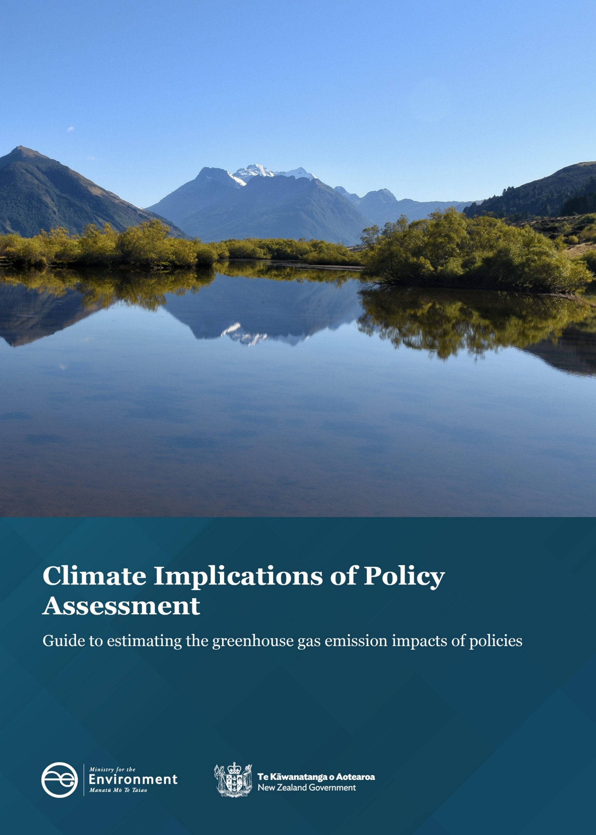
Disclaimer
The information in this publication is, according to the Ministry for the Environment’s best efforts, accurate at the time of publication. The Ministry will make every reasonable effort to keep it current and accurate. However, users of this publication are advised that:
- the information does not alter the laws of New Zealand, other official guidelines, or requirements
- it does not constitute legal advice, and users should take specific advice from qualified professionals before taking any action based on information in this publication
- the Ministry does not accept any responsibility or liability whatsoever whether in contract, tort, equity, or otherwise for any action taken as a result of reading, or reliance placed on this publication because of having read any part, or all, of the information in this publication or for any error, or inadequacy, deficiency, flaw in, or omission from the information in this publication
- all references to websites, organisations or people not within the Ministry are for convenience only and should not be taken as endorsement of those websites or information contained in those websites nor of organisations or people referred to.

This document may be cited as: Ministry for the Environment. 2026. Climate Implications of Policy Assessment: Guide to estimating the greenhouse gas emission impacts of policies. Wellington: Ministry for the Environment.

First published in November 2019.
Updated in July 2020, July 2024 and June 2026 by the
Ministry for the Environment
Manatū Mō Te Taiao
PO Box 10362, Wellington 6143, New Zealand
environment.govt.nz
ISBN: 978-1-991404-46-6
Publication number: ME 1972
© Crown copyright New Zealand 2026

Contents
1. Introduction 5
1.1 Purpose of this guide 5
1.2 Updated CIPA requirements consider impacts on our legislated emissions targets and budgets 5
1.3 CIPA requirement criteria 6
1.4 Who should use this guide 8
2. Understanding the climate implications of policy assessment process 9
2.1 Step 1: Early engagement form or RIA Online portal questions 9
2.2 Step 2: Disclosure form 10
2.3 Step 3: Report and disclose the CIPA 11
2.4 Updating the Minister of Climate Change 12
3. CIPA and other government processes 13
3.1 Ministry for Regulation’s regulatory impact assessment regime 13
4. Undertaking GHG emissions analysis 14
4.1 Structure of the CIPA disclosure form 14
4.2 Steps to carry out GHG emissions analysis to consider climate impacts 14
5. CIPA roles and responsibilities 19
Appendix 1: Preparing CIPA disclosure form 21
Background information for Criteria 2: analysis of GHG emissions implications 21
Background information for Criteria 3 and 4: (analysis of GHG emissions impact on EBs and ERP2 actions) 24
Appendix 2: Examples of how proposals could interact with CIPA criteria 27
Appendix 3: Answers to common questions 29
Questions and support 29
Appendix 4: Further resources 32
Guidance when considering GHG emission impacts of policy proposals 32
Guidance when carrying out GHG emissions analysis 32

Tables
Table 1: CIPA emissions threshold for emissions budgets 7
Table 2: Steps for modelling analysis 15
Table 3: Modelled impacts and emissions budgets 16
Table 4: Steps for assessing GHG emissions impacts when modelling is not available 17
Table A1.1: Examples of how policies may impact on emissions in different sectors 22
Table A1.2: Timescales for reporting GHG emission impacts 23
Table A2.1: Examples of how proposals could interact with CIPA criteria 27

Figures
Figure 1: Relationship to legislated emissions targets and budgets and monitoring progress 6
Figure 2: CIPA process 9
Figure 3: CIPA process and roles 20

1. Introduction

1.1 Purpose of this guide
The purpose of this guide is to support agencies to meet the Climate Implications of Policy Assessment (CIPA) requirement for Cabinet papers. This guide provides information on:
- understanding the CIPA process, criteria and required documentation
- how to complete a greenhouse gas (GHG) emissions analysis, and assess the impact of a proposal on meeting emissions budgets (EBs), and current emissions reduction plan (ERP)
- answers to common questions.
This guide and supporting documents, can be found on the Ministry for the Environment website. For more information, please contact the Ministry’s CIPA team at cipa@mfe.govt.nz.

1.2 Updated CIPA requirements consider impacts on our legislated emissions targets and budgets
Since 2019, central government agencies have been required to report on GHG emissions analysis for policy and regulatory proposals going to Cabinet, provided they meet certain criteria. This is known as the CIPA process.
This information is generally provided as part of a Cabinet paper process by:
- providing a CIPA disclosure outlining the analysis and modelling underpinning the climate implications of the proposal to the Ministry for the Environment, and
- adding a CIPA statement into the Cabinet paper.
In September 2025, Cabinet updated the CIPA purpose and criteria. A CIPA may now be required where estimated emissions impacts meet the quantitative threshold, and/or where a proposal could materially support, hinder or affect progress towards New Zealand’s emissions budgets or current emission reduction plan, even where those impacts cannot be quantified.
The purpose of the CIPA is to provide ministers with information about the climate implications of Cabinet decisions. This includes whether a proposal may have a material impact on New Zealand’s ability to meet its legislated EBs or on current ERP actions or policies. The CIPA process is part of a wider system of climate change monitoring tools and reports that keep ministers up to date on how efforts to meet legislated emissions targets and budgets are going. This system is shown in figure 1.
Figure 1: Relationship to legislated emissions targets and budgets and monitoring progress
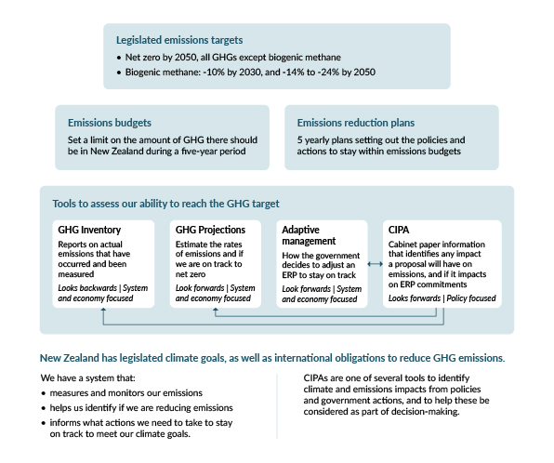

1.3 CIPA requirement criteria
Agencies are required to complete a CIPA disclosure and include a CIPA statement in Cabinet papers for all proposals that meet one or more of the four CIPA criteria.
Criterion 1: Objective
An objective of the policy proposal is to decrease GHG emissions or increase GHG removals.
Criterion 2 (quantitative threshold): 0.25 percent of a budget
The impact on GHG emissions or removals is likely to be equal to or above 0.25 percent of the total permitted emissions in carbon dioxide equivalent (CO₂e) of any of the notified emissions budget periods, whether it be an increase or decrease.
Criterion 3: Materially affects an emission reduction plan
The proposal could materially increase or decrease emissions related to an action or policy within a current emissions reduction plan.
Criterion 4: Materially affects emissions budget(s)
The proposal could materially affect the achievement of one or more of Aotearoa New Zealand’s emissions budgets.

Required actions
For proposals that meet any of the CIPA criteria, agencies are required to:
- evaluate direct and indirect GHG emission impacts of policies
- include a quantified assessment of GHG emission increases, decreases and removals where possible
- assess potential impacts on actions or policies in a current ERP
- ensure the respective portfolio minister is aware of the climate implications of the proposal as part of drafting the Cabinet paper.

Notified emissions budgets
New Zealand’s notified EBs and the CIPA thresholds for EB2 and EB3 are set out in table 1. New Zealand’s EBs cover all greenhouse gases,use net-emissions accounting￼ and are expressed in megatonnes of carbon dioxide equivalent (MtCO₂e).
Table 1: CIPA emissions threshold for emissions budgets
Emission budget (EB) | Total budget | 0.25% CIPA threshold
EB2 (2026–2030) | 305 MtCO₂e | 0.76 MtCO₂e
EB3 (2031–2035) | 240 MtCO₂e | 0.60 MtCO₂e
The government must set EB4 by 31 December 2027
A CIPA may still be required if a proposal’s effects are under the 0.25 percent threshold for a notified EB period, as its impacts may still be ‘material’ (either directly, indirectly or via flow-on effects) to the achievement of EB2 or EB3.

Current emissions reduction plan
The second emissions reduction plan is available on the Ministry for the Environment’s website.

Material impact
As a general guide, a policy proposal may be considered ‘material’ if it increases or decreases emissions or removals in a way that makes it harder or easier to achieve EBs or carry out ERP actions.
It may not be possible to quantify the impact of a policy proposal in CO₂e, or the impact may be less than 0.25 percent of a notified budget. However, the proposal may still have a material effect on progress towards EBs or the implementation of an ERP. This is important information to provide Cabinet.
Assessing material impact is a case-by-case process that should take into account factors such as:
- when in a budget period the effects will occur
- what the progress is towards a budget at that time
- how direct or indirect the effects are
- what mitigations are possible.
Talk to the CIPA team early about what material impact may look like. For further information on assessing material impact see section 4.2 on Steps to carry out a GHG emissions analysis to consider climate impacts and Appendix 1.

1.4 Who should use this guide
Anyone preparing policy or regulatory proposals that may have impacts on GHG emissions, progress towards emissions budgets and targets, or a current emissions reduction plan should use this guide. Specifically, it should be used when preparing:
- policy proposals for ministers and Cabinet
- regulatory proposals that are subject to the Ministry for Regulation’s regulatory impact assessment (RIA) regime.

2. Understanding the climate implications of policy assessment process
This section explains the process for carrying out and reporting on the GHG emissions implications of policy proposals under the CIPA requirement, including on EBs and ERPs.
See section 5 for more information about the roles and responsibilities.
Figure 2: CIPA process
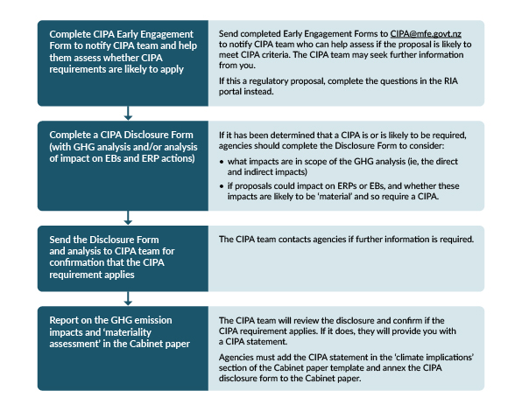

2.1 Step 1: Early engagement form or RIA Online portal questions
Central government agencies developing policy proposals for Cabinet should engage early with the CIPA team if they think their proposals may meet CIPA criteria. Agencies can use the CIPA early engagement form or, for regulatory proposals, the RIA Online portal. Information from the RIA Online portal is passed to the CIPA team automatically (see section 3.1 for more details).
Agencies do not need to be certain that a CIPA is required before engaging with the CIPA team. The early engagement form or RIA Online portal questions will notify the CIPA team of proposals and provide initial information to help them understand if a CIPA is likely to be required. This is particularly useful when the emissions impact cannot be easily quantified or it is not obvious how a proposal may affect achievement of EBs or affect ERPs.
Some proposals clearly meet a CIPA criterion, such as where an objective of the policy proposal is to decrease GHG emissions or increase GHG removals. Others may not be as clear, and agencies may need to provide further information.
The CIPA team will review the early engagement form or information provided via the RIA Online portal and then work with agencies to determine whether to:
- provide a CIPA statement to agencies to confirm CIPA requirements are not met (in the case of straightforward proposals)
- request that agencies complete the disclosure form for proposals (where it is clear this is required)
- request further information from agencies or ask for a disclosure form to be completed (if it is unclear whether CIPA requirements may apply).

2.2 Step 2: Disclosure form
Based on information provided to the CIPA team, you may be asked to complete a CIPA disclosure form.
The disclosure form allows agencies to outline the climate impacts of their proposals in greater detail than the early engagement form and the RIA Online portal questions. It is designed to provide a robust assessment of a proposal’s climate impacts and can provide greater clarity on whether a policy proposal meets CIPA criteria.
The disclosure form records the underlying analysis and modelling of the proposal and its possible effects on GHG emissions, progress towards EBs, or impact on ERPs and is key to ensuring the CIPA team can provide an accurate CIPA statement to include in a Cabinet paper for ministers.
- See section 4 for information on how to complete a CIPA disclosure form. It includes guidance on how to carry out a GHG emissions analysis and assessment for implications on EBs and ERPs.
- Before completing a disclosure form, see Appendix 1 for detailed information on scope.
- For examples of how policy proposals could interact with CIPA criteria, see Appendix 2.
- Send the completed form to the CIPA team for review at cipa@mfe.govt.nz.

The CIPA team will review the information provided and work with agencies to confirm which criteria the proposal meets.
Agencies are responsible for completing all modelling and analysis for a CIPA. The CIPA team will review and check this information, but it does not complete any modelling or analysis on behalf of agencies.

2.3 Step 3: Report and disclose the CIPA
If the decision is that CIPA criteria are met:
- the CIPA team provides agencies with a CIPA statement for their Cabinet paper
- agencies append the CIPA disclosure to their Cabinet paper.
The CIPA team does not proactively release CIPA information but, as CIPA statements are usually of public interest, the team recommends that agencies proactively release the CIPA statement and the disclosure form in line with standard processes.

CIPA statement
The CIPA statement will detail the implications of the proposal on GHG emissions, including impacts on current ERPs and EBs (where applicable), and will be included in the Cabinet paper.
When reviewing the CIPA disclosure and preparing a CIPA statement, the CIPA team will:
- assess whether relevant sources of GHG emissions (activity data) have been reliably identified
- assess how robust the emissions estimates for the activity data are, and the basis for these estimates
- consider any key assumptions or projections that have been flagged through the assessment process
- provide a light-touch quality check (note that most technical quality assurance should be undertaken by the responsible agency)
- consider New Zealand’s current progress towards EBs, and implementation of its current ERP
- consider the implications of the proposal in the context of other proposals that may also have a climate impact.
CIPA statements should appear in the body of the Cabinet paper. The underlying analysis or modelling around GHG emissions can also be included in the Cabinet paper at the agency’s or minister’s discretion.

Is a CIPA statement needed in a Cabinet paper if CIPA criteria don’t apply?
If a proposal does not meet CIPA criteria, it is not necessary to include a CIPA statement or disclosure in the Cabinet paper.
When this is the case, the CIPA team will still provide a statement to confirm that CIPA requirements do not apply to the proposal. The agency or minister can choose to include this information in the Cabinet paper to highlight to Cabinet that due consideration has been given to the issue of climate implications.

If CIPA disclosure cannot be completed before Cabinet
There may be circumstances where there is not enough time or information for a CIPA disclosure to be completed even when required. For example, this may happen when Cabinet requires an urgent paper or decision.
In these situations:
- agencies should provide all available information to the CIPA team who will prioritise support to the relevant agency
- agencies should identify when a full assessment of climate implications is likely to be completed and include this commitment in the CIPA statement section of the Cabinet paper
- the CIPA team will provide a statement for the Cabinet paper noting the limited scope, if it is likely that a CIPA would be required, and any other key information about possible implications even though not fully assessed
- the CIPA team may advise the Minister of Climate Change and the chair of the relevant Cabinet committee of the likely need for a CIPA.
Where applicable, it may be appropriate to include a CIPA disclosure as part of a supplementary analysis report, provided in accordance with Cabinet’s impact analysis requirement. If the submission does not address these issues, the responsible minister and the Minister of Climate Change will jointly determine when and to whom the completed CIPA will be provided, on advice from officials.

2.4 Updating the Minister of Climate Change
The Climate Change Chief Executives Board (the Board) is responsible for monitoring how the policies and actions in an ERP are being implemented. The Board also provides annual advice to the Minister of Climate Change on how New Zealand is tracking towards meeting EB2 (informed by Government projections), any risks and/or opportunities for EB2, then if necessary, advice on any corrective action that may be required to keep New Zealand on track towards EB2.
As part of the CIPA process, the CIPA team regularly update the Climate Change Interdepartmental Executive Board Unit (CCIEB Unit) and the Minister of Climate Change on policy changes or proposals that may be relevant for monitoring ERPs and identifying risks to meeting emissions budgets, regardless of whether a CIPA is required. This is separate from the usual process of ministers or agencies undertaking consultation on policies or Cabinet papers.

3. CIPA and other government processes

3.1 Ministry for Regulation’s regulatory analysis summary
For regulatory proposals, CIPA represents an additional, complementary requirement to those administered by the Ministry for Regulation.
For regulatory proposals, the CIPA early engagement questions are included in the RIA Online process confirmation form. To ensure the same document is sent to both the Ministry for the Environment and the Ministry for Regulation (so helping ensure the agencies can make consistent process decisions), the completed form should be sent to both the Ministry for Regulation and the CIPA team at cipa@mfe.govt.nz.
Agencies should follow steps outlined in the CIPA Guidance to determine whether a proposal requires a CIPA. The CIPA team will work with agencies to confirm their assessment of policy impact and compliance with CIPA requirements.
In terms of outputs, the CIPA disclosure will be integrated into the regulatory analysis summary that accompanies the Cabinet paper. This is in addition to the separate CIPA disclosure form.

4. Undertaking GHG emissions analysis

4.1 Structure of the CIPA disclosure form
Agencies should consider climate implications as a standard part of policy development. How this is done will vary depending on the proposal, availability of relevant data and evidence.
The CIPA disclosure form is where agencies should record their analysis when providing it to the CIPA team. The form has two main parts:
- Sections 1 to 3 cover:
- general information about the proposal (including areas of impact across the economy)
- grounds for CIPA disclosure
- emissions implications for the New Zealand Emissions Trading Scheme.
- Sections 4 to 5 focus on describing and recording the analysis and modelling underpinning the assessment of climate implications and includes:
- details of the modelling approach for the GHG emissions analysis, key assumptions, input data (if modelling is possible and regardless of if the impact is modelled at greater than 0.25 percent of a notified EB)
- policy impacts, setting out how the changes from the proposal may flow on to climate impacts or impacts on EBs etc, especially when it is not possible to model the impact, or the impacts are secondary rather than direct
- a material impact matrix to help identify if the impacts may be ‘material’ in reference to Criteria 3 and 4 (impact to ERP and EB respectively).
Agencies can provide any other relevant information as well.
Read the information provided throughout the rest of this guide and appendices before starting the analysis and modelling.
The disclosure form is available on the MfE website.

4.2 Steps to carry out GHG emissions analysis to consider climate impacts
This section outlines how agencies should approach a GHG emissions analysis. This analysis should be quantitative, using sector-based emission modelling where available, or qualitative where quantitative emissions estimates are not possible.

Modelling GHG emissions impacts
Most of the main economic sectors have a tool or model that will help identify emission impacts (for Land use, Agriculture, Transport, Energy, Waste). These should be used in all possible cases to inform the overall analysis. Quantitative analysis should be done alongside qualitative analysis.
If an emissions model cannot be used but some data is available about the possible emissions, the CIPA team can provide an Excel-based tool that may help.
- The latest annual GHG projections should be used in modelling (information about our economy-wide projections can be found here and is updated annually.
- The Ministry holds consolidated economy-wide modelling that may be an option to explore, particularly for larger proposals seeking to understand the flow-on effects to other areas of the economy, the CIPA team may be able to direct agencies to relevant information.
Note that the CIPA team does not complete any quantitative emissions analysis or modelling on behalf of agencies.
Connect with the relevant agency data or modelling team to support the analysis.

Steps for modelling analysis
Sector-specific models should be used to help identify emissions impacts. When this modelling is done follow the steps outlined in table 2. Agency modelling or data teams should be familiar with these steps and the data required.
Table 2: Steps for modelling analysis
Step | Description
- Confirm the quantified baseline | A baseline sets out the starting point that can then be used to consider what the impacts might be. It is a scenario that sets out what is expected should nothing change (ie, if the proposals are not implemented).  Most of the sector GHG emissions models have already established baselines in place.
- Identify changes in activity data | Activity data measures the actual operational process, human activities etc that are occurring in the real world during a specific time (for example, the number of cars being driven). In some sectors this data may be updated only annually, in other cases it may be updated more frequently.  The potential impact of a proposal must be modelled using the most up-to-date data and information available. This may mean the modelling for a proposal uses more up-to-date figures than the annual sector projections. If this is the case it should be noted to the CIPA team.
- Use the correct emissions factors | Emission factors (EFs) are a measurement unit used to estimate the amount of GHGs that are released into the atmosphere when a specific activity happens.  EFs give some consistency to the calculation and reporting of GHG emissions where there will be some variation in the real world. For example, cars produce a different volume of emissions based on the model, fuel type, condition of engine etc, but an EF evens out those differences so the GHG emissions at a large scale can be calculated.  EFs can be found here Measuring Emissions: A Guide for Organisations.  If there is no appropriate EF, contact the CIPA team.
- Identify possible policy overlaps | Confirm if there are any other policies, interventions etc that might also be affected by this proposal and would ‘act together’ to change emissions or removals. For example:  - Proposal A may increase emissions by X level from an emissions source.  - However, if Policy B (which may reduce emissions by Y) is put in place at a later date, and this affects the same process/behaviour etc, the overall impact of A would be reduced.  It is important to be able to outline to Cabinet the effect of the proposal on its own, as well as in conjunction with other proposals, policies or interventions which may act as mitigations or compounding factors.

Modelled impacts and emissions budgets
Once the modelled impact of the proposal has been completed, agencies should consider how the results compare to the CIPA requirement criteria for a CIPA disclosure and statement. These criteria apply to emissions changes, regardless of whether they are increases or carbon removals. The possible outcomes are noted below:
Table 3: Modelled impacts and emissions budgets
If the GHG impact is | Then
Greater than 0.76 MtCO₂e between 2026 and 2030 (EB2) | A CIPA disclosure and statement is needed under criteria 2.
Greater than 0.60 MtCO₂e between 2031 and 2035 (EB3) | A CIPA disclosure and statement is needed under criteria 2.
Less than 0.76 MtCO₂e for EB2, or 0.60 MtCO₂e for EB3 but greater than 0.60 MtCO₂e across both EBs  (eg, 0.80 MtCO₂e between 2029 and 2032, made up of 0.4 in EB2 and 0.4 in EB3) | A CIPA disclosure and statement is likely needed under criteria 4.
Less than 0.60 MtCO₂e across EB2 and EB3 combined | A CIPA disclosure and statement may be needed under criteria 4.

Proposals and the ETS waterbed effect
The ‘waterbed effect’ is when increases in emissions from a proposed change in one sector end up offset by reductions in another sector (or vice versa) within a cap-based system like the NZ ETS. Most of New Zealand’s key sectors other than agriculture are included in the NZ ETS.
Even if it is estimated that a proposal’s emissions impact will be offset by the waterbed effect over the long term, if the proposed impacts meet the criteria outlined above a CIPA disclosure and statement are still required.
See Appendix 3 for answers to common questions including potential interactions with the NZ ETS.

Information to provide
The disclosure form outlines the information agencies should share with the CIPA team about the modelling. This includes but is not limited to,
- overall quantified impact in CO₂e, the impact per year, per emission budget, and total cumulative impact
- baseline and inputs used, and outline of assumptions applied to modelling, and uncertainty around those
- the main drivers of emission volumes for each key source of impact, and if carbon leakage is likely.

Assessing GHG emissions impacts when modelling is not available
It is not always possible to model or quantify the emissions or removals a proposal may create, especially when these are secondary or indirect. Regardless, there may still be impacts or implications that Cabinet should be aware of when making decisions.
Table 4: Steps for assessing GHG emissions impacts when modelling is not available
Step | Description
- Identify any modelled impact on the most recent progress towards an EB | Even if a modelled impact is less than 0.76 or 0.60 MtCO₂e, it may still have a material impact on the actions in an ERP or on the ability to achieve a budget.  Even a small emissions impact may make it harder to achieve an EB, especially in the last year or two of a budget period, when some of the budget will have already been ‘spent’.  As part of your analysis, find out how New Zealand is tracking towards its notified budgets based on the most up-to-date projections that can be found here.
- Confirm if a proposal changes the actions set out in the latest ERP | ERP2 is available here.  ERP3 will be developed in 2029, and in effect from 2031.
- Identify possible policy overlaps | Confirm if there are any other policies or interventions etc that might be affected by this proposal and will ‘act together’ to change emissions or removals. For example:  Proposal A may be anticipated to increase emissions level from an emissions source.  However, if Policy B which may reduce emissions by Y is put in place later, which affects the same process or behaviour etc the overall impact of A would be reduced.  It is important to outline to Cabinet the effect of the proposal on its own as well as in conjunction with other proposals, policies or interventions which may act as a mitigation or compounding factor, regardless of ability to model them.
- Use the Policy Emissions Impacts table  (See section 5 of the Disclosure form) | This table helps set out what the intended or possible changes are from a policy, the immediate or secondary results, and how these may affect emissions.  Agencies may have completed something similar (such as an intervention logic map) as part of their overall policy development. In these situations, if that information covers the relevant information then it can be provided instead of completing the table.
- Use the Material Impact Matrix  (See section 5 of the Disclosure form) | This matrix helps identify, based on the emissions impacts, how material the impacts may be.  There is more information in Appendix 1 about what ‘material’ impact may mean.

Material impact and the CIPA criteria
Agencies should determine the material impact of the proposal in line with the CIPA criteria and the information provided in Appendix 1.
The CIPA team will review this and confirm if the criteria have been logically applied and all relevant information has been considered and weighted appropriately.

Information to provide
The disclosure form outlines the information agencies should share with the CIPA team about the analysis, including:
- a copy of the Policy Emissions Impacts table (section 5 of the disclosure sheet), unless a similar documented analysis that covers the relevant information can be provided instead
- an outline of how any relevant Emission Reduction Plan content will be affected by the proposal.
Agencies can supply any additional information to outline the rationale behind the assessment of materiality.

5. CIPA roles and responsibilities
Roles and responsibilities in the CIPA process are outlined below. Figure 3 provides an overview of roles in the CIPA process.
Agencies developing policy proposals should:
- consider GHG emission impacts as part of policy development
- complete any modelling of GHG emission impact for the proposal
- confirm if the proposal changes anything in a current ERP
- contact the CIPA team (as required) for advice during policy development
- complete the Early Engagement Form to notify the CIPA team of a possible CIPA statement requirement, or notify the CIPA team through the RIA Online portal
- complete the CIPA disclosure form as needed to outline how the GHG emissions implications of the policy have been considered, and what the likely impact is.
The CIPA team will:
- provide ad-hoc advice to agencies if requested on possible GHG emissions impacts during the policy development process
- review early engagement forms and requests from agencies to confirm if a CIPA disclosure may be required
- review information provided by agencies on proposals and CIPA disclosure if one is required
- draft a CIPA statement for inclusion in the Cabinet paper
- keep Minister of Climate Change up to date with policies that may impact on statutory duties in relation to New Zealand’s climate targets and budgets, and inform the CCIEB Unit.
Note: The CIPA team does not comprehensively quality assure agency modelling or endorse or approve a policy or Cabinet paper. Rather, the CIPA team:
- acts as an external assurance for Cabinet that material GHG emissions impacts have been robustly and sensibly assessed and identified for their decision-making
- does general ‘sense checks’ of agency modelling
- confirms compliance with CIPA requirements.
Figure 3: CIPA process and roles
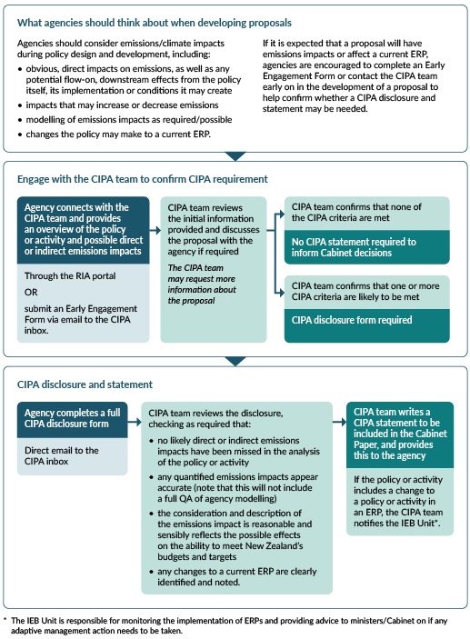

Appendix 1: Preparing CIPA disclosure form

Background information for Criteria 2: analysis of GHG emissions implications

Scope of analysis
An analysis of GHG emissions implications should be carried out for the preferred policy options (both the agency’s and the minister’s, should they differ). A GHG emissions analysis may also be undertaken for other options that were considered.
For Cabinet papers that present a range of options (for example, for the purposes of a consultation document), the GHG emissions analysis may be presented at a high level. The Ministry for the Environment expects a more detailed analysis to be completed once the range of options has been narrowed to preferred options.
The direct GHG emission impacts of policy proposals must be reported on, and the assessment should also consider indirect GHG emission impacts where possible.

Direct impacts
There is no clear consensus on the definition of direct and indirect GHG emission impacts internationally. For the purposes of the CIPA requirement, the Ministry for the Environment has defined direct impacts as those that flow automatically from the implementation of the proposed policy or decision. Direct GHG emission impacts can be further categorised as follows:
- Embodied GHG emission impacts are the GHG emissions associated with the consumption of materials in the production process. For example, in the construction of infrastructure, embodied emissions are from manufacturing and use of materials such as steel and cement.
- Operational GHG emissions are the GHG emissions associated with the ongoing operation of a policy or investment proposal. For example, for the creation of new infrastructure operational emissions span the design life of the structure and include emissions from associated appliances (such as air conditioners, hot water systems, refrigeration and lighting).
- GHG emissions associated with the rebound effect may result from proposals that improve energy efficiency (such as a heating policy) and reduce the overall amount of energy used. An immediate result will be a reduction in energy bills. This frees up funds that can be spent on energy or other goods and services.
For the purposes of the CIPA requirement, the Ministry for the Environment has defined rebound effects only in relation to changes in energy demand (both electricity and transport fuels). They will therefore be most relevant to proposals that are put forward by the Ministry for Business, Innovation and Employment, Ministry of Transport, the Energy Efficiency and Conservation Authority, and the New Zealand Transport Agency. The rebound effect may also be relevant to proposals that reduce biogenic methane emissions, particularly through technology.

Indirect impacts
The CIPA disclosure may include an assessment of any indirect GHG emission impacts of a policy proposal. These GHG emission impacts are less attributable to the policy proposal but may occur over a longer timeframe because of the policy.
Indirect impacts often include behavioural changes or technological changes.

Embodied emissions
The CIPA requirement refers to GHG emissions generated in New Zealand, so the direct GHG emissions from imported goods should not be included. This is most likely to be relevant for materials imported for manufacturing, such as steel or aluminium.

Main GHG emitting sectors
Analysis of the GHG emission impacts of proposals should consider the impacts on the following sectors. The CIPA requirement only applies to the GHG emissions identified and defined in New Zealand’s GHG Inventory. This covers carbon dioxide, methane, nitrous oxide and fluorinated gases.
There are several ways that policy proposals could increase or decrease emissions or removals (directly, indirectly or via flow-on effects) in these sectors. Examples include, but are not limited to the following:
Table A1.1: Examples of how policies may impact on emissions in different sectors
Sector | Examples of ways policies may impact on sectors
Electricity | Policies that have an impact on:  - renewable sources to replace fossil fuels in electricity generation  - the amount of electricity demanded, for example the building of a factory  - the electrification of process heat  - geothermal carbon capture and storage  - the energy efficiency of buildings.
Transport | Policies that have an impact on:  - total vehicle kilometres travelled by internal combustion engine vehicles (including public transport)  - fuel switching from fossil fuels to lower emission alternatives, such as electricity (battery), hydrogen and biofuels  - transport mode change (passenger and freight)  - electric vehicle uptake.
Waste creation or management | Policies that will result in an increase or decrease in waste going to landfill.
Agriculture (including biogenic methane and nitrous oxide) | Policies that have an impact on:  - the number and types of livestock on farms  - use of nitrogen fertiliser.
Land use, forestry, or wood products | Policies that have an impact on:  - the amount of land converted to or from forest land  - regeneration of native forest  - changes in forest type or species.
Industrial processes and product use | Policies that have an impact on:  - the use of greenhouse gas emitting process heat fuels and fuel switching to biomass  - energy efficiency in process heat  - changes in materials being used in construction.

Timescales for analysis
Table A1.2: Timescales for reporting GHG emission impacts
Time period | Report on GHG emission impacts?
2020–25 | Yes
2026–30 | Yes
2031–35 | Yes
2036–40 | Where possible
2041–45 | Where possible
2046–50 | Where possible

The Climate Change Response (Zero Carbon) Amendment Act sets in statute a GHG emissions reduction target for 2050. A series of five-year GHG emissions budgets act as stepping stones to reach that target. At a minimum, the CIPA disclosure should report on the GHG emission impacts of policy proposals to 2035, to align with the first three GHG emission budgets.
Where possible, the CIPA should also report on the GHG emission impacts for the 2036–40, 2041–45 and 2046–50 GHG emission budget periods (acknowledging that the government will not have yet received advice on what these budgets should be), to align with the GHG emissions reduction target for 2050.

Sensitivity analysis
There will be a level of uncertainty in the expected changes in activity data, particularly in relation to future impacts of policy proposals. There may also be uncertainty around the appropriate base case or counterfactual. It is optional, but encouraged, to carry out a sensitivity analysis around the CIPA results and present this appropriately. For example, for policy proposals with a high level of uncertainty, it may be appropriate to present the results in terms of low, central and high scenarios.

Examples

Research and development (R&D)
Policy proposals that encourage the development of lower-emitting technologies will have an impact on GHG emissions. For example, the decision to create a new R&D fund may lead to increased innovation that helps to develop new, lower-emitting technologies. However, it may be challenging to attribute the development of these technologies to the decision to create a new R&D fund as any new technologies may be developed many years after the creation of the fund and may have resulted from the cumulative impact of several technological advances, innovations and knowledge spillovers.
It is likely that the bulk of the GHG emission impacts would be classified as indirect. Where possible, agencies should consider these in their GHG emission analysis. Contact the Ministry for the Environment CIPA team for support at cipa@mfe.govt.nz.

Transport mode shift
A shift from the use of fuel-powered vehicles to public transport and other types of low-emissions transport would be associated with:
- a decrease in emissions associated with a decrease in the use of fossil fuels
- an increase in emissions associated with increased electricity demand, as uptake of electric vehicles increases.

Fuel switching for the purposes of industrial process heat
For policies that encourage fuel switching for the purpose of industrial process heat, for example from coal and gas to electricity or biomass, there may be changes in GHG emissions associated with:
- a reduction in fossil fuel use
- an increase in electricity demand, or an increase in the amount of biomass being used.

Background information for Criteria 3 and 4: (analysis of GHG emissions impact on EBs and ERP2 actions)
The updated CIPA requirements require agencies to consider indirect GHG emissions impacts where possible alongside direct impacts and to consider interactions between policy proposals and our emissions budgets and ERPs.
Agencies will also need to complete an assessment in the disclosure form to assess ‘material’ impact on emissions budgets or ERP actions.

Actions in New Zealand’s second emissions reduction plan (ERP2)
Key quantified ERP2 policies are:
- Electrify NZ
- enabling carbon capture and storage
- increasing the number of EV chargers by 2030
- introducing a refrigerants regulated product stewardship scheme
- limiting whole-farm conversions to forestry on high-quality land
- afforestation on Crown-owned land
- investing in resource recovery through the Waste Minimisation Fund
- improving organic waste management and landfill gas capture
- supporting and accelerating the uptake of new technologies in agriculture, forestry and energy.
For a full list of ERP2 policies and actions see the second emissions reduction plan here.

What is ‘material impact’?
Agencies will need to assess if their proposals materially affect EBs or ERP actions, with the CIPA team providing a sense-check where necessary. As a general guide, a policy proposal may be considered material if it increases or decreases emissions or removals in a way that makes it harder or easier to achieve New Zealand’s emissions budgets or ERP actions.
When considering if the proposal is ‘material’, agencies should consider a wide range of factors including:
- how likely the emissions impact is
- how significant the emissions impact is
- the size of the buffer compared to the size of the emissions impact
- what mitigations are in place or can be put in place for any emission increase
- if the proposal could increase or decrease the emissions profile of a sector
- if the proposal changes the emissions from a main emissions source in New Zealand’s Greenhouse Gas Inventory
- if the proposal is likely to impact demand for or supply of emissions-affecting technologies and investments.

Emission impacts can be indirect or hard to quantify, but this doesn’t rule out a possible impact through:
- direct consequences of the proposal’s intent or implementation
- flow-on or secondary effects from the conditions the proposal creates
- unintended consequences that may arise.
Material impact may look different depending on many factors, such as which sectors are affected, how the policy impacts drivers of emissions, when the emissions occur, and what progress New Zealand has made towards its targets and budgets when the proposal is implemented.

Key terms to assess material impact in the disclosure form
Agencies should use the key terms in table A1.2 when completing the Policy Impacts Table in 5. of the disclosure form. The same key terms apply to the Material Impact Matrix.
The table, matrix and key terms have been designed to work together to help agencies assess whether a policy proposal is likely to have material impact and whether a CIPA statement is required.

Appendix 2: Examples of how proposals could interact with CIPA criteria
Table A2.1: Examples of how proposals could interact with CIPA criteria*
CIPA Scenarios | What happens in this scenario? | Hypothetical examples of policy proposals
1. CIPA does not apply: no criteria met | For many policy and regulatory proposals, none of the CIPA criteria are met. For these proposals, the CIPA team will provide you with a generic CIPA statement you can use in the relevant Cabinet paper, which notes that the CIPA requirement does not apply. | - A proposal to change firearm regulations.  - A proposal to review regulations.  - A proposal about toy safety.  - Any proposal at discussion document stage.
2. CIPA does not apply: material emissions impact not likely | Some proposals relate to fossil fuel, forestry, or agriculture emissions, but do not intend to reduce emissions or meet other CIPA criteria that require a full CIPA disclosure. For these proposals, the CIPA team will provide a more detailed CIPA statement explaining why the proposal does not meet the CIPA requirements, usually after meaningful engagement with the proposal’s authors. Agencies may or may not need to complete a CIPA disclosure sheet to establish that material impact is not likely. | - A proposal that temporarily increases fossil fuel supply might not meet any CIPA criteria.  - A proposal that marginally alters farming regulations.
3. CIPA applies: direct and/or emissions impact likely, but modelling is not currently possible | Some proposals are likely to have emissions impacts but modelling may not be possible for technical reasons, capacity reasons, or due to the wide range of potential outcomes. In this scenario, agencies should complete the CIPA disclosure form, excluding the parts of the disclosure focused on GHG estimation. | - A proposal that is intended to increase the number of data centres in New Zealand would necessarily increase energy use, but may have uncertainty about what energy would power the data centres.  - A proposal to increase immigration could entail increased energy use, but the emissions impacts would be dependent on broader immigration and emigration conditions, as well as other decisions about the nature of energy in New Zealand.
4. CIPA applies: the proposal relates to an ERP action, but is below the CIPA quantitative threshold | Proposals that relate to an ERP action may still require a CIPA, even if the estimated emissions impact is below the quantitative threshold. In this case, agencies should complete the CIPA disclosure to the best of their ability, and the CIPA team will provide a statement noting which ERP actions the proposal relates to, as well as the potential impacts. The statement should be included in the Cabinet paper body, with the relevant parts of the disclosure added to an annex. | - A proposal that relates to the Electrify New Zealand goal of increasing the number of EV chargers.  - A proposal that improves emissions data for building products, materials and buildings.  - A proposal that accelerates deployment of mitigation tools and technology for on-farm emissions reduction.
5. CIPA applies: direct emissions impact likely, modelled and above the quantitative threshold. No ERP relation. | As has always been the case, for proposals with estimated emissions impact above the quantitative thresholds (0.25% of any EB), a CIPA is required, even if there is no relation to ERP actions. In this scenario, agencies should complete the disclosure form and send it to the CIPA team. The CIPA team will provide a statement summarising the expected emissions impacts. The statement should be included in the Cabinet paper body, with the relevant parts of the disclosure added to an annex. | - A proposal that subsidises national public or personal transport.  - A proposal for a large direct air carbon capture and storage system.  - A proposal that increases fossil fuel imports.
6. CIPA applies:  Emissions impact likely, has been modelled, and could affect the achievement of emissions budgets, even though emissions are below the quantitative threshold. No ERP relation. | Proposals that could affect the achievement of emissions budgets require a CIPA, even where the estimated emissions impact is below the quantitative threshold. This is because the margins for achieving New Zealand’s emissions budgets can be relatively small. In this scenario, agencies should complete the disclosure form and send it to the CIPA team. The CIPA team will provide a statement summarising the expected emissions impacts. The statement should be included in the Cabinet paper body, with the relevant parts of the disclosure added to an annex. | - A proposal that has the effect of increasing dairy, cattle or sheep herds.  - A proposal that drives an increase in forestry-based removals.  - A proposal to conserve fuel for energy security.
7. CIPA applies: direct emissions impact likely, has been modelled, and is above the quantitative threshold. Also relates to an ERP action or policy. | Proposals that can have their emissions modelled, are above the quantitative threshold, and relate to ERP actions need a disclosure sheet to be completed and sent to the CIPA team. The CIPA team will provide a statement summarising the expected emissions impacts and relation to ERP actions. The statement should be included in the Cabinet paper body, with the relevant parts of the disclosure added to an annex. | - A proposal that adjusts New Zealand’s emission reduction targets.  - A proposal that adjusts NZ ETS settings above the CIPA quantitative threshold.  - A proposal to increase renewable electricity and deliver Electrify New Zealand goals.

*Note, scenarios and examples are intended to be illustrative and are non-exhaustive

Appendix 3: Answers to common questions

Questions and support
For further questions about the process or guidance, the climate implications of policy assessment (CIPA) team at the Ministry for the Environment can help. Please contact the CIPA team at cipa@mfe.govt.nz for advice.

What if the information is uncertain, or there isn’t enough?
Where possible, agencies should quantify impacts on activity data. This is done through thorough policy impact analysis, which will help inform the CIPA disclosure form.
This requires research, so that options are informed by evidence. Agencies will need to make judgements based on the best available evidence and what is reasonable and fit-for-purpose analysis for the proposal.
For example, agencies will make judgements about the policy intervention options (such as what options are feasible), the counterfactual and impact assumptions. Developing policy options are inherently uncertain, as this requires advising on changes that may occur in the future.

What if there are impacts across multiple sectors?
The reporting template allows agencies to report on GHG emissions impacts in more than one sector. Agencies should ensure that all assessments of changes in GHG emissions consider the interactions that policies and projects in one sector can have on other sectors. For instance, planning decisions may impact on transport emissions, as well as GHG emissions in buildings through GHG-embodied emissions in construction, and GHG emissions arising from energy use in buildings.
The impacts of policies or projects might also overlap or reinforce each other, impacting their combined effectiveness. The analysis should account for any interaction. For example, the savings from a new, efficient boiler will be lower in a house that already has cavity wall insulation.

What about carbon leakage?
Carbon leakage occurs where, for reasons related to the cost of climate policies, businesses transfer production to other countries with less stringent emissions constraints. This could lead to an increase in those countries’ total emissions. The risk of carbon leakage may be higher in certain energy-intensive industries.
Agencies are not required to report on carbon leakage, but can choose to report on the likelihood or risk of carbon leakage in the CIPA disclosure form.

What if policies directly or indirectly impact emissions in NZ ETS sectors?
Following Cabinet agreement in September 2025, agencies should more explicitly consider whether a proposal could affect emissions under the NZ ETS or enable the ETS to operate more efficiently and effectively.
It is widely understood that cap-and-trade systems like the NZ ETS can prevent other policies from having any additional effect on overall emissions covered by the scheme. This neutralising effect is called the ‘waterbed effect’. The waterbed effect arises when emissions reductions in one area are offset by increases elsewhere within the ETS-covered sectors, leaving total emissions unchanged. Economic theory suggests that under a fixed, binding cap these additional impacts pass through to NZU prices, driving offsetting responses by ETS participants.
In practice, this offsetting response is delayed and spread over time, as participants draw on or add to a substantial stockpile of banked NZUs and adjust only slowly to price signals. Additionally, participants cannot instantaneously respond to altered demand for NZUs, as planning and investment changes can take time.
As a result, policies that reduce emissions under the ETS cap may ease the achievement of near-term targets. Policies that increase emissions under the cap may make near-term targets harder to meet, even where long-term effects are largely or fully offset. Over a long enough timeframe, with net emissions from ETS sectors limited to the long-run ETS cap (the total supply of NZUs) it is likely that the increase or reduction in emissions associated with the non-ETS policy will be more or less fully offset, all else being equal. These considerations underscore the need to understand how policies interact with the ETS cap and how they are assessed under CIPA.
While the waterbed effect can have a dampening effect on the effectiveness of proposals that reduce emissions, it is still important for agencies to consider the direct and indirect emissions impacts of their proposal and detail these in their CIPA disclosures. This is because:
- the purpose of CIPA is to provide ministers with information about how proposals impact the achievement of EBs. Since the waterbed effect is delayed and spread over time, proposals that increase or decrease emissions could impact the achievement of EBs before the waterbed effect plays out
- the Ministry for the Environment uses this information to help inform projections of New Zealand’s gross and net emissions
- New Zealand’s EBs cover all domestic emissions, including emissions under the NZ ETS and emissions from agriculture and other small sectors that sit outside of the NZ ETS. The NZ ETS cap is set for five-year periods and helps ensure that New Zealand achieves emissions reductions by ETS-covered sectors that help achieve our EBs. In response to proposals that increase or reduce emissions covered by New Zealand’s budgets, the government can decide to adjust the NZ ETS cap accordingly to help achieve EBs
- information about how proposals could affect emissions or removals can provide useful context for the government’s annual ERP2 adaptative management advice
- the proposal may help or hinder emissions reductions related to an ERP policy or action, regardless of whether the ETS waterbed effect materialises. Under CIPA, such interactions must be declared and the policy’s impacts on ERP policies or actions assessed
- if the proposal affects short-term demand for NZUs, details about emissions or removals can help inform the ETS policy team’s decisions about ETS auction volumes and price settings.

What if a CIPA statement needs updating?
There are times where CIPA statements may need to be updated based on new information or for other minor corrections. CIPA statements provided by CIPA team should not be adjusted without prior agreement. Contact the CIPA team, who can provide updated text.

Appendix 4: Further resources
See below for further resources to use when considering the GHG emission impacts of policy proposals and when carrying out GHG emissions analysis.

Guidance when considering GHG emission impacts of policy proposals
- Measuring Emissions Guide
- New Zealand's Greenhouse Gas Inventory
- New Zealand’s Interactive Emissions tracker
- New Zealand's First Biennial Transparency Report
- New Zealand’s projected GHG emissions
  - Note, the central projection (WAM B central) and related surplus or ‘buffer’ may be useful when assessing materiality for ‘affect achievement of EBs’

Guidance when carrying out GHG emissions analysis
- Government Expectations for Good Regulatory Practice
- Cabinet Circular: Expectations for Good Law-making
  - Note, this circular will come into effect on 1 July 2026
- Information about Regulatory Impact Analysis
- Guide to Social Cost Benefit Analysis
- The Regulatory Analysis Summary Process – Guidance Note

Cabinet agreed to an updated CIPA purpose and requirements as part of policy decisions on the Climate Change Response Amendment Bill, in September 2025.
See Appendix 1 for further information on direct and indirect impacts.
Carbon removal activities refer to deliberate technologies, practices and approaches that remove CO₂ from the atmosphere and store it long term in another CO₂ pool, such as vegetation, soil or the ocean.
Section 5X of the Climate Change Response Act 2002 sets out the duty on the Minister of Climate Change to set emissions budgets and to ensure they are met.
Net emissions are the difference between gross emissions and carbon removals. Net emissions provide information on emissions and removals in any given year as the result of all human activities in New Zealand.
Chapter 3 of ERP2 outlines the government’s adaptive management approach for meeting EB2.
Ministry for the Environment. 2025. Measuring Emissions: A Guide for Organisations. Wellington: Ministry for the Environment.
Further information on the waterbed effect is available at page 74 of New Zealand's second emissions reduction plan 2026–30: Technical annex – Amended January 2026 | Ministry for the Environment
Policies may lead to the re-allocation of production to countries/regions with less stringent mitigation, leading to higher emissions there.
Quantified ERP2 policies are set out in the ERP Technical Annex: New Zealand's second emissions reduction plan 2026–30: Technical annex – Amended January 2026 | Ministry for the Environment
At present the EB2 buffer is 4.5 MtCO₂e, but this will change year on year. Refer to Ministry for the Environment Emissions Projections for current estimates, or contact the CIPA team for further information.
ECO-MIN-0151 – Climate Change Response Amendment Bill: Policy Decisions

