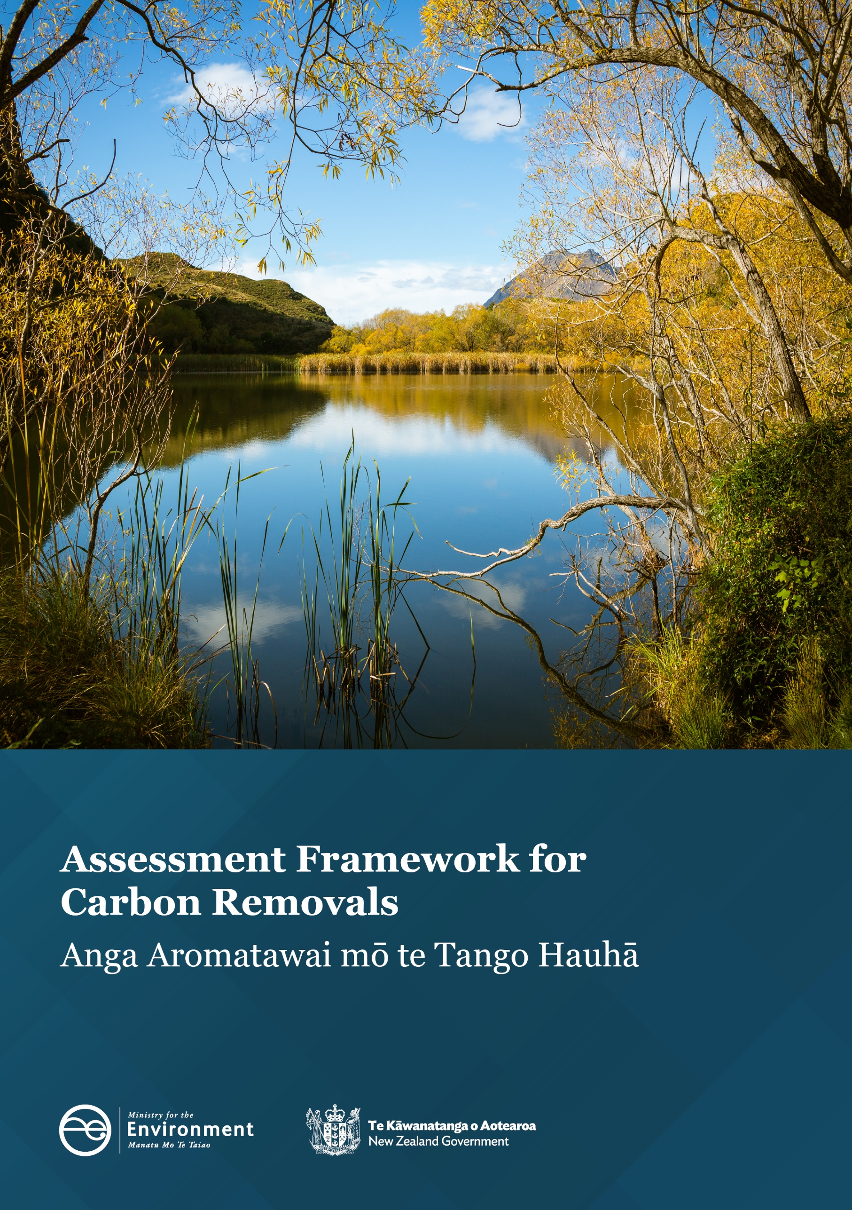
Subject to editing, formatting and proofing

Disclaimer
The information in this publication is, according to the Ministry for the Environment’s best efforts, accurate at the time of publication. The Ministry will make every reasonable effort to keep it current and accurate. However, users of this publication are advised that:
- the information does not alter the laws of New Zealand, other official guidelines, or requirements
- it does not constitute legal advice, and users should take specific advice from qualified professionals before taking any action based on information in this publication
- the Ministry does not accept any responsibility or liability whatsoever whether in contract, tort, equity, or otherwise for any action taken as a result of reading, or reliance placed on this publication because of having read any part, or all, of the information in this publication or for any error, or inadequacy, deficiency, flaw in, or omission from the information in this publication
- all references to websites, organisations or people not within the Ministry are for convenience only and should not be taken as endorsement of those websites or information contained in those websites nor of organisations or people referred to.

This document may be cited as: Ministry for the Environment. 2025. Assessment Framework for Carbon Removals. Wellington: Ministry for the Environment.

Published in November 2025 by the
Ministry for the Environment
Manatū mō te Taiao
PO Box 10362, Wellington 6143, New Zealand
environment.govt.nz
ISBN: 978-1-991404-20-6
Publication number: ME 1933
© Crown copyright New Zealand 2025

Contents
Removals are a vital tool to tackle climate change 5
The Assessment Framework 7
Who this framework is for 7
What this framework covers 7
How this framework helps 7
How this framework interacts with the wider removal activity landscape 8
The Assessment Framework process 9
Preparation stage 10
Assessment stage 12
Scientific criteria 12
Inclusion considerations 16
Decision-making and implementation stage 19
When can units be traded in the NZ ETS for a new activity? 19
Next steps for the Assessment Framework for Carbon Removals 19
Appendix 1 20
How the framework helps with units and carbon credits 20
How removal activities interact with New Zealand’s GHG Inventory reporting and NDC 22
Appendix 2 23
Glossary 24

Tables
Table 1: Steps to prepare for the assessment 10
Table 2: Criteria and required information for the readiness part of the science assessment 13
Table 3: Criteria and required information for the sufficiency part of the science assessment 14
Table 4: Summary of evidence assessment for each criterion, which will be considered in context of other criteria to support an overall recommendation 15
Table 5: Inclusion considerations – data and reporting 16
Table 6: Inclusion considerations - impact on NZ ETS and NDC 17

Figures
Figure 1: Five pillars of the Government’s Climate Strategy 5
Figure 2: Net-based approach 6
Figure 3: Main stages in the Assessment Framework process 9
Figure A1: How the NZ ETS market works 21
Figure A2: Interactions between the GHG Inventory, target accounting, New Zealand’s NDC and the NZ ETS 22
Figure A3: Assessment Framework for Carbon Removals process 23

Removals are a vital tool to tackle climate change
This document explains the Assessment Framework for Carbon Removals (the Assessment Framework). The Assessment Framework supports people and organisations who want their activities that remove carbon dioxide (CO₂) from the atmosphere recognised and rewarded. The second emissions reduction plan, released in December 2024, is the Government’s plan to meet the second emissions budget. In it, the Government recognised the importance of encouraging a variety of removal methods and signalled it would develop this framework to help the recognition and rewarding of removal activities.
The Assessment Framework aligns with the Government’s Climate Strategy, which organises the approach to reducing the impacts of climate change and preparing for its future impacts under five pillars (see figure 1). Actions to remove greenhouse gases from the atmosphere support three of these pillars:
- Pillar 2: Credible markets support the climate transition
- Pillar 4: World-leading climate innovation boosts the economy
- Pillar 5: Nature-based solutions address climate change.
Figure 1: Five pillars of the Government’s Climate Strategy
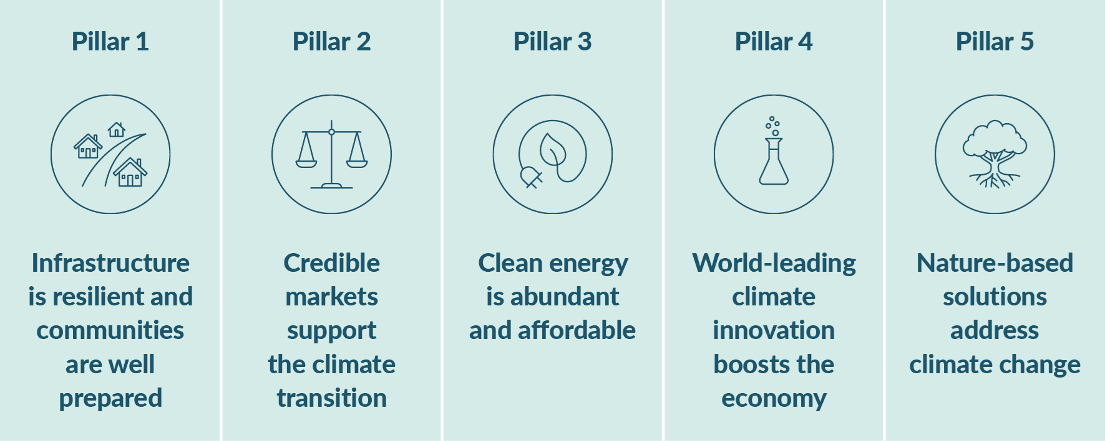
Removing greenhouse gases like CO₂ from the atmosphere is a vital part of New Zealand’s climate change response. Vegetation and soils do this naturally in the environment and are examples of ‘nature-based’ removals. Other types of removals include technological removal activities, such as direct air capture and storage. Removal activities can occur on land or in the ocean.
Forestry is currently the removal activity with the largest impact in New Zealand. A range of people and organisations in New Zealand are already actively exploring other nature-based projects, new technologies and opportunities to diversify the types of removal activities that happen here.
In Aotearoa New Zealand, our focus is on reducing emissions and making the most of the country’s unique environment to remove greenhouse gases from the atmosphere. This is often referred to as a ‘net-based’ approach to climate change (see figure 2) and makes sure we use all the tools available to meet the country’s nationally determined contribution (NDC) and domestic targets.
Figure 2: Net-based approach
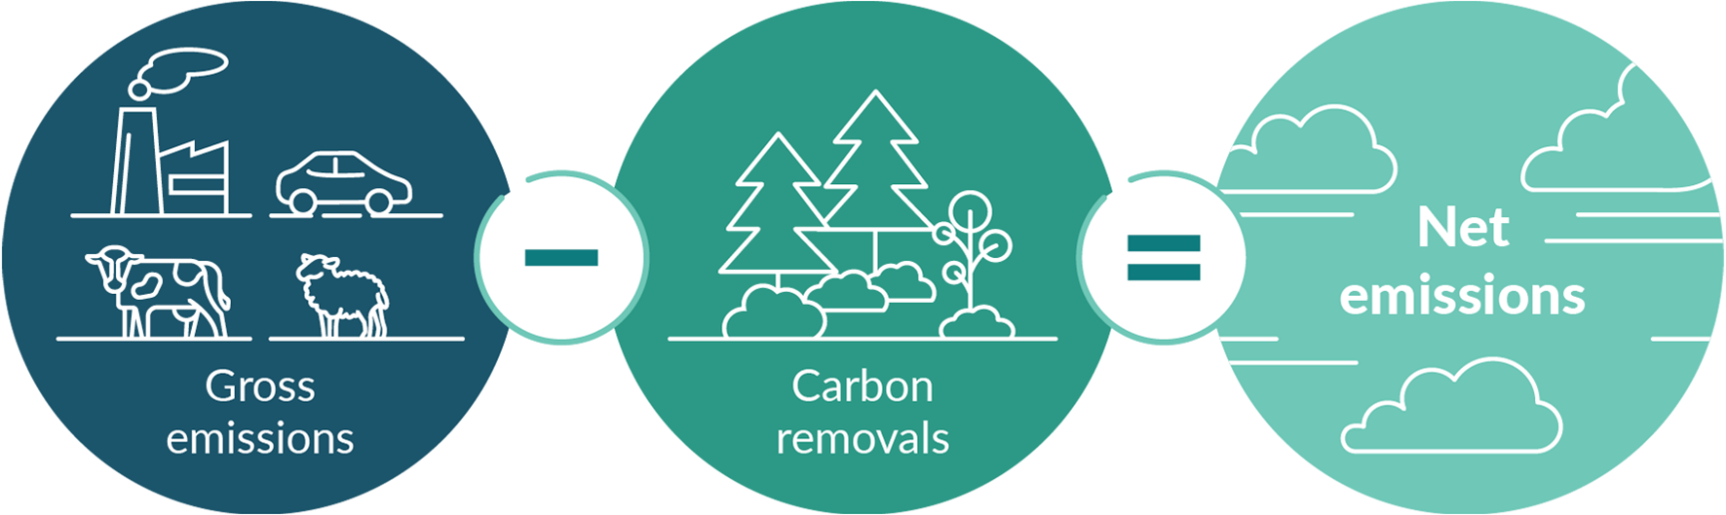
New Zealand has a target of net zero emissions by the year 2050. As stepping stones towards this target, emissions budgets place limits on emissions for specific periods. The first emissions budget covers the period 2022–25, and the second emissions budget covers the period 2026–30.

The Assessment Framework for Carbon Removals

Who this framework is for
The Assessment Framework is for anyone, including businesses, landholders, sector groups, environmental groups, iwi, hapū, interested in:
- pursuing some kind of removal activity project and wanting assurance of its scientific validity
- investigating the best way to get rewarded and recognised for removal activities through voluntary markets or the New Zealand Emissions Trading Scheme (NZ ETS).

What this framework covers
The framework process has three key stages:
- Preparation stage (which will include a self-assessment process being made available)
- Assessment stage in two parts – a science assessment and an inclusion assessment
- Decision-making and implementation stage.
The science assessment can be used regardless of whether someone is interested in voluntary markets or the Government including it in the NZ ETS or NDC. Removal activities need to meet high scientific standards before they can be included in voluntary markets and traded with integrity and confidence, included in the NZ ETS, or counted towards the NDC.

How this framework helps
The framework process has several important benefits for project owners/interested parties:
- helps them understand the robustness of the science needed to underpin a removal activity before it is likely to be considered for a high integrity voluntary market or by the Government for some form of recognition
- helps them make informed decisions about what market structures may suit their project best
- helps them understand the process by which the Government will review and consider any removal activity before taking decisions on if it should be included in the NZ ETS or NDC.
The Ministry for the Environment (the Ministry) will use the framework to review the scientific basis of any new removal activities that applicants request an assessment of, or that the Government has an interest in. The Ministry can then give potential project owners and methodology developers insights into how suitable, reliable and fit for purpose the activity is.

Benefits for New Zealand of diverse removal activities
- More diverse avenues to address climate change and manage risks
- Co-benefits like biodiversity improvements, habitat development for native species, water quality or climate resilience
- Economic benefits through job creation, creation of new markets or trade opportunities
- Potential to expand the activities that count towards New Zealand’s climate change targets
- Climate resilience in New Zealand communities and environment

How this framework interacts with the wider removal activity landscape
This Assessment Framework is part of a wider landscape of policies, processes and schemes focused on carbon removals nationally and internationally. There are voluntary markets that groups and companies can access which the Government does not regulate. Landholders and project owners can use these markets to monetise removal activities. While the Government does not regulate these markets, it is committed to ensuring high integrity, including through work underway for a New Zealand voluntary nature credits market (VNCM). For more information about the VNCM, see the Ministry webpage Voluntary nature credits market in New Zealand.
There is also the NZ ETS, where removal activities can be translated into units and traded, including through purchases from emitters. Currently, forestry is the main removal activity traded on the NZ ETS. The Government regulates the NZ ETS, and any decision to credit a new activity via the scheme requires a Cabinet decision and the making of regulations.
Under the Paris Agreement, every country has an NDC, which is the contribution each country will make towards meeting the goals from the Paris Agreement, including limiting global temperature rise. We can include removal activities in the accounting for our NDC, though the activity must occur at a scale at which it can be measured and reported on across the whole country.
Appendix 1 has more detail about the interaction between the Assessment Framework, voluntary markets, the NZ ETS and the NDC.

The Assessment Framework process
The Assessment Framework will cover a range of removal activities, and people will be able to choose to exit the framework process at any time to explore options in voluntary markets. The main stages in the framework are preparation, assessment, and decision-making and implementation (see figure 3 for an overview and Appendix 2, for more detail). A self-assessment tool will be available from 2026 to support the preparation stage.
Figure 3: Main stages in the Assessment Framework process
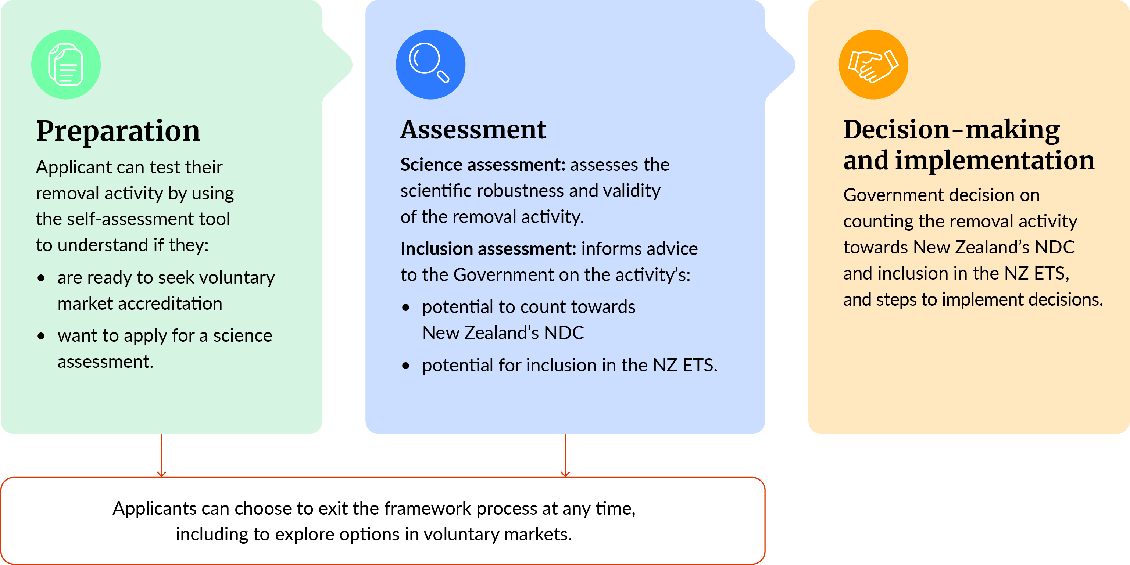
Note: NDC = nationally determined contribution; NZ ETS = New Zealand Emissions Trading Scheme.
Each part of the assessment may take several months, and timeframes will depend on:
- the availability of appropriate assessors (for the science assessment)
- what the activity is and the implications of adding this activity to the NZ ETS, including updating New Zealand’s NDC (for the inclusion assessment).
Following assessment, the Government will make final decisions on whether new removal activities can be included in the NZ ETS or NDC. Appendix 2 outlines the process flow for a removals assessment.

Preparation stage
The preparation stage will help people understand what is needed for a successful removal project and decide the best pathway for recognition. This can be a complex decision, so people should take the time to understand how different markets work, what scientific evidence is needed and what the various considerations are before they pursue a particular pathway.
An online self-assessment will be available in 2026 for people who want to understand how the information and evidence they have currently aligns with the assessment criteria, or with the kind of information that voluntary markets require.
The main steps that people should take to prepare themselves for the assessment are outlined in table 1.
Table 1: Steps to prepare for the assessment
Step | Details
1. Understand the markets | Read information about the voluntary markets and New Zealand Emissions Trading Scheme to understand how they work. Information is available on the following Ministry webpages: Voluntary nature credits market in New Zealand and the New Zealand Emissions Trading Scheme.  Consider existing standards for removal activities, which assessors may also refer to during an assessment. Examples of existing standards include the Peatland Code developed by the IUCN UK Peatland Programme, as well as those from leading international standard-setting bodies such as Verra and Gold Standard.
2. Understand the scientific criteria | The scientific criteria outline the areas of evidence required for any application, which apply regardless of the kind of removal activity. Become familiar with the scientific criteria and review the information that you currently have for your activity.  Consider how your information lines up with each of the criteria and whether any gaps exist.
3. Collate information | Once you understand how your information aligns with the criteria, collate the relevant information in preparation for the self-assessment.  Because a variety of methods and processes are used to remove and store carbon, the exact nature of the information needed will be different for each application.
4. Complete the self-assessment | Use the information you have collated to complete the self-assessment.
5. Decide whether to apply for the assessment | Informed by your self-assessment, choose either:  - to apply for assessment through the framework, or  - not to proceed through the framework and instead use the information from the self-assessment to investigate other options, including voluntary markets.
6. Complete the application | If you decide to continue in the framework, complete an application once this is made available.
Before applying, potential applicants are strongly encouraged to become familiar with the markets they are interested in and the scientific criteria outlined in table 2 and table 3.

Assessment stage
The assessment gives people a clear idea of whether a removal activity is scientifically robust and also informs any Government decision about recognition and reward for new removal activities. It has two parts: the science assessment and the inclusion assessment, each with underlying criteria. For some activities, the result of the science assessment (see table 4) may mean the inclusion assessment cannot proceed. In such cases, or at any other stage of the assessment process, people can exit the process and investigate voluntary market options.

Scientific criteria
Scientific credibility of removal activities is vital for the integrity of any market and for the inclusion of any activity into New Zealand’s NDC. The science assessment outlined below will help applicants test the scientific readiness and sufficiency of an activity to support that credibility.
Readiness means a carbon removal activity is backed by science to show it can effectively take carbon dioxide out of the atmosphere and keep it stored.
Sufficiency means that a carbon removal activity works in a robust enough way to possibly count toward New Zealand’s nationally determined contribution or earn carbon credits.

Outcome of the science assessment
An applicant who requests an assessment will receive a report indicating whether the type of removal activity they are considering undertaking is scientifically sound in the New Zealand environment.
The assessment will not provide a government endorsement for an individual project, because that would require a much more thorough assessment of many areas of a project’s management, finances and ways of operating.

Using established standards for assessing evidence
The integrity of any carbon market requires high standards for the generation of any credits traded. Internationally recognised, high-integrity standards are in place for various forms of carbon removal that align with the scientific expectations of the Paris Agreement and United Nations Framework Convention on Climate Change (UNFCCC).
The Government is working with various sectors across New Zealand to establish domestic government-endorsed standards for removals generated in New Zealand, for use in voluntary markets. Where suitable, the standards used by assessors under the science assessment will align with the endorsement approach for domestic standards that the Government is developing for the voluntary nature credit market (VNCM). This provides assurance that removal activities are scientifically robust and have been assessed consistently, regardless of their intended market.
This also means that, if an application does not result in a new activity being added into the NZ ETS or counted towards New Zealand’s NDC, the applicant could use the evidence gathered to support participation in voluntary markets.
What if no standard is available?
If no standard is available, removal activities will still be able to progress through the science assessment within the Assessment Framework. Applicants can work with the science assessor and the Ministry for the Environment to understand what evidence will be required for their initiative to be assessed against the scientific criteria.

Readiness criteria
Because the Earth’s system contains a set amount of carbon, a removal activity is one that moves CO₂ from the atmosphere into another carbon pool and can ensure that the CO₂ does not then return to the atmosphere. The readiness criteria, outlined in table 2, focuses on evidence that shows the activity does have the potential to affect CO₂ in this way, safely and effectively.
Table 2: Criteria and required information for the readiness part of the science assessment
Criteria | Information required
Measurable  How clearly evidenced is it that there is a quantifiable net reduction in a carbon dioxide equivalent (CO₂e) gas? | - Explanation of the methods, approaches, tools or technologies that can identify the change in carbon levels that can then be attributed to the activity being considered  - Evidence that these methods, approaches and techniques are reliable and appropriate for use with the activity in the New Zealand location and environment
Validated  Is it possible to cross-check proposed measurements against currently available techniques?  What is the outcome of this cross-check? | - Detail of chosen measurements, the tools, techniques and protocols used, and how they were applied  - Explanation for the chosen measurements, covering:  - how they do or do not align with established techniques  - what makes them appropriate for the carbon pool or flux involved and the context of the activity  - If new or innovative measures are being proposed, evidence of how their results align with established methods
Additional  What does the evidence show about how the reduction is caused by the activity?  How is it being shown that the carbon dioxide (CO₂) being removed and stored is additional to the amount of CO₂ that would have been removed and stored over time without the activity? | - Quantified baseline of the relevant carbon stocks  - Quantified status quo forecast or prediction of the CO₂ sequestration trajectories (the likely changes in CO₂ over time from natural causes and human activities that are already likely to occur)  - Comparison of the status quo forecast to various other scenarios that, at a minimum, include the deployment of the activity  - Explanation of how additionality is being calculated (eg, land-use change models or counterfactual processes or analyses calibrated with field data)
Permanent  What evidence is there of long-term storage of CO₂ in one or more carbon pools because of the activity?  What is the timeframe of the storage? | - Evidence that the storage of CO₂ under this activity is long term (generally considered a minimum of 50 years or in line with a scientifically agreed ‘best case scenario’ for the carbon pool in question)  - Clarification of how the storage of CO₂ through this activity may be affected by changes in the environment (ie, whether the CO₂ will remain embodied as temperatures rise, or when geological disturbances or biogeochemical changes occur in the location and/or process of the storage)

Sufficiency criteria
Once an activity has been assessed under the readiness criteria, assessment then focuses on whether an activity can be translated into real-world outcomes that warrant further consideration. Table 3 outlines these sufficiency criteria and the information required for assessment.
Table 3: Criteria and required information for the sufficiency part of the science assessment
Criteria | Information required
Material  What evidence is there that the volume of carbon dioxide (CO₂) potentially being removed and stored such that it is detectable at a meaningful national scale? | - Current baseline data or measurements that would allow identification of the impact of the activity at a national scale
Carbon dioxide leakage  Is there a clear assessment of the risk of leakage with this form of removal activity?  Is there a clear explanation of how such leakage can be mitigated? | - Detail on how leakage could occur from this activity and how it could be detected, measured and monitored  - Evidence of effective strategies project owners could use to mitigate and manage the risk of leakage
Sustainable  Is there a clear understanding of how the proposed activity could affect the wider ecosystem or biodiversity etc, of the areas where it would occur? | - Clear evidence and description of the likely positive and negative impacts of this activity on biodiversity, habitats, ecosystems etc.  - Where negative impacts are possible, an outline of:  - the scale of risk of this impact  - effective strategies for mitigating and managing this risk  - the relative size and scale of the trade-off between the impact and the potential for CO₂ removal  - Description of any ecosystems or environmental conditions where the activity would be inappropriate and explanation of why
Transparent  Are records of the evidence used to quantify the effect of the proposed activity well documented and accessible? | - Clear and accessible documentation setting out:  - scientific methods, approaches used to measure and monitor removals  - underlying assumptions, data and inputs used in any calculations or modelling  - any statistical models or analytical approaches used  - Assurance that, where relevant, the underlying assumptions, data and calculations have been tested and scrutinised by appropriate experts, peer reviewed and tested for reproducibility of results or predictions  - Demonstrated efforts to ensure the evidence underlying the proposed activity is in the public realm, open to review and consideration
Scalable  Is it clear that the measures and their proposed deployment are effective across various spatial scales? | - Detail about the sampling methods and monitoring regimes associated with all preferred measurement approaches at various scales  - Outline of any data used as inputs to support measurement or build accurate predictive forecasts or models of effects at scale (eg, land use data, vegetation coverage information or soil quality assessments).

Assessing the scientific evidence
Table 4 outlines options for the assessor’s recommendations, following the science assessment. Each criterion will be assessed independently to support an overall assessment of the scientific evidence.
Table 4: Summary of evidence assessment for each criterion, which will be considered in context of other criteria to support an overall recommendation
Assessment of evidence | Description | Recommendation
Insufficient evidence | A lack of robust, well-documented, or scientifically sound evidence or data in line with criteria  Evidence suggests a hypothesis of effective carbon dioxide (CO₂) sequestration from this activity in the New Zealand context is unlikely | A significant amount of new work is required (new studies, data collection or modelling) before the applicant can resubmit for assessment  Applicant should also consider undertaking new work before exploring voluntary market
Lacks consensus | Some promising evidence and data available in line with criteria, but overall evidence is inconclusive, highly variable, not replicable, or uses methods that are not in line with best practice  Evidence suggests the hypothesis is plausible | Some additional research, data or evidence required  Applicant should also consider undertaking new work before exploring voluntary markets
Partially established | Multiple studies, datasets or independent lines of evidence demonstrate potential of activity in line with criteria  Data available at a scale and to requirements that could support inclusion | Evidence may be adequate for the voluntary market  May be considered under inclusion criteria
Well established | Outcome is well supported by multiple studies or lines of evidence, and by independent investigators  Demonstrable evidence base for activities and outcomes for carbon  High level of confidence that the proposed activity results in an effective method of sequestration in a New Zealand context | Applicant could consider participating in voluntary market with confidence  Should be considered under inclusion criteria

Inclusion considerations
The inclusion assessment sets out considerations on the suitability of including any new removal activity in the NZ ETS or counting it towards New Zealand’s NDC. Any final decision will be made by the Government on a case-by-case basis. This part of the assessment will be completed by the Ministry with input from other agencies and the science assessors as required.

Data and reporting considerations
Once a science assessment has been completed, the Ministry will work with any other relevant government agencies (such as the Ministry for Primary Industries or Land Information New Zealand) to consider if and how the activity could be measured and monitored nationally and in such a way that it can be calculated as part of target accounting. This may require additional discussions with the applicant. The Ministry and other relevant agencies will then analyse and provide advice to the Minister of Climate Change and the Government on the implications of doing so. Table 5 outlines the inclusion considerations.
Table 5: Inclusion considerations – data and reporting
Consideration | Description
Monitoring and measuring | Are data available, or able to be developed, that will enable this activity to be included in the Greenhouse Gas (GHG) Inventory and target accounting? That is, do the data trend over time back to a nominated base year, and can the data be measured nationally?  Are there internationally recognised methods and guidance for inclusion of this activity or associated category in the GHG Inventory?
Emissions impact | What would the impact of adding this activity on New Zealand’s overall emissions profile be?
Data costs | What are the costs of the necessary improvements to monitoring and measuring regimes to incorporate this new activity into the GHG Inventory and target accounting?  What are the ongoing costs of yearly data collection, monitoring and measuring for reporting?

The ability to measure the emissions impact at a national level is an important difference between counting something towards New Zealand’s nationally determined contribution and including it in the New Zealand Emissions Trading Scheme, compared with it being appropriate for a voluntary market.

Impact considerations
Depending on the activity and the context, analysis will involve reviews of regulatory and legislative settings and an assessment of the likely implementation requirements.
Table 6 outlines the considerations that will be assessed at a minimum. Other factors may be considered if they are required.
The analysis could include economic modelling, scenario modelling of the projected trajectory for achieving New Zealand’s emissions budgets, and reviews of international agreements.
Table 6: Inclusion considerations - impact on NZ ETS and NDC
Consideration | Description
Contribution to climate goals | In adding this activity, what would be the impact on progress towards achieving New Zealand’s budgets, targets and nationally determined contribution?  Is the potential volume of removals generated through this activity adequate to justify inclusion?  How does the activity align with the Government’s approach to meeting its targets and budgets?
Market credibility | Would adding this activity create any risks to the credibility of the New Zealand Emissions Trading Scheme (eg, how will it affect the supply of units, price and confidence of market participants)?  Does the market have capacity for these removals (potentially over other removals)?
Liability | Is a reliable and valid plan in place for managing any future liability from this activity (eg, any leak of stored carbon)?
Economic impacts | Does including this activity generate significant economic growth opportunities?  What are the workforce implications?
Māori-owned land | Does this activity have any impacts on Māori- or iwi-owned land, land claims or interests?  Does this proposal meet legal obligations under Te Ture Whenua Māori Act 1993?
Community impacts | Will localised community impacts occur if this activity is encouraged?  Will social, equity, health or other impacts occur that need to be mitigated?
Mitigation | Are any potentially negative effects on environments, ecosystems etc being adequately managed and mitigated?
Trade and international agreements | Do any considerations need to be taken into account around this activity from a trade or international agreement perspective?
Administrative costs | What are the administrative costs of developing regulation?  What are the costs to the market of measuring, monitoring, reporting and processing activities and units?  What are the costs of making updates to the New Zealand Emissions Trading Scheme Registry and implementing resourcing at the Environmental Protection Authority to manage the new activity?
Other required changes | Are any other changes (such as regulatory changes or resource management considerations) needed to enable this activity in the New Zealand context?  If so, what is required to make those changes, and are they appropriate?

Decision-making and implementation stage
A positive outcome from the science assessment and a completed analysis of all inclusion considerations do not guarantee that a new activity will be allocated units in the NZ ETS or counted towards New Zealand’s NDC.
Once the full assessment process has been completed the Ministry may provide advice to the Minister of Climate Change (and other relevant Ministers) about the suitability and implications of adding a new removal activity into the NZ ETS or counting it towards our NDC. Ministers, and Cabinet, will then decide if they wish to pursue these changes and direct the relevant agencies to make it happen.

When can units be traded in the NZ ETS
for a new activity?
If the Government approves a new activity, steps are still needed before an individual can gain credits, including:
- drafting of new regulations for that specific activity
- consultation on the regulations
- changes to the NZ ETS Register and associated processes
- development of any verification or monitoring process for registered entities in the NZ ETS.
Creating this infrastructure is vital to ensure integrity in the trading of the activity, so this process will likely take 12 to 18 months, depending on the activity and complexity.

Next steps for the Assessment Framework for Carbon Removals
This document introduces the Assessment Framework for people interested in understanding their options for having removal activities recognised and rewarded. It provides a high-level overview of the three stages of the Assessment Framework: preparation, assessment, and decision-making and implementation.
People can use this information to start considering their options and understanding the scientific evidence for their removal activity, which is part of the preparation stage. A self-assessment tool and the application process will subsequently be made available.

Appendix 1

How the framework helps with units and carbon credits
Carbon removals can be incentivised and funded by issuing a ‘unit’ or ‘credit’ equivalent to the carbon being stored, which can then be sold on a market. Each unit or credit represents 1 tonne of CO₂ or its equivalent for other greenhouse gases (known as CO₂e) that has been either removed from the atmosphere or prevented from being emitted. More specifically, units, or New Zealand Units (NZUs), are used in the NZ ETS. Carbon credits can also be created and issued under various voluntary market schemes for purchase by companies wishing to make voluntary claims in support of climate action.
These units or credits have a market value and can be traded like financial assets. Markets create an incentive for removal activities and provide a mechanism for reducing greenhouse gas emissions, supporting governments, businesses and individuals to invest in climate action. Activities that significantly improve the biodiversity of an area can also be incorporated and priced into voluntary carbon credits or bundled with voluntary or compliance credits to demonstrate support for nature action. Assigning a financial value to removals and biodiversity improvements incentivises cleaner technologies, conservation efforts and sustainable practices, as well as supporting businesses to meet regulatory or voluntary climate targets.

Voluntary markets
Groups and companies in New Zealand can access voluntary markets. The Government does not regulate these markets or directly control what kinds of activities or projects can be credited and traded. However, the Government is developing an endorsement approach for domestic voluntary market project standards that can demonstrate integrity, to help landowners deliver nature and carbon projects to a New Zealand VNCM that credit buyers can trust.
Prices vary across voluntary credit markets. When an applicant can demonstrate that a strong scientific base underpins their credits, they will have greater opportunities to trade at a premium unit price. The Assessment Framework provides an avenue for scientific testing that can help groups that are unsure about their scientific evidence.
For more information about the VNCM, see the Ministry webpage Voluntary nature credits market in New Zealand.

New Zealand Emissions Trading Scheme
Legislation for the NZ ETS requires some companies to buy and surrender units in relation to the amount of greenhouse gases their activities produce (see figure A1). It is intended that the number of NZUs in circulation will decrease over time, to reduce emissions in line with New Zealand’s emissions budgets. Because forestry is the largest removal activity in New Zealand, most removals recognised in the NZ ETS are from forestry (though not all forestry is eligible, because activities must meet certain conditions).
The Climate Change Response Act 2002 sets out which activities are included in the NZ ETS. Before adding any new removal activity into the NZ ETS, the Government needs assurance that the activity is underpinned by robust scientific evidence and would support New Zealand to meet its NDC. Any activity included in the NZ ETS is subject to monitoring, reporting and compliance requirements.
The Assessment Framework provides the evidence to support the Government’s policy development pathway when considering whether to include a new removal activity in the NZ ETS or count it towards New Zealand’s NDC.
For more information, see the Ministry webpage on the New Zealand Emissions Trading Scheme.
Figure A1: How the NZ ETS market works
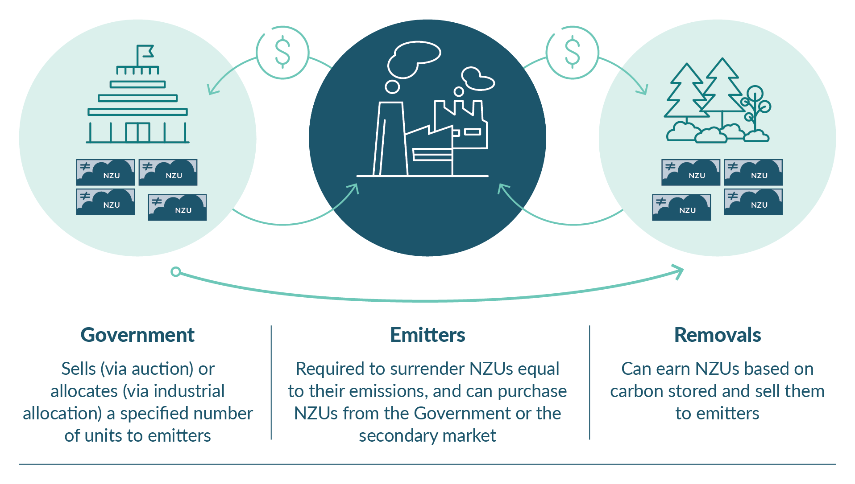
Note: NZUs = New Zealand Units.

How removal activities interact with New Zealand’s GHG Inventory reporting and NDC
Greenhouse Gas Inventory
New Zealand’s Greenhouse Gas (GHG) Inventory is the official annual report of all emissions and removals of greenhouse gases from human activities in New Zealand since 1990. The GHG Inventory is a core reporting requirement of the Paris Agreement and the United Nations Framework Convention on Climate Change (UNFCCC).
The GHG Inventory reports emissions at national and category or activity levels. If a category or activity is included, the GHG Inventory reports on all emissions and removals from that category or activity within New Zealand’s land area that have occurred since 1990.
Target accounting
Target accounting is used to measure progress towards domestic emissions budgets and targets, as well as progress towards New Zealand’s nationally determined contribution (NDC) (see below).
This method includes all New Zealand’s gross emissions, but only a subset of emissions and removals from the land use, land-use change and forestry sector.
Nationally determined contribution
Under the Paris Agreement, every country has an NDC, which is the contribution each country will make towards meeting the goals from the Paris Agreement, including limiting global temperature rise.
The Greenhouse Gas (GHG) Inventory and target accounting are important in the way they apply to any activity that is counted towards New Zealand’s NDC or included in the NZ ETS. Figure A2 outlines how these all interact.
Figure A2: Interactions between the GHG Inventory, target accounting, the NZ ETS and New Zealand’s NDC
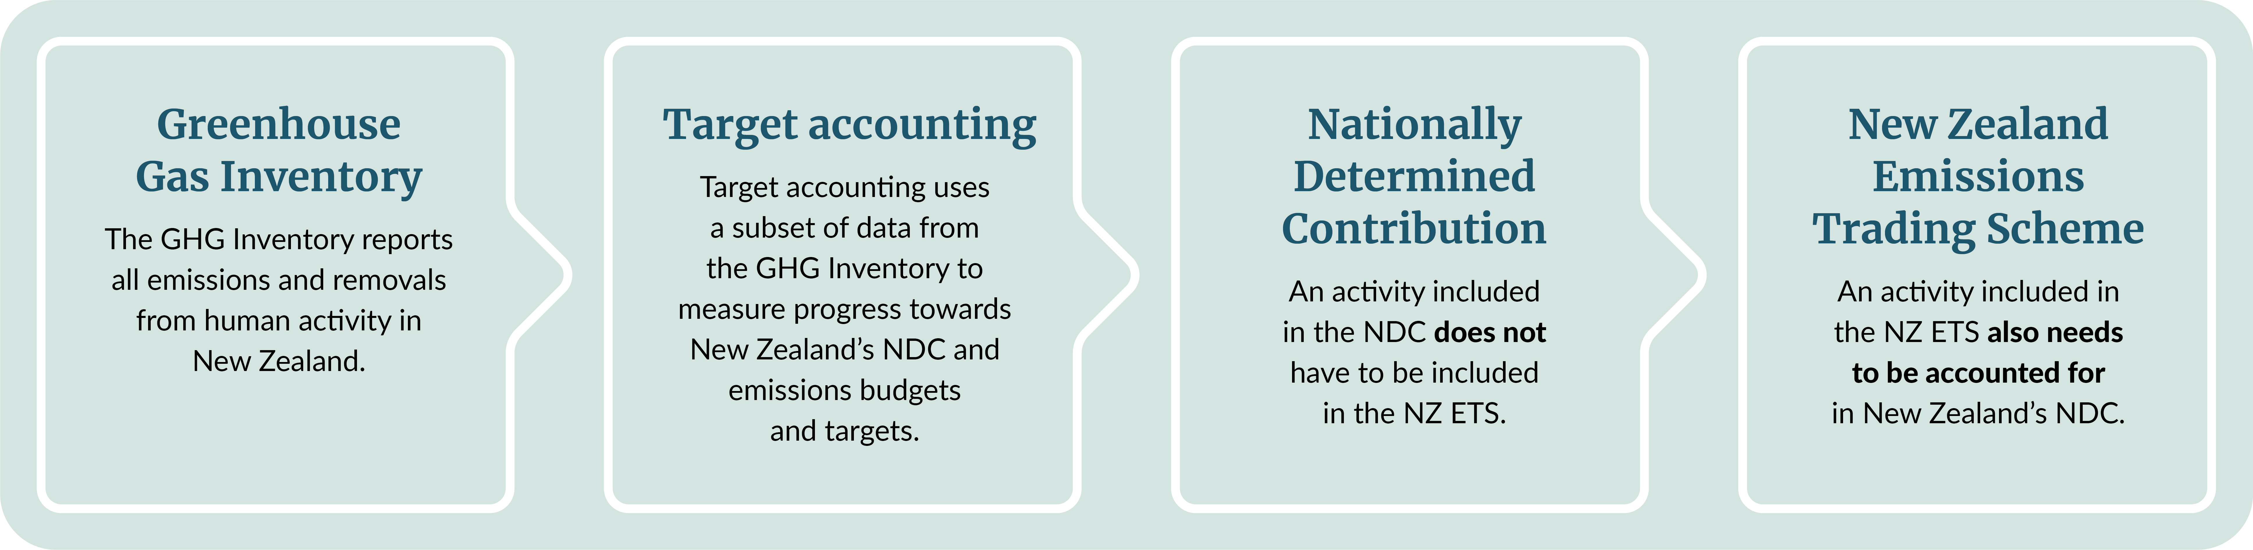
Evidence of a national impact over time is important when deciding which carbon market an activity fits into. For an activity to be considered for inclusion in the NZ ETS, it must be included in the GHG Inventory, which requires national-scale reporting. By contrast, for inclusion in voluntary markets, the scale of an activity can vary, with only evidence of project and/or site -specific impact being required.

Appendix 2
Figure A3: Assessment Framework for Carbon Removals process
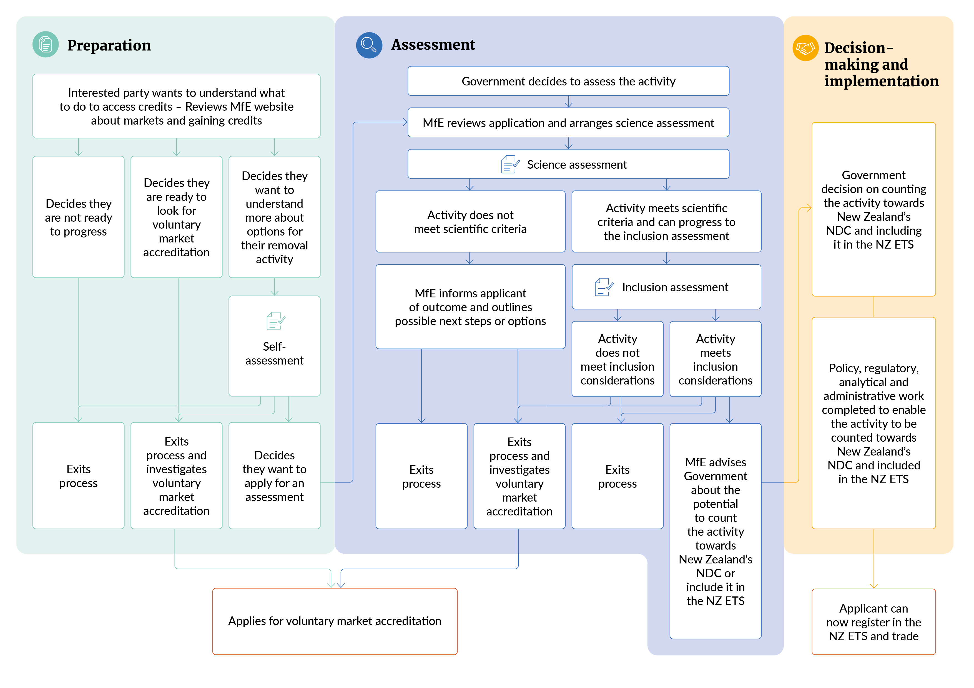
Note: MfE = Ministry for the Environment; NDC = Nationally Determined Contribution; NZ ETS = New Zealand Emissions Trading Scheme.

Glossary
Term | Description
Additionality | Demonstration that emissions reductions achieved through carbon market mechanisms are truly additional to what would have happened anyway (under the status quo).
Biodiversity | The variety of living organisms from all domains, including land, marine and freshwater ecosystems. This includes diversity within species (including genetic diversity), between species, and of ecosystems.
Carbon removal | Also known as ‘emissions removal’ – the process of removing CO₂ from the atmosphere and locking it away for decades, centuries or millennia.
Carbon sequestration | The capture and long-term storage of atmospheric CO₂ (eg, through establishing forests).
Climate Strategy | The Government’s approach to delivering on New Zealand’s climate goals.
Coastal blue carbon | Coastal blue carbon is the carbon captured and stored by coastal ecosystems, such as salt marshes, mangroves and seagrass beds.
Greenhouse gas emissions | The release into the atmosphere of gases that trap heat and contribute to global warming. These gases are emitted from both natural sources and human activities.
Emissions budgets | A total quantity of human-induced greenhouse gas emissions that is allowed to be released during an emissions budget period. In New Zealand, each emissions budget covers five years (except the first emissions budget, which covers 2022–25).
Emissions leakage (leakage, carbon dioxide leakage) | The risk that reducing emissions in one location causes emissions to increase elsewhere so that emissions overall do not reduce.
Forest land | New Zealand defines forest land as land that has a:  - minimum area of 1 hectare  - crown cover of at least 30 per cent  - minimum height of 5 metres at maturity in situ  minimum forest width of 30 metres from canopy edge to canopy edge.
Gross emissions | - The total of greenhouse gas emissions from the agriculture, energy, industrial processes and product use, and waste sectors.
Inclusion assessment | An assessment that forms advice on a removal activity’s potential to be included in the New Zealand Emissions Trading Scheme, and its suitability to be included in New Zealand’s target accounting.
Indigenous forest | A forest ecosystem composed primarily of tree species that are indigenous to a specific geographic area.
Nationally determined contribution (NDC) | A representation of efforts by each country to reduce national emissions and adapt to the impacts of climate change, as part of the country’s obligations under the Paris Agreement. New Zealand’s second NDC aims to reduce emissions from 51 per cent to 55 per cent, compared with 2005 levels, by 2035.
Net emissions | Gross emissions combined with the emissions and removals from land use, land-use change and forestry.
New Zealand Emissions Trading Scheme (NZ ETS) | A market-based policy to reduce emissions of greenhouse gases. The NZ ETS puts a price on emissions, charging certain sectors of the economy for the greenhouse gases they emit, and rewarding activities that remove emissions from the atmosphere.
New Zealand’s Greenhouse Gas Inventory (GHG Inventory) | New Zealand’s official annual report of all human-induced emissions and removals of greenhouse gases. The GHG Inventory is a core reporting requirement of the Paris Agreement and the United Nations Framework Convention on Climate Change. It enables New Zealand to track progress towards its emissions reduction targets.
Readiness | When a carbon removal activity is backed by science to show it can effectively take carbon dioxide out of the atmosphere and keep it stored for a long time.
Removals | The result of activities (such as forestry) that take greenhouse gases from the atmosphere and store them.
Removal activities | Actions that remove greenhouse gases from the atmosphere and keep them stored for a long time. Planting new forests or restoring wetlands are examples of ‘nature-based’ removal activities. Abiotic (not from living organisms) or technological removal activities also exist, such as direct air capture and storage. Removal activities can occur on land or in the ocean.
Science assessment | An assessment of the scientific validity and robustness of a removal activity.
Second emissions reduction plan | The plan setting out how New Zealand will meet its second emissions budget (2026–30) and move towards meeting long-term climate change targets.
Sufficiency | When a carbon removal activity can be monitored and managed robustly enough to count toward climate change targets or earn carbon credits.
Surrender | The transfer of one or more units to the Crown surrender account in the NZ ETS Register to meet an emissions obligation in the NZ ETS.
Target accounting | Target accounting is used to measure progress towards domestic emissions budgets and targets, as well as under New Zealand’s NDC. This method includes all gross emissions, but only a subset of emissions and removals from the land use, land-use change and forestry sector.
Voluntary market | A market for the voluntary buying and selling of biodiversity or carbon credits that represent the reduction or removal of emissions achieved through mitigation actions, such as afforestation or avoided deforestation. This is distinct from compliance markets, such as the NZ ETS, where entities have obligations to participate and surrender emissions units.
Voluntary nature credits market (VNCM) | A voluntary market governance framework that the Government is developing to encourage increased investment and activity in actions to protect and restore biodiversity, remove carbon, and drive other environmental improvements over time.

Ministry for the Environment. 2024. New Zealand’s second emissions reduction plan 2026–30. Wellington: Ministry for the Environment.
Intergovernmental Panel on Climate Change. 2022. Carbon dioxide removal (CDR): IPCC AR6 WGIII fact sheet. Geneva, Switzerland: IPCC.
Gross emissions include all emissions from all sectors of the New Zealand economy, except for land use, land-use change and forestry (LULUCF). Net emissions represent emissions and removals from all sectors of the New Zealand economy, including LULUCF.
For a description of New Zealand’s nationally determined contribution (NDC), see the section How this framework interacts with the wider removal activity landscape.
See the Ministry webpage Nationally Determined Contribution, for more information.
Information is available on websites from organisations, including the Integrity Council for the Voluntary Carbon Market, Ekos and Toitū Envirocare.
As work continues in the VNCM, more information will become available.
For more information, see the National Committee United Kingdom’s webpage on the Peatland Code.
For more information, see the Verra website.
For more information, see the Gold Standard website.
The voluntary nature credits market (VNCM) programme refers to the specific government work programme to bolster voluntary market activity. Voluntary markets refer to the broader landscape in which participants buy and sell nature, carbon and biodiversity credits.
A net reduction in CO₂e gas includes carbon dioxide removals and any emissions of greenhouse gases.
This does not mean that the carbon only needs to be stored for 50 years. Rather, this is a minimum amount that is required as evidence for the science assessment. If a removal were entered into the NZ ETS, surrender obligations would still be owed if the carbon were emitted after 50 years (this aligns with the permanent forestry category in the NZ ETS).
The same removal activity may occur across areas of various size and scale. Measurement approaches need to work at all scales to accurately identify the effect of the activity.
This table is adapted from table 1 in Bioeconomy Science Institute. Science framework for assessing new mitigation activities for natural carbon sequestration, based on the summary of the Intergovernmental Science-Policy Platform on Biodiversity and Ecosystem Services (IPBES) (2018) qualifiers for level of confidence.
The terms assigned here are adapted from IPBES. 2019. Global assessment report of the Intergovernmental Science-Policy Platform on Biodiversity and Ecosystem Services. Bonn, Germany: IPBES Secretariat.
For more information see the Land Information New Zealand website.
New Zealand Units represent tonnes of emissions of carbon dioxide equivalent (CO₂e) in the NZ ETS.
Ministry for the Environment. 2025. New Zealand’s Greenhouse Gas Inventory 1990–2023. Wellington: Ministry for the Environment.
See the Ministry webpage Greenhouse gas emissions targets and reporting, for a definition of target accounting emissions.
See the Ministry webpage Nationally Determined Contribution, for more information.

