**Disclaimer**

The information in this publication is, according to the Ministry for the Environment’s best efforts, accurate at the time of publication. The Ministry will make every reasonable effort to keep it current and accurate. However, users of this publication are advised that:

* the information does not alter the laws of New Zealand, other official guidelines, or requirements
* it does not constitute legal advice, and users should take specific advice from qualified professionals before taking any action based on information in this publication
* the Ministry does not accept any responsibility or liability whatsoever whether in contract, tort, equity, or otherwise for any action taken as a result of reading, or reliance placed on this publication because of having read any part, or all, of the information in this publication or for any error, or inadequacy, deficiency, flaw in, or omission from the information in this publication
* all references to websites, organisations or people not within the Ministry are for convenience only and should not be taken as endorsement of those websites or information contained in those websites nor of organisations or people referred to.

This document may be cited as: Ministry for the Environment. 2024. *Adaptation preparedness: 2024 update – A summary of responses to the second information request from reporting organisations under the Climate Change Response (Zero Carbon) Amendment Act 2019*. Wellington: Ministry for the Environment.

Published in July 2024 by the  
Ministry for the Environment   
Manatū mō te Taiao  
PO Box 10362, Wellington 6143, New Zealand  
[environment.govt.nz](http://www.environment.govt.nz)

ISBN: 978-1-991140-30-2 (online)

Publication number: ME 1839

© Crown copyright New Zealand 2024

# Contents

Executive summary 6

Introduction 9

Purpose of the information request 9

What we requested 9

Organisations subject to the 2024 request 10

Response analysis 10

Trends 12

Changes in response rate 12

Changes in adaptation preparedness 13

Adaptation preparedness in 2024 16

Is your organisation aware of the impacts that climate change may have on its ability to carry out functions and deliver services? 16

Does your organisation have access to data related to the impacts from climate change? 19

Has your organisation assessed its exposure to climate change impacts, in terms of its ability to continue to carry out functions and deliver services? 22

Has your organisation assessed its vulnerability to climate change impacts, in terms of its ability to continue to carry out functions and deliver services? 25

Does your organisation have a plan or strategy to improve its resilience and/or the resilience of the community it serves to climate change impacts? 28

Does your organisation have any indicators or measures to help it monitor and manage its risks for climate change impacts? 31

Are risks to your organisation’s ability to carry out functions and deliver services from the impacts of climate change reported to your organisation’s governance board? 33

Does your organisation require the impacts of climate change, and adaptation options to address these impacts, to be assessed and considered in decision-making? 36

Which actions or resources would help your organisation to better prepare for the impacts of climate change? 39

What are the barriers to an effective adaptation response that are faced by your organisation? 42

Impacts of risks from the National Climate Change Risk Assessment 46

Appendix 1: Climate Change Response (Zero Carbon) Amendment Act 2019, sections 5ZW and 5ZX 52

Appendix 2: Copy of climate change adaptation reporting information request 54

Appendix 3: Response rate between 2020 and 2024 61

Appendix 4: National Climate Change Risk Assessment significant risk and priority risk list 62

Appendix 5: Key themes for each risk 63

# Tables

Table 1: Key themes from the request for information 10

Table 2: Quantification of submitters 11

Table 3: Priority actions and resources by type of reporting organisation 41

Table 4: Most frequently selected barriers by type of reporting organisation 43

Table 5: Risks most selected for their potential for impacts – central government 49

Table 6: Risks most selected for their potential for impacts – local government 49

Table 7: Risks most selected for their potential for impacts – lifeline utilities 50

Table 8: Risks most selected for their potential for impacts – state services 50

Table 9: Risks most selected for their potential for impacts – council-controlled organisations 51

Table 10: Response rates over time by reporting organisation type 61

Table 11: Key themes identified for each risk 63

# Figures

Figure 1: Breakdown of responses by type of reporting organisation – 2024 request 12

Figure 2: Is your organisation aware of the impacts that climate change may have on its ability to carry out functions and deliver services? 17

Figure 3: Does your organisation have access to data related to the impacts from climate change? 20

Figure 4: Has your organisation assessed its exposure to climate change impacts, in terms of its ability to continue to carry out functions and deliver services? 23

Figure 5: Has your organisation assessed its vulnerability to climate change impacts, in terms of its ability to continue to carry out functions and services? 26

Figure 6: Does your organisation have a plan or strategy to improve its resilience and/or the resilience of the community it serves to climate change impacts? 29

Figure 7: Does your organisation have any indicators or measures to help it monitor and manage its risks from climate change impacts? 32

Figure 8: Are risks to your organisation’s ability to carry out functions and deliver services from the impacts of climate change reported to your organisation’s governance board? 34

Figure 9: Does your organisation require the impacts of climate change, and adaptation options to address these impacts, to be assessed and considered in decision-making? 37

Figure 10: Which actions or resources would help your organisation to better prepare for the impacts of climate change? 40

Figure 11: What are the barriers to an effective adaptation response faced by your organisation? 42

Figure 12: Potential for impacts by risk 48

Figure 13: Response rates over time by reporting organisation type 61

# Executive summary

The Climate Change Response (Zero Carbon) Amendment Act 2019 allows the Minister of Climate Change and the Climate Change Commission to request information on how organisations that provide essential services are preparing for the impacts of climate change.

In 2020, the Ministry for the Environment made an initial request for information, to set a baseline against which the effectiveness of adaptation actions to prepare for the impacts of climate change can be measured. A second request for information was made in 2024, to review changes in adaptation preparedness since the 2020 baseline request.

Key trends of organisations that reported in 2020 and 2024 are included below, as are the key findings from the 2024 responses.

### Key trends

Cross comparison of results and response rates between the 2020 baseline request and 2024 request suggests **an overall increase in climate adaptation preparedness**.

In 2024, information was requested from fewer organisations and the response rate increased by nearly two-thirds. This was observed across all types of reporting organisations.

Increases in adaptation preparedness were particularly observed when directly comparing the responses of organisations that submitted to both the 2020 baseline and 2024 information requests. The following findings suggest an improvement in these capabilities.[1]

##### Risks and impacts

* **Increases in awareness and documentation of climate change impacts**. In 2024, slightly more organisations indicated that climate change impacts are either well or partially understood and documented.
* **Increases in access to data on regional climate change impacts**. Many more organisations report having access to data at a regional, local and asset level.
* **More understanding of vulnerability and exposure to climate change risks.** Many more organisations have access to exposure data for some or all climate change impacts, and moderately more organisations are now undertaking some form of vulnerability assessment.

##### Strategy, government and metrics

* **More organisations have a strategy or plan in place to adapt to the impacts of climate change.** Many more organisations have some kind of strategy or plan in place to improve resilience to risks.
* **More organisations are considering the use of indicators and measures to monitor and manage climate risks.** Many more organisations have indicators or measures in place or under development.
* **Climate change impacts are being reported to governance boards more frequently and are being considered more in decision-making processes.** Moderately more organisations report these impacts more than once annually and consider these impacts in decision-making for some or all projects.

##### Priority actions and resources, and barriers to climate adaptation

* Priority actions and resources varied slightly between information requests, while barriers to effective adaptation action remained the same. *Funding to implement a strategy and deliver on-the-ground adaptation actions* was the most selected resource in 2024, whereas *Tools to help quantify impacts from climate change on your organisation* was the most selected in 2020. Despite this difference, both options were within the top three most selected resources in both requests.
* Responses from organisations to both requests indicated *that lack of awareness and education among decision-makers and the wider community about climate change impacts* was the greatest barrier to adaptation action.

##### Significant climate risks of importance to organisations

* **Organisations in both information requests had similar risks of concern, although they were ranked differently*.***In 2024, *E1 (risks to governments from economic costs)* was the most selected risk of concern, and it was selected the second most frequently in 2020. In 2020, *B2 (risks to buildings)* was the most selected risk of concern, but it was the second highest risk of concern in 2024.

### Key findings for 2024

The findings from the 2024 information request represent a ‘snapshot in time’ of the adaptation preparedness capabilities of all 212 organisations that responded.

##### Risks and impacts

* **Most organisations are aware of how climate change affects them.** Ninety-three per cent reported that climate change impacts are either well or partially understood and documented. This was observed most among local government agencies and state services.
* **Most organisations have access to climate data related to the impacts of climate change.** Seventy-nine per cent indicated they have access to some form of relevant data for their region. This was the highest among local government agencies and lifeline utilities.
* **Assessing exposure to climate change impacts is a limited capability.** Only 3 per cent of organisations have access to accurate data for all climate impacts and 44 per cent have these data for some impacts. However, local government agencies and council-controlled organisations reported having the greatest access to exposure data.
* **Most organisations assess their vulnerability to climate change impacts.** Seventy-five per cent reported that their organisation’s vulnerability is well understood or that some assessments of this have been undertaken. The greatest understanding of their organisations’ vulnerability to climate change impacts was reported by lifeline utilities.

##### Strategy, government and metrics

* **Many organisations have a plan or strategy to improve resilience to climate change impacts.** Nearly half of organisations (47 per cent) have some form of plan in place that addresses risk and resilience. This was expressed most strongly by central and local government agencies.
* **Organisations are considering indicators and measures to monitor and manage risks from climate change**. While only 27 per cent have these in place, 30 per cent advised that these are under development. Central government agencies and lifeline utilities have the most organisations with these in place.
* **Most organisations (69 per cent) report climate risks to their governance boards**, with 39 per cent reporting them more often than annually. Local and central government agencies report these risks the most often.
* **Most organisations assess and consider the impacts of climate change and adaptation options when making decisions.** Twenty-three per cent advise that this is required for decision-making, and 38 per cent assess and consider these in some projects. Local government agencies assess and consider these impacts in decision-making processes the most.

##### Priority actions and resources, and barriers to climate adaptation

* The most selected action or resource varied according to reporting organisation type. However, most organisations (75 per cent) expressed that **more information about how climate change is projected to impact a region or district** would help them better prepare for the impacts of climate change.
* The most selected barrier varied according to reporting organisation type. However, over half of organisations (51 per cent) agreed that **lack of awareness and education** among decision-makers and the wider community regarding the impacts of climate change was a barrier to effective climate adaptation. Organisations also widely discussed the additional barriers of **costs and lack of funding** for upgrading infrastructure and undertaking adaptation planning and recovery work.

##### Significant climate risks of importance to organisations

The risks most selected for having potential impacts varied by reporting organisation type. However, most organisations regarded the following as having potential impacts.

* B2: Risks to buildings due to extreme weather events, drought, increased fire weather and ongoing sea-level rise (selected by 77 per cent).
* E1: Risks to governments from economic costs associated with lost productivity, disaster relief expenditure and unfunded contingent liabilities due to extreme events and ongoing, gradual changes (selected by 75 per cent).
* H1: Risks to social cohesion and community wellbeing from displacement of individuals, families and communities due to climate change impacts (selected by 70 per cent).

In terms of impact on services, assets and infrastructure, organisations commonly considered their most urgent and immediate risks to be:

* severe weather, including high winds, storms and cyclones
* flooding
* sea-level rise, coastal inundation and coastal erosion
* risks associated with planning, including transitional risks and uncertainty in navigating changing regulations and resourcing adaptation responses.

# Introduction

## Purpose of the information request

The Climate Change Response (Zero Carbon) Amendment Act 2019 (the Act) allows the Minister of Climate Change (the Minister) and the Climate Change Commission (the Commission) to request information on how organisations that provide essential services are preparing for the impacts of climate change. This provision allows adaptation preparedness to be monitored over time.

Currently, more than 400 organisations in Aotearoa New Zealand could be asked to respond to these requests for information. Section 5ZW(8) of the Act describes these organisations, and the text of that section is attached as appendix 1. Examples include:

* lifeline utilities, which are public and private sector entities providing fuel, electricity, water, transport and telecommunications infrastructure
* central and local government agencies
* state services, such as Crown entities, public finance companies and state-owned enterprises
* the Police and the New Zealand Defence Force.

In 2020, the Ministry for the Environment (the Ministry) requested information from around 400 organisations on how they were preparing for the impacts of climate change (2020 baseline request). The results from this first request informed the development of the first national adaptation plan. They also set a baseline against which the effectiveness of adaptation actions to prepare for the impacts of climate change can be measured.

The Ministry made a second request for information in 2024, to review changes in adaptation preparedness since the 2020 baseline request (2024 request).

More information can be found in the appendices. A copy of the information request is attached as appendix 2, details on the response rates between 2020 and 2024 are attached as appendix 3, a list of the National Climate Change Risk Assessment’s significant risks and priority risks is attached as appendix 4, and a list of key themes for each risk is attached as appendix 5.

## What we requested

In March 2024, the Ministry sent a request to 264 organisations for high-level information about how they are preparing for the impacts of climate change. The questions in the request were the same as those in the 2020 baseline request, categorised under the four key themes outlined in table 1.

Table 1: Key themes from the request for information

| Theme | Purpose of questions |
| --- | --- |
| Risks and impacts | To test reporting organisations’ general awareness and understanding of the impacts and risks from climate change |
| Risks of most significance | To gather information on the risks from the National Climate Change Risk Assessment that are expected to affect the quality or consistency of services delivered by reporting organisations |
| Strategy, governance and metrics | To gather information about the internal governance and decision-making processes of reporting organisations |
| Support and resources | To gather information about the support and resource requirements of reporting organisations |

The information requested aligns with the climate-related financial disclosure requirements that publicly listed organisations, insurers, banks and some investors are subject to under [Part 7A](https://www.legislation.govt.nz/act/public/2021/0039/latest/LMS479740.html#LMS479739) of the Financial Sector (Climate-related Disclosures and Other Matters) Amendment Act 2021.

## Organisations subject to the 2024 request

The 2024 request followed the approach taken for the 2020 baseline request, with the exception of a change in selection criteria for reporting organisations. In 2020, information was widely requested from all types of organisations listed under section 5ZW of the Act. In 2024, information was only requested from organisations with a focus on policy and service delivery functions that contribute to adaptation outcomes for essential infrastructure, which included:

* all lifeline utilities, law and defence, and local government organisations
* select central government agencies, Crown entities, council-controlled organisations, state-owned enterprises and public finance companies that either:
* own, manage or make decisions about critical infrastructure or whose services rely on critical infrastructure, or
* are emergency and health services, primary industries, developers and/or construction companies, or selected public finance companies.

Crown entities, public finance companies, law and defence services and state-owned enterprises are included as one umbrella unit called ‘state services’. This is consistent with the methodology used for the 2020 baseline request.

## Response analysis

This document summarises the results of the 2024 request. The results will help us to understand the current levels of climate change preparedness across organisations that responded, and any general trends in how this may have changed since the 2020 baseline request. This information will also form part of the evidence for the Government response to the Commission’s progress report on the first national adaptation plan.

We have not received responses from all organisations we requested information from, but are confident the response rate has been enough to provide broadly representative information. The use of ‘reporting organisation’ in this report therefore refers to the group of responses as a whole.

Table 2 outlines the quantifiers used in this report when presenting the analysis of responses.

Table 2: Quantification of submitters

|  |  |
| --- | --- |
| Classification | Definition |
| Few | Fewer than 5% of respondents |
| Some | 5% to 25% of respondents |
| Many | 26% to 50% of respondents |
| Most/the majority of | More than 50% of respondents |
| All | 100% of respondents |

# Trends

## Changes in response rate

**Information was requested from fewer organisations in 2024 than in 2020 and the response rate increased by 31 percentage points.** We received 212 responses, representing 80 per cent of the total number of organisations that were sent the request.[2] For more details on the response rate, please see table 10 and figure 13 in appendix 3.

The proportion of total responses by reporting organisation type in 2024 are shown in figure 1.

Figure 1: Breakdown of responses by type of reporting organisation – 2024 request

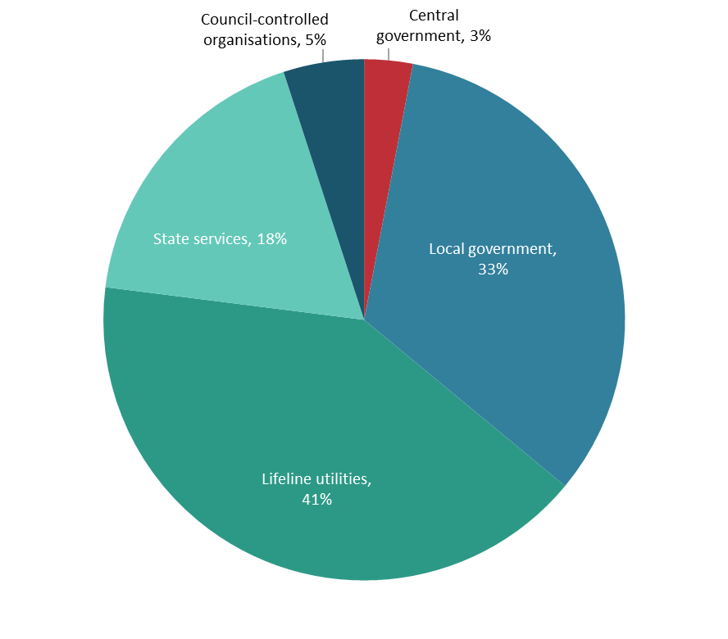

The increase in response rate across all reporting organisation types could be due to various factors. These include the change in selection criteria, improved adaptation preparedness capability, more capacity among organisations to respond, and more targeted communication with relevant contacts at each organisation.

## Changes in adaptation preparedness

We observed changes in adaptation preparedness when directly comparing the responses of the same organisations that submitted to both the 2020 baseline request and 2024 request. This comprised 120 organisations made up of:

* two central government organisations
* fifty-seven local government agencies
* thirty-seven lifeline utilities
* twenty-two state services
* two council-controlled organisations.

The sections below outline the changes we observed in responses from reporting organisations to particular questions in the survey.

### Risks and impacts

On awareness and documentation of climate change impacts (*question 7 and question 8*):

* Organisations generally increased their awareness and documentation of climate change impacts. Ninety-seven per cent of respondents to the 2024 request indicated that climate change impacts are either well or partially understood and documented. This is up from 91 per cent of respondents in 2020.
* Increases in this awareness were particularly observed among local government organisations (an increase from 96 per cent to 100 per cent) and state services (an increase from 73 per cent to 91 per cent).

On access to data on climate change impacts (*question 9 and question 10*):

* Organisations reported increased access to relevant data they had on climate change impacts in their region. Eighty-eight per cent of respondents in 2024 advised they have access to regional data on the impacts of climate change. This is up from 85 per cent in 2020.
* The scale of regional data also increased. Thirty-three per cent of reporting organisations have access to data at regional, local and asset levels. This is up from 25 per cent in 2020. This was particularly observed among local government agencies (an increase from 25 per cent to 35 per cent) and lifeline utilities (an increase from 24 per cent to 41 per cent).

On exposure to climate change impacts (*question 11 and question 12*) and vulnerability assessments (*question 13 and question 14*):

* More organisations understand their vulnerability and exposure to climate change risks.
* In 2024, 53 per cent reported having access to exposure data for all or some climate change impacts. This is up from 38 per cent in 2020. This was particularly observed among lifeline utilities, with an increase from 38 per cent to 62 per cent.
* In 2024, 79 per cent reported undertaking at least some kind of vulnerability assessment and embedding this into their organisational processes. This figure is up from 68 per cent in 2020.

### Strategy, government and metrics

On developing a strategy or plan for adapting to the impacts of climate change (*questions 37 to 39*):

* More organisations have a strategy or plan in place. Fifty-one per cent of respondents in 2024 reported they already have some kind of strategy or plan in place to improve resilience to risks such as climate change impacts. This is up from 36 per cent in 2020.
* This increase was observed among lifeline utilities (from 43 per cent to 65 per cent), state services (from 18 per cent to 36 per cent) and local government agencies (from 35 per cent to 49 per cent).

On indicators and measures for monitoring and managing climate risks (*question 40 and question 41*):

* More organisations use or are considering the use of indicators and measures to monitor and manage climate risks. Sixty-three per cent indicated that indicators and measures are either already in place or under development. This figure is up from 50 per cent in 2020.
* This increase was greatest in reporting organisations from central government (from 0 per cent to 100 per cent), state services (from 19 per cent to 36 per cent) and lifeline utilities (from 56 per cent to 70 per cent).

On the use of management and reporting to a governance board (*questions 42 to 44*):

* More organisations are reporting to their governance board on how climate change impacts affect operations. Seventy-one per cent in 2024 indicated they report these risks. This is up from 61 per cent in 2020.
* Climate change risks are also reported more regularly. Forty per cent advised these risks are reported to their organisation’s governance board more than once annually. This is up from 33 per cent in 2020.

On addressing and considering climate change impacts and adaptation options in decision-making (*question 45 and question 46*):

* More organisations require the impacts of climate change and adaptation options to be assessed and considered in decision-making. Sixty-four per cent advised that climate change is considered in decision-making for all or some projects. This is up from 55 per cent in 2020.
* This increase was generally observed among local government agencies (from 67 per cent to 75 per cent) and lifeline utilities (from 46 per cent to 65 per cent).

### Priority actions or resources and barriers to climate adaptation

Three priority actions or resources that could better help policy and service delivery organisations prepare for the impacts of climate change were most selected (*question 47 and question 48*).

* *Funding to implement a strategy and deliver on-the-ground adaptation actions*. Eighty per cent in 2024 selected this option. This is up from 74 per cent that selected this in 2020.
* *More information about how climate change is projected to impact a region or a district*. Seventy-eight per cent selected this in 2024, which is up from 73 per cent in 2020.
* *Tools to help quantify impacts from climate change on your organisation*. Seventy-eight per cent selected this in 2024, which is down from 81 per cent in 2020 (this was the most selected option in 2020).
* *Legislative requirements to publicly report on your organisation’s climate risks and adaptation plans* was the least-selected option across both years, with 43 per cent selecting this in 2024 and 36 per cent in 2020.

Two barriers to effective adaptation action were most selected (*question 49 and question 50*).

* *Lack of awareness/education of impacts of climate change by decision-makers/the wider community.* This was the most identified barrier across both years, with 60 per cent selecting it in 2024 and 63 per cent selecting it in 2020.
* *Lack of tools/methods by which to engage decision-makers/the community*. This was the second most identified barrier across both years, with 58 per cent selecting it in 2024 and 55 per cent selecting it in 2020.

### Risks of most significance

Variation could be seen in how organisations viewed the potential impacts of the most significant risks in the National Climate Change Risk Assessment (*questions 15 to 36*). For policy and service delivery organisations, the most identified risks of concern in 2024 were as follows.

* *E1: Risks to governments from economic costs associated with lost productivity, disaster relief expenditure and unfunded contingent liabilities due to extreme events and ongoing, gradual changes*. Eighty-two per cent of respondents reported this as a potential risk, making it the most selected risk of concern. This is up from 71 per cent in 2020, where it was the second most selected risk of concern.
* *B2: Risks to buildings due to extreme weather events, drought, increased fire weather and ongoing sea-level rise*. Eighty per cent reported this as a potential risk. This is up from 73 per cent in 2020, where it was the most selected risk of concern.
* *H1: Risks to social cohesion and community wellbeing from displacement of individuals, families and communities due to climate change impacts*. Seventy-seven per cent selected this as a potential risk, an increase from 64 per cent in 2020.

The least selected risk of concern for both years was *N2: Risks to indigenous ecosystems and species from the enhanced spread, survival and establishment of invasive species due to climate change*. Fifty-seven per cent selected this option in 2024 and 47 per cent selected it in 2020.

# Adaptation preparedness in 2024

This section summarises responses from the 212 organisations that provided information on their adaptation preparedness in 2024.

## Is your organisation aware of the impacts that climate change may have on its ability to carry out functions and deliver services?

|  |
| --- |
| This section corresponds to question 7 and question 8 in the survey. Respondents were invited to pick one of the following responses.   1. Climate change impacts are well understood and documented 2. Climate change impacts are acknowledged but only partially understood or documented 3. Climate change impacts are poorly understood and not documented or considered 4. We have not considered climate change impacts to date 5. Unsure |

Responses from the 2024 information request indicate that most respondents are aware of the impacts that climate change may have on their organisations. Most reporting organisations either responded that climate change impacts are *a.* ‘well understood and documented’ (25 per cent) or *b*. ‘partially understood and documented’ (68 per cent).

Only 1 per cent advised that climate change impacts are poorly understood and not documented or considered, and 2 per cent advised that climate change impacts have not been considered by their organisation to date. The remaining respondents were unsure whether their organisation was aware of climate change impacts.

### Key themes

Of the respondents that provided details with their answers, most mentioned they had completed assessments of climate change impacts, with more planned and others under way. However, many referenced a lack of data and understanding for some climate impacts, noting that some impacts had not been assessed by the organisation.

For respondents that noted climate change impacts are poorly understood and not documented, all advised that their organisations are aware of the risks but have not yet made plans to formally document and assess them.

Among respondents that have not considered climate change impacts to date, common themes included a lack of financial resourcing, staff and expertise as being barriers to carrying out these assessments.

### Responses by organisation type

Figure 2 shows how awareness of climate change impacts varies by type of reporting organisation. This variation was greatest among state services and lifeline utilities.

Generally, all reporting organisation types expressed a good understanding of climate change impacts. This was particularly the case among local government respondents, with all advising that climate change impacts are either well or partially understood and documented. Following local government agencies, state services reported having the greatest understanding of climate change impacts: 93 per cent of these respondents advised these impacts are either well or partially understood and documented. This figure is also high for lifeline utilities (92 per cent) and council-controlled organisations (80 per cent).

Figure 2: Is your organisation aware of the impacts that climate change may have on its ability to carry out functions and deliver services?

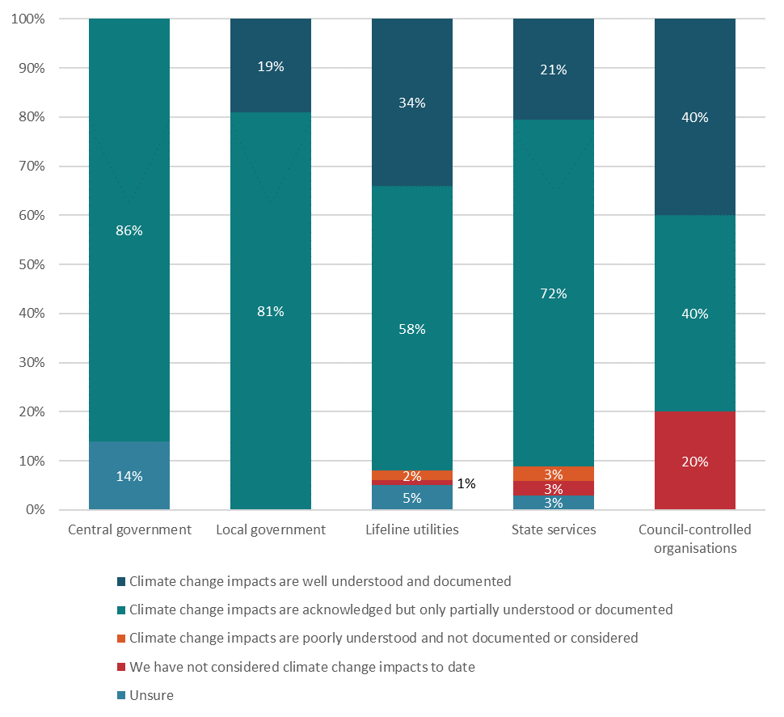

Note: Percentages have been rounded to the nearest whole number.

Of the respondents that provided details with their answers to the questions listed in the figure above, the following themes were commonly observed in the responses by each reporting organisation type.

##### Central government

* Organisations take a lead role in supporting other organisations with understanding and documenting climate change impacts.

##### Local government

* An understanding of specific climate change impacts is lacking, and improving understanding and documenting the impacts of climate change will require more data.
* Barriers to understanding and documenting the impacts of climate change include a lack of financial resourcing, staff and expertise.

##### Council-controlled organisations

* Barriers to understanding and documenting the impacts of climate change include a lack of financial resourcing and staff.

##### State services

* Climate change impacts are acknowledged but have not been formally documented.
* Barriers to better understanding and documenting these impacts include a lack of data, financial resourcing and staff.

##### Lifeline utilities

* An understanding of specific climate change impacts is lacking, and improving understanding and documenting the impacts of climate change will require more data.

## Does your organisation have access to data related to the impacts from climate change?

|  |
| --- |
| This section corresponds to question 9 and question 10 in the survey. Respondents were invited to pick one of the following responses.   1. Yes – at a regional, local and asset level 2. Yes – at a regional and local level 3. Yes – at a regional level 4. No 5. Unsure |

Considerable variation can be seen in both the extent and type of climate data that organisations have access to.

Most organisations selected option *a*., *b*. or *c.* indicating they have access to some form of relevant climate data. Within this group, 17 per cent have data at a regional level, 32 per cent have data at a regional and local level and 30 per cent have data at regional, local and asset levels.

Nine per cent advised that their organisation does not have access to this data. The remaining 12 per cent were unsure whether their organisation has access to this data.

### Key themes

Of the respondents that provided details with their answers, many expressed the need for more localised data, specific to their location, environment and climate. This was particularly needed to assess the impacts of climate change on their organisation’s infrastructure, assets and services.

Respondents also raised the issue of gaps in data on:

* flooding (including having access to maps and flood zones)
* groundwater impacts (including impacts from sea-level rise)
* land instability, erosion and landslips
* storms, winds and cyclones
* wildfires.

Many respondents advised they are working on programmes to assess particular risks or are working with other organisations to obtain relevant data.

### Responses by organisation type

Figure 3 outlines the variation among types of reporting organisation in their access to data related to the impacts of climate change.

Access to climate change impact data is greatest among local government agencies, with all local government respondents indicating they have access to some form of climate change data. The next greatest access was reported by lifeline utilities (75 per cent). Lifeline utilities also have the greatest proportion of respondents indicating that their organisations have access to data at a regional, local and asset level (35 per cent).

State services indicated having the least access, with 21 per cent of state respondents reporting they have no access to relevant climate change data.

Figure 3: Does your organisation have access to data related to the impacts from climate change?

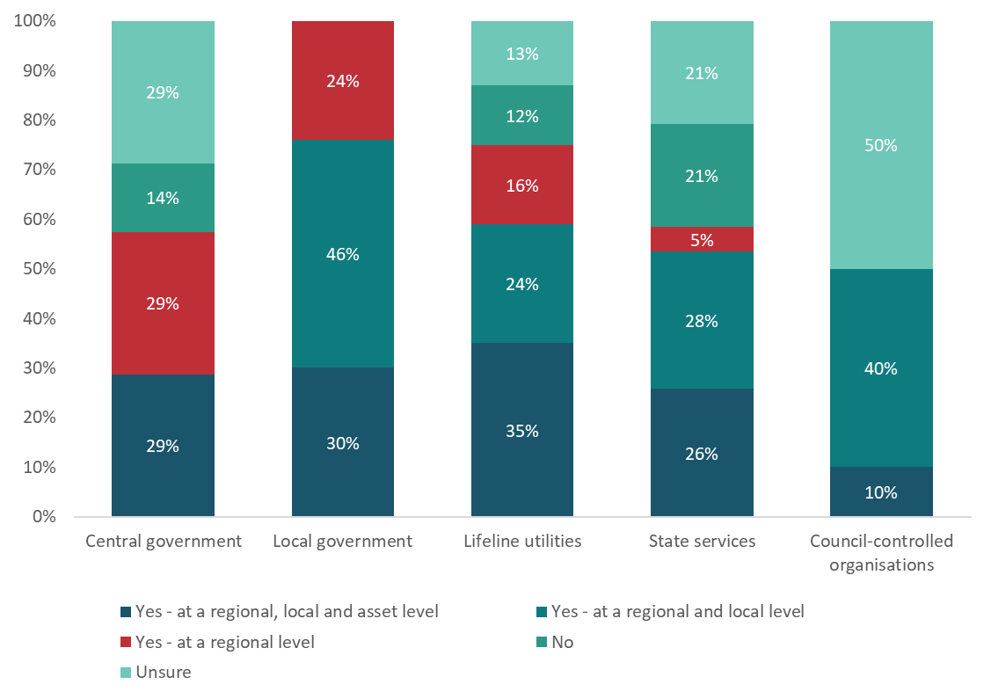

Note: Percentages have been rounded to the nearest whole number.

Of the respondents that provided details with their answers to the questions listed in the figure above, the following themes were commonly observed in the responses by each reporting organisation type.

##### Central government

* Information is needed to help identify communities most vulnerable to the impacts of climate change.
* Gaining a better understanding of the interaction of multiple hazards and hazards across geographical areas will require more data.

##### Local government

* More localised and geographically specific data are needed, specifically on the interaction of multiple hazards across various geographical areas.
* Data gaps include information on flooding zones, wildfires, land instability, landslips, erosion, and the impacts of sea-level rise on groundwater.

##### Lifeline utilities

* Updated and localised data are needed to determine the impacts of climate change on assets, services and infrastructure.
* Specific data gaps include data on flooding, storms, wind and cyclones.

##### State services

* More localised data and information are needed on future weather projections, including free and accessible data for the purpose of adaptation planning.
* Data gaps include information on wildfires.

##### Council-controlled organisations

* More information is needed on future weather projections, and historical climate data are needed to help with decision-making.
* More localised data are needed, along with data on groundwater impacts, river systems, land instability, erosion and landslips.

## Has your organisation assessed its exposure to climate change impacts, in terms of its ability to continue to carry out functions and deliver services?

|  |
| --- |
| This section corresponds to question 10 and question 11 in the survey. Respondents were invited to pick one of the following responses.   1. Yes, accurate (quantitative) exposure data is held for all relevant climate change impacts 2. Accurate exposure data is held for some climate change impacts 3. Limited or no understanding and assessment of exposure to relevant climate change impacts 4. No accurate exposure data, but climate change impacts relevant to our organisation are documented 5. Unsure |

Assessing an organisation’s exposure to climate change impacts appears to be a limited capability in 2024. Although 44 per cent of respondents have access to exposure data for some climate change impacts, only 3 per cent report having access to this data for all relevant climate change impacts. Seventeen per cent advised that their organisation has limited or no understanding of exposure data.

Many respondents (30 per cent) advised that their organisation does not have access to data for assessing its exposure to climate change. The remaining respondents advised that they are unsure whether their organisation has access to this data.

### Key themes

Common themes for this question suggest that organisations are in the process of developing these capabilities. Respondents that provided details with their answers commonly advised that their organisations have only examined certain hazards in assessments or have only assessed the exposure of certain services or assets to climate change impacts. Some noted that exposure data are only held for certain hazards or are only available at limited scales.

Other respondents advised that an approach to assessing these risks is currently under way. These themes were common, regardless of whether respondents advised they had access to exposure data.

### Responses by organisation type

As shown in figure 4, responses to this question were polarised across all reporting organisation types.

The reporting organisation types with the greatest access to exposure data are local government agencies and council-controlled organisations. Over half the respondents in each reported having access to exposure data for at least some climate change impacts. However, lifeline utilities and state services are the only reporting organisations with respondents that report having access to exposure data for *all* relevant climate change impacts (both at 5 per cent each).

The reporting organisation type with the least amount of access to exposure data includes central government respondents, of which only 14 per cent advised that their organisation holds exposure data.

Figure 4: Has your organisation assessed its exposure to climate change impacts, in terms of its ability to continue to carry out functions and deliver services?

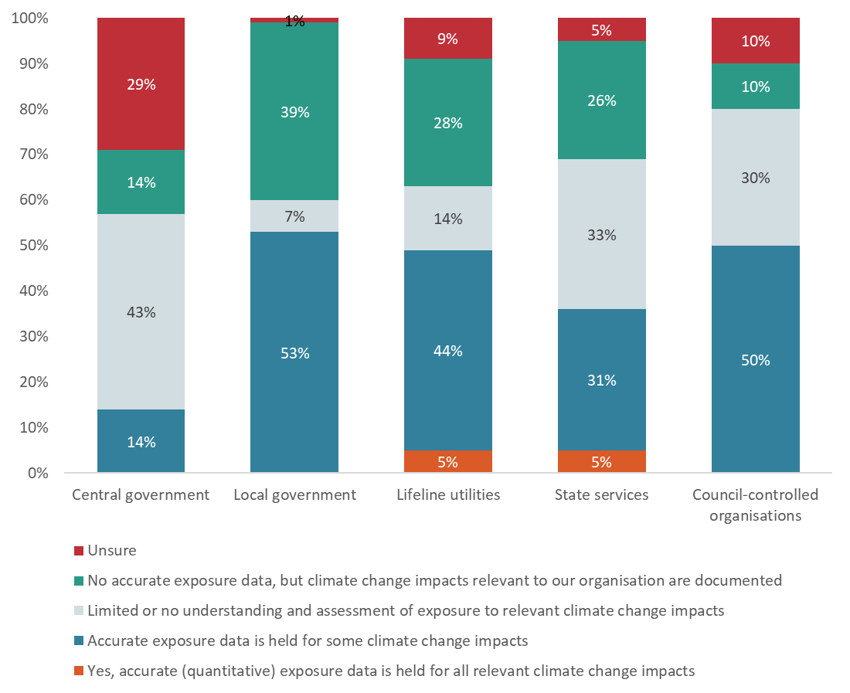

Note: Percentages have been rounded to the nearest whole number.

Of the respondents that provided details with their answers to the questions listed in the figure above, the following themes were commonly observed in the responses by each reporting organisation type that noted they did not have access to exposure data.

##### Central government

* Assessments are not needed, or plans are in place to obtain this data and undertake these assessments.

##### Local government

* Exposure assessments are under development, risks are only assessed for certain infrastructure and services, and data are only held for certain hazards.

##### Lifeline utilities

* Assessments are under development, or plans are in place to undertake assessments.
* Relevant data are only available at certain scales, and only specific hazards are analysed and assessed.

##### State services

* Assessments are under development.

##### Council-controlled organisations

* Assessments are under development, or plans are in place to undertake assessments.

## Has your organisation assessed its vulnerability to climate change impacts, in terms of its ability to continue to carry out functions and deliver services?

|  |
| --- |
| This section corresponds to question 13 and question 14 in the survey. Respondents were invited to pick one of the following responses.   1. Yes, vulnerability to climate change impacts is well understood and integrated into decision-making processes 2. Some assessment of vulnerability to climate change impacts has been done, but this is not well embedded in organisational processes 3. Limited or no assessment or understanding of vulnerability to climate change impacts 4. Unsure |

Unlike assessment of exposure data, most organisations appear to have capabilities in assessing their vulnerability to climate change impacts. Most respondents reported either that their organisation’s vulnerability to climate change is well understood (16 per cent) or that some assessments have been undertaken (59 per cent).

The remaining quarter of respondents either reported a limited understanding of their organisation’s vulnerability to climate change impacts (18 per cent) or were unsure on the issue (7 per cent).

### Key themes

Respondents that provided details with their answers revealed the extent and scale of their organisation’s vulnerability assessments. Respondents commonly indicated that vulnerability assessments have been undertaken for specific hazards, where some action has been taken to address climate change impacts. Many advised that more assessments are either planned or are under way.

Respondents indicating that some or no assessment has been undertaken noted common barriers, such as gaps in data, expertise and resources, to carrying out these assessments. A few referenced the need for better guidelines for undertaking these assessments.

### Responses by organisation type

As shown in figure 5, lifeline utilities report the greatest understanding of vulnerability to climate change impacts, with 86 per cent of respondents advising their organisation has undertaken at least some form of assessment. This reporting organisation type also has the greatest proportion of respondents (27 per cent) indicating that their organisation’s vulnerability to climate change impacts is well understood and integrated into decision-making processes.

Central government agencies report the least understanding of vulnerability to climate change impacts, with only 43 per cent advising their organisation has assessed this matter.

Figure 5: Has your organisation assessed its vulnerability to climate change impacts,  
in terms of its ability to continue to carry out functions and services?

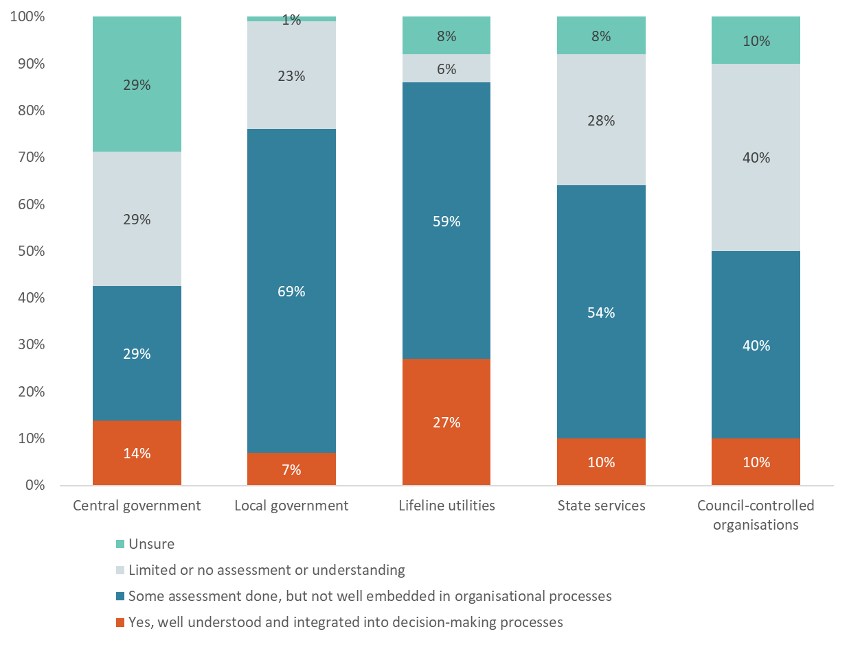

Note: Percentages have been rounded to the nearest whole number.

Of the respondents that provided details with their answers to the questions listed in the figure above, the following themes were commonly observed in the responses by each reporting organisation type.

##### Central government

* Actions needed to respond to vulnerabilities are dependent on the actions of other organisations.
* Some assessments are not undertaken, because organisations consider themselves to be low risk.

##### Local government

* Social vulnerability assessments have been undertaken for specific hazards.
* More data, expertise and resources are needed to carry out vulnerability assessments.
* Better guidelines are needed for assessing vulnerability.

##### Lifeline utilities

* Vulnerabilities have been assessed for specific hazards.
* Actions needed to respond to vulnerabilities are dependent on the actions of other organisations.

##### State services

* Vulnerabilities have been assessed for specific hazards.
* More data, expertise and resources are needed to support more thorough assessments.

##### Council-controlled organisations

* More data, expertise and resources are needed to support more thorough assessments.

## Does your organisation have a plan or strategy to improve its resilience and/or the resilience of the community it serves to climate change impacts?

|  |
| --- |
| This section corresponds to questions 37 to 39 in the survey. Respondents were invited to pick one of the following responses.   1. Yes, specifically for resilience to climate change impacts 2. Yes, but it is not focused exclusively on climate change (eg, risk and resilience strategy) 3. A plan is in development 4. No 5. Unsure |

Many respondents reported having at least some kind of plan or strategy in place, where a plan specifically for climate change resilience has already been developed (18 per cent) or a broader resilience plan or strategy not exclusively focused on climate change is in operation (29 per cent).

Many other respondents indicated that a plan or strategy is under development (33 per cent). The remaining respondents reported they either have no plan or strategy in place (16 per cent) or are unsure whether a plan or strategy is in place (4 per cent).

### Key themes

For reporting organisations with some kind of plan or strategy already in place, respondents that provided details with their answers generally indicated that such plans included asset management and infrastructure plans and risk and resilience frameworks.

For reporting organisations that indicated a plan is in development, respondents generally indicated that risk and resilience are already built into existing plans, but a general climate strategy is under development.

Common barriers to developing a plan were also raised in these responses, which noted:

* lack of resources and staff, including relevant expertise
* costs and lack of funding
* regulatory uncertainty, including changes in government direction and lack of clarity on roles and responsibilities
* lack of access to relevant and fit-for-purpose data and information
* managing competing priorities.

### Responses by organisation type

As shown in figure 6, responses to this question vary according to reporting organisation types.

Central government organisations have the largest number of respondents reporting that a plan or strategy is in place (71 per cent), although none of the respondents advised these plans are specifically focused on climate change resilience. Local government organisations have the highest proportion of its respondents (31 per cent) indicating these plans and strategies are climate change focused. Council-controlled organisations have the least number of respondents in this category, with only 20 per cent indicating that some plan or strategy is in place.

All types of reporting organisations had respondents that indicated plans were under development, with local government organisations having the highest proportion of its respondents reporting this (49 per cent).

Figure 6: Does your organisation have a plan or strategy to improve its resilience and/or the resilience of the community it serves to climate change impacts?

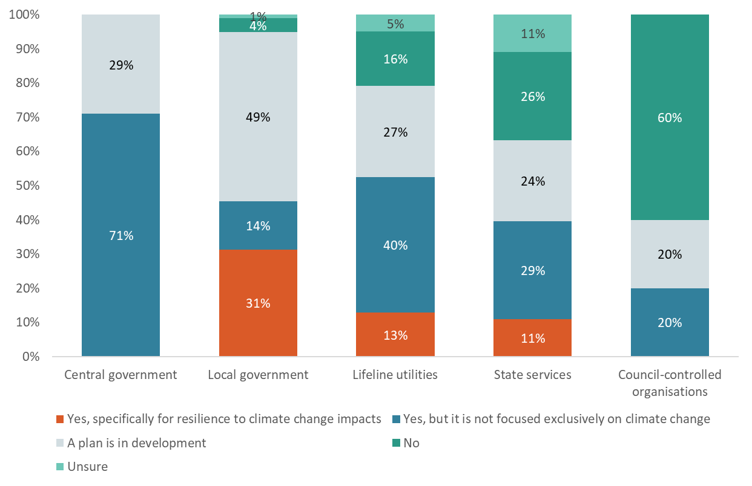

Note: Percentages have been rounded to the nearest whole number.

Of the respondents that provided details with their answers to the questions listed in the figure above, the following themes were commonly observed in the responses by each reporting organisation type.

##### Central government

* Climate risk and resilience are already built into existing plans and frameworks, or a specific climate resilience strategy is under development.

##### Local government

* Climate risk and resilience are already built into existing plans, with specific plans focused on climate change under development.
* Regulatory uncertainty and lack of funding, resources and staff are common barriers to developing a plan or strategy.

##### Lifeline utilities

* Climate risk and resilience are already built into existing asset management and infrastructure plans, business continuity plans, and risk and resilience frameworks.
* Common barriers to developing a plan include lack of access to relevant data and lack of funding, resources and staff.

##### State services

* Climate risk and resilience are already built into existing operational plans, and specific resilience strategies are under development for those without plans in place.
* Common barriers to developing a plan include managing competing priorities and lack of funding, resources and staff.

##### Council-controlled organisations

* Common barriers to developing a plan include managing competing priorities, challenges with coordination between agencies and partners, regulatory uncertainty and lack of funding, resources and staff.

## Does your organisation have any indicators or measures to help it monitor and manage its risks for climate change impacts?

|  |
| --- |
| This section corresponds to question 40 and question 41 in the survey. Respondents were invited to pick one of the following responses.   1. Yes 2. These are in development 3. No 4. Unsure |

Based on the responses received, indicators and measures used to monitor and manage risks for climate change appear to be part of a developing capability in 2024.

Although 27 per cent of respondents advised their organisations have indicators or measures in place to help them monitor and manage risks from climate change, 37 per cent advised these indicators or measures are not in place. Another 30 per cent of respondents advised that indicators and measures are under development. The remaining 6 per cent reported they are unsure whether their organisation has such indicators or measures.

### Key themes

Respondents were asked to list indicators or measures that their organisation used to monitor and manage risks from climate change impacts. Of the respondents that provided these details, the most frequently referenced indicators and measures were:

* impacts to specific assets, services and infrastructure (eg, disruptions to services, response incidents, and assets that are vulnerable to risks and whether these numbers are increasing or expanding in range)
* impacts and damage from flooding
* changes in waterways
* changes in ecology and vegetation (eg, changes in species populations or vegetation cover)
* changes in temperatures, including heatwaves
* variations in drought and precipitation
* coastal and ocean impacts (eg, changes in sea-level rise, shoreline ecosystems).

The reporting organisations that listed these indicators the most were local government organisations and lifeline utilities.

### Responses by organisation type

As shown in figure 7, reporting organisations varied in their responses to this question. Both central government (29 per cent) and lifeline utilities (31 per cent) reported the highest number of their organisations as having indicators and measures in place to manage risks from climate change impacts. Council-controlled organisations reported the lowest number of organisations in this category, with 70 per cent of respondents advising that no indicators or measures are in place.

Figure 7: Does your organisation have any indicators or measures to help it monitor and manage its risks from climate change impacts?

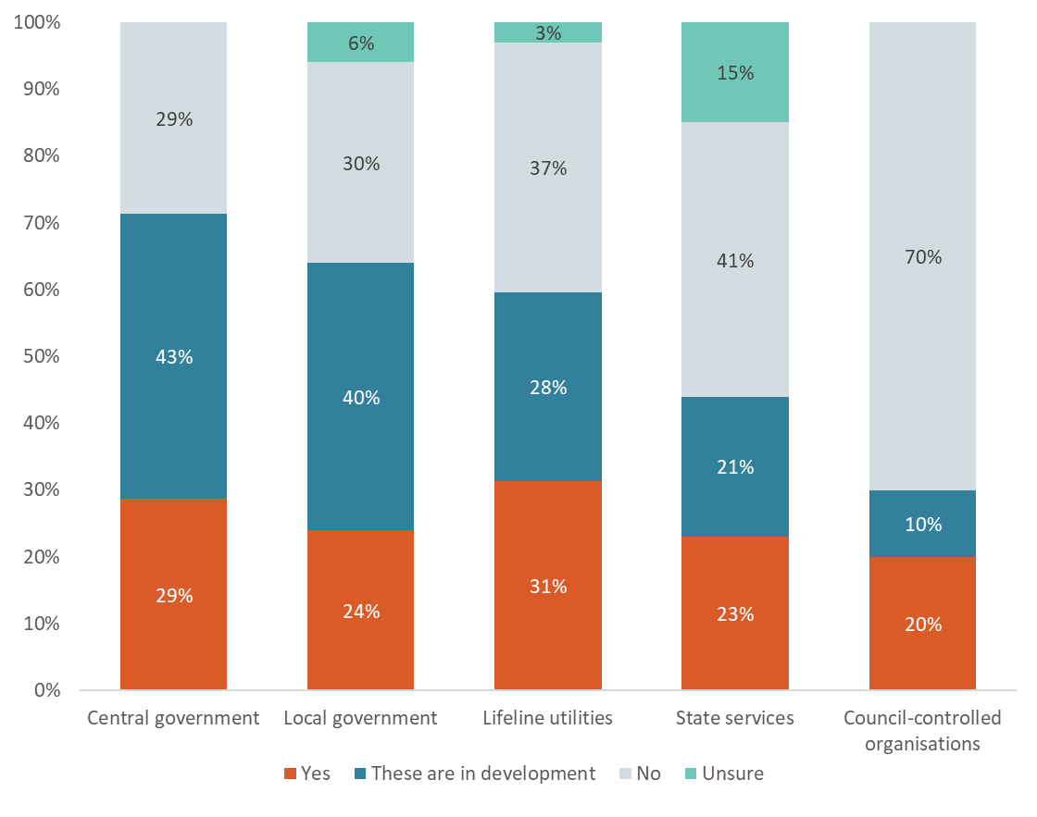

Note: Percentages have been rounded to the nearest whole number.

Of the respondents that provided details with their answers to the questions listed in the figure above, the following themes were commonly observed in the responses by each reporting organisation type.

##### Central government

* Indicators included changes to demand in services.

##### Local government

* Indicators included measuring impacts from flooding, changes in waterways, and variations in precipitation and drought.

##### Lifeline utilities

* Indicators included measuring the scale and number of coastal impacts on infrastructure, changes in the number of disruptions to services, and changes in the number of assets and services that are vulnerable to risks.

##### State services

* Indicators included changes in the number of disruptions to services, the effectiveness of efforts to reduce risk, the number of response incidents, and service reliability.

##### Council-controlled organisations

* Indicators included changes in the number of assets and services that are vulnerable to risks.

## Are risks to your organisation’s ability to carry out functions and deliver services from the impacts of climate change reported to your organisation’s governance board?

|  |
| --- |
| This section corresponds to questions 42 to 44 in the survey. Respondents were invited to pick one of the following responses.   1. Yes, more often than annually 2. Yes, annually 3. Yes, less often than annually 4. Not at all 5. Unsure |

Most organisations report climate risks to their governance boards. Of the respondents, 39 per cent of organisations advised reporting them more often than annually, 17 per cent on an annual basis and 13 per cent less often than annually.

Just under 17 per cent of organisations noted they do not report these risks to governance boards, and the remaining 15 per cent were unsure on this issue.

### Key themes

Respondents were invited to describe the role of management within their organisation in responding to the risks from climate change. The respondents that provided this information often mentioned that management was in charge of the following:

* enabling governance to make strategic decisions
* leading projects, teams and priorities
* managing organisational and broader system risks
* leading operational planning and decision-making.

When asked to give details on whether their organisation reports risks to their governance boards, many respondents advised that climate risks are specifically reported to a governance structure such as a board, committee or council. Others noted that climate risks are included in reports on organisational and strategic risks.

### Responses by organisation type

As shown in figure 8, reporting climate risks to governance boards is common among all reporting organisation types, with at least 50 per cent of respondents in each category advising that their organisation does this. Local government agencies have the highest proportion of respondents that report climate risks to a governance board (72 per cent), while council-controlled organisations have the lowest (50 per cent).

Local government agencies report climate risks the most often, with 44 per cent of respondents advising their organisation reports more often than annually. This is closely followed by central government agencies at 43 per cent.

Figure 8: Are risks to your organisation’s ability to carry out functions and deliver services from the impacts of climate change reported to your organisation’s governance board?

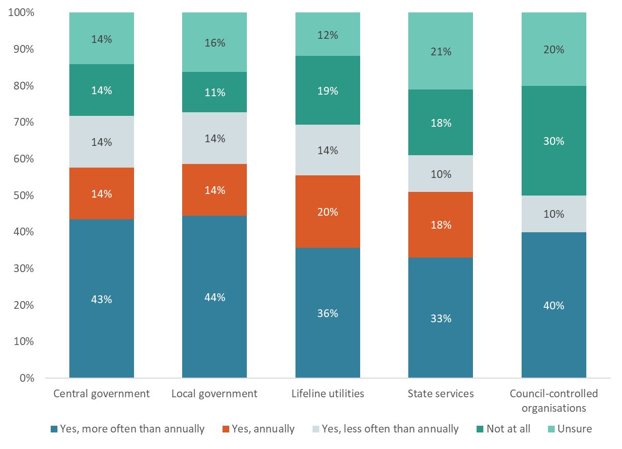

Note: Percentages have been rounded to the nearest whole number.

Of the respondents that provided details on the role of management, the following roles were commonly observed in the responses by each reporting organisation type.

##### Central government

Roles of management in central government organisations in responding to the risks from climate change include:

* leading operational planning and decision-making
* enabling governance to make strategic decisions
* leading projects, teams and priorities.

##### Local government

Roles of management in local government organisations in responding to the risks from climate change include:

* leading operational planning and decision-making
* managing organisational and broader system risks
* leading projects, teams and priorities
* enabling governance to make strategic decisions.

##### Lifeline utilities

Roles of management in lifeline utilities in responding to the risks from climate change include:

* managing organisational and broader system risks
* leading operational planning and decision-making
* leading projects, teams and priorities
* enabling governance to make strategic decisions.

##### State services

Roles of management in state services organisations in responding to the risks from climate change include:

* managing organisational and broader system risks
* leading operational planning and decision-making
* leading projects, teams and priorities
* enabling governance to make strategic decisions.

##### Council-controlled organisations

Roles of management in council-controlled organisations in responding to the risks from climate change include:

* enabling governance to make strategic decisions
* leading operational planning and decision-making

## Does your organisation require the impacts of climate change, and adaptation options to address these impacts, to be assessed and considered in decision-making?

|  |
| --- |
| This section corresponds to question 45 and question 46 in the survey. Respondents were invited to pick one of the following responses.   1. Yes 2. For some projects 3. Not yet, but this is in development 4. No 5. Unsure |

Most organisations assess and consider the impacts of climate change and adaptation options when making decisions, with 23 per cent of respondents advising this is required in their organisation for decision-making. Thirty-eight per cent reported that assessment and consideration of climate change impacts and adaptation options occur in some projects.

Seventeen per cent of respondents advised that climate change impacts and adaptation options are not yet considered, but processes to address these are under development. Another 17 per cent reported that climate change impacts and adaptation options are not considered in decision-making. The remaining 5 per cent were unsure if their organisations require this.

### Key themes

Respondents that provided details with their answers discussed various ways in which climate change impacts are considered in their organisation’s decision-making processes, including the following.

* Climate change impacts and adaptation options are broadly embedded into design and planning processes.
* Climate change impacts and adaptation options are embedded into design and planning processes in detail.
* High-level actions are in place to address climate change impacts and adaptation options, with further capabilities in this area being developed.

For respondents advising that climate change impacts and adaptation options are currently not considered, or are under development, common themes included the following.

* Climate change impacts and adaptation options are considered when necessary, although no formal processes are in place.
* Organisations are beginning to build capabilities to include climate change impacts and adaptation options in decision-making processes.
* Actions on addressing climate change impacts are currently considered unnecessary.

### Responses by organisation type

As shown in figure 9, of all reporting organisation types, local government agencies reported assessing and considering climate change impacts in decision-making the most, with 74 per cent advising these are considered and assessed in some or all projects. This figure is the lowest among state services, with only 33 per cent considering and assessing climate change impacts in decision-making.

Responses among central government respondents are polarised, with reporting organisations of this type either not considering climate change impacts in decision-making (43 per cent) or only considering them in some projects (57 per cent).

Figure 9: Does your organisation require the impacts of climate change, and adaptation options to address these impacts, to be assessed and considered in decision-making?

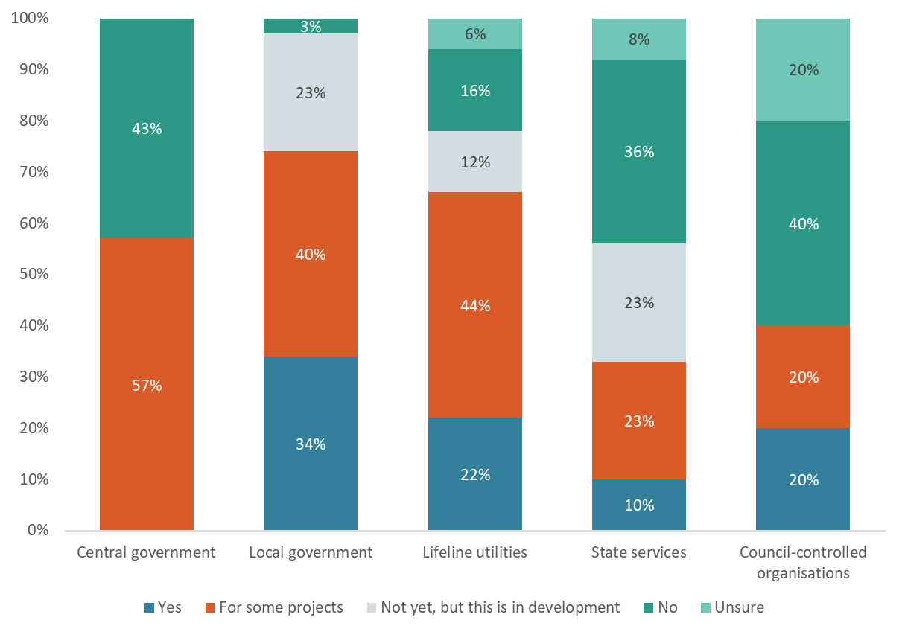

Note: Percentages have been rounded to the nearest whole number.

Of the respondents that provided details on how climate change impacts and adaptation options are considered in decision-making, the following themes were commonly observed in the responses by each reporting organisation type.

##### Central government

* Climate change impacts are considered for mitigation initiatives only.
* Climate change impacts and adaptation options are considered when necessary, although no formal processes are in place.

##### Local government

* Climate change impacts and adaptation options are broadly embedded into design and planning processes.
* Climate change impacts and adaptation options are embedded into design and planning processes in detail.
* High-level actions are in place to address climate change impacts and adaptation options, with further capabilities in this area being developed.

##### Lifeline utilities

* Climate change impacts and adaptation options are broadly embedded into design and planning processes.
* Climate change impacts and adaptation options are embedded into design and planning processes in detail.
* Climate change impacts and adaptation options are considered when necessary, although no formal processes are in place.

##### State services

* Climate change impacts and adaptation options are broadly embedded into design and planning processes.
* Climate change impacts and adaptation options are embedded into design and planning processes in detail.
* Organisations are beginning to build capabilities to include climate change impacts and adaptation options in decision-making processes.

##### Council-controlled organisations

* High-level actions are in place to address climate change impacts and adaptation options, with further capabilities in this area being developed.
* Climate change impacts and adaptation options are embedded into design and planning processes in detail.
* Climate change impacts are considered for mitigation initiatives only.

## Which actions or resources would help your organisation to better prepare for the impacts of climate change?

|  |
| --- |
| This section corresponds to question 47 and question 48 in the survey. Respondents were invited to pick one of the following responses.  Respondents were asked to pick as many of the following responses as applied.   1. More information about how climate change is projected to impact a region or a district 2. Guidance on how to assess and consider the impacts of climate change on your organisation 3. Tools to help quantify impacts from climate change on your organisation 4. Methodology for assessing and quantifying climate change risks 5. Legislative requirements to consider/plan for the effects of climate change 6. Legislative requirements to publicly report on your organisation’s climate risks and adaptation plans 7. Opportunities to engage and learn from others 8. Training to develop skills/capabilities 9. Improved and centralised data repository eg, flooding 10. Good practice guides, benchmarking and assessment tools 11. Funding to implement a strategy and deliver on-the-ground adaptation actions |

The survey asked respondents to identify actions and resources that would help their organisation better prepare for the impacts of climate change.

Figure 10 shows the percentage of respondents that selected each option. Option *a.**More information about how climate change is projected to impact a region or district* was the most sought-after resource to help reporting organisations to better prepare for the impacts of climate change. This was selected by 75 per cent of respondents.

A close second was option *k.* *Funding to implement a strategy and deliver on-the-ground adaptation actions*, which was selected by 73 per cent of respondents.

The least-selected resource to help reporting organisations to better prepare for the impacts of climate change was option *f.* *Legislative requirements to publicly report on your organisation’s climate risks and adaptation plans*. This was selected by 35 per cent of respondents.

Figure 10: Which actions or resources would help your organisation to better prepare for the impacts of climate change?

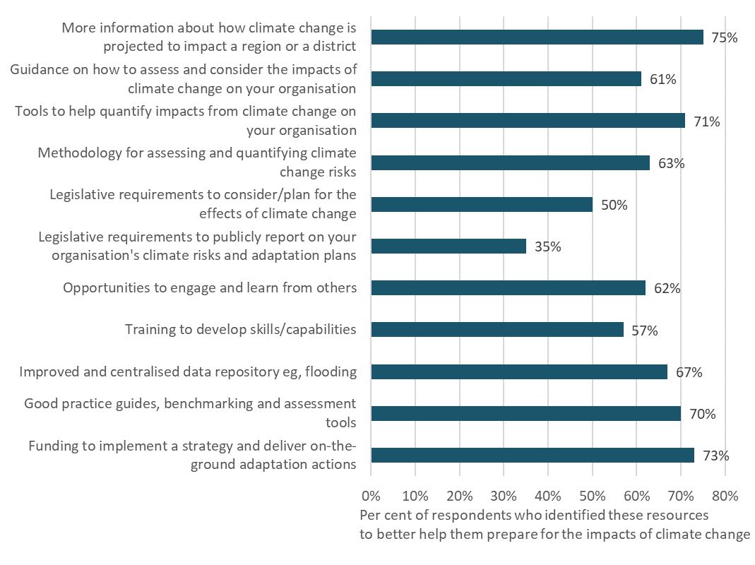

Note: Percentages have been rounded to the nearest whole number.

### Extra actions and resources

In addition to selecting from the options provided, respondents were asked to list any additional actions and resources they considered would be helpful to their organisation. From the 64 responses to this part of the question, the following actions and resources were most commonly listed.

* Centralised and fit-for-purpose data and information, including an online portal or access to mapping (27 per cent).
* Funding for more resources to help with the development of adaptation projects and planning (27 per cent).
* Standardised tools, methods and guidance to help with planning, reporting and assessing (19 per cent).
* Improved inter-organisational collaboration and coordination for sector-wide adaptation work programmes (16 per cent).

These resources and actions were referenced by respondents across most reporting organisation types.

### Responses by organisation type

Table 3 lists the most sought-after resources and actions by reporting organisation type in order of those most selected.

Table 3: Priority actions and resources by type of reporting organisation

|  |  |  |  |  |  |
| --- | --- | --- | --- | --- | --- |
| Ranking | Central government | Local government | Lifeline utilities | State services | Council-controlled organisations |
| #1 | *Option g.*  *Opportunities to engage and learn from others* | *Option k.*  *Funding to implement a strategy and deliver on-the-ground adaptation actions* | *Option a.*  *More information about how climate change is projected to impact a region or district* | *Option j.*  *Good practice guides, benchmarking and assessment tools* | *Option a.*  *More information about how climate change is projected to impact a region or district* |
|  | (72 per cent of respondents) | (100 per cent of respondents) | (81 per cent of respondents) | (85 per cent of respondents) | (70 per cent of respondents) |
| #2 | *Option i.*  *Improved and centralised data repository eg, flooding* | *Option j.*  *Good practice guides, benchmarking and assessment tools* | *Option i.*  *Improved and centralised data repository eg, flooding* | *Option g.*  *Opportunities to engage and learn from others* | *Option k.*  *Funding to implement a strategy and deliver on-the-ground adaptation actions* |
|  | (72 per cent of respondents) | (87 per cent of respondents) | (63 per cent of respondents) | (79 per cent of respondents) | (70 per cent of respondents) |
| #3 | Tie among options a, c, d, e and k. | *Option c.*  *Tools to help quantify impacts from climate change on your organisation* | *Option c.*  *Tools to help quantify impacts from climate change on your organisation* | *Option c.*  *Tools to help quantify impacts from climate change on your organisation* | *Option j.*  *Good practice guides, benchmarking and assessment tools* |
|  | (57 per cent of respondents) | (86 per cent of respondents) | (60 per cent of respondents) | (74 per cent of respondents) | (60 per cent of respondents) |

## What are the barriers to an effective adaptation response that are faced by your organisation?

|  |
| --- |
| This section corresponds to question 49 and question 50 in the survey. Respondents were invited to pick one of the following responses.  Respondents were asked to pick as many of the following responses as applied.   1. Lack of awareness/education regarding the impacts of climate change by decision-makers/the wider community 2. Lack of political will or desire from the community for change 3. Lack of tools/methods by which to engage decision-makers/the community 4. Inflexibility of current legislation 5. None of the above |

In addition to resources and actions, respondents were asked to identify, out of several options, the barriers that their organisation faces in forming an effective adaptation response.

Figure 11 shows the percentage of respondents that selected each option. Option *a. Lack of awareness/education regarding the impacts of climate change by decision-makers/the wider community* was the most selected barrier to an effective adaptation response. This barrier was selected by 51 per cent of respondents. The least selected barrier was option *d. Inflexibility of current legislation*, chosen by 33 per cent of respondents.

Although some respondents selected option *e.**None of the above*, many also provided information on additional barriers that were not indicated as an option in this question.

Figure 11: What are the barriers to an effective adaptation response faced by your organisation?

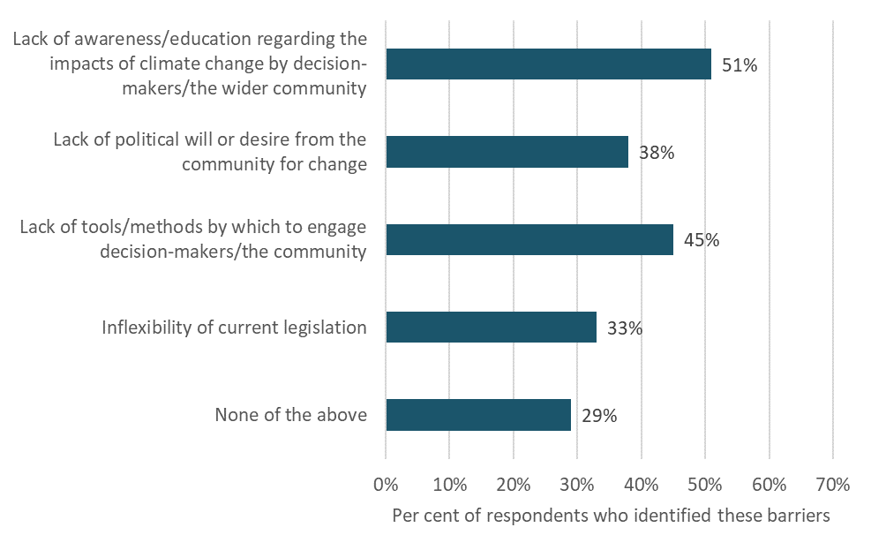

Note: Percentages have been rounded to the nearest whole number.

### Additional barriers

In addition to selecting the options above, respondents were asked to list any additional barriers faced by their organisations. From the 113 responses to this question, the most listed barriers were:

* costs and lack of funding for upgrading infrastructure and undertaking adaptation planning and recovery work (42 per cent)
* not enough resources, expertise or staff to undertake adaptation planning, and organisations being overloaded with responsibilities (19 per cent)
* lack of funding mechanisms or clarity on who pays, or the current funding system being regarded as inadequate to cover the costs of adaptation (16 per cent)
* the challenge of balancing adaptation work with other priorities, including business-as-usual work (13 per cent).

These barriers were referenced by respondents across most reporting organisation types.

### Responses by organisation type

Table 4 lists the most significant barriers by reporting organisation type, in order of those most selected.

Table 4: Most frequently selected barriers by type of reporting organisation

| **Ranking** | **Central government** | **Local government** | **Lifeline utilities** | **State services** | **Council-controlled organisations** |
| --- | --- | --- | --- | --- | --- |
| #1 | Tie among options a, b and e | *Option a.*  *Lack of awareness/ education regarding the impacts of climate change by decision-makers/ the wider community* | *Option e.*  *None of the above* | *Option c.*  *Lack of tools/ methods by which to engage decision-makers/ the community* | Tie between options a and e |
|  | (43 per cent of respondents) | (80 per cent of respondents) | (40 per cent of respondents) | (44 per cent of respondents) | (50 per cent of respondents) |
| #2 | Tie between options c and d | *Option c.*  *Lack of tools/ methods by which to engage decision-makers/the community* | *Option a.*  *Lack of awareness/ education regarding the impacts of climate change by decision-makers/ the wider community* | *Option a.*  *Lack of awareness/ education regarding the impacts of climate change by decision-makers/ the wider community* | *Option c.*  *Lack of tools/ methods by which to engage decision-makers/ the community* |
|  | (14 per cent of respondents) | (66 per cent of respondents) | (34 per cent of respondents) | (41 per cent of respondents) | (40 per cent of respondents) |
| #3 |  | *Option b.*  *Lack of political will or desire from the community for change* | *Option c.*  *Lack of tools/ methods by which to engage decision-makers/ the community* | *Option e.*  *None of the above* | *Option b.*  *Lack of political will or desire from the community for change* |
|  |  | (57 per cent of respondents) | (30 per cent of respondents) | (36 per cent of respondents) | (20 per cent of respondents) |

Extra barriers by reporting organisation type

Although option *e.**None of the above* was included in the top three options for all reporting organisation types, this does not indicate a lack of barriers. Rather, many respondents referenced extra barriers in their answers to this question. The following barriers were most commonly observed in the responses by each reporting organisation type.

##### Central government

* Not enough resources, expertise or staff are available to undertake adaptation planning, and organisations are overloaded with responsibilities.

##### Local government

* Costs and lack of funding are barriers to upgrading infrastructure and undertaking adaptation planning and recovery work.
* Either funding mechanisms or clarity on who pays are considered lacking, or the current funding system is regarded as inadequate to cover the costs of adaptation.
* Not enough resources, expertise or staff are available to undertake adaptation planning, and organisations are overloaded with responsibilities.

##### Lifeline utilities

* Costs and lack of funding are barriers to upgrading infrastructure and undertaking adaptation planning and recovery work.
* Consistent, coordinated and accessible data is lacking.
* Unpredictability and uncertainty make it difficult to plan. This includes uncertainty with changes in weather patterns and uncertainty associated with changing governments and regulations.

##### State services

* Costs and lack of funding are barriers to upgrading infrastructure and undertaking adaptation planning and recovery work.
* Not enough resources, expertise or staff are available to undertake adaptation planning, and organisations are overloaded with responsibilities.
* Either funding mechanisms or clarity on who pays are considered lacking, or the current funding system is regarded as inadequate to cover the costs of adaptation.
* It is challenging to balance adaptation work with other priorities, including business-as-usual work.

##### Council-controlled organisations

* Costs and lack of funding are barriers to upgrading infrastructure and undertaking adaptation planning and recovery work.

## Impacts of risks from the National Climate Change Risk Assessment

|  |
| --- |
| This section corresponds to questions 15 to 36 in the survey. Respondents were invited to indicate to what extent each risk is expected to impact the quality or consistency of services delivered by their organisation.  Respondents were asked to pick one of the following for each risk.   1. Potential for significant impacts 2. Potential for minor to moderate impacts 3. Unlikely to impact my organisation or the services it delivers 4. Unsure |

The National Climate Change Risk Assessment identified the 10 most significant risks and other priority risks that Aotearoa New Zealand faces from climate change. The risks are outlined in full in appendix 4.

For each of the 10 most significant risks, the survey asked respondents to indicate the extent to which these risks are expected to affect the quality or consistency of services delivered by their organisation or to affect infrastructure or capital investments they own or use. This also refers to risks affecting the communities to which these services are provided.

It was found that the three risks below were selected the most as those having potential impacts, with the largest number of respondents selecting either option *a. Potential for significant impacts* or option *b*. *Potential for minor to moderate impacts*.

* *B2: Risks to buildings due to extreme weather events, drought, increased fire weather and ongoing sea-level rise*. Seventy-seven per cent of respondents reported this as a potential risk.
* *E1: Risks to governments from economic costs associated with lost productivity, disaster relief expenditure and unfunded contingent liabilities due to extreme events and ongoing, gradual changes*. Seventy-five per cent of respondents reported this as a potential risk.
* *H1: Risks to social cohesion and community wellbeing from displacement of individuals, families and communities due to climate change impacts*. Seventy per cent of respondents reported this as a potential risk.

The following risks were selected the most as those having significant impacts (ie, respondents selected only option *a. Potential for significant impacts*).

* *E1: Risks to governments from economic costs associated with lost productivity, disaster relief expenditure and unfunded contingent liabilities due to extreme events and ongoing, gradual changes*. Fifty-one per cent of respondents reported this as a significant risk.
* *G2: Risk that climate change impacts across all domains will be exacerbated because current institutional arrangements are not fit for adaptation*. Forty-seven per cent of respondents reported this as a significant risk.
* *E2: Risks to the financial system from instability due to extreme weather events and ongoing, gradual changes*. Forty-two per cent of respondents reported this as a significant risk.

Figure 12 provides a breakdown of how respondents ranked the significance of each risk.

In addition to the 10 significant and priority risks in the National Climate Change Risk Assessment, respondents also referenced the following risks as significant to their organisations.[3]

* *E7****:*** *Risks to businesses and public organisations from supply chain and distribution network disruptions, due to extreme weather events and ongoing, gradual changes.*
* *B8****:*** *Risks to electricity infrastructure, due to changes in temperature, rainfall, snow, extreme weather events, wind and increased fire weather.*
* *G3****:*** *Risks to governments and businesses from climate change-related litigation, due to inadequate or mistimed climate change adaptation.*
* *B6****:*** *Risks to linear transport networks, due to changes in temperature, extreme weather events and ongoing sea-level rise.*
* *G6****:*** *Risks to the ability of the emergency management system to respond to an increasing frequency and scale of compounding and cascading climate change impacts in New Zealand and the Pacific region.*

Figure 12: Potential for impacts by risk

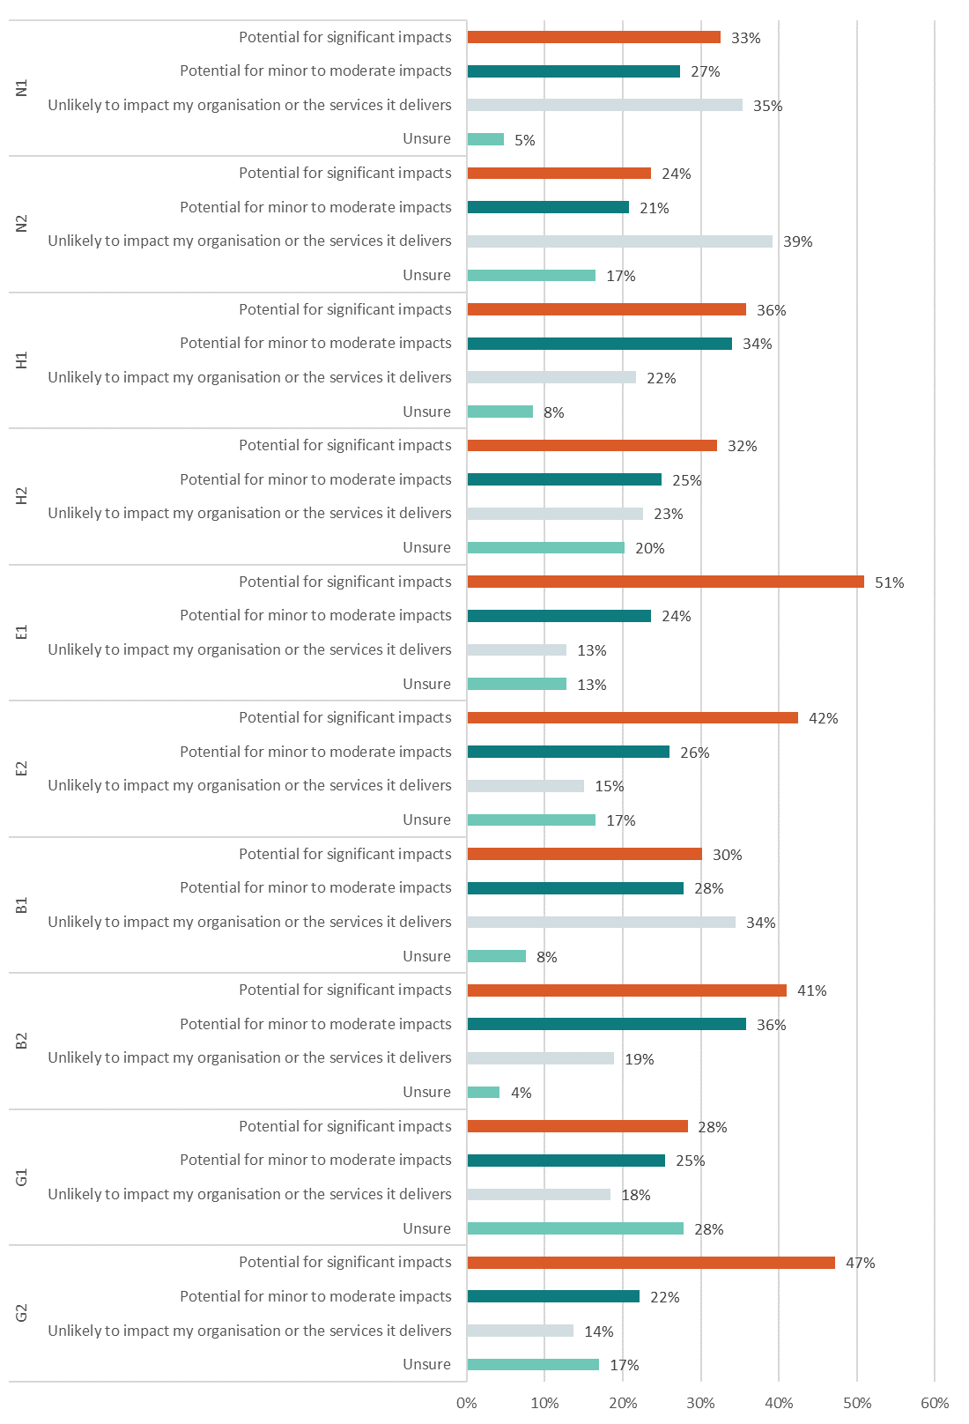

Note: Percentages have been rounded to the nearest whole number.

### Responses by organisation type

The significance of risks, and the number of risks considered to have impacts, varied according to a reporting organisation’s type and the services it provides. Tables 5 to 9 provide a breakdown of the risks most selected for their potential for impacts, by type of reporting organisation.

##### Central government

Table 5: Risks most selected for their potential for impacts – central government

|  |  |  |
| --- | --- | --- |
| **Ranking** | **Most selected for having** *any* **impacts  (options *a.* and *b.* selected)** | **Most selected for having** *significant* **impacts (option *a.* selected)** |
| #1 | *E1: Risks to governments from economic costs associated with lost productivity, disaster relief expenditure and unfunded contingent liabilities due to extreme events and ongoing, gradual changes* | *E1: Risks to governments from economic costs associated with lost productivity, disaster relief expenditure and unfunded contingent liabilities due to extreme events and ongoing, gradual changes* |
|  | (71 per cent of respondents) | (57 per cent of respondents) |
| #2 | *H1: Risks to social cohesion and community wellbeing from displacement of individuals, families and communities due to climate change impacts* | Tie between *H1* and *H2* |
|  | (71 per cent of respondents) | (43 per cent of respondents) |
| #3 | Tie among *G2, B2, B1, E2* and *H2*  (57 per cent of respondents) | Tie among *G2, B2* and *E2*  (29 per cent of respondents) |

##### Local government

Table 6: Risks most selected for their potential for impacts – local government

|  |  |  |
| --- | --- | --- |
| **Ranking** | **Most selected for having** *any* **impacts  (options *a.* and *b.* selected)** | **Most selected for having** *significant* **impacts (option *a.* selected)** |
| #1 | *E1: Risks to governments from economic costs associated with lost productivity, disaster relief expenditure and unfunded contingent liabilities due to extreme events and ongoing, gradual changes* | *E1: Risks to governments from economic costs associated with lost productivity, disaster relief expenditure and unfunded contingent liabilities due to extreme events and ongoing, gradual changes* |
|  | (99 per cent of respondents) | (83 per cent of respondents) |
| #2 | *H1: Risks to social cohesion and community wellbeing from displacement of individuals, families and communities due to climate change impacts* | *H1: Risks to social cohesion and community wellbeing from displacement of individuals, families and communities due to climate change impacts* |
|  | (97 per cent of respondents) | (74 per cent of respondents) |
| #3 | *B1: Risk to potable water supplies (availability and quality) due to changes in rainfall, temperature, drought, extreme weather events and ongoing sea‑level rise*  (94 per cent of respondents) | *G2: Risk that climate change impacts across all domains will be exacerbated because current institutional arrangements are not fit for adaptation*  (73 per cent of respondents) |

##### Lifeline utilities

Table 7: Risks most selected for their potential for impacts – lifeline utilities

|  |  |  |
| --- | --- | --- |
| **Ranking** | **Most selected for having** *any* **impacts  (options *a.* and *b.* selected)** | **Most selected for having** *significant* **impacts (option *a.* selected)** |
| #1 | *B2: Risks to buildings due to extreme weather events, drought, increased fire weather and ongoing sea-level rise* | *G2: Risk that climate change impacts across all domains will be exacerbated because current institutional arrangements are not fit for adaptation* |
|  | (77 per cent of respondents) | (42 per cent of respondents) |
| #2 | Tie between *G2* and *E2* | *E2: Risks to the financial system from instability due to extreme weather events and ongoing, gradual changes* |
|  | (63 per cent of respondents) | (36 per cent of respondents) |
| #3 | *E1: Risks to governments from economic costs associated with lost productivity, disaster relief expenditure and unfunded contingent liabilities due to extreme events and ongoing, gradual changes* | *B2: Risks to buildings due to extreme weather events, drought, increased fire weather and ongoing sea-level rise* |
|  | (62 per cent of respondents) | (31 per cent of respondents) |

##### State services

Table 8: Risks most selected for their potential for impacts – state services

|  |  |  |
| --- | --- | --- |
| **Ranking** | **Most selected for having** *any* **impacts  (options *a.* and *b.* selected)** | **Most selected for having** *significant* **impacts (option *a.* selected)** |
| #1 | *E1: Risks to governments from economic costs associated with lost productivity, disaster relief expenditure and unfunded contingent liabilities due to extreme events and ongoing, gradual changes* | *E1: Risks to governments from economic costs associated with lost productivity, disaster relief expenditure and unfunded contingent liabilities due to extreme events and ongoing, gradual changes* |
|  | (62 per cent of respondents) | (44 per cent of respondents) |
| #2 | *H1: Risks to social cohesion and community wellbeing from displacement of individuals, families and communities due to climate change impacts* | *B2: Risks to buildings due to extreme weather events, drought, increased fire weather and ongoing sea-level rise* |
|  | (62 per cent of respondents) | (33 per cent of respondents) |
| #3 | *B2: Risks to buildings due to extreme weather events, drought, increased fire weather and ongoing sea-level rise* | *E2: Risks to the financial system from instability due to extreme weather events and ongoing, gradual changes* |
|  | (59 per cent of respondents) | (31 per cent of respondents) |

##### Council-controlled organisations

Table 9: Risks most selected for their potential for impacts – council-controlled organisations

|  |  |  |
| --- | --- | --- |
| **Ranking** | **Most selected for having** *any* **impacts  (options *a.* and *b.* selected)** | **Most selected for having** *significant* **impacts (option *a.* selected)** |
| #1 | *E1: Risks to governments from economic costs associated with lost productivity, disaster relief expenditure and unfunded contingent liabilities due to extreme events and ongoing, gradual changes* | *E1: Risks to governments from economic costs associated with lost productivity, disaster relief expenditure and unfunded contingent liabilities due to extreme events and ongoing, gradual changes* |
|  | (70 per cent of respondents) | (40 per cent of respondents) |
| #2 | Tie among *G2*, *B2*, *E2* and *N1*  (50 per cent of respondents) | Tie among *B2, E2* and *N1*  (20 per cent of respondents) |

Respondents that provided details with their responses gave various reasons for why the risk has the potential to impact on their organisations. Key themes can be found in appendix 5.

### Immediate and urgent risks

The survey asked respondents to list any risks that are immediate and urgent to their organisation. Of the responses to this question, the risks commonly regarded as the most urgent and immediate to their organisation in terms of the impact on services, assets and infrastructure included:

* severe weather, including high winds, storms and cyclones
* flooding
* sea-level rise, coastal inundation and coastal erosion.

Respondents also raised risks associated with planning for the effects of climate change, including transitional risks and those associated with navigating changing regulations and resourcing adaptation responses.

# Appendix 1: Climate Change Response (Zero Carbon) Amendment Act 2019, sections 5ZW and 5ZX

### Power to request provision of information

**5ZW Minister or Commission may request certain organisations to provide information on climate change adaptation**

(1) The Minister or the Commission may, in writing, request that a reporting organisation provide all or any of the following information:

(a) a description of the organisation’s governance in relation to the risks of, and opportunities arising from, climate change:

(b) a description of the actual and potential effects of the risks and opportunities on the organisation’s business, strategy, and financial planning:

(c) a description of the processes that the organisation uses to identify, assess, and manage the risks:

(d) a description of the metrics and targets used to assess and manage the risks and opportunities, including, if relevant, time frames and progress:

(e) any matters specified in regulations.

(2) The reporting organisation must comply with a request made under subsection (1).

(3) The Minister must, as soon as practicable, provide the Commission with a copy of any information received in response to a request made by the Minister.

(4) The Commission must, as soon as practicable, provide the Minister with a copy of any information received in response to a request made by the Commission.

(5) The Minister and the Commission must not publicly disclose any information received in response to a request, unless disclosure of the information is necessary to enable the Minister or the Commission to perform a function or duty imposed by this Part.

(6) Subsection (5) does not apply in respect of information that is already in the public domain.

(7) Before publicly disclosing any information received in response to a request, the Minister or Commission must consult with the person to whom the information relates.

(8) For the purposes of this section and section 5ZX, the following are reporting organisations:

(a) the Public Service, as defined in section 27 of the State Sector Act 1988:

(b) local authorities, as defined in section 5(1) of the Local Government Act 2002:

(c) council-controlled organisations, as defined in section 6(1) of the Local Government Act 2002:

(d) Crown entities, as defined in section 7(1) of the Crown Entities Act 2004, but excluding school boards of trustees:

(e) companies listed in Schedule 4A of the Public Finance Act 1989:

(f) organisations listed in Schedule 1 of the State-Owned Enterprises Act 1986:

(g) lifeline utilities listed in Schedule 1 of the Civil Defence Emergency Management Act 2002:

(h) the New Zealand Police:

(i) the New Zealand Defence Force.

**5ZW Regulations relating to requiring provision of information**

(1) The Governor-General may, by Order in Council made on the recommendation of the Minister, make regulations specifying all or any of the following:

(a) requirements that relate to information that is provided in response to a request under section 5ZW(1), including different requirements for different sectors, classes of activity, or geographical areas:

(b) a date by which or time within which requested information must be provided to the Minister:

(c) ongoing or recurring reporting requirements (for example, requiring the provision of further information at regular intervals following a request):

(d) any administrative matters relating to responses to requests.

(2) In preparing the regulations, the Minister must consider—

(a) the ability to tailor a request to reflect the size and capability of the reporting organisation; and

(b) the potential extent and significance of climate change effects on the functions of the reporting organisation; and

(c) the avoidance of unnecessary duplication of information provided within existing reporting frameworks.

(3) Before recommending the making of the regulations, the Minister must consult the Commission and the reporting organisations that the Minister considers may be affected by the proposed regulations.

# Appendix 2: Copy of climate change adaptation reporting information request

### Monitoring adaptation preparedness – call for data

To: selected organisations subject to section 5ZW of the of the Climate Change Response Act 2002

**I am calling for data on your adaptation preparedness**

A priority for this government is to strengthen New Zealand’s ability to adapt to the effects of climate change. I am now calling for adaptation preparedness data under section 5ZW of the Climate Change Response Act 2002. This request is being made to selected organisations subject to section 5ZW with critical policy and service delivery functions.

I am asking you to provide high-level information about how your organisation is preparing for the impacts of climate change. It has been over three years since the last call for data, and 18 months since our first National Adaptation Plan was published, so it is timely to track progress in adaptation preparedness.

With this call for data, I am requesting information about:

* your organisation’s governance processes relating to risks of, and opportunities arising from, climate change
* your organisation’s general awareness and understanding of the actual and potential effects of the risks and opportunities on the organisation’s ability to carry out its functions and deliver services
* strategies or plans your organisation may have in place to address these risks, improve resilience and/or adapt to the impacts of climate change
* any support or resources your organisation might need to better prepare for the impacts of climate change.

Please provide adaptation preparedness data via this online survey by 12 April 2024. Please use information you already have available.

Information your organisation provides will be handled securely, as laid out in the Privacy Act 2020.

I am required to share the information received in response to this request with the Climate Change Commission.

I do not intend to publicly disclose organisation-specific information gathered through this survey. Neither the Climate Change Commission or I can publicly disclose any information received in response to this request unless its disclosure is necessary to perform a function or duty imposed by Part 1C of the Climate Change Response Act 2002.

Information gathered through this survey may be subject to requests under the Official Information Act 1982. However, there is provision for the protection of commercial or trade sensitive information.

Providing personal information is not mandatory. Any personal information supplied will only be used in relation to information requests including section 5ZW. You have the right to request access to or correct any personal information you supply.

Thank you for your participation in this call for data. If you have any questions, please contact adaptation@mfe.govt.nz.

Yours sincerely,

Hon Simon Watts  
Minister of Climate Change

Responses to this call for data are compulsory under section 5ZW of the Climate Change Response Act 2002.

Please ensure that only one person from your organisation fills out this survey. Thank you.

##### **Personal information**

Providing personal information is not mandatory. Any personal information supplied will only be used in relation to information requests including section 5ZW. You have the right to request access to or to correct any personal information you supply. If you have any questions, please contact adaptation@mfe.govt.nz.

1. What is your name?
2. What organisation do you work for?
3. What is your role?
4. Please provide contact email.
5. Please indicate if you are happy for the Ministry for the Environment to use the contact details provided above for broader climate change-related communications. Yes/No
6. If this response includes information related to subsidiary organisations, please name these organisations below.

##### **Risks and impacts**

These questions are intended to test general awareness and understanding of impacts and risks from climate change.

1. Is your organisation aware of the impacts that climate change may have on its ability to carry out functions and deliver services? For example, impacts from increased flooding, sea-level rise, more heat waves, more intense storms, more droughts and wildfires.
2. Climate change impacts are well understood and documented
3. Climate change impacts are acknowledged but only partially understood or documented
4. Climate change impacts are poorly understood and not documented or considered
5. We have not considered climate change impacts to date
6. Unsure
7. Please provide further details on why you selected the option you did. For example, links to reports.
8. Does your organisation have access to data related to the impacts from climate change?
9. Yes – at a regional, local and asset level
10. Yes – at a regional and local level
11. Yes – at a regional level
12. No
13. Unsure
14. Please provide details on any data gaps you are aware of for specific climate change impacts.
15. Specifically, has your organisation assessed its exposure to climate change impacts, in terms of its ability to continue to carry out functions and deliver services? Note: this includes the exposure of the communities to which these services are provided.
16. Yes, accurate (quantitative) exposure data is held for all relevant climate change impacts
17. Accurate exposure data is held for some climate change impacts
18. No accurate exposure data, but climate change impacts relevant to our organisation are documented
19. Limited or no understanding and assessment of exposure to relevant climate change impacts
20. Unsure
21. Please provide further details on why you selected the option you did. For example, links to reports
22. Specifically, has your organisation assessed its vulnerability to climate change impacts, in terms of its ability to continue to carry out functions and deliver services? Note: this includes the vulnerability of the communities to which these services are provided.
23. Yes, vulnerability to climate change impacts is well understood and integrated into decision-making processes.
24. Some assessment of vulnerability to climate change impacts has been done, but this is not well embedded in organisational processes
25. Limited or no assessment or understanding of vulnerability to climate change impacts
26. Unsure
27. Please provide further details on why you selected the option you did? For example, links to reports.

##### **National Climate Change Risk Assessment**

The National Climate Change Risk Assessment identified the 10 most significant risks that New Zealand faces from climate change. The risks are grouped according to five value domains: natural environment domain, human domain, economy domain, built environment domain and governance domain. For each of the risks listed below, indicate to what extent they are expected to impact the quality or consistency of services delivered by your organisation, or impact infrastructure or capital investments owned or used by your organisation. Note: this question also refers to risks affecting the communities to which these services are provided.

1. Risks to coastal ecosystems, including the intertidal zone, estuaries, dunes, coastal lakes and wetlands, due to ongoing sea-level rise and extreme weather events.
2. Potential for significant impacts
3. Potential for minor to moderate impacts
4. Unlikely to impact my organisation or the services it delivers
5. Unsure
6. Please provide further details on why you selected the option you did.
7. Risks to indigenous ecosystems and species from the enhanced spread, survival and establishment of invasive species due to climate change.
8. Potential for significant impacts
9. Potential for minor to moderate impacts
10. Unlikely to impact my organisation or the services it delivers
11. Unsure
12. Please provide further details on why you selected the option you did.
13. Risks to social cohesion and community wellbeing from displacement of individuals, families and communities due to climate change impacts.
14. Potential for significant impacts
15. Potential for minor to moderate impacts
16. Unlikely to impact my organisation or the services it delivers
17. Unsure
18. Please provide further details on why you selected the option you did.
19. Risks of exacerbating existing inequities and creating new and additional inequities due to differential distribution of climate change impacts.
20. Potential for significant impacts
21. Potential for minor to moderate impacts
22. Unlikely to impact my organisation or the services it delivers
23. Unsure
24. Please provide further details on why you selected the option you did.
25. Risks to governments from economic costs associated with lost productivity, disaster relief expenditure and unfunded contingent liabilities due to extreme events and ongoing, gradual changes.
26. Potential for significant impacts
27. Potential for minor to moderate impacts
28. Unlikely to impact my organisation or the services it delivers
29. Unsure
30. Please provide further details on why you selected the option you did.
31. Risks to the financial system from instability due to extreme weather events and ongoing, gradual changes.
32. Potential for significant impacts
33. Potential for minor to moderate impacts
34. Unlikely to impact my organisation or the services it delivers
35. Unsure
36. Please provide further details on why you selected the option you did.
37. Risk to potable water supplies (availability and quality) due to changes in rainfall, temperature, drought, extreme weather events and ongoing sea-level rise.
38. Potential for significant impacts
39. Potential for minor to moderate impacts
40. Unlikely to impact my organisation or the services it delivers
41. Unsure.
42. Please provide further details on why you selected the option you did.
43. Risks to buildings due to extreme weather events, drought, increased fire weather and ongoing sea-level rise.
44. Potential for significant impacts
45. Potential for minor to moderate impacts
46. Unlikely to impact my organisation or the services it delivers
47. Unsure
48. Please provide further details on why you selected the option you did.
49. Risk of maladaptation across all domains due to practices, processes and tools that do not account for uncertainty and change over long timeframes.
50. Potential for significant impacts
51. Potential for minor to moderate impacts
52. Unlikely to impact my organisation or the services it delivers
53. Unsure
54. Please provide further details on why you selected the option you did.
55. Risk that climate change impacts across all domains will be exacerbated because current institutional arrangements are not fit for adaptation. Institutional arrangements include legislative and decision-making frameworks, coordination within and across levels of government, and funding mechanisms.
56. Potential for significant impacts
57. Potential for minor to moderate impacts
58. Unlikely to impact my organisation or the services it delivers
59. Unsure
60. Please provide further details on why you selected the option you did.
61. What are the most immediate/urgent climate change risks to be managed from your organisation’s perspective?
62. Please list any other risks identified in the National Climate Change Risk Assessment that are significant for your organisation.

##### **Strategy, governance and metrics**

These questions are designed to gather information about internal governance and decision-making processes.

1. Does your organisation have a plan or strategy to improve its resilience and/or the resilience of the community it serves to climate change impacts?
2. Yes, specifically for resilience to climate change impacts
3. Yes, but it is not focused exclusively on climate change (eg, risk and resilience strategy)
4. A plan is in development
5. No
6. Unsure
7. Please provide more information and/or a link to the plan, and comment on its effectiveness.
8. What are the barriers to developing a plan?
9. Does your organisation have any indicators or measures to help it monitor and manage its risks from climate change impacts? For example, from increased flooding, sea-level rise, more heat waves, more intense storms, more droughts and wildfires. Note: this question includes risks affecting the communities to which these services are provided.
10. Yes
11. These are in development
12. No
13. Unsure
14. Please list the indicators or measures.
15. Are risks to your organisation’s ability to carry out functions and deliver services from the impacts of climate change reported to your organisation’s governance board?
16. Yes, more often than annually
17. Yes, annually
18. Yes, less often than annually
19. Not at all
20. Unsure
21. Any comments?
22. In the box below, please briefly describe the role that management plays within your organisation in responding to risks from climate change.
23. Does your organisation require the impacts of climate change, and adaptation options to address these impacts, to be assessed and considered in decision-making? For example, will climate change be considered before making a decision to invest in a physical asset. Note: this does not refer to requirements for mitigation/carbon emissions reduction.
24. Yes
25. For some projects
26. Not yet, but this is in development
27. No
28. Unsure
29. If applicable, please provide details about the requirements and their effectiveness.

##### **Support and resources**

1. Which actions or resources would help your organisation to better prepare for the impacts of climate change? Tick as many as apply:
2. More information about how climate change is projected to impact a region or a district
3. Guidance on how to assess and consider the impacts of climate change on your organisation
4. Tools to help quantify impacts from climate change on your organisation
5. Methodology for assessing and quantifying climate change risks
6. Legislative requirements to consider/plan for the effects of climate change
7. Legislative requirements to publicly report on your organisation’s climate risks and adaptation plans
8. Opportunities to engage and learn from others
9. Training to develop skills/capabilities
10. Improved and centralised data repository eg, flooding
11. Good practice guides, benchmarking and assessment tools
12. Funding to implement a strategy and deliver on-the-ground adaptation actions
13. Any other actions or resources?
14. What are the barriers to an effective adaptation response that are faced by your organisation? Tick as many as apply:
15. Lack of awareness/education regarding the impacts of climate change by decision-makers/the wider community
16. Lack of political will or desire from the community for change
17. Lack of tools/methods by which to engage decision-makers/the community
18. Inflexibility of current legislation
19. None of the above
20. Any other barriers?
21. Is there any further information you would like to provide about your organisation’s response to the risks and impacts of climate change? Please let us know in the box below.

##### **Sensitive information**

1. Please let us know in the box below if any of the information you have provided is sensitive to you or your organisation.

# Appendix 3: Response rate between 2020 and 2024

Table 10: Response rates over time by reporting organisation type

| Reporting organisation | | 2020 baseline* | | 2024 request | | Difference in response rate (%) |
| --- | --- | --- | --- | --- | --- | --- |
| No. of requests | Response rate | No. of requests | Response rate |
| Central government | | 11 | 55% | 9 | 78% | +23% |
| Local government | | 78 | 78% | 78 | 90% | +12% |
| Council-controlled organisations | | 20 | 10% | 19 | 53% | +43% |
| Lifeline utilities | | 142 | 35% | 112 | 77% | +42% |
| State services | Crown entities (including law and defence) | *38* | *63%* | *35* | *89%* | *+26%* |
| State-owned enterprises | *5* | *40%* | *7* | *71%* | *+31%* |
| Public finance companies | *7* | *43%* | *4* | *75%* | *+32%* |
| **Total** | | **301** | **49%** | **264** | **80%** | **+31%** |

*For organisations in scope of the 2024 request.

Figure 13: Response rates over time by reporting organisation type

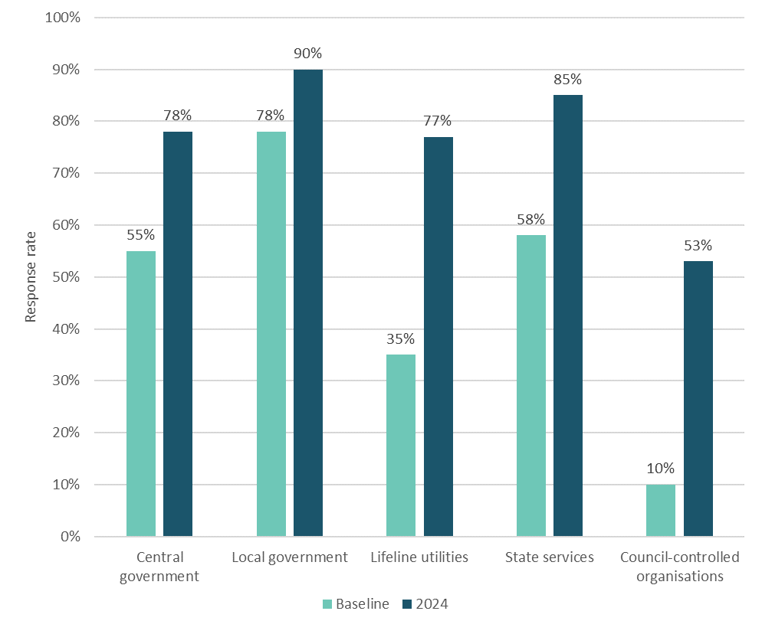

# Appendix 4: National Climate Change Risk Assessment significant risk and priority risk list

* **N1**: Risks to coastal ecosystems, including the intertidal zone, estuaries, dunes, coastal lakes and wetlands, due to ongoing sea-level rise and extreme weather events.
* **N2**: Risks to indigenous ecosystems and species from the enhanced spread, survival and establishment of invasive species due to climate change.
* **H1**: Risks to social cohesion and community wellbeing from displacement of individuals, families and communities due to climate change impacts.
* **H2**: Risks of exacerbating existing inequities and creating new and additional inequities due to differential distribution of climate change impacts.
* **E1**: Risks to governments from economic costs associated with lost productivity, disaster relief expenditure and unfunded contingent liabilities due to extreme events and ongoing, gradual changes.
* **E2**: Risks to the financial system from instability due to extreme weather events and ongoing, gradual changes.
* **B1**: Risk to potable water supplies (availability and quality) due to changes in rainfall, temperature, drought, extreme weather events and ongoing sea-level rise.
* **B2**: Risks to buildings due to extreme weather events, drought, increased fire weather and ongoing sea-level rise.
* **G1**: Risk of maladaptation across all domains due to practices, processes and tools that do not account for uncertainty and change over long timeframes.
* **G2**: Risk that climate change impacts across all domains will be exacerbated because current institutional arrangements are not fit for adaptation.

# Appendix 5: Key themes for each risk

Table 11: Key themes identified for each risk

| **Risk** | **Key themes, including why it is a potential risk** |
| --- | --- |
| **N1: Risks to coastal ecosystems, including the intertidal zone, estuaries, dunes, coastal lakes and wetlands, due to ongoing sea-level rise and extreme weather events** | * Impacts on local ecology and geography where an organisation is located * Relevant infrastructure, assets and services in coastal areas may be affected |
| **N2: Risks to indigenous ecosystems and species from the enhanced spread, survival and establishment of invasive species due to climate change** | * Impacts on local ecology and geography where an organisation is located * Relevant infrastructure, assets, sectors and services likely affected by changes in ecosystems, including spread of invasive species |
| **H1: Risks to social cohesion and community wellbeing from displacement of individuals, families and communities due to climate change impacts** | * Displacement or isolation of communities from severe weather events and sea-level rise * Negative impacts on the physical and mental health of individuals (including staff) with changes in the climate * Severe weather impacts leading to increased demands on assets and services that customers or the community rely on * Loss in sense of community from displacement * Loss of social order and trust in organisations if emergency response measures are insufficient or under-resourced |
| **H2: Risks of exacerbating existing inequities and creating new and additional inequities due to differential distribution of climate change impacts** | * Increased social inequalities for vulnerable people affected by climate change * Increased costs of providing products and services, making these less accessible and affordable for individuals who need them * Displacement or isolation of communities from severe weather events and sea-level rise |
| **E1: Risks to governments from economic costs associated with lost productivity, disaster relief expenditure and unfunded contingent liabilities due to extreme events and ongoing, gradual changes** | * Significant costs related to the provision of disaster recovery and climate resilience, including maintaining and building resilient infrastructure, and funding recovery efforts, disaster relief, insurance and property buy-outs * Impacts of climate change on multiple sectors, including loss in productivity and the ability to operate (this includes indirect impacts on organisations from sectors facing these challenges) * Costs and expenditure associated with recovery – organisations are reliant on external funding and policy priorities (including government funding and rates), lack capital reserve and have limited resources |
| **E2: Risks to the financial system from instability due to extreme weather events and ongoing, gradual changes** | * Possibility of insurance retreat and rising insurance premiums making operations costly and putting financial pressure on communities * Significant costs related to the provision of disaster recovery and climate resilience, including maintaining and building resilient infrastructure, and funding recovery efforts, disaster relief, insurance and property buy-outs * Economic stressors (such as supply chain disruptions) affecting the local and national economy * Costs and expenditure associated with recovery – organisations are reliant on external funding and policy priorities (including government funding and rates), lack capital reserve and have limited resources |
| **B1: Risk to potable water supplies (availability and quality) due to changes in rainfall, temperature, drought, extreme weather events and ongoing sea-level rise** | * Concerns regarding the availability of water supply for the health and safety of communities and staff * Effects of climate stressors on drinking water supply (such as saltwater infiltration, erosion, flooding, heatwaves and drought) * Water quality concerns, such as contamination issues and the spread of waterborne illnesses caused by climate change impacts |
| **B2: Risks to buildings due to extreme weather events, drought, increased fire weather and ongoing sea-level rise** | * Climate stressors and severe weather events that will directly damage services, assets and infrastructure essential to organisations and communities * Buildings, assets and infrastructure essential to organisations and communities in high-risk areas * Damaged buildings, assets and infrastructure may affect operations and service delivery |
| **G1: Risk of maladaptation across all domains due to practices, processes and tools that do not account for uncertainty and change over long timeframes** | * Uncertainty of climate change impacts and their severity can make planning and investment decisions difficult * Lack of skills, resources, relevant data and suitable guidance makes it difficult to plan, leading to risk of maladaptation * Decision-making is too focused on short-term funding, cost savings and political cycles, making it difficult to implement long-term effective action |
| **G2: Risk that climate change impacts across all domains will be exacerbated because current institutional arrangements are not fit for adaptation** | * Resourcing and funding mechanisms for climate adaptation planning and implementation are insufficient * National direction, leadership and commitment are too inconsistent to enable effective adaptation planning * Current frameworks and lack of coordination among relevant organisations are causing delays and making it difficult to plan * Lack of fit-for-purpose regulations, legislation, guidance and tools can cause delays and risk maladaptation |

1. Increases in capabilities between 2020 and 2024 have been quantified as follows: ‘slightly more’ represents a modest increase of under 10 per cent, ‘moderately more’ represents an increase of between 10 per cent to 25 per cent and ‘many more’ represents an increase of over 26 per cent.
2. To enable cross comparison of response rates between the 2024 request and 2020 baseline request, we have only calculated the 2020 baseline response rate for organisations within the scope of the 2024 selection criteria. This allowed a like-for-like comparison to better observe this change over time.
3. For more information on significant and priority risks in each domain, see Ministry for the Environment. 2020. [*National Climate Change Risk Assessment for Aotearoa New Zealand: Main report – Arotakenga Tūraru mō te Huringa Āhuarangi o Āotearoa: Pūrongo whakatōpū*](https://environment.govt.nz/assets/Publications/Files/national-climate-change-risk-assessment-main-report.pdf). Wellington: Ministry for the Environment.