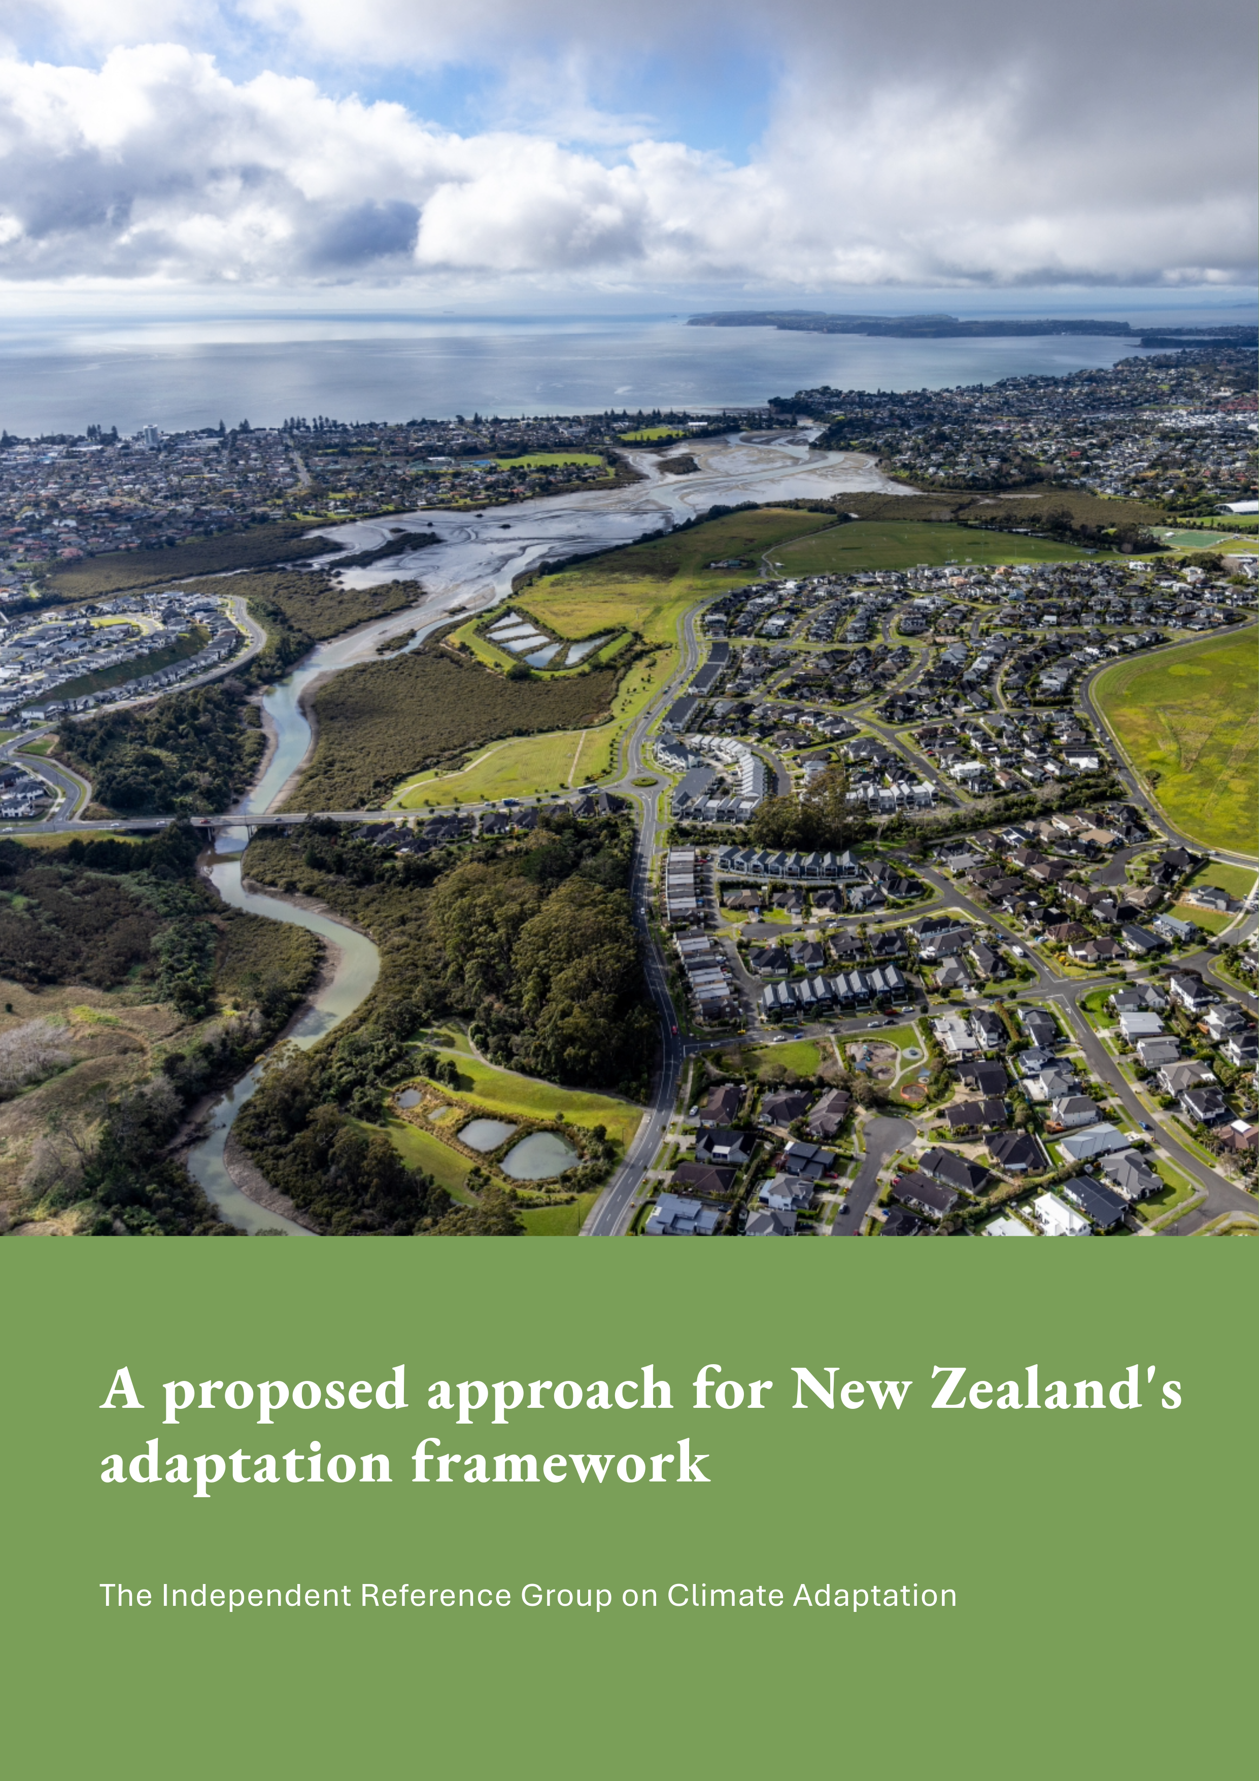

This document may be cited as: Independent Reference Group on Climate Adaptation. 2025. A proposed approach for New Zealand’s adaptation framework.

Published in July 2025 by
the Independent Reference Group on Climate Adaptation.
This document is available on the Ministry for the Environment website:
environment.govt.nz
ISBN: 978-1-991140-92-0
Publication number: CR 617
© Crown copyright New Zealand 2025

Contents
The Independent Reference Group 2
Summary of key recommendations 3
The proposed adaptation approach 3
To reach this state, we need a transition period 4
Key decisions needed to support the recommended approach 4
New Zealand’s current state 5
The barriers to adaptation in New Zealand 5
The impacts of current settings 6
Recommendations 8
A mature approach to managing risk, to reduce overall costs 8
A transition period is needed 10
Key decisions needed to support the recommended approach 12

The Independent Reference Group
The Ministry for the Environment established the Independent Reference Group (the Group) to support development of policy advice for the national adaptation framework.
The Group was established to test policy ideas and explore challenges under the current system in relation to sectors directly impacted by climate change, including Treaty partners, banking, insurance and local government.
The members are:
- Matt Whineray (Chair) – former chief executive of Guardians of New Zealand Superannuation
- Marama Royal – chair of Ngāti Whātua Ōrākei Trust
- Belinda Storey – economist and expert on pricing physical climate risk
- Malcolm Alexander – partner at Yule Alexander Limited and former chief executive of Local Government New Zealand
- Jimmy Higgins – chief executive of Suncorp New Zealand
- Aileen Lawrie – chief executive of Thames Coromandel District Council
- Rebekah Cain – chief sustainability officer at Bank of New Zealand.
This report summarises the Group’s advice and its proposed adaptation approach.

Summary of key recommendations

The proposed adaptation approach
The Group considers there to be an urgent need to change the way New Zealand adapts to climate change. New Zealand is already experiencing the impacts of climate change, but it is currently underprepared. This is leading to larger and more frequent recovery costs, unmanaged financial strain, and disproportionate impacts on some groups.
Climate change will continue to bring substantial financial costs for the country. Failing to act or delaying decisions will not avoid or reduce the costs that New Zealand governments, businesses and individuals face.
The Group recommends that New Zealand takes decisions with urgency to move towards a mature adaptation framework to manage risks from climate change. Making decisions now will enable New Zealand to spread the costs of adapting over as long a period as possible. The later the decisions are made, the sharper and more disruptive the adjustment will be, and the greater the risk that changing financial markets will impact homeowners in ways they cannot anticipate or prepare for.
The Group considers that New Zealand needs a consistent approach to decision making that is well informed about the risks. This should include proactive adaptation planning and response options. The approach should be implemented over time, to reduce risk to life, property and infrastructure, reduce fiscal pressure on the Crown, local government and other agencies, and minimise economic losses.
To achieve this approach and reduce overall costs, change is needed across three broad areas.
New Zealanders need to have fair warning about the way natural hazards could impact them, so they can make informed decisions. This means having easy access to risk information. They also need to know what is being done by others to adapt to or manage the risk, and what the financial implications are for them. There are considerable opportunities for both the public and private sector to reduce future costs when risks are well understood early enough, allowing people to plan for and mitigate the risks.
New Zealand should take the broadest interpretation of a ‘beneficiary pays’ approach to funding the increased investment in risk reduction because of climate change. This would mean those who benefit most from these investments contribute more. Central government should contribute to investment where that investment will protect Crown assets, or where broader national benefits can be realised. Central government investment or other financing strategies may be appropriate to help overcome challenges in particularly vulnerable areas, where there is less ability to pay.
People and markets should adjust over time to a changing climate. This means that people should be responsible for knowing their risks and making their own decisions on whether to stay in a high-risk area or move away, unless there is risk to life. Property values and the cost of ownership, such as insurance premiums or mortgages, should reflect the changing level of risk. While the Group sees an enduring role for central government to support those facing hardship to recover, it considers that people should not expect buyouts in the long term. Iwi/hapū/Māori should be empowered and resourced to make local adaptation decisions for whenua Māori and Māori assets.

To reach this state, we need a transition period
New Zealand needs a transition period to provide the time to build up and share information about exposure to natural hazards, and plan for change.
The transition period would allow New Zealand to move towards sharing risks and costs over time, to smooth impacts on people’s well-being and on financial markets. It would also allow for ‘fair warning’, sufficient time for people to adjust their expectations to respond to the newly available hazard information, and to the measures that are planned to reduce risks.
The transition period would give people time to make decisions about their property and help spread the cost of change over time.
The Group acknowledges that there is no ‘right’ answer to how long a transition should take. However, the Group considers that a transition period of 20 years would appropriately balance the need to spread costs with creating the right incentives to act. The Group also recognises the urgent need to establish a new approach to adaptation so that transition can begin as soon as possible.

Key decisions needed to support the recommended approach
The Government’s work to develop a national adaptation framework is focused on four key pillars or workstreams: sharing information about risks and responses, clarifying roles and responsibilities, guiding investment in resilience, and cost-sharing.
The Group makes 18 recommendations for key decisions needed to support its recommended adaptation approach. These are grouped under four areas, aligned with the four pillars of the framework: natural-hazard and risk information; decision making; Crown investment – risk reduction; and financial assistance for residential property owners.
The recommended key decisions are detailed on pages 12−14.

New Zealand’s current state

The barriers to adaptation in New Zealand
The Group identifies challenges under the current system, which a national adaptation framework might seek to address.

Information about climate and hazards is variable around the country. It can be costly and difficult for property owners or other parties to access or understand this information.
Property prices generally do not reflect the risk that properties face in locations that are exposed to a lot of natural hazards, such as floods, erosion or sea-level rise.
Local government has incomplete powers to manage the risks from natural hazards, and responsibilities are ambiguous. It is statutorily responsible for natural-hazard risk planning, but many interventions that it can make are optional. Given the place-based nature of hazards, adaptation planning is essentially local. However, capability and resources also vary considerably between councils. The respective roles of regional councils and territorial authorities are not always clear.
Local government carries out most of the investment in flood protection, but it is not required to invest. There are grey areas in how roles and responsibilities are split between regional and local authorities. Local government faces funding challenges and there is evidence of under-investment. Funding will be a challenging proposition if councils’ ability to increase rates is constrained. The value of flood protection, and councils’ ability to pay for it, is likely to decrease as the effects of climate change increase. There are also groups and individuals who benefit from, but do not contribute to, council investment in protection measures.
There is an expectation central and local government will step in to cover costs for individual homeowners, despite the fact that there is no legal or policy framework to require or guide these decisions. In the past, local and central government have offered buyouts of up to the full value of properties affected by natural hazards. These decisions reduce incentives for people to understand and manage their own risk, can distort property prices, and have given rise to an expectation that buyouts will continue, creating a moral hazard.
Processes can be slow, uncertain and may face legal challenge. This includes processes under the Resource Management Act 1991 (such as plan changes) and funding under the Local Government Act 2002 (such as options for setting council rates). Concerns about legal liability can deter or delay decisions, especially for councils.
It is very difficult to have conversations about the possibility of retreating from an area with owners or communities until an event leaves no alternative. There is no clear or straightforward existing pathway to retreat from an area that faces unacceptable risk.

The impacts of current settings
The Group considers the need for change to be urgent and critical, because the current state is leading to New Zealand being inadequately prepared for climate change. It identifies key impacts from current settings.

New Zealand is experiencing larger and more frequent costs. Cyclone Gabrielle was New Zealand’s costliest non-earthquake natural disaster, with economic losses expected to exceed the NZ$2 billion to $4 billion of losses from the 2016 Kaikōura earthquake.
The 2023 North Island weather events as a whole (including the flooding that hit Auckland as well as Cyclone Gabrielle) are estimated to have caused NZ$9 billion to $14.5 billion in damage to physical assets. They also set new benchmarks for the costliest weather events ever in New Zealand for insurers.
There are unmanaged social expectations and financial strain after major events. NZ$4.1 billion in household assets could face serious harm over the next 30 years. Central government is not liable for these losses, but faces growing public expectation to cover them, given New Zealand’s recent history of ad-hoc buyouts. This potential demand for central government assistance is uncapped and growing as a result.
Local government is also exposed to costs, given that previous approaches have included cost sharing for buyouts.
Declining insurance, insurance withdrawal and unaffordable insurance cover. Global reinsurers – the insurers of New Zealand’s insurance companies – were reportedly surprised by the costs of the 2023 North Island weather events. As a result, they have increased their prices, and are asking New Zealand insurance companies to carry more of the initial loss.
Recent climate change scenario analysis suggests average annual losses from weather-related events (floods, storms and coastal inundation) could increase between 19 per cent and 26 per cent by 2050. This is predominantly driven by sea-level rise, as well as more frequent and intense surface water flooding.
If left unaddressed, the rising risks will lead to increased costs for insurers, which may affect the cost and availability of insurance coverage. There is a risk of insurance premiums becoming unaffordable, especially for areas more exposed to natural hazards. Some areas could see insurance retreat, where insurance companies decline to provide coverage to assets facing high levels of known risk.
The Reserve Bank of New Zealand considered risks to financial stability from climate change in its latest climate scenario stress test.
Government expenditure typically happens after a major event. Proactive risk-reduction planning and investment presents the opportunity to reduce overall costs, where the investment is lower than the avoided costs. While unquantified, the Group considers that the opportunity to reduce overall costs through investment before major events occur is likely to be substantial. The Group notes that major events bring a wider cost to society than solely the financial costs of damage to physical assets.
As our climate changes, the scale and frequency of both small and large events are expected to increase. This means that reducing risk before events occur is generally the most cost-efficient approach.
Some groups face disproportionate impacts. Māori land and assets are particularly exposed to climate-change-related risk,, as are rural communities that may have small ratepayer bases or be dependent on critical infrastructure assets such as a single bridge.
Lower socioeconomic communities also face disproportionate impacts, and may lack the resources or opportunity to respond to risk. As prices of properties that are highly exposed to climate-change-related risks fall, lower socioeconomic communities will be more likely to live in them, increasing their financial and physical vulnerability.

Recommendations

A mature approach to managing risk, to reduce overall costs
The Group considers that New Zealand needs to urgently move towards a mature adaptation framework to manage risks. The later decisions are made, the sharper and more disruptive the adjustment will be. The Group proposes a risk-informed and consistent approach to decision making that includes proactive adaptation planning and response options.

New Zealanders need to have fair warning about the way natural hazards could affect them, so they can make informed decisions.
This means that:
- quality and timely information about the level of exposure to natural hazards is readily available
- anyone making decisions or participating in the market has access to the same information
- people know what is being done to adapt to or manage risk and what this will mean for them financially (for example, what will they be required to pay for).
The Group notes that transparency of information does not change the hazards and risks. Events will happen, and costs and losses will be incurred, whether data is available and risks are understood or not. Transparency supports the principle of providing ‘fair warning’ and allows people to plan for and mitigate risks. There are considerable opportunities for both the public and private sector to reduce future costs when risks are well understood early enough.
National climate modelling is essential to New Zealand’s ability to adapt. Climate models should be readily accessible to a wide range of users, with minimal restrictions on their use. The Group acknowledges the financial constraints on public research organisations and the pressure to generate commercial returns. However, it considers that arrangements should be in place, including with the private sector, to ensure critical models are continuously improved and access is not constrained. Poorly informed adaptation decisions have much greater potential costs than returns generated by public research organisations by charging for access to modelling.
The Group acknowledges that the nature of risk means there will always be uncertainty and some unknown risks. This should be communicated clearly to decision-makers and to stakeholders, especially private asset owners.
Measures need to be in place to better inform and educate people about known natural-hazard risks. This could include simple and frequent communications with property owners, renters and the public on their exposure to hazards, and the expected responses to manage risk.
Plans for adapting and reducing risk need to be made, communicated and executed in a timely manner. Communities, landowners, including iwi/hapū/Māori, and infrastructure providers all need to be able to participate in decisions about their local area and assets.
People need certainty about whether, when and how financial assistance and investment support will occur.
New Zealand needs clear legal requirements and processes to reduce the liability risks for decision-makers, while balancing New Zealanders’ right to access justice. Liability can be an important incentive to make decisions in good faith and with care. However, excessive litigation risk can reduce the incentive for decision-makers to take action to protect assets and communities.
New Zealand should take the broadest interpretation of a ‘beneficiary pays’ approach to funding increased investment in risk reduction because of climate change.
This would mean those who benefit most from these investments contribute more.
The Group takes a broad interpretation of who benefits from risk reduction and so who might invest, acknowledging the existing tools that local government has through the rating system to reflect the impacts of land-use activities in their area. This includes local and central government, infrastructure providers, and private individuals and businesses, especially in the highest-risk locations.
Investments by those who benefit should reflect the adaptation priorities included in:
- council long-term plans (including the plans of council-controlled organisations and water services organisations)
- regional spatial plans
- Crown infrastructure investment strategies
- other critical infrastructure providers’ investment plans.
Private landowners should have incentives and choices to reduce their risk or improve resilience, to the extent that it does not cause other negative impacts.
Central government should contribute to investment where that investment will protect Crown assets, or where broader national benefits can be realised through the investment.
The Group acknowledges some consideration of ability to pay will remain necessary, and does not recommend a strictly ‘beneficiary pays’ approach.
Central government investment or other financing strategies may be appropriate to help overcome challenges in particularly vulnerable areas, where there is less ability to pay.

People and markets should adjust to a changing climate over time.
This means that people should be responsible for knowing their risks and making their own decisions on whether to stay in a high-risk area or move away. Unless there is risk to life, some people may choose to stay in risky locations. In that case, they should be responsible for bearing the costs of their decision.
Adaptation policy should give careful consideration to the approach when risk to life is identified, and whether this is adequately covered by other policy settings.
Development in high-risk areas should be avoided. Development in lower-risk areas should include appropriate protections to mitigate risks. In particular, clarification of how residual risk should be managed under the Resource Management Act 1991 and Building Act 2004, to streamline development decisions.
Iwi/hapū/Māori should be empowered and resourced to make local adaptation decisions for whenua Māori and Māori assets.
Property values and/or the cost of ownership, such as insurance premiums or mortgages, should better reflect the changing level of risk. Any financial losses should be spread over time. For example, the value of the property in a high-risk area might gradually decrease over time, meaning that the losses are gradually borne by successive owners, rather than only one owner bearing an abrupt fall in value.
To support this, insurance and lending decisions should reflect up-to-date information about hazards and risks, including risk reduction. Much of this information relies on third party sources, such as council flood mapping. This would mean that riskier locations could be expected to have higher risk-adjusted premiums.
The reverse must also be true, as people invest in actions that reduce risk, insurance premiums should adjust accordingly. This would illustrate to reinsurers that New Zealand is planning for the long term and taking positive action on risk reduction, to lessen the severity of problems in the future.
The Group sees an enduring role for central government to support people after major events who are facing hardship and help them to recover, and potentially move on.
People should not expect buyouts. Following the transition period, the provision of hardship support should continue, but not be related to property values.
The Natural Hazards Commission should continue to play a key role.

A transition period is needed
The Group considers that a transition period will give people time to better understand risk, make decisions about their property, and enable costs to be shared over time.

A transition period would move New Zealand towards the proposed future state between now and 2045.
New Zealand needs a transition period so there is time to:
- build up and share a body of information about natural hazards and risk assessments so people have a good level of information about the risks
- plan for change and implement land-use planning changes to help reduce future risks
- build up to sharing risks and costs over time, to smooth the impacts on people’s well-being and on financial markets
- provide ‘fair warning’ and sufficient time for people to adjust their expectations to respond to the newly available hazard information, and to the measures that are planned to reduce risks.
The length of the transition period is important. A transition that is too short may not provide enough opportunity for people to understand and respond to risk and may put too much cost on current property owners. The transition should also consider council planning cycles and processes.
A transition that is too long risks blunting incentives to understand and respond to risk. This could increase overall costs to society because the impacts of climate change are expected to increase over time. Markets for insurance and mortgage lending are already beginning to develop responses to climate risks, for example, considering whether, how much and at what price, they will continue to invest in high-risk areas. The transition period needs to keep pace with these shifts, meaning decisions should be made and communicated as soon as possible.
The Group acknowledges that there is no ‘right’ answer to how long a transition should take. However, the Group considers that a transition period of 20 years would appropriately balance the need to spread costs with creating the right incentives to act. The Group also recognises the urgent need to establish a new approach to adaptation so that transition can begin as soon as possible.
Figure 1: Indicative timeframes for a 20-year transition period
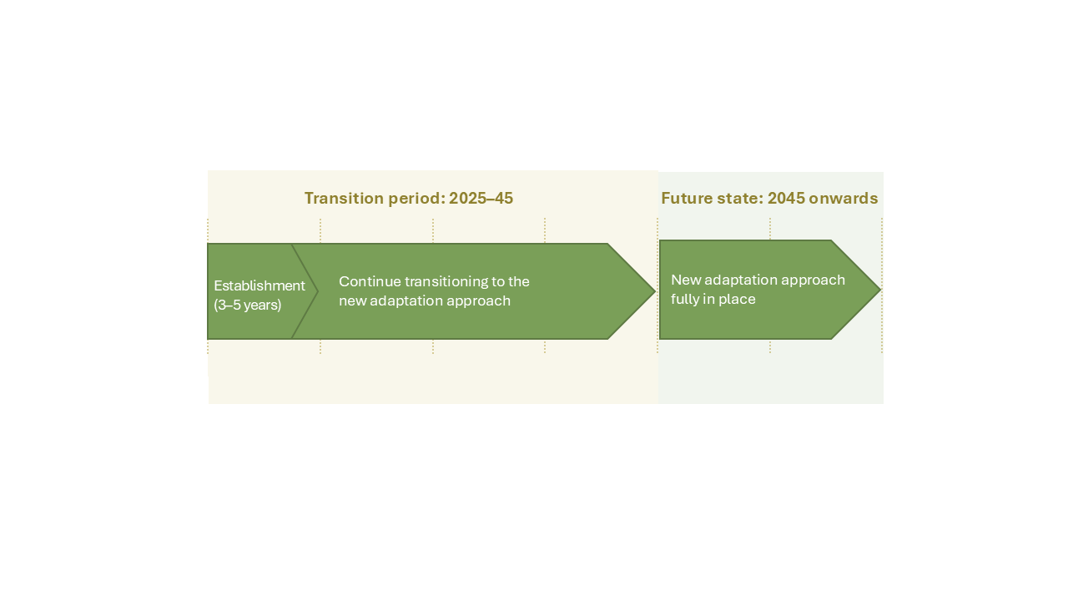

During the transition period
The first three to five years of the transition should be an establishment period. The foundational work should occur to implement the new system, where it is not happening already. This includes setting up systems and processes.
Adaptation plans are already being developed and implemented in some areas. In the transition period, this needs to continue and increase in pace, starting with the highest-risk areas.
Information about natural-hazard risks and exposure should become increasingly widely available and standardised.
Central government should signal a gradual reduction in any post-event financial assistance to property owners. The scale of assistance, if any, would depend on the number of events and their impact.
Investment in risk reduction pre-event should be incentivised and increase over time. Inaction and post-disaster recovery are generally substantially more costly than pre-event investment.
Iwi/hapū/Māori should be enabled to plan for and implement changes, with priority given to retaining ancestral whenua and marae where possible.
Implementation tools (for example, tools such as national direction, consenting processes, spatial planning and asset-management planning) should be improved to make decisions faster with less litigation, and at lower cost.

Key decisions needed to support the recommended approach
The Government’s work to develop a national adaptation framework is focused on four key pillars or workstreams: sharing information about risks and responses; clarifying roles and responsibilities; guiding investment in resilience; and cost-sharing. The Group makes recommendations aligned with each of these workstreams for the Ministry for the Environment to consider in policy advice.
Figure 2: The Group’s recommendations and the four key pillars
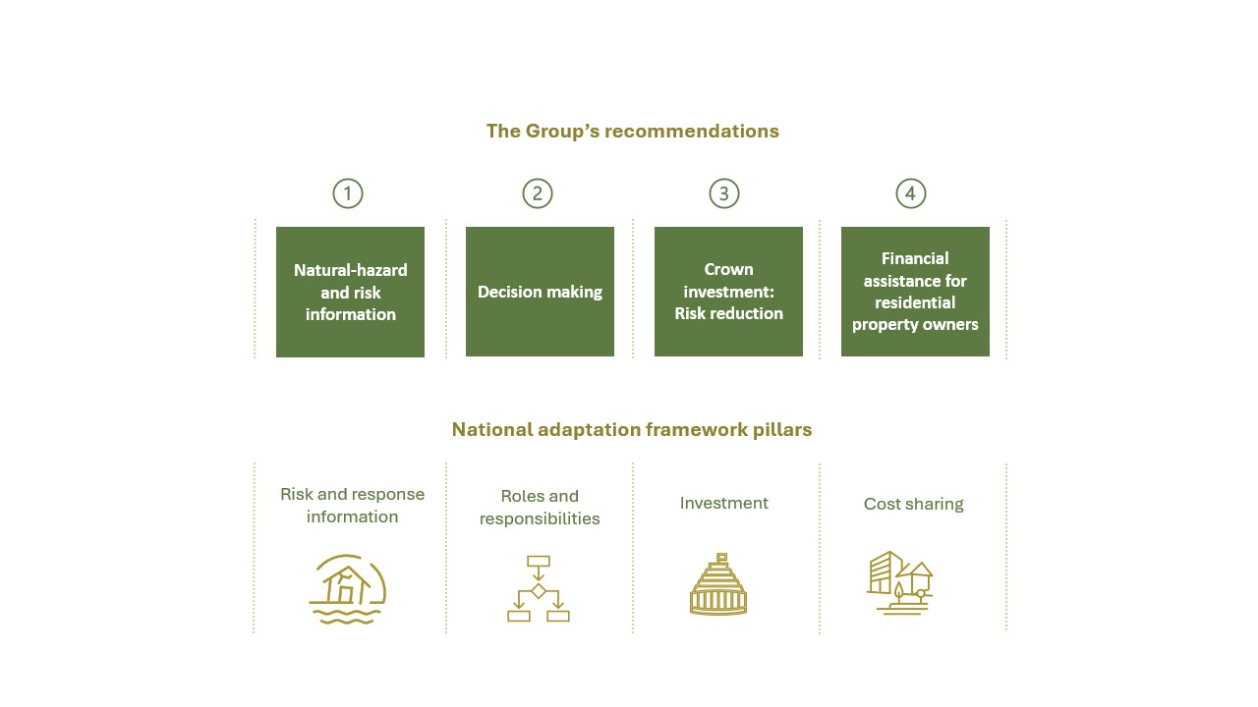

1. Natural-hazard and risk information
i. Make core datasets and models publicly and readily available.
ii. Improve the quality and usability of datasets and models.
iii. Standardise processes for producing data and models. Provide legal protection for those who produce, disseminate and use data models in accordance with the standards.
iv. Ensure hazards are mapped and risk is categorised in a nationally consistent way.
v. Communicate information about hazards and risks – as well as the planned adaptation and risk management responses – simply and frequently to property buyers, owners and occupiers.

2. Decision making
i. Ensure councils undertake adaptation planning in a way that considers the costs and benefits of a full range of protect–accommodate–retreat–avoid (PARA) options. In high-risk areas, this may include withdrawing services from some locations. Ensure that, in making these decisions, consideration is given to the specific needs of small or rural communities and iwi/hapū/Māori. Ensure councils publicly signal their medium- to long-term intentions, including how these will be funded.
ii. Ensure adaptation planning is mandated in the Local Government Act 2002 and linked to long-term plans, the Resource Management Act 1991, and civil-defence and emergency management decision making. Decision making should connect with infrastructure planning, funding processes, and recovery and land-use planning, and will need to be supported by effective tools, for example, a one-stop shop consenting process.
iii. Legislate to reduce liability risks for decision-makers, so that hard decisions can be made, and adaptation planning and implementation processes can happen faster.
iv. For whenua Māori and Māori cultural infrastructure, enable tangata whenua to lead the planning process with local and central government to enable collaborative solutions for adaptation. The Group notes that this is already underway in some regions and it is important that these processes are able to transition seamlessly to the new system.
v. Establish powers for central government to participate in local government adaptation processes, where local government does not have sufficient capability.

3. Crown investment: Risk reduction
i. Take a broad ‘beneficiary pays’ approach where those who benefit from investments in risk reduction contribute to the costs. This should strongly guide investment decisions (particularly risk-reduction decisions). The Crown should contribute where this protects its assets and where broader national benefits can be realised, or broader national costs reduced or avoided.
ii. Provide funding to support adaptation initiatives by iwi/hapū/Māori for Māori land and Māori cultural infrastructure.
iii. Ensure any central government investment encourages and incentivises proactive risk reduction in decision making, including as criteria for contestable funding.

4. Financial assistance for residential property owners
i. Ensure financial assistance for residential property in areas of very high risk is no longer linked to property values, with no buyouts provided after the end of the transition period.
ii. Where relocation is identified as the most cost-effective option for homes after an extreme weather event, ensure a formally communicated approach of central government assistance that declines from significant to zero over time, with flexibility to adjust to prevailing economic conditions. Clarity will be needed before or immediately after an event occurs.
iii. Provide continued hardship support from central government to support affected people post-event, but ensure this is not connected to property values.
iv. Take a specific approach to whenua Māori and Māori cultural assets. This includes considering what might be needed to ensure current work with rōpū Māori, such as the National Iwi Chairs Forum can endure between governments, acknowledging the enduring nature of the Treaty of Waitangi.
v. Further consider whether assistance should be available pre-event to maintain incentives to move out of harm’s way.

Ministry of Foreign Affairs and Trade. 2023. Cyclone Gabrielle’s impact on the New Zealand economy and exports – March 2023. Retrieved 24 April 2025.
The Treasury. 2023. Impacts from the North Island weather events. Wellington: The Treasury.
Swiss Re Institute. 2023. How extreme events reframe our thinking on weather-related perils in New Zealand. Retrieved 24 April 2025.
Climate Sigma. 2025. Estimated number and valuation of residential properties within inundation/flood zones impacted by climate change. Wellington: Ministry for the Environment.
Reserve Bank of New Zealand. 2023. 2023 climate stress test results. Wellington: Reserve Bank of New Zealand.
Finance and expenditure committee. 2024. Inquiry into climate adaptation. Wellington: New Zealand House of Representatives.
Te Puni Kōkiri. 2023. Understanding climate hazards for hapori Māori – Insights for policy makers. Wellington: Te Puni Kōkiri.

