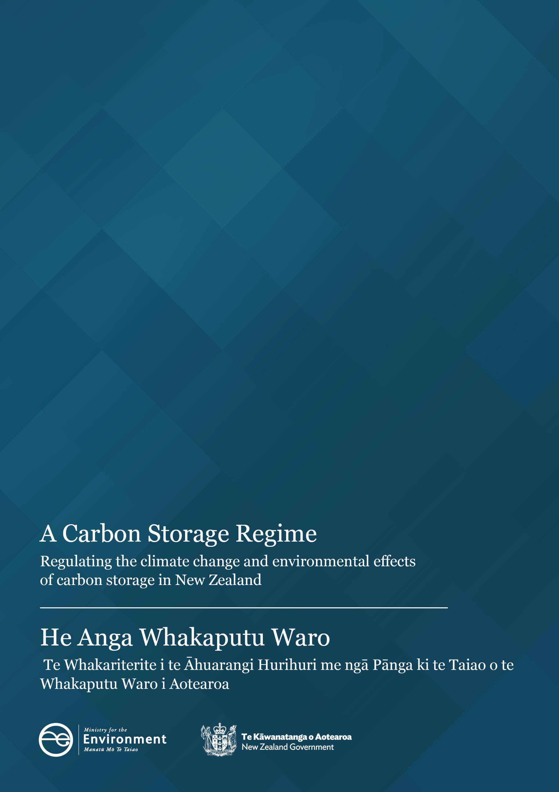

Disclaimer
The information in this publication is, according to the Ministry for the Environment’s best efforts, accurate at the time of publication. The Ministry will make every reasonable effort to keep it current and accurate. However, users of this publication are advised that:
- the information does not alter the laws of New Zealand, other official guidelines, or requirements
- it does not constitute legal advice, and users should take specific advice from qualified professionals before taking any action based on information in this publication
- the Ministry does not accept any responsibility or liability whatsoever whether in contract, tort, equity, or otherwise for any action taken as a result of reading, or reliance placed on this publication because of having read any part, or all, of the information in this publication or for any error, or inadequacy, deficiency, flaw in, or omission from the information in this publication
- all references to websites, organisations or people not within the Ministry are for convenience only and should not be taken as endorsement of those websites or information contained in those websites nor of organisations or people referred to.

This document may be cited as: Ministry for the Environment. 2025. A Carbon Storage Regime: Regulating the climate change and environmental effects of carbon storage in New Zealand. Wellington: Ministry for the Environment.

Published in December 2025 by the
Ministry for the Environment
Manatū mō te Taiao
PO Box 10362, Wellington 6143, New Zealand
environment.govt.nz
ISBN: 978-1-991404-24-4
Publication number: ME 1940
© Crown copyright New Zealand 2025

Contents
Executive summary 5
Background 6
What is in scope? 6
What do we mean by carbon storage? 6
Why is carbon storage important? 9
Work to date 9
Proposed carbon storage regime 10
Seeking approval to carry out carbon storage 10
Monitoring, reporting and verification 11
Decommissioning and closure of a storage site 12
Conditional removal of liabilities 13
Interactions with existing operations 14
New Zealand Emissions Trading Scheme rewards and liabilities 14
Next steps 18

Tables
Table 1: Proposed carbon storage regime across project lifecycle 19

Figures
Figure 1: An overview of carbon capture, utilisation and storage 7

Executive summary
The purpose of this document is to summarise policy decisions related to carbon capture and storage (CCS) so the decisions are available and accessible.
CCS is where carbon dioxide is injected into suitable, naturally created geological formations deep underground, such as deep saline aquifers, depleted oil and gas reservoirs, coal seams that cannot be mined and basalt formations. This process can be land-based or offshore.
Enabling this type of carbon storage in Aotearoa New Zealand can support economic growth and energy security and help New Zealand achieve its emissions budgets and targets.
Providing clarity on how CCS projects would be regulated, including long-term liabilities and financial incentives, is important for encouraging potential future CCS projects.
Under the proposed framework, businesses that carry out carbon storage would be rewarded through the New Zealand Emissions Trading Scheme (NZ ETS) as a reduction or removal of carbon dioxide.
Ensuring safe and effective long-term storage of carbon dioxide is critically important. That is why the proposed regime would require any CCS project to thoroughly assess the suitability of the proposed storage site and operations, and to follow this with ongoing monitoring.
This document is informed by policy decisions made by government (that is, by Cabinet in 2024 and by delegated Ministers in 2025). This document covers elements of the proposed regulatory regime that apply to:
- seeking approval to carry out carbon storage
- monitoring, reporting and verification related to carbon storage
- decommissioning and closure of a storage site
- conditional removal of liabilities associated with any leaks of carbon dioxide
- interactions with existing operations
- NZ ETS reward and liability.
The next step is developing legislation to provide for the carbon storage aspects of any future CCS projects. Subject to the Government’s 2026 legislative priorities, the Minister of Climate Change intends to introduce a Bill in 2026. The select committee process will provide opportunities for formal engagement once the Bill is introduced.

Background

What is in scope?
The proposed carbon storage regime (the proposed regime) would seek to manage the climate change and other environmental effects of storing carbon dioxide in sub-surface geological formations. The proposed regime would not apply to storing carbon dioxide elsewhere, for example, in concrete, forests or oceans.
The proposed regime would focus on regulating carbon storage. It would not regulate:
- carbon capture (eg, in industrial processes).
- carbon use (eg, in food and beverage production). Although carbon use may be associated with environmental impacts, it is not yet clear what carbon dioxide may be used for, so an effective and streamlined regulatory regime cannot yet be designed. In addition, use of carbon dioxide does not always result in its permanent removal from the atmosphere.
Other regulation applies to the capture, transport and use of carbon dioxide, for example, the Health and Safety at Work Act 2015.
As new ways of capturing, using and storing carbon dioxide emerge, the regulatory regime may need to be updated.

What do we mean by carbon storage?
Carbon capture, utilisation and storage (CCUS) involves the extraction and capture of carbon dioxide from industrial activity or directly from the air. The captured carbon dioxide can be used commercially (eg, in beverages, for dry-ice chilling meat, or in greenhouses to promote plant growth) or permanently stored underground.
Carbon capture and storage (CCS) is a subcategory of CCUS in which carbon dioxide is injected into suitable geological formations deep underground.
Figure 1: An overview of carbon capture, utilisation and storage
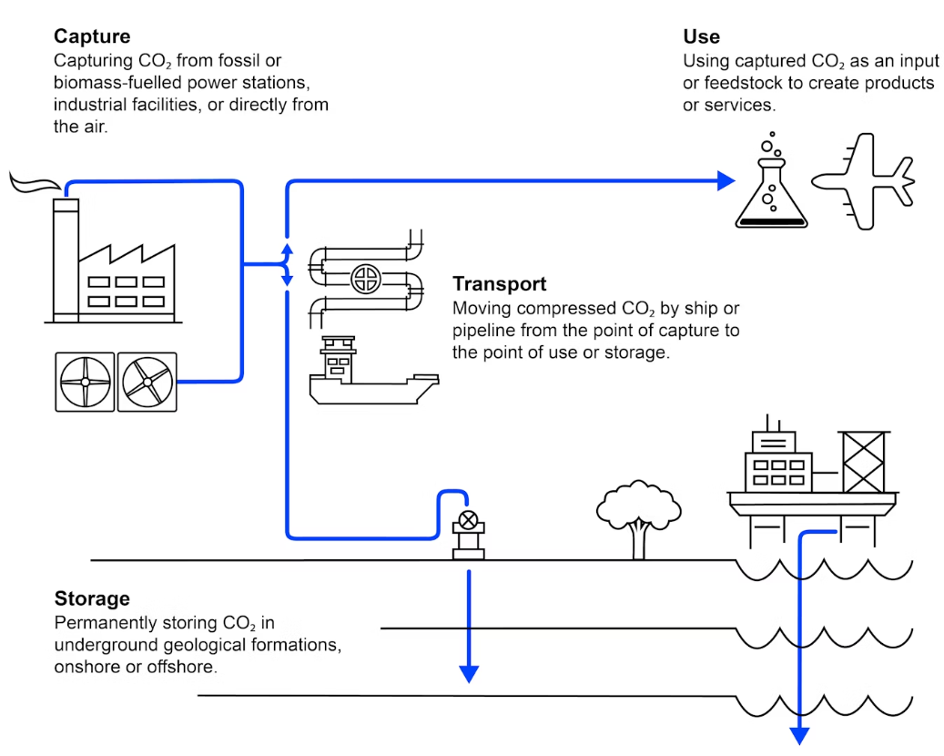

Steps involved in carbon capture and storage
Four main steps are involved in the CCS process: capture, transportation, injection and storage. The proposed regime for regulating carbon storage is focused on injection and storage.

Capture
Carbon dioxide is captured from large, single-point sources (eg, electricity generation plants) or from industrial processing plants (eg, cement or steel production plants). Carbon dioxide can be captured in different ways, including (but not limited to):
- post-combustion capture, where carbon dioxide is captured after the fuel has been burnt (as in a typical thermal electricity plant)
- pre-combustion capture, where the fuel source is oxidised to produce syngas, which can then be used in a variety of processes
- oxyfuel combustion, where thermal fuel is burnt in pure oxygen, rather than air, to produce an emission stream of virtually pure carbon dioxide and water vapour
- separating carbon dioxide during the purification process in natural gas production.
It is also possible to capture carbon dioxide directly from the atmosphere. This is an emerging technology that, although not presently deployed, could be upscaled and adopted in New Zealand in the longer term. Carbon dioxide captured in this way would be eligible for recognition under the proposed regime, if it still meets the relevant requirements when injected and stored.

Transportation
Carbon dioxide is condensed or compressed, then either moved by pipelines or shipped from its source to a storage site.

Injection
Carbon dioxide is injected through drilled wells into suitable geological formations. Under the proposed regime, stringent assessment criteria would be applied to find suitable sites for injection and storage, covering aspects such as:
- onshore or offshore locations
- capping layers above the geological formation
- how porous and deep the geological formation is
- seismic activity in the area
- any previous intensive exploration and drilling activity.

Storage
Carbon dioxide is stored long term in suitable geological formations such as:
- deep saline aquifers
- depleted oil and gas reservoirs
- coal seams that cannot be mined
- basalt formations.

Why is carbon storage important?
Deploying carbon storage could reduce the cost of meeting New Zealand’s emissions budgets and support net emissions reductions in hard-to-abate industries. If deployed by gas producers, carbon storage could contribute to energy security as receiving an NZ ETS reward for carbon storage could help reduce the cost of gas production.
Carbon storage is internationally recognised (eg, by the Intergovernmental Panel on Climate Change and the International Energy Agency) as an important technology that can contribute to reducing net greenhouse gas emissions.

Work to date
In mid-2024, the Ministry of Business, Innovation and Employment publicly consulted on the high-level elements of a regime to enable, recognise and reward CCS in New Zealand. The consultation also covered topics relating to carbon capture and utilisation.
Following public consultation, the Government agreed to enable and incentivise permanent storage of carbon dioxide by rewarding this through the New Zealand Emissions Trading Scheme (NZ ETS) and creating a corresponding NZ ETS liability.
The Government also agreed its approach to:
- seeking approval to carry out carbon storage
- monitoring, reporting and verification related to carbon storage
- decommissioning and closure of a storage site
- a pathway for the conditional removal of liabilities associated with any leaks of carbon dioxide
- interactions with existing operations.

Proposed carbon storage regime

Seeking approval to carry out carbon storage
Before starting carbon storage, an operator would need the necessary permit or consent from the Environmental Protection Authority (EPA). This document uses the term ‘permit’ to refer broadly to permission or consent to carry out the activity.
To carry out carbon storage, an applicant would only need to seek one permit, associated with injection and storage. As with other kinds of operations, the applicant may also need other permits or consents under other relevant legislation, for example, for roading or associated building. Operators would also need to comply with other legislative requirements (eg, health and safety).
To secure a permit, the operator would need to ensure the geological formation:
- is suitable for long-term carbon storage
- can be safely injected with carbon.
The permitting process would also provide assurance that the permit holder, and any parent company, can meet the costs of decommissioning (activities that occur after injection ceases) at the conclusion of the operation. This assurance would be achieved through a financial capability assessment by the EPA.
The information the EPA would require from the applicant includes:
- site geology and characteristics
- a site operations plan
- a monitoring, reporting and verification plan
- a decommissioning and closure proposal and post-decommissioning and closure proposal
- information to assess the applicant’s (and any parent company’s) financial capability to meet decommissioning costs
- a proposal for financial securities arrangements (to meet decommissioning costs).
The EPA would have the power to require the applicant to provide any information the EPA needs to assess and make a decision on an application.
Further work will be done to identify and set any minimum permit conditions, including ensuring that, where appropriate, these align with similar requirements across land, territorial sea and the Exclusive Economic Zone. The outcome of this work will inform the decision-making process.
As with the EPA’s other consenting activities, the full costs associated with the EPA’s permitting functions will be recoverable from the applicant.

Land access

Accessing cross-boundary sub-surface geological formations to store carbon
Sub-surface geological formations for carbon storage are likely to be hundreds of metres, if not several kilometres, underground. Property rights, however, effectively extend to the Earth’s core. Where a sub-surface geological formation crosses property boundaries, the operator would need access to private land (via the spread of carbon dioxide through the formation underground) to conduct carbon storage activities.
For land-based carbon storage, the approach to accessing private land is intended to balance the needs of the prospective carbon storage operator with the rights of land owner(s).
The operator would need a land access arrangement with the land owner(s), unless the activity will not or likely will not:
- cause any damage to the surface of the land, or
- prejudice the land owner’s use or enjoyment of the land, or the future use of the surface of the land.
Where agreement cannot be reached, an arbitration process would apply.

Access to surface private property for maintenance and post-decommissioning activities
Further work will be done to identify what else may need to be included in a land access arrangement. For example, access to surface private property may be required for maintenance, decommissioning and post-decommissioning monitoring, and an operator would need to negotiate the frequency and timing of the access with the land owner.

Environmental Protection Authority is the proposed decision-maker for carbon storage permits
A decision-making committee of the EPA Board would decide whether to grant a carbon storage permit. The decision would be informed by experts and the EPA’s Māori Advisory Committee could also provide advice on the application. Expert support for the decision-making committee may be contracted.
The EPA is already the decision-maker for marine consents under the Exclusive Economic Zone and Continental Shelf (Environmental Effects) Act 2012. Having the EPA as the decision-maker for carbon storage ensures a nationally consistent approach to the assessment of applications and determination of permits and conditions.

Monitoring, reporting and verification
Monitoring of compliance with the conditions of a carbon storage permit, and any associated enforcement action, would be the responsibility of:
- relevant territorial authorities for operations that are onshore and in the coastal marine area
- the EPA for operations in the Exclusive Economic Zone and extended continental shelf.
The regulator would be able to adjust monitoring requirements on an operator in the carbon storage permit, to effectively manage risks through the lifetime of the operation (an adaptive approach).
Monitoring requirements of emissions and removals under the Climate Change Response Act 2002, related to the NZ ETS reward and liability, would also apply.
Monitoring of the site would continue post closure.

Decommissioning and closure of a storage site
Once injection ceases and at the end of life for the whole operation, the operator (ie, the permit holder) would need to submit decommissioning and post-decommissioning plans. These would need to reflect any matters that may have changed since the original decommissioning and post-decommissioning proposals were submitted as part of the initial permit application process. This requirement would ensure that:
- the well(s) are properly capped, and associated site operations are properly decommissioned
- the site is appropriately monitored post decommissioning
- the site is remediated, as are any extenuating impacts on the environment and surrounding property, should there be a leak.
The EPA will need to approve the plans and determine the decommissioning permits.
The operator would be responsible for carrying out decommissioning, in accordance with the permit conditions, and for meeting 100 percent of decommissioning costs.

Financial securities
The operator would be required to provide financial securities to cover the costs of decommissioning, to ensure it can fund these when the time comes.
A permit applicant (or prospective operator) would need to propose financial securities arrangements as part of their application.
The operator would have some time to build up the amount required to meet the costs of decommissioning. To mitigate the risk that an operation is completed or abandoned before the operator has built up enough to fund decommissioning, further work will be done to identify and set any mandatory minimum financial securities (eg, capping the length of time for building up funds).
Financial securities would not be sought from operators to cover NZ ETS liabilities.

Post-decommissioning and closure requirements
Once the site is closed, the operator would be required to monitor the site for at least 15 years, or until released from their liabilities (see Conditional removal of liabilities below).
This monitoring requirement is to ensure the stored carbon dioxide is behaving as predicted. It is part of an adaptive approach to effectively manage risks (such as carbon leaks) through the lifetime of the operation.

Trailing liability
If financial securities are insufficient, and the permit holder cannot meet the costs of decommissioning or post-decommissioning activities, the liability will fall to the parent company (if any). If no parent exists, or the parent company is unable to meet the costs, liability will fall to any party who has significantly benefitted from or had influence over the carbon storage operation. These liability arrangements are similar to those in Australia.

Conditional removal of liabilities

Removal of liability for post-decommissioning costs
As is the case in other jurisdictions, the starting point for post-decommissioning liabilities is that they will be in perpetuity.
However, although the risks associated with stored carbon diminish over time, it can take hundreds (if not thousands) of years for stored carbon to mineralise and the risk to be fully removed. This means requiring an operator to be liable for post-decommissioning costs in perpetuity is likely to present a significant barrier to uptake.
Equally, it is unreasonable for the public to be subject to a liability generated by a commercial entity while it is seeking profits.
Therefore, the proposed regime would provide for the operator to be released from the post-decommissioning liability no sooner than 15 years after the start of the post-closure period, if certain tests are met.
The Minister for the Environment would be the decision-maker, in consultation with the Minister of Finance.
- When deciding to remove post-decommissioning liabilities, the decision-maker must consider:
- whether the injected carbon dioxide is behaving as predicted
- the risk that the carbon dioxide will have a significant adverse impact on the integrity of the storage formation, the environment, or on human health and safety.
- To inform this decision, the decision-maker must commission and consider an independent study from an expert body on the risk of carbon dioxide leakage from a site. The costs of this study will be covered by the operator seeking to have its liabilities removed.
- This does not remove any liabilities associated with carbon dioxide leakage that occurs through negligence of the operator; the operator remains liable for any such leakage.
- A condition of the decision to remove a potential future liability is that the operator remains responsible for monitoring the site for up to 30 years after the removal of the obligation.
- The decision-maker must consult with relevant Māori groups in making a decision on the removal of liability.
There is also a similar pathway for NZ ETS surrender obligations, see New Zealand Emissions Trading Scheme rewards and liabilities below.

Interactions with existing operations
At least in the near term, any carbon storage operation is likely to occur in end-of-life oil and gas wells. This section outlines some explicit provisions for how the carbon storage regime would apply.

Streamlining permitting where carbon storage is occurring post an existing operation
Many of the matters indicated in the section Seeking approval to carry out carbon storage may already have been considered during the approval of permits for an oil and gas operation. Where this is the case, and if the EPA determines that the information that underpins these permits can be relied upon, the EPA can accept this information and any existing arrangements (eg, permit or consent conditions, financial securities arrangements).
Before any permit can be transferred, the EPA would assess the financial and technical capability of the potential operator to receive the permit.
An applicant transitioning from oil and gas operations would also need to provide a repurposing plan as part of the application. The plan would describe the infrastructure associated with an installation and identify which items would be reused, repurposed, removed, or left in situ.
Where companies are already subject to financial securities arrangements under the Crown Minerals Act 1991, the EPA would assess the adequacy of these arrangements. If the arrangements were deemed sufficient, the EPA would work with New Zealand Petroleum and Minerals to transition the securities, in full or in part.

New Zealand Emissions Trading Scheme rewards and liabilities
The Climate Change Response Act 2002 states that the purpose of the NZ ETS is to assist New Zealand to meet its international obligations under the Paris Agreement, its 2050 target and domestic emissions budgets.
Emitters are required to surrender emissions units (known as New Zealand Units or NZUs) to the government equal to their emissions. The government issues NZUs via auction, industrial allocations for emission-intensive and trade-exposed activities, and as a reward for removals. People can also buy and sell NZUs in the secondary market.
The Government has agreed that carbon storage activities should be included in the NZ ETS.
Providing clarity on regulation of carbon storage activities, including on liabilities and financial incentives, is important for encouraging potential future CCS projects.
The proposed regime intends to clarify how:
- a carbon storage operator can be rewarded via the NZ ETS
- resulting liabilities and repayment obligations (ie, if carbon dioxide were to leak from the storage site) would work for a carbon storage operator.
The Government intends to amend the Climate Change Response Act 2002 to enable NZ ETS rewards and clarify the approach to NZ ETS liability and repayment obligations. Amendments to some NZ ETS regulations would also be needed.

How carbon storage can be rewarded
The Government has agreed that a carbon storage operator can receive an NZ ETS reward. This could be:
- a reduction in existing surrender obligations for current NZ ETS participants, for example, where an operator is reinjecting carbon dioxide into the field from which it was extracted or injecting carbon dioxide into the field from a third party (ie, offsite)
- receiving NZUs where the value of carbon stored exceeds any existing surrender obligations, or where an operator may not have an existing surrender obligation.

How liabilities and repayment obligations would work
The Government has agreed that:
- any carbon dioxide leakage from a carbon storage site would result in NZ ETS repayment or surrender obligations
- carbon dioxide produced by a third party can be reinjected for storage, but the responsibility – including liabilities for any carbon dioxide leakage – would sit with the carbon storage operator.

Liabilities and repayments for existing operations
Some existing oil and gas operations already carry out reinjection of carbon dioxide as a ‘closed-loop’ practice. This does not currently trigger NZ ETS reporting obligations, because the carbon dioxide never leaves the mining site and no carbon dioxide from offsite (or a third party) is involved. These operations would not be expected to change their emissions reporting practices or face any new liability for this activity.
However, for operations that enter the proposed regime to be rewarded for additional carbon storage, any carbon dioxide that leaks from the storage site would be subject to repayment obligations. This is because there is no way to know the original source of the carbon dioxide molecules, that is, whether they were from the mining site or a third party.

Amendments to New Zealand Emissions Trading Scheme regulations would be needed
The proposed regime would include changes to three sets of NZ ETS regulations to enable the appropriate reporting, reward and repayment obligations.
- Carbon storage would be integrated into natural gas emissions reporting by requiring operators to distinguish between carbon dioxide that is reinjected into the field from which it was extracted versus injected into the field but sourced from a third party (ie, offsite).
This would require an amendment to the Climate Change (Stationary Energy and Industrial Processes) Regulations 2009.
- A new ‘geological sequestration’ category would be included in the NZ ETS regulations, to:
- enable carbon storage to be rewarded
- ensure any reversal of storage or leakage results in repayment obligations
- outline monitoring requirements through the stages of a carbon storage operation.
This would require an amendment to the Climate Change (Other Removal Activities) Regulations 2009.
- The process for identifying experts to verify carbon storage information would be outlined, where this directly relates to the NZ ETS parts of the proposed regime.
This would require expanding the ‘verification’ provisions of the Climate Change (Unique Emission Factors) Regulations 2009. The provisions related to verification are relevant for carbon storage, but they currently apply only to the process of obtaining a unique emissions factor.

Removal of New Zealand Emissions Trading Scheme surrender obligations
International carbon storage regimes commonly allow for the possibility of removing NZ ETS (or equivalent) potential surrender obligations for any leakage of carbon dioxide into the atmosphere.
The proposed regime would include a pathway for removing potential NZ ETS surrender obligations for leaks to the atmosphere of any carbon dioxide stored in a carbon storage site no sooner than 15 years after the start of the post-closure period.
The aim of this is to encourage carbon storage investment and activity, with the goal of permanent storage of carbon dioxide.
This pathway is similar to that outlined under Removal of liability for post-decommissioning costs and, where relevant, would use the same evidence.
The Minister of Climate Change would be the decision-maker, in consultation with the Minister of Finance.
- When deciding to remove an NZ ETS surrender obligation, the decision-maker must consider:
- whether the injected carbon dioxide is behaving as predicted
- the risk that the carbon dioxide will have a significant adverse impact on the integrity of the storage formation, the environment, or on human health and safety.
- To inform this decision, the decision-maker must commission and consider an independent study from an expert body on the risk of carbon dioxide leakage from a site. The costs of this study will be covered by the operator seeking to have its obligation removed.
- This does not remove any NZ ETS obligations associated with carbon dioxide leakage that is through negligence of the CCUS; the operator remains liable for any such leakage.
A condition of the decision to remove a potential future obligation is that the operator remains responsible for monitoring the site for up to 30 years after the removal of the surrender obligation.

Next steps
The next step is drafting legislation that covers the carbon storage aspect of any future CCUS projects.
The detail, including regulatory design, will be shaped by ongoing work by officials. Provisions for carbon storage are likely to be through a bespoke Act, which would complement the broader consenting framework under the replacement resource management legislation and Exclusive Economic Zone and Continental Shelf (Environmental Effects) Act 2012.
Subject to the Government’s 2026 legislative priorities, the Minister of Climate Change intends to introduce a Bill in 2026, aiming for it to be passed in 2027.
Provisions relating to the NZ ETS rewards and liabilities would be included in the Climate Change Response Act 2002 through the intended Bill, as well as through regulatory change.
If you have any questions about the proposed carbon storage regime, please contact: info@mfe.govt.nz..

Table 1: Proposed carbon storage regime across project lifecycle
Approval | Injection | Site closure | Post closure
The applicant provides information on:  - site geology and characteristics  - site operations plan  - monitoring, reporting and verification plans  - decommissioning and closure proposal  - post-decommissioning and post-closure proposal  - information to assess the applicant’s, and any parent company’s, financial capability to meet decommissioning costs  - proposals for financial securities arrangements.  An applicant may also need to secure land access arrangements with relevant land owners.  A decision-making committee of the EPA Board (the EPA), as the proposed decision-maker considers application.  The applicant pays cost of assessing application.  The applicant provides financial assurance.  The EPA makes its final decision.  The applicant (now referred to as the operator) receives a permit to carry out carbon storage. | The operator begins injection of carbon into geological formation or well, in line with conditions of approval.  The operator:  - receives reward via the NZ ETS for emissions reduced or removed; and  - is liable for any carbon leakage.  The operator must monitor and report to the EPA on the amount injected and any leaks.  The operator to take corrective action if any adverse event or irregularity occurs.  If any carbon leaks occur, the operator incurs relevant costs (NZ ETS costs and costs associated with any harm to human health or the environment). | As the operator prepares to cease injection and close the site, the operator must provide plans for:  - decommissioning and closure  - post-decommissioning and post-closure.  These plans would need to reflect anything that has changed since the proposals for decommissioning and closure and post-decommissioning and post-closure.  The EPA approves these plans and determines the decommissioning permits.  The operator stops injecting and implements the decommissioning and closure plan.  If any carbon leaks occur, the operator incurs relevant costs (NZ ETS costs and costs associated with any harm to human health or the environment). | The operator must continue to monitor the site and remains liable for any carbon leaks after the site is closed.  If any carbon leaks occur, the operator incurs relevant costs (NZ ETS costs and costs associated with any harm to human health or the environment).  From 15 years after the site closure, the operator can apply to the relevant Minister to have potential surrender obligations conditionally removed.  The Minister agrees, contingent on:  - consulting with the Minister of Finance  - considering if the stored carbon is behaving as predicted and the risk to integrity of the storage formation, the environment or on human health  - commissioning and considering an independent expert study  - consulting with relevant Māori (for non-NZ ETS liabilities).  The operator is responsible for monitoring the site for up to 30 years after this decision.  Liabilities still apply where any leaks are due to operator negligence.
Note: EPA = Environmental Protection Authority; NZ ETS = New Zealand Emissions Trading Scheme.

Note that this document also uses ‘carbon’ to refer to carbon dioxide.
International Energy Agency (IEA) (2021), About CCUS, IEA, Paris https://www.iea.org/reports/about-ccus, Licence: CC BY 4.0. Retrieved 2 December 2025.
The Intergovernmental Panel on Climate Change (IPCC) is progressing work on a methodology report on carbon removal technologies and CCUS. See IPCC. 2025. IPCC calls for nominations of authors for 2027 Methodology Report on Carbon Dioxide Removal Technologies, Carbon Capture, Utilization and Storage. Retrieved 25 November 2025. See also IPCC. 2024. IPCC Expert Meeting on Carbon Dioxide Removal Technologies and Carbon Capture, Utilization and Storage. Japan: IGES. Retrieved 2 December 2025.
International Energy Agency (IEA). Carbon Capture Utilisation and Storage. Retrieved 25 November 2025.

