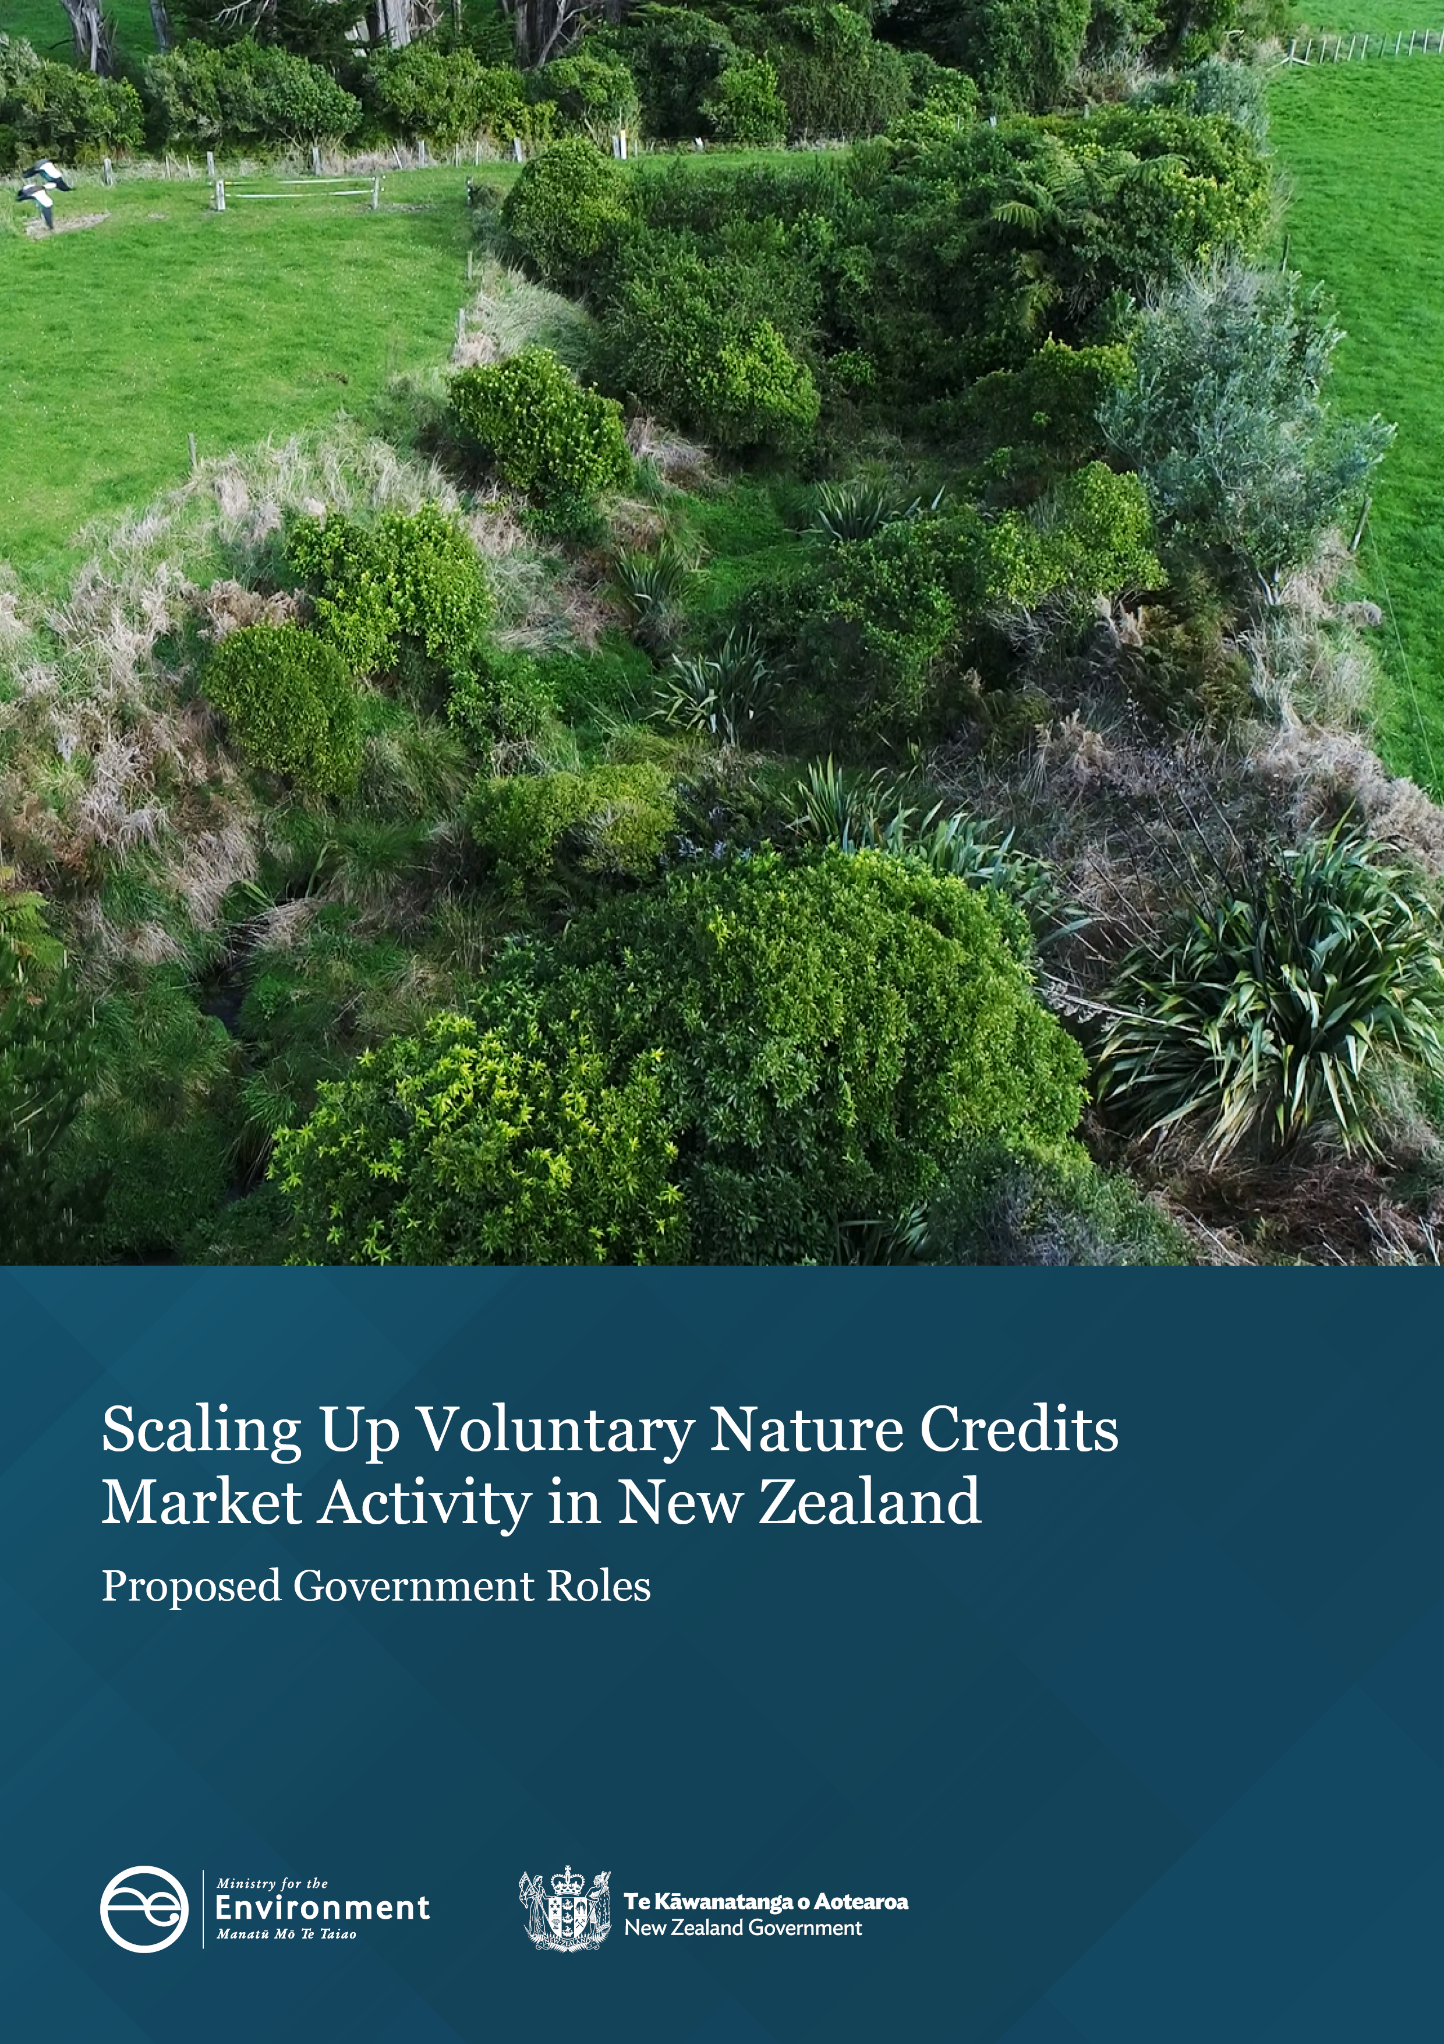

Disclaimer
The information in this publication is, according to the Ministry for the Environment’s best efforts, accurate at the time of publication. The Ministry will make every reasonable effort to keep it current and accurate. However, users of this publication are advised that:
- the information does not alter the laws of New Zealand, other official guidelines, or requirements
- it does not constitute legal advice, and users should take specific advice from qualified professionals before taking any action based on information in this publication
- the Ministry does not accept any responsibility or liability whatsoever whether in contract, tort, equity, or otherwise for any action taken as a result of reading, or reliance placed on this publication because of having read any part, or all, of the information in this publication or for any error, or inadequacy, deficiency, flaw in, or omission from the information in this publication
- all references to websites, organisations or people not within the Ministry are for convenience only and should not be taken as endorsement of those websites or information contained in those websites nor of organisations or people referred to.

This document may be cited as: Ministry for the Environment. 2025. Scaling Up Voluntary Nature Credits Market Activity in New Zealand: Proposed Government Roles. Wellington: Ministry for the Environment.

Published in June 2025 by the
Ministry for the Environment
Manatū mō te Taiao
PO Box 10362, Wellington 6143, New Zealand
environment.govt.nz
ISBN: 978-1-991140-89-0 (online)
Publication number: ME 1898
© Crown copyright New Zealand 2025

Contents
Purpose of this document 4
Context 5
Why is the Government interested in supporting voluntary nature credits markets? 5
Government’s approach 6
Oversight and governance 6
Measures to help the market grow 7
Key government roles 8
Integrity principles to support approving standards 10
1. Additional to business as usual 10
2. Durable 11
3. Real, measurable and verifiable outcomes and risk mitigation 12
4. Accessible 13
5. Transparent 13
6. Respectful of rights 14
7. Support accurate claims using appropriate terminology 14
Next steps 16

Purpose of this document
This document outlines proposed government roles being developed, which are intended to support confidence and growth in New Zealand’s voluntary nature and carbon credits markets.
The aim is to encourage increased investment and activity in actions to protect and restore biodiversity, remove carbon, and drive other environmental improvements over time.
This is the result of earlier public consultation in 2023 and engagement with parties interested in this work.

Context
Interest and investment in voluntary nature and carbon credits markets have been growing in recent years.
Voluntary nature and carbon credits markets support private investment in voluntary action in a range of areas including climate, biodiversity and the environment. They generally involve the selling and purchase of ‘credits’. These credits represent the finance put towards activities that generate environmental gains (usually for indigenous biodiversity and/or carbon removals but can also extend to other environmental improvements).
Voluntary credits can be traded and can hold value for organisations wanting to make, or be associated with, environmental improvements. The markets for them operate on a willing seller–willing buyer basis, with prices established that reflect the intersection of project costs and buyer preferences (resulting in large variations in credit prices).

Why is the Government interested in supporting voluntary nature credits markets?
New Zealand faces major challenges from climate change and biodiversity loss. Many of the country’s most threatened and at-risk native species and habitats are found on private land. Opportunities exist to harness the voluntary credits market as a mechanism to mobilise greater private investment towards positive nature action across New Zealand.
Businesses and other organisations are increasingly aware of the extent to which their activities rely on nature thriving and are looking for ways to support the environment. This awareness and dependency on nature is leading businesses to think beyond compliance, that is, to meeting obligations under the New Zealand Emissions Trading Scheme, and towards additional voluntary activity that can have a positive impact on the environment.
The demand for voluntary New Zealand nature credits is driven by businesses’ response to global markets and to increasing consumer expectations, which call for greater transparency and accountability about the effect their products and services have on the environment. In the future, nature credits markets could also help to:
- reduce a wider range of greenhouse gas emissions
- build resilience to extreme weather using native species
- improve the state of the environment.
An opportunity exists to catalyse greater use of credits for financing environmental initiatives on public and private land in New Zealand.

Government’s approach
The global credits market is buoyant, and investors can select from a range of credit offerings from different countries. For New Zealand to attract investors, it needs to offer credible and robust arrangements that are more accessible to New Zealand land owners.
Therefore, New Zealand’s approach to enhancing the environmental performance of voluntary nature credits markets must be consistent with its international environmental and trade agreements. This requires processes that, among other things:
- are truthful, consider scientific and technical information
- are based on relevant international principles, guidelines and best practice
- are transparent
- promote innovation
- do not treat a service less favourably based on its origin.

Oversight and governance
Voluntary credits must meet rigorous measuring, reporting and verification standards to be issued in the first place. Third party verification and certification are often required to give credits the credibility required by willing buyers to make robust environmental and climate claims.
In 2022, the Ministry for the Environment (the Ministry) issued interim guidance for voluntary climate change mitigation. Since then, the international landscape has evolved with the publication of new best practice guidelines and countries taking action to promote a greater scale of voluntary action through high integrity investment in nature.
Some large New Zealand projects use international voluntary market schemes to supply credits. However, these schemes can cost hundreds of thousands of dollars to access and are inaccessible to many New Zealand land owners. Some domestic schemes are available, but vary, creating uncertainties for investors.
Other countries are doing much more to promote voluntary investment. Voluntary nature credits markets showing the most promise in supporting projects and attracting financing in other countries are those that have effective market oversight and are accessible to a wide range of projects. This ensures that project standards and credit certification promote investor confidence and are cost effective for market participants.
International consensus is also emerging on the principles and governance roles needed for these markets to operate with integrity.

Measures to help the market grow
We are taking steps to support the growth and confidence in New Zealand’s voluntary nature credits market.
We have a broad perspective on what ‘nature credits’ can deliver and how they can contribute to building an integrated market covering biodiversity gains, carbon removals and potentially other actions over time. We prefer an integrated market rather than separate markets (eg, for biodiversity and carbon credits). This is due to overlaps in methodologies and the ways that individual projects often yield multiple benefits. For example, native planting in erosion-prone land can benefit biodiversity, remove carbon, increase the land’s resilience to extreme events, and improve water quality over time.
We are proposing one set of market arrangements to:
- promote coherence
- broaden accessibility to the market, keeping investment choices open
- ensure the approach is adaptable and more enduring.
Within these government-endorsed arrangements, generating ‘New Zealand recognised credits’ would require meeting certain integrity principles (p 10). This would not negate credits generated from projects operating under other domestic or international standards. However, it would signal to the market which standards and methodologies the government had reviewed and found to satisfy high integrity principles.
Supporting growth of the voluntary nature credits market is one of several work areas that this Government is progressing to enhance environmental investment. Other areas include enhancing the New Zealand Emissions Trading Scheme, improving the quality and availability of information to support investment (eg, the sustainable finance taxonomy), making New Zealand more attractive for international capital, and improving the effectiveness of the government’s role as an investor.

Key government roles
We plan to take a more targeted role to help the market operate more effectively and with integrity. The aim is to promote confidence to engage in market activity.
Building on the earlier interim guidance for voluntary climate change mitigation, we intend to introduce the following roles over time:
- Setting direction: articulating the Government’s position on, and intentions for, voluntary nature credits investment, including to formalise New Zealand-endorsed credits as a branded investment product.
- Supporting setting standards: establishing integrity principles to set the minimum requirements for recognising project standards (ie, the yardstick against which projects would be certified), as endorsed for use in the New Zealand market. This would include:
- developing a recognition framework, to underpin the integrity of different types of environmental gains
- determining mechanisms for accrediting key market actors as fit and proper to certify and validate monitoring of projects against project standards
- determining arrangements to address misconduct, including consequences and administrative or legal remedies.
- Supporting assurance: setting up arrangements to ensure trust in environmental gains, with a process for approving standards, roles and criteria for accrediting, and the accountability of assurance service providers.
- Promoting transparency: supporting the efficiency and integrity of market activity, requiring disclosure of core project information and reporting basic transaction data to a national registry.
The Ministry is developing arrangements for the four roles above. We would introduce these in stages, as the market scales up (figure 1). The first step would be to formally set up the oversight and governance components.
The roles would support several stages in the lifecycle of a voluntary market project: establishing project standards, project development, independent verification and certification, transaction of credits, and reporting.
Responsibilities for developing projects and activities would remain with the private sector, which has a role in all stages, from developing standards to project delivery and reporting.
Figure 1: Government and private sector roles in a developing voluntary nature credits market
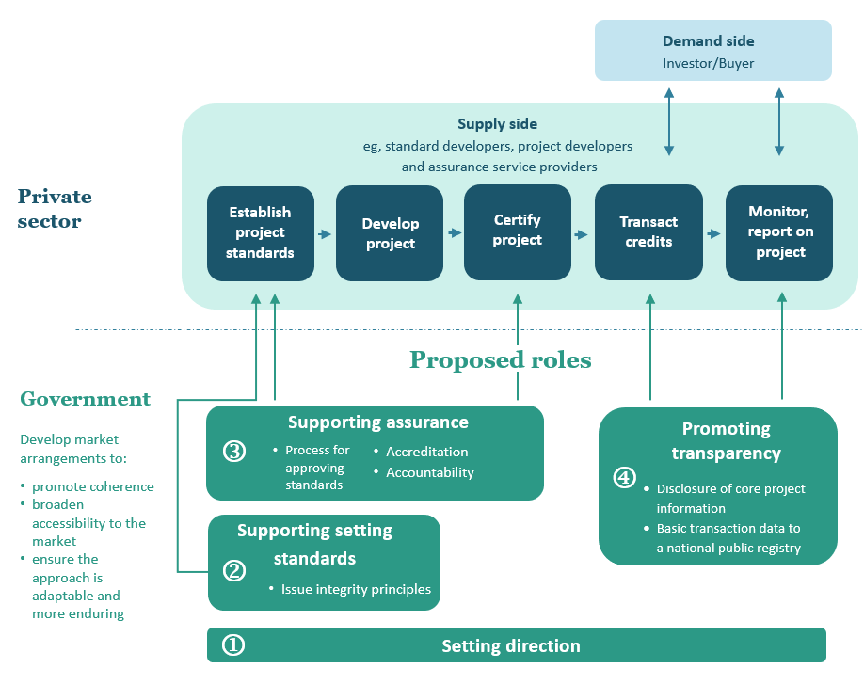
The market will continue to operate voluntarily on an opt-in basis, recognising the voluntary nature of the market and that voluntary credits are unlikely to suit all projects or investors. Legislation could be considered in the future, if market activity shows that a regulatory approach would help to build trust and further scale up investment.
The government’s roles can support different stages of the market as it scales up. In an emergent stage, where the market only has a small number of projects, there would be reduced due diligence and the primary focus would be on setting direction, market principles and, possibly, some emerging assurance support.
As the number of projects increases and the market enters a take-off stage, the supporting assurance role would expand to ensuring market actors are fit and proper. Finally, in a mature market stage, where there is reasonable scale and a steady supply and demand of credits, the role would include supporting market visibility, coherence and accountability.
This approach aims to support market efficiency by striking the right balance between assuring project integrity to support investor confidence, enabling innovation, and supporting New Zealand market solutions that are accessible to land owners and other project proponents.

Integrity principles to support approving standards
Integrity principles are at the core of the government’s role. The government would use these principles for reviewing and approving project standards for voluntary credits.
The principles are a reference point for assessing whether the project standards meet the level of integrity needed to build investor confidence. In turn, projects would also need to meet the level of integrity set by the principles, because projects would be developed and certified in accordance with principle-aligned standards.
We are proposing seven integrity principles. They build on the interim voluntary climate change mitigation principles released in 2022, and draw on recent developments in international markets.
The principles are intended to ensure that voluntary credits issued with standards that are endorsed by government:
- are additional to business as usual
- are durable
- have real, measurable and verifiable outcomes and risk mitigation
- are accessible
- are transparent
- are respectful of rights
- use appropriate terminology to support accurate claims.
The government would use these principles for reviewing and approving project standards for voluntary credits.

1. Additional to business as usual
Additionality is a well-established principle in voluntary markets (both the emerging ‘nature’ and more mature ‘carbon’ credits markets). Credits must represent positive climate, biodiversity and/or other environmental outcomes in addition to those that would have occurred anyway, without the project.
Projects would need to demonstrate that their outcomes are additional to business as usual, in accordance with endorsed standards. This would include describing how the project would avoid ‘double-counting’ or ‘double-claiming’ credits for the same environmental outcome or for interventions that have already been funded.
For example, a project would not satisfy the test if it simply delivered activities that are already a regulated requirement (ie, business as usual) or have already been fully funded by another mechanism (eg, a grant or sale of a different type of credit). However, positive environmental activities that go beyond the regulated or contracted minimum requirements on land owners could be eligible to generate such credits, and there may be buyers for such credits.
To avoid real or perceived concerns of double-counting and conflicts with the additionality principle, credit projects should disclose other revenue sources. For example, some voluntary carbon credits could already include priced-in biodiversity co-benefits if marketed and sold at a premium reflecting this. If these co-benefits from the same project were resold via separate biodiversity credits, it would constitute unacceptable double-selling.
Additionality may require demonstrating the added cost of elements beyond what would happen as a business-as-usual baseline (eg, the additional cost of using native species with biodiversity benefits versus exotics to generate carbon credits). In cases where more than one type of credit (eg, carbon and biodiversity) is offered separately for the same project, additionality may require a clear demarcation of inputs and outcome claims, to show additionality for each credit type.

2. Durable
Activities or projects recognised through carbon and nature credits are expected to contribute to long-lasting or permanent outcomes. Mechanisms to ensure durability may vary, depending on land types (tenure) and the environmental outcomes sought.
For New Zealand projects to restore or enhance biodiversity or remove carbon, durability could be shown by a land tenure commitment over the project area. Examples include: a Ngā Whenua Rāhui Kawenata (which can be applied on Māori land for 25 years, but is subject to renewal), a Conservation Act 1987 or QEII National Trust covenant (which would generally operate in perpetuity and are usually registered against land title), or an equivalent tenure agreement or conservation easement. This provides for longer term monitoring of outcomes and options for redress, if outcomes are undermined.
The international integrity principles for nature restoration projects generally require a commitment of at least 25 years, usually through a land tenure or contractual commitment, where feasible.
Options to demonstrate durability through project standards could include:
- a minimum commitment of 25 years, underpinned either by legal or contractual commitment over project areas, and/or
- other mechanisms to address the potential reversal of nature or carbon removal outcomes over the longer term.
Where the environmental outcome is a reduction in emissions, the standard would need to demonstrate how it will avoid leakage.
Some nature or carbon projects are unable to impose durability safeguards via tenure where ‘land titles’ or ‘customary marine titles’ do not apply. Examples include: some ‘blue carbon’ projects below mean high water springs in coastal waters; projects over Māori customary land; the beds of some navigable lakes and rivers; and certain other areas of Crown land. In such cases, durability may need to be demonstrated (and required by project standards) using other mechanisms, such as contracts with the project proponent to address the risk of outcomes reversing.

International approaches
An approach used overseas is to require assessment of the risk of reversed or inadequate outcomes, and measures (eg, buffer zones or diversified plantings) to mitigate, monitor and compensate for any loss.
Alternatively, some international voluntary carbon standards withhold a set percentage (depending on risk) of eligible credits from participating projects, to establish a buffer pool of credits. The credits are held in reserve as insurance, to cover the risk of reversals in individual projects due to fire or other events.

3. Real, measurable and verifiable outcomes and risk mitigation
Credible and robust evidence of effective actions and beneficial outcomes is an important principle underpinning nature and carbon credits markets. Stakeholders, including environmental groups and prospective investors, want to be confident that:
- credits, and the projects they represent, will deliver the tangible outcomes promised
- actions and outcomes are appropriate for the project area.
This is a core role for standards and methodologies.
The type of information to demonstrate effective actions, beneficial outcomes and risk mitigation will vary. It depends on the type of credit and the timing for issuing it (eg, planned actions in advance of the project beginning, showing progress underway, or comparing earlier baseline information with outcomes and maintenance plans after completion).
This principle includes ensuring that interventions and measurement, verification and reporting (MVR) of project actions and outcomes:
- are grounded in scientific and other knowledge (eg, mātauranga Māori), as appropriate
- use appropriate baselines to identify activity and outcomes arising from the project, framed in ways that are consistent with standard definitions of biodiversity and ecosystems and scientifically endorsed measurement methods
- are appropriate to the location and enhance environmental integrity (including for project ecosystems, adjacent land and local communities)
- manage risks through sound processes.
This can include MVR aligned with internationally recognised benchmarks, such as the Taskforce for Nature-related Financial Disclosures and Taskforce on Climate-related Financial Disclosures.
Where projects are restoring biodiversity or avoiding loss through active management of environmental pressures (eg, invasive pests), any interventions should be consistent with legal obligations, including regional plans. Interventions should also be consistent with international obligations for indigenous biodiversity protection, maintenance and enhancement.

Managing risk
Projects will need to demonstrate that the risk of any negative impacts and unintended consequences will be managed appropriately. Essentially, risk management is about:
- supporting the right project and intervention for the right place and ecosystem
- managing negative impacts or spillover (leakage)
- avoiding, mitigating or, if needed, addressing potential or actual conflicts of interest with the third parties undertaking MVR.
Avoiding, minimising or mitigating against negative impacts applies particularly to critical habitats of endangered species, or rare or at-risk habitats. It also applies in other cases, such as when a project increases carbon emissions in nearby areas.

4. Accessible
This principle requires that evidential rigour is balanced with considerations of practicality, cost-effectiveness and proportionality. This makes the market accessible for smaller-scale projects (eg, a farm or forestry block).
Accessibility for land owners is important for supporting the supply of projects. This is important in New Zealand, where much of the private land is in quite small holdings. In contrast, most international project standards are oriented to large-scale projects.
By balancing evidential rigour with a practical, cost-effective system, we can avoid administration eclipsing project viability and the costs of conservation. This requires that:
- transaction costs for project development, validation, certification, and ongoing monitoring and reporting are proportionate to the scale and risk
- the market is adaptable and open to trialling new or more cost-efficient validation technologies as they emerge (eg, satellite imagery, monitoring via AI).
Small-scale commercial initiatives often face challenges with economies of scale. This is also true for nature credit projects. Costs can often be reduced by aggregating across several smaller activities or land holdings, to meet the minimum quality control and assurance requirements in market-based mechanisms. However, aggregating activities can also be challenging, because different owners and stakeholders may have different motivations and risk appetites.

5. Transparent
Transparency refers to openness and clarity in disclosing, tracking and verifying information about credits. It ensures that all stakeholders (credit buyers, project developers, iwi, communities and third party verifiers) can see and understand how credits are created, validated, traded and retired. This requires proactive public disclosure of methodologies and standards, baselines and performance, and transaction data.
The aim is to prevent fraud, double-counting and greenwashing, and to promote accountability and confidence in the market. In practice, transparency operates at several levels:
- standards requiring project-level disclosure: reporting information about the project generating the credits (eg, location, methodology, environmental and other outcomes, impacts, risks and mitigation) to a registry
- credit lifecycle tracking: a public-facing and clear record of credit issuance, ownership, transfer and retirement in real time, usually via online public registries
- public accountability: public access to rules, methodologies, standards, oversight mechanisms, independent validation and summary data.

6. Respectful of rights
This principle requires project owners to identify:
- public or community rights and interests (including those of land owners and Māori) that relate to a project
- the ways in which a project might contribute to, accommodate or avoid detracting from these interests.
Internationally, best practice calls for voluntary nature credits to provide equity of access and recognition of interests, due to issues that have emerged in carbon markets. This concept extends to ensuring that all people (including Māori and local communities) can actively participate in the market, and that endeavours are made to identify and respond to rights relating to a project.
The above are all relevant to the New Zealand context. Project standards should describe:
- how projects can identify the rights and interests of Māori and local communities. For example, a project could relate to Māori rights and interests, such as local taonga species, where public conservation land has been vested in post-settlement governance entities, mātauranga, interest in kaitiakitanga, and any data sovereignty. Community rights and interests could include access to or enjoyment of public space where projects are proposed
- how projects might contribute to, accommodate or potentially detract from, Māori or local community interests (eg, economic opportunities or access to and enjoyment of local ecosystems).

7. Support accurate claims using appropriate terminology
A well-functioning voluntary market will need safeguards on the claims made about credits.
To help both suppliers and purchasers comply with consumer law and meet public and market expectations, credit offerings would need to give purchasers clear guidance on how they can use credits, and any claims that they can make in relation to them. Such guidance should use appropriate and accurate wording to describe the environmental outcomes of the credit. Similarly, organisations should use appropriate and accurate wording when stating how credits they have purchased contribute to their environmental objectives.
This principle would also encourage project standards to clearly reference and align to specific global initiatives that set quality thresholds for voluntary credits. This will help promote New Zealand offerings to international investors (while recognising any differences if required). Global organisations include the Biodiversity Credit Alliance, International Advisory Panel on Biodiversity Credits, the Integrity Council for the Voluntary Carbon Market and the International Carbon Reduction and Offset Alliance. Wider global initiatives underpinning demand for credits include the Task Force on Climate-related Financial Disclosures and the Taskforce on Nature-related Financial Disclosures.
Organisations should provide transparent disclosure when retiring credits that represent voluntary climate change mitigation. These credits also contribute to a country’s Nationally Determined Contribution under the Paris Agreement, and that should be transparently disclosed.

Next steps
The Ministry intends to:
- refine the above government roles and principles, including through incorporating insights from proof-of-concept pilot projects, funded by private sector organisations that have agreed to participate in testing and refining proposed market arrangements
- seek final Government decisions in early 2026 regarding implementation of the roles and principles.
If you would like further information or to provide feedback on this document, please contact the Ministry for the Environment using the following email address: naturemarket@mfe.govt.nz.

Ministry for the Environment. 2022. Interim guidance for voluntary climate change mitigation. Wellington: Ministry for the Environment.
These include the Core Carbon Principles from the Integrity Council for the Voluntary Carbon Market (https://icvcm.org/core-carbon-principles/) and the Claims Code of Practice from the Voluntary Carbon Markets Integrity Initiative (https://vcmintegrity.org/vcmi-claims-code-of-practice/).
For example, the Framework for high-integrity biodiversity credit markets from the International Advisory Panel on Biodiversity Credit (https://www.iapbiocredits.org/framework) and the Core Carbon Principles from the Integrity Council for the Voluntary Carbon Market (https://icvcm.org/core-carbon-principles/).
Ministry for the Environment. 2022. Interim guidance for voluntary climate change mitigation. Wellington: Ministry for the Environment.
Leakage occurs when the activity credited for reducing emissions results in unintended emissions outside the boundaries of the project.
See the Ministry for the Environment website for more information about the proof-of-concept pilot projects.

