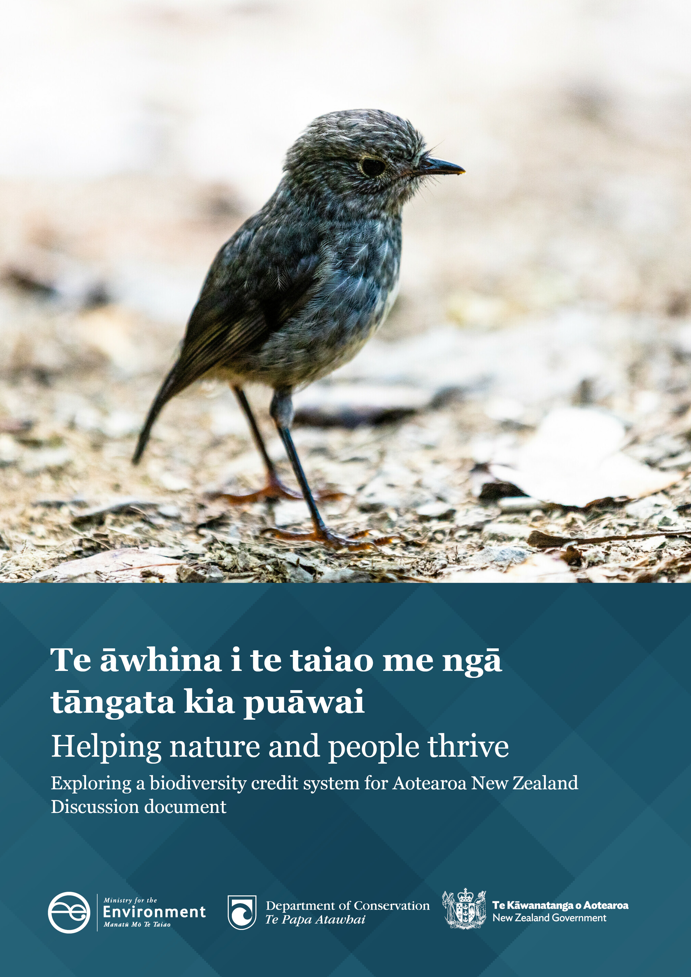
F

The information in this publication is, according to the Ministry for the Environment’s best efforts, accurate at the time of publication. The Ministry will make every reasonable effort to keep it current and accurate. However, users of this publication are advised that:
- the information does not alter the laws of New Zealand, other official guidelines, or requirements
- it does not constitute legal advice, and users should take specific advice from qualified professionals before taking any action based on information in this publication
- the Ministry does not accept any responsibility or liability whatsoever whether in contract, tort, equity, or otherwise for any action taken as a result of reading, or reliance placed on this publication because of having read any part, or all, of the information in this publication or for any error, or inadequacy, deficiency, flaw in, or omission from the information in this publication
- all references to websites, organisations or people not within the Ministry are for convenience only and should not be taken as endorsement of those websites or information contained in those websites nor of organisations or people referred to.

This document may be cited as: Ministry for the Environment. 2023. Helping nature and people thrive: Exploring a biodiversity credit system for Aotearoa New Zealand – Discussion document. Wellington: Ministry for the Environment.

Published in July 2023 by the
Ministry for the Environment
Manatū mō te Taiao
PO Box 10362, Wellington 6143, New Zealand
environment.govt.nz
ISBN: 978-1-991077-67-7 (online)
Publication number: ME 1777
© Crown copyright New Zealand 2023

Contents
Message from the Minister of Conservation 5
Message from the Associate Minister for the Environment (Biodiversity) 6
Summary 8
1 What is a biodiversity credit system? 10
What is a biodiversity credit? 10
International approaches 11
Potential use in different habitats 14
Different biodiversity credit system approaches 14
Activities a biodiversity credit could fund 15
Biodiversity credits versus biodiversity offsets 16
2. Why do we need a biodiversity credit system? 18
Why a biodiversity credit system? 18
Nature needs our help 18
Aotearoa New Zealand’s wildlife, plants and habitats are unique 20
We need the environment to thrive for people to thrive 20
Protecting the environment is critical to Māori 21
When we act, nature responds 21
A shared global challenge 24
Closing the funding gap 25
Growing interest in investing in nature 27
Clear biodiversity outcomes 29
3. How should we design and implement a biodiversity credit system? 32
Principles of design and implementation 32
System components 33
Measurement, verification and reporting 34
Legal recognition 35
Approaches to trading credits 36
Role of experts 36
Potential government roles 38
4. How a biodiversity credit system could complement the wider system 42
Links between policies that address the climate and biodiversity crises 42
Sharing methodologies to support land-use change 45
5. Next steps 47
Help shape the development of a biodiversity credit system 47
What happens next 48
Consultation questions 49
Appendix 1: Glossary 51
Appendix 2: Biodiversity credit systems and related schemes 56

Tables
Table 1: Pros and cons of different biodiversity credit system approaches 15
Table 2: Potential underlying principles for a biodiversity credit system 32
Table 3: Possible roles of government 40
Table 4: Biodiversity credit systems and related schemes 56

Figures
Figure 1: Green financing mechanisms 11
Figure 2: Biodiversity is an essential part of the natural world that contains and surrounds us 19
Figure 3: Aotearoa New Zealand’s unique wildlife 20
Figure 4: Principles of a biodiversity credit system 30
Figure 5: Components of a biodiversity credit system 33

Message from the Minister of Conservation
Aotearoa New Zealand has an abundance of unique and diverse plants and animals. From the towering kauri in the North to the iconic kākāpō in the South. We are a global biodiversity hotspot, with many of our species found nowhere else on earth. For example, 100 per cent of our reptiles, frogs and bats, and 72 per cent of our birds are only found here.
Our connection with indigenous biodiversity runs deep. It is part of our identity and inherent to the whakapapa relationship Māori have with te taiao, the natural world. In te ao Māori, we acknowledge the interconnected and holistic relationship that we have with living things, as well as our obligations as kaitiaki to look after te taiao.
Across the motu, many of us, from government and communities to individual landholders, are doing our best to help biodiversity thrive, but it needs more help. We have one of the highest percentages of threatened indigenous species in the world, and we have lost 79 species to extinction since the arrival of humans here. If we want future generations to enjoy our thriving ecosystems and habitats, we need to do more.
We know that biodiversity provides a wide range of benefits. Many people enjoy the social, cultural and environmental benefits. For example, visitors who come to Aotearoa to enjoy our beautiful national parks, whānau gathering mahinga kai, or people keeping healthy by going for walks in local forests.
We need to look at new and innovative ways to support landholders to protect and restore our indigenous biodiversity and ensure the range of ecosystems in Aotearoa are protected and restored. With the right financial incentives in place, we could do more.
A biodiversity credit system could be influential in improving the health and vibrancy of indigenous biodiversity by ensuring extra funding goes towards positive biodiversity outcomes. This would help us meet international obligations to protect biodiversity and deliver on outcomes sought through Te Mana o te Taiao – the Aotearoa New Zealand Biodiversity Strategy.
It could also supplement work already happening in our communities and on public land, ensuring that our prosperity as a people is intrinsically linked to the prosperity of the plants and animals that call Aotearoa home.
I encourage you to submit your thoughts on the potential for a biodiversity credit system in Aotearoa, and how to ensure such a system will work for all.

Hon Willow-Jean Prime
Minister for Conservation

Message from the Associate Minister for the Environment (Biodiversity)
Nature is being lost more rapidly now than at any time in human history, with an estimated one million species threatened with extinction.
Primarily as a result of human activity, Earth's wildlife populations have plunged by an average of 69 per cent in just under 50 years. The rate of species extinction today is somewhere between 1,000 and 10,000 times higher than it would be if our actions weren’t making it so much more extreme.
In Aotearoa, we are not immune. New Zealand currently has one of the worst rates of extinction in the world. Species like the kākā, Bartlett’s rātā, Archey’s frog and the Otago skink are in decline due to predation from introduced pests, climate change, the spread of weeds, land- and sea-use change, and habitat loss.
Despite some incredible conservation success stories, and sustained efforts by landowners, hapū, iwi and community groups, the overall picture in Aotearoa is one of continued depletion.
Sixty-three per cent of our ecosystems are now threatened, and a third of our native species are threatened or at risk of extinction.
In the face of this escalating crisis, it is critical that we find a way to better reward those who are helping to protect and restore our native flora and fauna. Current investment and conservation actions fall far short of what is needed.
Whilst public conservation land and water is an important refuge for some of our most threatened species and ecosystems, a significant amount of New Zealand’s last remaining indigenous biodiversity is on private and Māori land.
Given many of our threatened and at-risk species and habitats are found outside of conservation land, solutions to the biodiversity crisis need to involve the whole community, including our business sectors. It’s time we make it simpler and more cost effective to support the good work that landowners and tangata whenua are already doing on their land.
An effective system of biodiversity credits and incentives could go a long way towards that goal. It could help to recognise farmers and other landowners, hapū and iwi for their stewardship of nature and resource them to go further. It could help to close the gap in economic returns between fast-growing exotic monocrop forests and slower-growing, but more biodiverse, indigenous forests.
But biodiversity credits and incentives aren’t without risk or controversy. Any system would need unimpeachable environmental integrity. There are concerns about the commodification of nature, indigenous rights, and cultural and intellectual property.

Many of us feel a strong connection to our native plants and wildlife. We’re lucky enough to have ancient rainforests, tussock grasslands and braided rivers right on our doorstep.
We would like your help in resolving these questions as we consider what the best design of a system of biodiversity credits and incentives might look like for Aotearoa. Please let us know what you think.

Hon James Shaw
Associate Minister for the Environment (Biodiversity)

Summary
Nature needs our help. The twin crises of climate change and biodiversity are putting at risk many of Aotearoa New Zealand’s unique wildlife, plants and habitats. This is due to human impact and environmental pressures (land-use change, introduced pests, weeds and diseases, rising temperatures, and more frequent droughts and floods).
We have a strong attachment to our country’s landscapes, natural heritage and unique indigenous species. It is one of the features that defines us as a nation and as a people. While many landholders are doing great work to protect and restore species and habitats, without greater support to address these crises, we risk losing more species and habitats. This risks our own wellbeing, given the many ways in which the natural world supports us. We can’t just rely on government funding and the goodwill of landholders.
This is a shared challenge that needs new approaches and greater financial support.

A new way to finance ‘nature-positive’ projects
Looking after our richly diverse species and habitats is not only good for the environment it is essential to our wellbeing, economy and way of life. But to properly protect nature, much greater funding is needed to support the efforts of both public and private landholders.
One solution for bridging this funding gap is a ‘biodiversity credit system’ (BCS). This is an emerging approach that is gaining considerable interest internationally. In June this year 14 world leaders wrote an open letter calling for a green transition and for new, innovative and sustainable sources of finance and more trusted carbon and biodiversity credit markets.
Biodiversity credits are a way of attracting funding from the private sector, to invest in efforts by landholders to protect, maintain and enhance indigenous vegetation and habitats, including shrublands, grasslands, wetlands and natural and regenerating native forests.
The credits recognise, in a consistent way, landholder projects or activities that provide positive outcomes for indigenous biodiversity (species and habitats).
By purchasing credits, people and organisations can finance and claim credit for their contribution to ‘nature-positive’ actions and outcomes. In Aotearoa, these relate to protecting, restoring and enhancing nature on public and private land, including whenua Māori (Māori land).
Such an approach has the potential to complement traditional ways of financing projects that support and conserve nature. It could help support the implementation of the National Policy Statement for Indigenous Biodiversity and support landholder responses to our climate change emergency, by mobilising the funding and approaches needed to support their efforts.
Demand for credits is expected to increase over time as businesses look to understand and address their impacts on nature and protect the environment they operate it. Business drivers for this investment include: meeting stakeholder, customer and employee expectations, enhancing reputation and brand, addressing current and emerging industry and corporate reporting standards and building meaningful relationships with mana whenua and communities.
For a market to grow and operate effectively for nature, those participating will need assurances that biodiversity credits have integrity. Prospective investors will want to be confident that biodiversity credits can be trusted and have impact, and project developers and landholder will want certainty about what is expected of their projects.
Consequently, the Government is exploring the roles it could play to support the establishment of a BCS for Aotearoa that would operate with both integrity and impact and that suits the country’s unique circumstances. These include the need to recognise that iwi and hapū have unique rights, interests and obligations guaranteed under te Tiriti o Waitangi and Treaty settlements for safeguarding te taiao and kaitiaki relationships with taonga species.
A credit system could particularly benefit indigenous biodiversity on whenua Māori for those landholders who wish to protect and enhance indigenous biodiversity, given the large areas of remaining native vegetation still found on this land. It could do so by complementing other tools, such as carbon credits, to support sustainable land use.
This discussion document explores broad roles that the Government could play in different parts of a biodiversity credit system, for instance, using non-regulatory tools, such as guidance, or establishing regulatory tools to direct the operation and administration of the market.

Consultation
The Government is exploring its role alongside iwi and hapū in setting up a BCS for Aotearoa.
We are seeking feedback on the need for and the design of a BCS, and the different roles of government and Māori in implementing it. Our aim is for a system that has impact and integrity, tailored to Aotearoa New Zealand’s unique context and challenges. This includes how it could work with other programmes that support the environment.
Consultation is open from 7 July to 3 November 2023.
To make a submission, go to: https://consult.environment.govt.nz/biodiversity/nz-biodiversity-credit-system
Please contact us at biocredits@mfe.govt.nz for more information or to set up an online conversation.

1 What is a biodiversity credit system?
This section covers the following.
- What is a biodiversity credit?
- International approaches
- Potential use in different habitats
- Different biodiversity credit system approaches
- Activities a biodiversity credit could fund
- Biodiversity credits versus biodiversity offsets
For a detailed outline of the threat to Aotearoa New Zealand’s diverse species and ecosystems, see section 2: Why do we need a biodiversity credit system?.

What is a biodiversity credit?
Biodiversity credits are a type of ‘green financing’ mechanism. They are used to encourage and facilitate private investment in protecting the environment. The credits are measurable and traceable units representing projects or activities to protect, restore or enhance indigenous biodiversity. Some are tradeable. They recognise, in a consistent way, projects and activities that bring ‘nature-positive’ outcomes for biodiversity.
A biodiversity credit has been defined as a legal instrument that has been certified under a specific system. It represents the environmental action made or outcomes achieved, where it took place, who developed it, under what methodologies and timeframes. By purchasing credits, people and organisations can finance environmental projects and activities. Purchasers can then claim credit for their contribution to nature-positive actions and outcomes related to the protection, restoration and enhancement of indigenous biodiversity on public and private land.

What is a biodiversity credit market?
A biodiversity credit market is a market for buying and selling biodiversity credits, see section 3: Approaches to trading credits.

What is a biodiversity credit system?
A biodiversity credit system (BCS) provides the institutional settings, methods, systems and processes that enable and govern the creation, sale and purchase of, and claims made against, biodiversity credits.

How does a biodiversity credit system relate to other green financing mechanisms?
A range of financing mechanisms can be used to provide funding for environmentally friendly projects. Some provide either grants, debt funding or provide equity (figure 1).
Figure 1: Green financing mechanisms
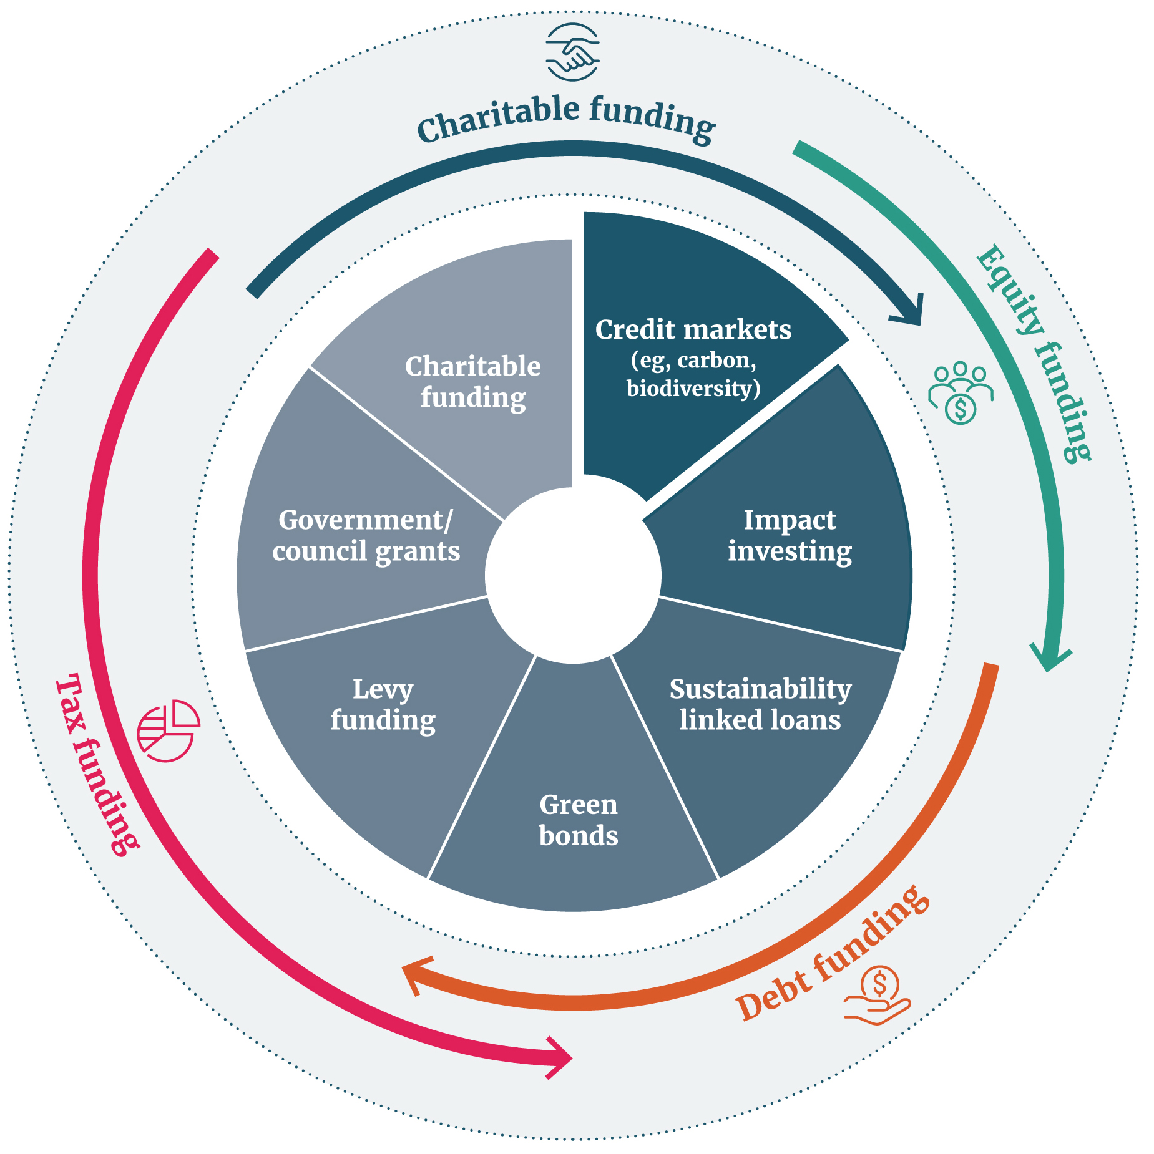

International approaches
Different approaches to BCSs and markets are emerging both internationally and domestically. For example, United Nations agencies are jointly supporting the Biodiversity Credit Alliance. This comprises field-based conservation practitioners and academics who are developing guidance for developing credible and scalable biodiversity credit markets, based on global principles.
World leaders are calling for a green transition and for new, innovative, and sustainable sources of finance and more trusted carbon and biodiversity credit markets.
Emerging government-supported and private sector approaches include the following (see also appendix 2).

Nature repair market – Biodiversity certificates
The Australian Government is establishing a ‘nature repair market’, as part of its Nature Positive Plan. The aim is to make it easier for companies and other businesses to invest in projects that improve biodiversity across Australia. To support this, the Nature Repair Market Bill 2023 (the Bill) has been introduced into the Australian Parliament, to provide a framework for this market. Eligible landholders (including First Nations people, conservation groups, state governments and farmers), will be able to participate in the market. Landholders taking environmental action to protect, restore or establish habitat would be able to receive a tradeable certificate that will be tracked through a national register. Eligible projects will be subject to various permanence periods based on prescribed methods or the Bill minimum periods of 25 or 100 years. Examples of projects include:
- improving or restoring native vegetation
- planting a mix of local native species
- re-establishing coral reefs
- protecting rare grasslands that provide habitat for an endangered species.
This framework is intended to facilitate private investment in biodiversity, including where carbon storage projects also benefit biodiversity.

VERRA – Nature-positive credits
VERRA is a non-profit organisation in the United States of America that sets standards for climate action and sustainable development. It manages the voluntary carbon market verified carbon standard programme. It is developing a biodiversity methodology for assessing and quantifying the benefits from conservation and restoration activities. The biodiversity standard will be used to certify the benefits of environmental projects verified by the Sustainable Development Verified Impact Standard (SD VISta) and allow market participants to make claims (a verified statement of a project’s measured benefits).

Wallacea Trust – Biodiversity credits
The Wallacea Trust is a United Kingdom charity that leads projects to protect ecosystems and biodiversity in developing countries. It is designing a BCS based on at least five metrics, to represent conservation objectives within an ecoregion. Objectives can be a measured uplift in biodiversity, a future uplift in biodiversity against a reference site, or avoidance of anticipated loss in biodiversity. Proposed projects are independently verified, and biodiversity credits issued by an international standards body (eg. Plan VIVO).

Greencollar – NaturePlus credit scheme
GreenCollar is a private Australian environmental market investor and project developer. It has developed a BCS trademarked as NaturePlus. Credits are awarded for delivered and third-party audited and certified restoration in high conservation value landscapes. Credits are issued at project level for activities such as:
- reducing loss and degradation
- improving the connectiveness and resilience of ecosystems
- maintaining and improving native habitat.
Once areas have been improved to sustainable levels, credits can be generated from successfully maintaining that condition. Each credit represents 1 hectare of achieved conservation or restoration over one year. Environmental conditions are benchmarked against the Australian Accounting for Nature Framework.

ClimateTrade and Terrasos – voluntary biodiversity credits
Spain’s ClimateTrade™ and Colombia’s Terrasos have joined forces to promote voluntary biodiversity credits to support habitat banking. Each credit corresponds to 30 years of conservation and restoration of 10 metres of habitat of threatened species. Credit generation is determined by the International Union for Conservation of Nature’s threat category for the ecosystem, subject to the preservation, restoration and duration of the project. Voluntary biodiversity credits allow companies to meet their decarbonisation targets, while becoming nature positive.
EKOS – Sustainable Development (Biodiversity) Units (NZ)
Sanctuary Mountain Maungatautari is an ancient ecosystem near Hamilton. It is the site of a project to restore an environment where some of New Zealand’s most endangered species, including birds, bats and reptiles, can be safely reintroduced.
To support the project, in July 2022 the New Zealand company EKOS launched the country’s first private sector biodiversity credit offering. Through EKOS’s Sustainable Development Unit programme, Sanctuary Mountain Maungatautari sold biodiversity units to Hamilton business Profile Group Ltd. This sale enabled the sanctuary to control pests and weeds over 83 hectares, for one year.
The integrity of the initiative is based on an environmental markets quality system. This includes a standard and methodologies developed by EKOS and validated by environmental auditing firm McHugh and Shaw Ltd.
‘The EKOS approach does not put a price on nature. It puts a price on the human labour and technology cost to look after nature,’ said the company’s Chief Executive Officer, Dr Sean Weaver.

Voluntary carbon market
The voluntary carbon market (VCM) is a closely related mechanism to tackle climate change and drive mitigation action, by recognising carbon removals from the atmosphere. The VCM enables the sale and purchase of carbon credits. Each credit represents 1 tonne of carbon dioxide equivalent either removed from the atmosphere or reduced from emissions. Some voluntary carbon credits also include the added value of biodiversity co-benefits, which may or not have been quantified. Carbon credits with biodiversity co-benefits are increasingly sought after and generally sell at a premium, compared with similar carbon credits without biodiversity co-benefits.

Potential use in different habitats
A BCS could recognise efforts to protect, enhance and restore indigenous biodiversity in any habitat (on land, in freshwater, or coastal and marine environments) or only in some. Likewise, a credit could represent work on whole ecosystems or catchments, or focus on endangered or taonga species or remnant habitats.
Most current international BCSs recognise work on land only. This is likely because we know more about biodiversity on land than elsewhere.
However, examples are increasing of systems that recognise work in other ecosystems, such as Niue’s Ocean Conservation Credit scheme.
The BCS proposed in Australia’s Nature Repair Bill aims to recognise projects both on land and in freshwater, coastal and marine environments, including, potentially, coral re-establishment projects.
New Zealand could start small, focusing on certain ecosystems and activities, to pilot this approach or to establish the framework for a system across all ecosystems and activities.
This will depend in part on the availability of suitable methodologies and data for each ecosystem.

Different biodiversity credit system approaches
A biodiversity credit could represent a measured positive outcome for biodiversity or for projects and activities that are likely to benefit biodiversity. Three broad approaches are emerging for the design of BCSs: outcome, activity and project based.

By outcome
VERRA and Operation Wallacea are examples of primarily an outcome-based approach, where one credit represents a 1 per cent increase (or avoided decrease) in the indigenous biodiversity of a hectare. This is also a unit-based approach. The aim is to simplify the valuation of the impact of different activities to a single unit of credit, to represent equivalent outcomes for biodiversity. This is intended to operate in a similar way to carbon markets: 1 tonne of carbon dioxide removed from the atmosphere by certain activities is recognised globally as a carbon credit and is considered to have an equivalent benefit in reducing global warming regardless of location.

By activity
The EKOS Sustainable Development Unit approach for ‘life on land’ is a type of BCS based mainly on the quantification of activities and effort to support biodiversity outcomes such as:
- hectares of wetland indigenous revegetation in a defined project area with a minimum planting density
- hectares of land managed for invasive pest or weed control.
This approach mainly recognises activities to improve biodiversity.

By project
The Australian Nature Repair Framework is an example of a project-based approach, issuing a certificate for biodiversity projects instead of credits. It uses standard methods and assessments, which specify what kinds of projects can be covered, and standardised presentation of project information. This ensures that projects are described accurately and consistently, so that the market can compare their biodiversity value.
Table 1: Pros and cons of different biodiversity credit system approaches
Approach | Advantages | Disadvantages
By outcomes | - Good recognition of benefits to biodiversity  - Outcomes are generally easier to see and understand for lay-people  - Comparative impact of credits easier to value on a unit basis  - Credits generally not given until outcomes achieved | - Perception of commodification of nature  - Could lead to focus on achieving outcomes that are less challenging  - Generally longer timeframe to see value from credits (outcomes take time)  - Factors outside of the control of participants can affect outcomes  - May require complicated and expensive methodology to monitor, measure, verify and report a basket of indicators for identifying progress against outcomes.
By activities | - Recognises time and actions of land owners and holders  - Value of credit tied to activity rather than the biodiversity itself  - Credits received faster (front footed)  - Lends itself well to a faster implementation timeline | - Positive outcomes for biodiversity are assumed based on activities  - Difficult to attribute benefits of activities  - Moderate monitoring, verification and reporting costs  - Outcomes may not be achieved
By project | - More flexibility in the types of activities and/or outcomes that qualify  - Recognises time and actions of land owners and holders  - High transparency in projects and how they fit in wider landscape  - Ability for participants to choose to support projects that align with their values and/or outcomes sought  - Easier to align with other related priorities (eg, climate) | - Difficulty in deciding what projects are in or out (where to draw the line)  - Each credit is likely to be more complicated with many facets  - Challenging to compare impact across projects and therefore harder to consistently value project certificates  - Likely to require a long implementation timeline to set up

Activities a biodiversity credit could fund
Under an activity- or project-based approach, a biodiversity credit could support different types of activities. In a New Zealand context, this could include any or all of the following:
- maintaining or restoring areas of existing indigenous biodiversity (shrublands, native grasslands, tussocklands, natural and regenerating forests and wetlands) by improving ecosystem integrity within significant natural areas (eg, pest, browser and weed control, stock- or predator-proof fencing, interplanting)
- expanding indigenous biodiversity around significant natural areas (eg, creating buffer zones and ecological corridors around and between forest remnants, natural wetlands or other natural areas)
- creating new areas of indigenous biodiversity (eg, by planting indigenous forest species, supporting transition from exotic to native forests, re-establishing wetlands, riparian planting using native plants along side lakes, rivers and streams, recreating seagrass beds, native grasslands and shrublands)
- specific interventions for indigenous or taonga species (eg, to improve species number, diversity, range)
- enhancing legal protection of existing significant areas of indigenous biodiversity (eg, supporting the establishment of Queen Elizabeth II National Trust Act 1977 or Conservation Act 1987 covenants, Ngā Whenua Rāhui kawenata, conservation easements, or land use restrictions)
- Māori-led initiatives to restore, maintain and/or improve indigenous biodiversity in accordance with local expressions of mātauranga Māori
- Activities may also be distinguishable based on the type of land (eg, public conservation land and regional parks, or private land including whenua Māori).

Biodiversity credits versus biodiversity offsets
Biodiversity credits operate in the voluntary market and are intended to bring benefits for indigenous biodiversity, against which nature-positive claims can be made.
Biodiversity offsets are a regulatory option. They are used as a requirement to offset negative impacts of development on indigenous biodiversity in limited circumstances. Offsets are designed to compensate for damage to nature with ‘equivalent’ or better improvements to indigenous biodiversity elsewhere.
In Aotearoa a requirement for a biodiversity offset is a resource management tool. It is available only in limited circumstances to provide redress for impacts on indigenous biodiversity that cannot be avoided, arising from the subdivision, use or development of land. Offsets are subject to national direction and principles.
Some overlap may occur between activities that could generate a biodiversity credit and those required to achieve net biodiversity gains as part of offsets. Offsets must generate a ‘like for like’ replacement and can be location dependent.
Both approaches require similar supporting tools and processes, such as measurement, monitoring and verification systems (section 3).
Whether credits are used as an offset or not could be a design choice for a BCS. If allowed, the credit would need to satisfy the requirements of both approaches and could not be used to make nature-positive claims. Alternatively, landholders who are developing projects that would generate biodiversity credits could have the option of selling into either the biodiversity credits market or to a developer as an offset.
Closing a BCS to the regulated offsets market would reduce one potential source of investment interest but might make the market more attractive to other investors.

Questions
1 | Do you support the need for a biodiversity credit system (BCS) for New Zealand?  Please give your reasons.
2 | Below are two options for using biodiversity credits. Which do you agree with?  (a) Credits should only be used to recognise positive actions to support biodiversity.  (b) Credits should be used to recognise positive action to support biodiversity, and actions that avoid future decreases in biodiversity.  Please answer (a) or (b) and give your reasons.
3 | Which scope do you prefer for a biodiversity credit system?  (a) Focus on terrestrial (land) environments.  (b) Extend from (a) to freshwater and estuaries (eg, wetland, estuarine restoration).  (c) Extend from (a) and (b) to coastal marine environments (eg, seagrass restoration).  Please answer (a) or (b) or (c) and give your reasons.
4 | Which scope do you prefer for land-based biodiversity credits?  (a) Cover all land types, including both public and private land including whenua Māori.  (b) Be limited to certain categories of land, for example, private land (including whenua Māori).  Please answer (a) or (b) and give your reasons.
5 | Which approach do you prefer for a biodiversity credit system?  (a) Based primarily on outcome.  (b) Based primarily on activities.  (c) Based primarily on projects.  Please answer approach (a) or (b) or (c) and give your reasons.
6 | Should there also be a requirement for the project or activity to apply for a specified period to generate credits?  Please answer Yes/No and give your reasons.
7 | Should biodiversity credits be awarded for increasing legal protection of areas of indigenous biodiversity (eg, QEII National Trust Act 1977 covenants, Conservation Act 1987 covenants or Ngā Whenua Rāhui kawenata?  Please answer Yes/No and give your reasons.
8 | Should biodiversity credits be able to be used to offset development impacts as part of resource management processes, provided they meet the requirements of both the BCS system and regulatory requirements?

2. Why do we need a biodiversity credit system?
This section gives an overview of the:
- benefits a BCS might bring
- challenges to the environment that it might address
- considerations relating to te Tiriti o Waitangi
- interest that is growing internationally and domestically in this new way to invest in nature.

Why a biodiversity credit system?
Government, Māori, businesses, philanthropists, environmentalists and community groups are looking for new ways to invest in projects that protect indigenous species and habitats, as well as those that address the climate crisis. Alongside governments, communities and landholders, they want to ensure that nature continues to thrive and support us and our wellbeing.
An emerging approach is to use BCSs. Overseas, both governments and the private sector are interested in developing and operating such systems to attract new sources of funding (see section 1).

Benefits
A BSC would directly benefit indigenous biodiversity and the wider environment by:
- complementing the National Policy Statement on Indigenous Biodiversity 2023. It could help to attract the funding landholders need, to protect significant natural areas and habitats of taonga species, and to restore indigenous biodiversity in the wider landscape
- help to protect and reconnect important remaining remnants of indigenous biodiversity and to build the resilience of land and soils in the face of climate change
- help landholders (including of whenua Māori) as stewards and kaitiaki
- support New Zealand’s response to the climate emergency.
To make the most of this opportunity, prospective investors will need to have confidence that biodiversity credits have integrity and that their investments have impact to support at-risk species and habitats.
Activities for credits must also recognise the unique rights, interest and obligations of Māori to taonga species and mātauranga Māori.

Nature needs our help
Aotearoa was isolated from the rest of the world for 80 million years. As a consequence, many indigenous species and habitats were not well prepared to adapt to the challenges of human settlement, or to the new domestic and pest animals and weed species brought here by European settlement. Climate change driven by rising greenhouse gas levels is adding pressure, with rising temperatures and more frequent floods and droughts.
Aotearoa has one of the highest proportions of threatened indigenous species in the world.
This includes 22 per cent of our terrestrial species, 17 per cent of freshwater species and 32 per cent of marine species. This is on top of the 79 species of birds, plants and other creatures we have already lost over recent centuries.
Almost two-thirds of Aotearoa New Zealand’s rare and ‘naturally uncommon’ ecosystems are also at risk. For example, less than 10 per cent of our inland wetlands remain.
If we don’t act to support the unique biodiversity in Aotearoa, we risk losing many more unique species and habitats.
Figure 2: Biodiversity is an essential part of the natural world that contains and surrounds us
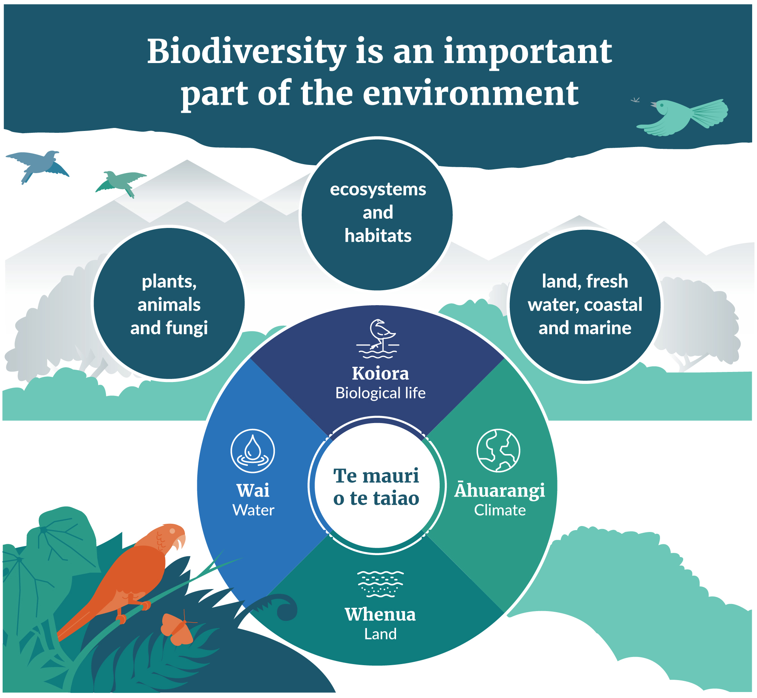

Aotearoa New Zealand’s wildlife, plants and habitats are unique
New Zealanders treasure their country’s biodiversity, which is part of the world’s shared heritage.
Aotearoa is a global biodiversity hotspot, and a huge proportion of species here are found nowhere else on earth. For example, we have more endemic seabirds than any other country.
Figure 3: Aotearoa New Zealand’s unique wildlife
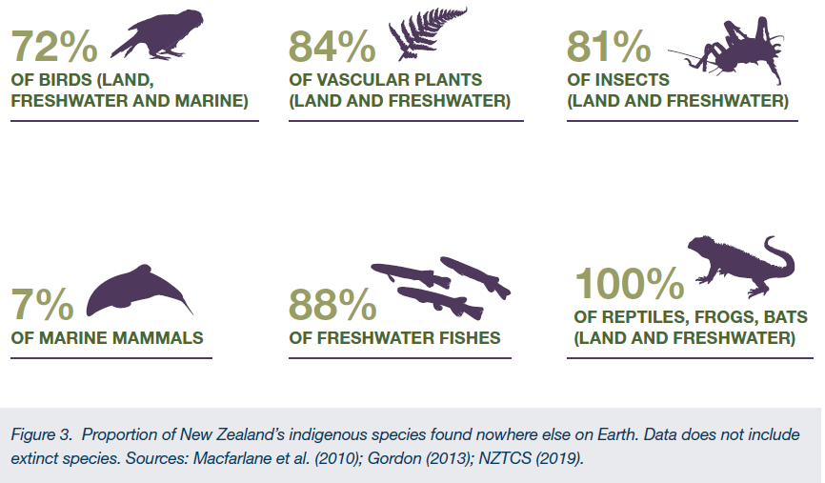
Proportion of New Zealand’s indigenous species found nowhere else on Earth. Data does not include extinct species.

We need the environment to thrive for people to thrive
Aotearoa New Zealand’s future and all aspects of our wellbeing are dependent on the health of the natural world. The natural environment provides us with fertile and stable soils, clean air and water, flood control, plant pollination, recreation, food, shelter, culture benefits and spiritual connection.
Te Oranga o te Taiao recognises:
(a) the health of the natural environment
(b) the essential relationship between the health of the natural environment and its capacity to sustain life
(c) the interconnectedness of all parts of the environment
(d) the intrinsic relationship between iwi and hapū and te Taiao.
Upholding Te Oranga o te Taiao supports the wellbeing of present and future generations.
More than half the world’s gross domestic product is moderately to highly dependent on nature and the services it provides to communities and economies.
Aotearoa New Zealand’s economic and social wellbeing is highly dependent on nature, with over 10 per cent of annual output derived from the food and fibre industries (including primary products, such as dairy farming, and the subsequent processing and commercialisation industries, such as dairy product manufacturing) and around 10 per cent from tourism.
A healthy and biodiverse environment also provides greater resilience, particularly the ability to adapt to and recover from the impacts of a changing climate.
When nature is in trouble, so are we.

Protecting the environment is critical to Māori
The relationship between whānau, hapū and iwi with their taiao is complex. Whānau, hapū and iwi share inherent whakapapa relationships, interconnectedness and an interdependency with their taiao. They will have interests in proposed solutions that are grounded in te ao Māori and enable the application of mātauranga Māori.
The Government has ongoing obligations under te Tiriti o Waitangi and in Treaty settlements and other agreements entered into between the Crown and iwi or hapū.
Te Tiriti o Waitangi and Treaty settlements provide guarantees to Māori for exercising tino rangatiratanga and kaitiakitanga in relation to taonga species and places.
A BCS must give effect to te Tiriti. This will be a critical consideration in the design of a BCS for Aotearoa.

When we act, nature responds
When we remove or manage threats to biodiversity, restore habitats and modify how we interact with nature, nature will recover. We can turn the tide of biodiversity decline, for those species and habitats that remain.
Aotearoa is a world leader and pioneer in bird conservation, research and management. Active management (eg, pest control, fencing, planting) has resulted in the population growth of 23 bird species, but many of these need ongoing support to continue to thrive.
Much is to be learned from mātauranga Māori, for example, Ngāpuhi mātauranga of rongoā species and how forests regenerate has helped to identify research pathways to address kauri dieback disease. The application of mātauranga Māori will be essential for addressing the biodiversity and climate crisis. BCS developers will need to consider how whānau, hapū and iwi kaitiaki are empowered to apply mātauranga Māori in keeping with their local tikanga and kawa.
A growing number of individuals, communities, whānau, hapū and iwi, farmers, foresters, businesses and private landholders, and others are doing critical work to re-establish, restore and protect indigenous biodiversity on private land.
In many cases, this brings benefits for other land uses, such as farming. For example, landholders protecting forest remnants and natural wetlands with Conservation or QEII covenants or Ngā Whenua Rāhui kawenata, or planting indigenous shelterbelts and river margins to provide shade, improve water quality, prevents erosion and provides habitat for indigenous birds and insects including pollinators.
A BCS has the potential to support landholders with their stewardship of land and help Aotearoa transition to more sustainable land uses.
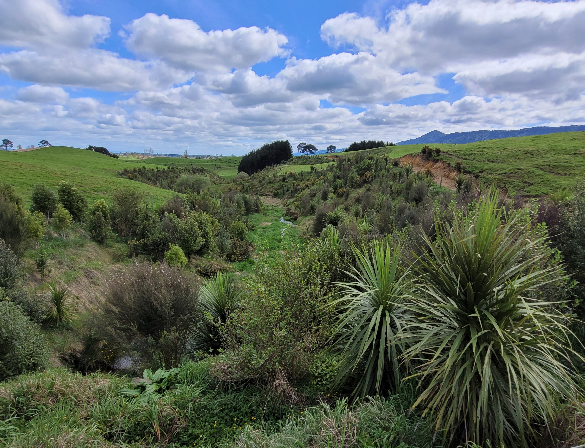
Te Hanga Kawenata
Photo: Ngā Whenua Rāhui
Farming with Native Biodiversity pilot
The Farming with Native Biodiversity pilot project has been developing an approach with industry to enhance, manage and protect native biodiversity on farm. The goal has been to develop training materials and resources and share information from experts that will support farm advisors and farmers with the skills and confidence to bring native biodiversity into on-farm planning. The resources and planning approach aim to encourage farmers to take long-term affirmative action.
This pilot aimed to develop win–win solutions and practical actions, making sustainable practices normal practice and returning the pride to farming through responsible land stewardship. One outcome was that the team worked with 40 farms across Aotearoa New Zealand, and produced 39 farm biodiversity management plans that would potentially see 224 individual biodiversity management projects being carried out including enhancement, management or restoration on:
- 34 wetlands
- 29 forest remnants
- 63 riparian margin restorations
- 460-plus hectares of native plantings
- 580 hectares of marginal land retired into supporting native biodiversity on private land.
Biodiversity credits may provide a potential source of funding to support the implementation of biodiversity management plans on farm.
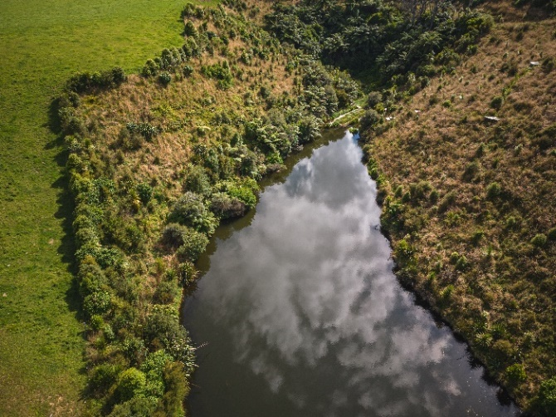
The New Zealand Landcare Trust is leading this project with support from Fonterra Living Water, Silver Fern Farms and the BioHeritage National Science Challenge Ngā Koiora Tuku Iho. The Ministry for Primary Industries Sustainable Food and Fibre Futures fund has provided funding for this project.
Photo: Courtesy of Farming with Native Biodiversity.

A shared global challenge
The world is waking up to the dual challenges of the climate change and biodiversity crises, and the risks they pose for the nations and people of the world.
In June 2023 world leaders Emmanuel Macron (France), Joe Biden (United States), Rishi Sunak (United Kingdom), Mia Mottley (Barbados), Luiz da Silva (Brazil), Ursula von der Leylen (EU Commission), Charles Michel (EU Council), Olaf Scholz (Germany), Fumio Kishida (Japan), William Ruto (Kenya), Macky Sall (Senegal), Cyril Ramaphosa (South Africa) and Mohamed Al Nahyan (United Arab Emirates) released an open letter calling for a green transition that leaves no one behind. The letter noted amongst other things ‘the need for new, innovative, and sustainable sources of finance, such as debt buy-backs, engagement from sectors that prosper thanks to globalisation, and more trusted carbon and biodiversity credit markets.’
New Zealand is party to the Convention on Biological Diversity. This promotes the development of global targets, national strategies and action plans for the conservation and sustainable use of biodiversity.
In December 2022, Convention on Biological Diversity parties agreed to the Kunming-Montreal Global Biodiversity Framework (the Framework), under which they committed to contribute to 4 global goals and 23 global targets to halt and reverse biodiversity loss by 2030. This includes a commitment to scale up positive incentives for the conservation and sustainable use of biodiversity.
Te Mana o te Taiao – Aotearoa New Zealand Biodiversity Strategy forms part of Aotearoa New Zealand’s commitment to help halt global biodiversity loss under the Convention on Biological Diversity. It sets out our approach to the protection, restoration and sustainable use of biodiversity for the next 30 years.
The Aotearoa New Zealand Biodiversity Strategy Implementation Plan calls for the exploration of tools, products, services and financial incentives for positive biodiversity. This could include a BCS.
In response to the climate change crisis, Aotearoa is also party to the Paris Agreement. This notes the importance of ensuring the integrity of all ecosystems and protecting biodiversity when addressing climate change. Aotearoa New Zealand’s first National Adaptation Plan and Emissions Reduction Plan include actions that will help improve the alignment between climate and biodiversity actions.
A BCS could support these endeavours. It would encourage investment using nature-based solutions to reduce emissions, enhance biodiversity and increase Aotearoa New Zealand’s resilience and adaptation to a changing environment.

Te Hoiere/Pelorus Catchment restoration project – using nature-based solutions
Identified as a priority by the Kotahitanga mō te Taiao Alliance, the Te Hoiere project is a partnership for environmental leadership across the Top of the South Island. Its purpose is the restoration of mauri and wairua of the river and estuary from the mountains to the sea.
Participants:
- iwi
- local government
- central government (Department of Conservation priority and Ministry for the Environment at-risk catchment)
- community and land owners
- farming and fishing industry.
Interventions:
- riparian fencing, weed control and native planting using eco-sourced plants
- use of dung beetles on pasture.
Outcomes:
- increased water quality, soil stability and biodiversity
- reduced run-off and increased fertilisation of pastures
- communities enjoy wellbeing of the river
- supports local aquaculture
- supports increased resilience of State Highway H6.

Closing the funding gap
Despite this expertise and the enthusiasm and efforts of landholders, iwi, hapū, and of the wider community, current public and private investment is falling short of what we need to protect nature.
Many ‘at-risk’ species and habitats are found outside the 30 per cent New Zealand managed by the Department of Conservation. Instead, they are present on private land.
Many farmers, foresters, other landholders, iwi, hapu, environmental and community groups are investing substantial amounts and forgoing significant development opportunities to protect and manage indigenous species and habitats on private and Crown lease land. This is happening either independently or in partnership with: QEII National Trust, Ngā Whenua Rāhui, Department of Conservation and other groups and councils. This work is appreciated by the wider community and often has additional benefits. However, actively managing and protecting indigenous biodiversity can also be costly, and can limit other uses for that land.
Landholders need more encouragement and financial support to build on these efforts to protect, maintain, restore and enhance the biodiversity on their land, and to share the cost of action.
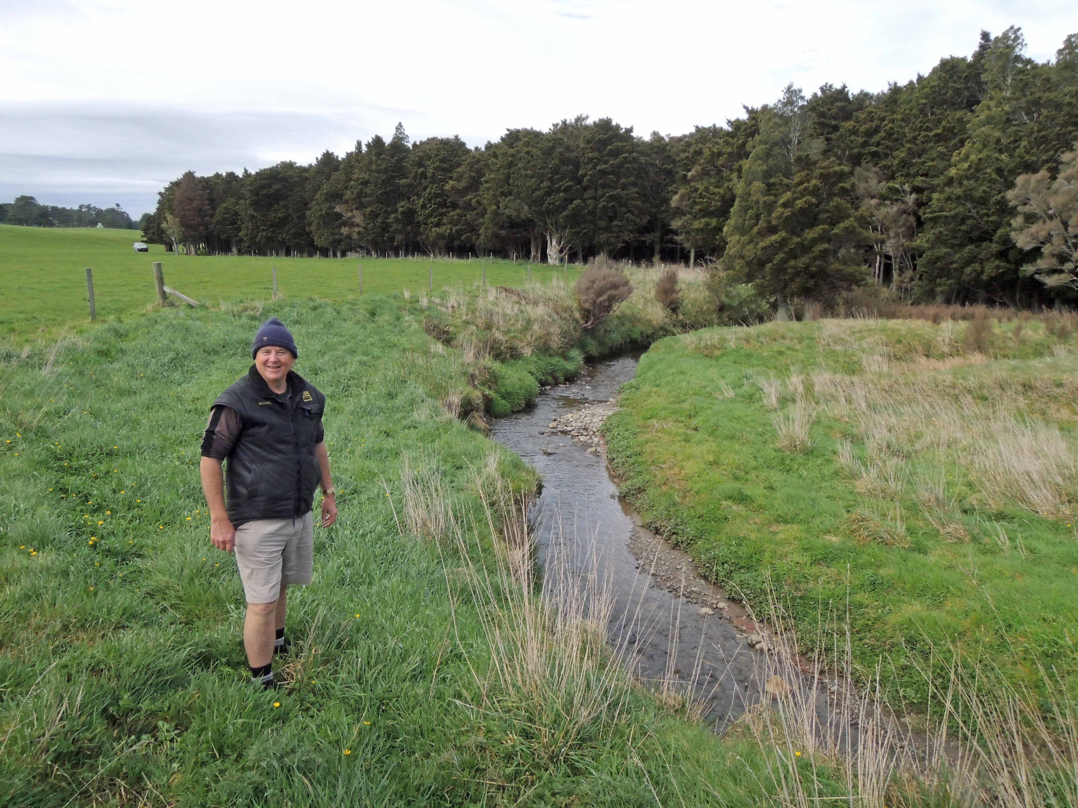
QEII covenantor Michael Kelly stands next to ‘Kelly’s Black Creek Bush’, a 4.3-hectare remnant bush block in Rua Roa, 20 kilometres west of Dannevirke, that he protected with a QEII Open Space Covenant in 2019.
Photo: QEII National Trust
The funding gap
In 2021 the Department of Conservation (DOC) estimated that 547 land-based and wetland species had conservation management plans in place, and that to fully fund them would cost up to an average of $95 million a year.
Extrapolating that for all species needing help, it was estimated to cost around $696 million per year. At the time, DOC spent $36 million per year on managing threatened, at-risk and conservation-dependent species. These figures are estimates and do not factor in the costs to landholders and the wider community of private efforts to protect nature, nor do they include the costs of the wider biodiversity work by DOC including for marine species.
Internationally, an estimated $722 billion to $967 billion is needed annually to halt global biodiversity loss. Work is being done to address the biodiversity crisis, but a global shortfall in funding is estimated of between US$598 billion and US$824 billion annually.
Biodiversity credit systems are a way to bridge this gap and finance actions that conserve and restore nature.

Growing interest in investing in nature
With increasing awareness of the biodiversity and climate challenges and their environmental, economic and social implications, philanthropists, businesses, investors and the wider community here and overseas are looking at new ways to invest in nature that have both integrity and impact.

Philanthropists and community groups
Aotearoa New Zealand’s environment and conservation philanthropic sector receives a small fraction of overall charitable income: just over 1.5 per cent ($368 million of a total of $24 billion in 2021). Although this is a small part of overall donations, giving to the environment is among the country’s fastest growing sectors. Between 2017 and 2020 it grew by 48 per cent.

Corporate and business interests
Predicting demand is challenging, even for established markets, but several signs can be seen that demand will increase over coming years.
Aotearoa New Zealand’s corporate and business giving is about $84 million, 0.1 per cent or $77.4 billion in pre-tax profits in 2019/20, against the global goal of 1 per cent. Businesses in the United States of America, for example, are giving just under 1 per cent of pre-tax profits for community causes including conservation. However, investment in environmental causes is trending upwards.
Investment into biodiversity outcomes is already occurring through the Voluntary Carbon Market (VCM) and New Zealand Emissions Trading Scheme (NZ ETS), where several credits include biodiversity co-benefits (typically linked with native forestry) and other impact-investing platforms.
Surveys of businesses indicate that businesses expect this investment will increase over time.
- A 2022 Sustainable Business Network survey of mainly smaller enterprises (less than 50 employees) found that about a fifth were considering increasing financial support for environmental causes.
- A follow-up Sustainable Business Network–Ministry for the Environment survey, which received 105 responses, found 14 per cent of respondents indicated their business is investing in a carbon credit with a biodiversity or native component. Additionally, over 20 per cent of respondents indicated they were investing in a combination of biodiversity projects and carbon-only credits. Most expected their nature-related investment to increase in the next five years, mostly in biodiversity-related projects.
- Qualitative research undertaken by PricewaterhouseCoopers for the Ministry for the Environment in 2023 involving corporates, financial institutions and project developers indicates there is either demand or interest in investments in biodiversity (either as co-benefits or separate projects) but that this interest would be contingent on the approach taken for a BCS.
- Investment into biodiversity outcomes is already occurring through the VCM where several credits include biodiversity co-benefits (typically linked with native forestry) and other impact-investing platforms. Three-quarters of interviewees indicated they were willing to pay a higher price for carbon credits with co-benefits. Biodiversity co-benefits (60 per cent) were ranked as the most desirable co-benefit of a VCM credit. Of survey respondents, 71 per cent stated that they anticipate demand for biodiversity-related projects will increase in the future, while 67 per cent stated that they expect their organisation’s investment in biodiversity-related projects will expand in the future.
These surveys indicate that business motivations for financially supporting nature vary:
- regulatory compliance, for instance, to offset emissions, or comply with legislated financial disclosure obligations
- industry standards and strategies, for instance, the International Air Transport Association requires airlines to offset carbon emissions
- stakeholder and employee expectations, voluntary or industry corporate social responsibility standards, such as environmental, social and governance reporting
- voluntary support for reputation and brand enhancement, market positioning or market access reasons
- as an investment opportunity where the investor might purchase the right to make a nature-positive claim but then looks to on-sell that claim for a profit instead of using it.
Many industries are now recognising their impact on nature. For instance, the second phase of the Tourism Industry Transformation Plan, created in partnership by representatives from the tourism industry, unions, government, workers and Māori, includes, as one of its goals, for tourism operators to understand their own impact on biodiversity, act to minimise that impact, and contribute more broadly.
This is in keeping with international developments. Increasingly, European listed companies are acknowledging biodiversity challenges in company reports (increasing from 74 per cent to 85 per cent between 2018 and 2021) and are including indicators as part of circular economy reporting (increasing from 22 per cent to 30 per cent between 2018 and 2021).
Such expectations will become business as usual over time, particularly with the emerging Taskforce on Nature-related Financial Disclosures framework. This enables corporates and large business to report and act on nature-related risks and opportunities. It follows Taskforce on Climate-Related Financial Disclosures, which is now a regulatory requirement in New Zealand for some large financial market participants.,
Over time, these trends are likely to encourage greater investment in biodiversity and climate change projects by corporates and businesses to demonstrate they are nature positive.
Many of Aotearoa New Zealand’s corporates operate on both sides of the Tasman. The development of a nature repair market in Australia (section 1), and growing corporate awareness internationally of the biodiversity crisis, may generate trans-Tasman interest in an Aotearoa biodiversity credit market.
However, the business surveys suggest that a biodiversity credit market would need to have integrity to be attractive to investment and reach scale. Sustainable Business Network–Ministry for the Environment survey respondents indicated the following would support confidence in nature-based markets: standards such as for
- measurement, monitoring and reporting (62 per cent of respondents)
- information tools (52 per cent)
- having regulatory oversight (eg, by government) (42 per cent).

Clear biodiversity outcomes
When considering new tools, such as a BCS, we must have a clear understanding of the outcomes we want to achieve and how to achieve them. Such tools need to work for Aotearoa and our unique circumstances.

Outcomes to aim for
We think an ideal BCS in Aotearoa needs to:
- work for the environment by:
- attracting investment to close the biodiversity funding gap
- having the impact to protect, maintain and restore biodiversity, resulting in nature-positive outcomes.
- Work for all people by:
- honouring and giving effect to te Tiriti o Waitangi
- recognising the work landholders do for biodiversity, including on whenua Māori
- giving investors, businesses and communities a trustworthy way to invest in biodiversity protection and restoration.
- Work as part of a wider system by:
- complementing and contributing to the wider system of tools, policies and programmes to address the biodiversity and climate crisis (which the Government, iwi and hapū, communities, businesses and others contribute to) (see section 4).
Figure 4: Principles of a biodiversity credit system
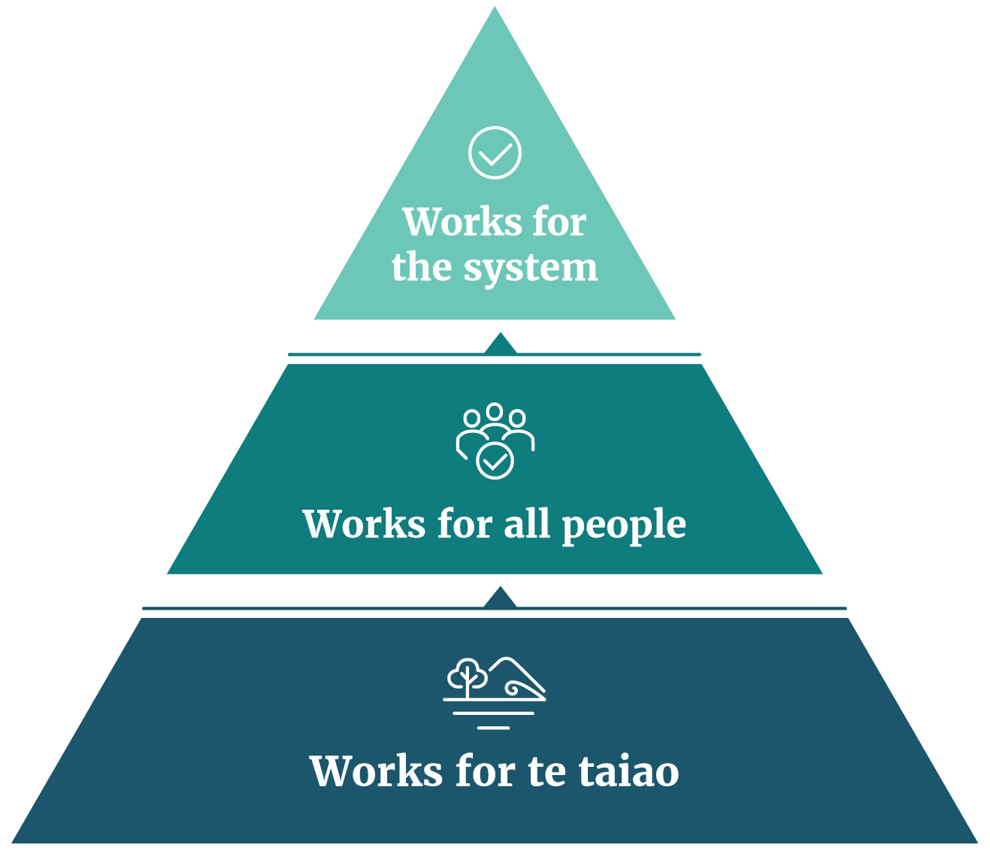

Outcomes to avoid
Private sector credit systems are emerging in Aotearoa and overseas with or without government help (section 2 – International approaches). Left to their own devices, the risk is that poorly designed systems might:
- fail to stop, or even enable, biodiversity loss (eg, by failing to support lasting, nature-positive impacts)
- lack transparency and integrity, or encourage ‘greenwashing’
- fail to attract investment and stifle innovation
- fail to support investment in high-impact action, including action that addresses the most urgent biodiversity needs
- fail to give effect to te Tiriti, or adequately provide for the rights and interests of iwi and hapū under te Tiriti or as part of Treaty settlements
- discourage productive land uses that also improve biodiversity outcomes
- create mismatch or conflict with other government and community programmes and policies
- lack mechanisms to police and remedy abuse, such as fraud (domestic or international).
Another undesirable outcome would be overwhelming potential investors with too many different BCSs, each with different standards and meanings.
To make decisions, investors need assurance this will not happen. This is why certain markets and economic instruments are often regulated to require upfront and ongoing disclosures.
As well as addressing the biodiversity crisis, opportunities exist to align or blend a BCS with other environmental tools to provide co-benefits (eg, food and erosion risk reduction, improving water quality, climate change mitigation and adaptation and resource management reform). See section 4.

Questions
9 | Do you think a biodiversity credit system will attract investment to support indigenous biodiversity in New Zealand?  Please give your reasons.
10 | What do you consider the most important outcomes a New Zealand biodiversity credit system should aim for?
11 | What are the main activities or outcomes that a biodiversity credit system for New Zealand should support?

3. How should we design and implement a biodiversity credit system?
This section discusses:
- principles that could apply to the design of a government-supported BCS
- components of a fully functioning system, including measurement, verification and reporting, legal recognition, approaches to trading credits, and the role of experts
- the potential role of government.

Principles of design and implementation
People need to know what they can expect when they participate in a BCS and what is expected of them. Clear principles are critical to this.
Chosen principles should work to make the system deliver the outcomes we want, and none we want to avoid.
The principles may be operational, ecological, social or financial. Some might have sub-principles. For example, the principle of integrity could include a sub-principle that requires activities beyond business as usual, to earn credit for demonstrating additionality (extra biodiversity benefits).
To uphold government obligations under te Tiriti o Waitangi, a BCS will need to be guided by the following principles:
- supports te ao Māori and mātauranga Māori
- gives effect to te Tiriti o Waitangi principles.

Example principles
Many different principles could lay the foundation of a credible, high-integrity BCS in Aotearoa New Zealand. Table 4 lists principles that could be relevant to the outcomes the Government is seeking.
Table 2: Potential underlying principles for a biodiversity credit system
Potential principle
Permanent (over 100 years) or long-term (25-year) positive impact
Transparent, verifiable claims
Robust, with measures to prevent abuse of the system and to address reversals in outcomes
Reward nature-positive activities additional to business as usual
Complement domestic and international actions for biodiversity
Clear rules for the claims investors can make for their impact, with ways to prevent ‘greenwashing’
Maximise positive impact on biodiversity (including uplifting mauri and mana of biodiversity)
Decisions need to be made on the principles to pursue. Choosing a long list or focusing on certain principles is likely to result in a large and complicated system. For example, a system that focuses on verification and additionality and permanence will likely be more costly and might take longer to yield benefits. A system that achieves long-term impacts would need a mechanism to monitor, report, and address changes of ownership.
Choosing only a few principles might result in a smaller, more targeted system, but may affect the confidence of stakeholders to invest.
Input from the public on which principles are most important will help shape the Government’s next steps in developing a system.

System components
An effective BCS is made from multiple components (figure 5).
Figure 5: Components of a biodiversity credit system
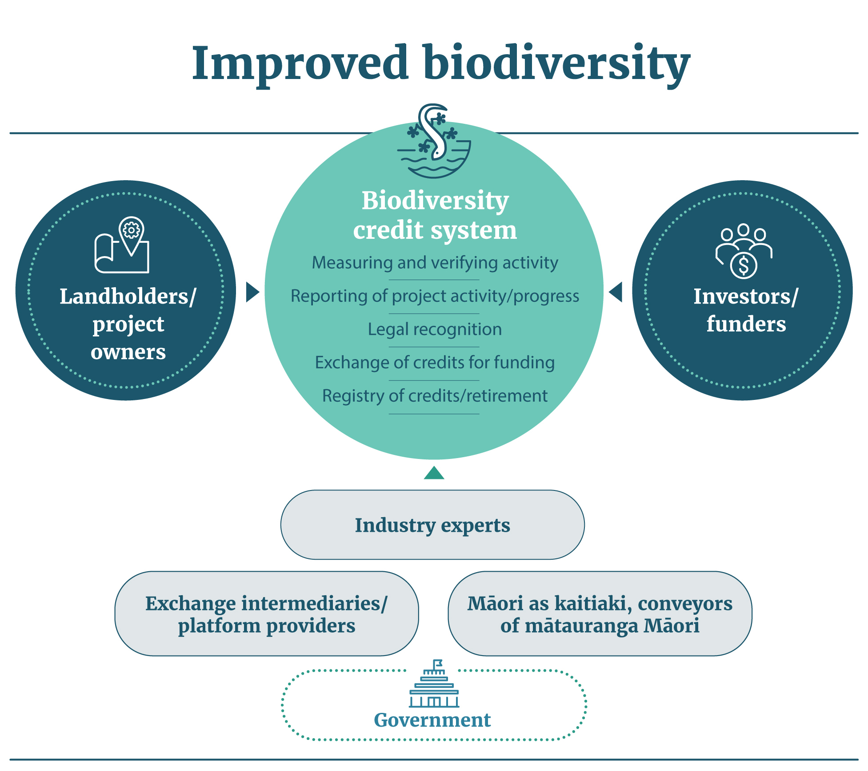

Measurement, verification and reporting
If biodiversity credits are to have integrity and credibility, they must demonstrate their impact through robust and cost-effective approaches to measurement, verification and reporting (MVR). Differences in approach will dictate what will be measured. Many MVR standards have been developed by independent international practitioners (eg, VERRA, Eco-Markets Australia, Accounting for Nature, Plan Vivo Foundation). Some have built off approaches to measure carbon removals from the atmosphere.
International organisations (eg, the Taskforce on Nature Markets, World Economic Forum – Financing for Nature Global Initiative, the International Union for the Conservation of Nature – Global Standard for Nature-based Solutions) as well as governments (eg, Australia) are working to develop a best practice for MVR. Most of these approaches have a strong focus on outcomes.
Many overseas BCSs measure outcomes with a ‘basket-of-metrics’ approach. This means measuring multiple indicators over time (eg, species diversity and numbers, fragmentation of habitats). It provides a more holistic and robust assessment of the state of biodiversity and the impact of activities and projects.
This requires an in-depth knowledge of the local ecosystem, which reinforces the need to work closely with Māori, landholders and local communities.
Such approaches can be expensive and time consuming. They must be flexible enough to take advantage of innovations and new technologies as they become available, as well as emerging practices focusing on ecosystem integrity.
It will also be important to consider project scale and the level of verification and auditing needed at different scales (with smaller scale projects having less rigorous monitoring requirements to reflect lower levels of financial risk.)
Innovative tools exist, or are being developed, to make the systems more feasible by reducing the cost of MVR.
Independence and accountability will also be important for MVR to have integrity, with differing levels of government involvement.
Emerging innovations to support measurement, verification and reporting
Remote sensing techniques (eg, satellite, aerial and drone mapping technology, bioacoustics), artificial intelligence and modelling that supports expert judgement (including mātauranga Māori) could make measurement, verification and reporting more cost effective.
Another example is using environmental DNA techniques to determine the presence and diversity of species by testing soil, water or air samples in project areas for traces of species DNA. Other tools, such as distributed ledger technology or blockchain technology, can make registering biodiversity credits more cost effective and transparent.

Legal recognition
Without specific regulations, the sale and purchase of emerging biodiversity credits would be covered by contract (and common) law and consumer law.
It may be difficult to cover all circumstances and eventualities using contracts, potentially resulting in possible legal ambiguity and a risk of gaming. Disputes could be expensive to resolve relying on court processes.
Contracts may not be an ideal way to ensure transparent and ongoing disclosures. Regulation can often provide a higher level of disclosure and scrutiny tailored to the system.
To attract investment, it may be desirable to have some form of legal recognition of nature-positive claims. This may require regulation, to ensure proper disclosure and transparency of information about who can make claims and on what basis. Sellers of credits will also need to demonstrate that they have the legal right to carry out biodiversity activities in the area (eg, permission of land owners or beneficial owners, and resource consents if needed).
For example, in the case of natural features granted legal personhood (eg, Te Urewera Forest, Whanganui River), where a custodian board has been appointed, a biodiversity credit project carried out on this land would require consent on behalf of the natural feature.
Transparency of data access and information sharing will be expected under a BCS, while enabling protection of privacy, indigenous knowledge and commercial-in-confidence information.
Another consideration for an Aotearoa BCS is the rights and interests of Māori, as kaitiaki of taonga species. A BCS will need to reflect the recommendations of the Waitangi Tribunal for Te Tumu mō Te Pae Tawhiti Wai 262 claim, and the Government response.
What is the Wai 262 claim?
Wai 262 was lodged on 9 October 1991. It concerns who controls Māori traditional knowledge, artistic and cultural works, and the environment that created Māori culture.
It also concerns the place in contemporary Aotearoa New Zealand life of core Māori cultural values. These include the obligation of iwi and hapū to act as kaitiaki (cultural guardians) towards taonga (treasured things), for example, traditional knowledge, important places, and flora and fauna that are significant to iwi or hapū identity.
The Waitangi Tribunal report on Wai 262, Ko Aotearoa Tēnei (2011) made several recommendations, including:
- new partnership models for conservation
- expanded roles for Māori advisory bodies
- amendments to laws relating to environmental protection
- amendments to laws covering resource management wildlife, conservation, environmental protection, patents and plant varieties, and more.

Approaches to trading credits
The central function of a biodiversity credit market is to facilitate the buying and selling of credits.
For this to occur smoothly and with integrity, prospective buyers need to:
- be aware of available biodiversity credit investment opportunities
- be well informed about, and compare, different biodiversity credit offers according to their investment objectives
- have confidence in the information provided.
Information will also be important to avoid scenarios such as double-selling and claiming of credits where more than one purchaser claims the same outcome.
Ideally, a market would also offer a range of projects for different investment preferences. This requires that exchange requirements should not be overly burdensome for credit sellers. Different options are available for how credits produced by project or landholders could be issued for sale to prospective buyers with various levels of government involvement:
- they could be directly sold by project managers or land owners, once their efforts or biodiversity outcomes have been independently measured and verified; or
- an overview body could issue credits for measured and verified projects or activities, and traded via a centralised platform (similar to the NZ ETS); and/or
- third-party or independent brokers could be involved in the sale of credits, for example, through an online digital platform.
Establishing a registry of biodiversity credits and verified biodiversity-related activities would:
- allow tracking of credits and outcomes (eg, with a unique identifier for each credit and activity)
- facilitate the issuing of verified credits after registration
- facilitate the trading and retirement or cancellation of credit claims
- avoid double-counting of credit claims (transaction registry).
Registry accounting would take place alongside a data management system that recorded information about credits and activities. This would not necessarily be stored in a transaction registry but would be required for transparency.

Role of experts
Landholders must be helped by people with the right knowledge and skills to support nature. A BCS must recognise and provide for this. The Outrage to Optimism ministerial inquiry into land uses in Tairawhiti and Wairoa acknowledges that, to improve environmental resilience, it is critical to build a “skilled and experienced labour force, environmental management and governance capability needed to tackle the task of transforming our most vulnerable land to forest”.
A scheme such as Mahi mō te Taiao – Jobs for Nature that creates nature-based projects, could support a BCS. It could, for instance, support environmental services such as weed and pest management, and freshwater and environmental restoration.
Likewise, expertise will be required to support functions such as MVR, and expertise in mātauranga Māori about taonga species at the appropriate whānau, hapū and iwi scales.
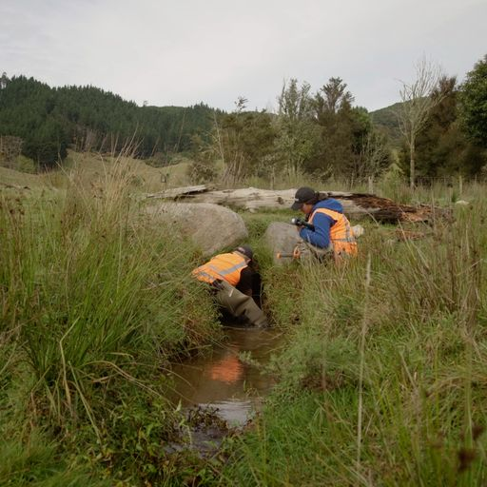
Mahi mō te Taiao | Jobs for Nature
The Jobs for Nature programme is part of the Government’s response to New Zealand’s economic recovery from the impact of COVID-19 by delivering nature-based employment. The programme funds nature-based work activities spread across Aotearoa New Zealand, including vegetation planting for freshwater and biodiversity restoration, fencing waterways, pest control (including wilding pines and other pest plants), fish passage remediation, building capability and capacity in freshwater management, and skills training to support career development. The programme is due to end in June 2025, when most projects conclude.
Photo: Ministry for the Environment.
Certain functions may require accountability, to ensure the integrity of the system. Options could be to use existing systems and processes or for additional government involvement, such as through occupational licensing.
Several organisations could also provide important expertise. For example, the following organisations could provide enhanced legal protection and monitoring for projects that are generating biodiversity credits.
- The QEII National Trust and Banks Peninsula Conservation Trust support land owners to protect biodiversity on their land through permanent covenants and by contributing to fencing, monitoring and advising on management of covenanted land.
- The Ngā Whenua Rāhui Fund supports the protection of indigenous biodiversity on Māori-owned land using kawenata (covenants) while enabling whānau, hapū and iwi to apply local mātauranga Māori in accordance with their tikanga.
Other organisations that could provide expertise to land owners for biodiversity credit projects include:
- regional and district councils
- Predator Free NZ
- Project Crimson Trust – Trees that Count
- Tāne’s Tree Trust
- NZ Landcare Trust – Farming with Native Biodiversity
- Reconnecting Northland
- iwi trusts and incorporations
- primary sector industry sustainability advisors.

Potential government roles
Section 2 outlined the outcomes we want to aim for and those to avoid. For a market to be trusted, and to grow and operate effectively, the participants need assurance about the integrity and impact of the system.
Sophus zu Ermgassen – an ecological economist at Oxford University noted in a recent interview that:
“the ecological success of voluntary biodiversity credit market will be almost entirely determined by the quality of the governance mechanisms and the measurement methods used.”
“We need an ecosystem of innovation with really good environmental and social science, underpinned by strong oversight to ensure credits are really delivering what they say they are, that also works for the local communities where the projects are taking place.”
The two broad roles the Government could play to support a biodiversity credit system are:
- market enablement: where it provides policies and guidance for the development and uptake of voluntary schemes in New Zealand, and potentially funding for system development as the market is established
- market administration: where it establishes and manages a voluntary biodiversity scheme and is active in the ongoing management and administration.
An enablement role seeks to influence the outcomes and operation of the market, using non-regulatory tools such as good practice guidance, optional standards (when compliant, accreditation issued) and direct investment in market systems and methods, and in the market itself.
A market administration role includes setting a regulatory framework, with tools to direct the outcomes and the operation of the market. Examples include determining standard methodologies for projects, entry and exit control measures, and establishing a regulatory body empowered to issue biodiversity credits, monitor, verify and enforce compliance and oversee the operation of the system.
A blend of these options may be appropriate, which could evolve over time. If regulations were in place, information and education would support compliance. Another consideration would be how to enforce any regulations.
Deciding on the best approach will be informed by the guiding principles for a BCS and a clear understanding of the risks. Any measures would need to allow the market to evolve towards promoting the best possible biodiversity outcomes and to enhance the credibility of the market.
Regulatory choices may also be informed by international frameworks, such as the Taskforce on Nature Based Financial Disclosures, the Australian Nature Repair legislation, Biodiversity Credit Alliance and other biodiversity credit market developers. This will be particularly important if credits are to be traded internationally or purchased by transnational corporates that may attribute integrity to consistency with other schemes they deal with. This could be relevant in the trans-Tasman context.
To justify a regulatory system it would need to deliver, over time, a stream of benefits or positive outcomes in excess of negative outcomes.
Another issue is how to distribute the costs and benefits of regulation and non-regulation.

Table 3: Possible roles of government
Component | Possible roles of central and local government
 | Market enablement | Market administration
Domains and aims | Provide guidance | Circumscribe domains and aims in line with proscribed methods and standards (see below)
Methodologies and  standards | Fund market to collectively develop and adapt open-source methodologies  This includes encouraging industry to involve Māori and mātauranga | Fund the development of methodologies  Approve methodologies for particular contexts  This would require involvement of Māori and mātauranga
Verification and certification | Third parties accredited to measure, verify and certify claims  This includes encouraging industry to involve Māori in identifying taonga interests in projects, and involve Māori in projects with significant taonga interests | Regulator performs verification and certification  This could require involvement of Māori in identifying taonga interests in projects, and an ongoing role in projects with significant taonga interests
Legal rights | Develop non-regulatory tools that help provide certainty of legal rights and remedies for market participants | Registry infrastructure (eg, expansion of Environment Protection Agency-administered registry)  Regulate for iwi to receive recompense from projects  Government develops regulatory tools to provide certainty of legal rights and remedies for market participants
Disclosure and reporting | Develop template reporting frameworks | Regulate disclosure and reporting
Claims and retirement | Provide clear guidance on: claims, using credits for RMA offsets, ‘retiring’ credits | Require public disclosure of claims, retirements  Certify claims
Data | Continue to invest in national data sets, making them freely available | Regulate credit projects to provide data for national data sets
Government as an investor | Potential co-investor in development of standards and methodologies for biodiversity credit system  Possible role as investor in biodiversity credit projects or pilots to give confidence to the market, or to endorse certain approaches | Investor in development of standards and methodologies for biodiversity credit system  Possible role as investor in biodiversity credit projects or pilots to give confidence to the market, or to endorse certain approaches

Questions
12 | Of the following principles, which do you consider should be the top four to underpin a New Zealand biodiversity credit system?  Principle 1 – Permanent or long-term (eg, 25-year) impact  Principle 2 – Transparent and verifiable claims  Principle 3 – Robust, with measures to prevent abuse of the system  Principle 4 – Reward nature-positive additional activities  Principle 5 – Complement domestic and international action  Principle 6 – No double-counting, and clear rules about the claims that investors can make  Principle 7 – Maximise positive impact on biodiversity
13 | Have we missed any other important principles? Please list and provide your reasons.
14 | What assurance would you need to participate in a market, either as a landholder looking after biodiversity or as a potential purchaser of a biodiversity credit?
15 | What do you see as the benefits and risks for a biodiversity credit market not being regulated at all?
16 | A biodiversity credit system has six necessary components (see figure 5). These are: project provision, quantification of activities or outcomes, monitoring measurement and reporting, verification of claims, operation of the market and registry, investing in credits.  To have the most impact in attracting people to the market, which component(s) should the Government be involved in? Please give your reasons.
17 | In which areas of a biodiversity credit system would government involvement be most likely to stifle a market?
18 | Should the Government play a role in focusing market investment towards particular activities and outcomes and if so why? For example, highlighting geographic areas, ecosystems, species most at threat and in need of protection, significant natural areas, certain categories of land.
19 | On a scale of 1, not relevant, to 5, being critical, should a New Zealand biodiversity credit system seek to align with international systems and frameworks? Please give your reasons.
20 | Should the Government work with private sector providers to pilot biodiversity credit system(s) in different regions, to test the concept?  If you support this work, which regions and providers do you suggest?

4. How a biodiversity credit system could complement the wider system
This section discusses how a biodiversity credit system could work with other programmes and policies, to support the environment and address the climate crisis.

Links between policies that address the climate and biodiversity crises
The climate and biodiversity crises are inextricably linked. Tensions can exist between the policies that address these challenges. Aligning work on climate change, biodiversity and the environment is critical to support positive environmental outcomes for the long term.
A BCS has the potential to complement freshwater reform, other climate change programmes and tools, current resource management reform and national direction including the National Policy Statement for Indigenous Biodiversity. It would encourage nature-based solutions to maintain and enhance indigenous biodiversity.

New Zealand Emissions Trading Scheme (NZ ETS) and
voluntary carbon market (VCM)
A carbon credit represents 1 tonne of carbon dioxide equivalent greenhouse gas emitted. Aotearoa has a regulated compliance market, that is, the government-administered NZ ETS, and also a VCM, where government currently has a limited role.
A review of the NZ ETS is underway. Matters under consideration include:
- the level of emission removals from exotic and indigenous forests
- redesign of the permanent forest category
- how to improve NZ ETS incentives for indigenous afforestation
- how to include additional sources of emission removals in the NZ ETS
- the extent to which the design of the NZ ETS should support emission reductions or a range of co-benefits.
An NZ ETS that provides stronger incentives for indigenous biodiversity by, for example, preferentially recognising native ecosystems, including planting or assisted reversion of indigenous vegetation, could support positive outcomes for biodiversity. The Climate change Commission’s draft advice on the Government’s emission reduction plan notes that, without incentives, native afforestation will be slow and small scale.
Aotearoa New Zealand’s current VCM is largely under-developed and unregulated. Many participants see an opportunity to increase its size and scale.
Some carbon credits, particularly in the VCM, can have biodiversity co-benefits and can be priced at a premium, whether the co-benefits are quantified or not.
Some international voluntary carbon credit certification frameworks recognise biodiversity co-benefits. These include Verra (the Climate, Community and Biodiversity Standards) and Plan Vivo (Plan Vivo Biodiversity+, still under development).
Carbon credits with an ‘attached’ biodiversity co-benefit are one way to encourage positive outcomes for climate change and biodiversity. This assumes buyers will pay a premium for carbon credits with biodiversity benefits, such as reforestation using indigenous tree species, and that biodiversity benefits will be provided.

Biodiversity credit system approach
BCSs focus on more accurately reflecting what biodiversity gains from activities. This could allow carbon credit systems to focus on removing carbon. Also, if the incentives for gross versus net emission reductions change, an independent BCS would help ensure enduring incentives for indigenous biodiversity.
Stand-alone biodiversity credits could be ‘stacked’ with a carbon credit or ‘stapled’ to a carbon credit. A stacked credit is where a carbon and biodiversity credit is issued for the same project. The Australian NaturePlus™ credit is an example. The independent stacked credits can be purchased by separate buyers or by buyers who want both carbon and biodiversity outcomes.
A stapled credit represents a carbon and biodiversity credit issued from separate projects but traded together as a whole product. The EcoAustralia credit is an example. The purchaser can claim a positive impact for both carbon and biodiversity.
Stacking and stapling different types of credits is generally done by private market intermediaries.

Carbon Neutral Government Programme
The Carbon Neutral Government Programme requires certain government agencies to be carbon neutral by 2025, including to offset any hard-to-abate emissions. The Programme may contribute to New Zealand’s Nationally Determined Contribution under the Paris Agreement.
A biodiversity credit system could facilitate investment in ecosystem restoration, which could also contribute carbon sequestration that could be counted towards New Zealand’s Nationally Determined Contribution. Further analysis would be needed, to ensure that claims over any gains made under a credit system would be of the highest integrity.

Resource management reform and national direction
The Government is reforming the resource management system to transform the way the environment is managed in Aotearoa by enacting new legislation, including the Natural and Built Environment Act.
Objectives of the proposed system include protecting and restoring the environment and its capacity to provide for the wellbeing of present and future generations, and to give effect to the principles of te Tiriti.
Integral to the purpose of the Act is Te Oranga o te Taiao, a concept drawn from te ao Māori. It is an intergenerational ethic that emphasises the importance of the health and wellbeing of te taiao for current and future generations. One outcome in the Bill is the protection and, if degraded, restoration of the ecological integrity of indigenous biodiversity. We expect work to set limits and targets to occur between early 2024 and 2026.
The Government has also introduced national direction: National Policy Statement for Indigenous Biodiversity 2023 and National Policy Statement for Freshwater Management 2020. Both support biodiversity and freshwater outcomes under the Resource Management Act 1991. These national policy statements will be transitioned and incorporated into the National Planning Framework, which will replace Resource Management Act 1991 national direction.
A credit scheme could complement the objectives of these reforms, and the implementation of national direction and the National Planning Framework, specifically for areas of significant biodiversity and significant natural areas on land and in freshwater habitats.

Encouraging land uses that support biodiversity
The Ministerial Inquiry into Land Uses in Tairawhiti and Wairoa recently published its findings, Outrage to Optimism The inquiry identified the potential for a BCS to support the return of erosion-prone land to permanent native forest.
The report emphasised (page 18) the need for catchment-based planning, “incorporating mosaics of activities that reflect the specific characteristics of the catchment”. Such regional transformation is hampered by the current resource management system, which is not fit for purpose. Access to capital, particularly on whenua Māori, is also a barrier.
The report recommended setting up a world-leading BCS, to incentivise permanent indigenous forests, to be piloted in the Tairawhiti–Wairoa region.
The recommendations are designed to lead to a vision of “flourishing biodiversity; healthy catchments, waterways, and coastlines; and resilient infrastructure and diversified economy” (page 38).
A BCS could be a source of finance, to make it feasible to invest in land-use changes (with core biodiversity benefits).
A BCS could be particularly beneficial for protecting and enhancing biodiversity on whenua Māori if that is the preference of the land holder. Many of the remaining at-risk species and habitats outside public conservation lands are on this land. An important benefit of credits would be as a mechanism for Māori to raise finance without the need to provide security against land. This has been one of the traditional challenges for developing whenua Māori.
In keeping with the Waitangi Tribunal’s findings in the Wai 1200 report, it will be important to consider how any government policies can best ensure that Māori realise the economic potential from whenua Māori.
Credits would not necessarily require any particular connection to land title. They could be project focused (credits in overseas schemes can also be attached to a public space, such as the Great Barrier Reef in the Australian scheme).
For instance, biodiversity credit projects could support catchment-scale land-use changes across multiple holdings. Credits could support groups of land owners with restoration of indigenous biodiversity in urban or rural settings. Credits could be applied to projects initiated by landholders on Crown land, such as pastoral leasehold land or on land administered by the Department of Conservation or other Crown agencies.

Sharing methodologies to support
land-use change

Under the current resource management system
The National Policy Statement for Indigenous Biodiversity includes four criteria for a Significant Natural Area (SNA), each with several attributes. The issuance of a biodiversity credit could be linked directly with SNAs, using these criteria. If credits were directly linked with SNAs, we would need to analyse the importance of management (eg, voluntary fencing, invasive weed and pest control) in issuing credits. Another consideration is how to encourage the prioritisation of SNA activities as part of a credit system.
The Department of Conservation’s natural heritage management includes tools to identify conservation priorities and monitor the impacts of its natural heritage work. The Department also uses an outcome monitoring framework to inform policy and management. Methodologies behind these systems could be useful for validating BCS claims alongside mātauranga indicators.
Questions
21 | What is your preference for how a biodiversity credit system should work alongside the New Zealand Emissions Trading Scheme or voluntary carbon markets?  - Little/no interaction: biodiversity credit system focuses purely on biodiversity, and carbon storage benefits are a bonus.  - Some interaction: biodiversity credits should be recognised alongside carbon benefits on the same land, via both systems, where appropriate.  - High interaction: rigid biodiversity ‘standards’ are set for nature-generated carbon credits and built into carbon markets, so that investors can have confidence in ‘biodiversity positive’ carbon credits.  Please answer (a) or (b) or (c) and give your reasons.
22 | Should a biodiversity credit system complement the resource management system? (Yes/No)  For example, it could prioritise:  - Significant Natural Areas and their connectivity identified through resource management processes  - endangered and at-risk taonga species identified through resource management processes.
23 | Should a biodiversity credit system support land-use reform? (Yes/No)  (For example, supporting the return of erosion-prone land to permanent native forest, or nature-based solutions for resilient land use.)

5. Next steps

Help shape the development of a biodiversity credit system

How to make a submission
Submissions close at 11:59pm on Friday 3 November 2023.
The Government welcomes your feedback on this discussion document. The questions posed throughout this document are summarised in the next section. They are a guide only and all comments are welcome. You do not have to answer all of the questions.
To ensure your point of view is clearly understood, you should explain your rationale and provide supporting evidence, where appropriate.
To help shape the future design of a BCS, you can provide a submission through Citizen Space, our consultation hub, by either following the feedback form or by uploading your own written submission.
We would prefer that you don’t email or post your submission to us because this makes our analysis more difficult. However, if you need to, mail your written submission to Water and Land Use Policy, Ministry for the Environment, PO Box 10362, Wellington 6143.
Please include in your submission:
- your name or name of the organisation you represent
- postal address
- telephone number
- email address.
If you are emailing your submission, send it to biocredits@mfe.govt.nz as a:
- PDF
- Microsoft Word document (2003 or later version).

Publishing, releasing and analysing submissions
All or part of any written comments (including names of submitters), may be published on the Ministry for the Environment’s website, environment.govt.nz. Unless you clearly specify otherwise in your submission, the Ministry will consider that you have consented to online posting of both your submission and your name.
Contents of submissions may be released to the public under the Official Information Act 1982 following requests to the Ministry for the Environment (including via email). Please advise if you have any objection to the release of any information contained in a submission and, in particular, which part(s) you consider should be withheld, together with the reason(s) for withholding the information. We will take into account all such objections when responding to requests for copies of, and information on, submissions to this document under the Official Information Act.
The Privacy Act 2020 applies certain principles about the collection, use and disclosure of information about individuals by various agencies, including by the Ministry for the Environment. It governs access by individuals to information about themselves held by agencies. Any personal information you supply to the Ministry in the course of making a submission will be used by the Ministry only in relation to the matters covered by this document. Please clearly indicate in your submission if you do not wish your name to be included in any summary of submissions that the Ministry may publish.
If you have any questions or want more information about the proposed changes or the submission process, please email biocredits@mfe.govt.nz.

What happens next

Proposed biodiversity credits system
The Government will consider the submissions, to help with design choices and the preferred role of government in a biodiversity credit system, along with working with key stakeholders.

Consultation questions
Questions
1 | Do you support the need for a biodiversity credit system (BCS) for New Zealand?  Please give your reasons.
2 | Below are two options for using biodiversity credits. Which do you agree with?  (a) Credits should only be used to recognise positive actions to support biodiversity.  (b) Credits should be used to recognise positive action to support biodiversity, and actions that avoid decreases in biodiversity.  Please answer (a) or (b) and give your reasons.
3 | Which scope do you prefer for a biodiversity credit system?  (a) Focus on terrestrial (land) environments.  (b) Extend from (a) to freshwater and estuaries (eg, wetland, estuarine restoration).  (c) Extend from (a) and (b) to coastal marine environments (eg, seagrass restoration).  Please answer (a) or (b) or (c) and give your reasons.
4 | Which scope do you prefer for land-based biodiversity credits?  (a) Cover all land types, including both public and private land including whenua Māori.  (b) Be limited to certain categories of land, for example, private land (including whenua Māori).  Please answer (a) or (b) and give your reasons.
5 | Which approach do you prefer for a biodiversity credit system?  (a) Based primarily on outcome.  (b) Based primarily on activities.  (c) Based primarily on projects.  Please answer approach (a) or (b) or (c) and give your reasons.
6 | Should there also be a requirement for the project or activity to apply for a specified period to generate credits?  Please answer Yes/No and give your reasons.
7 | Should biodiversity credits be awarded for increasing legal protection of areas of indigenous biodiversity (eg, QEII National Trust Act 1977 covenants, Conservation Act 1987 covenants or Ngā Whenua Rāhui kawenata?  Please answer Yes/No and give your reasons.
8 | Should biodiversity credits be able to be used to offset development impacts as part of resource management processes, provided they meet the requirements of both the BCS system and regulatory requirements?
9 | Do you think a biodiversity credit system will attract investment to support indigenous biodiversity in New Zealand?  Please give your reasons.
10 | What do you consider the most important outcomes a New Zealand biodiversity credit system should aim for?
11 | What are the main activities or outcomes that a biodiversity credit system for New Zealand should support?
12 | Of the following principles, which do you consider should be the top four to underpin a New Zealand biodiversity credit system?  Principle 1 – Permanent or long-term (eg, 25-year) impact  Principle 2 – Transparent and verifiable claims  Principle 3 – Robust, with measures to prevent abuse of the system  Principle 4 – Reward nature-positive additional activities  Principle 5 – Complement domestic and international action  Principle 6 – No double-counting, and clear rules about the claims that investors can make  Principle 7 – Maximise positive impact on biodiversity
13 | Have we missed any other important principles? Please list and provide your reasons.
14 | What assurance would you need to participate in a market, either as a landholder looking after biodiversity or as a potential purchaser of a biodiversity credit?
15 | What do you see as the benefits and risks for a biodiversity credit market not being regulated at all?
16 | A biodiversity credit system has six necessary components (see figure 5). These are: project provision, quantification of activities or outcomes, monitoring measurement and reporting, verification of claims, operation of the market and registry, investing in credits.  To have the most impact in attracting people to the market, which component(s) should the Government be involved in? Please give your reasons.
17 | In which areas of a biodiversity credit system would government involvement be most likely to stifle a market?
18 | Should the Government play a role in focusing market investment towards particular activities and outcomes and if so why? For example, highlighting geographic areas, ecosystems, species most at threat and in need of protection, significant natural areas, certain categories of land.
19 | On a scale of 1, not relevant, to 5, being critical, should a New Zealand biodiversity credit system seek to align with international systems and frameworks? Please give your reasons.
20 | Should the Government work with private sector providers to pilot biodiversity credit system(s) in different regions, to test the concept?  If you support this work, which regions and providers do you suggest?
21 | What is your preference for how a biodiversity credit system should work alongside the New Zealand Emissions Trading Scheme or voluntary carbon markets?  - Little/no interaction: biodiversity credit system focuses purely on biodiversity, and carbon storage benefits are a bonus.  - Some interaction: biodiversity credits should be recognised alongside carbon benefits on the same land, via both systems, where appropriate.  - High interaction: rigid biodiversity ‘standards’ are set for nature-generated carbon credits and built into carbon markets, so that investors can have confidence in ‘biodiversity positive’ carbon credits.  Please answer (a) or (b) or (c) and give your reasons.
22 | Should a biodiversity credit system complement the resource management system? (Yes/No)  For example, it could prioritise:  - Significant Natural Areas and their connectivity identified through resource management processes  - endangered and at-risk taonga species identified through resource management processes.
23 | Should a biodiversity credit system support land-use reform? (Yes/No)  (For example, supporting the return of erosion-prone land to permanent native forest, or nature-based solutions for resilient land use.)

Appendix 1: Glossary

Glossary of technical terms
Biodiversity | The variability among living organisms from all sources, including land, marine and freshwater ecosystems, and the ecological complexes of which they are a part. This includes diversity within species (including genetic diversity), between species, and of ecosystems (based on the definition of the Convention on Biological Diversity).
Biodiversity credit | A type of economic instrument that recognises in a consistent way projects or activities that provide positive outcomes for biodiversity, against which ‘nature-positive’ claims can be made.
Biodiversity credit market | A market for buying and selling biodiversity credits.
Biodiversity credit system | The institutional settings, systems and processes that enable and govern the creation, sale and purchase of, and claims made against, biodiversity credits.
Biodiversity offset | A measurable conservation outcome that results from actions designed to compensate for significant, residual biodiversity loss from development projects. In Aotearoa New Zealand, requiring a biodiversity offset is a resource management tool. It is available only in limited circumstances to provide redress for impacts on indigenous biodiversity that cannot be avoided, arising from the subdivision, use or development of land.
Catchment | Area of land in which rainfall drains towards a common watercourse, stream, river, lake or estuary.
Climate change | Changes in global or regional climate patterns that are evident over an extended period (typically decades or longer). May be due to natural factors or human activities.
Conservation | The preservation and protection of natural and historic resources for the purpose of maintaining their intrinsic values, providing for their appreciation and recreational enjoyment by the public, and safeguarding the options of future generations (Conservation Act 1987).
Ecological corridor | An area of habitat connecting wildlife populations that have been separated by human activities or structures.
Ecological integrity | The full potential of indigenous biotic and abiotic features and natural processes, functioning in sustainable communities, habitats and landscapes.
Ecosystem | A community of plants, animals and micro-organisms in a particular place or area, interacting with the non-living components of their environment (eg, air, water and mineral soil).
Endemic species | Indigenous species that breed only within a specified region or locality and are unique to that area. Aotearoa New Zealand’s endemic species include birds that breed only in this country, but may disperse to other countries in the non-breeding season or as sub-adults.
Erosion | The wearing away of land by the actions of water, wind or ice.
Habitat | A combination of environmental factors that provide the food, water, cover and space that a living thing needs to survive and reproduce.
Indigenous biodiversity | The diversity (or range) of indigenous species. This includes diversity within and between species.
Indigenous species | Species that occur naturally in an area.
Invasive introduced species | Non-indigenous species whose introduction or spread threatens biodiversity, food security, or human health and wellbeing.
Maintain (species, habitats, ecosystems) | Prevent a reduction in the:  - size of populations of indigenous species  - occupancy of indigenous species across their natural range  - properties and functions of ecosystems and habitats  - full range and extent of ecosystems and habitats  - connectivity between and buffering around ecosystems  - resilience and adaptability of ecosystems.  Maintaining indigenous biodiversity may also require restoring or enhancing ecosystems and habitats.
Nature | A holistic term that encompasses the living environment (te Taiao), which includes all living organisms and the ecological processes that sustain them. By this definition, people are a significant part of nature. This document uses the term ‘biodiversity’ to refer to biological diversity and ‘nature’ for the wider processes, functions and connections in the natural environment, of which biodiversity is a part.
Nature-based solutions | Actions to protect, conserve, restore, sustainably use and manage natural or modified terrestrial, freshwater, coastal and marine ecosystems.
Nature-positive | Activities that lead to nature being restored and regenerated, instead of declining.
Non-indigenous biodiversity or species | Species that have been brought to Aotearoa by humans, whether intentionally or not. A synonym is ‘introduced species’.
Predator | An organism that feeds on another living organism (its prey).
Private land | Land in private ownership, that is, land not managed by any public body.
Restore | The active intervention and management of modified or degraded habitats, ecosystems, landforms and landscapes to reinstate indigenous natural character, ecological and physical processes, and cultural and visual qualities.
Species | A group of living organisms consisting of similar individuals capable of freely exchanging genes or interbreeding. In this document, the term ‘species’ also includes subspecies and varieties.
Threatened species | Species that the New Zealand Threat Classification System lists as facing imminent extinction (or a reduction to just a few small, safe refuges) because of their small total population and/or rapid rate of population decline. This includes four sub-categories: ‘Nationally Critical’, ‘Nationally Endangered’, ‘Nationally Vulnerable and ‘Nationally Increasing’.
Weed | A plant that is considered unwanted or a nuisance. The term is often used to describe native or non-native plants that grow and reproduce aggressively. Ecological weeds can disrupt the integrity of ecosystems by overwhelming indigenous plants and suppressing recruitment of indigenous species.
Wellbeing | The health, happiness and prosperity of an individual or group. In this document, ‘wellbeing’ applies to material wellbeing (income and wealth, jobs and earnings, and housing), health (health status and work–life balance), security (personal security and environmental quality), social relations (social connection, subjective wellbeing, cultural identity and education), and freedom of choice and action (civic engagement and governance).

Kuputaka/Glossary of te reo terms
Awa | River, stream, creek.
Hapū | Kinship group, clan, tribe, subtribe.
Iwi | Extended kinship group, tribe, nation.
Kaitiaki | Guardian, trustee, minder.
Kaitiakitanga | The obligation to nurture and care for the mauri of a taonga, or the ethic of guardianship or protection.
Kawa | Custom and protocol
Kawenata | A covenant that provides for the protection of indigenous biodiversity on Māori owned land via agreement with a third party (usually Ngā Whenua Rāhui) for one generation (25 years) but renewable by agreement.
Mahi mo te Taiao | Jobs for Nature programme led by the Ministry for the Environment.
Mana | Prestige, authority, control or personal charisma.
Mātauranga Māori | The body of knowledge originating from Māori ancestors. This includes the Māori world view and perspectives, Māori creativity, and cultural practices. Also referred to as Māori knowledge.
Mauri | Life principle, life force or vital essence.
Moana | Sea, ocean, lake.
Rangatiratanga | Chieftainship, the right to exercise authority, sovereignty or self-determination.
Rongoā | Traditional Māori healing system.
Taonga | Treasure, anything prized. Can be applied to anything that is considered of value, including socially or culturally valuable objects, resources, phenomena, ideas and techniques.
Te ao Māori | The Māori world; a Māori perspective or world view.
Te Oranga o te Taiao | An intergenerational ethic that emphasises the importance of the health and wellbeing of te taiao for current and future generations.
Te Taiao | World around us, earth, natural world, environment, nature.
Te Tiriti o Waitangi | The Treaty of Waitangi.
Tikanga | A custom, practice or correct protocol. It refers to the customary system of values and practices that have developed over time and are deeply embedded in the social context.
Tino rangatiratanga | Self-determination, sovereignty, autonomy, self-government.
Wairua | Spirit, soul.
Whakapapa | Genealogy, genealogical table, lineage, descent
Whānau | Extended family, family group.
Whenua Māori | Māori land.

Abbreviations
BCS | Biodiversity credit system
DOC | Department of Conservation
MVR | Measurement, verification and reporting
NZ ETS | New Zealand Emissions Trading Scheme
SNA | Significant Natural Area
VCM | Voluntary carbon market

Appendix 2: Biodiversity credit systems and related schemes
Table 4 sets out related national and international biodiversity credit systems and schemes.
Table 4: Biodiversity credit systems and related schemes
 | EKOS – Sustainable Development Units (New Zealand) | Nature Repair Market Bill (Australia) | Biodiversity Net Gain  (United Kingdom) | Wallacea Trust (United Kingdom, global) | ClimateTrade (Spain) and Terrasos (Colombia) | Greencollar (Australia)
Go live | July 2022 | Still under development (subject to legislation and development statutory rules | November 2023 | 2021 | 2022 | 2022
Regulated | No | Yes | Yes | No | No | No, but may be regulated by the Nature Repair Market legislation
Purpose | Nature-positive scheme | Nature positive scheme (provides for environmental offsets that deliver a net gain) | Largely an offset scheme with nature-positive elements | Nature-positive scheme | Nature-positive scheme | Nature-positive scheme
Approach | - Primarily activities based  - Activities over 1 year | - Projects based  - subject to various permanence periods based on prescribed methods (minimum periods of 25 or 100 years)  - Regulated methodologies for different contexts | - Ecosystem qualities  - Sellers can stack ‘credits’ (eg, with nutrient credits)  - Revenue from government credits used for habitat projects  - Regulated metric | - Outcome based | - Activity based  - Credits issued based on International Union for Conservation of Nature threat category | - Outcome based
Accountability | - Uses third-party auditors  - Credit retirement protocols | - Independent auditing by an accredited greenhouse and energy auditor (based on the Bill) | - Local planning authorities responsible for monitoring delivery (can charge fees) and are encouraged to develop local Biodiversity Net Gain policies  - Government will cover new cost pressures on local planning authorities | - Independent verification, approval of metrics, credit issuance and retirement by third-party organisation (eg, Plan Vivo)  - Five yearly audits  - Credit retirement protocols | - Uses third-party auditors  - Credit retirement protocols | - Verified using ‘Accounting for Nature’ standard
Registration | - Uses specified registry | - National registry | - National registry | - Certified provider maintains a publicly available register | - Uses specified registry | - Publicly available register

The Guardian. 2023. ‘A green transition that leaves no one behind’: world leaders release open letter. 21 June.
Nature-positive refers to activities that lead to nature being restored and regenerated instead of declining.
Including post-settlement governance entities.
Carbon Credits. Biodiversity Credits: A New Way of Funding Nature Protection. Retrieved 23 June 2023.
The Guardian. 2023. ‘A green transition that leaves no one behind’: world leaders release open letter. 21 June.
Ministry for the Environment. Unpublished. Voluntary carbon and biodiversity markets – summary findings. Wellington: Ministry for the Environment.
Ministry for the Environment. 2023. National Policy Statement for Indigenous Biodiversity 2023. Wellington: Ministry for the Environment.
Department of Conservation. 2020. Te Mana o te Taiao – Aotearoa New Zealand Biodiversity Strategy 2020. Wellington: Department of Conservation.
Endemic to Aotearoa New Zealand means that the species do not breed anywhere else in the world.
Department of Conservation. 2020. Te Mana o te Taiao – Aotearoa New Zealand Biodiversity Strategy 2020. Wellington: Department of Conservation.
Macfarlane et al, 2010; Gordon, 2013, NZTCS 2019 in Department of Conservation. 2020. Biodiversity in Aotearoa – an overview of state, trends and pressures. Wellington: Department of Conservation.
World Economic Forum. 2020. Nature Risk Rising: Why the Crisis Engulfing Nature Matters for Business and the Economy. Switzerland: World Economic Forum.
Ministry for Primary Industries. 2002. Situation and Outlook for Primary Industries. Wellington: Ministry for Industries. This includes data for the year to 31 March 2021.
Stats NZ. 2002. Tourism satellite account: Year ended March 2022. Retrieved 24 June 2023.
Department of Conservation. 2020. Te Mana o te Taiao – Aotearoa New Zealand Biodiversity Strategy 2020. Wellington: Department of Conservation.
Sources: Lambert et al (2008); Scott et al (2019) and Department of Conservation. 2020. Te Mana o te Taiao – Aotearoa New Zealand Biodiversity Strategy 2020. Wellington: Department of Conservation.
The Guardian. 2023. ‘A green transition that leaves no one behind’: world leaders release open letter. 21 June.
Investment in Covenanted Land Conservation – University of Waikato Institute of Business Research 2017 – QEII National Trust
Deutz, A. et al. 2020. Financing Nature: Closing the Global Biodiversity Financing Gap. Paulson Institute, The Nature Conservancy and the Cornell Atkinson Center for Sustainability.
World Economic Forum. 2020. Nature Risk Rising: Why the crisis engulfing nature matters for business and the economy. Switzerland: World Economic Forum. World Economic Forum. 2022. The global risks report 2022, 17th edition. Switzerland: World Economic Forum.
McKinsey (2022). Where the world’s largest companies stand on nature | McKinsey Sustainability
JBWere. 2021. New Zealand Cause Report. Wellington: JBWere.
JBWere. 2022. The Corporate Support Report: The evolution of corporate giving and community investment in New Zealand. Wellington: JBWere.
Sustainable Business Network. 2022. Business survey: challenges and opportunities in nature regeneration. Retrieved 25 June 2023.
Marco-Fondevila M, Álvarez-Etxeberría I. 2023. Trends in private sector engagement with biodiversity: EU listed companies’ disclosure and indicators. Ecological Economics 210.
In Aotearoa New Zealand, this applies to large publicly listed companies, insurers, banks, non-bank deposit takers and investment managers.
The Taskforce on Climate-Related Financial Disclosures is the underpinning framework for the Financial Sector (Climate-related Disclosures and Other Matters) Amendment Act 2021 that requires Aotearoa New Zealand’s largest companies to report annually on their climate-related risks and opportunities.
Including post-settlement governance entities.
Nature Finance and Taskforce on Nature Markets. 2023. The Future of Biodiversity Credit Markets: Governing High-Performance Biodiversity Credit Markets. Switzerland: Nature Finance and Taskforce on Nature Markets.
Waitangi Tribunal. 2011. Ko Aotearoa Tēnei. Wellington: Waitangi Tribunal.
Ministerial Inquiry into Land Uses in Tairawhiti and Wairoa. 2023. Outrage to Optimism: Report of the Ministerial Inquiry into land use associated with the mobilisation of woody debris (including forestry slash) and sediment in Tairawhiti/Gisborne and Wairoa District. page 20.
Carbon Pulse. 2023. Interview: In biodiversity, more private finance must mean more state oversight. 19 June.
A carbon credit under the NZ Emission Trading System is called a New Zealand Emission Unit (NZU)
Ministry for the Environment. Unpublished. Voluntary carbon and biodiversity markets – summary findings. Wellington: Ministry for the Environment.
Ministry for the Environment. Unpublished. Pollination – Investigating the use of carbon and biodiversity markets to scale financing of nature-based solutions in Aotearoa New Zealand. Wellington: Ministry for the Environment.
Ibid.
Ibid.
Ministerial Inquiry into Land Uses in Tairawhiti and Wairoa. 2023. Outrage to Optimism: Report of the Ministerial Inquiry into land use associated with the mobilisation of woody debris (including forestry slash) and sediment in Tairawhiti/Gisborne and Wairoa District.

