Disclaimer
The information in this publication is, according to the Ministry for the Environment’s best efforts, accurate at the time of publication. The Ministry will make every reasonable effort to keep it current and accurate. However, users of this publication are advised that:
- The information does not alter the laws of New Zealand, other official guidelines, or requirements.
- It does not constitute legal advice, and users should take specific advice from qualified professionals before taking any action based on information in this publication.
- The Ministry does not accept any responsibility or liability whatsoever whether in contract, tort, equity, or otherwise for any action taken as a result of reading, or reliance placed on this publication because of having read any part, or all, of the information in this publication or for any error, or inadequacy, deficiency, flaw in, or omission from the information in this publication.
All references to websites, organisations or people not within the Ministry are for convenience only and should not be taken as endorsement of those websites or information contained in those websites nor of organisations or people referred to.

This document may be cited as: Ministry for the Environment. 2021. Measuring and reporting of water takes: a guide for consent holders. Wellington: Ministry for the Environment.

Published in July 2021 by the
Ministry for the Environment
Manatū Mō Te Taiao
PO Box 10362, Wellington 6143, New Zealand
ISBN: 978-1-99-003359-9
Publication number: ME 1568
© Crown copyright New Zealand 2021
This document is available on the Ministry for the Environment website: environment.govt.nz.

Contents
Water metering regulations 5
Who do the regulations apply to? 5
2010 requirements 5
2020 requirements 5
Timeframes for implementation 6
Exemptions 6
Applying for an exemption 6
Data requirements 8
Why is daily reporting required? 8
Benefits to councils 9
Benefits to consent holders 9
Benefits to the public 9
Data standards (NEMS) 11
Technology overview 12
What is telemetry? 12
Transfer methods 12
Standalone data loggers 13
Types of water meter and telemetry device 14
Mechanical meters 14
Electromagnetic and ultrasonic meters 14
Powering telemetry units 15
Who installs and maintains telemetry systems? 16
Installers 16
Data hosts 16
Cost of telemetry 16
Who is responsible for fixing failed transmission systems? 17
FAQs 18
How does telemetry benefit me? 18
What does it cost? 18
What is the deadline for complying? 18
Do I need a new water meter? 18
Do I need mains power at my site? 18
Do I need a new consent? 18
Where do I find an installer or host? 19
Supporting documents 20
Related laws 20
Related standards and codes 20

Water metering regulations

Who do the regulations apply to?
The Resource Management (Water Measurement and Reporting of Water Takes) Regulations 2010 were amended in 2020. The amended regulations apply to holders of resource consents that allow freshwater to be taken at a rate of 5 litres/second (l/sec) or more.
The regulations do not apply to situations that do not require a resource consent for taking water (permitted takes), including:
- individual households or businesses that take water from a reticulated supply
- takes permitted in section 14 of the Resource Management Act, including for domestic purposes, animals’ drinking water, or firefighting
- any takes permitted by a regional plan
- holders of permits that only allow water to be taken at a rate of less than 5 l/sec.
They also do not apply to:
- holders of permits for non-consumptive takes (irrespective of the rate of that take). This is when:
- the same amount of water is returned to the same water body at or near the location from which it was taken, and
- there is no significant delay between taking and returning the water
- holders of permits to take coastal or geothermal water.

2010 requirements
In November 2010 the Resource Management (Measurement and Reporting of Water Takes) Regulations 2010 were released. This required installing measuring devices or systems (nearly always water meters) for all consented water takes that the regulations applied to, by 10 November 2016. This was phased in over six years:
- Takes greater than or equal to 20 l/sec: by 10 November 2012
- Takes greater than or equal to 10 l/sec: by 10 November 2014
- Takes greater than or equal to 5 l/sec: by 10 November 2016.
Consent holders also had to report daily records of water use, and send them to the council at least annually. Dispensation could be given for records to be kept weekly.

2020 amendment
The regulations were amended in 2020 to increase the frequency of water take reporting, and generate more complete data on water use across New Zealand. To accomplish this, the regulations require water measurements to be taken in each 15-minute period, and records to be provided to the relevant council daily. To comply, consent holders will need to install devices typically telemetered to ensure automatic daily transfer of data to councils. Some exemptions are possible (see Exemptions).
Under Part 6 of the 2010 regulations, the devices and systems installed since 2010 needed to “be able to provide data in a form suitable for electronic storage”. Therefore, all devices and systems for monitoring water use should already be compatible with telemetry devices.

Timeframes for implementation
The new requirements will be phased in over six years:
- Takes greater than or equal to 20 l/sec: by 3 September 2022
- Takes greater than or equal to 10 l/sec: by 3 September 2024
- Takes greater than or equal to 5 l/sec: by 3 September 2026.

Exemptions
Although the regulations require daily submission of records, under Part 7A(5), councils may allow consent holders to provide records at a later deadline (at the council’s discretion). The council must approve this in writing.
Councils must also be satisfied that it is impracticable for the permit holder to comply with daily reporting. This must be due to limitations in telecommunications where the measurements are recorded. It is likely that councils will determine impracticality based on a cost/benefit analysis.
Records must still show measurements for each 15-minute period. However, under Part 9, councils may give approval for weekly recording.
We expect minimal use of these exemptions, due to improved technology and the recognition of the importance of accurate data.

Applying for an exemption
Part 7A (5) of the regulations states: “The regional council may grant a later deadline for providing the records for a water permit under [7A] (2)(b) if the permit holder applies for a later deadline no earlier than 12 months, and no later than 6 months, before the start of a water year (the relevant water year)”.
In effect this means consent holders have six months to apply for an exemption. This must be received no earlier than 12 months before and no later than six months before the start of the relevant water year (1 July–30 June).
For existing consents, this means the first application must be made during the following timeframes:
- 20 l/sec or more: 1 July 2021–31 December 2021
- 10 l/sec up to 20 l/sec: 1 July 2023–31 December 2023
- 5 l/sec up to 10 l/sec: 1 July 2025–31 December 2025.
The permit holder must reapply for each subsequent water year, between 1 July and 31 December.

Water year
A water year, for a water permit, means a period during the term of the permit –
- starting on 1 July or, for the permit’s first water year, on the first day on which these regulations apply to the permit; and
- ending on the next 30 June or, for the permit’s last water year, ending on the last day on which these regulations apply to the permit.

Data requirements
Part 6 (2) of the regulations states how to record data:
“The records must comprise measurements (in cubic metres) of the volume of water taken –
- in each 15-minute period; or
- in each week, but only if the permit holder has approval under regulation 9.”
Part 7A states that records that consist of measurements taken in each 15-minute period, must be sent electronically to the council daily:
“Permit holder measuring 15-minute periods must provide daily records to regional council
- A permit holder who must keep records under regulation 6(2)(a) must provide records that cover each day of the permit to the regional council that granted the permit.
- The records for a day must be provided—
- no later than the end of the next day; or
- if the records are for a day that falls within a relevant water year with a later deadline granted under subclauses (5) and (6), by that later deadline.
- The records must comply with regulation 6.
- The records must be provided electronically.”
Part 7A (5), (6) and (7) allow consent holders to apply for exemptions to daily reporting.
“7A(5) The regional council may grant a later deadline for providing the records for a water permit under subclause (2)(b) if—
- the permit holder applies for a later deadline no earlier than 12 months, and no later than 6 months, before the start of a water year (the relevant water year); and
- the regional council is satisfied that it is impracticable for the permit holder to comply with subclause (2)(a) because of any limitation in telecommunications where the recorded measurements are made.
- The regional council must specify any later deadline that it grants by notice to the permit holder.
- A later deadline applies only to the records for days that fall in the relevant water year, but the permit holder may apply for (and the regional council may grant) a later deadline each year in accordance with subclauses (5) and (6).”

Why is daily reporting required?
Reporting data to councils automatically, via telemetry, has many benefits for councils, consent holders and the public. This rule change also makes reporting easier for consent holders.

Benefits to councils

Limitations of 2010 regulations
The 2010 regulations did not specify the methods for measuring and reporting on water use. Records could be sent to councils in hard copy or electronic formats. This included posting handwritten records or emailing Excel spreadsheets. Some councils built web-based portals for consent holders to submit their data, and currently all councils have consent holders reporting via telemetry systems. However, there is varied uptake of the technology by councils and consent holders.
These different ways of sending data have generated challenges and increased costs for storing and archiving records in council databases. Issues include:
- poor data quality when records are manually recorded and then reported
- entire water years of data can be missing, if a consent holder does not manually record and then annually report their use
- significant time for councils to contact consent holders to gather their data.

Benefits of 2020 amendments
Daily records, with measurements for each 15-minute period, give councils access to data that can meet the highest quality threshold under the National Environmental Monitoring Standards for Water Meter Data and Open Channel Flow Measurement. This allows them to:
- monitor long-term trends in water use
- feed data into scientific modelling tools
- make informed decisions for regional planning and setting allocations
- accurately monitor consented rates of water take and allocation
- grant allocations for resource consent (rates and volume of take).

Benefits to consent holders
Consent holders who already use telemetry report many benefits.
- Better understanding of their water use.
- Can be used for system maintenance alerts and faults (eg, leaks and poor pump performance).
- Able to share water with other users in their communities.
- No time-consuming, manual reading and reporting.
- Easy to report against Farm Environment Plans.
- Accurate records to demonstrate need at consent renewal or review.
- Without accurate records, users cannot defend their use to the concerned public.

Benefits to the public
More transparency about water use is a consistent request from the public, here and overseas. New Zealand prides itself on its freshwater resources, and we all interact with these in some way – whether for leisure or commercial activities. Having accurate records of water use means the public can be better informed about:
- who uses water
- where are they using it
- why are they using it
- when it is being used.
This helps people understand how using water affects New Zealand’s freshwater resources, and guides environmentally-minded consumers.

Data standards (NEMS)
There are several standards for environmental data. They have been prepared by the steering group of the National Environmental Monitoring Standards, with the authority of the councils’ Regional Chief Executive Officers (RCEOs) and the Ministry for the Environment. The aim is to ensure consistency in gathering data throughout New Zealand.
For more information, see NEMS.org.nz.

Coding data quality
Two important standards are:
- NEMS for Water Meter Data
- NEMS for Open Channel Flow Measurement
These standards are used to ‘quality code’ telemetered data – essentially ranking it by its reliability and accuracy. There are six codes, indicating quality from low to high:
- QC100 Missing record
- QC200 No quality or unverified
- QC300 Synthesised
- QC400 Poor
- QC500 Fair
- QC600 Good
There is no official coding system for manually recorded and reported data. Many councils believe manual data could reach QC400 at a maximum, but would need to be identified as manual records.
Moving users to reporting daily measurements taken every 15 minutes would improve the consistency of processing and storing data for councils, as well as achieving more sites with Fair and Good codes.

Water Measurement Code of Practice
NEMS for Water Meter Data also refers to the New Zealand Water Measurement Code of Practice, held and maintained by IrrigationNZ. This is written and updated as required, by the service industry (usually irrigation or environmental data host companies) and regional council representatives.
The Code of Practice outlines how to install and verify water meters. It also has information on telemetry installation and data management.
Measurement systems must be installed and maintained in line with this code, to achieve the higher quality codes in the NEMS.

Technology overview

What is telemetry?
Telemetry is the automatic collection and transfer of data. When talking about telemetry units for water measurement, we are referring to two parts of the device:
- the logger that counts the pulses in each 15-minute period generated by the water meter it is connected to
- the communication device which sends the stored data to the data host and then to the relevant council.

Transfer methods
Data can be sent via a number of technologies, depending on the site. These include:
- the cellular network
- satellite
- radio
- the long-range (LoRa) network.
The most common method is via the cellular network. Telemetry units contain a sim card, like a cell phone, to send packets of data back to the host (see Data hosts). As New Zealand does not have cellular coverage in all areas, and many water measurement sites are in remote areas with poor coverage, other technologies are sometimes needed.
Radio is a common way to get data from places without cellular coverage. Radio technology is used to send the data from the unit to a receiver, which is usually in a place with cellular coverage or phone line/internet access. The data is then sent back to the host.
Not yet in common use is the LoRa network. This uses radio frequencies to transmit data over long ranges with low power. Users do not need a licence, so it could be a low-cost way to send small packets of data between measurement sites and data hosts.
Satellite networks have been available for many years, but the cost of access to the network is often seen as prohibitive.

Exemptions
Water users with measuring sites where sending data requires expensive solutions may be able to request an exemption under section 7A(5).
Subclause (b) states “the regional council is satisfied that it is impracticable for the permit holder to comply with subclause (2)(a) because of any limitation in telecommunications where the recorded measurements are made.”
It likely that those exempted from the daily transfer of data will need to use a data logger to store the 15-minute measurements, before it is manually downloaded for reporting.

Standalone data loggers
A data logger is a device that is connected to the meter and collects the number of ‘pulses’ in each 15-minute period. If a logger is not connected to a telemetry device then for this document it has been called a standalone data logger.
These devices may be a solution for those permit holders who are exempted from daily reporting if councils are satisfied it is impracticable to comply with the daily reporting requirement because of technological limitations at the measuring site.

Risks
Data loggers carry some risk, due to reports of significant portions of data being lost. If the logger fails, this may not be discovered for some time if the download frequency is months apart or annual.
Data can be lost through:
- power failure/surges
- lightning strikes
- animal damage
- accidental corruption during the download
- deliberate tampering.
With telemetry, these failings do not occur unnoticed, as the data hosts and councils receive alerts if data is not received in a timely manner (usually after 48 hours).
Although the exemption clause allows a pathway for using loggers, it is up to the council to determine the period between downloads. Users of this technology need to ensure the logger is maintained and still working between downloads.
Data loggers should not be seen as a cheaper or easier option than simple telemetry. For example, someone must physically visit the site and download the data before sending it on to the council. The advantages of telemetry for consent holders will not be fully realised when opting to use a data logger instead.

Types of water meter and telemetry device

Mechanical meters
All mechanical meters installed since 2010 should be compatible with telemetry devices. To connect the meter to the logger and transmitter, the installer will need to know the water meter type/brand, so they can purchase a compatible reed switch, which is retrofitted to the meter.
Mechanical water meters have no power supply, they have impellers that turn inside the waters flow column which turn mechanical dials (like old car odometers). As such they are fitted with reed switches when connecting them to dataloggers/telemetry units.

Reed switches
Reed switches generate pulses which the data logger counts. They work by using a switch inside the end plugged into the meter. The meter dials have magnets fitted in them and as the magnet moves past the reed switch pulls the switch closed. This closes an electrical circuit within the reed switch and produces a ‘pulse’. The logger records the number of pulses in each 15-minute period, and when the host receives the data they convert the pulse count to a volume.
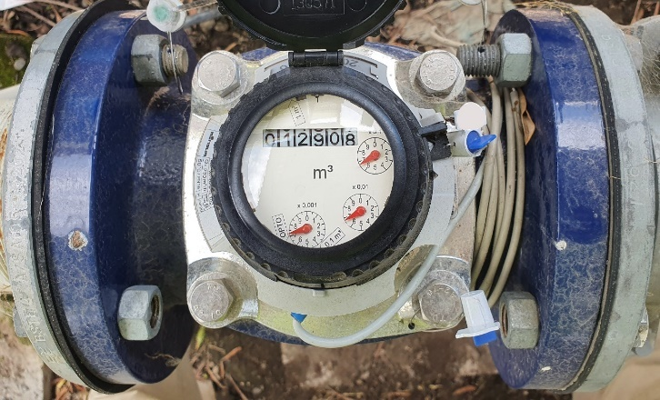
A mechanical water meter with a reed switch (grey cable at the bottom of meter), ready to be connected to a telemetry unit.

Electromagnetic and ultrasonic meters
Electromagnetic and ultrasonic meters both require power to operate and have digital output capabilities. These meters either use the 4-20mA system, or generate pulses. This information is stored by the logger for each 15-minute period.

4-20mA
The 4-20mA works like a sliding scale with 4 usually being set as zero flow and 20 being the highest flow the system is physically able to output. The mA output is measured continuously to provide the host with a recorded flow. This flow is converted into volume.
The 4-20mA system is preferred by many as it is more accurate and if the recorded output is less than 4, this tells the host there is something wrong with the system, not just that zero flow is passing through the system as the pump is off.

Pulse Generation
Both meter types can also generate pulses. Once a predetermined volume has passed through the meter it creates a pulse. The logger then counts and stores the pulses and the count is sent to the host. The host converts this into a volume measurement before transferring the data to Council.
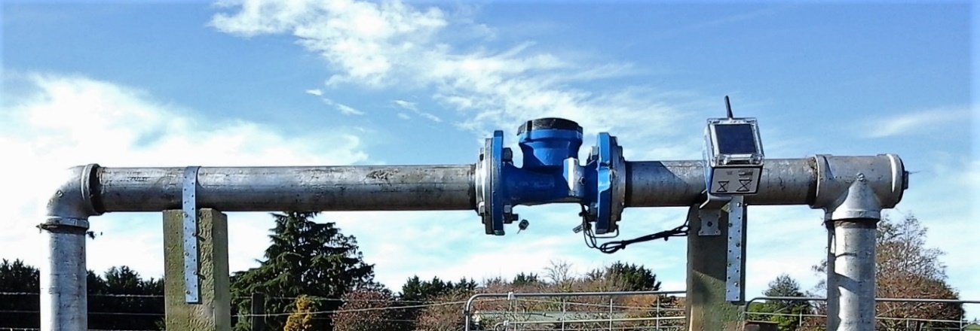
An ultrasonic water meter is connected to a solar powered telemetry unit.

Powering telemetry units
Telemetry units vary, as does the way they are installed. Like water meters, some can be connected to a 240v power supply. Others need their own power source, and usually have solar panels or a long-life battery.
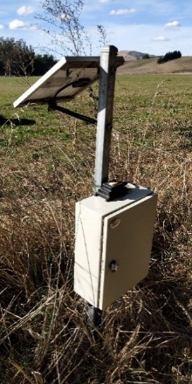 | 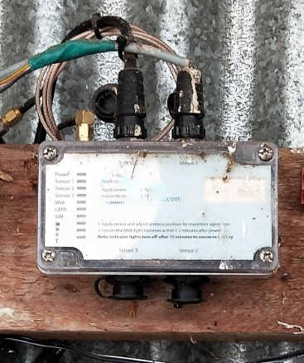  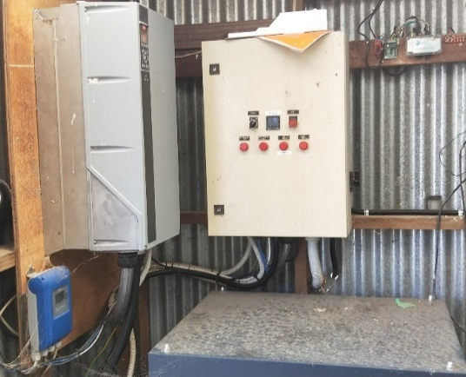
A solar-powered unit. The aerial is part of the small black box sitting on the bigger white box containing the logger. | A mains-powered unit. Left: The telemetry unit (inside the red circle) is hard-wired to the main electrical supply inside the pump shed. Right: A close up of the unit itself mounted on the framing. An aerial on the shed roof ensures the metal shed does not impair the signal when sending the data to the host.

Who installs and maintains telemetry systems?
Third-party providers usually do this work. The only council that does not use third-party providers is Horizons Regional Council (Manawatu-Whanganui): they install and maintain all telemetry units themselves. If you are in the Manawatu-Whanganui region, please talk to your council about the telemetry installation. Consent holders in the Manawatu-Whanganui region are responsible for purchasing, installing and maintaining their water meter.

Installers
Many electrical and irrigation companies can install telemetry devices, but they are often resellers. They usually have an existing relationship with the consent holder, purchasing the product from a data host and installing it for their clients. This is usually the end of their contracted role in ensuring the data is recorded and reported to councils, unless the site requires inspection and maintenance.

Data hosts
Data hosts are companies that provide sensors, measurement tools and telemetry equipment. Often, they use resellers to ensure national coverage for their product. Once the sensor or telemetry device is installed, the host takes over the ongoing relationship for data services with the consent holder. They ensure that the data recorded at the site is being transferred to the council daily.

Cost of telemetry
There are two main costs for telemetry:
- the unit and installation
- the monthly subscription for data management.
The prices below are as at publication of this guidance, and are meant to be indicative.
Units and installation prices range from $600 to $1500. The price difference is driven by the unit’s capabilities. Some units can handle multiple water meters (good for users with several take sites). Others may only be able to transfer data from one measuring device (good for people with one site). Some sites may require aerials or radio repeaters, which lead to higher costs.
Monthly subscriptions range from $20 to $30 per month for data transfer over the cellular network. This covers the transfer of data to the council, and includes access to the software to see the data, and receive alerts and customer support.

Exemptions
The exemption clause in 7A (5) was added to the regulations because sites with poor communication capabilities need more expensive technology. For example, where Satellite is the only option for the daily transfer of data, units are about $3000, with a $100 monthly service fee.
For large takes the cost/benefit may be feasible for this type of equipment, but for smaller takes, this may be excessive, qualifying for an exemption.
Get quotes for a tailored system that meets your needs and budget. Consider not just the initial cost but also the degree of service you receive from the different hosts and their data platforms.

Who is responsible for fixing failed transmission systems?
Telemetry systems are not fail-safe, and sometimes equipment stops reporting. It is ultimately the consent holder’s responsibility to ensure the council is receiving the data.
However, councils and data hosts will often first try and work together to resolve the issue, as they both receive automated alerts when transmission fails. Often, they can fix things quickly and remotely, and the consent holder is never alerted.
If the issue requires a technician to visit the site, you will be informed and asked to check the installation for any obvious faults – the power being switched off over winter is often a cause, or rodent damage to wiring. You will usually have to manually read the water meter daily until the site is working again.

FAQs

How does telemetry benefit me?
- Removes the time-consuming job of manually reading and reporting water use.
- You can set up alerts with your host for fault finding.
- Monitors pump performance by monitoring output (flow rate).
- Accurate records of water use are beneficial during consent renewals or reviews.

What does it cost?
Telemetry costs vary between hosts. The variation is largely driven by the units’ capabilities and subscription inclusions. The initial cost of an installed unit varies from about $600 to $1500.
Monthly subscriptions range from $20 to $30.
Contact a few providers and discuss the options.

What is the deadline for complying?
The requirement for more frequent recording and reporting is to be phased in over six years. These dates are:
- Takes greater than or equal to 20 l/sec: by 3 September 2022
- Takes greater than or equal to 10 l/sec: by 3 September 2024
- Takes greater than or equal to 5 l/sec: by 3 September 2026.

Do I need a new water meter?
This is unlikely. Under Part 6 of the 2010 regulations, all measuring devices and systems had to be compatible with electronic storage. This means that all meters installed since the 2010 regulations can be retrofitted with telemetry devices.

Do I need mains power at my site?
No, mains power is not required. It is very common for solar panels and long-life batteries to be used to power the logger and communication device.

Do I need a new consent?
No. Because the regulations have been made under section 360(1)(d) of the Resource Management Act (RMA), they apply directly to holders of qualifying consents.

Where do I find an installer or host?
There are three places you can seek advice:
- your usual service provider
- the council that issued your consent
- Irrigation New Zealand’s Blue Tick Accreditation page. Search under Water Measurement by your region and service type required.

Supporting documents

Related laws
Resource Management Act 1991 https://www.legislation.govt.nz/act/public/1991/0069/latest/whole.html
Resource Management (Measurement and Reporting Of Water Takes) Regulations 2010 (reprint 2020)
https://www.legislation.govt.nz/regulation/public/2010/0267/latest/DLM3174201.html?search=ts_act%40bill%40regulation%40deemedreg_water+takes_resel_25_a&p=1

Related standards and codes
National Environmental Monitoring Standards: Water Take Data
http://www.nems.org.nz/documents/water-meter-data/
National Environmental Monitoring Standards: Open Channel Flow Measurement
http://www.nems.org.nz/documents/open-channel-flow-measurement/
The New Zealand Water Measurement Code of Practice
https://www.irrigationnz.co.nz/accreditation

