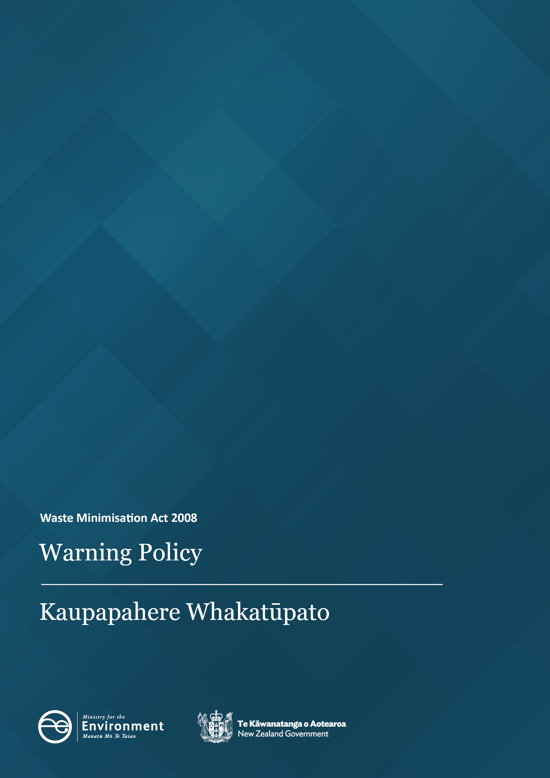
Disclaimer
The information in this publication is, according to the Ministry for the Environment’s best efforts, accurate at the time of publication. The Ministry will make every reasonable effort to keep it current and accurate. However, users of this publication are advised that:
- The information has no official status and so does not alter the laws of New Zealand, other official guidelines, or requirements.
- It does not constitute legal advice, and users should take specific advice from qualified professionals before taking any action based on information in this publication.
- The Ministry does not accept any responsibility or liability whatsoever whether in contract, tort, equity or otherwise for any action taken as a result of reading, or reliance placed on this publication because of having read any part, or all, of the information in this publication or for any error, or inadequacy, deficiency, flaw in or omission from the information in this publication.
- All references to websites, organisations, or people not within the Ministry are for convenience only and should not be taken as endorsement of those websites or information contained in those websites nor of organisations or people referred to.

This document may be cited as: Ministry for the Environment 2025. Waste Minimisation Act 2008: Warning Policy. Wellington: Ministry for the Environment.

Published in June 2025 by the
Ministry for the Environment
Manatū Mō Te Taiao
PO Box 10362, Wellington 6143, New Zealand
ISBN: 978-1-991140-94-4
Publication number: ME 1902
© Crown copyright New Zealand 2025
This document is available on the Ministry for the Environment website: environment.govt.nz.

Contents
Introduction 4
About this document 4
Deciding whether to issue a warning letter 5
Warning letters 5
Process for issuing a warning letter 6
Reconsideration process 6

Introduction
The Ministry for the Environment (the Ministry) is responsible for undertaking compliance monitoring and enforcement activities under the Waste Minimisation Act 2008 (the WMA).
The WMA is the main legislation to encourage waste minimisation and reduce waste disposal to protect the environment from harm, and provide environmental, social, economic and cultural benefits.
Our Waste Operations Team’s approach to compliance monitoring and enforcement is guided by three documents (available on our website as linked below):
- a Compliance, Monitoring and Enforcement Strategy
- an Enforcement Decision-Making Policy
- a Prosecutions Policy.
The Ministry has a range of enforcement tools, one of which is issuing warning letters.

About this document
This policy and procedure document sets out the process for issuing warning letters and the scope for a reconsideration of the warning under the WMA and associated regulations.
It aims to ensure we use warning letters and reconsiderations in the right circumstances and to achieve the intended purpose, as well as meeting the requirements of natural justice.
The policy ensures that when we carry out a compliance assessment or an investigation, we assess any conduct we consider as potentially breaching the WMA (and associated regulations) through a remedial response which follows due process and considers the public interest test.
This document applies to all compliance functions carried out by Waste Operations. We recommend you read it alongside the three documents referred to above and any other relevant Ministry policies and procedures.
This policy was developed in accordance with the Solicitor-General’s Guidelines for the Use of Warnings and natural justice, and the information privacy principles of the Privacy Act 2020.

Deciding whether to issue a warning letter
At the end of a compliance assessment or investigation, the investigator will recommend enforcement options to the Manager Waste Operations.
Waste Operations will consider issuing a warning where we deem a breach is serious but there is not enough evidence to prosecute. This evidential threshold for prosecution is set out in the Solicitor-General’s Prosecution Guidelines.
When the investigator recommends issuing a warning, the Manager Waste Operations will review the recommendation against the criteria outlined in the Enforcement Decision-Making Policy. The Manager will either decide to issue a warning or refer the matter to the Enforcement Decision Group for a decision.
When deciding whether to issue a warning, we consider the:
- needs and interests of the person to be warned, their whānau and community
- needs and interests of any person harmed or affected by the person’s behaviour, their whānau and community (the harmed person)
- the wider public interest.

Warning letters
We may issue warning letters to people to achieve a range of purposes. Some examples are to:
- show that we view the matter as serious
- mitigate the risk of the behaviour occurring again
- give the recipient an opportunity to change their behaviour and stop it occurring again
- send a clear message both to the recipient and others in similar situations, including the general public.
A warning letter must include:
- an accurate summary of the key facts underpinning the warning
- the reasons for issuing the warning
- the consequences related to the issuing of the warning, including:
- where we will save the warning letter (within our restricted internal compliance folder) and for how long
- how we may use the warning, for example with whom we may share it and whether we may publish it
- any likely consequence if, in the future, the recipient engages in similar behaviour.
- the recipient’s rights in relation to the warning, including how we will engage with them and their rights under the Privacy Act 2020
- any relevant response of the recipient to the warning, for example, whether they admit the facts or alleged conduct or dispute it
- the right of review and the process available to the recipient of the warning letter.

Process for issuing a warning letter
As required by our compliance and investigation approach and to give effect to the requirements of natural justice, we send a notification letter to all individuals or entities being investigated at the start of an investigation.
Throughout the investigation we continue to engage with the recipient to inform them of any potential non-compliance.
The recipient has an opportunity to respond to the alleged non-compliance either via an interview or in writing.
The requirements of natural justice will vary depending on the non-compliance and the consequences to the recipient of a warning.

Reconsideration process
Occasionally, we may reconsider our decision to issue a warning. This is called a reconsideration. Our reasons will be either because:
- a reassessment of the original decision shows that the warning should not be allowed to stand, or
- new evidence means the original decision to issue a formal warning was inappropriate.
For example, when we issue a formal warning early in an investigation, we will consider explaining to the person that we may review the warning if more evidence is found suggesting the offending was more serious.
We will seek internal legal advice, or the advice of a Crown solicitor, as part of any reconsideration process.

The Ministry does not issue ‘verbal warnings’.
The Ministry is not currently able to publish a warning letter.
The warning forms part of a history of non-compliance and will be considered if there are future incidents of non-compliance.
Individuals or entities are either natural or legal persons.

