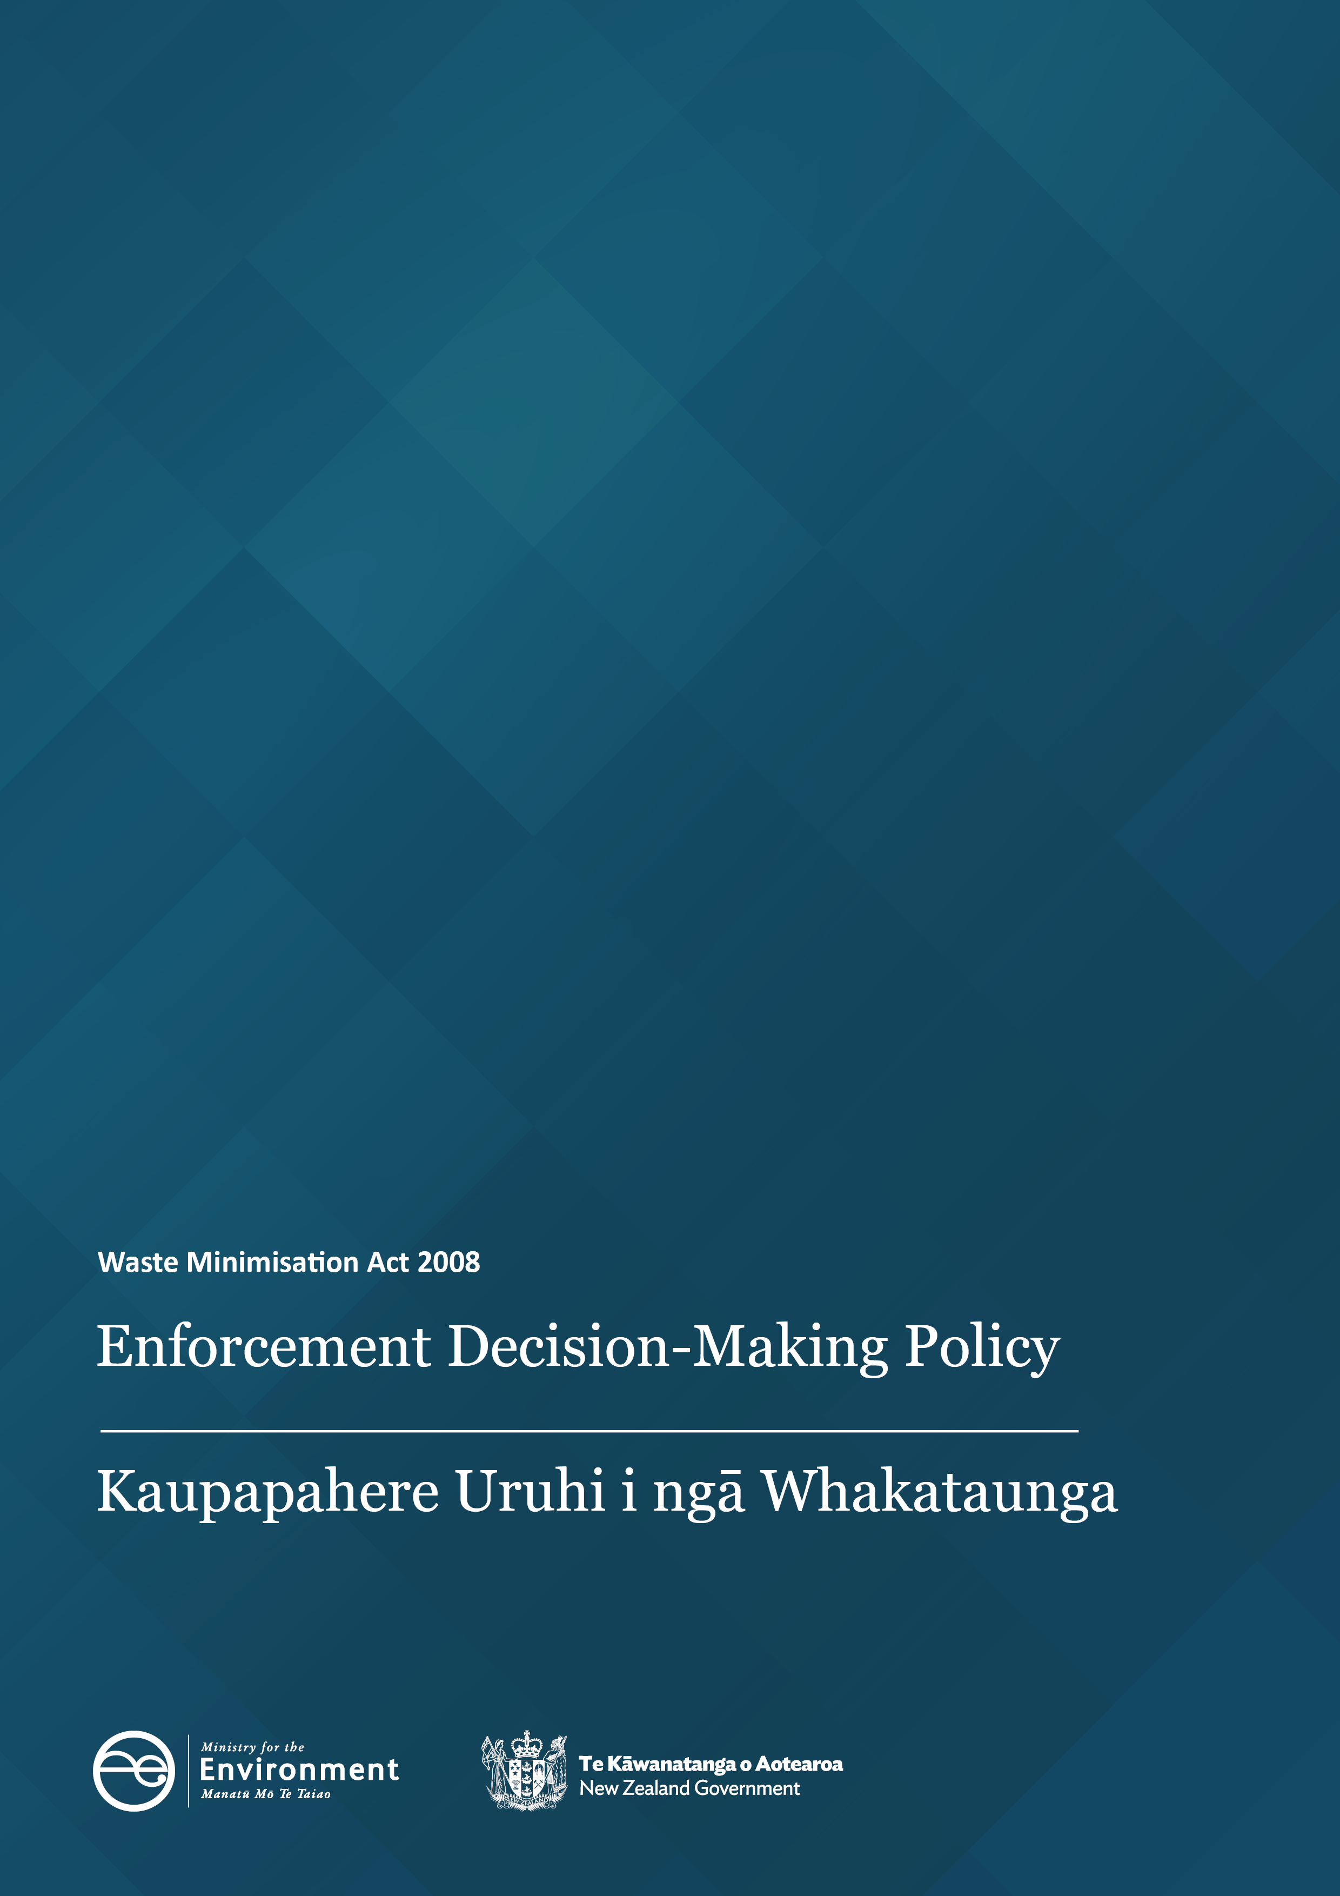

Disclaimer
The information in this publication is, according to the Ministry for the Environment’s best efforts, accurate at the time of publication. The Ministry will make every reasonable effort to keep it current and accurate. However, users of this publication are advised that:
- The information has no official status and so does not alter the laws of New Zealand, other official guidelines, or requirements.
- It does not constitute legal advice, and users should take specific advice from qualified professionals before taking any action based on information in this publication.
- The Ministry does not accept any responsibility or liability whatsoever whether in contract, tort, equity or otherwise for any action taken as a result of reading, or reliance placed on this publication because of having read any part, or all, of the information in this publication or for any error, or inadequacy, deficiency, flaw in or omission from the information in this publication.
- All references to websites, organisations, or people not within the Ministry are for convenience only and should not be taken as endorsement of those websites or information contained in those websites nor of organisations or people referred to.

This document may be cited as: Ministry for the Environment 2025. Waste Minimisation Act 2008: Enforcement Decision-Making Policy. Wellington: Ministry for the Environment.

First published in June 2021, revised in June 2025 by the
Ministry for the Environment
Manatū Mō Te Taiao
PO Box 10362, Wellington 6143, New Zealand
ISBN: 978-1-991140-93-7
Publication number: ME 1901
© Crown copyright New Zealand 2025
This document is available on the Ministry for the Environment website: environment.govt.nz.

Contents
Purpose of this policy 4
Our approach to enforcement 4
Enforcement tools 5
Enforcement Decision Group 7
Role and members 7
Scope for the EDG 7
EDG meetings 8
EDG decision-making 8
Appendix 1 – EDG escalation flow chart 9

Purpose of this policy
The Enforcement Decision-Making Policy sets out the scope and procedure for making enforcement decisions under the Waste Minimisation Act 2008 (the WMA) and associated regulations. It also sets out the terms of reference for the Enforcement Decision Group (EDG). We recommend you read it alongside other relevant Ministry policies and procedures, in particular the:
- Waste Minimisation Act 2008: Compliance, Monitoring and Enforcement Strategy
- Waste Minimisation Act 2008: Prosecutions Policy.

Our approach to enforcement
The purpose of the WMA is to encourage waste minimisation and reduce waste disposal to protect the environment from harm and provide environmental, social, economic and cultural benefits. The Ministry for the Environment (the Ministry) takes any breach of the WMA seriously.
Taking compliance or enforcement action ensures people who comply with the WMA are treated fairly. It also ensures people who breach the WMA are held to account while at the same time deterring others from doing so.
We take a risk-based approach to enforcing the requirements of the WMA and associated regulations. Our compliance strategy has five pillars to describe our actions:
- Educating, engaging and providing incentives to promote voluntary compliance.
- Monitoring the activities of our regulated communities via proactive programmes and quickly identifying potential breaches.
- Investigating alleged breaches.
- Taking appropriate action when a breach occurs.
- Monitoring the performance of our strategy.
The Enforcement Decision-Making Policy specifically links to Pillar 4: Taking appropriate action.
If, after a compliance assessment or investigation, we consider a breach has occurred, we follow a process to ensure our actions are:
- fair, appropriate and proportional
- targeted at the greatest risk to the purpose of the WMA.
Referring matters of non-compliance to other agencies
While we are performing our regulatory function, if we identify matters of non-compliance outside of the WMA, we may choose to refer these to other relevant agencies. This could include letting the local regional authority know about a compliance issue that is under their control or working with other regulatory agencies.

Enforcement tools
The WMA has a range of enforcement tools and compliance processes we can use to support, encourage or require people to comply. Different tools can be used to suit the nature of the situation. When making an enforcement decision, we consider all the available tools and take a graduated approach to non-compliance.
The enforcement tools are described in tables 1 and 2, with guidance on their use.
Table 1: Enforcement tools: Compliance – investigation
Enforcement tools  (Compliance – investigation) | Description and when used
Compliance letter | General communication to advise of a potential breach, request information and/or educate the person.  Suitable for minor breaches or alongside other enforcement options.
Warning letter | A breach of the WMA that is serious enough to warrant a warning but does not meet the threshold in the Solicitor-General’s Prosecution Guidelines for a prosecution or other remedy.  A warning letter is used for its deterrence value against further non–compliance and forms part of the recipient’s compliance history.  Note: Warnings will be issued in accordance with the Warning Policy.
Correction of levy payable | Where a waste facility has improperly managed the waste disposal levy, it is liable to pay any levy shortfall.  The levy collector will issue the facility with an invoice to pay the correct levy on the adjusted waste tonnage. This usually occurs as an outcome of an investigation.
Prosecution – Offences for preventing compliance officers from carrying out their functions and/or duties  Maximum penalty is $5000 (eg, intentionally prevents enforcement officer or auditor from carrying out their statutory duty)  Sections 65(3)(a) to (c) | This would apply in situations where an enforcement officer or auditor is prevented from performing their functions or duties under the WMA.  Prosecution requires the Solicitor-General’s Prosecution Guidelines (including the evidential test and public interest test) and the Ministry’s Prosecutions Policy to have been met.
Prosecution – Offences for breaches and/or contraventions  Maximum penalty is $100,000 (eg, a person who contravenes regulations made under the WMA)  Sections 65(1)(a) to (f)  Maximum penalty is $20,000 (eg, a territorial authority that fails to comply with a notice)  Section 65(2) | A breach of the regulations considered to be severe enough to warrant prosecution.  Prosecution requires the Solicitor-General’s Prosecution Guidelines (including the evidential test and public interest test) and the Ministry’s Prosecutions Policy to have been met.
Post-conviction – seek court order for commercial gain resulting from breach of the WMA  Section 67 | This can be sought when someone has been convicted of an offence.  We must be satisfied that on the balance of probabilities the contravention occurred in the course of producing a commercial gain.
Table 2: Enforcement tools: Waste disposal levy – compliance
Enforcement tools  (Waste disposal levy – compliance) | Description and when used
The enforcement of unpaid levy as debt  Section 36 | Waste disposal levy that is invoiced but unpaid can be recovered as debt.  Debt recovery is managed by the levy collector in its role as administrator of the Online Waste Levy System (OWLS).  We can recover outstanding debt either through an external debt recovery agency or via the court.
The withholding of levy on a non-discretionary basis  Section 33 | The Secretary for the Environment must withhold the levy allocation for a territorial authority that does not meet its waste-related planning obligations as set out in its waste management and minimisation plan.  Note: the sole test is whether the requirements of Section 33 of the WMA are met. The Secretary has no discretion about whether the levy can be fully or partially withheld or released with conditions.
The withholding of levy on a discretionary basis  Section 37 | The Minister for the Environment may direct that payments of levy money to territorial authorities be withheld under specific circumstances.  Where it is proposed to withhold the levy on a discretionary basis, we provide advice to the Minister on the reasons they may choose to make such a decision. The recommendation must be approved by the EDG.

Enforcement Decision Group

Role and members
The role of the Enforcement Decision Group (EDG) is to:
- make decisions on enforcement action for potentially serious contraventions of the WMA and associated regulations, or
- make decisions on compliance matters considered complex, sensitive or presenting a legal or reputational risk to the Ministry, and
- provide general oversight and quality assurance for the enforcement function of Waste Operations.
The EDG is not usually responsible for general compliance activity before the start of a formal investigation.
The EDG will consider:
- how much harm or potential harm the breach caused
- how severe the breach was
- the legislation and regulatory system’s intention or purpose.
EDG membership will comprise three to four decision-makers:
- General Manager – Waste Systems
- manager(s) responsible for Waste Operations
- General Manager – Legal and Risk (or a suitable alternative from the legal team).
Other EDG members who will attend meetings regularly might include, for example, the Waste Operations Principal Advisor, or investigators or compliance officers reporting to the EDG and requesting decisions, on a rotational or as needed basis.
All members of EDG must be qualified to make informed decisions on enforcement action. Collectively, the membership must have the following competencies:
- senior management experience
- experience in compliance monitoring and enforcement
- specialist knowledge of the WMA.
If an EDG member cannot attend a meeting, they may delegate to a person on the same management level or a sufficiently senior member of the legal team to replace the General Manager Legal. The EDG must be satisfied the delegate has the necessary knowledge and experience.

Scope for the EDG
The EDG’s decision-making powers relate to the following types of enforcement action:
- prosecution
- recovery of levy of more than $40,000
- recovery of financial gain (section 67)
- withholding of levy in respect to section 37
- enforcement for serious non-compliance of deed funding
- other matters referred at the discretion of a Waste Operations manager. These may include matters considered complex, sensitive or presenting legal or reputational risk to the Ministry (see appendix 1).

EDG meetings
The EDG will have regular scheduled meetings, either in person or over an online platform such as Microsoft Teams. All members must agree on decisions made.
Each regular meeting will include an update on any investigations and other compliance activities, usually given by the Waste Operations manager.
For any enforcement decision, the EDG or their delegates must be present to form a consensus. If a consensus decision is not reached at the meeting, then the matter under consideration must be adjourned for further consultation until a consensus can be achieved. When this happens, the EDG may wish to consult other subject matter experts or seek legal analysis.
Attendance at EDG meetings that are considering an enforcement decision must include a manager of Waste Operations and the investigator presenting the case. An EDG member or the investigator may invite others, such as subject matter experts, to present relevant information to help the EDG make its decision.
If an urgent decision is needed outside of the regular meeting schedule, the EDG will arrange a meeting with the same criteria applied as to a scheduled meeting.

EDG decision-making
The EDG’s objective at each meeting is to provide robust, independent, consistent and accountable decision-making in carrying out the Ministry’s role as a regulator under the WMA.
To deliver on this, the EDG will:
- be informed of all investigations into non-compliances under the WMA
- make decisions in line with the Solicitor-General’s Prosecution Guidelines, the Ministry’s Prosecutions Policy, and WMA Compliance Strategy
- make decisions independently, free of political interference
- ensure that decisions are made in proportion to the degree of non-compliance and are well documented
- ensure it fulfils the Ministry’s obligations in respect of the Information Privacy Principles under the Privacy Act 2020.

Appendix 1 – EDG escalation flow chart

Waste Minimisation (Calculation and Payment of Waste Disposal Levy) Regulations 2009; Waste Minimisation (Information Requirements) Regulations 2021; Waste Minimisation (Tyres) Regulations 2023; Waste Minimisation (Microbeads) Regulations 2017; Waste Minimisation (Plastic Shopping Bags) Regulations 2018; Waste Minimisation (Plastic and Related Products) Regulations 2022.

