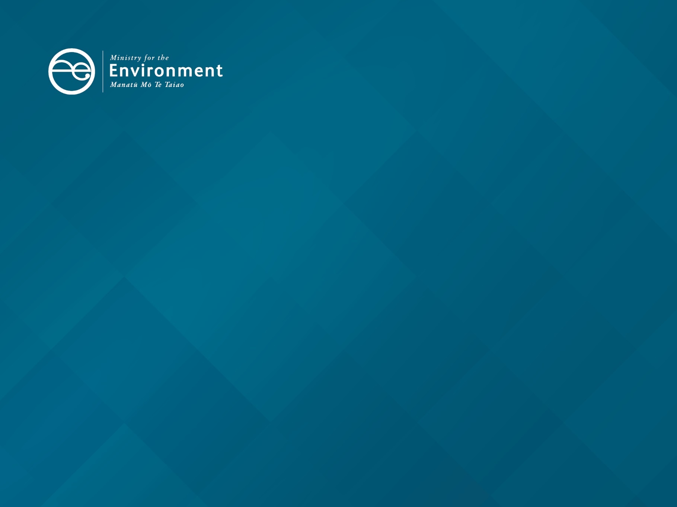

Waste and resource efficiency work programme 2024 to 2026

Reducing waste and waste emissions can help us reduce environmental impacts and meet our climate targets. The Government’s work programme for 2024 to 2026 will help us achieve the outcomes in the waste and resource efficiency strategy.

Focus area: Ensuring fit-for-purpose waste legislation
Workstreams | Timing
Implement recent changes established by the Waste Minimisation (Waste Disposal Levy) Amendment Act 2024
- Changes made to the Waste Minimisation Act include:  - enabling funding for activities that reduce environmental harm or increase environmental benefits  - emergency waste  - contaminated site remediation. | Ongoing  Contaminated Sites and Vulnerable Landfills Fund opened October 2024.
Modernise the Waste Minimisation Act and Litter Act
- Adjustments to how levy funds are allocated amongst councils, shifting from a fully population-based formula in recognition of the fixed costs and scale challenges faced by smaller councils.  - Options for councils to spend their share of the levy on a wider range of waste and environmental priorities.  - Improving compliance, monitoring and enforcement provisions to ensure more proportionate and practical intervention tools.  - Amending provisions for product stewardship to:  - ensure greater clarity of responsibilities  - manage financial risks  - enforce obligations, to ensure a level playing field.  - Inclusion of a regulatory framework to support the future introduction of a beverage container return scheme. | Consult on detailed legislation proposals in 2025.

Focus area: Cost-effective, outcomes-focused investment of the waste disposal levy
Workstreams | Timing
Independent review of investment of the waste disposal levy
- Independent review of the process for making investment decisions using the levy and back-office functions in the Ministry for the Environment relating to the levy.  - In consultation with the Minister for Regulation, review the performance of government spending funded by the levy.  - Implement recommendations of these reviews, including through legislative change (see above) where required. | Discussed with relevant Ministers in first quarter of 2025.
Investing the waste disposal levy
Implement the investment priorities Cabinet agreed in April 2024, including:  - contaminated sites including vulnerable landfill remediation (15 to 25 per cent of waste-related investment of the levy)  - infrastructure – for example, materials recovery, recycling and manufacturing facilities (70 to 80 per cent)  - innovation, community solutions and education – for example, product design, and recycling education campaigns (5 to 10 per cent)  - system design – for example, design and development of producer responsibility schemes (2 to 5 per cent).  Priority waste streams also agreed by Cabinet in April 2024 include:  - construction and demolition materials  - organic waste  - plastics  - kerbside recyclables  - priority products the Minister has declared by notice in the Gazette.  Projects seeking over $10 million in levy funding will be consulted on with the Minister of Finance, Minister for Infrastructure, Minister for Regional Development, and any other relevant portfolio Ministers. | Ongoing

Focus area: Reducing waste emissions
Workstream | Timing
Implement emissions reduction plan 1 and 2 actions
The first emissions reduction plan covers the period 2022 to 2025. The second emissions reduction plan covers the period 2026 to 2030. Waste actions include:  - making further targeted investment in resource recovery infrastructure and systems (including for construction and demolition waste)  - investigating ways of improving organic waste disposal and landfill gas capture  - implementing a regulated product stewardship scheme for synthetic refrigerant gases. | Ongoing

Focus area: Increasing reuse and recycling of materials
Workstreams | Timing
Plastics phase-outs
Ensure plastic packaging is recyclable and high value, including through:  - refining options for phasing out hard-to-recycle polyvinyl chloride (PVC) and polystyrene food and beverage packaging which is no longer collected through kerbside collections to ensure practicable alternatives are available and provide sufficient time to make operational changes and run-down existing stock. Advice will include outlining exemptions (or extensions) needed where there are no viable and cost-effective alternatives available  - amending the Waste Minimisation (Plastic and Related Products) Regulations 2022 to extend the date by which the labels on all produce sold in New Zealand must be certified home compostable (including both the label and its adhesive) to 1 July 2028. | Report back to Cabinet by mid-2025 with policy options to phase out additional polyvinyl chloride (PVC) and polystyrene (PS) packaging.  Produce labels to be certified home compostable by 1 July 2028.
Kerbside recycling policies
- Support territorial authorities to introduce standardised kerbside dry recycling and food organics or food and garden organics collections through targeted investment packages of the Waste Minimisation Fund.  - Work collaboratively with the sector, including on the Recycling Leadership Forum, which brings together sector representatives from across the system to explore challenging kerbside issues including solutions for some of the items that are no longer accepted in household recycling bins.  - Monitor outcomes, including in relation to council adoption of food scrap collections (which help to achieve emissions reduction objectives). Mandatory record-keeping and reporting by territorial authorities from 1 July 2024 will assist with monitoring. | Ongoing
Product stewardship
Develop product stewardship schemes to reduce waste and better meet international obligations and requirements of our export markets, including the following.  - Tyres – Every year about 6.5 million tyres reach their end of life in New Zealand. Of these, about 40 per cent are estimated to be recycled or exported, and the remainder are landfilled, stockpiled or illegally dumped. Industry led the co-design of the product stewardship scheme, known as Tyrewise, which collects and processes end-of-life tyres and turns them into new products. A tyre stewardship fee funds the scheme. The fee is built into the cost of the newly imported tyres that have entered the market from 1 March 2024. The fee replaces the old system of ad-hoc disposal charges that many tyre retailers used to charge but did not guarantee responsible end-of-life management. The scheme is given effect through the Waste Minimisation (Tyres) Regulations 2023, the second and final tranche of which has been in force since 1 September 2024. Ministry for the Environment officials will work with the sector to monitor and support ongoing implementation of the scheme. | Ongoing implementation by Tyrewise.
- Synthetic refrigerant gases – Refrigerant gases are used in heating, ventilation, air-conditioning and refrigeration technology. The Trust for the Destruction of Synthetic Refrigerants was established by the industry in 1993 and operates a voluntary product stewardship scheme to collect and destroy the highest risk refrigerant gases, which have much higher global warming potential than carbon dioxide. The scheme has been accredited under the Waste Minimisation Act since 2010, but as a voluntary scheme has had lower impact than is desirable. In 2020 a sector working party reported to government on how best to improve the collection and destruction or safe reuse of refrigerant gases and bring workforce competence up to international standards. Regulations to support full industry participation and restricting access to trained technicians is required to give this scheme full effect. In late 2022, the Government consulted on regulations to support this design. In December 2024, Cabinet agreed that regulations for a product stewardship scheme for synthetic refrigerants will be drafted in 2024/25, with progressive implementation. This initiative will reduce domestic emissions significantly by 2030, at almost no cost to businesses and consumers. | Enact regulations in 2025.
- Farm plastics, agrichemicals and their containers – Voluntary accredited product stewardship schemes Agrecovery and Plasback have engaged many farmers to recycle agrichemicals, their containers and other farm plastics over the last decade. However, on-farm burning and burial of these products remains common practice in some rural areas. Industry-led working parties designed improvements to the Agrecovery and Plasback schemes and proposed a combined regulated ‘Green-farms’ scheme which was accredited in 2023. Proposed regulations would affect producers who place these products on the market. Farmers would not be regulated and would have better options for reducing waste through a nationwide collection service funded by a small product fee charged to producers. | Consultation on regulations in 2024/25.
- Electrical and electronic products (including batteries) – Waste electronic and electrical products are known as e-waste. New Zealand generates an estimated 99,000 tonnes of e-waste annually, 98 per cent of which goes to landfill or illegal disposal. E-waste contains hazardous materials harmful to human health and the environment, but it also offers significant opportunities for business development, employment, and the extraction of valuable metals, including rare earth elements and precious metals. In addition, it is estimated that by 2030 New Zealand will have over 84,000 large batteries from electric vehicles reaching the end of their lifecycle, posing substantial environmental challenges. The most widely used battery chemistries pose risks of fire hazard, release of toxins, and loss of rare earth metals. Two industry led co-design projects have been completed, one for large batteries (led by the Battery Industry Group) and one for a small range of other e-waste (led by Tech-Collect NZ). The Ministry for the Environment will work with stakeholders to build on these designs and update the evidence base. | Work with industry on next steps.
- Plastic packaging – Plastic waste makes up an estimated 80 to 85 per cent of marine litter and most urban litter in New Zealand. Plastic packaging poses harm to freshwater and marine wildlife from ingestion and breaks down into microplastics and food chain contamination. Currently the financial and environmental burden of managing post-consumer packaging falls on councils and communities. Since 2018, the Packaging Forum has operated an accredited voluntary product stewardship scheme for soft plastics. However, limited participation and limited markets for the collected plastics have hindered significant environmental gains. In September 2022 the Packaging Forum (supported by the Food and Grocery Council) was awarded funding from the Waste Minimisation Fund to lead a two-year project to co-design a plastic packaging product stewardship scheme. Their final report to government was received in late February 2025, and Ministry for the Environment officials will work with the sector on the next scheme development. | Work with industry on next steps.

Beverage container return scheme
New Zealanders use over two and a half billion single-use drink containers each year. It is estimated that over half these empty beverage containers end up in landfills and unused stockpiles or as litter. A beverage container return scheme would encourage consumers and businesses to return beverage containers for recycling or re-use, through the use of a refundable deposit that would be added to the price of purchase.  - Develop a framework for a potential container return scheme as part of wider improvements to product stewardship provisions in the Waste Minimisation Act, which would enable the establishment of a beverage container return scheme should the Government choose to do so. | Consult on legislation proposals in 2025.
Construction and demolition waste
Initiatives to enable construction waste to be reduced in a cost-effective way, incorporating industry views on how this can best be achieved:  - prioritising levy funds to invest in construction and demolition separation and recovery infrastructure, including solutions to problematic materials such as treated timber  - work with industry to identify options to help manage surplus soil generated through construction and infrastructure projects, with the aim of developing cost-effective solutions that recognise the value of soil resources and maximise benefits. This will include work with and responding to sector group WasteMINZ, who have developed a white paper on soil reuse. | Ongoing
Waste-related trade opportunities
Waste-related trade opportunities include:  - European Union (EU) requirements for recycled content for packaging and the necessary domestic infrastructure to enable major New Zealand businesses to comply and continue to access the European market  - the role of the Eco Choice Aotearoa ecolabel in supporting businesses to substantiate their green credentials and adhere to the new EU laws on green claims. | Ongoing

Focus area: Reducing harm and addressing legacy issues
Workstreams | Timing
Contaminated site and vulnerable landfill remediation
- The environmental harm associated with closed landfills and the historic inappropriate dumping of waste is becoming more prominent, particularly as the impacts of severe weather events are becoming more prevalent. From 1 July 2024, projects to remediate contaminated sites can be funded through the levy. This will enable an increase in funding, and more proactive management of historic sites before they become a problem.  - Officials will investigate using levy revenue to also fund the remediation of contaminated sites on Crown land which pose an unacceptable risk to the environment and human health. | New Contaminated Sites and Vulnerable Landfills Fund opened in October 2024.

Compliance, monitoring and enforcement
Compliance, monitoring and enforcement of regulatory obligations under the Waste Minimisation Act, including:  - payment of the levy  - record-keeping and reporting provisions  - monitoring and audit of levy spend by territorial authorities and Waste Minimisation Fund recipients  - product bans including single-use shopping bags and other hard-to-recycle and single-use plastics  - regulated product stewardship (currently the Waste Minimisation (Tyres) Regulations 2023, with additional regulations under development). | Ongoing

Focus area: International chemical and waste commitments
Workstream | Timing
Work to support multilateral environmental agreements
Supporting global solutions to environmental issues through negotiating, ratifying and implementing international Treaties, including:  - continuing to engage in the negotiation of the United Nations global plastics treaty and advocating for New Zealand interests as outlined in the mandate Cabinet agreed in April 2024  - implementing the Basel Convention, including e-waste amendments – consultation on these proposals closed at the end of August 2024  - ratifying the Minamata Convention (on mercury) to ensure effective compliance and enforcement. This will include amending the National Environmental Standards for Air Quality. | Sixth session of the global plastics treaty to be held 4–14 August 2025.  Triple Conference of Parties (Basel, Rotterdam, Stockholm) 28 May – 9 April 2025.

Published in March 2025 by the  Ministry for the Environment – Manatū mō te Taiao  Publication number: INFO 1291 | 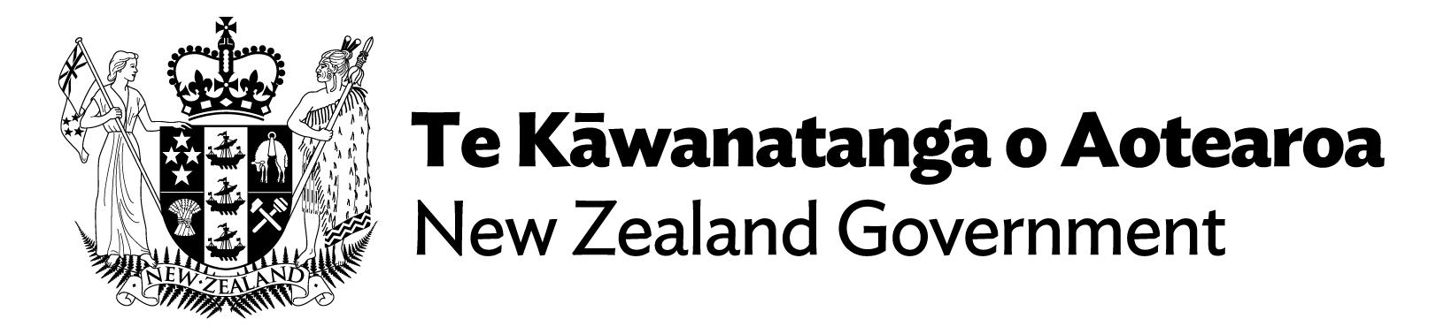

Excluding emergency waste and spending on the Ministry’s responsibilities for waste and hazardous substances.

